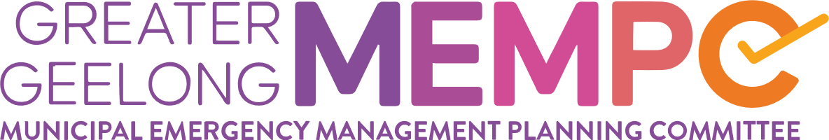
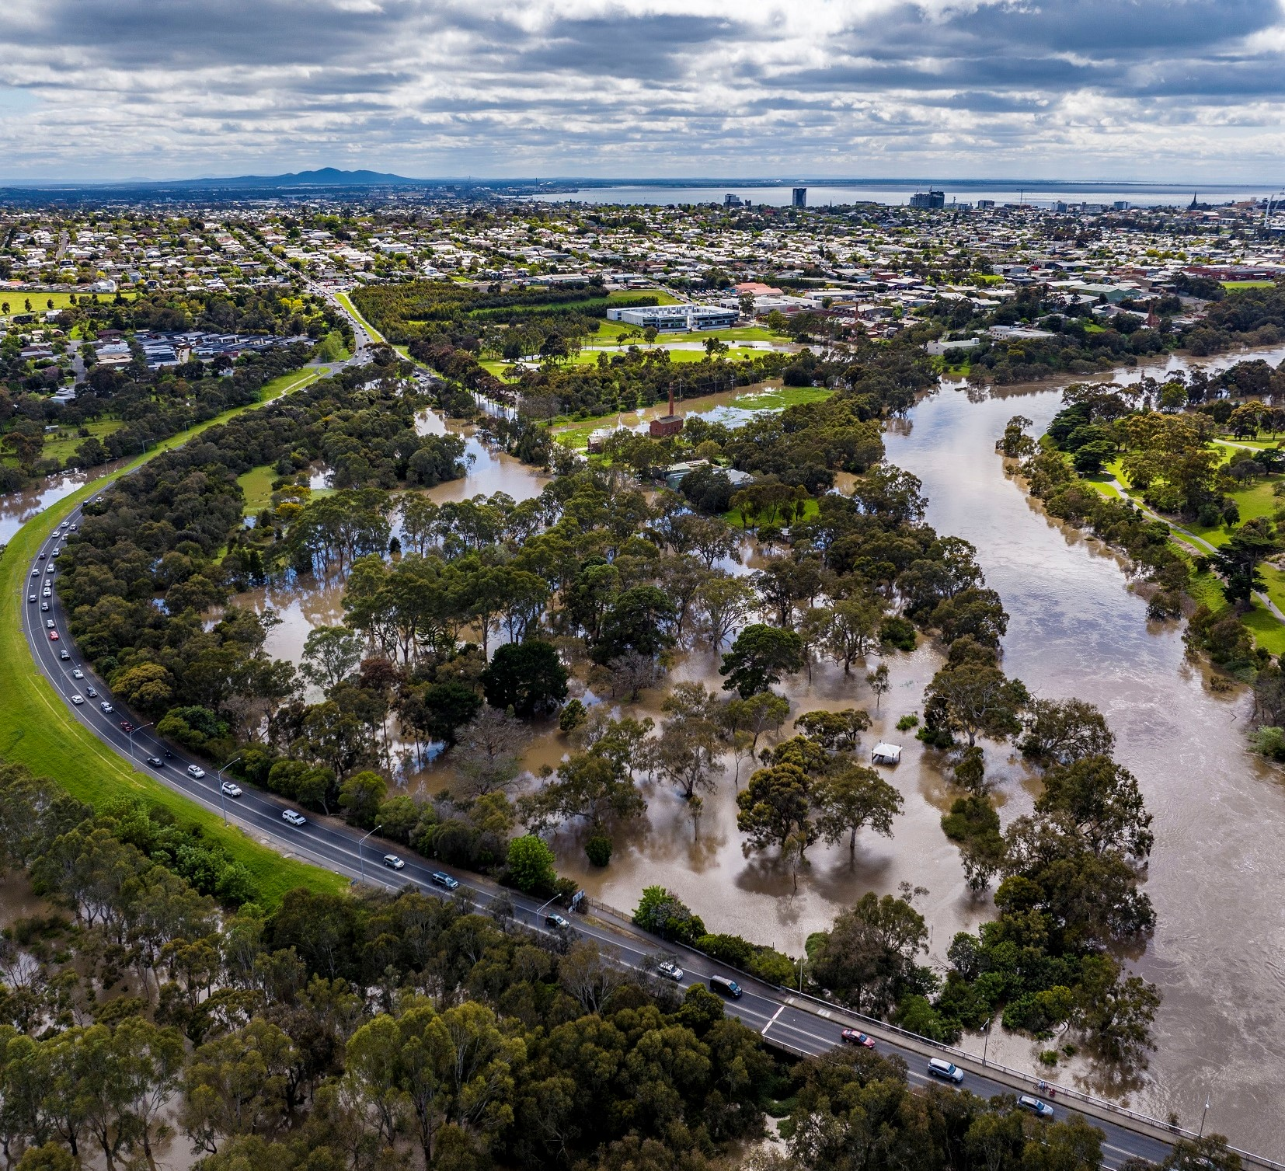

Municipal Emergency Management Plan (MEMP)

Version 1.0 - April 23

Collaborative and Multi-Agency Emergency Management Planning
Table of Contents
Municipal Emergency Management Plan (MEMP) 0
Version 1.0 - November 22 0
Collaborative and Multi-Agency Emergency Management Planning 0
1. INTRODUCTION 4
1.1 Authority 4
1.2 Assurance and Approval 4
1.3 Review 4
1.4 Glossary and Acronyms 4
1.5 Planning Context 4
1.6 Aim and Objectives 5
1.7 Training and Exercising 5
2. Municipal Characteristics 6
2.1 Community profile 6
2.2 Topography 6
2.3 Significant Natural Features 7
2.4 High Consequence Infrastructure 8
2.5 History of Emergencies 9
3. PLANNING ARRANGEMENT 12
3.1 Victorian Emergency Management Planning Framework 12
3.2 Municipal Emergency Management Planning Committee (MEMPC) 12
3.3 MEMPC Structure 13
3.4 Subplans and Complementary Plans 13
3.5 Restricted operational information 14
4. MITIGATION ARRANGEMENTS 15
4.1 Introduction 15
4.2 Hazard, Exposure, Vulnerability 15
4.3 Risk Assessment Process 15
4.4 Monitoring and Review 17
4.5 Resilience 18
5. RESPONSE ARRANGEMENTS 20
5.1 Introduction 20
Response Management Arrangements 20
5.2 Command, Control, Coordination 20
Classification of emergencies 21
5.3 Consequence Management 22
5.4 Local Response Arrangements 22
Impact Assessment 23
5.5 Financial Considerations 23
5.6 Neighbourhood Safer Places and Community Fire Refuges 23
5.7 Council Resource Sharing 23
5.8 Debriefing Arrangements 24
5.9 Transition to Recovery 24
Evacuation 24
5.10 Community Information and Warnings 25
6. Relief Arrangements 27
6.1 Relief Management and Governance 27
6.2 Activation of Relief Services 27
6.3 Escalation 27
6.4 Relief Communication 28
6.5 Relief Planning 28
6.6 Register.Find.Reunite 28
6.7 Animal Management in Emergencies 28
6.8 Vulnerable People and Facilities 28
7. RECOVERY ARRANGEMENTS 30
7.1 Introduction 30
7.2 Objectives of Recovery 30
7.3 Recovery Definition 30
7.4 Escalation 31
7.5 Management Structure 31
7.6 Secondary Impact Assessment 32
7.7 Government Assistance Measures 32
8. ROLES AND RESPONSIBILITIES 33
8.1 Introduction 33
8.2 Roles and Responsibilities 33
9. APPENDICIES 35
Appendix 1: Document Administration 35
Appendix 2: List of Other Emergencies to Impact the Greater Geelong Region 36
Appendix 3: MEMPC Contact List 38
Appendix 4: BSW Non-Major Emergency Protocol 41
Appendix 5: Maps 43

Acknowledgement of Country
We acknowledge the Wadawurrung People as the Traditional Owners of the Land, Waterways and Skies. We pay our respects to their Elders, past and present.
We acknowledge all Aboriginal and Torres Strait Islander people who are part of our Greater Geelong community today.

INTRODUCTION

Authority
In 2020, the Emergency Management Legislation Amendment Act 2018 amended the Emergency Management Act 2013 (EM Act 2013) to provide for new integrated arrangements for emergency management planning in Victoria at the State, regional and municipal levels; and create an obligation for a Municipal Emergency Management Planning Committee (MEMPC) to be established in each of the municipal districts of Victoria, including the alpine resorts which, for the purposes of the act, are taken to be a municipal district. Each MEMPC is a multi-agency collaboration group whose members bring organisation, industry or personal expertise to the task of emergency management planning for the municipal district.
The plan has been prepared in accordance with and complies with the requirements of the EM Act 2013 including having regard to the guidelines issued under section 77, Guidelines for Preparing State, Regional and Municipal Emergency Management Plans.

Assurance and Approval
A Statement of Assurance (including a checklist and certificate) has been prepared and submitted to the REMPC pursuant to EM Act 2013 (s60AG).
This Plan is approved by the Barwon South-West Regional Emergency Management Planning Committee.
This Plan comes into effect when it is published and remains in effect until superseded by an approved and published update.

Review
To ensure the plan provides for a current integrated, coordinated and comprehensive approach to emergency management and is effective, it is to be reviewed at least every three years or as required.
Urgent update of this Plan is permitted if there is significant risk that life or property will be endangered if the plan is not updated (EM Act 2013 s60AM). Urgent updates come into effect when published on the municipal council website and remain in force for a maximum period of three months.
This Plan will be reviewed not later than December 2025. This Plan is current at the time of publication and remains in effect until modified, superseded or withdrawn.
Refer to Appendix 1 for document administration.

Glossary and Acronyms
Definitions of words and phrases used in the MEMP have the same meaning as those prescribed in the relevant legislation and should be referred to, they include:
- Emergency Management Act 1986 and 2013
- State Emergency Management Plan (SEMP)
- Local Government Act 2020
- Risk Management Standard ISO: 31000 2018

The MEMP follows the practice of writing a name in full followed by the acronym in brackets after it and is used thereafter in the plan.

Planning Context
The MEMP provides for an integrated, coordinated, and comprehensive approach to emergency management at the municipal level. the Act 2013 requires the MEMP to contain provisions providing for the mitigation of, response to relief and recovery from emergencies (before, during and after), and to specify the roles and responsibilities of agencies in relation to emergency management.
It is recommended that the MEMP be read in conjunction with the Victorian State Emergency Management Plan (SEMP), Regional Emergency Management Plan (REMP) and subplans.

Aim and Objectives
The aim of the Greater Geelong MEMP is to document agreed emergency management arrangements for the prevention of, preparedness for, response, relief and recovery from emergencies that could impact on the municipality and its communities.

The MEMP is consistent with the following that have been consulted and engaged:
- community, through the appointed Community Representative
- sectors of the community, as the MEMPC considers appropriate
- departments or other agencies, the MEMPC considers appropriate.

The MEMP is consistent with the principles underlying the preparation of emergency management plans. Principles require that the plan is:
- prepared efficiently and effectively in a collaborative manner
- to enhance the coordination of public messaging, warnings and advice and communication of messaging within individual agencies
- prepared in a manner that acknowledges and reflects the importance of community emergency management planning.

The broad objectives of the MEMP are to:
- identify hazards and evaluate potential risks that may impact upon the municipality
- implement measures to prevent or reduce the likelihood or consequences of emergencies
- in collaboration, emergency services organisations, agencies and stakeholders will manage arrangements for the utilisation and implementation of resources available for use in prevention, preparedness, response, relief and recovery to emergencies
- manage support that may be provided to or from adjoining municipalities
- provide assistance to meet the essential needs of individuals, families and communities during and in the immediate aftermath of an emergency
- assist communities affected by emergencies to recover following an emergency; and
- complement other local, regional and state planning emergency arrangements.

Training and Exercising
The arrangements in the SEMP require the MEMP to be exercised at least once a year. Exercises are a valuable tool to test the arrangements set out in the MEMP.

The MEMP Committee will plan and undertake an annual exercise in either a desktop format or a practical exercise based on a hypothetical emergency event. Any improvements identified during these exercises will form part of the MEMP review or it may be decided by the MEMP Committee that the MEMP be updated immediately.

Exercises are structured to provide the following benefits:
- provide the opportunity for members and stakeholders to test their procedures and skills in simulated emergency situations
- provide an opportunity for the local emergency management community to work together, build capacity and capability
- test the plan and identify areas for continuous improvement; and
- use learnings and outcomes to update and improve the MEMP and sup-plans.

Municipal Characteristics

Greater Geelong is one of the largest Local Government bodies in regional Victoria. The municipality has a population of 274,647 which is forecast to increase by 43% by 2041 to a population of 393,216.
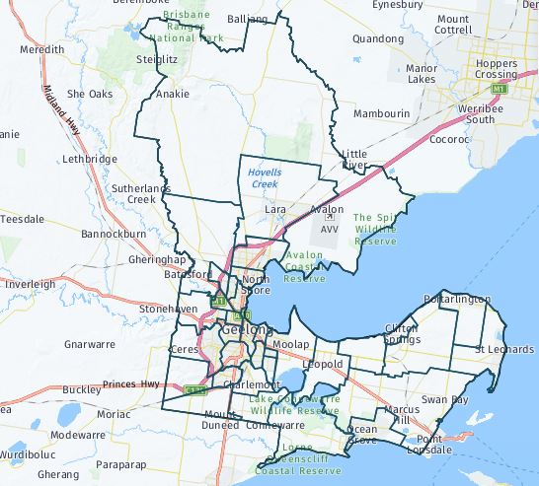
Figure 1: Map of City of Greater Geelong Map

source: http://forecast.id.com.au/geelong
Located 75 kms south-west of the State Capital, Melbourne, Geelong is the largest regional centre in the State of Victoria. The City, founded in 1838, is situated on the shores of both Corio Bay and Bass Strait and encompasses the lower reaches of the Barwon River, ensuring that the residents of Geelong are offered one of the best lifestyles in Australia.
The country now known as the City of Greater Geelong is the land of the Wadawurrung Aboriginal people. The name of this language group traditionally meant ‘The people who belong to the ‘water’, in reference to the rivers, creeks, lagoons and other water sources within the Wadawurrung boundary.
For more information on the Wadawurrung & the Kulin Nation, Lands and Way of Life go to: https://www.geelongaustralia.com.au/geelong/documents/item/8d97c1c5405a0b1.aspx
The City of Greater Geelong's Gross Regional Product is estimated at $15.42 billion, which represents 3.27% of the state's GSP (Gross State Product).

Community profile
Demographic profile and forecast data highlights some of the more complex risks and issues faced by the Municipality and that has been taken into consideration in Emergency Management Planning.
According to the Australian Bureau of Statistics’ 2016 Census of Population and Housing, our largest age group, at 19 per cent, is parents and homebuilders (35 to 49 years of age), with older workers and pre-retirees (50 to 59 years of age) the next largest group at 12.8 per cent.

The tertiary education and independence group (18 to 24 years of age) follow closely at 12.7 per cent, with the next largest group being empty nesters and retirees (60 to 69 years old) making up 11.8 per cent of the population.
Approximately 77 per cent of the community are Australian born, with the United Kingdom, India, New Zealand, Italy and China the main birthplaces outside Australia. Other than English, the most common languages spoken at home continue to include Italian, Croatian, Mandarin, Persian/Dari and Macedonian.
Couples with children made up 27.7 per cent of households, with a further 25.3 per cent being made up of couples without children. Lone person households made up 26.3 per cent and one parent families making up 11.1 per cent.
For more information, and suburb specific breakdown, visit: https://profile.id.com.au/geelong

Topography
The Municipality is bounded by Corio Bay and Port Phillip, a frontage to Bass Strait, a rural area to the west, the Brisbane Ranges to the north and Little River to the east. The landform is essentially flat for a large portion of the 1240 square kilometres. The You Yangs, a 300m high granite outcrop, forms a significant landmark to the north and the Brisbane Ranges rise to the north- west.
The principal river system is the Barwon, which is fed by the Moorabool River entering at Fyansford and the Leigh that enters further upstream. The Barwon passes through Lake Connewarre before it enters the sea at Barwon Heads.
There is limited forestation within the Municipality as most of the rural areas have either been cleared for farming activities or existed as plains in their original form. The Brisbane Ranges is heavily forested as is an area surrounding the You Yangs. Corio Bay and its coastline is relatively well protected in contrast to the coastline and beaches fronting Bass Strait.
The predominant geological formation is newer volcanic basalts which gives rise to highly expansive clays. Barrabool sandstone dominates to the west of the city with alluvium deposits on the Peninsula. There are scattered deposits of Moorabool viaduct sands as well as limestone. Fyansford clays are predominant in the Belmont area. A geological fault line, known as the Newtown Fault, runs east west from Newtown through Queens Park. A probable ancient fault line also exists east of Leopold running north south (see below).

Significant Natural Features

The Greater Geelong area has a number of environmentally significant natural features, including but limited to:

Natural Feature | Location
Brisbane Ranges | Anakie
You Yangs Regional Park | Lara
Serendip Sanctuary | Lara
Lara Lakelands | Lara
Limeburners Bay & North Coast of Corio Bay to Point Wilson – RAMSAR Site | Avalon
Reedy Lake – RAMSAR Site | Moolap
Gateway Sanctuary | Leopold
Lake Connewarre State Game Reserve – RAMSAR Site | Connewarre
Murtnaghurt Lagoon | Connewarre
Ocean Grove Nature Reserve | Ocean Grove
Lake Victoria | Point Lonsdale
Swan Bay Marine Park – RAMSAR site | Swan Bay
Edwards Point Wildlife Reserve | Saint Leonards

High Consequence Infrastructure

Examples of high consequence infrastructure includes, but not limited to:

Type | Name |  | Suburb
Major Hazard Facility | Viva Energy | Corio/Lara
Major Hazard Facility | Chemring | Lara
Major Hazard Facility | Viva Energy Polymers | Corio
Federal Major Hazard Facility | ADI Point Wilson ** | Point Wilson
Federal High-Risk Facility | CSIRO Australian Centre for Disease Preparedness | Newcomb
Road | Geelong By-Pass (Ring Road) | From Corio – Waurn Ponds
Road | Princes FWY | From Little River – Waurn Ponds
Road | Hamilton HWY | Fyansford
Road | Midland HWY | Bell Post Hill
Rail | National Railway Line | North Geelong
Rail | Regional Rail Line | North Geelong
Airport | Avalon Airport | Avalon
Airport | Barwon Heads Airport | Barwon Heads
Water Infrastructure | Lara Flood Level System | Lara
Water Infrastructure | Plummer Flood Levee | Connewarre
Water Infrastructure | Hovells Creek Flood Warning System | Lara
Water Infrastructure | Dams | Various
Water Infrastructure | Black Rock Sewer Treatment Plant | Connewarre
Communication | Mt Anakie Communication and Fire Tower | Anakie
Communication | Ceres Communication Tower | Ceres
Bridge | Barwon Heads Rd Bridge | Barwon Heads
Bridge | James Harrison Bridge | South Geelong
Bridge | Moorabool Railway Viaduct | Batesford
Ports/Terminals | Tasmania Quay | North Geelong
Ports/Terminals | Geelong Port | North Geelong
Ports/Terminals | Port Philip Ferries | Portarlington/ Geelong CBD
River | Barwon River | From Ceres – Barwon Heads
River | Moorabool River | From Batesford - Fyansford
Hospital | Barwon Health | Geelong CBD
Hospital | St John of God Hospital | Geelong CBD
Hospital | Epworth Hospital | Waurn Ponds
Major Entertainment/Sport Precincts | Geelong Showground | Breakwater
Major Entertainment/Sport Precincts | Geelong Racecourse | Breakwater
Major Entertainment/Sport Precincts | Geelong Arena | North Geelong
Major Entertainment/Sport Precincts | Kardinia Park | South Geelong
Major Entertainment/Sport Precincts | Geelong Botanical Gardens | East Geelong
Major Entertainment/Sport Precincts | Geelong Waterfront | Geelong
Major Entertainment/Sport Precincts | Beckley Park | Corio
Major Entertainment/Sport Precincts | Elcho Park Equestrian Centre | Lara
Other | Ford Proving Ground | Little River
Other | Deakin University | Waurn Ponds/ Geelong
Other | Avalon College | Avalon
Other | Geelong Grammar | Corio
Other | Kardinia International College | Bell Post Hill
Other | Prisons | Anakie
**Federal site, so not listed by Victoria’s WorkSafe Authority as a Major Hazard Facility.

History of Emergencies
Floods are a frequent occurrence along the Barwon River Valley, which is fed by the Leigh and Moorabool Rivers
The table below provides a brief example of the types of emergencies that have occurred in the Greater Geelong Region.
For a list of other emergencies impacting the Greater Geelong region, see Appendix 2.

Incident | Date | Location | Comments
Bushfire | January 8th 1969 | Lara, Little River & Princes Highway | 18 people lost their lives,  10 people at Lara and 44 homes destroyed.  Eight died on the Princes Highway near the 34-mile post.
Bushfire | January 14th 1985 | Lara & Little River | 90% of the You Yangs was burnt. The fire killed 4,500 stock, 275km of fencing and five houses. Two people lost their lives.
Bushfire | January 20th 2006 | Anakie | Fire in the Brisbane Ranges burnt 6708 hectares with 35 buildings destroyed.
Riverine Flooding | September 1880 | Barwon River | Highest ever recorded flood of 5.59m
Riverine Flooding | June 1952 | Barwon River | Significant property inundation and disruption with a heigh of 5.47m
Flash Flooding | January 27th 2016 | Geelong | Significant flash flooding event impacting many suburbs in Geelong. 213 private residents and over 140 community and council venues were impacted when 84mm fell in 45min.
Longford Gas Explosion | September 25th 1998 | State-wide | Major disruption to industrial users costing over $1.3 billion and domestic gas users including those in public housing were without gas, hot water or heating for 20 days.
Epidemic Thunderstorm Asthma | November 21st 2016 | Geelong | Public hospitals and Emergency Services experienced a 672% increase in respiratory presentations. 10 people across Geelong and Melbourne died.
COVID 19 Pandemic | March 2020 | Global | Extended lockdown in municipality with high cases and significant impacts on economy. The region experienced a population increase with more Melburnians choosing to isolate in their holiday homes.
Storm | April 8th and 9th 2017 | Bellarine | Strong south-westerly winds with high rainfall totals of 100mm recorded across Ocean Grove and Drysdale.
Tornado | May 20th 2020 | Waurn Ponds/Grovedale | Wind speeds in excess of 160km per hours with a corridor of 60 metres wide and 3km long caused significant damage to houses with some uninhabitable.
Storm | October 29th 2021 | Geelong and Bellarine | Wind gusts of more than 100km caused significant damage to trees and public land with loss of power to large sections of the Bellarine.

  - Events
Greater Geelong experiences a number of major international, national and local sporting and entertainment events annually, including but not limited to:
- The Avalon Airshow
- Cadel Evans Road Race.
- AFL games
- Big Bash Cricket Games
- Basketball Games
- Day on the Green Music Festival
- Geelong Cup
- Royal Geelong Show
- Festival of Sails

The region has seen an increase in the number of major events being hosted recently with the 2022 T20 World Cup and 2026 Commonwealth Games coming to the region.
The Avalon International Airshow is the region’s biggest paid event, with the Pako Festa held each February, the region’s biggest free local event attracting around 100,000 visitors.

For more information visit www.geelongaustralia.com.au/events/default.aspx

PLANNING ARRANGEMENT

Victorian Emergency Management Planning Framework
This plan supports holistic and coordinated emergency management arrangements within the region. It is consistent with and contextualises the State Emergency Management Plan (SEMP) and Regional Emergency Management Plan for the Barwon South West (BSW) region. The REMP is a subordinate plan to the SEMP and the MEMP is a subordinate plan to the REMP.
To the extent possible, this Plan does not conflict with or duplicate other in-force emergency management plans that exist.
Figure 1 outlines this Plan’s hierarchy. This Plan should be read in conjunction with the SEMP and the BSW REMP.

Figure 2: Plan hierarchy

Municipal Emergency Management Planning Committee (MEMPC)

The Greater Geelong Municipal Emergency Management Planning Committee has been established under the Emergency Management Legislation Reform 2018 (EMLR Act 2018) and the Emergency Management Act 2013 (the Act 2013) section 59D(b).

The MEMPC is one component of a broader structure that enables appropriate planning, response and recovery activities and arrangements at local and regional levels. Sub-committees and Working Groups are appointed to take on the responsibility of planning for emergencies including the provision of relief and recovery.

The MEMPC membership consists of core/voting members and non-voting members. Core/voting members are those specified in section 59A of the EM Act 2013 and subject matter experts the committee has invited. Non-voting members are previous MEMPC members not reflected in the legislative core membership and agency representatives in a support role. For a full membership list refer to Appendix 3.

The role of the Committee is to:
- develop a MEMP and the MEMPC Terms of Reference and review annually;
- assist in analysing and evaluating emergency related risks and help produce risk treatment strategies through the municipal sub committees and working groups and sub-plans;
- determine if a sub-committee and or working groups are required for more specific or complex arrangements that either enhance or contextualise this Plan; and
- help create more resilient communities.

It is not the MEMPC’s role to manage emergencies. This is the responsibility of the agencies and personnel identified under the response and recovery arrangements in the SEMP.

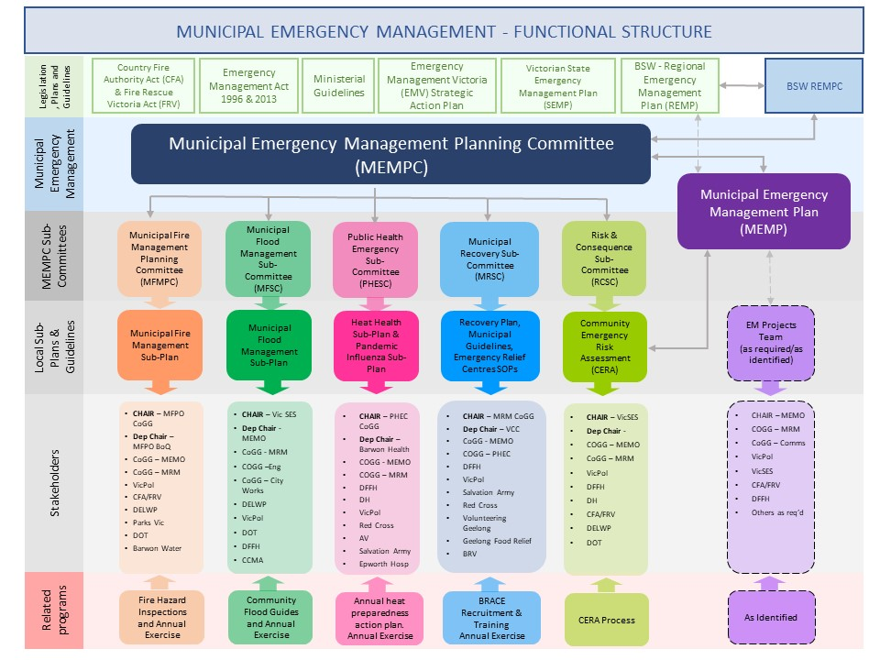
MEMPC Structure
Figure 3: MEMPC Structure

Subplans and Complementary Plans

All sub-plans are multi-agency plans and may be hazard specific where the consequences are likely to be significant. The MEMPC have determined the following sub-plans are required:
- Flood/Storm Management
- Fire Management,
- Heat Response
- Pandemic
- Recovery

All sub-plans to this Plan are subject to the same preparation, consultation, assurance, approval and publication requirements as this Plan, as outlined in Part 6A of the EM Act 2013.

Agencies with roles or responsibilities in a sub-plan must act in accordance with the plan (EM Act 2013 s60AK).
Complementary plans are prepared by agencies, council or industry for emergencies that do not fall within Part 6A of the EM Act 2013 or are not multi-agency shared plans. They may also be prepared under other legislation, governance or statutory requirements for a specific purpose.
Complementary plans do not form part of this Plan and are not subject to approval, consultation and other requirements under the EM Act 2013.

Restricted operational information
Section 60AI (2) of the EM Act 2013 allows the MEMPC and Emergency Management Victoria to exclude information from this published that is related to critical infrastructure, personal information or information that is of a commercially sensitive nature.

A short summary of the restricted information is included here, including who the contact point is should the user of this plan seek access to this information.

Summary of the restricted information (including location within the MEMP, e.g. page or section number) | Reason for restriction | Agency/ies that hold this information in full | Contact point/s
Vulnerable Persons Register | Personal Information | Municipal Council | Victoria Police
MEMPC Terms of Reference Appendix A – MEMPC Membership | Agency representative contact details | Municipal Council | City of Greater Geelong

MITIGATION ARRANGEMENTS

Introduction
The prevention of emergencies includes a range of activities that require the allocation of resources (human and financial) and multi-agency support to ensure a coordinated and well-planned approach and outcomes.
Risk management is a shared responsibility. Every effort will be given to consider risks identified at a regional and state level and ensure there are linkages in planning arrangements and risk treatments will be carried out in the context of local, regional and state-wide programs and policies.

The Greater Geelong Municipal Risk and Consequence sub-committee has responsibility to review current risks, identify new and emerging risks, undertake initial risk assessments and make recommendations on treatment options to the MEMPC for endorsement.

Hazard, Exposure, Vulnerability
Risk management is a shared responsibility. Individuals and Households, business and community should mitigate risk by
- Understanding their risk.
- Formulating and implementing policy and regulation (such as land use planning and building regulations and floodplain management).
- Building, operating and maintaining infrastructure.
- Promoting financial resilience to emergencies through home and contents insurance.
- Community engagement to build resilience to and awareness of risks and promote protective actions.
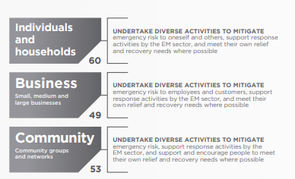
Figure 4: Mitigation is a shared responsibility

Risk Assessment Process
Emergency Management includes a range of activities that require allocated resources – including human, financial, equipment and a multi-agency support to ensure a co-ordinated and well-planned approach and outcomes. These resources are often limited and must be used effectively.
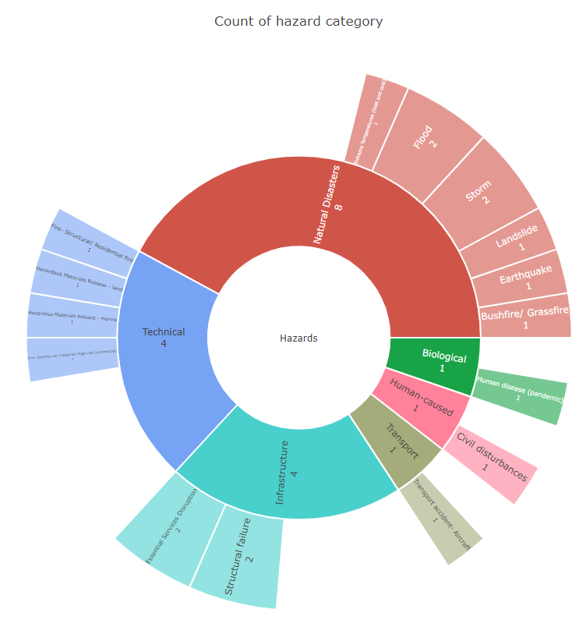
The Greater Geelong MEMPC has endorsed the Community Emergency Risk Assessment (CERA) as its method of risk assessment. The CERA is an ‘all hazards”, “all agencies” integrated risk assessment approach. The CERA Online tool developed by VICSES, assists to identify, and prioritise emergency risks, combines hazard information and intelligence from a number of sources in order to gain a clear understanding of the elements defined “risk” within a specific area that are likely to create most disruption to communities.
Figure 5: Current hazard categories in Greater Geelong
These sources include:
- existing ‘single hazard’ risk assessments, (e.g., the Victorian Fire Risk Register (VFRR), Integrated Fire Management Planning (IFMP) and Flood studies)
- new or existing community profile information, (e.g., Part 2 of Municipal Emergency Management Plans
- subject matter experts and local community representatives.
Through the CERA Tool kit the Greater Geelong MEMPC has identified the below risks.

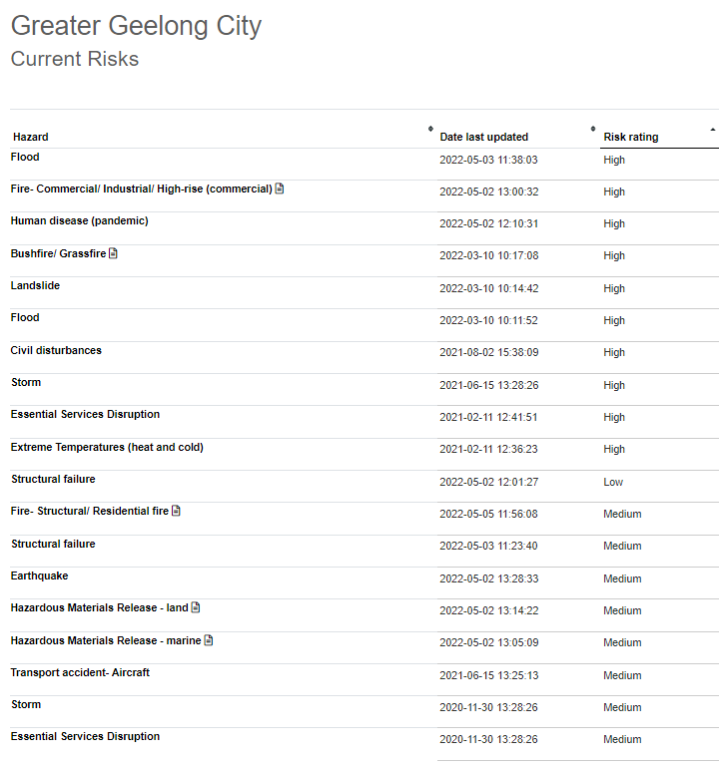
The CERA process is consistent with the Australian Standard AS/NZS ISO 31000:2018 Risk management principals and guidelines
Figure 6: List of current risks
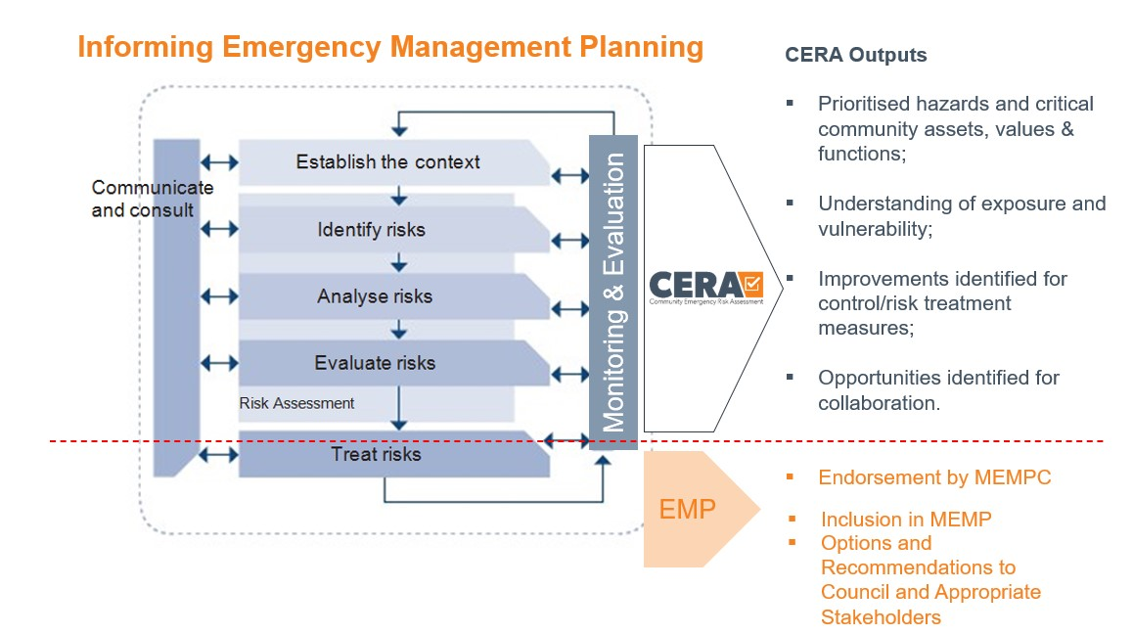
Figure 7: CERA flowchart
The Greater Geelong MEMPC will work towards creating a safer community by identifying, analysing and assessing risks, and where appropriate, identifying treatment options and implementing relevant plans.

The committee recognises that this process may lead to suggested risk treatments that may affect social, political, economic, and/or environmental aspects of the community. All risk treatment recommendations may be affected by the reality of financial constraints.

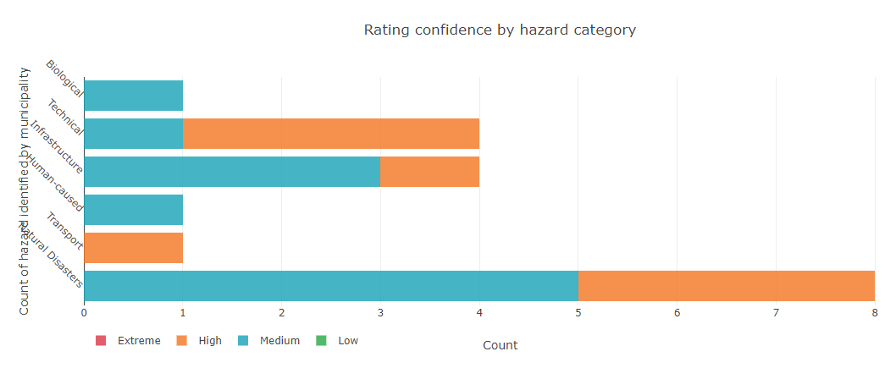
Figure 8: Hazard category risk rating for Greater Geelong
The Committee will invite representatives from various organisations as subject matter experts to support the risk assessment process.

Monitoring and Review
The MEMPC and key stakeholders from the major emergency service/support organisations identified the top risks in the municipal area. These risks are regularly reviewed at the risk and consequence sub-committee. Any changes to hazards and controls are reflected and actioned as soon as identified and assessed. A full risk assessment is undertaken every three years, led by the Greater Geelong Municipal Risk and Consequence sub-committee or major event.

The outputs of the assessment process are used to inform the MEMP, introduce risk action plans and ensure that communities are aware of and better informed about hazards and the associated emergency risks that may affect them.

Resilience
A resilient community is socially connected and has infrastructure that can withstand disaster or shocks and foster community recovery. Resilient communities promote individual and community wellbeing, use of available resources and cohesiveness to strengthen their communities for everyday, as well as extreme, challenges.
The ability of a community to respond to an emergency situation and in turn recover from the effects of an emergency will depend on the resilience of the affected community. A key role of the MEMPC is to help create more resilient communities.
Emergency service organisations, agencies and stakeholders have specific programs to build community resilience through awareness and education.
Other prevention and awareness activities to assist with building resilience may include:
- Australian Warning System
- Vic Emergency
- Community development activities
- Provision of information and promotion of practices that support resilience
- Supporting and strengthening the communities psychological and emotional response to an emergency through individual planning
- Legislation such as the Planning Scheme and Health and Wellbeing Act
For more information on specific emergencies, refer to the relevant sub-plan in section 5.4 of this plan.

Community Education
Community education is a vital component in the community understanding risks and preparing for emergencies. The development of relevant and appropriate community education resources and activities empower the community and enhance their resilience through being well informed and therefore being equipped (emotionally and physically) for an emergency.

The MEMPC members and other emergency management services/agencies collaborate to engage the community through:
- including community programs and projects
- emergency expo
- media (e.g. social media, print and publications)
- website
- relevant agency information guides.

For more information visit
https://www.cfa.vic.gov.au/home/local-information
https://www.ses.vic.gov.au/plan-and-stay-safe/flood-guides
https://www.parks.vic.gov.au/

Emergency Markers
Emergency markers are installed at complex addresses across the municipality.

Emergency markers look like street signs with white text on a green background. Each has a unique alphanumeric code of three letters and three numbers. This code is linked to the Emergency Services Telecommunications Authority (ESTA). ESTA receives all the triple zero calls in Victoria and dispatches emergency services as appropriate.

For additional mapping on emergency markers and other location specific resources visit:
https://www.iconyx.com/emergency-markers-map/
https://www.emergencyplus.com.au

RESPONSE ARRANGEMENTS

Introduction
The SEMP defines Emergency Response as the action taken immediately before, during and in the first period after an emergency to reduce the effects and consequences of the emergency on people, their livelihoods, wellbeing and property; on the environment; and to meet basic human needs.

This section outlines the Greater Geelong arrangements for response to an emergency which is consistent with the SEMP.

Response Management Arrangements
Emergency response arrangements provide the structure for establishment of appropriate resources to manage emergencies throughout the State including additional resource requirements and escalation strategies for example requesting assistance from State and Commonwealth.

Emergency events are categorised using three parameters:
- Operational Tier
- Class of Emergency
- Classification
Victorian emergency response management operates at three tiers:
- incident
- regional
- state.

Emergencies are managed at the appropriate operational tier until the event may require escalation to a higher level.

Response arrangements are largely hazard-based, and Control Agencies are responsible for developing and maintaining hazard-specific response plans, as sub-plans to the SEMP. Sub-plans include arrangements for readiness, the establishment of control, incident management systems, relief, escalation and de-escalation.
They also include arrangements for communications, coordination, consequence management and community connections.

Classes of emergency as defined in the Emergency Management Act 2013 relate to the ‘type’ of emergency. These are:
Class 1 - a major fire or any other major emergency for which the Fire Rescue Victoria, the Country Fire Authority or the Victoria State Emergency Service Authority is the control agency under the State Emergency Management Plan
Class 2 - a major emergency which is not a Class 1 emergency or a warlike act or act of terrorism or a hi-jack, siege or riot.
Class 3 - a warlike act or terrorist act, a hijack, siege or may also be referred to as security emergencies.

Command, Control, Coordination
Emergency response management is based on the functions of coordination, control, command, consequence management and communications. Broadly:
- Control is the overall direction of response activities in an emergency, operating horizontally across agencies
- Command is the internal direction of personnel and resources, operating vertically within an agency
- Coordination is the bringing together of agencies and resources to ensure effective response to and recovery from emergencies
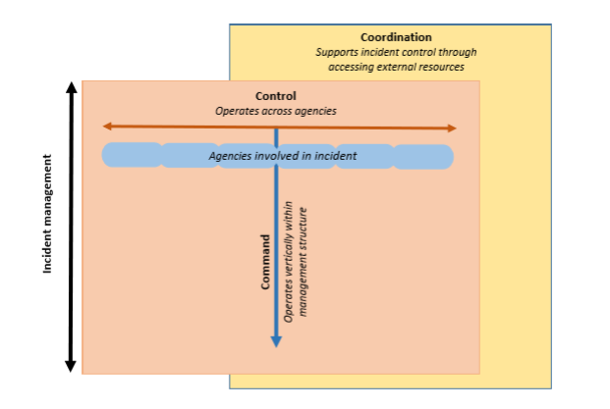
Figure 9: Functions of Command, Control and Coordination in Emergency Management

Additionally, in order to meet the objectives of emergency management in Victoria, those performing the control, command and coordination functions need to ensure:
- the consequences of the emergency are managed; and
- there is communication that meets the information needs of communities, stakeholders and government.

Classification of emergencies
Incident management commonly uses a three-level classification system. Typical features of each level is outlined below.
Level One Emergency
- A small-scale emergency that can be resolved through local or initial response resources.
- Response is less than 24hours in duration
- The response is in the incident area only
- There is little to no potential for escalation

Level Two Emergency
- Medium scale emergency requiring resources beyond the initial response
- Response duration is over 24 hours
- There are one or more incident areas
- There are multiple hazards involved
- There is potential for escalation to an emergency

Level Three Emergency
- Large scale emergency with high complexity
- Response duration is multiple days
- There are multiple incident areas
- Incident is likely to become state or emergency or lead to the declaration of a state of disaster.

Non-Major Emergency
A non-major emergency can be classified as a single incident or small-scale impact emergencies where individuals or families may have had their home or possessions severely damaged or destroyed, through an incident such as a house fire, localised flood, storm, burst pipes or vandalism.
These are emergencies that can be resolved using local resources and significant consequences to the wider community are not anticipated.
The Barwon South-West Non-Major Emergency Protocol outlines the process for activation and roles and responsibilities for these types of emergencies.
See Appendix 4 BSW Non-Major Emergency Protocol for detailed information.

Consequence Management
The objective of consequence management is to minimise the adverse consequences to community as a result of a major emergency. This could be impacts on services and infrastructure.

The safety of community members is the primary consideration in consequence management. Although consequence management is a key consideration for all emergencies, it should not interfere with the control of an emergency.

Consequence in the emergency management context, is the “change in circumstances, planned or otherwise, experienced by a community or its members as a result of an event and its subsequent management”.
The management of the individual hazard may differ, however the consequence for the community requires a coordinated response across agencies. The Emergency Management Commissioner is responsible for ensuring that consequence management is undertaken for major emergencies.

Local Response Arrangements
Activation of local arrangements are outlined within the MEMP Sub-Plans and complementary plans. Each individual agency has activation procedures, and these will be activated in line with the state sub-plans.

An Incident Management Team (IMT) or Incident Emergency Management Team (IEMT) will be established as part of any emergency situation. Early notification to other agencies is essential to enable them to implement their own emergency response arrangements to support the coordinated approach to incident management. This is especially important when there is a likelihood that the event could escalate or be protracted.

The emergency arrangements will be activated in four phases:
• Alert / Notification – control agency notifies IEMT that an emergency may require resources and keeps them informed about the situational awareness and conditions of the incident.
• Standby – As the threat becomes imminent, members of the relevant agencies are placed on standby so they can act immediately if required.
• Activation – The operational phase of an incident where agencies are committed to contain or control the emergency.
• Stand down – Once the response to the emergency has been completed all participating agencies are advised to stand down.

Initial information will generally come from the control agency to the MERC who advises the MEMO and the level of response will depend on the nature and extent of the emergency.

The planning for specific response, relief and recovery activities are detailed in the following sub-plans:

Sub-Plan
Municipal Fire Management Plan
Pandemic Influenza Plan
Municipal Heat Plan
Municipal Flood Emergency Plan (i.e. dams, flood, storm, storm surge)
Municipal Recovery Plan (under development)

Impact Assessment
Impact assessment is conducted in the aftermath of an emergency to assess the impact to the community and inform government of immediate and longer-term recovery needs.
Impact assessment must be community focused to ensure the data/information will assist decision making on how to best support impacted communities.

It is a three-stage process to gather and analyse information following an emergency event. The three types of impact assessment are:

Assessment Stage | Remarks
Initial Impact Assessment (IIA) | - Initiated in the first 48 hours of an emergency to determine the nature and scale of the impact on people, critical infrastructure, community infrastructure, economy, natural, built and agricultural environments.  - Assessments usually initiated by the Incident Controller.
Secondary Impact Assessment (SIA) | - This phase considers resources available within an affected community and identifies those needs and priorities that can only be met with outside assistance.  - Assessment is coordinated by Recovery Coordinator.
Post Emergency Needs Assessment | - Post Emergency Needs Assessment estimates the cost of destroyed assets across the five recovery ‘environments’.  - Assessment is coordinated by Recovery Coordinator.

Financial Considerations
Agencies are responsible for all costs involved in that agency responding to an emergency. Government agencies supporting the control agency are expected to defray all costs from their normal budgets.
State and Local Governments are responsible for funding their emergency operational expenditures from their general revenues. However, specific financial support arrangements are in place.
Reimbursement for costs associated with an event may be available through the State Government’s Natural Disaster Financial Assistance (NDFA) Scheme. Before an affected municipality can seek reimbursement from the Scheme for an emergency, the emergency must first be ‘Declared’ by the State.
Financial assistance is provided in accordance with the Commonwealth-State Disaster Recovery Funding Arrangements (DRFA).
For further information refer to Emergency Management Victoria website.

Neighbourhood Safer Places and Community Fire Refuges
The City of Greater Geelong does not have any declared Neighbourhood Safer Places – Bushfire Place or Last Resort or Fire Refuges.

Council Resource Sharing
The City of Greater Geelong is a signatory to the MAV Inter-Council Emergency Management Resource Sharing Protocol. This protocol sets out an agreed position between councils regarding the provision of resources to assist other municipalities with response and recovery tasks during and after emergencies.

The protocol is intended to clarify operational, insurance and reimbursement issues that may arise through municipal resource sharing arrangements. The City of Greater Geelong and stakeholder agencies also have existing planning relationships with neighbouring municipalities.

Debriefing Arrangements
The Municipal or Regional Emergency Response Coordinator is responsible for ensuring that the Control Agency for the emergency organises as operational debrief with participating agencies as soon as practicable after cessation of response activities.

The purpose of a debriefing is to:
- ensure participating agencies understand what happened during an operation or emergency, and
- identify areas of improvement and highlight areas that were handled well, in order to improve the efficiency, effectiveness and safety of future operations or emergencies.

Transition to Recovery
While it is recognised that recovery activities will have commenced shortly after impact, or preferably, simultaneously with response operations and run concurrently with same, there will be a termination of response activities and a hand over to recovery agencies.

The Incident Controller, MERC and MRM should commence transition planning [from response to recovery] as soon as possible following the start of the emergency.

The early notification of recovery agencies involved in the emergency will ensure a smooth transition of ongoing activities from response to recovery. Issues to be considered for the timing of transition from response to recovery include:
- the nature of the emergency and what ongoing specialist resources are required
- whether a recurring threat is likely to occur compounding the impact on the community
- the extent of the impact on communities, as this may determine the length of the transition period
- the level of loss/damage and the extent to which this has been validated (the stage of impact assessment reached e.g., if phasing into secondary/post impact stages may indicate transition requirements)
- the extent to which the community requires emergency relief services
- the resources required for the activation of recovery arrangements
- The transition agreement will be developed at the appropriate level between the response agency Incident Controller, MERC, MEMO, MRM and the recovery agency coordinator (typically ERV)

Evacuation
Victoria Police is responsible for managing evacuation in Victoria. Evacuation is a risk management strategy that involves the movement of people to a safer location and return of them at an appropriate time. As with emergency response activities, the main priority when deciding to undertake evacuation is the protection of life. There are five stages in the evacuation process:
1. Decision
2. Warning
3. Withdrawal
4. Shelter
5. Return.

In Victoria, evacuation is largely voluntary. The Incident Controller makes a recommendation to evacuate, and it is the choice of individuals as to how they respond to the recommendation. However, in particular circumstances, legislation provides some emergency service personnel with authority to remove people from areas or prohibit their entry.

Special consideration must be given to the evacuation of vulnerable people in the community.
Vulnerable people and those who may care for them, including facilities such as hospitals, aged care facilities, educational facilities and prisons, are likely to need more time, resources, support and assistance to evacuate safely.

Further information on evacuation can be found at Joint Standard Operating Procedure (JSOP) – Evacuation for Major Emergencies (JO3.12) available from EM-COP.

Council may be involved in assisting with the relocation/evacuation operation. Council’s Municipal Recovery Manager plays a lead role in relocation/evacuation operations. In the first instance, it is preferable for residents/evacuees to self-evacuate to a safe neighbour’s property or to a friend or relatives place of residence.

When Emergency Relief Centres are required, Council is the lead agency to establish relief centres supported by Police and agencies. These centres provide temporary short-term shelter as well as an avenue to provide the community with information, and, if needed, personal support.

Red Cross will assume the role of registration of relocated/evacuated people on behalf of Victoria Police, responsible for accessing the Vulnerable Persons Register during an evacuation.

An alternative to evacuation in some circumstances may be to shelter in a suitable home, building, structure, or other safe area. Sheltering in place should be considered as an alternative when the associated risks with evacuation are considered to be greater than the risks of sheltering in place.

Sheltering in place, however, will often not be without risk. Agencies should consider the risks posed to people when sheltering in place and provide advice to them about how to best minimise these. Agencies, in conjunction with their local planning committees, should work closely with their local community to provide advice and alternatives in regard to the suitability of sheltering in place during an emergency.

Some considerations for agencies and people considering taking shelter in place are:
- the nature of the emergency
- quality of the shelter or safer area
- the likely duration of the emergency
- the need for emergency supplies such as water, food and medical supplies
- the need for designated shelter managers, if applicable
- the contents of pre-arranged plans
- the age and health of the affected persons
- timely and relevant communication strategies.

Community Information and Warnings
It is important to ensure that warnings and public information are maintained at an optimum level for specific circumstances where community action is necessary, primarily to protect lives, and also for the protection of property and the environment.

Individuals and communities have a responsibility to prepare themselves in case of an emergency.
To assist them in the preparedness and during emergencies, the official emergency services web site for Victoria is www.emergency.vic.gov.au . It is a single all-emergencies website for Victorians. It is Victoria's primary website for incident information and warnings. Vic Emergency provides a single source of information and advice to help people prepare for, respond to and recover from emergencies.

Vic Emergency has a real-time Google Map display with incidents across Victoria including fires, floods, storms, power outages, hazardous material incidents and traffic incidents.

Warnings
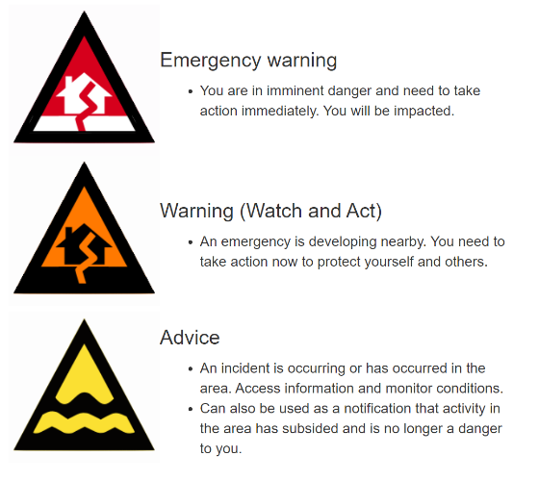
Warnings can be issued at several different levels depending on the type and severity of the event. They can include advice, watch and act, and emergency warnings.
Figure 10: Types of warnings
Emergency warnings are the highest level of warning and aims to warn individuals and communities to prepare for an impending event or in the event of an emergency.

Once a decision has been made to issue a warning, the Incident Controller will determine which method to use (i.e. television, radio or internet) and determine whether a telephone alert needs to be issued.

Where an extreme and imminent threat to life exists and authorisation from the
Incident Controller is not practicable in the circumstances, warnings may be issued by any response agency personnel with notification to the Incident Controller as soon as possible.

Public Information
The Incident Controller is responsible for issuing warnings and public information. The Regional Controller (where appointed) or State Response Controller for Class 2 state controller should assist if required.

The provision of information to the broader public/community, including those attending an Emergency Relief Centre (ERC), is vitally important to their capacity to understand what is happening, and to assist them in making informed decisions during a time of crisis.
Each agency manages community information through their own social media channels.
Community meetings may form part of the communications strategy for the event and coordinated by the response agency.
ABC 774 is the National Emergency Broadcaster.

Information can also be found through the local emergency broadcasters:
K-Rock FM 95.5
Bay FM 93.9
The Pulse FM 94.7
3YYR FM 100.3
Tourist FM 88

Relief Arrangements

Emergency Relief is the provision of essential needs to individuals, families and communities in the immediate aftermath of an emergency.

Emergency Management agencies with relief responsibilities incorporate the principles of relief as outlined in the SEMP and National Strategy for Disaster Resilience. Relief is focused on consequence management and should consider the principles of relief.

Relief encompasses a range of services such as, but not limited to community information, emergency shelter and provision of immediate needs, psychosocial support, material aid, first aid, financial assistance, animal welfare and legal support. It is important that assessment of needs is undertaken for each incident to determine needs.
Relief can be provided at a dedicated Relief Centre, places of community gathering, incident scenes, triage and transfer sites as appropriate, memorials or other locations as appropriate. Relief is considered part of response and must be integrated into the response arrangements, however it is important to note that relief is interconnected with recovery and must be seamlessly integrated with all other early recovery activities and considered in the response phase.

Further information on relief can be found in the City of Greater Geelong Emergency Management Operational Guidelines (in progress of development).

Relief Management and Governance
The City of Greater Geelong is responsible for relief coordination at the municipal level. The Department of Families, Fairness and Housing and Emergency Recovery Victoria are responsible for relief and recovery coordination at the regional and state level respectively.

Relief roles and responsibilities are outlined in Part 7 of the State Emergency Management Plan. For local arrangements in relief, refer to the Greater Geelong Recovery Sub-Plan. The Recovery Sub-Committee may be activated to support the governance of relief.

The City of Greater Geelong is responsible for the planning, management and operations of Emergency Relief Centres with the assistance of agencies and local service providers identified at the time of the incident. The City has designated a number of facilities that can utilised as Emergency Relief Centres across the city through a formal Facility Audit process.

Activation of Relief Services
The level and type of relief required to support affected communities will be determined in consultation with the Incident Controller, MERC, MEMO and MRM.
The MRM will coordinate the activation of the selected relief team and respective centre or services as depicted by the needs assessment.

Escalation
A formal request for escalation of relief will be made if the emergency event increases in complexity; exceeds the capacity and/or capability of the City of Greater Geelong to respond; or an emergency has affected multiple municipalities within a region or multiple regions. The decision to escalate will be undertaken in consultation with the Incident Controller, MERC, MEMO, MRM and the Regional Emergency Relief Coordinator.

Escalation of relief should build on existing local arrangement rather than replacing them.
Resources to support Council in its response to a local event may be obtained through the MAV Resource Sharing Protocol or through neighbouring councils.
In the event a neighbouring municipality requires support for relief services, including the activation of a City of Greater Geelong relief centre, the MAV resource sharing protocol will be the tool utilised to facilitate this escalation or alternatively a CEO-to-CEO request.

Relief Communication
Dissemination of community information as part of emergency relief assists the community to remain safe and understand support and services available to them.
Relief messaging should be integrated with response messaging, and it should inform the community about relief services and how to get assistance.
Where the formal transition from response to recovery has not yet occurred, the provision of community information remains the responsibility of the Control Agency in consultation with relevant stakeholders to ensure consistent localised emergency relief information.
Where transition has occurred, the Council in consultation with the Recovery Sub-Committee and relevant stakeholders will coordinate the public information.

Relief Planning
The City of Greater Geelong has a comprehensive Relief Program to support affected communities. This includes the development of plans, guidelines and programs to ensure staff are trained to support relief activities. The Greater Geelong Recovery Sub-Committee has the lead role in ensuring coordination of relief activities during an emergency such as:
- community information (public meetings, newsletters, information sheets, advertising and media requests)
- temporary or emergency shelter and Emergency Relief Centres (ERC)
- food, water and immediate material-aid
- psychosocial support and health and medical assistance
- reconnecting families and friends
- emergency financial assistance
- animal welfare
- legal assistance information
- providing advice and referral regarding goodwill, donated goods and services and spontaneous volunteering.

Register.Find.Reunite
A critical component of relief is connecting affected persons during and following an emergency. Victoria Police are responsible for the activation of Register.Find.Reunite and will activate Australian Red Cross to manage this service on their behalf.

Animal Management in Emergencies
Municipal Councils are the lead for housing displaced companion animals and lost/stray domestic animals and this includes supporting domestic animals and their owners within an Emergency Relief Centre.
The Victorian Emergency Animal Welfare Plan defines animal welfare support services in relief. This includes livestock, companion animals and wildlife.
Further information relating to domestic animals in emergencies is available through the City of Greater Geelong Municipal Emergency Management Officer.

Vulnerable People and Facilities

Vulnerable Persons Register
There are many in the community who would be considered vulnerable or at risk during an emergency depending on the type of event, these may include elderly, children, people with a disability and members of the Culturally and Linguistically Diverse (CALD) community. Local Government facilitates the Department of Families, Fairness and Housing Vulnerable Persons Register and this register can be accessed by Victoria Police during emergencies. Register participants are individually assessed against a set criteria and recorded in the Vulnerable Persons Register.

Vulnerable Facilities
A vulnerable facilities list has been developed by the City of Greater Geelong which provides information on facilities that may have gatherings of people. This list comprises community halls, community hubs, neighbourhood houses, senior citizens facilities, large event facilities and high frequency tourist venues. This list is reviewed annually or as required and for further information contact the MEMO or MRM.
In addition, data sets for state defined vulnerable facilities are located on EMCop.

RECOVERY ARRANGEMENTS

Introduction
Recovery is the coordinated process of supporting emergency affected individuals and communities to reconnect and re-establish a level of functioning, coordination and access to services.
Recovery is part of emergency management which includes the broader components of prevention, preparedness and response. Planning for recovery is integral to emergency preparation and mitigation actions may be initiated as part of recovery.
The Municipal Recovery arrangements for the municipal district of Greater Geelong have been developed in accordance with the Emergency Management Act 1986, Emergency Management Act 2013 and align to the SEMP, Regional Emergency Management Plan (REMP) and recovery planning across the Barwon South West Region.

Objectives of Recovery
The cooperation and coordination of services between all levels of government, non-government organisations, community agencies and the private sector is a key objective of recovery.

Key considerations of the recovery arrangements may include:
general principles of recovery
recovery planning and preparedness
clarity of roles and responsibilities
develop recovery action plans
long term recovery

In addition to the key considerations, Recovery should be community-led and enable participation by all members of the community and should integrate with emergency response and relief activities and commence as soon as possible following the emergency.

Recovery considerations typically fall under four environments that require coordination as part of the recovery process; Social, Economic, Built and Natural.

Consideration will also be given to adapt the recovery framework as necessary to align with Emergency Recovery Victoria’s Recovery Framework - Five Lines of Recovery:

People and Wellbeing
Aboriginal Culture and Healing
Environment and Biodiversity
Business and Economy
Building and Infrastructure

Recovery Definition
The SEMP states that recovery is “the assisting of persons and communities affected by emergencies to achieve a proper and effective level of functioning”.

The National Principles for Disaster Recovery outlines that for successful recovery, the following is Principles are relied on:
- Understanding the context
- Recognising complexity
- Using community-led approaches
- Ensuring coordination of all activities
- Employ effective communication
- Acknowledging and building capacity
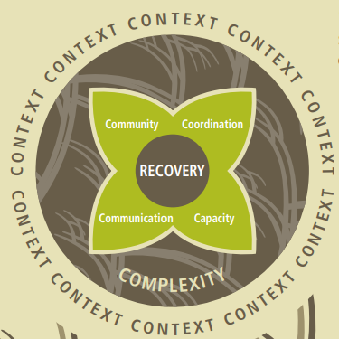
Figure 11: Principles of Recovery.

Escalation
Escalation of recovery coordination may escalate from Council coordinated recovery to regional recovery rapidly or over time depending on the emergency context, capacity, recovery environment and community requirements. The following factors may indicate the need for escalation of recovery and formalised regional coordination arrangements:
- The emergency is expected to exceed Local Government Authority capacity to manage recovery coordination.
- The recovery agencies intend to draw on regional or state-tier resources for the foreseeable future in relation to the emergency.
- An increasing scale or changing nature of the actual or expected recovery effort.
- Significant consequences.
- Escalating recovery costs and funding opportunities.

Additional considerations to activate regional recovery coordination in the Barwon South-West Region include:
- State border closure with South Australia.
- Initial impact assessments indicate that the damage to private property exceeds the Annual rates base of the municipality.
- High numbers of non-resident landowners impacted by the event.
- International tourists affected by the emergency, and diplomatic assistance is required.

Recovery escalation is undertaken in consultation with the MRM, MEMO, MERC and Emergency Recovery Victoria.

Management Structure
Where the need for formal recovery is identified, the Greater Geelong Recovery Sub-Committee, may establish an incident specific recovery committee in addition to the sub-committee. The initial responsibilities of the incident specific recovery committee is to formalise the governance structure, oversee the transition from Response to Recovery agreement, establish working groups and develop an Incident Specific Recovery Plan.

It is the responsibility of the incident specific Recovery Sub-Committee to ensure that affected communities are represented in the recovery arrangements which may be through Community Recovery Groups.

Secondary Impact Assessment
Secondary Impact Assessment (SIA) determines the long term needs of the community. It is informed by the Initial Impact Assessment. Secondary Impact Assessment can take many forms depending on the type of event, extent of damage and needs of affected individuals and communities. This could include but not limited to, appraisal of extent of damage and disruption and outreach support. Local Government coordinates secondary impact assessment at the local level.

Government Assistance Measures
State and Federal government assistance may be available in the recovery efforts following a declared event. The type of support available will depend on the level of impact.

ROLES AND RESPONSIBILITIES

Introduction
An agency that has a role or responsibility under this plan must act in accordance with the plan.
The SEMP and REMP outline agreed agency roles and responsibilities, noting that existing duties, functions, power, responsibility or obligation conferred on an agency by law, licence, agreement or arrangement prevail to the extent of its inconsistency with this plan (EM Act 2013 s60AK).

The roles and responsibilities outlined in this plan are specific to the region and are in addition to, or variations on, what is outlined in the SEMP and REMP. In the case of municipal-specific modifications, these are clearly identified as modifications.

All agencies with responsibilities under the MEMP should provide written confirmation of their capability and commitment to meet their obligations. This can be evidenced by their endorsement of the draft MEMP, including revisions, before it is presented to the REMPC for consideration.

This Plan details emergency management agency roles and responsibilities for: Mitigation, Response, Relief and Recovery. It also maps agency roles for core capabilities and critical tasks under the Victorian Preparedness Framework (VPF) for the management of major emergencies.

Roles and Responsibilities
Activity | Critical task alignment / activity source
Mitigation
Major Hazard Facilities (eg. Viva Energy, Chemring etc) | Planning and preparedness activities for emergencies related to the agency’s assets or area of control.
Barwon Health
St John of God Hospital
Epworth Hospital
Response (including Relief)
Barwon Health | Health Services
St John of God Hospital | Health Services
Epworth Hospital | Health Services
CREST | Telecommunication Support
VCC- Emergencies Ministry | Personal Support
Geelong Food Assistance Network | Food Relief
Department Families, Fairness and Housing | Power Dependent Support
Salvation Army | Catering and Material Aid
St John Ambulance Victoria | First Aid
Recovery
City of Greater Geelong | Secondary Impact Assessment and Recovery Outreach
VCC-Emergencies Ministry | Personal Support
Insurance Council of Australia | Insurance Advice
Financial Counselling Victoria | Financial Advice
Blaze Aid | Fencing Recovery
Disaster Legal Help Victoria | Legal Advice
Department of Jobs, Precincts and Regions | Business Recovery

APPENDICIES

Appendix 1: Document Administration

Document details
Criteria | Details
Document ID | TBC
Document title: | Greater Geelong Municipal Emergency Management Plan
Document owner: | MEMPC

Version control
Version | Date | Description | Author
A full rewrite of the MEMP was conducted in 2022, where more than 80% of the document was changed, therefore version control will commence at 1.0
V0.1 | Sep 2022 | MEMP Working Group final draft | MEMP Working Group
v0.2 | Oct 2022 | Formatting and copy edit | CoGG Communications & Marketing
v1.0 | 3 Nov 2022 | Distributed to MEMPC for review and Feedback | MEMPC Secretariat

Document approval
This document requires the approval of the MEMPC:
Name | Title | Signature
MEM  On behalf of the MEMPC | Chair

Audience
The audience for this document is the MEMPC
Terms | Description
Review Date | December 2025

Appendix 2: List of Other Emergencies to Impact the Greater Geelong Region

Date | Incident | Location | Outcome
May 1852 | Riverine flooding | Barwon 4.91m
Aug 1909 | Riverine flooding | Barwon 4.60m
Aug 1951 | Riverine flooding | Barwon 5.17m
1961 | Fire | Shell refinery
1973 | Riverine flooding | Hovells creek, Lara
Nov 1978 | Riverine flooding | Barwon 4.48
1977 | Bushfire | Little River x 2 | Grass fires destroyed around 2000 acres each
1982 | Bushfire | Anakie East | Losses of houses & outbuildings.  heavy stock losses  fencing in the Staughton Vale/Anakie, Lara and Little River areas.  2 lives lost.
Oct 1995 | Flood | Barwon 5.23
1997 | Grass fire | Ocean Grove Reserve
Dec1998 | Recovery | Linton Fires | Loss of 5 Geelong West Fire Fighters
Sep 2000 | Hopetoun Oil Spill
Mar 2001 | Grass Fire | Avalon
Mar 2001 | Rain event – flash flooding
Apr 2001 | Storm & flash flooding
Oct 2002 | Bali bombing | Impact on Geelong residents who were visiting Bali | Recovery activities
2004 | Floods
Dec 2004 | Tsunami – Asia | Impact on Geelong residents who were visiting Bali
Oct 2005 | Bali Bombing | As above | As above
Aug 2006 | Grass fire | Moolap – south of Woods and Coppards Road
Feb 2009 | Bushfire – recovery | Black Saturday | Management of donations
Feb 9th 2014 | Bushfire | Ceres
Jan 2014 | Gas release | Geelong ‘Gas Gate’, Corio.
2014 | fire | Steggles factory
2015- 2020 | Potential fire | Broderick Road Lara | Significant multi agency planning and preparedness
Sep 2015 | Methene Event | South Geelong
Jan 29th 2016, | Light plane crash | Off the Bellarine Peninsula. | Three bodies were recovered, but the 4th wasn’t found
Mar 3rd 2016, |  | Corio – Road spill of Butyl Acrylate along Princes FWY and Service Station (Geelong Bound) | 35 people hospitalised
Mar 2017 | Severe storm |  | Bellarine Peninsula
Dec 2019 | Woodchip fire
Dec 2020 | Bushfires | Gippsland | Residents concerned about smoke
Feb 2020 | Possible Dam Breach | Highton | Support agencies – possible scenario planning
Mar 2020 | Toxic chemical Dump
Aug 2020 | Riverine Flooding | Barwon
Jul 2021 | Battery fire | Victorian Big Battery fire, Lara
Oct 2021 | Riverine flooding | Barwon
Dec 2021 | Shark Attack | Ocean Grove | Significant injuries to 2 individuals as well as trauma to witnesses
Jan 2022 | Storm Event | Anakie/ Belmont
Jan 2022 | Storm event and flash flooding

Appendix 3: MEMPC Contact List

Not for Public Distribution

Appendix 4: BSW Non-Major Emergency Protocol

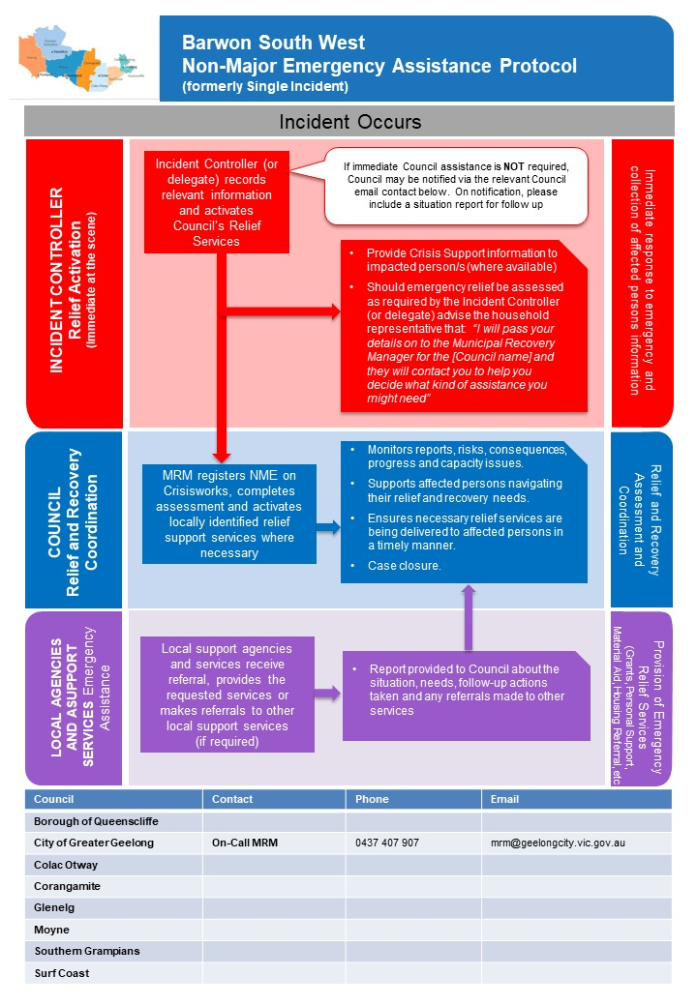

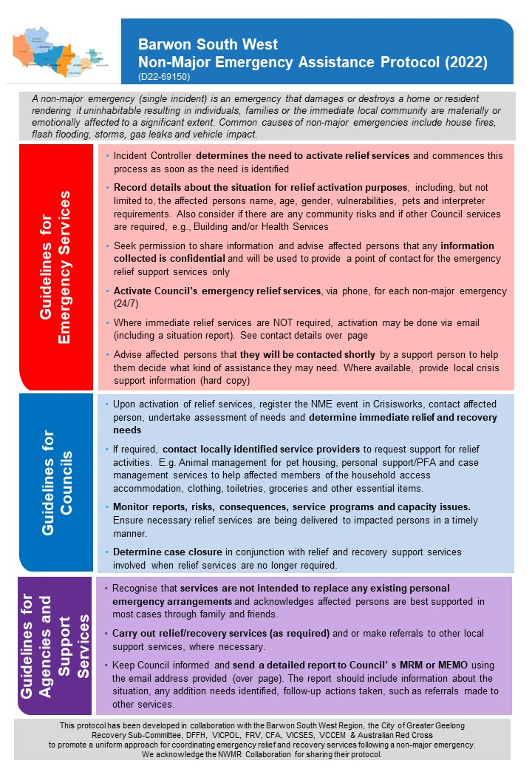

Appendix 5: Maps

Geological

Electoral Structure

