
Kerbside Numbering

background
Property owners must display the street number of their property, inside their property in a position that is easily visible from the street.
Property owners may choose to also install their street number on the kerb in addition to their property. Kerbside numbering may aid visitors and emergencies services looking for a property. Putting street numbers on the kerb is optional.

Installing kerbside numbers

General
Kerbside numbering is installed on the council kerb at the choice of the property owner to supplement the number displayed on the property.
Property owner must be aware that:
- It is NOT compulsory to have your house number painted on the kerb within the City of Greater Geelong.
- Council will not be responsible for the maintenance or repair of these painted numbers, under any circumstances.
- Numbering on kerbs does not reduce your responsibility to clearly display the correct house number on your building or fence fronting the street.
- They can ask for a price from any contractor registered with the City of Greater Geelong to undertake kerb numbering. Registered contractors can be found by visiting our website - Geelong Australia.
Contractors should be aware that:
- Permits do not give a business exclusive rights for the provision of kerbside numbering services in the City of Greater Geelong.
- Activities must comply with the requirements set out by the Australian Consumer and Competition Commission for door-to-door sales. Refer to Door to door sales - a guide for consumers (accc.gov.au)

Contractor Requirements
Contractors must abide by the code of conduct outlined in this document and keep a current permit for undertaking works.
The following added requirements apply to contractors looking to undertake kerbside numbering:
- Only contractors with a valid permit from the City may paint street numbers on the public kerb.
- Permits are valid for a period of 1 year from the date of issue. A new permit must be obtained past this date.
- Contractor’s must indemnify Council against any public liability claim resulting from their work and supply a copy of their current public liability cover to a value of $10,000,000.
- The clean-up of equipment is not allowed to enter the City’s stormwater drainage system. A proper waste disposal method is to be implemented.
- Due care must be undertaken to ensure that the correct house numbers are used for each property. Incorrect numbers will need to be removed and replaced at the contractor’s cost.
- Confirmation of the correct property number should be sought from council should there be concerns about the correct property number.
- Contractor’s must ensure pedestrian and vehicular access is kept free of obstruction and that no nuisance arises because of the works.
- Traffic Management must be set up whilst painting the kerbside number. Traffic Management must be erected in accordance with AS1742.3.

Code of Conduct
Contractors offering the installation of kerbside numbering must abide by the following code of conduct whilst working within the City of Greater Geelong. A permit to work may be withdrawn should ongoing complaints be received about failure to follow this code of conduct.
Contractors must:
- Clearly explain to residents that kerbside numbering is not compulsory in the City of Greater Geelong.
- Clearly explain that you hold a permit to undertake kerb numbering in the City of Greater Geelong but are NOT employed by and DO NOT represent the council.
- Not make representations that they act on behalf of any State organisation without the express written approval of that organisation.
- Clearly explain the intention of your organisation to the residents and/or owners of the property, where the work is being canvassed.
- Clearly explain to residents that they must still clearly display the correct house number on their building or fence fronting the street
- Supply a written agreement for works (quotation) which includes an upfront price for painting the kerb number.
- Clearly explain that the resident and/or property owner can seek a quotation from other contractors
- Supply a receipt for all payments received.
- Comply with the requirements set out by the Australian Consumer and Competition Commission for door-to-door sales. Refer to Door to door sales - a guide for consumers (accc.gov.au)

specification FOR KERBSIDE NUMBERING

SPECIFICATIONS

Numerals
All numbers are to be reflective white in colour, with letter sizes - Series D, AS1744 – 1975. Height to be 100mm and painted with the aid of a stencil. (Refer to Appendix A.)
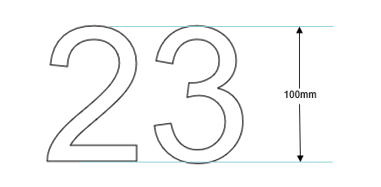

Background
The reflective white numbers are to be painted on a rectangular paint background, being 300mm x 120mm and again applied with the use of a stencil. Background colour to be Australian Standard colour N61 Black or Blue series – B21, B22, B23, B34, B51 or B61
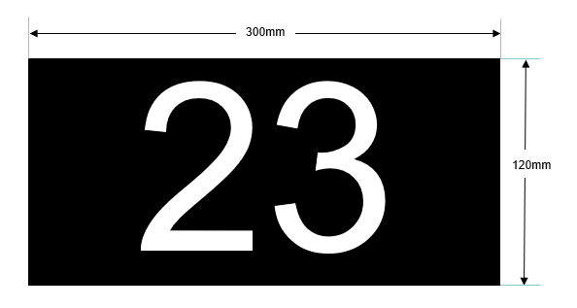

Location
The painted numbers must be on the vertical face of the kerb of the street that the number refers to only. The correct house numbers must be used for each property.
All numberings must face the direction of the correct street.

Stencils
Both the numbers and background must be applied with the aid of a stencil. In all instances the stencils used are to be precisely engineered to totally preclude over-spray and under-run.

Appendices

Appendix A – SERIES D NUMERALS – AS1744 - 1975

