FOOTPATH TRADING APPLICATION

ALFRESCO DINING, A-FRAMES, GOODS FOR SALE

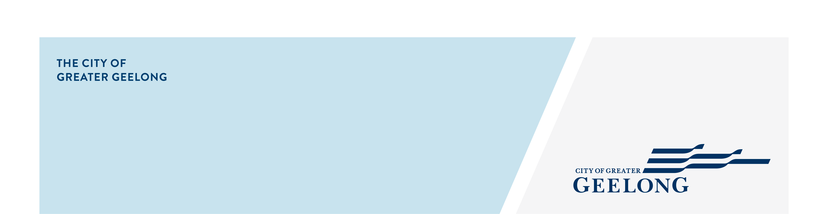
AND STREET FURNITURE
Applications can be submitted via email to pacadmin@geelongcity.vic.gov.au

APPLICANT TO COMPLETE:

Permit Details
Business Name: _________________________________________ ABN:___________________________
Trading as: ______________________________________________ ACN: __________________________
Address:_____________________________________________________________Postcode: ___________
Postal Address (if different): _________________________________________________________________
Hours of operation: M ________ T _________ W ________ T_________F_________ S________ S _______
Office contact: _______________________________________Phone No:____________________________
Position: __________________________ Email: ________________________________________________

Permit Details

ALFRESCO DINING APPLICATION – SEE CONDITION A
New Application fee $45.00 Transfer of Proprietor fee $45.00 (existing permit number: ________________)
Number of Chairs (CAA*) $20.00 each ___________________ (non-CAA*) $15.00 each ______________________ * Central Activities Area
Please indicate other furniture you wish to include within the Alfresco Dining Area
No. of Tables __________ Umbrellas _________ Planter Boxes __________ Gas Heaters (AGA______________)
Barrier Screens (temporary) _____________ Barrier Screens (fixed $45.00/m² floor space) ___________________
Other (please specify) _________________________________________________________________________
Attach a detailed site plan at scale 1:100 showing the layout of the proposed footpath activity
Photographs or detailed drawings of the proposed furniture (where engineering works required)

STREET FURNITURE – SEE CONDITION A
New Application fee $45.00
Umbrellas _____________________ Planter _________________ Other (please specify)____________________

A-FRAME APPLICATION – SEE CONDITION B
New Application fee $96.00 + Permit Fee $217.00 = $313.00 (total fee payable on application) Transfer fee-$96.00

DISPLAY GOODS FOR SALE – SEE CONDITION C
New Application fee $96.00 + Permit Fee $ 228.00 = $324.00 (total fee payable on application) Transfer fee-$96.00

REAL ESTATE AGENT PORTABLE SIGNAGE – SEE CONDITION D
New Application fee $134.00

Declaration by Applicant
I make this declaration in the firm belief that all the information provided on this form is, to the best of my knowledge, true and correct and I am aware that false declarations are liable to the penalties of perjury. I acknowledge that this declaration is true and correct, and I make it with the understanding and belief that a person who makes a false declaration is liable to the penalties of perjury. I have attached all supporting documentation for Council staff to confirm eligibility.
Public Liability Insurance Certificate (Insured for $10 million)
Applicant’s signature: ___________________________________________Date: ______________________

CONDITIONS OF USE

CONDITION A) ALFRESCO DINING / STREET FURNITURE APPLICATION INFORMATION
- Footpath width to be greater than 2900mm (2.9m)
- Alfresco Dining to be placed directly out the front of the business
- Alfresco Dining to be placed kerbside
- Alfresco Dining not to be placed in an exclusion zone i.e. (loading zone, no stopping zone, bus zone, taxi zone, adjacent to any red sign zone, 10 metres from an intersection and 20 metres from pedestrian crossing, traffic lights or school crossing unless approved)
- Alfresco Dining to be displayed during business operating hours only up until 1am unless otherwise approved
- Permit includes tables, chairs, umbrellas, barriers, heaters, & planter boxes

CONDITION B) A FRAME APPLICATION INFORMATION
- No sign may be displayed in a Residential Zoned area
- Footpath width to be greater than 2900mm (2.9m)
- One sign per business
- Sign to be placed directly out the front of the business
- Sign to be placed kerbside
- Sign maximum sizes dependant on street speed zone
    - 0-60kph 1200mm height x 600mm width
    - 61-80kph 1400mm height x 700mm width
    - 81kph+ 1600mm height x 800mm width
- Sign cannot be under 1 meter in height
- Inflatable signs, portable electronic signs, illuminated signs, revolving, spinning, or flashing signs, flags and banners are not permitted.
- Sign to be displayed during business operating hours only
- Sign not to be placed on a road, bicycle lane, roundabout, dividing strip, traffic Island or median strip
- Approved signs shall not be tied to poles, trees, street furniture or any other Council infrastructure
- Community Market Signage have separate conditions (refer to Council’s Footpath Trading Policy)

CONDITION C) DISPLAY GOODS FOR SALE APPLICATION INFORMATION
- Footpath width to be greater than 2900mm (2.9m)
- Goods to be placed directly out the front of the business
- Goods to be placed kerbside
- Goods displayed not to exceed 1500mm in height (1.5m)
- Goods displayed not to be less than 1 meter in height
- Goods not to be placed in an exclusion zone i.e. (loading zone, no stopping zone, bus zone, taxi zone, adjacent to any red sign zone, 10 metres from an intersection and 20 metres from a pedestrian crossing, traffic lights or school crossing unless approved)
- Goods to be displayed during business operating hours only
- White goods and bulky items i.e. beds, furniture and cupboards are not permitted

CONDITION D) REAL ESTATE AGENT PORTABLE SIGNAGE INFORMATION
- A maximum of three (3) signs may be permitted per ‘open for display’ or ‘auction’ event;
- No sign shall be placed on any a road, bicycle lane, roundabout, dividing strip, traffic Island or median strip, council reserve or other location that my impede and/or distract motorists and/or pedestrians.
- Signs shall be placed kerbside.
- Auction signs may only be displayed on the day of the auction event listed above and shall be removed no later than 4 p.m. on the day of the auction event.
- ‘Open for Inspection’ signs shall only be permitted to be displayed during the times that the property is open to the public.
- Signs shall not be larger than 1200mm high x 600mm wide.
- Signs shall be identified by the business (Permit Holder), its purpose (auction or open for inspection) and contact details of the Permit Holder.

- Fees are charged annually
- Unless a permit specific expiry date is stated all Permits expire on 31st December each year.

If you meet the above criteria then please fill out the application form and forward a copy of your Public Liability Insurance details noting the City of Greater Geelong as an interested party, pay the applicable fee and return all to Council for processing.

Council is collecting the information on this form for the purpose of processing your application. The information will be treated in accordance with the Information Privacy Act and will not be disclosed unless required by law. Failure to provide this information may result in your application not being processed.

