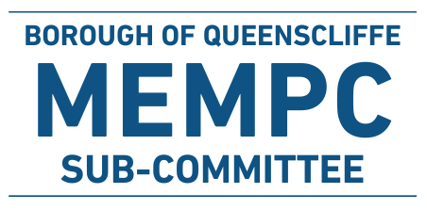

Greater Geelong and Borough of Queenscliffe Joint
Municipal Fire Management Sub-Plan
Version 1.0 – July 2023

Combined Greater Geelong and Borough of Queenscliffe

Municipal Fire Management Sub-Plan

Version 1.0 - October 23

Collaborative and Multi-Agency Emergency Management PlanningCombined Greater Geelong and Borough of Queenscliffe

Municipal Fire Management Sub-Plan

Version 1.0 - October 23
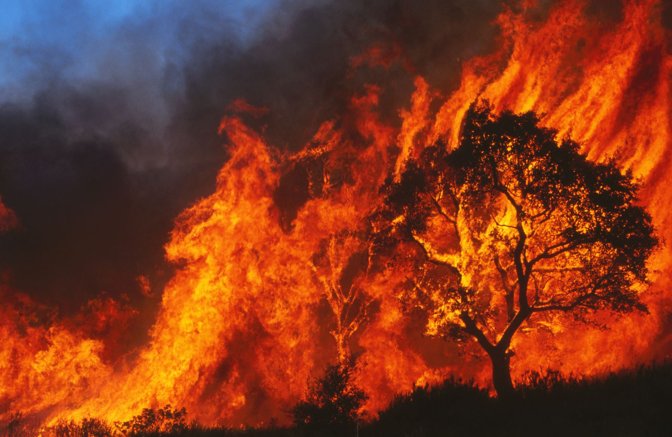

Collaborative and Multi-Agency Emergency Management Planning

Collaborative and Multi-Agency Emergency Management Planning
Contents
FOREWORD 4
1. Introduction 4
2. This Plan 5
Authority 5
Plan Development, Endorsement and Adoption 5
Period of Plan 6
Review 6
3. Municipal Fire Management Vision and Purpose 6
Vision 6
Principles 6
4. Context and Fire Risk 6
Profile 6
5. Environmental Scan 7
Recent Trends and Fire Risk 7
People 7
Built environment 7
Environment 7
Economy 8
Future Trends and Fire Risk 8
People 8
Environment 8
Built 8
Economy 8
6. Insights into Geelong’s Fire Risk 9
Overview 9
History of significant grass and bushfire events 10
Incidents within Greater Geelong 11
7. Insights into BoQ Fire Risk 12
Overview 12
History of significant fire 12
Incidents within Borough of Queenscliffe 12
8. Essential Infrastructure 13
9. The Role of Mitigation 15
Community and Mitigation 15
Mitigation Works for Hazard Type 16
10. Major Fire Hazards 17
Bushfire 17
Description 17
Consequences and Impacts 17
Grass and Scrub Fires 17
Description 17
Consequences and Impacts 17
Places of Last Resort & Fire Refuges 17
Structure 18
Description 18
Consequences and impacts 18
Structural Fire Risk Treatments 18
Transport, Aviation & Maritime Fires 18
Description 18
Consequences and Impacts 18
Relief & Recovery 18
11. Municipal Fire Management Planning 19
Municipal Fire Management Planning sub-committee 19
12. Plan development 19
Risk Assessment 19
Victorian Fire Risk Register (VFRR) 19
Pre-Incident Plans 19
13. Appendix 20
Appendix 1 – Glossary and Acronyms 20
Glossary 20
Acronyms 23
Appendix 2: Hazard Trees – Identification and Notification Procedures 24
Appendix 3 – Mitigation Programs 26
Detailed Mitigation Programs 26
Appendix 4 – Supporting Information 31
Joint Fuel Management Plans 31
Cross Boundary Arrangements 31
Complementary or Related Plans 31
Appendix 5 – Maps 32
FRV/CFA Boundaries 32
Strategic Fire Breaks CoGG 33
Appendix 6 – Document Information 34

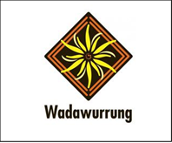
Acknowledgement of Country
Council acknowledges the Traditional Owners of these lands, waters and skies, the Wadawurrung People.
We acknowledge and respect their continuing connections to their Lands, Waters, Skies, Culture and the contribution they make to the life and spirit of our community.
We pay respect to their past and present Elders and their emerging leaders and extend this respect to all Aboriginal and Torres Strait Islander peoples.

FOREWORD
The purpose of this document is to chart the planned and co-ordinated implementation of measures to minimise occurrence, and mitigate the effect, of bushfire, grass and scrub fires, residential and industrial fires on the community.
This plan seeks to deliver an increased integrated approach to all fire issues between agencies and the community. Through a continuous improvement philosophy of agencies, the plan will endeavour to progressively close the gap between identified risks and on ground treatments over the next planning cycle of three years.
Fire Management Planning (prevention and preparedness) is a vital component in the protection of life and property against loss caused by fire. No matter how well trained and equipped Fire Agencies are, the greatest factor in limiting fire damage is the extent to which Fire Management Planning measures have been carried out before the event of fire. This document also identifies plans relevant to the response phase of fire events.
To be effective, everyone in the community must practice fire prevention, and where it involves several people there must be coordinated planning. This document is designed to provide a strategy for the co-ordination of fire prevention measures. As well as being relevant to the community generally, it particularly concerns relevant public authorities such as the City of Greater Geelong (CoGG), Borough of Queenscliffe (BoQ), Forest Fire Management Victoria (FFMV), Victoria Police (VicPol), Department of Transport and Planning (DTP), Barwon Water, Powercor, together with local Country Fire Authority (CFA) Brigades, Fire Rescue Victoria (FRV) and the Municipal Fire Management Planning Sub-Committee (MFMPSC), when planning fire prevention for their areas of responsibility.
Senior representatives from all the agencies mentioned in the plan at a regional level and those representing their agencies formally on the MFMPSC are required to endorse the agency commitments listed in the plan.
The effect of this action is that these organisations are indicating that all the plans/risk treatments and their associated commitments in personnel and monetary or other resources are reflected in their organisation priorities, budgets and works programs.
It is acknowledged that Council’s Municipal Fire Prevention Officer’s (MFPO) do not have the legislative authority to enforce other agencies to fulfil their obligations.

Introduction
We live in a fire prone natural environment dictated by our climate of wet winters (which creates fuel) and hot dry summers. Fire management needs to be conducted with an understanding of both the role fire plays with the threats it can pose to life and property, in biodiversity maintenance and the management of our parks and forests.
Bushfires are a vital part of our natural environment, driving regeneration and maintaining the health of species and ecosystems. The combination of drought, climate change and unnaturally high fuel loads have created an unprecedented bushfire risk. The last decade has seen a dramatic increase in the number, size and severity of bushfires in Victoria, evidenced by the 2003 Alpine, 2006 Grampians, 2006/07 Great Divide, 2009 Black Saturday and the 2019/2020 Black Summer fires.
The City of Greater Geelong is the largest regional local government area in Victoria. While Geelong is the second largest city in the state, the municipality has several large townships surrounded by rural land and pockets of bush. The risk of bush, coastal and grassfire remains high in the municipality. The greatest risk and where many fires occur is in the built environment.
The Borough of Queenscliffe is the smallest local government area in Victoria. Situated on the south coast of the Bellarine Peninsula and next to Port Phillip Heads, the municipality is largely surrounded by water on three sides with the City of Greater Geelong growth area to its west. The greatest fire risk in the area is the residential buildings and the coastal heathland that surrounds the town.
The multi-agency MFMPSC members will cooperatively develop collaborative planning including the aggregation of current plans as a basis for integrated Municipal Fire Management Plans (MFMP’s) through:
- the implementation of common planning models and methodologies
- allocation of resources and accountabilities
- participation in common decision making through the committee process
- collaborative delivery of fire management activities
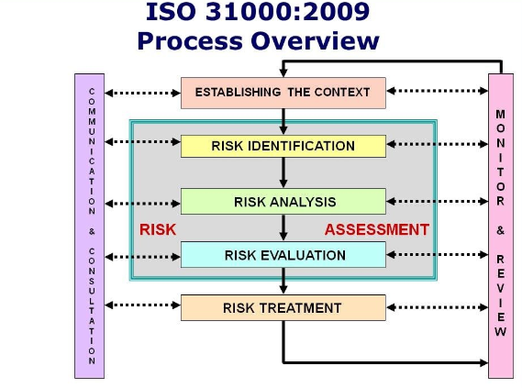
- cooperative engagement
Figure 1 Risk Process
This plan is risk based, having regard for the social, economic, built and natural environment aspects of fire and functions as a guiding document for participants involved in fire management planning activities across CoGG and BoQ.

This Plan

Authority
This Municipal Fire Management Plan (MFMP) has been produced by representatives of the joint Municipal Fire Management Planning Sub-Committee (MFMPSC) and has the authority of both the City of Greater Geelong and the Borough of Queenscliffe Councils pursuant to Section 20 of the Emergency Management Act 1986. The MFMP is a sub plan of the Greater Geelong Municipal Emergency Management Plan (MEMP) and Borough of Queenscliffe Municipal Emergency Management Plan (MEMP).

Plan Development, Endorsement and Adoption
The City of Greater Geelong and Borough of Queenscliffe Municipalities will be joint custodians of this MFMP pursuant to current legislative arrangement. This plan does not replace agency specific operational plans, rather it consolidates and coordinates the significant range of plans that exist across both municipalities and agencies that have a role in fire management.
This plan must be endorsed by the full sub-committee before presentation to each MEMPC for their endorsement. The final plan and accompanying statement of assurance will then be presented to the BSW REMPC for adoption.

Period of Plan
To ensure the MFMP provides for a current integrated, coordinated and comprehensive approach to effective fire management planning, it is to be reviewed at least every three years from the date that both MEMPC’s endorse it.

Review
This plan is a living document and will be subjected to ongoing monitoring and review by the joint MFMPSC to ensure the plan remains relevant and up to date with specific attention to:
- Changes to community demographics and level of risk,
- VFRR-B outcomes,
- Alterations to the status of NSP/Places of Last Resort,
- Changes to organisational responsibilities or other regulatory mechanisms,
- Following a major fire event; and
- More adequately reflecting the real fire risk. (e.g., structural/chemical)

Municipal Fire Management Vision and Purpose

Vision
For the communities of the City of Greater Geelong and the Borough of Queenscliffe to have a greater awareness of their fire risk and be fire safe and resilient.
Purpose of Plan
To guide the committee in integrated fire management planning activities, reduce risks to the community and increase the awareness of community regarding their own responsibilities.

Principles
The principles of the combined MFMPSC are to ensure a comprehensive, collaborative and an integrated approach to fire management planning occurring across both municipalities in line with our vision and purpose of plan.

Context and Fire Risk

Profile
The City of Greater Geelong is the largest regional city in Victoria and the leading commercial centre for south-western Victoria. Geographically, the heart of the Region comprises the Victorian Volcanic Plain, with the Central Highlands to the north and the Otway Ranges to the south. Geelong is characterised by extensive basalt plain grasslands to the north, extending to the landmark peaks of the You Yangs and the Brisbane Ranges. The Bellarine Peninsula and parts of the south-west coast are typified by undulating hills that extend through to coastal dunes.
Parts of the urban areas of the Geelong municipality are serviced by FRV stations with support from CFA Brigades. Outside the FRV districts, CFA Brigades serve these communities with support from FRV Stations.
The Urban areas of the Borough of Queenscliffe are located on a series of dunes and sandy limestone ridges, which falls towards Port Phillip Bay, Bass Strait, and Swan Bay. The Port Phillip Bay and Bass Strait coastlines are characterised by sand dunes covered in coastal scrub.

Environmental Scan

Recent Trends and Fire Risk

People
Demographic profile and forecast data highlights some of the more complex issues faced by the Geelong Municipality and that must be taken into consideration in Fire Management Planning as we move forward into the future. The estimated population of the municipality in 2022 was 276,000 and a population density of 220 per square kilometre. The City has seen an increase in the number of people moving to the area where English is not their first language. Approximately 12% of our population do not speak English. Additionally, there has been a slight increase in the number of people requiring assistance in their day to day lives including during emergencies.
The population for the Borough of Queenscliff area is approximately 3200 people with a population density of 375 people per square kilometre, however this population increases dramatically to around 17,000 over the holiday period. The population centres are Queenscliff and Point Lonsdale. The issues impacting on residents to prepare themselves for wildfire are the high elderly population, seasonal population changes and high level of residents who travel out of town for work.

Built environment
Geelong is the largest regional city in Victoria. It is the main transport corridor for both road and rail from Melbourne to the Western part of the state and into South Australia. As the City has grown, a number of medium and high-density housing and multi-storey office buildings have been built.
The City’s other significant infrastructure includes:
- Viva Refinery
- International airport at Avalon
- The CSIRO Australian centre for disease preparedness
- Significant road networks including Midland and Hamilton Hwy, Princes Fwy and Ring road
- National and Regional rail network
- Spirit of Tasmania
- Multiple hospitals
- International sports arena at Kardinia Park
- Correctional Facilities
- Numerous Education and Aged Care facilities

The Borough of Queenscliffe is a major tourist destination. It consists of two distinct towns, Point Lonsdale and Queenscliff and a large area of environmental significance including RAMSAR wetlands and coastal dunes.
Queenscliff is the gateway to Port Phillip Bay and the Ports of Geelong and Melbourne. There are a range of services on the privately owned Queenscliff marina including the Sea Road Ferry. It has a single road transport link through the narrows, Bellarine Hwy, connecting the town to the wider Bellarine Peninsula.
Both towns have a number of second residences which remain vacant for parts of the year. Additionally, the main street of Queenscliff has a number of significant heritage buildings.

Environment
A large and diverse range of flora communities characterises the Region and is influenced by the local soil types and the spatially and temporally variable rainfall patterns. Eucalypts dominate on the higher ground.
Grassland communities exist on the plains and ridges of the central valley developed after the (geologically recent) creation of the Volcanic Plain. Rainfall increases in the north with altitude, and the natural vegetation is mainly open woodland.
European colonisation has led to significant changes in land use. This includes the removal of grassland communities for crops and introduced pastures, woody vegetation removal for agriculture, the use of woodlands and native hardwood forests for construction timber, firewood and gold mining requirements, and more recently the introduction of exotic plantation forests.
Today, remnant native vegetation is primarily forest, while scrubs, grasslands, heaths and woodlands are much depleted. Approximately half of the remaining native vegetation in the Region is on private land or along roadsides, streams or disused rail lines. Seventy per cent of this vegetation is rare, endangered or vulnerable.

Economy
The City of Greater Geelong’s Gross Regional Product is estimated at $17.58 Billion which represents 3.52% of the states GSP. The largest industry in the municipality is health and social assistance.

The Borough of Queenscliffe’ s Gross Regional Product is estimated at $170 Million with the largest industry being tourism.

Future Trends and Fire Risk

People
The City of Greater Geelong’s population is expected to increase over the coming years with significant growth expected in the areas of Lara, Leopold and resort areas of the Bellarine. By 2041 it is expected that the municipality will see an increase of 40% to a population of 396,000.
As residential development continues and the expected increase in employment and educational opportunities, it is expected that the CALD community will continue to increase over time.
The Borough of Queenscliffe population is expected to increase marginally by 2031 to just under 3500 people. This is due to the limited opportunities for housing growth, the ageing population and continued substantial increase in tourist population over the holiday period.
Seasonal population is also expected to increase with the City’s Enterprise Geelong Unit indicating that during the peak summer season the population for City of Greater Geelong and Borough of Queenscliff could further increase by a total of 121,899 people. This must also be considered when agencies plan their fire mitigation strategies as many of these visitors may not understand the fire risk of the area.

Environment
The 2020 Bushfire Management Strategy identified that climate change is predicted to extend the areas that experience extreme weather, exposing communities that may not have previously experienced these extreme weather events in the past.
The latest Climate projections for Victoria suggest that by 2050 Victoria will have to cope with more extreme heat, longer droughts as well as increased risks of extreme fire, floods and storms. The CSIRO has indicated that there is high confidence that climate change will result in more severe bushfire danger days.

Built
Residential development will continue with the northwest growth zone and the development of more medium and high density living across the municipality including an increase in high-rise buildings in the Geelong Central Business District. An increase in major infrastructure is also planned with development occurring at Avalon Airport, the industrial area of Lara and sporting infrastructure and social housing developed as part of the Victorian Governments Comprehensive regional package.

Climate change and storm surge with sea level rise is a significant risk for BoQ. There is a risk that Queenscliff will become isolated.

Economy
The cost of managing emergencies in Victoria is expected to increase in the future with the increased risk of severity.
The economic costs of natural Disasters in Victoria are expected to reach over $3 billion a year by 2050.

Insights into Geelong’s Fire Risk

Overview
The City of Greater Geelong is a rural, residential, resort, industrial and commercial area. Geelong is the largest regional city in Victoria and the leading commercial centre for south-western Victoria. The City encompasses a total land area of around 1,250 square kilometres. Over two-thirds of the population live in the urban areas. The City includes the historic coastal townships and resort areas of Barwon Heads, Indented Head, Ocean Grove, Portarlington and St Leonards.
The City of Greater Geelong has the most fires in residential buildings than anywhere else in the State. An area of concern that has contributed to these types of fires is the number of hoarding properties across the municipality.
Hoarding is recognised as a mental health issue where a collaborative approach, with several health and support services, is required to support a person with hoarding. Properties cluttered with possessions increase the fuel load and the intensity at which a fire will burn at, consequently, this will have implications on both the resident and the emergency fire personnel.
The City also has the isolated community of Breamlea on its southern boundary. This community is identified as elevated risk due to it being built within the sand dunes, surrounded by coastal heath, with a single road in and out. The population of this small community dramatically increases over Christmas and Easter Holidays when grass and bushfire risk is at its highest.
Figure 2 Breamlea Road Access (Supplied CoGG FP)

History of significant grass and bushfire events
The Geelong region has a substantial bushfire history. This is because of its proximity to the Otway Ranges, Brisbane Ranges and large areas of grassland. Fires generally result from lightning strikes or by human carelessness, accident or wilfulness. According to CFA & FRV data, annually the City of Greater Geelong Council area has the highest occurrence of house fires in the State of Victoria.
Some of the more serious fire incidents are listed below:
- Feb 1851 – Moorabool Valley, Barrabool Hills to Barwon Heads fire. 10 fatalities and extensive property and stock losses. The unofficial maximum temperature that day was stated as 114 degrees F (45.6 degrees C)
- Jan 1969 – Lara and Little River fires. 18 fatalities and 44 homes at Lara were destroyed.
- Feb 1983 - Ash Wednesday fires devastated areas within 20kms of the urban Geelong area.
- Jan 1985 – You Yangs fire and was contained at the Princes Freeway. 2 fatalities and 2 farms incurred losses of houses and outbuildings. There were associated heavy stock losses as well as fencing in the Staughton Vale/Anakie, Lara and Little River areas.
- Jan 1997 – Ocean Grove Reserve fire threatened the residential area of Woodlands Estate.
- Jan 2006 - Brisbane Ranges fire. 6708 hectares burnt within a perimeter of 63 Kilometres, 3 houses destroyed, 2 houses partially damaged, 1 hall and 3 woolsheds and 28 significant buildings destroyed. 160km of fencing, 858 sheep, 25 cattle and 5 poultry destroyed.
- Jan 2013 - Lt River Ripley Road Grass Fire.
- Jan 2014 - Lara & Point Wilson Grass Fires.
- Feb 2014 - Ceres Grass Fire where 49ha burnt.
- Feb 2014, Geelong ‘Gas Gate’ gas leak, Corio – a main valve that controls gas supply to Geelong, the Bellarine Peninsula and southwestern Victoria suffered mechanical failure that permitted gas to escape. Neighbouring properties were evacuated as a safety precaution.
- Jun 2018 - Boat fire resulting in one fatality.
- Oct 2018 – SKM recycling centre fire.
- Mar 2019 – Fire at the Stacey’s Road recycling centres.
- Mar 2019 - Supermarket fire Hamlyn Heights entire structure lost.
- Jul 2020 – Yacht Fire with 2 fatalities.
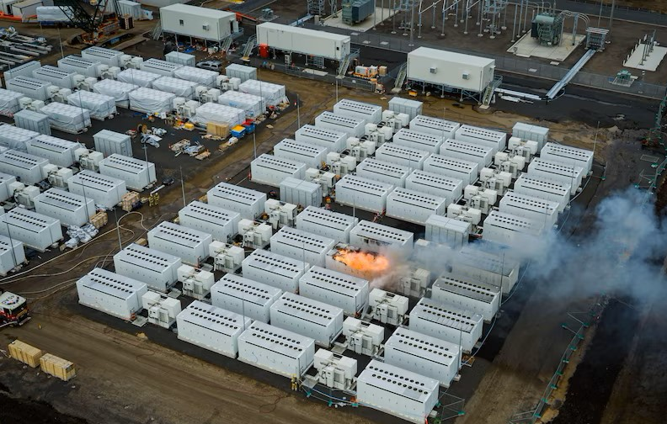
- Aug 2021 – Big Battery Fire in Moorabool.
Figure 3 Big Battery Fire (Supplied by FRV Aviation Unit)

Incidents within Greater Geelong
Current Fire and Incident Reporting System (FIRS) data has been supplied by the Country Fire Authority for the 2022 – 2023 financial year. Unfortunately, Fire Rescue Victoria data was unavailable.
Most of the call outs responded to by Brigades in the Geelong Municipality over this period were for false alarm calls. Traditionally, building fires have been what fire agencies respond to the most in the Greater Geelong area.
The City of Greater Geelong has identified several high-risk properties where evidence of clutter is visible from outside the property. Properties occupied by a resident with signs of hoarding presents an increased risk to themselves, adjoining properties, emergency service personnel and service providers attending at the property. Additionally, there may be an increased risk of fire due to disconnected utilities with unauthorised repairs by the resident, resulting in poor cooking, heating or lighting being used.

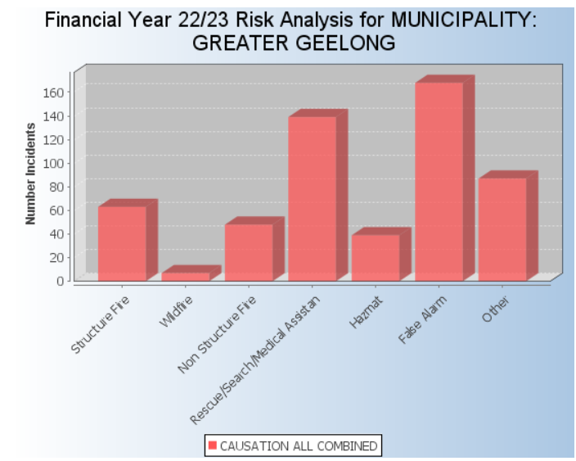

Figure 4 Incidents CoGG (Supplied CFA)

Insights into BoQ Fire Risk

Overview
The Borough of Queenscliffe is surrounded by water on 3 sides and the City of Greater Geelong on its Western boundary.
The two towns of Queenscliff and Point Lonsdale are located on a series of dunes and sandy limestone ridges, which falls towards Port Phillip Bay, Bass Strait and Swan Bay. The Port Phillip Bay and Bass Strait coastlines are characterised by primary dunes covered in costal vegetation, formal parkland and beaches.
Queenscliff is one of the oldest maritime townships with many buildings included on the Victorian Heritage Register having been built in the early 1800’s. These buildings are vulnerable to fire due to the materials used in their construction and the hidden voids and undivided roof spaces.

Both Queenscliff and Point Lonsdale are serviced by the Queenscliff CFA Fire Brigade, a fully volunteer brigade, that are active in the community for education events and responding to emergency calls. They are supported by Fire Rescue Victoria. It is important to point out that in comparison to the City of Greater Geelong, the Borough of Queenscliffe has a very small amount of emergency calls each year.
The Fire Prevention Unit can only become involved in properties that by the nature of items placed outside of the dwelling, i.e., in the yards that constitute a fire hazard. The CFA Act Section 41 (1) (a) and the FRV Act Section 87 (1) (a) state that a fire prevention notice may be served ‘on that land’, other than a building or in a building.

History of significant fire
The Borough of Queenscliffe has a limited history of fire events. The most notable incidents are below:

Dec 1914 – Fire in a prominent Boarding House in Queenscliff.
1936 – Large bushfire affecting the township of Point Lonsdale.
Jan 2013 – Grassfire along the Bellarine Rail Trail threatening a school and kindergarten in Queenscliff.
Mar 2017 – Fire destroyed a shed near the Point Lonsdale lighthouse.

Incidents within Borough of Queenscliffe
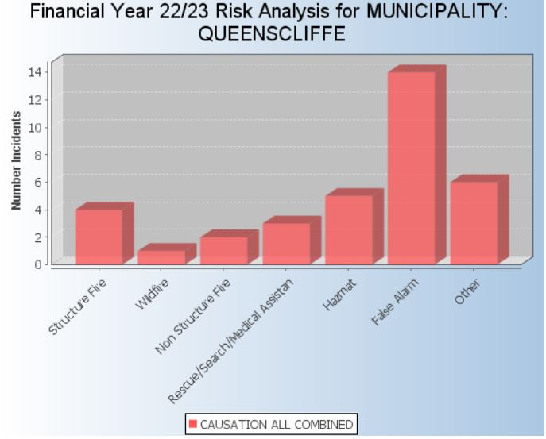
The areas of Point Lonsdale and Queenscliff are serviced by a solely volunteer CFA brigade, supported by Fire Rescue Victoria. They attend a variety of incidents including storm clean up each year. For the 2022 – 2023 financial year, the majority of calls attended by CFA were false alarm calls.
Figure 5 Incidents BoQ (Supplied CFA)

Essential Infrastructure
Grassfires, coastal heath fires, structural fires and to a lesser extent bushfires have the potential to severely impact essential infrastructure like power, gas and communications across both municipalities. This can lead to secondary consequences that can affect the community across a broad range of services and may impact on their day-to-day life.
Essential infrastructure is increasingly interconnected and interdependent, meaning disruption to one essential service can have consequences for multiple sectors and society in general.
Across both municipalities, the following essential infrastructure is present:

Telecommunication Infrastructure:
- Fire towers
- Radio towers
- Phone towers

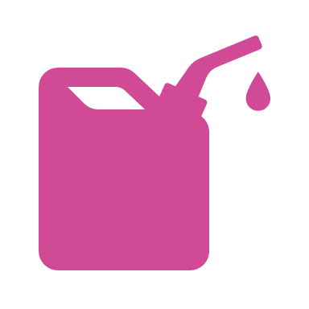
Gas and Oil Infrastructure:
- High pressure pipelines
- Storage tanks
- Refinery
- Terminals


Healthcare Facilities:
- Hospitals
- Medical Centres
- Maternal & Child health
- Aged Care
- Allied Health

Water Infrastructure:
- Treatment plants
- Water tanks
- Water basins
- Reservoirs



Electricity Infrastructure:
- Substations
- Solar farms
- Victoria’s big battery

The below graphic outlines the primary and secondary impacts of a fire and shows how communities not directly impacted by the fire can still be affected.
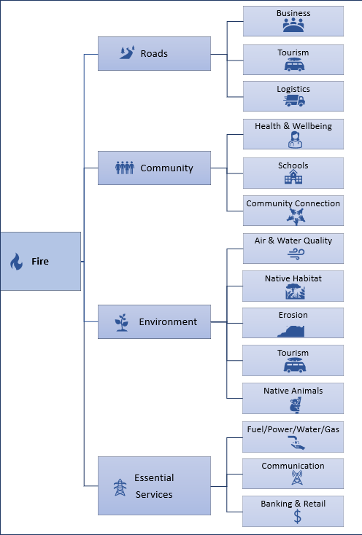
INCIDENT | PRIMARY IMPACT | SECONDARY IMPACT

The Role of Mitigation
Risk mitigation can reduce the likelihood of fires starting and reduce the consequences or impacts if a fire were to start. With the CSIRO expecting costs of response and recovery from an emergency to increase to over $3billion a year by 2050, investment in mitigation could see insurance premiums become more affordable for parts of the community.
At the higher-level, generic risk treatments exist such as the Victorian Planning Scheme, Building Regulations and the Building Code of Australia (BCA). In addition to these, every fire and land agency has had in place for many years’ various fire management strategies to treat both the bushfire and built environment risks which include but are not limited to:
- Hazard Reduction e.g., FFMV and CFA undertake planned burn programs, multi-agency slashing programs
- Ignition Management e.g. (Electric Line Clearance) Regulations 2012
- Community Education e.g., CFA/FRV/FFMV education programs - Campfire safety, Community Fire Guard, Smoke alarm installation and awareness session and school programs
- Preparedness e.g., community and organisational Incident Management Plans
- Property planning e.g., Pre incident plans, building inspections, private property inspections, planning and building legislation
- Fire Season Preparedness Actions

Community and Mitigation
It is important for Residents, tourists and workers in the City of Greater Geelong and Borough of Queenscliffe to understand that managing the risk of fire is a SHARED Responsibility.
Businesses, agencies, government and the community all have a role to play in risk mitigation and management including:
- Understanding their own risk
- Planning for their own circumstances in a fire
- Staying informed of current incidents and conditions
- Recognising and reducing the risk of fire on private land including structures e.g., clean up and maintenance of properties
- Supporting friends and neighbours to reduce their exposure and risk

CFA has free e-learning modules available for home fire safety and bushfire:
https://www.cfa.vic.gov.au/plan-prepare/your-local-area-info-and-advice/e-learning

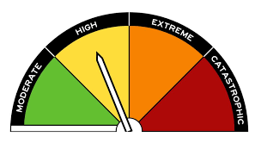
In 2022, a new Fire Danger Rating system was introduced Australia wide, whether residents are travelling or at home the rating system is the same. The Fire Danger Rating is a trigger to act and stay safe.

Ratings can be found on the Bureau of Meteorology and CFA websites.
https://www.cfa.vic.gov.au/warnings-restrictions/total-fire-bans-fire-danger-ratings
http://www.bom.gov.au/vic/forecasts/fire-danger-ratings.shtml

For more information on how you can prepare your property and reduce your risk of fire visit:
https://emergency.vic.gov.au/prepare/#where-do-i-get-information-in-an-emergency
Or
https://www.cfa.vic.gov.au/plan-prepare/before-and-during-a-fire

Mitigation Works for Hazard Type
The below table identifies which mitigation works are undertaken for each of the identified hazard types. These are carried out across both the City of Greater Geelong and the Borough of Queenscliffe.

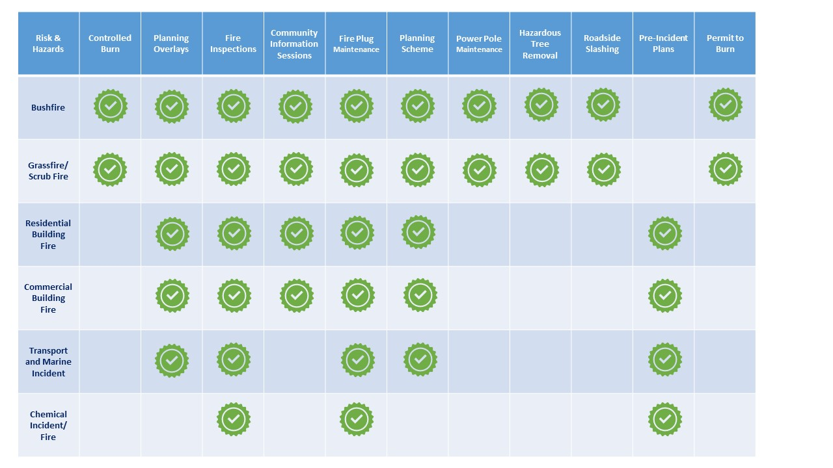
For a detailed account of these programs, responsible agencies and community actions, please refer to Appendix 3

Major Fire Hazards

Bushfire
The Borough of Queenscliffe has no bushfire risk, while the City of Greater Geelong has isolated areas of bushland. This includes the Brisbane Ranges National Park, You Yangs State Park, Dog Rocks Sanctuary, Ocean Grove Nature Reserve and smaller reserves like Kingston park.

Description
Bushfire is assessed as a significant risk in Victoria’s State-level emergency risk assessment. It is a particular risk in the northern part of the Geelong municipality.
A bushfire can start for a number of reasons including:
- Unattended BBQ’s or campfires
- Lightning
- Arson
- Sparking from powerlines

Hot, dry and windy conditions are ideal for bushfires to start and spread.

Consequences and Impacts
The consequence of bushfire is varied and potentially significant including:
- Loss of life
- Serious injury
- Loss of vegetation
- Biodiversity impacts
- Damage to buildings and infrastructure
- Loss of livestock and assets
- Loss of tourism
- Interruptions to business and services (water, telecommunications)
- Road and rail closures
- Loss of social connection from loss of social infrastructure e.g., recreation reserves and schools
- Financial loss
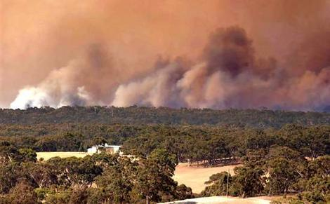
Figure 6 Anakie Fire (Supplied CoGG)

Grass and Scrub Fires
The City of Greater Geelong and the Borough of Queenscliffe have vast areas of grass and scrub. There are a number of rural urban interfaces and coastal areas where a fast-moving grass and scrub fire would have a significant impact on the communities.

Description
Grass and scrub fires can start in rural urban interface and spread rapidly and can start for a number of reasons:
- Unattended BBQ’s or campfires
- Machinery
- Lightning
- Arson
- Sparking from powerlines

Like bushfires, hot, dry and windy conditions are ideal for grass and scrub fires to start and spread.

Consequences and Impacts
The consequence of grass and scrub fires is varied and potentially significant including:
- Loss of life
- Serious injury
- Loss of vegetation
- Biodiversity impacts
- Damage to buildings and infrastructure
- Loss of livestock and assets
- Loss of tourism
- Interruptions to business and services (water, telecommunications)
- Road and rail closures
- Loss of social connection from loss of social infrastructure e.g., recreation reserves and schools
- Financial loss

Places of Last Resort & Fire Refuges
Neighbourhood Safer Places – Bushfire Place of Last resort (NSP)
Currently Neither the City of Greater Geelong or Borough of Queenscliffe have any declared NSP.
For information on Neighbourhood safer places, visit:
https://www.cfa.vic.gov.au/plan-prepare/your-local-area-info-and-advice/neighbourhood-safer-places

Structure
Both municipalities have a range of low, medium and high-density buildings including:
- Residential (statistically the city of Greater Geelong has the highest number of residential fires in the state)
- Industrial
- Commercial
- Education; and
- Health and community care facilities

Description
Structural fires may involve a range of structures from a single residential structure through to a large industrial building. Given the significant range of buildings across the two municipalities, and the age of some of these buildings, there is a risk of outdated building materials such as lead and asbestos becoming airborne during a structural fire.
Structural fires can start for a number of reasons with the most common including:
- Electrical faults
- Unattended cooking
- Improper use of electrical items such as overloading power boards
- Cigarettes, candles and incense burners left unattended
- Children playing with matches
- Arson
- Storage of combustible materials on balconies
- More recently, Lithium batteries left charging in garages or sheds attached to the property.

Consequences and impacts
The consequences of structural fires can be significant and includes:
- Death or serious injury
- Property loss
- Environmental impacts such as contaminated runoff into waterways
- Financial loss

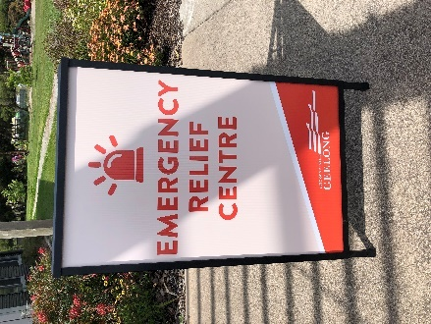
Structural Fire Risk Treatments
Structural Fire Risk is treated in a number of ways to minimize their occurrence and severity. Treatment actions may include:
- Building control and regulation
- Public awareness and education
- Household fire planning
- Occupational health and safety regulation
- Dangerous goods and hazardous material regulation
- Response procedures of fire agencies, including resource and training provision, proportional and specific, to the structural risk environment
Figure 7 Activation of an ERC (Supplied CoGG)

Transport, Aviation & Maritime Fires
Both municipalities have a variety of sites and businesses that have the potential for fire or hazardous incidents including:
- Road and rail accidents
- Fuel and chemical leaks
- Aviation incidents
- Boat fires

Description
It is recognised that the majority of chemical fires and incidents occur within townships, however isolated incidents have been known to occur including tanker leaks and fires outside of built-up areas.
These types of incidents can start for a number of reasons:
- Human error
- Spills and leaks
- Transport accidents
- Maritime accidents
- Aviation incidents
- Process failure
- Mechanical failure

Consequences and Impacts
The impacts of these fires and incidents can include:
- Death or serious injury
- Loss or damage of property
- Environmental losses or damage
- Financial loss

Relief & Recovery

Relief and Recovery Planning, as outlined in the Greater Geelong and Borough of Queenscliffe MEMP will commence at response. Depending on the type, size and duration of the fire event, a MEMP Incident Specific Recovery Committee may be established.

11. Municipal Fire Management Planning

Municipal Fire Management Planning sub-committee
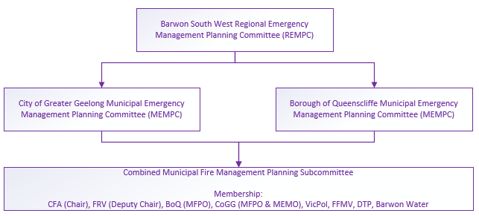
The Greater Geelong and Borough of Queenscliffe MEMPC’s have combined their Municipal Fire Management Planning sub-committee.
This sub-committee meets quarterly prior to the MEMPC and is chaired by the fire services with secretariat support from Council.

12. Plan Development

Risk Assessment
To determine fire risk within the municipality, incident and fire data is used to identify key risks.
Understanding risk and learning how to manage it effectively enables municipalities, fire services, government agencies and the broader community to reduce these hazards and risks to an acceptable level.
Ongoing monitoring and review are essential to ensure that this Combined Fire Management Plan remains relevant and up to date with specific attention to:
- Changes to municipality growth, demographics and level of risk
- To leverage learnings following a major fire event
It should be reviewed on an ongoing basis and aligned with the State and Regional Fire Management Sub-Plans.

Victorian Fire Risk Register (VFRR)
The VFRR is a systematic process, owned by the CFA and utilised by various agencies and key stakeholders to identify assets within the municipal footprint at risk from bushfire, grass and scrub fires. The VFRR provides for mapping and assignment of treatments to mitigate the risk.
The Combined Municipal Fire Management Planning Sub-Committee review this yearly. On occasion this committee may be involved in the development of new or temporary plans as new risks emerge.
https://www.vfrr.vic.gov.au/

Pre-Incident Plans
Fire agencies and significant industry sites have pre-plans and escalation plans for major hazard facilities and protected premises to assist with response to these properties.

13. Appendix

Appendix 1 – Glossary and Acronyms

Glossary
Acceptable risk | The level of potential losses that a society or community considers acceptable, given existing social, economic, political, cultural, technical and environmental conditions.
Assets and values | Recognised features of the built, natural and cultural environments. Built assets may include buildings, roads and bridges; structures managed by utility and service providers; or recognised features of private land, such as houses, property, stock and crops and associated buildings and equipment. Natural assets may include forest produce, forest regeneration, conservation values including vegetation types, fauna, air and water catchments*. Cultural values may include recreational, Indigenous, historical, archaeological and landscape values.
Community | A group of people with a commonality of association and generally defined by location, shared experience or function.
Community based disaster risk management | A process that seeks to develop and implement strategies and activities for disaster preparedness (and often risk reduction) that is locally appropriate and locally ‘owned’.
Consequence | Outcome or impact of an event.
Critical infrastructure | Critical infrastructure includes those services, physical facilities, supply chains, information technologies and communication networks that, if destroyed, degraded or rendered unavailable for an extended period, would significantly impact on the social or economic well-being of the community.  Includes:  - telecommunications  - electrical power systems  - gas and oil storage and transportation  - banking and finance  - transportation  - water supply systems (and sewerage)  Adapted from Critical Infrastructure Advisory Council (CIAC).
Elements at risk | The population, buildings and civil engineering works, economic activities, public services and infrastructure etc. exposed to sources of risk.
Emergency | An event, actual, or imminent that endangers or threatens to endanger life, property or the environment, and that requires a significant and coordinated response.
Essential service  (Essential Services Commission Act 2001) |  | A service (including the supply of goods) provided by:  - the electricity industry  - the gas industry  - the ports industry  - the grain handling industry  - the rail industry  - the water industry  - any other industry prescribed for the purpose of this definition
Event |  | Occurrence of a particular set of circumstances. An incident or situation that occurs in a particular place during a particular interval of time.
Frequency |  | A measure of the number of occurrences per unit of time.
Fire |  | Comes under the definition of an Emergency. The Emergency Management Act 1986 defines ‘emergency’ as: “… the actual or imminent occurrence of an event which in any way endangers or threatens to endanger the safety or health of any person in Victoria or which destroys or damages, or threatens to destroy or damage, any property in Victoria or in any way endangers or threatens to endanger the environment or an element of the environment in Victoria, including, without limiting the generality of the foregoing and specific to integrated fire management and therefore includes:  - A fire; and  - An explosion,  - A road accident or any other accident,  - A disruption
Hazard |  | A source of potential harm or situation with a potential to cause loss.  A potentially damaging physical event that may cause loss of life or injury, property damage, social and economic disruption or environmental degradation.
Likelihood |  | Used as a general description of probability or frequency – can be expressed qualitatively or quantitatively.
Loss |  | Any negative consequence or adverse effect – financial or otherwise.
Mitigation |  | Measures taken in advance of a disaster, aimed at decreasing or eliminating its impact on society and environment.
Monitor |  | To check, supervise, critically observe or measure the progress of an activity, action or system on a regular basis in order to identify change from the performance level required or expected.
Organisation |  | Group of people and facilities with an arrangement of responsibilities, authorities and relationships.
Practicable |  | What is realistic to achieve in the context of:  - the severity of the hazard or risk in question  - the state of knowledge about that hazard or risk and any ways of  - removing or mitigating that hazard or risk  - the availability and suitability of ways to remove or mitigate that  - hazard or risk  - the cost of removing or mitigating that hazard or risk.
Preparedness |  | Arrangements to ensure that in the event of an emergency occur all those resources and services that are needed to cope with the effects can be efficiently mobilised and deployed.
Prevention |  | Regulatory and physical measures to ensure that emergencies are prevented, or their effects mitigated.
Probability |  | A measure of the chance of occurrence expressed as a number between 0 and 1
Recovery |  | The coordinated process of supporting emergency affected communities in the reconstruction of the physical infrastructure and restoration of emotional, social, economic and physical wellbeing.
Residual risk |  | Risk remaining after implementation of risk treatment.
Resilience |  | The capacity of a system, community or society potentially exposed to hazards to adapt, by resisting or changing in order to reach and maintain an acceptable level of functioning and structure. This is determined by the degree to which the social system is capable of organizing itself to increase its capacity for learning from past disasters for better future protection and to improve risk reduction measures
Response |  | Actions taken in anticipation of, during and immediately after an emergency, to ensure its effects are minimised and that people affected are given immediate relief and support.
Risk |  | The chance of something happening that will have an impact on objectives.  The probability of harmful consequences resulting from interaction between natural or human-induced hazards and vulnerable conditions6.
Risk analysis |  | Systematic process to understand the nature of, and deduce, the level of risk.
Risk assessment |  | The overall process of risk identification, analysis and evaluation
Risk criteria |  | Terms of reference by which the significance of risk is assessed.
Risk evaluation |  | Process of comparing the level of risk against risk criteria.
Risk identification |  | The process of determining what, where, when why and how something could happen.
Risk management |  | The culture, process and structures that are directed towards realising potential opportunities whilst managing adverse effects.
Risk management process |  | The systematic application of management of policies, procedures and practices to the tasks of communicating, establishing the context, identifying, analysing, evaluating, treating, monitoring and reviewing risk.
Risk reduction |  | Actions taken to lessen the likelihood, negative consequences, or both, associated with a risk.
Risk treatment |  | Process of selection and implementation of measures to modify risk. The term ‘risk treatment’ is sometimes used for the measures themselves.
Stakeholders |  | Those people and organisations who may affect, be affected by, or perceive themselves to be affected by a decision, activity or risk.
Susceptibility |  | The potential to be affected by loss.
Tolerable Risk |  | A risk within a range that society can live with so as to secure certain net benefits. It is the range of risk regarded as non-negligible and needing to be kept under review and reduced further if possible.
Treatment |  | An existing process, policy, device, practice or other action that acts to minimise negative risk or enhance positive opportunities. The word control may also be applied to a process designed to provide reasonable assurance regarding the achievement of objectives.
Vulnerability |  | The conditions determined by physical, social, economic and environmental factors or processes, which increase the susceptibility of a community to the impact of hazards.
Vulnerable people (DFFH definition) |  | Those living in high bushfire risk areas and who are unable to make an independent decision, including due to cognitive impairment; physically dependant and totally reliant on in home personal care and support; and people who live alone and are geographically and socially isolated with no co-resident carer or family.

Acronyms
BMO | Bushfire Management Overlay
BPA | Bushfire Prone Area
BSW | Barwon South West
BOQ | Borough of Queenscliffe
CFA | Country Fire Authority
COGG | City of Greater Geelong
DEECA | Department of Energy, Environment and Climate Action
DET | Department of Education and Training
DTP | Department of Transport and Planning
DH | Department of Health
DFFH | Department of Family, Fairness & Housing
FRV | Fire Rescue Victoria
MEMP | Municipal Emergency Management Plan
MEMPC | Municipal Emergency Management Planning Committee
MFMP | Municipal Fire Management Plan
MFMPC | Municipal Fire Management Planning Committee
MFPO | Municipal Fire Prevention Officer
NSP | Neighbourhood Safer Place
PPRR | Preparation, Prevention, Response, Recovery
VFRR | Victorian Fire Risk Register

Appendix 2: Hazard Trees – Identification and Notification Procedures
The Electricity Safety Act 1998 (Vic) (ES Act) provides that a municipal council must specify, within its Municipal Fire Prevention Plan:
- procedures and criteria for the identification of trees that are likely to fall onto, or come into contact with, an electric line (hazard trees); and
- procedures for the notification of responsible persons of trees that are hazard trees in relation to electric lines for which they are responsible.
Under the ES Act, the person responsible for maintaining vegetation and clearance space around power lines is referred to as the 'responsible person'.
The procedures outlined in this section of the Municipal Fire Management Plan 2023 – 2025 seek to address the requirement detailed above.
Each responsible person should have its own internal procedure regarding the steps that will be taken when it receives notification of a potentially hazardous tree.
What is a hazard tree?
According to the ES Act, a hazard tree is a tree which ‘is likely to fall onto, or come into contact with, an electric line’.
The Electricity Safety (Electric Line Clearance) Regulations 2020 (the Regulations) further provide that a responsible person may cut or remove such a tree ‘provided that the tree has been assessed by a suitably qualified arborist; and that assessment confirms the likelihood of contact with an electric line having regard to foreseeable local conditions.’
Due to legal requirements which require a clearance space be maintained around an electric line, hazard trees are usually located outside the regulated clearance space. Despite being outside the clearance space, the tree may still have the potential to contact the line due to its size or because of a structural fault or weakness which renders part, or all, of the tree likely to contact or fall onto the line.
Who is responsible for a hazard tree?
Under the ES Act, the person responsible for maintaining vegetation and clearance space around power lines is referred to as the ‘responsible person’. This includes responsibility for keeping the whole or any part of a tree clear of the line.
Under the ES Act, responsibility is allocated between distribution businesses and other owners of electricity infrastructure, landowners and occupiers, public land managers such as municipal councils.
Municipal councils are responsible for trees on public land within their municipalities, for which they are the land manager, where these are also within a Declared Area for the purposes of the ES Act. Primary responsibility for vegetation clearance and management within the municipality, for areas which are not within a Declared Area, will usually fall to the relevant electricity distribution company.
Responsible Persons within City of Greater Geelong & Borough of Queenscliffe
There are a number of organisations that have responsibility for line clearance in City of Greater Geelong, including:
- Powercor: for trees affecting all 66KV, 22KV high voltage lines and low voltage lines outside the Declared Area (for the purposes of the ES Act) and trees on private property within the Declared Area.
- The Council’s: for trees on public lands which are managed by the Council’s and where road reserves are located within the Declared Area (for the purposes of the ES Act).
- Foreshore Committees of Management: for trees affecting power lines on land managed by the committee.
Other relevant information
Responsible persons, other than private persons, must have an electric line clearance management plan in place for areas for which they have responsibility (refer Electricity Safety (Electric Line Clearance) Regulations 2015).
Both municipalities have a Line Clearance Vegetation Management Plan 2019-2020 that outlines vegetation management under power lines.

Primary Responsible Person Representative (PRPR)
For the purposes of this part of the Plan, the primary responsible person is Powercor.
All reports of hazard trees to Powercor should be made on the ‘Municipal Hazard Tree Notification Form’ which is located on the Powercor Website
Contact details for the PRPR, are as follows:
Position title of contact person: Vegetation Technical Officer
Telephone Number: 13 12 80 – CitiPower
13 24 12 – Powercor
Email address: eqcustomer@powercor.com.au
vegtech@powercor.com.au

Reporting Timelines
The PRPR should provide reports to the relevant responsible person as soon as practicable.
In circumstances where:
- the potentially hazardous tree is located within a high bushfire risk area (as per s.80 of the ES Act) and the potentially hazardous tree is reported during the fire danger period declared under the Country Fire Authority Act 1958 (Vic); or
- the report indicates that there is an imminent danger that the tree will contact or fall onto lines as a result of minor environmental changes.
The potentially hazardous tree must be referred to the relevant responsible person for action as soon as possible. For Council, within three working days a council arborist will undertake a risk assessment and works will be programmed as a result of this assessment.
Each responsible person (other than the primary responsible person) must provide the PRPR with contact details of the person (position title) to whom reports should be provided. It is the responsibility of each responsible person to ensure that the PRPR is provided with up-to-date contact details.

Appendix 3 – Mitigation Programs

Detailed Mitigation Programs
The tables below are based on the six risk environments (Business and Community, Farming and Rural living, Interface Living, Industry, Bush and Parks, Urban Living) to achieve consistency across municipalities and government agencies within the Barwon Southwest Region.
Each program listed outlines the objectives, primary agency responsible and what actions the community can take.

Business and Community Activity Centres
Program/ Plan Title | Primary Agency | Partner Agency’s | Program/Plan Objectives | Community Action
Fire Safety at Community Events | CoGG & BoQ Events Coordinator | CFA, FRV, VicPol, SES, MEMPC, WorkSafe, DTP,  Ambulance Victoria,  Event Organiser | Conduct Inspection and other compliance with Building Act and Regulations & other applicable laws, i.e., OH&S Act, DG Regulations. CFA Act, Planning and Environment Act  Programmed Inspections of community events with all relevant partner agencies. | - Understand their risk  - Have up to date Evacuation Plans  - Know where to get information  - Stay informed  - Have working smoke alarms  - Practise fire evacuation drills  - Obtain an event permit if required  - Adhere to fire safety requirements  - Ensure children are educated on fire safety  - Dial 000 if a fire occurs
Fire Safety in Commercial, and Industrial Premises | CoGG & BoQ Building Surveyor | CFA, FRV, VicPol, WorkSafe, DFFH | Audits of high-risk buildings re compliance with Building Regulations.  Essential Services inspections.
Structure Fire Integrity Inspections | CoGG & BoQ Building Surveyor | CFA, FRV | Identify buildings that have been damaged by fire and inspect for public safety.
Fire Safety In Caravan Parks and Camping Grounds | CoGG & BoQ Building Surveyor and EHO | CFA, FRV, DEECA, WorkSafe | Programmed Inspections of Caravan Park and Camping Grounds with all partner agencies.
Fire Hazard Management on Council Owned or Managed Land (excludes roadsides) | CoGG & BoQ | DEECA, CFA, FRV | Management of fire hazards on Council land through fuel reduction works.

(B) Farming and Rural Living
Program/ Plan Title | Primary Agency | Partner Agency’s | Program/Plan Objectives | Community Action
Permit to Burn | CoGG & BoQ MFPO  FRV/CFA  FFMV |  | Issue Local Law permits with conditions for safe removal of fuel loads. | - Understand their risk  - Have a bushfire survival plan  - Know where to get information  - Stay informed  - Leave early on high fire risk days  - Apply for a permit to burn  - Understand the fire danger rating system  - Maintain your property  - Have a cleared paddock with water for livestock  - Dial 000 if a fire occurs  - Ensure machinery is maintained
Annual maintenance of Fire Management Roads/Breaks | CoGG & BoQ | Nil | Fire management roads/breaks (Strategic, Primary, Secondary) are reviewed and maintained throughout the municipality and detailed in Council’s operational plans and programs.
Roadside Vegetation Management | CoGG & BoQ  Parks Unit | Nil | Slash/spray Council managed roads within municipality to reduce fuel loads over fire season. Maintain clear path for vehicle access and maintenance of council trees on all Council managed roads.
Strategic Fire Fuel Breaks | DTP | CoGG & BoQ | Fuel reduction on arterial roads in accordance with municipal fire prevention plans by spraying, slashing of roadsides or grading fuse breaks prior to burning off activities by the CFA.
Arterial Roadside Maintenance | DTP | CoGG & BoQ | Maintenance standards regarding vegetation encroaching the road envelope and management of roadsides to reduce fuel loads prior to the fire season i.e., programming maintenance slashing in November

(C) Interface Living
Program/ Plan Title | Primary Agency | Partner Agency’s | Program/Plan Objectives | Community Action
Wildfire Management Overlay & Land Use Planning Controls | CoGG & BoQ Statutory Planning | CFA, FRV | Maintain and implement the previsions of WMO and other land use controls (Pending application). | - Understand their risk  - Have a bushfire survival plan  - Know where to get information  - Stay informed  - Leave early on high fire risk days  - Understand the fire danger rating system  - Maintain your property  - Move back two streets for grass fire  - Dial 000 if a fire occurs
Powerline Clearance | CoGG & BoQ  Tree Management Unit | Nil | Maintain tree clearances to energy Safe Regulations within declared areas.
Fire Access Tracks | CoGG & BoQ Works & Tree Management Unit | Nil | Annual inspection and maintenance of all designated Fire Management Tracks.
Building in BPA Areas | CoGG & BoQ Building  Surveyor | CFA* FRV* (during planning stage only), Private Building Surveyors | Check all new building applications to ensure they comply with Australian Standard AS3959/2009 prior to issue of building permit.

(D) Industry and State Infrastructure
Program/ Plan Title | Primary Agency | Partner Agency’s | Program/Plan Objectives | Community Action
Asset, Vegetation & Easement Management | SP-AusNet | Contractor | Maintain electrical transmission assets and future asset sites.  Maintain vegetation in the vicinity of Electrical Transmission Assets to the requirements of the Electrical Safety Act.  Maintain easement access tracks, gates and fences. | - Have a fire management plan  - Obtain permit for industry related open-air burning  - Report any issues/faults to the agency  - Dial 000 if a fire occurs
Power Supply & Power line Management | Powercor | Contractor,  CFA | The plan details Powercor’s policies, procedures and programs for the inspection, maintenance and operation of Powercor’s Electricity Distribution Network including Vegetation Management.
Permit for Open Air Burning | CFA/FRV |  | Permits required before undertaking hot works such as welding, grinding etc.

(E) Bush and Parks
Program/ Plan Title | Primary Agency | Partner Agency’s | Program/Plan Objectives | Community Action
MEMP | CoGG & BoQ MEMP | Control Agency, VicPol | Implements/activates the agreed arrangements to ensure a coordinated response. | - Understand their risk  - Have a bushfire survival plan when visiting high fire risk areas  - Know where to get information  - Stay informed  - Understand the fire danger rating system  - Report any issues/faults to agencies  - Ensure campfires are properly extinguished  - Dial 000 if a fire occurs
Campfire Prevention | DEECA | Nil | Provide information and undertake patrols to increase awareness of the risks associated with campfires to reduce the incidence of preventable wildfires.
Fire Investigation | DEECA | CFA, FRV, VicPol | DEECA, CFA and VicPol working collaboratively to investigate and establish the cause and origin of all human caused fires and as appropriate prosecute the offenders.
Local Mutual Aid Plans | DEECA | CFA, FRV | Multi-agency approach to emergency management lead by DEECA & CFA by working collaboratively to implement fire readiness and response arrangements to ensure integrated and effective fire suppression action.
Planned Burn Program | DEECA |  | Planned burning to reduce fuels on public lands based on ecological and risk management objectives to reduce the risk of bushfire to communities and maintain ecologically diverse environments.
Vegetation Monitoring | DEECA |  | Fuel hazard assessment, mapping of burn outcomes and monitoring of vegetation on public land to support decision making in scheduling of planned burn program.
Asset Protection Checklist | Barwon Water |  | Annual inspection of major water supply assets/sites to ensure preparedness for Fire Danger Period.
Routine Asset/Site Maintenance | Barwon Water |  | Ongoing mowing/slashing of sites to reduce fuel loads for protection of assets or adjoining properties.

(F) Township and Suburban Living
Program/ Plan Title | Primary Agency | Partner Agency’s | Program/Plan Objectives | Community Action
Pre-Season Community Awareness Campaign | CoGG & BoQ MFPO | CFA, DEECA, FRV | Pre-season advertising, courtesy letters and other information programs | - Understand their risk  - Have a fire escape plan for your family and pets  - Know where to get information  - Stay informed  - Understand the fire danger rating system  - Maintain your property  - Report residential hoarding to Council  - Report any faults/issues to agencies  - Dial 000 if a fire occurs
Annual Fire Hazard Inspections | CoGG & BoQ MFPO | CFA, FRV | Conduct inspections to municipality and identify potential and actual fire hazards on private land and direct removal of same through service of Fire Prevention Notices.
Non-Fire Season Inspection Program | CoGG & BoQ MFPO | Nil | Conduct random inspections for overgrown properties or inspect complaints with view to removing fire hazard outside FDP.
Recovery Projects | CoGG & BoQ Recovery Manager |  | Working with local communities to support their social, economic, natural and built recovery.
Fire Plug Installation and Maintenance | CoGG & BoQ Statutory Planner  Barwon Water | CFA, FRV | Ensure all subdivisions have fire plugs located as per Standard C29 of Clause 56.

Appendix 4 – Supporting Information

Joint Fuel Management Plans
Both the CFA and FFMV conduct fuel reduction through both burning and maintenance/ slashing programs.
For information on what reduction works are planned across the BoQ and CoGG, visit:
https://www.ffm.vic.gov.au/__data/assets/pdf_file/0033/609936/2022-23_JFMP_BSW_FINAL.pdf

Cross Boundary Arrangements
It is acknowledged that the municipal areas and stakeholder agencies have existing planning relationships across the following boundaries:
- Borough of Queenscliffe
- Golden Plains Shire
- Moorabool Shire
- Wyndham City Council
- Surf Coast Shire

Complementary or Related Plans
Name of the Plan | Plan Owner | Comment
Strategic Fuel Breaks | Council /FFMV / CFA/ FRV | Strategic roads and list of strategic burning and timing. For CoGG involving Melbourne road, Anakie and Bellarine.  Not applicable for the borough
Joint Fuel Management Plan | FFMV | Lists every burn in the state
Operational and Emergency Management Plans | Barwon Water | Strategic assets and contingencies and response arrangement for fire preparedness
Power line Bushfire Mitigation Plan | Powercor | Organisational operational and mitigation activities  Refer Powercor website www.Powercor.com.au
Pre-Incident Response Plans | CFA / FRV | Place plans for high-risk sites
Municipal Emergency Management Plan | Greater Geelong MEMPC  Borough of Queenscliffe MEMPC | The overarching emergency plan for each municipality, outlining agencies responsibilities and activities relating to preparedness, response, relief and recovery.
CFA Brigade Community Safety Plans | CFA | Each Individual brigade has its own plan
Bellarine Coastal and Summer Plan | CoGG/ BOQ | Details changes in population and activities over the summer that may impact on the consequence of any emergency

Appendix 5 – Maps

FRV/CFA Boundaries
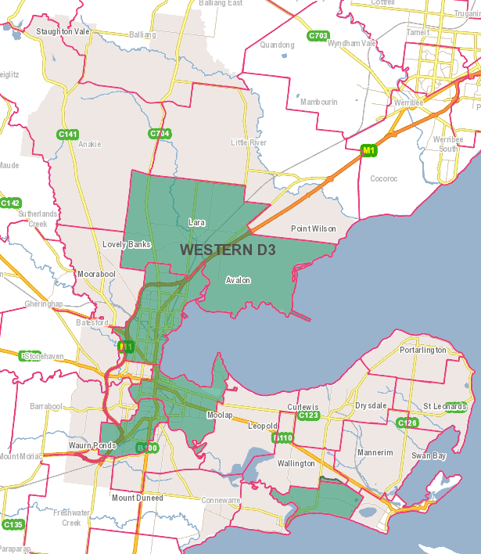
CFA Brigade Boundary FRV Districts

Strategic Fire Breaks CoGG
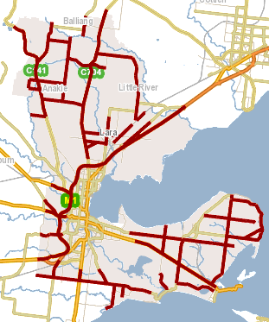
SFM Roads

Appendix 6 – Document Information
Document details
Document ID
Document title: | Greater Geelong and Borough of Queenscliffe combined Fire Management Sub-Plan
Document owner: | Greater Geelong and Borough of Queenscliffe joint Municipal Fire Management Planning Sub-Committee (MFMPSC)

Version control
Version | Date | Description | Author
1.0 | July 2023 | Document re-write to combine both Municipalities | MFMPSC

Document approval
This document requires the approval of the Sub-Committee:
Name | Title | Signature
Ian Beswick | Chair
Once this document is approved through the sub-committee, endorsement will be sought from the MEMPC and recorded in the minutes

Review
The audience for this document is the Municipal Fire Management Planning Sub-Committee
Terms | Description
24 months | This document will be reviewed every 24 months or more frequently as required.
Review Date | July 2025

