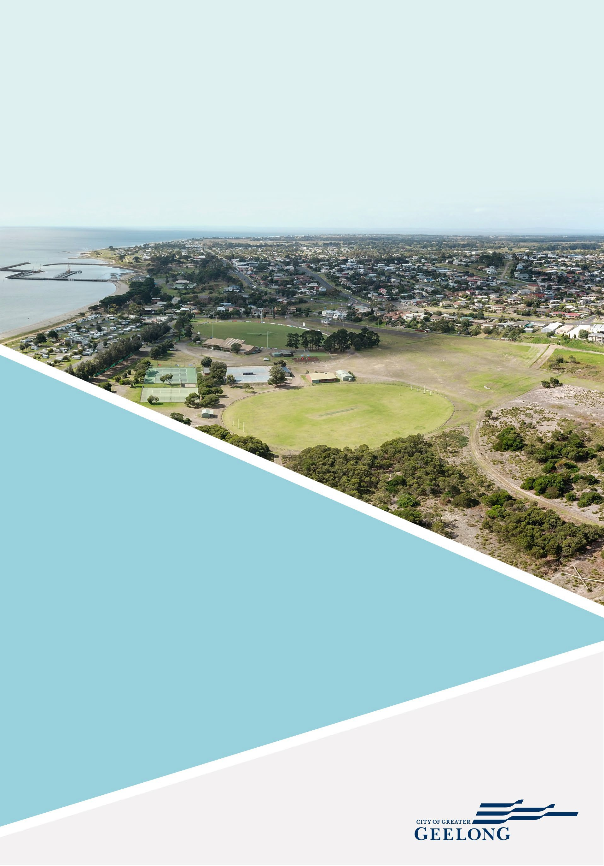

THE CITY OF GREATER GEELONG

PORTARLINGTON RECREATION RESERVE
MASTER PLAN

FINAL REPORT
MARCH 2022



We acknowledge the Wadawurrung People as the Traditional Owners of the Land, Waterways and Skies. We pay our respects to their Elders past and present. We acknowledge all Aboriginal and Torres Strait Islander people who are part of the Greater Geelong community today.

The Portarlington Recreation Reserve Master Plan was supported by the Victorian State Government.

Disclaimer: This Master Plan Report was prepared by an independent consultant in conjunction with the City of Greater Geelong. The Master Plan Report provides an overview of the context, need and community engagement methods undertaken which have helped to form the Master Plan. This report is also subject to further consultation and consideration by the City of Greater Geelong.
The contents of this report are approved by the City of Greater Geelong, however, may require revision over time to reflect current council policy.
All illustrative plans, perspectives and imagery contained within this report are indicative artists impressions to illustrate conceptual ideas only and are subject to further resolution, consultation, detailed design, and approvals.
All images throughout this document have been credited where required.
The City of Greater Geelong wish to acknowledge contributions to this report made by the Project Reference Group, Project Control Group, Project Working Group, and the greater Geelong community.

© 2022 City of Greater Geelong
This document may only be used for the purpose for which it was commissioned and in accordance with the terms of engagement for the commissions.
Unauthorised use of this document in any form whatsoever is prohibited.

CONTENTS

EXECUTIVE SUMMARY
Executive Summary 4
INTRODUCTION
  - Project Overview 7
  - Study Area 7
  - Project Objectives 7
  - Recent Infrastructure Projects 7
  - Project Methodology 9
  - Master Plan Development Principles 9
STRATEGIC CONTEXT
  - Literature Review 11
    - Statewide Strategic Context 11
    - Regional Strategic Context 12
    - Local Strategic Context 13
    - Sport Specific Strategies 14
  - Demographic Overview 15
    - Local demographic influences on
participation 16
  - Design Trends 16
    - Universal Design 16
    - Environmentally Sustainable Design 17
    - Gender Neutral Facilities 17
    - Multi Use 17
    - Open Space Design 18
    - Nature Design 18
    - Crime Prevention Through Environmental
Design 18
SITE OVERVIEW
  - Site Location and Context 19
EXISTING CONDITIONS
  - Active Sport and Recreation Area 20
  - Environmental Values and Passive
Recreation Area 31
SITE USAGE
  - Sporting Club Participation 36
  - Sporting Participation Catchment (AFL) 37
  - Sporting Infrastructure Supply and Provision Ratios 39
CONSULTATION SUMMARY
  - Project Reference Group 41
  - State Sporting Organisations 41
  - Community Consultation 42
MASTER PLAN
  - What is Proposed 44
  - Vision and Goals 44
  - Future Character Description 45
  - Master Plan (Landscape Plan) 46
  - Overview of Master Plan Recommendations and Costs 48
  - Implementation Schedule 61

This Master Plan has been developed to provide a clear direction for the overall improvement of Portarlington Recreation Reserve. Following broad consultation with stakeholders, the Master Plan aims to strike a balance between the embellishment of the Reserve and its intended future use as a local level facility. In addition, the Plan also considers the capacity of potential investment partners and future resources required for implementation.

EXECUTIVE SUMMARY
Portarlington Recreation Reserve is a 38-hectare allotment which serves a variety of purposes for the community including sport, recreation, event, and environmental uses. The Reserve is situated within the township of Portarlington, which has a current population of 4,046. The township offers an enviable combination of rural and coastal lifestyles, maintaining a small town feel whilst welcoming an influx of holiday makers throughout the summer months.
It is anticipated that the current Portarlington population is expected to experience growth of 26% to 2030, at an average annual change of approximately 2%. This equates to approximately 1,087 additional persons living in Portarlington in 2030. Most of the population growth will be experienced within the 60 – 75 year old age cohort.
Portarlington sits just outside of the City of Greater Geelong’s growth boundaries, and therefore, according to the 2017 Portarlington Structure Plan, the town’s role over the next 10 years will be as a popular holiday destination, along with an acknowledgement that elderly persons will continue to comprise a very high portion of permanent resident population.
The Portarlington Recreation Reserve Master Plan has been shaped around the future likely use of the Reserve and demographic of the township over the next 10 years. These considerations have resulted in the development of recommendations that are both aspirational and achievable.
The Reserve currently offers a diverse range of uses and activities across its sporting and active recreation precinct and throughout the passive recreation area. As discovered through the findings within this report, both active and passive areas of the Reserve are highly valued by the community and, as such, a balanced approach to their improvement, activation and management has been considered throughout.
The Reserve has a strong organised sporting contingent, with tennis, netball, football, and cricket all represented. The Reserve is also home to Girl Guides as well as an Agricultural Society, who host the town’s popular annual event, the Bellarine Agricultural Show.
The passive recreation area holds significant environmental and biodiversity values and is located to the west of the active sporting precinct. Trails and habitat throughout this area can be found, and it is well utilised by walkers, joggers, and nature enthusiasts alike.
The Master Plan’s recommendations have been developed alongside broad engagement with the Project Control Group,

Project Working Group and Project Reference Group, and the broader community. In addition, this report has reviewed relevant literature, facility inspections and participation analysis.
The Master Plan has been driven by four development principles and six goals, of which each of the recommendations align. These include sustainability, accessibility, multi-use and fit for purpose. In line with these, key themes of the Master Plan and its recommendations, include:
Refurbishment of identified sporting facilities where they do not align with recommended guidelines. The Plan recognises that most sporting infrastructure at the Reserve is in good structural condition, particularly in regard to the various pavilions, however there are some deficiencies in their quality and function. Several opportunities exist for the associated sporting amenities and playing surfaces to be upgraded to encourage multi-use and to contribute to greater programming and participation opportunities.
Improvement in vehicle and pedestrian movement and connections, making access safer and more inclusive. Throughout the Reserve, recommendations have been made to enhance car parking areas and to formalise access routes that experience high volumes of traffic. Connectivity throughout the Reserve and to neighbouring land parcels including the Point Richards Flora & Fauna Reserve and the Portarlington Holiday Park are recommended to increase visitation and the safety of pedestrians.
Greater improvements to the passive recreation area to enhance the biodiversity aspects of the Reserve, as well as contribute to a better user experience. The western area of Portarlington Recreation Reserve has been improved through the regeneration of vegetation and habitat. Combined with the Point Richards Flora and Fauna Reserve adjacent, this represents the largest area of native vegetation of the northern Bellarine Peninsula. The Master Plan’s recommendations include improving vegetation and habitat whilst elevating the quality of recreation access and enjoyment of the area.
A better variety of community activities throughout the Reserve such as diversified play for a broader age group of children and adolescents as well as community garden, will contribute to increased opportunities for involvement.
Additional tree canopy and landscaping commensurate with the character and context of the site, will make the Reserve more visually appealing and offer greater amenity and habitat. Strategically placing new plantings in areas which improve the overall value of the Reserve, but that does not hinder the deliverability of community events, is recommended.

EXECUTIVE SUMMARY
The following summary provides a high-level overview of the key recommendations of the Portarlington Recreation Reserve Master Plan:

 |  |  | 
Refurbishing the existing main (football/cricket) pavilion as well as small extentions to the tennis and netball pavilions to ensure essential sporting infrastructure components are meeting the requirements and expectations of the modern game. | Improvements to car parking and vehicle movement throughout the site will enhance connectivity, make it safer for pedestrians, and encourage more active modes of transport. | Upgraded entrances will make the Reserve more visually appealing and improve the management of foot and vehicle traffic. | Additional community activities have been recommended throughout the Master Plan including improved play space, multi-use sporting surfaces, BMX/bike jumps and community garden.
 |  |  | 
Upgrading the cricket practice nets will enable multi-use opportunities whilst providing a more up to date and safer facility for players and spectators. | Recommendations for the passive recreation area aim to improve the Reserve’s biodiversity properties and value whilst creating opportunities for visitation and casual recreational activities. | Recommendations to provide additional tree canopy throughout the Master Plan aim to enhance the amenity of the Reserve whilst contributing to a greener parkland. | Undertaking small improvements to the open space and events area within the Reserve will ensure it is well serviced to host current and future community events.
 |  |  | 
Consolidating and replacing old infrastructure, where appropriate, that is past its useful life and no longer fit for purpose has been recommended. | Accessible pathways and connections, including wayfinding signage is recommended both within the Reserve and to adjacent land parcels and neighbouring properties. Connections between the active recreation and passive recreation areas  are highlighted throughout. | Functional upgrades to the tennis and netball courts, including lighting and spectator seating, as well as the provision of a netball warm up area will provide greater participation and programming opportunities. | Improving community amenity within the Reserve, including park benches and picnic facilities will offer greater opportunities for other recreational activities including unstructured play and nature appreciation.

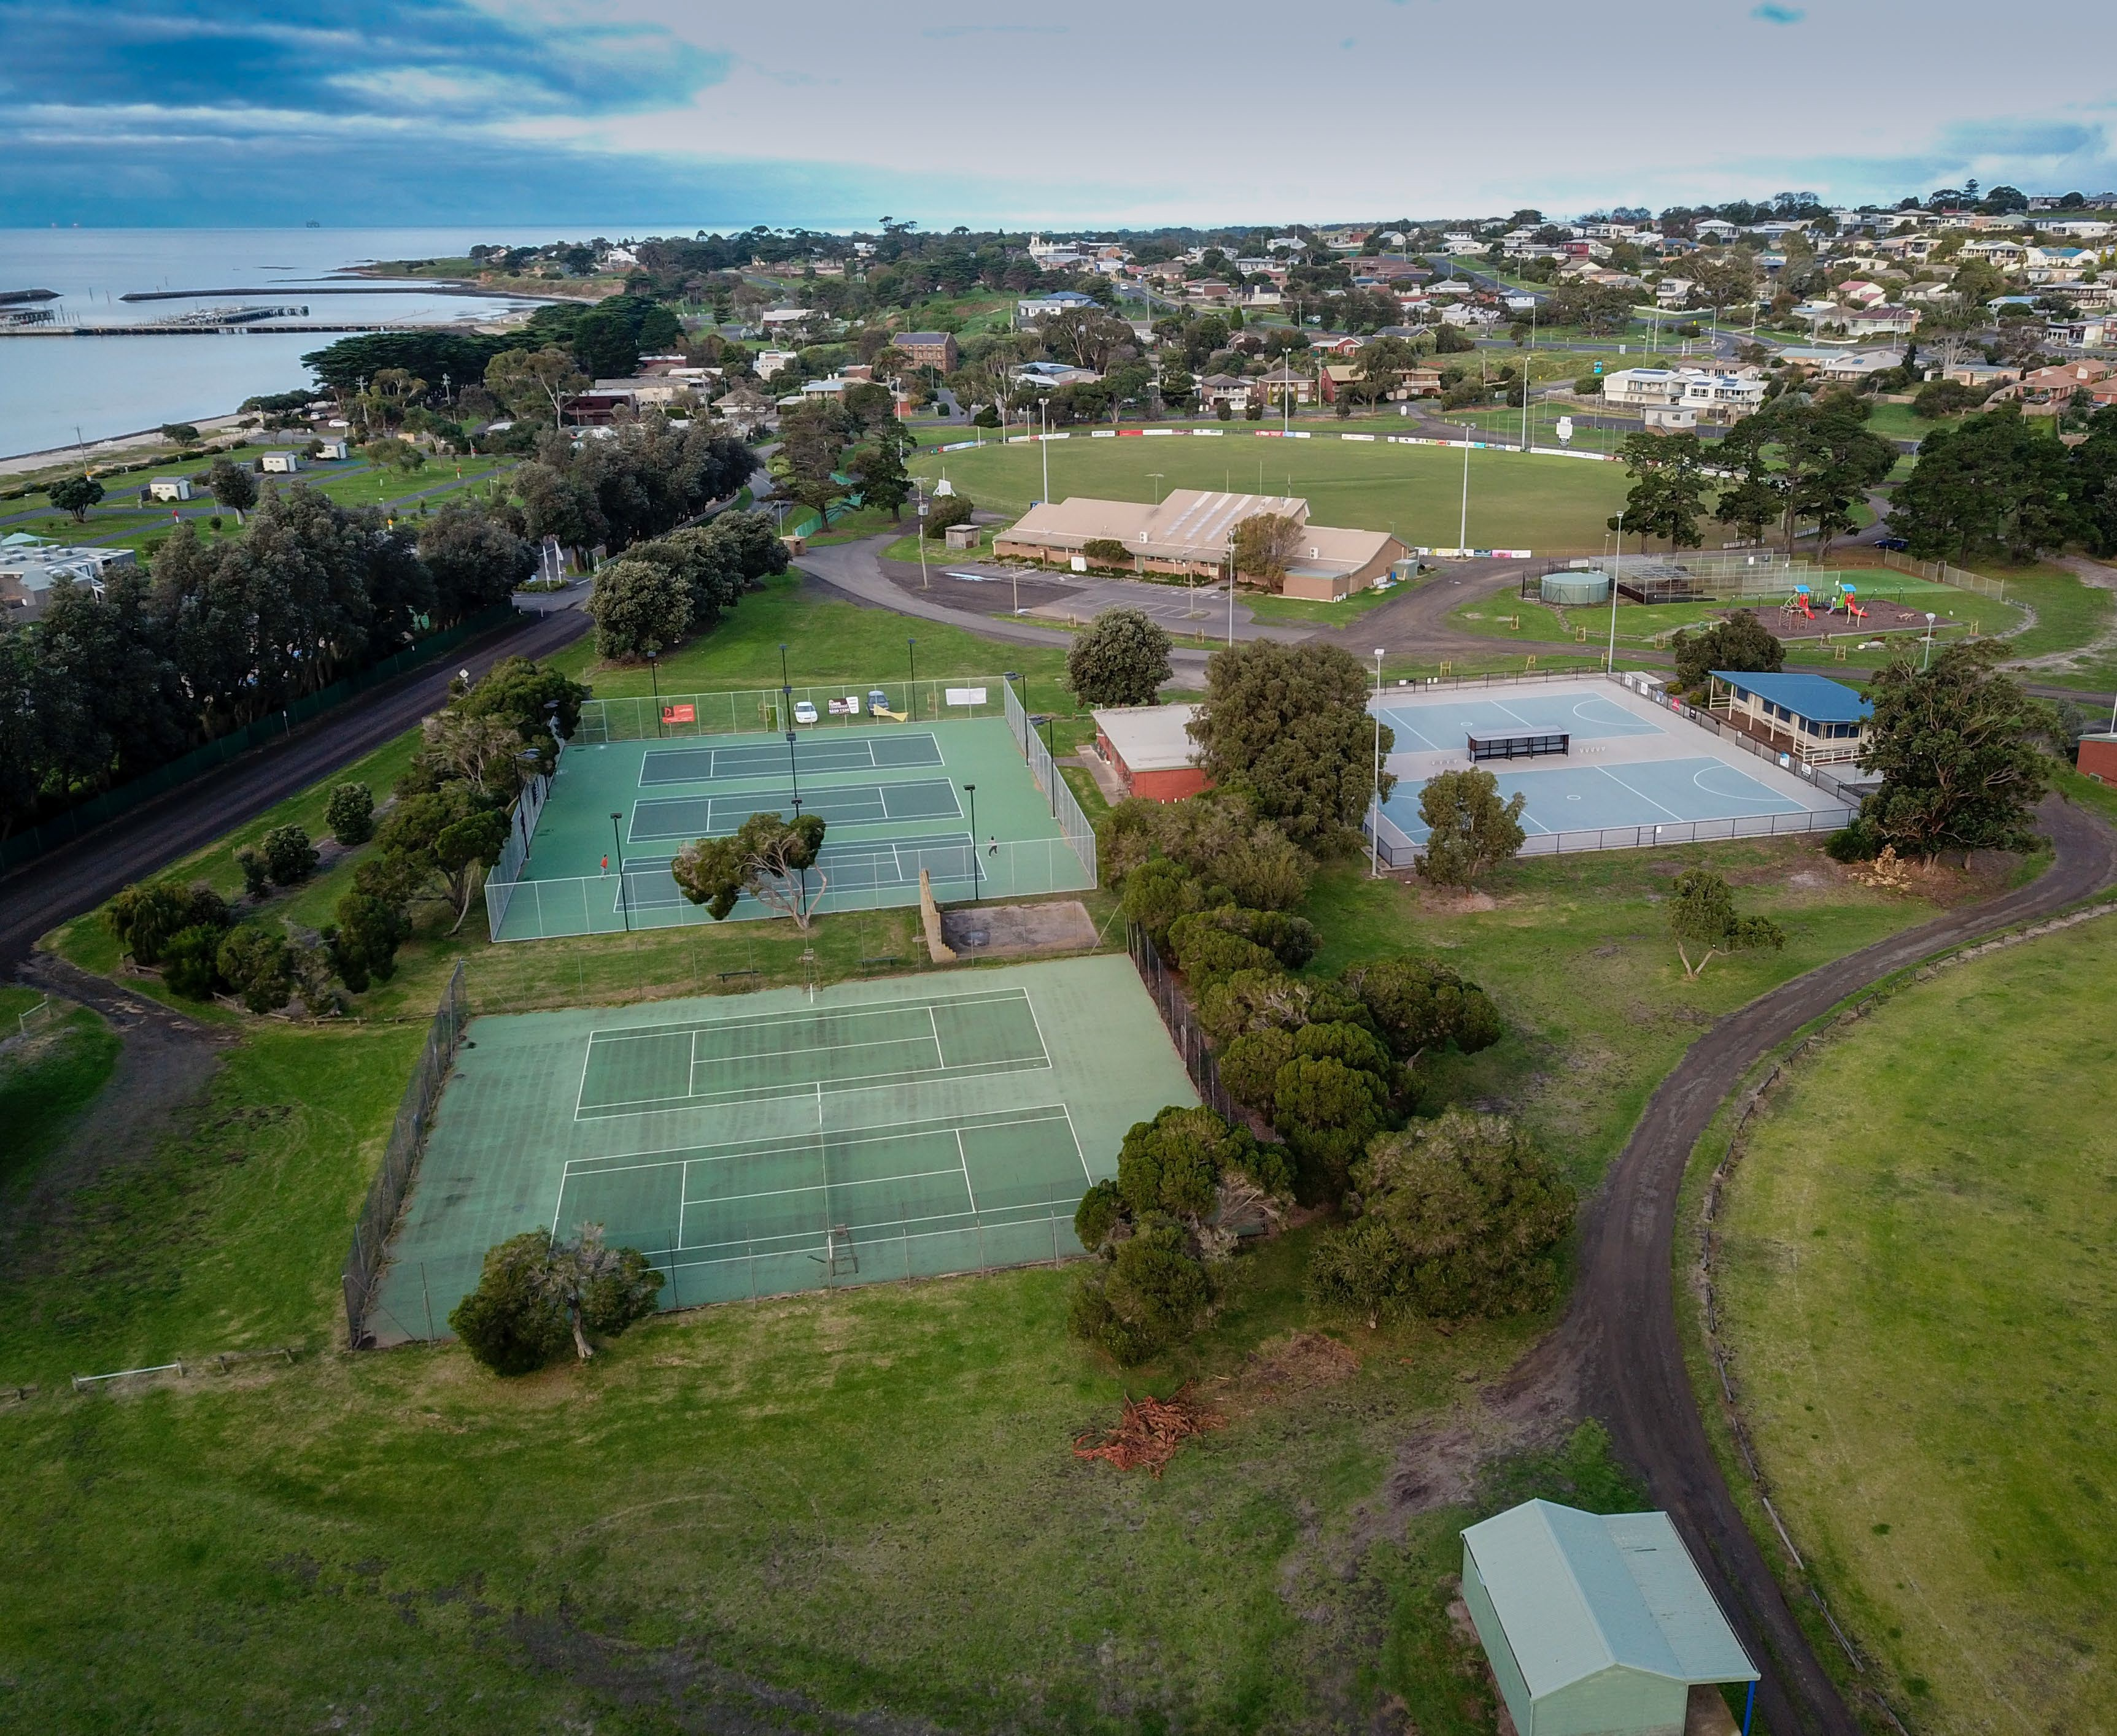

Image 1: Portarlington Recreation Reserve – image of active recreation area including tennis courts and netball courts

INTRODUCTION

PROJECT OVERVIEW
The City of Greater Geelong, with funding from the Victorian Government, has commissioned the development of a Master Plan for Portarlington Recreation Reserve. The Master Plan aims to assist in guiding the community’s vision for the site and to provide clear strategic direction for future investment and development.
With growing demand for improved sporting and community infrastructure, better pedestrian and vehicle accessibility and enhanced open space and passive recreation areas, a coordinated approach to development is required.
This report provides the supporting context to the Master Plan and a summary of the issues and opportunities that have been addressed as part of the process. Through the analysis of supporting information and consultation undertaken to date, the Master Plan will enable greater function, activation, and participation at the Reserve.

STUDY AREA
The project study area for the Portarlington Recreation Reserve is identified in ‘Map 1’ on the adjacent page. The study area includes the ovals, netball and tennis courts, playground and the open space area to the south which is commonly used for events. The area to the west of the active precinct is known, for the purposes of this report, as the ‘passive recreation area’ and is also included within the Master Plan’s scope. This area is primarily used for the creation and retention of habitat and for more passive recreation pursuits including walking, jogging, nature appreciation and for overflow event parking.
It should be noted that the original scope for the Master Plan’s development did not include the passive recreation area. A change in scope throughout the masterplanning process has seen the inclusion of this precinct.

PROJECT OBJECTIVES
Through broad consultation with user groups, the community, Council and other stakeholders, the objectives of the project are to:
    - Provide a strategic vision and future direction for the Reserve which responds to community need;
    - Understand the role Portarlington Recreation Reserve plays in the local community and its diverse range of uses including for active, passive and nature-based activities;
    - Highlight the most appropriate approach to the activation and programming of the Reserve so that capacity and utilisation is maximised;
    - Understand improvement opportunities that enhance user experience, sentiment, and sense of place;
    - Optimise sports facility and open space usage and increase multi-use of recreational facilities;
    - Plan for the protection and enhancement of the passive recreation area of the Reserve;
    - Identify infrastructure development opportunities for the Portarlington Recreation Reserve for the next 10 years;
    - Provide a preliminary concept plan showing potential layouts and various options to address identified priorities;
    - Identify the broad costs and staging opportunities associated with the implementation of proposed Master Plan recommendations; and
    - Identify areas where a soft transition in use, from active sport to informal recreation, can be achieved.

RECENT INFRASTRUCTURE PROJECTS
At the time of writing this report, investment has been confirmed for the delivery of the following infrastructure projects at Portarlington Recreation Reserve:
    - Upgrade to sports lighting on Oval 1 (underway)
    - Oval 2 shelter (underway)
    - Upgrade to sporting lighting on netball courts (completed)
Funding for these projects has been received through various funding streams including the Australian Government, Victorian Government, and the City of Greater Geelong.

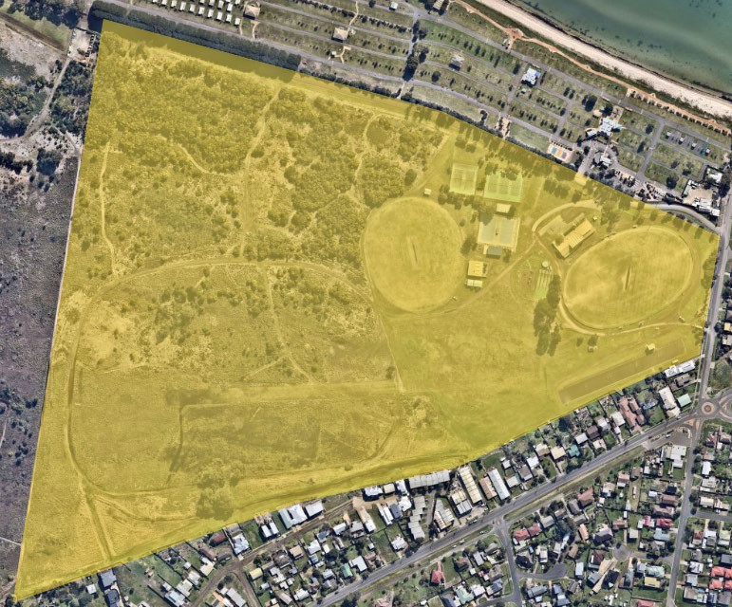

Map 1: Portarlington Recreation Reserve – image of study area

PROJECT METHODOLOGY
STAGE | TASKS | DATES
1 | Project Establishment | Completed
- Project commencement
- Project inception meeting
- Site inspections
2 | Needs Analysis and Stakeholder Engagement | Completed
- User group (Project Working Group, Project Reference Group) consultation
- Demographic review
- Literature review
- Site inventory and existing conditions assessment
- Community engagement
3 | Issues and Opportunities Report | Completed
- Consultation summary and findings
- Issues and Opportunities Report
- Project Working Group, Project Reference Group and Project Control Group meetings
4 | Draft Master Plan | Completed
- Draft Master Plan options identified
- Preliminary cost estimates and investment opportunities outlined
- Draft Master Plan for review and approval by PCG
- Draft Master Plan for review by PRG and PWG
5 | Public Exhibition Period | July- September 2021
 | - Draft Master Plan considered by Council and released to Public Exhibition. | July- September 2021
6 | Final Master Plan and Recommendations | This document
- Review of Public Exhibition feedback
- Development of Final Master Plan and Cost Estimates
- Review of final Master Plan and approval by PCG
- Review of final Master Plan by PRG and PWG
- Council Endorsement of final Master Plan

MASTER PLAN DEVELOPMENT PRINCIPLES
The following principles and goals have underpinned and guided the Master Plan’s development. These principles were shaped following the strategic literature review, site inspections, demographic analysis and community consultation outlined throughout this report.

SUSTAINABILITY

Economic Sustainability
- Utilising resources efficiently and responsibly, including technological advancements, through the recommendations in the Master Plan to deliver long term economic growth without any negative impact.
- Facility investment that increases the capacity of not-for-profit organisations to drive revenue and fundraising initiatives and deliver infrastructure upgrades that can demonstrate financial responsibility to the rate payer and offer opportunities for collaborative investment.

Environmental Sustainability
- Enhancing and protecting the values of the Reserve and its environmental properties and to make contributions towards managing the impacts of climate change.

Cultural Sustainability
- A need to understand and protect areas of cultural heritage sensitivity, and to work with traditional owners, throughout the management and development of the Reserve.

Social Sustainability
- Through the provision of facilities that support community participation that enhances social cohesion and capacity.

ACCESSIBILITY
- Improving opportunities for all people of all backgrounds, genders, abilities, cultures, and beliefs to utilise the facility in a manner that avoids segregating people and makes the facility more appealing and intuitive to use.
- Improving the connectivity of the Reserve with adjacent land parcels to create a more vibrant sense of place.

MULTI-USE
  - Offer opportunities to maximise community participation through flexible facilities that are available for a wide range of uses.
  - Building the capacity of facility’s existing attributes including improved utilisation.

FIT FOR PURPOSE
  - Use activity and industry specific, universal design, strategic and informing documents to determine facility and infrastructure needs to address facility gaps and needs.
  - Continue to ensure Portarlington Recreation Reserve provides a balance of sporting activity, event, community and environmental uses and functions.

GOALS
  - See page 44

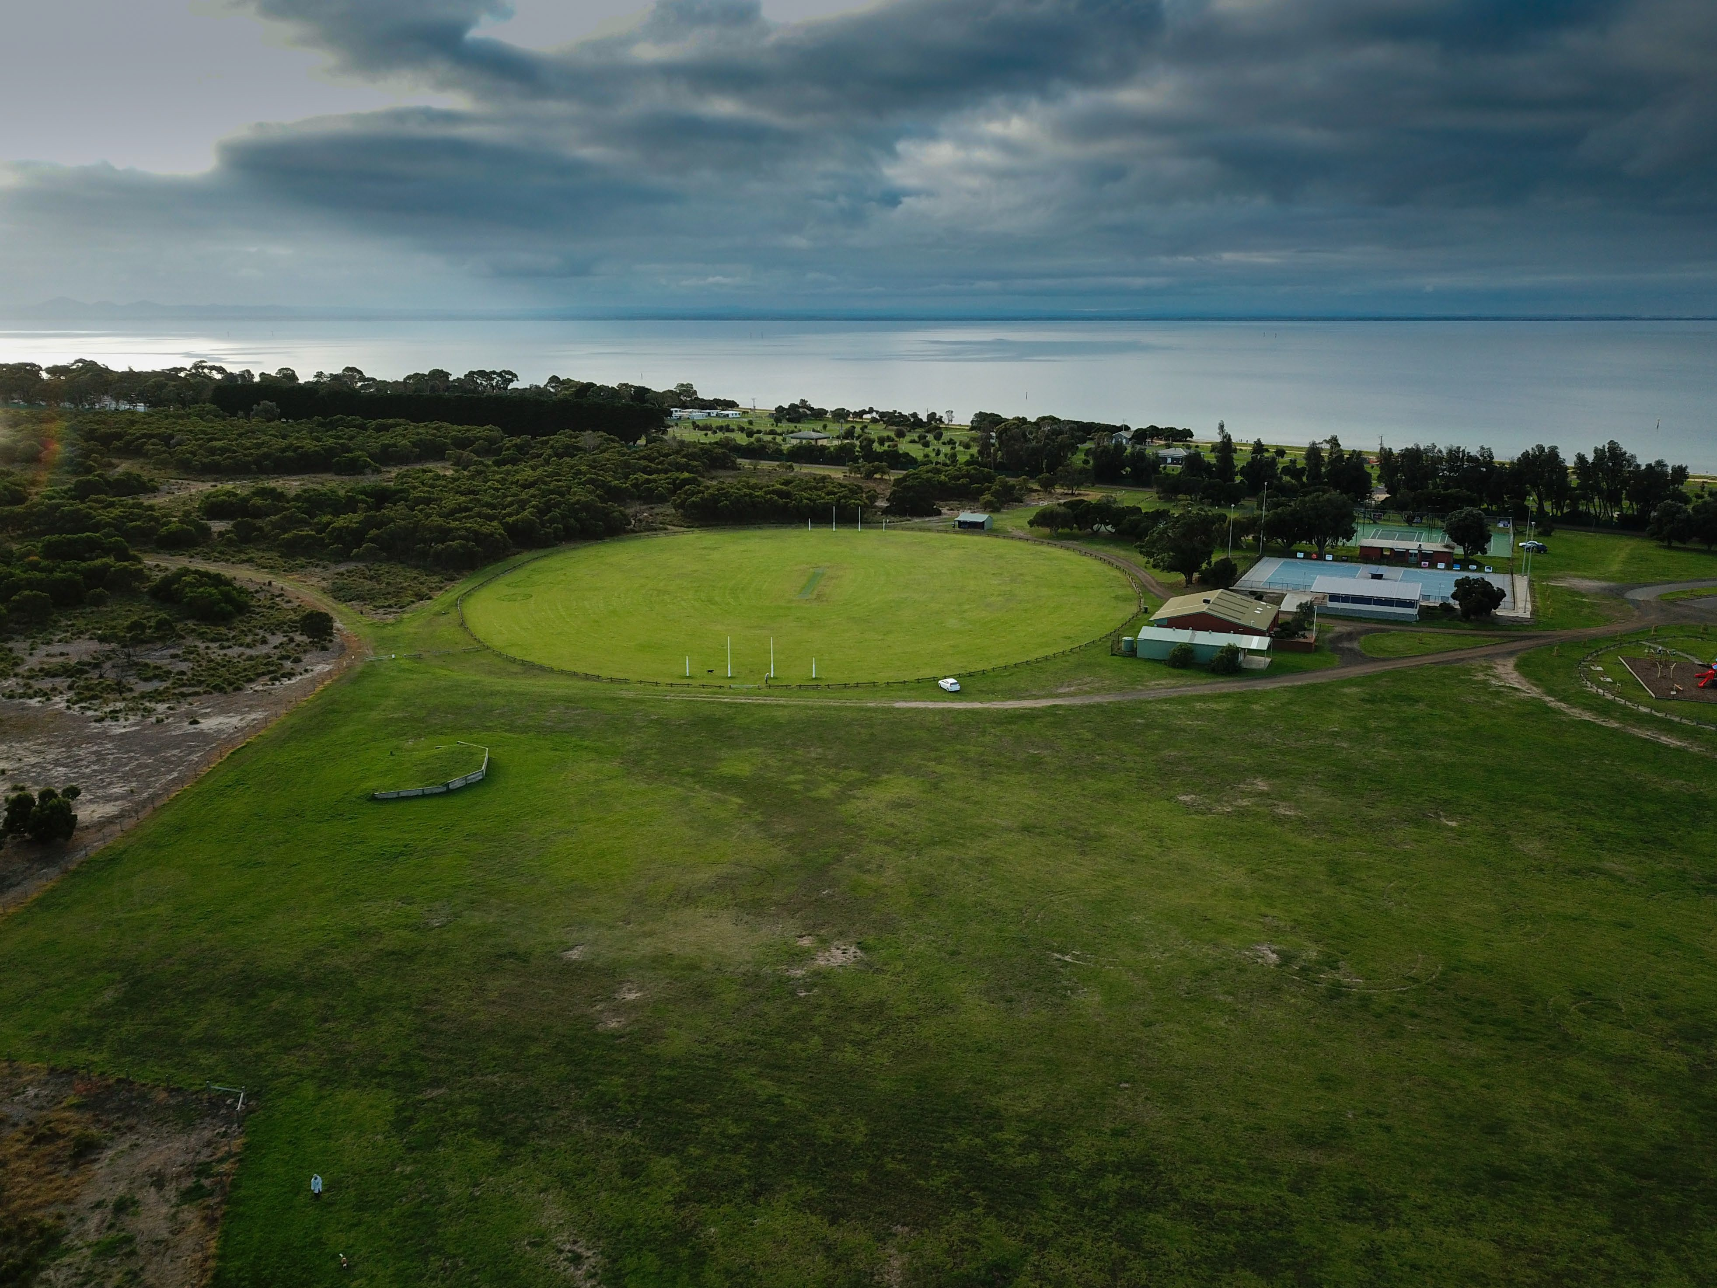

Image 2: Portarlington Recreation Reserve – active recreation area - view of Oval 2 and open space and events area

STRATEGIC CONTEXT

LITERATURE REVIEW
The following pages provide a high-level summary of the documents and key strategic influences which have guided the development of the Portarlington Recreation Reserve Master Plan. This summary was created close to the commencement of the project in early 2020 and therefore, some documents may have been superseded since this time.

STATEWIDE STRATEGIC CONTEXT

ACTIVE VICTORIA: A STRATEGIC FRAMEWORK FOR SPORT AND RECREATION IN VICTORIA 2017-2021

This document, developed by the Victorian Government, aims to provide a consolidated approach to the improvement in participation in sport and recreation from a state-wide perspective.
The vision for participation outcomes in sport within the document are based upon five key areas;
      - More active: increased proportion of Victorian’s regularly participating in sport or active recreation.
      - More diverse and inclusive: providing opportunities for all to become involved.
      - Robust, flexible, sustainable, and affordable: providing flexible and affordable choices for participants.
      - Collaborative: well-planned and connected investment that maximises participation and other community benefits.
      - Broad-based and connected: A system that addresses the different demands, contributors and structure of sport and active recreation and maximises connections across the system.
The Master Plan’s development has considered these focus areas throughout. The importance of delivering a Plan which drives multi-use and offers diverse and broad participation outcomes will be imperative to its success and implementation.

PROTECTING VICTORIA’S ENVIRONMENT – BIODIVERSITY 2037

This document provides a strategic approach to stop the decline of biodiversity and to see its improvement over the next 20 years.
The Biodiversity Plan outlines priorities which aim to see more Victorian’s valuing nature and for Victoria to have a healthy natural environment.
The Plan states that biodiversity in Victoria is experiencing a number of threats, with many plants and vertebrate animals considered as rare, threatened or near-threatened. It is outlined within the document that there is a continued decline in the quality and extent of habitat due to habitat loss, weeds, pest animals and changes in fire and water regimes – all of which will be exacerbated by the effects of climate change.
Biodiversity is considered fundamental to the health, wellbeing and prosperity of current and future generations, and it has an intrinsic value and right to exist.
The Key Priorities outlined in the Plan to protect and improve Victorian biodiversity, include:
      - Increase opportunities for all Victorian to have daily connections with nature.
      - Increase opportunities for all Victorians to act to protect biodiversity.
      - Embed consideration of natural capital into decision making across the whole of government.
      - Help to create more liveable and climate-adapted communities.
      - Better care for and showcase Victoria’s environmental assets as world-class natural and cultural tourism attractions.
      - Engage with Traditional Owners and Aboriginal Victorians to include Aboriginal values and traditional ecological knowledge in biodiversity planning and management.
The Master Plan’s development relies on the directions in the Biodiversity 2037 Plan to guide recommendations, particularly for those surrounding the passive recreation area.
Demonstrating the commitment to achieving a number of the noted key priorities will be important in the Master Plan’s future directions and implementation.

REGIONAL STRATEGIC CONTEXT

G21 PHYSICAL ACTIVITY STRATEGY 2014-2017

This document is a region-wide approach to improving opportunities for physical activity and participation in a range of passive and active sports.
The G21 Physical Activity Strategy provides an overview of the importance of physical activity and the way in which the G21 Region can help to create environments to support it. Key actions within the Strategy as they relate to the Master Plan include:
      - Work within local sport and active recreation settings to address barriers to participation for vulnerable groups within our community.
      - Encourage broader community access to tenanted sport and recreation facilities.
      - Ensure that all active sport and recreation settings such as recreation reserve, stadiums, tennis courts are planned, designed, managed, and maintained to be accessible and appropriate to the needs of all user groups.
The Master Plan has a strong focus on opportunities for broader community benefit and involvement through its implementation. This includes for all genders and abilities.

CITY OF GREATER GEELONG COUNCIL PLAN 2018-2022

This document provides the overall direction for Council, outlining their responsibilities and commitment to providing services, infrastructure, and opportunities to the community. The Council Plan supports the development of social infrastructure that provides opportunities for participation by a wide range of people, of all ages and abilities.
The City’s Council Plan outlines 11 strategic priorities towards making Greater Geelong a clever and creative city-region. The Plan aims to guide resources to deliver infrastructure, services, and programs to the community in a sustainable way.
Key focus areas which will be considered in the Master Plan’s development include: 1) Informed social infrastructure and planning – through providing more quality spaces that support active lifestyles as well as supporting the growth of localised sporting facilities 2) A more inclusive and diverse community through promoting gender equity and diversity in sporting facilities and improving access to facilities for people of all abilities.

CITY OF GREATER GEELONG SOCIAL INFRASTRUCUTRE PLAN (GENERATION ONE) 2020-2023

This document sets the strategic drivers for decision making and prioritisation in relation to the planning, development, and investment of social infrastructure in the City of Greater Geelong.
Five (5) directions for the strategic development of outdoor community sporting facilities are identified in the Plan, including the investment in infrastructure that improves the quality, functionality and carrying capacity of venues and the activation of facilities to increase participation and maximise use. The completion of the Portarlington Recreation Reserve Master Plan is listed as a priority under the ‘sport and recreation planning projects’ within the Outdoor Sport and Recreation Network Report.
The principles within the Social Infrastructure Plan have assisted in guiding and recommending the projects identified within the Master Plan. Ensuring projects align with the major objective identified in the Network Report being to ‘build capacity in the network’, including increased capability of facilities.

CITY OF GREATER GEELONG ENVIRONMENT STRATEGY 2020-2030

This document outlines a roadmap to improving the region’s environment and reducing its environmental footprint. The Strategy outlines several planning and decision-making initiatives to improve the health of the local environment over the next 10 years.
The Strategy acknowledges that to respond to population growth estimates for the City, that it must lead, educate, advocate and support for the improvement, retention, development, and restoration of the natural environment. Following extensive community consultation, five key goals were identified, including:
      - Become a zero-emission, climate ready city and region;
      - Create greener community spaces;
      - Contribute to a circular economy by reducing waste;
      - Protect, enhance, and restore our region’s biodiversity; and
      - Achieve better integrated water management through planning and design.
The Master Plan includes recommendations that align with improving the goals outlined within this Strategy. To ensure these objectives are met, the Master Plan has demonstrated commitment to contributing to a healthier natural environment for the present and future community.

CITY OF GREATER GEELONG URBAN FOREST STRATEGY 2015-2025

This document outlines the key actions and tasks associated with increasing the urban tree population throughout the City of Greater Geelong to improve the City’s look, feel and liveability as well as the health of the community.
The City of Greater Geelong’s Urban Forest Strategy has a vision for Geelong to be a ‘cool, green city for the future’. This vision aims to be achieved through the development of healthier and more dynamic urban forests and improved tree canopy in streetscapes, urban growth areas, open space areas and reserves.
The addition of tree planting, vegetation, and landscaping within Master Plan recommendations will improve the Reserve’s environmental properties will contribute to achieving this vision.

CITY OF GREATER GEELONG PLAY STRATEGY 2012-2021

This document provides a strategic approach to the need, role, and function of Geelong’s play spaces to ensure children receive equitable access to quality playgrounds and can also participate in a range of play experiences.
The Play Strategy outlines a range of principles regarding the provision and design of places of play, including:
Improving supporting infrastructure at play spaces. Creating better connections to cycling/walking networks.
Improving play opportunities throughout the municipality by focusing on delivering diversity in play for all ages and abilities. The Master Plan has considered the above in its recommendation for new or redeveloped play facilities within the Reserve.

LOCAL STRATEGIC CONTEXT

PORTARLINGTON RECREATION RESERVE MASTER PLAN 2011
The 2011 Portarlington Recreation Reserve Master Plan has guided the development and improvement of the Reserve over the last 10 years. The document aimed to enhance opportunities for community participation at the Reserve through sports, events, and informal recreation. The review of this document has been undertaken and consideration will be given to any outstanding, relevant actions that need to be considered in the updated Plan.
The 2011 Master Plan has been included within the strategic review, like all other informing and strategic documents, to further understand where the new Plan will need to address any outstanding items and/or where actions have been superseded. The new Master Plan refers to the new context and environment that it relates to, and to respond to newer and emerging trends that may not have been apparent or required within the previous Plan.

BELLARINE BAYSIDE COASTAL MANAGEMENT - DRAFT NORTHERN BELLARINE COASTAL AND MARINE MANAGEMENT PLAN
The Draft Plan aims to reflect the objectives and long-term aspirations for the sustainable management of the northern Bellarine foreshore. Specific to the Master Plan’s development, the following is noted within:
      - Contribute to CoGG’s Portarlington Recreation Reserve Master Plan to improve connections to Portarlington Holiday Park.
      - Work with CoGG to promote use of Portarlington Recreation Reserve for events during the peak holiday period.
The Master Plan’s development includes representation from the Bellarine Bayside Coastal Management Committee on the Project Reference Group to provide input and to assist in achieving collaborative aspirations.

PORTARLINGTON RECREATION RESERVE DRAFT WORKS PLAN 2016
This document lead by the City of Greater Geelong’s Environment Department, highlights improvements to be undertaken within the western section of Portarlington Recreation Reserve, otherwise referred to as the ‘passive recreation area’. These recommendations aim to expand the environmental properties and habitat within this area and make a clear distinction between the active and passive spaces.
Recommendations within the Draft Works Plan have been utilised alongside an ecological assessment, to inform the Master Plan which includes actions for the passive recreation area.

BELLARINE PENINSULA DISTINCTIVE AREAS AND LANDSCAPES
The Department of Environment, Land, Water and Planning is currently developing a draft Statement of Planning Policy for the Bellarine Peninsula. This Policy aims to acknowledge and protect the Peninsula which is currently noted by DEWLP as ‘under significant urban development pressure as well as threat from climate change risks. In addition, the Policy will include a 50 year vision and land use strategies to better protect the unique features of the Bellarine Peninsula, and designate long- term protected settlement boundaries to provide greater certainty for current and future generations. The Draft Policy is expected to be released for public consultation in late 2020.
The progress of the Distinctive Areas and Landscapes Policy for the Bellarine Peninsula has been monitored throughout the development of the Master Plan. Where recommendations and the final documentation is released, alignments to the Plan will be made.

PORTARLINGTON STRUCTURE PLAN 2017
The Portarlington Structure Plan aims to identify and address several purposes to determine the application of local planning policies, planning zones and overlays, and to assist the City of Greater Geelong when considering applications for planning permits. The key purposes of the Structure Plan, include:
      - Identify the strategic planning issues facing the township, including community aspiration and needs:
      - Articulate the preferred future planning directions for the township, and
      - Identify appropriate planning controls which will protect and enhance the distinctive elements of the township, biodiversity, and landscape features.
The Structure Plan, based on the above principles and underpinning information, created the following vision for Portarlington - ‘Portarlington will be the jewel of the Bellarine Peninsula. Our focus is a commitment to nurturing a vibrant, sustainable community, enhancing, and maintaining our lifestyle, heritage, and artistic pursuits’.
The Master Plan aligns with the recommendations within the Structure Plan to ensure Portarlington maintains a balance coastal-rural lifestyles, community, environment, and economic opportunity.

SPORT SPECIFIC STRATEGIES

The City of Greater Geelong and the G21 Geelong Region Alliance have several strategic documents that have been developed in conjunction with peak sporting bodies and are relevant to the Portarlington Master Plan. In addition, state-wide strategic sporting documents also provide support and justification.
These include:
      - AFL Victoria ‘Growing the Heartland’ Football Facilities Development Strategy (2014-2020);
      - Victoria Cricket Infrastructure Strategy (2018-2028);
      - Netball Victoria Statewide Infrastructure Strategy (2019- 2022);
      - Tennis Australia: Tennis 2020 Facility Development and Management Framework for Australian Tennis;
      - G21 & AFL Barwon Regional Strategy (2015);
      - G21 & Cricket Victoria Barwon Regional Strategy (2019); and
      - G21 Regional Tennis Strategy (2015-2025).
These documents have been summarised and utilised to help create and shape the recommendations within the Master Plan.

AFL VICTORIA ‘GROWING THE HEARTLAND’ FOOTBALL FACILITIES DEVELOPMENT STRATEGY 2014-2020
The ‘Growing the Heartland’ Strategy aims to provide a planned approach to the provision of infrastructure across the State.
One of the key development pillars of the Strategy is ‘Great Infrastructure’ which includes the objective to ‘advocate for and collaborate in facility development for the network of community football leagues, their clubs and schools’.
The Strategy notes that Geelong is its highest participation region for Country Victoria which, at the time of the Strategy’s development, boasted an additional 5,000+ players than the next highest region.
The development of the Portarlington Recreation Reserve Master Plan fits the AFL’s planning facility hierarchy identified in the Strategy, seeing venue improvement plans and master plans as a key component to infrastructure development.

VICTORIAN CRICKET INFRASTRUCTURE STRATEGY 2018- 2028
This Strategy provides the Victorian cricketing community and its stakeholders with a detailed assessment and analysis of the Victorian cricket facility landscape and identifies future planning and development priorities. The Strategy highlights critical actions for cricket participation and growth. Those most relevant to the development of the Portarlington Recreation Reserve Master Plan, includes:
      - Prioritise and support the upgrade and development of facilities at sites with identified and potential female participation growth.
The Geelong/Barwon region, similarly to AFL, had the highest participation of any Country Region and the Geelong LGA had one of the highest saturations of cricket players to population ratios.
The Strategy highlights a low provision of inclusive, all gender facilities along with 59% of cricket practice nets in the Barwon Region presenting potential safety concerns.
The aspirations to improve facilities including the delivery of all gender change facilities and safer, multi-use cricket practice facilities at Portarlington Recreation Reserve align with the directions within this Strategy.

NETBALL VICTORIA STATEWIDE FACILITIES STRATEGY 2019-2022
The Plan outlines how Netball Victoria aims to deliver on their key strategic drivers for the future direction, demand, and investment into netball facilities.
The Strategy indicates that two courts be provided for local outdoor club-based netball competition as well as supporting infrastructure including:
Floodlighting;
Accessible change rooms and amenities; and Player and officials shelters.
The G21 Region is recorded as having the highest number of participants of any Rural & Regional area in Netball.

TENNIS AUSTRALIA - TENNIS 2020: FACILITY DEVELOPMENT AND MANAGEMENT FRAMEWORK FOR AUSTRALIAN TENNIS
Key priorities identified within the Framework are:
      - Better planning;
      - More and better national infrastructure; and
      - Better management practices. This aims to result in:
      - Healthier communities;
      - More active players;
      - More great champions; and
      - More devoted fans.
The Framework identifies that community expectations of tennis facilities is changing and that certain standards must be met to attract and retain new participants. It notes that there is opportunity in offering multi-use facilities which promote broader community outcomes. The key role that facilities with greater than four courts, such as Portarlington Recreation Reserve, play is to host interclub tournaments and grass roots development and to help improve the sustainability of tennis and community health improvements.

G21 & AFL BARWON REGIONAL STRATEGY 2015
This document provides the principles and framework to support the future development, governance and growth of football and club-based netball throughout the Region. It also investigates issues facing the sport and makes recommendations for both regional and local priorities.
One of the priorities within the document is to ’Increase the quality and functionality of facilities to maximise carrying capacity’ and that investment into facilities to meet minimum requirements will ensure participation growth can be accommodated for.
Currently, a 2020 update to the Strategy is underway, which will focus on what is changed since 2015, most notably being the significant increase in female participation and the introduction of the AFL Preferred Facility Guidelines and Netball Victoria Facilities Manual.
The 2020 Strategy will continue to focus on infrastructure and enhanced participation opportunities and will utilise the Sports Facility Auditor data as one method to prioritise improvements. It is likely that the clubroom facilities at Portarlington Recreation Reserve will be identified as a priority.

G21 & CRICKET VICTORIA BARWON REGIONAL CRICKET STRATEGY 2019
This Strategy investigates issues and opportunities facing cricket both ‘on-field’ (facilities and infrastructure) as well as ‘off- field’ (sport development, increasing participation and partnerships). The key strategic priority within the Strategy is ‘Improved Governance and Cricket Activity Management’ through developing an aligned and collaborative structure to manage cricket. Subsequent priorities include participation growth and facility provision, capacity, and renewal.
In terms of facility development for the Region, the Strategy recommends utilising facility audit data to identify gaps in provision and site-specific renewal programs. Projects that increase carrying capacity, functionality and activation of existing facilities including change room refurbishment should be prioritised.
This priority further supports and underpins the opportunity to improve cricket facilities at Portarlington Recreation Reserve including practice nets and change rooms. With Portarlington Cricket Club’s steady growth in female participation, the improvement to these facilities will prove integral to the sustainability and prosperity for women in sport.

G21 REGIONAL TENNIS STRATEGY 2015-2025
The Strategy provides key directions to support the growth of tennis through the implementation of key priorities including infrastructure. The Strategy has a vision to see the G21 Region being the fastest growing and most accessible region for tennis. Key priorities including developing an aligned approach and structure to tennis as well as participation and facility provision and renewal are identified.
A key infrastructure focus within this Strategy is the provision of floodlighting to improve capacity. The Portarlington Tennis Club recently received investment to install improved floodlighting which supports flexible programming and greater participation opportunities. The upgrade to the supporting tennis amenities will further support their operations and offer modern infrastructure for players.

DEMOGRAPHIC REVIEW
The City of Greater Geelong has an average growth rate from 2020-2030 of 2.1%, which is higher than that of metropolitan Melbourne.
The City of Greater Geelong has an estimated population of 263,280 in 2020*. This is expected to grow to 324,289 in 2030 and 386,890 in 2040, primarily because of several growth areas to the south and north-west of the municipality.
Whilst the City of Greater Geelong boasts several residential growth areas, the township of Portarlington, as identified in the 2017 Portarlington Structure Plan, is set outside of this boundary. The Structure Plan recognises the uniqueness of Portarlington and sees its role over the next 10 years as a popular holiday destination, but with an acknowledgement that elderly persons will continue to comprise a very high proportion of the permanent population.
Portarlington itself has a total population of 4,046 in 2020 and is anticipated to reach 5,133 in 2030**. The average population growth rate of Portarlington is approximately 2%.
Portarlington and neighbouring towns including St Leonards and Indented Head have the smallest population base, with a total of 7,877 residents occupying the three towns with an expected population of 10,062 in 2030.
Portarlington experiences significant population growth in the summer months. It is estimated that an additional 6,000 – 8,000 people visit the seaside towns of Portarlington, St Leonards, and Indented Head from December to February each year.

LOCAL DEMOGRAPHIC INFLUENCES ON RECREATION
      - The majority of population growth expected between 2020 and 2030 in Portarlington is within the 60-74 year old age cohort. In 2030, this age group will make up approximately 32% of the total Portarlington population.
      - The largely older age demographic will present more demand for targeted activities that generally attract older people. This includes activities such as cycling, nature appreciation, tennis, and walking. Aging is inevitable, and the ability for active sports such as AFL, netball, and cricket to adapt to a point where they can continue to offer suitable and/or appealing programs for older adults is unlikely. It is therefore important that the Portarlington Recreation Reserve Master Plan considers participation opportunities and facilities that can service younger people, but flexible enough to cater for the diversity of its demographic profile.
      - In terms of the younger age demographic, it is forecasted that population growth of 4.2% in the 5-9 year old age cohort will be experienced. This is a change of approximately 24 persons from 2020 to 2030. The 5-9 year old age group is considered a key introductory market for organised sporting programs. The limited growth in this age cohort will likely decrease demand for junior programs. Attracting participants from neighbouring towns where appropriate may be necessary to support greater participation into the future.
      - There will be an average growth of 4%, or an additional 60 persons, from 2020-2030 in the 15-19 year old age cohort. This group is one where retention of active participants or players is important, as generally there is a decline or drop off in organised sport between these ages. A focus on modified formats, social and flexible participation opportunities will assist in the ongoing engagement of this demographic.
      - The 5-39 year old age cohort is considered the key market for organised sport, and particularly with the rise in female participation, the attraction and retention of females is imperative to both community health and the sustainability of the game. There will be an additional 115 females within this age group residing in Portarlington and opportunities to engage them in sport and recreation via welcoming and inclusive facilities will be crucial.
      - The seasonal population of Portarlington, particularly during summer months, offers opportunity to engage visitors in informal, social sport and recreation. Whilst these participants are unlikely to be retained post-holiday, it does offer more opportunities to improve health and activity outcomes as well as generate financial outcomes for Clubs.

“Portarlington will see an additional 24 people aged between 5-9 and 60 people aged between 15-19 living within the township between 2020 and 2030”

“An additional 115 females aged 5-39 will reside in Portarlington by 2030. This age cohort is considered the key market for organised sport”
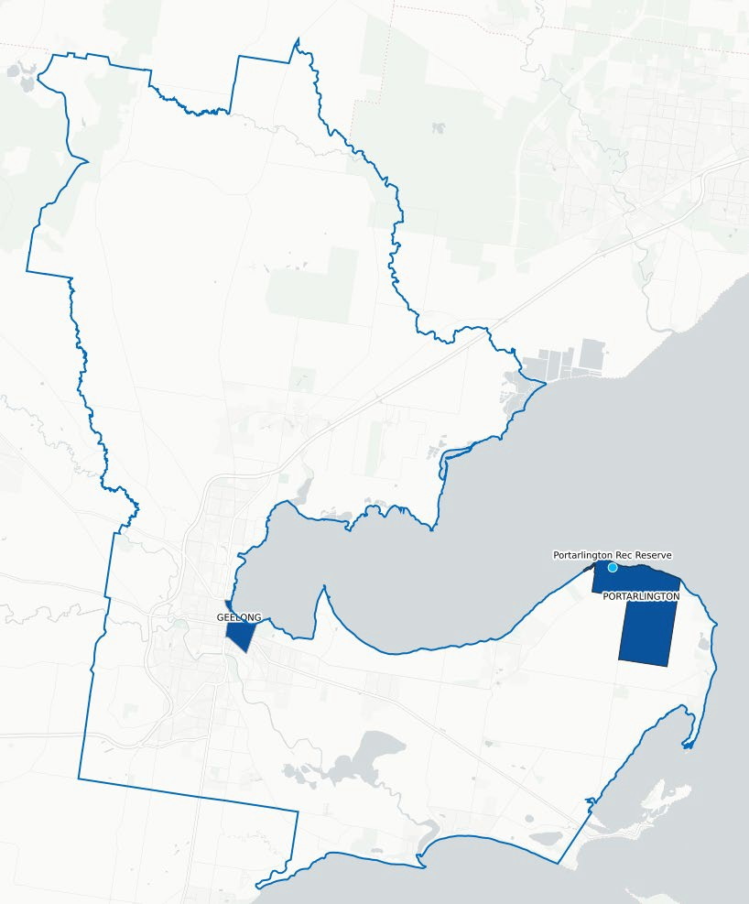

Map 2: The City of Greater Geelong indicating the location of the Geelong CBD and Portarlington Recreation Reserve

Source:
*City of Greater Geelong population projections
**Forecast.id

DESIGN TRENDS
Current design trends have influenced the development of the Master Plan as they inform modern, accessible, and efficient facilities that achieve the objectives of the community and the City, as well as potential future investment partners. These trends and associated strategic design documents include:

UNIVERSAL DESIGN
Universal Design involves a holistic approach to the design of an environment so that it is accessible, intuitive, and understood by all people regardless of age, ability, gender, or culture.
      - Sport & Recreation Victoria’s Design for Everyone Guide The Guide aims to instil the principles of Universal Design to make the built environment more simplified and inclusive of as many users as possible. Equitable design, for people of all genders, all abilities and of all cultures should be at the forefront of any design process and have been incorporated throughout the development of the Master Plan.

ENVIRONMENTALLY SUSTAINABLE DESIGN (ESD)
Environmentally Sustainable Design (ESD) aims to improve the health and comfort of the built environment for user groups and occupants whilst concurrently reducing negative impacts on the environment. ESD helps future proof communities against rising utility costs and reduces the impact of climate change.
      - Sport & Recreation Victoria’s Environmentally Sustainable Design Fact Sheet – This Fact Sheet outlines some key design opportunities that can be considered during design development to reduce operational and environmental impacts while increasing building resilience. These include, but are not limited to:
        - Renewal energy generation
        - Utilising environmentally friendly products
        - Water efficient and water saving
        - Reducing construction waste
        - Optimising site potential and reduced operating costs through north facing elements
        - Natural light and cross flow ventilation
        - Optimising operational and maintenance costs
        - Finding sustainable trades people and professionals

GENDER NEUTRAL FACILITIES
The inclusion of facilities that are inclusive of all people and gender is imperative to any modern development. For sporting facilities, the rise in female participation has created increased demand for amenities that cater to the diversity of people attracted to sport. Guiding documentation for the development of gender-neutral facilities in the active sport setting, include:
      - SRV Female Friendly Infrastructure Guide - The Guide aims to provide information on developing facilities which offer more gender equitable environments. This occurs through three main components, including facility planning and design, maximising use and policy that drives change.
      - Sporting Facility Guidelines - Most peak sporting bodies have guidelines relating to facility development that include information in relation to the provision of gender-neutral amenities.
      - AFL Preferred Facility Guidelines 2019 - These Guidelines outline the preferred facility requirements for venues which are utilised for AFL training and competition. The Guidelines are to be used as a key tool during the planning phase of a project to identify the spatial requirements for facilities to support male and female teams, umpires, officials, and the broader AFL community. The Guidelines also provide recommendations for the specification of supporting infrastructure such as floodlights.
      - Tennis Australia Infrastructure Planning 2018 - This resource is designed to educate, inform, and guide tennis facility planning and development for existing venues and new builds.
      - Netball Victoria Facilities Manual 2017 - Netball Victoria’s Facilities Manual contains technical information on netball courts and associated infrastructure. It is Netball Victoria’s expectation that all new and redeveloped facilities are constructed to meet the standards outlined within the Manual.
      - Cricket Australia Community Cricket Facility Guidelines 2015 - The Cricket Australia Community Cricket Facility Guidelines provides facility planning, development, management, and maintenance information for use by the community, government and national cricket industry partners and stakeholders.

MULTI USE
Providing flexible spaces that offer multi-use opportunities for the community will see better social outcomes and returns on investment. Encouraging broader use of facilities by the community, outside of traditional uses such as sport, will be an important consideration in the Master Plan’s development.
      - City of Greater Geelong’s Social Infrastructure Plan – This document, as referenced in the Strategic Context section of this Report, provides a framework as to how the City will prioritise and invest in social infrastructure. A key component guiding this decision making is the principle of ‘multi use’. The Plan outlines that a focus on moving standalone facilities to more flexible and multipurpose community hubs should be considered, and that community infrastructure should be developed where shared use and integration of other services and users can be adapted.

OPEN SPACE DESIGN
The design of the Portarlington Recreation Reserve Master Plan aims to create opportunities for unstructured recreation in a manner that is safe and integrates the balance of the Reserve’s activities.
      - Urban Design Guidelines for Victoria (Local Parks) – These Guidelines developed by the Victorian Government offer principles for a range of settings in the public realm. For the purposes of this Report however, those relating to the development of local parks, include:
        - Ensuring convenient and safe access to and through local parks.
        - To encourage use of local parks at different times of the day by a wide range of users.
        - To ensure amenity and safety for local park users.
        - To emphasise a sense of place and character in local parks.
        - To ensure local parks are well maintained.

NATURE DESIGN
Nature design is the concept of incorporating native plant communities into the designed landscape. The success of vibrant, public open spaces which offer diversity and respond to their contextual setting can be attributed to the principles of nature design. Nature design includes improving aesthetics as well as creating an ecological relationship to the indigenous landscape. Creating spaces that improve a connection to nature through better mental and physical wellbeing along with better habitat that supports native species and reduce greenhouse gas emissions. During the COVID-19 pandemic, the criticality of providing spaces that contribute to a healthier community and environment have never been more apparent.
Incorporating nature design within a strategic planning document such as a Master Plan, according to ecolandscpaing.org, can include:
      - Fostering a visual connection and contrast between the landscape and its surroundings;
      - Minimising the disturbance of existing native vegetation;
      - Allocating areas for varying landscape types including woodlands and open spaces;
      - Incorporating native plant communities found in similar conditions in the surrounding areas;
      - Using and planning for natural processes of change to modify the landscape;
      - Preserving rainwater on site including the use of ponds, irrigation catchments, and wetlands.

CRIME PREVENTION THROUGH ENVIRONMENTAL DESIGN
Crime Prevention Through Environmental Design poses the idea that by using knowledge and creativity in the approach to the built environment, crime can be lessened or prevented.
These ideas stem from the concept that where more people are around a public space, then incidents of crime are less likely to occur. The following guideline outlines this in further detail:
      - Victorian Government Safer Design Guidelines – These Guidelines were developed to help planners and designers apply principles that will improve the safety of the built environment, minimise the opportunity for crime and promote safe, accessible, and liveable places. The public spaces principles within the design guide framework include:
        - Ensuring all users have convenient and safe access to and through public spaces
        - Achieving and creating vibrant public spaces
        - Establishing and supporting activity at the edges of public spaces
        - Ensuring safety and amenity in public spaces
        - Ensuring comfortable and enjoyable public spaces
        - Supporting a strong sense of place and local character
        - Ensuring public spaces are well utilised and maintained

SITE OVERVIEW

SITE LOCATION AND CONTEXT
Land Tenure: Portarlington Recreation Reserve is a 38-hectare Crown Land allotment with the City of Greater Geelong as the responsible land manager. As designated public land, it is provided to the community for a range of uses including recreation, cultural, conservation and government services.
Zoning: Portarlington Recreation Reserve is zoned Public Park and Recreation Zone (PPRZ) under the Geelong Planning Scheme which encourages enhancement and use of the land in support of appropriate recreation activities.
Cultural Significance: The traditional custodians of Portarlington Recreation Reserve are the Wadawurrung People, with the Wathaurong Aboriginal Corporation as the Registered Aboriginal Party (RAP) for the land.

A property report for the Reserve generated through the Victorian Government’s Department of Environment, Land, Water and Planning (DELWP) website identified that the Reserve as an area of cultural sensitivity.
Under the Aboriginal Heritage Regulations (2018), the development of a Cultural Heritage Management Plan (CHMP) may be required for the delivery of infrastructure developments should they be designated as high-risk activities.
Regional Setting: Portarlington Recreation Reserve is located 31km from Geelong’s CBD on the popular Bellarine Peninsula.
Local Setting: The Reserve is adjacent to Point Richards Flora & Fauna Reserve which is Public Conservation Reserve and Marine and Coastal Act zoned land. The Point Richards Flora & Fauna Reserve contains significant vegetation, environmental and coastal properties. The western area of Portarlington Recreation Reserve, which borders Point Richards, supports important habitat for a range of coastal bird species and hosts important biodiversity properties (source: Portarlington Recreation Reserve – Environmental Draft Works Plan 2016).
The Portarlington Holiday Park to the north of the Reserve is touted as the largest holiday park in Australia with many of its occupants utilising the recreation reserve for activities and meals during their stay. Further north of the Holiday Park is the Portarlington Foreshore, with its natural coastal environment attracting recreational fishing, boating and beachgoers, particularly during summer.

Study Area: The project study area for the Portarlington Recreation Reserve consists of two parts - the active sporting area including playing fields and open space to the east, and the passive recreation area to the west of the Reserve.
Bordering land, including the Point Richards Flora & Fauna Reserve and Portarlington Holiday Park, will be considered in terms of their interface with the study area.

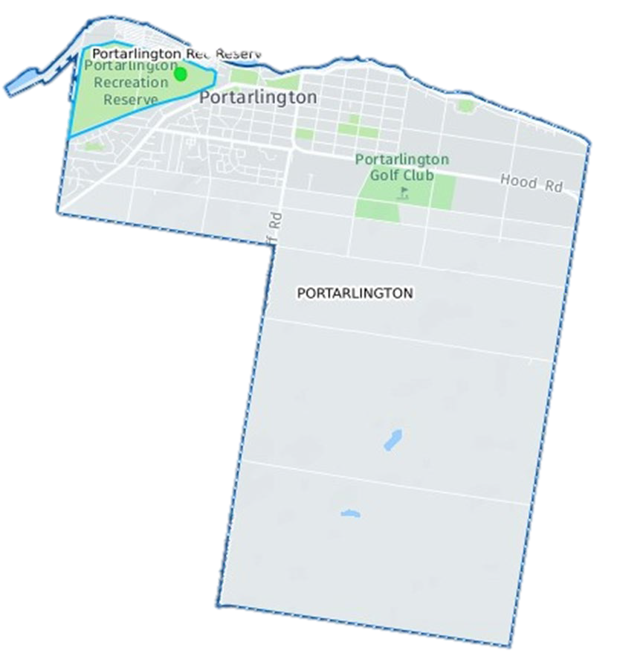
Map 3: Map of the Portarlington township boundary

EXISTING CONDITIONS
The existing conditions summary provides an overview of observations obtained through on-site inspections by the project team. These inspections were conducted in February 2020 and their findings have assisted in shaping the Master Plan’s recommendations.

ACTIVE RECREATION AREA

FOOTBALL/CRICKET PAVILION
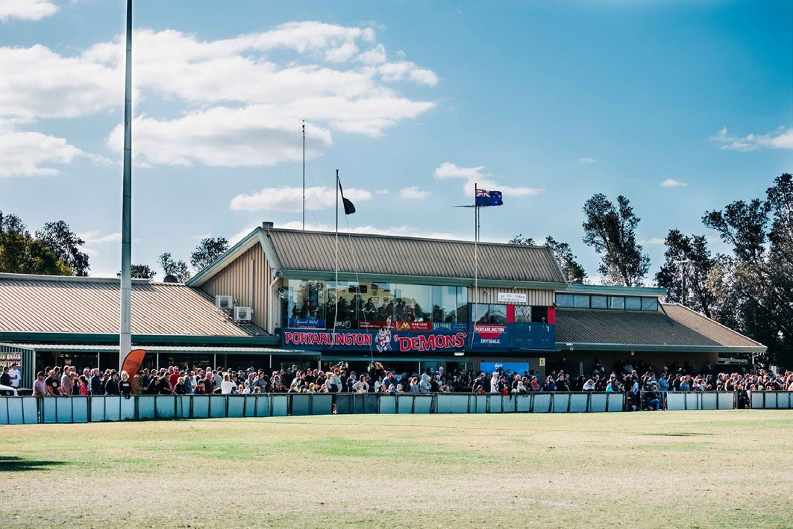
Asset age: Circa 1970
Building description: The building is generally single level and consists of a slab on ground, double external walls, and a gable truss framed roof with metal/Colourbond roof cladding.
Building condition: Building appears to be in good condition structurally however the finishes and fixtures are dated.
Building Owner: City of Greater Geelong
Building Maintainer: City of Greater Geelong and Clubs
Tenancy Arrangement: Seasonal Licence
Building Code compliance: The internal public amenities would not cater for maximum function room use/occupancy based on the current Code calculations. In addition, there is no accessible WC compartment or ambulant WC facilities.
Provision of these facilities would be a high priority for any refurbishment project.
DDA compliance: DDA access is not compliant in terms of door opening sizes and circulation space.
Sporting code compliance: The home and away change rooms are large in size, however the finishes are poor/dated. The amenities associated are not suitable for all genders. The umpire facilities are very undersized and internally accessed, which is not ideal from a functional perspective.
Opportunity: Overall the building is relatively large for a local pavilion and in good structural condition. The building could be retained and refurbished (internally and externally) and possibly extended to address several functional requirements.
Extensions or enhancement to the second storey of the pavilion must be fully funded by club or other external sources.

TENNIS PAVILION
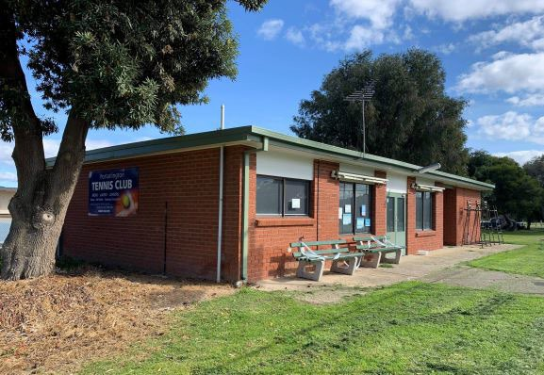
Asset age: Circa 1980
Building description: Slab on ground, single level, metal/Colourbond roof cladding.
Building condition: Building is in good structural condition. Finishes and fixtures are generally in good condition but are dated.
Building Owner: City of Greater Geelong
Building Maintainer: City of Greater Geelong and Club
Tenancy Arrangement: Seasonal Licence
Building code compliance: The accessible WC does not meet current standards (i.e. 2009 Australian Standard/NCC requirements).
DDA compliance: Some limitations existing with the building, pathways and access to the facility require improvement to ensure DDA compliance.
Sporting code compliance: There are no dedicated player change rooms which are recommended within the Tennis Vic planning guidelines.
Opportunity: The upgrade to the amenities block can provide compliant toilets and change facilities for both players and umpires. May also provide additional ancillary facilities such as improved storage and a first aid area.

NETBALL PAVILION
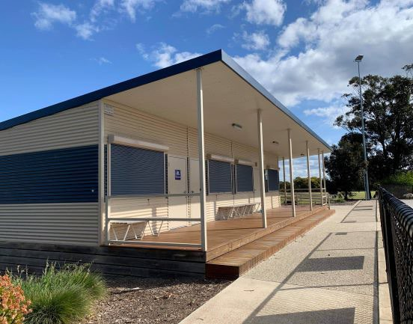
Asset age: Circa 2012
Building description: The facility was recently constructed and is in good condition internally and externally. The construction type is modular and consists of 8 square light weight modules in total.
Building condition: Excellent condition
Building Owner: City of Greater Geelong
Building Maintainer: City of Greater Geelong and Club
Tenancy Arrangement: Seasonal Licence
Building code compliance: The building appears to meet DDA compliance.
DDA compliance: DDA access provisions appear to meet current Code requirements and the accessible WC meets the 2009 Australian Standards.
Sporting code compliance: The player and umpire change rooms are split into 3 equal sized (13m2 each) compartments, with roller shutter access between each space. This is a functional design in terms of maximising space/usage, however the change rooms are undersized and should ideally be 20m2 each. It should be noted that the design/construction pre-dates the release of the 2017 Netball Victoria Facility Manual.
The umpire's room does not include any dedicated amenities (2 WC’s would be preferable) and are presumably shared with the player amenities.
The player amenities contain one WC and shower in each compartment – ideally two WC’s should be provided to meet both Code and Netball Victoria Facility requirements
There is currently no medical / first aid room within the facility, which is recommended under the Netball Facility standards at 10m2.
Opportunity: The building whilst in excellent condition, is slightly smaller than the recommendations of current sporting code guidelines. There is opportunity for a small footprint extension to ensure compliance, particularly with player and umpire change rooms and medical room.

GUIDE HALL
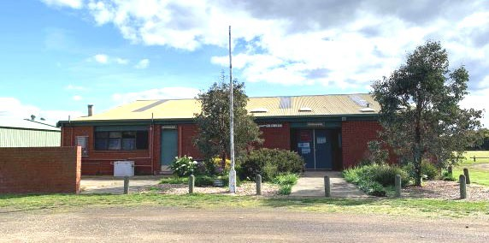
Asset age: Circa 1980
Building condition: Based on external observations, the building is in good condition structurally. The finishes are dated externally, and some maintenance repair is required, particularly to the eaves, gutters and downpipes.

Building Owner: Club
Building Maintainer: Club
Tenancy Arrangement: Ground Lease
Building Code compliance: Unsure – internal access was not available during the inspection.
DDA compliance: Unsure – internal access was not available during the inspection
Sporting code compliance: The facility is not currently used for sporting purposes hence no player change rooms or amenities are provided. Based on the existing conditions plan and external building site measurements, the hall and kitchen appear to be large / functional in size.
Opportunity: A refurbishment to this facility could provide improve functionality and usage opportunities.

AGRICULTURAL SOCIETY SHED
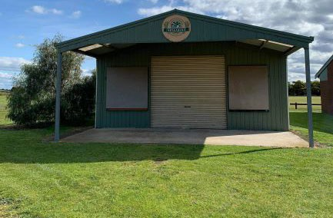
Asset age: Unknown
Building condition: Based on external observations, the shed is in good structural condition and appears to be fit for purpose.

Building Owner: Club
Building Maintainer: Club
Tenancy Arrangement: Ground Lease
Building Code compliance: Unsure – internal access was not available during the inspection.
DDA compliance: Unsure – internal access was not available during the inspection
Sporting code compliance: Not applicable.
Opportunity: Retain shed in existing condition to continue to service the needs of the Agricultural Society and for community events. Consider expansion of existing footprint of facility.

PATHWAYS AND CONNECTIONS
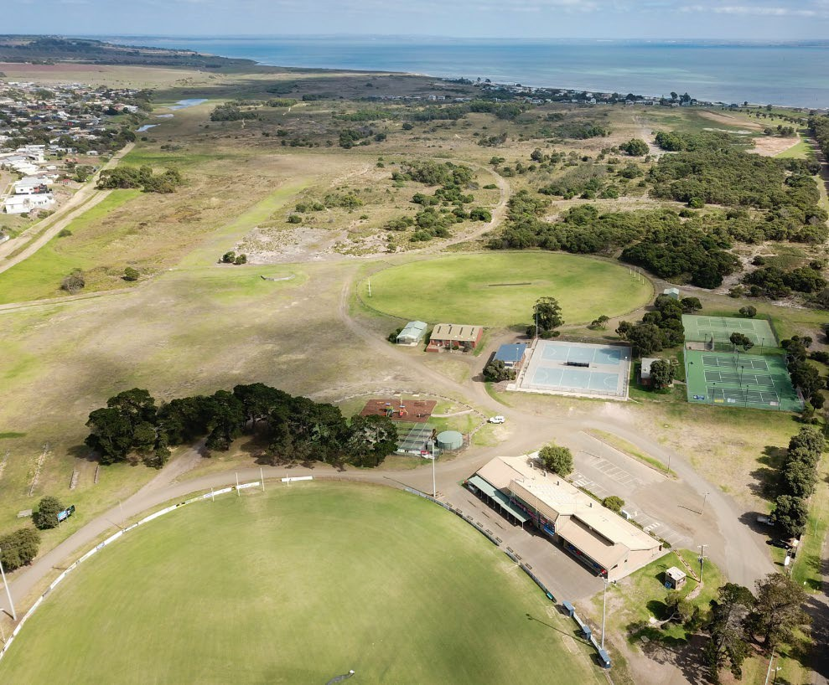

Description: There are no current defined pathways linking key features of facilities in the sporting precinct of the reserve.
Issues: Pedestrian pathways for general circulation, fitness and connectivity between recreational facilities and buildings are non-existent. Pedestrians share the use the gravel access roads. As a result, access for people in wheelchairs and reliant on mobility aids is difficult. Conflicts between vehicles and pedestrians are possible.
Connectivity to the caravan park and adjoining residential areas east of Sproat Street is ill defined.
The asphalt hardstand between the Main Sports Pavilion and Oval is in reasonable condition and provides ample spectator opportunities and good access from the main pavilion to the sports oval.
Opportunity: Address and improve pedestrian pathways and connections as part of the Master Plan to improve equity, accessibility, and safety.
Define connections to delineate clear access and egress to the Holiday Park and recreation and passive recreation area.

CAR PARKING AND VEHICULAR CIRCULATION
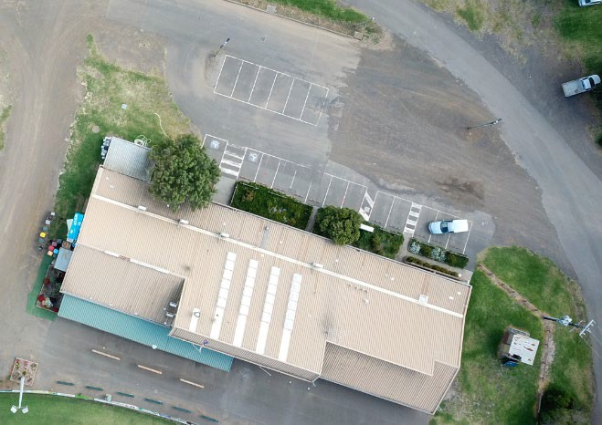
Description: There is limited hard stand parking at the Reserve. Informal car parking is unrestricted and disorganised throughout the reserve
Issues: The asphalt car park on the north side of the pavilion is broken up with gravel hardstands and could be made more efficient if it were sealed and line marked.
Vehicular movement and parking is generally unrestricted. Parking can occur anywhere in the reserve except for spectator areas around the pavilions and playground which are either fenced or safe guarded using timber bollards and post and rail fencing.
The nature of the car parking and vehicular movement throughout the site presents safety concerns due to a lack of safe access routes and pathways for pedestrians, along with the disorganised nature of the carparking throughout the site.
It is acknowledged that, particularly during peak use times including football, that some informal parking will continue to occur.
Opportunity: Address, organise and formalise vehicular circulation and parking to improve traffic flow, parking congestion and safety.

ENTRANCES
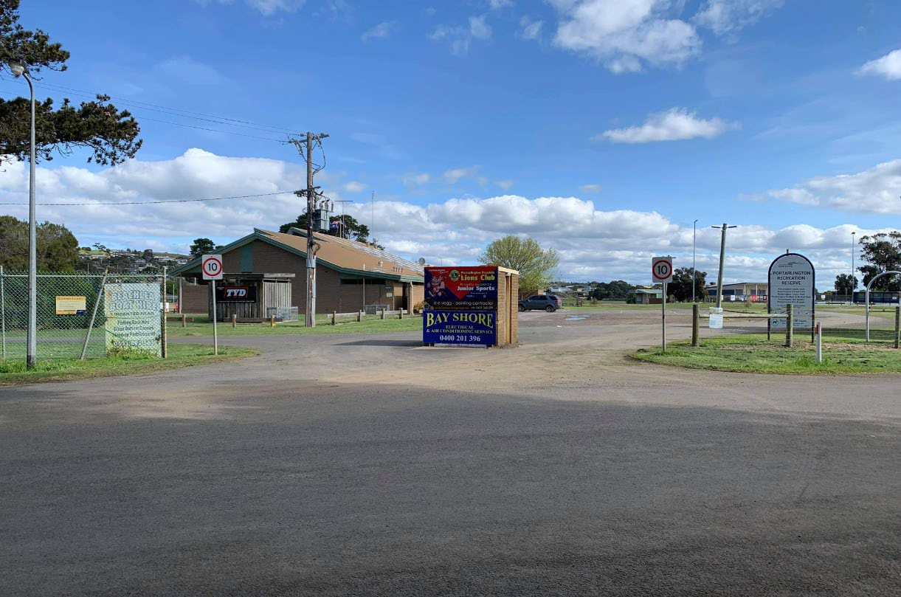
Description: Entrances for vehicles exist on Sproat Street (x1) and Boat Road (x2). These are poorly defined and visually lack appeal.
A ticket booth is located at the main entrance along Boat Road to control ticketed access during football match days.
The footpath on the west side of Sproat Street provides opportunity for additional dedicated pedestrian entry points from nearby surrounding areas into the reserve. This could connect to a broader pathway network if it were established.
Issues: Pedestrians would precariously (in busy times) share the same entrances into the reserve as vehicles, those arriving on foot are met with a confusing entry way to the reserve.
Opportunity: Improved entrances and wayfinding signage will improve safety and pedestrian experience. Separating vehicle and pedestrian entrances where appropriate should be explored. Improving and maintaining access for emergency vehicles will continue to be a priority.

RESERVE FRONTAGES
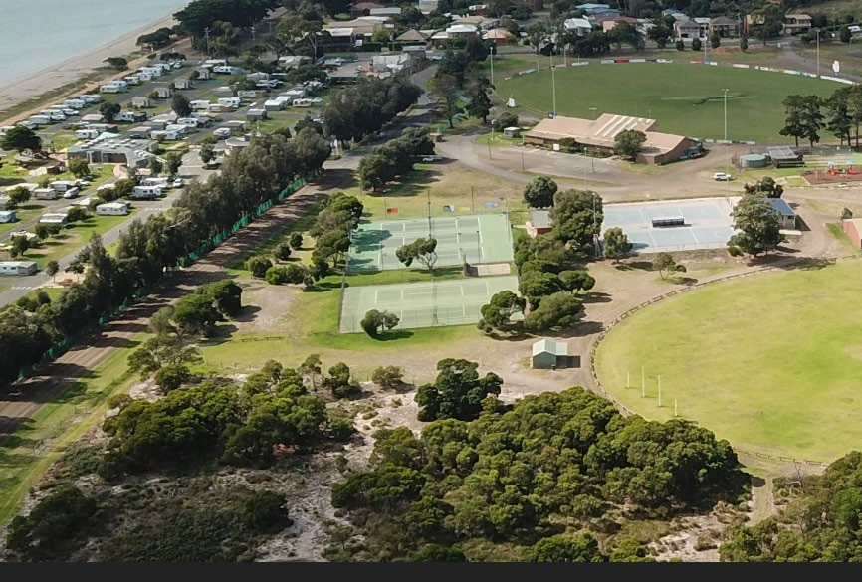
Description: The Reserve frontages consist of those along Boat Road and Sproat Street. There is a mix of fencing types and several advertising signs are scattered within entrances and along the Reserve boundary.
Issues: The residential interface along the site’s southern boundary is visually unappealing which may impact on visitor experience.
Opportunity: Addressing the interface of the Reserve along its residential and road boundaries with additional planting would improve the views to adjoining residential properties. Whilst the frontages to Boat Road and Sproat Street afford good views into the Reserve which should be maintained, the frontage could be softened to make it more visually appealing.

PARK LIGHTING
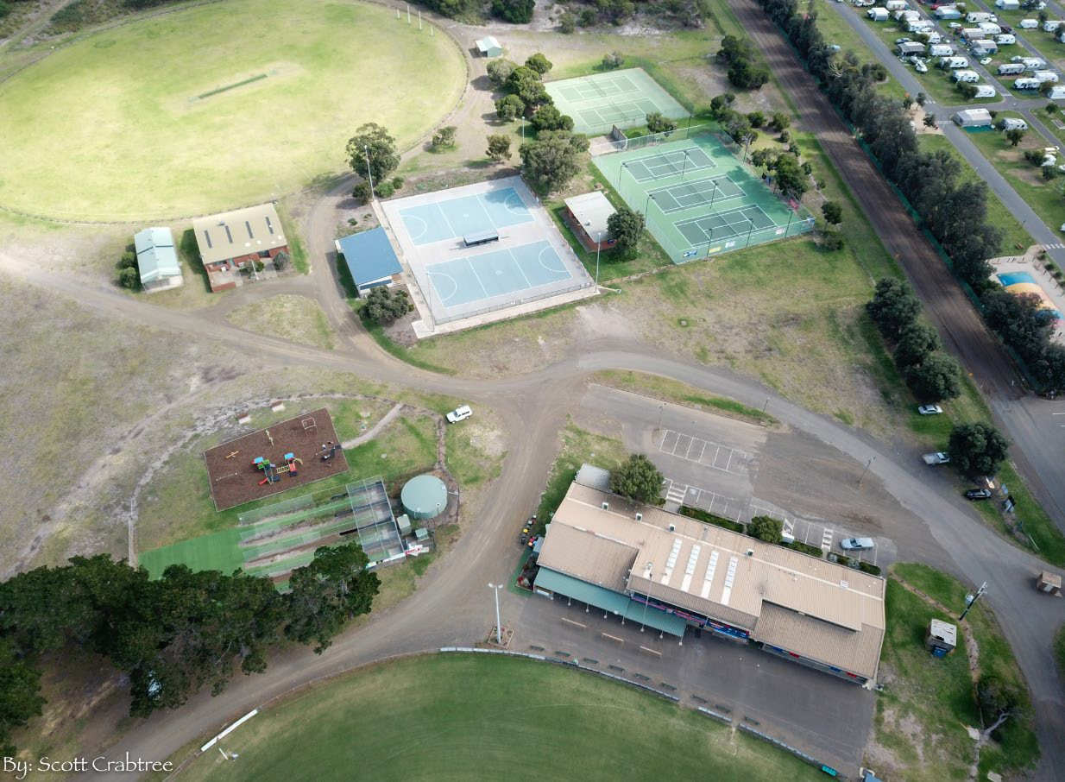
Description: Park lighting is limited to the car park north of the main pavilion. A solar light exists near the public toilets, however its effectiveness is unknown. Lighting to the car park is aged and most certainly non-compliant in achieving minimum levels of luminance at night.
Issues: Inadequate park lighting can present a safety concern, particularly during winter months when daylight is limited. It also can increase the risk of trips and falls, particularly for people with mobility concerns. With the current path network through the Reserve undefined, it is difficult to ascertain where additional park lighting would be best placed. In addition, there is a need to balance the amount of park lighting for visitor safety and amenity, without enabling light pollution.
Opportunity: The adequacy of lighting to the car park and other passive open spaces should be reviewed in accordance with Council policy and relevant Australian Standards. Lighting should be kept away from flora and fauna areas with lighting spill minimised.

CRICKET PRACTICE NETS
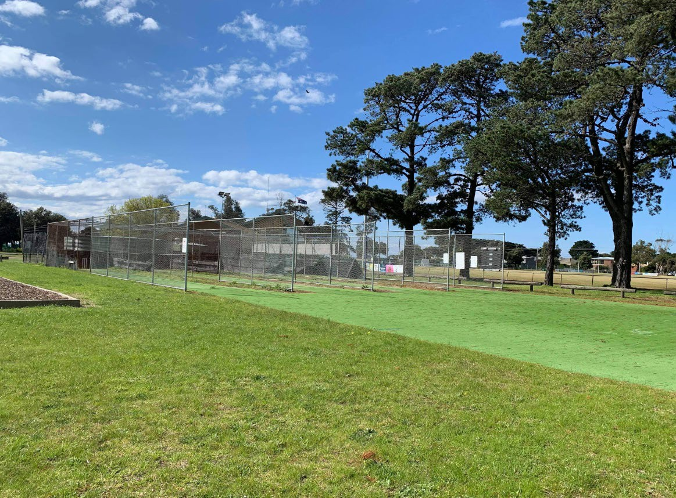
Description: The existing cricket practice nets are sited south of Oval 1 and comprise 4 synthetic grass lanes. The nets support training and provide opportunities for community participation also. The current fencing separating the lanes and the practice facility from the Reserve shows some signs of wear and does not encompass the entirety of the bowlers run up area.
Issues: There may be an element of potential risk to passers- by when the nets are in use. The location of the playground adjacent to the nets is questionable given there is the possibility of errant balls potentially causing injury.
Sporting code compliance: Cricket Victoria guidelines recommend the complete enclosure (i.e. chain link fencing around all four sides as well as the top) of cricket practice facilities where a ball may damage property or cause injury to pedestrians. A minimum of 3 synthetic training wickets are recommended.
Opportunity: Consider the redevelopment of the existing cricket practice nets into an outdoor multi-purpose training facility. Opportunities to include retractable, soft netting and line marking for sports such as half court netball and basketball.
This opportunity will provide for greater use of this facility, and address safety concerns, for usage both within and outside of cricket season.
A rainwater tank is located north of the cricket nets. It is visually obvious and could be partially screened\ with vegetation or relocated to reduce its visual impact and/or removed if redundant.

OVAL 1
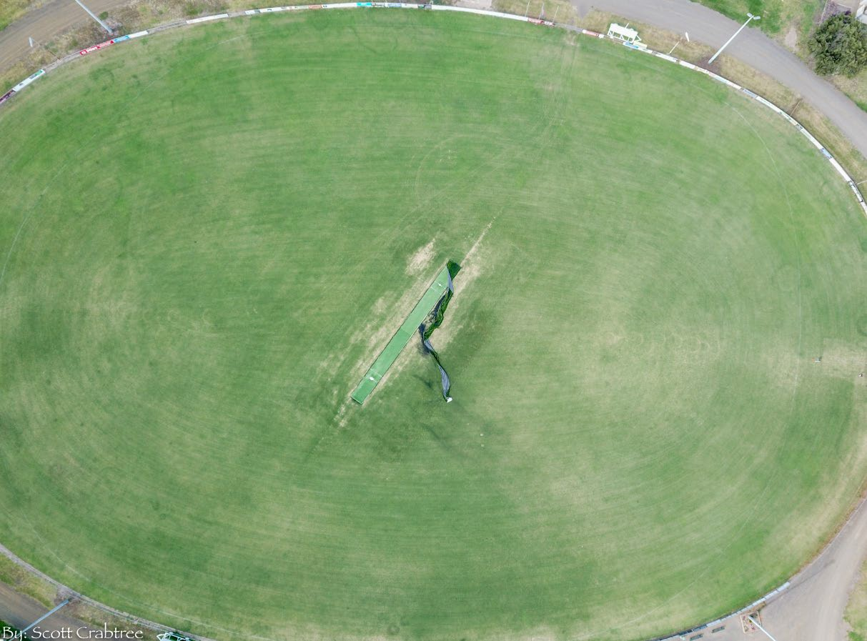
Description: Oval 1 measures approximately 170m x 115m and has a cool season turf profile with automatic irrigation system, perimeter pipe and rail fence, synthetic centre wicket and sports lights. There is a spectator area attached to the main pavilion.
Issues: No issues evident, the playing surface is in good condition with well-established grass cover.
Sporting code compliance: Oval 1 falls slightly short of the AFL’s preferred guideline of 165m x 135m boundary to boundary however this would not affect use. The sports lighting on Oval 1 has less than 50 lux which is lower than the recommended average of 50 lux (minimum) for football training (upgrade currently underway).
Opportunity: Although Oval 1 is slightly smaller than recommendations, this is a guide only. Any recommendation for expansion would be considered a low priority. The sports lighting identified as not meeting training standard recommendations is soon to be upgraded to 50 lux. This will therefore deem it adequate for AFL training activities.

OVAL 2
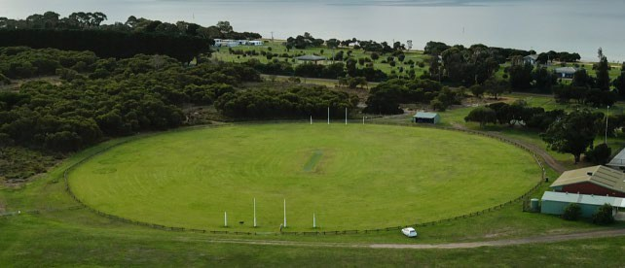
Description: Oval 2 measures approximately 135m x 115m and consists of a warm season turf profile, an automatic irrigation system, post and rail perimeter fence and synthetic centre wicket. There is also a small spectator/scorer’s shelter located in the northern pocket on the oval.
Issues: The perimeter fence shows some signs of age.
Sporting code compliance: Oval 2 is mostly used for junior football and lower grade cricket. Its measurements comply with the recommended guidelines for football as well as requirements for open age community cricket. The oval has good grass coverage and overall is in a very satisfactory condition. The oval does not have any sports lighting however this is not a requirement.
Opportunity: The development of the Master Plan should consider the inclusion of sports lighting (to training standard) on Oval 2. Providing sports lighting on Oval 2 could increase the capacity and programmability of the oval and broaden participation opportunities. A schedule of use demonstrating that Oval 1 is experiencing capacity, along with projected participation outcomes as a result of the installation of lights on Oval 2 should support this proposal. In addition, should future demand necessitate there is opportunity to extend Oval 2 in length to the south of its current footprint.

SPORTS LIGHTING: TENNIS AND NETBALL COURTS
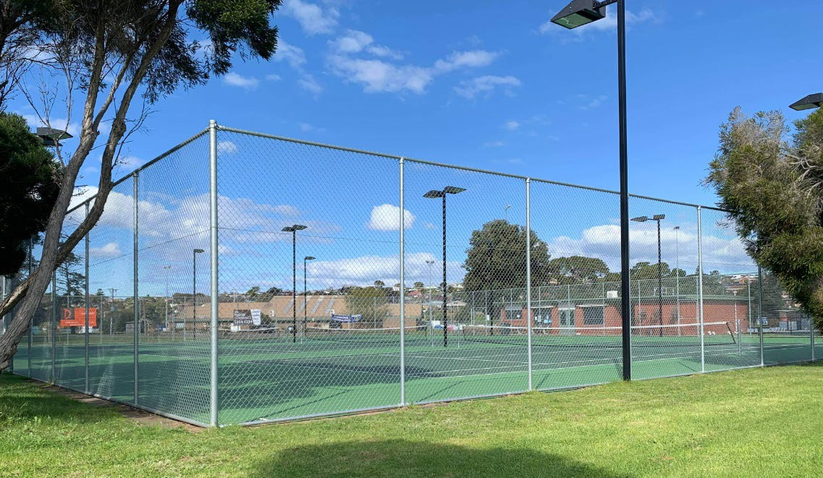
Description: Sports lighting is presently provided on 3 x tennis courts and the new netball courts. Some lighting is provided on old asphalt netball courts however this facility is not presently utilised.
Issues: The current provision of sports lighting is of a high standard on three tennis courts as well as the new netball courts, with both facilities having upgraded lighting recently installed. The lighting on the old asphalt netball courts does not likely meet minimum requirements.
Sporting code compliance: The current sports lighting on the 3 eastern tennis courts is commensurate with recommendations for training and competition. The two western courts are not lit.
Opportunity: Maintain existing sports lighting on new netball and three tennis courts.
Should a sixth tennis court be developed (see page 28 for further information) floodlighting should be provided to all western courts to further facilitate participation and use.

NETBALL COURTS (NEW)
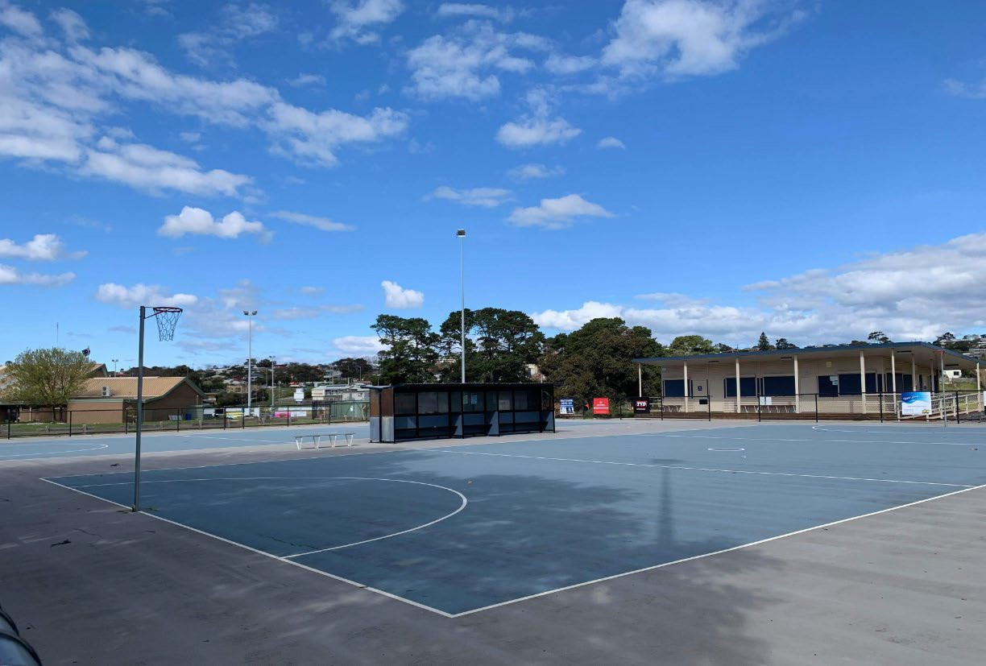
Description: There are two acrylic surface netball courts situated between the tennis club rooms and the main football/cricket pavilion. These courts are serviced by the netball pavilion and include bench areas for players, separate scorers’ shelter, covered spectator viewing area and perimeter fence. There is sports lighting on both courts which has recently been upgraded.
Issues: Both courts show some signs of wear and tear and the club notes that at times, capacity issues are being experienced due to high demand. Also there is presently no spectator seating within proximity to the courts.
Sporting code compliance: The two new netball courts comply with sporting code guidelines
Opportunity: Consider opportunity to additional spectator seating within close proximity to the netball courts.
Consideration should be given to ensure recommended distances for court-run offs are maintained. Consider surface upgrades.

NETBALL COURTS (OLD)
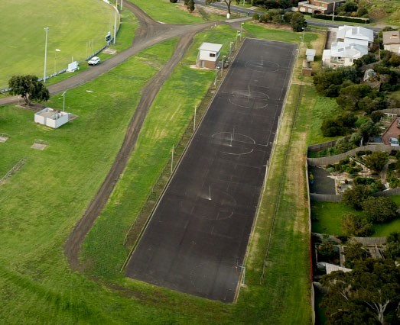
Description: There are four old netball courts located along the southern boundary of the Reserve which are constructed from asphalt. There is sports lighting on these courts however its condition is unknown.
Issues: The four old netball courts are underutilised, no longer compliant with guidelines for the sport and are not aesthetically pleasing. The courts have also been superseded by the two newer acrylic courts within the Reserve.
Sporting code compliance: All four courts do not comply with current sporting code guidelines.
Opportunity: The netball court area could be more widely activated, and the space reinvigorated for broader activity opportunities that appeal to the wider community. Opportunities including community garden, bike discovery area and netball warm up spaces all present valid opportunities and have been suggested through the community consultation process.

TENNIS COURTS
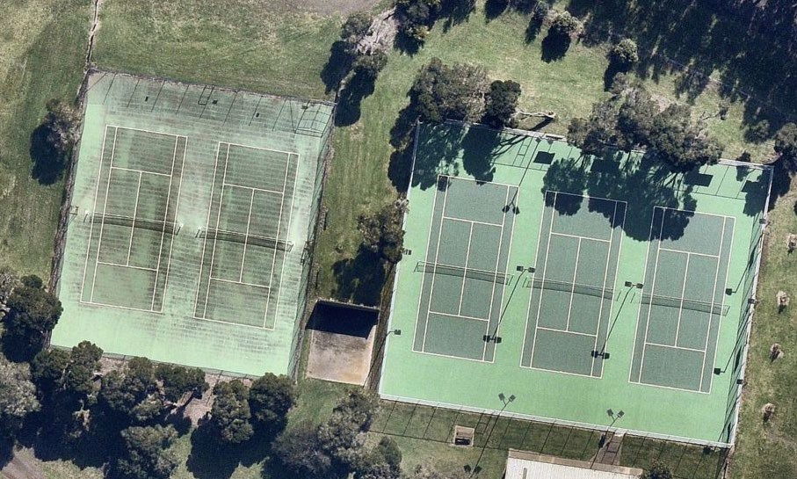
Description: There are five tennis courts with acrylic surfaces at the reserve. New perimeter fencing has been installed on first three courts (pictured right in above image). These three courts also have a high standard of sports lighting provision. The other two courts (to the left of above image) have an acrylic surface however it shows some signs of wear and requires cleaning.
These two courts do not have any sports lighting. The courts are separated by a hit up wall (also pictured) which shows signs of age however is in good structural condition.
Issues: Some cracking is evident on the two courts (pictured left in above image) however this is still considered playable and fit for purpose. Some slip issues may occur on these courts should cleaning be delayed.
Sporting code compliance: All courts comply with sporting code guidelines.
Opportunity: Monitor the cracking on the acrylic playing surface and program cyclical maintenance to improve asset performance and longevity. Consider upgrading lighting to training standards on two western courts.
Consider developing a sixth tennis court to the west of existing two court bank if demand necessitates.

HALF SIZE BASKETBALL COURT
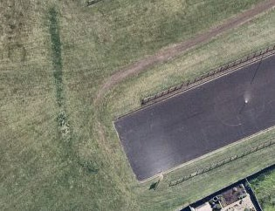
Description: There is a half-size basketball court located at the western end of the old netball courts.
Issues: The court’s use is unknown, and its positioning suggest it is not located in the most ideal location to facilitate use. The line marking is considerably faded, and the ring and back board are aged.
Opportunity: Consider transforming this area for broader community activities such as BMX and/or bike jumps area.

PARK FURNITURE
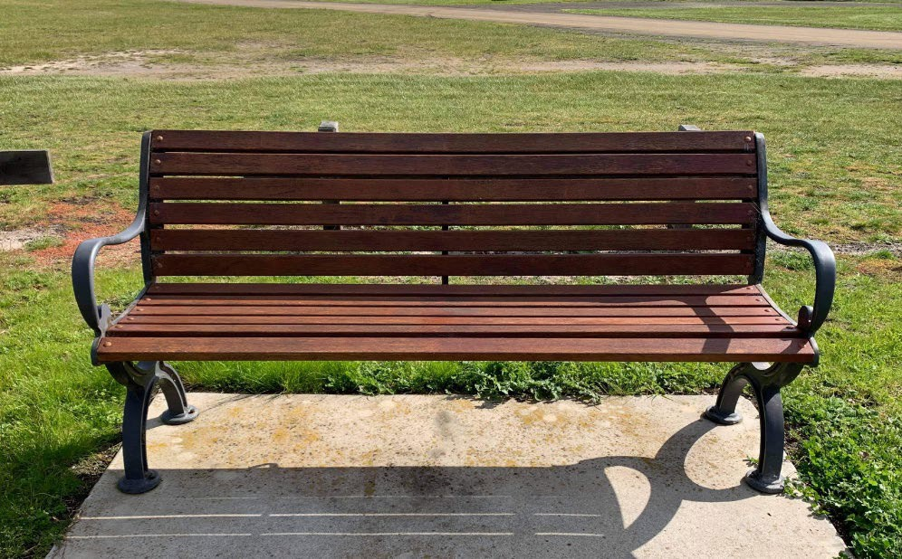
Description: Seating within the reserve is minimal and generally located near the netball and tennis courts and the main sports oval for spectating purposes. Two new styled seats existing near the playground, presumably installed as part of the previous playground upgrade.
Issues: The existing park seats are not consistent in style and there is a lack of seating throughout the Reserve. In addition, there are no other supporting picnic facilities, shelter, bike racks, drink fountains or bottle refill stations within the Reserve.
Opportunity: Consideration should be given to the installation of park furniture where demand is deemed highest. Aged seating should be removed and/or replaced where required. A consistent approach to style should be taken for uniformity and aesthetic purposes.

PLAYGROUND
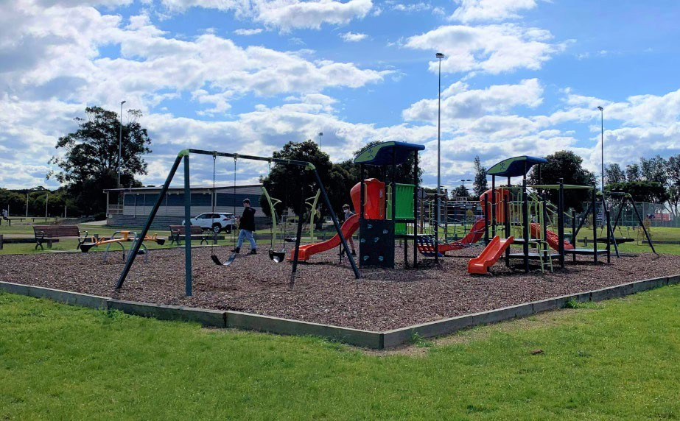
Description: There is a local level playground located at the Reserve which has recently been upgraded and caters for children under the age of 12. The playground is centrally located and includes perimeter seating and soft fall.
Issues: The playground is in good condition with some natural shade and amenity. The location of the playground may present a safety concern due to the cricket practice nets not being enclosed.
Opportunity: Consider the location of the playground in the context of the cricket practice nets and the broader public amenities of the Reserve including toilets, park furniture, BBQs etc. Improve natural shade through landscaping of its surrounds. Opportunity to incorporate playground into broader play space which appeals to a wider demographic including innovative features that are different from the main Portarlington playground located in the township. Opportunity to incorporate play elements that appeal to children and teens of all genders.

EVENTS AREA INCLUDING PUBLIC TOILETS
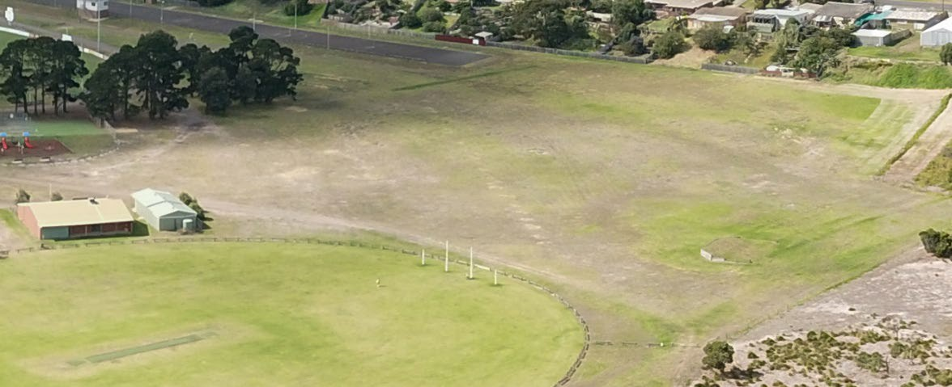
Description: The open space area to the south of the Reserve is used primarily for the Bellarine Agricultural Show but also for parking for the Portarlington Mussel Festival and other events. Due to the diverse use of the area, the grass cover appears varied and the surface is uneven in places. The event space is supported by several amenities including public toilets, horse/cattle tethering/yard area and a livestock loading ramp.
Issues: The post and rail area for tethering horses and livestock shows is currently fit for purpose. The public toilet block located between the main oval and the old netball courts is unroofed and generally non-compliant in terms of accessibility and standard amenity provision. The grass in the area appears to be Kikuyu with varying levels of condition.
Opportunity: Consider initiating improvements to the event grass area to enhance condition including levelling the surface to create more flexible usage and programming opportunities. Retain toilet block until end of useful life, and then replace for updated, compliant facility which will continue to support the area. Replace livestock tethering rails when they reach end of useful life.

OPEN SPACE AREAS AND LANDSCAPING
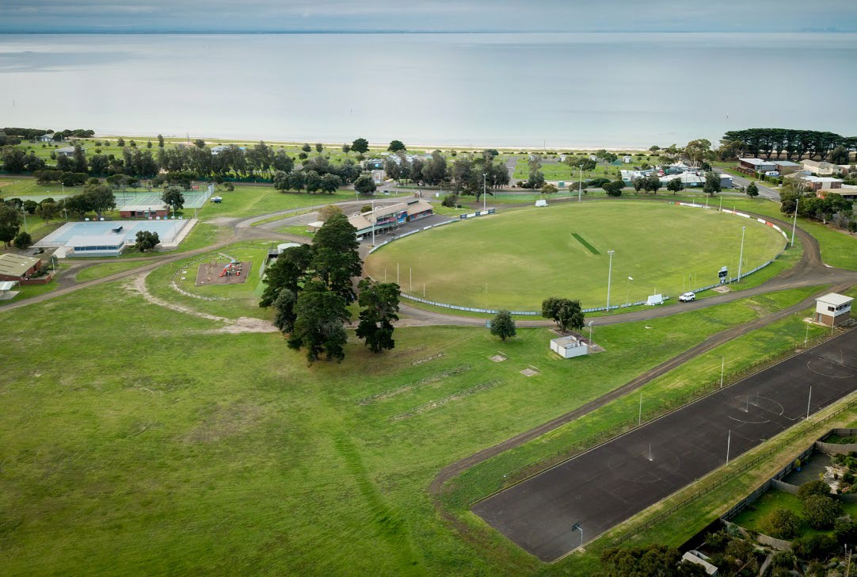
Description: There are vast amounts of open space within the active Reserve area which offer varied opportunities for passive recreational pursuits. Within the active Reserve at present, a grove of Cypress trees (pictured above) line a small section of the landscape. Other than this however, there is minimal other vegetation to support and improve the environmental aspects of the Reserve including habitat, biodiversity, and aesthetic. The wide open space areas of the Reserve are considered a key feature and that future recommendations for landscaping need to retain part of this character.
Issues: Vegetation coverage within the active reserve area is sparse and open. Understory planting is minimal except for several floral garden beds around the main pavilion. The Reserve has limited natural shade coverage around the active sport areas.
Limited landscaping makes the Reserve look and feel as though it is lacking in general amenity, with minimal natural shade and wind breaks. The tree species presently occupying the Reserve are non-native or non-indigenous and potentially create weed issues and possibly reduced biodiversity outcomes.
In terms of passive recreational opportunity, there is ample space for activities throughout the open space areas, however amenity is limited given the lack of landscaping that would contribute to the user’s experience.
Opportunity: Improve landscaping through the active Reserve area. A strategic approach to planting should be undertaken to minimise interference with any Reserve activity that requires a designated amount of space. That said however, greater plantings and improved landscaping will complement the Reserve when undertaken in a considered manner and should be a priority of the Master Plan’s implementation.

ENVIRONMENTAL VALUES AND PASSIVE RECREATION AREA EXISTING CONDITIONS
The passive recreation area of Portarlington Recreation Reserve hosts a range of values and habitat which have been considered within the Master Plan’s development. As part of the initial planning process, an Environmental Report undertaken by an independent ecologist was completed. This report aimed to understand the status of the area and has assisted in the Master Plan’s recommendations. There are no recognised environmental values remaining in the active sport and recreation area and therefore the focus of the assessment was on the passive recreation area only.
Description: The 25 hectare passive recreation area is situated in the western section of the Reserve (as highlighted in Map 4 adjacent) and adds significantly to the environmental values and landscape character of the Bellarine Peninsula and the City of Greater Geelong. It is particularly important as it extends the values of the adjoining Point Richards Flora & Fauna Reserve, which combined, represent the largest extant area of native terrestrial vegetation remaining on the northern Bellarine Peninsula.
The passive recreation area contains three depleted Ecological Vegetation Classes (EVC); EVC 3 Damp Sands Herb-rich Woodland, EVC 821 Tall Marsh and EVC 891 Plains Brackish Sedge Wetland, These EVC’s are listed as ‘vulnerable’ within the Otway Plain Bioregion and when combined with the adjacent Point Richards Flora & Fauna Reserve represent the only significantly sized area of EVC 3 (Damp Sands Herb-rich Woodland) on the Bellarine Peninsula and within the City of Greater Geelong.
The survey by Mark Trengove Ecological Services in July 2020 identified 40 indigenous plant species including Austral Crane’s- bill (Geranium solanderi var. solanderi) which is listed as ‘rare’ on the Victorian Rare and Threatened Advisory Species List.
Another species of note was the identification of a single Native Sow Thistle (Sonchus hydrophilus) which is of regional significance and potentially state significance.
The Victorian Biodiversity Atlas has recorded five bird species in the study area but as many as 118 fauna species combined with the Point Richards Flora & Fauna Reserve. These findings provide an indication of the value of the remnant habitat.
Thirteen species exist on the Department of Environment Water Land and Planning advisory list of threatened flora and fauna. The vulnerable Grey Goshawk and Great Egret are also recorded from the area. A significant population (greater than 50) of Growling Grass Frog (listed under the FFG and EPBC Acts) is present in the adjoining reserve, and likely utilised wetland habitat in the passive area.
The condition of vegetation and diversity of native flora species across the study area varies considerably, transitioning from good in the north to poor in the south. Whilst the vegetation in the Reserve has previously been quite degraded due to neglect, effective weed control efforts in recent years has significantly improved its quality and resulted in prolific natural regeneration of the indigenous vegetation.
Public consultation for the Portarlington Recreation Reserve Master Plan revealed the importance of the passive recreation area to the community (see Consultation Summary section of this report for further detail), with environmental and landscape amenity deemed one of the most valued aspects of the Reserve via the Quick Poll.
Consultation has also shown that, although most people surveyed use the Reserve for playing or watching sport, almost 28% use the Reserve for appreciating nature and walking with or without their dog. This was reinforced by the Social Map engagement tool, where nearly half of the responses indicated they highly value this area and its passive recreational opportunities.
Uses: At present, the passive recreation area is utilised for walking, jogging, cycling, bird watching and nature appreciation. It is currently zoned as an on-leash dog walking area. The area is also presently used for overflow event parking.
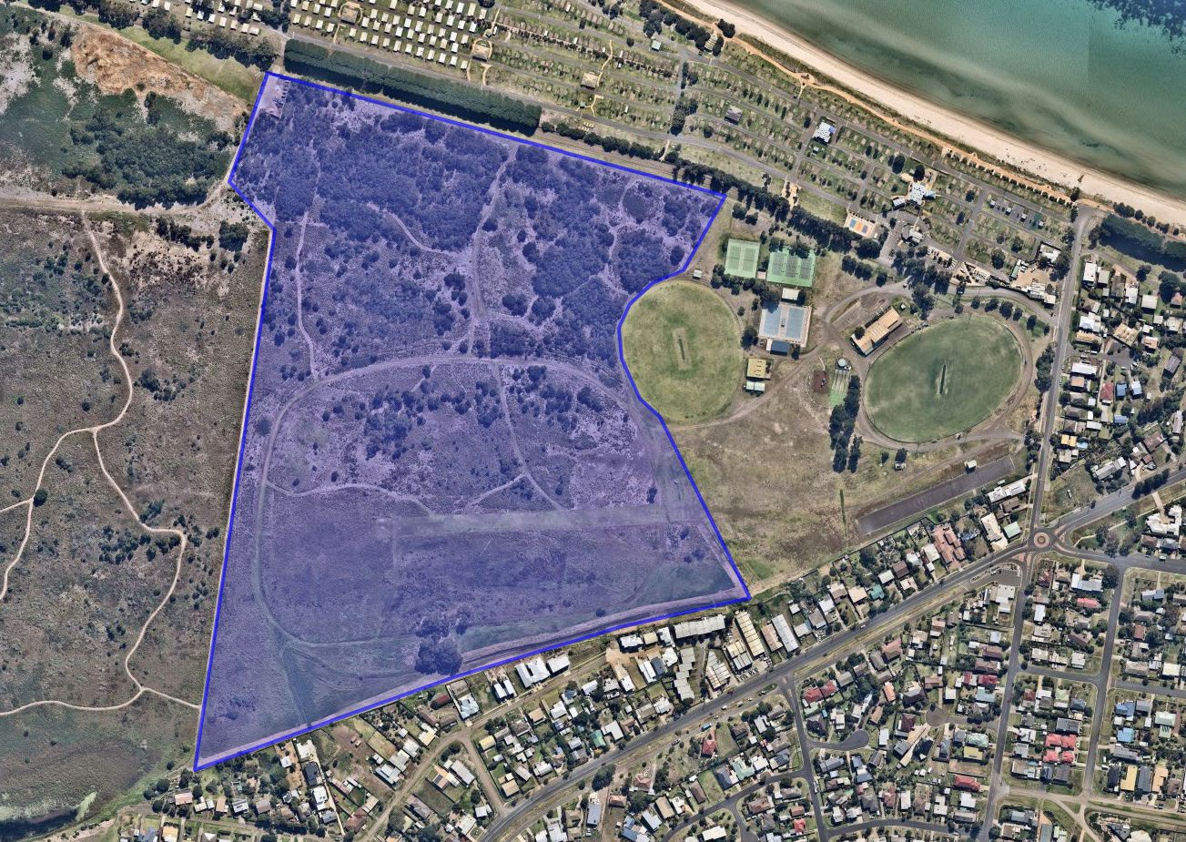
Map 4: Passive recreation area of Portarlington Recreation Reserve
Risks: To effectively protect the environmental values within the area, identifying and addressing the threats to its values must be considered. Through a risk evaluation process, each risk can be assessed based on its likelihood of occurring and the potential consequences associated. Through the development of a comprehensive risk assessment, strategies to assist in mitigation and action can be developed. A risk assessment for the area has been developed which will assist in the creation of the Master Plan. A summary of the risk assessment is provided on pages 33-34 of this report.
Past disturbances and land use have had a significant impact on the diversity and quality of values in the passive recreation precinct and ongoing and future risks will continue to make this area a challenge to manage. The relatively small size of the Reserve and fragmentated nature will limit the ability for many of the natural processes to occur. In this regard the adjoining Point Richards Flora & Fauna Reserve plays a critical role creating a larger body of vegetation and habitat. As a small Reserve, the loss of vegetation within the passive recreation area has a proportionally larger impact and therefore the variety of threats from trail expansion and other activities, particularly in better quality areas, is a high risk. The biodiversity and habitat values of the Reserve are important with vulnerable vegetation communities present, albeit in a variety of states of regeneration and recovery. The past and ongoing impacts of weeds and changes in fire regimes have had a deleterious impact on the diversity and condition of vegetation and habitat. Weeds continue to be the major threat to vegetation in this area due to their type and abundance. The changes in vegetation have also had significant impacts on the habitat values which have limited the presence and diversity of fauna in the Reserve.

Opportunity: Continued investment and responsible management of the passive recreation area will ensure the ongoing preservation of this regionally significant site, which will be for the benefit of current and future generations. Several opportunities exist to protect and enhance the environmental values of the area, which will assist in the Master Plan’s development. These include:
- Weed Management – a holistic and integrated approach to weed control to encourage the regeneration of native vegetation and increase flora diversity.
- Biodiversity Management – introduce targeted revegetation activities consistent with findings in the ecological report to supplement natural regeneration of indigenous species. Undertake further flora and fauna surveys and studies to improve knowledge of species, values and habitat. Review previous fire management plans to identify a suitable regime that promotes positive ecological outcomes and fuel management objectives. Consolidate trails for pedestrians and cyclists and create a formalised network.
- Collaborative Management – investigate opportunities for a more integrated and collaborative management of values and risks across this precinct and adjoining public land.
- Water and Wetland Management – consider re-establishing a wetland system along the southern end of the Reserve to enhance the EVC 821 Tall Marsh and EVC 891 Plains Brackish Sedge Wetland as well as improve run off from adjacent residential properties.

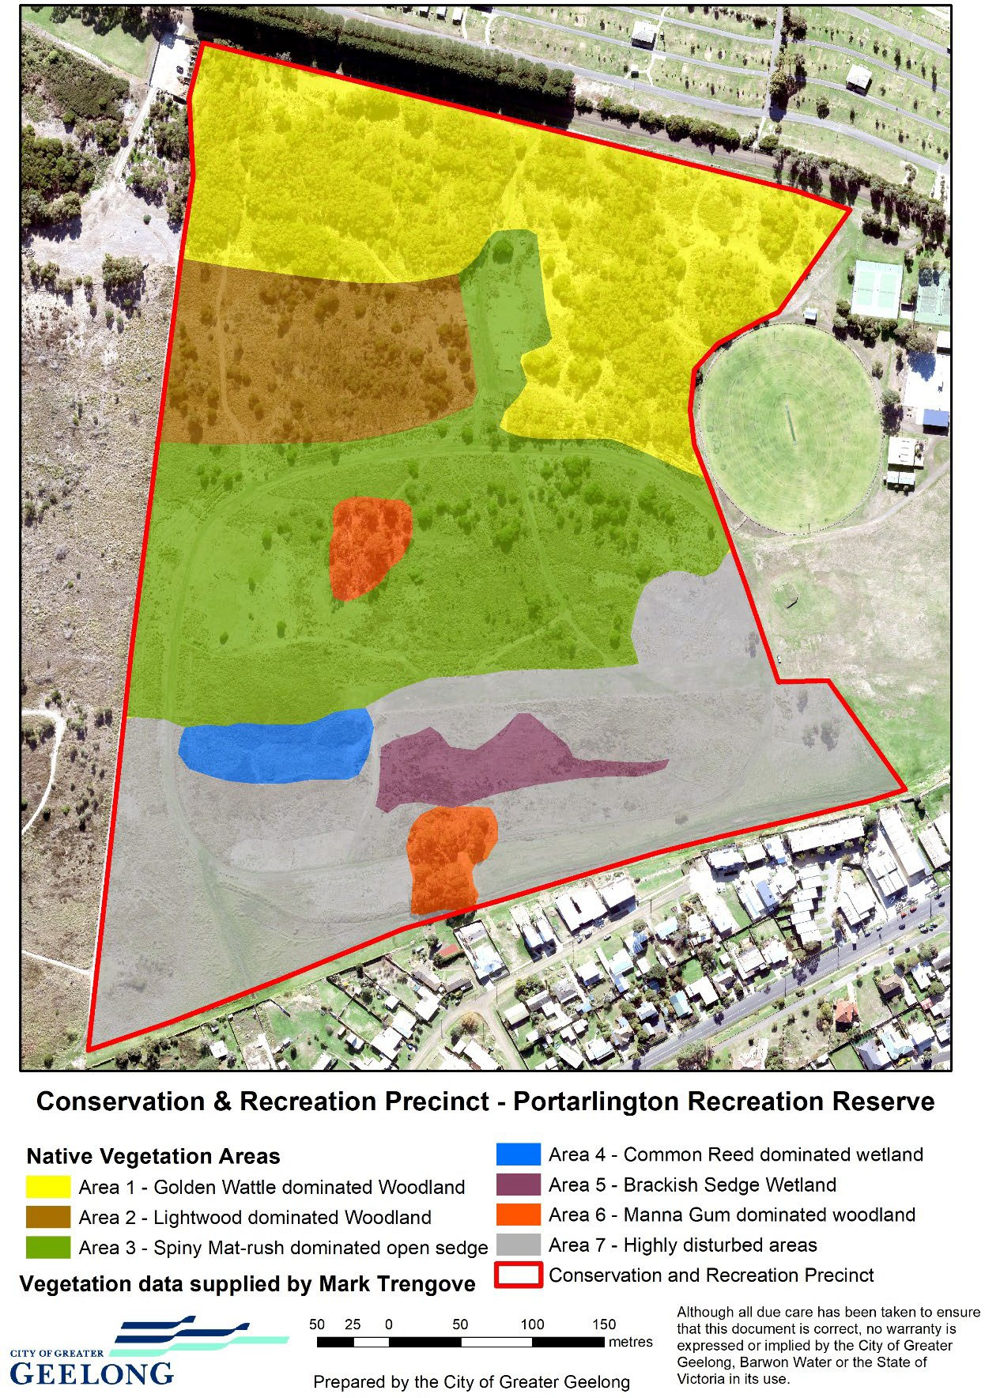
Map 5: Study area and distribution of vegetation areas based upon July 2020 survey

PASSIVE RECREATION AREA RISK ASSESSMENT

Key Risks: | Threats | Description of threat | Rating
Loss of vegetation and habitat | Re-opening horse trails | Loss of vegetation can result from new infrastructure, creation of new trails, trampling of vegetation from vehicles or people. | High
Loss of flora biodiversity and habitat | Invasion of native vegetation by ‘noxious weeds’ | An assessment of weed species within the reserve found 59 species of exotic species and 3 native species that pose a threat to native vegetation. Whilst it is acknowledged that the historical EVC is significantly altered, weed species will continue to threaten both the extent of native vegetation and quality by occupying greater space as they compete with and smother native vegetation.  The large variety of weed species makes this a greater challenge as the control techniques for one species may create a space for other exotic or environmental weeds to take over.  Aggressive weeds such as Flax-leaf Broom and Gorse have had large populations in the past and have significant annual seed set colonising areas quickly supressing native regeneration and biodiversity.  An ongoing source for weeds will come from both those areas that are more highly infested and adjoining private land where garden weeds may escape. | Extreme
 | New and emerging weeds | New and emerging weeds such as Bridal Creeper and Chilean Needlegrass pose one of the largest future threats to the reserve biodiversity due in part to its smothering nature and the difficulties in treating this weed. | Extreme
 | Inappropriate fire regimes causing disruption to sustainable ecosystem processes and resultant loss of biodiversity | Fire has been part of the Australian landscape for thousands of years. With colonisation those fire regimes and purposes have significantly altered along with the change and loss of vegetation. Fire regimes need to have clear objectives with fire frequency and intensity maintained within the tolerance limits of the desired native vegetation characteristics. Inappropriate use of fire could further alter the desired vegetation diversity and structure or trigger major weed events from dormant species such as Broom, Gorse and Coast Wattle. | High
 | Loss of biodiversity as a result of the spread of invasive plants native to Victoria, such as Coast Wattle (Acacia longifolia subsp. sophorae) and Sallow Wattle (Acacia longifolia subsp. longifolia), into areas outside their natural range | Coast Wattle is recognised as a particularly invasive and aggressive coloniser of disturbed areas. It is widely distributed across the study area and potentially has a large dormant seedbank. Further disturbance and/or the use of fire could trigger major colonisation events that would need to be carefully managed if they were to be used for other objectives. | High
 | Spread of Pittosporum undulatum in areas outside its natural distribution | Sweet Pittosporum is like many other native plants that have expanded beyond their range initially as garden escapees. The additional challenge of this species is the allelopathic effects it has on soil and the suppression of other plants species growing under its canopy.  There are relatively few plants in the reserve. | Moderate
 | Fragmentation | The passive recreation area, is quite fragmented with a high edge to core ratio. Fragmentation further reduces the ability for natural processes to occur with disturbance along edges being a source of further weed invasions and weed spread. | Moderate
 | Trail use spreading weeds | The use of trails may be a source of new weeds coming in or spread of weeds along tracks further reducing biodiversity values. | Low

 | Trail maintenance spreading weeds | Machinery brought into the reserve for maintenance, particularly slashing activities can be a source of weeds such as Chilean Needlgreass and potentially new weed species and or spread weeds along tracks and vegetation edges. | Low
Wetland loss and degradation | Change in water regime, dredging, draining, filling and grazing | Past and future changes to drainage at the Reserve dry out previously wetter areas reducing natural flooding and inundation regimes changing vegetation characteristics in key EVC’s.  Past changes to drainage have reduced the frequency and duration of ephemeral wetland events reducing the wetland habitat for a range of bird and frog species. | High
Loss of fauna biodiversity | Predation of native wildlife by the cat, Felis catus. | Cats are a highly aggressive and effective hunter of native wildlife. Although there are a small number of fauna species listed and an unknown cat population, they remain a risk to the presence or increase of fauna populations. | Moderate
 | Predation of native wildlife by the introduced Red Fox Vulpes vulpes. | Foxes are a highly aggressive and effective hunter of native wildlife. Although there are a small number of fauna species listed and an unknown fox population, they remain a risk to the presence or increase of fauna populations. Trails increase the access to habitat reducing core areas that may afford greater protection against predation. | Moderate
 | Off-lead dog disturbing or causing loss of wildlife | Dogs off-lead have the potential to reduce bird diversity and abundance through predation and disturbance. Under the current controls, dogs off-lead are not permitted, however evidence suggests this still may occur, but the frequency is uncertain. There is likely to be a higher consequence from dogs off-lead with potential bird mortality and a greater area impacted. This may also be a risk factor to other small mammals if they exist. | Moderate
 | Motorbikes | Motorbikes have the potential to reduce bird diversity and abundance through disturbance with higher speed and noise. | Moderate
 | Dogs on lead disturbing wildlife | Dogs on-lead have the potential to reduce bird diversity and abundance through disturbance. No data has been collected on the frequency or duration of dog walking but from the community consultation and anecdotal evidence suggests it is a common activity. The level of disturbance is unknown as no research has been undertaken on the abundance of birds, but research indicates this is a risk factor. | Low
 | Walking and cycling disturbing wildlife | Walking and cycling has the potential to reduce bird diversity and abundance through disturbance. No data has been collected on the frequency or duration of walking but from the community consultation and anecdotal evidence suggests it is a common activity. The level of disturbance is unknown as no research has been undertaken on the abundance of birds, but research indicates this is a risk factor. | Low
 | Impacts of climate change | Changes in climate may put further pressure on fauna through impacts on migratory species, changes in vegetation and habitat and increased risk of extreme weather events and fire. There are likely to be impacts over and above other impacts. | Low

PASSIVE RECREATION AREA IMAGES

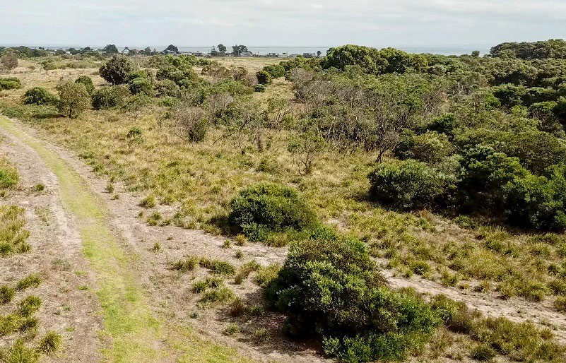 | 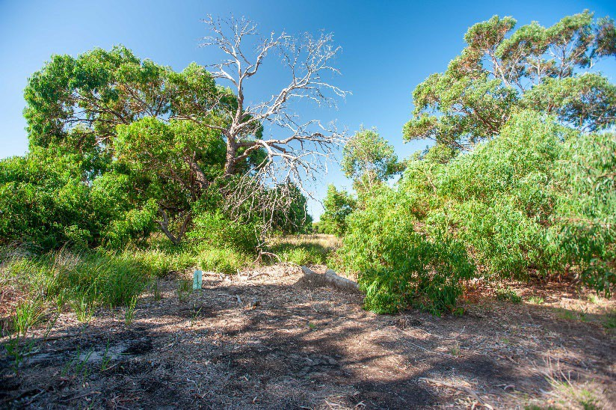
Lightwood Dominated Woodland | Manna Gum Dominated Woodland
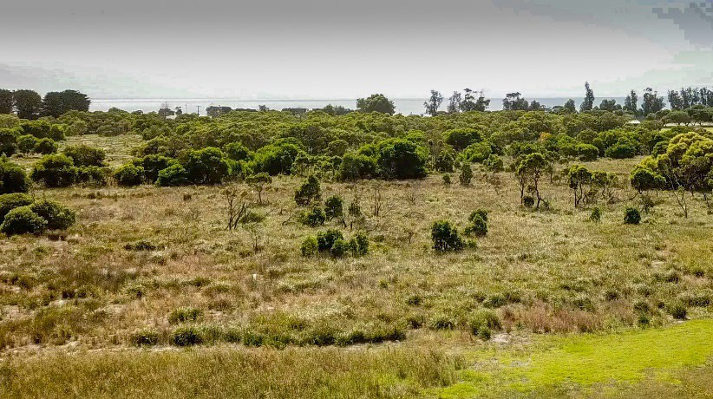 | 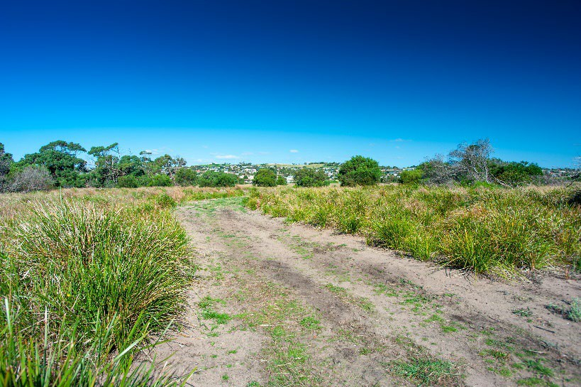
Spiny Mat-rush Dominated Open Sedge/Grassland | Spiny Mat-rush
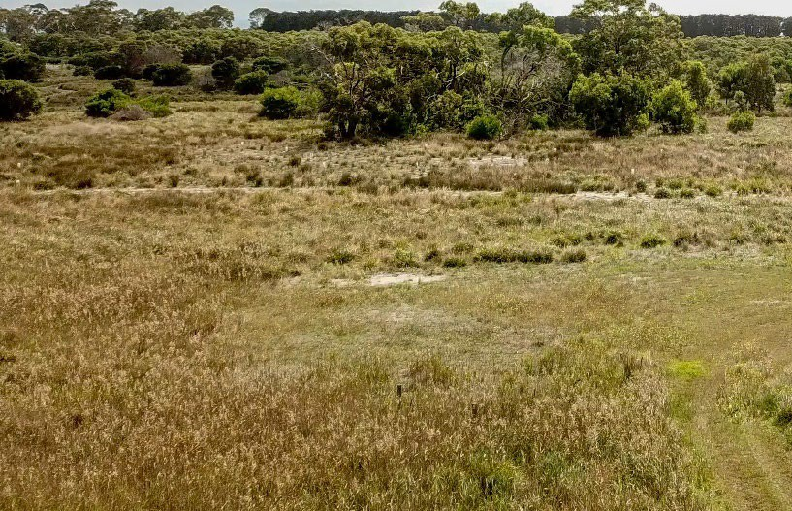 | 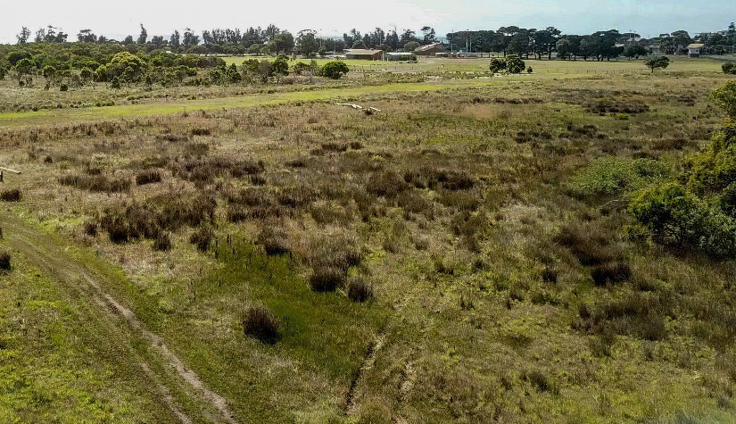
Common Reed Dominated Wetland | Brackish Sedge Wetland

SITE USAGE

SPORTING CLUB PARTICIPATION
The 2020 Sport Australia AusPlay Survey data found that the top activities for sports club participation within the City of Greater Geelong are:
- Australian Football
- Golf
- Netball
- Basketball
- Football/soccer
- Tennis
- Cricket
- Bowls
All four sports tenanting Portarlington Recreation Reserve are represented within this listing, demonstrating a strong demand for participation and access to clubs and programs, as well as facilities that are modern, accessible, welcoming and fit-for- purpose.
To assist in identifying current and future demand for sport at Portarlington Recreation Reserve, an overview of participation for all active sporting user groups is provided below.

TOTAL MEMBERSHIP – 2019
CLUB | TOTAL | SENIOR MALE | SENIOR FEMALE | JUNIOR MALE | JUNIOR FEMALE | JUNIOR PROGRAMS MALE | JUNIOR PROGRAMS FEMALE | SOCIAL MEMBERS
PORTARLINGTON FOOTBALL NETBALL CLUB (FOOTBALL) | 615 | 79 | - | 163 | 11 | 46 | 16 | 300
PORTARLINGTON CRICKET CLUB | 280 | 85 | 15 | 80 | 14 | 18 | - | 68
PORTARLINGTON FOOTBALL NETBALL CLUB (NETBALL) | 255 | - | 56 | - | 70 | - | 29 | 100
PORTARLINGTON TENNIS CLUB | 44 | 13 | 17 | 7 | 7 | - | - | -
TOTALS | 1,194 | 177 | 88 | 250 | 102 | 64 | 45 | 468

The previous table shows active participation numbers (i.e. registered players) per club, including social members and officials such as coaches, trainers, support staff and volunteers. The table demonstrates that there is a healthy number of junior and female participants which is considered imperative to the sustainability of any sporting club.
The Portarlington Recreation Reserve is one several sporting venues that host local competition finals. This includes for all four sports, i.e. AFL, Tennis, Cricket and Netball. During weekends in February/March and September/October the Reserve has an influx of spectators and competitors utilising the venue for final’s matches. These events attract a greater crowd than the home and away season, and there is recognition that the venue should continue this function. Finals games also offer a financial incentive for the hosting club and are an excellent way to raise revenue.
The AFL has detailed, historical participation information that demonstrates trends over a four-year period. The following table demonstrates the positive trend Portarlington Football Club has experienced since 2016:

FOOTBALL CLUB PARTICIPATION TRENDS
 | 2016 | 2017 | 2018 | 2019
No of players | 250 | 251 | 277 | 315
Change % | - | +0.4% | +10.4% | +13.7%

In addition, AFL Barwon has supplied detailed participation data for Portarlington Netball Club as follows:

NETBALL CLUB PARTICIPATION TRENDS
 | 2016 | 2017 | 2018 | 2019
No of players | 135 | 146 | 186 | 155
Change % | - | +8.2% | +27.4% | -16.6%

SPORTING PARTICIPATION CATCHMENT (AFL)
Whilst the future total population growth in Portarlington of 26% is high, the actual rate of change is approximately 2%, meaning that the number of additional people to 2030 within the township is minimal. In addition, a higher number of people will be aged over 60. It is therefore likely that future participation in organised sport at Portarlington Recreation Reserve will need to be drawn from the township as well as surrounding areas. This participation catchment is consistent with current trends, particularly in terms of the Portarlington Football Club who have the highest participant base of any tenant club at the Reserve. AFL also have detailed participation data available for analysis including the residential postcodes of registered participants.
This data has demonstrated that in season 2019, the highest number of AFL players at Portarlington Football Club resided in the following locations:

PORTARLINGTON | 116
CLIFTON SPRINGS | 38
INDENTED HEAD | 27
DRYSDALE | 30
ST LEONARDS | 25
CURLEWIS | 17
ELSEWHERE | 62

The Clifton Springs and Curlewis areas will continue to be important localities for the Club to source participants, with both suburbs set to experience population growth. Curlewis alone is forecast to double its population from 3,328 in 2020 to 6,583 in 2030. Both Clifton Springs and Curlewis do not have designated active recreation reserves and will become more reliant on facilities at Portarlington, Drysdale, and Leopold to accommodate demand.

It should be noted that other current users such as the Bellarine Agricultural Society and Portarlington Girl Guides will further boost participation numbers and reserve attendance numbers through their relevant activities. It is estimated that combined these activities, particularly the Bellarine Show and associated events, would attract thousands to the Reserve each year.
As previously mentioned within this report, due to the largely older demographic permanently residing in Portarlington that there will likely be demand for more unstructured activities and opportunities that appeal to the older age groups. Whilst participation trends remain healthy, it must be acknowledged that there may be a potential cap on the expansion of these sports purely due to demographic projections. The retention of players and a focus on no net loss of participants in the future can be viewed as a measure of success for these sports.

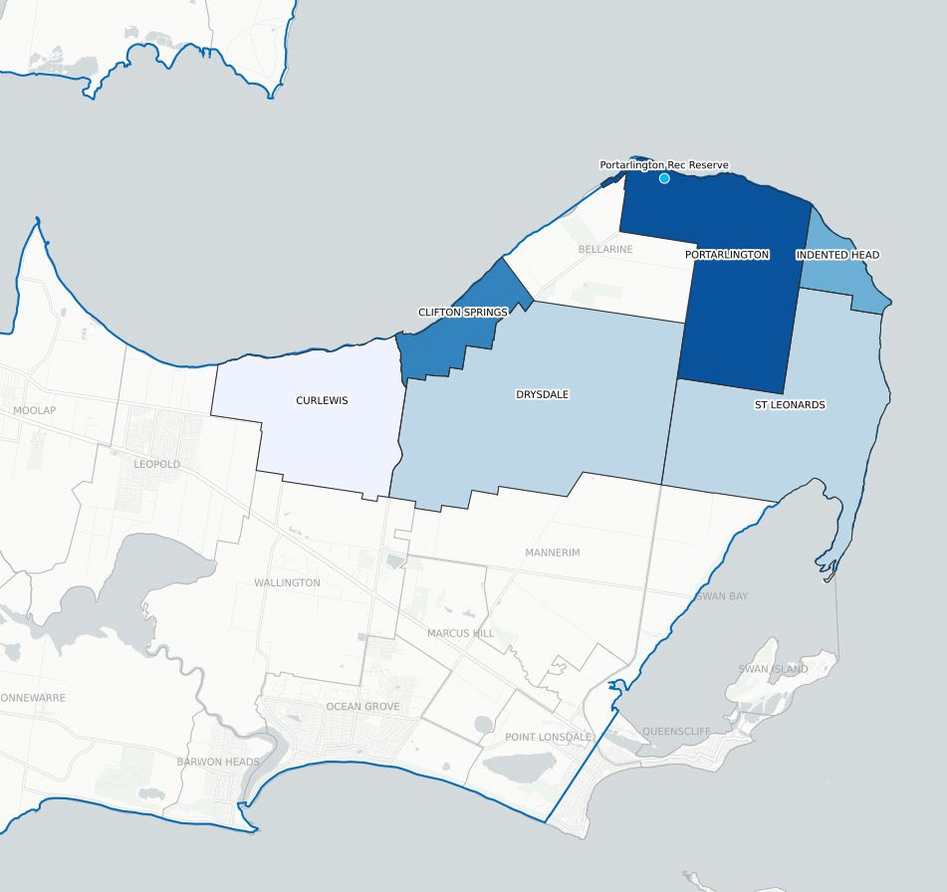

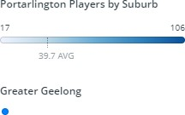

Map 6: Portarlington Football Club map of player catchment areas

For comparison, a participation catchment analysis was also conducted for neighbouring football clubs Drysdale and Leopold. The aim of this exercise was to understand whether many players residing in Portarlington were travelling outside of the township to participate elsewhere. As evident in the following tables, both clubs only attracted a minor number of participants from Portarlington. This will likely indicate that Portarlington Football Club offers programs that retain and attract local participants. The viability and sustainability of Portarlington Football Club will continue to depend upon its ability continue to attract participants from the local area. Strong junior introductory and player pathway programs along with girls’ and women’s’ teams are now the cornerstone of modern football. To remain competitive, the Club must proactively pursue these initiatives. Many clubs on the Bellarine Peninsula have access to modern facilities, which also contributes to participant experience and provides a welcoming and inclusive environment. As demonstrated in the tables below, these neighbouring clubs also attract a high number of their participants from their immediate local area. Therefore, it will be difficult for Portarlington to compete for and attract players from these areas given the strong local connection to all townships being experienced. The upgrade to Portarlington amenities along with program development however will assist the Club in staying competitive and on an equal playing field to the neighbouring clubs and others across the Bellarine.

DRYSDALE FOOTBALL CLUB

PORTARLINGTON | 7
CLIFTON SPRINGS | 164
DRYSDALE | 148
CURLEWIS | 70
ST LEONARDS | 10
LEOPOLD | 28
ELSEWHERE | 71
LEOPOLD FOOTBALL CLUB
PORTARLINGTON | 1
MOOLAP | 10
CURLEWIS | 6
LEOPOLD | 351
ELSEWHERE | 76
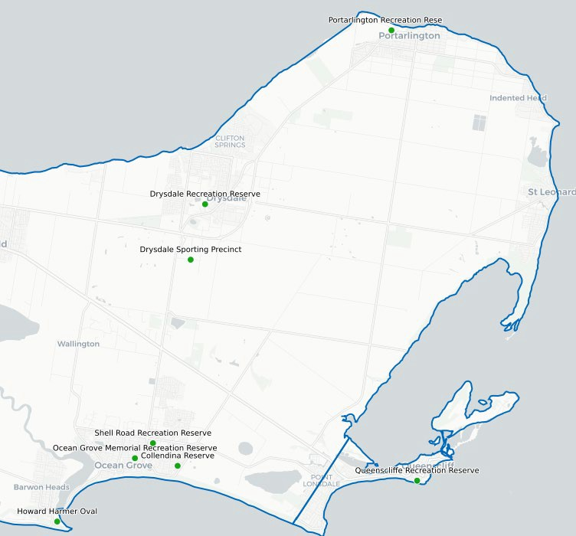
Map 7: Location of Bellarine Football Netball League venues within the City of Greater Geelong

SPORTING INFRASTRUCTURE SUPPLY AND PROVISION RATIOS
Supply and provision ratios are useful in assisting to understand, along with other influencing factors, the likely requirements for infrastructure. Ratios utilised within this report have been derived from industry benchmarks, recommended peak sporting body guidelines as well as other strategic infrastructure documents developed for sport. The ratios applied are those used for local sporting provision, which is consistent with the classification of Portarlington Recreation Reserve as a local level venue.
Provision ratios should be considered in conjunction with other influences such as participation, facility condition and community access. Other considerations when assessing provision ratios should include:
    - Any localised strategic planning that identifies gaps in facility provision based on need;
    - The proximity of like venues to those within the township and the geographical spread of infrastructure;
    - Access and ownership limitations of existing facilities; and
    - Condition of existing assets and their level of capacity to host sport.
The table on the following page indicates the current infrastructure provision at Portarlington Recreation Reserve against the township’s population ratios and future forecasts. From the analysis, the current provision of sporting ovals and courts is sufficient to meet the future needs of the community for the next 20 years considering a growth rate at the higher end of the forecast population projections and participation scenarios.
A focus of the Master Plan should be given to improving the quality and capacity of infrastructure through potential playing surface improvements, lighting upgrades and access rather than the inclusion of additional playing surfaces.
Given most sports are deemed to be well-serviced from a provision perspective, this provides ample opportunity to enhance other recreational aspects at the Reserve which encourage informal participation, particularly within the older age demographic. The Master Plan for the Reserve should focus on a balanced approach to both organised and unstructured recreation to better service the community now and into the future.

“The current provision of sporting ovals and courts is sufficient to meet the future needs of the Portarlington community for the next 20 years. This is considered against a growth rate that is at the higher end of forecasted population projections and participation scenarios”

SPORT | Total no. of assets at PRR | 2020  Portarlington population | 2019  Participants | Recommended Industry Population/Pro vision Benchmark* | 2020  Playing area to population ratio | Recommen ded Industry Participant/ Provision Benchmark  ** | 2020  Playing area to participant ratio | Does supply meet, exceed or is less than benchmark | 2031  Portarlington population | 2031  Playing area to population ratio | Does supply meet, exceed or is less than benchmark
AFL | 2 | 4,046 | 315 | 1:5,000 | 1:2,023 | 1:175  participants | 1:127 | Exceeds population ratio and participant ratio | 5,133 | 1:2,567 | Exceeds
NETBALL | 2 | 4,046 | 155 | 1:7,070 | 1:2,023 | 1:60  participants | 1:78 | Exceeds population ratio  Small need using participant ratio | 5,133 | 1:2,567 | Exceeds
TENNIS | 5 | 4,046 | 44 | 1:3,000 | 1:809 | N/A | N/A | Exceeds | 5,133 | 1:1,027 | Exceeds
CRICKET | 2 | 4,046 | 212 | 1:4,000 | 1:2,023 | N/A | N/A | Exceeds | 5,133 | 1:2,567 | Exceeds

*Recommended industry population/provision benchmark ratios utilised within the above table have been derived from the City of Greater Geelong’s Social Infrastructure Plan (Generation One) 2020-2023

**Recommended industry/participant provision benchmark ratios utilised have been supplied by the relevant peak sporting body (where available)

CONSULTATION SUMMARY
Community consultation for the Master Plan’s development aimed to understand what the community like, and what they think could be improved at Portarlington Recreation Reserve. The broad consultation program resulted in a high level of engagement and responses received. The below provides a summary of the various consultation methods undertaken.

PROJECT REFERENCE GROUP
Throughout the Master Plan’s development, the City worked closely with the Project Reference Group, many of whom were representatives of tenanting user groups of the Reserve as well as members of the local Portarlington community. The purpose of this group was to provide information to assist in forming recommendations, including guidance around the functionality of the Reserve and its future infrastructure requirements.
Representatives of the group, included:
    - Portarlington Football Netball Club
    - Portarlington Cricket Club
    - Portarlington Tennis Club
    - Portarlington Pony Club
    - Bellarine Agricultural Society
    - Portarlington Girl Guides
    - Portarlington Community Association
    - Portarlington Community Garden Group
    - Bellarine Bayside Foreshore Committee
    - Office of Lisa Neville MP, Member for Bellarine
Several key themes emerged from consultation with the Project Reference Group, including:


Improving existing sporting infrastructure within the active recreation area to meet modern standards.


Increasing the capacity of sporting infrastructure so that more programming and participation opportunities can be created.


Improving connections for vehicles and pedestrians both within and to the Reserve, making it safer and more accessible for all


Considering how other activities for the community can be incorporated within the Reserve outside of sport.

STATE SPORTING ORGANISATIONS
Interviews with State Sporting Organisations including AFL Barwon, Cricket Victoria, Tennis Victoria and Netball Victoria were undertaken to understand their aspirations for the sports who tenant the Reserve, including questions relating to participation, programs, infrastructure and alignment with strategic priorities. A summary of the key themes emerging from consultation with these organisations are below:


Participation rates in sport at Portarlington Recreation Reserve are increasing.


Sporting facilities, particularly club change rooms/pavilions and some ancillary infrastructure require improvement.


Enhancing gender equity outcomes by generating more diverse participation opportunities and facilities is important for all sports.


Encouraging multi-use outcomes so that facilities can support a range of sporting opportunities that have widespread community benefit.

COMMUNITY CONSULTATION
The Master Plan has followed a two-step consultation process with the broader community. The first engagement commenced during the initial phase of the project where the community were asked what the liked, and what they thought could be improved into the future at Portarlington Recreation Reserve. The consultation was open for a six-week period and welcomed responses via a survey, quick poll, and interactive map. The consultation was undertaken in May 2020 and had strong community input, including:
    - 192 survey responses
    - 191 quick poll responses
    - 75 comments on the interactive map
    - 6 emails
This feedback directly influenced the first iteration of the Draft Master Plan prior to it being released for public exhibition. A detailed overview of the initial consultation can be found as a supporting document to this report. A summary of key themes through this engagement period, included:

Improving the quality and functionality of the football and cricket pavilion.

 Developing trails and walking paths.
Enhancing vegetation, habitat and landscaping.


Developing all other existing sporting infrastructure.

 Improving car parking and access.

The subsequent community engagement process was conducted over a six week period, from June-September 2021, and was based on the public exhibition of the Draft Master Plan and its recommendations. The engagement including the following activities:
    - 515 flyers delivered to residents
    - 3 print adverts in local newspapers
    - 211 interactions on social media posts
These activities resulted in the following engagement outcomes:
    - 3,358 views of the Have Your Say webpage
    - 68 surveys completed
    - 50 online written submissions
    - 60 contributions via drop in sessions

Within the 68 surveys completed there was generally very positive feedback of the Draft Master Plan, including:
85% of survey respondents were ‘very supportive’ or ‘supportive’ of the overall Draft Master Plan.

90% of survey respondents were ‘very supportive’ or ‘supportive’ of the Draft Master Plan’s vision and goals

90% of survey respondents were ‘very supportive’ or ‘supportive’ of the Draft Master Plan’s recommendations.
As a result of feedback received through this period, the Draft Master Plan was updated and key themes were developed that represent what was heard via the engagement activities. A detailed summary of this engagement process and its findings are available as a supporting document to this report.


Upgrading existing facilities within the active recreation area a priority.


Environmental protection and cultural heritage valued and supported by the community.


Spaces for the community to gather and spend more time at the Reserve are important.


Improving safety outcomes for all users is required.


Flexibility in the use of different spaces will see more opportunity for community participation.

The Final Master Plan for Portarlington Recreation Reserve has considered all feedback received via the two-step engagement process, along with an assessment of themes and further review by the PRG to determine its recommendations.

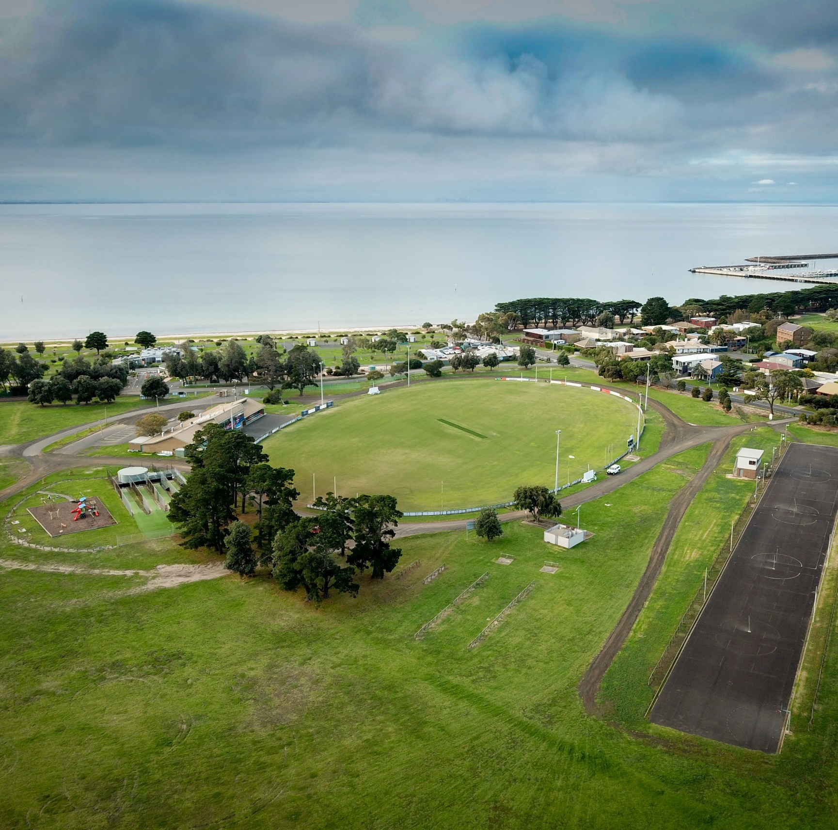
Quotes from initial community engagement

“There are some of my favourite trails through the (passive) Reserve. It is a beautiful oasis of plant and animal life”
“The current infrastructure could be upgraded while
keeping the environmental values and open space requirements for community events”
“I enjoy walking through the Reserve and the
freedom and tranquillity it provides”
“The community loves the football, netball, cricket
and other sports played here”
“The Bellarine Agricultural Show - what a great
community event - showcasing and celebrating our local farming community!”
“The venue is not fit for purpose. The facilities are
very old and need an upgrade. The facilities are not disability or gender diverse accessible”

Image 3: Portarlington Recreation Reserve Oval 1, Events Area/Open Space

MASTER PLAN

WHAT IS PROPOSED?
The Portarlington Recreation Reserve Master Plan has considered all consultation, background information, strategic context and other drivers in its development. The Plan has aimed to respond to the needs, aspirations and challenges to provide a clear approach to enhancing Portarlington Recreation Reserve.
The Plan is in line with community expectations as well as the City’s strategic direction. The Plan looks to enhance the Reserve’s existing features, whilst maintaining a close connection to its long history and function as a local level reserve. The Plan recommends improving facilities and attributes that will make Portarlington Recreation Reserve a more appealing place to visit, with modern facilities that enhance safety and amenity, as well as better environmental properties through tree planting and habitat creation.
The project objectives and Master Plan principles have been used to create vision and goals to guide the development of the Reserve.
The following section provides an overview along with a detailed summary of recommendations. This section begins by introducing the recommendations through the proposed Landscape Plan, followed by a summary of key recommendations and themes.
For the purposes of this report, the summary of recommendations has been broken down into individual areas to highlight the outcomes associated, particularly around key directions. An overview of these areas is provided on page 48 followed by a summary of each from page 49 onwards.

VISION AND GOALS

MASTER PLAN VISION
Portarlington Recreation Reserve is a spacious coastal recreation reserve in a rural setting providing contemporary facilities for sport, community use and events, balanced with passive recreation areas set amongst coastal bushland.

MASTER PLAN GOALS

Sporting & Social Infrastructure
Sporting and other social infrastructure will be redeveloped and replaced in line with the City’s Social Infrastructure Policy to ensure they are compliant, inclusive, accessible, support multi use and are fit for purpose.

Social infrastructure will be designed and developed in a way that is creative, sustainable, and responsive to the character and scale of the reserve.

Social infrastructure and trail connections will be developed to improve safety, wayfinding, and encourage more engaging experiences.

Places and Community Use

Maintain the diversity of opportunities and spaces including organised sport, other community use and informal recreation to support community connections, health, wellbeing, and enjoyment of the Reserve.

Environment & Amenity
The Reserve’s amenity and environmental values will be improved providing a more inviting and richer landscape.

Cultural Heritage
The cultural heritage values of the Reserve will be protected, and opportunities provided to improve awareness and understanding of its history and stories.

Park Management
The planning, development and management of the Reserve will be done in a holistic manner integrating all current uses and functions in consultation with the community.

New and emerging uses will be assessed according to the goals for the Reserve, local needs and the regional context to determine whether they are suitable.

Park Character
The Reserve will be managed in a way that protects the rural coastal character blending sporting and community use facilities with wide open spaces, scattered trees and areas of natural bushland explored through a winding trail network.

FUTURE CHARACTER DESCRIPTION
Portarlington Recreation Reserve is the primary home for the town’s sporting and recreation activities and an important area for tourists during the holiday season. It extends across the coastal flats fringed by the Portarlington Holiday Park and Port Phillip Bay, with houses overlooking the Reserve along its southern and eastern boundaries. The active sport and recreation area is the hub of the Reserve, built around a developed core that includes the main ovals, pavilion, netball courts, tennis courts, Guides Hall, and Agricultural Society buildings. More formal and organised parking, roads and paths provide access and movement between the key facilities. The sporting facilities are surrounded by wide open spaces that are the basis for its important role as an events destination. The loose informality of the roads, parking and trails in the area creates a relaxed atmosphere and sense of freedom. Indigenous tree plantings enhance the amenity of the open spaces, improving shade and shelter from the elements. The Reserve has a strong connection and transition between spaces with the active sport and recreation precinct blending into regenerating coastal bushland, providing a natural backdrop to the more developed pockets. This passive recreation area provides opportunities to explore wetlands, pockets of Manna Gums and coastal bushland through a web of interlinked trails. Usage of the Reserve ebbs and flows across the day, the week, and the seasons. It is a place where sporting trials, tribulations and memories are made. Events bring a burst of life to the Reserve, gathering the community together to celebrate the history, diversity and creativity of people and the town. It is also a place that provides opportunities for quiet reflection and the appreciation of nature, or a casual moment spent walking the dog.
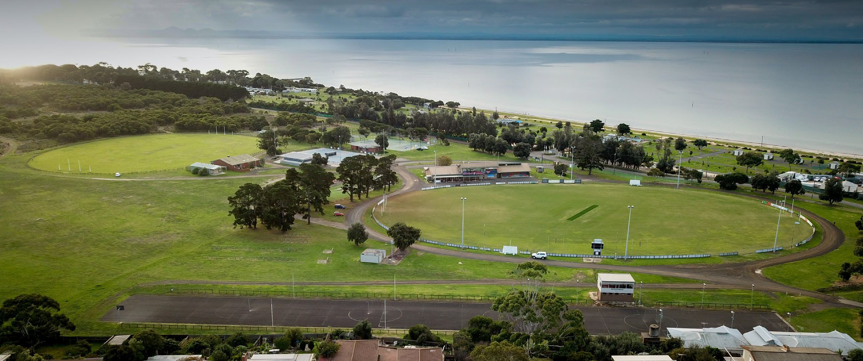

Image 4: Current view of active recreation area
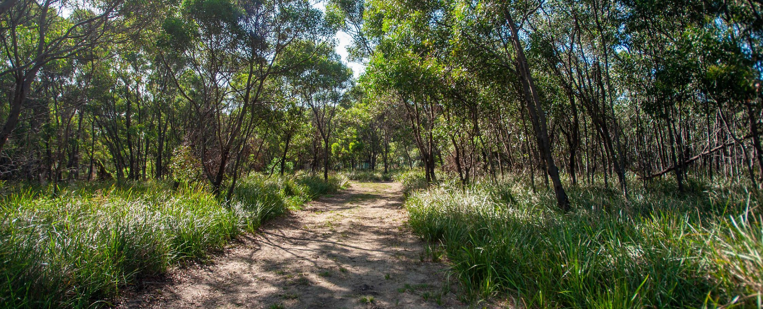

Image 5: Current view of passive recreation area

MASTER PLAN (LANDSCAPE PLAN)
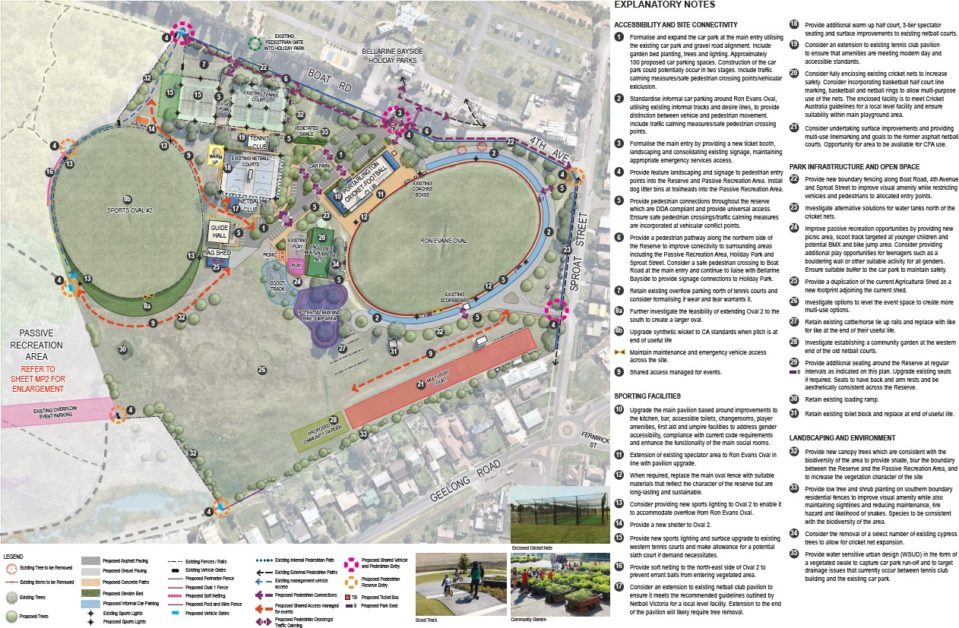
Map 8: Portarlington Recreation Reserve Master Plan – Landscape Plan – image 1 of 2

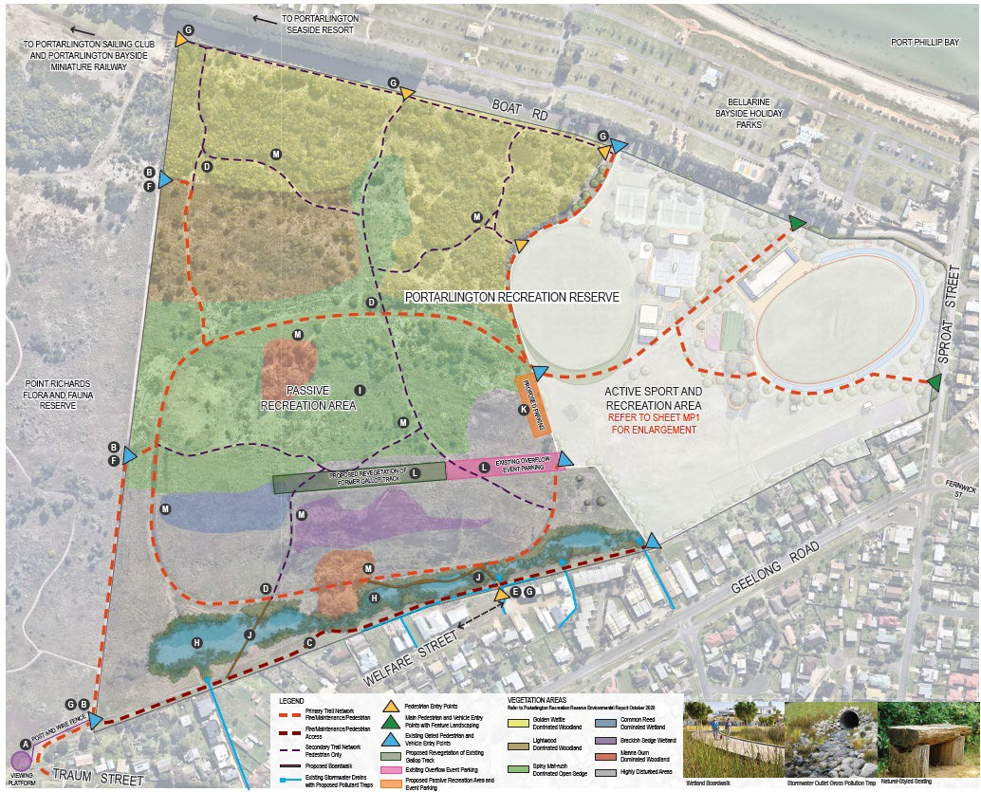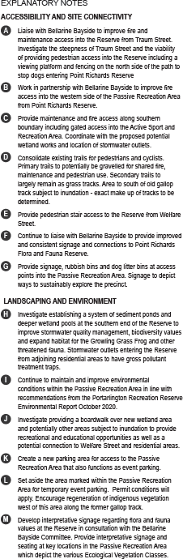
Map 9: Portarlington Recreation Reserve Master Plan – Landscape Plan –image 2 of 2

OVERVIEW OF MASTER PLAN RECOMMENDATIONS AND COSTS
For the purposes of this report, a summary of key Master Plan recommendations are discussed in further detail as per the six areas identified below. Due to the size and expanse of Portarlington Recreation Reserve, the following layout provides a more succinct way to summarise the recommendations and their associated outcomes. It should be noted that the below areas do not constitute the priority order of the Master Plan’s implementation. The total cost to implement all recommendations within the Master Plan is approximately $10.6m. Please note that this excludes contingencies and cost escalations that would need to be applied at the time of funding.
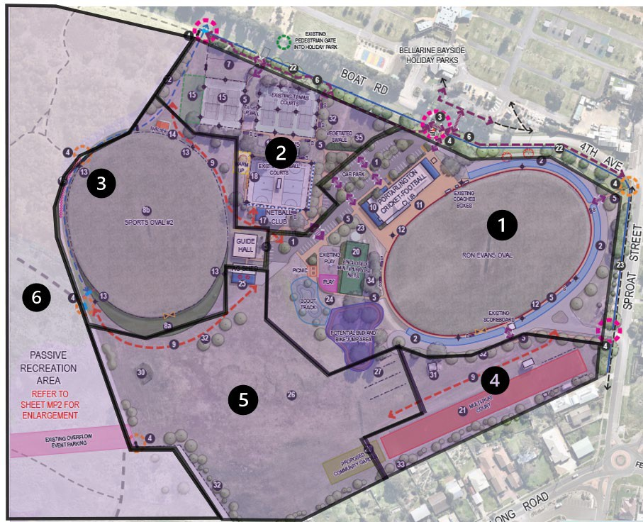

Map 10: Identification of areas used to separate and discuss the Master Plan’s recommendations

Within each area summary is a key to provide the reader with a reference back to the Master Plan Landscape Plan (see pages 46 & 47 of this report). The theme of each recommendation is represented by an infographic. A summary of these graphics can be found below.
Alongside each recommendation is also an indicative cost. Costs have been derived from a Quantity Survey undertaken in March 2022.

Sporting Facilities | Accessibility and Site Connectivity | Park Infrastructure and Open Space | Landscaping and Environment
 |  |  | 

AREA 1

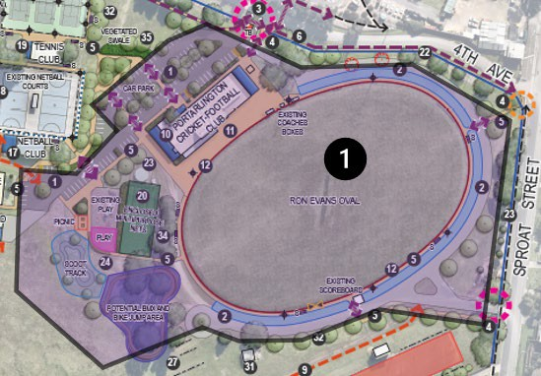 | - Main (Football/Cricket) Pavilion  - Oval 1  - Play Space  - Cricket Practice Nets  - Car Parking and Vehicles  - Reserve Entrances, Frontages and Pedestrians

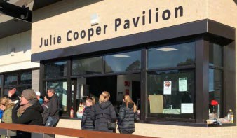
MAIN (FOOTBALL/CRICKET) PAVILION
A refurbishment and extension to the main pavilion is recommended to improve the core functions of the building. Whilst the pavilion has good structure and size, amendments to the player and umpire facilities will ensure the building is consistent with modern standards. This includes the provision of all gender, universally designed change rooms and amenities. Small improvements are also recommended for the kitchen, kiosk and foyer/entrance areas to improve functionality and accessibility. Upgrades to the internal social room toilets is also likely to be required to ensure building code requirements are met. Consideration should also be given to providing externally accessible toilets for broader community use outside of scheduled activities.
Sample image

Landscape Plan  ID | Recommendation | Key themes | Cost
10 | Upgrade the main pavilion based around improvements to the kitchen, bar, accessible toilets, changerooms, player amenities, fist aid and umpire facilities to address gender accessibility, compliance with current code requirements and enhance the functionality of the main social rooms. The enhancement and/or extension to the second storey of the main pavilion may be considered however club and/or external funding must be sought. |  | $1.53 m
11 | Extension of existing spectator area to Ron Evans Oval in line with pavilion upgrade. |  | $205,000

OVAL 1
Recommendations for Oval 1, also known as Ron Evans Oval, include improvements to the informal parking area around the oval’s perimeter. This recommendation aims to improve pedestrian and spectator safety, as well as create efficiencies in traffic flow and vehicle movement. Improved parking areas will assist in removing the current ad-hoc flow of cars and informal tracks throughout the Reserve. It is recommended that the perimeter parking however remain unsealed to retain the character of the Reserve. In addition, consideration should be given to the installation of a new oval perimeter fence to improve visual amenity, condition and reduce ongoing maintenance liability.
Landscape Plan  ID | Recommendation | Key themes | Cost
2 | Standardise informal car parking around Ron Evans Oval, utilising existing informal tracks and desire lines to provide distinction between vehicle and pedestrian movement. Include traffic calming measures/safe pedestrian crossing points. |  | $132,000
12 | When required, replace the main oval fence with suitable materials that reflect the character of the reserve but are long-lasting and sustainable. |  | $138,000

PLAY SPACE
Providing additional supporting infrastructure to the existing play space is recommended within the Master Plan to produce greater amenity and increase play offerings for a broader age range of children. Opportunities to explore additional play and active recreation components along with supporting infrastructure for park users, including parents, children and teens of all genders, will add to the broader value of this area. The existing playground serves the precinct well and will continue to be upgraded and maintained as per the City’s cyclical programs. Toilets and amenities to service the play area are recommended to be incorporated into the design of the main pavilion and/or the extension to the netball pavilion which are both in close proximity. The play space will continue to be supported with opportunities for informal recreation and unstructured play in the adjacent open space area. There is also opportunity to extend park furniture to include suitable facilities for picnics etc.

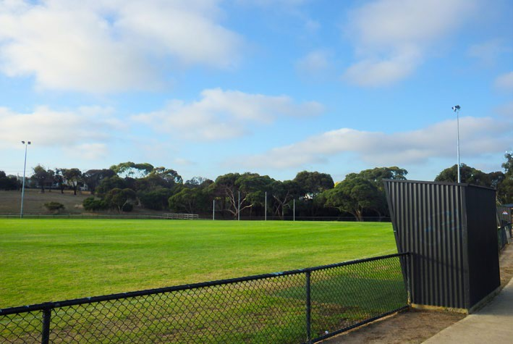
Sample image

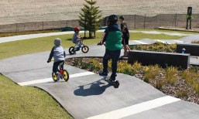
Sample image

Landscape Plan  ID | Recommendation | Key themes | Cost
24 | Improve passive recreation opportunities by providing new picnic area, scoot track targeted at younger children and potential BMX and bike jump area. Consider providing additional play opportunities for teenagers such as bouldering wall or other suitable activity for all genders. Ensure suitable buffer to the car park to maintain safety. |  | $650,000
CRICKET PRACTICE NETS  The Master Plan recommends the redevelopment of the existing cricket nets and the construction of a new, safer and multi-purpose facility that can facilitate cricket training as well other activities such as basketball, and/or as a warm up area for netball. It is recommended that the new facility is enclosed to enhance the safety of Reserve users. Investigating alternate solutions for water tanks presently located to the north of the cricket nets may improve sightlines and visual amenity of this area. |  | 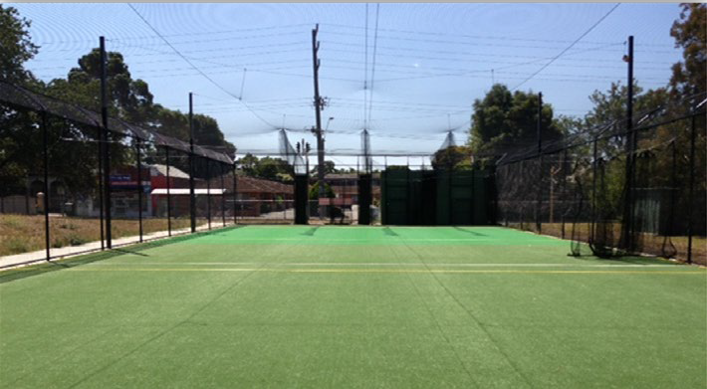  Sample image
Landscape Plan  ID | Recommendation | Key themes | Cost
20 | Consider fully enclosing existing cricket nets to increase safety. Consider incorporating basketball half court line marking, backboard, and ring to allow multi-purpose use of the nets. The enclosed facility is to meet Cricket Australia guidelines for a local level facility and ensure suitability within the main playground area. |  | $303,000

CAR PARKING AND VEHICLES
Widespread improvements to car parking and vehicle movement is recommended throughout the Master Plan, including within Area 1. These recommendations aim to improve traffic flow and organisation of vehicle management throughout the Reserve and maintain access for emergency vehicles. The recommendations aim to keep vehicles on designated roads and car parks, and to improve the safety of all pedestrians and encourage more active modes of travel. The Master Plan has proposed accomodating the majority of cars through a centralised car park, with up to 100 car parking spaces to service the main pavilion, tennis facilities, netball facilities, Oval 2, Guide Hall, Agricutural Society Shed and play space. The car park will have the ability to
be constructed in a staged fashion where necessary.

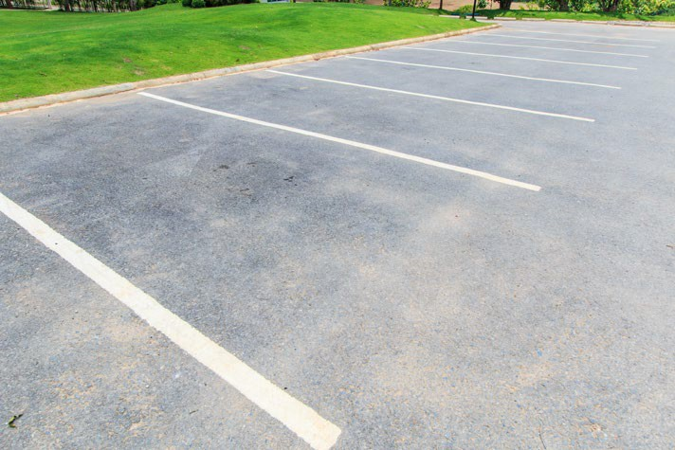
Sample image

Landscape Plan  ID | Recommendation | Key themes | Cost
1 | Formalise and expand the car park at the main entry utilising the existing car park and gravel road alignment. Include garden bed planting, trees and lighting. Construction of the car park could potentially occur in two stages. Include traffic calming measures/safe pedestrian crossing points/vehicular exclusion. |  | $379,000

RESERVE ENTRANCES, FRONTAGES AND PEDESTRIANS
Improved entrances to the Reserve will contribute to its overall visual appeal and better management of pedestrians. This includes during regular, daily use of the Reserve as well as levels of increased visitation, such as annual events, holiday periods and football and cricket matches and finals.
The use of signage and separating pedestrians and vehicles where appropriate will contribute to safer outcomes for all users. Improvements to pathways that are compliant with guidelines for people of all abilities are also essential. The provision of enhanced crossing points, connections to neighbouring residential areas and the Bellarine Bayside Holiday Park will provide a safer and more enjoyable experience for all.
The main entrance off Boat Road is recommended to be improved both functionally and

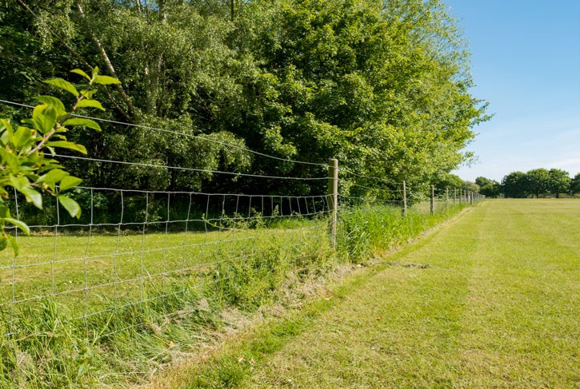
Sample image

visually and will be the main entry point to the Reserve and car park. Secondary entrances from Boat Road are recommended to be utilised to service the proposed informal car park for the tennis club in the event that overflow parking is required.
Emergency vehicle access points will be available to service all areas from the main entrance from Boat Road, with all facilities accessible from this entry point.
Maintenance vehicle access points will remain accessible via the main entrance for the active Reserve precinct, as well as via the current access point on Boat Road into the passive recreation area.

Landscape Plan  ID | Recommendation | Key themes | Cost
3 | Formalise the main entry by providing a new ticket booth, landscaping and consolidating existing signage and improving emergency services access. |  | $50,000
4 | Provide feature landscaping and signage to pedestrian entry points into the Reserve and into the passive recreation area. Install dog litter bins at trailheads into passive recreation area. |  | $50,000
5 | Provide pedestrian connections throughout the Reserve which are DDA compliant and provide universal access. Ensure safe pedestrian crossings/traffic calming measures are incorporated at vehicular conflict points. |  | $482,000
6 | Provide a pedestrian pathway along the northern side of the Reserve to improve connectivity to surrounding areas including the passive recreation area, Holiday Park and Sproat St. Consider a safe pedestrian crossing to Boat Road at the main entry and continue to liaise with Bellarine Bayside to provide signage and connections to the Holiday Park. |  | $482,000
22 | Provide new boundary fencing along Boat Road, 4th Avenue and Sproat Street to improve visual amenity while restricting vehicles and pedestrians to allocated entry points. |  | $181,000

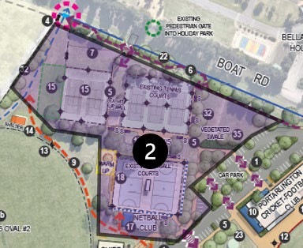
AREA 2

- Tennis Courts
- Tennis Club Rooms
- Netball Club Rooms and Courts
- Open Space Area (east of tennis courts)

TENNIS COURTS
The three existing tennis courts directly north of the tennis club rooms are currently well provisioned with good quality surface, fencing and sports lighting to competition standard. There is opportunity however for the remaining two tennis courts to the west to undertake surface and lighting upgrades to provide greater programming opportunities. There is also opportunity to identify a space for a sixth tennis court to the western bank of the existing courts to facilitate future participation if demand necessitates.

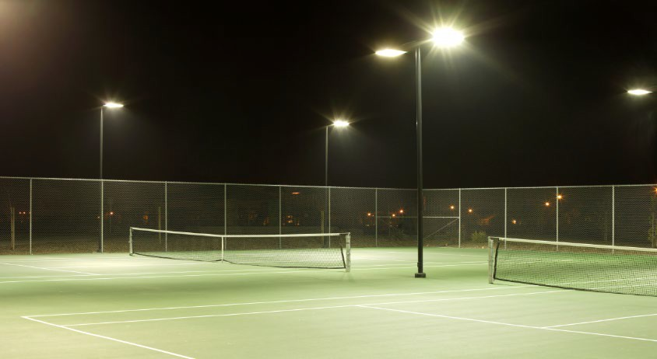
Sample image

Landscape Plan  ID | Recommendation | Key themes | Cost
15 | Provide new sports lighting and surface upgrade to existing western tennis courts and make allowance for a potential sixth court if demand necessitates. |  | $442,000
7 | Retain existing overflow parking north of tennis courts and consider formalising if wear and tear warrants. |  | $28,000

TENNIS CLUB ROOMS
A small extension to the existing tennis club rooms is recommended to ensure amenities meet accessible, modern standards. The proposed extension will include the demolition of the existing amenities block attached to the tennis club rooms, and the construction of new, compliant facilities. Additional access points via the proposed pathway network will provide better access and egress into the facility.

Landscape Plan  ID | Recommendation | Key themes | Cost
19 | Consider an extension to existing tennis club pavilion to ensure that amenities are meeting modern day and accessible standards. |  | $160,000

NETBALL CLUB ROOMS AND COURTS
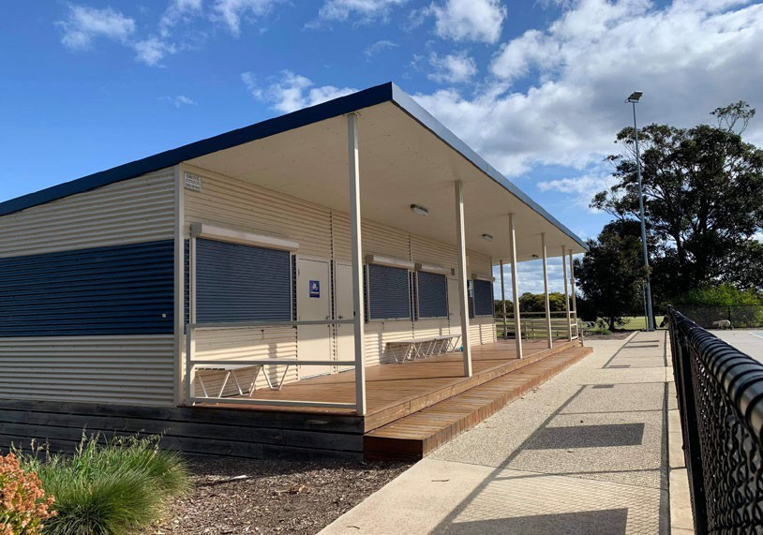
Whilst netball is well provisioned with new, modern courts and club rooms, there is a small deficiency in the size of the change facility. The current rooms are slightly undersized in accordance with Netball Victoria’s facility guidelines for local level venues. A small extension, utilising a similar, modular construction would see the facility present greater functionality and flexibility. This includes providing dedicated umpire change rooms and improved storage areas. An extension to the facility can be made to the east or west of the existing building and should consider the provision of an externally accessible toilet to support Oval 2 and the play space. In addition, the provision of a formalised warm up court and spectator area for netball, by way of 3-tiered seating, would enhance amenity for supporters and players. Some surface improvements to the netball courts would also address some concerns over wear and tear.

Landscape Plan  ID | Recommendation | Key themes | Cost
17 | Consider extension to existing netball club pavilion to ensure it meets the recommended guidelines outlined by Netball Victoria for a local level facility. Extension to the end of the pavilion will likely require tree removal. |  | $320,000
18 | Provide additional warm up half court, 3-tier spectator seating and surface improvements to existing netball courts. |  | $350,000

OPEN SPACE AREA (EAST OF TENNIS COURTS)
The open space/grassed area between the existing tennis courts and main entrance is utilised during the Bellarine Agricultural Show for display purposes. The area is also important to the Reserve’s drainage function, capturing run off from the car park and both tennis and netball courts. To improve its function, and to maintain the area’s importance for events, the Master Plan recommends the incorporation of a vegetated swale drain.
The swale would consider an appropriate location that does not encroach onto the area utilised for the Show and utilise water sensitive design principles to minimalise environmental impacts.

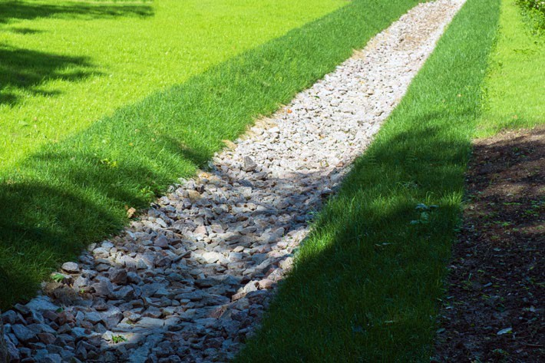

Sample image

Landscape Plan  ID | Recommendation | Key themes | Cost
35 | Provide water sensitive urban design (WSUD) in the form of a vegetated swale to capture car park run-off and to target drainage issues that currently occur between tennis club building and the existing car park. |  | $50,000

AREA 3

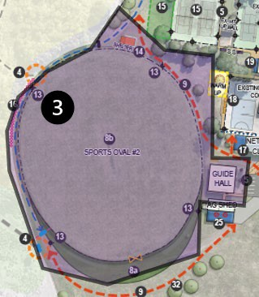 | - Oval 2 and surrounds

OVAL 2 AND SURROUNDS
The Master Plan includes recommendations for this area which are focused around Oval 2. This includes consideration towards the inclusion of sports lighting on this oval. Sports lighting, commensurate with AFL guidelines for local level facilities, can provide greater capacity for training, participation and programs, particularly during the winter months. The provision of lighting however needs to be supported by a detailed analysis of future use, to demonstrate the return on potential investment (both social and financial).
Furthermore, investigations into the expansion of Oval 2, particularly its length to the south of its existing boundary, could assist in further facilitation of participation should demand necessitate.
To support participation and the amenity of spectators, it is also recommended that the existing shelter on Oval 2 be replaced. It is recognised that a new, basic structure would replace the existing shelter which is nearing the end of its useful life.

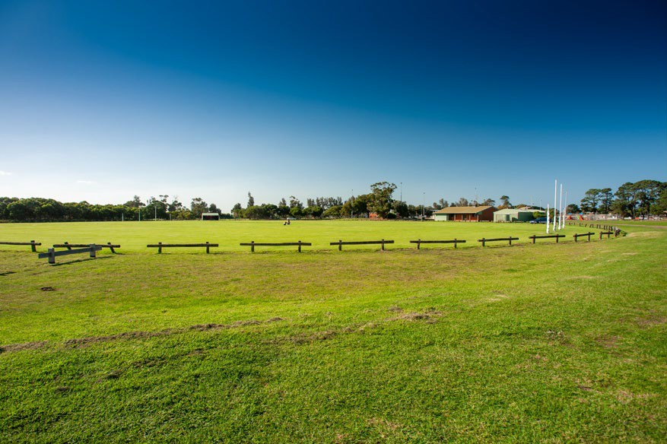

Sample image

Landscape Plan  ID | Recommendation | Key themes | Cost
13 | Consider providing new sports lighting to Oval 2 to enable it to accommodate overflow from Ron Evans Oval (i.e. Oval 1). |  | $320,000
14 | Provide a new shelter to Oval 2. |  | Recommendation has been funded
9 | Shared access managed for events. |  | Nil cost. Operational recommendation
16 | Provide soft netting to the north-eastern side of Oval 2 to prevent errant balls from entering the vegetated area. |  | $80,000
8a | Further investigate the feasibility of extending Oval 2 to the south to create a larger oval. |  | $200,000
8b | Upgrade wicket to CA standards once pitch reaches end of useful life. |  | $35,000

AREA 4

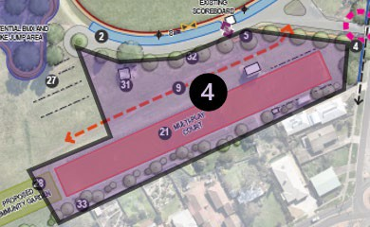 | - Multi-play courts  - Public toilets  - Tree canopy and landscaping

MULTI PLAY COURTS
It is recommended that a portion of the old asphalt netball courts be transformed into multi play courts that can host a range of recreational activities such as netball, basketball and futsal. Access through this area should be maintained, however primarily for events and for CFA use. Exploration into opportunities to consolidate or repurpose the old netball club rooms alongside the multi-court area should be considered.

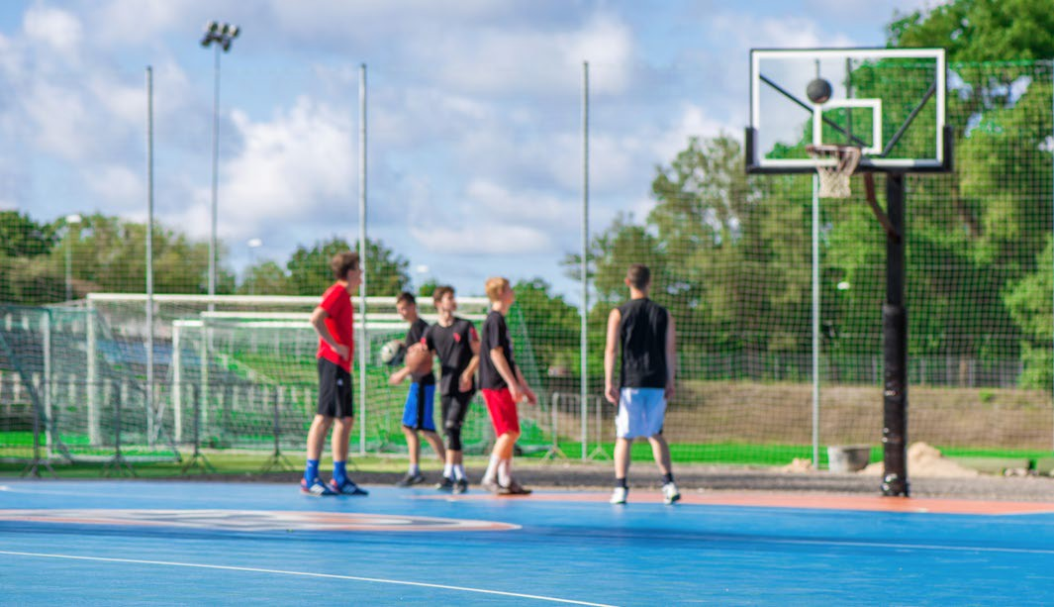
Sample image

Landscape Plan  ID | Recommendation | Key themes | Cost
21 | Consider undertaking surface improvements and providing multi- use line marking and goals to the former asphalt netball courts. Opportunity for area to be available for CFA use. |  | $105,000

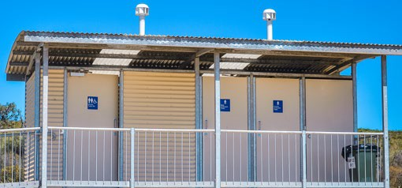
PUBLIC TOILETS
The existing public toilet block, located north-west of the old asphalt netball Courts, is reaching the end of its useful life as it no longer meets the expectations or standards of a modern facility. It is recognised that these public toilets are utilised during events, particularly the Bellarine Agricultural Show, and anticipated to be used by the proposed community garden. Therefore, it is
recommended that this facility is replaced once the asset is no longer fit for purpose
.

Sample image
Landscape Plan ID
Recommendation
Key themes
Cost
31
Retain existing toilet block and replace at end of useful life.
$250,000

TREE CANOPY AND LANDSCAPING
Improving landscaping throughout the Reserve will create a better aesthetic, deliver more shade for users and generate enhanced environmental properties. Selecting trees which are consistent with the biodiversity of the area as well as those which can connect and provide a sense of unity between the active recreation and passive recreation areas is recommended. Additional tree planting will contribute to a cooler and greener parkland and municipality, which is both a priority of the Victorian Government and the City of Greater Geelong.
Landscaping throughout the Reserve should connect to the local identity and context and be strategically placed throughout. Selecting species that are fit for purpose, can be well managed and maintained, and that do not impede on sightlines and on key activity areas throughout the Reserve is recommended.

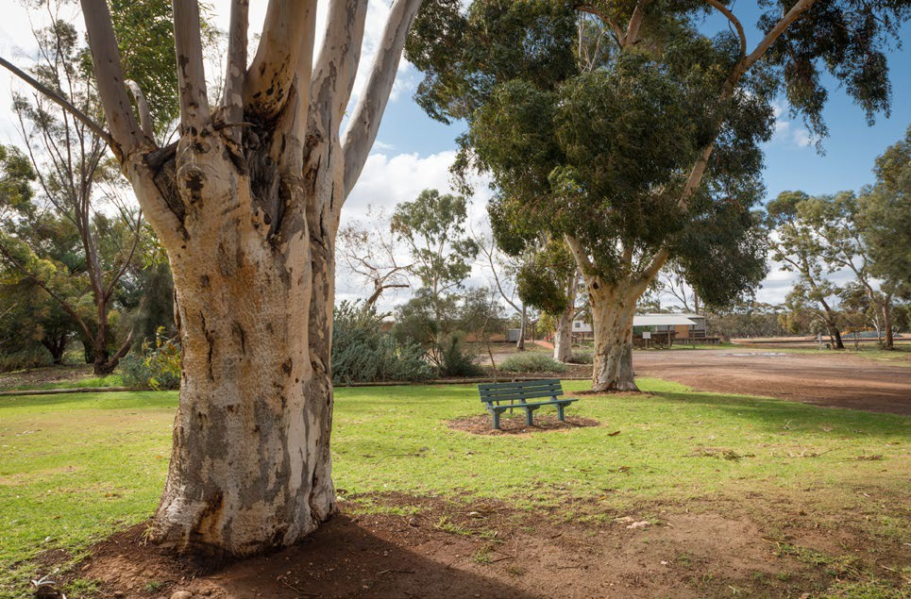
Sample image

Whilst the subject of providing additional tree canopy and landscaping is discussed within this specific area of the Reserve, it remains a common theme throughout the Master Plan and should be given an equal and holistic approach to its implementation.

Landscape Plan  ID | Recommendation | Key themes | Cost
32 | Provide new canopy trees which are consistent with the biodiversity of the area to provide shade, blur the boundary between the Reserve and the passive recreation area, and to increase the vegetation and character of the site. |  | $26,000
33 | Provide low tree and shrub planting on southern boundary residential fences to improve visual amenity while also maintaining sightlines and reducing maintenance, fire hazard and likelihood of snakes. Species to be consistent with the biodiversity of the area. |  | $40,000

AREA 5
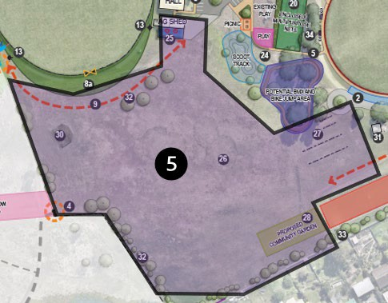

- Events/Open Space Area
- Community Garden

EVENTS/OPEN SPACE AREA/COMMUNITY GARDEN
The existing Events/Open Space area makes the Reserve unique, providing it with the ability to host broader community events including the Bellarine Agricultural Show.
Recommendations within the Master Plan include expanding the existing shed utilised by the Agricultural Society, to enable greater function and utilisation.
Further investigation into a community garden for the south-eastern corner is proposed to assess opportunities to provide a more diverse range of participation opportunities and community activities.
In addition, supplementary tree canopy around the perimeter of the area that does not encroach into the programmable event space will be important. The overall retention of this open space area aligns with broader open space planning principles regarding the

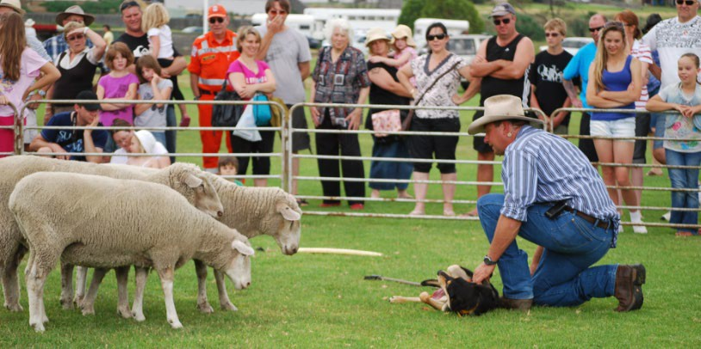
(Image courtesy of the Bellarine Agricultural Show)

value of green infrastructure and offering greater non-structured recreation including activities such as kite flying, dog walking and informal play. To improve the quality of the events area, opportunities to level and fill (where appropriate) the grassed area surface will further support show activities and other future opportunities.

Landscape Plan  ID | Recommendation | Key themes | Cost
25 | Provide a duplication of the current Agricultural Shed as a new footprint adjoining the current shed. |  | $143,000
26 | Investigate options to level the event space to create more multi- use options. |  | $150,000
28 | Investigate establishing a community garden at the western end of old netball courts. |  | $200,000

AREA 6
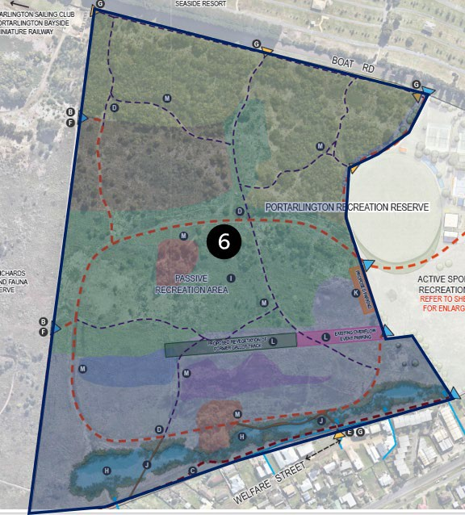
- Passive recreation area

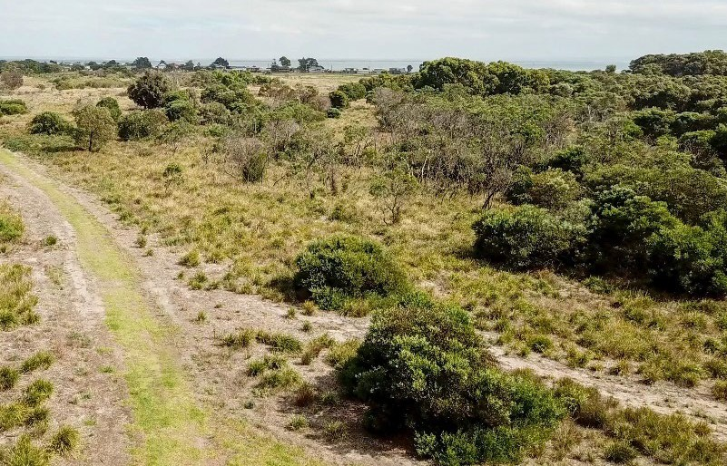
PASSIVE RECREATION AREA
The whole of the passive recreation area has significant value as a large patch of native vegetation that is limited across the Bellarine Peninsula. The area varies in its condition, however as a whole it holds significant environmental value through the combination of depleted EVC’s, rare and threatened species, wetland values and habitat. Legislation and policy require that the area is currently managed for those values, which is consistent with the City’s Environment Strategy.

Assessment process
Should there be an identified need to remove native vegetation in this area for another purpose, the proponent (the City or a person with consent from the City) will need to apply for a Planning Permit under Clause 52.17 of the Planning and Environment Act 1987. In addition, any proposal may also trigger the need to apply for a permit under the Flora and Fauna Guarantee Act 1988 and also be referred to the Commonwealth to assess if plans significantly
impact on matters of national significance under the EPBC Act 1999.

Assessment of need
As land manager, the City’s obligations are to avoid impacts to native vegetation in line with the objectives of the Native Vegetation Management Framework.
An assessment of the existing facilities, provision standards, benchmarking, changes in population and current and future demand indicate that the existing provision of sporting infrastructure at Portarlington Recreation Reserve is largely sufficient to meet future need. The assessment indicates that any new infrastructure for active sport can be met within the active sport and recreation precinct. A range of other recreation opportunities can be undertaken in the passive recreation area including walking, dog walking, running, trail running, cycling, nature appreciation and bird watching.
Page 2 of the Master Plan – Landscape Plan (see page 47) outlines the recommendations for the passive recreation area. As an expansive precinct, this area offers ample opportunity to improve the biodiversity and environmental properties of the Reserve, whilst creating an enhanced visitor experience, and encouraging more activities and recreational pursuits. The Master Plan has acknowledged the importance of balancing community access and use of the area for activities including overflow parking, in conjunction with protecting the vast environmental values of the area.

Accessibility and Site Connectivity
An improved and consolidated trail network, including wayfinding and interpretative signage will attract and enhance the local community’s connection with the area whilst providing greater protection to the areas under greatest threat.
Improved pedestrian access via Traum and Welfare Streets, will promote more foot traffic and active modes of off-road travel, including recreational cycling. Connecting trails aim to improve the interface with Point Richards Flora & Fauna Reserve, the active sporting and recreation area and surrounding residential areas. It is recommended that a variety of made and unmade trails be incorporated to encourage recreation and active travel, as well as offer passive experiences and to deter users from creating informal tracks through vegetated areas.
The Master Plan recommends retaining a large portion of the existing overflow parking area, also known as the ‘old gallop track’, as well as establishing an additional parking area on the fence line that borders the open space/events area. This recommendation aims to provide better connection and proximity for events, whilst minimising the environmental impact on the passive recreation area.
The Master Plan does not make any recommendation for the re-opening of former horse trails following consultation with stakeholders and the recommendations within the Portarlington Recreation Reserve Master Plan Environmental Report (2020).

Landscape Plan  ID | Recommendation | Key themes | Cost
D | Consolidate existing trails for pedestrians and cyclists. Primary trails to be potentially graveled for shared fire, maintenance, pedestrian and cyclist use. Secondary trails to largely remain as grass track for pedestrian and cyclist use only. |  | $200,000
E | Provide pedestrian stair access to the Reserve from Welfare Street. |  | $40,000
F | Continue to liaise with Bellarine Bayside to provide improved and consistent signage connections to Point Richards Reserve. |  | $10,000
G | Provide signage, rubbish bins and dog litter bins at access points into the passive recreation area. Signage to depict ways to sustainably explore the precinct. |  | $20,000
J | Investigate providing a boardwalk over new wetland area to provide recreational and educational opportunities as well as a potential connection to Welfare Street and residential areas |  | $500,000
K | Create a parking area for access to the passive recreation area that also functions as event parking. |  | $55,000
L | Set aside the area marked within the passive recreation area for temporary event parking. Permit conditions will apply.  Encourage regeneration of indigenous vegetation west of this area along the former gallop track. |  | $5,000
M | Develop interpretative signage regarding flora and fauna values at the Reserve in consultation with the Bellarine Bayside Committee. Provide interpretative signage and seating at key locations in the passive recreation area which depict the various Ecological Vegetation Classes. |  | $35,000

Weed, Environment and Biodiversity Management
The Draft Portarlington Recreation Reserve Works Plan (2016) and the Portarlington Recreation Reserve Master Plan Environmental Report (2020) remain important reference points and guiding documents for the area, particularly regarding the management of existing vegetation communities, weeds and flora and fauna. Within the passive recreation area, there are environmental and ecological values of varying degree, which presents opportunities to improve condition and quality as well as enhance education and knowledge of the importance of the area to the community.
Broad scale weed control to address specific weed threats in areas identified as having high environmental properties will continue to be an ongoing management priority. Encouraging the regeneration of highly disturbed areas, such as the western portion of the ‘old gallop track’ with indigenous species is recommended. Targeted revegetation and indigenous tree planting within the area, in partnerships with local community groups, is also recommended to encourage regeneration and improve value of the area.
Surveying, monitoring and evaluating flora and fauna changes as a result of management activities will create a measure of success, as well as a continued focus on identifying opportunities for improvement over the life of the Master Plan.
The establishment of sediment ponds and deeper wetland pools at the southern end of the area aims to create and expand habitat whilst providing drainage solutions and improving stormwater management and quality. Including pollutant traps within the future design of the wetlands will assist in preventing stormwater pollution from entering the waterway. The establishment of a boardwalk area across the wetland area which connects to proposed pedestrian connection points to residential areas is also recommended.

Landscape Plan  ID | Recommendation | Key themes | Cost
H | Investigate establishing a system of sediment ponds and deeper wetland pools at the southern end of the Reserve to improve stormwater quality management, biodiversity values and expand habitat for the Growling Grass Frog and other threatened fauna. Stormwater outlets entering the Reserve from adjoining residential areas to have gross pollutant treatment traps. |  | $2m

Collaborative Management
Recommendations include continuing to liaise with adjacent land managers, Bellarine Bayside Foreshore Committee, in collaborative management of both the passive recreation area and the Point Richards Flora & Fauna Reserve. Recommendations to improve connectivity between the two sites will increase the value of the two land parcels as well as ensure access for maintenance and emergency vehicles remains.

Landscape Plan  ID | Recommendation | Key themes | Cost
A | Liaise with Bellarine Bayside to improve fire and maintenance access into the Reserve from Traum Street. Investigate the steepness of Traum Street. Investigate the steepness of Traum Street and the viability of providing pedestrian access into the Reserve including a viewing platform and fencing on the north side of the path to stop dogs entering Point Richards Reserve. |  | $250,000
B | Work in partnership with Bellarine Bayside to improve fire management and access into the western side of the passive recreation area from Point Richards Reserve. |  | $30,000
C | Provide maintenance and fire access along southern boundary including gated access into the active sport and recreation area. Coordinate with the proposed potential wetland works and location of stormwater outlets. Work closely with traditional owners in the implementation management of the reserve. |  | $100,000
I | Continue to maintain and improve environmental conditions within the passive recreation area in line with recommendations for the Portarlington Recreation Reserve Environmental Report October 2020. |  | $50,000

IMPLEMENTATION SCHEDULE
The following table outlines each individual recommendation within the Master Plan and provides indicative capital costs for implementation as well as priority. Note that the following exclusions and assumptions have been applied within the cost estimates provided below:
    - Costs below do not include any allowances for non-construction costs.
    - Costs below are current as of March 2022 using the best available information and do not include contingency or cost escalations that would need to be applied at the time of funding these projects.
    - The cost plan is indicative only of the possible order of cost. All components of the cost plan are subject to further detailed design and investigation and would need to be confirmed at that point.

ACTIVE SPORT AND RECREATION AREA
Landscape Plan ID | Recommendation | Theme | Cost Estimate | Priority | Comments
ACCESSIBILITY AND SITE CONNECTIVITY
1 | Formalise and expand the car park at the main entry utilising the existing car park and gravel road alignment. Include garden bed planting, trees and lighting.  Approximately 100 proposed car parking spaces. Construction of the car park could potentially occur in two stages. Include traffic calming measures/safe pedestrian crossing points/vehicular exclusion. |  | $429,000 | High | Will assist in managing drainage, safety and functionality of main hub and access to key sporting areas.
2 | Standardise informal car parking around Ron Evans Oval, utilising existing informal tracks and desire lines, to provide distinction between vehicle and pedestrian movement. Include traffic calming measures/safe pedestrian crossing points. |  | $132,000 | Medium | Will support enhanced safety and access around the main oval.
3 | Formalise the main entry by providing a new ticket booth, landscaping and consolidating existing signage, maintaining appropriate emergency services access. |  | $50,000 | Medium | Supports improved safety and presentation of the Reserve and functionality during events.
4 | Provide feature landscaping and signage to pedestrian entry points into the Reserve and Passive Recreation Area. Install dog litter bins at trailheads into the Passive Recreation Area. |  | $50,000 | Low | Enhances amenity and presentation of the Reserve.
5 | Provide pedestrian connections throughout the reserve which are DDA compliant and provide universal access. Ensure safe pedestrian crossings/traffic calming measures are incorporated at vehicular conflict points. |  | $582,000 | High | Should be considered in conjunction with car park works to improve safety and access.
6 | Provide a pedestrian pathway along the northern side of the Reserve to improve connectivity to surrounding areas including the Passive Recreation Area, Holiday Park and Sproat Street. Consider a safe pedestrian crossing to Boat Road at the main entry and continue to liaise with Bellarine Bayside to provide signage  connections to Holiday Park. |  | $582,000 | High
7 | Retain existing overflow parking north of tennis courts and consider formalising if wear and tear warrants it. |  | $28,000 | Low | Will require ongoing monitoring to determine when to action.

8a | Further investigate the feasibility of extending Oval 2 to the south to create a larger oval. |  | $200,000 | Medium
8b | Upgrade synthetic wicket to CA standards when pitch is at end of useful life. |  | $35,000 | Medium
9 | Shared access managed for events. |  | Nil | Ongoing | Operational recommendation.
SPORTING FACILITIES
10 | Upgrade the main pavilion based around improvements to the kitchen, bar, accessible toilets, changerooms, player amenities, first aid and umpire facilities to address gender accessibility, compliance with current code requirements and enhance the functionality of the main social rooms. |  | $1.523m | High | Is identified as a priority to ensure building is fit for purpose for current and future use.
11 | Extension of existing spectator area to Ron Evans Oval in line with pavilion upgrade. |  | $205,000 | High | Is to be considered in conjunction with pavilion works to create more inviting space between oval and  pavilion.
12 | When required, replace the main oval fence with suitable materials that reflect the character of the reserve but are long-lasting and sustainable. |  | $138,000 | High | Addresses asset condition issues and character of the Reserve.
13 | Consider providing new sports lighting to Oval 2 to enable it to accommodate overflow from Ron Evans Oval. |  | $320,000 | Medium | Will support greater capacity for training.
14 | Provide a new shelter to Oval 2. |  | N/A | High | Recommendation has been funded.
15 | Provide new sports lighting and surface upgrade to existing western tennis courts and make allowance for a potential sixth court if demand necessitates. |  | $442,000 | Medium | Will create additional capacity for club and community use as demand  grows.
16 | Provide soft netting to the north-east side of Oval 2 to prevent errant balls from entering vegetated area. |  | $80,000 | High | Enhances safety for participants using Oval 2.
17 | Consider an extension to existing netball club pavilion to ensure it meets the recommended guidelines outlined by Netball Victoria for a local level facility. Extension to the end of the pavilion will likely require tree removal. |  | $320,000 | High | Will create a more functional pavilion to meet current standards.
18 | Provide additional warm up half court, 3-tier spectator seating and surface improvements to existing netball courts. |  | $350,000 | Medium | Enhances quality of netball facility for players and spectators.

19 | Consider an extension to existing tennis club pavilion to ensure that amenities are meeting modern day and accessible standards. |  | $160,000 | Medium | Will create a more functional pavilion to meet current standards.
20 | Consider fully enclosing existing cricket nets to increase safety. Consider incorporating basketball half court line marking, basketball and netball rings to allow multi-purpose use of the nets. The enclosed facility is to meet Cricket Australia  guidelines for a local level facility and ensure suitability within main playground area. |  | $303,000 | High | Enhances safety and multi-use options in the Reserve.
21 | Consider undertaking surface improvements and providing multi-use line marking  and goals to the former asphalt netball courts. Opportunity for area to be available for CFA use. |  | $105,000 | Low | Enhances safety and multi-use options in the Reserve.
PARK INFRASTRUCTURE AND OPEN SPACE
22 | Provide new boundary fencing along Boat Road, 4th Avenue and Sproat Street to improve visual amenity while restricting vehicles and pedestrians to allocated entry points. |  | $181,000 | Low | Improves amenity and presentation of Reserve. Should be considered in conjunction with path works.
23 | Investigate alternative solutions for water tanks north of the cricket nets. |  | $50,000 | Low | Seeking to improve amenity.
24 | Improve passive recreation opportunities by providing new picnic area, scoot track targeted at younger children and potential BMX and bike jump area. Consider providing additional play opportunities for teenagers such as a bouldering wall or other suitable activity for all genders. Ensure suitable buffer to the car park to maintain safety. |  | $650,000 | Medium | Creates an attractive destination for a more diverse group of users.
25 | Provide a duplication of the current Agricultural Shed as a new footprint adjoining the current shed. |  | $143,000 | Medium | Enhances the functionality for group and events.
26 | Investigate options to level the event space to create more multi-use options. |  | $150,000 | Low | Improves safety and enhances multi- use.
27 | Retain existing cattle/horse tie up rails and replace with like for like at the end of their useful life. |  | $15,000 | Low
28 | Investigate establishing a community garden at the western end of the old netball courts. |  | $200,000 | Medium | Part of ongoing investigations to diversify community use.
29 | Provide additional seating around the Reserve at regular intervals as indicated on this plan. Upgrade existing seats if required. Seats to have back and arm rests and be aesthetically consistent across the Reserve. |  | $42,000 | Medium | Enhances amenity across Reserve.
30 | Retain existing loading ramp. |  | Nil | Ongoing | Existing feature and no works are proposed.
31 | Retain existing toilet block and replace at end of useful life. |  | $250,000 | Low

LANDSCAPING AND ENVIRONMENT
32 | Provide new canopy trees which are consistent with the biodiversity of the area to provide shade, blur the boundary between the Reserve and the Passive Recreation Area, and to increase the vegetation character of the site. |  | $26,000 | High | Part of ongoing investigations to diversify community use
33 | Provide low tree and shrub planting on southern boundary residential fences to improve visual amenity while also maintaining sightlines and reducing maintenance, fire hazard and likelihood of snakes. Species to be consistent with the biodiversity of  the area. |  | $40,000 | Medium | Enhances amenity across Reserve.
34 | Consider the removal of a select number of existing cypress trees to allow for cricket net expansion. |  | $30,000 | Medium | Addresses safety and functionality needs for cricket nets.
35 | Provide water sensitive urban design (WSUD) in the form of a vegetated swale to capture car park run-off and to target drainage issues that currently occur between tennis club building and the existing car park. |  | $50,000 | Low | Should be considered in conjunction with car park works.

 |  | PASSIVE RECREATION AREA
Landscape Plan ID | Recommendation |  |  | Cost Estimate | Priority | Comments
ACCESSIBILITY AND CONNECTIVITY
A | Liaise with Bellarine Bayside to improve fire and maintenance access into the Reserve from Traum Street. Investigate the steepness of Traum Street and the viability of providing pedestrian access into the Reserve including a viewing platform and fencing on the north side of the path to stop dogs entering Point Richards Reserve. |  |  | $250,000 | High | Important preventative action in partnership with Bellarine Bayside.
B | Work in partnership with Bellarine Bayside to improve fire management and access into the western side of the Passive Recreation Area from Point Richards Reserve. |  |  | $30,000 | Medium | Important preventative action in partnership with Bellarine Bayside.
C | Provide maintenance and fire access along southern boundary including gated access into the Active Recreation Area. Coordinate with the proposed potential wetland works and location of stormwater outlets. |  |  | $100,000 | Medium | Important preventative action in partnership with Bellarine Bayside.
D | Consolidate existing trails for pedestrians and cyclists. Primary trails to potentially be gravelled for shared fire, maintenance and pedestrian use. Secondary trails to largely remain as grass tracks. Area to south of old gallop track subject to inundation - exact make up of tracks to be determined. |  |  | $200,000 | High | Enhances experience and diversity of use.
E | Provide pedestrian stair access to the Reserve from Welfare Street. |  |  | $40,000 | Medium | Enhances community accessibility.

F | Continue to liaise with Bellarine Bayside to provide improved and consistent signage and connections to Point Richards Flora and Fauna Reserve. |  | $10,000 | Low | Enhances safety and wayfinding.
G | Provide signage, rubbish bins and dog litter bins at access points into the Passive Recreation Area. Signage to depict ways to sustainably explore the precinct. |  | $20,000 | Low | Improves the level of service to the Reserve.
LANDSCAPING AND ENVIRONMENT
H | Investigate establishing a system of sediment ponds and deeper wetland pools at the southern end of the Reserve to improve stormwater quality management, biodiversity values and expand habitat for the Growling Grass Frog and other threatened fauna. Stormwater outlets entering the Reserve from adjoining residential areas to have  gross pollutant treatment traps. |  | $2m | Medium | A significant opportunity to enhance wetland values and amenity but requires considered design response.
I | Continue to maintain and improve environmental conditions within the Passive Recreation Area in line with recommendations from the Portarlington Recreation Reserve Environmental Report October 2020. |  | $50,000 | High | Annual maintenance cost to support the protection of key values and amenity.
J | Investigate providing a boardwalk over new wetland area and potentially other areas subject to inundation to provide recreational and educational opportunities as well as a potential connection to Welfare Street and residential areas. |  | $500,000 | Medium | Enhances visitor experience and access.
K | Create a new parking area for access to the Passive Recreation Area that also functions as event parking. |  | $55,000 | Low | Enhances visitor experience and access.
L | Set aside the area marked within the Passive Recreation Area for temporary event parking. Permit conditions will apply. Encourage regeneration of indigenous vegetation west of this area along the former gallop track. |  | $5,000 | Ongoing | Enhances access during events.
M | Develop interpretative signage regarding flora and fauna values at the Reserve in consultation with the Bellarine Bayside Committee. Provide interpretative signage and seating at key locations in the Passive Recreation Area which depict the various  Ecological Vegetation Classes. |  | $35,000 | High | Enhances understanding and appreciation of values of the Reserve.
TOTAL |  |  | $10.574m



CITY OF GREATER GEELONG

PO Box 104

GEELONG VIC 3220

P: 5272 5272

E: contactus@geelongcity.vic.gov.au

www.geelongaustralia.com.au

CUSTOMER SERVICE CENTRE

100 Brougham Street

