The City Of
Greater Geelong

new commercial food premises

  - a guide for start up and fit out

Contents
Introduction 3
Food Act Registration 3
Class Types 3
Food Safety Programs (FSP) 3
Standard Food Safety Program 4
Independent (non-standard) Food Safety Program 4
Registered Food Safety Program 4
Part One: Planning ahead 5
Volume vs kitchen size 5
Menu 5
Workflow 5
Registration process 6
Part Two: Structural guidelines 7
Surfaces 7
Floors 7
Coving 8
Floor drains 8
Walls 9
Splash backs 10
Ceilings 11
Lighting 12
Food preparation surfaces 13
Sinks 13
Hand wash basin 13
Double bowl sink 14
Dishwasher 14
Food preparation sink 14
Mop sink 15
Jug rinse / sink 15
Storage 15
Cold / frozen storage 15
Shelving options 16
Dry Store 16
Bins / Recycling 17
Ventilation 17
Mechanical ventilation systems 17
Water and sewage 18
Water 18
Sewage 18
Grease traps 18
Toilets 18
Customer toilets 18
Pest Control 19
Part Three: Food Safety 20
Food Safety Training 20
Food Safety Supervisor 20
Staff Training 20
Thermometers 21
Sanitiser 22
Food grade sanitiser 22
Household bleach 4% as a sanitiser 22
Disinfectants 22
Pest Control Program 23
Food Safety Records 23
Part Four: Appendices 24
APPENDIX ONE: Structural requirements checklist 24
APPENDIX TWO: Pre-opening checklist 25
APPENDIX THREE: Additional Contacts 26
Business Assistance 26
City of Greater Geelong Contacts 26
External Contacts 27
Part Five: Glossary of Terms 28

Introduction

This guide is for starting up and fitting out a commercial food premises within the City of Greater Geelong.
The document:
- Provides a brief guide of the food safety and structural requirements for new premises.
- Is aimed at proprietors of commercial businesses but may also be helpful for builders, architects, and project managers involved in the construction, or renovation of a commercial food business.
The information in this document is based on requirements outlined in the Food Act 1984, Chapter 3 of the Australian New Zealand Food Standards Code and Department of Health Victoria.

Food Act Registration
It is a requirement under the Food Act 1984 that any person or business selling food must be registered with their local Council. The Food Act registration is managed by our Environmental Health team whose role is to help food businesses make and sell safe food.

Class Types
We classify every food premises according to their food safety risk. An Environmental Health Officer will help you determine what class your food businesses will fall into once you apply for registration.
Class 1 - Class 1 premises are those that predominately handle potentially hazardous food that is served to vulnerable groups and includes childcare centres, hospitals, and aged care facilities.
Class 2 - Most commercial business fall into this category. Selling and handling high-risk foods.
Class 3 - Some manufacturers, convenience stores and most home-based businesses fall into this category. Predominantly those that handle low-risk foods or pre-packaged potentially hazardous foods.
Class 3A - Accommodation getaway premises selling food for immediate consumption or home-based businesses using a hot-fill process to make chutney, relish, salsa, tomato sauce etc.
Class 4 - Foods that pose a low risk to public including uncut fruit and vegetables, bottle shops, unpackaged drinks such as coffee, tea, soft drink and alcohol and pre-packaged shelf stable foods.
For a more extensive description of class types, visit Food Classifications

Food Safety Programs (FSP)
In Victoria, all Class 1, and some Class 2 and 3 food premises need a Food Safety Program.
A Food Safety Program is a written plan that shows what a business does to ensure that the food it sells is safe for people to eat. It is an important tool to help businesses safely handle, process, or sell potentially hazardous foods and maintain safe food handling practices to protect public health.
Class 2 food services and retail food premises are now exempt from the requirement to have a Food Safety Program unless they are undertaking any of the following eight high-risk food handling activities
- Sous vide cooking, (cooking at less than 75 °C) where the food is cooked under controlled temperature and time conditions inside vacuum sealed packages in water baths or steam ovens.
- Any potentially hazardous food that does not involve temperature control to minimise the growth of pathogenic or toxigenic organisms as described in Australia and New Zealand Food Standards Code, Standard 3.2.2
- Preparation of acidified/fermented foods or drinks that are ready to eat and have a high level of acidity required to keep food safe, acid may be naturally present or added or produced by the food (due to microbial activity).
- Preparation of ready-to-eat foods containing raw unshelled eggs (unpasteurised).
- Preparation of ready-to-eat raw or rare minced/finely chopped red meats.
- Preparation of ready-to-eat raw and rare poultry and game meats.

- Off-site catering where ready-to-eat potentially hazardous food is prepared or partially prepared in one location, transported to another location, where the food is served at a catering event.
- Any other complex food process activity such as:
- Pasteurisation/thermal processing, where food is heated to a certain temperature for a specified time, to eliminate pathogenic organisms.
- Packaging food where the oxygen has been removed and/or replaced with other gases for food safety or to increase shelf life of the food.
- Any food processing activity which does not involve the use of temperature control, to minimise the growth of pathogenic or toxigenic organisms in food, as described in Australia and New Zealand Food Standards Code, Standard 3.2.2
If you require a Food Safety Program this may be:
- Foodsmart Department of Health online Food Safety Program.
- An Independent Food Safety Program which requires a Department of Health 3rd Party Audit.
- Registered Food Safety Program.

Standard Food Safety Program
Most Class 2 business will be able to create their food safety program using Foodsmart the Department of Health online Food Safety Program. If Food Smart does not cover the types of food or processes your business is conducting, you will need an independent food safety program.

Independent (non-standard) Food Safety Program
All Class 1 food businesses require an independent food safety program along with some Class 2, and Class 3 businesses, including manufacturers. The reason is because these types of businesses have additional processes that are not covered in the standard food safety program.
An independent food safety program must be written by an auditor who must cover all the food handling activities at the premises.
An auditor’s certificate of adequacy is required at the time of registration to make sure the food safety program is suitable. The food safety program should them be audited again 3 months after trading to make sure the practices outlined in the program are in place.
All independent food safety programs must be audited annually. Find a list of approved auditors

Registered Food Safety Program
Some food businesses, mostly franchise stores, may use a registered standard food safety program template. Using a registered food safety program template may be cheaper, quicker, and simpler for a business than employing someone to write an independent food safety program.

Part One: Planning ahead
Before designing your kitchen, it is important to think about how your kitchen will operate.

Volume vs kitchen size
It is important to recognise that the size of your kitchen will impact the size of your menu and the volume of food you are able to produce. For example, a small kitchen may not have enough space to safely manage allergens and will be restricted on how much food can be prepared and served at any given time. A well-designed larger kitchen on the other hand may have multiple preparation areas that allows them to prepare a larger variety of food to more customers. Your menu and the volume of food you hope to produce should be reflected in the size and fit out of your kitchen, with attention given to the flow of production from ingredient storage to food preparation and cooking to service/packaging.

Menu
Whilst we don’t expect business owners to have finalised their menus prior to applying for registration it is still an important element to think about while designing your kitchen.

Things to consider
- Do you have a small kitchen or large kitchen? Your menu should reflect the capacity of the kitchen.
- Will you cater for allergies? If yes, then this should be considered when designing your kitchen and preparation areas.
- Will the menu items be made fresh daily, or will you batch cook? Consider how this food will need to be stored.
- What type of equipment will you need to prepare the menu items? For example, sous vide machine, wok burners, gyros and/or deep fryers.

Workflow
Once you have drafted a menu you will have a better understanding of what your kitchen will need in terms of space, equipment, and sinks. When designing your kitchen, it is important that it meets the structural requirements outlined in part two, however it is equally important that your kitchen has a good workflow.
For an example, if you are installing a food preparation sink there is no point locating it on the other side of the kitchen from the preparation bench where you plan to prepare salads because this will make it hard for staff to easily access it and it will mean they will be less likely to follow the correct procedures which may result in unsafe food.
Tip: Consider who will be using this kitchen. If your food business already has a head chef or kitchen manager, you should involve this person in the design stage as they will be able to assist with finding the best workflow for the kitchen.

Registration process
Please allow four to six weeks for this process.

Part Two: Structural guidelines
This section is a structural fit out guide for all areas where food is stored, prepared, and served. It does not include areas such as dining rooms, waiting areas, patron bathrooms, offices or other areas not directly related to the handling or storage of food.

Surfaces

Floors
The floor in a food business must be:
- appropriate for the area
- easy to clean and able to withstand cleaning chemicals and hot water
- unable to absorb grease, food particles or water
- laid so there is no ponding of water
- unable to provide places for pests to live and hide.
Exceptions to this are dining areas, drinking areas and other customer areas.
Product | Image | Suitable | Comments
Ceramic tiles with flush epoxy grouting |  |  | Tiles can chip or crack over time and it can be difficult to replace just one tile.  Invest in a good grout cleaner and brush.
Sealed quarry tiles | 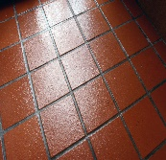 |  | See comments above.
Polished concrete | 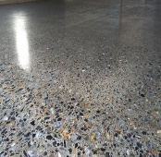 |  | Make sure good quality products are used as sometimes this type of flooring can bubble and flake. Polished concrete can wear easily in high traffic areas.
Epoxy resins |  |  | This type of flooring can wear easily in high traffic areas or where heavy equipment is used.
Carpet | 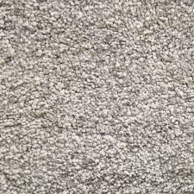 |  | Carpet may be laid in customer areas but consider how it would be cleaned.
Floorboards |  |  | Floorboards can only be used in customer areas.
Poly vinyl sheeting  (aka PVC or Vinyl) |  |  | When choosing a poly vinyl floor, it is important to install a commercial product suited for food businesses.  Poly vinyl must be laid on level ground for it to be effective.
Laminated thermosetting plastic sheeting | 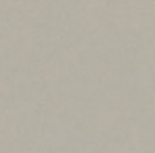 |  | A durable plastic that is lightweight and moisture resistant.
Stainless Steel non-slip | 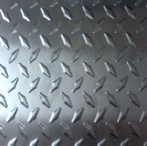 |  | This type of flooring is sometimes used in walk in cool rooms and freezers, please be aware this can be hard to clean.

Coving
It is recommended that food businesses install coving in food handling areas. Coving assists with cleaning as it can help to prevent grease, dirt, and food from building up in the corners.
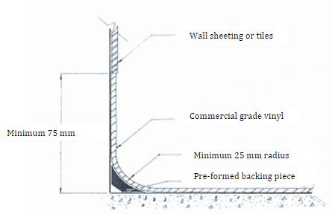
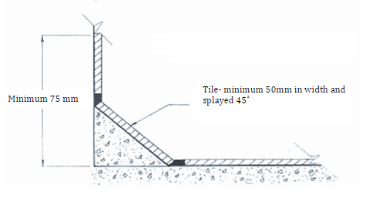
Below are two examples of coving.

Note: Feather edge style skirting is not permitted in a food business as it is not suitable or effective.

Floor drains
Some businesses choose to install floor drains. This allows staff to hose down floors to assist with cleaning. If you install a floor drain, is it important that floor is graded properly (at least 1:100)
It is important to make sure joins around the drain are sealed well to prevent water leaking under the floor.
For more information on floors read Division 3, Clauses 9 and 10 of Standard 3.2.3 Food Premises and Equipment

Walls
Walls should be:
- appropriate for the area
- easy to clean
- unable to provide places for pests to live and hide.
In food preparation areas walls should also be:
- sealed
- unable to absorb grease, food particles and water.

Things to consider
What are the food handling activities of the area i.e., will the wall be subjected to heat from cooking equipment?
- What is the likelihood of food splatter occurring in this area?
- How will the walls be cleaned?
- Will the walls be able to withstand damage from equipment such as large baking trays or trolleys?
- Maintenance.
Product | Image | Suitable | Comments
Ceramic tiles | 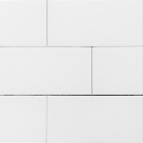 |  | Invest in a good grout cleaner and brush. If tiles begin to chip and crack it can be difficult to replace just one.
Vinyl sheeting |  |  | Vinyl walls are commonly seen where vinyl has been used on the flooring and is continued up the wall so create a seamless surface.
Stainless steel |  |  | Durable and easy to clean.
Painted plasterboard |  |  | Plasterboard should be painted with a high gloss or semi-gloss paint to assist with cleaning. Plasterboard is very prone to wear and tear and is only suitable in areas where no damage is likely to occur such as storerooms, walls above 1.8 metres or other similar areas.
Brick | 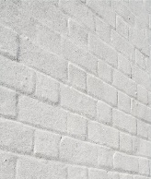  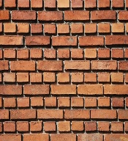 |  | Exposed brick absorbs grease and water and cannot be easily cleaned. If the brick is smooth, the mortar between the bricks flush with the face of the bricks, and it is painted with a semi or high gloss then it may be suitable for storerooms, walls above 1.8metres or other similar areas.
Other |  |  | If the product meets the standards in AS 4674-2004 and are sealed and unable to absorb grease, food, and water then it is suitable for a food business.

Splash backs
Splash backs can be an effective way to make sure walls in high use areas are protected. Instead of tiling to the roof a food business may choose to use a splash back instead. Splash backs should be at least 1800mm from the ground or 450mm from the top of a bench.

Ceilings
Ceilings should be:
- appropriate for the area
- easy to clean
- sealed
- unable to provide places for pests to live and hide.
Product | Image | Suitable | Comments
Painted plaster board |  |  | This is the most common ceiling surface found in food businesses.
Ceiling tiles | 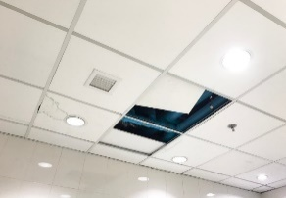 |  | The tiles are not sealed, are not easy to clean and move out of place creating entry points for pests
Warehouse ceilings | 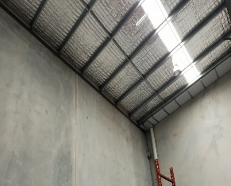 |  | If you are constructing a food business from a warehouse you will need to install a suspended ceiling. The ceilings in warehouses are not sealed, are not easy to clean and carry a lot of dirt and dust.
Other | 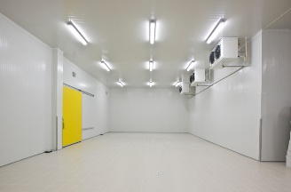 |  | If the product meets the standards in AS 4674-2004 and are sealed and easy to clean, then it is suitable for a food business, for example, coated steel in cool rooms and factories.
For more information on walls and ceiling read Division 3, Clause 11 of Standard 3.2.3 Food Premises and Equipment

Lighting
Light fittings must:
- be bright enough for staff to carry out food handling activities and cleaning
- not cause a contamination risk (see note below)
- be able to be easily cleaned.
Note: Glass globes can shatter easily and cause a contamination risk in a food business. Therefore, light fittings should contain shatter proof globes, protective plastic sleeves, or have appropriate light covers.
Product | Image | Suitable | Comments
Shatter proof fluorescent globes | 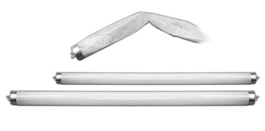 |  | This example shows the internal glass has shattered but has been contained within the globe.
Fluorescent light fitting/ cover | 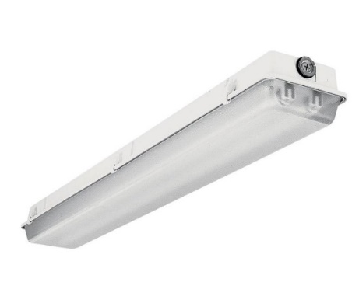 |  | These light fittings are commonly seen in food businesses. Over time these covers can fall off or break and can be difficult to replace. They can also fill up with dead insects and need to be removed for regular cleaning.
Downlight | 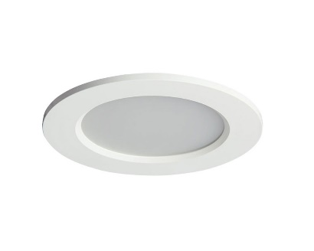 |  | Downlights sit flush with the ceiling which assists with cleaning. Most downlights are made with a plastic cover, however some older styles still contain glass which may not be suitable in a food business.
Decorative light fittings | 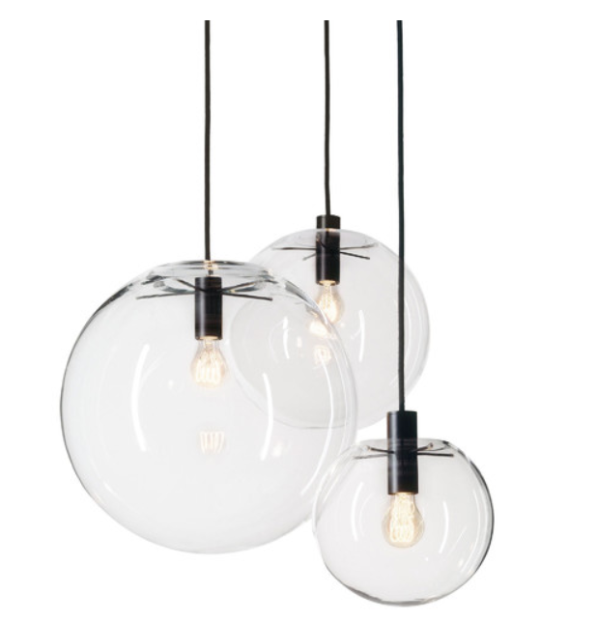 |  | Decorative light fittings usually contain glass which poses the risk of breaking. Decorative light fittings also have the tendency to harbour dirt and grease and are not always easy to clean. They can be used in the customer areas but should not be used in food preparation areas including front of house.
Glass light globe | 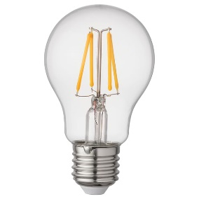  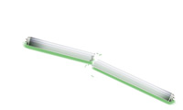 |  | Glass globes without light covers have the potential to break and can cause a contamination and safety issue.
For more information on lighting read Division 2, Clause 8 of Standard 3.2.3 Food Premises and Equipment

Food preparation surfaces
Food preparation benches must be:
- easy to clean
- unable to absorb grease, food particles, or water
- unable to provide places for pests to live and hide.

Things to consider
- amount of preparation space required
- size of benches
- incorporated storage such us an under-bench fridge or sandwich bar.
Product | Image | Suitable | Comments
Stainless steel | 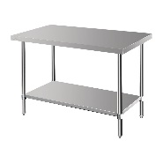 |  | Durable and easy to clean.
Wood | 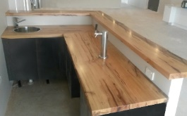 |  | Wooden bench tops, even when sealed, are not suitable in a food business as they are not durable.
Laminate | 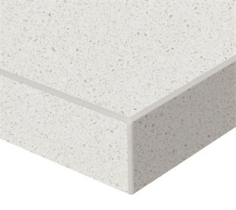 |  | Laminate benchtops are suitable but can show signs of wear and tear over time. It is common for the edge strips to peel or chip exposing the chipboard underneath.

Sinks
A food business can never have too many sinks. It is important that each sink has a designated use, this is to reduce the chances of cross contamination. All sinks should be connected to sewer or a septic tank system and must be connected to hot and cold water.

Hand wash basin
Washing your hands properly can help prevent the spread of germs (bacteria and viruses) therefore it is critical for a food business to have hand wash basins.
Where there is unpackaged food being handled there should be an easily accessible hand wash basin nearby. As a rule of thumb, a hand wash basin should be within a direct 5 metres of a food handling area. Hand wash basins that are NOT easily accessible include behind doors, in another room, below a bench, blocked by equipment, or in a hard-to-reach spot. If your food business has multiple food handling areas, then you may be required to install multiple hand wash basins.
Hand wash basins must be connected to warm potable water between 20°C- 40°C and be large enough so you can effectively wash your hands.
Suitable taps for hand wash basins include single lever mixer taps, knee operated levers, foot operated taps and electronic sensor taps. Turn taps are not suitable.
Note: A separate hand wash basin is required for toilet / bathroom areas.
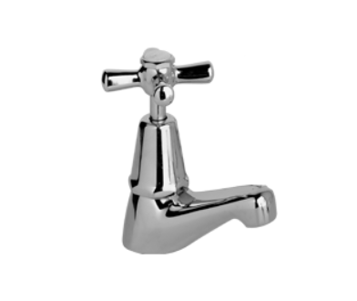
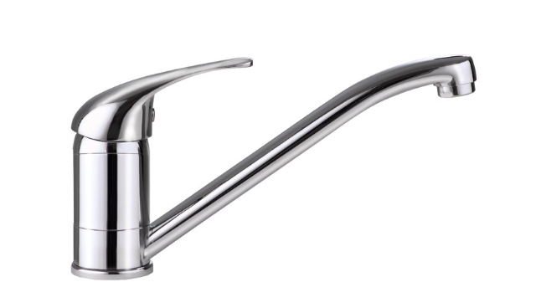

Approved: Single lever mixer tap Not Approved: Turn tap

Double bowl sink
A double bowl sink is required for effectively cleaning and sanitising equipment. If you plan to install a commercial dishwasher, then you will only need one sink instead of a double bowl (see dishwasher requirements below).
A double bowl sink must be connected to hot and cold water and be large enough to wash your largest piece of equipment.

Dishwasher
If you are installing a dishwasher, you should contact the manufacturer to make sure the dishwasher’s temperature cycles reach a temperature hot enough to sanitise equipment. As an example, a dishwasher that washes at 60°C and rinses at 82°C.
If you have a dishwasher, then you can install a single sink for cleaning as opposed to a double bowl sink. There may be exemptions to this, where a double bowl sink should still be installed.
Domestic dishwashers are not suitable for commercial food business and will only be approved for small scale home-based business.

Food preparation sink
If your food business prepares a lot of fresh fruits and vegetables, such as salads, stir-fries, and sandwich bars, then you will need an additional sink for cleaning and rinsing these foods. Fresh fruits and vegetables can carry dirt and bacteria, so it is important that they are washed thoroughly in a separate sink. This sink should be a separate sink from the sinks used for cleaning and sanitising.

Mop sink
Mop sinks, otherwise known as a cleaner’s sink, is a sink where you can wash your mops, and easily fill up and empty your mop bucket. Dirty mop water requires a separate sink as it is full of dirt and bacteria that could create a major cross contamination issue. A mop sink should have hot and cold water.

Jug rinse / sink
If your food business has a coffee or bar area, then it may be a good idea to install a jug rinse or small sink for rinsing milk jugs, spoons.

Storage
A food premises must have enough storage space to store all items in the food business not just the food. All items should be stored in a way that is unlikely to cause a cross contamination issue. As an example, a cleaning chemical should not be stored next to or above food items as any leaks may contaminate the food. Make sure there is enough space for cleaning under the shelving.
Items that may require additional storage areas:
- allergen-free food items/equipment
- clothing and personal belongings
- chemicals and cleaning equipment
- tablecloths, tea towels, napkins
- excess equipment
- other- office equipment, maintenance equipment.
Note: If you are in a premises with limited storage such as a shopping centre, you should speak to centre management to see if a storage cage is available.
For more information on storage read Division 5, Clause 15 of Standard 3.2.3 Food Premises and Equipment

Cold / frozen storage
Cool rooms, fridges and freezers should be large enough to safely store all potentially hazardous food onsite below 5°C or -15°C for freezers.

Things to consider
- How much cold/ frozen storage will the business need?
- Shelving options and ease of cleaning and maintenance.
- Is the location easy for delivery drivers to access?
Location of external plant equipment. Motors from cool rooms and freezers can create noise issues.
If the cool room is being used to store beverages gas cylinders, then a gas monitoring and alarm system should be installed. Visit www.worksafe.vic.gov.au for more information.
Note: A building permit is required for the installation of a walk-in cool room and freezer. Visit our website to find out more information about building permits.

Shelving options
Item | Example | Comments
Plastic shelf | 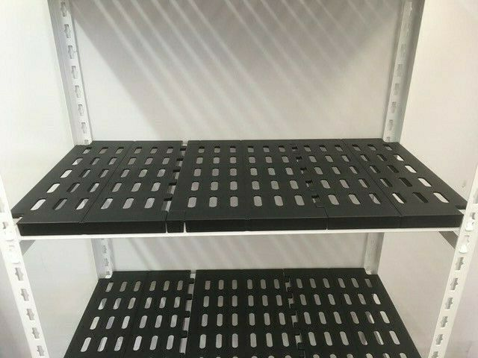 | Easy to clean.
Metal fridge rack | 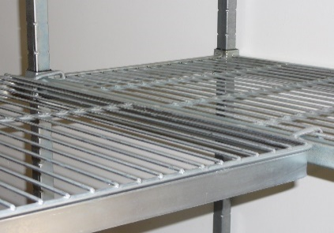 | Tricky to clean. The racks can get rusty over time but can be treated with rust products if you are proactive at maintaining them.
Powder coated metal rack | 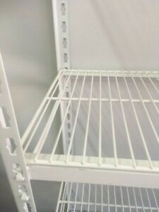 | Tricky to clean. The powder coat can wear down and peel back after time.

Dry Store
A dry storage area should be:
- easy to clean
- unable to provide places for pests to live and hide.

Things to consider
- Number of shelves and storage space requires
- Storage for allergen free foods, for example, gluten free flour
- Is it easy for delivery drivers to access?
Note: Any containers used to store food must be food grade containers.

Bins / Recycling
Storage facilities for rubbish and recycling must be:
- large enough to store all rubbish / recycling
- unable to provide a breeding ground for pests
- easy to clean.

Things to consider
- Having lids that can securely closed and locked will prevent pests from entering and will prevent others from using your bins.
- Bins should be screened from public to help prevent appearance and odour issues.
- The area should have a drain that leads to sewer.
- If you are planning to wash the bins with a hose, consider installing a tap nearby.
Note: If your external bin area is some distance from your premises such as a communal bin area in a shopping centre, it is important that you consider where the rubbish and recycling will be stored prior to being taken out.
For more information on storage of waste read Division 2, Clause 6 of Standard 3.2.3 Food Premises and Equipment

Ventilation
Food business must have enough ventilation to effectively remove fumes, smoke, steam, and vapour from the food premises.

Things to consider
- What activities in your food business create fumes, smoke, and steam?
- Amount of cooking the business will be doing
- Power capacity of the ventilation system
- Natural ventilation vs mechanical ventilation.

Mechanical ventilation systems
Mechanical ventilation systems including mechanical exhaust canopies must comply with the relevant Australian Standards and building code requirements. For more information, see our Mechanical Exhaust Ventilation Specifications for Food Premises guide.
Note: Installing a mechanical exhaust canopy requires a building permit
For more information on ventilation read Division 2, Clause 7 of Standard 3.2.3 Food Premises and Equipment

Water and sewage

Water
A food premises must have a suitable supply of drinkable (potable) water. A suitable supply of water is one that can provide good pressure, temperature and volume for all food handling activities carried out. This includes hand washing, food preparation, cleaning, and sanitising.
Hot and cold water must be available to all sinks.
For more information on water supply read Division 2, Clause 4 of Standard 3.2.3 Food Premises and Equipment

Sewage
A food business must be connected to sewer, or in unsewered areas, a septic tank system.

Grease traps
Often the waste going into the sewer from a food business contains chemicals, grease, oils, solids, and other substances. Because of this most food businesses require a grease trap. Grease traps are managed by the local water authority, Barwon Water, through a trade waste agreement.
If your grease trap location is on Council owned land, then you will need to speak to our Engineering team and apply for a ‘works within road reserve permit’.
Further information can be found on Barwon Water’s trade waste webpage.
For more information on sewage read Division 2, Clause 5 of Standard 3.2.3 Food Premises and Equipment

Toilets
A food business must provide toilets for their staff. Staff toilets must be:
- easily accessible always
- clean and operate properly
- provided with a handwash basin, warm water, soap, and paper towel
- well-lit and have good ventilation
- designed to minimise air borne contamination (see note).
Note: To help minimise air borne contamination, a food business should install an air lock, provide self-closing doors, and locate the toilet outside of the kitchen where possible.

Customer toilets
The number of toilets a food business must have is outlined in the Building Code for more information you can contact our Building department.
For more information on toilets read Division 5, Clause 16 of Standard 3.2.3 Food Premises and Equipment.

Pest Control
If you have followed this guide, then your food business should be off to a good start in making sure your kitchen surfaces are free of cracks and crevices which will prevent pest harbourage.
Other structural considerations to have a pest free premises include:
- Installing air curtains at entrances.
- Avoiding bi-fold door and windows.
- Installing PVC door strips or flyscreens on doors.
- Making sure all doors and windows are properly sealed.
- Installing weather strips below doors.
- Installing self-closing mechanisms to external doors.
TIP: Rodents can fit through gaps smaller than a 5-cent coin so make sure all gaps are sealed up properly to prevent their entry.
See Part Three: Food Safety for more information on pest control programs.
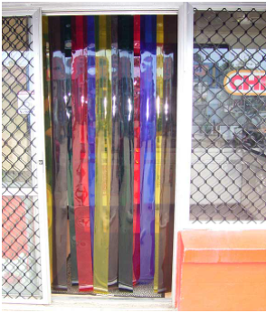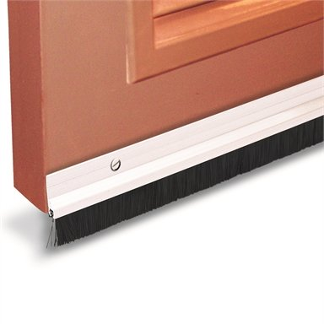
Left: PVC door strips Right: Weather strip below a door

Part Three: Food Safety

Food Safety Training

Food Safety Supervisor
If you are operating a Class 1, Class 2, or Class 3A food business, you will require a food safety supervisor.
A food safety supervisor is someone (appointed by the owner or proprietor of a food business) who:
- oversees the day-to-day food handling operations
- makes sure food handlers are adequately trained in food safety associated with the business
- helps food handlers to handle food safely
- makes sure food safety risks are managed
- is in attendance in the business often enough to effectively oversee food safety, and
- has completed the relevant, accredited food safety training for their workplace and has a ‘statement of attainment’ from a registered training organisation and should be able to provide their certificate to an authorised officer, if requested.
For more information visit Department of Health Food Safety Supervisor Training
There have been recent changes to the Food Standards Code. A Food Safety Supervisor must be a person who has obtained formal certification as a Food Safety Supervisor within the past 5 years.
There is a short-term exemption for Food Safety Supervisors in Victoria, who received their certification prior to 8 December 2023, this will give you five years from 8 December 2023 to re-certify.

Staff Training
Anyone who is working or volunteering in a food business, even at ad hoc times, is considered a food handler.
Businesses need to ensure all food handlers have adequate skills and knowledge in food safety and hygiene in line with the work that they do.
The standard requires that food handlers who handle high-risk foods complete a food safety training course in, or be able to show they understand, safe handling of food, food contamination, cleaning and sanitising equipment, and personal hygiene. It is recommended that businesses keep staff training records to easily demonstrate to authorised officers they have met the requirements of the food handler training.
Suitable training options include:
- Victorian Department of Health provided free, online food handler training course, DoFoodSafely, that covers the training required for Standard 3.2.2A. DoFoodSafely is available in eight languages.
- Food handler training through a registered training organisation.
- Development of training specific to your individual business, that all staff need to undertake and proof of completion is documented.
We also recommend, for those businesses making allergen free claims, or handling food with allergens, that food handlers complete All about allergens. This is another free training course. There are different versions available for different business types.

Thermometers
A food business must have an accurate thermometer onsite for checking and recording the temperature of food. The thermometer must be accurate within 1°C. It is recommended that your thermometer has a range of -50°C to 150°C. Each business should have a digital probe thermometer.
Below is a list of various kinds of thermometers available:
Types | Image | Comments
Digital probe | 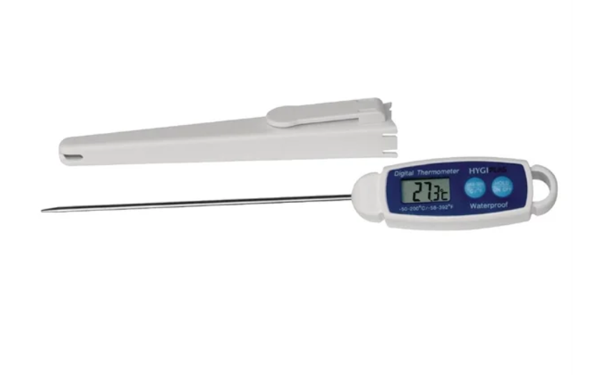 | Can measure internal temperature of food. The most accurate type of thermometer. It is recommended that every business has at least one.
Infrared ‘laser’ thermometer | 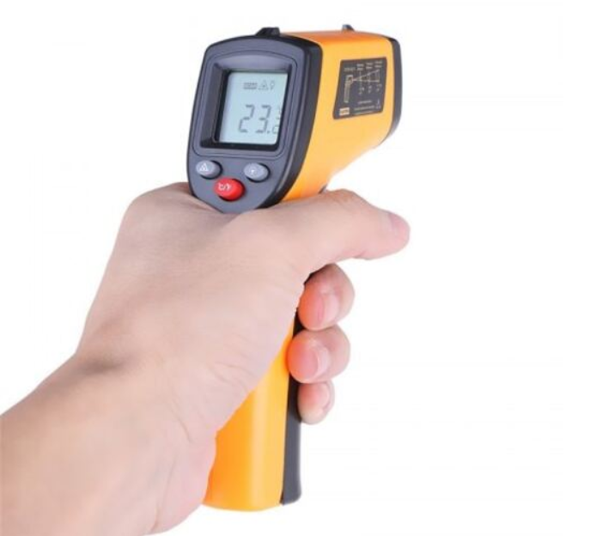 | Ok for a quick surface check but these thermometers cannot record internal temperatures of food.
Fridge/ Bain Marie dials | 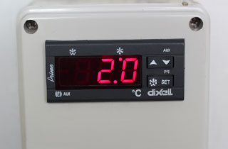 | These dials often do not accurately reflect the internal temperature of foods and shouldn’t be used for the daily fridge temperature records.
Coffee/ milk thermometers | 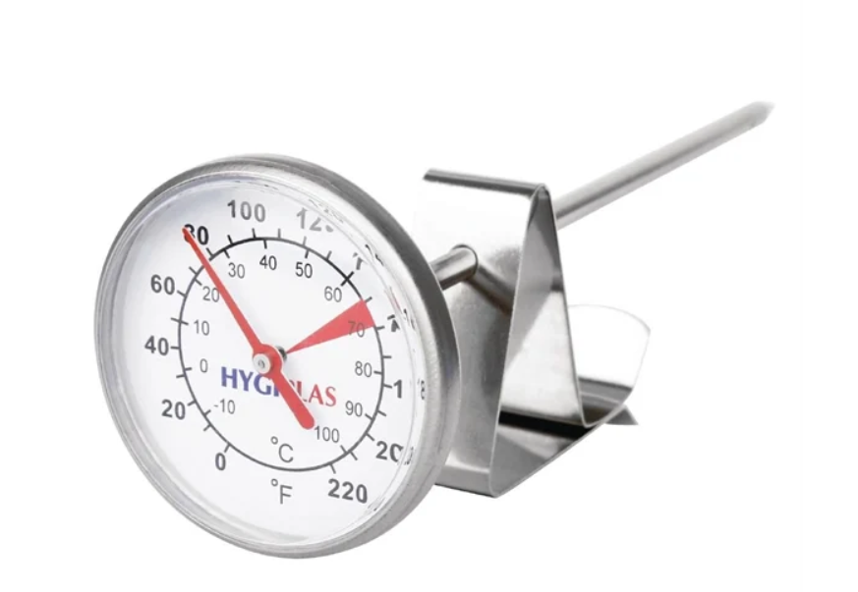 | These thermometers are suitable for coffee.
Fridge gauge | 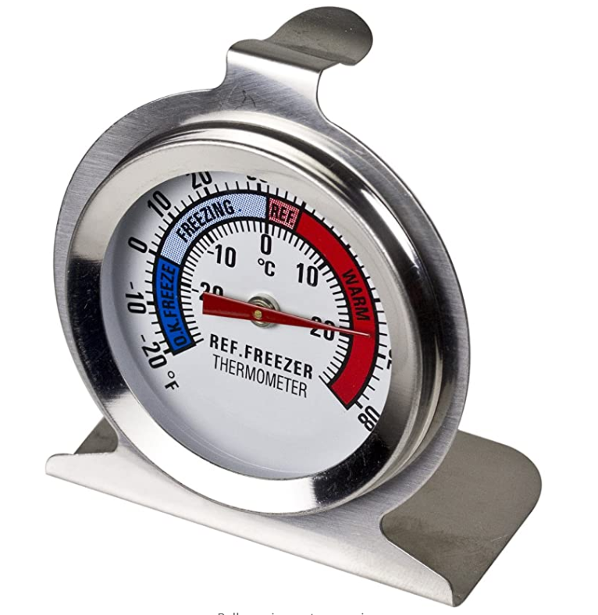 | These thermometer gauges are good for a quick glance however do not record the internal temperature of food.
Digital fridge / freezer thermometer | 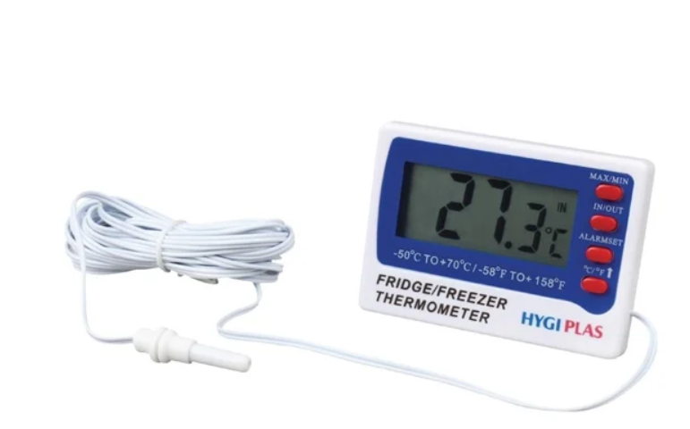 | When set up correctly these thermometers can accurately record the temperature of a fridge / freezer. A business will still need a probe thermometer to check and record the temperature of hot and cooked foods.
For more information on thermometers read Division 6, Clause 22 of Food safety practices and general requirements

Sanitiser
Sanitising is a process that destroys microorganisms (bacteria and viruses) by reducing their numbers to a safe level. Sanitising equipment and surfaces after cleaning are a critical step for food businesses to do.
Putting equipment through the commercial dishwasher will sanitise equipment, however when a dishwasher cannot be used, equipment and surfaces should be sanitised using a food-grade sanitiser.

Food grade sanitiser
There are many different brands and types of food grade sanitisers. The two main sanitisers often used have the active ingredient Chlorine or Quaternary Ammonium.

Things to consider
- Is the sanitiser ready to use or does it need to be diluted?
- Once diluted, how long is it effective for?
- Is it a non-rinse or rinse sanitiser? Non rinse sanitiser is a sanitiser you can spray and leave whereas a rinse sanitiser usually needs to sit for a period before being washed off.
Tip: If you are looking for convenience then a non-rinse ready to use quaternary ammonium food grade sanitiser is the best option for you.

Household bleach 4% as a sanitiser
The active ingredient in bleach is chlorine which is a sanitising chemical. Bleach must be diluted to use as a sanitiser the dilution rate is 2.5ml of bleach to 1 litre of water.
If you are using bleach as a sanitiser, make sure it is regular bleach and does not have a scent such as lavender or lemon.
Tip: Bleach is relatively inexpensive to buy but once diluted only lasts 24 hours therefore must be made up daily. Bleach is good to use as a sanitiser for equipment that needs to be cleaned and sanitised in a double bowl sink.

Disinfectants
While disinfectants may kill off bacteria and viruses, they also may include additional chemicals or scents that are not safe for food preparation surfaces. You can still use these products to clean the floors and toilet areas. Always check the label first to see if a product is a food grade sanitiser.
For more information on sanitisers read Division 5, Clause 20 of Food Safety Practices and General Requirements or Safe Food Australia Appendix 6

Pest Control Program
If you have followed the structural guide in part 2 then your premises should be constructed in a way that reduces pests from entering and living in your premises. However, you should still have a pest control program in place.
Pests that commonly affect food businesses include:
- rodents (for example, mice and rats)
- insects (for example, flies, cockroaches, ants, weevils)
- birds (for example, pigeons).
Professional pest controller – while not a legal requirement it will be necessary if pests cannot be adequately controlled by the food business.
Tip: Flies can be difficult to manage in a food business as the sprays are usually unsafe for food and food contact surfaces. A bug zapper with a sticky board is a good solution if you can find a suitable area away from exposed food.
For more information on pest control read Division 6, Clause 24 of Food Safety Practices and General Requirements or Safe Food Australia Appendix 7: Pest Management

Food Safety Records
Food businesses that require a Food Safety Program (see part 1 of this guide) are required to fully implement their Food Safety Program (FSP), including the specified records* as a minimum legal requirement under section 19D of the Food Act 1984. The FSP and records are designed to help you and your staff make sure that the foods you prepare, cook, reheat or store are safe for your customers.
*Standard 3.2.2A requires records to be kept for:
- food receipt
- food storage under temperature control
- for food handling where a process is required to make food safe to eat (for example, final cooking temperature, PH testing)
- food handling so that food remains at temperatures to prevent bacterial growth (2/4-hour rule)
- cooling of food
- reheating of food
- displaying food to prevent contamination
- transporting food.
Other businesses that don’t require a FSP may still choose to keep food safety records including fridge temperatures and temperature of cooked food to easily manage and keep on top of food safety in their premises.
Tip: Business can keep their records in hard copy or electronically, however they should be easily accessible. If you are keeping your records in hard copy, be sure to keep blank copies of these records so you don’t run out of them.
For templates visit Food Safety Program Record templates

Part Four: Appendices

APPENDIX ONE: Structural requirements checklist
Items | / | Notes
Adequate space for activities and equipment
Suitable flooring
Suitable wall surfaces
Suitable ceiling finishes
Adequate lighting
Suitable food preparation surfaces
Hand wash basins with warm water, soap, and paper towel
Double bowl sink or single sink and dishwasher
Adequate food preparation sinks
Cleaner / mop sinks
Jug rinse (if applicable)
Adequate cold and frozen food storage facilities.
Building permit for cool room (if applicable)
Adequate dry food storage facilities
Adequate food displays including self-serve displays (food protected)
Adequate facilities for storage of chemicals, clothing, and other items
Adequate storage of garbage and other waste
Adequate ventilation, including the exhaust system over cooking appliances working.
Adequate water supply (hot and cold)
Sewage connected and grease trap (if applicable)
Toilets for food handlers
Pest Control

APPENDIX TWO: Pre-opening checklist
Food Safety Items | / | Notes
Food Safety Supervisor
Staff training
Food Safety Program and records
Food Grade Sanitiser
Hand Wash Basin operational and correctly set up
Cleaning chemicals
Cleaning equipment- mop, broom, cloths etc
Pest control
Digital probe thermometer and sanitiser wipes

APPENDIX THREE: Additional Contacts

Business Assistance
Formulating a business plan is your first and most important step to ensure your business will be sustainable.
Increase your chances of success in your business by checking the tool kit on the Business Victoria website and formulating a business plan.
Our website also has information on starting and growing your business in Geelong.

City of Greater Geelong Contacts

Business & Industry Experience
If multiple permits are required to start up your business, or if you’re new to the permits approvals process, you can request free assistance from our Business Concierge service. They will get your application started by inviting you to meet with specialist members of our team to discuss your business proposal in detail. From there, you can also request support with filling out the form.

Local Laws
If you plan to have an alfresco dining area on Council land or wish to display an A Frame sign, then you will need to contact Local Laws for the relevant permits.
For information about A-frames
For information about alfresco dining

Statutory Planning
A planning permit is a legal document that gives permission for a use, development, or subdivision on a piece of land. A planning permit application is assessed against our Greater Geelong Planning Scheme which includes various requirements from both state government and Council.
A planning permit goes with the land not a person (for example, if a person sells their land after obtaining a planning permit the new owner can also act on the planning permit).
Some of the most commons reasons a planning permit might be required to establish/expand a food business are to:
- Change the way the land is used
- Construct a new building, alter/extend an existing building, or carry out works
- Subdivide the land
- Demolish a building in a heritage area
- Erect signage on the land
- Obtain a liquor licence
- Provide less parking on site (called a waiver or reduction in car parking)
- Amend a planning permit (for example, change the previously approved hours of operation, number of patrons)
- Operate a home-based business.

Building Services
A building permit is a control measure for the construction of buildings. It requires the submission of drawings/plans to a Building Surveyor for assessment against the Building Regulations, Building Code of Australia, and Australian Standards. The intent of this process to ensure are buildings are safe and achieve an acceptable level of amenity for building occupiers.
In relation to small business, some common scenarios that may require a building permit are:
- Changing the way, a building is used (for example, changing an office to a cafe)
- Constructing a new building
- Extending or altering an existing building (may include non-structural alterations)
- Demolishing part of or a whole building
- Installing a cool room, freezer room, and/or mechanical exhaust system.
It is a legislative requirement that a building permit be obtained prior to carrying out any of the abovementioned works.

External Contacts

Victorian Government Liquor
The Victorian Government Liquor is the authority that regulates Victoria’s liquor industries. If you are planning to sell alcohol at your food business, you will need determine the most suitable Liquor License for your business.

Barwon Water
Barwon Water is the local water authority. Barwon Water manages connection to sewer and mains water as well as trade waste agreements in relation to grease traps. For more info see part 2 of this guide.

Consumer Affairs Victoria
Consumer Affairs Victoria is a business unit of the Department of Justice and Community Safety, within the Victorian government and regulate Consumer Law within Victoria.

Part Five: Glossary of Terms
Term | Meaning
Building surveyor | A building surveyor ensures building work complies with the legal requirements and issues building permits allowing works to commence. They will conduct inspections of building work and issue a permit upon satisfactory completion.
Environmental Health Officer | Environmental Health Officers are responsible for carrying out measures to protect public health, including administering and enforcing legislation and providing support to minimise risks to the public.
Equipment | Examples of equipment include refrigerators, cool rooms, Bain Marie, utensils, or appliances used in connection with food handling or cleaning the food premises.
Fixtures and fittings | Examples of fixtures and fittings include benches, shelves, sinks, hand basins, cupboards, and light fittings.
Floor plans | A drawing that shows the shape, size, and arrangement of rooms in a building as viewed from above.
Food business or food premises | A business, enterprise, or activity (other than primary food production) that involves:  - handling of food intended for sale, or  - sale of food, regardless of whether the business enterprise or activity is of a commercial, charitable or community nature.
Food contact surfaces | Any surface that touches food such as knives, pots, chopping boards and plates.
Food preparation area | A food preparation area is any space where food and/or drinks are washed, prepared, cooked, poured and/or served.
Food storage area | A food storage area is any place where food is stored. It includes dry stores, cool rooms, freezer rooms and off-site storage areas.
Food Safety Program (FSP) | A written plan that shows what a business does to ensure that the food it sells is safe for people to eat. It is an important tool to help businesses safely handle, process, or sell potentially hazardous foods and maintain safe food handling practices to protect public health.

