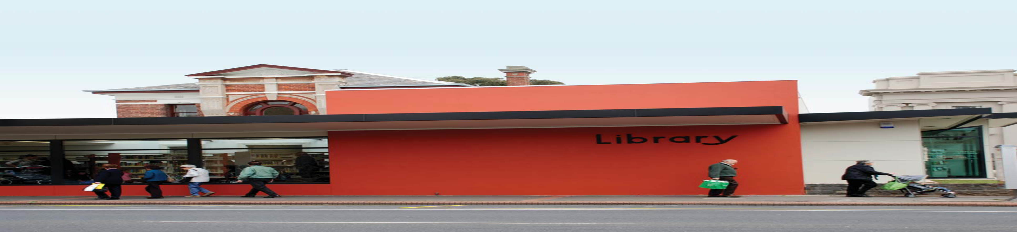

PUBLIC LIBRARY BUILDINGS
DEVELOPMENT STRATEGY

Adopted September 2009

WWW.GEELONGAUSTRALIA.COM.AU

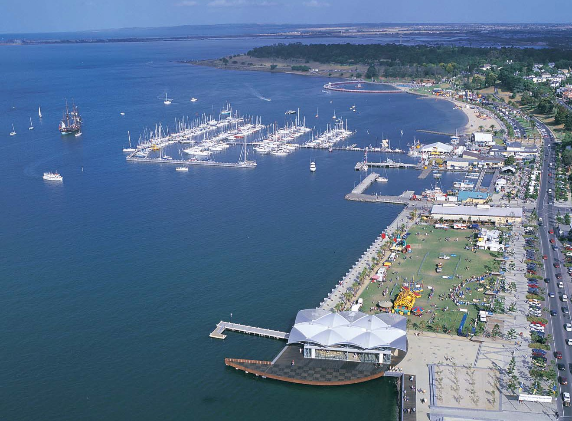2

CONTENTS

EXECUTIVE SUMMARY............................................................................... 3

.

.

...

.

..

INTRODUCTION........................................................................................... 6

BACKGROUND............................................................................................. 7

POLICY CONTEXT...................................................................................... 8

LIBRARIES CHANGING FOCUS................................................................. 10
CONTENTS

LIBRARY DESIGN PRINCIPLES &
GUIDELINES FOR GEELONG PUBLIC LIBRARIES................................ 13

GEELONG LIBRARY BUILDINGS DEVELOPMENT STRATEGY........... 18

AUSTRALIAN AND INTERNATIONAL
BEST PRACTICE LIBRARY BUILDINGS................................................... 35

REFERENCES AND PHOTO CREDITS...................................................... 48

3

EXECUTIVE SUMMARY
EXECUTIVE SUMMARY

Extensive research demonstrates that public libraries make a vital contribution to social, cultural, economic and educational development of communities. This contribution can be summarized in four key areas.

Creating informed communities through the provision of access to local and global information sources
Providing free and universal access to information technology infrastructure, computer literacy and technology resources
Providing opportunities for lifelong learning through resources to support self directed learning and programmed information & reading literacy activities
Building social capital by providing welcoming, neutral, community space that is open to all members of the community from
all walks of life and by connecting individuals, groups and government.

The public library’s role, in facilitating the free flow of information, the exchange of ideas and information, is fundamental to democracy. Even in this technological age public libraries are more relevant, needed and valued by their communities than ever before.

Council has recognised the need to review the existing service delivery model, current facilities and develop principles and guidelines for the redevelopment of existing stock and new libraries in future growth areas. The Building Strategy objectives are to:

Improve the library network capacity to service the City of Greater Geelong by tailoring future library developments to meet current and future community needs
Plan for new optimally designed libraries that can meet a range of purposes for the long term
Address the City’s growth areas and create welcoming and purpose designed libraries for lifelong learning, reading, cultural and leisure activities
Maximise efficiency and effectiveness of existing facilities
Establish review timeframes for planning purposes for both existing and proposed library facilities.

Rapid social, economic and technological change is shaping the way we live, work and play.
This change is driving the redevelopment of public libraries. By responding intelligently and flexibly to change, Geelong’s libraries will be better positioned to support and connect their communities.

For many communities the local library is the most important civic building in their neighbourhood. The design and construction of a new library is often seen to be the most significant piece of civic investment that a
Local Government body can make. This level of importance places a high degree of expectation on the final outcome in terms of both the library service and the built structure.

The experience in Australia and internationally has proven that well planned and designed libraries attract increased usage and provide a range of significant community wellbeing and livability outcomes. Underpinning the strategy principles is a commitment to best practice and to utilising the best available expertise to deliver each stage of all future library developments including library staff, library space planners, architects, interior designers, accessibility consultants and building firms.

The following principles and guidelines will shape future Geelong public library building developments:

Principle 1
Geelong Libraries will be planned and delivered utilising People Places guidelines and planning toolkit.

Principle 2
Geelong Libraries will meet People Places building area standards.

Principle 3
Geelong Libraries will be tailored to local community need.

Principle 4
Geelong Libraries will be designed as important
Civic spaces and places.

Principle 5
Geelong Libraries will provide “Whole of community” and universal service.

Principle 6
Geelong Libraries will be Future-Proof designed including Environmentally Sustainable Design (ESD).

Principle 7
New Libraries in Geelong will be developed in partnership and/or located with other services.

Principle 8
Geelong Libraries will be primary access points for Smart Technology.

4

The previous library service infrastructure model was inherited as part of the Local Government amalgamations of the mid 1990’s. The forward infrastructure model will be based on the development of a cascading hierarchy beginning with a new Geelong City Library and Heritage Centre providing central library and heritage services to the wider region, 5 sub-regional libraries, 8 branch libraries, community libraries
& service models specifically tailored for rural and isolated communities and e-services.

The Planning and Review Schedule recommendations for existing libraries are as follows:

Barwon Heads Library
A review of services, usage and suitability of current arrangements is required to determine future strategies for the provision of library services to this community. Given current innovations in the library industry there may
be more cost effective ways to deliver library services that offer improved access.
Identify partnership opportunities to deliver to
Barwon Heads residents in alternative ways.
Identify alternative models of service delivery and determine cost efficiencies against existing model.
Timeframe: Medium-term (5-10 years).

Belmont Library
Planning for refurbishment to be undertaken in the short term with a view to integrating the Council Customer Service Centre within the library.
Increase space for public access Internet provision.
Expand footprint of library to accommodate meeting room and tailored zones.
Timeframe: Short term (0-5 years)

Chilwell Library
Investigate feasibility of co-location with the
Maternal Child Health Centre.
Timeframe: Medium-term (5-10 years)

Corio Library
The Corio library is a sub-regional branch supporting mobile libraries and the new Lara Library.
Timeframe: A review of the facility will be required in 15+years.
Drysdale Library
Investigate the integration of the Council Customer Service Centre and library services. Redesign the large desk area to provide
smaller enquiry pod/s to provide increased public floor space.
Tailor the collection to meet the needs of the community based on usage.
Investigate the development of a new community hub to provide sub-regional level library services for the future.
Timeframe: Medium-term (5-10 years).

Geelong Library
The Geelong Central Library and Heritage Centre be redeveloped as part of the Cultural Precinct project on its current site with planned construction in Stage One of the project.
The facility should include an Integrated Library and Heritage Centre and floor area of at least 7,000m2.
Timeframe: Short-term (0-5years).

Geelong West Library
Monitor usage trends and ensure the services and facility are tailored to meet local community needs, especially once the new Geelong Central Library is established.
A review of the facility and services would be required in 15+ years.

Grovedale Library
Provide a new library for Grovedale and Waurn Ponds communities adjacent to Leisurelink facility.
Timeframe: Short-term (0-5 years).

Highton Library
Investigate opportunities to redevelop expand the library.
Timeframe: Medium-term (5-10 years).

Newcomb Library
Monitor usage trends and ensure the services and facility are tailored to meet local community needs, especially once the new Geelong Central Library is established.
A review of the facility and services would required in 15+ years.

5

Ocean Grove Library
Investigate opportunities to expand the library space and develop as a sub-regional library
either within the existing facility or in alternative leased or Council owned premises.
Timeframe: Long-term (10-15 years).

The Planning and Review Schedule recommendations for new library infrastructure are as follows:

Armstrong Creek
That planning commence for a sub-regional level library to be located in the Major Activity Centre.
That a new library is constructed in 3 stages, expanding with each major growth period.
That in the first stage a library of at least
1200m2 be considered with a view to expanding to 3,000m2.
Timeframe: Long term (10-15 years).

Lara
That an interim Library be established becoming operational in the 2009/10 financial year
That detailed planning commence for a new permanent Lara Branch Library.
Timeframe: Short term (0-5 years).

Leopold
That detailed planning for a Leopold Branch
Library is undertaken.
Timeframe: Short term (0-5 years).
Vines Road, Hamlyn Heights
That the current mobile library service to
Vines Road be replaced with community access
to the Western Heights Secondary College School
Library.
Timeframe: Short term (0-5 years).

Waurn Ponds
That a new library of 975m2 be constructed as part of the Waurn Ponds Recreation and Community Hub.
That detailed design for the Waurn Ponds Library to replace current Grovedale Library be commenced in the 2008/09 year.
Timeframe: Short term (0-5 years).

The building strategy will guide the development of future library buildings and refurbishments
of existing libraries over the next 15 years. Adoption of the strategy does not guarantee a facility will be upgraded, redeveloped or built. Factors such as Council priorities and
funding resources available will impact on the strategy outcomes. The strategy will be regularly reviewed and informed by the City’s planning processes including the City Plan, Urban Design Frameworks and Structure Plans.

6

INTRODUCTION

Extensive research demonstrates that public libraries make a vital contribution to social, cultural, economic and educational development of communities. A recent landmark research study Libraries Building Communities1 demonstrates a multitude of ways in which public libraries contribute to community building and which can be summarized in four key areas:
Creating informed communities through the provision of access to local and global information sources
Providing free and universal access to information technology infrastructure, computer literacy and technology resources
Providing opportunities for lifelong learning through resources to support self directed learning and programmed information and reading literacy activities
Building social capital by providing welcoming, neutral, community space that is open to all members of the community from
all walks of life and by connecting individuals, groups and government.

The library’s role, in facilitating the free flow of information, the exchange of ideas and information, is fundamental to democracy. Even in this technological age public libraries are more relevant, needed and valued by their communities than ever before.

The City of Greater Geelong Council understands the significant role public libraries undertake in community building and in increasing livability for the City’s residents. Also understood is the importance of providing contemporary library building infrastructure.

The City has a proud history of investing in library infrastructure with 11 branches and a mobile library delivering library services
across the municipality. Recent library building redevelopments include Corio Library (2005), Newcomb Library (2007) and Geelong West Library (2008). A State Government Living Libraries Funding contribution of $422,000 will see Belmont Library refurbished in 2009.

Council has recognised the need to review the existing service delivery model, current facilities and develop principles and guidelines for the redevelopment of existing stock and new libraries in future growth areas. The Public Library Buildings Development Strategy objectives are
to:
Improve the library network capacity to service the City of Greater Geelong by tailoring future library developments to meet current and future community needs
Plan for new optimally designed libraries that can meet a range of purposes for the long term
Address the City’s growth areas and create welcoming and purpose designed libraries for lifelong learning, reading, cultural and leisure activities
Maximise efficiency and effectiveness of existing facilities
Establish review timeframes for planning purposes for both existing and proposed library facilities.

This Public Library Buildings Development Strategy for the City of Greater Geelong has been informed by extensive community consultation, research, industry knowledge, analysis of the growth in the region and site visits to the library facilities within the City of Greater Geelong.

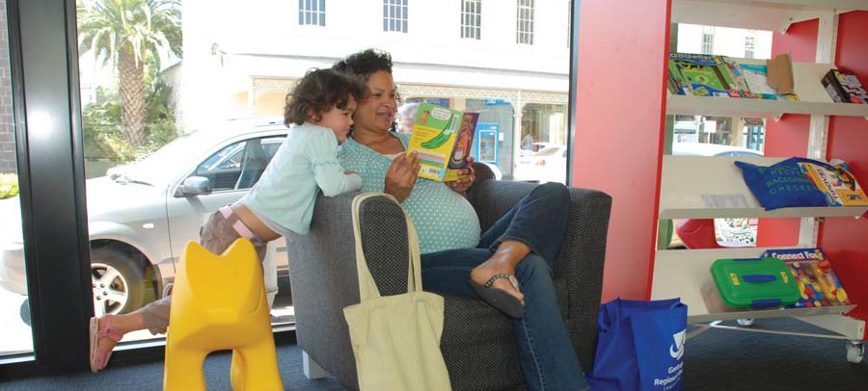

1 Libraries Building Communities: the vital contribution of Victoria’s public libraries, State Library of Victoria, 2005.
INTRODUCTION

7

BACKGROUND

The City of Greater Geelong is one of Victoria’s largest municipalities with a population of just over 200,000. Growth in the City is
rapid with new housing developments planned in several areas. The projected population for
2021 is 260,000 and 300,000 for 2030. The
City is located in south-western Victoria, about
75 km south west of Melbourne and is bounded by the Moorabool Shire in the north, Wyndham City and the Borough of Queenscliffe in the east, Bass Strait in the south and Surf Coast Shire and Golden Plains Shire in the west.

Covering 1,245km2 it is as diverse as it is exceptional with a mix of environments including urban and suburban areas, rural townships such as Lara in the north and Ceres in the west and coastal townships including Ocean Grove and Portarlington on the Bellarine Peninsula to the east. There are relatively wealthy and prosperous neighborhoods, as well as five postcodes rated as highly disadvantaged due to high unemployment, low levels of educational qualifications and low average incomes (Vinson, 2007)2.

The spread of economic activity is also diverse. Geelong is a self-contained regional city, a leading retail centre for South Western Victoria and home to state and commonwealth government service delivery agencies. The port and north shore of Geelong host areas of heavy industry. Broad acre farming and agricultural
activities occur in the region’s rural reaches, with tourism significant along the coast toward the Great Ocean Road.

The demographics of the City vary in age and profile, from traditional family and household structures to areas with high commuting populations and young families, and those
with high proportions of retirees and an ageing population. The region’s historically low level of ethnic diversity is changing as immigrants and refugees settle in the area. Over two thirds of the population lives in urban areas. Most recent growth has occurred in the fringe urban areas of Grovedale, Highton, St Albans Park, Wandana Heights and Waurn Ponds and the outlying areas of Lara, Leopold and Ocean Grove. Rapid growth is due to continue in existing areas and a new development with an estimated population of
66,000 is planned for Armstrong Creek.
Snapshot of Library usage
The Geelong Regional Library Corporation’s Annual Report 2007/2008 3 shows that Geelong’s library facilities experienced
1,052,687 visits and that over 1.9 million collection items were borrowed. Attendance to library programs and events increased by 14% and use of electronic databases increased by
27.5%. The annual report provides a wealth of data which clearly indicates a trend of increasing public library usage.

A survey recently undertaken by Geelong Regional Library Corporation utilising the Libraries Building Communities survey tool4 attracted an incredible 3,049 responses. In addition, a further 500 residents were involved in focus groups and library meeting forums to discuss library services. The huge response
to these consultation processes demonstrates the importance of public library services to the Geelong community and provides invaluable information regarding usage trends, community needs and expectations.

There are 90,690 public library members in the City of Greater Geelong. In addition there are approximately 34,000 Geelong residents who regularly use public libraries for services that
do not require a library membership card such as access to daily newspapers, periodical & reference collections, reading and study spaces, author events, information literacy training, holiday programs & storytimes and use of meeting rooms. It is estimated that over 60% of the community use public libraries.

Of those who have a library card 92% borrow books, 64% borrow audio-visual materials, 27% use information technology provided and over
46% access information services. The top five improvements suggested by community were:
Better / bigger / refurbished library buildings Greater volume and range of collections Extended opening hours
Increase in information technology provision
Increased study and program spaces.

These have implications for the City of Greater Geelong’s public library network service delivery model as well as current and future building infrastructure.

BACKGROUND

2 Vinson, T. Dropping off the edge, Jesuit Social Services, 2007.
3 Geelong Regional Library Corporation, Annual Report 2007/08, adopted 17 September 2008.
4 Geelong Regional Library Corporation, 2007 Libraries Building Communities Survey, August 2007.

8

POLICY CONTEXT

CITY OF GREATER GEELONG GEELONG REGIONAL LIBRARY CORPORATION (GRLC)

City Plan 2008-2012
Council’s vision is

“Geelong: coast, country and suburbs is the best place to live through prosperous and cohesive communities in an exceptional environment.”

Commitment to the wellbeing of the Geelong community is demonstrated through the development and implementation of the following plans:
City Plan 2008-2012
Geelong Strategic Health Plan Municipal Strategic Statement Youth Strategy
Geelong Community Safety Strategy
Municipal Early Years Plan Social Infrastructure Plans and Numerous Township Structure Plans.

Council has outlined actions that demonstrate its commitment to building a sustainable future that includes convenient and equitable access to local facilities and services at a neighbourhood level. Current library related actions outlined within
the City Plan include investigating options for the redevelopment of the Geelong Library & Geelong Heritage Centre, Lara Library building concept and design work, exploration of Community
Hub possibilities for Drysdale, Belmont Library upgrade, funding support of the Geelong Regional Library Corporation, and a Library Buildings Development Strategy.

Municipal Early Years Plan: Creating
POLICY CONTEXT
Communities for Children
The Municipal Early Years Plan: Creating Communities for Children identifies the direction for the City for the development of children and family services within multipurpose facilities. Further, those multipurpose children’s services facilities will be co-located in community
hubs that provide a focus for neighbourhood networking, community development and collaborative service delivery. The plan also recognises the need to strengthen linkages between early childhood services and the Geelong Regional Library Corporation and to continue to support development of specific initiatives through the city’s art and cultural programs for children including the Geelong Regional Library Corporation.5
Reading Revolution, new generation libraries: Library Plan 2008-2013
GRLC provides library and information services
to all residents and visitors in the Geelong Region through its physical network of library facilities and its virtual network of digital services. The GRLC documented vision is

“A strong connected community enriched by reading and emboldened by learning through access to the world of information and knowledge.”

One of the key issues identified in the Library Plan is the significant impact that building design has on GRLC’s ability to provide 21st century library services. This is detailed under Strategy 2: Places for people, present library services in purposeful safe physical and virtual environments. Specific relevant actions in the strategy are:

In the short-term
Actively participate in the Geelong Cultural Precinct Project with the view to significantly redevelop the Geelong City Library and Heritage Centre to become a regional facility
Address ageing infrastructure in partnership with member Councils; this includes refurbishing existing libraries and planning for new libraries in identified growth areas
Source funding opportunities.

In the medium term
Redevelop library interiors in existing library buildings
Increase the capacity for social and
reading spaces within existing library facilities
Provide for refurbished youth spaces, in consultation with youth, in existing library facilities.

Participation in Member Council neighbourhood planning and master planning projects was also identified as a key strategy to provide quality library building infrastructure for the community.6

5 Municipal Early Years Plan: Creating Communities for children, a local plan for families, children and the community, City of Greater Geelong, 2006.
6 Reading Revolution, new generation libraries: Library Plan 2008-2013, Geelong Regional Library Corporation, 2008.

9

STATE GOVERNMENT

The Victorian State Government outlined its vision for making Victoria a stronger, more caring and innovative state in Growing Victoria Together 7, which sets out goals for the future based on the priorities that Victorians identified as important. To make this vision a reality the
Government identified several strategic issues of relevance to public libraries:
Valuing and investing in lifelong education
Building cohesive communities and reducing inequalities
Promoting rights and respecting diversity.

A Fairer Victoria 8, the Victorian Government’s
2007 plan for social policy action, contains five main policy objectives aimed at reducing disadvantage in the state:

Access to universal services Reducing barriers to opportunity Support for disadvantaged groups Support for disadvantaged places
Making it easier to work with government.

The document emphasises the importance of investment in local community facilities like libraries as a way of providing a seed for the development of community networks and growth of human capital as people get involved in developing their skills and getting more involved in community projects.

Ministerial Advisory Council on Public Libraries
The Ministerial Advisory Council on Public
Libraries (MAC) has developed a vision for public library services in Victoria.9 The Vision sets out the key benefits of public libraries as an effective investment in furthering Victoria’s economy and competitiveness. The MAC also understands the core roles of the public library as a contributor
to the National Reform Agenda in human capital that focuses on early childhood and literacy and numeracy. The vision sets these core roles as:
Books and other tangible information resources
Access to information resources through IT Community meeting places.
One of the crucial elements identified in the plan is:
To provide places for innovative and inclusive communities to be formed.

Local Government Victoria
The Department of Planning and Community Development, Local Government Victoria administers the Victorian Public Library Infrastructure program, Living Libraries, which has been designed to assist Victorian Local Councils to provide quality public library buildings that support and strengthen local communities. Grants of up to $500,000
are provided to Councils and regional library services to build new libraries for their growing communities, or to upgrade and improve existing library facilities. There is one funding round remaining for this program in 2009.

Framework for Collaborative Action – Library Board of Victoria and Public Libraries Victoria Network
The Framework for Collaborative Action defines
the way in which the Library Board of Victoria, through the State Library of Victoria, works with the public library network to deliver improved library services to Victoria’s communities.
The focus is on working to support: improved library access and collections; collaboration and sharing across library services; better skilled staff; and increased community and government
understanding of, and engagement with libraries.

The Statewide Public Library Development
Projects, which are funded annually by
the Library Board of Victoria, are the main focus of the Framework’s activities. These projects complement strategic planning for libraries and support efficient management of shared resources. Recent research projects of significance to this strategy are:

Libraries Building Communities (2005) Strategic Asset Audit of Victorian Public
Libraries (2006)
Building Audit of Victorian Public
Libraries (2008).

7 Growing Victoria Together: A Vision for Victoria to 2010 and Beyond, Department of Premier and Cabinet, 2005.
8 A Fairer Victoria: building on our commitment, Department of Planning and Community Development, 2007
9 Ministerial Advisory Council on Public Libraries, The Library: The key to growing the knowledge and skills of the Victorian Community, 2007.

10

LIBRARIES CHANGING FOCUS

Societal Drivers and Trends
Rapid social, economic and technological change is shaping the way we live, work and play. This change is driving the redevelopment of public libraries. By responding intelligently
and flexibly to change, Geelong’s libraries will be better positioned to support and connect their communities.

Changing population… changing library needs
The proportion of older people in the community
over the age of 65 is rapidly increasing. The
2006 census shows an increase in Geelong’s residents aged over 65 years of 11% since
2001. Older residents are already strong users of libraries and active borrowers of books. In addition, recent research documents the desire of older people to continue to be involved in
the broader world and lifelong learning. Baby boomers and the generations that follow will not be content with collections of large print and talking books, though these will still be important. New approaches will be required to ensure that older adults are engaged in
LIBRARIES CHANGING FOCUS
the design of library programs and given opportunities for involvement in the social, learning and creative life of the community. Location, accessibility of library services, library design and availability of relevant collections and spaces will become more significant issues for libraries in servicing this age group, with
consideration given to more effective provision of services for people who are housebound and/or living in residential facilities.

At the other end of the age scale, young people who were ‘born digital’ have distinct information and communication needs. These ‘digital natives’ access information, learn and communicate in ways that older generations do not. As opposed
to reading books and magazines, digital natives prefer to draw on and create information via
the Internet, communicating using blogs,
social networking sites, SMS and web chat and participating in virtual worlds. To attract these young people libraries need to be inviting, offer the latest in technology and new media and be accessible around the clock. Geelong’s young people between the ages of 12-25 make up
18% of total population, clearly a significant and key library user group. In addition to being heavy users of technology young people are learning

in vastly different ways including cooperative learning, group interaction, discussion, and brainstorming. This requires a change in the traditional provision of study space and resources from quiet to noisy, physical and on-line spaces.

Globalisation has seen greater movement of people, goods, capital and ideas around the world as physical and trade barriers are reduced and technology makes it easier for people
to communicate. We are moving towards a borderless world. While this world has opened access to information and knowledge it has also led to the ‘graying of local color’ and blurring of the unique characteristics that define and shape localities (Montgomery, 2006).10 Not surprisingly therefore, globalisation has been accompanied
by a quest for local identity and culture. Libraries are tapping into this need for local distinctiveness through local history Wikipedia and events that celebrate cultural and linguistic diversity and create greater awareness of the rich array of people living in our communities. This has significant implications for library building location and design.

Other population and social trends are shaping library use and causing libraries to ensure they have effective mechanisms for understanding and responding to community needs.
Evolution in family and household make-up
– with increases in the number of single parent families and people living alone and potentially socially isolated. The 2006 census shows that Geelong’s lone person households increased by
9% since 2001. Projections for Geelong indicate that this trend will continue to grow.
Overseas migration overtaking natural increase as the principal driver of Australia’s population growth soon after 2010.
Rapidly changing labour markets with increasing casualisation of the workforce, greater participation rates for women, and people working until later in life.
Geelong’s key growth sectors include knowledge, innovation and research, advanced manufacturing, health, tourism, food and horticulture activities requiring a change
in Geelong’s traditional skills set and the provision of lifelong and self-directed learning opportunities.
Changing work-life balance and patterns of leisure time – with people making choices between longer and shorter working hours,

10 Montgomery, J. Community strengthening through urban sociability, research Paper funded by the Department for Victorian Communities, 2006.

11

accompanied by growing gaps between those who are ‘time-rich, income-poor’ and those who are ‘income-rich, time-poor’.
Increasing mobility. A recent report by Ken
Worpole notes that “a growing proportion of today’s urban population is made up of peripatetic business professionals, contract workers from other countries, asylum seekers
and other transient groups. All such groups want to stay in touch with colleagues, friends and family around the world and so the city library is becoming a kind of post restante, where people call in on a daily basis to communicate via email.”11 Other important groups in Geelong’s context are new arrivals/residents and tourists.

Lifelong learning
“A ‘Learning Community’ is one that creates formal and non-formal lifelong learning opportunities for individuals and groups to acquire the knowledge, skills, attitudes and values that will enable sustainable economic development and build social inclusion and cohesion.” Lifelong learning includes acquiring and updating all kinds of abilities, interests, knowledge and qualifications, from the pre- school years to post-retirement.12

Throughout our lives we will need to constantly acquire and update the competencies and knowledge required to actively participate in all spheres of social and economic life. Learning will not be confined to a period of formal education
at the beginning of our lives, but will be ongoing, unending. Emergence of a ‘knowledge’ or
‘innovation’ economy driven by the application of ideas is altering our lifestyles and creating demand for new skills. Continuous workplace change means that some skills can quickly become obsolete. Individuals must continue
to learn to maintain their employability, and will increasingly be expected to take greater responsibility for their personal development and seek learning opportunities.

Public libraries provide for informal learning, as well as supporting formal learning from preschool all the way to University of the Third Age. At their best they can be a focal point
for the community, improving individual self- confidence and stimulating learning at all levels.
Building Communities
Governments have recognised the need to develop and nurture more inclusive, integrated and resilient communities. Libraries are increasingly recognised as providing the spaces local communities need to meet and exchange ideas and as a strong force for social inclusion. Libraries are being seen as ‘third places’ (in contrast to the first and second places of home and work), where people can get together informally with others, socialise and exchange ideas. “Third places are central to local democracy and community vitality,” states urban sociologist Ray Oldenburg.13 Population and community profile changes will see an increase
in reliance on public libraries to provide what
has been coined as the ‘community lounge room’
or ‘community living room’ function.

Public libraries contribute to social capital by bringing people from a range of backgrounds together to meet, network and potentially develop relationships with other members of the
community. Social capital is important as it helps to build bridges of support with other members
of the community and promotes inclusiveness. The public library plays an invaluable role in ensuring equitable access to information and to technology, effectively bridging ever increasing gap between ‘haves’ and ‘have nots’.

For all users, public libraries provide a safe space where people can feel a part of the broader community regardless of race, ability, age,
gender or social/economic circumstance. The public library is often the only civic building in the area that is publicly accessible to everyone and typically generates significant pride. It is strongly valued by the community and this is
reflected in its high levels of visitation and usage.

Transformation through technology Technology and the media have created an explosion in the amount of information available through various sources and devices. While this supports us in our daily home and work lives, and is critical to participation in the life of our community, there are serious challenges in how we navigate, access and make sense of this information.

11 Worpole, K., 21st century libraries: changing forms, changing futures, Building Futures, 2004.
12 Faris, R & Peterson, W., Learning-based Community Development: Lessons learned for British Columbia, 2000.
13 Oldenburg, R, The great good place. New York: Marlowe and Company, 1989.

Limited access to information and lack of information retrieval and exchange skills concentrate disadvantage in some population groups and communities. Growth in unmediated information has an impact right across the community as people struggle to identify
what information is credible and trusted and what is not. It is highly likely that government elections will be carried out electronically in public libraries in future. Librarians are trusted and expert guides to this world of information. They play a key role in helping people develop their own skills in navigating and accessing information and in participating in electronic forums across a multitude of areas including political debate.

New technologies provide faster access to
greater amounts of information and connectivity, in different formats and through a variety of devices. This includes the ability to download music, movies and stream video and television. Search engines and online databases make
it easier for people to find and access the information they need. People with disabilities have more opportunities to access and share information, and there are greater opportunities for individuals to create information through online communities, blogs, podcasts and
e-postcards.

Emerging technology is shaping users’ expectations and experiences of libraries. Increasingly, patrons expect ‘on demand’ access to information and services, including virtual library services, access to databases, booking
of facilities and an enhanced range of self-serve online services. Some look to libraries to support their use of Web 2.0 tools to create online presences and strong virtual communities.
The public library’s role in technology must expand to facilitate community created content through social networking sites, wikis, blogs and other emerging web applications.

Accompanying this is exponential growth in demand for access to computers and high speed broadband Internet in libraries. In response, library services are increasingly using wireless
technology to allow users to connect freely to the Internet using their own personal IT equipment, their library card and PIN, thereby freeing up library PCs for other users.

New technology is also influencing the way libraries operate. Radio Frequency Identification (RFID) facilitates easy self-checkout of materials by patrons and is freeing library staff for more valuable customer assistance.

Alongside rapid technological development is
the continuing increasing rate of print publishing which continues to grow by at least 9% annually and is likely to do so in the foreseeable future.

Impacts of urban consolidation People Places14 notes a shift in government policy towards “compact cities”. The Victorian Government along with other State Governments across Australia seeks to reduce the spread of Melbourne by making greater use of existing
and new areas. Increasing housing densities are a key trend in strategic locations including Geelong. The increase in units, townhouses and greater housing density will impact greatly on communities and on library buildings
with demand for reading, study and meeting spaces increasing dramatically. Library space as “third place” will be essential. Growth in Geelong is occurring rapidly with new housing developments in existing areas such as Waurn Ponds, Lara, Leopold and Highton. New
developments are also planned in areas such as Armstrong Creek where it is envisaged 66,000 people will reside.

14 People Places: a guide for public library buildings in New South Wales, second edition, Library Council of New South Wales, 2005.

13

LIBRARY DESIGN PRINCIPLES & GUIDELINES FOR GEELONG PUBLIC LIBRARIES

For many communities the local library is the most important civic building in their neighbourhood. The design and construction of a new library is often seen to be the most significant piece of civic investment that a
Local Government body can make. This level of importance places a high degree of expectation on the final outcome in terms of both the library service and the built structure.

The GRLC Library Plan outlines a strategy to present library services in welcoming, purposeful and safe physical and virtual environments. The CABE document Better Public Libraries15 which supports and extends many of the issues raised in the GRLC Library
Plan notes the design of libraries and the quality of the built environment as a strong factor that impacts significantly on their capacity to deliver a 21st Century library service and draw in the diverse communities they serve.

New library buildings and thoughtful refurbishments and conversions of existing libraries can provide a drawcard for users, old and new. Attractive, well located new libraries invariably attract far greater use. Design is about the functionality of the building, as
well as how it looks. Attention is now on: distinctive spaces for diverse user groups; retailing approaches to ambience; interior design; comfortable ‘non-institutional’ furniture; appropriate lighting and signage; pervasive Information and Communications Technology and eating and drinking facilities.
In terms of layout and design, studies suggest that as the services which libraries provide expand and change, the design of libraries is much more likely to take the form of flexible open floor plans, with adaptable internal configurations of space. As libraries trend towards offering an increasing number of different functions and services, and at different times of the day and night, issues of public access and circulation need to be more carefully thought through and programmed.

Core service functions such as toilets, catering facilities, entrances and exits, need to be designed to be accessible to all users, when other parts of the building need to be made secure, or are closed. Long stay use of libraries for study purposes requires friendly and efficient support services including toilets, catering and recreational quiet zones.

The experience in Australia and internationally has proven that well planned and designed libraries attract increased usage and provide a range of significant community wellbeing and livability outcomes.

Underpinning the following principles is a commitment to best practice and to utilising the best available expertise to deliver each stage of all future library developments including library staff, library space planners, architects, interior designers, accessibility consultants and building firms.

LIBRARY DESIGN PRINCIPLES & GUIDELINES FOR GEELONG PUBLIC LIBRARIES

15 Commission for Architecture & the Built Environment. Better Public Libraries, 2003.

PRINCIPLE 1

Geelong Libraries will be planned and delivered utilising People Places guidelines and planning toolkit
The People Places planning process is summarized in the table below.

Library Planning Guidelines16

Planning stage Planning guidelines
1.0 Strategic Context | 1.1 Review Council management and strategic plans  1.2 Review Council social and cultural plans  1.3 Review statutory and strategic local area plans  1.4 Review Council budget and financial plans  1.5 Review existing library facilities and services  1.6 Review existing library business and strategic plans
2.0 Community Need | 2.1 Assess identified need (community & stakeholder consultation)  2.2 Assess normative need (demographic analysis)  2.3 Assess comparative need (case study comparison)  2.4 Assess benchmark-based need (service & population benchmarks)
3.0 Service Delivery Model  4.0 Location and Site | 3.1 Review industry trends and changing service delivery models  3.2 Outline library vision/ethos and strategic role of library  3.3 Specify the service delivery model and requirements: Develop local staffing plan  Develop local collection plan  Develop local programs/services plan  Develop local technology plan  3.4 Identify partnership opportunities  4.1 Specify site selection criteria  4.2 Identify potential sites and development options  4.3 Assess potential sites against site selection criteria  4.4 Determine preferred site
5.0 Building and Design  6.0 Cost and Value | 5.1 Specify design criteria and requirements  5.2 Determine new building or refurbishment development options  5.3 Layout and schedule of functional areas  5.4 Develop design brief and select architect  5.5 Concept planning and design  6.1 Preliminary estimate of project costs  6.2 Identify and assess funding options

16 Source AEC Group

15

PRINCIPLE 2

Geelong Libraries will meet People
Places building area standards The recently published Building Audit of Victorian Public Libraries17 found that physical space provision in Geelong’s current libraries at
24m2 per 1,000 people was under the Victorian
State average of 28m2 per 1,000 population and well under the standards recommended in People Places.18 Geelong’s libraries of the future will be designed to meet the Building Area Factor area recommendations of People Places. In summary these are:

42m2 per 1,000 population in catchments less than 20,000
39m2 per 1,000 population in catchments between 10,001-35,000
35m2 per 1,000 population in catchments between 35,001-65,000
31m2 per 1,000 population in catchments between 65,001-100,000
28m2 per 1,000 population for catchment greater than 100,000.
PRINCIPLE 3

Geelong Libraries will be tailored to local community need
The United Kingdom’s Commission for
Architecture and the Built Environment (CABE) describes the concept of libraries developing their own “bespoke program and service priorities.”19
Libraries are shifting from a “one size fits all” approach to starting with an understanding of service needs of the local communities for which libraries are being developed.

Geelong’s libraries of the future will be attuned and responsive to rapidly changing demographics and cultural change rather than offering a standardized service. For example libraries in areas of disadvantage may focus on Information Technology provision and training, literacy development collections and programs. Libraries catering specifically to children or teenagers have been built in countries such as the United States and New Zealand and the trend is increasing.

Libraries in urban areas with increasing single person households (an international demographic trend) may include “third place” or “living room in the City” characteristics of
place design including comfortable furniture and café in addition to providing library services. “Establishing the appropriate ethos”20 in response to community need is very important and will inform the design of the library facility.

17 Building Audit of Victorian Public Libraries: an independent report for the State Library of Victoria and the Victorian Public Library Network
by BBC Consulting Planners, May 2008.
18 People Places, op cit
19 Better Public Libraries, op cit..
20 Worpole, K. op cit.

PRINCIPLE 4

Geelong Libraries will be designed as important Civic Spaces and Places New and redeveloped libraries will emphasise the library as civic space and neutral territory and continue to be the most inclusive of all
public services, welcoming to the broadest, most diverse audience. Public Libraries have a distinct role in collective culture. New libraries are being designed with a quality relationship to the street outside, others with gardens or town squares inviting people to sit, to chat, take a break or meet with others. This guideline is particularly important when planning possible co-location in commercial spaces to ensure the civic space and place qualities are integral to the development. The library is a visible symbol of local culture
and identity and good design will capture and express them effectively and meaningfully. The inclusion of Public Art is a significant component and must be considered as part of any new library facilities development.

PRINCIPLE 5

Geelong Libraries will provide “Whole of community” and universal service
A public library must be open and accessible
to the whole community. This means designing a building incorporating Universal Design Principles21 that promote equitable access, cater for all abilities and provide social space that is inviting, easy to use and promotes independence. Distinctive spaces will be
provided for whole of community use with zones tailored specifically for a range of user groups. A wide range of people visit libraries and may have conflicting expectations and uses. Children’s spaces during storytime can be noisy with
stories, songs and games, teenagers need areas for group learning and discussion, others may require quiet individual reading and study space. The traditional model of the quiet library no longer applies. Good design can accommodate the conflicting demands of “solitude versus interaction, quiet versus noise, order versus mess, openness versus security, opening hours versus 24/7 expectations.”22
PRINCIPLE 6

Geelong Libraries will be Future-Proof designed including Environmentally Sustainable Design (ESD)
Building relevance and flexibility can ensure
the library will be there to help communities navigate rapidly changing times. “A future-proof library builds on the concept of sustainability
or green design to include consideration of how the building will respond to rapid unpredictable change that will continue to transform our social, economic and environmental reality.”23

Future-proof libraries are designed for perpetual relevance through a process that engages the community and the built-in ability to respond to changing needs. A future proof library is:

Designed and built with the long term in mind
Makes people feel elevated, comfortable and social. This includes the provision of quality, purpose designed furniture and fittings that reflect the ethos of the library
Unique to its local economic, social, cultural and environmental context
Located central to the paths people take on their daily treks
Green designed with consideration given to walkability, cycling, transport, air quality, natural ventilation, daylighting, energy positive features such as energy resource effectiveness, water and waste management, better building envelope
and systems, recycling of resources, life cycle maintenance
Flexible, adaptable and reconfigurable spaces that can adjust and adapt to a changing context. We will see more demands for flexibility in facilities of all kinds
Preference for new buildings structural systems that minimize use of interior columns with a raised floor plenum allowing for almost ductless delivery of heating, cooling, ventilation in a manner that offers better indoor air quality and comfort along with energy costs savings. It also allows for plug and play rewiring for data and power
In existing buildings it may not be possible to include multiuse, reconfigurable space. However other smart methods can be utilized such as collections on wheels to be rolled out of the way for special programs.

21 The term Universal Design and the seven principles defining the concept first coined by Cornell and Colleagues, North Carolina State University.
22 Building futures op cit.
23 Brown, William M. Library by Design Supplement to Library Journal, Fall 2008

PRINCIPLE 7

New Libraries in Geelong will be developed in partnership and/or located with other services
Libraries are the key anchor tenant in
partnership developments attracting the highest usage and broadest spectrum of community. When planned and delivered effectively they can be catalysts and contributors to urban and rural regeneration. Advantages of partnership may include spreading the cost of capital investment and maintaining the programs identified through community needs based assessment. Possible future partnership scenarios include:

Civic Landmark Library delivering comprehensive and in depth services in a town square or cultural precinct context. Libraries linked with Heritage Centres, Galleries, Museums, Civic Hall, Theatres, Tourist Information Centres, Council Administration and Customer Service Centres.

Community Hub Library co-located with synergistic services such as Community Centres, Community Learning Centres, Childcare
Centres, Maternal and Child Health Centres, Youth Spaces, Informal and Formal Education Providers, Social Support agencies, Community Health providers.

Recreation Hub Library linked with indoor sporting centres, playing fields, aquatic centres, youth centres.

Retail Hub Library located in commercial precinct undertaken with developer contribution funds or leased. Particular care must be taken to ensure that community outcomes are paramount in the planning and delivery of such a library
and that planning & design guidelines including location, size and design are not compromised.
PRINCIPLE 8

Geelong Libraries will be primary access points for Smart Technology
All library facilities need to include ICT
and online services. They have become primary access points to digital information and information technology training and
development. Innovations in ICT require flexible and adaptable design responses to enable libraries to provide leading edge technologies and online services for their communities. Other increasing trends include wireless hotspots,
hot desking and business incubator spaces. The growing convergence between personal computers and mobile phone telephony will mean that libraries will increasingly provide the connectivity and wireless environments and
not necessarily the equipment itself. Library facilities must be able to respond to changes and redundancy in technology.

GEELONG LIBRARY BUILDINGS DEVELOPMENT STRATEGY

HIERARCHY OF GEELONG LIBRARIES INFRASTRUCTURE AND SERVICES MODEL

The previous library service model was inherited as part of the Local Government amalgamations of the mid 1990’s. The forward infrastructure model will be based on the development of a cascading hierarchy beginning with a new Geelong City Library and Heritage Centre providing central library and heritage services to the wider region, 5 sub-regional libraries, 8 branch libraries, service models specifically tailored for rural and isolated communities and e-services.
GEELONG LIBRARY BUILDINGS DEVELOPMENT STRATEGY

Library Service Model Type Catchment
Population
Central Library  Geelong Library and Heritage Centre functions to the City of Greater Geelong and the wider Geelong region. Flagship and headquarters, specialist in depth collections, extensive Information Technology provision, cultural activities  and events, learning programs, outreach services, meeting spaces, extended opening hours 7 days per week, program and service development and delivery for the regional network. Supervision and support of sub-regional libraries. In major cultural, civic, central activity centres, retail precincts. Current provision: Geelong Library. Future provision: Geelong Library & Heritage Centre. Recommended 5,600m2 plus. 1500m2 additional space required for integrated Heritage Centre functions. | 200,000 plus
Sub-regional Libraries  Providing extended services for immediate and specific surrounding catchments. Retail opening hours. At least 2 evenings per week and  weekend hours. May be co-located with complementary services e.g. Council customer services, community hubs, recreational hubs, retail centres, education hubs. Current provision: Belmont, Corio, Drysdale, Ocean Grove Libraries. Future provision: Armstrong Creek. | 25,000 plus
Branch Libraries  Provision of services to immediate catchment area. Boutique model tailored specifically to needs of local community and providing popular collections and smaller spaces for social interaction. Co-location opportunities include community hubs, council customer services, retail centres, and education hubs. Current provision: Chilwell, Geelong West, Grovedale (to be replaced by Waurn Ponds Library), Highton, Newcomb libraries. Future provision: Lara, Leopold, Waurn Ponds.  Community Libraries and alternative models of service delivery  Community Library model providing popular collections, pick up and drop off points, public Internet access. A community library can be a space within an existing facility e.g. community centre or a co-location such as the Vines Road development  Mobile Library Service  Depot Library (located within existing / other infrastructure) Dispensing machine at transport and/or retail points  Current provision: Greater Geelong Mobile Library Service; Barwon Heads  Community Library (joint use with Barwon Heads Primary School).  Future provision: Vines Road Library (Western Heights Secondary College)  E-Library Services  Website access to library catalogue, local & global information, electronic databases, web 2.0 applications. Available 24/7. | 10,000- 25,000  Up to 10,000  All populations

The following schedule of local library planning and infrastructure review is outlined to guide future provision of libraries across Geelong. The suggested timeframes are based on population forecasts, current age and physical condition of existing buildings.

Library Planning and Infrastructure Review Schedule

Planning Areas Service Model Timeframe

Existing Libraries
Barwon Heads | Community Library Medium term (5-10 years)
Belmont | Sub-regional Short-term (0-5 years)
Chilwell | Branch Medium term (5-10 years)
Corio | Sub-regional Completed
Drysdale | Sub-regional Medium-term (5-10 years)
Geelong City | Central / Regional Short term (0-5 years)
Geelong West  Grovedale / Waurn Ponds | Branch Completed  Branch Short-term (0-5 years)
Highton  Newcomb | Branch Medium term (5-10 years)  Branch Completed
Ocean Grove | Sub-regional Long term (10-15 years)

New Libraries
Armstrong Creek | Sub-regional Long term (10-15 years)
Lara | Branch Short term (0-5 years)
Leopold  Waurn Ponds  (replacing current Grovedale Library) | Branch Short term (0-5 years) Branch Short term (0-5 years)
Vines Road | Community Library Short term (0-5 years)

LIBRARY SITE AND FACILITY REVIEW

Barwon Heads Community Library

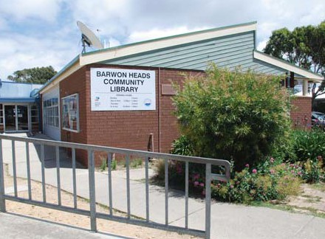

At its meeting held 24 May 2005 Council resolved to:
“Undertake negotiations with Barwon Heads Primary School to develop ways of increasing community utilization of the school/community library without increased costs to either party. Monitor the performance of the Barwon Heads School / Community Library.”

The Barwon Heads Community Library is presently housed in the local school library with
13 hours per week opening to the community. It serves a population of approximately 3,000. Current membership is 658 and in the 2007/08 year the library loaned 9,295 collection items and had 3,937 visits. This Library is situated
in a building owned by the Department of Education, which is responsible for the building maintenance and utilities costs. The location which is not in a main street or shopping area
is a disadvantage. There is parking at the site represented by street front parking.

The Barwon Heads Primary School owns the furniture and the Geelong Regional Library Corporation (GRLC) provides the budget for

staffing and funding for operational costs that apply to the community library operation. GRLC also operates and maintains the Library Management System for the school and community.

The library at 180m2 is relatively small though generally has enough space to meet current community demand. Benchmarks indicate the library should have a floor area over 150m2 to service its existing catchment. It is noted that
the designated library area for this shared library is not all for community use. The library has no development or expansion potential in its existing facility. Community use is relatively low recording the lowest visits and loans of all libraries and mobile libraries in the network. Transitioning the traditional library service delivery model to one
of a community library model will ensure tailored collection and relevant services are offered, maximising the space available for community benefit.

Recommendations
A review of services, usage and suitability of current arrangements is required to determine future strategies for the provision of library services to this community. Given the current innovations in the library industry there may
be more cost effective ways to deliver library services that offer improved access
Identify partnership opportunities to deliver to
Barwon Heads residents in alternative ways
Identify alternative models of service delivery and determine cost efficiencies against existing model.

Timeframe: Medium-term (5-10 years).

Belmont Library

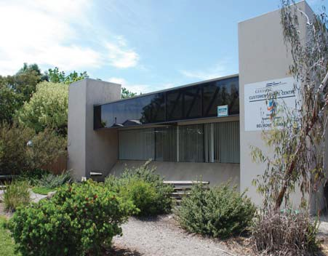

At its meeting held 24 May 2005 the City of
Greater Geelong Council resolved to:
“Confirm its support for library infrastructure at Geelong City, Belmont, Drysdale, Corio, Geelong West, Newcomb, Highton and Ocean Grove.”

The library was built in 1981, is Council owned and is open 49.5 hours per week. It is co-located with a Council Customer Service Centre. Current membership is 18,076 and in 2007/08 the library loaned 453,195 collection items (highest in the network) and experienced 208,450 visits (2nd highest in the network). There is access to the main street and it is situated within a retail precinct providing exposure to pedestrian and vehicular traffic. There is good parking at the rear
of the building and an open space/park area at the front.

The library is accessible and is in close proximity to schools, public transport and safe pedestrian access. The interior is very dated with traditional layout for collections, an overly large circulation desk and 8 public access Internet computers. There are suboptimal options for expansion in the front and south side of the library.

At 950m2 it is the second largest library in the Geelong Network and provides sub-regional support to Grovedale and Torquay (Surf Coast Shire) libraries. It meets People Places guidelines for catchment population and sub-regional function. There is adequate space for collections though it has insufficient space for library programming and events. There is no meeting room and additional space is required if this is to be provided. The size of the staff work areas are disproportionate to public spaces and should be reviewed with a view to increasing public space. Lighting needs to be addressed. The location of Internet computers is not suitable for learning programs or usage. A recent announcement of State Government Living Libraries Grants funding will enable a refurbishment, update and expansion of public space within the building.

Recommendations
Planning for refurbishment to be undertaken in the short term with a view to integrating the Council Customer Service Centre within the library
Increase space for public access Internet provision
Expand footprint of library to accommodate meeting room and tailored zones.

22

Chilwell Library

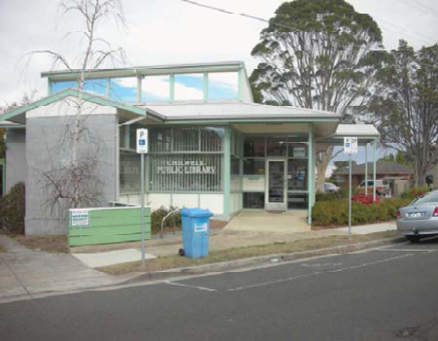

Timeframe: Short term (0-5 years).
The library is located on Russell Street in a Council owned building and is adjacent to a Maternal
Child Health Centre and a public park. Current membership is 1,739 and in the 2007/08 year loaned 66,490 collection items and experienced
44,235 visits. The library is currently open 30.5 hours per week.

Parking at the site is represented by street front parking. There are public toilets in the park. The library has expansion potential and currently a feasibility project is underway to determine future hub or co-location opportunities.

The library at 216m2 is relatively small though has adequate space to meet the needs of the catchment area. Recently refurbished and repainted the library has a modern look and feel. There are opportunities to better integrate the library with the park and the Maternal and Child Health Centre. It is noted that the Chilwell Library is in close proximity to both Geelong and Geelong West libraries.

A recent survey undertaken by the Geelong Regional Library Corporation showed a much higher than average number of library members visited with their children (37%). There is potential to tailor the library to early years focus. Co-location of services relevant to the local community can draw a variety of people visiting other facilities to the library on a regular basis.

Recommendation
Investigate feasibility of co-location with the
Maternal Child Health Centre. Timeframe: Medium-term (5-10 years).

23

Corio Library

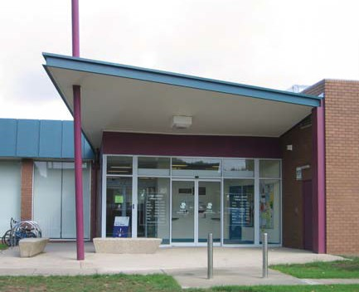

At its meeting held 24 May 2005 the City of
Greater Geelong Council resolved to:
“Confirm its support for library infrastructure at Geelong City, Belmont, Drysdale, Corio, Geelong West, Newcomb, Highton and Ocean Grove.”

The library was originally built in 1972 and recently refurbished in 2005. The building and land is owned by Council. The library is open for 45 hours per week. Current membership
is 11,262 and in 2007/08 loaned 209,555 collection items and experienced 146,885 visits. At 1,295m2 the library is the biggest in the network, serves a large catchment area in the northern part of the municipality and is in very good physical condition. The level of socioeconomic disadvantage in the local catchment served is high. As the only

library serving the northern area the physical space standards suggest the library should
be expanded by 500m2. This would enable, for example, expansion of community access Internet computers, which is a much needed improvement, given the relatively low rate of Internet access at home in the northern suburbs. Attention could be paid to updating the meeting room spaces to enable access to training equipment and multimedia. This would provide greater level of service to community members and groups and open usage up to a broader
range of community activities including training and development.

The library is adjacent to the Waterworld Aquatic Centre, gym and Centenary Hall, maximising the opportunity to provide a community destination incorporating health and wellness with library services. Access for residents with disabilities
and prams is adequate with good entrances to the library. Off street parking is available and adequate. Public toilet amenities are also provided. The location away from main street and retail precinct is a disadvantage.

Recommendations
The Corio library is a sub-regional branch supporting mobile libraries and the new Lara Library
A review of the facility will be required in 15+
years.

24

Drysdale Library

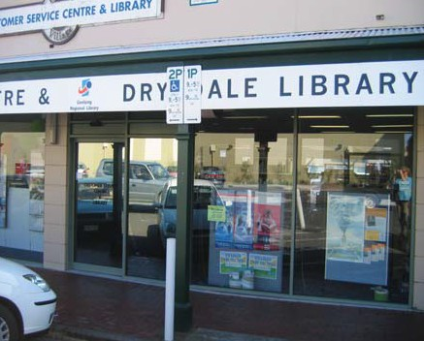

At its meeting held 24 May 2005 the City of
Greater Geelong Council resolved to:
1. “Confirm its support for library infrastructure at Geelong City, Belmont, Drysdale, Corio, Geelong West, Newcomb, Highton and Ocean Grove.
2. Undertake a detailed 10 to 15 year library facility plan be developed suggesting timeframe and estimated costs of building new libraries
at Waurn Ponds, Lara and Armstrong Creek
and redeveloping or replacing the Geelong City, Geelong West and Drysdale Libraries.”

Drysdale will experience significant growth with the catchment population projected to increase by 39% to 21,994 persons by 2030. Drysdale library is located on Hancock Street within the main retail precinct of the town.
The library is co-located with a City of Greater Geelong Customer Service Centre providing access to Council services and enquiries. It is currently open for 42.5 hours per week. Current membership is 5,832 and in 2007/08 the library loaned 128,782 collection items and
experienced 145,737 visits. Parking at the site is represented by street front parking.
The library at 240m2 does not provide adequate floor area. It has minimal development or expansion potential though greater integration
of the Customer Service Centre and Library operations could increase interior space and improve library layout in the short term. There are no meeting rooms and space for library programming and events. There is very limited space for reading, information technology provision and for young users. Benchmarks indicate the library should have a floor area of over 800m2 to service its existing catchment. A new Library of 1220m2 plus would be required to meet projected population growth and sub- regional level services.

The facility is situated in a leased building with tenure until 2012. Council’s responsibilities
for the building maintenance are for essential services. Council is investigating the feasibility of the development of a community hub in Drysdale including a new library. This offers
a good opportunity to develop contemporary library services for the local and surrounding community.

Recommendations
Investigate the integration of the Council Customer Service Centre and library services; Redesign the large desk area to provide
smaller enquiry pod/s to provide increased public floor space
Tailor the collection to meet the needs of the community based on usage
Investigate the development of a new community hub to provide sub-regional level library services for the future.

Timeframe: Medium-term (5-10 years).

25

Geelong City Library

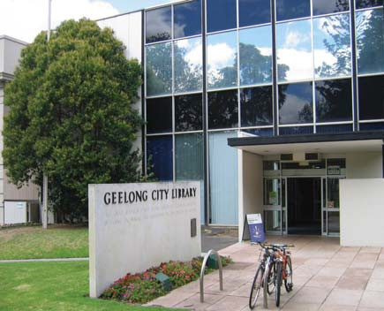

At its meeting held 24 May 2005 the City of
Greater Geelong Council resolved to:
1. “Confirm its support for library infrastructure at Geelong City, Belmont, Drysdale, Corio, Geelong West, Newcomb, Highton and Ocean Grove.
2. Undertake a detailed 10 to 15 year library facility plan be developed suggesting timeframe and estimated costs of building new libraries
at Waurn Ponds, Lara and Armstrong Creek
and redeveloping or replacing the Geelong City, Geelong West and Drysdale Libraries.
3. Continue work on identifying an appropriate site for the Geelong City Library.”

The current library building is located on Little Malop Street in the Cultural Precinct with other major cultural institutions including Courthouse Youth Arts Centre, Geelong Heritage Centre, Geelong Performing Arts Centre, Geelong Gallery and adjacent to Johnstone Park. The Library
is co-located with the City of Greater Geelong Heritage Centre, which occupies the first floor though currently the operations of the two organizations are separate. Current membership of the Geelong Library is 23,425 and in
2007/08 the library loaned 388,901 collection items.

The library has no development or expansion potential on its existing site unless redevelopment of the open space is considered or a multi-storey option is considered. It is the oldest library in the City having been built in
1959 and is Council owned and maintained. This library has had minimal refurbishment and is very dated though some efforts have been made to accommodate technology and a wide variety of collection formats to meet the central library services the facility attempts to provide. Most library programs other than storytimes are

held offsite due to the lack of any meeting or event spaces. This imposes increased operational costs on the service as alternative venues charge for hire.

The library currently has 702m2 of floor area, representing a shortfall of at least 6,298m2. Collections, information technology, lifelong learning programming and events, individual and group learning are all very limited. It clearly does not meet the community needs and expectations of a significant regional city. There is also inadequate space to house existing branch staff. Regional Library staff are not accommodated resulting in increasing operational costs through leasing additional administrative and technical services space. Parking at the site is represented by street front parking and a large multistorey carpark within 100 metres of the facility.

The Geelong Library has participated in a
major masterplanning process along with other Cultural Precinct institutions during 2007. The masterplanning project is a partnership between Major Projects Victoria (project managers) and the City of Greater Geelong. A resulting Vision document developed by Consultant Ken Gorbey and the final Masterplan submitted to the
State Government both recommended that a new integrated Library and Heritage Centre be developed and that the area allocation should increase to 7,000 - 10,000m2.

The Geelong Library is recognised as a key anchor currently attracting over 250,000 visits per year from the broadest spectrum of
community members and visitors to the City. The Masterplan has resulted in a further investment from the State Government to develop a detailed business case and design for the Library & Heritage Centre. The Geelong Heritage Centre Committee of Management recently resolved
to integrate the operations and governance of the Heritage Centre with the Geelong Regional Library Corporation. The Library Board resolved that it supports this direction and
both organizations are now moving towards an integrated approach which will provide greater service and community access outcomes. The success of the integration will depend greatly on a suitable and innovative architectural solution.

People Places standards indicate the library should have a floor area of at least 7,000m2 for current catchment population and to fulfill
Central Library functions. As a key anchor for the

26

Geelong West Library

proposed Geelong Cultural Precinct the Geelong City Library and Heritage Centre is ideally positioned to be redeveloped as a state of the art facility incorporating signature architecture, provision of 21st century integrated library and heritage centre services, and housing the GRLC
administration and collections services functions.

The Geelong Cultural Precinct is envisaged as a dynamic precinct for the Greater Geelong area that combines artistic, social, economic and
educational imperatives. The Geelong City Library and Heritage Centre will be the anchor institution to activate and animate the cultural precinct on a daily basis.

Recommendations
The Geelong Central Library and Heritage Centre be redeveloped as part of the Cultural Precinct project on its current site with planned construction in Stage One of the project
The facility should include an Integrated Library and Heritage Centre and floor area of at least 7,000m2.

Timeframe: Short-term (0-5yrs).

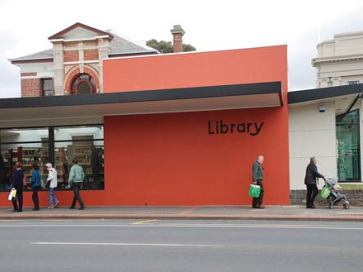

At its meeting held 24 May 2005 the City of
Greater Geelong Council resolved to:
1. Confirm its support for library infrastructure at Geelong City, Belmont, Drysdale, Corio, Geelong West, Newcomb, Highton and Ocean Grove.
2. Undertake a detailed 10 to 15 year library facility plan be developed suggesting timeframe and estimated costs of building new libraries
at Waurn Ponds, Lara and Armstrong Creek
and redeveloping or replacing the Geelong City, Geelong West and Drysdale Libraries.

The library is located on Pakington Street within the main retail precinct of Geelong West. This branch library has been refurbished and extended in 2008 providing 550m2 of library space. Immediately prior to redevelopment the Geelong West Library had 6,950 members, loaned over
160,000 collection items and experienced over
105,000 visits per year. Activity has doubled since reopening In October 2008.

The new floor area of 550m2 represents a shortage of physical space according to standards. Geelong West has been identified as a branch library in this strategy and as such would need 944m2 of floor space to meet People Places standards for the current and projected 2030 population. However, the
2008 redevelopment was constrained by site conditions in relation to expansion. Community consultation indicated that the community preferred the Library to stay in its current location which offered and provided a 30% expansion opportunity.

Recommendations
Monitor usage trends and ensure the services and facility are tailored to meet local community needs, especially once the new Geelong Central Library is established
A review of the facility and services would be required in 15+ years.

27

Grovedale Library Highton Library

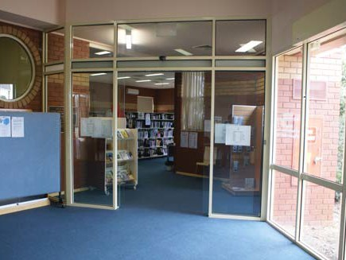

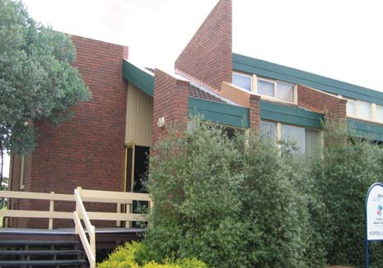At its meeting held 24 May 2005 Council resolved that it:
“Determine to close the Grovedale Library on the opening of Waurn Ponds Library.”

The library, situated on Heyers Road and co-located with the Community Centre, is one of the smallest in the library network at
150m2, though has adequate space for existing collections and staff. Benchmarks indicate the library should have a floor area of 809m2 to service its existing population catchment. This building is owned by Council and was built in
1985. The management responsibilities to this building sit with the Management Committee
of the Community Centre. The Library is open for 15 hours per week. Current membership is
1,083 and in 2007/08 loaned 17,728 collection items and experienced 10,137 visits.

Recommendations
Provide a new library for Grovedale and Waurn Ponds communities adjacent to Leisurelink Facility.

Timeframe: Short-term (0-5 years).
At its meeting held 24 May 2005 the City of
Greater Geelong Council resolved to:
“Confirm its support for library infrastructure at Geelong City, Belmont, Drysdale, Corio, Geelong West, Newcomb, Highton and Ocean Grove.”

Highton’s population catchment is projected to increase by 23% to 20,859 residents by 2030. A library of at least 970m2 would be required.

The library is identified as a branch library and currently at 135m2 is the smallest in the Geelong library network. This severely limits opportunities to provide the range of collections, programs and information technology provision expected. People Places standards indicate the library should have a floor area of 800m2 to service its existing local catchment. The shortfall in space indicates serious under-provision of library services in the Highton catchment area.

The Highton Library was built in 1977 and is owned by Council. The Library underwent an interior refurbishment with new carpet and new circulation desk in July 2004. It is located in the Highton Village retail precinct on a corner block on Roslyn Road adjacent to Safeway Supermarket and a sports field. Off–street
parking is provided by the supermarket carpark. Access for residents with disabilities is limited due to the steep ramp. This library is in close proximity to Geelong West, Chilwell and Belmont libraries. Current membership is 2,814 and in
2007/08 loaned 68,970 collection items and experienced 48,275 visits.

Recommendation
Investigate opportunities to redevelop and expand the library.

Timeframe: Medium-term (5-10 years).

28

Newcomb Library Ocean Grove Library

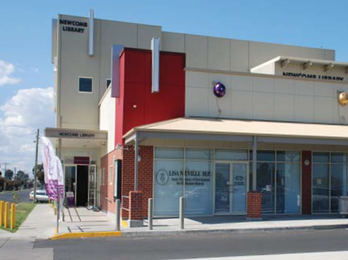

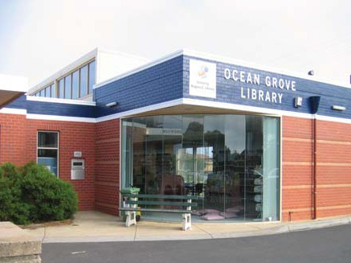At its meeting held 24 May 2005 the City of
Greater Geelong Council resolved to:
“Confirm its support for library infrastructure at Geelong City, Belmont, Drysdale, Corio, Geelong West, Newcomb, Highton and Ocean Grove.”

Newcomb Library is located in the Newcomb Centro Shopping Centre on the corner of Bellarine Highway and Wilsons Road. The Library was redeveloped along with the shopping centre
in 2007 and has a tenure lease of 997 years. Parking is provided as part of the overall shopping centre carpark.

Co-location with a City of Greater Geelong Maternal and Child Health Centre has enabled greater partnership programming with an early years focus for the local community which has been identified as disadvantaged.

Current membership is 7,482 and in 2007/08 loaned 114,164 collection items and experienced
65,773 visits. The library at approximately
700m2 offers sufficient floor area for current usage levels with flexible features such as shelves on wheels included. The library meeting room on level 1 provides a large space for programs and events.

Recommendations
Monitor usage trends and ensure the services and facility are tailored to meet local community needs, especially once the new Geelong Central Library is established
A review of the facility and services would be required in 15+ years.
At its meeting held 24 May 2005 the City of
Greater Geelong Council resolved to:
“Confirm its support for library infrastructure at Geelong City, Belmont, Drysdale, Corio, Geelong West, Newcomb, Highton and Ocean Grove.”

Ocean Grove’s catchment population is projected to increase by 15% to 13,645 by 2030. This would require a library of at least 990m2.

The library is located on the corner of Presidents Avenue, in the older established area of Ocean Grove. Current membership is 8,899 and in
2007/08 loaned 167,225 collection items and experienced 96,706 visits. The library is situated opposite a medium size shopping centre, which
is being extended.

Built in 1993 this is a purpose built facility provides three services to the community; Library, COGG Customer Service Centre and a Community Health Centre. A shared foyer
provides access to all three services. There is
off-street parking at the site represented by street front parking, 15 spaces at the rear of the facility and further parking available diagonally opposite in the shopping centre. The library has no development or expansion potential. The library
at 370m2 represents a shortage of space and does not meet requirements of the current and growing catchment area. There is adequate space for staff though there are no meeting rooms or space for library programming events, expanded collections or information technology provision. People Places standards indicate the library should have a floor area of 700m2 to service its existing catchment.

Recommendation
Investigate opportunities to expand the library space and develop as a sub-regional library either within the existing facility or in alternative leased or Council owned premises.

Timeframe: Long-term (10-15 years).

29

PRELIMINARY PLANNING FOR NEW LIBRARY INFRASTRUCTURE

Armstrong Creek

At its meeting held 24 May 2005 the City of Greater Geelong Council resolved to: “Undertake a detailed 10 to 15 year library
facility plan be developed suggesting timeframe and estimated costs of building new libraries
at Waurn Ponds, Lara and Armstrong Creek
and redeveloping or replacing the Geelong City, Geelong West and Drysdale Libraries.”

The Armstrong Creek Urban Growth Area has been identified as the primary growth corridor in the Geelong region. The growth area is located
10-20km to the south of Geelong. The area presently contains less than 1,000 persons but is expected to accommodate more than 6,000 persons by 2016, almost 25,000 persons by
2026 and nearing 40,000 persons by 2030. These forecasts correspond to significant residential development and annual growth rates of almost 30% during certain periods. Once fully developed, the Armstrong Creek Urban Growth Area is expected to accommodate approximately
25,000 homes, 22,000 new jobs, a population upwards of 66,000 people and extensive areas of passive, active and environmental parkland.

The Urban Growth Plan provides an overall vision statement for the Armstrong Creek development:
“The Armstrong Creek urban growth area will
be developed into a sustainable community that sets new benchmarks in best practice urban development. Natural and cultural features will be protected and enhanced to create a distinct urban character. Armstrong Creek will become
a highly sought-after location for living, working and recreation, forming an attractive addition to Geelong.”24

The Urban Growth Plan also states:
“The scale of the new development will enable the provision of a comprehensive range of community facilities and services such as schools, a library, medical centres and meeting spaces. These will reflect leading edge thinking in terms of efficient and convenient service
delivery. Community facilities and services to serve the new community will be provided early in the life of the development to ensure convenient access for new residents… …
Armstrong Creek will be a learning community. It will foster ‘lifelong learning’ through not only a comprehensive matrix of education facilities
but also the social institutions and organisations that support an inquiring and creative lifestyle. This culture of learning will create a climate
that is conducive to the establishment of new enterprise, harnessing people’s imagination
and talent to cultivate a durable, ‘home grown’
economy.”

Given the proposed scale of development and growth, Armstrong Creek was identified as a potential sub-regional centre in the Geelong Retail Strategy,25 meaning it is likely to accommodate 15,000-35,000m2 of retail
floorspace along with non-retail facilities such including office, community and medical services. The Framework Map for the Armstrong Creek Urban Growth Area identifies an area
to accommodate a Major Activity Centre for sub-regional land uses. The identification of Armstrong Creek as the future urban growth corridor of Geelong and the scale of the population forecasts will see the area account
for almost 40% of the total population growth in the City of Greater Geelong LGA over the next 25 years has necessitated strong consideration for a new library in this area.

Armstrong Creek is a greenfield site and presents a great opportunity to construct a large facility that can provide a full suite of contemporary library services to all members of the community in the one location. A larger centrally located library is preferable to a series of smaller libraries due to the dilution in quantity and range of services that occurs in smaller facilities. Such a facility would support the provision of Outreach Services including collections and programs through neighbourhood level community
facilities. It is planned that residential precincts

24 Armstrong Creek Urban Growth Plan Volume 1, City of Greater Geelong, October 2006.
25 Geelong Retail Strategy, op cit.

30

Lara

will range from 0.2 kms to 3.7kms in distance from the Major Activity Centre. In addition, walkability and public transport will be optimally planned and delivered, enabling excellent access to the Major Activity Centre.

Using the People Places benchmarks the required library floor area for the forecasted
2030 population in the Armstrong Creek area is 1,650m2. To accommodate the proposed population of 66,000 a library of approximately
3,000m2 would be required. Council will need to consider whether to build the total facility
from the outset or develop the facility in a staged approach. Given the population forecast pattern, it is recommended a staged development be undertaken. In the short-term, as the area establishes, the area could be serviced by the planned Waurn Ponds Library and other branch libraries in the Geelong urban area.

Recommendations
That planning commence for a sub-regional level library to be located in the Major Activity Centre
That a new library is constructed in 3 stages, expanding with each major growth period
That in the first stage a library of at least
1200m2 be considered with a view to expanding to 3,000m2.

Timeframe: Long term (10-15 years).
At its meeting held 24 May 2005 the City of Greater Geelong Council resolved to: “Undertake a detailed 10 to 15 year library
facility plan be developed suggesting timeframe and estimated costs of building new libraries
at Waurn Ponds, Lara and Armstrong Creek
and redeveloping or replacing the Geelong City, Geelong West and Drysdale Libraries.”

Lara is a residential and rural town located
15km northeast of Geelong, inland from the Princes Freeway to Melbourne. There were an estimated 11,509 persons living in the township of Lara in 2006. The township also serves the surrounding rural catchment which contained
an estimated 2,497 persons in 2006. The Lara catchment population is forecast to increase quite sharply through to 2016 to 16,605 persons, before moderating to around 17,400 persons through to 2030.

Lara is identified as a Town Centre in the
Geelong Retail Strategy26. The centre contains
4,080m2 of retail floor space, anchored
by a small Safeway supermarket, serving a convenience role for the residents of Lara and surrounds. Investigations are underway to expand the Town Centre given recent growth
and capacity constraints. The Lara Urban Design Framework27 identified the provision of a library as one of five key issues to be addressed. It
also identified library services as one of four key services requiring improvement.

The Lara and surrounding rural catchment is currently serviced by the Greater Geelong Mobile Library, 6 hours per week. The nearest library branch is Corio, around 10km to the south-west. The existing population size of 14,000 and the forecast population growth to 17,400 over the next 25 years has raised strong consideration for a physical library in the Lara area.

The Lara community has been voicing requests for a library branch for some time. The survey undertaken by the Geelong Regional Library

25 Geelong Retail Strategy, op cit.
26 Geelong Retail Strategy, op cit.
27 Lara Town Centre Urban Design Framework, City of Greater Geelong, March 2006.

31

Leopold

Corporation in August 2007 demonstrates overwhelming demand for a library branch in Lara. The Bendigo Bank located in Lara recently surveyed the Lara community regarding other services they would like to see in their town and
the top two items respondents gave were a library and facilities for young people.

Using the People Places benchmarks for library floor area the requirement for the current population is 650m2 and for the 2030 population a library of 900m2.

The anticipated expansion of the Town Centre is projected to occur within 3-5 years. The City of Greater Geelong believes this time frame is too long to wait for the development of a permanent library and has resolved to provide an interim
solution which is budgeted for in the 2008/09 and
2009/10 financial years. An interim Library will be established in close proximity to the Community Centre, the Maternal Child Health Centre and
retail area. A permanent library facility will be built at the time of the commercial redevelopment in
the Town Centre.

Recommendations
That an interim Library be established becoming operational in the 2009/10 financial year
That detailed planning commence for a new permanent Lara Branch Library.

Timeframe: Short term (0-5 years).
At its meeting held 26 August 2008 the City of
Greater Geelong Council resolved:
“That Council
1. Receive the Leopold Community Hub Plan.
2. Investigate funding options for the Leopold Community Hub including a comprehensive Developer Contribution Plan for Leopold, sale of land and Government Funding.
3. Undertake in 2008/09 detailed design of the
Leopold Community Hub.
4. Develop a Priorities Plan for the development of the Leopold Community Hub.
5. Investigate employment generation opportunities for Leopold.”

Leopold is the third largest township on the
Bellarine Peninsula, 10km to the east-south-east
of Geelong’s city centre. Leopold lies on both sides of the Bellarine Highway, with small shopping areas in each part. There were an estimated
8,450 people living in Leopold in 2006. The area’s population is forecast to grow to 15,000 persons by 2030.

Leopold was identified as a neighbourhood centre (with potential as a sub-regional centre) in the Geelong Retail Strategy28, along with Drysdale
and Newcomb. A new shopping centre has been constructed. The Bellarine Peninsula Strategic Plan 2006-201629 included a recommendation that the City of Greater Geelong “Investigate possible location for provision of additional
community services in Leopold including a library, family support, parent support, maternal and child health services, play groups, early intervention programs, youth health programs and community meeting room.” The Leopold Youth Needs Study30 recommended investigating the possibility of building a library.

28 City of Greater Geelong Retail Strategy op cit.
29 Bellarine Peninsula Strategic Plan 2006-2016, City of Greater Geelong, 2006.
30 Leopold Youth needs study, City of Greater Geelong Youth development Unit, 2006.
31 Leopold Community Hub Concept design, David Lock and Associates for the City of Greater Geelong, February 2008.

32

Vines Road

The City of Greater Geelong has undertaken further detailed work including a Social Infrastructure and Community Hub Plan. The Leopold Community Hub Plan31 includes a Lifelong Learning Centre providing library services for the community and for students of the adjacent primary school, a coffee shop, an information technology hub and an interpretive centre.

The Leopold area is presently serviced by the Greater Geelong Mobile Library for four hours per week. The nearest static library branches are the Newcomb Branch to the west and the Drysdale Branch to the east. Leopold area’s population size, impending growth and community demand present a strong case for the development of
a library in Leopold. Using the People Places benchmarks for library floor area, the required library floor area for the 2030 population in the Leopold area is at 800m2.

The community hub proposed model features a joint use library for the Leopold Primary school, information technology provision and a café
and would therefore require increased space to accommodate these additional functions. The provision in the Leopold Community Hub
Concept Plans is supported and will provide an innovative and integrated model of library service delivery to the Leopold Community.

Recommendation
That detailed planning for a Leopold Branch
Library is undertaken.

Timeframe: Short term (0-5 years).
At its meeting held 25 October 2005 the City of
Greater Geelong Council resolved that:
“Further to the decision on 27 September 2005 (to merge Chilwell and Newtown Libraries), Council resolves to work with the Department
of Education to consider a library service in any plans for community infrastructure to
be developed as part of the Western Heights
Secondary College proposed development.”

The Vines Road redevelopment project, located in Hamlyn Heights, is a partnership between
the City of Greater Geelong and the Department of Education and Early Childhood Development (DEECD). The existing Vines Road Western Heights Secondary College site into a state
of the art precinct that includes community, recreation, arts and educational benefits to the wider community. The amalgamated campuses of Western Heights Secondary College as well as a range of community and recreational facilities will be built on the site.

The school library will be open for community access during school hours, two evenings per week and Saturday mornings. The proposed floor area is approximately 400m2 in total which includes a café, designated community collections, and reading area of approximately
40m2. The library will be staffed by the school and will provide access to the Geelong Regional Library collection and services.

Recommendation
That the current mobile library service to Vines Road be replaced with community access to Vines Road Secondary College School Library.

Timeframe: Short term (0-5 years).

33

Waurn Ponds

As an integral part of the Waurn Ponds Recreation and Community facilities planning the City of Greater Geelong is proposing the introduction of library services. The Leisurelink Community Hub to be built on the corner of Pioneer Road and Colac Road will be a new community hub comprising
a number of community services as well as a replacement facility for the current Leisurelink in Reynolds Road, Belmont. It is a $34 million project to be built in 2 stages. Stage one will
include all the facilities to be available in the new Leisurelink including 50m pool, hydrotherapy pool and gymnasium. Stage two includes a community library of approximately 975m2, occasional child care and multipurpose meeting rooms.

The Community Hub will provide significantly improved facilities for residents of Grovedale, Waurn Ponds and the first stage of future residents of Armstrong Creek. For the purposes of library planning a 2021 forecast population for Waurn Ponds and Grovedale only of 20,837 has been used as it is proposed that library facilities will be provided as part of community infrastructure in Armstrong Creek.

Recommendation
That a new library of 975m2 be constructed as part of the Waurn Ponds Recreation and Community hub
That detailed design for the Waurn Ponds Library to replace current Grovedale Library be commenced in the 2008/09 year.

Timeframe: Short term (0-5 years).

34

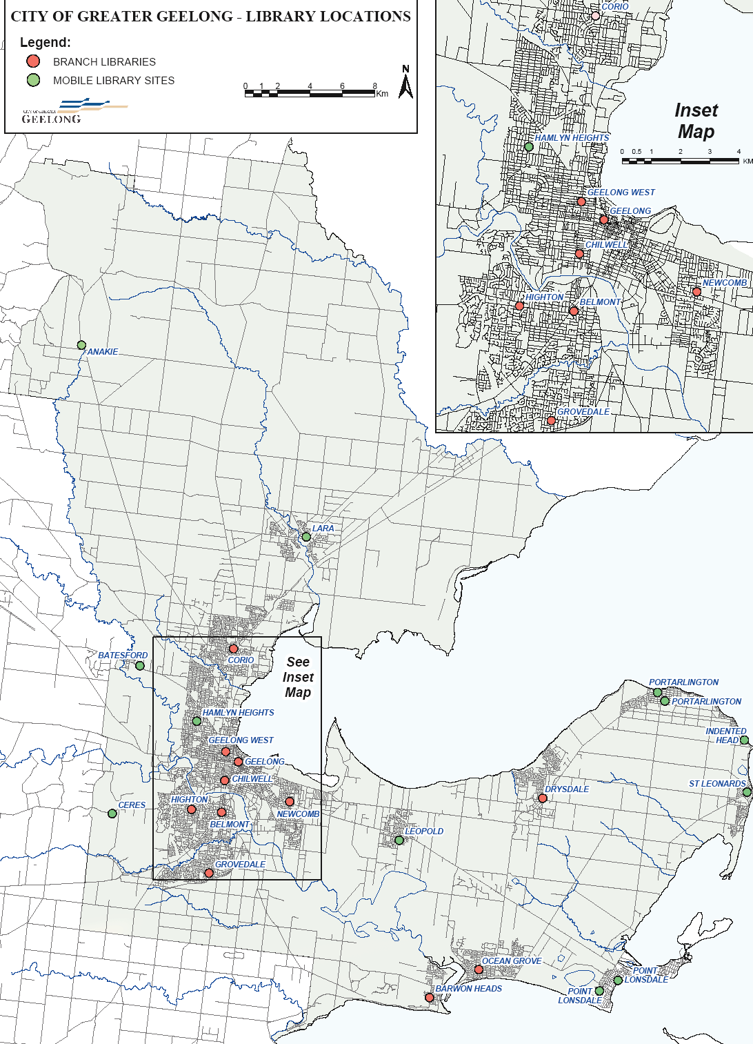CITY OF GREATER GEELONG LIBRARY LOCATIONS

HAMLYN HEIGHTS

GEELONG WEST GEELONG

CHILWELL

HIGHTON BELMONT
NEWCOMB

ANAKIE

GROVEDALE

LARA

BATESFORD

CERES

CORIO

HAMLYN HEIGHTS GEELONG WEST
GEELONG CHILWELL
HIGHTON

DRYSDALE

PORTARLINGTON PORTARLINGTON

INDENTED HEAD

ST LEONARDS

BELMONT
NEWCOMB

LEOPOLD

GROVEDALE

OCEAN GROVE

BARWON HEADS

POINT

POINT LONSDALE

LONSDALE

35

AUSTRALIAN AND INTERNATIONAL BEST PRACTICE LIBRARY BUILDINGS

ALBURY LIBRARY MUSEUM

Albury City Council, NSW, AUSTRALIA Architects: Ashton, Raggatt, McDougall Area: 3,000 m2
AUSTRALIAN AND INTERNATIONAL BEST PRACTICE LIBRARY BUILDINGS
Catchment population: 50,000
Opened 2007

Albury’s award winning Library Museum brings together a library, state of the art technology,
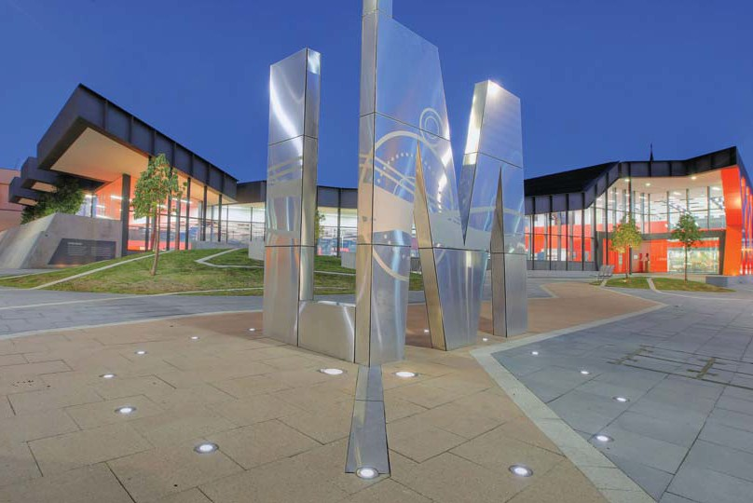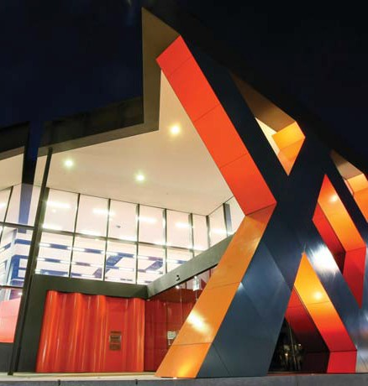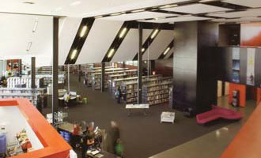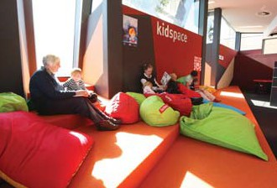a focus on the City’s heritage and interactive exhibitions. The landmark building is located
in a civic precinct and was designed as part of a larger CBD development with expressive elements drawn from aspects of the region’s heritage and environment. The criss-cross pattern of the façade is especially significant. Albury was established primarily as a cross-border town and the façade inspired by a local railway bridge.
The programming and management convergence model is a first for Australia.

36

BRISBANE SQUARE LIBRARY

Brisbane City Council, QLD, AUSTRALIA Architects: Denton, Corker, Marshall (Building); City Design, Brisbane City Council (Internal Design)
Area: 5,000 m2
Catchment population for central libraries and network of 32 libraries: 1m
Opened 2006

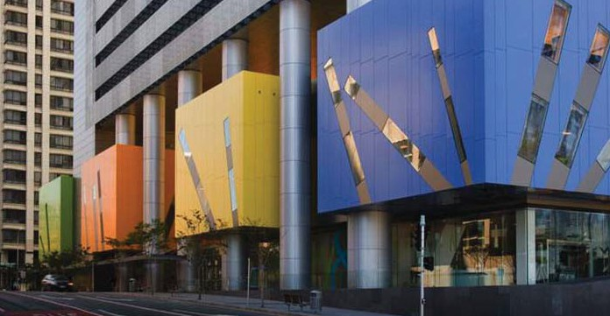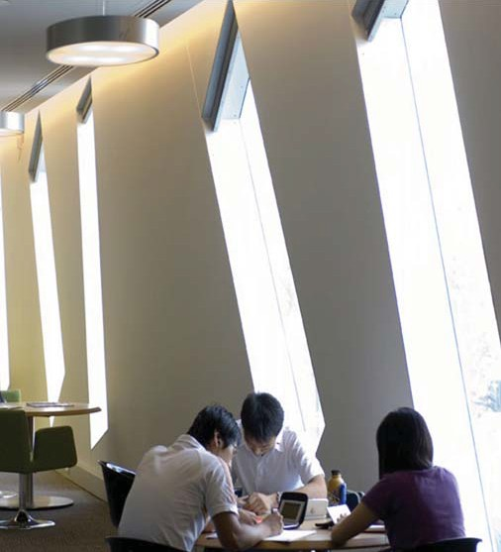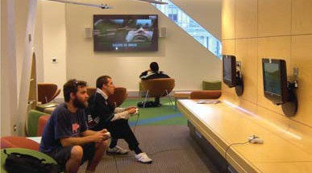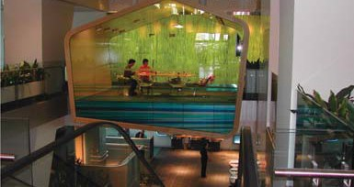The new Brisbane City Council Library and Customer Centre (LCC) brings together a number of previously separate service providers into a ‘one stop shop’ over three interconnected levels. It comprises a library, council customer services and council development and
regulatory services. Central Library services are provided from this location and the facility supports 32 neighbourhood libraries throughout the City of Brisbane. Facilities include a News Lounge, a Learning Lounge, a young peoples “ZOO” lounge, Sound and Vision Lounge, Brisbane History Gallery, Internet Lounge and collections throughout.

Sustainable initiatives developed for Brisbane Square include use of recycled material for the fit out, on-site treatment and reuse of solid waste, rainwater harvesting, a river water cooling system.

37

CAROLINE SPRINGS LIBRARY

Melton Shire Council, VIC, AUSTRALIA
Architects: Suters, Prior, Cheney
Area: 2,200 m2
Catchment population: 20,000 (projected to grow to 40,000 in the medium term)
Opened 2008

As part of an integrated development for the Caroline Springs Town Centre, the Shire of Melton commissioned the development of a
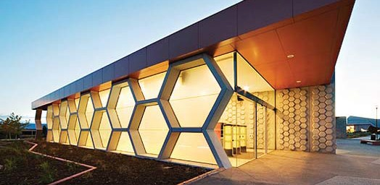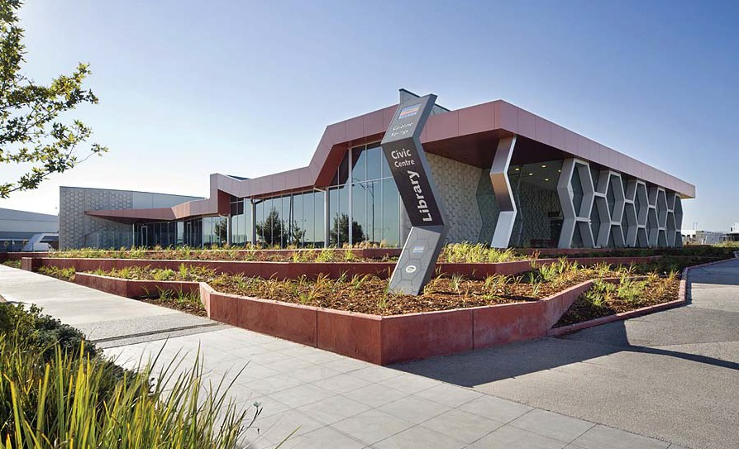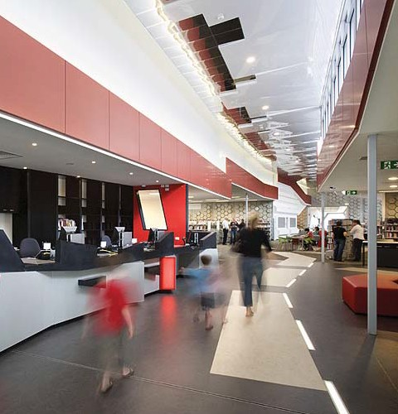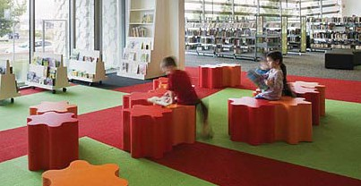2,200 m2 library and civic centre. The design for the Caroline Springs Library was inspired by the local geological features of the area from which
the Organ Pipes National Park takes its name. These distinctive columnar basalt formations are reflected in many interior design elements within the building. The design needed to accommodate large volumes of people moving through the building and representing different uses of the facility. In response a number of zones have
been created within the state of the art library. As well as an extensive range library services there is access to all council services, a variety
of meeting room facilities, e-learning facilities for the adjacent school and the community, a café and other spaces available for community use.

38

CASTLE HILL COMMUNITY HUB LIBRARY

Baulkham Hills Shire, NSW, AUSTRALIA
Architects: Brewster Hjorth
Area: 1,900 m2
Catchment population: 30,000
Opened 2004

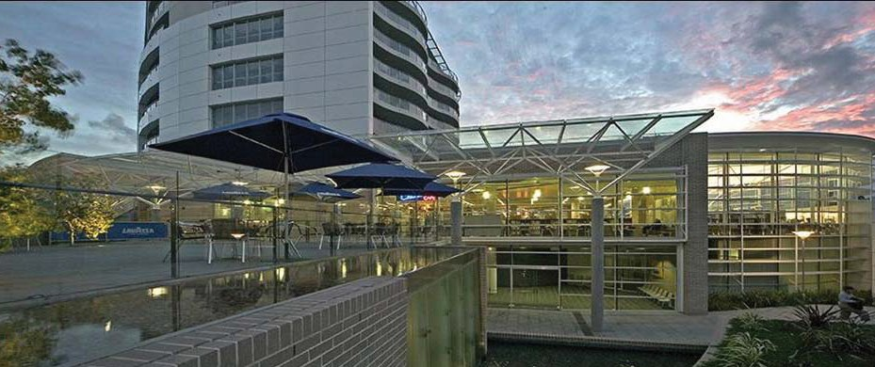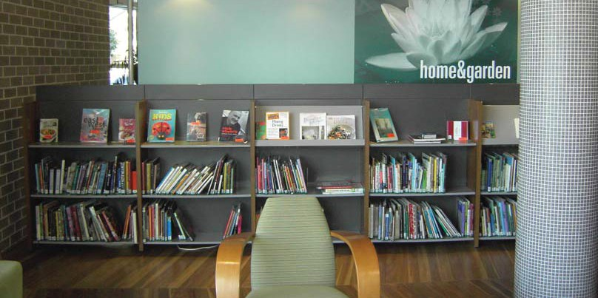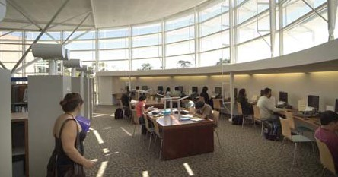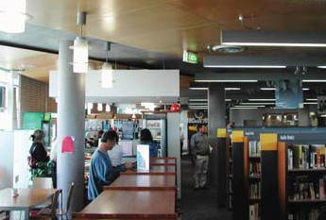Comprising a library, integrated Council customer services and a café. Well designed and comfortable spaces are provided for quiet study and reading, extensive information
technology provision, a ‘castle’ themed children’s area, collections located throughout and a café located within the library. Attention to detail can be seen throughout with careful selection of furniture, fittings and materials to create an “upmarket bookshop” ambience. A Maternal and Child Health Centre, Community Centre and Community meeting rooms co- located within the hub provide residents with a
key destination for local council service delivery.

39

CUSTOMS HOUSE LIBRARY

Sydney City Council, NSW, AUSTRALIA Architects: Lacoste and Stevenson Architects Area: 4,270 m2
Catchment population: 30,000 residents and city workers
Opened 2005

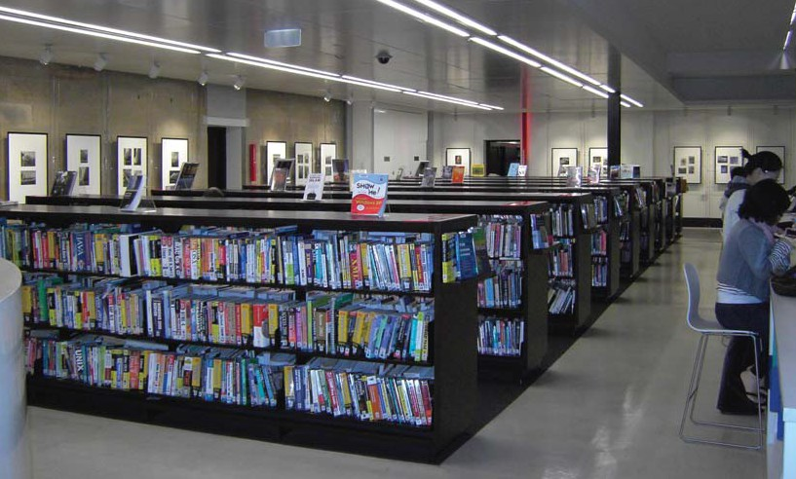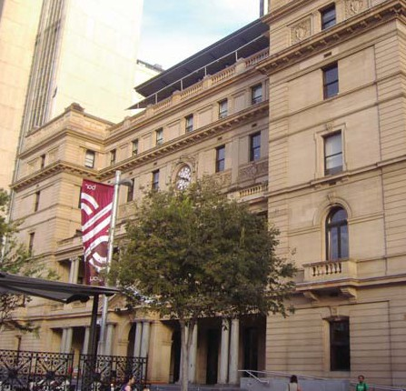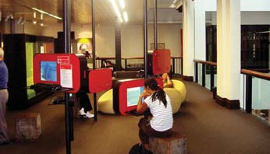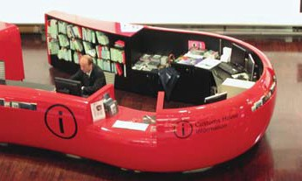The relocation of the City of Sydney Library to Customs House in Circular Quay has given the building a new lease of life. The ground floor was conceived of as a new public ‘living room’ and houses an extensive range of magazines and the largest range of local and international
newspapers in Australia. Levels 2 and 3 provide quieter spaces for reading and study and are where the book and audiovisual collections are housed. Exhibition spaces are also provided
on these levels around the sandstone walls. Extensive Information technology provision including Internet access and electronic databases is located throughout the facility. The library fit out is contemporary with furniture of high design quality and comfort. Cafe and bar service activates the building in the front rooms and in the square.

40

MAX WEBBER LIBRARY, (BLACKTOWN)

Blacktown City Council, NSW, AUSTRALIA Architects: FJMT (Francis-Jones, Morehen, Thorp)
Area: 5,000 m2
Catchment population: 300,000
Opened: 2005

Max Webber Library is the central library facility for the City of Blacktown located in
a purpose designed two storey building. The facility provides offers all lending collections
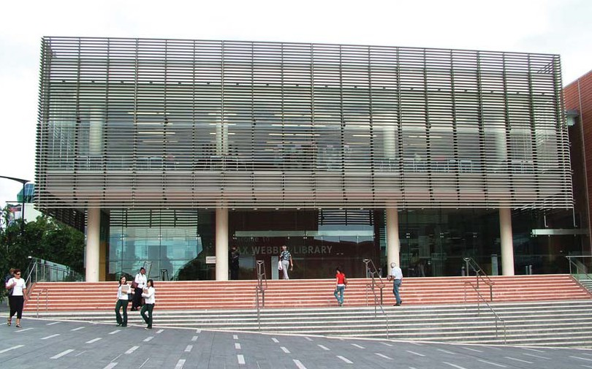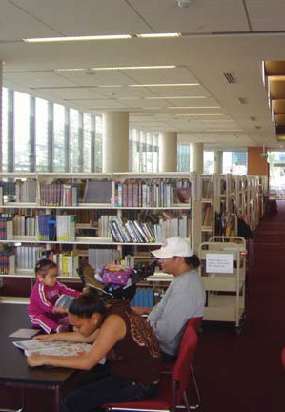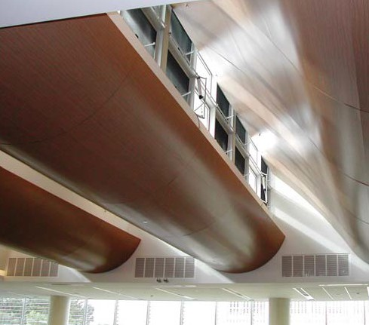and services on the ground floor, and reference,
local studies, family history and a technology centre on the first floor. The Library also includes a multi-function space that allows the library to deliver a program of lectures, seminars and social/cultural events. A Technology Room provides access to internet
facilities, word processing and other educational software packages. The building incorporates significant environmentally sustainable features including solar powered hot water, stormwater collection and temperature control through low energy systems.

41

WEST FOOTSCRAY COMMUNITY LEARNING CENTRE

Maribyrnong City Council, VIC, AUSTRALIA
Architects: Whitefield McQueen
Area: 960 m2
Catchment population: 10,000
Opened 2006

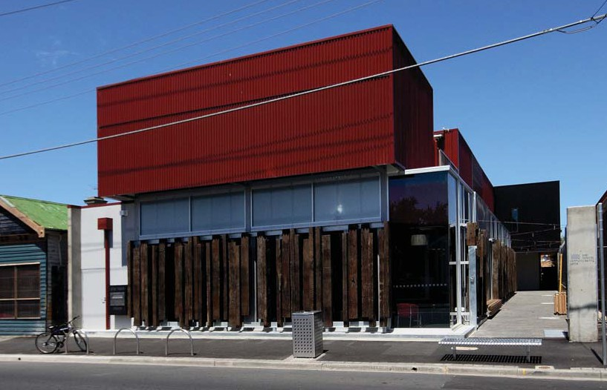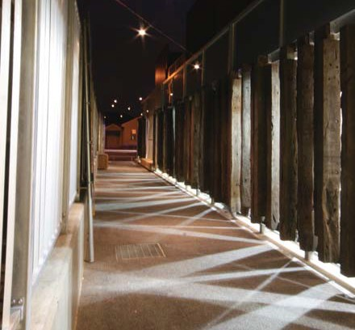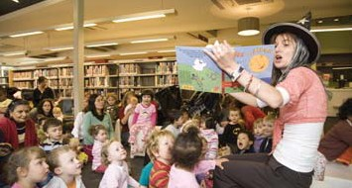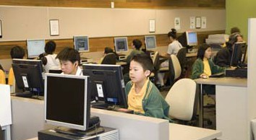The West Footscray Community Learning Centre comprises a library, Neighbourhood House and meeting spaces. Services provided include print and multimedia library collections, community access to information technology, lifelong learning programs, a discussion room,
two meeting rooms and a Toy Library. Extensive community consultation has resulted in a
facility that reflects the local area and West
Footscray’s industrial history. Original pieces
of art made from recycled metals and wood by artist Jos Van Hulsen, include a reading table and entrance gate. Environmentally responsible design has been addressed through passive solar design, the use of solar efficient “low-e” glass and the use of recycled natural materials to key areas.

42

AMSTERDAM CENTRAL LIBRARY

Amsterdam City Council, THE NETHERLANDS Architects: Jo Coenen Area: 28,000 m2
Catchment population for Central Library and
Network of 27 library branches: 800,000
Opened 2007

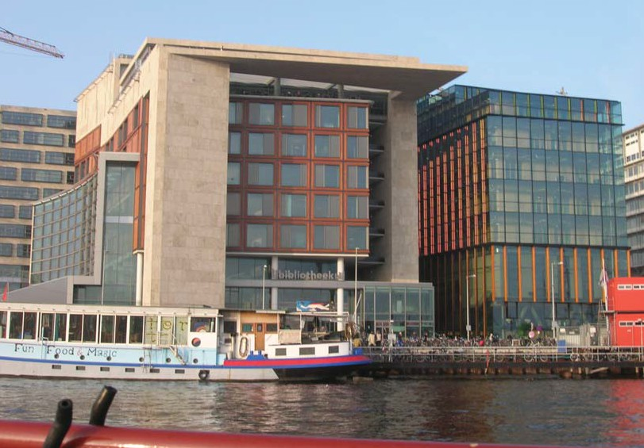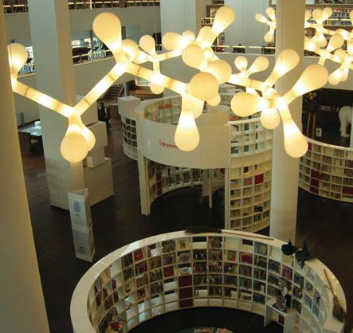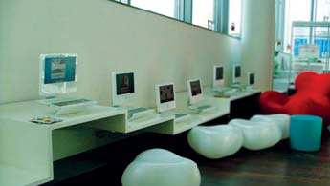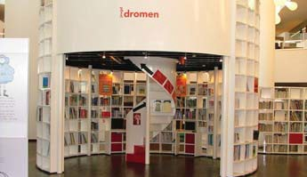Europe’s largest public library at 28,000m2 over 10 floors and featuring an impressive quality fitout attracted 1.6 million visits in its
first year of operation. The design includes spaces for collections, programs, events,
cafes and restaurant and most importantly for people. The design is informed by the library service’s vision to be “an exciting, stimulating and multifarious information source.” Tailored spaces include an expansive children’s area, a radio station, 600 computers, a theatre, four meeting rooms, an extensive general collection and five special collections including the significant Amsterdam collection.

43

BISHAN PUBLIC LIBRARY

Bishan Central, SINGAPORE Architects: LOOK Architects Area: 4,000 m2
Catchment population: 100,000
Opened 2006

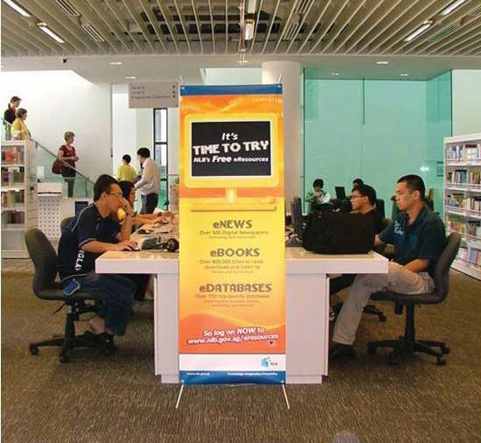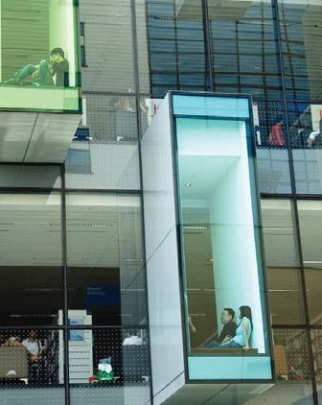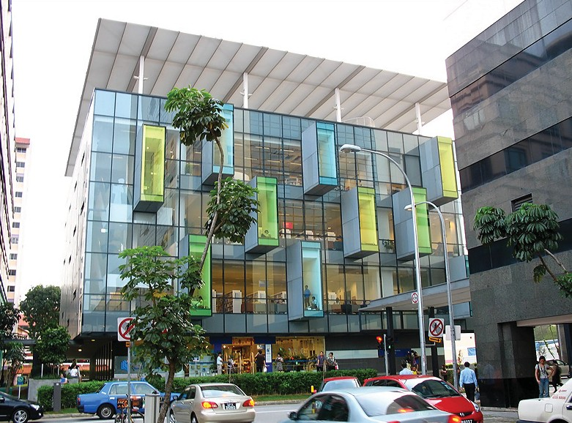Built over 5 levels, Bishan Library is architecturally distinctive, with protruding pods of coloured glass alcoves that are
cantilevered off the building’s main façade and in the building’s atrium. The concept of the design is that of a tree house invoked through the individual pods that serve as study and reading spaces. The library includes a café on the ground floor, an entire floor of children’s collections, play and programming spaces, another level specifically for teenagers and print and audiovisual collections across all levels.

44

DOK LIBRARY CONCEPT CENTRE

Delft, THE NETHERLANDS Architects: Dok Architecten Area: 5,000 m2
Catchment population: 100,000
Opened 2007

The DOK Library Concept Centre is located in
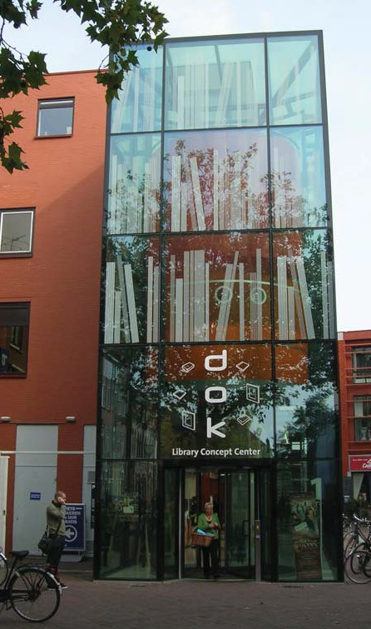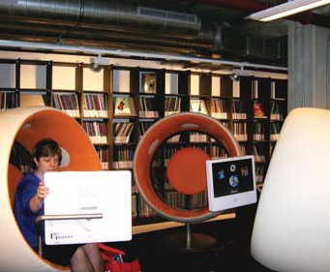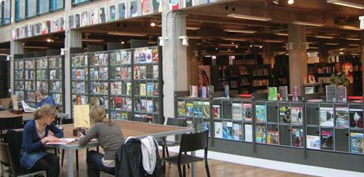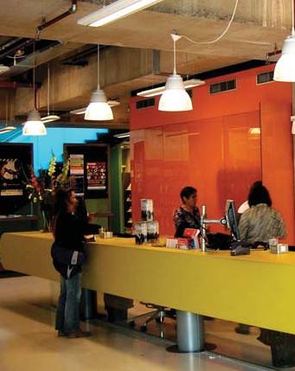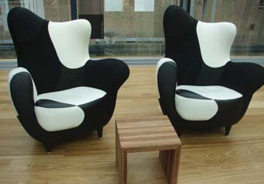the Delft City centre featuring a dynamic design. Frequently referred to as a library of the future and one of the most modern libraries in the world it features a variety of tailored areas for
different uses within the facility. Multimedia equipment is found throughout including ‘sonic’ music and listening chairs, gaming facilities
and Information Technology provision with an array of software. Content is available in many formats including print and digital collections, paintings and sculptures. The Library aims to be a place for testing new ideas and concepts and this is reflected in the architecture and the interior design.

45

MALMO CITY LIBRARY

Malmo City Council, SWEDEN Architects: Dane Henning Larsen Area: 15,000 m2
Catchment population: 270,000
Opened 1997

The City of Malmo is undergoing a transition from an industrial city to a city of knowledge. This transition is manifesting itself in many
ways not least in the development of the Malmo Library. The original part of the building “The Castle” was built in 1901 and restored in
1999. The “Calendar of Light” section
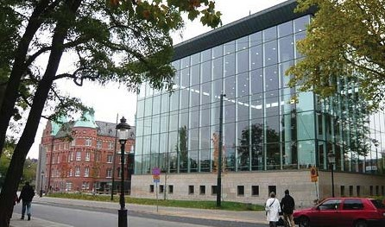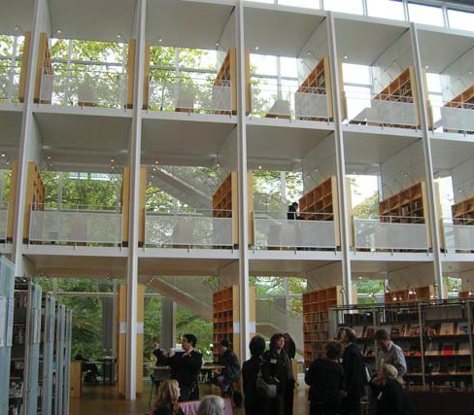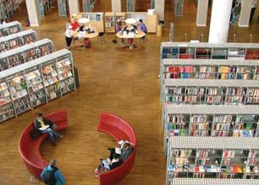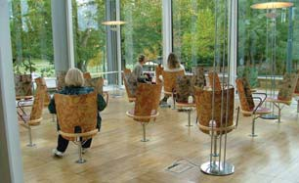of the Malmo Library was built in 1997.
This library is described as an architectonic masterpiece, the largest in Sweden and designed to accommodate one and a half million visitors a year. The integration of the old and new library is masterful. Designed to accommodate over 500,000 books, 20,000 cds, 2,000 periodicals, 160 daily newspapers
and extensive information technology provision. Purpose built spaces provide a range of seating options including individual study, lounges
and group learning spaces. Although a large architecturally magnificent inspiring facility, it is welcoming and easy to navigate.

46

SOUTH CHRISTCHURCH LIBRARY

Christchurch City Council, NEW ZEALAND
Architects: Warren and Mahoney
Area: 2,400 m2
Catchment population: 45,000
Opened 2004

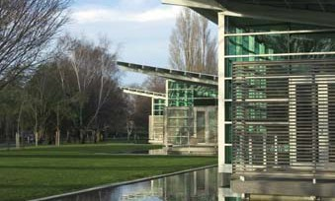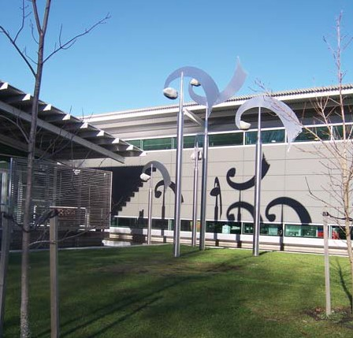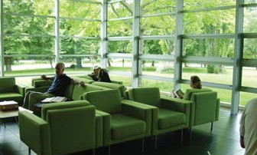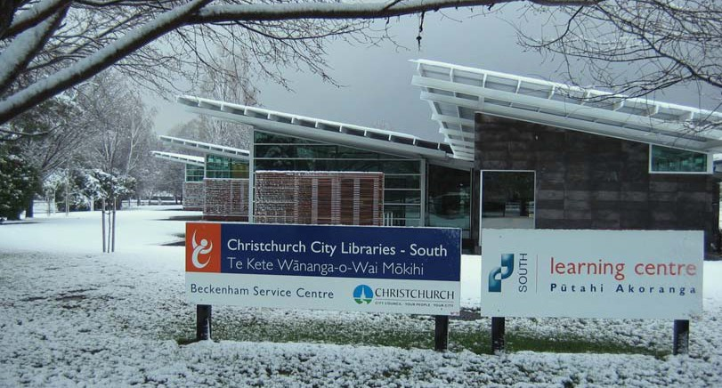A winner of the NZIA Resene Supreme New Zealand Award for Architecture this single storey building accommodates a wide range of community needs including a library, council customer service centre, meeting rooms, a learning centre with an information Technology suite servicing local schools and the general community. Environmental design includes rainwater collected from the roof for use in
the toilets and irrigation system, low water use plumbing fittings and waterless urinals, all timber sourced from certified sustainable sources, non-toxic materials used wherever possible, preference for recycled materials for example acoustic insulation manufactured from 100% recycled wool scraps, waste minimization and a design responding to the local topography and ecology – minimizing earth movement and the removal of trees. An
artwork “Engage” was added in 2006 and is a major feature. Highly visible and dramatic, the seven-piece metal sculpture stands up to four metres tall and moves from outside the library to indoors.

47

UPPER RICCARTON COMMUNITY AND SCHOOL LIBRARY

Christchurch City Council, NEW ZEALAND
Architects: Warren and Mahoney
Area: 1,500 m2
Catchment population: 35,000
Opened 2006

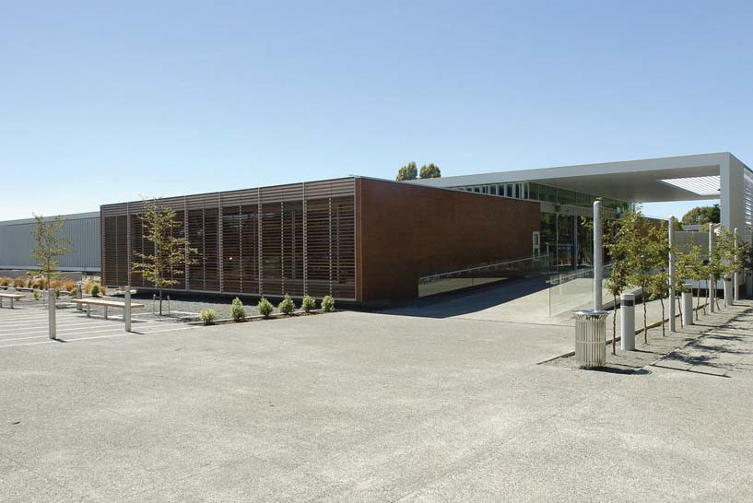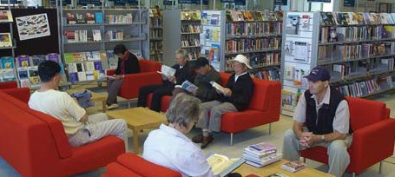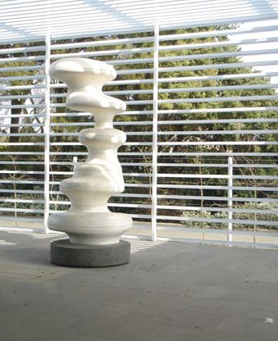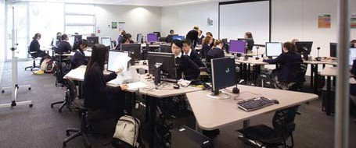The first of its kind in New Zealand, the building draws on Australian precedents for similar joint use facilities while offering a dynamic new structure in which community and school can interact. The new library incorporates outdoor
reading areas, a dedicated café, a children’s library and comprehensive media and learning research tools. Four shared teaching suites provide research and tuition opportunities for the 1,100 students and staff of the Riccarton High School. The new library enclosure is passively ventilated, taking advantage of environmentally sustainable design principles and methods which allow the building fabric to monitor climatic changes and reconfigure to accommodate them.

48

REFERENCES

A Fairer Victoria: building on our commitment, Department of Planning and Community Development, 2007

Armstrong Creek Urban Growth Plan Volume 1, City of Greater Geelong, October 2006.

Bellarine Peninsula Strategic Plan 2006-2016, City of Greater Geelong, 2006.

Brown, William M. Library by Design Supplement to Library Journal, Fall 2008

Building Audit of Victorian Public Libraries: an independent report for the State Library of Victoria and the Victorian Public Library Network by BBC Consulting Planners, May 2008.

Commission for Architecture & the Built
Environment. Better Public Libraries, 2003.

Dewe, M, Planning Public Library Buildings: concepts and issues for the librarian, Ashgate Publishing, AlderShot ENG, 2006.

Economic Indicators Bulletin 2006/07 – Geelong, Smart thinking. http://www.geelongcity.vic.gov.au/ library/pdf/5292/29.pdf

Geelong Retail Strategy
http://members.shaw.ca/rfaris/docs/lbcd.PDF

Geelong Regional Library Corporation, Annual report 2007/08, adopted September 2008.

Growing Victoria Together: a vision for Victoria to
2010 and beyond, Department of Premier and
Cabinet, 2005.

Lara Town Centre Urban Design Framework, City of Greater Geelong, March 2006.

Leopold Youth needs study, City of Greater
REFERENCES
Geelong Youth development Unit, 2006.

Leopold Community Hub Concept design, David Lock and Associates for the City of Greater Geelong, February 2008.

Libraries Building Communities: the vital contribution of Victoria’s public libraries, State Library of Victoria, 2005.

Library Design, Smith, K (ed) teNeus, Kempen
Germany, 2007.

Mattern, S., The new downtown library, Minneapolis, University of Minnesota Press,
2007.

Ministerial Advisory Council on Public Libraries, The Library: the key to growing the knowledge and skills of the Victorian Community, 2007.

Montgomery, J. Community strengthening through urban sociability, research paper funded by the Department from Victorian Communities, 2006.

Oldenburg, R, The great good place. New York: Marlowe and Company, 1989.

People Places: a guide for public library buildings in New South Wales, second edition, Library Council of New South Wales, 2005.

Viclink Tour: Great Public Libraries of the World
28 September – 17 October 2008 Report

Vinson T. Dropping off the edge, Jesuit Social
Services, 2007.

Worpole, K., 21st Century libraries: changing forms, changing futures, Building Futures 2004. http://www.cabe.org.uk/AssetLibrary/251/pdf

Photo Credits

Cover: Geelong Regional Library Corporation (GRLC).
Inside Cover: City of Greater Geelong.
Page 6: GRLC.
Pages 20-28: GRLC.
Page 35: Albury City Council.
Page 36: External Photo, John Gollings.
Internal Photos, Brisbane City Council
Library Services.
Page 37: Suters Prior Cheney Architects.
Photography by Gollings Studio; John
Gollings, Emma Cross, Kierston Gollings.
Page 38: External and Centre right photos,
Brewster Hjorth Architects. Bottom and
centre left photos, GRLC.
Pages 39-40: GRLC.
Page 41: External Photos Whitefield McQueen
Architects. Internal Photos, Maribyrnong City
Council.
Page 42: Viclink Great Libraries of the World
Report.
Page 43: Top External, Anna Stina’s Flickr
photostream under Creative Commons
Licence http://creativecommons.org/licenses/
by-nc-sa/2.0/deed.en . Other photos, Viclink
Great Libraries of the World Report.
Page 44: Left middle photo: The Shifted Librarian,
Flickr photostream under Creative Commons
Licence http://creativecommons.org/licenses/
by-nc-sa/2.0/deed.en . Other photos, Viclink
Great Libraries of the World Report.
Page 45: Great Libraries of the World Tour Report.
Pages 46-47: Christchurch City Council.
Back Cover: GRLC

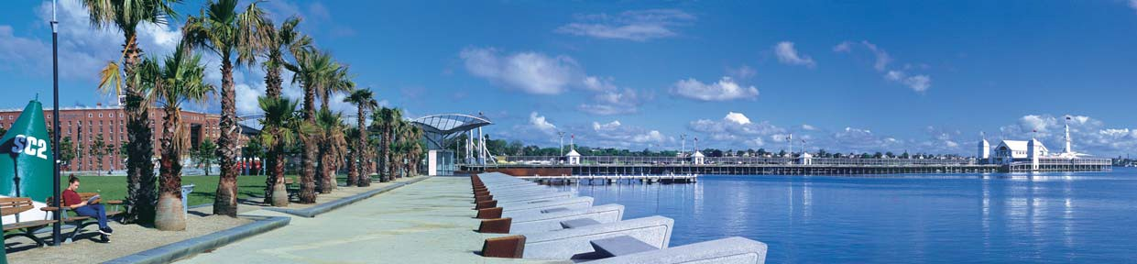

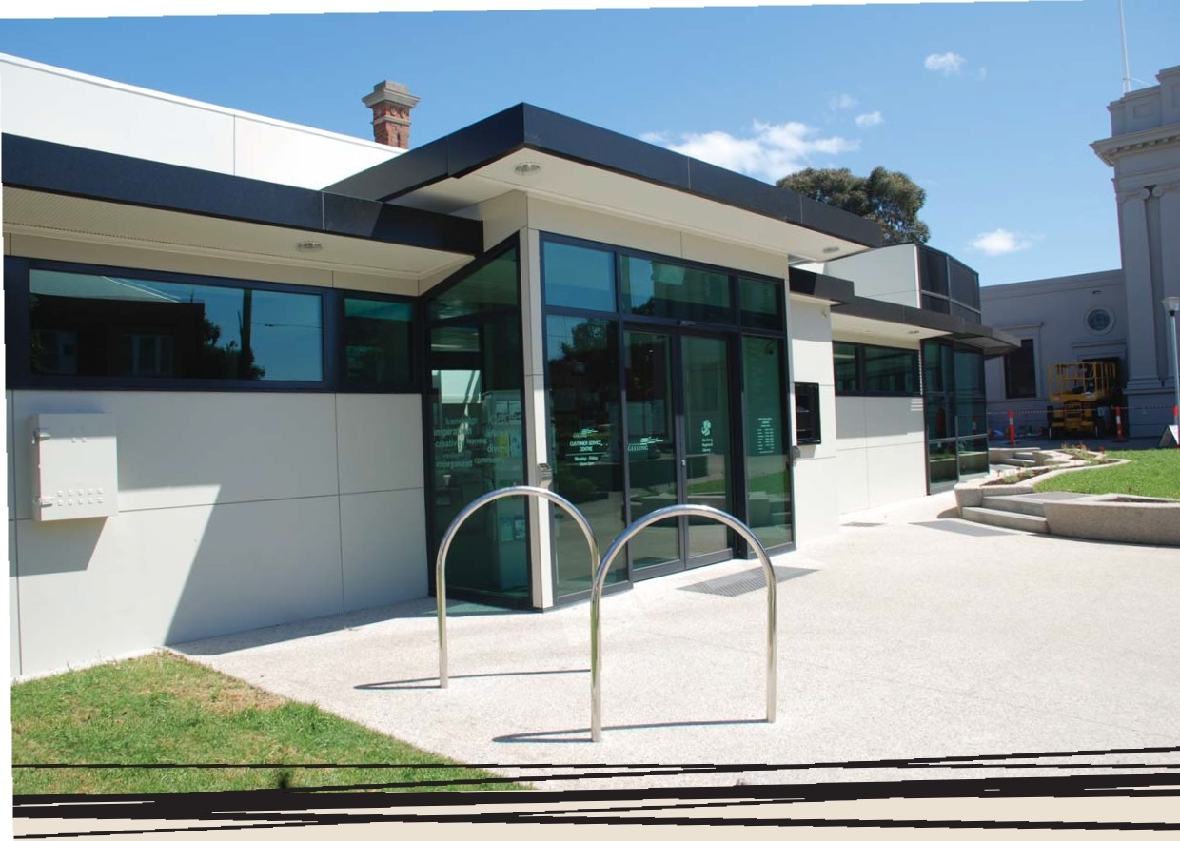

QT'l'Ol'caaAftl.
.!=:::::-=- :%.=. --

WWW.GEELONGAUSTRALIA.COM.AU
GEE LONG

