


THE CITY OF
GREATER GEELONG

BARWON HEADS
VILLAGE PARK
MASTER PLAN

September 2021
REVISION | DATE | AMENDMENT
L | 1/10/21 | Amend with CoGG comments
K | 30/9/21 | Amend with CoGG comments
J | 21/9/21 | Updated dog controls
I | 13/9/21 | Implementation Schedule included
H | 10/9/21 | Amend with CoGG comments
G | 07/09/21 | Amend with CoGG comments
F | 04/05/21 | Amend with CoGG comment
E | 14/04/21 | Amend with CoGG comment
D | 25/03/21 | Amend with CoGG comments
C | 24/03/21 | Amend with CoGG comments
B | 19/03/21 | Amend with CoGG comments
A | 26/02/21 | Draft for CoGG comment

CONTENTS
Page No.

ACKNOWLEDGEMENTS

1.0 INTRODUCTION 1
1.1 Project Scope 1
1.2 What is a Master Plan? 1
1.3 Study Area 2
1.4 Existing Conditions 2
1.5 Project Process 4
1.6 Consultation 4

2.0 STRATEGIC CONTEXT 7
2.1 Literature Review 7
2.2 Key Strategic Documents 8

3.0 ANALYSIS & PLANNING 13
3.1 Site Context 13
3.2 Land Ownership 13
3.3 History 13
3.4 Environment 15
3.5 Sports 18
3.6 Open Space 22
3.7 Other Users 24
3.8 Traffic and parking 26
3.9 Adjoining land use 29

4.0 STRATEGIC DIRECTIONS 30
4.1 What is proposed 30
4.2 Vision 30
4.3 Goals 30
4.4 Objectives 31
4.5 Statement of significance – Landscape and character 32

5.0 PARK MANAGEMENT ZONES 35
5.1 Environment and recreation zone 35
5.2 Recreation and open space zone 36
5.3 Active sport and recreation zone 36
5.4 Community service and use zone 37
5.5 Current and proposed spatial allocations 38
5.6 Proposed Actions 39

6.0 MASTER PLAN 40
6.1 BHVP - 02 - Master Plan Update 2020 40
6.2 Proposed Actions 40

7.0 IMPLEMENTATION SCHEDULE 45

8.0 BIBLIOGRAPHY 50

INDEX OF FIGURES
Figure 1. Site Location 2
Figure 2. Environmental Values 17
Figure 3. Access and Circulation 27
Figure 4. Park Management Zones 35

ACKNOWLEDGEMENTS

The project has been guided by a Reference Group comprising local stakeholders including:

Barwon Heads Bowls Club
Barwon Heads Fire Brigade (CFA)
Barwon Heads Scouts Group
Barwon Heads Little Athletics Club
Barwon Heads Association
Barwon Heads & District Pony Club
President, Barwon Heads Golf Club
President, Barwon Heads Cricket Club
President, Barwon Heads Soccer Club
Member, 13th Beach Boardriders
President, Barwon Heads Tennis Club
Barwon Heads Football Netball Club

1.0
INTRODUCTION

  - PROJECT SCOPE

The revised Master Plan has been undertaken as an update to the existing 2012 Master Plan. The project scope includes preparation of a revised master plan to accomplish the following objectives:

- Review the current 2012 Master Plan, comparing design to current site conditions, and ascertain if gaps and design differences need to be addressed to meet future challenges and changes in use.

- Identify issues and opportunities for the future use and development of the park and develop and test the appropriate design response with the local community.

- Develop a renewed Vision and Goals for Barwon Heads Village Park that is in line with the aspirations of the growing community, identifies appropriate works/infrastructure to upgrade, ensuring future facilities meet community needs both from an active and passive recreational perspective and recognising the significant environmental and cultural heritage considerations of the reserve.

The vision and goals have been developed through extensive consultation with Key Stakeholders (Project Reference Group) and the community to provide a holistic set of guidelines for the future management of the park.

1.2 WHAT IS A MASTER PLAN?

A Master Plan provides a vision for a site, identifying what it should look like and how it should function into the future. It establishes a strong and consistent direction by providing a framework for ongoing improvement. It considers the interrelationship between:

- Current character and functionality of the landscape
- Public expectations and needs delivered by date
- Emerging issues and trends
- The realities of the economic, social, environmental, and legislative context of the time.

The result is a plan that balances need across a range of often conflicting interests. The Master Plan does not necessarily suggest that all elements of the plan should proceed immediately, or that The City nor the user groups should be responsible for all capital costs, in respect of those items that are progressed.

It is important to note that the intent of a Master Plan is to provide a framework for future management, use and development of the park over an extended period of time so that ad-hoc improvements are avoided, and community use and long-term viability are maximised. To ensure this intent is achieved, a Master Plan should be regularly monitored to ensure the outcomes continue to meet community needs in the best possible way. Hence, the trigger for this project and its intent to review and update this existing plan.

1.3 STUDY AREA

Barwon Heads Village Park (BHVP) also known as the 54’s is the largest recreation reserve in the township of Barwon Heads. The 24ha District Level park is centrally located and bounded by Barwon Heads-Geelong Road to the south and Sheepwash Road to the west with established residential properties directly adjoining the northern and eastern boundaries. The park includes sporting facilities including tennis courts, synthetic bowling greens, two ovals, athletics facilities, basketball half court and pony club. The park provides facilities for and is used by local sporting clubs and community organisations including the Barwon Grove Golf Club and the local Scouts group. There is a large playground, skate facility picnic/BBQ area, public toilet facilities, open lawn areas and an extensive unsealed walking path network that is well used by both the local community and the large influx of visitors to Barwon Heads during summer holiday periods. The park also features a significant population of threatened Moonah Woodland, listed under the Flora and Fauna Guarantee Act 1988, and a section of Coastal Dune vegetation also known to contain areas of archaeological and cultural heritage sensitivity.

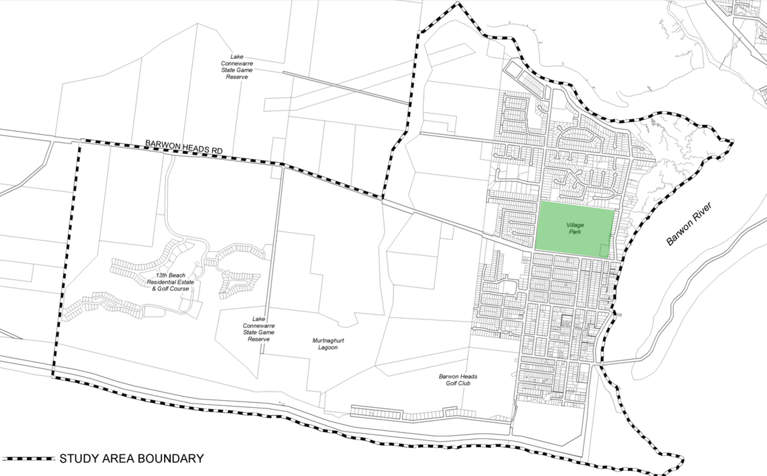

Lake Connewarre State Game Reserve
Ocean Grove

Barwon Heads Village Park

13th Beach Residential Estate & Golf Course

Lake Connewarre State Game Reserve
BARWON HEADS
Murtnaghurt Lagoon
Barwon Heads Golf Club
Bridge
Ingamells Bay

Point Flinders
(The Bluff)

Figure 1. Site location

1.4 EXISTING CONDITIONS

BHVP 01 Existing Conditions Plan

1.5 PROJECT PROCESS

Mar 2020
BACKGROUND RESEARCH

STAKEHOLDER CONSULTATION
Apr 2020
TO
Feb 2021
ISSUES & OPPORTUNITIES
Apr - Oct 2020

VISION & GOALS
Nov- Feb 2021

Dec - Feb 2021
PRELIMINARY OPTIONS

Mar 2021
DRAFT MASTERPLAN

May - Jun 2021

COMMUNITY CONSULTATION

Sep 2021
FINAL MASTER PLAN

1.6 CONSULTATION

1.6.1 Stakeholder Consultation

Representatives from the following local clubs and stakeholder groups formed a Project Reference Group (PRG). The PRG have been consulted to understand use, existing issues and opportunities associated with the existing park environment, facilities and management. Core needs and aspirations identified have been captured in the Vision and Key Goals and the PRG provided input to the Master Plan proposed actions prior to commencement of broader community consultation. There has also been direct consultation with the Wadawurrung Traditional Owners Aboriginal Corporation.
- Barwon Heads Association
- Barwon Heads Bowling Club
- Barwon Heads Fire Brigade - CFA
- Barwon Heads Scout Group
- Ocean Grove Barwon Heads Little Athletics Club
- Barwon Heads and District Pony Club
- Barwon Grove Golf Club
- Barwon Heads Football Netball Club
- Barwon Heads Cricket Club
- Barwon Heads Soccer Club
- Barwon Heads Tennis Club
- 13th Beach Boardriders

1.6.2 Community Consultation

Consultation with the broader Barwon Heads Community was conducted over seven weeks, from May to mid-June in 2021. Core engagement was conducted via the Have Your Say online platform, which was supplemented by two face-to-face drop-in sessions when COVID-related restrictions allowed. The engagement was promoted via multiple channels, including direct mailout, 10 posters in the park, a media release and our Facebook page. A targeted post on Facebook created a reach of over 9,500 and 250 actions. In total, there were over 3,000 views of the Have Your Say project page, which converted to 282 contributions. To encourage contributions, the platform offered a vision board, survey and submission form. This was also supported by phone and email contacts.

In total, 174 people participated in the Barwon Heads Draft Master Plan engagement process. 78 per cent engaged online, 17 per cent engaged in-person and the remaining 5 per cent by phone or email. The Barwon Heads Association also submitted a petition with 553 signatures seeking greater planning protections for the park, as well as a significant landscape overlay for the area.

There was a strong overall theme in the feedback that the park is well-loved as it is and that, generally, the community don’t want to see a great deal of change. The protection of the park and its character was therefore central to much of the feedback.
The feedback about the plan was generally very positive with:
- over 80 per cent of survey respondents ‘very supportive’ or ‘supportive’ of the vison and goals
- 70 per cent of survey respondents ’very supportive’ and ‘supportive’ of the proposed management zones and
- 70 per cent of survey respondents ‘very supportive’ and ‘supportive’ of the proposed actions proposed.

Key theme 1 – Protect open space and character of the park from over development
This was the most significant topic discussed and was also the focus of the Barwon Heads Association who led a campaign for a significant landscape overlay to be applied to the park using a petition, which attracted 553 signatures. The primary reason for this was concern about a loss of open space from overdevelopment, and the impact this might have on the character of the park. Another significant concern was controlling and managing future building development.

Key theme 2 – Sustainable pavilions
A key flow on from the first theme was a desire to not only limit the number and footprint of pavilions in the park, but to ensure their design was appropriate to the character of the park. Multi-use was identified as a priority. There was majority support for the establishment of a new bowling club pavilion on the west-side of the bowling green. The upgrade to the tennis pavilion and the shared cricket, soccer, football pavilion did not receive a great deal of feedback. However, comments received were focused on female participation.

The Scouts withdrew their support for the relocation to a new shared facility with the 13th Beach Boardriders, expressing a preference to maintain their current location or examining other potential locations in the park. The 13th Beach Boardriders made a submission strongly supporting a home for their group and this was the largest area of feedback we received about pavilion changes in the park.

Key theme 3 – Bike discovery area
The proposed actions for a new bike discovery area for children and young people was strongly supported and was one of the most highly discussed topics. There was support to move the proposed site to the south of the playground one segment of the community, while another sought to have it relocated out of the park. There was also a strong desire to see the existing damage in other areas of the park addressed.

Key theme 4 – Environment and cultural heritage
There was strong support for protecting the park environment and cultural values as well as educating a broader audience about these values.
Key theme 5 – Dog access
The proposed actions to provide a combination of areas that are dog on-lead, dog off-lead and dog-free was generally supported. However, there was some confusion over the way these areas were mapped. Other suggestions included building a fenced dog park and other comments related to dog bins, behaviour, compliance and more freedoms. Dog orders were recently reviewed as part of a separate consultation that ran in conjunction with this master plan engagement. This resulted in changed dog orders, which have increased dog-off lead areas in the park.

Other feedback
- The Barwon Heads and District Pony Club has low membership numbers and there was a lack of support for the facility upgrades. There was a strong desire to retain open spaces for varied informal use, including as retaining the dog-off-lead use recently adopted
- A petanque group (approximately 20–40 players) requested a small Petanque piste in the park. This is a 12 x 6 metre gravel rink where players throw their boules/balls towards a target ball.
- All feedback and responses were discussed with individual stakeholder groups and the Project Reference Group to confirm changes incorporated into the final master plan. Refer to the Barwon Heads Village Park Draft Masterplan Final Engagement Report Sept 2021 for further detail.

All feedback and responses were discussed with individual stakeholder groups and
the Project Reference Group to confirm changes incorporated into the final master
plan. Refer to the Barwon Heads Village Park Draft Masterplan Final Engagement
Report Sept 2021 for further detail.

2.0
STRATEGIC CONTEXT

2.1 LITERATURE REVIEW

In order to present a clear picture of the background issues and opportunities influencing the potential development of the park a review of literature and standards has been undertaken. The following documents have been reviewed, as part of developing the Master Plan proposed actions.

LIST OF REFERENCE DOCUMENTS
- Active Victoria, A strategic framework for sport and recreation in Victoria 2017-2021, Department of Health and Human Services, July 2017
- AFL Growing the Heartland, Football Facility Development Strategy 2017 – 2022, AFL Victoria.
- AFL Preferred Facility Guidelines, State, Regional, Local School and Remote Facilities, AFL, 2019.
- City of Greater Geelong, Barwon Heads Village Park Master Plan (2012)
- City of Greater Geelong, Barwon Heads Structure Plan (2017)
- City of Greater Geelong, Biodiversity Strategy
- City of Greater Geelong, Dog Controls in Public Places Policy (2020)
- City of Greater Geelong, Domestic Animal Management Plan (2018-2021)
- City of Greater Geelong, Outdoor Sport and Recreation – Social Infrastructure Plan Generation One: 2020-23
- City of Greater Geelong, Planning Scheme
- City of Greater Geelong, Social Infrastructure Plan (2020)
- Community Cricket Facility Guidelines, Cricket Australia, September 2015.
- DSE, EVC 858: Coastal Alkaline Scrub Otway Plain bioregion Ecological Vegetation Class Benchmark.
- DSE, Action Statement No. 141 Coastal Moonah Woodland – Flora and Fauna Guarantee Act 1988
- Football Victoria, Football Facilities Building Development Guide, 2019.
- G21 and AFL Barwon Regional Strategy, G21 Regional Alliance, April 2015.
- G21 and Cricket Victoria Barwon Regional Cricket Strategy, Final Report, G21 Geelong Regional Alliance, May 2019.
- G21 Regional Football (Soccer) Strategy, G21 Geelong Regional Alliance, May 2012.
- G21 Regional Hockey Strategy. G21 Geelong Regional Alliance, March 2019.
- G21 Regional Tennis Strategy 2015-2025, Final Strategy Report, April 2015.
- Netball Victoria Statewide Facilities Guideline, Netball Victoria.
- Tennis 2020, Facility development and management framework for Australian Tennis, Tennis Australia.
- Victorian Cricket Infrastructure Strategy 2018 - 2028, Cricket Victoria, March 2018.
- Sustainable Building Policy which applies to all council buildings: https://geelongaustralia.com.au/building/documents/item/8cf5f062b5bd3aa.aspx
- Environment Strategy which supports sustainable development: https://www.geelongaustralia.com.au/environment/documents/item/8d1d8319b995a84.aspx
- One Planet Living principles which supports sustainable development https://geelongaustralia.com.au/environment/article/item/8d3a0371f46bbd8.aspx
Community engagement policy
https://geelongaustralia.com.au/governance/documents/item/654812cd.aspx

2.2 KEY STRATEGIC DOCUMENTS

The following is a brief summary of the key outcomes and proposed actions from existing background documents that will inform the Master Plan Review. For more detailed descriptions please refer to the original reports.

2.2.1 Planning

The majority of the site is currently zoned Public Park and Recreation Zone (PPRZ). Two small areas are zoned as Public Utility Zone 1 (PUZ1) – the CFA Station in the north-west corner off Sheepwash Road and the Barwon Water Pumping Station located in the south-east corners of the park. There is a Special Building Overlay (SBO) showing in the north west area of the park, and in the centre of the southern-most boundary as these areas can be subject to low level flooding after heavy rainfall.

Long term lease agreements for clubrooms and license agreements for use of the ovals and sporting grounds are in place between CoGG and the existing clubs operating in the park.

Section 21.14.3 of the Planning Scheme requires:
- Protect the unique character of Barwon Heads as a coastal village located within a sensitive environment and significant landscape setting.
  - Ensure that new development complies with specified coastal character siting and design requirements.

Continue upgrading the Barwon Heads Village Park and foreshore reserves in accordance with established master plans.

2.2.2 Our Community Places, Spaces and Services: A Social Infrastructure Plan, Generation One: 2020-2023.

The Social Infrastructure Plan was prepared by the City of Greater Geelong as a strategic framework for the future development of the City of Greater Geelong area. The Plan outlines the needs of the community, investment priorities and the way forward to ensure that people know what is planned in the place that they live.

The plan is intended to provide Council and the community with a single, simpler and more integrated strategic summary of Council's investment priorities over the next 1-3 years.

Policy Context: The Social Infrastructure Planning and Investment Policy that underpins this plan and aims to provide Council and the City of Greater Geelong with a guide for prioritising investment decisions and to provide the community with a clear understanding of Council's role and how decisions are made.
Open Space
- Set open space quality standards covering land delivery, design, and infrastructure and user experience.
- Invest to improve the local park network by improving the basic amenity such as shade, shelter, seating, access, drinking fountains, signage, garden beds and trees in the older established areas.
- Barwon Heads Village Park is a local sport, open space and conservation reserve which due to its relative size also provides for other community uses.

Outdoor Sport and Recreation (including sports pavilions)
- Focus on infrastructure projects that build the quality, functionality and carrying capacity of the existing network. Maximise use of existing facilities by initiating and supporting upgrade projects that focus on sports lighting, gender neutral (i.e., Female Friendly) change facilities, sports surface conversion and supporting infrastructure such as supplementary training spaces.
- Focus on strategic partnerships to build capacity and capability across the network to deliver on infrastructure needs.
- Include planning for people and place (i.e., gender-neutral provisions, positive aging and access for all abilities).

Public Toilets
- Continue to audit, monitor and assess public toilets and amenity provision and performance.

2.2.3 Barwon Heads Structure Plan, City of Greater Geelong, March 2017

The Barwon Heads Structure Plan was prepared by the City of Greater Geelong and adopted as a strategic framework for the future development of the Barwon Heads township. The key issues, opportunities and constraints facing the township and relevant to BHVP identified in the Structure Plan are as follows:
- Policy Context
- There is a strong State and Local Planning Policy direction for the protection, enhancement and/or management of coastal environments, coastal hazards and the coastal impacts of climate change; sensitive environments, biodiversity and landscape features; Barwon Heads and its surrounding area including BHVP hold significant values for Indigenous cultural heritage and Building design and built form of the township including the opportunity for application of a range of policy and statutory planning controls. These controls will apply to any new buildings in the park as well.
- Natural and Urban Environment
- A need to recognise the significant landscape setting and key views of the coast and rural hinterland that surround the Barwon Heads ‘island’.
- There are significant biodiversity and sensitive environment features that require protection, including Ramsar wetlands.
- Indigenous cultural heritage values require protection.
- Demographics and Social Profile
- The town has a significant influx of people in the peak summer holiday season with moderate dwelling vacancy rates during the off season.
- A relatively wealthy and advantaged population with low unemployment.
- A private car reliant population.
- Slowing population growth as housing supply decreases.
- Township Facilities and Services
- The amount of open space within the town is sufficient to support the projected future population.
- Opportunity to enhance existing passive open space and recreation areas, particularly in northern areas of the town and improve linkages between recreational facilities.
- Opportunity for the continued improvement of facilities and amenities of the Village Park.
- Opportunity to establish and improve recreational paths and trails.
- Climate Change
- The Structure Plan acknowledges that Barwon Heads is particularly vulnerable to any effects of climate change due to its location and the history of flood events in the township. Most of the areas which may potentially be affected by climate change are located within the urban area, which includes BVHP. As such, and pending further research and information on climate change, the Structure Plan notes that a ‘no-risk’ approach is to be adopted for Barwon Heads, in regard to management of both infrastructure and natural values.

2.2.4 Overview of the 2012 Master Plan

Many of the operational initiatives have been implement but most of the larger capital projects have yet to be completed.

The following is a summary of the current status of proposed actions outlined in the 2012 Master Plan. These have been assessed as part of the master plan update to confirm if they are still valid and if any other new issues and opportunities need to be considered:

Environmental and Cultural Values
- Liaison with the Wadawurrung is ongoing and Cultural Heritage Management Plans have been completed for works in areas of known cultural heritage sensitivity.
- Weed control and natural regeneration works in the fenced Moonah Woodland areas is ongoing, however some large isolated Moonahs remain unprotected.
- Coastal Tea tree removal from Dune Complex areas is ongoing however unfenced areas near the Scout Halls are subject to ongoing disturbance from informal tracks and bike jumps.
- Some removals of Tuart Gums have occurred and monitoring and maintenance is ongoing. Attempts at replanting along the avenues with indigenous species have been undertaken but relatively unsuccessful due to ground compaction, overshading and nutrient/water competition from existing trees.

R.T. Fuller Oval
- The soccer, AFL junior football, netball and cricket have noted increased female participation and memberships is growing.
- Training lights have been installed.
- Pavilion facilities have not been upgraded to meet the demands of increased participation and gender diversity.

H. Blyth Field
- Lighting and irrigation projects have been completed for the main playing area.
- Soccer use has increased creating more wear and tear on the surface
- Cricket use has increased female participation.
- No longer needed as full athletics track and focus has been shifted to training only.
- No irrigation to southern end of the field.

Pony Club - L.G. Frost Reserve
- Membership numbers have reduced.
- L.G. Frost Reserve is now only used 12-16 times/year.
- There has been no change to the clubrooms and the proposed sand lunging area has not been delivered.
- The current dog control regulation for Barwon Heads Village Park allows for dog off leash in sporting grounds/ovals outside times when being used for organised sports, including training. This now includes the Pony Club area.

Tennis, Golf and Bowling Clubs
- Little change to the tennis and bowling club facilities.

Playspace, picnic areas and skate park
- There has been little change to the playspace, car park and picnic area

2.2.4 Sporting strategies

Since completion of the 2012 Master Plan there has been further emphasis in current sporting strategies and facility guidelines to ensure new facilities are fit for purpose and meet contemporary standards through universal design approaches that support greater gender equity, equality and accessibility. This in turn is providing facilities that will continue to support and grow participation in sport improving the community’s health and wellbeing. Key direction in outdoor sport and recreation include:

- Focus on infrastructure projects that build the quality, functionality and carrying capacity of the existing network.
- Maximise use of existing facilities by initiating and supporting upgrade projects that focus on sports lighting, gender neutral (i.e. Female Friendly) change facilities, sports surface conversion and supporting infrastructure such as supplementary training spaces.
- Focus on strategic partnerships to build capacity and capability across the network to deliver on infrastructure needs.
- Develop a robust understanding of network performance. Conduct a fit-for purpose audit of the network and investigate usage and occupancy, in both the public, private and education services, to help determine need and demand across the City.
- Invest in developing contemporary systems, data and insights and mature our current provision and performance reporting.
- Continue to enhance the relationship between peak governing bodies, government and community partners in the planning and provision of facilities. Align planning at local, municipal, regional, state and federal levels to ensure that all levels of the planning cycle are working collaboratively to deliver benefits to the community.
- Contemporise and undertake holistic planning and policy development. Focus on data, monitoring and reporting. Include planning for people and place (i.e. Gender-neutral provision, positive ageing and access for all abilities).
- Develop an Integrated Asset Management Plan and ensure planning, development and renewal budget programs are commensurate with the agreed service levels and outcomes for the network.
- Review existing renewal programs and budgets against agreed service levels.
- Initiate and support club and community development activities that respond to changing clubs needs with a focus on supporting financial sustainability, club capacity development and strategic planning.

Refer to 2.1 for a list of relevant guidelines and strategies.

2.2.5 Demand Analysis

Demographics
In 2016 Barwon Heads had a total permanent population of 4,554 usual residents according to the Australian Bureau of Statistics’ 2016 Census. The Australian Bureau of Statistics estimates this population to be 5,106 in 2019.

Statistics for the Barwon Heads - Connewarre - Breamlea area show that the population growth is forecast to slow considerably. In the 15 years from 2016 to 2031 the population is anticipated to grow by only 5.4% or 0.36% each year. The population projects indicate that there will be a significant growth in older residents and particularly those aged between 60-69 and 70-84 and that provision of open space and facilities is sufficient to meet future local population growth. (Barwon Heads Structure Plan, August 2017).

Sporting use
Since completion of the 2012 Master Plan there has been significant residential development in the nearby Armstrong Creek area which is within 10-15 minutes’ drive of the Barwon Heads Village Park. The time gap between expansion of the Armstrong Creek residential population and establishment of new sporting facilities for this community has seen growth in membership of existing nearby clubs including, those at BHVP.

The first active sporting reserve to be delivered for Armstrong Creek will be on the corner of Horseshoe Bend Road and Warralily Boulevard located within the Eastern Precinct. The design to be for a multipurpose reserve with soccer as a key tenant. New sports and open space facilities will continue to be added to this area as the population increases. Once the Armstrong Creek multipurpose reserve is established, membership and demand at Barwon Heads Village Park is expected to stabilise as new residents use the new facilities closer to home. Residents and seasonal visitors to Barwon Heads will also be able to easily access the new facilities at Armstrong Creek. BHVP will therefore remain a local reserve focused on meeting only the sporting needs of the local community.

Equestrian use
Demand for equestrian use at BHVP has been falling since the park was enclosed by residential development and with closure of the old round the park cross country track. There are two other pony clubs across the Bellarine Peninsula and major events have already been relocated to nearby better serviced equestrian facilities at Mt Duneed and Drysdale. Future demand for equestrian facilities in the region is likely to be met by these two locations.

Open space use
Use of open space during COVID-19, especially during lockdown has seen a significant increase including at BHVP. While tourism visitation has been variable and is expected to return to normal levels the long term trends arising from this increase in local open space use are not yet known. However, the size and diverse nature of BHVP means that it is well equipped to meet any future changes in local and tourism demand for passive and active open space.

3.0
ANALYSIS & PLANNING

3.1 SITE CONTEXT

Barwon Heads is a seaside town located at the mouth of the Barwon River. The township was first developed in the 1890’s, providing an attractive destination for recreational users with a keen interest in boating and fishing. Barwon Heads is now a popular tourist destination, with an increase in permanent and seasonal residential populations.

The Village Park is centrally located and as the largest park in the area provides for local community sport, passive and active recreation. The park also provides pedestrian links from the more recently developed residential areas to the Primary School, the foreshore and Hitchcock Avenue activity centre.

A typical district level park is approximately 10ha in size. However, the BHVP is 24ha in size while providing for only local level facilities and open space use for the majority of the year. The parks built infrastructure and facilities have been integrated with large areas of significant remnant indigenous vegetation and unfenced open grass which provide an important continuation to the relaxed coastal character of the township.

3.2 LAND OWNERSHIP

3.2.1 Land ownership

The existing site is Crown Land, the City of Greater Geelong is the delegated land manager under the Crown Land Reserves Act 1978.

3.3 HISTORY

3.3.1 Indigenous Cultural Heritage

The Barwon Heads township is located along the Barwon River estuary and the site would have been an ideal location for Aboriginal people to obtain food and water and many areas in Barwon Heads are of cultural and archaeological significance. The Wadawurrung Traditional Owners Aboriginal Corporation is the Registered Aboriginal Party (RAP) and as the park is located within 200m of the Barwon River it is classified as an area of cultural sensitivity as defined in the Aboriginal Heritage Regulations 2018.

Archaeological assessment of the park indicates that the prominent linear sand dune along its eastern boundary has yielded Aboriginal archaeological materials, including midden shells and stone artefacts. This material has been registered with Aboriginal Victoria. Ground disturbance in this area must be avoided and ongoing consultation with the Wadarurrung is an ongoing part of park management.

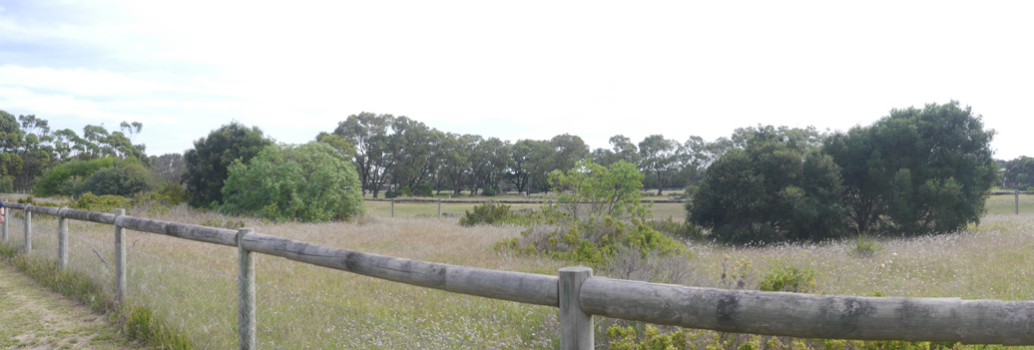

Photo 1: Existing remnant dune area

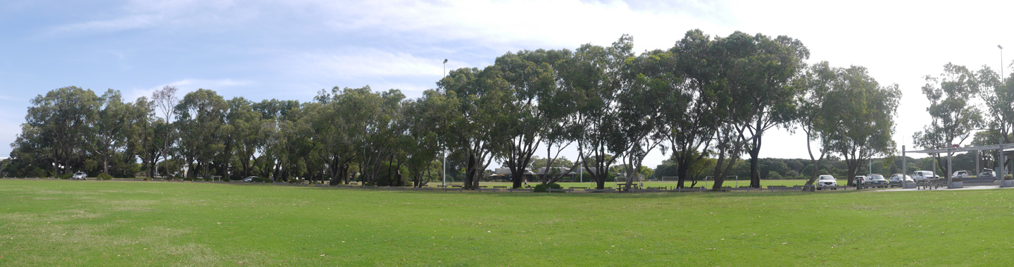
Photo 2: R.T. Fuller Oval

3.3.2 Non Indigenous History
There are records of Europeans settling on the Ocean Grove side of the Barwon River from around 1854, but settlement of the Barwon Heads side did not begin until the mid-1870’s when the area was used for fishing. In the 1890’s an influx of hunters started to visit Lake Connewarre for ducks and other native birds, which saw the small fishing village start to grow and by the 1920’s the township had more facilities including the Barwon Heads Golf Club. The bridge was constructed across the Barwon River linking Barwon Heads and Ocean Grove in 1927 and the area in close proximity to Geelong has been a popular beach side resort from this period.
The history of BHVP is not well documented and there are no details in the previous management plan aside from several local references to the “54” or “54 Acres”. The Barwon Grove Golf Club was relocated to the site almost 50 years ago following a land swap agreement between the then State Government and Barwon Heads Golf Club which also resulted in them retaining limited playing rights at the Barwon Heads Golf Club.

3.3.3 Key cultural heritage considerations

- The eastern side of the park is a known area of high cultural heritage sensitivity.
- A Cultural Heritage Management Plan will likely be required for and ground disturbing works at the park.
- There is no identification of the Wadawurrung as the traditional owners or other information regarding aboriginal cultural heritage values at the park.
- The early establishment of the park and its importance to the development of the Barwon Heads community is not well documented or acknowledged within the park.

3.4 ENVIRONMENT

3.4.1 Flora

BHVP is located within the Otway Plain bioregion characterised by 550-600mm annual rainfall and a naturally sandy geology over calcareous dune rock. The pre 1750 Ecological Vegetation Class (EVC) is EVC 858 – Coastal Alkaline Scrub (syn. Calcarenite Dune Woodland). Significant species within this EVC include Coastal Moonah (Melaleuca lanceolata) Woodland which is listed and protected on Schedule 2 of the Flora and Fauna Guarantee Act 1988 and rare Coast Wirilda Acacia retinoides var. uncifolia which is also protected.

There are of two remnant Coastal Alkaline Scrub sub communities at BHVP and the indigenous vegetation is listed as significant as most of the remnants of this type have been cleared and remaining areas have been degraded due to fragmentation and weed invasion.

Zone 1 - Remnant Moonah Woodland
The Moonah Woodland is located primarily in the north western end of the park and the largest area 4.8ha has been fenced and protected since 2002. The woodland includes a mixed age community of primarily Melaleuca lanceolata protected by a network of perimeter and internal fencing to a number of define through tracks. The fencing installed to the internal track network has reduced the number of informal tracks protecting the existing trees and reducing the impacts of human activities on ground layer including areas with sensitive moss vegetation. Woody weed control has been largely successful however control of grasses and ground layer weeds including Pampas Grass Cortaderia selloana, Crassula multicava, Couch Cynodon dactylon and Buffalo Grass Stenotaphrum secundatum is ongoing.
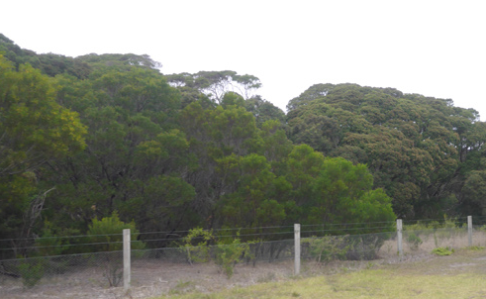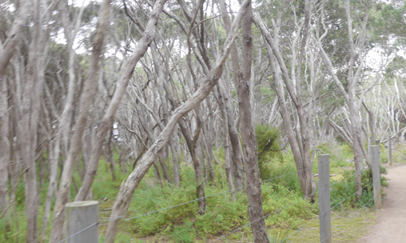
Photo 4: Moonah Woodland 2
Photo 3: Moonah Woodland 1

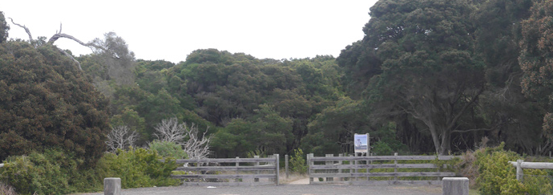
Photo 5: Moonah Woodland access gate

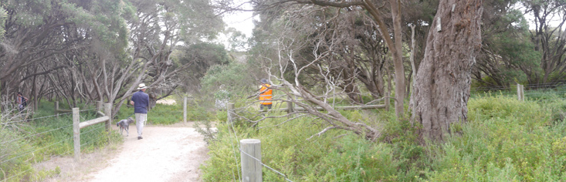
Photo 6: Moonah Woodland Internal paths

Zone 2 – Dune Woodland
The Dune Woodland is located along the remnant dune system running north south along the eastern park boundary. It features two separate fenced areas. The northern remnant (0.31ha) features primarily groundlayer species including Kangaroo Grass Themeda triandra, Wallaby Grass Austrodanthonia sp. Knobby Club-rush Ficinia nodosa, Clematis microphylla, Rhagodia candolleana and Swainsona lessertifolia. Refer Photo 1.

The southern area (0.9ha) contains several large Moonah and Coast Wirildra with infill of Coast Beard Heath Leucopogon parviflorus and Coast Tea-tree Leptospermum laevigatum, which have naturally recolonised the dune area. The presence of the Coast Tea-tree in the remnant Dune Woodland is seen as a long term management issue. While Coast Tea-tree is normally associated with sand dunes in coastal areas the percentage cover of this species can lead to a loss of diversity, out-competing other indigenous trees, shrubs and groundlayer species and cover of less than 5% is preferred in these areas. Coast Tea tree management is undertaken by CoGG Conservation Reserves Team to maintain biodiversity values and minimise fire risk for directly adjoining residential properties in the south east corner of the park.

Outside the core fenced Moonah Woodland perimeter there are also some very large and very old established Moonahs which are cut off from the main fenced remnant woodland area (refer photo 8). These trees located at the rear of the Pony Club, at the play space and the Barwon Grove Golf Club car park are subject to higher levels of ground layer weed invasion and despite the presence of some fencing appear unable to naturally regenerate and are subject to higher threat in the form of root compaction and branch damage.

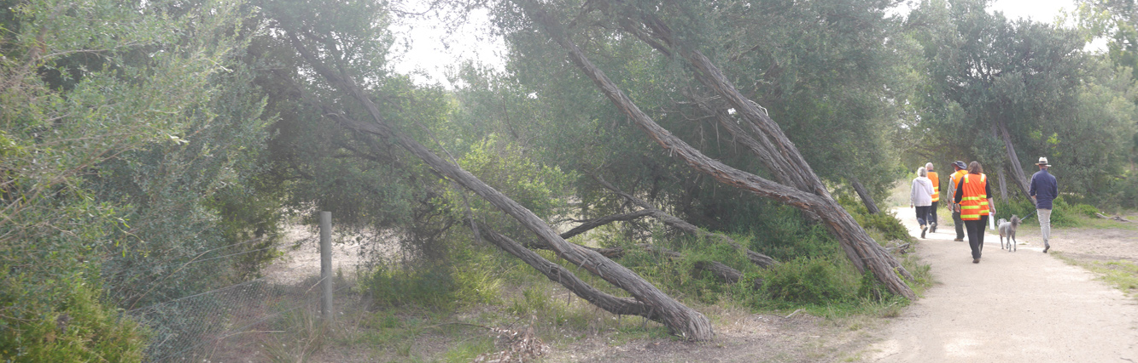
Photo 7: Coast Tea tree – SE Corner

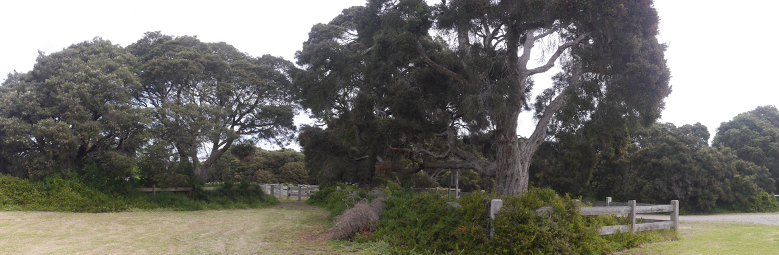
Photo 8: Moonahs at the Pony Club

There is a mix of planted native and indigenous vegetation across the remainder of the recreational areas of the park, which contributes to the habitat values and landscape character of the park.

A key landscape feature of the site is the crossed avenue of Tuart Gums Eucalyptus gomphocephala planted north-south along the main roadway extension of Hitchcock Avenue and east-west through the centre of the park. Tuart Gums are a native of Western Australia and were planted on the site 40-50 years ago. Drought conditions in the early 2000’s saw a decline in health and a third of the trees were removed due to safety concerns and parking areas were more clearly defined. Since then they remaining population has stabilised however these trees are subject to continuous monitoring with spot removals undertaken as required to protect public safety.

Figure 2. Environmental values

Tuart Gum avenue is declining in health and will require ongoing monitoring and a staged replacement strategy
Fenced access tracks through Moonah Woodland
Add Moonahs to fenced conservation area
Lack of connection between remnant vegetation areas
Lack of connection between fenced areas of Dune Woodland
Lack of protection and weed control to very old Moonahs at the Pony Club
Existing Moonahs on private land
Weed invasion in understorey of Moonah Woodland limits natural regeneration and biodiversity values.
Potential redevelopment of Golf Club and any car park improvement works must ensure protection of significant vegetation adjoining the area
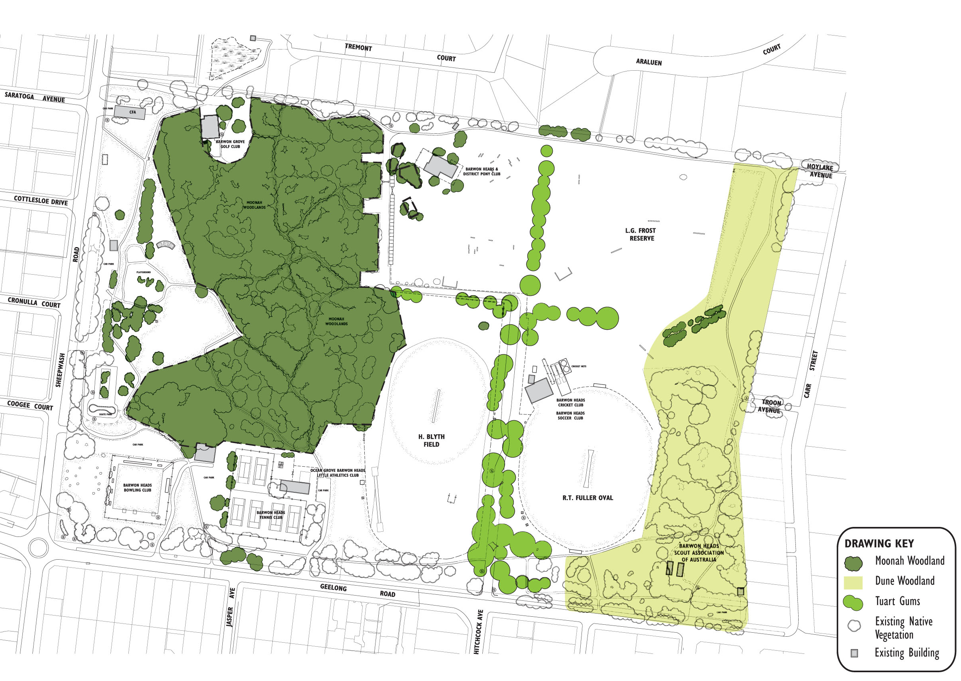
Southern area of Dune Woodland are unfenced and subject to higher levels of disturbance and weed invasion
Remove toilet facility to protect Moonah at Bowls Club
Add Moonahs to fenced conservation area
Potential issues with leaf litter and root damage at the tennis courts
High fire risk to adjacent residential properties due to proximity of vegetation and high percentage of Coast Tea tree

3.4.2 Fauna

There has not been a formal fauna assessment in BHVP, however the existing vegetation in the park provides important habitat values for local indigenous fauna. The DSE Field Guide to Coastal Moonah Woodland in Victoria notes that Moonah Woodlands provide habitat and food for many species of native animals and insects such bats, echidnas, ringtail possums, birds, beetles and spiders.

3.4.3 Key considerations
- Native vegetation within the park is protected by legislation and planning controls.
- Removal and control of Coast Tea-tree in the remnant vegetation areas to maintain biodiversity values and minimise fire risk will be ongoing.
- Density of vegetation at some road entries at path crossings will require pruning at times to maintain sightlines and public safety.
- Large Moonah trees near the Pony Club, playspace and within the Barwon Grove Golf Club car park remain unprotected.
- Large Moonah trees at the rear of the Bowling Club would be impacted by replacement of facilities in this location.
- Creation of informal bike jumps and tracks is impacting the Dune Woodland within in the south-east corner of the park.
- There is limited habitat connection between the fenced Moonah Woodland area and the Dune Complex along the eastern side of the site.
- Management of the ageing Tuart Gums avenue to minimise risk to the public will require ongoing removal of trees and infill planting will be required to retain the avenue character.

3.5 SPORTS

BHVP is the primary sporting reserve in Barwon Heads and provides for local cricket, soccer, athletics, tennis, junior AFL, lawn bowls and equestrian competition, training and informal use.

3.5.1 Existing Playing Fields

R.T. Fuller Oval
Full size irrigated unfenced grass cricket oval with synthetic wicket, sidescreens and recently installed training lights. The surface while undulating, is in good condition and the sandy subgrade assists drainage. The oval is also used for soccer and junior AFL over winter.

The pavilion has two change rooms, male/female and accessible amenities and a social room with kitchen/canteen facilities. There are male/female public toilets at the rear and synthetic cricket nets (3 lanes).

H. Blyth Field
The northern end of the large, unfenced reserve is irrigated and used for soccer and as the second cricket ground. The ground is narrow for cricket use.

The Little Athletics Club uses the reserve for training with permanent field sports areas including throwing cage, long jump put, shotput and high jump pad at the southern end of the field. There is no pavilion and the athletics club use an area in the Bop Bop Karrong building for storage.

3.5.2 Existing Clubs

Barwon Heads Cricket Club (BHCC)
The club fields 4 senior teams, and 10 junior teams using both R.T. Fuller and H. Blyth Field over summer for men’s, women’s and junior cricket. Training is held Monday to Thursday, with games Friday evening, all day Saturday and some Sundays. The existing pavilion was built primarily for cricket use and the social room is used for club and external functions.

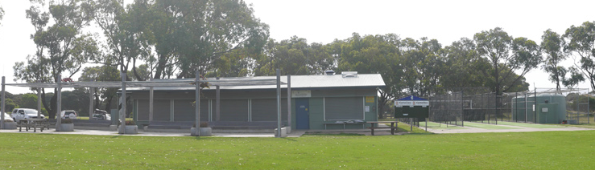
Photo 9: Cricket Club Pavilion

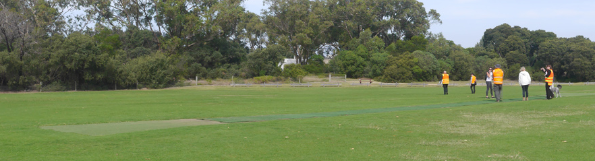
Photo 10: Wickets on R.T. Fuller Oval

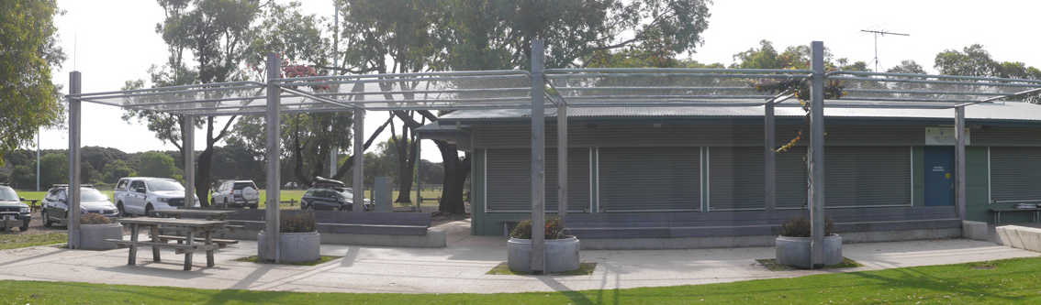
Photo 11: Picnic tables under the canopy area in front of cricket club

Barwon Heads Soccer Club (BHSC)
The club fields 3 senior teams and 17 junior teams using both R.T. Fuller and H. Blyth field over winter for men’s, women’s and junior soccer. Training is held Monday to Thursday afternoon/evenings with games on Saturday and Sunday through winter. The club has use of the Pavilion over winter.

Barwon Heads Junior Football Club (BHFC)
The Barwon Heads Football and Netball Club uses Hamer Oval within the Barwon Heads Caravan Park and does not have a permanent presence in the park but uses the R.T. Fuller Oval for junior and women’s footy games and training during winter.

3.5.3 Key AFL, Cricket and Soccer considerations

Key Soccer considerations
- Current Football Victoria (FV) guidelines for local and community competition level (senior level) pavilions require a minimum of four change rooms with corresponding amenities and two separate match officials change rooms as a minimum requirement to serve two soccer playing fields.
- The current pavilion was historically designed for cricket and provides for only two change rooms which are in reasonable condition. The pavilion configuration could be adapted to provide additional changerooms and amenities at the rear as required to meet current requirements for gender equity and at a reduced cost however more detailed cost benefit analysis will be required to determine if this is the preferred approach when weighted against the benefits of a complete, new build in lifecycle and management costs.
- The main access road divides the two playing fields with no defined crossing point or pedestrian priority crossing from the pavilion to H. Blyth Field.
- The current layout of the cricket pavilion does not cater for the needs of the Soccer Club in terms of availability of the required change rooms for men’s, ladies, juniors and referees.
- Lack of bicycle racks to cater for the large number of park users who cycle to the park.
- The growing club is looking for other spaces for training and warm-up which could be considered as part of a multi-use irrigated space to the south of the current field.

Key Cricket considerations
- While the existing pavilion was built for cricket gender participation changes mean increasing to four changerooms would also benefit gender equity cricket use at the park as well.
- There is no scoreboard on R.T. Fuller Oval.
- The grass surface at R.T. Fuller is undulating with mixed grass species, top dressing and reseeding with more durable warm season grass would improve playability.

Key AFL considerations
- R.T. Fuller is an important venue for AFL training and junior football as a second ground. Future demand needs to be managed cooperatively with soccer remaining the core winter tenant at the park.

3.5.4 Barwon Heads Bowling Club (BHBC)

The fenced bowling greens are synthetic and used all year round. The club has approximately 80 playing members, and more than 40 social members. The clubrooms are located west of the existing tennis courts, away from the bowling greens. Toilet facilities at the rear of the clubroom back into existing Moonah vegetation, which is leaning over and into the toilet block. The existing clubroom is also hired out for private functions and other groups such as The Friends of the Bluff and the Barwon Heads Music Society.

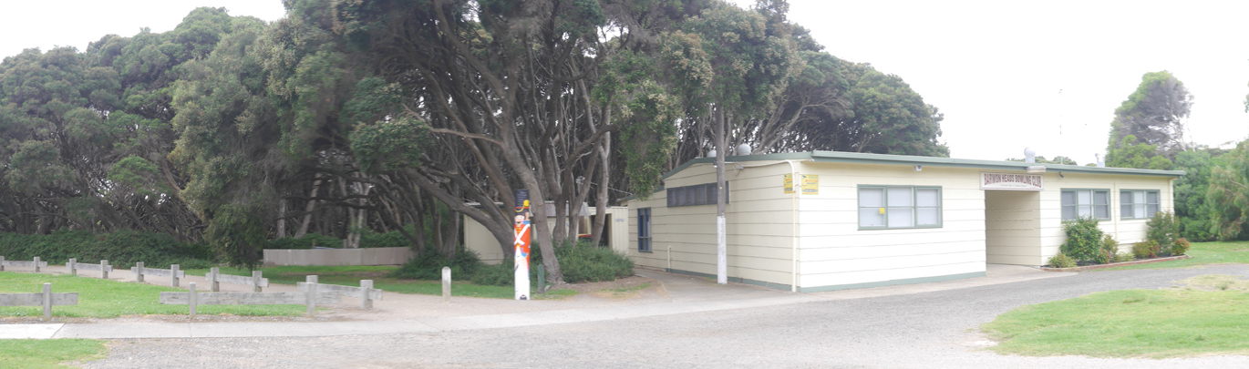
Photo 12: Bowling Club Pavilion

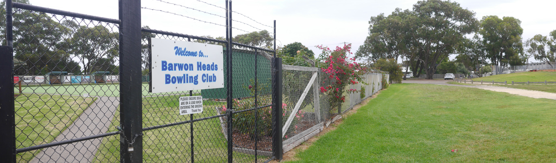
Photo 13: Synthetic Bowling Greens and existing car park

Key Bowling Club considerations
- The Club toilet facilities are in poor condition and impact on the adjoining Moonah Woodland.
- The location of the club room and toilets away from the bowling green restricts access especially for the elderly and those with a disability.
- The Bowling Club secured $500K of federal funding for a new building including social room and accessible toilet facility located on the west side of the bowling greens however additional funding will be required to complete the project.

3.5.5 Barwon Heads Tennis Club (BHTC)

There are six hard courts, and the club has approximately 70 members training mid-week and Saturday men’s, women’s and juniors’ competition. The two northern courts need resurfacing. The clubrooms have a social room, small kitchen and toilets and other facilities include a tennis hitting wall and a swing set.

Key Tennis Club considerations
- The tennis club are seeking funding for refurbishment of their clubrooms but have advised that these improvements will not require changes to their existing footprint.
- Upgrade the existing tennis pavilion within the current footprint to meet contemporary standards improving gender equity and accessibility.
- Upgrade of the northern courts in synthetic grass is preferred.

3.5.6 Barwon Heads and District Pony Club (BHPC)

The club has a long history at BHVP however club membership has been in decline and event use is at L.G. Frost Reserve is down to 12-16 times per year.

The pavilion is currently located in the north-west corner of L.G. Frost Reserve and includes a fenced storage area and undercover verandah. Several jumps are in poor condition and there is no water for the jump.

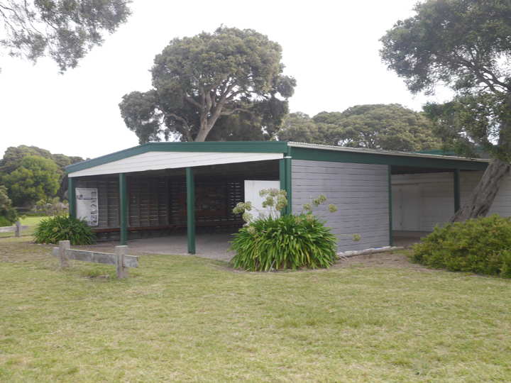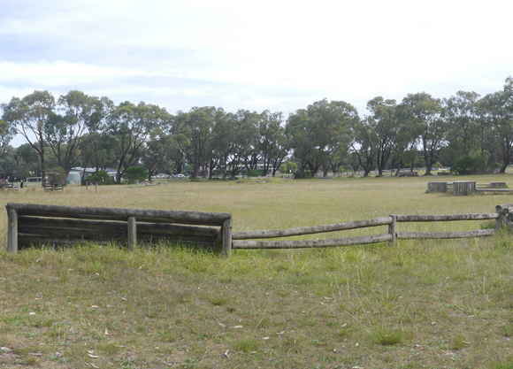
Photo 14: Pony Club pavilion
Photo 15: Show jumping infrastructure
Key Pony Club Considerations
- Other venue at Mt Duneed and Drysdale are well established for events and are capturing demand for equestrian activities in the region.
- The sand lunging area recommended from the 2012 Master Plan remains a key club priority.
- The age and proximity of Moonahs to the clubrooms will require ongoing monitoring to assess tree health and safety.

3.5.7 Ocean Grove Barwon Heads Little Athletics Club (BHLAC)

The club use H. Blyth Field for training over the summer. Existing facilities include a long jump pit and discus cage and shot put rink for field sports at the southern end of H. Blyth Field. The concrete high jump pit is no longer used.

Key athletics club considerations
- BHVP is now used for training only.
- Grass damage from field sports such as shot put impacts on the soccer/cricket playing surface and these activities would be better suited to the southern end of the field.
- There is no irrigation in southern end of the field which increases wear and tear on the multi-purpose grass areas.
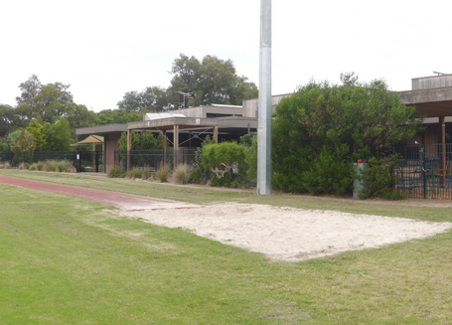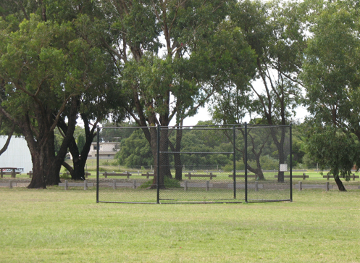
Photo 17: Existing throwing cage
Photo 16: Existing long jump pits

3.6 RECREATION

3.6.1 Informal recreation

The park provides an excellent range of park facilities and infrastructure for both formal and informal activities. The skate park built in 2011 remains a popular space for users. This features a bowl and ramp/activities area with sound protection for adjoining residents. Other park facilities include the playspace which was recently upgraded including two new flying foxes play equipment, the picnic shelter, BBQ and public toilet located adjacent to the play space with a maritime theme.

There is a basketball ring at the Barwon Grove Golf Club and several picnic tables located around H. Blyth Field, R.T. Fuller Oval and around the existing play space.

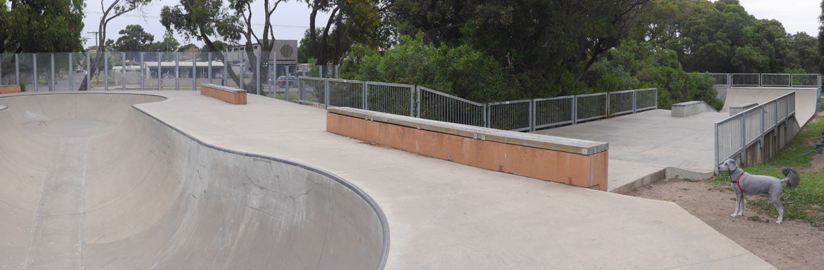
Photo 18: Existing skate park

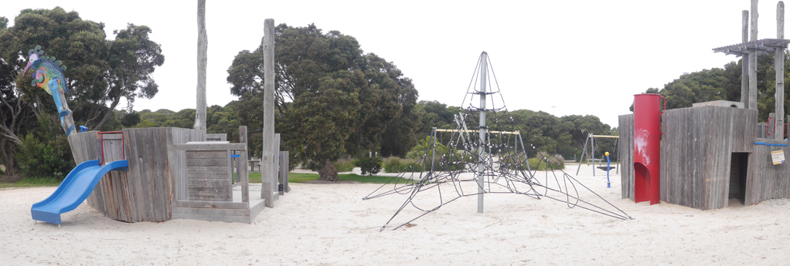
Photo 19: Existing playspace
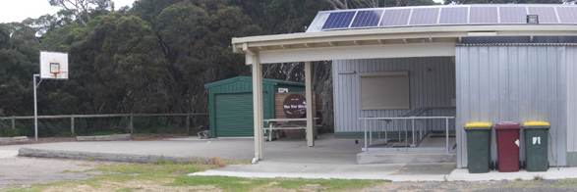
Photo 20: Basketball half-court at Golf Club

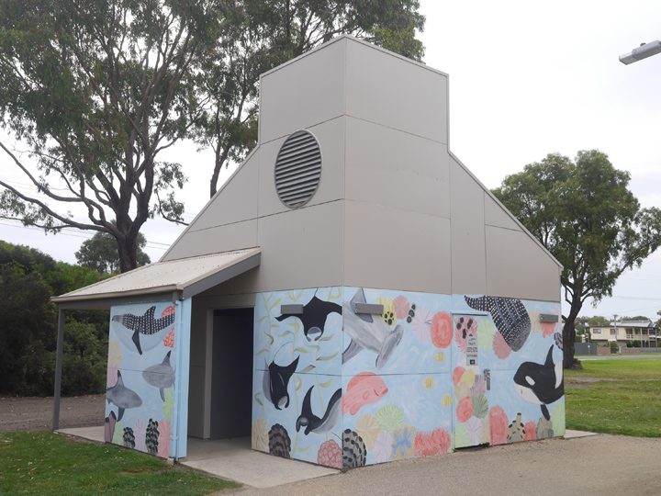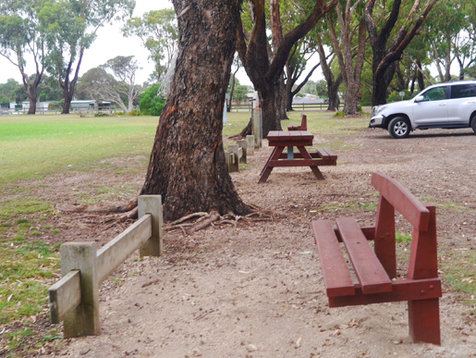
Photo 21: Public toilets on Sheepwash Road
Photo 22: Recently upgraded picnic tables and benches adjacent to H. Blyth Field

3.6.2 Toilets

There are two public toilets located in the park. The main public toilet block is located adjacent to the playspace in the west of the park and services the playspace, the picnic area and the skate park users. The other toilet located at the rear of the R.T. Fuller Oval and services spectators on game days or major events and walkers and dog walkers using the eastern side of the park. All clubrooms in the park have toilets, which can usually be accessed by club members only when open for Club match days/functions. The toilet block located at the rear of the Bowls Club pavilion is managed by the Bowls Club as part of their lease agreement. Redevelopment of the Bowls Club would allow this toilet facility to be removed reducing impacts on the Moonah Woodland. Their proximity to the adjacent Moonah Woodland is also a maintenance issue.

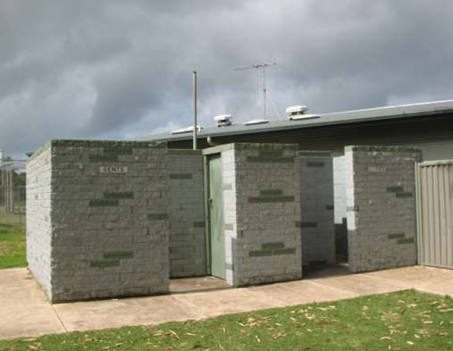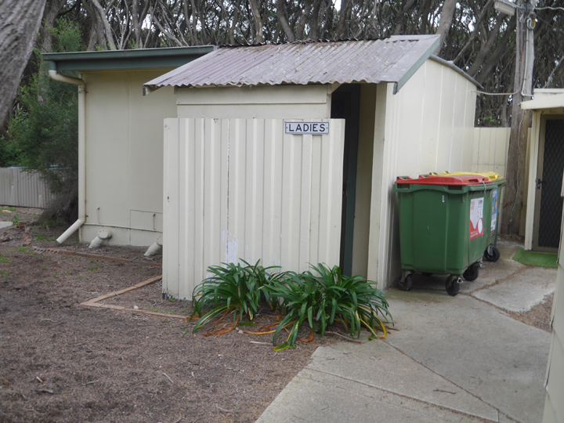
Photo 24: Toilet block at rear of Bowls Club
Photo 23: Public toilets at Cricket Club

3.6.3 Dog Access / Control

The City’s Dog Controls in Public Places Policy is used to establish dog use and regulations across the City. The master plan reflects the orders in place at the time the plan was approved.

An overview of the current orders relating to Barwon Heads Village Park include:
    - 2x sports grounds – off leash conditional - dogs allowed off leash outside times when being used for organised sports, including training (as defined by a formal booking with council);
    - Equestrian area (two large paddocks known as L.G. Frost reserve) - off leash conditional -dogs must be on leash when horses present, off leash allowed other times.
    - Dogs are prohibited within ten (10) metres of the children’s playground.
    - All other areas in the reserve dogs are required to be on leash at all times.

3.7 OTHER USERS

3.7.1 Barwon Grove Golf Club (BGGC)

The BGGC was established in 1961 and has more than 260 members the clubrooms are known as the 'Tin Shed' and located in the north-west area of the park, with vehicle access from Sheepwash Road. There is an unsealed car parking area adjacent to the building with a basketball half court and outdoor picnic area which can be used by the public.

The BGGC competitions and events are held off site at Barwon Heads Golf Club or 13th Beach Golf Club and the club operates as a social club only. The Club is available for community hire and plays an important role in local fundraising activities for various other clubs and community initiatives such as the Good Friday Appeal.
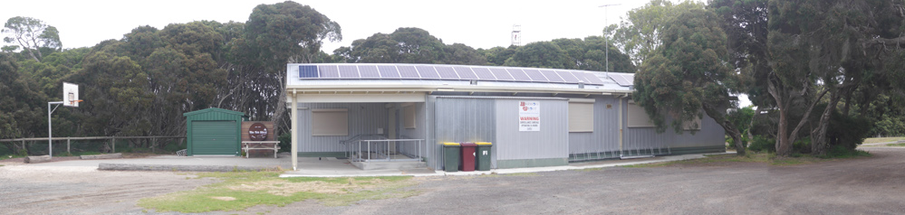

Photo 25: Barwon Grove Golf Club
Key consideration Barwon Grove Golf Club (BGGC)
- Car parking capacity is important to the Club however protection of several large Moonahs is also important to protect root systems from further compaction.

3.7.2 1st Barwon Heads Scout Group

1st Barwon Heads Scout Group was originally formed in 1959. After a hiatus of twelve years, the Scout Group was reformed in 2007 and now has more than 120 members.

The Scout Halls are located in the south-east corner of the park and include two steel cabins and a separate small toilet facility. The cabins are used as both meeting and storage space for camping and other key equipment and with the increase in membership there is limited space.

Key considerations 1st Barwon Heads Scout Group
- The Scout cabins are located in an areas of known cultural heritage sensitivity. While existing activities can be managed redevelopment of the building’s toilet facilities and storage areas at this location has several constraints including potential impacts on cultural heritage values, tree root protection zones, environmental values and accessibility.

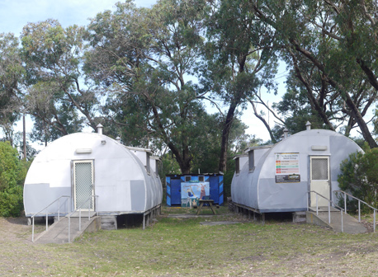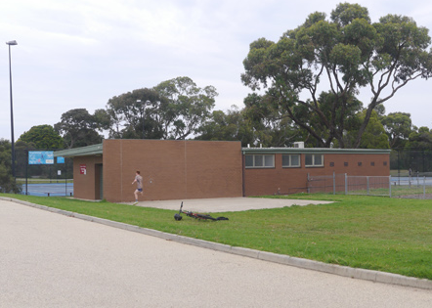
Photo 27: Tennis Courts
Photo 26: Scout’s Hall and toilet block

3.7.3 Barwon Heads Fire Brigade - CFA

The CFA building is located in the north-west corner of the park. The grassed areas south of the building on Sheepwash Road are used for training drills and as a staging area for larger deployments. Fire risk assessment for the park is completed annually by CoGG Fire prevention Officer in consultation with the local CFA.

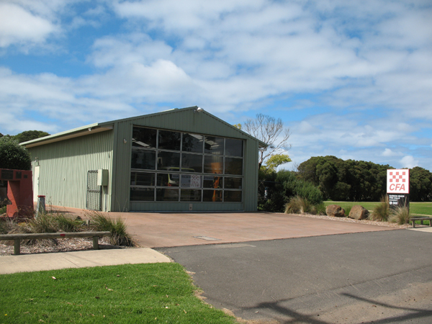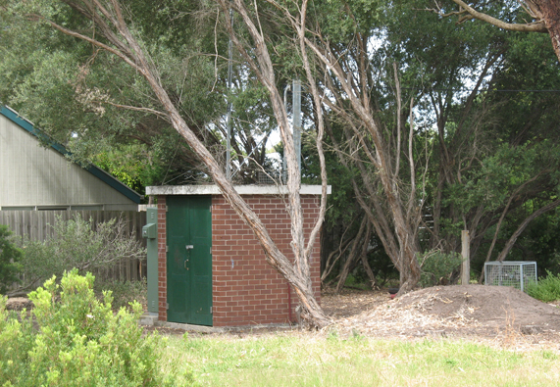
Photo 29: Barwon Water pumping station
Photo 28: Barwon Heads CFA

Key considerations for Barwon Heads Fire Brigade - CFA
- Retain unrestricted vehicle access to grass areas adjoining the CFA building for training and emergency management.

3.7.4 Barwon Water

Barwon Water has a lease agreement for the pumping station located in the south-east corner of the park. The facilities include a sewerage pumping station and equipment shed.

Key considerations for Barwon Water
- Retain vehicle access to the Barwon Water lease area from Geelong Road.
- Co-ordinate fire break vegetation management with the CoGG Conservation Reserves Team and Fire Prevention Officer.

3.7.5 13th Beach Boardriders

The 13th Beach Boardriders group is currently looking for a local home base within the Barwon Heads Village Park. The club has secured external funding to assist with establishment of a new storage facility and purchase of new equipment. A standalone facility is not proposed.

Key Considerations for 13th Beach Boardriders
- Location of the 13th Beach Boardriders within BHVP could be considered as part of improving facilities for an existing group such as the Scouts who are actively looking to relocate.

3.7.6 Bop Bop Karrong Barwon Heads (Kornoo) Integrated Child and Family Centre

The Barwon Heads Early Learning Centre was established in 2013 and is now called the Bop Bop Karrong Barwon Heads (Kornoo) Integrated Child and Family Centre and brings together a range of services for children and their families, including: three and four year old sessional Kindergarten programs, occasional care, Maternal and Child Health services, playgroups, parenting programs and other family support services. The building also provides storage area for the Little Athletics Club and parking areas area shared with the tennis club.

Key considerations for the Bop Bop Karrong Centre
- Parking areas are considered adequate however the grass overflow area on the north side of the building becomes wet over winter.

3.8 TRAFFIC AND PARKING

3.8.1 Vehicle access and circulation

Vehicular traffic in Barwon Heads is seasonal and is typically low for most of the year, and heavier during the peak holiday season and weekends.

There are three main vehicular access roads to Barwon Heads. Barwon Road Heads Road is considered the main arterial and entry point to the town as it provides direct access to the town centre for most of the traffic coming from Geelong and Melbourne. The other two routes into Barwon Heads are across the Barwon Heads Bridge from Ocean Grove, and Thirteenth Beach Road, which becomes Ewing Blyth Drive.

Vehicular entry points to the park are located along Sheep Wash Road and Geelong Road, to access the clubs and other park facilities. All roads and car parking areas within the park except the Bop Bop Karron Centre are unsealed. The main vehicle entry to the park is located at the intersection of Geelong Road and Hitchcock Avenue and provides vehicular access to the ovals and the Pony Club at the northern end of the park.

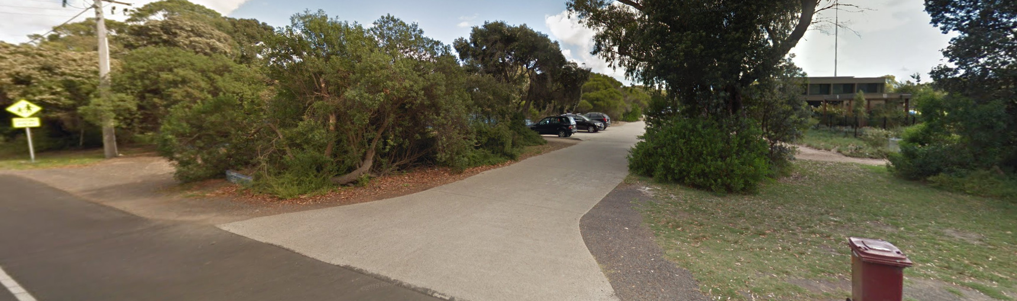
Photo 29: Vehicle entry to Barwon Heads Tennis Club and Bop Bop Kindergarten

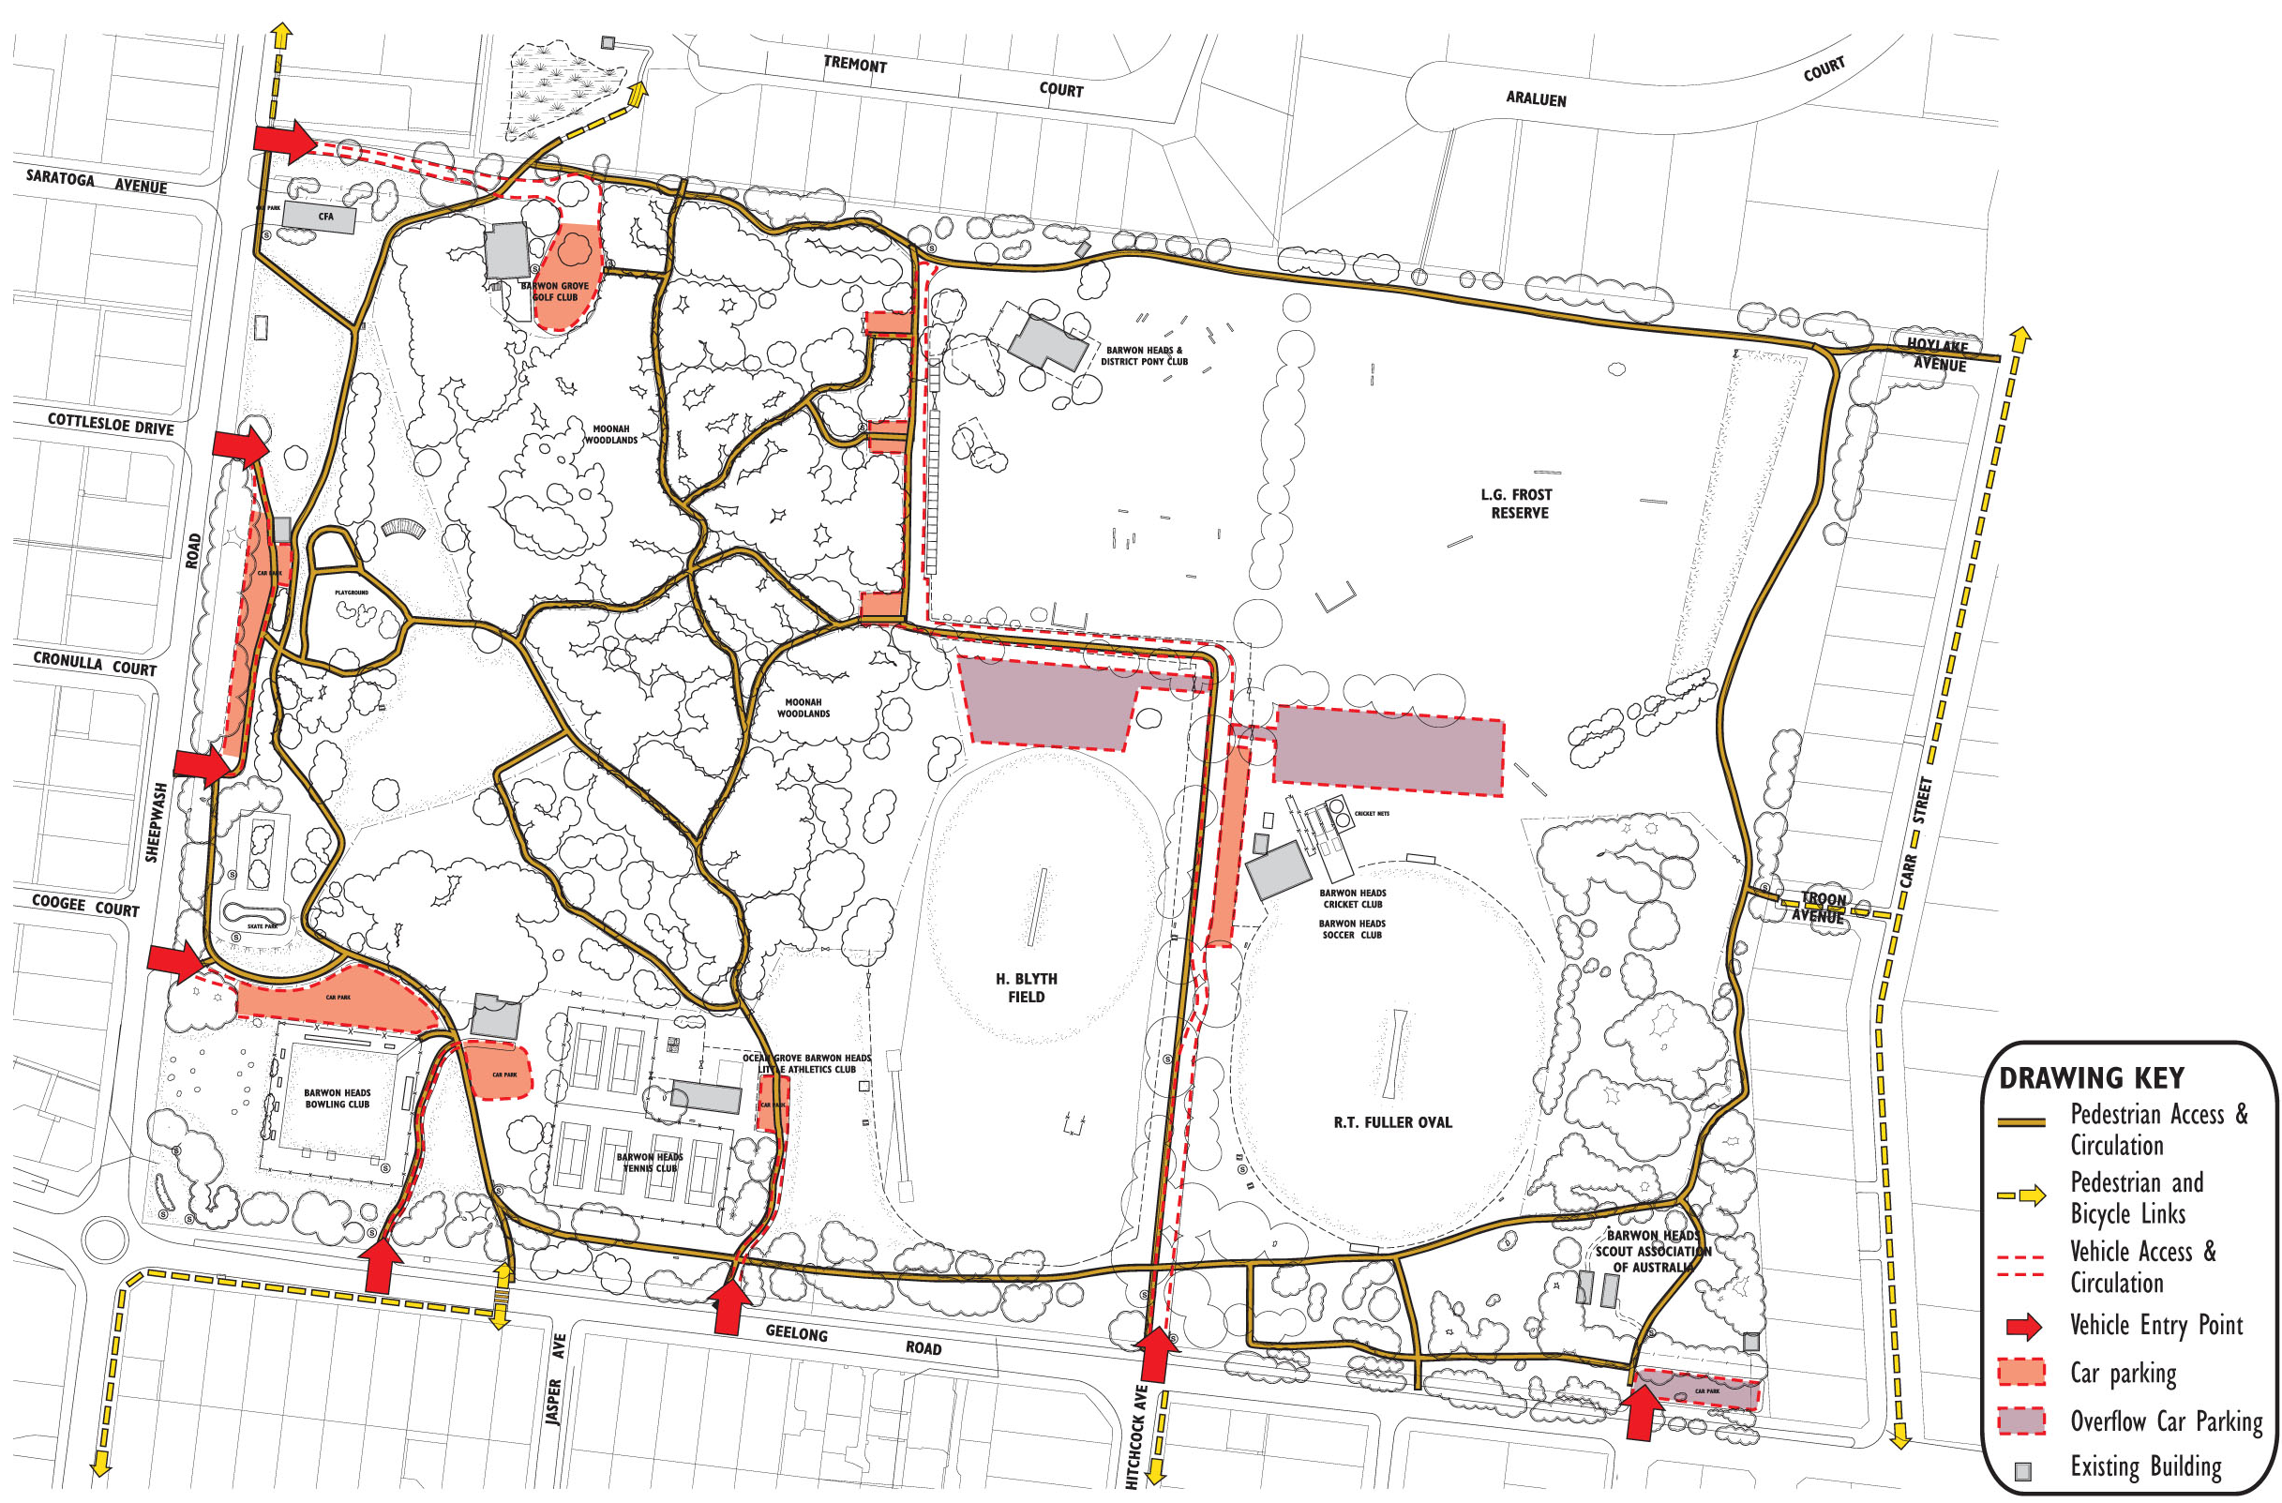
Figure 3. Access and circulation plan
Pedestrian link to school
Road layout at park entry creates confusion
Pedestrian access conflicts with vehicle access to residential properties
Link to town centre
No formal footpath along Geelong Road
Conflict between pedestrians and vehicles
Conflict between pedestrians and vehicles
Conflict between pedestrians and vehicles
No formal footpath along Carr Street
No formal footpath along Sheepwash Road
Grassed areas used as overflow car parking
Conflict between pedestrians and vehicles
Photo 30: Hitchcock Avenue entry

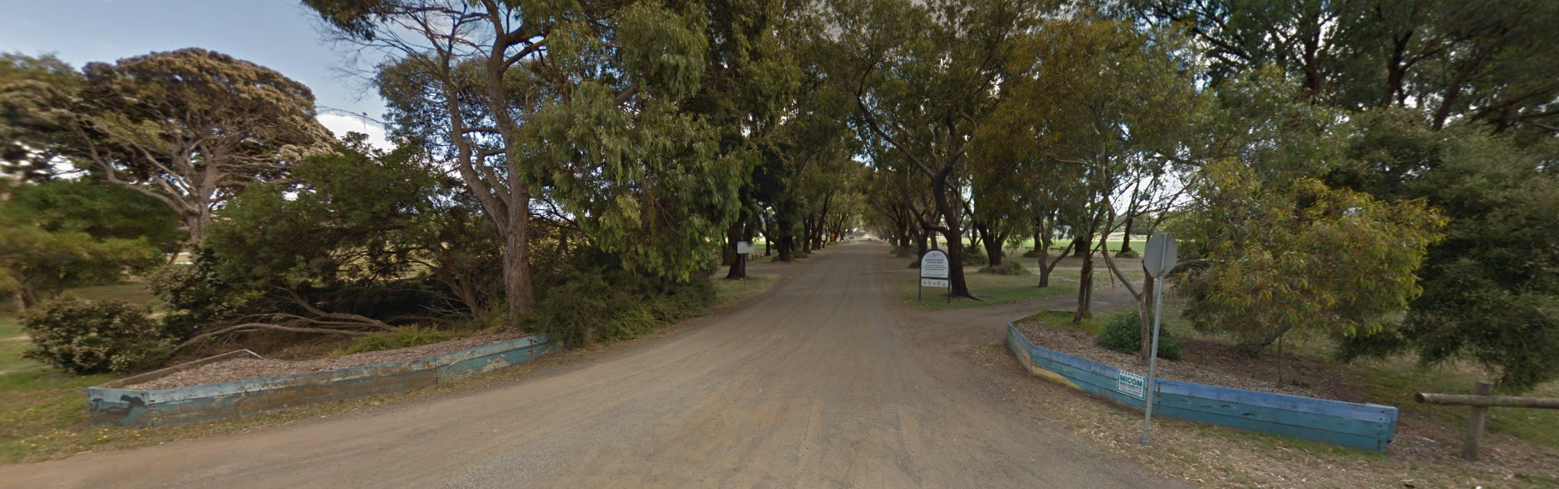

Photo 30: Hitchcock Avenue entry

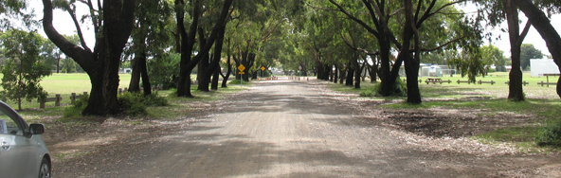
Photo 31: Hitchcock Avenue extension

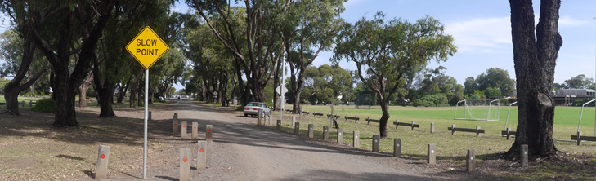
Photo 32: Existing slow point near the Cricket Club

3.8.2 Car parking

There is extensive car parking located around the park and in proximity to the various clubrooms and pavilions to service the clubs and visitors to the park. Refer Figure 5. The car parking spaces are unmarked and car parking is generally informal, and there is no definition of separate pedestrian access in these areas. The grassed areas north of H. Blyth Field and R.T. Fuller Oval are also used as overflow parking for trailers during major show jumping events.

3.8.3 Pedestrian and bicycle access and circulation

There is an extensive network of existing unsealed paths that provide a series of internal walking loops. The perimeter path provides a popular loop of approximately 1.8km. The north-south route from the pedestrian crossing past the playground and CFA has been designated as the 'safe school route'.

There are two minor access points along Carr Street from Hoylake Avenue and Troon Avenue and an access point from the adjoining reserve in the north, with links to Tremont Court. The existing network of unsealed access tracks within the Moonah Woodlands provides additional recreational walking experience and connectivity which is popular with visitors to the park.

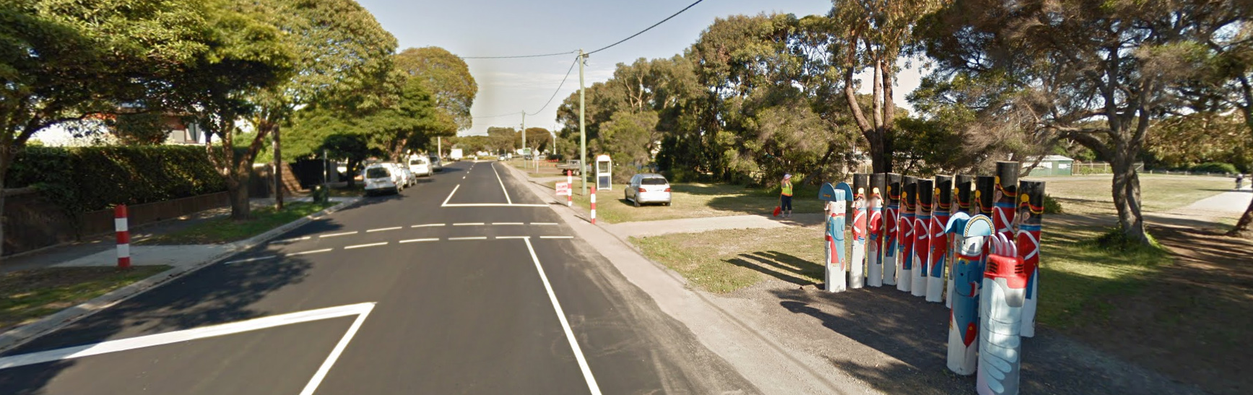
Photo 33: Geelong Road pedestrian crossing

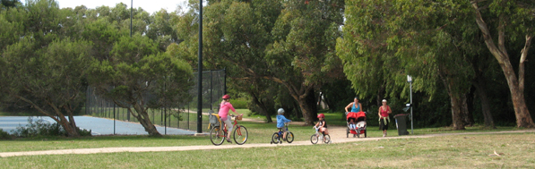
Photo 34: North-south safe school route
Key access and circulation considerations
- There is a lack of designated accessible parking spaces adjoining existing pavilions and clubrooms.
- Vehicle speeds on Hitchcock Avenue access road remain high and there is no designated pedestrian priority crossing between the R.T. Fuller Oval pavilion and H. Blyth Field.
- There is no off road path access from Geelong Road/Hitchcock Avenue to the R.T. Fuller Oval pavilion.
- Relocation of the Bowling Club to the new site on the west side of the Bowling Green will require realignment of pedestrian paths.
- Pedestrian access via Hoylake Avenue and Troon Avenue is shared with vehicle access to adjoining private properties.
- Lack of directional signage throughout the park.
- Informal track and bike jump construction increased in the south east corner of the park during COVID. Provision of a dedicated areas for this activity away from more sensitive environmental and culturally sensitive areas may be needed to reduce these impacts.

3.9 ADJOINING LAND USE

3.9.1 Residential properties

BHVP is bounded to the north and east by residential properties. Many of the properties along the northern boundary have an outlook onto the park and have access gates to the existing pedestrian path running parallel to the boundary line. The existing residential properties along the eastern boundary have standard timber fences and are not open to the park. There is pedestrian access though from Carr Street at Troon Avenue and Hoylake Avenue. The existing vegetation along the east boundary fence is actively managed to reduced fire risk.

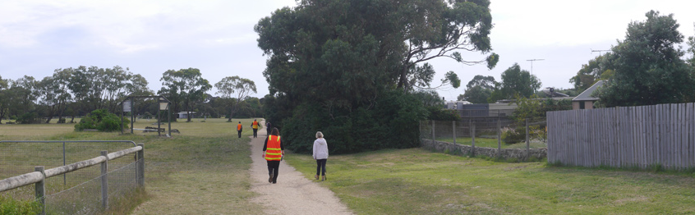
Photo 35: Open Views along northern boundary

4.0
STRATEGIC DIRECTIONS

4.1 WHAT IS PROPOSED

The updated Barwon Heads Village Park Master Plan has been developed in close conjunction with existing site users and community stakeholders. The plan seeks to address the key objectives of the project including ongoing protection of key environmental and cultural heritage values, staged improvement of passive an active recreational facilities and maintaining the spaces and places that create the park’s unique character.

VISION

4.2
Preserve the natural environment, open space and existing informal village parkland character while supporting renewal of existing facilities and infrastructure that improve access, sustainability and shared community use. Maintain the balance between organised sport, other community uses, service providers and informal recreation, while protecting and promoting understanding of the park’s significant environmental and cultural heritage values.

4.3 GOALS

Environment

• To protect and enhance the park’s unique natural environment of Moonah Woodlands, Dune Woodland, mature tree planting and grass open space for future generations.

Cultural Heritage
- To protect the significant cultural heritage of the park and provide opportunities to improve awareness and understanding of cultural values.

Places and Community Use
    - To maintain a balance between spaces for informal recreation, organised sport, other community use to enable people of all ages and backgrounds to gather, socialise and build greater social connections and connections with nature to support community health, wellbeing and enjoyment of the parkland.

Social Infrastructure
- To provide the appropriate type, quantity and level of social infrastructure that supports the sustainable use of the park for the agreed uses.

Park Management
- To ensure the planning, development and management of the park is done in a holistic manner integrating all current uses and functions in consultation with the community.

Park Character
- To ensure the character of the park is well defined and maintained.

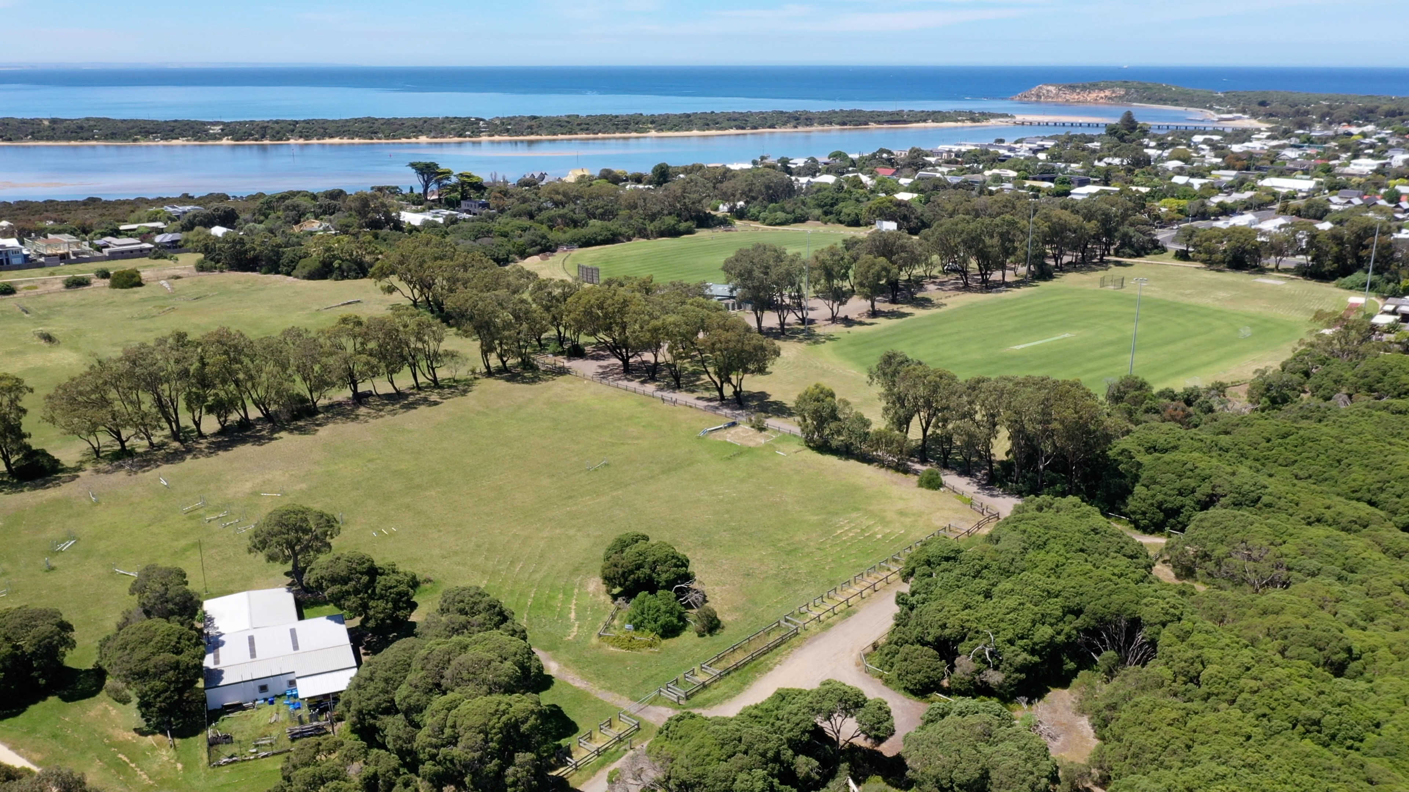

Photo 36: Aerial view across the park to the Barwon River Estuary

4.4 OBJECTIVES

The objectives indicate how the goal will be translated to guide the specific proposed actions for the park. Specific timeframes have not been identified for each objective but the intention is that they are delivered over the duration of the plan.

Environment
• Increase the environment managed area by converting 0.4% of open space to environment managed areas through new plantings of indigenous species, creating environmental corridors and fencing areas where required.
• Reduce the threats to the biodiversity values of the environment managed areas through ongoing weed control reducing weed cover below 10%.

Cultural Heritage
• Avoid or minimise soil disturbance in and around known cultural heritage sites and ensure any works complies with cultural heritage legislation.
• Continue to capture and celebrate the cultural heritage, history and stories of the park in creative and artistic installations.

Places and Community Use
• Acknowledge that the current balance of use is largely meeting community needs and minimise changes in use to those recommended in the plan.
• New and emerging uses will be assessed according to the Vision, goals and objectives for the park, local needs and the broader regional context to determine whether they are appropriate for the park or can be accommodated in other locations.

Social Infrastructure
• Social infrastructure will be redeveloped and replaced where it is deemed essential and supports the City’s Social Infrastructure Policy, ensuring they are compliant, inclusive and accessible facilities that support multi use and are fit for purpose guided by legislation, sporting or other facility guidelines.
• New social infrastructure will be designed in a way that is creative, sustainable and responsive to the character and scale of the local coastal village setting and adhere to the building design guidelines in this plan.
• The building footprints will be contained to the minimum requirements, with opportunities sought to retire redundant facilities where possible.

Park Management
• Implement a system of zoning through the park to provide a clearer focus and management intent for those areas.
• Develop cross department working groups for the planning, development and management of the park.
• Ensure the community are engaged in the planning, development and management of the park through the formation of appropriate reference groups and through broader community consultation in line with the City’s Community engagement policy.

Park character
• Develop a statement of significance and character to define the value of the park and how the community wish to see it protected and managed into the future in accordance with the Master Plan’s Vision.

4.5 STATEMENT OF SIGNIFICANCE - LANDSCAPE AND CHARACTER

The Barwon Heads Village Park, known locally as The 54 Acres, includes a diverse landscape of open space and areas of environmental significance including Moonah Woodlands protected under the Flora and Fauna Guarantee Act 1988 and Coastal Dune Woodlands. Recognised Aboriginal Cultural values highlight the connection and use of the area by Wadawurrung people. The park is also significant for its history and cultural function as a community park with diverse use reflecting the origins of its establishment as a place of recreation for a small coastal holiday town. The park contributes significantly to the landscape character and social connections of Barwon Heads and was recognised in the 2017 structure plan as playing a critical role in the provision of open space, sporting and recreation opportunities for the town. The park is a core part of the Barwon Heads township and is highly significant to the community along with its other natural features including the river, headland and coast, and as a whole is an important part of the Bellarine Distinctive Area Landscape.

Landscape and visual character
Barwon Heads Village Park is a diverse park built around the Moonah woodlands and spaces for small scale sport, recreation and community use consistent with the casual beachy and unpolished character of the coastal village.

The park is covered in trees and vegetation intersecting and wrapping around the park protecting it from the wind and weather. The central core to the park, the Moonah woodlands provide a blanket of densely intertwined canopies with sheltered, quiet and calm trails meandering through the understorey.

The relatively large park has a strong sense of distinct and separate spaces, delicately balancing natural, informal open green space areas with developed sporting and organised community use areas nestled amongst the trees. A core unsealed outer trail and a web of smaller trails connect the park for the community to wander and explore. Unsealed roads and parking further add to the organic and rustic charm of the park.

From the outside, the Park frames the main entrance to town from Barwon Heads Road, also bounded by Sheepwash Rd with views of trees, open space and Moonahs. Views to the threatened Moonah population are clearly visible from the street frontages along Sheepwash Road and Geelong Road. The Tuart Gum avenues in the eastern portion of the reserve create important view lines through the park and establishes a visual link to the main street, Hitchcock Avenue. The avenues define the different spaces, but an open understorey also creates a sense of spaciousness on this side of the park with views through the trees between the open space of the Equestrian area and sporting ovals.

On the northern and eastern boundary, residential properties border the park and a mixture of largely wooden paling and open wire fencing, gardens and trees help blend the interface between the park and private spaces.

The significant patches of vegetation and plantings create a dominant feature where buildings are subordinate to the surrounding landscape. Low set buildings are nestled in and surrounded by vegetation creating a softer and unobtrusive nature to the park.

Environmental Value
The Village Park contains sites of vegetation significance including a large population of Moonah Woodland which is listed and protected on Schedule 2 of the Flora and Fauna Guarantee Act 1988. It also includes Dune Woodland with remnant vegetation including the rare Coastal Wirilda. Plantings of Tuart Gums and other native species also contribute to the broader environmental value and habitat of the park and give the park a natural Australian feel with minimal exotic species present.

Cultural, Heritage and Social Values
The Village Park has significant cultural and heritage value pre and post-colonial settlement. An archaeological assessment of the park completed for the City of Greater Geelong by Terraculture in 2001 identified Aboriginal midden shells and stone artefacts, which have now been listed with Aboriginal Victoria and the entire dune system is culturally sensitive. Post colonisation, the land was part of the Challis farm and was leased and made into a golf course by families who had holiday cottages on the river in the late 1800s. The park officially began its sporting life as a golf course in 1909 when members purchased the land, and the Challis farmhouse became the first clubhouse on site. The park was created in a land swap with Barwon Heads Golf Club in the 1960’s and retains its historical links to the original Golf Club via The Tin Shed – Barwon Grove Golf Club (no course on site). It is now home to an incredibly diverse range of passive, recreational and community uses and clubs which have developed over the park’s history. In addition to sporting uses, the Village Park is also a cultural hub for music and arts events, run through the shared use of the park’s clubhouses and is the site for the original bollard artwork of local Artist Jan Mitchell. Today, the use of the park ebbs and flows across the day, the week and the seasons. If the main street is the heart of town, the Village Park is the lungs, bringing life to kids play, youthful adventure, sport and recreation for all ages, genders, backgrounds and abilities.
.

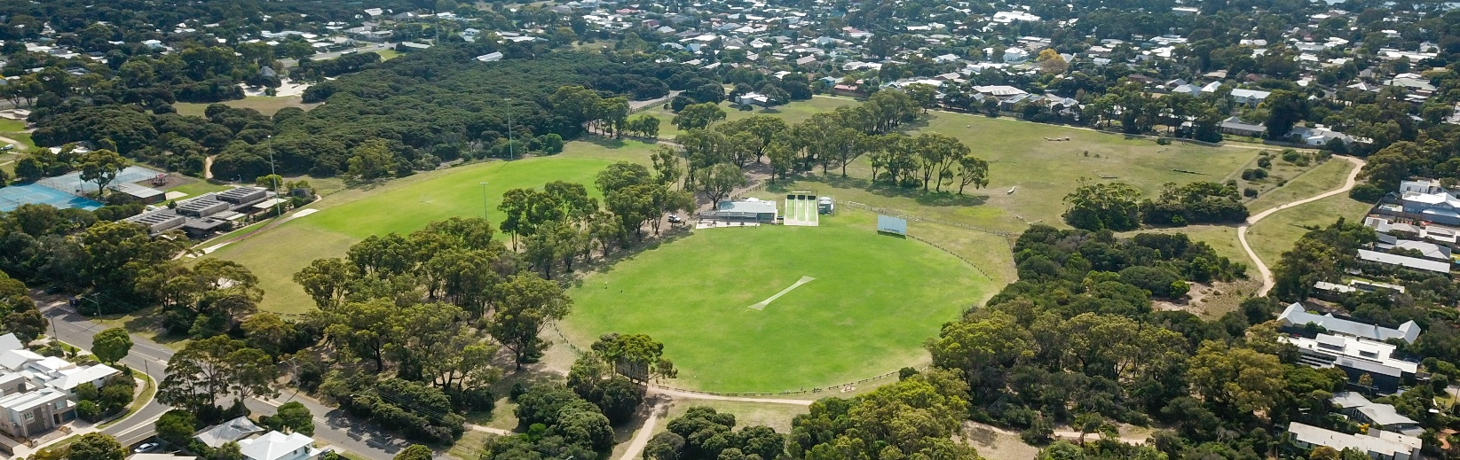

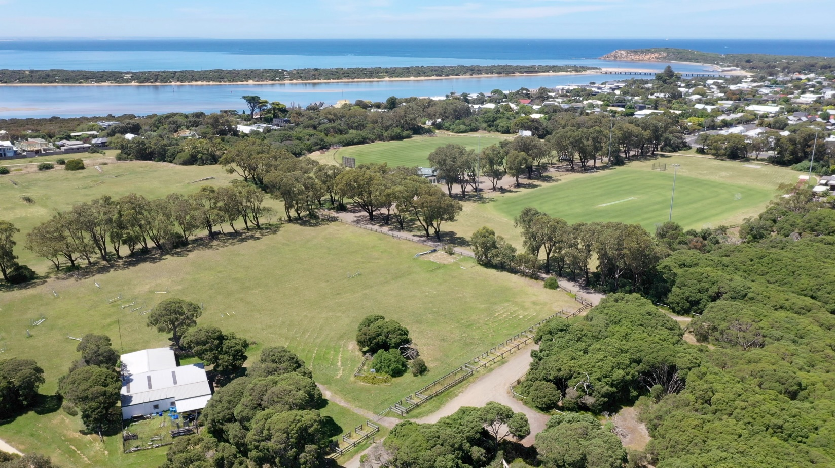

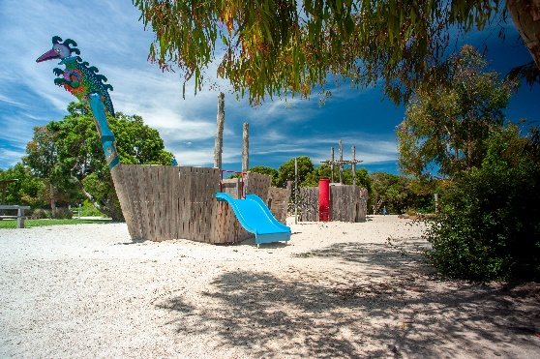

Photo 37: Park character images

5.0
PARK MANAGEMENT ZONES

The following zones build on work from the 2012 plan and are a key strategy to help achieve the vision and goals for the park. The zones are designed to guide the future development, use and management of different areas of the park to ensure there is a balanced approach to meet the needs of the park and the community.
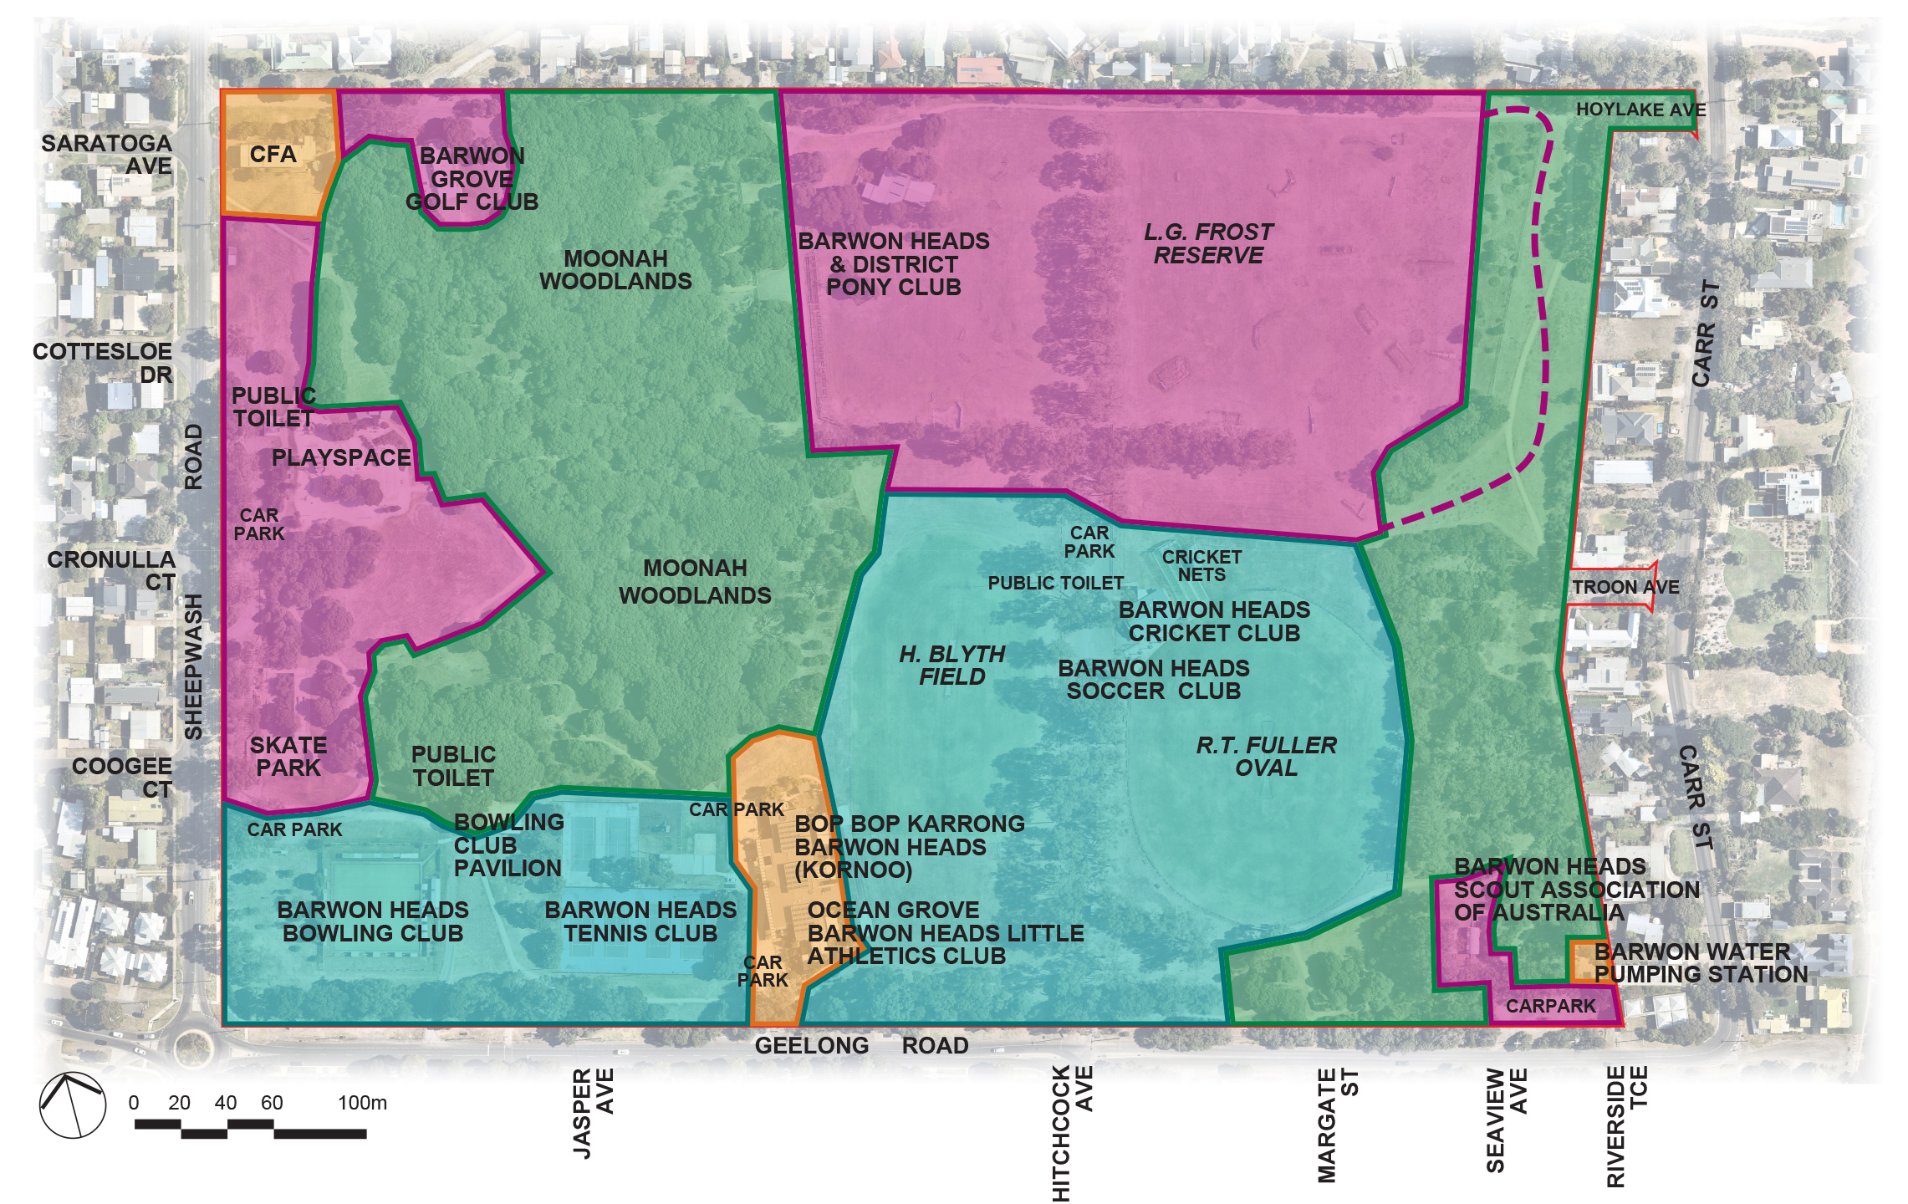

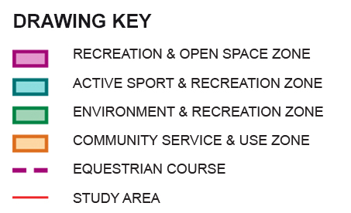
Figure 4. Park Management Zones

5.1 ENVIRONMENT AND RECREATION ZONE (Green)

The primary focus of this zone is to protect significant environmental and cultural values while allowing formalised trail use. Strategies in this zone will target key risks to environmental values with the aim of improving the condition and habitat value of the vegetation and reduce disturbance to cultural values. An appropriate fire management regime will be implemented. Activities in the zone include dog walking on-lead, walking, cycling, trail running and nature appreciation. Horses are only permitted during events on the designated cross country trail managed under additional controls.
Target measure:
- Increase in vegetation cover
- Improvement in overall vegetation condition
- Reduction in disturbance to primary dune containing key cultural values
- Fire risk managed within acceptable levels
- No increase in building footprint

5.2 RECREATION AND OPEN SPACE ZONE (Magenta)

The primary focus of this zone is to provide for organised recreation activities and open space for more informal recreation and passive use. A key feature of the zone is that development will be less obvious, less formalised and facilities will be nestled into the surrounding landscape providing greater open space. The zone covers four areas of the park. Activities in the North-east zone include equestrian activities, dog-off lead use and informal recreation and the western zone is focused on picnic and play with the main playspace, skate park and potential new bike discovery area. The North-West zone is focused on community use associated with the Tin Shed and the South East Zone captures the current Scout use.

Target measures:
- Increase in vegetation cover
- Maintain viewsheds and sightlines
- Facilities meet minimum standards and are fit for purpose
- Ensure that any new facilities comply with the building siting, design and development guidelines in this plan and any other relevant coastal character siting and design guidelines
- Minimal increase in building footprint (SE area only pending further investigation)
- Enhance recreation opportunities including the new Bike discovery area

5.3 ACTIVE SPORT AND RECREATION ZONE (Light blue)

The primary focus of this zone is to provide for smaller scale, club organised sport, recreation and community use that uses the park in a treed, parkland setting. Facilities should aim to meet minimum standards for the respective not-for-profit uses and will not be over-developed focusing on quality rather than quantity or size and will be designed and sited. Sport and uses in the zone include Cricket, Soccer, Football, Tennis and Lawn Bowls.

Target measures:
- Sports playing surfaces meet minimum standards and are fit for purpose
- Pavilions meet minimum standards and are fit for purpose
- Renewal or replacement of facilities within identified footprints
- Ensure that any new facilities comply with the building siting, design and development guidelines in this plan and any other relevant coastal character siting and design guidelines
- Tree cover maintained

5.4 COMMUNITY SERVICE AND USE ZONE (Orange)

The primary focus on the community service and use zone is on providing key public services to the community. The facilities will be fit for purpose and the spaces and design around these facilities will be in keeping with the parkland setting. The community services include the CFA, Bop Bop Karrong Integrated Child and Family Centre and Barwon Water pump facilities.

Target measures:
- Appropriate agreements will be in place to provide certainty of use for key tenants
- No further increase in building footprint
- Landscaping around facilities will ensure the parkland character is maintained
- Formal parking will be kept to a minimum

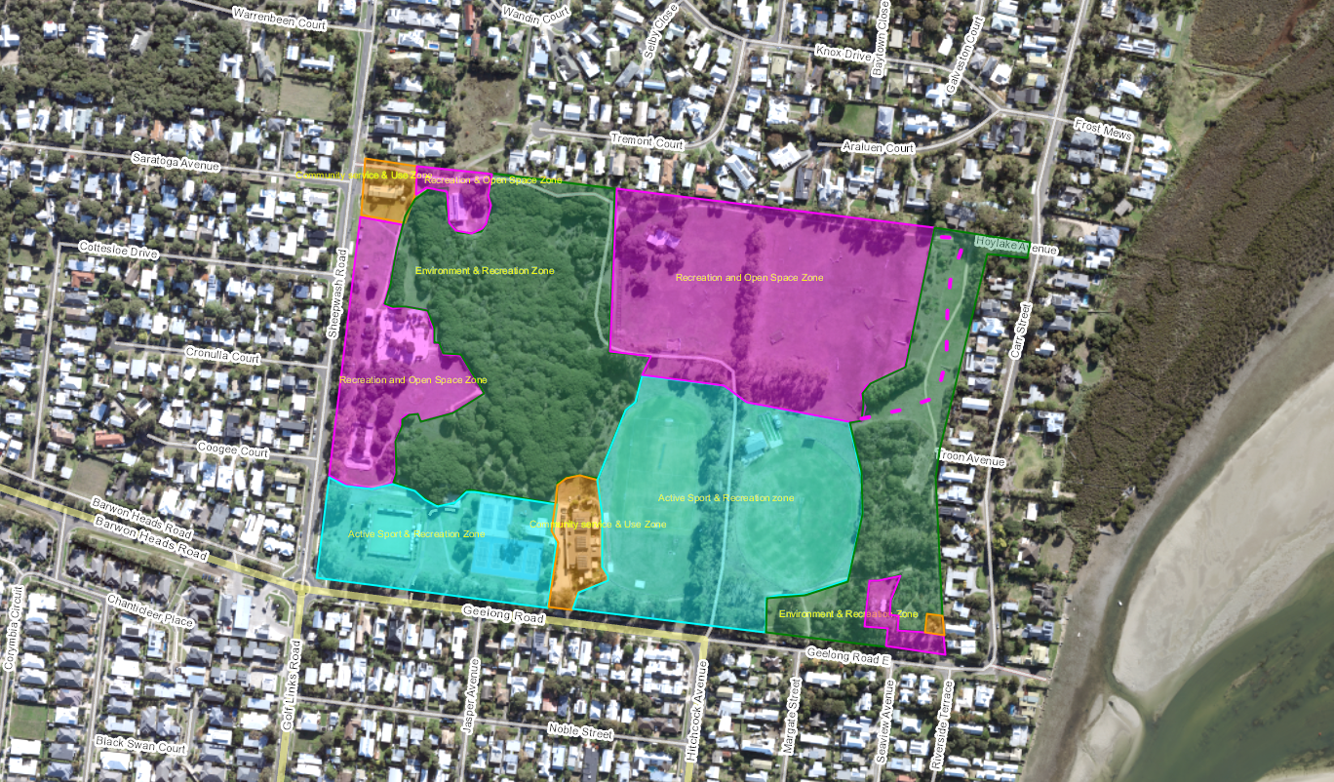

Building siting, design and development guidelines:

Siting and amenity
    - New buildings and works to occur within the indicative footprints described on the masterplan.
    - Maintain the visual dominance of trees and vegetation including the Moonah woodland
    - Ensure buildings are nestled in and do not dominate the landscape with a form that complements the surrounding parkland
    - Seek opportunities to enhance vegetation, landscaping around buildings whilst being cognisant of reducing fire risks.
    - Ensure that buildings do not adversely affect views within the park and are not intrusive when viewed from outside.
    - Any new building or extensions to have a minimum set back of 25m from the park boundary.

Design
- Buildings should be architecturally designed and include design detailing such as lightweight, natural and timber materials, simple detailing and muted colours that blend buildings within the coastal landscape setting, so they are not visually dominant.
- Ensure that new development and extensions to existing buildings are compatible with the existing scale and bulk of the other recreational / sporting club buildings in the surrounding park setting.
- Where new buildings are permitted, they must not be higher than the average Moonah tree canopy.
- Buildings must incorporate sustainability features and include universal design and CPTED principles.

Development process
- New or redeveloped buildings will follow the appropriate planning process to obtain planning, building or other permits where required.
- The siting and design of any major new or redeveloped building will be subject to the City’s community engagement policy and processes.

5.5 CURRENT AND PROPOSED SPATIAL ALLOCATIONS

5.6 PROPOSED ACTIONS

- Adopt the statement of landscape and character significance as a benchmark state to ensure this significant local landscape, its natural features, open space and character is protected and maintained for future generations.
- Implement the park zoning approach and adopt the current and proposed spatial allocations.
- Ensure new building and works comply with the building siting, design and development guidelines in the plan.
- Protect the parks open space and environmental areas from further development by adopting the target allocations in table xx to maintain at least 77.4% as open space incorporating the current equestrian area

6.0
MASTER PLAN

6.1 BHVP-02 MASTER PLAN UPDATE 2021

The proposed actions listed in the Landscape Master Plan are the culmination of background assessment of issues and opportunities, and feedback from the Project Reference Group and key stakeholders providing a clear rationale for their inclusion.

Each of the proposed actions has also been considered to ensure that they are consistent with vision, goals and management zoning approach for the park.

6.2 PROPOSED ACTIONS

PROPOSED ACTIONS
PARK MANAGEMENT
Implement the park zoning approach and adopt the current and proposed spatial allocations. (O)
OPEN SPACE AND CHARACTER
Adopt the statement of landscape and character significance as a benchmark state to ensure this significant local landscape, its natural features, open space and character is protected and maintained for future generations. (O)
Protect the parks open space and environmental areas from further development by adopting the target allocations in table xx to maintain at least 77.4% as open space incorporating the current equestrian area. (O)
ENVIRONMENT
Protect and undertake ongoing weed control to actively promote continued natural regeneration of the Moonah Woodland within the existing fenced reserve. (O)
Continue ongoing removal of Coast Tea-tree in the remnant Dune Woodland to reduce fire risk and maintain biodiversity values in accordance with the EVC Benchmark. (O)
Plant new indigenous overstorey trees to improve landscape amenity to the park. (H)
Extend fencing to protect isolated mature Moonahs across the park, undertaking weed control, encouraging natural regeneration and targeted revegetation to improve biodiversity and habitat in the designated areas. (H)
Retain Tuart Gums and improve the habitat connection between the Moonah Woodland, isolated Moonahs and Dune Woodland through staged fencing and revegetation of the east-west corridor using indigenous understorey species. (M)
Improve vehicle control to protect existing avenue trees and commence a replacement avenue planting program to maintain the landscape character of the avenue when trees need to be replaced for safety reasons. Infill planting is to be completed using indigenous Bellarine Yellow Gums which are similar in appearance to the Tuart Gums. (M)
Retain mature trees while maintaining a clear mown grass firebreak zone to private properties along the north and east park boundary and monitor fuel loads in consultation with the CFA. (O)
Monitor and assess tree health and tree risk for priority areas including around pavilions and facilities where there is extended use underneath. (O)
CULTURAL HERITAGE
Liaise with the Wadawurrung to improve understanding and protection of Aboriginal cultural values. (O)
Liaise with the Wadawurrung to review acknowledgement of Wadawurrung people on park signage (H)
Investigate the development of interpretive information regarding cultural heritage values of the park as part of enhancing the creative and artistic appeal of the reserve. (M)
PLACES AND COMMUNITY USE
Continue to provide a balance of opportunities for dog free areas, dog on lead and dog off lead areas across the park. (O)
Develop a designated bike discovery area in partnership with the community to support the creation, use and maintenance of a safe and challenging bike experience for kids in the area south of the playspace. (H)
Investigate the installation of a small Petanque Piste for community use south of the Bop Bop Karrong Integrated Child and Family Centre (L)
SOCIAL INFRASTRUCTURE - FACILITIES
Ensure new building and works comply with the building siting, design and development guidelines in the plan. (O)
Establish a new Bowling Club Pavilion on the west side of the bowling greens. (H)
Demolish the existing Bowls Club Pavilion and toilet facility and rehabilitate the area once the new pavilion is built. (H)
Install new sports oval lighting at R.T Fuller oval (H)
Undertake a feasibility study to further investigate the potential for a new multi-use building for Scouts and Boardriders at the current site or elsewhere in the park. (H)
Upgrade the existing tennis pavilion within the current footprint to meet contemporary standards improving gender equity and accessibility. (M)
Resurface the two northern tennis courts with synthetic grass. (M)
Upgrade the pavilion for local cricket, soccer and junior football and provide additional change rooms to meet current standards for men’s and women’s participation. The existing public toilet is to be replaced with an accessible toilet with access from the rear of the building. (M)
Relocate the existing throwing cage and shot-put pad to the south-western end of the field to minimise impacts on high use of grass areas for soccer, cricket and little athletics. (M)
Install additional picnic shelter and table facilities at the south-east corner of the playspace. (M)
Investigate options for adding drinking fountains near the two ovals. (L)
Investigate establishment of an electronic scoreboard in the NE corner of R.T Fuller oval in keeping with local setting. (L)
Investigate future surface improvements to the RT Fuller oval. (L)
Remove existing concrete pad and investigate extending the irrigation system to expand available grass area at the southern end of the field. (L)
Relocate cricket pitch 10m south of the field. (L)
Investigate requirements to provide a suitable water supply to fill the equestrian water jump. (L)
Enhance the memorial garden and park signage at the intersection with Geelong Road. (L)
SOCIAL INFRASTRUCTURE - ACCESS
Retain open grassed areas adjacent to the CFA building for staging area for fire and emergency deployments. (O)
Existing paths within the park are to remain unsealed, reducing cycling speeds and maintaining the relaxed informal character of the park. (O)
Extend 30m of sealed road into the park including new traffic control and signage to reduce vehicle speed and improve pedestrian safety at the intersection with the pedestrian/cycle path. (H)
Extend the north unsealed car park providing accessible parking and additional capacity next to the new Bowling Club pavilion. (H)
Formalise accessible parking with bike racks at the pavilion and the preferred pedestrian crossing point between ovals while maintaining required tree protection clearances. Provide additional seating on the western side of Hitchcock Avenue. (M)
Formalise the current car park layout at the Barwon Grove Golf Club to include accessible parking bays, improved safety at path crossings and protection of mature Moonahs. (M)
Establish directional signage to the Barwon Grove Golf Club and install warning signage to adjoining footpaths. (M)
Establish an off-road path link from Geelong Road to the cricket/soccer pavilion. (L)
Improve protection within the tree protection zones using bollards to accommodate informal parking. (L)
Top dress unsealed overflow parking at the Bop Bop Karrong Barwon Heads (Kornoo) Integrated Child and Family Centre and plant additional indigenous shade trees. (L)
Define parking areas and improve vehicle control in the unsealed car park while retaining access to the Barwon Water Sewer Pumping Station. Manage vegetation to retain sightlines for passive surveillance from the adjoining road. (L)
Manage existing vegetation to retain clear sightlines for safety and install signage regarding shared private vehicle and pedestrian use of the entry at Hoylake and Troon Ave. (L)
Retain the open space access from the Western end of Troon Avenue through to R.T Fuller oval. (L)

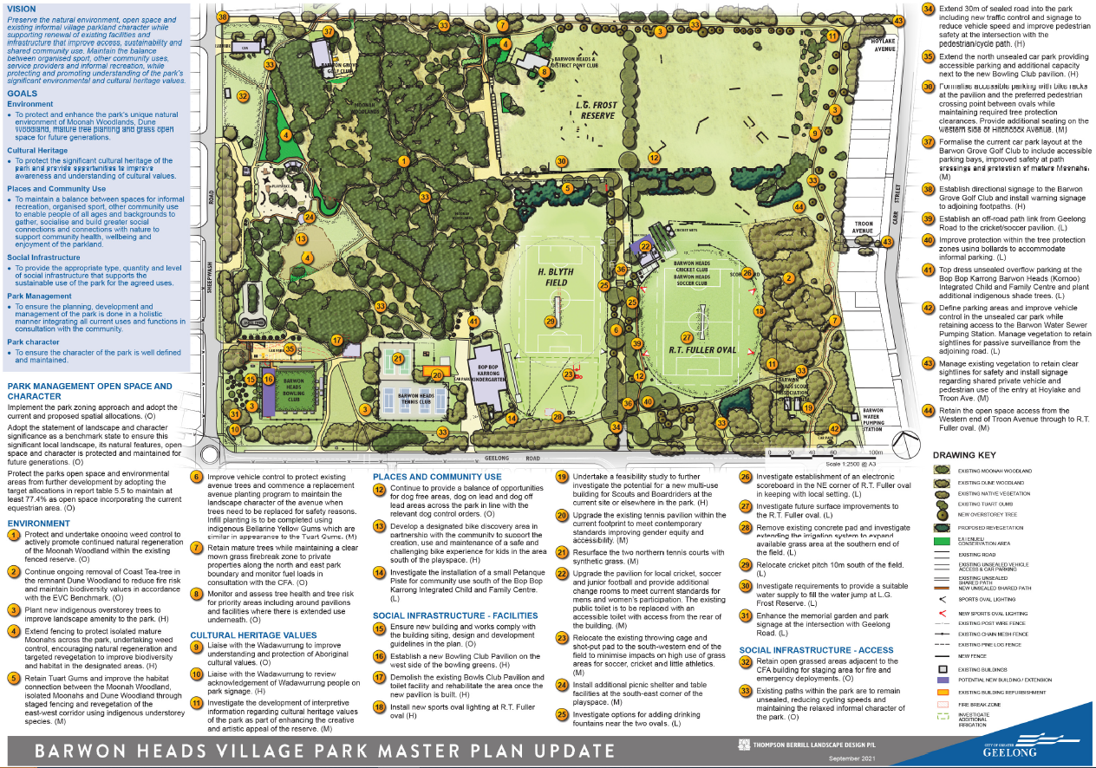
7.0
IMPLEMENTATION SCHEDULE

7.1 PRIORITIES
The following section provides an overview of the indicative capital costs to implement each of the key actions identified and presents these actions within an overall recommended implementation framework. The Environment Unit is the manager of specialist conservation areas within the park. Please note all works are subject to funding.

The priorities are as follows:
- High (H)
- Medium (M)
- Low (L)
- Ongoing (O)

7.2 INDICATIVE COST DETAILS

The tables on the following pages provides a detailed breakdown of the indicative costs for each action. These are indicative costs only, subject to planning, survey and detailed design.

7.3 EXCLUSIONS AND ASSUMPTIONS

The following exclusions and assumptions have been made in determining the indicative preliminary opinion of probable cost information:

- The indicative costs are provided for budget guidance purposes only, the cost of individual projects may vary significantly depending on the construction method used, materials, site conditions, engineering requirements and final designs
- Prices do not include GST
- No allowance has been made for volunteer labour or in-kind support.
- No allowance has been made for statutory planning costs or requirements. It is assumed these will be borne by Council
- Prices quoted are based on current rates; no allowance has been made for cost escalations associated with time delays
- No allowance has been made for service upgrades or improvements (i.e. power, water)

BARWON HEADS VILLAGE PARK MASTER PLAN REVIEW
IMPLEMENTATION SCHEDULE V2
Prepared by TBLD P/L for City of Greater Geelong, September 2021. Refer Drawing No BHVP-02 September 2021. Note preliminary cost estimates are for planning purposes only and subject to survey and detailed design.
Plan Number | Item No. | Action Name | Cost Estimate | Priority | Asset Manager | Partners | Comments
PARK MANAGEMENT OPEN SPACE AND CHARACTER
 | 1.1 | Implement the park zoning approach and adopt the current and proposed spatial allocations. |  | Ongoing | Sport & Rec Environment Unit | Parks & Gardens | Operational teams to monitor future management of park to ensure zones and spatial allocations are being adhered to.
 | 1.2 | Adopt the statement of landscape and character significance as a benchmark state to ensure this significant local landscape, its natural features, open space and character is protected and maintained for future generations. |  | Ongoing | Sport & Rec Environment Unit | Parks & Gardens | Review park character every five years to ensure the character of the park is being retained in line with the statement of significance and character.
 | 1.3 | Protect the parks open space and environmental areas from further development by adopting the target allocations in report table 5.5 to maintain at least 77.4% as open space incorporating the current equestrian area. |  | Ongoing | Sport & Rec Environment Unit | Parks & Gardens | Operational teams to monitor future management of park to ensure spatial allocations are being adhered to.
 |  | Sub total Park Management Open Space and Character | $0
ENVIRONMENT
1 | 2.1 | Protect and undertake ongoing weed control to actively promote continued natural regeneration of the Moonah Woodland within the existing fenced reserve. | $5,000 | Ongoing | Environment Unit |  | These checks and works are part of existing operations.
2 | 2.2 | Continue ongoing removal of Coast Tea-tree in the remnant Dune Woodland to reduce fire risk and maintain biodiversity values in accordance with the EVC Benchmark. | $5,000 | Ongoing | Environment Unit | CFA | The prevalence of Coast Tea-Tree in the remnant Dune Woodland reduces biodiversity values and increases fire risk works are largely completed. Removal works are part of existing operations.
3 | 2.3 | Plant new indigenous overstorey trees to improve landscape amenity to the park. | $15,000 | High | Parks & Gardens | Environment Unit | Complete as an annual program over 3 years use indigenous species of local provenance to compliment bio-diversity values.
4 | 2.4 | Extend fencing to protect isolated mature Moonahs across the park, undertaking weed control, encouraging natural regeneration and targeted revegetation to improve biodiversity and habitat in the designated areas. | $45,000 | High | Environment Unit | Parks & Gardens | The intent is to physically link as many of these trees to the Moonah conservation area to enable natural regeneration as required under legislation.
5 | 2.5 | Retain Tuart Gums and improve the habitat connection between the Moonah Woodland, isolated Moonahs and Dune Woodland through staged fencing and revegetation of the east-west corridor using Moonah and indigenous understorey species. | $40,000 | Medium | Environment Unit | Parks & Gardens | The new east-west revegetation corridor will improve the environmental habitat link between the Moonah Woodland and the Dune Woodland. Restructure of public access will also enable retention of Tuart Gums for habitat value even when they become more unstable. New planting is to be undertaken in accordance with the EVC benchmark understorey species only and low post and rail fencing.
6 | 2.6 | Improve vehicle control to protect existing avenue trees and commence a replacement avenue planting program to maintain the landscape character of the avenue when trees need to be replaced for safety reasons. Infill planting is to be completed using indigenous Bellarine Yellow Gums which are similar in appearance to the Tuart Gums. | $20,000 | Medium | Parks & Gardens |  | The Tuart Gums are an important landscape feature of the site. However they are native of Western Australia and are reaching senescence. Monitoring of the Tuart Gums is required to identify the trees that require removal to maintain public safety. As trees are removed, 2-3 new trees are to be planted. This will be an ongoing maintenance cost.
7 | 2.7 | Retain mature trees while maintaining a clear mown grass firebreak zone to private properties along the north and east park boundary and monitor fuel loads in consultation with the CFA. |  | Ongoing | Environment Unit | CFA | There is restricted fire access along the park boundaries in the north and east of the park and ongoing maintenance will be required to retain access. These checks and works are part of existing operations.
8 | 2.8 | Monitor and assess tree health and tree risk for priority areas including around pavilions and facilities where there is extended use underneath. |  | Ongoing | Parks & Gardens | Environment Unit | These checks and works are part of existing operations.
 |  | Sub total Environment | $130,000
CULTURAL HERITAGE
9 | 3.1 | Liaise with the Wadawurrung to improve understanding and protection of Aboriginal cultural values. |  | Ongoing |  |  | Any works requiring significant ground disturbance as defined in the Aboriginal Cultural Heritage Regulations 2018 may require a Cultural Heritage Management Plan. Allowance for this must be included in project delivery timeline and budgets subject to due diligence assessment.
10 | 3.2 | Liaise with the Wadawurrung to review acknowledgement of Wadawurrung people on park signage (H) | $5,000 | High | Parks & Gardens | Environment Unit | Works completed as part of park sign upgrade at main entries
11 | 3.3 | Investigate the development of interpretive information regarding cultural heritage values of the park as part of enhancing the creative and artistic appeal of the reserve. (M) | $30,000 | Medium | Arts & Culture | Parks & Gardens | Allow $15k for investigation and design and $15k for installation. May be signage or other artistic installations
 |  | Sub total Conservation and Cultural Heritage Works | $35,000
PLACES AND COMMUNITY USE
12 | 4.1 | Provide a balance of opportunities for dog free areas, dog on lead and dog off lead areas. | 0 | Ongoing | Local Laws | Parks & Gardens | Ongoing monitoring
13 | 4.2 | Develop a designated bike discovery area in partnership with the community to support the creation, use and maintenance of a safe and challenging bike experience for kids in the area south of the playspace. | $100,000 | High | Sport & Rec | Parks & Gardens | The bike discovery area provides an opportunity for the City to work with the local community and kids to develop a bike area together. The design would be focused on using soil to create tracks and jumps for a variety of skill levels that can change and evolve over time with changing needs. Safeguards need to be put in place to avoid collisions with other trail and park users.
14 | 4.3 | Investigate the installation of a small Petanque Piste for community use south of the Bop Bop Karrong Integrated Child and Family Centre | $15,000 | Low | Sport & Rec | Parks & Gardens | A 12 x 6m Petanque piste is proposed with a gravel surface and low edging to define the area. How to play instructions and bench seats would also be provided.
 |  | Sub total Places and Community Use | $61,500
SOCIAL INFRASTRUCTURE – FACILITIES
15 | 5.1 | Ensure new building and works comply with the building siting, design and development guidelines in the plan. (O) |  | Ongoing | Sport & Rec | Planning
16 | 5.2 | Establish a new Bowling Club Pavilion on the west side of the bowling greens. | $1,200,000 | High | Sport & Rec | Bowls Club | Bowling Club has secured $500K Federal Government Grant, $200k SRV grant and $500k from the City. Works include the new pavilion and demolition of the existing building. The car park and exterior landscaping is excluded from the curent budget.
17 | 5.3 | Demolish the existing Bowls Club Pavilion and toilet facility and rehabilitate the area once the new pavilion is built. | $0 | High | Sport & Rec | Environment Unit | Covered in budget and project for the establishment of the new pavilion.
18 | 5.4 | Install new sports oval lighting at R.T Fuller oval |  | High | Sport & Rec | Soccer Club | Completed 2021
19 | 5.5 | Undertake a feasibility study to further investigate the potential for a new multi-use building for Scouts and Boardriders at the current site or elsewhere in the park. | $25,000 | High | Parks & Gardens | Environment Unit Scouts Boardriders | The feasibility study will include further assessment of cultural heritage values and due diligence in relation to potential redevelopment at the current site and a further assessment of other locations including the preparation of new facility concept plans and preliminary QS.
20 | 5.6 | Upgrade the existing tennis pavilion within the current footprint to meet contemporary standards improving gender equity and accessibility. | $285,000 | Medium | Sport & Rec | Tennis Club | Internal refurbishment to improve accessibility and functionality. $285k funding secured from the state government.
21 | 5.7 | Resurface the two northern tennis courts with synthetic grass. | $50,000 | Medium | Sport & Rec | Tennis Club | Two northern courts would become main club courts with remaining four hardcourts available for public use.
22 | 5.8 | Upgrade the pavilion for local cricket, soccer and junior football and provide additional change rooms to meet current standards for men's and women’s participation. The existing public toilet is to be replaced with an accessible toilet with access from the rear of the building. | $950,000 | Medium | Sport & Rec | Soccer  Cricket  Football | Preliminary Cost Estimate for extension of two changerooms, public toilet, accessible public toilet and minor interior improvement subject to design.
23 | 5.9 | Relocate the existing throwing cage and shot-put pad to the south-western end of the field to minimise impacts on high use of grass areas for soccer, cricket and little athletics. | $10,000 | Medium | Sport & Rec | Little Athletics | Assume reuse of fencing panels with new concrete rink and reestablishment of grass.
24 | 5.10 | Install additional picnic shelter and table facilities at the south-east corner of the playspace. | $50,000 | Medium | Parks & Gardens |  | Provision of new shelter with 2 tables, potential BBQ and concrete base incl building permit
25 | 5.11 | Investigate options for adding drinking fountains near the two ovals. | $10,000 | Low | Parks & Gardens |  | Costs assume local connection to existing potable water supply and meter.
26 | 5.12 | Investigate establishment of an electronic scoreboard in the NE corner of R.T Fuller oval in keeping with local setting. | $20,000 | Low | Sport & Rec | Soccer  Cricket  Football | Utilise existing conduit laid as part of sports lighting project.
27 | 5.13 | Investigate future surface improvements to the RT Fuller oval. | $100,000 | Low | Sport & Rec | Soccer  Cricket  Football | Project would investigate levelling playing surface and reestablishment of suitable grass.
28 | 5.14 | Remove existing concrete pad and investigate extending the irrigation system to expand available grass area at the southern end of the field. | $100,000 | Low | Sport & Rec | Parks & Gardens | Existing irrigation system would need to be upgraded including tanks, pumps and enclosures to cater for increased usage.
29 | 5.15 | Relocate cricket pitch 10m south of the field. | $20,000 | Low | Sport & Rec | Cricket  Soccer | New concrete base and synthetic wicket widened to current standards.
30 | 5.16 | Investigate requirements to provide a suitable water supply to fill the water jump at L.G. Frost Reserve. | $10,000 | Low | Parks & Gardens | Pony Club | Connection potentially damaged with currently supply extremely slow to use. Investigate leakages and improvements to pressure to enable the jump to be filled more quickly and treatments to reduce water loss.
31 | 5.17 | Enhance the memorial garden and park signage at the intersection with Geelong Road. (L) | $7,500 | Low | Parks & Gardens |  | New sign and planting renewal.
 |  | Sub total Social Infrastructure - Facilities | $2,822,500
SOCIAL INFRASTRUCTURE – ACCESS
32 | 6.1 | Retain open grassed areas adjacent to the CFA building for staging area for fire and emergency deployments. |  | Ongoing | Parks & Gardens | CFA | No change
33 | 6.2 | Existing paths within the park are to remain unsealed, reducing cycling speeds and maintaining the relaxed informal character of the park. |  | Ongoing | Parks & Gardens | Engineering | No change
34 | 6.3 | Extend 30m of sealed road into the park including new traffic control and signage to reduce vehicle speed and improve pedestrian safety at the intersection with the pedestrian/cycle path. | $60,000 | High | Engineering |  | A new sealed road surface at the entry of the park at Hitchcock Avenue will enable vehicles to break effectively at the entry and reducing transfer of granitic material onto Geelong Road. New speed humps and signage will reduce vehicle speed along the Hitchcock Avenue extension into the park. New bollards and signage are required at the intersection with the pedestrian track to improve safety.
35 | 6.4 | Extend the north unsealed car park providing accessible parking and additional capacity next to the new Bowling Club pavilion. | $150,000 | High | Engineering | Bowls Club | Provisional estimate subject to design.
36 | 6.5 | Formalise accessible parking with bike racks at the pavilion and the preferred pedestrian crossing point between ovals while maintaining required tree protection clearances. Provide additional seating on the western side of Hitchcock Avenue. | $20,000 | Medium | Engineering | Soccer  Cricket  Football | Provisional estimate subject to design.
37 | 6.6 | Formalise the current car park layout at the Tin Shed to include accessible parking bays, improved safety at path crossings and protection of mature Moonahs. | $30,000 | Medium | Engineering | Environment Unit | Assume signage timber barriers and resurface of existing.
38 | 6.7 | Establish directional signage to the Barwon Grove Golf Club and install warning signage to adjoining footpaths. | $2,500 | High | Parks & Gardens | Golf Club | Costs assume standard signs only.
39 | 6.8 | Establish an off-road path link from Geelong Road to the cricket/soccer pavilion. | $30,000 | Low | Engineering | Parks & Gardens | Assume unsealed 1.5m wide walking path built with minimal excavation to avoid CHMP and impacts on trees.
40 | 6.9 | Improve protection within the tree protection zones using bollards to accommodate informal parking. | $10,000 | Low | Engineering | Parks & Gardens
41 | 6.10 | Top dress unsealed overflow parking at the Bop Bop Karrong Barwon Heads (Kornoo) Integrated Child and Family Centre and plant additional indigenous shade trees. | $30,000 | Low | Engineering | Parks & Gardens | Resurface half of the unsealed carpark and install semi advanced trees and protection bollards.
42 | 6.11 | Define parking areas and improve vehicle control in the unsealed car park while retaining access to the Barwon Water Sewer Pumping Station. Manage vegetation to retain sightlines for passive surveillance from the adjoining road. |  | Low | Barwon Water | Environment Unit | Works to be coordinated with Barwon Water. Consideration of space in feasibility study for Scouts/boardriders.
43 | 6.12 | Manage existing vegetation to retain clear sightlines for safety and install signage regarding shared private vehicle and pedestrian use of the entry at Hoylake and Troon Ave. | $500 | Medium | Parks & Gardens | Engineering | Assume signage and routine maintenance only.
44 | 6.13 | Retain the open space access from the Western end of Troon Avenue through to R.T. Fuller oval. | $500 | Medium | Parks & Gardens | Engineering | Assume signage and routine maintenance only.
 |  | Sub total Social Infrastructure - Access | $353,500
 |  | SUB TOTAL PROJECT WORKS (ex GST) |  | 3,456,000
 |  | Detailed Design / Contract Administration (10%) |  | $345,600
 |  | Contingencies (10%) |  | $345,600
 |  | TOTAL WORKS (ex GST) |  | $4,147,200

8.0
BIBLIOGRAPHY

Active Victoria, A strategic framework for sport and recreation in Victoria 2017-2021, Department of Health and Human Services, July 2017
AFL Growing the Heartland, Football Facility Development Strategy 2017 – 2022, AFL Victoria.
AFL Preferred Facility Guidelines, State, Regional, Local School and Remote Facilities, AFL, 2019.
City of Greater Geelong, Barwon Heads Village Park Master Plan (2012)
City of Greater Geelong, Barwon Heads Structure Plan (2017)
City of Greater Geelong, Biodiversity Strategy
City of Greater Geelong, Dog Controls in Public Places Policy (2020)
City of Greater Geelong, Domestic Animal Management Plan (2018-2021)
City of Greater Geelong, Outdoor Sport and Recreation – Social Infrastructure Plan Generation One: 2020-23
City of Greater Geelong, Planning Scheme
City of Greater Geelong, Social Infrastructure Plan (2020)
Community Cricket Facility Guidelines, Cricket Australia, September 2015.
DSE, EVC 858: Coastal Alkaline Scrub Otway Plain bioregion Ecological Vegetation Class Benchmark.
DSE, Action Statement No. 141 Coastal Moonah Woodland – Flora and Fauna Guarantee Act 1988
Football Victoria, Football Facilities Building Development Guide, 2019.
G21 and AFL Barwon Regional Strategy, G21 Regional Alliance, April 2015.
G21 and Cricket Victoria Barwon Regional Cricket Strategy, Final Report, G21 Geelong Regional Alliance, May 2019.
G21 Regional Football (Soccer) Strategy, G21 Geelong Regional Alliance, May 2012.
G21 Regional Hockey Strategy. G21 Geelong Regional Alliance, March 2019.
G21 Regional Tennis Strategy 2015-2025, Final Strategy Report, April 2015.
Netball Victoria Statewide Facilities Guideline, Netball Victoria.
Tennis 2020, Facility development and management framework for Australian Tennis, Tennis Australia.
Victorian Cricket Infrastructure Strategy 2018 - 2028, Cricket Victoria, March 2018.
Sustainable Building Policy which applies to all council buildings: https://geelongaustralia.com.au/building/documents/item/8cf5f062b5bd3aa.aspx
Environment Strategy which supports sustainable development: https://www.geelongaustralia.com.au/environment/documents/item/8d1d8319b995a84.aspx
One Planet Living principles which supports sustainable development https://geelongaustralia.com.au/environment/article/item/8d3a0371f46bbd8.aspx
Community engagement policy
https://geelongaustralia.com.au/governance/documents/item/654812cd.aspx

