
Note 7 – Advice to

Contractors

REVISED by: | Matt Mulqueeney, Development Coordinator | REVISION DATE: | 4TH Oct 2023

Subdivision Construction and asset establishment
The City of Greater Geelong (CoGG) wishes to draw attention to a number of issues relating to the construction of subdivisions.

Contractors will be aware that CoGG has adopted the Infrastructure Design Manual (IDM) as its’ standard for the design and construction of infrastructure within CoGG and in particular, the standard for civil works in subdivisions. Recently CoGG has developed a set of Design Notes which provide additional information relating to the construction of subdivisions within CoGG. It is expected that, in the future, these notes will be updated and/or added to as required. Contractors need to be aware that any civil works for subdivisions need to comply with both the IDM and the Design Notes.

The Design Notes can be found on the Geelong City website - search for “Design Notes”.
( http://www.geelongaustralia.com.au/business/support/article/item/8cf4e6e1a3fae51.aspx )

The Infrastructure Design Manual and associated standard drawings can be found at www.designmanual.com.au .

Construction matters
The IDM includes a number of standards which some contractors may be unaware of. Contractors should note that the IDM requires that –

- SD520 - Easement drain connections to as per standard drawing SD520.
- Use a “Conconect” or similar to connect a house stormwater pipe to an easement drain. Using a “Pan” connector is no longer acceptable. CoGG is currently trialling connecting to “Stormpro” pipes using the combination of a “ProGrommet” and a pan connector.
- The collection pit is to be as per SD520 – a 450mm x 450mm grated inlet pit. “Doughnuts” are no longer acceptable.
  - Collection pits can be precast concrete or plastic. Grates must be cast iron, galvanised steel or aluminium. Pits and grates must be suitable for light traffic. The pit/grate must have a clear opening of at least 400mm by 400mm and be a minimum of 300mm deep.
  - The “Property Connection” as shown on SD520 shall extend to 200mm clear of the outer edge of the pit.
  - Where the cover over the pipe is less than that required to construct as per SD520, the “T” junction may be omitted. The house connection shall be into the side of the pit, by the plumber, at the time of house construction.
  - The pipework must be a minimum of 100mm dia sewer class PVC
  - All pipework and connections to be to Plumbing Standards AS 3500
- Backfill to the top of the pipe shall be cement stabilised sand (2% to 4% cement)

- SD505 - House Drain Connection to Kerb & Channel shall be as per SD505 except that –
- The kerb adaptor shall be galvanised steel that matches the kerb profile
- The pipe connection shall be a minimum of 100mm dia Sewer class PVC
- The inspection opening shown in SD505 is to be installed by the plumber during the house construction.

- SD515 - Street Drain Connection shall be as per SD515 except that –
- Only one inspection opening is required
- The pipe connection shall be a minimum of 100mm dia Sewer class PVC
- Backfill to the top of the pipe shall be cement stabilised sand (2% to 4% cement)

- SD441 - Grated Side Entry Pit with Lightweight Cover & Concrete Surround for 'Sm2-M' shall be as per SD441 except that –
- Grate and frame should be bolted not hinged, to allow for grate to be able to slide out.

- SD510 - House Drain Under Road Pavement shall not be used without prior approval.
- Hold points and witness points are observed – IDM Appendix E, first page (attached). Contractors must ensure that Council inspectors have the opportunity to inspect work at all of these points. This is a minimum – there may be others required. Council inspectors may not necessarily attend at all of the points but they must be made aware, in advance, when hold points are approaching.
- Stormwater drainage pipes are to be inspected when they are bedded/ haunched and before the trenches have been backfilled. Contractors are to ensure that inspectors are advised when pipes have been laid so that inspections can be carried out prior to backfilling
- All new residential footpaths to be 125mm thick – SD’s 205,210, 240, 245
- The Defects Liability Period for new subdivisions is 12 months from the date of Practical Completion and a 5% bond will be held for this period. The Defects Liability Period is as described in the IDM Section 8. Any items/works, noted at the time of Practical Completion as being outstanding, are still to be completed within 3 months from the time of Practical Completion.

asset establishment requirements

SEDIMENT PONDS
Sediment ponds are open water bodies used to slow incoming stormwater and capture sediment and litter. They should be free from vegetation, except for fringing planting which is generally used to limit access to the system. As permanent infrastructure, sediment basins can be designed as the inlet to constructed wetlands or stand-alone infrastructure as part of a stormwater treatment train.

OVERARCHING CLEAN OUT REQUIREMENTS
Prior to completion of maintenance period for a sediment pond, it is required to be cleaned out to its design levels.
Sediment ponds can generally be cleaned out via two methods:

- Sediment removal via de-watering and excavation.
- Sediment removal via vacuum truck.
The selection of which method to use is the decision of the contractor/developer.
For more background information on approaching sediment pond clean outs, Melbourne Water’s Resetting sediment ponds best practice guide should be followed where appropriate.

A post clean out works survey needs to be provided to the City as evidence that the cleanout is as close to the as constructed levels as practicable.
The disposal dockets are to be supplied to the City prior to the completion of the maintenance period. The selection of laboratory and disposal centre is the responsibility of the contractor/developer. Sediment testing and disposal needs to be carried out in accordance with current EPA regulations.

SCOPE OF CLEANOUT WORKS
The scope of clean out works generally require but are not necessarily limited to, the following:
- Preparation of a site specific Environmental Management Plan (EMP), that should be provided to The City as part of the Operational and Maintenance manuals. The EMP needs to address all relevant safety and environmental management considerations of the site.
- Evidence of existing site conditions, such as photographs, immediately prior to commencement of works..
- Temporary site fencing for the duration of works and defects period.
- Set-out of works and site preparation works.
- Any nominated access works.
- Proving any existing services in the vicinity of the works as required.
- Sediment removal, via excavation or vacuum truck and (as/if required): de-watering, testing prior to disposal.
- Any required traffic management for works.
- Any required permits, e.g. Works on Waterways Permits if working in vicinity of designated waterways (Corangamite Catchment Management Authority).
- Ordering and securing of all plant stock.
- Supply and installation of any re-planting.
- Grassing turf/ hydro mulch as required.
- Site reinstatement - making good of any elements disturbed by construction process (e.g. reserve fencing, grass replacement)
- Maintenance of the reinstated works.

The City requires sediment ponds to be fully functional prior at the completion of the Developer maintenance period, as evidence of this the following is required:
- Sediment removal and disposal information (e.g. sediment disposal dockets).
- Survey of post sediment clean-out works survey that aligns with design/as constructed levels.
- Updated Operational and Maintenance plans.
- Onsite post works/reinstatement check with City Representative.

Attachments
- Appendix E – Infrastructure Design Manual – Council Inspections and Hold Points
- Easement Drain Connection – SD 520

Attachment 1
Infrastructure Design Manual - Appendix E - Council Inspections & Hold Points
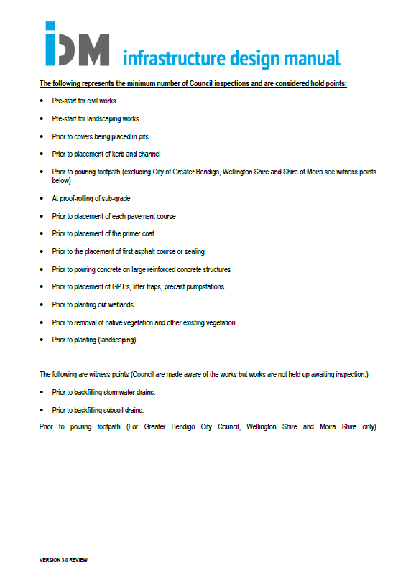
Attachment 2
Easement Drain Connection – SD 520
