Minor Bridges, Viewing Platforms and Boardwalks
Introduction:

This Design Note, No 9, provides guidelines for the design of minor bridges, viewing platforms and boardwalks with the intent to ensure that, for any new structures, long term maintenance costs are minimised.

Conventionally built timber structures have been found to have relatively short life spans and incur relatively high maintenance costs. As such the use of timber for the construction of new structures will, generally, not be approved.

Preferred materials

The preferred construction materials for minor bridges, viewing platforms and boardwalks are:
- Composite Fibre
- Recycled plastic
- Geopolymer concrete with non-metal reinforcement
- Steel – hot-dip galvanised with 2-pack paint coat
- Fibreglass
- Concrete

Materials with low maintenance requirements, high recyclability and materials incorporating recycled content are desirable for their benefits towards environmental sustainability.

Applicable Standards

These structures are to be designed using the following standards (or as amended):
- AS 1428.1 - Design for Access
- AS 5100 - Bridge design
- AS 2156.1 & .2 - Walking Tracks
- AS/NZS 1170.1 - Structural design actions - Permanent, imposed and other actions
- AS/NZS 1170.2 - Structural design actions - Wind actions
- AS 2700 - Colour Standards for General Purposes
- AustRoads - “Guide to Road Design Pt 6A – Pedestrian & Cycle Paths

Structure Identification

All structures shall have an ID plate installed to enable identification of the structure against the City’s asset register. The ID plate shall be a laser etched 3mm stainless steel plate meeting the requirements of Figure 1 and securely fixed to the NE corner of the structure in a location which is easily found and read.

The ID plate shall be procured and installed prior to handover at no cost to the City. An ID number for the structure shall be provided on application by the City’s Engineering Services department.

Design Certification

Certification by an independent accredited engineer shall be provided for all design drawings pre-construction. Following construction, a second certification is to be obtained stating that completed works are in accordance with the design drawings.

Design Submissions

All pedestrian structure designs submitted to the City for assessment and acceptance should be accompanied by the New Pedestrian Structure – Design Reference Form.

Plans related to a subdivision or growth area development must include reference to the endorsed landscape masterplan or for road structures the endorsed subdivision plans.

Handover

The City requires all structural drawings and certification documents to be provided as a package prior to handover of the structure for Council maintenance. All documents and drawings should be in pdf format, CAD drawing files where available should be provided in addition to the pdf copy.

Defect Liability Period

A defect liability period of 12months will apply to all new structures. No more than 2 months prior to completion of the defect liability period, a level 2 bridge inspection will be undertaken by an independent, qualified inspector and all identified defects repaired at no cost to the City.

A copy of the level 2 inspection shall be provided to the City at the end of the defects liability period.

Design Requirements

- Design Life

All structures should be designed for a minimum 100-year life span.

- Environmental Sustainability

The design should respond the to the need for environmental sustainability through material selection, consideration to whole of life maintenance requirements and the ability to repurpose and recycle materials at end of life.

Structures with low maintenance needs are favoured over those with frequent maintenance requirements for their greater ability to reach design life and achieve expected environmental outcomes.

- Design Loadings

The applicable design loading for pedestrian bridges shall be based on an assessment of the surrounding land use and alternative access available. In most cases the structure will need to as a minimum, accommodate use by a trail bike or mobility scooter and rider. Other vehicles likely to access structures where insufficient prevention measures are applied include 2 person ATV’s and quadbikes.

- Access Restrictions

Where the design live load excludes use by a certain type of vehicle, the structure shall be protected by a suitable access restriction system. Such systems could include, bollards, fencing, gates or chicanes designed to prevent access by that vehicle type.

Where a suitable restriction is deemed to prevent legitimate use of the structure or breach disability access requirements the design will need to be amended to cater for the higher loading applicable.

- Applicable Standards

Structures designed to AS2156 and not to AS5100, or a hybrid design incorporating both standards, will be permitted where it can be demonstrated that the requirements of this design note have been achieved and the structure is suitable for the location it is to be installed in.

- Style and Aesthetics

Designs should consider other structures present along the water course or in the immediate area and be sympathetic to the existing aesthetics presented by those structures. A response to the consideration of other structures should be made when submitting an application to the City for review.

- Steelwork

All steelwork accessible and visible to the public is to be hot-dip galvanised and then coated in a 2-pack paint or equivalent powder coating. This secondary coating provides protection to the structure from damage caused by vandalism in the form of etching.

- Colour Schemes

Where a structure is required to have painted elements, the colour scheme shall be selected from the available Australian Standard colour palette. The colours chosen shall be submitted to the City’s Engineering Services department for approval and shall be clearly marked on all plans.

- Bridge Widths and Approach Paths

Bridge and boardwalk structures need to be designed to cater for the safe movement of users. To facilitate safe passing of users the following unimpeded widths shall be provided across the structure:
- Low Volume pedestrians only – Minimum 2.0 metres clear width
- Shared use path – Minimum 3.0 metres clear width
- Vehicle traffic only - Minimum 7.0 metres clear width
- Boardwalks longer than 5 metres with no handrail - Minimum 2.5 metres clear width

The following requirements shall also be applied to the approach paths accessibility criteria:
- Unless otherwise approved, path approach grades at the abutments shall be no steeper than 1 in 14
- A 5 metre (minimum) path length on all approaches to structures is to be concrete finish and shall be tied/dowelled to the abutments

- Bridge and Approach Path Rails

Bridge rails where required, shall comply with the requirements for disability access. Requirements specific to cycle rails shall also be applied where the structure is intended to carry cyclists.

For clarification of the City’s requirements for compliance with AS2156 and the need for handrails:
- Tracks shall be taken to be class 1 or 2 unless otherwise approved
- Where track class 3 is approved, handrails will be required on both sides of any structure requiring at least one handrail under the standard

Approach rails, where required, shall be of the same general design and material(s) as the fall protection barrier of the bridge. Approach fencing, where due to approach grades, handrails are not required, may utilise products of a similar style to ARC Eden Flat Top fencing.

- Surrounding Vegetation

To enable unimpeded inspection of the structure and protection from tree root damage, the following requirements are to be applied to all planting around the structure:
- Trees shall not be planted within 7 metres of either side of the bridge
  - Root barrier to be installed between a bridge and any tree closer than 7 metres
- Low growth plants (shrubs & rushes) to be a minimum of 1 metre clear of the structures

- Safety In Design

Safety in design is the principle of considering the risks presented by a built structure and creating designs which reduce the risks.

Inspection and maintenance of a structure is an ongoing process through the life of the asset. Safe access locations for the inspection of bridge components and placement of maintenance equipment shall be incorporated into the design of the structure and shown on construction drawings.

Safe access provision can include, but are not limited to, inspection landings, reinforced grass areas for heavy equipment and safety harness connection points.

- Timber Structures

Where timber structures are approved the following design requirements and construction standards are to be adhered to:
- No Service Authority utilities are to be attached to the structure
- All connections excluding deck planks are to be horizontal
- Vertical deck plank connections:
  - For deck planks >50mm thick shall be from the underside of the timber and shall not penetrate the top surface of the deck
  - For deck planks <50mm thick may be through the timber if fixed to a non-timber element below such as steel or composite fibre and holes are pre-drilled. See Figure 2 for example.
- All elements are to be cut and pre-drilled prior to treatment with a solution containing 3% copper napthenate or equivalent
- No timber elements are to be cut or drilled after treatment
- No malthoid or moisture barriers are to be installed in the structure
- Scuppers and deck drains shall discharge clear of the bridge and structural elements
- Fastenings and design elements shall provide compensation for future swelling and shrinkage of the timber
- Designs shall be free of the use of banding and near end drift pinning
- Clearance shall be provided for breathing of timber elements including at abutments
- Notching of timbers is to be minimised and where notching is required a slope cut with minimum slope of 1:6 shall be provided and restricted to no more than 10% of the depth of member
- Timbers selected for pile bents shall be appropriately sized for the expected loadings
- Loads shall be distributed within “D” of the pile to prevent micro cracking in undersized crossheads
- Compression wood shall be avoided in selection of timber lengths
- Coatings comprising solids of greater than 29% shall not be applied to timber elements
- The use of salt diffusers may be specified, subject to the City’s approval, for locations of likely moisture retention greater than 22%
- No timber element shall be wrapped in concrete

Figure 1 – Structure ID Plate Design
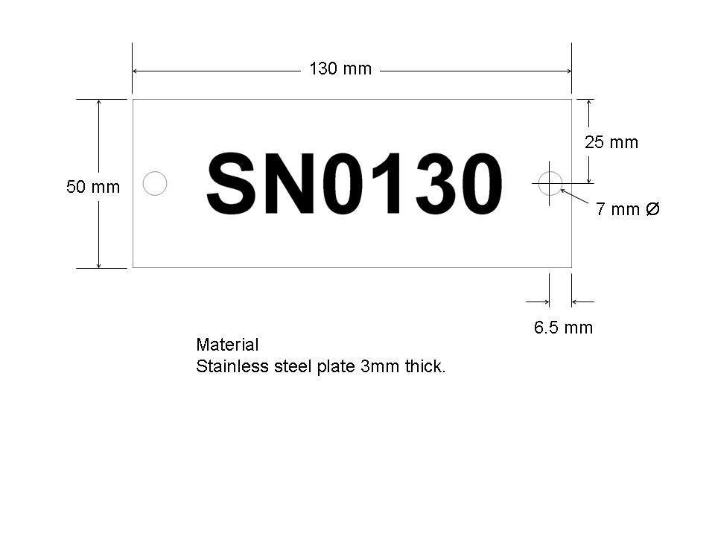

Figure 2 – Vertical Fixing Through Deck Plank <50mm

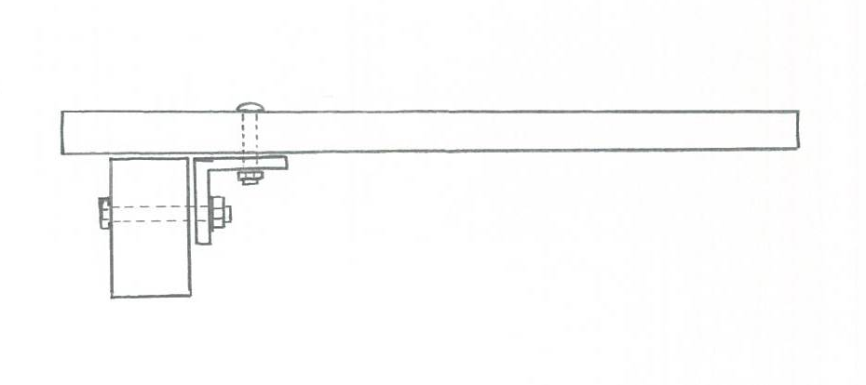
Stringers
Non-Timber Fixing Point
Timber Deck Plank
Fixing

