Ll

INDOOR

RECREATION FACILITIES

- BASKETBALL AND NETBALL NEEDS ANALYSIS

FEBRUARY 2022

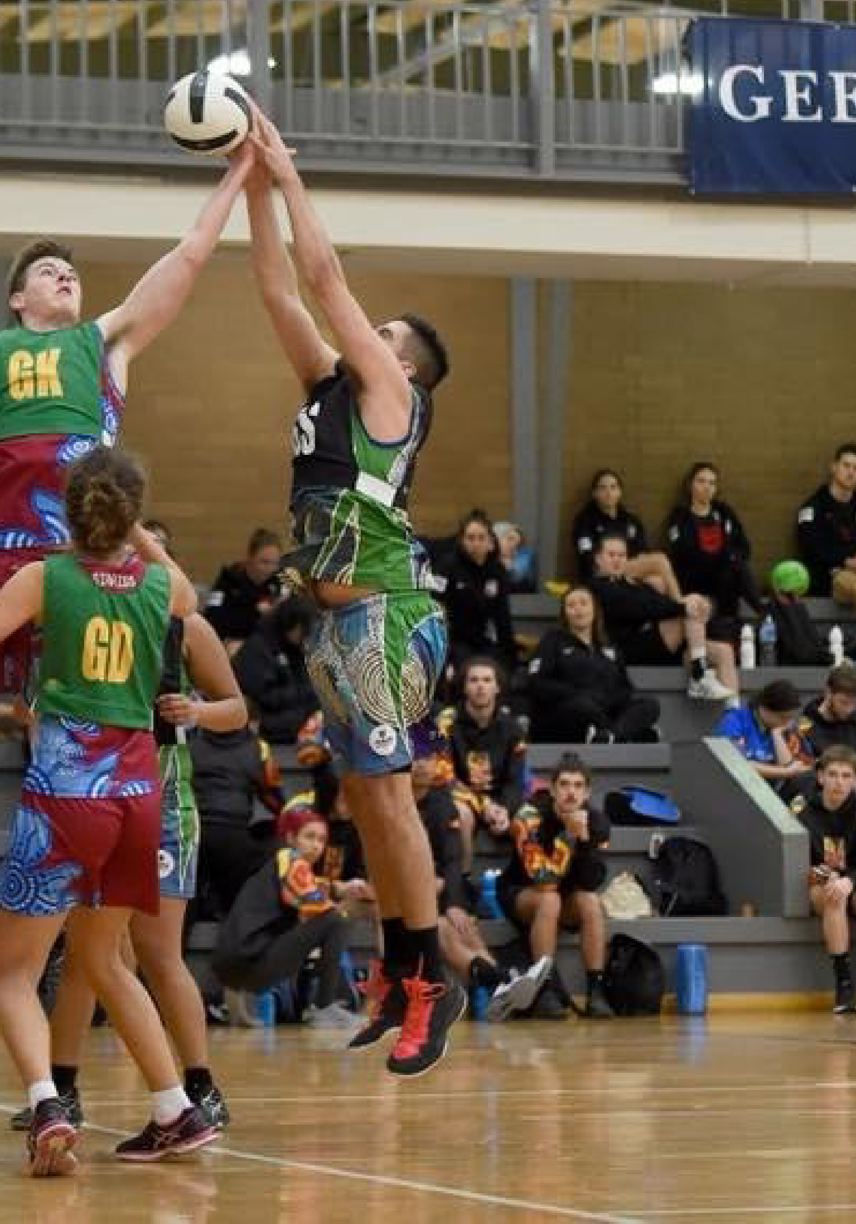

CONTENTS

- INTRODUCTION 4
- DOCUMENT REVIEW 6
- EXISTING FACILITIES 10
- DEMAND FACTORS 23
- APPENDICES 38

INTRODUCTION

BACKGROUND
The City of Greater Geelong is updating its 2014 Indoor Recreation Facilities Strategy.
Due to significant growth and development within the LGA, this Strategy needs to be refreshed to consider growth challenges, changing demographics, and to ensure the Strategy is relevant now and into the future.
The review considers the information and key findings from the 2014 Strategy and provides an updated assessment of the current and future needs for indoor sports within the municipality, with a clear focus on the needs of basketball and netball.
The 2014 Indoor Recreation Facilities Strategy made five key recommendations for the future provision of Indoor Recreation Facilities.
- New Regional Centre at Brearley Reserve (Marshall) 8 to 10 court facility to meet existing and future southern area facility gaps and future population growth.
- Expansion of the Leisuretime Centre
4 indoor courts to replace the existing outdoor netball courts with new amenities to meet future northern area population growth.
- New Courts in the Eastern Precinct
New courts at the Bellarine Aquatic and Sports Centre and Drysdale Secondary College to meet future eastern area population growth.
- Greater Use of Existing Facilities
Encourage greater use of underutilised community/ school indoor recreation facilities to provide more local area facility use/access.
- Develop New Growth Areas Facilities
Develop planned indoor growth area facilities at Armstrong Creek (3 facilities) and Lara West (1 facility) as development is taken up and population triggers are met.
In March 2020 the City endorsed its Social Infrastructure Plan (SIP), which provides guiding principles to ensure fair and equitable decision making for the future planning, investment and delivery of social infrastructure. The key objectives included within the SIP have been applied as guiding principles within the review:
Equitable: Fair access to facilities and services that are needed across the municipality including healthy, safe and inclusive places, spaces and services.

Accessible: Accessible for all abilities, affordable and easy for people to get to.
Adaptable: Flexible to meet the changing needs of the community and can be used for more than one purpose.
Integrated: Integrated with other services where possible and a place for people to come together.
Sustainable: Environmentally, fiscally, socially and culturally responsible, well designed, effectively managed and usage is optimised, now and into the future. The SIP guiding principles have been used to assess the equity and accessibility of indoors courts to residents across the municipality.
Parameters were developed to assess existing indoor court provision gaps and identify suburbs that are poorly serviced by indoor courts. The assessment focused
on travel time to access indoor courts for training and competition. The following assumptions were applied:
- 90% of residents live within a 20-minute drive of a sub-regional venue for indoor basketball / netball competition.
- 90% of residents live, work or attend school within 15-minute drive to a community level venue to participate in indoor basketball / netball training.
The study determined there were no suburbs that were poorly serviced at present with relation to travel times and accessibility.

NEW PLANNING DIRECTIONS FOR INDOOR FACILITIES (2022)
The following strategic priorities are recommended based on the findings of the review:
- Increase occupancy of The Arena by introducing netball or other indoor sports to occupy court time previously used by basketball.
- Undertake an asset assessment and business case regarding the long-term viability of The Arena and Barwon Valley Activity Centre with a view to making them fit for purpose, sale or redeveloped.
- Expand Bellarine Aquatic and Sports Centre to include additional courts to meet increased demand in the southern parts of Geelong.
- Redesign and expand Leisuretime Sports Precinct to meet increased demand in the northern parts of Geelong.
- Develop a major indoor sports centre in the southern parts of Geelong to meet growing demand. Initially a four-court facility, with capacity to increase to 10 courts.

- Commence planning for a major regional indoor sports venue with a Show Court catering for up to 5,000 spectators. It should include consideration of options such as upgrading The Arena, integrating as part of a Convention Centre, or as part of a major indoor sports facility such as the Leisuretime Sports Precinct or the potential sports centre in the eastern parts of Geelong.

REVIEW OBJECTIVES
The key objectives of the Indoor Recreation Facilities - Basketball and Netball Needs Analysis are to ensure the following factors are considered in the future planning and provision of indoor facilities:
- Establishment of Guiding Principles – Application of policy parameters mandated within the Social Infrastructure Plan which relate to equitable and accessible provision.
- Updated Demographics - Population profile and assessment of future demand requirements.
- Inventory Review – Current venue condition, capacity and usage data
- Benchmarking – Inventory provision review against neighbouring LGA’s
The review provides the opportunity to test the relevance of key findings presented within the 2014
PROJECT METHODOLOGY

Sport court inventory
COMPLETE
COMPLETE
COMPLETE
COMPLETE
Progress report
PHASE 1
Project classification
PHASE 2
Demand review
PHASE 3
Final Indoor Recreation Facilities - Basketball and Netball Needs Analysis

Benchmarking

Demographics analysis

Stakeholder meetings

Project inception meeting
Key stakeholders interviews

Review occupany
strategy and present a new set of strategic priorities for the City to consider.

REVIEW METHODOLOGY
Indoor Recreation Facilities - Basketball and Netball Needs Analysis was undertaken in three phases:
PHASE 1: PROJECT CLARIFICATION
- Project Inception Meeting
- Internal Stakeholder Meetings
PHASE 2: DEMAND REVIEW
- Sport Court Inventory
- Review Occupancy
- Demographic Analysis
- Benchmarking
- Key Stakeholder Interviews
- Progress Report
PHASE 3: UPDATE INDOOR RECREATION FACILITIES STRATEGY
- Review 2014 Key Strategy Initiatives
- Briefing and Review Updated Strategy
- Stakeholder Consultation
- Final Indoor Recreation Facilities - Basketball and Netball Needs Analysis

COMPLETE
COMPLETE

Project inception meeting
Stakeholder consultation
Councillor briefing and review updated strategy
Final report

DOCUMENT REVIEW

Two key Council documents have been used to inform and guide the review of the Indoor Recreation Facilities
Strategy: the Social Infrastructure Plan and the 2014 Indoor Recreation Facility Strategy.

SOCIAL INFRASTRUCTURE PLAN (SIP)
The purpose of the SIP is to ensure future decision making and investment in community infrastructure and services is clear, fair, equitable, and based on evidence of need and insights from our community.
This is to be achieved by focussing on:
- Improving access and connectivity – focus on interventions and investment that target the life stages and communities that will have the most impact.
- Empowered and informed – build capacity and social capital in our communities through facilities and services that develop local participation and leadership, and by extension, the social health, wellbeing, amenity and governance of communities including supporting our community networks and partners that make infrastructure ‘work’.
- Intergenerational and adaptive – meet the changing needs of our community over time. We will focus on interventions that use new models to create greater connectivity and efficiencies (including partnerships, digital technology, mobile services, hub and spoke models and shared infrastructure).
- Place based and fit-for-purpose – ensure targeted and place-based planning because different places, communities and activities have difference needs and unique challenges.
- Addressing our ageing and obsolete infrastructure – Some of our infrastructure is not meeting current levels of need and expectation. We also know that the investment in renewing ageing infrastructure is expected to significantly increase over the next few years.
- Bridging the differences in service provision across sectors and location - value manage and coordinate activities, ensuring that we deploy investment where and when it is needed. Some disparities in the levels of service and/or performance of infrastructure across different parts of Greater Geelong need to be addressed.
- Contemporary systems and data – invest in modernising our data, systems and insights. Some of our infrastructure, asset management and engagement systems are becoming obsolete and do not meet contemporary requirements. Current systems do not integrate or interact and will need
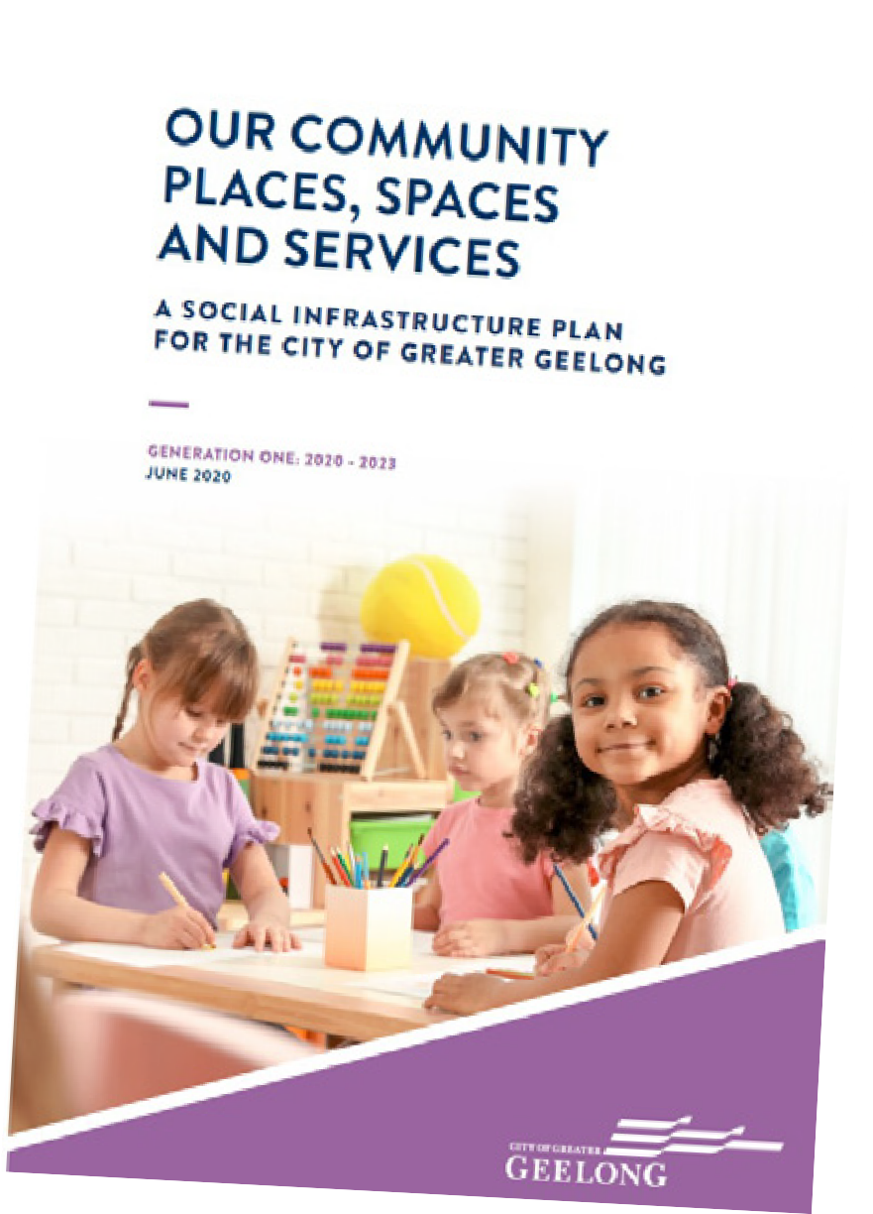improving in line with improved data governance and our asset management transformation program.

CITY-WIDE ISSUES
The SIP outlines the needs of the community, focus areas, investment priorities and the way forward to ensure that people can clearly see what is planned for the place that they live. Key issues identified in the SIP included:
      - The Plan is intended to provide Council and the community with a single, simpler and more integrated strategic summary of Council’s investment priorities over the next 1 - 3 years
      - The joint funding of social infrastructure with other levels of government to deliver on the needs of the community. The funding of Council and all levels of government should be consistent with the objectives and principles of the Social Infrastructure Planning and Investment Policy (2019).
      - Exploring opportunities with the private sector, where market conditions allow, when the community benefit can be demonstrated, while ensuring the policy principles and objectives can be achieved.
      - Continuing to work together with community clubs, organisations and the not-for-profit sector to deliver on shared priorities and maximise the capacity
and contributions that local clubs and community organisations can make in delivering the best value possible for our community.

INDOOR SPORTS AND RECREATION SPECIFIC ISSUES
The SIP has an addendum specifically related to the social infrastructure needs of indoor sport and recreation in the City. The addendum identifies indoor sport and recreation facilities as providing one of the most multi-use and dynamic facilities in the community. Key indoor sports and recreation issues identified in the SIP included:
      - Indoor facility usage trends indicate that people aged between 0 to 39 years are twice as likely to participate in indoor leisure / sporting activities and use indoor stadiums. This age group currently represents (54.4%) of the population.
      - Indoor recreation facility provision was relatively low, with only thirty-four (34) large/full size indoor courts available for community use in the City, whilst adjoining municipalities only provide a further six large indoor courts.
- Education providers in the City (Primary / Secondary Schools and Tertiary Education) provide a total of 25 large indoor courts. Only 13 of these courts (just above 50%) are available for regular community use. A total of 10 large indoor courts are provided by other organisations with all courts available for community use.
- With continuing growth in participation rates in sport, and more recently in women’s sport, facilities are being challenged to meet demand.
- Population growth affects all social infrastructure. Schools and educational institutions are also experiencing growth and as a result they are increasing their reliance and use of community infrastructure. This in turn can impact the amount of access time community groups have for the infrastructure they need.
- There is a significant need for access to full-size compliant indoor sport and recreation facilities. There is an inequity in the provision and distribution of access to indoor sports courts, with a particular focus on the southern areas of Greater Geelong.
- Over half of all courts provided across the 27 sites are considered undersized and not compliant for competition use. The emergence of private providers and new school developments creates opportunity for partnerships; however a placed-based approach will be required.
- Future indoor court developments will need to consider the ongoing management and operation during the design phase to ensure desired outcomes are achieved.

2014 INDOOR RECREATION FACILITIES STRATEGY

KEY ISSUES
Key issues identified in the Strategy included:

POPULATION IMPACTS
      - The City’s population was estimated to be 221,350 by the end of 2013 and predicted to increase to 297,956 people by 2031, an increase of 76,609 people (+34.6% or +1.92%/year). This was a projected annual population increase of 1.9% per annum or more than 4,200 new residents a year.
      - The regions younger age cohorts were expected to increase as a percentage of the population due to the large number of new residents moving into the new growth areas.
      - The review of future population growth areas indicated that there was sufficient facility opportunities in the growth areas of the southern, eastern and northern precincts to meet increasing demand subject to planning and funding strategies.
INDOOR RECREATION FACILITY PROVISION
A detailed facility inventory survey was completed and grouped into four City planning precincts. The number of courts in each precinct (refer to Map 2.1) was:
- City/Central - 15 courts • Northern - 13 courts
- Southern - 9 courts • Eastern - 9 courts
- Total of 46 full size/large courts: 45 large courts and 1 full size court. [Note: The report does not define “large”, and is assumed to refer to courts which are at least full basketball size, although the venue may not have sufficient run off to be “compliant” for basketball or netball.]
- Four Council owned venues providing eleven courts (10 large & 1 full size courts).
- Education providers (Primary/Secondary Schools and Tertiary Education) provide a total of twenty- five large indoor courts with 13 of these courts available for regular community use.
- 10 large indoor courts are provided by other organisations with all courts available for community use.
- There were a further 44 undersize courts in the area but the majority of these were not suitable for competition purposes (lack of run off and undersize of courts).
- 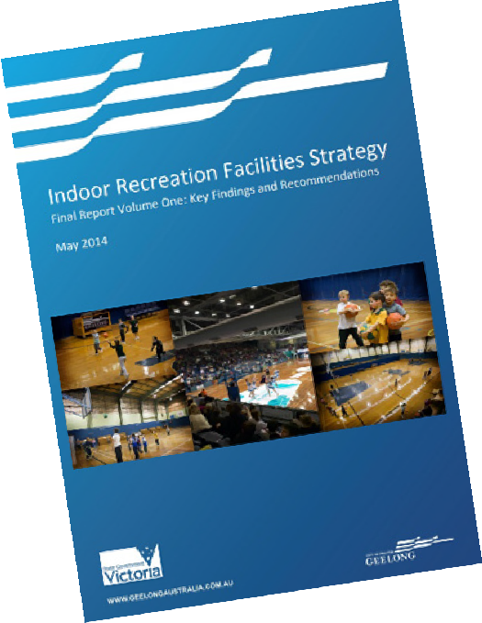The strategy identified that indoor recreation facility provision was low with only 34 large/full size indoor courts available for community use, whilst adjoining Council areas only provided a further six large indoor courts.
- The facility inventory survey also found most multiple court venues had high peak time use but many of the single court venues had low use and therefore had some capacity for more use, likely to be junior teams and training use.

FUTURE INDOOR RECREATION FACILITY DEVELOPMENT OPPORTUNITIES IDENTIFIED IN 2014
To meet future demand, the following new and existing indoor facility expansion opportunities by planning precinct were identified in the 2014 Strategy:
FUTURE INDOOR RECREATION FACILITY STRATEGY AND RECOMMENDATIONS (2014)
Future strategic directions were based on the current available indoor recreation facility supply being inadequate for the City’s future population needs, and:
- Increase use at existing centres that provide for community use.
- Support and improve access to education institutions that do not currently allow community use.
- Plan for between 7 to 10 new courts to be built and operational by 2018 and a further 7 to 10 courts planned and operational by 2031.
- 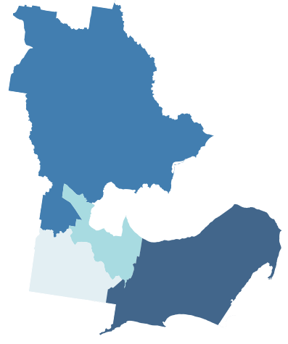Continue to operate and manage the facilities under direct Council management to ensure all user groups have access and that maximum facility occupancy is encouraged.

11 new court development opportunities

NORTHERN

SOUTHERN

CITY

7 new court development opportunities

EASTERN

17-19 new court development opportunities

EXISTING FACILITIES

REGIONAL CONTEXT
The City of Greater Geelong is in the southwest of Victoria, approximately 75 kilometres southwest of the Melbourne CBD. The City encompasses a total land area of approximately 1,250 square kilometres with over two-thirds of the population living in the Geelong urban areas. The City of Greater Geelong is bounded by:
- The Moorabool Shire in the north.
- Wyndham City to the east and back to Melbourne CBD.
- The Borough of Queenscliffe also to the east at the end of the Bellarine Peninsula.
- Surf Coast Shire and Bass Strait in the south.
- Golden Plains Shire in the west.
The City of Greater Geelong is a mixed and diverse municipality incorporating rural, residential, resort, industrial and commercial land areas. Geelong is the largest regional city, by population, in Victoria and is the leading commercial centre for southwest Victoria.
A substantial percentage of residents live close to coastal areas. The City includes the coastal townships of Barwon Heads, Breamlea, Indented Head, Ocean Grove, Portarlington St Leonards, Clifton Springs and part of Point Lonsdale.
The Geelong region has exceeded the previous population and growth projections that were outlined within the 2014 Strategy.

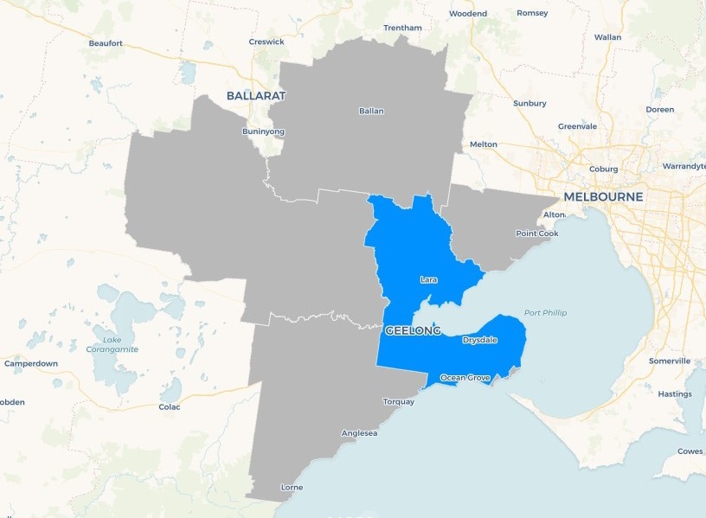Map 3.1 City of Greater Geelong and surrounding areas
1
5
2
4
3

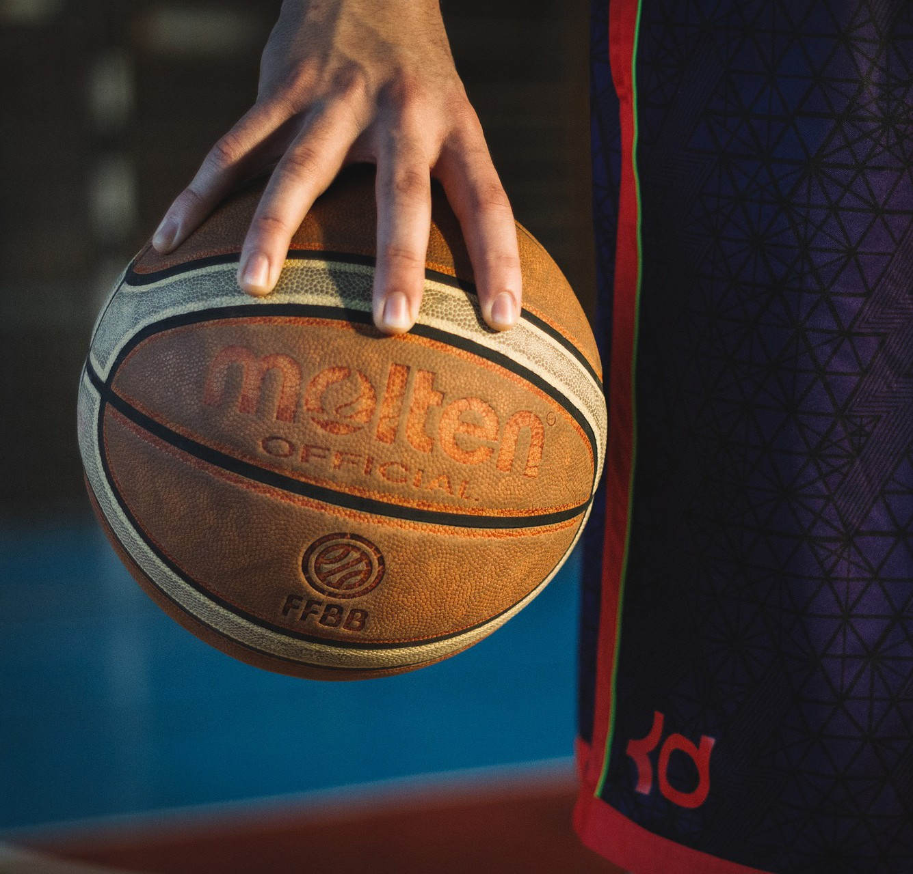

INDOOR COURT INVENTORY
In 2014, a survey of indoor recreation facilities found that there are 52 indoor sport courts in the project area, with 45 of these classified as large courts. Only one of these courts (at the Geelong Arena/Annex) met the full size compliant court size requirements for netball and basketball (30.5m x 15.25m plus 3.05m runoff from sides/ends).
The 52 full size and large indoor sport courts are made up of the following facility court configurations:
- Geelong Basketball Netball Centre - a commercial centre with 6 courts
- Crows Road Alliance Bank Stadium with 6 courts
- Geelong Arena/Annex - a Council owned facility with 4 courts, including a Show Court
- Leisuretime Sports Precinct - a Council owned facility with 3 courts
- St Joseph’s College and Bellarine Secondary College - both with 3 courts
- 8 centres with 2 court facilities - BVAC, Deakin University, Try Boys, YMCA Newtown and 4 school facilities.
- 11 single court facilities - at various school sites
- In addition, there are 44 undersize courts - mainly at school facilities that are not suitable for competition purposes but rather best used for local team training.

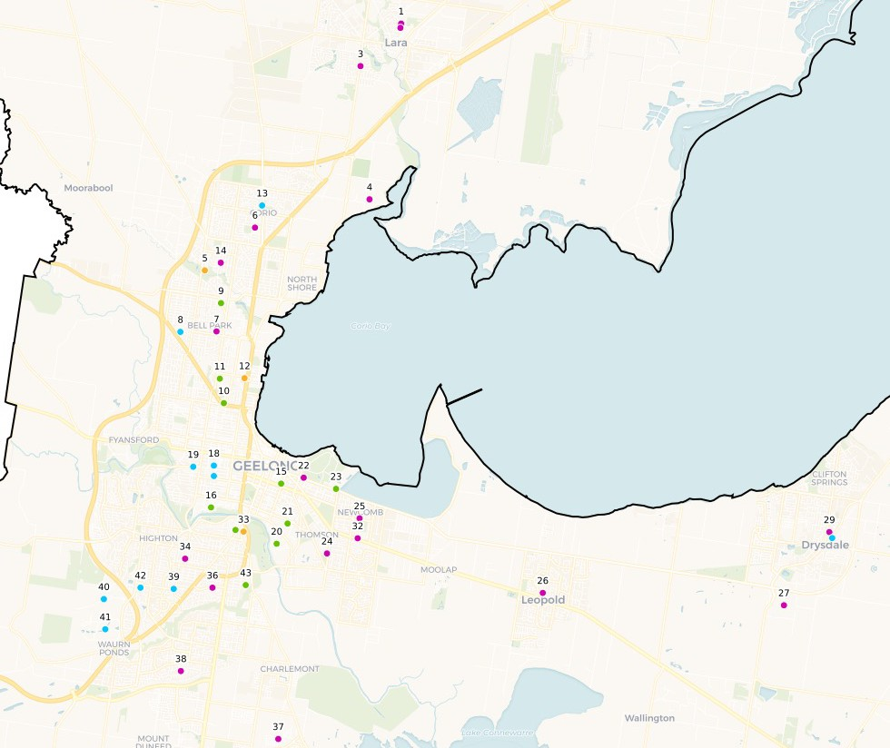Map 3.2: Existing Indoor Courts
School owned (DEECD) School owned (Other)
City of Greater Geelong (COGG) owned
Privately owned

NORTHERN PRECINCT
  - Lara Secondary College
  - Lara Primary School
  - Lara Lake Primary School
  - Geelong Grammar School
  - Leisuretime Sports Precinct
  - Northern Bay College - Goldsworthy Road Campus
  - North Geelong Secondary College
  - Kardinia International College
  - Action Indoor Sports Stadium
  - Geelong Table Tennis Association
  - Centre Court Indoor Tennis
  - Geelong Arena
  - St Francis Xavier School
  - Northern Bay College Peacock Campus
CITY/CENTRAL PRECINCT
  - Geelong Basketball Netball Centre
  - YMCA Newtown Stadium
  - The Geelong College – Senior School
  - Sacred Heart College, Geelong
  - St Joseph’s College Geelong
  - Geelong Indoor Sports
  - Vic Beach Volleyball Geelong
  - Geelong High School

EASTERN PRECINCT
  - Try Boys Basketball Stadium
  - Geelong East Primary School
  - Newcomb Park Primary School
  - Leopold Primary School
  - Bellarine Secondary College
  - Bellarine Aquatic & Sports Centre
  - Drysdale Primary School
  - Ocean Grove Memorial Hall
  - Christian College Geelong Bellarine Campus
  - Newcomb Secondary College

SOUTHERN PRECINCT
  - The Barwon Valley Activity Centre
  - Belmont High School
  - Geelong Lawn Tennis Club
  - Oberon South Primary School
  - Oberon High School
  - Grovedale College
  - Clairvaux Catholic School
  - Marcus Oldham College
  - Deakin University, Waurn Ponds Campus
  - Christian College Geelong Middle School
  - Highton
  - Crows Road Alliance Bank Stadium

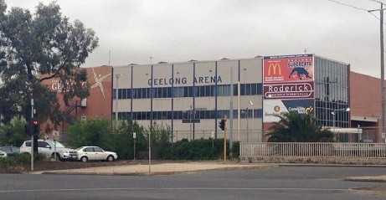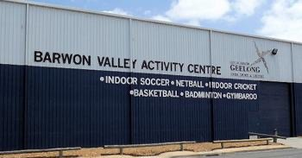Council currently owns and operates four indoor recreation facilities being:
    - The Geelong Arena (North Geelong), 4 courts

3
    - The Barwon Valley Activity Centre (Belmont) 2 courts 1

2

4
    - Leisuretime Centre (Norlane West), 3 courts
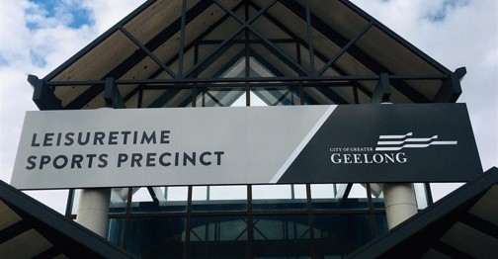
Available hours per week all sites (Monday to Saturday)

    - Bellarine Aquatic & Sports Centre (Ocean Grove)

Total (Average per week)

Barwon Valley Activity Centre

Leisuretime Sports Precinct

Bellarine Aquatics & Sports Centre

Geelong Arena Annexe

17
20
12

24
11

40
4

17
41.5
2019
2014

2 courts
Weekly occupany all sites (Monday to Saturday)

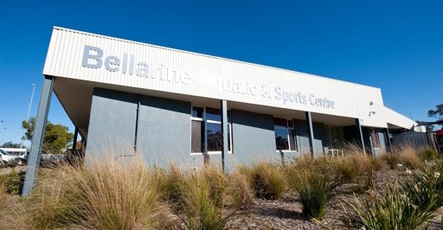
Total (Average occupancy)

Barwon Valley Activity Centre

Leisuretime

83%
79%
83%

67%

92%

2019
2014

Sports Precinct |  |  | 72%
Bellarine Aquatics |  |  |  | 94%
& Sports Centre |  |  | 77%
Geelong |  | 63%
Arena Annexe |  |  |  | 100%



Of the full or large indoor sport courts in the region, eleven are owned and managed by Council. Two of these courts at Barwon Valley Activity Centre are low standard due to industrial type floor surfaces and lighting.
25 of the large indoor courts are provided by primary, secondary and tertiary education institutions but only 13 of these courts are available for regular community use
12 large indoor courts have limited or no community use. About half of the non-community use courts are informally used by community teams for training on a limited use basis usually arranged through friends or work colleagues.
10 large indoor courts are provided by organisations such as the YMCA and Try Boys Brigade and all are available for community use.
34 large or full size indoor sport courts are available for community use in the Geelong Region.
A review of adjoining Council areas identified six large indoor sport courts at:
- Torquay - one court (Surf Coast Shire) + (3 new courts constructed in 2020)
- Bannockburn - 2 facilities with a large court at each site (Golden Plains Shire)
- Hoppers Crossing - 6 indoor sport courts (Wyndham City Council)
- Eagle Stadium Werribee (Wyndham City Council)
- 12 indoors courts
- Colac - 2 sport courts (Colac Otway Shire).

THE GEELONG ARENA & ANNEX

FACILITY OVERVIEW
The Geelong Arena is an indoor sports and entertainment venue located 4 kilometres from Geelong’s CBD. The venue is owned and managed by Council since purchased in May 2005. Previously this the facility had a varied ownership history:
      - The base facility was originally built as a wool storage business.
      - In the early 1980s a commercial developer purchased the main multi-storey brick structure and site and over 2 years was renovated to provide the main auditorium/court and seating and support areas. The redevelopment included a Gymnastics Centre and commercial social facilities. The venue was fitted out to host major events including concerts and dinners whilst from a sports perspective the main tenant
was the Geelong Supercats when competing in the National Basketball League.
      - In the late 1980s the Arena Annex was added and the commercial developer entered into usage and lease arrangements with then Geelong Basketball Association to base their competition at the site.
      - In 2005 the City of Greater Geelong in association with a Victorian State Government Grant purchased the site and facilities.

FACILITY COMPONENTS AND ISSUES
Geelong Arena is the region’s largest indoor sports and entertainment facility. It offers five operating modes being sports events, concerts, conferences, expos and banquets and has full bar facilities on two levels as well as a café and kitchen. It is the largest auditorium and largest single span room in the region. The venue is able to be flexible in its approach and looks to maximise event opportunities tailoring set up with production services to meet needs of the event market.
The stadium is home to a number of sporting and commercial organisations. The building centrepiece is the Auditorium show court built with fixed seating and
courtside box facilities overlooking the “Show Court”. The court area is 36.00 meters x 23.00 (850 square meters) with a clearance of 12 meters to the ceiling. The auditorium
is serviced by four change rooms, referee’s room, first aid station, green room, laundry, production office, merchandise area, box office and large toilet facilities
with disabled access. Also, a level 2 function room and commercial kitchen with capacity for up to 200 guests overlooking the show court.
The Annex Stadium was opened in 1995 has 2,000 sq. meters of clear space with three basketball courts on a sprung sports floor with clearance to the lighting of 10 metres.

Main Arena Usage Mode | Approximate User Capacity
Event - with seating and floor seats | 1,600
Event - no extra floor seats | 1,175
Concert - seated and standing | 2,250

The adjoining Arena Annex is a multi-purpose and versatile space used outside of basketball lease periods for functions and other sports activities.
The Arena was not a major consideration in the 2014 Strategy. As a key regional venue, a strategy and masterplan are required to ensure clear long term direction for the venue to support funding bids and met the needs of the region.
As an aging facility in a growing competitive economy, the Arena has been able to hold ground. There are however key challenges in managing the venue. These include:
- Asbestos management
- Roof loading capacity
- Lack of strong masterplan / strategy
- New entrants into market
- Community rate over commercial gains
- Venue building audits and maintenance
- Limited air handling
- Food and beverage operations – kitchen and café location
- Traffic management with limited parking
- Reliance on facilitation of activities
- Access control
- Event ticketing
- Restricted all abilities access and limited toilet capacity
The venue capacity is the region’s largest. This is also a limiting factor as new entrants provide improved

return on investment for touring events. The venue as a whole has an average of 300,000 visitors annually.
Tenants continue to evolve and drive active lifestyles with the venue’s event management averaging 80 major event days annually. The event program supports the community philosophy while also significantly providing regional economic benefits. For example, three major gymnastics events at the venue contributes $10M to the local economy annually.
Changes in the local basketball scene and introduction of Crows Road Alliance Bank Stadium has seen significant decreases of over 50% in Arena court usage since 2017. This has impacted core business and value add opportunities.
In 2018/19, Council considered the sale of the venue after an enquiry from local basketball associations. The purchase did not proceed, and current associations now have no interest in purchasing the venue. The enquiry
highlighted the lack of a vision and strategy for the venue.

FACILITY OCCUPANCY
Peak Hour availability for the Arena Annexe is as follows:
      - 4pm – 10.00pm Monday to Friday
      - 9am – 4pm - Saturday
      - 37 hours of peak time/ week
(3 courts in the Arena Annexe - total of 111 court hours peak time a week).
      - 46 weeks per year
      - 5,106 Total hours of Peak time court availability annually
In August 2017 people counters were installed tracking total visitors at main entrances overall assisting accuracy. This included event attendances, tenant operations, programmed activities & meeting room hire. Table 3.1 summarises attendance over 2017/18 and 2018/19.
Total visits in 2017/18 were 305,062 and de creased by approximately 40,000 in 2018/19.

Summary of Current Indoor Facilities Courts Peak Hour Availability @ Geelong Arena Annexe

GEELONG ARENA ANNEXE | MON | TUE | WED | THU | FRI | SAT | TOTAL
2014 | 0 | 0 | 0 | 0 | 0 | 0 | 0
2014 Occupancy |  |  |  |  |  |  | 100%
2019/20 | 1.5 | 1.5 | 1 | 1.5 | 18* | 18 | 41.5% hrs
2019 Occupancy |  |  |  |  |  |  | 62.6%
* Geelong United Basketball Rep Program Basketball was proposed to return in 2020 for Friday night’s yet with covid-19 situation this did not take place so availability this day remains unknown.

Table 3.1: Visits to Geelong Arena

YEAR | ANNEX & MAIN STADIUM | TENANTS | TOTAL VISITS
2017/2018 | 229,584 | 75,478 | 305,062
2018/2019 | 193,755 | 69,620 | 263,375

Table 3.2 summarises the availability of the Annex for regular sporting activities. When venue closure and major events are excluded, courts are available for 46 weeks
Day | Available Key Basketball  Hours | Weekly Hours | Annual Hours Available
Mon-Fri | 16:00 - 22:30 | 97.5 | 4,485
Saturday | 8:00 -16:00 | 24 | 1,104
Sunday | 8:00 -16:00 | 24 | 1,104
Total available hours |  | 145.5 | 6,693

per annum. It is important to note that from 2011-2017 the venue was available 52 weeks per annum for regular sporting activities, and in 2018 this reduced to 46 week as outlined below.

Table 3.2: Annex Availability
Table 3.4: Weekly Program of Basketball Use

Available court weeks
The show court is a major event venue and is made available when practical for domestic competitions although since the opening of Crows Road basketball use has decreased (refer Table 3.5).

46 Table 3.5: Basketball Use of the Show Court
Annex Event | Weeks
Annual | 52
Venue closure | - 4
Major events | - 2

With the introduction of Crows Road Alliance Bank Stadium in 2017 the Arena has experienced a significant decrease in basketball usage. Currently Annex courts are empty Friday night, Saturday and Sunday (refer Tables 3.3 and 3.4). The representative season for 2020 will
Year | Basketball hours used
2011 | 593
2012 | 609
2013 | 623
2014  2015 | 618  843
2016 | 1084
2017 | 647
2018 | 491

potentially restore Friday nights in part and some Saturday afternoons.
The impact of this did not go unnoticed in café sales which has seen a steady decline with the decrease in core weekday business. The 50% decrease in usage is almost mirrored in the impact to food and beverage operations.

Table 3.3: Annexe Basketball Occupancy

Year
 |  |  | 2019 | 297
2011 | 5,772 | 86%
2012 | 5,378 | 80%
2013 | 5,534 | 83%
2014 | 5,933 | 89%
2015 | 5,252 | 78%
2016 | 6,680 | 100%
2017 | 4,960 | 74%
2018 | 2,689 | 40%
2019 | 2,413 | 36%

Basketball hours used
Occupancy

BARWON VALLEY ACTIVITY CENTRE

FACILITY OVERVIEW
The Barwon Valley Activity Centre (BVAC) is located off Barwon Heads Road in Belmont. The building has a unique history with part of the structure built originally by the Pratt Brothers when the Belmont Common was the site for the Geelong Aerodrome. In the 1940s the building was used as an aircraft maintenance hangar during the Second World War.
The building was used for a range of purposes through to 1963, when it was then leased by the City of South Barwon to the Geelong YMCA as an indoor recreation facility. In 1983 the City took over management of the centre and expanded and refurbished the building for indoor recreation activities, including sport competitions,
roller-skating and skateboarding, volleyball, indoor cricket, Sunday markets and youth activities.

FACILITY COMPONENTS & ISSUES
Centre management identified the following facility issues at BVAC:
      - Playing surfaces have no resilience and floors are slippery and unsuitable for high-level sport.
      - Only one full size court on site with all others a mixture of sizes.
      - Long narrow venue layout so hard to supervise.
      - No spectator seating.
      - Location of food and beverage offering is away from where people are located.
      - No heating or cooling.
      - Toilets and change rooms are a low standard.
      - Venue is within a flood zone so has limited future use.
      - Lack of storage.
      - Public perception is a Sunday market venue and not a sports and recreation centre.
      - Running at full capacity and turning away teams/ participants in a facility that was never actual developed for sports activities.

FACILITY OCCUPANCY
Peak Hour availability for BVAC is allocated as follows:
      - 4pm – 10pm Monday to Friday
      - 9am – 4pm - Saturday
      - 37 hours of peak time/ week (2 courts in BVAC - total of 74 court hours peak time a week).
      - 46 weeks per year
      - 3404 total hours of peak time availability annually

BARWON VALLEY ACTIVITY CENTRE (BVAC) | MON | TUE | WED | THU | FRI | SAT | TOTAL
2014 | 0 | 2 | 0 | 0 | 10 | 12 | 24 hours
2014 Occupancy |  |  |  |  |  |  | 67%
2019/20 | 0 | 0 | 0 | 0 | 0 | 12* | 12* hours
2019 Occupancy |  |  |  |  |  |  | 83%

FACILITY USAGE
The courts are primarily used for high impact sports that usually do not suit timber floor facilities. Main usage includes futsal, roller derby and a Sunday Market. Netball and basketball find the floor unsuitable for higher-level competition, so when reviewing usage, the suitability of the venue needs to be considered.
The winter and summer booking schedule at BVAC indicates limited court time available on the two courts for any further use in peak time (after 4pm Monday to Friday) though there is little daytime court use. Booking and usage trends indicate:
      - Both sports courts are fully booked during winter and summer from 4pm to 11pm Monday to Friday for futsal (46 court hours/week), City of Greater Geelong Junior Sports Program (8 court hours/ week) and badminton (4 court hours a week).
      - There is limited weekday use of the courts with only badminton on a Monday for 1 hour and the only other daytime use for the courts is the Sunday market.
      - There is a purpose-built indoor cricket area and has limited use by other activities.
      - There is a volleyball size court which has 29 hours used for Gymbaroo on weekdays in the mornings Monday to Friday during school term.
      - Other users record less than 3 hours use per week per court.
During peak time (4pm to 10pm Monday to Friday and 9am to 4pm Saturdays):
      - No court space currently available on weekdays, compared with 24 hours available in 2014.
      - 12 court hours are available on Saturday’s, however, this can rotate across various other markets, events and community gatherings as a ‘space for hire’ these times are not attractive to court sports for clubs and/or groups not only at this site but also across various indoor facilities.
      - Since 2014 the venues occupancy has increased from 45% to 77% in 2019/20, leaving very little booking availability.

LEISURETIME SPORTS PRECINCT

FACILITY OVERVIEW
The Leisuretime Sports Precinct is located at Anakie Road, Norlane West and is one of Regional Victoria’s largest indoor leisure centres. The former Shire of Corio built the venue in 1976 on Council owned land, which was then known as Corio Leisuretime Centre. The original build cost was $1.3 million. Grants were received from State and Federal Governments to assist in funding the project.
The centre was predominantly built for the sports of badminton and basketball, with the Geelong Badminton Association and the Geelong Amateur Basketball Association original tenants.
The Geelong Badminton Association negotiated an agreement with the Shire of Corio in 1984 for the development of a new six court Badminton annex to be built on the site. The Badminton Association contributed
$190,000 to the cost of this development and entered a 30-year lease with the Shire for the use of these facilities. Leisuretime was further expanded in 1987 with the construction of eight squash courts.
The Shire of Corio directly managed the centre until 1994, where an agreement with Life Be In It was formed. In 1996 Life Be in It surrendered their agreement partly due to a major tenant of the venue moving a large portion of their operations to the newly built Geelong Arena Annexe. The Geelong Amateur Basketball Association (GABA) then undertook management until 1999, when the City of Greater Geelong was successful in securing the management and operation contract.
Both management agreements with Life Be in It and GABA were ceased due to pressures to achieve agreed financial outcomes.
The Leisuretime facility has quality facilities for sports such as basketball, netball, squash, volleyball, badminton and futsal as well as a full-sized outdoor FIFA standard synthetic pitch that opened 2018. Leisuretime is also a suitable venue for meetings, large events, and expos.

LEISURETIME FACILITY COMPONENTS AND ISSUES
The centre is open 9am to 10.45pm Monday to Thursday, Friday 9am to 5pm and Saturday 8.30am to 3pm and is closed Sundays. The centres facilities include:
      - Beggs Hall – 2 full size Netball/Basketball Courts (Floor area 1,569m2)
      - Branch Stadium – 2 Netball/Basketball Courts or 6 badminton or 2 volleyball (Floor area 1,162m2)
      - Badminton Stadium – 6 Badminton Courts (Floor Area 1,066m2) – managed by Badminton Geelong
      - 8 Glass Back Squash Courts
      - FIFA Standard outdoor synthetic pitch
      - Toilets and Change Facilities
      - Offices and Admin Area
      - Meeting Rooms
      - Multi-Purpose Room/Crèche
      - Café/kiosk
      - Outdoor Netball Courts and Netball Association Clubrooms
      - Outdoor 5 a side Synthetic Soccer Pitches
Centre management identified the following facility issues at Leisuretime:
LEISURETIME SPORTS PRECINCT TO MOVE TO A ‘REGIONAL’ CATEGORISATION
      - Improve, develop new and/or repurpose existing facilities.
      - Give the venue and precinct a clear purpose about what it is, what it does and why it does it.
      - Referencing the venue and precinct to a ‘regional’ categorisation will help management and Council challenge and remove old, outdated agreements, arrangements or perceptions that have held the venue back. It will enable greater use, multi-use and more diverse access as demands and trends change.
REVIEW 20 TO 30 YEAR ‘EXCLUSIVE’ LEASE ARRANGEMENTS. REPURPOSE AND RENOVATE EXISTING FACILITIES
- Four competition basketball courts could be placed at Leisuretime within the existing stadium building structure if the mezzanine area and grandstand seating were removed.
- Existing courts are 45 years old and Branch stadium courts are not suitable for competition. This could become ‘stage one’ to help with current operational challenges, make existing City of Greater Geelong infrastructure work harder.
- Stage two could be the addition of 2 to 4 courts as the northern and western growth areas expand and demands increase.
MISSING SOCIAL SPACE AVAILABLE WITHIN EXISTING FACILITIES
- Leisuretime has no space available for clubs, groups and the community to come together, connect and talk. The increase in social sport and participation in traditional sporting clubs declining, it is vital that we make facilities are welcoming and comfortable to encourage positive social connections.
- Leisuretime has no social space available other than some small tables and plastic chairs in the main foyer and corridors which is not attractive, with no heating or cooling, little to no privacy with passing foot traffic and loud noise generally associated with a sports venue of this nature.
- Currently players / members of the public either chat beside the court pre and post game or activity or while standing next to their cars in the car park. Various clubs also desperately want an area where they can be comfortable, socialise after games and competitions. The only exception is badminton who have their own exclusive space in the lounge area within their stadium.

    - FACILITY OCCUPANCY
Peak Hour availability for Leisuretime is allocated as follows:
      - 4pm – 10pm Monday to Friday
      - 9am – 4pm - Saturday
      - 37 hours of peak time/ week (4 courts at Leisuretime
- total of 148 court hours peak time a week).
      - 46 weeks per year
      - 6808 Total hours of Peak time availability annually

LEISURETIME SPORTS PRECINCT  (Formally Leisuretime Centre) | MON | TUE | WED | THU | FRI | SAT | TOTAL
2014 | 3 | 6 | 5 | 6 | 14 | 6 | 40 hours
2014 Occupancy |  |  |  |  |  |  | 72%
2019/20 | 1 | 1 | 0 | 2 | 4 | 3 | 11 hours max
2019 Occupancy |  |  |  |  |  |  | 92%



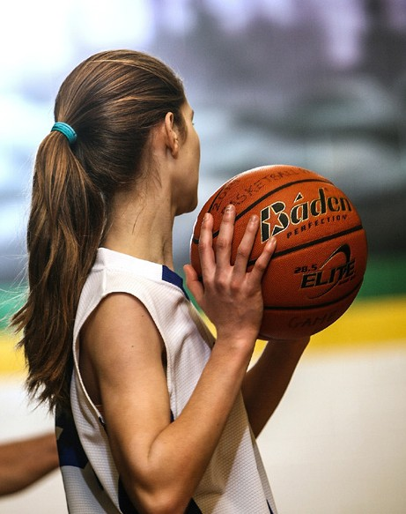

  - BELLARINE AQUATIC & SPORTS CENTRE
    - FACILITY OVERVIEW
The Bellarine Aquatic & Sports Centre (BASC) was originally constructed as an indoor sport and community meeting and child care facility. In 2007/08 an indoor aquatic centre was constructed, and a new-shared entry, café and office area was also added.
Sports court usage indicates indoor sport court visits made up approximately 27% of the centres total visits, with user group competitions the main use (76.5%) followed by Bellarine Secondary College use (20.5%).

FACILITY COMPONENT AND ISSUES
Centre management identified a series of issues to be addressed:
      - Additional storage is required.
      - Limited air handling on the courts.
      - Parking is currently an issue, which will be compounded with any additional courts added.
      - Additional courts would be welcomed from both a user group perspective and being able to expand our own programs (gymnastics and soccer) and initiate new programs.

FACILITY OCCUPANCY
Peak Hour availability for Leisuretime is allocated as follows:
      - 4pm – 10pm Monday to Friday
      - 9am – 4pm - Saturday
      - 37 hours of peak time/ week (2 courts at BSAC - total of 74 court hours peak time a week).
      - 46 weeks per year
      - 3,404 Total hours of Peak time availability annually

BELLARINE AQUATIC & SPORTS CENTRE (BASC) | MON | TUE | WED | THU | FRI | SAT | TOTAL
2014 | 0 | 2 | 0 | 6 | 5 | 4 | 17
2014 Occupancy |  |  |  |  |  |  | 77%
2019/20 | 0 | 0 | 0 | 0 |  | 4 | 4
2019 Occupancy |  |  |  |  |  |  | 94.5%

DEMAND FACTORS

A review of existing and potential demand for indoor sports courts in the Greater Geelong region was undertaken.

POPULATION AND

GROWTH ANALYSIS
The age structure of the City of Greater Geelong provides key insights into the level of demand for age- based services and facilities including indoor sports.
It is also an indicator of the City of Greater Geelong’s regional role and function and how it is likely to change in the future.

2016 CENSUS DATA
The population of City of Greater Geelong at the 2016 Census was 233,439 and was estimated to be 258,934 in 2019. Analysis of the five-year age groups compared to Victoria shows that there was a similar proportion of
people in the younger age groups (under 15) and a higher proportion of people in the older age groups (65+).
Overall, 18.1% of the population are aged between 0 and 15, and 18.6% were aged 65 years and over, compared with 18.2% and 15.6% respectively for Victoria.
The major differences between the age structure of the City of Greater Geelong and Victoria were:
- A larger percentage of persons aged 65 to 69 (5.7% compared to 4.9%)
- A smaller percentage of persons aged 25 to 29 (6.3% compared to 7.4%)
- A smaller percentage of persons aged 30 to 34 (6.4% compared to 7.6%)
- A smaller percentage of persons aged 35 to 39 (6.0% compared to 6.8%)
The number of households in the City of Greater Geelong increased by 8,407 between 2011 and 2016.

POPULATION PROJECTIONS
Projected changes in the age profile are summarised in Table 4.1. Key points to note are:
      - The population is projected to increase to 298,717 and 393,215 in 2026 and 2041, respectively.
      - The largest growth will occur in the 25 – 49 age cohort.
      - Substantial growth will occur in the high indoor sport participation age cohorts, 15 – 24 years and 25 – 34 years. Lower, although significant will occur in the junior sport age cohorts, particularly 10 – 14 years.

Table 4.1: City of Greater Geelong Projected Age Profile

AGE | 2019 | 2030 | 2040 | % CHANGE 2019 - 2030 | % CHANGE 2019 - 2040

0-4 years | 16,277 | 20,529 | 24,432 | 26.12% | 50.10%
5-9 years | 16,239 | 20,556 | 24,460 | 26.58% | 50.63%
10 - 14 years | 15,357 | 19,557 | 23,297 | 27.35% | 51.70%
15 - 24 years | 33,289 | 41,364 | 48,973 | 24.26% | 47.11%
25 - 34 years | 35,120 | 44,534 | 53,300 | 26.81% | 51.77%
35 - 49 years | 48,144 | 60,364 | 72,188 | 25.38% | 49.94%
50- 64 years | 45,880 | 53,571 | 62,476 | 16.76% | 36.17%
65 - 79 years | 34,162 | 44,768 | 52,845 | 31.05% | 54.69%
80+ years | 12,711 | 19,049 | 24,920 | 49.86% | 96.05%

Total | 257,179 | 324,292 | 386,891 | 26.10% | 50.44%

Table 4.2: Population Growth by Planning Areas

No. | PLANNING AREA | YEAR |  |  | % CHANGE
 |  | 2019 | 2030 | 2040 | 2019-2030 | 2019-2040
1 | Armstrong Creek/ Marshall - Charlemont | 10,973 | 30,234 | 42,664 | 176% | 281%
2 | Barwon Heads - Connewarre – Breamlea/ Ocean Grove/ Rural Bellarine Peninsula | 24,108 | 29,477 | 31,836 | 22% | 32%
3 | Clifton Springs/Curlewis/Drysdale Bellarine | 16,120 | 22,599 | 26,739 | 40% | 66%
4 | Portarlington/ St Leonards - Indented Head | 7,877 | 10,062 | 11,806 | 22% | 50%
5 | Leopold | 13,354 | 15,217 | 17,994 | 12% | 35%
6 | Newcomb – Moolap/ St Albans Park/ Thomson - Breakwater / Whittington | 18,088 | 19,395 | 20,597 | 7% | 14%
7 | Grovedale/ Mount Duneed/ Waurn Ponds | 23,221 | 34,022 | 38,732 | 32% | 67%
8 | Belmont/ Highton - Wandana Heights  - Ceres | 37,776 | 42,231 | 44,682 | 12% | 18%
9 | East Geelong/ Geelong - South Geelong  - Drumcondra | 11,778 | 14,122 | 19,259 | 11% | 63%
10 | Geelong West - Manifold Heights/Newtown | 20,879 | 22,031 | 24,433 | 5% | 17%
11 | Bell Park/Bell Post Hill/ North Geelong  - Rippleside | 15,055 | 18,011 | 23,624 | 16% | 57%
12 | Hamlyn Heights/ Herne Hill - Fyansford | 10,713 | 13,219 | 15,123 | 19% | 41%
13 | Corio/ Norlane - North Shore | 25,023 | 26,699 | 28,235 | 6% | 13%
14 | Lara | 17,550 | 20,552 | 23,995 | 15% | 37%
15 | Lovely Banks - Batesford – Moorabool/ Rural North | 4,665 | 6,422 | 17,171 | 27% | 268%
Grand Total 257,180 324,293 386,890

Northern precinct Southern precinct City/central precinct Eastern precinct

Key points to note from Table 4.2 as the data relates to the four planning precincts:
        - Southern precinct will have the largest population (150,511) by 2040, an increase of 57,662 on the 2019 projections.
        - Both Northern and Eastern precincts population will increase by 48% and 37% respectively, to approximately 108,000 by 2040.
        - City/central precinct will experience minimal growth (7,481) by 2040.
        - Highest priority for increasing the supply of indoor sports courts should be on the Southern precinct, given the projected population growth.
Review of the population growth by planning precinct identifies substantial growth over the next 10-20 years in many suburbs. While there will be population growth in all planning precincts, a few areas are expecting significant population growth. Population growth forecast will be significant in:
        - Planning Area 1; Armstrong Creek/Marshall Charlemont where the population is forecast to grow by 175.5% and 19,261 people over the next 10 years
        - Planning Area 7; Grovedale/ Mount Duneed/ Waurn Ponds where the population is forecast to grow by 46.5% and 10,901 people over the next 10 years
        - Planning Area 3; Clifton Springs/Curlewis/Drysdale Bellarine, where the population is forecast to grow by 40.2% and 6,479 people over the next 10 years

GROWTH PATTERNS
The population has grown strongly over the last ten years on the back of employment growth in service industries, as well as increased demand in coastal areas. Population growth has been most heavily concentrated in both suburban Geelong (Highton, St Albans Park), as well as Lara and Leopold and on the Bellarine Peninsula (Clifton Springs, Ocean Grove).
The second source of population growth includes persons from overseas and the outward flow of population from Melbourne. Some areas also gain from Geelong as a result of departures, such as Golden Plains Shire. This is generally made up of younger family households.
It is assumed that a number of these patterns will continue into the future, most notably flow into the City from surrounding areas. The number of persons coming to Geelong from overseas and metropolitan Melbourne
could be expected to increase as employment growth and tertiary education opportunities are further enhanced.
The variety of function and role of the small areas in the City of Greater Geelong means that population outcomes differ significantly across the municipality. There are also significant differences in the supply of residential property within the City, which will also have a major influence in structuring different population and household futures over the next five to twenty years. Large new ‘greenfield’ opportunities have been identified in the growth areas, notably Armstrong Creek, as well as significant short to medium term supplies in Highton, Lara, St Albans Park and Grovedale-Marshall.
Development is also expected, over the longer term as Highton, Ocean Grove, Point Lonsdale and Leopold
expand into surrounding rural areas. There are likely to be other greenfield, rural residential and most notably infill development opportunities throughout the City, albeit at lower levels than the major growth areas identified above.

STAKEHOLDER INTERVIEWS
The following information provides a summary of interviews and reviews completed with key stakeholders. [Note: key points below are presented ver batum from stakeholder interviews]:
- City of Greater Geelong staff
- Deakin University
- Surf Coast Shire
- Basketball Victoria
- Netball Victoria
- Sport and Recreation Victoria
- G21

CITY OF GREATER GEELONG

THE ARENA
      - The Arena has poor spectator amenities and there are significant challenges. There is an option to demolish or sell and replace on site or elsewhere.
      - The Arena is not fit for purpose and netball line marking is not suitable.

        - There is a possibility for redevelopment of the Arena for larger use. Administration, office space and the community room are good. Basketball would like to see some analysis done to see what a renovation would look like to expand the Arena show court.
        - If the Arena was sold, there would need to be an additional four courts built to replace the lost courts.
        - The Arena is a good space because of the transport linkages, which opens other areas.
CONVENTION CENTRE
        - A convention centre is still in planning stage. A 3000 - 4000 seat show court, would make the Arena superfluous. A Geelong team in NBL1 will draw
enough spectators to a facility of this kind, but Geelong is unlikely to field a team in the NBL.
CITY OF GREATER GEELONG FACILITIES
Leisuretime is a valuable piece of infrastructure and is well positioned for the northern area of Geelong. A new four court development would be well received. Building four more courts at Leisuretime would be appealing to Lara residents and other residents in North Geelong. Potential for an additional show court if the facility was upgraded.
The Bellarine area is a huge gap in terms of service provision for indoor courts. There is an 8 court facility in the north, but there is not enough in the south (other than Torquay). Current courts in the south include:
        - 2 courts at the Bellarine Aquatic Centre – Council (mainly used for training and social + domestic competition, but not representative).
        - 3 courts at the School – Bellarine High School (9-12 campus)
        - Crows Road Alliance Bank Stadium in Belmont (6 courts)
        - St Ignatius College – 2 indoor courts to code. – 3rd indoor court to code. (I court is used domestically for competition.)
        - Christian College – 1 basketball court to code used domestically for competition.
        - Adjacent to the Drysdale Sports Precinct.
        - Surf Coast – Torquay is developing a four-court facility which will take up some capacity. But not enough to meet demand.There is a perceived appetite from the State Government to build a high capacity facility in the City of Geelong to accommodate growing demand.

DEAKIN UNIVERSITY

      - Deakin University have two non-compliant indoor courts within their campus and have explored the possibility of developing a new 4 court facility with capacity for a 2000 seat retractable seating show court. This project was a G21 priority project.
      - Deakin did not receive funding support for its original proposal and is exploring opportunities to downsize to a new two compliant court facility.
      - Deakin is primarily an education facility, and the existing courts, and any new courts will be focused on education provision. This includes as a location for exams during each trimester. This will limit the ability for regular high-level competitions to use the facility regularly. An expanded Deakin facility would
be useful as an overflow centre, and for special events and competitions or carnivals, but not for weekly competitions.
      - Deakin have acknowledged that any expanded indoor sport court will not be in action for at least the next 5 years, as there is currently no funding committed, and planning is in very preliminary stage.

SURF COAST SHIRE
Surf Coast Shire is establishing a four court facility at Torquay which will address some existing emand..

BASKETBALL VICTORIA

Basketball Victoria provided data, reports and comments regarding demand for basketball facilities in the City
of Greater Geelong. In summary, Basketball Victoria believes that there is strong demand for indoor courts. There are often time constraints that do not allow for use when needed. Basketball demand is increasing, and this will put more pressure on facilities.

G21 REGION BASKETBALL STRATEGY (DRAFT FEBRUARY 2020)
Basketball Victoria is developing a G21 Region Basketball Strategy, which is currently in draft form and being circulated to key stakeholders across the region for comment. The G21 Region encompasses the Borough of Queenscliffe, Surf Coast Shire, Colac Otway Shire and Golden Plans Shire, in addition to the City of Greater Geelong.
The Strategy identified registered/affiliated Basketball Victoria members within the G21 region. In 2018, thre were 8,409 registered members of Basketball Victoria in the City of Greater Geelong:
      - Geelong United/Corio Bay Basketball Association - 6,377 (4,592 Male, 1,785 Female)
      - Bellarine Peninsula Basketball Association - 2,037 (1,463 Male, 569 Female)
Registered members of Basketball Victoria across the G21 Region in 2018 was 10,014, indicating around 84% of registered Basketball Victoria players in G21 region play in the City of Greater Geelong.
The G21 Region Basketball Strategy will have three main components; structure of the sport, administration and governance, and basketball facilities.
STRUCTURE OF THE SPORT
A structure is not detailed, although it is proposed to include:
      - Local domestic competitions to enable the identification of and pathway for athletes and coaches to progress through BV High-Performance pathways.
      - A regional competition structure that sits between local domestic and state competition.
- The role of the regional high-performance hub which will be focussed on the development of the player and coaches.
ADMINISTRATION AND GOVERNANCE
A draft administration and governance proposal includes:
- An over-arching board/advisory committee comprised eight elected representatives of BV, BVC, G21 Councils and the four affiliated Associations.
- A charter to develop and implement a plan for the development of basketball in the G21 Region that incorporates:
  - competitions and their structure
  - plans for regional competitions
  - pathways to regional and state high performance programs
  - events and promotion within the region
  - business development for Associations
  - source of income to cover operational costs.

BASKETBALL FACILITIES
The Strategy will advise the respective Councils on the need for future facilities in their area. Facilities proposed consider the 2017 Basketball Victoria Facility Master Plan. The Strategy notes that:
- A large capacity stadium in the City of Greater Geelong remains part of the wider objective for Sport and Recreation Victoria. This includes having a high capacity multi court facility in each of the major regional cities in Victoria.
- The Arena is the premier event indoor sports facility in Geelong, but has limited spectator capacity and needs major refurbishment.
- A priority for Geelong in the medium term is to provide a regional standard 4,000 to 5,000 seat stadium. Basketball Victoria believe there is a case for the upgrade and expansion of the Arena.
Proposed basketball facilities within the City of Greater Geelong include:
- New high ball court developments at Armstrong Creek be aggregated to create 3 - 4 court facilities rather than a range of 1 - 2 court facilities at various locations across the suburb.
- A two-court facility at Lara West contingent upon population targets.
- New court extensions at Bellarine Aquatic and Sports Centre, and Drysdale Secondary College to meet future eastern population growth.

GEELONG UNITED BASKETBALL ASSOCIATION
Basketball Victoria provided data on the total hours per year used across the Geelong United Basketball Association (GUBA) within the City of Greater Geelong.
GUBA USES 25 BASKETBALL FACILITIES:
      - Crows Road Alliance Bank Stadium
      - Geelong Arena
      - Geelong Arena Show Court
      - Grovedale Secondary College
      - Leisuretime Sports Precinct
      - Geelong College
      - Try Boys Stadium
      - Christian College
      - East Geelong Primary School
      - Geelong Grammar
      - YMCA- P-12 Bannockburn College
      - Geelong Basketball Netball Centre
      - Barwon Heads Primary School
      - YMCA Newtown
      - Lara Lake Primary School
      - Lara Primary School
      - Lara Secondary School
      - Deakin University
- Bannockburn Sports Centre
- Sacred Heart Girls College
- Northern Bay College
- Leopold Indoor Neighbourhood Centre
- Surfcoast Secondary College
- Torquay Primary School
- Western Heights
An analysis of how each venue is used identified: (refer to Table 4.3):
- Total annual court hours used was 12,444, with Crows Road Alliance Bank Stadium the most heavily used (2,947 hours).
- The most heavily used Council venue was the Leisuretime Sports Precinct with 1,179 hours. The Arena was used for 1,426 hours when the Show Court and the three community courts are considered together.
- Junior basketball programs had the highest court occupancy (5,547), followed by open domestic competition and training.
A detailed breakdown of total court use is summarised in Table 4.4. [Note the proportion of court hours for junior, U18 – U23 and Open domestic competitions has been estimated based on an average of eight teams in a league and seven players in a team, resulting in 52%, 9% and 38% of court hours respectively.]

Table 4.3: Annual Hourly Court Use

 | CROWS ROAD | ARENA (3 COURTS) | OTHER VENUES | TOTAL | ARENA SHOW COURT | LEISURETIME SPORTS PRECINCT

Junior activities | 987 | 480 | 4,080 | 5,547 | 0 | 634
U18 - U23 domestic competition | 143 | 83 | 691 | 918 | 0 | 101
Open domestic competition | 605 | 351 | 2,919 | 3,874 | 0 | 427
Junior representative teams | 1,165 | 0 | 0 | 1,165 | 0 | 0
Senior representative teams | 47 | 65 | 826 | 938 | 448 | 14

Total | 2,947 | 978 | 8,517 | 12,442 | 448 | 1,176

Table 4.4: Annual Hourly Court Use by Activity

COMPETITIONS | TOTAL HOURS
Junior Programs
Aussie hoops Program | 96
Basketball Clinic- Beginners (School Holidays) | 0
Basketball Clinic- Skill Development (School Holidays) | 150
Domestic Comp - Games | 2,007
Domestic Comp - Clubs training | 3,29
Domestic Comp - Games | 347
Domestic Comp - Clubs training | 570
Open domestic competition

Domestic Comp - Games | 1,466
Domestic Comp - Clubs training | 2,408
Junior representative teams
VJBL games | 580
VJBL training Sunday | 546
VJBL try outs | 39
Senior representative teams
Big V Games | 98
Big V Pre Season Training | 32
Big V training | 192
Big V try outs | 4
CBL training | 76
CBL Games | 28
NBL 1 games | 88
NBL1 training | 360
NBL1 pre season training | 60
TOTALS | 12,442

BELLARINE PENINSULA BASKETBALL ASSOCIATION
The Bellarine Peninsula Basketball Association (BPBA) currently operate from the Bellarine Sports Centre, located at Bellarine Secondary School, Peninsula Drive, Drysdale.
The Centre was a shared Education/Community State Government initiative of the early 1990’s, where it was to be used by the school during school hours and available for use by the community outside school hours. The Bellarine Sports Centre currently incorporates three- indoor sport courts to full size basketball requirements, with a kiosk, change rooms, weight room, office/ administration and storage areas. Currently the school uses the sports centre for approximately 25-hours each week (during school times 9am to 3pm Monday to Friday.
The Bellarine Peninsula Basketball Association (BPBA) operates from Bellarine Sports Centre. Use of the Centre is Monday through to Friday 3.45pm until 11.00pm and weekends on Saturday and Sunday between 9.00am until 10.00pm. BPBA runs a summer and winter competition season of approximately 22 weeks each, which sees the Bellarine Sports Centre fully booked for community use 44 to 45 weeks a year. Due to high demand for court space many of the BPBA clubs and representative teams toned to hire alternate sports courts to provide annually increasing court access for training and competition.
The other facilities hired in the area by BPBA clubs and representative teams include:
- Barwon Heads Primary School (2 Outdoor Courts)
- Christian College (1 Indoor Court)
- Surfside Primary School (2 Outdoor Courts)
- St Ignatius College (2 Outdoor Courts)
Total annual court usage is in the order of 2,500 hours in winter and is projected to be in the order of 1,600
hours in summer, a total in the order of 4,100 court hours per annum. [Note: Court hours estimated for summer assumes that it has about one third less participants.]
BPBA PLAYER MEMBERSHIP DATA
Big V teams, 21 Bellarine Storm representative teams and domestic competitions are at capacity with no available extra training times and space allocations at Bellarine Sports Centre and other training locations within the City. A review of the membership data for BPBA over the last five years indicatesthat overall memberships has increased from 1,957 in 2014 to 2,035 members in 2018. BPBA highest membership year was in 2016 with a total of 2,280 members, an increase
of 323 members which was 12% higher thancurrent membership numbers.

DEMAND FOR COURT SPACE
A single basketball court will generally be available for structured, non school based, basketball activities for 40 weeks per annum, as programs tend to be suspended during school holidays. In practice, it will be used between 4pm – 10pm on weekdays and 8am – 4pm on weekends, a total of 46 hours per week, or 1,840 hours per annum.
Based on BV data, the GUBA and BPBA have 76% and 24% of the regions basketball membership. Both associations have a similar program of activities and an annual court occupancy rate of 12,400 and 4,100,
resulting in total court use in the order of 16,500 across the region.
Based on this analysis the number of courts required to meet current basketball use is approximately 9 courts. This is a theoretical model and does account for splits between juniors and open uses, and higher demand for some time slots. Currently, GUBA uses venues with a combined 44 courts, although they are not all exclusively used for basketball. BPBA currently uses four indoor courts and six outdoor courts for its competitions and training.

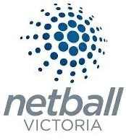NETBALL ACTIVITY

Netball Victoria provided comments and data relating to existing participation in the City of Greater Geelong.
- There is a shortage of indoor netball courts in Geelong. Netball has strong associations, which lead to pathways for competition and representative teams.
- There is a limited number of indoor netball compliant courts – only two courts within the Council area are compliant.
- The netball pathway program is very strong in Geelong and continues to provide a high-quality pool of players. Most of these players travel to Melbourne to train and compete.
- The talent identification program prioritises the use of indoor courts. There is limited space and access to compliant indoor courts for these programs. A strong stable home base is required for the Geelong Cougars, the representative team that plays from the Christian College and Geelong Grammar.
- Some major netball association competitions currently use outdoor courts and would likely move to indoor courts if they were available.
- Netball is always going to be played indoor and outdoor. The linkages with football will continue. It is a cheaper option than playing on indoor courts.
- Usage patterns are based on court availability. Netball must fit within a multisport facility, recognising two court facilities limit the ability to obtain space and time.
Netball Victoria has provided the number of registered players in each of the Netball Associations within the City of Greater Geelong (refer to Table 4.5). Additionally, they have included two associations that overlap with City of Greater Geelong, as they have players that may reside in the Council area.
The registration data shows 7,561 registered players in the catchment area (7,375 in the City of Greater Geelong). Player numbers have been relatively stable across the past three years, although with a minor reduction in total numbers from 2017 when there were
7,614 registered players in the catchment area. Outdoor netball is far more popular than indoor netball and accounts for 78% of overall usage.



Table 4.5: Registered Netball Victoria Players

ASSOCIATION VENUE VENUE
TYPE

LOCAL GOV’T 2017 2018 2019

Bellarine and District Netball Association Inc

Corio Netball Association

Geelong & Dist. Football Netball League

Geelong Central Netball Association

AFL Barwon

Peninsula Netball Association
Kardinia Park Netball Complex
Leisure Time Centre
Various

Kardinia Park Netball Complex
Various Drysdale
Recreation Reserve
Outdoor

Outdoor

Outdoor

Outdoor

Outdoor Outdoor
City of Greater Geelong
City of Greater Geelong
Multiple

City of Greater Geelong
Multiple City of Greater
Geelong

79

165

930

816

3736

47

53

104

954

871

3855

NA

43

57

864

929

4002

NA

TOTAL | 5,773 | 5,837 | 5,895

Kardinia Netball Association Geelong Basketball
Netball Centre
Indoor City of Greater Geelong
889

South Geelong Netball Association

Surfside Netball Association Inc.
Geelong Basketball Netball Centre
Bellarine Aquatic and Sport Centre
Indoor City of Greater Geelong
Indoor City of Greater Geelong

78 668 650

392 443 489

Southside Netball Association Inc.
YMCA Geelong Indoor City of Greater
Geelong

311 299 341

Surf Coast Netball Association

Bannockburn Netball Association
Surf Coast Sport & Recreation Centre
Bannockburn YMCA
Indoor Surf Coast Shire Council
Indoor Golden Plains Shire Council

131 111 147

40 54 39

TOTAL | 1,841 | 1,575 | 1,666

INDOOR COURT DEMAND
Estimating demand for indoor sports courts is difficult as the main constraint is multiple user groups and adults who travel longer distances to participate. For example,
it is likely that a substantial number of residents of City of Greater Geelong travel to use courts outside the Council area and residents in adjacent municipalities travel into the City of Greater Geelong to use facilities.
Two different approaches were used to estimate demand in 2014 and 2020. It must also be noted that the 2014 strategy addressed demand for all indoor sports, whereas the current review is restricted to addressing demand for indoor basketball and netball facilities.

2014 DEMAND ESTIMATES
The 2014 Indoor Facilities Strategy used several approaches to determine demand for indoor courts:
Growth Areas Authority (GAA) Standards adopted for Community Infrastructure Planning for Victorian Growth Councils in April 2008 for indoor recreation centres and courts indicate:
      - Level 1 Indoor stadium
(1 court per 10,000 to 15,000 people).
      - Level 2 Indoor stadium
(2 courts per 20,000 to 30,000 people).
      - Level 3 Indoor stadium
(4-6 courts per 40,000 to 60,000 people).
Current and likely membership of indoor sports which projected an increase in sporting association membership from 17,200 to 21,500 by 2026.
Consequently, after reviewing a range of facility provision demand indicators, the study determined that City of Greater Geelong had a demand for:
      - Now: between 34 to 38 courts (based on population increases)
      - 2021: 41 to 45 courts
      - 2031: 48 to 52 courts

2020 DEMAND ESTIMATES
The most recent participation data by the Australian Sports Commission (AusPlay survey results July 2017 - June 2018) addresses participation at least once in the previous 12 months by people. It covers all age groups from 0 – 65+ years. Children’s participation excludes participation during school hours. In addition, frequency of participation was obtained from ABS Participation in Sport and Physical Recreation publications.
To provide an indication of demand a simple approach has been adopted:
      - Using participation rates by children and adults, and the actual and projected population in each age cohort, participation in basketball has been projected.
      - It is assumed, based on industry knowledge, that basketball accounts for about 80% of indoor sports competitions in community sports centres. The balance comprises sports such as netball, volleyball, futsal and badminton.
      - 10% of participants will use sports halls in schools and/or outside of City of Greater Geelong – known as leakage.
      - Capacity of a single court is based on scheduling junior and senior competitions with 5 games per day, 6 days per week, 21 weeks per season and 2 seasons per annum. It is also assumed that training, school and other hire groups, and events will be held in non- competition periods.
      - An indoor sports team/squad comprises an average of eight players.
These assumptions are quantified in Table 4.6 which suggests demand existed for an additional 14 compliant competition sports courts in 2019. By 2030 and 2040, demand will exist for 17 and 20 compliant competition courts, respectively.

Table 4.6: Estimated Demand for Indoor Sports Courts

AGE GROUPS | BASKETBALL PARTICIPATION RATES | 2019 | 2030 | 2040
0 - 4 years | 0.0% | 0 | 0 | 0
5 - 9 years | 5.2% | 842 | 1,066 | 1,268
10 - 14 years | 13.7% | 2,099 | 2,674 | 3,185
15 - 24 years | 12.0% | 4,010 | 4,983 | 5,900
25 - 34 years | 5.4% | 1,906 | 2,417 | 2,892
35 - 49 years | 5.2% | 2,517 | 3,156 | 3,774
50- 64 years | 0.5% | 215 | 251 | 293
65+ `years | <1.0% | 13 | 17 | 20
Total Basketball Players |  | 11,602 | 14,563 | 17,332
Other sports |  | 2,901 | 3,641 | 4,333
Total Indoor sport Players |  | 14,503 | 18,203 | 21,664

Leakage | 10%
Available players |  | 13,052 | 16,383 | 19,498

Matches per week | 30
Matches per season | 630
Players per week | 480
Players per season | 960

Courts required | 14 | 17 | 20


4.5.3 CATCHMENTS
4.6 BENCHMARKING

A generic, reliable and valid method of estimating the
catchment for an indoor sports centre is not available. Each facility will have unique features which impacts on its catchment including:
        - Demographic composition of the catchment area e.g. age, gender, ethnicity.
        - Major geographic features which act as either barriers or travel conduits e.g. roads, rivers, railway lines.
        - Programs and sports offered e.g. junior sport has smaller catchment than adult sport, community sport has smaller catchment than elite sport, training venues have smaller catchment than competition venues and sports with few venues have larger catchments than sports with many venues.
        - Quality of the venue and management e.g. high quality facilities with excellent management are likely to attract customers from a wider catchment than low quality, poorly managed facilities.
Given these caveats it is likely that:
        - A major regional facility with significant spectator capacity will have a catchment of the City of Greater Geelong and surrounding municipalities.
        - Adult focussed community sporting venue will attract approximately 70%, of its customers from a catchment of about 20 minutes travel time. If the venue targets higher level competitions, the catchment may be larger.
        - Junior focussed community and training sporting venues will attract approximately 90% of its customers from a catchment of about 20 minutes. Venues catering for representative teams or training camps may have a larger catchment.
City of Greater Geelong indoor recreation facilities have
been benchmarked against three other LGAs; Ballarat City Council, Greater Bendigo City Council and Frankston City Council, and are summarised in the Table 5.1.
The data found:
      - Ballarat has one sports court per 3,400 population. The largest facility has four courts and three 6 to 8 court facilities are planned.
      - Bendigo has one sports court per 5,800 population. The largest facility has five courts and a three-court expansion to an existing facility is planned.
      - Frankston has one sports court per 7,450 population. The largest facility has six courts and four courts are planned to be added to two existing facilities.
In comparison, City of Greater Geelong has one sports court per 5,075 population. The largest facility has four courts (Geelong Arena)..

4.7 INDOOR SPORTS FACILITIES HIERARCHY
To assist in establishing an effective network of indoor sports facilities, a suggested catchment and hierarchy of facilities has been proposed. Table 4.8 outlines a hierarchy of indoor sports facilities and the respective catchment and activities conducted. Four levels
of facilities are proposed – regional, sub regional, community level 1 and community level 2. This hierarchy will accommodate all indoor sporting events from major national or international competitions to junior sports training sessions.
To appreciate the geographic catchment of the four Council owned and operated venues, an analysis of driving times to a range of suburbs was completed (refer table 4.7). Within the City of Greater Geelong, the main area not serviced by these venues are suburbs north of Drysdale on the Bellarine Peninsula. However, these suburbs are within 15 minutes’ drive of Bellarine
Secondary College. Similarly, other suburbs on the outer extremities are also serviced by venues at education institutions such as Deakin University, or be venues in adjacent municipalities such as Bannockburn and Torquay.


Table 4.7: Indoor Sports Venue Catchments

VENUE | SUBURB | DRIVING TIME (MINUTES)

Leisuretime Sports precinct

Geelong Arena

Barwon Valley Activity Centre
Bellarine Aquatic and Sports Centre
Lara 15
Gheringhap 16
North Shore 10
North Shore 7
Fyansford 14
East Geelong 12
Newcomb 13
Waurn Ponds 8
Armstrong Creek 11
Armstrong Creek 22
Drysdale 16
Connewarre 15

Table 4.8: Indoor Sports Facility Hierarchy and Catchment

DESCRIPTION | ACTIVITY | CATCHMENT | SUBURBS POORLY SERVICED
REGIONAL
- Large spectator capacity (2,000+)  - Meets recommended court dimensions including run off  - Adequate change rooms facilities for major event  - Sponsor and corporate facilities  - Event spaces eg drug testing, administration area  - Capacity to change configuration of sports courts eg three community courts converting to one show court | Major sporting events for all indoor court sports | City of Greater Geelong and adjacent Council areas | None
SUB REGIONAL
- Limited spectator capacity (100 – 500)  - Meets recommended court dimensions including run off  - Adequate change rooms facilities for all sports in use  - Multiple sports courts (3+)  - Caters for all indoor court sports | Regional sports competitions  Community adult sport competitions | 20 minutes drive  eg Geelong CBD to Drysdale, Geelong CBD to Breamlea, Geelong CBD to Corio, Corio to north and west rural | None
COMMUNITY LEVEL I
- Minimal spectator capacity (50+)  - Meets recommended court dimensions including run off  - Adequate change rooms facilities for all sports in use  - Multiple sports courts (2+)  - Caters for all most popular indoor court sports eg basketball, netball and futsal | Low level adult and junior competition for high participation sports eg netball and basketball,  Training for adult sports teams  Community adult sport competition for sports with lower levels of participation eg volleyball and badminton | x | None
COMMUNITY LEVEL II
- Minimal spectator capacity (<20)  - Meets recommended court dimensions including run off, adapted to the needs of junior sport  - Adequate change rooms facilities for all sports in use  - Single sports court  - Caters for all indoor court sports and physical activities eg martial arts | Junior training and competition | <15 minutes drive based on catchment of a public primary school | None

5. APPENDICES
Table 5.1: Indoor Recreation Facilities Benchmarking
BALLARAT CITY COUNCIL
Estimated LGA Population 2016
Approx. Number of Indoor Courts in LGA
Total Number Indoor Courts Owned by LGA
Total Number School Indoor Sport Courts
Total Number of Indoor Courts Owned by Commercial Operators
Major Indoor Recreation Facilities/Owner
(2 courts or greater)
Future Indoor Courts Planned (summary of development)

101,700 | 30 indoor  courts at 13 xenues have community use. | 12 indoor  courts at 4 venues are owned by Council | 8 courts are owned by the Department of Education across 4 venues. | One private indoor tennis centre [8 courts]. | Wendouree Sports & Events Centre – 2 court multi-purpose venue; owned by Council and operated under a lease to Ballarat Basketball Association. | New 6 court multi-purpose stadium proposed – Grampians Regional Sports & Community Centre.
 |  | Two venues are owned by (Table Tennis 25 tables) associations | University of Ballarat also has 2 courts. |  | WIN Minerdome – 4 court facility, catering for basketball, badminton and volleyball; owned & managed Ballarat Basketball Association. | Two sites within the Ballarat West Growth Area being planned, each with a 6-8 courts.
 |  | Badminton Stadium 17 Badminton Courts. |  |  | Arch Sports Centre – 3 courts [currently closed pending repairs] – located at Ballarat High School, owned by Dept. of Education and managed by Ballarat Basketball Association.
 |  |  |  |  | Damascus Sec College – 2 court stadium – owned and managed by the Dept. of Education.
Ken Kay Badminton Stadium – 17 courts for badminton – owned
by Council and managed by the Ballarat Badminton Association.
 |  |  |  |  | Ballarat Netball Centre – 4 indoor courts; owned and managed by Ballarat Netball
 |  |  |  |  | Table Tennis Centre – 25 courts, owned by Council and managed by the Ballarat Table Tennis Association.
Ballarat East Recreation Centre – 2 courts, owned by the Dept. of
Education and managed by Ballarat Sec College.

CITY OF GREATER BENDIGO
FRANKSTON CITY COUNCIL
Population 2016
Indoor Courts in LGA
Courts Owned by LGA
Indoor Sport Courts
Courts Owned by
Facilities/Owner
Planned (summary of

110,500 | 19 courts located across 9 venues. | 11 | 8 courts located across 4 school venues. | N/A | Bendigo Stadium – is a 5 court multi-purpose stadium, owned by Council and managed by a Board [consisting of community reps and Council]. | Bendigo Stadium expansion – additional 3 courts proposed.
 |  |  |  |  | Flora Hill Stadium – 3 court stadium, owned by the Dept. of Education and managed by the school [Bendigo South East Secondary College].

134,150 | 18 courts  at 7 venues are currently available for community use. | 8 of these courts at two venues are owned by Council. | 9 of these courts located at four schools are owned  by Dept. of Education. | 1 court is privately owned and operated. | Frankston Basketball Centre – 6 courts, owned by Council and operated under a lease by the Frankston District Basketball Association | An additional 2 courts are planned for Frankston Basketball Centre.
 |  |  |  |  | Frankston Netball Centre – 2 indoor courts, owned by Council and operated under a lease by the Frankston Netball Association. | An additional 2 courts are planned for Frankston Netball Centre.
 |  |  |  |  | Elisabeth Murdoch College – 3 courts, owned by the Dept of Education and managed by the FDBA.
 |  |  |  |  | Patterson River Secondary College – 3 courts owned by the Dept of Education and managed by the school.

CITY OF GREATER GEELONG
PO Box 104
Geelong VIC 3220
P: 5272 5272
E: contactus(a)geelongcity.vic.gov.au www.geelongaustralia.com.au

CUSTOMER SERVICE CENTRE
100 Brougham Street
Geelong VIC 3220 8.00am - 5.00pm

© City of Greater Geelong 2021

LATEST NEWS:
(D (a)CityofGreaterGeelong
@ (a)GreaterGeelong
@ (a)CityofGreaterGeelong
@ CityofGreaterGeelong

CITYOF GREATER

GEELONG

