TYPES OF CYCLING ROUTES

Rideable roads and trails on the Bellarine have been classified into four types.

Shared off-road trails Separated from roadways, shared trails and paths offer car-free riding pleasure.
Be sure to give way to

POPULAR RIDES

Shared trails
- Bellarine Rail Trail: 35km - Easy shared trail from Geelong Showgrounds via Drysdale to Queenscliff railway station
- Bellarine Coastal Trail: 17km - Easy shared trail from Pt Richards boat ramp Portarlington to Edwards Point Reserve, St Leonards


Scan to learn more about the Bellarine Rail Trail

ABOUT THE MAP
The Bellarine peninsula offers cyclists a variety of routes. The map includes information about places of interest, amenities, major/arterial roads, trail types and routes between towns. Residential areas have many quiet streets suitable for cycling.

Cycle safe
- Different bikes suit different surfaces. Road bikes are best on sealed roads while hybrid bikes can handle most surfaces.
- Ensure your bike is well maintained. Wear an approved helmet and suitable bright clothing. Carry a pump, basic repair kit, spare tube and mobile phone. Have a water bottle, basic provisions and use sunblock. On roads, front/rear lights and a rear view mirror are valuable.
- Choose your route according to your ability, fitness level, time available and weather conditions. Travel at speeds suited to local conditions and capability of riders.
- On shared trails and local tracks, look out for walkers, dogs and horse riders. Keep to the left and use your bell or voice to warn others of your approach. Be courteous, slow down when overtaking & call ‘passing on your right’.

Stay informed
- Bicycle Network’s website has useful tips and resources.
- Google Maps has a useful bike directions feature.
- Fellow cyclists are always happy to share their local knowledge too!

While all care has been taken in the preparation

The two grades are:
walkers and their dogs.

Unsealed roads Quieter back roads are suitable most of the year. Conditions can vary depending on
recent weather and road maintenance.

Local tracks
Often narrow, and shared with walkers, these tracks and paths may not be well maintained or inaccessible in wet weather

Sealed roads
Major and arterial roads were rated using a rideability schema that considered road speed limit, traffic volume, vehicle types and the riding corridor ie. shoulder.
- Drysdale Ring Road Path: 6km - Easy shared trail beside the Drysdale bypass road
- Griggs Creek Path: through Curlewis
- Pt Lonsdale: shared path along the seawall promenade
- Ocean Grove to Barwon Heads: from Golf Club car park along the Barwon River
- Ocean Grove to Barwon Heads: from Surf Lifesavers Club beside the dunes to the bridge

Sealed roads - Yellow
(suited to less confident riders)
- Ocean Grove to Pt Lonsdale - Shell Rd - narrow shoulder
- Queenscliff to Point Lonsdale - Pt Lonsdale Rd (C127) - narrow shoulder
- Ocean Grove to Barwon Heads - Barwon Heads-Ocean Grove Rd (C129) 40-60 kph, narrow shoulder
- Drysdale to Clifton Springs - Jetty Rd - Bay Shore Ave - Whitcombes Rd - some shoulders

Sealed roads - Orange
(suited to more experienced riders)
- Geelong to Queenscliff - Bellarine Hwy (B110) busy, good shoulder
- Geelong to Drysdale - Portarlington Rd (C123) 100 kph, busy, good shoulder
- Drysdale to Portarlington - Portarlington Rd (C123) 80 kph, narrow shoulders
- Drysdale to St Leonards - Murradoc Rd (C125) 100 kph, narrow shoulders
- Portarlington to Queenscliff - Queenscliff Rd (C126) 80-100 kph, no/narrow shoulders



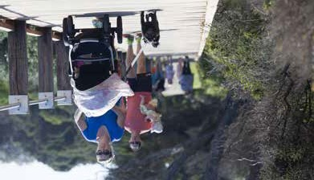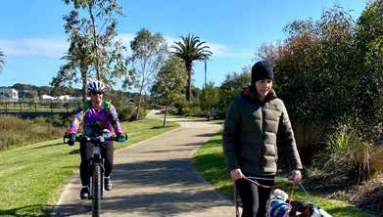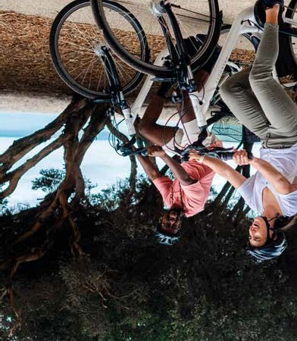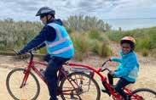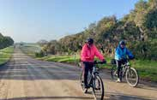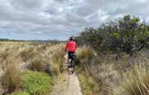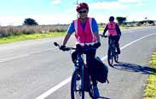of this map, things change and users must respond to the current situation. If you have feedback on the map or would like to request copies contact bellarinebug2@gmail.com.

Scan to access Bicycle Network’s website
Yellow - suited to less confident riders Orange - suited to more experienced riders White roads were ungraded.
- Drysdale to Ocean Grove - Grubb Rd, narrow shoulders
- Barwon Heads to Breamlea - Thirteen Beach Rd
60-80 kph, no shoulders then shared trail to Breamlea Rd

Sealed road: less confident riders

Local tracks

Public Toilets

Lighthouse

Scenic views
To Geelong
To Docklands
Port Phillip Bay

LEGEND
Sealed road: more experienced riders
Hilly
Water fountain
Parking
4 2
Cafes/shops ⁶

Unsealed roads Shared off-road trails
Ferry Terminal
Tourist info centre #
Places of interest
Parks & nature reserves
Point Richards Flora and Fauna Reserve
Wetlands
5
S.S Nash Reserve
Portarlington Pony Club

NORTH

Point Henry

PLACES OF INTEREST
1 Bellarine Rail Trail
6 Portarlington Pier & Harbour
10 Queenscliff Pier

PORTARLINGTON ²

2 Bellarine Coastal Trail
7 St Leonards Pier
11 Queenscliff Observation Tower

GEELONG

Stingaree Bay
3 Tourist Railway
4 Bayside Miniature Railway
5 Portarlington Rotunda
8 Swan Bay Jetty
9 Queenscliff Marina
12 Tourist Railway
13 Pt Lonsdale Promenade & Deck

The Dell Boardwalk
Beacon Point Road Track

Beacon Point Reserve

CLIFTON SPRINGS

BELLARINE
INDENTED HEAD
Ozone Shipwreck

Batman Memorial
ESPLANADE

2

Ervin Reserve

1
Grinter Reserve

Moolap Reserve

Leopold

Railway Reserve

1

CURLEWIS

Jetty Road Reserve

Drysdale Recreation Reserve

Lake Lorne 3
Reserve

Drysdale Playground Reserve

DRYSDALE

7
St Leonards
ST LEONARDS Lake Reserve

Memorial Fred Cook

Gateway Sanctuary
Park
Reserve
2

LEOPOLD
Daisley 1
Reserve

Reedy Lake
Lake Connewarre Lookout
Lake Connewarre

Wallington Reserve

WALLINGTON

Murrk Ngubitj Yarram Yaluk

MARCUS HILL

MANNERIM

8

Swan Bay

Two Bays Lookout
Edwards Point Reserve

Ocean Grove Nature Reserve

Arthur Powell

1

Kingston Park Recreation Reserve

Swan Island

QUEENSCLIFF

Barwon River
Reserve
Shell Road Reserve
Ocean Grove Memorial Reserve
Begola
RD
Collendina
12 9 11
10
To Sorrento

Barwon Heads Community Park
Wetlands

OCEAN GROVE
Reserve
Buckley Park Foreshore Reserve

Lake Victoria

POINT
1

Point Lonsdale Foreshore Reserve
Queenscliff Foreshore Reserve
Queenscliff White Lighthouse and Lookout

13th Beach Lookout

BARWON HEADS

Point Lonsdale Ganes Reserve
13TH B

LONSDALE
13
Rip View Lookout
Point Lonsdale Pier & Lighthouse

Breamlea Recreation Reserve

BREAMLEA
Barwon Heads Bluff

Whilst all care has been taken in the preparation of this document we recognise that it will become out of date and users must always consider their surroundings.

Ocean View Lookout
The Rip

SCALE
0 2 km

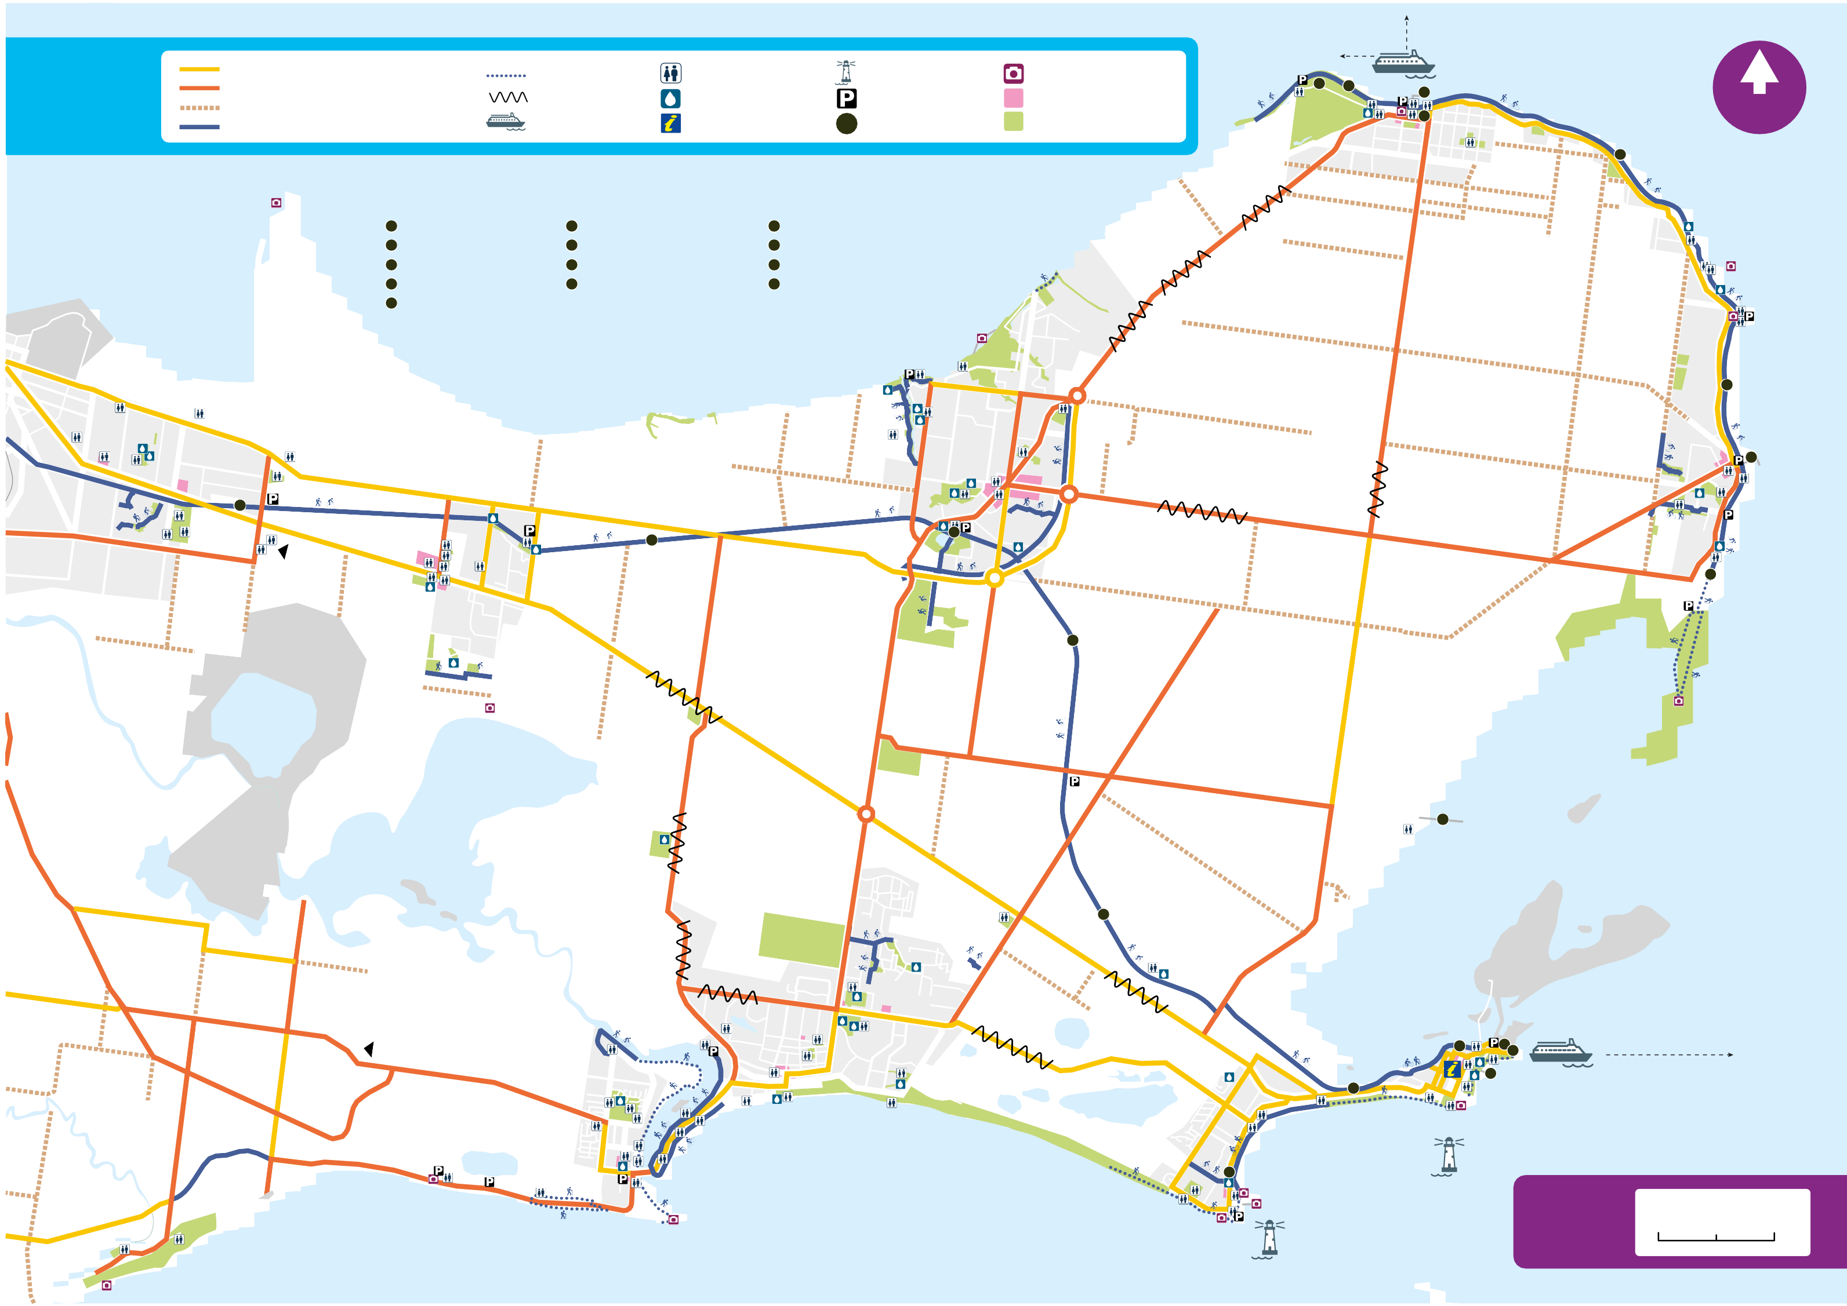Breamlea Lookout

