

minutes

PLANNING COMMITTEE MEETING
No. 226

Thursday 10 November 2022
City Hall, Little Malop Street, Geelong

ALSO LIVE STREAMED ON THE CITY’S WEBSITE:

www.geelongaustralia.com.au/meetings

PANEL:

Cr Grzybek, Chair
Cr Asher
Cr Mason
Cr Murrihy
Cr Nelson
Cr Sullivan

PRESENT

Present:

Cr Grzybek, Chair
Cr Asher
Cr Mason
Cr Murrihy
Cr Nelson
Cr Sullivan

Also Present:

Joanne van Slageren, Manager City Development
John Rush, Coordinator Statutory Planning
Tim Webb, Team Leader Statutory Planning
Erin Jones, Principal Planner Statutory Planning

Opening: The Chair declared the meeting open at 5.30pm

1. PROCEDURAL MATTERS

Acknowledgement Of Country

The Committee acknowledges the Wadawurrung People as the Traditional Owners of the Land, Waterways and Skies. We pay our respects to their Elders, past and present. We Acknowledge all Aboriginal and Torres Strait Islander people who are part of our Greater Geelong community today.

1.2. Introduce The Panel Members

1.3. Apologies

Cr Harwood
Cr Mansfield

1.4. Declarations Of Conflicts Of Interest

Nil

1.5. Confirmation Of Minutes

Moved: Cr Sullivan Seconded: Cr Asher

That the Minutes of the Planning Committee Meeting held on 27 October 2022
be confirmed.

CARRIED

2. MATTER FOR CONSIDERATION

Application Number: | PP-1459-2018
Applicant’s Name: | Tract Consultants Pty Ltd
Address/Title Details: | 65-105 Lings Road, CONNEWARRE
Proposal: | Use and Development of the Land for a Restaurant, Function Centre and Outdoor Recreation Facility (Children's Farm)
Date Received: | 14-Dec-2018
Date Report Prepared: | 12-Sep-2022
Was a site inspection done? | Yes
Zone/Overlays: | Farming Zone
Listed Buildings | Nil
Current Use/Development: | Dwelling
Proposed Use/Development | Use and Development of the Land for a Restaurant, Function Centre and Outdoor Recreation Facility (Children's Farm)
Date(s) of Plans Under Assessment | - 28-Jul-2022 – Site Plan  - 15-Jun-2020 – Revised Plans etc

Summary
- The subject site is located on the east side of Lings Road approximately 500m south of Barwon Heads Road. It compromises two lots known as 65-101 Lings Road, Connewarre and is irregular in shape. It has a frontage to Lings Road of 602m and has an overall area of approximately 22 hectares.
- The subject site is zoned Farming Zone and is not subject to any overlays. The two parcels of land are the only parcels zoned Farming Zone within the immediate vicinity.
- The site is currently developed with a dwelling and associated outbuildings. The site is not used for any agricultural activities.
- The application proposes the use and development of a restaurant, children’s farm and garden and a function centre.
- The function centre is proposed to be located in the existing machinery shed. The shed will be modified to accommodate the use of the function centre. The function centre seeks the operating hours of 6pm – 12 midnight on Thursday through Sunday with a maximum patronage of 200 people.
- The proposed restaurant is to be located in the existing shearing shed. It is proposed to have operating hours of 7am - 4pm and is seeking to operate 7 days a week with a total capacity of 80 patrons.
- The application has undertaken public notification three (3) times. The first occasion included signs on site and letters to adjoining residences. The two (2) additional times included letters to objectors and letters to adjoining residences.
- After the public notice periods a total of 150 objections were received. Subsequently the application was amended to reduce the proposed uses. The uses proposed are what is hereby being considered.
- In terms of planning policy the application was assessed against the provisions of the Farming Zone, and relevant State and Local planning policy contained within this report, and Clauses 52.06 – Car parking and 52.34 Bicycle Facilities.
- Overall, based on the assessment it is respectfully recommended that the application be supported subject to conditions and a Notice of Decision to Grant a Permit be issued in accordance with these conditions.

Alternate Recommendation
Moved: Cr Sullivan Seconded: Cr Mason

That the Responsible Authority having considered all matters which the Planning and Environment Act 1987, requires it to consider decides to Refuse to Grant a Planning Permit for the Use and Development of the Land for a Restaurant, Function Centre and Outdoor Recreation Facility (Children's Farm), at 65-105 Lings Road, Connewarre, on the following grounds:

- The proposed development does not comply with the Municipal Planning Strategy, particularly;
  - Clause 02.03-1 (Settlement) in that it:
    - Does not maintain the unique township, landscape, tourism, farming and environmental values of the Bellarine Peninsula.
    - Creates inconsistencies with the Settlement Boundary of Barwon Heads.
  - Clause 02.03-2 (Environmental and landscape values) as inadequate detail has been provided to show how potential environmental impacts on the Lagoon and how this will be sufficiently mitigated.
  - Clause 02.03-4 (Natural resource management) in that the proposal for non-agricultural uses is contrary to the purpose of the rural zone and vision for the area.
- The proposal does not comply with the Planning Policy Framework, particularly:
  - Clause 11.03-5S (Distinctive areas and landscapes) in that it:
    - Undermines the long-term natural or non-urban use of land.
  - Clause 11.03-6L-01 (The Bellarine Peninsula) in that it:
    - Compromises the rural and landscape value of the non-urban break; and,
    - Is not in accordance with the relevant Barwon Heads Structure Plan Map on the basis that it is outside the settlement boundary and in an area seeking to protect resource and scenic values.
  - Clause 17.04-1L-02 (Tourism in Rural Areas) in that it:
    - Is not sufficiently associated with an agricultural activity on the land,
    - The site is not on an identified tourist route.
  - Clause 18.02-4S (Roads) in that the increase in traffic on Lings Road creates potential safety issues for traffic at the intersection with Barwon Heads Road.
- The proposal does not comply with the objectives and policies of the Farming Zone (Clause 35.07) in that it:
  - Compromises the agricultural productivity of the land and would not be associated with an agricultural use on the land,
  - Is not compatible with adjoining and nearby land uses,
  - Results in potential detrimental environmental impacts to the Lagoon.

- The proposal does not comply with the Bellarine Peninsula Localised Planning Statement Sept 2015, in particular the proposal:
  - Compromises the rural character of the location,
  - Results in potential detrimental environmental impacts to the Lagoon.
- The proposal does not comply with Clause 65 (Decision Guidelines) of the Greater Geelong Planning Scheme in that:
  - The proposed uses and the development are not in accordance with the orderly and proper planning of the area
  - The proposed use will detrimentally affect the environment of the area, in particular the health of the Lagoon and protection of flora and fauna
  - The proposed use will detrimentally affect the amenity of the area, in particular the proposal would create unreasonable amenity impacts to the adjoining properties due to noise, evening/night operating hours, light spill, and vehicle movements on Lings Road

CARRIED

DELEGATE REPORT

PERMIT TRIGGER:

A planning permit is triggered for this application pursuant to the following clauses of the Greater Geelong Planning Scheme:
- Pursuant to Clause 35.07-1 of the Farming Zone a permit is required to use land for the purpose of a place of assembly and a restaurant.
- Pursuant to Clause 32.07-4 of the Farming Zone a permit is required to construct a building or carry out or works associated with a use in Section 2 of Clause 35.07-1.
- Pursuant to Clause 52.34-2 of the Bicycle Facilities Particular Provision a permit is required to vary, reduce or waive any requirement of Clause 52.34-5.
The application does include use of the land as a licensed premises, which would require a planning permit if sought.

DEFINITIONS

Pursuant to Clause 73.03 of the Planning Scheme a function centre is defined as:
- Land used, by arrangement, to cater for conferences, private functions, and in which food and drink may be served. It may include entertainment and dancing.
Pursuant to Clause 73.03 of the Planning Scheme a restaurant is defined as:
- Land used to prepare and sell food and drink, for consumption on the premises. It may include:
  - entertainment and dancing; and
  - the supply of liquor other than in association with the serving of meals, provided that tables and chairs are set out for at least 75% of patrons present on the premises at any one time.
It does not include the sale of packaged liquor.

Pursuant to Clause 73.03 of the Planning Scheme an outdoor recreation facility is defined as:
- Land used for outdoor leisure, recreation, or sport. It does not include an Open sports ground or Informal outdoor recreation.
Pursuant to Clause 73.04-10 of the Planning Scheme a function centre is nested in the Place of assembly group.

Pursuant to Clause 73.04-11 of the Planning Scheme a restaurant is nested in the Retail Premises group.

Pursuant to Clause 73.04-6 of the Planning Scheme an outdoor recreation facility is nested in the Leisure and recreation group.

RESTRICTIVE COVENANT OR SECTION 173 AGREEMENT:

The subject site is not burdened by a Restrictive Covenant or Section 173 Agreement.

OFFICER DIRECT OR INDIRECT INTEREST:

No Council officers have any direct or indirect interest in the matter to which this report relates, in accordance with Section 130(2) of the Local Government Act.

SITE/LOCALITY:

The subject site is located on the east side of Lings Road approximately 500m south of Barwon Heads Road. It comprises of two lots known as 65-101 Lings Road, Connewarre and is irregular in shape. It has a frontage to Lings Road of 602m and has an overall area of approximately 22 hectares.

The northernmost lot is currently vacant containing only boundary vegetation, the southern lot contains an existing dwelling and associated outbuildings. It also has planning approval for a replacement dwelling. The replacement dwelling does not form part of this proposal.

The site is not used for any significant agricultural uses and is more akin to a rural living use.

The southern boundary of the site adjoins Murtnaghurt Lagoon which is an area of conservation value and is covered by the Public Conservation and Resource Zone and the Environmental Significance Overlay – Schedule 2.

On the western side of Lings Road is the 13th Beach Resort which contains dwellings and a golf course with associated club facilities. The club house contains a restaurant and function spaces. The liquor licence for the club house allows for the sale and consumption of liquor to 1am Monday – Saturday (apart from Good Friday and ANZAC Day which is 11pm) and 11pm Sunday. The residential estates associated with the resort contain 255 lots. No access is provided to the estate or golf course from Lings Road. The land is zoned Comprehensive Development Zone – Schedule 1 and is partially covered by a Bushfire Management Overlay.

The other adjoining properties to the north and the east of the site are also zoned Comprehensive Development Zone – Schedule 1. Whilst currently vacant, the land is identified for future expansion of the 13th Beach Golf Links course. It is not identified for any residential, accommodation or commercial uses.

Lings Road is the only access to the subject site; it is an unsealed road and at present is not highly trafficable. The only access to Lings Road is provided from Barwon Heads Road.

The subject site is zoned Farming Zone and is not subject to any overlays. The two parcels of land are the only parcels zoned Farming Zone in the immediate vicinity. This is shown in the image below.
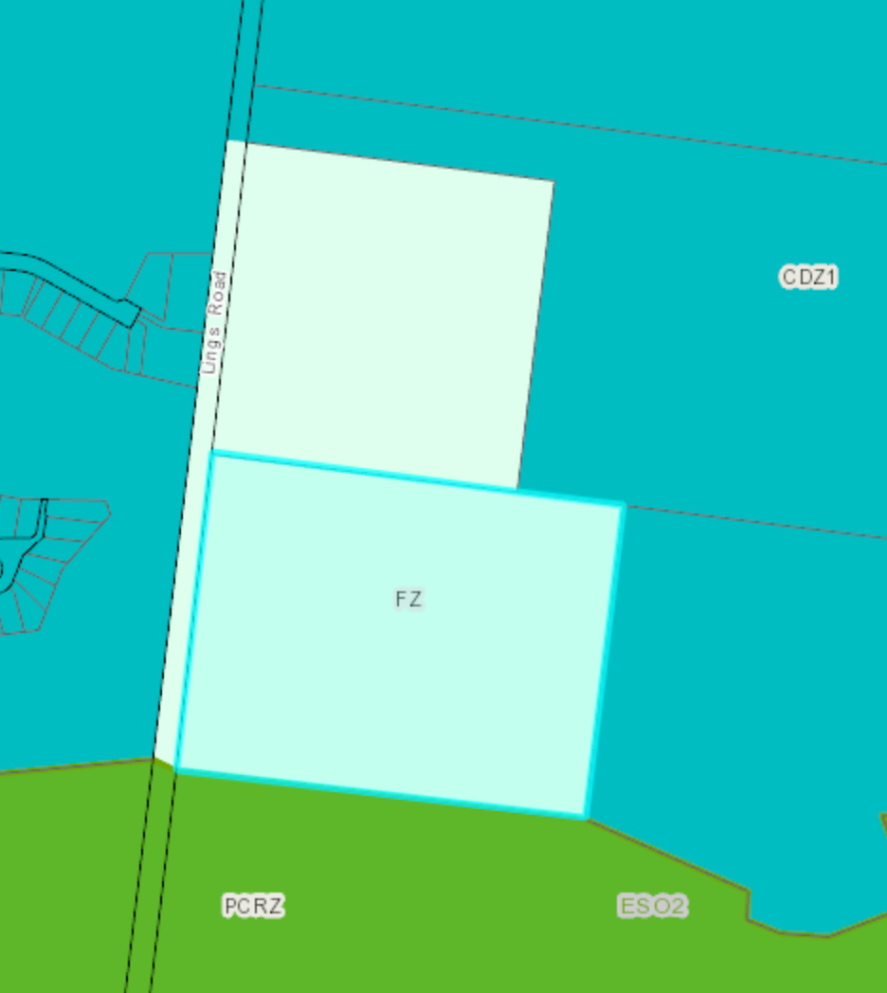

PROPOSAL:

The application proposes the Use and Development of the Land for a Restaurant, Function Centre and Outdoor Recreation Facility (Children's Farm)

The restaurant and function centre uses will be predominately accommodated within existing buildings on site consisting of the existing machinery and shearing shed. Some minor extensions will be undertaken to these buildings to accommodate the uses These buildings are all located along the western boundary of the site, being the frontage to Lings Road.

The function centre is proposed to be located in the existing machinery shed. The shed will be modified to accommodate the use. The application seeks the operating hours for the function centre of 6pm – 12am Thursday -Sunday with a maximum patronage of 200 people.

The works proposed to the machinery shed include recladding the shed in hardwood and installation of a set of double sliding barn doors within the eastern elevation to provide access to forecourt. It is also proposed to install operable timber panels along the southern façade to accommodate the servery.
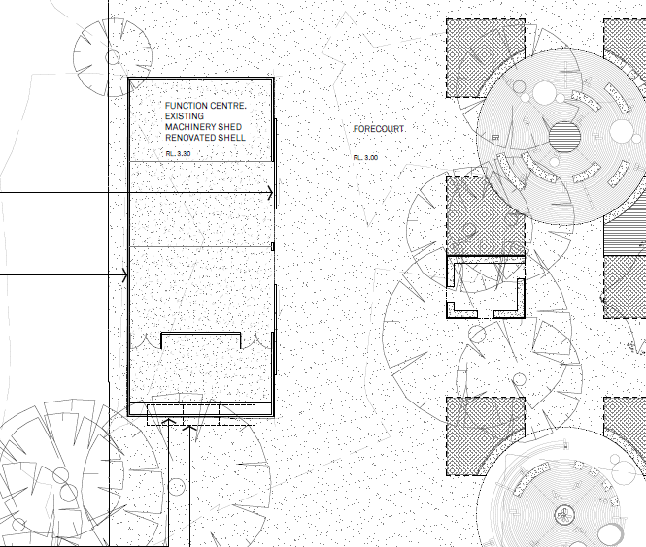

The proposed restaurant is to be located in the existing shearing shed. It is proposed to have operating hours of 7am -4pm 7 days a week with a total capacity of 80 patrons.

The proposed works to the shed include an extension to the eastern side incorporating an open timber deck and to the south incorporating an additional seating area. The extension to the south is to be constructed from glass and steel.

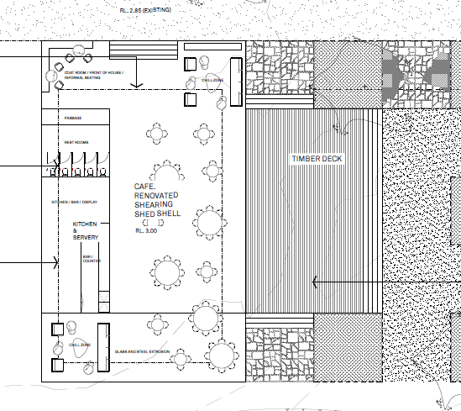

In summary the proposed operating hours across the site are as follows:
- Restaurant : 7am - 4pm Monday – Sunday
- Function Centre: 6pm – Midnight Thursday - Sunday
It is not proposed that the restaurant and function centre will operate at the same time.
Therefore, the maximum patrons on site at any one time is proposed to be 200 people.

The applicant has also indicated that they will be using the dwelling on site for a bed and breakfast. This is an as of right use under the zone and no planning permission is required.

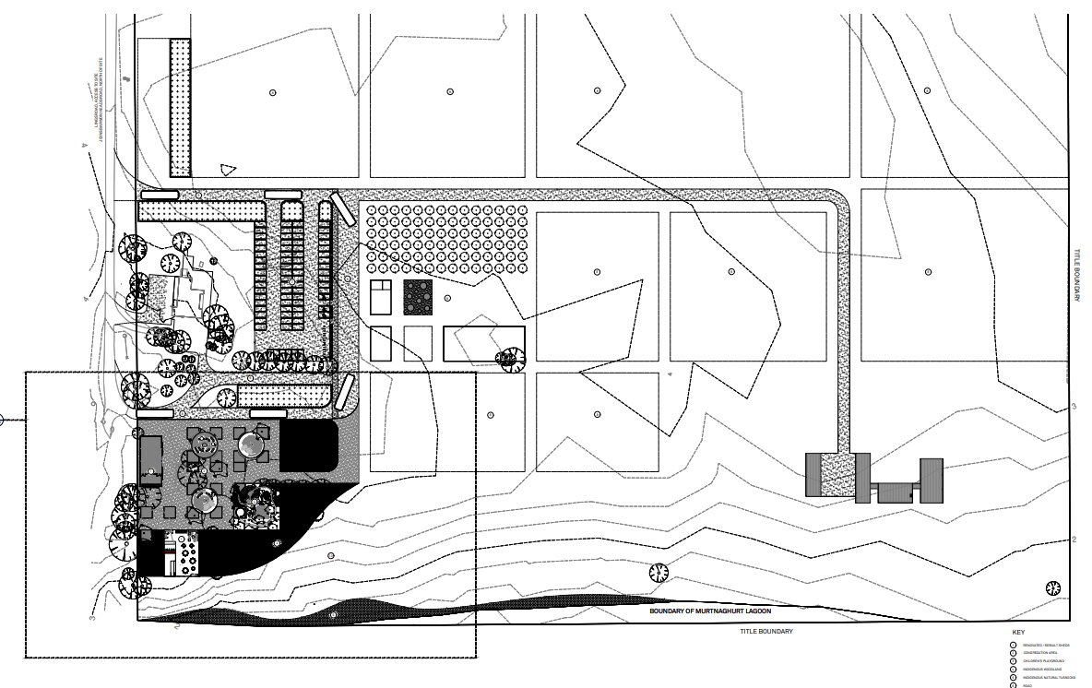
The above site plan shows the overall use of the site. As shown above the use is largely contained to the existing buildings on site.
The proposed children’s farm is located to the east of the car park. This will be utilised during the operating hours of the restaurant from 9am – 4pm with a maximum of 40 patrons.

PERMIT/SITE HISTORY:

PP-1196-2019 - Replacement Dwelling – Approved

REFERRALS:

The following referrals were undertaken:

Authority: | DELWP (and Parks Victoria)
Response: | Thank you for your correspondence dated 25 June 2020 and received on 2 July 2020, forwarding revised plans and reports in respect of the above-described planning permit application.  The Department of Environment, Land, Water and Planning (DELWP) has received notice of the above application in accordance with Section 52 (1)(a) of the Planning and Environment Act 1987. DELWP acts for the Minister for Energy, Environment and Climate Change in her role as land owner of Crown land to the south of the site (Crown Allotment S, Section 23, Parish of Connewarre; P141579), comprising the Murtnaghurt Lagoon component of the Lake Connewarre Wildlife Reserve.  The Crown land is managed by Parks Victoria, and this letter incorporates its views. In particular, DELWP has reviewed the following documents as relevant to our previous correspondence on this application: • Biodiversity Assessment, 65-105 Lings Road, Connewarre, Victoria, prepared by Ecolink Consulting, (May 2020) • Revised Plan Set, “Barwon Heads Farm – Landscape and Building Drawings”, Rev 3, prepared by Barber (May 2020) • Surface Water Management Strategy for Barwon Heads Farm, prepared by Water Technology (2 June 2020) Permit requirement/s and considerations The application has been reviewed in consideration of the following permit requirement/s and planning scheme considerations in the Greater Geelong Planning Scheme relevant to DELWP’s interests: • Clause 12.01-1S – Protection of biodiversity • Clause 21.05-2 – Waterways  Clause 35.07 and the Schedule to Clause 35.07 – The possibility that the application incorporates earthworks which change the rate of flow or the discharge point of water across a property boundary • Clause 56.07-4 – Stormwater management Commentary The revised application documents have been prepared in response to DELWP’s letter objecting to the grant of a permit (4 September 2019) and previous discussions and meetings.  DELWP appreciates that the applicant has proposed significant changes to the extent of built form and provided further advice and clarity in respect of matters identified in our objection, to allay those concerns very substantially. In particular,  I note that the Water Technology report’s assessment finds, that as amended, and including the increased extent of swale drains, the development Promotes stormwater infiltration across the site, allows a diffuse inflow of surface water into the Murtnagurt Lagoon reserve to the south, and has sought to mimic pre-development surface water flow patterns, and reduce the risk of creation of point ground and surface water inflows. In relation to the potential for noise and light impacts on wildlife using the adjoining Murtnagurt Lagoon reserve, the Ecolink Consulting report includes a number of recommendations as to stormwater management, preparation of a Construction Environment Management Plan, suitable monitoring of wildlife during tree felling, and lighting and sound minimisation measures. The recommendations are scattered in the report, and the project would benefit from preparation of a consolidated list. Response In consideration of the various amendments to the application scope and design, and inclusion of clearer detail, I confirm that DELWP withdraws the objection as document in our letter of 4 September 2019. I confirm that DELWP does not object to the issue of a permit and recommends that Council includes the following conditions in the planning permit: 1. That all recommended actions set out in the report Biodiversity Assessment, 65-105 Lings Road, Connewarre, Victoria, prepared by Ecolink Consulting, (May 2020) are implemented to the satisfaction of the responsible authority. I also confirm that DELWP is available and would appreciate the opportunity to be consulted in relation to preparation of the Construction Environment Management Plan, and any revised or detailed plans prepared in connection with this condition.
Officer Comment:
The support of DELWP is noted and the recommended conditions will be included on any permit issued.

Authority: | Vic Roads
Response: | I refer to the application for Planning Permit PP-1459-2018 and my previous response letter dated 31/08/2020 objecting to the granting of a permit.  The Barwon Heads Road/Lings Road intersection works proposed in the application documents submitted on 12/06/2020 were not considered adequate to mitigate the increased crash risk that would result from the additional traffic generated by the development. Since then, the applicant has provided an upgraded intersection treatment which would more satisfactorily mitigate the crash risk. On this basis the Head, Transport for Victoria will withdraw its objection to the proposal. Therefore, I wish to withdraw the response dated 31/08/2020 and replace it with the following response. The Head, Transport for Victoria has considered this application and does not object to the granting of a permit subject to the following conditions: 1. Before the use commences, the following roadworks at the Barwon Heads Road/Lings Road intersection must be completed to the satisfaction of and at no cost to the Head, Transport for Victoria: i. Construction of a right turn lane on Barwon Heads Road; ii. Construction of a rural basic left-turn treatment (BAL) on Barwon Heads Road; iii. Installation of street lighting; iv. Vegetation removal to achieve satisfactory intersection sight lines. Page 2 of 2 2. Before the development starts, a functional layout plan of the Barwon Heads Road/Lings Road intersection works must be prepared to the satisfaction of the Head, Transport for Victoria. 3. Prior to the start of any works within the Barwon Heads Road reserve, the applicant must enter into a Works Agreement with The Head, Transport for Victoria which will include the processes for the approval of designs and works, fees and charges, maintenance arrangements and the level of service obligations of the Head, Transport for Victoria.
Officer Comment:
The support of VicRoads is noted and the recommended conditions will be included on any permit issued.
Authority: | CCMA
Response: | In the Authority’s previous response, the Authority estimated a flood level for the site of 1.5 metres AHD which was obtained from interpolation of the flood Data Transfer Project (DSE, 2000) with new Lidar survey data. Water Technology have since completed a Stormwater Management Plan for the site, which was provided with the application. They have set a conservative 1% AEP flood level of 2.25 metres AHD for the site, based on the flood level on the Barwon River side of the Plummer bank levee. According to the plans provided, the café / kitchen (converted shearing shed) will have a finished floor level of 3.0 metres AHD and the function centre (converted machinery shed) will have a finished floor level of 3.3 metres AHD. The Authority notes the Surface Water Management Strategy for Barwon Heads Farm has provided a considered design for the protection of Murtanghurt Lagoon from the development’s stormwater. It is noted that the proposed kitchen / café / rest room (converted shearing shed) is situated less than 100 metres from Murtnaghurt Lagoon. It is understood that effluent disposal will be via the reticulated sewer system and therefore is not expected to impact on the lagoon. In light of the above information and pursuant to Section 56 of the Planning and Environment Act 1987, the Authority does not object, and recommends the following conditions: 1. The finished floor level of the proposed kitchen / cafe and function centre must be no lower than 2.55 metres to Australian Height Datum (AHD). (300 mm above the flood level). 2. No loss of floodplain storage associated with any works associated with the development, including drains and WSUD related infrastructure are to occur. Where possible, all infrastructure shall be placed on land at or above 2.25m AHD. 3. Prior to works commencing, a Construction Environment Management Plan is provided to and endorsed by the Responsible Authority. Please note: Murtnaghurt Lagoon is a designated waterway under the Water Act, 1989. As such, a Works on Waterways Permit will be required from the Corangamite CMA for any stormwater outfalls connected to the lagoon. This permit process is required under the Water Act 1989 and is independent of the planning permit process (under the Planning and Environment Act 1987) and it is the responsibility of the person or persons proposing to undertake the works to obtain a works on waterway permit. A Construction Environment Management Plan will need to be supplied as part of the application. Please note: given the proximity to Ramsar, the appropriate referral authority should be contacted to discuss suitability of this development.
Officer Comment:
The support of the CCMA is noted and the recommended conditions will be included on any permit issued.

INTERNAL

Department: | Engineering Services
Response: | The comments summarised are as follows:  The intensified farming at the location will likely result in increased nutrients entering Murtnaghurt Lagoon. The Stormwater management plan proposes swales to convey and treat water. The increased developed area in the stormwater plan is not reflective of the proposed plans developed area which needs to be clarified. The concentrated uses proposed swales need to be at a grade which will prevent waterlogging and/or have stagnant pooling. A copy of the MUSIC model is required to assess the WSUD efficiency.  The recommendation is for Lings Road to be upgraded to meet the proposed uses. The modelled increased traffic volumes may cause safety issues and community complaints.  The traffic and planning report were quiet on the impacts of increased traffic on Lings Road and the proposed option of increased maintenance via grading is an unsuitable long term option.  The increased traffic generated by the proposal to over 300 vehicles/day will require Lings Road to be upgraded.  Additionally, the properties to the west of Lings have alternate access arrangements and will be impacted by the increased usage of the road created by the proposal.  A 6.2m sealed road for Rural access as described in the IDM (Development Manual section 12 Table 6 and shown in SD (Standard Drawing) 600 is required to be constructed.  Sealed vehicle crossovers to serve the new uses will be required (see below Construction of Lings Road)  Recommended conditions:  Drainage:  The site shall be drained to the satisfaction of the responsible authority and no sullage, sewerage or polluted drainage shall drain or discharge from the land to adjoining properties.  Storm water is to be discharged as un-concentrated flow.  Note:  1. All internal property drainage must be designed and constructed to satisfy AS/NZS 3500  Access:  Prior to the new uses commencing, the developer must:  - Construct vehicular crossings in accordance with the requirements and standards of the City of Greater Geelong.  all to the satisfaction of the Responsible Authority.  Note:  1. Vehicle Crossing Permit must be obtained prior to commencement of works.  Car Parking  - Prior to the new uses commencing, the developer must construct the car park including accessways, surface with an all-weather material with the exception of disabled car parks which must be concrete and mark the carparks and accessways in accordance with the endorsed plans to the satisfaction of the Responsible Authority.  Water Quality  - Unless otherwise approved in writing by the Responsible Authority, site runoff must be discharged as unconcentrated flows with no resulting erosion, sediment deposit or other negative effects on Murtnaghurt Lagoon.  - Unless otherwise approved in writing by the Responsible Authority, the stormwater drainage system on the site must be designed, constructed and maintained such that stormwater runoff exiting the land exceeds the current best practice performance objectives for stormwater quality as follows:  - 80% retention of the typical annual load of suspended solids;  - 45% retention of the typical annual load of total phosphorous;  - 45% retention of the typical annual load of total nitrogen; and;  - 99% retention of the typical annual load of gross pollutants.  Construction of Lings Road  - Unless otherwise approved in writing by the Responsible Authority, Prior to the commencement of use the developer shall submit to Council for approval engineering construction plans for new Council assets, prepared by a suitably qualified and experienced professional and at the developer’s expense. The plans should detail the construction of Lings Road as a Rural Access road. The submitted plans must show, but are not limited to:  - A 6.2 meter sealed surface, road crossings and swale drains.  - Typical sections for the road construction, finished and existing surface levels, any required drainage construction and any other works required in respect to other services located within the road;  - The design and construction of the roadworks and any other new Council infrastructure which must be approved and supervised by Council.  - Unless otherwise approved in writing by the Responsible Authority, when the maximum vehicles per day exceeds 150 or buses begin using Lings Road, the developer must:  - Complete Lings Road construction in accordance with the approved plans;  - Make payment equivalent to 3.25% of the cost of the works, to be paid to Council for the checking and supervision of these works;  - Submit a maintenance bond of 5% of the cost of the works, to be paid to Council and returned after successful completion of a twelve month maintenance period;  - Provide to Council ‘as-built’ Engineering plans in PDF, and GIS-ready AutoCAD (DXF) format plans, to the satisfaction of the Responsible Authority.  all to the satisfaction of the Responsible Authority.  DRAINAGE NOTES  Flooding  While a detailed flood assessment has not yet been finalised and endorsed by Council, it is known that the property is in an area subject to flooding and predicted sea inundation. It is strongly recommended that the applicant contact Council’s Engineering Department and seek best available information and recommended minimum finished floor level for habitable floors, to be constructed with 300mm freeboard above the modelled flood level.  NOTE  A pre-commencement meeting with Council’s engineering department is required to be undertaken prior to works starting. To organise this meeting please contact 5272 4426
Officer Comment:
Generally the suggested conditions will be included in the permit, should one be issued.

Department: | Environment
Response: | Environment has reviewed the second round of revised information and does not support the application, as it fails to demonstrate impacts to Murtnaghurt Lagoon can be sufficiently avoided by the proposal. These impacts largely relate to proximity of the development to the Lagoon, increased noise/light and increased freshwater volumes entering the lagoon, these are explored in greater detail below. If amended plans are provided that address these concerns, the recommendation from Environment may change to support the application.  Background information  Murtnaghurt Lagoon is listed under the Ramsar Convention as a wetland of international significance, as part of the Port Phillip Bay (Western Shoreline) and Bellarine Peninsula Ramsar Complex. The environmental values of the Lagoon are well documented, as are impacts from surrounding land use that may adversely affect or change the wetland composition and structure. This information was explored in detail in the C375 amendment, in particular through a 2008 Ecology Australia submitted at this time, available here (https://www.geelongaustralia.com.au/common/public/documents/amendments/8d56887c2c4a98e-C375-JeffCranstonandAssociates-EcologyAustralia2008report%28D18-327505%29.PDF)  The lagoon is managed by Parks Victoria and is subject to a management plan that has the primary purpose of maintaining the ecological character and promoting wise use of the site. Wise use is defined by the RAMSAR convention as ‘the maintenance of their ecological character, achieved through the implementation of ecosystem approaches, within the context of sustainable development’.  The Environment unit has previously raised concerns with the applicant relating to acoustic/light impacts to nearby waterbird habitat as well as localised increases in freshwater pulses to the Lagoon. We also requested changes to the overall layout including relocating areas of concentrated activity (such as the proposed playground location) further away from the water’s edge, an increase to the width and density of buffer landscaping to the water’s edge and recommended that the entire proposal be set back as far as feasible from the Lagoon. These concerns have not been addressed in the revised design.  Noise & Light  A change in land use this close to the Lagoon will result in significant increases to average background noise levels, as demonstrated in the Environmental Noise Assessment submitted in support of the application. This assessment focusses on potential impacts to nearby dwellings only and does not consider increased noise impacting on birds or other fauna in the Lagoon.  Potential impacts from noise on shorebirds is identified as unclear in the Ecolink report, though they do note that increased noise levels can decrease foraging success of some bird species. They recommend noise baffling measures may be appropriate between the proposal and the Lagoon.  Such measures are not included in the plans, though this may be achieved by the installation of adequate landscaping areas.  Measures to baffle light are easier to achieve and have been conditioned below.  Landscape  The landscape buffer shown in the plans is inadequate for the protection/screening of the lagoon. A recommended permit condition is included below to address this concern.  Stormwater  Increases to, or the concentration to a point source, of stormwater discharge from the proposal will likely result in a localised change to ecological character of Murtnaghurt Lagoon. This is evident elsewhere in the lagoon where increases to freshwater runoff are entering the water body, in particular an area to the south west of the proposal where water is discharged from the 13th Beach Golf Course. In this location freshwater species (notably Phragmites) are expanding into the reserve and outcompeting the salt tolerant species previously present. This can be seen on Near Map imagery and has the potential to be replicated here.  Additionally, there appears to be some inconsistencies between the areas of hardstand modelled in the Water Technology report and the Revised Plans set. This may have implication of the modelling within the report.  The applicant should also examine the effects of sea level rise on the location of the proposal, particularly the location of the stormwater discharge junction.  Environment does not have confidence that environmental impacts downstream have been sufficiently mitigated by the proposal to date but are willing to work with the applicant to ensure that any design changes made as a result of these comments are adequate.  Recommend permit conditions  Notification of permit conditions  Before works start, the permit holder must advise all persons undertaking the vegetation removal or works on site of all relevant permit conditions and associated statutory requirements or approvals.  No grazing on native vegetation to be protected or the landscape buffer planted is permitted (unless permitted by a Management Plan approved by the Responsible Authority) to the satisfaction of the Responsible Authority.  Water run-off must be designed to ensure that native vegetation to be protected is not compromised, to the satisfaction of the Responsible Authority.  Pest Plant and Animal Management Plan  Prior to the commencement of works, a Weed Management Plan must be submitted to and approved by the Responsible Authority. When approved this Weed Management Plan will form part of this permit. The plan must detail:  - Species and extent of weed infestation.  - Location and number of pest animals located on the subject land.  - Current and/or proposed treatment methods.  - Timeframes.  - any other relevant information  The approved weed management plan must be implemented to the satisfaction of the Council’s Environment Unit. Any non-compliance identified by the Responsible Authority must be rectified immediately at no cost to Council.  Fauna Protection  Prior to the removal or lopping of any tree, the tree must be examined by a suitably qualified zoologist with relevant permits. If native fauna species are located, they must be salvaged and relocated to the closest suitable vegetation.  No plant or machinery is permitted to be used within 100m of Murtnaghurt Lagoon in the peak period for migratory waterbirds, this period to be defined and agreed in writing with the responsible authority.  Construction Environmental Management Plan  Prior to works commencing a Construction Environmental Management Plan (CEMP) must be submitted to and approved by the Responsible Authority. When approved this Construction Environmental Management Plan will form part of this permit. This plan must incorporate, but is not limited to, the following information:  - Control of site emissions during construction and the defects liability period to the satisfaction of the Responsible Authority.  - Measures to be taken to ensure that no polluted water and/or sediment laden runoff is to be discharged directly or indirectly into stormwater drains, natural water bodies or watercourses during the construction period.  - Be prepared in accordance with the EPA – Guideline for Environmental Management, Doing it Right on Subdivisions, Publication 960, September 2004 and CCF Environmental Guidelines for Civil Construction, 2010.  - Measures to control weeds and prevent the spread of weeds or weed contaminated materials.  - No go zones.  - Site compound and parking areas.  - Hours of work, and periods where plant and machinery cannot operate within the nominated waterbird buffer.  - Environmental Site induction requirements for all staff working onsite.  All development and works must be carried out in accordance with the Construction Management Plan, to the satisfaction of the Responsible Authority. Any non-compliance identified by the Responsible Authority must be rectified immediately at no cost to Council.  Landscape Buffer Plans  Prior to works commencing, a Landscape Buffer Plan for the southern boundary of the subject land must be submitted to the satisfaction of the responsible authority. Once approved this plan will be endorsed and form part of the permit. The must include:  - The ultimate 1% and 10% Annual Exceedance Probability storm event extents;  - A detailed planting schedule and proposed planting layout of all areas of and adjoining open space, including proposed trees, shrubs, groundcovers and aquatic planting (if applicable, with zonation detail), and showing botanical names, common names, pot sizes, sizes at maturity, quantities and densities of each plant, at 6 plants per square metre;  - The removal of existing disused structures, foundations, pipelines, farm dams or stockpiles and the eradication of weeds;  - An appropriate width sufficient to baffle light and noise from the proposal to the Lagoon.  Species selection must refer to the Ecological Vegetation Class (EVC) 858 – Coastal Alkaline Scrub, which can be found here -  https://www.environment.vic.gov.au/__data/assets/pdf_file/0031/48739/OtP_EVCs_combined.pdf  Species selection must not include species listed on the City of Greater Geelong Environmental Weeds list which can be found here https://www.geelongaustralia.com.au/weeds/documents/item/8d164ca100efeda.aspx
Officer Comment:
The concerns of the Environment Department are noted. However given the support of DELWP and the proposed recommended conditions it is considered that the concerns can be addressed.
It is also considered that the concerns from Environment can be largely addressed through the recommended conditions.

Department: | Environmental Health
Response: | The main concern we have are for the neighbouring properties in western side in the Thirteenth Beach Golf Club. The closest residents are at located at 42 & 44 Second Drive and 25 Fourth Loop. These properties range from 20-80m from 62-105 Lings Rd. Our recommended conditions focus mainly on noise (patron, music, outdoor area, deliveries etc.), connecting to sewer, light and dust control for the build.  With a function centre operating from 6pm to midnight 4 days a week with 200 patrons, amplified music should not be permitted in any outdoor areas.  This site is located next to significant mosquito breeding areas; Murtnagurt Swamp, and to the North are the wetlands of Lake Connewarre. This area can be heavily impacted by mosquitoes even when all treatment controls take place. We mention this for the applicant so they are aware that they may need to consider this in design of outdoor areas and that during the Spring/Summer/Autumn seasons that patron comfort may be impacted.  Recommended Permit Conditions (Without Prejudice)  - All buildings onsite must be connected to reticulated sewerage.  - No music is to be audible outside of the premises  - Unless otherwise approved in writing by the Responsible Authority, there must be no amplified music provided in outdoor areas at the premises at any time other than between the hours of 11am to 8pm Monday – Sunday to the satisfaction of the Responsible Authority  - The outside areas are not to be used for patrons after 9pm Wednesday to Sunday and 11pm Thursday to Saturday  - As referenced in the provided Marshal Day Environmental Acoustic Report dated 19 June 2019, patron noise is not covered under any State Environment Policy (SEPP) or Guidelines. The recommended targets for patron noise at residential locations is as follows;  Day Period – 50dB L_{Aeq} or background noise (L_{A90}) + 10dB, whichever is higher  Evening Period – 45dB L_{Aeq} or background (L_{A90}) + 10dB, whichever is higher  Night Period – 40B L_{Aeq} or background(L_{A90}) + 5dB, whichever is higher  Period definitions:  Day: Weekdays 7am - 6pm; Saturdays 7am - 1pm; Sundays NA  Evening: Weekdays 6pm - 10pm; Saturdays 1pm - 10pm; Sundays 7am - 10pm  Night: All days 10pm - 7am  - A notice to the satisfaction of the Responsible Authority shall be fixed in a prominent position visible to all patrons as they leave the premises. The notice shall be clearly legible and draw attention to the requirements for considerate and quiet behaviour of patrons on departing from the premises.  - Bottles shall be bagged during operation times and shall not be emptied into any external refuse bins between the hours of 9pm and 9am.  - Waste collection must not occur between the hours of 8pm - 6.30am Monday to Saturday and 8pm – 9am Sunday and Public Holidays if there is only one collection per week. If there are two or more collections, waste collection must not occur between the hours of 8pm – 7am Monday – Saturday and 8pm – 9am Sunday and Public Holidays.  - All security alarms or similar devices installed on the land must be of a silent type in accordance with any current standard published by Standards Australia International Limited and be connected to a monitored security service.  - All deliveries to the property and truck movements offsite must be in adherence with the EPA Noise Control Guidelines (publication 1245) which are:  - 7am – 10pm Monday to Saturday  - 9am – 10pm Sundays and public holidays  - At the written request of the Responsible Authority, the permit holder must submit a report prepared by a suitably qualified acoustic engineer which assesses any impacts of patron noise and/or compliance with the relevant legislation to provide any necessary recommendations to achieve compliance where noncompliance is identified or address any other issues as appropriate. Any recommendations of the assessment deemed appropriate by the Responsible Authority must be implemented within a timeframe specified by the Responsible Authority.  - All external plant, air conditioning units and equipment must be acoustically treated or placed in soundproof housing to reduce noise to a level satisfactory to the Responsible Authority. Once final equipment selections have been confirmed, the noise assessment should be updated to confirm the suitability of mechanical plant selections and specification of any attenuation measures required.  - Prior to the occupation of the building and/or the commencement of the use, the works outlined in the “Barwon Heads farm, restaurant and function centre environmental noise assessment dated 9th June 2020”, must be carried out to the satisfaction of the Responsible Authority. A 2.5 m high fence around the northern and western extents of the outdoor area being constructed with a surface mass of at least 15 kg/m2 and be free from any gaps or openings.  - Dust control measures to prevent emissions that may cause nuisance to adjoining properties must be implemented to the satisfaction of the Responsible Authority. Such as but not limited to:  - Identifying potential sources of dust and airborne particulates and processes which may generate dust and airborne particulates; and implementing dust and airborne suppression measures, including (but not limited to) covering materials and/or applying a light water spray, applying sprays before or during turning, but also avoiding excessive water- logging of organic materials and runoff;  - cessation of some activities during windy days  - Outdoor lighting must be designed, baffled and located to the satisfaction of the Responsible Authority to prevent any adverse effect on adjoining properties  - The amenity of the area must not be detrimentally affected by the use or development through the:  - Transport of materials, goods or commodities to or from the land;  - Appearance of any building, works or materials;  - Emission of noise, artificial light, vibration, odour, fumes, smoke, vapour, steam, soot, ash, dust, waste water, waste products, grit or oil;  - Presence of vermin;  to the satisfaction of the Responsible Authority.  - The storage, removal and disposal of such/garbage refuse must be undertaken in such a manner so as to avoid any nuisance, pollution or loss amenity to the surrounding area and must at all times be to the satisfaction of the Responsible Authority.  - Ensure compliance with any Commercial Noise regulations, Councils Local Laws and obtain permits where and when required  Notes  - The proprietor of the proposed food business will be required to apply to the City of Greater Geelong Council’s, Health Services Unit for registration of a food premises under the Food Act 1984. Recommend that contact is made prior to internal fit-out to be able to assist with compliance.
Officer Comment:
The recommended conditions will be included on any permit issued.

Department: | Waste
Response: | The Traffic Study quotes as follows “We recommend that a Waste Management Plan be prepared as a condition of permit to formalise waste collection activities for the development if one is not submitted as part of this application.”  No Waste management Plan has been submitted; requirements as follows:  Recommended Permit Conditions (Without Prejudice)  - A Waste Management Plan that is to the approval of the Responsible Authority must be provided prior to certification of the subdivision for this Development. The Approved Waste Management Plan must be incorporated into the Planning Permit.  - If the Waste Plan endorses the use of a private contractor to collect the residential waste and recycling from the development, the Applicant must enter into an agreement under Section 173 of the Planning and Environment Act 1987 with the Responsible Authority prior to the Statement of Compliance or the Certificate of Occupancy being issued for the development. The agreement must be in a form to the satisfaction of the Responsible Authority, and the applicant must be responsible for the expense of the preparation and registration of the agreement, including the Responsible Authority’s reasonable costs and expense (including legal expenses) incidental to the preparation, and enforcement of the agreement. The agreement will be registered on all the developments titles in accordance with Section 181 of the Planning and Environment Act 1987. The agreement must contain covenants to be registered on the Titles of the property so as to run with the land, and must provide for the following:  - The Council Residential Waste Service Charge is still payable even though a Private Waste Contractor provides the residential recycling and waste collection services.  - The Waste Plan must include  - land use type  - waste generation for residential and commercial uses  - the bin storage area for the commercial and residential uses on a scaled plan  - waste systems and how the waste and recycling is separated in the household and retail premises  - bin quantity, size and colour  - collection frequency  - collection location for residential and commercial  - scaled waste management drawings of any bin room or bin storage area showing all of the bins required to service the development  - collection contractors to be used  - additional waste requirements  - signage  - Area for parking of waste and recycling collection vehicles when bins are being emptied and the direction of travel of the vehicles, including swept paths for collection trucks.  - How the bins are transported from the bin storage room to the kerbside for collection and any mechanical assistance required to transport the bins.  - Location of where the bins will be presented for collection and the type of vehicles that are able to collect the bins from this nominated area
Officer Comment:
The recommended conditions will be included on any permit issued.

AMENDMENT OF THE PROPOSAL PRIOR TO PUBLIC NOTIFICATION:

The applicant made a request to amend the application pursuant to Section 50 of the Planning and Environment Act 1987 on 25 June 2019. Council accepted the amendment. The amendment made the following changes to the application:
- Updated reports to reflect questions comments raised in initial referrals.
PUBLIC NOTIFICATION:

The application is not exempt from the notice requirements of Section 52(1)(a), (b) and (d), the decision requirements of Section 64(1), (2) and (3) and the review rights of Section 82(1) of the Act and pursuant to Section 52 of the Planning and Environment Act 1987 the following forms of advertising were undertaken:
- Notices were sent to owners and occupiers of adjoining land (including opposite)
- A2 sign(s) was/were placed on the land
150 Objections have been lodged with Council

AMENDMENT OF THE APPLICATION FOLLOWING PUBLIC NOTIFICATION

The applicant made a request to amend the application following public notification pursuant to Section 57A of the Planning and Environment Act 1987 on 12 June 2020. Council has accepted the amendment. The amendment made the following changes to the application:
- Revised Plans – replacement dwelling deleted
- Operation Hours reduced for restaurant from closing time of 10pm to 4pm
- Patrons reduced for restaurant from 180 to 80
- Operation Hours reduced for function centre from start time of 11am to 6pm
- Patrons increased from 110 to 200 for function centre
These are the plans currently under assessment.
The amended application was renotified on 1st August 2019 and again 11th August 2022 pursuant to Section 57B of the Planning and Environment Act 1987 and the following forms of advertising were undertaken:

- Notices were sent to owners and occupiers of adjoining land (including opposite)
As a result of re-advertising, no additional objections have been received, however some objectors did provide additional objections.

OBJECTIONS:

A summary of the objections/concerns submitted are as follows
Objection
Generation of noise from a late-night function centre as well as patrons entering and exiting the site will have amenity impacts on adjoining residences.
Comment
The application proposes the use of a restaurant and function centre.
The restaurant is proposed to operate between 8am - 4pm 7 days a week and given these hours it is not expected to generate an undesirable amount of noise and as such the hours are considered to be appropriate. It is acknowledged that there will be some increase in overall noise, however it is not considered that it will not be detrimental due to the proposed operating hours.

The majority of the noise will likely be generated from the function centre use that is proposed to operate Thursday – Sunday 6pm – Midnight with a maximum patronage of 200 people.
On assessment, given the close proximity of adjoining residential properties that the use of the function centre operating Thursday to Sunday may be excessive. Based on this it is considered more appropriate to restrict the operating of the function centre as part of this recommendation to be restricted to
- Friday and Saturday nights (from 6pm – 11pm) therefore reducing the operating time in half.
It is also considered appropriate that conditions relating to noise generation and amenity protection be contained within the permit consistent with other similar operations within the municipality.

To ensure that noise from music played on-site is acceptable, consideration should be given to the doors to the function centre being closed whilst music is playing and ensuring that music in not played above an appropriate decibel level. It is therefore considered that acoustic reports should be required detailing how the buildings will be acoustically treated to ensure compliance with the relevant local laws and EPA requirements.

Increase in noise from those entering and exiting the site is acknowledged. Conditions requiring signage on site requesting patrons to consider the neighbours when exiting late at night is proposed. This is again consistent with other function centre approvals within similar locations.

Objection
Increase on traffic on Lings Road will result in increase of dust
Comment
The application was referred to Council’s Engineering Department who considered the proposed access and increased traffic along Lings Road. Conditions on permit, should a permit be issued, will include the construction of Lings Road as a Rural Access Road.

When the traffic volumes exceed 150 vehicles per day, Lings Road will be required to be fully sealed. It is considered that this will mitigate any dust issues due to the increased use of Lings Road.
Objection
Increase on traffic on Lings Road and entering from Barwon Heads Road will have traffic safety impacts
Comment
As stated above it is considered that conditions requiring the sealing and construction of Lings Road are appropriate to be included on any permit issued. It is considered that this will also have less traffic safety issues for those travelling along Lings Road.
The application was also referred to VicRoads who have provided conditions requiring the upgrade of the Barwon Heads Road/Lings Road intersection to allow for safer entry to and exit from Lings Road to Barwon Heads Road.
The upgrade to the intersection requires the removal of vegetation to improve sight lines, the installation of lighting, the construction of a right turn lane on Barwon Heads Road and the construction of a rural basic left-turn treatment (BAL) on Barwon Heads Road.
Barwon Heads Road is a VicRoads managed road and therefore any traffic safety measures are at the discretion of VicRoads.
It should be noted that VicRoads initially objected to the application on the basis that the access to Lings Road was insufficient. However, the applicant consulted with VicRoads and this resulted in the application being supported provided the intersection was upgraded to accommodate the increase in traffic.
Objection
The proposal will result in unreasonable Environmental impacts on Murtnaghurt Lagoon.
Comment
A Biodiversity Assessment, 65-105 Lings Road, Connewarre, Victoria, prepared by Ecolink Consulting, (May 2020) was prepared for the application.
The report outlined recommendations to ensure that the proposal did not result in any significant environmental impacts to the Lagoon. This report was referred to DELWP and Parks Victoria who are the land managers of the Lagoon.

DELWP and Parks Victoria provided support of the application subject to a condition on permit requiring that the recommendations of the report be followed.
It is considered that given the land managers of the Lagoon are supportive of the application and satisfied by the recommendations of the report that there will be of adverse environmental impacts as a result of the approval of the application.

Councils Engineering Department have also required conditions of the permit that satisfactory storm water management plans are submitted and approved prior to the commencement of the proposal, should a permit be issued, to ensure that there are no adverse impacts due to stormwater run-off.
It is therefore considered that potential environmental impacts can be mitigated through appropriate permit conditions.

Objection
The adjoining reserve is used for season duck hunting. Concern that the use of the land could result in objections to duck hunting due to noise impacts.
Comment
The use of the adjoining land as a gaming reserve is not a planning consideration. It is acknowledged that Duck Hunting is a lawful season use. It is not considered that the use of the private land as proposed will have any impacts on the adjoining gaming reserve use, which is managed by other authorities.

ASSESSMENT:

ZONE:
The subject site (and surrounding properties) are located with a Farming Zone.
Purpose
- To implement the Municipal Planning Strategy and the Planning Policy Framework.
- To provide for the use of land for agriculture.
- To encourage the retention of productive agricultural land.
- To ensure that non-agricultural uses, including dwellings, do not adversely affect the use of land for agriculture.
- To encourage the retention of employment and population to support rural communities.
- To encourage use and development of land based on comprehensive and sustainable land management practices and infrastructure provision.
- To provide for the use and development of land for the specific purposes identified in a schedule to this zone.
OVERLAY:

Nil

Response to zone and overlay(s)

The subject site is unique in that it is an isolated land parcel zoned Farming. All adjoining land , with the exception of the parcel to the north within the same ownership, is zoned Comprehensive Development Zone (land to the east and west) and Public Conservation and Resource Zone to the south. It therefore does not contribute to a larger area of land used for agricultural purposes.
Below is an assessment against the relevant decision guidelines of the zone

General issues
- The Municipal Planning Strategy and the Planning Policy Framework.
- Any Regional Catchment Strategy and associated plan applying to the land.
- The capability of the land to accommodate the proposed use or development, including the disposal of effluent.
- How the use or development relates to sustainable land management.
- Whether the site is suitable for the use or development and whether the proposal is compatible with adjoining and nearby land uses.
- How the use and development makes use of existing infrastructure and services.
Response

The existing buildings on site will be refurbished to accommodate the proposed uses with only minimal additions required. It will therefore not result in any significant increase in building area and making use of all existing infrastructure and services available to the site.

Whilst the adjoining land uses are residential and recreational in nature, it is considered that the proposal is not an incompatible use.

The nearest dwelling is approximately 140m away and is separated by vegetation on both the subject site and the golf course. It is also separated by Lings Road. The openings to the buildings to be used for the restaurant and function centre face internally to the site. It is therefore considered that a suitable buffer is provided between the dwellings and the use to prevent any unreasonable light spill.

Agricultural issues and the impacts from non-agricultural uses
- Whether the use or development will support and enhance agricultural production.
- Whether the use or development will adversely affect soil quality or permanently remove land from agricultural production.
- The potential for the use or development to limit the operation and expansion of adjoining and nearby agricultural uses.
- The capacity of the site to sustain the agricultural use.
- The agricultural qualities of the land, such as soil quality, access to water and access to rural infrastructure.
- Any integrated land management plan prepared for the site.
- Whether Rural worker accommodation is necessary having regard to:
  - The nature and scale of the agricultural use.
  - The accessibility to residential areas and existing accommodation, and the remoteness of the location.
- The duration of the use of the land for Rural worker accommodation.
Response

The subject site and surrounds are not used for any significant agricultural uses. Given the site is an isolated farming zone allotment it is not considered that the proposed uses will have any impact on the potential for agricultural uses on adjoining land and on the subject site due to its size.

The agricultural use of the site is proposed to be increased with the use of the Children’s Farm given that the existing site is not used for any agricultural purpose.

Accommodation issues
- Whether the dwelling will result in the loss or fragmentation of productive agricultural land.
- Whether the dwelling will be adversely affected by agricultural activities on adjacent and nearby land due to dust, noise, odour, use of chemicals and farm machinery, traffic and hours of operation.
- Whether the dwelling will adversely affect the operation and expansion of adjoining and nearby agricultural uses.
- The potential for the proposal to lead to a concentration or proliferation of dwellings in the area and the impact of this on the use of the land for agriculture.
- The potential for accommodation to be adversely affected by noise and shadow flicker impacts if it is located within one kilometre from the nearest title boundary of land subject to:
  - A permit for a wind energy facility; or
  - An application for a permit for a wind energy facility; or
  - An incorporated document approving a wind energy facility; or
  - A proposed wind energy facility for which an action has been taken under section 8(1), 8(2), 8(3) or 8(4) of the Environment Effects Act 1978.
- The potential for accommodation to be adversely affected by vehicular traffic, noise, blasting, dust and vibration from an existing or proposed extractive industry operation if it is located within 500 metres from the nearest title boundary of land on which a work authority has been applied for or granted under the Mineral Resources (Sustainable Development) Act 1990.
Response

An existing dwelling is located on site and will be retained. It is therefore considered that the dwelling on site will have no impacts on the surrounding land uses.

Environmental issues
- The impact of the proposal on the natural physical features and resources of the area, in particular on soil and water quality.
- The impact of the use or development on the flora and fauna on the site and its surrounds.
- The need to protect and enhance the biodiversity of the area, including the retention of vegetation and faunal habitat and the need to revegetate land including riparian buffers along waterways, gullies, ridgelines, property boundaries and saline discharge and recharge area.
- The location of on-site effluent disposal areas to minimise the impact of nutrient loads on waterways and native vegetation.

Response

The application has considered the potential environmental impacts of the use on the surrounding area and in particular the Lagoon. Reports including a Biodiversity Assessment and Surface Water Management Strategy which consider the potential impacts and appropriate mitigation measures. These reports were reviewed both by internal Council Departments and externally by relevant governments including DELWP and Parks Victoria as the land managers of the Lagoon and wetlands.
It is considered that with appropriate conditions ensuring the recommendations of these reports are followed that the proposal will have minimal impacts on the significant wetlands.

It is not proposed to remove any vegetation on site and therefore it is not proposed to remove any existing faunal habitats.

Design and siting issues
- The need to locate buildings in one area to avoid any adverse impacts on surrounding agricultural uses and to minimise the loss of productive agricultural land.
- The impact of the siting, design, height, bulk, colours and materials to be used, on the natural environment, major roads, vistas and water features and the measures to be undertaken to minimise any adverse impacts.
- The impact on the character and appearance of the area or features of architectural, historic or scientific significance or of natural scenic beauty or importance.
- The location and design of existing and proposed infrastructure including roads, gas, water, drainage, telecommunications and sewerage facilities.
- Whether the use and development will require traffic management measures.
- The need to locate and design buildings used for accommodation to avoid or reduce noise and shadow flicker impacts from the operation of a wind energy facility if it is located within one kilometre from the nearest title boundary of land subject to:
  - A permit for a wind energy facility; or
  - An application for a permit for a wind energy facility; or
  - An incorporated document approving a wind energy facility; or
  - A proposed wind energy facility for which an action has been taken under section 8(1), 8(2), 8(3) or 8(4) of the Environment Effects Act 1978.

- The need to locate and design buildings used for accommodation to avoid or reduce the impact from vehicular traffic, noise, blasting, dust and vibration from an existing or proposed extractive industry operation if it is located within 500 metres from the nearest title boundary of land on which a work authority has been applied for or granted under the Mineral Resources (Sustainable Development) Act 1990.
Response

The proposed uses will be largely accommodated in existing buildings on site that are to be refurbished with minimal additional buildings and works. The location of the buildings are concentrated to the western side of the site. The subject site and adjoining land holdings are not currently used for any significant agricultural uses. It is therefore considered that the proposed uses of the existing buildings will not compromise any existing agricultural activity.

The existing buildings appear as traditional farm sheds and are considered to blend with the landscape. As the buildings are existing it is considered that there will be no negative impacts on existing sight lines are views from adjoining properties and roads.

As stated above the use will require new traffic management measures in the form of an upgraded intersection at Barwon Heads Road and Lings Road. This is considered to improve the safety of this intersection for all road users and not just traffic generated from the proposed uses.

CULTURAL HERITAGE MANAGEMENT PLAN (CHMP):

The Aboriginal Heritage Regulations 2018 specify the circumstances in which a cultural heritage management plan is required for an activity or class of activity. Division 2 of the Aboriginal Heritage Regulations 2018 specifies exempt activities which do not require a cultural heritage management plan. The proposal is not listed as an exempt activity.

Areas of cultural heritage sensitivity are defined within Divisions 3 and 4 of the Aboriginal Heritage Regulations 2018. Division 3 identifies the site or part of the site as within an area of cultural heritage sensitivity. High impact activities are defined within Division 5 of the Aboriginal Heritage Regulations 2018. Division 5 lists the proposal as a high impact activity.

The site is not considered to have been the subject of significant ground disturbance which is defined as ‘disturbance of (a) the topsoil or surface rock layer of the ground or (b) a way - by machinery in the course of grading, excavating, digging, dredging or deep ripping, but does not include ploughing other than deep ripping.

In accordance with the above assessment, a cultural heritage management plan is required and a cultural heritage management plan has since been approved. Ref 15630 approved 12th April 2022.

It should be noted that as a result of the approval of the CHMP the proposed playground located to the east of the restaurant was deleted from the plans.

LANDFILL GAS RISK ASSESSMENT

The subject site is not located within 500 metres of an identified former landfill site, a risk assessment is not required.

DEVELOPMENTS IN BUSHFIRE PRONE AREAS

Clause 13.02-1S (Bushfire planning) seeks to strengthen the resilience of settlements and communities to bushfire through risk-based planning that prioritises the protection of human life.

The policy must be applied to all planning and decision making under the Planning and Environment Act 1987 relating to land which is:

- Within a designated bushfire prone area;
- Subject to a Bushfire Management Overlay; or
- Proposed to be used or developed in a way that may create a bushfire hazard.
The proposal is listed at Clause 13.02-1S as one of the uses or developments which should be considered:

- Subdivisions of more than 10 lots.
- Accommodation.
- Child care centre.
- Education centre.
- Emergency services facility.
- Hospital.
- Indoor recreation facility.
- Major sports and recreation facility.
- Place of assembly.
- Any application for development that will result in people congregating in large numbers.
As the site is located within a designated bushfire prone area the assessment of this application has considered:

- The risk of bushfire to people, property and community infrastructure.
- Whether the implementation of appropriate bushfire protection measures to address the identified bushfire risk is necessary.
- Whether the proposal can implement bushfire protection measures without unacceptable biodiversity impacts.
The application is not expected to create a risk bushfire to people, property and community infrastructure.
It is considered that no bushfire protection measures to address the identified bushfire risk are necessary.

It is recommended that the following notes also be included on any permit issued:
- This property is in a designated bushfire prone area.
- Special bushfire construction requirements apply at the Building Permit stage.
- This permit has not determined the Bushfire Attack Level (BAL).
- Any building should consider AS 3959-2018 Construction of Buildings in Bushfire-prone Areas (Standards Australia, 2018).

THE VICTORIAN PLANNING POLICY FRAMEWORK (VPPF):
The following Victorian Planning Policies are applicable to this application:
11.03-5S Distinctive areas and landscapes
11.03-6L-01 Bellarine Peninsula
12.03-1s – River corridors, waterways, lakes and wetlands
12.05-1S - Environmentally Sensitive Areas
13.05-1S Noise abatement
14.01-1S - Protection of Agricultural Land
17.04-1S - Facilitating tourism
17.04-1L-02 - Tourism in Rural Areas

Response

Clause 11.03-5S – Distinctive Areas and Landscapes
The objective of this policy is to recognise the importance of distinctive areas and landscapes to the people of Victoria and protect and enhance the valued attributes of identified or declared distinctive areas and landscapes.

The adjoining lagoon and wetlands are considered to be important and significant to Victoria. The proposed development on site is contained to existing buildings and it is not proposed to remove any vegetation to accommodate the use. It is considered that appropriate conditions can be included on the permit to allow for the protection of the significant wetlands.

Clause 11.03-6L-01 – Bellarine Peninsula

The objective of this policy is to ensure development responds to the identity and preferred character of the individual township in which it is located and to provide attractive and sustainable industrial, commercial, retail, agricultural and tourism development in designated locations, to service the wider Bellarine community.
Whilst the site is within Connewarre it is included within the Barwon Heads structure plan map as shown below.

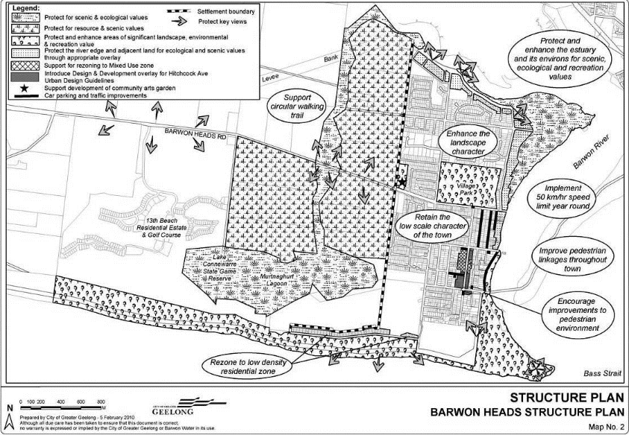

The site is located outside of the Barwon Heads settlement boundary.
The structure plan map seeks to protect the site for its resource and scenic values. Given the development is largely contained to existing buildings and that the proposed landscape works are to protect the lagoon it is considered that with appropriate conditions, the proposal will not have any detrimental impacts on the environmental resources and scenery.

There are no strategies for Barwon Heads that relate specifically to the site. However, there is a strategy for stage 3 of the 13th Beach resort that abuts the subject site to the east. The strategy is to support the development of Stage 3 of the 13th Beach Resort as a focus for golf that excludes residential development and provides net environmental benefits. It is not considered that the proposal will have any direct impact on the future development of stage 3 of the resort.

Clause 12.03-1S River corridors, waterways, lakes and wetlands

The objective of this policy to protect and enhance river corridors, waterways, lakes and wetlands.

Clause 12.05-1S Environmentally sensitive areas
The objective of this clause is to protect and conserve environmentally sensitive areas.

As stated above it is considered that the proposed use, subject to appropriate conditions on any permit issued, will have no adverse environmental impacts on the wetlands.

Clause 13.05-1S Noise management

The objective of this clause is to assist the management of noise effects on sensitive land uses.
It is acknowledged that the proposed uses will generate additional noise for the surrounding area. However, it is considered that this can be sufficiently mitigated through appropriate sound proofing and conditions relating to operating hours and operating management to ensure that the impact in minimal and acceptable.

It is proposed to condition the permit to only allow the use of the function centre on Friday and Saturday nights and requiring that appropriate acoustic treatments be undertaken so that the noise can be kept to a minimum off site.
It is noted that similar conditions have been used on other function centre uses within rural areas.

Whilst it is acknowledged that there are a greater number of dwellings located within close proximity to the subject site than a typical farming area, they are located over 140m away and the proposed opening to the function centre faces away from the dwellings. This together with the changes and recommendations of conditions are an appropriate response to manage the use/s.

Clause 14.01-1S Protection of agricultural land

The objective of this clause is to protect the state’s agricultural base by preserving productive farmland.

The subject site and surrounds are not used for any significant productive agricultural uses. It is therefore not considered that the proposed use will result in the loss of productive agricultural land. Due to the adjoining zones the site cannot be integrated with adjoining land to create a larger farming allotment capable of containing productive agricultural uses.

Clause 17.04-1S Facilitating tourism

The objective of this clause is to encourage tourism development to maximise the economic, social and cultural benefits of developing the state as a competitive domestic and international tourist destination.

Clause 17.04-1L-02 Tourism in rural areas

The objectives of this clause are to support tourism development in rural areas that contributes to the growth of the tourism market, to diversify the range of accommodation types, to preserve the productive agricultural capacity and environmental qualities of the land and to ensure the scale of development will complement and respect the rural landscape character of the area.
It is considered that the proposed use is consistent with this policy. While the site is not directly on the designated tourist route, the location of the site is accessed directly from a tourist route identified in the Bellarine Peninsula Localised Planning Statement, having access from Barwon Heads Road.
It is also located in an area where there are other non-rural activities given its proximity to the golf course estate however it will not result in the urbanisation of the locality.

As the proposal is utilising existing buildings on site it is considered that the associated development will not unreasonably visually compromise the non-urban break between settlements or any a significant view across the site.

The proposed children’s farm is the only agricultural use proposed on the site. This is an increase in agricultural uses that are currently on the site. However, it is considered that due to the proposes uses being concentrated to the west side of the development the remainder of the site is still capable of containing a small agricultural pursuit. It is not considered that the proposed uses will result in the remainder of the site being unable to sustain an agricultural use.

Bellarine Peninsula Localised Planning Statement Sept 2015

It is also considered appropriate to consider the application against the Bellarine Peninsula Localised Planning Statement (BPLS) 2015. The BPLPS seeks to identify the key valued attributes of these areas and put in place objectives and strategies to ensure that they are preserved and enhanced for ongoing use by present and future generations.

In relation to Land Use in Rural Areas the statement reads:
The vision for the rural areas of the Bellarine Peninsula is for the continuation of a working farmed landscape where the “right to farm” is respected and the key features of this open farmed landscape and values of the environmental assets are retained. This Statement supports the continuing use of the area for agriculture, in particular viticulture, horticulture, cropping and grazing as the main land use in rural areas on the Bellarine Peninsula and as an integral part of the rural economy and character of the area and the region. Intensive agricultural activities which could change the appearance of this open farmed landscape are encouraged to locate in other more suitable rural areas beyond the Bellarine Peninsula.
Strategies for Rural Land on the Bellarine include:

- Support the establishment and ongoing use of rural areas on the Bellarine Peninsula for agricultural activities which do not impact upon the open farmed landscape including viticulture, horticulture and crop raising and grazing.
- Discourage intensive agricultural development or industrial development in rural areas on the Bellarine Peninsula that would have an adverse impact on the rural landscape.
- Ensure the development of dwellings and the excision of existing dwellings in rural areas on the Bellarine Peninsula is consistent with the use of the land for sustainable rural uses.
- Ensure new development is designed and sited to avoid compromising the open farmed landscape.
It is considered that although the site is within a Farming Zone, its location is unique as it is not surrounded by other farming zone properties or land that is capable of containing significant agricultural pursuits. The land use of a children’s farm and function centre and restaurant supports a small agricultural use which is consistent with the above statement and strategies.

The statement also includes strategies relating to the preservation of the unique ecology of the Bellarine. These include:

- Protect cliff, dune and foreshore areas from inappropriate development and subdivision.
- Protect and restore significant and remnant native vegetation, particularly tea tree, moonah and coastal heath.
- Ensure that new development allows for the protection of significant vegetation and/or planting around buildings and has minimal impact on roadside vegetation.
- Ensure appropriate stormwater management measures are in place to avoid adverse impacts on marine waters, lakes, wetlands and waterways.
In relation to the above it is considered that appropriate conditions can be included on any permit issues to ensure appropriate stormwater management measures are in place to avoid impacts on the Lagoon.

The development also has no significant impact on existing native vegetation.
Bellarine Peninsula Distinctive Area and Landscape Draft Bellarine Peninsula Statement of Planning Policy June 2021

On 29 October 2019 the Bellarine Peninsula was declared a Distinctive Area and Landscape under the Planning and Environment Act 1987. The declaration triggers the requirement to prepare a Statement of Planning Policy. The Policy is still in draft form and is yet to be approved.

The Victorian Government has legislated to protect and enhance Victoria’s distinctive areas and landscapes, so they can be enjoyed by current and future generations.
Parts of the City of Greater Geelong and all the Borough of Queenscliffe — which together constitute the Bellarine Peninsula — were declared a distinctive area and landscape under section 46AO of the Planning and Environment Act 1987 (the Act) by order of the Governor in Council published in the Government Gazette on 29 October 2019. The order came into effect on the same day.

Under the Act, an area of Victoria can be declared a distinctive area and landscape if it has a majority of the attributes section 46AP of the Act specifies — outstanding environmental, geographical, heritage, cultural, natural resources or productive land, strategic infrastructure or built-form significance — and if its attributes are under threat of significant or irreversible land use change that would affect the environmental, social or economic value of the area.

The map below shows the Bellarine DAL Declared Area Framework Plan:
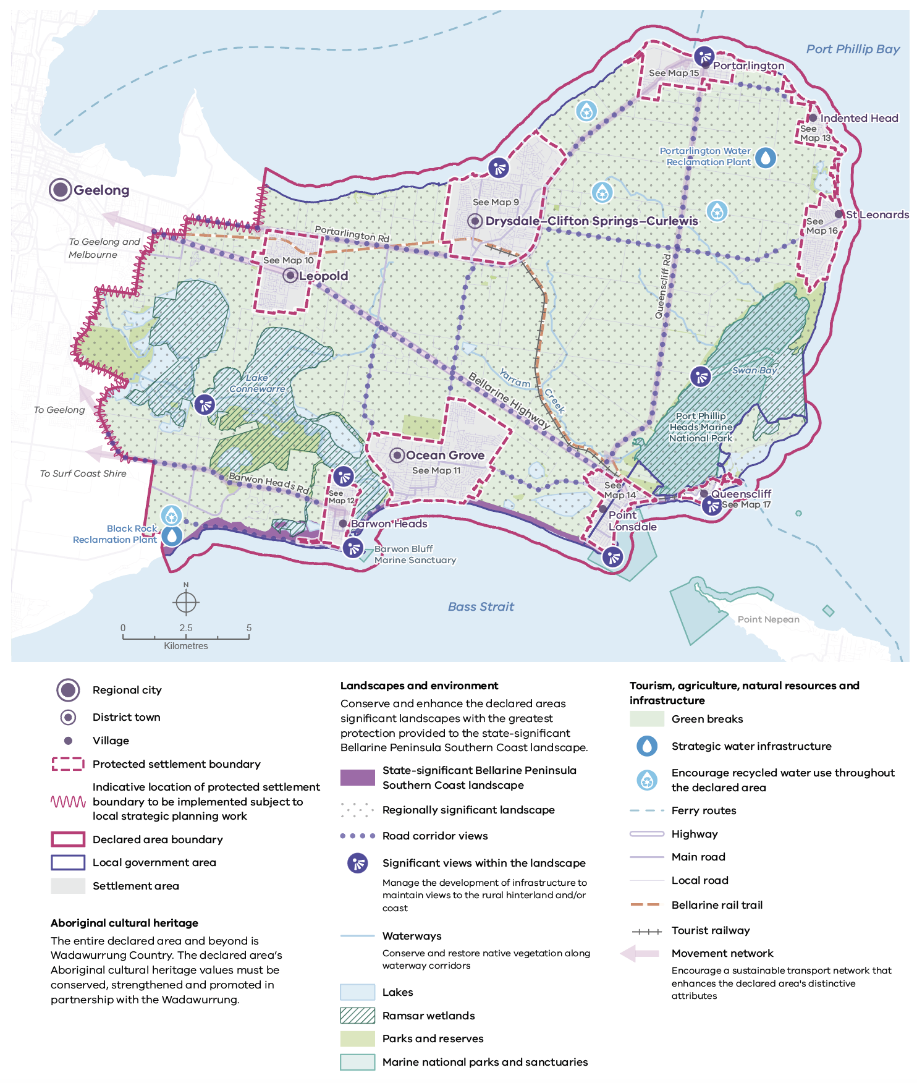
Map 1. Bellarine Peninsula declared area framework plan
Source: DELWP 2022

It is acknowledged that the subject site is located within this area and is located within a Green Break.

Lake Connewarre and the Barwon River landscape is identified as regionally significant area.

The draft policy states that:

Maintaining green breaks between the declared area’s settlements is important. As shown on Map 3, the green breaks together with the protected settlement boundaries will help conserve environmental and cultural heritage attributes, strategic infrastructure (such as water utilities), agricultural land and other natural resources from encroachment by urban development. Within the declared area, green breaks are mostly rural land zoned as Farming Zone, Rural Conservation Zone, Public Conservation and Recreation Zone or Rural Living Zone.

The green breaks will also help protect the character and significance of the open, rural landscapes between the Bellarine Peninsula’s settlements, the coastal wetlands bordering Barwon Heads, Ocean Grove, Point Lonsdale and St Leonards and the undulating landscape of the central and northern peninsula. They help to establish a sense of arrival and a unique identity for each settlement area by containing their outward growth and avoiding settlement areas coalescing.
The draft policy recognises that Tourism has long been a part of the Bellarine Peninsula’s post settlement history, however, discourages tourism development and supporting infrastructure incompatible with the landscape and environmental values of green breaks.

On balance, it is considered notable that that uses proposed will utilise existing buildings on site and do not require extensive building works; that is an important aspect taken into account and as such the existing landscape will be relatively unchanged.

Also, the proposal does not represent a large scale operation with intrusive buildings or development and will not be overly visible from key vantage points. It is therefore considered that the proposal will not result in any detrimental impacts on the landscape and environmental values of the green break between Barwon Heads and Armstrong Creek.

It is noted that this policy is still in draft form and there is no indication to date as to when the policy will be adopted and implemented through Planning Scheme Amendments. Therefore, it is not considered that the application needs a detailed assessment against this policy.

RELEVANT PARTICULAR PROVISIONS:

The following Particular Provisions are applicable to this application:

CLAUSE 52.06 – CAR PARKING
- To ensure that car parking is provided in accordance with the State Planning Policy Framework and the Local Planning Policy Framework.
- To ensure the provision of an appropriate number of car parking spaces having regard to the demand likely to be generated, the activities on the land and the nature of the locality.
- To support sustainable transport alternatives to the motor car.
- To promotes the efficient use of car parking spaces through the consolidation of car parking facilities.
- To ensure that car parking does not adversely affect the amenity off the locality.
- To ensure that the design and location of car parking is of a high standard, creates a safe environment for users and enables easy and efficient use.
Response

The proposed uses have the following car parking requirements within the scheme.
Restaurant:
- 0.4 Spaces to each patron permitted
Function Centre (Place of Assembly):
- 0.3 Spaces to each patron permitted
The proposal is to allow for a total of 80 patrons within the restaurant therefore the restaurant has a statutory car parking requirement of 32 car spaces.
The function centre will allow for a total of 200 patrons and therefore the function centre has a statutory car parking requirement of 60 car spaces.
As the restaurant and function centre will not operate at the same time the maximum number of car spaces required on site is considered to be 60 spaces.
A total of 75 car spaces are provided on site exceeding the statutory car parking requirement. Given this in information a permit is not triggered under this Clause to reduce the statutory car parking requirement.
The car parking area is conveniently located and whilst partially visible from the road is largely screened by existing vegetation.
The plans were referred to Council’s Engineering Department who raised no concerns with the overall design and layout of the car park.
Bicycle Spaces
Restaurant:
1 to each 100sqm of net floor area for employees
2 plus 1 to each 200 sqm of floor area available to the public if the floor area available to the public exceeds 400sqm

Function Centre (Place of Assembly):
1 to each 1500sqm of net floor area for employees.
2 plus 1 to each 1500sqm of net floor area for visitors.
- The proposal generates a requirement of three (3) bicycle spaces.
- The application proposes the provision of 28 spaces including 14 via bicycle hoops conveniently located.
DECISION GUIDELINES OF CLAUSE 65:

CLAUSE 65.01 – APPROVAL OF AN APPLICATION OR PLAN

Clause 65.01 of the Greater Geelong Planning Scheme outlines the decision guidelines to be considered by the Responsible Authority when making decisions on applications. These decision guidelines include:

- The matters set out in Section 60 of the Act.
- The Municipal Planning Strategy and the Planning Policy Framework.
- The purpose of the zone, overlay or other provision.
- Any matter required to be considered in the zone, overlay or other provision.
- The orderly planning of the area.
- The effect on the amenity of the area.
- The proximity of the land to any public land.
- Factors likely to cause or contribute to land degradation, salinity or reduce water quality.
- Whether the proposed development is designed to maintain or improve the quality of stormwater within and exiting the site.
- The extent and character of native vegetation and the likelihood of its destruction.
- Whether native vegetation is to be or can be protected, planted or allowed to regenerate.
- The degree of flood, erosion or fire hazard associated with the location of the
- land and the use, development or management of the land so as to minimise any such hazard.
- The adequacy of loading and unloading facilities and any associated amenity, traffic flow and road safety impacts.

Response

The application has been assessed and considered against the above decision guidelines of Clause 65.01 and is found to be consistent; including that an assessment against the relevant zone and planning policies have been detailed within the report.

This assessment has considered the effect of the amenity of the area, the proximity of the use to public land, stormwater management and environmental risks.

As stated in the assessment it is considered that through appropriate permit conditions, the proposal will not have significant impacts on the amenity of the area and the adjoining wetlands and that the use can be conducted and managed to be supported.

Loading and unloading can be conveniently undertaken on site without impacting on the surrounding street network or interrupting traffic flow.

CONCLUSION:

It is considered that the proposal is consistent with the relevant decision guidelines of the zone and the stated objectives of the relevant State and Local planning policies. Based on this assessment it is recommended that the application be supported subject to the conditions contained within this report.

CLOSE OF MEETING

The meeting closed at 7.15pm

