

minutes

PLANNING COMMITTEE MEETING
No. 236

Thursday 11 April 2024
City Hall, 57 Little Malop Street, Geelong

ALSO LIVE STREAMED ON THE CITY’S WEBSITE:

www.geelongaustralia.com.au/meetings

PANEL:

Cr Mason, Cr Nelson, Cr Sullivan, Cr Murrihy, Cr Aitken, Cr Moloney, Cr Kontelj

PRESENT

Present: Cr Mason, Cr Nelson, Cr Sullivan, Cr Murrihy, Cr Aitken, Cr Moloney,
Cr Kontelj

Council Officers:

Steve Roussac, Principal Planner, Statutory Planning
Shane Pritchard, Team Leader, Statutory Planning
John Rush, Coordinator, Statutory Planning
Joanne van Slageren, Manager City Development
Tennille Bradley, Executive Director Placemaking
Alana Martin, Chief Governance & Risk Officer
Jacquilyn Douglas, Coordinator Governance

Opening: The Chair declared the meeting open at 5.30pm

1. PROCEDURAL MATTERS

Acknowledgement Of Country

The Committee acknowledges the Wadawurrung People as the Traditional Owners of the Land, Waterways and Skies. We pay our respects to their Elders, past, present and emerging. We Acknowledge all Aboriginal and Torres Strait Islander people who are part of our Greater Geelong community today.

1.2. Introduce the Panel Members

1.3. Apologies

Cr Hathway, Cr Cadwell

1.4. Declarations of Conflicts Of Interest

Nil

1.5. Confirmation of Minutes

Moved: Cr Aitken Seconded: Cr Sullivan

That the Minutes of the Planning Committee Meeting held on 14 December 2023.
be confirmed.

CARRIED

2. MATTER(S) FOR CONSIDERATION
PP-320-2021 98 Marshalltown Road, Grovedale And PP-1512-2020 149 Bellarine Highway, Newcomb
2.1. | PP-935-2020 – 34 Barrabool Road, Highton

Application No: | PP-935-2020
Applicant: | JME Investments
Subject Land: | 34 Barrabool Road, Highton
Zone: | General Residential Zone – Schedule 4 (GRZ4)  The site is located within the Highton Shopping Centre Increased Housing Diversity Area
Overlays: | Special Building Overlay (SBO)
Existing Use: | Single detached dwelling
Proposed Use: | Construction of Ten (10) Apartments, Multi-lot Subdivision, and Alteration of Access to a Road in a Transport Zone 2

Summary
- This application seeks planning approval for the construction of ten (10) apartments, multi-lot subdivision, and alteration of access to a road in a Transport Zone 2.
- The land comprises an area of 993.7 sq/m on the northwest side of Barrabool Road and about 110 metres north of the Highton Village shops.
- It is a larger than average site for the area, with a frontage of 19.81 metres and depth of 50.29 metres. It currently hosts a single storey detached mid-20th century dwelling, with established garden, driveway, garage and outbuildings.
- The land is in the General Residential Zone 4 with direct abuttal to the Transport Zone 2 and Principal Road Network. The site is within the Special Building Overlay, and also close to the centre of the Highton Village Increased Housing Diversity Area.
- The application proposes construction of a 3 storey apartment building with a basement carpark, and a communal outdoor area at the rear. The building is setback 4m from the front boundary to the balconies at ground and mid floor levels, and to the upper front wall of the top storey. It has a contemporary flat roof with a mix of stone, metal mesh and cement cladding with vertical standing seam, smooth and textured finishes.
- Vehicle access is proposed from a new double width crossing and ramp to the basement accommodating all of the required carparking, including visitor car parking spaces.
- The plan of subdivision shows each of the 10 apartments to include their associated car parking as part of each lot, as well as communal access, outdoor space, and the building exterior to be common property.
- The application was referred to all required utility service providers and the relevant road authority who have all supported the grant of a permit subject to conditions.
- Referral of the application to internal departments of the City also led mostly to support for the grant of a permit subject to conditions.
- Public notice of the application was given, attracting 8 formal and 2 informal objections, and one submission of support. Matters of concern to objectors related primarily to the building size and number of apartments, traffic and parking congestion, pedestrian and road safety, loss of the established vegetation, overshadowing, and insufficient canopy tree coverage and an increase of an urban heat effect.
- The application has been assessed against all relevant planning policies of the Scheme, and against the purpose and decision guidelines of the Zone and Overlay. The proposal has been found to give effect to planning policy as it relates to increased density and diversity of housing in a location that offers convenient access to urban services and facilities. The proposal represents an infill redevelopment of existing urban land contributing to housing affordability and housing choice.
- A detailed design assessment of the application against the residential development standards of Clause 55 finds the proposal has been carefully designed for compliance with all relevant site layout and massing, on-site amenity and facilities, detailed design, and apartment development objectives. However, site width and orientation result in the 3 storey building height to cause significant overshadowing of the dwellings on adjoining land to the southwest. This results in a non-compliance with the mandatory ‘overshadowing of open space objectives’ such that the grant of a permit should not be given.
- The application was amended on three (3) occasions since it was first received in August 2020. The overshadowing matter has remained unresolved throughout that time and as such it is a recommended reason for refusing the grant of a permit.
- For this reason as set out in detail in the recommendations to follow, it is respectfully recommended that no planning permit be granted for this application in its proposed form.

Recommendation
That the hearing of the application be deferred.

Moved: Cr Murrihy Seconded: Cr Aitken

CARRIED

REPORT

PERMIT REQUIREMENTS:

A planning permit is required for this application pursuant to the following clauses of the Greater Geelong Planning Scheme:

- Pursuant to Clause 32.08-3 of the General Residential Zone a permit is required to subdivide land.
- Pursuant to Clause 32.08-6 of the General Residential Zone a permit is required to construct two or more dwellings on a lot.
- Pursuant to Clause 44.05-2 of the Special Building Overlay a permit is required to construct a building or to construct or carry out works.
- Pursuant to Clause 44.05-3 of the Special Building Overlay a permit is required to subdivide land.
- Pursuant to Clause 52.29-2 of the Particular Provisions a permit is required to:
  - alter access to a road in a Transport Zone 2
  - subdivide land adjacent to a road in a Transport Zone 2.

Planning Scheme Amendment GC172 on 04/08/2021 rezoned the land from Residential Growth Zone (RGZ2) to General Residential Zone (GRZ4). The amendment resulted in a reduced maximum building height requirement and introduced the mandatory garden area requirement that did not apply under the zone at the time the permit application was received.

Planning Scheme Amendment VC205 on 06/04/2022 introduced a new Transport Zone to replace the Road Zone, resulting in a change to the terminology used in relation to the permit requirements of what is now Clause 52.29 (Land Adjacent to the Principal Road Network).

DEFINITIONS:

All references to ‘the Scheme’ are a reference to the Greater Geelong Planning Scheme unless otherwise stated.

All references to ‘the Act’ are a reference to the Planning and Environment Act 1987 unless otherwise stated.

Pursuant to Clause 73.01 (General Terms) of the Scheme:

- Apartment is defined as ‘A dwelling located above the ceiling level or below the floor level of another dwelling and is part of a building containing two or more dwellings.’
- Basement is defined as ‘A storey below ground level, or that projects no more than 1.2 metres above ground level.’
- Building height is defined as ‘The vertical distance from natural ground level to the roof or parapet at any point.’
- Garden Area is defined as ‘Any area on a lot with a minimum dimension of 1 metre that does not include:
a) a dwelling or residential building, except for: an eave, fascia or gutter that does not exceed a total width of 600mm; a pergola; unroofed terraces, patios, decks, steps or landings less than 800mm in height; a basement that does not project above ground level; any outbuilding that does not exceed a gross floor area of 10 square metres; and domestic services normal to a dwelling or residential building;
b) a driveway; or
c) an area set aside for car parking.’

- Lot is defined as ‘A part (consisting of one or more pieces) of any land (except a road, a reserve, or common property) shown on a plan, which can be disposed of separately and includes a unit or accessory unit on a registered plan of strata subdivision and a lot or accessory lot on a registered cluster plan.’
- Private open space is defined as ‘An outdoor area of a dwelling or residential building or land for the exclusive use of the occupants.’
- Secluded private open space is defines as ‘That part of private open space primarily intended for outdoor living activities which enjoys a reasonable amount of privacy’
- Stormwater is defined as ‘The net increase in run-off from urban development due to water not being able to seep into the ground because of impervious surfaces, such as roofs and roads.’
- Storey is defined as ‘That part of a building between floor levels. If there is no floor above, it is the part between the floor level and ceiling. It may include an attic, basement, built over car parking area, and mezzanine.’
- Street reserve is defined as ‘Land set aside for a street pavement and verge.’

Pursuant to Clause 73.03 (Land Use Terms) of the Scheme:

- ‘Dwelling’ is defined as ‘A building used as a self-contained residence which must include: a) a kitchen sink; b) food preparation facilities; c) a bath or shower; and d) a closet pan and wash basin. It includes outbuildings and works normal to a dwelling.’

Pursuant to Clause 73.04 (Nesting Diagrams) of the Scheme:

- Dwelling is nested in the Accommodation group at Clause 73.04-1.

Subdivision is defined at s.3 (Definitions) of the Act to be ‘the division of land into two or more parts which can be disposed of separately’.

RESTRICTIVE COVENANT OR SECTION 173 AGREEMENT:

The subject site is not burdened by a Restrictive Covenant or Section 173 Agreement.

OFFICER DIRECT OR INDIRECT INTEREST:

No officer involved in the preparation of this report declared a general or material conflict of interest.

SITE/LOCALITY:

The subject site comprises 993.7 square metres on the northwest side of Barrabool Road, 140 metres southwest of the intersection with Ferndale Parade in Highton. The parallelogrammatic shaped site has a frontage of 19.81 metres and a depth of 50.29 metres, and slopes from the west to the east.

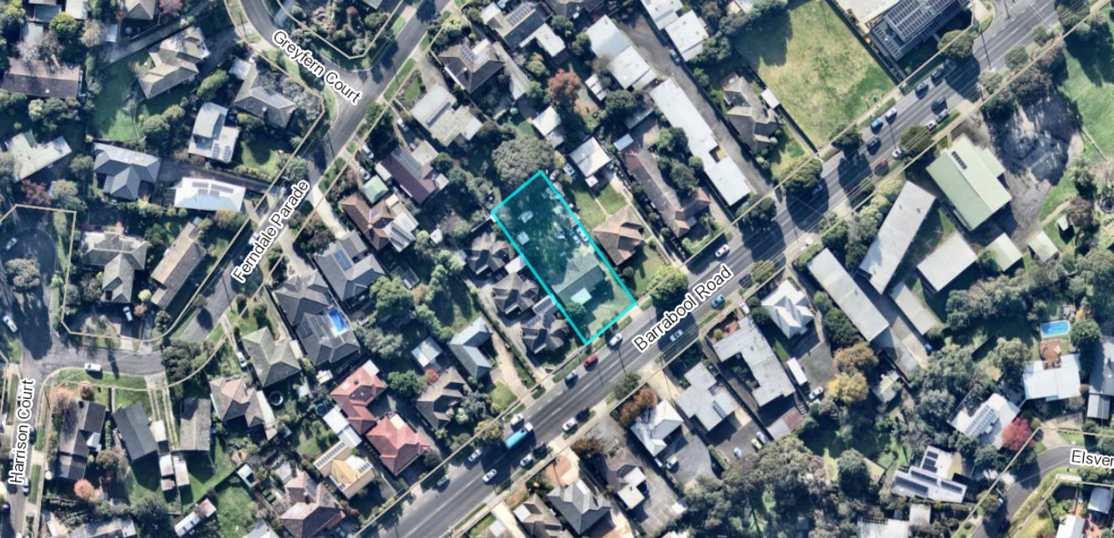
Figure 1: Aerial context view of the subject site (highlighted blue), circa 5 June 2023. Source: PLACES Weave GIS and Nearmap
The site is currently used and developed for dwelling, with a single storey mid-century detached brick and corrugated asbestos dwelling, recessed rear garage, boundary fences and established garden. Vehicle and pedestrian access to Barrabool Road is located at the east corner of the site.

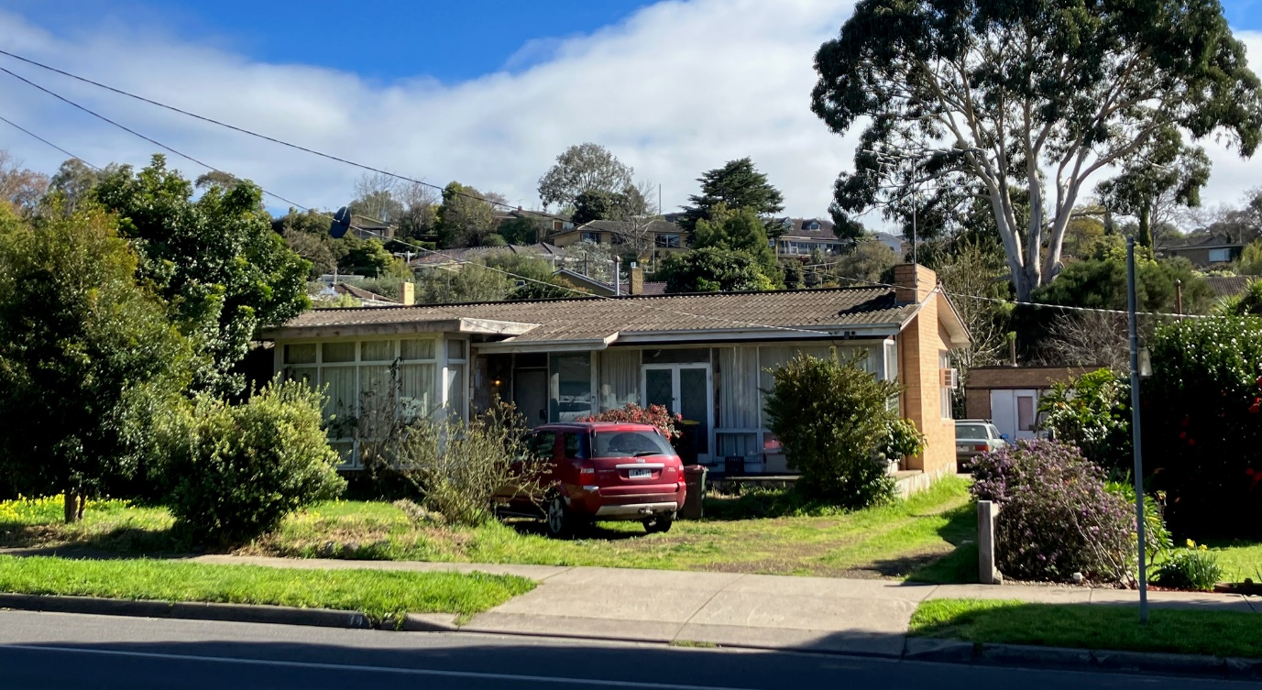
Figure 2: Terrestrial view of the subject site looking west from Barrabool Road, 15 August 2023. A mature eucalypt tree located on the adjoining land to the back is also visible at background right. Source: Author.
All adjoining land is similarly used and developed for dwelling, with single storey detached residences to the northeast side and the rear of the site, and a 3 unit development to its southwest.

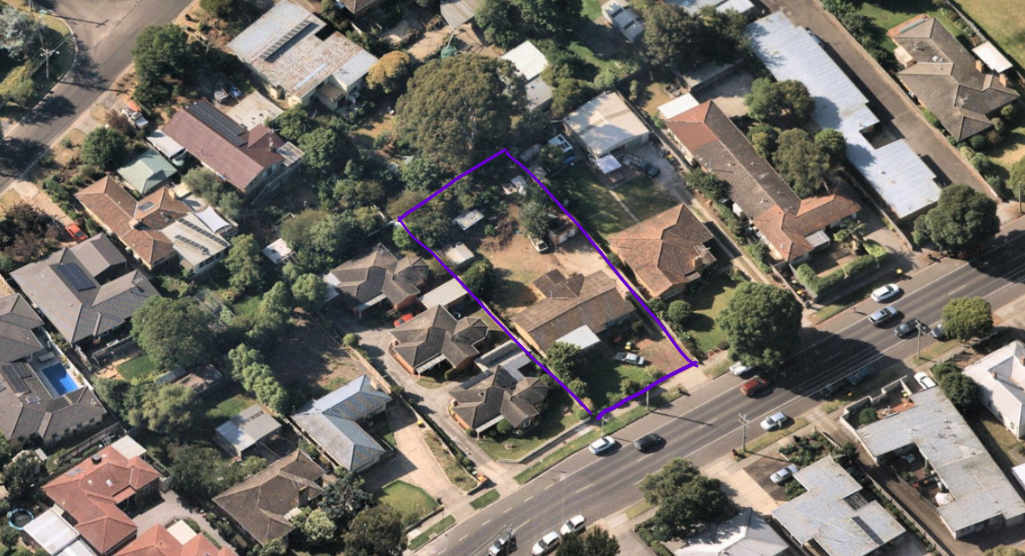
Figure 3: Oblique aerial view looking north to the subject site (highlighted purple) and showing the adjoining dwelling development. Source: Nearmap, annotated by Author.

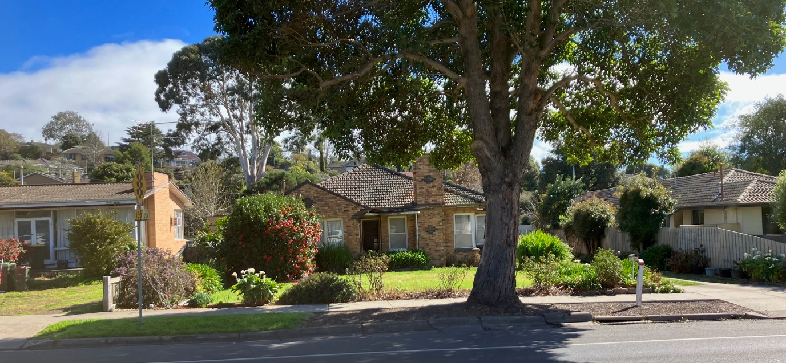
Figure 4: Terrestrial view of the dwelling on adjoining land to the north west of the subject site at 32 Barrabool Road, 15 August 2023. Source: Author.

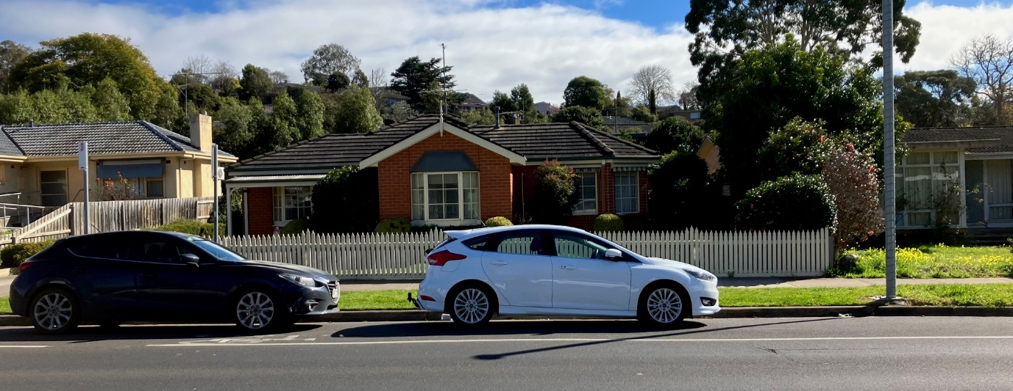
Figure 5: Terrestrial view of the dwelling on adjoining land to the south east of the subject site at 1/36 Barrabool Road, 15 August 2023. Source: Author.
The site and all adjoining land to the sides and rear is within the General Residential Zone (GRZ4) and the Special Building Overlay (SBO). Barrabool Road is within the Transport Zone (TRZ2).

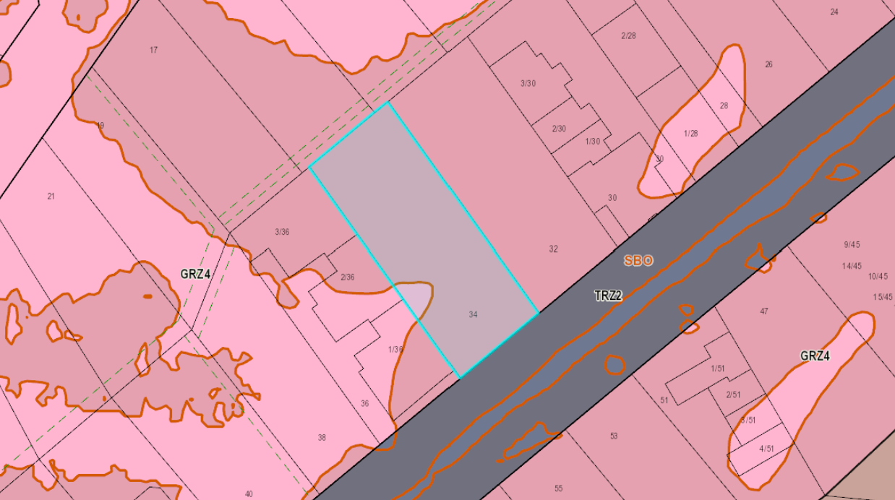
Figure 6: Map showing zones and overlays relevant to the site. Source: PLACES Weave GIS.
The site is located within the Highton Shopping Centre Increased Housing Diversity Area (IHDA), and approximately 70 metres north of Highton Village commercial area.

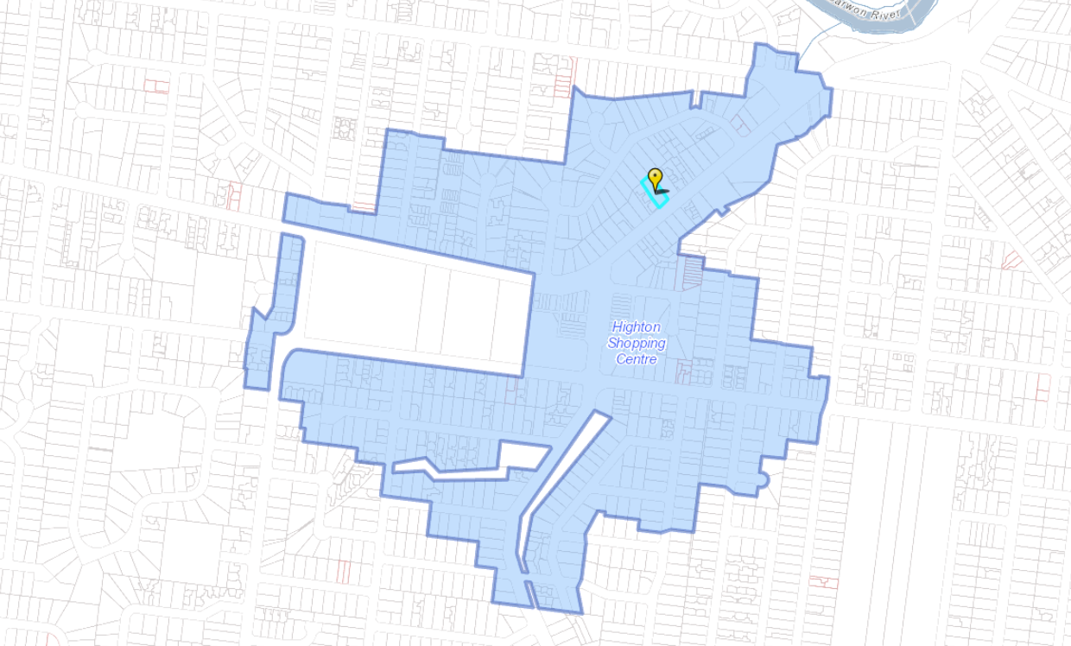
Figure 7: Map showing the extent of the Highton Shopping Centre IHDA and the proximity of the subject site (yellow flag). Source: PLACES Weave GIS
Highton Village offers a variety of retail, health, community and recreation services and is located within walking distance of the 42 (Deakin University via South Valley Road) and 43 (Deakin University via Highton) public bus routes.

PROPOSAL:

The application proposes construction of an apartment building comprising 10 apartments, a corresponding multi-lot subdivision, and alteration of access to a road in the TRZ2.

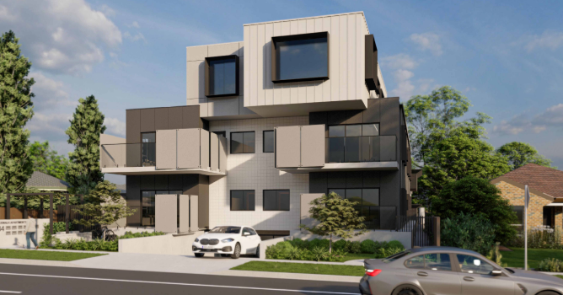
Figure 8: Artist impression of proposed apartment development. Source: Application documents.
Apartment Development

The proposed development comprises four (4) storeys including ground floor, mid floor and upper floor levels, and a basement car park.

The building is to occupy an area at ground level of 574 sq/m, being 57.75% of the 993.7 sq/m site. The total site area covered by buildings is 699 sq/m, being 70.3% of the site. The total permeable surface area is 232 sq/m, being 23.3% of the site.

The proposed maximum building height is dimensioned on the south east elevation drawing as 11.070 metres.

The building is designed to front Barrabool Road to the southeast. The building is to be set back from all adjoining lot boundaries, with recessed upper storey side walls and a contemporary flat roof form.

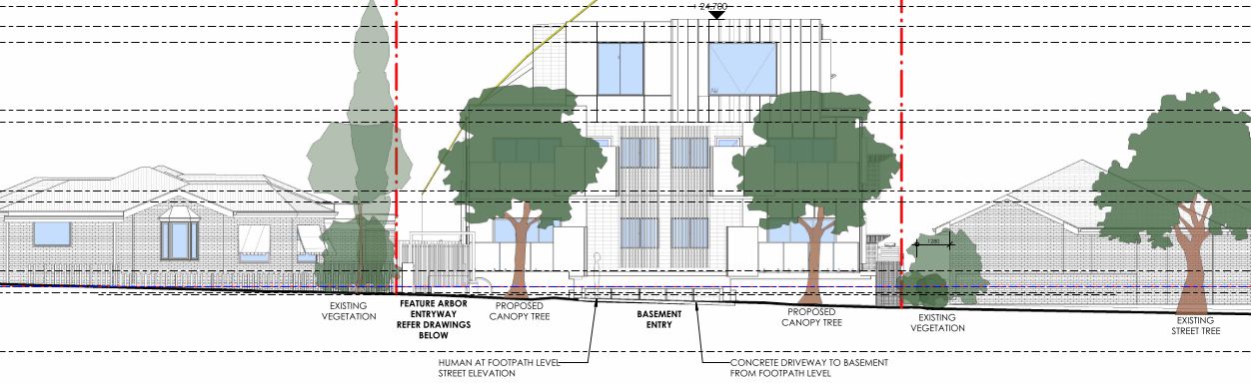
Figure 9 (Above): Southeast streetscape elevation showing frontage to Barrabool Road. Source: Application documents

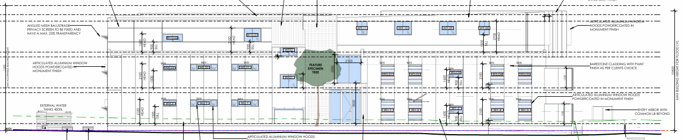
Figure 10 (Above): Southwest elevation showing presentation to land at 36 Barrabool Road. Source: Application documents.

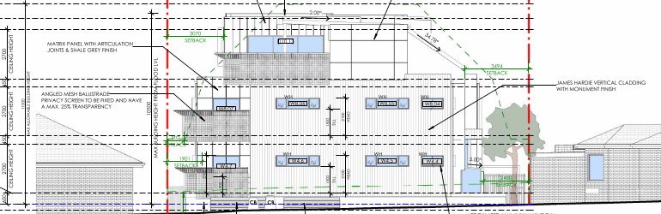
Figure 11 (Above): Northwest elevation showing presentation to the rear adjoining land at 13 and 15 Ferndale Parade. Source: Application documents.

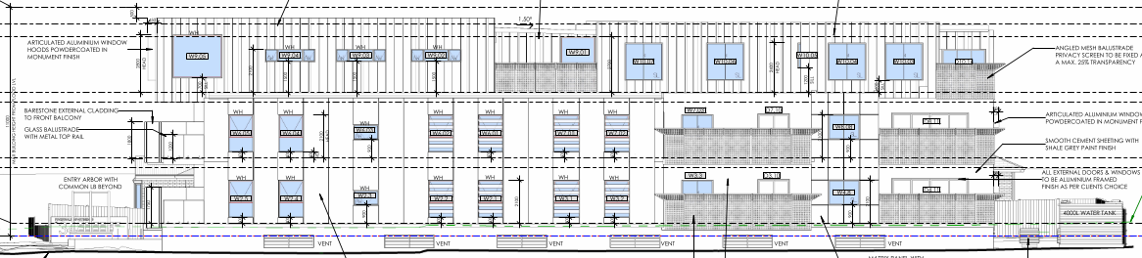
Figure 12: Northeast elevation showing presentation to adjoining land at 32 Barrabool Road. Source: Application documents.
A mix of cladding materials are proposed, with contrasting Cementil Barestone (Monument), Inax Tiles (white) and vertical standing seam (Shale Grey and Monument) cladding at the ground and mid floor levels, and vertical standing seam and Matrix panel at the upper storey. Oversized windows and mixed fenestration provides visual interest, along with feature angled mesh balustrade screening.

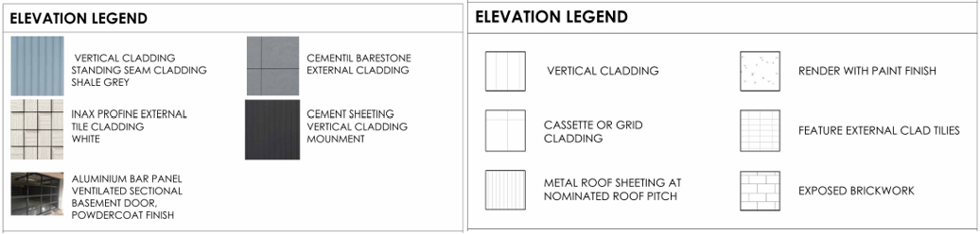
Figure 13: Schedule of materials and finishes. Source: Application documents.
Ground Floor

The ground floor layout plan shows separate primary pedestrian and vehicle access to the site from Barrabool Road from the southeast. The main building entry is located along the south west side of the building with a feature arbor and security gate to a paved path and landscaping leading to a sheltered building entry. The entry continues through to a foyer and common passage for access to the stairs and lift, and internally to Apartments 1 through 4.

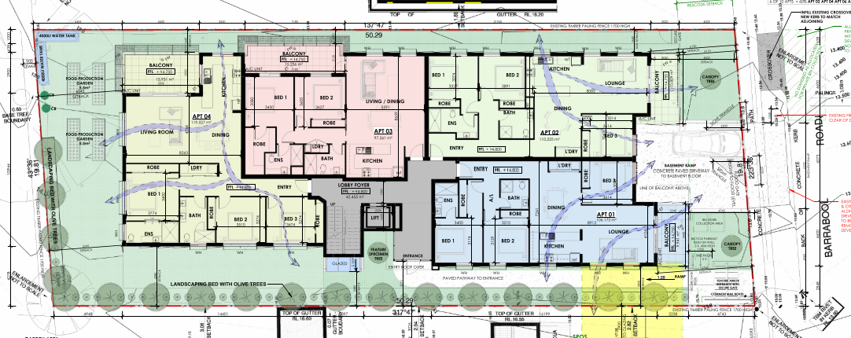
Figure 14: Ground floor plan showing common entry, apartment and private open space (balcony) layouts. Source: Application documents.
The ground floor area also provides communal outdoor areas at the front, sides and rear of the building. The communal area at the rear includes landscaping and food production garden beds.

Apartments 1, 2 and 4 each comprise three (3) bedrooms with secluded private open space on balconies to the southeast, north east, and north west sides of the building. Apartment 2 comprises two (2) bedrooms. All are provided with open plan kitchen, living and dining areas, ‘European’ style laundry cupboards, and internal robes and storage areas.

The ground floor walls are to be setback not less than 6.12 metres from the southeast (front) boundary, 2.48 metres from the southwest (side) boundary, 5.24 metres from the northwest (rear) boundary, and 1.64 metres from the northeast (side) boundary. The front balcony setback at ground floor level is not less than 4.11 metres.

Mid (First) Floor

The mid floor layout comprises three (3) 3-bedroom apartments and one (1) 2-bedroom apartment all with common access from the central stairs and lift. Apartments 6, 7 and 8 occupy the north and east sides of the building, and Apartment 5 with a predominantly south west aspect. Apartments 5 and 6 receive east light, and Apartments 7 and 8 will benefit from north aspect.

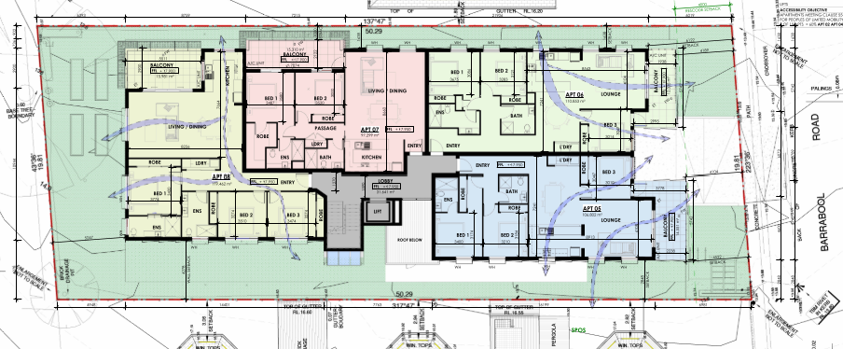
Figure 15: Mid (first) floor plan showing common area entry, apartment and private open space (balcony) layouts. Source: Application documents.
The mid floor walls are to be setback not less than 6.12 metres from the southeast (front) boundary, 2.84 metres from the southwest (side) boundary, 5.24 metres from the northwest (rear) boundary, and 1.63 metres from the northeast (side) boundary. The front balcony setback at mid floor level is not less than 4.18 metres.

Upper (Second) Floor

The upper floor layout comprises two (2) 3-bedroom apartments with common access from the central stairs and lift. Apartment 9 occupies the south east end of the building and Apartment 10 the north west. Both benefit from a north aspect.

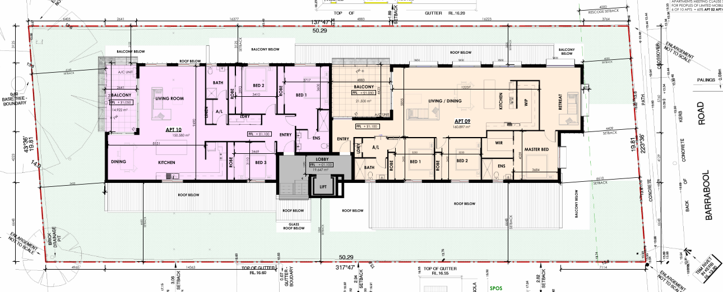
Figure 16: Upper (second) floor plan showing common area entry, apartment and private open space (balcony) layouts. Source: Application documents.
The mid floor walls are to be setback not less than 6.12 metres from the southeast (front) boundary, 2.84 metres from the southwest (side) boundary, 5.24 metres from the northwest (rear) boundary, and 1.63 metres from the northeast (side) boundary. The front balcony setback at mid floor level is to be not less than 4.18 metres.

Basement

The basement is to be accessed via a 6.1m wide vehicle access ramp to Barrabool Road, comprising a retractable flood gate at the property boundary and automatic door at the ramp base to allow vehicle passing and perching on the ramp. Lift and stair access from the apartments is also provided to 20 parking spaces including 2 visitor spaces, 10 secure storage units, 6 bike storage racks, bin room, and an underfloor stormwater retention tank.

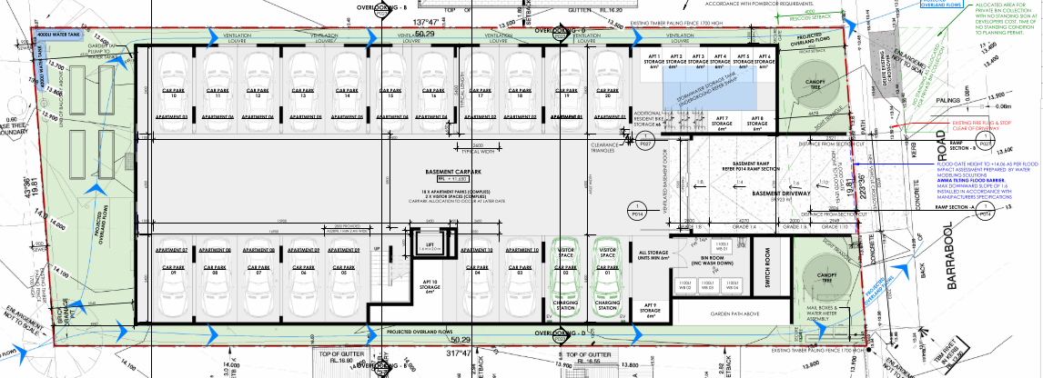
Figure 17: Basement layout plan. Source: Application documents.

The layout plan provides twenty (20) car parking spaces including two (2) visitor parking spaces allocated as follows:

Apartment No. | No. of Bedrooms | Allocated Space No. | Apartment No. | No. of Bedrooms | Allocated Space No.
1 | 3 | 19, 20 | 6 | 3 | 11, 12
2 | 3 | 17, 18 | 7 | 2 | 09
3 | 2 | 10 | 8 | 3 | 07,08
4 | 3 | 15, 16 | 9 | 3 | 05, 06
5 | 3 | 13, 14 | 10 | 3 | 03, 04

All parking spaces measure 5.4 metres long and 2.6 metres wide. All internal vehicle accessways measure a minimum of 6.1 metres wide and 6.3 metres at car parking space entries.

Multi-lot subdivision of land adjacent to a road in a Transport Zone 2

The proposed plan of subdivision shows creation of 10 apartment allotments each shown in 3 parts (apartment interior, balcony/POS, and basement parking spaces), with the balance of the interior spaces, the site at ground level site and the building exterior all to be within common property.

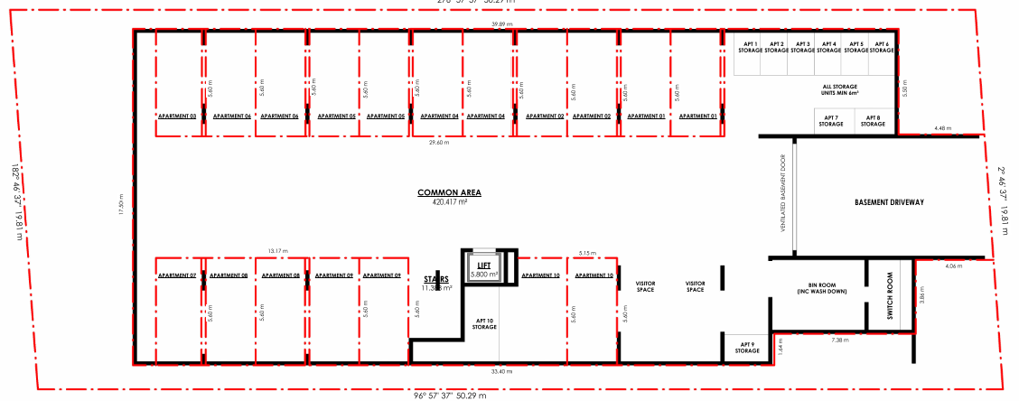
Figure 18: (Above) Proposed basement level plan of subdivision. Source: Application documents.

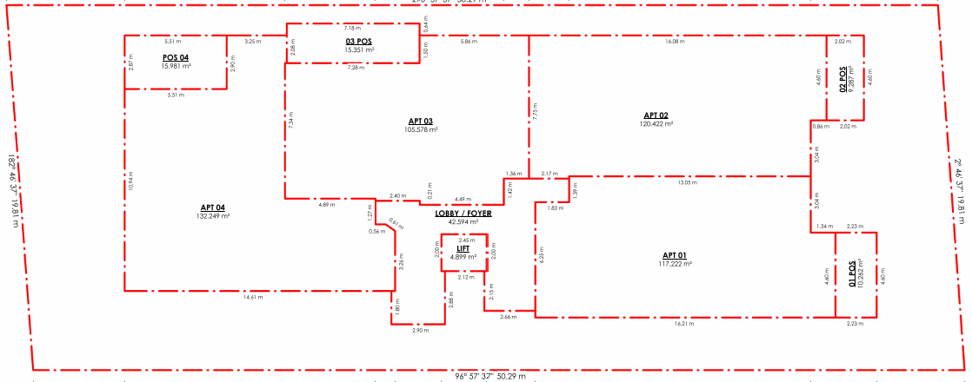
Figure 19: (Above) Proposed ground floor plan of subdivision. Source: Application documents.

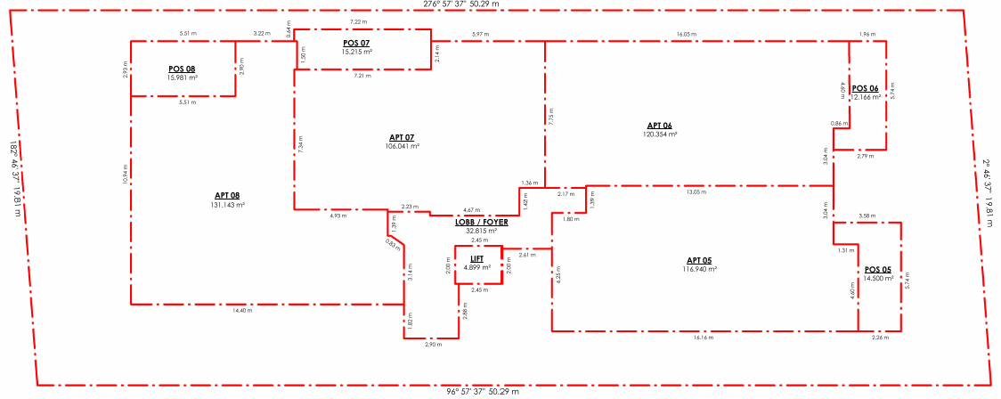
Figure 20: (Above) Proposed mid (first) floor plan of subdivision. Source: Application documents.

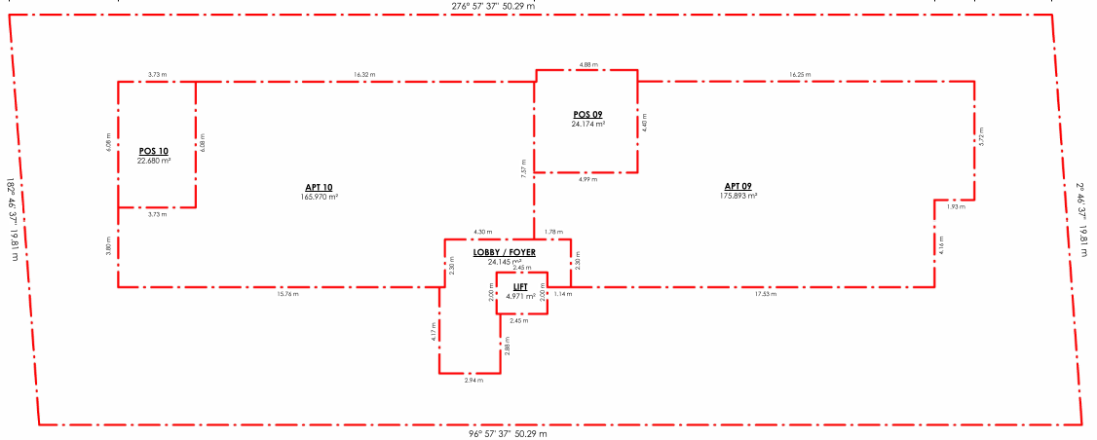
Figure 21: (Above) Proposed upper (second) floor plan of subdivision. Source: Application documents.
Alteration of Access to Road in TRZ2

The application proposes the removal of the existing vehicle crossing to Barrabool Road located at the east boundary corner to be reinstated to kerb and channel. A new double width vehicle crossing is proposed to be located centrally to the site frontage.

PERMIT/SITE HISTORY:

There is no permit/site history relevant to the application.

REFERRALS:

The following referrals were undertaken:

SECTION 55:

DETERMINING AUTHORITY

Authority: | Department of Transport
Response: | 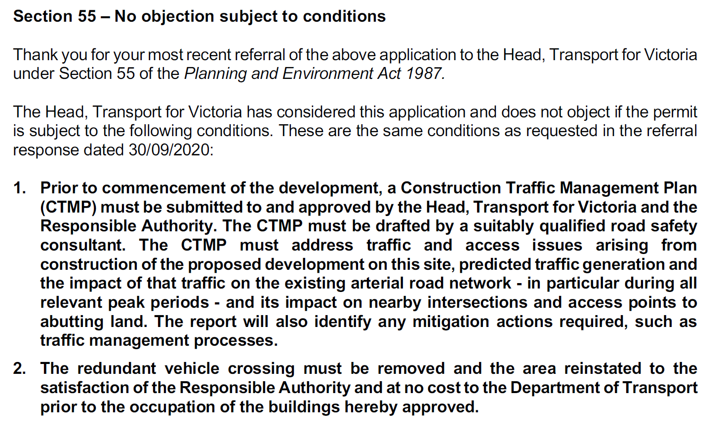
Officer Comment:
The required conditions must be included on any permit that were to be issued.

Authority: | Barwon Water
Response: | 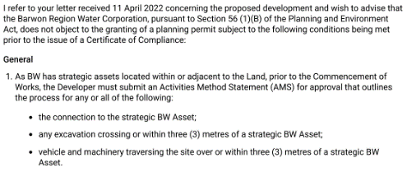  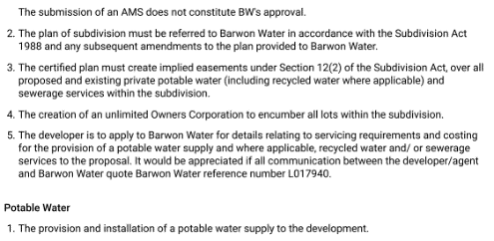  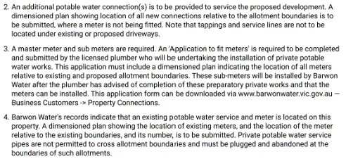  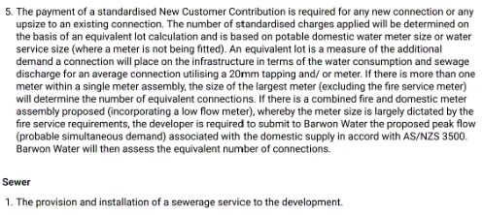  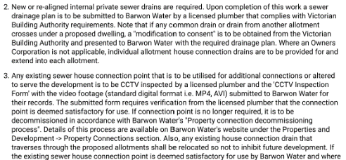  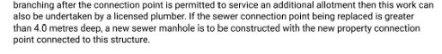
Officer Comment:
The required conditions must be included on any permit that were to be issued.

Authority: | Powercor
Response: | 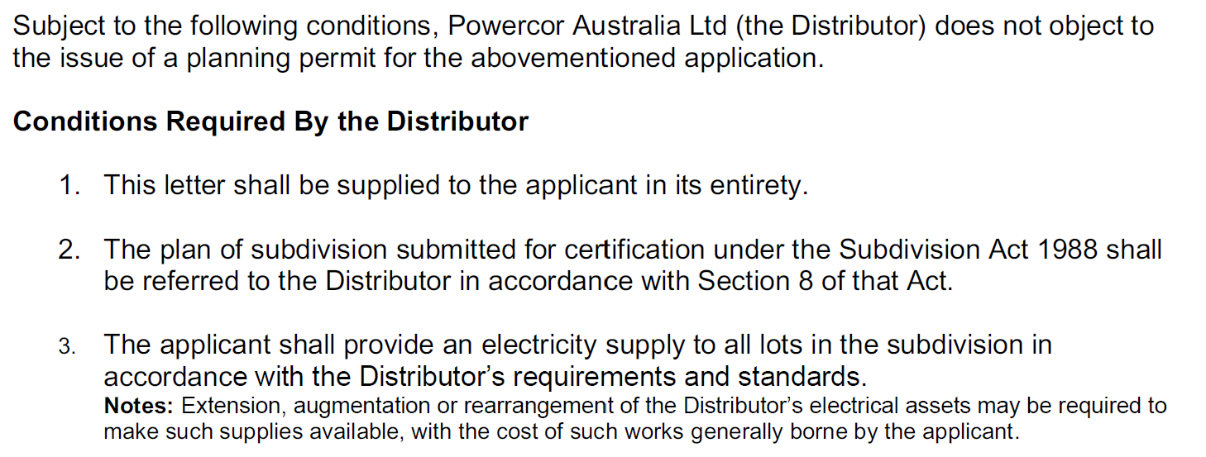  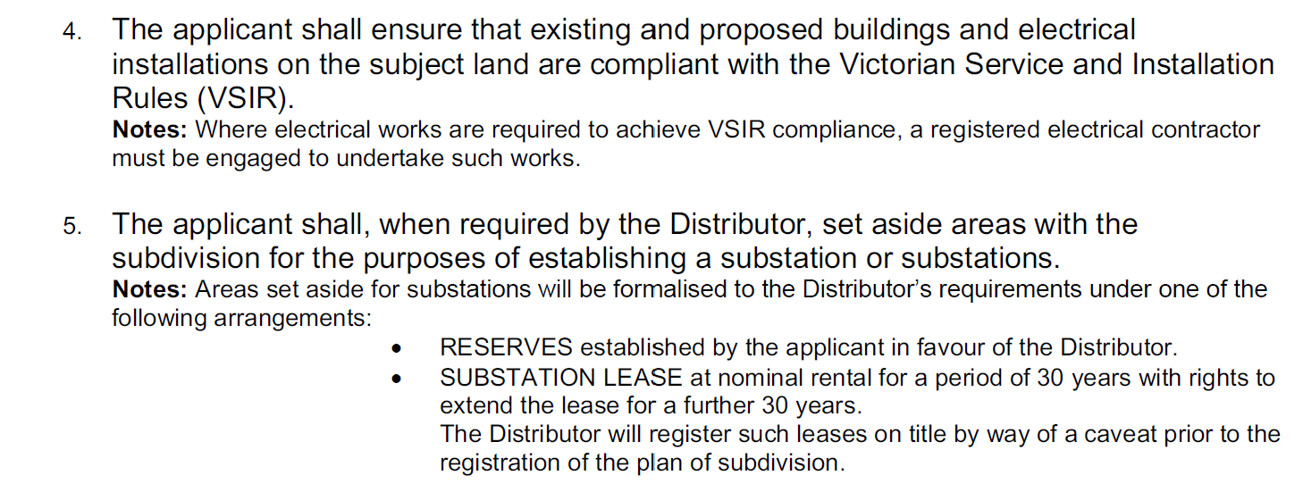  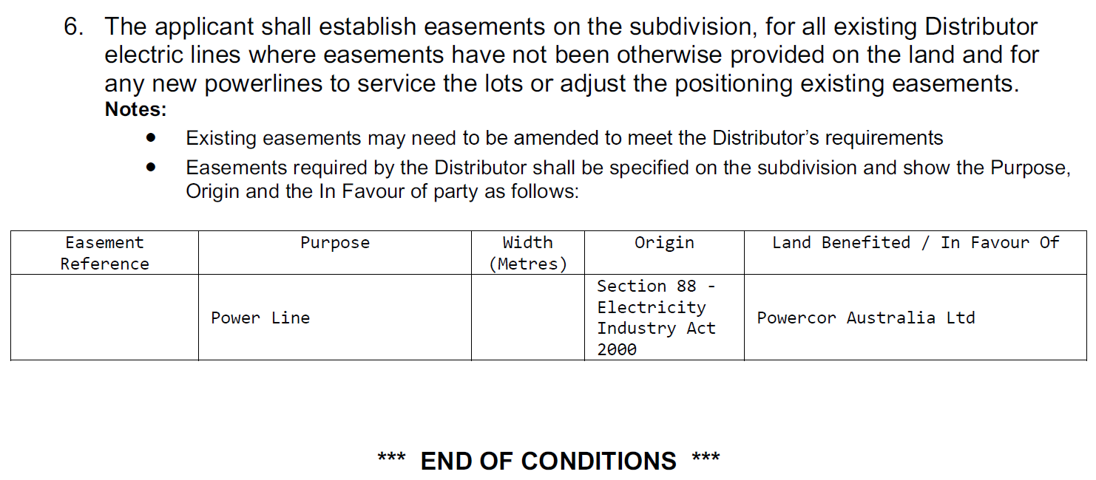
Officer Comment:
The required conditions must be included on any permit that were to be issued.

Authority: | Downer Tenex
Response: | No response was received.
Officer Comment:
Gas supply to the development is no longer a requirement of subdivision and has not specifically been proposed as part of this application. Were a permit to be granted, a condition should require the land owner meet agreed requirements with all relevant utility service providers prior to issue of statement of compliance.
It is notable that Amendment VC250 on 01/01/2024 introduced the Residential Reticulated Gas Service Connection general requirement prohibiting gas connection to new apartment developments. The application is exempt from this requirement pursuant to the transition provisions that apply for applications lodged prior to the approval date of Amendment VC250.

RECOMMENDING AUTHORITY

Authority: | Floodplain Management Authority (SBO)
Response: | A memorandum of understanding (MOU) was entered into between the Corangamite Catchment Management Authority (CCMA) and Greater Geelong City Council in September 2016 for the area of the municipality within the Corangamite Waterway Management District.  As Council is the relevant drainage authority for local drainage and the authority responsible for the flood mapping that forms the basis of the SBO on the Council drainage system, Corangamite Catchment Management Authority will no longer act as a Referral Authority for planning permit applications in areas affected by flooding from the local drainage system.  Engineering Services (as Floodplain Manager) Response  This response is based on the revised plan-set D23-36000 and the previous SBO responses (PW22-11060, 09/2/2022 and D20-418184, 01/10/2020). As per request for further information, the finished surface level of the basement access (footpath) has been shown on the Ramp Section as 13.616 which is deemed to be to AHD.  The onsite and offsite increase in flooding reported in Flood Impact Assessment (FIA) are unacceptable (below map). For a development in SBO, the City has ‘no-adverse impact’ policy. The increase in flooding onsite within the proposed building footprint does not make sense, indicating that the building has not been incorporated properly. Therefore, the modelling needs to be re-done to determine the appropriate flood levels, risks and impact.  According to the SBO flood study, the applicable flood level for the ramp access is 13.60m AHD. The proposed floodgate top/highest level is set at 14.06 m AHD (figure below) – 300 mm above the flood level resulted from the FIA. This level needs to be re-assessed based on re-modelling as per above.  Apparently, the proposed ground floor level 14.60m AHD complies with the required minimum 300 mm freeboard above the applicable flood level 14.20m AHD (SBO floodmap below) or 13.77m AHD as resulted from FIA. However, the latter needs to be reviewed due to the reason stated above.  Overall, the proposed development appears to be feasible with a review of the flooding/levels based on re-modelling.  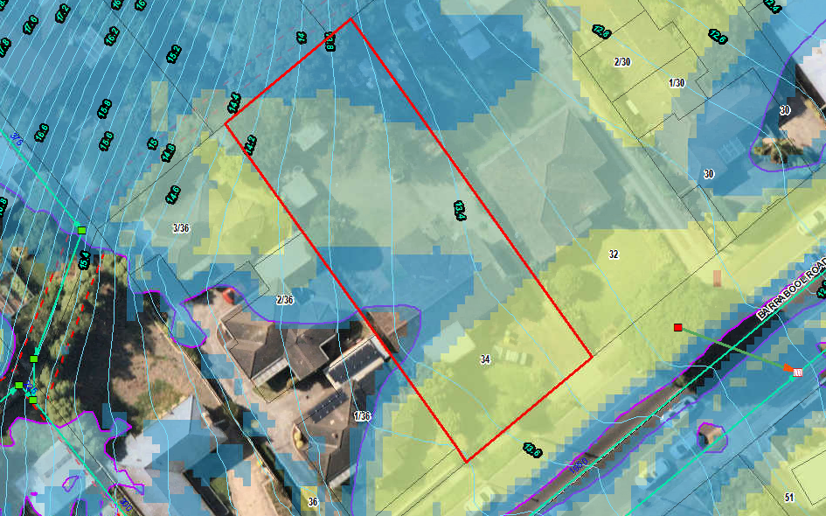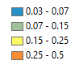  SBO flood map  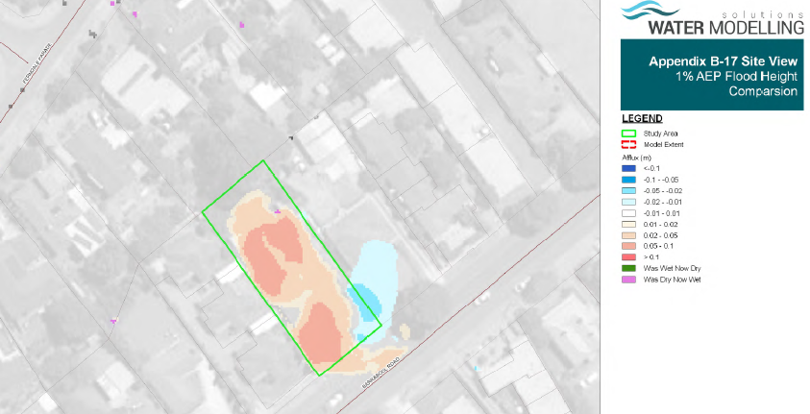  Development impact on flooding  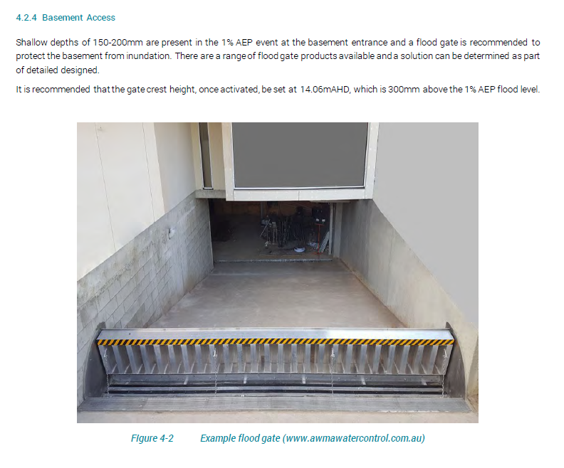  Pursuant to Section 56 of the Planning and Environment Act 1987 Engineering Services (SBO as Floodplain Manager), does not object to the granting of a permit, subject to the following conditions:  - Prior to the commencement of the development, amended plans and Flood Impact Assessment report to the satisfaction of the Responsible Authority must be submitted to and approved by the Responsible Authority. When approved, the documents will be endorsed and will then form part of the permit. The documents must be generally in accordance with those submitted with the application but modified to show:  - There is no adverse impact of the development on flooding for rainfall events up to 1% AEP (Annual Exceedance Probability) by properly incorporating the building in hydraulic modelling.  - The site or its access/egress will not be hazardous as per Victorian State Government Guidelines for Development in Flood Affected Areas for rainfall events up to 1% AEP (Annual Exceedance Probability).  - The proposed top/highest level of the floodgate is at least 300mm above the applicable flood level as determined from the modelling of development condition by properly incorporating the building.  - The Finished Floor Level (FFL) of the ground floor must be at least 300mm above the applicable flood level as determined from the modelling of development condition by properly incorporating the building.  - The north-eastern basement vents must set at least 150 mm freeboard above the applicable flood levels as determined from the modelling of development condition by properly incorporating the building. Such minimum freeboard for any north-western vents (which are not recommended due to flood risk) must be 300 mm.  - Any new fences and gates within the SBO area must have minimum 150 mm ground clearance or 25% opening to 450 mm height from the ground. The minimum clearance above any built/smooth surfaces (e.g. paved, concrete, decks etc) is 100mm.  - Any new decks within the SBO area must be non-obstructive to overland flows, that is, unenclosed type to allow passage of flood water underneath.  Notes from Engineering Services (SBO as Floodplain Manager)  A floor should generally be built at least 150 mm above the peripheral ground/finished surface of the building.  Any earth filling should be kept to a minimum on the property to ensure that existing flow paths are not impacted by the proposed works.
Officer Comment:
Generally, the recommendations should be included as part of any permit that might be issued.
The response requires that inconsistencies in the Flood Impact Assessment be corrected so as to establish the flood level for the site from which minimum floor levels, surface levels and the flood gate height (plus 300mm) can be determined for plan approval. A resultant effect of this is to determine what that maximum building height must be to accord with Clause 32.08-11 of the GRZ, which allows 11 metres from the minimum floor level determined by the relevant floodplain management authority. At present the maximum is shown to be 11.070 (measured from natural ground level) which is unlikely to be greater than the minimum finished ground floor level required.
Given the minimum floor level is yet to be formally established, it is recommended an amended plans condition require the maximum building height be dimensioned to be no greater than the minimum finished ground floor level plus 11 metres to comply with the height requirements of the GRZ4.

SECTION 52:

Nil

INTERNAL

Department: | Engineering Services
Response: | Ramp design does not achieve a one in ten (10%) grade for the first five metres and considered unsafe for pedestrians and vehicle access.  The vehicle crossing does not achieve a minimum 1m clearance to the fireplug. Barwon Water need to provide written confirmation of the vehicle crossing within 1m clearance if this clearance cannot be achieved.  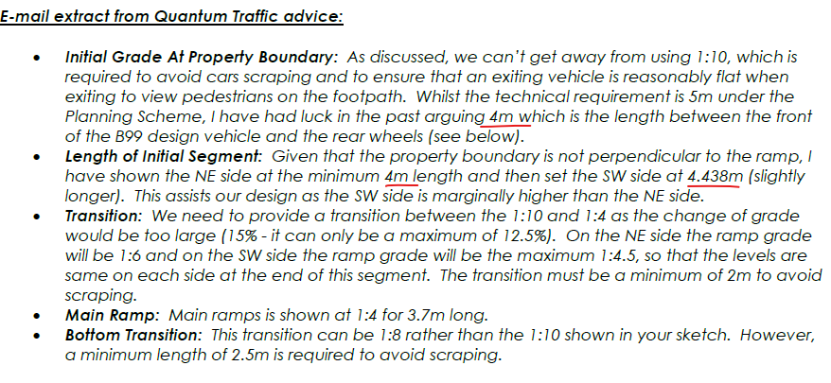  Extract from letter of response to grades does not match what the plan set shows where only the first 2.8m achieved a grade of one in ten (10%). Plans need to be in accordance with the Planning scheme requirements that the first 5m have a grade of one in ten.  Sewer Vent adjacent to proposed new multi-level development.  Barwon Water is required to make comment on the Sewer vent pipe and height of the proposed dwelling with respect to sewer miasma entering the living areas in the upper stories. The vent pipe may need to be modified.  Floodgate Detail Requirement  Engineering requires a detail plan to be submitted showing the floodgate setback by a minimum distance of 1m from the property boundary and how the driveway crossfall grades will transition to accommodate the floodgate that needs to be installed along a horizontal plane. It is noted there is a crossfall grade across the driveway and the driveway will need to transition, as needed, to accommodate the floodgate across a flat surface. An amended plans condition is included and a rough sketch provided.  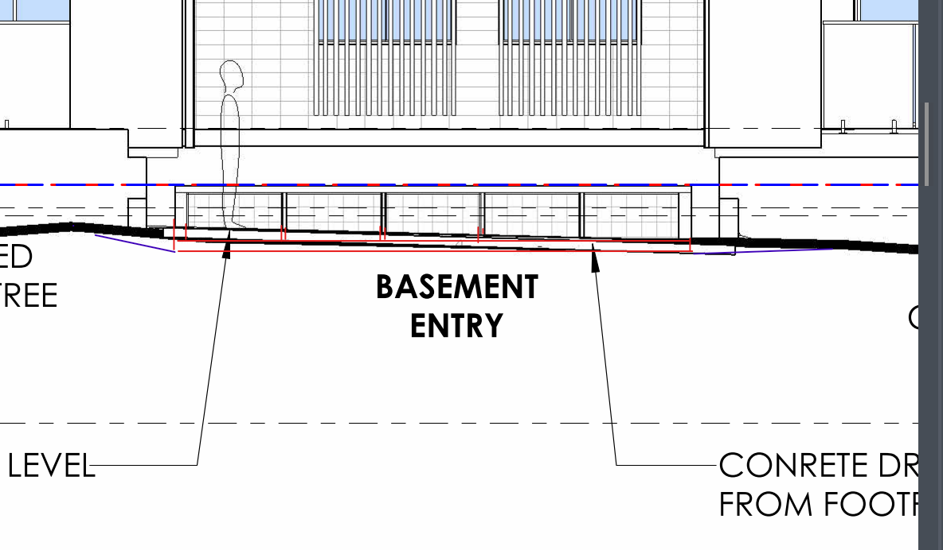  Transitions of driveway
Officer Comment:
The traffic engineering report submitted with the application demonstrates that a revised ramp gradient design can accommodate safe access and egress of vehicle whilst maintaining sightlines for pedestrian safety.
Additional flood gate design detail has been provided to show that the gate can be installed 1m from the site boundary and maintain full function in accordance with the manufacturer’s specifications and requirements.
The permit applicant has been advised to liaise with the sewer vent asset owner to consider what, if any action can be taken to relocate the sewer vent, if necessary.
The recommended conditions should be included on any permit that were to be issued.

Department: | Environmentally Sustainable Development (ESD)
Response: | This ESD response of this application is done on 15/3/2023 (3rd response). The applicant has not been satisfactorily responded all the previous ESD comments.  However, permit can be issued with permit conditions. The summary of the conditions or concerns are as below:  - The applicant needs to provide MUSIC file (.sqz) for validation so that the modelling assumptions and treatment measures is reasonably right.  - An updated catchment plan should be clearly marked and dimensioned based on the proposed treatment measures.  Council’s ESD Officer’s has reviewed the following:  - Development plans by Anotherdimension building design, May 2021, received on 23/1/2023  - ESD report by Anotherdimension building design, January 2023, received on 23/1/2023  - Storm report by Anotherdimension building design, May 2021 and received on 25/1/2022  - BESS report (project identifier: (739E3883-R2 Version -BESS 6), received on 23/1/2023  The outstanding issues of the previous ESD responses are below showing in BOLD  Environment (ESD) Response  - The MUSIC model is used for Storm water treatment measure to meet the objectives of 53.18. The MUSIC assessment detail report and MUSIC file (.sqz) must also be submitted for validation.  Not Resolved: MUSIC file (.sqz) is not visible in this submission. The applicant needs to provide MUSIC file (.sqz) for validation so that the modelling assumptions and treatment measures is reasonably right.  - Catchment plan: A complete response to the stormwater management requirements involves the preparation and submission of a site layout plan showing the different catchment areas size and the proposed stormwater treatment measures consistent with the MUSIC report, plans and the BESS report.  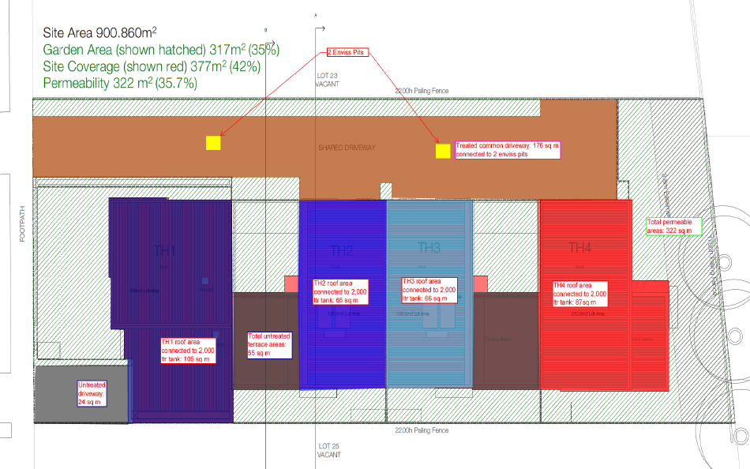  The underlying must be a roof plan that indicates slopes of different roofs to predict the potential path of rainwater from source to treatment destination. The catchment plan must include all the site and all the impervious areas including the paved areas in the private open space.  An updated catchment diagram will need to be added to the plans (e.g. above). Typically, catchment diagrams are colour coded – red shading showing the roofs draining to rainwater tanks, blue shading showing parts of the driveway draining to a raingarden, green areas showing vegetation and permeable/porous paving etc.  Not Resolved: An updated catchment diagram will need to be added to the plans.  Recommended Permit Conditions (Without Prejudice)  - Before the use and development commences, amended plans to the satisfaction of the Responsible Authority must be submitted to and approved by the Responsible Authority. When approved, the plans will be endorsed and will then form part of the permit. The plans must be drawn to scale with dimensions. The plans must be generally in accordance with the plans received 23/1/2023 but modified to show:  - Initiatives contained within the ESD report along with the proposed changes, including:  - An updated catchment plan clearly marked and dimensioned based on the proposed treatment measures in the development plan.  If a BESS report is included as part of the ESD report, the BESS report must achieve an overall score of 50% or higher and have a minimum ‘pass’ rates of 50% for the Energy, Water and IEQ categories and 100% for the Stormwater category.  - All works must be undertaken in accordance with the endorsed Plan, ESD report and stormwater management plan to the satisfaction of the Responsible Authority. No alterations to these plans may occur without the written consent of the Responsible Authority. The other condition is as below:  The applicant needs to provide MUSIC file (.sqz) for validation so that the modelling assumptions and treatment measures is reasonably right.
Officer Comment:
The application was supported, subject to conditions. The conditions should generally be included on any permit that were to be issued.

Department: | Urban Design
Response: | Urban Design Recommendation Response  The table below summarises the previous advice that was provided by Urban Design and whether the issues have been resolved in the current design.  Other Comments from Urban Design  While only some of the previous Urban Design recommendations have been addressed, Urban Design is in general supportive of this proposal. It will help achieve the objectives of evolving the character of Increased Housing Diversity Areas (IHDA) through more intensive development (16.01-1l-02).  The main outstanding issue is the excessive overshadowing of private open space at 36 Barrabool Road in particular to the unit at 2/36 Barrabool. While intensification of this area is appropriate this must be done in a manner that preserves amenity and liveability at the neighbourhood level. Noting that 16.01-1l-02 building height policy guidelines for IHDA areas includes that:  “Encouraging development up to three stories. Three storey development should be located on larger sites abutting the activity centre or where the amenity of adjoining properties will not be unreasonably impacted”.  The shading of the private open space at 2/36 Barrabool is an unreasonable burden on this dwelling. Redesign of the second floor level of the proposal to prevent overshadowing should be achievable if the size of apartments 9 and 10 is reduced. Reduction of these apartments from 3 bedrooms to 1 or 2 bedrooms would also assist the proposal to offer an increased housing diversity in terms of a more varied selection of apartment types. Likewise, reduction in overall built form on the second floor level will be more visually recessive and thus responsive to the neighbourhood character, reducing dominance of adjoining properties and the streetscape. Reduction of bulk on this level may also be useful to ensure compliance with B17 setback envelope standard which is not met in the current design on the North East side.  Also important is the way that the building encourages sustainable and active transport modes. A key goal of the Housing Diversity Strategy 2007 is to reduce urban sprawl and encourage modes of transport other than cars (3.2.1). The design of buildings should support these modes through providing adequate facilities. The revisions to the design adding an entry arbour and landscaping are welcomed as improving the sense of address and approach to the building for pedestrians encouraging pedestrian movement. However, the insufficient provision of bicycle parking within the proposal in comparison to the generous provision of carparking is at odds with the need to promote cycling as a mode of transport. Barrabool Road is a strategic cycling corridor identified in the Principal Cycling Network and has bike lanes in both directions. Better provision of bicycle parking will act as a strong incentive for bicycle use as a mode of transport supporting objectives of the Housing Diversity Strategy.  Non-Standard Conditions  1: Revised plans to be submitted showing a redesign of the second floor such that overshadowing impacts are reduced on the Secluded Private Open Space (SPOS) of units at 36 Barrabool Road to comply with 55.04-5 standard B21. The preferred method for this to be achieved is through reduction of the size of apartments 9 and 10 and/or repositioning of balconies and further alignment of built form away from the south-west boundary. Revised plans must be to the satisfaction of Urban Design and the Responsible Authority.  2: A high-quality landscape masterplan to be provided that depicts front garden plantings and trees at least as extensive as those depicted in artists impressions at P000 of the revised plans. To the satisfaction of Urban Design and the Responsible Authority.  3: Revised plans to show provision of additional bike parking. The number of resident bikes that are able to be parked should preferably be the same or more than the number of car spaces provided. As a minimum there must be more than 10 resident bike parks.  4: Any air conditioning units installed on the building frontage must be below the level of any balcony balustrade and fully concealed from view from the street.  Note to the Planner  Please note B17 is not compliant on the North East side.
  Issue | Recommendation | Resolved?
  Dominance of third storey | Recessing the upper level | Not resolved – design is essentially same form.
  Overshadowing of neighbours | Refine design to reduce | Not resolved – design is essentially same form.
  Interface quality | Direct entry to apartments from street | Not provided
   | Materials legend more specific- add colour | Resolved
   | Conceal A/C condenser units from public view | Still on front of building but should be concealed by balustrade of balcony.
  Landscaping | Landscape buffer between APT01 and path | Trees are enlarged on plan. But high-quality landscape plan not provided, landscaping shown in more detail on artists impressions.
   | Seating and additional trees to improve amenity of communal area | A high-quality landscape plan has not been provided. Trees are enlarged on plan and seating is shown in the artists impression.
   | Screening of rainwater tank to improve amenity of communal area. | Not resolved – not unreasonable though, in the far corner and screening with planting may restrict access.
  Apartment diversity | More two bedroom and add 1 bedroom | Not resolved
  RFI | Relationship paved entry and landscaping, more detail needed.  Landscape Plan is required. | Additional design of entry arbour provided.
   | What is proposed SW in the corner, more detail needed. | As above
Officer Comment:
The comments and recommendations have been considered. Further detailed assessment of the building form and context have been given later in these recommendations, including an assessment of Clause 55.

Department: | Waste Services
Response: | The road width at this point is satisfactory for private collections. A number of commercial properties use this style of collection, basement storage and mechanical assistance to move bins up ramp to street for emptying. Condition to ensure that bins are not left in street, either empty or full. Must only be moved to street for collection then returned.
Officer Comment:
The recommended condition required the waste management plan submitted be endorsed as part of the planning permit, and that an agreement under section 173 of the Act be executed to require the Council Residential Waste Services Charge be levied on future residents of the development.

AMENDMENT OF THE PROPOSAL PRIOR TO PUBLIC NOTIFICATION:

The applicant made a first request to amend the application pursuant to Section 50 of the Planning and Environment Act 1987 on 2 February 2022. Council accepted the amendment. The amendment made the following changes to the application:

- Redesign to comply with introduced mandatory garden area requirements of 35%.
- Reduction of number of apartments from 13 to 10.
- Provision of flood management and stormwater management plans.
- Relevant updates to planning report and planning assessment.

The applicant made a second request to amend the application pursuant to Section 50 of the Planning and Environment Act 1987 on 29 March 2022. Council accepted the amendment. The amendment made the following changes to the application:

- Multi-lot subdivision.

A request for further information and recommended matters for reconsideration was sent on 27 April 2022 in response to the 2nd amendment request.

Revised plans were received on 24 January 2023 after a number of extensions to the application lapse date.

PUBLIC NOTIFICATION:

The application is not exempt from the notice requirements of Section 52(1)(a), (b) and (d), the decision requirements of Section 64(1), (2) and (3) and the review rights of Section 82(1) of the Act and pursuant to Section 52 of the Planning and Environment Act 1987 the following forms of advertising were undertaken:

- 12 x notices were sent to owners and occupiers of adjoining land (including opposite).
- 1 x A2 sign was placed on the land.

Eight (8) written objections have been lodged with the City, plus two (2) incomplete submissions where the submitter has not been able to be contacted for locality verification. One (1) submission of support has been received.

LOCATION OF OBJECTIONS:

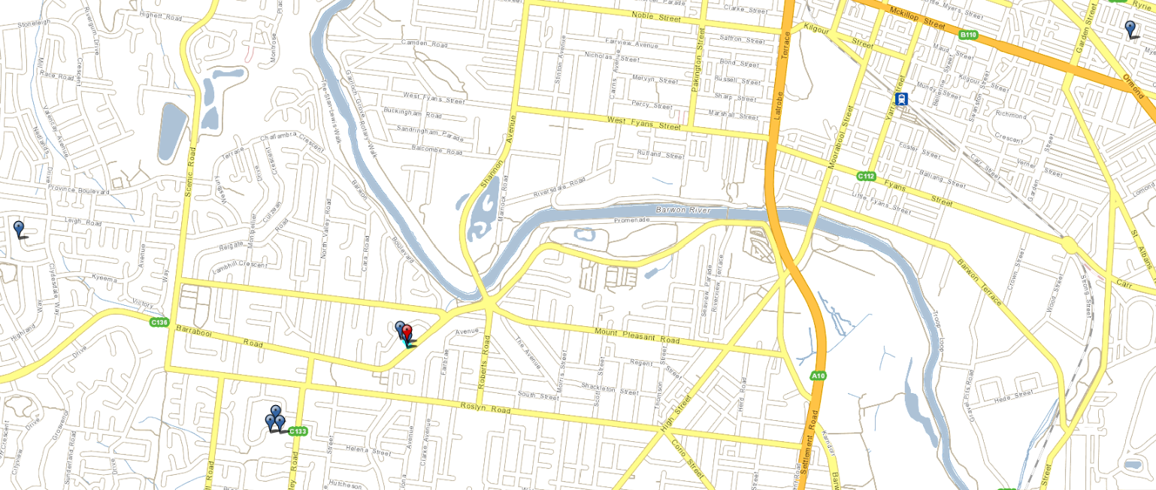
Figure 22: Location of objectors (blue flags) in relation to the subject site (red flag). The furtherest is 4.5km to the north east (top right), and the nearest is adjoining the site. Source: PLACES Weave GIS.

CONSULTATION:
A consultation meeting was not held between the applicant, council officers, and all objectors.

A meeting was held between the applicant, City planning officer, and the objector from the property abutting the site at 1/36 Barrabool Road. The meeting discussed the issues raised to see if any resolutions were possible.

The permit applicant submitted an offer to the owner of 1/36 Barrabool Road for the effective loss of energy generated by the rooftop solar energy system during the winter period. The offer equates to an amount calculated to be the effect of shadows on PV cells during the period 1 June to 31 August, being when the sun is at its lowest such that shadows will read the PV cells.

The offer has been given to the objector, however, no resolution has been confirmed and no withdrawal of objection has been received.

AMENDMENT OF THE APPLICATION FOLLOWING PUBLIC NOTIFICATION:

The applicant made a request to amend the application following public notification pursuant to Section 57A of the Planning and Environment Act 1987 on 8 March 2024. Council has accepted the amendment. The amendment made the following changes to the application:

- Revised basement access ramp grades, and resultant floor plan dimension changes

These are the plans currently under assessment.

It was not considered necessary to readvertise the proposal based on the amendment, as the amendment would not result in any additional material detriment compared with the advertised application, for the following reasons:

- The changes did not result in an increase to the scale, height or bulk of the development, or any change to building setbacks that would introduce or increase the likelihood of material detriment to others.
- The changes were in direct response to car park design matters raised by the assessing officer.

OBJECTIONS:

The concerns of objectors are summarised below, along with Officer consideration comments.

Objection Summary | Officer Consideration
- Development is too big in comparison to nearby houses. Will change the character of the neighbourhood. | The site is within the GRZ 4 and Highton Village Increased Housing Diversity Area (IHDA) that nominate the location to be suitable for residential development, including dwellings, townhouses and apartment buildings, up to and including 3 storeys and a height of 11.3 metres above the applicable flood level for the site. Redevelopment of land in the IHDA will result in a change to the existing character of the area by introducing a preferred character that accommodate increased density and diversity.  For these reasons, the development is not required to conform with the established building heights and housing types of the area such that a development of the type proposed can be approved.  It is notable that other relevant housing and settlement policy encourages infill development in location with good access to facilities and services. Were the proposal to be approved and constructed, it would provide for 10 dwelling on land that currently accommodates only 1, resulting in a significant gain in the need to provide more housing to meet a growing need.  Refer to the Clause 55 Assessment of the proposal for detailed consideration of the ResCode requirements later in this report.
- Landscape plan doesn’t provide enough trees in good locations. Doesn’t add to canopy tree coverage objective of the City. Existing trees should be retained. | The planning scheme does set out requirements for landscaping of multi-dwelling developments of this type. These are found at Clause 55.03-8 (Landscaping objectives) and requires development ‘respects the landscape character of the neighbourhood’ and to ‘encourage the retention of mature vegetation on the site’. The application proposes to meet these objectives (along with other, competing objectives of the Scheme) by providing a landscape plan that shows plantings of new canopy trees within the front setback and small trees along the south boundary of the site. The replacement plantings exceed the number of trees that will be removed, resulting in a net gain for the canopy coverage objectives of the City.
- Additional vehicles from the development won’t fit in basement and will cause traffic and parking disruption. | The development provides for car parking on the land in accordance with the requirements of the Scheme. This means 1 car parking space for each 2 bedroom apartment, 2 car parking spaces for each 3 or more bedroom apartment, and 2 shared visitor car parking spaces. On-street parking spaces are also proposed to be retained.  Because the development meets the car parking requirements of the scheme, it is not considered appropriate that more parking be sought in anticipation that more may be needed. The scheme already requires visitor car parking spaces to accommodate parking over-flow.
- Will ‘reduce the liveability of our suburb’. | The liveability of a neighbourhood, a suburb, and a region is dependent on the provision of a variety of housing types. Liveability is not static and is always subject to change that is most noticeable to those that have lived in an area the longest.  It is likely that the introduction of a diversity of dwelling styles into this part of Highton will add to the vitality and sense of place commonly associated with ‘liveability’.
- Will contribute to congestion at intersection of Ferndale and Barrabool | Road networks in urban areas are specifically designed and constructed with capacity to accommodate, and often exceed, the traffic volumes that will be generated by the surrounding urban land ‘catchment’ the road network services. Roads and their intersections are designed by engineers in anticipation of increases to traffic over the life of the road.  Barrabool Road is part of the Principal Road Network and specifically designed and constructed to take large volumes of traffic. The modest amount of additional traffic generated by the proposal will not result in an unacceptable change to the existing traffic volumes or function of nearby intersections.
- Overlooking from development to dwellings on the southwest - louvres could be removed. | The overlooking requirements of the Scheme provide for fixed screens to be constructed that limit down views to windows and private open space on adjoining land. Where these screening treatments are used and approved under a planning permit the building owner and occupants a bound by an ongoing obligation to maintain these screens for the life of the building, unless alternative screening treatments are approved.  Refer to the Clause 55 Assessment of the proposal for detailed consideration of the ResCode requirements later in this report.
- Excessive shadowing of SPOS of dwellings to southwest, and increased heating costs for those houses | The shadow drawings provided with the application show that the building will cast an additional shadow over the secluded private open space of the dwellings to the south west. The application proposes a variation to the standard set out in the Scheme. Further consideration to whether or not the objective has been met is given later in these recommendations.  Refer to the Clause 55 Assessment of the proposal for detailed consideration of the ResCode requirements later in this report.
- Disruption from foot traffic alongside to entrance of building and loss of privacy to dwelling adjoining | Concrete paving is proposed along boundary for path to front door. This is considered appropriate as unlikely to create intrusive noise unlike pebbles or the like. A 1m wide landscape strip provides separation from the path to the fence, and also limits overlooking to the SPOS of the adjoining dwelling on the other side of the existing 1.7m high fence. No unreasonable loss of privacy will result from the location of the entrance path.
- Will worsen urban heat in the area. | The application includes Environmentally Sustainable Development initiatives that respond to a variety of energy and resource reduction initiatives, including the need to provide permeable and landscaped areas. The landscape plan shows the provision of canopy trees and other plantings to reduce the extent of impervious surfaces, and the overall site coverage is within the requirements of the Scheme. Unlike some residential developments in urban areas, the proposed development achieves the provision of 10 dwellings within the site area coverage and impervious surface footprint commonly found by a single large dwelling. In this respect, the development generates a significant benefit for modest cost to the urban heat island effect. And it also reduces pressure on the need to further increase the urban area of Geelong.
- Increased flood risk from stormwater/rainfall runoff. | In its present state, the land already contributes to stormwater runoff via overland flows and impervious surfaces.  The increase to impervious surfaces brought by the development and increase in stormwater runoff (i.e. water leaving the site) must be managed on the site to meet current best practice performance objectives for stormwater quality such that erosion will be prevented. The site stormwater system is proposed to be designed and constructed to capture, retain and release stormwater runoff at a rate that is no greater than the current (pre-development) rate. This is achieved through the use of rainwater tanks and permeable surfaces as shown in the site Stormwater Management Strategy (SWMS) submitted as part of the application.  The drainage authority engineers and the stormwater planning engineers on behalf of the floodplain management authority have reviewed the SWMS and have agreed that the risk of flooding and erosion will not be increased were the development to proceed after detailed design and construction has been completed.
- Increased traffic risk to pedestrians. | The proposed basement ramp accessway is 6 metres wide, with grades that allow pedestrians at the entrance to the property and vehicles exiting a clear line of sight to prevent collisions. The development will not introduce an unacceptable safety risk to pedestrians.

ASSESSMENT:

ZONE:

Clause 32.08 General Residential Zone (GRZ4).

The purpose of the GRZ4 is:

- To implement the Municipal Planning Strategy and the Planning Policy Framework.
- To encourage development that respects the neighbourhood character of the area.
- To encourage a diversity of housing types and housing growth particularly in locations offering good access to services and transport.
- To allow educational, recreational, religious, community and a limited range of other non-residential uses to serve local community needs in appropriate locations.

The zone applies a mandatory minimum garden area requirement to the subject site of 35%.

The zone requires that the proposed development must meet the requirements of Clause 55 (Two or more Dwellings on a lot and Residential Buildings). Schedule 4 to the General Residential Zone specifies the following requirements of Clause 55:

- Minimum street setback (Standard B6)

If the site is in a heritage overlay, the average distance of the setbacks of the front walls of the existing buildings on the abutting allotments facing the front street or 9 metres, whichever is the lesser.
In all other areas, the average distance of the setbacks of the front walls of the existing buildings on the abutting allotments facing the front street or 4 metres, whichever is the lesser

- Site Coverage (Standard B8)

Maximum site coverage 70 per cent.
- Private open space (Standard B28)

A dwelling or residential building should have private open space consisting of:
  - An area of 20 square metres of secluded private open space at the side or rear of the dwelling or residential building with a minimum dimension of 3 metres and convenient access from a living room; or
  - A balcony of 8 square metres with a minimum width of 1.6 metres and convenient access from a living room; or
  - A roof-top area of 10 square metres with a minimum width of 2 metres and convenient access from a living room.

The zone applies a mandatory dwelling and residential building height limit to the subject site.

Schedule 4 to the General Residential Zone does not specify the maximum height or number of storeys for a dwelling or residential building.

If no maximum building height or maximum number of storeys is specified in a schedule to this zone:
- the building height must not exceed 11 metres; and
- the building must contain no more than 3 storeys at any point.

A building may exceed the maximum building height by up to 1 metre if the slope of the natural
ground level, measured at any cross section of the site of the building wider than 8 metres, is
greater than 2.5 degrees.

A basement is not a storey for the purposes of calculating the number of storeys contained in a building.

OVERLAY:

Clause 44.05 Special Building Overlay

The purpose of Clause 44.05 is:

- To implement the Municipal Planning Strategy and the Planning Policy Framework.
- To identify land in urban areas liable to inundation by overland flows from the urban drainage system as determined by, or in consultation with, the floodplain management authority.
- To ensure that development maintains the free passage and temporary storage of floodwaters, minimises flood damage, is compatible with the flood hazard and local drainage conditions and will not cause any significant rise in flood level or flow velocity.
- To protect water quality and waterways as natural resources by managing urban stormwater, protecting water supply catchment areas, and managing saline discharges to minimise the risks to the environmental quality of water and groundwater.

Response to zone and overlay(s)

The application accords with the purpose and decision guidelines of the General Residential Zone – Schedule 4.

The proposal increases the available supply of housing in a location with good access to services and transport. The mix of 2 and 3 bedroom apartments adds to the diversity of housing types in the area.

The proposal has been assessed against the requirements of Clause 55 and found, for the most part, to provide an acceptable design response with relatively few variations to the ResCode standards. However, the extent of overshadowing from the building to the Secluded Private Open Space of the dwellings at 1/36 and 2/36 Barrabool Road has been found to be significant such that the mandatory objective of Clause 55.04-5 (Overshadowing open space objective) has not been met.

The proposed development conforms with the mandatory height requirements for dwellings in the zone. The apartment building reaches a maximum height of 11.07 metres measured from natural ground level, which is lower than the allowable maximum height of 11.0 metres above the finished floor level required by the Floodplain Management Authority.

The site is provided with 348.53 square metres of garden area, representing 35.07% of the 993.73 square metre site, and in accordance with the mandatory minimum garden area requirement of the Scheme.

The development is likely to result in some overshadowing of the solar energy system on the dwelling at Unit 1, 36 Barrabool Road, Highton. The dwelling is located on the south side of the development.
The permit applicant completed a detailed assessment of the likely effect, calculating a worst-case outcome would be that a loss of 40% of available sunlight would be lost between the 1st of June and the 31st of August each year, for the remainder of the service life of the system. It was found that the system will be unaffected for the early part of the day during winter, and not at all through the rest of the year.

From these calculations, a financial settlement offer was made to the owner of the system. The assessing officer has reviewed the calculations and the settlement offer and found that the offer is reasonable if not generous, and likely to exceed the financial loss from the overshadowing of panels.

It is considered that the settlement offer is an acceptable response to offset the overshadowing of the solar energy system such that an acceptable planning outcome could be achieved should the affected land owner choose to accept it.

The application was reviewed by the Floodplain Management Authority engineers who do not object to the grant of a permit, subject to conditions. Were a permit to be granted, the conditions will require flood modelling to determine the applicable flood level and the relevant finished floor and surface levels more precisely such that an acceptable outcome will be achieved in terms of the purpose and decision guidelines of the SBO. The design response incorporates stormwater retention measures and provides for overland flow paths that are commensurate with pre-development conditions.

CULTURAL HERITAGE MANAGEMENT PLAN (CHMP):

The Aboriginal Heritage Regulations 2018 specify the circumstances in which a cultural heritage management plan is required for an activity or class of activity. Division 2 of the Aboriginal Heritage Regulations 2018 specifies exempt activities which do not require a cultural heritage management plan. The proposal is not listed as an exempt activity.

Areas of cultural heritage sensitivity are defined within Divisions 3 and 4 of the Aboriginal Heritage Regulations 2018. Division 3 does not identify the site or part of the site as within an area of cultural heritage sensitivity. High impact activities are defined within Division 5 of the Aboriginal Heritage Regulations 2018. Division 5 lists the proposal as a high impact activity.

The site is not considered to have been the subject of significant ground disturbance which is defined as ‘disturbance of (a) the topsoil or surface rock layer of the ground or (b) a way - by machinery in the course of grading, excavating, digging, dredging or deep ripping, but does not include ploughing other than deep ripping.
In accordance with the above assessment, a cultural heritage management plan is not required.

LANDFILL GAS RISK ASSESSMENT:

The subject site is not located within 500 metres of an identified former landfill site. A landfill gas risk assessment is not required.

DEVELOPMENTS IN BUSHFIRE PRONE AREAS:

The site is not located within a designated bushfire prone area. A bushfire risk assessment of the application is not required.

THE PLANNING POLICY FRAMEWORK (PPF):

The following clauses of the Planning Policy Framework are applicable to this application:

Clause 11 (Settlement):
- 11.01-1S Settlement
- 11.01-1R Settlement – Geelong G21
- 11.01-1L-01 Settlement – Greater Geelong
Clause 13 (Environmental Risk and Amenity):
- 13.03-1S Floodplain management
- 13.03-1L Floodplain management

Clause 15 (Built Environment and Heritage):
- 15.01-2L Environmentally sustainable development
- 15.01-3S Subdivision design
- 15.01-4S Healthy neighbourhoods
- 15.01-5S Neighbourhood character
- 15.01-5L Neighbourhood character

Clause 16 (Housing):
- 16.01-1S Housing supply
- 16.01-1R Infill housing - Geelong G21
- 16.01-1L-01 Integrated housing and housing diversity
- 16.01-1L-02 Increased housing diversity areas
- 16.01-2S Housing affordability

Clause 18 (Transport):
- 18.01-1S Land use and transport integration
- 18.02-4S Roads

Response to Policy

The application has been considered against all relevant objectives and strategies, and has been found to give appropriate effect to the PPF of the Scheme.

It proposes an infill housing development that will assist with meeting the growing need for diverse housing in Geelong. It is located on land offering convenient access to a full range of employment, education, health, social, recreational and commercial services. The site is fully serviced by utilities, and the established road and alternative transport network, and is within walking distance of the public bus network.

The apartment development offers a contemporary accommodation option that adds to the diversity of available housing to meet a variety of needs within the community. This diversity is likely to assist with housing affordability, particularly given the mix of 2, and 3 bedroom apartments proposed, and the compact layout and generous communal shared spaces provided.

The Floodplain Management Authority has determined that the proposal can produce an acceptable outcome in terms of flood risk. With further work and approval of flood mapping the development maintains free passage and temporary storage of floodwaters and is compatible with local drainage conditions.

Similarly, that application incorporates an acceptable variety of environmentally sustainable development features. The sustainable design assessment submitted with the application shows that the ESD policy will be given effect at detailed design.

Importantly, the design detail of the development responds appropriately to the preferred character of the area. This part of Highton is appropriately located to accommodate housing developments of increased density and diversity in accordance with Schedule 4 to the GRZ (Urban Increased Housing Diversity Areas) that invokes Clause 16.01-1L-02 (Increased housing diversity areas). In this respect, the zone and policy invoke dwelling (including apartment) developments up to and including 3 storeys. This development has incorporated built form strategies by incorporating horizontal and vertical articulation, and a mix of materials, textures, and colours to create visual interest. The upper storey is recessed, reducing visual dominance, and setting a design standard for multi-dwelling developments along this part of Barrabool Road for the future.

The site access from the principal road network allows for safe and unobstructed vehicle movements in and out of the basement. The access has been carefully designed to allow entry and exit in a forward direction; vehicle circulation and turning in the basement car park; and no net loss of on-street car parking.

RELEVANT PARTICULAR PROVISIONS:

The following Particular Provisions are applicable to this application.

CLAUSE 52.06 – CAR PARKING

The purpose of Clause 52.06 is:
- To ensure that car parking is provided in accordance with the State Planning Policy Framework and the Local Planning Policy Framework.
- To ensure the provision of an appropriate number of car parking spaces having regard to the demand likely to be generated, the activities on the land and the nature of the locality.
- To support sustainable transport alternatives to the motor car.
- To promotes the efficient use of car parking spaces through the consolidation of car parking facilities.
- To ensure that car parking does not adversely affect the amenity off the locality.
- To ensure that the design and location of car parking is of a high standard, creates a safe environment for users and enables easy and efficient use.

Response

Clause 52.06-5 requires the provision of 1 car parking space for every 1 or 2 bedroom apartment, plus 2 car parking spaces for every 3 or more bedroom apartment, plus 1 car parking space for visitors to each 5 apartments. The total car parking space requirement for the proposed development is therefore 20 spaces.

A total of 20 car spaces are provided within the basement car parking area in accordance with the requirements of the Scheme.

The car parking plan shows that all spaces are a minimum of 2.6m wide and 5.4m long and oriented at 90 degrees to the accessway. The accessway is not less than 5.5m wide at any point and exceeds the minimum 3.0 metres. The accessway width increases to 6.3 metres at the parking spaces but narrows to 5.8 metres adjoining parking space 16, which is less than the 6.4m width sought by the design standard.

The additional 0.5m of parking space length either side of the 6.3m wide accessway effectively reduces the accessway width by 1 metre. Were the spaces to be 4.9m long, the accessway could be shown to be up to 7.4m wide. Instead, the layout design reduces the accessway by 0.1m (less than the 6.4m design standard) but allows the extra length without adverse effect on the circulation of vehicles within the car park.

The access ramp proposes non-standard grades in the form of the following:

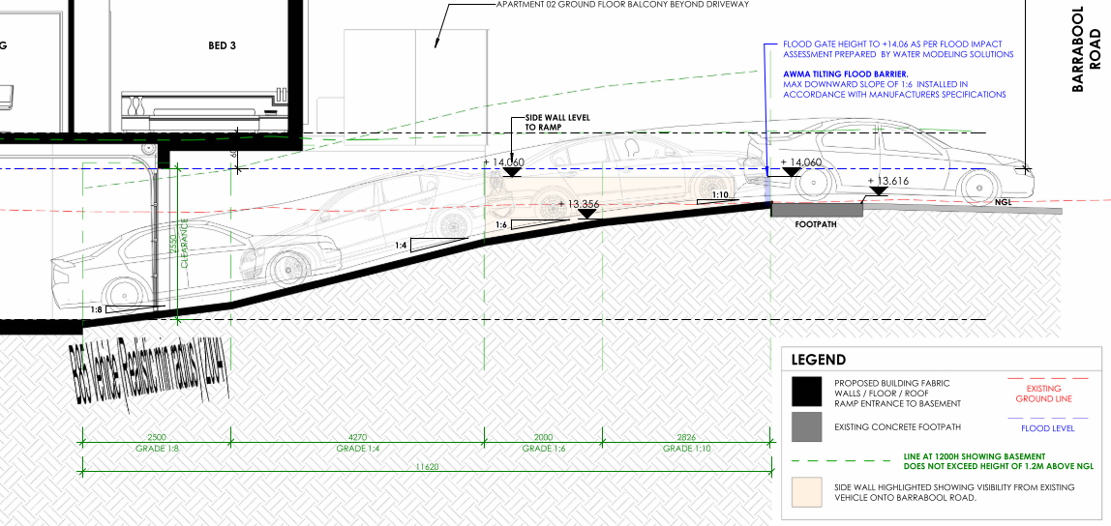

Figure 23 (Above): Section showing the ramp grade for the accessway at ingress to the basement from Barrabool Road. Note, the vehicle illustrated is travelling in the wrong direction. Source: Application documents.

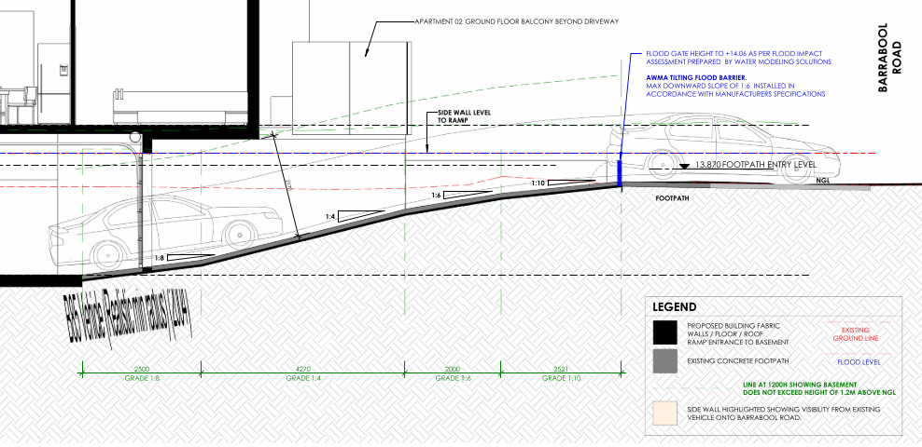
Figure 24 (Above): Section showing the ramp grade for the accessway at egress from the basement to Barrabool Road. Source: Application documents.

The traffic engineering report submitted as part of the application finds that the reduced minimum length of ramp grade at 1:10 at the top (2.521m instead of 5.0m) can continue to maintain safety for pedestrians and vehicles where the side walls of the ramp entrance are no greater than 0.9m in accordance with the sight-splay requirement. The sections and elevations show this area to remain clear of visual obstructions.

Similarly, the section of 1:6 gradient transition to 1:10 will minimise the risk of vehicle scraping that can otherwise occur if the grade change is too great. No vehicle scraping should normally occur at the top or the bottom of the access ramp.

The proposed minimum height clearance of 2.17 metres exceeds the standard of 2.1 metres.

All B85 passenger vehicles that enter the basement carpark can change direction such that they enter and exit the site in a forward direction in accordance with the design standard.

The vehicle access and car parking plan shows that an acceptable outcome will be achieved with some variations to the car parking design standards such that an acceptable planning outcome will be achieved.

RELEVANT GENERAL REQUIREMENTS:

CLAUSE 53.01 – PUBLIC OPEN SPACE CONTRIBUTION

A person who proposes to subdivide land must make a contribution to the council for public open space in an amount specified in the schedule to this clause (being a percentage of the land intended to be used for residential, industrial or commercial purposes, or a percentage of the site value of such land, or a combination of both). If no amount is specified, a contribution for public open space may still be required under Section 18 of the Subdivision Act 1988.

Response

Pursuant to the schedule to Clause 53.01, the following contribution is required to be made:

Creation of one additional lot | None
Creation of two to nine additional lots | 1 percent per additional lot up to a maximum of 5 percent
Creation of 10 or more lots on land zoned for residential purposes prior to August 31st 2007 | 5 percent
Creation of 10 or more lots on land zoned for residential purposes after August 31st 2007 | 10 percent
Waurn Ponds Creek Environs | 10 percent

Pursuant to the above table a 5 percent contribution is required to be made. A condition of any permit requires a cash contribution to be made.

CLAUSE 53.03 – RESIDENTIAL RETICULATED GAS SERVICE CONNECTION

The purpose of Clause 53.03 is to prohibit residential reticulated gas connections to new dwellings, new apartment developments and new residential subdivisions.

Response

Clause 53.03 was introduced to the Scheme as part of Amendment VC250 on 01/01/2024.

The transition provisions of Clause 53.03-5 apply because the application was received prior to amendment VC250. The mandatory conditions prescribed by the provision are not required to be included as part of any permit that may be issued.

CLAUSE 55 - TWO OR MORE DWELLINGS ON A LOT AND RESIDENTIAL BUILDINGS:

The application has been assessed against the objectives and standards of Clause 55 of the Planning Scheme.

The following are variations to Standards which are considered satisfactory:

55.04-1 Side and rear setbacks objective  To ensure that the height and setback of a building from a boundary respects the existing or preferred neighbourhood character and limits the impact on the amenity of existing dwellings.  If a development meets standard B17, it is deemed to meet the objective for that standard.  Where standard B17 is met the decision guidelines for that standard do not apply to the application. | Standard B17  A new building not on or within 200mm of a boundary should be set back from side or rear boundaries:  - At least the distance specified in a schedule to the zone, or  - If no distance is specified in a schedule to the zone, 1 metre, plus 0.3 metres for every metre of height over 3.6 metres up to 6.9 metres, plus 1 metre for every metre of height over 6.9 metres.  Sunblinds, verandahs, porches, eaves, fascias, gutters, masonry chimneys, flues, pipes, domestic fuel or water tanks, and heating or cooling equipment or other services may encroach not more than 0.5 metres into the setbacks of this standard.  Landings having an area of not more than 2 square metres and less than 1 metre high, stairways, ramps, pergolas, shade sails and carports may encroach into the setbacks of this standard. | Yes – Complies, with variation to Standard B17  The application proposes a variation to the side setback standard at the upper storey along the north east of the building as illustrated in orange hatch below:  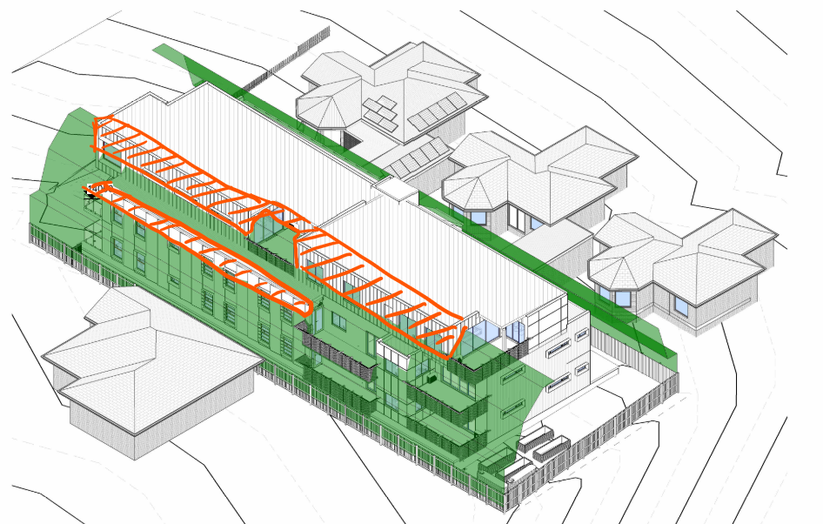  Before deciding on an application, the responsible authority must consider:  - Any relevant neighbourhood character objective, policy or statement set out in this scheme.  - The design response.  - The impact on the amenity of the habitable room windows and secluded private open space of existing dwellings.  - Whether the wall is opposite an existing or simultaneously constructed wall built to the boundary.  - Whether the wall abuts a side or rear lane.  With consideration to the decision guidelines of the objective, the variation is considered acceptable where:  - The relevant neighbourhood character objective in the Scheme is the IHDA which encourages upper storeys be recessed to reduce visual prominence. The proposal has recessed the upper storey from the ground and mid storey side wall such that its visual prominence when viewed for the dwelling on land adjoining to the north east will be significantly reduced.  - The design response lends itself to a 3 storey development in close proximity to the centre of the IHDA.  - The variation is situated on the south east side of the nearest affected dwelling and is recessed to allows sufficient light to the south east windows of the nearest dwelling.  - There is no existing or simultaneously constructed wall for consideration.  - There is no relevant side or rear lane.  The variation results in an acceptable outcome that meets the objective where the preferred character includes buildings of up to 3 storeys and the amenity impact on the adjoining dwelling is not unacceptable with consideration to the orientation and aspect of the dwelling to the street.

55.04-3 Daylight to windows objective  To allow adequate daylight into existing habitable room windows.  If a development meets standard B19, it is deemed to meet the objective for that standard.  Where standard B19 is met the decision guidelines for that standard do not apply to the application. | Standard B19  Buildings opposite an existing habitable room window should provide for a light court to the existing window that has a minimum area of 3 square metres and minimum dimension of 1 metre clear to the sky. The calculation of the area may include land on the abutting lot.  Walls or carports more than 3 metres in height opposite an existing habitable room window should be set back from the window at least 50 per cent of the height of the new wall if the wall is within a 55 degree arc from the centre of the existing window. The arc may be swung to within 35 degrees of the plane of the wall containing the existing window.  Where the existing window is above ground floor level, the wall height is measured from the floor level of the room containing the window. | Yes – Complies, with variation to Standard B19  The southwest wall of the development (2nd storey wall) is setback 5.66m from the windows at 1/36 Barrabool Rd, and scales at 7.5m from ngl requiring a setback of 3.75 in accordance with the standard. 3rd storey wall also complies.  The northeast wall of the development is setback 3.52m (2nd storey wall) from the windows at 32 Barrabool Rd, and scales at 7.6m from ngl requiring a setback of 3.8m being less than the Standard. This represents a 0.28m variation to Standard B19.  The northeast wall of the development is setback 5.11m (3rd storey wall) from the windows at 32 Barrabool Rd, and scales at 11.8m from ngl requiring a setback of 5.9m being less than the Standard. This represents a 0.78 metre variation to the standard.  Before deciding on an application, the responsible authority must consider:  - The design response.  - The extent to which the existing dwelling has provided for reasonable daylight access to its habitable rooms through the siting and orientation of its habitable room windows.  - The impact on the amenity of existing dwellings.  With consideration to the decision guidelines of the objective, the variation is considered acceptable where:  - The design response respects the preferred neighbourhood character of this IHDA.  - The window most likely to be affected on the north east side of the development is located under an eve within 1.89m of the site boundary but it retains well in excess of 1m clear to the sky (measured from the edge of the eave.  - The amenity impact on the existing dwelling is limited to the aspect from this single window. All other habitable room windows are unaffected.  The extent of variation as it affects the relevant within meets the objective.

However, the following mandatory objective of Clause 55 has not been met.

55.04-5 Overshadowing open space objective  To ensure buildings do not significantly overshadow existing secluded private open space. | Standard B21  Where sunlight to the secluded private open space of an existing dwelling is reduced, at least 75 per cent, or 40 square metres with minimum dimension of 3 metres, whichever is the lesser area, of the secluded private open space should receive a minimum of five hours of sunlight between 9 am and 3 pm on 22 September.  If existing sunlight to the secluded private open space of an existing dwelling is less than the requirements of this standard, the amount of sunlight should not be further reduced. | No – Does not meet the objective  The extent of overshadowing to the SPOS of the dwellings at 1/36 and 2/36 Barrabool Road to the south west of the site significantly exceeds the requirements of the Standard, and results in an unacceptable amount of additional overshadowing between 9am and 1pm such that the amenity of these dwellings will be compromised.

CLAUSE 56 – RESIDENTIAL SUBDIVISION:

This is an application to subdivide the apartments such that the apartments will exist on separate titles. In this case there is no need to assess the application against the provisions of Clause 56 as issues in relation to amenity, both on and off site, have been considered via the Clause 55 assessment, as has neighbourhood character.

It is recommended that a condition of any permit requires the apartment development be substantially completed (e.g. to lock-up stage as a minimum) prior to the issue of statement of compliance so that an orderly planning outcome is achieved.

DECISION GUIDELINES OF CLAUSE 65:

Because a permit can be granted does not imply that a permit should or will be granted. The responsible authority must decide whether the proposal will produce acceptable outcomes in terms of the decision guidelines of this clause.

CLAUSE 65.01 – APPROVAL OF AN APPLICATION OR PLAN

The responsible authority must consider, as appropriate:

- The matters set out in Section 60 of the Act.
- The Municipal Planning Strategy and the Planning Policy Framework.
- The purpose of the zone, overlay or other provision.
- Any matter required to be considered in the zone, overlay or other provision.
- The orderly planning of the area.
- The effect on the environment, human health and amenity of the area
- The proximity of the land to any public land.
- Factors likely to cause or contribute to land degradation, salinity or reduce water quality.
- Whether the proposed development is designed to maintain or improve the quality of stormwater within and exiting the site.
- The extent and character of native vegetation and the likelihood of its destruction.
- Whether native vegetation is to be or can be protected, planted or allowed to regenerate.
- The degree of flood, erosion or fire hazard associated with the location of the
- land and the use, development or management of the land so as to minimise any such hazard.
- The adequacy of loading and unloading facilities and any associated amenity, traffic flow and road safety impacts.

CLAUSE 65.02 – APPROVAL OF AN APPLICATION TO SUBDIVIDE LAND

The responsible authority must consider, as appropriate:

- The suitability of the land for subdivision
- The existing use and possible future development the land and nearby land
- The availability of subdivided land in the locality, and the need for the creation of further lots
- The effect of development on the use or development of other land which has a common means of drainage
- The subdivision pattern having regard to the physical characteristics of the land including existing vegetation
- The density of the proposed development
- The area and dimensions of each lost in the subdivision
- The layout of roads having regard to their function and relationship to existing roads
- The movement of pedestrians and vehicles throughout the subdivision and the ease of access to all lots
- The provision and location of reserves for public open space and other community facilities
- The staging of the subdivision
- The design and siting of buildings having regard to safety and the risk of spread of fire
- The provision of off street parking
- The provision and location of common property
- The functions of any body corporate
- The availability and provision of utility services, including water, sewerage, drainage, electricity and gas
- If the land is not sewered and no provision has been made for the land to be sewered, the capacity of the land to treat and retain all sewage and sullage within the boundaries of each lot
- Whether, in relation to subdivision patterns, native vegetation can be protected through subdivision and siting of open space areas.

Response

The application has been assessed against the decision guidelines of Clauses 65.01 and 65.02.

An assessment of Clause 55 is a requirement of the General Residential Zone (GRZ4), which has found that the development for the most part results in an acceptable outcome, with the exception of the significant overshadowing will result such that the mandatory overshadowing objective will not be met. Consequently, the proposal will not result in an acceptable planning outcome in terms of the General Residential Zone, or the decision guidelines of Clause 65.01.

APPENDIX

CLAUSE 55 ASSESSMENT TOOL – TWO OR MORE DWELLINGS ON A LOT AND RESIDENTIAL BUILDINGS

Date of Assessment: 1/03/2022. Updated 27/03/2024
Plans Assessed: 8/03/2024 (provided with s57A Amendment received 8/3/2024)
Permit Application Number: PP-935-2020

The following objectives apply to an application to:
- Construct a dwelling if there is at least one dwelling existing on the lot,
- Construct two or more dwellings on a lot,
- Extend a dwelling if there are two or more dwellings on the lot,
- Construct or extend a dwelling on common property, or
- Construct or extend a residential building,

in the Neighbourhood Residential Zone, General Residential Zone, Residential Growth Zone, Mixed Use Zone or Township Zone.

The following objectives are current up to and including Amendment VC250 on 01/01/2024.

55.02-1 Neighbourhood character objectives  To ensure that the design respects the existing neighbourhood character or contributes to a preferred neighbourhood character.  To ensure that development responds to the features of the site and the surrounding area. | Standard B1  The design response must be appropriate to the neighbourhood and the site.  The proposed design must respect the existing or preferred neighbourhood character and respond to the features of the site. | Yes – Complies with Standard B1  The development responds to the preferred character of Highton Village Increased Housing Diversity Area by incorporating a contemporary mix of materials and finishes commonly found on new residential developments nearby. The 3 storey building includes a recessed upper storey form, extensive frontage glazing and landscaping within the front setback that responds both to the established landscape character, and the emerging character of townhouse, unit and apartment development anticipated by planning policy.
55.02-2 Residential policy objectives  To ensure that residential development is provided in accordance with any policy for housing in the Municipal Planning Strategy and the Planning Policy Framework.  To support medium densities in areas where development can take advantage of public transport and community infrastructure and services. | Standard B2  An application must be accompanied by a written statement to the satisfaction of the responsible authority that describes how the development is consistent with any relevant policy for housing in the Municipal Planning Strategy and the Planning Policy Framework. | Yes – Complies with Standard B2  As set out above, the application complies with the planning policy framework. The required written statement has been provided.
55.02-3 Dwelling diversity objective  To encourage a range of dwelling sizes and types in developments of ten or more dwellings. | Standard B3  Developments of ten or more dwellings should provide a range of dwelling sizes and types, including:  - Dwellings with a different number of bedrooms.  - At least one dwelling that contains a kitchen, bath or shower, and a toilet and wash basin at ground floor level. | Yes – Complies with Standard B3  Ten dwellings are proposed, comprising a mix of 2 and 3 bedrooms each, and 4 apartments accessible at ground floor level.
55.02-4 Infrastructure objectives  To ensure development is provided with appropriate utility services and infrastructure.  To ensure development does not unreasonably overload the capacity of utility services and infrastructure. | Standard B4  Development should be connected to reticulated services, including reticulated sewerage, drainage and electricity, if available.  Development should not unreasonably exceed the capacity of utility services and infrastructure, including reticulated services and roads.  In areas where utility services or infrastructure have little or no spare capacity, developments should provide for the upgrading of or mitigation of the impact on services or infrastructure. | Yes – Complies with Standard B4  The site is serviced by the required infrastructure and the application has been referred to the City’s Engineers who have not raised any concern about the ability of the site to be drained. Conditions of any permit cover off on this issue.
55.02-5 Integration with the street objective  To integrate the layout of development with the street. | Standard B5  Developments should provide adequate vehicle and pedestrian links that maintain or enhance local accessibility.  Development should be oriented to front existing and proposed streets.  High fencing in front of dwellings should be avoided if practicable.  Development next to existing public open space should be laid out to complement the open space. | Yes – Complies with Standard B5  The development is designed to address Barrabool Road, with pedestrian and vehicle links to the street provided.  There is no high front fencing proposed for this development.  Before deciding on an application, the responsible authority must consider:  - Any relevant neighbourhood character objective, policy or statement set out in this scheme.  - The design response.  The building entrance is enhanced by the proposed arbour and wayfinding elements at the south east frontage.
55.03-1 Street setback objective  To ensure that the setbacks of buildings from a street respect the existing or preferred neighbourhood character and make efficient use of the site. | Standard B6  Walls of buildings should be set back from streets:  - At least the distance specified in a schedule to the zone, or  - If no distance is specified in a schedule to the zone, the distance specified in Table B1.  Porches, pergolas and verandahs that are less than 3.6 metres high and eaves may encroach not more than 2.5 metres into the setbacks of this standard.  Refer Table B1 of Clause 55.03-1. | Yes – Complies with Standard B6  The front setback proposed measures 4.0m at the front wall of APT09, in accordance with Standard B6. Front setbacks to balconies at ground and first floor are greater than 4.0 metres.
55.03-2 Building height objective  To ensure that the height of buildings respects the existing or preferred neighbourhood character. | Standard B7  The maximum building height should not exceed the maximum height specified in the zone, schedule to the zone or an overlay that applies to the land.  If no maximum height is specified in the zone, schedule to the zone or an overlay, the maximum building height should not exceed 9 metres, unless the slope of the natural ground level at any cross section wider than 8 metres of the site of the building is 2.5 degrees or more, in which case the maximum building height should not exceed 10 metres. | Yes – Complies with Standard B7  The allowable maximum building height in this location is:  - the building height must not exceed 11 metres; and  - the building must contain no more than 3 storeys at any point (does not include basement).  Maximum height in this location is the vertical distance from the minimum floor level determined by the relevant drainage authority or floodplain management authority to the roof or parapet at any point.  Minimum floor level nominated by the FMA is 14.5m AHD, providing for a maximum building height of 25.5m AHD.  Based on this the proposal is considered to readily comply with Standard B7.
55.03-3 Site coverage objective  To ensure that the site coverage respects the existing or preferred neighbourhood character and responds to the features of the site. | Standard B8  The site area covered by buildings should not exceed:  - The maximum site coverage specified in a schedule to the zone, or  - If no maximum site coverage is specified in a schedule to the zone, 60 per cent. | Yes – Complies with Standard B8  The site coverage of buildings is 57% percent of the site, which is less than the 70% allowed by the standard, and 65% practically achievable with consideration to the 35% garden area requirement for this site.
55.03-4 Permeability and stormwater management objectives  To reduce the impact of increased stormwater run-off on the drainage system.  To facilitate on-site stormwater infiltration.  To encourage stormwater management that maximises the retention and reuse of stormwater. | Standard B9  The site area covered by the pervious surfaces should be at least:  - The minimum area specified in a schedule to the zone, or  - If no minimum is specified in a schedule to the zone, 20 percent of the site.  The stormwater management system should be designed to:  - Meet the current best practice performance objectives for stormwater quality as contained in the Urban Stormwater - Best Practice Environmental Management Guidelines (Victorian Stormwater Committee, 1999).  - Contribute to cooling, improving local habitat and providing attractive and enjoyable spaces. | Yes – Complies with Standard B9  The site retains 23.3 per cent permeability, assisting in on site stormwater filtration.  A Stormwater Management Plan report has been provided which corresponds with the assessment plans which show suitably sized rainwater tanks to be located in the basement to meet best practice.
55.03-5 Energy efficiency objectives  To achieve and protect energy efficient dwellings and residential buildings.  To ensure the orientation and layout of development reduce fossil fuel energy use and make appropriate use of daylight and solar energy. | Standard B10  Buildings should be:  - Oriented to make appropriate use of solar energy.  - Sited and designed to ensure that the energy efficiency of existing dwellings on adjoining lots is not unreasonably reduced.  - Sited and designed to ensure that the performance of existing rooftop solar energy systems on dwellings on adjoining lots in a General Residential Zone, Neighbourhood Residential Zone or Township Zone are not unreasonably reduced. The existing rooftop solar energy system must exist at the date the application is lodged.  Living areas and private open space should be located on the north side of the development, if practicable.  Developments should be designed so that solar access to north-facing windows is maximised. | This objective does not apply:  - To construct or extend an apartment development, or  - To construct or extend a dwelling in or forming part of an apartment development.
55.03-6 Open space objective  To integrate the layout of development with any public and communal open space provided in or adjacent to the development. | Standard B11  If any public or communal open space is provided on site, it should:  - Be substantially fronted by dwellings, where appropriate.  - Provide outlook for as many dwellings as practicable.  - Be designed to protect any natural features on the site.  - Be accessible and useable. | This objective does not apply:  - To construct or extend an apartment development, or  - To construct or extend a dwelling in or forming part of an apartment development.
55.03-7 Safety objective  To ensure the layout of development provides for the safety and security of residents and property. | Standard B12  Entrances to dwellings and residential buildings should not be obscured or isolated from the street and internal accessways.  Planting which creates unsafe spaces along streets and accessways should be avoided.  Developments should be designed to provide good lighting, visibility and surveillance of car parks and internal accessways.  Private spaces within developments should be protected from inappropriate use as public thoroughfares. | Yes – Complies with Standard B12  The development is designed to provide for the safety and security of residents and property. All dwelling entrances are clearly visible from the street or internal accessway and private spaces within the development will be fenced.
55.03-8 Landscaping objectives  To encourage development that respects the landscape character of the neighbourhood.  To encourage development that maintains and enhances habitat for plants and animals in locations of habitat importance.  To provide appropriate landscaping.  To encourage the retention of mature vegetation on the site. | Standard B13  The landscape layout and design should:  - Protect any predominant landscape features of the neighbourhood.  - Take into account the soil type and drainage patterns of the site.  - Allow for intended vegetation growth and structural protection of buildings.  - In locations of habitat importance, maintain existing habitat and provide for new habitat for plants and animals.  - Provide a safe, attractive and functional environment for residents.  Development should provide for the retention or planting of trees, where these are part of the character of the neighbourhood.  Development should provide for the replacement of any significant trees that have been removed in the 12 months prior to the application being made.  The landscape design should specify landscape themes, vegetation (location and species), paving and lighting.  Development should meet any additional landscape requirements specified in a schedule to the zone. | This objective does not apply:  - To construct or extend an apartment development, or  - To construct or extend a dwelling in or forming part of an apartment development.
55.03-9 Access objective  To ensure the number and design of vehicle crossovers respects the neighbourhood character. | Standard B14  The width of accessways or car spaces should not exceed:  - 33 per cent of the street frontage, or  - if the width of the street frontage is less than 20 metres, 40 per cent of the street frontage.  No more than one single-width crossover should be provided for each dwelling fronting a street.  The location of crossovers should maximise the retention of on-street car parking spaces.  The number of access points to a road in a Transport Zone 2 or a Transport Zone 3 should be minimised.  Developments must provide for access for service, emergency and delivery vehicles. | Yes – Complies with Standard B14  One 6.0m wide crossing is provided for the 19.81m wide frontage to the TRZ2 road, resulting in a total of 30.3 per cent of the frontage taken up with vehicle crossings, which complies with the standard.
55.03-10 Parking location objective  To provide convenient parking for resident and visitor vehicles.  To protect residents from vehicular noise within developments. | Standard B15  Car parking facilities should:  - Be reasonably close and convenient to dwellings and residential buildings.  - Be secure.  - Be well ventilated if enclosed.  Shared accessways or car parks of other dwellings and residential buildings should be located at least 1.5 metres from the windows of habitable rooms. This setback may be reduced to 1 metre where there is a fence at least 1.5 metres high or where window sills are at least 1.4 metres above the accessway. | Yes – Complies with Standard B15  Convenient parking is provided for residents and shared accessways are located at least 1.5 metres from the windows of habitable rooms.
55.04-1 Side and rear setbacks objective  To ensure that the height and setback of a building from a boundary respects the existing or preferred neighbourhood character and limits the impact on the amenity of existing dwellings.  If a development meets standard B17, it is deemed to meet the objective for that standard.  Where standard B17 is met the decision guidelines for that standard do not apply to the application. | Standard B17  A new building not on or within 200mm of a boundary should be set back from side or rear boundaries:  - At least the distance specified in a schedule to the zone, or  - If no distance is specified in a schedule to the zone, 1 metre, plus 0.3 metres for every metre of height over 3.6 metres up to 6.9 metres, plus 1 metre for every metre of height over 6.9 metres.  Sunblinds, verandahs, porches, eaves, fascias, gutters, masonry chimneys, flues, pipes, domestic fuel or water tanks, and heating or cooling equipment or other services may encroach not more than 0.5 metres into the setbacks of this standard.  Landings having an area of not more than 2 square metres and less than 1 metre high, stairways, ramps, pergolas, shade sails and carports may encroach into the setbacks of this standard. | Yes – Complies, with variation supported to Standard B17  The application proposes a variation to the side setback standard at the upper storey along the north east of the building as illustrated in orange hatch below:  Before deciding on an application, the responsible authority must consider:  - Any relevant neighbourhood character objective, policy or statement set out in this scheme.  - The design response.  - The impact on the amenity of the habitable room windows and secluded private open space of existing dwellings.  - Whether the wall is opposite an existing or simultaneously constructed wall built to the boundary.  - Whether the wall abuts a side or rear lane.  With consideration to the decision guidelines of the objective, the variation is considered acceptable where:  - The relevant neighbourhood character objective in the Scheme is the IHDA which encourages upper storeys be recessed to reduce visual prominence. The proposal has recessed the upper storey from the ground and mid storey side wall such that its visual prominence when viewed for the dwelling on land adjoining to the north east will be significantly reduced.  - The design response lends itself to a 3 storey development in close proximity to the centre of the IHDA.  - The variation is situated on the south east side of the nearest affected dwelling and is recessed to allows sufficient light to the south east windows of the nearest dwelling.  - There is no existing or simultaneously constructed wall for consideration.  - There is no relevant side or rear lane.  The variation results in an acceptable outcome that meets the objective where the preferred character includes buildings of up to 3 storeys and the amenity impact on the adjoining dwelling is not unacceptable with consideration to the orientation and aspect of the dwelling to the street.
55.04-2 Walls on boundaries objective  To ensure that the location, length and height of a wall on a boundary respects the existing or preferred neighbourhood character and limits the impact on the amenity of existing dwellings.  If a development meets standard B18, it is deemed to meet the objective for that standard.  Where standard B18 is met the decision guidelines for that standard do not apply to the application. | Standard B18  A new wall constructed on or within 200mm of a side or rear boundary of a lot or a carport constructed on or within 1 metre of a side or rear boundary of lot should not abut the boundary:  - For a length of more than the distance specified in a schedule to the zone; or  - If no distance is specified in a schedule to the zone, for a length of more than:  - 10 metres plus 25 per cent of the remaining length of the boundary of an adjoining lot, or  - Where there are existing or simultaneously constructed walls or carports abutting the boundary on an abutting lot, the length of the existing or simultaneously constructed walls or carports,  whichever is the greater.  A new wall or carport may fully abut a side or rear boundary where slope and retaining walls or fences would result in the effective height of the wall or carport being less than 2 metres on the abutting property boundary.  A building on a boundary includes a building set back up to 200mm from a boundary.  The height of a new wall constructed on or within 200mm of a side or rear boundary or a carport constructed on or within 1 metre of a side or rear boundary should not exceed an average of 3.2 metres with no part higher than 3.6 metres unless abutting a higher existing or simultaneously constructed wall. | Not Applicable  No new walls on or within 200mm of a boundary, or carport within 1m of a boundary are proposed as part of this application.
55.04-3 Daylight to windows objective  To allow adequate daylight into existing habitable room windows.  If a development meets standard B19, it is deemed to meet the objective for that standard.  Where standard B19 is met the decision guidelines for that standard do not apply to the application. | Standard B19  Buildings opposite an existing habitable room window should provide for a light court to the existing window that has a minimum area of 3 square metres and minimum dimension of 1 metre clear to the sky. The calculation of the area may include land on the abutting lot.  Walls or carports more than 3 metres in height opposite an existing habitable room window should be set back from the window at least 50 per cent of the height of the new wall if the wall is within a 55 degree arc from the centre of the existing window. The arc may be swung to within 35 degrees of the plane of the wall containing the existing window.  Where the existing window is above ground floor level, the wall height is measured from the floor level of the room containing the window. | Yes – Complies, with support to variation of Standard B19  The southwest wall of the development (2nd storey wall) is setback 5.66m from the windows at 1/36 Barrabool Rd, and scales at 7.5m from ngl requiring a setback of 3.75 in accordance with the standard. 3rd storey wall also complies.  The northeast wall of the development is setback 3.52m (2nd storey wall) from the windows at 32 Barrabool Rd, and scales at 7.6m from ngl requiring a setback of 3.8m being less than the Standard. This represents a 0.28m variation to Standard B19.  The northeast wall of the development is setback 5.11m (3rd storey wall) from the windows at 32 Barrabool Rd, and scales at 11.8m from ngl requiring a setback of 5.9m being less than the Standard. This represents a 0.78 metre variation to the standard.  Before deciding on an application, the responsible authority must consider:  - The design response.  - The extent to which the existing dwelling has provided for reasonable daylight access to its habitable rooms through the siting and orientation of its habitable room windows.  - The impact on the amenity of existing dwellings.  With consideration to the decision guidelines of the objective, the variation is considered acceptable where:  - The design response respects the preferred neighbourhood character of this IHDA.  - The window most likely to be affected on the north east side of the development is located under an eve within 1.89m of the site boundary but it retains well in excess of 1m clear to the sky (measured from the edge of the eave.  - The amenity impact on the existing dwelling is limited to the aspect from this single window. All other habitable room windows are unaffected.  The extent of variation (0.28m – 0.78m) is considered in the context of the design to be minimal and the overall design is considered the meet this objective.
55.04-4 North facing windows objective  To allow adequate solar access to existing north-facing habitable room windows. | Standard B20  If a north-facing habitable room window of an existing dwelling is within 3 metres of a boundary on an abutting lot, a building should be setback from the boundary 1 metre, plus 0.6 metres for every metre of height over 3.6 metres up to 6.9 metres, plus 1 metre for every metre of height over 6.9 metres, for a distance of 3 metres from the edge of each side of the window. A north-facing window is a window with an axis perpendicular to its surface oriented north 20 degrees west to north 30 degrees east. | Not Applicable  There are no north facing habitable room windows on abutting lots that require consideration.
55.04-5 Overshadowing open space objective  To ensure buildings do not significantly overshadow existing secluded private open space. | Standard B21  Where sunlight to the secluded private open space of an existing dwelling is reduced, at least 75 per cent, or 40 square metres with minimum dimension of 3 metres, whichever is the lesser area, of the secluded private open space should receive a minimum of five hours of sunlight between 9 am and 3 pm on 22 September.  If existing sunlight to the secluded private open space of an existing dwelling is less than the requirements of this standard, the amount of sunlight should not be further reduced. | No – Does not meet the objective  The extent of overshadowing to the SPOS of the dwellings at 1/36 and 2/36 Barrabool Road to the south west of the site significantly exceeds the requirements of the Standard, and results in an unacceptable amount of additional overshadowing between 9am and 1pm such that the amenity of these dwellings will be compromised.
55.04-6 Overlooking objective  To limit views into existing secluded private open space and habitable room windows. | Standard B22  A habitable room window, balcony, terrace, deck or patio should be located and designed to avoid direct views into the secluded private open space of an existing dwelling within a horizontal distance of 9 metres (measured at ground level) of the window, balcony, terrace, deck or patio. Views should be measured within a 45 degree angle from the plane of the window or perimeter of the balcony, terrace, deck or patio, and from a height of 1.7 metres above floor level.  A habitable room window, balcony, terrace, deck or patio with a direct view into a habitable room window of existing dwelling within a horizontal distance of 9 metres (measured at ground level) of the window, balcony, terrace, deck or patio should be either:  - Offset a minimum of 1.5 metres from the edge of one window to the edge of the other.  - Have sill heights of at least 1.7 metres above floor level.  - Have fixed, obscure glazing in any part of the window below 1.7 metre above floor level.  - Have permanently fixed external screens to at least 1.7 metres above floor level and be no more than 25 per cent transparent.  Obscure glazing in any part of the window below 1.7 metres above floor level may be openable provided that there are no direct views as specified in this standard.  Screens used to obscure a view should be:  - Perforated panels or trellis with a maximum of 25 per cent openings or solid translucent panels.  - Permanent, fixed and durable.  - Designed and coloured to blend in with the development.  This standard does not apply to a new habitable room window, balcony, terrace, deck or patio which faces a property boundary where there is a visual barrier at least 1.8 metres high and the floor level of the habitable room, balcony, terrace, deck or patio is less than 0.8 metres above ground level at the boundary. | Yes – Complies with Standard B22  The development is designed to meet the requirements of the standard with overlooking into existing secluded private open space areas and habitable room windows limited in accordance with the standard.  Proposed habitable rooms and balconies that are within 9m of habitable rooms and SPOS of adjoining dwellings are screened by fixed louvres, privacy mesh to 1.7m above floor level, or lower level roof sections as shown below.  Were a permit to be granted, an amended plans conditions is recommended to screen the following windows with treatments to limit overlooking:  APT 04 and APT 08 Kitchen Window  All windows to be treated with ‘fixed louvre’ window hoods to be illustrated on elevations to a minimum height of 1.7m above floor level.
55.04-7 Internal views objective  To limit views into the secluded private open space and habitable room windows of dwellings and residential buildings within a development. | Standard B23  Windows and balconies should be designed to prevent overlooking of more than 50 per cent of the secluded private open space of a lower-level dwelling or residential building directly below and within the same development. | Yes – Complies with Standard B23  Internal views have been considered in the design solution and there is no internal overlooking.
55.04-8 Noise impacts objective  To contain noise sources in developments that may affect existing dwellings.  To protect residents from external noise | Standard B24  Noise sources, such as mechanical plant, should not be located near bedrooms of immediately adjacent existing dwellings.  Noise sensitive rooms and secluded private open spaces of new dwellings and residential buildings should take account of noise sources on immediately adjacent properties.  Dwellings and residential buildings close to busy roads, railway lines or industry should be designed to limit noise levels in habitable rooms. | This objective does not apply:  - To construct or extend an apartment development, or  - To construct or extend a dwelling in or forming part of an apartment development.
55.05-1 Accessibility objective  To encourage the consideration of the needs of people with limited mobility in the design of developments. | Standard B25  The dwelling entries of the ground floor of dwellings and residential buildings should be accessible or able to be easily made accessible to people with limited mobility. | This objective does not apply:  - To construct or extend an apartment development, or  - To construct or extend a dwelling in or forming part of an apartment development.
55.05-2 Dwelling entry objective  To provide each dwelling or residential building with its own sense of identity. | Standard B26  Entries to dwellings and residential buildings should:  - Be visible and easily identifiable from streets and other public areas.  - Provide shelter, a sense of personal address and a transitional space around the entry. | This objective does not apply:  - To construct or extend an apartment development, or  - To construct or extend a dwelling in or forming part of an apartment development.
55.05-3 Daylight to new windows objective  To allow adequate daylight into new habitable room windows. | Standard B27  A window in a habitable room should be located to face:  - An outdoor space clear to the sky or a light court with a minimum area of 3 square metres and minimum dimension of 1 metre clear to the sky, not including land on an abutting lot, or  - A verandah provided it is open for at least one third of its perimeter, or  - A carport provided it has two or more open sides and is open for at least one third of its perimeter. | Yes – Complies with Standard B27  All habitable room windows face an outdoor space of the required dimensions, allowing light into habitable rooms.
55.05-4 Private open space objective  To provide adequate private open space for the reasonable recreation and service needs of residents. | Standard B28  A dwelling or residential building should have private open space of an area and dimensions specified in the schedule to the zone.  If no area or dimensions are specified in the schedule to the zone, a dwelling or residential building should have private open space consisting of:  - An area of 40 square metres, with one part of the private open space to consist of secluded private open space at the side or rear of the dwelling or residential building with a minimum area of 25 square metres, a minimum dimension of 3 metres and convenient access from a living room, or  - A balcony of 8 square metres with a minimum width of 1.6 metres and convenient access from a living room, or  - A roof-top area of 10 square metres with a minimum width of 2 metres and convenient access from a living room. | Yes – Complies with Standard B28  All apartments are provided with balconies in excess of the minimum 8 sq/m and 1.6m dimension, and with convenient access to living rooms in accordance with the standard.
55.05-5 Solar Access to Open Space  To allow solar access into the secluded private open space of new dwellings and residential buildings. | Standard B29  The private open space should be located on the north side of the dwelling or residential building, if appropriate.  The southern boundary of secluded private open space should be set back from any wall on the north of the space at least (2+0.9h) metres, where ‘h’ is the height of the wall. | Yes – Complies with Standard B29  The proposed secluded private open space receives adequate solar access and complies with the setback requirement of the standard.
55.05-6 Storage objective  To provide adequate storage facilities for each dwelling. | Standard B30  Each dwelling should have convenient access to at least 6 cubic metres of externally accessible, secure storage space. | This objective does not apply:  - To construct or extend an apartment development, or  - To construct or extend a dwelling in or forming part of an apartment development.
55.06-1 Design Detail  To encourage design detail that respects the existing or preferred neighbourhood character. | Standard B31  The design of buildings, including:  - Façade articulation and detailing,  - Window and door proportions,  - Roof form, and  - Verandahs, eaves and parapets,  - should respect the existing or preferred neighbourhood character.  Garages and carports should be visually compatible with the development and the existing or preferred neighbourhood character. | Yes – Complies with Standard B31  The proposed development is considered to respect the preferred neighbourhood character through the appropriate use and design of façade articulation and detailing, window and door proportions, roof forms, and verandahs, eaves and parapets.  The basement garage entrance is considered visually compatible with the development and the preferred neighbourhood character.
55.06-2 Front Fences  To encourage front fence design that respects the existing or preferred neighbourhood character. | Standard B32  A front fence within 3 metres of a street should not exceed:  - The maximum height specified in a schedule to the zone, or  - If no maximum height is specified in a schedule to the zone, the maximum height specified in Table B3.  Refer Table B3 of Clause 55.06-2. | Not Applicable  No front fence is proposed as part of this permit application.
55.06-3 Common Property  To ensure that communal open space, car parking, access areas and site facilities are practical, attractive and easily maintained.  To avoid future management difficulties in areas of common ownership. | Standard B33  Development should clearly delineate public, communal and private areas.  Common property, where provided, should be functional and capable of efficient management. | Yes – Complies with Standard B33  The common property area provided as part of this development is practical and could easily be maintained.
55.06-4 Site Services  To ensure that site services can be installed and easily maintained.  To ensure that site facilities are accessible, adequate and attractive. | Standard B34  The design and layout of dwellings and residential buildings should provide sufficient space (including easements where required) and facilities for services to be installed and maintained efficiently and economically.  Bin and recycling enclosures, mailboxes and other site facilities should be adequate in size, durable, waterproof and blend in with the development.  Bin and recycling enclosures should be located for convenient access by residents.  Mailboxes should be provided and located for convenient access as required by Australia Post. | Yes – Complies with Standard B34  The dwelling layout and design provides for sufficient space and facilities for services to be installed and maintained. Bin and recycling enclosures, mailboxes, clotheslines, and other site facilities have been conveniently located and will blend in with the development and located for convenient access.

Clause 55.07 APARTMENT DEVELOPMENTS

In addition to Clause 55.01 to 55.05 (inclusive), the following Clause 55.07-1 to 55.07-19 (inclusive) apply only:
- To construct or extend an apartment development, or
- To construct or extend a dwelling in or forming part of an apartment development.

These provisions do not apply to an application to construct or extend a development of five or more storeys, excluding a basement or to construct or extend a dwelling in a development of five or more storeys, excluding a basement.

55.07-1 Energy efficiency objectives  To achieve and protect energy efficient dwellings and buildings.  To ensure the orientation and layout of development reduce fossil fuel energy use and make appropriate use of daylight and solar energy.  To ensure dwellings achieve adequate thermal efficiency. | Standard B35  Buildings should be:  - Oriented to make appropriate use of solar energy.  - Sited and designed to ensure that the energy efficiency of existing dwellings on adjoining lots is not unreasonably reduced.  - Sited and designed to ensure that the performance of existing rooftop solar energy systems on dwellings on adjoining lots in a General Residential Zone, Neighbourhood Residential Zone or Township Zone are not unreasonably reduced. The existing rooftop solar energy system must exist at the date the application is lodged.  Living areas and private open space should be located on the north side of the development, if practicable.  Developments should be designed so that solar access to north-facing windows is optimised.  Dwellings located in a climate zone identified Table B4 in should not exceed the maximum NatHERS annual cooling load specified in the following table.  Refer Table B4 of Clause 55.07-1. | Yes – Complies, with variation to Standard B35  The apartments are appropriately oriented where practicable to benefit from solar access.  The NatHERS maximum cooling load MJ/M2 per annum for Climate zone 60 Tullamarine (includes Highton 3216) is 22. The BESS assessment nominates a maximum cooling load no greater than 20.  The development will result in some loss of performance of the rooftop solar system located at 1/36 Barrabool Road.  Before deciding on an application, the responsible authority must consider:  - The design response.  - The size, orientation and layout of the site.  - The existing amount of solar access to abutting properties.  - The availability of solar access to north-facing windows on the site.  - The annual cooling load for each dwelling.  - The extent to which an existing rooftop solar energy system on an adjoining lot is overshadowed by existing buildings or other permanent structures.  - Whether the existing rooftop solar energy system on an adjoining lot is appropriately located.  - The effect of overshadowing on an existing rooftop solar energy system on an adjoining lot.  The extent of performance loss has been quantified in relation to the life expectancy of the system and the limited extent of performance loss. A financial offer was made to the affected property owner to offset the loss as a reasonable response to the objective.
55.07-2 Communal open space objective  To provide communal open space that meets the recreation and amenity needs of residents.  To ensure that communal open space is accessible, functional, and is easily maintained.  To ensure that communal open space is integrated with the layout of the development and enhances resident amenity. | Standard B36  A development of 10 or more dwellings should provide a minimum area of communal outdoor open space of 30 square metres.  If a development contains 13 or more dwellings, the development should also provide an additional minimum area of communal open space of 2.5 square metres per dwelling or 220 square metres,  whichever is the lesser. This additional area may be indoors or outdoors and consist of multiple separate areas of communal open space.  Each area of communal open space should be:  - Accessible to all residents.  - A useable size, shape and dimension.  - Capable of efficient management.  - Be located to:  - Provide passive surveillance opportunities, where appropriate.  - Provide outlook for as many dwellings as practicable.  - Avoid overlooking into habitable rooms and private open space of new dwellings.  - Minimise noise impacts to new and existing dwellings.  Any area of communal outdoor open space should be landscaped and include canopy cover and trees. | Yes – Complies with Standard B36  More than 112 sq/m of communal open space is located at the rear of the development.
55.07-3 Solar access to communal outdoor open space objective  To allow solar access into communal outdoor open space. | Standard B37  The communal outdoor open space should be located on the north side of a building, if appropriate.  At least 50 per cent or 125 square metres, whichever is the lesser, of the primary communal outdoor open space should receive a minimum of two hours of sunlight between 9am and 3pm on 21 June. | Yes – Complies with Standard B37  Shadow drawings submitted with the application shows that in excess of 50% of the communal open space will receive sunlight between 12pm and 3pm on 21 June in accordance with Standard B37.
55.07-4 Landscaping objective  To provide landscaping that supports the existing or preferred urban context of the area and reduces the visual impact of buildings on the streetscape.  To preserve existing canopy cover and support the provision of new canopy cover.  To ensure landscaping is climate responsive, supports biodiversity, wellbeing and amenity and reduces urban heat. | Standard B38  Development should retain existing trees and canopy cover.  Development should provide for the replacement of any significant trees that have been removed in the 12 months prior to the application being made.  Development should:  - Provide the canopy cover and deep soil areas specified in Table B5. Existing trees can be used to meet the canopy cover requirements of Table B5.  - Provide canopy cover through canopy trees that are:  - Located in an area of deep soil specified in Table B6. Where deep soil cannot be provided trees should be provided in planters specified in Table B6.  - Consistent with the canopy diameter and height at maturity specified in Table B7.  - Located in communal outdoor open space or common areas or street frontages.  - Comprise smaller trees, shrubs and ground cover, including flowering native species.  - Include landscaping, such as climbing plants or smaller plants in planters, in the street frontage and in outdoor areas, including communal outdoor open space.  - Shade outdoor areas exposed to summer sun through landscaping or shade structures and use paving and surface materials that lower surface temperatures and reduce heat absorption.  - Be supported by irrigation systems which utilise alternative water sources such as rainwater, stormwater and recycled water.  - Protect any predominant landscape features of the area.  - Take into account the soil type and drainage patterns of the site.  - Provide a safe, attractive and functional environment for residents.  - Specify landscape themes, vegetation (location and species), irrigation systems, paving and lighting.  Refer Table B5, B6 and B7 of Clause 55.07-4. | Yes – Complies with Standard B38  Canopy cover required of 5% of 993.72 = 49.7 sq/m  Min 1 x Type A tree (4m diameter, 6 metres high)  Indicative landscape plans show canopy cover can be achieved.  Were a permit to be granted it is recommended that a detailed landscape plan include a calculation of canopy tree coverage area of not less than 49.7 sq/m in compliance with Standard B38.
55.07-5 Integrated water and stormwater management objectives  To encourage the use of alternative water sources such as rainwater, stormwater and recycled water.  To facilitate stormwater collection, utilisation and infiltration within the development.  To encourage development that reduces the impact of stormwater run-off on the drainage system and filters sediment and waste from stormwater prior to discharge from the site. | Standard B39  Buildings should be designed to collect rainwater for non-drinking purposes such as flushing toilets, laundry appliances and garden use.  Buildings should be connected to a non-potable dual pipe reticulated water supply, where available from the water authority.  The stormwater management system should be:  - Designed to meet the current best practice performance objectives for stormwater quality as contained in the Urban Stormwater - Best Practice Environmental Management Guidelines (Victorian Stormwater Committee, 1999).  - Designed to maximise infiltration of stormwater, water and drainage of residual flows into permeable surfaces, tree pits and treatment areas. | Yes – Complies with Standard B39  The stormwater management system has been designed for appropriate retention and reuse in accordance with Standard B39.
55.07-6 Access objective  To ensure that vehicle crossovers are designed and located to provide safe access for pedestrians, cyclists and other vehicles.  To ensure that vehicle crossovers are designed and located to minimise visual impact. | Standard B40  Vehicle crossovers should be minimised.  Car parking entries should be consolidated, minimised in size, integrated with the façade and where practicable located at the side or rear of the building.  Pedestrian and cyclist access should be clearly delineated from vehicle access.  The location of crossovers should maximise pedestrian safety and the retention of on-street car parking spaces and street trees.  Development must provide access for service, emergency and delivery vehicles. | Yes – Complies with Standard B40  Site access for vehicles and pedestrians have been provided in accordance with Standard B40.
55.07-7 Noise impacts objective  To contain noise sources in developments that may affect existing dwellings.  To protect residents from external and internal noise sources. | Standard 41  Noise sources, such as mechanical plants should not be located near bedrooms of immediately adjacent existing dwellings.  The layout of new dwellings and buildings should minimise noise transmission within the site.  Noise sensitive rooms (such as living areas and bedrooms) should be located to avoid noise impacts from mechanical plants, lifts, building services, non-residential uses, car parking, communal areas and other dwellings.  New dwellings should be designed and constructed to include acoustic attenuation measures to reduce noise levels from off-site noise sources.  Buildings within a noise influence area specified in Table B8 should be designed and constructed to achieve the following noise levels:  - Not greater than 35dB(A) for bedrooms, assessed as an LAeq,8h from 10pm to 6am.  - Not greater than 40dB(A) for living areas, assessed LAeq,16h from 6am to 10pm.  Buildings, or part of a building screened from a noise source by an existing solid structure, or the natural topography of the land, do not need to meet the specified noise level requirements.  Noise levels should be assessed in unfurnished rooms with a finished floor and the windows closed.  Refer Table B8 of Clause 55.07-7. | Yes – Complies with Standard B41  There are no external noise sources that require consideration.  Noise sensitive rooms are located away from mechanical plant, including the lift, and the site is not within a nominated noise influence area.
55.07-8 Accessibility objective  To ensure the design of dwellings meets the needs of people with limited mobility | Standard 42  At least 50 per cent of dwellings should have:  - A clear opening width of at least 850mm at the entrance to the dwelling and main bedroom.  - A clear path with a minimum width of 1.2 metres that connects the dwelling entrance to the main bedroom, an adaptable bathroom and the living area.  - A main bedroom with access to an adaptable bathroom.  - At least one adaptable bathroom that meets all of the requirements of either Design A or Design B specified in Table B9.  Refer Table B9 of Clause 55.07-8. | Yes – Complies with Standard B42  At least 50 percent of apartments are provided with accessible entries with clear paths to accessible bathrooms in accordance with the standard.  Of the 10 apartments proposed, 6 have been designed to allow for relative convenient adaption as required by this standard. Apartments 02, 04, 06, 08, 09 and 10 have adaptable layouts.
55.07-9 Private open space objective  To provide adequate private open space for the reasonable recreation and service needs of residents. | Standard 43  A dwelling should have private open space consisting of at least one of the following:  - An area at ground level of at least 25 square metres, with a minimum dimension of 3 metres and convenient access from a living room.  - A balcony with at least the area and dimensions specified in Table B10 and convenient access from a living room. If a cooling or heating unit is located on a balcony, the minimum balcony area specified in Table B10 should be increased by at least 1.5 square metres.  - An area on a podium or other similar base of at least 15 square metres, with a minimum dimension of 3 metres and convenient access from a living room.  - An area on a roof of at least 10 square metres, with a minimum dimension of 2 metres and convenient access from a living room.  Refer Table B10 of Clause 55.07-9. | Yes – Complies with Standard B43  Each proposed apartment oriented to the north (between north 20 degrees west to north 30 degrees east) is provided with a balcony of not less than 8 sq/m and minimum dimension of not less than 1.7 metres.  Each proposed apartment oriented to the south (between south 20 degrees west to south 30 degrees east) is provided with a balcony of not less than 8 sq/m and minimum dimension of not less than 1.2 metres.  Each 2 bedroom apartment oriented east (between north 30 degrees east to south 30 degrees east) or west (between north 20 degrees west to south 20 degrees west) is provided with a balcony of not less than 8 sq/m and minimum dimension of 2 metres.  Each 3 or more bedroom apartment oriented east (between north 30 degrees east to south 30 degrees east) or west (between north 20 degrees west to south 20 degrees west) is provided with a balcony of not less than 12 sq/m and minimum dimension of 2.4 metres.
55.07-10 Storage objective  To provide adequate storage facilities for each dwelling. | Standard B44  Each dwelling should have convenient access to usable and secure storage space.  The total minimum storage space (including kitchen, bathroom and bedroom storage) should meet the requirements specified in Table B11.  Refer Table B11 of Clause 55.07-10. | Yes – Complies with Standard B44  Each 2 bedroom apartment is provided with not less than 14 cubic metres of useable and secure storage, including not less than 9 cubic metres of combined kitchen, bathroom and bedroom storage within the dwelling.  Each 3 or more bedroom apartment is provided with not less than 18 cubic metres of useable and secure storage, including not less than 12 cubic metres of combined kitchen, bathroom and bedroom storage within the dwelling.  A storage location plan has been provided to show the location and dimensions of storage facilities.
55.07-11 Waste and recycling objectives  To ensure dwellings are designed to encourage waste recycling.  To ensure that waste and recycling facilities are accessible, adequate and attractive.  To ensure that waste and recycling facilities are designed and managed to minimise impacts on residential amenity, health and the public realm | Standard B45  Developments should include dedicated areas for:  - Waste and recycling enclosures which are:  - Adequate in size, durable, waterproof and blend in with the development.  - Adequately ventilated.  - Located and designed for convenient access by residents and made easily accessible to people with limited mobility.  - Adequate facilities for bin washing. These areas should be adequately ventilated.  - Collection, separation and storage of waste and recyclables, including where appropriate opportunities for on-site management of food waste through composting or other waste recovery as appropriate.  - Collection, storage and reuse of garden waste, including opportunities for on-site treatment, where appropriate, or off-site removal for reprocessing.  - Adequate circulation to allow waste and recycling collection vehicles to enter and leave the site without reversing.  - Adequate internal storage space within each dwelling to enable the separation of waste, recyclables and food waste where appropriate.  - Waste and recycling management facilities should be design and managed in accordance with a Waste Management Plan approved by the responsible authority and:  - Be designed to meet the better practice design options specified in Waste Management and Recycling in Multi-unit Developments (Sustainability Victoria, 2019).  - Protect public health and amenity of residents and adjoining premises from the impacts of odour, noise and hazards associated with waste collection vehicle movements. | Yes – Complies with Standard B45  A waste Management Plan has ben provided demonstrating that the development meets the requirements of Standard B45.
55.07-12 Functional layout objective  To ensure dwellings provide functional areas that meet the needs of residents. | Standard 46  Bedrooms should:  - Meet the minimum internal room dimensions specified in Table B12.  - Provide an area in addition to the minimum internal room dimensions to accommodate a wardrobe.  Refer Table B12 of Clause 55.07-12.  Living areas (excluding dining and kitchen areas) should meet the minimum internal room dimensions specified in Table B13.  Refer Table B13 of Clause 55.07-12. | Yes – Complies with Standard B46  All apartments are provided with a main bedroom with a width and depth of not less than 3.0m x 3.4m, and other bedrooms of not less than 3.0m x 3.0m and all excluding areas provided for a wardrobe.  All 2 or more bedroom apartments are provided with a living area (excluding dining and kitchen areas) with an internal room width of not less than 3.6m and area of not less than 12 sq/m.
55.07-13 Room depth objective  To allow adequate daylight into single aspect habitable rooms. | Standard B47  Single aspect habitable rooms should not exceed a room depth of 2.5 times the ceiling height.  The depth of a single aspect, open plan, habitable room may be increased to 9 metres if all the following requirements are met:  - The room combines the living area, dining area and kitchen.  - The kitchen is located furthest from the window.  - The ceiling height is at least 2.7 metres measured from finished floor level to finished ceiling level. This excludes where services are provided above the kitchen.  The room depth should be measured from the external surface of the habitable room window to the rear wall of the room. | Yes – Complies with Standard B47  All single aspect habitable rooms with a ceiling height of at least 2.7 metres have a maximum room depth of not more than 9 metres in accordance with Standard B47.
55.07-14 Windows objective  To allow adequate daylight into new habitable room windows. | Standard B48  Habitable rooms should have a window in an external wall of the building.  A window may provide daylight to a bedroom from a smaller secondary area within the bedroom where the window is clear to the sky.  The secondary area should be:  - A minimum width of 1.2 metres.  - A maximum depth of 1.5 times the width, measured from the external surface of the window. | Yes – Complies with Standard B48  All habitable rooms have windows in external walls and clear to the sky and in accordance with the Standard B48.
55.07-15 Natural ventilation objectives  To encourage natural ventilation of dwellings.  To allow occupants to effectively manage natural ventilation of dwellings. | Standard B49  The design and layout of dwellings should maximise openable windows, doors or other ventilation devices in external walls of the building, where appropriate.  At least 40 per cent of dwellings should provide effective cross ventilation that has:  - A maximum breeze path through the dwelling of 18 metres.  - A minimum breeze path through the dwelling of 5 metres  - Ventilation openings with approximately the same area.  The breeze path is measured between the ventilation openings on different orientations of the dwelling. | Yes – Complies with Standard B49  All apartments are provided with cross ventilation in accordance with the Standard.
55.07-16 Building entry and circulation objectives  To provide each dwelling and building with its own sense of identity.  To ensure the internal layout of buildings provide for the safe, functional and efficient movement of residents.  To ensure internal communal areas provide adequate access to daylight and natural ventilation. | Standard B50  Entries to dwellings and buildings should:  - Be visible and easily identifiable.  - Provide shelter, a sense of personal address and a transitional space around the entry.  The layout and design of buildings should:  - Clearly distinguish entrances to residential and non-residential areas.  - Provide windows to building entrances and lift areas.  - Provide visible, safe and attractive stairs from the entry level to encourage use by residents.  - Provide common areas and corridors that:  - Include at least one source of natural light and natural ventilation.  - Avoid obstruction from building services.  - Maintain clear sight lines. | Yes – Complies with Standard B50  The building entry and common areas are provided in accordance with the Standard.
55.07-17 Integration with the street objective  To integrate the layout of development with the street.  To support development that activates street frontages. | Standard B51  Development should be oriented to front existing and proposed streets.  Along street frontages, development should:  - Incorporate pedestrian entries, windows, balconies or other active spaces.  - Limit blank walls.  - Limit high front fencing, unless consistent with the existing urban context.  - Provide low and visually permeable front fences, where proposed.  - Conceal car parking and internal waste collection areas from the street.  Development next to existing public open space should be designed to complement the open space and facilitate passive surveillance. | Yes – Complies with Standard B51  The layout of the development incorporates design elements that enhance integration with the street in accordance with the Standard.
55.07-18 Site services objective  To ensure that site services are accessible and can be easily installed and maintained.  To ensure that site services and facilities are visually integrated into the building design or landscape. | Standard B52  Development should provide adequate space (including easements where required) for site services to be installed and maintained efficiently and economically.  Meters and utility services should be designed as an integrated component of the building or landscape.  Mailboxes and other site facilities should be adequate in size, durable, weather-protected, located for convenient access and integrated into the overall design of the development. | Yes – Complies with Standard B52  All required site services are provided in accordance with the Standard.
55.07-19 External walls and materials objective  To ensure external walls use materials appropriate to the existing urban context or preferred future development of the area.  To ensure external walls endure and retain their attractiveness. | Standard B53  External walls should be finished with materials that:  - Do not easily deteriorate or stain.  - Weather well over time.  - Are resilient to the wear and tear from their intended use.  External wall design should facilitate safe and convenient access for maintenance. | Yes – Complies with Standard B53  Cladding materials are durable, attractive, and respectful of the urban context in accordance with the Standard.

Attachment_2.1.1 pagCLOSE OF MEETING

As there was no further business the meeting closed at 6.30pm on 11 April 2024.

