

minutes

PLANNING COMMITTEE MEETING
No. 235

14 December 2023
City Hall, 57 Little Malop Street, Geelong

ALSO LIVE STREAMED ON THE CITY’S WEBSITE:

www.geelongaustralia.com.au/meetings

PANEL:

Cr Mason
Cr Hathway
Cr Sullivan
Cr Wilkinson
Cr Nelson
Cr Aitken

PRESENT

Present: Cr Mason, Cr Hathway, Cr Sullivan (dial in), Cr Wilkinson, Cr Nelson, Cr Aitken

Council Officers:

Clara Gartland, Senior Statutory Planner
Rory O’Loghlen, Team Leader Statutory Planning
Peter Smith, Acting Manager City Development

Opening: The Chair declared the meeting open at 5.33pm.

1. PROCEDURAL MATTERS

Acknowledgement Of Country

The Committee acknowledges the Wadawurrung People as the Traditional Owners of the Land, Waterways and Skies. We pay our respects to their Elders, past and present. We Acknowledge all Aboriginal and Torres Strait Islander people who are part of our Greater Geelong community today.

1.2. Introduce the Panel Members

1.3. Apologies

Cr Kontelj, Cr Cadwell, Cr Moloney, Cr Murrihy

1.4. Declarations of Conflicts Of Interest

Nil

1.5. Confirmation of Minutes

Moved: Cr Hathway Seconded: Cr Nelson

That the Minutes of the Planning Committee Meeting held on 7 December 2023.
be confirmed.

CARRIED
.
2. MATTER(S) FOR CONSIDERATION
PP-320-2021 98 Marshalltown Road, Grovedale And PP-1512-2020 149 Bellarine Highway, Newcomb
2.1. | PP-219-2022 – 1-45 Point Richards Road, Bellarine

Application No: | PP-219-2022
Applicant: | Context Planning Pty Ltd
Subject Land: | 1-45 Point Richards Road, Bellarine
Zone: | Farming Zone
Overlays: | Heritage Overlay - HO49  Public Acquisition Overlay PAO3  Significant Landscape Overlay – Schedule 14
Existing Use: | Agricultural uses and an existing building of heritage significance
Proposed Use: | Use and Development of the Land for a Chocolaterie (Industry and Manufacturing Sales) Restaurant, Group Accommodation, Place of Assembly (Childrens Farm), Caretakers Dwelling and Business Identification Signage

Summary
- The subject site is located on the northwest side of the intersection of Portarlington Road and Point Richards Road the west of the township of Portarlington. It comprises one lot, known as Lot 2, Plan of Subdivision 146695K and has a total area of 23.67 hectares. The land is currently used for low level grazing and crops. The site currently has an agricultural shed and an historically significant outbuilding on the site.
- The subject site is in the Farming Zone and subject to Heritage Overlay Schedule HO49 (Former Dairy of Lincoln Farm) , Public Acquisition Overlay Schedule 3 and the Significant Landscape Overlay – Schedule 14. Portarlington Road adjacent to the site is in the Transport Zone 2.
- The proposal is for use and development of a chocolaterie, which consists of the use and development of the land for industry, manufacturing sales, restaurant, group accommodation place of assembly (children’s farm), a caretakers dwelling and the installation of business identification signage. The proposal will include an associated office, carparking areas and signage. The proposal includes an orchard, berry farm and grazing animals and associated buildings. These uses fall under the definition of agriculture and only require planning approval for associated development in the Farming Zone.
- The proposed hours of operation of the chocolaterie are 10am to 6pm, 7 days a week
- It has been submitted that the proposed use for the chocolaterie will require between approximately 36 to 53 staff, including chocolate makers, chocolate packers and retail staff.
- Access to the chocolaterie will be from Point Richards Road, approximately 93m from the intersection with Portarlington Road. A sealed car park is provided with 76 car parking spaces and bus parking area will be located at the chocolaterie. A separate car park with 14 car parking spaces and 4 bus parking spaces is proposed to be close to the group accommodation/children’s farm building. The car parking areas to the north and south are connected by pedestrian pathways.
- The proposed development consists of several single storey buildings along the east boundary of the site which abuts Point Richards Road. The main building to the south-east of the site, referred as the Chocolaterie will include a manufacturing area, restaurant and manufacturing sales area associated toilets. The single storey building is L shaped and includes a courtyard/open play area. The berry greenhouse, berry fields and primary produce sales building are located to the north of the Chocolaterie building. Further north of the site is the caretakers dwelling, communal group accommodation/Children’s Farm building and stables, which relate to the agricultural use of the land. Two agricultural sheds have been proposed towards the centre of the site close to the proposed orchard.
- The restaurant contains indoor and outdoor seating and has capacity for 140 patrons. It is proposed that there will be no more than 100 patrons at the children’s farm.
- There are 12 group accommodation units proposed to be located along the northeast of the site. Each unit includes two bedrooms and a lounge room. It is intended that the units will be used by patrons of the Children’s Farm and the Chocolaterie for short term accommodation.
- The agricultural aspects of the proposed use include the use of the north-western section of the site for animal grazing and an orchard, an indoor and outdoor berry farm picking area and stables close to the group accommodation. The proposal includes substantial planting along the existing waterway.
- The application underwent public notice with letters to adjoining properties and signs on-site. As a result 67 objections and 59 letters of support were received.
- A consultation meeting was held on 23 February 2023. This was attended by Council Officers, the applicant, and submitters to the application. Following the consultation meeting, the applicant submitted updated plans and more detail including geotechnical information and a revised stormwater management plan. These plans were circulated to objectors. No objections were withdrawn.
- The application has been referred to the relevant internal and external departments they include the Corangamite Catchment Management Authority (CCMA), Barwon Water and Country Fire Authority (CFA) who were supportive subject to conditions. The Department of Transport also supported the application with no conditions. The Department of Environment, Land, Water & Planning (DELWP) provided advice but no conditions.
- The City’s internal units, Engineering, Environmentally Sustainability Design, Urban Design and Tourism have provided support to the application, some with conditions. Heritage and Environmental Health requested further information which was considered appropriate to provide as conditions of a permit. The City’s Environment team were not supportive of the application however they have provided conditions for a permit if one is granted.
- The Environment Unit were concerned about the impacts to the Growling Grass Frog. However the application has been considered in respect to the potential impacts on flora and fauna of the nearby Point Richards Flora and Fauna Reserve, particularly the growling grass frog. The application was accompanied by a suitably qualified Ecology Assessment prepared by Okologie Consulting (8 April 2022) and a Preliminary Site Stormwater Management Plan prepared by Cardno TGM (1 October 2021).
- The assessment found that there was no suitable habitat for the growling grass frog and advised that the rehabilitation of the waterway would provide suitable habitat. These requirements are part of the conditions on the permit.

- Assessment of the application involves balancing competing policy objectives. This refers to non-agricultural activities in agricultural areas and the expansion of tourism related activities adjacent to designated tourist routes that do not adversely impact agricultural activities or environmental and significant landscape values. Additionally, there are other considerations, in particular biodiversity and environmental related impact of the proposal in proximity to the Point Richards Flora and Fauna Reserve.
- On balance, it is considered that the proposal would have minimal impact on the surrounding rural area which is acknowledged to form part of a non-urban break. It is also noted that the proposal is respectful to its Portarlington Road interface with the works well setback from this frontage (approx. 121m). Detailed landscaping including screening of the main building from Point Richards Road and Portarlington Road is anticipated to further mitigate the impact of the proposal on the surrounding landscape. The proposed buildings are built into the slope and will be single storey to reduce their impact on the landscape. To this end it is considered that the proposal has been designed to be visually recessive and blend into its surrounds.
- Local policy encourages tourist uses fronting major tourist routes, much of which is agricultural land. As it is addressed in this report, the agricultural potential of the land is relatively low due to landscape policy, proximity to dwellings and the waterway dividing the site. Further, the proposal includes a connection to the agricultural use of the land with berry picking, animal grazing and an orchard. Given the minimal productive agricultural land loss and the net economic and tourism benefit gained from the proposal on a recognised Tourist Route, the loss of agricultural land is considered acceptable.
- In terms of increased traffic volume, while it is acknowledged there will be an increase between the site entrance and the intersection with Portarlington Road, it is considered that this can comfortably be accommodated on a sealed road. DOT and Council’s Engineering Unit supported the application. It is further noted that the entrance to the chocolaterie is approximately 70 metres from the intersection with Portarlington Road, which will further limit the amenity impacts from increased traffic volumes.
- From a traffic safety perspective, the existing road infrastructure is considered to be able to accommodate the proposal safely and efficiently. The City’s engineering team are satisfied that the car parking provided is sufficient for the site and that it has been designed in accordance with Clause 52.06-9.
- Any potential adverse amenity impacts to nearby residents are considered to be mitigated by the characteristics of the proposal and conditions included in the officer recommendation. The proposed use of land for a chocolaterie is limited to daylight hours, reducing the impacts on nearby residential uses. The use of the land for group accommodation will be able to be managed with a caretaker to be on site to manage any potential impacts. The proposal includes substantial setbacks and landscape will further reduce any adverse impacts from the proposal.
- The proposed signage is minimal and respectful of the rural character of the area.
- The application has been reviewed against the relevant planning policies relating to agriculture, environment, amenity, economic, tourism and significant landscapes.
- In view of the above, it is recommended that the application be supported subject to the conditions contained in this report.

.

Recommendation
Moved: Cr Aitken Seconded: Cr Nelson
That the Responsible Authority having considered all matters which the Planning and Environment Act 1987, decides to issue a Notice of Decision for Use and Development of the Land for a Chocolaterie (Industry and Manufacturing Sales) Restaurant, Group Accommodation, Place of Assembly (Childrens Farm), Caretakers Dwelling and Business Identification Signage in accordance with the plans and documentation submitted with the application subject to the following conditions:

- Prior to works commencing, amended plans to the satisfaction of the Responsible Authority must be submitted to and approved by the Responsible Authority. When approved, the plans will be endorsed and will then form part of the permit. The plans must be drawn to scale with dimensions and must be generally in accordance with the plans submitted with the application but modified to show:

- The area of cultural significance area to the north of property, outside of the activity area to have a post and wire fence to prevent access to the culturally sensitive area.
- Floor plans and Elevation plans of the two agricultural sheds.
- Any changes to the implement the Environmentally Sustainable Design requirements as required by Conditions 2 and 3 (ESD Conditions).
- Any changes as a result of the Land and Water Rehabilitation Plan in accordance with Condition 26 (Environment condition).
- Location of mechanical pumps and other equipment associated with the use, water management and processing, and operation of accommodation and restaurant facilities. Locations must be detailed to show acoustic and visual mitigation measures.
- Design details of the proposed signage
- Storage bin areas are to be screened using screening devices and/or landscaping.
- A landscaping plan in accordance with Condition 22 of this permit.
- Amendments to the elevations of the existing heritage building as detailed by Condition 5 (Heritage Condition).
- Amendments to plans that show the mitigation measures as required by Conditions 35 - 37 (CFA conditions)

Environmentally Sustainable Design

- Before the use and development commences, amended plans to the satisfaction of the Responsible Authority must be submitted to and approved by the Responsible Authority. When approved, the plans will be endorsed and will then form part of the permit. The plans must be drawn to scale with dimensions.

The plans must be generally in accordance with the plans received 23 May 2023 but modified to show:

  - Initiatives contained within the Sustainable Design Assessment along with the proposed changes, including:

    - A minimum 30kW roof or ground mounted solar photovoltaic system
    - At least 1 dedicated electric vehicle parking complete with charger and signage
- Prior to the endorsement of plans, a Sustainability Management Plan (SMP) must be submitted to and approved to the satisfaction by the Responsible Authority. The Sustainability Management Plan must demonstrate a best practice standard of environmentally sustainable design and be generally in accordance with the report by Context Planning dated 25 February 2022 and received by Council on 3 March 2022, but modified to include the following changes:

- BESS setup so that the group accommodation cabins are included in the nominated buildings
- 4-star WELS rated toilets selected in the BESS water category
- 30kW solar photovoltaic system specified
- A preliminary Section J façade assessment demonstration compliance with the minimum thermal performance requirements
- Evidence supporting the natural ventilation of buildings as claimed in BESS, being crossflow path and operable windows shown on plans
- Only one mechanical ventilation strategy selected in BESS for each HVAC zone

Where alternative ESD initiatives are proposed to those specified in conditions above, the Responsible Authority may vary the requirements of this condition at its discretion, subject to the development achieving equivalent (or greater) ESD outcomes in association with the development.

- All works must be undertaken in accordance with the endorsed Sustainability Management Plan and stormwater management plan to the satisfaction of the Responsible Authority. No alterations to these plans may occur without the written consent of the Responsible Authority.

Heritage

- Before the use and development commences, amended plans to the satisfaction of the Responsible Authority must be submitted to and approved by the Responsible Authority. The plans must be drawn to scale with dimensions. The plans must be generally in accordance with the plans received 3 May 2023 but modified to show the following changes to the refurbishment of the existing outbuilding unless agreed in writing by the Responsible Authority:

- The stonework is sandstone and not bluestone – the image supplied for material “14” does not reflect the composition, texture and colour, and more random coursing of the existing stonework (if this is to represent the existing building). Any replacement stonework should match existing in texture and colour and the existing coursing pattern be retained. Any repairs to the stonework that go beyond routine maintenance will require a planning permit or an amendment to the existing permit (this might be dependent on the outcomes of the structural engineering assessment).
- The roof pitch is to be within the range of 30-35 degrees.
- The roof cladding material is to be listed as double-smelted galvanised corrugated steel and galvanised steel rainwater goods. No specific details on the proposed colour of the Colorbond material have been given in any case. The drawings (material 6) shows a dark grey Colorbond roof sheeting of different profile to that proposed. Ideally, ogee profile gutters are considered.
- The lime-based mortar is of the same strength (composition/mix), texture and colour as existing original
- All proposed colours for this building (fascias, doors, frames, etc) are documented given that external paint controls apply.
- A membrane is considered between the stone walls and the proposed concrete floor slab so that the slab can be readily removed at any point in the future without damage to the stone.

Endorsed Plans

- The use and development as shown on the endorsed plan(s) shall not be altered or modified without the written consent of the Responsible Authority.

Notification of permit conditions
- Prior to works commencing, the permit holder must advise all persons undertaking the works on site of all relevant permit conditions and endorsed plans/documents associated with this permit.

Amenity
- Outdoor lighting must be designed, baffled and located to the satisfaction of the Responsible Authority to prevent any adverse effect on adjoining properties.

- The amenity of the area must not be detrimentally affected by the use or development through the:

- Transport of materials, goods or commodities to or from the land;
- Appearance of any building, works or materials;
- Emission of noise, artificial light, vibration, odour, fumes, smoke, vapour, steam, soot, ash, dust, waste water, waste products, grit or oil;
- Presence of vermin;

to the satisfaction of the Responsible Authority.

Noise and Amenity Plan/Patron Management Plan

- Prior to the commencement of the use, a Noise and Amenity Plan / Patron Management Plan to the satisfaction of the Responsible Authority must be submitted to and approved by the Responsible Authority. When approved, the plan will be endorsed and will then form part of the permit. All activities forming part of the use must comply with the plan. The plan must include:

a) staffing and other measures which are designed to ensure the orderly arrival and departure of patrons;
b) signage to be used to encourage responsible off-site patron behaviour;
c) the training of staff in the management of patron behaviour;
d) staff communication arrangements;
e) measures to control noise emissions from the premises;
f) specify other requirements

All to the satisfaction of the Responsible Authority

Audible Music or Announcements

- Unless otherwise approved by the Responsible Authority, no amplified music, including live amplified music, must be played or piped to external areas.

Hours of Operation

- Unless otherwise approved by the Responsible Authority, the manufacturing sales, restaurant and place of assembly must only operate during the following times:
- Monday to Sunday − 10am to 6pm
All to the satisfaction of the Responsible Authority.

Number of Persons

- Unless otherwise approved in writing, not more than the following numbers of patrons, may be present on the premises at any one time:

- Restaurant – Indoor and outdoor seating capacity for no more than 140 patrons.
- Place of Assembly (Childrens Farm) - no more than 100 patrons at the children’s farm.
- Group Accommodation: is to be limited to be within the proposed cabins

All to the satisfaction of the Responsible Authority.

Waste Collection

- If waste collections are to occur with two or more collections per week, they must only occur during these times:

- 7 am – 8 pm Monday to Saturday
- 9 am – 8 pm Sunday and public holidays

Unless otherwise approved by the Responsible Authority

Delivery Restrictions

- All deliveries to the property and truck movements offsite must be in adherence with the EPA Noise Control Guidelines (publication 1245.2) which are:

- 7am – 10pm Monday to Saturday
- 9am – 10pm Sundays and public holidays.

Security Alarms

- All security alarms or similar devices installed on the land must be of a silent type in accordance with any current standard published by Standards Australia International Limited and be connected to a monitored security service to the satisfaction of the Responsible Authority.

Plant and Equipment Insulation

- All external plant and equipment must be acoustically treated or placed in soundproof housing to reduce noise to a level satisfactory to the Responsible Authority.

Dust Emissions

- Dust control measures to prevent emissions that may cause nuisance to adjoining properties must be implemented to the satisfaction of the Responsible Authority. Such as but not limited to:

- Identifying potential sources of dust and airborne particulates and processes which may generate dust and airborne particulates; and implementing dust and airborne suppression measures, including (but not limited to) covering materials and/or applying a light water spray, applying sprays before or during turning, but also avoiding excessive water- logging of organic materials and runoff;
- cessation of some activities during windy days

Waste Storage

- Provision must be made on the land for the storage and collection of garbage and other solid waste. This area must be graded, drained and screened from public view to the satisfaction of the Responsible Authority.

- The storage, removal and disposal of such/garbage refuse must be undertaken in such a manner so as to avoid any nuisance, pollution or loss amenity to the surrounding area and must at all times be to the satisfaction of the Responsible Authority.

Environmental Management Plan

- Before the use starts, an environmental management plan for the management and operation of the use which is to the satisfaction of the Responsible Authority must be submitted to and approved by the Responsible Authority. When approved, the plan will be endorsed and will then form part of the permit. The environmental management plan must be reviewed and submitted to the authority/ authorities for further approval annually. The use must at all times be conducted in accordance with the endorsed plan. The Environmental Management Plan must include:

- overall environmental objectives for the operation of the use and techniques for their achievement relating to stormwater, pollution, runoff etc.
- procedures to ensure that no significant adverse environmental impacts occur as a result of the use
- proposed monitoring systems
- identification of possible risks of operational failure and response measures to be implemented
- day to day management requirements for the use
- The conservation and protection of any significant vegetation;
- Methods for the control and eradication of weeds;
- Methods for the control of pest animals;
- The use of fencing which is permeable for native fauna;
- Re-vegetation of the site using native and indigenous species;
- Measures to ensure the on-going effectiveness of the Environmental Management Plan.
All to the satisfaction of the Responsible Authority.

Preparation of Landscape Plan
- Prior to the works commencing, a landscape plan prepared by a suitably qualified or experienced, person to the satisfaction of the Responsible Authority, must be submitted to and approved by the Responsible Authority. The plan must be drawn to scale and show:

- A survey (including botanical names) of all existing vegetation to be retained and/ or removed;
- Details of surface finishes of pathways and driveways;
- A planting schedule of all proposed trees, shrubs and ground covers including botanical names, common names, pot sizes, sizes at maturity, and quantities of each plant;
- Landscaping and planting within all open areas of the site;
- The use of indigenous plants of the Geelong Region, Zone 3. The trees along the boundaries along Point Richards Road must be native indigenous plants

When approved, the plan will be endorsed and form part of the permit, all to the satisfaction of the Responsible Authority.

Completion of Landscape Works

- Prior to the commencement of the use, the landscaping works as shown on the endorsed plans must be carried out and completed to the satisfaction of the Responsible Authority.

The landscaping shown on the endorsed plans must be maintained to the satisfaction of the Responsible Authority.

Waste Management Plan

- Prior to the commencement of the development, a waste management plan must be submitted to and approved by the Responsible Authority. The plan must provide details of a regular garbage collection service to each of the uses on the subject land, including information regarding the type of refuse bins, type/size of trucks, means of accessing bins and frequency of refuse collection, measures to ensure that the site is kept free from rubbish to the satisfaction of the Responsible Authority. Once approved, the plan must be implemented to the satisfaction of the Responsible Authority.

Environment

Fauna Protection

- Prior to the commencement of any tree removal or other potential fauna habitat, the permit holder must appoint an ecologist to conduct a pre-clearing survey to assess the presence of fauna. Where fauna is likely to be present in trees or vegetation proposed for removal, a suitably qualified wildlife handler must be present to ensure that native fauna is managed in accordance with DECCA guidance and all necessary authorisations must be obtained prior to removing native fauna. Dams filled as part of the approved development must be drained at least 48 hours prior to works commencing to enable the relocation or translocation of fauna.

A brief letter style report must be submitted to the Responsible Authority to satisfy the condition. The report must include a description of the survey, any fauna found, and steps taken to protect fauna during the works. Any instances of harm or death to fauna need to be reported.

Land and Waterway Rehabilitation Plan

- Prior to works commencing a Land and Waterway Rehabilitation Plan must be submitted to and approved by the Responsible Authority. When approved the Plan will be endorsed and form a part of the permit. The plan must include:
- An area within the project footprint along and adjacent the waterway corridor to be rehabilitated as a habitat corridor allowing for design in accordance with the DELWP Growling Grass Frog Habitat Design Guidelines 2017
- All revegetation sourced from local provenance stock. Species selection must not include species listed on the City of Greater Geelong Environmental Weeds list.
- Density of planting per square metre
- Installation of potential habitat in accordance with the Growling Grass Frog Habitat Design Guidelines 2017
- Soil preparation and weed control
- The timing of the revegetation
- The ultimate1% and 10% Annual Exceedance Probability storm event extents
- A detailed planting schedule and proposed planting layout of all areas, including proposed trees, shrubs, groundcovers and aquatic planting (if applicable, with zonation detail), and showing botanical names, common names, pot sizes, sizes at maturity, quantities and densities of each plant
- The proposed layout, materials and finish of all finished surfaces, structures, fences or other measures to exclude the public, maintenance vehicle access crossovers, maintenance access gates, furniture and paths
- Crossings over the waterway should be designed with consideration to the Growling Grass Frog Habitat Guidelines 2017
- Detailed drawing(s) of the interface with any adjoining properties
- Detailed planting and construction drawings including site contours and any proposed changes to existing levels including any structural elements such as retaining walls or bridges.
- Measures to protect downstream wetland environs during works.
- Maintenance schedule.
Unless otherwise agreed in writing, the plan must be fully implemented prior to the commencement of the use to the satisfaction of the Responsible Authority. A practical completion inspection is required and must be arranged by the permit holder with a minimum of two weeks’ notice provided for the Responsible Authority. The completion of works must be to a standard to the satisfaction of the Responsible Authority to pass this inspection.
Environmental Audit

- Prior to the commencement of any works a preliminary Environmental Assessment must be submitted to the Responsible Authority. It must include an assessment of the land by a suitably qualified environmental professional detailing the level and location of any contamination. This assessment is to be peer reviewed by a suitably qualified environmental professional approved by Council. If the Responsible Authority is satisfied that significant levels of contamination have been found the following must be provided to the Responsible Authority, either:

- A preliminary risk screen assessment statement in accordance with the Environment Protection Act 2017 must be issued stating that an environmental audit is not required for the use or the proposed use;
- A Certificate of Environmental Audit must be issued for the land in accordance with Part 1XD of the Environment Protection Act 1970, or
- A Statement of Environmental Audit must be issued in accordance with Part 1XD of the Environment Protection Act 1970 stating that the environmental condition of the land is suitable for the sensitive use (with or without conditions on the use of the site).

Should an Environmental Audit not be required any recommendations of the preliminary assessment, if applicable must be undertaken to the satisfaction of the responsible authority.

The Preliminary Assessment should also consider contaminants that may impact the downstream population of Growling Grass Frog Litoria raniformis.

Engineering

Drainage

- The site must be drained to the satisfaction of the Responsible Authority and no concentrated storm water may drain or discharge from the land to adjoining properties.

Car Park Construction

- Prior to the commencement of works/commencement of use, the developer must construct the car park/s including accessways, surface with an all-weather sealed coat and linemark the car and accessways in accordance with the endorsed plans to the satisfaction of the Responsible Authority.

Detailed Design Plans

- Prior to the commencement of works/commencement of use, detailed Engineer designed roadworks and drainage construction plans for the works within Point Richards Rd must be submitted to and approved by the Responsible Authority. The plans are to be in accordance with the design standards of the City of Greater Geelong and the Infrastructure Design Manual (IDM), to the satisfaction of the Responsible Authority.

Construction of Roadworks / Drainage

- Unless otherwise approved in writing by the Responsible Authority, prior to the commencement of works/commencement Point Richards Road and drainage must be constructed in accordance with the Endorsed plans and specifications to the satisfaction of the Responsible Authority.

Environmental Construction Management Plan (ECMP)

- Unless otherwise approved in writing by the Responsible Authority, prior to the commencement of works for the construction of Point Richards Road shall be submitted to and Endorsed by the Responsible Authority. When endorsed, all conditions on the ECMP will form part of the permit. The plan must address, but not be limited to, the following:

- Methods to contain dirt and mud within the site, and the method and frequency of clean up procedures;
- On site facilities for vehicle washing;
- Methods used with regards to Dust suppression which may include but not limited to the following:
- Water truck to be retained on site at all times;
- Soil stockpiles to be retained on site must be seeded or provide a treatment to provide a crusted surface;
- Cease all works on site during high wind incidences;
- Vehicle/truck movements to be limited to a reduced speed to prevent dust emissions;
- Dust suppression measures including fencing in locations to existing dwelling;
- The protection measures for site features to be retained (e.g. vegetation, retaining walls, buildings, other structures and pathways, etc.);
- Delivery and unloading points and expected frequency;
- A liaison personnel for contact by residents and the Responsible Authority in the event of relevant queries or problems experienced;
- The movement of construction vehicles to and from the site must be regulated to ensure that no traffic hazards are created in and around the site;
- Parking facilities for construction workers;
- Measures to minimise the impact of construction vehicles arriving at / departing from the land;
- An outline of requests to occupy public footpaths or roads, and anticipated disruptions to local services;
- The processes to be adopted for the separation, re-use and recycling of demolition materials;
- The measures for prevention of the unintended movement of building waste and hazardous materials and other pollutants on or off the site, whether by air, water or other means;
- Any other measures that are consistent with the following Environmental Protection Authority publications: ‘Environmental Management Guidelines for Major Construction Sites’, ‘Construction Techniques for Sediment and Pollution Control’ and ‘Doing it Right on Subdivisions’;
- Handling, tracking and testing of all imported fill;
- Measures to be taken to ensure that no polluted water and/or sediment laden runoff is to be discharged directly or indirectly into stormwater drains or watercourses during the construction period; and;
- Methodology detailing how service vehicles (i.e. Council Garbage Trucks) will be catered for during all stages of construction, including the removal of temporary turn around areas; and;
- Any other condition as required by the Responsible Authority that addresses any other issues i.e. location of earth mound / soil stockpiles, rumble grids, construction of and materials used for all whether access roads up to 30 meters on entry and exit to the site entry.
- The control of site emissions during construction and the defects liability period to the satisfaction of the Responsible Authority.
- The measures to be taken to ensure that no polluted water and/or sediment laden runoff is to be discharged directly or indirectly into stormwater drains or watercourses during the construction period.
- The ECMP must be prepared in accordance with the EPA – Civil Construction, building and demolition guide Publication 1834.1, August 2023.
- Measures to protect native vegetation and/or trees to be retained;
- Weed control measures including the identification of infestations and the proposed treatment measures for any species identified;
- Plant and vehicle hygiene measures;
- Stockpile locations and laydown areas;
- Parking locations for machinery and construction personnel.

Once the Environmental Construction Management Plan (ECMP) has been endorsed by the Responsible Authority under this permit it must be implemented and complied with at all times to the satisfaction of the Responsible Authority unless with the further written approval of the Responsible Authority.
Stormwater Quality / Management

- The site stormwater system must be designed and installed such that;

- The site stormwater discharge is not increased by the proposed development. An appropriate on site detention system designed in accordance with the submitted Stormwater Management Plan;
- Runoff is to be treated to achieve current best practice pollutant removal targets by connection to an appropriate Water Treatment Facility, with capacity to treat at least a 3 month ARI storm event, unless approved otherwise by the Responsible Authority. The Water Treatment Facility must be maintained.

All to the satisfaction of the Responsible Authority.

CAD Drawings

- Unless otherwise approved in writing by the Responsible Authority, CAD (MGA Zone 55) versions of any Endorsed plans for the works in Point Richards Road must be submitted to the Responsible Authority prior to the commencement of works. The provided 3D CAD model must satisfy the requirements of Council’s Assets Unit.

Country Fire Authority Conditions

Emergency Management Plan

- Before the use commences, an Emergency Management Plan (EMP) must be submitted to and endorsed by the Responsible Authority. Once endorsed, the use of the facility must at all times operate in accordance with the EMP. The EMP should be developed in accordance with ‘AS 3745 Planning for emergencies in facilities’ and must clearly describe the proposed emergency management arrangements for the site. The plan should address (but is not limited to) the following matters:

- The Fire Danger Rating triggers for the closure of the facility (if applicable).
- Monitoring and notifying staff and visitors of forecast Fire Danger Rating and
- any consequential actions.
- Details of the location/s for emergency assembly, evacuation and shelter -in place (in the event that evacuation from the site is not practicable).
- Transport arrangements for staff and visitors
- The need for any additional arrangements for persons with special needs.
- Training of staff, visitors on emergency procedures.
- The nature and frequency of emergency procedure exercises.
- Emergency procedures (bushfire action statements) including the assignment
- of roles and responsibilities to staff. This must include assigning responsibility for the:
    - Management and oversight of emergency procedures.
    - Training of employees in emergency procedures.
    - Reviewing the effectiveness of emergency procedure exercises and implementing procedure improvements.
    - Accounting for all persons during the emergency procedures.
    - Monitoring and review of the Emergency Plains at least annually.

Water Supply

- Unless with the written consent of CFA, 10,000 litres of effective water supply for firefighting purposes must be provided at the chocolaterie building, communal farm stay building and berry greenhouse building which meets the following requirements:

- Be stored in an above ground water tank constructed of concrete or metal.
- All fixed above-ground water pipes and fittings required for firefighting purposes must be made of corrosive resistant metal
- Incorporate a ball or gate valve (British Standard Pipe (BSP) 65mm) and coupling (64 mm CFA 3 thread per inch male fitting).
- The outlet/s of the water tank must be within 4m of the accessway and be unobstructed.
- Be readily identifiable from the building or appropriate identification signage to the satisfaction of CFA must be provided.
- Any pipework and fittings must be a minimum of 65 mm (excluding the CFA coupling).

Emergency Vehicle Access

- Internal vehicle access (including within the group accommodation cabin area and to the western part of site via the main bridge) must be constructed to a standard so that they are accessible in all weather conditions and capable of accommodating a vehicle of 15 tonnes for the trafficable road width.

- Access Roads more than 60m in length from the nearest intersection must have a turning circle with a minimum radius of 8m (including roll-over kerbs if they are provided) T or Y heads of dimensions specified by the CFA may be used as alternatives.
- The average grade must be no more than 1 in 7 (14.4%) (8.1 degrees) with a maximum of no more than 1 in 5 (20%) (11.3 degrees) for no more than 50 meters. Dips must have no more than a 1 in 8 (12%) (7.1 degree) entry and exit angle.
- Curves must have a minimum inner radius of 9 metres.
- Have a minimum trafficable width of 3.5 metres and be clear of encroachments for at least 0.5 metres on each side and 4 metres above the access way.

CCMA Conditions

- Prior to the commencement of the use or works, a Flood Impact Assessment must be submitted to and approved by the Responsible Authority and Floodplain Management Authority. The Flood Impact Assessment must be undertaken in accordance with the recommendations of Australian Rainfall and Runoff 2019 and must consider the existing and developed conditions of the property, demonstrating the following:

a. No adverse impacts to flood behaviour off site
b. All proposed buildings and development are outside the 1 % AEP flood extent

- Prior to the commencement of the use or works, a Stormwater Management Plan must be submitted to and approved by the Responsible Authority.

Expiry of Permit

- This permit will expire if one of the following circumstances applies:

a) The use and/or development is not commenced within two (2) years of the date of this permit.
b) The development is not completed within four (4) years of the date of this permit.

The Responsible Authority may extend the periods referred to if a request is made in writing before the permit expires; or

a) within six (6) months after the permit expires where the use or development has not yet started; or
b) within twelve (12) months after the permit expires, where the development allowed by the permit has lawfully commenced before the permit expiry.

NOTATIONS

- All completed landscaping works within the street and/or reserve must be inspected by Council’s Parks Unit.
- A pre-commencement meeting with Council’s engineering department is required to be undertaken prior to works starting within the road reserve.
- This property is in a designated bushfire prone area.
- Special bushfire construction requirements apply at the Building Permit stage.
- This permit has not determined the Bushfire Attack Level (BAL).
- Any building should consider AS 3959-2018 Construction of Buildings in Bushfire-prone Areas (Standards Australia, 2018).
- The site was listed on the Victorian Heritage Inventory in October 2022 for its potential to contain historical archaeological features, deposits and artefacts that relate to the mid-nineteenth century occupation of the site by J Birkett and E Collins. The Heritage Inventory is a listing of all known historical archaeological sites in the state. It is necessary to obtain a Heritage Act Consent to authorise works that may affect historical archaeological remains at a place. Please be aware that archaeological remains may be affected by activities such as the removal of large stumps or by the traversing of machinery across the surface of the land.
Barwon Water Notations
- The developer is to apply to Barwon Water for details relating to servicing requirements and costing for the provision of a potable water supply and where applicable, recycled water and/ or sewerage services to the proposal. It would be appreciated if all communication between the developer/agent and Barwon Water quote Barwon Water reference number L019199.
Potable Water
- The provision and installation of a potable water supply to the development.
- An additional potable water connection(s) is to be provided to service the proposed development. A dimensioned plan showing location of all new connections relative to the allotment boundaries is to be submitted, where a meter is not being fitted. Note that tappings and service lines are not to be located under existing or proposed driveways.
- Assessment of this application has shown a potential backflow hazard exists. In line with current regulations the owner is required to employ a suitably qualified person to install an appropriate containment device located at the potable and recycled water meter, at or near the property boundary for the prevention of backflow.
- Individual potable water supply meters are required for each lot or building as part of water connection works.
- Barwon Water's records indicate that an existing potable water service and meter is located on this property. A dimensioned plan showing the location of existing meters, and the location of the meter relative to the existing boundaries, and its number, is to be submitted. Private potable water service pipes are not permitted to cross allotment boundaries and must be plugged and abandoned at the boundaries of such allotments. This is required to be cut and sealed and a new service provide off the dn150mm water main located in Point Richards Road.
- The payment of a standardised New Customer Contribution is required for any new connection or any upsize to an existing connection. The number of standardised charges applied will be determined on the basis of an equivalent lot calculation and is based on potable domestic water meter size or water service size (where a meter is not being fitted). An equivalent lot is a measure of the additional demand a connection will place on the infrastructure in terms of the water consumption and sewage discharge for an average connection utilising a 20mm tapping and/ or meter. If there is more than one meter within a single meter assembly, the size of the largest meter (excluding the fire service meter) will determine the number of equivalent connections. If there is a combined fire and domestic meter assembly proposed (incorporating a low flow meter), whereby the meter size is largely dictated by the fire service requirements, the developer is required to submit to Barwon Water the proposed peak flow (probable simultaneous demand) associated with the domestic supply in accord with AS/NZS 3500. Barwon Water will then assess the equivalent number of connections.
Sewer
- The provision and installation of a sewerage service to the development.
- The provision of a new sewer connection(s) point is required. The sewer connection point is to be constructed by a Barwon Water Accredited Contractor.
- Assessment of your application indicates this development requires the owner to enter into a Sewer by Agreement. The application form can be found on Barwon Water's website and the payment of an application fee is required upon lodgment.
- New or re-aligned internal private sewer drains are required. Upon completion of this work a sewer drainage plan is to be submitted to Barwon Water by a licensed plumber that complies with Victorian Building Authority requirements. Note that if any common drain or drain from another allotment crosses under a proposed dwelling, a "modification to consent" is to be obtained from the Victorian Building Authority and presented to Barwon Water with the required drainage plan. Where an Owners Corporation is not applicable, individual allotment house connection drains are to be provided for and extend into each allotment.
- The payment of a standardised New Customer Contribution is required for any new sewer connection. This will be calculated based on the potable domestic water meter size or water service size.
LOST

Alternate Recommendation
Moved: Cr Wilkinson Seconded: Cr Hathway
That the Responsible Authority having considered all matters which the Planning and Environment Act 1987, decides to Refuse to Grant a Planning Permit for Use and Development of the Land for a Chocolaterie (Industry and Manufacturing Sales) Restaurant, Group Accommodation, Place of Assembly (Childrens Farm), Caretakers Dwelling and Business Identification Signage in accordance with the plans and documentation submitted with the application subject to the following conditions:

- The proposal does not produce acceptable outcomes in terms of the Bellarine Statement of Planning Policy, the Municipal Planning Strategy (MPS) or the Planning Policy Framework (PPF)’ as it:

- Does not sufficiently consider the vision Bellarine Distinctive Areas and Landscapes SPP July 2023.
- Does not conform to Objectives and Strategies of the Bellarine Statement of Planning Policy relating to.
  - Environment and Biodiversity (5.2.2 and 5.2.3)
  - Landscapes (5.3.3)
  - Environmental risks and resilience (5.4)
  - Tourism, agriculture and natural resources (5.6.2, 5.6.7, 5.6.8, and 5.6.9)
- Will result in the permanent removal of agricultural land for agricultural production.
- Is an incompatible use that will adversely affect existing agricultural activity.
- Is an incompatible use that will adversely affect existing residential uses.
- Does not complement and support adjoining rural land uses.
- Is not of a scale that will complement and respect the rural landscape character.
- Does not protect and enhance Victoria’s biodiversity.
- Will negatively impact on an important area of biodiversity
- Does not protect and enhance a significant landscape or open space that contributes to character, identity and sustainable environments
- Is not ancillary with an agricultural activity on the land, and
- is not in a location where there is an existing cluster of non-rural activities,
- will result in urbanisation of the locality,
- the circumstances of the use are not unique and do not support the site selection over an urban location.

- The proposal does not produce acceptable outcomes in terms of the purpose and decision guidelines of the Farming Zone as it:

- Does not produce acceptable outcomes in terms of the DAL, SPP, MPS and the PPF.
- Is not compatible with nearby agricultural land uses.
- Does not support and enhance agricultural production.
- Will permanently remove land from agricultural production.
- Will limit the operation and expansion of nearby agricultural uses.
- Has not satisfactorily demonstrated what impact, if any, it will have on the flora and fauna of the site and its surrounds.

- The proposal does not produce acceptable outcomes in terms of the purpose and decision guidelines of the Significant Landscape Overlay – Schedule 13 as it:
- Does not conserve and enhance the character of the significant landscape
- Does not protect the continuation of the land as a working farmed landscape
- Does not minimise the visual impact as buildings are not:
i. integrated into the landscape with appropriate vegetation
- located to protect road corridors

- The proposal does not produce acceptable outcomes in terms of the purpose and decision guidelines of the Heritage Overlay as it:
- Will adversely affect the significance of heritage places.
- Does not conserve and enhance heritage places of natural or cultural significance.
- The location, bulk, form or appearance of the proposed buildings will adversely affect the significance of the heritage place.

- The proposal does not produce acceptable outcomes in terms of the decision guidelines of Clause 65.01 (Approval of an Application or Plan) of the Scheme as it:

- Will result in a material detriment to the owners of nearby residential
- Does not produce acceptable outcomes in terms of the DAL, SPP, MPS and the PPF.
- Does not produce acceptable outcomes in terms of the purpose and decision guidelines of the Farming Zone.
- Does not contribute to the orderly planning of the area.
- Will have an adverse effect on the amenity of the area.
- Has not demonstrated that native vegetation is to be planted or allowed to regenerate.
CARRIED

REPORT

PERMIT REQUIREMENTS

A planning permit is triggered for this application pursuant to the following clauses of the Greater Geelong Planning Scheme:

- Pursuant to Clause 35.07-1 of the Farming Zone for Use of land for the purpose of Industry, Manufacturing Sales, Restaurant, Group Accommodation, Place of Assembly (Children’s Farm) and Dwelling (Caretakers house)

- Pursuant to Clause 35.07-4 of the Farming Zone, a permit is required to construct a building or construct or carry out works in association with a Section 2 use, to construct or carry out earthworks which change the rate of flow or the discharge point of water across a property boundary, and to construct a building within any of the following setbacks:
  - 100 metres of a Transport Zone 2 or Public Acquisition Overlay if the Head, Transport for Victoria is the acquiring authority, and the purpose of the acquisition is for a road.
  - 100 metres of a waterway, wetlands, or designated flood plain
Note:

  - The proposed Chocolaterie would include a proposed office component which is considered ancillary to the use of the land
  - Pursuant to Clause 64.02 for the use of land to be considered in conjunction with another use:
  - there must be an essential association between the two uses; and
  - the use must have a genuine, close, and continuing functional relationship in its operation with the other use.
- Pursuant to Clause 43.01-1 of the Heritage Overlay a permit is required for partial demolition, buildings and works to an existing building (Former Dairy of Lincoln’s Farm) and buildings and works for the proposed buildings.
- Pursuant to Clause 43.03-2 of the Significant Landscape Overlay – Schedule 14 a permit is required for buildings and works for the proposed buildings.
- Clause 52.05-5 Particular Provisions - Signage a permit is required for installation and display of a business identification sign
- Pursuant to Clause 45.01-1 of the Public Acquisition Overlay, a permit is required to:
- Use land for any section 1 or section 2 use in the zone.
- Construct a building or construct or carry out works.

DEFINITIONS

Pursuant to Clause 73.03 of the Planning Scheme the land uses are defined as follows.

- Pursuant to Clause 73.03 of the Planning Scheme, Industry is defined as:
Land used for any of the following operations:
a) any process of manufacture;
b) dismantling or breaking up of any article;
c) treating waste materials;
d) winning clay, gravel, rock, sand, soil, stone, or other materials;
e) laundering, repairing, servicing or washing any article, machinery, or vehicle, other than on-site work on a building, works, or land; or
f) any process of testing or analysis.

If on the same land as any of these operations, it also includes:
a) storing goods used in the operation or resulting from it;
b) providing amenities for people engaged in the operation;
c) selling by wholesale, goods resulting from the operation; and
d) accounting or administration in connection with the operation.

If Materials recycling, goods resulting from the operation may be sold by retail

- Pursuant to Clause 73.03 of the Planning Scheme, Manufacturing sales is defined as:

Land used, as an incidental part of an industry, to retail goods made materially different on the land by that industry.

- Pursuant to Clause 73.03 of the Planning Scheme, Place of Assembly is defined as:

Land where people congregate for religious, spiritual or cultural activities, entertainment, or meetings.

- Pursuant to Clause 73.03 of the Planning Scheme, Group Accommodation is defined as:

Land, in one ownership, containing a number of dwellings used to accommodate persons away from their normal place of residence.
- Pursuant to Clause 73.03 of the Planning Scheme, a dwelling is defined as:

A building used as a self-contained residence which must include:
a) a kitchen sink;
b) food preparation facilities;
c) a bath or shower; and
d) a toilet and wash basin.
It includes outbuildings and works normal to a dwelling.

- Pursuant to Clause 73.03 of the Planning Scheme, a Restaurant is defined as:
Land used to prepare and sell food and drink, for consumption on the premises. It may include:
entertainment and dancing; and the supply of liquor other than in association with the serving of meals, provided that tables and chairs are set out for at least 75% of patrons present on the premises at any one time.
It does not include the sale of packaged liquor.
- Pursuant to Clause 73.03 of the Planning Scheme, agriculture is defined as:
Land used to:
a) propagate, cultivate or harvest plants, including cereals, flowers, fruit, seeds, trees, turf, and vegetables;
b) keep, breed, board, or train animals, including livestock, and birds; or
c) propagate, cultivate, rear, or harvest living resources of the sea or inland waters.

RESTRICTIVE COVENANT OR SECTION 173 AGREEMENT:

The subject site is not burdened by a Restrictive Covenant or Section 173 Agreement.

OFFICER DIRECT OR INDIRECT INTEREST:

No officer involved in the preparation of this report declared a general or material conflict of interest.

SITE/LOCALITY:

The subject site is located on the north-west side of the intersection of Portarlington Road and Point Richards Road west of the township of Portarlington. It comprises one lot, known as Lot 2, Plan of Subdivision 146695K and has a total area of 23.67 hectares.
The subject site is in the Farming Zone and subject to Heritage Overlay Schedule HO49 (HO49), Public Acquisition Overlay Schedule 3 (PAO3) and the Significant Landscape Overlay – Schedule 14 (SLO14). The site's southern boundary abuts Portarlington Road, which is in the Transport Road Zone 2. The PAO3 covers a depth of 25 metres along the 20-metre-long southern boundary.
The site has minimal vegetation, with some scattered trees throughout the site. A waterway traverses the site from the south and diagonally intersects the site. The area is undulating with a slope down towards the bay.
The site was previously known as ‘Rosedale’ and has historical significance. The site is occupied by a remnant building that was once used for cheese making. The area surrounding the remanent building is subject to a Victorian Heritage Inventory. Further, there is an agricultural shed and some farm maintenance equipment on the site. In recent history, the site has been used for canola and wheat crops and animal grazing.
The site has a 541 metres frontage along the western site of Point Richards Road. Land to the east of Point Richards Road is in the General Residential Zone. This area is developed with 23 dwellings on lots ranging from 678 to 923m². The dwellings are modern in design, generally double storey and accessed from Point Richards Road.
To the west of the site is a 36-hectare agricultural property occupied by a single dwelling located towards the centre of the site. The site appears to be used for cropping and some grazing.
Adjoining the site to the north is approximately 102 hectares and is occupied by a single dwelling located to the far west of the site. The site is low and prone to flooding. It is used for low-level agricultural purposes and has several substantial clusters of vegetation. Further north and the northeast of the site are pockets of residential lots in the General Residential Zone – Schedule 2.
To the northeast is the ‘Point Richards Flora and Fauna Reserve’, which spans over 62 hectares. The reserve is one of the largest areas of native bushland and ephemeral wetlands on the Bellarine Peninsula. It includes a network of pedestrian trails that are accessed from Point Richards Road and Boat Road. The reserve is within the Public Conservation and Resource Zone.
South of the site is the ‘Panorama Estate’ (185-235, 181-183 and 151-179 Geelong Road and 62-80 Pigdon Street, Portarlington) which will also utilise the intersection with Point Richards Road. The current 24.59-hectare site has been approved for subdivision to create 317 residential lots (including 2 super lots). This is shown in Figure 4 with the red delineation showing the approved lots.
The site is located to the west of the coastal township of Portarlington, located approximately 26km east of Geelong. The area is within the Bellarine Peninsula which is characterised by contained townships that are separated by substantial non-urban breaks. The Bellarine Region is valued for its scenic landscapes and tourism, agricultural and environmental attributes.
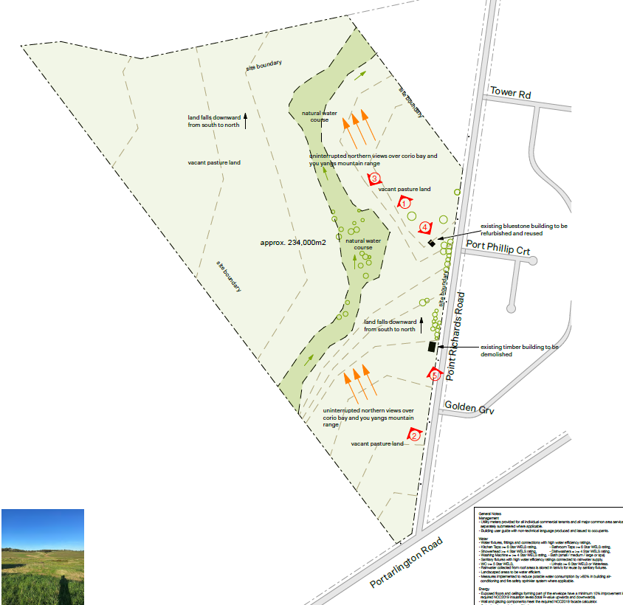
Figure 1 – Plan showing features of the site. Source: Application documents.

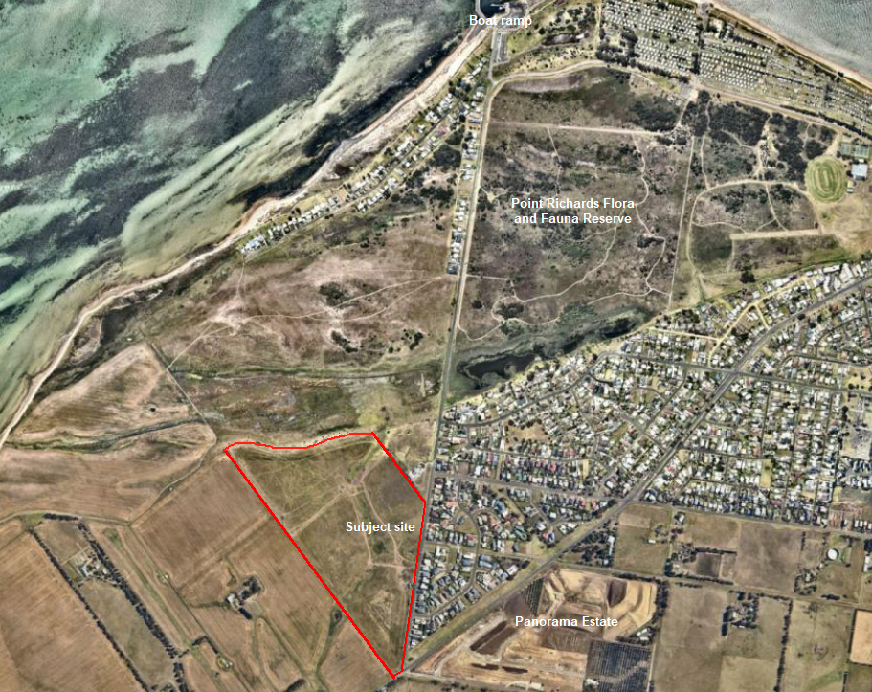
Figure 2 - Aerial of the subject site and nearby properties. Source: Nearmap.
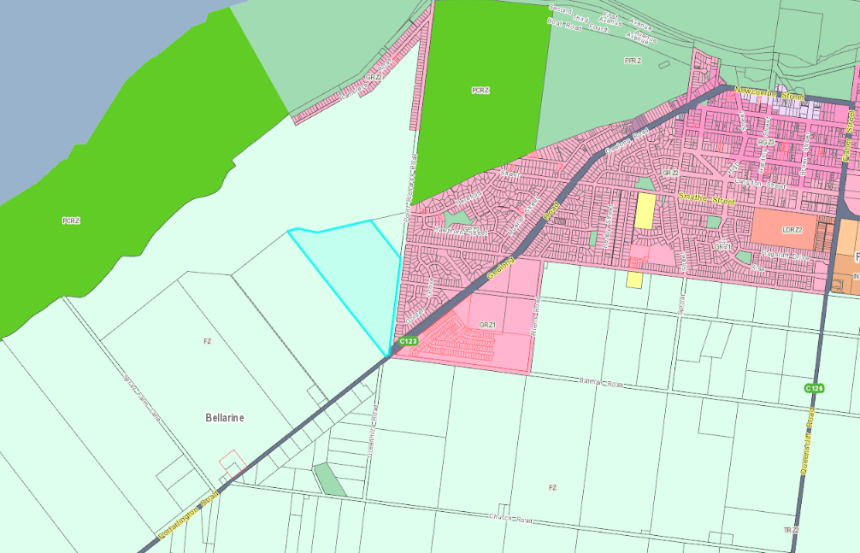
Figure 3 - Weave mapping image displaying zoning of subject site (highlighted in blue) and the surrounding land.

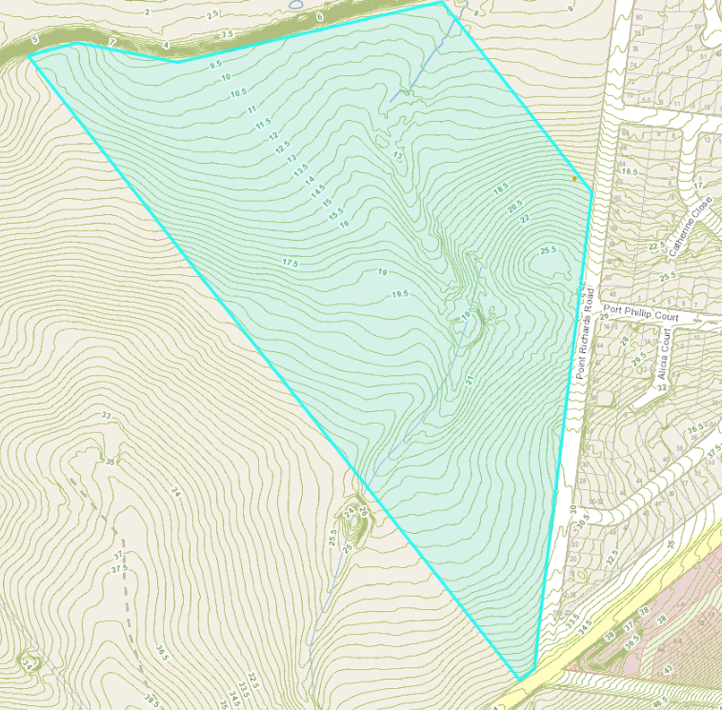
Figure 4 – Weave mapping image displaying contours of the subject site.
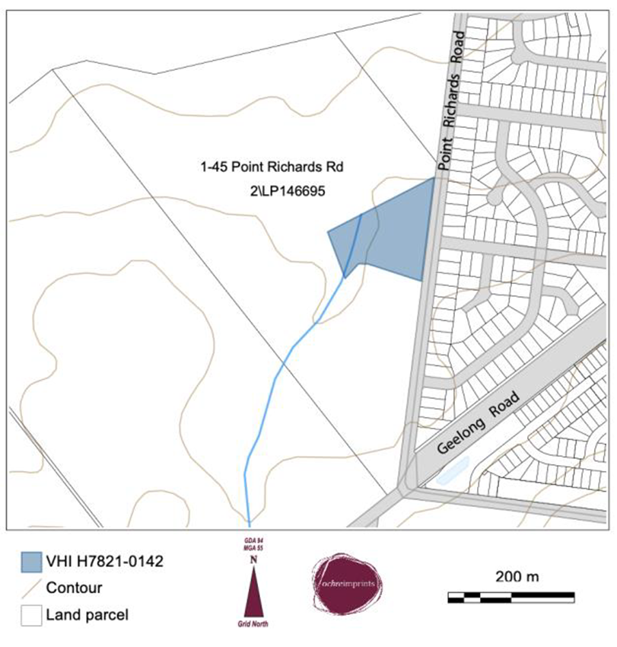
Figure 5 - Area subject to the Victorian Heritage Inventory. Source: Application documents.
PROPOSAL:
The proposed use and development of the site for ‘The Bellarine Chocolaterie and Agricultural Park’.

The proposed uses and developments that require planning approval including:
- Industry (Manufacturing of chocolate and manufacturing sales)
- Restaurant
- Group accommodation
- Place of Assembly (Children’s Farm)
- Dwelling (Caretakers house)

The use of land for agriculture is exempt from requiring planning approval however, the proposed buildings associated with agriculture require approval.

Chocolaterie

The main building, referred to as the chocolaterie, would be used for the manufacturing of chocolate, manufacturing sales and the restaurant. The building is single storey, and L shaped with lengths running along with Point Richards Road and Portarlington Road. This creates two separate wings and an enclosed courtyard. The building has a maximum height of 5.6 metres.

All operations associated with the chocolaterie are proposed between the hours of 10am to 6pm each day.

The manufacturing area of the building would have a floor area of approximately 400m². It includes an area for manufacturing and an associated office. The proposed restaurant has a small indoor area of approximately 100m² which includes a small kitchen and serving area and some seating. The restaurant opens onto two alfresco areas. The chocolate retail sales area has a floor area of approximately 400m².

The building is setback approximately 121 metres from Portarlington Road and 31 metres from Point Richards Road.

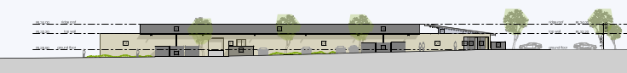
Figure 6 - Southern elevation of the main chocolaterie building. Source: Application documents.
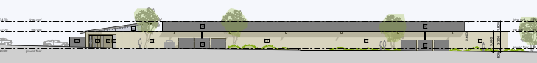
Figure 7 - Eastern elevation of the main chocolaterie building. Source: Application documents.
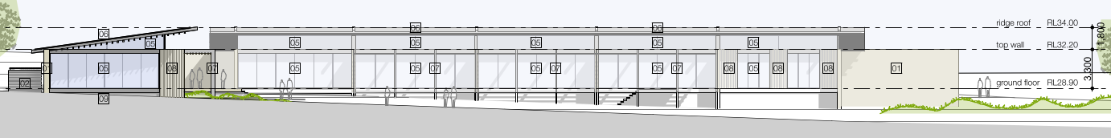
Figure 8 - Northern elevation of the chocolaterie building. Source: Application documents.
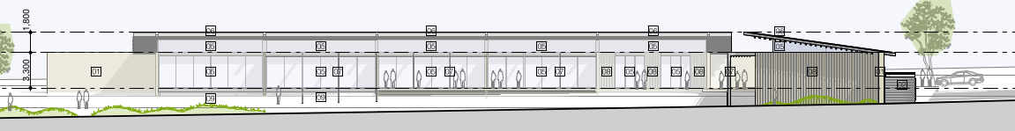
Figure 9 - Western elevation of the chocolaterie building. Source: Application documents.
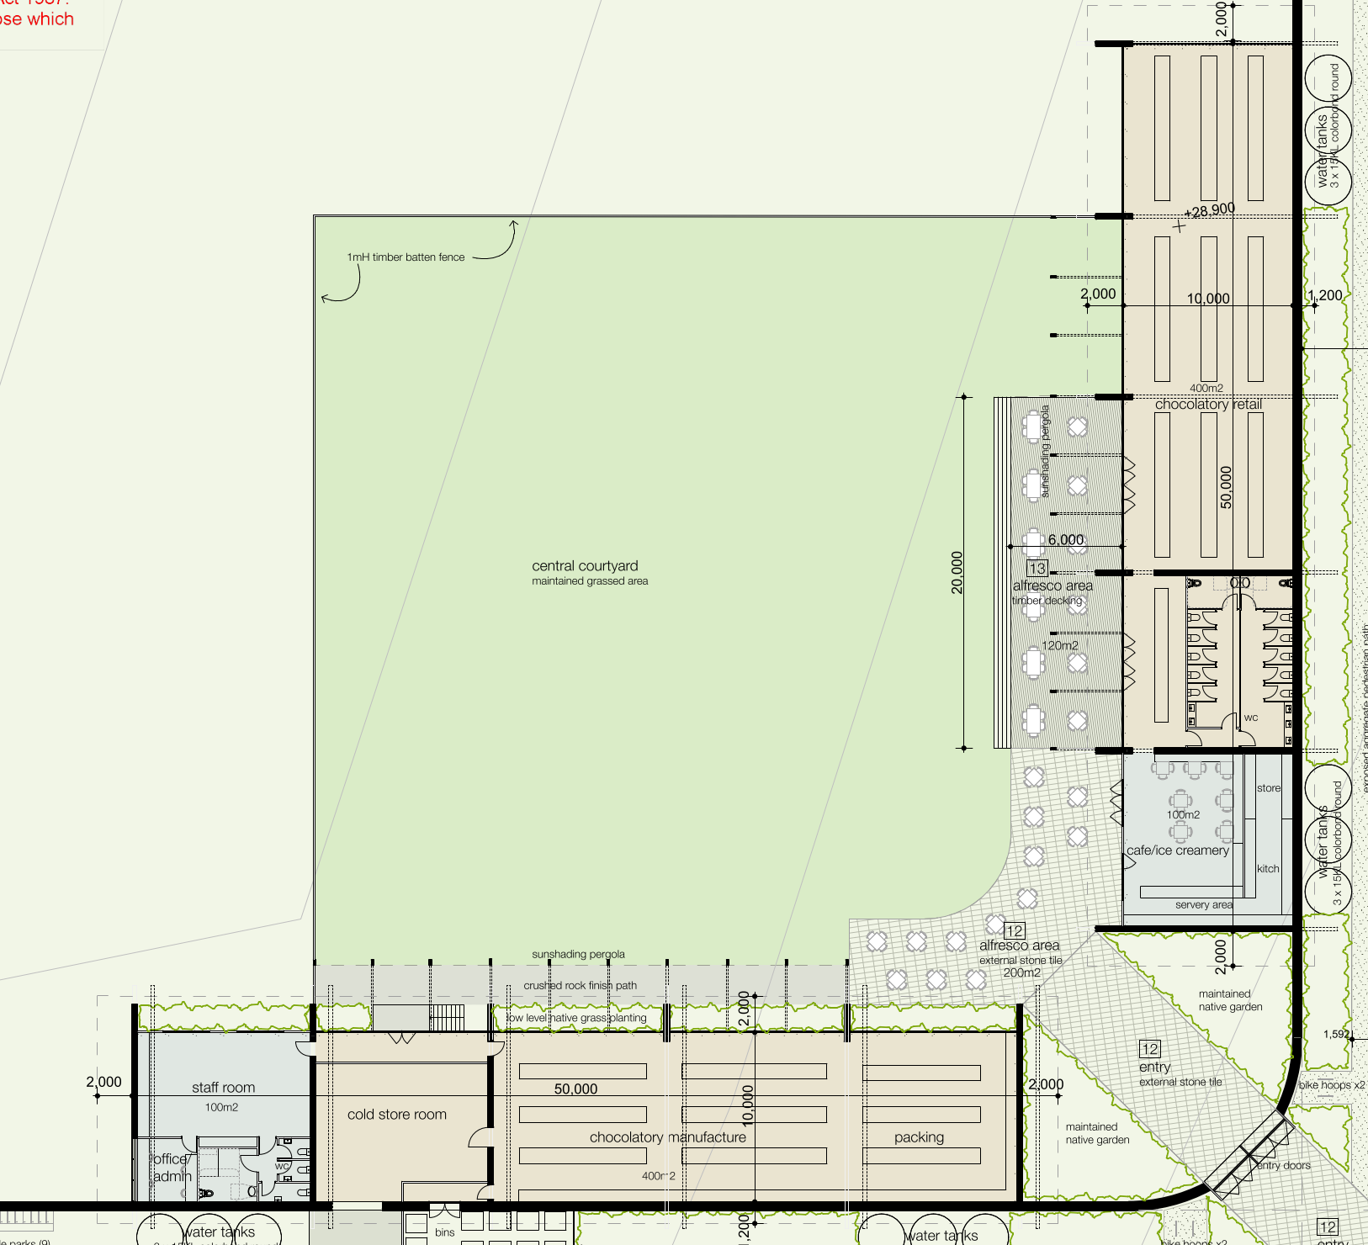
Figure 10 - Chocolaterie building and central courtyard. Source: Application documents.
Group Accommodation

The development associated with the group accommodation consists of a communal building, car parking area and 12 individual cabins.

The communal building includes a reception, children’s farm presentation rooms, a communal group accommodation kitchen, toilets and a deck and a maximum height of 7.6 metres. The proposal includes grazing animal stables to be located in front of the communal farm stay building.

The twelve cabins all comprise of 2 bedrooms, a bathroom and a living/dining area and raised deck. Each cabin is to be constructed of Colorbond with a gabled roof and a dark grey finish. The highest point is 5 metres from natural ground level. The cabins are proposed to be accessed by a pedestrian track which links to the farm stay carpark/main building.

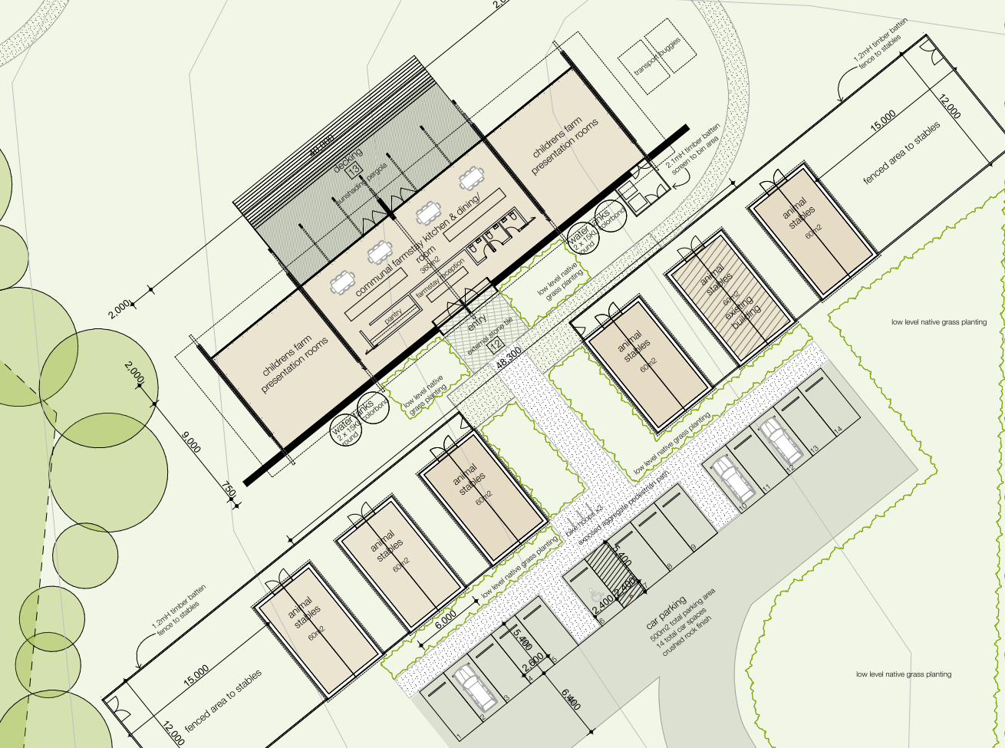
Figure 11 - Communal group accommodation and Children’s farm building and animal stables. Source: Application documents.
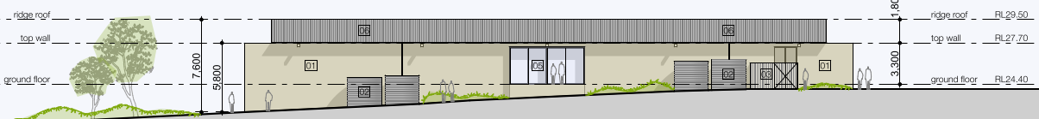
Figure 12 - Southern elevation of the communal building. Source: Application documents.
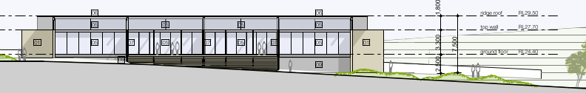
Figure 13 - Northern elevation of communal building. Source: Application documents.
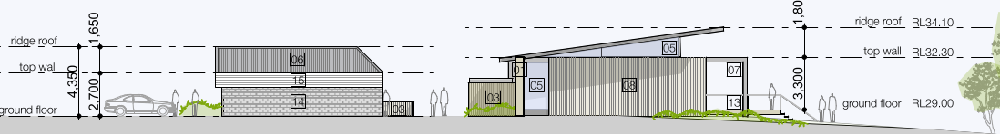
Figure 14 - Eastern elevation of stables and communal building. Source: Application documents.
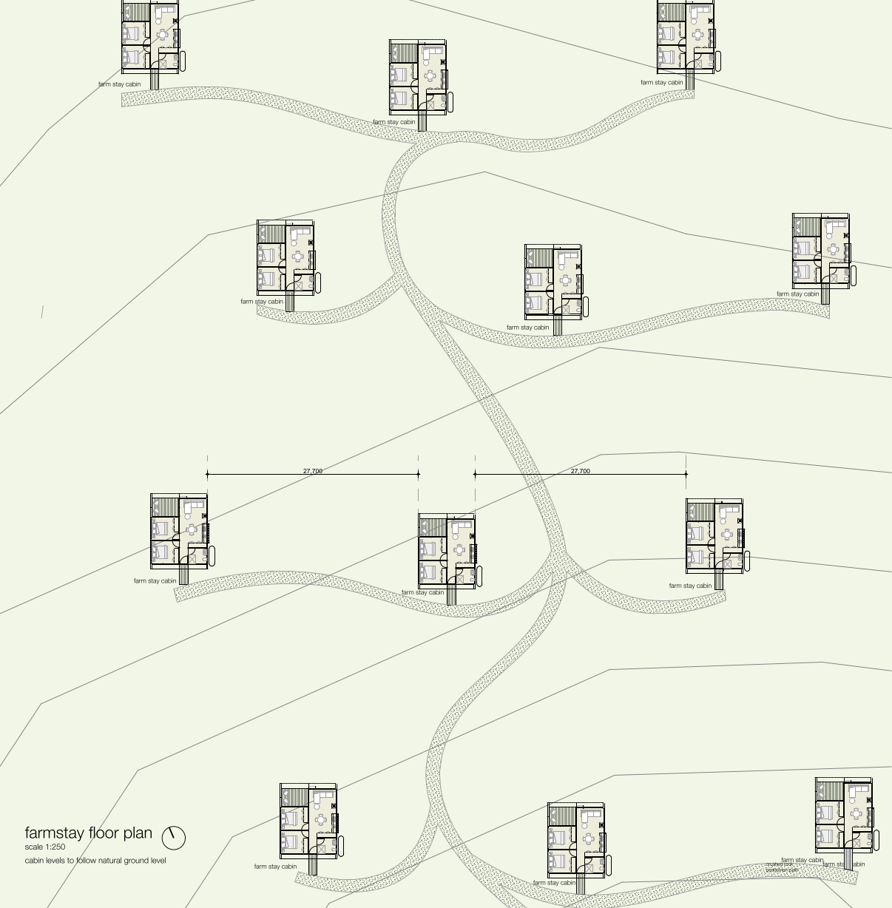
Figure 15 - Group accommodation cabins. Source: Application documents.
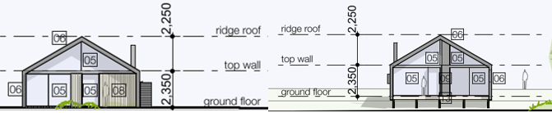
Figure 16 - South and north elevations of the group accommodation cabins. Source: Application documents.
Place of Assembly (Children’s Farm)

The proposal includes a Children’s Farm which falls under the definition of a Place of Assembly.

The Children’s Farm will also utilise the communal farm stay building.

Primary Produce Sales

The proposal includes berry growing and picking operation, both indoors and outdoors. The outdoor berry picking will be provided by two large open fields whilst the indoor berry picking will be made available through vertical garden stands contained within a green house. Further, the proposal includes a 40m² primary sales and reception area.

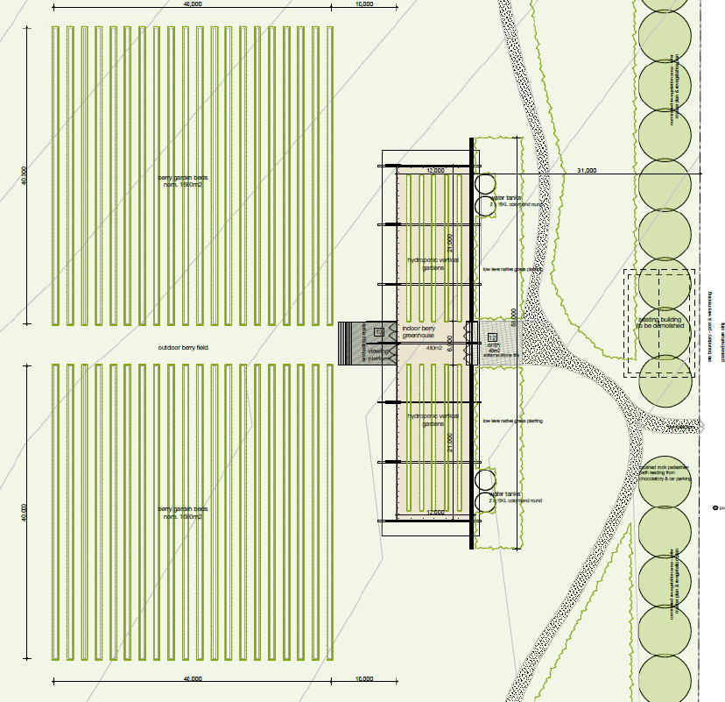
Figure 17 – Plan of greenhouse, primary sales and berry picking area. Source: Application documents.
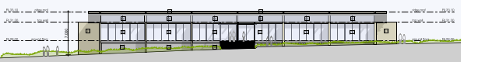
Figure 18 - Western elevation greenhouse. Source: Application documents.
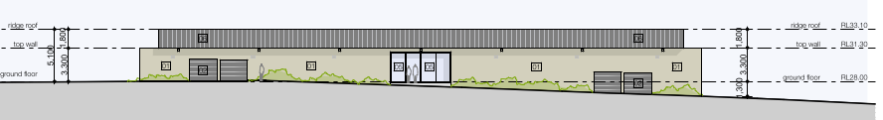
Figure 19 - Eastern elevation of greenhouse. Source: Application documents.
Dwelling (Caretakers house)

The caretaker’s house will include three (3) bedrooms, two bathrooms, open plan kitchen/meals/living area and open deck which fronts the northern aspect of the property with an overview of the farm stay and open grazing land. Access to the caretaker’s house will be shared via the proposed farm stay access from Point Richards Road.
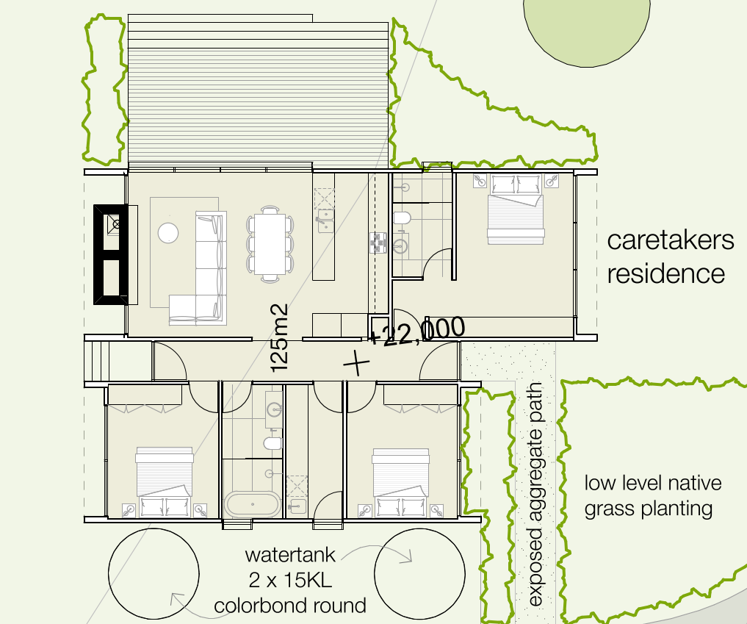
Figure 20 - Floor plan of caretakers dwelling. Source: Application documents.
Carparking

A total of ninety-two (92) car parking spaces and five (5) bus parking spaces will be provided on the site which are located as follows:

- 76 car parking and one (1) bus spaces within proximity of the Chocolaterie building.
- 14 car parking spaces and four (4) bus parking spaces within proximity of the group accommodation and Childrens Farm communal building
- 2 car parking spaces within proximity of the Dwelling (Caretaker’s House)

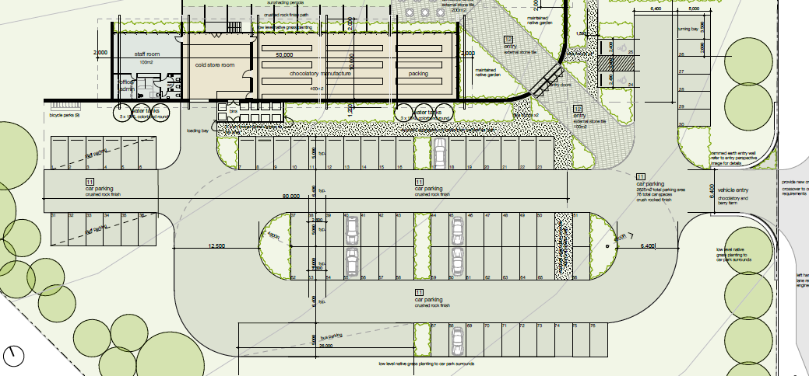
Figure 21 - Car parking at main chocolaterie building. Source: Application documents.
Signage

The proposed signage is proposed to be located on both the chocolaterie and the group accommodation/children’s farm entrance. It will be situated on the proposed rammed earth wall.

No design plans have been provided with the application. It is noted that the signage will not exceed 3 square metres.

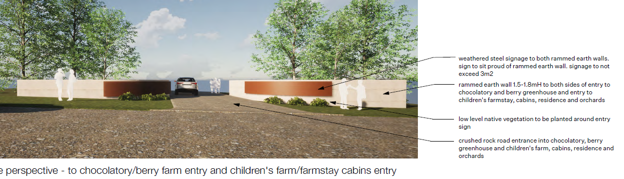
Figure 22 - Entrance with proposed signage. Source: Application documents.
Agricultural use

The land is to continue to be used for agricultural purposes which do not require planning approval. This includes animal grazing, an orchard and berry farms.

There is an association between the agricultural uses and the proposed use of the land for the group accommodation and chocolaterie.

Development of the land for agricultural use requires planning approval. The proposal includes the construction of stables close to the group accommodation and children’s farm buildings and two agricultural sheds close to the orchard and waterway.

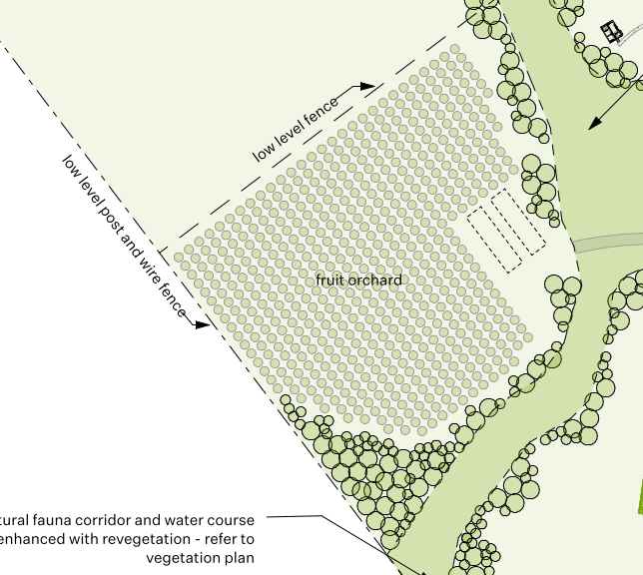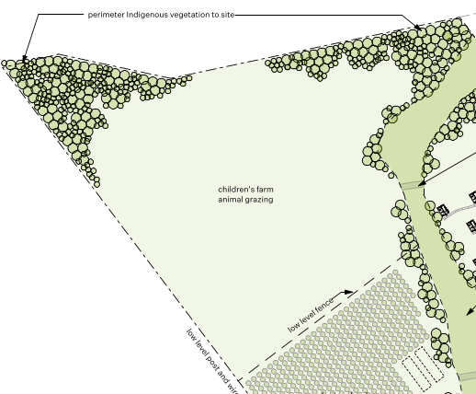
Figure 23 - Fruit orchard. Source: Application documents. Figure 24 - Animal grazing area. Source: Application documents.
Land Management/ Biodiversity outcomes

The proposal includes a plan for complete revegetation of the site, particularly along the waterway that traverses the centre of the site. There is proposed to be substantial planting of native vegetation along the northern boundary.

It is proposed that there will be a mix of low-level native grass, mid storey shrubs and canopy native trees and will be revegetated in accordance with the ‘DELWP Growling Grass Frogs Habitat Guidelines, 2017’. Further, the waterway will be protected by a post and wire fence to prevent visitors accessing the waterway.

The applicant has submitted that the proposed revegetation works and their species have been selected to reflect the City of Greater Geelong’s Central Bellarine Hills Indigenous Plant schedule which nominates the subject site as being within Zone 3.

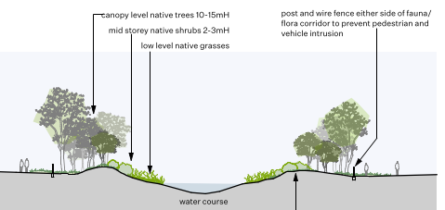
Figure 25 - Proposed planting along watercourse. Source: Application documents.

PERMIT/SITE HISTORY:

The following permits/site history is applicable to this application:
- PP-533-2008 – Use and development of dwelling – Planning permit issued

REFERRALS (See Appendix 1 for full referral responses):

The following referrals were undertaken:

SECTION 55 REFERRAL AUTHORITIES
Department of Transport (Section 55) |  | Supportive – no conditions
Noted.
SECTION 52 REFERRAL AUTHORITIES
Corangamite Catchment management Authority (CCMA) |  | Supportive subject to conditions
The CCMA provided conditions that required a final Stormwater Management Plan and Flood Impact Assessment are provided to their satisfaction. The provided conditions were included in the officer recommendation.
Barwon Water |  | Supportive subject to notations being included on the planning permit
The provided notations were included in the officer recommendation. The notations relate to the connection of sewerage and potable water .
Country Fire Authority |  | Supportive subject to conditions
The CFA provided conditions relating to the requirement for an Emergency Management Plan, water supply and emergency access. The provided conditions were included in the officer recommendation.
Department of Environment, Land, Water & Plan |  | Letter of advice
Comments were included as a notation in the officer recommendation. The comments related to the sites inclusion in the Victorian Heritage Inventory and requirements under the Heritage Act.
INTERNAL
Engineering |  | Supportive subject to conditions.
The provided conditions were included in the officer recommendation.
Further, the Construction Environmental Management Plan requirements were combined with the CEMP requirements from the Environment Unit.
Environmentally Sustainable Design |  | Supportive subject to conditions
The provided conditions were included in the officer recommendation.
Environment |  | Not Supportive but conditions supplied if permit granted.
The Environment Unit have submitted that they do not support the proposal due to the lack of detail on the management of the waterway and the potential impacts on the Growling Grass Frog.
The following amendments were made to the provided conditions:
- The provided conditions were included in the officer recommendation, with an amendment to the required timing of the from within 12 months of the development to prior to the use.
- The Environmental Audit Condition was updated to allow for a Preliminary Risk Screen Assessment to be submitted in accordance with current requirements.
- Further, the Construction Environmental Management Plan requirements were combined with the CEMP requirements from the Engineering Unit.
Environmental Health |  | Further information required which can be conditioned
The provided conditions were generally included in the officer recommendation.
The following conditions were not included in the officer recommendation as they were considered to be covered by other conditions:

Nuisance
The stables, yards and pens must be kept clean at all times and must not cause nuisance to any person on any adjoining properties by way of offensive odour, to the satisfaction of the Responsible Authority.
Odour
Pest control measures must be put in place to minimise pest issues.
The use of land for agriculture does not require planning approval and therefore it would not be appropriate to condition the use. Further pest control measures had already been addressed in the General Amenity condition.
Urban Design |  | Supportive with suggestions of minor changes to the proposal
The applicant made changes as suggested by the Urban Design team relating to the built form of the buildings and inclusion of pedestrian paths
Heritage |  | Supportive but further information required which can be conditioned
Conditions included that require the further information/minor amendments in relation to the reconstruction of the existing heritage building.
Tourism |  | Supportive
Noted.
Strategic Implementation | Supportive
Noted.

PUBLIC NOTIFICATION:

The application is not exempt from the notice requirements of Section 52(1)(a), (b) and (d), the decision requirements of Section 64(1), (2) and (3) and the review rights of Section 82(1) of the Act and pursuant to Section 52 of the Planning and Environment Act 1987 the following forms of advertising were undertaken:

- Notices were sent to owners and occupiers of adjoining land (including opposite)
- A2 sign(s) were placed on the land

67 objections were received against the application.

59 letters of support were received for the application.

Objections were received from immediate neighbours as well as concerns residents in Portarlington. Some objections were received from further away. See images below for location of objectors in the immediate area.

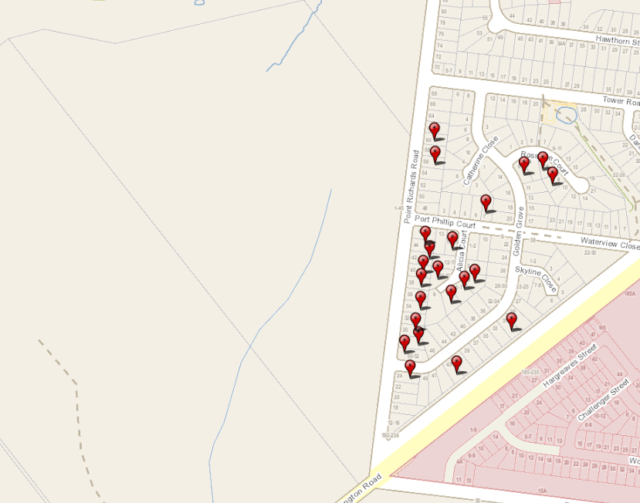
Figure 26 - Location of objectors in the immediate area
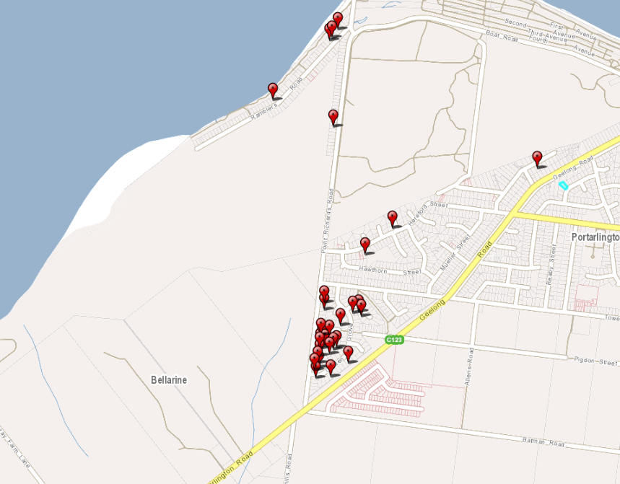
Figure 27 - Location of objectors slightly further from the site
CONSULTATION:

A consultation meeting was held between the applicant, council officers, and objectors. The meeting discussed the issues raised to see if any resolutions were possible.

Amended plans were later submitted following this and these were circulated to objectors. As result of the consultation meeting no objections to the application were withdrawn.

AMENDMENT OF THE APPLICATION FOLLOWING PUBLIC NOTIFICATION

The applicant made a request to amend the application following public notification pursuant to Section 57A of the Planning and Environment Act 1987 on 9 May 2023. Council has accepted the amendment. The amendment made the following changes to the application:

• Revised Development and Site Layout
o Revised car parking layout enabling bus parking and maneuverability
internally;
o Reduced greenhouse building footprint;
o Additional bus parking in proximity to children’s farm;
o Revised design and materials to repurposed bluestone building;
o Minor alteration to caretaker residence siting and access;
o Revised indicative vegetation layout to eastern boundary.
- Modified design of the existing bluestone remnants
- An updated traffic management report

The amended application was renotified pursuant to Section 57B of the Planning and Environment Act 1987 and the following forms of advertising were undertaken:

- Notices were sent to all current objectors to the application.

As a result of re-advertising, no additional objections have been received.

No objectors have withdrawn their objection because of these amended plans being lodged with Council.

AMENDMENT OF THE APPLICATION FOLLOWING PUBLIC NOTIFICATION

The applicant made a request to amend the application following public notification pursuant to Section 57A of the Planning and Environment Act 1987 on 16 August 2023. Council has accepted the amendment. The amendment made the following changes to the application:
- Changes to address concerns raised by Barwon Water

These are the plans currently under assessment.

It was not considered necessary to readvertise the proposal based on the amendment, as the amendment would not result in any additional material detriment compared with the advertised application, for the following reasons:
- The changes only added further detail and clarification to address a request from Barwon Water. There were no notable differences to the previously advertised plans. The plans showed the location of the Barwon Water Easement and confirmed there would be not planting in this section.

OBJECTIONS:

The concerns of objectors are summarised and commented on below:

- Objection – Non-agricultural use in the Farming Zone
  - Use for industrial manufacturing and retail not agriculture
  - Loss of agricultural land
  - Impacts on adjoining agricultural land and their ability for cultivation, spraying, fertiliser application and harvesting.
  - Proposed agricultural use is not a substantive use
  - High quality agricultural land
  - No Farm Management Plan has been provided
  - No pest control management
  - The proposed agricultural activity (berry growing and animal grazing) are actually to support retail/manufacturing activity (chocolaterie, restaurant, farm stay, children’s farm) and are certainly not the primary activity.
  - Permanent removal from agricultural uses

Response

An assessment of the application against the Farming Zone and agricultural policy is provided below.

- Objection – Local and state heritage significance of the site
  - Geelong and Region Branch National Trust of Australia (Victoria) strongly objects to any demolition and infill of the former Lincoln’s Farm House Cheese Cellar.
  - The National Trust encourages the applicant to reconsider the treatment of this highly significant heritage structure and make an important lasting positive contribution to the heritage of the area and particularly to the story of the Bellarine Peninsula.
  - We also encourage the Applicant to consider retaining the ancient tree beside the Cheese Cellar.
  - As the owner of the Portarlington Mill, which may be the only other surviving building constructed from the same stone, the Geelong and Region National Trust Branch offers to assist by way of research to achieve this worthy goal.
  - The research would be to locate the quarry site from where the stone was sourced, and to identify the description in precise geological terminology.

Response

The site is listed on the VHI, and therefore a Consent to Damage will be required from Heritage Victoria (HV) prior to any ground disturbing works associated with the proposed development taking place on the site.

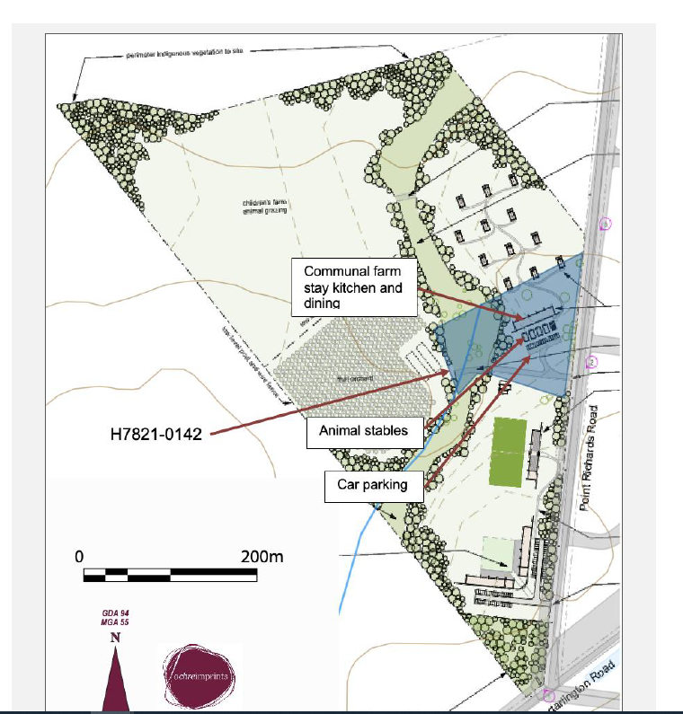
Figure 28 - Map showing the development within the boundaries of the development in the Victorian Heritage Inventory. Source: Application documents.
A response to the Heritage Overlay is provided below.

- Objection – Traffic impacts
  - Heavy vehicles
  - No coach parking
  - Increase in traffic
  - Boat users, caravanners, tourists going to the beach, visitors to the miniature railway, sailing club users and residents will be impacted.
  - The traffic impact assessment was not completed at peak times
  - Traffic safety concerns
  - The recently expanded Point Richards Boat ramp approved by Council will in itself attract an increase in traffic particularly at the intersection of Point Richards Road and Portarlington Road.
  - Near impossible during weekends and holidays to make a right hand turn into Geelong Portarlington Road from Point Richards Road

Response

The application was accompanied by a traffic impact assessment that was assessed and considered by the City’s engineering team and the Department of Transport. It was considered that the potential traffic impacts would be able to be sufficiently mitigated.

This is addressed further below against relevant planning policy.

- Objection – Environmental concerns
  - The water course running through the property angles towards the Point Richards Flora and Fauna Reserve
  - Potential negative impacts of the increased pressure include: increased wildlife disturbance; trampling or removal of vegetation; increased litter; increased habitat fragmentation; and changes to stormwater runoff.
  - The Growling Grass Frog is listed as Vulnerable nationally under the Environment Protection and Biodiversity Conservation Act 1999.
  - Hawks and Eagles feed in this paddock.

Response

The potential impacts on the environment on the subject site and adjoining sites considered in the assessment of the application.

The application was accompanied by an ecological assessment that detailed the low environmental value of the subject site. The proposal includes the native re-vegetation of the site, in particular along the existing waterway. It is considered that with appropriate conditions, there will be a net biodiversity impact.

This has been addressed further below against the relevant policy.

- Objection – Application is not consistent with the covenant on property
- Covenant only allows for one dwelling, plans show dwelling and 12 group accommodation units

Response

The title does not include a covenant on the lands.

- Objection – Noise impacts on nearby residential uses
- Animals in barns all night are close to existing residences
- Increase in people to the site

Response

The proximity of dwellings to the subject site

This has been addressed below against the relevant policy.

- Objection – Pollution
- Rubbish may be picked up by the wind

Response

It is considered that waste management and litter control can be addressed with appropriate permit conditions and a waste management plans.
Conditions have been included in the officer recommendation that address waste management.
It cannot be guaranteed that no rubbish will be discarded by patrons or other members of the community in the public realm and that this might blow onto other properties. However, a Waste Management Plan has been included in the officer recommendation that includes the requirement for the regular insurance that rubbish is picked up.

- Objection – Landscaping
- Proposed black wood and banksia trees will eventually impact on our current views, smaller trees should be considered.
- The construction of the caretaker’s lodge is to be built directly opposite our home. This and the proposed planting of tall trees will have a significant impact on our views of the farm, the ocean and the mountain range, the reason we purchased this home in the first place.

Response

We cannot restrict the vegetation to be planted.

This has been addressed below against the relevant policy.

- Objection – Barwon Water has not approved the supply of sewerage to the site

Response

Barwon Water have now provided conditional consent to the application.

- Objection – The application is not consistent with the Portarlington Structure Plan
- The proposal is located outside the defined settlement boundary:
- The western boundary is located between the existing residential zone and the Point Richards Flora and Fauna Reserve. Further urban development westwards is inappropriate as it would irreversibly affect unique environmental assets and landscape features and undermine the non-urban break between Portarlington and Drysdale;

Response

This has been addressed below against the relevant policy.

- Objection – Aboriginal Cultural Heritage Sensitivity

Response

The proposed area to be used for high impact activities is not within and area of cultural sensitivity under the Aboriginal Heritage Act 2006.

As discussed below, the area within an area of sensitivity is far removed from the proposal area and is not included in the planning permit application.

- Objection – Stormwater discharge will not be managed appropriately

Response

The application was accompanied by a stormwater management strategy that detailed that the proposal will manage stormwater using best practice.

This has been addressed further below against the relevant policy.

- Objection – The proposal fails to respond appropriately to the matters within Clause 45.01 Public Acquisition Overlay

Response

The proposed use and development are located outside of the Public Acquisition Overlay – Schedule 3.

This has been addressed below against the relevant policy.

- Objection – Odour impacts

- The odour generated by the proposal's structures and particularly uses will generate unreasonable amenity impacts upon the surrounding sites and the public realm.

Response

This has been addressed below against the relevant policy.

- Objection – Impact on the rural amenity of the locality

Response

This has been addressed below against the relevant policy.

- Objection – The proposal is not in accordance with the Significant Landscape Overlay – Schedule 14
- Over 100+ car spaces (yet doesn’t appear to have any space allocated for buses as yet), building height approximately 6 metres high (although stated as low level single storey) and in excess of 15 structures
- The chocolatier at 5.1 metres, also gets higher as you go downhill, but this height is not indicated on the drawings. If it is low profile at the top of the hill then it also needs to be low profile down the hill. Please note that the farm stay and greenhouse buildings appear to be taller than what would impact a low impact dwelling along Point Richards Road. The communal farm stay building does also not clearly indicate the dwellings height. Diagrams are shown at floor level not natural ground level, so are actually potentially higher. Height differences between the ground floor and natural ground levels are not stated.
- BELLARINE DAL. The DAL is specific about:
- maintaining rural landscapes and views. This proposed development, will significantly alter the rural landscape and
- views of uninterrupted paddock, and is not in the spirit of the DAL
- No view impact assessment has been provided
- Those living or driving past, including tourists will lose those views of the currently mostly open paddock, and uninterrupted views across Corio Bay to the You Yangs.
- The planning proposal highlights the uninterrupted views that will be enjoyed by the farm stay visitors and those to the restaurant which are to be achieved at the expense of all those that live in the area and the many walkers and cyclists that use Point Richards Road on a daily basis and who enjoy the vista as part of their day.

Response

The visual amenity impacts have been thoroughly considered in the assessment of the application. It is considered that the single storey design of the buildings, spacing between the buildings along with the rural design, ensure that the landscape is protected.

This has been addressed further below against the relevant policy.

- Objection – Another site would be more suitable.

Response

It is not possible consider whether another site would be more appropriate. The Responsible Authority is required to assessment the application submitted on its merits.
- Objection – Restaurant
In relation to the Restaurant, I see that they have allowed for 140 seats. I would be interested to know what hours that they will operate the Restaurant and whether they will be seeking to make the Restaurant a Licensed venue.

Response

The restaurant will operate during the day between 10am – 6pm. The current application does not seek approval for a liquor license.

- Objection – The proposal will set a precedent.

Response

Every planning permit application is assessed on its merits.

- Objection –The use and development will intensify over time

I am also concerned that once the planning is changed what occurs if the business fails and new occupants change the nature of the business. What assurances do we have that protect us from a progression of planning changes that will completely impact the area in a negative manner.

Response

The Responsible Authority can only assess what the applicant has sought approval for. Should the applicant wish to change the proposed use, an amended planning permit application would be required.

SUBMISISONS OF SUPPORT

The submissions of support are summarised as follows:
- The proposal is family friendly which will compliment other tourism attractions, including the wineries and distilleries.
- The proposal will promote tourism to the town which will complement the playground, miniature railway and skate park.
- The proposal will provide for employment in the town during the construction phase and operation.
- This proposed use of a designated 'Farming Zone', which has sat virtually unused and with buildings undergoing 'demolition by neglect' (heritage term), will re-establish and maintain appropriate agricultural land use and also increase net local community benefit.
- The extensive ecological survey seems to have been undertaken and it appears there is an opportunity for re-vegetation along the natural watercourse and also to protect and expand on the growling grass frog community.
- The animal farm and berry picking maintains a country feel and is perfect in a 'farming zone'. The chocolaterie would be great and compliments the berry picking.
- The proposal is preferrable to a housing estate on the land.
- the developer has committed to low elevation, single story buildings which are set well inside of the property. They appear unlikely to impact on the views of the residents along Point Richards road, whilst providing impressive views from all parts of the development itself.
- There appears to have been great consideration given to protecting and enhancing the native vegetation and place of cultural signficance.

ASSESSMENT:

Clause 35.07 - Farming Zone

Purpose
- To implement the Municipal Planning Strategy and the Planning Policy Framework.
- To provide for the use of land for agriculture.
- To encourage the retention of productive agricultural land.
- To ensure that non-agricultural uses, including dwellings, do not adversely affect the use of land for agriculture.
- To encourage the retention of employment and population to support rural communities.
- To encourage use and development of land based on comprehensive and sustainable land management practices and infrastructure provision.
- To provide for the use and development of land for the specific purposes identified in a schedule to this zone.
Clause 36.07-6 Decision Guidelines
Before deciding on an application to use or subdivide land, construct a building or construct or carry out works, in addition to the decision guidelines in Clause 65, the responsible authority must consider, as appropriate:

General issues
- The Municipal Planning Strategy and the Planning Policy Framework.
- Any Regional Catchment Strategy and associated plan applying to the land.
- The capability of the land to accommodate the proposed use or development, including the disposal of effluent.
- How the use or development relates to sustainable land management.
- Whether the site is suitable for the use or development and whether the proposal is compatible with adjoining and nearby land uses.
- How the use and development makes use of existing infrastructure and services.

Agricultural issues and the impacts from non-agricultural uses
- Whether the use or development will support and enhance agricultural production.
- Whether the use or development will adversely affect soil quality or permanently remove land from agricultural production.
- The potential for the use or development to limit the operation and expansion of adjoining and nearby agricultural uses.
- The capacity of the site to sustain the agricultural use.
- The agricultural qualities of the land, such as soil quality, access to water and access to rural infrastructure.
- Any integrated land management plan prepared for the site.
- Whether Rural worker accommodation is necessary having regard to:
  - The nature and scale of the agricultural use.
  - The accessibility to residential areas and existing accommodation, and the remoteness of the location.
- The duration of the use of the land for Rural worker accommodation.

Accommodation issues
- Whether the dwelling will result in the loss or fragmentation of productive agricultural land.
- Whether the dwelling will be adversely affected by agricultural activities on adjacent and nearby land due to dust, noise, odour, use of chemicals and farm machinery, traffic and hours of operation.
- Whether the dwelling will adversely affect the operation and expansion of adjoining and nearby agricultural uses.
- The potential for the proposal to lead to a concentration or proliferation of dwellings in the area and the impact of this on the use of the land for agriculture.

Environmental issues
- The impact of the proposal on the natural physical features and resources of the area, in particular on soil and water quality.
- The impact of the use or development on the flora and fauna on the site and its surrounds.
- The need to protect and enhance the biodiversity of the area, including the retention of vegetation and faunal habitat and the need to revegetate land including riparian buffers along waterways, gullies, ridgelines, property boundaries and saline discharge and recharge area.
- The location of on-site effluent disposal areas to minimise the impact of nutrient loads on waterways and native vegetation.

Design and siting issues
- The need to locate buildings in one area to avoid any adverse impacts on surrounding agricultural uses and to minimise the loss of productive agricultural land.
- The impact of the siting, design, height, bulk, colours and materials to be used, on the natural environment, major roads, vistas and water features and the measures to be undertaken to minimise any adverse impacts.
- The impact on the character and appearance of the area or features of architectural, historic or scientific significance or of natural scenic beauty or importance.
- The location and design of existing and proposed infrastructure including roads, gas, water, drainage, telecommunications and sewerage facilities.
- Whether the use and development will require traffic management measures.

Clause 45.01 – Public Acquisition Overlay – Schedule 3:

Purpose
- To implement the Municipal Planning Strategy and the Planning Policy Framework.
- To identify land which is proposed to be acquired by a Minister, public authority or municipal council.
- To reserve land for a public purpose and to ensure that changes to the use or development of the land do not prejudice the purpose for which the land is to be acquired.
- To designate a Minister, public authority or municipal council as an acquiring authority for land reserved for a public purpose.

Decision guidelines
- Before deciding on an application, in addition to the decision guidelines in Clause 65, the responsible authority must consider, as appropriate:
- The Municipal Planning Strategy and the Planning Policy Framework.
- The effect of the proposed use or development on the purpose for which the land is to be acquired as specified in the schedule to this overlay.
- A permit granted under this clause may be conditional on:
- The extent of alterations and extensions to an existing building and works, and the materials that may be used.
- The location, dimensions, design and material or a new building or works.
- The demolition, removal or alteration of any buildings or works.
- The demolition or removal of buildings or works constructed or carried out in accordance with a permit under this clause.
- No compensation being payable for the demolition or removal of any buildings or works constructed under the permit.

Clause 42.03 – Significant Landscape Overlay – Schedule 14

Purpose
- To implement the Municipal Planning Strategy and the Planning Policy Framework.
- To identify significant landscapes.
- To conserve and enhance the character of significant landscapes.

Clause 42.03-5 - Decision guidelines
- The statement of the nature and key elements of the landscape and the landscape character objective contained in a schedule to this overlay.
- The conservation and enhancement of the landscape values of the area.
- The need to remove, destroy or lop vegetation to create a defendable space to reduce the risk of bushfire to life and property.
- The impact of the proposed buildings and works on the landscape due to height, bulk, colour, general appearance or the need to remove vegetation.
- The extent to which the buildings and works are designed to enhance or promote the landscape character objectives of the area.
- The impact of buildings and works on significant views.
- Any other matters specified in a schedule to this overlay.

Design Objectives of Schedule 14
- To protect outviews and vistas, including outviews to the Bays, views across Corio Bay to the coastal escarpment, and significant vistas from the higher points of slopes and rises throughout.
- To ensure that the prominent slopes between Portarlington and Clifton Springs retain a largely unbuilt and partially vegetated character, free from intrusive built development.
- To minimise the visual impact of infrastructure and signage throughout the landscape.
- To maintain and improve indigenous vegetation throughout the landscape, particularly at roadsides and in riparian strips.
- To protect indigenous coastal vegetation and ensure that it is the dominant feature of the landscape, when viewed from the coastal strip.
- To protect cultural vegetation elements that positively contribute to the character of the landscape, including exotic wind breaks and feature planting around homesteads.
- To recognise and protect the continuation of the land as a working farmed landscape.

HERITAGE OVERLAY – HO49

Purpose
- To implement the Municipal Planning Strategy and the Planning Policy Framework.
- To conserve and enhance heritage places of natural or cultural significance.
- To conserve and enhance those elements which contribute to the significance of heritage places.
- To ensure that development does not adversely affect the significance of heritage places.
- To conserve specified heritage places by allowing a use that would otherwise be prohibited if this will demonstrably assist with the conservation of the significance of the heritage place.

Decision guidelines
- The significance of the heritage place and whether the proposal will adversely affect the natural or cultural significance of the place.
- Any applicable statement of significance (whether or not specified in the schedule to this overlay), heritage study and any applicable conservation policy.
- Any applicable heritage design guideline specified in the schedule to this overlay.
- Whether the location, bulk, form or appearance of the proposed building will adversely affect the significance of the heritage place.
- Whether the location, bulk, form and appearance of the proposed building is in keeping with the character and appearance of adjacent buildings and the heritage place.
- Whether the demolition, removal or external alteration will adversely affect the significance of the heritage place.
- Whether the proposed works will adversely affect the significance, character or appearance of the heritage place.
- Whether the proposed subdivision will adversely affect the significance of the heritage place.
- Whether the proposed subdivision may result in development which will adversely affect the significance, character or appearance of the heritage place.
- Whether the proposed sign will adversely affect the significance, character or appearance of the heritage place.
- Whether the lopping or development will adversely affect the health, appearance or significance of the tree.
- Whether the location, style, size, colour and materials of the proposed solar energy system will adversely affect the significance, character or appearance of the heritage place.

Schedule HO49 - Rosedale (formerly Lincoln’s Farm House)
Complex of weatherboard buildings comprising stables, outbuildings, house and cheese factory.

Statement of Significance
What is significant?

The Rosehill farm site shows a rare intact example of a nineteenth century dairy farm and cheese processing facility. Any archaeological deposits, features and artefacts relating to the nineteenth century phases of occupation have to potential to contain information about the residential life in the nineteenth-century Bellarine Peninsula, the nineteenth century cheese making process and the composition of dairy farms in the region. The ruinous structures that are present on the site have the potential to contain sub-floor deposits and there is potential for nineteenth century wash closet deposits to be intact.

How is it significant?
The site is of local historical and archaeological significance.

Why is it significant?
The site is of historical significance as the site has been occupied as a farm and residence since the c.1840s. The site is associated with J Birkett who is a prominent businessperson around the Portarlington Area at the time. The site was also occupied by Edwin Collins who had a very successful cheese making business on the site for approximately 15 years. The Collins Dairy farm was famous for making a cheddar like cheese that won multiple colonial awards.
The site has the potential to contain archaeological information relating to the initial occupation phase by Birkett and information about the colonial cheese making process. Archaeological material relating to both [and later] phases of occupation is likely to be present, and it is possible that the demolition/ remodeling of the existing ruins will exposure further archaeological features and deposits related to the historical occupation. The age of the earliest occupation, and absence of broad-scale modern construction having taking place on the property allows for the likelihood of features such as wash closets/ cesspits and former industrial structures to be present on the property.

CULTURAL HERITAGE MANAGEMENT PLAN (CHMP)

The Aboriginal Heritage Regulations 2018 specify the circumstances in which a cultural heritage management plan is required for an activity or class of activity. Division 2 of the Aboriginal Heritage Regulations 2018 specifies exempt activities which do not require a cultural heritage management plan. The proposal is not listed as an exempt activity.

Areas of cultural heritage sensitivity are defined within Divisions 3 and 4 of the Aboriginal Heritage Regulations 2018.

Division 3 identifies a section on the northern boundary of 1-45 Point Richards Road as within an area of cultural heritage sensitivity.

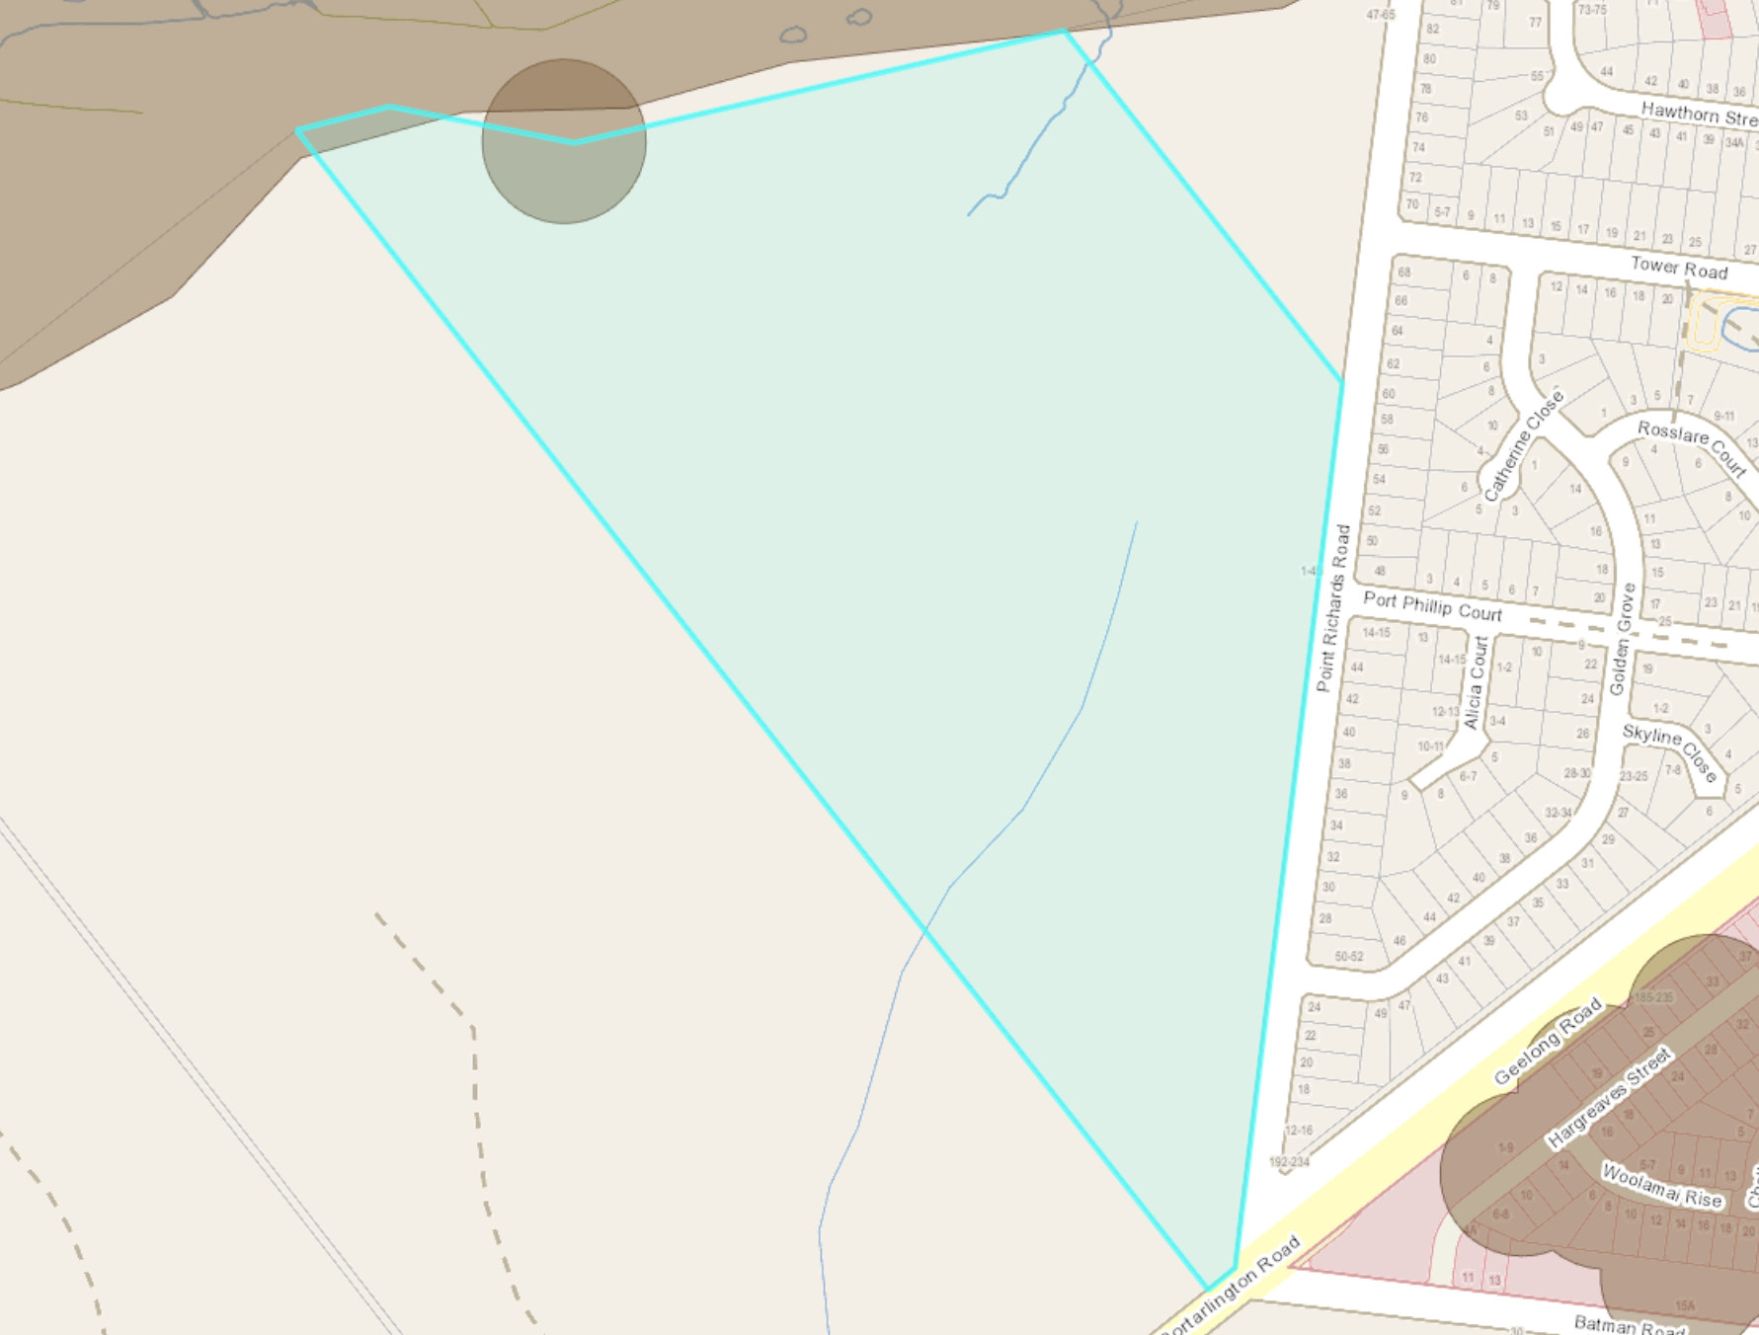
Figure 29 - Area of cultural sensitivity

High impact activities are defined within Division 5 of the Aboriginal Heritage Regulations 2018. Division 5 lists the proposed uses of Place of Assembly and Industry as a high impact activities.

The applicant has submitted:

In relation to the activity, none of the activity area in this application which may otherwise be a high impact activity (i.e. use for industry and place of assembly) is an area of cultural heritage sensitivity.
There is a clear demarcation between the area to be used and developed (which is classed as an activity area) and the area where nothing is to occur as a result of this planning permit (except some planting of trees and continued use of land for agriculture).

The City has considered whether a CHMP is required in this instance by reviewing various VCAT tribunal findings.

Tribunal decision of Big Hill Vineyard Pty Ltd v Greater Bendigo CC3 (Big Hill Vineyard), the definition of activity area was considered and found that the activity area need not encompass the entire lot for which the activity was proposed. Senior Member Baird said:

“A purposive approach draws me to the conclusion that, with respect to the two arms of r6, even though the proposed construction is a high impact activity, none of the activity area for the activity is within an area of cultural heritage sensitivity. I therefore find no cultural heritage management plan is required.”

The Big Hill Vineyard was followed in the Tribunal decision of Clifftop at Hepburn Pty Ltd v Hepburn SC5 (Clifftop) that concluded:

I am satisfied that the amendment of the plans to exclude the CHS area and provide a physical barrier through a post and wire fence, together with the amendment of the description of the subject land to refer to ‘part’ of the property as shown on the plans, is sufficient to exclude the CHS area from the ‘activity area’ of the use and development as defined by the Regulations.

The additional information provided by the permit applicant has allayed concerns that the location of Yurts 3 and 4 and any landscaping or development around them may encroach on to the CHS area. I also find that the use of post and wire fencing in this situation is an acceptable treatment to delineate a physical separation from the part of the property that is not the subject of this application.

Williamson & Ors v Yarra CC & Anor [2011] VCAT 357 (Williamson)

In Williamson the Tribunal considered a proposal in Alphington for 81 dwellings where the rear 20-25 metres (the ‘southern portion’) was separated from the remainder of the site by a retaining wall and wire fence and dropped approximately 15 metres down to the Yarra River.

The Tribunal was ultimately satisfied that the activity area did not consider ‘southern portion’ to be part of the high impact activity on the basis that this area was to be fenced off from the remaining part of the land and was not going to be used or developed for the activity.

Fulton v Boroondara CC [2005] VCAT 2416 describes the concept of a planning unit as follows:

The concept of the ‘planning unit’ is well recognized in planning law and practice. What the planning unit may be in any case will depend upon the facts. Depending on the facts, it may be the whole of one or more lots; it may be the whole of the land in a title or only part of the land. But its determination will be practical rather than an artifice to avoid planning controls or rob the Tribunal of jurisdiction.

For the avoidance of doubt, the area of sensitivity will be excluded from the site by a post and wire fence, and it will be noted on the plans that the planning unit does not include this area.

In accordance with the above assessment, it is the position of the City that a cultural heritage management plan is not required.

LANDFILL GAS RISK ASSESSMENT

The subject site is not located within 500 metres of an identified former landfill site, a risk assessment is not required.

DEVELOPMENTS IN BUSHFIRE PRONE AREAS

The site is located within a designated bushfire prone area.

Clause 13.02-1S (Bushfire planning) seeks to strengthen the resilience of settlements and communities to bushfire through risk-based planning that prioritises the protection of human life.

The policy must be applied to all planning and decision making under the Planning and Environment Act 1987 relating to land which is:

- Within a designated bushfire prone area;
- Subject to a Bushfire Management Overlay; or
- Proposed to be used or developed in a way that may create a bushfire hazard.

The proposal is listed at Clause 13.02-1S as one of the uses or developments which should be considered:

- Subdivisions of more than 10 lots.
- Accommodation.
- Child care centre.
- Education centre.
- Emergency services facility.
- Hospital.
- Indoor recreation facility.
- Major sports and recreation facility.
- Place of assembly.
- Any application for development that will result in people congregating in large numbers.

As the site is located within a designated bushfire prone area the assessment of this application has considered:

- The risk of bushfire to people, property and community infrastructure.
- Whether the implementation of appropriate bushfire protection measures to address the identified bushfire risk is necessary.
- Whether the proposal can implement bushfire protection measures without unacceptable biodiversity impacts.

The application is not expected to create a risk bushfire to people, property and community infrastructure.

It is considered that the following bushfire protection measures to address the identified bushfire risk is necessary are required:
- Implement the advice received from the CFA.
- Ensure vegetation is removed and/or maintained where possible.

It is recommended that the following notes also be included on any permit issued:
- This property is in a designated bushfire prone area.
- Special bushfire construction requirements apply at the Building Permit stage.
- This permit has not determined the Bushfire Attack Level (BAL).
- Any building should consider AS 3959-2018 Construction of Buildings in Bushfire-prone Areas (Standards Australia, 2018).

THE VICTORIAN PLANNING POLICY FRAMEWORK (VPPF):

The following Planning Policies are applicable to this application:

SETTLEMENT
Clause 11.01-1S Settlement
Looks to support prosperous and sustainable settlements in-part through balancing strategic objectives to achieve improved land use and development outcomes at a regional, catchment and local level.

Clause 11.01-1R Settlement – Geelong G21
Sets out strategies including providing for settlement breaks between towns to maintain their unique identities.

Clause 11.01-1L-01 Settlement – Greater Geelong
Includes a strategy to maintain urban breaks between townships on the Bellarine Peninsula

Clause 11.03-5S – Distinctive areas and landscapes
To recognise the importance of distinctive areas and landscapes to the people of Victoria and protect and enhance the valued attributes of identified or declared distinctive areas and landscapes.
The planning policy requires consideration of the Bellarine Peninsula Localised Planning Statement (Victorian Government,2015)
On 29 October 2019 the Bellarine Peninsula was declared a Distinctive Area and Landscape under the Planning and Environment Act 1987. The declaration triggered the requirement to prepare a Statement of Planning Policy, which was approved by the Governor in July 2023.

The Statement of Planning Policy includes a 50-year vision and land use objectives and strategies to better protect the unique features of the Bellarine Peninsula for current and future generations. It also provides the opportunity to designate long term settlement boundaries.

The Bellarine Peninsula Statement of Planning Policy includes 8 objectives that must be meet and strategies to achieve these objectives that must be considered.

ENVIRONMENTAL AND LANDSCAPE VALUES
Clause 12.01-1S – Protection of biodiversity
Sets out a strategy to avoid impacts of land use and development on important areas of biodiversity.

Clause 12.01-1L – Protection of biodiversity
Sets out a strategy to avoid impacts of land use and development on important areas of biodiversity.

Clause 12.01-2S – Native vegetation management
Sets out a strategy to minimise impacts from the removal, destruction or lopping of native vegetation that cannot be avoided.

Clause 12.03-1S – River corridors, waterways, lakes and wetlands
Seeks to protect the environmental, cultural and landscape values of all water bodies and wetlands and ensure development is sensitively designed and sited to maintain and enhance environmental assets, significant views and landscapes along river corridors and waterways and adjacent to lakes and wetlands.

Clause 12.03-1L – River corridors, waterways, lakes and wetlands
Seeks to ensure wetlands are not drained or adversely affected as a result of development

Clause 12.05-2S – Landscapes
Includes policy to recognise the natural landscape for its aesthetic value and as a fully functioning system, and ensure important natural features are protected and enhanced.

ENVIRONMENTAL RISK AND AMENITY
Clause 13.02-1S – Bushfire planning
Seeks to strengthen the resilience of settlements and communities to bushfire through risk-based planning that prioritises the protection of human life. The policy sets out that designated bushfire prone areas are to be considered when assessing planning applications for uses and development that will result in people congregating in large numbers. The subject site is within a bushfire prone area.

Clause 13.03-1S – Floodplain management
Seeks to assist in the protection of environmental significance and flood storage function of wetlands.

Clause 13.05-1S – Noise management
Sets out a strategy to ensure that development is not prejudiced and community amenity and human health is not adversely impacted by noise emissions, using a range of building design, urban design and land use separation techniques as appropriate to the land use functions and character of the area.

Clause 13.07-1S – Land use compatibility
Includes policy to avoid or otherwise minimise adverse off-site impacts from commercial and other uses through land use separation, siting, building design and operational measure.

NATURAL RESOURCE MANAGEMENT
Clause 14.01-1S – Protection of agricultural land
To protect the state’s agricultural base by preserving productive farmland.
Strategies include:
- Protect productive agricultural land from unplanned loss due to permanent changes in land use.
- Consider the compatibility between the proposed or likely development and the existing use of the surrounding land.
- Protect strategically important agricultural and primary production land from incompatible uses.
- Balance the potential off-site effects of a use or development proposal (such as degradation of soil or water quality and land salinisation) against the benefits of the proposal.

Clause 14.01-1L-01 – Discretionary uses in rural areas
Seeks to preserve the productive agricultural capacity of the land and where possible enhance the environmental condition of the land and to maintain the landscape character of rural areas. Includes a policy for Council to consider whether buildings and structures have been designed or sited to be visually recessive and can blend into the surrounding landscape and natural environment through design, landscaping, materials and colours.

BUILT ENVIRONMENT AND HERITAGE
Clause 15.01-1S – Urban design
Sets out policy that requires development to respond to its context in terms of character, cultural identity, natural features, surrounding landscape and climate, with the objective to create urban environments that are safe, healthy, functional and enjoyable and that contribute to a sense of place and cultural identity.

Clause 15.01-2S – Building design
Seeks to ensure site analysis forms the starting point of the design process and provides the basis for the consideration of height, scale and massing of new development. It looks at ensuring development responds and contributes to the strategic context of its location, with the objective to achieve building design outcomes that contribute positively to the local context and enhance the public realm and support environmentally sustainable development.

Clause 15.01-2L – Environmentally sustainable design
Seeks to achieve best practice in environmentally sustainable development from the design stage through to construction and operation.
Clause 15.01-5S – Neighbourhood character
Requires development to respond to its context, reinforce a sense of place and the valued features and characteristics of the local environment and place.
Clause 15.01-6S – Design for rural areas
Seeks to ensure development respects valued areas of rural character.
Strategies include:
- Ensure that the siting, scale and appearance of development protects and enhances rural character.
- Protect the visual amenity of valued rural landscapes and character areas along township approaches and sensitive tourist routes by ensuring new development is sympathetically located.
- Site and design development to minimise visual impacts on surrounding natural scenery and landscape features including ridgelines, hill tops, waterways, lakes and wetlands.

Clause 15.03-1S – Heritage conservation
Seeks to ensure the conservation of places of heritage significance.
Strategies include:
- Provide for the conservation and enhancement of those places that are of aesthetic, archaeological, architectural, cultural, scientific or social significance.
- Encourage the conservation and restoration of contributory elements of a heritage place.
- Ensure an appropriate setting and context for heritage places is maintained or enhanced.
- Support adaptive reuse of heritage buildings where their use has become redundant.
- Consider whether it is appropriate to require the restoration or reconstruction of a heritage building in a Heritage Overlay that has been unlawfully or unintentionally demolished in order to retain or interpret the cultural heritage significance of the building, streetscape or area.

ECONOMIC DEVELOPMENT
Clause 17.01-1S – Diversified economy
Strategies include:
- Facilitate growth in a range of employment sectors including tourism, based on the emerging and existing strengths of each region;
- Improve access to jobs closer to where people live; and Support rural economies to grow and diversify.

Clause 17.01-1R – Diversified economy Geelong G21
Seeks to build on the region’s competitive strengths, including tourism and agricultural land resources and economic, social and natural assets and support new businesses that provide employment and innovation opportunities in identified employment nodes across the region.

Clause 17.01-1L-01 Diversified Economy – Greater Geelong
Seeks to support industry development in the strategic growth sectors, including tourism.

Clause 17.02-2S – Out-of-centre development
Includes policy to ensure that out-of-centre proposals are only considered where the proposed use or development is of net benefit to the community in the region.
Clause 17.04-1S – Facilitating tourism

Seeks to encourage tourism development to maximise the economic, social and cultural benefits of developing the state as a competitive domestic and international tourist destination.

Encourage the development of a range of well-designed and sited tourist facilities, including integrated resorts, accommodation, host farm, bed and breakfast and retail opportunities.

Strategies:
- Seek to ensure that tourism facilities have access to suitable transport.
- Promote tourism facilities that preserve, are compatible with and build on the assets and qualities of surrounding activities and attractions.
- Create innovative tourism experiences.
- Encourage investment that meets demand and supports growth in tourism.

Clause 17.04-1L-02 – Tourism in rural areas
Seeks to support tourism development in rural areas that contributes to the growth of the tourism market, diversify the range of accommodation types, preserve agricultural activity and ensure scale of development respects the rural landscape character.
General strategies
- Support tourism uses associated with an agricultural activity on the land.
- Discourage tourism uses not associated with an agricultural activity on the land unless:
  - The site is strategically located with respect to an identified tourist route, such as the tourist route identified in the Bellarine Peninsula Localised Planning Statement or along the Bellarine Highway.
  - The site is in a location where there is an existing cluster of non-rural activities.
  - The use and development will not result in urbanisation of the locality.
  - The use and its associated development would not unreasonably visually compromise a non-urban break between settlements, a significant view or area identified as being of landscape or environmental significance.
  - The circumstances of the use are unique and support site selection in a rural location over an urban location.
- Encourage tourist accommodation that provides a connection or access to a tourist facility, tourist attraction or outdoor recreation.
- Encourage the diversification of the type of accommodation provided in rural areas and encourage longer term stays

TRANSPORT

Clause 18.01-1S – Land use and transport integration
Seeks to facilitate access to social, cultural and economic opportunities by effectively integrating land use and transport.
Strategies include:
Plan land use and development to:
- Protect existing transport infrastructure from encroachment or detriment that would impact on the current or future function of the asset.
- Protect transport infrastructure that is in delivery from encroachment or detriment that would impact on the construction or future function of the asset.
- Protect planned transport infrastructure from encroachment or detriment that would impact deliverability or future operation.
- Protect identified potential transport infrastructure from being precluded by land use and development.
Plan land use and development to allow for the ongoing improvement and development of the State Transport System in the short and long term.

DEVELOPMENT INFRASTRUCTURE

Clause 19.03-3S - Integrated water management
To sustainably manage water supply and demand, water resources, wastewater, drainage and stormwater through an integrated water management approach.
Strategies include:
- Plan and coordinate integrated water management, bringing together stormwater, wastewater, drainage, water supply, water treatment and re-use, to:
- Take into account the catchment context.
- Protect downstream environments, waterways and bays.
- Manage and use potable water efficiently.
- Minimise drainage, water or wastewater infrastructure and operational costs.
- Minimise flood risks.
- Provide urban environments that are more resilient to the effects of climate change.

Response to Zoning, Overlay and Policy
As Per Clause 71.02-3 of the Planning Scheme (Integrated Decision Making), Council as the Responsible Authority, must endeavour to integrate the range of policies relevant to an application and balance conflicting objectives in favour of net community benefit and sustainable development for present and future generations.
For this application, there is a need to assess the proposal in the context of both policy discouragement for non-agricultural activities in rural areas and policy encouragement for an expansion of tourism related activities adjacent to designated tourist routes that do not adversely impact agricultural activities, or the amenity impacts for the occupants of nearby dwellings. Further, the assessment of the application has assessed whether the proposal respects and enhances that environmental and rural landscape values. The benefits of the proposal have been considered against the potential adverse impacts and whether they can be sufficiently mitigated has been a central consideration in the assessment of this application.

Non-Agricultural use and development in the Farming Zone
(Clause 36.07 – Farming Zone, Clause 14.01-1S – Discretionary uses in rural areas, Clause 14.01-1S – Protection of agricultural land)

The Farming Zone allows for applications for non-agricultural uses to occur on the land which must be considered by the purpose and decision guidelines of the Farming Zone. This includes, whether the proposed use and development will support and enhance agriculture, whether it will limit or detract from agriculture on other land, whether it is compatible with adjoining and nearby land uses, whether it will permanently remove land from agricultural production, and the agricultural qualities of the land including soil quality.

The proposed uses of the land for group accommodation and a Children’s Farm have a relationship with the agricultural use of the land. The use of the land for an orchard, berry farm and animal grazing are connected to the proposal. The proposed scale of the chocolaterie and group accommodation area is considered to be the primary use of the land with the proposed agricultural use being secondary.

The proposal has been sited with significant setbacks from the adjoining agricultural properties to limit impacts on agricultural production or cause any adverse amenity impacts on the residential uses.

The proposed non-agricultural uses and developments on the site will permanently remove some land from agricultural production. However, the site has limited agricultural value due to the proximity to residential uses, the waterway that traverses the property and planning policy that discourages intensive agricultural use of the land.

Due to potential land use conflicts, there are limitations to the agricultural use of land in close proximity to residential uses. Residential uses have expected amenity conditions and some agricultural activities are not able to occur within proximity to the residential uses.

The development area is separated from the agricultural land by the waterway that traverses the site. It is important that waterways are protected and revegetated which creates and logical separation of the non-agricultural uses from the agricultural uses. Due the size of the site, there remains a substantial area that will be able to continue to be used for agricultural uses.

The Bellarine Peninsula Localised Planning Statement states that it, supports the continuing use of the area for agriculture, in particular viticulture, horticulture, cropping and grazing as the main land use in rural areas on the Bellarine Peninsula and as an integral part of the rural economy and character of the area and the region. Intensive agricultural activities which could change the appearance of this open farmed landscape are encouraged to locate in other more suitable rural areas beyond the Bellarine.

It is evident that intensive agriculture are not encouraged in this location which further limits the agricultural capacity and potential of the land.

While the proposal will result in the loss of agricultural land, it has been considered within the context of the proposal and characteristics of the site. While this loss is a negative outcome, policy does not preclude or mandate a permit be refused for this reason. The loss is a factor to be considered when making a decision.

Response to the Public Acquisition Overlay – Schedule 3
(Clause 45.01 – Public Acquisition Overlay, Clause 18.01-1S – Land use and transport integration)

The Public Acquisition Overlay – Schedule 3 covers a depth of 25 metres along the Portarlington Road.

The proposed chocolaterie building is substantially setback from the Public Acquisition Overlay, with landscaping and carparking to be located between the PAO and the proposed building.

The proposal will not encroach or have a detrimental impact on the potential future transport infrastructure construction.

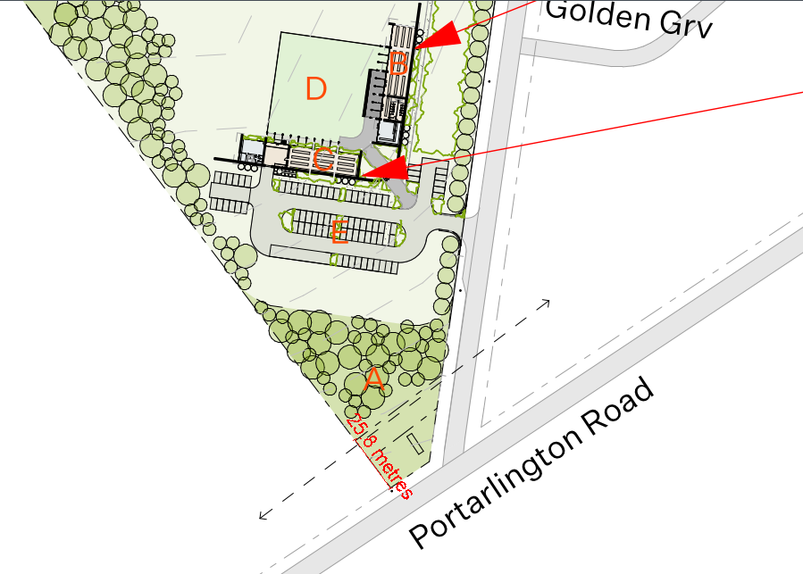
Figure 30 - Plan showing the location of the main chocolaterie building in relation to the Public Acquisition Overlay - Schedule 3. Source: Application documents.
Landscape and built form considerations

(Clause 42.03 – Significant Landscape Overlay - Schedule 14, Clause 11.01-1S Settlement, Clause 11.01-1R Settlement – Geelong G21, Clause 11.01-1L-01 Settlement – Greater Geelong, Clause 11.03-5S – Distinctive areas and landscapes, Clause 12.05-2S – Landscapes, Clause 15.01-1S – Urban design, Clause 15.01-6S – Design for rural areas)
The subject site is covered by the Significant Landscape Overlay – Schedule 14 and is identified as within a Distinctive Area and Landscape. The assessment of the proposed development has considered it in the context of the recognised significance of the locality.

The Significant Landscape Overlay – Schedule 14 identifies the site as coastal hinterland which is highly visible across Corio Bay and provides a break between the settlements of Clifton Springs and Portarlington. Schedule 14 of the overlay provides design objectives which have been considered in the assessment of this proposal.

Aspects of the proposal show consideration to the design objectives, include:
- The location of the buildings to the southeast of the site along Point Richards Road, in reasonable proximity to the residential development.
- The maximum height of the buildings being 7.6 metres, single storey and set into the land.
- The scale of the buildings are not unlike farm buildings and do not resemble an urban development/urbanisation of the land
- While taking up a minimal portion of the subject site, the buildings have separation to limit the bulk of the development in the landscape
- Use of muted tones to blend into the landscape.
- Proposed landscaping and revegetation with native vegetation to screen and soften the development
- The proposed signage is minimal and set into the proposed rammed earth walls at the access points to minimise its visual impact on the landscape
- Agricultural activities will be visible in the landscape including the proposed orchards, berry farm and animal grazing

The slope of the land coupled with the design of the buildings allows dwellings on the opposite side of the road to retain views, particularly from the first floor of two storey dwellings. While there will be an intrusion in the landscape, due to the extensive views available, reasonable view sharing will be easily achieved.

It is considered that the visual impact of the proposal is able to respect and sufficiently maintain the settlement boundary between Clifton Springs and Portarlington. The proposal does not resemble urban development or the removal of the settlement boundary. The rural characteristics of the proposal along with the low heights and spacing between buildings respect the existing landscape.

As set out by Bellarine Peninsula Localised Planning Statement, the vision for the rural areas of the Bellarine Peninsula is for the continuation of a working farmed landscape where the “right to farm” is respected and the key features of this open farmed landscape and values of the environmental assets are retained. The size of the buildings are not unlike buildings which would be commonly found on agricultural land, particularly when used for associated tourist attractions such as wineries and distilleries.

This is consistent with the approach taken in, Great Ocean Road Adventure Park Pty Ltd v Surf Coast SC [2016] VCAT 1185 (26 July 2016) where approval was sought for an adventure park. In considering landscape impacts outside of settlement boundaries it was found development can be designed and laid out in a manner ‘that will erode the clear distinction between townships that is sought through local policies’. The ability of the buildings to be absorbed into the setting with sizeable setbacks and additional landscaping.

Biodiversity and environmental impacts
(Clause 36.07-6 – Farming Zone, Decision Guidelines, Clause 12.01-1S – Protection of biodiversity, Clause 12.01-1L – Protection of biodiversity, Clause 12.01-2S – Native vegetation management, Clause 12.03-1L – River corridors, waterways, lakes and wetlands, Clause 19.03-3S - Integrated water management)

The potential impact on the biodiversity value of the site and the nearby Point Richards Flora and Fauna Reserve has been considered in the assessment of the application. The proposal was accompanied by an ecological assessment that found that the site does not have a high biodiversity value.

Removal of native vegetation
The proposal did not include a planning permit requirement for the removal of native vegetation. The ecological assessment that accompanied the application found:

The site was highly modified from agricultural use (cultivation and cropping) and was characterised by cropped vegetation, interspersed with exotic dominated vegetation. Planted trees and shrubs were present around sections of the property. No remnant native vegetation was recorded on the site.

It was further noted that there appears to be a substantial amount of exotics vegetation on the site including Chilean Needle Grass, Patterson’s Curse and African Boxthorn which have been declared as noxious weeds in Victoria.

It is considered that there will be no removal of native vegetation from the proposed use and development. Further, the proposed land management of the site will result in the reduction of exotic vegetation, including declared noxious weeds.

Growling Grass Frog

If the growling grass frog is located on the site then obligations under the Flora and Fauna Guarantee Act 1988 and the federal Environment Protection and Biodiversity Act 1999 (EPBC Act) both come in to play. These, however, are obligations the applicant needs to address regardless of the planning consideration under the planning scheme.
As discussed above, the site has little biodiversity value and is dominated by exotic vegetation which does not provide a suitable habitat for the Growling Grass Frog.
As found in the ‘Growling Grass Frog Habitat Design Standards’, DEECA, 2017:

Growling Grass Frog populations and habitats within and outside the growth corridors need to be protected and managed on a landscape level and also on a patch or population level, where frogs have the capacity to move within and between sites. The greatest opportunity to achieve this outcome is by protecting key waterways with large buffers that allow for protection and creation of additional breeding habitat with sufficient area for foraging and dispersal between sites.

As part of processing the permit application, the council requested the applicant to provide an assessment of biodiversity issues at the site. The applicant provided an ecology report that advised:

The VBA (DELWP 2022d) contains eight records for Growling Grass Frog Litoria
raniformis in the local area. Growling Grass Frog listed as vulnerable under the EPBC
Act (DAWE 2021). The farm dams and ephemeral waterway do not currently provide
suitable habitat for this species. However, there is an opportunity to create suitable
habitat for this species by rehabilitating the ephemeral waterway and undertaking
stormwater management. This would involve establishing permanent waterbodies on
the site with connectivity to areas of existing habitat in the Portarlington (Point
Richard) Flora and Fauna Reserve to the east and north of the site. The wetland design should follow the Growling Grass Frog Habitat Design Standards (DELWP 2017), which specifies the key habitat attributes for this species in urban development. (Okologie Consulting, 8 April 2022)

The provided plans show that the area surrounding the existing waterway will be vegetated with a mix native vegetation to improve the biodiversity value of the site. Furthermore, visitors to the site would be prevented from accessing the rehabilitation area to further protect the frogs from humans and spread of fungus. It is considered that there will be a net benefit to the biodiversity value of the site.

The impact of the proposal on the growling grass frog habitation in Point Richards Flora and Fauna Reserve has been considered in the assessment of the application.

The City’s Environment Unit have advised that the threats to the species that may result from the proposal include:
- Land use change
- Altered wetland regime or hydrology
- Chytrid fungus
- Nutrient enrichment
- Pesticide use
- Toxicants and sedimentation

As discussed above, the applicant has proposed fencing to prevent access to the waterway and revegetation area. Further, the application was accompanied by a Stormwater Management Assessment, which detailed the potential quantities that would result from the development and the required treatment and storage methods. Conditions have been provided by the City’s engineering and environment teams and the Corangamite Catchment Management Authority relating to stormwater management to ensure stormwater is appropriately treated.

It is noted that the Point Richards Flora and Fauna Reserve is promoted for families to walk along the several paths in the reserve. Further, there are residential dwellings that adjoin the reserve, near the growling grass frogs habitat. This suggests that control measures can be used to manage and limit impacts on the growling grass frog population.

Further, it is noted that the land in the Farming Zone can be used for agricultural use without requiring any planning approval. The use of pesticides, toxicants and sedimentation is not likely to increase as a result of the proposal. The proposal will include a storm management system that will be required to meet ‘best practice’, allowing greater control over management of the wetlands than is currently possible.

In light of the existing conditions and as-of-right use of the land for agriculture, it is not considered that the proposal, with the proposed extensive control measures, will create an increased risk to the Growling Grass Frog population. Further, it is noted that the site does not currently contain any native vegetation or suitable habitat for the growling grass frog. As part of the proposal, the waterway will be revegetated in accordance with the Growling Grass Frog Habitat Design Standards (DELWP 2017) and is considered to result in a net benefit to the biodiversity of the site.

Amenity impacts on nearby residential uses
(Clause 11.01-1S Settlement, Clause 13.05-1S – Noise management, Clause 13.07-1S – Land use compatibility)

The potential amenity impacts on nearby residential properties have been understood and considered in the assessment of this application.

Potential noise sources include vehicle movement, such as cars and buses, noise from people participating in outdoor attractions, noise associated with chocolate manufacturing, and waste removal.

The potential noise emissions are considered to be acceptable due to the operating hours, location and buffering of the outdoor attractions by buildings and landscaping. Further, conditions that relate to the operation of the proposal have been included in the officer recommendation to ensure the site is suitably managed.

It is noted that noise travels broadly in this location, and we also note that other activities that generate noise occur on farms and local properties. Examples include farm equipment and recreational motorbikes.

The proposed use of the land for the Chocolaterie will operate during the day between the hours of 10 am to 6 pm, ensuring amenity impacts on surrounding residential uses can be managed. While the proposed use of the land for group accommodation will be outside of these hours, it is considered to be able to be appropriately addressed by the onsite caretaker.

The design of the buildings assists in reducing noise impacts on residential uses. All the buildings include outdoor areas that face away from the residential uses. For example, the outdoor eating area associated with the restaurant is setback from the road a minimum of 70 metres from the closest residential property. Noise from the central courtyard will be buffered as it is enclosed by the main Chocolaterie building. The area for berry picking is a similar distance from the residential properties and will be buffered by the proposed greenhouse.

The main carpark associated with the use is located on the southern end of the site, 96 metres from the intersection with Portarlington Road. This reduces the traffic noise impacts from cars travelling along Point Richards Road and from people parking at the site and closing doors.

The proposed carparking areas will be substantially buffered by vegetation and substantially setback from residential developments. Further, most visitors to the site will be arriving between 10 am to 6 pm when noise emissions are not required to be as mitigated as at more sensitive times of the day.

The permit conditions included in the officer recommendation include requirements for operation plans that will ensure the site is appropriately managed to reduce noise impacts. These conditions will achieve an acceptable outcome and can be properly enforced if ever required.

It is considered that the daytime hours of operation, setbacks from residential uses, buffers from landscaping and building design, along with the proposed conditions, ensure that the amenity of nearby residential uses is adequately protected.

Built environment and heritage conservation
(Clause 15.01-1S – Urban design, Clause 15.01-2S – Building design, Clause 15.01-2L – Environmentally sustainable design, Clause 15.01-6S – Design for rural areas, Clause 43.01 – Heritage Overlay, Clause 15.03-1S – Heritage conservation)

The site is identified as HO49, a consequence of all but one ruinous building comprising what was known as Lincoln’s Farm. The farm was identified as having State significance in 1986 but was not included in the Victorian Heritage Register. The homestead has suffered from demolition by neglect and the only remaining building is the former dairy built in 1864 -65.

The proposed development and its relationship to the rural setting and heritage values of the site have been considered against the above heritage and design policy. It is considered that the proposed adaptive reconstruction is a reasonable solution given the extent of disrepair and lower order integrity of the building.

The City’s heritage advisor has provided comments that the proposal can be supported subject to the protection of the remaining building. It is considered that the protection and ensuring the reconstruction accurately reflects the former building can be conditioned.

Traffic impacts
(Clause 36.07-6 – Farming Zone, Decision Guidelines; Clause 18.01-1S – Land use and transport integration)

The application included a Traffic Engineering Assessment which detailed the impacts from the potential increase in traffic along Portarlington Road and Point Richards Road and the intersection between the two roads.
It is appreciated that there is significant concern about increased traffic on the road network and safety associated with the intersection of Point Richards Road and Portarlington Road. The intersection of Point Richards Road and Portarlington Road/Geelong Road was recently upgraded as part of the Panorama residential estate. Portarlington Road/Geelong Road now has 4 lanes for the length of this intersection.
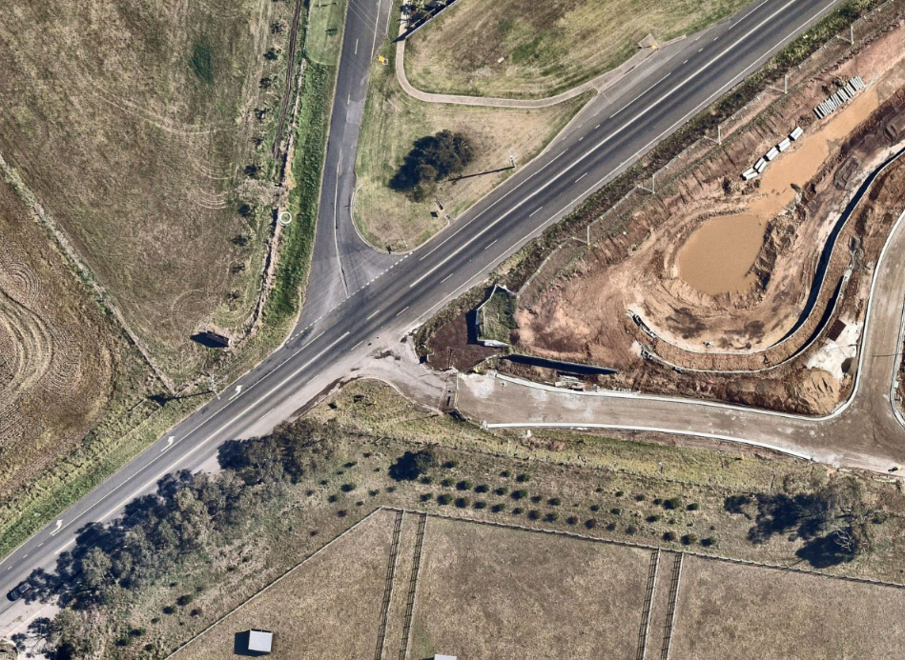
Figure 31 - Intersection of Point Richards Road with Portarlington Road/Geelong Road. Source: Nearmap.
The City’s engineering team and the Department of Transport are supportive of the proposal given the recent upgrades to the intersection.

It is not considered that impacts on residents, cyclists, and other road users because of more traffic on this public road give a sufficient basis to refuse a permit particularly in light of the Department of Transport support of the proposal.

Point Richards Road is a busy road with a range of users and the proposal will not substantially change the conditions. Further, it is considered that traffic volumes will continue to increase over time, due to population increase and other tourist ventures and businesses. The proposed development will contribute to an increase in traffic, but it is considered that the existing infrastructure can accommodate the increase.

Tourism policy
(Clause 17.04-1S – Facilitating tourism and Clause 17.04-1L-02 – Tourism in rural areas)

The above tourism policy recognises and encourages appropriate tourism opportunities in rural areas when balanced against removal of agricultural land, impacts on amenity of local residents and visual impacts on the rural landscape.

In particular, the application strongly aligns with local policy Clause 17.04-1L-02 – Tourism in rural areas.

The policy states that tourism uses, not associated with an agricultural use in rural areas are discouraged unless they meet the following requirements:

- The site is strategically located with respect to an identified tourist route, such as the tourist route identified in the Bellarine Peninsula Localised Planning Statement or along the Bellarine Highway.

The proposal is strategically located on an identified tourist route, being Portarlington Road. While the site is accessed from Point Richards Road, the access point is close to the intersection with Portarlington Road.

- The site is in a location where there is an existing cluster of non-rural activities.

The site is located in close proximity to non-rural activities, being the nearby residential area, the township, the flora and fauna reserve and the boat ramp.

- The use and development will not result in urbanisation of the locality.

The proposed use and development would not be considered the urbanisation of the locality. The design of the buildings and the proposed agricultural uses will ensure that the proposal retains a rural look. As discussed above, the development is distinctly rural and buildings are similar to what would be typically seen in the Farming Zone.

- The use and its associated development would not unreasonably visually compromise a non-urban break between settlements, a significant view or area identified as being of landscape or environmental significance.

The proposal is located on the edge of the non-urban break settlements. However, it is considered that the proposed design of the buildings, coupled with the nearby residential uses, it is considered that it will not unreasonably visually comprise the non-urban break.

- The circumstances of the use are unique and support site selection in a rural location over an urban location.

The proposed use of the Chocolaterie is required to be in a rural location due to the agricultural nature of the attraction. The proposal includes agricultural uses that form part of the proposal and tourist attraction. Including the animal grazing, orchards and berry farms. Further, the attraction of the site is the rural outlook.

Economic Development
(Clause 17.01-1S – Diversified economy, Clause 17.01-1R – Diversified economy Geelong G21, Clause 17.01-1L-01 Diversified Economy – Greater Geelong, Clause 17.02-2S – Out-of-centre development)

Local and state policies on economic development are relevant to the assessment of the application and balancing the benefits and potential adverse impacts and loss of agricultural land.
The land is within the Bellarine Peninsula which has a tourism focus and encourages appropriately place tourist development. As discussed above, it is considered that the proposal is consistent with policy relating to tourism in rural areas.

The application was accompanied by an Economic Benefit Assessment which detailed the expected economic benefits to be generated by the proposal through the construction phase and ongoing. The economic benefits to the locality are substantial with the creation of local employment opportunities, attracting visitors to the area and the promotion of the Bellarine tourism industry.
The proposed Chocolaterie and group accommodation would add to and reinforce the tourism role of the Bellarine Peninsula and would be likely to increase visitation, investment, and employment. Employment benefits would occur during construction and on an ongoing basis, including local jobs and attracting workers from the Greater Geelong region.
Bellarine Distinctive Areas Landscape (DAL)
The application has been considered against the objectives and strategies of the DAL as follows:

Objective | Response
Objective 1 - To conserve, strengthen and promote the declared area’s Aboriginal cultural heritage values and partner with the Wadawurrung to care for Country. | The activity site is not in an area with declared Aboriginal cultural heritage values.
Objective 2 - To conserve and enhance the significant biodiversity, ecological and environmental values of the declared area. | As discussed above, the subject site does not currently have a high biodiversity or ecological value.  The proposal has demonstrated that it will enhance the biodiversity and ecological value of the site by the revegetation of the waterway with native vegetation in accordance with the Growling Grass Frogs Habitat Guidelines (DELWP,2017)
Objective 3 - To protect and enhance the identified landscape character, physical features, view corridors and natural and cultural values of the declared area’s significant landscapes. | As discussed above, the potential impacts on the landscape character of the area have been considered in the assessment of the application.  The proposal is consistent with the strategies contained within Objective 3.  Strategy 3.3:  Reserve green breaks between settlements for conservation, agriculture, nature-based tourism and recreation and natural resource purposes that prioritise the protection and enhancement of the significant landscapes and landscape character settings.
Objective 4 - To achieve a zero-carbon future and support the resilience of the declared area’s distinctive attributes by taking sustained measures to reduce greenhouse gas emissions, mitigate climate change and natural hazards risks and adapt to their impacts. | The proposal has been considered against best practice energy outcomes in the forms of BESS and music assessments. The proposal has been found to satisfactorily comply with the requirements.
Objective 5 - To protect, strengthen and promote the declared area’s post-colonial historic heritage values. | The proposal has been considered in relation to heritage values of the site as a former cheese making factory.
Objective 6 - To enable a diverse, sustainable and strong regional economy (including responsible tourism, agriculture and natural resource industries) that protects and promotes the declared area’s landscape significance, environment and biodiversity, agriculture and Wadawurrung living cultural heritage and historic heritage values. | As discussed above, the proposal is considered to be beneficial to the regional economy. The proposal will protect the landscape significance through the use of low impact agricultural uses. The environmental and biodiversity of the site are proposed to be improved.  As stated in the BPDPC, ‘Water is the most valuable, dominant feature of Wadawurrung Country. The name of the Wadawurrung language group means ‘people who belong to the water’ in reference to the rivers, creeks, lagoons and other water sources within Wadawurrung Country. Waterways provided family groups with living spaces and freshwater, and water is central to stories and storylines that are part of the Wadawurrung cultural history and identity.’  The proposal’s commitment to the improvement of the waterway on site is consistent of Wadawurrung cultural history and identity.
Objective 7 - To ensure the integrated provision and protection of transport, strategic water assets, essential services and community infrastructure that meets the community’s needs while increasing resilience to climate change. | The proposal will not have an adverse impact on the protection of transport, strategic water assets and essential services or community infrastructure. The proposal will meet the community needs by providing employment and the promotion of tourism to the area.  The proposal included a ‘Sustainable Development Assessment’ and the City’s Environmentally Sustainable Design team is confident that the proposal can achieve best practice for sustainability with appropriate conditions.
Objective 8 - To plan and manage the sustainable development of settlements in the declared area consistent with the protection of the area’s landscape significance, environment and biodiversity values, Wadawurrung living cultural heritage and historic heritage values and consistent with the unique character and hierarchy designation of each settlement.  Central Bellarine Hills landscape area Covering the whole central and northern area of the Bellarine Peninsula, the Central Bellarine Hills landscape area is characterised by terrain that is gently undulating to hilly. Its high points include Mount Bellarine (also known as Murradoc Hill and which is the most dominant topographic rise in the north), Scotchman’s Hill and Marcus Hill. The landscape area forms a backdrop to many settlements and offers expansive views of the coast and beyond. The hilly landscape interfaces with the coast with prominent slopes to Lake Connewarre and a steep escarpment overlooking the Bass Strait coast at Ocean Grove. There is a discernible, steeper edge to the landscape area in the north near Portarlington and Clifton Springs as it meets the coast. Before colonisation, the area would have supported a complex woodland community: now, only pockets of remnant native vegetation remain in small clusters, including those adjacent to waterways and along roadside reserves. The balance of the land is a cleared, agricultural patchwork of paddocks and planted windbreaks, with some exotic trees around homesteads and vineyard plantings. | As discussed above, the proposal is respectful of the significance of the landscape. The proposal will allow the majority of the land to continue to be farmed and continue to contribute to the agricultural patchwork of paddocks, planted windbreaks and some exotic trees.

CLAUSE 52.06 – CAR PARKING
- To ensure that car parking is provided in accordance with the State Planning Policy Framework and the Local Planning Policy Framework.
- To ensure the provision of an appropriate number of car parking spaces having regard to the demand likely to be generated, the activities on the land and the nature of the locality.
- To support sustainable transport alternatives to the motor car.
- To promotes the efficient use of car parking spaces through the consolidation of car parking facilities.
- To ensure that car parking does not adversely affect the amenity off the locality.
- To ensure that the design and location of car parking is of a high standard, creates a safe environment for users and enables easy and efficient use.

Response

Clause 52.06 does not specify the number of car spaces required to be located on the land as some uses are not included in Clause 52.06-3 Table 1.

A total of ninety-two (92) car parking spaces and five (5) bus parking spaces will be provided on the site which are located as follows:
- 76 car parking and one (1) bus spaces within proximity of the Chocolaterie building.
- 14 car parking spaces and four (4) bus parking spaces within proximity of the group accommodation and Children’s Farm.
- 2 car parking spaces within proximity of the Dwelling (Caretaker’s House)

The application was accompanied by a traffic report that detailed the carparking demand to be generated from the proposed site. It is considered that the car parking is sufficient and meets the requirements of Clause 52.06.

CLAUSE 52.34 – BICYCLE FACILTIIES

Purpose
- To encourage cycling as a mode of transport.
- To provide secure, accessible and convenient bicycle parking spaces and associated shower and change facilities.

12 bicycle spaces are required for the proposal for all the proposed uses, including 9 for employees.

The applicant has broken down the bicycle parking spaces as follows:
- Industry: 1 space
- Retail (Chocolaterie manufacturing sales): 1 space for employees and 1 space for visitors
- Restaurant: 3 spaces for employees and 4 spaces for visitors
- Place of Assembly (Children’s Farm): 0 spaces for employees and 2 spaces for visitors

The applicant has not included a shower for the bicycle spaces as each use requires no more than 5 bicycle spaces for employees and it is therefore not required under Clause 52.34.

A total of 23 bicycle parking has been proposed which exceeds the number of bicycle spaces required by the scheme but was required to address ESD requirements.

DECISION GUIDELINES OF CLAUSE 65:

CLAUSE 65.01 – APPROVAL OF AN APPLICATION OR PLAN

Clause 65.01 of the Greater Geelong Planning Scheme outlines the decision guidelines to be considered by the Responsible Authority when making decisions on applications. These decision guidelines include:

- The matters set out in Section 60 of the Act.
- The Municipal Planning Strategy and the Planning Policy Framework.
- The purpose of the zone, overlay or other provision.
- Any matter required to be considered in the zone, overlay or other provision.
- The orderly planning of the area.
- The effect on the amenity of the area.
- The proximity of the land to any public land.
- Factors likely to cause or contribute to land degradation, salinity or reduce water quality.
- Whether the proposed development is designed to maintain or improve the quality of stormwater within and exiting the site.
- The extent and character of native vegetation and the likelihood of its destruction.
- Whether native vegetation is to be or can be protected, planted or allowed to regenerate.
- The degree of flood, erosion or fire hazard associated with the location of the
- land and the use, development or management of the land so as to minimise any such hazard.
- The adequacy of loading and unloading facilities and any associated amenity, traffic flow and road safety impacts.

Response

The proposal is considered by Council to meet the decision guidelines set out in Section 60 of the act. On balance, when considering all relevant policy and conflicting objectives the proposal as discussed above is considered to provide an appropriate outcome subject to conditions.

CONCLUSION:

That the Responsible Authority having considered all matters which the Planning and Environment Act 1987, requires it to consider decides to issue a Notice of Decision for Use and Development of Use and Development of the Land for a Chocolaterie (Industry and Manufacturing Sales) Restaurant, Group Accommodation, Place of Assembly (Childrens Farm), Caretakers Dwelling, and Business Identification Signage at 1-45 Point Richards Road, BELLARINE, generally in accordance with the plans and documentation submitted with the application subject to the conditions as listed above.

APPENDIX 1 – REFERRAL RESPONSES

Authority: | Country Fire Authority
Response: | CFA has reviewed the Planning Report prepared by Context Planning dated  1 March 2022 and has no objections to the overall proposal. However, CFA recommends the following conditions form part of any permit which may be issued:  1. Emergency Management Plan  Before the use commences, an Emergency Management Plan (EMP) must be submitted to and endorsed by the Responsible Authority. Once endorsed, the use of the facility must at all times operate in accordance with the EMP. The EMP should be developed in accordance with ‘AS 3745 Planning for emergencies in facilities’ and must clearly describe the proposed emergency management arrangements for the site. The plan should address (but is not limited to) the following matters:  • The Fire Danger Rating triggers for the closure of the facility (if applicable).  • Monitoring and notifying staff and visitors of forecast Fire Danger Rating and any consequential actions.  • Details of the location/s for emergency assembly, evacuation and shelter -in place (in the event that evacuation from the site is not practicable).  • Transport arrangements for staff and visitors  • The need for any additional arrangements for persons with special needs.  • Training of staff, visitors on emergency procedures.  • The nature and frequency of emergency procedure exercises.  • Emergency procedures (bushfire action statements) including the assignment of roles and responsibilities to staff. This must include assigning responsibility for the:  - Management and oversight of emergency procedures.  - Training of employees in emergency procedures.  - Reviewing the effectiveness of emergency procedure exercises and  implementing procedure improvements.  - Accounting for all persons during the emergency procedures.  - Monitoring and review of the Emergency Plains at least annually.  2. Water Supply  Unless with the written consent of CFA, 10,000 litres of effective water supply for firefighting purposes must be provided at the chocolaterie building, communal farm stay building and berry greenhouse building which meets the following requirements:  • Be stored in an above ground water tank constructed of concrete or metal.  • All fixed above-ground water pipes and fittings required for firefighting purposes must be made of corrosive resistant metal  • Incorporate a ball or gate valve (British Standard Pipe (BSP) 65mm) and coupling (64 mm CFA 3 thread per inch male fitting).  • The outlet/s of the water tank must be within 4m of the accessway and be  unobstructed.  • Be readily identifiable from the building or appropriate identification signage to the satisfaction of CFA must be provided.  • Any pipework and fittings must be a minimum of 65 mm (excluding the CFA coupling).  3. Emergency Vehicle Access  Internal vehicle access (including within the farm stay cabin area and to the western part of site via the main bridge) must be constructed to a standard so that they are accessible in all weather conditions and capable of accommodating a vehicle of 15 tonnes for the trafficable road width.  • Access Roads more than 60m in length from the nearest intersection must have a turning circle with a minimum radius of 8m (including roll-over kerbs if they are provided) T or Y heads of dimensions specified by the CFA may be used as alternatives.  • The average grade must be no more than 1 in 7 (14.4%) (8.1 degrees) with a maximum of no more than 1 in 5 (20%) (11.3 degrees) for no more than 50 meters. Dips must have no more than a 1 in 8 (12%) (7.1 degree) entry and exit angle.  • Curves must have a minimum inner radius of 9 metres.  • Have a minimum trafficable width of 3.5 metres and be clear of encroachments for at least 0.5 metres on each side and 4 metres above the access way.  -End Conditions-  Further Comments  CFA notes that the current plans do not show emergency vehicle access to the western part of site, to the berry greenhouse or within the group accommodation area. CFA request the above access be provided to better support emergency response activity throughout site.  Similarly, to ensure the CFA has access to water in the event of the reticulated water supply being compromised, a 10,000lt water supply that meets the above requirements is requested to be provided at the chocolaterie building, communal farm stay building and berry  greenhouse building.
Officer Comment:
Noted and conditions of permit can be applied.

Authority: | Department of Environment, Energy and Climate Change Action
Response: | ROSEHILL DAIRY FARM ARCHAEOLOGICAL SITE H7821-0142  It has come to the attention of Heritage Victoria that tree or vegetation remediation works may be taking place at the Rosehill Dairy Farm Archaeological site.  The site was listed on the Victorian Heritage Inventory in October 2022 for its potential to contain historical archaeological features, deposits and artefacts that relate to the mid nineteenth century occupation of the site by J Birkett and E Collins. The site was a successful dairy and cheesemaking facility during the 19th century.  The Heritage Inventory is a listing of all known historical archaeological sites in the state. It is necessary to obtain a Heritage Act Consent to authorise works that may affect historical archaeological remains at a place. Please be aware that archaeological remains may be affected by activities such as the removal of large stumps or by the traversing of machinery across the surface of the land.  Some information about the Heritage Inventory and the Heritage Act Consent process is attached. Please contact Laura Campbell, Archaeologist at laura.m.campbell@delwp.vic.gov.au if you have any questions or queries relating to this advice.
Officer Comment:
This advise was provided to the application

Authority: | Department of Transport and Planning
Response: | Section 52 – No objection  Thank you for forwarding planning permit application PP-219-2022 pursuant to Section 52 of the Planning and Environment Act 1987.  The Head, Transport for Victoria has considered the application and has no objection to the proposal.
Officer Comment:
Noted.

Authority: | Corangamite Catchment Management Authority
Response: | The Authority understands the application relates to a Business/Commercial Building(s) and Outbuilding(s) at 1-45 Point Richards Road Bellarine Vic 3223.  The Authority has reviewed the Preliminary Stormwater Management Plan (SWMP) supplied with the application. It is assumed that a final SWMP is intended to be developed prior to the commencement of the development. The Authority recommends taking the following comments into consideration during development of the final SWMP:  • Any modelled swales must consider the “effective length” of the swale and justify the adopted model swale length with a layout of drainage outlets to the swale  • The MUSIC model removal efficiency for gross pollutants is likely overestimated, particularly when considering the intended use of the property as a tourism facility which is likely to generate trash etc.  o Consideration could be given to the use of either a Gross Pollutant Trap or implementation of a maintenance regime to ensure the swale is de-littered frequently.  • The Authority requests that the waterway is not considered a treatment swale in accordance with Melbourne Water’s MUSIC Guidelines (2018): “Waterways within developments cannot be deemed as swales and shall not be included in the treatment train model.” (page 14)  The property is traversed by a Designated Waterway within the Corangamite CMA Waterway Management District. The Authority does not possess flood information for this waterway however it is noted that the contributing catchment to the subject property exceeds 250 hectares according to ground level information held by the Authority. It is also noted that the waterway appears to have been historically filled towards the north of the property, and that this fill appears to remain in the piles it was presumably dumped in.  Given the reasonable contributing catchment size, historical filling of the waterway, proximity of proposed development to the waterway and uncertainty of flood behavior, the Authority requests a Flood Impact Assessment (FIA) is completed prior to commencement of the development or use. The FIA should be completed in accordance with the latest  Australian Rainfall and Runoff guidelines (ARR2019) and should consider the existing and developed conditions, including any proposed works within the waterway. All proposed buildings should be placed outside of the 1% AEP flood extent.  While the Authority requires provision of the abovementioned information prior to the commencement of the development and use, it is clear that there is sufficient space on the subject property to accommodate the required infrastructure and allow for flood storage and conveyance.  Any works within the waterway will require a permit from the Authority prior to their commencement. The Authority will be unlikely to permit works which drastically alter a waterway from its natural state (for example, piping of a waterway).  In light of the above information and pursuant to Section 56 of the Planning and Environment Act 1987, the Authority does not object to the granting of a permit subject to the following conditions:  1. Prior to the commencement of the use or works, a Flood Impact Assessment must be submitted to and approved by the Responsible Authority and Floodplain Management Authority. The Flood Impact Assessment must be undertaken in accordance with the recommendations of Australian Rainfall and Runoff 2019 and must consider the existing and developed conditions of the property, demonstrating the following:  a. No adverse impacts to flood behaviour off site  b. All proposed buildings and development are outside the 1% AEP flood extent  2. Prior to the commencement of the use or works, a Stormwater Management Plan must be submitted to and approved by the Responsible Authority.  Note: Any proposed works in the waterway will require a Works on Waterways Permit from the Waterway Management Authority in accordance with the Water Act 1989.
Officer Comment: Conditions of permit can be included as provided.
Recommended conditions have been included in the officer recommendation.

INTERNAL

Department: | Engineering Services
Response: | The application was supported and standard conditions were suggested:  Drainage:  The site must be drained to the satisfaction of the Responsible Authority and no concentrated storm water may drain or discharge from the land to adjoining properties.  Car Parking  Prior to the commencement of works/commencement of use, the developer must construct the car park/s including accessways, surface with an all-weather sealed coat and linemark the car and accessways in accordance with the endorsed plans to the satisfaction of the Responsible Authority.  Detailed Design Plans  Prior to the commencement of works/commencement of use, detailed Engineer designed roadworks and drainage construction plans for the works within Point Richards Rd must be submitted to and approved by the Responsible Authority. The plans are to be in accordance with the design standards of the City of Greater Geelong and the Infrastructure Design Manual (IDM), to the satisfaction of the Responsible Authority.  Construction of Roadworks / Drainage  Unless otherwise approved in writing by the Responsible Authority, prior to the commencement of works/commencement Point Richards road and drainage must be constructed in accordance with the Endorsed plans and specifications to the satisfaction of the Responsible Authority.  Environmental Construction Management Plan (ECMP)  Unless otherwise approved in writing by the Responsible Authority, prior to the commencement of works for the construction of Point Richards Road shall be submitted to and Endorsed by the Responsible Authority. When Endorsed, all conditions on the ECMP will form part of the permit. The plan must address, but not be limited to, the following:  - Hours of works, demolition or construction;  - Methods to contain dirt and mud within the site, and the method and frequency of clean up procedures;  - On site facilities for vehicle washing;  - Methods used with regards to Dust suppression which may include but not limited to the following:  - Water truck to be retained on site at all times;  - Soil stockpiles to be retained on site must be seeded or provide a treatment to provide a crusted surface;  - Cease all works on site during high wind incidences;  - Vehicle/truck movements to be limited to a reduced speed to prevent dust emissions;  - Dust suppression measures including fencing in locations to existing dwelling;  - The protection measures for site features to be retained (e.g. vegetation, retaining walls, buildings, other structures and pathways, etc.);  - Delivery and unloading points and expected frequency;  - A liaison personnel for contact by residents and the Responsible Authority in the event of relevant queries or problems experienced;  - The movement of construction vehicles to and from the site must be regulated to ensure that no traffic hazards are created in and around the site;  - Parking facilities for construction workers;  - Measures to minimise the impact of construction vehicles arriving at / departing from the land;  - An outline of requests to occupy public footpaths or roads, and anticipated disruptions to local services;  - The processes to be adopted for the separation, re-use and recycling of demolition materials;  - The measures for prevention of the unintended movement of building waste and hazardous materials and other pollutants on or off the site, whether by air, water or other means;  - Any other measures that are consistent with the following Environmental Protection Authority publications: ‘Environmental Management Guidelines for Major Construction Sites’, ‘Construction Techniques for Sediment and Pollution Control’ and ‘Doing it Right on Subdivisions’;  - Handling, tracking and testing of all imported fill;  - Measures to be taken to ensure that no polluted water and/or sediment laden runoff is to be discharged directly or indirectly into stormwater drains or watercourses during the construction period; and;  - Methodology detailing how service vehicles (ie; Council Garbage Trucks) will be catered for during all stages of construction, including the removal of temporary turn around areas; and;  - Any other condition as required by the Responsible Authority that addresses any other issues i.e. location of earth mound / soil stockpiles, rumble grids, construction of and materials used for all whether access roads up to 30 meters on entry and exit to the site entry.  Once the Environmental Construction Management Plan (ECMP) has been endorsed by the Responsible Authority under this permit it must be implemented and complied with at all times to the satisfaction of the Responsible Authority unless with the further written approval of the Responsible Authority.  Stormwater Quality / Management  The site stormwater system must be designed and installed such that;  - The site stormwater discharge is not increased by the proposed development. An appropriate on site detention system designed in accordance with the submitted Stormwater Management Plan;  - Runoff is to be treated to achieve current best practice pollutant removal targets by connection to an appropriate Water Treatment Facility, with capacity to treat at least a 3 month ARI storm event, unless approved otherwise by the Responsible Authority. The Water Treatment Facility must be maintained to the satisfaction of the Responsible Authority.  CAD Drawings  Unless otherwise approved in writing by the Responsible Authority, CAD (MGA Zone 55) versions of any Endorsed plans for the works in Point Richards Road must be submitted to the Responsible Authority prior to the commencement of works. The provided 3D CAD model must satisfy the requirements of Council’s Assets Unit.  Non-Standard Conditions  NOTE  A pre-commencement meeting with Council’s engineering department is required to be undertaken prior to works starting within the road reserve. To organise this meeting please contact 5272 4426
Officer Comment:
Generally the suggested conditions have been included in the permit.

Department: | ESD Response
Response: | - Before the use and development commences, amended plans to the satisfaction of the Responsible Authority must be submitted to and approved by the Responsible Authority. When approved, the plans will be endorsed and will then form part of the permit. The plans must be drawn to scale with dimensions. The plans must be generally in accordance with the plans received but modified to show:  - Initiatives contained within the Sustainable Design Assessment along with the proposed changes, including:  - A minimum 30kW roof or ground mounted solar photovoltaic system  - At least 1 dedicated electric vehicle parking complete with charger and signage  - Prior to the endorsement of plans, a Sustainability Management Plan (SMP) must be submitted to and approved to the satisfaction by the Responsible Authority. The Sustainability Management Plan must demonstrate a best practice standard of environmentally sustainable design and be generally in accordance with the report by Context Planning dated 25 February 2022 and received by Council on 03/03/2022, but modified to include the following changes:  - BESS setup so that the farm stay cabins are included in the nominated buildings  - 4-star WELS rated toilets selected in the BESS water category  - 30kW solar photovoltaic system specified  - A preliminary Section J façade assessment demonstration compliance with the minimum thermal performance requirements  - Evidence supporting the natural ventilation of buildings as claimed in BESS, being crossflow path and operable windows shown on plans  - Only one mechanical ventilation strategy selected in BESS for each HVAC zone  Where alternative ESD initiatives are proposed to those specified in conditions above, the Responsible Authority may vary the requirements of this condition at its discretion, subject to the development achieving equivalent (or greater) ESD outcomes in association with the development.  - All works must be undertaken in accordance with the endorsed Sustainability Management Plan and stormwater management plan to the satisfaction of the Responsible Authority. No alterations to these plans may occur without the written consent of the Responsible Authority.
Officer Comment:
Generally the above recommended conditions have been included in the officer recommendation.

Department: | Environment
Response: | Environment’s primary interest in the proposed development remains ensuring that the significant population of Growling Grass Frog (Litoria raniformis) downstream at the Point Richards Flora and Fauna Reserves (approx... 300m north east) suffers no detrimental impact from either the construction or ongoing use of the proposal.  The information provided to date does not allow the City to assess this potential impact or determine if the proposal is suitable considering the GGF. The species is listed under both the FFG and EPBC act and key threats to the species that may result from the proposal include –  1. Land use change  2. Altered wetland regime or hydrology  3. Chytrid fungus  4. Nutrient enrichment  5. Pesticide use  6. Toxicants and sedimentation  Further information regarding the species and threatening processes is available here.  Recommended Permit Conditions (Without Prejudice)-  Notification of permit conditions  Prior to works commencing, the permit holder must advise all persons undertaking the vegetation removal or works on site of all relevant permit conditions and endorsed plans/documents.  No grazing within the areas defined in the RIPARIAN ZONE is permitted (unless permitted by a Management Plan approved by the Responsible Authority) to the satisfaction of the Responsible Authority.  Water run-off must be designed to ensure that native vegetation to be protected is not compromised, to the satisfaction of the Responsible Authority.  Fauna Protection  Prior to the commencement of any tree removal or other potential fauna habitat, the permit holder must appoint an ecologist to conduct a pre-clearing survey to assess the presence of fauna. Where fauna is likely to be present in trees or vegetation proposed for removal, a suitably qualified wildlife handler must be present to ensure that native fauna is managed in accordance with DECCA guidance and all necessary authorisations must be obtained prior to removing native fauna. Dams filled as part of the approved development must be drained at least 48 hours prior to works commencing to enable the relocation or translocation of fauna.  A brief letter style report must be submitted to the Responsible Authority to satisfy the condition. The report must include a description of the survey, any fauna found, and steps taken to protect fauna during the works. Any instances of harm or death to fauna need to be reported.  Construction Environmental Management Plan  Prior to works commencing a Construction Environmental Management Plan (CEMP) must be submitted to and approved by the Responsible Authority. When approved this Construction Environmental Management Plan will form part of this permit. This plan must incorporate, but is not limited to, the following information:  The control of site emissions during construction and the defects liability period to the satisfaction of the Responsible Authority.  The measures to be taken to ensure that no polluted water and/or sediment laden runoff is to be discharged directly or indirectly into stormwater drains or watercourses during the construction period.  The CMP must be prepared in accordance with the EPA – Civil Construction, building and demolition guide Publication 1834.1, August 2023.  Measures to protect native vegetation and/or trees to be retained;  Weed control measures including the identification of infestations and the proposed treatment measures for any species identified;  Plant and vehicle hygiene measures;  Intended access for construction vehicles;  Dust suppression measures;  Stockpile locations and laydown areas;  Parking locations for machinery and construction personnel.  All development and works must be carried out in accordance with the approved Construction Management Plan, to the satisfaction of the Responsible Authority. Any non-compliance identified by the Responsible Authority must be rectified immediately and at no cost to Council.  Land and Waterway Rehabilitation Plan  Prior to works commencing a Land and Waterway Rehabilitation Plan must be submitted to and approved by the Responsible Authority. When approved the Plan will be endorsed and form a part of the permit. The plan must include:  An area within the project footprint along and adjacent the waterway corridor to be rehabilitated as a habitat corridor allowing for design in accordance with the Growling Grass Frog Habitat Design Guidelines.  All revegetation sourced from local provenance stock;  Density of planting per square metre.  Installation of potential habitat in accordance with the Growling Grass Frog Habitat Design Guidelines  Soil preparation and weed control.  The timing of the revegetation  The ultimate1% and 10% Annual Exceedance Probability storm event extents  A detailed planting schedule and proposed planting layout of all areas, including proposed trees, shrubs, groundcovers and aquatic planting (if applicable, with zonation detail), and showing botanical names, common names, pot sizes, sizes at maturity, quantities and densities of each plant  The proposed layout, materials and finish of all finished surfaces, structures, fences or other measures to exclude the public, maintenance vehicle access crossovers, maintenance access gates, furniture and paths.  Detailed drawing(s) of the interface with any adjoining properties  Detailed planting and construction drawings including site contours and any proposed changes to existing levels including any structural elements such as retaining walls or bridges.  Measures to protect downstream wetland environs during works.  Maintenance schedule.  Species selection must not include species listed on the City of Greater Geelong Environmental Weeds list which can be found here  https://www.geelongaustralia.com.au/weeds/documents/item/8d164ca100efeda.aspx  Unless otherwise agreed in writing, the plan must be fully implemented within 12 months of works completing to the satisfaction of the Responsible Authority. A practical completion inspection is required and must be arranged by the permit holder with a minimum of two weeks’ notice provided for the Responsible Authority. The completion of works must be to a standard to the satisfaction of the Responsible Authority to pass this inspection.  ENVIRONMENTAL AUDIT  Prior to the commencement of any works a preliminary Environmental Assessment must be submitted to the Responsible Authority. It must include an assessment of the land by a suitably qualified environmental professional detailing the level and location of any contamination. This assessment is to be peer reviewed by a suitably qualified environmental professional approved by Council. If the Responsible Authority is satisfied that significant levels of contamination have been found the following must be provided to the Responsible Authority, either:  A Certificate of Environmental Audit must be issued for the land in accordance with Part 1XD of the Environment Protection Act 1970, or  A Statement of Environmental Audit must be issued in accordance with Part 1XD of the Environment Protection Act 1970 stating that the environmental condition of the land is suitable for the sensitive use (with or without conditions on the use of the site).  Should an Environmental Audit not be required any recommendations of the preliminary assessment, if applicable must be undertaken to the satisfaction of the responsible authority.  The Preliminary Assessment should also consider contaminants that may impact the downstream population of Growling Grass Frog Litoria raniformis.
  https://www.environment.vic.gov.au/__data/assets/pdf_file/0032/679154/Growling_Grass_Frog_Litoria_raniformis.pdf
  https://www.dcceew.gov.au/sites/default/files/documents/litoria-raniformis.pdf
  The City has a duty under the revised FFG Act to consider potential biodiversity impacts in decision making. The information provided in support of the application to date does not allow the City to fulfill our obligations under this duty. The duty is available at the following link –
  https://www.environment.vic.gov.au/__data/assets/pdf_file/0031/466681/Public-Authority-Duty-factsheet.pdf
  Despite the uncertainty regarding risk to biodiversity downstream, the proposal also presents an opportunity to reinstate additional habitat for the GGF through an appropriately designed waterway corridor throughout the subject land. If achieved this has the potential to be a net positive outcome for the downstream population, provided that the key threats to the species are mitigated ongoing.
  Recommended conditions attempting to address risk and require environmental improvements on the land are provided below. Please feel free to condense the CEMP requirements already recommended by the Engineering team where they may double up with the recommended condition below.
Officer Comment:
Noted.

Department: | Environmental Health
Response: | Recommended Permit Conditions (Without Prejudice)  Standard Conditions:  Audible Music or Announcements  No amplified music, including live amplified music, must be played or piped to external areas without the further written consent of the Responsible Authority.  Restrictions on operating time  The premises must only operate during the following times:  - Monday to Sunday − 10am to 6pm  Waste Collection  If waste collections are to occur with two or more collections per week, they must only occur during these times:  - 7 am – 8 pm Monday to Saturday  - 9 am – 8 pm Sunday and public holidays  Delivery Restrictions  All deliveries to the property and truck movements offsite must be in adherence with the EPA Noise Control Guidelines (publication 1245.2) which are:  - 7am – 10pm Monday to Saturday  - 9am – 10pm Sundays and public holidays.  Truck mounted refrigeration units  Non-residential premises (e.g., noise from a delivery truck, whether moving or parked on the street)  - 10 pm – 7 am Monday to Saturday  - 10 pm – 9 am Sundays and public holidays  Security Alarms  All security alarms or similar devices installed on the land must be of a silent type in accordance with any current standard published by Standards Australia International Limited and be connected to a monitored security service.  Plant and Equipment Insulation  All external plant and equipment must be acoustically treated or placed in soundproof housing to reduce noise to a level satisfactory to the Responsible Authority.  Dust Emissions  Dust control measures to prevent emissions that may cause nuisance to adjoining properties must be implemented to the satisfaction of the Responsible Authority. Such as but not limited to:  - Identifying potential sources of dust and airborne particulates and processes which may generate dust and airborne particulates; and implementing dust and airborne suppression measures, including (but not limited to) covering materials and/or applying a light water spray, applying sprays before or during turning, but also avoiding excessive water- logging of organic materials and runoff;  - cessation of some activities during windy days  Light Emissions  Outdoor lighting must be designed, baffled and located to the satisfaction of the Responsible Authority to prevent any adverse effect on adjoining properties.  General Amenity  The amenity of the area must not be detrimentally affected by the use or development through the:  - Transport of materials, goods or commodities to or from the land;  - Appearance of any building, works or materials;  - Emission of noise, artificial light, vibration, odour, fumes, smoke, vapour, steam, soot, ash, dust, waste water, waste products, grit or oil;  - Presence of vermin;  to the satisfaction of the Responsible Authority.  Garbage Storage  Provision must be made on the land for the storage and collection of garbage and other solid waste. This area must be graded, drained and screened from public view to the satisfaction of the Responsible Authority.  The storage, removal and disposal of such/garbage refuse must be undertaken in such a manner so as to avoid any nuisance, pollution or loss amenity to the surrounding area and must at all times be to the satisfaction of the Responsible Authority.  Connection to sewer  Any development on the proposed new allotment/s must be connected to reticulated sewerage, if available.  Animal developments  Nuisance  The stables, yards and pens must be kept clean at all times and must not cause nuisance to any person on any adjoining properties by way of offensive odour, to the satisfaction of the Responsible Authority.  Odour  Pest control measures must be put in place to minimise pest issues.  Waste  All solid waste stored on site must be regularly disposed of so as not to cause nuisance to any persons on adjoining properties to the satisfaction of the Responsible Authority.  Notes: Environmental Health has considered the information submitted with the application for a planning permit at the abovementioned property. Environmental Health has no objection to the granting of a planning permit providing the following notes are included within:  Food Registration  The proprietor of the proposed food business will be required to apply to the City of Greater Geelong Council’s, Environmental Health Unit for registration of a food premises under the Food Act 1984. Recommend that contact is made prior to internal fit-out to be able to assist with compliance.  Accommodation Registration  The proprietor of the proposed accommodation business will be required to apply to the City of Greater Geelong Council’s, Environmental Health Unit for registration of a prescribed accommodation premises under the Public Health and Wellbeing Act 2008. Recommend that contact is made prior to internal fit-out to be able to assist with compliance.  Noise  Ensure compliance with any Commercial Noise regulations, Councils Local Laws and obtain permits where and when required  Construction noise for residential and commercial construction  Noise during construction is to be managed and not emit unreasonable noise at any time of the day under the Environment Protection Act 2017
Officer Comment:
Noted, generally the provided conditions were included in the recommendation.
The following conditions were not included in the officer recommendation:

Nuisance
The stables, yards and pens must be kept clean at all times and must not cause nuisance to any person on any adjoining properties by way of offensive odour, to the satisfaction of the Responsible Authority.
Odour
Pest control measures must be put in place to minimise pest issues.
The use of land for agriculture does not require planning approval and therefore it would not be appropriate to condition the use. Further pest control measures had already been addressed in the General Amenity condition.

Department: | Tourism
Response: | This is a significant tourism development within the region and one that provide large scale benefit to the region’s visitor economy. It is the opinion of the Tourism Unit for the CoGG that this development also compliments the overarching Tourism Development Plan for the region which specifically identifies the need for the experiential accommodation within the Northern Bellarine and compliments regions strong food and beverage offerings.  Other Comments from Tourism  This development is aligned to our vision for the region to be a world-class inclusive destination that inspires visitors to create memories and depart with a desire to return and builds on our strategic pillar of sustainable destination development.  Reference documents:  - Tourism Development Plan 2019-22 https://www.tourismgeelongbellarine.com.au/resources/tourism-development-plan/  - Tourism Greater Geelong and The Bellarine Corportae Plan 2021-25 https://www.tourismgeelongbellarine.com.au/resources/strategic-plan/
Officer Comment:
Noted.

Department: | Heritage
Response: | First referral response  Background  The site is identified as HO49, a consequence of all but one ruinous building comprising what was known as Lincoln’s Farm. The farm was identified as having State significance in 1986 but was not included in the Victorian Heritage Register. Dating from the 1850s, the homestead suffered from demolition by neglect and only one building survived an Emergency Building Order a few years ago. I am surprised that there is no roof on this surviving building (according to NearMap).  The surviving building is the former dairy built in 1864-65. The following is an extract from About Corayo: A Thematic History of Greater Geelong (to be published 2021) [now published by the City of Greater Geelong, 2021):  ‘Rosedale’/’Lincoln’s Farm’, Portarlington  One of the more notable was ‘Rosedale’, 1-65 Point Richards Road, Portarlington, acquired by Edwin Collins in 1862 from Joseph Birkett, the first Crown purchaser in 1849 who had established ‘one of, it not the best and most productive farms in the whole of the Bellarine district’ as well as a dwelling house ‘and all necessary outbuildings.’[i] In 1864-65, Collins had extended the double-gabled four-roomed dwelling with the construction of a zinc-roofed dairy that consisted of a submerged white-washed stone cool room with a gabled loft above.[ii] There, he commenced the manufacture of cheese, winning second prize for his ‘Five Cwt Cheese’ in the Autumn Exhibition of the Port Phillip Farmer’s Society in 1865.[iii] In 1866, Collins won first prize by the Board of Agriculture for his salted butter that had successfully made the return voyage to England.[iv] In 1872, the Geelong Advertiser gave a detailed account of Collins’ enterprise:  Alterations and additions to his previously large dairy establishment, have been made during the past few months, by Mr Collins, Bellarine, whose Cheddar cheeses are so sought after in this and the Melbourne markets, that he is able to command his own price, and although he anticipates making ten tons this season, he has already received orders for nearly every pound of it. Mr Collins' success shows what may be done by careful dairy farming. A very few years ago, colonial cheese, like colonial ales, and wines, was not appreciated, and Mr Collins had some difficulty in making his article well-known, and to be known, knew would cause it to be appreciated. In those days our colonial cheesemakers ' either did not know how to make cheese, or they had not the pasturage adapted for the business, and it was not until Mr Cooper of Turkeith, Mr Coulson of Ondit, and Mr Collins of Bellarine, the two former with Stilton and Mr Collins with Cheddar cheese began to send their goods to market that the use of the imported article commenced to decrease in favor and give way to the produce of our own makers. Whatever others may have done since, there is not much doubt about it that the pioneers of good cheese-making in this district were the three persons mentioned, and their doings are always therefore watched with interest. The season for cheesemaking has just opened, and that, owing to the cold wet weather, very unfavorably as from cows fed on cold wet grass the milk could not possibly be so rich as would otherwise be the case. Still Mr Collins looks forward to a very successful season, he having made a large quantity of English grass hay on which the cows taken from the pasturage thrive amazingly. His place, as already reported, has been sown with English grass, and that portion reserved for the grazing of his cattle is about 200 acres in extent. From the cows so fed he anticipates, this season, making at least £1000 worth of cheese, or at the rate of £5 to the acre.[v]  In 1875, the Illustrated Sydney News and News South Wales Agriculturalist and Grazier described Collins’ ‘Rose Hill’ Farm:  On the 335 acres 1200 head of cattle, young and old, are kept, and the luxuriance of the pasture shows that the farm is not overstocked. The dairy cows in milk at one time run from about 25 to 50 head, the usual number being about 40. The subdivision of the farm, by permitting the fields, time about, to be rested and seeded, contributes along with the system of fertilising adopted, to keep the large quantity of stock always in abundance of pasture.  In a large yard opening from the milking shed hundreds of loads of seashells are carted from the beach throughout the year, and deposited and spread. This serves the two fold purpose of keeping the yard clean, and by absorbing all the liquid and solid manurial matter from the heard adds to the value of the seashell, which, of itself, is found to be a most valuable fertiliser for the class of soil of which the farm consists, viz., strong black loam. From the yard the fields are systematically top-dressed with this compost, beginning with one paddock and going round till all have received a turn, the more clayey patches receiving the thickest coat. The influence of this fertiliser is most marked in its effects on the thickness of the pasture, and that the grass is also sweetened is shown by the fondness of the cows for the top-dressed portion of an unfinished field. Mr. Collins’s out-buildings, including milking-house, cheese-house, and milking sheds are notable for their handiness and cleanliness, but cowsheds for winter stabling are not used … The cows are fed in the winter with oaten hay, and in the summer with green maize, liberal supplies of which are raised on the farm and always kept on hand.[vi]  Collins sold the farm in 1876 and it was later named ‘Lincoln’s Farm’ after William Lincoln, owner in the later 19th century.[vii]  Comments on the Proposal  The proposed farm and Chocolaterie at Lincoln’s Farm is considered to be a contemporary version of the 19th century farming and butter-making. The use therefore should have no adverse effect on the surviving dairy building.  However, the proposed use and success of any application in relation to the existing HO is dependent on the conservation of the dairy building. The masterplan indicates that it is to be reused. This is supported but further detail is required in relation to how this will be achieved. Some photos of the dairy I took in 2007 can be supplied. Repairing existing fabric and reconstructing missing fabric as part of the new use would provide an ideal heritage outcome. This would require specialist expertise to provide a Schedule of Conservation Works.  The proposed revegetation of the site, including the revegetation of the natural water course, has the possibly for interpreting (in part) the landscape prior to European colonisation. Historical evidence exists in early maps which give some clues to early vegetation. Attached is one example, dated 1840. The site at 1-45 Pt Richards Road is shown under the name of Joseph Birkett (as per history earlier given – the first purchasers of Crown land were later added to the plan). While beyond any assessment under the heritage overlay, discussion with the Wadawurrung Traditional Owners Aboriginal Corporation might give some insights into Traditional names of this part of Country that may provide further interpretive opportunities.  2.0 Assessment of this Application  2.1 Background  The basis to HO49 is the heritage citation by Allan Willingham in the Geelong Region Historic Buildings and Objects Study (1986) which reads:  This complex of weatherboard buildings comprises stables, outbuildings, house and cheese factory in an unaltered condition. The house has been added to several times and the whole complex is extraordinary in its intactness, maintaining all the different stages of development. The house has a hipped roof section and an earlier double gabled section with simple decorated barge boards. It is remarkable as an early complex of weatherboard buildings of the 1850s.  The former Lincoln’s Farm was in a deteriorated state at the time of the heritage assessment by Allan Willingham in 1986. This is specifically noted in the heritage citation. Due to demolition by neglect, all except the walls, mezzanine floor and basement floor of the former dairy building survive, the ruinous fabric of the complex having been demolished in 2020 following a Building Order. Photographs of the homestead complex give an appreciation of its appearance that has now been lost:  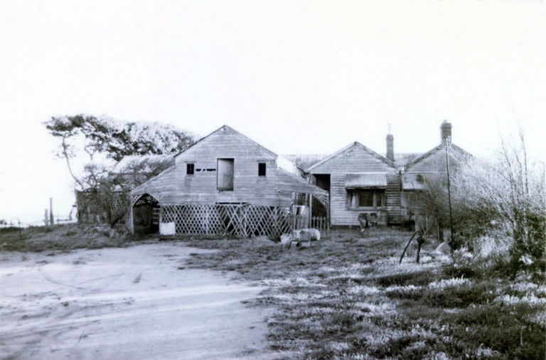  Lincoln’s Farm, south elevation, showing dairy facilities (left) and dwelling (right), 1991.  The surviving dairy building walls and floor is shown on the far left in the background.  Source: Glenn Underwood, ‘Rosedale Dairy Farm: A Conservation Study’, School of Architecture  & Building, Deakin University, 1991.  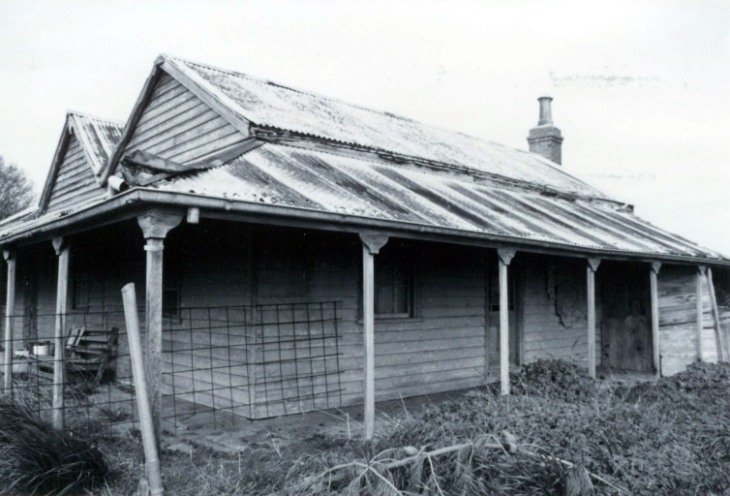  Lincoln’s Farm, north-east corner of former dwelling, 1991. Source: Underwood.  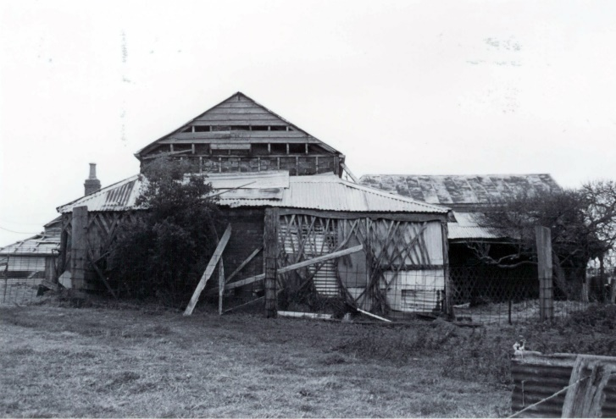  West end of dairy complex (now removed), 991. Source: Underwood.  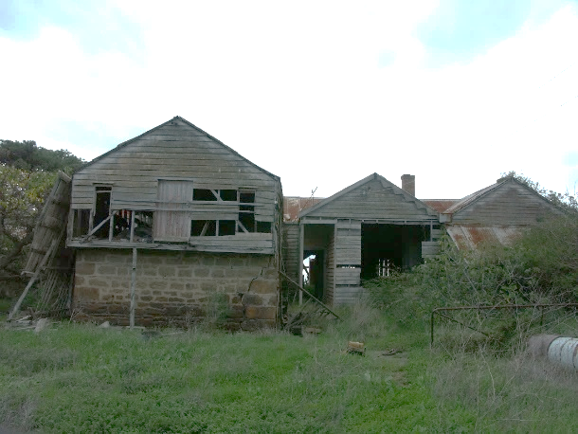  Former Dairy building (left), south elevation, 2007. Source: David Rowe.  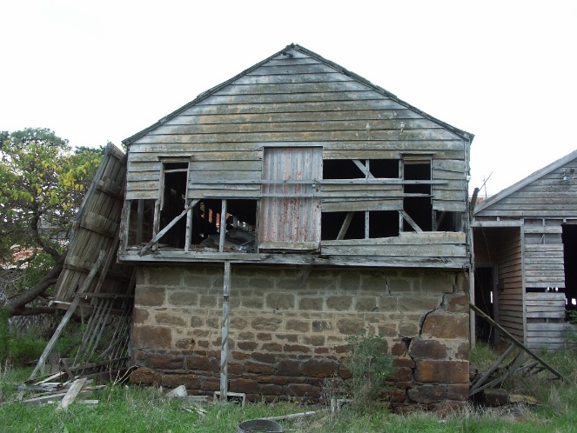  Former Dairy Building, south elevation, 2007. Source: David Rowe.  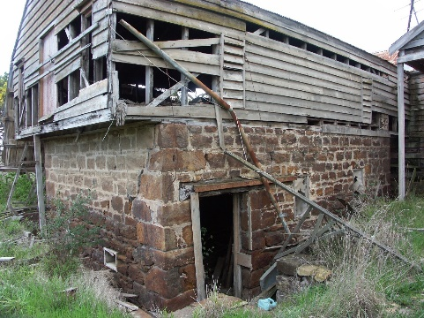  Former Dairy Outbuilding, east and south elevations, 2007. Source: David Rowe.  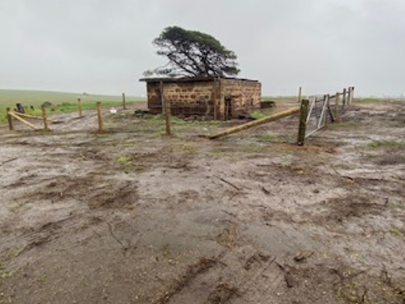  Former Dairy Outbuilding following the removal of the roof and other historic adjoining fabric,  2020. Source: Michael Burge, City of Greater Geelong.  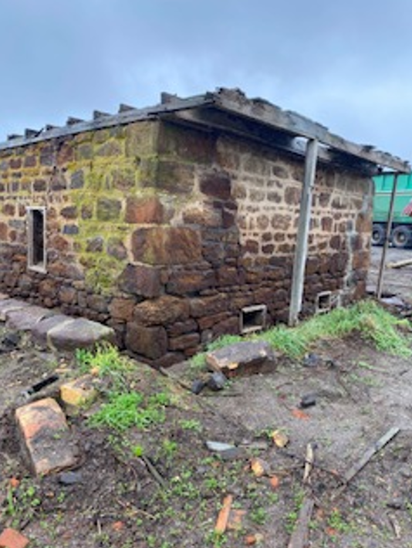  Former Dairy Outbuilding, west and south elevations,  2020, following removal of the roof.  Source: Michael Burge, City of Greater Geelong.  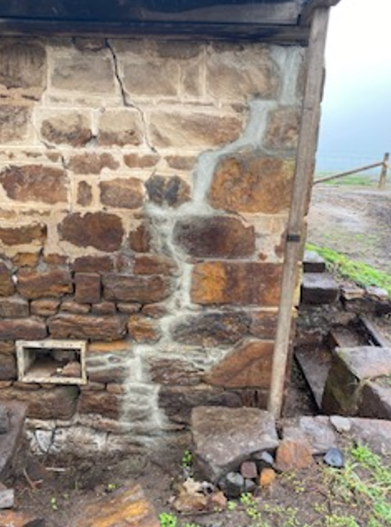  Former Dairy Outbuilding, wall detail, showing steps to the entry, 2020.  Source: Michael Burge, City of Greater Geelong.  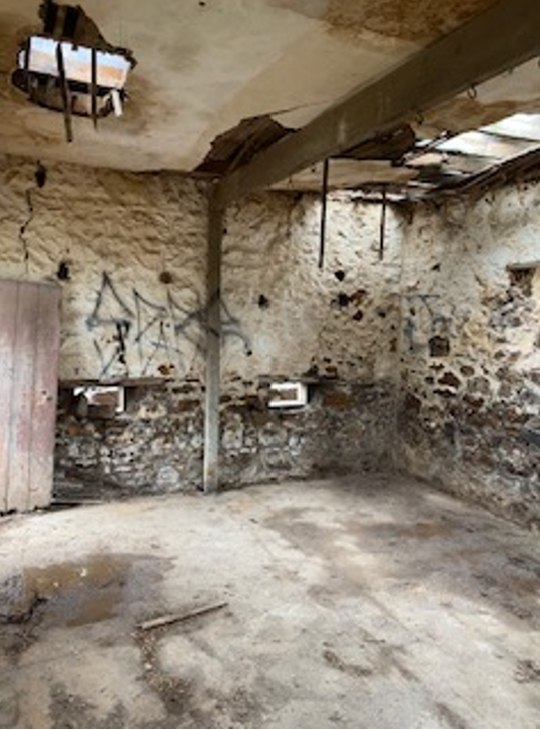  Former Dairy Outbuilding, interior, 2020.  Source: Michael Burge, City of Greater Geelong.  An appreciation of the location, form and integration of the former dairy outbuilding, and its present isolated and ruinous state, is given in aerial imagery:  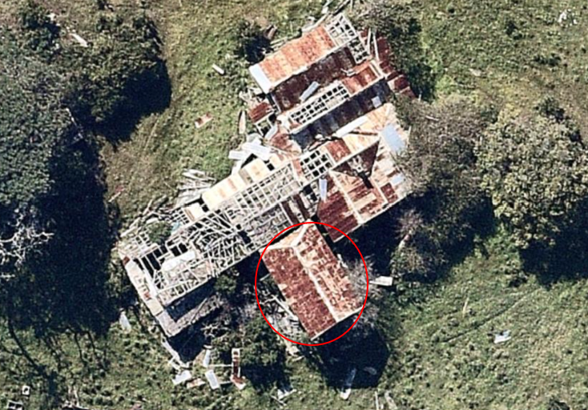  Aerial image, 9 September 2018. The surviving wing of the dairy outbuilding, showing the ‘front’ hipped roof face is circled. Source: NearMap.  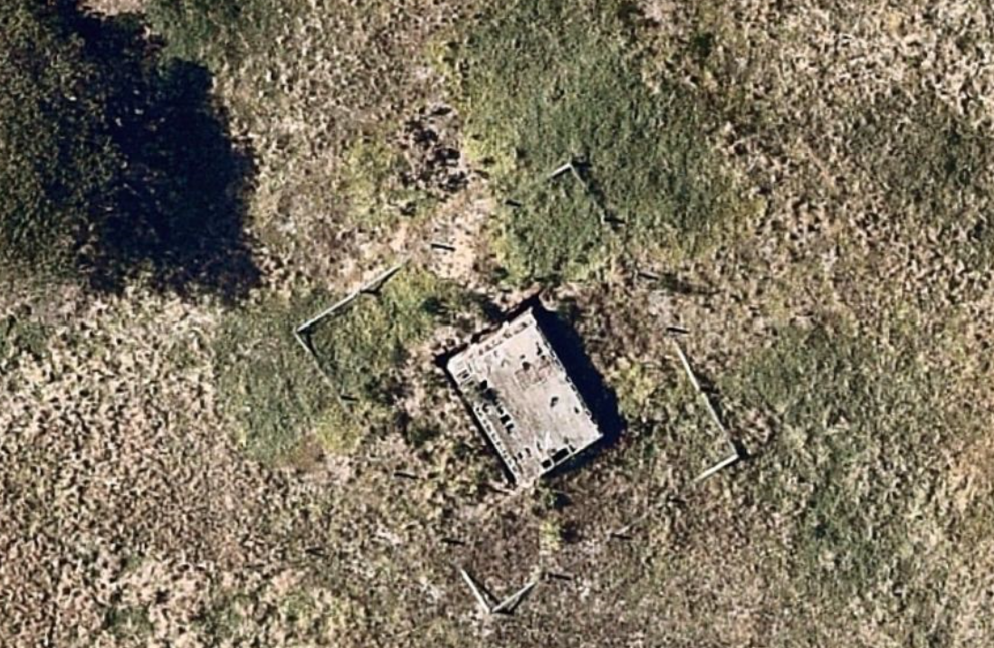  Aerial image, 20 January 2022 showing remnant former dairy outbuilding. Source: NearMap.  2.2 Proposed Demolition of Interwar Era Dairy Outbuilding  Situated south of the remnant 1860s dairy outbuilding, the interwar era dairy outbuilding is proposed to be demolished. According to the study by Glenn Underwood, this interwar era outbuilding was constructed in c.1928. Some of the existing fabric (including walls) suggests that the outbuilding has experienced alterations. While this outbuilding is a legacy of farming developments on the site, it is outside the mid-19th century era of construction that comprises the significant fabric on the site (and also now lost to the site), as inferred in the Willingham heritage citation. Given this, no adverse effect should result from the demolition of the interwar era outbuilding.  2.3 Proposed Adaptation of the Dairy Outbuilding  The proposal is to raise the existing stone walls (in bluestone) and construct a gabled roof of timber construction to be clad in dark grey Colorbond. The profile shown on TP15 is not corrugated profile. Some windows are to be altered and the door opening also enlarged with the existing narrow openings retained. Aluminium framed and glazed infill is proposed in the ‘front’ elevation with timber window framing elsewhere. Aluminium framed and glazed doors also appear to be proposed.  In assessing this application influential has been the loss of much of the significant fabric, as well as the purpose of the heritage overlay at Clause 43.01 which is:  - To implement the Municipal Planning Strategy and the Planning Policy Framework.  - To conserve and enhance heritage places of natural or cultural significance.  - To conserve and enhance those elements which contribute to the significance of heritage places.  - To ensure that development does not adversely affect the significance of heritage places.  - To conserve specified heritage places by allowing a use that would otherwise be prohibited if this will demonstrably assist with the conservation of the significance of the heritage place  It is recognised that much of the Lincoln’s Farm complex has been lost due to neglect and demolition following a Building Order. This has substantially undermined the significance and integrity of this heritage place, to a point where there is only a remnant of surviving mid 19th century fabric. The now isolated state and loss of the roof of the dairy outbuilding currently undermines an appreciation of its original function and significance.  It is also recognised that this proposal is to adapt some of the surviving fabric into animal stables as part of a children’s farm. It is to comprise one of five identical gabled stables buildings. While the roof has been removed and the surviving fabric appears to be in poor condition, there are opportunities to interpret the original appearance of the outbuilding more fully.This includes the provision of weatherboard wall cladding above the existing stone walls and the construction of a ‘front’ hipped roof face. While an accurate reconstruction would be most ideal, this is not essential in enabling an appreciation of the original function and design if a contemporary interpretation comes closer to reflecting the original, intended appearance.  The surviving structure is partially submerged into the ground, accessed by bluestone steps. This is not reflected in the submitted drawings (either showing the removal of the existing retaining walls and steps, and the existing ground levels around the building). While the adaptation might require the door access to be at ground level, opportunities should be explored in retaining the raised ground level at the sides and rear.  As outlined in the pre-application advice, a Schedule of Conservation Works outlining the method of repair of the retained fabric is suggested. The walls appear to have suffered some lateral movement, deterioration in the mortar (due to rising and falling damp) and other damaging weathering effects. Measures for conserving the walls, both structurally and in repairs (including mortar to match existing original in strength (composition/mix), texture and colour) should form part of the application. Removal of any cement-rich mortar is advised. As internal alteration controls apply, a broad outline of any proposed interior restoration and change is advised.  The above advice will therefore ensure that the existing remnant outbuilding will also be distinguished in the design and construction of the proposed adjoining stables. This is important is ensuring no confusion in what represents (or partly represents) original fabric. Some interpretation (such as interpretive panel) should also be considered for the retained and adapted outbuilding, explaining its original function as part of Lincoln’s Farm, the significance of the cheese making and on the site.  2.4 Other Proposed Development and Signage  Given the loss of most of the significant fabric of the former Lincoln’s Farm and given the proposed uses that complement the original and significant function of the heritage place, no adverse effect should result. While the property will be transformed by the buildings, infrastructure and signage that are proposed, the integrity of Lincoln’s Farm, apart from the surviving stone dairy outbuilding, has been greatly undermined.  3.0 Recommendations  It is recommended that this application is supported subject to a reconsideration being given to the method of adaptation of the surviving dairy outbuilding structure, as well as further details on its conservation (as outlined). In addition, corrugated profile roof cladding should be considered for the adapted outbuilding.  Re-referral 11 May 2023  I have reviewed the revised drawings date-stamped 3 May 2023 in relation to the development at 1-45 Point Richards Road, Bellarine. This assessment focusses solely on the remnant heritage building and the proposed works to it. Please advise if there are any other matters requiring heritage consideration.  The revised proposal is for an adaptation reconstruction of the former dairy building, the only surviving fabric being the stone walls, remnant floor and other structure. Conceptually, the proposal is an adaptive reconstruction rather than a complete reconstruction in the Australia ICOMOS Burra Charter sense. This is because the new work will not accurately recreate the original building. The original upper timber portion previously had a height of approximately 11-12 weatherboards below the springing height of the roof (a height of six weatherboards is proposed). The roof form – with a gable at one end and a hipped face at the other – accords with the original construction although the roof pitch appears to be shallower (no pitch is documented). The building is likely to have had a pitch of between 30 and 35 degrees. The attic doors and windows to the ‘rear’ elevation are not proposed for reconstruction. Small, narrow side openings are proposed in the stone walls on the east and west elevations, with one existing window to be blocked in with stone. On the north elevation, the opening is to be enlarged for a double door opening with what appear to be vertically boarded timber doors. The roof is to be corrugated Colorbond although the proposed colour has not been documented. Round Colorbond downpipes are proposed as are round-profile gutters. Ogee profile gutters were more common when this building was constructed. A concrete floor is proposed inside. The coursed stone walls are to be repaired (the drawings indicate regular coursing and regular stones but the existing walls are coursed with some irregular-sized stones). The stonework appears to be sandstone (not bluestone) and is similar to that used in the construction of the Portarlington Mill in the 1850s, the stone being local to the area. Also proposed is the removal of introduced cement rich mortar and repointing in new lime based mortar (internally and externally). The drawings include an annotation that a structural engineer is to assess the walls prior to the commencement of remedial work.  At issue is whether the proposed adaptive reconstruction will have an adverse effect on the significance of this heritage place (as per the relevant Decision Guideline at Clause 43.01-8). Given the extent of disrepair and lower order integrity of this building, the last survivor of the former farm, the proposed adaptative reconstruction concept is a reasonable solution. However, there are aspects of the proposal that require further consideration and/or clarification as follows:  - The stonework is sandstone and not bluestone – the image supplied for material “14” does not reflect the composition, texture and colour, and more random coursing of the existing stonework (if this is to represent the existing building). Any replacement stonework should match existing in texture and colour and the existing coursing pattern be retained. Any repairs to the stonework that go beyond routine maintenance will require a planning permit or an amendment to the existing permit (this might be dependent on the outcomes of the structural engineering assessment).  - The roof pitch is further considered given that it is a principal feature of the building. It appears too shallow for an 1860s building which is more likely to have at least been within the range of 30-35 degrees.  - The roof cladding material is further considered. It is recognised that the building is subject to the marine environment but ideally, double-smelted galvanised corrugated steel and galvanised steel rainwater goods would best suit this building. No specific details on the proposed colour of the Colorbond material have been given in any case. The drawings (material 6) shows a dark grey Colorbond roof sheeting of different profile to that proposed. Ideally, ogee profile gutters are considered.  - The lime-based mortar is of the same strength (composition/mix), texture and colour as existing original (as previously advised).  - All proposed colours for this building (fascias, doors, frames, etc) are documented given that external paint controls apply.  - A membrane is considered between the stone walls and the proposed concrete floor slab so that the slab can be readily removed at any point in the future without damage to the stone.
Officer Comment:
It is considered that the above requirements can be included on any planning permit that is issued.
The applicant will require further approval from Heritage Victoria for the works.

Department: | Urban Design
Response: | Supportive with minor changes  - SLO14 objectives include protection of views and vistas and minimising the visual impact of infrastructure and signage throughout the landscape. The need to ensure the proposal is sited to minimise visual impacts of the buildings and structures from road is noted. Clause 21.07 notes that development should respect the rural landscape character. BPLPS notes that new development should be designed and sited to avoid compromising the open farmed landscape.  Chocolaterie has been designed as two long rectangular ‘wings’ one of which is aligned with Point Richards Rd and the other faces Portarlington Rd, with services such as bin enclosures placed along the southern and eastern façade. Berry Greenhouse has also been designed as a long rectangle with services such as bin enclosures placed along the eastern façade and aligned with Point Richards Rd. The parking area has been placed on the corner of the site at the entry. It extends the whole length of Chocolaterie. The arrival experience does not unveil or celebrate the site.  Encourage the applicant to consider how the prominent location of the carpark may impact on the character and natural scenic beauty of the area and how buildings and services may be designed and placed on the site to reduce their cumulative impact on views. Furthermore, encourage the applicant to consider whether through manipulation of built form on the corner of Portarlington Rd and Point Richards Rd wayfinding and a sense of legibility within the broader setting can be improved.  a) Consider refinements to massing and placement of buildings on the site to further reduce the impact of the proposed development on views.  b) Consider refinements to the design and placement of the parking area to further reduce its dominance on the landscape.  c) Consider whether the proposed development can further acknowledge its corner location while remaining sensitive to the setting.  Movement  - Clause 15.01 notes that development should facilitate accessibly and support safe access to walking and cycling. The design of publicly accessible private spaces, including car parking areas, should create a safe environment for users. Potential conflict between pedestrian and vehicle movement may be addressed through provision of pedestrian links through car parking areas.  Recommend providing pedestrian access via a path from the entry area to the edge of the road reserve.  Interfaces  - Clause 15.01 notes that interfaces between the private and public realm should protect and enhance personal safety. The design of publicly accessible private spaces, including car parking areas, should create a safe environment for users. Building design outcomes should contribute positively to the local context and enhance the public realm.  Chocolaterie and Berry Greenhouse present a solid and inactive frontage to Portarlington Rd and Point Richards Rd, seeming to ‘turn their back to the street’ with services such as bin enclosures facing the thoroughfares. Surveillance of the parking areas and walking paths is limited.  Encourage the applicant to review the design to address and activate the thoroughfares and provide opportunities for passive surveillance of the parking areas and walking paths.
Officer Comment:
The applicant was provided with these comments.
As a result they updated the plans to provide:
- Paths that connect the car parking areas
- The size of the greenhouse was reduced by 25 metres

[i] Geelong Advertiser, 10 April 1849, p.1 & 30 June 1862, p.3.
[ii] Bellarine Shire Valuation Books, 1863-64, 1865, Geelong Heritage Centre collection.
[iii] Age, 30 March 1865, p.5.
[iv] Leader, 3 December 1870, p.6.
[v] Geelong Advertiser, 15 July 1872, p.2.
[vi] Illustrated Sydney News & New South Wales Agriculturalist & Grazier, 16 October 1875, p.18.
[vii] W. Lincoln, Probate Administration files, 1908, VPRS 28/P0 Unit 1378, item 106/751, PROV. pagCLOSE OF MEETING As there was no further business the meeting closed at 7.28pm

