

minutes

PLANNING COMMITTEE MEETING
No. 224

14 July 2022 at 7pm
City Hall, 57 Little Malop Street, Geelong

ALSO LIVE STREAMED ON THE CITY’S WEBSITE:

www.geelongaustralia.com.au/meetings

PANEL:

Cr Murrihy (Chair)
Cr Kontelj
Cr Mansfield
Cr Moloney
Cr Nelson
Cr Aitken

PRESENT

Present:

Cr Murrihy (Chair)
Cr Kontelj
Cr Mansfield
Cr Moloney
Cr Nelson
Cr Aitken

Also Present:

Joanne van Slageren (Manager City Development)
John Rush (Coordinator Statutory Planning)
Rory O’Loghlen (Team Leader Statutory Planning)
Amelia Green (Principal Planner Statutory Planning)

Opening: The Chair declared the meeting open at 7pm

1. PROCEDURAL MATTERS

Acknowledgement Of Country

The Committee acknowledges the Wadawurrung People as the Traditional Owners of the Land, Waterways and Skies. We pay our respects to their Elders, past and present. We Acknowledge all Aboriginal and Torres Strait Islander people who are part of our Greater Geelong community today.

1.2. Introduce The Panel Members

1.3. Apologies

Cr Sullivan
Cr Mason
Cr Grzybek
Cr Asher

1.4. Declarations Of Conflicts Of Interest

None

1.5. Confirmation Of Minutes

That the Minutes of the Planning Committee Meeting held on 26 May 2022 be confirmed.

Moved: Cr Moloney Seconded: Cr Mansfield

CARRIED

2. MATTER(S) FOR CONSIDERATION

2.1. | PP-975-2018/B - 1-37 Rollins Road, Bell Post Hill

Application Number: | PP-975-2018/B
Responsible Officer: | Amelia Green
Applicant’s Name: | Sincock Planning
Address/Title Details: | 1-37 Rollins Road, BELL POST HILL
Original Proposal: | Development and Use of a Childcare Centre, Food & Drink Premises, Associated Business Identification Signage and the Construction of Nine (9) Dwellings and a Nine (9) Lot Subdivision
Date Received: | 27 August 2021
Date Report Prepared: | 27 June 2022
Was a site inspection done? | Yes – 25 January 2022
Zoning:  Overlays: | General Residential Zone Schedule 1  Design and Development Overlay Schedule 14
Listed Buildings | N/A
Current Use/Development: | 9 dwellings (under construction), childcare centre (constructed and operational)
Proposed Use/Development | - N/A
Date(s) of Plans Under Assessment | - 15 December 2021 – Revised Plans etc.
Amendment | - Amend the Plan of Subdivision to Create One Extra Lot and Change Area of Common Property to its own lot  - Amend Preamble to the existing planning permit to delete reference to the Food & Drink Premises  - Amend Condition 68 to increase Number of Children at the childcare centre (from 123 to 156)  - Delete the Conditions for Food & Drink Premises (current Conditions 64 & 65)  Amend Plans to Show Extended Childcare Centre and Subdivision changes

Summary
- The subject land is currently being developed in accordance with the original approved planning permit PP-975-2018.
- The childcare centre is fully constructed and operational and the 9 dwellings have almost completed construction. The food and drink premises (café) and open area have not yet started construction.
- The following amendments are proposed to the permit:
- Amend the Plan of Subdivision to Create One Extra Lot and Change Area of Common Property to its own lot
- Amend the Preamble to the existing Planning Permit to delete reference to the Food & Drink Premises
- Amend Condition 68 to increase Number of Children at the childcare centre (from 123 to 156)
- Delete Conditions for Food & Drink Premises (conditions 64 & 65)
- Amend Plans to Show Extended Childcare Centre and Subdivision changes

- The following amendments are recommended to be included on the permit following the assessment of the application:

- Include a new Condition 1c) To amend the submitted plan of subdivision so the land affected by the powerlines is directly linked to each of the proposed 9 dwellings and their lots as common property; and
- Include a new Condition 1d) To apply no standing zones for waste collection days and times to be installed in approved locations, at no cost to Council and to the satisfaction of the Responsible Authority; and
- Amend Condition 63 to include lighting restrictions for the childcare centre signage
- Include a new condition 73 public open space contribution of 5% which was left off the original permit in error.

- The land is zoned General Residential Zone Schedule 1 and within a Design and Development Overlay Schedule 14.
- The application was advertised by signs on site and mail to adjoining owners and occupiers of land. A total of 51 objections have been lodged against the application. In summary the objections relate to the current impact the existing childcare centre operation has been having on the residential streets, with significant on street car parking being taken up along Rollins Road and all adjoining residential streets. This parking is creating traffic impacts by impeding sight lines of on-coming traffic and impacting the residential amenity of the area. The proposal is deleting the café and open area for public use, which were parts of the original application that many residents were looking forward to utilising.

- The application has been assessed against the relevant planning policies contained within the Greater Geelong Planning Scheme, including the General Residential Zone Schedule 1, Clause 22.01 (Discretionary Uses in Residential Areas) and
- It is recommended that a Notice of Decision for the Development and Use of a Childcare Centre, Associated Business Identification Signage and the Construction of Nine (9) Dwellings and a Nine (9) Lot Subdivision at 1-37 Rollins Road BELL POST HILL in accordance with the plans and documentation submitted with the application be issued, subject to conditions.
Recommendation
Moved: Cr Murrihy Seconded: Cr Mansfield

That the Responsible Authority having considered all matters which the Planning and Environment Act 1987, requires it to consider decides to issue a Notice of Decision for the Development and Use of a Childcare Centre, Associated Business Identification Signage and the Construction of Nine (9) Dwellings and a Nine (9) Lot Subdivision at 1-37 Rollins Road BELL POST HILL, subject to the following conditions:

DEVELOPMENT

Amended Plans

- Prior to works commencing, plans to the satisfaction of the Responsible Authority must be submitted to and approved by the Responsible Authority. When approved, the plans will be endorsed and will then form part of the permit. The plans must be drawn to scale with dimensions and must be generally in accordance with the plans submitted with the application but modified to show:

- Provision of an acoustic fence between the Childcare centre and the proposed dwellings.
- The provision of an acoustic noise barrier erected along the boundary of lots 35 - 36 of the site to a minimum height of two (2) metres above natural ground level as required by Conditions 60 and 61 of this permit.
- A plan displaying the land affected by the power lines as common property linked to all of the 9 dwellings on the subject site and their future 9 lots as part of this application.
- No standing signage for waste collection days and times to be installed in approved locations, at no cost to Council and to the satisfaction of the Responsible Authority.

Endorsed Plans

2. The development as shown on the endorsed plans must not be altered without the written consent of the Responsible Authority.

Drainage

3. The site stormwater system must be designed and installed such that the site stormwater discharge is not increased by the proposed development. An appropriate on site detention system designed in accordance with the Infrastructure Design Manual may be required to the satisfaction of the Responsible Authority.

Prior to the Occupation of the Development

4. Unless otherwise approved in writing by the Responsible Authority, prior to the occupation of the development, the subdivision of land as part of this permit must obtain statement of compliance all to the satisfaction of the Responsible Authority.

SUBDIVISION

Endorsed Plan

5. The layout and site dimensions of the proposed subdivision as shown on the endorsed plan(s) shall not be altered or modified without the written consent of the Responsible Authority. There are no requirements to alter or modify the endorsed plan if a plan is certified under the provisions of the Subdivision Act 1988 that is generally in accordance with the endorsed plans.

Prior to Certification

6. The Plan of Subdivision submitted for certification must include all easements deemed necessary to protect existing or future drainage lines within the subject site, and any easements required between the subject site and the nominated legal point of discharge must be created to the satisfaction of the Responsible Authority.

Subdivision Works

7. Unless otherwise approved in writing by the Responsible Authority, prior to the commencement of any works/statement of compliance the parent property (Planning Permit 1305-2016) must obtain statement of compliance to the satisfaction of the Responsible Authority.

Construction Plans

8. Prior to the commencement of works, engineer designed drainage construction plans must be submitted to and approved by the Responsible Authority. The engineering construction plans must show the extent of any proposed interim or temporary measures associated with road or other infrastructure and must detail construction to a standard that achieves a functional design with no adverse external impacts and achieve an acceptable standard of aesthetics including landscaping and is maintained in perpetuity to the satisfaction of the Responsible Authority.

Site Stormwater Management Plan

9. Prior to the commencement of works on the subdivision, and unless otherwise approved in writing by the Responsible Authority, a detailed Site Stormwater Management Plan must be submitted to and approved by the Responsible Authority. When approved the Site Stormwater Management Plan will form part of this permit. The plan must include, but is not limited to, detailed hydrological, hydraulic and water quality treatment analysis to the satisfaction of the Responsible Authority.

The stormwater drainage system on the site must be designed so that stormwater runoff exiting the land meets the current best practice performance objectives for on-site detention (back to pre-development levels) and stormwater quality, as contained in the Urban Stormwater Best Practice Environmental Management Guidelines (Victorian Stormwater Committee, 1999) as follows.

- 80% retention of the typical annual load of suspended solids;
- 45% retention of the typical annual load of total phosphorous;
- 45% retention of the typical annual load of total nitrogen, and;
- 70% retention of the typical annual load of gross pollutants.

Construction of Roadworks / Drainage

10. Prior to the issuing of a Statement of Compliance of the subdivision, roadworks and drainage including any basins, slope stabilization works and any retaining structures must be constructed in accordance with the approved plans and specifications to the satisfaction of the Responsible Authority.
11. The underground site stormwater drainage system shall be constructed within easements and/or road reserves to cater for all lots, roads, streets and courts created by the subdivision and the surrounding developed and undeveloped area all to the satisfaction of the Responsible Authority.
12. All temporary road connections to existing roads must be maintained by the developer until the ultimate alignment is constructed, to the satisfaction of the Responsible Authority.

Maintenance of Civil Works

13. Unless otherwise approved in writing by the Responsible Authority, the civil works shown on any endorsed engineering plan must be maintained to the satisfaction of the Responsible Authority for a period of one (1) year.

Engineering Fees and Bonds

14. The design and construction of stormwater drainage connections and any new Council infrastructure needs to be approved and supervised by the Responsible Authority. Unless otherwise approved in writing by the Responsible Authority, prior to the issue of a Statement of Compliance for each stage of the subdivision, a fee of 3.25% of the cost of the works must be paid to the Responsible Authority for the checking and supervision of these works.
A maintenance bond of 5% of the cost of the works is to be paid to Council and will be returned after successful completion of a one (1) year maintenance period, all to the satisfaction of the Responsible Authority.

Council Assets
15. Prior to the issuing of a Statement of Compliance for each relevant stage of the subdivision, repair and reinstatement necessitated by any damage to Council assets caused by or as a result of the subdivision construction is required to be carried out at the developer’s expense to the satisfaction of the Responsible Authority.

Prior to Statement of Compliance

16. Unless otherwise approved in writing by the Responsible Authority, prior to the issue of the Statement of Compliance:
a) The development approved by Planning Permit 975-2018 must be substantially completed (e.g. lockup stage as a minimum) in accordance with the endorsed plans forming part of that Planning Permit (or any amendment to that permit) to the satisfaction of the Responsible Authority. Evidence must be submitted which demonstrates that the development is substantially completed to the satisfaction of the Responsible Authority.
or
b) The owner of the land must enter into an agreement with the Responsible Authority pursuant to Section 173 of the Planning and Environment Act 1987 which provides for all development to be in accordance with the endorsed plans forming part of the Planning Permit 975-2018 (or any amendment to that permit) or any subsequent Planning Permit.

The owner must pay the costs of preparation, review, execution and registration of the agreement and the agreement must be registered on the newly created title/s. The Section 173 Agreement may be ended by the Responsible Authority at the written request of the owner and at no cost to Council.

Telecommunications

17. The owner of the land must enter into agreements with:

a) a telecommunications network or service provider for the provision of telecommunication services to each lot shown on the endorsed plan in accordance with the provider’s requirements and relevant legislation at the time; and,
b) a suitably qualified person for the provision of fibre ready telecommunication facilities to each lot shown on the endorsed plan in accordance with any industry specifications or any standards set by the Australian Communications and Media Authority, unless the applicant can demonstrate that the land is in an area where the National Broadband Network (NBN) will not be provided by optical fibre.

18. Before the issue of a Statement of Compliance for any stage of the subdivision under the Subdivision Act 1988, the owner of the land must provide written confirmation from:

a) a telecommunications network or service provider that all lots are connected to or are ready for connection to telecommunications services in accordance with the provider’s requirements and relevant legislation at the item; and,
b) a suitably qualified person that fibre ready telecommunications facilities have been provided in accordance with any industry specifications or any standards set by the Australian Communications and Media Authority, unless the applicant can demonstrate that the land is in an area where the National Broadband Network will not be provided by optical fibre.

Barwon Water Conditions

General

19. The plan of subdivision must be referred to Barwon Water in accordance with the Subdivision Act 1988 and any subsequent amendments to the plan provided to Barwon Water

20. The owner shall create easements for Pipelines or Ancillary Purposes in Favour of Barwon Region Water Corporation over all existing and proposed sewer mains located within the subdivision. The width of these easements shall be 10m.

21. The certified plan must create implied easements under Section 12(2) of the Subdivision Act, over all proposed and existing private potable water (including recycled water where applicable) and sewerage services within the subdivision.

22. The creation of an unlimited Owners Corporation to encumber all lots within the subdivision for the nine-unit development only.

23. The proposed development must conform to Barwon Water's Asset Protection policy and any "build over" approval issued. Structures are generally to be no closer than 1.0m to a Barwon Water pipeline. If you propose to construct a structure closer then consent from Barwon Water is required. This application form can be downloaded via www.barwonwater.vic.gov.au - Business Customers -> Property Connections. Where the applicant is required to seek approval from Barwon Water works must not commence until written approval has been issued and all fees paid. The lodgement of an application does not constitute approval of this development.

Potable Water

24. The provision and installation of a potable water supply to the development.

25. Reticulated potable water mains are required. This work must be undertaken by a Barwon Water accredited Consultant and accredited Contractor following the "Developer Works" process.

26. An additional potable water connection(s) is to be provided to service the proposed development.

27. A dimensioned plan showing location of all new connections relative to the allotment boundaries is to be submitted, where a meter is not being fitted. Note that tappings and service lines are not to be located under existing or proposed driveways.

28. Individual potable water supply meters are required for each lot or building as part of water connection works.

29. A master meter and sub meters may be required for nine-unit development. An 'Application to fit meters' is required to be completed and submitted by the licensed plumber who will be undertaking the installation of private potable water works. This application must include a dimensioned plan indicating the location of all meters relative to existing and proposed allotment boundaries. These sub-meters will be installed by Barwon Water after the plumber has advised of completion of these preparatory private works and that the meters can be installed. This application form can be downloaded via www.barwonwater.vic.gov.au - Business Customers -> Property Connections.

30. The payment of a standardised New Customer Contribution is required for any new connection or any upsize to an existing connection. The number of standardised charges applied will be determined on the basis of an equivalent lot calculation and is based on potable domestic water meter size or water service size (where a meter is not being fitted). An equivalent lot is a measure of the additional demand a connection will place on the infrastructure in terms of the water consumption and sewage discharge for an average connection utilising a 20mm tapping and/ or meter. If there is more than one meter within a single meter assembly, the size of the largest meter (excluding the fire service meter) will determine the number of equivalent connections.

If there is a combined fire and domestic meter assembly proposed (incorporating a low flow meter), whereby the meter size is largely dictated by the fire service requirements, the developer is required to submit to Barwon Water the proposed peak flow (probable simultaneous demand) associated with the domestic supply in accord with AS/NZS 3500. Barwon Water will then assess the equivalent number of connections.

Sewer

31. The provision and installation of a sewerage service to the development.

32. Reticulated sewer mains are required. This work must be undertaken by a Barwon Water accredited Consultant and accredited Contractor following the "Developer Works" process.

33. The provision of a new sewer connection(s) point and/ or the replacement of the existing end of line with a Sewer Maintenance Shaft (SMS) is required. Note that the sewer connection point and SMS is to be constructed by a Barwon Water accredited Contractor. Where an Owners Corporation is not applicable, a separate sewer connection point is required for each allotment.

34. New or re-aligned internal private sewer drains are required. Upon completion of this work a sewer drainage plan is to be submitted to Barwon Water by a licensed plumber that complies with Victorian Building Authority requirements. Note that if any common drain or drain from another allotment crosses under a proposed dwelling, a "modification to consent" is to be obtained from the Victorian Building Authority and presented to Barwon Water with the required drainage plan. Where an Owners Corporation is not applicable, individual allotment house connection drains are to be provided for and extend into each allotment.

Note: The developer is to apply to Barwon Water for details relating to servicing requirements and costing for the provision of a potable water supply and where applicable, recycled water and/ or sewerage services to the subdivision.

It would be appreciated if all communication between the developer/agent and Barwon Water quote Barwon Water reference number L015684.

Powercor Conditions

35. The plan of subdivision submitted for certification under the Subdivision Act 1988 shall be referred to Powercor Australia Ltd in accordance with Section 8 of that Act.
36. The applicant shall provide an electricity supply to all lots in the subdivision in accordance with Powercor’ s requirements and standards, including the extension, augmentation or re-arrangement of any existing electricity supply system, as required by Powercor.

37. The applicant shall, where buildings or other installations exist on the land to be subdivided and are connected to the electricity supply, they shall be brought into compliance with the Service and Installation Rules issued by the Victorian Electricity Supply Industry. You shall arrange compliance through a Registered Electrical Contractor and provide to Powercor Australia Ltd a completed Electrical Safety Certificate in accordance with Electricity Safe Victoria’s Electrical Safety System.

38. The applicant shall provide to Powercor Australia Ltd, a copy of the version of the plan of subdivision submitted for certification, which shows any amendments which have been required.

39. Any buildings must comply with the clearances required by the Electricity Safety (Installations) Regulations.

40. Any construction work must comply with Energy Safe Victoria’s “No Go Zone” rules.

41. The applicant shall set aside on the plan of subdivision for the use of Powercor Australia ltd reserves and/or easements satisfactory to Powercor Australia Ltd where any electric substation (other than a pole mounted type) is required to service the subdivision. Alternatively, at the discretion of Powercor Australia Ltd a lease(s) of the site(s) and for easements for associated powerlines, cables and access ways shall be provided. Such a lease shall be for a period of 30 years at a nominal rental with a right to extend the lease for a further 30 years. Powercor Australia Ltd will register such leases on the title by way of a caveat prior to the registration of the plan of subdivision.

42. The applicant shall provide easements satisfactory to Powercor Australia Ltd, where easements have not been otherwise provided, for all existing Powercor Australia Ltd electric lines on the land and for any new powerlines required to service the lots and adjoining land, save for lines located, or to be located, on public roads set out on the plan. These easements shall show on the plan an easement(s) in favour of Powercor Australia Ltd for ‘Powerline Purposes’ pursuant to Section 88 of the Electricity Industry Act 2000.

43. The applicant shall obtain for the use of Powercor Australia Ltd any other easement external to the subdivision required to service the lots.

44. The applicant shall adjust the position of any existing easement(s) for powerlines to accord with the position of the line(s) as determined by survey.

45. The applicant shall obtain Powercor Australia Ltd.’s approval for a lot boundaries within any area affected by an easement for a powerline and for the construction of any works in such an area.

46. The applicant shall provide to Powercor Australia Ltd, a copy of the version of the plan of subdivision submitted for certification, which shows any amendments which have been required.

Downer Conditions

47. The plan of subdivision submitted for certification must be referred to AusNet Services (Gas) in accordance with Section 8 of the Subdivision Act 1988.

48. No part of the proposed buildings, including eaves, awnings, canopies, shelters and the like, is permitted on AusNet Transmission Groups easement.

49. Scaffolding is not permitted on the easement.

50. The plan of subdivision must show the AusNet Transmission group easement fully dimensioned on all affected lots

51. The position of the easement must be adjusted where necessary to accord with the position of the existing transmission lines as determined by survey.
52. Approval must be obtained from AusNet Transmission Group as to the position of the lot boundaries within the easement. Lot boundaries must have a minimum clearance of 10 metres from the nearest tower steelwork.

53. Approval must be obtained from AusNet Transmission Group as to the position and/or suitability of any roads that are proposed within the AusNet Transmission Group easement.

54. Details of proposed road construction and the installation of services within the easement must be submitted to AusNet Transmission Group and approved in writing prior to the commencement of work on site.

55. Gates must be installed in any new boundary fences that cross the easement to enable access for AusNet Transmission Group vehicles.

56. Vehicles and equipment exceeding 3 metres operating height are not permitted on the easement during construction without prior written approval from AusNet Transmission Group.

57. All trees and shrubs planted on the easement must not exceed 3 metres maximum mature growth height.

58. Natural ground surface levels on the easement must not be altered by the stockpiling of excavated material or by landscaping without prior written approval from AusNet Transmission Group.

59. Details of all future works within the easement must be submitted to AusNet Transmission Group and approved in writing prior to the commencement of work on site.

Vic Roads Conditions

60. Before the use commences, an acoustic noise barrier must be erected along the boundary of lots 35 - 36 of the site to a minimum height of two (2) metres above natural ground level. The design of the fence/mounding must accord with the report submitted with the application prepared by Broner Consulting on May 14, 2019, and the detailed plans for Rollins Road, Bell Post Hill.

61. Maintenance of the acoustic treatment is required so as to ensure the continual achievement of VicRoads criterion LA10, 18 Hour, 63dBA.

Use

Endorsed Plans

62. The use and development as shown on the endorsed plan(s) must not be altered without the written consent of the Responsible Authority.

63. The location and details of the signage, including those of the supporting structure, as shown on the endorsed plans, must not be altered without the written consent of the Responsible Authority.

The signage lighting must be designed, baffled and located so as to prevent any adverse effect on adjoining properties or roads to the satisfaction of the Responsible Authority.
The signage must not be illuminated by external or internal light to the satisfaction of the Responsible Authority.

Operating Hours – Café

64. Deleted.

Delivery Times – Café

65. Deleted.

Amenity

66. The amenity of the area must not be detrimentally affected by the use or development through the:
a) Transport of materials, goods or commodities to or from the land.
b) Appearance of any building works or materials.
c) Emission of noise, artificial light, vibration, odour, fumes, smoke, vapour, steam, soot, ash, dust, waste water, waste products, grit or oil.
d) Presence of vermin.
To the satisfaction of the Responsible Authority.

Operating Hours – Child Care

67. Unless otherwise approved in writing by the Responsible Authority, the use hereby permitted may only operate during the following times:
- Monday – Friday: 7am to 7pm
to the satisfaction of the Responsible Authority.

Maximum Number of Children

68. Unless otherwise approved in writing by the Responsible Authority no more than 156 children may attend the centre at one time, unless otherwise approved by the Responsible Authority.

EXPIRY

Development

69. This permit as it relates to the development of buildings will expire if one of the following circumstances applies:

a) The development of the building(s) hereby approved has not commenced within two (2) years of the date of this permit.
b) The development of the building(s) hereby approved is not completed within four (4) years of the date of this permit.

The Responsible Authority may extend the periods referred to if a request is made in writing before the permit expires; or

a) Within six (6) months after the permit expires where the use or development has not yet started; or
b) Within twelve (12) months after the permit expires, where the development allowed by the permit has lawfully commenced before the permit expiry.

Subdivision

70. This permit as it relates to subdivision will expire if one of the following circumstances applies:
a) The plan of subdivision has not been certified within two (2) years of the date of this permit.
b) A statement of compliance is not issued within five (5) years of the date of certification.

The Responsible Authority may extend the period referred to under part a) if a request is made in writing before the permit expires or within six (6) months afterwards.

Use

71. This permit will expire if the use hereby permitted is not commenced within two (2) years of the date of this permit.
The Responsible Authority may extend the periods referred to if a request is made in writing within six (6) months of the date of expiry.

Sign Expiry

72. Unless otherwise extended in writing by the Responsible Authority, this permit, as it relates to signage expires 15 years from the date of issue, at which time the signage and all supporting structures must be removed and the site made good to the satisfaction of the Responsible Authority.

Public Open Space Contribution

73. The owner of the subject land must pay to the Council a sum equivalent to five (5) per cent of the site value of all of the land in the subdivision as a Public Open Space contribution pursuant to the Schedule to Clause 53.01 of the Greater Geelong Planning Scheme. The contribution will be payable prior to the issue of a Statement of Compliance.

PART B to the Planning resolution

Moved: Cr Murrihy Seconded: Cr Mansfield

The Planning Committee requests Council’s Engineering Department to investigate the traffic measures in the area around Tova Avenue and Rollins Road Bell Post Hill to better understand the existing traffic conditions with a view to determine, if and where practical, to improve the existing conditions to assist the amenity of the area

CARRIED

THIS PERMIT HAS BEEN EXTENDED AS FOLLOWS:

Date | Brief Description
21 January 2022 | Planning Permit PP-975-2018 was extended by the City of Greater Geelong. The use must now commence by 4th July 2023 and the development must now be completed by 4th July 2023.  Planning Permit PP-975-2018 was extended by the City of Greater Geelong. All stages of the plan of subdivision must be certified by 4th July 2023 and all stages are to be completed within five years of the date of certification of the plan of subdivision for that stage.

On the 21st February 2022 this Planning Permit has been amended pursuant to Section 71(a) of the Planning and Environment Act 1987 to correct a clerical error in that.
- The expiry of the permit amended to read ‘the development must now be completed by 4th July 2023’.

PERMIT TRIGGER:

A planning permit is triggered for this application pursuant to the following clauses of the Greater Geelong Planning Scheme:
Zone/Overlay Clause:
- Pursuant to Clause 32.08-2 of the General Residential Zone, a permit is required to use the land for a childcare centre.
- Pursuant to Clause 32.08-3 of the General Residential Zone, a permit is required to subdivide land.
- Pursuant to Clause 32.08-9 of the General Residential Zone, a permit is required to construct a building or construct or carry out works for a Section 2 use (i.e. childcare centre and food and drink premises).
- Pursuant to Section 72 (1) the application proposes to amend or delete conditions and plans on the planning permit and endorsed plans approved under the original planning permit PP-975-2018.
PLANNING & ENVIRONMENT ACT 1987:

- Section 73(1) of the Planning and Environment Act 1987 states that Sections 47 to 62 apply to an application to amend a permit as if the application were an application for a permit and any reference to a permit were a reference to the amendment to the permit.

DEFINITIONS

Childcare centre:

Pursuant to Clause 73.03 (Land Use Terms) of the Planning Scheme, a ‘Child care centre’ is defined as: Land used to care for five or more children who are not permanently resident on the land.
Pursuant to Clause 73.04 (Nesting Diagrams) of the Planning Scheme ‘Child care centre’ is nested within its own ‘Child care centre’ group.
Subdivision is not defined or nested in the Planning Scheme.

A lot is defined as a part (consisting of one or more pieces) of any land (except a road, a reserve, or common property) shown on a plan, which can be disposed of separately and includes a unit or accessory unit on a registered plan of strata subdivision and a lot or accessory lot on a registered plan.
Subdivision is defined in the Subdivision Act 1988 as the division of land into two or more parts which can be disposed of separately.

RESTRICTIVE COVENANT OR SECTION 173 AGREEMENT:

The subject site is burdened by a Restrictive Covenant/Section 173 Agreement.
Reference No: AR194626Y Section 173 Agreement registered on 2 July 2018. This 173 Agreement is listed on Lot 34 and Lot 35 of PS806328W
Details: Section 173 Agreement between the Council and the owner of the land, which sets out the owner’s obligations. These include the specific obligation in the provision of public open space.

It is considered that this application does not breach any provisions of this Section 173 Agreement.

OFFICER DIRECT OR INDIRECT INTEREST:

No Council officers have any direct or indirect interest in the matter to which this report relates, in accordance with Section 130(2) of the Local Government Act.

SITE/LOCALITY:

The subject land is currently being developed in accordance with this original planning permit PP-975-2018. The childcare centre is fully constructed and operational and the 9 dwellings have almost completed construction. The café and open area have not yet started construction.

The land is zoned General Residential Zone Schedule 1 and within a Design and Development Overlay Schedule 14.

The subject site is located adjacent to a recent residential subdivision to the north west, and an established residential neighbourhood to the north, east and south east of the site.

To the west is Geelong Ring Road, approximately 100 metres from the site. The land between Geelong Ring Road and the subject site contains electrical towers and powerlines as well as a bike path below running north-south.
A bus stop is located on the Rollins Road frontage of the site near the intersection of Rollins Road and Corinella Street.

Across Rollins Road to the east is a mix of residential parcels and detached dwellings.

To the north is mix of residential parcels subdivided as part of PP-1305-2016. Further north is a row of detached dwellings fronting Rollins Road.

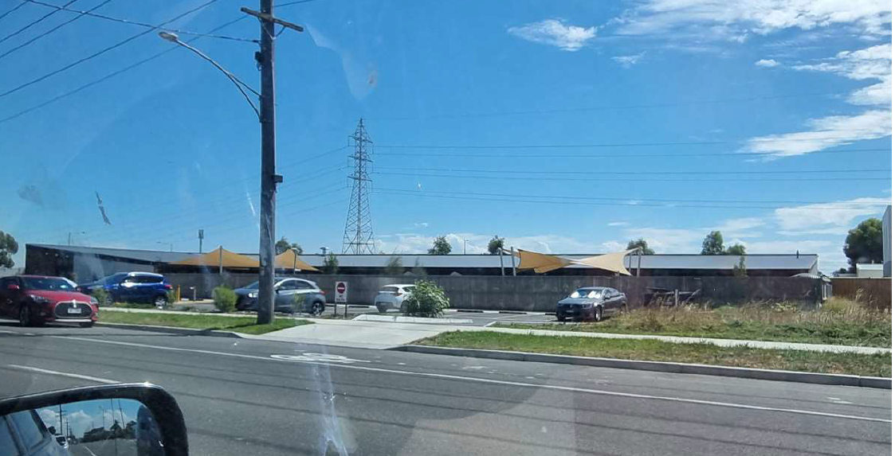
Childcare centre

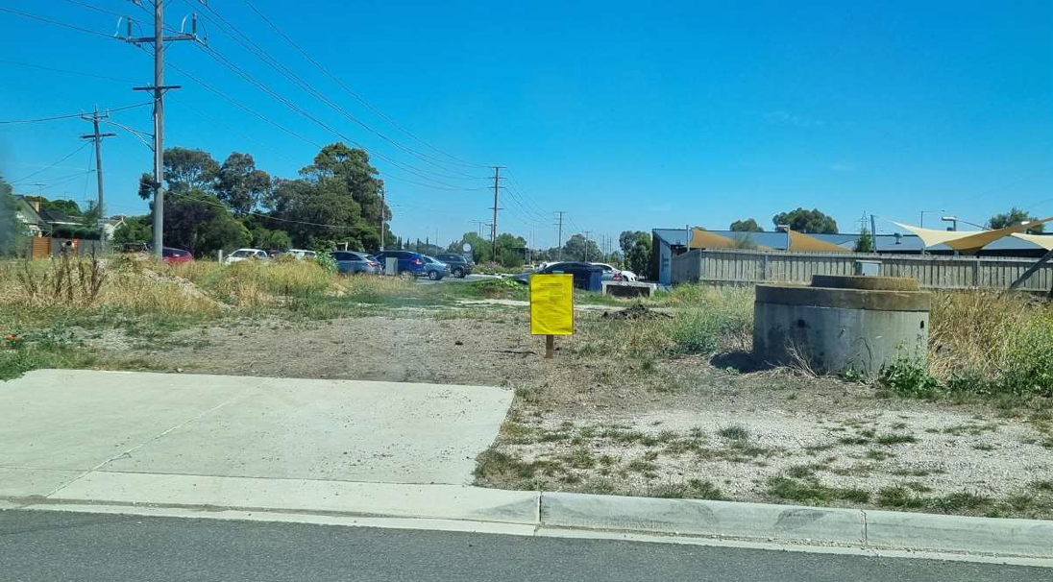
Location of the new addition to the childcare centre with advertising sign displayed
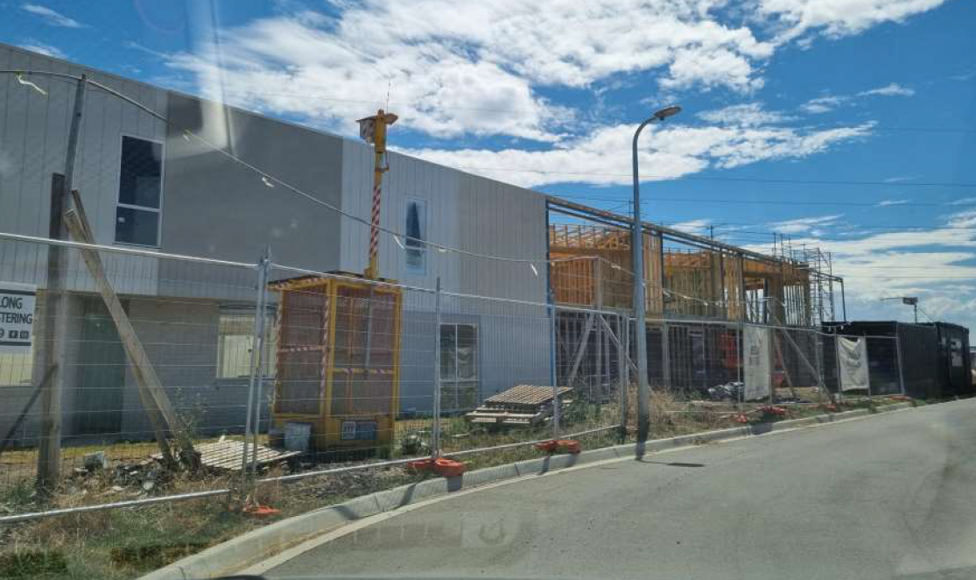
The 9 dwellings currently under construction

PROPOSAL:

Amend Subdivision to Create One Extra Lot and Change Area of Common Property to its own lot
The currently approved plan of subdivision includes the long lot which contains the power lines, as common property shared between all of the 9 lots which contain a dwelling.

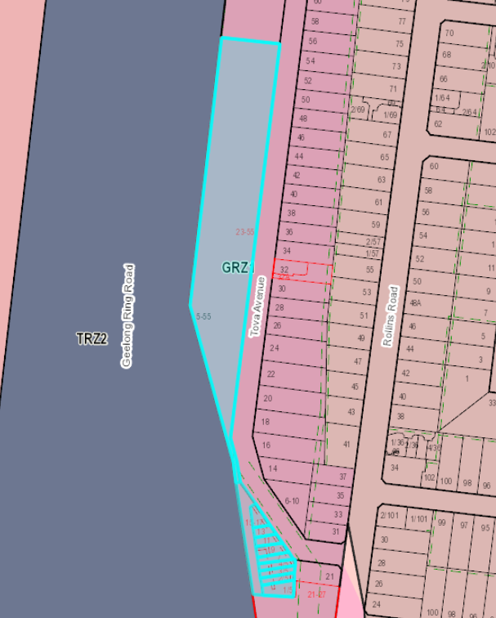

The permit and plans are proposed to be amended to create a tenth lot which contains the powerlines without any connection to the 9 dwellings.

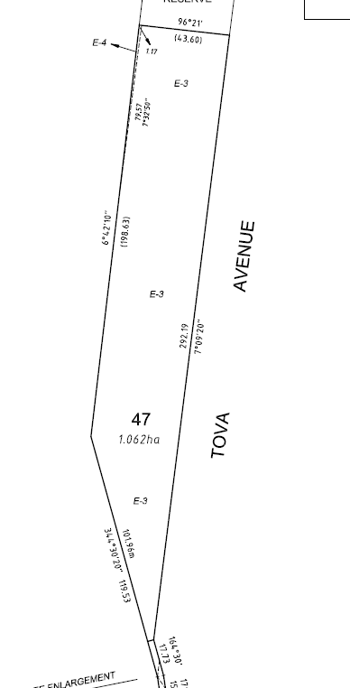

Proposed plan of subdivision displaying proposed lot 47 which would contain only the powerlines and would have no link to the 9 dwellings.
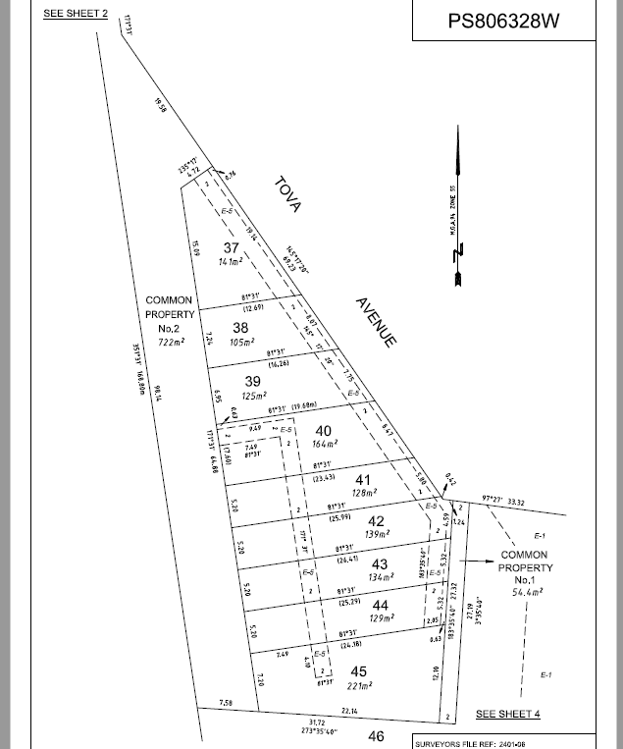

Proposed plan of subdivision displaying the 9 dwellings and common property/garden area.

Amend Preamble to delete Food & Drink Premises and Delete Conditions for Food & Drink Premises (conditions 64 & 65)

The existing permit has approved a food and drink premises and related conditions. The amendment includes the removal of the food and drink premises and therefore its related condition should also be removed from any amended permit issued.

Amend condition 68 to increase Number of Children

The amendment proposes to increase the number of children permitted at the site. The current number of children permitted on site is 123. The amendment proposes to allow an additional 33 children which will bring the total of children at the site to 156 children.

Amend Plans to Show Extended Childcare Centre and Subdivision changes

A new childcare building used for a kindergarten associated with the childcare centre is proposed to be located where the previous food and drink premises had been approved. There will be 2 additional staff car parking spaces constructed at the rear of the building.
The plan of subdivision is proposed to be amended to show a separate allotment for the power line land rather than having it combined as common property with the 9 lots, each containing a dwelling.

PERMIT/SITE HISTORY:

The original application and permit was issued for the Development and Use of a Childcare Centre, Food & Drink Premises, Associated Business Identification Signage and the Construction of Nine (9) Dwellings and a Nine (9) Lot Subdivision. The subdivision included a large lot which contained the powerlines as common property linked to the 9 dwellings.

The application was advertised by signs on site, mail to adjoining owners and occupiers and a notice in the newspaper. One objection was lodged that was later withdrawn.

The objection related to the inadequate notification of the application, the proposal being inconsistent with the character of the area, the potential amenity impact from anti-social behaviour, increased traffic and overlooking from the proposed dwellings.

The application was re-advertised and given the subdivision to the north has been given statement of Compliance and titles have been created, the application was advertised by signs on site and mail to adjoining owners and occupiers, without any notice in the newspaper.

REFERRALS:

The following referrals were undertaken:

Section 52:

Authority: | AusNet
Response: | 1. No part of the proposed buildings, including eaves, awnings, canopies, shelters and the like, is permitted on AusNet Transmission Group’s easement.  2. Written agreement to the final plan of subdivision must be obtained from AusNet Transmission Group prior to certification.  3. The plan of subdivision must show the AusNet Transmission Group easement fully dimensioned on all affected lots.  4. The position of the easement must be adjusted where necessary to accord with the position of the existing transmission lines as determined by survey.  5. Approval must be obtained from AusNet Transmission Group as to the position of lot boundaries within the easement. Lot boundaries must have a minimum clearance of 10 metres from the nearest tower steelwork.  6. Approval must be obtained from AusNet Transmission Group as to the position and/or suitability of any roads that are proposed within the AusNet Transmission Group easement. Roads that run parallel or cut at an angle of less than 45 degrees to the power line/s are not permitted within the easement.  In this regard the applicant must make contact with AusNet Transmission Group (LMG@ausnetservices.com.au) at an early stage to ensure that any road proposals within a transmission line easement are acceptable to AusNet Transmission Group. There are strict requirements regarding roads in transmission easements including road length, clearance to existing and future towers and overhead conductors as well as safety considerations relating to installation,  operation and maintenance of services within road reserves.  7. Details of proposed road construction and the installation of services within the easement must be submitted to AusNet Transmission Group and approved in writing prior to the commencement of work on site.  Services that run parallel or cut at an angle of less than 45 degrees to the power line/s are not permitted within the easement.  8. Gates must be installed in any new boundary fences that cross the easement to enable access for AusNet Transmission Group vehicles.  9. Vehicles and equipment exceeding 3 metres operating height are not permitted on the easement during construction without prior written approval from AusNet Transmission Group.  10. All trees and shrubs planted on the easement must not exceed 3 metres maximum mature growth height.  11. Natural ground surface levels on the easement must not be altered by the stockpiling of excavated material or by landscaping without prior written approval from AusNet Transmission Group.  12. Details of all future works within the easement must be submitted to AusNet Transmission Group and approved in writing prior to the commencement of work on site.
Officer Comment:
Response noted, all of the above conditions will be checked against the existing conditions of the permit and if any are new they will be included on any amended permit issued.

Internal

Department: | Engineering
Response: | Condition 68 on previous permit limited the cap to max 123 children. The spaces available for the childcare remains at 32 spaces. They have introduced 2 spaces which are highlighted for staff use only (and should remain as such).  Statutory requirement determines x 0.22 = 156 children x .22 = 34.22 car spaces are required) rounded down in accordance with Clause 52.06).  Same conditions as previously recommended  Permit conditions-  The following conditions must be placed on the planning permit:  Subdivision works  Unless otherwise approved in writing by the Responsible Authority, prior to the commencement of any works/statement of compliance the parent property (Planning Permit 1305-2015) must obtain statement of compliance to the satisfaction of the Responsible Authority.  Development works  Unless otherwise approved in writing by the Responsible Authority, prior to the commencement of use, The subdivision of land as part of this permit must obtain statement of compliance all to the satisfaction of the Responsible Authority.  Creation of Drainage and Carriageway Easements  Prior to certification of the Plan of Subdivision, drainage and carriageway easements in favour of the City of Greater Geelong must be created (as appropriate) on the Plan on Subdivision to the satisfaction of the Responsible Authority.  Construction Plans  Prior to the commencement of works, engineer designed drainage construction plans must be submitted to and approved by the Responsible Authority. The engineering construction plans must show the extent of any proposed interim or temporary measures associated with road or other infrastructure and must detail construction to a standard that achieves a functional design with no adverse external impacts and achieve an acceptable standard of aesthetics including landscaping and is maintained in perpetuity to the satisfaction of the Responsible Authority.  Site Stormwater Management Plan  Prior to the commencement of works on the subdivision, and unless otherwise approved in writing by the Responsible Authority, a detailed Site Stormwater Management Plan must be submitted to and approved by the Responsible Authority. When approved the Site Stormwater Management Plan will form part of this permit. The plan must include, but is not limited to, detailed hydrological, hydraulic and water quality treatment analysis to the satisfaction of the Responsible Authority. The stormwater drainage system on the site must be designed so that stormwater runoff exiting the land meets the current best practice performance objectives for on-site detention (back to pre-development levels) and stormwater quality, as contained in the Urban Stormwater Best Practice Environmental Management Guidelines (Victorian Stormwater Committee, 1999) as follows;  - 80% retention of the typical annual load of suspended solids;  - 45% retention of the typical annual load of total phosphorous;  - 45% retention of the typical annual load of total nitrogen, and;  - 70% retention of the typical annual load of gross pollutants.  Environmental Construction Management Plan (ECMP)  Prior to the commencement of works of the subdivision, an Environmental Construction Management Plan shall be submitted to and approved by the Responsible Authority. When approved all conditions on the ECMP plan will form part of the permit. The plan must address, but not be limited to, the following:  - Hours of works, demolition or construction;  - Methods to contain dirt and mud within the site, and the method and frequency of clean up procedures;  - On site facilities for vehicle washing;  - Methods used with regards to Dust suppression which may include but not limited to the following:  - Water truck to be retained on site at all times;  - Soil stockpiles to be retained on site must be seeded or provide a treatment to provide a crusted surface;  - Cease all works on site during high wind incidences;  - Vehicle/truck movements to be limited to a reduced speed to prevent dust emissions;  - Dust suppression measures including fencing in locations to existing dwelling;  - The protection measures for site features to be retained (e.g. vegetation, retaining walls, buildings, other structures and pathways, etc.);  - Delivery and unloading points and expected frequency;  - A liaison personnel for contact by residents and the Responsible Authority in the event of relevant queries or problems experienced;  - The movement of construction vehicles to and from the site must be regulated to ensure that no traffic hazards are created in and around the site;  - Parking facilities for construction workers;  - Measures to minimise the impact of construction vehicles arriving at / departing from the land;  - An outline of requests to occupy public footpaths or roads, and anticipated disruptions to local services;  - The processes to be adopted for the separation, re-use and recycling of demolition materials;  - The measures for prevention of the unintended movement of building waste and hazardous materials and other pollutants on or off the site, whether by air, water or other means;  - Any other measures that are consistent with the following Environmental Protection Authority publications: ‘Environmental Management Guidelines for Major Construction Sites’, ‘Construction Techniques for Sediment and Pollution Control’ and ‘Doing it Right on Subdivisions’;  - Handling, tracking and testing of all imported fill;  - Measures to be taken to ensure that no polluted water and/or sediment laden runoff is to be discharged directly or indirectly into stormwater drains or watercourses during the construction period; and;  - Methodology detailing how service vehicles (ie; Council Garbage Trucks) will be catered for during all stages of construction, including the removal of temporary turn around areas; and;  - Any other condition as required by the Responsible Authority that addresses any other issues i.e. location of earth mound / soil stockpiles, rumble grids, construction of and materials used for all whether access roads up to 30 meters on entry and exit to the site entry.  Once the Environmental Construction Management Plan (ECMP) has been endorsed by the Responsible Authority under this permit it must be implemented and complied with at all times to the satisfaction of the Responsible Authority unless with the further written approval of the Responsible Authority.  Construction of Roadworks / Drainage  Prior to the issuing of a Statement of Compliance of the subdivision, roadworks and drainage including any basins, slope stabilization works and any retaining structures must be constructed in accordance with the approved plans and specifications to the satisfaction of the Responsible Authority.  The underground site stormwater drainage system shall be constructed within easements and/or road reserves to cater for all lots, roads, streets and courts created by the subdivision and the surrounding developed and undeveloped area all to the satisfaction of the Responsible Authority.  All temporary road connections to existing roads must be maintained by the developer until the ultimate alignment is constructed, to the satisfaction of the Responsible Authority.  Maintenance of Civil Works  Unless otherwise approved in writing by the Responsible Authority, the civil works shown on any endorsed engineering plan must be maintained to the satisfaction of the Responsible Authority for a period of one (1) year.  Engineering Fees and Bonds  The design and construction of stormwater drainage connections and any new Council infrastructure needs to be approved and supervised by the Responsible Authority. Unless otherwise approved in writing by the Responsible Authority, prior to the issue of a Statement of Compliance for each stage of the subdivision, a fee of 3.25% of the cost of the works must be paid to the Responsible Authority for the checking and supervision of these works. A maintenance bond of 5% of the cost of the works is to be paid to Council and will be returned after successful completion of a one (1) year maintenance period, all to the satisfaction of the Responsible Authority.  Council Assets  Prior to the issuing of a Statement of Compliance for each relevant stage of the subdivision, repair and reinstatement necessitated by any damage to Council assets caused by or as a result of the subdivision construction is required to be carried out at the developer’s expense to the satisfaction of the Responsible Authority.
Officer Comment:
Response noted, all of the above conditions are the same as recommended on original permit and no engineering conditions that were included on the existing permit are being amended.

AMENDMENT OF THE PROPOSAL PRIOR TO PUBLIC NOTIFICATION:

The applicant made a request to amend the application pursuant to Section 50 of the Planning and Environment Act 1987 on 15 December 2021. Council accepted the amendment. The amendment made the following changes to the application:
- Revised layout and subdivision to contain the required 35% garden area within the townhouse lot and subsequent reduction in size of lot 47 (proposed powerline lot).

These are the plans that form the basis of this report.

PUBLIC NOTIFICATION:

The application is not exempt from the notice requirements of Section 52(1)(a), (b) and (d), the decision requirements of Section 64(1), (2) and (3) and the review rights of Section 82(1) of the Act and pursuant to Section 52 of the Planning and Environment Act 1987 the following forms of advertising were undertaken:
- Notices were sent to owners and occupiers of adjoining land (including opposite)
- A2 signs were placed on the land

Fifty one (51) objections have been lodged with Council.

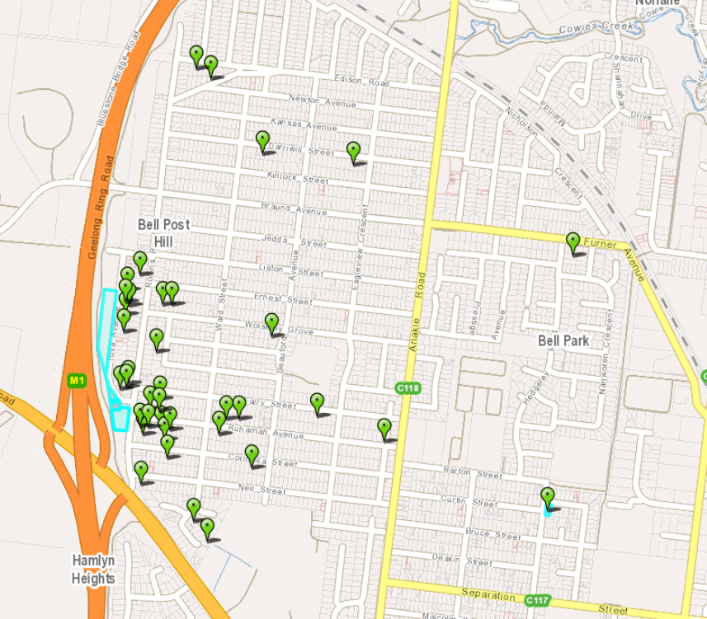
Image displaying location of objectors

CONSULTATION:

A consultation meeting was not held at the time given the COVID climate; however, a written response was provided by the applicant which was circulated to the objectors. No objections were withdrawn following this, and one objector asked further questions about car parking. The questions were sent on to Engineering, however no response from Engineering was provided.

AMENDMENT OF THE APPLICATION FOLLOWING PUBLIC NOTIFICATION

The application was not amended following public notification.

OBJECTIONS:

The concerns of objectors are summarised and commented on below:

- Objection -
The childcare centre has created significant car parking issues within Rollins Road and other adjoining residential streets. The car park often remains empty, while the surrounding streets are congested with on street car parking of staff from the childcare centre. This impacts on the safety of the road networks, more specifically reducing visibility when entering and exiting Rollins Road from all adjoining nearby streets. By increasing the number of children at the childcare centre, this existing problem will be increased.
There are not enough car parks available on site for the existing childcare centre, therefore an increase in children should not be permitted.

Response
The current operation of the child care centre and the parking of staff vehicles within the site and the availability of parking on site for care givers at busy drop off and pick up times could be better managed by the child care centre operators. For the car park to be empty during the day and the surrounding streets to be filled with staff vehicles is a result of its current operations and management of the car park.

That said, notably the car parking numbers provided on site comply with the requirements of Clause 52.06 Car Parking of the Greater Geelong Planning Scheme.

The additional children require 2 additional car parks to be provided on site, which is achieved with a small additional car park area located in the northern section of the land. There is no reduction of car parking proposed as part of the proposal or the original application.

Council’s Engineering Unit were referred the application for comment regarding traffic impacts of the proposal and visibility, they raised no concerns with the operation of the road network and the childcare centre.

- Objection -
The original permit included a café and a public area adjoining it. This was an anticipated outcome of the original permit by the local residents as there is nothing of this nature in the immediate area. The residents are disappointed that this is now proposed to be removed from the application.

Response

This disappointment has come through in many objections, and while the residents would like this element to be retained, it is not possible to require or force an applicant to retain this element of their original proposal.

- Objection -
The previously approved residential development will overlook neighbouring residential properties.

The residential development will create further parking issues as there are not enough car parks provided for these dwellings.

Response
The units that were approved as part of this original application comply with overlooking requirements of Clause 55 ResCode of the Planning Scheme. A 9 metre distance is the overlooking arc to be considered with the site and the width of Tova Avenue including its road reserves is approximately 15 metres wide – therefore all windows comply with overlooking requirements of Clause 55.

The residential development has been approved as part of the original application and all car parking requirements were met, including the provision of two visitor car parking spaces.

- Objection -
The proposal will decrease property values in the area.

Response
Property valuation is not a planning consideration.

- Objection -
The area affected by the powerlines should not be created as its own lot, there is no reason for this.

Response
It is agreed that the land affected by the powerlines should not be created as its own lot. A condition of permit on any permit issued, if one is issued, will be to retain the powerline land as common property linked to the 9 dwellings as is the current situation.

- Objection -
There have been more break ins in the area recently following the operation of the childcare centre and units being constructed on the subject site.

Response
While this is may be true, no evidence has been provided to support this statement the use of the land for a childcare centre and the construction of dwellings within a residential area are supported and allowable use and developments.

- Objection -
Bins can’t get picked up due to on street parking and people are having to place them on the road which is creating a further safety issue.

Response
This is a frustrating outcome for residents and Council waste collection alike. A condition has been recommended to be included on any planning permit issued requiring street signage to be erected in the surrounding area that no parking is permitted between the days and hours of bin collection to alleviate this issue.

- Objection -
Time limited parking areas and no standing signs need to be erected at the entrances to all surrounding residential streets to assist in lessening on street car parking and safety issues.

Response
No standing and time limited car parking locations need to be considered by council’s traffic unit as they need to meet relevant legislation and requirements. Councils Traffic unit can be contacted about these matters, however, no suggested conditions relating to no standing or time limited car parking were suggested to be required as part of the amended application

- Objection -
If the child care centre is increased in size, will they need access to the easement at the rear of properties within Tova Avenue/Rollins Road to the north of the subject site?

Response
Access to the easement at the rear of other residential properties does not form part of the proposal and does not require planning approval. Barwon Water are the relevant authority to contact regarding any easement access requirements. It is not envisaged, however, that access would be required.

ASSESSMENT:

ZONE:

Clauses 32.08 – General Residential Zone

Purpose

- To implement the Municipal Planning Strategy and the Planning Policy Framework.
- To encourage development that respects the neighbourhood character of the area.
- To encourage a diversity of housing types and housing growth particularly in locations offering good access to services and transport.
- To allow educational, recreational, religious, community and a limited range of other non-residential uses to serve local community needs in appropriate locations.
Garden Area
Pursuant to Clause 32.08-4, an application to construct or extend a dwelling on a lot must provide a minimum garden area as set out in the following table:

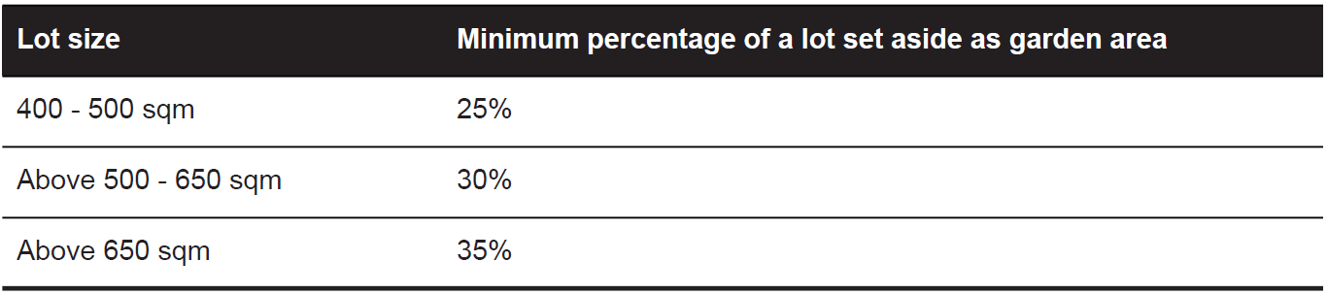

Garden Area Response
The garden area requirement for this site is 35% as the land area is greater than 650 square metres, at 2008 square metres. The common property area linked to the 9 dwellings, and lots has an area of 727m2 which is greater than the required amount of 702.80 square metres. This has been displayed on TP-11 below.
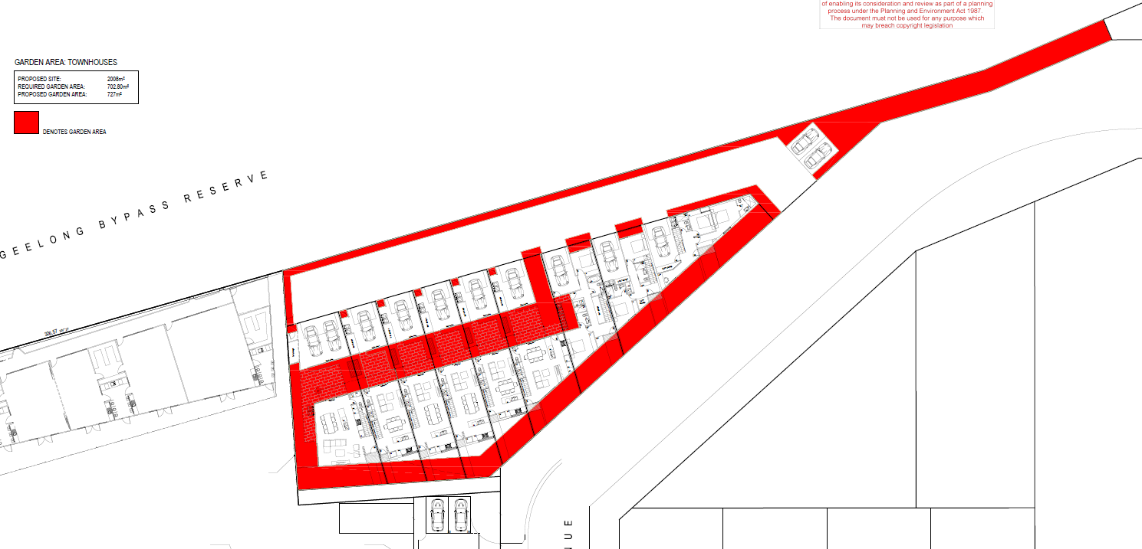
Garden area plan

Maximum Building Height

The new proposed child care building will stand at a maximum height of 3.847 metres which is less than 9 metres and therefore compliant with the maximum height permitted within this zone.

OVERLAY:

Clause 43.02 – Design and Development Overlay

Design objectives

To ensure that the siting, height and visual bulk of dwellings achieves a reasonable sharing of views between properties to significant landscape features such as the coast (ocean and foreshore), Corio Bay, Barwon River, Central Geelong, Barrabool Hills and the You Yangs.

Buildings and works

A permit is not required for buildings and works other than to construct a dwelling which is more than 7.5 metres above natural ground level (excluding any television antenna, chimney or flue) or extend a dwelling where the extension is more than 7.5 metres above natural ground level (excluding any television antenna, chimney or flue).

Response to zone and overlay(s)

The proposed new child care building and shed will provide for additional community related use on the subject site and is a supported non-residential use within the General Residential Zone Schedule 1. The building is directly associated with the existing approved and operating child care centre on the land and will provide for additional space and children.
The proposed buildings and additional childcare places are considered to serve a local community need given the proposal. The scale and intensity of the proposed additions are considered to be minor and requires only 2 additional car spaces - that are being provided. The design, height setback and appearance of the building are considered to be acceptable as it will sit in a similar location to the previously approved café.

Endorsed café location under PP-975-2018 and proposed child care addition, shed and car park (see below)
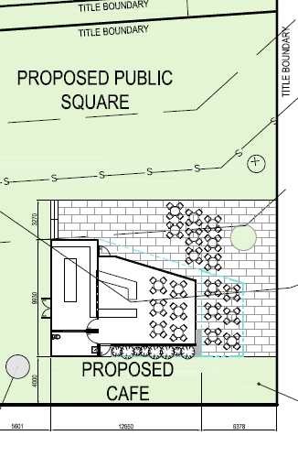 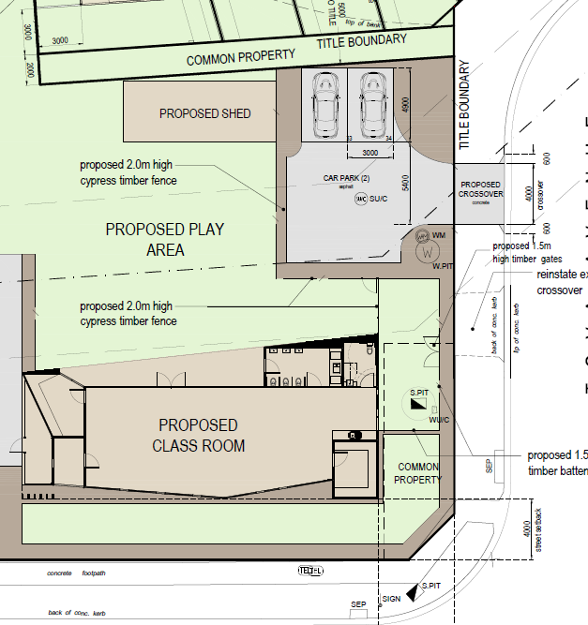.

The child care building and shed are both single storey in height with low pitched roofing. The two additional car spaces being provided for the child care centre will be for staff only and accessed from Tova Avenue. The vehicles are likely to be parked in the spaces all day and not impact on the efficiency of the road network or increase the traffic generated on the roads considerably. The proposal was referred to Engineering who raised no concerns with traffic to be generated by the additional child care places.

The proposed subdivision of the powerline affected land to be on its own Title has been considered under the zone and it is considered that the maintenance of the land is more appropriately linked to all of the 9 dwellings, rather than be on its own parcel of land as it is more likely to be appropriately maintained and managed with this arrangement. It is noted that the property as it currently exists which contains the powerlines, is not well maintained.

As the proposed buildings and works are less than 7.5m in height the Design and Development Overlay Schedule 14 is not triggered in this instance.

CULTURAL HERITAGE MANAGEMENT PLAN (CHMP):

The Aboriginal Heritage Regulations 2007 specify the circumstances in which a cultural heritage management plan is required for an activity or class of activity.
Part 2 - Division 2 of the Aboriginal Heritage Regulations 2007 specifies exempt activities which do not require a cultural heritage management plan.

The proposal is not listed as an exempt activity.

Areas of cultural heritage sensitivity are defined within Part 2 - Division 3 of the Aboriginal Heritage Regulations 2007. Part 2 - Division 3 does not identify the site or part of the site as within an area of cultural heritage sensitivity.

High impact activities are defined within Part 2 - Division 5 of the Aboriginal Heritage Regulations 2007. Part 2 - Division 5 lists the proposal as a high impact activity.
The site is not considered to have been the subject of significant ground disturbance which is defined as ‘disturbance of (a) the topsoil or surface rock layer of the ground or (b) a way - by machinery in the course of grading, excavating, digging, dredging or deep ripping, but does not include ploughing other than deep ripping.

In accordance with the above assessment, a cultural heritage management plan is not required.

LANDFILL GAS RISK ASSESSMENT

The subject site is not located within 500 metres of an identified former landfill site, a risk assessment is not required.

DEVELOPMENTS IN BUSHFIRE PRONE AREAS

The site is not located within a designated bushfire prone area.

THE VICTORIAN PLANNING POLICY FRAMEWORK (VPPF):

The following Victorian Planning Policies are applicable to this application:

11.01-1S - Settlement

Objective
- To promote the sustainable growth and development of Victoria and deliver choice and opportunity for all Victorians through a network of settlements.

15.01- 1S Urban Design

Objective
- To create urban environments that are safe, healthy, functional and enjoyable and that contribute to a sense of place and cultural identity.

19.02-2S - Education Facilities

Objective
- To assist the integration of education and early childhood facilities with local and regional communities

Strategies
- Consider demographic trends, existing and future demand requirements and the integration of facilities into communities in planning for the location of education and early childhood facilities.

- Locate childcare, kindergarten and primary school facilities to maximise access by public transport and safe walking and cycling routes.
- Ensure childcare, kindergarten and primary school and secondary school facilities provide safe vehicular drop-off zones.
THE LOCAL PLANNING POLICY FRAMEWORK (LPPF) AND MUNICIPAL STRATEGIC STATEMENT (MSS):
MSS

The following policies of the Municipal Strategic Statement are applicable to this application:

21.06-4 - Housing Diversity

Objectives
- Ensure housing diversity is achieved in established and growth area communities.
- Increase the level of affordable and social housing in Greater Geelong.

21.06-5 - Urban Consolidation

Objectives
- Facilitate infill development to increase its housing supply contribution to 50 per cent, by 2047.
- Nominate the preferred location for increased housing densities.
- Manage the impact of increased housing densities on neighbourhoods.

LPPF

There following Local Planning Policy is relevant to this application.

22.01 – Discretionary Uses in Residential Areas

Objectives
- To provide for non-residential and service uses which are compatible with the residential character, scale and amenity of neighbourhoods.
- To provide for non-residential uses which serve the needs of the local community.
- To encourage the re-use of purpose built non-residential buildings for a mix of appropriate local convenience/service and commercial uses.
- To ensure that car parking can be appropriately accommodated on site and that on street parking is relied upon only where it can be demonstrated that it will not be to the detriment of surrounding residential uses.
- To ensure that traffic generated by the use can be accommodated within the surrounding street network.
- To discourage new non-residential uses in residential zones that could reasonably be located in a nearby commercial or mixed use zones.
- To avoid the concentration of non-residential uses where it would create a de-facto commercial area, isolate residential properties or contribute to unplanned expansion of commercial or mixed use zones into surrounding residential land.

Policy
- Non-residential uses are located so as to benefit and be convenient to local residents.
- Non-residential uses generally be encouraged to locate on sites which have access to a Road Zone and discouraged from locating within a local access street, access lane or access place. Other locations may be considered appropriate where it can be demonstrated that residential amenity can be protected.
- Residential properties are not isolated between non-residential uses.
- Non-residential uses are encouraged to locate on sites where it can be demonstrated that due to existing conditions or constraints the site has a low standard of residential amenity.
- Shops, offices, taverns and larger medical centres (5 or more practitioners) be located within commercial zones, unless it is adequately justified that this is not practical, in which case the use should be located adjoining a Road Zone.
- Commercial uses in residential zones within a 400 metre radius of an existing commercial zone are provided only where it can be justified that the use cannot be reasonably located within the nearby commercial zone.

Amenity
- Residential amenity should be protected from:
  - Noise, light and odours emitted from the site.
  - Disturbance associated with the hours of operation.

Design and Siting
- The re-use of buildings originally built for non-residential uses be encouraged and facilitated.
- The design of purpose built premises should have regard to the existing neighbourhood character and reflect a residential scale and appearance, particularly with regard to the following elements:
  - Building and roof form.
  - Building height and setback.
  - Design detail (including façade articulation, verandahs, window and door style and placement).
  - Building materials.
  - Colours and finishes.
- The design and siting of new buildings should have regard to the location of adjacent buildings.

Landscaping
- The landscape character of an area is maintained by ensuring that there is adequate space available for planting of vegetation and that significant trees be retained where practicable.
- Adequate buffers in the form of landscape strips be provided between adjoining properties and areas used for access and parking within the subject site.

Car parking & Traffic
- Adequate area is set aside for on-site car parking.
- Areas set aside for car parking be located to ensure that they do not dominate the streetscape.
- Residential amenity be protected from significant changes in traffic conditions and significant increases in on street parking demand.
- Loading and unloading of vehicles does not cause unreasonable detrimental impact to residential amenity.

Advertising Signage
- Advertising signage be designed and located so as to create a balance between providing appropriate identification for visitors to a site and ensuring signage has regard to its residential context.
Response

The proposed additional child care building and associated outbuilding appropriately responds to relevant planning policy considerations. There is a demand and need for the additional places within the existing child care centre. The site is located within close proximity to the International School to the east of the site and is located within an established and recently increased residential neighbourhood.

The proposal has been considered against Clause 22.01 Discretionary Uses in Residential Areas. This is an important assessment tool for applications of a non-residential nature, such as the child care centre.

The residential amenity of the area should be protected from noise, light and odours emitted from the site, and from disturbance associated with the hours of operation. The operation of the child care centre in relation to these matters is considered to be satisfactory and not impacting the residential amenity of the surrounding neighbourhood.

The design and siting of the proposed new building is in a very similar location to the previously approved café on the site, its building materials are visually soft and reflecting of weatherboard dwellings within the neighbourhood and are at a height and setbacks which are complementary to the existing residential neighbourhood.

The site has sufficient space for landscaping to be provided within open areas.
Car parking is one of the main concerns raised by residents, given the current operations of the child care centre appear to have created significant on street car parking demand which in turn has impacted the ability of residents to access their properties and to safely drive in the immediate vicinity due to vehicles parked on the streets blocking lines of sight. The residential amenity is considered to have been impacted by the current operations of the child care centre, with a proposed increase in children being of concern to the residents who are already feeling impacted.

While car parking on the street has been an issue, this is considered to be a result of the management of the child care centre, rather than the ability for vehicles to park within the subject site. The objections often discuss that the child care centre car park sits empty, while staff vehicles are parked in the surrounding streets. The site contains all required car spaces, and the proposal will provide an additional two car spaces to ensure compliance with the car parking requirements for the additional children proposed. It is therefore considered that while there have been amenity impacts from the current operations of the child care centre, these do not relate from there not being enough car parking. With well managed operations of the child care centre, less vehicles should be parking on street in the future.

RELEVANT PARTICULAR PROVISIONS:

The following Particular Provisions are applicable to this application:

CLAUSE 52.05 – SIGNS
- To regulate the development of land for signs and associated structures.
- To ensure signs are compatible with the amenity and visual appearance of an area, including the existing or desired future character.
- To ensure signs do not contribute to excessive visual clutter or visual disorder.
- To ensure that signs do not cause loss of amenity or adversely affect the natural or built environment or the safety, appearance or efficiency of a road.
Response

The plans submitted display the signage area proposed, and the 3D plans display the type of signage proposed. The signage is considered to be simple and appropriate in the site and building context. A condition will be included on any planning permit issued stating the signage is not required to be illuminated internally or externally.

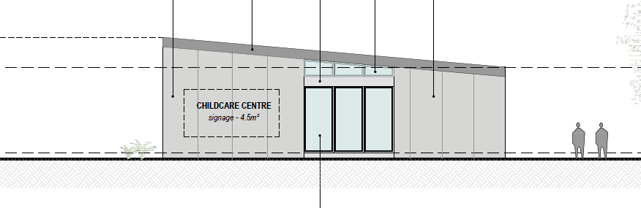
North facing signage proposed
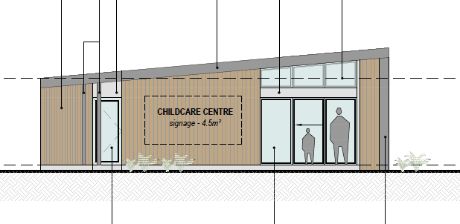
South facing signage proposed

CLAUSE 52.06 – CAR PARKING

- To ensure that car parking is provided in accordance with the State Planning Policy Framework and the Local Planning Policy Framework.
- To ensure the provision of an appropriate number of car parking spaces having regard to the demand likely to be generated, the activities on the land and the nature of the locality.
- To support sustainable transport alternatives to the motor car.
- To promotes the efficient use of car parking spaces through the consolidation of car parking facilities.
- To ensure that car parking does not adversely affect the amenity off the locality.
- To ensure that the design and location of car parking is of a high standard, creates a safe environment for users and enables easy and efficient use.
Response

The proposed new child care building is proposed to provide for an additional 33 children. Clause 52.06 has a requirement of 0.22 car spaces to be provided for each child. 0.22 x 33 = 7.26 car spaces (round down to 7 spaces).

The existing childcare centre has an approved number of 123 children which requires a total of 27.06 (rounded down to 27) car spaces.

Therefore, the total amount of car parking required for the site is 27 + 7 = 34
The existing car park at the subject site contains a total of 32 car spaces and the new small car park will contain 2 additional car parking spaces resulting in a total of 34 car parking spaces. The proposal complies with the car parking requirements of the Planning Scheme.
CLAUSE 53.01 – PUBLIC OPEN SPACE CONTRIBUTION

A person who proposes to subdivide land must make a contribution to the council for public open space in an amount specified in the schedule to this clause (being a percentage of the land intended to be used for residential, industrial or commercial purposes, or a percentage of the site value of such land, or a combination of both). If no amount is specified, a contribution for public open space may still be required under Section 18 of the Subdivision Act 1988.

Response

Pursuant to the schedule to Clause 53.01, the following contribution is required to be made:

Creation of one additional lot | None
Creation of two to nine additional lots | 1 percent per additional lot up to a maximum of 5 percent
Creation of 10 or more lots on land zoned for residential purposes prior to August 31st 2007 | 5 percent
Creation of 10 or more lots on land zoned for residential purposes after August 31st 2007 | 10 percent
Waurn Ponds Creek Environs | 10 percent

Pursuant to the above table a 5% contribution is required to be made.
It is noted this was requested in the previous delegate report however it was not included in the original permit.

DECISION GUIDELINES OF CLAUSE 65:

CLAUSE 65.01 – APPROVAL OF AN APPLICATION OR PLAN

Clause 65.01 of the Greater Geelong Planning Scheme outlines the decision guidelines to be considered by the Responsible Authority when making decisions on applications. These decision guidelines include:
- The matters set out in Section 60 of the Act.
- The Municipal Planning Strategy and the Planning Policy Framework.
- The purpose of the zone, overlay or other provision.
- Any matter required to be considered in the zone, overlay or other provision.
- The orderly planning of the area.
- The effect on the amenity of the area.
- The proximity of the land to any public land.
- Factors likely to cause or contribute to land degradation, salinity or reduce water quality.
- Whether the proposed development is designed to maintain or improve the quality of stormwater within and exiting the site.
- The extent and character of native vegetation and the likelihood of its destruction.
- Whether native vegetation is to be or can be protected, planted or allowed to regenerate.
- The degree of flood, erosion or fire hazard associated with the location of the
- land and the use, development or management of the land so as to minimise any such hazard.
- The adequacy of loading and unloading facilities and any associated amenity, traffic flow and road safety impacts.

Response

The proposal is considered to satisfactorily respond to the decision guidelines at Clause 65.01. The additional room and shed for the child care centre is appropriate in response to the zoning of the land. All car parking has been provided on the land for the additional and existing child numbers as part of the child care centre and residential development and therefore the proposal is not considered to create amenity impacts.

It is acknowledged that the current operation of the child care centre is not ideal and could be better managed to space out staff parking so they do not rely on on-street car parking for staff.

CLAUSE 65.02 – SUBDIVISION

Clause 65.02 of the Greater Geelong Planning Scheme outlines the decision guidelines to be considered by the Responsible Authority when making decisions on an application to subdivide land. These decision guidelines include:

- The suitability of the land for subdivision
- The existing use and possible future development the land and nearby land
- The availability of subdivided land in the locality, and the need for the creation of further lots
- The effect of development on the use or development of other land which has a common means of drainage
- The subdivision pattern having regard to the physical characteristics of the land including existing vegetation
- The density of the proposed development
- The area and dimensions of each lost in the subdivision
- The layout of roads having regard to their function and relationship to existing roads
- The movement of pedestrians and vehicles throughout the subdivision and the ease of access to all lots
- The provision and location of reserves for public open space and other community facilities
- The staging of the subdivision
- The design and siting of buildings having regard to safety and the risk of spread of fire
- The provision of off street parking
- The provision and location of common property
- The functions of any body corporate
- The availability and provision of utility services, including water, sewerage, drainage, electricity and gas
- If the land is not sewered and no provision has been made for the land to be sewered, the capacity of the land to treat and retain all sewage and sullage within the boundaries of each lot
- Whether, in relation to subdivision patterns, native vegetation can be protected through subdivision and siting of open space areas.

Response

The subdivision element of the application to separate the land impacted by the powerlines from the residential development is not supported as it is not considered to result in an orderly planning outcome to have a parcel of land that is unlikely to be able to be developed or used in any way, on its own without any link the surrounding development. The land currently does not appear to be well maintained, and without a link to the approved development, there is no mechanism to ensure the land is maintained in the future.

CONCLUSION:

That the Responsible Authority having considered all matters which the Planning and Environment Act 1987, requires it to consider decides to issue a Notice of Decision for the Development and Use of a Childcare Centre, Associated Business Identification Signage and the Construction of Nine (9) Dwellings and a Nine (9) Lot Subdivision at 1-37 Rollins Road, BELL POST HILL, generally in accordance with the plans and documentation submitted with the application subject to conditions.

- ttachment_.1.1 page 3
2.1.1 page 4
A

ttCLOSE OF MEETING

As there was no further business the meeting closed at 7.55pm on Thursday 14th July 2022

