

minutes

PLANNING COMMITTEE MEETING
No. 231
Wednesday 16 August 2023
City Hall, 57 Little Malop Street, Geelong

ALSO LIVE STREAMED ON THE CITY’S WEBSITE:

www.geelongaustralia.com.au/meetings

PANEL:

Cr Mason, Cr Murrihy, Cr Cadwell, Cr Hathway, Cr Sullivan, Cr Moloney

PRESENT

Present:

Cr Mason, Cr Murrihy, Cr Cadwell, Cr Hathway, Cr Sullivan & Cr Moloney

Council Officers:

Steve Roussac – Acting Team Leader, Statutory Planning
Rory O’Loghlen, Team Leader Statutory Planning
John Rush – Coordinator Statutory Planning
Joanne Van Slageren – Manager, City Development

Opening: The Chair declared the meeting open at 5.34pm.

1. PROCEDURAL MATTERS

Acknowledgement Of Country

The Committee acknowledges the Wadawurrung People as the Traditional Owners of the Land, Waterways and Skies. We pay our respects to their Elders, past and present and emerging. We Acknowledge all Aboriginal and Torres Strait Islander people who are part of our Greater Geelong community today.

1.2. Introduce The Panel Members

1.3. Apologies

Cr Harwood & Cr Nelson

1.4. Declarations Of Conflicts Of Interest

Nil

1.5. Confirmation Of Minutes

That the Minutes of the Planning Committee Meeting held on 31 May 2023
be confirmed.

Moved: Cr Moloney Seconded: Cr Sullivan

CARRIED

2.1. | PP-509-2022 – 6 Greenway Court, Wandana Heights

Application Number: | PP-509-2022
Responsible Officer: | Steve Roussac
Applicant’s Name: | 6GCWH Pty Ltd
Address/Title Details: | 6 Greenway Court, WANDANA HEIGHTS
Proposal: | Construction of two or more dwellings on a lot (including apartments), and removal of native vegetation (native grasses).
Date Received: | 11 May 2022
Date Report Prepared: | 25 July 2023
Was a site inspection done? | Yes:  11 November 2022  13 December 2022  26 April 2023
Zone: | General Residential Zone – Schedule 1 (GRZ1)
Overlays: | Design and Development Overlay – Schedule 14 (DDO14)  Special Building Overlay (SBO)
Listed Buildings | Nil
Current Use/Development: | Vacant Development Site
Date(s) of Plans Under Assessment | 15/2/2023 – Site Plans, Floor Plans and Elevations  ‘For Discussion’ plans for Planning Committee consideration of recommended permit conditions have been submitted and stamped received 9/6/2023.

PP-320-2021 98 Marshalltown Road, Grovedale And PP-1512-2020 149 Bellarine Highway, Newcomb\

Summary
- This application seeks planning permit approval for the construction of 58 dwellings including 24 apartments with some greater than 7.5m in height, and the removal of scattered native grasses on the land at 6 Greenway Court in Wandana Heights.
- The land comprises 2 parcels with a combined area of 1.685 hectares that form a triangular shaped site. The land is accessed from the public road network along its north boundary at Greenway Court. The land abuts private properties at 3 and 4 Greenway Court, and 68 and 70 James Cook Drive along its north side. The east boundary abuts Barwon Water owned and managed land at 14-26 Basin Rise, and the Geelong Ring Road freeway reserve to the southwest.
- The site presents as open grassland that slopes significantly from the southeast to a gully and open seasonal waterway traversing the site from the southwest. It is enclosed by sections of rural style post-and-wire fencing, timber paling fences, and high woven and barbed wire security fencing.
- The land is burdened by a registered restrictive covenant limiting development within a gas transmission pipe easement inside the east site boundary. Written consent from the covenant benefactor has been given so that the approval of the development will not breach this restrictive covenant.
- The land is in the General Residential Zone (GRZ1) and the Design and Development Overlay (DDO14), with the low-lying parts of the site within the Special Building Overlay (SBO). Abutting land to the east is in the Public Use Zone (PUZ1) and the freeway reserve is zoned Transport Zone 2 (TRZ2).
- The application proposes the redevelopment of the land in 2 parts. The first comprises an extension to Greenway Court and the construction of 8 double storey townhouses fronting it. This involves buildings and works within the flood prone part of the site covered by the Special Building Overlay. Stormwater management and drainage design treatments proposed within the Greenway Court extension are to be engineered and constructed as part of the drainage infrastructure in the area.
- The second part of the development comprises 50 dwellings to be accessed via a new accessway from Basin Rise. This new accessway crosses the Pipeline Shared Path on the adjoining Barwon Water land and into the elevated south end of the site. From here, the access crosses to the north parcel on which 50 dwellings are proposed for construction.
- A planning permit is required for this proposal to:
- construct two or more dwellings on a lot
- construct a dwelling greater than 7.5 metres in height
- construct a building or carry out works in the Special Building Overlay
- remove, destroy or lop native vegetation

- It is notable that this permit application does not propose subdivision of the land.
- The mix of proposed dwellings includes:
- 12 x 2-bedroom ground floor apartments
- 12 x 2-bedroom first floor apartments
- 8 x 3-bedroom single storey detached dwellings
- 3 x 3-bedroom double storey detached dwellings
- 14 x 3-bedroom double storey townhouses
- 1 x 4-bedroom double storey detached dwelling

- 32 of the dwellings are to be greater than 7.5 metres in height, with the highest of these being 9.372 metres. None of these are located within significant view lines from dwellings on adjoining land.
- The land is also host to scattered native spear grasses that would be removed to accommodate the development. No other trees, shrubs or grasses on the land require planning approval to be removed.
- The application was referred to AusNet Transmission Group, the Head [of] Transport for Victoria, and the relevant Floodplain Management Authority in accordance with Section 55 of the Act. None objected to the grant of a permit, subject to conditions.
- Notice of the application was given to the Australian Pipeline Authority, AusNet (Gas Transmission) Services, Barwon Water, Fire Rescue Victoria, the Corangamite CMA, the Department of Energy, Environment and Climate Action (DEECA, formally DJPR), Energy Safe Victoria, and the Department of Transport (DoT) in accordance with the requirements of the Scheme. None objected to the grant of a permit, subject to conditions.
- The application was referred internally to units at the City, including Engineering Services, Environmental Planning, ESD Planning, Open Space Planning, Parks Planning, Urban Design and Waste Services. Their responses are detailed later in these recommendations.
- Public notice of the application was given in accordance with the notice requirements of the Act. The application attracted 91 objections. The main matters raised in objections include the increase to dwelling density, respect for neighbourhood character, increased traffic, lack of services in the area, loss of habitat and open aspect, road safety at Thornhill Road intersection, emergency service access and response, crossing of the Pipeline Track, on-street parking demand, no public transport proposed, stormwater run-off and increased flooding risk, and unsuitable housing for students, the elderly and families. These and other objections are detailed later in these recommendations.
- A planning information meeting between Officers, Objectors and the Applicant’s project team was held on 6 December 2022. Objectors were able to question the applicant’s project team and Officers, emphasise their concerns, and request changes for consideration.
- The application was amended with the submission of revised plans on 15 February 2023. Among other changes, the amendment reduced the number of dwellings proposed and reduced the scale of dwellings along the east boundary from double storey to single. The amended plans were circulated to all objectors for review on 23 March 2023. No objections have been withdrawn.
- The application has been assessed against the relevant requirements of the GRZ, DDO14 and the SBO, Clause 55 (ResCode) and Clause 65 (Decision Guidelines), including local, regional and State planning policy. The proposal is considered to achieve a net community benefit through the delivery of much needed additional housing on under-developed land within an established urban area, and on land that presents a development challenge due to its topography, shape and accessibility.
- The range of dwelling types proposed would add housing diversity to the area and is suitable for a range of households including singles, couples and shared living for those looking to live and work in proximity to employment and education hubs such as Deakin University and the Epworth hospital.
- The development of this vacant urban land at an increased density to that of the adjoining residential area will allow for a more affordable housing product than would otherwise be available were fewer houses proposed. This meets the dual policy objectives of adding to available housing supply and choice and supports diverse communities as they move through their various stages of life.
- It has been found that the design and layout of the development is respectful of the established character of the residential area to the north through somewhat traditional dwelling layouts and frontages to the Greenway Court extension, and to the east with single storey detached dwellings that preserve views from Basin Rise and the pipeline track.
- The preparation of ‘For Discussion’ plans by the permit applicant shows that 5 dwellings fronting the new extension to Greenway Court can be achieved in response to recommended permit conditions, and that 3,220 sq/m (approximately 19%) of the site can accommodate canopy tree coverage resulting in a substantial increase to the extent of canopy trees on the site today.
- Clause 65 (Decision Guidelines) of the Scheme requires that planning permit decisions produce acceptable outcomes in terms of: the requirements of the Act, including full consideration of the objections received; all relevant planning policies; and the purpose of each relevant Zone, Overlay and Particular Provision of the Greater Geelong Planning Scheme. The City’s Statutory Planning Officers have assessed this application carefully against all these matters in the preparation of these recommendations.
- Having considered all of the planning related matters required of the relevant Planning Authority, it is respectfully recommended that the permit application be approved and a Notice of Decision to grant a planning permit be issued subject to the conditions set out in this report.

Recommendation
Moved: Cr Murrihy Seconded: Cr Cadwell
That the Responsible Authority having considered all matters which the Planning and Environment Act 1987, requires it to consider decides to issue a Notice of Decision to Grant a Planning Permit for Construction of two or more dwellings on a lot (including apartments), and removal of native vegetation (native grasses), generally in accordance with the plans and documentation submitted with the application subject to the following conditions:

Carried
Conditions of Permit

AMENDED PLANS

Development Plans and Elevations

- Prior to the commencement of the development, amended plans to the satisfaction of the responsible authority must be submitted to and approved by the responsible authority. When approved, the plans will be endorsed and will then form part of the permit.

The revised plan must be accompanied by a written statement from the gas transmission pipeline easement Grantee and beneficiary to Covenant F716763 consenting to the works shown on revised plan.

The plans must be drawn to scale with dimensions and must be generally in accordance with the plans submitted with the application but modified to show:

a) No more than 5 dwellings with frontage and access to the proposed extension to Greenway Court.
b) Annotations stating ‘All buildings and works in proximity to the gas transmission pipeline are to be carried out in accordance with AusNet Gas Services requirements’.
c) The continuation of Greenway Court as a future road reserve vested to the City of Greater Geelong.
d) A future new reserve at the end of the extended Greenway Court vested to the City of Greater Geelong.
e) All water quality treatment devices (including raingardens) to be located on private property and not within any existing or proposed reserves.
f) Changes resulting from recommendations or requirements of the approved Stormwater Management Strategy, including minimum finished floor levels for all dwellings.
g) Changes to the car parking layout plan, including:
i. The width of all visitor car parking spaces fully dimensioned in accordance with ‘Design standard 2 – Car parking spaces’ of Clause 52.06-9 (Design standards for car parking) of the Scheme.
ii. The location and dimensions of above-ground electric vehicle charging infrastructure associated with visitor car parking spaces
iii. Car parking space allocation for all apartments.
v. Low intensity lighting for vehicle accessways, pedestrian paths, bicycle storage areas, and visitor parking spaces.
vi. Designated signage for non-resident, visitor car parking spaces.
vii. An area adjoining the site boundary and new accessway to Basin Rise that is at least 50 per cent clear of visual obstructions greater than 900mm in height, extending at least 2 metres along the east frontage to the Pipeline Track from the edge of an exit lane and 2.5 metres along the exit lane.
h) Vehicle noise attenuation treatments for all ground floor habitable room windows of dwelling Units 5, 6, 8, 9, 13, 14, 15, 16, 26 and 43 that are within 1.5m of the shared accessway.
i) Site boundary fence details, including materials, finishes and dimensioned elevations for;
i. the East site boundary fence with a minimum of 30% permeability.
ii. the North site boundary fences abutting private open space of dwellings on adjoining land to be no less than 1.8m high, and visually impermeable
iii. the site boundary abutting the Geelong Ring Road reserve to be a minimum of 30% permeable except where adjoining the secluded private open space of dwellings within the development, or as otherwise agreed in writing by the Department of Transport.
iv. Fences within the mapped area of the Special Building Overlay to be in accordance with relevant Floodplain Management Authority conditions of this permit, any amendment to this permit, or any subsequent permit issued.
j) The south west facing kitchen splashback windows of apartment Units 29, 33 and 37 be fixed obscure glazing, or have permanently fixed external screens to be no more than 25 per cent transparent.
k) Dimensioned bin storage locations for all dwellings fronting Greenway Court to be shown clear of minimum areas provided for car parking, vehicle access, and secluded private open space. Design detail for bin storage enclosures or visual screening must be shown for bin locations that are visible from the street.
l) Layout changes to apartments with Typical Ground Floor Plan F and Typical Ground Floor Plan H dimensioned to show:
i. A clear opening width of at least 850mm at the entrance to the apartment and main bedroom.
ii. A clear path with a minimum width of 1.2 metres that connects the apartment entrance to the main bedroom, an adaptable bathroom and the living area.
iii. A main bedroom with access to an adaptable bathroom that meets all of the requirements of either Design A or Design B specified in Table B9 of Clause 55.07-8 (Accessibility objective) of the Scheme.
m) The location of cooling or heating units for all apartments to be no closer than 1 metre from all habitable room windows.
n) Communal bin washing facilities that are graded and drained, with a hosecock, hose, and floor waste.
o) Location, design and dimensions of enclosures and screening treatments for above-ground utility service infrastructure that is within 5 meters of the site boundary.
p) All mailboxes annotated to be located and constructed in accordance with Australia Post standards and requirements.
q) The location and details of address and wayfinding signage that provides direction from the site entrance to each dwelling.
r) The deletion of,
i. All gates across or within 1 metre of the vehicle accessway.
ii. The basketball court, playground area, and picnic & BBQ area.
iii. The 3m wide easement to north boundary.
iv. The ‘Typical First Floor Plan G’.
s) Tree Protection Zones (TPZ) and Structural Root Zones (SRZ) in accordance with the Tree Protection Management Plan approved in accordance with Condition 8 of this permit.
t) Landscaping in accordance with Condition 9 of this permit.
u) Initiative contained within:
i. the Waste Management Plan approved in accordance with Condition 34 of this permit.
ii. the Sustainable Management Plan, including double glazing to all habitable room windows, approved in accordance with Condition 10 of this permit.
iii. the Green Travel Plan approved in accordance with Condition 39 of this permit.

Functional Layout Plan – Greenway Court extension

2. Unless otherwise approved in writing by the Responsible Authority and prior to the commencement of works, a detailed Functional Layout Plan (FLP) for the extension of Greenway Court within a new road reserve is to be submitted to and approved by the Responsible Authority. When approved, the FLP will be endorsed and will then form part of the permit.

The FLP is to include, but not be limited to:

a) Extend the existing 20.0 m road reserve from the existing Greenway Court with a minimum 5.5 m wide sealed road pavement (measured between the Face of Kerbs) and provision of a ‘half’ T-head that is designed to accommodate turning movements of a Dennis Eagle 6 x 4 waste vehicle.
b) Provision of vehicle crossings to council standard for each dwelling (maximum one vehicle crossing per dwelling).
c) Provision of footpaths in front of all dwellings and provision of a pram crossing to provide a link to the existing Greenway Court footpath.
d) Potential provision of indented on-street car spaces and bin pads.
e) Underground drainage connection via a minimum 1350 mm diameter stormwater drain from the existing 1350 mm diameter stormwater drain to the existing 1050 mm diameter stormwater drain at the site’s southern boundary.
f) Demonstrate where all services, drainage pits, etc can fit within the new road reserve.

Functional Layout Plan – Private accessway from Basin Rise

3. Unless otherwise approved in writing by the Responsible Authority and prior to the commencement of works, a detailed Functional Layout Plan (FLP) for the new accessway connection to Basin Rise is to be submitted to and approved by the Responsible Authority. When approved, the FLP will be endorsed and will then form part of the permit.

The FLP is to include, but not be limited to:

a) The width of the proposed carriageway easement across the Barwon Water reserve.
b) The location and dimensions of the concrete vehicle crossing in Basin Rise. The vehicle crossing must be designed to accommodate the swept path and gross mass of the largest expected vehicle.
c) Notation showing the existing maintenance vehicle crossing to be removed.
d) Details of the construction of a new concrete shared path to include coloured concrete that will be close to matching the adjoining asphalt construction.
e) Details of how the shared path will have priority by use of ‘Give Way’ signage, a raised pavement on the approaches and use of any warning signs. The use of zebra or wombat crossings is not acceptable.
f) Details of how pedestrians can access the site from Basin Rise.
g) Details of additions to or modification of any existing parking signage and linemarking.
h) Demonstrate how any required services can be accommodated within the carriageway easement.
i) Demonstrate that the text of the site’s address identification (e.g. 30 Basin Rise) to placed near to or as part of the letterboxes is clearly visible from Basin Rise.

Service Plan

4. Prior to commencement of works, and unless otherwise approved in writing by the responsible authority, a service plan with cross sections detailing the locations of services including underground drainage and other infrastructure within the Greenway Court continuation and the new accessway connection to Basin Rise such as paths, street trees, lighting poles etc. must be submitted to the responsible authority for approval in conjunction with the submission of the Functional Layout Plan.

When approved, the services plans will be endorsed and will then form part of the permit.

Stormwater Management Strategy

5. Prior to the commencement of works, and unless otherwise approved in writing by the responsible authority, a revised Stormwater Management Strategy (SMS) for the overall development must be submitted to and approved by the responsible authority. When approved, the SMS will be endorsed and will then form part of the permit.
The SMS must be generally in accordance with the SMS submitted with the application (Spiire, 22nd February 2023, Rev No 03), but revised to include:

a) Water quality treatment assets to be relocated outside the area of the future Greenway Court road reserve.
b) Further clarifications of the development condition flooding in comparison to the SBO flood extents and flood levels along with necessary flow information – both underground drainage and overland
c) For any flood risk determined from the modelled pipe blockage scenario, the flood depth and/or flow must not be a significant hazard to the properties or their access/egress.
d) For any flood risk determined from the modelled pipe blockage scenario, the floor levels must be set at least 300 mm and 150 mm freeboards above the applicable flood levels respectively for the main dwellings and garages.
all to the satisfaction of the responsible authority.

The revised SMS must be prepared with consideration to the Floodplain Management Authority conditions forming part of this permit.

Road and Drainage Construction Plans

6. Unless otherwise approved in writing by the responsible authority and prior to the commencement of works, engineer designed roadworks and drainage construction plans for the continuation of Greenway Court and the accessway connection to Basin Rise must be submitted to and approved by the responsible authority. When approved, the plans will be endorsed and will then form part of the permit.

The plans are to be in accordance with the design standards of the City of Greater Geelong and the Infrastructure Design Manual, with no adverse external impacts, to achieve an acceptable standard of aesthetics (including landscaping) which can be maintained in perpetuity, to the satisfaction of the responsible authority.
Site runoff must be limited to equivalent pre-developed levels for rainfall events up to and including the critical 100yr ARI event in accordance with the Drainage and Water Sensitive Urban Design Strategy. The stormwater drainage system on the site must be designed such that stormwater runoff exiting the land meets the current best practice performance objectives for stormwater quality as follows:

● 80% retention of the typical annual load of suspended solids;
● 45% retention of the typical annual load of total phosphorous;
● 45% retention of the typical annual load of total nitrogen; and;
● 70% retention of the typical annual load of gross pollutants.
all to the satisfaction of the responsible authority.

Streetscape Construction Plans

7. Prior to the commencement of works a detailed Streetscape Construction Plans (SCP) must be submitted to and approved by the responsible authority. The SCP must be prepared by a person suitably qualified in landscape design and must adhere to the City of Greater Geelong Landscape Standards Manual. Any plan must include the following:

● The name of project and the Planning Permit Number
● Scale and dimensions
● The layout of proposed new planting (where applicable) in all road reserves and traffic management devices (e.g. medians, islands, and roundabouts)
● Details of all other infrastructure within the reserve (e.g. underground services, street lights, stormwater pits, fire plugs etc.)
● Pedestrian linkages inclusive of proposed landscape treatments
● Proposed treatments within street closures
● Buffer zones (i.e. rural interfaces and main roads)
● A detailed planting schedule of all proposed trees and plants including botanical names, common names, pot sizes, sizes at maturity and quantities for each species
● All proposed groundcover & shrub planting with a minimum container size of 150mm and must not exceed 400 mm in height at maturity
● Grassed areas which are vested to the City must have Kikuyu turf installed
● Eucalyptus ovata or Acacia mearnsii as street trees will not be accepted
● The maintenance schedule for all proposed planting

Tree Protection Management Plan

8. All works must be undertaken in accordance with the approved Tree Protection Management Plan (Appendix 1, Arboricultural Report, Rigoni Tree Solutions, 25/07/2022) to the satisfaction of the responsible authority.

No alterations to these plans may occur without the written consent of the responsible authority.

Landscape Plan

9. Prior to the commencement of works, a revised Landscape Plan must be submitted to the satisfaction of the responsible authority. Once approved this plan will be endorsed and form part of the permit.

The revised plan must be accompanied by a written statement from the gas transmission pipeline easement Grantee and beneficiary to Covenant F716763 consenting to the works shown on revised plan.

The revised plan must be prepared by a qualified Landscape Architect who is a member of the Institute of Landscape Architects, and must be based on the plans assessed as part of the permit application (CDA Design Group Pty Ltd, JAN 2022) but modified to show:

a) Communal area landscape themes, vegetation (location and species), irrigation systems, paving and lighting.
b) The ultimate 1% and 10% Annual Exceedance Probability storm event extents.
c) Communal area irrigation systems which utilise alternative water sources such as rainwater, stormwater and recycled water.
d) A detailed planting schedule and proposed planting layout of all areas, including proposed trees, shrubs, groundcovers and aquatic planting (if applicable, with zonation detail), and showing botanical names, common names, pot sizes, sizes at maturity, quantities and densities of each plant.
e) Landscaping elements or plantings that provide visual screening for privacy along the east site boundary to be located no less than 300mm from the visually permeable boundary fence.
f) The proposed layout, materials and finish of all finished surfaces, structures, fences abutting council reserves, maintenance vehicle access crossovers, maintenance access gates, furniture and paths.
g) Detailed drawing(s) of the interface with any adjoining properties.
h) Detailed planting and construction drawings including site contours and any proposed changes to existing levels including any structural elements such as retaining walls.
i) A detailed vegetation assessment showing vegetation to be retained, protected and/ or removed.
j) Tree Protection Zones (TPZ) and Structural Root Zones (SRZ) in accordance with the Tree Protection Management Plan (Appendix 1, Arboricultural Report, Rigoni Tree Solutions, 25/07/2022).
k) A minimum canopy tree coverage area for the site of 3,220 sq/m, comprising indigenous or Australian native canopy tree species each with a minimum mature canopy diameter of 8 metres and minimum mature height of 8 metres.
l) The use of indigenous plants of the Geelong Region, Zone 7 - Limestone Plains and Hills indigenous plants list.

When approved, the plan will be endorsed and form part of the permit, all to the satisfaction of the responsible authority.

Note:
Species selection must not include species listed on the City of Greater Geelong Environmental Weeds list.

Sustainable Management Plan

10. Prior to the commencement of the development, a Sustainable Management Plan (SMP) must be submitted to and approved by the responsible authority. When approved, the SMP will be endorsed and will then form part of the permit.
The SMP submitted for endorsement must be generally in accordance with the SMP submitted with the application (GIW Environmental Solutions Pty Ltd, 12 July 2022, Rev E).

ENDORSED PLANS

11. The development as shown on the endorsed plans must not be altered without the written consent of the responsible authority, unless the Greater Geelong Planning Scheme specifies that a permit is not required.

CREATION OF RESERVES

12. Prior to the commencement of development, including any preparatory works, road and drainage reserves to the satisfaction of the responsible authority, must be created within the subject site with to provide for an extension to Greenway Court and all related public infrastructure. The road and drainage reserve must be created in accordance with the requirements of the relevant drainage authority and road management authority and must be vested to Greater Geelong City Council at no cost to the Greater Geelong City Council.

Section 173 Agreement (Basin Rise Vehicle and Service Access)

13. Prior to the commencement of the development, the owner of the land must enter into an agreement under Section 173 of the Planning and Environment Act 1987 with the Responsible Authority. The agreement must be in a form to the satisfaction of the Responsible Authority, and the applicant must be responsible for the expense of the preparation, review, execution and registration of the agreement, including the Responsible Authority’s reasonable costs and expense (including legal expenses) incidental to the enforcement, ending or amending of the agreement. The agreement must contain covenants to be registered on the Title of the property so as to run with the land, and must provide for the following:

a) The creation of easements to be registered on the title/s for the land at 14-26 Basin Rise, Highton to provide for the legal right of access and connection to services from Basin Rise to the owner’s land at 6 Greenway Court, Wandana Heights, and at no cost to Barwon Water or the City of Greater Geelong.
b) The construction of a vehicle accessway, intersection with the public path, and all required signage and infrastructure on the land at 14-26 Basin Rise, Highton in accordance with the standards and requirements of Barwon Water and the City of Greater Geelong, and at no cost to Barwon Water or the City of Greater Geelong.
c) The ongoing maintenance of the vehicle accessway, intersection with the public path, and all required signage and infrastructure constructed in fulfilment of this agreement and within the easement created under this agreement to the satisfaction of Barwon Water and the City of Greater Geelong, and at no cost to Barwon Water or the City of Greater Geelong.
The agreement will be registered on Title in accordance with Section 181 of the Planning and Environment Act 1987.

PRIOR TO COMMENCMENT OF WORKS

Environmental Construction Management Plan

14. Unless otherwise approved in writing by the responsible authority, and prior to the commencement of any works, an Environmental Construction Management Plan (ECMP) shall be prepared in accordance with the ‘EPA – Civil Construction, building and demolition guide Publication 1834, November 2020’ and submitted to and endorsed by the responsible authority. When endorsed, all conditions on the ECMP will form part of the permit. The plan must address, but not be limited to, the following:

a) Hours of works, demolition or construction.
b) Methods to contain dirt and mud within the site, and the method and frequency of clean up procedures.
c) On site facilities for vehicle washing.
d) Methods used with regards to dust suppression which may include but not limited to the following:
i. Water truck to be retained on site at all times
ii. Soil stockpiles to be retained on site must be seeded or provide a treatment to provide a crusted surface
iii. Cease all external works on site during high wind incidences
iv. Vehicle/truck movements to be limited to a reduced speed to prevent dust emissions
v. Dust suppression measures including fencing in locations to existing dwelling

e) The protection measures for site features to be retained (e.g. vegetation, retaining walls, buildings, other structures and pathways, etc.).
f) Delivery and unloading points and expected frequency.
g) A liaison personnel for contact by residents and the responsible authority in the event of relevant queries or problems experienced.
h) The movement of construction vehicles to and from the site must be regulated to ensure that no traffic hazards are created in and around the site.
i) Parking facilities for construction workers.
j) Measures to minimise the impact of construction vehicles arriving at / departing from the land.
k) An outline of requests to occupy public footpaths or roads, and anticipated disruptions to local services.
l) The processes to be adopted for the separation, re-use and recycling of demolition materials.
m) The measures for prevention of the unintended movement of building waste and hazardous materials and other pollutants on or off the site, whether by air, water or other means.
n) Any other measures that are consistent with the following Environmental Protection Authority publications: ‘Environmental Management Guidelines for Major Construction Sites’, ‘Construction Techniques for Sediment and Pollution Control’ and ‘Doing it Right on Subdivisions’.
o) Handling, tracking and testing of all imported fill.
p) Measures to be taken to ensure that no polluted water and/or sediment laden runoff is to be discharged directly or indirectly into stormwater drains or watercourses during the construction period.
q) Methodology detailing how service vehicles (i.e.; Council Garbage Trucks) will be catered for during all stages of construction, including the removal of temporary turn around areas.
r) Any other condition as required by the responsible authority that addresses any other issues i.e. location of earth mound / soil stockpiles, rumble grids, construction of and materials used for all whether access roads up to 30 meters on entry and exit to the site entry.
s) Measures to protect native vegetation and/or trees to be retained.
t) Weed control measures including the identification of infestations and the proposed treatment measures for any species identified, with a particular focus on management of Chilean Needle-grass. Weed management must also include:
i. Current and/or proposed treatment methods.
ii. Timeframes.
iii. Any other relevant information
u) Plant and vehicle hygiene measures.

15. Once the Environmental Construction Management Plan (ECMP) has been endorsed by the responsible authority under this permit it must be implemented and complied with at all times to the satisfaction of the responsible authority, unless with the further written approval of the responsible authority.

Notification of permit conditions

16. Prior to works commencing, all persons undertaking the vegetation removal or works on site must be advised of all relevant permit conditions and endorsed plans/documents.

Tree Protection

17. Prior to the commencement of any works at the site (including demolition and excavation whether or not a planning permit is required), a letter of engagement must be provided to the responsible authority) from the Project Arborist selected to oversee all relevant tree protection works. In accordance with Australian Standard 4970-2009 Protection of trees on developments sites the Project Arborist must be an appropriately experienced and qualified professional (minimum AQF Level 5 Arborist).

18. Unless otherwise approved in writing and prior to the works commencing (including any demolition works), Tree Protection Fencing must be installed and maintained until works are completed to the satisfaction of the Responsible Authority.

All works within the nominated Tree Protection Zones must be:
● carried out in accordance with Australian Standard 4373–2007 Pruning of amenity trees and Australian Standard 4970–2009 Protection of trees on development sites
● overseen by a suitably qualified, level-5 arborist
● carried out to the satisfaction of the responsible authority by suitably trained and qualified arboricultural staff.

Works encroaching within the nominated Tree Protection Zones must not be undertaken without the written consent of the Responsible Authority.

Fauna Protection

19. Prior to the commencement of any tree removal or other potential fauna habitat, the permit holder must appoint an ecologist to conduct a pre-clearing survey to assess the presence of fauna. Where fauna is likely to be present in trees or vegetation proposed for removal, a suitably qualified wildlife handler must be present to ensure that native fauna is managed in accordance with DECCA guidance and all necessary authorisations must be obtained prior to removing native fauna. Dams filled as part of the approved development must be drained at least 48 hours prior to works commencing to enable the relocation or translocation of fauna.

A brief letter style report must be submitted to the responsible authority to satisfy the condition. The report must include a description of the survey, any fauna found, and steps taken to protect fauna during the works. Any instances of harm or death to fauna need to be reported.

CAD Drawings

20. Unless otherwise approved in writing by the responsible authority, CAD (MGA Zone 55) versions of any endorsed plans must be submitted to the responsible authority prior to the commencement of works. The provided 3D CAD model must satisfy the requirements of Council’s Assets Unit.

Roadworks and Drainage Construction

21. Unless otherwise agreed in writing by the responsible authority, and prior to the commencement of works approved by this permit, roadworks and drainage for the new road extension to Greenway Court and the new accessway connection to Basin Rise must be constructed in accordance with the endorsed plans and specifications, to the satisfaction of the responsible authority.
Note:
A pre-commencement meeting with Council’s engineering department is required to be undertaken prior to works starting within a Council reserve. To organise this meeting please contact (03) 5272 4426.

Access and Storage Prohibited

22. There must be no parking on, access through, or storage of materials on the adjoining Barwon Water land at any time during construction.

PRIOR TO OCCUPATION OF THE DEVELOPMENT

Tree Protection

23. Prior to occupation of the development, a written statement from the Project Arborist must be submitted to the responsible authority that certifies that the following items have been addressed as part of the works:

● Installation and correct placement of tree protection fencing 2 weeks prior to works commencing and for the duration of works
● Attendance during Tree Protection Zone incursions
● Adherence to Australian Standard 4970–2009 Protection of trees on development sites

Note:
In the instance that minor pruning is anticipated the applicant must contact Council’s Parks Planning Officers on 5272 5272 (treeplanning@geelongcity.vic.gov.au) to lodge a request and provide adequate notice.

Construction of Offsite Drainage

24. Unless otherwise approved in writing by the responsible authority, and prior to the occupation of the development, offsite drainage must be constructed in accordance with the supporting incorporated drainage documentation. Drainage infrastructure such as pits and pipework, local retardation basins, overland flow paths, water quality treatment trains and stream interface / outlet works (including surcharge pits), must be provided to the satisfaction of the responsible authority on relevant land parcels and within appropriate easements / reserves in favour of the City of Greater Geelong and in accordance with the Stormwater Management Strategy as approved by the responsible authority.

Construction of Roadworks / Drainage

25. Unless otherwise approved in writing by the responsible authority, and prior to the occupation of the development, roadworks and drainage must be constructed in accordance with the endorsed plans and specifications to the satisfaction of the responsible authority.

Street Names and Signs

26. Unless otherwise approved in writing by the responsible authority and prior to the occupation of the development, all relevant street signs must be provided and installed to the satisfaction of the responsible authority.

Street Lighting

27. Unless otherwise approved in writing by the responsible authority and prior to the occupation of the development, street lighting is to be provided within and abutting the development to the satisfaction of the responsible authority and at no cost to the responsible authority.

No Access to the Geelong Ring Road

28. Unless otherwise agreed in writing by the responsible authority, no gates or public access is to be constructed along the southwest boundary with the Geelong Ring Road.

Redundant Crossovers

29. Unless otherwise approved in writing by the responsible authority and prior to the occupation of the development, any vehicular crossovers which are redundant as a result of this development shall be removed, and the kerb and channel, footpath and naturestrip shall be reinstated as required, at the expense of the developer and to the satisfaction of the responsible authority.

Completion of Streetscape Works

30. Unless otherwise agreed in writing and prior to the occupation of the development, the streetscape works shown on the endorsed Streetscape Construction Plans must be completed to the satisfaction of the responsible authority.

Where streetscape works shown on the endorsed Streetscape Construction Plans are not completed prior to the occupation of the development, the applicant must submit to a cost estimate for all outstanding works for approval by the responsible authority. Once the cost estimates have been approved, a bond or bank guarantees to the value of 125 per cent of the cost of works must be submitted to the responsible authority separately prior to occupation of the development.

Where a bond or bank guarantee has been accepted for incomplete streetscape works, the outstanding works must be completed to the satisfaction of the responsible authority within 1 year of occupation of the development unless otherwise agreed by the responsible authority.

A practical completion inspection is required to satisfy this condition and must be organised by the permit holder with two weeks’ notice given. The incomplete works bond will be returned once practical completion has been awarded.
Note:
Bond estimates must be sent to statplanning@geelongcity.vic.gov.au for approval at least two (2) weeks prior to occupation of the development.

Maintenance of Streetscape Works

31. All works must be maintained to the satisfaction of the responsible authority for a period of two (2) years from the date of practical completion. During this period, any dead, diseased or damaged plants must be repaired or replaced as required.

Where the streetscape works are bonded, the maintenance period will commence from the date that the works are awarded practical completion by the responsible authority.

A maintenance bond to the value of 125 per cent of the cost of works must be submitted to the responsible authority prior to practical completion of landscaping works being awarded and will be retained until such time that the works have been accepted by Council for handover.

Works that have achieved practical completion will be audited throughout the maintenance period. Works being inappropriately maintained or established will not be accepted and will remain on maintenance until such time that the responsible authority deem it acceptable.

A handover inspection is required to satisfy this condition and must be organised by the permit holder with two weeks’ notice given. The maintenance bond will be returned on acceptance of handover.

Notes:
1. No handovers will be accepted during the summer period, between 30 November and 1 March.
2. Bond estimates must be sent to statplanning@geelongcity.vic.gov.au for approval at least two (2) weeks prior to seeking Statement of Compliance.

Repair of Public Assets

32. Unless otherwise approved in writing by the responsible authority and prior to the occupation of the development, repair and reinstatement necessitated by any damage to public assets caused by or as a result of the construction of the development is required to be carried out at the developer’s expense to the satisfaction of the responsible authority.

Landscaping Maintenance

33. The landscaping shown on the endorsed Landscape Plan must be maintained to the satisfaction of the responsible authority.

Waste Management and Collection

34. Prior to the occupation of the development, a Waste Management Plan (WMP) must be submitted to and approved by the responsible authority. When approved, the WMP will be endorsed and will then form part of the permit.

The WMP submitted for endorsement must be generally in accordance with the WMP submitted with the application (Waste Space Solutions, 20 September 2022).

35. All onsite waste management, storage and collection activities must be carried out in accordance with the endorsed Waste Management Plan.

36. All waste and recycling collection vehicles must enter and exit the development in a forward direction.

Outdoor Lighting

37. Prior to the occupation of the dwellings, low intensity lighting must be provided to the satisfaction of the responsible authority to ensure that vehicle accessways, car park areas and pedestrian accessways are adequately illuminated during evening periods without any loss of amenity to occupiers of nearby land to the satisfaction of the responsible authority. All external lighting must conform with the approved Sustainability Management Plan and AS 4282:2019 (Control of the obtrusive effects of outdoor lighting).

38. Any outdoor and/or security lighting provided must be designed to prevent adverse light spill on adjoining land or road reserve to the satisfaction of the responsible authority.

Green Travel Plan

39. Prior to the occupation of the development, and unless otherwise agreed in writing by the responsible authority, a Green Travel Plan (GTP) to the satisfaction of the responsible authority must be submitted to and approved by the responsible authority. The GTP submitted for approval must provide detailed advice to residents and visitors of the development about how to access and use sustainable alternative, active and public transport modes. The GTP must detail, but not be limited to:

a) facilities for bicycles, motorbikes, small cars, electric cars and onsite and nearby car share systems
b) bicycle and walking maps
c) nearby public transport stops
d) timetables for public transport services
e) transport ticketing information
f) nearby recreation areas (e.g. parks, paths and trails)
g) resident car-pooling opportunities
h) ongoing monitoring and review of the Green Travel Plan
Once approved, the approved Green Travel Plan must be implemented to the satisfaction of the responsible authority.

Completion of Development

40. Prior to the occupation of the dwellings, the developer must:

a) Construct and drain vehicle accessway and car parking, surface with an all-weather sealed coat and linemark all car parks and accessways in accordance with the endorsed plans
b) Clean and finish all external walls on or facing property boundaries
c) Complete all landscaping in accordance with the endorsed landscape plan
d) Complete all buildings and works in accordance with the endorsed plans
all to the satisfaction of the responsible authority.

RELEVANT FIRE AUTHORITY CONDITION

41. Prior to occupation of the dwellings, and unless otherwise approved in writing by the responsible authority, underground fire plugs (or preferably single headed above ground fire hydrants) shall be installed within the site such that coverage to all parts of the site and rear of the building envelopes may be achieved by the use of 60m fire hose laid from a fire appliance sited at a distance of no more than 20m from the fire hydrant. The fire plugs and hydrants must be identified with marker posts, road reflectors and white painted triangles as applicable to the satisfaction of Fire Rescue Victoria.

FLOODPLAIN MANAGEMENT AUTHORITY (SBO) CONDITIONS

42. The Stormwater Management Strategy must be upgraded with further clarifications of the development condition flooding in comparison to the SBO flood extents and flood levels along with necessary flow information – both underground drainage and overland.

43. Pipe blockage scenario must be modelled as per Australian Rainfall Runoff (ARR) guidelines to test the sensitivity of any blockage of the main 1350 mm diameter pipe proposed through the site.

44. For any flood risk determined from the modelled pipe blockage scenario, the flood depth and/or flow must not be a significant hazard to the properties or their access/egress.

45. For any flood risk determined from the modelled pipe blockage scenario, the floor levels must be set at least 300 mm and 150 mm freeboards above the applicable flood levels respectively for the main dwellings and garages.

46. Any new fences and gates within flood-prone areas, if found any from the modelled pipe blockage scenario, must have minimum 150 mm ground clearance or 25% opening to 450 mm height from the ground. The minimum clearance above any built/smooth surfaces (e.g., paved, concrete, decks etc) is 100mm.

47. Any new decks within flood-prone areas, if found any from the modelled pipe blockage scenario, must be non-obstructive to overland flows, that is, unenclosed type to allow passage of flood water underneath.

Notes:
- A floor should generally be built at least 150 mm above the peripheral ground/finished surface of the building.

2. Any earth filling should be kept to a minimum on the property to ensure that existing flow paths are not impacted by the proposed works.

BARWON WATER CONDITIONS

48. As Barwon Water has strategic assets located within or adjacent to the Land, prior to the Commencement of Works, the Developer must submit an Activities Method Statement (AMS) for approval that outlines the process for any or all of the following:

● the connection to the strategic Barwon Water Asset;
● any excavation crossing or within three (3) metres of a strategic Barwon Water Asset;
● vehicle and machinery traversing the site over or within three (3) metres of a strategic Barwon Water Asset.

The submission of an AMS does not constitute Barwon Water's approval.

49. As Barwon Water has strategic assets located adjacent to the Land, prior to the Commencement of Works, the Developer must submit design plans for any retaining wall within 3.0 metres of Barwon Water land and demonstrate the retaining walls have no structural impact on water mains or will inhibit Barwon Water's opportunity to repair any section of water main, to the satisfaction of Barwon Water.

50. The owner shall create easements for Carriageway purposes in favour of the owner over Barwon Water land where access is required. Barwon Water will only consent to the creation of any easement where all costs associated with creation of easements, including compensation as determined by a VGV valuation, legal costs, and other out of pocket expenses are paid to Barwon Water by the Developer.

51. Barwon Water land is available for use as open space along the southern boundary of the northern parcel subject to the owner entering into a Land Use Agreement with Barwon Water.

52. The proposed development must conform with Barwon Water's Asset Protection policy, Standards, and any "build over" approval for proposed roadways over strategic Barwon Water pipelines.

53. A landscape plan for land within 3.0 metres of Barwon Water land is to be submitted to Barwon Water for acceptance.

54. The developer is to apply to Barwon Water for details relating to servicing requirements and costing for the provision of a potable water supply and where applicable, recycled water and/ or sewerage services to the proposal. It would be appreciated if all communication between the developer/agent and Barwon Water quote Barwon Water reference number L011745.

DEPARTMENT OF TRANSPORT CONDITIONS

Head, Transport for Victoria

55. Prior to the occupation of the development and unless otherwise agreed in writing by the responsible authority, the owner of the land must enter into an agreement with the responsible authority and the Department of Transport, pursuant to Section 173 of the Planning and Environment Act 1987. The owner of the land is responsible for the cost of the preparation and registration of the agreement, including the costs (including legal expenses) incidental to the preparation, registration, and enforcement of the agreement.

The agreement must contain covenants to be registered on the title of the property so as to run with the land, and must provide for the following:

- The Head Transport for Victoria will not be held accountable for future noise related compensation costs, and that the responsibility for associated noise attenuation works are to be at the land owners expense, and at no cost to the Head Transport for Victoria.

The agreement will be registered on Title in accordance with Section 181 of the Planning and Environment Act 1987.

PERMIT EXPIRY

56. This permit will expire if one of the following circumstances applies:

a) The development hereby approved has not commenced within three (3) years of the date of this permit.
b) The development hereby approved is not completed within five (5) years of the date of this permit.
The responsible authority may extend the periods referred to if a request is made in writing before the permit expires; or

a) Within six (6) months after the permit expires where the development has not yet started; or
b) Within twelve (12) months after the permit expires, where the development allowed by the permit has lawfully commenced before the permit expiry.
NOTES

1. All internal property drainage must be designed and constructed to satisfy AS/NZS 3500.
2. As the site is subject to flooding, the developer is advised that any new habitable floors must be set above the applicable site flood level as determined by the relevant Building Surveyor.
3. The permit holder is advised to seek comment from the relevant Building Surveyor on the requirement, if any, for overland flow paths to be provided on the site to convey major flows through the site in accordance with Clause 5.4.2 of AS/NZS 3500.3.
4. A pre-commencement meeting with the City’s Engineering Services department is required to be undertaken prior to works starting. To organise this meeting please contact 5272 4426.
5. The design and construction of stormwater drainage connections and any new Council infrastructure must be approved and supervised by the responsible authority. A fee of 3.25% of the cost of the works must be paid to the responsible authority for the checking and supervision of these works. A maintenance bond of 5% of the cost of the works is to be paid to Council and will be returned after successful completion of a one (1) year maintenance period, all to the satisfaction of the responsible authority.
6. This property is in a designated bushfire prone area. Special bushfire construction requirements apply at the Building Permit stage. This permit has not determined the Bushfire Attack Level (BAL). Any building should consider AS 3959-2018 Construction of Buildings in Bushfire-prone Areas (Standards Australia, 2018).
OFFICER REPORT

PERMIT REQUIREMENTS:

A planning permit is required for this application pursuant to the following clauses of the Greater Geelong Planning Scheme (hereafter, the Scheme):

- To construct two or more dwellings on a lot pursuant to Clause 32.08-6 of the General Residential Zone
- To construct a building or construct or carry out works pursuant to Clause 43.02-2 of the Design and Development Overlay
- To construct a building or to construct or carry out works pursuant to Clause 44.05-2 of the Special Building Overlay
- To remove, destroy or lop native vegetation, including dead native vegetation pursuant to Clause 52.17 of the Particular Provisions

DEFINITIONS

All references to ‘the Scheme’ are a reference to the Greater Geelong Planning Scheme unless otherwise stated.

All references to ‘the Act’ are a reference to the Planning and Environment Act 1987 unless otherwise stated.

Pursuant to Clause 73.01 (General Terms) of the Scheme:

- Apartment is defined as ‘A dwelling located above the ceiling level or below the floor level of another dwelling and is part of a building containing two or more dwellings.’
- Basement is defined as ‘A storey below ground level, or that projects no more than 1.2 metres above ground level.’
- Building height is defined as ‘The vertical distance from natural ground level to the roof or parapet at any point.’
- Garden Area is defined as ‘Any area on a lot with a minimum dimension of 1 metre that does not include:
a) a dwelling or residential building, except for: an eave, fascia or gutter that does not exceed a total width of 600mm; a pergola; unroofed terraces, patios, decks, steps or landings less than 800mm in height; a basement that does not project above ground level; any outbuilding that does not exceed a gross floor area of 10 square metres; and domestic services normal to a dwelling or residential building;
b) a driveway; or
c) an area set aside for car parking.’
- Ground level is defined as ‘The natural level of a site at any point.’
- Habitable room is defined as ‘Any room of a dwelling or residential building other than a bathroom, laundry, toilet, pantry, walk-in wardrobe, corridor, stair, lobby, photographic darkroom, clothes drying room and other space of a specialised nature occupied neither frequently nor for extended periods.’
- Native vegetation is defined as ‘Plants that are indigenous to Victoria, including trees, shrubs, herbs, and grasses.’
- Private open space is defined as ‘An outdoor area of a dwelling or residential building or land for the exclusive use of the occupants.’
- Site coverage is defined as ‘The proportion of a site covered by buildings.’
- Storey is defined as ‘That part of a building between floor levels. If there is no floor above, it is the part between the floor level and ceiling. It may include an attic, basement, built over car parking area, and mezzanine.’
- Stormwater is defined as ‘The net increase in run-off from urban development due to water not being able to seep into the ground because of impervious surfaces, such as roofs and roads.’
- Street reserve is defined as ‘Land set aside for a street pavement and verge.’

Pursuant to Clause 73.03 (Land Use Terms) of the Scheme:

- ‘Dwelling’ is defined as ‘A building used as a self-contained residence which must include: a) a kitchen sink; b) food preparation facilities; c) a bath or shower; and d) a closet pan and wash basin. It includes outbuildings and works normal to a dwelling.’

Pursuant to Clause 73.04 (Nesting Diagrams) of the Scheme:
- Dwelling is nested in the Accommodation group at Clause 73.04-1.

RESTRICTIVE COVENANT OR SECTION 173 AGREEMENT:

The subject site is burdened by a Restrictive Covenant.

Reference no: COVENANT F716763 21/11/2001

Details: A covenant that sets out the obligations of the landowner (the ‘Grantor’) in respect to the rights of the beneficiary (the ‘Grantee’) of the easement shown as E-3 on the PS613933D set aside for the purpose of a gas transmission pipeline.

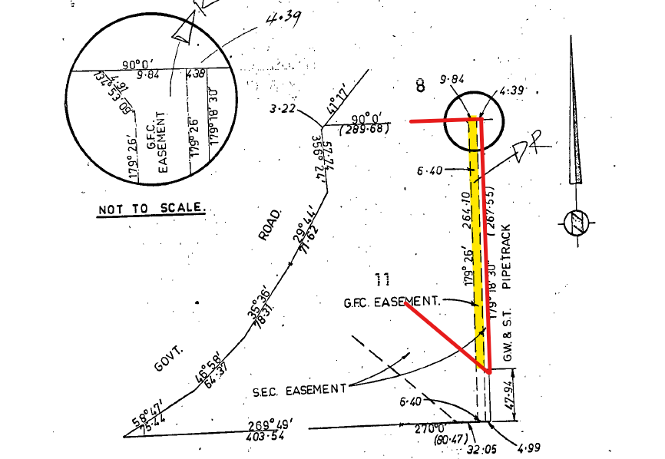
Figure 1 (above): Location and extent of gas transmission easement (yellow) in relation to the site boundary (red). Source: Application documents, annotated by Author.
The covenant specifies activities that must not be carried out within the area of the easement (the ‘servient tenement’) by the land owner and their agents or successors without the prior written consent of the Grantee.

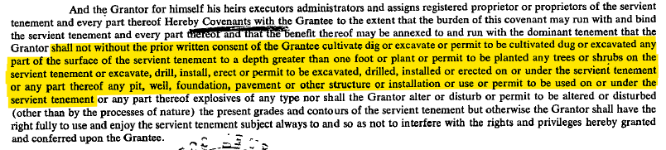
Figure 2 (above): Extract of Covenant F716763 21/11/2001. Source: Application documents, highlighted by Author.
A letter from AusNet Gas Services Pty Ltd dated 21 February 2023, and undersigned by or on behalf of the ‘Property Manager AusNet Services’ was submitted to form part of the permit application on 28/02/2023. AustNet Gas Services is the successor to the Grantor at the time being the former Gas & Fuel Corporation of Victoria. An extract of this letter is shown at Figure 3 below.

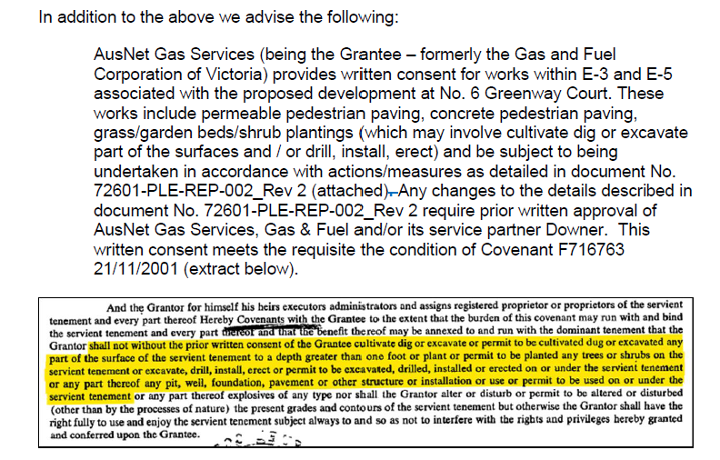
Figure 3: Extract of the letter giving consent to works within the land affected by Covenant F7167763 21/11/2001. Source: Permit Applicant, 28/02/2023.
It is considered this letter gives consent to the proposed development in accordance with the consent requirements of the restrictive covenant such that no breach of the covenant will occur were a permit to be granted.

OFFICER DIRECT OR INDIRECT INTEREST:

No officer involved in the preparation of this report declared a general or material conflict of interest.

SITE/LOCALITY:

The subject site comprises 2 parcels of land with a combined area of 16,849 sq/m at the south end of Greenway Court in Wandana Heights. The 2 parcels combine to form a triangular shaped site that is bisected by a 6 m wide strip of land in Reserve comprising 443 sq/m vested with Barwon Water.

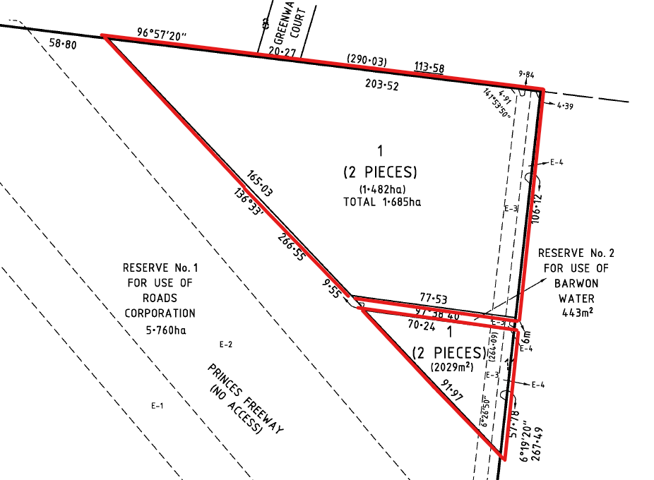
Figure 4 (above): Extract of title plan annotated to generally highlight the geometry and boundaries of the site. Source: Application documents, annotated by Author.
The larger north parcel comprises 14,820 sq/m with a 20.27m frontage to Greenway Court. The irregular shaped parcel has a 203.52 north boundary, 106.12 m east boundary, 77.53 m south boundary, and 165.03 south west boundary. The smaller south parcel comprises 2,029 sq/m with no abuttal or formalised access to the public road network. This parcel has a north boundary of 70.42 m, east boundary of 57.78 m, and southeast boundary of 91.97 m.
Both parcels are burdened by easements along the full length of the east site boundary. E-4 on the title plan extends to 4.99 m inside the east boundary for electricity purposes. E-3 on the title plan abuts the west side of E4 to a width of 6.4 m for gas transmission pipeline purposes. E3 splays to a width of 9.84m at the north boundary of the site.

The site is located at the southeast edge of Wandana Heights and bordered along the east by the linear ‘Highton Pipe Track Shared Path’ and the western edge of Highton. The southwest of the site is bordered by the Geelong Ring Road reserve and high voltage transmission lines and related easements. Further south of the Ring Road is Waurn Ponds.

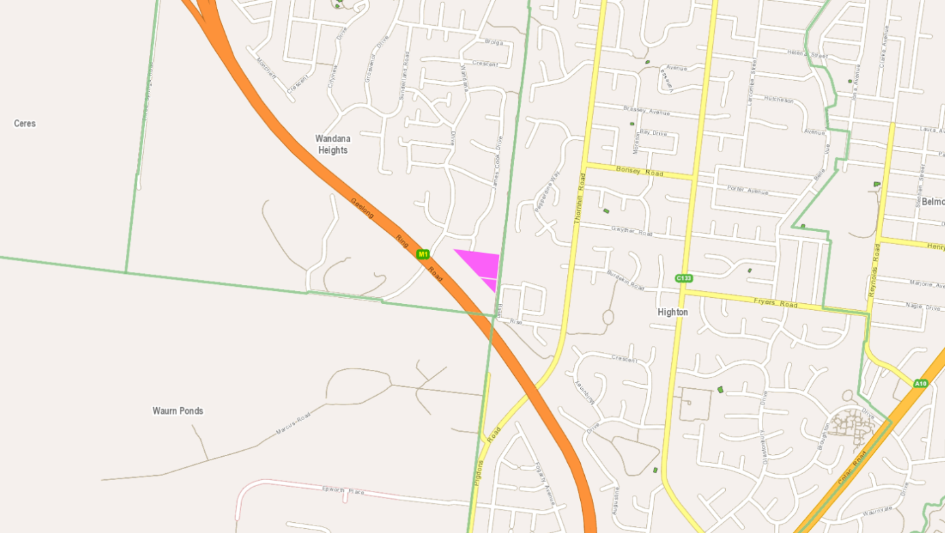
Figure 5 (above): Locality plan showing subject site in purple. Source: PLACES Weave GIS, annotated by Author.

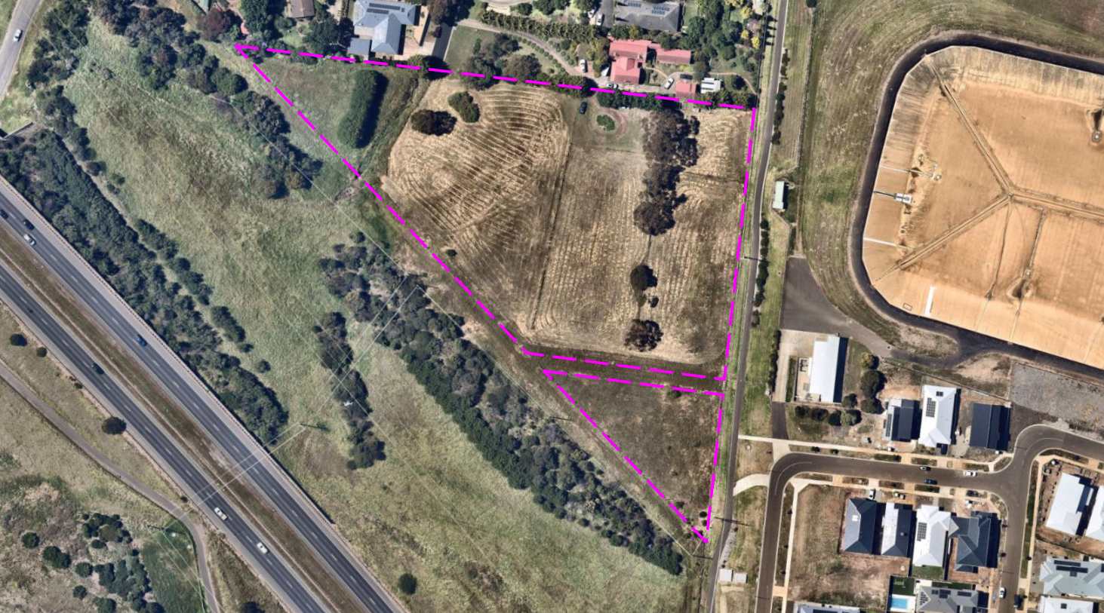
Figure 6 (above): Aerial context photo showing the boundaries of the subject site in purple. Source: PLACES Weave GIS/Nearmap, annotated by Author.

The site, and the adjoining land to the north is within the General Residential Zone (GRZ1). This land, except for the subject site, is used and developed with detached dwellings on lots of between 1,002 and 2,492 sq/m. The land to the east is within the Public Use Zone (PUZ1 – Service & Utility) comprising the publicly accessible Highton Pipe Track Shared Path, and the water authority’s Highton Basin. The land to the south is in the Transport Zone 2 (TRZ2) comprising the Geelong Ring Road reserve.

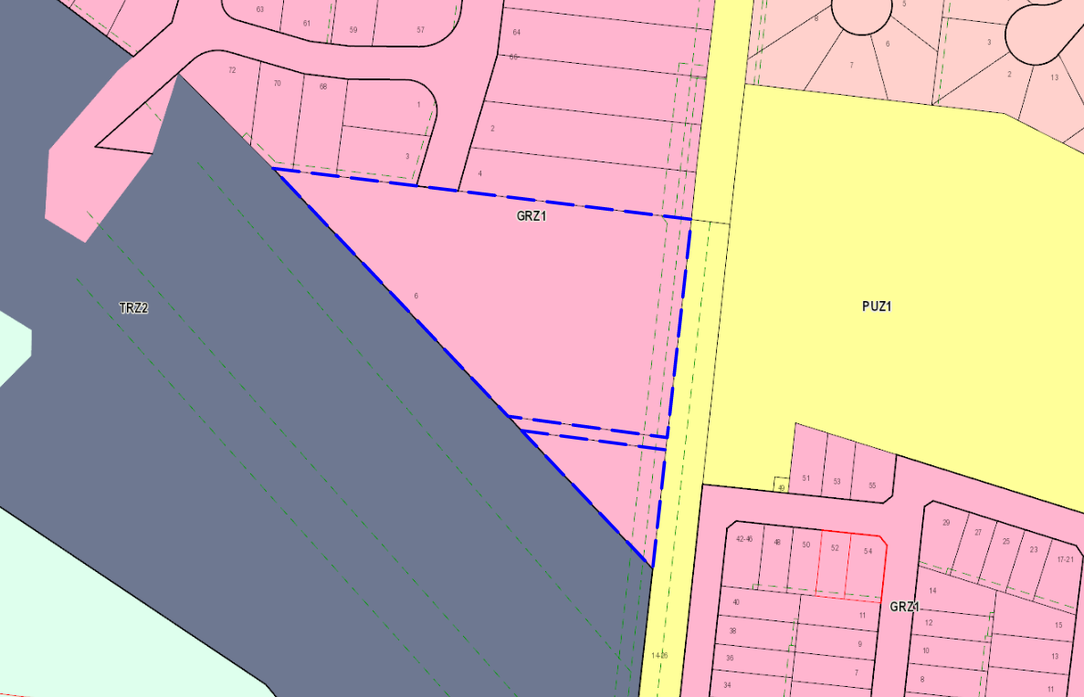
Figure 7 (above): Zone map showing the boundaries of the subject site in blue. Source: PLACES Weave GIS.

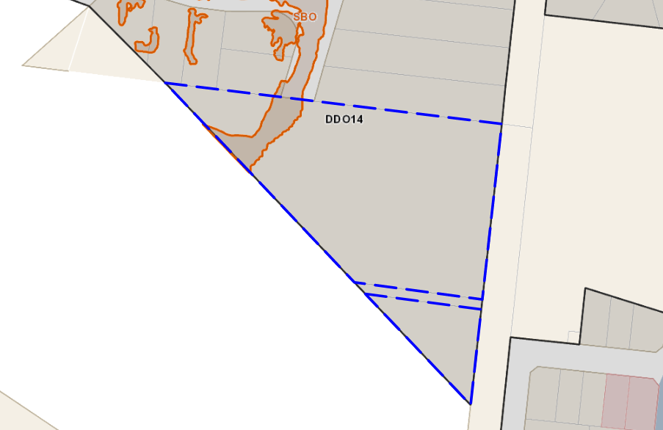
Figure 8 (above): Overlay map showing the boundaries of the subject site in blue. Source: PLACES Weave GIS.

The site is characterised by its sloping topography. From the lowest part of the site at Greenway Court, the land rises 28 metres to the berm of the Highton Basin at the east, and 29 metres to the highest part of the site at its south end. This rise averages 14-15% and slopes 33% at its steepest parts.

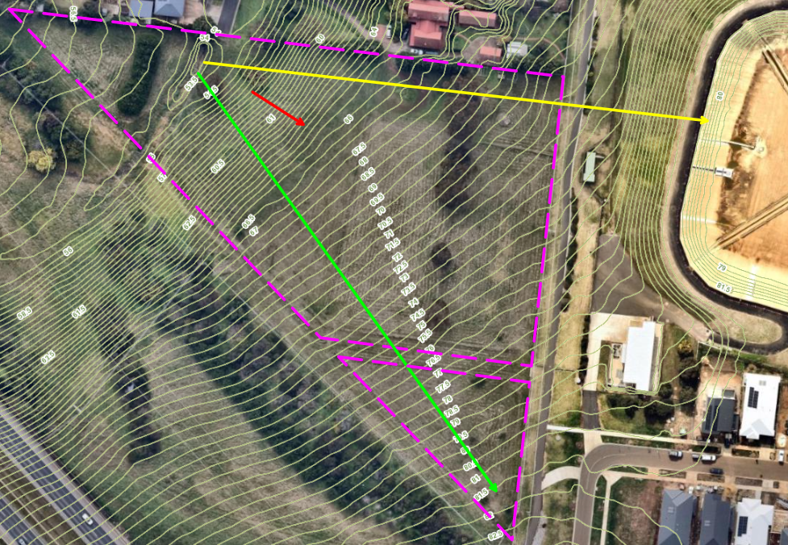
Figure 9 (above): Aerial photo of the site annotated to show 0.5 m contours and the extent of slope from the lowest part of the site to the highest (green arrow), to the top of the water authority berm (yellow arrow) and the steepest slope at 33% (red arrow). Source: PLACES Weave GIS/Nearmap, annotated by Author.

The site features a waterway forming part of the drainage system receiving stormwater from the ring road catchment to the west and south west and flowing through to the underground drainage network to the north in Greenway Court and James Cook Drive.

Vegetation on the site comprises a mix of remnant exotic shrubs and grasses, patches of native grass, and some mature individual trees and planted rows. Rural style post-and-wire fences enclose the site, with some remnant fencing from past livestock keeping on the land present. The east boundary is fenced with a high galvanised woven and barbed wire security fence.

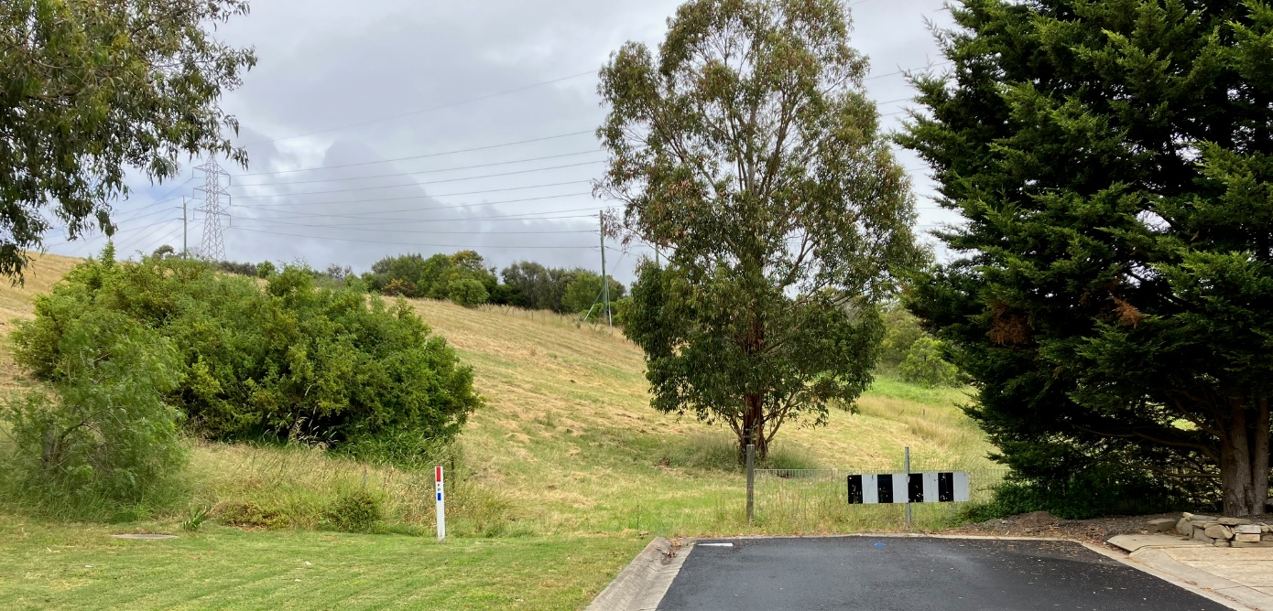
Figure 10 (above): Terrestrial view of the subject site looking south from the end of Greenway Court. Source: Author, 13 December 2022.

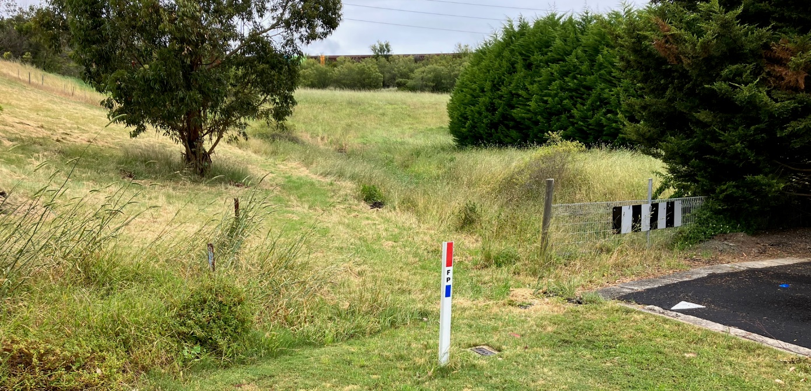
Figure 11 (above): Terrestrial view of the subject site looking southwest from Greenway Court toward the Geelong Ring Road noise wall in the background. Source: Author, 13 December 2022.

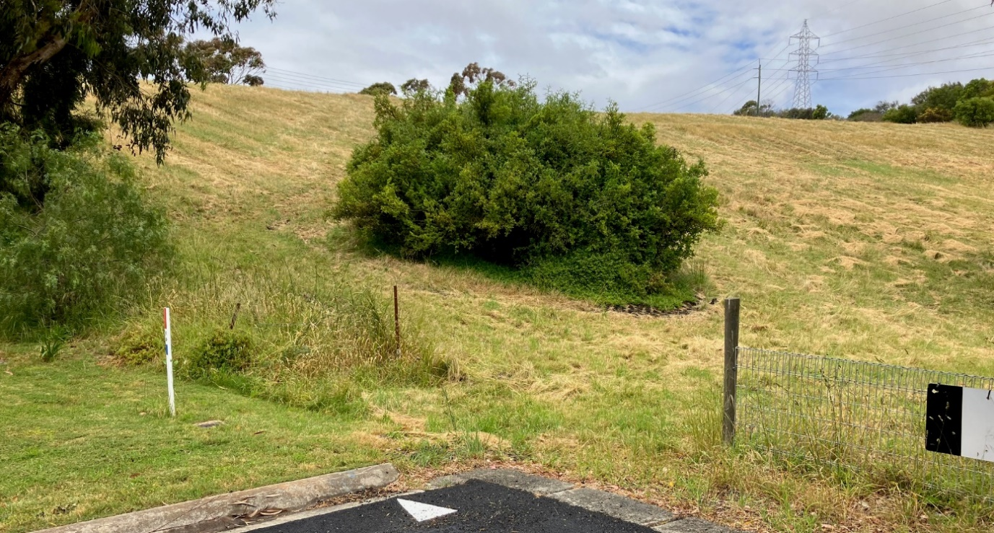
Figure 12 (above): Terrestrial view of the subject site looking southeast from Greenway Court toward the transmission tower and power pole near the top of the site at its south end. Source: Author, 13 December 2022.

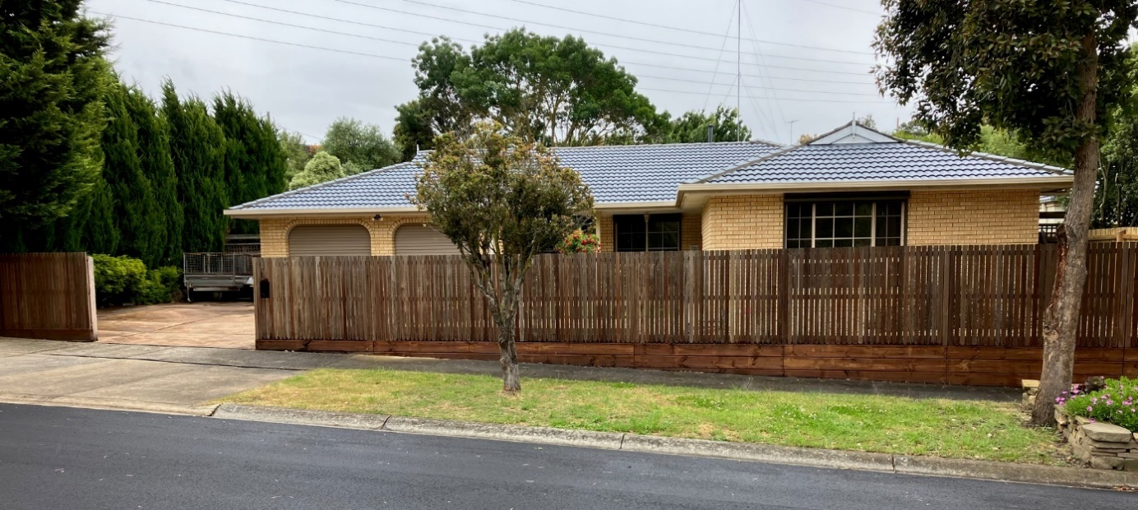
Figure 13 (above): Terrestrial view looking west to the dwelling on adjoining land at 3 Greenway Court. Source: Author, 13 December 2022.

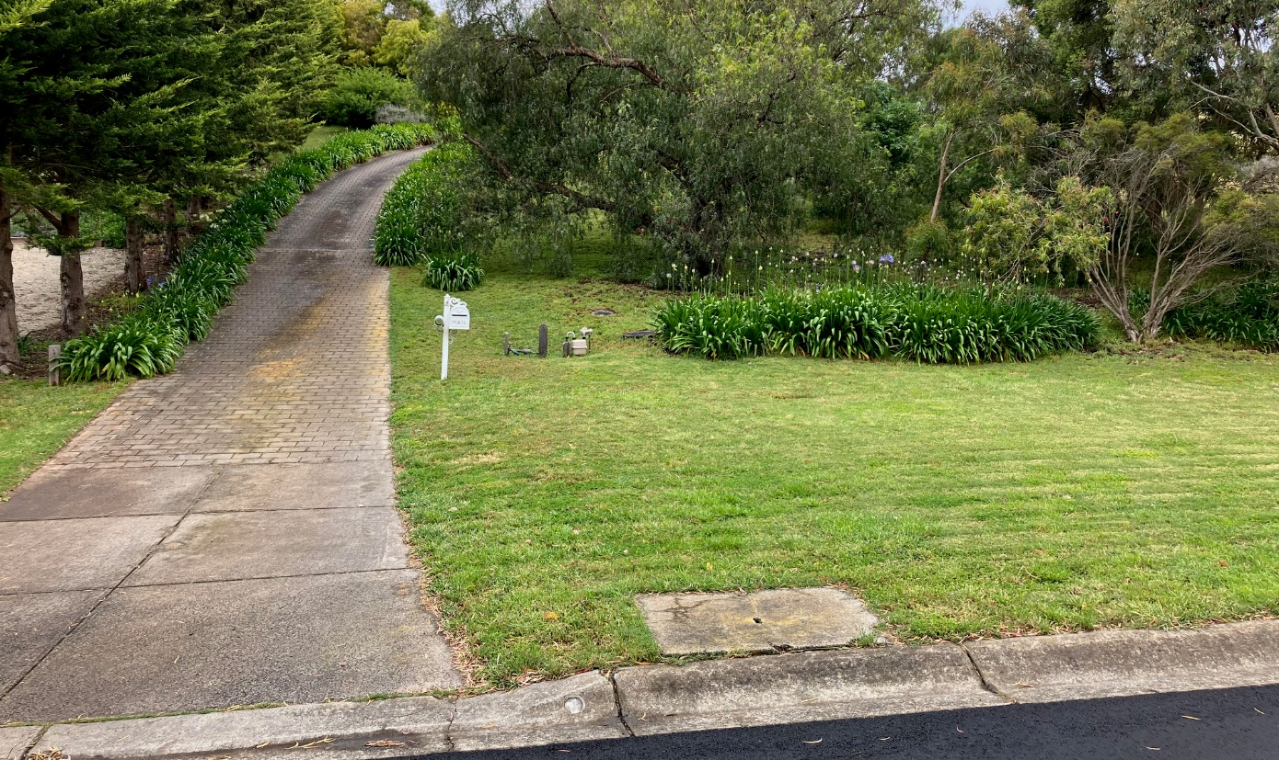
Figure 14 (above): Terrestrial view looking east toward the dwelling on adjoining land at 4 Greenway Court. Source: Author, 13 December 2022.

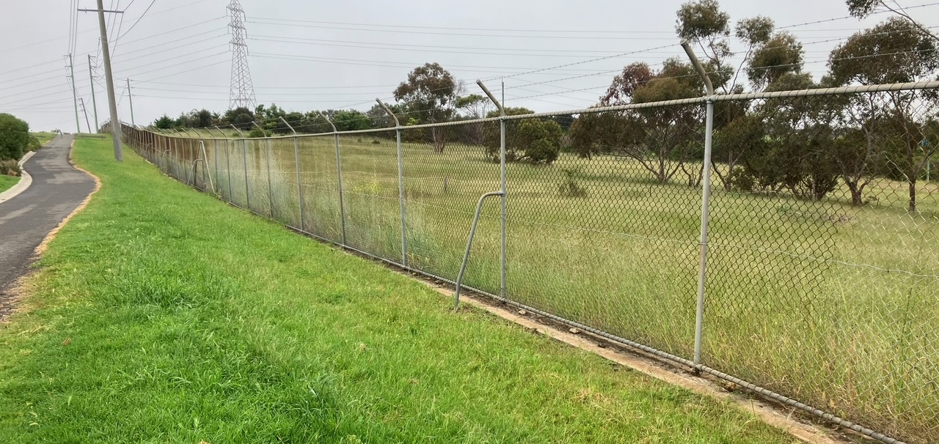
Figure 15 (above): View toward the subject site looking south from the Highton Pipe Track Shared Path adjoining the northeast corner of the site. Source: Author, 11 November 2022.

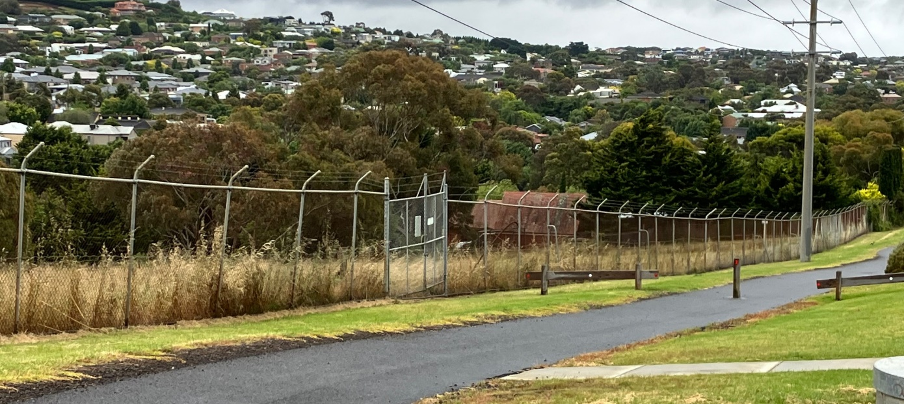
Figure 16 (above): View toward the subject site looking north from Basin Rise toward the security gates at the east end of the Barwon Water reserve that bisects the site. Source: Author, 11 November 2022.

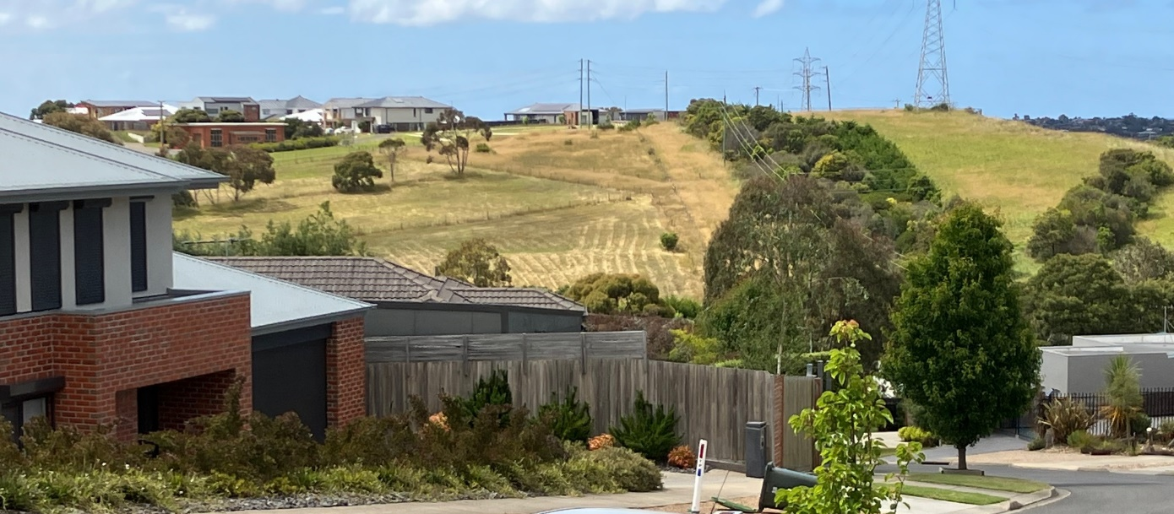
Figure 17 (above): View toward the subject site (centre and left of image) looking southeast from Sunhill Court at a range of 300-400 metres. Source: Author, 16 December 2022.

PROPOSAL:

The application seeks permit approval to allow construction of 58 dwellings including 24 apartments, and removal of native vegetation.

Construction of 58 Dwellings, including 24 apartments

The application proposes the construction of 58 dwellings comprising a mix of 7 single storey 3 bedroom dwellings, 27 double storey 3 bedroom dwellings, and 24 apartments arranged in 12 double storey ‘walk-up’ apartment buildings.

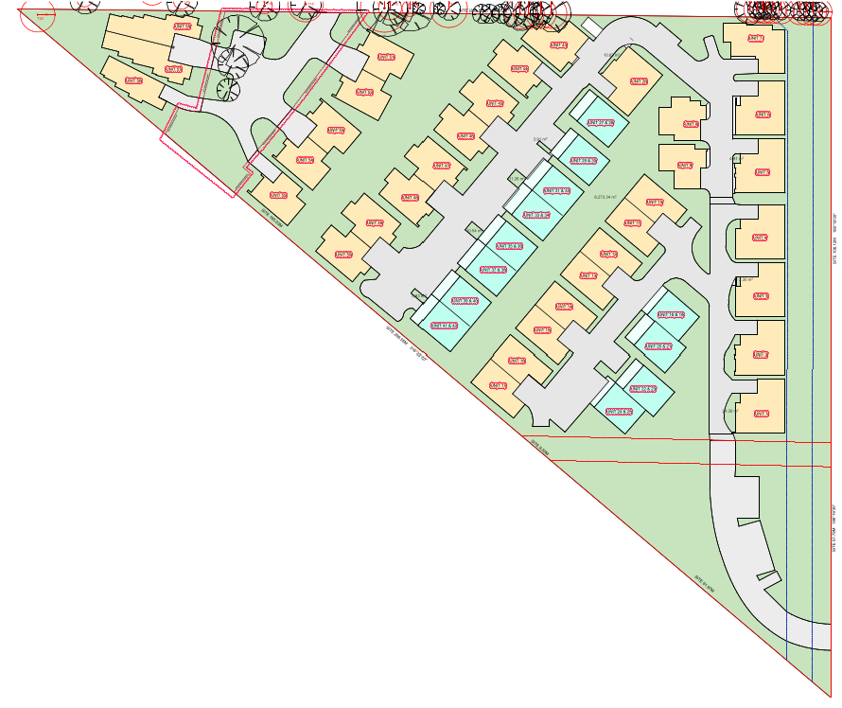
Figure 18 (above): Proposed layout plan showing 3-bedroom dwellings (pale yellow), 2-bedroom apartments (aqua blue), and vehicle accessways from Greenway Court (grey) at the north (top) and Basin Rise at the south east (bottom right). Source: Application documents.
A new private vehicle entrance and accessway to the upper part of the site is proposed from Basin Rise, across the Pipeline Shared Trail and into the top end of the site at its southeast corner. This accessway will traverse land owned by Barwon Water, the gas and electricity easements on the land, and the strip of Barwon Water owned land between the 2 allotments that form the subject site.

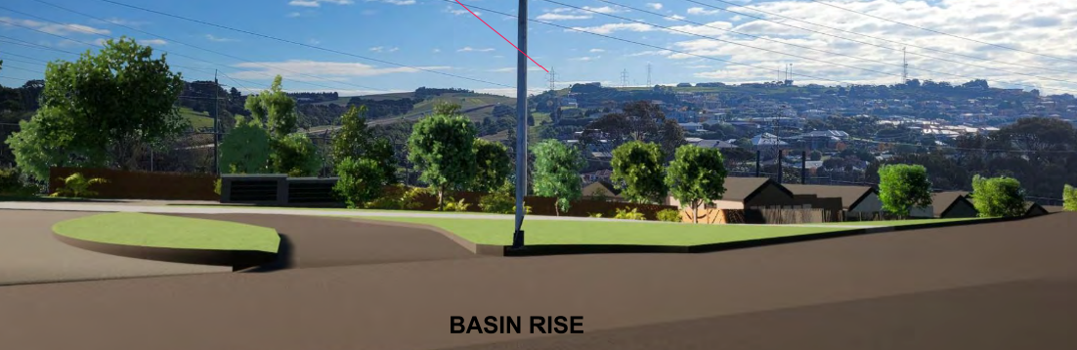
Figure 19: Rendering of new access to the upper part of the site showing views to the northwest from Basin Rise. Source: Application documents.
The upper entrance to the site is proposed to feature a private communal area with recreation facilities, visitor parking, and to be enclosed by a 1.8m high black palisade fence with sliding access gate.

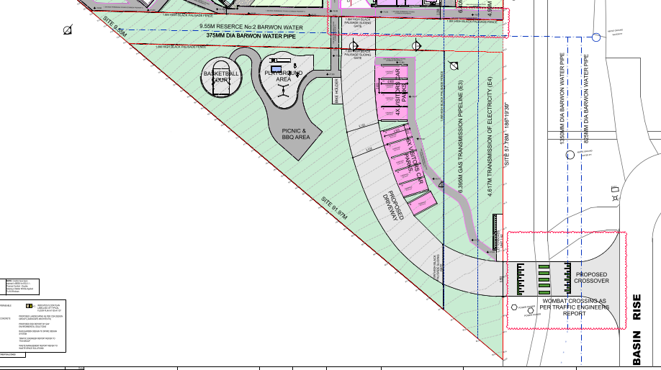
Figure 20: The proposed Basin Rise access to the upper part of the site showing visitor parking and communal recreation facilities. Access from Basin Rise is proposed over land owned by Barwon Water to be constructed with a wombat crossing at the intersection with the pipeline track. Source: Application documents.
The upper site entrance provides vehicle and pedestrian access to 50 of the 58 proposed dwellings.

These include a mix of the following:
- 12 x 2-bedroom ground floor apartment dwellings (Units 18, 21, 22, 25, 27, 30, 31, 34, 35, 38, 39 and 42, Typical Plan F and H)
- 12 x 2-bedroom first floor apartment dwellings (Units 19, 20, 23, 24, 28, 29, 32, 33, 36, 37, 40 and 41, Typical Plan F1 and H1)
- 8 x 3-bedroom single storey detached dwellings (Units 1 to Unit 7 inclusive, Unit 26, Typical Plan A, B and G)
- 3 x 3-bedroom double storey detached dwellings (Units 9, 43, and 44, Typical Plans D, I, and J)
- 14 x 3-bedroom double storey townhouse dwellings (Units 10 to 17, 45 to 50 inclusive, Typical Plans E and K)
- 1 x 4-bedroom double storey detached dwelling (Unit 8, Typical Plan C)

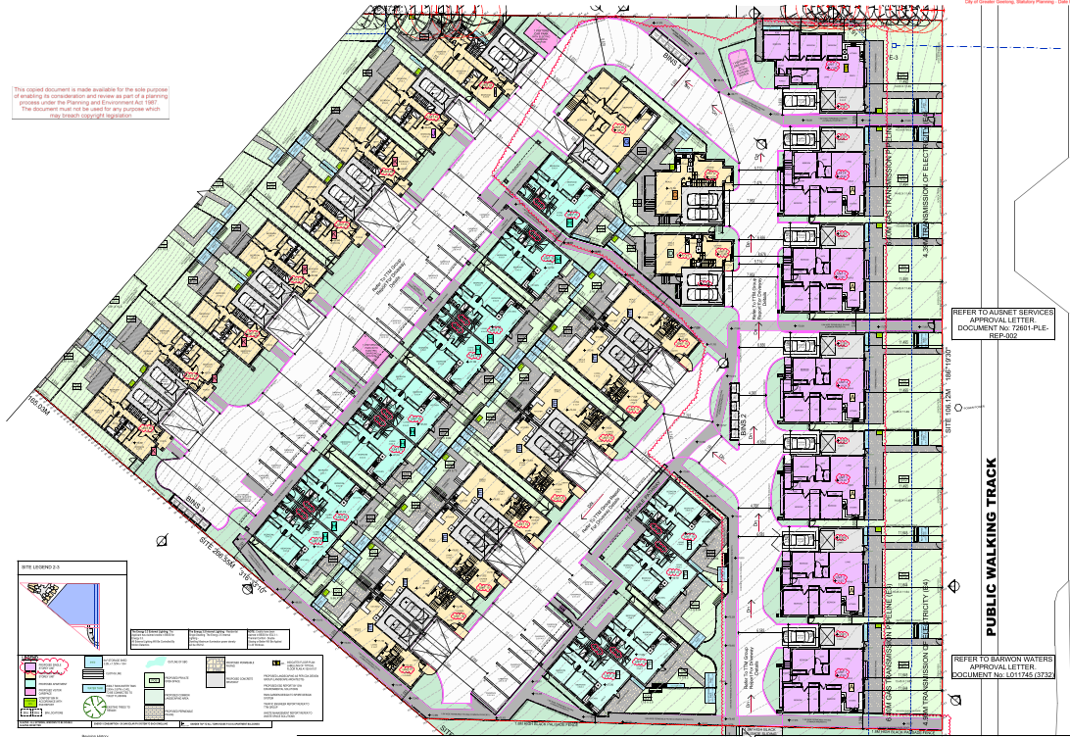
Figure 21 (above): Part site and ground floor layout of dwellings accessed from the upper entrance to the site from Basin Rise. Source: Application documents.

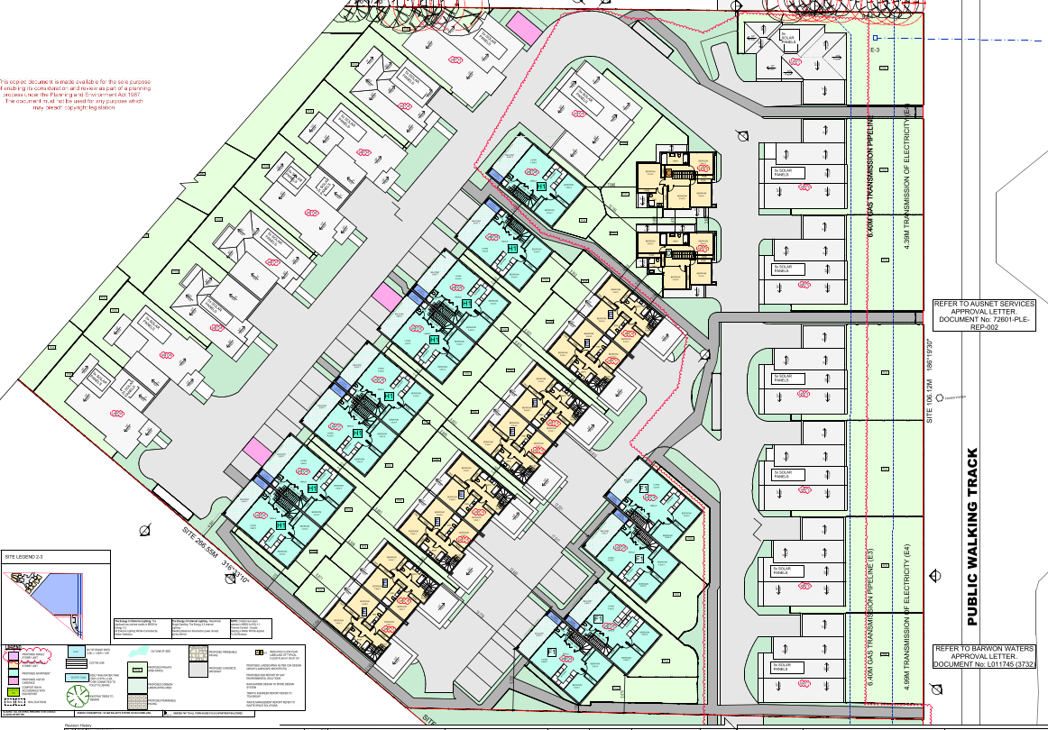
Figure 22: Part site and upper floor layout of dwellings accessed from the upper entrance to the site from Basin Rise. Upper floor plans for Units 43 to 50 (inclusive) are shown at Figure 26 later. Source: Application documents.

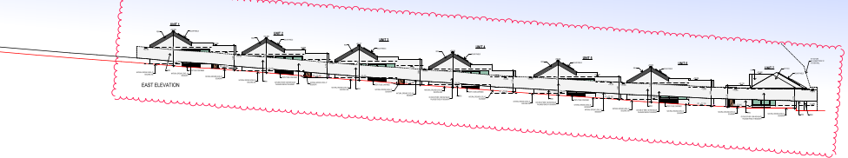
Figure 23: Proposed east site elevation showing the extent of building form presenting to the pipeline track. Source: Application document.
A new road extension to Greenway Court is also proposed to provide vehicle access to 8 dwellings at the entrance to the site. This part of the proposal includes construction of dwellings and associated works within the area of the Special Building Overlay. The plans submitted propose this court extension to be a public road in the future.

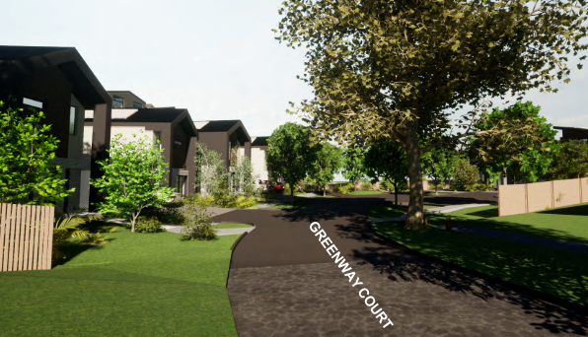
Figure 24: Artist impression of Greenway Court extension and lower entrance to the site. Source: Application documents.

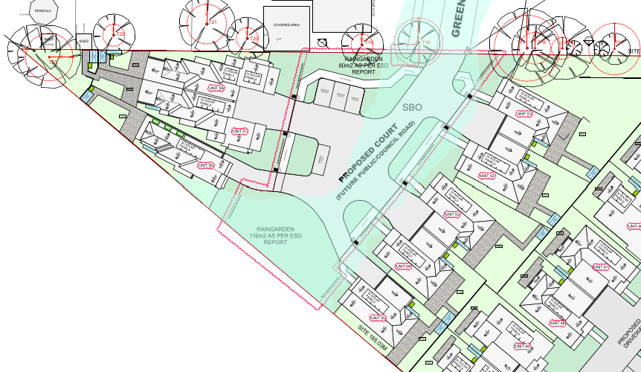
Figure 25: Site layout plan showing entrance to the lower part of the site from Greenway Court. Source: Application documents.
The Greenway Court (lower) site entrance provides vehicle and pedestrian access to 8 of the 58 proposed dwellings. These include a mix of the following:

- 5 x 3-bedroom reverse-living double storey townhouses (Unit 51 to Unit 55 inclusive, Typical Plan L)
- 1 x 3-bedroom double storey detached dwelling (Unit 56, Typical Plan M)
- 2 x 4-bedroom double storey townhouse dwellings (Units 57 and 58, Typical Plan N)

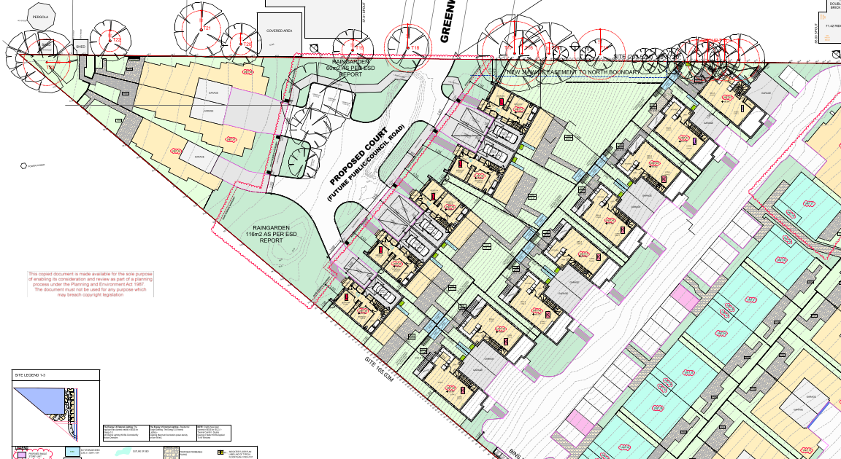
Figure 26 (above): Part site and ground floor layout of dwellings accessed from the lower entrance to the site from Greenway Court. The upper floor plans of Dwellings 43 to 50 are also shown here. Source: Application documents.

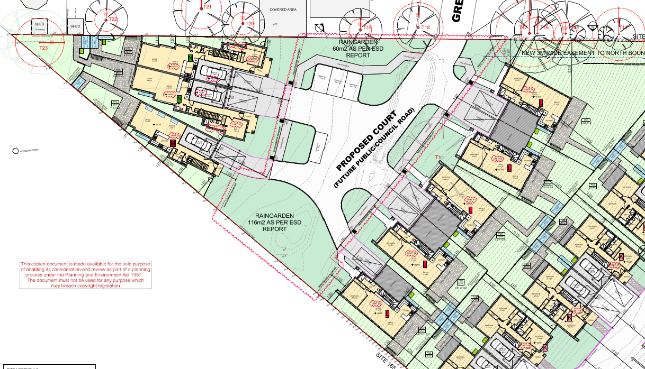
Figure 27 (above): Part site and floor layout plan of dwellings accessed from the lower entrance to the site from Greenway Court. Source: Application documents.

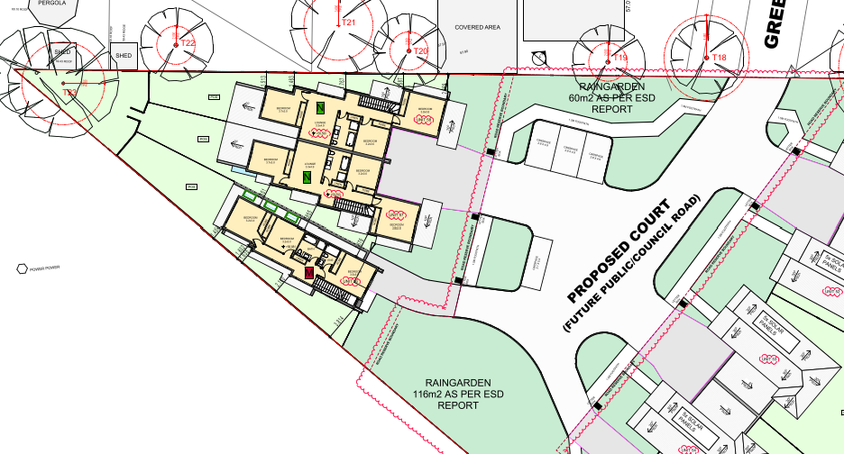
Figure 28 (above): Part site and upper floor plan of dwellings 56-58. Source: Application documents.

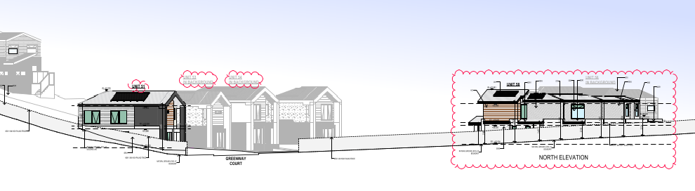
Figure 29 (above): Proposed north site elevation showing the entrance to the site from Greenway Court. Source: Application document.
The application proposes dwelling heights greater than 7.5 metres above natural ground level. Dwellings greater than 7.5m are shown by an asterisk (*) in the maximum building height table below.

Unit No. | Height | Unit No. | Height | Unit No. | Height | Unit No. | Height
1 | 6133 | 13* | 8033 | 31 & 32* | 8081 | 49* | 9154
2 | 6210 | 14* | 8361 | 33 & 34* | 8051 | 50* | 9295
3 | 6310 | 15* | 8255 | 35 & 36* | 7886 | 51* | 7974
4 | 6383 | 16* | 8290 | 37 & 38* | 7831 | 52* | 7988
5 | 6394 | 17* | 8142 | 29 & 40* | 7894 | 53* | 8531
6 | 6416 | 18 & 19* | 8149 | 41 & 42* | 7837 | 54* | 8218
7 | 6882 | 20 & 21* | 7731 | 43 | 6513 | 55* | 8563
8* | 9372 | 22 & 23* | 7625 | 44 | 7068 | 56 | 7465
9* | 8690 | 24 & 25* | 7841 | 45 | 7332 | 57 | 7046
10* | 8350 | 26 | 7033 | 46* | 7897 | 58 | 7045
11* | 8269 | 27 & 28* | 8152 | 47* | 7563
12* | 8132 | 29 & 30* | 7972 | 48* | 7533

Removal of native vegetation

The application proposes the removal of scattered native spear grasses from the site. No other native vegetation occurs on the site that requires planning permit approval.

PERMIT/SITE HISTORY:

There have been no previous planning permits approved for the subject site.
A planning permit application PP-1093-2017 was received on 17 October 2017 seeking approval for a multi lot subdivision. The application was withdrawn on 30 July 2021.

REFERRALS:

The following referrals were undertaken:

SECTION 55:

DETERMINING AUTHORITY

Authority: | Electricity transmission authority (AusNet Transmission Group)
Response: | Received via email on 31/05/2022:  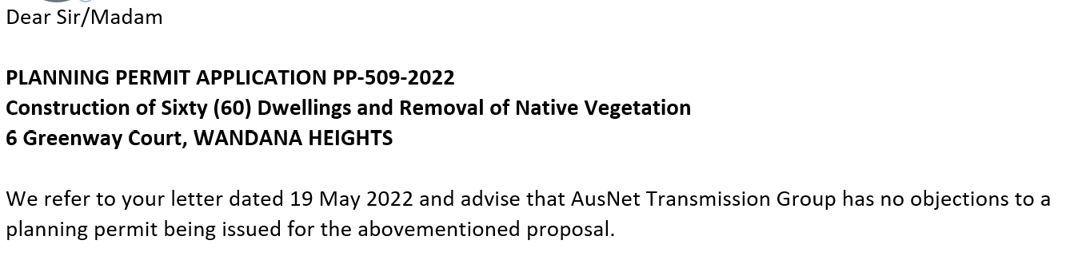
Officer Comment:
The application to construct a building or construct or carry out works on land within 60 metres of a major electricity transmission line (220 Kilovolts or more) or an electricity transmission easement was referred to the relevant electricity transmission authority in accordance with Clause 66.02-4 of the Scheme.
The relevant electricity transmission authority has no objection and no conditions to the grant of a permit.

Authority: | Head, Transport for Victoria
Response: | Non received
Officer Comment:
The application to construct a building or to construct or carry out works for a residential development comprising 60 or more dwellings was referred to the Head, Transport for Victoria in accordance with Clause 66.02-11 (Land use and transport integration) of the Scheme.
No response was received from the Head, Transport for Victoria.
Refer to comments in response to notice of the application given to the Department of Transport later in these recommendations, for which the Head, Transport for Victoria did provide a response.

RECOMMENDING AUTHORITY

Authority: | Floodplain Management Authority
Response: | Response received on 03/04/2023:  A memorandum of understanding (MOU) was entered into between the Corangamite Catchment Management Authority (CCMA) and Greater Geelong City Council in September 2016 for the area of the municipality within the Corangamite Waterway Management District.  As Council is the relevant drainage authority for local drainage and the authority responsible for the flood mapping that forms the basis of the SBO on the Council drainage system, Corangamite Catchment Management Authority will no longer act as a Referral Authority for planning permit applications in areas affected by flooding from the local drainage system.  Engineering Services (as Floodplain Manager) Response  This response is based on the submitted revised Stormwater Management Strategy (D23-96748), amended development plan (D23-75238) and previous referral responses/comments. The revised SMS document has included hydraulic modelling along with an impact assessment of the development on flooding. In general, it shows that the development plan satisfies the SBO conditions previously put forward.  Although the SMS has described the modelling work generally well, it lacks some key information/presentation. They are for example, model schematisation (scheme plan) to show the areas flood-mapped, model boundary conditions, major drainage network, rainfall patterns for critical durations, peak flows (pipe and overland) etc.  Furthermore, the SMS report needs to present the flood map with levels/contours resulted from the pre-developed condition modelling with reference to the SBO extent.  The previous version of the SMS reported the capacity of the downstream 1350 mm diameter pipe (1 in 600 slope) as 2.3 cumec. However, design charts indicate it should be less than 2.0 cumec. As per revised SMS, the peak flow 3.9 cumec implies 2.0 cumec (approx.) will flow overland. It is expected that this much flow would inundate roadway, in contrary to the modelling outcome (below screenshots) showing no overland flow.  It needs to be clarified how the existing drainage system would reduce SBO flood extent. The flooding and flows should be reported with necessary data, hydrographs and long profile. If required, the model is to be revised.  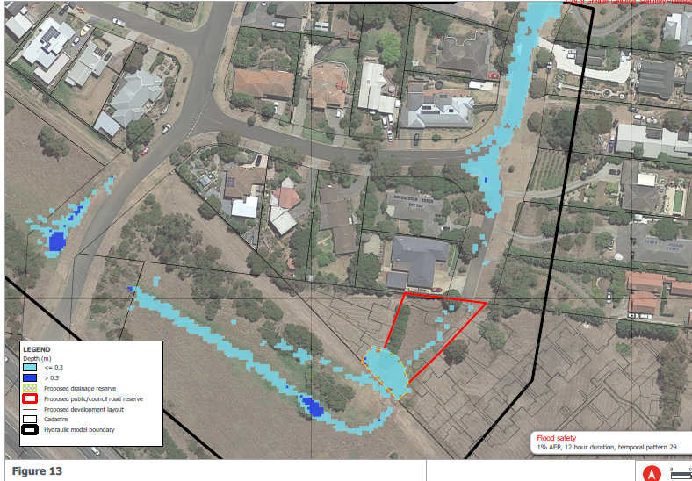  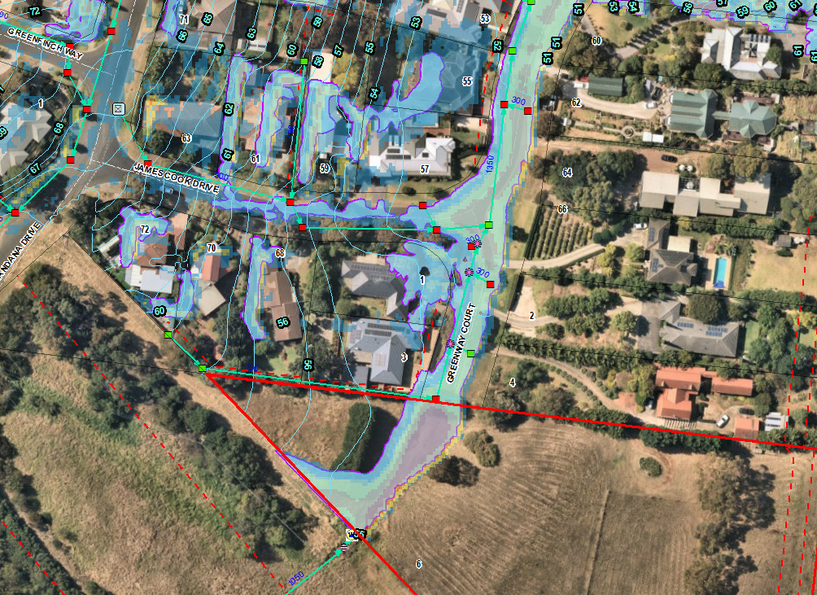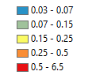  SBO Flood map  Also, the model needs to be re-run for sensitivity test of pipe blockage (1350 mm dia) scenario as per ARR.  Overall, it is promising that the development would not cause adverse impact on flooding. However, the SMS needs to be upgraded with further information and clarifications, for example, in comparison to the existing SBO flood extent, impact of blockage in the main drain passing through the site, flow data etc. They can be done post-permit if that helps.  Pursuant to Section 56 of the Planning and Environment Act 1987 Engineering Services (SBO as Floodplain Manager), does not object to the granting of a permit, subject to the following conditions:  - The Stormwater Management Strategy must be upgraded with further clarifications of the development condition flooding in comparison to the SBO flood extents and flood levels along with necessary flow information – both underground drainage and overland.  - Pipe blockage scenario must be modelled as per Australian Rainfall Runoff (ARR) guidelines to test the sensitivity of any blockage of the main 1350 mm diameter pipe proposed through the site.  - For any flood risk determined from the modelled pipe blockage scenario, the flood depth and/or flow must not be a significant hazard to the properties or their access/egress.  - For any flood risk determined from the modelled pipe blockage scenario, the floor levels must be set at least 300 mm and 150 mm freeboards above the applicable flood levels respectively for the main dwellings and garages.  - Any new fences and gates within flood-prone areas, if found any from the modelled pipe blockage scenario, must have minimum 150 mm ground clearance or 25% opening to 450 mm height from the ground. The minimum clearance above any built/smooth surfaces (eg, paved, concrete, decks etc) is 100mm.  - Any new decks within flood-prone areas, if found any from the modelled pipe blockage scenario, must be non-obstructive to overland flows, that is, unenclosed type to allow passage of flood water underneath.  Notes from Engineering Services (SBO as Floodplain Manager)  A floor should generally be built at least 150 mm above the peripheral ground/finished surface of the building.  Any earth filling should be kept to a minimum on the property to ensure that existing flow paths are not impacted by the proposed works.
Officer Comment:
The recommended conditions are predicated on the submission of an updated Stormwater Management Strategy (SMS) that will include consideration to the requirements of the City’s drainage authority engineers too. Both parties are in agreement that the SMS submitted with the application has demonstrated that the site can be developed generally as proposed, but the SMS and the detailed design for future drainage authority assets within a proposed future road reserve requires further work. Were a permit to be granted, engineer designed drainage and road construction plans will be required to be submitted and approved to accord with a revised SMS all before any construction commences as a condition of permit approval. This allows the developer to work with the drainage authority and future asset manager to achieve compliance with relevant engineering standards in detailed design.

The Floodplain Manager has shown in their response and conditional support for the grant of a permit that they are comfortable that all of this can be achieved via relevant permit conditions were a permit to be granted.

SECTION 52:

Authority: | Australian Pipeline Authority
Response: | Response received on 8/6/2022:  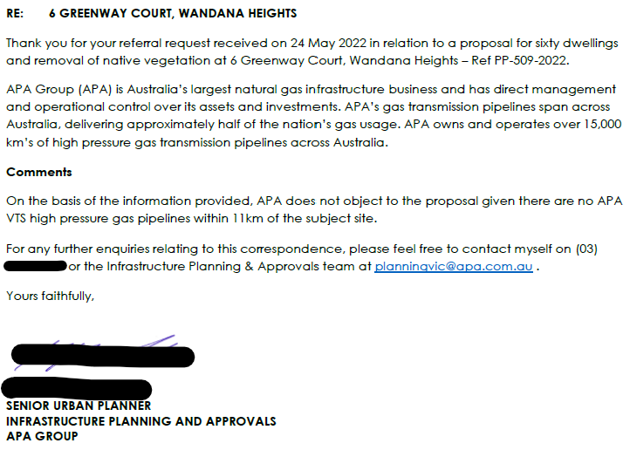
Officer Comment:
Notice of this application for residential development - within the notification zone of the Fyansford to Waurn Ponds gas pipeline corridor (licensed to AusNet Services) - was given to the Australian Pipeline Authority (APA) for consideration of the objectives and strategies of Clause 19.01-3S (Pipeline infrastructure) of the Scheme and in accordance with Section 52(1)(d) of the Act.
No objection and no conditions were recommended by this referral authority.
Further consideration to this matter is given in the Energy Safe Victoria referral response comments later in these recommendations.

Authority: | AusNet (Gas Transmission) Services
Response: | None received
Officer Comment:
Notice of this application for residential development - within the notification zone of the Fyansford to Waurn Ponds gas pipeline corridor (licensed to AusNet Services) - was given to AusNet (Gas Transmission) Services for consideration of the objectives and strategies of Clause 19.01-3S (Pipeline infrastructure) of the Scheme and in accordance with Section 52(1)(d) of the Act.
No response was received.
The application was sent a second time to a contact person at AusNet Services that was nominated by the APA on 8/6/2022. No response to this referral was received either.
Further consideration to this matter is given in the Energy Safe Victoria referral response comments later in these recommendations.

Authority: | Barwon Water
Response: | Response received 21/06/2022:  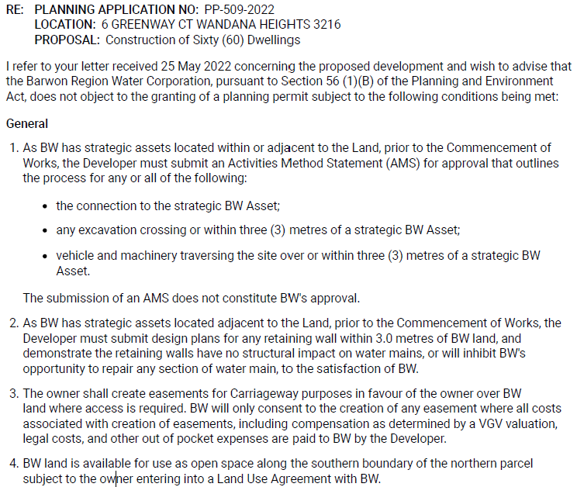  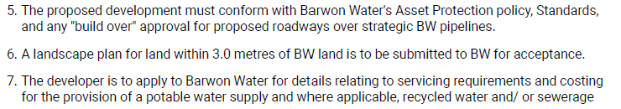  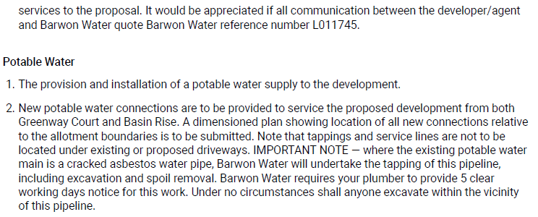  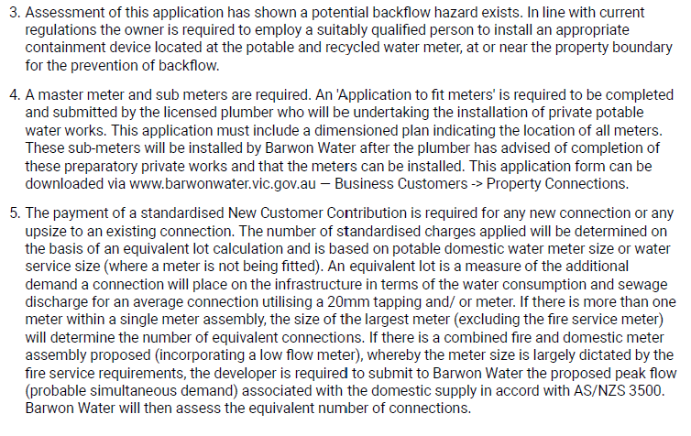  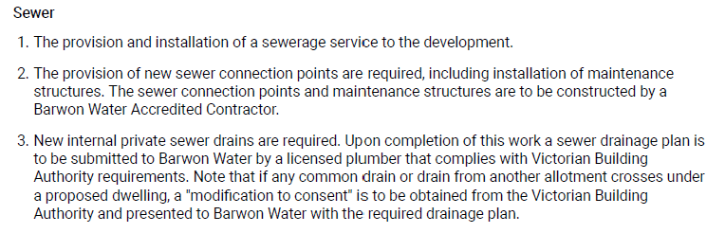
Officer Comment:
Notice of this application for residential development was given to Barwon Water for consideration to the effect of the development on adjoining and nearby Barwon Water land, easements and infrastructure, and in accordance with Section 52(1)(d) of the Act. It is notable that referral of this planning permit application is not required under section 55 of the Act because no subdivision of the land is proposed. Barwon Water is not a recommending or determining referral authority.
The conditions under which Barwon Water do not object to the grant of a permit cover a mix of issues relating to their easements and assets, but also to the future connection to water and sewer services they provide.
The ‘General’ conditions numbered 1-7 address the significant changes brought to the area by the proposal that could affect strategic utility infrastructure located outside the boundaries of the site and existing easements. It is recommended these conditions be included on any permit to be issued to minimise risk to these assets.
It is notable that Barwon Water have not raised any concern regarding infrastructure capacity or connection constraints such that careful consideration should be given in accordance with Clause 55.02-4 (Infrastructure objectives) of the Scheme. To this end, future connections and the matters raised in the ‘Potable Water’ and ‘Sewer’ conditions are not a matter for planning permit approval but are instead dealt with in agreement between the developer and the utility service provider. It is recommended these conditions not be included on any permit that were to be issued, particularly as their General condition 7 invokes a requirement to apply directly to Barwon Water for details pertaining to future connections.
Barwon Water will be provided with a Notice of Decision (NOD) to Grant a Planning permit were the permit application approved. Barwon Water retains a right of review in accordance with Section 82 of the Act.

Authority: | Relevant Fire Authority (Fire Rescue Victoria)
Response: | Response received 15/6/2022:  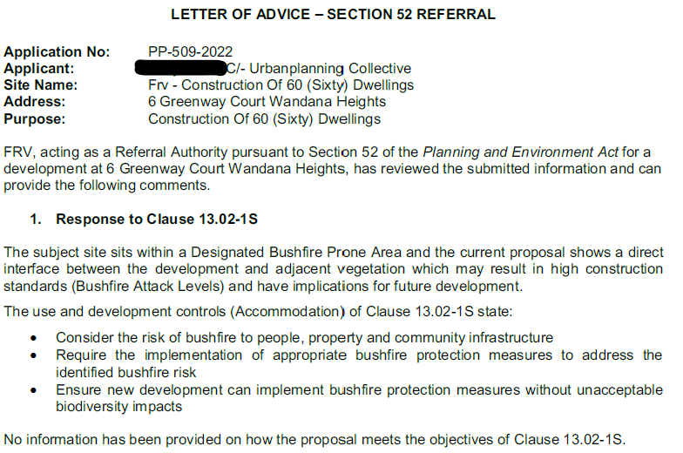  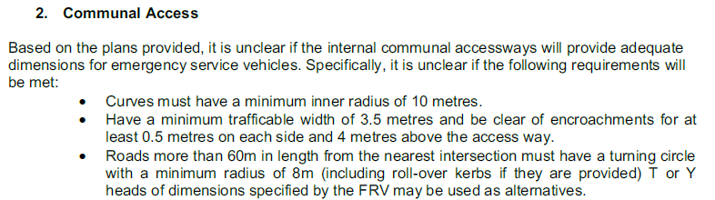  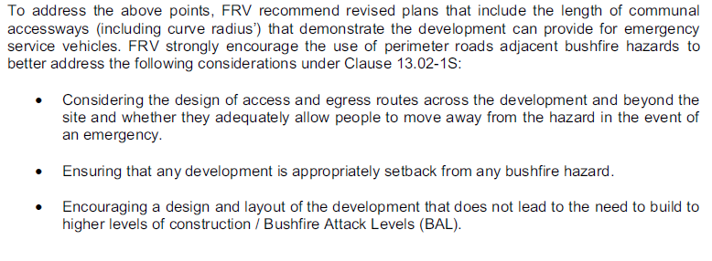  Response received 8/6/2023:  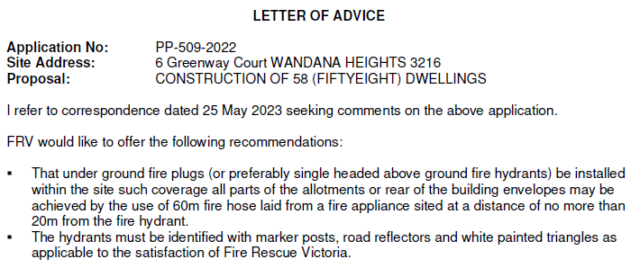
Officer Comment:
Notice of this application for accommodation use and development in a designated Bushfire Prone Area was given to Fire Rescue Victoria for consideration of the objectives and strategies of Clause 13.02-1S (Bushfire planning) of the Scheme and in accordance with Section 52(1)(d) of the Act.
After the response from FRV the application was amended and a written response to Clause 13.02-1S was submitted. The matters raised by FRV were somewhat incorporated into the design response or will be compliance matters to be resolved at building permit stage.
As the land is in a designated Bushfire Prone Area (BPA), specific construction requirements must be met to achieve the required Bushfire Attack Level (BAL) to obtain building approval. The written response, prepared by an experienced registered Building Surveyor, advises that the proposal can meet these requirements for approval without any changes to the design response proposed as part of this planning permit application.
The amended application and response to Clause 13.02-1S was re-referred to FRV on 25/05/2023 for further review and comment. FRV responded on 08/06/2023.
It is notable that FRV have not objected to the grant of a permit and have not sought conditions be included on any planning permit that might be issued.
Instead, FRV provided recommendations for the installation of fire plugs and/or hydrants and markers allowing for appliance vehicles to respond to a fire emergency at the site. It is recommended the installation of underground fire plus, hydrants and markers be included as a condition of any permit to be issued, giving effect to the recommendations of FRV.

Authority: | Catchment Management Authority (CCMA)
Response: | Response received 17/6/2022:  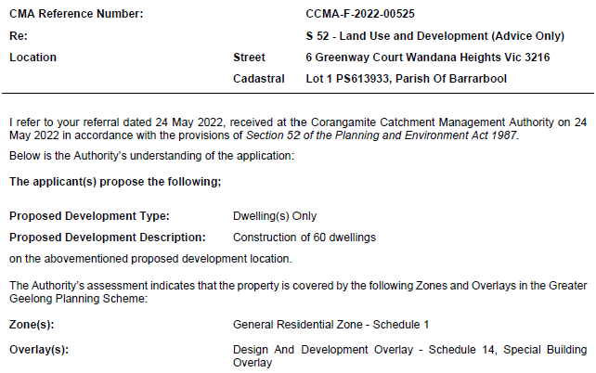  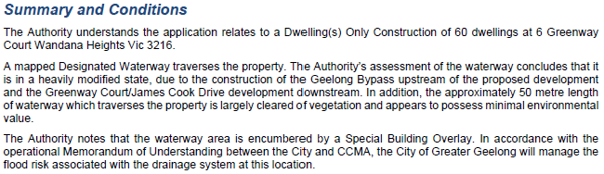  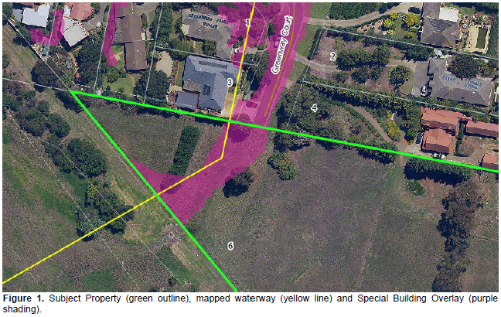
Officer Comment:
Notice of this application to develop land - comprising a designated waterway - was given to the Corangamite Catchment Management (CCMA) for consideration of the objectives and strategies of Clause 12.03 (Water Bodies and Wetlands) and 14.02-1S (Catchment planning and management), and in accordance with Section Authority 52(1)(d) of the Act.
No objection to the grant of a permit, and no conditions have been recommended.
Refer to the comments in response to the Floodplain Management Authority referral earlier in these recommendations, and to Engineering Services (as drainage authority) later in these recommendations.

Authority: | Department of Energy, Environment and Climate Action (previously DJPR)
Response: | None received.
Officer Comment:
Notice of this application to develop land for accommodation - within a mapped extractive industries interest area - was given to the Secretary of the (then) Department of Jobs, Precincts and Regions as the department administering the Mineral Resources (Sustainable Development) Act 1990 in accordance with Clause 66.05 of the Scheme, and Section 52(1)(c) of the Act.
No further action is required were a permit to be issued.

Authority: | Energy Safe Victoria
Response: | Response received 9/6/2022:  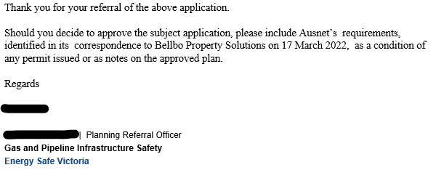  Correspondence to Bellbo Property Solutions from 17 March 2022:  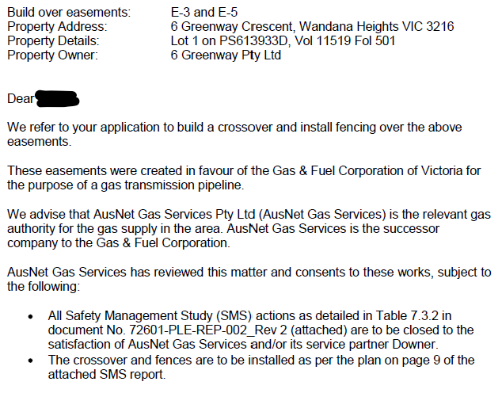  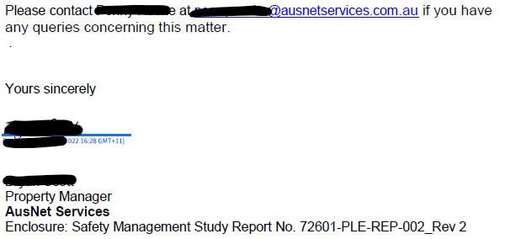
Officer Comment:
Notice of this application for residential development - within the notification zone of the Fyansford to Waurn Ponds gas pipeline corridor (licensed to AusNet Services) - was given to Energy Safe Victoria for consideration of the objectives and strategies of Clause 19.01-3S (Pipeline infrastructure) of the Scheme and in accordance with Section 52(1)(d) of the Act.
The response from Energy Safe Victoria references a letter to the property developer relating to build over easement comments and advice from the gas pipe owner and operator, AusNet Services, that was also submitted as part of the permit application. The letter included an attachment titled ‘Safety Management Study Report’ (OPG Group, 27th Jan. 2021) which included compliance matters relating to the build over easement consent.
It is considered that the design, construction and maintenance requirements for buildings and works within the relevant easement are matters to be agreed between the landowner and easement beneficiary and not within the purview of the relevant planning authority to administer or enforce.
Were a permit to be issued, it is recommended that a condition require plans submitted for approval include an annotation to say that all buildings and works be carried out in accordance with AusNet Gas Services requirements.

Authority: | Department of Transport (previously VicRoads)
Response: | Response received 27/06/2022:  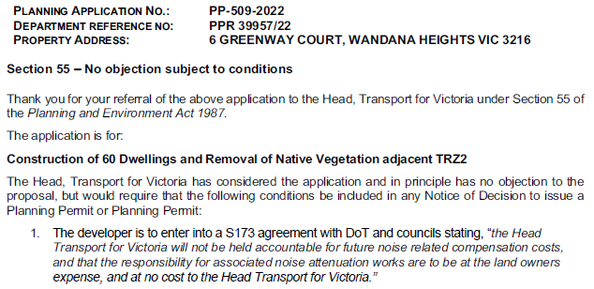
Officer Comment:
Notice of this application to develop land adjoining the Geelong Ring Road was given to the Department of Transport for consideration of the objectives and strategies of Clause 18.02 (Movement networks), and in accordance with Section Authority 52(1)(d) of the Act.
Were a permit to be issued, it is recommended that a version of the condition be included. The condition should be altered to include reference to when the agreement should be executed (i.e.. prior to occupation) and other matters normally prescribed in conditions of this type:
Prior to the occupation of the development and unless otherwise agreed in writing by the responsible authority, the owner of the land must enter into an agreement with the responsible authority and the Department of Transport, pursuant to Section 173 of the Planning and Environment Act 1987. The owner of the land is responsible for the cost of the preparation and registration of the agreement, including the costs (including legal expenses) incidental to the preparation, registration, and enforcement of the agreement.
The agreement must contain covenants to be registered on the title of the property so as to run with the land, and must provide for the following:

- The Head Transport for Victoria will not be held accountable for future noise related compensation costs, and that the responsibility for associated noise attenuation works are to be at the land owners expense, and at no cost to the Head Transport for Victoria.

The agreement will be registered on Title in accordance with Section 181 of the Planning and Environment Act 1987.

INTERNAL

Department: | Engineering Services
Response: | Response to Amended Application on 27/3/2023:  Request for Further Information  Traffic Engineering comments  I have raised the issue that this application has created where access from Basin Rise for the townhouses on the top level of the site results in a problem where Basin Rise sits in Highton and the townhouse sits in Wandana Heights, as the suburb boundary is the Barwon Water pipe track reserve.  In discussing this with our Properties and Revenue unit, there will have to be a change to the suburb boundary so that the townhouses are located in Highton; the dwellings lots that are accessed from the Greenway Ct extension will remain Wandana Heights.  The fact that there is no subdivision application creates a problem as a suburb boundary cannot be a back fence or retaining wall; it must be a title boundary.  It doesn’t make any sense that there is no subdivision with this application, as the Greenway Ct road reserve has to be created, including the Greenway Ct lots.  The benefit in creating lots with frontage to Greenway Ct is that a title boundary is created demarcating the townhouse and allows a logical suburb boundary.  The plan overleaf shows the location of the proposed suburb boundary at the rear of the Greenway Ct lots. The southern and northern suburb boundary line follows two existing lot boundaries.  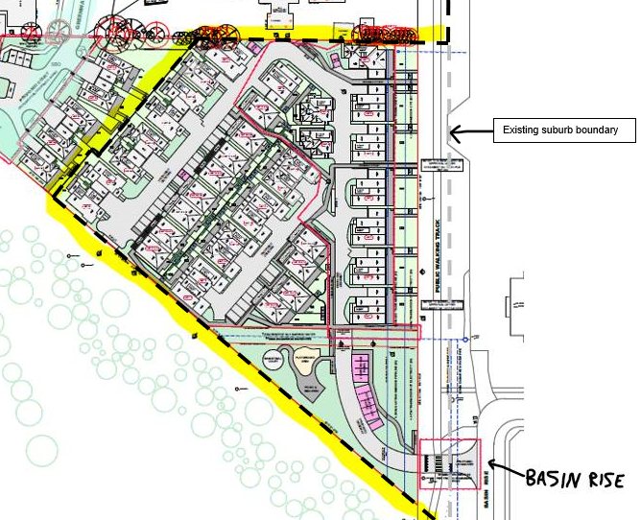  It is proposed that an application for subdivision be made by the applicant immediately after the development permit is issued, and that this Plan of Subdivision be approved prior the commencement of the development. It would be beneficial if this can be a condition of permit for PP-509-2022.  The Plan of Subdivision must include the new road reserve (Greenway Ct extension), the reserve at the end of Greenway Ct, and the lot boundaries of all dwellings with frontage to Greenway Ct.  Basin Rise Access  The proposed access driveway across the Barwon Water reserve will not be a ‘road’, and therefore the proposed ‘wombat crossing’ of the shared path cannot be implemented.  While a solution has not been finalised, measures such as small speed humps on each side of the shared path and warning signs are being considered.  It is proposed that the applicant provides an FLP and includes longitudinal sections of the shared path and access driveway to be assessed and ultimately approved by Development Planning unit prior to the driveway’s construction by way of a permit condition.  Greenway Ct  The proposed extension of Greenway Ct must be confined within a new road reserve that is to be created as part of a Plan of Subdivision.  The applicant must provide a FLP and detailed construction drawings to be assessed and ultimately approved by Development Planning.  Recommended Permit Conditions (Without Prejudice)  Note: please provide conditions whether or not supporting  Condition 1 Amended Plans:  Prior to the commencement of development works lodgment of amended plans must be submitted to and approved by the Responsible Authority. When approved, the plans will be endorsed and will then form part of the permit. The plans must be generally in accordance with the plans submitted with the application but modified to show:  - The continuation of Greenway Court as a road reserve vested to the City of Greater Geelong. The road reserve is to be created via a Plan of Subdivision and vested to Council prior to commencement of the development.  - A drainage reserve at the end of the extended Greenway Court and the lot boundaries fronting Greenway Court created via the Plan of Subdivision creating the extension of Greenway Court.  - All water quality treatment devices are to be located on private property and not within any existing or proposed Council reserves.  - The proposed access driveway across the Barwon Water reserve will not be a ‘road’, and therefore the proposed ‘wombat crossing’ of the shared path cannot be implemented.  Creation of Greenway Court Extension Road and Drainage Reserve  Prior to the commencement of works the Plan of Subdivision must be certified, creating the road and drainage reserve in favour of the City of Greater Geelong to the satisfaction of the Responsible Authority.  Functional Layout Plans  Unless otherwise approved in writing by the Responsible Authority, prior to the commencement of works for the subdivision and the Access off Basin Rise, a detailed Functional Layout Plan is to be submitted and Endorsed by the Responsible Authority. The plan is also to include locations of future bus stops, all Local Area Traffic Management items along with maintenance vehicle access points, maintenance vehicle access tracks, tree protection measures, footpaths and utility installations on or adjacent to public reserves, all to the satisfaction of the Responsible Authority. The Functional Layout Plan must also include documentation that addresses the overall stormwater strategy for the site. This needs to include but is not limited to; the underground drainage system / alignment, and the high-flow or ‘gap-flows’ that occur during a 100yr ARI storm event.  Road Reservation Widths  Prior to commencement of works, and in conjunction with the submission of the Functional Layout Plan, a service plan with cross sections detailing the locations of services, including underground drainage together with other infrastructure within the road reserve, such as paths, street trees, lighting poles etc must be submitted to the Responsible Authority for approval.  Greenway Court Extension Road and Drainage Construction Plans  Unless otherwise approved in writing by the Responsible Authority, prior to the commencement of works for the subdivision creating the extension of Greenway Court and separately the access off Basin Rise, Engineer designed roadworks and drainage construction plans must be submitted to and Endorsed by the Responsible Authority. The plans are to be in accordance with the design standards of the City of Greater Geelong and the Infrastructure Design Manual, with no adverse external impacts, to achieve an acceptable standard of aesthetics (including landscaping) which can be maintained in perpetuity, to the satisfaction of the Responsible Authority.  Site runoff must be limited to equivalent pre-developed levels for rainfall events up to and including the critical 100yr ARI event in accordance with the Drainage and Water Sensitive Urban Design Strategy. The stormwater drainage system on the site must be designed such that stormwater runoff exiting the land meets the current best practice performance objectives for stormwater quality as follows:  - 80% retention of the typical annual load of suspended solids;  - 45% retention of the typical annual load of total phosphorous;  - 45% retention of the typical annual load of total nitrogen; and;  - 70% retention of the typical annual load of gross pollutants.  all to the satisfaction of the Responsible Authority.  Environmental Construction Management Plan (ECMP)  Unless otherwise approved in writing by the Responsible Authority, prior to the commencement of works for the construction of Greenway Court extension, and associated drainage works and the separate access off Basin Rise, an Environmental Construction Management Plan (ECMP) shall be submitted to and Endorsed by the Responsible Authority. When Endorsed, all conditions on the ECMP will form part of the permit. The plan must address, but not be limited to, the following:  - Hours of works, demolition or construction;  - Methods to contain dirt and mud within the site, and the method and frequency of clean up procedures;  - On site facilities for vehicle washing;  - Methods used with regards to Dust suppression which may include but not limited to the following:  - Water truck to be retained on site at all times;  - Soil stockpiles to be retained on site must be seeded or provide a treatment to provide a crusted surface;  - Cease all works on site during high wind incidences;  - Vehicle/truck movements to be limited to a reduced speed to prevent dust emissions;  - Dust suppression measures including fencing in locations to existing dwelling;  - The protection measures for site features to be retained (e.g. vegetation, retaining walls, buildings, other structures and pathways, etc.);  - Delivery and unloading points and expected frequency;  - A liaison personnel for contact by residents and the Responsible Authority in the event of relevant queries or problems experienced;  - The movement of construction vehicles to and from the site must be regulated to ensure that no traffic hazards are created in and around the site;  - Parking facilities for construction workers;  - Measures to minimise the impact of construction vehicles arriving at / departing from the land;  - An outline of requests to occupy public footpaths or roads, and anticipated disruptions to local services;  - The processes to be adopted for the separation, re-use and recycling of demolition materials;  - The measures for prevention of the unintended movement of building waste and hazardous materials and other pollutants on or off the site, whether by air, water or other means;  - Any other measures that are consistent with the following Environmental Protection Authority publications: ‘Environmental Management Guidelines for Major Construction Sites’, ‘Construction Techniques for Sediment and Pollution Control’ and ‘Doing it Right on Subdivisions’;  - Handling, tracking and testing of all imported fill;  - Measures to be taken to ensure that no polluted water and/or sediment laden runoff is to be discharged directly or indirectly into stormwater drains or watercourses during the construction period; and;  - Methodology detailing how service vehicles (ie; Council Garbage Trucks) will be catered for during all stages of construction, including the removal of temporary turn around areas; and;  - Any other condition as required by the Responsible Authority that addresses any other issues i.e. location of earth mound / soil stockpiles, rumble grids, construction of and materials used for all whether access roads up to 30 meters on entry and exit to the site entry.  Once the Environmental Construction Management Plan (ECMP) has been endorsed by the Responsible Authority under this permit it must be implemented and complied with at all times to the satisfaction of the Responsible Authority unless with the further written approval of the Responsible Authority.  Construction of Offsite Drainage  Unless otherwise approved in writing by the Responsible Authority, prior to the issuing of a Statement of Compliance, offsite drainage must be constructed in accordance with the supporting incorporated drainage documentation. Drainage infrastructure such as pits and pipework, local retardation basins, overland flow paths, water quality treatment trains and stream interface / outlet works (including surcharge pits), must be provided to the satisfaction of the Responsible Authority on relevant land parcels and within appropriate easements / reserves in favour of the City of Greater Geelong and in accordance with the Stormwater Management Strategy as approved by the Responsible Authority.  Construction of Roadworks / Drainage  Unless otherwise approved in writing by the Responsible Authority, prior to the issuing of a Statement of Compliance for the extension of Greenway Court, roadworks and drainage must be constructed in accordance with the Endorsed plans and specifications to the satisfaction of the Responsible Authority.  Engineering Fees and Bonds  The design and construction of stormwater drainage connections and any new Council infrastructure needs to be approved and supervised by the Responsible Authority. Unless otherwise approved in writing by the Responsible Authority, prior to the issue of a Statement of Compliance for the Plan of Subdivision creating the extension of Greenway Court, a fee of 3.25% of the cost of the works must be paid to the Responsible Authority for the checking and supervision of these works. A maintenance bond of 5% of the cost of the works is to be paid to Council and will be returned after successful completion of a one (1) year maintenance period, all to the satisfaction of the Responsible Authority.  Street Names and Signs  Unless otherwise approved in writing by the Responsible Authority, prior to the issuing of a Statement of Compliance for the Plan of Subdivision creating the extension of Greenway Court, the subdivider must provide and place all relevant street signs to the satisfaction of the Responsible Authority.  Street Lighting  Unless otherwise approved in writing by the Responsible Authority, prior to the issuing of a Statement of Compliance for the Plan of Subdivision creating the extension of Greenway Court, street lighting is to be provided within and abutting the subdivision to the satisfaction of the Responsible Authority and at the full cost of the subdivider.  Redundant Crossovers  Unless otherwise approved in writing by the Responsible Authority, prior to the issuing of a Statement of Compliance for the Plan of Subdivision creating the extension of Greenway Court, any vehicular crossovers which are redundant as a result of this subdivision shall be removed, and the kerb and channel, footpath and naturestrip shall be reinstated as required, at the expense of the developer and to the satisfaction of the Responsible Authority.  Council Assets  Unless otherwise approved in writing by the Responsible Authority, prior to the issuing of a Statement of Compliance for the Plan of Subdivision creating Greenway Court, repair and reinstatement necessitated by any damage to Council assets caused by or as a result of the subdivision construction is required to be carried out at the developer’s expense to the satisfaction of the Responsible Authority.  CAD Drawings  Unless otherwise approved in writing by the Responsible Authority, CAD (MGA Zone 55) versions of any Endorsed plans must be submitted to the Responsible Authority prior to the commencement of works. The provided 3D CAD model must satisfy the requirements of Council’s Assets Unit.  NOTE  A pre-commencement meeting with Council’s engineering department is required to be undertaken prior to works starting within a Council reserve. To organise this meeting please contact 5272 4426  Response to Discussion Plans 13/7/2023:  …engineering request the access from Basin Rise over the Barwon Water owned land (14-26 Basin Rise) to be an accessway and not a road vested to council.  See requested changes to the draft conditions provided below.  Functional Layout Plan  2. See conditions provided by traffic below  Road and Drainage Construction Plans  4. Unless otherwise approved in writing by the responsible authority and prior to the commencement of works, engineer designed roadworks and drainage construction plans for the continuation of Greenway Court and the road any accessway connections to Basin Rise must be submitted to and approved by the responsible authority. When approved, the plans will be endorsed and will then form part of the permit.  The plans are to be in accordance with the design standards of the City of Greater Geelong and the Infrastructure Design Manual, with no adverse external impacts, to achieve an acceptable standard of aesthetics (including landscaping) which can be maintained in perpetuity, to the satisfaction of the responsible authority.  Site runoff must be limited to equivalent pre-developed levels for rainfall events up to and including the critical 100yr ARI event in accordance with the Drainage and Water Sensitive Urban Design Strategy. The stormwater drainage system on the site must be designed such that stormwater runoff exiting the land meets the current best practice performance objectives for stormwater quality as follows:  ● 80% retention of the typical annual load of suspended solids;  ● 45% retention of the typical annual load of total phosphorous;  ● 45% retention of the typical annual load of total nitrogen; and;  ● 70% retention of the typical annual load of gross pollutants.  all to the satisfaction of the responsible authority.  CREATION OF RESERVES  11. Condition removed  Engineering is otherwise satisfied with the draft conditions provided:  Traffic Engineering comments  It is recommended that there be separate conditions for Functional Layout Plans for the extension of Greenway Court and the Barwon Water reserve to contain a carriageway easement.  [Engineering Services] provided a draft FLP condition on 8 June 2023, and the following conditions are now site specific and expanded on:  Proposed conditions  Functional Layout Plan – Greenway Court extension  Unless otherwise approved in writing by the Responsible Authority and prior to the commencement of works, a detailed Functional Layout Plan (FLP) for the extension of Greenway Court within a new road reserve is to be submitted to and approved by the Responsible Authority. When approved, the FLP will be endorsed and will then form part of the permit.  The FLP is to include, but not be limited to:  - Extend the existing 20.0 m road reserve from the existing Greenway Court with a minimum 5.5 m wide sealed road pavement (measured between the Face of Kerbs) and provision of a ‘half’ T-head that is designed to accommodate turning movements of a Dennis Eagle 6 x 4 waste vehicle.  - Provision of vehicle crossings to council standard for each lot (maximum one vehicle crossing per lot).  - Provision of footpaths in front of all lots and provision of a pram crossing to provide a link to the existing Greenway Court footpath.  - Potential provision of indented on-street car spaces and bin pads.  - Underground drainage connection via a minimum 1350 mm diameter stormwater drain from the existing 1350 mm diameter stormwater drain to the existing 1050 mm diameter stormwater drain at the site’s southern boundary.  - Demonstrate where all services, drainage pits, etc can fit within the new road reserve.  Functional Layout Plan – private access driveway from Basin Rise  Unless otherwise approved in writing by the Responsible Authority and prior to the commencement of works, a detailed Functional Layout Plan (FLP) for the new accessway connection to Basin Rise is to be submitted to and approved by the Responsible Authority. When approved, the FLP will be endorsed and will then form part of the permit.  The FLP is to include, but not be limited to:  - The width of the proposed carriageway easement across the Barwon Water reserve.  - The location and dimensions of the concrete vehicle crossing in Basin Rise. The vehicle crossing must be designed to accommodate the swept path and gross mass of the largest expected vehicle.  - Notation showing the existing maintenance vehicle crossing to be removed.  - Details of the construction of a new concrete shared path to include coloured concrete that will be close to matching the adjoining asphalt construction.  - Details of how the shared path will have priority by use of ‘Give Way’ signage, a raised pavement on the approaches and use of any warning signs. The use of zebra or wombat crossings is not acceptable.  - Details of how pedestrians can access the site from Basin Rise.  - Details of additions to or modification of any existing parking signage and linemarking.  - Demonstrate how any services can be accommodated within the carriageway easement.  - Demonstrate that the text of the site’s address identification (e.g. 30 Basin Rise) to be placed near to or as part of the letterboxes is clearly visible from Basin Rise.
Officer Comment:
Greenway Court Extension (road and drainage construction)
Engineering Services have recommended permit conditions predicated on the submission of a permit application for a corresponding subdivision, and that this be approved prior to the commencement of the development. Whilst this may be a preferred outcome, subdivision does not form any part of this planning permit application proposal and therefore must not form any condition were this development permit to be approved as these conditions do not directly relate to the purpose of the application.
Given that no corresponding subdivision permit has been issued is not considered reasonable nor defendable for grounds for refusal of the current planning permit application.
Nevertheless, the application plans clearly show an intention to create a reserve vested to the road and drainage authority but have not sought planning approval for a subdivision to facilitate it when the agreement of the road and drainage authority has not yet been fully obtained. Instead, it is considered acceptable that any permit to be issued be conditional on the creation and construction of a road and drainage reserve extension to Greenway Court in accordance with the plans submitted with this planning permit application.
To this end, it is recommended that were a permit to be issued, conditions requiring the creation of relevant road and drainage reserves to the satisfaction of the road and drainage authorities, and that relevant road and drainage infrastructure be constructed and vested to the satisfaction of these authorities be completed prior to the commencement of preparatory works for dwelling construction.

Basin Rise Access
An enduring problem to be resolved as part of this proposal has been how best to provide a permanent and irrevocable right of access to the subject site from Basin Rise. There are no known legal impediments to achieving this if the road authority responsible for the management of Basin Rise (being Geelong City Council), the relevant adjoining landowner (Barwon Water) and the site owner (represented by the permit Applicant) can reach an agreement on the best mechanism to achieve it.
At issue has been that there is no abuttal of the land to the Basin Rise road reserve. The Barwon Water land separating the two is used and maintained under agreement with Barwon Water by the City as a public shared path that is within the Public Use Zone (PUZ4) and must remain land in public ownership unless it is rezoned. This zoning prevents Barwon Water from excising (via subdivision) and selling the land to the private landowner, as was originally proposed as part of the planning permit application.
An alternative option is to create a public road reserve over the Barwon Water land and public shared path to link the Basin Rise road reserve to the site boundary. If this reserve was created and vested to the road authority, the land would remain in public ownership and zoned for public purposes and allow for the construction of public path and road construction to be managed and maintained by the road authority to road authority requirements. This option introduces the need to provide a turning area (court bowl, t-head or similar) in front of or inside the subject site boundary.
However, this option is not supported by Engineering Services as it would require a significant area of land to be vested to the City for the provision of access to a single property only. Unlike the extension to Greenway Court, this part of the site will not include any drainage authority infrastructure that should be vested as land in reserve. For these reasons, Engineering Services do not support this alternative option.
A third and preferred option is to encumber the Barwon Water owned land with a right-of-carriage (carriageway) easement in favour of the owner of the subject land. This would add a potential ‘layer’ of complexity to the management, maintenance and access rights and responsibilities to the Barwon Water land abutting Basin Rise and the subject site. Nevertheless, this option provides for the private landowner to obtain permanent and irrevocable vehicle access to their land.
A carriageway easement creates an intersection of the new vehicle accessway with the publicly accessible shared path along the Barwon Water land. The accessway will have to be constructed across the shared path pavement and will require agreement from Barwon Water regarding its creation, construction and maintenance. It is primarily in the interest of the subject site owner that agreement be reached with Barwon Water to facilitate these things. But the City also has an interest in these matters, given the shared path is currently maintained by the City under agreement with Barwon Water for the purposes of providing a publicly accessible linear trail. Engineering Services has articulated the interests of the City in the recommendation for details to be shown on a Functional Layout Plan for endorsement as part of any permit that were to be issued.
Insofar as these are planning matters for consideration, it is recommended that a Section 173 agreement also be used to formalise these access arrangements in a manner that burdens the subject site landowner to create the necessary easement, and to construct and maintain an accessway to their property in accordance with the design and maintenance requirements of both the City and Barwon Water.
Permit conditions to this effect have been recommended for inclusion as part of any permit to be issued.

Department: | Environment (Environmental Planning)
Response: | Supportive with conditions  Thanks for referring the proposal to the Environment Unit. I have reviewed the amended Landscape Plan (CDA Design Group Feb 2023) against my previous request for information and I am satisfied with the plan, subject to a few amendments, which I have conditioned as part of the Environment Unit’s standard conditions as set out below.  Native and Introduced Vegetation  We reiterate the requirement for a permit to remove native vegetation for scattered indigenous grasses (<25% cover) and acknowledge that no offsets are required to be secured for the development. The vegetation assessment reports the presence of Chilean Needle-grass (Nasella neesiana), a Weed of National Significance. It is a highly invasive weed and will need to be considered pre, during and post construction, with its management incorporated into the Construction Environment Management Plan.  Environment Unit Standard Conditions:  Notification of permit conditions  Prior to works commencing, the permit holder must advise all persons undertaking the vegetation removal or works on site of all relevant permit conditions and endorsed plans/documents.  No Removal of Native Vegetation  No native vegetation shall be removed other than that marked on the endorsed plan, to the satisfaction of the Responsible Authority.  Vegetation Protection  Removal, including pruning, of native trees must be undertaken using a suitably qualified arborist and be carried out in accordance with AS4373 – 2007; ‘Pruning of Amenity Trees to the satisfaction of the Responsible Authority’. The use of an excavator, backhoe, bulldozer blade or loader to trim branches of trees is not permitted.  Prior to any vegetation removal, vegetation to be removed must be clearly marked on site and accord with the endorsed plan. The vegetation to be retained on site shall be protected by fencing in accordance with AS4970-2009 Protection of Trees on Development Sites. Management of trees must comply with the Tree Management Protection Plan prepared by Rigoni Tree Solutions Report no. 089-2022 (25 July 2022) during all stages of the development. The Tree Protection Fencing must have signs attached around the fencing which clearly states – TREE PROTECTION ZONE - No Access Permitted. An inspection is required once the Tree Protection Fencing has been erected. Please contact the City’s Environment Unit on 5272 5272 to arrange this inspection.  Except with the written consent of the Responsible Authority, the following is not permitted to occur within the Tree or Vegetation Protection Zone:  - vehicular or public pedestrian access.  - trenching or soil excavation.  - storage or dumping of tools, equipment, soil, stone or waste.  - construction of entry and exit pits for underground services.  - temporary or permanent installation of signs and utilities.  - any other actions or activities that may result in adverse impacts to retained native vegetation.  All work within the Tree Protection Zone of any tree to be retained above or below ground must be supervised by a suitably qualified level 5 arborist to ensure that the works are done in a manner which protects and minimises damage to those trees to the satisfaction of the Responsible Authority.  Fauna Protection  Prior to the commencement of any tree removal or other potential fauna habitat, the permit holder must appoint an ecologist to conduct a pre-clearing survey to assess the presence of fauna. Where fauna is likely to be present in trees or vegetation proposed for removal, a suitably qualified wildlife handler must be present to ensure that native fauna is managed in accordance with DECCA guidance and all necessary authorisations must be obtained prior to removing native fauna. Dams filled as part of the approved development must be drained at least 48 hours prior to works commencing to enable the relocation or translocation of fauna.  A brief letter style report must be submitted to the Responsible Authority to satisfy the condition. The report must include a description of the survey, any fauna found, and steps taken to protect fauna during the works. Any instances of harm or death to fauna need to be reported.  Construction Environmental Management Plan  Prior to works commencing a Construction Environmental Management Plan (CEMP) must be submitted to and approved by the Responsible Authority. When approved this Construction Environmental Management Plan will form part of this permit. This plan must incorporate, but is not limited to, the following information:  - The control of site emissions during construction and the defects liability period to the satisfaction of the Responsible Authority.  - The measures to be taken to ensure that no polluted water and/or sediment laden runoff is to be discharged directly or indirectly into stormwater drains or watercourses during the construction period.  - The CMP must be prepared in accordance with the EPA – Civil Construction, building and demolition guide Publication 1834, November 2020.  - Measures to protect native vegetation and/or trees to be retained.  - Weed control measures including the identification of infestations and the proposed treatment measures for any species identified, with a particular focus on management of Chilean Needle-grass. Weed management must also include:  - Current and/or proposed treatment methods.  - Timeframes.  - Any other relevant information  - Plant and vehicle hygiene measures.  - Intended access for construction vehicles.  - Dust suppression measures.  - Stockpile locations and laydown areas.  - Parking locations for machinery and construction personnel.  All development and works must be carried out in accordance with the approved Construction Management Plan, to the satisfaction of the Responsible Authority. Any non-compliance identified by the Responsible Authority must be rectified immediately and at no cost to Council.  LANDSCAPE PLANS  Prior to the commencement of works, a revised Landscape Plan must be submitted to the satisfaction of the Responsible Authority. Once approved this plan will be endorsed and form part of the permit. The revised plan must be based on the (insert plan) submitted with the application, but modified to show:  - The ultimate1% and 10% Annual Exceedance Probability storm event extents  - A detailed planting schedule and proposed planting layout of all areas, including proposed trees, shrubs, groundcovers and aquatic planting (if applicable, with zonation detail), and showing botanical names, common names, pot sizes, sizes at maturity, quantities and densities of each plant  - The proposed layout, materials and finish of all finished surfaces, structures, fences abutting council reserves, maintenance vehicle access crossovers, maintenance access gates, furniture and paths.  - Detailed drawing(s) of the interface with any adjoining properties  - Detailed planting and construction drawings including site contours and any proposed changes to existing levels including any structural elements such as retaining walls  - A detailed vegetation assessment showing vegetation to be retained, protected and/ or removed.  - Tree Protection Zones for trees to be retained.  Species selection should refer to the indigenous plants list for Zone 7, which can be found here Limestone Plains and Hills Indigenous Plants.  Species selection must not include species listed on the City of Greater Geelong Environmental Weeds list which can be found here https://www.geelongaustralia.com.au/weeds/  documents/item/8d164ca100efeda.aspx
Officer Comment:
No objection to the grant of a permit subject to conditions. It is notable that the extent of native vegetation removal is not sufficient to generate an offset requirement.
The recommended conditions should be included as part of any permit that is issued, with the following exceptions.
There is no need to include the recommended native vegetation protection condition because the application has demonstrated that the only native vegetation for removal comprises remnant native grasses, and that any other native vegetation that may occur on the land has been planted such that permit approval for its removal is not required.
The CEMP condition is generally reflective of that sought by the engineering services and should be incorporated into that condition to avoid duplication.

Department: | Environment (ESD Planning)
Response: | Supportive  All works must be undertaken in accordance with the endorsed Plan, ESD report and stormwater management plan to the satisfaction of the Responsible Authority.  No alterations to these plans may occur without the written consent of the Responsible Authority.
Officer Comment:
No objection to the grant of a permit subject to conditions.

Department: | Open Space Planning
Response: | Supportive – Subject to access from Basin Rise being resolved.  Open Space are still of the opinion that the accessway from Basin Rise remains unresolved.  Road V’s Private Property? I’m unclear if Engineering and/or Barwon Water have a preference for either option?  Our concerns remain that if it is to be a private accessway and not a road, how does Council ensure that we maintain right of access (for use and maintenance) for the shared path? Would a carriageway easement be possible? and would this be sufficient for the purpose of access and maintenance requirements?  I’m in contact with Barwon Water to try and understand their sale process however am still waiting on a response.  If stat planning decide to grant a permit, a condition ensuring the development does not commence until this matter is finalised will be important.  Recommended Permit Conditions (Without Prejudice)  Commencement of Works  Prior to the commencement of any works… (insert resolution of access arrangement from Basin Rise).  Amended plans  Prior to the commencement of works, amended plans to the satisfaction of the Responsible Authority must be submitted to and approved by the Responsible Authority. When approved, the plans will be endorsed and will then form part of the permit. The plans must be drawn to scale with dimensions and must be generally in accordance with the plans submitted with the application but modified to show:  - Fencing detail that allow a minimum of 30% permeability.  - Design of accessway over the shared path. The design must include traffic calming measures and/or signage with priority given to shared path users.  Access and Storage Prohibited on Council Reserves  There must be no parking, access through or storage on the adjoining Barwon Water reserve at any time during construction.
Officer Comment:
No objection to the grant of a permit, subject to conditions. Generally, these conditions should be included on any permit that were to be issued.
It is recommended that any permit include a condition requiring the owner of the land enter into a Section 173 agreement to formalise the access arrangements to Basin Rise in a manner that burdens the subject site landowner to create a carriageway easement, and to construct and maintain an accessway to their property in accordance with the design and maintenance requirements of both the City and Barwon Water.

Department: | Parks Planning
Response: | Internal Referral Advice to Planner  - There have been no further changes to Arborist report, but a revised landscape plan has been submitted  - Happy to condition changes for Council tree protection  - Any other changes recommendations you have are welcome  Parks Department Recommendation Response  Streetscape Landscape Plan  The extension to Greenway Court is now listed as a Council Road (previously shown as a private road). A streetscape landscape plan will now be required for future Council street tree assets.  Raingardens  I also note two large raingardens listed to be created adjacent to the public road shown in the common landscaping area. I would like confirmation on who will be responsible for the maintenance of these areas post project completion.  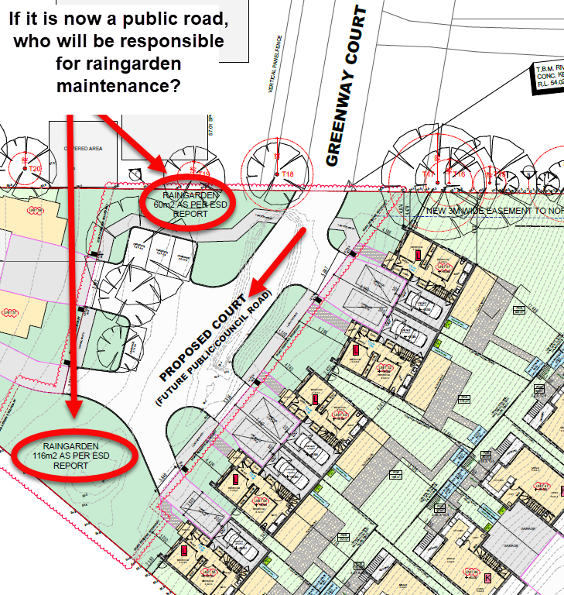  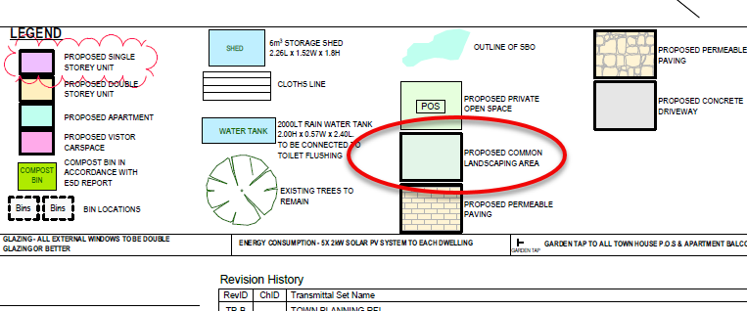  Landscape Plan  Numbers of species, where species are being planted, and the installation sizes must be included on the plan.  Recommended Permit Conditions (Without Prejudice)  Note: please provide conditions whether or not supporting  Tree Protection Management Plan  The Rigoni Tree Solutions Tree Management Protection Plan by Sean Rigoni dated 25/7/2022 and its recommendations are endorsed as the Tree Protection Management Plan for this site and form part of the permit.  The approved Tree Protection Management Plan must not be amended or altered without the consent of the Responsible Authority.  Prior to the commencement of any works at the site (including demolition and excavation whether or not a planning permit is required), a letter of engagement must be provided to us (as the Responsible Authority) from the Project Arborist selected to oversee all relevant tree protection works. In accordance with Australian Standard 4970-2009 Protection of trees on developments sites the Project Arborist must be an appropriately experienced and qualified professional (minimum AQF Level 5 Arborist).  Tree Protection Zones  Prior to the works commencing (including any demolition works), Tree Protection Fencing must be installed and maintained until works are completed to the satisfaction of the Responsible Authority.  All works within the nominated Tree Protection Zones must be:  - carried out in accordance with Australian Standard 4373–2007 Pruning of amenity trees and Australian Standard 4970–2009 Protection of trees on development sites  - overseen by a suitably qualified, level-5 arborist  - carried out to the satisfaction of the Responsible Authority by suitably trained and qualified arboricultural staff.  Works encroaching within the nominated Tree Protection Zones must not be undertaken without the written consent of the Responsible Authority.  Prior to occupation of the development/the issue of Statement of Compliance, a written statement from the Project Arborist must be submitted to the Responsible Authority that certifies that the following items have been addressed as part of the works:  - Installation and correct placement of tree protection fencing 2 weeks prior to works commencing and for the duration of works  - Attendance during Tree Protection Zone incursions  - Adherence to Australian Standard 4970–2009 Protection of trees on development sites  Note  - In the instance that minor pruning is anticipated the applicant must contact Council’s Parks Planning Officers on 5272 5272 (treeplanning@geelongcity.vic.gov.au) to lodge a request and provide adequate notice.  Streetscape Detailed Plans  Prior to the commencement of works a detailed Landscape Plan must be submitted to and approved by the Responsible Authority. The Landscape Plan must be prepared by a person suitably qualified in landscape design, be generally in accordance with the approved Street Tree Master Plan/ Precinct Structure Plan/ Development Plan (if applicable) and must adhere to the City of Greater Geelong Landscape Standards Manual. Any plan must include the following:  - The name of project and the Planning Permit Number  - Scale and dimensions  - The layout of proposed new planting (where applicable) in all road reserves and traffic management devices (e.g. medians, islands, and roundabouts)  - Details of all other infrastructure within the reserve (e.g. underground services, street lights, stormwater pits, fire plugs etc.)  - Pedestrian linkages inclusive of proposed landscape treatments  - Proposed treatments within street closures  - Buffer zones (i.e. rural interfaces and main roads)  - A detailed planting schedule of all proposed trees and plants including botanical names, common names, pot sizes, sizes at maturity and quantities for each species  - All proposed groundcover & shrub planting with a minimum container size of 150mm and must not exceed 400 mm in height at maturity  - The maintenance schedule for all proposed planting  Completion of Streetscape Works  Unless otherwise agreed in writing, prior to the issue of Statement of Compliance for that stage, the streetscape works shown on the endorsed Detailed Streetscape Plans must be completed to the satisfaction of the Responsible Authority.  Where streetscape works shown on the endorsed Detailed Streetscape Plans are not completed prior to the issue of Statement of Compliance for that stage, the applicant must submit to a cost estimate for all outstanding works for approval by the Responsible Authority. Once the cost estimates have been approved, a bond or bank guarantees to the value of 125 per cent of the cost of works must be submitted to the Responsible Authority separately prior to the Statement of Compliance for that stage.  Where a bond or bank guarantee has been accepted for incomplete streetscape works, the outstanding works must be completed to the satisfaction of the Responsible Authority within 1 year of Statement of Compliance being issued for that stage unless otherwise agreed by the Responsible Authority.  A practical completion inspection is required to satisfy this condition and must be organised by the permit holder with two weeks’ notice given. The incomplete works bond will be returned once practical completion has been awarded.  Notes  - Bond estimates must be sent to statplanning@geelongcity.vic.gov.au for approval at least two (2) weeks prior to seeking Statement of Compliance.  Maintenance of Streetscape Works  All works must be maintained to the satisfaction of the Responsible Authority for a period of two (2) years from the date of practical completion. During this period, any dead, diseased or damaged plants must be repaired or replaced as required.  Where the streetscape works are bonded, the maintenance period will commence from the date that the works are awarded practical completion by the Responsible Authority.  A maintenance bond to the value of 125 per cent of the cost of works must be submitted to the Responsible Authority prior to practical completion of landscaping works being awarded and will be retained until such time that the works have been accepted by Council for handover.  Works that have achieved practical completion will be audited throughout the maintenance period. Works being inappropriately maintained or established will not be accepted and will remain on maintenance until such time that the Responsible Authority deem it acceptable.  A handover inspection is required to satisfy this condition and must be organised by the permit holder with two weeks’ notice given. The maintenance bond will be returned on acceptance of handover.  Notes  - No handovers will be accepted during the summer period, between 30 November and 1 March.  Bond estimates must be sent to statplanning@geelongcity.vic.gov.au for approval at least two (2) weeks prior to seeking Statement of Compliance.
Officer Comment:
No objection to the grant of a permit, subject to conditions.
Were a permit to be issued, it is recommended the conditions be included with some changes to address consistency with similar conditions.

Department: | Urban Design
Response: | Not Supportive  Urban Design Recommendation Response  Provide response (justify/explain the inclusion of non-standard condition)  Urban design has reviewed the amended plan set and remain unsupportive of the proposed development. The overall approach to the development has not changed despite our comments outlining issues with the density and access to amenities.  The latest plan set have some issues that Urban Design does not believe can be addressed without a significant reduction in dwellings. A series of issues relate to the pedestrian network which has been neglected in the design. Please find below an outline of all the issues that need to be addressed. The applicant should take into consideration the Urban Design Guidelines Victoria as well as clause 15.01-1S in the planning framework which relates to Urban Design.  Density compared with surrounding area  The current proposal has reduced the dwelling count by two when compared to previous iterations. This has reduced the overall site density from 34 Dwellings/Ha to 33.5 Dwellings/Ha. The density is highly concentrated to the Basin Rise side of the site which would create an area of development that is noticeably different to its surround. The development is not within an IHDA zone which is The City’s approach to allowing increased density on infill sites throughout the LGA. Urban Design has serious concerns that the level of density in the proposed location given it is not within walking distance to surrounding amenities.  RECOMMENDATION: The applicant should reduce the number of dwellings to ensure a density that is not significantly greater than its surrounding. Urban Design will support an incremental increase of density.  Quality of pedestrian Network  The latest plan set shows areas of the pedestrian network that are constricted by Residential Units, Parking, and Refuge areas. The network has a greater level of inconvenience for pedestrians than is necessary with routes being indirect and overshadowed by development. In many areas the pedestrian network appears to be an afterthought. Please see figure 1 below for example areas of the forementioned issues.  RECOMMENDATION: Provide a consistent and uninterrupted pathway width of 1.5m throughout the development. Ensure an efficient route that would not require users to double back and has as direct as possible connection to the road network. The applicant should consider introducing travel calming measures that reduce will reduce vehicle speeds as many pedestrians will still be reliant on the road network.  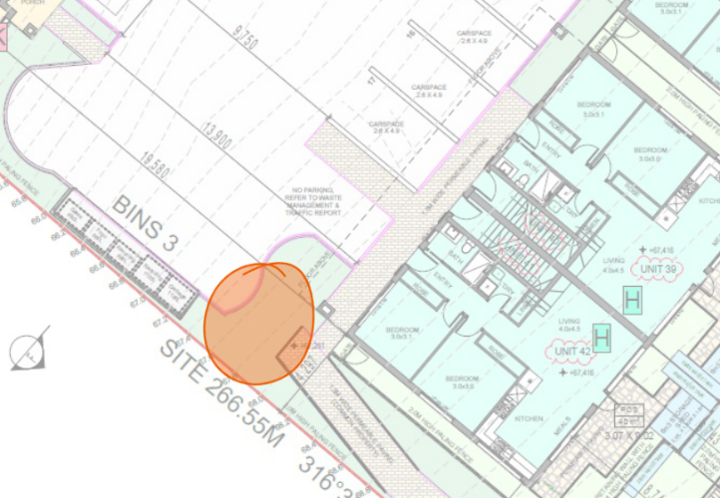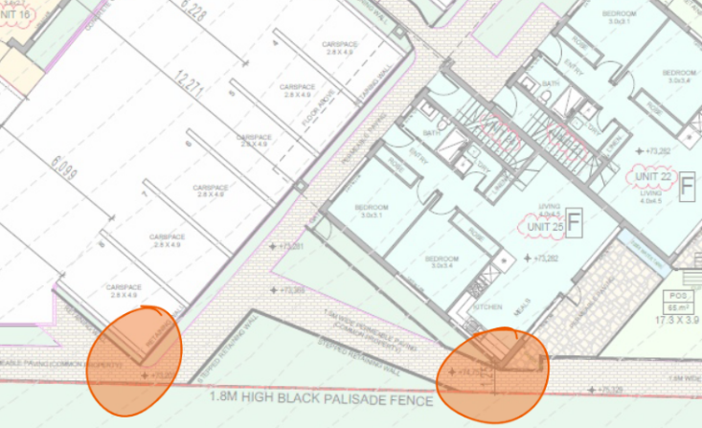  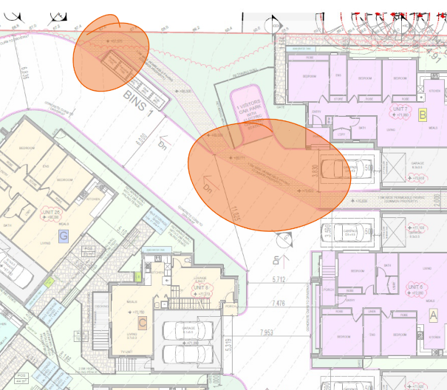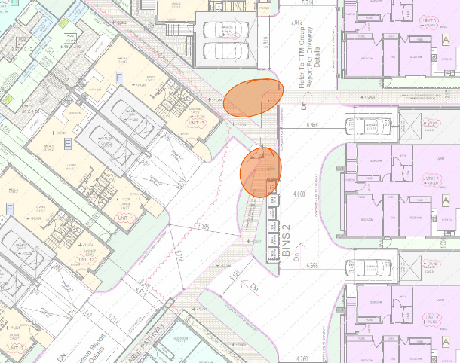  Figure 1. Highlighted areas of the pedestrian network that [caption incomplete]  Connection through development  The development does not support any broader cross development connections despite having two entry locations on opposite sides of the site. An outcome of the separation of the development is the creation of two large street blocks that are counter to the permeability objectives of the Urban Design Guidelines Victoria. The design has created an unnecessary 700m walk for residents of Greenway Court area of the development to the abutting Basin Rise side. The lack of site wide connection is particularly damaging for this development as it is a considerable distance from many amenities. In particular it has removed the opportunity for pedestrians be connect to School, Parks and some shard path networks.  RECOMMENDATION: Introduce at least one site wide pedestrian connection through the development that maintains public access. See figure 2 below as a suggested route. This connection could be moved to be beside the site boundary if that is more convenient from an insurance point of view.  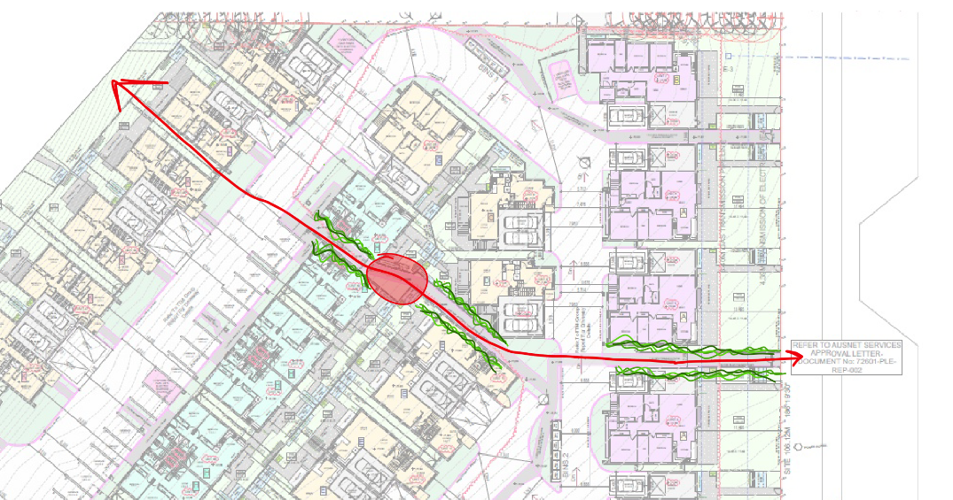  Figure 2. Suggested pedestrian connection through the Basin Rise development towards Greenway Court.  Landscaping around the Pedestrian Network  There is a lack of landscaping around the pedestrian network with fencing and residential units directly abutting some pathways. This will create an overshadowed and suppressed pedestrian network that is likely to seen as a less desirable option for many users.  RECOMMENDATION: Provide a landscape buffer to soften the visual impact of any fencing or property walls. Urban Design suggests the buffer be a minimum of 1m with greater width in places to facilitate the planting of larger trees. This should be provided on either side unless the pathway is directly abutting a road then the buffer for the corresponding side is not required.  Passive Surveillance  Two of the pedestrian linkages that run through the central block do not have direct visual connections through the length of the link. This creates a lack of passive surveillance and would potentially lead to reduced perception of safety as well as usage. As outlined above the lack of landscaping along pedestrian paths also needs to be addressed and the applicant should aim to resolve these two issues together.  RECOMMENDATION: Ensure pedestrian links that run between Residential Units have adequate passive surveillance and a visual connection across the length of the linkage. The applicant should consider the placement of windows, the built form as well as fencing styles and the inclusion of street lighting.  Residential overhangs on to pathway  In certain locations, residential units are overhanging the pedestrian network and, in some cases, completely covering the pathway. This is not an acceptable outcome as it removes the sense of communal ownership and would deter general use of pedestrian network. Please look at figure 3 for reference of the concerned areas. Streetscape built form dominates  RECOMMENDATION: Ensure the pedestrian network is clear of any overhanging Residential Units by reducing or shifting the upper floorplates of conflicting Units.  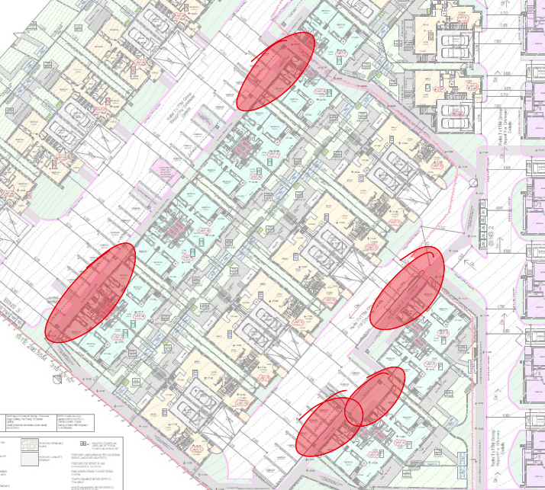  Figure 3. Residential overhang over pedestrian path  Sense of address  Multiple Units have a poorly designed entry condition that either come directly off the pedestrian network or come off driveways that do not include any pedestrian/shared zone treatment. The purple-coloured Units on the applicant’s submitted plans are of particular concern as the entry to each Unit will be to the side of a parked car. This will create a poor interface between communal and private property which in turn reduces the quality of communal/public spaces. The design has reduced the opportunity for landscaping and the closeness of the front door to vehicle movements has the potential to cause conflicts.  RECOMMENDATION: The applicant should provide a landscaped setback for each Unit with the entryway having a pedestrian focused connection to the communal road network.  Gated Communities  Urban Design acknowledges the applicant’s issues in relation to insurance for the development. The Planning Framework is clear that there must be an avoidance of Gated Communities. Urban design has previously compromised on this issue for other applications so long as certain conditions are met by the applicant. This has included at least one publicly accessible pedestrian link through a development which has been met by other applicants in the recent past.  RECOMMENDATION: The applicant should ensure at least one public pedestrian linkage though the development.  Recommended Permit Conditions (Without Prejudice)  Note: please provide conditions whether or not supporting  Prior to the commencement of works, amended plans based on those submitted in the application to the satisfaction of the Responsible Authority must be submitted to and approved by the Responsible Authority. When approved, the plans will be endorsed and will then form part of the permit. The plans should be modified from the those submitted in the application to show the following:  - Provide a consistent and uninterrupted pathway width of 1.5m throughout the development. Ensure an efficient route that would not require users to double back and has as direct as possible connection to the road network.  - Introduce at least one site wide pedestrian connection through the development that maintains public access.  - Provide a landscape buffer to soften the visual impact of any fencing or property walls. This should be provided on either side unless the pathway is directly abutting a road then the buffer for the corresponding side is not required.  - Ensure pedestrian links that run between Residential Units have adequate passive surveillance and a visual connection across the length of the linkage.  - Ensure the pedestrian network is clear of any overhanging Residential Units by reducing or shifting the upper floorplates of conflicting Units.  - The applicant should provide a landscaped setback for each Unit with the entryway having a pedestrian focused connection to the communal road network.  - The applicant should reduce the number of dwellings to ensure a density that is not significantly greater than its surrounding.  - The applicant should ensure at least one public pedestrian linkage though the development.
Officer Comment:
The comments, recommendations and objection to the grant of a permit are noted, however it is considered that the comments provided can be readily addressed in a planning context.
The application proposes a multi-dwelling development, but not a subdivision that present conventional opportunities for parts of this private land to be provided for public roads, paths or open space. There is a reasonable expectation however, that if the development is constructed, it will be subdivided in the future. It’s at that point when the Scheme requires consideration to the creation of new roads, public open space (including paths) and the like. Instead, the current layout has concerned itself with the necessary access requirements for each dwelling and meets the requirements of the Scheme in this respect.
It is acknowledged that, from an urban design perspective, a public path through the site could bring some benefit such as a convenient short-cut from Basin Rise and Thornhill Road to Wandana Drive via Greenway Court and James Cook Drive. Although, there is already a path link from the pipeline track to James Cook Drive across the public land at 50A James Cook Drive (less than 250 metres north of the site). Or if a more direct connection from Basin Rise to Wandana Drive is preferred, the freeway reserve land abutting the subject site offers ample opportunity to link through to the proposed Greenway Court extension and the access track abutting 70 and 72 James Cook Drive.
Therefore, not only is there already a link 250 metres north of the site, there is also ample public land abutting the site that may be more suitable. The problem with requiring a public path through the subject site is that there is no strategic justification for it, and that this could in fact be the wrong place to put it.
For these reasons, recommendations 1, 2 and 8 are not supported.
Recommendation 3 has been generally adopted with the landscape plan showing perimeter plantings along fences seen from outside the property, except along the interface with the freeway reserve.
The extent of passive surveillance of pedestrian walkways through the site referred to in recommendation 4 is considered acceptable with the provision of upper storey windows and abutting areas of Secluded Private Open Space.
The overhang referred to in recommendation 5 relates to the balconies of upper storey apartments. These provide some shelter and a sense of entrance to the apartment buildings and are considered an acceptable design response.
The landscape plan shows all dwellings are provided with landscaping within front setbacks with the exception of the apartment units that are provide with car parking spaces with landscaped island garden beds as a response to recommendation 6.
A condition giving effect to recommendation 7 is supported, particularly as it relates to the number of dwellings fronting the extension to Greenway Court.

Department: | Waste Services
Response: | Supportive  The Waste Management Plan is satisfactory, private collectors are to be engaged for the collections, and access is acceptable for small and medium rigid vehicles. Either a full or adjusted Council Residential Waste Service charge will still apply to each dwelling. This may require a special attention by rates department. 173 agreement is not needed as long as the Waste Plan is a condition of the Permit.  Recommended Permit Conditions (Without Prejudice)  A Waste Management Plan that is to the approval of the Responsible Authority must be provided prior to certification of the subdivision for this Development. The Approved Waste Management Plan must be incorporated into the Planning Permit(s).
Officer Comment:
No objection to the grant of a permit, subject to conditions.
Were a permit to be issued, it is recommended the condition be included with some changes to address consistency with the waste and recycling objectives of Clause 55.07-11 of the Scheme.

AMENDMENT OF THE PROPOSAL PRIOR TO PUBLIC NOTIFICATION:

The applicant made a first request to amend the application pursuant to Section 50 of the Planning and Environment Act 1987 on 29 July 2022. Council accepted the amendment. The amendment made the following changes to the application:
- Changes in response to further information
- Provision of additional visitor parking spaces
- A Clause 55.07 Assessment
- A bushfire risk assessment
- An arboriculture assessment
- A preliminary risk screen assessment
- Revised traffic engineering report
- A revised sustainable design assessment
- Revised plans and elevations
- Additional statutory fees

The applicant made a second request to amend the application pursuant to Section 50 of the Planning and Environment Act 1987 on 29 September 2022. Council accepted the amendment. The amendment made the following changes to the application:
- Changes in response to officer recommendations
- A waste management plan
- Basin Rise access details
- Greenway court extension details
- Revised plans and elevations
- Additional statutory fees

PUBLIC NOTIFICATION:

The application is not exempt from the notice requirements of Section 52(1)(a), (b) and (d), the decision requirements of Section 64(1), (2) and (3) and the review rights of Section 82(1) of the Act and pursuant to Section 52 of the Planning and Environment Act 1987 the following forms of advertising were undertaken:
- Fifty (50) notices were sent to owners and occupiers of adjoining land (including nearby)
- Three (3) A2 signs were placed on the land
A supplementary round of public notice was given to the owners and occupiers of 5 properties with frontage to Cumulus Avenue that had not been given notice previously.
Ninety-one (91) written objections have been received by the City.

OBJECTOR CONSULTATION:

A consultation meeting (Planning Information Meeting) was held on 6 December 2022 between the applicant, council officers, and objectors. The meeting discussed the issues raised to see if any resolutions were possible.

No objections were withdrawn following the Planning Information Meeting.

LOCATION OF OBJECTIONS:

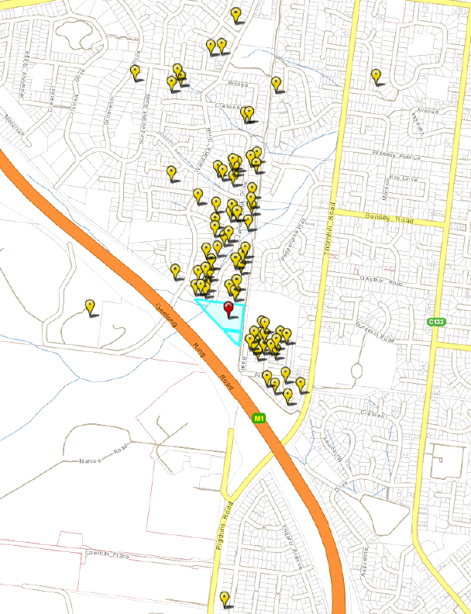
Figure 30: The proximity of objectors (yellow flags) within 1km of the subject site (red flag). Source: PLACES Weave, annotated by Author.

AMENDMENT OF THE APPLICATION FOLLOWING PUBLIC NOTIFICATION
The applicant made a request to amend the application following public notification pursuant to Section 57A of the Planning and Environment Act 1987 on 15 February 2023. The City accepted the amendment.
The amendment made the following changes to the application, as listed in the amendment cover letter:

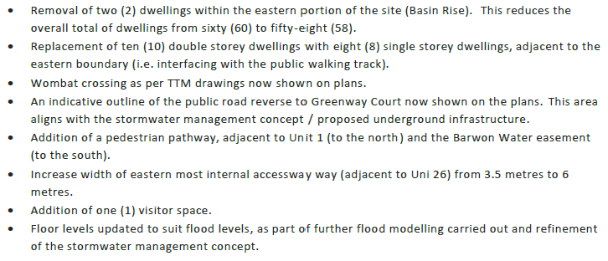

These are the plans assessed in the preparation of these officer recommendations.
The amended plans were circulated to all objectors for review and comment on 23 March 2023.

Two (2) additional objections and seven (7) follow-up objections were received, and no objections were withdrawn.

OBJECTIONS:

The written objections received and officer consideration of the objections has been summarised below.

Objection Summary | Officer Consideration
- Nearby land can’t be subdivided so this should not be either | The City is aware that there are properties located along Greenway Court, James Cook Drive and elsewhere that are burdened by registered restrictive covenants preventing further subdivision and the construction of more than one dwelling. The land at 6 Greenway Court does not have this restriction. And whilst it is the intention that these covenants achieve a particular benefit to covenant parties and the neighbourhood, the application proposal is not bound by the same restrictive covenants.
- This will devalue other properties in the area | The factors that contribute to the value of a property are many and wide ranging, and primarily influenced by the activities of the owners and occupiers of the valued land. For this reason, and consistent with past decisions of the Tribunal (VCAT), any effect the proposal may have on nearby property values cannot be reasonably quantified or assessed as a planning permit matter for a nearby proposal.
- The proposal does not respect the existing character of the area, and doesn't meet requirements of Clause 55 (ResCode) | A detailed assessment of the existing neighbourhood character, and assessment of whether the design response appropriately respects the existing neighbourhood character is set out later in this officer report.  It is notable that this is comparatively a very large site with distinctly different character interfaces including Greenway Court and the side and rear fences of established private land to the north, but also to the Pipeline Track and the Geelong Ring Road freeway reserve to the east and southwest respectively. When assessing the existing neighbourhood character, it is not appropriate to identify one aspect to be copied – respecting the existing character requires an objective consideration of the cumulative impact all elements of the public and private realms have on the character of the area.  Refer to the Clause 55 Assessment of the proposal for detailed consideration of the ResCode requirements later in this report.
- Will cause an increase to traffic in the area, particularly along James Cook Drive, Wandana Drive, and the Basin Rise/Thornhill Road intersection | Expert traffic engineering advice prepared as part of the application and reviewed by the City’s own expert traffic engineers has not found that the capacity of Greenway Court, James Cook Drive and Wandana Drive will be exceeded by the increased traffic volume generated by the 8 additional dwellings proposed to front an extension to Greenway Court.  Likewise, it has not been determined that the capacity of Basin Rise, Cumulus Avenue, and Thornhill Road will be exceeded by the additional traffic accessing the additional 50 dwellings proposed. This fully constructed street network includes concrete footpaths, wide naturestrips, bitumen roads with kerb and channel construction wide enough to allow on street parking between concrete crossings.  Road networks in urban areas are specifically designed and constructed with capacity to accommodate, and often exceed, the traffic volumes that will be generated by the surrounding urban land ‘catchment’ the road network services. Roads and their intersections are designed by engineers in anticipation of increases to traffic over the life of the road.  To this end, the intersection of Basin Rise and Thornhill Road is fully constructed and line marked with turning lanes and pedestrian islands in Thornhill Road and marked on-street parking bays extending more then 200m west of the intersection allowing 2-way traffic to pass through the intersection unimpeded.
- Removal of all vegetation should not be allowed | The proposal requires planning permission for the removal of remnant patches of native grasses on the land. No permit is required for the land owner to remove any or all of the trees and shrubs that are there.  The planning scheme does set out requirements for landscaping of multi-dwelling developments of this type. These are found at Clause 55.03-8 (Landscaping objectives) and requires development ‘respects the landscape character of the neighbourhood’ and to ‘encourage the retention of mature vegetation on the site’. The application proposes to meet these objectives (along with other, competing objectives of the Scheme) by providing a landscape plan that shows significant plantings of new trees and vegetation throughout the site, and the protection of trees on adjoining land.  Were a permit to be issued, it is recommended that this landscape plan be further refined with details showing significant new canopy tree plantings, and that the landscaping can be established and maintained as a condition of any permit that is issued.
- The density of dwellings and buildings is too great for this area | The density of development can be measured in a variety of ways, including number of dwellings per hectare, the percentage of the site covered by buildings, and the extent of impervious surface coverage. It is possible for example to have a high proportion of dwellings per hectare, and a low percentage of site coverage (a single, tall apartment building on a large lot for example), or the opposite where large sprawling dwellings are constructed on small lots. For these reasons, the Scheme does not nominate preferred, maximum or minimum dwelling densities in residential areas. Instead, it relies on objective assessments of these and other determinants such as building height, site constraints (topography, landscape elements, vegetation etc) and specific planning controls (Overlays, Development Plans, Design Guidelines) to produce specific planning outcomes.  With all of this in mind, the application proposes a 33 dwellings per hectare, or an average of 298.76 square metres per dwelling. Of course, some of these are apartments and some of the land is set aside for shared purposes such as vehicle access and communal open space. This means some dwellings will have more space, and the apartments will occupy less.  Overall, the proportion of the site covered by buildings is 49.2 percent which is significantly less than the 60% maximum allowed to meet the relevant site coverage standard in the Scheme, and 49.2 percentage of the site is to remain pervious which is significantly more than the 20% nominated by the Scheme. The maximum building height requirement for this land is 12 metres (11 + 1) and 3 storeys (excluding a basement), and the application proposes a maximum of 9.38 m and 2 storeys.  There are no planning controls in the Scheme that seek to achieve a nominated density outcome for this site and this area.
- Access roads are inadequate, particularly for/during emergency | The application proposes an extension to the end of Greenway Court into the site, to become a future road reserve vested to the road authority. If a permit were to be granted, it is recommended that a permit condition require this extension be designed, approved and constructed to the requirements and satisfaction of the road authority.  The access road from Basin Rise will be required to traverse the land comprising the Pipeline Track which is owned by Barwon Water and maintained by the City under an agreement with Barwon Water. If a permit were to be issued, it is recommended that the owner of the subject site secure a legal right of access to the land over the Pipeline Track in the form of a carriageway easement. The Barwon Water land and Pipeline Track under this arrangement will remain in public ownership but will require that the vehicle access be constructed and maintained in accordance with the requirements of Barwon Water (as the owner of the land on which the Pipeline Track is located), and the City as the party responsible for maintaining the track. The requirement that the easement be created and the access constructed and maintain to required standards is recommended to form part of a legally binding agreement under Section 173 of the Act and will covenant the site owner as an agreement registered to their land title into the future.  It is further recommended that prior to the  commencement of any works, that the design and construction of the Basin Rise vehicle crossing and accessway, and all associated street furniture to the satisfaction of the road authority be completed at no cost to the City or Barwon Water. Only once this has been completed should any works be commenced for the construction of an internal access road on the private land.  The internal accessway is proposed to provide private access for the future residents and visitors of 50 dwellings only. The Scheme sets out the design requirements for accessways on private land at Clause 52.06-9 (Design standards for car parking). Where these design standards are not shown on plans, advice and recommendations from a suitably qualified traffic engineer will be required to demonstrate that access for all required vehicles, including delivery, waste collection and emergency services vehicle, can be achieved.  The largest emergency services vehicles to access the site are likely to be FRV (fire emergency) appliances. Changes to the internal access layout were made to the proposal in response to FRV recommendations that FRV have supported.
- New Access to Basin Rise unsafe for pipeline track users | Current users of the public Pipeline Track benefit from an uninterrupted passage along the path without interruption.  As a publicly accessible path it is appropriate that the public continue to enjoy uninterrupted passage in a similar way, they would along a public footpath in front of any other private property.  Were the development to be approved and constructed therefore, it is recommended that the Basin Rise access to the site be created, constructed and maintained to the requirements of the City and Barwon Water. This will include a legally binding agreement providing that Pipeline Path users be given right-of-way such that the intersection should be designed and constructed with appropriate traffic calming and control devices that reduce the risk of crash or conflict between path users and vehicles accessing the subject site, and that maintains priority right-of-way to path users to the satisfaction of the responsible authority.  The City’s engineers have recommended permit conditions that require the intersection of the site accessway and the shared path be constructed to required standards.
- Too much traffic for Intersection with Thornhill Road - Old Traffic Data | The traffic engineering assessment submitted with the application includes consideration of 2015 traffic count data, empirical survey data from 23 November 2022, and derived data anticipating a 30% increase in volume from 2015. The assessment conservatively concludes that at peak periods the intersection is fit for purpose and along with Basin Rise has a capacity that far exceeds the 1,200 vehicle movements anticipated, including the 300 additional movements likely to be generated by the proposal. The proposal is likely to produce an average peak time increase of 30 vehicle movements per hour representing a negligible increase to the demand on the street network in this area.
- Not enough parking proximate to Christian College | The car parking demand associated with Christian College is a matter to be managed by the College itself in consultation with the road management authority. It is unlikely that the proposed development will in any way increase the demand for parking near the College. The subject land is not used for over-flow parking by the College, and occupants and visitors to the proposed development are unlikely to park vehicles on the streets proximate to the College given that visitor and resident parking is proposed as part of the development in accordance with the requirements of the Scheme.
- Council should not be considering this proposal | The City of Greater Geelong is the responsible planning authority for administering and enforcing the Greater Geelong Planning Scheme (the Scheme) and the relevant planning laws (the Act). The City has a responsibility to consider all planning permit applications it receives in a fair and reasonable way, and to assess the merit of each planning permit application against the requirements of the Scheme and the Act.  The City does not get to choose which permit applications it wants to accept or reject and assesses each proposal on the planning merits presented in the application.
- No public transport provided, poor access to shops and other services | Public bus Route 43 (Geelong Station – Deakin University via Highton) includes stops in Thornhill Road that are within 630 metres walking distance (stop to Geelong Station) and 530 metres (stop to Deakin University) from the east site boundary - significantly closer than the vast majority of existing residents of Wandana Heights. Future residents of the Greenway Court extension, as with all existing residents of the area in Greenway Court and James Cook Drive are not within convenient walking distance of a public bus route.  Universal and convenient access to public transport proximate to homes is a preferred planning outcome for new development. But because the site is on the perimeter of an established urban area, it is not reasonable nor required that public transport be provided to service a development of this size, nor is it acceptable to curtail the development of this land where all other residents in the area are equally disadvantaged in their access to public transport yet have been allowed to develop land and reside in this location without access to convenient public transport.  Similarly, it is not a determinative planning matter that the development does not include or is not immediately proximate to shops and other urban services. The land is in an urban zone (GRZ1) with an acceptable level of access to urban services via the public road (including footpath) network, and the convenience of the Pipeline track for active and alternative transport to nearby parks, schools and public open space.
- Not enough parking or bicycle spaces provided, will increase street parking and visitor spaces too far from houses | The development provides for car parking on the land in accordance with the requirements of the Scheme. This means 1 car parking space for each 2 bedroom apartment, 2 car parking spaces (including 1 undercover) for each 3 bedroom dwelling, and 13 shared visitor car parking spaces in excess of the required 11 being 1 for every 5 of the 58 dwellings has been provided. 4 new on-street parking spaces are also proposed for the extension to Greenway Court.  The scheme does not require that bicycle parking spaces and facilities be provided on the land where the dwellings are less than 4 storeys. Nevertheless, the application proposes the provision of bicycle parking facilities to be located at the entrance to the site from Basin Rise, and the applicant has requested that a Green Travel Plan be a condition of any permit to be issued.  Because the development meets the car parking requirements of the scheme, it is not considered appropriate that more parking be sought in anticipation that more may be needed. The scheme already requires visitor car parking spaces to accommodate parking over-flow and the proposal shows these in locations that are considered reasonably convenient and in a way that reduces the likelihood that existing on-street parking spaces will be used.  Were a permit to be issued, it is recommended that a green travel plan be prepared and endorsed to form part of the permit.
- Insufficient environment and sustainability features – dark roofs, no alternative transport, increase to car dependency, gas hot water, increased heat island effect, additional load on power grid, overloading sewer system. | The application includes an Environmentally Sustainable Development (ESD) assessment that demonstrates an acceptable ESD outcome giving effect to the objectives and strategies of local planning policy set out at Clause 15.01-2L (Environmentally sustainable development). The treatments and initiatives proposed will be required to be given affect via a permit condition were a permit to be issued.  The application has also been assessed against the objectives of Clause 55.03-5 and Clause 55.07-1 (Energy efficiency objectives) and found to comply. There is capacity for the developer and for future occupiers to further enhance the ESD credentials of this development if they choose.  This is encouraged but is not a matter that the planning authority can reasonably pursue where the ESD requirements of the Scheme have already been met.  As the development is located within the service districts of the relevant water, sewer, electricity, gas and telecommunications authorities, the development will have to meet any connection and servicing requirements they have. Where load or capacity constraints occur, the upgrade requirements of these authorities will have to be met by the developer.  There are no known utility service capacity constraints in this location that would result in the need to constrain the development from what has been proposed.
- Insufficient waste management and collection information | The application includes a Waste Management Plan (WMP) showing that the solid waste and recycling for the dwellings accessed from Basin Rise will be managed and collected by a private waste management contractor. The WMP shows private collection will occur on the land from 3 storage locations each comprising enclosed communal bins using a Mini Rearloader vehicle operated by the private contractor.  Municipal waste collection is proposed for the dwellings fronting the extension to Greenway Court. Occupants from each of these dwellings will be required to manage their own waste for kerbside waste in the same way that existing residents of Greenway Court and James Cook Drive do.  Were a permit to be granted, it is recommended that a condition require the waste management plan be endorsed as part of the permit.
- Developer is not from the area | It is not a requirement of the planning scheme that the owner, developer, builder or any other member of the permit applicant’s project team be local to the area.  Insofar as it might be implied that the developer may not have local knowledge or any personal interest in the area, it is notable that large housing projects are normally completed using the skills, knowledge, money and resources of people that are from somewhere else.
- Reports are all on behalf of the developer but not Council | All of the plans, reports and other documents that are part of the planning permit application have been prepared by or on behalf of the permit applicant to conform with the information requirements for a planning permit application and for consideration and assessment by the relevant planning authority. The planning authority is independent and does not prepare information to be included in the application.  The information and advice, including internal and external referral responses do not form part of the application and are therefore not subject to advertising during the public notice period. Instead, this information is included as part of the officer recommendations that you are reading now.
- Weight restriction over gas pipe won't be enforced | The construction of all buildings and works on land subject to easements, including all permanent structures such as fences and roads, must obtain consent from the easement beneficiary. With respect to the gas transmission easement, AusNet Gas Transmission Services has reviewed the proposal and has provided a set of detailed requirements that the developer must comply with as part of the consent given.  The enforcement of these requirements is a matter between the easement beneficiary and the land owner/developer, and not an enforceable matter for the responsible planning authority.
- Increased flooding, stormwater run-off and erosion risk | In its present state, the land already contributes to stormwater runoff via the gully at the low part of the site, where evidence of erosion can already be found.  The increase to impervious surfaces brought by the development and increase in stormwater runoff (i.e. water leaving the site) must be managed on the site to meet current best practice performance objectives for stormwater quality such that erosion will be prevented. The site stormwater system is proposed to be designed and constructed to capture, retain and release stormwater runoff at a rate that is no greater than the current (pre-development) rate. This is achieved through the use of rainwater tanks, raingardens, and an upgrade to the drainage retention capacity of the land under the proposed extension to Greenway Court as shown in the site Stormwater Management Strategy (SWMS) submitted as part of the application.  The drainage authority engineers and the stormwater planning engineers on behalf of the floodplain management authority have reviewed the SWMS and have agreed that the risk of flooding and erosion will not be increased were the development to proceed after detailed design and construction has been completed.  Were the development to proceed, the builder responsible for the management of the construction site is required to conform with all relevant construction environment protection requirements of the Building Regulations and the EPA.
- Loss of vegetation and faunal habitat | The development would result in the loss of established trees and other vegetation on the land, all of which provides habitat for local species of animals including birds and insects. However, this is an inevitable consequence of setting aside land for residential development as this land has been since it was zoned R1Z and eventually GRZ many years ago.  As set out in the native vegetation and biodiversity assessment forming part of the application, the site is not in a location of habitat importance such that it might be if it hosted threatened floral or faunal species, and no specific planning controls apply that prevent the land to be developed for residential purposes.  Nevertheless, the Scheme sets out landscaping objectives that encourage the retention of mature vegetation, provide appropriate landscaping and encourage development that respects the landscape character of the neighbourhood. The landscape concept plan nominates plantings of native trees and shrubs that, over time, are likely to achieve these objectives. And were a permit to be granted, it is recommended that a refined and detailed landscape plan be submitted for endorsement and those landscaping works be completed as a condition of that permit.
- Doesn't conform with Clause 21.15 (Wandana - now Clause 02.03-1), and doesn’t respond to the Wandana Structure Plan 1998 (Background Document, Clause 72.08) | The subject site is outside the area included in the Wandana Structure Plan (City of Greater Geelong, 1998). Clause 02.03-1 of the Scheme as it now relates to Wandana is not relevant to this permit application.
- Insufficient tree screening of the development, and landscape plan doesn’t show canopy tree detail | An objective assessment of the landscape and roofscape character of the area north of the subject site finds that canopy trees are a contributing element to that character. Canopy trees, along with other tree planting are an effective treatment that has been used to ‘soften’ the appearance of development and contributes to an improved residential amenity.  Whilst it is considered impractical to plant trees that would screen the proposed development from short and medium range views, it is considered appropriate that viable canopy tree plantings be a feature of the development as an effective way of respecting the character of the adjoining neighbourhood to the north (in particular). For this reason, it is recommended that a permit condition require a landscape plan feature viable canopy tree plantings throughout the site, were a permit to be granted.  In consideration of this proposed permit condition, a revised ‘For Discussion’ landscape plan was prepared by a qualified landscape architect and provided by the permit applicant to show that location of trees that contribute to the canopy tree coverage necessary to meet the objective of Clause 55.07-4 (Landscaping objective). The plan shows canopy coverage of up to 21% of the site. The mature heights of proposed species range between 8 and 15 metres offering some screening and softening of buildings and roof forms through the development.
- Doesn't provide affordable or social housing | It is not a requirement of the Scheme that a multi-dwelling development of this type include provision of affordable or social housing. Whilst the need for affordable and social housing is well established, there is no requirement for this private development include this.  The development will contribute to the overall supply of new housing in the area which, in some small way, will offer alternative housing opportunities for those looking for a first home, for those looking to move into more compact dwelling from the established and older large family homes in the area, or for residential rental investors to provide rental accommodation in the area.
- No limit on dog or cat ownership | The Scheme does not include any requirements that dwelling developments be designed or constructed to accommodate nor prevent the keeping of domestic pets.  Insofar as the pets of future occupants present any residential amenity issues, the obligations of pet owners are set out in relevant Local Laws.
- No limit on barbeques and related pollution | The Scheme does not include any requirements that dwelling developments be designed or constructed to require nor prevent the installation or use of outdoor barbeques.  Insofar as the use of domestic barbeques by future occupants present any residential area amenity issues, the obligations of residents are set out in relevant Local Laws.
- Poor liability and wellbeing for future occupants | The Scheme seeks to encourage the provision of a variety of accommodation types that are appropriately located, designed, and constructed. This variety should include large, detached dwellings, small dwellings, townhouses, apartments and the like. Each type of housing offers a unique set of opportunities suitable for a variety of household.
- Located in bushfire prone area - no fire plan provided | The Bushfire Prone Area designation relates to requirements under the building regulations that set out standards for the design and construction of buildings. The Scheme requires that some consideration be given to the advice given be relevant emergency services agencies regarding the risk in the event of a bushfire, and also to prioritising safety above all other considerations where there are competing planning policy objectives.  The application includes an assessment of the proposal against the relevant planning policy for consideration of bushfire risk by a qualified building surveyor, and this was reviewed by the relevant fire authority (FRV).  Were a permit to be granted, it is recommended that a condition give effect to the recommendations of FRV.
- No caravan or boat parking provided | The Scheme does not include any requirements that dwelling developments be designed or constructed to accommodate caravan or boats.
- Waste and water will attract mosquitoes and vermin | Domestic waste is proposed to be managed, stored and collected in accordance with the waste management plan submitted as part of the application. This includes the use of enclosed bins that are to be emptied on a regular basis which should be sufficient to minimise the presence of vermin.  Stormwater quality and retention treatments, including tanks and raingardens will require regular maintenance for ongoing reliability. These are matters for the private property owner and or occupier to maintain as part of any normal maintenance routine for private buildings and properties here or elsewhere.
- Does not include communal area for students, and does not provide suitable accommodation for families | The application does not seek to limit who is likely to occupy the dwellings were they to be built. Instead, it is likely that these dwellings will offer an attractive housing option for singles, couples, shared households and families. Likewise, these households are likely to represent a range of life stages including students, working aged adults, and people of retirement age.  The Scheme does not require that communal areas or facilities be provided for any specific resident cohort such as students or families. The dwellings have been designed to be occupied by a variety of household types. Consequently, the proposal offers an alternative to the large dwelling on a large allotment commonly associated with a ‘family home’ that are already abundant in the area.
- Steep slopes not suitable for elderly | The application includes information showing the extent of existing and proposed levels and gradients across the site, including for vehicle accessways and footpaths. The slope of the site makes it inevitable that there will be steps, stairs, ramps and sloping paths for any development, and the Scheme does not constrain dwelling developments that are on sloped sites.  Nevertheless, an appropriate design response will allow for convenient access to dwellings and should conform with vehicle access design standards for ramps and gradients. It is considered the proposal achieves both.  Were the development to be completed, future occupants will determine for themselves if the paths and accessways are too much for them, regardless of their age.
- Increased likelihood of excessive noise from music, parties, etc. | Excessive noise and amenity issues in residential areas are matters that are dealt with under environmental protection legislation, and in some cases, relevant Local Laws. These can include animal noise or amplified music from gatherings on private land, as well as mechanical noise from power tools, construction and other sources and activities.  The Scheme does not set requirements for multi-dwelling developments relating to activities normally associated with dwelling on the land. And the proposal does not include any unusual elements that are likely to result in an unacceptable impact on residential amenity in the area.
- Disruption, noise, dust and inconvenience during construction. | Were the development to proceed, the builder responsible for the management of the construction site is required to conform with all relevant construction environment protection requirements of the Building Regulations and the EPA. This includes relevant Local Laws regarding construction noise and neighbourhood amenity.
- NBN is already overloaded in the area | NBN connection and service matters are the responsibility of NBN service providers and NBN Co. The Scheme does not set out requirements addressing the NBN where subdivision of the land is not proposed. Network capacity issues are matters to be dealt with by the relevant utility service provider.
- Will contribute to road congestion in the event of emergency evacuation | In the event of an emergency, future residents of the development would be advised by and act in accordance with instructions of relevant emergency service authorities. This would include information regarding the timing and route for any evacuation.  All roads are designed to accommodate typical daily peak use. An emergency evacuation may result in congestion due to the traffic demand exceeding the design capacity of the local road network. However this is an established risk in all urban areas that is managed through incident response planning by relevant emergency services agencies.
- Insufficient SBO response and exceeds capacity of ageing drainage infrastructure downstream | The application was referred to the Floodplain Management Authority engineers in accordance with the referral requirements of the SBO and Section 55 of the Act. The application includes all of the information required by the application requirements of the SBO.  The part of the site that is within the mapped area of the SBO is located at the entrance to Greenway Court and shows the extent of flooding from an unnamed waterway in the gully during a heavy rain event.  The site Stormwater Management Plan demonstrates that the development can be constructed to provide stormwater retention without additional runoff to the drainage system downstream. To this end, it has been shown that the development will not further exceed the capacity of the existing drainage infrastructure.
- Significant loss of green space in the area, and fewer dwellings would allow more green space | The subject site is in private ownership and comprises remnant land zoned for residential use and development. It is not ‘green space’ reserved or planned to be reserved for any type of public open space, recreation space, or space for natural systems. It was once land owned by a public authority as part of the Geelong Ring Road project but was determined to be surplus by the public land manager and was sold out of public ownership.  On advice from the City’s Open Space Planning unit, the area is considered to be well serviced by public open space, including green space, such that no part of the site is sought to be acquired for public purposes.  It is common ground that fewer dwellings on the land might allow for more space between buildings. The application has demonstrated that the proposal complies with all relevant requirements of the Scheme regarding this idea though. It complies with the minimum Garden Area requirement, the site coverage and permeability standards, and minimum dimension requirements for private and secluded private open space, and for all other spatial requirements for a multi-dwelling development set out by the Scheme.
- There are no other developments of this density anywhere else | Even if this were the case, the Scheme does not require the proposed multi-dwelling developments be of the same density as adjoining developments. The General Residential Zone (GRZ1) that applies to the land encourages a diversity of housing types and housing growth resulting in areas of increased diversity in comparison to other areas of lesser diversity. The GRZ1 anticipates that housing will be provided at a variety of densities in the area.  It is notable that the application proposes 58 dwellings on 1.685 ha, representing a density of less than 35 dwellings per hectare, or an average of 290 sq/m per dwelling. This is consistent with medium density development (20-40 dwellings per hectare) commonly associated with infill development in existing residential areas and new greenfield growth areas for which the subject site shares is development characteristics.
- Development does not meet requirements of Clause 56 (Subdivision). | Clause 56 (Residential Subdivision) of the Scheme doesn’t apply to this permit application because no subdivision of the land is not part of the development proposal.  Instead, the application is assessed against the objectives and standards of Clause 55 (Two or More Dwellings on a Lot and Residential Buildings), including Clause 55.07 (Apartment Developments).  Refer to the detailed Clause 55 assessment later in these recommendations.
- Nearby streets were not surveyed or constructed for current or proposed traffic volumes | Roads, intersections and road networks are designed and constructed in accordance with established engineering standards to provide for the safe and efficient movement of vehicular traffic. Regular users of the network in this area are likely to experience times of relative congestion in periods of peak demand that result in the need to change their normal driver behaviour. Traffic engineers do not regard this to be evidence that the road network is failing or in need of upgrade or change. Indeed, changes such as widening intersections, duplicating lanes or installing round-abouts or traffic signals can introduce a greater level of risk to road users or could even induce congestion within the road network resulting in a less safe and less efficient system.  The traffic engineering report submitted as part of the application and reviewed by the road management authority engineers does not find that the local street network is nearing capacity nor that the construction standard of the network requires any type of upgrade to accommodate current or future projected traffic volumes generated by this development.
- The development will create a traffic through-way from Basin Rise to Greenway Court and out to Barrabool Road | There is no proposed road connection through the site that links Basin Rise with Greenway Court. Traffic from Basin Rise/Thornhill Road will have to travel north to Roselyn Road to reach Barrabool Road in the same way they do at present.
- Will not meet the required standard of maximum 63dB noise in residential area within two to three years due to increases in traffic | The Traffic Noise Assessment submitted as part of the permit application found that the current freeway traffic noise levels on the land, and those predicted for the year 2034 are below the limit of the Department of Transport External Noise Level Requirement.  Nevertheless, the application was referred to the Department of Transport did not object to the grant of a permit on condition that the developer is to enter into a S173 agreement with DoT and councils stating, “the Head Transport for Victoria will not be held accountable for future noise related compensation costs,  and that the responsibility for associated noise attenuation works are to be at the land owners expense, and at no cost to the Head Transport for Victoria.  It is notable also that noise attenuation measures have been shown on the plans in response to the objectives of Clauses 55.07-7 (Noise impacts)
- Will not contribute to affordable housing supply because Wandana Heights is an expensive area, with high construction cost due to slope, and will not be built by locals. | The permit applicant and developer is not a provider of affordable housing, and the permit application does not propose the delivery of affordable housing.  The application does not benefit from any social or affordable housing concessions or exemptions under the Act or the Scheme, and the cost of construction and the financial mechanism used to fund the project is not a planning matter for permit consideration.

ASSESSMENT:

ZONE:

General Residential Zone
The subject site (and surrounding properties) are located within the General Residential Zone – Schedule 1 (GRZ1). The purpose of the GRZ1 is:

- To implement the Municipal Planning Strategy and the Planning Policy Framework.
- To encourage development that respects the neighbourhood character of the area.
- To encourage a diversity of housing types and housing growth particularly in locations offering good access to services and transport.
- To allow educational, recreational, religious, community and a limited range of other non-residential uses to serve local community needs in appropriate locations.
The zone applies a mandatory minimum garden area requirement to the subject site of 35%.

The zone requires that the proposed development must meet the requirements of Clause 55 (Two or more Dwellings on a lot and Residential Buildings).

The zone applies a mandatory dwelling and residential building height limit to the subject site.

Schedule 1 to the GRZ does not specify the maximum height or number of storeys for a dwelling or residential building. Where no maximum building height or maximum number of storeys is specified in a schedule to the zone:
- the building height must not exceed 11 metres; and
- the building must contain no more than 3 storeys at any point.

A building may exceed the maximum building height by up to 1 metre if the slope of the natural
ground level, measured at any cross section of the site of the building wider than 8 metres, is
greater than 2.5 degrees.

A basement is not a storey for the purposes of calculating the number of storeys contained in a building.

OVERLAY:

The following overlays are relevant to this permit application.
Design and Development Overlay
The purpose of Clause 43.02 Design and Development Overlay is:

- To implement the Municipal Planning Strategy and the Planning Policy Framework.
- To identify areas which are affected by specific requirements relating to the design and built form of new development.
The design objective to be achieved as set out at Schedule 14 to Clause 43.02 Design and Development Overlay is:
- To ensure that the siting, height and visual bulk of dwellings achieves a reasonable sharing of views between properties to significant landscape features such as the coast (ocean and foreshore), Corio Bay, Barwon River, Central Geelong, Barrabool Hills and the You Yangs.

Special Building Overlay

The purpose of Clause 44.05 Special Building Overlay is:

- To implement the Municipal Planning Strategy and the Planning Policy Framework.
- To identify land in urban areas liable to inundation by overland flows from the urban drainage system as determined by, or in consultation with, the floodplain management authority.
- To ensure that development maintains the free passage and temporary storage of floodwaters, minimises flood damage, is compatible with the flood hazard and local drainage conditions and will not cause any significant rise in flood level or flow velocity.
- To protect water quality and waterways as natural resources by managing urban stormwater, protecting water supply catchment areas, and managing saline discharges to minimise the risks to the environmental quality of water and groundwater.

Response to zone and overlay(s)

The application accords with the purpose and decision guidelines of the General Residential Zone – Schedule 1.

The proposal increases the available supply of housing in a location with access to urban services and transport. The mix of 2, 3 and 4 bedroom detached dwellings, townhouses and apartments adds to the diversity of housing types in the area.

The proposal has been assessed against the requirements of Clause 55 and found to provide an acceptable design response with relatively few variations to the ResCode standards. This includes some consideration to whether the development respects the neighbourhood character of the area. In this respect, it is considered that the site must appropriately respond to its various interfaces that include new development at the east, the established character of the neighbourhood to the north, and the freeway interface to the southwest. The development must also respond to the other purposes of the zone that include to ‘implement the MPS and PPF, but also to ‘encourage a diversity of housing types and housing growth…’.

The development has quite deliberately sought to deliver a mix of housing that includes compact detached double storey dwellings, townhouse dwellings and apartment dwellings that add to the established provision of large single and double storey detached dwellings on large lots that are at the forefront of supply in the area. Refer to Appendix 2 for a response to the Neighbourhood Character objectives (Clause 55.02-1) and a detailed assessment of the elements that contribute to the existing neighbourhood character of the area.

The land title shows the subject site has a total area of 16,849 sq/m (1.482 ha + 2,029 sq/m). This total excludes a 6m wide reserve for use by Barwon Water with a total area of 443 m/s that separates the 2 parcels of land. The detailed Garden Area Plan submitted with the application shows that the development provides for an area of 6,051 square metres to be set aside for garden area, representing 47% of the site area, and in excess of the minimum 35% mandatory requirement for compliance with the Scheme.

The maximum building height requirement for this land is 12 metres (11 + 1) and 3 storeys (excluding a basement), and the application proposes a maximum of 9.372 metres and 2 storeys.

The proposal will not cause overshadowing on existing rooftop solar energy systems on dwellings on adjoining lots.

With consideration to the DDO requirements it is found that those dwellings to be constructed greater than 7.5m above ground level are located well within the site boundaries and outside any established views from dwellings on adjoining land such that a reasonable sharing of views to significant landscape features will easily be maintained.

The purpose and decision guidelines of the Special Building Overlay have been met with the preparation and submission of a site stormwater management plan that demonstrates the development will not add to stormwater run-off further flooding downstream of the site. It demonstrates that drainage and stormwater infrastructure can be designed and constructed such that flood hazard is compatible with, and possibly improved by the new infrastructure to be constructed as part of the development, and that stormwater quality can achieve best practice management requirements.

CULTURAL HERITAGE MANAGEMENT PLAN (CHMP):

The Aboriginal Heritage Regulations 2018 specify the circumstances in which a cultural heritage management plan is required for an activity or class of activity. Division 2 of the Aboriginal Heritage Regulations 2018 specifies exempt activities which do not require a cultural heritage management plan. The proposal is not listed as an exempt activity.
Areas of cultural heritage sensitivity are defined within Divisions 3 and 4 of the Aboriginal Heritage Regulations 2018. Division 3 does not identify the site or part of the site as within an area of cultural heritage sensitivity. High impact activities are defined within Division 5 of the Aboriginal Heritage Regulations 2018. Division 5 lists the proposal as a high impact activity.
The site is considered to have been the subject of significant ground disturbance which is defined as ‘disturbance of (a) the topsoil or surface rock layer of the ground or (b) a way - by machinery in the course of grading, excavating, digging, dredging or deep ripping, but does not include ploughing other than deep ripping.
In accordance with the above assessment, a cultural heritage management plan is not required.

LANDFILL GAS RISK ASSESSMENT

Before deciding on a Planning Permit application, a Responsible Authority is required to consider, amongst other things:

- Any significant effects the responsible authority considers the environment may have on the use or development [S 60(1) of the PEA].
- Clause 13.04-1S of The Planning Policy Framework which aims to ensure that potentially contaminated land is suitable for its intended future use and development, and that contaminated land is used safely.

The EPA has adopted the “Best Practice Environmental Management, Siting, Design Operation and Rehabilitation of Landfills” (September 2010) or “Landfill BPEM.”.

The Landfill BPEM identifies that:

- Risks associated with landfill gases may occur for at least 30 years post-closure.
- Appropriate buffer distances must be maintained between the landfill and sensitive land uses. The BPEM recommends a 500 metre buffer for landfills that contained putrescible waste and 200 metres for landfills that contained non-putrescible waste.
- Where the recommended buffers are unavailable, it must be demonstrated that risks are suitably mitigated.
- All buildings and structures and associated infrastructure should be considered.

The subject site is not located within 500 metres of an identified former landfill site, a risk assessment is not required.

DEVELOPMENTS IN BUSHFIRE PRONE AREAS

Clause 13.02-1S (Bushfire planning) seeks to strengthen the resilience of settlements and communities to bushfire through risk-based planning that prioritises the protection of human life.

The policy must be applied to all planning and decision making under the Planning and Environment Act 1987 relating to land which is:

- Within a designated bushfire prone area;
- Subject to a Bushfire Management Overlay; or
- Proposed to be used or developed in a way that may create a bushfire hazard.

The site is located within a designated bushfire prone area.
The proposal is listed at Clause 13.02-1S as one of the uses or developments which should be considered:

- Subdivisions of more than 10 lots.
- Accommodation.
- Child care centre.
- Education centre.
- Emergency services facility.
- Hospital.
- Indoor recreation facility.
- Major sports and recreation facility.
- Place of assembly.
- Any application for development that will result in people congregating in large numbers.

As the site is located within a designated bushfire prone area the assessment of this application has considered:

- The risk of bushfire to people, property and community infrastructure.
- Whether the implementation of appropriate bushfire protection measures to address the identified bushfire risk is necessary.
- Whether the proposal can implement bushfire protection measures without unacceptable biodiversity impacts.

The application is not expected to create a risk bushfire to people, property and community infrastructure.
It is recommended that the following note be included on any permit that were to be issued:

This property is in a designated bushfire prone area. Special bushfire construction requirements apply at the Building Permit stage. This permit has not determined the Bushfire Attack Level (BAL). Any building should consider AS 3959-2018 Construction of Buildings in Bushfire-prone Areas (Standards Australia, 2018).

THE PLANNING POLICY FRAMEWORK (PPF):

The following Planning Policies are applicable to this application:

Clause 11 SETTLEMENT

11.01-1S Settlement

Objective is to facilitate the sustainable growth and development of Victoria and deliver choice and opportunity for all Victorians through a network of settlements.
Relevant strategies include:
- Develop sustainable communities through a settlement framework offering convenient access to jobs, services, infrastructure and community facilities.
- Focus investment and growth in places of state significance in Metropolitan Melbourne and the major regional cities of Ballarat, Bendigo, Geelong, Horsham, Latrobe City, Mildura, Shepparton, Wangaratta, Warrnambool and Wodonga.
- Ensure regions and their settlements are planned in accordance with their relevant regional growth plan.
- Guide the structure, functioning and character of each settlement taking into account municipal and regional contexts and frameworks.
- Create and reinforce settlement boundaries.
- Deliver networks of high-quality integrated settlements that have a strong identity and sense of place, are prosperous and are sustainable by:
  - Building on strengths and capabilities of each region across Victoria to respond sustainably to population growth and changing environments.
  - Developing settlements that will support resilient communities and their ability to adapt and change.
  - Balancing strategic objectives to achieve improved land use and development outcomes at a regional, catchment and local level.
  - Preserving and protecting features of rural land and natural resources and features to enhance their contribution to settlements and landscapes.
  - Integrating the management of water resources into the urban environment in a way that supports water security, public health, environment and amenity outcomes.
  - Minimising exposure to natural hazards, including increased risks due to climate change.
  - Contributing to net zero greenhouse gas emissions through renewable energy infrastructure and energy efficient urban layout and urban design.
- Encourage a form and density of settlements that supports healthy, active and sustainable transport.
- Limit urban sprawl and direct growth into existing settlements.

11.01-1L Geelong Settlement

Relevant strategies include:
- Ensure urban development occurs within designated settlement boundaries.
- Reduce the share of new housing development on the Bellarine Peninsula.

Clause 12 ENVIRONMENTAL AND LANDSCAPE VALUES

12.01-1S Protection of biodiversity

Objective is to protect and enhance Victoria’s biodiversity.
Relevant strategies include:
- Support land use and development that contributes to protecting and enhancing habitat for indigenous plants and animals in urban areas.

12.01-1L Protection of biodiversity

Relevant strategy is to ensure that land use and development enhances areas of native vegetation and other habitats

12.01-2S Native vegetation management

Objective is to ensure that there is no net loss to biodiversity as a result of the removal, destruction or lopping of native vegetation.

Relevant strategy is to Ensure decisions that involve, or will lead to, the removal, destruction or lopping of native vegetation, apply the three-step approach in accordance with the Guidelines for the removal, destruction or lopping of native vegetation (Department of Environment, Land, Water and Planning, 2017):

- Avoid the removal, destruction or lopping of native vegetation.
- Minimise impacts from the removal, destruction or lopping of native vegetation that cannot be avoided.
- Provide an offset to compensate for the biodiversity impact from the removal, destruction or lopping of native vegetation.

Clause 13 ENVIRONMENTAL RISKS AND AMENITY

13.01-1S Natural hazards and climate change

Objective is to minimise the impacts of natural hazards and adapt to the impacts of climate change through risk-based planning.
Relevant strategies include:
- Respond to the risks associated with climate change in planning and management decision making processes.
- Identify at risk areas using the best available data and climate change science.
- Integrate strategic land use planning with emergency management decision making.
- Direct population growth and development to low risk locations.
- Develop adaptation response strategies for existing settlements in risk areas to accommodate change over time.
- Ensure planning controls allow for risk mitigation and climate change adaptation strategies to be implemented.
- Site and design development to minimise risk to life, health, property, the natural environment and community infrastructure from natural hazards.

13.02-1S Bushfire planning

Objective is to strengthen the resilience of settlements and communities to bushfire through risk-based planning that prioritises the protection of human life.
Relevant strategies include:

- Give priority to the protection of human life by:
  - Prioritising the protection of human life over all other policy considerations.
  - Directing population growth and development to low risk locations and ensuring the availability of, and safe access to, areas where human life can be better protected from the effects of bushfire.
  - Reducing the vulnerability of communities to bushfire through the consideration of bushfire risk in decision making at all stages of the planning process.

- Identify bushfire hazard and undertake appropriate risk assessment by:
  - Applying the best available science to identify vegetation, topographic and climatic conditions that create a bushfire hazard.
  - Considering the best available information about bushfire hazard including the map of designated bushfire prone areas prepared under the Building Act 1993 or regulations made under that Act.
  - Consulting with emergency management agencies and the relevant fire authority early in the process to receive their recommendations and implement appropriate bushfire protection measures.
  - Not approving development where a landowner or proponent has not satisfactorily demonstrated that the relevant policies have been addressed, performance measures satisfied or bushfire protection measures can be adequately implemented.

- Ensure settlement growth and development approvals can implement bushfire protection measures without unacceptable biodiversity impacts by discouraging settlement growth and development in bushfire affected areas that are important areas of biodiversity.
- In a bushfire prone area designated in accordance with regulations made under the Building Act 1993, bushfire risk should be considered when assessing planning applications for the following uses and development:

  - Accommodation.
  - Any application for development that will result in people congregating in large numbers.

- When assessing a planning permit application for the above uses and development:

  - Consider the risk of bushfire to people, property and community infrastructure.
  - Require the implementation of appropriate bushfire protection measures to address the identified bushfire risk.
  - Ensure new development can implement bushfire protection measures without unacceptable biodiversity impacts.

13.03-1S Floodplain management

Objectives is to assist the protection of:

  - Life, property and community infrastructure from flood hazard, including coastal inundation, riverine and overland flows.
  - The natural flood carrying capacity of rivers, streams and floodways.
  - The flood storage function of floodplains and waterways.
  - Floodplain areas of environmental significance or of importance to river, wetland or coastal health.

Relevant strategies include:
- Avoid intensifying the impact of flooding through inappropriately located use and development.
- Plan for the cumulative impacts of use and development on flood behaviour.
- Ensure land use on floodplains minimises the risk of waterway contamination occurring during floods and floodplains are able to function as temporary storage to moderate peak flows and minimise downstream impacts.

13.03-1L Floodplain management

Relevant strategy is discourage land use and development in floodplains where flood function may be impaired.

13.04-1S Contaminated and potentially contaminated land

Objective is to ensure that contaminated and potentially contaminated land is used and developed safely.

Relevant strategies include:

- Ensure contaminated or potentially contaminated land is or will be suitable for the proposed use, prior to the commencement of any use or development.
- Protect a sensitive use (residential use, childcare centre, kindergarten, pre-school centre, primary school, even if ancillary to another use), children's playground or secondary school from the effects of contamination.

13.05-1S Noise management

Objective is to assist the management of noise effects on sensitive land uses.
Relevant strategies include:

- Ensure that development is not prejudiced and community amenity and human health is not adversely impacted by noise emissions.
- Minimise the impact on human health from noise exposure to occupants of sensitive land uses (residential use, child care centre, school, education centre, residential aged care centre or hospital) near the transport system and other noise emission sources through suitable building siting and design (including orientation and internal layout), urban design and land use separation techniques as appropriate to the land use functions and character of the area.

Clause 15 BUILT ENVIRONMENT AND HERITAGE

15.01-1D Urban design

Objective is to create urban environments that are safe, healthy, functional and enjoyable and that contribute to a sense of place and cultural identity.
Relevant strategies include:
- Require development to respond to its context in terms of character, cultural identity, natural features, surrounding landscape and climate.
- Ensure development contributes to community and cultural life by improving the quality of living and working environments, facilitating accessibility and providing for inclusiveness.
- Ensure the interface between the private and public realm protects and enhances personal safety.
- Ensure development supports public realm amenity and safe access to walking and cycling environments and public transport.
- Ensure that the design and location of publicly accessible private spaces, including car parking areas, forecourts and walkways, is of a high standard, creates a safe environment for users and enables easy and efficient use.
- Ensure that development provides landscaping that supports the amenity, attractiveness and safety of the public realm.
- Promote good urban design along and abutting transport corridors.

15.01-2L Environmentally sustainable development

Objective is to achieve best practice in environmentally sustainable development from the design stage through to construction and operation.
Relevant strategies include:

General strategies
- Facilitate development that minimises environmental impacts.
- Encourage environmentally sustainable development that:
- Is consistent with the type and scale of the development.
- Responds to site opportunities and constraints.
- Adopts best practice through a combination of methods, processes and locally available technology that demonstrably minimise environmental impacts.

Energy performance strategies
- Reduce both energy use and energy peak demand through design measures such as:
- Building orientation.
- Shading to glazed surfaces.
- Optimising glazing to exposed surfaces.
- Inclusion of or space allocation for renewable technologies.

Integrated water management strategies
- Reduce total operating potable water use through appropriate design measures such as water efficient fixtures, appliances, equipment, irrigation and landscaping.
- Encourage the use of alternative water sources, including greywater, rainwater and stormwater.
- Incorporate water sensitive urban design to improve the quality of stormwater runoff and reduce impacts on water systems and water bodies.

Indoor environment quality
- Achieve a healthy indoor environment quality, including thermal comfort and access to fresh air and daylight, prioritising passive design over mechanical heating, ventilation, cooling and lighting.
- Reduce indoor air pollutants by encouraging use of materials containing chemicals that have low levels of toxicity.
- Minimise noise levels and noise transfer within and between buildings and associated external areas.

Transport strategies
- Design development to promote the use of walking, cycling and public transport, in that order; and to minimise car dependency.
- Promote the use of low emissions vehicle technologies and supporting infrastructure.

Waste management strategies
- Promote waste avoidance, reuse and recycling during the design, construction and operation stages of development.
- Encourage use of durable and reusable building materials.
- Ensure sufficient space is allocated for future change in waste management needs, including (where possible) composting and green waste facilities.

Urban ecology strategies
- Protect and enhance biodiversity by incorporating natural habitats and planting indigenous vegetation.
- Reduce urban heat island effects through building design, landscape design, water sensitive urban design and the retention and provision of canopy trees.
- Encourage the provision of space for productive gardens, particularly in larger residential developments.

15.01-4S Healthy neighbourhoods

Objective is to achieve neighbourhoods that foster healthy and active living and community wellbeing.

Relevant strategies include:
- Design neighbourhoods that foster community interaction and make it easy for people of all ages and abilities to live healthy lifestyles and engage in regular physical activity by providing:
  - Connected, safe, pleasant and attractive walking and cycling networks that enable and promote walking and cycling as a part of daily life.
  - Streets with direct, safe and convenient access to destinations.
  - Conveniently located public spaces for active recreation and leisure.
  - Accessibly located public transport stops.
  - Amenities and protection to support physical activity in all weather conditions.

15.01-5S Neighbourhood character

Objective is to recognise, support and protect neighbourhood character, cultural identity, and sense of place.

Relevant strategies include:
- Support development that respects the existing neighbourhood character or contributes to a preferred neighbourhood character.
- Ensure development responds to its context and reinforces a sense of place and the valued features and characteristics of the local environment and place by respecting the:
  - Pattern of local urban structure and subdivision.
  - Underlying natural landscape character and significant vegetation.
  - Neighbourhood character values and built form that reflect community identity.

15.01-5L Neighbourhood character

Objectives are:
- To manage the impact of urban change on existing neighbourhoods.
- To protect areas with a significant garden character.

Relevant strategies include:
- Support medium density housing that respects the existing neighbourhood character in the General Residential Zone areas.
- Retain existing vegetation wherever possible, particularly vegetation that contributes to the municipality’s tree canopy.
- Avoid gated communities.

Clause 16 HOUSING

16.01-1S Housing supply

Objective is to facilitate well-located, integrated and diverse housing that meets community needs.

Relevant strategies include:
- Ensure that an appropriate quantity, quality and type of housing is provided, including aged care facilities and other housing suitable for older people, supported accommodation for people with disability, rooming houses, student accommodation and social housing.
- Increase the proportion of housing in designated locations in established urban areas (including under-utilised urban land) and reduce the share of new dwellings in greenfield, fringe and dispersed development areas.
- Encourage higher density housing development on sites that are well located in relation to jobs, services and public transport.
- Identify opportunities for increased residential densities to help consolidate urban areas.
- Facilitate diverse housing that offers choice and meets changing household needs by widening housing diversity through a mix of housing types.
- Encourage the development of well-designed housing that:
  - Provides a high level of internal and external amenity.
  - Incorporates universal design and adaptable internal dwelling design.
- Support opportunities for a range of income groups to choose housing in well-serviced locations.
- Plan for growth areas to provide for a mix of housing types through a variety of lot sizes, including higher housing densities in and around activity centres.

16.01-2S Housing affordability

Objective is to deliver more affordable housing closer to jobs, transport and services.
Relevant strategies include:
- Improve housing affordability by:
  - Increasing choice in housing type, tenure and cost to meet the needs of households as they move through life cycle changes and to support diverse communities.
  - Promoting good housing and urban design to minimise negative environmental impacts and keep costs down for residents and the wider community.

Response to Planning Policy

It is significant to this permit decision that the subject site, as unusual as its location, size, shape and topography is, has for many years remained un-developed for residential purposes despite being within an urban residential zone. This is significant because despite the constraints it presents, the current proposal has demonstrated these can be overcome to deliver a development that provides a mix of housing types to meet the already overwhelming demand for new housing in our region.

The site is located within a short commute of Deakin University’s Waurn Ponds campus that places significant demand for housing its large staff and student population. Similarly, the Epworth Hospital, who’s staff both permanent and visiting are likely to be well serviced by the compact and diverse housing proposed by the development. The 2 large Middle School and Senior School campuses of Christian College are within walking distance of the site, both with a large staff and student catchment. All of these examples give rise to the need for a diversity of housing in the immediate area.

This demand for additional and diverse housing is driven by broader economic and social factors too. All of which require that planning authorities and decision makers move beyond ‘more of the same’, particularly in areas that have not been nominated for conservation for heritage or neighbourhood character reasons. The site presents a ‘greenfield’ development opportunity to provide more compact housing in an area that is already well serviced by large single dwellings on large allotments. This is not the type of housing that policy seeks more of. Instead, policy seeks to:

- Increase the proportion of housing in designated locations in established urban areas (including under-utilised urban land) and reduce the share of new dwellings in greenfield, fringe and dispersed development areas.
- Encourage higher density housing development on sites that are well located in relation to jobs, services and public transport.
- Facilitate diverse housing that offers choice and meets changing household needs by widening housing diversity through a mix of housing types.

The proposed development implements these strategies, more of the same simply type of housing in the area does not. The new dwellings offer a contemporary accommodation option that adds to the diversity of available housing to meet a variety of needs within the community. This diversity is likely to assist with housing affordability, particularly given the mix of 2, 3, and 4 bedroom dwellings proposed, and the compact layout and generous communal shared spaces provided.

The proposal has demonstrated that the site can be developed for residential purposes with no net loss of biodiversity, and with a stormwater management solution that does not contribute further urban flooding and will meet best practice water quality requirements. The development also achieves the requirements for environmentally sustainable development.
The extent of native vegetation removal is not significant enough to require offsets. Nevertheless, the proposal includes significant plantings of native and indigenous vegetation that will contribute to a likely improvement to urban ecology.

Whilst the development is in a designated Bushfire Prone Area, expert advice submitted with the application finds that bushfire risk can be reduced to acceptable levels by achieving compliance requirements with the Building Regulations.

The application includes a Preliminary Site Investigation report (Alpha Environmental Pty Ltd, 05/07/202) which concluded that the subject site does not require an Environmental Audit under Section 53V of the Environmental Protection Act 2017 to determine that the subject site is suitable for the proposed land use and development.

RELEVANT PARTICULAR PROVISIONS:

The following Particular Provisions are applicable to this application.

CLAUSE 52.06 – CAR PARKING

The purpose of Clause 52.06 Car parking is:
- To ensure that car parking is provided in accordance with the State Planning Policy Framework and the Local Planning Policy Framework.
- To ensure the provision of an appropriate number of car parking spaces having regard to the demand likely to be generated, the activities on the land and the nature of the locality.
- To support sustainable transport alternatives to the motor car.
- To promotes the efficient use of car parking spaces through the consolidation of car parking facilities.
- To ensure that car parking does not adversely affect the amenity off the locality.
- To ensure that the design and location of car parking is of a high standard, creates a safe environment for users and enables easy and efficient use.

Response

The car parking plan has been considered against the decision guidelines of Clause 52.06-10 and determined to be in accordance with the purpose of Clause 52.06 (Car parking).
The proposal includes the provision of 2 on-site parking spaces (at least one being undercover) for each 3 or more bedroom dwelling, and 1 on-site parking space for each 2 bedroom apartment. The proposal also includes an excess of on-site visitor car parking spaces in excess of the requirements of 1 space for every 5 dwellings. 11 visitor spaces are required, and 13 have been provided.

The plans submitted with the application show the provision of car parking spaces in accordance with Clause 52.06-8 (Requirement for a car parking plan). An assessment of these plans against the requirements of Clause 52.06-9 (Design standards for car parking) finds that all required car parking spaces and accessways conform with relevant requirements. Were a permit to be issued, it is recommended that amended plans be submitted to show all parking spaces dimensioned on the plans for clarity.
Refer to ‘Appendix 1 – Clause 52.06 Car Parking Assessment’ for detailed assessment comments.

CLAUSE 52.17 – NATIVE VEGETATION

The purpose of Clause 52.17 is:

- To ensure that there is no net loss to biodiversity as a result of the removal, destruction or lopping of native vegetation. This is achieved by applying the following three step approach in accordance with the Guidelines for the removal, destruction or lopping of native vegetation (Department of Environment, Land, Water and Planning, 2017) (the Guidelines):

1. Avoid the removal, destruction or lopping of native vegetation.
2. Minimise impacts from the removal, destruction or lopping of native vegetation that cannot be avoided.
3. Provide an offset to compensate for the biodiversity impact if a permit is granted to remove, destroy or lop native vegetation.

- To manage the removal, destruction or lopping of native vegetation to minimise land and water degradation.
- Trees on the site had all been planted given their even age and spatial arrangement generally in rows along paddock and property boundaries.

Response

The application includes an assessment of native vegetation and other biodiversity present on the subject site that are is likely to be affected by the proposed development. The assessment was prepared by a qualified and experienced ecologist.

In summary, the assessment finds that:
- The site has been cleared of its original vegetation and subject to extensive planting or invasion of introduced grass species.
- No remnant native vegetation patches of indigenous scattered trees occur on the site.
- All trees on the site are planted and of native species not indigenous to the area.
- Fauna habitat on the site is limited and supports common, urban-adapted, mobile bird species.
- The waterway on the site is highly modified, lacks riparian vegetation and is therefore of limited value for aquatic fauna.

A planning permit is required to remove scattered spear grasses that qualify as native vegetation under the definition at Clause 73.01 of the Scheme. All trees on the site, including Cypress, Spotted Gum and Eurabbie, are planted amenity trees they qualify for the ‘planted vegetation’ exemption under Clause 52.-17-7 and do not need a planning permit for removal.
In accordance with the decision guidelines of the Guidelines for the removal, destruction or lopping of native vegetation, the removal does not generate an offset requirement such that a permit condition to obtain a native vegetation offset should not be included on any permit to be issued.

CLAUSE 55 - RESCODE ASSESSMENT – TWO OR MORE DWELLINGS ON A LOT

The application has been assessed against the objectives and standards of Clause 55 of the Planning Scheme. Refer to Appendix 2 of these recommendations for a detailed response to all relevant Clause 55 objectives.
The following are variations to Standards are considered satisfactory:

55.03-1 Street setback objective  To ensure that the setbacks of buildings from a street respect the existing or preferred neighbourhood character and make efficient use of the site. | Standard B6  Walls of buildings should be set back from streets:  - At least the distance specified in a schedule to the zone, or  - If no distance is specified in a schedule to the zone, the distance specified in Table B1.  Porches, pergolas and verandahs that are less than 3.6 metres high and eaves may encroach not more than 2.5 metres into the setbacks of this standard. | Yes – Complies, with variation to Standard B6  Before deciding on an application, the responsible authority must consider:  - Any relevant neighbourhood character objective, policy or statement set out in this scheme.  - The design response.  - Whether a different setback would be more appropriate taking into account the prevailing setbacks of existing buildings on nearby lots.  - The visual impact of the building when viewed from the street and from adjoining properties.  - The value of retaining vegetation within the front setback.  The nearest relevant dwelling setback is located at 3 Greenway Court and measures approximately 4.5 metres. However, the new dwellings are proposed to front an extension to the Greenway Court road reserve that is yet to be formally established.  Indicative setbacks of 4.16 and 3.0 metres are shown to the proposed road reserve boundary, and the setback from the front corner of proposed Dwelling 51 to the current site boundary with Greenway Court is shown to be 4.479. This is approximately similar to that of the dwelling at 3 Greenway Court, but possibly less.  It is considered that the proposed variation to Standard B6 be supported given:  - There is no relevant neighbourhood character objective, policy or statement regarding this front setback objective  - The design response incorporates an extension to Greenway Court that is generally supported but yet to be established subject to detailed design of road and drainage infrastructure to be accommodated  - Prevailing setbacks in the area vary between 4.5 metres and 53 metres and are not a consistent pattern from which to determine a more appropriate setback  - The adjoining property most likely affected is located at 4 Greenway Court and is setback approximately 53 metres. Its view of the development is to be partly screened by plantings along the common boundary that are to be protected with tree protection zones were the development to progress  - The proposed Greenway Court extension will be landscaped in a manner consistent with the adjoining road reserve, and space for landscaping within the front setback of Dwellings 51-58 and at the entrance to the site at Basin Rise has been provided.
55.03-10 Parking location objective  To provide convenient parking for resident and visitor vehicles.  To protect residents from vehicular noise within developments. | Standard B15  Car parking facilities should:  - Be reasonably close and convenient to dwellings and residential buildings.  - Be secure.  - Be well ventilated if enclosed.  Shared accessways or car parks of other dwellings and residential buildings should be located at least 1.5 metres from the windows of habitable rooms. This setback may be reduced to 1 metre where there is a fence at least 1.5 metres high or where window sills are at least 1.4 metres above the accessway. | Yes – Complies, with variation to Standard B15  All car parking spaces are appropriately located and conveniently accessible for residents and visitors.  Habitable room windows of dwelling Units 5, 6, 8, 9, 13, 14, 15, 16, 26 and 43 all have a sill height of less than 1.4 metres and are located less than 1.5 metres from the shared accessway, resulting in a variation to Standard B15.  Before deciding on an application, the responsible authority must consider the design response.  Were a permit to be granted, it is recommended that amended plans show vehicle noise attenuation window treatments to all ground level habitable room windows within 1.5m of the shared accessway of Units 5, 6, 8, 9, 13, 14, 15, 16, 26 and 43.
55.05-4 Private open space objective  To provide adequate private open space for the reasonable recreation and service needs of residents. | Standard B28  A dwelling or residential building should have private open space of an area and dimensions specified in the schedule to the zone.  If no area or dimensions are specified in the schedule to the zone, a dwelling or residential building should have private open space consisting of:  - An area of 40 square metres, with one part of the private open space to consist of secluded private open space at the side or rear of the dwelling or residential building with a minimum area of 25 square metres, a minimum dimension of 3 metres and convenient access from a living room, or  - A balcony of 8 square metres with a minimum width of 1.6 metres and convenient access from a living room, or  - A roof-top area of 10 square metres with a minimum width of 2 metres and convenient access from a living room. | Yes – Complies, with variation to Standard B28  Schedule 1 to the GRZ does not nominate a reduced POS or SPOS requirement for this development.  Detached dwelling Unit 9 has a minimum areas of SPOS that is constrained by the location of a water tank and external storage such that the minimum SPOS area of 25 sq/m has not been achieved.  All other detached and townhouse dwellings have been provided with at least 40 sq/m of private open space, of which 25 sq/m is secluded with a minimum dimension of 3 metres and convenient access to a living room in accordance with Standard B28.  Before deciding on an application, the responsible authority must consider:  - The design response.  - The useability of the private open space, including its size and accessibility.  - The availability of and access to public or communal open space.  - The orientation of the lot to the street and the sun.  The constrained area of SPOS is supplemented by a secondary SPOS areas and provides a useable outdoor space for activities consistent with townhouse living. The development offers a large communal outdoor area, and the reduced SPOS area will achieve good solar access in accordance with the objective.
55.05-5 Solar Access to Open Space  To allow solar access into the secluded private open space of new dwellings and residential buildings. | Standard B29  The private open space should be located on the north side of the dwelling or residential building, if appropriate.  The southern boundary of secluded private open space should be set back from any wall on the north of the space at least (2+0.9h) metres, where ‘h’ is the height of the wall. | Yes – Complies, with variation to Standard B29  The orientation buildings in this development results in a reduction of solar access to the minimum area of SPOS for the following ground floor apartment Units 18, 21, 22, 25, 27, 30, 31, 34, 35, 38, 39 and 42, and detached dwelling Unit 26.  Before deciding on an application, the responsible authority must consider:  - The design response.  - The useability and amenity of the secluded private open space based on the sunlight it will receive.  The variation is considered acceptable due to the orientation of these dwellings providing for an acceptable amount of solar access through the early parts of the day, and the design response utilising pitched roofs to minimise the loss of solar access where practicable. All of these affected dwellings have parts of their SPOS that conform with the solar access standard providing for an acceptable level of usability at those times of the day when solar access is good, and in accordance with the objective.
55.07-9 Private open space objective  To provide adequate private open space for the reasonable recreation and service needs of residents. | Standard B43  A dwelling should have private open space consisting of at least one of the following:  - An area at ground level of at least 25 square metres, with a minimum dimension of 3 metres and convenient access from a living room.  - A balcony with at least the area and dimensions specified in Table B10 and convenient access from a living room. If a cooling or heating unit is located on a balcony, the minimum balcony area specified in Table B10 should be increased by at least 1.5 square metres.  - An area on a podium or other similar base of at least 15 square metres, with a minimum dimension of 3 metres and convenient access from a living room.  - An area on a roof of at least 10 square metres, with a minimum dimension of 2 metres and convenient access from a living room.  Refer Table B10 of Clause 55.07-9. | Yes – Complies, with variation to Standard B43  Ground level apartment Units 18, 27, 30, 31, 34, 35, 38, 39 and 42 all have minimum areas of SPOS that are constrained by the location of a water tank and external storage such that the minimum SPOS area of 25 sq/m has not been achieved.  All upper storey apartments are provided with an oversized balcony of at least 8 square metres and a minimum width of 2 metres and convenient access from a living room.  All other ground level apartment dwellings has been provided with at least 40 sq/m of private open space, of which 25 sq/m is secluded with a minimum dimension of 3 metres and convenient access to a living room in accordance with Standard B43.  Before deciding on an application, the responsible authority must consider:  - The design response.  - The useability and functionality of the private open space, including its size and accessibility.  - The amenity of the private open space based on the orientation of the lot, noise exposure, the wind conditions and the sunlight it will receive.  - The availability of and access to public or communal open space.  In each instance, the constrained areas of SPOS are supplemented by secondary SPOS areas and provide a useable outdoor space for activities consistent with apartment living. The development offers a large communal outdoor area, and all SPOS areas will achieve acceptable solar access in accordance with the objective.

DECISION GUIDELINES OF CLAUSE 65:

CLAUSE 65.01 – APPROVAL OF AN APPLICATION OR PLAN

Clause 65.01 of the Greater Geelong Planning Scheme outlines the decision guidelines to be considered by the Responsible Authority when making decisions on applications. These decision guidelines include:

- The matters set out in Section 60 of the Act.
- The Municipal Planning Strategy and the Planning Policy Framework.
- The purpose of the zone, overlay or other provision.
- Any matter required to be considered in the zone, overlay or other provision.
- The orderly planning of the area.
- The effect on the amenity of the area.
- The proximity of the land to any public land.
- Factors likely to cause or contribute to land degradation, salinity or reduce water quality.
- Whether the proposed development is designed to maintain or improve the quality of stormwater within and exiting the site.
- The extent and character of native vegetation and the likelihood of its destruction.
- Whether native vegetation is to be or can be protected, planted or allowed to regenerate.
- The degree of flood, erosion or fire hazard associated with the location of the land and the use, development or management of the land so as to minimise any such hazard.
- The adequacy of loading and unloading facilities and any associated amenity, traffic flow and road safety impacts.

Response

The proposal has been assessed against the above and is considered to accord with the decision guidelines of Clause 65.01 of the Greater Geelong Planning Scheme.

CONCLUSION:

It is recommended that the Responsible Authority, having considered all matters which the Planning and Environment Act 1987 requires it to consider, decides to issue a Notice of Decision to Grant a Planning Permit for Construction of two or more dwellings on a lot (including apartments), and removal of native vegetation (native grasses) generally in accordance with the plans and documentation submitted with the application subject to the conditions set out previously in this report.

APPENDIX 1

Clause 52.06 Car Parking Assessment

Date of Assessment: 26 May 2023.
Plans Assessed: Stamped received 15/2/2023
Application Number: PP-509-2022
This assessment is up-to date to: Amendment VC160 on 24/01/2020.

Plans prepared in accordance with Clause 52.06-8 must meet the design standards of Clause 52.06-9, unless the responsible authority agrees otherwise.
Design standards 1, 3, 6 and 7 do not apply to an application to construct one dwelling on a lot.

Design standard 1 – Accessways

Accessways must:  Be at least 3 metres wide. | Complies  All vehicle accessways and access to garages and car parking spaces are a minimum of 3.0 metres wide.
Accessways must:  Have an internal radius of at least 4 metres at changes of direction or intersection or be at least 4.2 metres wide. | Complies  Swept path diagrams submitted as part of the traffic impact assessment demonstrate all intersections and change of direction can be navigated without conflict.
Accessways must:  Allow vehicles parked in the last space of a dead-end accessway in public car parks to exit in a forward direction with one manoeuvre. | Complies  Vehicles exiting all parking spaces, including those at the end of accessways, are provided with a turning area in accordance with the requirement.
Accessways must:  Provide at least 2.1 metres headroom beneath overhead obstructions, calculated for a vehicle1 with a wheel base of 2.8 metres. | Complies  Access ways to all parking spaces retain a minimum headroom in excess of 2.1 metres and in accordance with the requirement.
Accessways must:  If the accessway serves four or more car spaces or connects to a road in a Road Zone, the accessway must be designed so that cars can exit the site in a forward direction. | Complies  All car parking spaces accessed via the internal accessway can change directions to access and exit the site in a forward direction in accordance with the requirement.
Accessways must:  Provide a passing area at the entrance at least 6.1 metres wide and 7 metres long if the accessway serves ten or more car parking spaces and is either more than 50 metres long or connects to a road in a Road Zone. | Complies, with condition recommended.  The accessway serves more than 10 parking spaces, exceeds 50 metres but does not connect to a road in a road zone.  The accessway maintains a shared width of 6.1 metres within the first 7 metres in accordance with the design requirement.
Accessways must:  Have a corner splay or area at least 50 per cent clear of visual obstructions extending at least 2 metres along the frontage road from the edge of an exit lane and 2.5 metres along the exit lane from the frontage, to provide a clear view of pedestrians on the footpath of the frontage road. The area clear of visual obstructions may include an adjacent entry or exit lane where more than one lane is provided, or adjacent landscaped areas, provided the landscaping in those areas is less than 900mm in height. | Complies  The shared accessway provides for sight lines in accordance with the design standard.
If an accessway to four or more car parking spaces is from land in a Road Zone, the access to the car spaces must be at least 6 metres from the road carriageway. | Complies  The location of the car parking spaces complies with the design standard.
If entry to the car space is from a road, the width of the accessway may include the road. | Complies  The accessway width complies with the design standard.

Design standard 2 – Car parking spaces
Car parking spaces and accessways must have the minimum dimensions as outlined in Table 2.  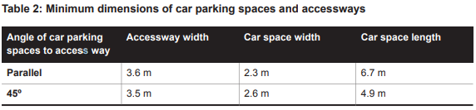  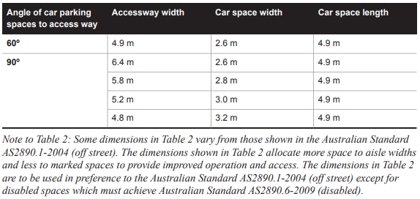 | Complies, with condition recommended  All parking spaces are provided at 90 degrees to the relevant accessway with a minimum space dimension of 2.8 x 4.9 metres.  All spaces within garages accord with the minimum dimension requirements.  Most visitor parking spaces are accessible from a minimum 5.8m wide accessway in accordance with the design requirement.  All parking spaces accord with the requirement of Table 2. Were a permit to be granted, it is recommended that all visitor parking spaces are fully dimensioned in accordance with the design standard.
A wall, fence, column, tree, tree guard or any other structure that abuts a car space must not encroach into the area marked ‘clearance required’ on Diagram 1, other than:  - A column, tree or tree guard, which may project into a space if it is within the area marked ‘tree or column permitted’ on Diagram 1.  - A structure, which may project into the space if it is at least 2.1 metres above the space.  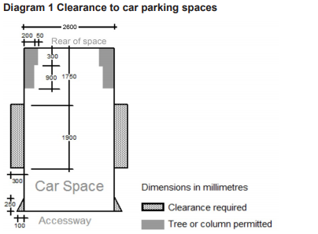 | Complies, with condition recommended  Each car parking space provided is clear of encroachment in accordance with the requirement.  Some visitor spaces are proposed to include electric vehicle charging infrastructure that has not been shown. If a permit were issued, it is recommended a condition require this be located and dimensioned to demonstrate clearance from parking spaces will be maintained.
Car spaces in garages or carports must be at least 6 metres long and 3.5 metres wide for a single space and 5.5 metres wide for a double space measured inside the garage or carport. | Complies  All car parking spaces within garages meet a minimum requirement of 3.5 x 6 metres for single garages, and 5.5 x 6 metres for double garages.
Where parking spaces are provided in tandem (one space behind the other) an additional 500 mm in length must be provided between each space. | Complies, with condition recommended  All tandem parking spaces are provided with an additional 500mm length in accordance with the requirement.
Where two or more car parking spaces are provided for a dwelling, at least one space must be under cover. | Complies  At least 1 parking space per 3 or 4 bedroom dwelling is provided undercover in accordance with the requirement.
Disabled car parking spaces must be designed in accordance with Australian Standard AS2890.6-2009 (disabled) and the Building Code of Australia. Disabled car parking spaces may encroach into an accessway width specified in Table 2 by 500mm. | Not Applicable  No disability access parking spaces are proposed.

Design standard 3: Gradients

Accessway grades must not be steeper than 1:10 (10 per cent) within 5 metres of the frontage to ensure safety for pedestrians and vehicles. The design must have regard to the wheelbase of the vehicle being designed for; pedestrian and vehicular traffic volumes; the nature of the car park; and the slope and configuration of the vehicle crossover at the site frontage. This does not apply to accessways serving three dwellings or less. | Complies  All accessway grades are less than 10 per cent in accordance with the design standard.
Ramps (except within 5 metres of the frontage) must have the maximum grades as outlined in Table 3 and be designed for vehicles travelling in a forward direction.  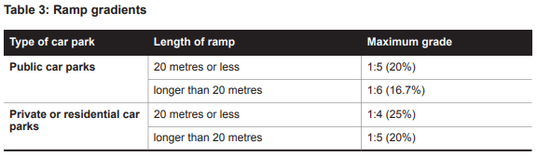 | Complies  All ramps are no steeper than 1:6 in accordance with the design standard.
Where the difference in grade between two sections of ramp or floor is greater that 1:8 (12.5 per cent) for a summit grade change, or greater than 1:6.7 (15 per cent) for a sag grade change, the ramp must include a transition section of at least 2 metres to prevent vehicles scraping or bottoming. | Not Applicable  No relevant grade changes are proposed.
Plans must include an assessment of grade changes of greater than 1:5.6 (18 per cent) or less than 3 metres apart for clearances, to the satisfaction of the responsible authority. | Not Applicable  No relevant grade changes are proposed.

Design standard 4: Mechanical parking

Mechanical parking may be used to meet the car parking requirement provided:  - At least 25 per cent of the mechanical car parking spaces can accommodate a vehicle height of at least 1.8 metres.  - Car parking spaces that require the operation of the system are not allocated to visitors unless used in a valet parking situation.  - The design and operation is to the satisfaction of the responsible authority. | Not Applicable  No mechanical parking is proposed.

Design standard 5: Urban design

Ground level car parking, garage doors and accessways must not visually dominate public space. | Complies  Parking facilities visible from public space are designed not to be visually dominant in accordance with the requirement.
Car parking within buildings (including visible portions of partly submerged basements) must be screened or obscured where possible, including through the use of occupied tenancies, landscaping, architectural treatments and artworks. | Complies  Parking facilities are visually compatible with the development.
Design of car parks must take into account their use as entry points to the site. | Complies  Car parking is not proposed at the entry to the site.
Design of new internal streets in developments must maximise on street parking opportunities. | Not Applicable  No new internal streets are proposed.

Design standard 6: Safety

Car parking must be well lit and clearly signed. | Complies, with condition recommended  No lighting detail has been proposed.  Were a permit to be granted, a condition is recommended that requires low-intensity lighting and designated non-resident (visitor) car parking signage to be provided in accordance with the requirement.
The design of car parks must maximise natural surveillance and pedestrian visibility from adjacent buildings. | Complies  Garage entrances and accessways are generally visible from adjoining dwellings and communal areas in accordance with the requirement.
Pedestrian access to car parking areas from the street must be convenient. | Complies  Convenient access to carparking area is provided in accordance with the requirements.
Pedestrian routes through car parking areas and building entries and other destination points must be clearly marked and separated from traffic in high activity parking areas. | Not Applicable  No high activity parking areas are proposed.

Design standard 7: Landscaping

The layout of car parking areas must provide for water sensitive urban design treatment and landscaping. | Complies  Appropriate WSUD treatments are proposed as part of the development.
Landscaping and trees must be planted to provide shade and shelter, soften the appearance of ground level car parking and aid in the clear identification of pedestrian paths. | Complies  Landscaping is provided to soften the appearance of the accessway where practical.
Ground level car parking spaces must include trees planted with flush grilles. Spacing of trees must be determined having regard to the expected size of the selected species at maturity. | Not Applicable  No relevant ground level car parking is proposed.

52.06-10 Decision guidelines

Before deciding that a plan prepared under Clause 52.06-8 is satisfactory the responsible authority must consider, as appropriate:  - The role and function of nearby roads and the ease and safety with which vehicles gain access to the site.  - The ease and safety with which vehicles access and circulate within the parking area.  - The provision for pedestrian movement within and around the parking area.  - The provision of parking facilities for cyclists and disabled people.  - The protection and enhancement of the streetscape.  - The provisions of landscaping for screening and shade.  - The measures proposed to enhance the security of people using the parking area particularly at night.  - The amenity of the locality and any increased noise or disturbance to dwellings and the amenity of pedestrians.  - The workability and allocation of spaces of any mechanical parking arrangement.  - The design and construction standards proposed for paving, drainage, line marking, signage, lighting and other relevant matters.  - The type and size of vehicle likely to use the parking area.  - Whether the layout of car parking spaces and access lanes is consistent with the specific standards or an appropriate variation.  - The need for the required car parking spaces to adjoin the premises used by the occupier/s, if the land is used by more than one occupier.  - Whether the layout of car spaces and accessways are consistent with Australian Standards AS2890.1-2004 (off street) and AS2890.6-2009 (disabled).  - The relevant standards of Clauses 56.06-2, 56.06-4, 56.06-5, 56.06-7 and 56.06-8 for residential developments with accessways longer than 60 metres or serving 16 or more dwellings.  - Any other matter specified in a schedule to the Parking Overlay. | Complies  The car parking plan has been considered against the decision guidelines of Clause 52.06-10 and determined to be in accordance with the purpose of Clause 52.06 (Car parking).

APPENDIX 2

Clause 55 Assessment – TWO OR MORE DWELLINGS ON A LOT AND RESIDENTIAL BUILDINGS

Plans Assessed: 15/02/2023 (All dwelling units except apartment Units 18 to 25 (inclusive), and 27 to 42 (inclusive) where indicated.
Permit Application Number: PP-509-2022

The following objectives apply to an application to:
- Construct a dwelling if there is at least one dwelling existing on the lot,
- Construct two or more dwellings on a lot,
- Extend a dwelling if there are two or more dwellings on the lot,
- Construct or extend a dwelling on common property, or
- Construct or extend a residential building,

in the Neighbourhood Residential Zone, General Residential Zone, Residential Growth Zone, Mixed Use Zone or Township Zone.

The following objectives are current up to and including Amendment VC221 on 04/08/2022.

55.02-1 Neighbourhood character objectives  To ensure that the design respects the existing neighbourhood character or contributes to a preferred neighbourhood character.  To ensure that development responds to the features of the site and the surrounding area. | Standard B1  The design response must be appropriate to the neighbourhood and the site.  The proposed design must respect the existing or preferred neighbourhood character and respond to the features of the site. | Yes – Complies with Standard B1  The site comprises a large area at the interface of an established residential neighbourhood to the north; a linear public path, water authority land and emerging residential estate to the east; and the Geelong Ring Road freeway reserve to the southwest. These interfaces present distinctively different characteristics to be considered when assessing the existing neighbourhood character for the purposes of deriving a design response that meets with the objectives of Clause 55.02-1.  Greenway Court (north interface)  The character of this area is significantly influenced by its topography. With the north approach to the site along James Cook Drive and Greenway Court following the path of a former creek (now piped under the road), the public realm is ‘nestled’ along a gully giving a sense of seclusion from the surrounding area. The topography has supported the establishment of formal gardens and canopy trees that have become a dominant feature of the area, and the meandering course of James Cook Drive, even with its wide nature strips and single footpath, providing only short range views to the next bend.  Established dwellings along Greenway Court and James Cook Drive typify a spacious ‘garden suburban’ character. Detached dwellings with typically generous front setbacks are prevalent, with some along the east side of the street set high on the ridge and beyond view behind screening vegetation. Dwellings are large, with many examples of double storey and some split 3 level dwellings constructed in response to sloping land. Heavy construction materials feature in the area, with brick, block and rendered walls, hipped and tiled roofs. A wide mix of architectural styles and feature elements have been used, including hipped metal roofs, decorative gables, flat roofs, (brick) quoining, finials, bay windows, and porticos. Front fences occur only occasionally, and many dwellings feature garages and carparking in the front setback.  In this location, Greenway Court ‘dead ends’ at the site property boundary, with no court bowl, ‘T head’ or similar turning area provided. This treatment is similar to nearby cul-de-sacs that end at large allotments likely to be subject to future subdivision and residential development including Lapin Grove, Stanfield Drive, Greenfinch Way, and more recently constructed (2005) examples at Dione Mews, Xavier Court and Kates Court.  Fully developed cul-de-sacs in the area are typically fronted by between 4 and 6 dwelling lots, with frontages of between 12 and 23 metres wide. Allotments fronting James Cook Drive and Greenway Court are typically between 21 and 25 metres wide (excluding curvature), and some include double width accessways and vehicle crossings.  The design response proposes a layout that extends Greenway Court to provide frontage for 8 dwellings with a mix of single and double width crossings. The extended road reserve creates a publicly accessible place, visually recessed from James Cook Drive and to a lesser extent the entrance to Greenway Court and derives its built form character and layout from developed cul-de-sacs in the area and the topographic constraints of the site.  Basin Rise (east interface)  The elevated land to the east of the site is characterised by the prevalence of the bank and berm of the Highton Basin, the Pipeline Shared Trail, and the sweeping views west to the hills of Ceres and north across Wandana Heights to the hills of Highton. The application was submitted at a time when the new Cumulus Estate had commencement construction, comprising single dwelling lots and multi-dwelling townhouse balance lots.  This new estate occupies a visually prominent position high on the ridge and offers views in all directions for the single and several double storey houses being constructed. The emerging character of the estate is influenced by the compact street layout and lot sizes of between 414 sq/m and 676 sq/m.  The proposal responds to the existing character of this area with a single entry off Basin Rise leading into the site and down to a row of single storey dwellings along its east boundary. A visually permeable boundary fence and site landscaping along the shared boundary with the pipeline track will present a single storey building form when viewed into and across the development from the east, and views from the south end of the track adjoining Basin Rise will be maintained to the hills of Ceres and Highton.  Ring Road (southwest interface)  The adjoining land to the southwest of the site is all part of the freeway reserve, visible only when exiting the Wandana Drive underpass to the ring road and is encumbered by power transmission lines, low voltage power lines and vegetation. Views to the site from the Geelong Ring Road are almost entirely obscured by an acoustic wall along the east side of the freeway. This land is not in a residential zone and forms a residential development boundary to Wandana Heights. The land further to the southwest is in the Farming Zone, with no relevant existing residential character requiring consideration in the design response.
55.02-2 Residential policy objectives  To ensure that residential development is provided in accordance with any policy for housing in the Municipal Planning Strategy and the Planning Policy Framework.  To support medium densities in areas where development can take advantage of public transport and community infrastructure and services. | Standard B2  An application must be accompanied by a written statement to the satisfaction of the responsible authority that describes how the development is consistent with any relevant policy for housing in the Municipal Planning Strategy and the Planning Policy Framework. | Yes – Complies with Standard B2  As set out above, the application complies with the planning policy framework. The required written statement has been provided.  The proposal represents a medium density development that takes advantage of nearby bus services, and local education, health, recreation and other relevant community infrastructure and services.
55.02-3 Dwelling diversity objective  To encourage a range of dwelling sizes and types in developments of ten or more dwellings. | Standard B3  Developments of ten or more dwellings should provide a range of dwelling sizes and types, including:  - Dwellings with a different number of bedrooms.  - At least one dwelling that contains a kitchen, bath or shower, and a toilet and wash basin at ground floor level. | Yes – Complies with Standard B3  The design response includes dwellings with a mix of 2, 3 and 4 bedroom dwellings, with Dwellings 1-7, 18, 21, 22, 25-27, 30, 31, 34, 35, 38, 39, 42, 51-55, 57 and 58 all providing a kitchen, bath or shower, toilet and wash basin at ground level.
55.02-4 Infrastructure objectives  To ensure development is provided with appropriate utility services and infrastructure.  To ensure development does not unreasonably overload the capacity of utility services and infrastructure. | Standard B4  Development should be connected to reticulated services, including reticulated sewerage, drainage and electricity, if available. Connection to a reticulated gas service is optional.  Development should not unreasonably exceed the capacity of utility services and infrastructure, including reticulated services and roads.  In areas where utility services or infrastructure have little or no spare capacity, developments should provide for the upgrading of or mitigation of the impact on services or infrastructure. | Yes – Complies with Standard B4  The site is serviced by the required infrastructure and the application has been referred to Council’s Engineers who have not raised any concern about the ability of the site to be drained, on condition that new drainage infrastructure is constructed on part of the site to be vested to the drainage authority.  Recommended permit conditions of permit cover off on this issue.
55.02-5 Integration with the street objective  To integrate the layout of development with the street. | Standard B5  Developments should provide adequate vehicle and pedestrian links that maintain or enhance local accessibility.  Development should be oriented to front existing and proposed streets.  High fencing in front of dwellings should be avoided if practicable.  Development next to existing public open space should be laid out to complement the open space. | Yes – Complies with Standard B5  Dwellings 1 to 50 are designed to address a private accessway to Basin Rise, with pedestrian and vehicle links to the street provided.  Dwellings 51 to 58 are designed to address an extension to Greenway Court, with publicly accessible pedestrian and vehicle links to the street provided.  No high front fencing is proposed along Greenway Court.  The fence along the east site boundary comprises a visually permeable metal palisade design to a height of 1.8 metres with pedestrian gate access to the rear of dwellings 1-7. This fence comprises a common boundary fence between the subject site and the land owned by Barwon Water.
55.03-1 Street setback objective  To ensure that the setbacks of buildings from a street respect the existing or preferred neighbourhood character and make efficient use of the site. | Standard B6  Walls of buildings should be set back from streets:  - At least the distance specified in a schedule to the zone, or  - If no distance is specified in a schedule to the zone, the distance specified in Table B1.  Porches, pergolas and verandahs that are less than 3.6 metres high and eaves may encroach not more than 2.5 metres into the setbacks of this standard. | Yes – Complies, with variation to Standard B6  Before deciding on an application, the responsible authority must consider:  - Any relevant neighbourhood character objective, policy or statement set out in this scheme.  - The design response.  - Whether a different setback would be more appropriate taking into account the prevailing setbacks of existing buildings on nearby lots.  - The visual impact of the building when viewed from the street and from adjoining properties.  - The value of retaining vegetation within the front setback.  The nearest relevant dwelling setback is located at 3 Greenway Court and measures approximately 4.5 metres. However, the new dwellings are proposed to front an extension to the Greenway Court road reserve that is yet to be formally established.  Indicative setbacks of 4.16 and 3.0 metres are shown to the proposed road reserve boundary, and the setback from the front corner of proposed Dwelling 51 to the current site boundary with Greenway Court is shown to be 4.479. This is approximately similar to that of the dwelling at 3 Greenway Court, but possibly less.  It is considered that the proposed variation to Standard B6 be supported given:  - There is no relevant neighbourhood character objective, policy or statement regarding this front setback objective  - The design response incorporates an extension to Greenway Court that is generally supported but yet to be established subject to detailed design of road and drainage infrastructure to be accommodated  - Prevailing setbacks in the area vary between 4.5 metres and 53 metres and are not a consistent pattern from which to determine a more appropriate setback  - The adjoining property most likely affected is located at 4 Greenway Court and is setback approximately 53 metres. Its view of the development is to be partly screened by plantings along the common boundary that are to be protected with tree protection zones were the development to progress  - The proposed Greenway Court extension will be landscaped in a manner consistent with the adjoining road reserve, and space for landscaping within the front setback of Dwellings 51-58 and at the entrance to the site at Basin Rise has been provided.
55.03-2 Building height objective  To ensure that the height of buildings respects the existing or preferred neighbourhood character. | Standard B7  The maximum building height should not exceed the maximum height specified in the zone, schedule to the zone or an overlay that applies to the land.  If no maximum height is specified in the zone, schedule to the zone or an overlay, the maximum building height should not exceed 9 metres, unless the slope of the natural ground level at any cross section wider than 8 metres of the site of the building is 2.5 degrees or more, in which case the maximum building height should not exceed 10 metres.  Changes of building height between existing buildings and new buildings should be graduated. | Yes – Complies with Standard B7  The maximum building height applicable to the site is 12.0 metres and 3 storeys at any point (excluding a basement). The proposed maximum building height of 9.372 metres meets the mandatory building height requirement of the GRZ1.  The dwellings are a mix of single storey and double storey in scale and respectful of surrounding development.
55.03-3 Site coverage objective  To ensure that the site coverage respects the existing or preferred neighbourhood character and responds to the features of the site. | Standard B8  The site area covered by buildings should not exceed:  - The maximum site coverage specified in a schedule to the zone, or  - If no maximum site coverage is specified in a schedule to the zone, 60 per cent. | Yes – Complies with Standard B8  The maximum site coverage specified for this site is 60 percent.  The proposed site coverage of buildings is 45.25 percent of the site, which is less than the maximum allowed by the standard.
55.03-4 Permeability and stormwater management objectives  To reduce the impact of increased stormwater run-off on the drainage system.  To facilitate on-site stormwater infiltration.  To encourage stormwater management that maximises the retention and reuse of stormwater. | Standard B9  The site area covered by the pervious surfaces should be at least:  - The minimum area specified in a schedule to the zone, or  - If no minimum is specified in a schedule to the zone, 20 percent of the site.  The stormwater management system should be designed to:  - Meet the current best practice performance objectives for stormwater quality as contained in the Urban Stormwater - Best Practice Environmental Management Guidelines (Victorian Stormwater Committee, 1999).  - Contribute to cooling, improving local habitat and providing attractive and enjoyable spaces. | Yes – Complies with Standard B9  The minimum pervious surface area specified for this site is 20 percent.  The site retains 54.75 per cent permeability, assisting in on site stormwater filtration.  A STORM assessment report has been provided which corresponds with the assessment plans and documents submitted with the application and show suitably sized rainwater tanks and/or raingardens to meet best practice.
55.03-5 Energy efficiency objectives  To achieve and protect energy efficient dwellings and residential buildings.  To ensure the orientation and layout of development reduce fossil fuel energy use and make appropriate use of daylight and solar energy.  This objective does not apply:  - To construct or extend an apartment development, or  - To construct or extend a dwelling in or forming part of an apartment development. | Standard B10  Buildings should be:  - Oriented to make appropriate use of solar energy.  - Sited and designed to ensure that the energy efficiency of existing dwellings on adjoining lots is not unreasonably reduced.  - Sited and designed to ensure that the performance of existing rooftop solar energy systems on dwellings on adjoining lots in a General Residential Zone, Neighbourhood Residential Zone or Township Zone are not unreasonably reduced. The existing rooftop solar energy system must exist at the date the application is lodged.  Living areas and private open space should be located on the north side of the development, if practicable.  Developments should be designed so that solar access to north-facing windows is maximised. | Yes – Complies with Standard B10  Where practicable, the dwellings are designed to take advantage of solar energy with living rooms and private open space areas to be located to receive northern light.  There are no existing rooftop solar energy facilities on adjoining land that will be affected by the proposed development.
55.03-6 Open space objective  To integrate the layout of development with any public and communal open space provided in or adjacent to the development.  This objective does not apply:  - To construct or extend an apartment development, or  - To construct or extend a dwelling in or forming part of an apartment development. | Standard B11  If any public or communal open space is provided on site, it should:  - Be substantially fronted by dwellings, where appropriate.  - Provide outlook for as many dwellings as practicable.  - Be designed to protect any natural features on the site.  - Be accessible and useable. | Yes – Complies with Standard B11  The site adjoins the publicly accessible Pipeline Track along its east boundary. This interface has been designed to provide access to the rear of units 1 to 7 and visually permeable fencing.  Consideration has been given to fronting the dwellings to the pipeline track but found not to be appropriate given the location of a high pressure gas transmission pipe that prevents a road from being constructed and an east frontage for these dwellings to be achieved.
55.03-7 Safety objective  To ensure the layout of development provides for the safety and security of residents and property. | Standard B12  Entrances to dwellings and residential buildings should not be obscured or isolated from the street and internal accessways.  Planting which creates unsafe spaces along streets and accessways should be avoided.  Developments should be designed to provide good lighting, visibility and surveillance of car parks and internal accessways.  Private spaces within developments should be protected from inappropriate use as public thoroughfares. | Yes – Complies with Standard B12  The development is designed to provide for the safety and security of residents and property. All dwelling entrances are clearly visible from the street or internal accessway and public access to private spaces within the development will be minimised through passive surveillance and fencing.  No public thoroughfares are proposed as part of this development.
55.03-8 Landscaping objectives  To encourage development that respects the landscape character of the neighbourhood.  To encourage development that maintains and enhances habitat for plants and animals in locations of habitat importance.  To provide appropriate landscaping.  To encourage the retention of mature vegetation on the site.  This objective does not apply:  - To construct or extend an apartment development, or  - To construct or extend a dwelling in or forming part of an apartment development. | Standard B13  The landscape layout and design should:  - Protect any predominant landscape features of the neighbourhood.  - Take into account the soil type and drainage patterns of the site.  - Allow for intended vegetation growth and structural protection of buildings.  - In locations of habitat importance, maintain existing habitat and provide for new habitat for plants and animals.  - Provide a safe, attractive and functional environment for residents.  Development should provide for the retention or planting of trees, where these are part of the character of the neighbourhood.  Development should provide for the replacement of any significant trees that have been removed in the 12 months prior to the application being made.  The landscape design should specify landscape themes, vegetation (location and species), paving and lighting.  Development should meet any additional landscape requirements specified in a schedule to the zone. | Yes – Complies with Standard B13  There are adequate areas available on site to allow for planting which will complement the landscape character of the area.  A landscaping concept plan has been submitted for assessment.  The development will result in the removal of some established trees and shrubs from the site.  Were a permit to be granted, it is recommended that amended plans include submission of a detailed landscape plan. The revised landscape plan should show the location of significant plantings of canopy trees to continue the established landscape character of residential area to the north. Tree plantings should provide for the replacement of those to be removed, and to give effect to the biodiversity strategies of the scheme.
55.03-9 Access objective  To ensure the number and design of vehicle crossovers respects the neighbourhood character. | Standard B14  The width of accessways or car spaces should not exceed:  - 33 per cent of the street frontage, or  - if the width of the street frontage is less than 20 metres, 40 per cent of the street frontage.  No more than one single-width crossover should be provided for each dwelling fronting a street.  The location of crossovers should maximise the retention of on-street car parking spaces.  The number of access points to a road in a Transport Zone 2 or a Transport Zone 3 should be minimised.  Developments must provide for access for service, emergency and delivery vehicles. | Yes – Complies with Standard B14  The existing vehicle access from Greenway Court is proposed to be reconstructed as part of an extension to the road. The new road reserve alignment at this part of the site is proposed to provide no more than a single crossing per dwelling and shared double crossings for dual townhouses.  A new access from Basin Rise provides a single shared point of access to the site.
55.03-10 Parking location objective  To provide convenient parking for resident and visitor vehicles.  To protect residents from vehicular noise within developments. | Standard B15  Car parking facilities should:  - Be reasonably close and convenient to dwellings and residential buildings.  - Be secure.  - Be well ventilated if enclosed.  Shared accessways or car parks of other dwellings and residential buildings should be located at least 1.5 metres from the windows of habitable rooms. This setback may be reduced to 1 metre where there is a fence at least 1.5 metres high or where window sills are at least 1.4 metres above the accessway. | Yes – Complies, with variation to Standard B15  All car parking spaces are appropriately located and conveniently accessible for residents and visitors.  Habitable room windows of dwelling Units 5, 6, 8, 9, 13, 14, 15, 16, 26 and 43 all have a sill height of less than 1.4 metres and are located less than 1.5 metres from the shared accessway, resulting in a variation to Standard B15.  Before deciding on an application, the responsible authority must consider the design response.  Were a permit to be granted, it is recommended that amended plans show vehicle noise attenuation window treatments to all ground level habitable room windows within 1.5m of the shared accessway of Units 5, 6, 8, 9, 13, 14, 15, 16, 26 and 43.
55.04-1 Side and rear setbacks objective  To ensure that the height and setback of a building from a boundary respects the existing or preferred neighbourhood character and limits the impact on the amenity of existing dwellings. | Standard B17  A new building not on or within 200mm of a boundary should be set back from side or rear boundaries:  - At least the distance specified in a schedule to the zone, or  - If no distance is specified in a schedule to the zone, 1 metre, plus 0.3 metres for every metre of height over 3.6 metres up to 6.9 metres, plus 1 metre for every metre of height over 6.9 metres.  Sunblinds, verandahs, porches, eaves, fascias, gutters, masonry chimneys, flues, pipes, domestic fuel or water tanks, and heating or cooling equipment or other services may encroach not more than 0.5 metres into the setbacks of this standard.  Landings having an area of not more than 2 square metres and less than 1 metre high, stairways, ramps, pergolas, shade sails and carports may encroach into the setbacks of this standard. | Yes – Complies with Standard B17  The required setbacks have been achieved for the development and all side and rear setbacks comply with the formula contained in the standard.
55.04-2 Walls on boundaries objective  To ensure that the location, length and height of a wall on a boundary respects the existing or preferred neighbourhood character and limits the impact on the amenity of existing dwellings. | Standard B18  A new wall constructed on or within 200mm of a side or rear boundary of a lot or a carport constructed on or within 1 metre of a side or rear boundary of lot should not abut the boundary:  - For a length of more than the distance specified in a schedule to the zone; or  - If no distance is specified in a schedule to the zone, for a length of more than:  - 10 metres plus 25 per cent of the remaining length of the boundary of an adjoining lot, or  - Where there are existing or simultaneously constructed walls or carports abutting the boundary on an abutting lot, the length of the existing or simultaneously constructed walls or carports,  whichever is the greater.  A new wall or carport may fully abut a side or rear boundary where slope and retaining walls or fences would result in the effective height of the wall or carport being less than 2 metres on the abutting property boundary.  A building on a boundary includes a building set back up to 200mm from a boundary.  The height of a new wall constructed on or within 200mm of a side or rear boundary or a carport constructed on or within 1 metre of a side or rear boundary should not exceed an average of 3.2 metres with no part higher than 3.6 metres unless abutting a higher existing or simultaneously constructed wall. | Not Applicable  No new walls on or within 200mm of a boundary, or carport within 1m of a boundary are proposed as part of this application.
55.04-3 Daylight to windows objective  To allow adequate daylight into existing habitable room windows. | Standard B19  Buildings opposite an existing habitable room window should provide for a light court to the existing window that has a minimum area of 3 square metres and minimum dimension of 1 metre clear to the sky. The calculation of the area may include land on the abutting lot.  Walls or carports more than 3 metres in height opposite an existing habitable room window should be set back from the window at least 50 per cent of the height of the new wall if the wall is within a 55 degree arc from the centre of the existing window. The arc may be swung to within 35 degrees of the plane of the wall containing the existing window.  Where the existing window is above ground floor level, the wall height is measured from the floor level of the room containing the window. | Not Applicable  There are no existing habitable room windows opposite the proposed buildings that require consideration.
55.04-4 North facing windows objective  To allow adequate solar access to existing north-facing habitable room windows. | Standard B20  If a north-facing habitable room window of an existing dwelling is within 3 metres of a boundary on an abutting lot, a building should be setback from the boundary 1 metre, plus 0.6 metres for every metre of height over 3.6 metres up to 6.9 metres, plus 1 metre for every metre of height over 6.9 metres, for a distance of 3 metres from the edge of each side of the window. A north-facing window is a window with an axis perpendicular to its surface oriented north 20 degrees west to north 30 degrees east. | Not Applicable  There are no north facing habitable room windows on abutting lots that require consideration.
55.04-5 Overshadowing open space objective  To ensure buildings do not significantly overshadow existing secluded private open space. | Standard B21  Where sunlight to the secluded private open space of an existing dwelling is reduced, at least 75 per cent, or 40 square metres with minimum dimension of 3 metres, whichever is the lesser area, of the secluded private open space should receive a minimum of five hours of sunlight between 9 am and 3 pm on 22 September.  If existing sunlight to the secluded private open space of an existing dwelling is less than the requirements of this standard, the amount of sunlight should not be further reduced. | Yes – Complies with Standard B21  The extent of overshadowing associated with the proposed development is within the requirements of the standard.
55.04-6 Overlooking objective  To limit views into existing secluded private open space and habitable room windows. | Standard B22  A habitable room window, balcony, terrace, deck or patio should be located and designed to avoid direct views into the secluded private open space of an existing dwelling within a horizontal distance of 9 metres (measured at ground level) of the window, balcony, terrace, deck or patio. Views should be measured within a 45 degree angle from the plane of the window or perimeter of the balcony, terrace, deck or patio, and from a height of 1.7 metres above floor level.  A habitable room window, balcony, terrace, deck or patio with a direct view into a habitable room window of existing dwelling within a horizontal distance of 9 metres (measured at ground level) of the window, balcony, terrace, deck or patio should be either:  - Offset a minimum of 1.5 metres from the edge of one window to the edge of the other.  - Have sill heights of at least 1.7 metres above floor level.  - Have fixed, obscure glazing in any part of the window below 1.7 metre above floor level.  - Have permanently fixed external screens to at least 1.7 metres above floor level and be no more than 25 per cent transparent.  Obscure glazing in any part of the window below 1.7 metres above floor level may be openable provided that there are no direct views as specified in this standard.  Screens used to obscure a view should be:  - Perforated panels or trellis with a maximum of 25 per cent openings or solid translucent panels.  - Permanent, fixed and durable.  - Designed and coloured to blend in with the development.  This standard does not apply to a new habitable room window, balcony, terrace, deck or patio which faces a property boundary where there is a visual barrier at least 1.8 metres high and the floor level of the habitable room, balcony, terrace, deck or patio is less than 0.8 metres above ground level at the boundary. | Yes – Complies with Standard B22  The development is designed to meet the requirements of the standard with overlooking into existing secluded private open space areas and habitable room windows limited in accordance with the standard.  Overlooking from ground level areas to private open space of dwellings on adjoining land can be reduced with the construction of appropriate visual barrier by way of common boundary fences to a height of 1.8 metres.  Were a permit to be granted, it is recommended a condition require that a minimum 1.8m high boundary fence be constructed to provide a visual barrier to all private open space of dwellings on allotments adjoining the development site.
55.04-7 Internal views objective  To limit views into the secluded private open space and habitable room windows of dwellings and residential buildings within a development. | Standard B23  Windows and balconies should be designed to prevent overlooking of more than 50 per cent of the secluded private open space of a lower-level dwelling or residential building directly below and within the same development. | Yes – Complies with Standard B23  Internal views have been considered in the design solution and there is no internal overlooking.  Were a permit to be granted, it is recommended a condition require the obscure glazing of the southeast facing habitable room windows of Apartments 19, 20, 23, 24, 28, 29, 32, 33, 36, 37, 40 and 41 be dimensioned to a minimum of 1.7m above finished floor level.  Some consideration has been given to the potential internal views between upper storey apartment Units 29 and 32, 33 and 36, 37 and 40 (all Type H1). These kitchen splashback windows have a sill height above finished floor level of (approx..) 900mm and window height of 650mm. Linear views from a height of between 0.9m and 1.55 metres will be directly into the adjoining apartment kitchen window.  Were a permit to be granted, it is recommended that the south west facing kitchen splashback windows of apartment Units 29, 33 and 37 be fixed obscure glazing, or have permanently fixed external screens to be no more than 25 per cent transparent.
55.04-8 Noise impacts objective  To contain noise sources in developments that may affect existing dwellings.  To protect residents from external noise  This objective does not apply:  - To construct or extend an apartment development, or  - To construct or extend a dwelling in or forming part of an apartment development. | Standard B24  Noise sources, such as mechanical plant, should not be located near bedrooms of immediately adjacent existing dwellings.  Noise sensitive rooms and secluded private open spaces of new dwellings and residential buildings should take account of noise sources on immediately adjacent properties.  Dwellings and residential buildings close to busy roads, railway lines or industry should be designed to limit noise levels in habitable rooms. | Yes – Complies with Standard B24  The Geelong Ring Road is significant noise source proximate to the proposed development.  A Traffic Noise Assessment was submitted with the application, confirming that traffic noise was a matter for design consideration, but made no recommendation for acoustic attenuation to be incorporated into the design response.  Given that traffic noise will be generated and is likely to increase in years to come, but all within acceptable thresholds, it is considered appropriate that noise attenuation window treatments be included for all habitable room windows facing in the direction of the traffic noise source. An example might be for the provision of double glazing, consistent with the proposed installation of double glazed windows to achieve an acceptable ESD rating.  Were a permit to be granted, it is recommended that a condition require all double glazed windows be shown on floor plans and elevations for plan approval.
55.05-1 Accessibility objective  To encourage the consideration of the needs of people with limited mobility in the design of developments.  This objective does not apply:  - To construct or extend an apartment development, or  - To construct or extend a dwelling in or forming part of an apartment development. | Standard B25  The dwelling entries of the ground floor of dwellings and residential buildings should be accessible or able to be easily made accessible to people with limited mobility. | Yes – Complies with Standard B25  The entries to the ground floor of the dwellings are accessible to those with limited mobility.
55.05-2 Dwelling entry objective  To provide each dwelling or residential building with its own sense of identity.  This objective does not apply:  - To construct or extend an apartment development, or  - To construct or extend a dwelling in or forming part of an apartment development. | Standard B26  Entries to dwellings and residential buildings should:  - Be visible and easily identifiable from streets and other public areas.  - Provide shelter, a sense of personal address and a transitional space around the entry. | Yes – Complies with Standard B26  All dwelling entries are clearly visible and identifiable from the street providing for a sense of identity for each dwelling. Shelter and a transitional space are provided at each dwelling entry.
55.05-3 Daylight to new windows objective  To allow adequate daylight into new habitable room windows. | Standard B27  A window in a habitable room should be located to face:  - An outdoor space clear to the sky or a light court with a minimum area of 3 square metres and minimum dimension of 1 metre clear to the sky, not including land on an abutting lot, or  - A verandah provided it is open for at least one third of its perimeter, or  - A carport provided it has two or more open sides and is open for at least one third of its perimeter. | Yes – Complies with Standard B27  All habitable room windows face an outdoor space of the required dimensions, allowing light into habitable rooms.
55.05-4 Private open space objective  To provide adequate private open space for the reasonable recreation and service needs of residents. | Standard B28  A dwelling or residential building should have private open space of an area and dimensions specified in the schedule to the zone.  If no area or dimensions are specified in the schedule to the zone, a dwelling or residential building should have private open space consisting of:  - An area of 40 square metres, with one part of the private open space to consist of secluded private open space at the side or rear of the dwelling or residential building with a minimum area of 25 square metres, a minimum dimension of 3 metres and convenient access from a living room, or  - A balcony of 8 square metres with a minimum width of 1.6 metres and convenient access from a living room, or  - A roof-top area of 10 square metres with a minimum width of 2 metres and convenient access from a living room. | Yes – Complies, with variation to Standard B28  Schedule 1 to the GRZ does not nominate a reduced POS or SPOS requirement for this development.  Detached dwelling Unit 9 has a minimum areas of SPOS that is constrained by the location of a water tank and external storage such that the minimum SPOS area of 25 sq/m has not been achieved.  All other detached and townhouse dwellings have been provided with at least 40 sq/m of private open space, of which 25 sq/m is secluded with a minimum dimension of 3 metres and convenient access to a living room in accordance with Standard B28.  Before deciding on an application, the responsible authority must consider:  - The design response.  - The useability of the private open space, including its size and accessibility.  - The availability of and access to public or communal open space.  - The orientation of the lot to the street and the sun.  The constrained area of SPOS is supplemented by a secondary SPOS areas and provides a useable outdoor space for activities consistent with townhouse living. The development offers a large communal outdoor area, and the reduced SPOS area will achieve good solar access in accordance with the objective.
55.05-5 Solar Access to Open Space  To allow solar access into the secluded private open space of new dwellings and residential buildings. | Standard B29  The private open space should be located on the north side of the dwelling or residential building, if appropriate.  The southern boundary of secluded private open space should be set back from any wall on the north of the space at least (2+0.9h) metres, where ‘h’ is the height of the wall. | Yes – Complies, with variation to Standard B29  The orientation buildings in this development results in a reduction of solar access to the minimum area of SPOS for the following ground floor apartment Units 18, 21, 22, 25, 27, 30, 31, 34, 35, 38, 39 and 42, and detached dwelling Unit 26.  Before deciding on an application, the responsible authority must consider:  - The design response.  - The useability and amenity of the secluded private open space based on the sunlight it will receive.  The variation is considered acceptable due to the orientation of these dwellings providing for an acceptable amount of solar access through the early parts of the day, and the design response utilising pitched roofs to minimise the loss of solar access where practicable. All of these affected dwellings have parts of their SPOS that conform with the solar access standard providing for an acceptable level of usability at those times of the day when solar access is good, and in accordance with the objective.
55.05-6 Storage objective  To provide adequate storage facilities for each dwelling.  This objective does not apply:  - To construct or extend an apartment development, or  - To construct or extend a dwelling in or forming part of an apartment development. | Standard B30  Each dwelling should have convenient access to at least 6 cubic metres of externally accessible, secure storage space. | Yes – Complies with Standard B30  All dwellings are provided with access to 6 cubic metres of externally accessible, secure storage in accordance with the standard.
55.06-1 Design Detail  To encourage design detail that respects the existing or preferred neighbourhood character. | Standard B31  The design of buildings, including:  - Façade articulation and detailing,  - Window and door proportions,  - Roof form, and  - Verandahs, eaves and parapets,  - should respect the existing or preferred neighbourhood character.  Garages and carports should be visually compatible with the development and the existing or preferred neighbourhood character. | Yes – Complies with Standard B31  The proposed development is considered to respect the garden suburban neighbourhood character through the appropriate use and design of façade articulation and detailing, window and door proportions, roof forms, and verandahs, eaves and parapets.  All garages are considered visually compatible with the development.
55.06-2 Front Fences  To encourage front fence design that respects the existing or preferred neighbourhood character | Standard B32  The design of front fences should complement the design of the dwelling or residential building and any front fences on adjoining properties.  A front fence within 3 metres of a street should not exceed:  - The maximum height specified in a schedule to the zone, or  - If no maximum height is specified in a schedule to the zone, the maximum height specified in Table B3. | Not Applicable  No front fence is proposed as part of this permit application.
55.06-3 Common Property  To ensure that communal open space, car parking, access areas and site facilities are practical, attractive and easily maintained.  To avoid future management difficulties in areas of common ownership. | Standard B33  Development should clearly delineate public, communal and private areas.  Common property, where provided, should be functional and capable of efficient management. | Yes – Complies with Standard B33  Access paths, vehicle parking and accessways and communal spaces are delineated with surface finishes, walls and fences of materials that are able to be easily maintained by occupants and the land owner in accordance with the objective.
55.06-4 Site Services  To ensure that site services can be installed and easily maintained.  To ensure that site facilities are accessible, adequate and attractive. | Standard B34  The design and layout of dwellings and residential buildings should provide sufficient space (including easements where required) and facilities for services to be installed and maintained efficiently and economically.  Bin and recycling enclosures, mailboxes and other site facilities should be adequate in size, durable, waterproof and blend in with the development.  Bin and recycling enclosures should be located for convenient access by residents.  Mailboxes should be provided and located for convenient access as required by Australia Post. | Yes – Complies with Standard B34  The dwelling layout and design provides for sufficient space and facilities for services to be installed and maintained. Bin and recycling enclosures, mailboxes, clotheslines, and other site facilities have been conveniently located and will blend in with the development and located for convenient access.  Were a permit to be granted, it is recommended that amended plans for approval show bin storage areas for dwellings fronting the extension to Greenway Court.

Clause 55.07 APARTMENT DEVELOPMENTS

In addition to Clause 55.01 to 55.05 (inclusive), the following Clause 55.07-1 to 55.07-19 (inclusive) apply only:
- To construct or extend an apartment development, or
- To construct or extend a dwelling in or forming part of an apartment development.

These provisions do not apply to an application to construct or extend a development of five or more storeys, excluding a basement or to construct or extend a dwelling in a development of five or more storeys, excluding a basement.

55.07-1 Energy efficiency objectives  To achieve and protect energy efficient dwellings and buildings.  To ensure the orientation and layout of development reduce fossil fuel energy use and make appropriate use of daylight and solar energy.  To ensure dwellings achieve adequate thermal efficiency. | Standard B35  Buildings should be:  - Oriented to make appropriate use of solar energy.  - Sited and designed to ensure that the energy efficiency of existing dwellings on adjoining lots is not unreasonably reduced.  - Sited and designed to ensure that the performance of existing rooftop solar energy systems on dwellings on adjoining lots in a General Residential Zone, Neighbourhood Residential Zone or Township Zone are not unreasonably reduced. The existing rooftop solar energy system must exist at the date the application is lodged.  Living areas and private open space should be located on the north side of the development, if practicable.  Developments should be designed so that solar access to north-facing windows is optimised.  Dwellings located in a climate zone identified Table B4 in should not exceed the maximum NatHERS annual cooling load specified in the following table.  Refer Table B4 of Clause 55.07-1. | Yes – Complies with Standard B35  Where practicable the design response has been oriented to maximise solar access to private open space areas, internal living areas and north facing windows.  There are no rooftop solar energy systems on dwellings adjoining the site that will be affected by the apartment development.  The site is within Climate zone 60 Tullamarine with a recommended NatHERS maximum cooling load of 22 MJ/M2 per annum. The apartments achieve with an average load of 12.2 MJ/M2 per annum in accordance with the Standard.
55.07-2 Communal open space objective  To provide communal open space that meets the recreation and amenity needs of residents.  To ensure that communal open space is accessible, functional, and is easily maintained.  To ensure that communal open space is integrated with the layout of the development and enhances resident amenity. | Standard B36  A development of 10 or more dwellings should provide a minimum area of communal outdoor open space of 30 square metres.  If a development contains 13 or more dwellings, the development should also provide an additional minimum area of communal open space of 2.5 square metres per dwelling or 220 square metres, whichever is the lesser. This additional area may be indoors or outdoors and consist of multiple separate areas of communal open space.  Each area of communal open space should be:  - Accessible to all residents.  - A useable size, shape and dimension.  - Capable of efficient management.  - Be located to:  - Provide passive surveillance opportunities, where appropriate.  - Provide outlook for as many dwellings as practicable.  - Avoid overlooking into habitable rooms and private open space of new dwellings.  - Minimise noise impacts to new and existing dwellings.  Any area of communal outdoor open space should be landscaped and include canopy cover and trees. | Yes – Complies with Standard B36  A communal open space area of approximately 880 sq/m is provided at the west side of the new Basin Rise entrance to the site and is well in excess of the minimum area for compliance.  The landscape plan submitted with the application shows canopy trees to be planted in this location.
55.07-3 Solar access to communal outdoor open space objective  To allow solar access into communal outdoor open space. | Standard B37  The communal outdoor open space should be located on the north side of a building, if appropriate.  At least 50 per cent or 125 square metres, whichever is the lesser, of the primary communal outdoor open space should receive a minimum of two hours of sunlight between 9am and 3pm on 21 June. | Yes – Complies with Standard B37  Solar access to the communal open space meets the Standard.
55.07-4 Landscaping objective  To provide landscaping that supports the existing or preferred urban context of the area and reduces the visual impact of buildings on the streetscape.  To preserve existing canopy cover and support the provision of new canopy cover.  To ensure landscaping is climate responsive, supports biodiversity, wellbeing and amenity and reduces urban heat. | Standard B38  Development should retain existing trees and canopy cover.  Development should provide for the replacement of any significant trees that have been removed in the 12 months prior to the application being made.  Development should:  - Provide the canopy cover and deep soil areas specified in Table B5. Existing trees can be used to meet the canopy cover requirements of Table B5.  - Provide canopy cover through canopy trees that are:  - Located in an area of deep soil specified in Table B6. Where deep soil cannot be provided trees should be provided in planters specified in Table B6.  - Consistent with the canopy diameter and height at maturity specified in Table B7.  - Located in communal outdoor open space or common areas or street frontages.  - Comprise smaller trees, shrubs and ground cover, including flowering native species.  - Include landscaping, such as climbing plants or smaller plants in planters, in the street frontage and in outdoor areas, including communal outdoor open space.  - Shade outdoor areas exposed to summer sun through landscaping or shade structures and use paving and surface materials that lower surface temperatures and reduce heat absorption.  - Be supported by irrigation systems which utilise alternative water sources such as rainwater, stormwater and recycled water.  - Protect any predominant landscape features of the area.  - Take into account the soil type and drainage patterns of the site.  - Provide a safe, attractive and functional environment for residents.  - Specify landscape themes, vegetation (location and species), irrigation systems, paving and lighting.  Refer Table B5, B6 and B7 of Clause 55.07-4. | Yes – Complies with Standard B38  A landscape concept plan submitted with the application demonstrates capacity for canopy tree plantings in communal and shared areas of the site.  The entire site conforms with the deep soil requirements of the Standard. Therefore, compliance with table B5 has been calculated as:  16,849-2,500 sq/m = 14,349 sq/m  20% of 14,349 sq/m = 2,869.8 sq/m  2,869.8+350 sq/m = 3,219.8 sq/m  The canopy tree coverage requirement to conform with Table B5 is 3,219.8 sq/m. It is notable that 1,475 sq/m of the site is burdened by easements containing underground utility assets that are subject to planting constraints set out in a restrictive covenant.  Were a permit to be issued, it is recommended a condition require a minimum canopy tree coverage area for the site of 3,220 sq/m be shown on landscape plan for approval, comprising indigenous or Australian native canopy tree species with a minimum canopy diameter of 8 metres and minimum height at maturity of 8 metres. Approved landscape plans should be annotated to show that conformance with the relevant restrictive covenant will be achieved.
55.07-5 Integrated water and stormwater management objectives  To encourage the use of alternative water sources such as rainwater, stormwater and recycled water.  To facilitate stormwater collection, utilisation and infiltration within the development.  To encourage development that reduces the impact of stormwater run-off on the drainage system and filters sediment and waste from stormwater prior to discharge from the site. | Standard B39  Buildings should be designed to collect rainwater for non-drinking purposes such as flushing toilets, laundry appliances and garden use.  Buildings should be connected to a non-potable dual pipe reticulated water supply, where available from the water authority.  The stormwater management system should be:  - Designed to meet the current best practice performance objectives for stormwater quality as contained in the Urban Stormwater - Best Practice Environmental Management Guidelines (Victorian Stormwater Committee, 1999).  - Designed to maximise infiltration of stormwater, water and drainage of residual flows into permeable surfaces, tree pits and treatment areas. | Yes – Complies with Standard B39  A MUSIC model shows the development has been designed to meet best practice in accordance with the standard with:  - Rainwater is to be collected from the double storey dwelling and unit roofs and directed into individual 2,000 litre rainwater tanks. All double storey dwelling and unit WC's and landscape irrigation are to be connected to the rainwater tank.  - Rainwater is to be collected from the eastern part of the site will be directed into a 116m2 raingarden with 300mm of extended detention.  - Rainwater is to be collected from the western part of the site will be directed into a 20m2 raingarden with 300mm of extended detention.
55.07-6 Access objective  To ensure that vehicle crossovers are designed and located to provide safe access for pedestrians, cyclists and other vehicles.  To ensure that vehicle crossovers are designed and located to minimise visual impact. | Standard B40  Vehicle crossovers should be minimised.  Car parking entries should be consolidated, minimised in size, integrated with the façade and where practicable located at the side or rear of the building.  Pedestrian and cyclist access should be clearly delineated from vehicle access.  The location of crossovers should maximise pedestrian safety and the retention of on-street car parking spaces and street trees.  Development must provide access for service, emergency and delivery vehicles. | Yes – Complies with Standard B40  The existing vehicle access from Greenway Court is proposed to be reconstructed as part of an extension to the road. The new road reserve alignment at this part of the site is proposed to provide no more than a single crossing per dwelling and shared double crossings for dual townhouses.  A new access from Basin Rise provides a single shared point of access to the site.  Accessways have been designed in accordance with FRV (fire appliance) access requirements.
55.07-7 Noise impacts objective  To contain noise sources in developments that may affect existing dwellings.  To protect residents from external and internal noise sources. | Standard 41  Noise sources, such as mechanical plants should not be located near bedrooms of immediately adjacent existing dwellings.  The layout of new dwellings and buildings should minimise noise transmission within the site.  Noise sensitive rooms (such as living areas and bedrooms) should be located to avoid noise impacts from mechanical plants, lifts, building services, non-residential uses, car parking, communal areas and other dwellings.  New dwellings should be designed and constructed to include acoustic attenuation measures to reduce noise levels from off-site noise sources.  Buildings within a noise influence area specified in Table B8 should be designed and constructed to achieve the following noise levels:  - Not greater than 35dB(A) for bedrooms, assessed as an LAeq,8h from 10pm to 6am.  - Not greater than 40dB(A) for living areas, assessed LAeq,16h from 6am to 10pm.  Buildings, or part of a building screened from a noise source by an existing solid structure, or the natural topography of the land, do not need to meet the specified noise level requirements.  Noise levels should be assessed in unfurnished rooms with a finished floor and the windows closed.  Refer Table B8 of Clause 55.07-7. | Yes – Complies with Standard B41  The Geelong Ring Road is significant noise source proximate to the proposed development but is not carrying 40,000 Annual Average Daily Traffic Volume. The development is not within in noise influence area as set out in Table B8.  Nevertheless, a Traffic Noise Assessment was submitted with the application, confirming that traffic noise was a matter for design consideration, but made no recommendation for acoustic attenuation to be incorporated into the design response.  Given that traffic noise will be generated and is likely to increase in years to come, but all within acceptable thresholds, it is considered appropriate that noise attenuation window treatments be included for all habitable room windows facing in the direction of the traffic noise source. An example might be for the provision of double glazing, consistent with the proposed installation of double glazed windows to achieve an acceptable ESD rating.  Were a permit to be granted, it is recommended that a condition require all double glazed windows be shown on floor plans and elevations for plan approval.  Noise sensitive rooms are located away from mechanical plant, including the lift, and the site is not within a nominated noise influence area.
55.07-8 Accessibility objective  To ensure the design of dwellings meets the needs of people with limited mobility | Standard 42  At least 50 per cent of dwellings should have:  - A clear opening width of at least 850mm at the entrance to the dwelling and main bedroom.  - A clear path with a minimum width of 1.2 metres that connects the dwelling entrance to the main bedroom, an adaptable bathroom and the living area.  - A main bedroom with access to an adaptable bathroom.  - At least one adaptable bathroom that meets all of the requirements of either Design A or Design B specified in Table B9.  Refer Table B9 of Clause 55.07-8. | Yes – Complies with Standard B42  The application proposes accessible apartments at Typical First Floor Plan F1 and H1. Strangely, whilst the internal layouts of these meet with the standard, they are located at the top of a flight of stairs with no lift access rendering accessibility unsuitable for people with limited mobility.  Were a permit to be issued, it is recommended that an amended plans condition require the accessibility requirements of Standard B42 be shown and fully dimensioned on the Typical Ground Floor Plan F and Typical Ground Floor Plan H instead.  This change will ensure the design response meets the objective.
55.07-9 Private open space objective  To provide adequate private open space for the reasonable recreation and service needs of residents. | Standard B43  A dwelling should have private open space consisting of at least one of the following:  - An area at ground level of at least 25 square metres, with a minimum dimension of 3 metres and convenient access from a living room.  - A balcony with at least the area and dimensions specified in Table B10 and convenient access from a living room. If a cooling or heating unit is located on a balcony, the minimum balcony area specified in Table B10 should be increased by at least 1.5 square metres.  - An area on a podium or other similar base of at least 15 square metres, with a minimum dimension of 3 metres and convenient access from a living room.  - An area on a roof of at least 10 square metres, with a minimum dimension of 2 metres and convenient access from a living room.  Refer Table B10 of Clause 55.07-9. | Yes – Complies, with variation to Standard B43  Ground level apartment Units 18, 27, 30, 31, 34, 35, 38, 39 and 42 all have minimum areas of SPOS that are constrained by the location of a water tank and external storage such that the minimum SPOS area of 25 sq/m has not been achieved.  All upper storey apartments are provided with an oversized balcony of at least 8 square metres and a minimum width of 2 metres and convenient access from a living room.  All other ground level apartment dwellings has been provided with at least 40 sq/m of private open space, of which 25 sq/m is secluded with a minimum dimension of 3 metres and convenient access to a living room in accordance with Standard B43.  Before deciding on an application, the responsible authority must consider:  - The design response.  - The useability and functionality of the private open space, including its size and accessibility.  - The amenity of the private open space based on the orientation of the lot, noise exposure, the wind conditions and the sunlight it will receive.  - The availability of and access to public or communal open space.  In each instance, the constrained areas of SPOS are supplemented by secondary SPOS areas and provide a useable outdoor space for activities consistent with apartment living. The development offers a large communal outdoor area, and all SPOS areas will achieve acceptable solar access in accordance with the objective.
55.07-10 Storage objective  To provide adequate storage facilities for each dwelling. | Standard B44  Each dwelling should have convenient access to usable and secure storage space.  The total minimum storage space (including kitchen, bathroom and bedroom storage) should meet the requirements specified in Table B11.  Refer Table B11 of Clause 55.07-10. | Yes – Complies with Standard B44  Each 2 bedroom apartment is provided with not less than 14 cubic metres of useable and secure storage, including not less than 9 cubic metres of combined kitchen, bathroom and bedroom storage within the dwelling.  A storage location plan has been provided to show the location and dimensions of storage facilities.
55.07-11 Waste and recycling objectives  To ensure dwellings are designed to encourage waste recycling.  To ensure that waste and recycling facilities are accessible, adequate and attractive.  To ensure that waste and recycling facilities are designed and managed to minimise impacts on residential amenity, health and the public realm | Standard B45  Developments should include dedicated areas for:  - Waste and recycling enclosures which are:  - Adequate in size, durable, waterproof and blend in with the development.  - Adequately ventilated.  - Located and designed for convenient access by residents and made easily accessible to people with limited mobility.  - Adequate facilities for bin washing. These areas should be adequately ventilated.  - Collection, separation and storage of waste and recyclables, including where appropriate opportunities for on-site management of food waste through composting or other waste recovery as appropriate.  - Collection, storage and reuse of garden waste, including opportunities for on-site treatment, where appropriate, or off-site removal for reprocessing.  - Adequate circulation to allow waste and recycling collection vehicles to enter and leave the site without reversing.  - Adequate internal storage space within each dwelling to enable the separation of waste, recyclables and food waste where appropriate.  Waste and recycling management facilities should be design and managed in accordance with a Waste Management Plan approved by the responsible authority and:  - Be designed to meet the better practice design options specified in Waste Management and Recycling in Multi-unit Developments (Sustainability Victoria, 2019).  - Protect public health and amenity of residents and adjoining premises from the impacts of odour, noise and hazards associated with waste collection vehicle movements. | Yes – Complies with Standard B45  Each apartment is provided with adequate waste and recycling facilities.  Shared onsite waste management and storage areas have been provided and set out in a waste management plan for the development. It is recommended a condition of any permit that is issued require the development be in accordance with the waste management plan endorsed to form part of the permit.  Were a permit to be issued, it is recommended that revised plans show communal bin washing facilities adjoining each shared bin storage area that is graded and drained, with a hosecock, hose, and floor waste in accordance with the standard.
55.07-12 Functional layout objective  To ensure dwellings provide functional areas that meet the needs of residents. | Standard B46  Bedrooms should:  - Meet the minimum internal room dimensions specified in Table B12.  - Provide an area in addition to the minimum internal room dimensions to accommodate a wardrobe.  Refer Table B12 of Clause 55.07-12.  Living areas (excluding dining and kitchen areas) should meet the minimum internal room dimensions specified in Table B13.  Refer Table B13 of Clause 55.07-12. | Yes – Complies with Standard B46  All apartments are provided with a main bedroom with a width and depth of not less than 3.0m x 3.4m, and other bedrooms of not less than 3.0m x 3.0m and all excluding areas provided for a wardrobe.  All 2 or more bedroom apartments are provided with a living area (excluding dining and kitchen areas) with an internal room width of not less than 3.6m and area of not less than 12 sq/m.
55.07-13 Room depth objective  To allow adequate daylight into single aspect habitable rooms. | Standard B47  Single aspect habitable rooms should not exceed a room depth of 2.5 times the ceiling height.  The depth of a single aspect, open plan, habitable room may be increased to 9 metres if all the following requirements are met:  - The room combines the living area, dining area and kitchen.  - The kitchen is located furthest from the window.  - The ceiling height is at least 2.7 metres measured from finished floor level to finished ceiling level. This excludes where services are provided above the kitchen.  The room depth should be measured from the external surface of the habitable room window to the rear wall of the room. | Yes – Complies with Standard B47  The minimum proposed single aspect habitable room ceiling height is 2.55 metres requiring a maximum room depth of not more than 6.375 metres. All apartments meet the Standard.
55.07-14 Windows objective  To allow adequate daylight into new habitable room windows. | Standard B48  Habitable rooms should have a window in an external wall of the building.  A window may provide daylight to a bedroom from a smaller secondary area within the bedroom where the window is clear to the sky.  The secondary area should be:  - A minimum width of 1.2 metres.  - A maximum depth of 1.5 times the width, measured from the external surface of the window. | Yes – Complies with Standard B48  All habitable rooms are provided with windows in an external wall of the building in accordance with the requirements of Standard B48.
55.07-15 Natural ventilation objectives  To encourage natural ventilation of dwellings.  To allow occupants to effectively manage natural ventilation of dwellings. | Standard B49  The design and layout of dwellings should maximise openable windows, doors or other ventilation devices in external walls of the building, where appropriate.  At least 40 per cent of dwellings should provide effective cross ventilation that has:  - A maximum breeze path through the dwelling of 18 metres.  - A minimum breeze path through the dwelling of 5 metres  - Ventilation openings with approximately the same area.  The breeze path is measured between the ventilation openings on different orientations of the dwelling. | Yes – Complies with Standard B49  All habitable rooms are provided with openable windows and doors to provide cross ventilation in accordance with Standard B49.
55.07-16 Building entry and circulation objectives  To provide each dwelling and building with its own sense of identity.  To ensure the internal layout of buildings provide for the safe, functional and efficient movement of residents.  To ensure internal communal areas provide adequate access to daylight and natural ventilation. | Standard B50  Entries to dwellings and buildings should:  - Be visible and easily identifiable.  - Provide shelter, a sense of personal address and a transitional space around the entry.  The layout and design of buildings should:  - Clearly distinguish entrances to residential and non-residential areas.  - Provide windows to building entrances and lift areas.  - Provide visible, safe and attractive stairs from the entry level to encourage use by residents.  - Provide common areas and corridors that:  - Include at least one source of natural light and natural ventilation.  - Avoid obstruction from building services.  - Maintain clear sight lines. | Yes – Complies with Standard B50  The entrances to al apartments are easily identifiable with shelter, a sense of address and transitional space in accordance with Standard B50.
55.07-17 Integration with the street objective  To integrate the layout of development with the street.  To support development that activates street frontages. | Standard B51  Development should be oriented to front existing and proposed streets.  Along street frontages, development should:  - Incorporate pedestrian entries, windows, balconies or other active spaces.  - Limit blank walls.  - Limit high front fencing, unless consistent with the existing urban context.  - Provide low and visually permeable front fences, where proposed.  - Conceal car parking and internal waste collection areas from the street.  Development next to existing public open space should be designed to complement the open space and facilitate passive surveillance. | Yes – Complies with Standard B51  All apartments have entries that are integrated with the internal accessway, and all car parking areas are concealed from the street in accordance with Standard B51.
55.07-18 Site services objective  To ensure that site services are accessible and can be easily installed and maintained.  To ensure that site services and facilities are visually integrated into the building design or landscape. | Standard B52  Development should provide adequate space (including easements where required) for site services to be installed and maintained efficiently and economically.  Meters and utility services should be designed as an integrated component of the building or landscape.  Mailboxes and other site facilities should be adequate in size, durable, weather-protected, located for convenient access and integrated into the overall design of the development. | Yes – Complies with Standard B52  The design response provides space for site services and utility infrastructure in accordance with Standard B52.  Were a permit to be issued, it is recommended a condition require the location, dimensions and design detail of site services, metering and utility infrastructure be shown on plans for endorsement.
55.07-19 External walls and materials objective  To ensure external walls use materials appropriate to the existing urban context or preferred future development of the area.  To ensure external walls endure and retain their attractiveness. | Standard B53  External walls should be finished with materials that:  - Do not easily deteriorate or stain.  - Weather well over time.  - Are resilient to the wear and tear from their intended use.  External wall design should facilitate safe and convenient access for maintenance. | Yes – Complies with Standard B53  External wall materials include brick, and a mix of resilient contemporary cladding materials in accordance with Standard B53.

- ttachment_.1.1 page 3
2.1.1 page 4
Attachment_2.1.1 page 5
Attachment_2.1.1 pagCLOSE OF MEETING

As there was no further business the meeting closed at 7.35pm on 16 August 2023.

