

minutes

PLANNING COMMITTEE MEETING
No. 232

21 September 2023
City Hall

ALSO LIVE STREAMED ON THE CITY’S WEBSITE:

www.geelongaustralia.com.au/meetings

PANEL:

Cr Harwood (Chair)
Cr Cadwell
Cr Murrihy
Cr Nelson
Cr Moloney
Cr Hathway
Cr Aitken

PRESENT

Present: Cr Cadwell, Cr Murrihy, Cr Nelson, Cr Moloney, Cr Harwood, Cr Hathway,
Cr Aitken

Council Officers:

Clara Gartland, Senior Statutory Planner
Rory O’Loghlen, Team Leader Statutory Planning
Shane Pritchard, Team Leader Statutory Planning
Joanne van Slageren, Manager City Development

Opening: The Chair declared the meeting open at 5.40pm.

Cr Cadwell, Deputy Chair announced Cr Harwood would Chair this meeting.

1. PROCEDURAL MATTERS

Acknowledgement Of Country

The Committee acknowledges the Wadawurrung People as the Traditional Owners of the Land, Waterways and Skies. We pay our respects to their Elders, past and present. We Acknowledge all Aboriginal and Torres Strait Islander people who are part of our Greater Geelong community today.

1.2. Introduce The Panel Members

1.3. Apologies

Cr Mason

1.4. Declarations Of Conflicts Of Interest

Nil

1.5. Confirmation Of Minutes

That the Minutes of the Planning Committee Meeting held on 16 August 2023
be confirmed.

Moved: Cr Moloney Seconded: Cr Murrihy

CARRIED

- ttachment_.1.1 page 3
2.1.1 page 4
Attachment_2.1.1 page 5
2. MATTER(S) FOR CONSIDERATION320-2021 98 Marshalltown Road, Grovedale And PP-1512-2020 149 Bellarine Highway, Newcomb
2.1. | PP-1550-2021 - 127-165 Heales Road, CORIO

Application No: | PP-1550-2021
Applicant: | Midnight Properties Pty Ltd
Subject Land: | 125 & 127 to 165 Heales Road, Corio
Zone: | Industrial 2 Zone (IN2Z)
Overlays: | Design & Development Overlay Schedule 18 (DDO18)  Environmental Audit Overlay (EAO)
Existing Use: | Vacant Land
Proposed Use: | Multi Lot Subdivision

Summary
- The application was originally brought to planning committee on the 23 March 2023. A decision on the application was deferred.
- At that meeting Council and Council Officers received an updated response from Worksafe in the afternoon on 23 March 2023. The updated response from Worksafe did not advise against the issuing of a permit subject to conditions. A copy of this referral is provided in this agenda (see appendix 1).
- Following the Planning Committee meeting Council has also received an updated response from Viva Energy, this response was received on 5 April 2023. The letter advised that Viva Energy would not object to the application subject to conditions being included on the permit. These conditions referenced the Worksafe conditions provided on 23 March 2023 and included a number of additional restrictions on the land (see appendix 1)
- The officer recommendation provided on 23 March 2023 has not changed and a copy of the planning report is provided (see Appendix 2). Council officers rely on the Committee Report presented to the planning committee on 23 March 2023.
- The planning application submitted was assessed against the purpose and decision guidelines of the zone, overlays and relevant planning policies of the Greater Geelong Planning Scheme (“The Scheme”). It was considered that the proposal is at odds with the following planning considerations under the Scheme:
- Clause 13.07-2S Major Hazard Facilities due to the proximity to the Viva Energy Refinery
- Clause 43.02 Design and Development Overlay as it does not meet the 5-hectare minimum lot size as set out in Schedule 18
- Stormwater Management including Onsite Water Quality Treatment and Flood Impact have not been adequately addressed
- Clause 65.01 and 65.02, as the proposal is inconsistent with the orderly planning of the Geelong Ring Road Employment Precinct (GREP) as outlined in Council’s Geelong Ring Road Employment Precinct Framework Plan Map at Clause 17.01-1L-02 and Design & Development Overlay Schedule 18.
- In our assessment the proposal is considered to be inconsistent with the policy aspects under the Greater Geelong Planning Scheme noting that the intent for larger lots in this area was hereby provided to attract larger businesses to Geelong. On the basis of this assessment we respectfully recommended that the application be refused based on the grounds of refusal provided in the planning committee report presented on the 23 March 2023.
.

Alternate Recommendation
That the Responsible Authority having considered all matters which the Planning and Environment Act 1987, requires it to consider decides to issue a Notice of Decision to Grant a Planning Permit for a multi lot subdivision at 125 & 127 to 165 Heales Road, Corio generally in accordance with the plans and documentation submitted with the application subject to the following conditions:

Moved: Cr Aitken Seconded: Cr Nelson

CARRIED
Amended Plans

- Prior to certification of the plan of subdivision, amended plans to the satisfaction of the Responsible Authority must be submitted to and approved by the Responsible Authority. When approved, the plans will be endorsed and will then form part of the permit. The plans must be drawn to scale with dimensions and must be generally in accordance with the plans submitted with the application but modified to show:

a) Any changes as a result of the Safety Management Study referred to in condition 4
b) Dimensions of the road reserve (20 metres) and the diameter of the court bowl (40 metres)
c) A Viva pipeline easement to be noted on the plan of subdivision as referred to in Condition 7(II)

Endorsed Plans

- The layout and site dimensions of the proposed subdivision as shown on the endorsed plan(s) shall not be altered or modified without the written consent of the Responsible Authority. There are no requirements to alter or modify the endorsed plan if a plan is certified under the provisions of the Subdivision Act 1988 that is generally in accordance with the endorsed plans.

Section 173 Agreement

- Prior to Statement of Compliance, the applicant must enter into an agreement under Section 173 of the Planning and Environment Act 1987 with the Responsible Authority and Viva Energy. The agreement must be in a form to the satisfaction of the Responsible Authority, and the applicant must be responsible for the expense of the preparation and registration of the agreement, including the Responsible Authority’s reasonable costs and expense (including legal expenses) incidental to the preparation, registration and enforcement of the agreement. The agreement must contain covenants to be registered on the Title of the property so as to run with the land, and must provide for the following:

- Regarding the two lots within the Inner Safety Area in the top north-western corner of the development:
- No subsequent use of land for an industry, utility installation or warehouse where any of the following apply:

        - A fire protection quantity is exceeded under the Dangerous Goods (Storage and Handling) Regulations 2022
        - A notification is required under the Occupational Health and Safety Regulations 2017
        - A licence is required under the Dangerous Goods (Explosives) Regulations 2022
        - A licence is required under Dangerous Goods (HCDG) Regulations 2016
- Low population density industrial/bulk storage use only. Population density in line with ‘normal working population’ only as per WorkSafe Guidance Land Use Planning Near a Major Hazard Facility to the satisfaction of Viva Energy
- The site occupier(s) develop and implement an emergency response plan to ensure that persons present at site are able to safely respond to potential incidents at the nearby major hazard facility.
- Subsequent land use not to be used for purposes which would encourage general public – E.g. Developments that involve population from sensitivity categories ‘Vulnerable’ or ‘General Public’ as per WorkSafe Guidance Land Use Planning Near a Major Hazard Facility to the satisfaction of Viva Energy.

- Regarding the remaining eleven lots that lie within the Outer Safety Area:

- Non-retail land use purposes only with low employee and visitor numbers, such as low density industrial/warehouse use to the satisfaction of Viva Energy
- The site occupier(s) develop and implement an emergency response plan to ensure that persons present at site are able to safely respond to potential incidents at the nearby major hazard facility
- Subsequent land use not to be used for purposes which would encourage general public, such as gyms, registered training organisations, or food and drink premises to the satisfaction of Viva Energy

- The permit holder must, at no cost to Viva Energy Australia Pty Ltd, carry out the works associated with the subdivision (whether or not within the pipeline easement) for the development to meet the requirements and actions required of:

- Australian Standard AS2885 Pipelines – Gas and Liquid Petroleum;
- Pipelines Act 2005; and
- Pipeline Regulations 2017
- The Safety Management Study (which would need to be prepared by a Viva Energy Australia approved independent facilitator)

- A Viva Energy Pipeline Easement be created, including
- A Viva Energy Pipeline Easement Agreement to be signed
- A pipeline easement to be noted on the plan of subdivision
- The pipeline easement is to be registered with the titles office

The agreement must be registered on the certificate of title/s to the subject site under section 181 of the Planning and Environment Act 1987. The owner will be responsible for the reasonable costs and expenses incurred by Viva Energy Australia Pty Ltd and the responsible authority in relation to the preparation, review and registration of the agreement.

Safety Management Study

- Prior to certification of the plan of subdivision, a Safety Management Study (SMS) that assesses the risks associated with the subdivision adjacent to the high pressure gas pipeline must be undertaken to the satisfaction of the Responsible Authority. The findings and outcomes of the SMS must be implemented to the satisfaction of the Responsible Authority.

Drainage

- The site must be drained to the satisfaction of the Responsible Authority and no concentrated storm water may drain or discharge from the land to adjoining properties.

Creation of easements

- The Plan of Subdivision submitted for certification must include all easements deemed necessary to protect existing or future drainage lines within the subject site, and any easements required between the subject site and the nominated legal point of discharge must be created to the satisfaction of the Responsible Authority.

Site Stormwater Management Strategy

- Unless otherwise approved in writing by the Responsible Authority, prior to the commencement of works or submission of any Functional Layout plan, a Site Stormwater Management Strategy (SSMS) for the overall development must be submitted to the Responsible Authority for review. The Site Stormwater Management Strategy must contain (but not be limited to) the following:
- Demonstrate how runoff from the subdivision will be achieving objectives for environmental management of stormwater as set out in the 'Urban Stormwater Best Practice Environmental Management Guidelines (CSIRO) 1999'.
- Provide details of the Water Sensitive Urban Design (WSUD) treatment on the development site in accordance with the City’s standards
  - Infrastructure Design Manual (Local Government Infrastructure Design Association)
  - Design Note 2: Stormwater Detention Storage Design (City of Greater Geelong)
  - Design Note 3: MUSIC - Modelling Approach and Parameters for use within the City of Greater Geelong (City of Greater Geelong)
  - Constructed Wetland Design Manual (Melbourne Water)
  - Biofiltration systems in Development Services Schemes guidelines (Melbourne Water)
  - Construction and establishment guidelines: swales, bioretention systems and wetlands guideline (Water by Design 2010b)
- Details of the management of internal and external flows during and after the construction period.
- Details of how floodwaters will be conveyed with no adverse downstream impact;
- Mapping of the catchment area and stormwater infrastructure to the downstream stormwater system. Catchment plan must include RORB model showing allowed flows downstream to Reedy Lake
- That site stormwater runoff is to be limited to equivalent pre-developed levels for rainfall events up to and including the critical 1% AEP event on the development site or capacity of the downstream drainage network
- Include Maintenance regime of assets and handover maintenance (i.e. resetting materials to design levels and replanting) at final Stage practical completion
- Safety analysis of design including; public safety, maintenance and inspection procedures
All to the satisfaction of the Responsible Authority.

Functional Layout Plan

- Unless otherwise approved in writing by the Responsible Authority, prior to the submission and approval of detailed design construction plans (engineering plans) and the certification of the relevant plan of subdivision for each stage, a functional layout plan must be submitted to and approved by the Responsible Authority , for the subdivision or stage of subdivision, in accordance with the design standards of the City of Greater Geelong and the Infrastructure Design Manual, to the satisfaction of the Responsible Authority.

When approved, the functional layout plan will be endorsed and will then form part of the permit. The functional layout plan must be submitted with the completed Design Engineers Checklist – Request for functional layout approval; showing all items defined in the checklist inclusive of the following except where not applicable:

- The subdivider shall provide treatments to cater for B - double trucks at all intersections proposed as part of this subdivision including the turning within the court bowl.
- The plan to show a minimum 20m road reserves width and a minimum 40m road reserve width within the court bowl.
- A fully dimensioned subdivision layout, including proposed street names, approximate lot areas, lot numbers and widths of street reservations,
- Topography and existing features, including contours for the subject land and any affected adjacent land,
- Identification by survey of all trees (or group of trees) existing on the subject land, including dead trees and those that overhang the subject land from adjoining land,
- Details of tree protection zones (TPZs) for all trees to be retained on the subject land,
- All trees proposed for removal from the subject land clearly designated,
- Typical cross-sections for each street type, dimensioning individual elements, services offsets and any other spatial requirements identified in the Development Plan,
- Location and alignment of kerbs, indented parking spaces, footpaths, shared paths, bus stops and traffic controls,
- The proposed minor drainage network and any spatial features requiring access,
- The major drainage system with reference to the approved Stormwater management Plan and including ; any watercourse, lake, wetland, sediment pond, rain gardens and/or piped elements showing preliminary sizing,
- Overland flow paths and road cross section levels (1% AEP) to indicate how excess runoff will safely be conveyed to its destination,
- Drainage outfall system (both interim and ultimate), indicating legal point of discharge and any access requirements for the construction and maintenance,
- A table of offsets for all utility services and street trees,
- Preliminary location of reserves for electrical kiosks, sub stations and High voltage cable routes
- Traffic management plan showing sufficient notional (unmarked) on-street car parking spaces, at the rate of one space per lot, traffic control devices and large vehicle turning overlays.
- Waste bin presentation plan
- Telcom/NBN kiosks and pits
- Adjacent public reserves including any proposed footpaths and/or utility installations,

Sites that are not adjacent to existing or approved infrastructure will be required to show the following information in addition to the above standard requirements:

- The relationship between the subject subdivision stage and surrounding land,
- Proposed linkages to future streets, open space, regional path network and upstream drainage,
- Works external to the subdivision, including both interim and ultimate access requirements,
- Intersections with Category 1 roads showing interim and ultimate treatments,
- Drainage and sewerage outfalls including any easements required over other property.
all to the satisfaction of the Responsible Authority.

Road and Drainage Construction Plans

- Prior to the commencement of works for each relevant stage of the subdivision, detailed Engineer designed roadworks and drainage construction plans must be submitted to and approved by the Responsible Authority. The plans are to be in accordance with the design standards of the City of Greater Geelong and the Infrastructure Design Manual, with no adverse external impacts, to achieve an acceptable standard of aesthetics (including landscaping) which can be maintained in perpetuity.

to the satisfaction of the Responsible Authority.

- The construction plans will not be considered until:

  - The functional layout plan(s) for the relevant stage has been approved by the Responsible Authority,
  - The landscape plans are submitted in an acceptable format to the satisfaction of the Responsible Authority,
  - The plan of subdivision has been lodged for certification with the Responsible Authority and
  - The locations of other authorities’ services have been provided to the satisfaction of the Responsible Authority.
  - They are submitted with the completed Design Engineers Checklist – Request for Detailed Design Approval

- The construction plans must show all items defined in the checklist inclusive of the following except where not applicable:

- All necessary computations and supporting documentation, including structural Certification for any structure, traffic data, road safety audit, stormwater treatment (MUSIC) modelling and geotechnical investigation report,
- All details of works consistent with the approved functional layout plan, submitted landscape plan and lodged plan of subdivision, including agreed location of services,
- Design for full construction of streets and underground drainage, including measures to control/capture pollutants and silt,
- Provisions for all services and conduits (underground), including alignments and offsets, on a separate services layout plan,
- Provisions of standard public lighting and underground electricity supply within all street,
- Traffic control measures,
- Provision of street name plates to the Council standard design including a schedule of individual signs and associated street numbers,
- Provision of concrete footpaths in all streets and reserves,
- Shared paths in accordance with the approved Development Plan within streets, reserves and adjacent to schools or future school sites,
- Provision of underground easement drains of sufficient capacity to serve all lots being created to a legal point of discharge and the provision of an inlet on each such lot,
- The location of maintenance vehicle access to reserves and provision of vehicle exclusion mechanisms abutting reserves,
- Details of proposed treatment and provision for lot boundary fencing adjoining all reserves other than road reserves,
- Appropriate mechanisms for protecting environmental and heritage assets during the construction phase of the subdivision Construction Environment Management Plan (CEMP)
- Provision for the utilisation of any surplus top soil from this stage,
- Permanent survey markers,
- On a separate construction plan sheet if considered necessary by the applicant, provision of conduits, including pits and ancillary works for optical fibre, telecommunications services or any equivalent alternative approved by the Responsible Authority.
- On a separate construction plan sheets, Identification of works in kind Items approved by the Responsible Authority and Bill of quantity/ scope.
- Survey details of the canopy trunk location and size of trees to be retained and associated tree protection zones,
- Details in relation to all filling on the subject land which must be compacted to specifications approved by the Responsible Authority,
- The relocation underground of all existing aerial services, on the layout plan,
- The location of any earthworks (cut or fill) or service provision in a location outside the designated tree protection zone which does not adversely impact on the health and integrity of any trees to be retained.
- All revisions to the original submitted construction plans must be documented in the drawings revision schedule and amendments highlighted with a ‘cloud’.
Street Lighting

- Prior to the issuing of a Statement of Compliance for each relevant stage of the subdivision, standard street lighting is to be provided within and abutting the subdivision to the satisfaction of the Responsible Authority and at the full cost of the subdivider.

Engineering Fees and Bonds

- The design and construction of stormwater drainage connections and any new Council infrastructure needs to be approved and supervised by the Responsible Authority. Unless otherwise approved in writing by the Responsible Authority, prior to the issue of a Statement of Compliance for each stage of the subdivision, a fee of 3.25% of the cost of the works must be paid to the Responsible Authority for the checking and supervision of these works. A maintenance bond of 5% of the cost of the works is to be paid to Council and will be returned after successful completion of a one (1) year maintenance period, all to the satisfaction of the Responsible Authority.

Environmental Construction Management Plan (ECMP)

- Unless otherwise approved in writing by the Responsible Authority, at least 14 days prior to the commencement of works for each relevant stage of the subdivision, an Environmental Construction Management Plan (ECMP) shall be submitted to and Endorsed by the Responsible Authority. When Endorsed, all conditions on the ECMP will form part of the permit. The plan must address, but not be limited to, the following:

- Measures that are consistent with the following Environmental Protection Authority publications: ‘Environmental Management Guidelines for Major Construction Sites’, ‘Construction Techniques for Sediment and Pollution Control’ and ‘1834: Civil construction, building and demolition guide’ or later approved;
- Hours of works, demolition or construction;
- Methods to contain dirt and mud within the site, and the method and frequency of clean up procedures;
- On site facilities for vehicle washing;
- Methods used with regards to Dust suppression which may include but not limited to the following:
- Water truck to be retained on site at all times;
- Soil stockpiles to be retained on site must be seeded or provide a treatment to provide a crusted surface;
- Cease all works on site during high wind incidences;
- Vehicle/truck movements to be limited to a reduced speed to prevent dust emissions;
- Dust suppression measures including fencing in locations to existing dwelling;

- The protection measures for site features to be retained (e.g. vegetation, retaining walls, buildings, other structures and pathways, etc.);
- Delivery and unloading points and expected frequency;
- A liaison personnel for contact by residents and the Responsible Authority in the event of relevant queries or problems experienced;
- The movement of construction vehicles to and from the site must be regulated to ensure that no traffic hazards are created in and around the site;
- Parking facilities for construction workers;
- Measures to minimise the impact of construction vehicles arriving at / departing from the land;
- Haul routes used for fill carting must be shown on a separate plan within the ECMP and need to consider the scale of development and works, the construction access and any on-site haul road location, and the surrounding road network. Haul routes must avoid local roads in the vicinity of the site as far as practical, and link to the arterial road network via an approved route.
- An outline of requests to occupy public footpaths or roads, and anticipated disruptions to local services;
- Maps providing the location of the works zones including;
  - Site office and facilities;
  - Stockpiles, Equipment and material management
  - No Go zones;
  - Location of bunded and lined Hydrocarbon filling area designated and spill kit available
  - Location of bunded and lined Concrete washout area
- Fencing of and establishing No Go Zones as required by Environmental or Cultural heritage management plans which are clearly designated on-site;
- The processes to be adopted for the separation, re-use and recycling of demolition materials;
- The measures for prevention of the unintended movement of building waste and hazardous materials and other pollutants on or off the site, whether by air, water or other means;
- Handling, tracking and testing of all imported fill;
- Measures to be taken to ensure that no polluted water and/or sediment laden runoff is to be discharged directly or indirectly into stormwater drains or watercourses during the construction period; and;
- Methodology detailing how service vehicles (i.e. Council Garbage Trucks) will be catered for during all stages of construction, including the removal of temporary turn around areas; and;
- Any other condition as required by the Responsible Authority that addresses any other issues i.e. location of earth mound / soil stockpiles, rumble grids, construction of and materials used for all whether access roads up to 30 meters on entry and exit to the site entry.

Once the Environmental Construction Management Plan (ECMP) has been Endorsed by the Responsible Authority under this permit it must be implemented and complied with at all times to the satisfaction of the Responsible Authority, unless with the further written approval of the Responsible Authority.

Construction of Roadworks / Drainage

- Prior to the issuing of a Statement of Compliance for each relevant stage of the subdivision, roadworks and drainage including any basins, slope stabilization works and any retaining structures must be constructed in accordance with the approved plans and specifications to the satisfaction of the Responsible Authority.

- The underground site stormwater drainage system shall be constructed within easements and/or road reserves to cater for all lots, roads, streets and courts created by the subdivision and the surrounding developed and undeveloped area all to the satisfaction of the Responsible Authority.
- Install the new drains in accordance with the approved plans:
- Provide to Council ‘as-built’ Engineering plans in PDF, and GIS-ready AutoCAD (DXF) format plans, to the satisfaction of the Responsible Authority;
- Submit a CCTV inspection report for all new Council underground drainage pipes and pits;

- All temporary road connections to existing roads must be maintained by the developer until the ultimate alignment is constructed, to the satisfaction of the Responsible Authority.

- The detailed drainage plans for the underground stormwater drainage and stormwater outlets to be installed must avoid impacts on the structural root zone and tree protection zone of any trees to be retained to the satisfaction of the Responsible Authority.

Filling / Bulk Earthworks

- Excavated material, including topsoil, shall not be carted off the site unless with the written approval of the Responsible Authority.

- Unless otherwise approved in writing by the Responsible Authority, the permit holder must provide written evidence that the site of the earthworks under this Permit does not contain contaminated material, to the satisfaction of the Responsible Authority. If the site does contain contaminated material, the applicant must submit for approval to the Responsible Authority, proposed method/s of treatment on site, or proposed removal in accordance with the requirements of the E.P.A. and to the satisfaction of the Responsible Authority.

- Unless otherwise approved in writing by the Responsible Authority, no material must be brought onto the site for use as filling within the subject area under this Permit without the written approval of the Responsible Authority. Prior to any approval being issued by the Responsible Authority for imported filling to be used on the site, the applicant must submit for approval to the Responsible Authority, samples of proposed filling, details of the source of the filling, details of proposed traffic routes to be traversed, soil testing results and reports in regard to the presence of contaminants in the filling, and the suitability of filling to be placed on site.

- All areas to be filled shall be stripped of vegetation and any top soil shall be removed and stockpiled for reuse over the filled areas. Only approved filling material shall be placed on the site. The filling shall be placed in maximum 150 mm layers, or as approved otherwise by the Responsible Authority, and compacted to the applicable level for filling on allotments and within future roadways in accordance with AS3798, to the satisfaction of the Responsible Authority.

- At the completion of the earthworks, all disturbed areas shall be hydromulched with an approved seed and fertilizer mixture to the satisfaction of the Responsible Authority to suppress dust, and minimise erosion, unless approved otherwise by the Responsible Authority.

- Prior to the issuing of a Statement of Compliance for each relevant stage of the subdivision, all disturbed surfaces on the land authorised by this permit except those areas set aside for roadways and footpaths shall be dressed with topsoil and, where appropriate, re-vegetated and stabilised to the satisfaction of the Responsible Authority to prevent any erosion or siltation either on or adjacent to the land.

- All works must be in accordance with the recommendations of any relevant geotechnical reports and previous advice for the site.

Street Tree Master Plan

- Prior to any works commencing, a Street Tree Master Plan must be submitted to and approved by the Responsible Authority.

- The Street Tree Master Plan must be prepared by a qualified person and must be developed in accordance with the principles of the approved Precinct Structure Plan/ Development Plan. It must also include:

- Street tree planting using semi-advanced trees with a minimum container size of 45 litres that comply with Australian Standard 2303-2018 Tree stock for landscape use
- One tree per standard property frontage
- All nature strips (includes future Council maintained land and residential properties) within the development must be instant turf grassed to the satisfaction of the Responsible Authority. Alternative treatments may be used in agreement with the Responsible Authority.
- Pedestrian linkages
- Street closures reserves
- Land created for the purposes of creating a buffer zone (i.e. rural interface or main road)
- The estimated canopy of the mature trees (at 20 years) must be shown to scale

Streetscape Works, Detailed Plans

- Prior to the issue of Statement of Compliance for each stage, a detailed Streetscape Plan must be submitted to and approved by the Responsible Authority. The Streetscape Plan must be prepared by a person suitably qualified in landscape design, must be generally in accordance with the approved Street Tree Master Plan/ Precinct Structure Plan/Development Plan, and must adhere to the City of Greater Geelong Landscape Standards Manual and must include:

- The name and stage of the estate and the Planning Permit Number
- Scale and dimensions
- The layout of proposed new planting in all road reserves and traffic management devices (e.g. medians, islands, and roundabouts)
- Details of all other infrastructure within the road reserve (e.g. underground services, street lights, stormwater pits, fire plugs etc.)
- Pedestrian linkages inclusive of proposed landscape treatments
- Proposed treatments within street closures
- Buffer zones (i.e. rural interfaces and main roads)
- A detailed planting schedule of all proposed trees and plants including botanical names, common names, pot sizes, sizes at maturity and quantities for each species
- All proposed groundcover & shrub planting with a minimum container size of 150mm and must not exceed 400 mm in height at maturity
- The maintenance schedule for all proposed planting
- The estimated canopy of the mature trees (at 20 years) must be shown to scale
- All road cross sections applicable to the site
- Tree Protection Zones on all plans
- Street tree planting must be achieved in no less than 85% of the lots for that particular stage of the development.
- A note within the specification for the site stating, “all works and maintenance within the stage must be in accordance with the City of Greater Geelong Landscapes Standards Manual”.
- All nature strips (includes future Council maintained land and residential properties) within the development must be instant turf grassed to the satisfaction of the Responsible Authority. Alternative treatments may be used in agreement with the Responsible Authority.
When approved, the Streetscape Plan will be endorsed and will then form part of the permit.

Completion of Streetscape Works

- Unless otherwise agreed in writing, prior to the issue of Statement of Compliance for that stage, the streetscape works shown on the endorsed Streetscape Plans must be completed to the satisfaction of the Responsible Authority.

- Where streetscape works shown on the endorsed Detailed Streetscape Plans are not completed prior to the issue of Statement of Compliance for that stage, the applicant must submit to a cost estimate for all outstanding works for approval by the Responsible Authority. Once the cost estimates have been approved, a bond or bank guarantees to the value of 125 per cent of the cost of works must be submitted to the Responsible Authority separately prior to the Statement of Compliance for that stage.

- Where a bond or bank guarantee has been accepted for incomplete streetscape works, the outstanding works must be completed to the satisfaction of the Responsible Authority within 1 year of Statement of Compliance being issued for that stage unless otherwise agreed by the Responsible Authority.

- A practical completion inspection is required to satisfy this condition and must be organised by the permit holder with two weeks’ notice given. The incomplete works bond will be returned once practical completion has been awarded.

Maintenance of Streetscape Works

- All works must be maintained to the satisfaction of the Responsible Authority for a period of two (2) years from the date of practical completion. During this period, any dead, diseased or damaged plants must be repaired or replaced as required.

- Where the streetscape works are bonded, the maintenance period will commence from the date that the works are awarded practical completion by the Responsible Authority.

- A maintenance bond to the value of 125 per cent of the cost of works must be submitted to the Responsible Authority prior to practical completion of landscaping works being awarded and will be retained until such time that the works have been accepted by Council for handover.

- Works that have achieved practical completion will be audited throughout the maintenance period. Works being inappropriately maintained or established will not be accepted and will remain on maintenance until such time that the Responsible Authority deem it acceptable.

- A handover inspection is required to satisfy this condition and must be organised by the permit holder with two weeks’ notice given. The maintenance bond will be returned on acceptance of handover.

Powercor

- The plan of subdivision submitted for certification under the Subdivision Act 1988 shall be referred to the Distributor in accordance with Section 8 of that Act.

- The applicant shall provide an electricity supply to all lots in the subdivision in accordance with the Distributor’s requirements and standards. Notes: Extension, augmentation or rearrangement of the Distributor’s electrical assets may be required to make such supplies available, with the cost of such works generally borne by the applicant.

- The applicant shall ensure that existing and proposed buildings and electrical installations on the subject land are compliant with the Victorian Service and Installation Rules (VSIR). Notes: Where electrical works are required to achieve VSIR compliance, a registered electrical contractor must be engaged to undertake such works.

- The applicant shall, when required by the Distributor, set aside areas with the subdivision for the purposes of establishing a substation or substations. Notes: Areas set aside for substations will be formalised to the Distributor’s requirements under one of the following arrangements:

• RESERVES established by the applicant in favour of the Distributor.
• SUBSTATION LEASE at nominal rental for a period of 30 years with rights to extend the lease for a further 30 years. The Distributor will register such leases on title by way of a caveat prior to the registration of the plan of subdivision.

- The applicant shall establish easements on the subdivision, for all existing Distributor electric lines where easements have not been otherwise provided on the land and for any new powerlines to service the lots or adjust the positioning existing easements.

Powercor Notes
- Existing easements may need to be amended to meet the Distributor’s requirements
- Easements required by the Distributor shall be specified on the subdivision and show the Purpose, Origin and the In Favour of party as follows:

Easement Reference | Purpose | Width (Metres) | Origin | Land Benefited / In Favour of
 | Powerline |  | Section 88 – Electricity Industry Act 2000 | Powercor Australia Ltd

Barwon Water

General

- The plan of subdivision must be referred to Barwon Water in accordance with the Subdivision Act 1988 and any subsequent amendments to the plan provided to Barwon Water.
- The owner shall create easements for Pipelines or Ancillary Purposes in Favour of Barwon Region Water Corporation over all existing and proposed sewer mains located within the subdivision.
- A restriction is to be created on title for any land where an existing or proposed sewer main is located within. The restriction is to allow for "reasonable access" as required under the adopted sewer design code. Should Barwon Water agree to partial or no gravity control of sewer to any allotment, a separate restriction is to be created highlighting the limit of gravity control or the reliance on a non-gravity sewer connection.
- The developer is to apply to Barwon Water for details relating to servicing requirements and costing for the provision of a potable water supply and sewerage services to the proposal. It would be appreciated if all communication between the developer/agent and Barwon Water quote Barwon Water reference number L019635.

Potable Water

- The provision and installation of a potable water supply to the development.
- Reticulated potable water mains are required. This work must be undertaken by a Barwon Water accredited Consultant and accredited Contractor following the "Developer Works" process.
- Barwon Water's records indicate that an existing potable water service and meters are located on this property. A dimensioned plan showing the location of existing meters, and the location of the meter relative to the existing boundaries, and its number, is to be submitted. Private potable water service pipes are not permitted to cross allotment boundaries and must be plugged and abandoned at the boundaries of such allotments.
- The payment of a standardised New Customer Contribution is required for any new connection or any upsize to an existing connection.
Sewer
- The provision and installation of a sewerage service to the development.
- Reticulated sewer mains are required. This work must be undertaken by a Barwon Water accredited Consultant and accredited Contractor following the "Developer Works" process.
- Assessment of your application indicates this development requires the owner to enter into a Sewer by Agreement for each lot. The application form can be found on Barwon Water's website and the payment of an application fee is required upon lodgment.
- Any existing sewer house connection point that is to be utilised for additional connections or altered to serve the development is to be CCTV inspected by a licensed plumber and the 'CCTV Inspection Form' with the video footage (standard digital format i.e. MP4, AVI) submitted to Barwon Water for their records. The submitted form requires verification from the licensed plumber that the connection point is deemed satisfactory for use. If connection point is no longer required, it is to be decommissioned in accordance with Barwon Water's "Property connection decommissioning process". Details of this process are available on Barwon Water's website under the Properties and Development -> Property Connections section. Also, any existing house connection drain that traverses through the proposed allotments shall be relocated so not to inhibit future development. If the existing sewer house connection point is deemed satisfactory for use by Barwon Water and where branching after the connection point is permitted to service an additional allotment then this work can also be undertaken by a licensed plumber. If the sewer connection point being replaced is greater than 4.0 metres deep, a new sewer manhole is to be constructed with the new property connection point connected to this structure.
- Existing Barwon Water sewerage assets are to be abandoned as part of development works. Further details will be provided in the relevant servicing requirements and costing.

Gas

- The plan of subdivision submitted for certification must be referred to AusNet Gas Services in accordance with Section 8 of the Subdivision Act 1988.

Permit Expiry

- The permit will expire if the plan of subdivision is not certified within 2 years from the date of this permit and if a statement of compliance is not issued within 5 years of the date of certification of that plan.

The Responsible Authority may extend the certification period referred to if a request is made in writing before the permit expires or within 6 months afterwards.

APPENDIX 1 – REFERRAL RESPONSES

Worksafe referral response

Planning Permit Application No. PP-1550-2021, 125 & 127-165 Heales Road, CORIO VIC 3214

Following discussions with Riordan Grain Services on 23 March 2023, a WorkSafe Analyst has reassessed the request for advice based on WorkSafe’s updated Land Use Planning guidance and provides the following updated response.

The referral concerns an application for use and development of the above site for a multi lot subdivision. The scope of WorkSafe Victoria’s comment is limited to providing advice and information about matters that could affect the health and safety of members of the community present at land surrounding the VIVA Lara LPG Terminal at 137-207 McManus Road, Lara VIC 3212. The VIVA Lara LPG Terminal is a licenced Major Hazard Facility (MHF), by virtue of the large quantity of dangerous goods that are stored and handled at the site.

In the case of this planning application, Worksafe Victoria has had regard to:

1. The proposed development is approximately 170m from the VIVA Lara LPG Terminal Major Hazard Facility, which is classified as ‘Highly Flammable’
2. Under WorkSafe’s updated Land Use Planning Near a Major Hazard Facility Guidance which commenced in April 2022, a revised Inner Safety Area of 300m and Outer Safety Area of 1000m for the Lara LPG Terminal Major Hazard Facility was applied.
3. The proposal is therefore placed partially within the Inner Safety Area, and partially within the Outer Safety Area.
4. Current population sensitivity of the site is ‘Not Normally Occupied’, however it is noted the site is within an Industrial 2 Zone (IN2Z).

Based on the information provided within the referral provided to WorkSafe, I can confirm that WorkSafe Victoria does not advise against the granting of a planning permit, subject to the following conditions:

1) Regarding the two lots within the Inner Safety Area in the top north-western corner of the development:
a) No subsequent use of land for an industry, utility installation or warehouse where any of the following apply:
• A fire protection quantity is exceeded under the Dangerous Goods (Storage and Handling) Regulations 2022
• A notification is required under the Occupational Health and Safety Regulations 2017
• A licence is required under the Dangerous Goods (Explosives) Regulations 2022
• A licence is required under Dangerous Goods (HCDG) Regulations 2016
b) Low population density industrial/bulk storage use only. Population density in line with ‘normal working population’ only as per WorkSafe Guidance Land Use Planning Near a Major Hazard Facility.
c) The site occupier(s) develop and implement an emergency response plan to ensure that persons present at site are able to safely respond to potential incidents at the nearby major hazard facility.
d) Subsequent land use not to be used for purposes which would encourage general public – Eg. Developments that involve population from sensitivity categories ‘Vulnerable’ or ‘General Public’ as per WorkSafe Guidance Land Use Planning Near a Major Hazard Facility.

2) Regarding the remaining eleven lots that lie within the Outer Safety Area:

- Non-retail land use purposes only with low employee and visitor numbers, such as low density industrial/warehouse use
- b) The site occupier(s) develop and implement an emergency response plan to ensure that persons present at site are able to safely respond to potential incidents at the nearby major hazard facility
- c) Subsequent land use not to be used for purposes which would encourage general public, such as gyms, registered training organisations, or food and drink premises.

VIVA Energy Australia

Planning Permit Application No. PP-1550-2021, 125 & 127-165 Heales Road, CORIO VIC 3214

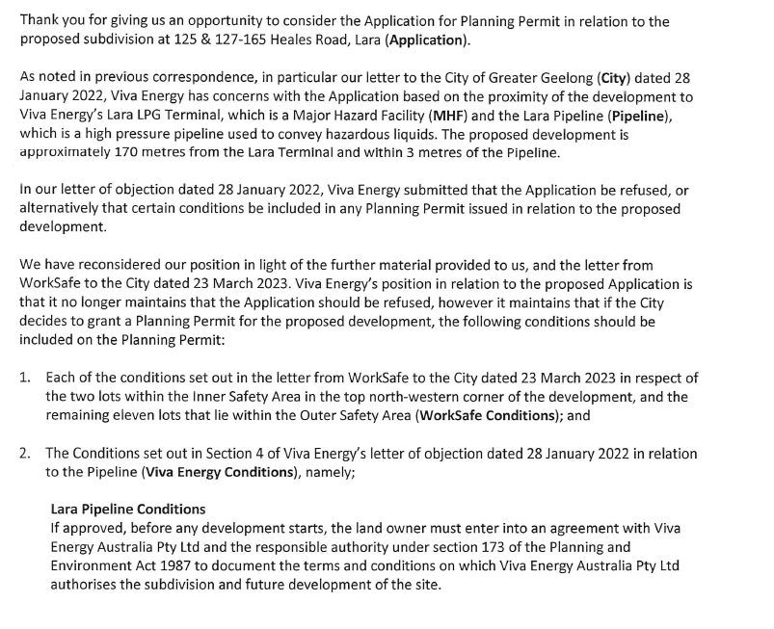
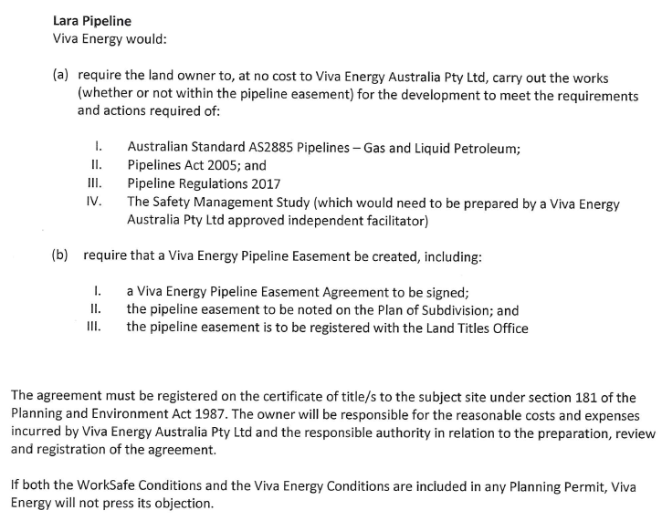

APPENDIX 2 - PLANNING REPORT

PERMIT TRIGGER:

A planning permit is triggered for this application pursuant to the following clauses of the Greater Geelong Planning Scheme:

- Pursuant to Clause 33.02-3 of the Industrial 2 Zone a permit is required to subdivide land.
- Pursuant to Clause 43.02-3 of the Design & Development Overlay a permit is required to subdivide land.
DEFINITIONS

Subdivision is not defined or nested in the Planning Scheme.
A lot is defined as a part (consisting of one or more pieces) of any land (except a road, a reserve, or common property) shown on a plan, which can be disposed of separately and includes a unit or accessory unit on a registered plan of strata subdivision and a lot or accessory lot on a registered plan.

Subdivision is defined in the Subdivision Act 1988 as the division of land into two or more parts which can be disposed of separately.

RESTRICTIVE COVENANT OR SECTION 173 AGREEMENT:

The subject site is not burdened by a Restrictive Covenant or Section 173 Agreement.

OFFICER DIRECT OR INDIRECT INTEREST:

No Council officers have any direct or indirect interest in the matter to which this report relates, in accordance with Section 130(2) of the Local Government Act.

SITE/LOCALITY:

The subject site is located on the south-east corner of Heales Road and McManus Road, Corio in an Industrial 2 Zone covered by a Design & Development Overlay Schedule 18 and an Environmental Audit Overlay (This only affects 125 Heales Road). The site consists of three parcels of land within two titles known as Lot 1 on PS322559 and Lot S4 on PS615585.
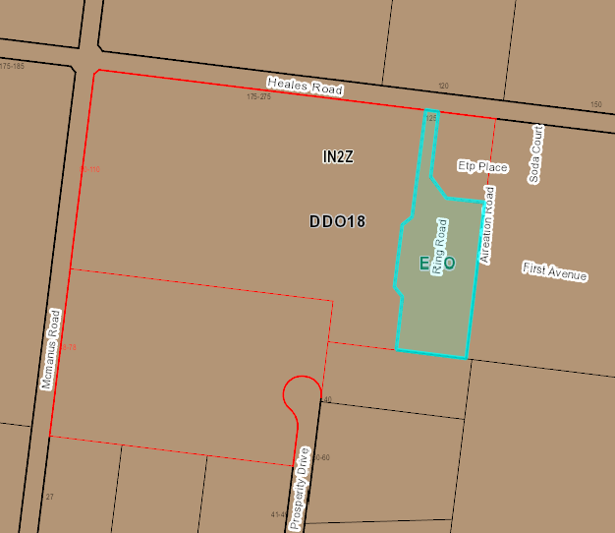
Figure 1 - 125 Heales Road, Corio (Lot 1 on PS 322559)
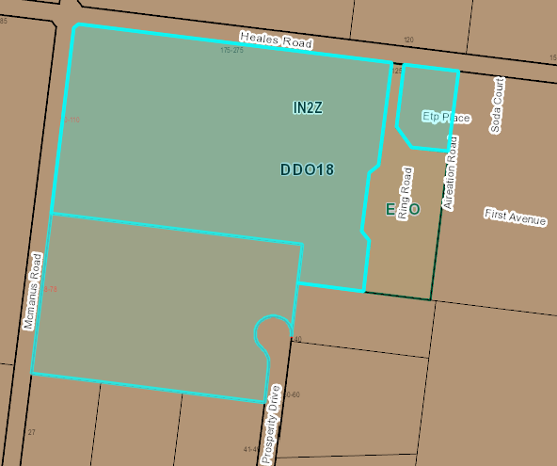
Figure 2 - 127-165 Heales Road, Corio (Lot S4 on PS615585)
The site has an overall area of approximately 14.9 hectares and is irregularly shaped. It contains some remnant industrial structures within the north-east corner adjacent to the Heales Road frontage.

Vegetation on the site is primarily concentrated along the western and northern site boundaries which are lined by sparsely scattered shrubs and some mature trees.
The site has three road frontages as follows:

- Heales Road – primary frontage to the north, measuring approximately 430m. Heales Road is a fully sealed road with swale drains on either side.
- McManus Road – secondary frontage to the west, measuring approximately 390m. McManus Road is currently unsealed with swale drains on either side.
- Prosperity Drive – secondary frontage to a court bowl which terminates at the south-east corner of the site. Prosperity Drive is a recently constructed sealed road and contains kerb and channel.
The surrounding area forms part of the Geelong Ring Road Employment Precinct (GRREP), formerly known as the Heales Road Industrial Estate. The site is located 170m south of the Viva Energy Refinery which is an LPG Manufacturing facility and is registered as a Major Hazard Facility. The LPG pipeline runs along the western property boundary with the McManus Road road reserve.

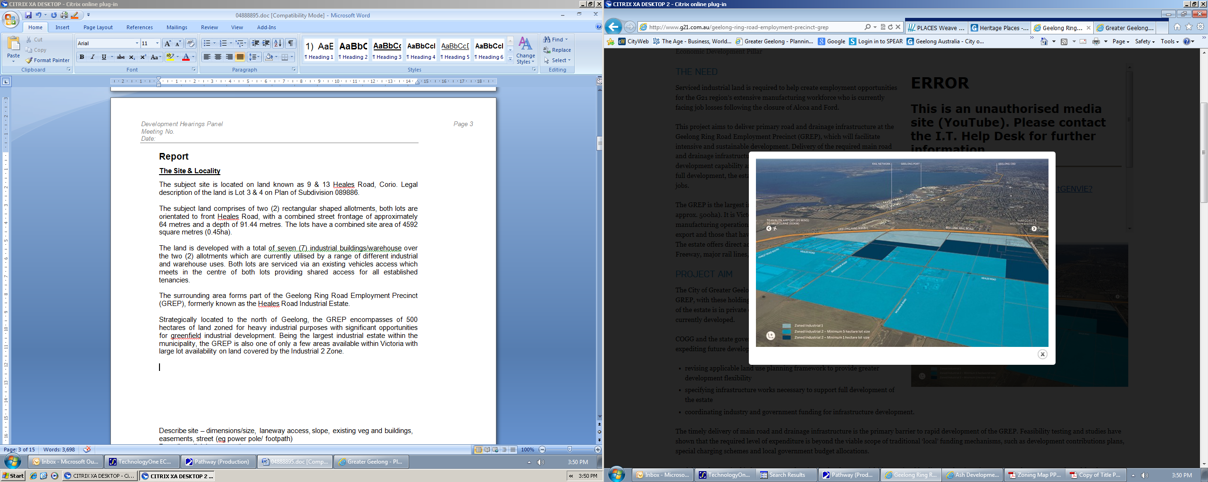
Figure 3 - Aerial image showing GRREP
Strategically located to the north of Geelong, the GRREP encompasses approximately 500 hectares of land zoned for heavy industrial purposes with significant opportunities for greenfield industrial development. Being the largest industrial estate within the municipality, the GRREP is also one of only a few areas available within Victoria with large lot availability on land covered by the Industrial 2 Zone.

The area also has a strategic relationship with the Geelong Port and has direct accessibility to the Geelong Ring Road, Princes Freeway, major rail lines and Avalon Airport.

PROPOSAL:

The application proposes a multi lot subdivision. The subdivision proposes a yield of 13 allotments with an average lot size of approximately 1.07 hectares ranging in area from 1.0 to 1.2 hectares.

All lots will be provided with access via Heales Road or Prosperity Drive.

The subdivision layout incorporates a new road that extends north from the court bowl of Prosperity Drive and bisects the site to the west. The new internal road terminates at a court bowl and provides access to six allotments.

The proposed subdivision incorporates a 10.0m landscape buffer along the entire length of McManus Road providing a setback from the pipeline corridor asset situated in the McManus Road road reserve.

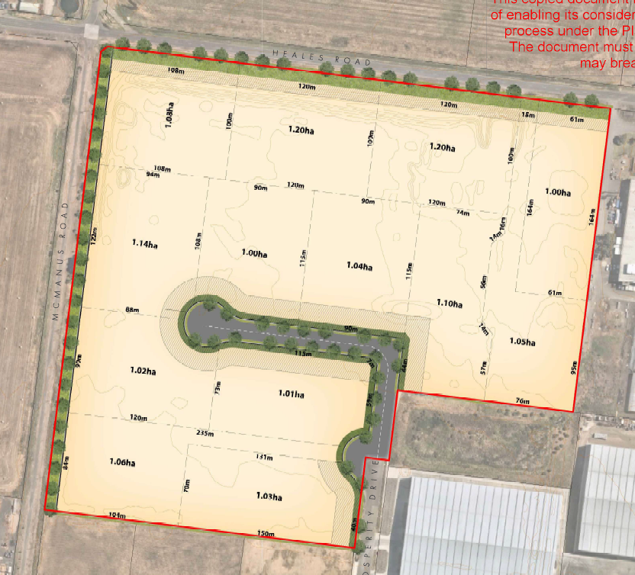
Figure 4 - Proposed plan of subdivision

PERMIT/SITE HISTORY:

The following permits/site history is applicable to this application:
- PP-1443-2010 – Staged Multi Lot Subdivision
REFERRALS:

The following referrals were undertaken.

SECTION 55:

DETERMINING AUTHORITY

Authority: | Barwon Water – No objection subject to conditions  Powercor- No objection subject to conditions  Downer (Tenix) – No response  APA – No response
Officer Comment:
Generally, if supported, the suggested conditions will be included on any permit issued.

SECTION 52:

Authority: | WorkSafe
Response: | This proposal involves subdivision only and makes no comment on the intended use of the smaller lots. However, given the premise of the subdivision proposal, it is reasonable to assume that the lots will be developed individually for light industrial purposes, similar to those in the adjacent Enterprise Drive/Prosperity Drive precinct.  This type of development typically introduces a small worker population, which across thirteen lots would significantly introduce the population intensity in the Outer Advisory Area of the Viva Lara LPG Terminal.  On the basis of the information provided with the referral, and the further information provided in response to our request of 16 March 2022, WorkSafe Victoria has reviewed the application and advises against the granting of a planning permit at the proposed location.
Officer Comment:
Noted - that Worksafe advise that the application should be refused.

INTERNAL

Department: | Engineering Services
Response: | Request for further information:  - Stormwater Management Strategy including onsite water quality treatment: The City of Greater Geelong Letter head dated 12/09/2008 accepted the SWMS report submitted on 10/09/2008 satisfying the requirement of PP-1216-2007.  The report submitted under (Stormwater Response) for planning permit PP-1550-2021 (Pages 9-11 of the PDF) from Peter Berry & Associates does not indicate the date of 10/09/2008.  Development Engineering Unit requires the applicant to provide a letter from Peter Berry & Associates to confirm that the subdivision of what was then Lot 23 as shown in appendix 6 was considered as part of (Catchment 2 - North) under the Stormwater Management Plans submitted on 10/09/2008.  - The letter needs to advise that the storage and Water Sensitive Urban Design requirements for this subdivision plan under PP-1550-2021 was addressed in the previous SWMS dated 10/09/2008.  - The letter needs to include the subdivision plans under this application PP-1550-2021.  - The letter shall advise that lot 23 as shown in Appendix 6 is designed to drain into the Basin #2.  The legend colour indicating the depth of fill is not very clear, it needs to be amended with different colour that matches the plan.  Needs to be amended and show extension of the drainage pipe in McManus Road up to the intersection of the Heals Road as shown in yellow highlighted section.  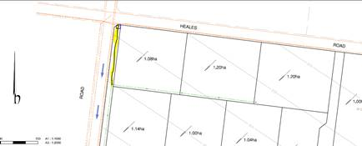  The only issue of concern is the size of the internal radius at the 90 degree curve should be larger, i.e. 15 m minimum. The swept path diagram shows that larger vehicles can negotiate the curve, however there is risk of damage to the kerb and nature strip at the internal curve. It is recommended that the splay on the adjacent lot is made large enough to allow for a 15 m internal kerb radius.  Flood Impact Assessment based on proposed cut and fill earthworks: Flood Modelling has been reviewed, it is noted that the report stated the current proposed design is not expected to result in any change to the overall flood risk of the project area in the 1% AEP flood event, including all upstream and downstream areas of site. Engineering requires a confirmation including any previous endorsed design plans to show that Obrien’s Road retarding basin was designed to cater the flood from the proposed development.
Officer Comment:
It is considered that items 2, 3 & 4 could be included as conditions on any permit that might be issued.
Items 1 & 5 have been included as grounds for refusal as it is unclear whether the subject sites have been included in a previous Stormwater Management Plan and Flood Impact Assessment from previous development within the area.

Department: | Strategic Planning
Response: | Prior to any final determination, Strategic Planning recommends that the application is formally referred to WorkSafe Victoria to consider the appropriateness and acceptability of the proposal in the context of the adjacent MHF.
Officer Comment:
The application was referred to WorkSafe Victoria who advised against the granting of a planning permit for the proposed subdivision.

AMENDMENT OF THE PROPOSAL PRIOR TO PUBLIC NOTIFICATION:

The application was not amended prior to public notification.

PUBLIC NOTIFICATION:

Pursuant to Clause 33.02-3 of the Industrial 2 Zone an application is exempt from the notice requirements of section 52(1)(a), (b) and (d), the decision requirements of section 64(1), (2) and (3) and the review rights of section 82(1) of the Act. This exemption does not apply to land within 30 metres from land (not a road) which is in a residential zone or land used for a hospital or an education centre or land in a Public Acquisition Overlay to be acquired for a hospital or an education centre.

The land is not located within 30 metres from land within a residential zone or land used for a hospital or an education centre or land in a Public Acquisition Overlay to be acquired for a hospital or an education centre.

However, the application is not exempt from the notice requirements of Section 52(1)(a), (b) and (d), the decision requirements of Section 64(1), (2) and (3) and the review rights of Section 82(1) of the Act under the Design & Development Overlay therefore, pursuant to Section 52 of the Planning and Environment Act 1987 the following forms of advertising were undertaken:

- Notices were sent to owners and occupiers of adjoining land (including opposite)
- A2 sign(s) were placed on the land
One (1) objection and one letter of support has been lodged with Council.

CONSULTATION:

A consultation meeting was not held.

AMENDMENT OF THE APPLICATION FOLLOWING PUBLIC NOTIFICATION

The application was not amended following public notification.

OBJECTIONS:

The concerns of objectors are summarised and commented on below.

- Objection – The subdivision of land is directly adjacent to a high pressure licenced Pipeline and its associated corridor and is close to our Lara LPG Terminal.
The objection is from Viva and is summarised as follows:
- Viva Energy owns and operates the Lara LPG Terminal (Terminal), licensed as a Major Hazard Facility. The Terminal is located in McManus Rd, Lara, which is close to the proposed subdivision. The Terminal stores and distributes Liquid Petroleum Gas (LPG) products. The facility can store up to 5,000t of butane, 1,200t propane and 1,000t of propylene (chemical feedstock). The Terminal is connected to Viva Energy’s Geelong Refinery by a licensed LPG pipeline. The Terminal operates 24 hours per day, 365 days per year.
- Viva Energy also owns and operates the Lara pipeline (Pipeline) which is licensed to operate in Victoria under licence 6. The Pipeline operates 24 hours per day, 365 days per year. The Maximum Allowable Operating Pressure (MAOP) for this licensed pipeline is 2758 kPa (27.5 times standard atmospheric pressure). The conveying of hazardous liquids through pipelines at high pressure is an activity that requires strict management of potential risks to public safety and the environment.
- Both the Terminal and the Pipeline are part of and interconnected to Viva Energy’s broader supply chain assets which includes the Geelong Refinery (which produces the LPG) which is classified as critical infrastructure under the Victoria Emergency Management Act 2013. This infrastructure currently supplies around 55% of Victoria’s fuel requirements.
- The proposed subdivision is located within 250 metres of the Lara LPG Terminal and within 3m of the pipeline which represents an unacceptable risk of future encroachment from inappropriate land use and development.
Response

Viva Energy received notification of the application.

The Viva Energy Lara LPG Terminal is licensed as a Major Hazard Facility by WorkSafe. WorkSafe have advised against the issuing of a planning permit. It is considered that the proposed subdivision is not consistent with Clause 13.07-2S (Major Hazard Facilities) of the Greater Geelong Planning Scheme. This is due to the increase in lot density which in turn will increase the intensity of use and development within the threshold distance of an existing major hazard facility.

ASSESSMENT:

ZONE:

Clause 33.02 – Industrial 2 Zone

The purpose of the Industrial 2 Zone is:
- To implement the Municipal Planning Strategy and the Planning Policy Framework.
- To provide for manufacturing industry, the storage and distribution of goods and associated facilities in a manner which does not affect the safety and amenity of local communities.
- To promote manufacturing industries and storage facilities that require a substantial threshold distance within the core of the zone.
- To keep the core of the zone free of uses which are suitable for location elsewhere so as to be available for manufacturing industries and storage facilities that require a substantial threshold distance as the need for these arises.

Response to zone

The purpose of the Industrial 2 Zone seeks to provide for larger scale and more intensive industrial land uses. Although the proposed lot sizes could accommodate an industrial land use, the Design & Development Overlay informs the decision making in relation to lot size, lot type and setting and design.

OVERLAY:

Clause 43.02 - Design & Development Overlay

The purpose of the Design & Development Overlay is:
- To implement the Municipal Planning Strategy and the Planning Policy Framework.
- To identify areas which are affected by specific requirements relating to the design and built form of new development.

Schedule 18 – Geelong Ring Road Employment Precinct
Design Objectives

- To facilitate the development of the Geelong Ring Road Employment Precinct as a high amenity industrial area suited to the needs of advanced manufacturing and production support industries.
- To provide a high level of amenity for workers on and visitors to the estate.
- To ensure development provides an attractive frontage to the Geelong Ring Road.
- To ensure development provides a high level of visual amenity when viewed from major transport routes and surrounding non-industrial land uses.
- To promote best practise sustainable design including storm water quality and reuse measures.
Subdivision within the estate should ensure:
- The provision of an appropriate range of lot types and settings.
- The provision of lot configurations that facilitate energy efficient site and building design.
- That no lots have a rear aspect to the Geelong Ring Road.
- The following minimum lot sizes within each precinct in the estate, as defined on the Geelong Ring Road Employment Precinct Framework Plan Map at clause 17.01-1L-02 of this Planning Scheme:

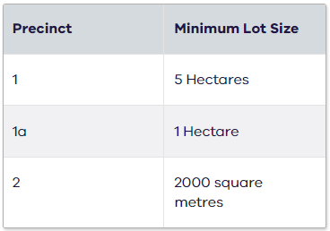

Response to the overlay: The purpose of a design and development overlay is to both implement the Municipal Planning Strategy and the Planning Policy Framework, while also identifying areas which are affected by specific requirements relating to new development.

It is recognised that pursuant to the definitions set out in the Planning and Environment Act 1987, “development” includes the subdivision or consolidation of land.

The design objectives set out in the DDO18, amongst other things, seek to facilitate the development of the GREP as a high amenity industrial area suited to the needs of advanced manufacturing and production support industries.

The DDO18 sets out requirements to be met as they relate to subdivision. Clause 3.0 of the DDO18 states that:

Subdivision within the estate should ensure:

The provision of an appropriate range of lot types and settings;
- The provision of lot configurations that facilitate energy efficient site and building design;
- That no lots have a rear aspect to the Geelong Ring Road; and
- The following minimum lot sizes within each precinct of the estate, as defined on the GREP Framework Plan Map at Clause 17.01-1L-02 of this Planning Scheme:
  - Precinct 1 – 5 Hectares
  - Precinct 1a – 1 Hectare
  - Precinct 2 – 2000 square metres
It is noted that the subject site is included within the area known as Precinct 1 and therefore a minimum lot size of 5.0ha is required.

The proposed subdivision seeks to create 13 allotments with an average lot size of approximately 1.07 hectares ranging in area from 1.0 to 1.2 hectares and is in conflict with the requirement set out in the DDO18.

It is noted that Precinct 1 of the GREP is intended to support medium-sized industry requiring substantial buffer zones from sensitive land uses (i.e. residential areas in Lara and Corio). Allowing smaller lot sizes than those specified under the GREP Framework Plan would diminish lot diversity and therefore limit the City’s ability to accommodate a diversity of industrial uses within the GREP, and Greater Geelong more broadly.

It is also noted within the supporting Industrial Land Assessment Report submitted with the application that the vast majority of industrial allotments (77%) in Greater Geelong are less than 0.5 hectares. The Report also notes that:

“demand for large allotments (>2ha) are only available in the GRREP. Interest in this lot size has been variable, but the appetite appears to be growing slowly; primarily because this product is unavailable elsewhere in the municipality.”

This would point to a need for more (rather than less) medium-sized industrial allotments.

The Land Assessment Report also states that there is a ready market for 1ha lots and the GREP is the only place that can fill this demand. This is considered short sighted. There is a considered framework plan to provide industrial land suitable for larger industries that are capable of driving considerable economic growth and take advantage of the unique offering in terms of location to rail, port and road.

CULTURAL HERITAGE MANAGEMENT PLAN (CHMP):

The Aboriginal Heritage Regulations 2018 specify the circumstances in which a cultural heritage management plan is required for an activity or class of activity. Division 2 of the Aboriginal Heritage Regulations 2018 specifies exempt activities which do not require a cultural heritage management plan. The proposal is not listed as an exempt activity.

Areas of cultural heritage sensitivity are defined within Divisions 3 and 4 of the Aboriginal Heritage Regulations 2018. Division 3 does not identify the site or part of the site as within an area of cultural heritage sensitivity.
In accordance with the above assessment, a cultural heritage management plan is not required.

LANDFILL GAS RISK ASSESSMENT

The subject site is not located within 500 metres of an identified former landfill site, a risk assessment is not required.

DEVELOPMENTS IN BUSHFIRE PRONE AREAS

The site is located within a designated bushfire prone area.
Clause 13.02-1S (Bushfire planning) seeks to strengthen the resilience of settlements and communities to bushfire through risk-based planning that prioritises the protection of human life.

The policy must be applied to all planning and decision making under the Planning and Environment Act 1987 relating to land which is:

- Within a designated bushfire prone area;
- Subject to a Bushfire Management Overlay; or
- Proposed to be used or developed in a way that may create a bushfire hazard.
The proposal is listed at Clause 13.02-1S as one of the uses or developments which should be considered:

- Subdivisions of more than 10 lots.
- Accommodation.
- Child care centre.
- Education centre.
- Emergency services facility.
- Hospital.
- Indoor recreation facility.
- Major sports and recreation facility.
- Place of assembly.
- Any application for development that will result in people congregating in large numbers.
As the site is located within a designated bushfire prone area the assessment of this application has considered:
- The risk of bushfire to people, property and community infrastructure.
- Whether the implementation of appropriate bushfire protection measures to address the identified bushfire risk is necessary.
- Whether the proposal can implement bushfire protection measures without unacceptable biodiversity impacts.
The application is not expected to create a risk bushfire to people, property and community infrastructure.
It is considered that no bushfire protection measures to address the identified bushfire risk is necessary.

THE PLANNING POLICY FRAMEWORK (PPF):

MUNICIPAL STRATEGIC STATEMENT

The following Municipal Planning Strategies are applicable to this application:
02.03 – Strategic Direction
- 02.03-1 – Settlement
- 02.03-7 – Economic development
- 02.03-8 – Transport

PLANNING POLICY FRAMEWORK

The following Planning Policy Framework is applicable to this application:
11 – Settlement
- 11.01 – Victoria
- 11.01-1L-01 – Settlement – Greater Geelong
- 11.02 – Managing Growth
- 11.02-1S – Supply of urban land
13 – Environmental Risks & Amenity
- 13.07 – Amenity, human health and safety
- 13.07-1S – Land use compatibility
- 13.07-2S Major Hazard Facilities
17 – Economic Development
- 17.01 – Employment
- 17.01-1L-01 – Diversified economy – Greater Geelong
- 17.01-1L-02 – Geelong Ring Road Employment Precinct
- 17.03 – Industry
- 17.03-1S – Industrial land supply
- 17.03-2L – Sustainable industry in Greater Geelong
- 17.03-3S – State significant industrial land
18 – Transport
- 18.02 – Movement Networks
- 18.02-5R – Freight Links – Geelong G21
Response to Policy

State Planning Policy Framework at Clauses 17 and 17.03-1S inform strategic planning policy for the location of land suitable for industrial development. The subject land has been zoned Industrial 2 and the location of the continued development of this land for industrial activities are supported by Planning Policy Framework.

While the Geelong Ring Road Employment Precinct (GREP) is not specifically listed in Clause 17.03-3S as industrial land of state significance, it is considered that the GREP is of strategic importance to the state of Victoria, by way of providing 500 hectares of land with significant opportunities for heavy industrial development. The GREP is one of only a few greenfield sites available across Victoria with large lot land covered by the Industrial 2 Zone, and therefore appropriately zoned for heavy industrial purposes. If the proposed subdivision was to go ahead the opportunity to create large lots will be lost forever as it is highly likely the lots will be sold to separate owners. Whilst each application is assessed on its merit, allowing a ‘watering down’ of the Design & Development Overlay will likely mean the purpose/considered strategic direction of the control will also be lost forever as similar future applications will be inevitable.

The availability of land, including the subject site for future major industrial use or development is further emphasised by Council’s planning controls for the site and the surrounding area.

The Municipal Planning Strategy in relation to Economic Development and Industry along with Council’s Planning Policy Framework at Clauses 17.01-1L-01, 17.01-1L-02, 17.03-1L and 17.03-2L outlines strategies, which seek to encourage regional and national scale industrial businesses to locate within the GREP, minimise amenity and land use conflicts, provide a high level of amenity for workers, provide sufficient industrial land to meet a range of industrial needs in Geelong and direct industries that require substantial buffer distances from sensitive land uses to the core of the Industrial 2 Zone of the GREP.

The GREP is identified as a major industrial area within the municipality with land that can cater to meet the needs of the industrial land market through the provision of vacant, well serviced, high amenity industrial land that can compete for investment in emerging forms of industrial land use and development. The Framework Plan seeks to implement the vision for the GREP and the proposed subdivision of the land fails to support what the Framework Plan has been designed to achieve.

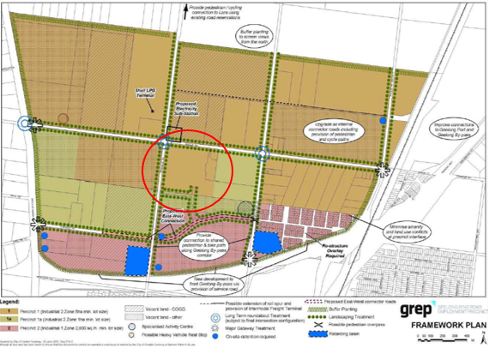

Figure 5 - GREP Framework Plan (Subject site circled in red)
The plan identifies the subject site within precinct 1 of this plan, strategically highlighted for heavy manufacturing industries. The intention of this precinct seeks to accommodate heavy industrial industries which require significant buffer distances from sensitive land uses. Precinct 1 as set out in the framework plan seeks to require minimum lot sizes to be retained at 5 hectare to remain available for larger heavy industrial activities.

It is considered that the proposed subdivision conflicts with Council’s PPF as it will result in the limitation of larger scale industries that require substantial buffer distances from sensitive land uses to locate within the GREP. The GREP provides unique opportunities with its ability to attract large regional and national scale industrial businesses to the Greater Geelong area due to its location to Avalon Airport, Melbourne Road and rail infrastructure. This would impact on Geelong’s economic growth as supported in Clauses 17.01 & 17.03 of the Greater Geelong Planning Scheme.

It is also of importance to consider the location of the proposed subdivision in relation to the Lara Major Hazard Facility (MHF) (Viva LPG Terminal). The objective of Clause 13.07-2S is to minimise the potential for human and property exposure to risk from incidents that may occur at a major hazard facility and to ensure the ongoing viability of major hazard facilities. Strategies include considering the risks associated with increasing the intensity of use and development within the threshold distance of an existing major hazard facility.

The land is located within the threshold distance of the Lara Major Hazard Facility as identified by WorkSafe. A WorkSafe Information Sheet title ‘Land use planning near a major hazard facility’ published in March 2010 which provides that operators of a MHF must reduce risk to the surrounding area so far as is reasonably practicable where it cannot be eliminated. It also provides advice to planning and responsible authorities on residual risk from proposing developments in proximity to MHFs. WorkSafe advises against land use or developments within the inner area, apart from low density industrial uses such as non-retail warehousing or other low employee density business or industrial use and Planning Scheme amendments that may result in unacceptable societal risk because of the cumulative effects to all developments and persons that may be present on land surrounding an MHF.

It is relevant to highlight that the proposed lot sizes within the subdivision being reduced from the recommended 5.0ha to 1.0ha will create a higher density industrial area. This in turn increases the risk and potential for inappropriate land use substantially increasing population density around the MHF This could also result in unacceptable societal risk because of the cumulative effects to all developments and persons that may be present on the subject land.

RELEVANT PARTICULAR PROVISIONS:

The are no Particular Provisions applicable to this application.

DECISION GUIDELINES OF CLAUSE 65:

Because a permit can be granted does not imply that a permit should or will be granted. The responsible authority must decide whether the proposal will produce acceptable outcomes in terms of the decision guidelines of this clause.

CLAUSE 65.01 – APPROVAL OF AN APPLICATION OR PLAN

Clause 65.01 of the Greater Geelong Planning Scheme outlines the decision guidelines to be considered by the Responsible Authority when making decisions on applications. These decision guidelines include:
- The matters set out in Section 60 of the Act.
- The Municipal Planning Strategy and the Planning Policy Framework.
- The purpose of the zone, overlay or other provision.
- Any matter required to be considered in the zone, overlay or other provision.
- The orderly planning of the area.
- The effect on the amenity of the area.
- The proximity of the land to any public land.
- Factors likely to cause or contribute to land degradation, salinity or reduce water quality.
- Whether the proposed development is designed to maintain or improve the quality of stormwater within and exiting the site.
- The extent and character of native vegetation and the likelihood of its destruction.
- Whether native vegetation is to be or can be protected, planted or allowed to regenerate.
- The degree of flood, erosion or fire hazard associated with the location of the land and the use, development or management of the land so as to minimise any such hazard.
- The adequacy of loading and unloading facilities and any associated amenity, traffic flow and road safety impacts.

Response

It is considered that the proposed subdivision will compromise the orderly planning of the area through fragmentation of Industrial 2 Zoned land. The PPF seeks to encourage investment from regional and national scale industrial businesses to locate to the GREP for heavy industries that require substantial buffer distances from sensitive land uses and larger lot holdings. The proposed subdivision will reduce the capability of the land to meet these strategic directions.

CLAUSE 65.02 – SUBDIVISION

Clause 65.02 of the Greater Geelong Planning Scheme outlines the decision guidelines to be considered by the Responsible Authority when making decisions on an application to subdivide land. These decision guidelines include:
- The suitability of the land for subdivision
- The existing use and possible future development the land and nearby land
- The availability of subdivided land in the locality, and the need for the creation of further lots
- The effect of development on the use or development of other land which has a common means of drainage
- The subdivision pattern having regard to the physical characteristics of the land including existing vegetation
- The density of the proposed development
- The area and dimensions of each lost in the subdivision
- The layout of roads having regard to their function and relationship to existing roads
- The movement of pedestrians and vehicles throughout the subdivision and the ease of access to all lots
- The provision and location of reserves for public open space and other community facilities
- The staging of the subdivision
- The design and siting of buildings having regard to safety and the risk of spread of fire
- The provision of off street parking
- The provision and location of common property
- The functions of any body corporate
- The availability and provision of utility services, including water, sewerage, drainage, electricity and gas
- If the land is not sewered and no provision has been made for the land to be sewered, the capacity of the land to treat and retain all sewage and sullage within the boundaries of each lot
- Whether, in relation to subdivision patterns, native vegetation can be protected through subdivision and siting of open space areas.

Response
It is considered that the proposed subdivision will compromise the future use and development of the land such that an acceptable planning outcome would not be produced by the granting of a permit for this proposal
act_.1.1 page 3

Attachment_2.1.1 pagCLOSE OF MEETING

As there was no further business the meeting closed at 6.24pm on 21 September 2023

