

minutes

PLANNING COMMITTEE MEETING
No. 227

Thursday 23 March 2023
City Hall

ALSO LIVE STREAMED ON THE CITY’S WEBSITE:

www.geelongaustralia.com.au/meetings

PANEL:

Cr Harwood (Chair), Cr Mason, Cr Moloney, Cr Nelson, Cr Cadwell, Cr Murrihy

PRESENT

Present: Cr Harwood (Chair), Cr Mason, Cr Moloney, Cr Nelson, Cr Cadwell, Cr Murrihy
Also
Present: Joanne van Slageren, John Rush, Hugh Griffiths, Clara Gartland

Opening: The Chair declared the meeting open at 5.45pm

1. PROCEDURAL MATTERS

Acknowledgement Of Country

The Committee acknowledges the Wadawurrung People as the Traditional Owners of the Land, Waterways and Skies. We pay our respects to their Elders, past and present. We Acknowledge all Aboriginal and Torres Strait Islander people who are part of our Greater Geelong community today.

1.2. Introduce The Panel Members

1.3. Apologies

Cr Sullivan, Cr Aitken, Cr Kontelj, Cr Grzybek, Cr Asher

1.4. Declarations Of Conflicts Of Interest

Nil

1.5. Confirmation Of Minutes

That the Minutes of the Planning Committee Meeting held 24 November 2022 were not able to be confirmed, to be brought to the next meeting on 30 March.

2. MATTER(S) FOR CONSIDERATION
PP-320-2021 98 Marshalltown Road, Grovedale And PP-1512-2020 149 Bellarine Highway, Newcomb
2.1. | PP-508-2021 – 16 Duggan Court Highton

Application No: | PP-508-2021
Applicant: | Context Planning Pty Ltd
Subject Land: | 16 Duggan Court, Highton
Zone: | General Residential Zone Schedule 4  The site is located within the Highton Shopping Centre Increased Housing Diversity Area
Overlays: | Special Building Overlay
Existing Use: | Single dwelling
Proposed Use: | Buildings and Works Associated with the Construction of Nine (9) Dwellings, Alteration of Access to a Road in a Road Zone Category 1 and Reduction of Visitor Car Parking

SUMMARY

Subject site and surrounds
- The subject site is irregular in shape and consists of the land formally known as Lot 1 on Plan of Subdivision 094195 and has a total area of 712 square metres. The subject site is located on a corner situated with frontage to the northern side of Barrabool Road and the eastern Side of Duggan Court in Highton. Access to the site is available via an existing single vehicular crossover from Barrabool Road at the south-eastern corner of the site.
- The subject site is within an established residential area of Highton, opposite the Highton Reserve on the southern side of Barrabool Road, and approximately 70 metres north-west of the Highton Village Neighbourhood Centre.
- The subject site is presently developed with an existing single storey dwelling constructed of a combination of face brickwork and tiled roof cladding. The site contains established landscaping within the front and side street setbacks.
- The site is situated in relatively close proximity to local shops and services, given its proximity to Highton Village, which is a neighbourhood centre under the City of Greater Geelong Retail Centre Hierarchy.
- The following services/centres are within proximity to the subject site:
- Highton Village: approx. 70 metres;
- Roslyn Primary School: approx. 950 metres;
- Highton Primary School: approx. 500 metres;
- Belmont High School: approx. 850 metres;
- Highton Reserve: approx. 20 metres;
- Roslyn Road/Highton Library Bus Stops (Route 42): approx. 200 metres;
- Cedar Grove/Mt Pleasant Road Bus Stops (Route 43): approx. 400 metres;
- South Geelong Station: approx. 3.2 kilometres;
- Geelong CBD: approx. 4 kilometres.

- The ground levels of the subject site and surrounding area undulate considerably. The subject site slopes consistently down from the northern rear boundary to the south-eastern corner at its Barrabool Road street frontage of approximately 3m.
- Existing residential development within the immediate surroundings of the subject site can be generally characterised as medium density dwellings displaying somewhat varied design details and architectural intent.
- Duggan Court generally contains single dwellings on individual lots, with some multi-dwelling developments existing at numbers 2 and 12. The built form character within Duggan Court generally incorporates single and double storey built forms unified by pitched roof forms and external materials of face brickwork and tiled or metal clad roofing.
- Within the Barrabool Road streetscape, residential development consists of a mix of mainly single storey dwellings within multi-unit developments of traditional design constructed of face brickwork or weatherboard cladding, with metal and tiled pitched roof forms.
- Some examples exist of contemporary residential developments, including an existing 9 dwelling multi-unit development at 4 Taylor Court, and an apartment development comprising 7 dwellings at no. 54 Barrabool Road, approximately 100 metres east of the site.
Zoning and Overlays
- The site and surrounding area is situated within the General Residential Zone (Schedule 4) that reflects the locale of the Highton Shopping Centre Increased Housing Diversity Area. A Special Building Overlay covers the majority of the site and surrounding area including residential lots to the north and east of the site.

- Land to the north, east and west of the subject site is zoned General Residential Zone (Schedule 4). Further north, at the rear of the northern most lots fronting Duggan Court, is land zoned Neighbourhood Residential Zone (Schedule 8), which is also subject to a Design and Development Overlay (Schedule 14)

- Opposite the site on the southern side of Barrabool Road is the Highton Reserve, zoned Public Park and Recreation Zone. Adjoining the Highton Reserve to the east is the Commercial 1 Zone which forms the Highton Village neighbourhood centre.

Proposal
- This application seeks a planning permit for the construction of 9 dwellings on a lot, buildings and works in the special building overlay, reduction in car parking requirements to provide a (one) visitor parking space, and alteration of access to a road in a Transport Zone 2.
- The proposed development consists of the construction of an apartment building comprising a basement level car park with three (3) levels of apartments on top of the basement car park. The maximum height of the building is 11 metres.
- Vehicle access would be provided to the basement car park via a proposed widened crossover from Barrabool Road on the south-eastern corner of the site. The main pedestrian access from Barrabool Road to a lobby area, lift and stair core would be adjacent to the vehicular access fronting the street. The stairwell and lift core would be within the southern elevation of the proposed building spanning the basement to top floor levels. The application does not propose any walls on boundaries. Side and rear setbacks vary from 1m to 5.15m
- No landscaping plan has been submitted to form part of the application, however areas set aside for landscaping are shown on the proposed basement and level 1 plans within the respective Barrabool Road and Duggan Court street setbacks, and adjacent to the northern rear and eastern side boundaries.
- On the floor level above the basement (Level 1), would be four (4) two-bedroom apartments, with access via a central corridor from the lift core and stairwell within the southern elevation.
- At second floor, would be three (3) proposed two-bedroom apartments, generally following a similar layout to the floor level below. Each of the apartments would contain private balconies facing either Barrabool Road or Duggan Court, with the exception of apartment 2.03 which would also include a separate balcony facing north.
- At level 3 (top level), would be two (2) three-bedroom apartments. Both of which would contain access via the central corridor. Proposed apartment 3.01 would be orientated to face south, with a wrap-around external balcony. The proposed apartment 3.02 would be orientated to face north, with two separate balcony areas to its north-west and south-west, respectively.
- The proposed building would be constructed of a combination of face brickwork, aluminium window and door frames, concrete columns and painted render. Detailed elements would incorporate perforated metal screening, clear glazing and metal louvres. The proposed basement car park would be provided with a perforated metal roller door fronting Barrabool Road.
- The application provides eleven (11) car spaces in the basement level.
- The application seeks to reduce the visitor parking requirement from one (1) to zero (0).
Referrals
- The application was referred to internal Council units, and externally to relevant utility servicing authorities. Detailed responses are outlined within the body of this report.
Public Notice
- The application was put to public notice with signs on the site at its street frontage and letters sent to adjoining and surrounding owners and occupiers. Fifty-one (51) letters of representation objecting to the proposals have been submitted against the application.
- A consultation meeting was not held because the applicant choose to submit a written response to objections raised for circulation to objectors. No objections have been withdrawn.
- A summary of the matters raised within the objections received relate to:
- Garden area requirements
- Neighbourhood character concerns
- Amenity impacts
- Increased population density concerns
- Car parking and traffic concerns
- Impacts on stormwater infrastructure
- Car parking and noise impacts during construction
- Unsatisfactory ESD response
- Devaluation of property

Relevant planning scheme controls considered
- In Council’s assessment the application has been assessed against the relevant Planning Policy Framework (PPF), Municipal Planning Strategy (MPS), Zone, Overlay, Particular and General Provisions of the Greater Geelong Planning Scheme.
- Based on the assessment it is considered that the application accords with the Scheme by proposing a residential development that increases the density and diversity of housing on a site close to the activity centre of Highton. It is well serviced and in close proximity to retail, education, recreation and the alternative transport network. The building height, bulk, form and material detail provides an appropriate design response based on the policy considerations and given the advantages of the sites location subject to some modest variations to relevant residential development standards (ResCode).
- The proximity of Duggan Court to the neighbourhood centre supports a higher density of development within the street than what has occurred to date. The proposed development represents a built form is considered to respond to the evolving character of the area and is consistent with the intent expressed in Clause 16.01-1L-02 to support evolution to more intensive development with visually interesting built forms. The design response also accords with the Purpose of the GRZ4 to provide dwellings at increased densities and diversity.
- The design response is consistent with the principles of consideration of neighbourhood character where policy supports housing at increased densities as identified in numerous VCAT decisions outlined in this report.
- The Applicant has not appealed the application to VCAT.
Recommendation
Moved: Cr Murrihy Seconded: Cr Mason
CARRIED

That the Responsible Authority having considered all matters which the Planning and Environment Act 1987, requires it to consider decides to issue a Notice of Decision to Grant a Planning Permit for Buildings and Works Associated with the Construction of Nine (9) Dwellings, Alteration of Access to a Road in a Transport Zone 2 and Reduction of Visitor Car Parking in accordance with the plans and documentation submitted with the application subject to the following conditions:

Amended Plans
- Prior to works commencing, amended plans to the satisfaction of the Responsible Authority must be submitted to and approved by the Responsible Authority. When approved, the plans will be endorsed and will then form part of the permit. The plans must be drawn to scale with dimensions and must be generally in accordance with the plans submitted with the application on 13th September 2022, but modified to show:
  - The mailbox location re-sited so as to be visible from the Barrabool Road reserve.
  - Privacy screens or obscure glazing to east facing habitable rooms and east facing balcony of dwelling APT 2.03, and east facing balcony of dwelling APT 3.02, to comply with standard B22 of Clause 55.04-6.
  - A car parking allocation plan to show what tenancy is assigned to each car space(s). The plan must provide information about how these car spaces will be assigned on the ground, whether it be line marking or signage, or a combination of both.
  - A basement storage allocation plan to show which tenancy is assigned to each basement storage area. The plan must provide information on how the storage spaces will be assigned on the ground and may be incorporated into the car parking plan required by condition 1(b) above.
  - Design of the proposed cut-off drain shown on all plans and elevations. The design must be presented comprehensively with its full alignment up to the discharge point and provide detail of its long and cross sections designed by a suitably qualified drainage engineer.
  - The proposed floor level 24.40 m AHD of Level 1 is at least 150 mm higher than the adjoining ground/surface, particularly at the rear (north) where the finished surface must be further graded down away to the cut-off drain. The relevant elevations and sections must be made consistent by showing the cut-off drain and the finished surface levels.
  - All key surface levels are to be clearly shown to Australian Height Datum AHD in the long-section of the ramp and basement.
  - The top of the retaining wall adjoining the ramp to the basement is at least 300 mm above the ground/surface in the relevant elevations and sections.
  - Annotate all plans that the levels are based on Australian Height Datum (AHD) in each of the relevant drawings.
  - Annotate development plans detailing all commitments made within Sustainable Design Assessment (prepared by LID Consulting dated 08-06-2022, received: 14-07-2022).
  - Annotate proposed plans detailing that all landscaping and fencing within corner splay area of vehicle accessway are to be maintained to be not more than 900mm in height above the accessway level at its street frontage in accordance with Design Standard 1 of Clause 52.06-8.
  - Any changes to plans required by conditions 11-17 (inclusive) of this permit.
  - The location of all air conditioning units must be shown and annotated on the plans to accord with Condition 21.
  - Landscape plan in accordance with condition 8 of this permit
All to the satisfaction of the Responsible Authority.

Endorsed Plans
- The development as shown on the endorsed plan(s) must not be altered without the written consent of the Responsible Authority.
Sustainability Management Plan
- The development hereby approved must not be carried out other than in accordance with the endorsed Sustainability Management Plan to the satisfaction of the Responsible Authority.
Prior to Works Commencing
- Prior to works commencing, Council’s City Services Transport Unit must be engaged to provide on street line marking and sign replacement for car parking. Any relocation, alteration or replacement required shall be in accordance with the requirements of the relevant Authority and shall be at the applicant’s expense.
- Prior to works commencing, an Arboricultural Impact Assessment Report must be prepared by a suitably qualified arborist and submitted to the Responsible Authority. The assessment must address all:
- council-owned trees adjacent to the property (e.g. street trees or trees within reserves)
- privately owned trees and
- trees owned by other parties that are located within 4 metres of the property boundary.

The assessment shall be completed whilst having regard to the context of the tree’s location, the impact of any works and the intended setting in which it sits. The assessment report must include as a minimum:
- Tree number
- Species Identification
- Estimate age (e.g. juvenile, semi-mature, mature, over mature)
- Useful life expectancy
- Health
- Structure
- Arboricultural Significance
- Hazard ranking
- Structural Root Zone
- Tree Protection Zone
- Recommendation for retention or removal
- Comments / Remedial Actions Required
- Recommended Design Response for surrounding areas proposed for landscaping
- Images / photos
- Proposed protection fencing locations

The assessment must include a plan which accurately records tree locations and shall be submitted the Responsible Authority.
- Prior to works commencing, a Tree Protection Management Plan must be submitted to and approved by the Responsible Authority. The tree protection management plan must be informed by the recommendations contained within arboricultural assessment report as required by Condition 5 of this permit. The Tree Protection Management Plan must be prepared by a suitably qualified arborist and must include all:
- council-owned trees
- privately owned trees and
- trees owned by other parties that are located within 4 metres of the property boundary.

When approved the Tree Protection Management Plan and its recommendations will be endorsed and will then form part of the permit. The approved Tree Protection Management Plan must not be amended or altered without the consent of the Responsible Authority.
- Prior to the works commencing (including any demolition works), Tree Protection Fencing must be installed and maintained until works are completed to the satisfaction of the Responsible Authority.
All works within the nominated Tree Protection Zones must be:
- carried out in accordance with Australian Standard 4373–2007 Pruning of amenity trees and Australian Standard 4970–2009 Protection of trees on development sites
- overseen by a suitably qualified, level-5 arborist
- carried out to the satisfaction of the Responsible Authority by suitably trained and qualified arboricultural staff.

Works encroaching within the nominated Tree Protection Zones must not be undertaken without the written consent of the Responsible Authority.
- Prior to the works commencing, an amended landscape plan prepared by a suitably qualified or experienced, person to the satisfaction of the Responsible Authority, must be submitted to and approved by the Responsible Authority.
  - Details of the proposed materials, finishes and depth of any planters for the landscape spaces;
  - Surface treatment and materials of all external, publicly accessible and/or communal open areas, paths and terraces within the site;
  - A planting schedule of all proposed trees, shrubs and ground covers including botanical names, common names, pot sizes, sizes at maturity, and quantities of each plant;
  - Incorporate canopy coverage over at least 5% of the site area, including at least one (1) Type A Tree as defined within Table B7 of Clause 55.07-4 of the Greater Geelong Planning Scheme within planting schedule;
  - Show deep soil areas for at least 5% of the site area;
  - Detailed planter sections, including soil volumes and schedules of species with consideration given to soil volume requirements and growing medium proposed, and indicative irrigation and drainage layouts.
  - Detail of planter boxes and their dimensions on balconies as shown on the proposed development plans drawn by Watson Young and submitted with the application on 13 September 2022;
  - Details of proposed maintenance regimes with provision for maintenance to all communal areas beyond 2 years;
  - Align with any initiatives of the Sustainability Management Plan, including the use of drought tolerant species;

When approved, the Landscape Plan will be endorsed to form part of the planning permit. The landscaping shown on the endorsed plans must be maintained to the satisfaction of the Responsible Authority, including that any dead, diseased or damaged plants are replaced.
- Unless otherwise approved in writing by the Responsible Authority, prior to works commencing, the landowner must enter an agreement with the Responsible Authority pursuant to Section 173 of the Planning and Environment Act 1987. All costs associated with setting up the agreement must be borne by the landowner. The agreement is to be registered on title and run with the land, and is to provide to the satisfaction of the Responsible Authority:
- All storm water runoff is to be collected on site and discharged to the legal point of discharge using a pump system or as otherwise nominated by the responsible authority. The pump system is to be designed and constructed in accordance with Australian Standard 3500 Part 3.2 Section 9
- In the event of any operational difficulties with the pump system, it is the Responsibility of the landowner to rectify these difficulties;
- Any pump system is to be replaced by gravity discharge if and when available, and if directed by the Responsible Authority, at the landowner’s full cost.
- Provision is made (if appropriate) in any subdivision for Body Corporate drainage works, and access to those drainage works to be on common property or within an easement in favour of the Body Corporate
Note: Where the legal point of discharge is kerb and channel, discharge velocity at the kerb must be no greater than 1.5 m/s with a maximum discharge flow rate of 10 l/s and the outlet directed at an angle of 45º to the direction of flow in the kerb and channel.

Verification of Building Height
- Written statements from a licensed surveyor must be submitted to the Responsible Authority confirming:

  - That the maximum building height does not exceed the maximum building height specified on the endorsed plans.

The statements must be submitted to the Responsible Authority:
  - At completion of the frame of the development; and
  - At completion of the development
to the satisfaction of the Responsible Authority.

Prior to Occupation of Development
- Prior to the occupation of the development, the developer must:
- Construct the site stormwater system including separate connection for each dwelling into a common drain that outfalls into the existing side entry pit of the underground drain in Barrabool Road, or other nominated point/s as approved by the Responsible Authority. The stormwater connection must be in accordance with City of Greater Geelong Standard Drawings;
- Construct vehicular crossings in accordance with the requirements and standards of the City of Greater Geelong and centered on the location of the driveway:
  - Construct a new 5.5m wide vehicle crossing that is centered on the location of the driveway.
  - The driveway must be 5.5m at the intersection of the road reserve boundary and offset a minimum of 0.6m from the eastern property boundary line;
- Ensure any proposed vehicular crossing has a satisfactory clearance to any existing crossover, side entry pit, lighting or telecommunication pole, manhole cover or maker, fire hydrant or street tree. Any relocation, alteration or replacement required shall be in accordance with the requirements of the Relevant Authority and shall be at the applicant’s expense;
- Remove any redundant vehicular crossings with kerb and channel and the footpath/nature strip area reinstated to match existing construction in the street;
- Construct and drain the car park including accessways, surface with an all-weather sealed coat and line mark the car and accessways in accordance with the endorsed plans;
- Clean and finish all external walls on or facing property boundaries;
- Complete all buildings and works including landscaping works in accordance with the endorsed plans.

- Install low intensity lighting to ensure that car park areas, communal outdoor areas and pedestrian accessways are adequately illuminated during evening periods without any loss of amenity to occupiers of nearby land. All external lighting must conform with the approved Sustainability Management Plan and AS 4282:2019 (Control of the obtrusive effects of outdoor lighting).

All to the satisfaction of the Responsible Authority.
Special Building Overlay (SBO)
- The finished floor level (FFL) of the ground floor must be no lower than 22.90 metres Australian Height Datum (AHD).
- The finished surface level of the basement ramp crest (apex) must be no lower than 22.40 m AHD.
- The basement (floor, walls, columns etc.) must be constructed using flood resilient materials at least 150 mm above its floor level and any electrical fittings must be located above this protection level.
- The bottom sill of the basement louvre openings must be at least 300mm above the adjoining ground/surface.
- Any new fences and gates within the SBO area must have minimum 150 mm ground clearance or 25% opening to 450 mm height from the ground. The minimum clearance above any built/smooth surfaces (e.g., paved, concrete, decks etc) is 100mm.
- Any new decks within the SBO area must be non-obstructive to overland flows, that is, unenclosed type to allow passage of flood water underneath.
Waste Management and Collection
- Unless otherwise agreed in writing by the Responsible Authority, the collection of waste and recycling from the dwellings must not be carried out other than in accordance with the endorsed Waste Management Plan.
All waste, garbage and recycling stored on the land must be regularly disposed of so as to not cause nuisance, pollution, or loss of amenity to any persons or the surrounding area to the satisfaction of the Responsible Authority.
Acoustic Treatments
- All external plant and equipment must be acoustically treated or placed in soundproof housing to reduce noise to a level satisfactory to the Responsible Authority.

- All air-conditioning units are to be placed in an appropriate location or alternatively acoustically treated to reduce noise to a level satisfactory to the Responsible Authority.

Stormwater Management
- The site must be drained to the satisfaction of the Responsible Authority and no concentrated storm water may drain or discharge from the land to adjoining properties.

- The site stormwater system must be designed and installed such that the site stormwater discharge is not increased by the proposed development. An appropriate on-site detention system designed in accordance with the Infrastructure Design Manual may be required to the satisfaction of the Responsible Authority.
Outdoor Lighting
- Any outdoor and/or security lighting provided must be designed, baffled, and located to prevent adverse light spill on adjoining land or road reserve to the satisfaction of the Responsible Authority.

Silent Security Alarms
- All security alarms or similar devices installed on the land must be of a silent type in accordance with any current standard published by Standards Australia International Limited and be connected to a security service to the satisfaction of the Responsible Authority.

Head, Transport for Victoria
- The access crossover shall be constructed to the satisfaction of the Responsible Authority and at no cost to the Department of Transport.

Expiry
- This permit as it relates to the development of buildings will expire if one of the following circumstances applies:

  - The development of the building(s) hereby approved has not commenced within two (2) years of the date of this permit.
  - The development of the building(s) hereby approved is not completed within four (4) years of the date of this permit.
  - The use hereby approved is not commenced within four (4) years of the date of this permit.
The Responsible Authority may extend the periods referred to if a request is made in writing before the permit expires; or

  - Within six (6) months after the permit expires where the use or development has not yet started; or
  - Within twelve (12) months after the permit expires, where the development allowed by the permit has lawfully commenced before the permit expiry.
Notes:
- A pre-commencement meeting with Council’s Engineering department is required to be undertaken prior to works starting. To organise this meeting please contact 5272 4426.
- Construction of the site stormwater connections is to be inspected by Council Representative at various stages. An appropriate fee equivalent to 3.25% of total cost of civil works, excluding GST (a minimum fee of $100 applies if the 3.25% amount is less than $100), is to be paid to Council for inspection. Relevant evidential documentation of the cost is to be provided.
- All internal property drainage must be designed and constructed to satisfy AS/NZS 3500.
- A Vehicle Crossing Permit must be obtained prior to commencement of works.
- The Applicant is also advised to seek comment from the building surveyor on the requirement, if any, for overland flow paths to be provided on the site to convey major flows through the site in accordance with Clause 5.4.2 of AS/NZS 3500.3

PLANNING REPORT
PERMIT TRIGGER:
A planning permit is triggered for this application pursuant to the following clauses of the Greater Geelong Planning Scheme:
- Pursuant to Clause 32.08-6 of the General Residential Zone, a permit is required to construct two or more dwellings on a lot.
- Pursuant to Clause 44.05-2 of the Special Building Overlay, a permit is required to construct a building or construct or carry out works.
- Pursuant to Clause 52.06-3 of the Car Parking Particular Provision, a permit is required to reduce (including reduce to zero) the number of car parking spaces required under Clause 52.06-5.
- Pursuant to Clause 52.29-2 of the Land Adjacent to Principal Road Network Road Particular Provision, a permit is required to create or alter access to a road in a Transport Zone 2
DEFINITIONS
Pursuant to Clause 73.01 of the Planning Scheme:
Basement is defined as:
A storey below ground level, or that projects no more than 1.2 metres above ground level.
Building Height is defined as:
The vertical distance from natural ground level to the roof or parapet at any point.
Garden Area is defined as:
Any area on a lot with a minimum dimension of 1 metre that does not include:
- a dwelling or residential building, except for:
  - an eave, fascia or gutter that does not exceed a total width of 600mm;
  - a pergola;
  - unroofed terraces, patios, decks, steps or landings less than 800mm in height;
  - a basement that does not project above ground level;
  - any outbuilding that does not exceed a gross floor area of 10 square metres; and
  - domestic services normal to a dwelling or residential building;
- a driveway; or
- an area set aside for car parking.

Ground Level is defined as:
The natural level of a site at any point.
Storey is defined as:
That part of a building between floor levels. If there is no floor above, it is the part between the floor level and ceiling. It may include an attic, basement, built over car parking area, and mezzanine.
Pursuant to Clause 73.03 of the Planning Scheme:
Dwelling is defined as:
A building used as a self-contained residence which must include:
a) a kitchen sink;
b) food preparation facilities
c) a bath or shower; and
d) a closet pan and wash basin.
It includes outbuildings and works normal to a dwelling.
Pursuant to Clause 73.04 of the Planning Scheme, a dwelling is nested in the Accommodation group.

RESTRICTIVE COVENANT OR SECTION 173 AGREEMENT:
The subject site is not burdened by a Restrictive Covenant or Section 173 Agreement.

OFFICER DIRECT OR INDIRECT INTEREST:
No Council officers have any direct or indirect interest in the matter to which this report relates, in accordance with Section 130(2) of the Local Government Act.

SITE/LOCALITY:
The subject site is irregular in shape and consists of the land formally known as Lot 1 on Plan of Subdivision 094195 and has a total area of 712 square metres. The subject site is situated with frontage to the northern side of Barrabool Road and the eastern Side of Duggan Court in Highton. Access to the site is available via an existing single vehicular crossover from Barrabool Road at the south-eastern corner of the site.
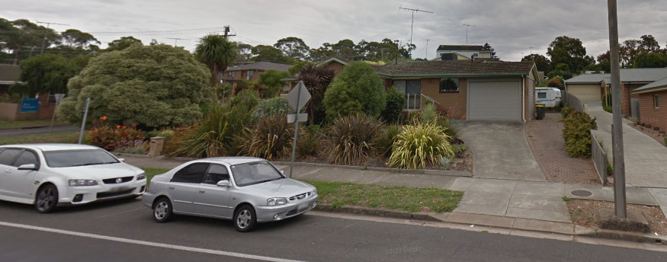
Image 1 – Subject site frontage to Barrabool Road
The subject site is within an established residential area of Highton, opposite the Highton Reserve on the southern side of Barrabool Road, and approximately 70 metres north-west of the Highton Village Neighbourhood Centre.
The subject site is presently developed with an existing single storey dwelling constructed of a combination of face brickwork and tiled roof cladding. The site contains established landscaping within the front and side street setbacks.
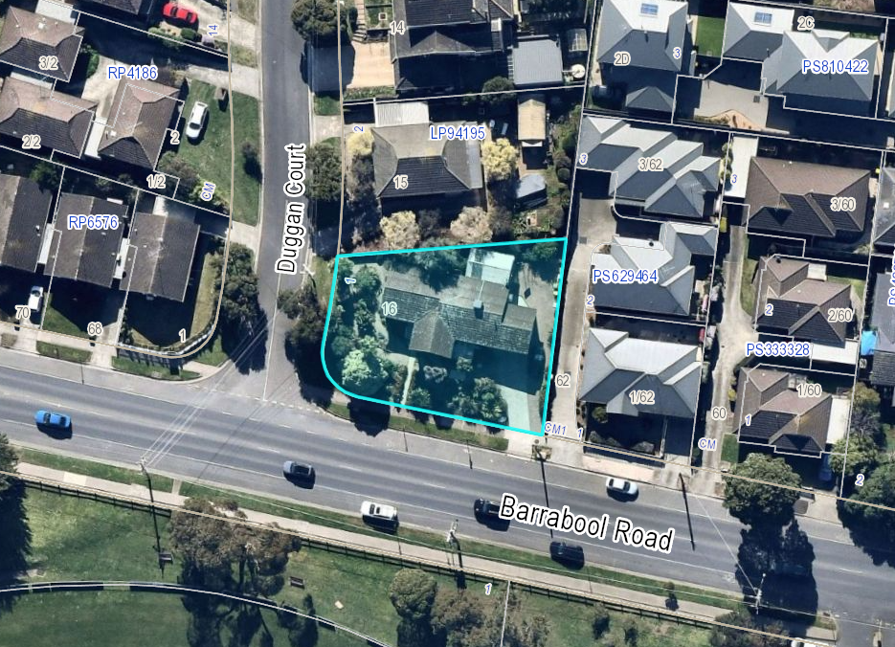Image 2 – Aerial image of subject site (Nearmap imagery dated: 37-07-2021).
The site is situated in relatively close proximity to local shops and services, given its proximity to Highton Village, which is a neighbourhood centre under the City of Greater Geelong Retail Centre Hierarchy.
The following services/centres are within proximity to the subject site:
- Highton Village: approx. 70 metres;
- Roslyn Primary School: approx. 950 metres;
- Highton Primary School: approx. 500 metres;
- Belmont High School: approx. 850 metres;
- Highton Reserve: approx. 20 metres;
- Roslyn Road/Highton Library Bus Stops (Route 42): approx. 200 metres;
- Cedar Grove/Mt Pleasant Road Bus Stops (Route 43): approx. 400 metres;
- South Geelong Station: approx. 3.2 kilometres;
- Geelong CBD: approx. 4 kilometres.

The site and surrounding area is situated within the General Residential Zone (Schedule 4) that reflects the locale of the Highton Shopping Centre Increased Housing Diversity Area. A Special Building Overlay covers the majority of the site and surrounding area including residential lots to the north and east of the site.
Land to the north, east and west of the subject site is zoned General Residential Zone (Schedule 4). Further north, at the rear of the northern most lots fronting Duggan Court, is land zoned Neighbourhood Residential Zone (Schedule 8), which is also subject to a Design and Development Overlay (Schedule 14).
Opposite the site on the southern side of Barrabool Road is the Highton Reserve, zoned Public Park and Recreation Zone. Adjoining the Highton Reserve to the east is the Commercial 1 Zone which forms the Highton Village neighbourhood centre.
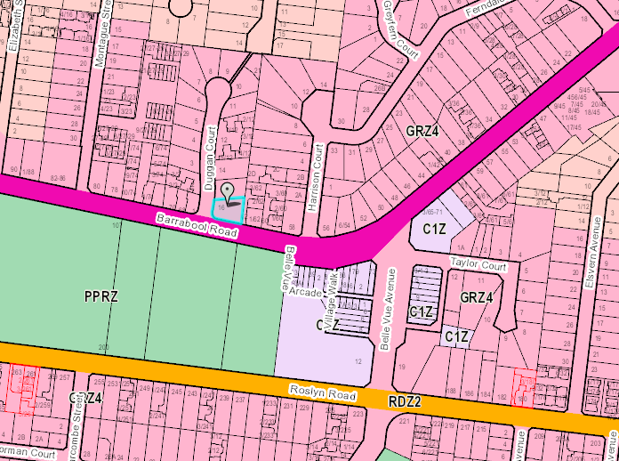
Image 3: Subject site context showing Zoning (site indicated in blue).
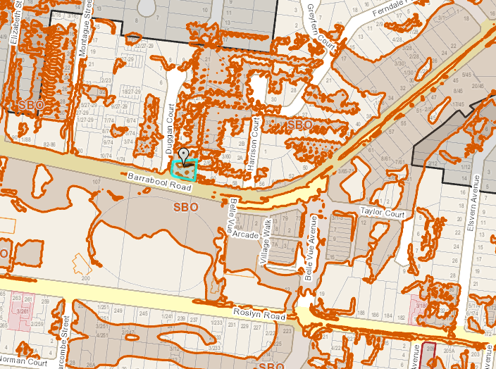
Image 4 – Subject site context showing Planning Scheme Overlays (site indicated blue).
The ground levels of the subject site and surrounding area undulate considerably. The subject site slopes consistently down from the northern rear boundary to the south-eastern corner at its Barrabool Road street frontage of approximately 3m.
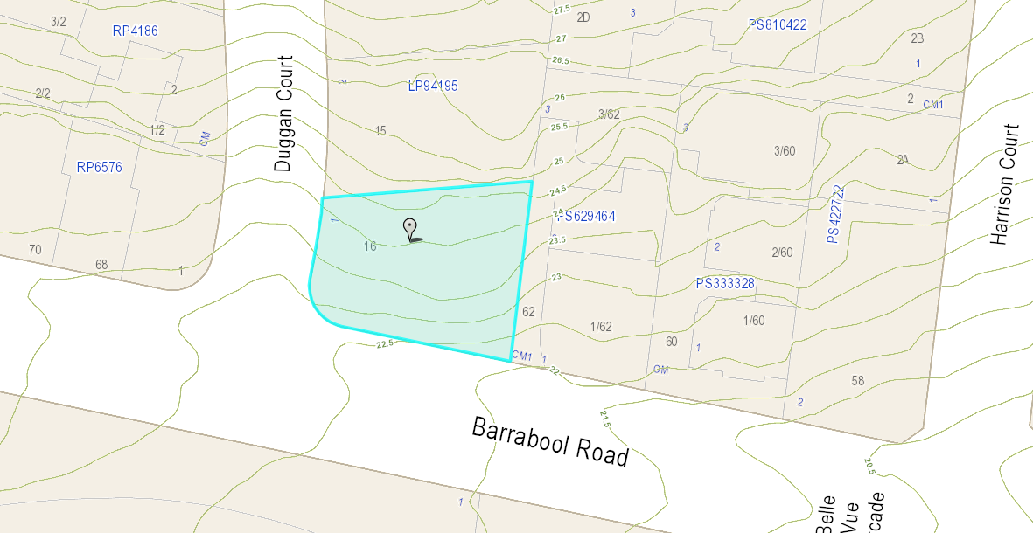
Image 5 – Subject site and surrounds contours.

The subject site is located centrally within the Highton Shopping Centre Increased Housing Diversity Area (IHDA).
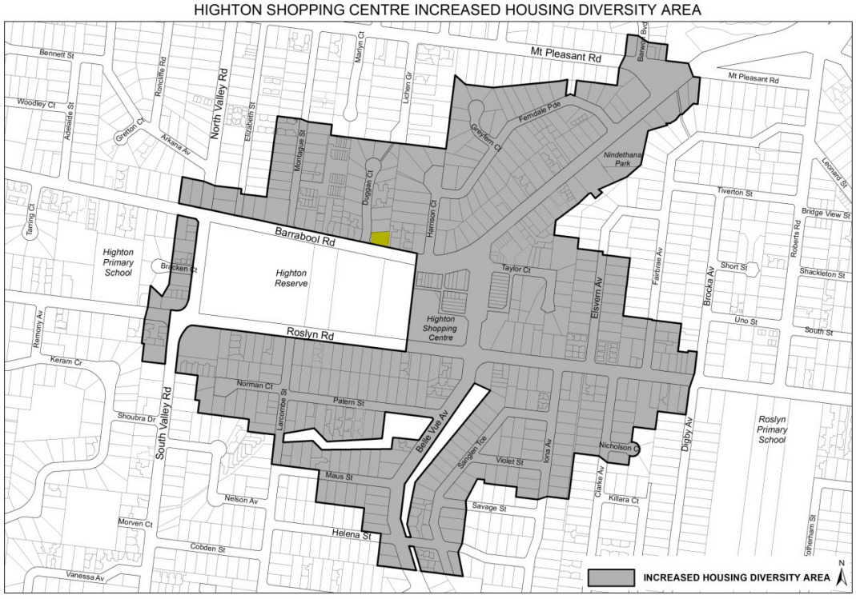
Image 6 – Subject site (shown yellow) within Highton Shopping Centre IHDA

The subject site has a frontage to Barrabool Road of approximately 26 metres. The street frontage follows the curvature of the junction of Barrabool Road and Duggan Court, with a side street frontage of approx. 12.5 metres to the eastern side of Duggan Court. The site’s eastern side boundary extends approximately 27.5 metres to the northern rear boundary, which has a length of approx. 31.5 metres.
There are no expressed easements on the subject site indicated on the Title Plan. However, it is noted that there is an existing Barwon Water sewer asset adjacent to the eastern side boundary of the site, as well as a Council drainage asset within the south-western corner of the site.
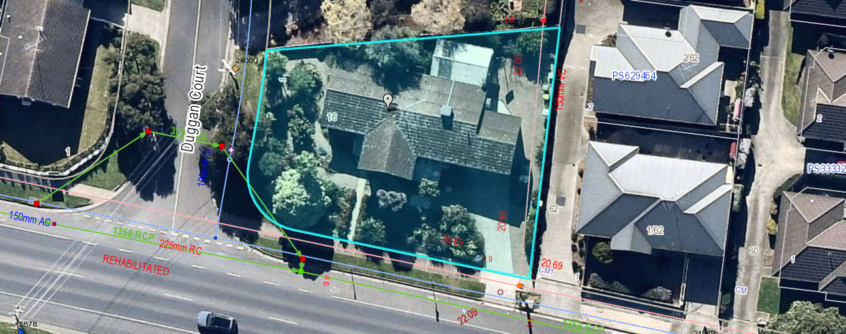
Image 7 – Subject site aerial image showing mapped infrastructure locations
Existing residential development within the immediate surroundings of the subject site can be generally characterised as medium density dwellings displaying somewhat varied design details and architectural intent.

Duggan Court generally contains single dwellings on individual lots, with some multi-dwelling developments existing at numbers 2 and 12. The built form character within Duggan Court generally incorporates single and double storey built forms unified by pitched roof forms and external materials of face brickwork and tiled or metal clad roofing.

Within the Barrabool Road streetscape, residential development consists of a mix of mainly single storey dwellings within multi-unit developments of traditional design constructed of face brickwork or weatherboard cladding, with metal and tiled pitched roof forms.

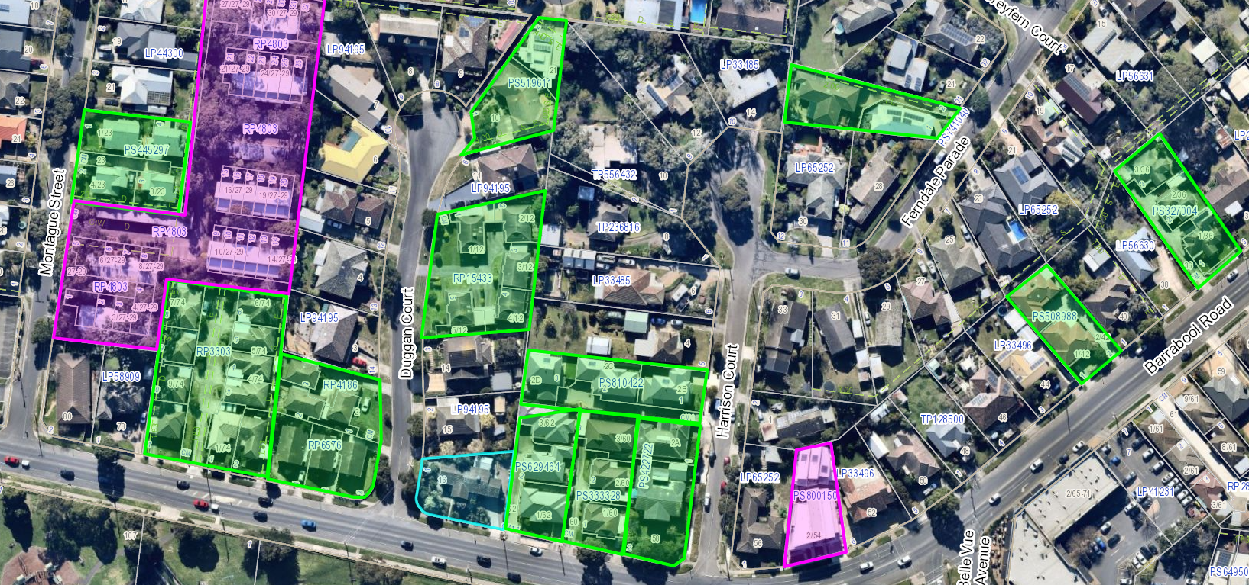
Image 8 – aerial amagery showing occurrence of infill devleopment in proximity to subject site.
Green: typical medium density infill (mainly detached dwellings with pitched roof forms)
Pink: higher density infill (multi-storey/terraced units)

Some examples exist of contemporary residential developments, including an existing 9 dwelling multi-unit development at 4 Taylor Court, apartment development comprising 7 dwellings at no. 54 Barrabool Road, approximately 100 metres east of the site. This building generally reflects the mixed used character of the neighbourhood centre on the opposite side of Barrabool Road.
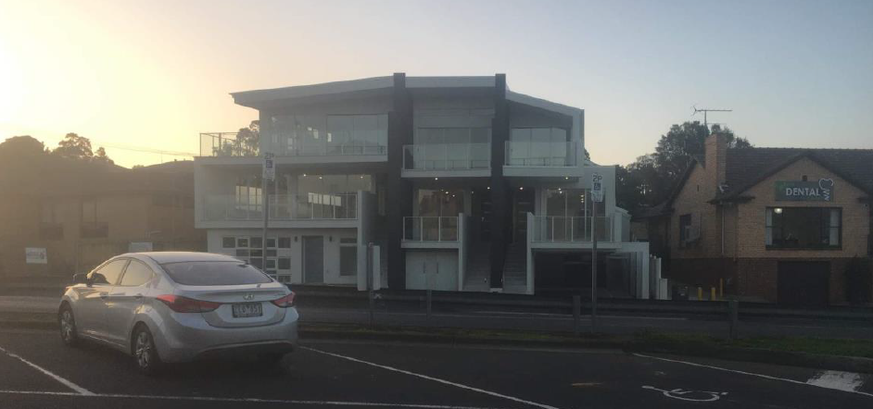
Image 9 – Example of dwellings of contemporary building design fronting Barrabool Road
The wider locality around the Highton Village area has seen a somewhat significant number of infill developments over recent times providing multi-dwellings on traditionally single dwelling allotments.

PROPOSAL:
This application seeks a planning permit for the construction of 9 dwellings on a lot, buildings and works in the special building overlay, reduction in car parking requirements to not provide a visitor parking space, and alteration of access to a road in a Transport Zone 2.
The proposed development consists of the construction of an apartment building comprising a basement level car park with three levels of apartments on top of the basement car park.

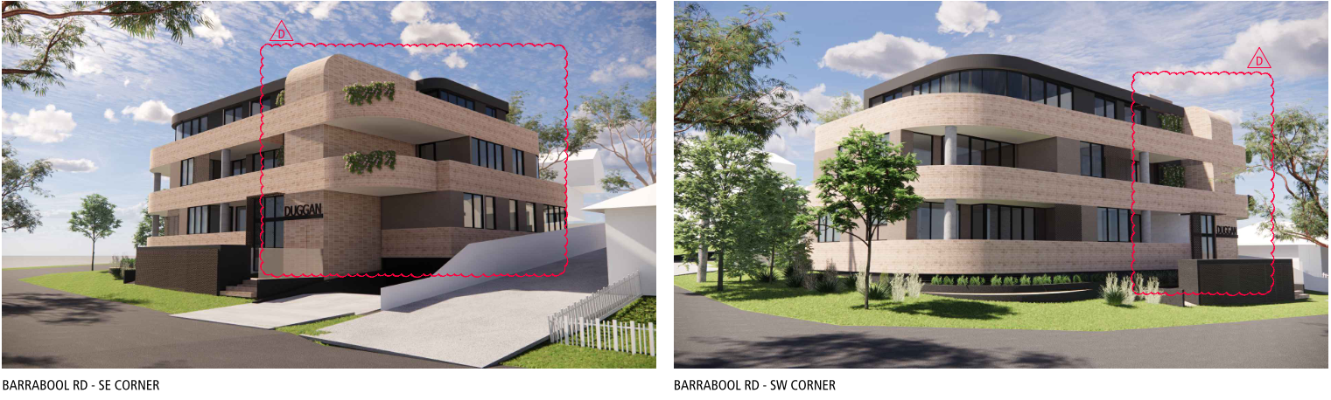
Proposed development viewed from Barrabool Road.
Vehicle access would be provided to the basement car park via a proposed widened crossover from Barrabool Road on the south-eastern corner of the site. The main pedestrian access from Barrabool Road to a lobby area, lift and stair core would be adjacent to the vehicular access fronting the street. The stairwell and lift core would be within the southern elevation of the proposed building spanning the basement to top floor levels. The application does not propose any walls on boundaries and the minimum side and rear setbacks proposed would be:
- Ground level northern rear setback: 1m  - First-floor northern rear setback: 2.775m  - Second-floor northern rear setback: 2.37m | - Ground level eastern side setback: 2.3m  - First-floor eastern side setback: 3m  - Second-floor eastern side setback: 3m to balcony and 5.15m to external wall
The proposed services including mailboxes, meters and fire booster would be situated within an enclosure incorporated into the proposed pedestrian entrance fronting Barrabool Road. No landscaping plan has been submitted to form part of the application, however areas set aside for landscaping are shown on the proposed basement and level 1 plans within the respective Barrabool Road and Duggan Court street setbacks, and adjacent to the northern rear and eastern side boundaries.

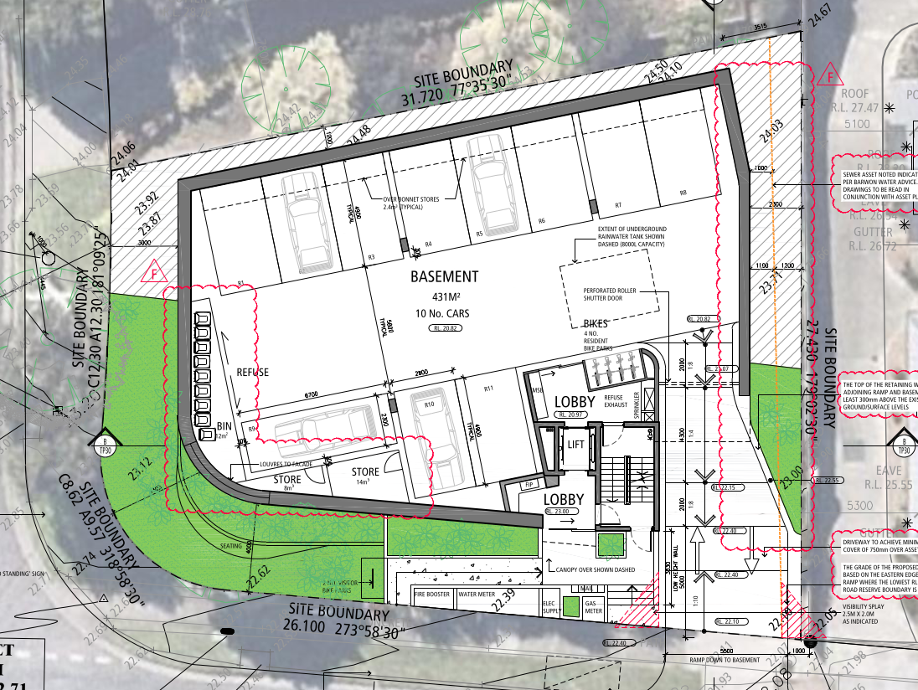
Proposed basement car park and access from Barrabool Road

On the floor level above the basement (Level 1), would be four (4) two-bedroom apartments, with access via a central corridor from the lift core and stairwell within the southern elevation.
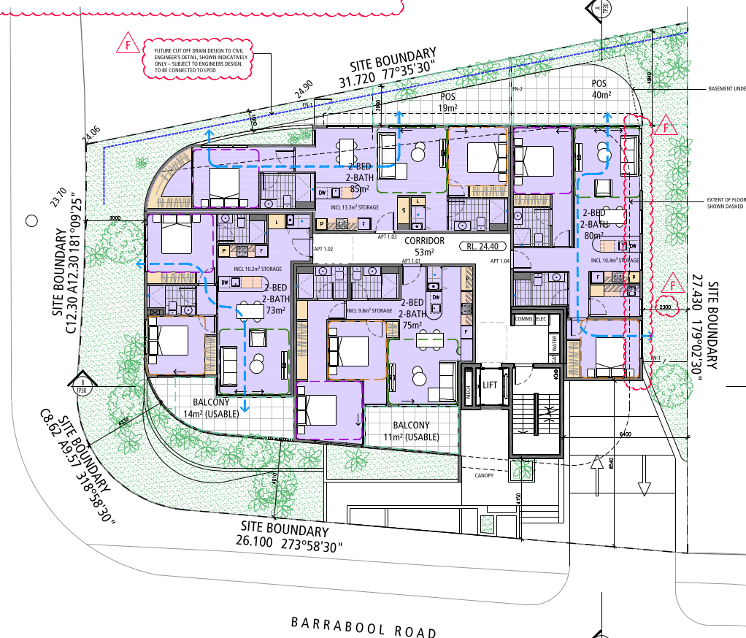
Proposed first-floor plan
At second-floor, would be three (3) proposed two-bedroom apartments, generally following a similar layout to the floor level below. Each of the apartments would contain private balconies facing either Barrabool Road or Duggan Court, with the exception of apartment 2.03 which would also include a separate balcony facing north.
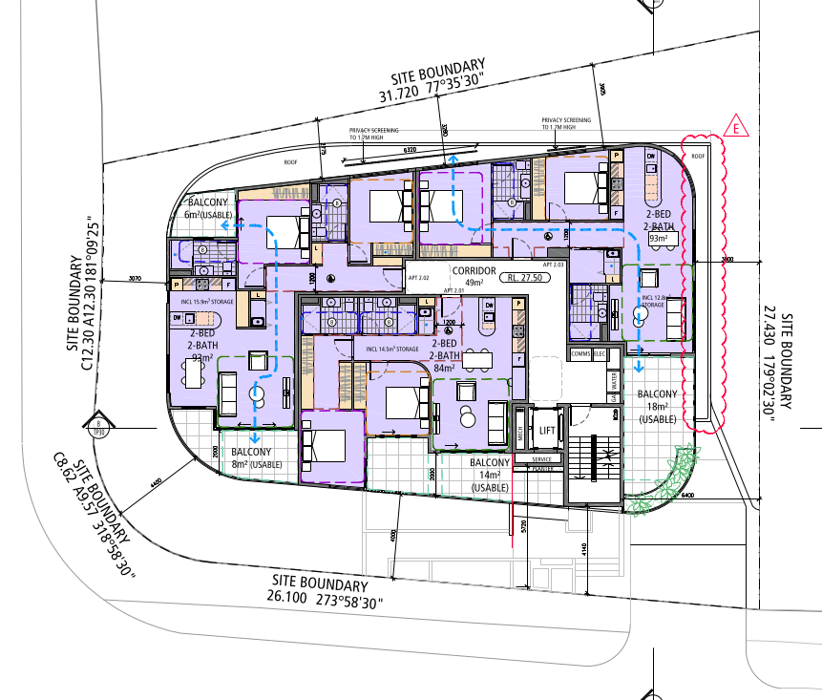
Proposed second-floor plan
At level 3 (top level), would be two (2) three-bedroom apartments. Both of which would contain access via the central corridor. Proposed apartment 3.01 would be orientated to face south, with a wrap-around external balcony. The proposed apartment 3.02 would be orientated to face north, with two separate balcony areas to its north-west and south-west, respectively.
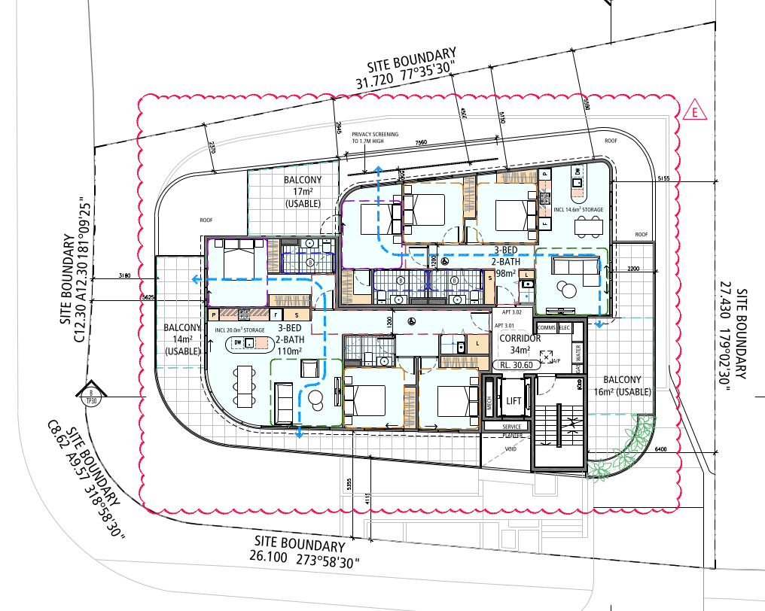
Proposed third-floor plan
The proposed building would be constructed of a combination of face brickwork, aluminium window and door frames, concrete columns and painted render. Detailed elements would incorporate perforated metal screening, clear glazing and metal louvres. The proposed basement car park would be provided with a perforated metal roller door fronting Barrabool Road.
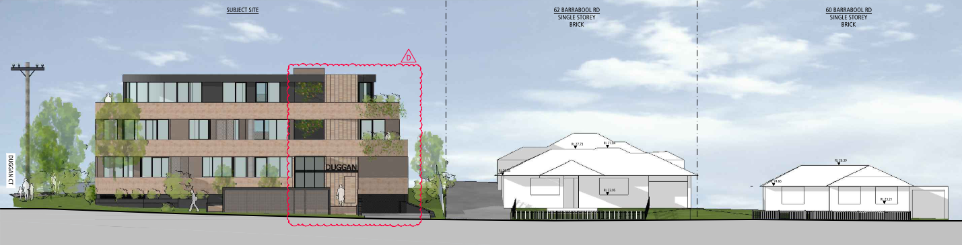
Proposed Barrabool road streetscape elevation
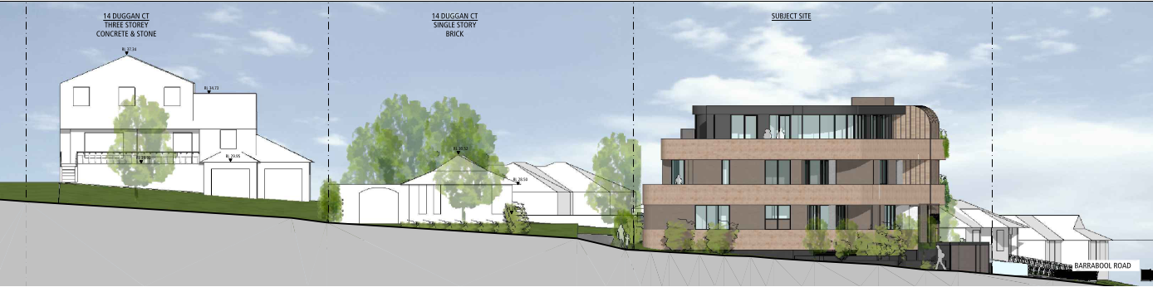
Proposed Duggan Court streetscape elevation
The application proposes two 3-bedroom dwellings and seven 2-bedroom dwellings together with 11 car parking spaces in the basement level serving the proposed dwelling occupants. The application seeks to reduce the visitor parking requirement to zero.
PERMIT/SITE HISTORY:
There is no permit/site history relevant to the application.

REFERRALS:
The following referrals were undertaken:

SECTION 55:
DETERMINING AUTHORITY

Authority: | Department of Transport
Response: | No objection to the grant of a permit subject to conditions requiring vehicle crossings to Barrabool Road being constructed to the satisfaction of the department.
Officer Comment: Noted. Should any permit be granted, the condition requested will be included.

RECOMMENDING AUTHORITY

Authority: | Engineering Services, as Relevant Floodplain Management Authority - SBO
Response: | - Prior to the commencement of the development, amended plans to the satisfaction of the Responsible Authority must be submitted to and approved by the Responsible Authority. When approved, the plans will be endorsed and will then form part of the permit. The plans must be generally in accordance with the plans submitted with the application but modified to show:  - the arrangement of the proposed cut-off drain which must be presented comprehensively with its full alignment up to the discharge point, its long and cross sections based on proper drainage design.  - that the proposed floor level 24.40 m AHD of Level 1 is at least 150 mm higher than the adjoining ground/surface, most importantly, at the rear (north) where the finished surface must be further graded down away to the cut-off drain. The relevant elevations and sections must be made consistent by showing the cut-off drain and the finished surface levels.  - all the key levels clearly and properly in the long-section of the ramp and basement.  - that the top of the retaining wall adjoining ramp is at least 300 mm above the ground/surface in the relevant elevations and sections.  - that the levels are based on Australian Height Datum (AHD) in each of the relevant drawings.  - The finished floor level (FFL) of the ground floor must be no lower than 22.90 metres Australian Height Datum (AHD).  - The finished surface level of the basement ramp crest (apex) must be no lower than 22.40 m AHD.  - The basement (floor, walls, columns etc.) must be constructed using flood resilient materials at least 150 mm above its floor level and any electrical fittings must be located above this protection level.  - The bottom sill of the basement louvre openings must be at least 300mm above the adjoining ground/surface.  - Any new fences and gates within the SBO area must have minimum 150 mm ground clearance or 25% opening to 450 mm height from the ground. The minimum clearance above any built/smooth surfaces (eg, paved, concrete, decks etc) is 100mm.  - Any new decks within the SBO area must be non-obstructive to overland flows, that is, unenclosed type to allow passage of flood water underneath.
Officer Comment: Noted. Should any permit be granted, the conditions requested are recommended to be included.

SECTION 52:

Authority: | Barwon Water
Response: | Barwon Region Water Corporation, pursuant to Section 52 of the Planning and  Environment Act, does not object to the granting of a planning permit.
Officer Comment: No objection noted. Barwon Water has requested that notes are added to any permit granted. The information is not considered necessary to be included as notes on any permit. The applicant has been provided with a copy of the Barwon Water referral response already.
Authority: | Powercor
Response: | No objection subject to conditions.
Officer Comment: Noted. Generally, the recommended conditions are to be included on any permit granted.

INTERNAL

Department: | Engineering Services
Response: | Engineering Services Recommendation: Supportive Subject to conditions
Officer Comment:
Noted that no objection is raised. Generally the suggested conditions are recommended to be included on any permit granted.

Department: | ESD Response
Response: | The application was supported, and conditions were suggested.
Officer Comment: Noted. Generally, the recommended conditions are to be included on any permit granted.

Department: | Waste Services
Response: | The application was supported subject to conditions requiring the waste management plan to be endorsed to form part of the permit.
Officer Comment: Noted. Generally, the recommended conditions are to be included on any permit granted.

Department: | Parks
Response: | Further information requested – Arboricultural Impact Assessment for trees on neighbouring lots.
Officer Comment:
Noted. This request was put to the applicant and no arboricultural impact assessment has been provided. It is noted that the anyone carrying out building works is required to protect assets on neighbouring sites, including trees (under the Works Protection Notice). Whilst there are trees on neighbouring sites to the north, it is noted that these trees do not appear to be significant specimens. It is noted council’s parks officer has not advised that these trees are significant.
The relevant obligations to protect adjoining property from potential damage are considered appropriate to apply and, in this instance, it is not considered necessary to require arboricultural impact assessments and tree protection management plans for non-significant trees on adjacent sites.
Nevertheless it is considered appropriate to require that these trees are protected through the requirement to submit a tree protection management plan to the satisfaction of the responsible authority (see Condition 5)

Department: | Urban Design
Response: | Not supportive  RFI: Landscape Plan  Context  The proposed development is located on a corner, close to amenity and is not near the edge of the IHDA therefore increased density in this location is supported. However, as housing density intensifies, it is important that design quality improves to ensure a positive contribution to the neighbourhood and that the development provides a high level of onsite amenity.  Built Form  A three-storey development is proposed, however, due to the carpark not being located fully underground, the southern elevation and southeast and southwest corners present as more than three storeys. The massing of the stairwell is prominent and dominates the southeast corner. Since it has been advised that the basement RL cannot be lowered, increased upper level setbacks would help to create a more sympathetic site response that provides transition to the built form. The applicant may consider relocating the stairwell to a less prominent position.  - Recommend recessing upper levels to reduce dominance of the built form, especially to the east and south.  - Recommend further consideration of how the southeast corner can be integrated into the streetscape and passive surveillance supported to make a positive urban design contribution.  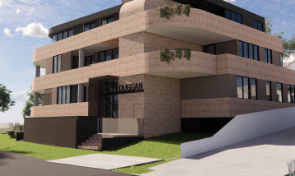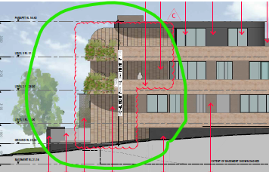  Interface Response  Building entry is dominated by services which have not been integrated into the design of the building and limit views into the lobby. The interface between the private and public realm should protect and enhances personal safety.  - Recommend relocating building services and integrating them into the design of the building.  - Further design consideration is required to allow direct views into the lobby from the street to improve passive surveillance and activation.  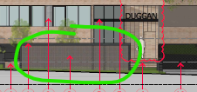  - Encourage further consideration of north west corner to improve connectivity between Apt 1.03 entry and the street.  Other  - Recommend that all parking to be located underground.
Officer Comment:
Noted. An assessment of the design response with regard to evolving neighbourhood character in IHDA areas has been detailed within this report.
In response to point 1, it is not considered that the proposed building form is unreasonably dominant. The proposed building form includes recessed roof forms at the top floor level and exhibits balconies which wrap around the front and side elevations, assisting in breaking up the building mass and reducing the dominance of the built form.
In response to point 3, it is understood that services have been provided in this location to provide access from the street.
With regard to point 2, whilst the south-eastern corner of the proposed building exhibits limited fenestration, it is considered that the presence of the balconies and alternating brickwork finishes provides sufficient visual interest to prevent a stark wall fronting the street, with passive surveillance available from the upper floor balconies to the street.
In addition, with regard to point 4, it is noted that the proposal provides a clearly distinguishable access point to the lobby. This transitional space suitably ensures that activation would occur with the street to an extent akin to that which would be expected for a residential development such as that which is proposed. It is noted that the presence of dwellings facing the street with balconies will provide ample passive surveillance opportunities.
In response to points 5 and 6, the plans have been amended to remove the (original) car park in the north-western corner which improved visual connectivity to the building and rear private open space of apt 1.03.

AMENDMENT OF THE PROPOSAL PRIOR TO PUBLIC NOTIFICATION:
The application was not amended prior to public notification.

PUBLIC NOTIFICATION:
The application is not exempt from the notice requirements of Section 52(1)(a), (b) and (d), the decision requirements of Section 64(1), (2) and (3) and the review rights of Section 82(1) of the Act and pursuant to Section 52 of the Planning and Environment Act 1987 the following forms of advertising were undertaken:
- Notices were sent to owners and occupiers of adjoining land (including opposite)
- A2 sign(s) were placed on the land

CONSULTATION:

A consultation meeting was not held because the applicant submitted a written response to objections raised for circulation to objectors.
AMENDMENT OF THE APPLICATION FOLLOWING PUBLIC NOTIFICATION

The application was amended following public notification of the application on 14 July 2022 pursuant to s57a of the Planning and Environment Act 1987. The amendment to the proposal include:
- Update plans to show:
  - NGL shown on plans relevant to elevation sections instead of at site boundary
  - Revised building siting to increase garden area
  - Annotation detailing cut-off drain to redirect
  - Update car parking layout
  - Detail of Barwon Water Asset shown on plans

Following receipt of the amended plans, the application was readvertised pursuant to s57B of the Planning and Environment Act 1987.
- Notices were sent to owners and occupants of adjoining land
- A2 signs were placed on the land
- Notices were sent to previous objectors.
Fifty-one (51) objections have been lodged with Council.

OBJECTIONS:
The concerns of objectors are summarised and commented on below:
- Does not meet minimum garden area requirement and exceeds maximum building height.

Response
As outlined in response to the garden area and maximum building height requirements contained in the General Residential Zone, the application has been amended to address non-compliance with garden area, building height and maximum number of storeys. The application demonstrates that it does meet the mandatory garden area and maximum building heights. This is discussed in detail in the body of this report.
- Neighbourhood character concerns including:
  - Size, bulk and height is inappropriate in this location
  - Does not reflect the village character nor an emerging character of the area
  - Does not retain existing vegetation wherever possible

Response
It is important to note that the subject site is within an area which has been identified as appropriate for increased housing diversity and density.
This is a policy objective for the Highton area and the subject site. Relevantly, VCAT has identified that the character of Highton is expected to evolve through more intensive development.
This was discussed in Arc26 Pty Ltd v Greater Geelong CC [2021] VCAT 201, where in its decision to set aside the Council’s refusal of 9 dwellings within Taylor Court, Highton, Member Wilson stated within paragraph 46,
46. The character in this area is expected to evolve through more intensive development and a departure from the detached dwellings evident in the area is specifically sought for this area in local policy relating to IHDA [Increased Housing Diversity Areas].
The General Residential Zone Schedule 4 which applies to the subject site reduces the requirements in Clause 55 standards in relation to street setbacks, site coverage and private open space. As outlined in response to Clause 55, it is considered that the proposal provides an acceptable response to the objectives within ResCode (Clause 55).
The application complies with the standards for side and rear setbacks and site coverage and provides private open space in accordance with the relevant standards for all but 1 proposed dwelling.

- Amenity concerns including:
  - Noise from heating and air conditioning units and other external plant
  - Overshadowing neighbouring dwellings.
  - Overlooking to neighbouring properties including 1 and 15 Duggan Court

Response
As outlined in response to Clause 55, it is considered that subject to conditions on any permit granted, the proposed development would not result in an unreasonable level of overlooking. Furthermore, to ensure that noise from rooftop plant does not unacceptably impact on neighbourhood dwelling’s amenity, conditions should be included on any permit granted ensuring sufficient acoustic treatment is provided to limit off-site amenity impacts.
The submitted shadow diagrams identify that at 22nd September, the projected shadow cast by the proposed development would not unreasonably overshadow neighbouring dwelling’s SPOS.

- Increased population density is inappropriate in this location.

Response
The subject site is situated within an area identified as appropriate for increased housing diversity and dwelling density. The net gain of 8 dwellings in this locality would accord with the strategic objectives of relevant planning policy to both evolve character through more intensive development and provide a higher varieties of housing types to cater to a variety of lifestyle needs.

Policy in the planning scheme identifies that this site is well positioned in that this part of Highton is appropriate for increased housing density. As outlined by Member Wilson in Arc26 Pty Ltd v Geelong CC. In the Tribunal’s decision to set aside the Council’s decision to refuse 9 Dwellings in Taylor Court, Highton, it states at paragraph 37-40 of its decision:
37. The review site is in the IHDA under local policy. These are locations around activity centres that have been identified with significant capacity to accommodate residential growth and increased housing diversity and where maximising opportunities for housing is sought.
38. State and regional policy supports the development of increased dwelling numbers around existing activity centres to maximise the accessibility to jobs, services and facilities. Increased diversity in housing is sought to offer choice and meet changing household needs.
39. The purpose of the GRZ includes encouraging a diversity of housing types and housing growth, particularly in locations offering good access to services and transport.
40. The review site is well located for access to the services and facilities provided by the Highton activity centre. I find nine dwellings on the review site will contribute to the number and diversity of houses in a location that is specifically targeted for this outcome under planning policy and encouraged by the purpose of the zone.

The site subject of this application is situated 280m from the review site in ARC26 v Greater Geelong CC.

- Car parking and traffic concerns including:
  - Insufficient car parking which does not meet relevant Australian Standard for size and number of car parks.
  - Loss of pedestrian, cyclist and vehicle safety due to basement car park exiting onto Barrabool Road.
  - Increased congestion on the existing road network, including on-street carparking including as a result of reduced visitor parking.

Response
- The proposed car parking layout at basement level has been reviewed by Council’s Traffic Engineers. No objection to the grant of a permit has been raised on the basis that the car parking spaces are non-compliant or unusable. The proposal provides 11 car parking spaces serving the proposal with the required amount of residential parking spaces. There is no statutory basis for requiring residential car parking at a greater rate than prescribed by the planning scheme. Matters relating to visitor parking is outlined below.

- The application has been referred to the Head, Transport for Victoria with regard to creation of access to the site from Barrabool Road. No issues have been raised by the relevant road authority in relation to the proposal causing unreasonable impact to road safety. As outlined in response to Clause 52.06, the application is considered to comply with the required design standards for car parking. Subject to conditions, the proposal will provide adequate sightlines at the entrance to the car park.
- Whilst the application proposes the reduction of 1 visitor parking space, it is considered that the surrounding car parking on-street would be able to accommodate the shortfall of 1 on-site visitor parking space. This has been justified by way of a traffic impact assessment submitted with the application, which has been reviewed and supported by Council’s Traffic Engineers.

- Impacts on existing infrastructure including:
  - Stormwater runoff

Response
No concerns have been raised by Council’s development engineers with regard to the impact the proposal will have on the existing drainage network.
The subject site is in a Special Building Overlay. As such, the proposal has been referred to Council’s Flood and Stormwater Development Engineers as the relevant floodplain management authority. Subject to conditions, no objection to the grant of a permit has been raised on the basis that the proposal would result in an unreasonable on-site or off-site stormwater flooding impact.

- Construction management concerns including:
  - Construction vehicle parking and access.
  - Noise impacts during construction

Response

It is not considered that the temporary presence of construction vehicles on site would be sufficient grounds to refuse the application.

Construction management is noted to generally sit outside of the planning system (it’s a requirement under the Building Regulations) and vehicles parking within the street would be subject to the same car parking restrictions which are presently in place.

Noise impacts associated with construction sites is controlled under legislation sperate to the Planning and Environment Act 1987.

- Unsatisfactory Environmentally Sustainable Design, including:
  - Insufficient shading
  - Lack of climate responsive landscape design
  - Application only marginally meets garden area and does not retain existing garden
  - Does not respond to ESD policy

Response
The application, including the submitted sustainable design assessment, has been assessed by Council’s ESD officer. It has been determined that subject to conditions, the proposed development would achieve an appropriate level of environmentally sustainable design in accordance with relevant ESD policy at Clause 15.01-2L of the scheme.

- Non-planning planning considerations including:
  - Devaluation of property values

Response
VCAT have regularly determined that the issue of potential property devaluation is not a relevant planning consideration. Senior Member Margaret Baird discussed devaluation of property in paragraph 55 in the case of Filcam Property Group Pty Ltd v Whitehorse CC [2014] VCAT 508.

Devaluation of property
55. As with the case with many other instances when this ground is identified by Respondent Objectors to a planning permit application, potential loss in property values is not a matter upon which there is any evidence. Moreover, if values are affected by adverse amenity impacts, then it is the amenity questions that must be considered, not their ramifications in terms of property values. This is the approach usually adopted by the Tribunal in these proceedings.
As such, the assessment and decision making on this application should not be based on devaluation of property.

ASSESSMENT:
ZONE:

Clauses 32.08 – General Residential Zone – Schedule 4
The purpose of the General Residential Zone is:
- To implement the Municipal Planning Strategy and the Planning Policy Framework.
- To encourage development that respects the neighbourhood character of the area.
- To encourage a diversity of housing types and housing growth particularly in locations offering good access to services and transport.
- To allow educational, recreational, religious, community and a limited range of other non-residential uses to serve local community needs in appropriate locations

Schedule 4 to the General Residential Zone applies to urban increased housing diversity areas.
Schedule 4 to the General Residential Zone does not:
- Specify any neighbourhood character objectives.
- Exempt the construction of a dwelling or residential building from the minimum garden are requirement contained within the zone.

Schedule 4 to the General Residential Zone varies the following requirements of Clause 55:
 | Standard | Requirement as per GRZ4
Minimum Street Setback | Standard B6 | If the site is in a heritage overlay, the average distance of the setbacks of the front walls of the existing buildings on the abutting allotments facing the front street or 9 metres, whichever is the lesser.  In all other areas, the average distance of the setbacks of the front walls of the existing buildings on the abutting allotments facing the front street or 4 metres, whichever is the lesser.
Site Coverage | Standard B8 | Maximum site coverage 70 per cent
Private open space | Standard B28 | A dwelling or residential building should have private open space consisting of:  - An area of 20 square metres of secluded private open space at the side or rear of the dwelling or residential building with a minimum dimension of 3 metres and convenient access from a living room; or  - A balcony of 8 square metres with a minimum width of 1.6 metres and convenient access from a living room; or  - A roof-top area of 10 square metres with a minimum width of 2 metres and convenient access from a living room.

Garden Area
Pursuant to Clause 32.08-4, an application to construct or extend a dwelling on a lot must provide a minimum garden area as set out in the following table:
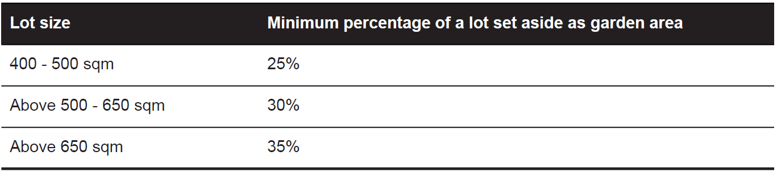
This does not apply to:
- An application to construct or extend a dwelling or residential building if specified in a schedule to this zone as exempt from the minimum garden area requirement;
- An application to construct or extend a dwelling or residential building on a lot if:
  - The lot is designated as a medium density housing site in an approved precinct structure plan or an approved equivalent strategic plan;
  - The lot is designated as a medium density housing site in an incorporated plan or approved development plan; or
- An application to alter or extend an existing building that did not comply with the minimum garden area requirement of Clause 32.08-4 on the approval date of Amendment VC110.

Garden Area Response
The garden area requirement contained within the zone is applicable given:
- An application to construct or extend a dwelling or residential building is not exempt from the minimum garden area requirement under Schedule 4 to the General Residential Zone.
- The subject site is not:
  - a lot designated as a medium density housing site in an approved precinct structure plan,
  - designated as a medium density housing site in an incorporated plan or approved development plan; or
- The application does not relate to an existing building that did not comply with the minimum garden area requirement of Clause 32.08-4 on the approval date of Amendment VC110.
The subject site has a total area of approximately 711sqm. As such, in accordance with Clause 32.08-4, a minimum of 35% of the site, or 248.85sqm of the site is required to be set aside as garden area. The application is supported by a Garden area diagram (TP15 – B) received: 13 September 2022 as follows:
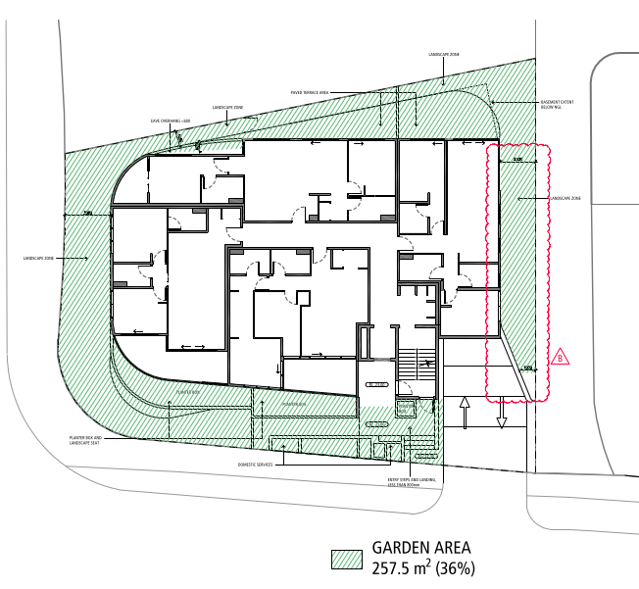
Garden area diagram included on proposed level 1 flood plan (TP15 – Revision B).

The submitted Garden area diagram specifies that an area of 251sqm, or 36% of the site is proposed to be set aside as garden area. This has been scaled and measured to be accurate.
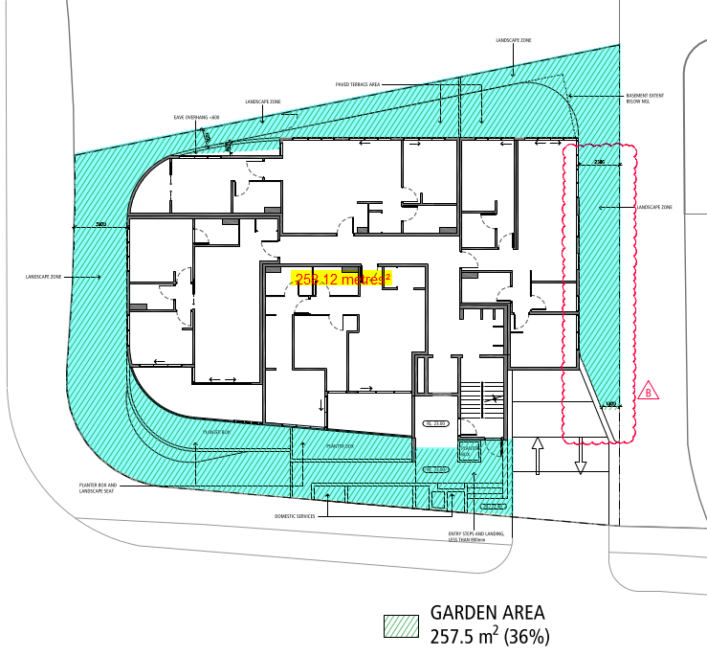
Garden area diagram measured to scale

The provision of 257.5sqm of garden area is 36% of the site, which exceeds the minimum requirement specified at Clause 32.08-4 of the General Residential Zone.
The garden areas include steps, terraces and service enclosures fronting Barrabool Road. These areas can contribute to Garden Area as they do not exceed 800mm in height or are domestic services normal to a residential building.
Maximum Building Height
Pursuant to Clause 32.08-10 of the General Residential Zone, a building must not be constructed for use as a dwelling or a residential building that:
- Exceeds the maximum building height specified in a schedule to the zone; or
- Contains more than the maximum number of storeys specified in a schedule to the zone.

If no maximum building height or maximum number of storeys is specified in a schedule to the zone:
- The building height must not exceed 11 metres; and
- The building must contain no more than 3 storeys at any point.

A building may exceed the applicable maximum building height or contain more than the applicable number of storeys if:
- It replaces an immediately pre-existing building and the new building does not exceed the building height or contain a greater number of storeys than the pre-existing building.
- There are existing buildings on both abutting allotments that face the same street and the new building does not exceed the building height or contain a greater number of storeys than the lower of the existing buildings on the abutting allotments.
- It is on a corner lot abutted by lots with existing buildings and the new building does not exceed the building height or contain a greater number of storeys than the lower of the existing buildings on the abutting allotments.
- It is constructed pursuant to a valid building permit that was in effect prior to the introduction of this provision.

An extension to an existing building may exceed the applicable maximum building height or contain more than the applicable maximum number of storeys if it does not exceed the building height of the existing building or contain a greater number of storeys than the existing building.
A building may exceed the maximum building height by up to 1 metre if the slope of the natural ground level, measured at any cross section of the site of the building wider than 8 metres, is greater than 2.5 degrees.
A basement is not a storey for the purposes of calculating the number of storeys contained in a building.
The maximum building height and maximum number of storeys requirements in the Zone or a schedule to the zone apply whether or not a planning permit is required for the construction of a building.

Building height if land is subject to inundation:
If the land is in a Special Building Overlay (SBO), the maximum building height specified in the zone or schedule to the zone is the vertical distance from the minimum floor level determined by the relevant floodplain management authority to the roof or parapet at any point.

Response to Maximum Building Height
The maximum building height requirements contained within the zone, which are applicable to this application are relevantly outlined below:
- Schedule 4 to the General Residential Zone does not specify a maximum building height requirement for a dwelling or residential building. The requirements within the parent clause are applicable.
- The proposed building exceeds the building height and number or storeys of the existing building;
- The site is on a corner and the proposed building exceeds the building height and number of storeys than the lower of the existing buildings on the abutting allotments.
- The building may exceed the maximum building height by up to 1 metre as the slope of the site is greater than 2.5 degrees.
- The land is in an SBO. The Engineering Services SBO Unit (as relevant floodplain manager) has determined the minimum finished floor level as 22.90m AHD.

In view of the above, it is considered that:

Pursuant to Clause 32.08-10, the allowable maximum building height applicable to the proposed development, is 12 metres above the minimum finished floor level of 22.90m AHD and a maximum of 3 storeys at any point.

The proposed elevations show that the maximum building height to the roof / parapet would sit at a relevant level of 33.90m AHD. This would be a maximum of 11m above the specified minimum finished floor level.
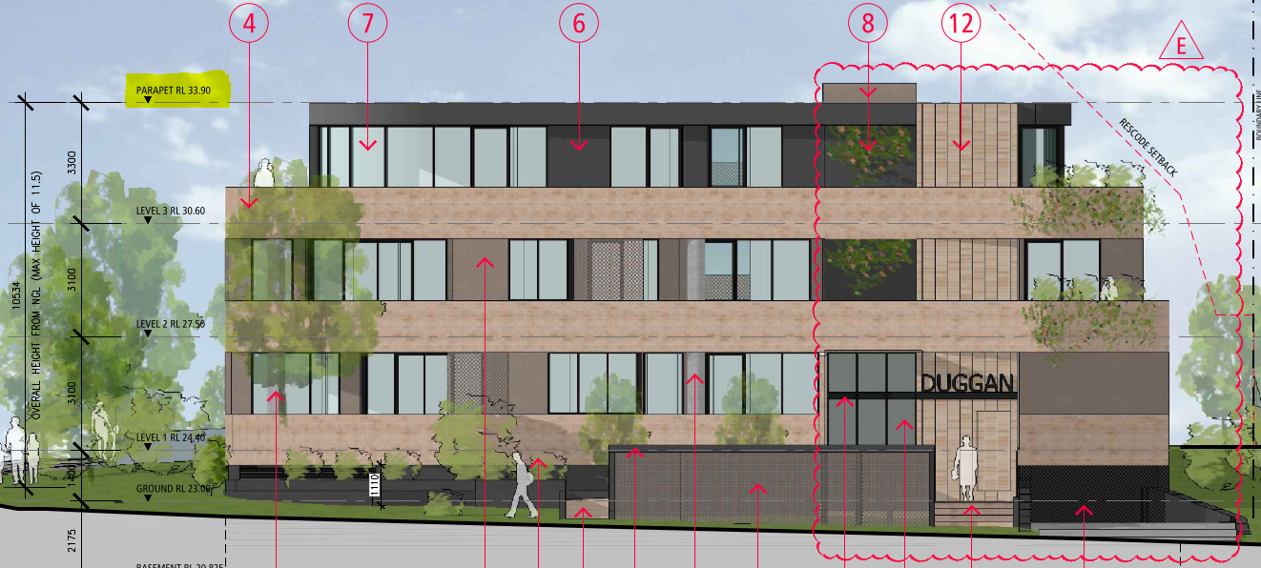
Maximum building height shown to be 33.9m AHD
In view of the above, it is considered that, based on the information provided within the application, the proposed building would comply with the maximum building height specified within the Zone.

In addition to the above, the maximum number of storeys permitted in the General Residential Zone is three (3). The application proposed to construct a building which includes 3 levels of living space about a basement car park. Clause 32.08-10 states that a basement is not a storey for the purposes of calculating the number of storeys contained in a building.

To determine whether or not the proposed development, as shown on the proposed plans, complies with the maximum number of storeys, it is necessary to consider the relevant definitions of Basement, Building Height, Ground level and Storey. Clause 73.01 of the Planning Scheme defines these terms as:

Basement: | A storey below ground level, or that projects no more than 1.2 metres above ground level.
Building height: | The vertical distance from natural ground level to the roof or parapet at any point.
Ground level: | The natural level of a site at any point.
Storey: | That part of a building between floor levels. If there is no floor above, it is the part between the floor level and ceiling. It may include an attic, basement, built over car parking area, and mezzanine.
In view of the above definitions, it is considered that the basement car park forming part of the proposed development does meet the definition of a basement as contained within clause 73.01. This is because the submitted proposed Section A-A and proposed Section B-B drawings show that the proposed basement level would not project greater than 1.2 metres above the annotated NGL.

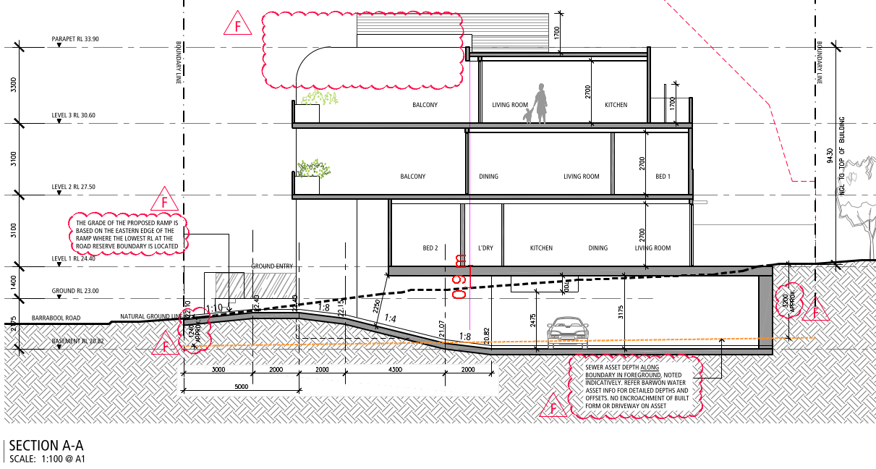
Proposed section A-A showing the proposed basement projecting 0.9m above natural ground level to the FFL of the floor above where there are three-storeys above.

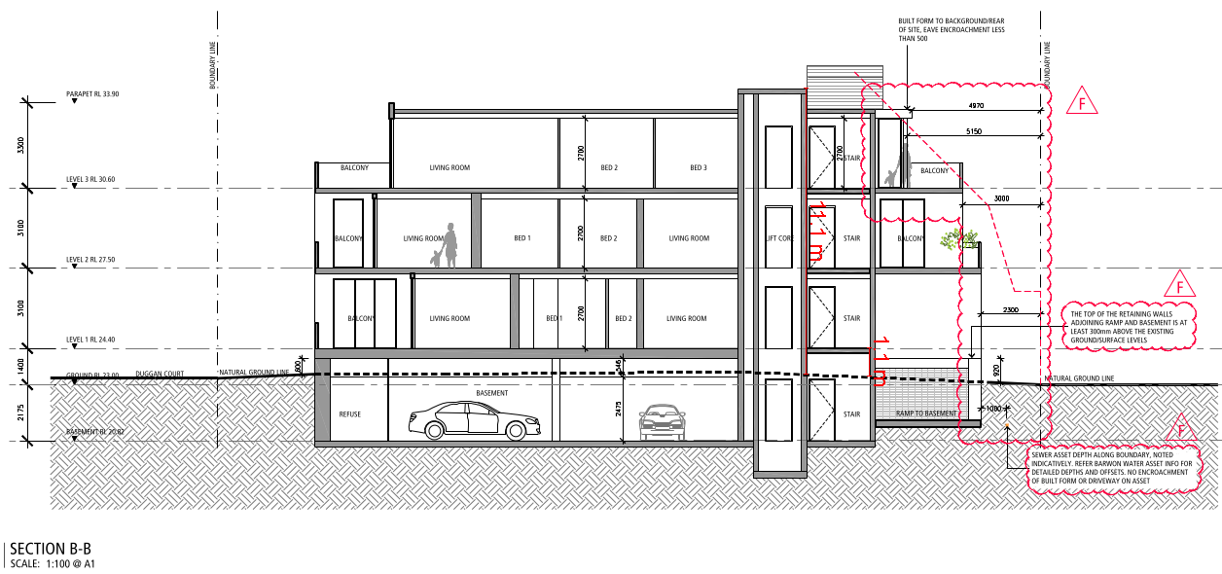
Proposed section B-B showing the proposed basement projecting 1.1m above natural ground level to the FFL of the floor above where there a three-storeys above.

As the proposed basement does not project more than 1.2m above NGL where there are three-storeys above, the proposed development would not exceed the maximum number of storeys under the zone.

This is considered to be the case in view of the findings of VCAT in Mrocki v Bayside CC (Includes Summary) (Red Dot) [2015] VCAT 1731. Within the Tribunal’s decision in Mrocki, when considering whether a basement contributes to the maximum number of storeys (when a basement is expressly excluded from the maximum number of storeys) for the purpose of maximum building heights, Deputy President Gibson and Member Keddie state at paragraphs 39 - 41,

- Basement is defined to mean:
A storey below ground level, or that projects no more than 1.2 metres above ground level.

- Therefore, so long as the basement on 29 St Ninians Road does not project more than 1.2 metres above ground level it will fall within the definition of ‘basement’ in the planning scheme and consequently will be excluded from the mandatory building height limit of 2 storeys.

- If the basement of the development on 29 St Ninians Road projects more than 1.2 metres above ground level, it will not be a ‘basement’ as defined in the scheme. It will still be a storey (because a basement is defined to be a storey but one below ground level) but it will not be a storey that is excluded from the mandatory building height of 2 storeys. In other words, it will have to be counted as a storey in determining how many storeys the proposed plans contemplate. If it is a storey and not a ‘basement’ (as defined), then given there are two storeys above the basement level shown on the plans, the development will be for a 3 storey building, which is not permitted under DDO1.

Response to General Residential Zone – Schedule 4
Pursuant to Clause 32.08-13 of the General Residential Zone, before deciding on an application, in addition to the decision guidelines in Clause 65, the responsible authority must consider, as appropriate:
General
- The Municipal Planning Strategy and the Planning Policy Framework.
- The purpose of this zone.
- The objectives set out in a schedule to this zone.
- Any other decision guidelines specified in a schedule to this zone.
- The impact of overshadowing on existing rooftop solar energy systems on dwellings on adjoining lots in a General Residential Zone, Mixed Use Zone, Neighbourhood Residential Zone, Residential Growth Zone or Township Zone.

Dwellings and residential buildings
- For the construction and extension of two or more dwellings on a lot, dwellings on common property and residential buildings, the objectives, standards and decision guidelines of Clause 55. This does not apply to an apartment development of five or more storeys, excluding a basement.

Schedule 4 to the GRZ applies to the ‘urban increased housing diversity areas’. The Schedule varies the ResCode requirements in relation to front setbacks, site coverage and provision of secluded private open space.
In consideration of the relevant decision guidelines outlines within the General Residential Zone, it is noted that the purpose of the zone seeks to
- encourage development that respects the neighbourhood character of the area and to encourage a diversity of housing types and housing growth in locations offering good access to services and transport.
Such objectives are brought forward within the planning policy framework, particularly at clause 16.01-1L-02 regarding increased housing diversity areas. The decision guidelines require the responsible authority to have regard to the design response to the surrounding locality, both via the purpose of the zone and thorough assessment against the objectives, standards and decision guidelines of Clause 55.

Whilst the purpose of the zone promotes diversity of housing and housing growth in appropriate locations, it is noted that this does not discount the purpose of encouraging development that respects the neighbourhood character of the area. Whilst these objectives seemingly compete with one another, it is considered appropriate to require development to respond to relevant policy provisions which promote increased dwelling densities whilst at the same time responding positively and creatively to existing and preferred neighbourhood character. In particular, it is noted that the Schedule 4 to the GRZ applies to urban increased housing diversity areas and it does not specify any specific neighbourhood character objectives for the area.

In considering whether the application proposes an acceptable neighbourhood character response as well as a suitable increase in housing density and diversity, it is noted that planning does not seek perfect or ideal outcomes, or outcomes which respond positively to every relevant policy.
This principle has been discussed in many VCAT decisions, including Dang v Greater Geelong CC [2022] VCAT 737, where Member Tait states at paragraph 7 of the Tribunal’s decision,
- Planning does not seek ideal outcomes, or outcomes which respond positively to every relevant policy. Rather, acceptable outcomes are the measure by which planning decisions are made. I must decide whether the proposal will produce an acceptable outcome having regard to the relevant policies and provisions in the Scheme. Clause 71.02-3 requires the decision-maker to integrate the range of policies relevant to the issues to be determined and balance conflicting objectives in favour of net community benefit and sustainable development.

The proposed development would provide a net gain of eight (8) additional dwellings, in the form of nine (9) apartments. Seven (7) of the proposed dwellings would be two-bedroom dwellings, with two being three-bedrooms. The subject site is situated approximately 70 metres from the Highton Village neighbourhood centre, and as discussed earlier, is in close proximity to amenities and services including schools, public open space and public transport.

In view of the above, it is considered that the proposed development would provide an increased dwelling density, and diversity of housing types in an area which has access to existing services, in accordance with the purpose of the zone in this regard.

In consideration of achieving a balance between urban consolidation policies and respecting neighbourhood character, the Tribunal has often stressed the importance in striking a balance between urban consolidation and respecting character. In numerous decisions, the Tribunal has explained that respecting neighbourhood character does not mean more of the same or replicating existing (assessing officer emphasized).
Within Ice Kozlovski/Ice Corp Pty Ltd v Stonnington CC [2010] VCAT1956, the Tribunal notes that the desire to preserve neighbourhood character should not be given undue weight at the expense of the “background hum” of policies that encourage the provision of additional housing.

In Iloray Pty Ltd v Darebin CC and Ors [2003 VCAT692, the Tribunal stated at Paragraph 53,
53. In considering this issue, the first point to be made is that the notion of development which is “respectful” of neighbourhood character does not imply that such development must be the same as what already exists. If policy, the purpose of the zone and the objectives of Clause 55 were calling for the development that is “more of the same”, then they would say so. Rather, the notion of “respectful” development must embrace the need for change and diversity in the type of dwellings that are provided and an increase in the intensity of development in circumstances where this is encouraged by planning policy and the purpose of the zone.

Similarly, whilst the GRZ4 emphasises the need to respect neighbourhood character, it is noted that within Duggan v Melton SC [2006] VCAT135, the Tribunal outlined (partly in reiteration of the findings of the Tribunal in the Iloray decision), that whilst policies and the zone may emphasise a need for new development to respect neighbourhood character, it states that at paragraphs 23-25:

23. …That does not mean more of the same, nor does it preclude double storey dwellings, unit developments or smaller lots.
25. As such, it is an overly simplistic view to say that medium density housing should be rejected because the level of development is more intense than what exists on adjacent or nearby land. The assessment of whether a proposal is respectful or “fits in” with neighbourhood character is more complex than this.

Finally, In AXF Constructions Pty Ltd v Boroondara CC [2009] VCAT 2523, the Tribunal approved a two-storey building comprising eight dwellings and basement car parking in an area consisting of single and two storey dwellings on typically large lots.
The Tribunal stated at paragraph 22:

22. The fact that the proposal introduces into this locality a built form which may not currently be present or which may not be prominent is not a basis for concluding that the proposal fails to respect the character of the neighbourhood. The assessment of the proposal’s design response is more complex than that and it is an assessment which must be undertaken in the context of the policy framework and zone provisions which encourage a variety of residential developments at a range of densities. In simple terms however, the neighbourhood character objective of the planning scheme is capable of being met by an applicant being able to demonstrate that the proposal respects the scale and form of surrounding development and/or respects the architectural style of surrounding development.

The surrounding locality generally exhibits an existing built form character typical of an area in such proximity to a local centre, which is going through a phase of evolution in accordance with relevant policies seeking such change. It contains a combination of traditional single dwellings and examples of medium density infill development. The established built form exhibits a diverse range of single, two-storey and three-storey dwellings and residential buildings.

Generally, dwellings feature similar side and rear setbacks, with varied street setbacks, particularly in Duggan Court and along the northern side of Barrabool Road. Furthermore, the surrounding residential development, including infill development is unified by similar roof forms and external facing materials, including face brickwork, weatherboard cladding and concrete render or cladding. Many roof forms include traditional hipped and gabled roofs of corrugate metal or roof tile construction.
Some examples of more recent contemporary infill at higher densities are exhibited to the northern side of Barrabool Road opposite the Highton Village neighbourhood centre. These existing infill developments support the policy intent and objectives to evolve the character of the area away from traditional residential housing built forms. It is expected that the character of the surrounding locality will evolve through more intensive development and the few examples of attached built forms and apartment developments are evident of such evolving character. Specific to IHDA areas, as outlined later within this report, policy objectives and strategies at Clause 16.01-1L-02, include to:

Evolve the character of Increased Housing Diversity Areas (IHDA) through more intensive development).
Support development that makes a positive architectural and urban design contribution to the IHDA.

Whilst the proposed development of nine apartments with flat roof forms and projecting balconies at the subject site would be distinct from the combined detached single-dwellings and existing infill developments on adjacent sites, the proposed development has incorporated built form and design elements which respond to and respect the neighbourhood character of the wider locality. These include:

- Avoiding boundary construction and allowing for landscaping to side and rear boundary interfaces.
- A front setback that allows for a sense of space to the street and responds to the built form presenting to this part of Barrabool Road and Duggan Court.
- An open front boundary which is similar to nearby development with low or no front fencing.
- External facing materials incorporating brick, render, glazing and metal cladding which is representative of existing nearby development.
- Site coverage which complies with the standards prescribed within the schedule to the zone
- Side and rear setbacks which comply with the standards prescribed within the schedule to the zone.
- A recessed third-floor level and open balconies which provide outlook and interaction with the public open space to the southern side of Barrabool Road.

The application would comply with the mandatory requirements of the zone to provide 35% garden area and would not exceed the maximum building height, nor the maximum number of storeys. The proposal would provide a three-storey residential development which responds to established built form characteristics and exhibits a built form character which responds to the purpose of the zone and relevant policies which anticipate the character of the locality is expected to evolve through intensive development. More specifically, a departure from typical detached dwellings in this locality is sought by the purpose of the zone and the relevant policies.

Furthermore, the zone varies the standards applicable in clause 55. These standards are varied to allow for a more intensive form of development. The application has been assessed against the requirements of Clause 55 and Clause 55.07 and is considered to accord with the relevant objectives. A complete assessment against Clause 55 is appended to this report.

The proposed development would provide a form of development that provides an increased diversity of housing choice and housing growth in an area which has excellent access to services and transport, while adequately respecting the preferred character of the locality is expected to evolve through more intensive residential development. This accords with the purpose of the zone.
The application site is not situated adjacent any dwellings with existing rooftop solar energy facilities. As such the development would not result in the unreasonable overshadowing of existing rooftop solar energy facilities in the neighbouring residential zone.
An assessment against relevant planning policy is contained below in this report.
A detailed Clause 55 assessment is appended to this report.

Clause 36.04 – Transport Zone
- The purpose of the Road Zone is:
- To implement the Municipal Planning Strategy and the Planning Policy Framework.
- To identify significant existing roads.
- To identify land which has been acquired for a significant proposed road

Response to Road Zone
No planning permit is required under the Transport Zone.

OVERLAY:
Clause 44.05 – Special Building Overlay

Response to Overlay
Pursuant to Clause 44.0.5-7 of the Special Building Overlay, before deciding on an application, in addition to the decision guidelines in Clause 65, the responsible authority must consider, as appropriate:
- The Municipal Planning Strategy and the Planning Policy Framework.
- Any local floodplain development plan.
- Any comments from the relevant floodplain management authority.
- The existing use and development of the land.
- Whether the proposed use or development could be located on flood-free land or land with a lesser flood hazard outside this overlay.
- The susceptibility of the development to flooding and flood damage.
- Flood risk factors to consider include:
  - The frequency, duration, extent, depth and velocity of flooding of the site and accessway.
  - The flood warning time available.
  - The danger to the occupants of the development, other floodplain residents and emergency personnel if the site or accessway is flooded.
- The effect of the development on redirecting or obstructing floodwater, stormwater or drainage water and the effect of the development on reducing flood storage and increasing flood levels and flow velocities.
- Any other matters specified in a schedule to this overlay.

The application has been referred to Council’s SBO engineering unit as the relevant floodplain management authority for the Special Building Overlay area. It has been advised that, according to the City's ground level data, the site slopes down from north to southeast (approximately from 24.75m AHD to 22.25m AHD).

The flood extent during the projected 1 in 100 year event covers the site with flood depth approximately up to 0.10m. Access to the property from Barrabool Road may be cut off or affected by floodwaters of depth up to 0.30 metres.

The Council’s SBO engineering unit has confirmed that:
- The proposed basement entrance crest at 22.4m AHD would match the recommended minimum Finished Floor Level (FFL).
- The ground floor lobby FFL at 23.00m AHD exceeds the recommended minimum floor level of 22.90m AHD.
- The proposed first-floor FFL of 24.40m AHD would sit 0.5m beneath the recommended minimum finished floor level.

The level 1 (first floor) FFL is at this height to ensure compliance with maximum number of storeys allowable under the zone. To account for the lower FFL of the first floor level, the plans show a future cut off drain to the northern side of the proposed building, to be designed to engineering details and discharged at the legal point of discharge (LPOD).

It’s noted that this drain is not shown on the proposed elevations and sections. This will be required to be shown on all elevations and sections by way of permit conditions. Additionally, the elevations and sections will be required to show the finished surface level adjacent the cut off drain to be at least 150mm lower than the floor level with the surface graded down towards the drain from the rear of the proposed building.

The Council’s SBO unit has raised no objection to the grant of a permit subject to conditions controlling minimum finished floor levels and requiring the detail of the cut-off drain design to be shown on the submitted floor plans and elevations.
Subject to such conditions, the SBO unit as the relevant floodplain management authority has raised no objection to the grant of a planning permit.

CULTURAL HERITAGE MANAGEMENT PLAN (CHMP):
The Aboriginal Heritage Regulations 2018 specify the circumstances in which a cultural heritage management plan is required for an activity or class of activity. Division 2 of the Aboriginal Heritage Regulations 2018 specifies exempt activities which do not require a cultural heritage management plan. The proposal is not listed as an exempt activity.

Areas of cultural heritage sensitivity are defined within Divisions 3 and 4 of the Aboriginal Heritage Regulations 2018. Division 3 does not identify the site or part of the site as within an area of cultural heritage sensitivity.
High impact activities are defined within Division 5 of the Aboriginal Heritage Regulations 2018. Division 5 lists the proposal as a high impact activity.
In accordance with the above assessment, a cultural heritage management plan is not required.

LANDFILL GAS RISK ASSESSMENT
The subject site is not located within 500 metres of an identified former landfill site, a risk assessment is not required.

DEVELOPMENTS IN BUSHFIRE PRONE AREAS
The site is not located within a designated bushfire prone area.

MUNICIPAL PLANNING STRATEGY (MPS):
02.01 – Context
02.02 – Vision
02.03 – Strategic Directions
    - – Settlement
Strategic Directions
  - Direct and contain growth within identified locations across the municipality.
  - Minimise the economic, environmental, visual and servicing impacts of residential development on rural areas.
  - Maintain the unique township, landscape, tourism, farming and environmental values of the Bellarine Peninsula.
  - Maintain the unique identity of Greater Geelong and its townships.
  - Locate and design urban areas to mitigate the potential impacts of climate change.

Bellarine Peninsula - Strategic Directions
- Support and preserve the individual character, identity, role and function of each Bellarine Peninsula township.
- Protect and enhance the rural and coastal environment and landscapes on the Bellarine Peninsula and maintain non-urban breaks between settlements.
- Protect the Bellarine Peninsula as a productive rural area with highly significant landscapes.

Activity Centres and Retail - Strategic Directions
- Ensure that new retail development is consistent with the Geelong Retail Centre Hierarchy.
- Encourage expanding existing centres over developing new centres in out-of-centre locations.
- Ensure the transition of retail centres to activity centres with a diverse range of uses.

    - – Environmental and landscape values
Biodiversity, waterbodies and coastal areas - Strategic Directions
- Reduce the amount of runoff from urban development and improve the quality of stormwater runoff entering waterways, estuarine and marine waters.

02.03-5 – Built environment and sustainability
Built Environment Strategic Directions
- Ensure that development enhances Geelong’s sense of place and identity.
- Support the design and provision of healthy, walkable neighbourhoods.
- Encourage environmentally sustainable design in all development.
- Encourage all development to provide high quality urban design and landscaping.

02.03-6 – Housing
Strategic Directions
- Facilitate infill development to increase its housing supply contribution.
- Support residential development where the density, mass and scale is complementary to the location, role and character of the specific IHDA.
- Ensure housing diversity is achieved in established and growth area communities.
- Increase the level of affordable and social housing in Greater Geelong.

02.04 – Strategic Framework Plans
02.04-1 – Municipal Framework Plan
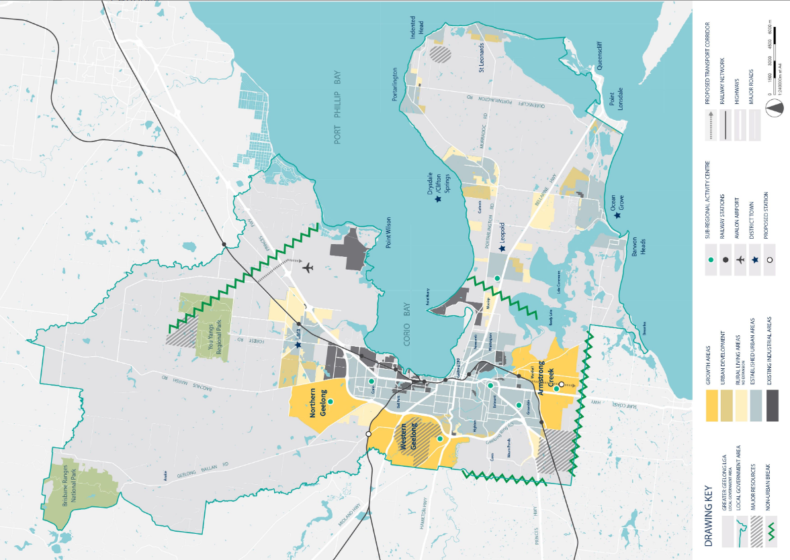

02.04-2 – Retail Activity Centre Hierarchy
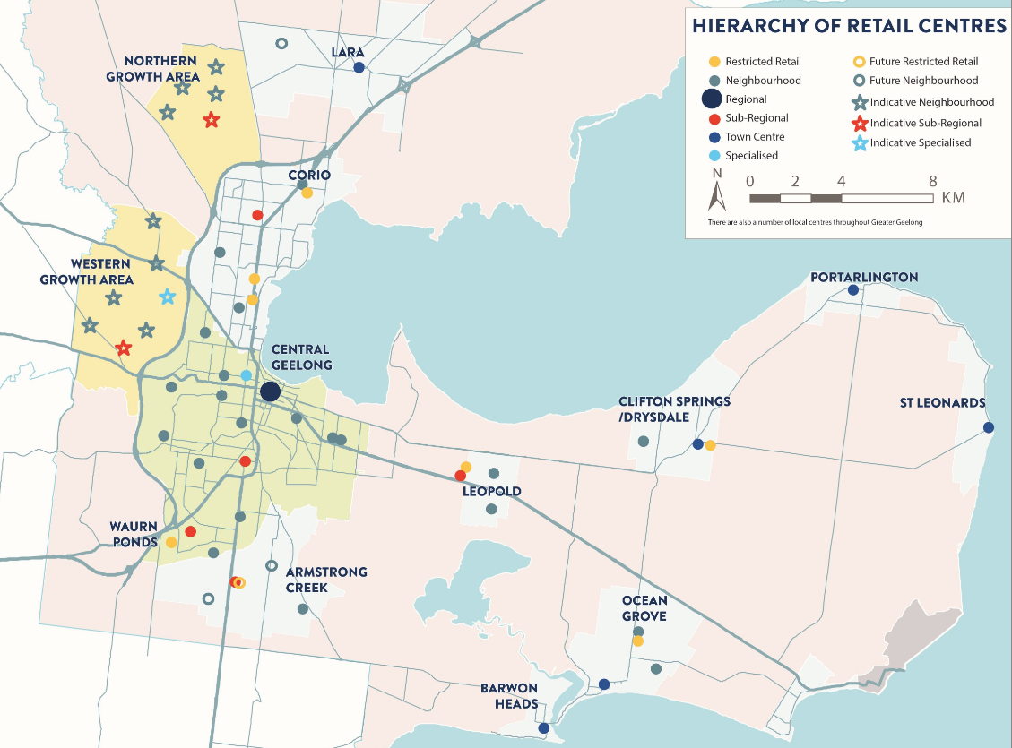

02.04-3 – Housing and Settlement Framework Plan
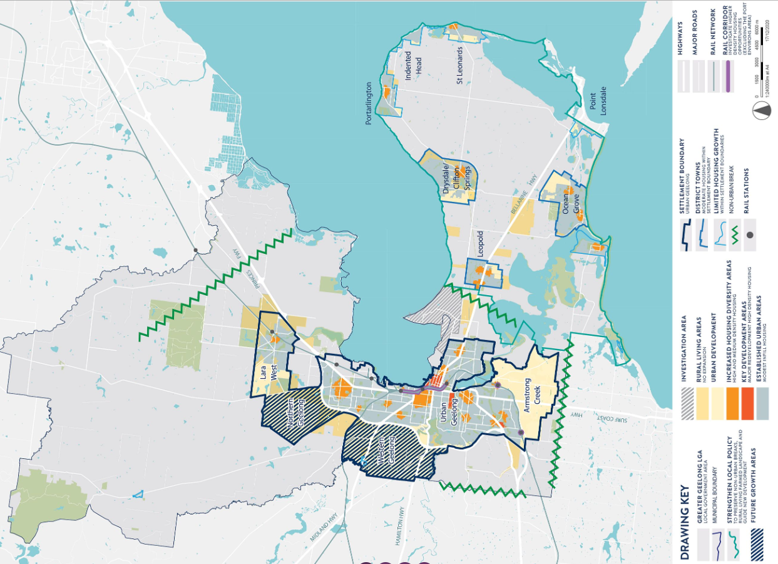

THE PLANNING POLICY FRAMEWORK (PPF):
The following Victorian Planning Policies are applicable to this application:

11.00 – Settlement
11.01-1S - Settlement
Sets objectives and strategies to facilitate the sustainable growth and development of Victoria and deliver choice and opportunity for all Victorians through a network of settlements.

11.01-1R – Settlement – Geelong G21
Sets strategies to:
  - reinforce the role of district towns in providing services to surrounding areas,
  - provide for settlement breaks between towns to maintain their unique identities.

11.02-1S – Supply of Urban Land
Objective:
- to ensure a sufficient supply of land is available for residential, commercial. Retail, industrial, recreational, institutional and other community uses.

Relevant Strategies:
- Ensure the ongoing provision of land and supporting infrastructure to support sustainable urban development.
- Plan to accommodate projected population growth over at least a 15 year period and provide clear direction on locations where growth should occur. Residential land supply will be considered on a municipal basis, rather than a town-by-town basis.

- Planning for urban growth should consider:
  - Opportunities for the consolidation, redevelopment and intensification of existing urban areas.
  - Neighbourhood character and landscape considerations.
  - The limits of land capability and natural hazards and environmental quality.
  - Service limitations and the costs of providing infrastructure.

11.01-1L – Geelong Settlement
Relevant Strategies:
- Maintain the non-urban breaks between Geelong and Melbourne (Wyndham), Geelong and the Surf Coast, urban Geelong and the Bellarine Peninsula, and the townships on the Bellarine Peninsula.
- Direct the majority of future housing needs to urban Geelong (urban infill, Armstrong Creek and the Northern and Western Geelong Growth Areas).
- Ensure urban development occurs within designated settlement boundaries.
- Reduce the share of new housing development on the Bellarine Peninsula.

15 - Built Environment and Heritage
15.01- 1S – Urban Design
Relevant Strategies
  - Require development to respond to its context in terms of character, cultural identity, natural features, surrounding landscape and climate.
  - Ensure development contributes to community and cultural life by improving the quality of living and working environments, facilitating accessibility and providing for inclusiveness.
  - Ensure the interface between the private and public realm protects and enhances personal safety.
  - Ensure that the design and location of publicly accessible private spaces, including car parking areas, forecourts and walkways, is of a high standard, creates a safe environment for users and enables easy and efficient use.
  - Ensure that development provides landscaping that supports the amenity, attractiveness and safety of the public realm.
  - Ensure that development, including signs, minimises detrimental impacts on amenity, on the natural and built environment and on the safety and efficiency of roads.

15.01-2S – Building design
Strategies
- Ensure a comprehensive site analysis forms the starting point of the design process and provides the basis for the consideration of height, scale, massing and energy performance of new development.
- Ensure development responds and contributes to the strategic and cultural context of its location.
- Minimise the detrimental impact of development on neighbouring properties, the public realm and the natural environment.
- Improve the energy performance of buildings through siting and design measures that encourage:
  - Passive design responses that minimise the need for heating, cooling and lighting.
  - On-site renewable energy generation and storage technology.
  - Use of low embodied energy materials.
- Ensure the layout and design of development supports resource recovery, including separation, storage and collection of waste, mixed recycling, glass, organics and e-waste.
- Encourage use of recycled and reusable materials in building construction and undertake adaptive reuse of buildings, where practical.
- Encourage water efficiency and the use of rainwater, stormwater and recycled water.
- Minimise stormwater discharge through site layout and landscaping measures that support on-site infiltration and stormwater reuse.
- Ensure the form, scale, and appearance of development enhances the function and amenity of the public realm.
- Ensure buildings and their interface with the public realm support personal safety, perceptions of safety and property security.
- Ensure development is designed to protect and enhance valued landmarks, views and vistas.
- Ensure development considers and responds to transport movement networks and provides safe access and egress for pedestrians, cyclists and vehicles.
- Encourage development to retain existing vegetation.
- Ensure development provides landscaping that responds to its site context, enhances the built form, creates safe and attractive spaces and supports cooling and greening of urban areas.

15.01-2L – Environmentally Sustainable Development
Objective
- To achieve best practice in environmentally sustainable development from the design stage through to construction and operation.

General strategies
- Facilitate development that minimises environmental impacts.
- Encourage environmentally sustainable development that:
- Is consistent with the type and scale of the development.
- Responds to site opportunities and constraints.
- Adopts best practice through a combination of methods, processes and locally available technology that demonstrably minimise environmental impacts.

Energy performance strategies
- Reduce both energy use and energy peak demand through design measures such as:
  - Building orientation.
  - Shading to glazed surfaces.
  - Optimising glazing to exposed surfaces.
  - Inclusion of or space allocation for renewable technologies.

Integrated water management strategies
- Reduce total operating potable water use through appropriate design measures such as water efficient fixtures, appliances, equipment, irrigation and landscaping.
- Encourage the use of alternative water sources, including greywater, rainwater and stormwater.
- Incorporate water sensitive urban design to improve the quality of stormwater runoff and reduce impacts on water systems and water bodies.

Indoor environment quality
- Achieve a healthy indoor environment quality, including thermal comfort and access to fresh air and daylight, prioritising passive design over mechanical heating, ventilation, cooling and lighting.
- Reduce indoor air pollutants by encouraging use of materials containing chemicals that have low levels of toxicity.
- Minimise noise levels and noise transfer within and between buildings and associated external areas.

Transport strategies
- Design development to promote the use of walking, cycling and public transport, in that order; and to minimise car dependency.
- Promote the use of low emissions vehicle technologies and supporting infrastructure.

Waste management strategies
- Promote waste avoidance, reuse and recycling during the design, construction and operation stages of development.
- Encourage use of durable and reusable building materials.
- Ensure sufficient space is allocated for future change in waste management needs, including (where possible) composting and green waste facilities.

Urban ecology strategies
- Protect and enhance biodiversity by incorporating natural habitats and planting indigenous vegetation.
- Reduce urban heat island effects through building design, landscape design, water sensitive urban design and the retention and provision of canopy trees.
- Encourage the provision of space for productive gardens, particularly in larger residential developments.

15.01-5S – Neighbourhood character
Strategies
- Support development that respects the existing neighbourhood character or contributes to a preferred neighbourhood character.
- Ensure the preferred neighbourhood character is consistent with medium and higher density housing outcomes in areas identified for increased housing.
- Ensure development responds to its context and reinforces a sense of place and the valued features and characteristics of the local environment and place by respecting the:
  - Pattern of local urban structure and subdivision.
  - Underlying natural landscape character and significant vegetation.
  - Neighbourhood character values and built form that reflect community identity

15.01-5L – Neighbourhood Character
Relevant Strategies
- Design development on the periphery of the Residential Growth Zones to be responsive to and respectful of the neighbourhood character in any adjoining residential zones.
- Retain existing vegetation wherever possible, particularly vegetation that contributes to the municipality’s tree canopy.

16 – Housing

16.01-1S - Housing supply
Objective
- To facilitate well-located, integrated and diverse housing that meets community needs.

16.01-1L-02 – Increased Housing Diversity Areas.
Objectives
- To evolve the character of Increased Housing Diversity Areas (IHDA) through more intensive development.
- To support development that makes a positive architectural and urban design contribution to the IHDA.
- To maintain streetscape character in heritage areas.
- To promote pedestrian safety within the IHDA.

General Strategies
- Maximise opportunities for housing in IHDA by accommodating:
- High density housing in the activity centres consistent with their primary commercial and retail role.
- Medium density housing in residential areas with more intensive development being located closest to the core of activity centres.
- Encourage a diversity of housing types to cater to a variety of lifestyle needs.
- Encourage development to provide a high level of on-site amenity for future residents.

Built form strategies
- Encourage development that incorporates a combination of horizontal and vertical articulation, materials, textures and colours to create visual interest.
- Encourage a sympathetic design response when addressing any unique characteristics such as heritage places, significant vegetation, topography and public spaces.
- Discourage storage areas located within the minimum area of secluded open space.
- Support development that does not reduce opportunities for neighbouring sites to reasonably develop.

Building height strategies
- Design development to recess upper levels to reduce dominance of the building from adjoining properties and the streetscape.
- Design development on interface properties, between an IHDA and other residential areas, so that the height and bulk is responsive to the adjoining character and provides a transition in the built form between areas.

Building height policy guidelines
- Consider as relevant:
- Encouraging development of up to three stories. Three storey development should be located on larger sites abutting the activity centre or where the amenity of adjoining properties will not be unreasonably impacted.
- Encouraging the recessing of third storeys to reduce dominance of the building from adjoining properties and the streetscape.

Subdivision and consolidation strategies
- Encourage the consolidation of lots to increase development potential.
- Discourage the fragmentation of sites and underdevelopment of sites.

Car parking strategies
- Locate car parking structures behind the line of the front façade and design them to form a visually unobtrusive part of the building to minimise their visual prominence.
- Minimise the number of vehicle crossings and where possible, provide access from lower order roads and rear laneways.

Car parking policy guideline
- Consider as relevant:
- Where more than one car space is provided, encouraging the use of a single-width garage or carport and a tandem parking space on existing or proposed lots with a frontage of less than 10.5 metres.

Heritage strategies
  - Design development adjacent to heritage places to respect and be sympathetic to the significance of the place.
  - On sites adjacent to a heritage place, set back building elements above one storey in height behind the roof ridgeline of the heritage buildings.

Response to Policy

A range of policy matters within of the Scheme are relevant to the consideration of urban development and housing. Settlement objectives seek to promote sustainable growth and development, with strategies seeking long term growth options that building on existing infrastructure.

Clause 15.01-1S – Urban Design sets out strategies for safe, functional and good quality urban environments facilitating accessibility and providing for inclusiveness. While also seeking to ensure development responds to its context in terms of character, cultural identify, natural features, surrounding landscape and climate.

Clause 15.01-2S – Building design, sets objectives to achieve design outcomes that contribute positively to the local context and enhance the public realm.

The proximity of the site to the neighbouring Highton Village neighbourhood centre and main roads in the form of Barrabool Road and Roslyn Road, ensures that the proposed development would be well located for multipurpose trips and encouraging sustainable transport modes including active and public transport. The subject site is located in close proximity to a range of services and facilities, including shops, recreational open spaces and schools. The development of multi-dwellings would therefore be encouraged under relevant objectives and strategies, including Clause 15.01-4S – Healthy Neighbourhoods, which seeks to promote neighbourhoods that foster healthy and active living and community wellbeing, partly through the promoted walking and cycling as part of daily life.

Clause 16 of the Scheme states that planning should provide for housing diversity which includes access to services, walkability to activity centres, public transport, open spaces and schools. The development is located a walkable distance to all such services. The proposal provides a range of housing types, as mentioned above, which ensures that housing stock is changing to accord with the market needs and allowing for a larger choice in housing as encouraged by Clause 16.01-2S.

Clause 02.03 of the Scheme details the Council’s strategic direction for growth with regard to settlement and housing. This clause identifies key drivers to include population growth, a rapidly aging population and increased demand for smaller and low maintenance dwellings in close proximity to urban services. Clause 02.03-6 Housing sets out that to accommodate the growing population, Council has identified Increased Housing Diversity Areas (IHDA). IHDAs are located around activity centres and transport hubs and have significant capacity to accommodate residential growth and increased housing diversity. Within areas of heritage significance, new development should balance the preservation and restoration of the heritage place and other opportunities for housing.

In order to address these issues, adopted strategies include the consolidation of existing urban areas in a managed way to encourage an appropriate range of development densities with improved access to urban services. The strategies in place to manage urban consolidation in a managed way and promote appropriate development densities include:
- Maximise opportunities for housing within Increase Housing Diversity Areas (as defined in Clause 16.01-1L-02 Increased Housing Diversity Areas) by accommodating:
  - High density housing in the activity centres consistent with their primary commercial and retail role;
  - Medium density housing in residential areas with more intensive development being located closest to the core of activity centres.
In view of the above, Clause 16.01-1L-02 Increased Housing Diversity Areas is relevant to the consideration of this application. In this policy, land within the Highton Village IHDA is identified in the following map:
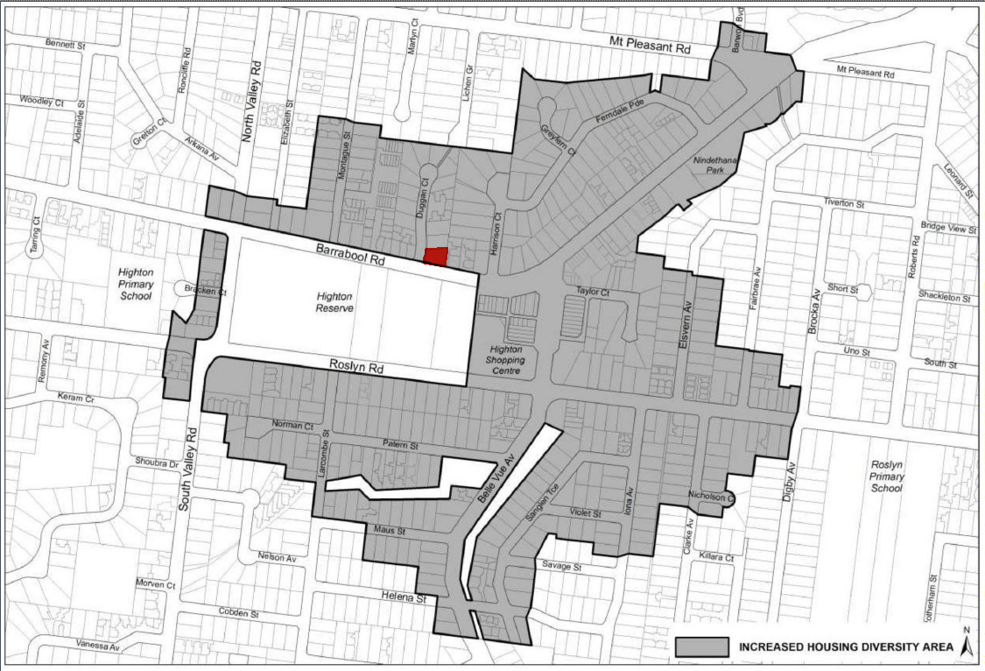

The IHDA policy specifies objectives to:
- Evolve the character of IHDAs through more intensive development.
- To support development that makes a positive architectural and urban design contribution to the IHDA.
- To maintain streetscape character in heritage areas.
- To promote pedestrian safety within the IHDA.

In view of the above, and combined with its proximity to the neighbourhood centre, the subject site is well located for access to the services and facilities provided by the Highton Village neighbourhood centre. The provision of 9 dwellings on this site will contribute to the number and diversity of houses in a location that is specifically targeted for this outcome under planning policy and encouraged by the purpose of the zone.

In achieving the specified objectives, a combination of General, Built Form and Building Height Strategies, Car parking and Heritage Strategies are set out. These strategies include to:
- Maximise opportunities for housing in IHDA by accommodating:
  - High density housing in activity centres,
  - Medium density housing in residential areas – with more intensive development located closest to the core of activity centres.
- Encourage a diversity of housing types to cater to a variety of lifestyle needs.
- Encourage development to provide a high level of on-site amenity for future residents.
- Encourage a sympathetic design response when addressing any unique characteristics such as heritage places.
- Discourage storage areas within the minimum area of secluded private open space.
- Support development that does not reduce opportunities or neighbouring sites to reasonably develop.
- Design development to recess upper levels to reduce dominance of the building form adjoining properties and the streetscape.
- Minimise visual prominence of car parking areas.
- Minimise the number of vehicle crossings and provide access from lower order roads where possible.
- Design development adjacent heritage places to respect and be sympathetic to the significance of the place.
- Set back building elements above one storey to be behind the ridgeline of heritage buildings.

Consideration of the proposed development against these objectives is outlined below:

Built Form and Building Height:
The proximity of the subject site to the Highton Village neighbourhood centre supports a higher density of development within the street than what has generally occurred to date. The proposed development would evolve the character of the area through more intensive development as strategized within local policy for IHDAs. The provision of nine apartments in this location would promote a diversity of housing types catering to a variety of lifestyle needs.

However, it is also necessary to consider whether the proposal exhibits a density, mass and scale appropriate to the location, role and character of the IHDA. As well as whether the development makes a positive architectural and urban design contribution to the IHDA.

The proposal is considered to appropriately respond to the design objectives contained within Clause 16.01-1L-02. The design objectives seek to encourage up to three storey development, with recessed third storeys in order to reduce the dominance of the building to the adjoining properties and streetscape.

The proposed development would present to Barrabool Road as a three-storey building, which utilises a recessed third storey. As a result, it would go some way to reducing the dominance of the upper level building form when viewed from the street. The design response incorporates both horizontal and vertical articulation through the use of balconies and external material treatments and fenestration arrangements.

In addition to the above, as outlined in the response to the zone, there are no unique characteristics such as heritage places or significant vegetation applicable to the site. Whilst the site is sloped and faces public open space to the south, it is considered that the proposed development suitably responds to this context. The proposal would be built into the site to mitigate its visual bulk and scale at the rear (north) of the site and would incorporate substantial areas of glazing and open balconies facing the public open space to the south, which would assist in both its visual presentation and improving passive surveillance to public spaces.

It is considered that the built form proposed would provide an appropriate building form and height, which contributes to a preferred character of both two and three storey residential development in this location in order to evolve the character of the locality away from traditional residential building forms. Furthermore, given the application accords with the objectives of ResCode, maximum building height and mandatory garden area requirement in the zone, the proposal is considered to represent a form of development anticipated in this locality, and provides an appropriate site responsive medium density housing development in this area identified for increased housing diversity.

In view of the above, it is considered that the proposal would adequately accord with the design objectives contained within clause 16.01-1L-02, particularly in regard to building height and scale.

Car Parking:
Car parking design objectives within Clause 16.01-1l-02 seek to ensure that the visual prominence of car parking structures is minimised, by designing them to form a visually unobtrusive part of the building. Additional objectives seek to minimise the number of vehicle crossings, and where possible provide access from lower order roads.

The proposed development seeks to provide access from a Transport Zone 2. It is noted that this does not provide access of the lower order road, being Duggan Court, however this is due to existing constraints in the form of an existing power pole, street trees and gradients limiting the ability to access the site from Duggan Court.

The application proposes a built form which will suitability minimise the visual prominence of car parking areas by incorporating all car parking at basement level. The proposed access from Barrabool Road has been referred to the Head, Transport for Victoria and no objection has been raised.

Environmentally Sustainable Design

In addition to the discussion outlined above, the Planning Policy Framework encourages development that is energy and resource efficient at Clause 15.02-1S. Local planning policy at Clause 15.01-2L of the Scheme encourages environmentally sustainable design to be considered as part of the planning process.

It is noted that this application has suitably demonstrated that, subject to conditions, the proposed development is able to achieve best practice in Environmentally Sustainable Design (ESD) in accordance with the objectives of Clause 15.01-2L.
As identified in the ESD Officer referral response, conditions are recommended to provide clarification of ESD treatments on proposed plans as well as additional detail / clarification of some matters within the submitted Sustainable Design Assessment.

RELEVANT PARTICULAR PROVISIONS:

The following Particular Provisions are applicable to this application:

Clause 52.06 – Car Parking
The purpose of the Car Parking particular provision is:
- To ensure that car parking is provided in accordance with the State Planning Policy Framework and the Local Planning Policy Framework.
- To ensure the provision of an appropriate number of car parking spaces having regard to the demand likely to be generated, the activities on the land and the nature of the locality.
- To support sustainable transport alternatives to the motor car.
- To promotes the efficient use of car parking spaces through the consolidation of car parking facilities.
- To ensure that car parking does not adversely affect the amenity off the locality.
- To ensure that the design and location of car parking is of a high standard, creates a safe environment for users and enables easy and efficient use.

Response
Table 1 to Clause 52.06-5 sets out the car parking requirement that applies to specified land uses.
The breakdown of required car parking provision for the dwellings is as follows:
- One (1) off-street carparking spaces required to each two or less bedroom dwelling (with studies or studios that are separate rooms counted as bedrooms), plus
- Two (2) off-street carparking spaces required to each three or more bedroom dwelling (with studies or studios that are separate rooms counted as bedrooms), plus
- One (1) off-street visitor carparking space to every five (5) dwellings for developments of five (5) of more dwellings.
The application proposes the construction of seven (7) two-bedroom dwellings and two (2) three-bedroom dwellings.
Therefore, the required car parking provision as prescribed within Table 1 of Clause 52.06-5, is:
- Eleven (11) private off-street carparking spaces with one (1) to each of the proposed single bedroom dwellings and two (2) to each of the proposed three bedroom dwellings;
- One (1) visitor car parking space as the proposed development is for nine dwellings.
A total of eleven (11) car spaces are provided as follows:
Basement | 11 residential parking spaces
Visitor Space | Nil

Reduction in Car Parking
In light of the above, the application seeks a reduction of the minimum on-site visitor car parking provision.

The application is supported by a Transport Impact Assessment prepared by One Mile Gride, dated 12th September 2022.

The Transport Impact assessment includes a car parking demand assessment which considers the demand likely to be generated by the proposed development and the likely generation of and any impacts associated with overflow car parking onto the street network.

The car parking demand assessment outlines that the proposal will meet the requirement of resident parking, while seeking to waive the requirement for one (1) visitor space. The car parking demand assessment therefore adopts the demand for one visitor space as the parking shortfall associated with the proposed development. However, given that the proposed widening of the vehicle crossover to Barrabool Road would result in the loss of an existing on-street parking space as well, the car parking demand assessment has considered the ability to accommodate 2 spaces on street.

The submitted car parking demand assessment has assessed the parking occupancy across typical weekdays and weekends within the surrounding area. The submitted information details that a supply of 85 spaces exists on-street within the surrounding area. Peak occupancy within the survey area occurred on a Friday, with 45 spaces occupied. This equates to 53% of the available spaces.

When considering the on street parking demand associated with 1 visitor space and the loss of 1 existing on-street parking space, the maximum occupancy would be 55% of available on-street parking spaces.

It is noted that the parking survey information was carried out within December 2019 in order to conservatively consider car parking demand. It is noted that this occurred prior to the Covid-19 Pandemic. Council’s Traffic Engineers have accepted this approach to consideration of car parking demand and have raised no objection to the grant of a permit in relation to the proposed waiver of 1 visitor parking space associated within the proposed development.

In view of the above, it is considered that the proposed development would have a negligible impact on the future on-street parking supply, particularly given the proposed reduction of visitor parking spaces.

Clause 52.06-8 – Requirement for a Car Parking Plan
Plans must be prepared to the satisfaction of the responsible authority prior to the floor area or site area of an existing use being increased. The submitted car parking plan is assessed below:

Clause 52.06-9 Car Parking Design Standards
- Design Standard 1 – Accessways must:
Requirement | Comment
Be at least 3m wide | Complies
Have an internal radius of at least 4 metres at changes of direction or intersection or be at least 4.2 metres wide | Complies
Allow vehicles parked in the last space of a dead-end accessway in public car parks to exit in a forward direction with one manoeuvre | n/a private car park
Provide at least 2.1 metres headroom beneath overhead obstructions, calculated for a vehicle with a wheelbase of 2.8 metres | Complies – minimum clearance of 2.1m provided.
If the accessway serves four or more car spaces or connects to a road in a Road Zone, the accessway must be designed so that cars can exit the site in a forward direction. | Complies – swept paths have been submitted which show that vehicles can enter and exit the car park in a forward direction.
Provide a passing area at the entrance at least 6.1 metres wide and 7 metres long if the accessway serves ten or more car parking spaces and is either more than 50 metres long or connects to a road in a Road Zone. | Does not comply – deemed satisfactory.  A passing area is provided at the entrance of the site. This passing area measures 6.1m in width for a length of 4 metres, and tapers down to a width of 4.8 metres 7 metres from the street frontage. A swept path diagram has been provided demonstrating that a B99 vehicle and B85 vehicle can pass within this area. Council’s traffic engineers have not objected to the passing area dimensions provided.
Have a corner splay or area at least 50 per cent clear of visual obstructions extending at least 2 metres along the frontage road from the edge of an exit lane and 2.5 metres along the exit lane from the frontage, to provide a clear view of pedestrians on the footpath of the frontage road. The area clear of visual obstructions may include an adjacent entry or exit lane where more than one lane is provided, or adjacent landscaped areas, provided the landscaping in those areas is less than 900mm in height. | Does not comply – deemed satisfactory.  No objection has been raised by Council’s Traffic Engineers  Barrabool Road:  To the western side of the Barrabool Road entrance, the visibility splay would be obstructed by the pedestrian stairway to the front of the building. Within the splay area, the maximum height of the stairway wall would be 0.76metres.  To the eastern side, an existing 1900mm high boundary fence would encroach the visibility splay area.  Given the double-width of the accessway and the maximum height of the stairway to the west being less than the maximum height of permitted landscaping, it is considered that adequate pedestrian visibility would be retained. Subject to conditions requiring the existing boundary fence with number 62 Barrabool road to be reduced in height, it is considered sufficient visibility would be maintained.

- Design Standard 2 – Car Parking Spaces: Complies:
Angled parking spaces are proposed with a minimum width of 2.8 metres, length of 4.9 metres and are accessed from aisles of no less than 5.8 metres. Spaces adjacent to walls have been suitably widened in accordance with Design Standard 2 of the Planning Scheme.

One parallel space is provided in the basement and is provided at 2.3 metres wide and 6.7 metres long and is accessed from an aisle of 5.8 metres, which is in accordance with Design Standard 2 of the Planning Scheme.

- Design Standard 3 – Gradients: Complies to satisfaction of RA. The ramp gradient is 1:9.1 within 5 metres of the frontage along the eastern side of the accessway. Along the western side the gradient is 1:13.7. Outside of 5 metres from the street frontage, the proposed accessway would not exceed 1:4. Whilst the access ramp would exceed 1:10 within 5 metres of the street frontage, it is noted that it would only exceed 1:10 by 0.9%. Council’s traffic engineers have raised no concern with this gradient.
- Design Standard 4 – Mechanical Parking: N/A – Mechanical parking is not required.
- Design Standard 5 – Urban Design: Complies – The proposal does not include ground level car parking. The visible portion of the basement car park would be suitably screened by landscaping within the front and side setbacks.
- Design Standard 6 – Safety: Complies – Parking areas/accessways are clearly visible and would be secured from the public. Conditions are recommended requiring the car parking area to be suitably lit.
- Design Standard 7 – Landscaping: Complies subject to conditions – Conditions are recommended requiring the submission of a detailed landscaping plan on any permit granted.

Clause 52.06-10 Decision Guidelines
In response to the decision guidelines contained at clause 52.06-10, it is considered that the proposed car parking layout would not result in an unreasonable impact on the role and function of nearby roads, nor the ease and function, nor safety with which vehicles would access and circulate the parking area. It is noted that the non-compliance relates to accessway gradients and in this regard the council’s traffic engineers have advised they have no objection to the car parking layout or access arrangements.

Clause 52.29 – Land Adjacent to the Principal Road Network
The purpose of the Land Adjacent to a Principal Road Network particular provision is:
- To ensure appropriate access to identified roads.
- To ensure appropriate subdivision of land adjacent to identified roads.

As the applications proposed to create/alter access to Barrabool Road, a planning permit is required pursuant to Clause 52.29-2.
Before deciding on an application, in addition to the decision guidelines in Clause 65, the responsible authority must consider:

- The Municipal Planning Strategy and the Planning Policy Framework;
- The view of the relevant Road Authority.
- The effect of the proposal on the operation of the road and on public safety.
- Any policy made by the relevant road authority pursuant to Schedule 2, Clause 3 of the Road Management Act 2004 regarding access between a controlled access road and adjacent land.

Response
The proposed alteration to access to/from Barrabool Road is considered to provide appropriate access to the site from a main road while adequately maintaining the operation of the road and public safety.

It is noted that the Head, Transport for Victoria has raised no objection to the alterations to the access from Barrabool Road. Transport for Victoria is a determining referral authority in this regard.

In view of the above and given that no objection has been raised by the Head, Transport for Victoria, it is considered the proposed alterations to access from the adjacent Transport Zone 2 will suitably mitigate any negative effect on the operation of the road and on public safety.

Clause 52.34 – Bicycle Facilities
The purpose of the Bicycle Facilities particular provision is:
- To encourage cycling as a mode of transport.
- To provide secure, accessible and convenient bicycle parking spaces and associated shower and change facilities.

Response
Clause 52.34-5 requires the provision of bicycle parking spaces for a Dwelling as follows:
Resident | Visitor
In developments of four or more storeys, 1 to each 5 dwellings. | In developments of four or more storeys, 1 to each 10 dwellings.

The proposed development would be three (3) storeys and includes nine (9) dwellings.
There is no requirement under Clause 52.34-5 to provide bicycle parking.
The application proposes that four (4) resident bicycle parks are provided at basement level. Two (2) visitor bicycle parks are proposed to be provided on site within the front setback.
As such, the proposed development would exceed the required on site bicycle parking in accordance with clause 52.34-5.

CLAUSE 55 - RESCODE ASSESSMENT – TWO OR MORE DWELLINGS ON A LOT
The application has been assessed against the objectives and standards of Clause 55, including Clause 55.07 of the Planning Scheme. The development is considered to satisfy all of these requirements. The application seeks a variation to the following standards which is considered acceptable as outlined within the Clause 55 assessment.
- 55.03-1 – Street Setback objective – Standard B6
- 55.05-5 – Solar Access to Open Space objective – Standard B29
- 55.07-14 – Windows Objective – Standard B48
- 55.074-16 – Building Entry and Circulation Objectives – Standard B50

An assessment of the application against Clause 55, including Clause 55.07 is included at Appendix 1 of this report.

DECISION GUIDELINES OF CLAUSE 65:
CLAUSE 65.01 – APPROVAL OF AN APPLICATION OR PLAN
Clause 65.01 of the Greater Geelong Planning Scheme outlines the decision guidelines to be considered by the Responsible Authority when making decisions on applications. These decision guidelines include:
- The matters set out in Section 60 of the Act.
- The Municipal Planning Strategy and the Planning Policy Framework.
- The purpose of the zone, overlay or other provision.
- Any matter required to be considered in the zone, overlay or other provision.
- The orderly planning of the area.
- The effect on the amenity of the area.
- The proximity of the land to any public land.
- Factors likely to cause or contribute to land degradation, salinity or reduce water quality.
- Whether the proposed development is designed to maintain or improve the quality of stormwater within and exiting the site.
- The extent and character of native vegetation and the likelihood of its destruction.
- Whether native vegetation is to be or can be protected, planted or allowed to regenerate.
- The degree of flood, erosion or fire hazard associated with the location of the land and the use, development or management of the land so as to minimise any such hazard.
- The adequacy of loading and unloading facilities and any associated amenity, traffic flow and road safety impacts.

Response
The application has been considered against the MPS and the PPF, the General Residential Zone, Special Building Overlay and relevant particular provisions as outlined within this report. The application would provide increased housing diversity in an area anticipated to see infill medium density residential development, and it is considered to result in an acceptable neighbourhood character response which contributes to the preferred character of the surrounding area, which seeks to evolve the character of this locality through more intensive development.
The application has been assessed against the objectives contained within Clause 55 and is considered to represent an appropriate design response to the relevant objectives within Clause 55, including clause 55.07.

CONCLUSION:
In view of the above assessment it is recommended that the Responsible Authority having considered all matters which the Planning and Environment Act 1987, that it is required hereby respectfully request that the Planning Committee determine to issue a Notice of Decision to Grant a Planning Permit - subject to the conditions included.
APPENDIX 1 - CLAUSE 55 - RESCODE ASSESSMENT – TWO OR MORE DWELLINGS ON A LOT

Date of Assessment: February 2023
Plans Assessed: S57a Amendment Plans – Received: 13th September 2022
Permit Application Number PP-508-2021

The following objectives apply to an application to:
- Construct a dwelling if there is at least one dwelling existing on the lot,
- Construct two or more dwellings on a lot,
- Extend a dwelling if there are two or more dwellings on the lot,
- Construct or extend a dwelling on common property, or
- Construct or extend a residential building,

The development is required to be assessed against Clause 55 as set out below:
55.02-1 Neighbourhood character objectives  To ensure that the design respects the existing neighbourhood character or contributes to a preferred neighbourhood character.  To ensure that the design responds to the features of the site and the surrounding area. | Standard B1  The design response must be appropriate to the neighbourhood and the site.  The proposed design must respect the existing or preferred neighbourhood character and respond to the features of the site. | Yes – Complies with Standard B1  The proposal is considered to adequately respond to the preferred character of the area.  The development of residential building up to three-storeys is encouraged under the zone, and it is considered that the built form proposed offers an appropriate scale of development within this location in close proximity to the Highton Village Neighbourhood Centre. The height, siting and design of the proposed apartment building is site responsive in that it limits its height to three storeys with recessed third-floor level. The proposal incorporates external facing materials which are reflected within the surrounding area and provides adequate side and rear setbacks to maintain spacing between the proposed building and neighbouring dwellings.
55.02-2 Residential policy objectives  To ensure that residential development is provided in accordance with any policy for housing in the State Planning Policy Framework and the Local Planning Policy Framework, including the Municipal Strategic Statement and local planning policies.  To support medium densities in areas where development can take advantage of public transport and community infrastructure and services. | Standard B2  An application must be accompanied by a written statement to the satisfaction of the responsible authority that describes how the development is consistent with any relevant policy for housing in the State Planning Policy Framework and the Local Planning Policy Framework, including the Municipal Strategic Statement and local planning policies. | Yes – Complies with Standard B2  As set out in the delegate report, the application complies with the planning policy framework. The required written statement has been provided.
55.02-3 Dwelling diversity objective  To encourage a range of dwelling sizes and types in developments of ten or more dwellings. | Standard B3  Developments of ten or more dwellings should provide a range of dwelling sizes and types, including:  - Dwellings with a different number of bedrooms.  - At least one dwelling that contains a kitchen, bath or shower, and a toilet and wash basin at ground floor level. | N/A  Less than ten dwellings are proposed.
55.02-4 Infrastructure objectives  To ensure development is provided with appropriate utility services and infrastructure.  To ensure development does not unreasonably overload the capacity of utility services and infrastructure. | Standard B4  Development should be connected to reticulated services, including reticulated sewerage, drainage, electricity and gas, if available.  Development should not unreasonably exceed the capacity of utility services and infrastructure, including reticulated services and roads.  In areas where utility services or infrastructure have little or no spare capacity, developments should provide for the upgrading of or mitigation of the impact on services or infrastructure. | Yes – Complies with Standard B4  The site is serviced by the required infrastructure and the application has been referred to Council’s Engineers who have not raised any concern about the ability of the site to be drained. Conditions of permit cover off on this issue.
55.02-5 Integration with the street objectives  To integrate the layout of development with the street. | Standard B5  Developments should provide adequate vehicle and pedestrian links that maintain or enhance local accessibility.  Development should be oriented to front existing and proposed streets.  High fencing in front of dwellings should be avoided if practicable.  Development next to existing public open space should be laid out to complement the open space. | Yes – Complies with Standard B5  The development is designed to address Barrabool Road, with pedestrian and vehicle links to the street provided.  There is no high front fencing proposed for this development.
55.03-1 Street setback objective  To ensure that the setbacks of buildings from a street respect the existing or preferred neighbourhood character and make efficient use of the site. | Standard B6  Walls of buildings should be set back from streets the distance specified in Table B1.  Porches, pergolas and verandahs that are less than 3.6 metres high and eaves may encroach not more than 2.5 metres into the setbacks of this standard.  Schedule 4 to the General Residential Zone varies the requirements of Standard B6 as follows:  If the site is in a heritage overlay, the average distance of the setbacks of the front walls of the existing buildings on the abutting allotments facing the front street or 9 metres, whichever is the lesser.  In all other areas, the average distance of the setbacks of the front walls of the existing buildings on the abutting allotments facing the front street or 4 metres, whichever is the lesser. | Yes – Complies with Variation to Standard B6  The adjoining property fronting Barrabool Road is setback 6.1 metres, and the adjoining property fronting Duggan Court is set back 4.35 metres, which results in a requirement for a 4 metre street setback to Barrabool Road and a 3 metres side street setback to Duggan Court.  This has been achieved as the proposed building is setback 4.01 metres from Barrabool Road and the side street setback to Duggan Court would be 3 metres.  Notwithstanding the above, the proposed canopy porch at the building entrance is noted to exceed 3.6m in height. As such, given it encroaches the street setback standard of 4 metres, technically the standard is not met.  Variation required  The decision guidelines require consideration to be given to the following issues:  - The design response.  - Whether a different setback would be more appropriate taking into account the prevailing setbacks of existing buildings on nearby lots.  - The visual impact of the building when viewed from the street and from adjoining properties.  - The value of retaining vegetation within the front setback.  Comments:  The proposed design response would generally appear as complying with the street setback standard.  Given the variation to the standard purely relates to a porch incursion, it is considered that the alternative street setback is appropriate.  The design of the portico area is noted as being proportionate to the proposed building. Whilst it would be possible to reduce the height of the portico to bring the proposed development into compliance with standard B6, it is considered this would both reduce the sense of address to the proposed building, as well as create an entrance circulation space which appears disproportionate to the overall building composition.  It is noted that the height of the porch would have no bearing on the ability to retain vegetation within the front setback.  In view of the above, it is considered that the proposed variation to Standard B6 would remain in accordance with the objectives of Clause 55.03-1 to ensure that the setbacks of buildings from a street respect the existing or preferred neighbourhood character and make efficient use of the site.
55.03-2 Building height objectives  To ensure that the height of buildings respects the existing or preferred neighbourhood character. | Standard B7  The maximum building height should not exceed the maximum height specified in the zone, schedule to the zone or an overlay that applies to the land.  If no maximum height is specified in the zone, schedule to the zone or an overlay, the maximum building height should not exceed 9 metres, unless the slope of the natural ground level at any cross section wider than 8 metres of the site of the building is 2.5 degrees or more, in which case the maximum building height should not exceed 10 metres.  Changes of building height between existing buildings and new buildings should be graduated. | Yes – Complies with Standard B7  As outlined in the delegate report, the proposed development would not exceed the maximum building height specified in the zone.
55.03-3 Site coverage objective  To encourage development that respects the landscape character of the neighbourhood.  To encourage the retention of significant trees on the site. | Standard B8  The site area covered by buildings should not exceed 60 per cent.  Schedule 4 to the GRZ varies standard B8 to allow for a maximum site coverage over 70%. | Yes – Complies with Standard B8  The site coverage of buildings is 61% of the site, which is less than the 70% allowed by the standard.
55.03-4 Permeability and stormwater management objectives  To reduce the impact of increased stormwater run-off on the drainage system.  To facilitate on-site stormwater infiltration.  To encourage stormwater management that maximises the retention and reuse of stormwater. | Standard B9  The site area covered by the pervious surfaces should be at least:  - The minimum area specified in a schedule to the zone, or  - If no minimum is specified in a schedule to the zone, 20 percent of the site.  The stormwater management system should be designed to:  - Meet the current best practice performance objectives for stormwater quality as contained in the Urban Stormwater - Best Practice Environmental Management Guidelines (Victorian Stormwater Committee, 1999).  - Contribute to cooling, improving local habitat and providing attractive and enjoyable spaces. | Yes – Complies with Standard B9  The site retains 21% permeable surfaces, assisting in on site stormwater filtration.  A STORM rating report has been incorporated into the submitted sustainable design assessment which demonstrates best practice performance objectives for stormwater quality as required by standard B9.
55.03-5 Energy efficiency objectives  To achieve and protect energy efficient dwellings and residential buildings.  To ensure the orientation and layout of development reduce fossil fuel energy use and make appropriate use of daylight and solar energy. | Standard B10  Buildings should be:  - Oriented to make appropriate use of solar energy.  - Sited and designed to ensure that the energy efficiency of existing dwellings on adjoining lots is not unreasonably reduced.  - Sited and designed to ensure that the performance of existing rooftop solar energy facilities on dwellings on adjoining lots in a General Residential Zone, Neighbourhood Residential Zone or Township Zone are not unreasonably reduced. The existing rooftop solar energy facility must exist at the date the application is lodged.  Living areas and private open space should be located on the north side of the development, if practicable.  Developments should be designed so that solar access to north-facing windows is maximised. | Refer Standard B35 – Clause 55.07-1
55.03-6 Open space objective  To integrate the layout of development with any public and communal open space provided in or adjacent to the development. | Standard B11  If any public or communal open space is provided on site, it should:  - Be substantially fronted by dwellings, where appropriate.  - Provide outlook for as many dwellings as practicable.  - Be designed to protect any natural features on the site.  - Be accessible and useable. | Refer Standard B36 - Clause 55.07- 2
55.03-7 Safety objective  To ensure the layout of development provides for the safety and security of residents and property. | Standard B12  Entrances to dwellings and residential buildings should not be obscured or isolated from the street and internal accessways.  Planting which creates unsafe spaces along streets and accessways should be avoided.  Developments should be designed to provide good lighting, visibility and surveillance of car parks and internal accessways.  Private spaces within developments should be protected from inappropriate use as public thoroughfares. | Yes – Complies with Standard B12  The development is designed to provide for the safety and security of residents and property. The dwellings clearly present to Barrabool Road as an apartment building. The entrance lobby is proposed centrally within the building, accessed via the entrance off Barrabool Road. This central access point would clearly read as the access to the dwellings.  This area is entirely surrounded by dwellings and is considered to be adequately designed to maintain safety, visibility and surveillance.
55.03-8 Landscaping objectives  To encourage development that respects the landscape character of the neighbourhood.  To encourage development that maintains and enhances habitat for plants and animals in locations of habitat importance.  To provide appropriate landscaping.  To encourage the retention of mature vegetation on the site. | Standard B13  The landscape layout and design should:  - Protect any predominant landscape features of the neighbourhood.  - Take into account the soil type and drainage patterns of the site.  - Allow for intended vegetation growth and structural protection of buildings.  - In locations of habitat importance, maintain existing habitat and provide for new habitat for plants and animals.  - Provide a safe, attractive and functional environment for residents.  Development should provide for the retention or planting of trees, where these are part of the character of the neighbourhood.  Development should provide for the replacement of any significant trees that have been removed in the 12 months prior to the application being made.  The landscape design should specify landscape themes, vegetation (location and species), paving and lighting. | Refer– Clause 55.07-4
55.03-9 Access objective  To ensure the number and design of vehicle crossovers respects the neighbourhood character. | Standard B14  The width of accessways or car spaces should not exceed:  - 33 per cent of the street frontage, or  - if the width of the street frontage is less than 20 metres, 40 per cent of the street frontage.  No more than one single-width crossover should be provided for each dwelling fronting a street.  The location of crossovers should maximise the retention of on-street car parking spaces.  The number of access points to a road in a Road Zone should be minimised.  Developments must provide for access for service, emergency and delivery vehicles. | Yes – Complies with Standard B14  A total of 21% of the Barrabool Road frontage is taken up with vehicle accessways, which complies with the standard.
55.03-10 Parking location objective  To provide convenient parking for resident and visitor vehicles.  To protect residents from vehicular noise within developments. | Standard B15  Car parking facilities should:  - Be reasonably close and convenient to dwellings and residential buildings.  - Be secure.  - Be well ventilated if enclosed.  Large parking areas should be broken up with trees, buildings or different surface treatments.  Shared accessways or car parks of other dwellings and residential buildings should be located at least 1.5 metres from the windows of habitable rooms. This setback may be reduced to 1 metre where there is a fence at least 1.5 metres high or where window sills are at least 1.4 metres above the accessway. | Yes – Complies with Standard B15  Convenient parking is provided for residents and no accessways are located within 1.5 metres from the windows of habitable rooms.
55.04-1 Side and rear setbacks objective  To ensure that the height and setback of a building from a boundary respects the existing or preferred neighbourhood character and limits the impact on the amenity of existing dwellings. | Standard B17  A new building not on or within 200mm of a boundary should be set back from side or rear  boundaries:  - At least the distance specified in a schedule to the zone, or  - If no distance is specified in a schedule to the zone, 1 metre, plus 0.3 metres for every metre of height over 3.6 metres up to 6.9 metres, plus 1 metre for every metre of height over 6.9 metres.  Sunblinds, verandahs, porches, eaves, fascias, gutters, masonry chimneys, flues, pipes, domestic fuel or water tanks, and heating or cooling equipment or other services may encroach not more than 0.5 metres into the setbacks of this standard.  Landings having an area of not more than 2 square metres and less than 1 metre high, stairways, ramps, pergolas, shade sails and carports may encroach into the setbacks of this standard. | Yes – Complies with standard B17  Eastern Side Setback:  The application complies with the standard in regard to the eastern side setback. The slope of the land makes it difficult to determine compliance with the standard when viewing 2D elevations, particularly given the recessed upper floor levels.  The applicant has provided a 3D ResCode assessment diagram which details that the eastern side setback requirement would be encroached by the eaves at roof level and the verandah at third-floor level would encroach the eastern side set back by up to 490mm. This is an allowable encroachment which would comply with the standard.  Northern Rear Setback:  The northern rear setback would comfortably comply at the north-eastern side of the proposed building.  Given the orientation of the northern rear boundary, the proposed building would be sited closer to this rear boundary at its western side.  The required setbacks based on the heights of the proposed development are:  - First-Floor: 1.15m based on 4.1m balcony height  - Second-floor: 2.39m based on 7.3m balcony height  - Third-floor: 4.59m based on 9.5m roof height  The proposed first-floor, second-floor and third-floor levels would slightly encroach these setback requirements.  All of these encroachments would be less than 0.5m and in the form of balustrading and eaves. These would therefore be allowable encroachments under the Standard.
55.04-2 Walls on boundaries objective  To ensure that the location, length and height of a wall on a boundary respects the existing or preferred neighbourhood character and limits the impact on the amenity of existing dwellings. | Standard B18  A new wall constructed on or within 200mm of a side or rear boundary of a lot or a carport constructed on or within 1 metre of a side or rear boundary of lot should not abut the boundary:  - For a length of more than the distance specified in a schedule to the zone; or  - If no distance is specified in a schedule to the zone, for a length of more than:  - 10 metres plus 25 per cent of the remaining length of the boundary of an adjoining lot, or  - Where there are existing or simultaneously constructed walls or carports abutting the boundary on an abutting lot, the length of the existing or simultaneously constructed walls or carports,  whichever is the greater.  A new wall or carport may fully abut a side or rear boundary where slope and retaining walls or fences would result in the effective height of the wall or carport being less than 2 metres on the abutting property boundary.  A building on a boundary includes a building set back up to 200mm from a boundary.  The height of a new wall constructed on or within 200mm of a side or rear boundary or a carport constructed on or within 1 metre of a side or rear boundary should not exceed an average of 3.2 metres with no part higher than 3.6 metres unless abutting a higher existing or simultaneously constructed wall. | - N/A  There are no new walls proposed on property boundaries.
55.04-3 Daylight to windows objective  To allow adequate daylight into existing habitable room windows. | Standard B19  Buildings opposite an existing habitable room window should provide for a light court to the existing window that has a minimum area of 3 square metres and minimum dimension of 1 metre clear to the sky. The calculation of the area may include land on the abutting lot.  Walls or carports more than 3 metres in height opposite an existing habitable room window should be set back from the window at least 50 per cent of the height of the new wall if the wall is within a 55 degree arc from the centre of the existing window. The arc may be swung to within 35 degrees of the plane of the wall containing the existing window.  Where the existing window is above ground floor level, the wall height is measured from the floor level of the room containing the window. | Yes – Complies with Standard B19  The required light courts have been achieved and all windows have access to the required level of daylight.
55.04-4 North facing windows objective  To allow adequate solar access to existing north-facing habitable room windows. | Standard B20  If a north-facing habitable room window of an existing dwelling is within 3 metres of a boundary on an abutting lot, a building should be setback from the boundary 1 metre, plus 0.6 metres for every metre of height over 3.6 metres up to 6.9 metres, plus 1 metre for every metre of height over 6.9 metres, for a distance of 3 metres from the edge of each side of the window. A north-facing window is a window with an axis perpendicular to its surface oriented north 20 degrees west to north 30 degrees east. | - N/A  There are no north facing windows on abutting lots which require consideration.
55.04-5 Overshadowing open space objective  To ensure buildings do not significantly overshadow existing secluded private open space. | Standard B21  Where sunlight to the secluded private open space of an existing dwelling is reduced, at least 75 per cent, or 40 square metres with minimum dimension of 3 metres, whichever is the lesser area, of the secluded private open space should receive a minimum of five hours of sunlight between 9 am and 3 pm on 22 September.  If existing sunlight to the secluded private open space of an existing dwelling is less than the requirements of this standard, the amount of sunlight should not be further reduced. | Yes – Complies with Standard B21  The level of overshadowing associated with the development is within the requirements of the standard.
55.04-6 Overlooking objective  To limit views into existing secluded private open space and habitable room windows. | Standard B22  A habitable room window, balcony, terrace, deck or patio should be located and designed to avoid direct views into the secluded private open space of an existing dwelling within a horizontal distance of 9 metres (measured at ground level) of the window, balcony, terrace, deck or patio. Views should be measured within a 45 degree angle from the plane of the window or perimeter of the balcony, terrace, deck or patio, and from a height of 1.7 metres above floor level.  A habitable room window, balcony, terrace, deck or patio with a direct view into a habitable room window of existing dwelling within a horizontal distance of 9 metres (measured at ground level) of the window, balcony, terrace, deck or patio should be either:  - Offset a minimum of 1.5 metres from the edge of one window to the edge of the other.  - Have sill heights of at least 1.7 metres above floor level.  - Have fixed, obscure glazing in any part of the window below 1.7 metre above floor level.  - Have permanently fixed external screens to at least 1.7 metres above floor level and be no more than 25 per cent transparent.  Obscure glazing in any part of the window below 1.7 metres above floor level may be openable provided that there are no direct views as specified in this standard.  Screens used to obscure a view should be:  - Perforated panels or trellis with a maximum of 25 per cent openings or solid translucent panels.  - Permanent, fixed and durable.  - Designed and coloured to blend in with the development.  This standard does not apply to a new habitable room window, balcony, terrace, deck or patio which faces a property boundary where there is a visual barrier at least 1.8 metres high and the floor level of the habitable room, balcony, terrace, deck or patio is less than 0.8 metres above ground level at the boundary. | Yes – Complies with Standard B22 Subject to Conditions  The development appears to be designed to intend compliance with the requirements of the standard and therefore, subject to conditions, views into existing secluded private open space areas and habitable room windows would be suitably limited.  Overlooking to north  It is noted that the existing dwelling at number 15 Duggan Court is sited approximately 7.8m from the common boundary with the subject site, with a vehicle accessway sited to the southern side of number 15 Duggan Court.  As such, due to the rear setback of the proposed building at first and second floor level, proposed north-facing habitable room windows would be sited in excess of 9 metres from the existing dwelling at number 15. Nevertheless, screening is proposed where bedrooms windows would exhibit outlook to the north. The north-facing balconies serving dwellings APT2.02 and APT3.02 would not be within 9 metres of neighbouring dwellings SPOS or habitable room windows.  Overlooking to east  It is noted that the existing dwellings at 1/62 and 2/62 Barrabool Road to the east are sited approximately 5.3m from the common boundary with the subject site.  The proposed balcony serving APT 3.02 and the east facing living room and bedroom windows of APT 2.03 would be within 9 metres of the neighbouring dwellings to the east. The proposed floor plans do not show sufficient detail to confirm whether additional screening is required to prevent unreasonable overlooking to SPOS areas or west-facing habitable room windows of 1/62 or 2/62 Barrabool Road.  In view of the above, it is recommended that any permit is subject to conditions requiring the submission of amended plans showing additional screening to habitable room windows and the east facing balcony of APT 2.03, as well as the east facing balcony of APT 3.02 in order to comply with standard B22.  Subject to conditions the proposed development would suitably limit unreasonable overlooking to neighbouring dwellings habitable rooms and SPOS areas.
55.04-7 Internal views objective  To limit views into the secluded private open space and habitable room windows of dwellings and residential buildings within a development. | Standard B23  Windows and balconies should be designed to prevent overlooking of more than 50 per cent of the secluded private open space of a lower-level dwelling or residential building directly below and within the same development. | Yes – Complies with Standard B23  Internal views have been considered in the design solution and there is no internal overlooking.
55.04-8 Noise impacts objective  To contain noise sources in developments that may affect existing dwellings.  To protect residents from external noise. | Standard B24  Noise sources, such as mechanical plant, should not be located near bedrooms of immediately adjacent existing dwellings.  Noise sensitive rooms and secluded private open spaces of new dwellings and residential buildings should take account of noise sources on immediately adjacent properties.  Dwellings and residential buildings close to busy roads, railway lines or industry should be designed to limit noise levels in habitable rooms. | Refer - Clause 55.07-7
55.05-1 Accessibility objective  To encourage the consideration of the needs of people with limited mobility in the design of developments. | Standard B25  The dwelling entries of the ground floor of dwellings and residential buildings should be accessible or able to be easily made accessible to people with limited mobility. | Refer – Clause 55.07-8
55.05-2 Dwelling entry objective  To provide each dwelling or residential building with its own sense of identity. | Standard B26  Entries to dwellings and residential buildings should:  - Be visible and easily identifiable from streets and other public areas.  - Provide shelter, a sense of personal address and a transitional space around the entry. | Refer – Clause 55.07-16
55.05-3 Daylight to new windows objective  To allow adequate daylight into new habitable room windows. | Standard B27  A window in a habitable room should be located to face:  - An outdoor space clear to the sky or a light court with a minimum area of 3 square metres and minimum dimension of 1 metre clear to the sky, not including land on an abutting lot, or  - A verandah provided it is open for at least one third of its perimeter, or  - A carport provided it has two or more open sides and is open for at least one third of its perimeter. | Refer – Clause 55.07-14
55.05-4 Private open space objective  To provide adequate private open space for the reasonable recreation and service needs of residents. | Standard B28  A dwelling or residential building should have private open space of an area and dimensions specified in the schedule to the zone.  If no area or dimensions are specified in the schedule to the zone, a dwelling or residential building should have private open space consisting of:  - An area of 40 square metres, with one part of the private open space to consist of secluded private open space at the side or rear of the dwelling or residential building with a minimum area of 25 square metres, a minimum dimension of 3 metres and convenient access from a living room, or  - A balcony of 8 square metres with a minimum width of 1.6 metres and convenient access from a living room, or  - A roof-top area of 10 square metres with a minimum width of 2 metres and convenient access from a living room. | Refer – Clause 55.07-9
55.05-5 Solar Access to Open Space  To allow solar access into the secluded private open space of new dwellings and residential buildings. | Standard B29  The private open space should be located on the north side of the dwelling or residential building, if appropriate.  The southern boundary of secluded private open space should be set back from any wall on the north of the space at least (2+0.9h) metres, where ‘h’ is the height of the wall. | Yes – Complies, with variation to Standard B29  Variation required  Given the proposed dwellings would be apartments, served by balconies for secluded private open space areas, there are a number of SPOS areas which would not meet the southern boundary setback formula contained within the standard.  Decision Guidelines  Before deciding on an application, the responsible authority must consider:  - The design response.  - The useability and amenity of secluded private open space based on the sunlight it will received.  Comments:  The proposed design response seeks to provide balconies with more than 1 aspect to the majority of proposed dwellings.  Of the 9 proposed dwellings, 2 would exhibit balconies with single aspect to the south.  It is considered that the design response has sought to make efficient use of the site with the majority of dwellings being provided with SPOS balcony areas with access to northern light.  In addition to the above, it is noted that given the proposal is for an apartment development, it is unlikely all dwellings will be able to be provided with northern aspect to balconies in accordance with standard B29. The proposed balconies would all be situated with easy access from living rooms and would remain useable to an extent that is akin to that which would be expected in an apartment development. Similarly, the proposed balconies would be sufficiently open in accordance with standard B27.  In addition to the above, it is noted that the application site is situated opposite public open space. The presentation of balconies to face public open space is considered to contribute to the amenity of these dwellings and their SPOS where they have single aspect to the south.  In view of the above, it is considered that the proposed secluded private open space areas would, on balance, be provided with sufficient solar access.
55.05-6 Storage objective  To provide adequate storage facilities for each dwelling. | Standard B30  Each dwelling should have convenient access to at least 6 cubic metres of externally accessible, secure storage space. | Refer Standard B44 – Clause 55.07-10
55.06-1 Design Detail  To encourage design detail that respects the existing or preferred neighbourhood character. | Standard B31  The design of buildings, including:  - Façade articulation and detailing,  - Window and door proportions,  - Roof form, and  - Verandahs, eaves and parapets, should respect the existing or preferred neighbourhood character.  Garages and carports should be visually compatible with the development and the existing or preferred neighbourhood character. | Yes – Complies with Standard B31  The proposed design detail is considered to respect the preferred neighbourhood through the appropriate use and design of façade articulation & detailing, window and door proportions, roof form and verandahs, eaves and parapets.  It is noted that the GRZ4 does not set any design objectives and the purpose of the zone seeks to provide housing at increased densities and to encourage diversity of housing types close to town centres.  The surrounding GRZ4 generally exhibits residential dwellings with some examples of multi-dwelling developments. The design detail of surrounding residential development is generally varied.  The proposed design detail would incorporate a contemporary, flat roof form with expressed projecting balconies and roof levels.  The recessed third-storey would both respond to the purpose of the GRZ4 and IHDA Policy to encourage housing at increased densities while respecting the existing surrounding built form where there are limited examples three-storey development.  The proposed car parking is entirely underground, mostly obscured from view within the public realm and is considered to be visually compatible with the development and neighbourhood character.
55.06-2 Front Fences  To encourage front fence design that respects the existing or preferred neighbourhood character. | Standard B32  The design of front fences should complement the design of the dwelling or residential building and any front fences on adjoining properties.  A front fence within 3 metres of a street should not exceed:  - Streets in a Road Zone, Category 1: 2 metres.  - Other streets: 1.5 metres. | - N/A  No front fence is proposed.
55.06-3 Common Property  To ensure that communal open space, car parking, access areas and site facilities are practical, attractive and easily maintained.  To avoid future management difficulties in areas of common ownership. | Standard B33  Development should clearly delineate public, communal and private areas.  Common property, where provided, should be functional and capable of efficient management. | Yes – Complies with Standard B33  The communal areas forming part of the proposal are clearly delineated from private areas and would be suitably capable of being efficiently managed and functional for their purpose and use.
55.06-4 Site Services  To ensure that site services can be installed and easily maintained.  To ensure that site facilities are accessible, adequate and attractive. | Standard B34  The design and layout of dwellings and residential buildings should provide sufficient space (including easements where required) and facilities for services to be installed and maintained efficiently and economically.  Bin and recycling enclosures, mailboxes and other site facilities should be adequate in size, durable, waterproof and blend in with the development.  Bin and recycling enclosures should be located for convenient access by residents.  Mailboxes should be provided and located for convenient access as required by Australia Post. | Yes – Complies with Standard B34  The dwelling layout and design provides for sufficient space and facilities for services to be installed and maintained. Bin and recycling enclosures, mailboxes and other site facilities have been provided adequately and will blend in with the development.  The site facilities including mailboxes, bin and recycling enclosures and mailboxes have been provided and located for convenient access.

CLAUSE 55.07 - RESCODE ASSESSMENT APARTMENT DEVELOPMENTS

Date of Assessment: February 2023
Plans Assessed: S57a Amendment Plans – Received: 13th September 2022.
Permit Application Number PP-508-2021

The development is required to be assessed against Clause 55 as set out below:

55.07-1  Energy Efficiency Objectives  To achieve and protect energy efficient dwellings and buildings.  To ensure the orientation and layout of development reduce fossil fuel energy use and make  appropriate use of daylight and solar energy.  To ensure dwellings achieve adequate thermal efficiency. | Standard B35  Buildings should be:  - Oriented to make appropriate use of solar energy.  - Sited and designed to ensure that the energy efficiency of existing dwellings on adjoining lots is not unreasonably reduced.  - Sited and designed to ensure that the performance of existing rooftop solar energy facilities on dwellings on adjoining lots in a General Residential Zone, Neighbourhood Residential Zone or Township Zone are not unreasonably reduced. The existing rooftop solar energy facility must exist at the date the application is lodged.  Living areas and private open space should be located on the north side of the development, if  practicable.  Developments should be designed so that solar access to north-facing windows is optimised.  Dwellings located in a climate zone identified Table B4 in should not exceed the maximum NatHERS annual cooling load specified in the following table. | Yes – Complies with Standard B35  Given the size and orientation of the subject site, the proposed development has been designed and oriented to make appropriate use of solar energy where practicable. The majority of the proposed dwellings would be provided with dual aspect or northern aspect. Two of the proposed nine dwellings would exhibit single aspect looking south.  As shown on the submitted shadow diagrams, the proposed development would not result in the unreasonable reduction of neighbouring dwelling’s energy efficiency, nor the performance of rooftop solar energy facilities on dwellings on adjoining lots.  The subject site is within Climate zone 60 – Tullamarine. The submitted application includes a sustainable design assessment which outlines that the maximum cooling load for the proposed development would be 21.3MJ/m², which does not exceed the maximum NatHERS cooling load of 22MJ/m² specified for Climate Zone 60 – Tullamarine, within Table B4.
55.07-2  Communal open space objective  To provide communal open space that meets the recreation and amenity needs of residents.  To ensure that communal open space is accessible, functional, and is easily maintained.  To ensure that communal open space is integrated with the layout of the development and enhances resident amenity. | Standard B36  A development of 10 or more dwellings should provide a minimum area of communal outdoor open space of 30 square metres.  If a development contains 13 or more dwellings, the development should also provide an additional minimum area of communal open space of 2.5 square metres per dwelling or 220 square metres, whichever is the lesser. This additional area may be indoors or outdoors and consist of multiple separate areas of communal open space.  Each area of communal open space should be:  - Accessible to all residents.  - A useable size, shape and dimension.  - Capable of efficient management.  - Be located to:  - Provide passive surveillance opportunities, where appropriate.  - Provide outlook for as many dwellings as practicable.  - Avoid overlooking into habitable rooms and private open space of new dwellings.  - Minimise noise impacts to new and existing dwellings.  Any area of communal outdoor open space should be landscaped and include canopy cover and trees. | - N/A  Less than 10 dwellings proposed.
55.07-3  Solar access to communal outdoor open space objective  To allow solar access into communal outdoor open space. | Standard B37  The communal outdoor open space should be located on the north side of a building, if appropriate.  At least 50 per cent or 125 square metres, whichever is the lesser, of the primary communal outdoor open space should receive a minimum of two hours of sunlight between 9am and 3pm on 21 June. | - N/A  No communal outdoor space proposed.
55.07 - 4 Landscaping Objective  To provide landscaping that supports the existing or preferred urban context of the area and reduces the visual impact of buildings on the streetscape.  To preserve existing canopy cover and support the provision of new canopy cover.  To ensure landscaping is climate responsive, supports biodiversity, wellbeing and amenity and reduces urban heat. | Standard B38  Development should retain existing trees and canopy cover.  Development should provide for the replacement of any significant trees that have been removed in the 12 months prior to the application being made.  Development should:  - Provide the canopy cover and deep soil areas specified in Table B5. Existing trees can be used to meet the canopy cover requirements of Table B5.  - Provide canopy cover through canopy trees that are:  - Located in an area of deep soil specified in Table B6. Where deep soil cannot be provided trees should be provided in planters specified in Table B6.  - Consistent with the canopy diameter and height at maturity specified in Table B7.  - Located in communal outdoor open space or common areas or street frontages.  - Comprise smaller trees, shrubs and ground cover, including flowering native species.  - Include landscaping, such as climbing plants or smaller plants in planters, in the street frontage and in outdoor areas, including communal outdoor open space.  - Shade outdoor areas exposed to summer sun through landscaping or shade structures and use paving and surface materials that lower surface temperatures and reduce heat absorption.  - Be supported by irrigation systems which utilise alternative water sources such as rainwater, stormwater and recycled water.  - Protect any predominant landscape features of the area.  - Take into account the soil type and drainage patterns of the site.  - Provide a safe, attractive and functional environment for residents.  - Specify landscape themes, vegetation (location and species), irrigation systems, paving and lighting.  Refer Table B5, B6 and B7 of Clause 55.07-4. | Yes - complies with standard B38 subject to conditions  Table B5 requires the provision of 5% of the site as canopy cover with a minimum 1 Type A tree, and 5% of the site (or 12sqm if greater) deep soil.  This equates to 35sqm canopy coverage and 35sqm deep soil given the site is 711sqm.  Table B6 requires 12sqm with a minimum dimension of 2.5m of deep soil for a type A tree. Alternatively, a type A tree can be in a planter with 12cubic metres soil and a minimum plan dimension of 2.5m and depth of 0.8m.  Table B7 outlines that a type A tree exhibits a minimum canopy diameter of 4 metres and height of 6 metres at maturity.  The application is not supported by a landscaping plan. However, the submitted plans show sufficient areas to comply with the requirements of Standard B38.  Within the frontage to Duggan Court and the south-western corner of the site there is in excess of 35sqm of deep soil available for planting. Furthermore, within the north-eastern corner there is additional deep soil however it is noted there is a Barwon water asset in this part of the site.  The deep soil within the Duggan Court frontage would exhibit a minimum dimension and area to accommodate a Type A tree in accordance with table B6.  Conditions are recommended requiring the submission of a detailed landscape plan for approval. The landscape plan will be required to include deep soil areas and planting of at least 1 type A tree and a minimum of 35sqm canopy coverage.
55.07-5  Integrated water and stormwater management objectives.  To encourage the use of alternative water sources such as rainwater, stormwater and recycled  water.  To facilitate stormwater collection, utilisation and infiltration within the development.  To encourage development that reduces the impact of stormwater run-off on the drainage system and filters sediment and waste from stormwater prior to discharge from the site. | Standard B39  Buildings should be designed to collect rainwater for non-drinking purposes such as flushing toilets, laundry appliances and garden use.  Buildings should be connected to a non-potable dual pipe reticulated water supply, where available  from the water authority.  The stormwater management system should be:  - Designed to meet the current best practice performance objectives for stormwater quality as contained in the Urban Stormwater - Best Practice Environmental Management Guidelines (Victorian Stormwater Committee, 1999).  - Designed to maximise infiltration of stormwater, water and drainage of residual flows into permeable surfaces, tree pits and treatment areas. | Yes – Complies with standard B39  The proposed building is considered to incorporate an appropriately designed stormwater collection and utilisation system.  As set out in the submitted Sustainable Design Assessment, a STORM rating report has been prepared which demonstrates that the proposed development will achieve best practice performance objectives in accordance with standard B39.  Rainwater tanks will be connected to all toilets within the development for flushing purposes.  Non-potable dual pipe reticulated water supply is not available to the subject site.
55.07-6 Access objective  To ensure that vehicle crossovers are designed and located to provide safe access for pedestrians, cyclists and other vehicles.  To ensure that vehicle crossovers are designed and located to minimise visual impact. | Standard B40  Vehicle crossovers should be minimised.  Car parking entries should be consolidated, minimised in size, integrated with the façade and where practicable located at the side or rear of the building.  Pedestrian and cyclist access should be clearly delineated from vehicle access.  The location of crossovers should maximise pedestrian safety and the retention of on-street car parking spaces and street trees.  Development must provide access for service, emergency and delivery vehicles. | Yes – Complies with Standard B40  Only one vehicle access is proposed.  The car parking proposed is in the form of basement car parking and the entrance is integrated into the proposed building frontage to Barrabool Road.  There are no street trees within the verge in front of the subject site in Barrabool Road.  Pedestrian entry points are clearly delineated from vehicle access points.  Visitor cycle parking is clearly delineated from vehicle access. It’s noted that resident cycle parking is available through the lobby in the basement this could be accessed via the vehicle entry or the pedestrian entry. Given the parking area only serves 11 space,s it is not considered that cyclists would be unable to navigate the vehicle entry if preferred.
55.07-7  Noise impacts objectives  To contain noise sources in developments that may affect existing dwellings.  To protect residents from external and internal noise sources. | Standard B41  Noise sources, such as mechanical plant should not be located near bedrooms of immediately  adjacent existing dwellings.  The layout of new dwellings and buildings should minimise noise transmission within the site.  Noise sensitive rooms (such as living areas and bedrooms) should be located to avoid noise impacts  from mechanical plant, lifts, building services, non-residential uses, car parking, communal areas  and other dwellings.  New dwellings should be designed and constructed to include acoustic attenuation measures to reduce noise levels from off-site noise sources.  Buildings within a noise influence area specified in Table B6 should be designed and constructed  to achieve the following noise levels:  - Not greater than 35dB(A) for bedrooms, assessed as an LAeq,8h from 10pm to 6am.  - Not greater than 40dB(A) for living areas, assessed LAeq,16h from 6am to 10pm.  Buildings, or part of a building screened from a noise source by an existing solid structure, or the  natural topography of the land, do not need to meet the specified noise level requirements.  Noise levels should be assessed in unfurnished rooms with a finished floor and the windows closed.  Refer Table B8 of Clause 55.07-7. | Yes – Complies with standard B41  Noise sources such as mechanical plant are situated at roof level. Conditions are recommended on any permit granted requiring noise sources at roof level to be acoustically treated so as to not cause nuisance to neighbouring dwellings occupants.  Lifts have been sited away from living rooms and bedrooms where practicable.  The subject site is not within a noise influence area specified in Table B6.
55.07-8 Accessibility objective  To ensure the design of dwellings meets the needs of people with limited mobility | Standard B42  At least 50 per cent of dwellings should have:  - A clear opening width of at least 850mm at the entrance to the dwelling and main bedroom.  - A clear path with a minimum width of 1.2 metres that connects the dwelling entrance to the main bedroom, an adaptable bathroom and the living area.  - A main bedroom with access to an adaptable bathroom.  - At least one adaptable bathroom that meets all of the requirements of either Design A or Design B specified in Table B9.  Refer Table B9 of Clause 55.07-8. | Yes- Complies with Standard B42  At least 50% of the proposed dwellings are provided with:  - A clear opening width of at least 850mm at the entrance to the dwelling and main bedroom  - A clear path with a minimum width of 1.2 metres that connects the dwelling entrance to the main bedroom, an adaptable bathroom and the living area.  - A main bedroom with access to an adaptable bathroom.  - At least one adaptable bathroom that meets all of the requirements of either Design A or Design B specified in Table B9.  These include:  - APT 2.01  - APT 2.02  - APT 2.03  - APT 3.01  - APT 3.02
55.07-9 Private open space objective  To provide adequate private open space for the reasonable recreation and service needs of residents. | Standard B43  A dwelling should have private open space consisting of at least one of the following:  - An area at ground level of at least 25 square metres, with a minimum dimension of 3 metres and convenient access from a living room.  - A balcony with at least the area and dimensions specified in Table B10 and convenient access from a living room. If a cooling or heating unit is located on a balcony, the minimum balcony area specified in Table B10 should be increased by at least 1.5 square metres.  - An area on a podium or other similar base of at least 15 square metres, with a minimum dimension of 3 metres and convenient access from a living room.  - An area on a roof of at least 10 square metres, with a minimum dimension of 2 metres and convenient access from a living room.  Refer Table B10 of Clause 55.07-9. | Yes- Complies with variation to Standard B43  All dwellings above ground floor level are provided with balconies which exhibit minimum areas and dimensions at least that specified in Table B10.  Dwellings APT1.03 and APT1.04 exhibit ground level SPOS of 19sqm and 40sqm respectively.  Dwelling APT1.03 would therefore not meet standard B43.  Decision Guidelines  Before deciding on an application, the responsible authority must consider:  - The design response.  - The useability and functionality of the private open space, including its size and accessibility.  - The amenity of the private open space based on the orientation of the lot, noise exposure, the wind conditions and the sunlight it will receive.  - The availability of and access to public or communal open space.  Comments  The design response would provide POS in accordance with the standard for all but 1 dwelling. In this regard it has sought to ensure that all dwellings above ground level exhibit useable POS areas. It is noted that APT1.03 is sited at ground level, whilst its POS would not meet the minimum area prescribed, it would meet the minimum area if it were above ground level.  Notwithstanding the above, the POS is considered to be suitably functional and accessible, with efficient access from a living room and northern aspect.  Furthermore the site is situated opposite a large public open space area which will ensure that all the proposed dwellings are situated in very close proximity to public open space, which will assist in improving the amenity of these proposed dwellings.
55.07-10  Storage objective  To provide adequate storage facilities for each dwelling. | Standard B44  Each dwelling should have convenient access to usable and secure storage space.  The total minimum storage space (including kitchen, bathroom and bedroom storage) should meet the requirements specified in Table B11.  Refer Table B11 of Clause 55.07-10. | Yes- Complies with standard B44 subject to conditions.  Table B11 outlines that 2 bedroom dwellings should be provided with 14cubic metres total storage and 9 cubic metres minimum storage internal to the dwelling.  Table B11 outlines that 3 bedroom dwellings should be provided with 18 cubic metres total storage and 12 cubic metres minimum storage internal to the dwelling.  All dwellings exceed the minimum internal storage requirements as specified on the floor plans.  It’s noted that the plans do not allocate storage or parking spaces to dwellings.  Storage shown at basement level could be provide as follows:  The above is a conservative estimate of what storage could serve which dwellings in the basement.  Conditions are required on any permit granted to require detail of storage allocation in the basement so as to ensure that each dwelling is provided with the minimum total storage required specified in table B11.
  Dwelling | No. Beds | internal storage | basement storage | total | minimum req.
  APT1.01 | 2 bed | 9.8 | 8 | 17.8 | 14
  APT1.02 | 2 bed | 10.2 | 14 | 24.2 | 14
  APT1.03 | 2 bed | 13.3 | 2.4 | 15.7 | 14
  APT1.04 | 2 bed | 10.4 | 2.4 | 12.8 | 14
  APT2.01 | 2 bed | 14.5 |  | 14.5 | 14
  APT2.02 | 2 bed | 15.9 |  | 15.9 | 14
  APT2.03 | 2 bed | 12.8 | 2.4 | 15.2 | 14
  APT3.01 | 3 bed | 20 |  | 20 | 18
  APT3.02 | 3 bed | 14.6 | 4.8 | 19.4 | 18
55.07-11  Waste and Recycling objectives  To ensure dwellings are designed to encourage waste recycling.  To ensure that waste and recycling facilities are accessible, adequate and attractive.  To ensure that waste and recycling facilities are designed and managed to minimise impacts on  residential amenity, health and the public realm. | Standard B45  Developments should include dedicated areas for:  - Waste and recycling enclosures which are:  - Adequate in size, durable, waterproof and blend in with the development.  - Adequately ventilated.  - Located and designed for convenient access by residents and made easily accessible to people with limited mobility.  - Adequate facilities for bin washing. These areas should be adequately ventilated.  - Collection, separation and storage of waste and recyclables, including where appropriate opportunities for on-site management of food waste through composting or other waste recovery as appropriate.  - Collection, storage and reuse of garden waste, including opportunities for on-site treatment, where appropriate, or off-site removal for reprocessing.  - Adequate circulation to allow waste and recycling collection vehicles to enter and leave the site without reversing.  - Adequate internal storage space within each dwelling to enable the separation of waste, recyclables and food waste where appropriate.  Waste and recycling management facilities should be design and managed in accordance with a  Waste Management Plan approved by the responsible authority and:  - Be designed to meet the best practice waste and recycling management guidelines for residential development adopted by Sustainability Victoria.  - Protect public health and amenity of residents and adjoining premises from the impacts of odour, noise and hazards associated with waste collection vehicle movements. | Yes – Complies with Standard B45  Sufficient waste and recycling enclosures are provided. The application is supported by a waste management plan which details the required waste storage and collection methods. The WMP states that ventilation will be provided in accordance with Australia standards and will incorporate a graded area and hose for bin washing  The WMP outlines that green waste will be collected and disposed of by the landscaping maintenance contractor.  It also outlines that composting is considered impractical.  Council’s Waste department have raised no objection in this regard.
55.07-12 Functional layout objective  To ensure dwellings provide functional areas that meet the needs of residents. | Standard 46  Bedrooms should:  - Meet the minimum internal room dimensions specified in Table B12.  - Provide an area in addition to the minimum internal room dimensions to accommodate a wardrobe.  Refer Table B12 of Clause 55.07-12.  Living areas (excluding dining and kitchen areas) should meet the minimum internal room dimensions specified in Table B13.  Refer Table B13 of Clause 55.07-12. | Yes – Complies with Standard B46  Table B12 specifies that main bedrooms should have a minimum width of 3 metres and a minimum depth of 3.4m. All other bedrooms should be 3m x 3m.  The proposed plans show all main bedrooms have a minimum depth of at least 3.4m and width of 3 metres (excluding a wardrobe)  All other bedrooms are at least 3m x 3m (excluding a wardrobe).  Table B13 sets out that two or more bedroom dwellings should have a living area with a minimum width of 3.6m and minimum area of 12sqm.  All of the proposed 2 and 3 bedroom dwellings have living areas exceeding 3.6m width and 12sqm
55.07-13  Room depth objective  To allow adequate daylight into single aspect habitable rooms. | Standard B47  Single aspect habitable rooms should not exceed a room depth of 2.5 times the ceiling height.  The depth of a single aspect, open plan, habitable room may be increased to 9 metres if all the  following requirements are met:  - The room combines the living area, dining area and kitchen.  - The kitchen is located furthest from the window.  - The ceiling height is at least 2.7 metres measured from finished floor level to finished ceiling level. This excludes where services are provided above the kitchen.  The room depth should be measured from the external surface of the habitable room window to  the rear wall of the room. | Yes - complies with standard B47  Ceiling heights proposed are 2.7 metres. As such, single aspect habitable rooms should not exceed 6.75m, or 9 metres if the room:  - combines the living, dining and kitchen area  - includes a kitchen furthest from the window  - the ceiling height is at least 2.7 metres above FFL.  The following proposed apartments would exhibit single aspect living room areas:  - APT 1.01  - APT 1.02  - APT 1.03  - APT 2.01  Each of the above listed apartments would have living areas which combine the living, dining and kitchen area, has a kitchen located furthest from the window, and a ceiling height of 2.7 metres. As such, the room depths can be up to 9 metres in accordance with the standard.  Each of the apartments listed above exhibit the following maximum approximate room depths:  - APT 1.01: 7.3m  - APT 1.02: 7.9m  - APT 1.03: 5.3M  - APT 2.01: 7.2m  The proposed development would therefore comply with standard B47
55.07-14  Windows objective  To allow adequate daylight into new habitable room windows. | Standard B48  Habitable rooms should have a window in an external wall of the building.  A window may provide daylight to a bedroom from a smaller secondary area within the bedroom  where the window is clear to the sky.  The secondary area should be:  - A minimum width of 1.2 metres.  - A maximum depth of 1.5 times the width, measured from the external surface of the window. | Yes, Complies with variation to standard B48  Variation required  All habitable rooms have windows within external walls of the proposed building.  The second bedroom of Apt1.01 exhibits a window serving a smaller secondary area, this opening is approx. 1.1m wide and would not be clear to the sky and therefore do not meet the requirements of standard B28.  The secondary area would be 1.4m deep which is less than 1.5 times the width of the opening.  Decision guidelines  Before deciding on an application, the responsible authority must consider:  - The design response.  - The extent to which the habitable room is provided with reasonable daylight access through the number, size, location and orientation of windows.  - The useability and amenity of the dwelling based on the layout, siting, size and orientation of habitable rooms.  Comments:  Notably, out of 20 bedrooms, one does not achieve compliance with standard B48 with respect to windows serving secondary areas. This opening is only 10cm less than the prescribed 1.2m.  Whilst this bedroom would face south and would not comply with standard B48, it is noted that it would face an open balcony which overlooks Barrabool Road and public open space. Therefore, it is noted that this room would have a relatively high level of outlook amenity.  It is particularly acknowledged that living areas of these dwellings would be exceed the minimum areas and dimensions for functional layouts and room depths sought by standards B46 and B47 in relation to functional layouts and room depths.  It is therefore considered that, on balance, the proposal achieves adequate daylight to new habitable room windows
55.07-15  Natural ventilation objectives  To encourage natural ventilation of dwellings.  To allow occupants to effectively manage natural ventilation of dwelling | Standard B49  The design and layout of dwellings should maximise openable windows, doors or other ventilation devices in external walls of the building, where appropriate.  At least 40 per cent of dwellings should provide effective cross ventilation that has:  - A maximum breeze path through the dwelling of 18 metres.  - A minimum breeze path through the dwelling of 5 metres.  - Ventilation openings with approximately the same area.  The breeze path is measured between the ventilation openings on different orientations of the  dwelling. | Yes – Complies with Standard B49  6 out of the 9 proposed dwellings (66%) exhibit cross flow ventilation that has:  - A maximum breeze path through the dwelling of not more than 18 metres.  - A minimum breeze path through the dwelling in excess of 5 metres.  - Ventilation openings with approximately the same area.
55.07-16  Building entry and circulation objectives  To provide each dwelling and building with its own sense of identity.  To ensure the internal layout of buildings provide for the safe, functional and efficient movement  of residents.  To ensure internal communal areas provide adequate access to daylight and natural ventilation | Standard B50  Entries to dwellings and buildings should:  - Be visible and easily identifiable.  - Provide shelter, a sense of personal address and a transitional space around the entry.  The layout and design of buildings should:  - Clearly distinguish entrances to residential and non-residential areas.  - Provide windows to building entrances and lift areas.  - Provide visible, safe and attractive stairs from the entry level to encourage use by residents.  - Provide common areas and corridors that:  - Include at least one source of natural light and natural ventilation.  - Avoid obstruction from building services.  Maintain clear sight lines | Yes – Complies with Objective  Variation to Standard B50  Variation required  The proposed development would exhibit a main building entry to Barrabool Road with a clearly distinguishable opening and portico area which provides both a sense of address and transitional space.  The internal layout and external layout of the proposal clearly distinguishes entrances to residential and non-residential area.  Notwithstanding the above, the proposed common areas and corridors would not be provided with at least one source of natural light and natural ventilation.  Decision Guidelines  Before deciding on tan application, the responsible authority must consider:  - The design response  - The useability and amenity of internal communal areas based on daylight access and the natural ventilation it will receive.  Comments  The design response is considered to provide satisfactory sense of address and a clearly distinguishable circulation space fronting Barrabool Road.  The non-residential areas and residential areas on site would be clear.  Private open space areas would either be fenced or sited above ground level.  The internal communal areas are solely access areas to the proposed dwellings and are highly transient in nature. As such, it is not considered that natural light or natural ventilation would increase the useability or amenity of these areas.  It is therefore considered that the proposed development meets the building entry and circulation objectives within Clause 55.07-16.
55.07-17 Integration with the street objective  To integrate the layout of development with the street.  To support development that activates street frontages. | Standard B51  Development should be oriented to front existing and proposed streets.  Along street frontages, development should:  - Incorporate pedestrian entries, windows, balconies or other active spaces.  - Limit blank walls.  - Limit high front fencing, unless consistent with the existing urban context.  - Provide low and visually permeable front fences, where proposed.  - Conceal car parking and internal waste collection areas from the street.  Development next to existing public open space should be designed to complement the open space and facilitate passive surveillance. | Yes – Complies with Standard B51  The proposed development fronts Barrabool Road. The development would exhibit dwellings balconies and windows to the street frontage.  Pedestrian entries would be available from Barrabool Road and the proposed development does not provide high front fencing across the street frontage.  The proposed car parking is located wholly at basement level and would be appropriately concealed from public view.  The subject site is not next to public open space, however it has been designed to facilitate passive surveillance to the open space opposite on the southern side of Barrabool Road.
55.07-18 Site services objective  To ensure that site services are accessible and can be easily installed and maintained.  To ensure that site services and facilities are visually integrated into the building design or landscape. | Standard B52  Development should provide adequate space (including easements where required) for site services to be installed and maintained efficiently and economically.  Meters and utility services should be designed as an integrated component of the building or landscape.  Mailboxes and other site facilities should be adequate in size, durable, weather-protected, located for convenient access and integrated into the overall design of the development. | Yes – Complies with Standard B52  The dwelling layout and design provides for sufficient space and facilities for services to be installed and maintained.  Bin and recycling enclosures, mailboxes and other site facilities have been provided at basement level and will blend in with the development, being concealed from public view.  Meters and utility services are designed as integrated components of the built form.  The site facilities including mailboxes, bin and recycling enclosures and mailboxes have been provided and located for convenient access.  Conditions on permit require that drainage assets and utility service requirements be designed and connected to the satisfaction of the relevant authority. As this application proposes subdivision, conditions will require the provision of any easements deemed necessary.
55.07-19 External walls and materials objective  To ensure external walls use materials appropriate to the existing urban context or preferred future development of the area.  To ensure external walls endure and retain their attractiveness. | Standard B53  External walls should be finished with materials that:  - Do not easily deteriorate or stain.  - Weather well over time.  - Are resilient to the wear and tear from their intended use.  External wall design should facilitate safe and convenient access for maintenance. | Yes – Complies with Standard B53  External materials proposed include brick, metal cladding and neutral paint finishes.  The proposed materials are considered to suitably deteriorate over time and would be resilient to the wear and tear from their intended use.  Given the site layout and prevalence of proposed balconies, it is considered that external walls would facilitate safe and convenient access for maintenance.

PP-320-2021 98 Marshalltown Road, Grovedale And PP-1512-2020 149 Bellarine Highway, Newcomb
2.2. | PP-1550-2021 - 125 & 127 to 165 Heales Road, Corio

Application No: | PP-1550-2021
Applicant: | Midnight Properties Pty Ltd
Subject Land: | 125 & 127 to 165 Heales Road, Corio
Zone: | Industrial 2 Zone (IN2Z)
Overlays: | Industrial 2 Zone (IN2Z)  Design & Development Overlay Schedule 18 (DDO18)  Environmental Audit Overlay (EAO)
Existing Use: | Vacant Land
Proposed Use: | Multi Lot Subdivision

SUMMARY
- The site has an overall area of approximately 14.9 hectares and is irregularly shaped. The site contains some remnant industrial structures within the north-east corner adjacent to the Heales Road frontage. Vegetation on the site is primarily concentrated along the western and northern site boundaries which are lined by sparsely scattered shrubs and some mature trees. The site has three road frontages including Heales Road, McManus Road and Prosperity Drive.
- The surrounding area forms part of the Geelong Ring Road Employment Precinct (GREP), formerly known as the Heales Road Industrial Estate. The site is located 170m south of the Viva Energy Refinery which is an LPG Manufacturing facility and is registered as a Major Hazard Facility. The LPG pipeline runs along the western property boundary within the McManus Road road reserve.
- The subject site is located in an Industrial 2 Zone covered by a Design & Development Overlay Schedule 18 and an Environmental Audit Overlay (This only affects 125 Heales Road).
- The application proposes a multi lot subdivision. The subdivision proposes a yield of 13 allotments with an average lot size of approximately 1.07 hectares ranging in area from 1.0 to 1.2 hectares.
- All lots will be provided with access via Heales Road or Prosperity Drive.
- The application was advertised and received one (1) objection. The objection related to the proximity to the Viva Energy Lara LPG Terminal which is licensed as a Major Hazard Facility.
- The application was assessed against the purpose and decision guidelines of the zone, overlays and relevant planning policy. It was considered that the proposal is at odds with the following planning considerations under the Greater Geelong Planning Scheme:
  - Clause 13.07-2S Major Hazard Facilities due to the proximity to the Viva Energy Refinery
  - Clause 43.02 Design and Development Overlay as it does not meet the 5 hectare minimum lot size as set out in Schedule 18
  - Stormwater Management including Onsite Water Quality Treatment and Flood Impact have not been adequately addressed
  - Clause 65.01 and 65.02, as the proposal is inconsistent with the orderly planning of the Geelong Ring Road Employment Precinct (GREP) as outlined in Council’s Geelong Ring Road Employment Precinct Framework Plan Map at Clause 17.01-1L-02 and Design & Development Overlay Schedule 18.
- Given the proposal is inconsistent with the policy aspects as assessed under the Greater Geelong Planning Scheme it is respectfully recommended that the application be refused based on the grounds of refusal provided in this report.
RECOMMENDATION:

Moved: Cr Mason Seconded: Cr Cadwell

Lost

That the Responsible Authority having considered all matters which the Planning and Environment Act 1987, requires it to consider decides to Refuse to Grant a Planning Permit for Multi Lot Subdivision at 125 & 127 to 165 Heales Road, Corio in accordance with the plans and documentation submitted with the application subject to the following grounds:

1. The proposed subdivision does not accord with decision guidelines of Clause 65.01 and 65.02. The land is not considered suitable for subdivision as it will compromise the future development of the land and nearby land and is considered to be inconsistent with the orderly planning of the Geelong Ring Road Employment Precinct (GREP) as outlined in Council’s Geelong Ring Road Employment Precinct Framework Plan Map at Clause 17.01-1L-02 and Design & Development Overlay Schedule 18.
2. The proposed subdivision does not meet the minimum lot size requirement of 5 hectares as set out in Schedule 18 to the Design and Development Overlay.
3. The proposed subdivision is at odds with the Municipal Planning Strategy and Planning Policy Framework in relation to Economic Development and Industry.
4. The proposed subdivision is at odds with Clause 13.07-2S Major Hazard Facilities due to its location proximate to the Viva Energy Lara LPG Terminal (Major Hazard Facility).
5. The application did not demonstrate that the proposal has adequately addressed Stormwater Management including Onsite Water Quality Treatment and Flood Impact.

ALTERNATE RECOMMENDATION:

Moved: Cr Mason Seconded: Cr Cadwell

Carried

Motion to defer item for officers to review the conditions.

PLANNING REPORT
PERMIT TRIGGER:
A planning permit is triggered for this application pursuant to the following clauses of the Greater Geelong Planning Scheme:
- Pursuant to Clause 33.02-3 of the Industrial 2 Zone a permit is required to subdivide land.
- Pursuant to Clause 43.02-3 of the Design & Development Overlay a permit is required to subdivide land.
DEFINITIONS
Subdivision is not defined or nested in the Planning Scheme.
A lot is defined as a part (consisting of one or more pieces) of any land (except a road, a reserve, or common property) shown on a plan, which can be disposed of separately and includes a unit or accessory unit on a registered plan of strata subdivision and a lot or accessory lot on a registered plan.
Subdivision is defined in the Subdivision Act 1988 as the division of land into two or more parts which can be disposed of separately.
RESTRICTIVE COVENANT OR SECTION 173 AGREEMENT:
The subject site is not burdened by a Restrictive Covenant or Section 173 Agreement.
OFFICER DIRECT OR INDIRECT INTEREST:
No Council officers have any direct or indirect interest in the matter to which this report relates, in accordance with Section 130(2) of the Local Government Act.
SITE/LOCALITY:
The subject site is located on the south-east corner of Heales Road and McManus Road, Corio in an Industrial 2 Zone covered by a Design & Development Overlay Schedule 18 and an Environmental Audit Overlay (This only affects 125 Heales Road). The site consists of three parcels of land within two titles known as Lot 1 on PS322559 and Lot S4 on PS615585.
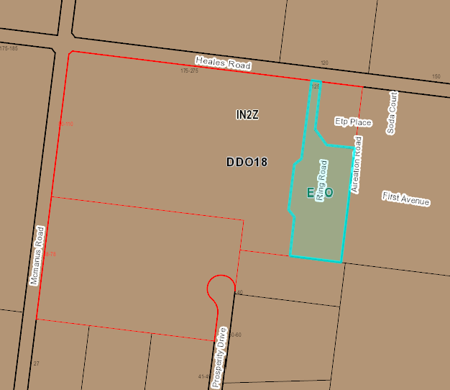
Figure 1 - 125 Heales Road, Corio (Lot 1 on PS 322559)
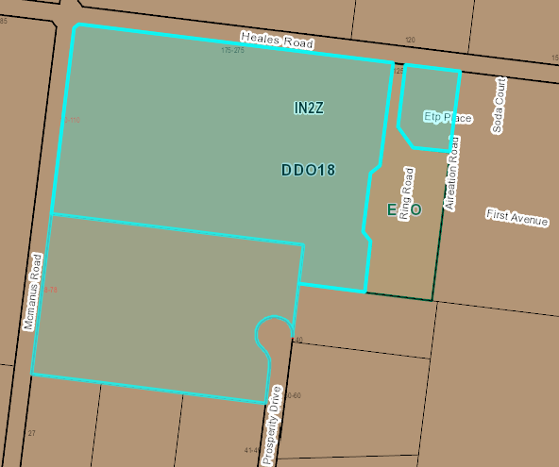
Figure 2 - 127-165 Heales Road, Corio (Lot S4 on PS615585)
The site has an overall area of approximately 14.9 hectares and is irregularly shaped. It contains some remnant industrial structures within the north-east corner adjacent to the Heales Road frontage.
Vegetation on the site is primarily concentrated along the western and northern site boundaries which are lined by sparsely scattered shrubs and some mature trees.
The site has three road frontages as follows:
- Heales Road – primary frontage to the north, measuring approximately 430m. Heales Road is a fully sealed road with swale drains on either side.
- McManus Road – secondary frontage to the west, measuring approximately 390m. McManus Road is currently unsealed with swale drains on either side.
- Prosperity Drive – secondary frontage to a court bowl which terminates at the south-east corner of the site. Prosperity Drive is a recently constructed sealed road and contains kerb and channel.
The surrounding area forms part of the Geelong Ring Road Employment Precinct (GRREP), formerly known as the Heales Road Industrial Estate. The site is located 170m south of the Viva Energy Refinery which is an LPG Manufacturing facility and is registered as a Major Hazard Facility. The LPG pipeline runs along the western property boundary with the McManus Road road reserve.
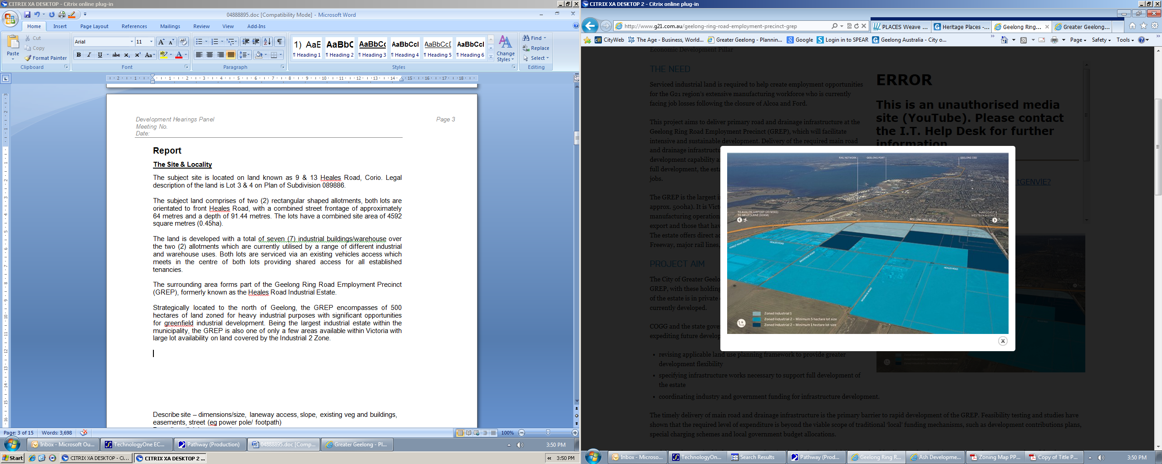
Figure 3 - Aerial image showing GRREP
Strategically located to the north of Geelong, the GRREP encompasses approximately 500 hectares of land zoned for heavy industrial purposes with significant opportunities for greenfield industrial development. Being the largest industrial estate within the municipality, the GRREP is also one of only a few areas available within Victoria with large lot availability on land covered by the Industrial 2 Zone.
The area also has a strategic relationship with the Geelong Port and has direct accessibility to the Geelong Ring Road, Princes Freeway, major rail lines and Avalon Airport.

PROPOSAL:
The application proposes a multi lot subdivision. The subdivision proposes a yield of 13 allotments with an average lot size of approximately 1.07 hectares ranging in area from 1.0 to 1.2 hectares.
All lots will be provided with access via Heales Road or Prosperity Drive.
The subdivision layout incorporates a new road that extends north from the court bowl of Prosperity Drive and bisects the site to the west. The new internal road terminates at a court bowl and provides access to six allotments.
The proposed subdivision incorporates a 10.0m landscape buffer along the entire length of McManus Road providing a setback from the pipeline corridor asset situated in the McManus Road road reserve.
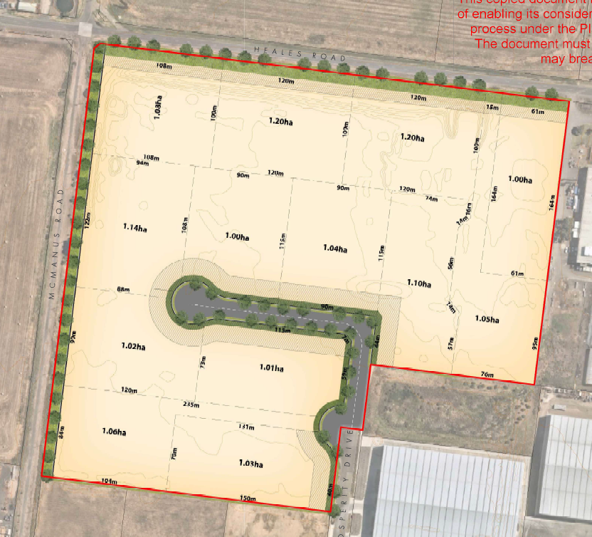
Figure 4 - Proposed plan of subdivision
PERMIT/SITE HISTORY:
The following permits/site history is applicable to this application:
- PP-1443-2010 – Staged Multi Lot Subdivision
REFERRALS:
The following referrals were undertaken.
SECTION 55:
DETERMINING AUTHORITY
Authority: | Barwon Water – No objection subject to conditions  Powercor- No objection subject to conditions  Downer (Tenix) – No response  APA – No response
Officer Comment:
Generally, if supported, the suggested conditions will be included on any permit issued.

SECTION 52:
Authority: | WorkSafe
Response: | This proposal involves subdivision only and makes no comment on the intended use of the smaller lots. However, given the premise of the subdivision proposal, it is reasonable to assume that the lots will be developed individually for light industrial purposes, similar to those in the adjacent Enterprise Drive/Prosperity Drive precinct.  This type of development typically introduces a small worker population, which across thirteen lots would significantly introduce the population intensity in the Outer Advisory Area of the Viva Lara LPG Terminal.  On the basis of the information provided with the referral, and the further information provided in response to our request of 16 March 2022, WorkSafe Victoria has reviewed the application and advises against the granting of a planning permit at the proposed location.
Officer Comment:
Noted - that Worksafe advise that the application should be refused.

INTERNAL
Department: | Engineering Services
Response: | Request for further information:  - Stormwater Management Strategy including onsite water quality treatment: The City of Greater Geelong Letter head dated 12/09/2008 accepted the SWMS report submitted on 10/09/2008 satisfying the requirement of PP-1216-2007.  The report submitted under (Stormwater Response) for planning permit PP-1550-2021 (Pages 9-11 of the PDF) from Peter Berry & Associates does not indicate the date of 10/09/2008.  Development Engineering Unit requires the applicant to provide a letter from Peter Berry & Associates to confirm that the subdivision of what was then Lot 23 as shown in appendix 6 was considered as part of (Catchment 2 - North) under the Stormwater Management Plans submitted on 10/09/2008.  - The letter needs to advise that the storage and Water Sensitive Urban Design requirements for this subdivision plan under PP-1550-2021 was addressed in the previous SWMS dated 10/09/2008.  - The letter needs to include the subdivision plans under this application PP-1550-2021.  - The letter shall advise that lot 23 as shown in Appendix 6 is designed to drain into the Basin #2.  The legend colour indicating the depth of fill is not very clear, it needs to be amended with different colour that matches the plan.  Needs to be amended and show extension of the drainage pipe in McManus Road up to the intersection of the Heals Road as shown in yellow highlighted section.  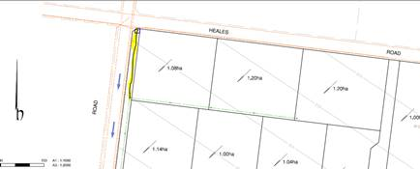  The only issue of concern is the size of the internal radius at the 90 degree curve should be larger, i.e. 15 m minimum. The swept path diagram shows that larger vehicles can negotiate the curve, however there is risk of damage to the kerb and nature strip at the internal curve. It is recommended that the splay on the adjacent lot is made large enough to allow for a 15 m internal kerb radius.  Flood Impact Assessment based on proposed cut and fill earthworks: Flood Modelling has been reviewed, it is noted that the report stated the current proposed design is not expected to result in any change to the overall flood risk of the project area in the 1% AEP flood event, including all upstream and downstream areas of site. Engineering requires a confirmation including any previous endorsed design plans to show that Obrien’s Road retarding basin was designed to cater the flood from the proposed development.
Officer Comment:
It is considered that items 2, 3 & 4 could be included as conditions on any permit that might be issued.
Items 1 & 5 have been included as grounds for refusal as it is unclear whether the subject sites have been included in a previous Stormwater Management Plan and Flood Impact Assessment from previous development within the area.

Department: | Strategic Planning
Response: | Prior to any final determination, Strategic Planning recommends that the application is formally referred to WorkSafe Victoria to consider the appropriateness and acceptability of the proposal in the context of the adjacent MHF.
Officer Comment:
The application was referred to WorkSafe Victoria who advised against the granting of a planning permit for the proposed subdivision.

AMENDMENT OF THE PROPOSAL PRIOR TO PUBLIC NOTIFICATION:
The application was not amended prior to public notification.

PUBLIC NOTIFICATION:
Pursuant to Clause 33.02-3 of the Industrial 2 Zone an application is exempt from the notice requirements of section 52(1)(a), (b) and (d), the decision requirements of section 64(1), (2) and (3) and the review rights of section 82(1) of the Act. This exemption does not apply to land within 30 metres from land (not a road) which is in a residential zone or land used for a hospital or an education centre or land in a Public Acquisition Overlay to be acquired for a hospital or an education centre.

The land is not located within 30 metres from land within a residential zone or land used for a hospital or an education centre or land in a Public Acquisition Overlay to be acquired for a hospital or an education centre.

However, the application is not exempt from the notice requirements of Section 52(1)(a), (b) and (d), the decision requirements of Section 64(1), (2) and (3) and the review rights of Section 82(1) of the Act under the Design & Development Overlay therefore, pursuant to Section 52 of the Planning and Environment Act 1987 the following forms of advertising were undertaken:

- Notices were sent to owners and occupiers of adjoining land (including opposite)
- A2 sign(s) were placed on the land
One (1) objection and one letter of support has been lodged with Council.

CONSULTATION:
A consultation meeting was not held.

AMENDMENT OF THE APPLICATION FOLLOWING PUBLIC NOTIFICATION
The application was not amended following public notification.

OBJECTIONS:
The concerns of objectors are summarised and commented on below.
- Objection – The subdivision of land is directly adjacent to a high pressure licenced Pipeline and its associated corridor and is close to our Lara LPG Terminal.
The objection is from Viva and is summarised as follows:
- Viva Energy owns and operates the Lara LPG Terminal (Terminal), licensed as a Major Hazard Facility. The Terminal is located in McManus Rd, Lara, which is close to the proposed subdivision. The Terminal stores and distributes Liquid Petroleum Gas (LPG) products. The facility can store up to 5,000t of butane, 1,200t propane and 1,000t of propylene (chemical feedstock). The Terminal is connected to Viva Energy’s Geelong Refinery by a licensed LPG pipeline. The Terminal operates 24 hours per day, 365 days per year.
- Viva Energy also owns and operates the Lara pipeline (Pipeline) which is licensed to operate in Victoria under licence 6. The Pipeline operates 24 hours per day, 365 days per year. The Maximum Allowable Operating Pressure (MAOP) for this licensed pipeline is 2758 kPa (27.5 times standard atmospheric pressure). The conveying of hazardous liquids through pipelines at high pressure is an activity that requires strict management of potential risks to public safety and the environment.
- Both the Terminal and the Pipeline are part of and interconnected to Viva Energy’s broader supply chain assets which includes the Geelong Refinery (which produces the LPG) which is classified as critical infrastructure under the Victoria Emergency Management Act 2013. This infrastructure currently supplies around 55% of Victoria’s fuel requirements.
- The proposed subdivision is located within 250 metres of the Lara LPG Terminal and within 3m of the pipeline which represents an unacceptable risk of future encroachment from inappropriate land use and development.
Response
Viva Energy received notification of the application.
The Viva Energy Lara LPG Terminal is licensed as a Major Hazard Facility by WorkSafe. WorkSafe have advised against the issuing of a planning permit. It is considered that the proposed subdivision is not consistent with Clause 13.07-2S (Major Hazard Facilities) of the Greater Geelong Planning Scheme. This is due to the increase in lot density which in turn will increase the intensity of use and development within the threshold distance of an existing major hazard facility.

ASSESSMENT:
ZONE:
Clause 33.02 – Industrial 2 Zone
The purpose of the Industrial 2 Zone is:
- To implement the Municipal Planning Strategy and the Planning Policy Framework.
- To provide for manufacturing industry, the storage and distribution of goods and associated facilities in a manner which does not affect the safety and amenity of local communities.
- To promote manufacturing industries and storage facilities that require a substantial threshold distance within the core of the zone.
- To keep the core of the zone free of uses which are suitable for location elsewhere so as to be available for manufacturing industries and storage facilities that require a substantial threshold distance as the need for these arises.

Response to zone
The purpose of the Industrial 2 Zone seeks to provide for larger scale and more intensive industrial land uses. Although the proposed lot sizes could accommodate an industrial land use, the Design & Development Overlay informs the decision making in relation to lot size, lot type and setting and design.

OVERLAY:
Clause 43.02 - Design & Development Overlay
The purpose of the Design & Development Overlay is:
- To implement the Municipal Planning Strategy and the Planning Policy Framework.
- To identify areas which are affected by specific requirements relating to the design and built form of new development.

Schedule 18 – Geelong Ring Road Employment Precinct
Design Objectives
- To facilitate the development of the Geelong Ring Road Employment Precinct as a high amenity industrial area suited to the needs of advanced manufacturing and production support industries.
- To provide a high level of amenity for workers on and visitors to the estate.
- To ensure development provides an attractive frontage to the Geelong Ring Road.
- To ensure development provides a high level of visual amenity when viewed from major transport routes and surrounding non-industrial land uses.
- To promote best practise sustainable design including storm water quality and reuse measures.
Subdivision within the estate should ensure:
- The provision of an appropriate range of lot types and settings.
- The provision of lot configurations that facilitate energy efficient site and building design.
- That no lots have a rear aspect to the Geelong Ring Road.
- The following minimum lot sizes within each precinct in the estate, as defined on the Geelong Ring Road Employment Precinct Framework Plan Map at clause 17.01-1L-02 of this Planning Scheme:

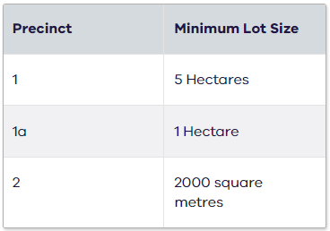

Response to the overlay:
The purpose of a design and development overlay is to both implement the Municipal Planning Strategy and the Planning Policy Framework, while also identifying areas which are affected by specific requirements relating to new development.

It is recognised that pursuant to the definitions set out in the Planning and Environment Act 1987, “development” includes the subdivision or consolidation of land.

The design objectives set out in the DDO18, amongst other things, seek to facilitate the development of the GREP as a high amenity industrial area suited to the needs of advanced manufacturing and production support industries.

The DDO18 sets out requirements to be met as they relate to subdivision. Clause 3.0 of the DDO18 states that:

Subdivision within the estate should ensure:
- The provision of an appropriate range of lot types and settings;
- The provision of lot configurations that facilitate energy efficient site and building design;
- That no lots have a rear aspect to the Geelong Ring Road; and
- The following minimum lot sizes within each precinct of the estate, as defined on the GREP Framework Plan Map at Clause 17.01-1L-02 of this Planning Scheme:
  - Precinct 1 – 5 Hectares
  - Precinct 1a – 1 Hectare
  - Precinct 2 – 2000 square metres
It is noted that the subject site is included within the area known as Precinct 1 and therefore a minimum lot size of 5.0ha is required.

The proposed subdivision seeks to create 13 allotments with an average lot size of approximately 1.07 hectares ranging in area from 1.0 to 1.2 hectares and is in conflict with the requirement set out in the DDO18.

It is noted that Precinct 1 of the GREP is intended to support medium-sized industry requiring substantial buffer zones from sensitive land uses (i.e. residential areas in Lara and Corio). Allowing smaller lot sizes than those specified under the GREP Framework Plan would diminish lot diversity and therefore limit the City’s ability to accommodate a diversity of industrial uses within the GREP, and Greater Geelong more broadly.

It is also noted within the supporting Industrial Land Assessment Report submitted with the application that the vast majority of industrial allotments (77%) in Greater Geelong are less than 0.5 hectares. The Report also notes that:
“demand for large allotments (>2ha) are only available in the GRREP. Interest in this lot size has been variable, but the appetite appears to be growing slowly; primarily because this product is unavailable elsewhere in the municipality.”

This would point to a need for more (rather than less) medium-sized industrial allotments.

The Land Assessment Report also states that there is a ready market for 1ha lots and the GREP is the only place that can fill this demand. This is considered short sighted. There is a considered framework plan to provide industrial land suitable for larger industries that are capable of driving considerable economic growth and take advantage of the unique offering in terms of location to rail, port and road.

CULTURAL HERITAGE MANAGEMENT PLAN (CHMP):
The Aboriginal Heritage Regulations 2018 specify the circumstances in which a cultural heritage management plan is required for an activity or class of activity. Division 2 of the Aboriginal Heritage Regulations 2018 specifies exempt activities which do not require a cultural heritage management plan. The proposal is not listed as an exempt activity.

Areas of cultural heritage sensitivity are defined within Divisions 3 and 4 of the Aboriginal Heritage Regulations 2018. Division 3 does not identify the site or part of the site as within an area of cultural heritage sensitivity.
In accordance with the above assessment, a cultural heritage management plan is not required.

LANDFILL GAS RISK ASSESSMENT
The subject site is not located within 500 metres of an identified former landfill site, a risk assessment is not required.

DEVELOPMENTS IN BUSHFIRE PRONE AREAS
The site is located within a designated bushfire prone area.
Clause 13.02-1S (Bushfire planning) seeks to strengthen the resilience of settlements and communities to bushfire through risk-based planning that prioritises the protection of human life.

The policy must be applied to all planning and decision making under the Planning and Environment Act 1987 relating to land which is:
- Within a designated bushfire prone area;
- Subject to a Bushfire Management Overlay; or
- Proposed to be used or developed in a way that may create a bushfire hazard.
The proposal is listed at Clause 13.02-1S as one of the uses or developments which should be considered:
- Subdivisions of more than 10 lots.
- Accommodation.
- Child care centre.
- Education centre.
- Emergency services facility.
- Hospital.
- Indoor recreation facility.
- Major sports and recreation facility.
- Place of assembly.
- Any application for development that will result in people congregating in large numbers.
As the site is located within a designated bushfire prone area the assessment of this application has considered:
- The risk of bushfire to people, property and community infrastructure.
- Whether the implementation of appropriate bushfire protection measures to address the identified bushfire risk is necessary.
- Whether the proposal can implement bushfire protection measures without unacceptable biodiversity impacts.
The application is not expected to create a risk bushfire to people, property and community infrastructure.
It is considered that no bushfire protection measures to address the identified bushfire risk is necessary.

THE PLANNING POLICY FRAMEWORK (PPF):
MUNICIPAL STRATEGIC STATEMENT
The following Municipal Planning Strategies are applicable to this application:
02.03 – Strategic Direction
- 02.03-1 – Settlement
- 02.03-7 – Economic development
- 02.03-8 – Transport
PLANNING POLICY FRAMEWORK
The following Planning Policy Framework is applicable to this application:
11 – Settlement
- 11.01 – Victoria
- 11.01-1L-01 – Settlement – Greater Geelong
- 11.02 – Managing Growth
- 11.02-1S – Supply of urban land
13 – Environmental Risks & Amenity
- 13.07 – Amenity, human health and safety
- 13.07-1S – Land use compatibility
- 13.07-2S Major Hazard Facilities
17 – Economic Development
- 17.01 – Employment
- 17.01-1L-01 – Diversified economy – Greater Geelong
- 17.01-1L-02 – Geelong Ring Road Employment Precinct
- 17.03 – Industry
- 17.03-1S – Industrial land supply
- 17.03-2L – Sustainable industry in Greater Geelong
- 17.03-3S – State significant industrial land
18 – Transport
- 18.02 – Movement Networks
- 18.02-5R – Freight Links – Geelong G21
Response to Policy
State Planning Policy Framework at Clauses 17 and 17.03-1S inform strategic planning policy for the location of land suitable for industrial development. The subject land has been zoned Industrial 2 and the location of the continued development of this land for industrial activities are supported by Planning Policy Framework.

While the Geelong Ring Road Employment Precinct (GREP) is not specifically listed in Clause 17.03-3S as industrial land of state significance, it is considered that the GREP is of strategic importance to the state of Victoria, by way of providing 500 hectares of land with significant opportunities for heavy industrial development. The GREP is one of only a few greenfield sites available across Victoria with large lot land covered by the Industrial 2 Zone, and therefore appropriately zoned for heavy industrial purposes. If the proposed subdivision was to go ahead the opportunity to create large lots will be lost forever as it is highly likely the lots will be sold to separate owners. Whilst each application is assessed on its merit, allowing a ‘watering down’ of the Design & Development Overlay will likely mean the purpose/considered strategic direction of the control will also be lost forever as similar future applications will be inevitable.

The availability of land, including the subject site for future major industrial use or development is further emphasised by Council’s planning controls for the site and the surrounding area.

The Municipal Planning Strategy in relation to Economic Development and Industry along with Council’s Planning Policy Framework at Clauses 17.01-1L-01, 17.01-1L-02, 17.03-1L and 17.03-2L outlines strategies, which seek to encourage regional and national scale industrial businesses to locate within the GREP, minimise amenity and land use conflicts, provide a high level of amenity for workers, provide sufficient industrial land to meet a range of industrial needs in Geelong and direct industries that require substantial buffer distances from sensitive land uses to the core of the Industrial 2 Zone of the GREP.

The GREP is identified as a major industrial area within the municipality with land that can cater to meet the needs of the industrial land market through the provision of vacant, well serviced, high amenity industrial land that can compete for investment in emerging forms of industrial land use and development. The Framework Plan seeks to implement the vision for the GREP and the proposed subdivision of the land fails to support what the Framework Plan has been designed to achieve.
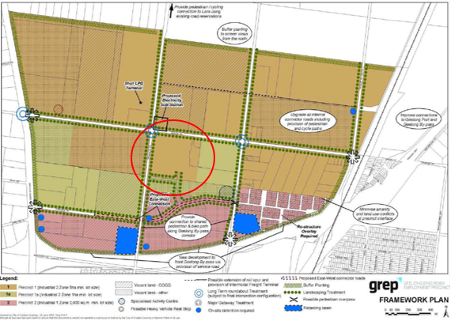

Figure 5 - GREP Framework Plan (Subject site circled in red)
The plan identifies the subject site within precinct 1 of this plan, strategically highlighted for heavy manufacturing industries. The intention of this precinct seeks to accommodate heavy industrial industries which require significant buffer distances from sensitive land uses. Precinct 1 as set out in the framework plan seeks to require minimum lot sizes to be retained at 5 hectare to remain available for larger heavy industrial activities.

It is considered that the proposed subdivision conflicts with Council’s PPF as it will result in the limitation of larger scale industries that require substantial buffer distances from sensitive land uses to locate within the GREP. The GREP provides unique opportunities with its ability to attract large regional and national scale industrial businesses to the Greater Geelong area due to its location to Avalon Airport, Melbourne Road and rail infrastructure. This would impact on Geelong’s economic growth as supported in Clauses 17.01 & 17.03 of the Greater Geelong Planning Scheme.

It is also of importance to consider the location of the proposed subdivision in relation to the Lara Major Hazard Facility (MHF) (Viva LPG Terminal). The objective of Clause 13.07-2S is to minimise the potential for human and property exposure to risk from incidents that may occur at a major hazard facility and to ensure the ongoing viability of major hazard facilities. Strategies include considering the risks associated with increasing the intensity of use and development within the threshold distance of an existing major hazard facility.

The land is located within the threshold distance of the Lara Major Hazard Facility as identified by WorkSafe. A WorkSafe Information Sheet title ‘Land use planning near a major hazard facility’ published in March 2010 which provides that operators of a MHF must reduce risk to the surrounding area so far as is reasonably practicable where it cannot be eliminated. It also provides advice to planning and responsible authorities on residual risk from proposing developments in proximity to MHFs. WorkSafe advises against land use or developments within the inner area, apart from low density industrial uses such as non-retail warehousing or other low employee density business or industrial use and Planning Scheme amendments that may result in unacceptable societal risk because of the cumulative effects to all developments and persons that may be present on land surrounding an MHF.

It is relevant to highlight that the proposed lot sizes within the subdivision being reduced from the recommended 5.0ha to 1.0ha will create a higher density industrial area. This in turn increases the risk and potential for inappropriate land use substantially increasing population density around the MHF This could also result in unacceptable societal risk because of the cumulative effects to all developments and persons that may be present on the subject land.

RELEVANT PARTICULAR PROVISIONS:
The are no Particular Provisions applicable to this application.

DECISION GUIDELINES OF CLAUSE 65:
Because a permit can be granted does not imply that a permit should or will be granted. The responsible authority must decide whether the proposal will produce acceptable outcomes in terms of the decision guidelines of this clause.

CLAUSE 65.01 – APPROVAL OF AN APPLICATION OR PLAN
Clause 65.01 of the Greater Geelong Planning Scheme outlines the decision guidelines to be considered by the Responsible Authority when making decisions on applications. These decision guidelines include:
- The matters set out in Section 60 of the Act.
- The Municipal Planning Strategy and the Planning Policy Framework.
- The purpose of the zone, overlay or other provision.
- Any matter required to be considered in the zone, overlay or other provision.
- The orderly planning of the area.
- The effect on the amenity of the area.
- The proximity of the land to any public land.
- Factors likely to cause or contribute to land degradation, salinity or reduce water quality.
- Whether the proposed development is designed to maintain or improve the quality of stormwater within and exiting the site.
- The extent and character of native vegetation and the likelihood of its destruction.
- Whether native vegetation is to be or can be protected, planted or allowed to regenerate.
- The degree of flood, erosion or fire hazard associated with the location of the land and the use, development or management of the land so as to minimise any such hazard.
- The adequacy of loading and unloading facilities and any associated amenity, traffic flow and road safety impacts.

Response
It is considered that the proposed subdivision will compromise the orderly planning of the area through fragmentation of Industrial 2 Zoned land. The PPF seeks to encourage investment from regional and national scale industrial businesses to locate to the GREP for heavy industries that require substantial buffer distances from sensitive land uses and larger lot holdings. The proposed subdivision will reduce the capability of the land to meet these strategic directions.

CLAUSE 65.02 – SUBDIVISION
Clause 65.02 of the Greater Geelong Planning Scheme outlines the decision guidelines to be considered by the Responsible Authority when making decisions on an application to subdivide land. These decision guidelines include:
- The suitability of the land for subdivision
- The existing use and possible future development the land and nearby land
- The availability of subdivided land in the locality, and the need for the creation of further lots
- The effect of development on the use or development of other land which has a common means of drainage
- The subdivision pattern having regard to the physical characteristics of the land including existing vegetation
- The density of the proposed development
- The area and dimensions of each lost in the subdivision
- The layout of roads having regard to their function and relationship to existing roads
- The movement of pedestrians and vehicles throughout the subdivision and the ease of access to all lots
- The provision and location of reserves for public open space and other community facilities
- The staging of the subdivision
- The design and siting of buildings having regard to safety and the risk of spread of fire
- The provision of off street parking
- The provision and location of common property
- The functions of any body corporate
- The availability and provision of utility services, including water, sewerage, drainage, electricity and gas
- If the land is not sewered and no provision has been made for the land to be sewered, the capacity of the land to treat and retain all sewage and sullage within the boundaries of each lot
- Whether, in relation to subdivision patterns, native vegetation can be protected through subdivision and siting of open space areas.

Response
It is considered that the proposed subdivision will compromise the future use and development of the land such that an acceptable planning outcome would not be produced by the granting of a permit for this proposal
act_.1.1 page 3

Attachment_2CLOSE OF MEETING

As there was no further business the meeting closed at 7.35pm.

VCAT201
VCAT201
VCAT 508
VCAT 1731
VCAT 737
VCAT 1956
VCAT 692
VCAT 135
VCAT 2523

