

minutes

PLANNING COMMITTEE MEETING
No. 233

Thursday 23 November 2023
City Hall, 57 Little Malop Street, Geelong

ALSO LIVE STREAMED ON THE CITY’S WEBSITE:

www.geelongaustralia.com.au/meetings

PANEL:

Cr Mason (Chair)
Cr Moloney
Cr Sullivan
Cr Cadwell
Cr Wilkinson
Cr Hathway

PRESENT

Present: Cr Mason, Cr Moloney, Cr Sullivan, Cr Cadwell, Cr Wilkinson, Cr Hathway

Council Officers:

Amelia Lovejoy, Principal Planner Statutory Planning
Steve Roussac, Principal Planner Statutory Planning
Rory O’Loghlen, Team Leader Statutory Planning
John Rush, Coordinator Statutory Planning

Opening: The Chair declared the meeting open at 5.30pm

1. PROCEDURAL MATTERS

Acknowledgement Of Country

The Committee acknowledges the Wadawurrung People as the Traditional Owners of the Land, Waterways and Skies. We pay our respects to their Elders, past and present. We Acknowledge all Aboriginal and Torres Strait Islander people who are part of our Greater Geelong community today.

1.2. Introduce the Panel Members

1.3. Apologies

Cr Nelson, Cr Kontelj, Cr Aitken, Cr Harwood, Cr Murrihy

1.4. Declarations of Conflicts Of Interest

Nil

1.5. Confirmation of Minutes

That the Minutes of the Planning Committee Meeting held on 21 September 2023
be confirmed.

Moved: Cr Hathway Seconded: Cr Cadwell

CARRIED
2. MATTER(S) FOR CONSIDERATION
PP-320-2021 98 Marshalltown Road, Grovedale And PP-1512-2020 149 Bellarine Highway, Newcomb
2.1. | PP-158-2023 - 24 Patullos Road, Lara

Application No: | PP-158-2023
Applicant: | Meraq Building Designers
Subject Land: | 24 Patullos Road, LARA
Zone: | General Residential Zone Schedule 1
Overlays: | Nil
Existing Use: | Single Dwelling
Proposed Use: | Construction of Five Dwellings, Five Lot Subdivision and the  Waiver of One Visitor Car Parking Space

Summary
- The subject site is located on the southern side of Patullos Road, Lara. The site is square in shape and has a frontage to Patullos Road of 24.4 metres, a depth of 26.82 metres and a total lot area of approximately 654 square metres. The site contains a single dwelling and outbuilding, with one crossover to Patullos Road.
The site sits between residentially zoned land on its southern and western boundaries, with a commercial zone containing several small shops on its eastern boundary.
- The proposal consists of the construction of five two storey dwellings, the subdivision of the land into five allotments, with a common property accessway and the waiver of one visitor car space.
- The proposal is for five x 2 bedroom dwellings with separate access for vehicles and residents. The vehicle access is located closer to the commercial zone and the residents access closer to the neighbouring property. Each dwelling has reverse living arrangements with an accessible a balcony to the living areas.
- The subject site is located within a General Residential Zone Schedule 1 and is not affected by any Overlays. Patullos Road is a Transport Zone Schedule 3 which requires vehicles to enter and exit a site within a forward direction.
- The application was referred to the relevant internal departments and external authorities. All authorities have no objections to the proposal subject to conditions of permit.
- The application was advertised to adjoining owners and occupiers of land. A total of six (6) objections have been received. A consultation meeting was not held, however the applicant submitted informal plans displaying some additional changes to further address the concerns by objectors. The changes included obscuring windows to the neighbouring property (up to 1.8m from floor level the west facing first floor habitable room windows of dwellings 3 to 5), reducing the front setback by 200mm and providing a 200mm increase to the rear setback of dwelling 5 from the southern boundary, also the rear facing windows were raised to 1.85m from floor level and the detail of screening to the Dwelling 5 (rear) was added. Also, it was noted that the existing boundary fencing is now to be retained (it was previously to be replaced) and an additional lattice screening was added to western boundary fence.
- Following the circulation of these informally amended plans, no objections have been withdrawn.
- In terms of assessment, the application has been reviewed against the relevant planning policies at Clause 32.01 General Residential Zone Schedule 1, Clause 52.06 Car Parking, Clause 55 Two or more dwellings on a lot. The assessment also was considered under the planning policy framework at Clause 15.01-5L Neighbourhood Character and Clause 16.01-1S Housing Supply.
- On balance, the proposal is considered to satisfactorily respond to the relevant zone, planning policy and ResCode, noting a high compliance with the standards of ResCode have been achieved.
- Based on the assessment the proposal is respectfully recommended to be supported with conditions for amended plans.
.
Alternate Recommendation
Moved: Cr Hathway Seconded: Cr Sullivan
That the Responsible Authority having considered all matters which the Planning and Environment Act 1987, requires it to consider decides to refuse to Grant a Planning Permit for the Construction of Five Dwellings and a 5 Lot Subdivision and the Waiver of One (1) Visitor Car Space at 24 Patullos Road LARA in accordance with the plans and documentation submitted with the application subject to the following grounds:

CARRIED

- The proposal fails to meet Clause 15.01-5L. The proposed density of dwellings is uncharacteristic of the streetscape and neighbourhood character. The proposed five dwellings are joined in one mass without any physical break between dwellings which creates an uncharacteristic visual response to the existing streetscape. The site is located outside of an Increased Housing Diversity Area, therefore the density proposed should respect the existing streetscape and neighbourhood to a higher degree.

- The proposal fails to meet Clause 16.01-1S as the internal and external amenity for the five dwellings is limited through the lack of northern light to four of the five dwellings, and each dwelling having a balcony as the designated areas of secluded private open space, that have a poor visual amenity interface with a commercial car park and businesses.

- The proposal fails to adequately satisfy the following standards of Clause 55 (Rescode):

- Clause 55.02-1 Neighbourhood Character as the two storey design with sheer north and south walls do not reflect the existing or preferred neighbourhood character, with single storey dwellings forming a strong element of the neighbourhood character. There is no articulation in the design that steps down to single storey to reflect the neighbouring single storey buildings.

- Clause 55.03-1 Standard B6 Street setback as the front setback does not meet the average setback between the adjoining properties this does not provide an adequate graduation to respect the character of the area.

- Clause 55.03-5 Standard B10 Energy Efficiency as four out of the five dwellings do not receive northern light to living areas or habitable rooms.

- Clause 55.03-7 Standard B12 Safety and Clause 55.05-2 Standard B26 Dwelling entry, as the entries to each dwelling are not highly visible from the entry to the site and do not satisfactorily provide for a safe and visible entry to each dwelling.

- The proposal fails to meet Clause 65.01 of the Greater Geelong Planning Scheme as the fails to provide an orderly planning outcome for the site through an uncharacteristic dwelling density and design which is an outcome of over development.

REPORT

PERMIT TRIGGER:

A planning permit is triggered for this application pursuant to the following clauses of the Greater Geelong Planning Scheme:

- Pursuant to Clause 32.08-3 of the General Residential Zone a permit is required to subdivide land.
- Pursuant to Clause 32.08-6 of the General Residential Zone a permit is required to construct two or more dwellings on a lot.
- Pursuant to Clause 52.06 of the Car Parking Particular Provisions a permit is required to Waive a Visitor Space.
DEFINITIONS
Pursuant to Clause 73.03 of the Planning Scheme a dwelling is defined as:
A building used as a self-contained residence which must include:

a) a kitchen sink;
b) food preparation facilities
c) a bath or shower; and
d) a closet pan and wash basin.

It includes outbuildings and works normal to a dwelling.

Pursuant to Clause 73.04 of the Planning Scheme a dwelling is nested in the Accommodation group.

Subdivision is not defined or nested in the Planning Scheme.

A lot is defined as a part (consisting of one or more pieces) of any land (except a road, a reserve, or common property) shown on a plan, which can be disposed of separately and includes a unit or accessory unit on a registered plan of strata subdivision and a lot or accessory lot on a registered plan.

Subdivision is defined in the Subdivision Act 1988 as the division of land into two or more parts which can be disposed of separately.

RESTRICTIVE COVENANT OR SECTION 173 AGREEMENT:

The subject site is not burdened by a Restrictive Covenant or Section 173 Agreement.

OFFICER DIRECT OR INDIRECT INTEREST:

No officer involved in the preparation of this report declared a general or material conflict of interest.

SITE/LOCALITY:

The subject site is located on the southern side of Patullos Road, Lara. The site is square in shape and has a frontage to Patullos Road of 24.4 metres, a depth of 26.82 metres and a total lot area of approximately 654 square metres. The site contains a single dwelling and outbuilding, with one crossover to Patullos Road.

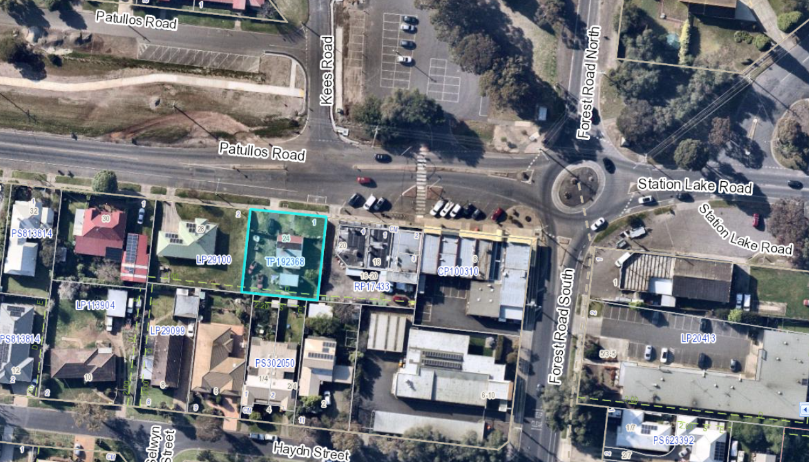
Image 1 – Nearmap image with subject site highlighted in blue.

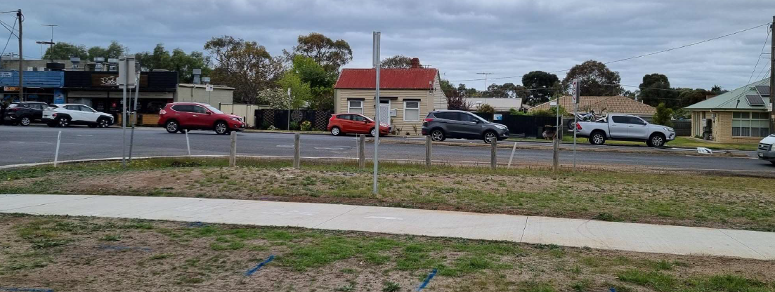
Image 2 – Site photo displaying house with red roof being on the subject site, with shops to the left in the photo and residential to the right
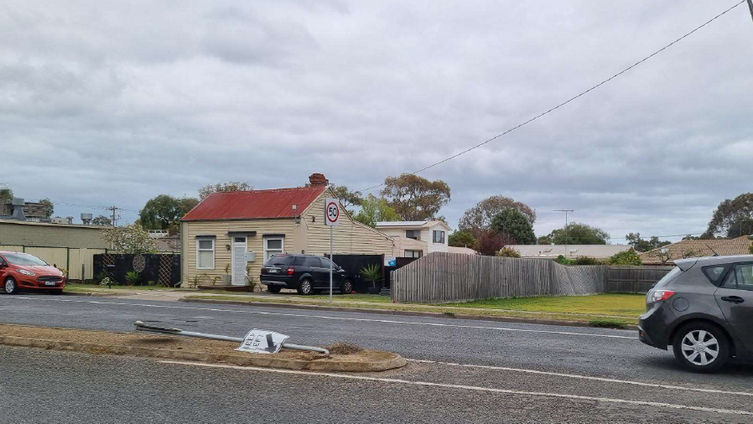
Image 3 – Site photo displaying house with red roof being on the subject site

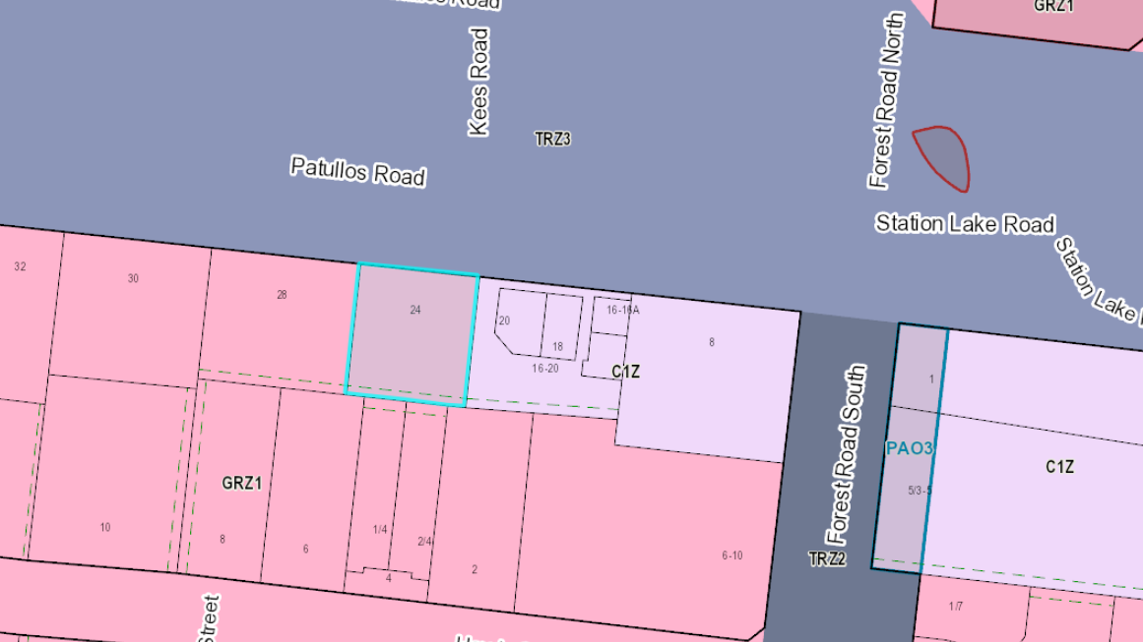
Image 4 – Weave mapping image displaying zoning of subject site (highlighted in blue) and the surrounding land.
The subject site is located within a General Residential Zone Schedule 1 and is not affected by any Overlays. Patullos Road is a Transport Zone Schedule 3 which requires vehicles to be enter and exit a site within a forward direction. The site sits between residentially zoned land on its southern and western boundaries, with a commercial zone containing several small shops on its eastern boundary.
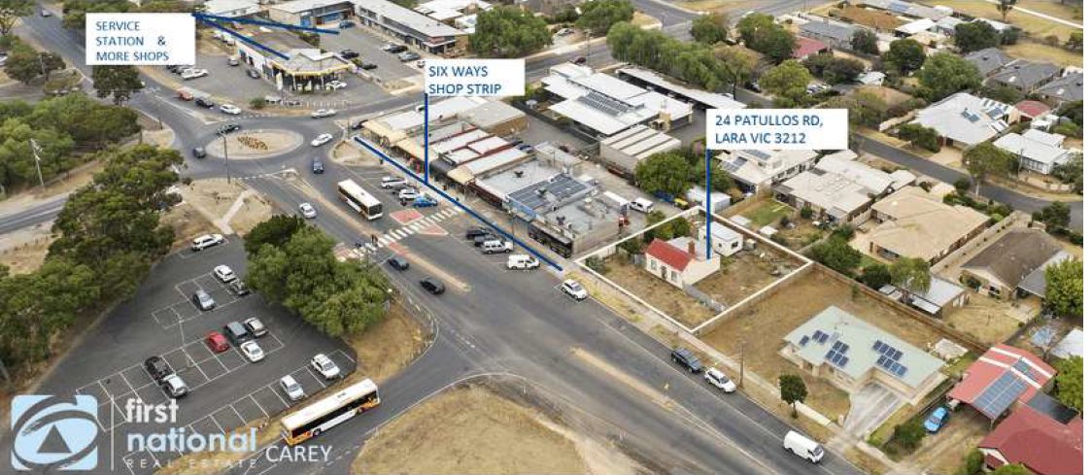
Image 5 – Taken from planning report submitted with application – aerial view of subject site and surrounding streetscape.

PROPOSAL:

The proposal consists of the construction of five two storey dwellings, the subdivision of the land into five allotments, with a common property accessway and the waiver of one visitor car space. The five dwellings will all be attached, with one fronting Patullos Road and the others fronting the internal accessway and a neighbouring property to the west. Only one vehicle crossover is proposed which will service each of the five dwellings.
The dwellings garage entries are along the eastern sides of the dwellings, with their front entry doors being located up a walkway on the western side of the dwelling.
Each of the five dwellings are identical as follows:
- Ground floor, single garage measuring 6m x 3.9m which will include a 500mm width 6 cubic metre area of storage.
- A bathroom, European laundry, a bedroom, a small courtyard with an area of 8.07 square metres which includes the location of a 2000L water tank, and an external area on the western boundary containing an additional 6 cubic metres of storage in the form of a shed and an area for four bins per dwelling to be stored.
- First floor, a second bedroom, a second bathroom, an open plan meal, kitchen and living area which opens out to the east to a balcony which faces the commercial area to the east.

The subdivision proposed will follow the proposed development and lot sizes and common property areas as follows:

- Lot 1- 85 square metres (including the allocated section along the western boundary)
- Lot 2 – 79 square metres (including the allocated section along the western boundary)
- Lot 3 – 79 square metres (including the allocated section along the western boundary)
- Lot 4 - 79 square metres (including the allocated section along the western boundary)
- Lot 5 – 119 square metres; and
- Common property - 212 square metres

PERMIT/SITE HISTORY:

The following permits/site history is applicable to this application:
- PP-34-2022 – Proposed 5 dwellings, five lot subdivision, use and development of a food and drink premises (café) and waiver of car parking spaces. (This application lapsed as further information was not submitted in time).

REFERRALS:

The following referrals were undertaken:

SECTION 55:

DETERMINING AUTHORITY

Authority: | Barwon Water
Response: | No objections subject to conditions being included on any planning permit issued.  Barwon Water’s records indicate than an existing potable water service and meter is located on this property. A dimensioned plan showing the location of existing meters, and the location of the meter relative to the existing boundaries, and its number, is to be submitted. Private potable water service pipes are not permitted to cross allotment boundaries and must be plugged and abandoned at the boundaries of such allotments.
Officer Comment:
The conditions proposed seem standard other than the one included above – this will be something that the applicant needs to consider. All recommended conditions will be included on any planning permit issued.

Authority: | Powercor
Response: | No objections subject to conditions being included on any planning permit issued.
Officer Comment:
All recommended conditions will be included on any planning permit issued.

INTERNAL

Department: | Engineering Services
Response: | No objections to the proposal, subject to conditions being included on any planning permit issued.
Officer Comment:
Response noted, recommended conditions will be included on any planning permit issued.

Department: | ESD Response
Response: | No objections to the proposal, subject to conditions being included on any planning permit issued.
Officer Comment:
Response noted, recommended conditions will be included on any planning permit issued.

Department: | Waste
Response: | No objections to the proposal, subject to conditions being included on any planning permit issued.
Officer Comment:
Response noted, recommended conditions will be included on any planning permit issued.

Department: | Environmental Health
Response: | There are concerns relating to noise levels from the commercial area on the eastern side of the property, impacting the proposed dwellings, particularly their eastern facing balconies. The applicant has suggested in an email dated 27 September 2023 that they could enclose the east facing balconies with bi folding doors.  Conditions are proposed including general amenity conditions.
Officer Comment:
Response noted, most of the conditions will be included on any planning permit issued, however conditions relating to general amenity, commercial noise (as no commercial use is proposed) and waste collection (as standard residential waste collection will apply) will not be included as the proposal is for a residential development with a standard Council waste collection from the Patullos Road frontage. The conditions relating to amenity, commercial noise from the subject site and waste collection relate to the original application which included a food and drink premises and are no longer relevant to include within the conditions.

AMENDMENT OF THE PROPOSAL PRIOR TO PUBLIC NOTIFICATION:

The applicant made a first request to amend the application pursuant to Section 50 of the Planning and Environment Act 1987 on 15 July 2023. Council accepted the amendment. The amendment made the following changes to the application:

- Change application from four dwellings and a food and drink premises (cafe) and a waiver of car parking – to the construction of five dwellings and a five lot subdivision, with the waiver of one visitor space.

Further amended plans were submitted with additional detail requested on 28 July 2023, however the applicant did not submit a Section 50 form with the amended plans.

PUBLIC NOTIFICATION:

The application is not exempt from the notice requirements of Section 52(1)(a), (b) and (d), the decision requirements of Section 64(1), (2) and (3) and the review rights of Section 82(1) of the Act and pursuant to Section 52 of the Planning and Environment Act 1987 the following forms of advertising were undertaken:

- Notices were sent to owners and occupiers of adjoining land
- A2 sign was placed on the land

Six (6) Objections were received.

CONSULTATION:

A consultation meeting was not held; however, a written response and informally amended plans responding to a number of concerns raised in the objections, were provided by the applicant which were then sent to the objectors. Following this, the application was called in to a Planning Committee Meeting.

The response included informally amended plans displaying the following changes:
- the obscuring up to 1.8m from floor level the west facing first floor habitable room windows of dwellings 3 to 5,
- reduction of front setback by 200mm, resulting in a front setback proposed of 3m which is a variation of 213mm from the B6 ResCode Street Setback Standard (providing a 200mm increase in rear setback of dwelling 5 from the southern boundary to meet B17 ResCode Side and Rear Setback Standard),
- rear windows raised to 1.85m from floor level,
- screening to balcony of dwelling 5, and;
- existing boundary fencing to be retained with additional 300mm lattice screening added to western boundary fence.

AMENDMENT OF THE APPLICATION FOLLOWING PUBLIC NOTIFICATION

The application was not amended following public notification.

OBJECTIONS:

The concerns of objectors are summarised and commented on below:

- Objection -
Existing fence proposed relocation and replacement, consent is not given for this to occur the fence like has not moved in 40 years.
A gap is proposed at the base of the fencing which will allow pets to escape to adjoining properties.

Response
While the applicant has placed this wording on the plans for assessment, this is not a matter that will be considered by planning regulations, this is a civil matter to be considered privately. Nonetheless an amended plans permit condition can require the removal of these plan notations.

Objection –

- Overshadowing and overlooking to adjoining residential properties. 1.7m high window sills are still able to be seen out of.

Screening is not proposed as solid so people can see through screening.

Response

The shadow plans that were informally submitted in response to the objections provide detailed break downs of the shadow created by the proposal. The shadow plans demonstrate that the overshadowing created by the proposal meets Clause 55.04-5 B21 Overshadowing standard of Clause 55 ResCode.

The rear wall of the proposal has been moved to comply with the required setback under Clause 55.04-1 B17 Side and rear setbacks standard of Clause 55 ResCode

As detailed in Clause 55.04-6 B22 Overlooking standard of Clause 55 ResCode, no more than 25% transparency is permitted to screens that will restrict overlooking. Given the concerns raised by this objector, an amended plans condition will be included on any planning permit issued requiring the southern screen of dwelling 5 to be solid and to extend out to the east an appropriate distance to limit views out to the south.

It is noted that the informal plans show fixed louvres to provide screening to the rear balcony to assist in restricting overlooking to the south.
Window heights at 1.7m above floor level meet the requirement to restrict overlooking. However on the informally submitted plans to respond to objectors concerns, it is noted that the south facing windows of dwelling 5 have been raised to 1.85m from the floor level. This will be included through an amended plans condition as part of recommended conditions to be included on any planning permit issued.

- Objection –

Height and density of proposal does not follow existing neighbourhood character and is visually obtrusive.

Response
There are very few two storey developments within the immediate surrounds of the subject site. However, this does not result in two storey development being prohibited. The design has been setback from all boundaries of the site. This assists with providing spacing within the streetscape in response to the adjoining residential properties, with very few walls on boundaries. The eastern elevation has been articulated with balconies at the first floor, and the western elevation has been articulated with fenced outdoor areas of secluded private open space at the ground floor.

The density of the development is considerably higher than the surrounding residential development. The development however has managed to achieve compliance with almost all elements of Clause 55 ResCode, with the front setback variation being one of the only areas of non-compliance, however, is only a minor variation to the front setback standard.

While there are 5 dwellings proposed, the building has been designed in one mass and set off all side and rear boundaries providing a physical gap between neighbouring properties. It is acknowledged however, that having all of the dwellings attached provides the applicant with greater dwelling numbers, as spacing between the proposed dwellings would reduce the number of dwellings that could be placed on the site, in this particular layout. The lot sizes proposed are very small with only one proposed being just over 100 square metres. These small lot sizes are not seen anywhere in the immediate neighbourhood.

The existing neighbourhood character for this section of Patullos Road is for single dwellings on larger allotments. One of the closest multi dwelling sites within the adjoining residential zone on Patullos Road is 38 Patullos Road there a total of eight, two storey dwellings have been constructed. This site has a frontage of approximately 30 metres and a site area of approximately 1980 square metres.

To the west of that site at 40 Patullos Road a total of four single storey dwellings have been constructed. The site has a frontage of approximately 16 metres and a site area of approximately 1056 square metres.

In comparison the subject site, where five two storey dwellings have been proposed, has a frontage of approximately 24 metres and a site area of approximately 660 square metres. Therefore, the proposal does have a higher concentration of dwellings than can be found in the existing streetscape. This has been justified by the applicant given the site’s close proximity to services including shops, a laundromat, restaurants, the police station, and medical centre.

- Objection –

Reduction in property value.

Response
Property values are not a planning consideration as has determined by VCAT on multiple occasions.

- Objection –

Excess residential noise from increase in people living within the five dwellings and having balconies at the first floor of the dwellings.

Response
Residential noise created by dwellings is reasonably anticipated within a residential neighbourhood. The east facing balconies will be required to have bi-fold doors to limit noise impacts from the commercial zone into the dwellings, however this design element is also likely to reduce residential noise from the dwellings.

- Objection –

Car parking waiver and parking implications for Patullos Road which is already busy.
Traffic in area is already heavily congested.

Concerns about 5 dwellings utilising one accessway within close proximity to a busy intersection, directly opposite Kees Road.

Response
The application has been submitted with a Traffic Report prepared by TTM. This report prepared by Traffic Engineers has considered the proposed accessway, the traffic created by the proposal and the surrounding street network.

The Traffic Report has been referred to Council’s Traffic and Engineering Unit who have reviewed the report and considered the proposed car parking waiver for one visitor space. The Traffic and Engineering Unit are supportive of the proposed crossover location and the waiver of one visitor space.

Car parking provision for the dwellings on site (other than the waiver of one visitor space) complies with Clause 52.06 Car Parking.

- Objection –

Bins being put on street frontage on collection day will limit line of sight for neighbouring properties existing their sites.

Response
The placement of bins for collection is a standard requirement for residential dwellings. As there is enough street frontage for the bins to be placed for collection, the proposal has the option to do this. Council’s Waste Department provided support with conditions.

- Objection –

The site should have heritage protection and should not be demolished. The building could be retained and be used as a café with outdoor dining.

Response
This matter was directed to Council’s Built Heritage Coordinator, who advised that the site has been reviewed as part of two Lara Heritage Studies, one in the year 2000 and again in 2013. While the site was of some of historical interest, it was not sufficient to warrant inclusion in a Heritage Overlay.

- Objection –

Strongly oppose the proposed reduction of rear setback from boundary as it will impact the amenity of the property behind, through additional shadow and overlooking.

Response
The informal plans submitted in response to the objections, that were circulated to all of the objectors, has amended the rear setback to now comply with B17 Side and Rear Setbacks of Clause 55 ResCode. This will be required through an amended plans condition included on any planning permit issued.

The informal plans submitted also demonstrate compliance with overshadowing through shadow plans and also calculated shadow areas of the adjoining sites.

- Objection –

The planning report is misleading in its definition of the 6 ways shops to attempt to justify and support the development proposal.

Response
The subject site, while being located next to a commercially zoned area, is not included within an Increased Housing Diversity Area (IHDA). IHDA areas have been carefully considered and are within close proximity to services such as shops and medical centres, but also schools, recreation areas and good links to public transport, generally being train stations.

The commercial area adjoining contains a bakery, cafes and around the corner to the south east there is a medical centre and restaurants. It is convenient to have these services nearby, and they will provide for future residents of the site. Although the commercial area is not a high servicing area with a supermarket or train station, the location of this commercial area does assist the applicant in providing justification for additional dwellings.

From a built form perspective and front setback consideration, having commercial buildings with a zero front setback and connected development without spacing between, does form part of the consideration for the proposed built form and front setback.

- Objection –

Opposing view to statistical data in planning report about community needs in the housing market.

The report discusses the age bracket of potential residents to the proposed dwellings as being between the ages of 25 to 54 years. This would indicate that older persons would potentially be a target market, however if this is the case how would two storey dwellings be relevant to older occupants?

Response
The report has been prepared by a planning consultant seeking to justify the proposal. It is unclear where this information has been taken from, for example, no references have been made to the Australian Bureau of Statistics.

If the dwellings are catering for an older resident, each of the dwellings are two storeys, without any elevators and reverse living requiring constant walking up and down stairs. The dwellings do not appear to have been designed for older residents or residents with limited mobility.

- Objection –

Clarification and context to VCAT decision examples given to support submission for efficient use of land. Two examples given by the applicant and then discussed in this objection.

Response
The detailed responses provided by this objection are correct in discussing that VCAT decisions referenced differ significantly from the subject site and proposal. When referencing VCAT decisions, the entire decision needs to be carefully considered by the party referencing it, not just one or two statements.

The planning decision made by the assessing officer has not have specific regard to the two VCAT references listed in the submitted Town Planning Report as they are not considered to be relevant.

- Objection –

Waste collection. It appears from street view images that the shops currently place their bins for collection out the front of the subject site. How will this work with the current proposal?

Response
Council’s Waste Department has been contacted regarding this objection and it has been confirmed that the image submitted is not current and the shops which did have a commercial collection and placed their bins in front of 24 Patullos Road, no longer have a private collection, with the bins no longer being placed in this location for collection.

- Objection –

Additional context relating to Clause 02.03-1.
The Town Planning Report submitted by the applicant failed to include certain important elements of this Clause which are relevant to the consideration of this application.

"The rural landscape setting is important to the character of the town."

"Protect and enhance key environmental, cultural and landscape features, including the rural characteristics of Lara."

"There is a strong reliance on the private motor car as a form of transport and active and public transport infrastructure and services need to be improved".

All these points are in direct contrast to the argument put forward in this proposal that a high-density townhouse is necessary in this area.

Response
The points left out from the submitted Town Planning Report which are relevant to Lara are noted. They are being considered by the assessing officer and are detailed within this report in the response to policy.
- Objection –

Dwelling diversity and affordability vs character of the area. Increased density of residential development at the subject site should not be considered with more importance than the character of the area.

Response
This objection is correct, particularly as the site is not located within an Increased Housing Diversity Area (IHDA) which encourages higher density and contains design guidance for development in these areas.
As the site is located within a General Residential Zone Schedule 1 and outside an identified IHDA area, the neighbourhood character is just as important as the provision of housing for the area. The character of the area is mixed however, given it abuts a commercial zone and commercial development on its east and residential on the west.

- Objection –

There is no evidence put forward by the applicant that this will be affordable housing.

Response
No evidence has been provided that these dwellings will be affordable, they have not been proposed as social housing and there is no way for the assessing officer to ensure that the properties will be affordable. This statement put forward by the applicant is therefore not considered to be relevant as part of the assessment of the proposal.

ASSESSMENT:

ZONE:

General Residential Zone Schedule 1
Purpose
- To implement the Municipal Planning Strategy and the Planning Policy Framework.
- To encourage development that respects the neighbourhood character of the area.
- To encourage a diversity of housing types and housing growth particularly in locations offering good access to services and transport.
- To allow educational, recreational, religious, community and a limited range of other non-residential uses to serve local community needs in appropriate locations.
Garden Area
Pursuant to Clause 32.08-4, an application to construct or extend a dwelling on a lot must provide a minimum garden area as set out in the following table:
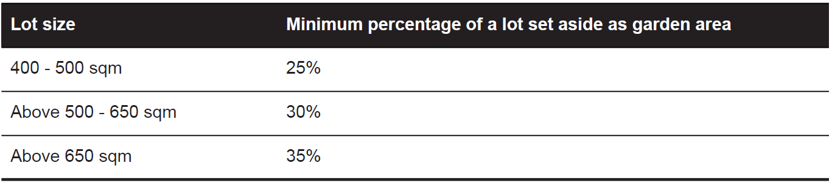
Garden Area Response:
The site has an area of approximately 660 square metres, requiring a garden area of at least 35%.
The site has been provided with exactly 35% of Garden Area. While this is met, any changes to the plans need to be carefully considered in the future to ensure garden area remains met.

Maximum Building Height

The maximum building height measures 11 metres from natural ground level to the roof or parapet at the highest point. At not more than 2 storeys and a max height of 8.3 metres, the proposal complies with the maximum building height requirements in the Zone.

OVERLAY:

No overlays affect the subject site.

Response to zone and overlay(s)

The proposal appropriately responds to the purposes of the zone, the proposed dwellings present to the street as one single built form that has been setback from both side boundaries by generous distances of 4.86 metres from the eastern boundary and 4.8 metres from the western boundary. The front setback of 2.8 metres is considered to provide an appropriate transition from the zero front setback of the commercial buildings on the eastern side and the 6.7 metre front setback of the singe dwelling to the west. The dwellings are simple in design and have a mix of materials proposed including concrete roof tiles, Colorbond roof sheeting, brick veneer and face brick. There is a mix of flat and pitched roofing to respond to the mix of development within the immediate vicinity, with materials assisting in visually articulating the façade and side elevations.

While the site is not located within an Increased Housing Diversity Area, the site is considered to have access to commercial shops including a bakery and café, a medical centre and restaurants, all within 400m of the subject site. The site has access to public transport and is located on Patullos Road which is a significant municipal road within a Transport Zone Schedule 3. There are bus stops within walking distance (400m) of the site as can be seen in the image below.

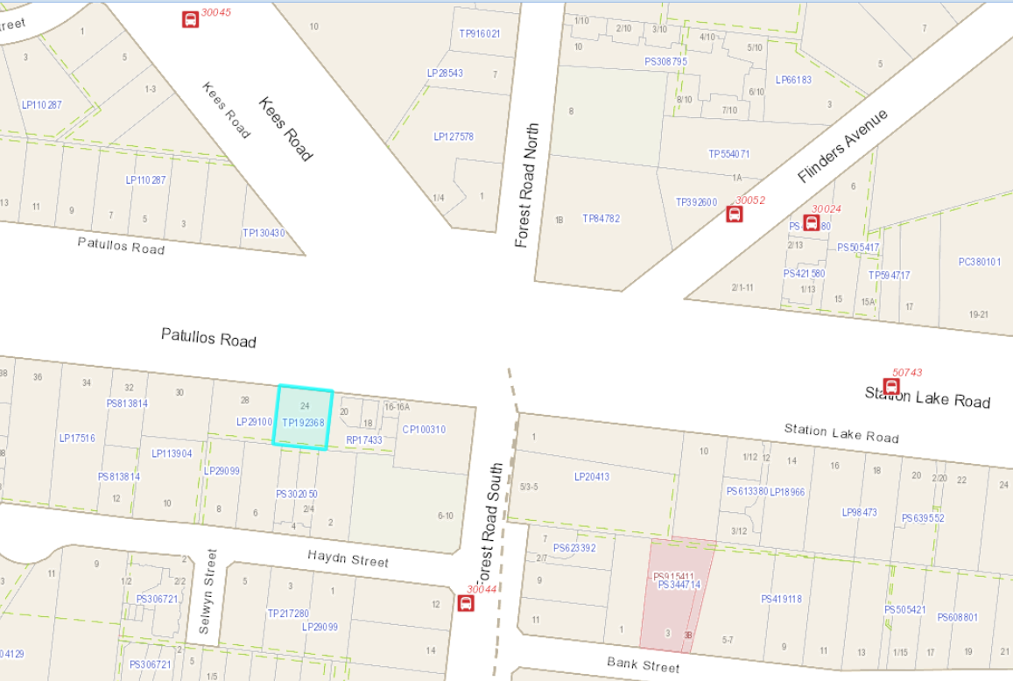
Image 6 – weave mapping image displaying locations of nearby bus stops.

CULTURAL HERITAGE MANAGEMENT PLAN (CHMP):

The Aboriginal Heritage Regulations 2018 specify the circumstances in which a cultural heritage management plan is required for an activity or class of activity. Division 2 of the Aboriginal Heritage Regulations 2018 specifies exempt activities which do not require a cultural heritage management plan. The proposal is not listed as an exempt activity.

Areas of cultural heritage sensitivity are defined within Divisions 3 and 4 of the Aboriginal Heritage Regulations 2018. Division 3 does not identify the site or part of the site as within an area of cultural heritage sensitivity. High impact activities are defined within Division 5 of the Aboriginal Heritage Regulations 2018. Division 5 lists the proposal as a high impact activity.

The site is not considered to have been the subject of significant ground disturbance which is defined as ‘disturbance of (a) the topsoil or surface rock layer of the ground or (b) a way - by machinery in the course of grading, excavating, digging, dredging or deep ripping, but does not include ploughing other than deep ripping.

In accordance with the above assessment, a cultural heritage management plan is not required.

LANDFILL GAS RISK ASSESSMENT

The subject site is not located within 500 metres of an identified former landfill site, a risk assessment is not required.

DEVELOPMENTS IN BUSHFIRE PRONE AREAS

The site is not located within a designated bushfire prone area.

PLANNING POLICY FRAMEWORK (VPPF):

The following Planning Policies are applicable to this application:
Clause 02.03-1 Settlement
Geelong is expected to grow by an additional 152,000 people by 2036 based on an average annual growth rate of 2.5 per cent. This growth will create demand for over 73,400 additional dwellings which can be met under the City's identified planned growth. While the City is keen to take advantage of Geelong’s proximity to Melbourne it is important to the community that the unique identity and character of the municipality is retained.
A combination of greenfield and infill development will deliver housing for Geelong’s growing population. Over time the share of new housing from infill is expected to increase.
The majority of greenfield housing supply will be provided in urban Geelong in the master planned communities of Armstrong Creek and the Northern and Western Geelong Growth Areas. New residential communities should incorporate sustainable living principles and deliver infrastructure to meet community needs.
Targeted infill development is supported in areas with access to infrastructure, goods and services. In order for medium and high density housing to be embraced by established communities it needs to deliver high quality design and achieve a high level of amenity for future residents while being appropriate for the site and neighbourhood.
The Bellarine Peninsula has been delivering around 27 per cent of the City’s new housing supply over the past few years. Continued housing development at this rate will have a detrimental impact on the character and values of this area.
Rural living areas offer an important lifestyle choice in the housing market. However, they can be inefficient to service and are generally contrary to the objective of maintaining a farmed rural landscape and supporting agriculture in rural areas. Farming and rural landscapes form non-urban breaks and are a critical element to the settlement strategy, tourism function and lifestyle of the region.
Lara
Lara is a township designated for urban growth and is strategically located between Geelong and Melbourne with excellent road, rail, seaport and airport links.
The rural landscape setting is important to the character of the town.
The Hovells and Serendip Creek systems have a propensity to flood and in low lying areas are putting constraints on development.
Retail and commercial expansion is required to meet the needs of local residents and to reduce the high level of escape expenditure.
There is a strong reliance on the private motor car as a form of transport and active and public transport infrastructure and services need to be improved.
The Geelong Ring Road Employment Precinct, Avalon Airport and nearby land provide significant opportunities for employment and economic growth.
Strategic Directions
- Maintain a compact urban form and provide for sustainable communities.
- Protect and enhance key environmental, cultural and landscape features, including the rural characteristics of Lara.
- Facilitate an adequate supply of residential and commercial land, community and recreation services and infrastructure.
- Facilitate an efficient and integrated movement network for all modes of transport.
Clause 02.03-5 Built Environment and Sustainability
Built Environment
Geelong’s sense of place and identity is valued by its community. Council seeks to balance growth in the municipality while maintaining its identity by identifying areas for varying levels of change and by balancing the need for conservation and renewal. Medium density housing can have a greater impact on neighbourhood character than traditional detached housing. As housing density intensifies, it is important that housing makes a positive contribution to the neighbourhood. The protection of amenity and facilitation of environmentally sustainable and healthy development that will benefit and improve the community’s quality of life is at the forefront of Council’s built environment goals.
Strategic Directions
- Ensure that development enhances Geelong’s sense of place and identity.
- Support the design and provision of healthy, walkable neighbourhoods.
- Encourage environmentally sustainable design in all development.
- Encourage all development to provide high quality urban design and landscaping.
Clause 02.03-6 Housing
To accommodate its growing population Council has identified Increased Housing Diversity Areas (IHDA). IHDAs are located around activity centres and transport hubs and have significant capacity to accommodate residential growth and increased housing diversity. These areas can provide for local shopping needs or are serviced by public transport. Development in these areas should encourage walking and discourage reliance on cars for all trips. The intensity of redevelopment will be highest around the activity centre core and lower at the edge of the IHDA.
For areas of heritage significance, new development should balance the preservation and restoration of the heritage place and other opportunities for housing.
Suburban detached family homes make up 85 per cent of current housing stock. Increasing the diversity of the City’s housing stock over time will help cater for the growing trend of smaller households, the need for affordable housing, ageing in place and low maintenance housing, and strong demand for housing in high amenity locations.
In order to meet these demands, there is a need to provide for a range of housing types in both established and developing communities.
Strategic Directions
- Facilitate infill development to increase its housing supply contribution.
- Support residential development where the density, mass and scale is complementary to the location, role and character of the specific IHDA.
- Ensure housing diversity is achieved in established and growth area communities.
- Increase the level of affordable and social housing in Greater Geelong.
Clause 11.01-1S Settlement
Strategies
Ensure regions and their settlements are planned in accordance with their relevant regional growth plan.
Guide the structure, functioning and character of each settlement taking into account municipal and regional contexts and frameworks.
Create and reinforce settlement boundaries.
Deliver networks of high-quality integrated settlements that have a strong identity and sense of place, are prosperous and are sustainable by:
- Building on strengths and capabilities of each region across Victoria to respond sustainably to population growth and changing environments.
- Developing settlements that will support resilient communities and their ability to adapt and change.
- Balancing strategic objectives to achieve improved land use and development outcomes at a regional, catchment and local level.
- Preserving and protecting features of rural land and natural resources and features to enhance their contribution to settlements and landscapes.
- Encouraging an integrated planning response between settlements in regions and in adjoining regions and states in accordance with the relevant regional growth plan.
- Providing for appropriately located supplies of residential, commercial, and industrial land across a region, sufficient to meet community needs in accordance with the relevant regional growth plan.
- Improving transport network connections in and between regional cities, towns and Melbourne.
- Integrating the management of water resources into the urban environment in a way that supports water security, public health, environment and amenity outcomes.
- Minimising exposure to natural hazards, including increased risks due to climate change.
- Contributing to net zero greenhouse gas emissions through renewable energy infrastructure and energy efficient urban layout and urban design.
Encourage a form and density of settlements that supports healthy, active and sustainable transport.
Limit urban sprawl and direct growth into existing settlements.
Promote and capitalise on opportunities for urban renewal and infill redevelopment.
Develop compact urban areas that are based around existing or planned activity centres to maximise accessibility to facilities and services.
Clause 11.01-1L-03 Lara
Strategies
Contain urban development within the defined settlement boundary shown on the Lara Structure Plan map.
Limit rural living development to existing zoned land within Lara.
Locate and integrate future education, community and recreation facilities to enhance their accessibility and to maximise joint use wherever possible.
Provide additional bicycle and pedestrian opportunities and connections throughout the township including new footpaths and bicycle lanes.
Limit the Patullos Road shopping strip to the existing Commercial 1 zoned land.
Limit industrial uses within the township to land currently zoned for industrial purposes.
Design subdivision on General Residential Zone Schedule 1 zoned land to incorporate urban design treatments that reinforce the rural characteristics of the town.
Direct the sequential development of the ‘future residential’ area west of O’Hallorans Road to proceed from east to west.
Support the rezoning of ‘future residential’ areas when rezoning is necessary to continue to achieve at least 15 years lot supply taking into consideration any infill opportunities that will not be realised in the short term.

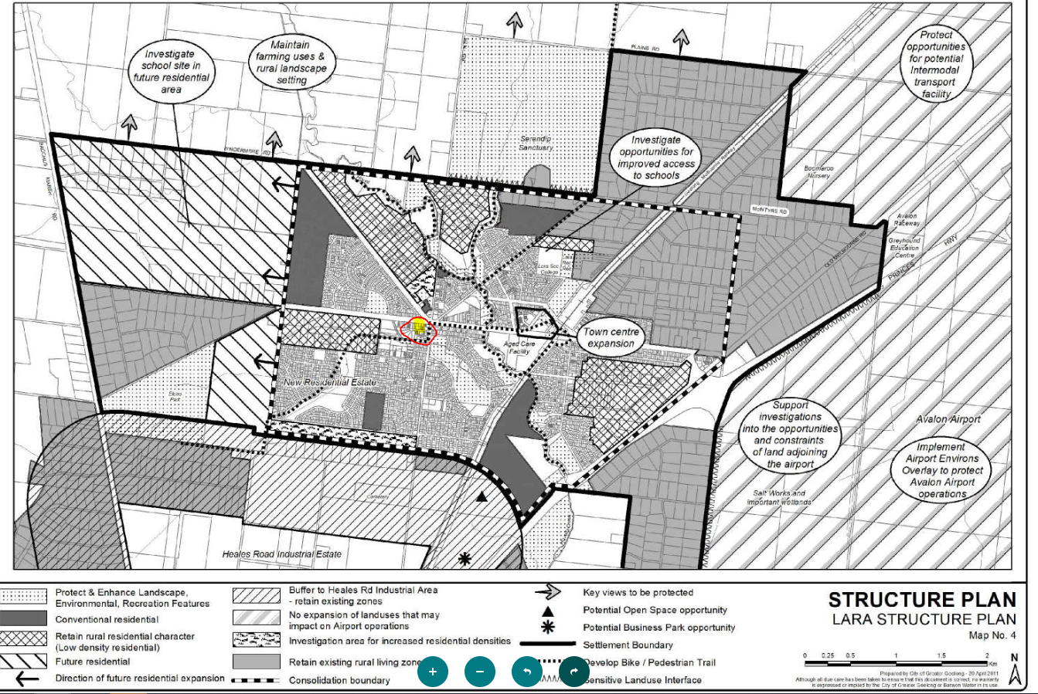
Image 7 – Lara Structure Plan Clause 11.01-1L-03

Clause 13.05-1S Noise Management

Objective
To assist the management of noise effects on sensitive land uses.

Strategy
Ensure that development is not prejudiced and community amenity and human health is not adversely impacted by noise emissions.
Minimise the impact on human health from noise exposure to occupants of sensitive land uses (residential use, child care centre, school, education centre, residential aged care centre or hospital) near the transport system and other noise emission sources through suitable building siting and design (including orientation and internal layout), urban design and land use separation techniques as appropriate to the land use functions and character of the area.
Clause 16.01-1S Housing Supply
Objective
To facilitate well-located, integrated and diverse housing that meets community needs.

Strategies
Ensure that an appropriate quantity, quality and type of housing is provided, including aged care facilities and other housing suitable for older people, supported accommodation for people with disability, rooming houses, student accommodation and social housing.
Increase the proportion of housing in designated locations in established urban areas (including under-utilised urban land) and reduce the share of new dwellings in greenfield, fringe and dispersed development areas.
Encourage higher density housing development on sites that are well located in relation to jobs, services and public transport.
Identify opportunities for increased residential densities to help consolidate urban areas.
Facilitate diverse housing that offers choice and meets changing household needs by widening housing diversity through a mix of housing types.
Encourage the development of well-designed housing that:
- Provides a high level of internal and external amenity.
- Incorporates universal design and adaptable internal dwelling design.
Support opportunities for a range of income groups to choose housing in well-serviced locations.
Plan for growth areas to provide for a mix of housing types through a variety of lot sizes, including higher housing densities in and around activity centres.
Response to Policy

The proposal appropriately responds to relevant planning policy including but not limited to the above listed policy.

Clause 02.03-1 Settlement – the proposal will provide for infill development with a site that currently provides one dwelling, is now proposed to provide for five dwellings and a total of 10 bedrooms. The proposed design has provided an acceptable level of Environmental Sustainability through its ESD design elements and associated documentation. The dwellings have each been provided with two outdoor areas of open space, one being an east facing balcony, the other being a private area within the western side of the dwellings at ground level. The dwellings have been designed in a way that attempts to achieve a balance between providing five dwellings on the land while also being set off all boundaries to respond to the immediate residential streetscape which consists of single dwellings on larger allotments with side and rear setbacks from boundaries.

The site is located in Lara which has an identified area for growth as can be seen in the Lara Structure Plan above. The subject site is not in an identified growth area in the Structure Plan and is also not located within an area of Increased Housing Diversity of Lara. The site however can provide for additional residential development as it is residentially zoned and is located on a significant Municipal Road being Patullos Road. The site is located within walking distance (within 400m) of a bakery, shops, restaurants, a service station and medical centre. The site also has access to more than 3 bus stops all within walking distance of the site.
Clause 02.03-5 Built environment and sustainability – the proposal, while high in density, has endeavored to provide a design that is simple in design with a mix of flat and pitched roofing, a mix of construction materials to provide visual articulation and has provided generous side setbacks on both sides of the dwellings. The garaging has been designed to face the eastern boundary fencing, reducing the garage visibility to Patullos Road, as garaging does not form a strong element of the streetscape. The dwellings have been designed to meet Environmental Sustainability requirements of the Greater Geelong Planning Scheme. Landscaping can be increased within the site, there are opportunities for more landscaping to be provided within the front setback in particular.

Clause 02.03-6 Housing – the proposal will provide an opportunity for smaller households with easy walking access to shops, restaurants, a medical centre and public transport. The proposal provides for a range of housing types within an established residential area of Lara, although the proposal in itself does not provide a range as each of the five dwellings are identical. The immediate streetscape and neighbourhood has lot areas ranging from 300 square metres (Haydn Street), with the neighbouring properties to the west in Patullos Road being 824 square metres, 886 square metres and 576 square metres. The proposal will result in lot sizes ranging from 79 square metres to 119 square metres, with access to common property. The dwellings have been designed to appear as one dwelling from the frontage of the site in an attempt to respond to the single dwelling per allotment that can be seen in the immediate western streetscape in Patullos Road.

Clause 11.01-1S Settlement – the proposal will provide for infill development within the Lara settlement boundary in a General Residential Zone. The proposed subdivision design has an open frontage without any fencing proposed and common property areas on both side boundaries which will limit construction in these areas. The proposed subdivision layout responds to the rural characteristics of the town.

Clause 13.05-1S Noise management – the proposed east facing balconies of the five dwellings face a commercial area which includes a bakery. Bakeries create noise from their operation from very early in the morning, therefore the Environmental Health Unit has requested conditions to be included on any planning permit issued to assist in lessening noise from the commercial area into the proposed dwellings. The applicant has suggested via email that they can enclose the eastern balconies with bi-fold doors and they can also use specific insulation to limit noise impacts to the dwellings.

Clause 16.01-1S Housing supply – the subject site is well located and will provide for a smaller housing type choice within Lara. The proposal will provide for infill development which assists in reducing the share of new dwellings in greenfield areas. The proposed dwellings provide for reasonable internal and external amenity, with ground level and first floor level areas of secluded private open space, limited areas which require maintenance, environmentally sustainable design and is located in an area that provides a number of shops, restaurants, a medical centre and bus stops.

RELEVANT PARTICULAR PROVISIONS:

The following Particular Provisions are applicable to this application:

CLAUSE 52.06 – CAR PARKING
- To ensure that car parking is provided in accordance with the State Planning Policy Framework and the Local Planning Policy Framework.
- To ensure the provision of an appropriate number of car parking spaces having regard to the demand likely to be generated, the activities on the land and the nature of the locality.
- To support sustainable transport alternatives to the motor car.
- To promotes the efficient use of car parking spaces through the consolidation of car parking facilities.
- To ensure that car parking does not adversely affect the amenity off the locality.
- To ensure that the design and location of car parking is of a high standard, creates a safe environment for users and enables easy and efficient use.

Response

In accordance with Clause 52.06 requires the provision of 6 car spaces (5 for the dwellings and 1 visitor space) are to be located on the land.
A total of 5 car spaces are provided, one for each dwelling, and the 1 required visitor space is proposed to be waived.

The applicant submitted a Traffic Report to justify the waiver in one visitor car space at the site. This report has been considered by the Engineering Traffic Unit, with the Engineering Unit being supportive of the waiver of the one visitor space. The site is proposing the construction of five dwellings, and it could be considered that not having ample space on site for a visitor space is an indication of over development of the site. However, it could also be considered that the site is located within an area that has walking distance access to bus stops, has parking for a visitor in front of the site as well as the relocated disabled parking space that needs to be moved to allow the proposed 3.5m crossover to be established. Although five dwellings are proposed, only one crossover is proposed which results in on street car parking spaces being available at the front of the site. As this section of Patullos Road has a mix of commercial uses to the east and residential to the west, it is considered that alternative visitor car parking within the immediate area is available to the north with a pedestrian crossing providing safe access to cross Patullos Road.

CLAUSE 53.01 – PUBLIC OPEN SPACE CONTRIBUTION

A person who proposes to subdivide land must make a contribution to the council for public open space in an amount specified in the schedule to this clause (being a percentage of the land intended to be used for residential, industrial or commercial purposes, or a percentage of the site value of such land, or a combination of both). If no amount is specified, a contribution for public open space may still be required under Section 18 of the Subdivision Act 1988.

Response

Pursuant to the schedule to Clause 53.01, the following contribution is required to be made:
Creation of one additional lot | None
Creation of two to nine additional lots | 1 percent per additional lot up to a maximum of 5 percent
Creation of 10 or more lots on land zoned for residential purposes prior to August 31st 2007 | 5 percent
Creation of 10 or more lots on land zoned for residential purposes after August 31st 2007 | 10 percent
Waurn Ponds Creek Environs | 10 percent

Pursuant to the above table a 4 percent contribution is required to be made. A condition of permit requires a cash contribution to be made.

CLAUSE 55 - RESCODE ASSESSMENT – TWO OR MORE DWELLINGS ON A LOT

The application has been assessed against the objectives and standards of Clause 55 of the Planning Scheme.

The following are variations to Standards which are considered satisfactory:

Clause 55.03-1 Standard B6 Street setback

The adjoining properties are setback 0 metres and 6.7 metres, which results in a requirement for a 3.35 metre street setback.
The front setback proposed is 3 metres which is a proposed variation of 0.350mm.
The front setback has the ground floor of proposed dwelling 1 setback a distance of 3m and the upper level setback a distance of 2.6m. the first floor cantilevers over the top of the ground floor on the front or north elevation.
Given the site sits between a zero setback commercial development and zoning and a residential zone and single dwelling, the proposed variation is considered to be an acceptable setback to provide a graduation between the two abutting sites.

Clause 55.03-5 Standard B10 Energy efficiency

Dwelling 1 is the only dwelling containing a north facing window – one to the bedroom at ground floor, and one to the bedroom, meals/kitchen area and one to the lounge room at the upper level.
Dwellings 2 to 5 have no north facing windows. Each of these dwellings have east facing balconies at the upper level.
Each of the dwellings have west facing ground floor court yard areas opening out from bedrooms.
Given the orientation of the land the proposed design of the proposal is considered to be reasonable, however sky lights will be required to be included within the roofs over the living areas for dwellings 2 to 5 to allow additional natural light into the buildings.

Clause 55.03-7 Standard B12 Safety

The entry to each of the five dwellings are not highly visible. The entries are all located up a pedestrian walkway and are hidden behind the fenced areas of private open space. Security lighting and semi permeable fencing of the private open space areas are required to be provided and a security gate to the entry of the walkway into the site.

Clause 55.04-1 Standard B17 Side and rear setbacks

The informal plans submitted display the rear wall setback meeting the standard. This will be confirmed through the inclusion of the compliant setback to form part of an amended plans condition.

Clause 55.04-6 Standard B22 Overlooking
Given each of the five dwellings have a large west facing bedroom window and no sectional diagrams provided demonstrating that a view will be blocked by the western boundary fence – screening is required to be proposed to all of the windows, not just the last three dwellings. The dwelling to the west has a large glass sliding door that opens to their living area and one of their outdoor areas of private open space. This property requires privacy from the 5 proposed dwellings which all have an outlook over the neighbouring western property.

Screening is also required to the deck of Dwelling 5 to ensure overlooking does not occur from the upper floor deck into the southern residential properties. As the objectors to the south of the site have concerns about a non-solid screen, a solid screen will be required on the southern side of the dwelling 5 balcony and it will be required to extend out to the east to a distance to restrict views to the south and south east with a demonstrated diagram as an amended plans condition.

Clause 55.04-8 Standard B24 Noise impacts
The site abuts a commercial area which includes a balcony, therefore the balconies through the provision of bi-fold doors and insulation and the double glazing of any east facing windows should appropriately treat the proposed dwellings for noise reduction.

Clause 55.05-1 Standard B25 Accessibility
The entries to the ground floor of the dwellings are not accessible to those with limited mobility currently as steps are proposed to each entry. Ramps could be provided if required, however the grades would need to be considered in relation to the common property walkway.

Clause 55.05-2 Standard B26 Dwelling entry
As discussed at Standard B12 for safety, the entry to each of the five dwellings are not highly visible. The entries are all located up a pedestrian walkway and are hidden behind the fenced areas of private open space. Security lighting and semi permeable fencing of the private open space area fencing are required to be provided and a security gate to the entry of the walkway into the site.

Clause 55.05-6 Standard B30 Storage
As 6 cubic metres of storage has been provided within each garage, other than dwelling 5 which only has 4.23 cubic metres provided in the garage, the sheds on the western boundary are not required and should be deleted from the plans. This will result in landscaping being provided in these areas. An amended plans condition will be included to add an amount to achieve a total of 6 cubic metres of storage to dwelling five under the staircase, and a condition to remove all sheds from the western boundary and for landscaping to be included in its place.

CLAUSE 56 – SUBDIVISION

This is an application to subdivide the dwellings such that the dwellings will exist on separate titles. In this case there is no need to assess the application against the provisions of Clause 56 as issues in relation to amenity, both on and off site, have been considered via the Clause 55 assessment, as has neighbourhood character.

A condition of permit ties the subdivision and development via a Section 173 Agreement so that an orderly planning outcome is achieved.

DECISION GUIDELINES OF CLAUSE 65:

CLAUSE 65.01 – APPROVAL OF AN APPLICATION OR PLAN

Clause 65.01 of the Greater Geelong Planning Scheme outlines the decision guidelines to be considered by the Responsible Authority when making decisions on applications. These decision guidelines include:
- The matters set out in Section 60 of the Act.
- The Municipal Planning Strategy and the Planning Policy Framework.
- The purpose of the zone, overlay or other provision.
- Any matter required to be considered in the zone, overlay or other provision.
- The orderly planning of the area.
- The effect on the environment, human health and amenity of the area
- The proximity of the land to any public land.
- Factors likely to cause or contribute to land degradation, salinity or reduce water quality.
- Whether the proposed development is designed to maintain or improve the quality of stormwater within and exiting the site.
- The extent and character of native vegetation and the likelihood of its destruction.
- Whether native vegetation is to be or can be protected, planted or allowed to regenerate.
- The degree of flood, erosion or fire hazard associated with the location of the
- land and the use, development or management of the land so as to minimise any such hazard.
- The adequacy of loading and unloading facilities and any associated amenity, traffic flow and road safety impacts.

Response

The proposal satisfactorily responds to the Decision Guidelines at Clause 65.01. The proposed five dwellings and five lot subdivision will occur on residentially zoned land with walking distance access to shops, bus stops and a medical centre. The proposal provides for infill development within an established area of Lara and although not within an area of Increased Housing Diversity, planning policy supports infill development within established areas. Amenity impacts on the proposal from the neighbouring bakery within the commercial zone will be considered through amended plans conditions to be included on any planning permit issued. There are no flooding overlays to be considered by the planning scheme and waste will be collected via standard Council waste collection.

CLAUSE 65.02 – SUBDIVISION

Clause 65.02 of the Greater Geelong Planning Scheme outlines the decision guidelines to be considered by the Responsible Authority when making decisions on an application to subdivide land. These decision guidelines include:
- The suitability of the land for subdivision
- The existing use and possible future development the land and nearby land
- The availability of subdivided land in the locality, and the need for the creation of further lots
- The effect of development on the use or development of other land which has a common means of drainage
- The subdivision pattern having regard to the physical characteristics of the land including existing vegetation
- The density of the proposed development
- The area and dimensions of each lost in the subdivision
- The layout of roads having regard to their function and relationship to existing roads
- The movement of pedestrians and vehicles throughout the subdivision and the ease of access to all lots
- The provision and location of reserves for public open space and other community facilities
- The staging of the subdivision
- The design and siting of buildings having regard to safety and the risk of spread of fire
- The provision of off street parking
- The provision and location of common property
- The functions of a body corporate
- The availability and provision of utility services, including water, sewerage, drainage, electricity and gas
- If the land is not sewered and no provision has been made for the land to be sewered, the capacity of the land to treat and retain all sewage and sullage within the boundaries of each lot
- Whether, in relation to subdivision patterns, native vegetation can be protected through subdivision and siting of open space areas.

Response

The subject site is appropriate for residential subdivision, it has connections to services, has access to a significant municipal road and will provide five dwellings in place of one dwelling at a location that has good access to shops, bus stops and a medical centre.

The commercial zoned land to the east will not be further increased as is outlined in the Lara policy.

The residential land to the west consists of large allotments with single dwellings. There is potential for this land to be developed further in the future with infill development.

There is not an abundance of vacant residential allotments within the immediate established residential area.

The density of the subdivision proposed is much higher than surrounding the site, with lot areas being less than 100 square metres, these lots follow the proposed development of five small dwellings each containing two bedrooms.

The proposed subdivision is not staged. Two on street car parking spaces can be provided in front of the site, one being a relocated disabled space and a second being a standard vehicle space.

The common property proposed is a shared accessway on the east and a pedestrian shared entry path to each of the five dwellings and is considered to be easily managed.

CONCLUSION:

That the Responsible Authority having considered all matters which the Planning and Environment Act 1987, requires it to consider decides to issue a Notice of Decision for the Construction of Five Dwellings, Five Lot Subdivision, and the Waiver of One Visitor Car Parking Space at 24 Patullos Road, LARA, generally in accordance with the plans and documentation submitted with the application subject to conditions.

Appendix 1

CLAUSE 55 ASSESSMENT TOOL – TWO OR MORE DWELLINGS ON A LOT AND RESIDENTIAL BUILDINGS

Plans Assessed: Amended Plans submitted 16 June 2023
Permit Application Number: PP-158-2023

The following objectives apply to an application to:
- Construct a dwelling if there is at least one dwelling existing on the lot,
- Construct two or more dwellings on a lot,
- Extend a dwelling if there are two or more dwellings on the lot,
- Construct or extend a dwelling on common property, or
- Construct or extend a residential building,

in the General Residential Zone.

55.02-1 Neighbourhood character objectives  To ensure that the design respects the existing neighbourhood character or contributes to a preferred neighbourhood character.  To ensure that development responds to the features of the site and the surrounding area. | Standard B1  The design response must be appropriate to the neighbourhood and the site.  The proposed design must respect the existing or preferred neighbourhood character and respond to the features of the site. | Yes – Complies with Standard B1  The development responds to the character of the area by proposing one dwelling to front the street, having side setbacks to both side boundaries. The site has commercially zoned land and development abutting to the east and established residential development of single dwellings on generous allotments to the west.
55.02-2 Residential policy objectives  To ensure that residential development is provided in accordance with any policy for housing in the Municipal Planning Strategy and the Planning Policy Framework.  To support medium densities in areas where development can take advantage of public transport and community infrastructure and services. | Standard B2  An application must be accompanied by a written statement to the satisfaction of the responsible authority that describes how the development is consistent with any relevant policy for housing in the Municipal Planning Strategy and the Planning Policy Framework. | Yes – Complies with Standard B2  As set out above, the application complies with the planning policy framework. The required written statement has been provided.
55.02-3 Dwelling diversity objective  To encourage a range of dwelling sizes and types in developments of ten or more dwellings. | Standard B3  Developments of ten or more dwellings should provide a range of dwelling sizes and types, including:  - Dwellings with a different number of bedrooms.  - At least one dwelling that contains a kitchen, bath or shower, and a toilet and wash basin at ground floor level. | Not Applicable  Fewer than ten dwellings are proposed.
55.02-4 Infrastructure objectives  To ensure development is provided with appropriate utility services and infrastructure.  To ensure development does not unreasonably overload the capacity of utility services and infrastructure. | Standard B4  Development should be connected to reticulated services, including reticulated sewerage, drainage, electricity and gas, if available.  Development should not unreasonably exceed the capacity of utility services and infrastructure, including reticulated services and roads.  In areas where utility services or infrastructure have little or no spare capacity, developments should provide for the upgrading of or mitigation of the impact on services or infrastructure. | Yes – Complies with Standard B4  The site is serviced by the required infrastructure and the application has been referred to Council’s Engineers who have not raised any concern about the ability of the site to be drained. Conditions of permit cover off on this issue.
55.02-5 Integration with the street objective  To integrate the layout of development with the street. | Standard B5  Developments should provide adequate vehicle and pedestrian links that maintain or enhance local accessibility.  Development should be oriented to front existing and proposed streets.  High fencing in front of dwellings should be avoided if practicable.  Development next to existing public open space should be laid out to complement the open space. | Yes – Complies with Standard B5  The development is designed to address Patullos Road, with pedestrian and vehicle links to the street provided.  There is no high front fencing proposed for this development.
55.03-1 Street setback objective  To ensure that the setbacks of buildings from a street respect the existing or preferred neighbourhood character and make efficient use of the site. | Standard B6  Walls of buildings should be set back from streets:  - At least the distance specified in a schedule to the zone, or  - If no distance is specified in a schedule to the zone, the distance specified in Table B1.  Porches, pergolas and verandahs that are less than 3.6 metres high and eaves may encroach not more than 2.5 metres into the setbacks of this standard. | Yes – Complies with Variation to Standard B6  The adjoining properties are setback 0 metres and 6.7 metres, which results in a requirement for a 3.35 metre street setback.  The front setback proposed is 3 metres which is a proposed variation of 0.35m.  The front setback has the ground floor of proposed dwelling 1 setback a distance of 3m and the upper level setback a distance of 2.6m. the first floor cantilevers over the top of the ground floor on the front or north elevation.  Given the site sits between a zero setback commercial development and zoning and a residential zone and single dwelling, the proposed variation is considered to be an acceptable setback to provide a graduation between the two abutting sites.
55.03-2 Building height objective  To ensure that the height of buildings respects the existing or preferred neighbourhood character. | Standard B7  The maximum building height should not exceed the maximum height specified in the zone, schedule to the zone or an overlay that applies to the land.  If no maximum height is specified in the zone, schedule to the zone or an overlay, the maximum building height should not exceed 9 metres, unless the slope of the natural ground level at any cross section wider than 8 metres of the site of the building is 2.5 degrees or more, in which case the maximum building height should not exceed 10 metres.  Changes of building height between existing buildings and new buildings should be graduated. | Yes – Complies with variation to Standard B7  The maximum building height applicable to the site is 11 metres and 3 storeys at any point (excluding a basement). The proposed maximum building height of 8.4 metres (to the top of the pitch of dwelling 1) meets the mandatory building height requirement of the General Residential Zone Schedule 1.  The dwellings are all two storey in height with a setback area on the western side of the development which provides for spacing between the single storey dwelling to the west of the site and double storey where the site sits adjacent to the commercial zone. While the development on the commercial side is single storey, there is also a setback between the eastern side of the development to create a visual break between the single storey commercial development.
55.03-3 Site coverage objective  To ensure that the site coverage respects the existing or preferred neighbourhood character and responds to the features of the site. | Standard B8  The site area covered by buildings should not exceed:  - The maximum site coverage specified in a schedule to the zone, or  - If no maximum site coverage is specified in a schedule to the zone, 60 per cent. | Yes – Complies with Standard B8  The maximum site coverage specified for this site is 60 percent.  The proposed site coverage of buildings is 50.41 percent of the site, which is less than the maximum allowed by the standard.
55.03-4 Permeability and stormwater management objectives  To reduce the impact of increased stormwater run-off on the drainage system.  To facilitate on-site stormwater infiltration.  To encourage stormwater management that maximises the retention and reuse of stormwater. | Standard B9  The site area covered by the pervious surfaces should be at least:  - The minimum area specified in a schedule to the zone, or  - If no minimum is specified in a schedule to the zone, 20 percent of the site.  The stormwater management system should be designed to:  - Meet the current best practice performance objectives for stormwater quality as contained in the Urban Stormwater - Best Practice Environmental Management Guidelines (Victorian Stormwater Committee, 1999).  - Contribute to cooling, improving local habitat and providing attractive and enjoyable spaces. | Yes – Complies with Standard B9  The site retains 34.28 per cent permeability, assisting in on site stormwater filtration.  A STORM report has been provided which corresponds with the assessment plans which show suitably sized rainwater tanks.
55.03-5 Energy efficiency objectives  To achieve and protect energy efficient dwellings and residential buildings.  To ensure the orientation and layout of development reduce fossil fuel energy use and make appropriate use of daylight and solar energy.  This objective does not apply:  - To construct or extend an apartment development, or  - To construct or extend a dwelling in or forming part of an apartment development. | Standard B10  Buildings should be:  - Oriented to make appropriate use of solar energy.  - Sited and designed to ensure that the energy efficiency of existing dwellings on adjoining lots is not unreasonably reduced.  - Sited and designed to ensure that the performance of existing rooftop solar energy systems on dwellings on adjoining lots in a General Residential Zone, Neighbourhood Residential Zone or Township Zone are not unreasonably reduced. The existing rooftop solar energy system must exist at the date the application is lodged.  Living areas and private open space should be located on the north side of the development, if practicable.  Developments should be designed so that solar access to north-facing windows is maximised. | Variation with Standard B10 – with skylights added through amended plans condition.  Dwelling 1 is the only dwelling containing a north facing window – one to the bedroom at ground floor, and one to the bedroom, meals/kitchen area and one to the lounge room at the upper level.  Dwellings 2 to 5 have no north facing windows. Each of these dwellings have east facing balconies at the upper level.  Each of the dwellings have west facing ground floor court yard areas opening out from bedrooms.  Given the orientation of the land the proposed design of the proposal is considered to be reasonable, however sky lights will be required to be included within the roofs over the living areas for dwellings 2 to 5 to allow additional natural light into the buildings.
55.03-6 Open space objective  To integrate the layout of development with any public and communal open space provided in or adjacent to the development.  This objective does not apply:  - To construct or extend an apartment development, or  - To construct or extend a dwelling in or forming part of an apartment development. | Standard B11  If any public or communal open space is provided on site, it should:  - Be substantially fronted by dwellings, where appropriate.  - Provide outlook for as many dwellings as practicable.  - Be designed to protect any natural features on the site.  - Be accessible and useable. | Not Applicable  No public or communal open space is proposed as part of this application.
55.03-7 Safety objective  To ensure the layout of development provides for the safety and security of residents and property. | Standard B12  Entrances to dwellings and residential buildings should not be obscured or isolated from the street and internal accessways.  Planting which creates unsafe spaces along streets and accessways should be avoided.  Developments should be designed to provide good lighting, visibility and surveillance of car parks and internal accessways.  Private spaces within developments should be protected from inappropriate use as public thoroughfares. | Yes – Complies with condition Standard B12  The entry to each of the five dwellings are not highly visible. The entries are all located up a pedestrian walkway and are hidden behind the fenced areas of private open space. Security lighting and semi permeable fencing of the private open space areas are required to be provided and a security gate to the entry of the walkway into the site.
55.03-8 Landscaping objectives  To encourage development that respects the landscape character of the neighbourhood.  To encourage development that maintains and enhances habitat for plants and animals in locations of habitat importance.  To provide appropriate landscaping.  To encourage the retention of mature vegetation on the site.  This objective does not apply:  - To construct or extend an apartment development, or  - To construct or extend a dwelling in or forming part of an apartment development. | Standard B13  The landscape layout and design should:  - Protect any predominant landscape features of the neighbourhood.  - Take into account the soil type and drainage patterns of the site.  - Allow for intended vegetation growth and structural protection of buildings.  - In locations of habitat importance, maintain existing habitat and provide for new habitat for plants and animals.  - Provide a safe, attractive and functional environment for residents.  Development should provide for the retention or planting of trees, where these are part of the character of the neighbourhood.  Development should provide for the replacement of any significant trees that have been removed in the 12 months prior to the application being made.  The landscape design should specify landscape themes, vegetation (location and species), paving and lighting.  Development should meet any additional landscape requirements specified in a schedule to the zone. | Yes – Complies with condition Standard B13  There are adequate areas available on site to allow for planting which will complement the landscape character of the area.  Were a permit to be granted, it is recommended that amended plans include submission of a detailed landscape plan.
55.03-9 Access objective  To ensure the number and design of vehicle crossovers respects the neighbourhood character. | Standard B14  The width of accessways or car spaces should not exceed:  - 33 per cent of the street frontage, or  - if the width of the street frontage is less than 20 metres, 40 per cent of the street frontage.  No more than one single-width crossover should be provided for each dwelling fronting a street.  The location of crossovers should maximise the retention of on-street car parking spaces.  The number of access points to a road in a Transport Zone 2 or a Transport Zone 3 should be minimised.  Developments must provide for access for service, emergency and delivery vehicles. | Complies –Standard B14  Only one 3.5m crossover is proposed so this meets the standard.
55.03-10 Parking location objective  To provide convenient parking for resident and visitor vehicles.  To protect residents from vehicular noise within developments. | Standard B15  Car parking facilities should:  - Be reasonably close and convenient to dwellings and residential buildings.  - Be secure.  - Be well ventilated if enclosed.  Shared accessways or car parks of other dwellings and residential buildings should be located at least 1.5 metres from the windows of habitable rooms. This setback may be reduced to 1 metre where there is a fence at least 1.5 metres high or where window sills are at least 1.4 metres above the accessway. | Complies  Convenient parking is provided for residents and shared accessways are located at least 1.5 metres from the windows of habitable rooms.
55.04-1 Side and rear setbacks objective  To ensure that the height and setback of a building from a boundary respects the existing or preferred neighbourhood character and limits the impact on the amenity of existing dwellings. | Standard B17  A new building not on or within 200mm of a boundary should be set back from side or rear  boundaries:  - At least the distance specified in a schedule to the zone, or  - If no distance is specified in a schedule to the zone, 1 metre, plus 0.3 metres for every metre of height over 3.6 metres up to 6.9 metres, plus 1 metre for every metre of height over 6.9 metres.  Sunblinds, verandahs, porches, eaves, fascias, gutters, masonry chimneys, flues, pipes, domestic fuel or water tanks, and heating or cooling equipment or other services may encroach not more than 0.5 metres into the setbacks of this standard.  Landings having an area of not more than 2 square metres and less than 1 metre high, stairways, ramps, pergolas, shade sails and carports may encroach into the setbacks of this standard. | Complies with Standard B17 – setback displayed on informal plans to be confirmed through amended plans condition.  Generally the required setbacks have been achieved for the development and all side and rear setbacks comply with the formula contained in the standard.  The informal plans submitted display the rear wall setback meeting the standard. This will be confirmed through the inclusion of the compliant setback to form part of an amended plans condition.
55.04-2 Walls on boundaries objective  To ensure that the location, length and height of a wall on a boundary respects the existing or preferred neighbourhood character and limits the impact on the amenity of existing dwellings. | Standard B18  A new wall constructed on or within 200mm of a side or rear boundary of a lot or a carport constructed on or within 1 metre of a side or rear boundary of lot should not abut the boundary:  - For a length of more than the distance specified in a schedule to the zone; or  - If no distance is specified in a schedule to the zone, for a length of more than:  - 10 metres plus 25 per cent of the remaining length of the boundary of an adjoining lot, or  - Where there are existing or simultaneously constructed walls or carports abutting the boundary on an abutting lot, the length of the existing or simultaneously constructed walls or carports,  whichever is the greater.  A new wall or carport may fully abut a side or rear boundary where slope and retaining walls or fences would result in the effective height of the wall or carport being less than 2 metres on the abutting property boundary.  A building on a boundary includes a building set back up to 200mm from a boundary.  The height of a new wall constructed on or within 200mm of a side or rear boundary or a carport constructed on or within 1 metre of a side or rear boundary should not exceed an average of 3.2 metres with no part higher than 3.6 metres unless abutting a higher existing or simultaneously constructed wall. | N/A  No walls are proposed on boundaries.
55.04-3 Daylight to windows objective  To allow adequate daylight into existing habitable room windows. | Standard B19  Buildings opposite an existing habitable room window should provide for a light court to the existing window that has a minimum area of 3 square metres and minimum dimension of 1 metre clear to the sky. The calculation of the area may include land on the abutting lot.  Walls or carports more than 3 metres in height opposite an existing habitable room window should be set back from the window at least 50 per cent of the height of the new wall if the wall is within a 55 degree arc from the centre of the existing window. The arc may be swung to within 35 degrees of the plane of the wall containing the existing window.  Where the existing window is above ground floor level, the wall height is measured from the floor level of the room containing the window. | Yes – Complies with Standard B19  The required light courts have been achieved and all windows have access to the required level of daylight.  The existing dwelling to the west of the site is setback a distance greater than 3 metres.
55.04-4 North facing windows objective  To allow adequate solar access to existing north-facing habitable room windows. | Standard B20  If a north-facing habitable room window of an existing dwelling is within 3 metres of a boundary on an abutting lot, a building should be setback from the boundary 1 metre, plus 0.6 metres for every metre of height over 3.6 metres up to 6.9 metres, plus 1 metre for every metre of height over 6.9 metres, for a distance of 3 metres from the edge of each side of the window. A north-facing window is a window with an axis perpendicular to its surface oriented north 20 degrees west to north 30 degrees east. | Complies  There are no north facing habitable room windows on abutting lots that are within close proximity to the subject site.
55.04-5 Overshadowing open space objective  To ensure buildings do not significantly overshadow existing secluded private open space. | Standard B21  Where sunlight to the secluded private open space of an existing dwelling is reduced, at least 75 per cent, or 40 square metres with minimum dimension of 3 metres, whichever is the lesser area, of the secluded private open space should receive a minimum of five hours of sunlight between 9 am and 3 pm on 22 September.  If existing sunlight to the secluded private open space of an existing dwelling is less than the requirements of this standard, the amount of sunlight should not be further reduced. | Yes – Complies with Standard B21 –  The extent of overshadowing associated with the proposed development is within the requirements of the standard.
55.04-6 Overlooking objective  To limit views into existing secluded private open space and habitable room windows. | Standard B22  A habitable room window, balcony, terrace, deck or patio should be located and designed to avoid direct views into the secluded private open space of an existing dwelling within a horizontal distance of 9 metres (measured at ground level) of the window, balcony, terrace, deck or patio. Views should be measured within a 45 degree angle from the plane of the window or perimeter of the balcony, terrace, deck or patio, and from a height of 1.7 metres above floor level.  A habitable room window, balcony, terrace, deck or patio with a direct view into a habitable room window of existing dwelling within a horizontal distance of 9 metres (measured at ground level) of the window, balcony, terrace, deck or patio should be either:  - Offset a minimum of 1.5 metres from the edge of one window to the edge of the other.  - Have sill heights of at least 1.7 metres above floor level.  - Have fixed, obscure glazing in any part of the window below 1.7 metre above floor level.  - Have permanently fixed external screens to at least 1.7 metres above floor level and be no more than 25 per cent transparent.  Obscure glazing in any part of the window below 1.7 metres above floor level may be openable provided that there are no direct views as specified in this standard.  Screens used to obscure a view should be:  - Perforated panels or trellis with a maximum of 25 per cent openings or solid translucent panels.  - Permanent, fixed and durable.  - Designed and coloured to blend in with the development.  This standard does not apply to a new habitable room window, balcony, terrace, deck or patio which faces a property boundary where there is a visual barrier at least 1.8 metres high and the floor level of the habitable room, balcony, terrace, deck or patio is less than 0.8 metres above ground level at the boundary. | Complies with amended plans condition for Standard B22  The development is designed to meet the requirements of the standard with overlooking into existing secluded private open space areas and habitable room windows limited in accordance with the standard.  Given each of the five dwellings have a large west facing bedroom window and no sectional diagrams provided demonstrating that a view will be blocked by the western boundary fence – screening is required to be proposed to all of the windows, not just the last three dwellings. The dwelling to the west has a large glass sliding door that opens to their living area and one of their outdoor areas of private open space. This property requires privacy from the 5 proposed dwellings which all have an outlook over the neighbouring western property.  .  Screening is also required to the deck of Dwelling 5 to ensure overlooking does not occur from the upper floor deck into the southern residential properties. As the objectors to the south of the site have concerns about a non-solid screen, a solid screen will be required on the southern side of the dwelling 5 balcony and it will be required to extend out to the east to a distance to restrict views to the south and south east with a demonstrated diagram as an amended plans condition.
55.04-7 Internal views objective  To limit views into the secluded private open space and habitable room windows of dwellings and residential buildings within a development. | Standard B23  Windows and balconies should be designed to prevent overlooking of more than 50 per cent of the secluded private open space of a lower-level dwelling or residential building directly below and within the same development. | Yes – Complies with Standard B23  Internal views have been considered in the design solution and there is no internal overlooking.
55.04-8 Noise impacts objective  To contain noise sources in developments that may affect existing dwellings.  To protect residents from external noise  This objective does not apply:  - To construct or extend an apartment development, or  - To construct or extend a dwelling in or forming part of an apartment development. | Standard B24  Noise sources, such as mechanical plant, should not be located near bedrooms of immediately adjacent existing dwellings.  Noise sensitive rooms and secluded private open spaces of new dwellings and residential buildings should take account of noise sources on immediately adjacent properties.  Dwellings and residential buildings close to busy roads, railway lines or industry should be designed to limit noise levels in habitable rooms. | Yes – Complies with Standard B24 – with condition  The site abuts a commercial area which includes a balcony, therefore the balconies through the provision of bi-fold doors and insulation and the double glazing of any east facing windows should appropriately treat the proposed dwellings for noise reduction.
55.05-1 Accessibility objective  To encourage the consideration of the needs of people with limited mobility in the design of developments.  This objective does not apply:  - To construct or extend an apartment development, or  - To construct or extend a dwelling in or forming part of an apartment development. | Standard B25  The dwelling entries of the ground floor of dwellings and residential buildings should be accessible or able to be easily made accessible to people with limited mobility. | Variation to Standard B25  The entries to the ground floor of the dwellings are not accessible to those with limited mobility currently as steps are proposed to each entry.  Ramps could be provided if required, however the grades would need to be considered in relation to the common property walkway.
55.05-2 Dwelling entry objective  To provide each dwelling or residential building with its own sense of identity.  This objective does not apply:  - To construct or extend an apartment development, or  - To construct or extend a dwelling in or forming part of an apartment development. | Standard B26  Entries to dwellings and residential buildings should:  - Be visible and easily identifiable from streets and other public areas.  - Provide shelter, a sense of personal address and a transitional space around the entry. | Complies with amended plans condition for Standard B26  As discussed at Standard B12 for safety, the entry to each of the five dwellings are not highly visible. The entries are all located up a pedestrian walkway and are hidden behind the fenced areas of private open space. Security lighting and semi permeable fencing of the private open space areas are required to be provided and a security gate to the entry of the walkway into the site.
55.05-3 Daylight to new windows objective  To allow adequate daylight into new habitable room windows. | Standard B27  A window in a habitable room should be located to face:  - An outdoor space clear to the sky or a light court with a minimum area of 3 square metres and minimum dimension of 1 metre clear to the sky, not including land on an abutting lot, or  - A verandah provided it is open for at least one third of its perimeter, or  - A carport provided it has two or more open sides and is open for at least one third of its perimeter. | Yes – Complies with Standard B27  All habitable room windows face an outdoor space of the required dimensions, allowing light into habitable rooms.
55.05-4 Private open space objective  To provide adequate private open space for the reasonable recreation and service needs of residents. | Standard B28  A dwelling or residential building should have private open space of an area and dimensions specified in the schedule to the zone.  If no area or dimensions are specified in the schedule to the zone, a dwelling or residential building should have private open space consisting of:  - An area of 40 square metres, with one part of the private open space to consist of secluded private open space at the side or rear of the dwelling or residential building with a minimum area of 25 square metres, a minimum dimension of 3 metres and convenient access from a living room, or  - A balcony of 8 square metres with a minimum width of 1.6 metres and convenient access from a living room, or  - A roof-top area of 10 square metres with a minimum width of 2 metres and convenient access from a living room. | Yes – Complies with Standard B28  The schedule 1 to the General Residential Zone requires either balcony 8 sqm min width 1.6m OR 40 total square metres with minimum 25m2 with minimum dimension 3m.  All dwellings have an east facing balcony coming off the lounge room at the upper level with minimum dimension of 2m and area of 8sqm and each dwelling has a west facing ground floor outdoor area of 8 square metres but they open off a bedroom.
55.05-5 Solar Access to Open Space  To allow solar access into the secluded private open space of new dwellings and residential buildings. | Standard B29  The private open space should be located on the north side of the dwelling or residential building, if appropriate.  The southern boundary of secluded private open space should be set back from any wall on the north of the space at least (2+0.9h) metres, where ‘h’ is the height of the wall. | Yes – Complies with Standard B29  All proposed secluded private open space areas – formally being the upper floor deck to each dwelling on the eastern side, receives adequate solar access and complies with the setback requirement of the standard.
55.05-6 Storage objective  To provide adequate storage facilities for each dwelling.  This objective does not apply:  - To construct or extend an apartment development, or  - To construct or extend a dwelling in or forming part of an apartment development. | Standard B30  Each dwelling should have convenient access to at least 6 cubic metres of externally accessible, secure storage space. | Yes – Complies with Standard B30 with amended plans  As 6 cubic metres of storage has been provided within each garage, other than dwelling 5 which only has 4.23 cubic metres provided in the garage, the sheds on the western boundary are not required and should be deleted from the plans. This will result in landscaping being provided in these areas. An amended plans condition will be included to add an amount to achieve a total of 6 cubic metres of storage to dwelling five under the staircase, and a condition to remove all sheds from the western boundary and for landscaping to be included in its place.
55.06-1 Design Detail  To encourage design detail that respects the existing or preferred neighbourhood character. | Standard B31  The design of buildings, including:  - Façade articulation and detailing,  - Window and door proportions,  - Roof form, and  - Verandahs, eaves and parapets,  - should respect the existing or preferred neighbourhood character.  Garages and carports should be visually compatible with the development and the existing or preferred neighbourhood character. | Yes – Complies with Standard B31  The proposed development is considered to respect the evolving neighbourhood character through the appropriate use and design of façade simple articulation and detailing, window and door proportions, roof forms, and verandahs, eaves and parapets.  The garages are not incorporated into the facades but located on the eastern side of the development, which is considered visually compatible with the development and the existing neighbourhood character, as garage do not form a strong element of the streetscape.
55.06-2 Front Fences  To encourage front fence design that respects the existing or preferred neighbourhood character | Standard B32  The design of front fences should complement the design of the dwelling or residential building and any front fences on adjoining properties.  A front fence within 3 metres of a street should not exceed:  - The maximum height specified in a schedule to the zone, or  - If no maximum height is specified in a schedule to the zone, the maximum height specified in Table B3. | Not Applicable  No front fence is proposed as part of this permit application.
55.06-3 Common Property  To ensure that communal open space, car parking, access areas and site facilities are practical, attractive and easily maintained.  To avoid future management difficulties in areas of common ownership. | Standard B33  Development should clearly delineate public, communal and private areas.  Common property, where provided, should be functional and capable of efficient management. | Yes - Complies  Communal and common property areas are considered to be easily accessible and main table and functional.
55.06-4 Site Services  To ensure that site services can be installed and easily maintained.  To ensure that site facilities are accessible, adequate and attractive. | Standard B34  The design and layout of dwellings and residential buildings should provide sufficient space (including easements where required) and facilities for services to be installed and maintained efficiently and economically.  Bin and recycling enclosures, mailboxes and other site facilities should be adequate in size, durable, waterproof and blend in with the development.  Bin and recycling enclosures should be located for convenient access by residents.  Mailboxes should be provided and located for convenient access as required by Australia Post. | Yes – Complies with Standard B34  The dwelling layout and design provides for sufficient space and facilities for services to be installed and maintained. Bin and recycling enclosures, mailboxes, clotheslines, and other site facilities have been conveniently located and will blend in with the development and located for convenient access.

The application has been assessed against the objectives and standards of Clause 55 of the Planning Scheme.

2.2. | PP-1290-2022 - 26-34 Sharland Rd & 11 McHarry Court, Corio

Application No: | PP-1290-2022
Applicant: | Tract Consultants Pty Ltd
Subject Land: | 26-34 Sharland Road and 11 McHarry Court, CORIO
Zone: | - General Residential Zone – Schedule 1 (GRZ1)  - Public Park and Recreation Zone (PPRZ)
Overlays: | - Design and Development Overlay – Schedule 37 (DDO37)  - Special Building Overlay (SBO)
Existing Use: | Former primary school, and Municipal parkland
Proposed Use: | Construction of 108 dwellings including 48 apartments, associated multi-lot re-subdivision including boundary re-alignment, reduction to the car parking requirement, and removal of Reserve 1 on Plan of Subdivision 123689

Summary
- This planning permit application proposes:
  - To remove a reservation from part of the land in reserve at 11 McHarry Court
  - To Subdivide the land at 11 McHarry Court and create 3 new reserves vested in Council
  - To Subdivide the land at 26-34 Sharland Road, and create a new public road and a new drainage reserve vested in Council
  - To re-subdivide the land to create a total of 109 lots including 1 large balance lot, and create 2 additional reserves and an extension to the new public road
  - To construct 108 new dwellings

- The subject land comprises 2 parcels, being:
  - A 1.986 hectare in reserve for drainage, sewerage and recreation purposes at 11 McHarry Court. This land is publicly owned and managed by Greater Geelong City Council and includes the public open space known locally as Connections Park West, and also includes a narrow strip of land linking through to Connections Park East.
  - A 3.068 hectare allotment known as 26-34 Sharland Road. This land is privately owned, having recently been acquired from the former Department of Education and Early Childhood Development (DEECD) now the Department of Education.

- Only part of the subject land is proposed for redevelopment, being the narrow strip of 11 McHarry Court between Connections Park West and McHarry Court and all of 26-34 Sharland Road. This ‘site area’ is limited to approximately 3.34 hectare and is within the General Residential Zone (GRZ1), the Special Building Overlay (SBO), and the Design and Development Overlay (DDO37).

- The site area is also shown on the Former Rosewall Primary School Concept Plan forming part of the 2012 Corio Norlane Structure Plan. Proposed actions for redevelopment include new public open space to be acquired by Council; new residential land and streets through the disposal of surplus land by Council and the (former) DEECD; new pedestrian and cycle links; and improved surveillance of open space. The structure plan was introduced into the Scheme in 2013, and the concept plan was given effect by the DDO37 in 2015.

- The site area is not burdened by any easements and is generally flat except for the southwest part that has been modified for landscaping purposes. The southwest corner retains a fully constructed and publicly accessible car park primarily servicing the recently redeveloped Rosewall Community Centre on adjoining land at 36-38 Sharland Road, and a park bench seat servicing commuters waiting at the adjoining Bus Stop for PTV Route 23 to North Shore.

- The application proposes the construction of 108 dwellings comprising a mix of the following:

  - 24 x 2-bedroom ground floor apartment dwellings (22%)
  - 24 x 2-bedroom upper floor apartment dwellings (22%)
  - 4 x 3-bedroom single storey townhouse dwellings (4%)
  - 53 x 4-bedroom single storey townhouse dwellings (49%)
  - 3 x 4-bedroom single storey detached dwellings (3%)

- The application for subdivision was referred to the relevant water and sewerage, power, and gas supply authorities, to Fire Rescue Victoria, and the Head, Transport for Victoria. None of these authorities objected to the grant of a permit.

- The application was referred internally to a variety of internal units at the City including the Floodplain Management Authority (SBO planning), Engineering Services (Local Road and Drainage Authority), Open Space Planning, Parks Planning, Social Planning, Strategic Planning and Planning Delivery, Urban Design, and Waste Services.

- Council’s Planning Delivery, Social Planning, Strategic Planning, and Urban Design Departments did not support the proposal and recommended significant changes. Engineering Services and the Floodplain Management Authority support is conditional upon layout changes and additional information.
- The application was referred to WorkSafe Victoria for review and comment regarding the redevelopment of land for a sensitive use within the outer safety area of the Viva Geelong Refinery. WorkSafe advised against the grant of a permit for this proposal.

- Public notice of the application was given to all owners and occupiers of adjoining land. 9 objections and 1 letter of support were received.
- Matters of concern for objectors related to the loss of mature trees and vegetation from the site, the loss of access to the car park adjoining the Community Centre, the loss of publicly accessible open space, increased vehicle traffic and street parking demand, the density and small lot sizes, uncertainty of how the balance lot will be developed, and the effect on the operation of the Rosewall Community Centre.

- A planning information meeting was attended by the applicant’s project team, objectors and statutory planning officers on 24 July 2023. No changes to the proposal were negotiated, and no objections have been withdrawn.

- The site area represents a significant redevelopment opportunity to provide much needed additional housing at a time of increasing demand and insufficient supply due a range of local and global factors that have increased the cost of construction for developers and owner builders alike. The challenges for households, the construction and development industry, and government agencies are widely recognised. The challenges ahead for all parties to provide viable housing projects to address housing supply and affordability is evident.

- Nevertheless, the demand for housing and population growth in our region has been somewhat anticipated in the strategic work done to prepare the Housing Diversity Strategy (2008), and the subsequent Settlement Strategy (2020). This work informs decision making for the kind of housing needed (high, medium, conventional, low and rural residential density) and where it should be located.

- This strategic work informs the structure planning necessary for new growth areas like Armstrong Creek, Lara West, and the emerging Northern and Western Growth Areas and provides opportunities for new styles of housing to be serviced by new, fit-for-purpose infrastructure. Likewise, this strategic work identifies suitable areas for increased density and diversity of housing by encouraging medium and high density development to be located in places that are well serviced with facilities and infrastructure to support it. By exclusion, this strategic work also provides some protection for our conventional suburban streetscapes by allowing for incremental change with in-fill development that is respectful of the established neighbourhood character.

- Our Planning Scheme has been updated to provide for areas where medium and high density housing is to be encouraged. The subject site area is not one of those areas. Instead, it is simply identified as a location suitable to be redeveloped for residential purposes. There is no strategic justification or support within the Planning Scheme that encourages medium density development of this site because it is not well serviced by the infrastructure and facilities that support higher density living.

- Consequently, the detailed assessment of the application against the strategic and specific requirements of the Scheme finds that it fails to achieve an acceptable planning outcome in the following ways:

  - It does not give appropriate effect to the relevant State and Local policy objectives and strategies of the Scheme
  - It does not achieve acceptable outcomes in terms of the General Residential Zone – Schedule 1 because:
    - The density of dwellings and small lot sizes and resulting intensity of built form does not respect the existing neighbourhood character
    - It does not show that the mandatory minimum garden area requirement will be met, as it must
    - It does not meet 3 of the mandatory ResCode objectives for subdivision (Clause 56), as it must
    - It does not meet 9 of the mandatory ResCode objectives for multi-dwelling construction (Clause 55), as it must
  - It does not achieve acceptable outcomes in terms of the Design and Development Overlay – Schedule 37 because it doesn’t integrate with the community facilities, maximise surveillance of public open space, and is not in keeping with the character and appearance of the area
  - It does not achieve acceptable outcomes in terms of the Special Building Overlay because hydraulic modelling is required to show the susceptibility of the development to flooding
  - It does not produce acceptable outcomes in terms of the decision guidelines of Clause 65 (Decision Guidelines)

- The sale of the former Department of Education land in 2022 unlocked the opportunity for the subject site area to be redeveloped in a way that is generally in accordance with the objectives of the Corio Norlane Structure Plan, the relevant DDO37, and the Zone. Instead, the application proposes a significant over-development of the site with medium and high density housing on land suitable for convention residential development of a type that respects the established character of the area. Orderly planning outcomes would instead be achieved with redevelopment proposal that provides appropriately design and located housing that gives appropriate effect to the strategic work that the City has done, and the requirements of the Scheme necessary to justify the support of the responsible planning authority.

- For these reasons and those set out in detail in the recommendations to follow, it is respectfully recommended that no planning permit be granted for this application in its proposed form.
.

Recommendation
Moved: Cr Sullivan Seconded: Cr Wilkinson
That the Responsible Authority having considered all matters which the Planning and Environment Act 1987, requires it to consider recommends at the Victorian Civil and Administrative Tribunal (VCAT) that it advocates that Council would have recommended refusal based on the following grounds:

CARRIED

1. The proposal does not produce acceptable outcomes in terms of the Municipal Planning Strategy (MPS) or the Planning Policy Framework (PPF) as it:
a) intensifies a sensitive land use and development within the threshold distance of an existing major hazard facility, and does not protect a licenced major hazard facility from encroachment
b) does not respond to its context and reinforce a sense of place and the valued features and characteristics of the local environment and place
c) does not retain existing vegetation wherever possible, particularly vegetation that contributes to the municipality’s tree canopy
d) does not provide encumbered land as open space that adds to the recreational and environmental amenity and diversity of the locality.
e) does not provide for the consistent approach to the design and construction of infrastructure across the municipality consistent with the objectives and requirements of the Infrastructure Design Manual
f) does not appropriately ensure land is set aside for water management infrastructure at the subdivision design stage

2. The proposal does not produce acceptable outcomes in terms of the purpose and decision guidelines of the General Residential Zone as it:
a) does not produce acceptable outcomes in terms of the MPS and the PPF
b) does not provide for development that respects the neighbourhood character of the area
c) has not conclusively demonstrated that a minimum of 35% of a lot is set aside for garden area
d) does not meet the following objectives of Clause 56:
    - 56.03-4 Built environment objective (Standard C5)
    - 56.04-1 Lot diversity and distribution objectives Standard C7)
    - 56.04-2 Lot area and building envelopes objective (Standard C8)

e) does not meet the following objectives of Clause 55:
    - 55.02-1 Neighbourhood character objectives (Standard B1)
    - 55.03-1 Street setback objective (Standard B6)
    - 55.03-5 Energy efficiency objectives (Standard B10)
    - 55.03-8 Landscaping objectives (Standard B13)
    - 55.05-5 Solar Access to Open Space (Standard B29
    - 55.06-4 Site Services (Standard B34)
    - 55.07-4 Landscaping objective (Standard B38)
    - 55.07-8 Accessibility objective (Standard B42)
    - 55.07-12 Functional layout objective (Standard B46)

3. The proposal does not produce acceptable outcomes in terms of the purpose and decision guidelines of the Design and Development Overlay as it:
a) does not produce acceptable outcomes in terms of the MPS and the PPF
b) does not maximise surveillance of public open space and integrate with community facilities in accordance with the design objectives of Schedule 37 to the DDO
c) is not in keeping with the character and appearance of the streetscape or area

4. The proposal does not produce acceptable outcomes in terms of the purpose and decision guidelines of the Special Building Overlay as it:
a) does not include 2D hydraulic modelling to show the susceptibility of the development to flooding such that flood risk factors may be determined by the relevant floodplain management authority

5. The proposal does not produce acceptable outcomes in terms of the decision guidelines of Clause 65 of the Scheme as it:
a) does not produce acceptable outcomes in terms of the MPS and the PPF
b) does not produce acceptable outcomes in terms of the purpose and decision guidelines of the General Residential Zone
c) does not produce acceptable outcomes in terms of the purpose and decision guidelines of the Design and Development Overlay
d) does not produce acceptable planning outcomes in terms of the purpose and decision guidelines of the Special Building Overlay
e) does not contribute to the orderly planning of the area
f) will have an adverse effect on the amenity of the area
g) does not appropriately response to its proximity to public land
h) does not have appropriate regard to the physical characteristics of the land including existing vegetation
i) does not propose a development density appropriate to the area
j) does not provide for appropriate lot areas and dimensions

REPORT

PERMIT REQUIREMENTS:

A planning permit is required for this application pursuant to the following clauses of the Greater Geelong Planning Scheme (hereafter, the Scheme):

- To subdivide land pursuant to Clause 32.08-3 of the General Residential Zone
- To construct two or more dwellings on a lot pursuant to Clause 32.08-6 of the General Residential Zone
- To subdivide land pursuant to Clause 36.02-2 of the Public Park and Recreation Zone
- To construct a building or construct or carry out works pursuant to Clause 43.02-2 of the Design and Development Overlay
- To construct a building or to construct or carry out works pursuant to Clause 44.05-2 of the Special Building Overlay
- Before a person proceeds under Section 24A of the Subdivision Act 1988 to remove a reservation from land set aside as a reserve on a certified and registered plan pursuant to Clause 52.02 of the Particular Provisions
- Reduce (including reduce to zero) the number of car parking spaces required under Clause 52.06-5 pursuant to Clause 52.06-6 of the Particular Provisions

DEFINITIONS

All references to ‘the Scheme’ are a reference to the Greater Geelong Planning Scheme unless otherwise stated.

All references to ‘the Act’ are a reference to the Planning and Environment Act 1987 unless otherwise stated.

Pursuant to Clause 73.01 (General Terms) of the Scheme:

- Apartment is defined as ‘A dwelling located above the ceiling level or below the floor level of another dwelling and is part of a building containing two or more dwellings.’
- Garden Area is defined as ‘Any area on a lot with a minimum dimension of 1 metre that does not include:
a) a dwelling or residential building, except for: an eave, fascia or gutter that does not exceed a total width of 600mm; a pergola; unroofed terraces, patios, decks, steps or landings less than 800mm in height; a basement that does not project above ground level; any outbuilding that does not exceed a gross floor area of 10 square metres; and domestic services normal to a dwelling or residential building;
b) a driveway; or
c) an area set aside for car parking.’
- Lot is defined as ‘A part (consisting of one or more pieces) of any land (except a road, a reserve, or common property) shown on a plan, which can be disposed of separately and includes a unit or accessory unit on a registered plan of strata subdivision and a lot or accessory lot on a registered cluster plan.’
- Private open space is defined as ‘An outdoor area of a dwelling or residential building or land for the exclusive use of the occupants.’
- Stormwater is defined as ‘The net increase in run-off from urban development due to water not being able to seep into the ground because of impervious surfaces, such as roofs and roads.’
- Street reserve is defined as ‘Land set aside for a street pavement and verge.’

Pursuant to Clause 73.03 (Land Use Terms) of the Scheme:

- ‘Dwelling’ is defined as ‘A building used as a self-contained residence which must include: a) a kitchen sink; b) food preparation facilities; c) a bath or shower; and d) a closet pan and wash basin. It includes outbuildings and works normal to a dwelling.’

Pursuant to Clause 73.04 (Nesting Diagrams) of the Scheme:

- Dwelling is nested in the Accommodation group at Clause 73.04-1.

RESTRICTIVE COVENANT OR SECTION 173 AGREEMENT:

The subject site is not burdened by a Restrictive Covenant or Section 173 Agreement.

OFFICER DIRECT OR INDIRECT INTEREST:

No officer involved in the preparation of this report declared a general or material conflict of interest.

SITE/LOCALITY:

The subject site comprises 2 parcels of land with a combined area of 5.054 hectares on the north side of Sharland Road at the intersection with McHarry Court in Corio.

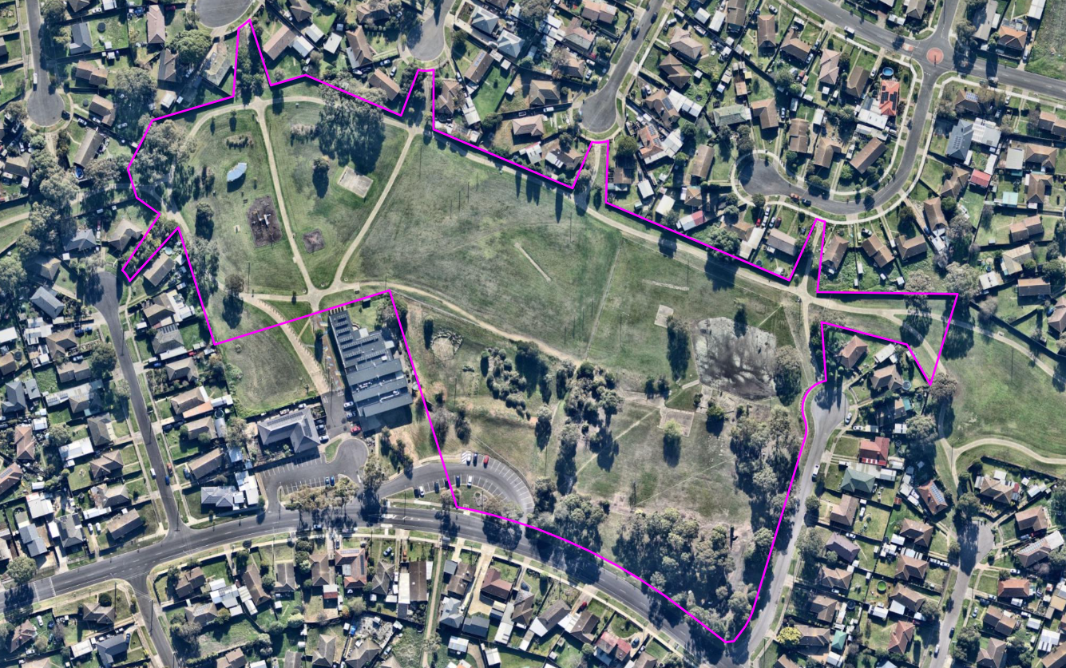
Figure 1: Aerial context photo showing the boundaries of the subject site in purple, circa 14/09/2023. Source: PLACES Weave GIS/Nearmap.
The land fronting Sharland Road is addressed as 26-34 Sharland Road, with an area of 3.068 hectares known as Lot 190 on LP 123692. This land was recently purchased by the current owner as surplus Department of Education land since the closure of the former Rosewall Primary School in 2009-2010. The buildings and structures were demolished soon after the school closed, retaining some hard courts, paving and many of the mature trees and allowed to remain accessible for community use.

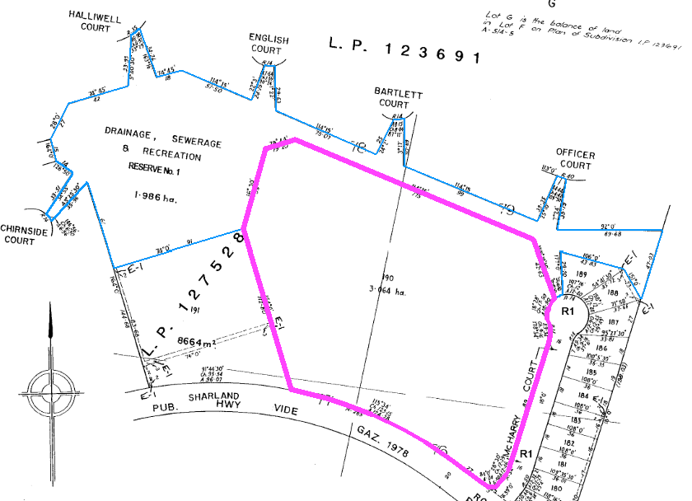
Figure 2: Extract of the title plan showing Lot 190 on LP 123692 (purple boundary) known as 26-34 Sharland Road, Corio. Source: Application documents, annotated by Author.
This land abuts Sharland Road (151 metres) to the south, McHarry Court (141 metres) to the east with a 4 metre corner splay. It also abuts public land owned by Greater Geelong City Council (112.8 metres) to the west at 36-38 Sharland Road, with the balance of the west, north and northeast abuttals forming the balance of the subject site.

This land is not burdened by any easements and is generally flat except for the southwest part that has been modified for landscaping purposes. The southwest corner retains a fully constructed and publicly accessible car park primarily servicing the Rosewall Community Centre on adjoining land at 36-38 Sharland Road, and a park bench seat servicing commuters waiting at the adjoining Bus Stop for PTV Route 23 to North Shore.

The balance of the subject site is addressed as 11 McHarry Court, with an area of 1.986 hectares and known as Reserve 1 on LP 123692. The land is publicly owned and managed by Greater Geelong City Council and used as part of the public open space network known locally as Connections Park West and providing public land access through to Connections Park East.
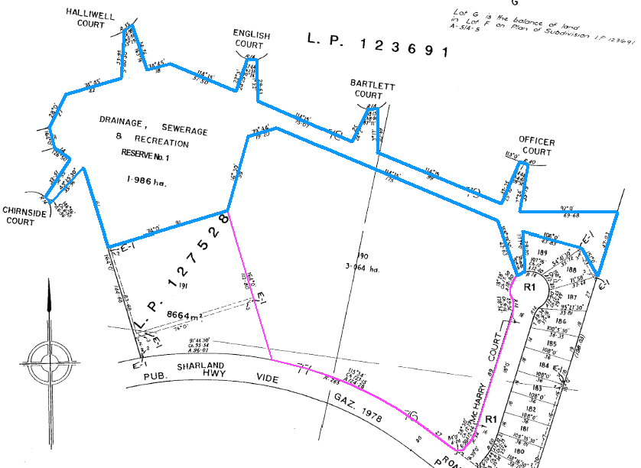
Figure 3: Extract of the title plan showing Reserve 1 on LP123692 (blue boundary) known as 11 McHarry Court, Corio. Source: Application documents, annotated by Author.
This land is set aside as a reserve for drainage, sewerage & recreation purposes, and developed with playground equipment and park furniture including seating, overhead path lighting, a basketball hardcourt, trees and soft landscaping, and constructed pedestrian and shared paths linking to the street network in all directions. In addition to its frontage to McHarry Court (southeast), this land has abuttals to Officer Court, Bartlett Court, English Court and Halliwell Court to the north, Chirnside Court to the west, and a narrow path connection to Sharland Road at the west side of the Rosewall Community Centre. This land also abuts land in reserve to the west with links to Goodall Court, Nixon Court and McGuinness Court, and to the east via Connections Park East through to Welch Court, Considine Court, Kilpatrick Court and Goodwin Court.

The balance of properties abutting this land comprises the rear boundary fences of dwellings to the west and the north, the balance of the subject site to the south, and a parcel of privately held vacant development land to the southwest at 40 Sharland Road.

The subject site is located within an established residential area of Corio and in proximity by road to retail (Aldi Supermarket 625m), sporting facilities (Hendy St Reserve, 590m), education (Northern Bay SC Hendy St, 1050m), community spaces and services (adjoining), and the Central Geelong Activity Centre (9km).

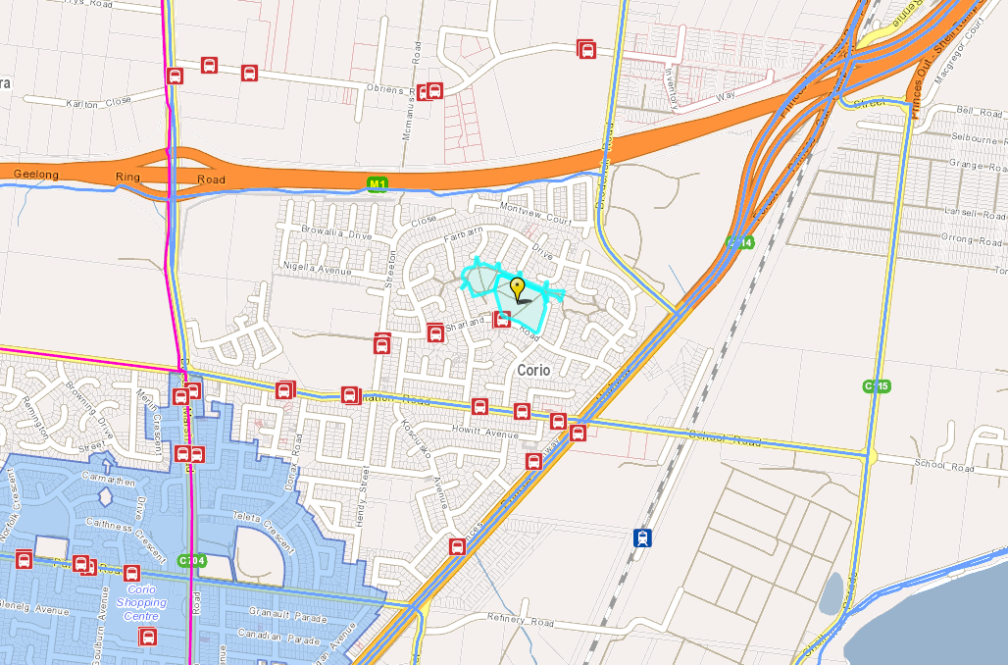
Figure 4: Locality plan showing the subject site (yellow flag) in proximity to bus stops (red), bike routes (blue line), the major road network (orange and yellow lines), and the Corio Village Increased Housing Diversity Area (light blue shade). Source: PLACES Weave GIS.
The subject site is within the General Residential Zone (GRZ1) and the Public Park and Recreation Zone (PPRZ). Part of the site is also within the Design and Development Overlay (DDO37) and the Special Building Overlay (SBO).
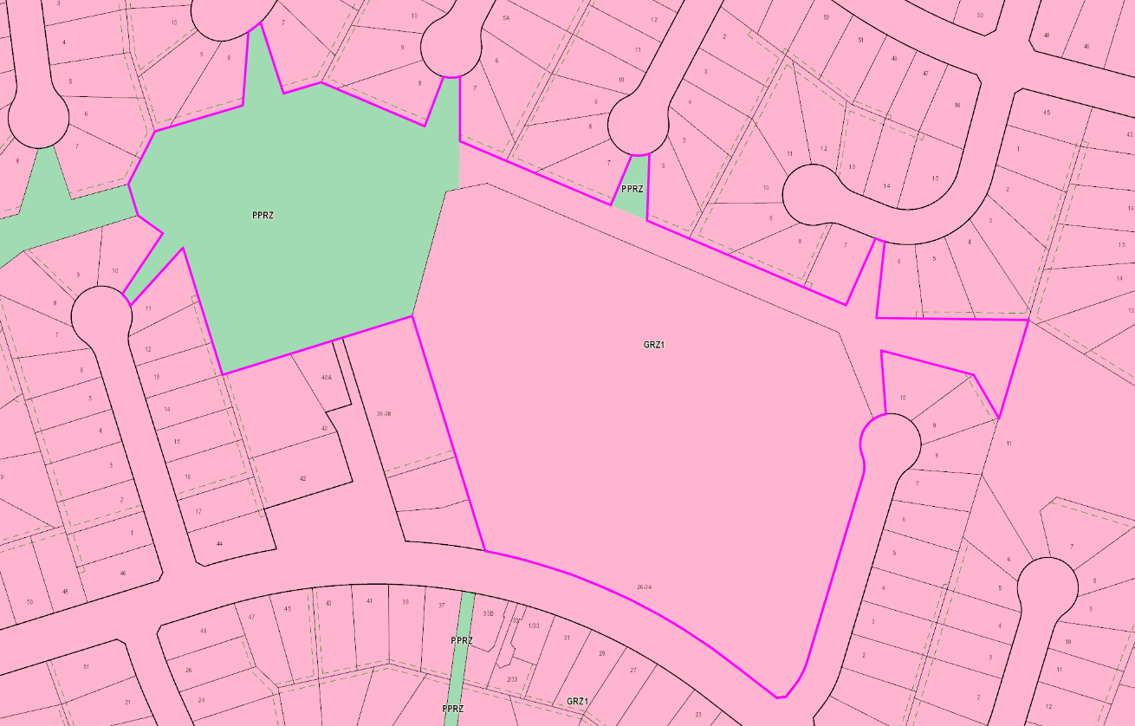
Figure 5 (above): Zone map showing the boundaries of the subject site highlighted purple. Source: PLACES Weave GIS annotated by Author.

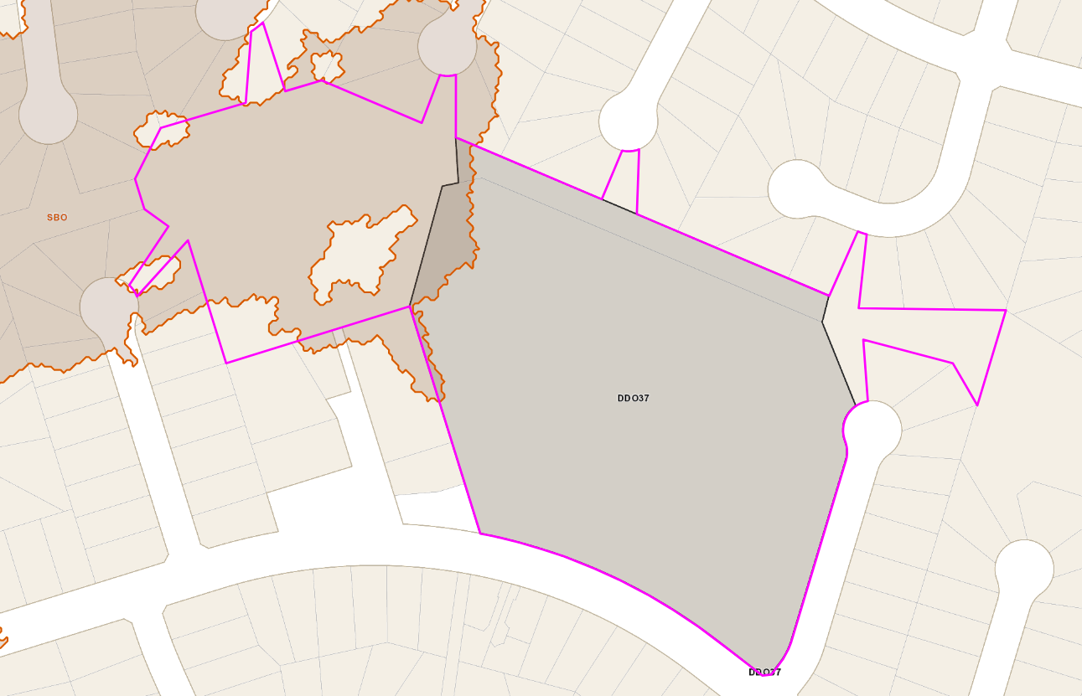
Figure 6: Overlay map showing the boundaries of the subject site highlighted purple. Source: PLACES Weave GIS, annotated by Author.
Amendment C305 (23/04/2015) rezoned the eastern part of the land at 11 McHarry Court from the Public Park and Recreation Zone (PPRZ) to the General Residential Zone (GRZ1) and applied the Design and Development Overlay (DDO37) to all the land at 26-34 Sharland Road and part of 11 McHarry Court. The explanatory note for the amendment states the amendment (underlined for emphasis):

- Rezones a strip of land at Connections Park, Corio, from the Public Park and Recreation Zone to the General Residential Zone Schedule 1; and
- Applies a Design and Development Overlay Schedule 37 to all the land being rezoned and to the former Rosewall Primary School site at 26-34 Sharland Road, Corio.

However, the western boundary of the GRZ1 and the DDO37 boundary do not neatly align, resulting in a wedge of land up to 1.6m wide in the GRZ1 abutting the PPRZ that is not within the mapped area of the DD037. This discrepancy is almost imperceptible from the amended map sheets but can be measured by reviewing the Vicmap spatial data maps as shown below.

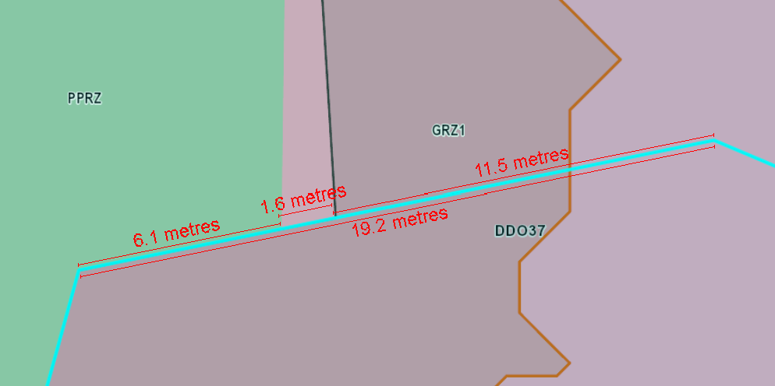
Figure 7: Map showing the wedge of GRZ1 land not within the DDO37 on the land at 11 McHarry Court. Source: PLACES Weave GIS, dimensioned by the Author.
PROPOSAL:

The planning permit application proposes the construction of 108 dwellings including 48 apartments, an associated staged re-subdivision of the land, a reduction to the visitor car parking requirement for dwellings, the removal of Reserve 1 on Plan of Subdivision 123689 and the creation of Reserves.

Construction of 108 dwellings including 48 apartments

The application proposes the construction of 108 dwellings comprising a mix of the following:
- 24 x 2-bedroom ground floor apartment dwellings (Typical Layout A Courtyard)
- 24 x 2-bedroom upper floor apartment dwellings (Typical Layout A Terrace)
- 4 x 3-bedroom single storey townhouse dwellings (Typical Layout B1)
- 53 x 4-bedroom single storey townhouse dwellings (Typical Layout B, Typical Layout C, Typical Layout D, Typical Layout F, Typical Layout G and Typical Layout H)
- 3 x 4-bedroom single storey detached dwellings (Typical Layout D and Typical Layout E)
The development layout proposes dwelling frontages to Sharland Road (Units 1-9) to the south, and McHarry Court (Units 12-15) to the east, with all other units fronting proposed new roads within the development site.

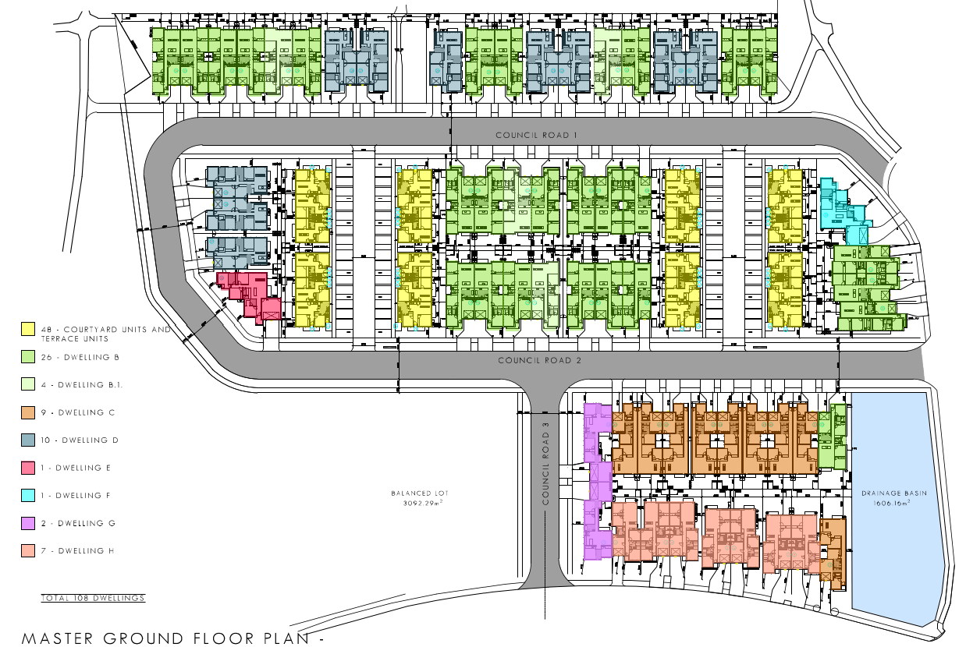
Figure 8: Proposed site layout plan showing location of proposed dwelling types within the development. Source: Application documents.
All dwellings facing site boundaries are proposed to be single storey townhouse units, except unit 38 which is a single storey detached unit.

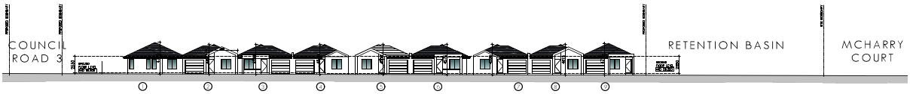
Figure 9 (above): Proposed south site elevation showing frontage to Sharland Road. Source: Application documents.
Figure 10 (above): Proposed east site elevation showing frontage to McHarry Court. Source: Application documents, combined by Author.
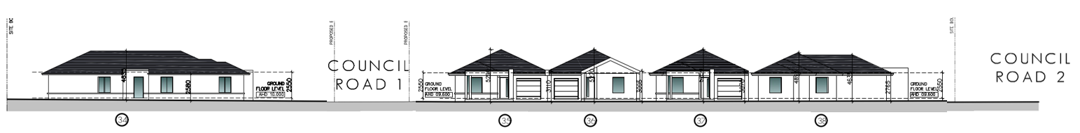
Figure 11: Proposed west site elevation showing frontage to Connections Park West public reserve. Source: Application documents, combined by Author.
All proposed dwellings conform with one of 10 standardised design and layout ‘Types’ as follows.
Typical Layout A Courtyard (Ground Floor) Units: 2-bedroom upper floor apartment dwellings
Units 47, 49, 51, 53, 55, 57, 59, 61, 63, 65, 67, 69, 78, 80, 82, 84, 86, 88, 90, 92, 94, 96, 98, and 100

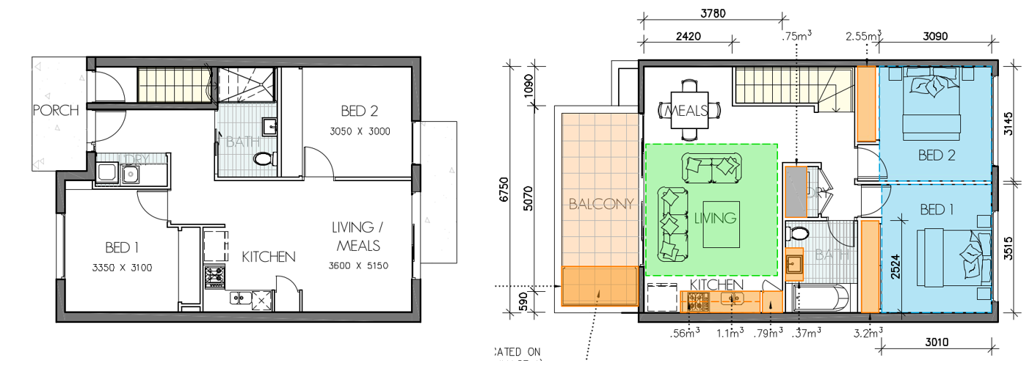
Figure 12: Layout A Courtyard ground floor plan (left) and Layout A Terrace upper storey floor plan (right). Source: Application documents.

Typical Layout A Terrace (Upper Storey) Units: 2-bedroom ground floor apartment dwellings
Units 48, 50, 52, 54, 56, 59, 60, 62, 64, 66, 68, 70, 79, 81, 83, 85, 87, 89, 91, 93, 95, 97, 99, and 101

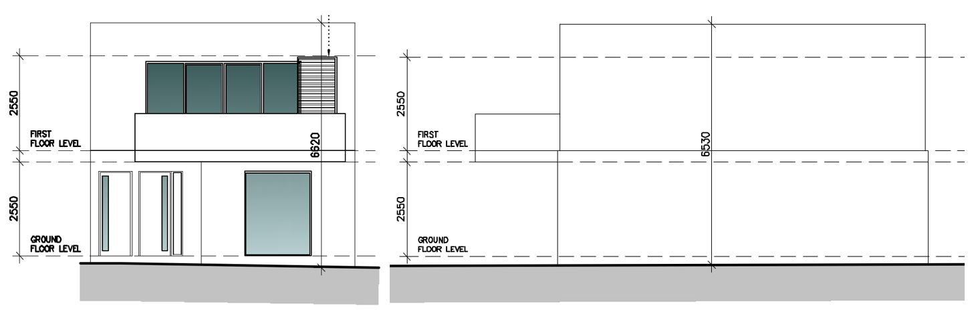
Figure 13: Layout A Courtyard and Terrace Units front (left) and side (right) elevations. Refer to plan set for materials and finishes. Source: Application documents.

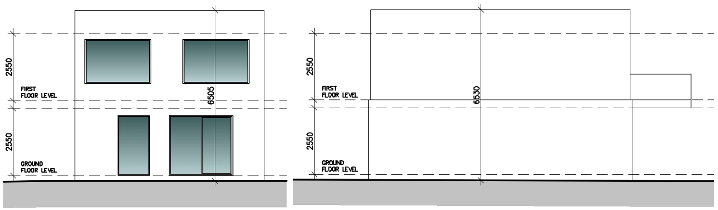
Figure 14: Layout A Courtyard and Terrace Units rear (left) and side (right) elevations. Refer to plan set for materials and finishes. Source: Application documents.

Typical Layout B Units: 4-bedroom single storey townhouse dwellings
Units 10, 12, 13, 14, 16, 17, 20, 24, 25, 29, 31, 32, 33, 34, 71, 72, 73, 75, 76, 77, 102, 103, 105, 106, 107 and 108

Typical Layout B1 Units: 3-bedroom single storey townhouse dwellings
Units 21, 30, 74 and 104

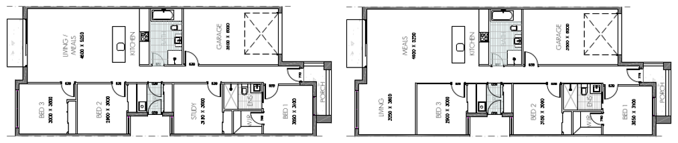
Figure 15: Layout B Units floor plan (left) and Layout B1 Units floor plan (right). Source: Application documents.

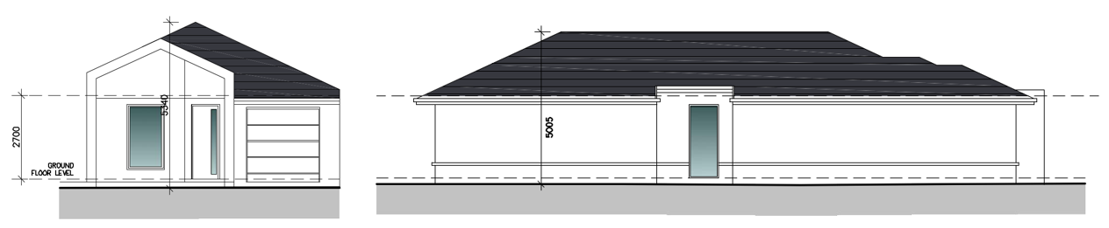
Figure 16: Layout B and B1 front (left) and side (right) elevations. Refer to plan set for materials and finishes. Source: Application documents.

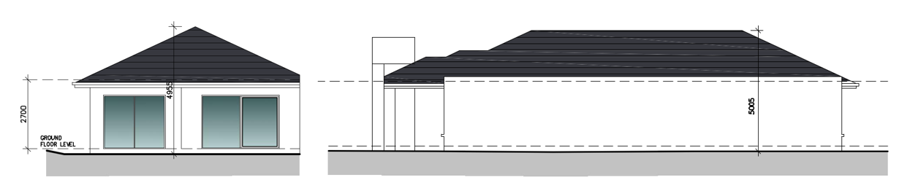
Figure 17: Layout B and B1 rear (left) and side (right) elevations. Refer to plan set for materials and finishes. Source: Application documents.

Typical Layout C Units: 4-bedroom single storey townhouse dwellings
Units 9, 11, 40, 41, 42, 43, 44, 45, and 46

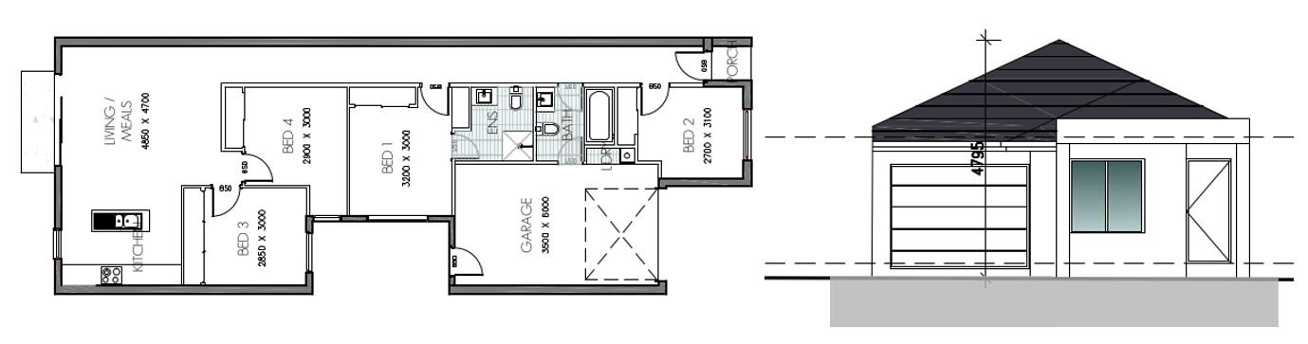
Figure 18 (above): Layout C Units floor plan (left) and front elevation (right). Source: Application documents.
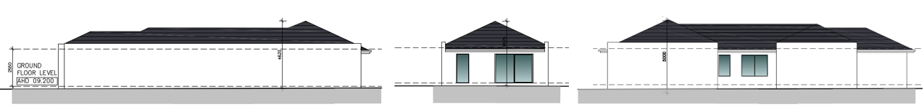
Figure 19: Layout C Units side (left), rear (centre) and side (right) elevations. Refer to plan set for materials and finishes. Source: Application documents.
Typical Layout D Units: 4-bedroom single storey townhouse or detached dwellings
Units 18, 19, 22, 23, 27, 28, 35 and 36, and Units 26 and 37

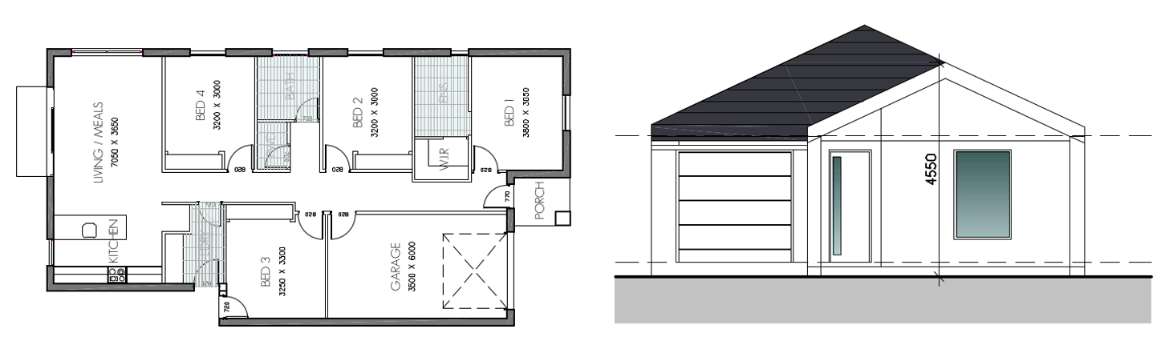
Figure 20 (above): Layout D Units floor plan (left) and front elevation (right). Source: Application documents.

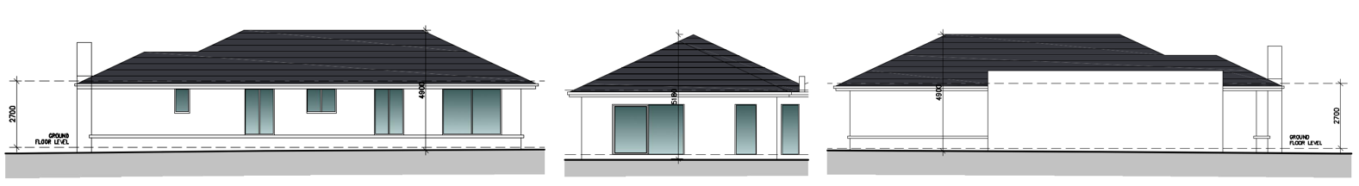
Figure 21: Layout D Units side (left), rear (centre) and side (right) elevations. Refer to plan set for materials and finishes. Source: Application documents.

Typical Layout E Unit: 4-bedroom single storey detached dwelling
Unit 38

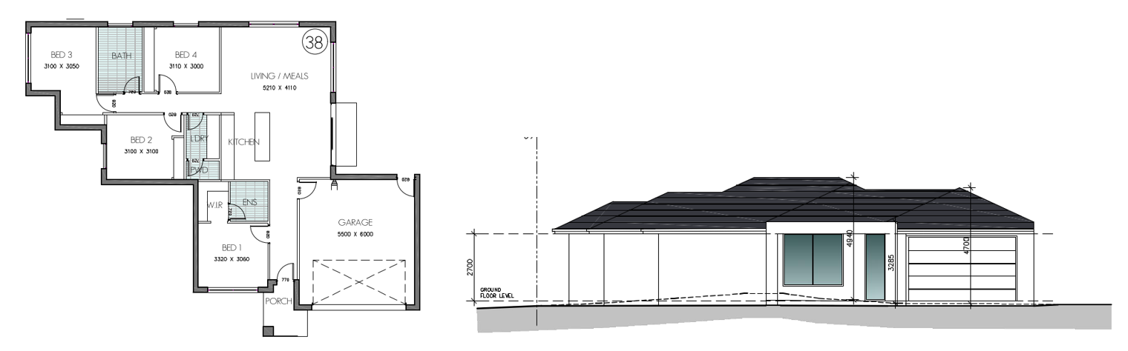
Figure 22 (above): Layout E Unit floor plan (left) and front elevation (right). Source: Application documents.
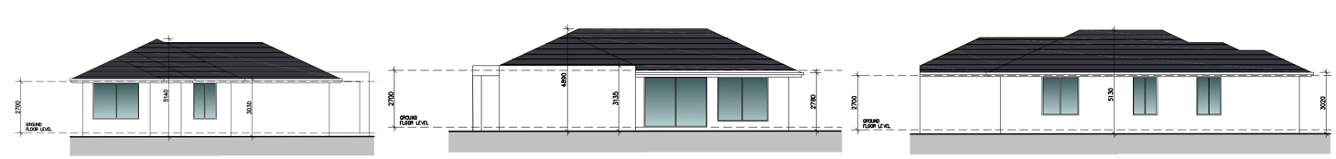
Figure 23: Layout E Units side (left), rear (centre) and side (right) elevations. Refer to plan set for materials and finishes. Source: Application documents.

Typical Layout F Unit: 4-bedroom single storey townhouse dwelling
Unit 15

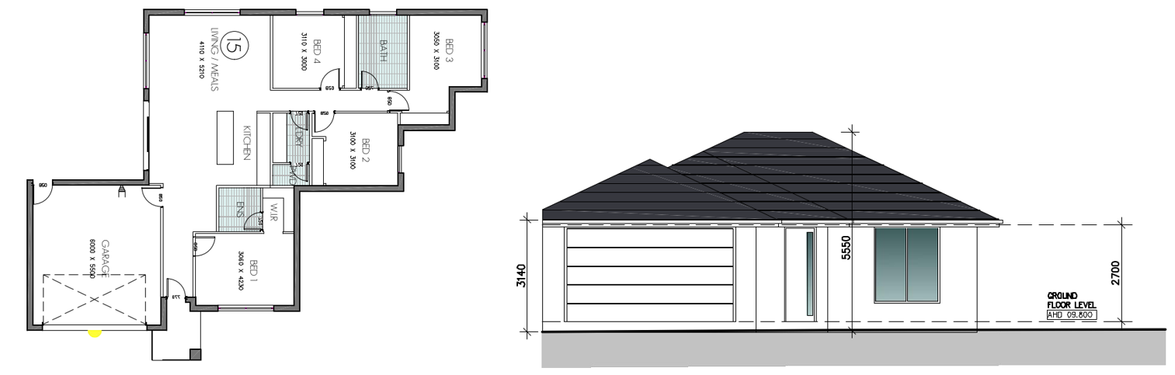
Figure 24 (above): Layout F Unit floor plan (left) and front elevation (right). Source: Application documents.

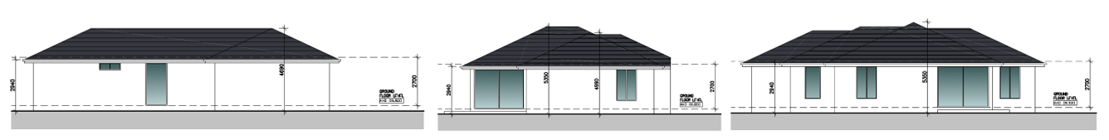
Figure 25: Layout F Unit side (left), rear (centre) and side (right) elevations. Refer to plan set for materials and finishes. Note that elevations and floor plan provided do not match. Source: Application documents.

Typical Layout G Units: 4-bedroom single storey townhouse dwellings
Units 1 and 39

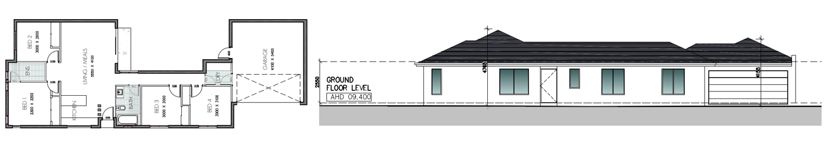
Figure 26: (above): Layout G Units floor plan (left) and front elevation (right). Source: Application documents.

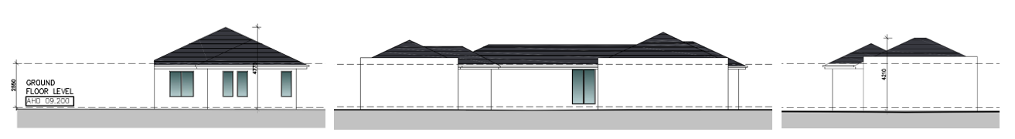
Figure 27: Layout G Units side (left), rear (centre) and side (right) elevations. Refer to plan set for materials and finishes. Source: Application documents.

Typical Layout H Units: 4-bedroom single storey townhouse dwellings
Unit 2, 3, 4, 5, 6, 7 and 8

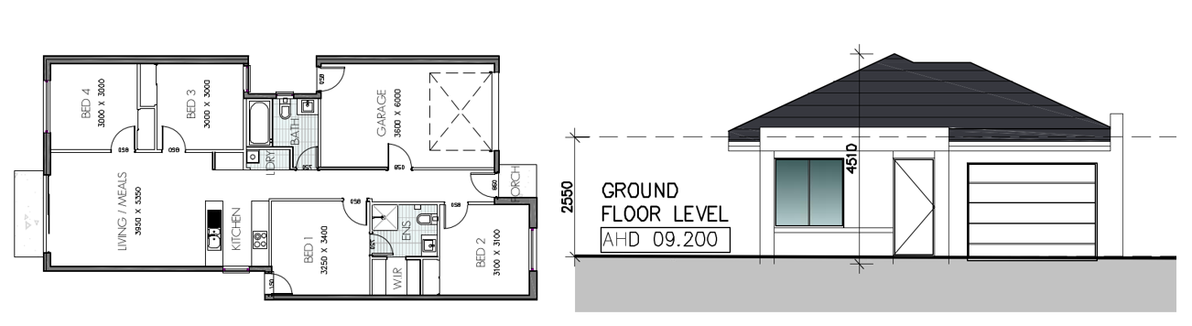
Figure 28: (above): Layout H Units floor plan (left) and front elevation (right). Source: Application documents.

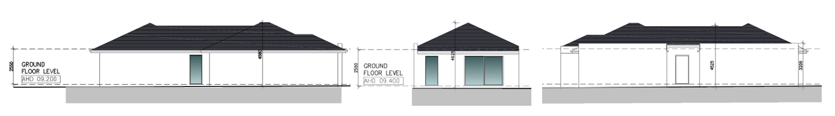
Figure 29: Layout H Units side (left), rear (centre) and side (right) elevations. Refer to plan set for materials and finishes. Source: Application documents.
Staged re-subdivision of the land

The staged subdivision is proposed to provide for the construction of 2 new public roads, removal of 1 reserve and creation of 5 new reserves, the consolidation of part of the land, and creation of 109 residential development lots including 1 balance lot for future development. The re-subdivision is proposed in 4 stages.

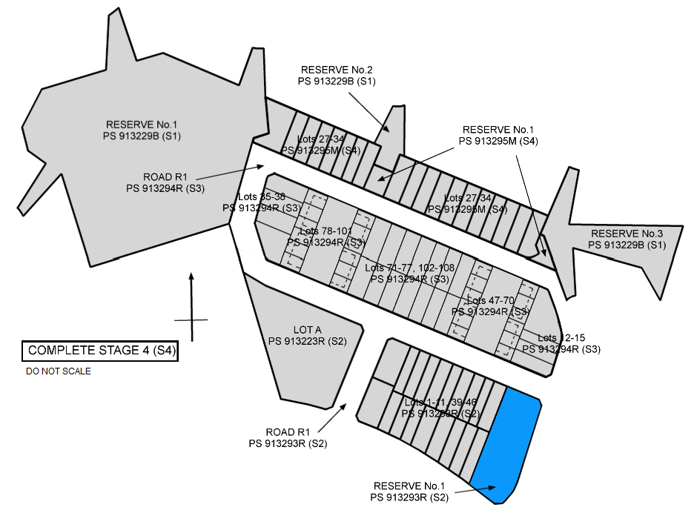
Figure 30: Indicative subdivision concept plan showing the proposed subdivision at completion. Refer to Figure 2 and 3 (previous) for existing conditions lot and reserve layout. Source: Drawn by the Author.
Stage 1 (hereafter, S1) proposes the subdivision of the land at 11 McHarry Court for the creation of 1 lot in 2 parts, each of 1,021 sq/m and 1,312 sq/m respectively, and the balance of the land to be set aside as Reserve No.1 at the west end, Reserve No.2 abutting Bartlett Court, and Reserve No.3 at the east end. The new reserves are to be vested with the Greater Geelong City Council.

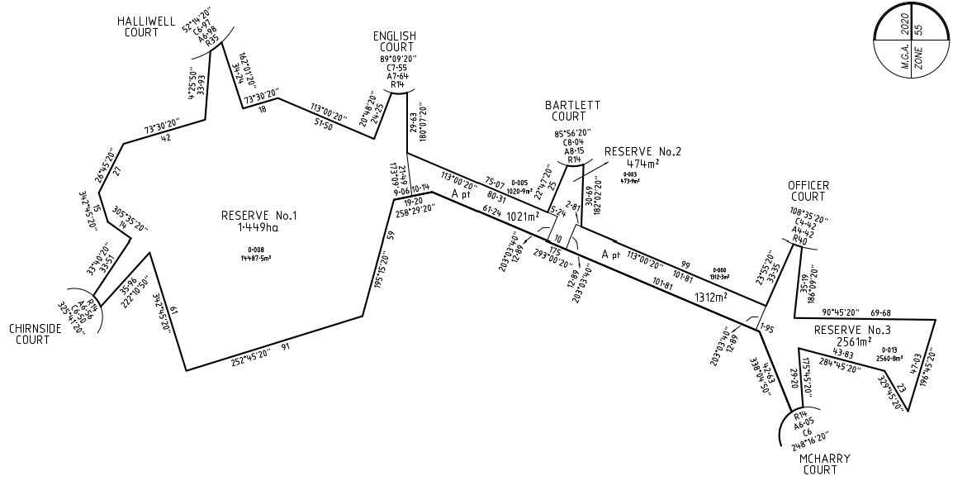
Figure 31: Extract from the S1 subdivision creating 2 lots and removal of reserve at 11 McHarry Court, and creation of Reserve No.1, Reserve No.2 and Reserve No.3. Source: Application documents.
Stage 2 (hereafter, S2) proposes the construction of a new public road, the creation of 1 reserve, and 21 lots including 2 balance lots. The road and the reserve are to be vested with Greater Geelong City Council, with the reserve intended to be encumbered for drainage purposes.
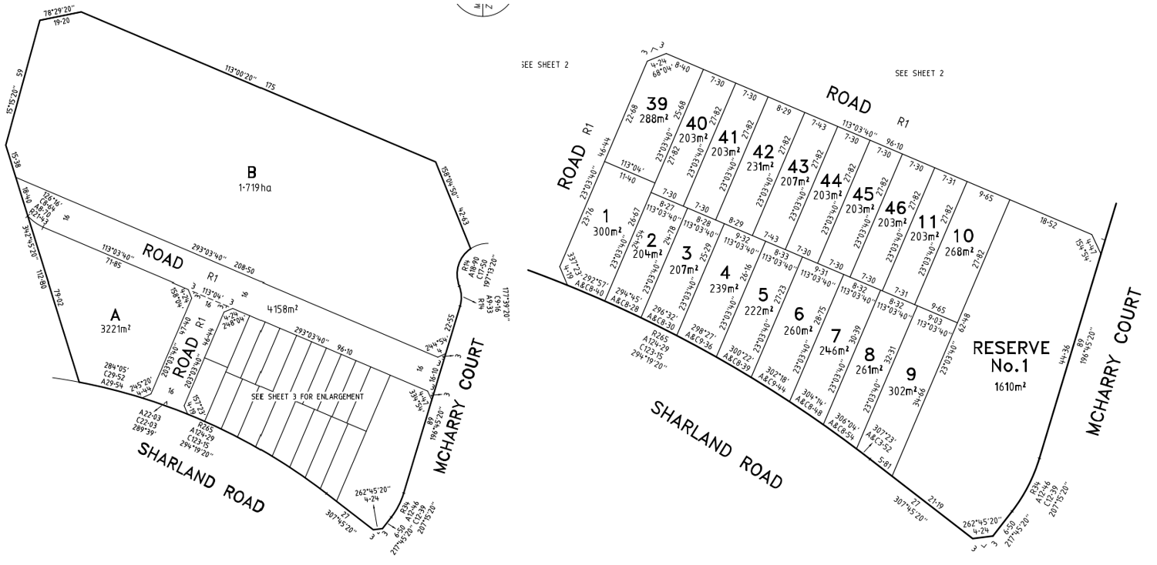
Figure 32: Extract of from the S2 subdivision plan shown at left and inset detail at right. Source: Application documents.
Stage 3 (hereafter, S3) proposes the creation of a new public road that completes the S2 road connection north then east to McHarry Court, and 71 lots including 1 balance lot of 2,615 sq/m, 48 apartment lots (in parts) and 2 areas of common property, and 22 dwelling lots. The road is to be vested with Greater Geelong City Council, and the common property land is intended to be affected by an owners corporation shared equally by apartment lots 47 to 70 and 78 to 101 on the plan (inclusive).
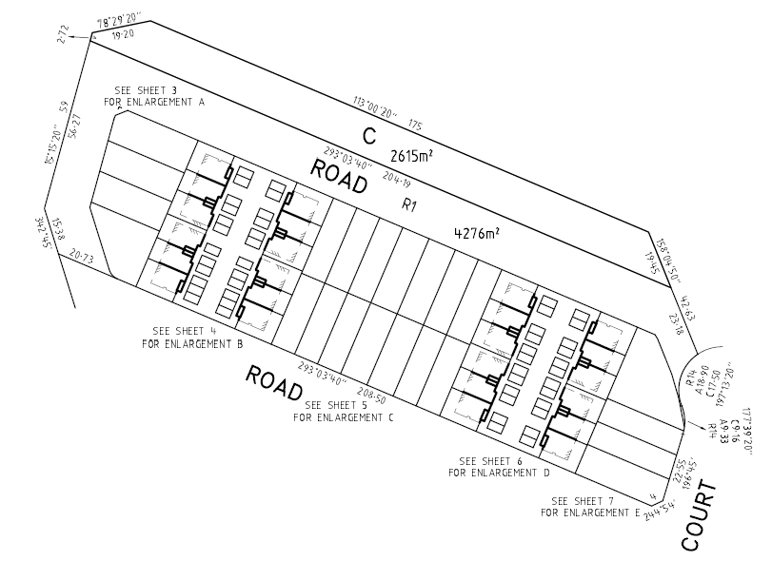
Figure 33 (above): Extract from the S3 subdivision plan shown new road extension and the 2,615 sq/m balance lot. Source: Application documents.
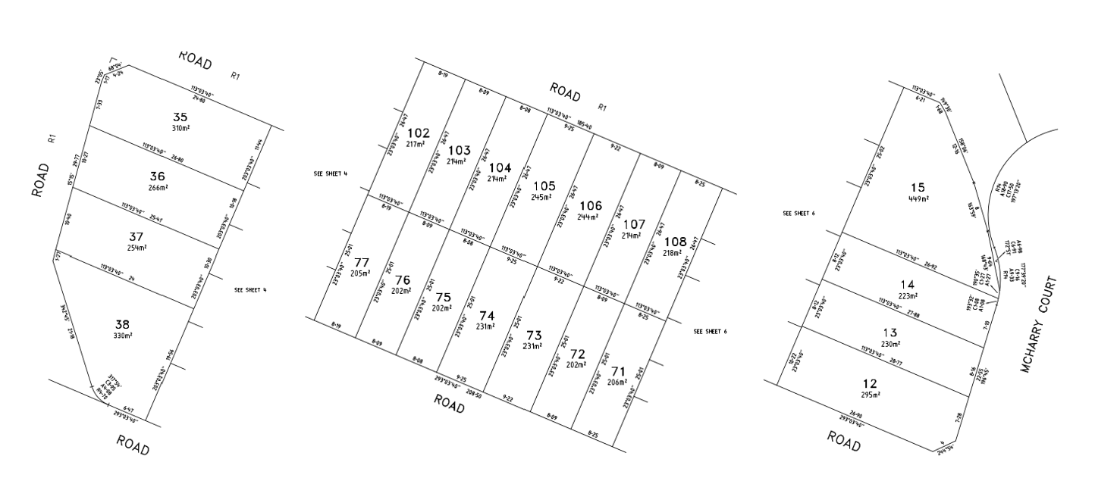
Figure 34 (above): Extracts of enlargements from the S3 subdivision plan showing lots at the west end of the site (left), the centre of the site (centre), and the east adjoining McHarry Court (right). Source: Application documents.

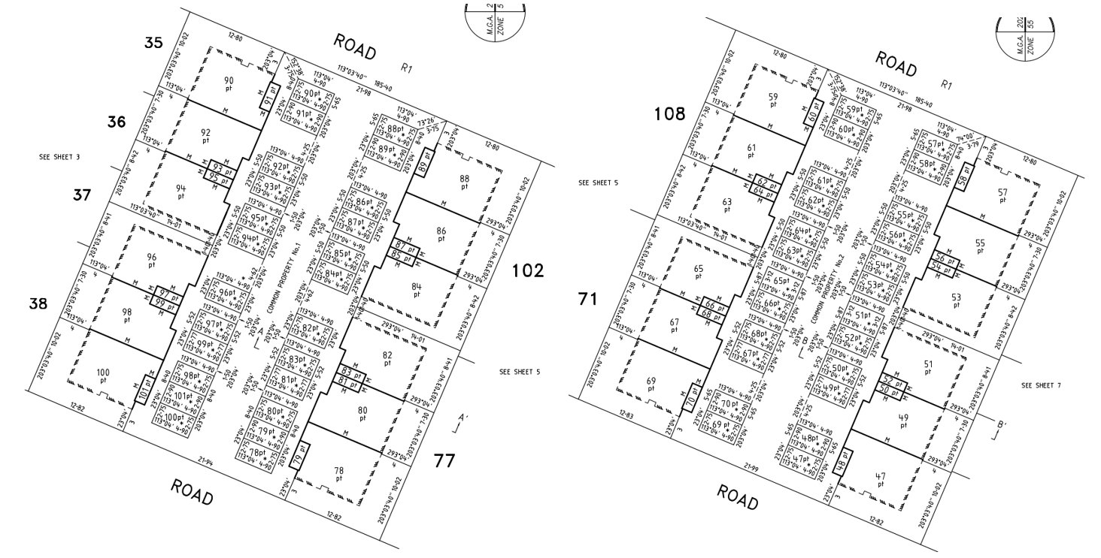
Figure 35 (above): Extracts of enlargements from the S3 subdivision plan showing ground level apartment lots and part lots within common property at the west end of the site (left) and the east (right). Source: Application documents.

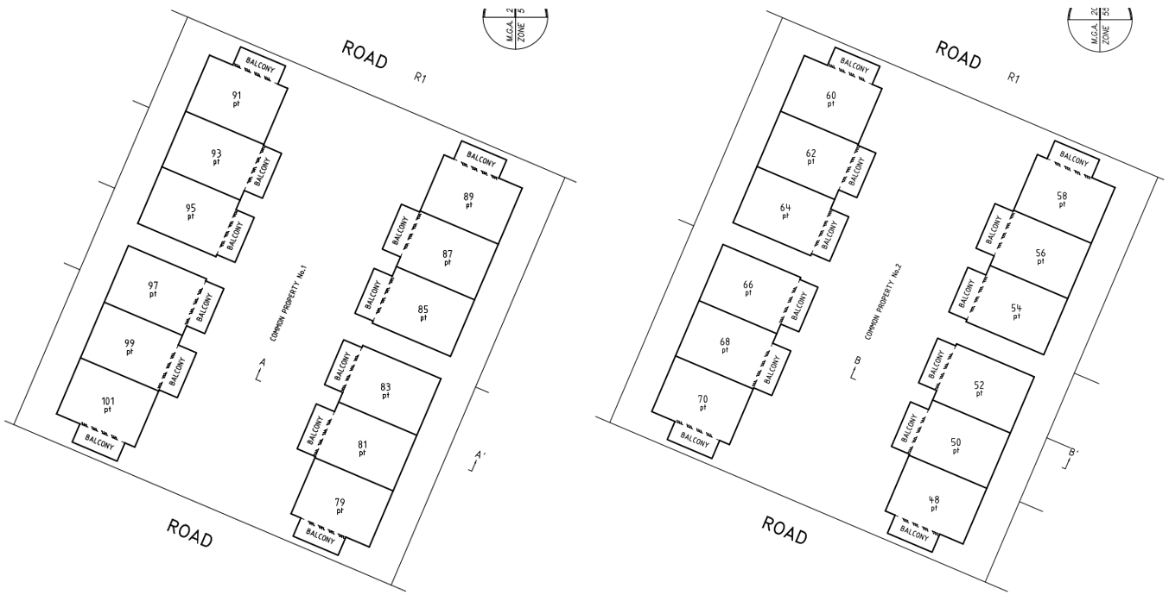
Figure 36: Extracts of enlargements from the S3 subdivision plan showing upper-level apartment lots at the west end of the site (left) and the east (right). Source: Application documents.
Stage 4 (hereafter, S4) proposes a re-subdivision of the lot in 2 parts created at S1 and the balance lot created at S3 into 19 dwelling lots, and the balance of the land to be set aside as Reserve No.1 abutting Reserve No.2 created at S1 and Reserve No.2 at the east end abutting Reserve No.3 created at S1. The new reserves are to be vested with the Greater Geelong City Council.
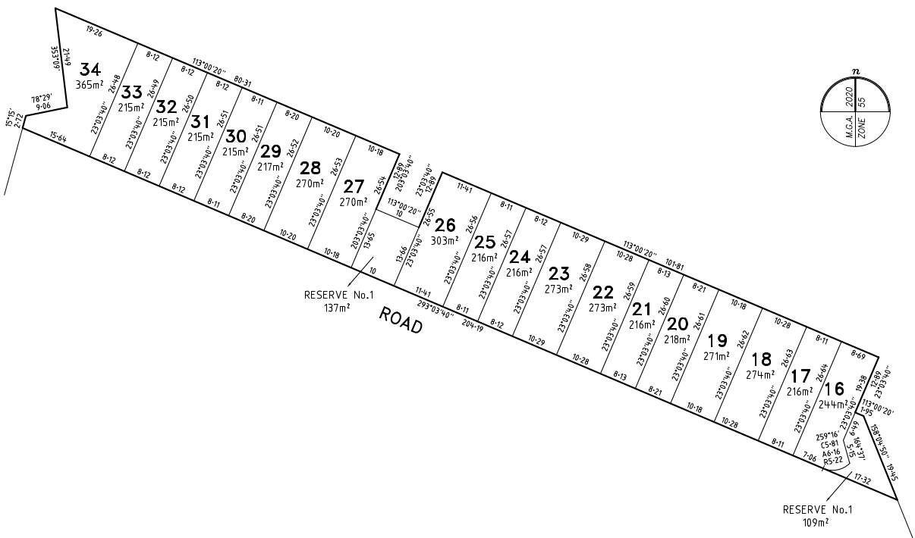
Figure 37: Extract from the S4 subdivision plan creating 19 lots and Reserve No.1 and Reserve No.2. Note that Reserve No.2 at the east end (right) is mis-labelled to be RESERVE No.1. Source: Application documents.
Reduction to the visitor car parking requirement for dwellings

The application proposes a reduction to the visitor car parking space requirements of the Scheme.

The Scheme requires that a new residential development proposal of 108 dwellings provide 1 car parking space for visitors to every 5 dwellings, for a total of 21 visitor parking spaces. No visitor car parking spaces are to be provided, proposing a reduction to the requirement of 21 visitor car parking spaces.

Removal of Reserve 1 on Plan of Subdivision 123689 and the creation of Reserves

The application proposes that Reserve 1 on Plan of Subdivision 123689 be removed, and that 6 new reserves be created as follows:
- Proposed S1 Plan of Subdivision PS913229B removes the existing reserve and creates 3 new reserves.

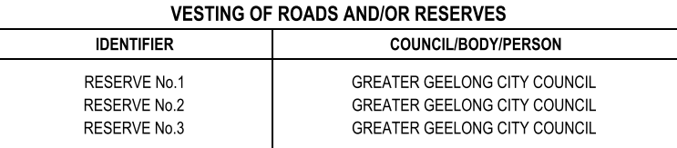

- Proposed S2 Plan of Subdivision PS913229B creates a 4th reserve for drainage purposes vested with the drainage authority (Greater Geelong City Council) and a new public road.

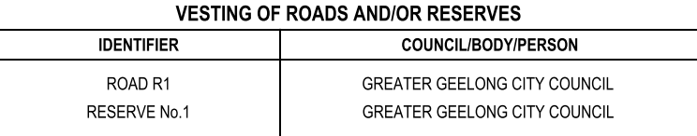

- Proposed S3 Plan of Subdivision PS913293R creates no new reserves and a new public road.

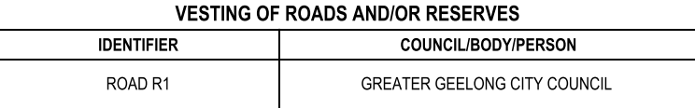

- Proposed S4 Plan of Subdivision PS913295M creates a 5th and 6th reserve.

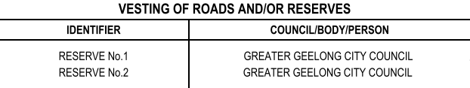

It is notable that RESERVE No.1 on PS913295M created at Stage 4 (ref. Figure 37 previous) is located on the same land as RESERVE No.2 on PS913229B created at Stage 1 (ref. Figure 31 previous), and the mis-labelled eastern RESERVE No.1 on PS913295M is located on the same land as RESERVE No.3 on PS913229B created at Stage 1.

PERMIT/SITE HISTORY:

There is no permit/site history relevant to the application.

REFERRALS:

SECTION 55:

DETERMINING AUTHORITY

Authority: | Barwon Water
Response: | 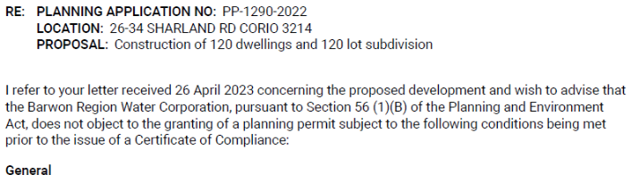  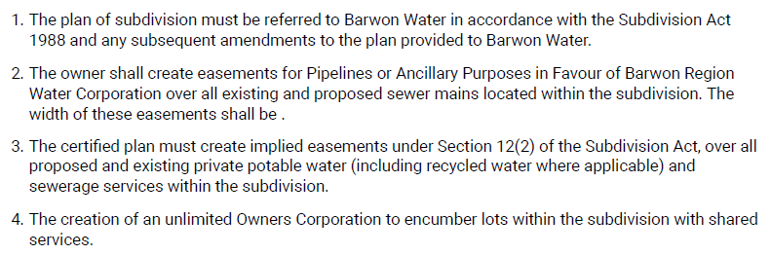  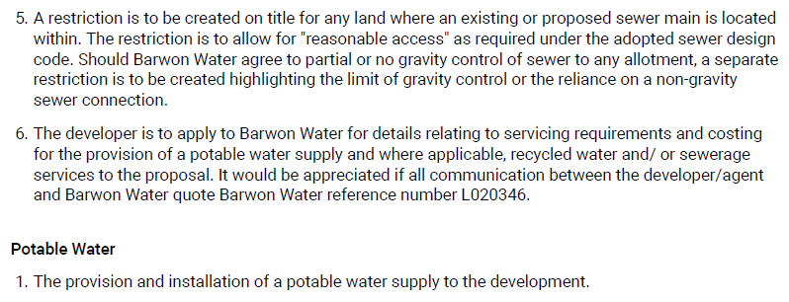  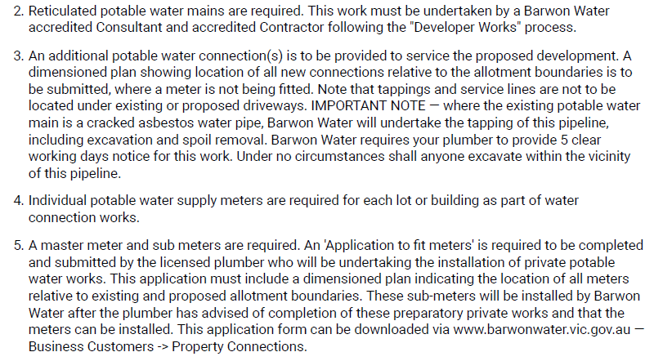  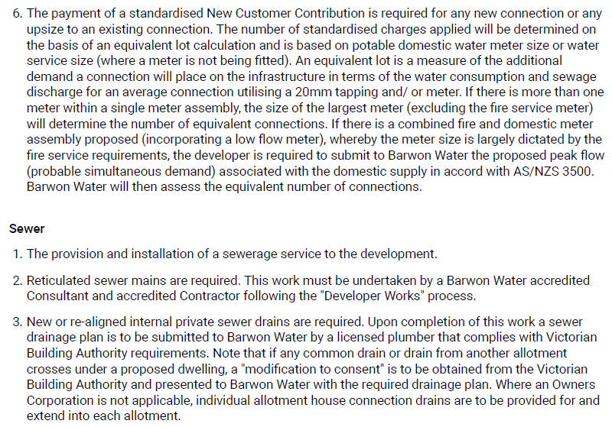
Officer Comment:
This application to subdivide land was referred to Barwon Water in accordance with Clause 66.01 (Subdivision Referrals) of the Scheme.
Barwon Water have not objected to the grant of a permit, subject to conditions. These conditions are to be included on any permit that were to be issued.

Authority: | Powercor
Response: | 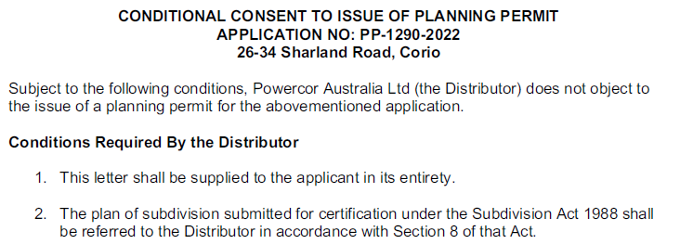  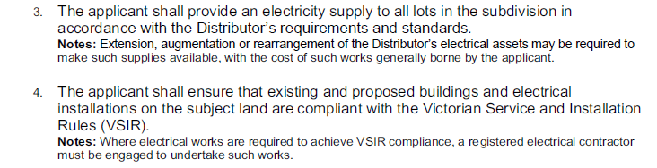  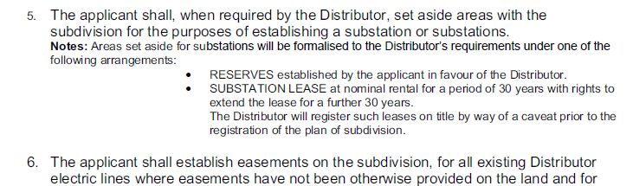  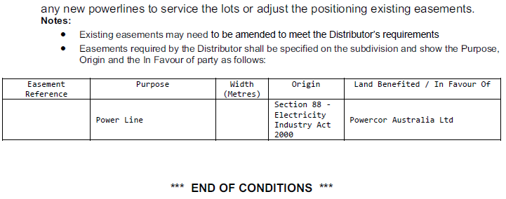
Officer Comment:
This application to subdivide land was referred to Powercor in accordance with Clause 66.01 (Subdivision Referrals) of the Scheme.
Powercor have not objected to the grant of a permit, subject to conditions. These conditions must be included on any permit that were to be issued.

Authority: | Downer Utilities
Response: | No response received.
Officer Comment:
This application to subdivide land was referred to Downer Utilities as the relevant gas supply authority where the subdivision is proposed to connect to a reticulated gas supply system, in accordance with Clause 66.01 (Subdivision Referrals) of the Scheme.
As no response has been received by Downer Utilities, it is recommended that any permit that were to be granted include a condition requiring the developer enter into agreement with the relevant gas authority to establish gas connections for each lot prior to the issue of Statement of Compliance.

Authority: | Head, Transport for Victoria
Response: | First response received 12/10/2023:  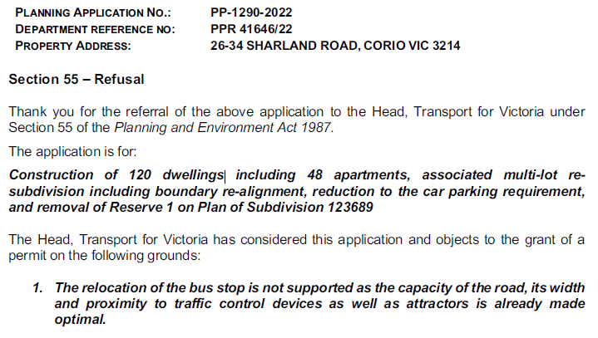  Second response received 1/11/2023 (dated 30/05/2022):  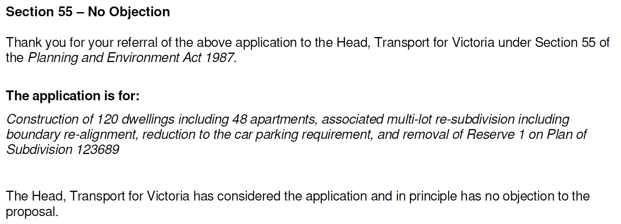
Officer Comment:
This application to subdivide land and to construct and carry out works for a residential development comprising 60 or more dwellings or lots, and alteration or development of public transport infrastructure or stops, was referred to the Head, Transport for Victoria pursuant to Clause 66.02-11 (Land use and transport integration) of the Scheme.
The application was amended to no longer propose alteration or development of public transport infrastructure or stops and re-referred to the Head, Transport for Victoria on 26 April 2023.
The Head, Transport for Victoria does not object to the grant of a permit, and no conditions are required.

Authority: | Relevant Fire Authority (Fire Rescue Victoria)
Response: | 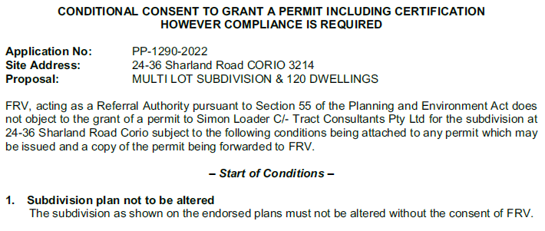  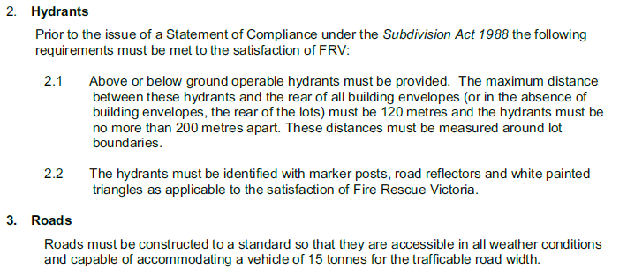  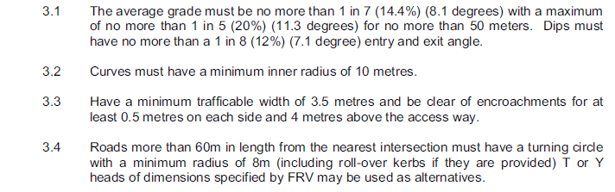  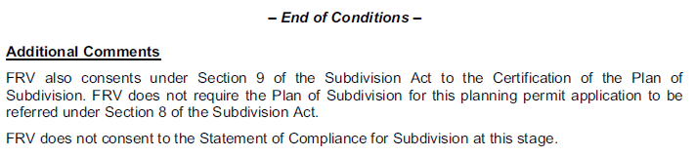
Officer Comment:
This application to subdivide land which creates a road, where the requirements of Clause 56.09-3 (Fire hydrants objective) are not met, was referred to Fire Rescue Victoria in accordance with Clause 66.01 (Subdivision Referrals) of the Scheme.
Fire Rescue Victoria have not objected to the grant of a permit, subject to conditions. These conditions are to be included on any permit that were to be issued.

RECOMMENDING AUTHORITY

Authority: | Floodplain Management Authority
Response: | 1st response received on 13/12/2022:  A memorandum of understanding (MOU) was entered into between the Corangamite Catchment Management Authority (CCMA) and Greater Geelong City Council in September 2016 for the area of the municipality within the Corangamite Waterway Management District.  As Council is the relevant drainage authority for local drainage and the authority responsible for the flood mapping that forms the basis of the SBO on the Council drainage system, Corangamite Catchment Management Authority will no longer act as a Referral Authority for planning permit applications in areas affected by flooding from the local drainage system.  Engineering Services (as Floodplain Manager) Response  This response is based on plans in the record number D22-527826. SBO marginally covers north-western part of the site with shallow flood depth (up to 0.10m). The maximum flood level here is 16.10m AHD (approximately).  Most part of the site is shown as flood-free on the City’s flood map. The SBO-related flood mapping area was limited to the northwest part of the site and no flood map is available for the remaining areas (east of red line on the following map). Although the site appears less likely to be at significant flood risk, only a 2D hydraulic modelling can confirm if this is true.  The submitted stormwater management document (D22-527815) needs to be updated to base it on a 2D hydraulic modelling. It also to be edited for the ground level information (as follows) which are found to be very wrong.  - High point of approximately 10.05m AHD located centrally along the northern boundary of subject site  - Low point of approximately 8.79m AHD located at the south-eastern corner of subject site, at Sharland Road.  - Average site fall equating to 1 in 150.  Although the above levels are said to be to AHD, the sheet 34 of the plan set indicates that they are based on an arbitrary datum. The ground levels at this site should be in the order of 16.0-16.5 m AHD as shown on the following screenshot.  Once the expected hydraulic modelling is carried out, the finished surface/floor levels along with the flood mitigation measures (as/if required) in response to any flood risks/impact to be determined and reported/presented in the document and plans.  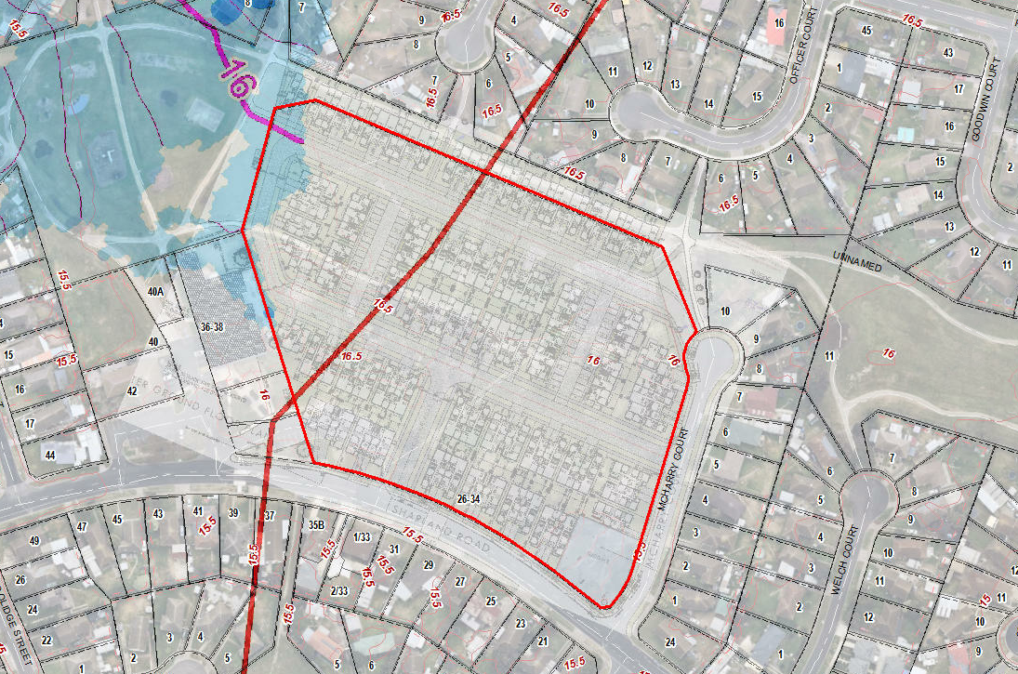  Pursuant to Section 56 of the Planning and Environment Act 1987 Engineering Services (SBO as Floodplain Manager), does not object to the granting of a permit, subject to the following conditions:  - Prior to the commencement of the development, amended plans to the satisfaction of the Responsible Authority must be submitted to and approved by the Responsible Authority. When approved, the plans will be endorsed and will then form part of the permit. The plans must be generally in accordance with the plans submitted with the application but modified to show:  - The finished surface levels (FSL) are free of any flood risks as determined based on 2D hydraulic modelling.  - The finished floor levels (FFL) of the proposed main buildings are at least 0.30 metres above any applicable flood levels as determined based on 2D hydraulic modelling.  - The finished floor levels (FFL) of the proposed garages are at least 0.15 metres above any applicable flood levels as determined based on 2D hydraulic modelling.  - There are necessary flood mitigation measures to address any adverse impact of the development plan on the existing condition flooding as determined based on 2D hydraulic modelling.  - If flood prone, the garages must be constructed using flood resilient materials at least 150 mm above their recommended minimum floor levels and any electrical fittings must be located above these minimum levels.  - If flood prone, any new fences and gates within the SBO area must have minimum 150 mm ground clearance or 25% opening to 450 mm height from the ground. The minimum clearance above any built/smooth surfaces (e.g. paved, concrete, decks etc) is 100mm.  - If flood prone, any new decks within the SBO area must be non-obstructive to overland flows, that is, unenclosed type to allow passage of flood water underneath.  Notes from Engineering Services (SBO as Floodplain Manager)  A floor should generally be built at least 150 mm above the peripheral ground/finished surface of the building.  Any earth filling should be kept to a minimum on the property to ensure that existing flow paths are not impacted by the proposed works.  2nd response received on 16/5/2023:  As per above-mentioned assessment/memo, the previous SBO conditions remain valid and have not been re-stated in this document.
Officer Comment:
Support for the grant of a permit is conditional upon 2D hydraulic modelling to determine the applicable flood levels for which compliance or non-compliance with the recommended conditions will be required. However, the recommended conditions do not include the preparation of 2D Hydraulic Modelling for approval, which makes the conditions unworkable as this modelling will be relied upon at the time of construction to determine if the condition has been met.
That the Floodplain Management Authority has given conditional support for the grant of a permit indicates that they are comfortable that the 2D hydraulic modelling can produce an acceptable outcome.
Were a permit to be grated, the recommended conditions should be included along with the following additional condition (or similar):
Prior to the commencement of the development, 2D Hydraulic modelling and a revised Stormwater Management Strategy to the satisfaction of the responsible authority must be submitted to and approved by the responsible authority. When approved, the plans will be endorsed and will then form part of the permit. The plans must be generally in accordance with the Stormwater Management Strategy plans submitted with the application (SMEC, 20 March 2023, Rev. No. 03) and must show the flood level for each affected lot along with finished surface/floor levels and flood mitigation measures if required in response to any flood risks or impact.
Refer to the officer response to the Special Building Overlay for further consideration of this referral response later in these recommendations.

SECTION 52:

Authority: | WorkSafe Victoria
Response: | First response received 07/08/2023:  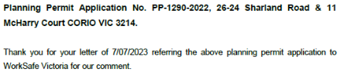  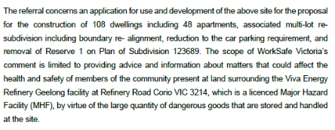  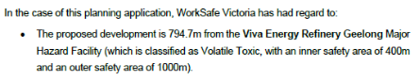  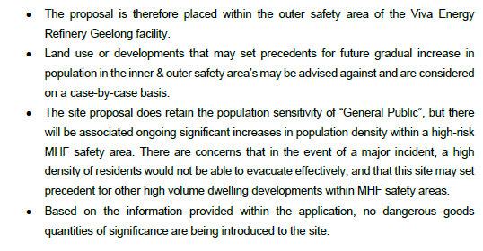  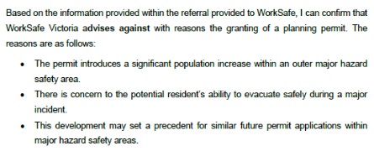  Second referral response received 25 October 2023  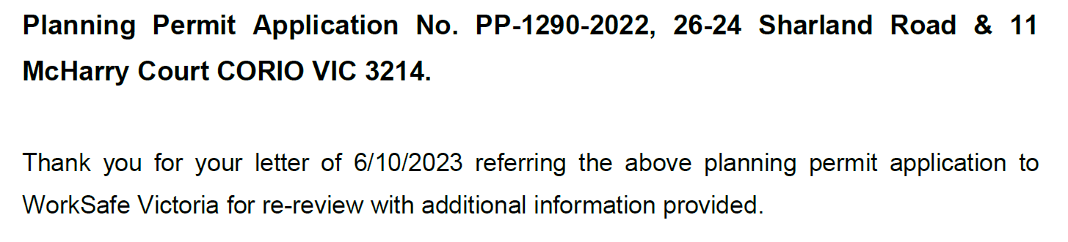  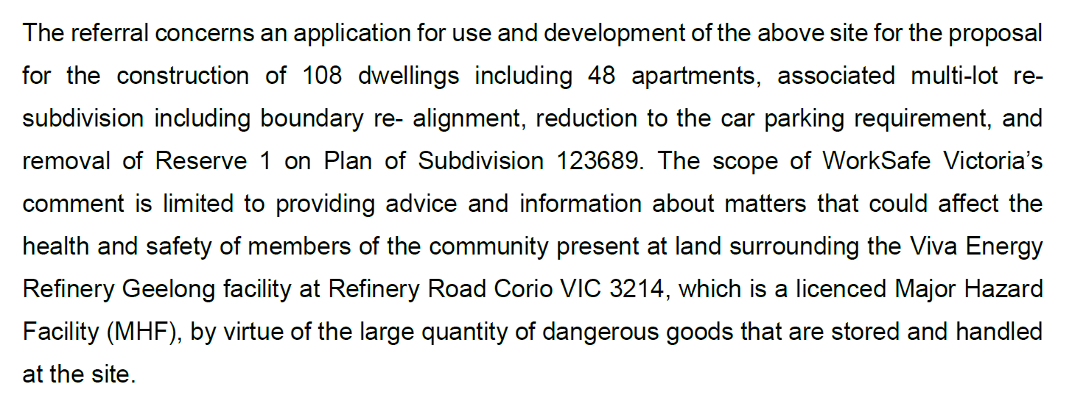  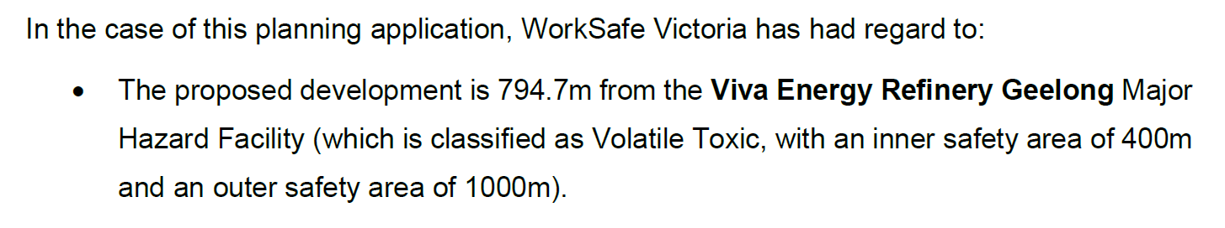  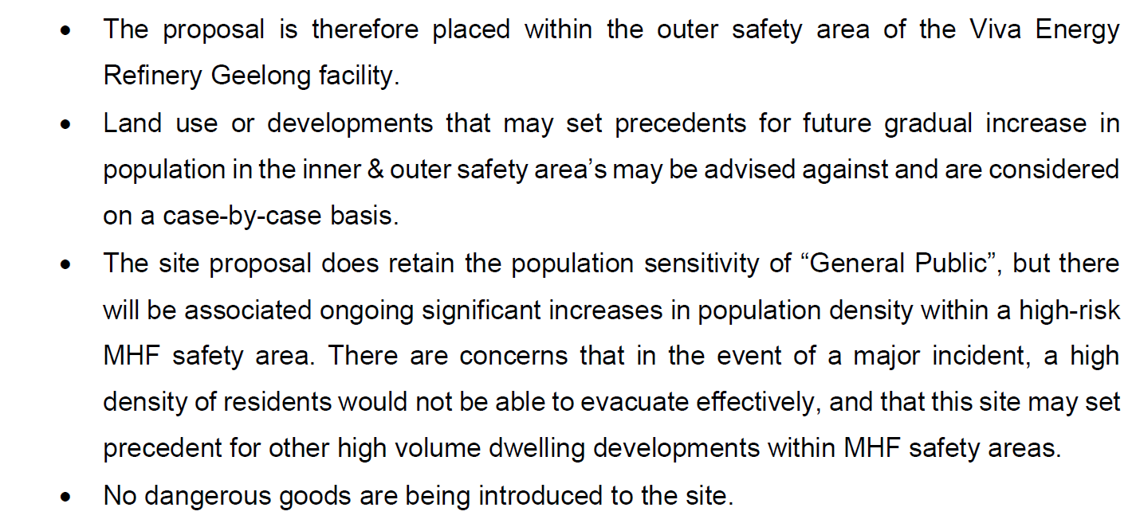  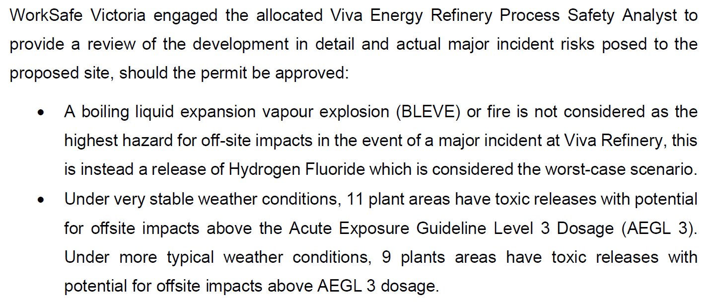  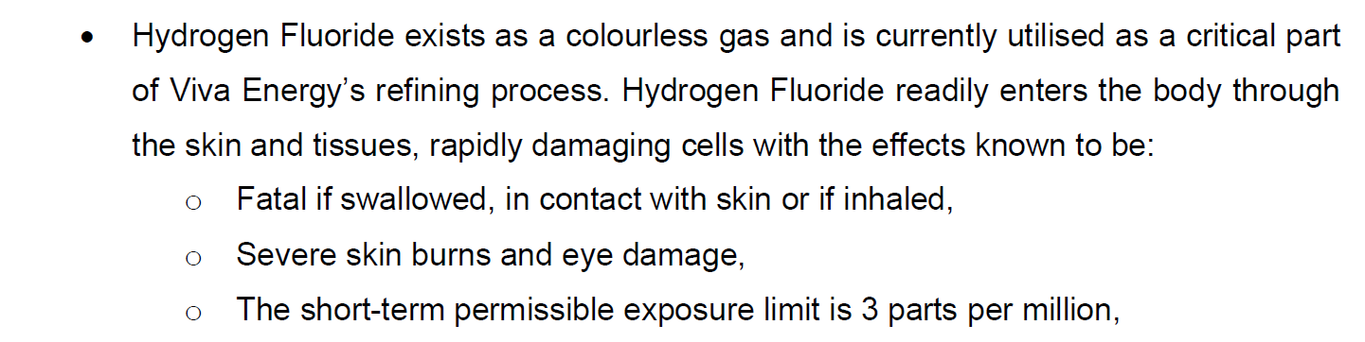  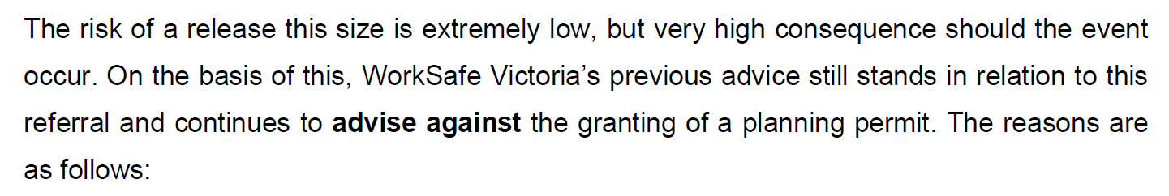  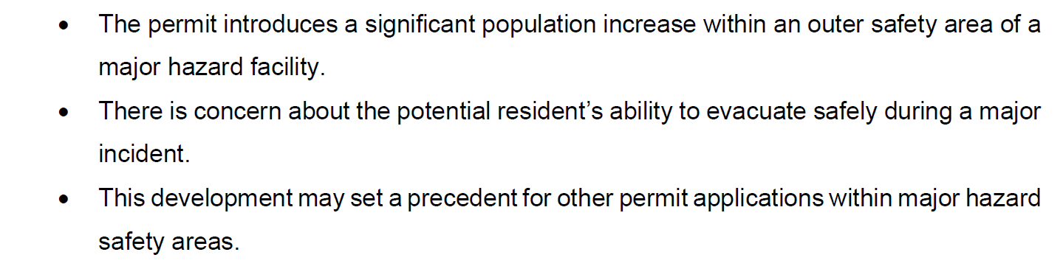
Officer Comment:
The application was referred to WorkSafe Victoria pursuant to Section 52(1)(d) of the Planning and Environment Act, with advice sought on the potential impact on the health and safety of people and property associated with the proposal.
The subject site is located within the Outer Safety Area of the land comprising 2 Major Hazard Facilities at 90 Refinery Road, Corio, being Viva Energy Refining and Viva Energy Polymers.
WorkSafe have advised against the grant of a permit.
Further consideration to the matters raised by WorkSafe are set out later in these recommendations.

INTERNAL REFERRALS:

Department: | Engineering Services
Response: | Final response received on 17 October 2023:  Engineering Services Recommendation  Not supportive  - Drainage – The proposed Stormwater System does not comply with the IDM and council standards in terms of battering, the bioretention system, retainage wall, among others.  Considering that the area is limited by space, the applicant has sought alternative solutions from the City.  Engineering recommends the following:  - To amend the Stormwater System following the City’s and the IDM standards, or  - To build the non-standard stormwater system and the City is willing to consider a one-off financial contribution for the increased operational costs an alternative system will impose on the City. This contribution value will need to be extrapolated across a 50-year period, including both maintenance and renewal costs. The City expects that any alternative proposal is supported with a costed operational mgmt. plan clearly detailing the extra over costs an alternative solution will impose. This plan will need to consider both the maintenance and renewal activities.  Non-standard Conditions have been given below (please see highlighted in blue – Condition 9).  - Traffic –  - Sharland Road Access – 16 m section is supported as per the IDM standards. Works are required to relocate the Speed bump. Plans are required.  - Access to McHarry Court – Need to be continuous of 16m cross section.  Second access needs to be amended and plans are required. This should be submitted with the LATM.  Recommended Permit Conditions (Without Prejudice)  Road Names and Signs  1. Unless otherwise approved in writing by the Responsible Authority, prior to the development of the Road Naming Plan and lodgement of the Functional Layout Plan for Stage 1, the subdivider must provide a list of all proposed road names within the subdivision for Endorsement by Council’s Properties and Valuations unit. The subdivider must provide and place all relevant street signs, to be consistent with the road names shown on all Endorsed plans, to the satisfaction of the Responsible Authority.  Local Area Traffic Management and Road Name Plan  2. Unless otherwise approved in writing by the Responsible Authority, prior to the lodgement of the Stage 1 Functional Layout Plans:  a) A Local Area Traffic Management (LATM) Plan must be developed with Council’s Traffic Development Engineer and submitted to and Endorsed by the Responsible Authority. The LATM treatments may include, but not limited to: traffic management devices, modified intersection priorities, indented car parking, signage, linemarking, and vehicle crossing locations. All treatments shown on the LATM Plan on subsequent construction plans for each stage must be consistent with the Endorsed LATM Plan.  b) When the LATM plan has been finalised, a Road Naming Plan must be developed with Council’s Traffic Development Engineer and submitted to and Endorsed by the Responsible Authority. The Road Naming Plan must respect the LATM plan and the Naming Rules For Places in Victoria document. Pre-approved road names and descriptors shall be applied to a color-coded length of road on the Road Naming Plan. All road naming on subsequent plans of subdivision for each stage must be consistent with the Endorsed Road Naming Plan.  all to the satisfaction of the Responsible Authority.  Functional Layout Plan  3. Unless otherwise approved in writing by the Responsible Authority, prior to the submission and approval of detailed design construction plans (engineering plans) and the certification of the relevant plan of subdivision for each stage, a functional layout plan must be submitted to and approved by the Responsible Authority , for the subdivision or stage of subdivision, in accordance with the design standards of the City of Greater Geelong and the Infrastructure Design Manual, to the satisfaction of the Responsible Authority.  4. When approved, the functional layout plan will be endorsed and will then form part of the permit. The functional layout plan must be submitted with the completed Design Engineers Checklist – Request for functional layout approval; showing all items defined in the checklist inclusive of the following except where not applicable:  a) A fully dimensioned subdivision layout, including proposed street names, approximate lot areas, lot numbers and widths of street reservations,  b) Topography and existing features, including contours for the subject land and any affected adjacent land,  c) Identification by survey of all trees (or group of trees) existing on the subject land, including dead trees and those that overhang the subject land from adjoining land,  d) Details of tree protection zones (TPZs) for all trees to be retained on the subject land,  e) All trees proposed for removal from the subject land clearly designated,  f) Typical cross-sections for each street type, dimensioning individual elements, services offsets and any other spatial requirements identified in the Development Plan,  g) Location and alignment of kerbs, indented parking spaces, footpaths, shared paths, bus stops and traffic controls,  h) The proposed minor drainage network and any spatial features requiring access,  i) The major drainage system with reference to the approved Stormwater management Plan and including ; any watercourse, lake, wetland, sediment pond, rain gardens and/or piped elements showing preliminary sizing,  j) Overland flow paths and road cross section levels (1% AEP) to indicate how excess runoff will safely be conveyed to its destination,  k) Drainage outfall system (both interim and ultimate), indicating legal point of discharge and any access requirements for the construction and maintenance,  l) A table of offsets for all utility services and street trees,  m) Preliminary location of reserves for electrical kiosks, sub stations and High voltage cable routes  n) Traffic management plan showing sufficient notional (unmarked) on-street car parking spaces, at the rate of one space per lot, traffic control devices and large vehicle turning overlays.  o) Waste bin presentation plan  p) Telcom/NBN kiosks and pits  q) Adjacent public reserves including any proposed footpaths and/or utility installations,  Sites that are not adjacent to existing or approved infrastructure will be required to show the following information in addition to the above standard requirements:  r) The relationship between the subject subdivision stage and surrounding land,  s) Proposed linkages to future streets, open space, regional path network and upstream drainage,  t) Works external to the subdivision, including both interim and ultimate access requirements,  u) Intersections with Category 1 roads showing interim and ultimate treatments,  v) Drainage and sewerage outfalls including any easements required over other property.  all to the satisfaction of the Responsible Authority.  Certification of plans of subdivision  Creation and removal of Carriageway Easements & Drainage Easements and/or Reserves  5. Unless otherwise approved in writing by the Responsible Authority, prior to the commencement of works and certification for each relevant stage of the Plan of Subdivision, the following easements and/or reserves must be created and registered with Land Victoria, or there must be an agreement in writing to the satisfaction of the Responsible Authority which secures their creation of:  a) Carriageway easements on adjoining land where required to facilitate the construction of drainage infrastructure and works.  b) A carriageway easement must be provided over any private property that is required to facilitate a vehicle turnaround area for waste services/fire services and to create the Temporary Hammerhead Turnaround at the dead end of a street or streets. The use of private property driveways to create a hammerhead is acceptable and must be approved by the Responsible Authority, unless other options are agreed to and approved by the Responsible Authority. The Temporary Hammerhead Turnarounds of each stage must be maintained by the applicant until the connecting road network is completed and the kerbside collection trucks can undertake all collections in a forward motion. The carriageway easements created to facilitate access for works and/or vehicle turnaround areas, must be removed by the developer once the connecting road for the following stage is constructed to the satisfaction of the responsible authority.  c) Drainage easements and/or reserves between the subject site and the outfall at Sharland Road, generally in accordance with the Precinct Structure Plan (PSP), Development Plan and/or Stormwater Management Plan;  d) Existing and proposed easements and sites for existing and required utility services and roads must be set aside in favour of the relevant authority for which the easement or site is to be created on the plan of subdivision submitted for certification under the Subdivision Act 1988  all to the satisfaction of the Responsible Authority.  Corner Splay  - The Plan of Subdivision submitted for certification for each relevant stage of the subdivision must include a splay for road purposes at all internal and external intersections in accordance with the Infrastructure Design Manual and to the satisfaction of the Responsible Authority.  Road and Drainage Construction Plans  7. Prior to the commencement of works for each relevant stage of the subdivision, detailed Engineer designed roadworks and drainage construction plans must be submitted to and approved by the Responsible Authority. The plans are to be in accordance with the design standards of the City of Greater Geelong and the Infrastructure Design Manual, with no adverse external impacts, to achieve an acceptable standard of aesthetics (including landscaping) which can be maintained in perpetuity, to the satisfaction of the Responsible Authority.  The construction plans will not be considered until:  ● The functional layout plan(s) for the relevant stage has been approved by the Responsible Authority,  ● The landscape plans are submitted in an acceptable format to the satisfaction of the Responsible Authority,  ● The plan of subdivision has been lodged for certification with the Responsible Authority and  ● The locations of other authorities’ services have been provided to the satisfaction of the Responsible Authority.  ● They are submitted with the completed Design Engineers Checklist – Request for Detailed Design Approval  The construction plans must show all items defined in the checklist inclusive of the following except where not applicable:  a) All necessary computations and supporting documentation, including structural Certification for any structure, traffic data, road safety audit, stormwater treatment (MUSIC) modelling and geotechnical investigation report,  b) All details of works consistent with the approved functional layout plan, submitted landscape plan and lodged plan of subdivision, including agreed location of services,  c) Design for full construction of streets and underground drainage, including measures to control/capture pollutants and silt,  d) Provisions for all services and conduits (underground), including alignments and offsets, on a separate services layout plan,  e) Provisions of standard public lighting and underground electricity supply within all street,  f) Traffic control measures,  g) Provision of street name plates to the Council standard design including a schedule of individual signs and associated street numbers,  h) Provision of concrete footpaths in all streets and reserves,  i) Shared paths in accordance with the approved Development Plan within streets, reserves and adjacent to schools or future school sites,  j) Provision of underground easement drains of sufficient capacity to serve all lots being created to a legal point of discharge and the provision of an inlet on each such lot,  k) The location of maintenance vehicle access to reserves and provision of vehicle exclusion mechanisms abutting reserves,  l) Details of proposed treatment and provision for lot boundary fencing adjoining all reserves other than road reserves,  m) Appropriate mechanisms for protecting environmental and heritage assets during the construction phase of the subdivision Construction Environment Management Plan (CEMP)  n) Provision for the utilisation of any surplus top soil from this stage,  o) Permanent survey markers,  p) On a separate construction plan sheet if considered necessary by the applicant, provision of conduits, including pits and ancillary works for optical fibre, telecommunications services or any equivalent alternative approved by the Responsible Authority.  q) On a separate construction plan sheets, Identification of works in kind Items approved by the Responsible Authority and Bill of quantity/ scope.  r) Survey details of the canopy trunk location and size of trees to be retained and associated tree protection zones,  s) Details in relation to all filling on the subject land which must be compacted to specifications approved by the Responsible Authority,  t) The relocation underground of all existing aerial services, on the layout plan,  u) The location of any earthworks (cut or fill) or service provision in a location outside the designated tree protection zone which does not adversely impact on the health and integrity of any trees to be retained.  v) All revisions to the original submitted construction plans must be documented in the drawings revision schedule and amendments highlighted with a ‘cloud’.  Design of adjacent Existing Roads  8. Unless otherwise approved in writing by the Responsible Authority, prior to the Statement of Compliance for Stage 1, existing City of Greater Geelong Roads abutting each relevant stage of the subdivision must be designed in accordance with Geotechnical advise for the existing pavement and traffic volumes for the full length in accordance with the Infrastructure Development Manual, Development Plan and/or Precinct Structure Plan, and as per the below requirements:  a) Sharland Road and McHarry Court to have kerb and channel on the development side, including footpath and nature strip, and a minimum 6.7m asphalt seal with gravel shoulder on the non-development side of the Road;  b) Provision of bus stop seating and shelters  c) Provision for relocation of the Speed bump and reinstatement of Sharland Road.  d) Provision two accesses in McHarry Court.  all to the satisfaction of the Responsible Authority.  Site Stormwater Management Strategy  9. Unless otherwise approved in writing by the Responsible Authority, prior to the commencement of works or submission of any Functional layout plan, a Site Stormwater Management Strategy (SSMS) for the overall development must be submitted to and approved by the Responsible Authority. When approved, the plans will be endorsed and will then form part of the permit. The Site Stormwater Management Strategy must contain (but not be limited to) the following:  a) Demonstrate how runoff from the subdivision will be achieving objectives for environmental management of stormwater as set out in the 'Urban Stormwater Best Practice Environmental Management Guidelines (CSIRO) 1999'.  b) Provide details of the Water Sensitive Urban Design (WSUD) treatment in accordance with the City’s standards  i. Infrastructure Design Manual (Local Government Infrastructure Design Association)  ii. Design Note 2: Stormwater Detention Storage Design (City of Greater Geelong)  iii. Design Note 3: MUSIC - Modelling Approach and Parameters for use within the City of Greater Geelong (City of Greater Geelong)  iv. Constructed Wetland Design Manual (Melbourne Water)  v. Biofiltration systems in Development Services Schemes guidelines (Melbourne Water)  vi. Construction and establishment guidelines: swales, bioretention systems and wetlands guideline (Water by Design 2010b)  c) Details of the management of internal and external flows during and after the construction period.  d) Details of how floodwaters will be conveyed with no adverse downstream impact;  e) Mapping of the catchment area and stormwater infrastructure to the downstream stormwater system. Catchment plan must include RORB model showing allowed flows downstream.  f) That site stormwater runoff is to be limited to equivalent pre-developed levels for rainfall events up to and including the critical 1% AEP event or capacity of the downstream drainage network  g) Include Maintenance regime of assets and handover maintenance (i.e. resetting materials to design levels and replanting) at final Stage practical completion, including provision of cost for maintenance costs of non – standard elements.  h) Safety analysis of design including; public safety, maintenance and inspection procedures  all to the satisfaction of the Responsible Authority.  Non-Standard Stormwater Management Contribution  10. Unless otherwise approved in writing by the Responsible Authority, prior to the commencement of works, a financial contribution must be made to the City of Greater Geelong in recognition of the financial burden associated with the non-standard stormwater management infrastructure being delivered. The contribution value will be calculated by the City of Greater Geelong and will represent all additional operational costs associated with the non-standard stormwater infrastructure design for a 50-year period.  all to the satisfaction of the Responsible Authority.  Stormwater  11. Site runoff must be limited to equivalent pre-developed levels for rainfall events up to and including the critical 1% AEP event in accordance with the Drainage and Water Sensitive Urban Design Strategy. The stormwater system on the site must be designed such that stormwater runoff exiting the land meets the current best practice performance objectives for stormwater quality at all times as follows:  a) 80% retention of the typical annual load of suspended solids;  b) 45% retention of the typical annual load of total phosphorous;  c) 45% retention of the typical annual load of total nitrogen; and;  d) 70% retention of the typical annual load of gross pollutants.  Flood Mapping  12. Unless otherwise approved in writing by the Responsible Authority, at the completion of earthworks for each relevant stage of Plan of subdivision, a declaration that the Stage is no longer subject to flooding and flood maps will need to be submitted to Council detailing the extent of flood affected land both prior to and after the subdivision of land in order to allow Council to revoke the flood prone status of the land. The submission of flood mapping documentation should be submitted to Council’s Engineering Department.  13. Prior to the issuing of a Statement of Compliance for Stage 1, the linear wetland system works identified in the SWMS within the subject site and in the abutting land if approved by the Responsibility, must be constructed and operational.  14. The minimum surface gradient on all lots to allow for appropriate drainage must be 1:150 (0.67 per cent);  15. The absolute minimum finished surface level of road pavement, kerb invert levels and paths within the development must be 3.30m AHD or not less than 300 millimeters above the 1% AEP flood level.  Water Sensitive Urban Design (WSUD) Landscape Plans  16. Unless otherwise approved in writing by the Responsible Authority, prior to the commencement of works for each relevant stage of the subdivision, plans which outline the WSUD landscaping elements must be submitted to and approved by the Responsible Authority. The plans must include, but are not limited to:  a) Construction details of all water sensitive urban design elements including materials and plantings required for effective stormwater pollutant removal in accordance with the drainage design criteria specified in the conditions of this permit;  b) Planting and establishment schedule for all water sensitive urban design planting, including species and densities in accordance with the drainage design criteria specified in this permit;  c) Q10 and Q100 levels, and associated flow rates;  d) Details of existing and finished surface levels; and;  e) Construction and establishment methodology and associated staging of the WSUD works specific to the site, in accordance with relevant industry standards to the satisfaction of the Responsible Authority. (reference is made to Water By Design – Construction and Establishment Guidelines: Swales, Bioretention Systems and Wetlands, April 2010).  all to the satisfaction of the Responsible Authority.  Water Sensitive Urban Design (WSUD) Landscape Works  17. Unless otherwise approved by the Responsible Authority, the Water Sensitive Urban Design works shown on the approved landscape plan must be carried out and completed to the satisfaction of the Responsible Authority.  18. Practical Completion for the WSUD works can only be awarded when the ultimate landscape design is complete and subject to:  a) Civil works within the treatment device being issued Practical Completion; and  b) Landscape works within the treatment device being completed; and  c) The final stage of the development draining to that treatment device is issued Statement of Compliance; and;  d) A relevant maintenance bond being in place for the planting works.  19. A Practical Completion inspection is required and must be arranged by the permit holder with a two week notice period provided prior to onsite inspections. Any incomplete landscape works bond for WSUD will be returned on award of Practical Completion.  Water Sensitive Urban Design (WSUD) Maintenance  20. Unless otherwise approved by the Responsible Authority, Water Sensitive Urban Design works must be maintained in accordance with Council’s Landscape Standards Manual (June 2013), or any replacement landscape standard guidelines or manual which may be adopted by the Council, to the satisfaction of the Responsible Authority until:  a) The end of a period of no less than two (2) years from the date of Practical Completion of the landscaping unless otherwise agreed in writing by the Responsible Authority; or;  b) Statement of Compliance is issued for the final stage of the development draining to that treatment device; whichever is the latter.  21. A Handover inspection is required and must be organised by the permit holder with a two week notice period provided prior to onsite inspections. No handovers will be accepted during summer months from 1 December to 29 February inclusive. Any landscape maintenance bond for WSUD will be returned on award of Handover.  Environmental Construction Management Plan (ECMP)  22. Unless otherwise approved in writing by the Responsible Authority, at least 14 days prior to the commencement of works for each relevant stage of the subdivision, an Environmental Construction Management Plan (ECMP) shall be submitted to and Endorsed by the Responsible Authority. When Endorsed, all conditions on the ECMP will form part of the permit. The plan must address, but not be limited to, the following:  a) Measures that are consistent with the following Environmental Protection Authority publications: ‘Environmental Management Guidelines for Major Construction Sites’, ‘Construction Techniques for Sediment and Pollution Control’ and ‘1834: Civil construction, building and demolition guide’ or later approved;  b) Hours of works, demolition or construction;  c) Methods to contain dirt and mud within the site, and the method and frequency of clean up procedures;  d) On site facilities for vehicle washing;  e) Methods used with regards to Dust suppression which may include but not limited to the following:  i. Water truck to be retained on site at all times;  ii. Soil stockpiles to be retained on site must be seeded or provide a treatment to provide a crusted surface;  iii. Cease all works on site during high wind incidences;  iv. Vehicle/truck movements to be limited to a reduced speed to prevent dust emissions;  v. Dust suppression measures including fencing in locations to existing dwelling;  f) The protection measures for site features to be retained (e.g. vegetation, retaining walls, buildings, other structures and pathways, etc.);  g) Delivery and unloading points and expected frequency;  h) A liaison personnel for contact by residents and the Responsible Authority in the event of relevant queries or problems experienced;  i) The movement of construction vehicles to and from the site must be regulated to ensure that no traffic hazards are created in and around the site;  j) Parking facilities for construction workers;  k) Measures to minimise the impact of construction vehicles arriving at / departing from the land;  l) Haul routes used for fill carting must be shown on a separate plan within the ECMP and need to consider the scale of development and works, the construction access and any on-site haul road location, and the surrounding road network. Haul routes must avoid local roads in the vicinity of the site as far as practical, and link to the arterial road network via an approved route.  m) An outline of requests to occupy public footpaths or roads, and anticipated disruptions to local services;  n) Maps providing the location of the works zones including;  i. Site office and facilities;  ii. Stockpiles, Equipment and material management  iii. No Go zones;  iv. Location of bunded and lined Hydrocarbon filling area designated and spill kit available  v. Location of bunded and lined Concrete washout area  o) Fencing of and establishing No Go Zones as required by Environmental or Cultural heritage management plans which are clearly designated on-site;  p) The processes to be adopted for the separation, re-use and recycling of demolition materials;  q) The measures for prevention of the unintended movement of building waste and hazardous materials and other pollutants on or off the site, whether by air, water or other means;  r) Handling, tracking and testing of all imported fill;  s) Measures to be taken to ensure that no polluted water and/or sediment laden runoff is to be discharged directly or indirectly into stormwater drains or watercourses during the construction period; and;  t) Methodology detailing how service vehicles (ie; Council Garbage Trucks) will be catered for during all stages of construction, including the removal of temporary turn around areas; and;  u) Any other condition as required by the Responsible Authority that addresses any other issues i.e. location of earth mound / soil stockpiles, rumble grids, construction of and materials used for all whether access roads up to 30 meters on entry and exit to the site entry.  Once the Environmental Construction Management Plan (ECMP) has been Endorsed by the Responsible Authority under this permit it must be implemented and complied with at all times to the satisfaction of the Responsible Authority, unless with the further written approval of the Responsible Authority.  Filling / Bulk Earthworks  23. Excavated material, including topsoil, shall not be carted off the site unless with the written approval of the Responsible Authority.  24. Unless otherwise approved in writing by the Responsible Authority, the permit holder must provide written evidence that the site of the earthworks under this Permit does not contain contaminated material, to the satisfaction of the Responsible Authority. If the site does contain contaminated material, the applicant must submit for approval to the Responsible Authority, proposed method/s of treatment on site, or proposed removal in accordance with the requirements of the E.P.A. and to the satisfaction of the Responsible Authority.  25. Unless otherwise approved in writing by the Responsible Authority, no material must be brought onto the site for use as filling within the subject area under this Permit without the written approval of the Responsible Authority. Prior to any approval being issued by the Responsible Authority for imported filling to be used on the site, the applicant must submit for approval to the Responsible Authority, samples of proposed filling, details of the source of the filling, details of proposed traffic routes to be traversed, soil testing results and reports in regard to the presence of contaminants in the filling, and the suitability of filling to be placed on site.  26. All areas to be filled shall be stripped of vegetation and any top soil shall be removed and stockpiled for reuse over the filled areas. Only approved filling material shall be placed on the site. The filling shall be placed in maximum 150 mm layers, or as approved otherwise by the Responsible Authority, and compacted to the applicable level for filling on allotments and within future roadways in accordance with AS3798, to the satisfaction of the Responsible Authority.  27. At the completion of the earthworks, all disturbed areas shall be hydromulched with an approved seed and fertilizer mixture to the satisfaction of the Responsible Authority to suppress dust, and minimise erosion, unless approved otherwise by the Responsible Authority.  28. Prior to the issuing of a Statement of Compliance for each relevant stage of the subdivision, all disturbed surfaces on the land authorised by this permit except those areas set aside for roadways and footpaths shall be dressed with topsoil and, where appropriate, re-vegetated and stabilised to the satisfaction of the Responsible Authority to prevent any erosion or siltation either on or adjacent to the land.  29. All works must be in accordance with the recommendations of any relevant geotechnical reports and previous advice for the site.  Construction of Roadworks / Drainage  30. Prior to the issuing of a Statement of Compliance for each relevant stage of the subdivision, roadworks and drainage, both internal and external of the plan of subdivision must be constructed in accordance with the approved plans and specifications along with the submission of all documentation required in Design Note 5, to the satisfaction of the Responsible Authority.  31. All temporary road connections to existing roads must be maintained by the developer until the ultimate alignment is constructed, to the satisfaction of the Responsible Authority.  32. The underground site stormwater drainage system shall be constructed within easements and/or road reserves to cater for all lots, roads, streets and courts created by the subdivision and the surrounding developed and undeveloped area all to the satisfaction of the Responsible Authority.  a) Install the new drains in accordance with the approved plans:  b) Provide to Council ‘as-built’ Engineering plans in PDF, and GIS-ready AutoCAD (DXF) format plans, to the satisfaction of the Responsible Authority;  c) Submit a CCTV inspection report for all new Council underground drainage pipes and pits;  33. All temporary road connections to existing roads must be maintained by the developer until the ultimate alignment is constructed, to the satisfaction of the Responsible Authority.  34. The detailed drainage plans for the underground stormwater drainage and stormwater outlets to be installed into the future WSUD Asset must avoid impacts on the structural root zone and tree protection zone of any trees to be retained to the satisfaction of the Responsible Authority.  Engineering Fees and Bonds  35. The design and construction of stormwater drainage connections and any new Council infrastructure needs to be approved and supervised by the Responsible Authority. Unless otherwise approved in writing by the Responsible Authority, prior to the issue of a Statement of Compliance for each stage of the subdivision, a fee of 3.25% of the cost of the works must be paid to the Responsible Authority for the checking and supervision of these works. A maintenance bond of 5% of the cost of the works is to be paid to Council and will be returned after successful completion of a one (1) year maintenance period, all to the satisfaction of the Responsible Authority.  Street Lighting  36. Prior to the issuing of a Statement of Compliance for each relevant stage of the subdivision, street lighting is to be provided within and abutting the subdivision to the satisfaction of the Responsible Authority and at the full cost of the subdivider.  Redundant Crossovers  37. Prior to the issuing of a Statement of Compliance for each relevant stage of the subdivision, any vehicular crossovers which are redundant as a result of this subdivision shall be removed, and the kerb and channel, footpath and nature strip shall be reinstated as required, at the expense of the developer and to the satisfaction of the Responsible Authority.  Crossover covenant on title  38. Prior to the issuing of a Statement of Compliance for each relevant stage of the subdivision, any Lots with frontages less than 10.5m must have a restriction on title to maintain the position of vehicular crossovers with 1 on street car space adjacent to each 2 lots to preserve on street parking and amenity.  Council Reserves  39. The subdivider shall construct a reinforced concrete footpath, loam and sow down, landscape, etc. within and abutting all Council Reserves to the satisfaction of the Responsible Authority.  40. Suitable vehicle barrier fencing shall be provided abutting all Council Reserves to the satisfaction of the Responsible Authority. Crossings with lockable swing gates shall be provided to allow access for Emergency and Council maintenance vehicles. The location of these crossings shall be determined by the Responsible Authority.  41. Prior to the issuing of a Statement of Compliance for each relevant stage of the subdivision, the subdivider shall erect a standard fence on the boundaries of all Council Reserves abutting allotments and where otherwise determined, to the satisfaction of the Responsible Authority and at no cost to Council.  Council Assets  42. Prior to the issuing of a Statement of Compliance for each relevant stage of the subdivision, repair and reinstatement necessitated by any damage to Council assets caused by or as a result of the subdivision construction is required to be carried out at the developer’s expense to the satisfaction of the Responsible Authority.  Interim Works  43. The engineering construction plans must show with each stage the extent of any proposed interim measures associated with road, drainage or other infrastructure and must detail construction to a standard that achieves a functional design with no adverse external impacts and achieves an acceptable standard of aesthetics including landscaping and is maintainable in perpetuity to the satisfaction of the Responsible Authority. The Responsible Authority may approve modifications to the execution of this requirement upon receipt of an application in writing that successive stages are to immediately follow on with construction and a guarantee that should this not occur within a prescribed time.  NOTE  1. A pre-commencement meeting with Council’s engineering department is required to be undertaken prior to works starting. To organise this meeting please contact 5272 4426
Officer Comment:
The application was not initially been supported due to the proposal to install a bioretention system within the non-standard retarding basin. Standard requirements for drainage systems are set out in Council’s Infrastructure Design Manual (IDM) and design notes published on the City’s website.
These documents outline the preferred design and construction requirements for size, depth, steepness of slopes, maintenance burden, safety and other matters.
Nonetheless, without prejudice permit conditions have been provided in response to the applicant’s project team that a non-standard stormwater system should be accepted against the initial advice of the drainage authority engineers that non-standard systems are (in their opinion) prone to failure and impose a greater maintenance burden on the drainage authority for the life of the infrastructure when compared to assets designed and constructed in accordance with the Infrastructure Design Manual (IDM) and the City’s standards.
In discussion to overcome Engineering Services concerns, the developer has proposed to make a payment to the City of an amount equivalent to the difference between the ordinary cost of maintaining a standard dryland retarding basin with separate quality treatments located on private land, and the additional cost of maintaining the non-standard and co-located quality treatment system (bioretention) and retarding basin.
It is notable that the effect of agreeing to accepting a payment the conditions provided requires that the City attempt to calculate these variable costs for a period of 50 years. If an amount were to be agreed, the payment of this amount would need to be in accordance with a Section 173 Agreement to be registered on the title in accordance with Section 62(5)(b) of the Act.
Further consideration to the matters of concern regarding the non-standard stormwater system raised in this Engineering Services response is given later in these recommendations.
The subdivision layout plan will also require review to comply with the need to provide a 16 metre wide cross section for the new Stage 3 road connection to McHarry Court as highlighted below:
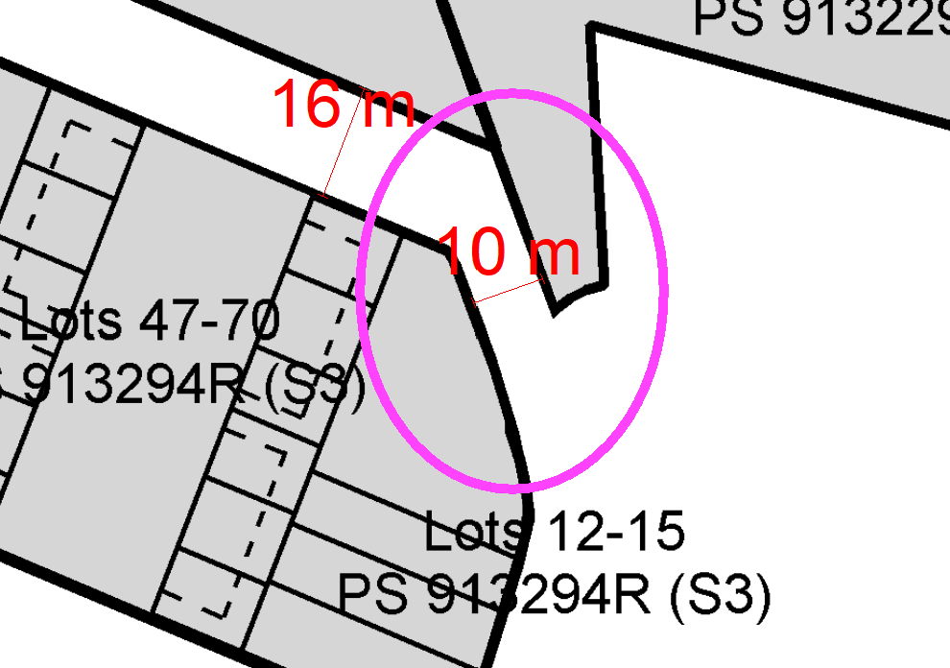
Were a permit to be issued, the without prejudice conditions provided should be included.

Department: | ESD Response
Response: | Environment Recommendation: Supportive and comply  - All works must be undertaken in accordance with the submitted development plan, Sustainability Management Plan and stormwater management plan to the satisfaction of the Responsible Authority. No alterations to these plans may occur without the written consent of the Responsible Authority.
Officer Comment:
No objection to the grant of a permit.
The recommended conditions should be included on any permit that were to be issued.

Department: | Open Space Planning
Response: | First referral response received 9/12/2022:  Open Space Planning have reviewed the documentation provided as part of the permit application and have the following comments.  A permit cannot be granted until the removal of reserve status has been finalised for the section of reserve along the northern boundary and the proponent has acquired the land. Open Space are supportive of the inclusion of the existing reserve into this permit area as it provides improved passive surveillance outcomes and retains the east-west pedestrian and cycling connection.  Open Space require clarification on where the proposed title boundary will sit following the inclusion of the reserve along the northern boundary. Currently the proposal appears to encroach into land zoned as PPRZ in the north-west corner of the site, shown below. The title boundary should be updated to exclude the PPRZ area. Residential uses do not comply with the purpose of the PPRZ.  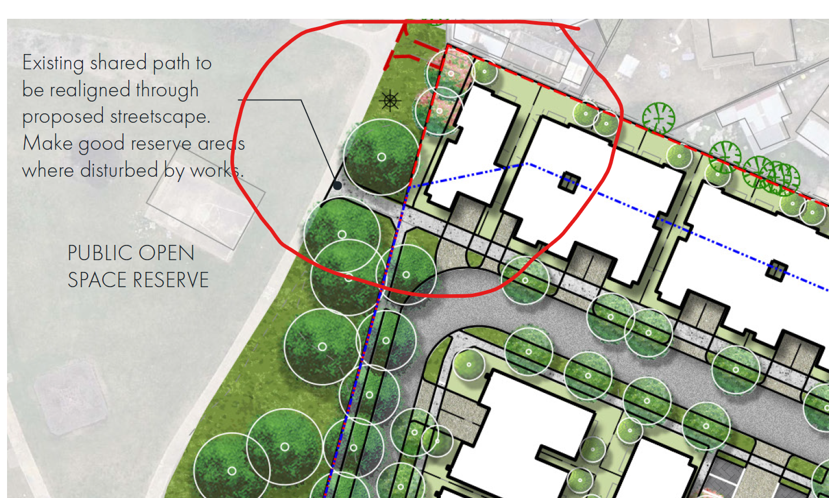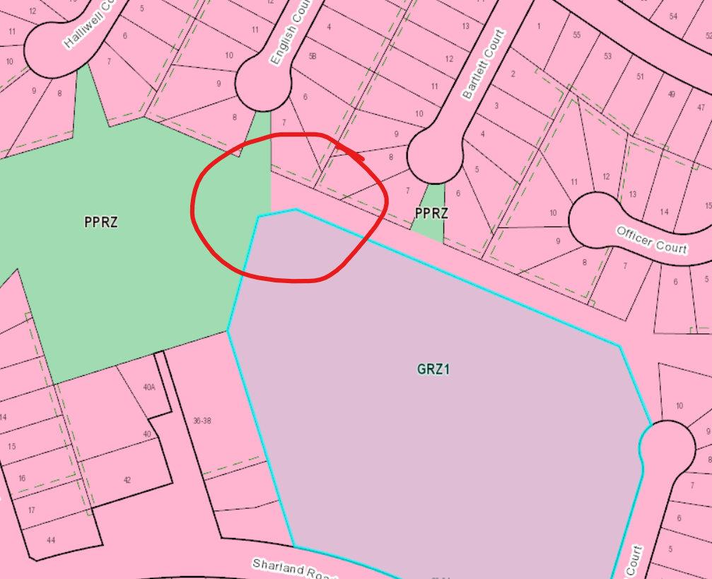  A 10 per cent cash contribution is required as per Clause 53.01, refer below for schedule. The exemption outlined in the Town Planning report ‘it subdivides land into two lots and the council considers it unlikely that each lot will be further subdivided’ does not apply to this subdivision which is proposing 120 lots. This section of the Town Planning report also requests consideration of ‘the concurrent Section 96A application’, please clarify what this is referring to, as we have no record of a current Section 96A application with regard to this site.  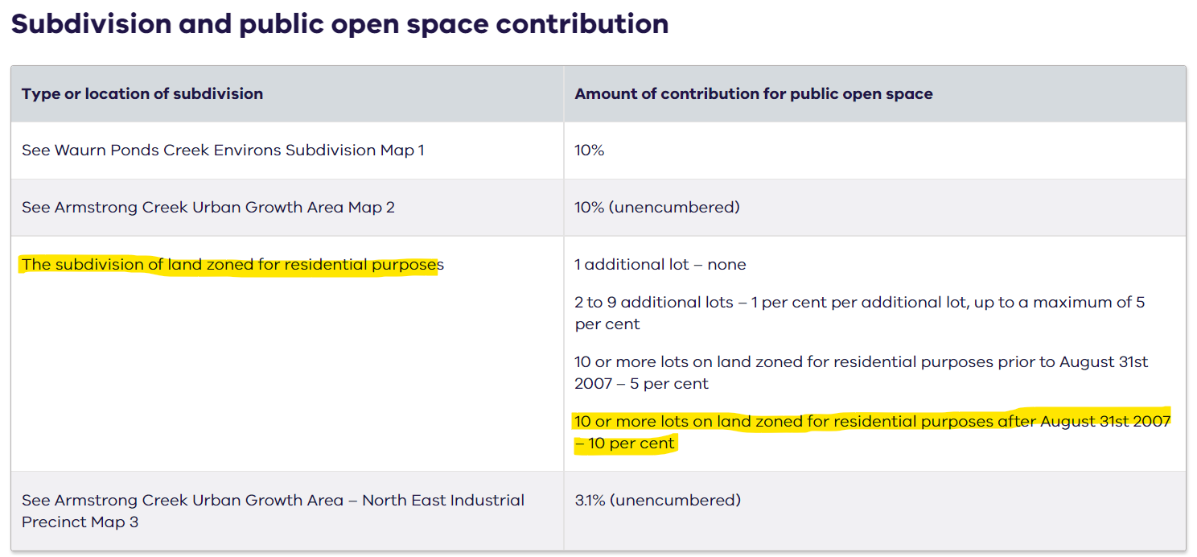  The proposed 4m width pedestrian link reserve connecting to Bartlett Court (as shown below) will need to be a minimum 10m in width. This is our minimum acceptable width for a pedestrian link reserve to ensure adequate passive surveillance and sense of safety.  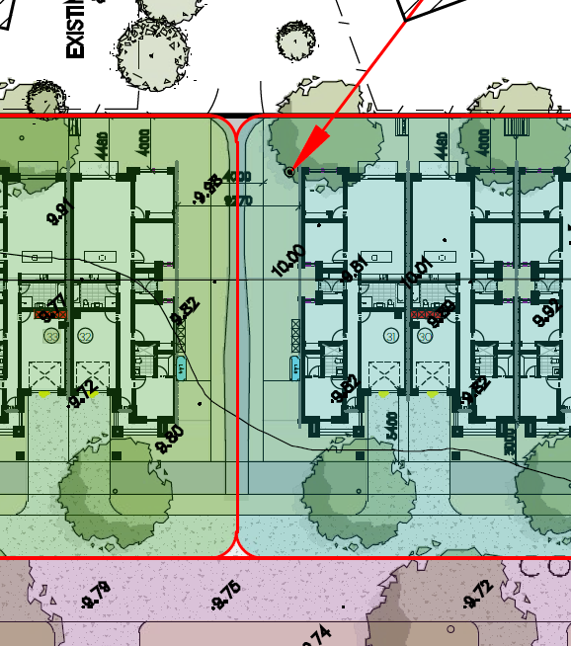  The drainage report notes that the development will be delivered in stages. To understand when the linear reserve and drainage reserve will be delivered, please provide a staging plan.  The proposed path connection from the development into the existing public open space should tie into the existing path width, refer below location for reference.  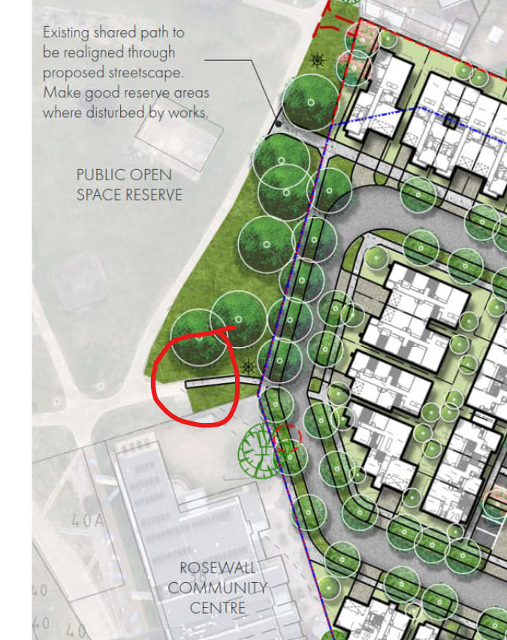  Include the red dashed line as shown below in the legend and confirm if this is referring to the sections of existing path to be removed.  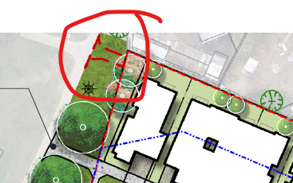  Our maintenance team have reviewed the proposed planting schedule and request that the following species are removed:  - Carpobrotus rossii  - Myoporum parvifolia  - Lomandra longifolia  We also note that Asparagus densiflorus and the Kniphofia are considered invasive and request their removal from the plant schedule.  Second Referral response received 2/05/2023:  Recommendation  Supportive – pending sale of land to the north  Recreation & Open Space Infrastructure and Planning Response  Open Space Planning have reviewed the amended application and are supportive, we note that a permit cannot be granted until the removal of reserve status has been finalised for the section of reserve along the northern boundary and the proponent has acquired the land. Our understanding is our property team are currently working on getting a valuation for the land and then will continue with the sale process.  Our remaining comments can be dealt with through amended plans conditions and permit conditions. We note that the Landscape Master Plan should not be endorsed as part of the permit application and can be dealt with through permit conditions.  The Town Planning report refers to the proposed subdivision being exempt from a public open space contribution. As the proposed subdivision for 26-34 Sharland Road is for 10 or more lots on land zoned for residential purposes prior to August 31st 2007 a five (5) per cent cash contribution will be required under Clause 53.01. As the proposed subdivision for the portion of 11 McHarry Court (shown below in red) is for 10 or more lots on land zoned for residential purposes after August 31st 2007 a ten (10) per cent cash contribution will be required under Clause 53.01. Permit conditions have been included for this.  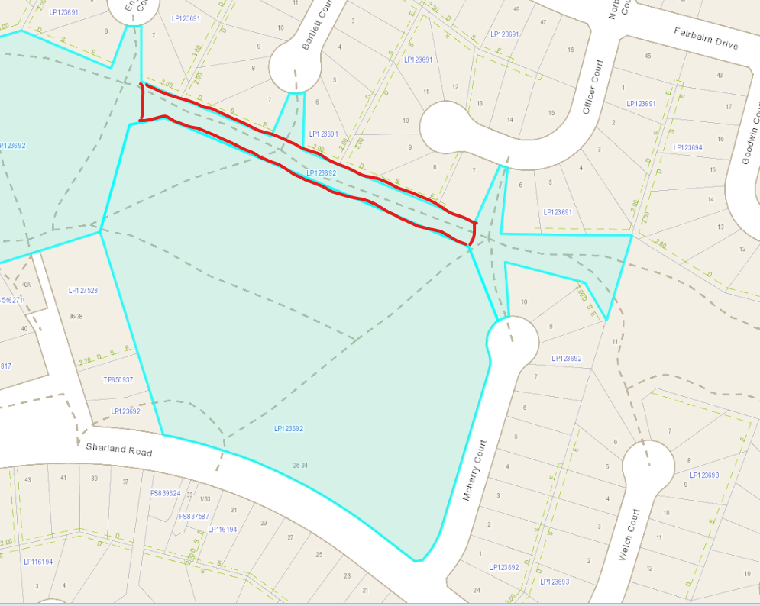  The pedestrian link reserve connecting to Bartlett Court is too narrow, as previously stated our minimum required width for a pedestrian link is 10m to ensure adequate passive surveillance and public safety.  Please update the Landscape Master Plan to show the super lot a different colour to the ‘Townhouse lot garden area to future detail design’ for improved legibility as they currently read as the same thing.  Update the Landscape Master Plan legibility of the ‘Existing trees to be removed’ and ‘Existing trees to be retained subject to future Arboricultural assessment and recommendations and detailed design’. Currently the symbols read as the same thing.  Council’s preference for vehicle exclusion fencing is to use the standard post and rail timber fencing as per CoGG standard drawing CGG709, refer below. When the Landscape Master Plan is updated please include this instead of the timber post and steel rail fence. All post and rail fencing where it interfaces grass or garden bed is to have a 500mm granitic gravel strip underneath to allow ease of maintenance.  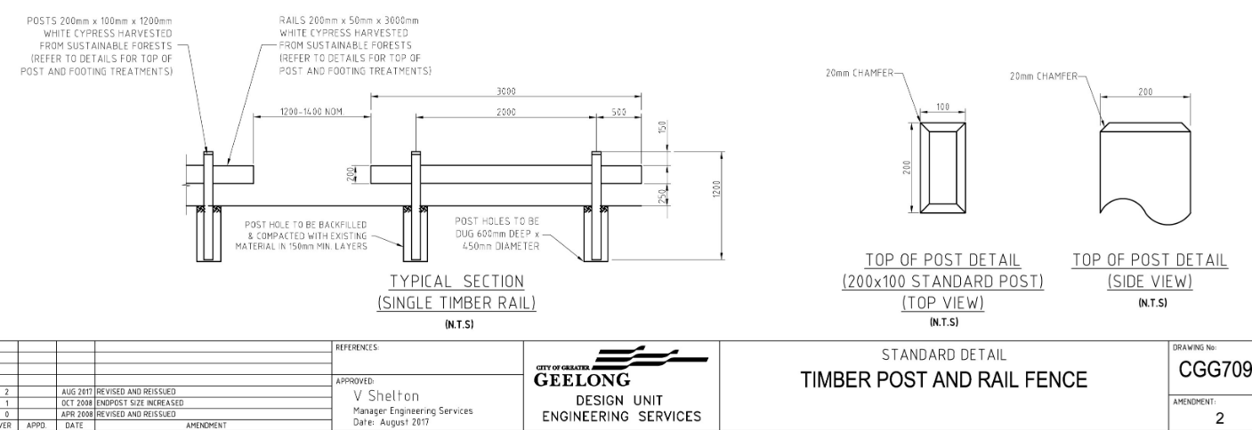  Standard Conditions  Amended plans  Prior to the commencement of works, amended plans to the satisfaction of the Responsible Authority must be submitted to and approved by the Responsible Authority. When approved, the plans will be endorsed and will then form part of the permit. The plans must be drawn to scale with dimensions and must be generally in accordance with the plans submitted with the application but modified to show:  - All plans updated showing the pedestrian link reserve to Bartlett Court as a 10m width.  Public Open Space (Monetary Contribution)  Prior to the issue of Statement of Compliance for Stages 1 and 2, the owner of the subject land must pay to the Council a sum equivalent to five per cent of the site value of all of the land in that stage of subdivision (26-34 Sharland Road, Corio 3214) as a Public Open Space contribution pursuant to the Schedule to Clause 53.01 of the Greater Geelong Planning Scheme. The contribution will be payable prior to the issue of a Statement of Compliance for Stages 1 and 2.  Prior to the issue of Statement of Compliance for Stage 3, the owner of the subject land must pay to the Council a sum equivalent to ten per cent of the site value of all of the land in that stage of subdivision (11 McHarry Court, Corio 3214) as a Public Open Space contribution pursuant to the Schedule to Clause 53.01 of the Greater Geelong Planning Scheme. The contribution will be payable prior to the issue of a Statement of Compliance for Stage 3.  Access and Storage Prohibited on Council Reserves  There must be no parking, access through or storage on the adjoining council reserve at any time during construction.  Fencing of Council Reserves  Prior to the issuing of a Statement of Compliance for any relevant stage of the subdivision which includes, or is adjacent to, a Council reserve, the subdivider must erect a fence on the boundaries of the Council Reserve to the satisfaction of the Responsible Authority and at no cost to the City unless otherwise approved in writing by the Responsible Authority.  No Utility Services On Public Open Space  Utility service substations, kiosk sites and the like must not be located on any land identified as open space unless otherwise agreed in writing by the Responsible Authority. Any existing or future easements affecting all land which is to be vested in council must be clearly identified on the detailed landscape plans.  Landscape Master Plan  Prior to issue of Statement of Compliance for the first stage of the subdivision, unless otherwise approved in writing by the Responsible Authority, a landscape master plan (incorporating a street tree master plan) for the entire permit area must be prepared (by a qualified landscape architect), submitted and approved by the Responsible Authority. The plan must be submitted electronically. When approved, the plan will be endorsed and form part of the permit. The landscape master plan must show and include but is not limited to:  - The location, size (including area and dimensions) and primary function of all land to be developed as reserves, including, but not limited to, Linear Reserves, Road Reserves and Drainage Reserves;  - Any open space or landscaped areas to be common property must be distinguished from public open space areas;  - All plans must show north and be drawn to scale. Plans should be oriented to have the northern most point at the top of the page;  - Current reserve area grades and any proposed changes to site gradients for all reserve areas;  - A survey prepared by a suitably qualified person (arborist and/or ecologist) (including the location, size and botanical name) of all existing vegetation, identifying what is proposed to be retained on the land; and show details of tree protections zones. This survey must also show what vegetation is approved for retention, removal and/or lopping in accordance with the Native Vegetation Precinct Plan, highlighting any changes between the two.  - The ultimate 1% and 10% Annual Exceedance Probability storm event extents;  - The location and size of any water sensitive urban design (WSUD) assets;  - Location of any proposed services/utilities in open space (including drainage infrastructure such as swales);  - A general indication of what recreation infrastructure is proposed and its location, including but not limited to: furniture, paths, vehicle exclusion barriers and maintenance access points;  - The style and location of all fencing for all boundaries abutting reserves (excluding road reserves other than paper roads);  - Road Reverse treatments including, footpaths, street trees etc  - Pedestrian and cyclist transport/movement plan – shared path locations, widths, surface treatments;  Notes:  - Consultation with the City’s Open Space Planning Unit during early concept design is encouraged to help facilitate efficient approval processes.  - Any pathway within the open space reserves should be located having regard to the protection of existing vegetation worthy of retention.  Detailed Landscape Plans  Prior to the Statement of Compliance being issued for each applicable stage of the subdivision, unless otherwise agreed in writing by the Responsible Authority, a detailed landscape plan for the stage must be prepared and submitted to the Responsible Authority for approval. When approved, the plan will be endorsed and form part of the permit. The landscape plan must be drawn to scale with dimensions and submitted electronically. The plan must address and be consistent with any endorsed landscape master plan applying to the site and show, but not be limited to:  - The location, size (including area and dimensions) and primary function of all land to be developed as reserves, including, but not limited to, Linear Reserves, Road Reserves and Drainage Reserves;  - Site amelioration works, such as rubbish removal, demolition of existing structures, foundations, pipelines, farm dams or stockpiles and the eradication of weeds;  - Landscaping treatment of any road reserve (to back of kerb) abutting public open space;  - Location of all services, utilities or encumbrances (including drainage infrastructure/WSUD)  - Site contours and any proposed changes to existing levels including any structural elements such as retaining walls;  - Any reserve containing gradients 1 in 14 or steeper must include a minimum of two (2) individual cross sections that stipulate the proposed treatment options;  - The ultimate 1% and 10% Annual Exceedance Probability storm event extents;  - Vegetation that is to be retained, removed and/or lopped in accordance with the Native Vegetation Precinct Plan (NVPP), as well as any other practical retention tree(s) within a reserve.  - An arborist report which demonstrates the vegetation proposed for retention is suitable for public space. The report must show the location, size, botanical name, health, TPZ and any management recommendations.  - The proposed layout including all paths, furniture, bike parking, signage, maintenance vehicle access crossovers and maintenance access gate/s – including materials and finish of all surfaces;  - Specifications for all proprietary products shown on the plan. Construction details for all custom/bespoke furniture, etc;  - A detailed planting schedule and proposed planting layout of all areas of open space, including proposed trees, shrubs, groundcovers and aquatic planting (if applicable, with zonation detail), and showing botanical names, common names, pot sizes, sizes at maturity, quantities and densities of each plant;  - Indication of mature tree sizes, shown to scale/75% to illustrate the extent of canopy coverage;  - Detailed planting and hardscaping construction drawings;  - Permeable fence design details for lots abutting all reserves except road reserves.  - Detailed planting and construction drawings including site contours and any proposed changes to existing levels including any structural elements such as retaining walls;  - Detailed planting and construction drawings of any drainage and WSUD infrastructure within public reserves;  - Additional supporting information, such as certified structural designs or building forms;  - A detailed schedule of quantities showing accurate cost estimates of each item included in the plan;  Notes:  - Landscape plan changes must be identified on any amended plans with a revision cloud. Any changes not identified on a plan that is subsequently endorsed will not be accepted and Council has the right to require rectification.  - Consultation with the City’s Open Space Planning Unit during early concept design is encouraged to help facilitate efficient approval processes.  - Estate entry signage must not be located on public land.  Completion of Landscape Works  Unless otherwise approved in writing, prior to the issue of a Statement of Compliance for any stage that includes a reserve and/or open space, the works shown on the approved landscape plan for that stage must be completed to the satisfaction of the Responsible Authority and Practical Completion awarded.  A practical completion inspection is required and must be arranged by the permit holder with a minimum of two weeks notice provided for the Responsible Authority. The completion of works must be to a standard to the satisfaction of the Responsible Authority to pass this inspection. Standards are detailed in documents including but not limited to the City’s Landscape Standards Manual or the equivalent document in place at the time of the practical completion inspection.  Prior to the issue of practical completion of landscaping works, or any other time as agreed by the Responsible Authority, the following must be provided to the Responsible Authority:  - The vesting of the reserve to the City, and at no cost to the City;  - As-built landscaping plans in PDF and GIS-ready AutoCAD (DXF) format.  - Landscaping maintenance plan, where required,  - Building permits and structural engineering compliance, as-built construction plans, and materials detail as required by the Responsible Authority.  - Schedule of Quantities by a suitably qualified person, showing the quantities and financial value of all assets.  - Any other documentation as required by the Responsible Authority.  Landscaping Bonds  If the Responsible Authority agrees to issue Statement of Compliance prior to the landscaping works being completed, the entire landscaping works must be bonded to the satisfaction of the Responsible Authority. The landscape works bond or bank guarantee must be 125 per cent of the estimated cost of entire landscape works as shown in the schedule of quantities submitted as part of the landscape plans. Unless otherwise agreed in writing by the Responsible Authority the bonded works must be completed within one (1) year of the date of statement of compliance being awarded. The landscaping works bond will be returned following award of practical completion. A practical completion inspection is required and must be arranged by the permit holder with a minimum of two weeks notice provided for the Responsible Authority. The completion of works must be to a standard to the satisfaction of the Responsible Authority to pass this inspection.  Prior to Statement of Compliance, a landscaping maintenance bond must be submitted to and approved by the Responsible Authority. The maintenance bond must be 125 per cent of the agreed cost of maintenance of landscape works for a two (2) year period. The maintenance bond will be returned following acceptance of Handover.  Maintenance of Council Reserve  The works/development shown on any endorsed landscape plan for a particular stage must be maintained to the satisfaction of the Responsible Authority for a period of no less than two (2) years from the date of practical completion of the landscaping unless otherwise agreed in writing by the Responsible Authority. During this period, any dead, diseased or damaged plants are to be replaced and any landscaped area and hard assets and equipment are to be repaired as required to ensure the landscaping is maintained to the same standard as when practical completion was awarded.  Should the permit holder default on landscape maintenance requirements which leads to a partial or full replanting, the Responsible Authority will determine an appropriate extension of the maintenance period as necessary to provide for establishment of replacements.  Handover  A handover inspection is required for the reserve and must be arranged by the permit holder with a minimum of two weeks notice provided to the Responsible Authority. The condition of the reserve must be at a standard to the satisfaction of the Responsible Authority and meet the requirements detailed in the City’s Landscape Standards Manual or the equivalent document in place at the time of the inspection to pass this inspection. No landscape handovers will be accepted from 30 November to 1 March inclusive. The maintenance bond will be returned following acceptance of Handover.
Officer Comment:
No objection to the grant of a permit.
The recommended conditions should be included on any permit that were to be issued.

Department: | Parks Planning
Response: | First referral response received 16 November 2022:  Trees within Public Land  It is hard to determine with this level of detail the impact to any Council tree assets adjacent to this site, but the building setbacks near any trees listed as Council assets appear to enable their retention with the aid of a conditioned TPMP.  Street Tree Plan  The following species are too large for the future space being provided for their growth / are very hard to establish in the Corio area,  - Eucalyptus melliodora  - Corymbia ficifolia  Species substitutions could be taken from the following list,  - Koelreuteria paniculata  - Zelcova serrata  - Acer buergerianum  - Tilia cordata ‘Greenspire’  - Fraxinus ‘Urbanite’  - Nyssa sylvatica  - Pistachia chinensis  - Acer campestre ‘Elsrijk’  - Eucalyptus pauciflora  - Brachychiton ‘Jerilderie Red’  - Acacia pendula  - Cercis siliquastrum  - Pistachia chinensis  - Brachychiton ‘Griffith Pink’  - Geijera parviflora  - Parrotia persica  - Jacaranda mimosifolia  Open Space Tree Plan  The following species are very hard to establish in the Corio area,  - Quercus coccinea  - Banksia integrifolia  - Acacia melanoxylon  Species substitutions could be taken from the following list,  - Quercus canariensis  - Quercus castaneifolia  - Quercus acutissima  - Quercus cerris  - Grevillea robusta  - Cedrus deodara  - Cedrus atlantica  - Brachychiton acerifolius  - Pinus pinea  - Pinus halepensis  Other Comments from Parks Department  It is noted that the small common property streets between Council Roads 1 & 2 list a 500mm wide grass strip for future street trees to be planted (listed as Pyrus ‘Chanticleer’ in the street tree plan). This is an insufficient amount of space both above and below ground with which to establish canopy street trees. Any street tree planting within these heavily hardscaped streets will require a detailed below ground engineering solution (Strata Cells / Structural Soils) before Council agrees to street tree installation in this scenario.  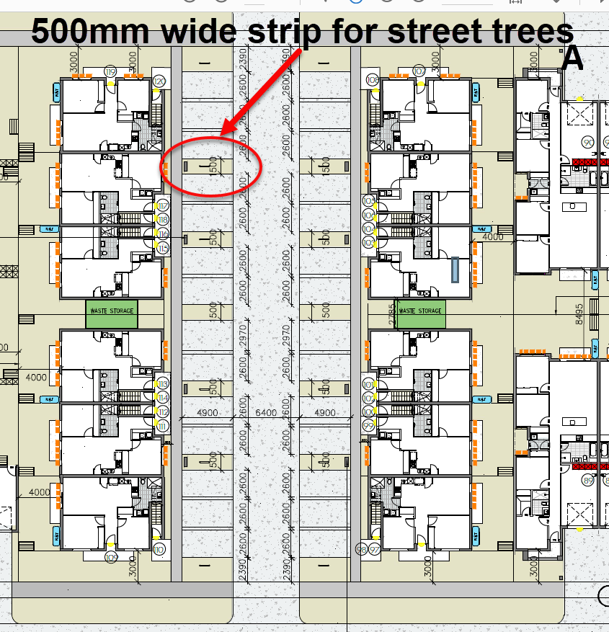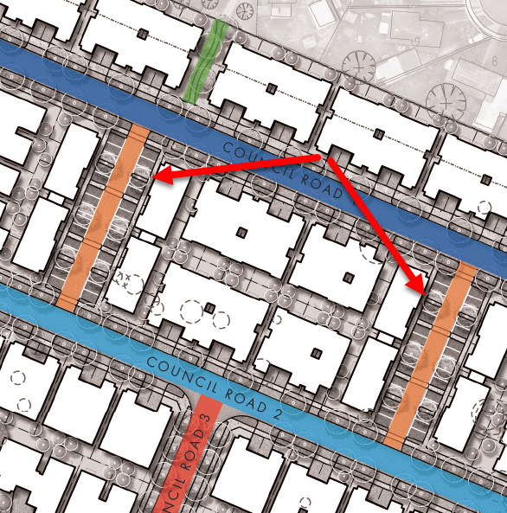  Tree Protection Management Plan  Prior to the commencement of the development, a Tree Protection Management Plan must be submitted to and approved by the Responsible Authority. The Tree Protection Management Plan must be prepared by a suitably qualified arborist and must include all:  - council-owned trees  - privately owned trees and  - trees owned by other parties that are located within 4 metres of the property boundary.  Prior to the commencement of any works at the site (including demolition and excavation whether or not a planning permit is required), a letter of engagement must be provided to us (as the Responsible Authority) from the Project Arborist selected to oversee all relevant tree protection works. In accordance with Australian Standard 4970-2009 Protection of trees on developments sites the Project Arborist must be an appropriately experienced and qualified professional (minimum AQF Level 5 Arborist).  When approved the Tree Protection Management Plan and its recommendations will be endorsed and will then form part of the permit.  The approved Tree Protection Management Plan must not be amended or altered without the consent of the Responsible Authority.  Tree Protection Zones  Prior to the works commencing (including any demolition works), Tree Protection Fencing must be installed and maintained until works are completed to the satisfaction of the Responsible Authority.  All works within the nominated Tree Protection Zones must be:  - carried out in accordance with Australian Standard 4373–2007 Pruning of amenity trees and Australian Standard 4970–2009 Protection of trees on development sites  - overseen by a suitably qualified, level-5 arborist  - carried out to the satisfaction of the Responsible Authority by suitably trained and qualified arboricultural staff.  Works encroaching within the nominated Tree Protection Zones must not be undertaken without the written consent of the Responsible Authority.  Prior to occupation of the development/the issue of Statement of Compliance, a written statement from the Project Arborist must be submitted to the Responsible Authority that certifies that the following items have been addressed as part of the works:  - Installation and correct placement of tree protection fencing 2 weeks prior to works commencing and for the duration of works  - Attendance during Tree Protection Zone incursions  - Adherence to Australian Standard 4970–2009 Protection of trees on development sites  Note  - In the instance that minor pruning is anticipated the applicant must contact Council’s Parks Planning Officers on 5272 5272 (treeplanning@geelongcity.vic.gov.au) to lodge a request and provide adequate notice.  Street Tree Master Plan  Prior to any works commencing/stage 1 commencing, a Street Tree Master Plan must be submitted to and approved by the Responsible Authority.  The Street Tree Master Plan must be prepared by a qualified person and must be developed in accordance with the principles of the approved Precinct Structure Plan/ Development Plan. It must also include:  - Street tree planting using semi-advanced trees with a minimum container size of 45 litres that comply with Australian Standard 2303-2018 Tree stock for landscape use  - One tree per standard property frontage  - All nature strips (includes future Council maintained land and residential properties) within the development must be instant turf grassed to the satisfaction of the Responsible Authority. Alternative treatments may be used in agreement with the Responsible Authority.  - Pedestrian linkages  - Street closures reserves  - Land created for the purposes of creating a buffer zone (i.e. rural interface or main road)  - The estimated canopy of the mature trees (at 20 years) must be shown to scale  Notes:  - Street tree species selection within the Street Tree Master Plan is subject to approval by Powercor in accordance with the requirements of the Distribution Construction Standard, Underground Trenching. Consult with the Electrical Designer regarding this requirement.  - For staged developments the Street Tree Master Plan may form part of the Landscape Master Plan  Streetscape Works, Detailed Plans  Prior to the issue of Statement of Compliance for each stage, a detailed Streetscape Plan must be submitted to and approved by the Responsible Authority. The Streetscape Plan must be prepared by a person suitably qualified in landscape design, must be generally in accordance with the approved Street Tree Master Plan/ Precinct Structure Plan/Development Plan, and must adhere to eth City of Greater Geelong Landscape Standards Manual and must include:  - The name and stage of the estate and the Planning Permit Number  - Scale and dimensions  - The layout of proposed new planting in all road reserves and traffic management devices (e.g. medians, islands, and roundabouts)  - Details of all other infrastructure within the road reserve (e.g. underground services, street lights, stormwater pits, fire plugs etc.)  - Pedestrian linkages inclusive of proposed landscape treatments  - Proposed treatments within street closures  - Buffer zones (i.e. rural interfaces and main roads)  - A detailed planting schedule of all proposed trees and plants including botanical names, common names, pot sizes, sizes at maturity and quantities for each species  - All proposed groundcover & shrub planting with a minimum container size of 150mm and must not exceed 400 mm in height at maturity  - The maintenance schedule for all proposed planting  - The estimated canopy of the mature trees (at 20 years) must be shown to scale  - All road cross sections applicable to the site  - Tree Protection Zones on all plans  - Street tree planting must be achieved in no less than 85% of the lots for that particular stage of the development.  - A note within the specification for the site stating, “all works and maintenance within the stage must be in accordance with the City of Greater Geelong Landscapes Standards Manual”.  - All nature strips (includes future Council maintained land and residential properties) within the development must be instant turf grassed to the satisfaction of the Responsible Authority. Alternative treatments may be used in agreement with the Responsible Authority.  When approved, the Streetscape Plan will be endorsed and will then form part of the permit.  Notes:  - Proposed entry signage must not be located on public land and must remain in private ownership  Completion of Streetscape Works  Unless otherwise agreed in writing, prior to the issue of Statement of Compliance for that stage, the streetscape works shown on the endorsed Streetscape Plans must be completed to the satisfaction of the Responsible Authority.  Where streetscape works shown on the endorsed Detailed Streetscape Plans are not completed prior to the issue of Statement of Compliance for that stage, the applicant must submit to a cost estimate for all outstanding works for approval by the Responsible Authority. Once the cost estimates have been approved, a bond or bank guarantees to the value of 125 per cent of the cost of works must be submitted to the Responsible Authority separately prior to the Statement of Compliance for that stage.  Where a bond or bank guarantee has been accepted for incomplete streetscape works, the outstanding works must be completed to the satisfaction of the Responsible Authority within 1 year of Statement of Compliance being issued for that stage unless otherwise agreed by the Responsible Authority.  A practical completion inspection is required to satisfy this condition and must be organised by the permit holder with two weeks’ notice given. The incomplete works bond will be returned once practical completion has been awarded.  Notes  - Bond estimates must be sent to statplanning@geelongcity.vic.gov.au for approval at least two (2) weeks prior to seeking Statement of Compliance.  Maintenance of Streetscape Works  All works must be maintained to the satisfaction of the Responsible Authority for a period of two (2) years from the date of practical completion. During this period, any dead, diseased or damaged plants must be repaired or replaced as required.  Where the streetscape works are bonded, the maintenance period will commence from the date that the works are awarded practical completion by the Responsible Authority.  A maintenance bond to the value of 125 per cent of the cost of works must be submitted to the Responsible Authority prior to practical completion of landscaping works being awarded and will be retained until such time that the works have been accepted by Council for handover.  Works that have achieved practical completion will be audited throughout the maintenance period. Works being inappropriately maintained or established will not be accepted and will remain on maintenance until such time that the Responsible Authority deem it acceptable.  A handover inspection is required to satisfy this condition and must be organised by the permit holder with two weeks’ notice given. The maintenance bond will be returned on acceptance of handover.  Notes  - No handovers will be accepted during the summer period, between 30 November and 1 March.  - Bond estimates must be sent to statplanning@geelongcity.vic.gov.au for approval at least two (2) weeks prior to seeking Statement of Compliance.  Second Referral response received 26 April 2023:  The previous concerns have been addressed with the amended submission.
Officer Comment:
No objection to the grant of a permit.
The recommended conditions should be included on any permit that were to be issued.

Department: | Planning Delivery
Response: | - Section 5.1 and 5.2 of Town Planning report states that the development supports the delivery for affordable housing product and increase of the supply of social and affordable housing stock. The proposal shall identify:  - The appropriate mix of private dwellings and affordable housing  - It is noted that the proposed development is delivering a housing diversity in typology in Corio Norlane. This can be further enhanced by mixing the typology and diversifying its housing tenure toward a segment for affordable housing. The proposed affordable housing product can be one that delivers a specific product to a specific group participation, in example, to assist residents in Corio or other lower income household, in supported rentals such as public housing move up in the housing continuum toward a shared equity arrangement.  - Affordable Housing mentioned product shall be in accordance to the definition for affordable housing under the provision of section 3AA of the Planning and Environment Act 1987.  - Affordable housing must be delivered through the proposed development. Otherwise, there will be a net loss of community benefit due to removal of the reserve status and land value uplift gained that are not circulated back as community benefit through rezoning of council land.  From an affordable housing perspective, Planning Delivery team supports the permit application, including the removal of the reserve status, rezoning and sale of 11 McHarry Court, strictly conditional upon the fulfillment of the following contribution toward affordable housing delivery in accordance to the definition under the Section 3AA of P&E Act 1987:  - A contribution and delivery of dwelling, land or cash toward mix of affordable housing at minimum of 10% of total residential yield to a Geelong Affordable Housing Trust or Registered Housing Association. Alternatively, the 10% contribution can be delivered as dwellings sold to eligible low income purchaser currently residing in public housing in Corio through a shared equity arrangement.  - The delivery of affordable housing shall be in accordance with the principles set out in the City’s Social Housing Plan and the following:  - How affordable housing is to be delivered, including the identification of intended partners, timeframes, built form and response to each of the matters set out by the Minister pursuant to section 3AA of the Planning and Environment Act 1987.  - How affordable housing product can deliver a specific product to a specific group in participation, such as to assist lower income households move up the housing continuum from their current supported housing tenure.  - Locations for the affordable housing to be delivered to be delivered within the development  - A summary of the range of housing types, densities and sizes.  - Staging requirements and ensuring that affordable housing are provided in a timely manner as development occurs.  - Outline of the proposed development are achieving good outcomes for affordable housing such as density and mix, massing, interface management, streetscape response, internal amenity, architectural language, sustainability, landscape response.  - The proposed delivery of N-S road in accordance to the Corio 2012 Structure Plan has strategic importance to achieve in the outcomes and further enhance the interface between community infrastructure and affordable housing  - It should also consider  - The provision of affordable housing should be:  - functionally and physically indistinguishable from other dwellings within the development;  - and are distributed across the development; and  - a mix of lot or housing types to respond to local housing needs.  From an affordable housing perspective, Planning Delivery team supports the permit application, including the removal of the reserve status, rezoning and sale of 11 McHarry Court, subject to the fulfillment of the following contribution toward affordable housing delivery in accordance to the definition under the Section 3AA of P&E Act 1987:  Affordable Housing Delivery  Prior to the commencement of development, an affordable housing strategy should be submitted and approved to the satisfaction of the Responsible Authority based on:  - Primary Obligation: a transfer of dwellings (at zero consideration) to an affordable housing association under the Housing Act 1983 or the City of Greater Geelong Affordable Housing Trust at the target rate of minimum of 10% of the total residential yield generated for the proposed development on the land in the application or;  - the 10% contribution can be delivered as dwellings sold to eligible low income purchaser currently residing in public housing in Corio through a shared equity arrangement or  - through a combination of the options a and b above; or  - in any other way as agreed between the permit applicant and the Responsible Authority, which is of equal value to the Primary Obligation.  - An agreement under Section 173 of the Planning and Environment Act 1987 between the landowner and the Responsible Authority for the proposed delivery of affordable housing. All costs associated with setting up the agreement must be borne by the landowner. The agreement is to be registered on title and run with the land.  The affordable housing strategy and delivery shall be in accordance to the following principles:  - How affordable housing is to be delivered, including the identification of intended partners, timeframes, built form and response to each of the matters set out by the Minister pursuant to section 3AA of the Planning and Environment Act 1987.  - How affordable housing product can deliver a specific product to a specific group, such as to assist lower income households move up the housing continuum from their current supported housing tenure.  - Locations for the affordable housing to be delivered within the development  - A summary of the range of housing types, densities and sizes.  - Staging requirements and ensuring that affordable housing are provided in a timely manner as development occurs.  - Outline of the proposed development are achieving good outcomes for affordable housing such as density and mix, massing, interface management, streetscape response, internal amenity, architectural language, sustainability, landscape response.  - The proposed delivery of N-S road in accordance to the Corio 2012 Structure Plan has strategic importance to achieve in the outcomes and further enhance the interface between community infrastructure and affordable housing  - The provision of affordable housing should be:  - functionally and physically indistinguishable from other dwellings within the development;  - and are distributed across the development; and  - a mix of lot or housing types to respond to local housing needs.
Officer Comment:
Support for the grant of a permit is conditional on provision of affordable housing, or inclusion of a permit condition requiring provision of affordable housing.
However, the application does not propose the provision of affordable housing as defined at Section 3AA of P&E Act 1987.
Were the recommended condition to be included on any permit to be issued, the condition would effectively transform the proposal in a manner that would not provide the developer or the responsible authority the certainty and clarity of planning outcome that a condition must provide.
Were a permit to be granted, it is not recommended that a condition requiring affordable housing be included.

Department: | Social Planning
Response: | First referral response received 19/12/2022:  Plan is not generally in accordance with the Corio Norlane Structure Plan – Rosewall Concept Plan which requires a north south road to be incorporated into the design to ensure  “Redevelopment of the former Rosewall Primary School site provides an opportunity to address the lack of permeability in the existing street layout, as well as improve the surveillance and security of the Connections Park open space area. Part of the former school site could also be used to provide for an expansion of the Rosewall Neighbourhood Centre and adjacent community garden. The Rosewall Concept Plan (see page 22) represents the preferred redevelopment option for this site and includes the reallocation of land between the CoGG and the Department of Education and Early Childhood Development” (CoGG,2012,p12)  Directions  Support the redevelopment of the Rosewall Primary School site for future residential use integrated into a safe and accessible street and open space network (see Rosewall Concept Plan).”  The Rosewall Concept Plan shows a north south oriented road from Sharland Road to the north west corner of the site. This has not been achieved in the proposed subdivision plan for the site.  Land negotiations between COGG and the Department of Education and subsequently the Department of Treasury & Finance have been undertaken to achieve the intent of the concept plan to maximise permeability and passive surveillance of the community centre and open space reserve. The City has discussed the possibility of acquiring a Department of Housing property at either 7 or 8 English Court to facilitate the creation of a road linkage from Sharland Road to English Court to improve urban permeability.  Community infrastructure was design to address the ‘future north south road” to achieve a direct pedestrian connection to and passive surveillance from the proposed development site. The proposed subdivision layout design proposes back fences fronting the community centre secondary entry point to the east of the building is contrary to achieving pedestrian access and passive surveillance of the community centre site.  The properties that turn their back on the community centre exacerbate the ‘enclosure’ of the community centre and open space behind the street frontage of the community centre.  Has the Planner identified any potential further information relevant to this Unit?  The Planning professionals proposed that the north south road could not be achieved from Sharland Road due to traffic concerns. Social Planning & Investment would request a traffic report be provided proving that a direct road link from Sharland Road is unsafe and not possible within the Victorian Road Management Act 2004 or other related legislation.  Second Referral response received 19/05/2023:  The development proposal is not in accordance with the Rosewall Concept Plan and therefore not in accordance with the Corio Norlane Structure Plan (CNSP) 2012.  The intent for the local area is clearly outlined in the CNSP  Principle 1 –  Action 1.1 Increase Corio and Norlane’s resident population and diversify the types of available housing  Offer the Rosewall Primary School site for sale to achieve redevelopment in accordance with the Rosewall Concept Plan including reconfiguration of adjacent public open space.  Action 1.2 Negotiate a swap of COGG and DEECD owned land to ensure future development of the Rosewall Primary School site creates improved permeability and connection with the surrounding road and open space network  Principle 2 – Support opportunities for sustainable urban renewal  “Redevelopment of the former Rosewall Primary School site provides an opportunity to address the lack of permeability in the existing street layout, as well as improve the surveillance and security of the Connections Park open space area. Part of the former school site could also be used to provide for an expansion of the Rosewall Neighbourhood Centre and adjacent community garden. The Rosewall Concept Plan (see page 22) represents the preferred redevelopment option for this site and includes the reallocation of land between the CoGG and the Department of Education and Early Childhood Development. (Pg 12)  ‘Support the redevelopment of the Rosewall Primary School site for future residential use integrated into a safe and accessible street and open space network (see Rosewall Concept Plan). ‘(Pg 13)  The development application represents the only current opportunity to realise Structure Plan objective for a future road connection between Sharland Road and English Court mitigating circuitous street network and lack of road network permeability.  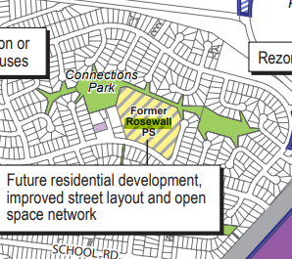  Reference to improved street layout  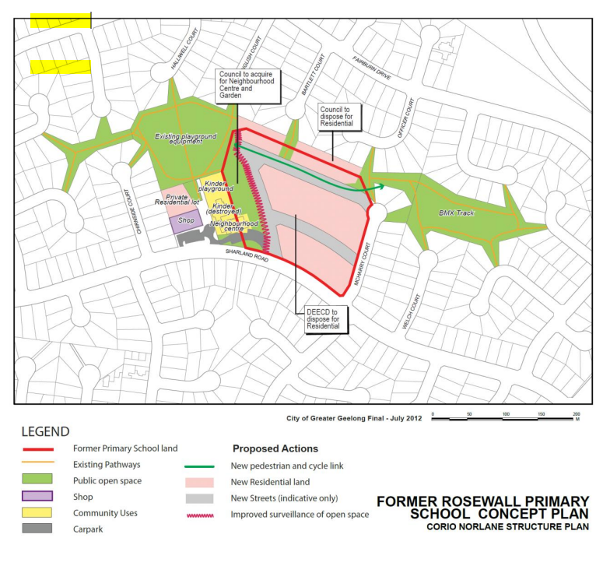  Page 18 Rosewall Concept Plan – reflecting south road creating opportunity to create a connection to English Court in future.  As referenced extensively in the CNSP, there are multiple objectives for the north south road including road layout, open space surveillance and improved surveillance and access to community facilities.  Planning Report (Pg 13) states incorrectly that layout respond directly to DDO by nominating only one of these objectives:  “The western site boundary remains largely undeveloped whilst providing a connecting road and  allowing the establishment of a connection node to Connections Park West. The proposed road layout responds directly to the provisions of the Design & Development Overlay – Schedule 37 by ensuring surveillance to the Rosewall Reserve is maximised through the establishment of a north-south road along the majority of the western boundary of the site.”  Inconsistencies are apparent in different planning documents. The acquisition of northern strip of land is proposed to be developed in Stage 3 in Concept Staging Plan but Planning Report states (Pg 15) “The proposal intends to proceed under Section 24A of the Subdivision Act 1988 (removal of reserve status) and will importantly form part of the first stage of the site subdivision.”  “Road reserves are predominantly 16 metres in width except for the western edge road which is a 14m road adjacent Public Open Space.” Does this mean footpath is on Council owned open space and who pays for footpath?  The Planning Report dated October 2022 states that…” As part of the development of the subject site, connection to Sharland Rd is proposed west of the existing speed hump and east of the existing bus stop in Sharland Rd. This intersection shall be constructed in accordance with the Industrial Design Manual (IDM) and City of Greater Geelong (COGG) standards where applicable. There will only be one connection from Sharland Rd to the subject site. The location of the intersection has been informed by the traffic and engineering advice prepared by Ration & SMEC. The location is consistent with that highlighted in the Corio Norlane Structure Plan to separate local traffic from the traffic entering and exiting the Rosewall Community Centre, noting that Council did not proceed with acquisition of additional land for the community centre. Separating the two areas will increase safety outcomes for the Site and provide an intersection not obstructed by stagnant and parked traffic.” (Tract,2023, Pg 17)  The Traffic Report does not discuss the benefit or otherwise of the proposed location of the access road from Sharland Road and indicates that “External access and circulation will be provided by a new intersection with Sharland Road…This layout is in accordance with the Corio Norlane Structure Plan.” (Ration, 2022,p4)  I have asked for Further Information and evidence to be provided confirming traffic advice in relation to the perceived traffic safety and congestion issues raised as the justification for not aligning the road more closely with the Concept Plan proposal but have not received updated advise to date.  Carparking for the community centre is well defined on Council land and this and traffic movements from the community centre is questioned as a valid argument to not achieve the road layout as proposed in the Rosewall Concept Plan. Traffic movements from the centre and the impact on the road network is detailed in the Traffic Report 2022 stating “The carriageway and function of Sharland Road reflects that of a Connector Street which can accommodate upwards of 3000 vpd…the total post development traffic volume on Sharland Road will be in the order of 2,438vpd, and therefore within the roads environmental and amenity capacity.” (Ratio, 2022, Pg21)  No further updated traffic report was provided to justify non-compliance with the Concept Plan directions in relation to a road connection from Sharland Road.  Unable to comment in detail on potential impact of ‘balanced lot’ development on community facilities as no detail is available. Cannot support the application in the current state due to uncertain impacts of this large portion of the development site on existing community facilities.  The City undertook the Corio North Community Infrastructure Plan in 2013 to understand the needs of the community. The report highlighted the impact of deep and persistent intergenerational disadvantage in this particular community and further that ”data correlates with broader ABS data to indicate that there are significant indicators of vulnerability across the whole precinct but that, relatively speaking, there are clear indicators of greater vulnerability in the Rosewall estate area. This finding is significant to this project as it provides a backdrop to the process of evaluating options for the location and nature of community services infrastructure for this precinct.“ (Hastrich, 2013,p42)  Three key findings that neatly summarise conclusions from consultation and other data analysis processes used within this project:  - There are significant levels of ‘disadvantage’ across the Corio North precinct that are highly relevant to the planning of Council community services infrastructure  - The overall profile of the precinct is complex, yet it is clear that there are local areas where a series of interacting structures reinforce significant disadvantage for potentially traumatised women and children who may experience difficulties accessing services  - Planning for the whole precinct must balance the aspirations of locally integrated services with Council’s responsibilities to the most vulnerable members of our community. (Hastrich, 2013,P47)  The following conceptual designs were developed to reflect the intent for the local area in relation to community facilities in accordance with the structure plan.  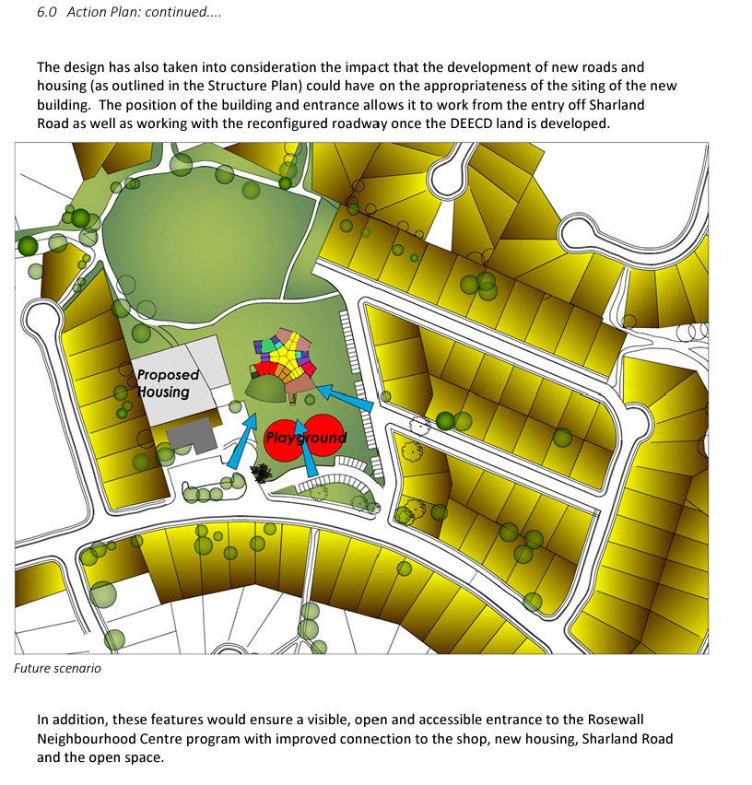  Hastrich,2013, p78  The Hastrich report further outlines:  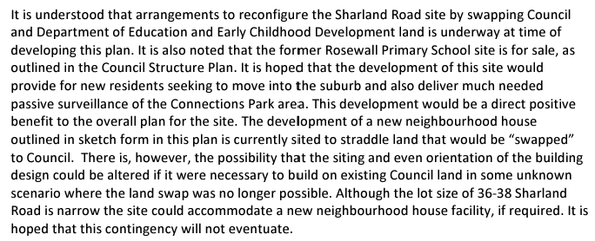  Vulnerable communities can engage with Council Services and community infrastructure in a different way to other communities in that they need to build neighbourhood connections, trust with service providers, informal social connection opportunities and subsequently “gain permission” to access the services.  Highly visible entry points, visible community events and activities in the outdoor spaces like the BBQ, men’s shed and community garden to the east of the community centre, add to vibrancy, interest in activities, the sense of place, the welcome and physical access and address are critical in the uptake of community services and activities.  To this end, the community facility was specifically designed to provide an address and eastern access for the future population of the subject site. A secondary eastern entry point was included in the facility to facilitate fluid access for residents east of the facilities to use the community garden and outdoor space and have confidence to subsequently access the neighbourhood house services.  Please note below the indicative location for future access point to the site and the eastern entry and corridor designed to welcome new residents from the east in blue. The social enterprise café was designed in the southeast corner of the facility to foster and maximise access to the open space to the south of the building through the alfresco café space ‘café outdoor area’. A 1.9m fence will detract from the amenity of the landscape arrival to the café and the experience of the alfresco component of the design.  The proposal was to remove exterior fencing post residential development and the realisation of active frontages and passive surveillance for the community centre.  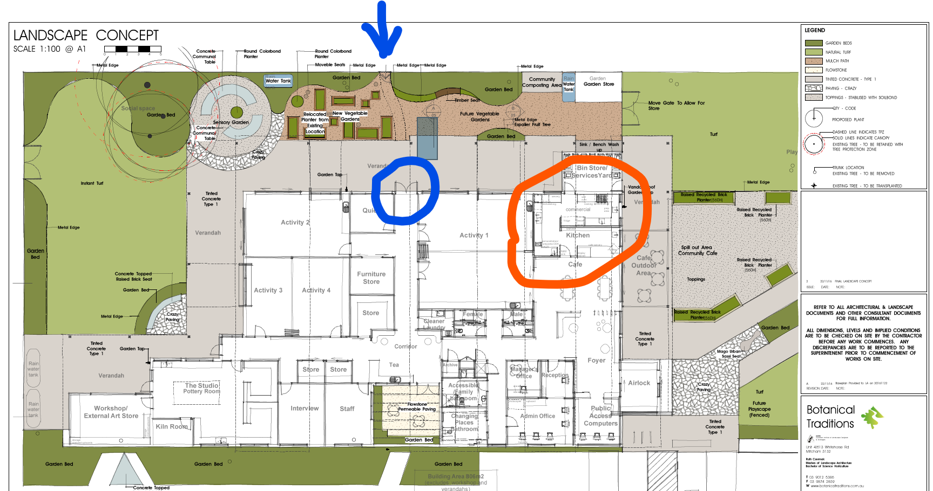  Fencing along property boundary is proposed to be 1.9m transparent fencing as is not supported as we require an active frontage to the east of the community facility.  Please consider an alternate subdivision layout to achieve the objectives of the Structure Plan.  If the Planning Permit is approved, please include a s173 agreement condition for the ‘balanced lot’ to include a road on the western edge of the ‘balanced lot” or an alternate active frontage to the community centre site.  Other Comments from Social Planning  The City originally intended to acquire the land to the east of the Rosewall Community Centre based on the pre-existing neighbourhood centre spanning the title boundary and at the time no capital budget was available to replace the centre. Following the arson and loss of the kindergarten, the City undertook a “Corio North Community Infrastructure Plan” Link to plan in 2013 to determine the requirements for the community.  The Report determined to relocate the kindergarten program and demolish the existing infrastructure and replace the community infrastructure on land owned by the City instead of waiting indefinitely to realise the land swap and further disrupt services for the community.  The land swap did not proceed as intended in the structure plan with the acquisition of the land to the east of the community centre as it was no longer required, but that does not mitigate the need for a north south road to provide a permeable road network, surveillance of the open space and community centre site.  In addition to this, the City are offering the sale of the northern easement enabling better development outcomes for the developer yet they are not complying with a fundamental requirement in the Corio Norlane Structure Plan that will vastly improve the urban structure and passive surveillance of the community centre.  Standard Conditions  1. Section 173 agreement in relation to the balanced lot to achieve active frontage to the community centre site.  Non-Standard Conditions  1. Include a north south road to the east of the community centre site as required in the Rosewall Concept Plan (Corio Norlane Structure Plan)
Officer Comment:
The grant of a permit is not supported.
The permit applicant has given in-principal agreement to a condition requiring the owner of the balance lot enter into a Section 173 agreement giving effect of the standard condition recommended.
Refer to consideration of the DDO37 and Former Rosewall Primary School Concept Plan later in these recommendations, including consideration of the suitability of a Section 173 agreement being applied to the balance lot. Were a permit to be granted, it is recommended the proposed Section 173 Agreement relating to future development on the balance lot be included.
However, the condition requiring the re-alignment of the proposed north-south road would result in a significant change to the subdivision layout that would likely result in significant changes to dwelling layouts and infrastructure requirements (stormwater, road design and drainage). Reconfiguring the proposal via permit condition is not recommended.

Department: | Strategic Planning
Response: | First referral response received 9 November 2022:  Strategic Planning does not support the proposal as currently submitted.  Design and Development Overlay Schedule 37 (DDO37) includes a subdivision requirement that a north-south road should be provided along the western boundary of the site as an interface with adjoining community facilities and park. The submitted plans only provide a road along a portion of the western boundary of the site, not extending south to Sharland Road or north to the northern boundary of the site.  As a result the submitted plan does not meet the following requirements of DDO37:  - Buildings must address Connections Park East, the Rosewall Neighbourhood House …  - Subdivision design must maximise surveillance of the public land.  - A north-south road should be provided along the western boundary of the site as an interface with the adjoining community facilities and Connections Park East.  A road along the western boundary of the site would provide an appropriate interface with the Cloverdale Community Centre (formerly Rosewall Neighbourhood House). It will also maintain the option for future vehicular connectivity to English Court to the north.  We would be pleased to consider a revised plan addressing the above.  Also recommend referral to Worksafe Victoria as the site is affected by the outer safety area of a Major Hazard Facility (Viva refinery) – see Worksafe Victoria’s guidance on the issue at: https://www.worksafe.vic.gov.au/land-use-planning-near-major-hazard-facility.  Other Comments from Strategic Planning  In any revised plan, subdivision design and vehicular access should not preclude or hamper the option of future vehicle access from the McHarry Court court bowl to 11 McHarry Court (formerly Connections Park East).  Although it has close proximity to the Cloverdale Community Centre and a bus route, the subject land is not identified as an Increased Housing Diversity Area. The submitted Planning Report indicates that the site and surrounds are identified in the Greater Geelong Settlement Strategy and Greater Geelong Housing Framework Plan as within a Key Development Area. This is incorrect. Assessment of the proposal against the requirements of the Greater Geelong Planning Scheme and the General Residential Zone Schedule 1 should be on the basis that the land is not identified as an Increased Housing Diversity Area (or Key Development Area).  Second Referral response received 3/05/2023:  Strategic Planning Recommendation  Not Supportive  This response is based on the revised plans received by Statutory Planning on 27 March 2023.  Strategic Planning remains unsupportive of the proposal.  The application is not considered to meet with the Corio Norlane Structure Plan, July 2012 or the objectives of the DDO37 with regard to the following:  - The absence of a north-south road along the western boundary of the site. The plans remain unchanged and only provide a road along a portion of the western boundary of the site. This is not considered to maximise surveillance of public open space and integrate with the adjoining community facilities. An opportunity exists to still provide the north-south connection road via an internal road along the western boundary, extending north to English Court and ensuring surveillance is maximised. An internal north-south road would also relinquish the need for the bus top to be relocated.  - The proposed balance lot makes it difficult to determine whether future buildings can address Rosewall Community Centre. Without an internal road, or a proposed development outcome, it is uncertain whether the objectives of the DDO37 can be met. There seems to also be a further site constraint on the balance lot with the presence of the existing car park. How is this to be addressed in terms of removal/relocation of existing car park for the Rosewall Community Centre?
Officer Comment:
Grant of a permit is not supported.
Further consideration to the matters raised is given later in these recommendations.
No without prejudice conditions have been recommended.

Department: | Urban Design
Response: | First referral response received 9/12/2022:  Access and movement along entire layout-  Urban Design (UD) is generally supportive of the road network and appreciates the integration of walkable networks to and through the site, with some change recommendations.  - Shared path and dwelling interface to the North:  - The length of the shared path as per sections is 2.5m. This is insufficient for cyclists and pedestrians to share and we recommend a minimum 3m width to the shared path.  - There are many driveways crossing the path resulting in increased pedestrian-vehicle conflict along this key route.  - There is a lack of buffer between the driveway car spaces and the shared path. The lack of buffer means vehicles reversing from driveways further risks the safety of pedestrians and cyclists using this path.  - The properties to the north outside of the subject site are substantially bigger. Given the proposal is much higher density than the surrounding urban context, to respond to the surrounding character, a transition in lot sizes towards the north should be considered.  - UD recommends housing to the north of the shared path be reduced in density to improve shared path safety as well as in response of transitioning to the properties abutting the north of the site. The number of driveways crossing the shared path should be minimised, and the garage setback and driveway lengths of these properties be increased. The shared path material, tactility (texture) and color could also be designed to emphasise the shared path priority and prevent the cars spilling out of the garage onto the front yard and further onto the shared path.  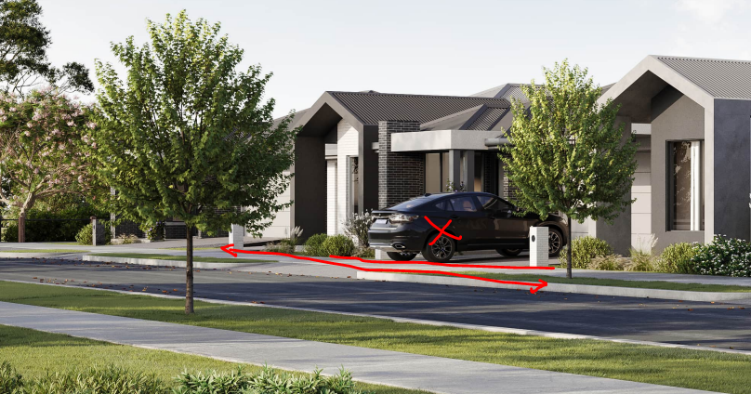  Figure 38: Cars being parked right outside the garage are a safety risk to users of the shared path.  - Fencing:  Describe the problem better and state the facts. UD is not supportive of high fencing of 1.9 m especially in areas identified to require high level of passive surveillance (Western edge of site, main entrance to site along council road 3). Show on plan?  Recommend all fences be maximum 1.2m and visually connected realms preventing blank fences and reduced safety along boundaries of the site.  Building Design & Layout:  - Apartment design: The apartments are front facing towards the carpark. What’s your point? Put your concerns here…  Recommend flipping the carparks to the external edges and creating a pedestrian connection to the main entrances of the apartments with high quality landscape and urban realm.  UD also queries if apartment/unit style housing would better suit the western edge of the site along parkland and community centre from passive surveillance point of view.  - Interfaces: describe the problem here and why it’s bad…  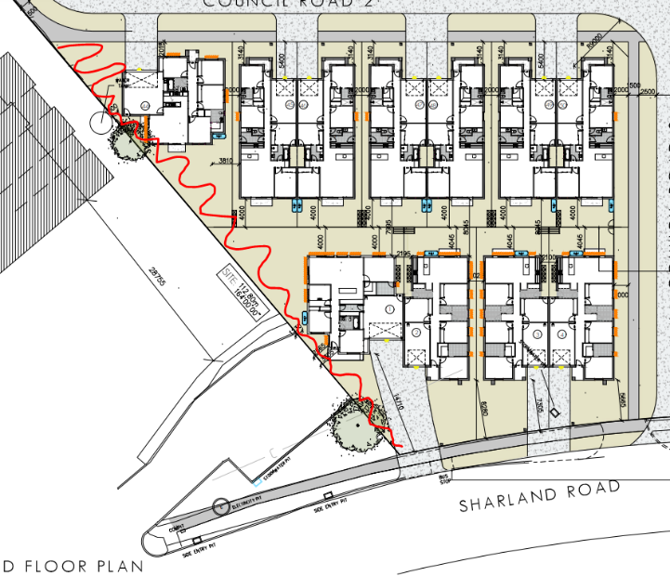  Not supportive of interface along west of site (as in figure below)  The built form sits far too close to the edge at a rather odd angle, which reduces the use of open space. Reconsider the design + detailed design of fence & landscape.  Not supportive of interface along drainage basin:  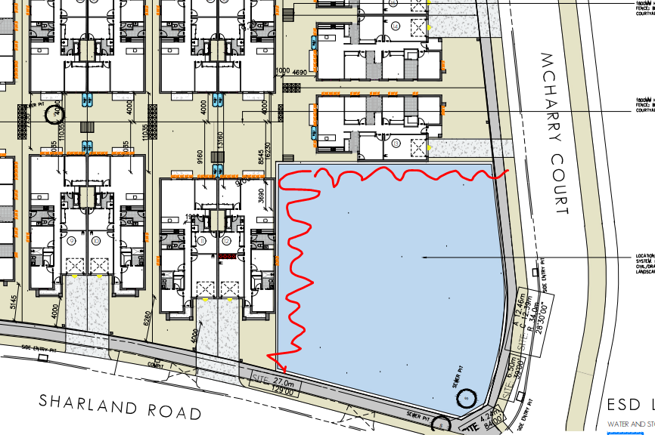  This interface is critical to the & identity of the entire development as the drainage corner will not visually obstruct view-lines to and from the interfaces in unit 12 & 13. Fencing the development from the drainage basin could result in reduced safety along the corner of Sharland Road & McHarry Court. UD recommends creating active interfaces along the corner and improving safety through passive surveillance.  Location of Bins:  Bin locations in several of the floorplans appears to result in bins being circulated through internal rooms or across whole built form to reach the collection street. Reconsider locations of bins where they cannot be accommodated in the carparks to be in concealed locations that have direct access to the street.  Second Referral response received 22/05/2023:  Access and movement along entire layout-  - North-South link through the site.  As specified in the Corio Norlane Structure Plan, July 2012; a north-south connection is recommended along the west of the site. This connection has not been achieved. As a result the development does not maximise surveillance of public open space and integrate with the adjoining community facilities. UD recommends one of the following two options:  OPTION 1: Provide as per the Structure plan and DDO, the north-south connection road along the western boundary, potentially extending north to English Court and ensuring surveillance is maximised. This road may need to be re-oriented to exit in a 90 degrees corner onto Sharland Road by using a small part of the carpark to the west. This will require further reinstatement works to the public realm in front of the community centre. Further conversations with the City will be required on the potential land take and other flow on impacts.  OPTION 2: That the applicant enters into a S713-agreement in relation to the balance lot to ensure an appropriate urban design outcomes which ensures that integration with community facilities and passive surveillance can be achieved. The design guidelines for the balance lot will include, as a minimum, the requirements for:  - All future dwellings must have entrances & opportunities of passive surveillance along all abutting boundaries. Frontages must be created towards the current carpark/ forecourt area of the Rosewall Community Centre, Sharland Road, Council Road 2 & Council Road 3.  - As a minimum, a continuous pedestrian connection must be provided along the western boundary abutting Rosewall Community Centre.  - Shared path and dwelling interface to the North:  - The length of the shared path as per sections is 2.5m. This is insufficient for cyclists and pedestrians to share, and we recommend a minimum 3m width to the shared path. Further the road reserve nature strip should not be compromised as a result of widening the shared path.  - There are far too many vehicle crossings cutting through the path resulting in increased pedestrian-vehicle conflict along this key route. We recommend using shared vehicle crossings leading to the driveways between neighbouring properties to minimise width.  - There is a lack of buffer between the driveway car spaces and the shared path. The lack of buffer means vehicles reversing from driveways further risks the safety of pedestrians and cyclists using this path. A minimum 5.4m setback from shared path to the garage entrance must be provided to prevent cars spilling onto shared path.  - The connection towards Bartlett court is greatly appreciated, however the design will result in creating blind corners (marked as red dots in the figure below) which will result in safety concerns arising in the area. UD Recommends adjusting the fencing & built form to create a safe and visually connected pedestrian link (As marked with yellow lines in figure below).  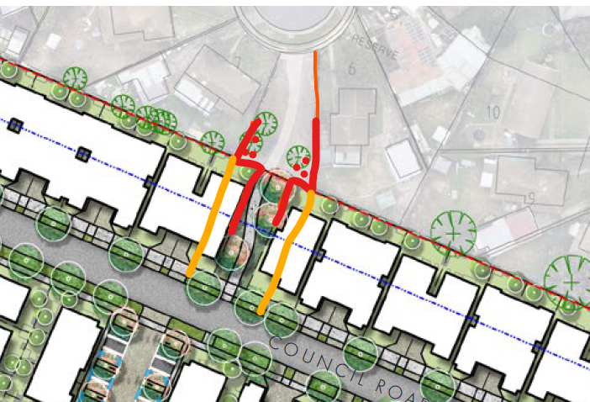  - The properties to the north outside of the subject site are substantially bigger. Given the proposal is much higher density than the surrounding urban context, to respond to the surrounding character, a transition in lot sizes towards the north should be considered.  UD recommends housing to the north of the shared path be reduced in density to improve shared path safety as well as in response of transitioning to the properties abutting the north of the site. The number of vehicle crossings cutting crossing the shared path should be minimised, and the garage setback and driveway lengths of these properties be increased. The shared path material, tactility (texture) and colour should also be designed to emphasise the shared path priority and prevent the cars spilling out of the garage onto the shared path.  - Fencing:  UD is not supportive of high fencing of 1.5m especially in areas identified to require high level of passive surveillance (Western edge of site, main entrance to site along council road 3).  Recommend all fences be maximum 1.2m and visually connected preventing blank fences and reduced safety along boundaries of the site.  Building Design & Layout:  - Courtyard units and terrace units design: The town houses are internalised and front facing towards the carpark reducing a sense of address and frontage to dwellings.  Recommend flipping the carparks to the external edges (Council Road 1 and 2) and creating a pedestrian connection to the main entrances of the apartments with high quality landscape and urban realm.  UD also queries if unit style housing would better suit the western edge of the site fronting parkland and community centre from passive surveillance point of view.  - Interfaces:  Not supportive of interface along drainage basin:  This interface is critical to the identity of the entire development. Fencing the development from the drainage basin could result in reduced safety along the corner of Sharland Road & McHarry Court. UD recommends housing to front drainage, creating an active interface along the corner of drainage basin and improving safety through passive surveillance.  Location of Bins:  Bins are located in backyards and will require to be brought to the front yard to reach collection street. Reconsider locations of bins where they cannot be accommodated in the carparks to be in concealed locations that have direct access to the street. The location of bins for courtyard units and terrace units is unclear.  Recommended Permit Conditions (Without Prejudice)  Standard Conditions:  - Unless otherwise approved in writing by the Responsible Authority, prior to the issue of statement of compliance for the first stage, the applicant must enter into an agreement under Section 173 of the Planning and Environment Act 1987, to provide the following housing design guidelines for balance lot, including:  - A pedestrian connection along the west of the balanced lot abutting Rosewall Community Centre  - Design of future dwellings to have entrances & opportunities of passive surveillance along all abutting roads- namely the new pedestrian connection along west; as well as along interfaces of Sharland Road, Council Road 2 & Council Road 3.  - Prior to commencement of works, revised drawings with following changes to be submitted for approval:  - Shared path:  - Dwellings to the north of the shared path should be reduced in density to improve shared path safety as well as in response of transitioning to the properties abutting the north of the site.  - The number of vehicle crossings that cross the shared path should be minimised and the garage setback and driveway lengths of these properties be increased.  - The shared path material, tactility (texture) and colour to be designed to emphasise the shared path priority and prevent the cars spilling out of the garage onto the shared path.  - Pedestrian link to Bartlett court:  - The design of the pedestrian connection be modified to prioritise safety and visual connection, that avoids entrapment and dead spaces.  - Interface:  - Houses should front drainage, creating an active interface along the corner of drainage basin and improve safety through passive surveillance.  Plans to provide location of secure bin storage in concealed yet accessible locations
Officer Comment:
Grant of a permit is not supported.
Further consideration to the layout and design matters raised is given later in these recommendations.
Were a permit to be granted, the recommended conditions should generally be included.

Department: | Waste Services
Response: | First referral response received 21/11/2022:  Swept paths for the development show a smaller truck than Council collection vehicles. Swept paths for 10.2 metre tandem drive trucks are required for consideration.  - A Waste Management Plan that is to the approval of the Responsible Authority must be provided prior to certification of the subdivision for this Development. The Approved Waste Management Plan must be incorporated into the Planning Permit.  - If the Waste Plan endorses the use of a private contractor to collect the residential waste and recycling from any part of the development, the Applicant must enter into an agreement under Section 173 of the Planning and Environment Act 1987 with the Responsible Authority prior to the Statement of Compliance or the Certificate of Occupancy being issued for the development. The agreement must be in a form to the satisfaction of the Responsible Authority, and the applicant must be responsible for the expense of the preparation and registration of the agreement, including the Responsible Authority’s reasonable costs and expense (including legal expenses) incidental to the preparation, and enforcement of the agreement. The agreement will be registered on all the developments titles in accordance with Section 181 of the Planning and Environment Act 1987. The agreement must contain covenants to be registered on the Titles of the property so as to run with the land, and must provide for the following:  - An adjusted Council Residential Waste Service Charge is still payable even though a Private Waste Contractor provides the residential recycling and waste collection services.  - If the Waste Plan endorses the use of Councils kerbside collection contractor to collect the residential waste and recycling from inside the property boundaries of the development then an Indemnity Agreement must be entered in to prior to the Statement of Compliance for the development. The indemnity Agreement is to be with the body corporate and must indemnify, keep indemnified and hold harmless the Council’s collection contractor and the Council against any liability in respect of damage caused by any Collection Vehicles that may enter the property to provide residential waste and recycling collection services  - Any internal road within the property that will be used to provide the residential waste and recycling collection services must be designed for commercial truck traffic and the design and associated Swept Path Clearance Zones must be approved by the Responsible Authority prior to Compliance being issued.  - The residential waste and recycling collection vehicles must enter and exit the development in a forward motion.  - All Bins must be presented on the kerb for collection and removed once the bins have been emptied by the Building occupants or Body Corporate for any Council provided collection service  - The Waste Plan must include  - land use type  - waste generation for residential uses  - The bin storage area for the residential uses on a scaled plan  - waste systems and how the waste and recycling is separated in the household and transported to the bin storage area with meeting all access mobility requirements.  - bin quantity, size and colour  - collection frequency  - collection location  - scaled waste management drawings of bin room or bin storage area showing all of the bins required to service the development  - collection contractors to be used  - additional waste requirements  - signage  - Area for parking of waste and recycling collection vehicles when bins are being emptied and the direction of travel of the vehicles, including swept paths for collection trucks. Collection trucks are 10.2 metre wheelbase, single steer, tandem drive.  - How the bins are transported from the bin storage room to the kerbside for collection and any mechanical assistance required to transport the bins.  - Location of where the bins will be presented for collection and the type of vehicles that are able to collect the bins from this nominated area  Second Referral response received 23/04/2023:  Swept paths are acceptable. An adjusted waste and recycling charge is still payable by the apartments even though a private contractor carries out the services.
Officer Comment:
No objection to the grant of a permit.
Were a permit to be granted, recommended condition 2 requiring a Section 173 agreement for payment of an adjusted waste charge is not supported and should not be included.
The balance of recommended conditions should be included on any permit that were to be issued.

AMENDMENT OF THE PROPOSAL PRIOR TO PUBLIC NOTIFICATION:
The applicant made a request to amend the application pursuant to Section 50 of the Planning and Environment Act 1987 on 23 April 2023. The City accepted the amendment. The amendment made the following changes to the application:
- Layout refinements
- Extension of retention basin
- Reduction in number of dwellings
- Dwelling modifications
These are the application documents used for public notice.
PUBLIC NOTIFICATION:
This permit application, except for the provisions of clause 67.01 (Exemptions from Section 96(1) and 96(2) of the Act) of the Scheme, would be made to the Minister in accordance with section 96 of the Act. Therefore, in accordance with Clause 67.02-2 (Notice requirements) of the Scheme and section 52(1)(c) of the Act, notice of an application must be given to:
- The owners and occupiers of adjoining land.
- The National Trust of Australia (Victoria), if the application relates to land on which there is a building classified by the Trust.
The application is not exempt from the notice requirements of Section 52(1)(a), (b) and (d), the decision requirements of Section 64(1), (2) and (3) and the review rights of Section 82(1) of the Act. Pursuant to Section 52 of the Planning and Environment Act 1987 the following forms of advertising were undertaken:
- 56 x notices were sent to owners and occupiers of adjoining land (including opposite)
- 14 x A2 signs were placed on the land
- A notice was placed in ‘The Geelong Advertiser’ and ‘The Geelong Independent’ Newspaper

Nine (9) objections and One (1) letter of support have been lodged with the City.

LOCATION OF OBJECTIONS:

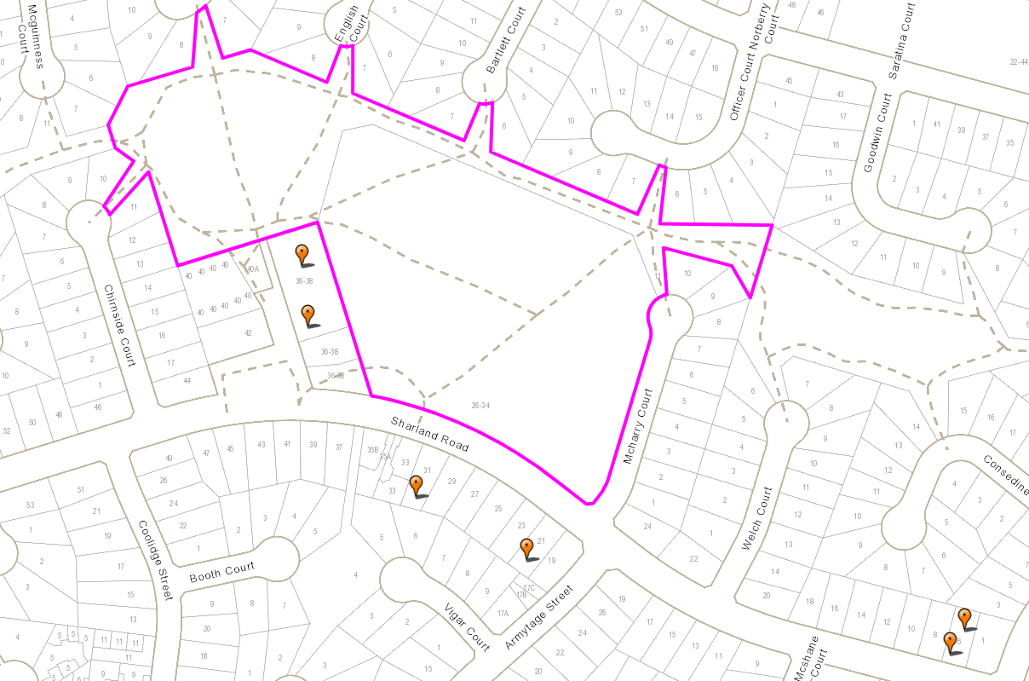
Figure 39: The proximity of objectors (orange flags) within 250 metres of the subject site (purple). Source: PLACES Weave, annotated by Author.
Six (6) of the Nine (9) objections were received from owners or occupiers of land within 250 metres of the site boundary as shown at Figure 38 above.
The other 3 objections were received from community members in Ocean Grove and Highton. And the submission of support was received from an undisclosed Corio address.

OBJECTOR CONSULTATION:
A consultation meeting (Planning Information Meeting) was held on 24 July 2023 between the applicant, council officers, and objectors. The meeting discussed the issues raised to see if any resolutions were possible.

No objections were withdrawn following the Planning Information Meeting.

AMENDMENT OF THE APPLICATION FOLLOWING PUBLIC NOTIFICATION
The applicant made a first request to amend the application following public notification pursuant to Section 57A of the Planning and Environment Act 1987 on 8 August 2023. The City accepted the amendment. The amendment made the following changes to the application:

- Minor updates to Proposed Plan of Subdivision to reflect council referral comments including:
  - Section 24A plan – PS913229B – Version C dated 8/8/23
    - Plan amended for change in width of the proposes access reserve to 10m
  - Plan of Subdivision PS 913295M – Version B dated 8/8/23
    - Plan amended for change in width of the proposes access reserve to 10m
    - Affecting Lots 16, 26 and Reserve no 1

The applicant made a second request to amend the application following public notification pursuant to Section 57A of the Planning and Environment Act 1987 on 9 August 2023. The City accepted the amendment. The amendment made the following changes to the application:

- Amendment to Plans and Reports to Formalise Response to Objections
These are the plans currently under assessment.
It was not considered necessary to readvertise the proposal based on the amendment, as the amendment would not result in any additional material detriment compared with the advertised application because the amendments did not introduce any new matters for permit consideration and did not increase the scale or intensity of the development.
These are the plans assessed in the preparation of these officer recommendations.
The amended plans were circulated to all objectors for review and comment on 24 August 2023.

No objections were withdrawn.

OBJECTIONS:
The concerns of objectors and officer consideration of objections are summarised below.

Objection Summary | Officer Consideration
- Mature trees should be kept for birdlife and habitat, with respect for neighbourhood character, to maintain canopy coverage in Municipality, and the proposal fails to retain existing vegetation wherever possible. | No permit is required for the landowner to remove any or all of the trees and shrubs that are there.  The planning scheme does set out requirements for landscaping of multi-dwelling developments of this type. These are found at Clause 55.03-8 (Landscaping objectives) and requires development ‘respects the landscape character of the neighbourhood’ and to ‘encourage the retention of mature vegetation on the site’. The application purports to meet these objectives (along with other, competing objectives of the Scheme) by providing a landscape plan that shows replacement plantings of new street trees and vegetation throughout the site, and the protection of trees on adjoining land. It is notable that none of the mature trees presently on the land are to be retained, and it has not been shown that the retention of these cannot practically be achieved.  A detailed assessment of the existing neighbourhood character, and assessment of whether the design response appropriately respects the existing neighbourhood character is set out later in these recommendations. Refer to the Clause 55 Assessment of the proposal for detailed consideration of the ResCode requirements later in this report.
- Public car park should be kept for community centre and public use | The Rosewall Community Centre is located on public land at 36-38 Sharland Road adjoining the subject site. The centre was re-developed in 2018-2019 with the construction of the centre in its current form, and the demolition of the previous buildings once located within its front setback. The site of the former community centre buildings has since been replaced with landscaping. With this redevelopment, the centre has retained approximately 7 car parking spaces on its land and continued to benefit from access to another 29 spaces (including 1 disability access space) located on the land at 26-34 Sharland Road. Car parking on this part of the subject site has been a long established practice dating back to when the site was occupied by Rosewall Primary School. The land has since been vacated by the School and the Department of Education, and ownership has passed on without the assertion of rights by the Community Centre to continue to use the subject site for parking in a way that would prevent the loss of these 29 spaces. Consequently, the responsibility to providing car parking spaces for visitors to the community centre does not rest with the permit applicant or owner of the subject site, but with the owner or occupier of the community centre.
- Should be kept open space for people to walk, a community garden and play area | At present, the land at 26-34 Sharland Road is no longer public land, with the new private property owner retaining the right to allow or to prevent access to their land as they choose. The permit application proposes that part of the land at 11 McHarry Court be retained as public land, with connections to be constructed providing links from Sharland Road to Connections Park West (located north of the community centre), to Halliwell, English, Bartlett and Officer Courts to the north, and to Connections Park East.
- Will cause more parking demand and traffic in the area | Additional dwellings will generate additional vehicle traffic. The development proposes the construction of new public roads within the site, that are connected in 3 locations to the established road network. Traffic Engineering advice has not identified that the established road network is unable to accommodate the additional traffic movements that will be generated, and the City’s traffic engineers have set out the requirements for road construction that can be included as part of a permit if granted.  Each dwelling proposed as part of the development is provided with the required number of car parking spaces, and the new public roads within the development will provide additional on-street car parking for public use at a rate that is similar to that of the street network in the area.
- Will bring noise to the area | The proposal does not include any development or activity that would introduce any unusual or additional sources of noise to the area. The construction and ongoing use of the development will be subject to the same amenity and noise control requirements as all other residential areas within the Municipality.
- Subdivision lot sizes proposed in established area seem wrong | A detailed assessment of the subdivision is given later in these recommendations. In summary, it finds that the proposed lots fronting Sharland Road average 249 sq/m and 56% smaller than those opposite. Along McHarry Court the proposed average of 299 sq/m per lot is 52% smaller than those opposite.  And proposed lots along the north boundary average 247 sq/m, being 67% smaller, or one third of the average size of those lots adjoining. The Scheme encourages development in this location that respects the neighbourhood character of the area, and this includes proposed lot areas and dimensions.
- Drainage basin will be used as rubbish dump | New drainage and stormwater infrastructure is proposed with the creation of a non-standard bioretention system and retarding basin at the intersection of Sharland Road and McHarry Court. The basin is non-standard in that it is smaller in area and deeper than standard design, requiring that vehicle exclusion fencing be installed, and planted out with shrubs and grasses. If a permit was issued, the design will require a safety assessment to determine if a security fence would be required to exclude people from accessing the basin. If not required, people would have access to the basin and there is no way of preventing the dumping of rubbish, or the capture of litter in this area.
- Sharland road will become unsafe, and hoon behaviour will increase | The application does not propose any significant changes to the current alignment or construction of Sharland Road, except for the construction of a new intersection with the new public road into the site and need to relocated the speed hump from this location. This intersection, as with all public roads, will be required to be constructed to approved engineering standards, including providing for orderly traffic flows.  The proposal to construct dwellings fronting Sharland Road is unlikely to increase irresponsible driver behaviour along Sharland Road, and it is possible that the new dwellings and crossings may have a traffic calming effect where the presence of vehicles entering these lots and turning into the new public road can cause other road users to exercise caution that they don’t have to exercise in front of the current vacant site.
- Stress on the power supply causing outages | Network capacity issues are matters to be dealt with by the relevant utility service provider. Power supply to the future development is not a planning matter for consideration where the relevant power distribution authority has not objected to the proposal subject to conditions.
- Stress on stock supplies at local Aldi supermarket | Supermarket operators are responsible for maintaining their stock levels in accordance with their own private business practices. Planning permit decisions and responsible planning authorities have no part to play in the availability or stock items in supermarkets.
- The future of the balance lot is unclear | The application was amended to excise previously proposed development and for the creation of the balance lot to allow more time to allow for ‘detailed and proactive planning for future needs’ and a ‘more thoughtful decision-making and consultation with the Community Centre’. Part of the amendment proposed that the balance lot owner enter into an agreement with the City to create an area of ‘no build’ adjoining the northwest corner of the lot. A copy of the draft agreement formed part of the amendment. Consideration of the prospective agreement and the future of for future development in this location.  Any future development will require planning approval due to the permit requirements of the DDO37 that will continue to apply to the land. Nevertheless, there are no requirements of the zone or the overlay that prevent the creation of a balance lot.
- Effect on the users of the Community Centre:  - Loss of car parking (approx. 30 spaces)  - Balance lot to be community space/community garden  - Provision of affordable and community housing not private development  - Loss and disruption to operations during construction | The car parking spaces currently located on the subject site are proposed to remain for the time being, until such time as the balance lot were to be redeveloped. It is notable that this car park is located on privately help land that was once in public ownership. However, the onus on meeting car parking obligations for visitors to the Rosewall Community Centre does not rest with the private property owner but with the Community centre owner and operator.  As the balance lot is private property, the opportunity for the land to be obtained for public and community use has passed. The private property owner is not under any obligation to provide land for community space or a community garden where relevant public authorities did not avail themselves of the opportunity to procure it.  Were a permit to be granted and construction to commence, the construction site and all associated amenity matters must be managed by the land owner and builder in accordance with relevant environmental protection requirements and the building regulations. Vehicle access and parking of construction vehicles will continue to be required in accordance with local parking and road traffic rules.
- Proposal fails to mitigate the risks associated with climate change | The proposal to construct dwellings within an established urban area reduces the need to further expand urban areas beyond settlement boundaries for the retention and protection of non-urban land. The proposal has sought to meet environmentally sustainable development requirements by achieving the required 50% BESS rating in accordance with the ESD requirements of the Scheme. And where planning permit approvals are limited only to achieving acceptable outcomes rather than preferred or optimum outcomes, the proposal has demonstrated that current climate change mitigation requirements, such as they are, have been achieved.

ASSESSMENT:

ZONE:

General Residential Zone
Part of the subject site is located within the General Residential Zone – Schedule 1 (GRZ1). The purpose of the GRZ1 is:

- To implement the Municipal Planning Strategy and the Planning Policy Framework.
- To encourage development that respects the neighbourhood character of the area.
- To encourage a diversity of housing types and housing growth particularly in locations offering good access to services and transport.
- To allow educational, recreational, religious, community and a limited range of other non-residential uses to serve local community needs in appropriate locations.

The GRZ1 applies a mandatory minimum garden area requirement.
The GRZ1 requires that the proposed development must meet the requirements of Clause 55 (Two or more Dwellings on a lot and Residential Buildings).
The GRZ1 applies a mandatory dwelling and residential building height limit to the subject site. Schedule 1 to the GRZ does not specify the maximum height or number of storeys for a dwelling or residential building. Where no maximum building height or maximum number of storeys is specified in a schedule to the zone:
- the building height must not exceed 11 metres; and
- the building must contain no more than 3 storeys at any point.

Public Park and Recreation Zone
Part of the subject site is located within the Public Park and Recreation Zone (PPRZ). The purpose of the PPRZ is:
- To implement the Municipal Planning Strategy and the Planning Policy Framework.
- To recognise areas for public recreation and open space.
- To protect and conserve areas of significance where appropriate.
- To provide for commercial uses where appropriate.

OVERLAY:

Design and Development Overlay
The purpose of Clause 43.02 Design and Development Overlay is:

- To implement the Municipal Planning Strategy and the Planning Policy Framework.
- To identify areas which are affected by specific requirements relating to the design and built form of new development.

Before deciding on an application, in addition to the decision guidelines in Clause 65, the responsible authority must consider, as appropriate:
- The Municipal Planning Strategy and the Planning Policy Framework.
- The design objectives of the relevant schedule to this overlay.
- The provisions of any relevant policies and urban design guidelines.
- Whether the bulk, location and appearance of any proposed buildings and works will be in keeping with the character and appearance of adjacent buildings, the streetscape or the area.
- Whether the design, form, layout, proportion and scale of any proposed buildings and works is compatible with the period, style, form, proportion, and scale of any identified heritage places surrounding the site.
- Whether any proposed landscaping or removal of vegetation will be in keeping with the character and appearance of adjacent buildings, the streetscape or the area.
- The layout and appearance of areas set aside for car parking, access and egress, loading and unloading and the location of any proposed off street car parking
- Whether subdivision will result in development which is not in keeping with the character and appearance of adjacent buildings, the streetscape or the area.
- Any other matters specified in a schedule to this overlay.

The design objective to be achieved as set out at Schedule 37 to Clause 43.02 Design and Development Overlay is:
- To implement the Former Rosewall Primary School Concept Plan, Corio Norlane Structure Plan, July 2012.
- To maximise surveillance of public open space and integration with community facilities.
- To maintain public open space connections

Special Building Overlay
The purpose of Clause 44.05 Special Building Overlay is:

- To implement the Municipal Planning Strategy and the Planning Policy Framework.
- To identify land in urban areas liable to inundation by overland flows from the urban drainage system as determined by, or in consultation with, the floodplain management authority.
- To ensure that development maintains the free passage and temporary storage of floodwaters, minimises flood damage, is compatible with the flood hazard and local drainage conditions and will not cause any significant rise in flood level or flow velocity.
- To protect water quality and waterways as natural resources by managing urban stormwater, protecting water supply catchment areas, and managing saline discharges to minimise the risks to the environmental quality of water and groundwater.

Response to zone and overlay(s)

Purpose of the General Residential Zone (GRZ1)

The following proposed Reserves are located on parts of the site within the GRZ1:
- RESERVE No.2 (South end only, Stage 1)
- RESERVE No.3 (Stage 1)
- RESERVE No.1 (Stage 2 drainage)
- RESERVE No.1 (Stage 4 re-subdivision)

All proposed reserves, including those within the GRZ1, are to be vested with Greater Geelong City Council for public access or drainage purposes in support of the proposed residential development. Likewise, the new roads are also within the GRZ1.
The balance of the site is proposed for privately held medium density (33 dwellings per hectare) residential development purposes with a mix of predominantly medium density (150-250 sq/m) and high density (less than 150 sq/m) dwelling lots.
The maximum building height requirement for this land is 11 metres (measured from the minimum floor level determined by the relevant floodplain management authority) and 3 storeys (excluding a basement), and the application proposes a maximum of 6.745 metres and 2 storeys. And the proposal will not cause overshadowing on existing rooftop solar energy systems on dwellings on adjoining lots.
The proposal contrasts with the established pattern of residential development in the area which is characterised by its conventional density (10-15 dwellings per hectare) of ‘suburban dwellings’ (400-750 sq/m) and ‘low density suburban’ (greater than 750 sq/m) dwelling lots. At a proposed dwelling density double that of the surrounding area, it is considered the proposal does not respect the prevailing neighbourhood character as required to accord with the purpose of the GRZ1.

Likewise, the site is not among those identified as ‘locations offering good access to services and transport’ normally suitable for ‘a diversity of housing types and housing growth’.
For permit approval, the application must meet all of the objectives of:
- All of Clause 56, except Clause 56.03-5, and
- All of Clause 55 except Clause 55.03-5, Clause 55.03-6, Clause 55.03-8, Clause 55.04-8, Clause 55.05-1, Clause 55.05-2 and Clause 55.05-6.

The proposal has been assessed against the requirements of Clause 55 and found not to have met all the relevant Clause 55 and Clause 56 objectives. Refer to the detailed assessment later in these recommendations.

It is therefore considered that the application does not implement the MPS and PPF and does not produce an acceptable planning outcome with regard to the purpose and decision guidelines of the GRZ1.

Mandatory Minimum Garden Area
The application proposes a concurrent subdivision and multi-dwelling development. The mandatory minimum garden area requirements of Clause 32.08-3 (Subdivision) do not apply to each lot where that lot is created in accordance with the Corio Norlane Structure Plan, being an ‘approved precinct structure plan or an equivalent strategic plan’, or if created in accordance with a permit for development. Both exemptions are considered relevant to this concurrent subdivision permit application.

However, Clause 32.08-4 (Construction or extension of a dwelling or residential building) imposes a minimum garden area requirement of 35% of a lot above 650 sq/m. The title plans show the subject site comprises 1 lot of 3.064 hectares (26-34 Sharland Road), and 1 reserve of 1.986 hectares (11 McHarry Court). It is notable that Clause 73.01 (General terms) does not include land in a reserve to be any part of a lot.

The relevant lot is not considered to have been designated as a ‘medium density housing site’ as part of the Corio Norlane Structure Plan, or any other approved precinct structure plan or approved equivalent strategic plan such that an exemption from the garden area requirement of Clause 32.08-4 would apply.

A mandatory minimum garden area requirement of 35% therefore applies to this application.
The Scheme provides no clear direction on how to calculate the garden area requirement for a combined application such as this, where a concurrent subdivision will remove a reserve, create new reserves, public roads, a balance lot, and common property.
When faced with a similar matter, the Tribunal in its findings for Clayton Gardens Pty Ltd v Monash CC took a purposive approach to calculating garden area by establishing the ‘planning unit’ in respect to the type of permit application and the composition of that planning unit.

In other words, the land proposed for multi-dwelling development should be determined by the area to be developed for dwellings and not areas that would otherwise be excluded. This approach accords also with s.35 of the Interpretation of Legislation Act 1984 that says (paraphrased) that it is preferable to interpret a requirement of the Scheme in a way that promotes the purpose of that requirement instead of interpreting it in a way that doesn’t promote the purpose of the requirement. Because the purpose of the garden area requirement is understood to be to provide an ‘area for garden’ in established urban areas, then the purposeful interpretation should be to exclude the proposed public reserves, roads and common property that will not be part of a ‘lot’ that can be used for a garden. Similarly, the balance lot can also be excluded as it will attract its own garden area requirement at a future time.

Applying this interpretation, the overall available area should comprise 6 parts with a combined (assessment calculation) area of approximately 17,467 sq/m and illustrated at Figure 40 below.

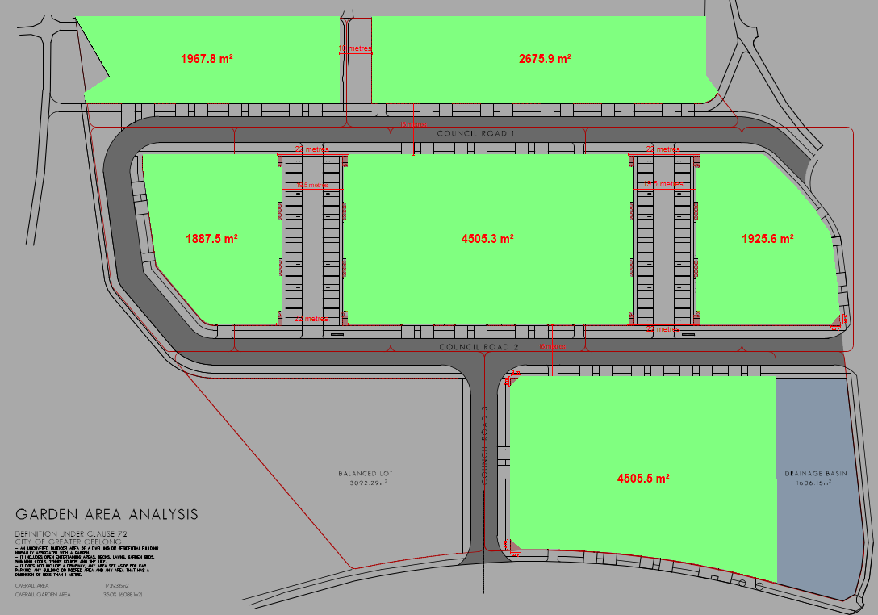
Figure 40: Indicative plan showing the areas from which the minimum garden area requirement should be set aside. Source: Application documents, annotated by Author.

However, the garden area analysis plan submitted with the application shows the following:

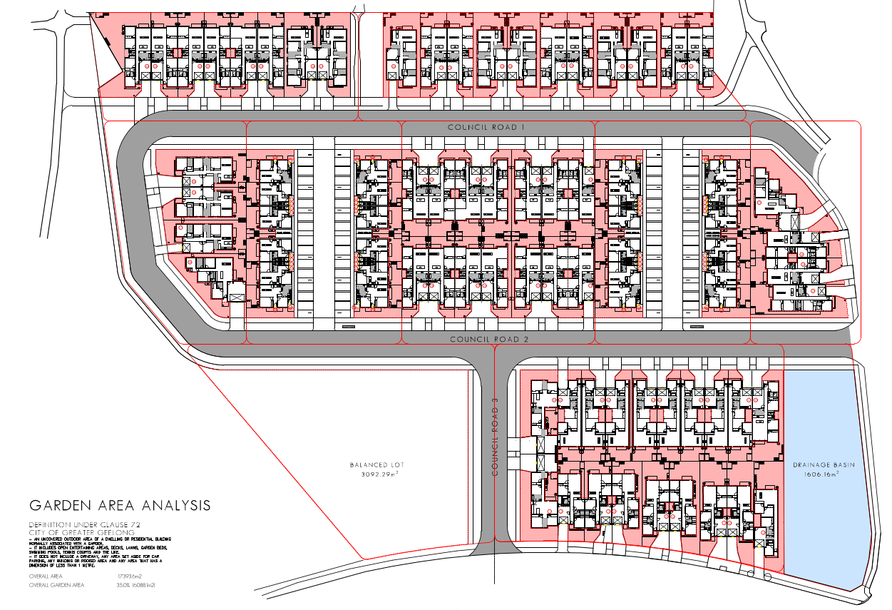
Figure 41: Garden Area Analysis plan submitted as part of the application, understood to show the area to be set aside for garden shaded pink. Source: Application documents.
In summary, it purports to set aside 6,088.1 sq/m as ‘overall garden area’, representing 35.0% of an ‘overall area’ of 17,393.6 sq/m. The overall area is 74 sq/m less than the assessment calculation (17,467 sq/m), and the overall garden area set aside is 25 sq/m less than that required by the assessment calculation (6113 sq/m).
Further, the garden area analysis plan submitted includes a significant number of areas that do not conform with the garden area requirement as defined at Clause 73.01 (General Terms). For example, areas of less than 1m, areas under porches, and undersized vehicle accessways (Figure 42); areas of common property nominated on the subdivision plan (Figure 43); and corner splays required by Standard C20 of Clause 56 (Residential Subdivision) have all been incorrectly set aside as garden area.
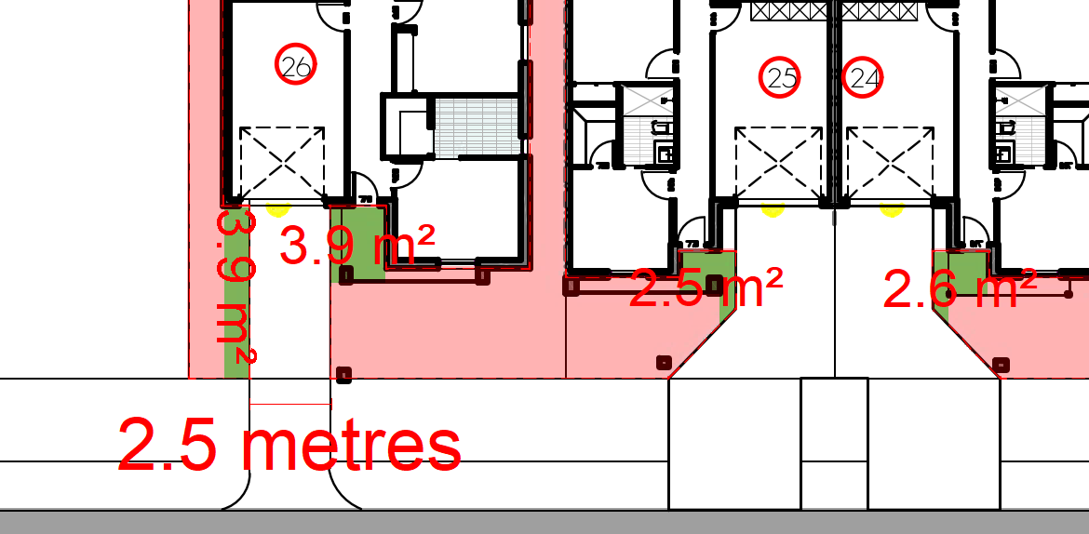
Figure 42 (above): Extract from the Garden Area Analysis plan annotated to show examples (green) that have been set aside as garden area that do not comply with the garden area definition of the Scheme. Source: Application documents, annotated by the Author.
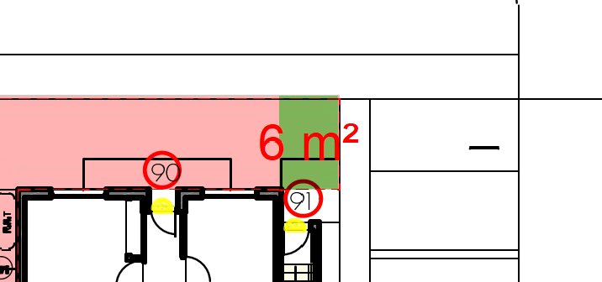

Figure 43: Extract from the Garden Area Analysis plan annotated to show an example (green) of an area incorrectly set aside as garden are but on land nominated to be part of the common property, and not part of a future lot. Source: Application documents, annotated by the Author.
The garden area requirement is a mandatory requirement of the Scheme for multi-dwelling developments in this location. The garden area analysis plan submitted does not show that the mandatory minimum requirement has been met.

Purpose of the Public Park and Recreation Zone (PPRZ)
The areas of land within the PPRZ are to be excised into separate reserves as part of the proposed subdivision; retained for public access and recreation purposes; and likely to remain in public ownership as it is currently. No residential use or development is proposed on land within the PPRZ.
The proposal accords with the purpose and decision guidelines of the Clause 36.02 (Public Park and Recreation Zone).

Purpose and Decision Guidelines of the Design and Development Overlay (DDO37)
The DDO allows for a permit to be granted to subdivide land or carry out buildings and works which are not in accordance with a requirement of the DDO schedule, because Schedule 37 to the DDO does not specify otherwise. Nevertheless, the following requirements apply to the proposal as set out by the Schedule:

- Buildings must address Connections Park East, the Rosewall Neighbourhood House, Sharland Road and McHarry Court.
- The development design must provide public access through the site to connect Connections Park East, Connections Park West and Bartlett Court.
- Subdivision of land must provide a public link between Connections Park East and Connections Park West and maintain access from Bartlett Court to Connections Park.
- Subdivision design must maximise surveillance of the public land.
- A north-south road should be provided along the western boundary of the site as an interface with the adjoining community facilities and Connections Park East.

In responding to these requirements, the application proposes:
- No buildings address Connections Park East as this land will have no abuttals to the allotments on which buildings are to be constructed.
- A balance lot is proposed abutting 36-38 Sharland Road, being the land on which the Rosewall Neighbourhood House (now known as the Rosewall Community Centre) is located. The future development on this land is not the subject of this application.
- Buildings along Sharland Road and McHarry Court are all provide with active frontages addressing the street and in accordance with the requirement.
- The subdivision layout plan provides a public road connection linking directly between Connections Park West to McHarry Court (east-west) with shared path connections directly to through to Connections Park West, Officer Court, Bartlett Court and Sharland Road in excess of the requirement.
- Public land is located abutting the activity area of the site to the north west (Connections Park West), to the north (path to Bartlett Court and Officer Court), and to the southwest (Rosewall Community Centre). The Landscape Masterplan submitted shows ‘1.8m H semi-permeable timber fence’ to be constructed adjoining the path links between public land and Units 16, 26, 27, 34, and the drainage basin adjoining Units 9 and 10. The fencing examples provided do not show the extent to which this fencing allows maximum surveillance of the adjoining public land. In each case this fencing adjoins areas of secluded private open space such that it is unlikely the surveillance requirement will be achieved.
- The public access road proposed does not provide an interface along the west boundary of the site within the DDO, except from the interface with Connections Park West, noting that the requirement references a west interface to Connections Park East which is not land within the area included in the DDO.

The application has sought to respond to this last requirement with the creation of a new road connecting with Sharland Road in generally the same location as shown on the Former Rosewall Primary School Concept Plan at Figure 44 (below).
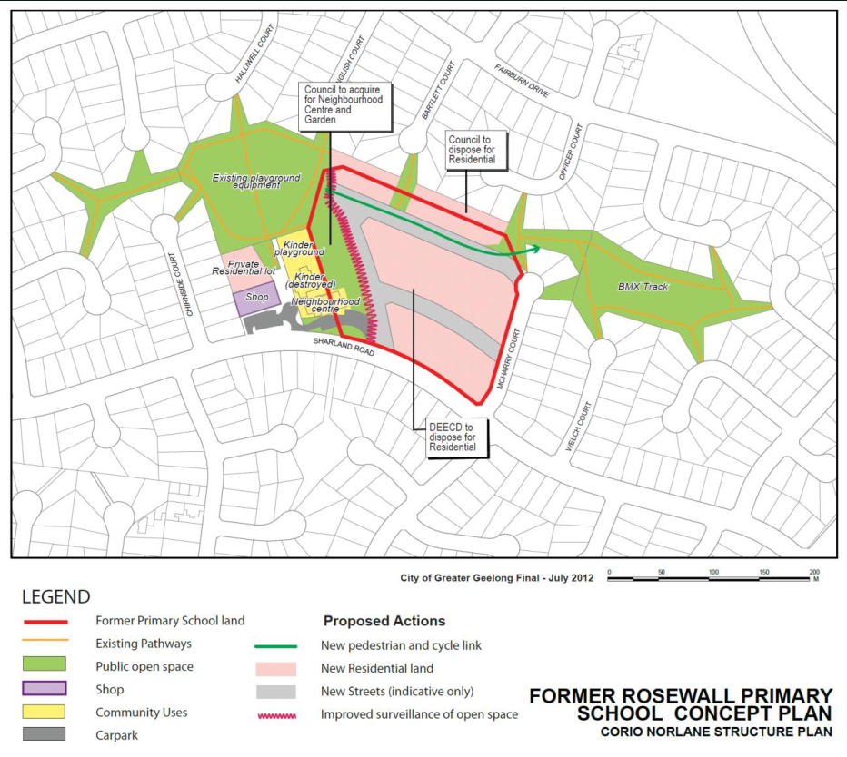
Figure 44: Former Rosewall Primary School Concept Plan. Source: Corio Norlane Structure Plan, July 2012 (p.22).
A notable feature of the concept plan is the creation of new public open space along the east side of what is now the Rosewall Community Centre that would provide a generous public open space link from Sharland Road to the ‘Existing playground equipment’ at Connections Park West.

The Concept Plan, and indeed the Corio Norlane Structure Plan itself, nominates this land for ‘Council to acquire for Neighbourhood Centre and Garden’. This is a notable feature because the City has not completed the steps necessary to realise this acquisition, despite the intent of the concept plan in this location being re-iterated by the internal referral responses of the Social Planning, Strategic Planning, and Urban Design units of Council.

Until such time that Council either acquires some or all the public open space land or the DDO37 is amended (or ended) to better reflect Council’s precise intentions, the full weight of the Scheme must be given to what is presented by the concept plan. To this end, publicly accessible open space along the east side of the community centre should be set aside for Council to provide an open space link from Sharland Road along the east side of the Community Centre to Connections Park West and offering improved surveillance from the new residential development forming the balance of the development site.

Instead, the application details some of the constraints to delivering a north-south road along the west boundary of the site, most prominent of which is the location of a PTV bus stop that cannot be moved, and the incompatibility with road design and construction standards posed by the acute angled intersection with Sharland Road. However, it is not clear that these constraints cannot deliver on the intent of the concept plan for ‘Council to acquire for Neighbourhood Centre and Garden’ as part of the land along the west of the site to realise the requirement to ‘improve surveillance of open space’, or to provide open space in this location. Instead, the application delays consideration of the balance lot that may forever extinguish this opportunity. Were the subdivision to include the balance lot (or part thereof) as public open space, it could be said that the requirement has been met. As proposed however, this key requirement has not.

As a compromise measure the application proposes that all future owners of the balance lot be bound by an agreement with the City under Section 173 of the Act for:
- Creation of a No Building Zone at the northwest corner of the balance lot;
- The use of the area for landscaping and car parking which may be associated with future development on the balance lot, but the No Building Zone to be generally clear of all structures which would impede the views and open aspect of the Community Building from the new public road;
- The Owner to construct a footpath along the entire extent of the western boundary where it abuts the existing Community Centre, as shown on the plan at Figure 45; and
- The Owner to vest that part of the subject Land comprising the Footpath in Council as a reserve.

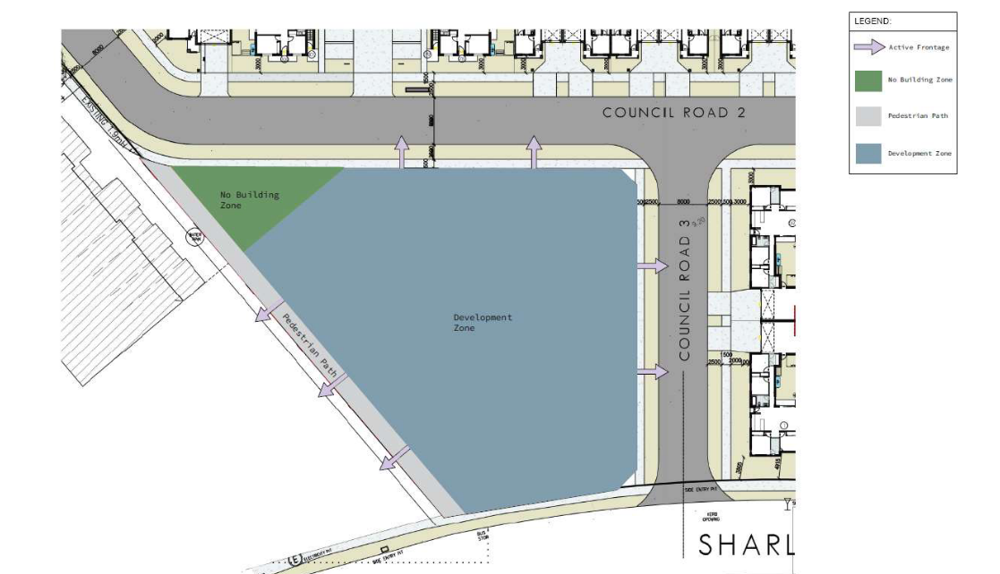
Figure 45: Proposed Annexure A from the draft Section 173 Agreement to create a No Build Zone (green) and footpath vested with the City on the balance lot. Source: Application documents.
However, entering in to such an agreement and the creation of a balance lot does not realise the concept of providing public open space along the west boundary adjoining the community centre and, more importantly, the public open space ‘link’ and improved surveillance that the concept plan very clearly seeks.

It is notable that the decision guidelines of the DDO (Clause 43.02-6) are not limited to the design objectives of the Schedule. Before deciding on an application, in addition to the decision guidelines in Clause 65, the responsible authority must consider, as appropriate (underlined for emphasis):

- The Municipal Planning Strategy and the Planning Policy Framework.
- The design objectives of the relevant schedule to this overlay.
- The provisions of any relevant policies and urban design guidelines.
- Whether the bulk, location and appearance of any proposed buildings and works will be in keeping with the character and appearance of adjacent buildings, the streetscape or the area.
- Whether the design, form, layout, proportion and scale of any proposed buildings and works is compatible with the period, style, form, proportion, and scale of any identified heritage places surrounding the site.
- Whether any proposed landscaping or removal of vegetation will be in keeping with the character and appearance of adjacent buildings, the streetscape or the area.
- The layout and appearance of areas set aside for car parking, access and egress, loading and unloading and the location of any proposed off street car parking
- Whether subdivision will result in development which is not in keeping with the character and appearance of adjacent buildings, the streetscape or the area.
- Any other matters specified in a schedule to this overlay.

The DDO was applied with the intention of facilitating residential redevelopment of surplus DEECD land in accordance with the Corio Norlane Structure Plan. This structure plan clearly nominates locations for medium and high density residential development in the form of Increased Housing Diversity Areas (IHDA’s) and could have, but did not, nominate the subject site as one of them. The decision guidelines of the DDO require the responsible authority give effect to what was intended by the DDO including the location, appearance, character, landscaping, carparking and streetscape whilst allowing for a permit to be granted that was not in accordance with a requirement of the schedule.
For these reasons, it is considered that the application does not produce acceptable planning outcomes in terms of the purpose and decision guidelines of Clause 43.02 (Design and Development Overlay).

Purpose and Decision Guidelines of the Special Building Overlay (SBO)
The application responds to the purpose and decision guidelines of the Special Building Overlay with submission of a site stormwater management plan that demonstrates the development can be constructed to retain stormwater run-off to limit flooding downstream of the site. It demonstrates that new drainage and stormwater infrastructure can be designed and constructed such that flood hazard can be managed with the new infrastructure to be constructed as part of the development, and that stormwater quality can achieve best practice management requirements.

Before deciding on an application, in addition to the decision guidelines in Clause 65, the responsible authority must consider, as appropriate (underlined for emphasis):
- The Municipal Planning Strategy and the Planning Policy Framework.
- Any local floodplain development plan.
- Any comments from the relevant floodplain management authority.
- The existing use and development of the land.
- Whether the proposed use or development could be located on flood-free land or land with a lesser flood hazard outside this overlay.
- The susceptibility of the development to flooding and flood damage.
- Flood risk factors to consider include:
  - The frequency, duration, extent, depth and velocity of flooding of the site and accessway.
  - The flood warning time available.
  - The danger to the occupants of the development, other floodplain residents and emergency personnel if the site or accessway is flooded.

- The effect of the development on redirecting or obstructing floodwater, stormwater or drainage water and the effect of the development on reducing flood storage and increasing flood levels and flow velocities.
- Any other matters specified in a schedule to this overlay.

It is notable however, that the floodplain management authority requires 2D flood modelling to properly respond to the flood risk profile of the site and to fully assess the proposal set out as part of the Stormwater Management Strategy. The floodplain management authority is of the opinion that the flood risk profile for the development will likely be acceptable, but until the 2D Hydraulic modelling is completed it cannot be determined that the purpose of the SBO will be achieved.
For these reasons, it is considered that the application does not produce acceptable planning outcomes in terms of the purpose and decision guidelines of Clause 44.01 (Special Building Overlay).

CULTURAL HERITAGE MANAGEMENT PLAN (CHMP):

The Aboriginal Heritage Regulations 2018 specify the circumstances in which a cultural heritage management plan is required for an activity or class of activity. Division 2 of the Aboriginal Heritage Regulations 2018 specifies exempt activities which do not require a cultural heritage management plan. The proposal is not listed as an exempt activity.

Areas of cultural heritage sensitivity are defined within Divisions 3 and 4 of the Aboriginal Heritage Regulations 2018. Division 3 does not identify the site or part of the site as within an area of cultural heritage sensitivity. High impact activities are defined within Division 5 of the Aboriginal Heritage Regulations 2018. Division 5 lists the proposal as a high impact activity.
The site is considered to have been the subject of significant ground disturbance which is defined as ‘disturbance of (a) the topsoil or surface rock layer of the ground or (b) a way - by machinery in the course of grading, excavating, digging, dredging or deep ripping, but does not include ploughing other than deep ripping.
In accordance with the above assessment, a cultural heritage management plan is not required.

LANDFILL GAS RISK ASSESSMENT
The subject site is not located within 500 metres of an identified former landfill site. No assessment of landfill gas risk is required.

DEVELOPMENTS IN BUSHFIRE PRONE AREAS

The site is not located within a designated bushfire prone area. No assessment of bushfire risk is required.

THE PLANNING POLICY FRAMEWORK (PPF):
The following planning policies are applicable to this application.
Clause 11 (Settlement), including,
- 11.01-1S Settlement
- 11.01-1R Settlement – Geelong G21
- 11.01-1L-01 Settlement – Greater Geelong
- 11.02-2S Structure planning
- 11.03-6S Regional and local places
- 11.03-6L-02 Corio Norlane

Clause 13 (Environmental Risk and Amenity)
- 13.03-1S Floodplain management
- 13.03-1L Floodplain management
- 13.07-1S Land use compatibility

Clause 15 (Built Environment and Heritage)
- 15.01-1S Urban design
- 15.01-2S Building design
- 15.01-2L Environmentally sustainable development
- 15.01-3S Subdivision design
- 15.01-4S Healthy neighbourhoods
- 15.01-5S Neighbourhood character
- 15.01-5L Neighbourhood character

Clause 16 (Housing)
- 16.01-1S Housing supply
- 16.01-1R Infill housing - Geelong G21
- 16.01-1L-01 Integrated housing and housing diversity
- 16.01-2S Housing affordability

Clause 18 (Transport)
- 18.01-1S Land use and transport integration
- 18.01-2S Transport system
- 18.01-2R Transport system - Geelong G21
- 18.01-3S Sustainable and safe transport
- 18.02-1S Walking
- 18.02-2S Cycling
- 18.02-3S Public transport
- 18.02-4S Roads

Clause 19 (Infrastructure)
- 19.02-6S Open space
- 19.02-6L Open space
- 19.03-2S Infrastructure design and provision
- 19.03-2L Infrastructure planning, design and construction
- 19.03-3S Integrated water management
- 19.03-3L Integrated water management

Response to Policy
This permit application is being determined at a unique time of critical housing shortage in our region and more widely across the State and the nation. The challenges of this shortage are being exacerbated by rising costs of construction caused by a range of local and global cost pressures that risk the affordability and the viability of housing construction projects for both commercial ‘developers’ and private owner-occupier builders alike. The societal effect of housing affordability stress has led to unsustainably high rates of housing insecurity and homelessness. Consideration of relevant planning policy is given in full appreciation of these critical challenges, and the responsibilities incumbent on all levels of government to respond.

To this end, the following amendments to the Scheme were introduced by the Minister for Planning as part of the Victorian Government’s ‘Victoria’s Housing Statement: The decade ahead 2024-2034’ announced on 20 September 2023:

- Amendment VC243 (22/09/2023) … to codify residential development standards, implement the Future Homes project across Victoria, remove permit requirements for single dwellings on lots of 300 square metres or more and introduce VicSmart permits for single dwellings on lots less than 300 square metres. These changes support the delivery of housing in Victoria.

- Amendment VC242 (20 September 2023) … by introducing two new particular provisions to facilitate significant residential development and significant economic development.

However, the only change brought in to affect the current permit application has been to codify some specific Clause 55 Standards that, for the most part, deal with matters of detailed design that are not contested as part of this application proposal. In all other aspects, the planning policy and decision making framework that applies to this permit application has not changed since the application was received by the City.
This is relevant because, despite the current environment of critical demand for new housing, the City in its duty as the responsible planning authority must apply the requirements of the scheme to permit decision:

- Clause 71.02-2 (Operation): …A responsible authority must take into account and give effect to the Planning Policy Framework when it makes a decision under this planning scheme.

- Clause 71.02-3 (integrated decision making): …Planning and responsible authorities should endeavour to integrate the range of planning policies relevant to the issues to be determined and balance conflicting objectives in favour of net community benefit and sustainable development for the benefit of present and future generations.

The application presents a medium density (33 dwellings per hectare) residential development in an area zoned for residential purposes and on land that has been identified through the structure planning process as surplus to the needs of the (then) Department of Education and Early Childhood Development to be suitable for residential development when not required for a community use. However, it is the built environment (Clause 15) and housing (Clause 16) policies of the PPF that inform the location and type of residential development to be encouraged and are the primary ‘planning policies relevant to the issues…’ required for integrated decision making for this proposal.

Whilst the Scheme does not provide a definition for low, medium or high density housing, the ‘City of Greater Geelong Settlement Strategy’ (pp.44-45), and the ‘Greater Geelong Housing Diversity Strategy’ (pp.7-8) - both relevant policy documents for consideration - provide the following helpful guidance:

- High density = 40+ dwellings per hectare
- Medium density = 20 to 40 dwellings per hectare
- Conventional density = 10 to 15 dwellings per hectare

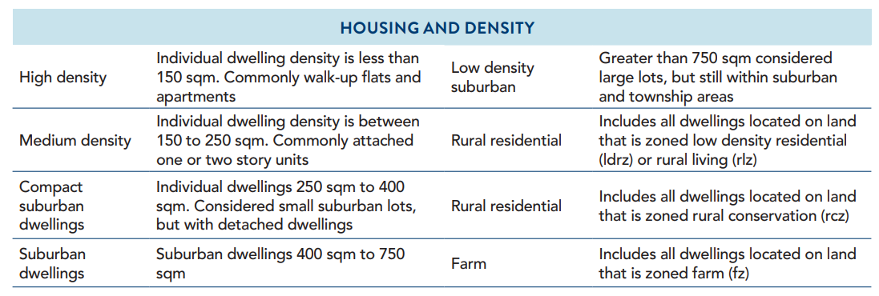

It is notable that the subject site is not located within a key development area, nor is it in an increased housing diversity area or close to an activity centre. Instead, it is surrounded by a mix of open space, community uses, and a well-established pattern of conventional suburban dwellings at a density of 10 to 15 dwellings per hectare:
- Dwelling lots opposite the site in Sharland Road average 576 sq/m, ranging from 341 sq/m (1/33 Sharland Road) to 763 sq/m (25 Sharland Road).
- Along McHarry Court dwelling lots opposite the site average 621 sq/m, ranging from 584 sq/m (7 McHarry Court) to 767 sq/m (10 McHarry Court).
- Along the north boundary of the site the average lot size is 759 sq/m with the smallest (7 Officer Court) being 687 sq/m and the largest (9 English Court) at 828 sq/m.

This contrasts noticeably with the proposed lots:
- fronting Sharland Road averaging 249 sq/m, being more than 56% smaller than those opposite.
- fronting McHarry Court the proposed average of 299 sq/m per lot is more than 52% smaller than those opposite.
- adjoining the north boundary average of 247 sq/m, being 67% smaller, or one third the average size of those lots adjoining.

With reference to the metrics from the Settlement Strategy and set out earlier, a summary of the proposed individual housing lot density finds that:
- 44% are ‘High density’ with individual dwelling density of less than 150 sq/m
- 37% are ‘Medium density’ with individual dwelling density of 150 sqm to 250 sqm
- 19% are compact suburban dwellings with individual dwelling density of 250 sqm to 400 sqm
- The overall average of 33 dwellings per hectare (or 61 dwellings per hectare when excluding proposed roads, the balance lot and reserves)

The significant increase in density proposed represents a clear divergence from settlement and housing policy that seeks to direct this density of dwelling development to key development areas and increased housing diversity areas. If this location was preferred for densities of the kind proposed, it would have been explicitly stated in the Corio Norlane Structure Plan and by extension the Former Rosewall Primary School Concept Plan (hereafter, RPSCP); at the time the land was rezoned and the DDO applied; or earmarked for future work as part of the updated Settlement Strategy in 2020. But at none of these points has such an increase in dwelling density in this location been encouraged, because it is not within the walkable catchment of facilities and services normally associated with an Increased Housing Diversity Area, for example.

There is policy support for providing housing that offers choice and meets changing household needs by widening housing diversity. On this point, it is notable that the area is predominantly developed with single storey, detached 3-bedroom houses. This has been found with an anecdotal review of 50 residential properties listed for sale in Corio on 24 October 2023 (realestateview.com.au).
Of the 50 most recently listed properties:
- 6% are 1 or 2-bedroom dwellings
- 78% are 3 bedrooms
- 16% are 4 bedrooms or more
Of the 108 dwellings proposed by the permit application:
- 44% are to be 2-bedroom apartments; and
- 4% are to be 3-bedroom single storey dwellings
- 52% are to be 4-bedroom single storey dwellings.

The proposal increases the diversity of housing in the area by providing more 3 and 4 bedroom dwellings on compact lots and introducing apartments on even smaller lots, with no ground level private or communal open space for future upper floor apartment occupants. If the diversity of available housing in the area is to be widened in accordance with policy, a development of this size should provide a quality mix of 1, 2, and 4 or more bedroom dwellings in the form of townhouses, 2 storey attached and detached dwellings, 1, 2 and 3 (or more) bedroom apartments with good communal open space areas would provide housing suitable for people at various stages of life and diverse housing need. Whilst it is acknowledged that the provision of 2 bedroom apartments goes some way to contributing to the diversity of housing in the area, it is considered that predominance of proposed medium density single storey 3 and 4 bedroom dwellings on compact allotments does not.
The Corio Norlane Structure Plan (p.12) does not seek an increased density or diversity of future housing for the site. Instead, it offers the following vision for the land:

Redevelopment of the former Rosewall Primary School site provides an opportunity to address the lack of permeability in the existing street layout, as well as improve the surveillance and security of the Connections Park open space area. Part of the former school site could also be used to provide for an expansion of the Rosewall Neighbourhood Centre and adjacent community garden. The Rosewall Concept Plan (see page 22) represents the preferred redevelopment option for this site and includes the reallocation of land between the CoGG and the Department of Education and Early Childhood Development.
And direction to (p.13):

Support the redevelopment of the Rosewall Primary School site for future residential use integrated into a safe and accessible street and open space network (see Rosewall Concept Plan).

Further complicating the issue of whether increased density and diversity is appropriate is the combination of new land use planning considerations that have come into play since the closure and demolition of the former Rosewall Primary School that once occupied the land and the redevelopment opportunity was first identified. These changes are set out in the following timeline:

- March 2010: Land use planning near a major hazard facility information sheet was published by WorkSafe Victoria.
- Late 2010: Rosewall Primary School had been closed, and the buildings demolished.
- 8 August 2012: Shell Company of Australia v Hobsons Bay CC & Ors (includes Summary) (Red Dot) [2012] VCAT 1184 gives significance to consideration of WorkSafe’s Land use planning near a Major Hazard Facility guidelines and Environment Protection Authority’s Recommended Buffer Distances for Industrial Residual Air Emissions, AQ2/86 – Concept of the ‘tyranny of small decisions’.
- 21 November 2013: Planning Scheme Amendment C281 introduces strategy to give effect to the Corio Norlane Structure Plan 2012, including the ‘Former Rosewall Primary School Concept Plan’.
- 13 November 2014: Planning Scheme Amendment C300 implements the new residential zones into the Greater Geelong Planning Scheme relacing Residential 1 zone with General Residential Zone. Also introduces local policy Clause 22.63 Increased Housing Diversity Areas.
- 23 April 2015: Amendment C305 rezoned a strip of land at Connections Park, Corio from the Public Park and Recreation Zone to the General Residential Zone and applied the Design and Development Overlay to all the land being rezoned and to the former Rosewall Primary School site at 26-34 Sharland Road, Corio.
- 4 October 2015: Minister for Planning appointed an Advisory Committee to consider planning around Major Hazard Facilities (MHF).
- 5 May 2016: Amendment C330 rezoned the adjoining land to the east of the subject site being part of Connections Park, Corio, from the Public Park and Recreation Zone to the General Residential Zone Schedule 1
- 19 July 2016: Major Hazard Facilities Advisory Committee Final Report released.
- January 2018: Government response to Major Hazard Facilities Advisory Committee Report released.
- 7 October 2018: Ministerial Direction No.20 - Major Hazard Facilities commences. Directs, in part, that in preparing a planning scheme amendment, a planning authority must seek the views of WorkSafe Victoria and the Minister for Economic Development about the amendment.
- 26 October 2018: Planning Scheme Amendment VC152 introduced Clause 13.07-2S (Major hazard facilities).
- 6 May 2021: Amendment C395ggee implements the City of Greater Geelong’s Settlement Strategy (August 2020)
- February 2022: The DEECD offers the land at 26-34 Sharland Road for sale
- 30 July 2022: WorkSafe Victoria’s ‘Land use planning near a major hazard facility’ guidance for planners, developers and other relevant authorities was last updated.

As set out above, the former Rosewall Primary School land was first identified in the Scheme for redevelopment as part of the 2012 Corio Norlane Structure Plan (Amendment C281 in late 2013). It was further recognised in 2015 with the relevant part rezoning to GRZ1 and introduction of DDO37 giving statutory effect to the FRPSCP. The land was not offered for sale by the former State Government Department of Education and Early Childhood Development (DEECD) for another 7 years.

Within that time, the land use planning considerations within proximity to Major Hazard Facilities have evolved. Land use and development decision making has trended toward a cautionary approach to the risks of, and to, Major Hazard Facilities. Ministerial Direction No.20 and the policy objective and strategies of Clause 13.07-2S did not apply at the time when the land was nominated for residential redevelopment, or when it was rezoned and the DDO applied. But the purpose of the zone and the DDO, and the decision guidelines of the zone and the DDO all require that the responsible authority consider the Planning Policy Framework before deciding on a planning permit application. This elevates Clause 13.07-2S to a current and relevant planning matter for consideration that in the past, was not.

A large part of the site is located within the outer safety area of a Major Hazard Facility being the Viva Geelong Refinery located to the southeast. The outer safety area extends to within 100m of the facilities and includes the established residential parts of Corio west of the Princes Highway.

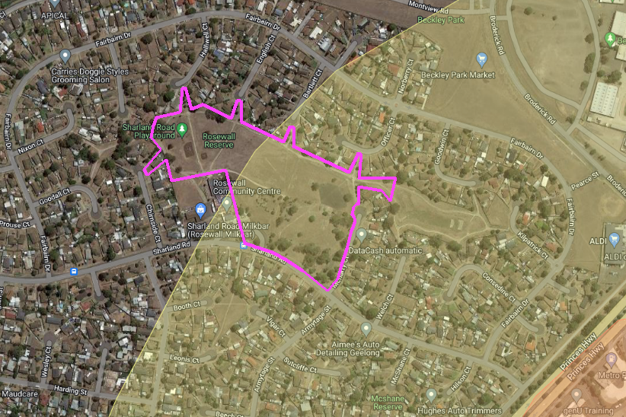
Figure 46: Map showing the extent of the subject site (purple boundary) located within the Viva Geelong Refinery Major Hazard Facility outer safety area (yellow shade). Source: Google and MHU WorkSafe, annotated by the Author.
The extent of the proposed development that is located within the outer safety area is shown at Figure 43 below. This area includes all but 4 of the 104 proposed dwelling lots.

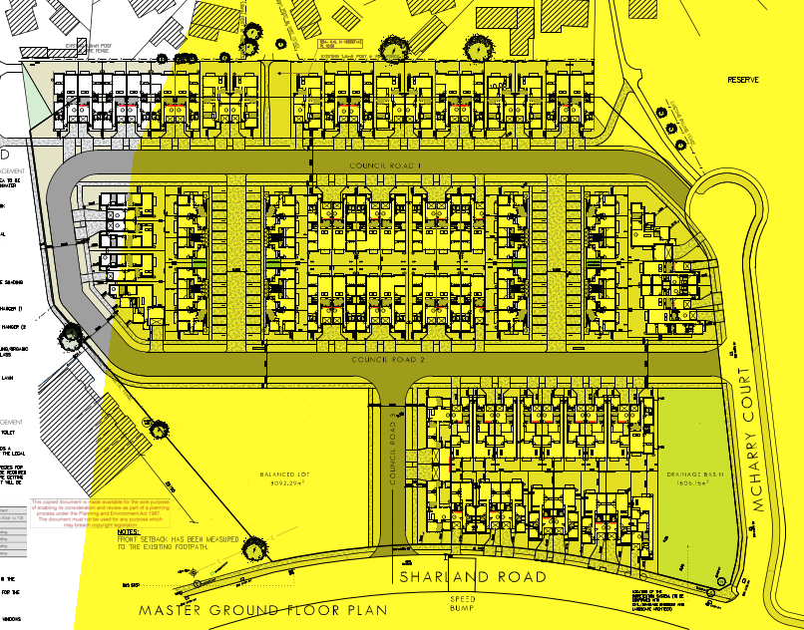
Figure 47: Plan showing the extent of the proposed development located within the outer safety area (shaded yellow) of the Viva Geelong Refinery Major Hazard Facility. Source: Application documents, annotated by the Author using MHU WorkSafe map provided.
WorkSafe Victoria has expressly advised against the grant of a permit for the following reasons (underlined for emphasis):
- The permit introduces a significant population increase within an outer major hazard safety area.
- There is concern to the potential resident’s ability to evacuate safely during a major incident.
- This development may set a precedent for similar future permit applications within major hazard safety areas.

In response, the applicant provided a technical Risk Assessment Report (I F Thomas & Associates, 29 September 2023), a town planning response (Tract Consultants, 15 August 2023) and two separate legal opinions (Maddocks lawyers, 6 September 2023 and Planning Property Partners, 20 October 2023) all advising among other things that the City, as the responsible planning authority, can set aside the WorkSafe Victoria advice if it chooses to. No changes were made to the proposal in response to the WorkSafe Victoria advice. WorkSafe Victoria reiterated its original advice in a review of the Risk Assessment Report and second response received on 25 October 2023.

It is notable that WorkSafe Victoria hasn’t ruled out all redevelopment of the land for residential purposes in its advice such that a ‘planning blight’ or ‘land sterilisation’ would result, as referenced in the respondent Risk Assessment Report (p.6). WorkSafe Victoria instead advises that it is this permit proposal that ‘…introduces a significant population increase…’ and that this ‘…development may set a precedent for similar…applications…’. It may be that an alternative land redevelopment proposal is acceptable if it were to introduce a lesser population increase that reflects the residential density precedent already set in the area. In the absence of an alternative or revised redevelopment proposal, it remains unknown what WorkSafe Victoria may advise.

It is not considered appropriate however, for the responsible planning authority to simply set aside WorkSafe Victoria’s advice or to diminish its significance on the basis that the land was once a primary school and that other land within the outer safety area gives a precedent for how risk to future residents of this proposal might be considered. Nor is it reasonable to conclude that the 2015 rezoning and application of the DDO (Amendment C305) gives a ‘green light’ to this particular development when those changes occurred prior to the release of the MHF Advisory Committee final report, and years before the introduction of Clause 13.07-2S to the Scheme. It is incumbent on the City to give weight to WorkSafe Victoria’s advice, consistent with the Tribunal’s comments in Wilcon Projects Pty Ltd v Hobsons Bay CC [2016] VCAT 1929 (paragraph 20) and reiterated in Bujar Pty Ltd v Hobsons Bay CC [2023] VCAT 635 (paragraph 34) that:

20. It is common sense for the Tribunal to give a substantial level of weight per se to the views of WorkSafe as the applicable specialist State government agency dealing with risks arising from MHFs and other neighbouring uses. I am conscious that this proposal is not supported by WorkSafe.

It is notable also that various VCAT reviews of decisions regarding sensitive uses within proximity to MHF’s have continued to give weight to the advice that WorkSafe Victoria provides, particularly as the practice of WorkSafe has evolved over time from providing high-level assessment of generic safety concerns to considered advice at a more detailed level, and regardless of whether those decisions for review were upheld or set aside. A very recent exception to this has been in reasons given by the Tribunal for Henry Trucking Pty Ltd v Hobsons Bay CC [2023] VCAT 1185 on 25 October 2023 which set aside the advice of WorkSafe.

Finally, the application has not been found to give appropriate effect to relevant policy regarding housing affordability (Clause 16.01-2S) and infrastructure planning, design and construction (Clause 19.03-2L). These are related matters where the medium and high dwelling density and resulting lot yield proposed is said to be necessary to deliver a more affordable housing product in this otherwise location. It follows that more houses on smaller lots bring economies of scale to reduce infrastructure and dwelling construction costs. And it is acknowledged that redevelopment projects such as this can easily become unviable where the right balance is not achieved. However, the financial efficiencies gained by constructing more housing on smaller lots comes at a cost to the internal and external amenity of future residents; to the effect of change on the established character of the area enjoyed by existing residents; and to the increased failure frequency, maintenance cost, and labour burden of non-standard drainage infrastructure.

Of course, increasing the supply of houses in an area could improve housing affordability if the demand for existing housing stock is eased and new residents to the area get additional housing choice – conventional wisdom being that increasing supply reduces scarcity and cost. However, this proposal does not provide any social or affordable housing (as defined at s.3AA of the Act) and remains an entirely private development on land with no strategic justification for the development intensity proposed, but instead seeks dispensations for its significantly increased density and reduced provision of encumbered open space (with a small, non-standard bioretention and retarding basin) that is antithetical to the conventional dwelling density and character of the area. The efficiencies gained are likely to be to the benefit of the developer, but amenity and livability costs are to be borne by the residents and by the drainage authority into the future.

It may seem an impossible task to meet the challenge of redeveloping this land in a viable way, whilst giving effect to the countervailing policy objectives and strategies of the Scheme that now apply to the site but did not at the time the Corio Structure Plan took effect. There’s no doubt there is policy support for residential redevelopment in this location, and no doubt that the demand for new housing is greater now than it was back then. But medium and high density development in this location is not supported by the PPF. Where housing affordability and the viability of the development is invoked as the reason why more land cannot be given over to providing a more diverse mix of housing and conventional drainage infrastructure, it is considered the proposal does not give appropriate effect to the relevant policy objectives and strategies of the PPF.

RELEVANT PARTICULAR PROVISIONS (CLAUSE 52)

The following Particular Provisions are applicable to this application.

CLAUSE 52.02 – EASEMENTS, RESTRICTIONS AND RESERVES

The purpose of Clause 52.02 is To enable the removal and variation of an easement or restrictions to enable a use or development that complies with the planning scheme after the interests of affected people are considered.
Before deciding on an application, in addition to the decision guidelines in clause 65, the responsible authority must consider the interests of affected people.

Response
The removal of Reserve 1 from the public land at 11 McHarry Court is in accordance with the stated objectives of the Corio Norlane Structure Plan in that it allows for the creation of lots via a subdivision and disposal of surplus public land. The affected people are the drainage and sewerage authorities, and the public users of the reserve land owned and managed by the City of Greater Geelong Council. None of whom have objected to the grant of a permit authorising the removal of the reserve or the creation of new reserves in places that are not proposed to form any part of the new residential development land.

The proposal accords with the purpose and decision guidelines of Clause 52.02.

CLAUSE 52.06 – CAR PARKING

The purpose of Clause 52.06 Car parking is:
- To ensure that car parking is provided in accordance with the State Planning Policy Framework and the Local Planning Policy Framework.
- To ensure the provision of an appropriate number of car parking spaces having regard to the demand likely to be generated, the activities on the land and the nature of the locality.
- To support sustainable transport alternatives to the motor car.
- To promotes the efficient use of car parking spaces through the consolidation of car parking facilities.
- To ensure that car parking does not adversely affect the amenity off the locality.
- To ensure that the design and location of car parking is of a high standard, creates a safe environment for users and enables easy and efficient use.

Response

The car parking plan has been considered against the decision guidelines of Clause 52.06-10 and determined to be in accordance with the purpose of Clause 52.06 (Car parking).
The proposal includes the provision of 2 on-site parking spaces (at least one being undercover) for each 3 or more bedroom dwelling, and 1 on-site parking space for each 2 bedroom apartment.

The plans submitted with the application show the provision of car parking spaces in accordance with Clause 52.06-8 (Requirement for a car parking plan). An assessment of these plans against the requirements of Clause 52.06-9 (Design standards for car parking) finds that all required car parking spaces and accessways conform with relevant requirements. Were a permit to be issued, it is recommended that amended plans be submitted to show all parking spaces dimensioned on the plans for clarity.

The application proposes a reduction to the visitor car parking requirement of 1 parking space For visitors to every 5 dwellings for developments of 5 or more dwellings, for a requirement of 21 visitor spaces for this development.

It is considered that the reduction is acceptable in this location where the proposal includes the creation of new public roads designed and to be constructed in accordance with road authority requirements that include on-street car parking spaces well in excess of the 21 required by the scheme.

The application is considered to accord with the purpose and decision guidelines of Clause 52.06.

RELEVANT GENERAL REQUIREMENTS AND PERFORMANCE STANDARDS (CLAUSE 53):
The following General Requirements and Performance Standards are applicable to this application.

CLAUSE 53.01 – PUBLIC OPEN SPACE CONTRIBUTION

A person who proposes to subdivide land must make a contribution to the council for public open space in an amount specified in the schedule to this clause (being a percentage of the land intended to be used for residential, industrial or commercial purposes, or a percentage of the site value of such land, or a combination of both). If no amount is specified, a contribution for public open space may still be required under Section 18 of the Subdivision Act 1988.

Response

Pursuant to the schedule to Clause 53.01, the following contribution is required to be made:

Creation of one additional lot | None
Creation of two to nine additional lots | 1 percent per additional lot up to a maximum of 5 percent
Creation of 10 or more lots on land zoned for residential purposes prior to August 31st 2007 | 5 percent
Creation of 10 or more lots on land zoned for residential purposes after August 31st 2007 | 10 percent
Waurn Ponds Creek Environs | 10 percent

As the proposed subdivision for 26-34 Sharland Road is for 10 or more lots on land zoned for residential purposes prior to August 31st 2007 a five (5) per cent cash contribution will be required and the proposed subdivision for the portion of 11 McHarry Court (shown below in red) is for 10 or more lots on land zoned for residential purposes after August 31st 2007 a ten (10) per cent cash contribution will be required.
Were a permit to be granted, it is recommended a condition require a cash contribution to be made.

TWO OR MORE DWELLINGS ON A LOT AND RESIDENTIAL BUILDINGS (CLAUSE 55)

Clause 55 of the Scheme requires that a development:
- Must meet all of the objectives of this clause that apply to the application.
- Should meet all of the standards of this clause that apply to the application.

The application has been assessed against the objectives and standards of Clause 55 of the Planning Scheme. The application proposes a variation to each of the following Clause 55 Standards:

- 55.02-2 Residential policy objectives (Standard B2)
- 55.02-4 Infrastructure objectives (Standard B4)
- 55.02-5 Integration with the street objective (Standard B5)
- 55.03-4 Permeability and stormwater management objectives (Standard B9)
- 55.03-7 Safety objective (Standard B12)
- 55.05-4 Private open space objective (Standard B28)
- 55.06-1 Design Detail (Standard B31)
- 55.06-2 Front Fences (Standard B32)
- 55.07-2 Communal open space objective (Standard B36)
- 55.07-9 Private open space objective (standard B43)
- 55.07-11 Waste and recycling objectives (Standard B45)
- 55.07-15 Natural ventilation objectives (Standard B49)

The application has been found not to meet the following mandatory objectives such that the grant of a permit should not be supported:
- 55.02-1 Neighbourhood character objectives (Standard B1)
- 55.03-1 Street setback objective (Standard B6)
- 55.03-5 Energy efficiency objectives (Standard B10)
- 55.03-8 Landscaping objectives (Standard B13)
- 55.05-5 Solar Access to Open Space (Standard B29
- 55.06-4 Site Services (Standard B34)
- 55.07-4 Landscaping objective (Standard B38)
- 55.07-8 Accessibility objective (Standard B42)
- 55.07-12 Functional layout objective (Standard B46)

Refer to APPENDIX 1 – Clause 55 Assessment – Two Or More Dwellings On A Lot And Residential Buildings for detailed assessment of Clause 55 objectives.

The assessment findings of each is set out below.

55.02-1 Neighbourhood character objectives  To ensure that the design respects the existing neighbourhood character or contributes to a preferred neighbourhood character.  To ensure that development responds to the features of the site and the surrounding area. | Standard B1  The design response must be appropriate to the neighbourhood and the site.  The proposed design must respect the existing or preferred neighbourhood character and respond to the features of the site. | No – Does not meet the objective  The character of the area is significantly influenced by the curved street layout, the prevalence of court bowls, and the park-like amenity of the former Rosewall Primary School site and the Connections Park that surrounds it. The site interfaces with the street at its south and east, the rear fences of adjoining dwellings along its north, the open spaces of Connections Park West and the recently constructed Rosewall Community Centre to its west.  The residential streetscapes of the area are characterised by predominantly detached single storey dwellings with pitched hipped and gabled roofs. These are mostly constructed of brick and cement tiles, with low and visually permeable front fences constructed of brick, timber palings or corrugated metal. Garages and car ports are primarily located to the side and rear of dwellings. Front setbacks of dwellings are predominantly greater than 7 metres with established but modest landscaping that contributes to a spacious garden suburban character.  Residential lots in the area range from 562 sq/m (4 McHarry Court) to 898 sq/m (4 Officer Court). The only infill ‘battle-axe’ subdivisions nearby is located at 33 and 35 Sharland Road has created the only compact suburban dwelling lots sizes in the area of between 267 sq/m and 345 sq/m (2/33 and 35B Sharland Road, respectively). Of 724 residential allotments that are located within 350 metres of the site, only 39 are smaller than 400 sqm, representing fewer than 5.4% or 2 in every 37. Only 32 lots are smaller than 250 sq/m, representing only 4% (or 1 in 25).  In contrast, the application proposes a mean average dwelling lot size (excluding apartments) of 254.5 sq/m for the 72 dwellings on the net total allotment area of 18,322 sq/m with the smallest at 207.7 sq/m and the largest at 485.3 sq/m. The gross average area per dwelling, including apartments, is 272.1 sq/m.  Significant trees to the area are primarily located on public land and nature strips, and a large number of these are located on the subject site and have been assessed to be in good health with canopy heights of between 10 and 16 metres. These make a significant contribution to the garden suburban landscape of the area, in addition to the established front, side and rear gardens of dwellings nearby.  The design response proposes a contrasting medium dwelling density development with primarily attached single storey townhouses on compact allotments and reduced front and side setbacks, with many constructed ‘boundary-to-boundary’ on narrow allotments of typically 7-9 metres wide. Garages and driveways are prominent streetscape elements with driveway paving commonly comprising 55-61% of proposed lot frontages. The streetscape elevations show sections with an unbroken rhythm of single storey prominently hipped roof dwellings with little distinction between each, including along Sharland Road and McHarry Court, and even less distinction for dwellings fronting new internal roads. Distinguishing materials and finishes are to be provided with the application of 8 individual façade detail palates comprising brick, linear weatherboard and Colorbond with feature concrete rendered porch frames in a limited range of contemporary muted colours including ‘Monument’, ‘Casper White’, ‘Dune’, and ‘Feather soft’.  This low scale but compact, medium density proposal contrasts significantly with the established conventional density garden suburban character of the area. It has drawn some of its design cues from nearby, for the roof forms and material palate, but diverges in its lack of space between buildings, its use of boundary-to-boundary built form, and limited retention of trees and landscaping opportunities on new lots such that the proposal represents a variation to Standard B1 and does not meet the objective of this clause.

55.02-2 Residential policy objectives  To ensure that residential development is provided in accordance with any policy for housing in the Municipal Planning Strategy and the Planning Policy Framework.  To support medium densities in areas where development can take advantage of public transport and community infrastructure and services. | Standard B2  An application must be accompanied by a written statement to the satisfaction of the responsible authority that describes how the development is consistent with any relevant policy for housing in the Municipal Planning Strategy and the Planning Policy Framework. | Yes – Complies, with variation to Standard B2  The required written statement has been provided.  The written statement proposes that the development is in accordance with the housing policy of the MPS and the PPF.  It is considered the MPS and PPF does not encourage medium density development in this location that is not nominated as part of any policy, structure plan or equivalent plans to be suitable for medium density residential development.  Before deciding on an application, the responsible authority must consider:  - The Municipal Planning Strategy and the Planning Policy Framework.  - The design response.  It is considered that proposing medium density development in this location is not encouraged or supported by the MPS and the PPF, and the design response seeks to over-develop the site in contrast to the relevant policy objectives and strategies.

55.02-4 Infrastructure objectives  To ensure development is provided with appropriate utility services and infrastructure.  To ensure development does not unreasonably overload the capacity of utility services and infrastructure. | Standard B4  Development should be connected to reticulated services, including reticulated sewerage, drainage and electricity, if available. Connection to a reticulated gas service is optional.  Development should not unreasonably exceed the capacity of utility services and infrastructure, including reticulated services and roads.  In areas where utility services or infrastructure have little or no spare capacity, developments should provide for the upgrading of or mitigation of the impact on services or infrastructure. | Yes – Complies, with variation to Standard B4  The application proposes construction of a non-standard bioretention system within a retarding basin to become an infrastructure asset owned and maintained by the drainage authority. The drainage authority does not support the proposal preferring instead that a standard stormwater and drainage infrastructure be provided.  Before deciding on an application, the responsible authority must consider:  - The capacity of the existing infrastructure.  - In the absence of reticulated sewerage, a Land Capability Assessment on the risks to human health and the environment of an on-site wastewater management system constructed, installed or altered on the lot in accordance with the requirements of the Environment Protection Regulations under the Environment Protection Act 2017.  - If the drainage system has little or no spare capacity, the capacity of the development to provide for stormwater drainage mitigation or upgrading of the local drainage system.  The non-standard infrastructure can be constructed to meet performance requirements such that the objective will be met, where agreement can be reached with the drainage authority for the increased ongoing maintenance cost to be met under an acceptable agreement with the developer.

55.02-5 Integration with the street objective  To integrate the layout of development with the street. | Standard B5  Developments should provide adequate vehicle and pedestrian links that maintain or enhance local accessibility.  Development should be oriented to front existing and proposed streets.  High fencing in front of dwellings should be avoided if practicable.  Development next to existing public open space should be laid out to complement the open space. | Yes – Complies, with variation to Standard B5  The development is designed to address Sharland Road and McHarry Court, with combined pedestrian and vehicle links to the street provided.  Dwellings 16, 26. 27 and 34 all comprise typical layouts that have not been designed to complement the abutting public open space. These layouts lend themselves to presenting walls on boundary and privacy fencing to screen secluded private open space instead, representing a variation to Standard B5.  Before deciding on an application, the responsible authority must consider:  - Any relevant neighbourhood character objective, policy or statement set out in this scheme.  - The design response.  The relevant DDO37 and Former Rosewall Primary School Concept Plan both set out the requirement to maximise surveillance of public open space and public land. The design response adopts a series of standard layouts that have not been designed for each relevant allotment such that some buildings will have a poor integration with the existing open space, resulting in a variation to the Standard.

55.03-1 Street setback objective  To ensure that the setbacks of buildings from a street respect the existing or preferred neighbourhood character and make efficient use of the site.  If a development meets standard B6, it is deemed to meet the objective for that standard.  Where standard B6 is met the decision guidelines for that standard do not apply to the application. | Standard B6  Walls of buildings should be set back from streets:  - At least the distance specified in a schedule to the zone, or  - If no distance is specified in a schedule to the zone, the distance specified in Table B1.  Porches, pergolas and verandahs that are less than 3.6 metres high and eaves may encroach not more than 2.5 metres into the setbacks of this standard.  Refer Table B1 of Clause 55.03-1. | No – Does not meet the objective  The site is on a corner with no buildings on the abutting allotment facing Sharland Road, being the same street. Table B1 of Clause 55.03-1 provides for a 4m front setback.  Side walls of new development may be setback 2 metres.  Front walls of new development fronting the side street (McHarry Court) may be 3 metres.  The design response proposes a consistently reduced front setback for all new dwellings fronting Sharland Road of between 3.33 m (dwelling 5) and 3.975 m (Dwelling 1), with only Dwellings 4, 6, 7, 8 and 9 conforming with the front setback requirement of 4.0m.  The side setback requirement is achieved by the location of the drainage basin at the corner of the site.  Before deciding on an application, the responsible authority must consider:  - Any relevant neighbourhood character objective, policy or statement set out in this scheme.  - The design response.  - Whether a different setback would be more appropriate taking into account the prevailing setbacks of existing buildings on nearby lots.  - The visual impact of the building when viewed from the street and from adjoining properties.  - The value of retaining vegetation within the front setback.  The area is characterised by dwellings with front setbacks consistently greater than 7 metres, particularly opposite the site along Sharland Road and McHarry Court. The reduced setback proposed contrasts with this character element and will result in an adverse visual impact where very little space is being provided to offset the loss of vegetation established along the frontage of the site currently, and the buildings will create a sense of enclosure along the otherwise sweeping views along Sharland Road. The design response does not meet the objective.

55.03-4 Permeability and stormwater management objectives  To reduce the impact of increased stormwater run-off on the drainage system.  To facilitate on-site stormwater infiltration.  To encourage stormwater management that maximises the retention and reuse of stormwater. | Standard B9  The site area covered by the pervious surfaces should be at least:  - The minimum area specified in a schedule to the zone, or  - If no minimum is specified in a schedule to the zone, 20 percent of the site.  The stormwater management system should be designed to:  - Meet the current best practice performance objectives for stormwater quality as contained in the Urban Stormwater - Best Practice Environmental Management Guidelines (Victorian Stormwater Committee, 1999).  - Contribute to cooling, improving local habitat and providing attractive and enjoyable spaces. | Yes – Complies, with variation to Standard B9  The plans state that the site retains 33.8 per cent permeability, assisting in on site stormwater filtration.  A MUSIC model has been used as part of the Sustainable Design Assessment (using BESS) modelling proposed quality treatment, and also includes provision of 72 x 2kl rainwater tanks for townhouse dwellings.  The non-standard bioretention system is proposed to be located within a retarding basin that is smaller in area and deeper than that normally acceptable to the drainage authority as a new combined quality treatment and retention drainage asset. This design reduces the opportunity that the stormwater system will provide an attractive and enjoyable space given the steep batters, dense plantings, and wall structures are less accessible than a standard retarding basin with batters of 1:3 would be.  Before deciding on an application, the responsible authority must consider:  - The design response.  - The capacity of the site to incorporate stormwater retention and reuse.  - The existing site coverage and any constraints imposed by existing development.  - The capacity of the drainage network to accommodate additional stormwater.  - The capacity of the site to absorb run-off.  - The practicality of achieving the minimum site coverage of pervious surfaces, particularly on lots of less than 300 square metres.  - Whether the owner has entered into an agreement to contribute to off-site stormwater management in lieu of providing an on-site stormwater management system.  The site is not constrained by existing development or the capacity of the drainage network such that it is impractical to accommodate a conventional drainage asset that would better contribute to cooling, improving local habitat and providing attractive and enjoyable spaces. The constraint has instead been imposed as part of the design response seeking to maximise the extend of development on the land with attached dwellings on compact lots at an increased density to that of the surrounding area.  The proposal represents a variation to the Standard whilst achieving the objective via non-preferred method.

55.03-5 Energy efficiency objectives  To achieve and protect energy efficient dwellings and residential buildings.  To ensure the orientation and layout of development reduce fossil fuel energy use and make appropriate use of daylight and solar energy.  This objective does not apply:  - To construct or extend an apartment development, or  - To construct or extend a dwelling in or forming part of an apartment development. | Standard B10  Buildings should be:  - Oriented to make appropriate use of solar energy.  - Sited and designed to ensure that the energy efficiency of existing dwellings on adjoining lots is not unreasonably reduced.  - Sited and designed to ensure that the performance of existing rooftop solar energy systems on dwellings on adjoining lots in a General Residential Zone, Neighbourhood Residential Zone or Township Zone are not unreasonably reduced. The existing rooftop solar energy system must exist at the date the application is lodged.  Living areas and private open space should be located on the north side of the development, if practicable.  Developments should be designed so that solar access to north-facing windows is maximised. | No – Does not meet the objective  The compact lot layout results in the prevalence of attached dwellings across the development, constraining north facing townhouses from achieving any solar access to north facing windows.  Before deciding on an application, the responsible authority must consider:  - The design response.  - The size, orientation and slope of the lot.  - The existing amount of solar access to abutting properties.  - The availability of solar access to north-facing windows on the site.  - The extent to which an existing rooftop solar energy system on an adjoining lot is overshadowed by existing buildings or other permanent structures.  - Whether the existing rooftop solar energy system on an adjoining lot is appropriately located.  - The effect of overshadowing on an existing rooftop solar energy system on an adjoining lot.  The lot presents no topographical or other site constraints that limit the ability for the design response to meet the Standard.  Likewise, Instead, the use of standardised layouts for dwellings along the south side of proposed streets should be reconsidered to meet the standard given there are no site constraints for solar access to north facing windows.  The orientation and layout of development does not make appropriate use of daylight and solar energy and does not meet the objective.

55.03-7 Safety objective  To ensure the layout of development provides for the safety and security of residents and property. | Standard B12  Entrances to dwellings and residential buildings should not be obscured or isolated from the street and internal accessways.  Planting which creates unsafe spaces along streets and accessways should be avoided.  Developments should be designed to provide good lighting, visibility and surveillance of car parks and internal accessways.  Private spaces within developments should be protected from inappropriate use as public thoroughfares. | Yes – Complies, with variation to Standard B12  All dwelling entrances are clearly visible from the street or internal accessway.  The common property access to the apartments is not protected and will become a public thoroughfare for the public traversing north-south through the site and does not meet the Standard.  Before deciding on an application, the responsible authority must consider the design response.  The design response should be reconsidered to limit public access to the common property area shared by the apartments to protect residents from use as a public thoroughfare.

55.03-8 Landscaping objectives  To encourage development that respects the landscape character of the neighbourhood.  To encourage development that maintains and enhances habitat for plants and animals in locations of habitat importance.  To provide appropriate landscaping.  To encourage the retention of mature vegetation on the site.  This objective does not apply:  - To construct or extend an apartment development, or  - To construct or extend a dwelling in or forming part of an apartment development. | Standard B13  The landscape layout and design should:  - Protect any predominant landscape features of the neighbourhood.  - Take into account the soil type and drainage patterns of the site.  - Allow for intended vegetation growth and structural protection of buildings.  - In locations of habitat importance, maintain existing habitat and provide for new habitat for plants and animals.  - Provide a safe, attractive and functional environment for residents.  Development should provide for the retention or planting of trees, where these are part of the character of the neighbourhood.  Development should provide for the replacement of any significant trees that have been removed in the 12 months prior to the application being made.  The landscape design should specify landscape themes, vegetation (location and species), paving and lighting.  Development should meet any additional landscape requirements specified in a schedule to the zone. | No – Does not meet the objective  The site contributes to the landscape character of the area with established, mature and significant trees. The design response has not proposed to retain any of these trees, but instead proposes removal and planting of street trees of lesser significance.  Before deciding on an application, the responsible authority must consider:  - Any relevant neighbourhood character objective, policy or statement set out in this scheme.  - Any relevant plan or policy for landscape design in the Municipal Planning Strategy and the Planning Policy Framework.  - The design response.  - The location and size of gardens and the predominant plant types in the neighbourhood.  - The health of any trees to be removed.  - Whether a tree was removed to gain a development advantage.  The proposal to remove all established and mature trees identified in the arborist report to be of Long or Medium Useful Life Expectancy (ULE) and of Good Health and Good Structure should be reconsidered. A significant number of these trees should be retained to meet the objective for the retention of mature vegetation on the site.

55.05-4 Private open space objective  To provide adequate private open space for the reasonable recreation and service needs of residents.  If a development meets standard B28, it is deemed to meet the objective for that standard.  Where standard B28 is met the decision guidelines for that standard do not apply to the application. | Standard B28  A dwelling or residential building should have private open space of an area and dimensions specified in the schedule to the zone.  If no area or dimensions are specified in the schedule to the zone, a dwelling or residential building should have private open space consisting of:  - An area of 40 square metres, with one part of the private open space to consist of secluded private open space at the side or rear of the dwelling or residential building with a minimum area of 25 square metres, a minimum dimension of 3 metres and convenient access from a living room, or  - A balcony of 8 square metres with a minimum width of 1.6 metres and convenient access from a living room, or  - A roof-top area of 10 square metres with a minimum width of 2 metres and convenient access from a living room. | Yes – Complies, with variation to Standard B28  Each proposed townhouse dwelling has been provided with at least 40 sq/m of private open space.  Each apartment is provided with either a balcony of at least 8.8 sq/m (2.1 x 4.2 m) and a minimum width of 1.6 metres and convenient access to a living room.  However, ground floor apartments are generally provided a courtyard of 7.2 x 4.9 m that is encumbered with a storage shed and rainwater tank reducing this area to 4.0 x 4.9 for a total of 19.6 sq/m (with a minimum dimension of 3 metres), representing a variation to Standard B28.  Before deciding on an application, the responsible authority must consider:  - The design response.  - The useability of the private open space, including its size and accessibility.  - The availability of and access to public or communal open space.  - The orientation of the lot to the street and the sun.  The reduced areas of SPOS for ground floor apartments is generally acceptable as the space is functional in shape and is likely to receive good north light.

55.05-5 Solar Access to Open Space  To allow solar access into the secluded private open space of new dwellings and residential buildings. | Standard B29  The private open space should be located on the north side of the dwelling or residential building, if appropriate.  The southern boundary of secluded private open space should be set back from any wall on the north of the space at least (2+0.9h) metres, where ‘h’ is the height of the wall. | No – Does not meet the objective  The wall on the north of SPOS for proposed dwellings 40-46, and 11 is 2.8 metres high, requiring the south boundary set back 4.52 metres from the wall.  The south boundary of proposed dwellings 40-46, and 11 is set back 4.3 metres representing a variation to the standard.  Before deciding on an application, the responsible authority must consider:  - The design response.  - The useability and amenity of the secluded private open space based on the sunlight it will receive.  All of these dwellings are provided with minimum SPOS areas that are encumbered by external storage sheds and rainwater tanks, and all have been designed with living areas facing south. The amenity of these SPOS areas are compromised by the compact layout of the development such that the objective has not been met.

55.06-2 Front Fences  To encourage front fence design that respects the existing or preferred neighbourhood character.  If a development meets standard B32, it is deemed to meet the objective for that standard.  Where standard B32 is met the decision guidelines for that standard do not apply to the application. | Standard B32  A front fence within 3 metres of a street should not exceed:  - The maximum height specified in a schedule to the zone, or  - If no maximum height is specified in a schedule to the zone, the maximum height specified in Table B3.  Refer Table B3 of Clause 55.06-2. | Yes – Complies, with variation to Standard B32  Visually permeable, low front fences are a prevailing feature of the existing character of the area. No front fences are proposed for dwellings fronting Sharland Road or McHarry Court representing a variation to Standard B32.  Before deciding on an application, the responsible authority must consider:  - Any relevant neighbourhood character objective, policy or statement set out in this scheme.  - The design response.  - The setback, height and appearance of front fences on adjacent properties.  - The extent to which slope and retaining walls reduce the effective height of the front fence.  - Whether the fence is needed to minimise noise intrusion.  Where no front fences are proposed in an area featuring low, visually permeable front fences, the standard has not been met. It is recommended the design response be reconsidered to meet the Standard.

55.06-4 Site Services  To ensure that site services can be installed and easily maintained.  To ensure that site facilities are accessible, adequate and attractive. | Standard B34  The design and layout of dwellings and residential buildings should provide sufficient space (including easements where required) and facilities for services to be installed and maintained efficiently and economically.  Bin and recycling enclosures, mailboxes and other site facilities should be adequate in size, durable, waterproof and blend in with the development.  Bin and recycling enclosures should be located for convenient access by residents.  Mailboxes should be provided and located for convenient access as required by Australia Post. | No – Does not meet the objective  Mailboxes, clotheslines, and other site facilities have been conveniently located and will blend in with the development and located for convenient access.  Bin storage areas for all townhouse dwellings are located within garages of minimum dimension, and encroaching upon the car parking spaces provided. Many townhouses built ‘boundary-to-boundary’ provide no practical alternative but to store bins in the garage or within the front setback for which no enclosure has been proposed to blend in with the development.  Before deciding on an application, the responsible authority must consider the design response.  The compact layout and density of the development results in limited available space for all of the spatial requirements necessary to conform with the scheme.  In particular, those dwellings without external access to side and rear yards (boundary-to-boundary townhouses) have not been provided with adequate bin storage locations but instead are shown within the minimum garage dimension necessary to allow convenient car parking and passenger circulation. These dwellings, being units 2,3,8, 72, 75 and 76 for example, do not meet the objective.

55.07-2 Communal open space objective  To provide communal open space that meets the recreation and amenity needs of residents.  To ensure that communal open space is accessible, functional, and is easily maintained.  To ensure that communal open space is integrated with the layout of the development and enhances resident amenity. | Standard B36  A development of 10 or more dwellings should provide a minimum area of communal outdoor open space of 30 square metres.  If a development contains 13 or more dwellings, the development should also provide an additional minimum area of communal open space of 2.5 square metres per dwelling or 220 square metres,  whichever is the lesser. This additional area may be indoors or outdoors and consist of multiple separate areas of communal open space.  Each area of communal open space should be:  - Accessible to all residents.  - A useable size, shape and dimension.  - Capable of efficient management.  - Be located to:  - Provide passive surveillance opportunities, where appropriate.  - Provide outlook for as many dwellings as practicable.  - Avoid overlooking into habitable rooms and private open space of new dwellings.  - Minimise noise impacts to new and existing dwellings.  Any area of communal outdoor open space should be landscaped and include canopy cover and trees. | Yes, with variation to Standard B36  No communal outdoor open space has been provided as part of the apartment development.  Before deciding on an application, the responsible authority must consider:  - Any relevant urban design objective, policy or statement set out in this scheme.  - The design response.  - The availability of and access to public open space.  There is no relevant urban design objective policy or statement in the scheme that exempts this apartment development from the requirement to provide communal open space.  The design response has not made provision for communal areas for apartment residents, particularly upper storey apartments that are provided only with a balcony and no areas at ground level.  At issue is whether providing no communal open space is acceptable. For this, the development should provide good areas of private open space, proximity to a variety of ‘communal’ or public places such as cafes and restaurants, urban spaces and public parks. In this respect, apartment design response provides secluded private open space in accordance with the Standard and good access to Connections Park West, such that the objective has been met.

55.07-3 Solar access to communal outdoor open space objective  To allow solar access into communal outdoor open space. | Standard B37  The communal outdoor open space should be located on the north side of a building, if appropriate.  At least 50 per cent or 125 square metres, whichever is the lesser, of the primary communal outdoor open space should receive a minimum of two hours of sunlight between 9am and 3pm on 21 June. | Not applicable  No communal open space is provided as part of this apartment development.

55.07-4 Landscaping objective  To provide landscaping that supports the existing or preferred urban context of the area and reduces the visual impact of buildings on the streetscape.  To preserve existing canopy cover and support the provision of new canopy cover.  To ensure landscaping is climate responsive, supports biodiversity, wellbeing and amenity and reduces urban heat. | Standard B38  Development should retain existing trees and canopy cover.  Development should provide for the replacement of any significant trees that have been removed in the 12 months prior to the application being made.  Development should:  - Provide the canopy cover and deep soil areas specified in Table B5. Existing trees can be used to meet the canopy cover requirements of Table B5.  - Provide canopy cover through canopy trees that are:  - Located in an area of deep soil specified in Table B6. Where deep soil cannot be provided trees should be provided in planters specified in Table B6.  - Consistent with the canopy diameter and height at maturity specified in Table B7.  - Located in communal outdoor open space or common areas or street frontages.  - Comprise smaller trees, shrubs and ground cover, including flowering native species.  - Include landscaping, such as climbing plants or smaller plants in planters, in the street frontage and in outdoor areas, including communal outdoor open space.  - Shade outdoor areas exposed to summer sun through landscaping or shade structures and use paving and surface materials that lower surface temperatures and reduce heat absorption.  - Be supported by irrigation systems which utilise alternative water sources such as rainwater, stormwater and recycled water.  - Protect any predominant landscape features of the area.  - Take into account the soil type and drainage patterns of the site.  - Provide a safe, attractive and functional environment for residents.  - Specify landscape themes, vegetation (location and species), irrigation systems, paving and lighting.  Refer Table B5, B6 and B7 of Clause 55.07-4. | No – Does not meet the objective  The canopy cover and deep soil requirements of Table B5 require the following for the site, being a lot over 2,500 sq/m or more:  - Canopy Cover of 350 square metres plus 20% of site area above 2,500 square metres. Include at least 2 Type B trees or 1 Type C tree  - Deep Soil: 15% of the site  With a site area of 17,445.5 sq/m:  - 17445.5 – 2500 = 14,945.5  - x 0.2 = 2,989.1  - +350 = 3,339.1 sq/m canopy cover required  Deep Soil area required is 15% of 17,445.5, for 2,616.8 sq/m  The application states that:  ‘the proposal does not align with the technical area and volume requirements set out in Standard B38, the landscape response complies with the objectives of Clause 55.07-8.’  The landscape masterplan planting schedule nominates the following mature size canopy trees for ‘Private Open Space Trees’ (quantity x canopy diameter @ canopy area = combined total):  - 25 x 1m @ 0.7854 sq/m = 19.635  - 47 x 3m @ 7.069 sq/m = 332.243  - 25 x 4m @ 12.566 sq/m = 314.15  - 31 x 5m @ 19.635 sq/m = 608.685  For a total of 1,275 sq/m.  All trees are to be planted in deep soil.  The application does not meet the standard for deep soil planting on private allotments.  Instead, the landscape masterplan provides additional canopy tree planting in future public reserves and street trees (along roads).  The development does not however, protect and retain established mature canopy trees that are significant to the character of the area.  The design response does not reasonably preserve existing canopy cover and support the provision of new canopy cover such that the objective has not been met.

55.07-8 Accessibility objective  To ensure the design of dwellings meets the needs of people with limited mobility | Standard B42  At least 50 per cent of dwellings should have:  - A clear opening width of at least 850mm at the entrance to the dwelling and main bedroom.  - A clear path with a minimum width of 1.2 metres that connects the dwelling entrance to the main bedroom, an adaptable bathroom and the living area.  - A main bedroom with access to an adaptable bathroom.  - At least one adaptable bathroom that meets all of the requirements of either Design A or Design B specified in Table B9.  Refer Table B9 of Clause 55.07-8. | No – Does not meet the objective  None of the apartment dwellings meet the access dimension or adaptable bathroom requirements of the standard.  Likewise, none of the townhouse dwellings meet the access dimension or adaptable bathroom requirements of the standard.  The application does not meet the objective.

55.07-9 Private open space objective  To provide adequate private open space for the reasonable recreation and service needs of residents. | Standard B43  A dwelling should have private open space consisting of at least one of the following:  - An area at ground level of at least 25 square metres, with a minimum dimension of 3 metres and convenient access from a living room.  - A balcony with at least the area and dimensions specified in Table B10 and convenient access from a living room. If a cooling or heating unit is located on a balcony, the minimum balcony area specified in Table B10 should be increased by at least 1.5 square metres.  - An area on a podium or other similar base of at least 15 square metres, with a minimum dimension of 3 metres and convenient access from a living room.  - An area on a roof of at least 10 square metres, with a minimum dimension of 2 metres and convenient access from a living room.  Refer Table B10 of Clause 55.07-9. | Yes – Complies, with variation to Standard B43  Each proposed apartment oriented to the north (between north 20 degrees west to north 30 degrees east) is provided with a balcony of not less than 8 sq/m and minimum dimension of not less than 1.7 metres.  Each proposed apartment oriented to the south (between south 20 degrees west to south 30 degrees east) is provided with a balcony of not less than 8 sq/m and minimum dimension of not less than 1.2 metres.  Each 2 bedroom apartment oriented east (between north 30 degrees east to south 30 degrees east) or west (between north 20 degrees west to south 20 degrees west) is provided with a balcony of not less than 8 sq/m and minimum dimension of 2 metres.  Ground floor apartments without balconies represent a variation to the standard by providing unencumbered areas of SPOS of 4.0 x 4.9m for a total of 19.6 sq/m being less than the 25 sq/m required by the standard.  Before deciding on an application, the responsible authority must consider:  - The design response.  - The useability and functionality of the private open space, including its size and accessibility.  - The amenity of the private open space based on the orientation of the lot, noise exposure, the wind conditions and the sunlight it will receive.  - The availability of and access to public or communal open space.  The reduced areas of SPOS for ground floor apartments is generally acceptable as the space is functional in shape and is likely to receive good north light, and public open space is readily accessible in the area.

55.07-11 Waste and recycling objectives  To ensure dwellings are designed to encourage waste recycling.  To ensure that waste and recycling facilities are accessible, adequate and attractive.  To ensure that waste and recycling facilities are designed and managed to minimise impacts on residential amenity, health and the public realm | Standard B45  Developments should include dedicated areas for:  - Waste and recycling enclosures which are:  - Adequate in size, durable, waterproof and blend in with the development.  - Adequately ventilated.  - Located and designed for convenient access by residents and made easily accessible to people with limited mobility.  - Adequate facilities for bin washing. These areas should be adequately ventilated.  - Collection, separation and storage of waste and recyclables, including where appropriate opportunities for on-site management of food waste through composting or other waste recovery as appropriate.  - Collection, storage and reuse of garden waste, including opportunities for on-site treatment, where appropriate, or off-site removal for reprocessing.  - Adequate circulation to allow waste and recycling collection vehicles to enter and leave the site without reversing.  - Adequate internal storage space within each dwelling to enable the separation of waste, recyclables and food waste where appropriate.  - Waste and recycling management facilities should be design and managed in accordance with a Waste Management Plan approved by the responsible authority and:  - Be designed to meet the better practice design options specified in Waste Management and Recycling in Multi-unit Developments (Sustainability Victoria, 2019).  - Protect public health and amenity of residents and adjoining premises from the impacts of odour, noise and hazards associated with waste collection vehicle movements. | Yes – Complies, with variation to Standard B45  The waste management plan submitted with the application (Frater Consulting Services, 03/11/2022) incorrectly references waste collection areas within a basement, bin washing areas that have not been provided, and no reference to internal waste storage for apartments or on-site food waste management or composting,  Before deciding on an application, the responsible authority must consider:  - The design response.  - Any relevant waste and recycling objective, policy or statement set out in this scheme.  Were a permit to be issued, a condition is recommended to require the waste management plan and plans be updated to achieve the requirements of the Standard.

55.07-12 Functional layout objective  To ensure dwellings provide functional areas that meet the needs of residents. | Standard B46  Bedrooms should:  - Meet the minimum internal room dimensions specified in Table B12.  - Provide an area in addition to the minimum internal room dimensions to accommodate a wardrobe.  Refer Table B12 of Clause 55.07-12.  Living areas (excluding dining and kitchen areas) should meet the minimum internal room dimensions specified in Table B13.  Refer Table B13 of Clause 55.07-12. | No – Does not meet the objective  Only the upper storey apartments are provided with a main bedroom with a width and depth of not less than 3.0m x 3.4m, and other bedrooms of not less than 3.0m x 3.0m and all excluding areas provided for a wardrobe. However, the circulation space provided for the kitchen is 0.4m wide and likely to encroach into the minimum lounge dimension shown on the plan.  The ground floor apartments do not provide a main bedroom with minimum dimensions of 3.0 x 3.4m.  The ground floor apartments also do not provide a living area in accordance with the standard.  Before deciding on an application, the responsible authority must consider:  - The design response.  - The useability, functionality and amenity of habitable rooms.  The layout and dimensions of the open plan living, kitchen and meals area for both apartment types are not considered to be functional or offering an acceptable level of amenity for habitable rooms. The application does not meet the objective.

55.07-15 Natural ventilation objectives  To encourage natural ventilation of dwellings.  To allow occupants to effectively manage natural ventilation of dwellings. | Standard B49  The design and layout of dwellings should maximise openable windows, doors or other ventilation devices in external walls of the building, where appropriate.  At least 40 per cent of dwellings should provide effective cross ventilation that has:  - A maximum breeze path through the dwelling of 18 metres.  - A minimum breeze path through the dwelling of 5 metres  - Ventilation openings with approximately the same area.  The breeze path is measured between the ventilation openings on different orientations of the dwelling. | Yes – Complies, with variation to Standard B49  None of the apartment types provide ventilation devices (openable doors, windows or other devices) on external walls of different orientations.  Before deciding on an application, the responsible authority must consider:  - The design response.  - The size, orientation, slope and wind exposure of the site.  - The extent to which the orientation of the building and the layout of dwellings maximises opportunities for cross ventilation.  - Whether an alternative design meets the relevant objectives having regard to the amenity of the dwelling and the site context.  The variation is considered acceptable where natural ventilation can be achieved by opening devices on opposite sides of the apartment such that occupants can effectively manage natural ventilation.

RESIDENTIAL SUBDIVISION (CLAUSE 56)

This is an application to subdivide the land such that the dwellings will exist on separate titles. This concurrent subdivision application also proposes the creation of new public roads, reserves and drainage infrastructure.

Clause 56 of the Scheme requires that an application to subdivide land:
- Must be accompanied by a site and context description and a design response.
- Must meet all of the objectives included in the clauses specified in the zone.
- Should meet all of the standards included in the clauses specified in the zone.

The application has been assessed against the objectives and standards of Clause 56. The application proposes a variation to each of the following Clause 56 Standards:

- 56.02-1 Strategic implementation objective (Standard C1)
- 56.04-3 Solar orientation of lots objective (Standard C9)
- 56.04-4 Street orientation objective (Standard C10)
- 56.06-8 Lot access objective (Standard C21)
- 56.07-4 Stormwater management objectives (Standard C25)

The application has been found not to meet the following mandatory objectives such that the grant of a permit should not be supported:
- 56.03-4 Built environment objective (C5)
- 56.04-1 Lot diversity and distribution objectives Standard C7)
- 56.04-2 Lot area and building envelopes objective (Standard C8)

Refer to APPENDIX 2 – Clause 56 Assessment – Residential Subdivision for detailed assessment of Clause 55 objectives.

DECISION GUIDELINES OF CLAUSE 65

APPROVAL OF AN APPLICATION OR PLAN (CLAUSE 65.01)

Clause 65.01 of the Greater Geelong Planning Scheme outlines the decision guidelines to be considered by the Responsible Authority when making decisions on applications. These decision guidelines include:

- The matters set out in Section 60 of the Act.
- The Municipal Planning Strategy and the Planning Policy Framework.
- The purpose of the zone, overlay or other provision.
- Any matter required to be considered in the zone, overlay or other provision.
- The orderly planning of the area.
- The effect on the environment, human health and amenity of the area
- The proximity of the land to any public land.
- Factors likely to cause or contribute to land degradation, salinity or reduce water quality.
- Whether the proposed development is designed to maintain or improve the quality of stormwater within and exiting the site.
- The extent and character of native vegetation and the likelihood of its destruction.
- Whether native vegetation is to be or can be protected, planted or allowed to regenerate.
- The degree of flood, erosion or fire hazard associated with the location of the land and the use, development or management of the land so as to minimise any such hazard.
- The adequacy of loading and unloading facilities and any associated amenity, traffic flow and road safety impacts.

APPROVAL OF AN APPLICATION TO SUBDIVIDE LAND (CLAUSE 65.02)

Clause 65.02 of the Greater Geelong Planning Scheme outlines the decision guidelines to be considered by the Responsible Authority when making decisions on an application to subdivide land. These decision guidelines include:

- The suitability of the land for subdivision
- The existing use and possible future development the land and nearby land
- The availability of subdivided land in the locality, and the need for the creation of further lots
- The effect of development on the use or development of other land which has a common means of drainage
- The subdivision pattern having regard to the physical characteristics of the land including existing vegetation
- The density of the proposed development
- The area and dimensions of each lot in the subdivision
- The layout of roads having regard to their function and relationship to existing roads
- The movement of pedestrians and vehicles throughout the subdivision and the ease of access to all lots
- The provision and location of reserves for public open space and other community facilities
- The staging of the subdivision
- The design and siting of buildings having regard to safety and the risk of spread of fire
- The provision of off street parking
- The provision and location of common property
- The functions of any body corporate
- The availability and provision of utility services, including water, sewerage, drainage, electricity and gas
- If the land is not sewered and no provision has been made for the land to be sewered, the capacity of the land to treat and retain all sewage and sullage within the boundaries of each lot
- Whether, in relation to subdivision patterns, native vegetation can be protected through subdivision and siting of open space areas.

Response to Clause 65

Clause 65 (Decision Guidelines) of the Scheme states that:

Because a permit can be granted does not imply that a permit should or will be granted. The responsible authority must decide whether the proposal will produce acceptable outcomes in terms of the decision guidelines of this clause.

Having considered all that is required by the responsible authority in accordance with Clause 65, the proposal has been found not to produce an acceptable outcome in terms of the decision guidelines of this clause, and that a permit should not be granted. In particular, the proposal:

- does not produce acceptable outcomes in terms of the MPS and the PPF.
- does not produce acceptable outcomes in terms of the purpose and decision guidelines of the General Residential Zone.
- does not produce acceptable outcomes in terms of the purpose and decision guidelines of the Design and Development Overlay.
- does not produce acceptable planning outcomes in terms of the purpose and decision guidelines of Special Building Overlay.
- does not contribute to the orderly planning of the area.
- will have an adverse effect on the amenity of the area.
- does not appropriately response to its proximity to public land
- does not have appropriate regard to the physical characteristics of the land including existing vegetation
- does not propose a development density appropriate to the area
- does not provide for appropriate lot areas and dimensions

CONCLUSION:

It is recommended that the Responsible Authority, having considered all matters which the Planning and Environment Act 1987 requires it to consider, decides to refuse the grant of a permit for construction of 108 dwellings including 48 apartments, associated multi-lot re-subdivision including boundary re-alignment, reduction to the car parking requirement, and removal of Reserve 1 on Plan of Subdivision 123689 subject to the grounds for refusal set out previously in this report.

APPENDIX 1 – Clause 55 Assessment – Two Or More Dwellings On A Lot And Residential Buildings

Date of Assessment: 30/10/2023
Plans Assessed:
- Site layout and floor plans, streetscape elevations, landscape masterplan stamped received 08/08/2023
- Subdivision plans stamped received 09/08/2023
- Dwelling type floor plans and elevations received 25/10/2023

Permit Application Number: PP-1290-2022

The following objectives apply to an application to:
- Construct a dwelling if there is at least one dwelling existing on the lot,
- Construct two or more dwellings on a lot,
- Extend a dwelling if there are two or more dwellings on the lot,
- Construct or extend a dwelling on common property, or
- Construct or extend a residential building,

in the Neighbourhood Residential Zone, General Residential Zone, Residential Growth Zone, Mixed Use Zone or Township Zone.

The following objectives are current up to and including Amendment VC243 on 22/09/2023.

55.02-1 Neighbourhood character objectives  To ensure that the design respects the existing neighbourhood character or contributes to a preferred neighbourhood character.  To ensure that development responds to the features of the site and the surrounding area. | Standard B1  The design response must be appropriate to the neighbourhood and the site.  The proposed design must respect the existing or preferred neighbourhood character and respond to the features of the site. | No – Does not meet the objective  The character of the area is significantly influenced by the curved street layout, the prevalence of court bowls, and the park-like amenity of the former Rosewall Primary School site and the Connections Park that surrounds it. The site interfaces with the street at its south and east, the rear fences of adjoining dwellings along its north, the open spaces of Connections Park West and the recently constructed Rosewall Community Centre to its west.  The residential streetscapes of the area are characterised by predominantly detached single storey dwellings with pitched hipped and gabled roofs. These are mostly constructed of brick and cement tiles, with low and visually permeable front fences constructed of brick, timber palings or corrugated metal. Garages and car ports are primarily located to the side and rear of dwellings. Front setbacks of dwellings are predominantly greater than 7 metres with established but modest landscaping that contributes to a spacious garden suburban character.  Residential lots in the area range from 562 sq/m (4 McHarry Court) to 898 sq/m (4 Officer Court). The only infill ‘battle-axe’ subdivisions nearby is located at 33 and 35 Sharland Road has created the only compact suburban dwelling lots sizes in the area of between 267 sq/m and 345 sq/m (2/33 and 35B Sharland Road, respectively). Of 724 residential allotments that are located within 350 metres of the site, only 39 are smaller than 400 sqm, representing fewer than 5.4% or 2 in every 37. Only 32 lots are smaller than 250 sq/m, representing only 4% (or 1 in 25).  In contrast, the application proposes a mean average dwelling lot size (excluding apartments) of 254.5 sq/m for the 72 dwellings on the net total allotment area of 18,322 sq/m with the smallest at 207.7 sq/m and the largest at 485.3 sq/m. The gross average area per dwelling, including apartments, is 272.1 sq/m.  Significant trees to the area are primarily located on public land and nature strips, and a large number of these are located on the subject site and have been assessed to be in good health with canopy heights of between 10 and 16 metres. These make a significant contribution to the garden suburban landscape of the area, in addition to the established front, side and rear gardens of dwellings nearby.  The design response proposes a contrasting medium dwelling density development with primarily attached single storey townhouses on compact allotments and reduced front and side setbacks, with many constructed ‘boundary-to-boundary’ on narrow allotments of typically 7-9 metres wide. Garages and driveways are prominent streetscape elements with driveway paving commonly comprising 55-61% of proposed lot frontages. The streetscape elevations show sections with an unbroken rhythm of single storey prominently hipped roof dwellings with little distinction between each, including along Sharland Road and McHarry Court, and even less distinction for dwellings fronting new internal roads. Distinguishing materials and finishes are to be provided with the application of 8 individual façade detail palates comprising brick, linear weatherboard and Colorbond with feature concrete rendered porch frames in a limited range of contemporary muted colours including ‘Monument’, ‘Casper White’, ‘Dune’, and ‘Feather soft’.  This low scale but compact, medium density proposal contrasts significantly with the established conventional density garden suburban character of the area. It has drawn some of its design cues from nearby, for the roof forms and material palate, but diverges in its lack of space between buildings, its use of boundary-to-boundary built form, and limited retention of trees and landscaping opportunities on new lots such that the proposal represents a variation to Standard B1 and does not meet the objective of this clause.
55.02-2 Residential policy objectives  To ensure that residential development is provided in accordance with any policy for housing in the Municipal Planning Strategy and the Planning Policy Framework.  To support medium densities in areas where development can take advantage of public transport and community infrastructure and services. | Standard B2  An application must be accompanied by a written statement to the satisfaction of the responsible authority that describes how the development is consistent with any relevant policy for housing in the Municipal Planning Strategy and the Planning Policy Framework. | Yes – Complies, with variation to Standard B2  The required written statement has been provided.  The written statement proposes that the development is in accordance with the housing policy of the MPS and the PPF.  It is considered the MPS and PPF does not encourage medium density development in this location that is not nominated as part of any policy, structure plan or equivalent plans to be suitable for medium density residential development.  Before deciding on an application, the responsible authority must consider:  - The Municipal Planning Strategy and the Planning Policy Framework.  - The design response.  It is considered that proposing medium density development in this location is not encouraged or supported by the MPS and the PPF, and the design response seeks to over-develop the site in contrast to the relevant policy objectives and strategies.
55.02-3 Dwelling diversity objective  To encourage a range of dwelling sizes and types in developments of ten or more dwellings. | Standard B3  Developments of ten or more dwellings should provide a range of dwelling sizes and types, including:  - Dwellings with a different number of bedrooms.  - At least one dwelling that contains a kitchen, bath or shower, and a toilet and wash basin at ground floor level. | Yes – Complies with Standard B3  The development proposes:  - 24 x 2-bedroom ground floor apartment dwellings  - 24 x 2-bedroom upper floor apartment dwellings  - 4 x 3-bedroom single storey townhouse dwellings  - 53 x 4-bedroom single storey townhouse dwellings  - 3 x 4-bedroom single storey detached dwellings  All townhouse dwellings and the ground floor apartments provide a kitchen, bath or shower, and a toilet and wash basin at ground floor level.
55.02-4 Infrastructure objectives  To ensure development is provided with appropriate utility services and infrastructure.  To ensure development does not unreasonably overload the capacity of utility services and infrastructure. | Standard B4  Development should be connected to reticulated services, including reticulated sewerage, drainage and electricity, if available. Connection to a reticulated gas service is optional.  Development should not unreasonably exceed the capacity of utility services and infrastructure, including reticulated services and roads.  In areas where utility services or infrastructure have little or no spare capacity, developments should provide for the upgrading of or mitigation of the impact on services or infrastructure. | Yes – Complies, with variation to Standard B4  The application proposes construction of a non-standard bioretention system within a retarding basin to become an infrastructure asset owned and maintained by the drainage authority. The drainage authority does not support the proposal preferring instead that a standard stormwater and drainage infrastructure be provided.  Before deciding on an application, the responsible authority must consider:  - The capacity of the existing infrastructure.  - In the absence of reticulated sewerage, a Land Capability Assessment on the risks to human health and the environment of an on-site wastewater management system constructed, installed or altered on the lot in accordance with the requirements of the Environment Protection Regulations under the Environment Protection Act 2017.  - If the drainage system has little or no spare capacity, the capacity of the development to provide for stormwater drainage mitigation or upgrading of the local drainage system.  The non-standard infrastructure can be constructed to meet performance requirements such that the objective will be met, where agreement can be reached with the drainage authority for the increased ongoing maintenance cost to be met under an acceptable agreement with the developer.
55.02-5 Integration with the street objective  To integrate the layout of development with the street. | Standard B5  Developments should provide adequate vehicle and pedestrian links that maintain or enhance local accessibility.  Development should be oriented to front existing and proposed streets.  High fencing in front of dwellings should be avoided if practicable.  Development next to existing public open space should be laid out to complement the open space. | Yes – Complies, with variation to Standard B5  The development is designed to address Sharland Road and McHarry Court, with combined pedestrian and vehicle links to the street provided.  Dwellings 16, 26. 27 and 34 all comprise typical layouts that have not been designed to complement the abutting public open space. These layouts lend themselves to presenting walls on boundary and privacy fencing to screen secluded private open space instead, representing a variation to Standard B5.  Before deciding on an application, the responsible authority must consider:  - Any relevant neighbourhood character objective, policy or statement set out in this scheme.  - The design response.  The relevant DDO37 and Former Rosewall Primary School Concept Plan both set out the requirement to maximise surveillance of public open space and public land. The design response adopts a series of standard layouts that have not been designed for each relevant allotment such that some buildings will have a poor integration with the existing open space, resulting in a variation to the Standard.
55.03-1 Street setback objective  To ensure that the setbacks of buildings from a street respect the existing or preferred neighbourhood character and make efficient use of the site.  If a development meets standard B6, it is deemed to meet the objective for that standard.  Where standard B6 is met the decision guidelines for that standard do not apply to the application. | Standard B6  Walls of buildings should be set back from streets:  - At least the distance specified in a schedule to the zone, or  - If no distance is specified in a schedule to the zone, the distance specified in Table B1.  Porches, pergolas and verandahs that are less than 3.6 metres high and eaves may encroach not more than 2.5 metres into the setbacks of this standard.  Refer Table B1 of Clause 55.03-1. | No – Does not meet the objective  The site is on a corner with no buildings on the abutting allotment facing Sharland Road, being the same street. Table B1 of Clause 55.03-1 provides for a 4m front setback.  Side walls of new development may be setback 2 metres.  Front walls of new development fronting the side street (McHarry Court) may be 3 metres.  The design response proposes a consistently reduced front setback for all new dwellings fronting Sharland Road of between 3.33 m (dwelling 5) and 3.975 m (Dwelling 1), with only Dwellings 4, 6, 7 8 and 9 conforming with the front setback requirement of 4.0m.  The side setback requirement is achieved by the location of the drainage basin at the corner of the site.  Before deciding on an application, the responsible authority must consider:  - Any relevant neighbourhood character objective, policy or statement set out in this scheme.  - The design response.  - Whether a different setback would be more appropriate taking into account the prevailing setbacks of existing buildings on nearby lots.  - The visual impact of the building when viewed from the street and from adjoining properties.  - The value of retaining vegetation within the front setback.  The area is characterised by dwellings with front setbacks consistently greater than 7 metres, particularly opposite the site along Sharland Road and McHarry Court. The reduced setback proposed contrasts with this character element and will result in an adverse visual impact where very little space is being provided to offset the loss of vegetation established along the frontage of the site currently, and the buildings will create a sense of enclosure along the otherwise sweeping views along Sharland Road. The design response does not meet the objective.
55.03-2 Building height objective  To ensure that the height of buildings respects the existing or preferred neighbourhood character.  If a development meets standard B7, it is deemed to meet the objective for that standard.  Where standard B7 is met the decision guidelines for that standard do not apply to the application. | Standard B7  The maximum building height should not exceed the maximum height specified in the zone, schedule to the zone or an overlay that applies to the land.  If no maximum height is specified in the zone, schedule to the zone or an overlay, the maximum building height should not exceed 9 metres, unless the slope of the natural ground level at any cross section wider than 8 metres of the site of the building is 2.5 degrees or more, in which case the maximum building height should not exceed 10 metres. | Yes – Complies with Standard B7  The maximum building height applicable to the site is 11 metres and 3 storeys at any point (excluding a basement). The proposed maximum building height of 6.62 metres meets the mandatory building height requirement of the GRZ1.
55.03-3 Site coverage objective  To ensure that the site coverage respects the existing or preferred neighbourhood character and responds to the features of the site.  If a development meets standard B8, it is deemed to meet the objective for that standard.  Where standard B8 is met the decision guidelines for that standard do not apply to the application. | Standard B8  The site area covered by buildings should not exceed:  - The maximum site coverage specified in a schedule to the zone, or  - If no maximum site coverage is specified in a schedule to the zone, 60 per cent. | Yes – Complies with Standard B8  The maximum site coverage specified for this site is 60 percent.  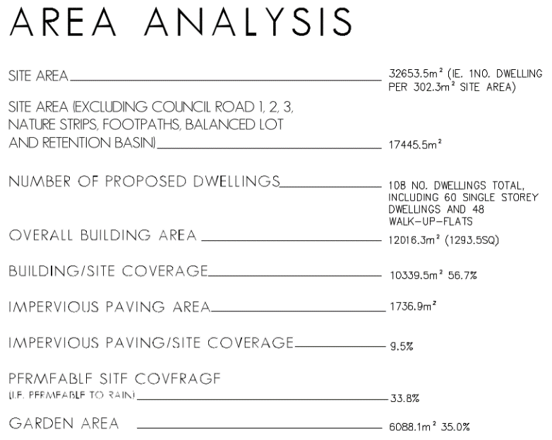  The activity area proposed for multi-dwelling development as part of this application is understood to include the site area (32,653.5 sq/m) less the roads, balance lot and retention basin, being 17,445.5 sq/m. To comply with the standard, site coverage should not exceed 60% of this, being 10,467 sq/m. The plans state site coverage to be 10,339.5 and in compliance with the Standard.  It is notable that whilst the Standard has been met for the overall site coverage, individual lot site coverage frequently exceeds the standard including, for example, Townhouse/Lot 75 (202 sq/m) with a proposed site coverage of 70%:  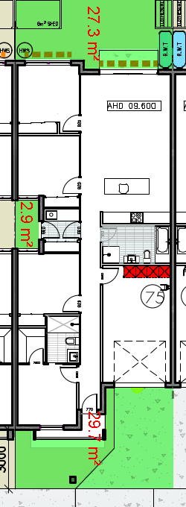
55.03-4 Permeability and stormwater management objectives  To reduce the impact of increased stormwater run-off on the drainage system.  To facilitate on-site stormwater infiltration.  To encourage stormwater management that maximises the retention and reuse of stormwater. | Standard B9  The site area covered by the pervious surfaces should be at least:  - The minimum area specified in a schedule to the zone, or  - If no minimum is specified in a schedule to the zone, 20 percent of the site.  The stormwater management system should be designed to:  - Meet the current best practice performance objectives for stormwater quality as contained in the Urban Stormwater - Best Practice Environmental Management Guidelines (Victorian Stormwater Committee, 1999).  - Contribute to cooling, improving local habitat and providing attractive and enjoyable spaces. | Yes – Complies, with variation to Standard B9  The plans state that the site retains 33.8 per cent permeability, assisting in on site stormwater filtration.  A MUSIC model has been used as part of the Sustainable Design Assessment (using BESS) modelling proposed quality treatment, and also includes provision of 72 x 2kl rainwater tanks for townhouse dwellings.  The non-standard bioretention system is proposed to be located within a retarding basin that is smaller in area and deeper than that normally acceptable to the drainage authority as a new combined quality treatment and retention drainage asset. This design reduces the opportunity that the stormwater system will provide an attractive and enjoyable space given the steep batters, dense plantings, and wall structures are less accessible than a standard retarding basin with batters of 1:3 would be.  Before deciding on an application, the responsible authority must consider:  - The design response.  - The capacity of the site to incorporate stormwater retention and reuse.  - The existing site coverage and any constraints imposed by existing development.  - The capacity of the drainage network to accommodate additional stormwater.  - The capacity of the site to absorb run-off.  - The practicality of achieving the minimum site coverage of pervious surfaces, particularly on lots of less than 300 square metres.  - Whether the owner has entered into an agreement to contribute to off-site stormwater management in lieu of providing an on-site stormwater management system.  The site is not constrained by existing development or the capacity of the drainage network such that it is impractical to accommodate a conventional drainage asset that would better contribute to cooling, improving local habitat and providing attractive and enjoyable spaces. The constraint has instead been imposed as part of the design response seeking to maximise the extend of development on the land with attached dwellings on compact lots at an increased density to that of the surrounding area.  The proposal represents a variation to the Standard whilst achieving the objective via non-preferred method.
55.03-5 Energy efficiency objectives  To achieve and protect energy efficient dwellings and residential buildings.  To ensure the orientation and layout of development reduce fossil fuel energy use and make appropriate use of daylight and solar energy.  This objective does not apply:  - To construct or extend an apartment development, or  - To construct or extend a dwelling in or forming part of an apartment development. | Standard B10  Buildings should be:  - Oriented to make appropriate use of solar energy.  - Sited and designed to ensure that the energy efficiency of existing dwellings on adjoining lots is not unreasonably reduced.  - Sited and designed to ensure that the performance of existing rooftop solar energy systems on dwellings on adjoining lots in a General Residential Zone, Neighbourhood Residential Zone or Township Zone are not unreasonably reduced. The existing rooftop solar energy system must exist at the date the application is lodged.  Living areas and private open space should be located on the north side of the development, if practicable.  Developments should be designed so that solar access to north-facing windows is maximised. | No – Does not meet the objective  The compact lot layout results in the prevalence of attached dwellings across the development, constraining north facing townhouses from achieving any solar access to north facing windows.  Before deciding on an application, the responsible authority must consider:  - The design response.  - The size, orientation and slope of the lot.  - The existing amount of solar access to abutting properties.  - The availability of solar access to north-facing windows on the site.  - The extent to which an existing rooftop solar energy system on an adjoining lot is overshadowed by existing buildings or other permanent structures.  - Whether the existing rooftop solar energy system on an adjoining lot is appropriately located.  - The effect of overshadowing on an existing rooftop solar energy system on an adjoining lot.  The lot presents no topographical or other site constraints that limit the ability for the design response to meet the Standard.  Likewise, Instead, the use of standardised layouts for dwellings along the south side of proposed streets should be reconsidered to meet the standard given there are no site constraints for solar access to north facing windows.  The orientation and layout of development does not make appropriate use of daylight and solar energy and does not meet the objective.
55.03-6 Open space objective  To integrate the layout of development with any public and communal open space provided in or adjacent to the development.  This objective does not apply:  - To construct or extend an apartment development, or  - To construct or extend a dwelling in or forming part of an apartment development. | Standard B11  If any public or communal open space is provided on site, it should:  - Be substantially fronted by dwellings, where appropriate.  - Provide outlook for as many dwellings as practicable.  - Be designed to protect any natural features on the site.  - Be accessible and useable. | Not Applicable  No new public or communal open space is proposed as part of this application.
55.03-7 Safety objective  To ensure the layout of development provides for the safety and security of residents and property. | Standard B12  Entrances to dwellings and residential buildings should not be obscured or isolated from the street and internal accessways.  Planting which creates unsafe spaces along streets and accessways should be avoided.  Developments should be designed to provide good lighting, visibility and surveillance of car parks and internal accessways.  Private spaces within developments should be protected from inappropriate use as public thoroughfares. | Yes – Complies, with variation to Standard B12  All dwelling entrances are clearly visible from the street or internal accessway.  The common property access to the apartments is not protected and will become a public thoroughfare for the public traversing north-south through the site, and does not meet the Standard.  Before deciding on an application, the responsible authority must consider the design response.  The design response should be reconsidered to limit public access to the common property area shared by the apartments to protect residents from use as a public thoroughfare.
55.03-8 Landscaping objectives  To encourage development that respects the landscape character of the neighbourhood.  To encourage development that maintains and enhances habitat for plants and animals in locations of habitat importance.  To provide appropriate landscaping.  To encourage the retention of mature vegetation on the site.  This objective does not apply:  - To construct or extend an apartment development, or  - To construct or extend a dwelling in or forming part of an apartment development. | Standard B13  The landscape layout and design should:  - Protect any predominant landscape features of the neighbourhood.  - Take into account the soil type and drainage patterns of the site.  - Allow for intended vegetation growth and structural protection of buildings.  - In locations of habitat importance, maintain existing habitat and provide for new habitat for plants and animals.  - Provide a safe, attractive and functional environment for residents.  Development should provide for the retention or planting of trees, where these are part of the character of the neighbourhood.  Development should provide for the replacement of any significant trees that have been removed in the 12 months prior to the application being made.  The landscape design should specify landscape themes, vegetation (location and species), paving and lighting.  Development should meet any additional landscape requirements specified in a schedule to the zone. | No – Does not meet the objective  The site contributes to the landscape character of the area with established, mature and significant trees. The design response has not proposed to retain any of these trees, but instead proposes removal and planting of street trees of lesser significance.  Before deciding on an application, the responsible authority must consider:  - Any relevant neighbourhood character objective, policy or statement set out in this scheme.  - Any relevant plan or policy for landscape design in the Municipal Planning Strategy and the Planning Policy Framework.  - The design response.  - The location and size of gardens and the predominant plant types in the neighbourhood.  - The health of any trees to be removed.  - Whether a tree was removed to gain a development advantage.  The proposal to remove all established and mature trees identified in the arborist report to be of Long or Medium Useful Life Expectancy (ULE) and of Good Health and Good Structure should be reconsidered. A significant number of these trees should be retained to meet the objective for the retention of mature vegetation on the site.
55.03-9 Access objective  To ensure the number and design of vehicle crossovers respects the neighbourhood character. | Standard B14  The width of accessways or car spaces should not exceed:  - 33 per cent of the street frontage, or  - if the width of the street frontage is less than 20 metres, 40 per cent of the street frontage.  No more than one single-width crossover should be provided for each dwelling fronting a street.  The location of crossovers should maximise the retention of on-street car parking spaces.  The number of access points to a road in a Transport Zone 2 or a Transport Zone 3 should be minimised.  Developments must provide for access for service, emergency and delivery vehicles. | Yes – Complies with Standard B14  Where the frontage of the site is located on Sharland Road, approximately 36m of the a total of the frontage is taken up with vehicle crossings, representing significantly less than the 33% allowable by the Standard.  Not more than one single width crossover is proposed for each dwelling.
55.03-10 Parking location objective  To provide convenient parking for resident and visitor vehicles.  To protect residents from vehicular noise within developments. | Standard B15  Car parking facilities should:  - Be reasonably close and convenient to dwellings and residential buildings.  - Be secure.  - Be well ventilated if enclosed.  Shared accessways or car parks of other dwellings and residential buildings should be located at least 1.5 metres from the windows of habitable rooms. This setback may be reduced to 1 metre where there is a fence at least 1.5 metres high or where window sills are at least 1.4 metres above the accessway. | Yes – Complies with Standard B15  Convenient parking is provided for residents and shared accessways are located at least 1.5 metres from the windows of habitable rooms.
55.04-1 Side and rear setbacks objective  To ensure that the height and setback of a building from a boundary respects the existing or preferred neighbourhood character and limits the impact on the amenity of existing dwellings.  If a development meets standard B17, it is deemed to meet the objective for that standard.  Where standard B17 is met the decision guidelines for that standard do not apply to the application. | Standard B17  A new building not on or within 200mm of a boundary should be set back from side or rear boundaries:  - At least the distance specified in a schedule to the zone, or  - If no distance is specified in a schedule to the zone, 1 metre, plus 0.3 metres for every metre of height over 3.6 metres up to 6.9 metres, plus 1 metre for every metre of height over 6.9 metres.  Sunblinds, verandahs, porches, eaves, fascias, gutters, masonry chimneys, flues, pipes, domestic fuel or water tanks, and heating or cooling equipment or other services may encroach not more than 0.5 metres into the setbacks of this standard.  Landings having an area of not more than 2 square metres and less than 1 metre high, stairways, ramps, pergolas, shade sails and carports may encroach into the setbacks of this standard. | Yes – Complies with Standard B17  The required setbacks have been achieved for the development and all side and rear setbacks comply with the formula contained in the standard.
55.04-2 Walls on boundaries objective  To ensure that the location, length and height of a wall on a boundary respects the existing or preferred neighbourhood character and limits the impact on the amenity of existing dwellings.  If a development meets standard B18, it is deemed to meet the objective for that standard.  Where standard B18 is met the decision guidelines for that standard do not apply to the application. | Standard B18  A new wall constructed on or within 200mm of a side or rear boundary of a lot or a carport constructed on or within 1 metre of a side or rear boundary of lot should not abut the boundary:  - For a length of more than the distance specified in a schedule to the zone; or  - If no distance is specified in a schedule to the zone, for a length of more than:  - 10 metres plus 25 per cent of the remaining length of the boundary of an adjoining lot, or  - Where there are existing or simultaneously constructed walls or carports abutting the boundary on an abutting lot, the length of the existing or simultaneously constructed walls or carports,  whichever is the greater.  A new wall or carport may fully abut a side or rear boundary where slope and retaining walls or fences would result in the effective height of the wall or carport being less than 2 metres on the abutting property boundary.  A building on a boundary includes a building set back up to 200mm from a boundary.  The height of a new wall constructed on or within 200mm of a side or rear boundary or a carport constructed on or within 1 metre of a side or rear boundary should not exceed an average of 3.2 metres with no part higher than 3.6 metres unless abutting a higher existing or simultaneously constructed wall. | Not Applicable  No new walls on or within 200mm of a boundary, or carport within 1m of a boundary are proposed as part of this application.
55.04-3 Daylight to windows objective  To allow adequate daylight into existing habitable room windows.  If a development meets standard B19, it is deemed to meet the objective for that standard.  Where standard B19 is met the decision guidelines for that standard do not apply to the application. | Standard B19  Buildings opposite an existing habitable room window should provide for a light court to the existing window that has a minimum area of 3 square metres and minimum dimension of 1 metre clear to the sky. The calculation of the area may include land on the abutting lot.  Walls or carports more than 3 metres in height opposite an existing habitable room window should be set back from the window at least 50 per cent of the height of the new wall if the wall is within a 55 degree arc from the centre of the existing window. The arc may be swung to within 35 degrees of the plane of the wall containing the existing window.  Where the existing window is above ground floor level, the wall height is measured from the floor level of the room containing the window. | Not Applicable  There are no existing habitable room windows opposite the proposed buildings that require consideration.
55.04-4 North facing windows objective  To allow adequate solar access to existing north-facing habitable room windows.  If a development meets standard B20, it is deemed to meet the objective for that standard.  Where standard B20 is met the decision guidelines for that standard do not apply to the application. | Standard B20  If a north-facing habitable room window of an existing dwelling is within 3 metres of a boundary on an abutting lot, a building should be setback from the boundary 1 metre, plus 0.6 metres for every metre of height over 3.6 metres up to 6.9 metres, plus 1 metre for every metre of height over 6.9 metres, for a distance of 3 metres from the edge of each side of the window. A north-facing window is a window with an axis perpendicular to its surface oriented north 20 degrees west to north 30 degrees east. | Not Applicable  There are no north facing habitable room windows on abutting lots that require consideration.
55.04-5 Overshadowing open space objective  To ensure buildings do not significantly overshadow existing secluded private open space.  If a development meets standard B21, it is deemed to meet the objective for that standard.  Where standard B21 is met the decision guidelines for that standard do not apply to the application. | Standard B21  Where sunlight to the secluded private open space of an existing dwelling is reduced, at least 75 per cent, or 40 square metres with minimum dimension of 3 metres, whichever is the lesser area, of the secluded private open space should receive a minimum of five hours of sunlight between 9 am and 3 pm on 22 September.  If existing sunlight to the secluded private open space of an existing dwelling is less than the requirements of this standard, the amount of sunlight should not be further reduced. | Yes – Complies with Standard B21  The extent of overshadowing associated with the proposed development is within the requirements of the standard.
55.04-6 Overlooking objective  To limit views into existing secluded private open space and habitable room windows.  If a development meets standard B22, it is deemed to meet the objective for that standard.  Where standard B22 is met the decision guidelines for that standard do not apply to the application. | Standard B22  A habitable room window, balcony, terrace, deck or patio should be located and designed to avoid direct views into the secluded private open space of an existing dwelling within a horizontal distance of 9 metres (measured at ground level) of the window, balcony, terrace, deck or patio. Views should be measured within a 45 degree angle from the plane of the window or perimeter of the balcony, terrace, deck or patio, and from a height of 1.7 metres above floor level.  A habitable room window, balcony, terrace, deck or patio with a direct view into a habitable room window of existing dwelling within a horizontal distance of 9 metres (measured at ground level) of the window, balcony, terrace, deck or patio should be either:  - Offset a minimum of 1.5 metres from the edge of one window to the edge of the other.  - Have sill heights of at least 1.7 metres above floor level.  - Have fixed, obscure glazing in any part of the window below 1.7 metre above floor level.  - Have permanently fixed external screens to at least 1.7 metres above floor level and be no more than 25 per cent transparent.  Obscure glazing in any part of the window below 1.7 metres above floor level may be openable provided that there are no direct views as specified in this standard.  Screens used to obscure a view should be:  - Perforated panels or trellis with a maximum of 25 per cent openings or solid translucent panels.  - Permanent, fixed and durable.  - Designed and coloured to blend in with the development.  This standard does not apply to a new habitable room window, balcony, terrace, deck or patio which faces a property boundary where there is a visual barrier at least 1.8 metres high and the floor level of the habitable room, balcony, terrace, deck or patio is less than 0.8 metres above ground level at the boundary. | Yes – Complies with Standard B22  The development is designed to meet the requirements of the standard with overlooking into existing secluded private open space areas and habitable room windows limited in accordance with the standard.
55.04-7 Internal views objective  To limit views into the secluded private open space and habitable room windows of dwellings and residential buildings within a development. | Standard B23  Windows and balconies should be designed to prevent overlooking of more than 50 per cent of the secluded private open space of a lower-level dwelling or residential building directly below and within the same development. | Yes – Complies with Standard B23  Internal views have been considered in the design solution and there is no internal overlooking.  The rear facing windows of upper floor apartments are proposed to include ‘frosted glazing to 1700mm above floor level to limit internal views to ground floor apartment SPOS below.
55.04-8 Noise impacts objective  To contain noise sources in developments that may affect existing dwellings.  To protect residents from external noise  This objective does not apply:  - To construct or extend an apartment development, or  - To construct or extend a dwelling in or forming part of an apartment development. | Standard B24  Noise sources, such as mechanical plant, should not be located near bedrooms of immediately adjacent existing dwellings.  Noise sensitive rooms and secluded private open spaces of new dwellings and residential buildings should take account of noise sources on immediately adjacent properties.  Dwellings and residential buildings close to busy roads, railway lines or industry should be designed to limit noise levels in habitable rooms. | Not Applicable  There are no external noise sources that require consideration as part of this application.
55.05-1 Accessibility objective  To encourage the consideration of the needs of people with limited mobility in the design of developments.  This objective does not apply:  - To construct or extend an apartment development, or  - To construct or extend a dwelling in or forming part of an apartment development. | Standard B25  The dwelling entries of the ground floor of dwellings and residential buildings should be accessible or able to be easily made accessible to people with limited mobility. | Yes – Complies with Standard B25  The entries to the ground floor of the dwellings are accessible to those with limited mobility.
55.05-2 Dwelling entry objective  To provide each dwelling or residential building with its own sense of identity.  This objective does not apply:  - To construct or extend an apartment development, or  - To construct or extend a dwelling in or forming part of an apartment development. | Standard B26  Entries to dwellings and residential buildings should:  - Be visible and easily identifiable from streets and other public areas.  - Provide shelter, a sense of personal address and a transitional space around the entry. | Yes – Complies with Standard B26  All dwelling entries are clearly visible and identifiable from the street providing for a sense of identity for each dwelling. Shelter and a transitional space are provided at each dwelling entry.
55.05-3 Daylight to new windows objective  To allow adequate daylight into new habitable room windows.  If a development meets standard B27, it is deemed to meet the objective for that standard.  Where standard B27 is met the decision guidelines for that standard do not apply to the application. | Standard B27  A window in a habitable room should be located to face:  - An outdoor space clear to the sky or a light court with a minimum area of 3 square metres and minimum dimension of 1 metre clear to the sky, not including land on an abutting lot, or  - A verandah provided it is open for at least one third of its perimeter, or  - A carport provided it has two or more open sides and is open for at least one third of its perimeter. | Yes – Complies with Standard B27  All habitable room windows face an outdoor space of the required dimensions, allowing light into habitable rooms.
55.05-4 Private open space objective  To provide adequate private open space for the reasonable recreation and service needs of residents.  If a development meets standard B28, it is deemed to meet the objective for that standard.  Where standard B28 is met the decision guidelines for that standard do not apply to the application. | Standard B28  A dwelling or residential building should have private open space of an area and dimensions specified in the schedule to the zone.  If no area or dimensions are specified in the schedule to the zone, a dwelling or residential building should have private open space consisting of:  - An area of 40 square metres, with one part of the private open space to consist of secluded private open space at the side or rear of the dwelling or residential building with a minimum area of 25 square metres, a minimum dimension of 3 metres and convenient access from a living room, or  - A balcony of 8 square metres with a minimum width of 1.6 metres and convenient access from a living room, or  - A roof-top area of 10 square metres with a minimum width of 2 metres and convenient access from a living room. | Yes – Complies, with variation to Standard B28  Each proposed townhouse dwelling has been provided with at least 40 sq/m of private open space.  Each apartment is provided with either a balcony of at least 8.8 sq/m (2.1 x 4.2 m) and a minimum width of 1.6 metres and convenient access to a living room.  However, ground floor apartments are generally provided a courtyard of 7.2 x 4.9 m that is encumbered with a storage shed and rainwater tank reducing this area to 4.0 x 4.9 for a total of 19.6 sq/m (with a minimum dimension of 3 metres), representing a variation to Standard B28.  Some ground floor apar  Before deciding on an application, the responsible authority must consider:  - The design response.  - The useability of the private open space, including its size and accessibility.  - The availability of and access to public or communal open space.  - The orientation of the lot to the street and the sun.  The reduced areas of SPOS for ground floor apartments is generally acceptable as the space is functional in shape and is likely to receive good north light.
55.05-5 Solar Access to Open Space  To allow solar access into the secluded private open space of new dwellings and residential buildings. | Standard B29  The private open space should be located on the north side of the dwelling or residential building, if appropriate.  The southern boundary of secluded private open space should be set back from any wall on the north of the space at least (2+0.9h) metres, where ‘h’ is the height of the wall. | No – Does not meet the objective  The wall on the north of SPOS for proposed dwellings 40-46, and 11 is 2.8 metres high, requiring the south boundary set back 4.52 metres from the wall.  The south boundary of proposed dwellings 40-46, and 11 is set back 4.3 metres representing a variation to the standard.  Before deciding on an application, the responsible authority must consider:  - The design response.  - The useability and amenity of the secluded private open space based on the sunlight it will receive.  All of these dwellings are provided with minimum SPOS areas that are encumbered by external storage sheds and rainwater tanks, and all have been designed with living areas facing south. The amenity of these SPOS areas are compromised by the compact layout of the development such that the objective has not been met.
55.05-6 Storage objective  To provide adequate storage facilities for each dwelling.  This objective does not apply:  - To construct or extend an apartment development, or  - To construct or extend a dwelling in or forming part of an apartment development.  If a development meets standard B30, it is deemed to meet the objective for that standard.  Where standard B30 is met the decision guidelines for that standard do not apply to the application. | Standard B30  Each dwelling should have convenient access to at least 6 cubic metres of externally accessible, secure storage space. | Yes – Complies with Standard B30  Convenient access to 6 cubic metres of externally accessible, secure storage has been shown to be located in the courtyard of each dwelling, and in accordance with the standard.
55.06-1 Design Detail  To encourage design detail that respects the existing or preferred neighbourhood character. | Standard B31  The design of buildings, including:  - Façade articulation and detailing,  - Window and door proportions,  - Roof form, and  - Verandahs, eaves and parapets,  should respect the existing or preferred neighbourhood character.  Garages and carports should be visually compatible with the development and the existing or preferred neighbourhood character. | Yes – Complies, with variation to Standard B31  The façade articulation and detail proposed, and the attached townhouse form does not respect the existing neighbourhood character where eaves and gables, verandahs and recessed garages and carports are common in the area.  Before deciding on an application, the responsible authority must consider:  - Any relevant neighbourhood character objective, policy or statement set out in this scheme.  - The design response.  - The effect on the visual bulk of the building and whether this is acceptable in the neighbourhood setting.  - Whether the design is innovative and of a high architectural standard.  The proposal introduces a compact dwelling layout that precents space between dwellings and respectful inclusion of eaves and verandahs, and recessed garaging at the side and rear. The development represents a conventional style of medium density design detail without providing an innovative or high architectural standard. Design detail has incorporated roof forms and materials that are respectful of the exiting character of the area such that the objective has been met.
55.06-2 Front Fences  To encourage front fence design that respects the existing or preferred neighbourhood character.  If a development meets standard B32, it is deemed to meet the objective for that standard.  Where standard B32 is met the decision guidelines for that standard do not apply to the application. | Standard B32  A front fence within 3 metres of a street should not exceed:  - The maximum height specified in a schedule to the zone, or  - If no maximum height is specified in a schedule to the zone, the maximum height specified in Table B3.  Refer Table B3 of Clause 55.06-2. | Yes – Complies, with variation to Standard B32  Visually permeable, low front fences are a prevailing feature of the existing character of the area. No front fences are proposed for dwellings fronting Sharland Road or McHarry Court representing a variation to Standard B32.  Before deciding on an application, the responsible authority must consider:  - Any relevant neighbourhood character objective, policy or statement set out in this scheme.  - The design response.  - The setback, height and appearance of front fences on adjacent properties.  - The extent to which slope and retaining walls reduce the effective height of the front fence.  - Whether the fence is needed to minimise noise intrusion.  Where no front fences are proposed in an area featuring low, visually permeable front fences, the standard has not been met. It is recommended the design response be reconsidered to meet the Standard.
55.06-3 Common Property  To ensure that communal open space, car parking, access areas and site facilities are practical, attractive and easily maintained.  To avoid future management difficulties in areas of common ownership. | Standard B33  Development should clearly delineate public, communal and private areas.  Common property, where provided, should be functional and capable of efficient management. | Yes – Complies with Standard B33  The 2 areas of common property adjoining the apartments provide for pedestrian and vehicles access, private parking, bike hoops and landscape opportunities in accordance with the standard.
55.06-4 Site Services  To ensure that site services can be installed and easily maintained.  To ensure that site facilities are accessible, adequate and attractive. | Standard B34  The design and layout of dwellings and residential buildings should provide sufficient space (including easements where required) and facilities for services to be installed and maintained efficiently and economically.  Bin and recycling enclosures, mailboxes and other site facilities should be adequate in size, durable, waterproof and blend in with the development.  Bin and recycling enclosures should be located for convenient access by residents.  Mailboxes should be provided and located for convenient access as required by Australia Post. | No – Does not meet the objective  Mailboxes, clotheslines, and other site facilities have been conveniently located and will blend in with the development and located for convenient access.  Bin storage areas for all townhouse dwellings are located within garages of minimum dimension, and encroaching upon the car parking spaces provided. Many townhouses built ‘boundary-to-boundary’ provide no practical alternative but to store bins in the garage or within the front setback for which no enclosure has been proposed to blend in with the development.  Before deciding on an application, the responsible authority must consider the design response.  The compact layout and density of the development results in limited available space for all of the spatial requirements necessary to conform with the scheme.  In particular, those dwellings without external access to side and rear yards (boundary-to-boundary townhouses) have not been provided with adequate bin storage locations but instead are shown within the minimum garage dimension necessary to allow convenient car parking and passenger circulation. These dwellings, being units 2,3,8, 72, 75 and 76 for example, do not meet the objective.

Clause 55.07 APARTMENT DEVELOPMENTS

In addition to Clause 55.01 to 55.05 (inclusive), the following Clause 55.07-1 to 55.07-19 (inclusive) apply only:
- To construct or extend an apartment development, or
- To construct or extend a dwelling in or forming part of an apartment development.

These provisions do not apply to an application to construct or extend a development of five or more storeys, excluding a basement or to construct or extend a dwelling in a development of five or more storeys, excluding a basement.

55.07-1 Energy efficiency objectives  To achieve and protect energy efficient dwellings and buildings.  To ensure the orientation and layout of development reduce fossil fuel energy use and make appropriate use of daylight and solar energy.  To ensure dwellings achieve adequate thermal efficiency. | Standard B35  Buildings should be:  - Oriented to make appropriate use of solar energy.  - Sited and designed to ensure that the energy efficiency of existing dwellings on adjoining lots is not unreasonably reduced.  - Sited and designed to ensure that the performance of existing rooftop solar energy systems on dwellings on adjoining lots in a General Residential Zone, Neighbourhood Residential Zone or Township Zone are not unreasonably reduced. The existing rooftop solar energy system must exist at the date the application is lodged.  Living areas and private open space should be located on the north side of the development, if practicable.  Developments should be designed so that solar access to north-facing windows is optimised.  Dwellings located in a climate zone identified Table B4 in should not exceed the maximum NatHERS annual cooling load specified in the following table.  Refer Table B4 of Clause 55.07-1. | Yes – Complies with Standard B35  Where practicable the design response has been oriented to maximise solar access to private open space areas, internal living areas and north facing windows.  There are no rooftop solar energy systems on dwellings adjoining the site that will be affected by the apartment development.  The site is within Climate zone 60 Tullamarine with a recommended NatHERS maximum cooling load of 22 MJ/M2 per annum. The apartments achieve with an average load of 20 MJ/M2 per annum in accordance with the Standard.
55.07-2 Communal open space objective  To provide communal open space that meets the recreation and amenity needs of residents.  To ensure that communal open space is accessible, functional, and is easily maintained.  To ensure that communal open space is integrated with the layout of the development and enhances resident amenity. | Standard B36  A development of 10 or more dwellings should provide a minimum area of communal outdoor open space of 30 square metres.  If a development contains 13 or more dwellings, the development should also provide an additional minimum area of communal open space of 2.5 square metres per dwelling or 220 square metres, whichever is the lesser. This additional area may be indoors or outdoors and consist of multiple separate areas of communal open space.  Each area of communal open space should be:  - Accessible to all residents.  - A useable size, shape and dimension.  - Capable of efficient management.  - Be located to:  - Provide passive surveillance opportunities, where appropriate.  - Provide outlook for as many dwellings as practicable.  - Avoid overlooking into habitable rooms and private open space of new dwellings.  - Minimise noise impacts to new and existing dwellings.  Any area of communal outdoor open space should be landscaped and include canopy cover and trees. | Yes, with variation to Standard B36  No communal outdoor open space has been provided as part of the apartment development.  Before deciding on an application, the responsible authority must consider:  - Any relevant urban design objective, policy or statement set out in this scheme.  - The design response.  - The availability of and access to public open space.  There is no relevant urban design objective policy or statement in the scheme that exempts this apartment development from the requirement to provide communal open space.  The design response has not made provision for communal areas for apartment residents, particularly upper storey apartments that are provided only with a balcony and no areas at ground level.  At issue is whether providing no communal open space is acceptable. For this, the development should provide good areas of private open space, proximity to a variety of ‘communal’ or public places such as cafes and restaurants, urban spaces and public parks. In this respect, apartment design response provides secluded private open space in accordance with the Standard and good access to Connections Park West, such that the objective has been met.
55.07-3 Solar access to communal outdoor open space objective  To allow solar access into communal outdoor open space. | Standard B37  The communal outdoor open space should be located on the north side of a building, if appropriate.  At least 50 per cent or 125 square metres, whichever is the lesser, of the primary communal outdoor open space should receive a minimum of two hours of sunlight between 9am and 3pm on 21 June. | Not applicable  No communal open space is provided as part of this apartment development.
55.07-4 Landscaping objective  To provide landscaping that supports the existing or preferred urban context of the area and reduces the visual impact of buildings on the streetscape.  To preserve existing canopy cover and support the provision of new canopy cover.  To ensure landscaping is climate responsive, supports biodiversity, wellbeing and amenity and reduces urban heat. | Standard B38  Development should retain existing trees and canopy cover.  Development should provide for the replacement of any significant trees that have been removed in the 12 months prior to the application being made.  Development should:  - Provide the canopy cover and deep soil areas specified in Table B5. Existing trees can be used to meet the canopy cover requirements of Table B5.  - Provide canopy cover through canopy trees that are:  - Located in an area of deep soil specified in Table B6. Where deep soil cannot be provided trees should be provided in planters specified in Table B6.  - Consistent with the canopy diameter and height at maturity specified in Table B7.  - Located in communal outdoor open space or common areas or street frontages.  - Comprise smaller trees, shrubs and ground cover, including flowering native species.  - Include landscaping, such as climbing plants or smaller plants in planters, in the street frontage and in outdoor areas, including communal outdoor open space.  - Shade outdoor areas exposed to summer sun through landscaping or shade structures and use paving and surface materials that lower surface temperatures and reduce heat absorption.  - Be supported by irrigation systems which utilise alternative water sources such as rainwater, stormwater and recycled water.  - Protect any predominant landscape features of the area.  - Take into account the soil type and drainage patterns of the site.  - Provide a safe, attractive and functional environment for residents.  - Specify landscape themes, vegetation (location and species), irrigation systems, paving and lighting.  Refer Table B5, B6 and B7 of Clause 55.07-4. | No – Does not meet the objective  The canopy cover and deep soil requirements of Table B5 require the following for the site, being a lot over 2,500 sq/m or more:  - Canopy Cover of 350 square metres plus 20% of site area above 2,500 square metres. Include at least 2 Type B trees or 1 Type C tree  - Deep Soil: 15% of the site  With a site area of 17,445.5 sq/m:  - 17445.5 – 2500 = 14,945.5  - x 0.2 = 2,989.1  - +350 = 3,339.1 sq/m canopy cover required  Deep Soil area required is 15% of 17,445.5, for 2,616.8 sq/m  The application states that:  ‘the proposal does not align with the technical area and volume requirements set out in Standard B38, the landscape response complies with the objectives of Clause 55.07-8.’  The landscape masterplan planting schedule nominates the following mature size canopy trees for ‘Private Open Space Trees’ (quantity x canopy diameter @ canopy area = combined total):  - 25 x 1m @ 0.7854 sq/m = 19.635  - 47 x 3m @ 7.069 sq/m = 332.243  - 25 x 4m @ 12.566 sq/m = 314.15  - 31 x 5m @ 19.635 sq/m = 608.685  For a total of 1,275 sq/m.  All trees are to planted in deep soil.  The application does not meet the standard for deep soil planting on private allotments.  Instead, the landscape masterplan provides additional canopy tree planting in future public reserves and street trees (along roads).  The development does not however, protect and retain established mature canopy trees that are significant to the character of the area.  The design response does not reasonably preserve existing canopy cover and support the provision of new canopy cover such that the objective has not been met.
55.07-5 Integrated water and stormwater management objectives  To encourage the use of alternative water sources such as rainwater, stormwater and recycled water.  To facilitate stormwater collection, utilisation and infiltration within the development.  To encourage development that reduces the impact of stormwater run-off on the drainage system and filters sediment and waste from stormwater prior to discharge from the site. | Standard B39  Buildings should be designed to collect rainwater for non-drinking purposes such as flushing toilets, laundry appliances and garden use.  Buildings should be connected to a non-potable dual pipe reticulated water supply, where available from the water authority.  The stormwater management system should be:  - Designed to meet the current best practice performance objectives for stormwater quality as contained in the Urban Stormwater - Best Practice Environmental Management Guidelines (Victorian Stormwater Committee, 1999).  - Designed to maximise infiltration of stormwater, water and drainage of residual flows into permeable surfaces, tree pits and treatment areas. | Yes – Complies with Standard B39  A MUSIC model has been used as part of the Sustainable Design Assessment (using BESS) modelling proposed quality treatment, and also includes provision of 72 x 2kl rainwater tanks for townhouse dwellings and non-potable connections for toilet flushing.
55.07-6 Access objective  To ensure that vehicle crossovers are designed and located to provide safe access for pedestrians, cyclists and other vehicles.  To ensure that vehicle crossovers are designed and located to minimise visual impact. | Standard B40  Vehicle crossovers should be minimised.  Car parking entries should be consolidated, minimised in size, integrated with the façade and where practicable located at the side or rear of the building.  Pedestrian and cyclist access should be clearly delineated from vehicle access.  The location of crossovers should maximise pedestrian safety and the retention of on-street car parking spaces and street trees.  Development must provide access for service, emergency and delivery vehicles. | Yes – Complies with Standard B40  No more than a single width crossing is provided per dwelling, with on-street parking in Sharland Road and McHarry Court retained.
55.07-7 Noise impacts objective  To contain noise sources in developments that may affect existing dwellings.  To protect residents from external and internal noise sources. | Standard B41  Noise sources, such as mechanical plants should not be located near bedrooms of immediately adjacent existing dwellings.  The layout of new dwellings and buildings should minimise noise transmission within the site.  Noise sensitive rooms (such as living areas and bedrooms) should be located to avoid noise impacts from mechanical plants, lifts, building services, non-residential uses, car parking, communal areas and other dwellings.  New dwellings should be designed and constructed to include acoustic attenuation measures to reduce noise levels from off-site noise sources.  Buildings within a noise influence area specified in Table B8 should be designed and constructed to achieve the following noise levels:  - Not greater than 35dB(A) for bedrooms, assessed as an LAeq,8h from 10pm to 6am.  - Not greater than 40dB(A) for living areas, assessed LAeq,16h from 6am to 10pm.  Buildings, or part of a building screened from a noise source by an existing solid structure, or the natural topography of the land, do not need to meet the specified noise level requirements.  Noise levels should be assessed in unfurnished rooms with a finished floor and the windows closed.  Refer Table B8 of Clause 55.07-7. | Yes – Complies with Standard B41  There are no external noise sources that require consideration.  Noise sensitive rooms are located away from mechanical plant, including the lift, and the site is not within a nominated noise influence area.
55.07-8 Accessibility objective  To ensure the design of dwellings meets the needs of people with limited mobility | Standard B42  At least 50 per cent of dwellings should have:  - A clear opening width of at least 850mm at the entrance to the dwelling and main bedroom.  - A clear path with a minimum width of 1.2 metres that connects the dwelling entrance to the main bedroom, an adaptable bathroom and the living area.  - A main bedroom with access to an adaptable bathroom.  - At least one adaptable bathroom that meets all of the requirements of either Design A or Design B specified in Table B9.  Refer Table B9 of Clause 55.07-8. | No – Does not meet the objective  None of the apartment dwellings meet the access dimension or adaptable bathroom requirements of the standard.  Likewise, none of the townhouse dwellings meet the access dimension or adaptable bathroom requirements of the standard.  The application does not meet the objective.
55.07-9 Private open space objective  To provide adequate private open space for the reasonable recreation and service needs of residents. | Standard B43  A dwelling should have private open space consisting of at least one of the following:  - An area at ground level of at least 25 square metres, with a minimum dimension of 3 metres and convenient access from a living room.  - A balcony with at least the area and dimensions specified in Table B10 and convenient access from a living room. If a cooling or heating unit is located on a balcony, the minimum balcony area specified in Table B10 should be increased by at least 1.5 square metres.  - An area on a podium or other similar base of at least 15 square metres, with a minimum dimension of 3 metres and convenient access from a living room.  - An area on a roof of at least 10 square metres, with a minimum dimension of 2 metres and convenient access from a living room.  Refer Table B10 of Clause 55.07-9. | Yes – Complies, with variation to Standard B43  Each proposed apartment oriented to the north (between north 20 degrees west to north 30 degrees east) is provided with a balcony of not less than 8 sq/m and minimum dimension of not less than 1.7 metres.  Each proposed apartment oriented to the south (between south 20 degrees west to south 30 degrees east) is provided with a balcony of not less than 8 sq/m and minimum dimension of not less than 1.2 metres.  Each 2 bedroom apartment oriented east (between north 30 degrees east to south 30 degrees east) or west (between north 20 degrees west to south 20 degrees west) is provided with a balcony of not less than 8 sq/m and minimum dimension of 2 metres.  Ground floor apartments without balconies represent a variation to the standard by providing unencumbered areas of SPOS of 4.0 x 4.9m for a total of 19.6 sq/m being less than the 25 sq/m required by the standard.  Before deciding on an application, the responsible authority must consider:  - The design response.  - The useability and functionality of the private open space, including its size and accessibility.  - The amenity of the private open space based on the orientation of the lot, noise exposure, the wind conditions and the sunlight it will receive.  - The availability of and access to public or communal open space.  The reduced areas of SPOS for ground floor apartments is generally acceptable as the space is functional in shape and is likely to receive good north light, and public open space is readily accessible in the area.
55.07-10 Storage objective  To provide adequate storage facilities for each dwelling. | Standard B44  Each dwelling should have convenient access to usable and secure storage space.  The total minimum storage space (including kitchen, bathroom and bedroom storage) should meet the requirements specified in Table B11.  Refer Table B11 of Clause 55.07-10. | Yes – Complies with Standard B44  Each 2 bedroom apartment is provided with not less than 14 cubic metres of useable and secure storage, including not less than 9 cubic metres of combined kitchen, bathroom and bedroom storage within the dwelling.
55.07-11 Waste and recycling objectives  To ensure dwellings are designed to encourage waste recycling.  To ensure that waste and recycling facilities are accessible, adequate and attractive.  To ensure that waste and recycling facilities are designed and managed to minimise impacts on residential amenity, health and the public realm | Standard B45  Developments should include dedicated areas for:  - Waste and recycling enclosures which are:  - Adequate in size, durable, waterproof and blend in with the development.  - Adequately ventilated.  - Located and designed for convenient access by residents and made easily accessible to people with limited mobility.  - Adequate facilities for bin washing. These areas should be adequately ventilated.  - Collection, separation and storage of waste and recyclables, including where appropriate opportunities for on-site management of food waste through composting or other waste recovery as appropriate.  - Collection, storage and reuse of garden waste, including opportunities for on-site treatment, where appropriate, or off-site removal for reprocessing.  - Adequate circulation to allow waste and recycling collection vehicles to enter and leave the site without reversing.  - Adequate internal storage space within each dwelling to enable the separation of waste, recyclables and food waste where appropriate.  - Waste and recycling management facilities should be design and managed in accordance with a Waste Management Plan approved by the responsible authority and:  - Be designed to meet the better practice design options specified in Waste Management and Recycling in Multi-unit Developments (Sustainability Victoria, 2019).  - Protect public health and amenity of residents and adjoining premises from the impacts of odour, noise and hazards associated with waste collection vehicle movements. | Yes – Complies, with variation to Standard B45  The waste management plan submitted with the application (Frater Consulting Services, 03/11/2022) incorrectly references waste collection areas within a basement, bin washing areas that have not been provided, and no reference to internal waste storage for apartments, or on-site food waste management or composting,  Before deciding on an application, the responsible authority must consider:  - The design response.  - Any relevant waste and recycling objective, policy or statement set out in this scheme.  Were a permit to be issued, a condition is recommended to require the waste management plan and plans be updated to achieve the requirements of the Standard.
55.07-12 Functional layout objective  To ensure dwellings provide functional areas that meet the needs of residents. | Standard B46  Bedrooms should:  - Meet the minimum internal room dimensions specified in Table B12.  - Provide an area in addition to the minimum internal room dimensions to accommodate a wardrobe.  Refer Table B12 of Clause 55.07-12.  Living areas (excluding dining and kitchen areas) should meet the minimum internal room dimensions specified in Table B13.  Refer Table B13 of Clause 55.07-12. | No – Does not meet the objective  Only the upper storey apartments are provided with a main bedroom with a width and depth of not less than 3.0m x 3.4m, and other bedrooms of not less than 3.0m x 3.0m and all excluding areas provided for a wardrobe. However, the circulation space provided for the kitchen is 0.4m wide and likely to encroach into the minimum lounge dimension shown on the plan.  The ground floor apartments do not provide a main bedroom with minimum dimensions of 3.0 x 3.4m.  The ground floor apartments also do not provide a living area in accordance with the standard.  Before deciding on an application, the responsible authority must consider:  - The design response.  - The useability, functionality and amenity of habitable rooms.  The layout and dimensions of the open plan living, kitchen and meals area for both apartment types are not considered to be functional or offering an acceptable level of amenity for habitable rooms. The application does not meet the objective.
55.07-13 Room depth objective  To allow adequate daylight into single aspect habitable rooms. | Standard B47  Single aspect habitable rooms should not exceed a room depth of 2.5 times the ceiling height.  The depth of a single aspect, open plan, habitable room may be increased to 9 metres if all the following requirements are met:  - The room combines the living area, dining area and kitchen.  - The kitchen is located furthest from the window.  - The ceiling height is at least 2.7 metres measured from finished floor level to finished ceiling level. This excludes where services are provided above the kitchen.  The room depth should be measured from the external surface of the habitable room window to the rear wall of the room. | Yes – Complies with Standard B47  The minimum proposed single aspect habitable room ceiling height is 2.55 metres requiring a maximum room depth of not more than 6.375 metres. All single aspect habitable rooms meet with the standard.
55.07-14 Windows objective  To allow adequate daylight into new habitable room windows. | Standard B48  Habitable rooms should have a window in an external wall of the building.  A window may provide daylight to a bedroom from a smaller secondary area within the bedroom where the window is clear to the sky.  The secondary area should be:  - A minimum width of 1.2 metres.  - A maximum depth of 1.5 times the width, measured from the external surface of the window. | Yes – Complies with Standard B48  All habitable rooms are provided with windows in accordance with the Standard.
55.07-15 Natural ventilation objectives  To encourage natural ventilation of dwellings.  To allow occupants to effectively manage natural ventilation of dwellings. | Standard B49  The design and layout of dwellings should maximise openable windows, doors or other ventilation devices in external walls of the building, where appropriate.  At least 40 per cent of dwellings should provide effective cross ventilation that has:  - A maximum breeze path through the dwelling of 18 metres.  - A minimum breeze path through the dwelling of 5 metres  - Ventilation openings with approximately the same area.  The breeze path is measured between the ventilation openings on different orientations of the dwelling. | Yes – Complies, with variation to Standard B49  None of the apartment types provide ventilation devices (openable doors, windows or other devices) on external walls of different orientations.  Before deciding on an application, the responsible authority must consider:  - The design response.  - The size, orientation, slope and wind exposure of the site.  - The extent to which the orientation of the building and the layout of dwellings maximises opportunities for cross ventilation.  - Whether an alternative design meets the relevant objectives having regard to the amenity of the dwelling and the site context.  The variation is considered acceptable where natural ventilation can be achieved by opening devices on opposite sides of the apartment such that occupants can effectively manage natural ventilation.
55.07-16 Building entry and circulation objectives  To provide each dwelling and building with its own sense of identity.  To ensure the internal layout of buildings provide for the safe, functional and efficient movement of residents.  To ensure internal communal areas provide adequate access to daylight and natural ventilation. | Standard B50  Entries to dwellings and buildings should:  - Be visible and easily identifiable.  - Provide shelter, a sense of personal address and a transitional space around the entry.  The layout and design of buildings should:  - Clearly distinguish entrances to residential and non-residential areas.  - Provide windows to building entrances and lift areas.  - Provide visible, safe and attractive stairs from the entry level to encourage use by residents.  - Provide common areas and corridors that:  - Include at least one source of natural light and natural ventilation.  - Avoid obstruction from building services.  - Maintain clear sight lines. | Yes – Complies with Standard B50  Apartment entries are visible and easily identifiable and provide a sense of personal address and sheltered entry in accordance with the Standard.
55.07-17 Integration with the street objective  To integrate the layout of development with the street.  To support development that activates street frontages. | Standard B51  Development should be oriented to front existing and proposed streets.  Along street frontages, development should:  - Incorporate pedestrian entries, windows, balconies or other active spaces.  - Limit blank walls.  - Limit high front fencing, unless consistent with the existing urban context.  - Provide low and visually permeable front fences, where proposed.  - Conceal car parking and internal waste collection areas from the street.  Development next to existing public open space should be designed to complement the open space and facilitate passive surveillance. | Yes – Complies with Standard B51  Apartments adjoining streets are oriented to provide good street integration in accordance with the Standard.
55.07-18 Site services objective  To ensure that site services are accessible and can be easily installed and maintained.  To ensure that site services and facilities are visually integrated into the building design or landscape. | Standard B52  Development should provide adequate space (including easements where required) for site services to be installed and maintained efficiently and economically.  Meters and utility services should be designed as an integrated component of the building or landscape.  Mailboxes and other site facilities should be adequate in size, durable, weather-protected, located for convenient access and integrated into the overall design of the development. | Yes – Complies with Standard B52  Site services for the apartment development are adequate, accessible, and able to be maintained in accordance with the Standard.
55.07-19 External walls and materials objective  To ensure external walls use materials appropriate to the existing urban context or preferred future development of the area.  To ensure external walls endure and retain their attractiveness. | Standard B53  External walls should be finished with materials that:  - Do not easily deteriorate or stain.  - Weather well over time.  - Are resilient to the wear and tear from their intended use.  External wall design should facilitate safe and convenient access for maintenance. | Yes – Complies with Standard B53  External wall materials include face brick, and a mix of resilient contemporary cladding materials in accordance with Standard B53.

APPENDIX 2 – Clause 56 Assessment – Residential Subdivision

The development is required to be assessed against Clause 56 as set out below.
This assessment matrix is current up to and including Amendment VC229 20/03/2023.

Zone | Objectives and standards to be met (60 or more lots only)
TZ | Clauses 56.02-1, 56.03-5, 56.04-2 to 56.04-5, 56.05-1, 56.05-2, 56.06-2, 56.06-4, 56.06-5, 56.06-7, 56.06-8 and 56.07-1 to 56.09-4.
MUZ, RGZ, GRZ, NRZ, and CDZ | All except Clause 56.03-5.
PDZ | Not Applicable

OFFICER ASSESSMENT

Permit Application Number: PP-1290-2022
Address: 26-34 Sharland Road and 11 McHarry Court, CORIO
Responsible Officer: Steve Roussac
Date of Assessment: 30 October 2023
Plans Assessed: 09/08/2023

OBJECTIVES | STANDARDS | ASSESSMENT
56.02 POLICY IMPLEMENTATION
56.02-1 Strategic implementation objective  To ensure that the layout and design of a subdivision is consistent with and implements any objective, policy, strategy or plan for the area set out in this scheme. | Standard C1  An application must be accompanied by a written statement that describes how the subdivision is consistent with and implements any relevant growth area, activity centre, housing, access and mobility, community facilities, open space and recreation, landscape (including any native vegetation precinct plan) and urban design objective, policy, strategy or plan for the area set out in this scheme. | Yes - Complies, with variation to Standard C1.  The subdivision layout generally accords with the Former Rosewall Primary School Concept Plan forming part of the Corio Norlane Precinct Structure Plan.  The subdivision design, however, proposes a medium density subdivision in an area not identified for medium density infill development such that the design represents a variation to Standard C1.
56.03 LIVEABLE AND SUSTAINABLE COMMUNITIES
56.03-1 Compact and walkable neighbourhoods objectives  To create compact neighbourhoods that are oriented around easy walking distances to activity centres, schools and community facilities, public open space and public transport.  To allow easy movement through and between neighbourhoods for all people. | Standard C2  A subdivision should implement any relevant growth area or any approved land-use and development strategy, plan or policy for the area set out in this scheme.  An application for subdivision must include a plan of the layout of the subdivision that:  - Meets the objectives (if relevant to the class of subdivision specified in the zone) of:  - Clause 56.03-2 Activity centres  - Clause 56.03-3 Planning for community facilities  - Clause 56.04-1 Lot diversity and distribution  - Clause 56.06-2 Walking and cycling network  - Clause 56.06-3 Public transport network  - Clause 56.06-4 Neighbourhood street network  - Shows the 400 metre street walking distance around each existing or proposed bus stop, 600 metres street walking distance around each existing or proposed tram stop and 800 metres street walking distance around each existing or proposed railway station and shows the estimated number of dwellings within those distances.  - Shows the layout of the subdivision in relation to the surrounding area.  - Is designed to be accessible for people with disabilities. | Yes - Complies with Standard C2.  The subdivision layout and design corresponds with a proposed multi dwelling development that provides pedestrian links, access to public transport, schools and community facilities in accordance with relevant policies and Scheme requirements.
56.03-2 Activity centre objective  To provide for mixed-use activity centres, including neighbourhood activity centres, of appropriate area and location. | Standard C3  A subdivision should implement any relevant activity centre strategy, plan or policy for the area set out in this scheme.  Subdivision should be supported by activity centres that are:  - Accessible by neighbourhood and regional walking and cycling networks.  - Served by public transport that is connected to the regional public transport network.  - Located at public transport interchange points for the convenience of passengers and easy connections between public transport services.  - Located on arterial roads or connector streets.  - Of appropriate size to accommodate a mix of uses that meet local community needs.  - Oriented to support active street frontages, support street-based community interaction and pedestrian safety. | Not Applicable.  The proposed subdivision is not within or near to an activity centre.
56.03-3 Planning for community facilities objective  To provide appropriately located sites for community facilities including schools, libraries, preschools and childcare, health services, police and fire stations, recreation and sports facilities. | Standard C4  A subdivision should:  - Implement any relevant regional and local community facility strategy, plan or policy for the area set out in this scheme.  - Locate community facilities on sites that are in or near activity centres and public transport.  School sites should:  - Be integrated with the neighbourhood and located near activity centres.  - Be located on walking and cycling networks.  - Have a bus stop located along the school site boundary.  - Have student drop-off zones, bus parking and on-street parking in addition to other street functions in abutting streets.  - Adjoin the public open space network and community sporting and other recreation facilities.  - Be integrated with community facilities.  - Be located on land that is not affected by physical, environmental or other constraints.  Schools should be accessible by the Principal Public Transport Network in Metropolitan Melbourne and on the regional public transport network outside Metropolitan Melbourne.  Primary schools should be located on connector streets and not on arterial roads.  New State Government school sites must meet the requirements of the Department of Education and abut at least two streets with sufficient widths to provide student drop-off zones, bus parking and on-street parking in addition to other street functions. | Not Applicable.  The proposed subdivision does not provide for community facilities or schools.
56.03-4 Built environment objective  To create urban places with identity and character. | Standard C5  The built environment should:  - Implement any relevant urban design strategy, plan or policy for the area set out in this scheme.  - Provide living and working environments that are functional, safe and attractive.  - Provide an integrated layout, built form and urban landscape.  - Contribute to a sense of place and cultural identity.  An application should describe the identity and character to be achieved and the elements that contribute to that identity and character. | No - Does not meet the Objective.  The subdivision layout and design corresponds with a proposed multi dwelling development that has been assessed to not meet all of the objectives of Clause 55 of the Scheme such that the objective has not been met.
56.03-5 Neighbourhood character objective  To design subdivisions that respond to neighbourhood character. | Standard C6  Subdivision should:  - Respect the existing neighbourhood character or achieve a preferred neighbourhood character consistent with any relevant neighbourhood character objective, policy or statement set out in this scheme.  - Respond to and integrate with the surrounding urban environment.  - Protect significant vegetation and site features | Not Applicable.  Does not apply to a subdivision of 60 or more lots in the GRZ.
56.04 LOT DESIGN
56.04-1 Lot diversity and distribution objectives  To achieve housing densities that support compact and walkable neighbourhoods and the efficient provision of public transport services.  To provide higher housing densities within walking distance of activity centres.  To achieve increased housing densities in designated growth areas.  To provide a range of lot sizes to suit a variety of dwelling and household types. | Standard C7  A subdivision should implement any relevant housing strategy, plan or policy for the area set out in this scheme.  Lot sizes and mix should achieve the average net residential density specified in any zone or overlay that applies to the land or in any relevant policy for the area set out in this scheme.  A range and mix of lot sizes should be provided including lots suitable for the development of:  - Single dwellings.  - Two dwellings or more.  - Higher density housing.  - Residential buildings and Retirement villages.  Unless the site is constrained by topography or other site conditions, lot distribution should provide for 95 per cent of dwellings to be located no more than 400 metre street walking distance from the nearest existing or proposed bus stop, 600 metres street walking distance from the nearest existing or proposed tram stop and 800 metres street walking distance from the nearest existing or proposed railway station.  Lots of 300 square metres or less in area, lots suitable for the development of two dwellings or more, lots suitable for higher density housing and lots suitable for Residential buildings and Retirement villages should be located in and within 400 metres street walking distance of an activity centre. | No - Does not meet the Objective.  The proposed subdivision creates medium density development in an area that has not been identified as suitable for medium density development on lot sizes of less than 300 sq/m. The application does not meet the objective.
56.04-2 Lot area and building envelopes objective  To provide lots with areas and dimensions that enable the appropriate siting and construction of a dwelling, solar access, private open space, vehicle access and parking, water management, easements and the retention of significant vegetation and site features. | Standard C8  An application to subdivide land that creates lots of less than 300 square metres should be accompanied by information that shows:  - That the lots are consistent or contain building envelope that is consistent with a development approved under this scheme, or  - That a dwelling may be constructed on each lot in accordance with the requirements of this scheme.  Lots of between 300 square metres and 500 square metres should:  - Contain a building envelope that is consistent with a development of the lot approved under this scheme, or  - If no development of the lot has been approved under this scheme, contain a building envelope and be able to contain a rectangle measuring 10 metres by 15 metres, or 9 metres by 15 metres if a boundary wall is nominated as part of the building envelope.  If lots of between 300 square metres and 500 square metres are proposed to contain dwellings that are built to the boundary, the long axis of the lots should be within 30 degrees east and 20 degrees west of north unless there are significant physical constraints that make this difficult to achieve.  Lots greater than 500 square metres should be able to contain a rectangle measuring 10 metres by 15 metres and may contain a building envelope.  A building envelope may specify or incorporate any relevant siting and design requirement. Any requirement should meet the relevant standards of Clause 54, unless:  - The objectives of the relevant standards are met, and  - The building envelope is shown as a restriction on a plan of subdivision registered under the Subdivision Act 1988 or is specified as a covenant in an agreement under Section 173 of the Act.  Where a lot with a building envelope adjoins a lot that is not on the same plan of subdivision or is not subject to the same agreement relating to the relevant building envelope:  - The building envelope must meet Standards A10 and A11 of Clause 54 in relation to the adjoining lot, and  - The building envelope must not regulate siting matters covered by Standards A12 to A15 (inclusive) of Clause 54 in relation to the adjoining lot. This should be specified in the relevant plan of subdivision or agreement.  Lot dimensions and building envelopes should protect:  - Solar access for future dwellings and support the siting and design of dwellings that achieve the energy rating requirements of the Building Regulations.  - Existing or proposed easements on lots.  - Significant vegetation and site features. | No – Does not meet the Objective.  The subdivision layout and design corresponds with a proposed multi dwelling development that has been assessed to not meet all of the objectives of Clause 55 of the Scheme such that the objective has not been met.
56.04-3 Solar orientation of lots objective  To provide good solar orientation of lots and solar access for future dwellings. | Standard C9  Unless the site is constrained by topography or other site conditions, at least 70 percent of lots should have appropriate solar orientation.  Lots have appropriate solar orientation when:  - The long axis of lots are within the range north 20 degrees west to north 30 degrees east, or east 20 degrees north to east 30 degrees south.  - Lots between 300 square metres and 500 square metres are proposed to contain dwellings that are built to the boundary, the long axis of the lots should be within 30 degrees east and 20 degrees west of north.  - Dimensions of lots are adequate to protect solar access to the lot, taking into account likely dwelling size and the relationship of each lot to the street. | Yes - Complies, with variation to Standard C9.  The subdivision layout and design corresponds with a proposed multi dwelling development that has been assessed to not meet all of the objectives of Clause 55 of the Scheme such that the objective has not been met.
56.04-4 Street orientation objective  To provide a lot layout that contributes to community social interaction, personal safety and property security. | Standard C10  Subdivision should increase visibility and surveillance by:  - Ensuring lots front all roads and streets and avoid the side or rear of lots being oriented to connector streets and arterial roads.  - Providing lots of 300 square metres or less in area and lots for 2 or more dwellings around activity centres and public open space.  - Ensuring streets and houses look onto public open space and avoiding sides and rears of lots along public open space boundaries.  - Providing roads and streets along public open space boundaries. | Yes - Complies, with variation to Standard C10.  The subdivision layout and design corresponds with a proposed multi dwelling development that has been assessed to not meet all of the standards of Clause 55 of the Scheme such that the standard has not been met.
56.04-5 Common area objectives  To identify common areas and the purpose for which the area is commonly held.  To ensure the provision of common area is appropriate and that necessary management arrangements are in place.  To maintain direct public access throughout the neighbourhood street network. | Standard C11  An application to subdivide land that creates common land must be accompanied by a plan and a report identifying:  - The common area to be owned by the body corporate, including any streets and open space.  - The reasons why the area should be commonly held.  - Lots participating in the body corporate.  - The proposed management arrangements including maintenance standards for streets and open spaces to be commonly held. | Yes - Complies with Standard C11.  The subdivision includes creation of common property in appropriate ownership of apartment owners in accordance with the Standard.
56.05 URBAN LANDSCAPE
56.05-1 Integrated urban landscape objectives  To provide attractive and continuous landscaping in streets and public open spaces that contribute to the character and identity of new neighbourhoods and urban places or to existing or preferred neighbourhood character in existing urban areas.  To incorporate natural and cultural features in the design of streets and public open space where appropriate.  To protect and enhance native habitat and discourage the planting and spread of noxious weeds.  To provide for integrated water management systems and contribute to drinking water conservation. | Standard C12  An application for subdivision that creates streets or public open space should be accompanied by a landscape design.  The landscape design should:  - Implement any relevant streetscape, landscape, urban design or native vegetation precinct plan, strategy or policy for the area set out in this scheme.  - Create attractive landscapes that visually emphasise streets and public open spaces.  - Respond to the site and context description for the site and surrounding area.  - Maintain significant vegetation where possible within an urban context.  - Take account of the physical features of the land including landform, soil and climate.  - Protect and enhance any significant natural and cultural features.  - Protect and link areas of significant local habitat where appropriate.  - Support integrated water management systems with appropriate landscape design techniques for managing urban run-off including wetlands and other water sensitive urban design features in streets and public open space.  - Promote the use of drought tolerant and low maintenance plants and avoid species that are likely to spread into the surrounding environment.  - Ensure landscaping supports surveillance and provides shade in streets, parks and public open space.  - Develop appropriate landscapes for the intended use of public open space including areas for passive and active recreation, the exercising of pets, playgrounds and shaded areas.  - Provide for walking and cycling networks that link with community facilities.  - Provide appropriate pathways, signage, fencing, public lighting and street furniture.  - Create low maintenance, durable landscapes that are capable of a long life.  - The landscape design must include a maintenance plan that sets out maintenance responsibilities, requirements and costs. | Yes - Complies with Standard C12.  The subdivision includes a landscape master plan in accordance with the requirements of the Standard.
56.05-2 Public open space provision objectives  To provide a network of quality, well-distributed, multi-functional and cost-effective public open space that includes local parks, active open space, linear parks and trails, and links to regional open space.  To provide a network of public open space that caters for a broad range of users.  To encourage healthy and active communities.  To provide adequate unencumbered land for public open space and integrate any encumbered land with the open space network.  To ensure land provided for public open space can be managed in an environmentally sustainable way and contributes to the development of sustainable neighbourhoods. | Standard C13  The provision of public open space should:  - Implement any relevant objective, policy, strategy or plan (including any growth area precinct structure plan) for open space set out in this scheme.  - Provide a network of well-distributed neighbourhood public open space that includes:  - Local parks within 400 metres safe walking distance of at least 95 percent of all dwellings. Where not designed to include active open space, local parks should be generally 1 hectare in area and suitably dimensioned and designed to provide for their intended use and to allow easy adaptation in response to changing community preferences.  - Additional small local parks or public squares in activity centres and higher density residential areas.  - Active open space of a least 8 hectares in area within 1 kilometre of 95 percent of all dwellings that is:  - Suitably dimensioned and designed to provide for the intended use, buffer areas around sporting fields and passive open space  - Sufficient to incorporate two football/cricket ovals  - Appropriate for the intended use in terms of quality and orientation  - Located on flat land (which can be cost effectively graded)  - Located with access to, or making provision for, a recycled or sustainable water supply  - Adjoin schools and other community facilities where practical  - Designed to achieve sharing of space between sports.  - Linear parks and trails along waterways, vegetation corridors and road reserves within 1 kilometre of 95 percent of all dwellings.  Public open space should:  - Be provided along foreshores, streams and permanent water bodies.  - Be linked to existing or proposed future public open spaces where appropriate.  - Be integrated with floodways and encumbered land that is accessible for public recreation.  - Be suitable for the intended use.  - Be of an area and dimensions to allow easy adaptation to different uses in response to changing community active and passive recreational preferences.  - Maximise passive surveillance.  - Be integrated with urban water management systems, waterways and other water bodies.  - Incorporate natural and cultural features where appropriate. | Yes - Complies with Standard C13.  A public open space contribution will be required in accordance with Clause 53.01. The subdivision rearranges existing public open space in accordance with relevant policy and the DDO37.
56.06 ACCESS AND MOBILITY MANAGEMENT
56.06-1 Integrated mobility objectives  To achieve an urban structure where compact and walkable neighbourhoods are clustered to support larger activity centres on the Principal Public Transport Network in Metropolitan Melbourne and on the regional public transport network outside Metropolitan Melbourne.  To provide for walking (including persons with impaired mobility), cycling, public transport and other motor vehicles in an integrated manner.  To contribute to reduced car dependence, improved energy efficiency, improved transport efficiency, reduced greenhouse gas emissions and reduced air pollution. | Standard C14  An application for a subdivision must include a plan of the layout of the neighbourhood that meets the objectives of:  - Clause 56.06-2 Walking and cycling network.  - Clause 56.06-3 Public transport network.  - Clause 56.06-4 Neighbourhood street network. | Yes - Complies with Standard C14.  The subdivision provides appropriate connections to walking and cycling paths, the public transport network and the neighbourhood street network.
56.06-2 Walking and cycling network objectives  To contribute to community health and well being by encouraging walking and cycling as part of the daily lives of residents, employees and visitors.  To provide safe and direct movement through and between neighbourhoods by pedestrians and cyclists.  To reduce car use, greenhouse gas emissions and air pollution. | Standard C15  The walking and cycling network should be designed to:  - Implement any relevant regional and local walking and cycling strategy, plan or policy for the area set out in this scheme.  - Link to any existing pedestrian and cycling networks.  - Provide safe walkable distances to activity centres, community facilities, public transport stops and public open spaces.  - Provide an interconnected and continuous network of safe, efficient and convenient footpaths, shared paths, cycle paths and cycle lanes based primarily on the network of arterial roads, neighbourhood streets and regional public open spaces.  - Provide direct cycling routes for regional journeys to major activity centres, community facilities, public transport and other regional activities and for regional recreational cycling.  - Ensure safe street and road crossings including the provision of traffic controls where required.  - Provide an appropriate level of priority for pedestrians and cyclists.  - Have natural surveillance along streets and from abutting dwellings and be designed for personal safety and security particularly at night.  - Be accessible to people with disabilities. | Yes - Complies with Standard C15.  The proposed paths and roads are to be created in accordance with relevant local authority requirements and in accordance with the Standard.
56.06-3 Public transport network objectives  To provide an arterial road and neighbourhood street network that supports a direct, efficient and safe public transport system.  To encourage maximum use of public transport. | Standard C16  The public transport network should be designed to:  - Implement any relevant public transport strategy, plan or policy for the area set out in this scheme.  - Connect new public transport routes to existing and proposed routes to the satisfaction of the relevant public transport authority.  - Provide for public transport links between activity centres and other locations that attract people using the Principal Public Transport Network in Metropolitan Melbourne and the regional public transport network outside Metropolitan Melbourne.  - Locate regional bus routes principally on arterial roads and locate local bus services principally on connector streets to provide:  - Safe and direct movement between activity centres without complicated turning manoeuvres.  - Direct travel between neighbourhoods and neighbourhood activity centres.  - A short and safe walk to a public transport stop from most dwellings. | Yes - Complies with Standard C16.  No change to the public transport network infrastructure adjoining the site is proposed and no additional public transport infrastructure has been sought by the relevant determining authority.
56.06-4 Neighbourhood street network objective  To provide for direct, safe and easy movement through and between neighbourhoods for pedestrians, cyclists, public transport and other motor vehicles using the neighbourhood street network. | Standard C17  The neighbourhood street network must:  - Take account of the existing mobility network of arterial roads, neighbourhood streets, cycle paths, shared paths, footpaths and public transport routes.  - Provide clear physical distinctions between arterial roads and neighbourhood street types.  - Comply with the Head, Transport for Victoria’s arterial road access management policies.  - Provide an appropriate speed environment and movement priority for the safe and easy movement of pedestrians and cyclists and for accessing public transport.  - Provide safe and efficient access to activity centres for commercial and freight vehicles.  - Provide safe and efficient access to all lots for service and emergency vehicles.  - Provide safe movement for all vehicles.  - Incorporate any necessary traffic control measures and traffic management infrastructure.  The neighbourhood street network should be designed to:  - Implement any relevant transport strategy, plan or policy for the area set out in this scheme.  - Include arterial roads at intervals of approximately 1.6 kilometres that have adequate reservation widths to accommodate long term movement demand.  - Include connector streets approximately halfway between arterial roads and provide adequate reservation widths to accommodate long term movement demand.  - Ensure connector streets align between neighbourhoods for direct and efficient movement of pedestrians, cyclists, public transport and other motor vehicles.  - Provide an interconnected and continuous network of streets within and between neighbourhoods for use by pedestrians, cyclists, public transport and other vehicles.  - Provide an appropriate level of local traffic dispersal.  - Indicate the appropriate street type.  - Provide a speed environment that is appropriate to the street type.  - Provide a street environment that appropriately manages movement demand (volume, type and mix of pedestrians, cyclists, public transport and other motor vehicles).  - Encourage appropriate and safe pedestrian, cyclist and driver behaviour.  - Provide safe sharing of access lanes and access places by pedestrians, cyclists and vehicles.  - Minimise the provision of culs-de-sac.  - Provide for service and emergency vehicles to safely turn at the end of a dead-end street.  - Facilitate solar orientation of lots.  - Facilitate the provision of the walking and cycling network, integrated water management systems, utilities and planting of trees.  - Contribute to the area’s character and identity.  - Take account of any identified significant features. | Yes - Complies with Standard C17.  The proposed street layout and design accords with the requirements of the municipal road authority requirements, subject to permit conditions requiring detailed design approval in accordance with relevant infrastructure design standards.
56.06-5 Walking and cycling network detail objectives  To design and construct footpaths, shared path and cycle path networks that are safe, comfortable, well constructed and accessible for people with disabilities.  To design footpaths to accommodate wheelchairs, prams, scooters and other footpath bound vehicles. | Standard C18  Footpaths, shared paths, cycle paths and cycle lanes should be designed to:  - Be part of a comprehensive design of the road or street reservation.  - Be continuous and connect.  - Provide for public transport stops, street crossings for pedestrians and cyclists and kerb crossovers for access to lots.  - Accommodate projected user volumes and mix.  - Meet the requirements of Table C1.  - Provide pavement edge, kerb, channel and crossover details that support safe travel for pedestrians, footpath bound vehicles and cyclists, perform required drainage functions and are structurally sound.  - Provide appropriate signage.  - Be constructed to allow access to lots without damage to the footpath or shared path surfaces.  - Be constructed with a durable, non-skid surface.  - Be of a quality and durability to ensure:  - Safe passage for pedestrians, cyclists, footpath bound vehicles and vehicles.  - Discharge of urban run-off.  - Preservation of all-weather access.  - Maintenance of a reasonable, comfortable riding quality.  - A minimum 20 year life span.  - Be accessible to people with disabilities and include tactile ground surface indicators, audible signals and kerb ramps required for the movement of people with disabilities. | Yes - Complies with Standard C18.  Footpaths and shared paths are proposed to be created in accordance with relevant design standards.
56.06-6 Public transport network detail objectives  To provide for the safe, efficient operation of public transport and the comfort and convenience of public transport users.  To provide public transport stops that are accessible to people with disabilities. | Standard C19  Bus priority measures must be provided along arterial roads forming part of the existing or proposed Principal Public Transport Network in Metropolitan Melbourne and the regional public transport network outside Metropolitan Melbourne to the requirements of the relevant roads authority.  Road alignment and geometry along bus routes should provide for the efficient, unimpeded movement of buses and the safety and comfort of passengers.  The design of public transport stops should not impede the movement of pedestrians.  Bus and tram stops should have:  - Surveillance from streets and adjacent lots.  - Safe street crossing conditions for pedestrians and cyclists.  - Safe pedestrian crossings on arterial roads and at schools including the provision of traffic controls as required by the roads authority.  - Continuous hard pavement from the footpath to the kerb.  - Sufficient lighting and paved, sheltered waiting areas for forecast user volume at neighbourhood centres, schools and other locations with expected high patronage.  - Appropriate signage.  Public transport stops and associated waiting areas should be accessible to people with disabilities and include tactile ground surface indicators, audible signals and kerb ramps required for the movement of people with physical disabilities. | Yes - Complies with Standard C19.  No additional public transport infrastructure is proposed as part of this subdivision, and no arterial roads are to be constructed.
56.06-7 Neighbourhood street network detail objective  To design and construct street carriageways and verges so that the street geometry and traffic speeds provide an accessible and safe neighbourhood street system for all users. | Standard C20  The design of streets and roads should:  - Meet the requirements of Table C1. Where the widths of access lanes, access places, and access streets do not comply with the requirements of Table C1, the requirements of the relevant fire authority and roads authority must be met.  - Provide street blocks that are generally between 120 metres and 240 metres in length and generally between 60 metres to 120 metres in width to facilitate pedestrian movement and control traffic speed.  - Have verges of sufficient width to accommodate footpaths, shared paths, cycle paths, integrated water management, street tree planting, lighting and utility needs.  - Have street geometry appropriate to the street type and function, the physical land characteristics and achieve a safe environment for all users.  - Provide a low-speed environment while allowing all road users to proceed without unreasonable inconvenience or delay.  - Provide a safe environment for all street users applying speed control measures where appropriate.  - Ensure intersection layouts clearly indicate the travel path and priority of movement for pedestrians, cyclists and vehicles.  - Provide a minimum 5 metre by 5 metre corner splay at junctions with arterial roads and a minimum 3 metre by 3 metre corner splay at other junctions unless site conditions justify a variation to achieve safe sight lines across corners.  - Ensure streets are of sufficient strength to:  - Enable the carriage of vehicles.  - Avoid damage by construction vehicles and equipment.  - Ensure street pavements are of sufficient quality and durability for the:  - Safe passage of pedestrians, cyclists and vehicles.  - Discharge of urban run-off.  - Preservation of all-weather access and maintenance of a reasonable, comfortable riding quality.  - Ensure carriageways of planned arterial roads are designed to the requirements of the relevant road authority.  - Ensure carriageways of neighbourhood streets are designed for a minimum 20 year life span.  - Provide pavement edges, kerbs, channel and crossover details designed to:  - Perform the required integrated water management functions.  - Delineate the edge of the carriageway for all street users.  - Provide efficient and comfortable access to abutting lots at appropriate locations.  - Contribute to streetscape design.  - Provide for the safe and efficient collection of waste and recycling materials from lots.  - Be accessible to people with disabilities.  - Meet the requirements of Table C1. Where the widths of access lanes, access places, and access streets do not comply with the requirements of Table C1, the requirements of the relevant fire authority and roads authority must be met. Where the widths of connector streets do not comply with the requirements of Table C1, the requirements of the relevant public transport authority must be met.  A street detail plan should be prepared that shows, as appropriate:  - The street hierarchy and typical cross-sections for all street types.  - Location of carriageway pavement, parking, bus stops, kerbs, crossovers, footpaths, tactile surface indicators, cycle paths and speed control and traffic management devices.  - Water sensitive urban design features.  - Location and species of proposed street trees and other vegetation.  - Location of existing vegetation to be retained and proposed treatment to ensure its health.  - Any relevant details for the design and location of street furniture, lighting, seats, bus stops, telephone boxes and mailboxes. | Yes - Complies with Standard C20.  New neighbourhood streets are to be constructed in accordance with municipal road authority requirements and construction standards.
56.06-8 Lot access objective  To provide for safe vehicle access between roads and lots. | Standard C21  Vehicle access to lots abutting arterial roads should be provided from service roads, side or rear access lanes, access places or access streets where appropriate and in accordance with the access management requirements of the relevant roads authority.  Vehicle access to lots of 300 square metres or less in area and lots with a frontage of 7.5 metres or less should be provided via rear or side access lanes, places or streets.  The design and construction of a crossover should meet the requirements of the relevant road authority.  Refer to Table C1 Design of roads and neighbourhood streets | Yes - Complies, with variation to Standard C21.  Lots 40, 41, 43-46, 11 and 16 all have frontages of less than 7.5 metres and are not provided with access via rear or side streets.
56.07 INTEGRATED WATER MANAGEMENT
56.07-1 Drinking water supply objectives  To reduce the use of drinking water.  To provide an adequate, cost-effective supply of drinking water. | Standard C22  The supply of drinking water must be:  - Designed and constructed in accordance with the requirements and to the satisfaction of the relevant water authority.  - Provided to the boundary of all lots in the subdivision to the satisfaction of the relevant water authority. | Yes - Complies with Standard C22.  Drinking water is to be supplied in accordance with relevant water supply authority requirements.
56.07-2 Reused and recycled water objective  To provide for the substitution of drinking water for non-drinking purposes with reused and recycled water. | Standard C23  Reused and recycled water supply systems must be:  - Designed, constructed and managed in accordance with the requirements and to the satisfaction of the relevant water authority, Environment Protection Authority and Department of Health.  - Provided to the boundary of all lots in the subdivision where required by the relevant water authority. | Not Applicable.  No reused and recycled water supply is available in this location.
56.07-3 Waste water management objective  To provide a waste water system that is adequate for the maintenance of public health and the management of effluent in an environmentally friendly manner. | Standard C24  Waste water systems must be:  - Designed, constructed and managed in accordance with the requirements and to the satisfaction of the relevant water authority and the Environment Protection Authority.  - Consistent with a domestic waste water management plan adopted by the relevant council.  Reticulated waste water systems must be provided to the boundary of all lots in the subdivision where required by the relevant water authority. | Yes - Complies with Standard C24.  Reticulated waste water connections are to be provided in accordance with relevant sewer authority requirements.
56.07-4 Stormwater management objectives  To minimise damage to properties and inconvenience to residents from stormwater.  To ensure that the street operates adequately during major storm events and provides for public safety.  To minimise increases in stormwater and protect the environmental values and physical characteristics of receiving waters from degradation by stormwater  To encourage stormwater management that maximises the retention and reuse of stormwater.  To encourage stormwater management that contributes to cooling, local habitat improvements and provision of attractive and enjoyable spaces. | Standard C25  The stormwater management system must be:  - Designed and managed in accordance with the requirements and to the satisfaction of the relevant drainage authority.  - Designed and managed in accordance with the requirements and to the satisfaction of the water authority where reuse of stormwater is proposed.  - Designed to meet the current best practice performance objectives for stormwater quality as contained in the Urban Stormwater - Best Practice Environmental Management Guidelines (Victorian Stormwater Committee, 1999).  - Designed to ensure that flows downstream of the subdivision site are restricted to pre-development levels unless increased flows are approved by the relevant drainage authority and there are no detrimental downstream impacts.  - Designed to contribute to cooling, improving local habitat and providing attractive and enjoyable spaces.  The stormwater management system should be integrated with the overall development plan including the street and public open space networks and landscape design.  For all storm events up to and including the 20% Average Exceedance Probability (AEP) standard:  - Stormwater flows should be contained within the drainage system to the requirements of the relevant authority.  - Ponding on roads should not occur for longer than 1 hour after the cessation of rainfall.  For storm events greater than 20% AEP and up to and including 1% AEP standard:  - Provision must be made for the safe and effective passage of stormwater flows.  - All new lots should be free from inundation or to a lesser standard of flood protection where agreed by the relevant floodplain management authority.  - Ensure that streets, footpaths and cycle paths that are subject to flooding meet the safety criteria d_{a} V_{ave} < 0.35 m2/s (where, d_{a} = average depth in metres and V_{ave} = average velocity in metres per second).  The design of the local drainage network should:  - Ensure stormwater is retarded to a standard required by the responsible drainage authority.  - Ensure every lot is provided with drainage to a standard acceptable to the relevant drainage authority. Wherever possible, stormwater should be directed to the front of the lot and discharged into the street drainage system or legal point of discharge.  - Ensure that inlet and outlet structures take into account the effects of obstructions and debris buildup. Any surcharge drainage pit should discharge into an overland flow in a safe and predetermined manner.  - Include water sensitive urban design features to manage stormwater in streets and public open space. Where such features are provided, an application must describe maintenance responsibilities, requirements and costs.  Any flood mitigation works must be designed and constructed in accordance with the requirements of the relevant floodplain management authority. | No - Does not meet the Objective.  The subdivision layout and design corresponds with a proposed multi dwelling development that has been assessed to not meet all of the standards of Clause 55 of the Scheme such that the standard has not been met.
56.08 SITE MANAGEMENT
56.08-1 Site management objectives  To protect drainage infrastructure and receiving waters from sedimentation and contamination.  To protect the site and surrounding area from environmental degradation or nuisance prior to and during construction of subdivision works.  To encourage the re-use of materials from the site and recycled materials in the construction of subdivisions where practicable. | Standard C26  A subdivision application must describe how the site will be managed prior to and during the construction period and may set out requirements for managing:  - Erosion and sediment.  - Dust.  - Run-off.  - Litter, concrete and other construction wastes.  - Chemical contamination.  - Vegetation and natural features planned for retention.  Recycled material should be used for the construction of streets, shared paths and other infrastructure where practicable. | Yes - Complies with Standard C26.  A permit condition will require the submission of the construction management plan.
56.09 UTILITIES
56.09-1 Shared trenching objectives  To maximise the opportunities for shared trenching.  To minimise constraints on landscaping within street reserves. | Standard C27  Reticulated services for water, gas, electricity and telecommunications should be provided in shared trenching to minimise construction costs and land allocation for underground services. | Yes - Complies with Standard C27.  Shared trenching can be utilised where appropriate.
56.09-2 Electricity, telecommunications and gas objectives  To provide public utilities to each lot in a timely, efficient and cost effective manner.  To reduce greenhouse gas emissions by supporting generation and use of electricity from renewable sources. | Standard C28  The electricity supply system must be designed in accordance with the requirements of the relevant electricity supply agency and be provided to the boundary of all lots in the subdivision to the satisfaction of the relevant electricity authority.  Arrangements that support the generation or use of renewable energy at a lot or neighbourhood level are encouraged.  The telecommunication system must be designed in accordance with the requirements of the relevant telecommunications servicing agency and should be consistent with any approved strategy, policy or plan for the provision of advanced telecommunications infrastructure, including fibre optic technology. The telecommunications system must be provided to the boundary of all lots in the subdivision to the satisfaction of the relevant telecommunications servicing authority.  Where proposed to be connected, a reticulated gas supply system must be designed in accordance with the requirements of the relevant gas supply agency. | Yes - Complies with Standard C28.  Relevant servicing authorities have been consulted and have no objection, subject to conditions aimed at servicing the land with required infrastructure.
56.09-3 Fire hydrants objective  To provide fire hydrants and fire plugs in positions that enable fire fighters to access water safely, effectively and efficiently. | Standard C29  Fire hydrants should be provided:  - A maximum distance of 120 metres from the rear of each lot.  - No more than 200 metres apart.  Hydrants and fire plugs must be compatible with the relevant fire service equipment. Where the provision of fire hydrants and fire plugs does not comply with the requirements of standard C29, fire hydrants must be provided to the satisfaction of the relevant fire authority. | Yes - Complies with Standard C29.  The relevant fire authority has been consulted and have no objection to the grant of a permit, subject to conditions aimed at servicing the land with required infrastructure.
56.09-4 Public lighting objective  To provide public lighting to ensure the safety of pedestrians, cyclists and vehicles.  To provide pedestrians with a sense of personal safety at night  To contribute to reducing greenhouse gas emissions and to saving energy. | Standard C30  Public lighting should be provided to streets, footpaths, public telephones, public transport stops and to major pedestrian and cycle paths including public open spaces that are likely to be well used at night to assist in providing safe passage for pedestrians, cyclists and vehicles.  Public lighting should be designed in accordance with the relevant Australian Standards.  Public lighting should be consistent with any strategy, policy or plan for the use of renewable energy and energy efficient fittings. | Yes - Complies with Standard C30.  Permit conditions will require street lighting.

The Meeting closed at 6.45pm.

