

minutes

PLANNING COMMITTEE MEETING
No. 226

Thursday 24 November 2022 5.30pm
City Hall, 57 Little Malop Street, Geelong

ALSO LIVE STREAMED ON THE CITY’S WEBSITE:

www.geelongaustralia.com.au/meetings

PANEL:

Cr Sullivan (Chair)
Cr Asher
Cr Aitken
Cr Mason
Cr Moloney
Cr Nelson

PRESENT

Present:

Cr Sullivan (Chair)
Cr Asher
Cr Aitken
Cr Mason
Cr Moloney
Cr Nelson

Also Present:

Joanne van Slageren, Manager City Development
John Rush, Coordinator, Statutory Planning
Shane Pritchard, Team Leader Statutory Planning
Julian Pollard, Senior Statutory Planner

Opening: The Chair declared the meeting open at 5.35pm.

1. PROCEDURAL MATTERS

Acknowledgement Of Country

The Committee acknowledges the Wadawurrung People as the Traditional Owners of the Land, Waterways and Skies. We pay our respects to their Elders, past and present. We Acknowledge all Aboriginal and Torres Strait Islander people who are part of our Greater Geelong community today.

1.2. Introduce The Panel Members

1.3. Apologies

Nil

1.4. Declarations Of Conflicts Of Interest

Nil

1.5. Confirmation Of Minutes

That the Minutes of the Planning Committee Meeting held on 10 November 2022
be confirmed.

Moved: Cr Asher Seconded: Cr Mason

CARRIED

2. MATTER(S) FOR CONSIDERATION
.1. PP-1578-2021 Planning Committee Report 2 And 4 Stephens Parade, Barwon Heads
2.1. | PP-1578-2021 Planning Committee Report 2 and 4 Stephens Parade, Barwon Heads
Application Number: | PP-1578-2021
Responsible Officer: | Julian Pollard
Applicant’s Name: | Contour Consultants Australia
Address/Title Details: | 2 and 4 Stephens Parade, BARWON HEADS
Proposal: | Demolition of Two (2) Dwellings and Fences and Construction of a Dwelling and Fences
Date Received: | 24-Dec-2021
Date Report Prepared: | 28-Oct-2022
Was a site inspection done? | Yes – 11-Jul-2022
Zone/Overlays: | Low Density Residential Zone  Heritage Overlay (HO1650 – Golf Links Heritage Area)  Bushfire Management Overlay
Listed Buildings | None
Current Use/Development: | 2 Stephens Parade contains a double storey dwelling  4 Stephens Parade contains a double storey dwelling
Proposed Use/Development | The application is seeking to demolish the two existing dwellings onsite, associated outbuildings and fencing and replace with a single double storey dwelling constructed over both lots with new fencing proposed.
Date(s) of Plans Under Assessment | 24-May-2022– Amended Site/Floor Plans/Elevations Etc
Amendment | N/A

Summary
- The subject sites are located on the northern side of Stephens Parade, Barwon Heads. The land at 2 Stephens Parade currently has a double storey earth rammed dwelling that is setback a minimum 8.9 metres from the northern (rear) boundary, minimum 8.3 metres from the eastern (side) boundary, 5 metres from the southern (front) boundary and a minimum 4.138 metres from the western (side) boundary. It has a maximum building height approx. 7.6 metres. Access to the property is via the eastern section of Stephens Parade. The site contains a 1.6 metre semi-transparent vertical timber fence along the southern and eastern boundaries, which front Stephens Parade and Golf Links Road.
- The land at 4 Stephens Parade contains a double storey weatherboard dwelling, which contains a detached double garage located along the southern (front) boundary and eastern (side) boundary, with the dwelling setback a minimum 11.17 metres from the northern (rear) boundary and 1.656 metres from the western (side) boundary. It will have a maximum building height of approx. 7.5 metres. The site contains no front fencing.
- The proposal is seeking to demolish the existing two dwellings onsite, associated outbuildings and fencing and replace with one double storey dwelling, with basement car parking and living areas and it will include seven (7) bedrooms.
- It is acknowledged that a planning permit was previously issued for the site at 4 Stephens Parade on 27 February 2018. The permit was for demolition of the existing dwelling and construction of a new dwelling (8.8m in height) in a Heritage Overlay.
- This new proposal is for a single dwelling which will have a maximum building height of approximately 8.6 metres, new fencing proposed along the boundary perimeter 1.6 metres in height and constructed from Colorbond. The building footprint of the new proposed dwelling is approximately 520 square metres. A new access is proposed in the western section of Stephens Parade.
- The subject site is located within the Low Density Residential Zone, where a permit is not required under the provisions of the zone for a single dwelling (this is a section 1 use).
- The subject site is subject to a Heritage Overlay, where under the provisions of the Overlay a permit is required to demolish a dwelling and construct a new dwelling and fencing.
- It is noted that the plans submitted show a pool to the rear. A permit is not required for a domestic swimming pool if it cannot be seen from the street or public park. It is considered that the proposal will not be seen from Stephens Parade or Golf links Drive and the golf course is not considered a public park. Based on this and under the provisions of the Overlay - no planning permit is required.
- The plans also show tree removal. A planning permit is only required if the schedule for the Heritage Overlay has tree controls. The Golf Links Heritage Area has no tree controls and therefore the removal of trees also does not require planning consent under the Heritage Overlay.
- A permit for the proposed dwelling is required under the Bushfire Management Overlay.
- Based on the planning permit triggers - Public notice of the current application was given via letters to adjoining and nearby properties, a sign on the land and on Council’s website.
- At the completion of public notice forty six (46) objections have been lodged with Council. The matters raised by objectors included:
- The development is inconsistent and unsympathetic to existing neighbourhood and streetscape and is an overdevelopment of the site.
- The dwelling is a bulky structure that is not consistent with Barwon Heads Urban Design Framework in relation to its built form and existing character of Stephens Parade.
- The principle of development being construction of a large dwelling is out of character with HO1650.
- The proposed dwelling will be a dominant feature within the landscape setting when viewed from The Bluff, Thirteenth Beach Road and lookouts, the Golf course and golf club.
- The development is out of character with existing development within Stephens Parade.
- The front setback needs to be greater to allow for greater landscaping opportunities.
- The proposed development for the demolition is not sustainable for the environment, considering the dwelling at 2 Stephens Parade is approximately only 20 years old.
- The proposed dwelling and it bulky structure will impact on views to the Barwon Heads Golf club.
- The proposal is not consistent with Clause 15.03-1S as it fails to ensure development does not affect the significance of a heritage place (the golf club) due its size and bulk.
- The proposed development is not consistent with the Bellarine Peninsula policy as it presents as one single elongated building with no breaks in built form.
- The proposed development does not comply with Marine and Coastal Act 2018, as it will be a dominant built form not sympathetic to coastal surrounds of Thirteenth Beach.
- As part of the planning permit application process the application was referred to the City’s Heritage Advisor. The advice of the Heritage Advisor supported the proposal as overall the gabled forms, height and construction were deemed to accord with the significant characteristics in the heritage area whilst it is considered to be a contemporary interpretation. It was considered the proposed dwelling will add some additional bulk compared to the existing dwellings onsite, particularly when viewed from the golf course, however it was assessed and determined that it was unlikely to cause an adverse impact on the heritage significance of the Golf Club building, given its setback of over 100 metres to the south of the golf club.
- It is noted the dwelling will be more dominant when viewed from the eastern section of the golf course, but this view is considered to be less sensitive from a heritage perspective.
- The application was referred to the CFA who have no objections to the proposal from a bushfire safety perspective.
- Based on the assessment of the application under the Greater Geelong Planning Scheme and taking into account comments from the City’s Heritage advisor, the proposal is hereby respectfully recommended to be supported subject to the recommendation and the conditions provided.
Alternate Recommendation
Moved: Cr Asher Carried: Cr Mason
Carried

That the Responsible Authority having considered all matters which the Planning and Environment Act 1987, requires it to consider decides to Refuse to Grant a Planning Permit for the Demolition of Two (2) Dwellings, Associated Outbuildings and Fences and Construction of a Dwelling and Fences, at 2 and 4 Stephens Parade, Barwon Heads, on the following grounds:

- The proposal does not comply with the Planning Policy Framework at:
  - Clause 11.03-6L-01 (The Bellarine Peninsula) in that it:
    - Does not protect the unique character of Barwon Heads as a coastal village located within a sensitive environment and significant landscape setting.
  - Clause 15.03-1L (Heritage Conservation – Incorporated document HO1650 – Golf links) in that it:
    - Does not promote a dwelling design that draws on traditional architectural characteristics.
- The proposal does not accord with the Heritage decision guidelines of Clause 43.01-8 given the location, bulk, form and appearance of the proposed dwelling will adversely affect the significance of the heritage place.
- The proposal does not comply with Clause 65 (Decision Guidelines) of the Greater Geelong Planning Scheme in that:
  - The proposed development inappropriately affects the environment and amenity of the area.

REPORT

PERMIT TRIGGERS:

A planning permit is triggered for this application pursuant to the following clauses of the Greater Geelong Planning Scheme:
- Pursuant to Clause 43.01-1 of the Heritage Overlay a permit is required to demolish a dwelling, demolish fencing and associated outbuildings, construct a dwelling and construct a fence.
- Pursuant to Clause 44.06-2 of the Bushfire Management Overlay, a permit is required to construct a dwelling.
As explained above the proposed pool does not trigger a planning permit under the Heritage Overlay, as it will not be seen from either Stephens Parade or Golf Links Road or from a public park and therefore under the provisions of the Heritage Overlay, no permit is required.
The plans show a number of trees proposed to be removed. Under the Heritage Overlay, tree removal only triggers a planning permit if tree controls apply under the schedule to the Heritage Overlay. No tree controls apply to the Golf Links Heritage Area, therefore the tree removal does require planning consent under the Heritage Overlay.
DEFINITIONS:

Pursuant to Clause 73.03 of the Planning Scheme a dwelling is defined as:
A building used as a self-contained residence which must include:
a) a kitchen sink;
b) food preparation facilities
c) a bath or shower; and
d) a closet pan and wash basin.
It includes outbuildings and works normal to a dwelling.
Pursuant to Clause 73.04 of the Planning Scheme a dwelling is nested in the Accommodation group.

RESTRICTIVE COVENANT OR SECTION 173 AGREEMENT:

The subject site is not burdened by a Restrictive Covenant or Section 173 Agreement.

OFFICER DIRECT OR INDIRECT INTEREST:

No officer involved in the preparation of this report declared a general or material conflict of interest.

SITE/LOCALITY:

The subject sites are particularly described as Lot 1 on title plan 187371D and Lot 2 on Plan of Subdivision 098670.

The key features of the subject land and surrounds are as follows:
- The subject site is located on the northern side of Stephens Parade, Barwon Heads.
- The combined sites are irregular in shape and comprise an area of 1,823 square metres.
- The site contains a gentle slope from the southern (front) boundary to the northern (rear) boundary.
- The site at 2 Stephens Parade contains a dwelling approximately in the centre of the site, setback 8.9 metres from the northern (rear) boundary, a minimum 8.3 metres from the eastern (side) boundary, 5.08 metres from the southern (front) boundary and a minimum 4.1 metres from the western (side) boundary. It contains mature trees located along the eastern, western (side) and northern (rear) boundaries. The dwelling is double storey in design constructed from rammed earth, with the maximum building height of 26.00 AHD. The site contains a 1.6 metre high semi-transparent vertical timber fence along the southern (front) and eastern (side) boundaries that front Stephens Parade and Golf Links Road.
- The site at 4 Stephens Parade contains a double storey weatherboard dwelling with a detached double garage located on the southern (front) boundary, 627mm off the eastern (side) boundary, 1.656 metres from the western (side) boundary and a minimum 11.710 metres from the northern (rear) boundary. No front fencing is located on site. The dwelling has a maximum building height of 25.93 AHD.
- The surrounding properties along the eastern section of Stephens Parade are generally similar in size to the subject sites. The land at 6 Stephens Parade contains a double storey dwelling located approximately in the centre of the site, with a detached double garage located in front of the dwelling, setback 2.4 metres from the southern (front) boundary, with a maximum building height of 27.52 AHD. The land at 8-10 Stephens Parade contains single storey dwelling located in the northern (rear) section of the site.

There is approximately 120 metres break from the golf course between 8-10 Stephens Parade and to the next dwelling to the west along Stephens Parade. There is a consistent pattern of development within the four lots in the eastern section of Stephens Parade, consisting of generally dwellings double storey in design with buildings generally located closer to Stephens Parade. The Barwon Heads Golf Course is located to the north (rear) of the subject sites, which is much larger in size and contains the heritage significant club rooms located approximately 120 metres to the north of the subject site. The golf course also operates on the eastern side of Golf Links Road. To the south of the subject site is crown land, which is moderately vegetated of native shrubs and trees and provides a pedestrian path to access Thirteenth Beach Road and Thirteenth Beach. The Bluff is located approximately 1.2 kilometres east of the subject site.

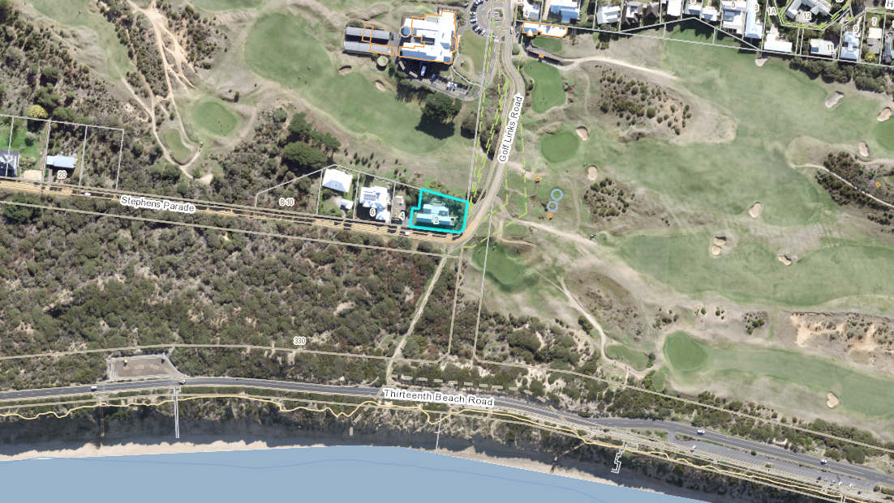
Aerial photo of the subject site and surrounds.
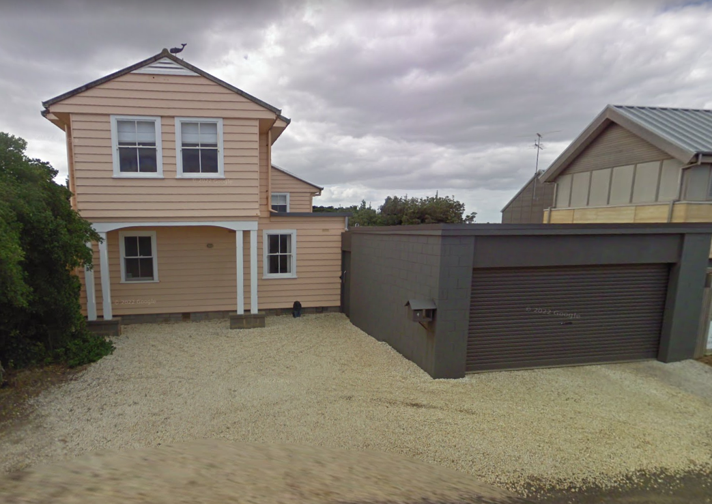
4 Stephens Parade
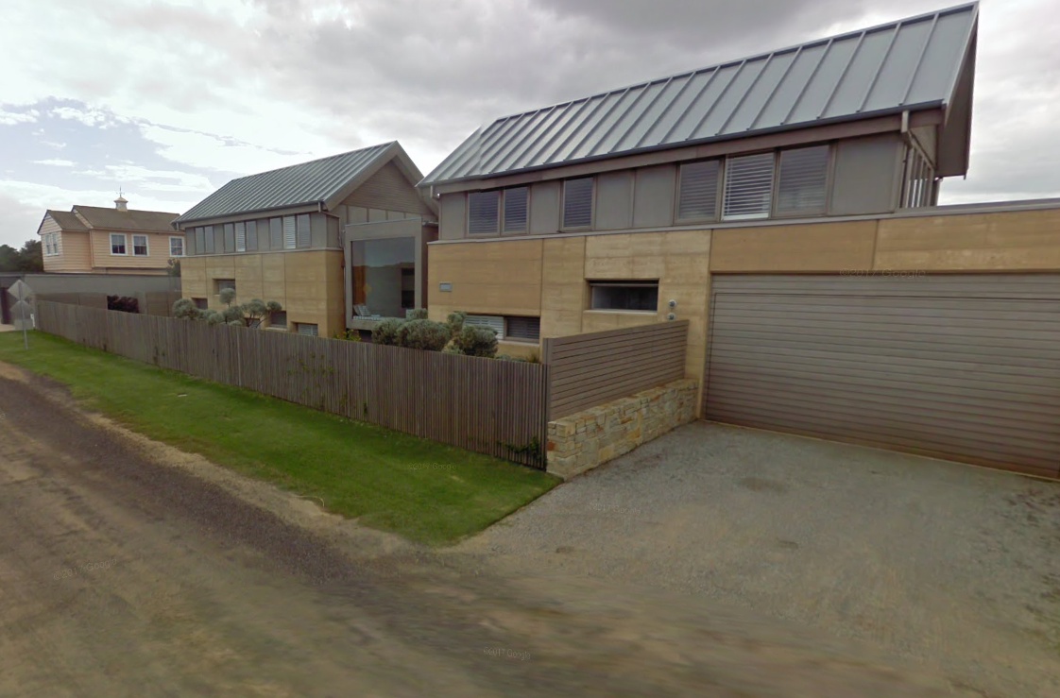
2 Stephens Parade, with 4 Stephens Parade in the background
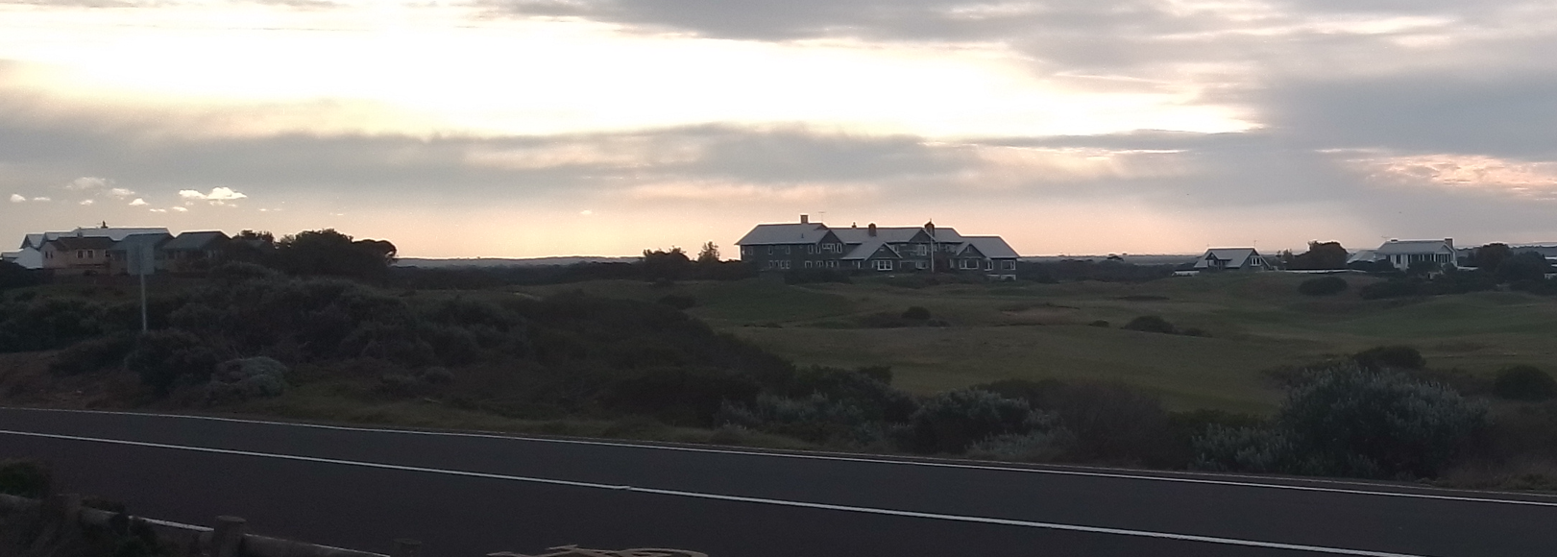
View from Thirteenth Beach Road, showing 2 Stephens Parade, Barwon Heads Golf Club

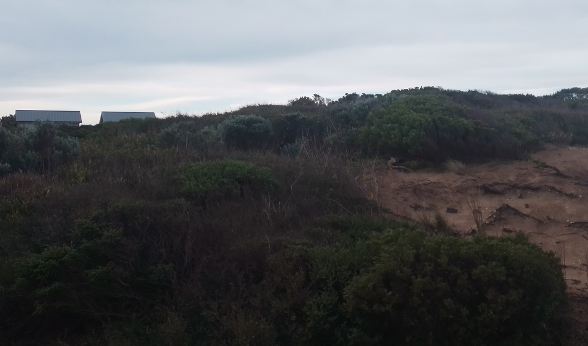
View from the pedestrian access looking north to 2 Stephens Parade.
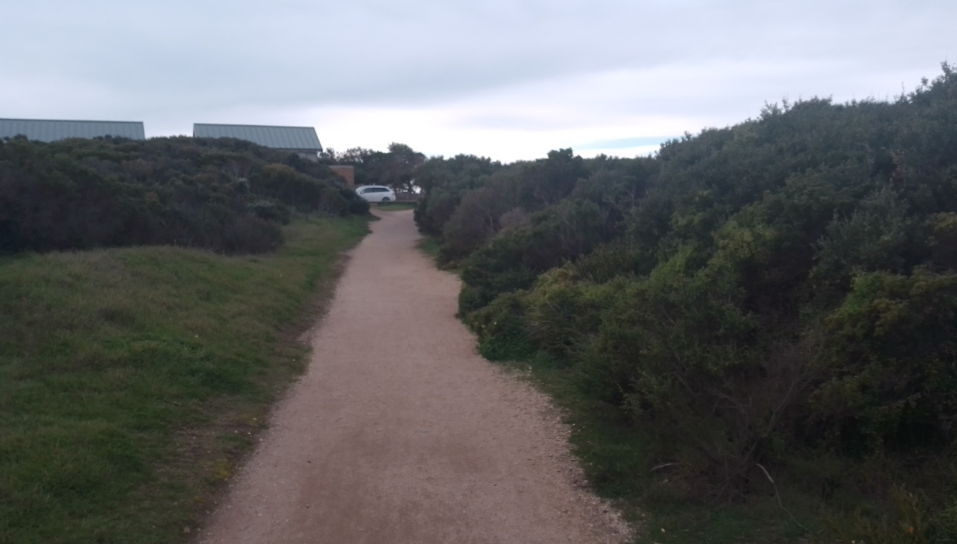
Start of pedestrian track looking north to 2 Stephens Parade.

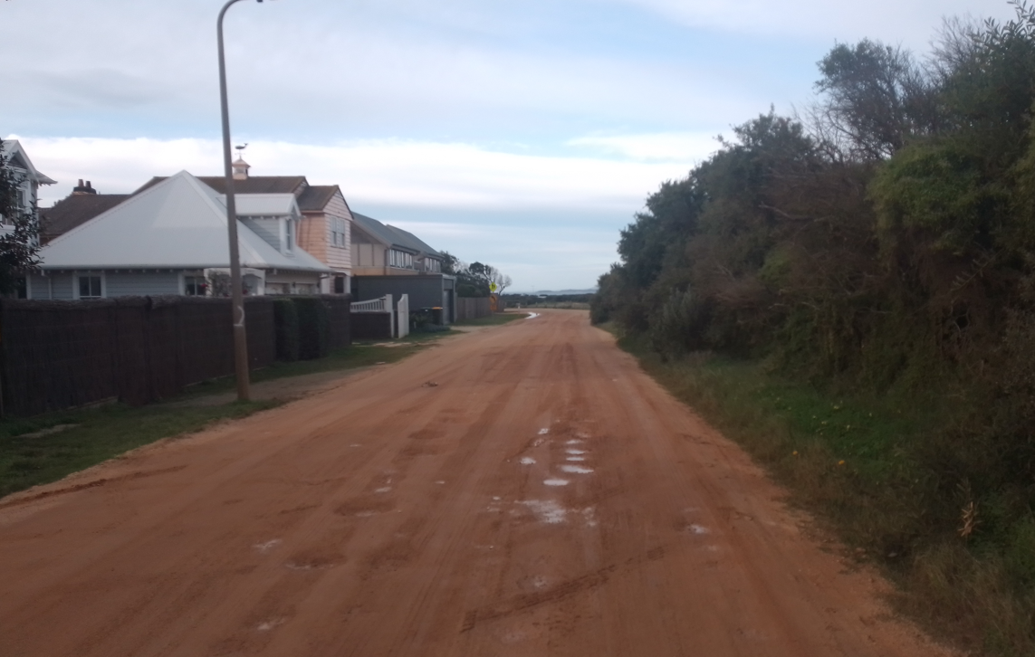
In front of 8-10 Stephens Parade looking east to 6, 4 and 2 Stephens Parade.
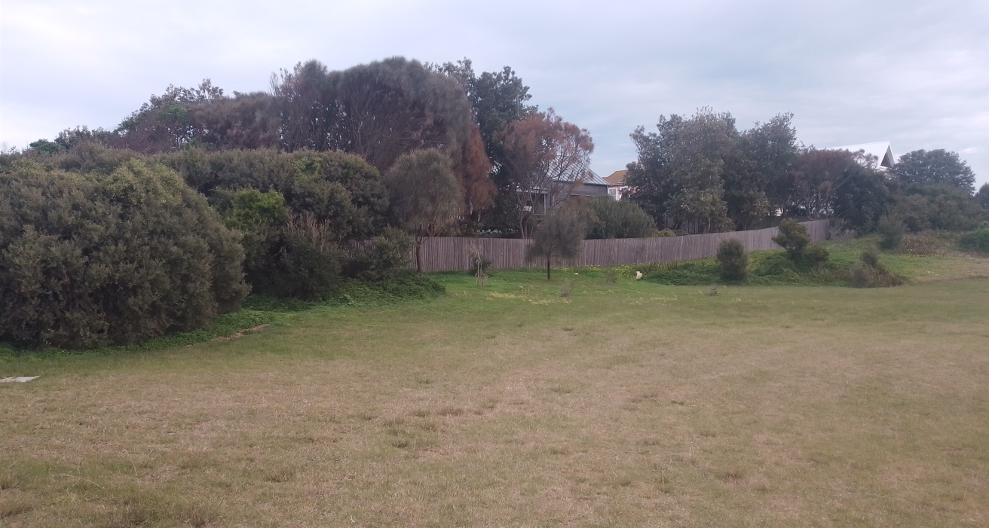
Rear of 2 and 4 Stephens Parade from Golf Links Road

PROPOSAL:

The key features of the proposal include:
- The demolition of the two existing dwellings, associated outbuildings and fencing and the construction of one double storey dwelling, with basement located within the two lots and construction of a 1.6 metre fence around the boundary perimeter.
- The proposed new dwelling will be setback 12.7 metres from the eastern (side) boundary, 5 metres from the southern (front) boundary, 4.23 metres from the western (side) boundary and a minimum 6.143 metres from the northern (rear) boundary. The dwelling will have an approximate 520 square metre building footprint.
- The basement level will provide six (6) car parking spaces, storage, laundry, lounge, gymnasium, bathroom and movie room, with vehicle access provided along the western boundary of the site. The ground level will comprise of kitchen/living, two internal terraces (one to the north, one to the east), study, rumpus and bathroom. The upper level will contain seven bedrooms, each with their own ensuite, with access to each level provided via two stairwells and a lift.
- The dwelling will be a maximum of 8.6 metres in height (26.913 AHD) and will be constructed with the external walls finished in a light grey render, grey Colorbond roof, with extensive glazing located along the northern and southern elevations and the upper level slightly recessed to provide articulation to the building.
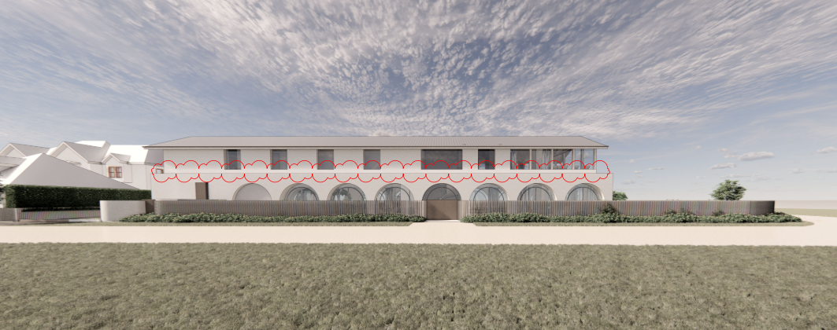
Southern elevation of the proposed dwelling

PERMIT/SITE HISTORY:

A search of Council’s records has found the following permit history (the history is for 57 The Parade only):

Permit Number | Description

PP-985-2013 | Alterations and additions to the existing dwelling (2 Stephens Parade)
PP-689-2017 | Demolition of the existing dwelling and construction of a new dwelling

REFERRALS:

The following referrals were undertaken:

SECTION 55:

RECOMMENDING AUTHORITY

Authority: | CFA
Response: | CFA, as a Referral Authority pursuant to Section 55 of the Planning and Environment Act 1987 (Act) has considered and does not object to the grant of a permit for the above proposal subject to –  • Any mandatory conditions specified within the planning scheme; and  • The following conditions being included on any planning permit that may be issued.  – Start of Conditions –  1. Endorsement of Bushfire Management Plan Before the development starts, the Bushfire Management Plan prepared by Keystone Alliance (Ref:C3232\1.1, dated December 2021) must be endorsed by the Responsible Authority. Once endorsed the plan must not be altered unless agreed to in writing by CFA and the Responsible Authority.
Officer Comment:
Generally the suggested conditions are to be included in any permit.

INTERNAL

Department: | Engineering Services
Response: | First response 27 January 2022  Engineering request the following additional information:  - That all services be shown on the plans and the clearances from the proposed vehicle crossing. Where the minimum clearances from the assets are not achieved, the applicant is to contact the relevant service authority and provide written correspondence to Engineering to confirm their requirements.  - Show the vehicle crossing on the plans and the width at the road reserve boundary.  - The vehicle crossing edges should be perpendicular to the road edge in line with our vehicle crossing design note 4.  - Show adjacent vehicle crossings and confirm clearances to them. Engineering requires at least 1.5m clearances between vehicle crossings to avoid double or joined vehicle crossing arrangements.  - Add notes on plans for any redundant vehicle crossings to be removed and nature strip reinstated.  There appears to be a Telstra asset and electrical pit on the western side between No. 6 and No.4 Stephen Parade. A Telstra service generally requires 1.2m clearance between the lid and the vehicle crossing and if the clearance cannot be obtained Telstra may allow the use a trafficable lid.  The plans do show the driveway to be 3.6m so engineering expect the driveway and vehicle crossing width to also be 3.6m so that it aligns with the driveway. It is also noted that the plans show a tapered vehicle crossing edge that is not to our standards.  Second response 25 April 2022  Applicant has responded to previous Engineering Request.  Standard Conditions  Drainage & Vehicular Access:  Prior to the occupation of the dwellings, the developer must:  - Construct the site stormwater system including connection into the existing legal point of discharge (LPOD), or other nominated point/s as approved by the Responsible Authority. The stormwater connection must be in accordance with City of Greater Geelong Standard Drawings.  - Construct vehicular crossings in accordance with the requirements and standards of the City of Greater Geelong.  - Remove any redundant vehicular crossings with kerb and channel and the footpath/nature strip area reinstated to match existing construction in the street.  Note:  1. Construction of the site stormwater connection/s is to be inspected by Council Representative prior to any backfilling. An appropriate fee equivalent to 3.25% of total cost of civil works, excluding GST (a minimum fee of $100 applies if the 3.25% amount is less than $100), is to be paid to Council for inspection. Relevant evidential documentation of the cost is to be provided.  2. All internal property drainage must be designed and constructed to satisfy AS/NZS 3500.  3. A Vehicle Crossing Permit must be obtained prior to commencement of works.  Car Parking  Prior to the occupation of the dwelling, the developer must construct the car park including accessways, surface with an all-weather sealed coat and linemark the car and accessways in accordance with the endorsed plans to the satisfaction of the Responsible Authority.  Stormwater Quality / Management  The site stormwater system must be designed and installed such that;  - The site stormwater discharge is not increased by the proposed development. An appropriate on site detention system designed in accordance with the Infrastructure Design Manual may be required;  to the satisfaction of the Responsible Authority.  Corner Splay  The Plan of Subdivision submitted for certification must include a splay for road purposes at the intersection of Stephens Parade and Golf Links Road to the satisfaction of the Responsible Authority.  Creation of easements  The Plan of Subdivision submitted for certification must include all easements deemed necessary to protect existing or future drainage lines within the subject site, and any easements required between the subject site and the nominated legal point of discharge must be created to the satisfaction of the Responsible Authority.
Officer Comment:
Generally the suggested conditions are to be included in any permit.

Department: | Environment Unit Response
Response: | I have reviewed the referral documents, zone/overlays and aerial imagery; with a specific focus on the arborist report.  Arborist Report (John Patrick Landscape Architects, Dec 2021)  The arborists report identified 24 trees/groups of trees across the two properties. Of these, 18 were indigenous, four were exotic and two were Australian native trees. The arborist has identified that all the trees were planted as they were of a similar age/size class and they ‘fitted in’ with the house, framed some views and blocked some other angles.  As outlined in the arborist report there are no ‘vegetation protection’ mechanisms covering the sites; and as both sites combined are less than 4000m2, Clause 52.17 does not apply.  The proposal outlined in the arborist report is that 10 trees (trees 13-17 and 20-24) will be removed to accommodate the pool, al fresco area and construction envelope for the basement.  The discussion in the arborist report does not align with the trees that are indicated for removal.  - In Section 4.10 it is indicated that Tree 21 will be removed, whilst section 5.8 indicates that Tree 21 is a Moonah growing near the perimeter fence that will be retained.  - The discussion also indicates that Tree 18 will be retained, although no tree protection measures have been provided.  - No tree protection measures for the retention of Trees 1 to 12, 19 and 21 have also been provided. As indicated in the Tree Impact Assessment Plan, most of these trees are located close to the proposed new dwelling/pool footprint and tree protection measures are required.  Bushfire Management Overlay- Bushfire Management Statement  Whilst the Country Fire Authority reviews and endorses Bushfire Management Plans/Statements, the Bushfire Management Statement was checked to ensure no trees in the adjacent golf course were proposed for removal for defendable space.  The defendable space for the property was to the property boundaries, so no trees in the golf course were proposed for removal.  Whilst supportive of the application, the Environment Unit requests the following information and/or changes to the arborist report, that are to be submitted prior to the commencement of works:  - Review and revise the inconsistency with Tree 21- is it to be retained or removed?  - Revise the arborist report to include tree protection measures, to conserve and manage the trees to be retained during and after the construction works  Second response  The Environment Unit have reviewed the amended arboricultural report (John Patrick Landscape Architects, Dec 2021) and Tree Management Plan (John Patrick Landscape Architects, Feb 2022) which has been provided in response to our RFI issued on the 12th of January 2022. Our requests for additional information pertaining to tree 21 and tree protection measures for all retained information have been addressed. We are satisfied that the Tree Management Plan has been prepared satisfactorily and that the retained trees on-site will be adequately protected if the Tree Management Plan is properly followed.  We do ask however that the date on the arboricultural report be altered as the date December 2022 is marked on the front, when we assume this should be December 2021. Please amend this for clarity and accuracy.  Once this has been changed we are happy to support the arboricultural report and corresponding Tree Management Plan. These are to be endorsed and they will form a part of any permit issued. Actions outlined within the Tree Management Plan are to be implemented as a condition of permit to ensure all retained trees are properly protected.
Officer Comment: Noted - condition 11 and 12 capture the arborist report requirements.

Department: | City’s Heritage Advisor
Response: | I have reviewed the submitted drawings (date-stamped 24 December 2021), heritage impact statement (date-stamped 19 April 2022), arboricultural report (date-stamped 24 December 2021), landscape plans (date-stamped 19 April 2022), tree management plan (date-stamped 19 April 2022) and bushfire management statement (date-stamped 24 December 2022) in relation to the proposed demolition of the existing dwellings, outbuildings and fencing at 2 and 4 Stephens Parade, Barwon Heads.  Heritage Significance and Status  The properties at 2 and 4 Stephens Parade are located within the Golf Links Heritage Area HO1650. The significance of the Golf Links Heritage Area is given in the Greater Geelong Outer Areas Heritage Study 2000, the statement of significance including the following:  - Intact links type golf course of 1920-22 (with aesthetic, historic, scientific and social heritage values).  - Distinctive features including the natural and semi-natural undulating terrain; rolling greens and sandy hillocks; manicured greens and fairways covered in native and exotic grasses including couch grass; strategically placed and substantial cypress trees forming wind buffers, screens and visual foci within the course landscape; bunkers situated on the slopes and valleys of natural inclines; and views to the clubhouse and coastline panoramas beyond to Ocean Grove, Point Lonsdale and the Mornington Peninsula.  - Some intact, detached, single and double storey, horizontal weatherboard and rendered brick houses of the interwar period. These houses are visually connected to the golf course and contribute to the highly significant, unique character of the precinct.  - Stephens Parade is distinguished for is unmade gravel road with gravel verges and narrow, grassed nature strips.  The significant dwellings along Stephens Parade are the result of a subdivision in the early 1920s. A key landmark is the Barwon Heads Golf Clubhouse (included in the Victorian Heritage Register and hence why it is not identified in the statement of significance for the Golf Links Heritage Area). Early photos show the clubhouse as a key feature in the open golf links setting that was punctuated by exotic Cypresses.  The subject sites, as part of the Golf Links Heritage Area, are identified as HO1650. No external paint controls, internal alteration controls and tree controls apply.  Proposed Demolition  The dwellings, outbuildings and fencing at 2 and 4 Stephens Parade do not relate to the significant era of development for the Golf Links Heritage Area. They are not identified as having significance in the Outer Areas Heritage Study. Consequently, no adverse effect on the significance of the heritage place will result from their removal (as per the relevant Decision Guidelines at Clause 43.01-8).  Proposed Dwelling  A contextually substantial, two storey dwelling (plus basement) is proposed to replace the two existing dwellings at 2 and 4 Stephens Parade. The proposed dwelling is to be constructed with an elongated gabled roof form that is to traverse both existing sites and return towards the north at the west end (comprising an L plan overall). These roof forms are to be constructed with generous eaves. The dwelling is to be set back 5000 mm from the Stephens Parade boundary, 6143 mm from the northern boundary (adjoining the golf course) while a generous setback from the east (Golf Links Road) and a more modest setback from the west are proposed. Curved wall enclosures (comprising a bicycle and bin store, and water tank) are proposed at the west end, on the Stephens Parade boundary.  The proposed dwelling is to be constructed with grey Colorbond roof cladding (mid tone) and light grey rendered walls. The ground floor facades are to feature arcades. Bronze metal mullions for the windows, doors and columns, are also proposed, as are first floor privacy screens on the west elevation (of unknown construction).  At issue is whether the proposed dwelling will have an adverse effect on the significance of the Golf Links Heritage Area, and whether it is in keeping with the location, bulk, form and appearance of adjacent buildings and the Golf Links Heritage Area (as per the relevant Decision Guidelines at Clause 43.01-8). In determining any significance impacts, consideration is given to the heritage policy for the area at Clause 22.37. The two storey height, gabled roof form and generally the roof and wall construction accord with the policy and some of the characteristics of significant dwellings in the heritage area, and the Barwon Heads Golf Club House which is visually connected to this site. The drawings (particularly the proposed south elevation and section drawings, and the front cover image) provide some contextual information as to how the proposed dwelling will appear in this part of the heritage area, and particularly its relationship with the neighbouring dwelling at 6 Stephens Parade. The Heritage Impact Statement provides informative contextual information about the existing conditions, including the views of the existing dwellings from Stephens Parade (Figure 5) interface of the golf course, clubhouse and subject sites (Figure 6 - p11), and particularly the views of the subject sites from outside the Golf Club House (Figure 6 – p12) and from the top of the golf course between the club house and the subject sites (another Figure 6 – p12). Yet, this information has not been translated graphically with the proposed dwelling, showing how it will appear in the broader context in the heritage area, and particularly from the key views from outside the Club House (Golf Links Road) and from the top of the golf course (between the Club House and the subject sites). The photos presented show the two storey dwellings in this stretch of Stephens Parade, but these dwellings are detached. The gable roofs of the existing dwelling at 2 Stephens Parade are also articulated.  Overall, the gabled forms, height and construction accord with significant characteristics in the heritage area as per Clause 22.37, and therefore be a considered, contemporary interpretation. Yet, the proposed dwelling is likely to have some additional bulk (compared to the existing conditions), particularly from the view from the top of the golf course. This is not likely to cause an adverse effect on the significance of the heritage place given the location of the proposed dwelling, the topography of the adjoining golf course (particularly when viewed from Golf Links  Road outside the Club House) and the notable distance of the dwelling from the Club House. However, this could be confirmed with photo montages showing the key views from outside the Club House and from the top of the golf course. There will be greater exposure of the dwelling when viewed from the eastern portion of the course (east of Golf Links Road), but the view from this location is considered to be less sensitive.  Proposed Pool  As the pool will not be visible from the public realm, no adverse effect on the significance of the heritage area will result.  Proposed Boundary Fencing  New boundary fencing is proposed. Drawing TP.100 shows batten fencing on the south and east and part of the north boundaries to 1500 mm, and a portion fo the north fencing at 1800 mm ‘on top of retaining wall’. Drawing TP.110 has the fencing at 1600 mm on the south and east and parts of the north boundaries, and no mention of fencing on top of a retaining wall. The latter proposed height is shown on the elevation drawings and fence elevations. These fence elevations show that the fencing on the south boundary (the principal frontage) and east boundary is to be 1600 mm high and visually permeable and constructed of bronze finish metal battens. Similar construction is shown for the rear (north) fencing, which is to be 1600 mm and 1800 mm from the respective ground levels.  While ideally Drawing TP.100 could be updated for consistency, the proposed design ,construction and height of the boundary fencing is considered to be an innovative response to fencing in the heritage area. No adverse effect on the significance of the heritage place should result.  Proposed Driveway and Cross Over  The construction finish for the proposed driveway to the basement, and the finish of the proposed cross over should be clarified. While the construction of the driveway is a lesser issue, the significance of this part of the Golf Links Heritage Area relies (in part) on the gravelled road and verges (and cross overs) as part of the informal infrastructure of the Stephens Parade streetscape.  Recommendations  It is recommended that this application is supported subject to:  - Provision photo montages showing the proposed dwelling from the key views outside the Golf Club House (Golf Links Road) and from the top of the golf course (between the Club House and the subject sites) to confirm the height and bulk of the proposal dwelling and its contextual relationship with this part of the Golf Links Heritage Area.  - Ideally, the fence heights shown on Drawing TP.100 are updated to reflect the proposed fence heights shown on the other drawings.  - The proposed construction finish to the driveway, and the finish to the cross over, are documented for assessment and any planning permit.
Officer Comment:
The applicant has provided a photo montage of the subject site and key view areas to show the height and bulk of the proposed dwelling will not impact unreasonably on the heritage values of the Golf Links heritage Area. Based on this the application is supported.

Department: | Environmental Health Unit
Response: | The areas outlined in the referral were wastewater/sewer and general amenity.  Wastewater/sewer  There is connection to the reticulated sewer available along the northern boundary of the property in which the applicant can connect to.  Amenity  As this will be a large build and demolition of two dwellings the general amenity condition will be required to be added to ensure that the noise, dust and waste from the works completed do not affect the neighbouring properties.  I also recommend adding the plant and equipment insulation condition to the permit as there will be a swimming pool pump and a large air-conditioning unit to be installed as part of the build, which if not appropriately be installed emit a significant amount of noise.
Officer Comment:
Noted – see proposed Condition 8 re: Amenity

AMENDMENT OF THE PROPOSAL PRIOR TO PUBLIC NOTIFICATION:

The application was not amended prior to public notification.

PUBLIC NOTIFICATION:

The application is not exempt from the notice requirements of Section 52(1)(a), (b) and (d), the decision requirements of Section 64(1), (2) and (3) and the review rights of Section 82(1) of the Act and pursuant to Section 52 of the Planning and Environment Act 1987 the following forms of advertising were undertaken:

- Notices were sent to owners and occupiers of adjoining land (including opposite).
- A2 sign(s) was/were placed on the land.
- Forty six (46) objections have been lodged with Council and the matters raised by objectors included:
- The development is inconsistent and unsympathetic to existing neighbourhood and streetscape and is an overdevelopment of the site.
- The dwelling is a bulky structure that is not consistent with Barwon Heads Urban Design Framework in relation to its built form and existing character of Stephens Parade.
- The principle of development being construction of a large dwelling is out of character with HO1650.
- The proposed dwelling will be a dominant feature within the landscape setting when viewed from The Bluff, Thirteenth Beach Road and lookouts, the Golf course and golf club.
- The development is out of character with existing development within Stephens Parade.
- The front setback needs to be greater to allow for greater landscaping opportunities.
- The proposed development for the demolition is not sustainable for the environment, considering the dwelling at 2 Stephens Parade is approximately only 20 years old.
- The proposed dwelling and it bulky structure will impact on views to the Barwon Heads Golf club.
- The proposal is not consistent with Clause 15.03-1S as it fails to ensure development does not affect the significance of a heritage place (the golf club) due its size and bulk.
- The proposed development is not consistent with the Bellarine Peninsula policy as it presents as one single elongated building with no breaks in built form.
- The proposed development does not comply with Marine and Coastal Act 2018, as it will be a dominant built form not sympathetic to coastal surrounds of Thirteenth Beach.
CONSULTATION:

A consultation meeting was not held because the applicant did not want to be part of a consultation process, due to the number of objectors where they felt it was unlikely a resolution could be reached.

AMENDMENT OF THE APPLICATION FOLLOWING PUBLIC NOTIFICATION

The application was not amended following public notification.

OBJECTIONS:

The concerns of objectors are summarised and commented on below:

- Objection - The proposed dwelling will be a dominant feature within the landscape setting when viewed from The Bluff, Thirteenth Beach Road and lookouts
Response –
The subject sites do not have a Significant Landscape Overlay applied to them, to preserve and enhance significant landscape features. The planning controls within the City of Greater Geelong Planning Scheme, where the relevant zones and overlays don’t invoke the ability to assess the application in relation to its built form on the landscape.
The Heritage Overlay requires the built form assessment in relation to the impacts it will have on the heritage value buildings such as the golf club from the built form.
- Objection - The proposed development does not comply with Marine and Coastal Act 2018
Response –
The Marine and Coastal Act is under planning the policy for Coastal Settlement whilst it is considered the proposed replacement dwelling meets the Coastal Settlement policy and local Bellarine Policy in relation to its built form as set out below.
- Objection - The proposed development for the demolition is not sustainable for the environment, considering the dwelling at 2 Stephens Parade is approximately only 20 years old

Response –
The demolition of the existing dwellings was referred to the City’s Heritage Advisor. As the existing buildings do not have individual heritage significance to the Golf Links area, their removal was and has previously been supported.
The planning controls within the City of Greater Geelong do not provide the ability to keep a dwelling from being demolished for sustainability reasons.

ASSESSMENT:

ZONE:

Low Density Residential Zone
- A permit is not required to develop the land for a dwelling (section 1 use)
Garden Area
Under the policy the Low Density Residential Zone does not consider garden area.

Maximum Building Height

There is no maximum building height within the Low Density Residential Zone.

OVERLAY:

Bushfire Management Overlay
Heritage Overlay (HO-1650 – Golf Links Heritage Area)

Response to zone and overlay(s)

The application site is located within an area affected by the Bushfire Management Overlay. Development for sensitive uses (such as dwellings) requires a planning permit. The purpose of this requirement is to strengthen community resilience to bushfire and to minimise risk from wildfire by ensuring that residential and other forms of development catering for people in rural areas are appropriately sited and designed.

The application is accompanied by a Bushfire Management Statement, prepared by Bushfire Planning and Design, in accordance with the requirements of Clause 53.02. This document has been referred to Country Fire Authority (CFA) for their review. Upon consideration of the BMS and the proposal, CFA have advised they have no objection to the proposal, subject to conditions relating to the standard of construction of the building, maintenance of defendable space, provision of on-site fire-fighting supplies and access.
On the basis that CFA have reviewed the BMS and approved the development and use, it is considered that the requirements of the planning scheme have been satisfied and risk from bushfire to people and property will be appropriately minimised.

The purpose of the Heritage Overlay (“HO”) is to conserve and enhance heritage places of nature or cultural significance, conserve and enhance those elements which contribute to the significance of heritage places and ensure that development does not adversely affect the significance of the heritage place. It is considered the proposed dwelling meets the above objectives, which will be discussed further within the planning policy framework section relating to the incorporated document within the City of Greater Geelong’s planning scheme Golf Links Heritage Area Statement of Significance.

CULTURAL HERITAGE MANAGEMENT PLAN (CHMP):

The construction of one dwelling on a lot is exempt from requiring a CHMP pursuant the Aboriginal Heritage Regulations 2018.

LANDFILL GAS RISK ASSESSMENT:

The subject site is not located within 500 metres of an identified former landfill site, a risk assessment is not required.

DEVELOPMENTS IN BUSHFIRE PRONE AREAS:

The site is located within a designated bushfire prone area.
Clause 13.02-1S (Bushfire planning) seeks to strengthen the resilience of settlements and communities to bushfire through risk-based planning that prioritises the protection of human life.
The policy must be applied to all planning and decision making under the Planning and Environment Act 1987 relating to land which is:
- Within a designated bushfire prone area;
- Subject to a Bushfire Management Overlay; or
- Proposed to be used or developed in a way that may create a bushfire hazard.
The proposal is listed at Clause 13.02-1S as one of the uses or developments which should be considered:
- Subdivisions of more than 10 lots.
- Accommodation.
- Child care centre.
- Education centre.
- Emergency services facility.
- Hospital.
- Indoor recreation facility.
- Major sports and recreation facility.
- Place of assembly.
- Any application for development that will result in people congregating in large numbers.

As the site is located within a designated bushfire prone area the assessment of this application has considered:

- The risk of bushfire to people, property and community infrastructure.
- Whether the implementation of appropriate bushfire protection measures to address the identified bushfire risk is necessary.
- Whether the proposal can implement bushfire protection measures without unacceptable biodiversity impacts.

The application is not expected to create a risk bushfire to people, property and community infrastructure.

It is considered that the CFA conditions will address any concerns relating to bushfire.

THE VICTORIAN PLANNING POLICY FRAMEWORK (VPPF):

The following Victorian Planning Policies are applicable to this application:
Clause No. | Clause name
11.01-1S | Settlement
11.01-1R | Settlement – Geelong G21
11.03 | Planning for Places
11.03-4S | Coastal settlement
11.03-6L-01 | Bellarine Peninsula
13.02-1S | Bushfire Planning
13.07-1L-03 | Amenity in Rural Living and Low Density Residential Zones
15 | Built Environment and Heritage
15.01-2S | Building Design
15.01-5S | Neighbourhood Character
15.01-5L | Neighbourhood Character
15.03-1L | Heritage Conservation – Incorporated document HO1650 – Golf Links Statement of Significance
16.01 | Residential Development
Response to Policy

The subject site is located within the defined settlement boundary of Barwon Heads and within the heritage area of the Golf links, where there are a number of policies seeking consideration of the proposed built form in relation to the heritage values of the area and development within Barwon Heads.

The most relevant strategies within Clause 11.03-6L-01 (Bellarine Peninsula) specifically relating to Barwon Heads are:
- Maintain a compact urban form and avoid outward sprawl by ensuring that urban development does not occur outside of the defined settlement boundary shown on the Barwon Heads Structure Plan map.
- Protect the unique character of Barwon Heads as a coastal village located within a sensitive environment and significant landscape setting
In relation to the Golf links Heritage Area the following objectives and policies are sought for a built form design:
Objectives
- To encourage contemporary interpretation of traditional building design within the Heritage Overlay Area, which includes detached, buildings, hipped and/or gabled roofs, verandahs, and minimal timber detailing.
- To encourage the use of traditional construction materials which includes horizontal timber weatherboard wall cladding, timber framed windows, brick chimneys and unpainted, non-zincalume (non-highly reflective zincalume) corrugated sheet metal roofing.
Policy
- Promote buildings that incorporate the following design characteristics:
- Draws on traditional architectural characteristics.
- Detached single storey or double buildings with a roof pitch between 25 and 35 degrees.
- Hipped and/or gabled roofs.
- Wide eaves.
- Rectangular timber framed windows.
- Employs traditional and contemporary building materials, including horizontal weatherboard wall cladding or an alternative to horizontal weatherboard cladding is a render over masonry, cement sheet with strapping, rendered or stuccoed finishes or other lightweight non reflective finishes.

- Encourage new additions to existing buildings and new infill to be recessive in the cultural landscape, to enable the dominant features of the golf course and clubhouse to be retained within the heritage area.

- Building setbacks and allotment configuration should be retained:
- The north setback (to Stephens Parade) should be equivalent to the setback of neighbouring buildings or if these are different, the setback may be between the setbacks of neighbouring buildings.
- The side setbacks should be equivalent to neighbouring buildings within the Heritage Overlay Area and have a side driveway

The application is seeking to demolish the existing dwellings onsite and construct a double storey dwelling, where it is considered the built form of the proposed development will not result in an inappropriate built form for this section of Barwon Heads in relation to the above local policy and the above heritage values of the area.
The main differences from the existing dwellings onsite and the proposed dwelling is a larger building footprint, with the height of the proposed dwelling approximately 900mm to a 1 metre higher than the existing dwellings onsite.

The proposed development is located within the existing settlement boundary of the town and in relation to the above heritage polices the design incorporates a gabled roof and external grey render finish will continue to contribute to the heritage values of the area and remain consistent with the building pattern of development. The development is consistent with the existing development pattern along the eastern section of Stephens Parade, where the dwellings are generally located close to the southern (front) boundary of the site, to create further distance from the Golf club and golf course, where there is landscaping to the rear to provide a buffer between the built form and golf course to lessen the built forms impacts on the heritage values of the Golf Club building, and retaining a setback of over 100 metres to the golf course building.
It is noted the application was referred to the City’s Heritage Advisor, who’s above response was supportive of the application from a heritage perspective.
On the basis that the City’s Heritage Advisor has reviewed the demolition of the existing buildings and design response of the proposed dwelling, it is considered that the requirements of the planning scheme have been satisfied and risk from a heritage perspective and the impacts to the heritage precinct will be appropriately minimised.

RELEVANT PARTICULAR PROVISIONS:

DECISION GUIDELINES OF CLAUSE 65:

CLAUSE 65.01 – APPROVAL OF AN APPLICATION OR PLAN

Clause 65.01 of the Greater Geelong Planning Scheme outlines the decision guidelines to be considered by the Responsible Authority when making decisions on applications. These decision guidelines include:
- The matters set out in Section 60 of the Act.
- The Municipal Planning Strategy and the Planning Policy Framework.
- The purpose of the zone, overlay or other provision.
- Any matter required to be considered in the zone, overlay or other provision.
- The orderly planning of the area.
- The effect on the amenity of the area.
- The proximity of the land to any public land.
- Factors likely to cause or contribute to land degradation, salinity or reduce water quality.
- Whether the proposed development is designed to maintain or improve the quality of stormwater within and exiting the site.
- The extent and character of native vegetation and the likelihood of its destruction.
- Whether native vegetation is to be or can be protected, planted or allowed to regenerate.
- The degree of flood, erosion or fire hazard associated with the location of the
- land and the use, development or management of the land so as to minimise any such hazard.
- The adequacy of loading and unloading facilities and any associated amenity, traffic flow and road safety impacts.

Response

The proposal has been assessed against the above decision guidelines within 65.01 and is acceptable. On balance, the proposal is acceptable taking into account the competing objectives and decision guidelines within the zone and overlays.

CONCLUSION:

That the Responsible Authority having considered all matters which the Planning and Environment Act 1987, requires it to consider decides to issue a Notice of Decision to Grant a Planning permit for 2 and 4 Stephens Parade Barwon Heads, generally in accordance with the plans and documentation submitted with the application.

AttaCLOSE OF MEETING

As there was no further business the meeting closed at 6.35pm.

