

minutes

PLANNING COMMITTEE MEETING
No. 237

26 June 2024
City Hall, 57 Little Malop Street, Geelong

ALSO LIVE STREAMED ON THE CITY’S WEBSITE:

www.geelongaustralia.com.au/meetings

PANEL:

Cr Mason (Chair)
Cr Moloney
Cr Hathway
Cr Nelson
Cr Aitken
Cr Wilkinson

PRESENT

Councillors Present:
Cr Mason, Cr Moloney, Cr Hathway, Cr Nelson, Cr Aitken and Cr Wilkinson.

Council Officers:
Silvie Tynan, Senior Statutory Planner
Verity Bright, Principal Statutory Planner
Steve Roussac, Team Leader Statutory Planning
Rory O’Loghlen, Team Leader Statutory Planning
John Rush, Coordinator Statutory Planning
Joanne van Slageren, Manager City Development
Tennille Bradley, Executive Director Placemaking
Alana Martin, Chief Governance & Risk Officer
Jacquilyn Douglas, Coordinator Governance

Opening: The Chair declared the meeting open at 5.42pm.

1. PROCEDURAL MATTERS

Acknowledgement Of Country

The Committee acknowledges the Wadawurrung People as the Traditional Owners of the Land, Waterways and Skies. We pay our respects to their Elders, past, present and emerging. We Acknowledge all Aboriginal and Torres Strait Islander people who are part of our Greater Geelong community today.

1.2. Introduce the Panel Members

1.3. Apologies

Cr Sullivan, Cr Kontelj, Cr Murrihy

1.4. Declarations of Conflicts Of Interest

Nil

1.5. Confirmation of Minutes

Moved: Cr Aitken Seconded: Cr Nelson

That the Minutes of the Planning Committee Meeting held on 11 April 2024.
be confirmed.

CARRIED

2. MATTER(S) FOR CONSIDERATION
PP-320-2021 98 Marshalltown Road, Grovedale And PP-1512-2020 149 Bellarine Highway, Newcomb
PP-320-2021 98 Marshalltown Road, Grovedale And PP-1512-2020 149 Bellarine Highway, Newcomb
2.1. | PP-935-2020 - 34 Barrabool Road, HIGHTON

Application No: | PP-935-2020
Applicant: | JEM Investments Pty Ltd
Subject Land: | 34 Barrabool Road, Highton
Zone: | - General Residential Zone - Schedule 4 (GRZ4)  - Adjoins land in the Transport Zone 2 (TRZ2)
Overlays: | - Special Building Overlay (SBO)
Existing Use: | Single Detached Dwelling
Proposed Use: | Construction of Ten (10) Apartments, Multi-lot Subdivision, and Alteration of Access to a Road in a Transport Zone 2

Summary
- This application seeks planning approval for the construction of ten (10) apartments, multi-lot subdivision, and alteration of access to a road in a Transport Zone 2.
- The land comprises an area of 993.7 sq/m on the northwest side of Barrabool Road and about 110 metres north of the Highton Village shops.
- It is a larger than average site for the area, with a frontage of 19.81 metres and depth of 50.29 metres. It currently hosts a single storey detached mid-20th century dwelling, with established garden, driveway, garage and outbuildings.
- The land is in the General Residential Zone 4 with direct abuttal to the Transport Zone 2 and Principal Road Network. The site is within the Special Building Overlay, and also close to the centre of the Highton Village Increased Housing Diversity Area.
- The application proposes construction of a 3 storey apartment building with a basement carpark, and a communal outdoor area at the rear. The building is setback 4m from the front boundary to the balconies at ground and mid floor levels, and to the upper front wall of the top storey. It has a contemporary flat roof with a mix of stone, metal mesh and cement cladding with vertical standing seam, smooth and textured finishes.
- Vehicle access is proposed from a new double width crossing and ramp to the basement accommodating all of the required carparking, including visitor car parking spaces.
- The plan of subdivision shows each of the 10 apartments to include their associated car parking as part of each lot, as well as communal access, outdoor space, and the building exterior to be common property.
- The application was referred to all required utility service providers and the relevant road authority who have all supported the grant of a permit subject to conditions.
- Referral of the application to internal departments of the City also led mostly to support for the grant of a permit subject to conditions.
- Public notice of the application was given, attracting 8 formal and 2 informal objections, and one submission of support. Matters of concern to objectors related primarily to the building size and number of apartments, traffic and parking congestion, pedestrian and road safety, loss of the established vegetation, overshadowing, and insufficient canopy tree coverage and an increase of an urban heat effect.
- The application has been assessed against all relevant planning policies of the Scheme, and against the purpose and decision guidelines of the Zone and Overlay. The proposal has been found to give effect to planning policy as it relates to increased density and diversity of housing in a location that offers convenient access to urban services and facilities. The proposal represents an infill redevelopment of existing urban land contributing to housing affordability and housing choice.
- A detailed design assessment of the application against the residential development standards of Clause 55 finds the proposal has been carefully designed for compliance with all relevant site layout and massing, on-site amenity and facilities, detailed design, and apartment development objectives. After first proposing a development that produced an unacceptable extent of overshadowing to the dwellings on adjoining land, the building was redesigned to meet the overshadowing objective. The revised proposal and plans were circulated to all objectors in the period since the deferment of this matter by Planning Committee on 11 April 2024, with no further submissions or withdrawal of objections received.

- The proposal represents a considered design response that contributes to a diversity of housing in an area for increased density, diversity and building height. The site is conveniently located with convenient access to all urban services giving effect to the relevant settlement, environmental risk, built environment and housing policies of the Greater Geelong Planning Scheme.
- For these reasons, it is respectfully recommended that a Notice of Decision to Grant a Planning Permit be issued.

RECOMMENDATION:

That the Responsible Authority having considered all matters which the Planning and Environment Act 1987, requires it to consider decides to issue a Notice of Decision to Grant a Planning Permit for Construction of Ten (10) Apartments, Multi-lot Subdivision, and Alteration of Access to a Road in a Transport Zone 2 generally in accordance with the plans submitted with the application, and subject to the following conditions:

Moved: Cr Hathway Seconded: Cr Wilkinson

CARRIED

AMENDED PLANS
- Before the development starts, amended plans must be submitted to and approved by the responsible authority. When approved, the plans will be endorsed and will then form part of the permit. The plans must be drawn to scale with dimensions and must be generally in accordance with the plans submitted (including Plans, Elevations and Sections by Another Dimension Building Design, Revision F, 09/04/2024); but modified to show:

a) The kitchen windows of APT 04 and APT 08 and all windows already shown treated with ‘fixed louvre’ window hoods to be illustrated on elevations to a minimum height of 1.7m above floor level.
b) Tree Protection Zones in accordance with the approved Arboricultural Assessment.
c) Floodgate setback by a minimum distance of 1m from the property boundary.
d) Cross section detail of how the driveway crossfall grades will transition to accommodate the floodgate that needs to be installed along a horizontal plane.
e) Changes in accordance with the Floodplain Management Authority Conditions forming part of this permit.
f) Initiatives contained within the Sustainable Management Plan report along with the proposed changes, including an updated catchment plan clearly marked and dimensioned based on the proposed water quality treatment measures.
g) MUSIC file (.sqz) for validation so that the modelling assumptions and treatment measures are acceptable.
h) Line marking for all on-street car parking spaces to the satisfaction of the responsible authority.

Drainage Plans
2. Before the development starts, drainage plans for new Council assets prepared by a suitably qualified and experienced person must be submitted to and approved by the responsible authority, and at no cost to the responsible authority. Unless otherwise agreed in writing by the responsible authority:

a) The plans should cater for the units draining to the existing Council drainage network via a new 225mm diameter pipe. The plans shall show pits and pipes sizes, finished and existing surface levels, creation of appropriate easements and connection to the existing Council drainage network.
b) The design and construction of the roadworks and stormwater drainage and any other new council infrastructure must be approved and supervised by council.
c) A fee of 3.25% of the cost of the works is to be paid to council for the checking and supervision of these works.
d) A maintenance bond of 5% of the cost of the civil works is to be paid to council and will be returned after successful completion of a twelve month maintenance period.
e) Install the new drain in accordance with the approved plans:
f) Provide to Council ‘as-built’ Engineering plans in PDF, and GIS-ready AutoCAD (DXF) format plans, to the satisfaction of the responsible authority.
g) Submit a CCTV inspection report for all new Council underground drainage pipes and pits.

APARTMENT CONSTRUCTION
Endorsed Plans
3. The development as shown on the endorsed plans must not be altered without the written consent of the responsible authority, unless the Greater Geelong Planning Scheme specifies that a permit is not required.

4. All works must be undertaken in accordance with the approved Built Environment Sustainability Scorecard (BESS) report and STORM Rating Report to the satisfaction of the responsible authority. No alterations to these plans may occur without the written consent of the responsible authority.

Drainage
5. The site must be drained to the satisfaction of the responsible authority and no concentrated storm water may drain or discharge from the land to adjoining properties.

Stormwater Quality/Management
6. The site stormwater system must be designed and installed such that the site stormwater discharge is not increased by the proposed development. An appropriate on site detention system designed in accordance with the Infrastructure Design Manual may be required, to the satisfaction of the responsible authority.

Prior to Commencement of Development
7. Unless otherwise approved by the responsible authority and prior to the commencement of works, the development must obtain written agreement from Barwon Water on the requirement for the clearance of the new vehicle crossing to their stop valve asset. Where relocation of the stop valve is required, this to be done at the developer’s expense and to the satisfaction of the responsible authority.

8. Unless otherwise approved by the responsible authority and prior to the commencement of the development, the existing power supply is to be relocated underground to the satisfaction of the responsible authority.

9. Before the development starts, a revised landscape plan prepared by a suitably qualified or experienced person, to the satisfaction of the responsible authority, must be submitted to and approved by the responsible authority. The plan(s) must be drawn to scale and show:

a) A survey (including botanical names) of all existing vegetation to be retained and/ or removed;
b) Details of surface finishes of pathways and driveways;
c) A planting schedule of all proposed trees, shrubs and ground covers including botanical names, common names, pot sizes, sizes at maturity, and quantities of each plant. The planting schedule must demonstrate (with relevant calculations) a canopy tree coverage area of not less than 49.7 sq/m by providing either:
i. Canopy trees or climbers (over a pergola) with planter pits sized appropriately for the mature tree soil volume requirements.
ii. Vegetated planters, green roofs or green facades.
d) Landscaping and planting within all open areas of the site;
e) Where proposed as a stormwater quality management treatment, raingarden design detail in accordance with the relevant Melbourne Water design guidelines.

When approved, the plan will be endorsed and form part of the permit, all to the satisfaction of the responsible authority.

10. Before the development starts and unless otherwise approved by the responsible authority, the land owner must enter an agreement with the responsible authority pursuant to Section 173 of the Planning and Environment Act 1987. All costs associated with setting up the agreement must be borne by the land owner. The agreement is to be registered on title and run with the land, and is to provide to the satisfaction of the responsible authority:
a) All storm water runoff is to be collected on site and discharged to the legal point of discharge using a pump system or as otherwise nominated by the responsible authority. The pump system is to be designed and constructed in accordance with Australian Standard 3500 Part 3.2 Section 9.
b) In the event of any operational difficulties with the pump system, it is the responsibility of the land owner to rectify these difficulties.
c) Any pump system is to be replaced by gravity discharge if and when available, and if directed by the responsible authority, at the land owner’s full cost.
d) Provision is made (if appropriate) in any subdivision for Owners Corporation drainage works, and access to those drainage works to be on common property or within an easement in favour of the Owners Corporation.

Flood Gate
11. Before the development starts or the issue of statement of compliance, whichever comes first and unless otherwise approved by the responsible authority, the landowner must enter an agreement with the responsible authority pursuant to Section 173 of the Planning and Environment Act 1987. All costs associated with setting up the agreement must be borne by the landowner. The agreement is to be registered on title and run with the land, and is to provide to the satisfaction of the responsible authority:
a) Flood gate to be installed and maintained in accordance with the relevant manufacturer’s requirements.
b) In the event of any operational difficulties with the flood gate system, it is the responsibility of the landowner to rectify these difficulties.

Waste Management and Collection
12. Before the development starts and unless otherwise approved by the responsible authority, a Waste Management Plan (WMP) prepared by a suitably qualified or experienced person, to the satisfaction of the responsible authority, must be submitted to and approved by the responsible authority. The WMP must be generally in accordance with the WMP submitted with the application, but modified to include:
a) A statement explaining how the waste and recycling management facilities:
i. are designed to meet the best practice waste and recycling management guidelines for residential development adopted by Sustainability Victoria; and
ii. Protect public health and amenity of residents and adjoining premises from the impacts of odour, noise and hazards associated with waste collection vehicle movements.
b) Waste and recycling enclosures that are:
i. Adequate in size, durable, waterproof and blend in with the development;
ii. Adequately ventilated; and
iii. Located and designed for convenient access by residents and made easily accessible to people with limited mobility.
c) Adequate facilities for bin washing. These areas should be adequately ventilated.
d) Collection, separation and storage of waste and recyclables, including where appropriate opportunities for on-site management of food waste through composting or other waste recovery as appropriate.
e) Collection, storage and reuse of garden waste, including opportunities for on-site treatment, where appropriate, or off-site removal for reprocessing.
f) Adequate circulation to allow waste and recycling collection vehicles to enter and leave the site without reversing, where relevant.
g) Adequate internal storage space within each dwelling to enable the separation of waste, recyclables and food waste where appropriate.
h) Relevant details of:
i. Land use type;
ii. Waste systems and how the waste and recycling is separated in the household and retail premises and transported to the bin storage area with meeting all access mobility requirements;
iii. Collection frequency;
iv. Collection location;
v. Scaled waste management drawings of bin room or bin storage area showing all of the bins required to service the development;
vi. Collection contractors to be used;
vii. Signage;
viii. Area for parking of waste and recycling collection vehicles when bins are being emptied and the direction of travel of the vehicles, including swept paths for collection trucks;
ix. How the bins are transported from the bin storage room to the kerbside for collection and any mechanical assistance required to transport the bins;
x. Location of where the bins will be presented for collection and the type of vehicles that are able to collect the bins from this nominated area;
xi. Traffic and parking control signs to provide for on-street waste collection vehicle access, to the satisfaction of the responsible authority.

When approved, the plan will be endorsed and form part of the permit, all to the satisfaction of the responsible authority.

13. Before the development is occupied, the land owner must enter into an agreement under Section 173 of the Planning and Environment Act 1987 with the responsible authority. The agreement must be in a form to the satisfaction of the responsible authority, and the applicant must be responsible for the expense of the preparation and registration of the agreement, including the responsible authority’s reasonable costs and expense (including legal expenses) incidental to the preparation, registration and enforcement of the agreement. The agreement must contain covenants to be registered on the Title of the property so as to run with the land, and must provide for the following:

a) All onsite waste management, storage and collection activities must be carried out by private waste collection contractor in accordance with the Waste Management Plan endorsed as part of planning permit PP-935-2020, and to the satisfaction of the responsible authority.
The agreement will be registered on Title in accordance with Section 181 of the Planning and Environment Act 1987.
14. Unless otherwise agreed in writing by the responsible authority, the collection and disposal of waste from the premises by private waste collection contractor (other than normal Council collection) must only occur between the hours of 8am and 6pm, to the satisfaction of the responsible authority.

Outdoor Lighting
15. Any outdoor and/or security lighting provided must be designed to prevent adverse light spill on adjoining land or road reserve to the satisfaction of the responsible authority.

Air-conditioning and Heating Units
16. Unless otherwise agreed in writing by the responsible authority, no air-conditioning or heating units are to be permanently fixed to balconies or other external parts of the building other than those shown on the endorsed plans, to the satisfaction of the responsible authority.

Before Occupation of the Dwellings
17. Before the development is occupied and unless otherwise approved in writing by the responsible authority, the land owner must enter an agreement with the responsible authority pursuant to Section 173 of the Planning and Environment Act 1987. All costs associated with setting up the agreement must be borne by the land owner. The agreement is to be registered on title and run with the land, and is to provide to the satisfaction of the responsible authority:

a) All storm water runoff is to be collected on site and discharged to the legal point of discharge using a pump system or as otherwise nominated by the responsible authority. The pump system is to be designed and constructed in accordance with Australian Standard 3500 Part 3.2 Section 9.
b) In the event of any operational difficulties with the pump system, it is the Responsibility of the land owner to rectify these difficulties.
c) Any pump system is to be replaced by gravity discharge if and when available, and if directed by the responsible authority, at the land owner’s full cost.
d) Provision is made (if appropriate) in any subdivision for Owners Corporation drainage works, and access to those drainage works to be on common property or within an easement in favour of the Owners Corporation.

18. Unless otherwise approved in writing by the responsible authority, prior to the occupation of the dwellings, the developer must:

a) Construct the site stormwater system including separate connection for each unit into the underground Council drain as per the approved engineering drawings, or other nominated point/s as approved by the responsible authority. The stormwater connection must be in accordance with City of Greater Geelong Standard Drawings.
b) Construct a 6m wide vehicular crossing centred on the driveway location in accordance with the requirements and standards of the City of Greater Geelong. The vehicular crossing shall have satisfactory clearance to any existing crossover, side-entry pit, power, lighting or telecommunication pole, manhole cover or marker, fire hydrant, water stop valve or street tree. Any relocation, alteration or replacement required shall be in accordance with the requirements of the relevant Authority and shall be at the applicant's expense.
c) Construct and drain the common property accessway and car park, surface with an all-weather sealed coat and linemark the car park and accessways in accordance with the endorsed plans.
d) Remove any redundant vehicular crossings and replace with kerb and channel and the footpath/nature strip area reinstated to match existing construction in the street.
e) Remove redundant on-street line marking and line mark any new on-street car parks to the satisfaction of the Responsible Authority.
f) Clean and finish all external walls facing property boundaries.
g) Complete all landscaping works in accordance with the endorsed plans.
h) Complete all buildings and works in accordance with the endorsed plans.

All to the satisfaction of the responsible authority.

SUBDIVISION
Endorsed Plan
19. The layout and site dimensions of the proposed subdivision as shown on the endorsed plan(s) shall not be altered or modified without the written consent of the responsible authority. There are no requirements to alter or modify the endorsed plan if a plan is certified under the provisions of the Subdivision Act 1988 that is generally in accordance with the endorsed plans.

Prior to Certification
20. The Plan of Subdivision submitted for certification must include all easements deemed necessary to protect existing or future drainage lines within the subject site, and any easements required between the subject site and the nominated legal point of discharge must be created to the satisfaction of the responsible authority.

Telecommunications
21. The owner of the land must enter into agreements with:
a) a telecommunications network or service provider for the provision of telecommunication services to each lot shown on the endorsed plan in accordance with the provider’s requirements and relevant legislation at the time; and
b) a suitably qualified person for the provision of fibre ready telecommunication facilities to each lot shown on the endorsed plan in accordance with any industry specifications or any standards set by the Australian Communications and Media Authority, unless the applicant can demonstrate that the land is in an area where the National Broadband Network (NBN) will not be provided by optical fibre.

Prior to Issue of Statement of Compliance
22. Before the issue of Statement of Compliance and unless otherwise approved by the responsible authority, the land owner must enter an agreement with the responsible authority pursuant to Section 173 of the Planning and Environment Act 1987. All costs associated with setting up the agreement must be borne by the land owner. The agreement is to be registered on title and run with the land, and is to provide to the satisfaction of the responsible authority:
a) All storm water runoff is to be collected on site and discharged to the legal point of discharge using a pump system or as otherwise nominated by the responsible authority. The pump system is to be designed and constructed in accordance with Australian Standard 3500 Part 3.2 Section 9.
b) In the event of any operational difficulties with the pump system, it is the Responsibility of the land owner to rectify these difficulties.
c) Any pump system is to be replaced by gravity discharge if and when available, and if directed by the responsible authority, at the land owner’s full cost.
d) Provision is made (if appropriate) in any subdivision for Owners Corporation drainage works, and access to those drainage works to be on common property or within an easement in favour of the Owners Corporation.

23. Before the issue of Statement of Compliance, the developer must:
a) Construct the site stormwater system including separate connection for each lot into the underground Council drain as per the approved engineering drawings, or other nominated point/s as approved by the responsible authority. The stormwater connection must be in accordance with City of Greater Geelong Standard Drawings.
b) Construct a 6m wide vehicular crossing centred on the driveway location in accordance with the requirements and standards of the City of Greater Geelong. The vehicular crossing shall have satisfactory clearance to any existing crossover, side-entry pit, power, lighting or telecommunication pole, manhole cover or marker, fire hydrant, water stop valve or street tree. Any relocation, alteration or replacement required shall be in accordance with the requirements of the relevant Authority and shall be at the applicant's expense.
c) Construct and drain the common property accessway and car park, surface with an all-weather sealed coat and line-mark the car park and accessways in accordance with the endorsed plans.
d) Remove any redundant vehicular crossings and replace with kerb and channel and the footpath/nature strip area reinstated to match existing construction in the street.
e) Remove redundant on-street line marking and line-mark any new on-street car parks to the satisfaction of the Responsible Authority.
f) Remove any existing buildings/services that traverse the lot boundaries
g) Complete all common property landscaping works in accordance with the endorsed plans.

All to the satisfaction of the responsible authority.

24. Before the issue of Statement of Compliance and unless otherwise approved by the responsible authority, the development approved by Planning Permit PP-935-2020 must be substantially completed (e.g. lockup stage as a minimum) in accordance with the endorsed plans forming part of that Planning Permit (or any amendment to that permit) to the satisfaction of the responsible authority. Evidence must be submitted which demonstrates that the development is substantially completed to the satisfaction of the responsible authority.

25. The owner of the subject land must pay to the Council a sum equivalent to 5 per cent of the site value of all of the land in the subdivision as a Public Open Space contribution pursuant to Clause 53.01 of the Greater Geelong Planning Scheme. The contribution will be payable prior to the issue of a Statement of Compliance.
26. Before the issue of a Statement of Compliance for any stage of the subdivision under the Subdivision Act 1988, the owner of the land must provide written confirmation from:
a) a telecommunications network or service provider that all lots are connected to or are ready for connection to telecommunications services in accordance with the provider’s requirements and relevant legislation at the item; and,
b) a suitably qualified person that fibre ready telecommunications facilities have been provided in accordance with any industry specifications or any standards set by the Australian Communications and Media Authority, unless the applicant can demonstrate that the land is in an area where the National Broadband Network will not be provided by optical fibre.

FLOODPLAIN MANAGEMENT AUTHORTY CONDITIONS (SBO)
27. Before the development starts, amended plans and Flood Impact Assessment report to the satisfaction of the responsible authority must be submitted to and approved by the responsible authority. When approved, the documents will be endorsed and will then form part of the permit. The documents must be generally in accordance with those submitted with the application but modified to show:

a. There is no adverse impact of the development on flooding for rainfall events up to 1% AEP (Annual Exceedance Probability) by properly incorporating the building in hydraulic modelling.
b. The site or its access/egress will not be hazardous as per Victorian State Government Guidelines for Development in Flood Affected Areas for rainfall events up to 1% AEP (Annual Exceedance Probability).
c. The proposed top/highest level of the floodgate is at least 300mm above the applicable flood level as determined from the modelling of development condition by properly incorporating the building.
d. The Finished Floor Level (FFL) of the ground floor must be at least 300mm above the applicable flood level as determined from the modelling of development condition by properly incorporating the building.

28. The north-eastern basement vents must set at least 150 mm freeboard above the applicable flood levels as determined from the modelling of development condition by properly incorporating the building. Such minimum freeboard for any north-western vents (which are not recommended due to flood risk) must be 300 mm.

29. Any new fences and gates within the SBO area must have minimum 150 mm ground clearance or 25% opening to 450 mm height from the ground. The minimum clearance above any built/smooth surfaces (eg, paved, concrete, decks etc) is 100mm.

30. Any new decks within the SBO area must be non-obstructive to overland flows, that is, unenclosed type to allow passage of flood water underneath.

BARWON WATER CONDITIONS
General
31. As BW has strategic assets located within or adjacent to the Land, prior to the Commencement of Works, the Developer must submit an Activities Method Statement (AMS) for approval that outlines the process for any or all of the following:
- the connection to the strategic BW Asset;
- any excavation crossing or within three (3) metres of a strategic BW Asset;
- vehicle and machinery traversing the site over or within three (3) metres of a strategic BW Asset.

The submission of an AMS does not constitute BW's approval.

32. The plan of subdivision must be referred to Barwon Water in accordance with the Subdivision Act 1988 and any subsequent amendments to the plan provided to Barwon Water.

33. The creation of an unlimited Owners Corporation to encumber all lots within the subdivision.

34. The developer is to apply to Barwon Water for details relating to servicing requirements and costing for the provision of a potable water supply and where applicable, recycled water and/ or sewerage services to the proposal. It would be appreciated if all communication between the developer/agent and Barwon Water quote Barwon Water reference number L017940.

Potable Water
35. The provision and installation of a potable water supply to the development.

36. An additional potable water connection is to be provided to service the proposed development. A dimensioned plan showing location of all new connections relative to the allotment boundaries is to be submitted. Note that tappings and service lines are not to be located under existing or proposed driveways.

37. A master meter and sub meters are required. An 'Application to fit meters' is required to be completed and submitted by the licensed plumber who will be undertaking the installation of private potable water works. This application must include a dimensioned plan indicating the location of all meters relative to existing and proposed allotment boundaries. These sub-meters will be installed by Barwon Water after the plumber has advised of completion of these preparatory private works and that the meters can be installed. This application form can be downloaded via www.barwonwater.vic.gov.au - Business Customers -> Property Connections.

38. Barwon Water's records indicate that an existing potable water service and meter is located on this property. A dimensioned plan showing the location of existing meters, and the location of the meter relative to the existing boundaries, and its number, is to be submitted. Private potable water service pipes are not permitted to cross allotment boundaries and must be plugged and abandoned at the boundaries of such allotments.

39. The payment of a standardised New Customer Contribution is required for any new connection or any upsize to an existing connection. The number of standardised charges applied will be determined on the basis of an equivalent lot calculation and is based on potable domestic water meter size or water service size (where a meter is not being fitted). An equivalent lot is a measure of the additional demand a connection will place on the infrastructure in terms of the water consumption and sewage discharge for an average connection utilising a 20mm tapping and/ or meter. If there is more than one meter within a single meter assembly, the size of the largest meter (excluding the fire service meter) will determine the number of equivalent connections. If there is a combined fire and domestic meter assembly proposed (incorporating a low flow meter), whereby the meter size is largely dictated by the fire service requirements, the developer is required to submit to Barwon Water the proposed peak flow (probable simultaneous demand) associated with the domestic supply in accord with AS/NZS 3500. Barwon Water will then assess the equivalent number of connections.
Sewer
40. The provision and installation of a sewerage service to the development.

41. New or re-aligned internal private sewer drains are required. Upon completion of this work a sewer drainage plan is to be submitted to Barwon Water by a licensed plumber that complies with Victorian Building Authority requirements. Note that if any common drain or drain from another allotment crosses under a proposed dwelling, a "modification to consent" is to be obtained from the Victorian Building Authority and presented to Barwon Water with the required drainage plan. Where an Owners Corporation is not applicable, individual allotment house connection drains are to be provided for and extend into each allotment.

42. Any existing sewer house connection point that is to be utilised for additional connections or altered to serve the development is to be CCTV inspected by a licensed plumber and the 'CCTV Inspection Form' with the video footage (standard digital format i.e. MP4, AVI) submitted to Barwon Water for their records. The submitted form requires verification from the licensed plumber that the connection point is deemed satisfactory for use. If connection point is no longer required, it is to be decommissioned in accordance with Barwon Water's "Property connection decommissioning process". Details of this process are available on Barwon Water's website under the Properties and Development -> Property Connections section. Also, any existing house connection drain that traverses through the proposed allotments shall be relocated so not to inhibit future development. If the existing sewer house connection point is deemed satisfactory for use by Barwon Water and where branching after the connection point is permitted to service an additional allotment then this work can also be undertaken by a licensed plumber. If the sewer connection point being replaced is greater than 4.0 metres deep, a new sewer manhole is to be constructed with the new property connection point connected to this structure.

POWERCOR CONDITIONS

43. This letter shall be supplied to the applicant in its entirety.

44. The plan of subdivision submitted for certification under the Subdivision Act 1988 shall be referred to the Distributor in accordance with Section 8 of that Act.

45. The applicant shall provide an electricity supply to all lots in the subdivision in accordance with the Distributor's requirements and standards.

46. The applicant shall ensure that existing and proposed buildings and electrical installations on the subject land are compliant with the Victorian Service and Installation Rules (VSIR).

47. The applicant shall, when required by the Distributor, set aside areas with the subdivision for the purposes of establishing a substation or substations.

48. The applicant shall establish easements on the subdivision, for all existing Distributor electric lines where easements have not been otherwise provided on the land and for any new powerlines to service the lots or adjust the positioning existing easements.

HEAD, TRANSPORT FOR VICTORIA CONDITIONS

49. Prior to commencement of the development, a Construction Traffic Management Plan (CTMP) must be submitted to and approved by the Head, Transport for Victoria and the Responsible Authority. The CTMP must be drafted by a suitably qualified road safety consultant. The CTMP must address traffic and access issues arising from construction of the proposed development on this site, predicted traffic generation and the impact of that traffic on the existing arterial road network – in particular during all relevant peak periods – and its impact on nearby intersections and access points to abutting land. The report will also identify any mitigation actions required, such as traffic management processes.

50. The redundant vehicle crossing must be removed and the area reinstated to the satisfaction of the Responsible Authority and at no cost to the Department of Transport prior to the occupation of the buildings hereby approved.

EXPIRY

Development
51. This permit as it relates to the development of buildings will expire if one of the following circumstances applies:
a) The development of the building(s) hereby approved has not commenced within two (2) years of the date of this permit.
b) The development of the building(s) hereby approved is not completed within four (4) years of the date of this permit.

The responsible authority may extend the periods referred to if a request is made in writing before the permit expires; or
a) Within six (6) months after the permit expires where the use or development has not yet started; or
b) Within twelve (12) months after the permit expires, where the development allowed by the permit has lawfully commenced before the permit expiry.

Subdivision
52. This permit as it relates to subdivision will expire if one of the following circumstances applies:
a) The plan of subdivision has not been certified within two (2) years of the date of this permit.
b) A statement of compliance is not issued within five (5) years of the date of certification.

The responsible authority may extend the period referred to under part ‘a)’ if a request is made in writing before the permit expires or within six (6) months afterwards.

NOTES:
City of Greater Geelong
1. Construction of the site stormwater connection/s is to be inspected by Council Representative at various stages. An appropriate fee equivalent to 3.25% of total cost of civil works, excluding GST (a minimum fee of $100 applies if the 3.25% amount is less than $100), is to be paid to Council for inspection. Relevant evidential documentation of the cost is to be provided.
2. All internal property drainage must be designed and constructed to satisfy AS/NZS 3500.

3. A Vehicle Crossing Permit must be obtained prior to commencement of works.

4. City Services Transport unit must be engaged prior to commencement of works to provide onstreet linemarking and sign replacement for car parking.

5. Where the legal point of discharge is kerb and channel, discharge velocity at the kerb must be no greater than 1.5 m/s with a maximum discharge flow rate of 10 l/s and the outlet directed at an angle of 45 degrees to the direction of flow in the kerb and channel.

Barwon Water
1. The developer is to apply to Barwon Water for details relating to servicing requirements and costing for the provision of a potable water supply and where applicable, recycled water and/ or sewerage services to the subdivision.

2. It would be appreciated if all communication between the developer/agent and Barwon Water quote Barwon Water reference number L016127

Powercor
1. The Powercor referral response letter dated 26 May 2022 (Powercor Ref: 308401091) was provided to the permit applicant in its entirety by the responsible authority on 26 March 2024, and in fulfillment of Condition 43.

2. Extension, augmentation or rearrangement of the Distributor's electrical assets may be required to make such supplies available, with the cost of such works generally borne by the applicant.

3. Where electrical works are required to achieve VSIR compliance, a registered electrical contractor must be engaged to undertake such works.

4. Areas set aside for substations will be formalised to the Distributor’s requirements under one of the following arrangements:
- RESERVES established by the applicant in favour of the Distributor.
- SUBSTATION LEASE at nominal rental for a period of 30 years with rights to
extend the lease for a further 30 years.
The Distributor will register such leases on title by way of a caveat prior to the registration of the plan of subdivision.

5. Existing easements may need to be amended to meet the Distributor’s requirements

6. Easements required by the Distributor shall be specified on the subdivision and show the Purpose, Origin and the In Favour of party as follows:

Easement Reference | Purpose | Width (Metres) | Origin | Land Benefited / In Favour of
 | Powerline |  | Section 88 – Electricity Industry Act 2000 | Powercor Australia Ltd

DELEGATE REPORT
PERMIT REQUIREMENTS:

A planning permit is required for this application pursuant to the following clauses of the Greater Geelong Planning Scheme:

- Pursuant to Clause 32.08-3 of the General Residential Zone a permit is required to subdivide land.
- Pursuant to Clause 32.08-6 of the General Residential Zone a permit is required to construct two or more dwellings on a lot.
- Pursuant to Clause 44.05-2 of the Special Building Overlay a permit is required to construct a building or to construct or carry out works.
- Pursuant to Clause 44.05-3 of the Special Building Overlay a permit is required to subdivide land.
- Pursuant to Clause 52.29-2 of the Particular Provisions a permit is required to:
  - alter access to a road in a Transport Zone 2
  - subdivide land adjacent to a road in a Transport Zone 2.
Planning Scheme Amendment GC172 on 04/08/2021 rezoned the land from Residential Growth Zone (RGZ2) to General Residential Zone (GRZ4). The amendment resulted in a reduced maximum building height requirement and introduced the mandatory garden area requirement that did not apply under the zone at the time the permit application was received.
Planning Scheme Amendment VC205 on 06/04/2022 introduced a new Transport Zone to replace the Road Zone, resulting in a change to the terminology used in relation to the permit requirements of what is now Clause 52.29 (Land Adjacent to the Principal Road Network).

DEFINITIONS:

All references to ‘the Scheme’ are a reference to the Greater Geelong Planning Scheme unless otherwise stated.
All references to ‘the Act’ are a reference to the Planning and Environment Act 1987 unless otherwise stated.
Pursuant to Clause 73.01 (General Terms) of the Scheme:

- Apartment is defined as ‘A dwelling located above the ceiling level or below the floor level of another dwelling and is part of a building containing two or more dwellings.’
- Basement is defined as ‘A storey below ground level, or that projects no more than 1.2 metres above ground level.’
- Building height is defined as ‘The vertical distance from natural ground level to the roof or parapet at any point.’
- Garden Area is defined as ‘Any area on a lot with a minimum dimension of 1 metre that does not include:
a) a dwelling or residential building, except for: an eave, fascia or gutter that does not exceed a total width of 600mm; a pergola; unroofed terraces, patios, decks, steps or landings less than 800mm in height; a basement that does not project above ground level; any outbuilding that does not exceed a gross floor area of 10 square metres; and domestic services normal to a dwelling or residential building;
b) a driveway; or
c) an area set aside for car parking.’

- Lot is defined as ‘A part (consisting of one or more pieces) of any land (except a road, a reserve, or common property) shown on a plan, which can be disposed of separately and includes a unit or accessory unit on a registered plan of strata subdivision and a lot or accessory lot on a registered cluster plan.’
- Private open space is defined as ‘An outdoor area of a dwelling or residential building or land for the exclusive use of the occupants.’
- Secluded private open space is defines as ‘That part of private open space primarily intended for outdoor living activities which enjoys a reasonable amount of privacy’
- Stormwater is defined as ‘The net increase in run-off from urban development due to water not being able to seep into the ground because of impervious surfaces, such as roofs and roads.’
- Storey is defined as ‘That part of a building between floor levels. If there is no floor above, it is the part between the floor level and ceiling. It may include an attic, basement, built over car parking area, and mezzanine.’
- Street reserve is defined as ‘Land set aside for a street pavement and verge.’

Pursuant to Clause 73.03 (Land Use Terms) of the Scheme:

- ‘Dwelling’ is defined as ‘A building used as a self-contained residence which must include: a) a kitchen sink; b) food preparation facilities; c) a bath or shower; and d) a closet pan and wash basin. It includes outbuildings and works normal to a dwelling.’
Pursuant to Clause 73.04 (Nesting Diagrams) of the Scheme:
- Dwelling is nested in the Accommodation group at Clause 73.04-1.

Subdivision is defined at s.3 (Definitions) of the Act to be ‘the division of land into two or more parts which can be disposed of separately’.

RESTRICTIVE COVENANT OR SECTION 173 AGREEMENT:
The subject site is not burdened by a Restrictive Covenant or Section 173 Agreement.

OFFICER DIRECT OR INDIRECT INTEREST:
No officer involved in the preparation of this report declared a general or material conflict of interest.

SITE/LOCALITY:
The subject site comprises 993.7 square metres on the northwest side of Barrabool Road, 140 metres southwest of the intersection with Ferndale Parade in Highton. The parallelogrammatic shaped site has a frontage of 19.81 metres and a depth of 50.29 metres, and slopes from the west to the east.

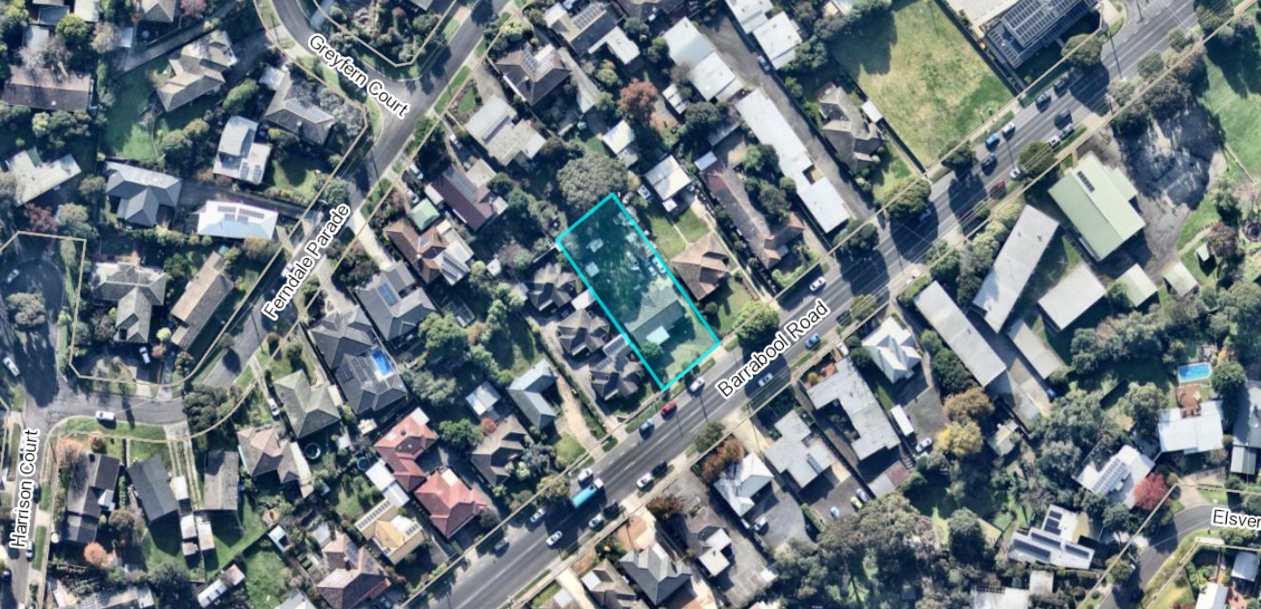
Figure 1: Aerial context view of the subject site (highlighted blue), circa 5 June 2023. Source: PLACES Weave GIS and Nearmap
The site is currently used and developed for dwelling, with a single storey mid-century detached brick and corrugated asbestos dwelling, recessed rear garage, boundary fences and established garden. Vehicle and pedestrian access to Barrabool Road is located at the east corner of the site.

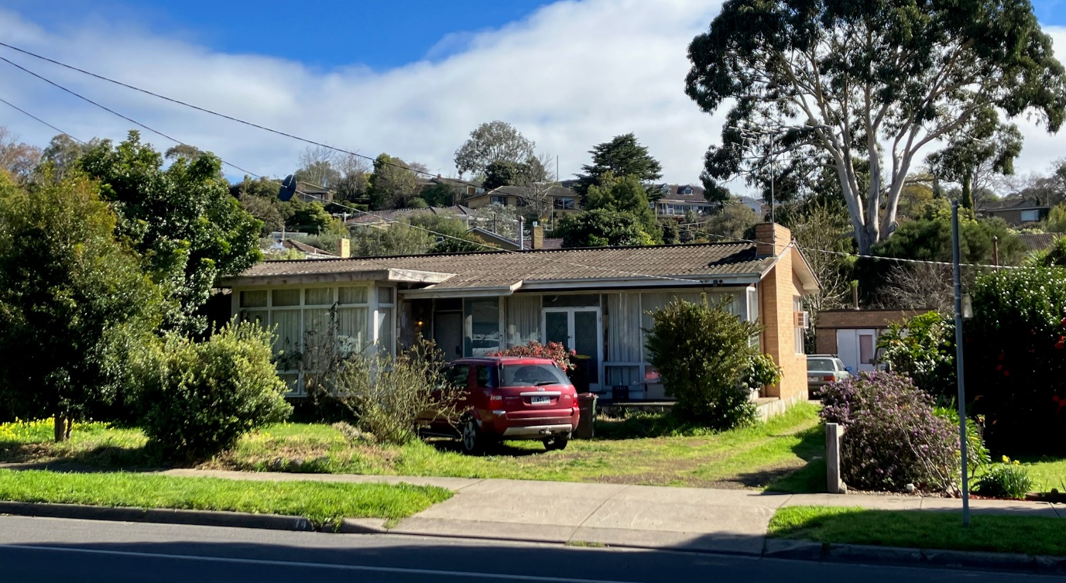
Figure 2: Terrestrial view of the subject site looking west from Barrabool Road, 15 August 2023. A mature eucalypt tree located on the adjoining land to the back is also visible at background right. Source: Author.

All adjoining land is similarly used and developed for dwelling, with single storey detached residences to the northeast side and the rear of the site, and a 3 unit development to its southwest.

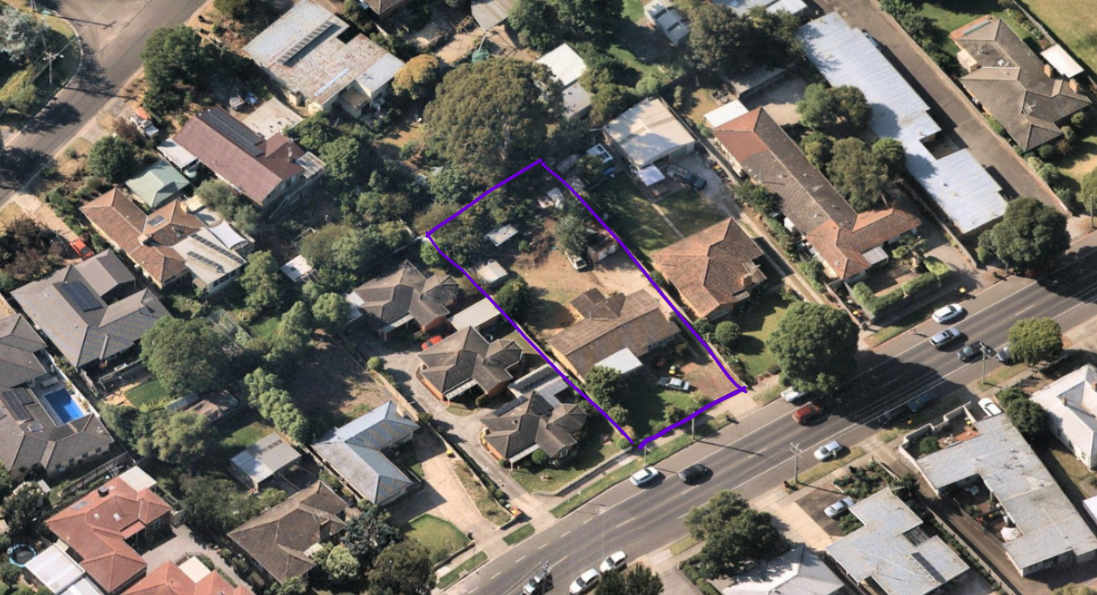
Figure 3: Oblique aerial view looking north to the subject site (highlighted purple) and showing the adjoining dwelling development. Source: Nearmap, annotated by Author.

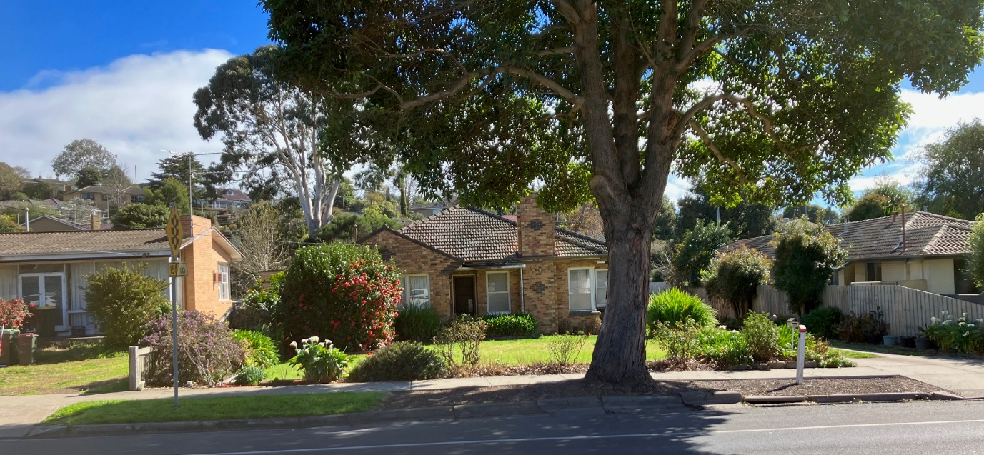
Figure 4: Terrestrial view of the dwelling on adjoining land to the north west of the subject site at 32 Barrabool Road, 15 August 2023. Source: Author.

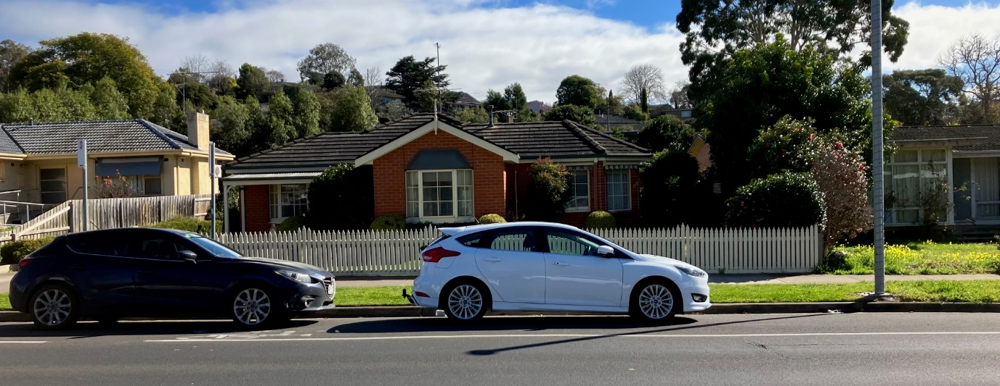
Figure 5: Terrestrial view of the dwelling on adjoining land to the south east of the subject site at 1/36 Barrabool Road, 15 August 2023. Source: Author.
The site and all adjoining land to the sides and rear is within the General Residential Zone (GRZ4) and the Special Building Overlay (SBO). Barrabool Road is within the Transport Zone (TRZ2).

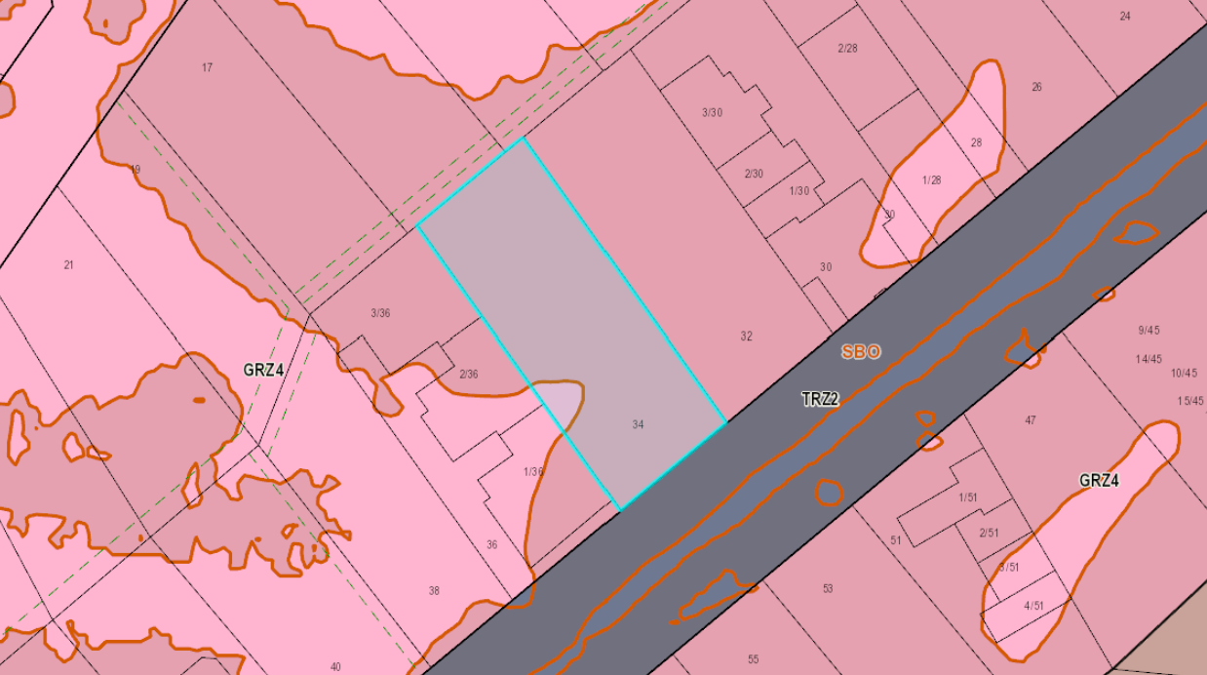
Figure 6: Map showing zones and overlays relevant to the site. Source: PLACES Weave GIS.
The site is located within the Highton Shopping Centre Increased Housing Diversity Area (IHDA), and approximately 70 metres north of Highton Village commercial area.

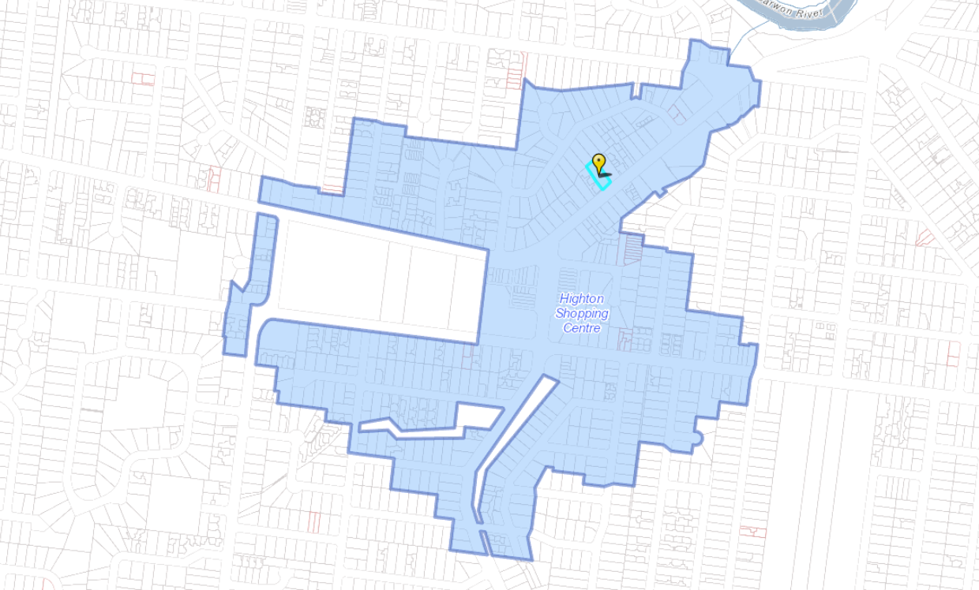
Figure 7: Map showing the extent of the Highton Shopping Centre IHDA and the proximity of the subject site (yellow flag). Source: PLACES Weave GIS
Highton Village offers a variety of retail, health, community and recreation services and is located within walking distance of the 42 (Deakin University via South Valley Road) and 43 (Deakin University via Highton) public bus routes.

PROPOSAL:
The application proposes construction of an apartment building comprising 10 apartments, a corresponding multi-lot subdivision, and alteration of access to a road in the TRZ2.

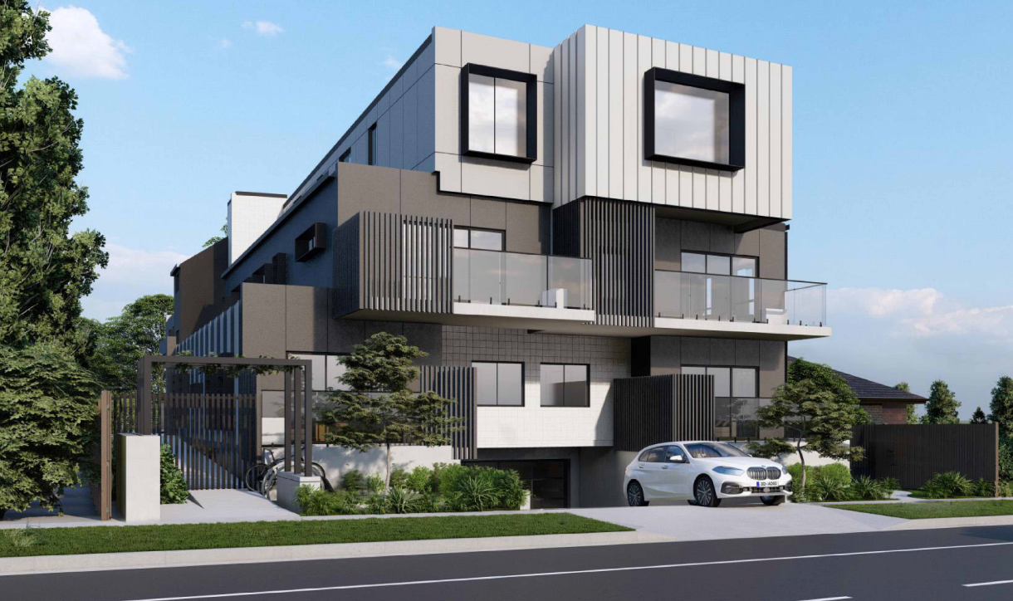
Figure 8: Artist impression of proposed apartment development. Source: Application documents.

Apartment Development
The proposed development comprises four (4) storeys including ground floor, mid floor and upper floor levels, and a basement car park.

The building is to occupy an area at ground level of 574 sq/m, being 57.75% of the 993.7 sq/m site. The total site area covered by buildings is 699 sq/m, being 70.3% of the site. The total permeable surface area is 232 sq/m, being 23.3% of the site.
The proposed maximum building height is dimensioned on the south east elevation drawing as 11.00 metres.
The building is designed to front Barrabool Road to the southeast. The building is to be set back from all adjoining lot boundaries, with recessed upper storey side walls and a contemporary flat roof form.

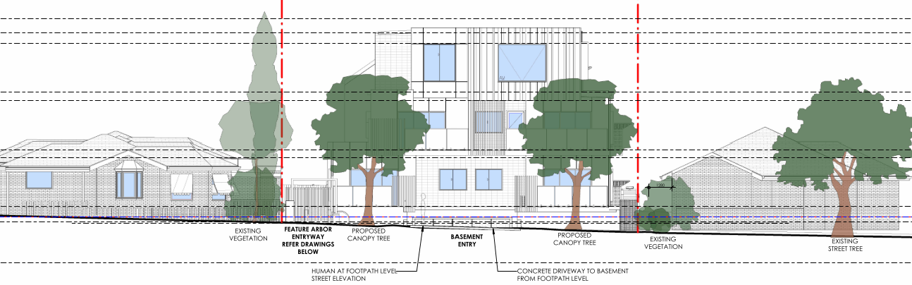
Figure 9 (Above): Southeast streetscape elevation showing frontage to Barrabool Road. Source: Application documents

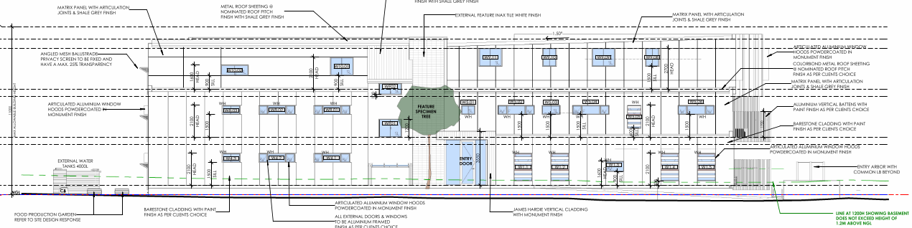
Figure 10 (Above): Southwest elevation showing presentation to land at 36 Barrabool Road. Source: Application documents.

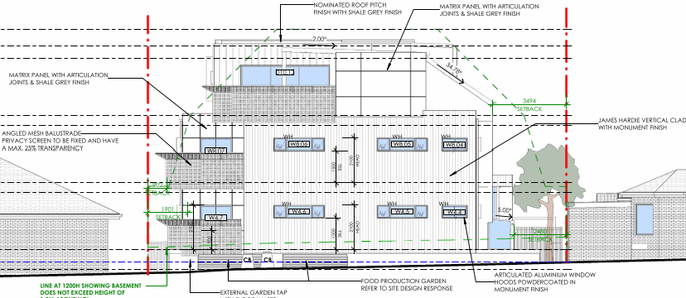
Figure 11 (Above): Northwest elevation showing presentation to the rear adjoining land at 13 and 15 Ferndale Parade. Source: Application documents.

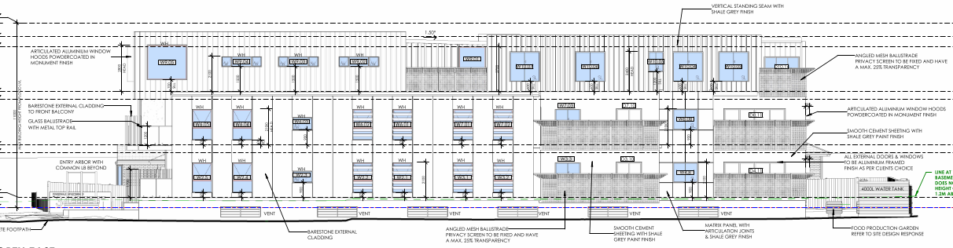
Figure 12: Northeast elevation showing presentation to adjoining land at 32 Barrabool Road. Source: Application documents.
A mix of cladding materials are proposed, with contrasting Cementil Barestone (Monument), Inax Tiles (white) and vertical standing seam (Shale Grey and Monument) cladding at the ground and mid floor levels, and vertical standing seam and Matrix panel at the upper storey. Oversized windows and mixed fenestration provides visual interest, along with feature angled mesh balustrade screening.

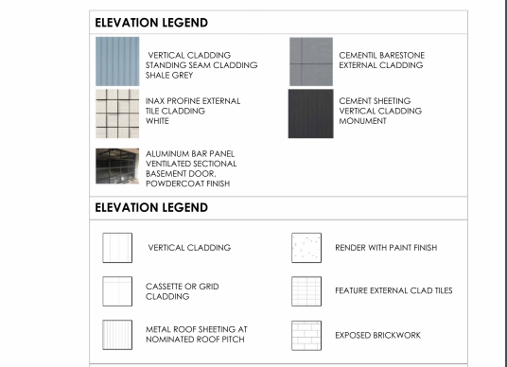
Figure 13: Schedule of materials and finishes. Source: Application documents.

Ground Floor
The ground floor layout plan shows separate primary pedestrian and vehicle access to the site from Barrabool Road from the southeast. The main building entry is located along the south west side of the building with a feature arbor and security gate to a paved path and landscaping leading to a sheltered building entry. The entry continues through to a foyer and common passage for access to the stairs and lift, and internally to Apartments 1 through 4.

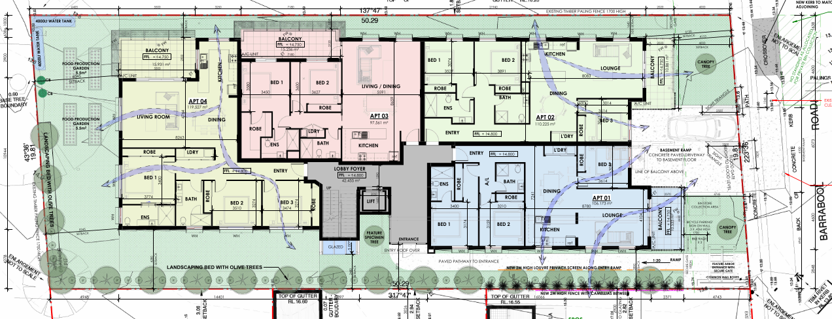
Figure 14: Ground floor plan showing common entry, apartment and private open space (balcony) layouts. Source: Application documents.
The ground floor area also provides communal outdoor areas at the front, sides and rear of the building. The communal area at the rear includes landscaping and food production garden beds.
Apartments 1, 2 and 4 each comprise three (3) bedrooms with secluded private open space on balconies to the southeast, north east, and north west sides of the building. Apartment 2 comprises two (2) bedrooms. All are provided with open plan kitchen, living and dining areas, ‘European’ style laundry cupboards, and internal robes and storage areas.
The ground floor walls are to be setback not less than 6.12 metres from the southeast (front) boundary, 2.48 metres from the southwest (side) boundary, 5.24 metres from the northwest (rear) boundary, and 1.64 metres from the northeast (side) boundary. The front balcony setback at ground floor level is not less than 4.11 metres.

Mid (First) Floor
The mid floor layout comprises two (2) 3-bedroom apartments and two (2) 2-bedroom apartment all with common access from the central stairs and lift. Apartments 6, 7 and 8 occupy the north and east sides of the building, and Apartment 5 with a predominantly south west aspect. Apartments 5 and 6 receive east light, and Apartments 7 and 8 will benefit from north aspect.

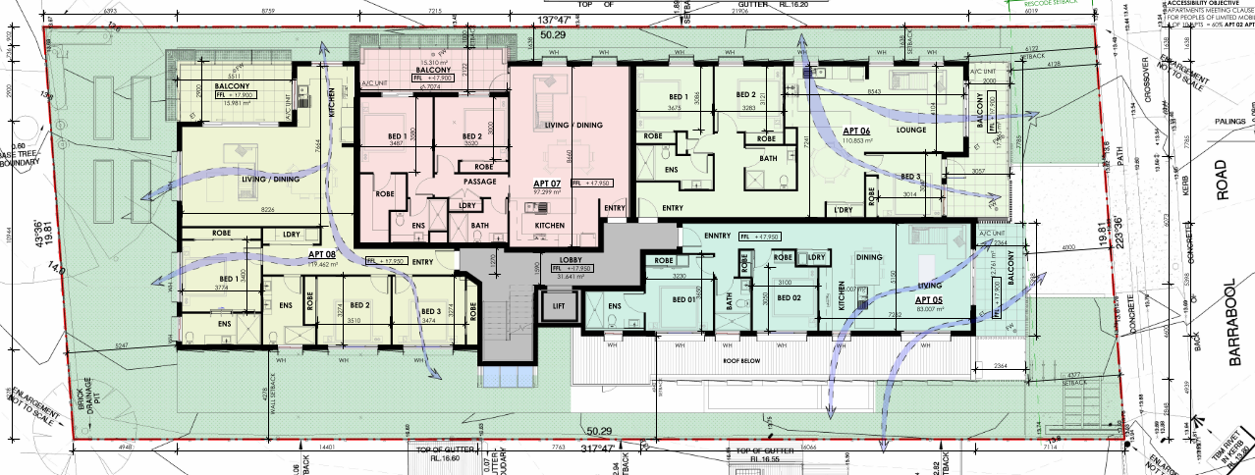
Figure 15: Mid (first) floor plan showing common area entry, apartment and private open space (balcony) layouts. Source: Application documents.
The mid floor walls are to be setback not less than 6.12 metres from the southeast (front) boundary, 4.94 metres from the southwest (side) boundary, 5.25 metres from the northwest (rear) boundary, and 1.64 metres from the northeast (side) boundary. The front balcony setback at mid floor level is not less than 4.0 metres.

Upper (Second) Floor
The upper floor layout comprises two (2) 3-bedroom apartments with common access from the central stairs and lift. Apartment 9 occupies the south east end of the building and Apartment 10 the north west. Both benefit from a north aspect.

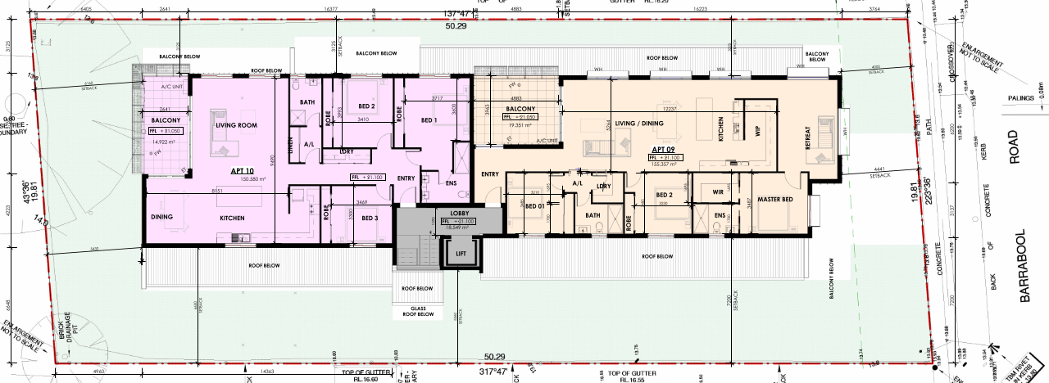
Figure 16: Upper (second) floor plan showing common area entry, apartment and private open space (balcony) layouts. Source: Application documents.
The upper floor walls are to be setback not less than 4.0 metres from the southeast (front) boundary, 5.36 metres from the southwest (side) boundary, 5.43 metres from the northwest (rear) boundary, and 3.12 metres from the northeast (side) boundary.

Basement
The basement is to be accessed via a 6.1m wide vehicle access ramp to Barrabool Road, comprising a retractable flood gate at the property boundary and automatic door at the ramp base to allow vehicle passing and perching on the ramp. Lift and stair access from the apartments is also provided to 20 parking spaces including 2 visitor spaces, 10 secure storage units, 6 bike storage racks, bin room, and an underfloor stormwater retention tank.

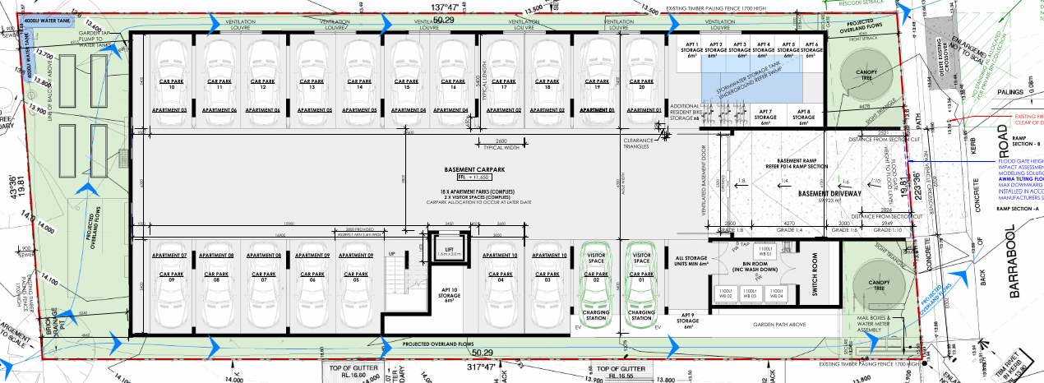
Figure 17: Basement layout plan. Source: Application documents.
The layout plan provides twenty (20) car parking spaces including two (2) visitor parking spaces allocated as follows:

Apartment No. | No. of Bedrooms | Allocated Space No. | Apartment No. | No. of Bedrooms | Allocated Space No.
1 | 3 | 19, 20 | 6 | 3 | 11, 12
2 | 3 | 17, 18 | 7 | 2 | 09
3 | 2 | 10 | 8 | 3 | 07,08
4 | 3 | 15, 16 | 9 | 3 | 05, 06
5 | 2 | 13, 14 | 10 | 3 | 03, 04
All parking spaces measure 5.4 metres long and 2.6 metres wide. The nominal width of the internal vehicle accessway is 6.3 metres wide, with a minimum of 5.5m at the vehicle entry door, and 5.8m at the entrance to Car Park 16.
Multi-lot subdivision of land adjacent to a road in a Transport Zone 2
The proposed plan of subdivision shows creation of 10 apartment allotments each shown in 3 parts (apartment interior, balcony/POS, and basement parking spaces), with the balance of the interior spaces, the site at ground level site and the building exterior all to be within common property.

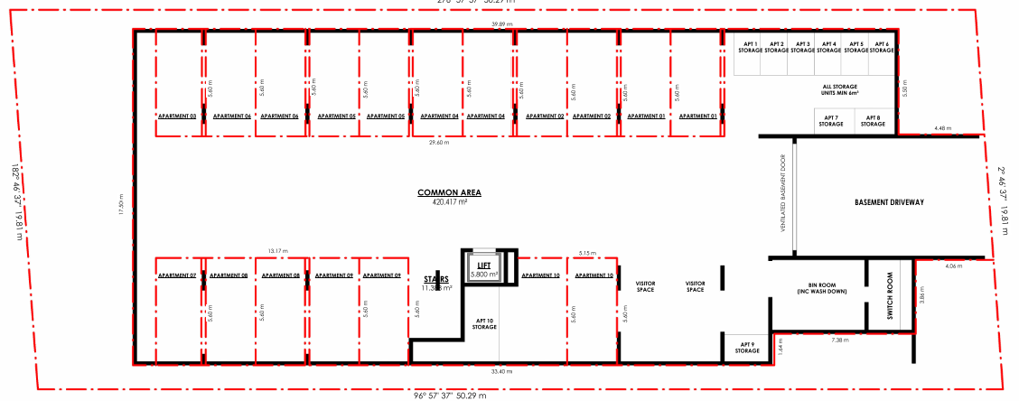
Figure 18: (Above) Proposed basement level plan of subdivision. Source: Application documents.

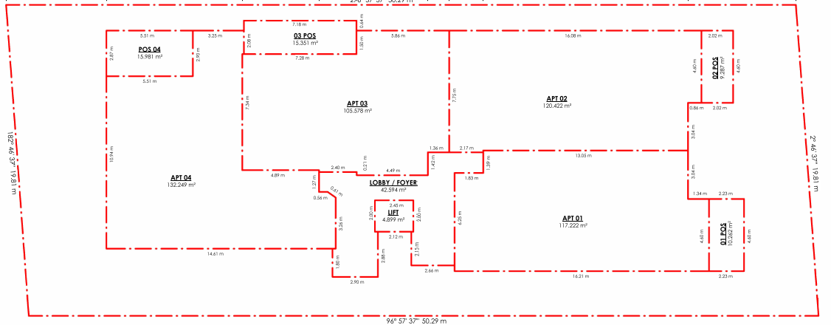
Figure 19: (Above) Proposed ground floor plan of subdivision. Source: Application documents.

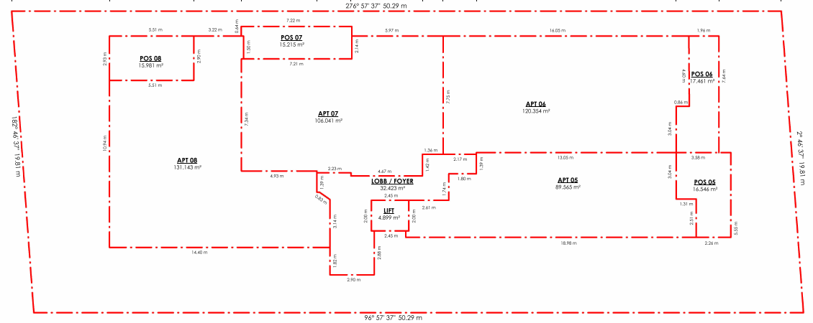
Figure 20: (Above) Proposed mid (first) floor plan of subdivision. Source: Application documents.

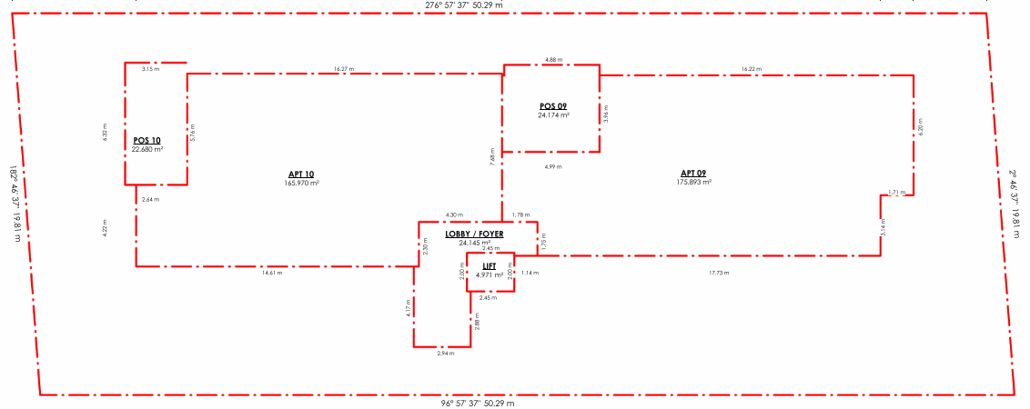
Figure 21: (Above) Proposed upper (second) floor plan of subdivision. Source: Application documents.
Alteration of Access to Road in TRZ2
The application proposes the removal of the existing vehicle crossing to Barrabool Road located at the east boundary corner to be reinstated to kerb and channel. A new double width vehicle crossing is proposed to be located centrally to the site frontage.

PERMIT/SITE HISTORY:
There is no permit/site history relevant to the application.

REFERRALS:
The following referrals were undertaken:

SECTION 55:
DETERMINING AUTHORITY

Authority: | Department of Transport
Response: | 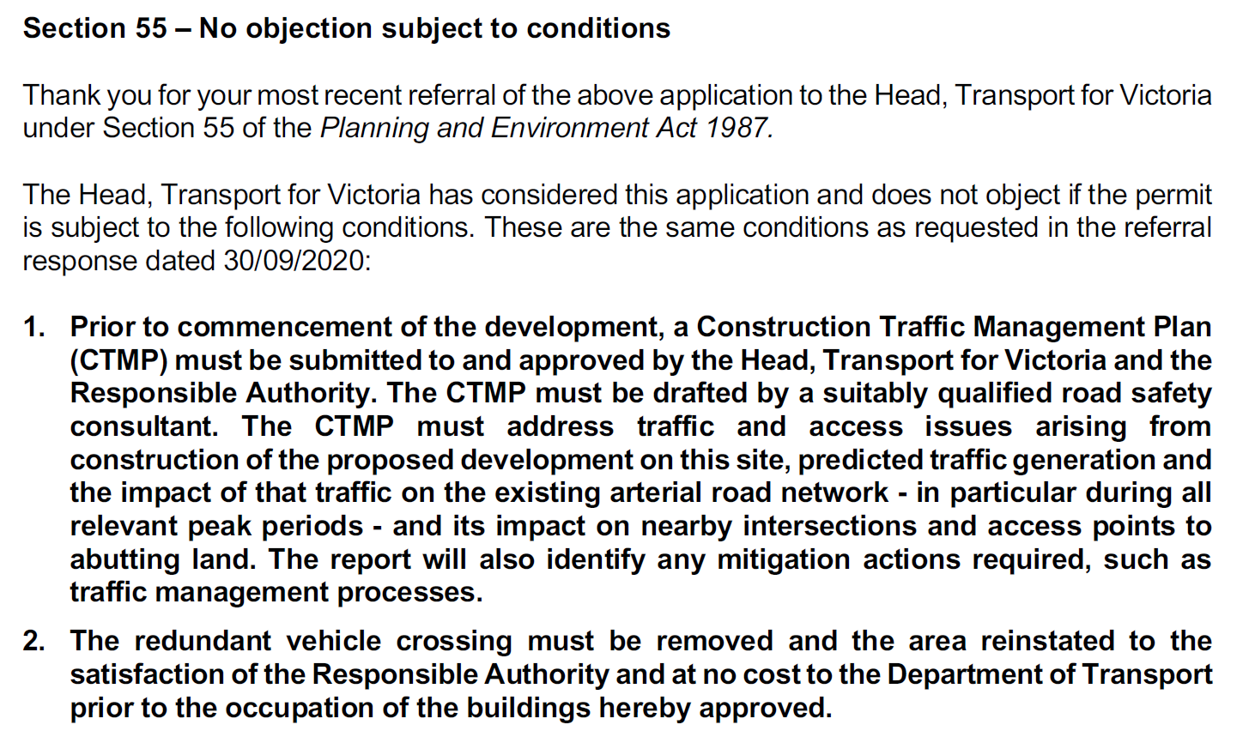
Officer Comment:
The required conditions must be included on any permit that were to be issued.

Authority: | Barwon Water
Response: | 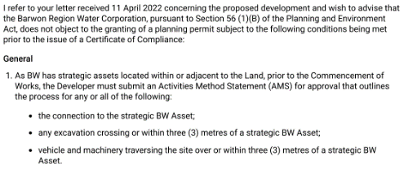  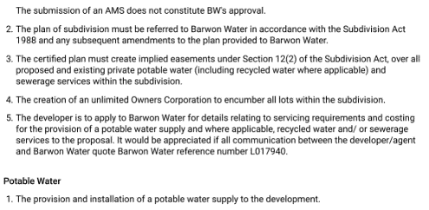  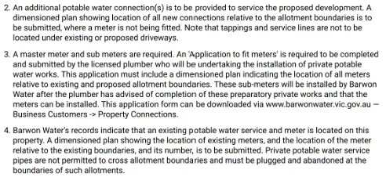  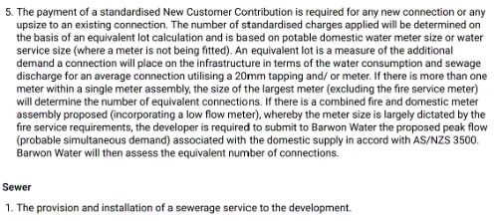  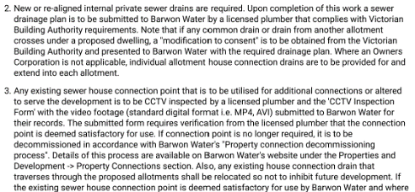  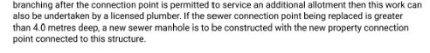
Officer Comment:
The required conditions must be included on any permit that were to be issued.

Authority: | Powercor
Response: | 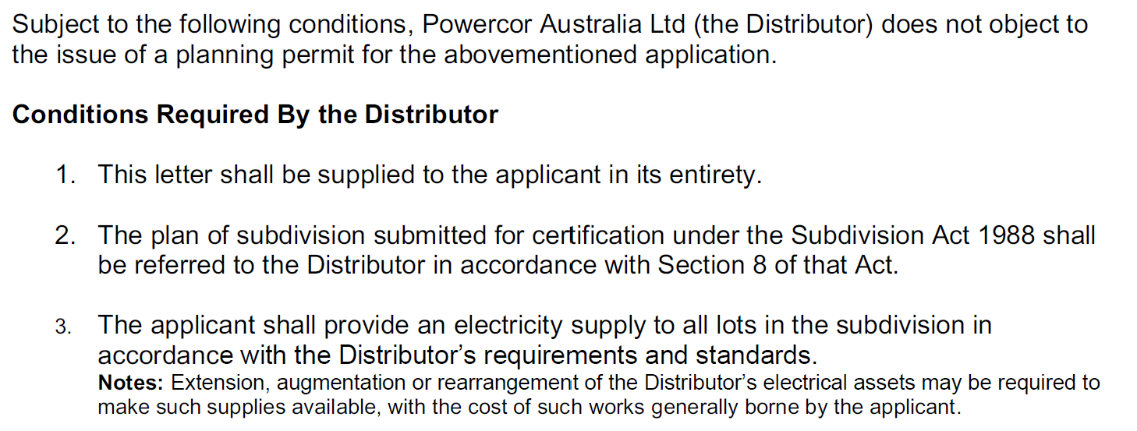  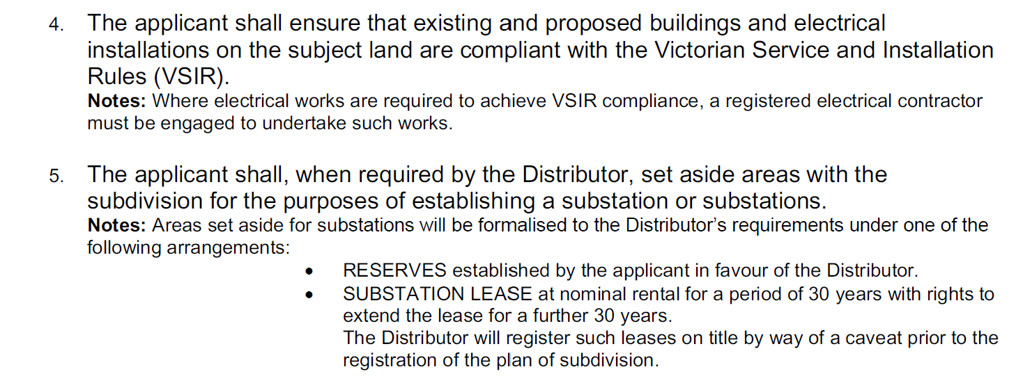  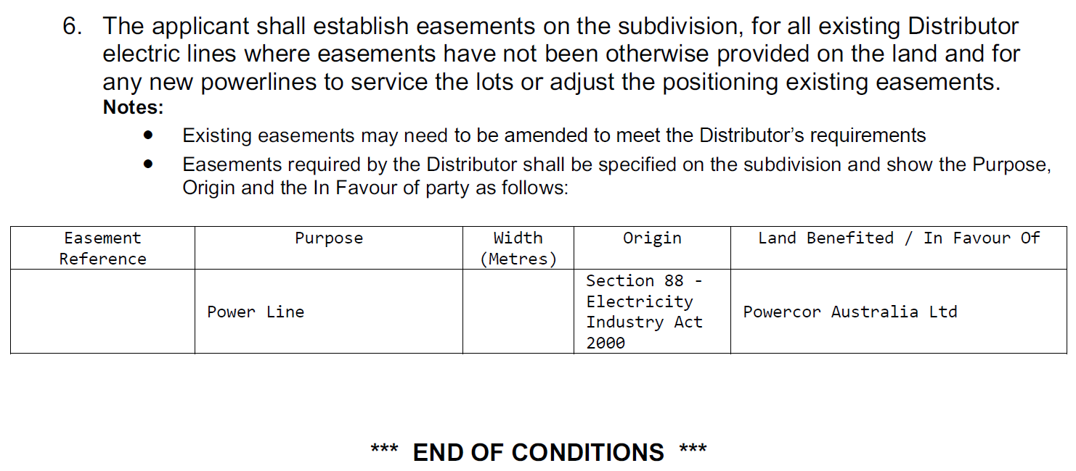
Officer Comment:
The required conditions must be included on any permit that were to be issued.

Authority: | Downer Tenex
Response: | No response was received.
Officer Comment:
Gas supply to the development is no longer a requirement of subdivision and has not specifically been proposed as part of this application. Were a permit to be granted, a condition should require the land owner meet agreed requirements with all relevant utility service providers prior to issue of statement of compliance.
It is notable that Amendment VC250 on 01/01/2024 introduced the Residential Reticulated Gas Service Connection general requirement prohibiting gas connection to new apartment developments. The application is exempt from this requirement pursuant to the transition provisions that apply for applications lodged prior to the approval date of Amendment VC250.

RECOMMENDING AUTHORITY

Authority: | Floodplain Management Authority (SBO)
Response: | A memorandum of understanding (MOU) was entered into between the Corangamite Catchment Management Authority (CCMA) and Greater Geelong City Council in September 2016 for the area of the municipality within the Corangamite Waterway Management District.  As Council is the relevant drainage authority for local drainage and the authority responsible for the flood mapping that forms the basis of the SBO on the Council drainage system, Corangamite Catchment Management Authority will no longer act as a Referral Authority for planning permit applications in areas affected by flooding from the local drainage system.  […]  Engineering Services (as Floodplain Manager) Response  This response is based on the revised plan-set D23-36000 and the previous SBO responses (PW22-11060, 09/2/2022 and D20-418184, 01/10/2020). As per request for further information, the finished surface level of the basement access (footpath) has been shown on the Ramp Section as 13.616 which is deemed to be to AHD.  The onsite and offsite increase in flooding reported in Flood Impact Assessment (FIA) are unacceptable (below map). For a development in SBO, the City has ‘no-adverse impact’ policy. The increase in flooding onsite within the proposed building footprint does not make sense, indicating that the building has not been incorporated properly. Therefore, the modelling needs to be re-done to determine the appropriate flood levels, risks and impact.  According to the SBO flood study, the applicable flood level for the ramp access is 13.60m AHD. The proposed floodgate top/highest level is set at 14.06 m AHD (figure below) – 300 mm above the flood level resulted from the FIA. This level needs to be re-assessed based on re-modelling as per above.  Apparently, the proposed ground floor level 14.60m AHD complies with the required minimum 300 mm freeboard above the applicable flood level 14.20m AHD (SBO floodmap below) or 13.77m AHD as resulted from FIA. However, the latter needs to be reviewed due to the reason stated above.  Overall, the proposed development appears to be feasible with a review of the flooding/levels based on re-modelling.  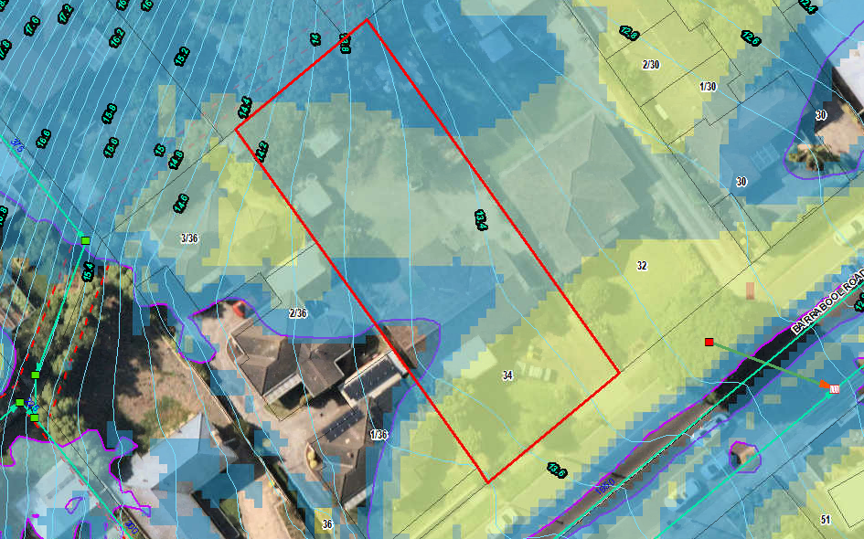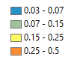  SBO flood map  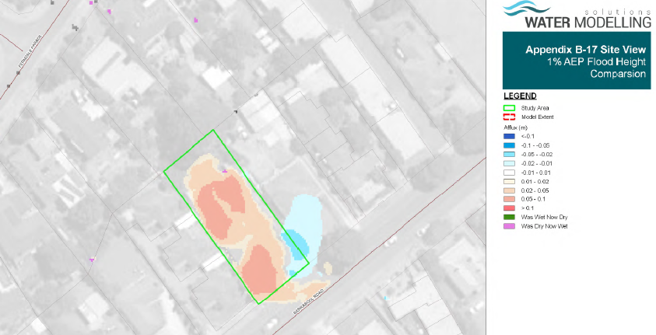  Development impact on flooding  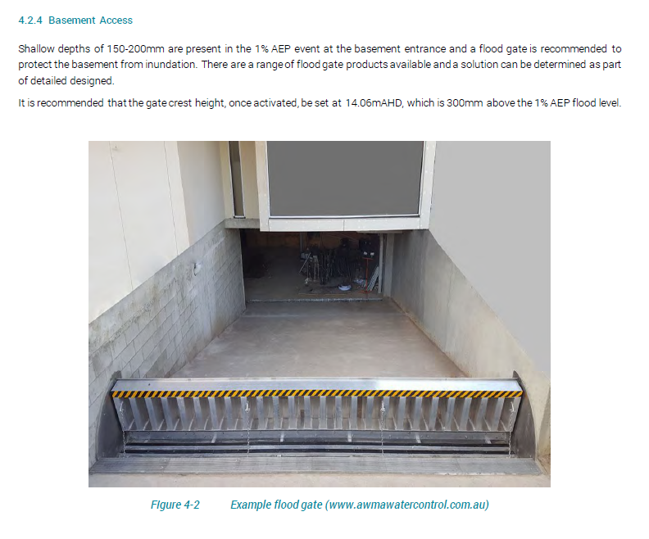  Pursuant to Section 56 of the Planning and Environment Act 1987 Engineering Services (SBO as Floodplain Manager), does not object to the granting of a permit, subject to the following conditions:  - Prior to the commencement of the development, amended plans and Flood Impact Assessment report to the satisfaction of the Responsible Authority must be submitted to and approved by the Responsible Authority. When approved, the documents will be endorsed and will then form part of the permit. The documents must be generally in accordance with those submitted with the application but modified to show:  - There is no adverse impact of the development on flooding for rainfall events up to 1% AEP (Annual Exceedance Probability) by properly incorporating the building in hydraulic modelling.  - The site or its access/egress will not be hazardous as per Victorian State Government Guidelines for Development in Flood Affected Areas for rainfall events up to 1% AEP (Annual Exceedance Probability).  - The proposed top/highest level of the floodgate is at least 300mm above the applicable flood level as determined from the modelling of development condition by properly incorporating the building.  - The Finished Floor Level (FFL) of the ground floor must be at least 300mm above the applicable flood level as determined from the modelling of development condition by properly incorporating the building.  - The north-eastern basement vents must set at least 150 mm freeboard above the applicable flood levels as determined from the modelling of development condition by properly incorporating the building. Such minimum freeboard for any north-western vents (which are not recommended due to flood risk) must be 300 mm.  - Any new fences and gates within the SBO area must have minimum 150 mm ground clearance or 25% opening to 450 mm height from the ground. The minimum clearance above any built/smooth surfaces (eg, paved, concrete, decks etc) is 100mm.  - Any new decks within the SBO area must be non-obstructive to overland flows, that is, unenclosed type to allow passage of flood water underneath.  Notes from Engineering Services (SBO as Floodplain Manager)  A floor should generally be built at least 150 mm above the peripheral ground/finished surface of the building.  Any earth filling should be kept to a minimum on the property to ensure that existing flow paths are not impacted by the proposed works.
Officer Comment:
Generally, the recommendations should be included as part of any permit that might be issued.
The response requires that inconsistencies in the Flood Impact Assessment be corrected so as to establish the flood level for the site from which minimum floor levels, surface levels and the flood gate height (plus 300mm) can be determined for plan approval. A resultant effect of this is to determine what that maximum building height must be to accord with Clause 32.08-11 of the GRZ, which allows 11 metres from the minimum floor level determined by the relevant floodplain management authority. At present the maximum is shown to be 11.070 (measured from natural ground level) which is unlikely to be greater than the minimum finished ground floor level required.
Given the minimum floor level is yet to be formally established, it is recommended an amended plans condition require the maximum building height be dimensioned to be no greater than the minimum finished ground floor level plus 11 metres to comply with the height requirements of the GRZ4.

SECTION 52:
Nil
INTERNAL
Department: | Engineering Services
Response: | Ramp design does not achieve a one in ten (10%) grade for the first five metres and considered unsafe for pedestrians and vehicle access.  The vehicle crossing does not achieve a minimum 1m clearance to the fireplug. Barwon Water need to provide written confirmation of the vehicle crossing within 1m clearance if this clearance cannot be achieved.  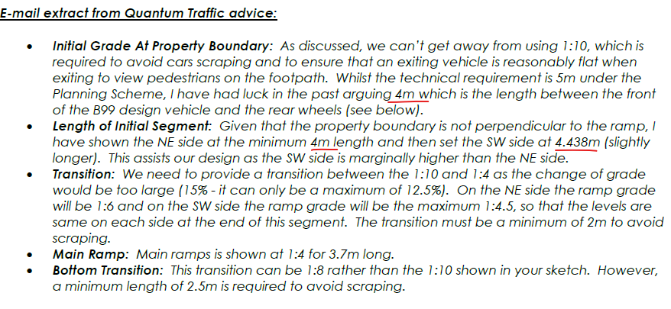  Extract from letter of response to grades does not match what the plan set shows where only the first 2.8m achieved a grade of one in ten (10%). Plans need to be in accordance with the Planning scheme requirements that the first 5m have a grade of one in ten.  Sewer Vent adjacent to proposed new multi-level development.  Barwon Water is required to make comment on the Sewer vent pipe and height of the proposed dwelling with respect to sewer miasma entering the living areas in the upper stories. The vent pipe may need to be modified.  Floodgate Detail Requirement  Engineering requires a detail plan to be submitted showing the floodgate setback by a minimum distance of 1m from the property boundary and how the driveway crossfall grades will transition to accommodate the floodgate that needs to be installed along a horizontal plane. It is noted there is a crossfall grade across the driveway and the driveway will need to transition, as needed, to accommodate the floodgate across a flat surface. An amended plans condition is included and a rough sketch provided.  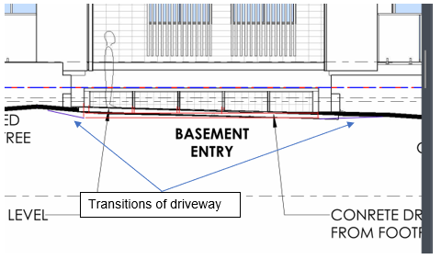
Officer Comment:
The traffic engineering report submitted with the application demonstrates that a revised ramp gradient design can accommodate safe access and egress of vehicle whilst maintaining sightlines for pedestrian safety.
Additional flood gate design detail has been provided to show that the gate can be installed 1m from the site boundary and maintain full function in accordance with the manufacturer’s specifications and requirements.
The permit applicant has been advised to liaise with the sewer vent asset owner to consider what, if any action can be taken to relocate the sewer vent, if necessary.
The recommended conditions should be included on any permit that were to be issued.

Department: | Environmentally Sustainable Development (ESD)
Response: | This ESD response of this application is done on 15/3/2023 (3rd response). The applicant has not been satisfactorily responded all the previous ESD comments.  However, permit can be issued with permit conditions. The summary of the conditions or concerns are as below:  - The applicant needs to provide MUSIC file (.sqz) for validation so that the modelling assumptions and treatment measures is reasonably right.  - An updated catchment plan should be clearly marked and dimensioned based on the proposed treatment measures.  Council’s ESD Officer’s has reviewed the following:  - Development plans by Anotherdimension building design, May 2021, received on 23/1/2023  - ESD report by Anotherdimension building design, January 2023, received on 23/1/2023  - Storm report by Anotherdimension building design, May 2021 and received on 25/1/2022  - BESS report (project identifier: (739E3883-R2 Version -BESS 6), received on 23/1/2023  The outstanding issues of the previous ESD responses are below showing in Blue.  Environment (ESD) Response  - The MUSIC model is used for Storm water treatment measure to meet the objectives of 53.18. The MUSIC assessment detail report and MUSIC file (.sqz) must also be submitted for validation.  Not Resolved: MUSIC file (.sqz) is not visible in this submission. The applicant needs to provide MUSIC file (.sqz) for validation so that the modelling assumptions and treatment measures is reasonably right.  - Catchment plan: A complete response to the stormwater management requirements involves the preparation and submission of a site layout plan showing the different catchment areas size and the proposed stormwater treatment measures consistent with the MUSIC report, plans and the BESS report.  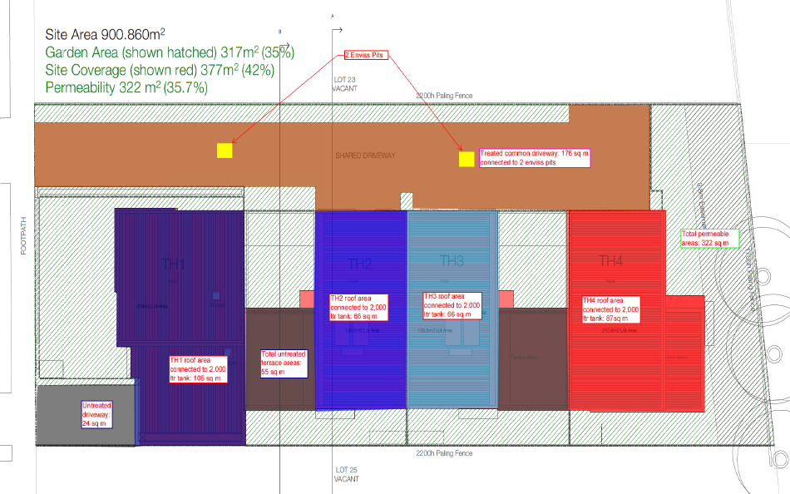  The underlying must be a roof plan that indicates slopes of different roofs to predict the potential path of rainwater from source to treatment destination. The catchment plan must include all the site and all the impervious areas including the paved areas in the private open space.  An updated catchment diagram will need to be added to the plans (e.g. above). Typically, catchment diagrams are colour coded – red shading showing the roofs draining to rainwater tanks, blue shading showing parts of the driveway draining to a raingarden, green areas showing vegetation and permeable/porous paving etc.  Not Resolved: An updated catchment diagram will need to be added to the plans.  Recommended Permit Conditions (Without Prejudice)  - Before the use and development commences, amended plans to the satisfaction of the Responsible Authority must be submitted to and approved by the Responsible Authority. When approved, the plans will be endorsed and will then form part of the permit. The plans must be drawn to scale with dimensions. The plans must be generally in accordance with the plans received 23/1/2023 but modified to show:  - Initiatives contained within the ESD report along with the proposed changes, including:  - An updated catchment plan clearly marked and dimensioned based on the proposed treatment measures in the development plan.  If a BESS report is included as part of the ESD report, the BESS report must achieve an overall score of 50% or higher and have a minimum ‘pass’ rates of 50% for the Energy, Water and IEQ categories and 100% for the Stormwater category.  - All works must be undertaken in accordance with the endorsed Plan, ESD report and stormwater management plan to the satisfaction of the Responsible Authority. No alterations to these plans may occur without the written consent of the Responsible Authority. The other condition is as below:  The applicant needs to provide MUSIC file (.sqz) for validation so that the modelling assumptions and treatment measures is reasonably right.
Officer Comment:
The application was supported, subject to conditions. The conditions should generally be included on any permit that were to be issued.

Department: | Urban Design
Response: | Internal Referral Advice to Planner  - Please review additional information provided and comment in relation to your previous comments and concerns.  - Previous referral responses are included in ReX binder for your reference.  Urban Design Recommendation Response  The table below summarises the previous advice that was provided by Urban Design and whether the issues have been resolved in the current design.  Other Comments from Urban Design  While only some of the previous Urban Design recommendations have been addressed, Urban Design is in general supportive of this proposal. It will help achieve the objectives of evolving the character of Increased Housing Diversity Areas (IHDA) through more intensive development (16.01-1l-02).  The main outstanding issue is the excessive overshadowing of private open space at 36 Barrabool Road in particular to the unit at 2/36 Barrabool. While intensification of this area is appropriate this must be done in a manner that preserves amenity and liveability at the neighbourhood level. Noting that 16.01-1l-02 building height policy guidelines for IHDA areas includes that:  “Encouraging development up to three stories. Three storey development should be located on larger sites abutting the activity centre or where the amenity of adjoining properties will not be unreasonably impacted”.  The shading of the private open space at 2/36 Barrabool is an unreasonable burden on this dwelling. Redesign of the second floor level of the proposal to prevent overshadowing should be achievable if the size of apartments 9 and 10 is reduced. Reduction of these apartments from 3 bedrooms to 1 or 2 bedrooms would also assist the proposal to offer an increased housing diversity in terms of a more varied selection of apartment types. Likewise, reduction in overall built form on the second floor level will be more visually recessive and thus responsive to the neighbourhood character, reducing dominance of adjoining properties and the streetscape. Reduction of bulk on this level may also be useful to ensure compliance with B17 setback envelope standard which is not met in the current design on the North East side.  Also important is the way that the building encourages sustainable and active transport modes. A key goal of the Housing Diversity Strategy 2007 is to reduce urban sprawl and encourage modes of transport other than cars (3.2.1). The design of buildings should support these modes through providing adequate facilities. The revisions to the design adding an entry arbour and landscaping are welcomed as improving the sense of address and approach to the building for pedestrians encouraging pedestrian movement. However, the insufficient provision of bicycle parking within the proposal in comparison to the generous provision of carparking is at odds with the need to promote cycling as a mode of transport. Barrabool Road is a strategic cycling corridor identified in the Principal Cycling Network and has bike lanes in both directions. Better provision of bicycle parking will act as a strong incentive for bicycle use as a mode of transport supporting objectives of the Housing Diversity Strategy.  Non-Standard Conditions  1: Revised plans to be submitted showing a redesign of the second floor such that overshadowing impacts are reduced on the Secluded Private Open Space (SPOS) of units at 36 Barrabool Road to comply with 55.04-5 standard B21. The preferred method for this to be achieved is through reduction of the size of apartments 9 and 10 and/or repositioning of balconies and further alignment of built form away from the south-west boundary. Revised plans must be to the satisfaction of Urban Design and the Responsible Authority.  2: A high-quality landscape masterplan to be provided that depicts front garden plantings and trees at least as extensive as those depicted in artists impressions at P000 of the revised plans. To the satisfaction of Urban Design and the Responsible Authority.  3: Revised plans to show provision of additional bike parking. The number of resident bikes that are able to be parked should preferably be the same or more than the number of car spaces provided. As a minimum there must be more than 10 resident bike parks.  4: Any air conditioning units installed on the building frontage must be below the level of any balcony balustrade and fully concealed from view from the street.  Note to the Planner  Please note B17 is not compliant on the North East side.
  Issue | Recommendation | Resolved?
  Dominance of third storey | Recessing the upper level | Not resolved – design is essentially same form.
  Overshadowing of neighbours | Refine design to reduce | Not resolved – design is essentially same form.
  Interface quality | Direct entry to apartments from street | Not provided
   | Materials legend more specific- add colour | Resolved
   | Conceal A/C condenser units from public view | Still on front of building but should be concealed by balustrade of balcony.
  Landscaping | Landscape buffer between APT01 and path | Trees are enlarged on plan. But high-quality landscape plan not provided, landscaping shown in more detail on artists impressions.
   | Seating and additional trees to improve amenity of communal area | A high-quality landscape plan has not been provided. Trees are enlarged on plan and seating is shown in the artists impression.
   | Screening of rainwater tank to improve amenity of communal area. | Not resolved – not unreasonable though, in the far corner and screening with planting may restrict access.
  Apartment diversity | More two bedroom and add 1 bedroom | Not resolved
  RFI | Relationship paved entry and landscaping, more detail needed.  Landscape Plan is required. | Additional design of entry arbour provided.
   | What is proposed SW in the corner, more detail needed. | As above
Officer Comment:
The comments and recommendations have been considered. Further detailed assessment of the building form and context have been given later in these recommendations, including an assessment of Clause 55.

Department: | Waste Services
Response: | The road width at this point is satisfactory for private collections. A number of commercial properties use this style of collection, basement storage and mechanical assistance to move bins up ramp to street for emptying. Condition to ensure that bins are not left in street, either empty or full. Must only be moved to street for collection then returned.
Officer Comment:
The recommended condition required the waste management plan submitted be endorsed as part of the planning permit, and that an agreement under section 173 of the Act be executed to require the Council Residential Waste Services Charge be levied on future residents of the development.

AMENDMENT OF THE PROPOSAL PRIOR TO PUBLIC NOTIFICATION:
The applicant made a first request to amend the application pursuant to Section 50 of the Planning and Environment Act 1987 on 2 February 2022. Council accepted the amendment. The amendment made the following changes to the application:

- Redesign to comply with introduced mandatory garden area requirements of 35%.
- Reduction of number of apartments from 13 to 10.
- Provision of flood management and stormwater management plans.
- Relevant updates to planning report and planning assessment.
The applicant made a second request to amend the application pursuant to Section 50 of the Planning and Environment Act 1987 on 29 March 2022. Council accepted the amendment. The amendment made the following changes to the application:

- Multi-lot subdivision.
A request for further information and recommended matters for reconsideration was sent on 27 April 2022 in response to the 2nd amendment request. Revised plans were received on 24 January 2023 after 4 extensions to the application lapse date.

PUBLIC NOTIFICATION:
The application is not exempt from the notice requirements of Section 52(1)(a), (b) and (d), the decision requirements of Section 64(1), (2) and (3) and the review rights of Section 82(1) of the Act and pursuant to Section 52 of the Planning and Environment Act 1987 the following forms of advertising were undertaken:
- 12 x notices were sent to owners and occupiers of adjoining land (including opposite).
- 1 x A2 sign was placed on the land.
Eight (8) written objections have been lodged with the City, plus two (2) incomplete submissions where the submitter has not been able to be contacted for locality verification. One (1) submission of support has been received.

LOCATION OF OBJECTIONS:

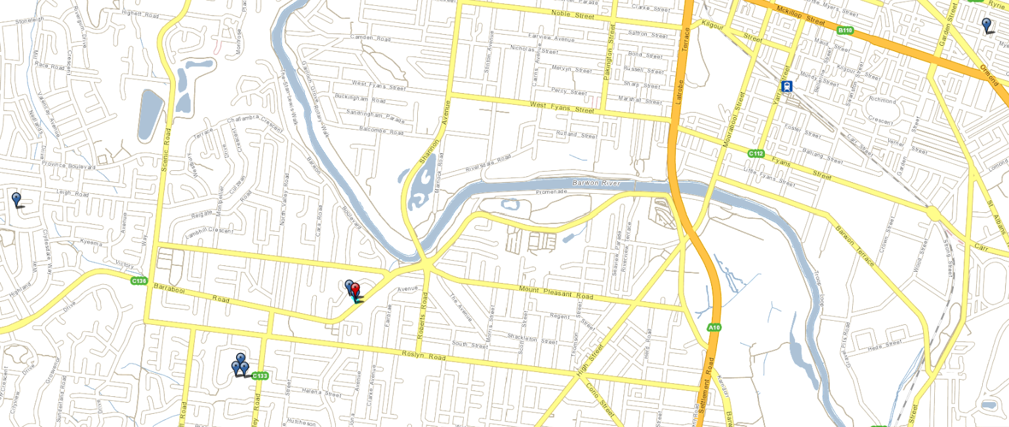
Figure 22: Location of objectors (blue flags) in relation to the subject site (red flag). The furtherest is 4.5km to the north east (top right), and the nearest is adjoining the site. Source: PLACES Weave GIS.
CONSULTATION:
A consultation meeting was not held between the applicant, council officers, and all objectors.

A meeting was held between the applicant, City planning officer, and the objector from the property abutting the site at 1/36 Barrabool Road. The meeting discussed the issues raised to see if any resolutions were possible.

The permit applicant submitted an offer for financial compensation to the owner of 1/36 Barrabool Road for the effective loss of energy generated by the rooftop solar energy system during the winter period. The offer equates to an amount calculated to be the effect of shadows on PV cells during the period 1 June to 31 August, being when the sun is at its lowest such that shadows will read the PV cells.

The offer has been given to the objector. No resolution has been confirmed and no withdrawal of objection has been received.

AMENDMENT OF THE APPLICATION FOLLOWING PUBLIC NOTIFICATION:

The applicant made a first request to amend the application following public notification pursuant to Section 57A of the Planning and Environment Act 1987 on 8 March 2024. The City accepted the amendment. The amendment made the following changes to the application:
- Revised basement access ramp grades, and resultant floor plan dimension changes
These are the plans currently under assessment.

It was not considered necessary to readvertise the proposal based on the amendment, as the amendment would not result in any additional material detriment compared with the advertised application, for the following reasons:

- The changes did not result in an increase to the scale, height or bulk of the development, or any change to building setbacks that would introduce or increase the likelihood of material detriment to others.
- The changes were in direct response to car park design matters raised by the assessing officer.

The applicant made a second request to amend the application following public notification pursuant to Section 57A of the Planning and Environment Act 1987 on 1 May 2024. The City accepted the amendment. The amendment made the following changes to the application:
- The southwest side walls at the first floor (APT 05) and second floor (APT 09) have been further setback from the side property boundary to reduce the extent of overshadowing.
- 1 fewer bedroom for Apartment 5 (APT 05).
- Addition of vertical batten privacy screening to APT 01 and APT 05 balconies.
- A 2m high boundary fence and plantings of Camellias along the paved pathway to entrance.
- A net increase to the area of SPOS on adjoining land that receives sunlight as shown on sheets P015, P016 and P020 of the plan set.
These are the plans currently under assessment.

The amended plans were circulated via email to all parties that had submitted a written objection on Wednesday 8 May 2024. The plans were accompanied by a cover letter detailing the changes shown.
It was not considered necessary to give notice of the amendment to the application because the overall bulk and scale of the building was reduced resulting in a lesser likelihood of material detriment to others than the application previously advertised.

OBJECTIONS:
The concerns of objectors are summarised below, along with Officer consideration comments.

Objection Summary | Officer Consideration
- Development is too big in comparison to nearby houses. Will change the character of the neighbourhood. | The site is within the GRZ 4 and Highton Village Increased Housing Diversity Area (IHDA) that nominate the location to be suitable for residential development, including dwellings, townhouses and apartment buildings, up to and including 3 storeys and a height of 11.3 metres above the applicable flood level for the site. Redevelopment of land in the IHDA will result in a change to the existing character of the area by introducing a preferred character that accommodate increased density and diversity.  For these reasons, the development is not required to conform with the established building heights and housing types of the area such that a development of the type proposed can be approved.  It is notable that other relevant housing and settlement policy encourages infill development in location with good access to facilities and services. Were the proposal to be approved and constructed, it would provide for 10 dwelling on land that currently accommodates only 1, resulting in a significant gain in the need to provide more housing to meet a growing need.  Refer to the Clause 55 Assessment of the proposal for detailed consideration of the ResCode requirements later in this report.
- Landscape plan doesn’t provide enough trees in good locations. Doesn’t add to canopy tree coverage objective of the City. Existing trees should be retained. | The planning scheme does set out requirements for landscaping of multi-dwelling developments of this type. These are found at Clause 55.03-8 (Landscaping objectives) and requires development ‘respects the landscape character of the neighbourhood’ and to ‘encourage the retention of mature vegetation on the site’. The application proposes to meet these objectives (along with other, competing objectives of the Scheme) by providing a landscape plan that shows plantings of new canopy trees within the front setback and small trees along the south boundary of the site. The replacement plantings exceed the number of trees that will be removed, resulting in a net gain for the canopy coverage objectives of the City.
- Additional vehicles from the development won’t fit in basement and will cause traffic and parking disruption. | The development provides for car parking on the land in accordance with the requirements of the Scheme. This means 1 car parking space for each 2 bedroom apartment, 2 car parking spaces for each 3 or more bedroom apartment, and 2 shared visitor car parking spaces. On-street parking spaces are also proposed to be retained.  Because the development meets the car parking requirements of the scheme, it is not considered appropriate that more parking be sought in anticipation that more may be needed. The scheme already requires visitor car parking spaces to accommodate parking over-flow.
- Will ‘reduce the liveability of our suburb’. | The liveability of a neighbourhood, a suburb, and a region is dependent on the provision of a variety of housing types. Liveability is not static, and is always subject to change that is most noticeable to those that have lived in an area the longest.  It is likely that the introduction of a diversity of dwelling styles into this part of Highton will add to the vitality and sense of place commonly associated with ‘liveability’.
- Will contribute to congestion at intersection of Ferndale and Barrabool | Road networks in urban areas are specifically designed and constructed with capacity to accommodate, and often exceed, the traffic volumes that will be generated by the surrounding urban land ‘catchment’ the road network services. Roads and their intersections are designed by engineers in anticipation of increases to traffic over the life of the road.  Barrabool Road is part of the Principal Road Network and specifically designed and constructed to take large volumes of traffic. The modest amount of additional traffic generated by the proposal will not result in an unacceptable change to the existing traffic volumes or function of nearby intersections.
- Overlooking from development to dwellings on the southwest - louvres could be removed. | The overlooking requirements of the Scheme provide for fixed screens to be constructed that limit down views to windows and private open space on adjoining land. Where these screening treatments are used and approved under a planning permit the building owner and occupants a bound by an ongoing obligation to maintain these screens for the life of the building, unless alternative screening treatments are approved.  Refer to the Clause 55 Assessment of the proposal for detailed consideration of the ResCode requirements later in this report.
- Excessive shadowing of SPOS of dwellings to southwest, and increased heating costs for those houses | The shadow drawings provided with the application show that the building will cast an additional shadow over the secluded private open space of the dwellings to the south west. The application proposes a variation to the standard set out in the Scheme. Further consideration to whether or not the objective has been met is given later in these recommendations.  Refer to the Clause 55 Assessment of the proposal for detailed consideration of the ResCode requirements later in this report.
- Disruption from foot traffic alongside to entrance of building and loss of privacy to dwelling adjoining | Concrete paving is proposed along boundary for path to front door. This is considered appropriate as unlikely to create intrusive noise unlike pebbles or the like. A 1m wide landscape strip provides separation from the path to the fence, and also limits overlooking to the SPOS of the adjoining dwelling on the other side of the existing 1.7m high fence. No unreasonable loss of privacy will result from the location of the entrance path.
- Will worsen urban heat in the area. | The application includes Environmentally Sustainable Development initiatives that respond to a variety of energy and resource reduction initiatives, including the need to provide permeable and landscaped areas. The landscape plan shows the provision of canopy trees and other plantings to reduce the extent of impervious surfaces, and the overall site coverage is within the requirements of the Scheme. Unlike some residential developments in urban areas, the proposed development achieves the provision of 10 dwellings within the site area coverage and impervious surface footprint commonly found by a single large dwelling. In this respect, the development generates a significant benefit for modest cost to the urban heat island effect. And it also reduces pressure on the need to further increase the urban area of Geelong.
- Increased flood risk from stormwater/rainfall runoff. | In its present state, the land already contributes to stormwater runoff via overland flows and impervious surfaces.  The increase to impervious surfaces brought by the development and increase in stormwater runoff (ie. water leaving the site) must be managed on the site to meet current best practice performance objectives for stormwater quality such that erosion will be prevented. The site stormwater system is proposed to be designed and constructed to capture, retain and release stormwater runoff at a rate that is no greater than the current (pre-development) rate. This is achieved through the use of rainwater tanks and permeable surfaces as shown in the site Stormwater Management Strategy (SWMS) submitted as part of the application.  The drainage authority engineers and the stormwater planning engineers on behalf of the floodplain management authority have reviewed the SWMS and have agreed that the risk of flooding and erosion will not be increased were the development to proceed after detailed design and construction has been completed.
- Increased traffic risk to pedestrians. | The proposed basement ramp accessway is 6 metres wide, with grades that allow pedestrians at the entrance to the property and vehicles exiting a clear line of sight to prevent collisions. The development will not introduce an unacceptable safety risk to pedestrians.

ASSESSMENT:
ZONE:
Clause 32.08 General Residential Zone (GRZ4).
The purpose of the GRZ4 is:

- To implement the Municipal Planning Strategy and the Planning Policy Framework.
- To encourage development that respects the neighbourhood character of the area.
- To encourage a diversity of housing types and housing growth particularly in locations offering good access to services and transport.
- To allow educational, recreational, religious, community and a limited range of other non-residential uses to serve local community needs in appropriate locations.

The zone applies a mandatory minimum garden area requirement to the subject site of 35%.
The zone requires that the proposed development must meet the requirements of Clause 55 (Two or more Dwellings on a lot and Residential Buildings). Schedule 4 to the General Residential Zone specifies the following requirements of Clause 55:

- Minimum street setback (Standard B6)
If the site is in a heritage overlay, the average distance of the setbacks of the front walls of the existing buildings on the abutting allotments facing the front street or 9 metres, whichever is the lesser.
In all other areas, the average distance of the setbacks of the front walls of the existing buildings on the abutting allotments facing the front street or 4 metres, whichever is the lesser

- Site Coverage (Standard B8)
Maximum site coverage 70 per cent.
- Private open space (Standard B28)
A dwelling or residential building should have private open space consisting of:
  - An area of 20 square metres of secluded private open space at the side or rear of the dwelling or residential building with a minimum dimension of 3 metres and convenient access from a living room; or
  - A balcony of 8 square metres with a minimum width of 1.6 metres and convenient access from a living room; or
  - A roof-top area of 10 square metres with a minimum width of 2 metres and convenient access from a living room.

The zone applies a mandatory dwelling and residential building height limit to the subject site.
Schedule 4 to the General Residential Zone does not specify the maximum height or number of storeys for a dwelling or residential building.
If no maximum building height or maximum number of storeys is specified in a schedule to this
zone:
- the building height must not exceed 11 metres; and
- the building must contain no more than 3 storeys at any point.

A building may exceed the maximum building height by up to 1 metre if the slope of the natural
ground level, measured at any cross section of the site of the building wider than 8 metres, is
greater than 2.5 degrees.

A basement is not a storey for the purposes of calculating the number of storeys contained in a
building.

OVERLAY:
Clause 44.05 Special Building Overlay
The purpose of Clause 44.05 is:

- To implement the Municipal Planning Strategy and the Planning Policy Framework.
- To identify land in urban areas liable to inundation by overland flows from the urban drainage system as determined by, or in consultation with, the floodplain management authority.
- To ensure that development maintains the free passage and temporary storage of floodwaters, minimises flood damage, is compatible with the flood hazard and local drainage conditions and will not cause any significant rise in flood level or flow velocity.
- To protect water quality and waterways as natural resources by managing urban stormwater, protecting water supply catchment areas, and managing saline discharges to minimise the risks to the environmental quality of water and groundwater.

Response to zone and overlay(s)
The application accords with the purpose and decision guidelines of the General Residential Zone – Schedule 4.

The proposal increases the available supply of housing in a location with good access to services and transport. The mix of 2 and 3 bedroom apartments adds to the diversity of housing types in the area.

The proposal has been assessed against the requirements of Clause 55 and found, for the most part, to provide an acceptable design response with relatively few variations to the ResCode standards. However, the extent of overshadowing from the building to the Secluded Private Open Space of the dwellings at 1/36 and 2/36 Barrabool Road has been found to be significant such that the mandatory objective of Clause 55.04-5 (Overshadowing open space objective) has not been met.

The proposed development conforms with the mandatory height requirements for dwellings in the zone. The apartment building reaches a maximum height of 11.00 metres measured from natural ground level, which is lower than the allowable maximum height of 11.0 metres above the finished floor level required by the Floodplain Management Authority.

The site is provided with 348.53 square metres of garden area, representing 35.07% of the 993.73 square metre site, and in accordance with the mandatory minimum garden area requirement of the Scheme.

The development is likely to result in some overshadowing of the solar energy system on the dwelling at Unit 1, 36 Barrabool Road, Highton. The dwelling is located on the south side of the development.
The permit applicant completed a detailed assessment of the likely effect, calculating a worst-case outcome would be that a loss of 40% of available sunlight would be lost between the 1st of June and the 31st of August each year, for the remainder of the service life of the system. It was found that the system will be unaffected for the early part of the day during winter, and not at all through the rest of the year.

From these calculations, a financial settlement offer was made to the owner of the system. The assessing officer has reviewed the calculations and the settlement offer and found that the offer is reasonable if not generous, and likely to exceed the financial loss from the overshadowing of panels.

It is considered that the settlement offer is an acceptable response to offset the overshadowing of the solar energy system such that an acceptable planning outcome could be achieved should the affected land owner choose to accept it.

The application was reviewed by the Floodplain Management Authority engineers who do not object to the grant of a permit, subject to conditions. Were a permit to be granted, the conditions will require flood modelling to more precisely determine the applicable flood level and the relevant finished floor and surface levels such that an acceptable outcome will be achieved in terms of the purpose and decision guidelines of the SBO. The design response incorporates stormwater retention measures and provides for overland flow paths that are commensurate with pre-development conditions.

CULTURAL HERITAGE MANAGEMENT PLAN (CHMP):
The Aboriginal Heritage Regulations 2018 specify the circumstances in which a cultural heritage management plan is required for an activity or class of activity. Division 2 of the Aboriginal Heritage Regulations 2018 specifies exempt activities which do not require a cultural heritage management plan. The proposal is not listed as an exempt activity.

Areas of cultural heritage sensitivity are defined within Divisions 3 and 4 of the Aboriginal Heritage Regulations 2018. Division 3 does not identify the site or part of the site as within an area of cultural heritage sensitivity. High impact activities are defined within Division 5 of the Aboriginal Heritage Regulations 2018. Division 5 lists the proposal as a high impact activity.

The site is not considered to have been the subject of significant ground disturbance which is defined as ‘disturbance of (a) the topsoil or surface rock layer of the ground or (b) a way - by machinery in the course of grading, excavating, digging, dredging or deep ripping, but does not include ploughing other than deep ripping.

In accordance with the above assessment, a cultural heritage management plan is not required.

LANDFILL GAS RISK ASSESSMENT:
The subject site is not located within 500 metres of an identified former landfill site. A landfill gas risk assessment is not required.

DEVELOPMENTS IN BUSHFIRE PRONE AREAS:
The site is not located within a designated bushfire prone area. A bushfire risk assessment of the application is not required.

THE PLANNING POLICY FRAMEWORK (PPF):
The following clauses of the Planning Policy Framework are applicable to this application:

Clause 11 (Settlement):
- 11.01-1S Settlement
- 11.01-1R Settlement – Geelong G21
- 11.01-1L-01 Settlement – Greater Geelong

Clause 13 (Environmental Risk and Amenity):
- 13.03-1S Floodplain management
- 13.03-1L Floodplain management

Clause 15 (Built Environment and Heritage):
- 15.01-2L Environmentally sustainable development
- 15.01-3S Subdivision design
- 15.01-4S Healthy neighbourhoods
- 15.01-5S Neighbourhood character
- 15.01-5L Neighbourhood character

Clause 16 (Housing):
- 16.01-1S Housing supply
- 16.01-1R Infill housing - Geelong G21
- 16.01-1L-01 Integrated housing and housing diversity
- 16.01-1L-02 Increased housing diversity areas
- 16.01-2S Housing affordability

Clause 18 (Transport):
- 18.01-1S Land use and transport integration
- 18.02-4S Roads

Response to Policy
The application has been considered against all relevant objectives and strategies and has been found to give appropriate effect to the PPF of the Scheme.

It proposes an infill housing development that will assist with meeting the growing need for diverse housing in Geelong. It is located on land offering convenient access to a full range of employment, education, health, social, recreational and commercial services. The site is fully serviced by utilities, and the established road and alternative transport network, and is within walking distance of the public bus network.

The apartment development offers a contemporary accommodation option that adds to the diversity of available housing to meet a variety of needs within the community. This diversity is likely to assist with housing affordability, particularly given the mix of 2, and 3 bedroom apartments proposed, and the compact layout and generous communal shared spaces provided.

The Floodplain Management Authority has determined that the proposal can produce an acceptable outcome in terms of flood risk. With further work and approval of flood mapping the development maintains free passage and temporary storage of floodwaters and is compatible with local drainage conditions.

Similarly, that application incorporates an acceptable variety of environmentally sustainable development features. The sustainable design assessment submitted with the application shows that the ESD policy will be given effect at detailed design.

Importantly, the design detail of the development responds appropriately to the preferred character of the area. This part of Highton is appropriately located to accommodate housing developments of increased density and diversity in accordance with Schedule 4 to the GRZ (Urban Increased Housing Diversity Areas) that invokes Clause 16.01-1L-02 (Increased housing diversity areas). In this respect, the zone and policy invoke dwelling (including apartment) developments up to and including 3 storeys. This development has incorporated built form strategies by incorporating horizontal and vertical articulation, and a mix of materials, textures, and colours to create visual interest. The upper storey is recessed, reducing visual dominance, and setting a design standard for multi-dwelling developments along this part of Barrabool Road for the future.

The site access from the principal road network allows for safe and unobstructed vehicle movements in and out of the basement. The access has been carefully designed to allow entry and exit in a forward direction; vehicle circulation and turning in the basement car park; and no net loss of on-street car parking.

RELEVANT PARTICULAR PROVISIONS:
The following Particular Provisions are applicable to this application.
CLAUSE 52.06 – CAR PARKING
The purpose of Clause 52.06 is:
- To ensure that car parking is provided in accordance with the State Planning Policy Framework and the Local Planning Policy Framework.
- To ensure the provision of an appropriate number of car parking spaces having regard to the demand likely to be generated, the activities on the land and the nature of the locality.
- To support sustainable transport alternatives to the motor car.
- To promotes the efficient use of car parking spaces through the consolidation of car parking facilities.
- To ensure that car parking does not adversely affect the amenity off the locality.
- To ensure that the design and location of car parking is of a high standard, creates a safe environment for users and enables easy and efficient use.

Response
Clause 52.06-5 requires the provision of 1 car parking space for every 1 or 2 bedroom apartment, plus 2 car parking spaces for every 3 or more bedroom apartment, plus 1 car parking space for visitors to each 5 apartments. The total car parking space requirement for the proposed development is therefore 19 spaces.

A total of 20 car spaces are provided within the basement car parking area in excess of the requirements of the Scheme.

The car parking plan shows that all spaces are a minimum of 2.6m wide and 5.4m long and oriented at 90 degrees to the accessway. The accessway is not less than 5.5m wide at any point and exceeds the minimum 3.0 metres. The accessway width increases to 6.3 metres at the parking spaces but narrows to 5.8 metres adjoining parking space 16, which is less than the 6.4m width sought by the design standard.

The additional 0.5m of parking space length either side of the 6.3m wide accessway effectively reduces the accessway width by 1 metre. Were the spaces to be 4.9m long, the accessway could be shown to be up to 7.4m wide. Instead, the layout design reduces the accessway by 0.1m (less than the 6.4m design standard) but allows the extra length without adverse effect on the circulation of vehicles within the car park.

The access ramp proposes non-standard grades in the form of the following:

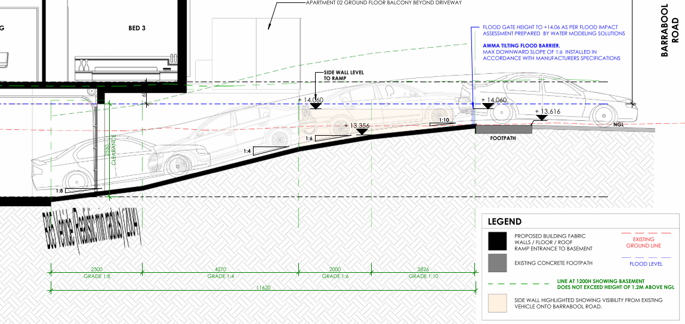

Figure 23 (Above): Section showing the ramp grade for the accessway at ingress to the basement from Barrabool Road. Note, the vehicle illustrated is travelling in the wrong direction. Source: Application documents.

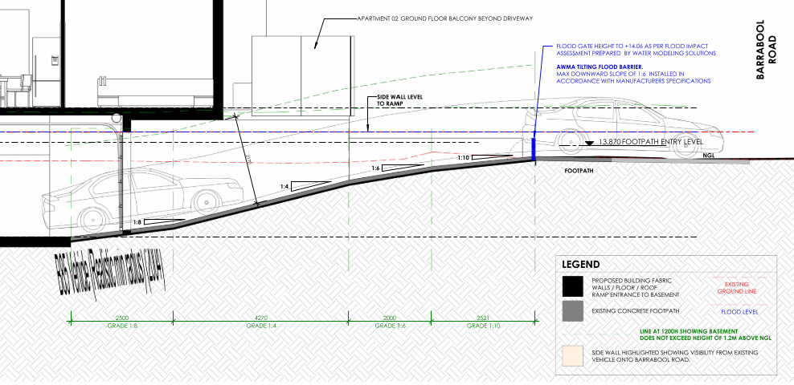
Figure 24 (Above): Section showing the ramp grade for the accessway at egress from the basement to Barrabool Road. Source: Application documents.

The traffic engineering report submitted as part of the application finds that the reduced minimum length of ramp grade at 1:10 at the top (2.521m instead of 5.0m) can continue to maintain safety for pedestrians and vehicles where the side walls of the ramp entrance are no greater than 0.9m in accordance with the sight-splay requirement. The sections and elevations show this area to remain clear of visual obstructions.

Similarly, the section of 1:6 gradient transition to 1:10 will minimise the risk of vehicle scraping that can otherwise occur if the grade change is too great. No vehicle scraping should normally occur at the top or the bottom of the access ramp.
The proposed minimum height clearance of 2.17 metres exceeds the standard of 2.1 metres.
All B85 passenger vehicles that enter the basement carpark can change direction such that they enter and exit the site in a forward direction in accordance with the design standard.
The vehicle access and car parking plan shows that an acceptable outcome will be achieved with some variations to the car parking design standards such that an acceptable planning outcome will be achieved.

RELEVANT GENERAL REQUIREMENTS:
CLAUSE 53.01 – PUBLIC OPEN SPACE CONTRIBUTION
A person who proposes to subdivide land must make a contribution to the council for public open space in an amount specified in the schedule to this clause (being a percentage of the land intended to be used for residential, industrial or commercial purposes, or a percentage of the site value of such land, or a combination of both). If no amount is specified, a contribution for public open space may still be required under Section 18 of the Subdivision Act 1988.
Response
Pursuant to the schedule to Clause 53.01, the following contribution is required to be made:

Creation of one additional lot | None
Creation of two to nine additional lots | 1 percent per additional lot up to a maximum of 5 percent
Creation of 10 or more lots on land zoned for residential purposes prior to August 31st 2007 | 5 percent
Creation of 10 or more lots on land zoned for residential purposes after August 31st 2007 | 10 percent
Waurn Ponds Creek Environs | 10 percent

Pursuant to the above table a 5 percent contribution is required to be made. A condition of any permit requires a cash contribution to be made.

CLAUSE 53.03 – RESIDENTIAL RETICULATED GAS SERVICE CONNECTION
The purpose of Clause 53.03 is to prohibit residential reticulated gas connections to new dwellings, new apartment developments and new residential subdivisions.

Response
Clause 53.03 was introduced to the Scheme as part of Amendment VC250 on 01/01/2024.

The transition provisions of Clause 53.03-5 apply because the application was received prior to amendment VC250. The mandatory conditions prescribed by the provision are not required to be included as part of any permit that may be issued.

CLAUSE 55 - TWO OR MORE DWELLINGS ON A LOT AND RESIDENTIAL BUILDINGS:
The application has been assessed against the objectives and standards of Clause 55 of the Planning Scheme.

The following are variations to Standards which are considered satisfactory:

55.04-1 Side and rear setbacks objective  To ensure that the height and setback of a building from a boundary respects the existing or preferred neighbourhood character and limits the impact on the amenity of existing dwellings.  If a development meets standard B17, it is deemed to meet the objective for that standard.  Where standard B17 is met the decision guidelines for that standard do not apply to the application. | Standard B17  A new building not on or within 200mm of a boundary should be set back from side or rear boundaries:  - At least the distance specified in a schedule to the zone, or  - If no distance is specified in a schedule to the zone, 1 metre, plus 0.3 metres for every metre of height over 3.6 metres up to 6.9 metres, plus 1 metre for every metre of height over 6.9 metres.  Sunblinds, verandahs, porches, eaves, fascias, gutters, masonry chimneys, flues, pipes, domestic fuel or water tanks, and heating or cooling equipment or other services may encroach not more than 0.5 metres into the setbacks of this standard.  Landings having an area of not more than 2 square metres and less than 1 metre high, stairways, ramps, pergolas, shade sails and carports may encroach into the setbacks of this standard. | Yes – Complies, with variation to Standard B17  The application proposes a variation to the side setback standard at the upper storey along the north east of the building as illustrated in purple shade below:  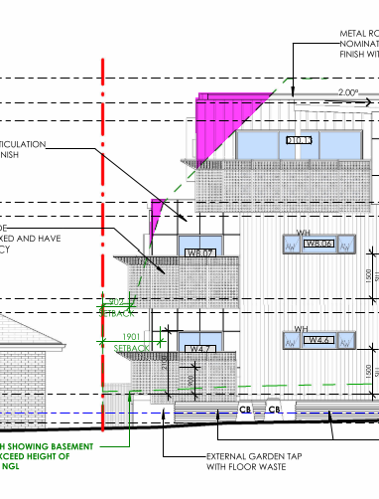  Before deciding on an application, the responsible authority must consider:  - Any relevant neighbourhood character objective, policy or statement set out in this scheme.  - The design response.  - The impact on the amenity of the habitable room windows and secluded private open space of existing dwellings.  - Whether the wall is opposite an existing or simultaneously constructed wall built to the boundary.  - Whether the wall abuts a side or rear lane.  With consideration to the decision guidelines of the objective, the variation is considered acceptable where:  - The relevant neighbourhood character objective in the Scheme is the IHDA which encourages upper storeys be recessed to reduce visual prominence. The proposal has recessed the upper storey from the ground and mid storey side wall such that its visual prominence when viewed for the dwelling on land adjoining to the north east will be significantly reduced.  - The design response lends itself to a 3 storey development in close proximity to the centre of the IHDA.  - The variation is situated on the south east side of the nearest affected dwelling and is recessed to allows sufficient light to the south east windows of the nearest dwelling.  - There is no existing or simultaneously constructed wall for consideration.  - There is no relevant side or rear lane.  The variation results in an acceptable outcome that meets the objective where the preferred character includes buildings of up to 3 storeys and the amenity impact on the adjoining dwelling is not unacceptable with consideration to the orientation and aspect of the dwelling to the street.

55.04-3 Daylight to windows objective  To allow adequate daylight into existing habitable room windows.  If a development meets standard B19, it is deemed to meet the objective for that standard.  Where standard B19 is met the decision guidelines for that standard do not apply to the application. | Standard B19  Buildings opposite an existing habitable room window should provide for a light court to the existing window that has a minimum area of 3 square metres and minimum dimension of 1 metre clear to the sky. The calculation of the area may include land on the abutting lot.  Walls or carports more than 3 metres in height opposite an existing habitable room window should be set back from the window at least 50 per cent of the height of the new wall if the wall is within a 55 degree arc from the centre of the existing window. The arc may be swung to within 35 degrees of the plane of the wall containing the existing window.  Where the existing window is above ground floor level, the wall height is measured from the floor level of the room containing the window. | Yes – Complies, with variation to Standard B19  The southwest wall of the development (2nd storey wall) is setback 7.76m from the windows at 1/36 Barrabool Rd, and scales at 7.5m from ngl requiring a setback of 3.75 in accordance with the standard. 3rd storey wall also complies.  The northeast wall of the development is setback 3.528m (2nd storey wall) from the windows at 32 Barrabool Rd, and scales at 7.6m from ngl requiring a setback of 3.8m being less than the Standard. This represents a 0.28m variation to Standard B19.  The northeast wall of the development is setback 5.11m (3rd storey wall) from the windows at 32 Barrabool Rd, and scales at 11.2m from ngl requiring a setback of 5.6m being less than the Standard. This represents a 0.49 metre variation to the standard.  Before deciding on an application, the responsible authority must consider:  - The design response.  - The extent to which the existing dwelling has provided for reasonable daylight access to its habitable rooms through the siting and orientation of its habitable room windows.  - The impact on the amenity of existing dwellings.  With consideration to the decision guidelines of the objective, the variation is considered acceptable where:  - The design response respects the preferred neighbourhood character of this IHDA.  - The window most likely to be affected on the north east side of the development is located under an eve within 1.89m of the site boundary but it retains well in excess of 1m clear to the sky (measured from the edge of the eave.  - The amenity impact on the existing dwelling is limited to the aspect from this single window. All other habitable room windows are unaffected.  It is considered that the modest variation to the Standard meets the objective.

55.04-5 Overshadowing open space objective  To ensure buildings do not significantly overshadow existing secluded private open space. | Standard B21  Where sunlight to the secluded private open space of an existing dwelling is reduced, at least 75 per cent, or 40 square metres with minimum dimension of 3 metres, whichever is the lesser area, of the secluded private open space should receive a minimum of five hours of sunlight between 9 am and 3 pm on 22 September.  If existing sunlight to the secluded private open space of an existing dwelling is less than the requirements of this standard, the amount of sunlight should not be further reduced. | Yes – Complies, with variation to Standard B21  The small areas of SPOS of the dwellings at 1/36 and 2/36 Barrabool Road to the south west of the site are already constrained and experience overshadowing from the dwelling and boundary fence currently on the subject site. The proposed development will alter the extent of shadowing in the early part of the day, resulting in a minor increase shown on the shadow diagrams for 9am and 10am.  However, the development has been carefully designed to provide a similar extent of shadowing from 11am onwards. The application proposes a variation to Standard B21 by introducing a reduced amount of sunlight to the minimum required.  Before deciding on an application, the responsible authority must consider:  - The design response.  - The impact on the amenity of existing dwellings or small second dwellings.  - Existing sunlight penetration to the secluded private open space of the existing dwelling or small second dwelling.  - The time of day that sunlight will be available to the secluded private open space of the existing dwelling or small second dwelling.  - The effect of a reduction in sunlight on the existing use of the existing secluded private open space.  With consideration to the decision guidelines of the objective, the variation is considered acceptable where:  - The design response respects the preferred neighbourhood character of this IHDA.  - The amenity of the affected dwellings is likely to be similar to pre-development, with altered areas of sunlight provided at all times of the day.  - The extent of additional overshadowing is not considered significant when compared to the extent of existing shadows cast at pre-development, and the times of the day when the proposal will provide some improvement in sunlight to SPOS.  - The existing SPOS areas will continue to provide for outdoor living activities whilst enjoying an acceptable extent of sunlight.  It is considered that the existing SPOS of adjoining dwellings will not be significantly overshadowed by the proposed development, in accordance with the objective.

55.07-1 Energy efficiency objectives  To achieve and protect energy efficient dwellings and buildings.  To ensure the orientation and layout of development reduce fossil fuel energy use and make appropriate use of daylight and solar energy.  To ensure dwellings achieve adequate thermal efficiency. | Standard B35  Buildings should be:  - Oriented to make appropriate use of solar energy.  - Sited and designed to ensure that the energy efficiency of existing dwellings on adjoining lots is not unreasonably reduced.  - Sited and designed to ensure that the performance of existing rooftop solar energy systems on dwellings on adjoining lots in a General Residential Zone, Neighbourhood Residential Zone or Township Zone are not unreasonably reduced. The existing rooftop solar energy system must exist at the date the application is lodged.  Living areas and private open space should be located on the north side of the development, if practicable.  Developments should be designed so that solar access to north-facing windows is optimised.  Dwellings located in a climate zone identified Table B4 in should not exceed the maximum NatHERS annual cooling load specified in the following table.  Refer Table B4 of Clause 55.07-1. | Yes – Complies, with variation to Standard B35  The apartments are appropriately oriented where practicable to benefit from solar access.  The NatHERS maximum cooling load MJ/M2 per annum for Climate zone 60 Tullamarine (includes Highton 3216) is 22. The BESS assessment nominates a maximum cooling load no greater than 20.  The development will result in some loss of performance of the rooftop solar system located at 1/36 Barrabool Road.  Before deciding on an application, the responsible authority must consider:  - The design response.  - The size, orientation and layout of the site.  - The existing amount of solar access to abutting properties.  - The availability of solar access to north-facing windows on the site.  - The annual cooling load for each dwelling.  - The extent to which an existing rooftop solar energy system on an adjoining lot is overshadowed by existing buildings or other permanent structures.  - Whether the existing rooftop solar energy system on an adjoining lot is appropriately located.  - The effect of overshadowing on an existing rooftop solar energy system on an adjoining lot.  The extent of performance loss has been quantified in relation to the life expectancy of the system and the limited extent of performance loss. A financial offer was made to the affected property owner to offset the loss as a reasonable response to the objective.

CLAUSE 56 – RESIDENTIAL SUBDIVISION:

This is an application to subdivide the apartments such that the apartments will exist on separate titles. In this case there is no need to assess the application against the provisions of Clause 56 as issues in relation to amenity, both on and off site, have been considered via the Clause 55 assessment, as has neighbourhood character.

It is recommended that a condition of any permit requires the apartment development be substantially completed (eg. to lock-up stage as a minimum) prior to the issue of statement of compliance so that an orderly planning outcome is achieved.

DECISION GUIDELINES OF CLAUSE 65:
Because a permit can be granted does not imply that a permit should or will be granted. The responsible authority must decide whether the proposal will produce acceptable outcomes in terms of the decision guidelines of this clause.

CLAUSE 65.01 – APPROVAL OF AN APPLICATION OR PLAN
The responsible authority must consider, as appropriate:

- The matters set out in section 60 of the Act.
- Any significant effects the environment, including the contamination of land, may have on the use or development.
- The Municipal Planning Strategy and the Planning Policy Framework.
- The purpose of the zone, overlay or other provision.
- Any matter required to be considered in the zone, overlay or other provision.
- The orderly planning of the area.
- The effect on the environment, human health and amenity of the area.
- The proximity of the land to any public land.
- Factors likely to cause or contribute to land degradation, salinity or reduce water quality.
- Whether the proposed development is designed to maintain or improve the quality of stormwater within and exiting the site.
- The extent and character of native vegetation and the likelihood of its destruction.
- Whether native vegetation is to be or can be protected, planted or allowed to regenerate.
- The degree of flood, erosion or fire hazard associated with the location of the land and the use, development or management of the land so as to minimise any such hazard.
- The adequacy of loading and unloading facilities and any associated amenity, traffic flow and road safety impacts.
- The impact the use or development will have on the current and future development and operation of the transport system.

CLAUSE 65.02 – APPROVAL OF AN APPLICATION TO SUBDIVIDE LAND
The responsible authority must consider, as appropriate:

- The suitability of the land for subdivision.
- The existing use and possible future development of the land and nearby land.
- The availability of subdivided land in the locality, and the need for the creation of further lots.
- The effect of development on the use or development of other land which has a common means of drainage.
- The subdivision pattern having regard to the physical characteristics of the land including existing vegetation.
- The density of the proposed development.
- The area and dimensions of each lot in the subdivision.
- The layout of roads having regard to their function and relationship to existing roads.
- The movement of pedestrians and vehicles throughout the subdivision and the ease of access to all lots.
- The provision and location of reserves for public open space and other community facilities.
- The staging of the subdivision.
- The design and siting of buildings having regard to safety and the risk of spread of fire.
- The provision of off-street parking.
- The provision and location of common property.
- The functions of any owners corporation.
- The availability and provision of utility services, including water, sewerage, drainage, electricity, and, where the subdivision is not a residential subdivision, gas.
- If the land is not sewered and no provision has been made for the land to be sewered, the capacity of the land to treat and retain all sewage and sullage within the boundaries of each lot.
- Whether, in relation to subdivision plans, native vegetation can be protected through subdivision and siting of open space areas.
- The impact the development will have on the current and future development and operation of the transport system.

Response
The application has been assessed against the decision guidelines of Clauses 65.01 and 65.02.
The development proposed is considered to produce acceptable outcomes in terms of the decision guidelines of the Scheme.

That the Responsible Authority having considered all matters which the Planning and Environment Act 1987, requires it to consider decides to issue a Notice of Decision to Grant a Planning Permit for Construction of Ten (10) Apartments, Multi-lot Subdivision, and Alteration of Access to a Road in a Transport Zone 2 generally in accordance with the plans submitted with the application, and subject to the following conditions:

Attachment 1

CLAUSE 55 ASSESSMENT TOOL – TWO OR MORE DWELLINGS ON A LOT AND RESIDENTIAL BUILDINGS

Date of Assessment: 1/03/2022. Updated 28/05/2024
Plans Assessed: 01/05/2024 (provided with s57A Amendment received 01/5/2024)
Permit Application Number: PP-935-2020

The following objectives apply to an application to:
- Construct a dwelling if there is at least one dwelling existing on the lot,
- Construct two or more dwellings on a lot,
- Extend a dwelling if there are two or more dwellings on the lot,
- Construct or extend a dwelling on common property, or
- Construct or extend a residential building,

in the Neighbourhood Residential Zone, General Residential Zone, Residential Growth Zone, Mixed Use Zone or Township Zone.

A development:
- Must meet all of the objectives of this clause that apply to the application.
- Should meet all of the standards of this clause that apply to the application.

If a development meets standard B6, B7, B8, B17, B18, B19, B20, B21, B22, B27, B28, B30 or B32, it is deemed to meet the objective for that standard.
Where standard B6, B7, B8, B17, B18, B19, B20, B21, B22, B27, B28, B30 or B32 is met the decision guidelines for that standard do not apply to the application.

The following objectives are current up to and including Amendment VC250 on 01/01/2024.

55.02-1 Neighbourhood character objectives  To ensure that the design respects the existing neighbourhood character or contributes to a preferred neighbourhood character.  To ensure that development responds to the features of the site and the surrounding area. | Standard B1  The design response must be appropriate to the neighbourhood and the site.  The proposed design must respect the existing or preferred neighbourhood character and respond to the features of the site. | Yes – Complies with Standard B1  The development responds to the preferred character of Highton Village Increased Housing Diversity Area by incorporating a contemporary mix of materials and finishes commonly found on new residential developments nearby. The 3 storey building includes a recessed upper storey form, extensive frontage glazing and landscaping within the front setback that responds both to the established landscape character, and the emerging character of townhouse, unit and apartment development anticipated by planning policy.
55.02-2 Residential policy objectives  To ensure that residential development is provided in accordance with any policy for housing in the Municipal Planning Strategy and the Planning Policy Framework.  To support medium densities in areas where development can take advantage of public transport and community infrastructure and services. | Standard B2  An application must be accompanied by a written statement to the satisfaction of the responsible authority that describes how the development is consistent with any relevant policy for housing in the Municipal Planning Strategy and the Planning Policy Framework. | Yes – Complies with Standard B2  As set out above, the application complies with the planning policy framework. The required written statement has been provided.
55.02-3 Dwelling diversity objective  To encourage a range of dwelling sizes and types in developments of ten or more dwellings. | Standard B3  Developments of ten or more dwellings should provide a range of dwelling sizes and types, including:  - Dwellings with a different number of bedrooms.  - At least one dwelling that contains a kitchen, bath or shower, and a toilet and wash basin at ground floor level. | Yes – Complies with Standard B3  Ten dwellings are proposed, comprising a mix of 2 and 3 bedrooms each, and 4 apartments accessible at ground floor level.
55.02-4 Infrastructure objectives  To ensure development is provided with appropriate utility services and infrastructure.  To ensure development does not unreasonably overload the capacity of utility services and infrastructure. | Standard B4  Development should be connected to reticulated services, including reticulated sewerage, drainage and electricity, if available.  Development should not unreasonably exceed the capacity of utility services and infrastructure, including reticulated services and roads.  In areas where utility services or infrastructure have little or no spare capacity, developments should provide for the upgrading of or mitigation of the impact on services or infrastructure. | Yes – Complies with Standard B4  The site is serviced by the required infrastructure and the application has been referred to the City’s Engineers who have not raised any concern about the ability of the site to be drained. Conditions of any permit cover off on this issue.
55.02-5 Integration with the street objective  To integrate the layout of development with the street. | Standard B5  Developments should provide adequate vehicle and pedestrian links that maintain or enhance local accessibility.  Development should be oriented to front existing and proposed streets.  High fencing in front of dwellings should be avoided if practicable.  Development next to existing public open space should be laid out to complement the open space. | Yes – Complies with Standard B5  The development is designed to address Barrabool Road, with pedestrian and vehicle links to the street provided.  There is no high front fencing proposed for this development.  Before deciding on an application, the responsible authority must consider:  - Any relevant neighbourhood character objective, policy or statement set out in this scheme.  - The design response.  The building entrance is enhanced by the proposed arbour and wayfinding elements at the south east frontage.
55.03-1 Street setback objective  To ensure that the setbacks of buildings from a street respect the existing or preferred neighbourhood character and make efficient use of the site. | Standard B6  Walls of buildings should be set back from streets:  - At least the distance specified in a schedule to the zone, or  - If no distance is specified in a schedule to the zone, the distance specified in Table B1.  Porches, pergolas and verandahs that are less than 3.6 metres high and eaves may encroach not more than 2.5 metres into the setbacks of this standard.  Refer Table B1 of Clause 55.03-1. | Yes – Complies with Standard B6  The front setback proposed measures 4.0m at the front wall of APT09, in accordance with Standard B6. Front setbacks to balconies at ground and first floor are not less than 4.0 metres in accordance with Standard B6.
55.03-2 Building height objective  To ensure that the height of buildings respects the existing or preferred neighbourhood character. | Standard B7  The maximum building height should not exceed the maximum height specified in the zone, schedule to the zone or an overlay that applies to the land.  If no maximum height is specified in the zone, schedule to the zone or an overlay, the maximum building height should not exceed 9 metres, unless the slope of the natural ground level at any cross section wider than 8 metres of the site of the building is 2.5 degrees or more, in which case the maximum building height should not exceed 10 metres. | Yes – Complies with Standard B7  The allowable maximum building height in this location is:  - the building height must not exceed 11 metres; and  - the building must contain no more than 3 storeys at any point (does not include basement).  Maximum height in this location is the vertical distance from the minimum floor level determined by the relevant drainage authority or floodplain management authority to the roof or parapet at any point.  Minimum floor level nominated by the FMA is 14.5m AHD, providing for a maximum building height of 25.5m AHD.  The maximum height proposed is 25.2m AHD resulting in a building height above the minimum floor level of 10.7 metres and complies with Standard B7.
55.03-3 Site coverage objective  To ensure that the site coverage respects the existing or preferred neighbourhood character and responds to the features of the site. | Standard B8  The site area covered by buildings should not exceed:  - The maximum site coverage specified in a schedule to the zone, or  - If no maximum site coverage is specified in a schedule to the zone, 60 per cent. | Yes – Complies with Standard B8  The site coverage of buildings is 57% percent of the site, which is less than the 70% allowed by the standard, and 65% practically achievable with consideration to the 35% garden area requirement for this site.
55.03-4 Permeability and stormwater management objectives  To reduce the impact of increased stormwater run-off on the drainage system.  To facilitate on-site stormwater infiltration.  To encourage stormwater management that maximises the retention and reuse of stormwater. | Standard B9  The site area covered by the pervious surfaces should be at least:  - The minimum area specified in a schedule to the zone, or  - If no minimum is specified in a schedule to the zone, 20 percent of the site.  The stormwater management system should be designed to:  - Meet the current best practice performance objectives for stormwater quality as contained in the Urban Stormwater - Best Practice Environmental Management Guidelines (Victorian Stormwater Committee, 1999).  - Contribute to cooling, improving local habitat and providing attractive and enjoyable spaces. | Yes – Complies with Standard B9  The site retains 23.3 per cent permeability, assisting in on site stormwater filtration.  A Stormwater Management Plan report has been provided which corresponds with the assessment plans which show suitably sized rainwater tanks to be located in the basement to meet best practice.
55.03-7 Safety objective  To ensure the layout of development provides for the safety and security of residents and property. | Standard B12  Entrances to dwellings and residential buildings should not be obscured or isolated from the street and internal accessways.  Planting which creates unsafe spaces along streets and accessways should be avoided.  Developments should be designed to provide good lighting, visibility and surveillance of car parks and internal accessways.  Private spaces within developments should be protected from inappropriate use as public thoroughfares. | Yes – Complies with Standard B12  The development is designed to provide for the safety and security of residents and property. All dwelling entrances are clearly visible from the street or internal accessway and private spaces within the development will be fenced.
55.03-9 Access objective  To ensure the number and design of vehicle crossovers respects the neighbourhood character. | Standard B14  The width of accessways or car spaces should not exceed:  - 33 per cent of the street frontage, or  - if the width of the street frontage is less than 20 metres, 40 per cent of the street frontage.  No more than one single-width crossover should be provided for each dwelling fronting a street.  The location of crossovers should maximise the retention of on-street car parking spaces.  The number of access points to a road in a Transport Zone 2 or a Transport Zone 3 should be minimised.  Developments must provide for access for service, emergency and delivery vehicles. | Yes – Complies with Standard B14  One 6.0m wide crossing is provided for the 19.81m wide frontage to the TRZ2 road, resulting in a total of 30.3 per cent of the frontage taken up with vehicle crossings, which complies with the standard.
55.03-10 Parking location objective  To provide convenient parking for resident and visitor vehicles.  To protect residents from vehicular noise within developments. | Standard B15  Car parking facilities should:  - Be reasonably close and convenient to dwellings and residential buildings.  - Be secure.  - Be well ventilated if enclosed.  Shared accessways or car parks of other dwellings and residential buildings should be located at least 1.5 metres from the windows of habitable rooms. This setback may be reduced to 1 metre where there is a fence at least 1.5 metres high or where window sills are at least 1.4 metres above the accessway. | Yes – Complies with Standard B15  Convenient parking is provided for residents and shared accessways are located at least 1.5 metres from the windows of habitable rooms.
55.04-1 Side and rear setbacks objective  To ensure that the height and setback of a building from a boundary respects the existing or preferred neighbourhood character and limits the impact on the amenity of existing dwellings.  If a development meets standard B17, it is deemed to meet the objective for that standard.  Where standard B17 is met the decision guidelines for that standard do not apply to the application. | Standard B17  A new building not on or within 200mm of a boundary should be set back from side or rear boundaries:  - At least the distance specified in a schedule to the zone, or  - If no distance is specified in a schedule to the zone, 1 metre, plus 0.3 metres for every metre of height over 3.6 metres up to 6.9 metres, plus 1 metre for every metre of height over 6.9 metres.  Sunblinds, verandahs, porches, eaves, fascias, gutters, masonry chimneys, flues, pipes, domestic fuel or water tanks, and heating or cooling equipment or other services may encroach not more than 0.5 metres into the setbacks of this standard.  Landings having an area of not more than 2 square metres and less than 1 metre high, stairways, ramps, pergolas, shade sails and carports may encroach into the setbacks of this standard. | Yes – Complies, with variation to Standard B17  The application proposes a variation to the side setback standard at the upper storey along the north east of the building as illustrated in purple shade below:  Before deciding on an application, the responsible authority must consider:  - Any relevant neighbourhood character objective, policy or statement set out in this scheme.  - The design response.  - The impact on the amenity of the habitable room windows and secluded private open space of existing dwellings.  - Whether the wall is opposite an existing or simultaneously constructed wall built to the boundary.  - Whether the wall abuts a side or rear lane.  With consideration to the decision guidelines of the objective, the variation is considered acceptable where:  - The relevant neighbourhood character objective in the Scheme is the IHDA which encourages upper storeys be recessed to reduce visual prominence. The proposal has recessed the upper storey from the ground and mid storey side wall such that its visual prominence when viewed for the dwelling on land adjoining to the north east will be significantly reduced.  - The design response lends itself to a 3 storey development in close proximity to the centre of the IHDA.  - The variation is situated on the south east side of the nearest affected dwelling and is recessed to allows sufficient light to the south east windows of the nearest dwelling.  - There is no existing or simultaneously constructed wall for consideration.  - There is no relevant side or rear lane.  The variation results in an acceptable outcome that meets the objective where the preferred character includes buildings of up to 3 storeys and the amenity impact on the adjoining dwelling is not unacceptable with consideration to the orientation and aspect of the dwelling to the street.
55.04-2 Walls on boundaries objective  To ensure that the location, length and height of a wall on a boundary respects the existing or preferred neighbourhood character and limits the impact on the amenity of existing dwellings.  If a development meets standard B18, it is deemed to meet the objective for that standard.  Where standard B18 is met the decision guidelines for that standard do not apply to the application. | Standard B18  A new wall constructed on or within 200mm of a side or rear boundary of a lot or a carport constructed on or within 1 metre of a side or rear boundary of lot should not abut the boundary:  - For a length of more than the distance specified in a schedule to the zone; or  - If no distance is specified in a schedule to the zone, for a length of more than:  - 10 metres plus 25 per cent of the remaining length of the boundary of an adjoining lot, or  - Where there are existing or simultaneously constructed walls or carports abutting the boundary on an abutting lot, the length of the existing or simultaneously constructed walls or carports,  whichever is the greater.  A new wall or carport may fully abut a side or rear boundary where slope and retaining walls or fences would result in the effective height of the wall or carport being less than 2 metres on the abutting property boundary.  A building on a boundary includes a building set back up to 200mm from a boundary.  The height of a new wall constructed on or within 200mm of a side or rear boundary or a carport constructed on or within 1 metre of a side or rear boundary should not exceed an average of 3.2 metres with no part higher than 3.6 metres unless abutting a higher existing or simultaneously constructed wall. | Not Applicable  No new walls on or within 200mm of a boundary, or carport within 1m of a boundary are proposed as part of this application.
55.04-3 Daylight to windows objective  To allow adequate daylight into existing habitable room windows.  If a development meets standard B19, it is deemed to meet the objective for that standard.  Where standard B19 is met the decision guidelines for that standard do not apply to the application. | Standard B19  Buildings opposite an existing habitable room window should provide for a light court to the existing window that has a minimum area of 3 square metres and minimum dimension of 1 metre clear to the sky. The calculation of the area may include land on the abutting lot.  Walls or carports more than 3 metres in height opposite an existing habitable room window should be set back from the window at least 50 per cent of the height of the new wall if the wall is within a 55 degree arc from the centre of the existing window. The arc may be swung to within 35 degrees of the plane of the wall containing the existing window.  Where the existing window is above ground floor level, the wall height is measured from the floor level of the room containing the window. | Yes – Complies, with variation to Standard B19  The southwest wall of the development (2nd storey wall) is setback 7.76m from the windows at 1/36 Barrabool Rd, and scales at 7.5m from ngl requiring a setback of 3.75 in accordance with the standard. 3rd storey wall also complies.  The northeast wall of the development is setback 3.528m (2nd storey wall) from the windows at 32 Barrabool Rd, and scales at 7.6m from ngl requiring a setback of 3.8m being less than the Standard. This represents a 0.28m variation to Standard B19.  The northeast wall of the development is setback 5.11m (3rd storey wall) from the windows at 32 Barrabool Rd, and scales at 11.2m from ngl requiring a setback of 5.6m being less than the Standard. This represents a 0.49 metre variation to the standard.  Before deciding on an application, the responsible authority must consider:  - The design response.  - The extent to which the existing dwelling has provided for reasonable daylight access to its habitable rooms through the siting and orientation of its habitable room windows.  - The impact on the amenity of existing dwellings.  With consideration to the decision guidelines of the objective, the variation is considered acceptable where:  - The design response respects the preferred neighbourhood character of this IHDA.  - The window most likely to be affected on the north east side of the development is located under an eve within 1.89m of the site boundary but it retains well in excess of 1m clear to the sky (measured from the edge of the eave.  - The amenity impact on the existing dwelling is limited to the aspect from this single window. All other habitable room windows are unaffected.  It is considered that the modest variation to the Standard meets the objective.
55.04-4 North facing windows objective  To allow adequate solar access to existing north-facing habitable room windows. | Standard B20  If a north-facing habitable room window of an existing dwelling is within 3 metres of a boundary on an abutting lot, a building should be setback from the boundary 1 metre, plus 0.6 metres for every metre of height over 3.6 metres up to 6.9 metres, plus 1 metre for every metre of height over 6.9 metres, for a distance of 3 metres from the edge of each side of the window. A north-facing window is a window with an axis perpendicular to its surface oriented north 20 degrees west to north 30 degrees east. | Not Applicable  There are no north facing habitable room windows on abutting lots that require consideration.
55.04-5 Overshadowing open space objective  To ensure buildings do not significantly overshadow existing secluded private open space. | Standard B21  Where sunlight to the secluded private open space of an existing dwelling is reduced, at least 75 per cent, or 40 square metres with minimum dimension of 3 metres, whichever is the lesser area, of the secluded private open space should receive a minimum of five hours of sunlight between 9 am and 3 pm on 22 September.  If existing sunlight to the secluded private open space of an existing dwelling is less than the requirements of this standard, the amount of sunlight should not be further reduced. | Yes – Complies, with variation to Standard B21  The small areas of SPOS of the dwellings at 1/36 and 2/36 Barrabool Road to the south west of the site are already constrained and experience overshadowing from the dwelling and boundary fence currently on the subject site. The proposed development will alter the extent of shadowing in the early part of the day, resulting in a minor increase shown on the shadow diagrams for 9am and 10am.  However, the development has been carefully designed to provide a similar extent of shadowing from 11am onwards. The application proposes a variation to Standard B21 by introducing a reduced amount of sunlight to the minimum required.  Before deciding on an application, the responsible authority must consider:  - The design response.  - The impact on the amenity of existing dwellings or small second dwellings.  - Existing sunlight penetration to the secluded private open space of the existing dwelling or small second dwelling.  - The time of day that sunlight will be available to the secluded private open space of the existing dwelling or small second dwelling.  - The effect of a reduction in sunlight on the existing use of the existing secluded private open space.  With consideration to the decision guidelines of the objective, the variation is considered acceptable where:  - The design response respects the preferred neighbourhood character of this IHDA.  - The amenity of the affected dwellings is likely to be similar to pre-development, with altered areas of sunlight provided at all times of the day.  - The extent of additional overshadowing is not considered significant when compared to the extent of existing shadows cast at pre-development, and the times of the day when the proposal will provide some improvement in sunlight to SPOS.  - The existing SPOS areas will continue to provide for outdoor living activities whilst enjoying an acceptable extent of sunlight.  It is considered that the existing SPOS of adjoining dwellings will not be significantly overshadowed by the proposed development, in accordance with the objective.
55.04-6 Overlooking objective  To limit views into existing secluded private open space and habitable room windows. | Standard B22  A habitable room window, balcony, terrace, deck or patio should be located and designed to avoid direct views into the secluded private open space of an existing dwelling within a horizontal distance of 9 metres (measured at ground level) of the window, balcony, terrace, deck or patio. Views should be measured within a 45 degree angle from the plane of the window or perimeter of the balcony, terrace, deck or patio, and from a height of 1.7 metres above floor level.  A habitable room window, balcony, terrace, deck or patio with a direct view into a habitable room window of existing dwelling within a horizontal distance of 9 metres (measured at ground level) of the window, balcony, terrace, deck or patio should be either:  - Offset a minimum of 1.5 metres from the edge of one window to the edge of the other.  - Have sill heights of at least 1.7 metres above floor level.  - Have fixed, obscure glazing in any part of the window below 1.7 metre above floor level.  - Have permanently fixed external screens to at least 1.7 metres above floor level and be no more than 25 per cent transparent.  Obscure glazing in any part of the window below 1.7 metres above floor level may be openable provided that there are no direct views as specified in this standard.  Screens used to obscure a view should be:  - Perforated panels or trellis with a maximum of 25 per cent openings or solid translucent panels.  - Permanent, fixed and durable.  - Designed and coloured to blend in with the development.  This standard does not apply to a new habitable room window, balcony, terrace, deck or patio which faces a property boundary where there is a visual barrier at least 1.8 metres high and the floor level of the habitable room, balcony, terrace, deck or patio is less than 0.8 metres above ground level at the boundary. | Yes – Complies with Standard B22  The development is designed to meet the requirements of the standard with overlooking into existing secluded private open space areas and habitable room windows limited in accordance with the standard.  Proposed habitable rooms and balconies that are within 9m of habitable rooms and SPOS of adjoining dwellings are screened by fixed louvres, privacy mesh to 1.7m above floor level, or lower level roof sections as shown below.  Were a permit to be granted, an amended plans conditions is recommended to screen the following windows with treatments to limit overlooking:  - APT 04 and APT 08 Kitchen Window  - All windows to be treated with ‘fixed louvre’ window hoods to be illustrated on elevations to a minimum height of 1.7m above floor level.
55.04-7 Internal views objective  To limit views into the secluded private open space and habitable room windows of dwellings and residential buildings within a development. | Standard B23  Windows and balconies should be designed to prevent overlooking of more than 50 per cent of the secluded private open space of a lower-level dwelling or residential building directly below and within the same development. | Yes – Complies with Standard B23  Internal views have been considered in the design solution and there is no internal overlooking.
55.05-3 Daylight to new windows objective  To allow adequate daylight into new habitable room windows. | Standard B27  A window in a habitable room should be located to face:  - An outdoor space clear to the sky or a light court with a minimum area of 3 square metres and minimum dimension of 1 metre clear to the sky, not including land on an abutting lot, or  - A verandah provided it is open for at least one third of its perimeter, or  - A carport provided it has two or more open sides and is open for at least one third of its perimeter. | Yes – Complies with Standard B27  All habitable room windows face an outdoor space of the required dimensions, allowing light into habitable rooms.
55.05-4 Private open space objective  To provide adequate private open space for the reasonable recreation and service needs of residents. | Standard B28  A dwelling or residential building should have private open space of an area and dimensions specified in the schedule to the zone.  If no area or dimensions are specified in the schedule to the zone, a dwelling or residential building should have private open space consisting of:  - An area of 40 square metres, with one part of the private open space to consist of secluded private open space at the side or rear of the dwelling or residential building with a minimum area of 25 square metres, a minimum dimension of 3 metres and convenient access from a living room, or  - A balcony of 8 square metres with a minimum width of 1.6 metres and convenient access from a living room, or  - A roof-top area of 10 square metres with a minimum width of 2 metres and convenient access from a living room. | Yes – Complies with Standard B28  All apartments are provided with balconies in excess of the minimum 8 sq/m and 1.6m dimension, and with convenient access to living rooms in accordance with the standard.
55.05-5 Solar Access to Open Space  To allow solar access into the secluded private open space of new dwellings and residential buildings. | Standard B29  The private open space should be located on the north side of the dwelling or residential building, if appropriate.  The southern boundary of secluded private open space should be set back from any wall on the north of the space at least (2+0.9h) metres, where ‘h’ is the height of the wall. | Yes – Complies with Standard B29  The proposed secluded private open space receives adequate solar access and complies with the setback requirement of the standard.
55.06-1 Design Detail  To encourage design detail that respects the existing or preferred neighbourhood character. | Standard B31  The design of buildings, including:  - Façade articulation and detailing,  - Window and door proportions,  - Roof form, and  - Verandahs, eaves and parapets,  - should respect the existing or preferred neighbourhood character.  Garages and carports should be visually compatible with the development and the existing or preferred neighbourhood character. | Yes – Complies with Standard B31  The proposed development is considered to respect the preferred neighbourhood character through the appropriate use and design of façade articulation and detailing, window and door proportions, roof forms, and verandahs, eaves and parapets.  The basement garage entrance is considered visually compatible with the development and the preferred neighbourhood character.
55.06-2 Front Fences  To encourage front fence design that respects the existing or preferred neighbourhood character. | Standard B32  A front fence within 3 metres of a street should not exceed:  - The maximum height specified in a schedule to the zone, or  - If no maximum height is specified in a schedule to the zone, the maximum height specified in Table B3.  Refer Table B3 of Clause 55.06-2. | Not Applicable  No front fence is proposed as part of this permit application.
55.06-3 Common Property  To ensure that communal open space, car parking, access areas and site facilities are practical, attractive and easily maintained.  To avoid future management difficulties in areas of common ownership. | Standard B33  Development should clearly delineate public, communal and private areas.  Common property, where provided, should be functional and capable of efficient management. | Yes – Complies with Standard B33  The common property area provided as part of this development is practical and could easily be maintained.
55.06-4 Site Services  To ensure that site services can be installed and easily maintained.  To ensure that site facilities are accessible, adequate and attractive. | Standard B34  The design and layout of dwellings and residential buildings should provide sufficient space (including easements where required) and facilities for services to be installed and maintained efficiently and economically.  Bin and recycling enclosures, mailboxes and other site facilities should be adequate in size, durable, waterproof and blend in with the development.  Bin and recycling enclosures should be located for convenient access by residents.  Mailboxes should be provided and located for convenient access as required by Australia Post. | Yes – Complies with Standard B34  The dwelling layout and design provides for sufficient space and facilities for services to be installed and maintained. Bin and recycling enclosures, mailboxes, clotheslines, and other site facilities have been conveniently located and will blend in with the development and located for convenient access.

Clause 55.07 APARTMENT DEVELOPMENTS

In addition to Clause 55.01 to 55.05 (inclusive), the following Clause 55.07-1 to 55.07-19 (inclusive) apply only:
- To construct or extend an apartment development, or
- To construct or extend a dwelling in or forming part of an apartment development.

These provisions do not apply to an application to construct or extend a development of five or more storeys, excluding a basement or to construct or extend a dwelling in a development of five or more storeys, excluding a basement.

55.07-1 Energy efficiency objectives  To achieve and protect energy efficient dwellings and buildings.  To ensure the orientation and layout of development reduce fossil fuel energy use and make appropriate use of daylight and solar energy.  To ensure dwellings achieve adequate thermal efficiency. | Standard B35  Buildings should be:  - Oriented to make appropriate use of solar energy.  - Sited and designed to ensure that the energy efficiency of existing dwellings on adjoining lots is not unreasonably reduced.  - Sited and designed to ensure that the performance of existing rooftop solar energy systems on dwellings on adjoining lots in a General Residential Zone, Neighbourhood Residential Zone or Township Zone are not unreasonably reduced. The existing rooftop solar energy system must exist at the date the application is lodged.  Living areas and private open space should be located on the north side of the development, if practicable.  Developments should be designed so that solar access to north-facing windows is optimised.  Dwellings located in a climate zone identified Table B4 in should not exceed the maximum NatHERS annual cooling load specified in the following table.  Refer Table B4 of Clause 55.07-1. | Yes – Complies, with variation to Standard B35  The apartments are appropriately oriented where practicable to benefit from solar access.  The NatHERS maximum cooling load MJ/M2 per annum for Climate zone 60 Tullamarine (includes Highton 3216) is 22. The BESS assessment nominates a maximum cooling load no greater than 20.  The development will result in some loss of performance of the rooftop solar system located at 1/36 Barrabool Road.  Before deciding on an application, the responsible authority must consider:  - The design response.  - The size, orientation and layout of the site.  - The existing amount of solar access to abutting properties.  - The availability of solar access to north-facing windows on the site.  - The annual cooling load for each dwelling.  - The extent to which an existing rooftop solar energy system on an adjoining lot is overshadowed by existing buildings or other permanent structures.  - Whether the existing rooftop solar energy system on an adjoining lot is appropriately located.  - The effect of overshadowing on an existing rooftop solar energy system on an adjoining lot.  The extent of performance loss has been quantified in relation to the life expectancy of the system and the limited extent of performance loss. A financial offer was made to the affected property owner to offset the loss as a reasonable response to the objective.
55.07-2 Communal open space objective  To provide communal open space that meets the recreation and amenity needs of residents.  To ensure that communal open space is accessible, functional, and is easily maintained.  To ensure that communal open space is integrated with the layout of the development and enhances resident amenity. | Standard B36  A development of 10 or more dwellings should provide a minimum area of communal outdoor open space of 30 square metres.  If a development contains 13 or more dwellings, the development should also provide an additional minimum area of communal open space of 2.5 square metres per dwelling or 220 square metres,  whichever is the lesser. This additional area may be indoors or outdoors and consist of multiple separate areas of communal open space.  Each area of communal open space should be:  - Accessible to all residents.  - A useable size, shape and dimension.  - Capable of efficient management.  - Be located to:  - Provide passive surveillance opportunities, where appropriate.  - Provide outlook for as many dwellings as practicable.  - Avoid overlooking into habitable rooms and private open space of new dwellings.  - Minimise noise impacts to new and existing dwellings.  Any area of communal outdoor open space should be landscaped and include canopy cover and trees. | Yes – Complies with Standard B36  More than 112 sq/m of communal open space is located at the rear of the development.
55.07-3 Solar access to communal outdoor open space objective  To allow solar access into communal outdoor open space. | Standard B37  The communal outdoor open space should be located on the north side of a building, if appropriate.  At least 50 per cent or 125 square metres, whichever is the lesser, of the primary communal outdoor open space should receive a minimum of two hours of sunlight between 9am and 3pm on 21 June. | Yes – Complies with Standard B37  Shadow drawings submitted with the application shows that in excess of 50% of the communal open space will receive sunlight between 12pm and 3pm on 21 June in accordance with Standard B37.
55.07-4 Landscaping objective  To provide landscaping that supports the existing or preferred urban context of the area and reduces the visual impact of buildings on the streetscape.  To preserve existing canopy cover and support the provision of new canopy cover.  To ensure landscaping is climate responsive, supports biodiversity, wellbeing and amenity and reduces urban heat. | Standard B38  Development should retain existing trees and canopy cover.  Development should provide for the replacement of any significant trees that have been removed in the 12 months prior to the application being made.  Development should:  - Provide the canopy cover and deep soil areas specified in Table B5. Existing trees can be used to meet the canopy cover requirements of Table B5.  - Provide canopy cover through canopy trees that are:  - Located in an area of deep soil specified in Table B6. Where deep soil cannot be provided trees should be provided in planters specified in Table B6.  - Consistent with the canopy diameter and height at maturity specified in Table B7.  - Located in communal outdoor open space or common areas or street frontages.  - Comprise smaller trees, shrubs and ground cover, including flowering native species.  - Include landscaping, such as climbing plants or smaller plants in planters, in the street frontage and in outdoor areas, including communal outdoor open space.  - Shade outdoor areas exposed to summer sun through landscaping or shade structures and use paving and surface materials that lower surface temperatures and reduce heat absorption.  - Be supported by irrigation systems which utilise alternative water sources such as rainwater, stormwater and recycled water.  - Protect any predominant landscape features of the area.  - Take into account the soil type and drainage patterns of the site.  - Provide a safe, attractive and functional environment for residents.  - Specify landscape themes, vegetation (location and species), irrigation systems, paving and lighting.  Refer Table B5, B6 and B7 of Clause 55.07-4. | Yes – Complies with Standard B38  Canopy cover required of 5% of 993.72 = 49.7 sq/m  Min 1 x Type A tree (4m diameter, 6 metres high)  Indicative landscape plans show canopy cover can be achieved.  Were a permit to be granted it is recommended that a detailed landscape plan include a calculation of canopy tree coverage area of not less than 49.7 sq/m in compliance with Standard B38.
55.07-5 Integrated water and stormwater management objectives  To encourage the use of alternative water sources such as rainwater, stormwater and recycled water.  To facilitate stormwater collection, utilisation and infiltration within the development.  To encourage development that reduces the impact of stormwater run-off on the drainage system and filters sediment and waste from stormwater prior to discharge from the site. | Standard B39  Buildings should be designed to collect rainwater for non-drinking purposes such as flushing toilets, laundry appliances and garden use.  Buildings should be connected to a non-potable dual pipe reticulated water supply, where available from the water authority.  The stormwater management system should be:  - Designed to meet the current best practice performance objectives for stormwater quality as contained in the Urban Stormwater - Best Practice Environmental Management Guidelines (Victorian Stormwater Committee, 1999).  - Designed to maximise infiltration of stormwater, water and drainage of residual flows into permeable surfaces, tree pits and treatment areas. | Yes – Complies with Standard B39  The stormwater management system has been designed for appropriate retention and reuse in accordance with Standard B39.
55.07-6 Access objective  To ensure that vehicle crossovers are designed and located to provide safe access for pedestrians, cyclists and other vehicles.  To ensure that vehicle crossovers are designed and located to minimise visual impact. | Standard B40  Vehicle crossovers should be minimised.  Car parking entries should be consolidated, minimised in size, integrated with the façade and where practicable located at the side or rear of the building.  Pedestrian and cyclist access should be clearly delineated from vehicle access.  The location of crossovers should maximise pedestrian safety and the retention of on-street car parking spaces and street trees.  Development must provide access for service, emergency and delivery vehicles. | Yes – Complies with Standard B40  Site access for vehicles and pedestrians have been provided in accordance with Standard B40.
55.07-7 Noise impacts objective  To contain noise sources in developments that may affect existing dwellings.  To protect residents from external and internal noise sources. | Standard 41  Noise sources, such as mechanical plants should not be located near bedrooms of immediately adjacent existing dwellings.  The layout of new dwellings and buildings should minimise noise transmission within the site.  Noise sensitive rooms (such as living areas and bedrooms) should be located to avoid noise impacts from mechanical plants, lifts, building services, non-residential uses, car parking, communal areas and other dwellings.  New dwellings should be designed and constructed to include acoustic attenuation measures to reduce noise levels from off-site noise sources.  Buildings within a noise influence area specified in Table B8 should be designed and constructed to achieve the following noise levels:  - Not greater than 35dB(A) for bedrooms, assessed as an LAeq,8h from 10pm to 6am.  - Not greater than 40dB(A) for living areas, assessed LAeq,16h from 6am to 10pm.  Buildings, or part of a building screened from a noise source by an existing solid structure, or the natural topography of the land, do not need to meet the specified noise level requirements.  Noise levels should be assessed in unfurnished rooms with a finished floor and the windows closed.  Refer Table B8 of Clause 55.07-7. | Yes – Complies with Standard B41  There are no external noise sources that require consideration.  Noise sensitive rooms are located away from mechanical plant, including the lift, and the site is not within a nominated noise influence area.
55.07-8 Accessibility objective  To ensure the design of dwellings meets the needs of people with limited mobility | Standard 42  At least 50 per cent of dwellings should have:  - A clear opening width of at least 850mm at the entrance to the dwelling and main bedroom.  - A clear path with a minimum width of 1.2 metres that connects the dwelling entrance to the main bedroom, an adaptable bathroom and the living area.  - A main bedroom with access to an adaptable bathroom.  - At least one adaptable bathroom that meets all of the requirements of either Design A or Design B specified in Table B9.  Refer Table B9 of Clause 55.07-8. | Yes – Complies with Standard B42  At least 50 percent of apartments are provided with accessible entries with clear paths to accessible bathrooms in accordance with the standard.  Of the 10 apartments proposed, 6 have been designed to allow for relative convenient adaption as required by this standard. Apartments 02, 04, 06, 08, 09 and 10 have adaptable layouts.
55.07-9 Private open space objective  To provide adequate private open space for the reasonable recreation and service needs of residents. | Standard 43  A dwelling should have private open space consisting of at least one of the following:  - An area at ground level of at least 25 square metres, with a minimum dimension of 3 metres and convenient access from a living room.  - A balcony with at least the area and dimensions specified in Table B10 and convenient access from a living room. If a cooling or heating unit is located on a balcony, the minimum balcony area specified in Table B10 should be increased by at least 1.5 square metres.  - An area on a podium or other similar base of at least 15 square metres, with a minimum dimension of 3 metres and convenient access from a living room.  - An area on a roof of at least 10 square metres, with a minimum dimension of 2 metres and convenient access from a living room.  Refer Table B10 of Clause 55.07-9. | Yes – Complies with Standard B43  Each proposed apartment oriented to the north (between north 20 degrees west to north 30 degrees east) is provided with a balcony of not less than 8 sq/m and minimum dimension of not less than 1.7 metres.  Each proposed apartment oriented to the south (between south 20 degrees west to south 30 degrees east) is provided with a balcony of not less than 8 sq/m and minimum dimension of not less than 1.2 metres.  Each 2 bedroom apartment oriented east (between north 30 degrees east to south 30 degrees east) or west (between north 20 degrees west to south 20 degrees west) is provided with a balcony of not less than 8 sq/m and minimum dimension of 2 metres.  Each 3 or more bedroom apartment oriented east (between north 30 degrees east to south 30 degrees east) or west (between north 20 degrees west to south 20 degrees west) is provided with a balcony of not less than 12 sq/m and minimum dimension of 2.4 metres.
55.07-10 Storage objective  To provide adequate storage facilities for each dwelling. | Standard B44  Each dwelling should have convenient access to usable and secure storage space.  The total minimum storage space (including kitchen, bathroom and bedroom storage) should meet the requirements specified in Table B11.  Refer Table B11 of Clause 55.07-10. | Yes – Complies with Standard B44  Each 2 bedroom apartment is provided with not less than 14 cubic metres of useable and secure storage, including not less than 9 cubic metres of combined kitchen, bathroom and bedroom storage within the dwelling.  Each 3 or more bedroom apartment is provided with not less than 18 cubic metres of useable and secure storage, including not less than 12 cubic metres of combined kitchen, bathroom and bedroom storage within the dwelling.  A storage location plan has been provided to show the location and dimensions of storage facilities.
55.07-11 Waste and recycling objectives  To ensure dwellings are designed to encourage waste recycling.  To ensure that waste and recycling facilities are accessible, adequate and attractive.  To ensure that waste and recycling facilities are designed and managed to minimise impacts on residential amenity, health and the public realm | Standard B45  Developments should include dedicated areas for:  - Waste and recycling enclosures which are:  - Adequate in size, durable, waterproof and blend in with the development.  - Adequately ventilated.  - Located and designed for convenient access by residents and made easily accessible to people with limited mobility.  - Adequate facilities for bin washing. These areas should be adequately ventilated.  - Collection, separation and storage of waste and recyclables, including where appropriate opportunities for on-site management of food waste through composting or other waste recovery as appropriate.  - Collection, storage and reuse of garden waste, including opportunities for on-site treatment, where appropriate, or off-site removal for reprocessing.  - Adequate circulation to allow waste and recycling collection vehicles to enter and leave the site without reversing.  - Adequate internal storage space within each dwelling to enable the separation of waste, recyclables and food waste where appropriate.  - Waste and recycling management facilities should be design and managed in accordance with a Waste Management Plan approved by the responsible authority and:  - Be designed to meet the better practice design options specified in Waste Management and Recycling in Multi-unit Developments (Sustainability Victoria, 2019).  - Protect public health and amenity of residents and adjoining premises from the impacts of odour, noise and hazards associated with waste collection vehicle movements. | Yes – Complies with Standard B45  A waste Management Plan has ben provided demonstrating that the development meets the requirements of Standard B45.
55.07-12 Functional layout objective  To ensure dwellings provide functional areas that meet the needs of residents. | Standard 46  Bedrooms should:  - Meet the minimum internal room dimensions specified in Table B12.  - Provide an area in addition to the minimum internal room dimensions to accommodate a wardrobe.  Refer Table B12 of Clause 55.07-12.  Living areas (excluding dining and kitchen areas) should meet the minimum internal room dimensions specified in Table B13.  Refer Table B13 of Clause 55.07-12. | Yes – Complies with Standard B46  All apartments are provided with a main bedroom with a width and depth of not less than 3.0m x 3.4m, and other bedrooms of not less than 3.0m x 3.0m and all excluding areas provided for a wardrobe.  All 2 or more bedroom apartments are provided with a living area (excluding dining and kitchen areas) with an internal room width of not less than 3.6m and area of not less than 12 sq/m.
55.07-13 Room depth objective  To allow adequate daylight into single aspect habitable rooms. | Standard B47  Single aspect habitable rooms should not exceed a room depth of 2.5 times the ceiling height.  The depth of a single aspect, open plan, habitable room may be increased to 9 metres if all the following requirements are met:  - The room combines the living area, dining area and kitchen.  - The kitchen is located furthest from the window.  - The ceiling height is at least 2.7 metres measured from finished floor level to finished ceiling level. This excludes where services are provided above the kitchen.  The room depth should be measured from the external surface of the habitable room window to the rear wall of the room. | Yes – Complies with Standard B47  All single aspect habitable rooms with a ceiling height of at least 2.7 metres have a maximum room depth of not more than 9 metres in accordance with Standard B47.
55.07-14 Windows objective  To allow adequate daylight into new habitable room windows. | Standard B48  Habitable rooms should have a window in an external wall of the building.  A window may provide daylight to a bedroom from a smaller secondary area within the bedroom where the window is clear to the sky.  The secondary area should be:  - A minimum width of 1.2 metres.  - A maximum depth of 1.5 times the width, measured from the external surface of the window. | Yes – Complies with Standard B48  All habitable rooms have windows in external walls and clear to the sky and in accordance with the Standard B48.
55.07-15 Natural ventilation objectives  To encourage natural ventilation of dwellings.  To allow occupants to effectively manage natural ventilation of dwellings. | Standard B49  The design and layout of dwellings should maximise openable windows, doors or other ventilation devices in external walls of the building, where appropriate.  At least 40 per cent of dwellings should provide effective cross ventilation that has:  - A maximum breeze path through the dwelling of 18 metres.  - A minimum breeze path through the dwelling of 5 metres  - Ventilation openings with approximately the same area.  The breeze path is measured between the ventilation openings on different orientations of the dwelling. | Yes – Complies with Standard B49  All apartments are provided with cross ventilation in accordance with the Standard.
55.07-16 Building entry and circulation objectives  To provide each dwelling and building with its own sense of identity.  To ensure the internal layout of buildings provide for the safe, functional and efficient movement of residents.  To ensure internal communal areas provide adequate access to daylight and natural ventilation. | Standard B50  Entries to dwellings and buildings should:  - Be visible and easily identifiable.  - Provide shelter, a sense of personal address and a transitional space around the entry.  The layout and design of buildings should:  - Clearly distinguish entrances to residential and non-residential areas.  - Provide windows to building entrances and lift areas.  - Provide visible, safe and attractive stairs from the entry level to encourage use by residents.  - Provide common areas and corridors that:  - Include at least one source of natural light and natural ventilation.  - Avoid obstruction from building services.  - Maintain clear sight lines. | Yes – Complies with Standard B50  The building entry and common areas are provided in accordance with the Standard.
55.07-17 Integration with the street objective  To integrate the layout of development with the street.  To support development that activates street frontages. | Standard B51  Development should be oriented to front existing and proposed streets.  Along street frontages, development should:  - Incorporate pedestrian entries, windows, balconies or other active spaces.  - Limit blank walls.  - Limit high front fencing, unless consistent with the existing urban context.  - Provide low and visually permeable front fences, where proposed.  - Conceal car parking and internal waste collection areas from the street.  Development next to existing public open space should be designed to complement the open space and facilitate passive surveillance. | Yes – Complies with Standard B51  The layout of the development incorporates design elements that enhance integration with the street in accordance with the Standard.
55.07-18 Site services objective  To ensure that site services are accessible and can be easily installed and maintained.  To ensure that site services and facilities are visually integrated into the building design or landscape. | Standard B52  Development should provide adequate space (including easements where required) for site services to be installed and maintained efficiently and economically.  Meters and utility services should be designed as an integrated component of the building or landscape.  Mailboxes and other site facilities should be adequate in size, durable, weather-protected, located for convenient access and integrated into the overall design of the development. | Yes – Complies with Standard B52  All required site services are provided in accordance with the Standard.
55.07-19 External walls and materials objective  To ensure external walls use materials appropriate to the existing urban context or preferred future development of the area.  To ensure external walls endure and retain their attractiveness. | Standard B53  External walls should be finished with materials that:  - Do not easily deteriorate or stain.  - Weather well over time.  - Are resilient to the wear and tear from their intended use.  External wall design should facilitate safe and convenient access for maintenance. | Yes – Complies with Standard B53  Cladding materials are durable, attractive, and respectful of the urban context in accordance with the Standard.

2.2. | 26 Hicks Street, LARA

Application No: | PP-1585-2021
Applicant: | Ashmark Investments Pty Ltd
Subject Land: | 26 Hicks Street, LARA
Zone: | Commercial 2 Zone (C2Z)
Overlays: | N/A
Existing Use: | Dwelling
Proposed Use: | Development of a Multi Storey Building, Use of the Land for a Shop, Internally Illuminated Sign and a Reduction of Car Parking

SUMMARY

- The site is located at 26 Hicks Street, Lara, opposite the Lara Train Station. The site is located within a Commercial 2 Zone and the site is not covered by any Overlays.

- The site contains an existing dwelling and has a street frontage of 15 metres and a side boundary of 57 metres. The site has a total area of 882m2.

More information on site detail is located within the Site/ Locality Section of this report.

- The application is for a commercial development within a Commercial 2 Zone.

- The application also proposes to display internally illuminated signage, seeks a reduction of the standard car parking requirements and to use the land for a shop.

- It is noted that the food and drink premises and the office use does not require planning permission in accordance with the planning scheme requirements.

- The height of building has a maximum height of 11.6 metres and contains three storeys.

- The total number of car parking spaces provided is 49 car parking spaces.

- A total of 13 statutory car spaces are required to be reduced from the standard requirement as part of this application for the development (the standard requirement is for 62 statutory car spaces).

- The car parking is located within the basement level. Car parking within the basement is includes the provisions of mechanical stackers.

- Access to/from the site is provided to/from a 5.5m single crossover from Hicks Street.

More information is within the Proposal Section of this report.

- The application was on public notice three times throughout the application process.
This was undertaken via a sign on site, letters to the adjoining owners and occupiers as well as emailed directly to objectors during the additional notice periods. The application was available on Council’s website during this time. The public notice outcome can be summarised as follows:

- Two (2) letters of support were received.
- Four (4) objections were withdrawn during the process, including from V/Line, VicTrack and Department of Transport.
- A total of 125 objections were submitted to Council.

More information is within the Public Notice Section of this report.

- The application was externally referred to the department of Transport, Fire Services Victoria (FRV) and Vic Track – all of these referrals did not object to the proposal.

- The proposal was internally referred to the following Departments at Council – Engineering, Waste, Environmental Sustainable Development and Urban Design – the internal departments do not object to the proposal subject to conditions of permit.

- The application was assessed against the relevant parts of the Greater Geelong Planning Scheme including the following:

- Municipal Planning Strategy
- Planning Policy Framework
- Commercial 2 Zone
- Clause 52.05 Signs
- Clause 52.06 Car Parking
- Clause 52.34 Bicycle Facilities

- On balance, the application was assessed and considered to comply with the relevant
policies.

- Having considered all the relevant matters within the Planning Scheme, the recommendation of the officers is to issue a Notice of Decision for a planning permit, subject to the conditions outlined within the Recommendation Section of this report.

More information is included in the Zone, Policy and Particular Provisions of this report.

ALTERNATIVE RECOMMENDATION

Moved: Cr Aitken Seconded: Cr Nelson

CARRIED

That the Responsible Authority having considered all matters which the Planning and Environment Act 1987, requires it to consider decides to refuse the grant of a planning permit for Development of a Multi Storey Building, Use of the Land for a Shop, Internally Illuminated Sign and a Reduction of Car Parking on the following grounds:

- The proposal fails to achieve best practice in environmentally sustainable development in accordance with Clause 15.01-2L Environmentally sustainable development.

- The proposal fails to satisfy the purpose of Clause 52.06 Car Parking and the decision guidelines of Clause 52.06-7 for a car parking reduction.

- The proposal is inconsistent with Clause 65.01 of the Greater Geelong Planning Scheme, in that the proposal does not adequately respond to the relevant policy and will not result in an orderly planning outcome for the site.

- The proposal does not respect the neighbourhood character of the area.

- The proposal will have an adverse effect on the amenity of the area.

- That the proposal is detrimental to traffic management goals identified in the Lara Traffic Management Plan.

DELEGATE REPORT

PERMIT TRIGGER:

A planning permit is triggered for this application pursuant to the following clauses of the Greater Geelong Planning Scheme:

- Pursuant to Clause 34.02-1 of the Commercial 2 Zone a permit is required to use the land as a shop.

- Pursuant to Clause 34.02-4 of the Commercial 2 Zone a permit is required construct a building or construct or carry out works.

- Pursuant to Clause 52.05-11 of the Signs Particular Provisions a permit is required to for an internally illuminated sign that is more than 3.7 above pavement level.

- Pursuant to Clause 52.06- of the Car Parking Particular Provisions a permit is required to reduce (including reduce to zero) the number of car parking spaces required under Clause 52.06-5. The application is seeking a reduction of 13 spaces.

Permit not required:

It is noted the following uses do not require planning permission under the Commercial 2 Zone:
- Food and drink premises as the floor area is under 100m2.
- Office.

DEFINITIONS

General Terms

Pursuant to Clause 73.01 of the Planning Scheme:

Basement is defined as:

A storey below ground level, or that projects no more than 1.2 metres above ground level.

Building Height is defined as:

The vertical distance from natural ground level to the roof or parapet at any point.

Storey is defined as:

That part of a building between floor levels. If there is no floor above, it is the part between the floor level and ceiling. It may include an attic, basement, built over car parking area, and mezzanine.

Land Use Terms

Pursuant to Clause 73.03 of the Planning Scheme is defined as:

Office is defined as:

Land used for administration, or clerical, technical, professional or other like business activity. No goods or materials intended for manufacture, sale, or hire may be stored on the land. Other than electoral office and medical centre, it does not include any other defined use.

Pursuant to Clause 73.04-8 of the Planning Scheme, Office is its own nesting group

Food and drink premises is defined as:

Land used to prepare and sell food and drink for immediate consumption on, or off, the premises.

Pursuant to Clause 73.04-11 of the Planning Scheme, a Food and drink premises is nested in the Retail premises group.

Shop is defined as:

Land used to sell goods or services, or to hire goods. It includes:
- the selling of bread, pastries, cakes or other products baked on the premises;
- demonstrations of products including music performances in shops selling recorded music.

It does not include:
- food and drink premises, gambling premises, landscape gardening supplies, manufacturing sales, market, motor vehicle, boat, or caravan sales, postal agency, primary produce sales or trade supplies.

Pursuant to Clause 73.04-12 of the Planning Scheme, Shop is nested in the retail premises group, sub-group of shop.

Sign Terms

Clause 73.02 Sign Terms definitions:

Business identification sign is defined as:

A sign that provides business identification information about a business or industry on the land where it is displayed. The information may include the name of the business or building, the street number of the business premises, the nature of the business, a business logo or other business identification information.

Internally Illuminated Sign is defined as:

A sign illuminated by internal lighting or which contains lights or illuminated tubes arranged as an advertisement.

Above verandah sign is defined as:

A sign above a verandah or, if no verandah, that is more than 3.7 metres above pavement level, and which projects more than 0.3 metre outside the site.

RESTRICTIVE COVENANT OR SECTION 173 AGREEMENT:

The subject site is not burdened by a Restrictive Covenant or Section 173 Agreement.

OFFICER DIRECT OR INDIRECT INTEREST:

No officer involved in the preparation of this report declared a general or material conflict of interest.

SITE/LOCALITY:

The site is located on the south side of Hicks Street Lara, within the Commercial 2 Zone and is not covered by any overlays. The site has a frontage of approximately 15 metres and a side boundary length of 57 metres, resulting it a total lot size of 882m2. The site contains and existing dwelling and a detached garage, as well as scattered vegetation across the site. There is an existing crossover on the western side on the lot and a power pole towards the middle of the frontage.

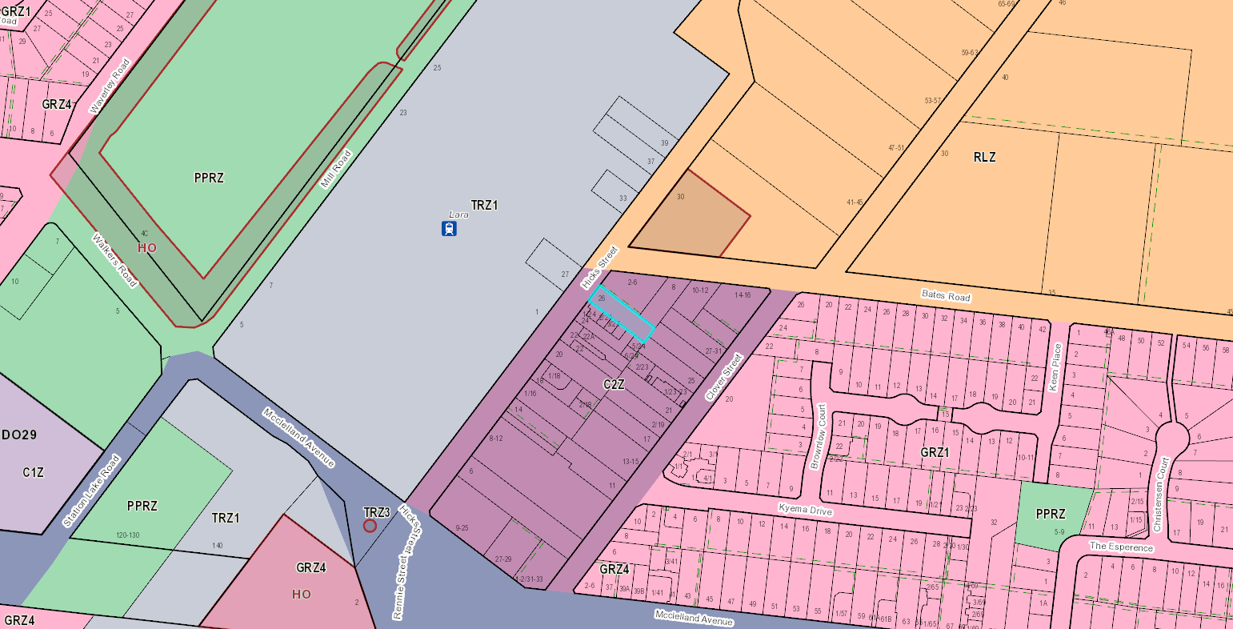
Image 1 - Subject site surrounding area and zoning.

The northern side of Hicks Street is a Transport Zone, which is set aside for the Lara Train Station car park and associated buildings. The car park has three dual entry and exit points to the car park, three entry only and one exit only accessways. Hicks Street is a two-lane street with a narrow pedestrian footpath (eastern side) and an associated nature strip with very limited vegetation coverage. Given the width of the street, on-street car parking is afforded as well as opportunities for off-street car parking accessed via private driveways.

The surrounding area is also within a Commercial 2 Zone and contains a mix of uses, including:
- Warehouse including small scale industrial uses
- Offices
- Lara Hotel
- Shops and food and drink premises

A small number of dwelling forms remain within this commercial area, likely developed prior to the Commercial 2 Zoning. Clover Street frontage has larger industrial buildings on the north side and the south side is a General Residential Zone. Clover Street has an existing Child Care Centre as well as residential dwellings. McClelland Avenue is a Transport Road Zone – 3, which is a significant municipal road. The commercial area of Lara is located approximately 1.5km west of the Princes Highway.

24 Hicks Street has recently been developed with one warehouse and five stores, which has been constructed and complete. A permit was only required for the development of the land, as the uses of the land complied with the section 1 requirements of the Commercial 2 Zone.

North of the subject site is a Rural Living Zone, this area contains dwellings on larger rural allotments. On the corner of Hicks Street and Bates Road is an existing heritage listed dwelling and dairy. This dwelling is historically significant at a local level, to Geelong.

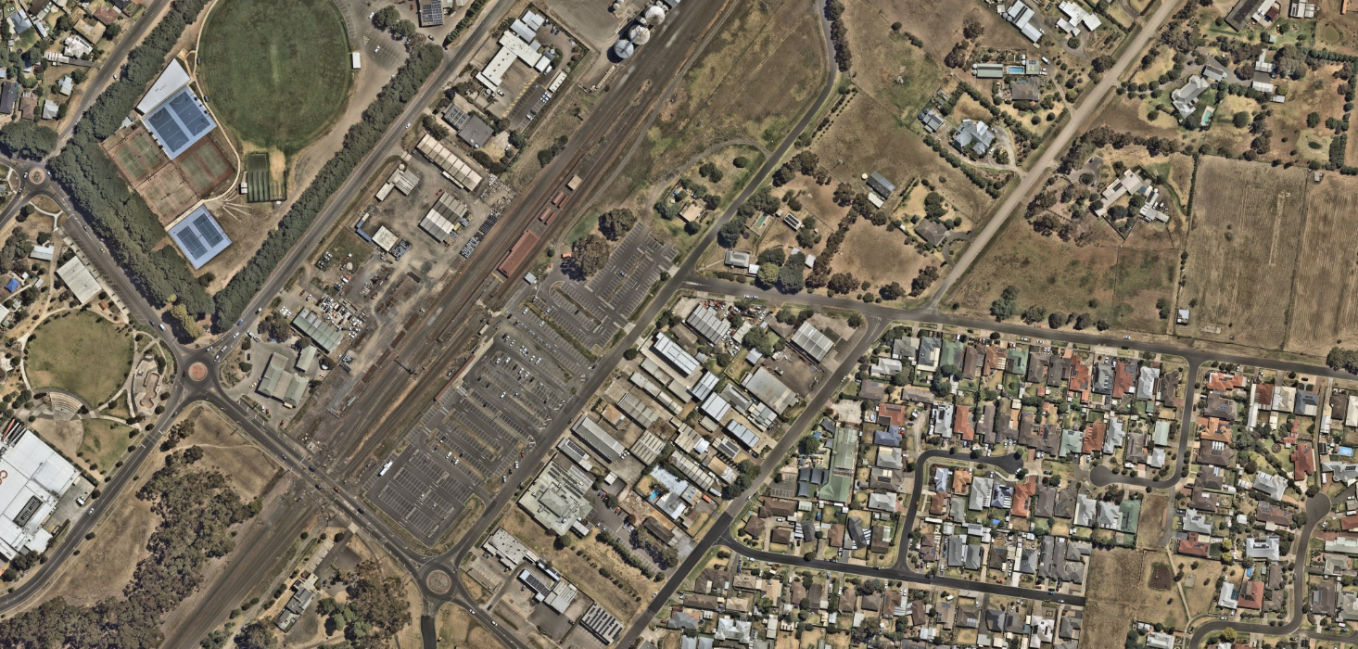
Image 2 - Nearmap February 2024

PROPOSAL:

Use of the land

A multiple-storey mixed use (office, shop and café) building is proposed.

Tenants have not been confirmed for each premises. As mentioned within the permit triggers, only the shop use requires planning permission. The food and drink (café) premise and the office uses, do not require planning permission.

Given the tenants are unknown at this stage, provisional and/or typical operating hours are anticipated to be 07:00am – 19.00pm for the office (typically Monday to Friday for core operations), while the shop and café uses are anticipated to operate seven-days a week.

Building and Works

The development is for a three-storey mixed use building, plus a basement. The maximum building height is 11.63m from natural ground level, plus 1.2m screening around the plant equipment on the roof.

The basement contains 49 parking spaces provided including accessible parking space. There are two car stacker arrangements in the basement, one contains 28 car spaces, and one contains 16 car spaces. Four spaces not included in the stacker system as well as one accessible space adjacent to the lift. There is both lift and stair access from the basement.

Ground level
Ground level contains the food and drink premises, 90m2, the shop 58m2 and 347m2 of office space. In addition, a bin room, bicycle storage (for staff) and end of trip facilities, 14 bicycle spaces provided. There is a north facing outdoor area of 44m2.

Level 1 and 2
Level 1 contains 743m2 of office floor area and a north facing outdoor area of 45m2. Level 2 contains 543m2 of office floor area and two separate outdoor areas, both north facing, that have a combined total area of 151m2. Overall, the total floor area, for the office use, across the three levels is 1633m2.

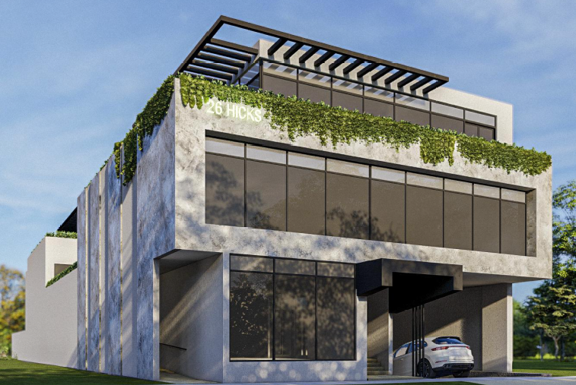
Image 3 - TP001 – Application Plans, 3D Renders
The building will be constructed from concrete panels and a finished in various renders.

Sign

One sign is proposed, which has been described as an internally illuminated sign and is to be 2100m in length by 700mm high. The sign is located 7.6m above natural ground level and attached to the building.

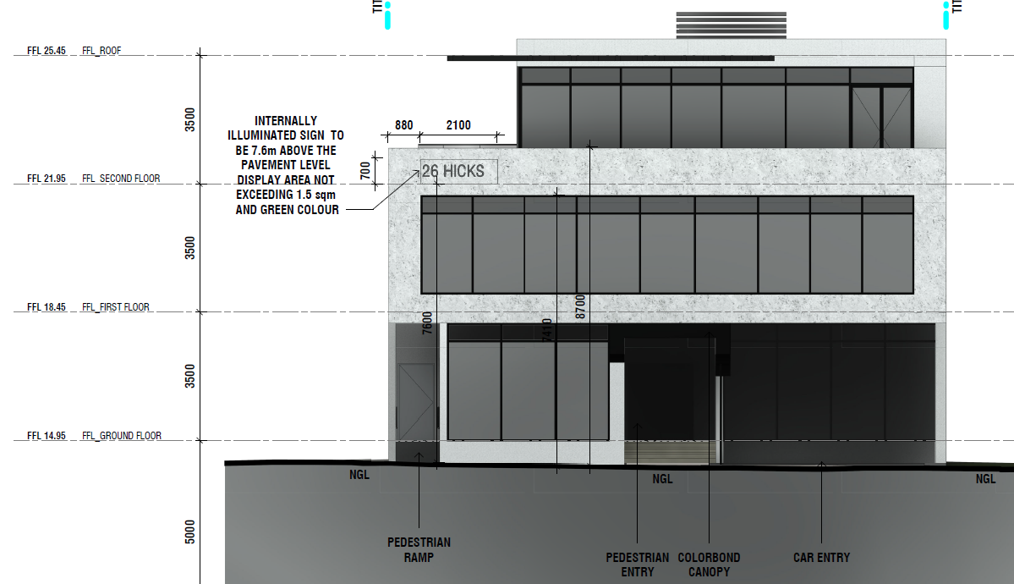
Image 4 - TP601 – Signage Location - Application Plans

Car Parking

The proposal seeks to reduce the number of car parking spaces required under Clause 52.06-5 by 13
spaces, from a total of 62 to 49 spaces.

Use | Requirement | Total
Shop | 4 per 100 sqm floor area | 2 spaces
Food and Drink | 4 per 100 sqm floor area | 3 spaces
Office | 3.5 per 100 sqm floor area | 57 spaces
Total required for the development |  | 62 spaces
Total provided |  | 49 spaces

A total of 13 spaces are required to be reduced for the total development. 5 spaces are provided on ground level in the basement, 44 spaces are provided within mechanical car stackers.

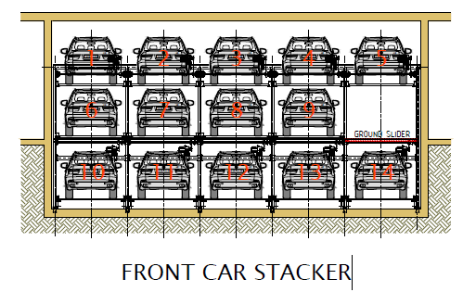
Image 5 - Extract from Hercules Carparking System

Bicycle Requirements

Use | Employee | Visitor/ Shopper/Student
Shop | 1 to each 600 sq m of leasable floor area if the leasable floor area exceeds 1000 sq metres | 1 to each 500 sq m of leasable floor area if the leasable floor area exceeds 1000 sq metres | Not required as the shop floor area is only 90m2.
Food and Drink | N/A | N/A | Not rate therefore no requirements.
Office | 1 to each 300 sq m of net floor area if the net floor area exceeds 1000 sq m | 1 to each 1000 sq m of net floor area if the net floor area exceeds 1000 sq m | 5 staff spaces and 1 visitor space.
Total required for the development |  |  | 6 total
Total provided |  |  | 16 provided, 10 surplus.

PERMIT/SITE HISTORY:

There is no permit/site history relevant to the application.

REFERRALS:

The following referrals were undertaken:

SECTION 55:

Authority: | Department of Transport
Response: | Thank you for notifying the Head, Transport for Victoria of planning permit application PP-1585- 2021 under Section 55 of the Planning and Environment Act 1987.  The application is for the use and development of a Four Storey Mixed Use (Education Centre and Retail Premises) Building and Reduction of Car Parking Requirements. The Head, Transport for Victoria has considered this application and objects to the granting of a permit on the following grounds:  1. Insufficient car parking has been provided on the site, which will create an unacceptable negative impact on the operational efficiency of the road and road user safety.  2. The significant waiver of car parking proposed will result in the loss of commuter car parking by students of this facility.  Please forward a copy of Council’s decision in relation to this permit application to this office as required under Section 64 of the Planning and Environment Act 1987.
Response – June 2023 | Thank you for (re-referring) planning permit application PP-1585-2021 pursuant to Section 52 of the Planning and Environment Act 1987.  The Head, Transport for Victoria has considered the amended application.  Noting a significant reduction to the previous request for a car parking dispensation, DTP has no objection to the proposal.
Officer Comment:
The original version of the application included the use for an education centre, and in accordance with the Planning Scheme, a Section 55 referral was required to the Department of Transport (DoT). The application has since been amended to remove the education centre use and change it to office. It is noted that when the application was referred, DoT did object to the application on the basis of the original car parking reduction requirement of 54 spaces.

A follow up non mandatory referral was sent to DoT, post the education centre use being removed, whilst no longer required, it is noted that DoT did withdraw their objection subject to additional car parking spaces being provided, which limited the amount of spaces that needed to be reduced.

SECTION 52:

Authority: | Fire Rescue Victoria
Response: | I refer to correspondence dated 09 October 2023 and referral pursuant to Section 52 of the Planning and Environment Act seeking comments on the above application.  FRV has no objection to the proposed planning permit.  Whilst the Planning Report does not specifically address VPP 13.02-1S, existing development surrounding the proposed site reduces risk to what is would be considered as LOW risk.  The development will need to comply with Building Code and associated Australian Standards requirements for onsite fire services therefore increasing fire safety for occupants.  FRV has no conditions.
Officer Comment:
The comments from FRV have been noted.

Authority: | VicTrack
Response – March 2023: | We refer to Council’s correspondence notifying VicTrack under section 52 of the  Planning and Environment Act 1987 of a planning application for land at the above  address. The application seeks approval for a four storey mixed use commercial building comprising office, retail and education centre and an associated dispensation of parking.  VicTrack is owner of the majority of Victoria’s railway land and infrastructure, including the land abutting the application site. The rail corridor is adjacent the application site and is leased to V/Line rail operators.  Pursuant to the Transport Integration Act 2010, VicTrack manages rail land,  infrastructure and assets on behalf of the State. As such, our interest in this application relates to the proposed interface with railway land and to ensure that during construction and on an ongoing basis that rail infrastructure and services are protected to minimise damage and delays.  VicTrack has reviewed the plans and supporting documents in the context of the site and abutting railway land and have received advice from the Department of Transport and Planning in relation to the traffic impact of the proposed development and the associated dispensation of parking on the commuter railway car park at Lara Station.  VicTrack objects to the application on the basis that insufficient parking for the development is provided and may result in patrons of the development using the railway station commuter car park, diminishing the number of car spaces available for commuters. We believe this will have an adverse impact on the operation of public transport in the area.
Response – June 2023: | We refer to Council’s correspondence notifying VicTrack under section 52 of the Planning and Environment Act 1987 of a planning application for land at the above address.  The application seeks approval for proposed Use and Development of a Four Storey Mixed Use (Office, Shop and Cafe) Building and Reduction of Car Parking Requirements.  It is understood that the application has been amended since VicTrack’s last correspondence dated 20 March 2023, to remove the educational use and significant reduction to the previous request for a car parking dispensation.  VicTrack has reviewed the amended plans and supporting documents in the context of the site and impact on railway land and hereby withdraw our objection.  VicTrack has no objection to the granting of a planning permit.  V/Line has been consulted in the preparation of this response.  For our records, we would appreciate a copy of Council’s decision be forwarded to VicTrack at your earliest convenience.
Officer Comment:
The application was referred to VicTrack as owning the land across the road of the subject site. VicTrack raised concerns that proper notice was not provided to them being across the road from the subject site.
In accordance with Section 52(1)a notice is required to be provided owners and occupiers of all allotments or lots adjoining the land to which the application applies to. VicTrack land is not adjacent to the site. Nonetheless notice was provided via Section 52 following the standard public notice. VicTrack was notified the same way as adjoining owners and occupies albeit later in the process. VicTrack also objected to the original proposal which contained the education centre and reduction of 54 car spaces. However, during the application process, subsequently has been withdrawn.
It is also noted that Council contacted V/Line directly about the potential upgrade of the Lara Train Station Car Park, a response was received that explained there are no planned works for the site.

INTERNAL

Whilst the application has been referred to internal departments on numerous occasions, it is noted that only the latest comments have been included, as they relate to the final set of plans. Previous comments on previous versions of the plans are not relevant to the final assessment of the application.

Department: | Engineering Services – Supportive Subject to Conditions
Final Response – December 2023: | Car Parking Reduction  The proposal generates a car parking demand of 62 spaces in accordance with the cl 52.06 of the planning scheme (refer snip from traffic report below).  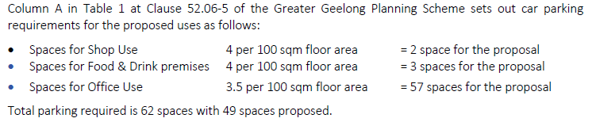  The proposal incorporates provision of total 49 spaces including 1 DDA space, 44 stacker parking spaces and 4 angles parking spaces.  Therefore, a reduction of 13 car parking spaces has been sought by the applicant as a part of this application.  The proposed development is likely to generate long term parking demand linked to the staff of the proposed office, retail, and café on-site and short-term parking demand generated by the visitor/patrons to the proposed land-use.  Based on the traffic report submitted, the applicant seeks to generally cater for most of the long-term parking demand on-site and seeks a reduction of visitor parking spaces on the basis of:  - Proximity to the principle public transport facility (Lara Station)  - Availability of on-street parking  - Likelihood of multipurpose trips (most of the customers to the café will be staff working on-site or within the area, choosing to walk to the café, reducing the car parking demand)  Relevant Clauses of Planning Scheme  Clause 18.02-1 – Sustainable Personal Transport  Clause 18 of the Greater Geelong Planning Scheme is the State Planning Policy on Transport.  Clause 18.01-3S – Sustainable and safe transport  Clause 18.01-3S is in relation to facilitating an environmentally sustainable and safe transport system that supports health and wellbeing.  It “supports forms of transport and energy use that have the greatest benefit for, and least negative impact on, health and wellbeing.”  In relation to development, it states:  Design development to promote walking, cycling and the use of public transport, in that order, and minimise car dependency.  Clause 18.02-3S – Public Transport  The objective of this policy is to “facilitate an efficient and safe public transport network and increase the proportion of trips.” made by public transport.  The strategy to meet this objective includes planning and developing public transport to:  — Connect activity centres, job-rich areas and outer suburban areas.  — Enable people to not have to rely on cars for personal transport.  Clause 18.02-3S –Public Transport Network  The site is within the Commercial Zone. This policy, amongst other things seeks to “Maximise the use of existing infrastructure and increase the diversity and density of development along the Principal Public Transport Network, particularly at interchanges, activity centres and where principal public transport routes intersect.”  Based on the above, the engineering supports the proposed reduction of 13 car parking spaces on-site.  Car Park Design  Traffic report details following in regard to the access driveway design.  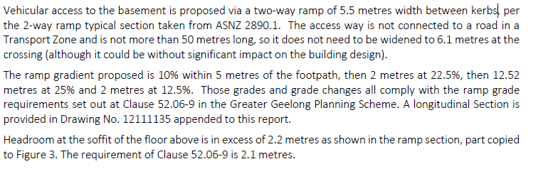  The proposed development plans currently show a 5.5m wide ramp offset 600mm from the property boundary.  Given the two-way ramp is proposed, it is required that the minimum 300mm wide kerbs are to be shown on the plans in accordance with the AS2890.1. The 600mm offset of the crossover from the southern property boundary is still required to ensure the 600mm splays of the crossover are constructed within the site boundary.  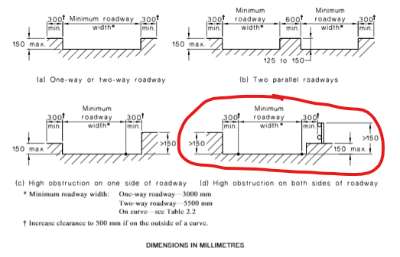  Construction Traffic  Given the size of the development, construction traffic management plan addressing the traffic generation, pedestrian management, heavy vehicle movement and parking impact during the construction phase is required to be submitted. This can be conditioned as a part of any planning permit.  Planner is also recommended to condition a requirement of a Green Travel Plan to be prepared as a part of this application. Given the reduction in parking and proximity to the station, the Green Travel Plan will need to be updated every year.
Recommended conditions | Condition 1 – Amended Plans:  Prior to the commencement of works / commencement of use, and unless otherwise approved in writing by the Responsible Authority, amended plans shall be submitted to Planning for Endorsement that show:  - A 5.5m wide ramp leading to basement car park with a minimum of 300mm wide kerbs on the either side of proposed ramp and a minimum offset of 600mm from the southern property boundary, in accordance to AS/NZS 2890.1:2004.  - A convex mirror to be installed at a suitable location to assist sight lines between the access ramp and parking areas.  All to the satisfaction of the Responsible Authority.  Drainage Plans  Unless otherwise approved in writing by the Responsible Authority prior to the commencement of works and or commencement of use, the developer must submit and have approved drainage construction plans showing but not limited to:  - A new 600x900 junction pit within the property frontage constructed on the existing 375mm drain.  - Connection for the property from pit perpendicular to the road.  Unless otherwise approved in writing by the Responsible Authority prior to the commencement of internal building works and or commencement of use, the developer must:  - Construct drainage in accordance with the approved plans.  - Supply as-constructed information in GIS ready format.  - Pay a 12-month defects liability bond.  - Make payment of a design checking fee, at 3.25% of the cost of works with a minimum $100 inspection fee.  All to the satisfaction of the Responsible Authority  Drainage & Vehicular Access:  Prior to the occupation of the development, the developer must:  - Construct the site stormwater system including connection into a newly constructed junction pit in the underground drain in Hicks Street in accordance with the approved drainage plans, or other nominated point/s as approved by the Responsible Authority. The stormwater connection must be in accordance with City of Greater Geelong Standard Drawings.  - Construct a new 5.5m wide vehicular crossings in accordance with the requirements and standards of the City of Greater Geelong and centred on the location of the driveway.  - The width of the driveway is to be 5.5m at the road reserve boundary with a minimum offset of 0.6m from the southern property boundary line.  - Any proposed vehicular crossing shall have satisfactory clearance to any existing crossover, side entry pit, lighting or telecommunication pole, manhole cover or maker, fire hydrant or street tree. Any relocation, alteration or replacement required shall be in accordance with the requirements of the Relevant Authority and shall be at the applicant’s expense.  - Remove any redundant vehicular crossings with kerb and channel and the footpath/nature strip area reinstated to match existing construction in the street.  all to the satisfaction of the Responsible Authority.  Note:  1. Construction of the site stormwater connection/s is to be inspected by Council Representative prior to any backfilling. An appropriate fee equivalent to 3.25% of total cost of civil works, excluding GST (a minimum fee of $100 applies if the 3.25% amount is less than $100), is to be paid to Council for inspection. Relevant evidential documentation of the cost is to be provided.  2. All internal property drainage must be designed and constructed to satisfy AS/NZS 3500.  3. A Vehicle Crossing Permit must be obtained prior to commencement of works.  Car Parking  Prior to the occupation of the development, the developer must construct the car park including accessways, surface with an all-weather sealed coat and line mark the car and accessways in accordance with the endorsed plans to the satisfaction of the Responsible Authority.  Common Property – PRIOR TO OCCUPATION  Prior to the occupation of the building the common access road within the development shall be constructed and drained to the satisfaction of the Responsible Authority.  Stormwater Management  The site stormwater system must be designed and installed such that the site stormwater discharge is not increased by the proposed development. An appropriate on-site detention system designed in accordance with the Infrastructure Design Manual may be required to the Satisfaction of the Responsible Authority.  Pump System  Unless otherwise approved by the Responsible Authority and prior to the Commencement of the Development, the land owner must enter an agreement with the Responsible Authority pursuant to Section 173 of the Planning and Environment Act 1987. All costs associated with setting up the agreement must be borne by the land owner. The agreement is to be registered on title and run with the land, and is to provide to the satisfaction of the Responsible Authority:  - All storm water runoff is to be collected on site and discharged to the legal point of discharge using a pump system or as otherwise nominated by the responsible authority. The pump system is to be designed and constructed in accordance with Australian Standard 3500 Part 3.2 Section 9  - In the event of any operational difficulties with the pump system, it is the Responsibility of the land owner to rectify these difficulties;  - Any pump system is to be replaced by gravity discharge if and when available, and if directed by the Responsible Authority, at the land owner’s full cost.  - Provision is made (if appropriate) in any subdivision for Body Corporate drainage works, and access to those drainage works to be on common property or within an easement in favour of the Body Corporate  Note: Where the legal point of discharge is kerb and channel, discharge velocity at the kerb must be no greater than 1.5 m/s with a maximum discharge flow rate of 10 l/s and the outlet directed at an angle of 45º to the direction of flow in the kerb and channel.  Non-Standard Conditions  Car Park Management Plan  Prior to the commencement of the use/ occupation of the development, a Car Park Management Plan to the satisfaction of the Responsible Authority must be submitted to and approved by the Responsible Authority. When approved, the Car Park Management Plan will be endorsed and will form part of this permit. The Car Park Management Plan must detail but not limited to:  - Any changes as required pursuant to condition 1.  - Mechanical carparking management plan consistent with AS 5124:2017.  - Commercial carparking in the Car Stacker is restricted to staff of the café, office and shop uses.  - Training in use and competency of using the Car stacker is required for all staff prior to use.  - The number and location of car parking spaces allocated to each use including:  (i) Office spaces provided at a minimum rate of 2.9 space per NFA;  (ii) Two spaces (one each) allocated to the staff of Café and Shop component of the development.  to the satisfaction of the Responsible Authority  The provisions, recommendations and requirements of the endorsed Car Park Management Plan must be implemented and complied with to the satisfaction of the Responsible Authority.  NOTE  A pre-commencement meeting with Council’s engineering department is required to be undertaken prior to works starting. To organise this meeting please contact 5272 4426
Officer Comment:
The suggested permit conditions have been included in the planning permit. All the conditions outlined have been agreed upon and the addition of the car park management plan and convex mirror is supported.

Department: | ESD Response – Supportive, subject to conditions
Final Response – April 2024: | Council’s ESD Officer has reviewed the below documents in accordance with Council's ESD Local Planning Policy (15.01 and 53.18), and this development has not reached an acceptable level of ESD for a permit to be issued.  Permit can be issued with permit conditions. The conditions are showing at the end of the report.  Council’s ESD Officer’s has reviewed the following:  Documents reviewed:  - Development plans by Ammache architects dated 16/11/2023 and received by Council on 1/12/2023  - Sustainable Management Plan & WSUD Response by Makao dated 1/6/2023 and received by Council on 5/6/2023  - BESS report (project identifier: (941C9E53-R4 Version-BESS-6), received on 5/6/2023  Environment (ESD) Response  - BESS Energy 1.1 Thermal Performance Rating – Non-Residential: National Construction Code façade calculator was not included in the submitted ESD (SMP) report, although the energy section was completed on the basis that the buildings comply with the wall-glazing requirement of the National Construction Code 2019 Section J. Therefore, an updated preliminary the facade calculator must be completed and included in the amended ESD(SDA) report showing that compliance will be achieved.  An updated preliminary facade calculator must be completed and included in the SMP report. Detailed NCC section J report should be provided prior construction.  - BESS Water 1.1 Potable Water Use Reduction: The submitted report shows that Dishwasher have been selected 4-star. It is however more likely that the future occupiers will be using their own dishwasher, and therefore the developer has no influence on the water efficiency of the appliances in use. As per the BESS help notes, in this case ‘default or unrated’ should be selected from the drop-down list.  - The Water 3.1 – Water Efficient Landscaping: Credit has been claimed in BESS. Information regarding xeriscaping and/or the use of drought tolerant species will need to be added to the landscape plan and Architectural plan, otherwise the Water 3.1 – Water Efficient Landscaping credit should not be claimed.  - 4.1 - Building Systems Water Use Reduction: Points are allocated by the water calculator based upon an estimated reduction in potable (mains) water consumption due to the recycling of water used for fire testing and building systems such as evaporative cooling or air conditioning chillers. Estimated reductions are to be at least 80%.  If the building does not have a sprinkler system and water-based heat rejection systems, this credit is 'N/A' and should be scoped out.  Documentation & evidence required:  Site / Floor plans showing location of fire test system water tank and specifications including tank capacity and intended re-use  - The Energy 3.7 Internal Lighting –Non-Residential credit has been claimed in BESS. The Applicant needs to clearly annotate on the plans with a note to say what is the maximum illumination power density of this development.  - Daylight assessment: it is claimed in the BESS report that 80% office, 60% shop and 5% other building of the nominated floor area achieve 2% daylight factor. An updated daylight report musty be provided.  An updated daylight report musty be assessed by using either computer modelling or by following Green Star daylight hand calculation guidelines. Moreover, plans show that some offices do not have an external window which will lead to poor daylight levels within these spaces. It is recommended that offices and other primary spaces are located on the perimeter whenever possible to allow for natural daylight and ventilation.
Recommended conditions | - Before the use and development commences, amended plans to the satisfaction of the Responsible Authority must be submitted to and approved by the Responsible Authority. When approved, the plans will be endorsed and will then form part of the permit. The plans must be drawn to scale with dimensions. The plans must be generally in accordance with the plans received 1/12/2023 but modified to show:  - Initiatives contained within the ESD report (SMP) along with the proposed changes, including:  - Select ‘default or unrated’ for water efficiency of the dishwasher water efficiency in BESS Water category.  - The Applicant needs to clearly annotate in the Development Plans with a note to say what will be the maximum illumination power density for this development.  - Information regarding xeriscaping and/or the use of drought tolerant species will need to be added to the landscape plan and architectural plan.  - Site/Floor plans must be showing location of fire test system water tank and specifications including tank capacity and intended re-use. Otherwise, BESS credit of 4.1 - Building Systems Water Use Reduction must be removed from BESS report.  - An updated daylight modelling in accordance with BESS criteria must be provided.  If a BESS report is included as part of the ESD report, the BESS report must achieve an overall score of 50% or higher and have a minimum ‘pass’ rates of 50% for the Energy, Water and IEQ categories and 100% for the Stormwater category.  - Prior to the issue of occupancy permit for the development or issue of a Statement of Compliance, whichever comes first, a report from the author of Sustainability Management Plan (SMP) approved under this permit, or similarly qualified person or company, must be submitted to the Responsible Authority. The report must be to the satisfaction of the Responsible Authority and must confirm all measures specified in the Sustainability Management Plan (SMP) have been implemented in accordance with the approved Plan.  - All works must be undertaken in accordance with the endorsed Plan, ESD report (SDA) and stormwater management plan to the satisfaction of the Responsible Authority. No alterations to these plans may occur without the written consent of the Responsible Authority. The other conditions are as below:  - National Construction Code façade calculator was not included in the submitted ESD (SMP) report. National Construction Code preliminary façade calculator should be submitted. Prior to construction, Section J modelling report should be submitted which aligns with the modelling/commitments in the submitted ESD report.
Officer Comment: The recommended planning conditions have been included in the planning permit.

Department: | Waste – Supportive, subject to conditions
Final Response – June 2023: | The Waste Management Plan is satisfactory.
Recommended conditions | A Waste Management Plan that is to the approval of the Responsible Authority must be provided prior to certification for this Development. The Approved Waste Management Plan must be incorporated into the Planning Permit.
Officer Comment:
Noted, the condition is to be included in the recommendation.

Department: | Urban Design – Supportive, not subject to conditions
Final Response – December 2023: | The overall building height proposed is acceptable given the mid-block location and lack of sensitive uses in the adjoining properties. However, further modifications are necessary to ensure an acceptable urban design outcome.  Interface to Hicks Street  - The proposal provides ramp access along the northern boundary and a pedestrian entrance more centrally to the development. The recessed positioning of both are highly problematic as it creates entrapment spaces adjacent to the footpath that creates safety concerns for users of the public realm. Further, it impacts internal organisation through the creation of winding and inefficient corridors. We recommend that the stairs and ramp are collocated and abut the property boundary to Hicks Street.  - Entrance into the shop is currently off the landing. This does not lend itself to good design. Further entrances aid in activating the street. We recommend that the shop’s entrance is relocated off Hicks Street with awnings extending across the entire façade with exception to the vehicular entry located to the south of the proposed development.  - We query if the bin room is better located within the basement.  - We also query the location of meter and services within the building.  Daylight access  - Albeit offices, considering the extended hours of use, it should be considered as habitable rooms. In this context, some of the office spaces in the proposed development lack adequate access to daylight (particularly to the eastern end of the development). We encourage the applicant to consider well sized courtyards that are centrally located and reconsider the internal layout of the offices such that they are well spaces and receive a good level of daylight.  Blank walls and façade strategy  - We strongly encourage the applicant to consider an interim façade strategy that ensures the blank walls visually enhance the public realm in the short term whilst adjoining properties are being realised particularly along the southern interface.  Landscape Plan  - The proposal comprises of several landscaped terraces, courtyards, and balconies. A landscape plan with details of planting and maintenance is necessary to complete the assessment.
Recommended conditions | N/A
Officer Comment:
Interface with Hicks Street
The ramp on the northern side of the building is to provide cyclist access direct to the building and to the end of trip facilities. The stair access and ramp access have been made separate to allow for pedestrians to enter the building without interfering with the bicycle access.
The tenant for the shop is currently unknown and therefore has access off the entrance hall area. The location of the access ensures that pedestrians visiting the site are all directed to one point, making the entrance a safer space and a high trafficable area.
The bin area has been assessed via the waste management plan and has been supported by the Waste Department. If the bin room was included in the basement, this would result in a further reduction of car parking, which is not recommended.
Regarding the location of the meters and services - the servicing authorities have their own requirements and they are located within the building and will not impact the urban design outcome.
Daylight Access
Clause 73.01 General Terms, defines habitable room windows as:
Any room of a dwelling, small second dwelling or residential building other than a bathroom, laundry, toilet, pantry, walk-in wardrobe, corridor, stair, lobby, photographic darkroom, clothes drying room and other space of a specialised nature occupied neither frequently nor for extended periods.
Whilst it is noted that some of the proposed offices only receive one area of direct daylight, there are no controls which allow the implementation of required light courts. The use of the land for an office is as of right and as per the above definition an office does not have habitable room windows.
Blank walls and façade strategy
The south elevation abuts an existing warehouse development and therefore part of the southern elevation will be hidden by this development. The front section of the southern elevation provides a variety of render colours.
The northern elevation also provides a variety of render patterns to ensure what is visible from the street is not a blank wall. The design still allows for equitable development and over time if the adjoining property is development, this can be achieved.
Landscape Plan
A condition on permit to seek a satisfactory landscape plan has been added to ensure this is seen post permit. It is noted there is limited space for landscaping however a plan should be submitted to demonstrate how the planter boxes will be planted out with appropriate plants.

Department: | Engineering – Special Building Overlay Team
Response | N/A
Officer Comment:
The original plans were referred to the SBO team as the site is only flood prone under the Building Regulations, not covered by a planning overlay. The comments have been addressed through the application process and ultimately covered off through the standard Engineering Referral response and recommended conditions, however the applicant would be required to address this via the Building Regulations at the appropriate time.

AMENDMENT OF THE PROPOSAL PRIOR TO PUBLIC NOTIFICATION:

1st amendment: 16 MAY 2022

The applicant made a request to amend the application pursuant to Section 50 of the Planning and Environment Act 1987 on 16 May 2022. Council accepted the amendment. The amendment made the following changes to the application:

- Amended plans to address Council’s request for information.
  - Car park moved to the centre of the site to reduce driveway length to under 50m.
  - Internal layout rearranged to locate amenities on the south side of the office to the north side with windows.
  - Recessed upper levels from the front boundary.
  - Driveway and crossover amended.
- Apply for the Use of the Land and Reduction of car parking.

2nd Amendment: 17 AUGUST 2022

The applicant made a request to amend the application pursuant to Section 50 of the Planning and Environment Act 1987 on 17 August 2022. Council accepted the amendment. The amendment made the following changes to the application:

- Amended reports.
  - Amended Town planning report.
  - Amended Sustainability Management Plan completed by Makao.
  - Amended Traffic Assessment along with swept path diagrams completed by One Mile Grid.
  - Letter from Telstra approving Telstra pit can remain in current location.
- Amended Town planning drawings.
  - Increase parking with a basement car park added.
  - Added outdoor courtyard, increase landscaping.
  - Upper floors modified.

3rd Amendment: 11 NOVEMBER 2022

The applicant made a request to amend the application pursuant to Section 50 of the Planning and Environment Act 1987 on 11 November 2022. Council accepted the amendment. The amendment made the following changes to the application:

- Amended plans and reports
  - Updated finished floor levels and ramp redesign.
  - Updated Planning report, traffic report and waste management report.

PUBLIC NOTIFICATION:

First Round – December 2022

The application is not exempt from the notice requirements of Section 52(1)(a), (b) and (d), the decision requirements of Section 64(1), (2) and (3) and the review rights of Section 82(1) of the Act and pursuant to Section 52 of the Planning and Environment Act 1987 the following forms of advertising were undertaken:
- Notices were sent to owners and occupiers of adjoining land (including opposite)
- A2 sign(s) were placed on the land

It is noted that the application was on public notice during December 2023. It is standard Council practice that applications on public notice during this time are on public notice for three weeks rather than the standard two weeks. The application was on Council’s website from 15 December 2022 to 13 January 2023.

66 objections were lodged with Council, including from V/Line, VicTrack and Department of Transport and Planning.

Image 6 - Original Plans advertised – four storey development which required a car parking reduction of 54 spaces.

AMENDMENT OF THE APPLICATION FOLLOWING PUBLIC NOTIFICATION

4th Amendment: 15 FEBRUARY 2023

The applicant made a request to amend the application following public notification pursuant to Section 57A of the Planning and Environment Act 1987 on 15 February 2023 Council has accepted the amendment. The amendment made the following changes to the application:
- New planning consultant engaged, and application details updated to reflect this.

Given no other information was formally updated at this stage, this amendment was not formally readvertised.

5th Amendment: 6 JUNE 2023
The applicant made a request to amend the application following public notification pursuant to Section 57A of the Planning and Environment Act 1987 on 6 June 2023 Council has accepted the amendment. The amendment made the following changes to the application:

- Amended plans, traffic report, sustainability management plan and waste management plan submitted.
- Amendment to permit preamble.
- Removal of education centre use.
- Improved basement access and increase in onsite parking provision.
- Improved street activation, end of trip and bicycle facilities and landscaping at ground level.
- Increased terrace at first, second and third floor levels.
- Improved external expression of building through variation in materials and setbacks.

These plans were not advertised as Council has raised issues and concerns. The applicant advised they were changing the plans to address these concerns.

6th Amendment: 15 AUGUST 2023

The applicant made a request to amend the application following public notification pursuant to Section 57A of the Planning and Environment Act 1987 on 15 August 2023 Council has accepted the amendment. The amendment made the following changes to the application:
- Amend proposal preamble to include internally illuminated sign. Preamble to read: “Use and Development of a Four Storey Mixed Use (Office, Shop and Cafe) Building, Internally Illuminated Sign, and Reduction of Car Parking Requirements”
- Submission of amended architectural plans, planning report and traffic report in response to Council’s.
- Request for Further Information dated 3 July 2023.

PUBLIC NOTIFICATION:

Second Round – August 2023

The amended application was renotified pursuant to Section 57B of the Planning and Environment Act 1987 and the following forms of advertising were undertaken:

- Notices were sent to owners and occupiers of adjoining land (including opposite)
- A3 sign(s) was/were placed on the land

As a result of re-advertising, a combination of further submission and 17 new objections were received.

FINAL (7th) AMENDMENT 1 DECEMBER 2023
(these are the plans under assessment)
The applicant made a request to amend the application following public notification pursuant to Section 57A of the Planning and Environment Act 1987 on 1 December 2023 Council has accepted the amendment. The amendment made the following changes to the application:

- Amended plans and traffic report submitted.
- Changes to the plans as described by the applicant:
  - A reduction of proposal to three storeys (removal of third floor), resulting in a reduction in maximum building height from 15m to 11.65m.
  - An amendment to the proposed preamble to read "Use and Development of a Three Storey Mixed Use (Office, Shop and Cafe) Building, Internally illuminated Sign, and a Reduction of Car Parking Requirements”. It is noted that the preamble has been updated to reflect the Planning Scheme and the relevant planning permit triggers.
  - Addition of mechanical equipment area to roof top with 1.2 metres roof plant screening added around the area.
  - Removal of ground and first floor level street setbacks to achieve consistent street wall in response to Council Urban Design Referral request.
  - Increase to minimum north boundary setbacks at second floor level.
  - Replacement of ground floor visitor bicycle parking hoop (1 x hoop for 2 bicycles) within front setback with new bicycle hoop on the nature strip (1 x hoop for 2 bicycles).
  - Increase in the carparking reduction from 5 to 13 carparking spaces (49 spaces proposed as per previous design).
  - Reconfiguration of internal spaces and outdoor areas at ground, first and second floor levels.

PUBLIC NOTIFICATION:

Third and Final Round of Public Notice – January 2024

The amended application was renotified pursuant to Section 57B of the Planning and Environment Act 1987 and the following forms of advertising were undertaken:

- Notices were sent to owners and occupiers of adjoining land (including opposite)
- A3 sign(s) was/were placed on the land.

As a result of re-advertising, a combination of further submission and 42 new objections were received.
SUMMARY OF PUBLIC NOTICE

The application was on public notice three times throughout the application process. The public notice outcome can be summarised as follows:

- Two (2) letters of support were received.
- Four (4) objections were withdrawn, including from V/Line, VicTrack and Department of Transport.
- A total of 125 objections have been submitted with Council.

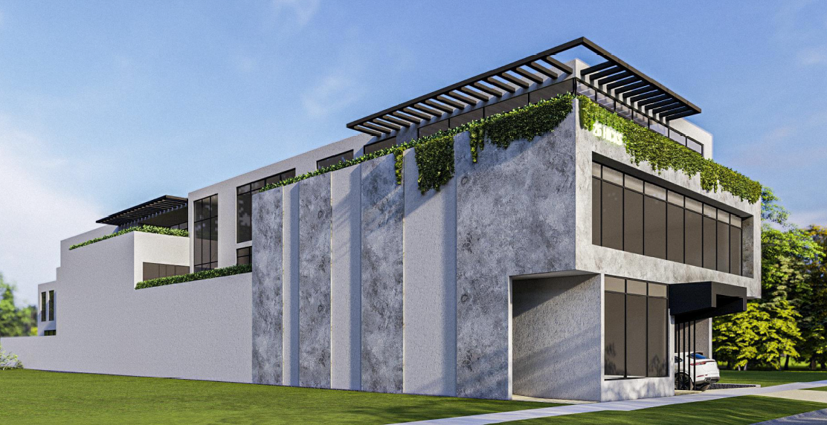
Image 7 - Final set of plans advertised.
PLANNING INFORMATION MEETING

A planning information meeting was held on 12 March 2024 between the applicant, council officers, and objectors. The meeting allowed the opportunity for objectors to ask questions of the applicant and the traffic engineering who completed the traffic impact assessment.
The purpose of the meeting was for objectors to ask questions ahead of any decision-making.

The plans were not amended following the meeting and no objections were withdrawn.

OBJECTIONS:

A summary of the concerns of objectors are provided and commented on below:

Objection – Traffic
- Increase in traffic
- Reduction of car parking
- Existing traffic and car parking issues
- Lara train station car park at capacity

Response

It is prudent to note that it is not the obligation of developers to fix existing on-street traffic conditions.

As outlined in response to Clause 52.06 later in this report, the proposed development is not considered to result in an unreasonable impact to the surrounding on-street car parking network. It is noted that car parking provision on street within the surrounding area already exhibits a high demand.

Whilst there will be a change in the traffic movements, it has been considered acceptable through the assessment of Clause 52.06. A response to the traffic changes to the intersections and above listed streets has been further assessed and explained through the Clause 52.06 response.

It is noted that existing on street car parking spaces are not reserved for residents/ train station uses etc and are available and accessible to any traffic users. The residential properties in proximity to the site have off site parking available; it is up to the residents whether they utilise their own off street parking or rely on on-street parking.

Increase in bicycle movements are encouraged and the site provides more than the required bicycle facilities. With proximity to the Lara Train Station, this should encourage people to utilise sustainable means of transport.

It is noted that Council contacted VicTrack/VLine to seek comments around the existing Lara Train Station and the car park, to ascertain if any planned upgrades were proposed. The response was that there are no planned upgrades in the pipeline for either the station or the car park.

Objection – Built Form
- Neighbourhood character
- National Construction Code
- Change to the rural character/ township
- Future precedent

Response

The site is located within a Commercial 2 Zone and there are no Planning Overlays that control the built form outcome. A response to the relevant planning policy and the urban design outcomes have been addressed further within this report. However, it is noted that through the course of the application, the plans have been amended a number of times and now present an acceptable urban design outcome.

Whilst this development is the first of its kind, it does not mean that it is automatically an unacceptable outcome for the subject site. The southern side of Hicks Street is within a commercial area where commercial development can be expected and is encouraged.

If this application is approved, it does not mean all other further planning applications will be approved. All applications are assessed case by case on their merits when they are lodged.
The National Construction Code is not directly incorporated into the Planning Scheme. Nonetheless it is considered through the ESD requirements and will be dealt with through the Building Regulations at the appropriate time.

Objection – General Amenity
- Increase in noise (traffic/ vehicle noise)
- Impacts to quality of life for the area.
- Disruption to local residents during construction.
- Impacts to local schools and businesses.

Response

The site is located within a Commercial 2 Zone, which aims to provide for a range commercial, uses which complement the function of the locality.

Sites within commercial areas are expected to contain uses that are normal noise generating uses. Traffic and pedestrian noise will increase across the site, however, again this is considered acceptable in this zone. The waste collection will take place in accordance with the waste management plan and will protect noise still from the waste collection during the week. Construction noise is protected through other legislation.

It is unclear how the development might impact local schools and businesses. The development will provide the opportunity for more and new businesses to move in and there will be more car parking (than present on the site) available on site to attract people to the area.

Overall, whilst the area will undergo significant change over time, as described above, it can be adequately managed or is dealt with through separate legislation outside of the planning system.

Objection – Public Notice
- Lack of public notice (bare minimum has been undertaken)
- Not enough time to review the application.

Response

The application was advertised in accordance with Section 52 of the Planning and Environment Act 1987, which specifies the following prescribed form of notice:

(1) Unless the responsible authority requires the applicant to give notice, the responsible authority must give notice of an application in a prescribed form—
a) to the owners (except persons entitled to be registered under the Transfer of Land Act 1958 as proprietor of an estate in fee simple) and occupiers of allotments or lots adjoining the land to which the application applies unless the responsible authority is satisfied that the grant of the permit would not cause material detriment to any person; and
b) to a municipal council, if the application applies to or may materially affect land within its municipal district; and
c) to any person to whom the planning scheme requires it to give notice; and….
d) to any other persons, if the responsible authority considers that the grant of the permit may cause material detriment to them.

(2) A notice under subsection (1)(d) may be given—
(a) in all or any of the following ways—
(i) by placing a sign on the land concerned;
(ii) by publishing a notice in newspapers generally circulating in the area in which the land is situated;
(iii) by giving the notice personally or sending it by post; or
(b) in any other way that the responsible authority considers appropriate.

As outlined above in the report, multi notice periods were undertaken, included extended periods when required. A sign was placed on site when required, letters to adjoining owners and occupiers. The application was also published on Council’s website. Additional notice periods, objectors were also notified via email by the email address they submitted to Council.

It has been considered that the Responsible Authority (Council) has given notice, greater than the prescribed form of Section 52 of the Planning and Environment Act 1987. Given the number of objections, it has been considered that public notice has been undertaken to an extent that ensured the community was familiar with the application.

Council can receive objections up until a time a decision is made.

ASSESSMENT:

ZONE:

Clause 34.02 Commercial 2 Zone

Purpose

- To implement the Municipal Planning Strategy and the Planning Policy Framework.
- To encourage commercial areas for offices, appropriate manufacturing and industries, bulky goods retailing, other retail uses, and associated business and commercial services.
- To ensure that uses do not affect the safety and amenity of adjacent, more sensitive uses.

34.02-7 Decision guidelines

General

Before deciding on an application, in addition to the decision guidelines in Clause 65, the responsible authority must consider, as appropriate:

- The Municipal Planning Strategy and the Planning Policy Framework.
- The interface with adjoining zones, especially the relationship with residential areas.

Use

- The effect that existing uses may have on the proposed use.
- The drainage of the land.
- The availability of and connection to services.
- The effect of traffic to be generated on roads.
- The interim use of those parts of the land not required for the proposed use.
- If an industry or warehouse, the effect that the use may have on nearby existing or proposed residential areas or other uses which are sensitive to industrial off-site effects, having regard to any comments or directions of the referral authorities.

Building and works

- The movement of pedestrians and cyclists, and vehicles providing for supplies, waste removal, emergency services and public transport.
- The provision of car parking.
- The streetscape, including the conservation of buildings, the design of verandahs, access from the street front, protecting active frontages to pedestrian areas, the treatment of the fronts and backs of buildings and their appurtenances, illumination of buildings or their immediate spaces and landscaping of land adjoining a road.
- Defining the responsibility for the maintenance of buildings, landscaping and paved areas.
- The availability of and connection to services.
- Any natural or cultural values on or nearby the land.
- Outdoor storage, lighting, and stormwater discharge.
- The design of buildings to provide for solar access.

OVERLAY:

No planning overlays apply to the site

Response to zone

The application has been considered to appropriately respond to the Commercial 2 Zone.

The development is proposed to consist of predominately office spaces within a commercial area with an adjoining shop front. The surrounding area is zoned commercial as the strip of commercial uses along this section of Hicks Street and the rear section of Clover Street which interfaces with the wider Lara area. The adjoining development to the southwest of the site has previously been developed into a double storey warehouse development which altered the pattern of the street development along the Hicks Street interface. The proposal continues to evolve the built form and rhythm of the neighbourhood as Lara is updated incrementally.

Use
As stated previously, the office use is as of right in the Commercial 2 Zone and as such is considered an appropriate use. The use of the land as a Shop requires planning permission.

It is considered the shop use is appropriate to integrate with the wider officer use on the subject site. The shop use is able to adhere to drainage requirements, connect to services and is not considered to create a burdened load on the traffic generated by the use. Appropriate car parking measures have been considered later within this report.

Buildings and Works
The proposal has been designed in a way in which the movement of pedestrians is intuitive to the design response, with a centred entry and steps up to the entry way. The shop and proposed café are accessed from this central point, with a ramp also provided on the eastern side for disability access. The movement of cyclists has been accounted for with bicycle parking in excess of the required minimum with spots both at ground level and in the undercover basement for a range of end users. The proposal is considered to adequately allow for the movement of provisions to the site, waste removal (will be completed by a private collection company), emergency services and is connected directly to the Lara train station and surrounding bus stops.

Car parking is to be located in the proposed basement and movements of vehicles has been approved by the internal engineering department. Further explanation on the rates and reduction of car parking can be found in the response to Clause 52.06.

The proposal has been assessed to be able to appropriately maintain the building, landscaping and paved areas which will be managed by the private landowner. The site is available to connect to all required services, manage any stormwater discharge and is not considered to pose any adverse effects on any natural or cultural values on or near by to the land.

The proposed building has been designed to receive ample solar access with the stepped built form and large balconies on each level to provide light into the development. The extent of overshadowing to the neighbouring property is considered acceptable with the adjoining warehouses being built to the boundary.

On balance it is considered that the proposal adheres with the decision guidelines of the Commercial 2 Zone and is able to achieve an orderly planning outcome.

CULTURAL HERITAGE MANAGEMENT PLAN (CHMP):

The Aboriginal Heritage Regulations 2018 specify the circumstances in which a cultural heritage management plan is required for an activity or class of activity. Division 2 of the Aboriginal Heritage Regulations 2018 specifies exempt activities which do not require a cultural heritage management plan. The proposal is not listed as an exempt activity.

Areas of cultural heritage sensitivity are defined within Divisions 3 and 4 of the Aboriginal Heritage Regulations 2018. Division 3 does not identify the site or part of the site as within an area of cultural heritage sensitivity.
In accordance with the above assessment, a cultural heritage management plan is not required.

LANDFILL GAS RISK ASSESSMENT

The subject site is not located within 500 metres of an identified former landfill site, a risk assessment is not required.

DEVELOPMENTS IN BUSHFIRE PRONE AREAS

The site is partially located within a designated bushfire prone area.

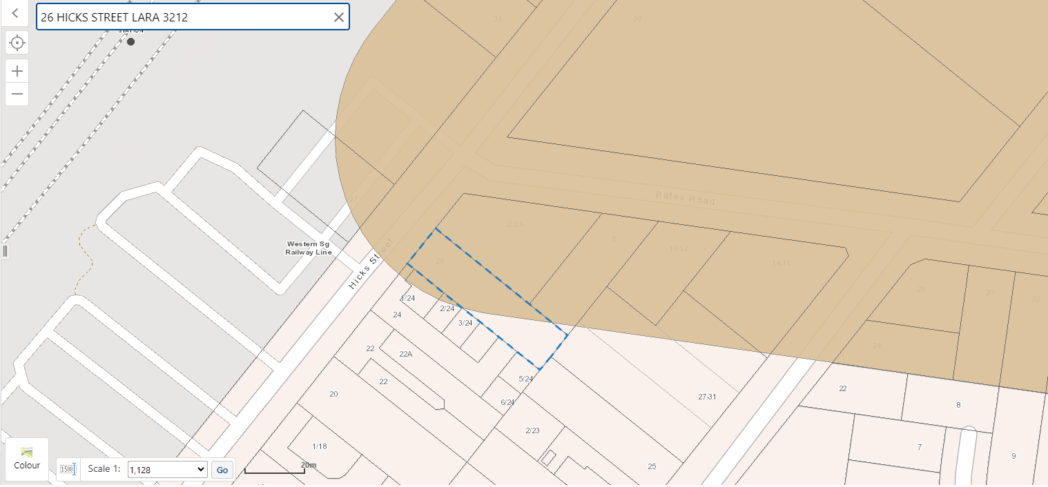
Image 8 - Subject site is partially located within a bushfire prone area. Source: VicPlan.

Clause 13.02-1S (Bushfire planning) seeks to strengthen the resilience of settlements and communities to bushfire through risk-based planning that prioritises the protection of human life.

The policy must be applied to all planning and decision making under the Planning and Environment Act 1987 relating to land which is:
- Within a designated bushfire prone area;
- Subject to a Bushfire Management Overlay; or
- Proposed to be used or developed in a way that may create a bushfire hazard.

The proposal is not listed at Clause 13.02-1S as one of the uses or developments which should be considered:

- Subdivisions of more than 10 lots.
- Accommodation.
- Child care centre.
- Education centre.
- Emergency services facility.
- Hospital.
- Indoor recreation facility.
- Major sports and recreation facility.
- Place of assembly.
- Any application for development that will result in people congregating in large numbers.

As the site is located within a designated bushfire prone area the assessment of this application has considered:

- The risk of bushfire to people, property and community infrastructure.
- Whether the implementation of appropriate bushfire protection measures to address the identified bushfire risk is necessary.
- Whether the proposal can implement bushfire protection measures without unacceptable biodiversity impacts.

The application is not expected to create a risk bushfire to people, property and community infrastructure.

It is considered that no bushfire protection measures to address the identified bushfire risk is necessary. However, it is recommended that the following notes also be included on any permit issued:

- This property is in a designated bushfire prone area.
- Special bushfire construction requirements apply at the Building Permit stage.
- This permit has not determined the Bushfire Attack Level (BAL).
- Any building should consider AS 3959-2018 Construction of Buildings in Bushfire-prone Areas (Standards Australia, 2018).

As noted above in the report, the application was referred to Fire Rescue Victoria, who did not object to the application and the proposed site risks have been considered low.

THE MUNICIPAL PLANNING STRATEGY (MPS):

02.01 – Context

02.02 – Vision

02.03 – Strategic Directions

02.03-1 – Settlement

Lara

Lara is a township designated for urban growth and is strategically located between Geelong and Melbourne with excellent road, rail, seaport and airport links.

The rural landscape setting is important to the character of the town.
The Hovells and Serendip Creek systems have a propensity to flood and in low lying areas are putting constraints on development.

Retail and commercial expansion is required to meet the needs of local residents and to reduce the high level of escape expenditure.

There is a strong reliance on the private motor car as a form of transport and active and public transport infrastructure and services need to be improved.

The Geelong Ring Road Employment Precinct, Avalon Airport and nearby land provide significant opportunities for employment and economic growth.

Strategic directions
- Maintain a compact urban form and provide for sustainable communities.
- Protect and enhance key environmental, cultural and landscape features, including the rural characteristics of Lara.
- Facilitate an adequate supply of residential and commercial land, community and recreation services and infrastructure.
- Facilitate an efficient and integrated movement network for all modes of transport.

02.04 – Strategic Framework Plans

THE PLANNING POLICY FRAMEWORK (PPF):

The following Planning Policies are applicable to this application:

11.00 – SETTLEMENT

11.03 – Planning for Places
11.03-1L – Activity centres in Greater Geelong

13 - ENVIRONMENTAL RISKS AND AMENITY

13.05-1S – Noise abatement
13.07-1S – Land Use Compatibility

15 - BUILT ENVIRONMENT AND HERITAGE

15.01- 1S – Urban Design
15.01-2S – Building design
15.01-2L – Environmentally Sustainable Development
15.02-1S – Energy and resource efficiency

17 – ECONOMIC DEVELOPMENT

17.01-1S – Diversified Economy
17.01-1R – Diversified Economy – Geelong G21
17.02-1S – Business
17.02-2S – Out-of-Centre Development
17.02-2L – Out-of-Centre Development

18 – TRANSPORT

18.02-1S – Walking
18.02-2S – Cycling
18.02-4S – Road

19 – INFRASTRUCTURE

19.03-2S – Infrastructure Design and Provision
19.03-2L – Infrastructure Planning, Design and Construction
19.03-3S – Integrated Water Management

71.02 – OPERATION OF THE PLANNING POLICY FRAMEWORK
71.02-3 – Integrated Decision Making

Response to Policy

The proposed development has been assessed and in the policy context it provides an acceptable addition to the mixed-use streetscape and small commercial node in Lara township.

It is expected that the development tenancies will provide opportunities for small office operations to locate in this central position in the township and provide opportunity for business to grow within the area. The proposed application directly correlates with what is sought within the Activity centres in Greater Geelong policy at Clause 11.03-1L by providing a mix of office, café and a shop within a sub-regional centre in Lara. The application supports increased intensity and vertical growth of the Lara streetscape and encourages the expansion of growth instead of developing a new centre elsewhere.

The subsection of commercial and industrial land strategies within the policy seeks to encourage use and development that will provide for strategic employment land by assisting in the office use of the site. As multiple different tenanted offices are to be provided, it can be assumed there will be the opportunity for various business to establish over time.

The proposal is considered to adhere to the policy outlining the compatibility of the land at Clause 13.07-1S. The proposal is not considered to cause potential adverse off-site impacts as the land is zoned for the purpose of commercial activity which is what is proposed. The use is compatible with the wider area and does not encroach in a negative manner on any other use surrounding the site.

The proposed built form of the building offers to create an urban environment which is safe, functional and contributes to a sense of place within the Lara streetscape. The proposed built form is responding to the context of the adjacent warehouse building site and other warehouse styled buildings within the Commercial 2 Zone node. A typical flat roof form and lighter coloured materials are common, which the proposal seeks to utilise.

The proposal is considered to effectively contribute to the community life by improving the working environment with the opportunity of the multi tenancy offices, shop and café which have been designed to be used by a variety of users (to the local community) in a safe, effective manner for the site.

The frontage of the proposed building will activate at street level by providing the shop use and a large glass frontage. The proposal has provided a successful response to the municipality’s objectives for future development in a sustainable form. The objectives are met by the proposal including the relevant built form commitments to the site that achieves a BESS score of greater than 50%, with Council’s ESD officer recommending a minor change to ensure commitments are delivered through conditions on the permit.

Policy surrounding economic development including Clause 17.01-1S and Clause 17.01-R seeks to diversify and strengthen the economy to facilitate growth in a range of employment sectors including professional services. In conjunction with these policies the Business (Clause 17.02-1S) policy seeks to meet the communities needs for retail and office and commercial services. The proposal provides ample opportunity to allow for the office land use which is not dominant current offering within the locality.

Most of the uses surrounding the Commercial 2 Zone pocket in Lara are often seen as trades, small shop fronts or food and drink premises. The addition of a multi-storey office, shop and café is considered to enable the continual diversification in the area which is also connected directly to services including the Lara railway station, various bus routes and the Princes Freeway.

The application successfully responds to the transport policy located within Clause 18 of the scheme. The site is well serviced by pedestrian links to the site from various hubs including the train station, local shops and other public open space areas. The site is to provide bicycle parking in excess of the statutory requirement, making the site able to accommodate cycling as an everyday part of life. Car parking provision and access to the site have been reviewed internally by Council’s Traffic Engineers who are supportive of the proposal.

The proposal is considered to comply with the infrastructure policy objective by providing a proposed development that will enhance the Lara community with the integration of new use and development within an area that is undergoing incremental change. The proposal has been assessed to comply with all integrated water management principals through the use of sustainable water management approaches as assessed under stormwater management policy (Clause 53.18).

Overall, the proposal has been considered to appropriately comply and respond to the above listed planning policies and provides a high-level design response. The policy expectations of land for settlement, protection of the environment, economic wellbeing, various social needs, proper management of resources and infrastructure have been assessed, and are met through integrated decision making. The balance to meet these needs and expectations of addressing aspects of economic, environment and social wellbeing affected by land use and development has been assessed and considered acceptable. The proposal provides a net community benefit.

RELEVANT PARTICULAR PROVISIONS:

The following Particular Provisions are applicable to this application:

CLAUSE 52.05 – SIGNS

- To regulate the development of land for signs and associated structures.
- To ensure signs are compatible with the amenity and visual appearance of an area, including the existing or desired future character.
- To ensure signs do not contribute to excessive visual clutter or visual disorder.
- To ensure that signs do not cause loss of amenity or adversely affect the natural or built environment or the safety, appearance or efficiency of a road.

RESPONSE

The one sign has been assessed against the new gazetted local Advertising Signage Guidelines and has been considered to appropriately comply within a Commercial area.

The character of the area including:
The sensitivity of the area in terms of the natural environment, heritage values, waterways and open space, rural landscape or residential character. | The proposed signage is considered compatible with the character of the local area and is not considered to have any negative impacts on the sensitivity of the natural environment due to its small size and location on the building façade. There is only proposed to one sign which mitigates any clutter. The general theme of the area is similar in style to which has been provided.
The compatibility of the proposed sign with the existing or desired future character of the area in which it is proposed to be located.
The cumulative impact of signs on the character of an area or route, including the need to avoid visual disorder or clutter of signs.
The consistency with any identifiable outdoor advertising theme in the area

Impacts on views and vistas:
The potential to obscure or compromise important views from the public realm. | The proposed small internally illuminated signage is of no consequence to any impact on views or visits in the area.
The potential to dominate the skyline.
The potential to impact on the quality of significant public views.
The potential to impede views to existing signs. The relationship to the streetscape, setting or landscape:
The proportion, scale and form of the proposed sign relative to the streetscape, setting or landscape.
The position of the sign, including the extent to which it protrudes above existing buildings or landscape and natural elements.
The ability to screen unsightly built or other elements.
The ability to reduce the number of signs by rationalising or simplifying signs.
The ability to include landscaping to reduce the visual impact of parts of the sign structure.

The relationship to the site and building:
The scale and form of the sign relative to the scale, proportion and any other significant characteristics of the host site and host building. | The proposed sign is considered to form an appropriate relationship via the scale and form that has been submitted. The proposed sign will be used for address identification purposes and integrates with the proposed design. No removal of vegetation or installation of a structure is required as the sign is to be attached to the building.
The extent to which the sign displays innovation relative to the host site and host building.
The extent to which the sign requires the removal of vegetation or includes new landscaping. The impact of structures associated with the sign:
The extent to which associated structures integrate with the sign.
The potential of associated structures to impact any important or significant features of the building, site, streetscape, setting or landscape, views and vistas or area.

The impact of any illumination:
The impact of glare and illumination on the safety of pedestrians and vehicles. | The illumination is not considered to have any impacts from glare to cause issue to the safety of pedestrians or vehicles.
The impact of illumination on the amenity of nearby residents and the amenity of the area. | The sign is be orientated on the front of the building which faces north-west towards the Lara train station car park.
The potential to control illumination temporally or in terms of intensity. The impact of any logo box associated with the sign: | The light illumination is not considered to cause any detrimental impacts.
The extent to which the logo box forms an integral part of the sign through its position, lighting and any structures used to attach the logo box to the sign. | No logo box is proposed.
The suitability of the size of the logo box in relation to its identification purpose and the size of the sign. | -
The need for identification and the opportunities for adequate identification on the site or locality. | The sign provides identification for the site.

The impact on road safety.
A sign is a safety hazard if the sign: | The sign is not considered to be a safety hazard or impact the line of sight of any driver. The sign is to be located 7.6m above ground level. The sign is to be a constant illuminated sign and will not dazzle or distract drivers.
Obstructs a driver’s line of sight at an intersection, curve or point of egress from an adjacent property.
Obstructs a driver’s view of a traffic control device, or is likely to create a confusing or dominating background that may reduce the clarity or effectiveness of a traffic control device.
Could dazzle or distract drivers due to its size, design or colouring, or it being illuminated, reflective, animated or flashing.
Is at a location where particular concentration is required, such as a high pedestrian volume intersection.
Is likely to be mistaken for a traffic control device, because it contains red, green or yellow lighting, or has red circles, octagons, crosses, triangles or arrows.
Requires close study from a moving or stationary vehicle in a location where the vehicle would be unprotected from passing traffic.
Invites drivers to turn where there is fast moving traffic or the sign is so close to the turning point that there is no time to signal and turn safely.
Is within 100 metres of a rural railway crossing.
Has insufficient clearance from vehicles on the carriageway.
Could mislead drivers or be mistaken as an instruction to drivers

CLAUSE 52.06 – CAR PARKING

- To ensure that car parking is provided in accordance with the State Planning Policy Framework and the Local Planning Policy Framework.
- To ensure the provision of an appropriate number of car parking spaces having regard to the demand likely to be generated, the activities on the land and the nature of the locality.
- To support sustainable transport alternatives to the motor car.
- To promotes the efficient use of car parking spaces through the consolidation of car parking facilities.
- To ensure that car parking does not adversely affect the amenity off the locality.
- To ensure that the design and location of car parking is of a high standard, creates a safe environment for users and enables easy and efficient use.

RESPONSE

The application is supported by sufficient detail to address the requirement for a car parking plan in accordance with Clause 52.06-8.

The car parking plan submitted with the application is considered to suitably respond to the decision guidelines contained at Clause 52.06-10. The suite of plans submitted with the application demonstrate that the proposal will incorporate sufficient safety, cycling and accessibility measures. The proposed plans provide for all the car parking at basement level which is considered to suitably minimise the potential amenity impacts on existing nearby uses.

The relevant requirements for car parking on-site, as set out at Table 1 to Clause 52.06-8 are outlined in the following table:

Use | Requirement | Total
Shop | 4 per 100 sqm floor area | 2 spaces
Food and Drink | 4 per 100 sqm floor area | 3 spaces
Office | 3.5 per 100 sqm floor area | 57 spaces
Total required for the development |  | 62 spaces
Total provided |  | 49 spaces

Under the proposed management of car parking, only office staff and one staff member from each of the shop and café will be allowed to park in the basement. Therefore, the on‐site provision rate for the office component of the proposal is 47/1632 = 2.9 spaces per 100 square metres of floor area.

Typically, client parking forms some part of the total demand generated by office use. An allowance of 5‐10% would not be uncommon, dependent upon the type of business being conducted within the tenancies. With a total demand rate at 3 spaces per 100 metres the staff demand is likely to be satisfied in the basement by 2.9 spaces per 100 square metres of floor area.

In this case, all client parking demand (likely up to about 4 spaces) will need to be satisfied in public parking areas managed by the Council or clients will need to alternative transport to attend. It is unlikely the rail station car park will be significantly impacted by office related clients because most commuters will be parked before office opening hours.

Two cars can be parked along the immediate frontage of the site in Hicks Street, and the site has a de-facto share of more public on‐street car parking due to Bates Road and Clover Street, which contributes to the overall on‐street parking availability. The estimated peak “spill” of parking from the site is that associated with shop and café patrons plus any office client visitors, some of which may be the same and will use the generally short-term parking on the street network.

Whilst the proposal will result in a reduction of car parking and increased vehicular traffic on the surrounding road network, it is acknowledged that there is substantial policy support for the redevelopment of the subject site. In accordance with clause 71.02-3 Integrated Decision Making, the application provides for a net community benefit as outlined earlier in this report despite the reduction of car parking and increased traffic generation proposed.

Design standard 1 – Accessways

Accessways must:  Be at least 3 metres wide. | ü Complies  Vehicular access to the basement is proposed via a two‐way ramp of 5.5 metres width between kerbs, per the 2‐way ramp typical section taken from ASNZ 2890.1.
Accessways must:  Have an internal radius of at least 4 metres at changes of direction or intersection or be at least 4.2 metres wide. | ü Complies  4.2m widths are provided at changes of direction. Swept path diagrams submitted as part of the transport impact assessment demonstrate all intersections and change of direction can be navigated without conflict.
Accessways must:  Allow vehicles parked in the last space of a dead-end accessway in public car parks to exit in a forward direction with one manoeuvre. | ü Complies  N/A no spaces are provided at a dead end.
Accessways must:  Provide at least 2.1 metres headroom beneath overhead obstructions, calculated for a vehicle with a wheelbase of 2.8 metres. | ü Complies  Headroom at the soffit of the floor above is more than 2.2 metres as shown in the ramp section.
Accessways must:  If the accessway serves four or more car spaces or connects to a road in a Transport Zone, the accessway must be designed so that cars can exit the site in a forward direction. | ü Complies  Swept path diagrams submitted as part of the traffic report demonstrate that all vehicles can enter and exit in a forward direction.
Accessways must:  Provide a passing area at the entrance at least 6.1 metres wide and 7 metres long if the accessway serves ten or more car parking spaces and is either more than 50 metres long or connects to a road in a Road Zone. | ü Complies  The access way is not connected to a road in a Transport Zone and is not more than 50 metres long, so it does not need to be widened to 6.1 metres at the crossing (although it could be without significant impact on the building design).
Accessways must:  Have a corner splay or area at least 50 per cent clear of visual obstructions extending at least 2 metres along the frontage road from the edge of an exit lane and 2.5 metres along the exit lane from the frontage, to provide a clear view of pedestrians on the footpath of the frontage road. The area clear of visual obstructions may include an adjacent entry or exit lane where more than one lane is provided, or adjacent landscaped areas, provided the landscaping in those areas is less than 900mm in height. | ü Complies  Compliant sight triangles are provided on the exit side of each accessway.  Sight triangles are not required on the entry side given sight lines are achieved within the width of the accessway.
If an accessway to four or more car parking spaces is from land in a Transport Zone, the access to the car spaces must be at least 6 metres from the road carriageway. | N/A – Not connected to Transport Zone
If entry to the car space is from a road, the width of the accessway may include the road. | N/A – Parking spaces do not take direct access from a road.

Design standard 2 – Car parking spaces

Car parking spaces and accessways must have the minimum dimensions as outlined in Table 2.  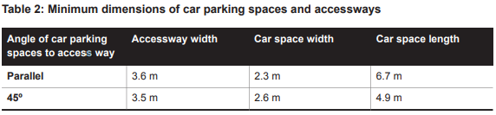  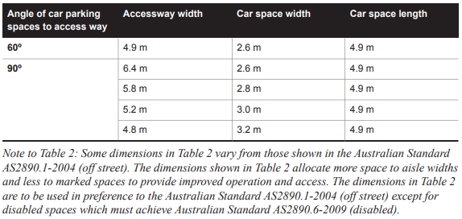 | ü Complies  All parking spaces are provided at 90 degrees to the relevant accessway with a minimum space dimension of 2.6 x 4.9 metres.  Several car spaces are labelled as ‘small’ car spaces and will be signed, and line marked as appropriate. These spaces will be allocated to residents at time of purchase.
A wall, fence, column, tree, tree guard or any other structure that abuts a car space must not encroach into the area marked ‘clearance required’ on Diagram 1, other than:  - A column, tree or tree guard, which may project into a space if it is within the area marked ‘tree or column permitted’ on Diagram 1.  - A structure, which may project into the space if it is at least 2.1 metres above the space.  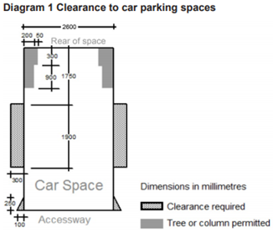 | ü Complies subject to conditions.  Each car parking space provided is clear of encroachment in accordance with the requirement.  In accordance with the Traffic Engineering Assessment, a condition of any permit granted should be included relating to the dimensioning of columns throughout the basement to demonstrate compliance with Diagram 1 of Clause 52.06-9.
Car spaces in garages or carports must be at least 6 metres long and 3.5 metres wide for a single space and 5.5 metres wide for a double space measured inside the garage or carport. | N/A – All parking provided at basement level or at grade level.
Where parking spaces are provided in tandem (one space behind the other) an additional 500 mm in length must be provided between each space. | ü Complies  The car stackers are provided in tandem however the car space dimensions are to be assessed via the mechanical parking requirements.
Where two or more car parking spaces are provided for a dwelling, at least one space must be under cover. | ü Complies  N/A no dwellings proposed.
Disabled car parking spaces must be designed in accordance with Australian Standard AS2890.6-2009 (disabled) and the Building Code of Australia. Disabled car parking spaces may encroach into an accessway width specified in Table 2 by 500mm. | ü Complies  Disabled car parking is provided in accordance with AS2890.6-2009. One space is provided within the basement.

Design standard 3: Gradients

Accessway grades must not be steeper than 1:10 (10 per cent) within 5 metres of the frontage to ensure safety for pedestrians and vehicles. The design must have regard to the wheelbase of the vehicle being designed for; pedestrian and vehicular traffic volumes; the nature of the car park; and the slope and configuration of the vehicle crossover at the site frontage. This does not apply to accessways serving three dwellings or less. | ü Complies  The ramp gradient proposed is 10% within 5 metres of the footpath, then 2 metres at 22.5%, then 12.52 metres at 25% and 2 metres at 12.5%. Those grades and grade changes all comply with the ramp grade requirements.
Building section showing ramp gradient
Ramps (except within 5 metres of the frontage) must have the maximum grades as outlined in Table 3 and be designed for vehicles travelling in a forward direction.  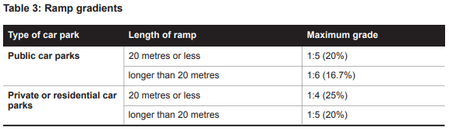 | ü Complies
Where the difference in grade between two sections of ramp or floor is greater that 1:8 (12.5 per cent) for a summit grade change, or greater than 1:6.7 (15 per cent) for a sag grade change, the ramp must include a transition section of at least 2 metres to prevent vehicles scraping or bottoming. | ü Complies  All changes to the grades comply with this requirement.
Plans must include an assessment of grade changes of greater than 1:5.6 (18 per cent) or less than 3 metres apart for clearances, to the satisfaction of the responsible authority. | N/A – Grade changes of greater than 1:5.6 are not proposed

Design standard 4: Mechanical parking

Mechanical parking may be used to meet the car parking requirement provided:  - At least 25 per cent of the mechanical car parking spaces can accommodate a vehicle height of at least 1.8 metres.  - Car parking spaces that require the operation of the system are not allocated to visitors unless used in a valet parking situation.  - The design and operation is to the satisfaction of the responsible authority. | The stacker spaces have a minimum floor to ceiling height to 2095 mm so all can accommodate a vehicle height of 1.8 metres. The appended typical section taken from the drawings by Hercules shows the clearances that are included in the stacker designs.  Staff only are to be provided with access to the stacker spaces, this will be included in the car park management plan.  A car stacker timing analysis has been provided and has been considered acceptable.

Design standard 5: Urban design
Ground level car parking, garage doors and accessways must not visually dominate public space. | ü Complies  N/A - no parking is provided at ground level.
Car parking within buildings (including visible portions of partly submerged basements) must be screened or obscured where possible, including through the use of occupied tenancies, landscaping, architectural treatments and artworks. | ü Complies  Parking facilities are visually compatible with the development.
Design of car parks must take into account their use as entry points to the site. | ü Complies  Access to the basement is provided from the street, and the entry to the site is compatible with the building.
Design of new internal streets in developments must maximise on street parking opportunities. | N/A – No new internal streets are proposed.

Design standard 6: Safety
Car parking must be well lit and clearly signed. | ü Complies, with condition recommended  No lighting detail has been proposed.  Were a permit to be granted, a condition is recommended that requires low-intensity lighting be provided in accordance with the requirement.
The design of car parks must maximise natural surveillance and pedestrian visibility from adjacent buildings. | ü Complies  The entrance to the parking basement parking area is clearly distinguishable when viewed from Hicks Street.
Pedestrian access to car parking areas from the street must be convenient. | ü Complies  Pedestrian access is provided internally from the building. The basement access is for vehicle only.
Pedestrian routes through car parking areas and building entries and other destination points must be clearly marked and separated from traffic in high activity parking areas. | N/A – No high activity parking areas are proposed.

Design standard 7: Landscaping

The layout of car parking areas must provide for water sensitive urban design treatment and landscaping. | ü Complies  Appropriate WSUD treatments are proposed as part of the development where required. The basement has a concealed flood barrier in the event of any flooding.
Landscaping and trees must be planted to provide shade and shelter, soften the appearance of ground level car parking and aid in the clear identification of pedestrian paths. | ü Complies  Given the zero lot line and the basement ramp, there is not a lot of room for landscaping and landscaping is not required in the basement.
Ground level car parking spaces must include trees planted with flush grilles. Spacing of trees must be determined having regard to the expected size of the selected species at maturity. | ü Complies  N/A – no parking is provided at ground level.

CLAUSE 52.34 – BICYCLE FACILITIES

- To encourage cycling as a mode of transport.
- To provide secure, accessible and convenient bicycle parking spaces and associated shower and change facilities.

Decision guidelines

Before deciding on an application, in addition to the decision guidelines in Clause 65, the responsible authority must consider, as appropriate:
- Whether the proposed number, location and design of bicycle facilities meets the purpose of this clause.
- The location of the proposed land use and the distance a cyclist would need to travel to reach the land.
- The users of the land and their opportunities for bicycle travel.
- Whether showers and change rooms provided on the land for users other than cyclists are available to cyclists.
- The opportunities for sharing of bicycle facilities by multiple uses, either because of variation of bicycle parking demand over time or because of efficiencies gained from the consolidation of shared bicycle facilities.
- Australian Standard AS 2890.3 1993 Parking facilities Part 3: Bicycle parking facilities.
- Any relevant bicycle parking strategy or equivalent.

Required bicycle facilities

- Tables 1, 2 and 3 to this clause set out the number and type of bicycle facilities required. Bicycle facilities are required if the use is listed in column 1 of the table. The number of bicycle facilities required for a use is the sum of columns 2 and 3 of the tables.
- If in calculating the number of bicycle facilities the result is not a whole number, the required number of bicycle facilities is the nearest whole number. If the fraction is one-half, the requirement is the next whole number.
- A bicycle space for an employee or resident must be provided either in a bicycle locker or at a bicycle rail in a lockable compound.
- A bicycle space for a visitor, shopper or student must be provided at a bicycle rail.

Table 1 to Clause 52.34-5 Bicycle spaces
Use | Employee | Visitor/ Shopper/Student
Shop | 1 to each 600 sq m of leasable floor area if the leasable floor area exceeds 1000 sq metres | 1 to each 500 sq m of leasable floor area if the leasable floor area exceeds 1000 sq metres | Not required as the shop floor area is only 90m2.
Food and Drink | N/A | N/A | Not rate therefore no requirements.
Office | 1 to each 300 sq m of net floor area if the net floor area exceeds 1000 sq m | 1 to each 1000 sq m of net floor area if the net floor area exceeds 1000 sq m | 5 staff spaces and 1 visitor space.
Total required for the development |  |  | 6 total
Total provided |  |  | 16 provided, 10 surplus.

Table 2 to Clause 52.34-5 Showers
Use | Employee | Visitor/ Shopper/Student
Any use listed in Table 1 | If 5 or more employee bicycle spaces are required, 1 shower for the first 5 employee bicycle spaces, plus 1 to each 10 employee bicycle spaces thereafter. | None
Total required for the development |  |  | 1 shower
Total provided |  |  | 4 showers

Table 3 to Clause 52.34-5 – Change rooms
Use | Employee | Visitor/ Shopper/Student
Any use listed in Table 1 | 1 change room or direct access to a communal change room to each shower. The change room may be a combined shower and change room. | None
Total required for the development |  |  | 1 change room area
Total provided |  |  | 4 change room area provided with shower area.

RESPONSE

The overall site provides more bicycle spaces than the statutory requirement under Clause 52.34-4, by 10 spaces. A minimum of the required 20% of spaces have been provided at ground level in accordance with the relevant Australian Standard, within the building. Two additional spaces are proposed on the road reserve, this is to be further review by City Engineering post permit decision.

Design of bicycle spaces

The basement spaces have been provided in a lockable storage room. The storage areas all able to be directly access via bicycles. There is a separate pedestrian/ bicycle access direct from the street.

Bicycle rails

Bicycle rails have been provided on the road reserve and within the building. These spaces are highly visible from the common areas and are easily accessible. These are provided within proximity to the lobby and lift well areas as well as direct ramp from the street.
The bicycle rails provided in the storages area are fixed to either the ground or the wall, depending on if the spaces are vertical or horizontal.

The following have been met throughout the development:

- A bicycle space for an employee in a bicycle locker or at a bicycle rail in a lockable compound.
- A bicycle space for a visitor, shopper or student must be provided at a bicycle rail.

Bicycle compounds and lockers

The basement parking for the residential spaces meet the following:

A bicycle compound must:
- Include wall or floor rails for bicycle parking.
- Provide an internal access path of at least 1.5 metres in width.

The ground floor provides areas that are fully enclosed as well as open areas for bicycle storage. They have direct and convenient access to the end of trip facilities. The end of trip facilities are fitted out with lockers and showers.

Bicycle signage

Bicycle signage has not been provided at this stage, however, is a requirement that if bicycle facilities are required under this clause, it must be provided to the satisfaction of the Responsible Authority. A condition on the permit will require signage to be provided in accordance with Clause 52.34-7.

Decision Guidelines
Overall, the development has a surplus of bicycle parking and therefore meets the purpose of the Clause. The location of the EOT facilities, storage is convenient for the cyclists coming and going from the site. The site complies with the EOT facilities and are available to cyclists coming to the site.

CLAUSE 53.18 – STORMWATER MANAGEMENT IN URBAN DEVELOPMENT

Purpose

To ensure that stormwater in urban development, including retention and reuse, is managed to mitigate the impacts of stormwater on the environment, property and public safety, and to provide cooling, local habitat and amenity benefits.

Decision guidelines

Before deciding on an application, in addition to the decision guidelines in Clause 65, the responsible authority must consider, as appropriate:

- Any relevant water and stormwater management objective, policy or statement set out in this planning scheme.
- The capacity of the site to incorporate stormwater retention and reuse and other water sensitive urban design features.
- Whether the development has utilised alternative water sources and/or incorporated water sensitive urban design.
- Whether stormwater discharge from the site will adversely affect water quality entering the drainage system.
- The capacity of the drainage network to accommodate additional stormwater.
- Whether the stormwater treatment areas can be effectively maintained.
- Whether the owner has entered into an agreement to contribute to off-site stormwater management in lieu of providing an on-site stormwater management system.

RESPONSE

The requirements of Clause 53.18-3 set out that:

An application to construct a building or construct or carry out works:

- Must meet all of the objectives of Clauses 53.18-5 and 53.18-6.
- Should meet all of the standards of Clauses 53.18-5 and 53.18-6.

An application must be accompanied by details of the proposed stormwater management system, including drainage works and retention, detention and discharges of stormwater to the drainage system.

The submitted Sustainability Management Plan details stormwater management initiatives.

The SMP includes a STORM rating report which details that the proposal would meet best practice performance objectives as required by Standard W2 of Clause 53.18-5.

It is sometimes appropriate to include conditions requiring the submission and approval of a construction management plan on any permit granted, to ensure the proposal would meet the requirements of Standard W3. However, given the urban context and that City Engineering has not recommended a construction environmental management plan (CEMP), one has not been required via a condition.

In view of the above, it is considered the proposal would accord with the objectives of clauses 53.18-5 and 53.18-6.

DECISION GUIDELINES OF CLAUSE 65:

CLAUSE 65.01 – APPROVAL OF AN APPLICATION OR PLAN

Clause 65.01 of the Greater Geelong Planning Scheme outlines the decision guidelines to be considered by the Responsible Authority when making decisions on applications. These decision guidelines include:

- The matters set out in Section 60 of the Act.
- The Municipal Planning Strategy and the Planning Policy Framework.
- The purpose of the zone, overlay or other provision.
- Any matter required to be considered in the zone, overlay or other provision.
- The orderly planning of the area.
- The effect on the environment, human health and amenity of the area
- The proximity of the land to any public land.
- Factors likely to cause or contribute to land degradation, salinity or reduce water quality.
- Whether the proposed development is designed to maintain or improve the quality of stormwater within and exiting the site.
- The extent and character of native vegetation and the likelihood of its destruction.
- Whether native vegetation is to be or can be protected, planted or allowed to regenerate.
- The degree of flood, erosion or fire hazard associated with the location of the land and the use, development or management of the land so as to minimise any such hazard.
- The adequacy of loading and unloading facilities and any associated amenity, traffic flow and road safety impacts.

Response

The application has been assessed against the above decision guidelines and considered the Municipal Planning Strategy, the Planning Policy Framework, the Commercial 2 Zone, relevant Particular Provisions, as well as all the relevant policies as listed within this report. On balance, the application has been considered an acceptable response and a planning permit should be issued subject to the relevant conditions.

CONCLUSION:

That the Responsible Authority having considered all matters which the Planning and Environment Act 1987, requires it to consider, recommends issuing a Notice of Decision for Development of a Multi Storey Building, Use of the Land for a Shop, Internally Illuminated Sign and a Reduction of Car Parking in accordance with the plans and documentation submitted with the application.

pagCLOSE OF MEETING

As there was no further business the meeting closed at 8.05pm on 26 June 2024.

