

minutes

PLANNING COMMITTEE MEETING
No. 223

Thursday 26 May 2022
5:30 pm
City Hall

ALSO LIVE STREAMED ON THE CITY’S WEBSITE:

www.geelongaustralia.com.au/meetings

PANEL:

Cr Sullivan – Chair
Cr Mason
Cr Mansfield
Cr Murrihy
Cr Moloney
Cr Nelson

INDEX

1. PROCEDURAL MATTERS 3
1.1. Acknowledgement Of Country 3
1.3. Introduce The Panel Members 3
1.4. Apologies 3
1.5. Declarations Of Conflicts Of Interest 3
1.6. Confirmation Of Minutes 3
2. MATTER(S) FOR CONSIDERATION 4
2.1. PP-320-2021 - 98 Marshalltown Road, Grovedale…. 4
2.2 PP-1512-2020 - 149 Bellarine Highway, Newcomb 9

3. CLOSE OF MEETING 130

PRESENT

Present: Cr Sullivan, Cr Mason, Cr Mansfield, Cr Murrihy, Cr Moloney and
Cr Nelson

Also
Present: J Van Slageren (Manager City Development), John Rush (Coordinator Statutory Planning), Rory O’Loghlen (Team Leader Statutory Planning), Tracey McCooke (Senior Statutory Planner), Lewis Muston (Senior Statutory Planner)

Opening: The Chair declared the meeting open at 5.30pm.

PROCEDURAL MATTERS

Acknowledgement Of Country

The Committee acknowledges the Wadawurrung People as the Traditional Owners of the Land, Waterways and Skies. We pay our respects to their Elders, past and present. We Acknowledge all Aboriginal and Torres Strait Islander people who are part of our Greater Geelong community today.

1.3. Introduce The Panel Members

1.4. Apologies

C Grzybek, Cr Harwood, Cr Kontelj, Cr Aitken

1.5. Declarations Of Conflicts Of Interest

Nil

1.6. Confirmation Of Minutes

That the Minutes of the Planning Committee Meeting held on 24 February 2022 be confirmed.
Moved: Cr Moloney Seconded: Cr Nelson

CARRIED

2. MATTER(S) FOR CONSIDERATION

PP-320-2021 98 Marshalltown Road, Grovedale And PP-1512-2020 149 Bellarine Highway, Newcomb
2.1. | PP-320-2021 98 Marshalltown Road, Grovedale

Application No: | PP-320-2021
Applicant: | Villawood Homes Pty Ltd and Eden Builders Ltd
Subject Land: | 98 Marshalltown Road, Grovedale
Zone: | General Residential Zone Schedule 4  The site is located within an Increased Housing Diversity Area
Overlays: | None
Existing Use: | Single dwelling
Proposed Use: | Construction of multiple dwellings (41) and staged multi lot subdivision

Summary
- The subject site is located on the south side of Marshalltown Rd, 36m west of the intersection with Barwarre Rd in Grovedale. The location is a 500m walk west of the Marshall railway station. Given its location, the site is included in the Marshall Station Increased Housing Diversity Area (IHDA).
- The site is located in the General Residential Zone, Schedule 4, which covers the land nominated for the Increased Housing Diversity Area. Land to the west and south of the site is located in the General Residential Zone Schedule 1. There are no overlays affecting the subject site or surrounding land.
- The subject site is regular in shape with a frontage to Marshalltown Rd of 40.2m and depth of 201.7m. The site contains a single dwelling and outbuildings on an area of 8093sqm. The site is flat and is not affected by any easements. A number of large trees are located generally around the perimeter of the site.
- Surrounding land is generally developed with single dwellings and outbuildings with lot sizes varying, albeit significantly smaller than the subject site (except the two lots adjoining the east boundary and opposite). Most lots adjoining to the west and south front (and are oriented toward) Hewitt Dr and Bradley Place, with secluded private open space generally abutting the subject site.
- The application seeks approval for the development of 41 dwellings on the site with associated staged subdivision.
- The development proposes the following dwelling layouts:
- 4 x detached two bedroom single storey dwellings (Dwellings 25, 26, 27 & 39).
- 37 double storey dwellings, attached in groups of 2 to 6 and comprising 2 four bedroom, 9 three bedroom and 26 two bedroom dwelling types.
- Car parking will generally be provided as a single garage with tandem car space where required.

- Dwellings 3 - 41 are proposed to be accessed via a central common property drive way and 5.5m width vehicle crossing, which would also provide access to eight visitor car spaces. Dwellings 1 and 2 will have separate driveways and one 6.4m width vehicle crossing on the frontage to Marshalltown Rd.

- The maximum building height would be 7.148m.

- A variety of materials are proposed to external wall including face brickwork, render, vertical and horizontal boards, timber cladding, with ground and upper storeys generally having different types. Each dwelling includes a variation to portico and/or door style.

- The application includes a subdivision of the development to include individual lots and a common property accessway in four stages. The lots will range in area from 86sqm to 273.8sqm.

- A large area of communal open space is also proposed in between dwellings 31 & 32. The communal open space will measure approximately 50m x 14 m and will contain 7 of the 8 visitor car parking spaces. The eighth car parking space will be located between dwellings 26 & 27.

- Eight trees are proposed to be retained along the perimeter of the site. The trees include 7 x Tuart Gum and 1 x Yellow Gum which are all in fair to good health. A tree protection zone has been applied for all the trees.
- A condition requiring an appropriate landscape plan is recommended to form part of the permit.
- A previous application for the construction of forty two (42) dwellings and a staged forty two (42) lot subdivision on the subject site was previously refused by the Planning Committee and was appealed to VCAT by the applicant.
- Although VCAT upheld Council’s decision this was based on the following (excerpt from VCAT decision paragraph 34):

For these reasons I consider that the proposed development fails to achieve a key part of the policy framework that applies to the review site. Through the failure to properly identify and protect the appropriate existing trees on the review site, the proposed development has failed to respond to this key part of the existing and preferred neighbourhood character. As such, I consider that I have no option but to refuse to grant a permit for the proposed development. However, in refusing to grant a permit I note that the fundamentals of the design before me are appropriate for this locality, subject to an appropriate analysis of which of the existing trees should be retained, and how the development should be modified to provide for their safe retention.

- This application provides for the retention and protection of 8 trees and a slightly different layout to provide a large area of communal open space within common property. A review of the vegetation on site via a Vegetation Assessment, Arboricultural Assessment and Development Impact Assessment has been undertaken. Council’s Environment Unit & Parks Department have agreed with the conclusions within the reports and require conditions on the permit for a Tree Protection Management Plan and Tree Protection Zones.
- VCAT also considered that the proposal should not be judged or refused on the basis of a density assessment, that the extent of failure to other standards and objectives of Clause 55 were not unreasonable and could easily be addressed by way of permit conditions and insofar as the proposed arrangement and articulation of the built form is concerned it is an appropriate response to the interface condition of the review site.
- The application was referred to relevant internal and external referral authorities. The authorities responded with no objection subject to conditions or advice.
- The application was advertised by way of one sign on site and notices sent to owners and occupiers of adjoining land (including opposite).

- As a result of advertising 17 objections were received with concerns relating to overshadowing, overlooking, vehicle access, car parking, traffic safety, neighbourhood character, proposed density, vegetation retention, waste collection and property values.

- A consultation meeting was not held due to COVID however a response prepared by the applicant was circulated to all objectors.

- The application has been assessed against the zone and relevant provisions and clauses of the Greater Geelong Planning Scheme.
- The assessment of the application has found the proposal to be a satisfactory response to the purpose of the zone in relation to providing an increase in dwelling density in a location that offers good access to services and transport. It also supports a diversity in housing design to address identified needs within the community. The proposal responds appropriately to Clause 55 (Rescode) and given the subject site is located within the Marshall Station Increased Housing Diversity Area the development is supported by a combination of policies applying to the land in relation to an increase in dwelling density.

- The assessment against policy provisions within the planning scheme provides clear support for the development. As mentioned, the site is located within an area of Increased Housing Diversity (IHDA), which is a marker for expected change in built form, where dwelling design is expected to make more efficient use of sites. The proposal not only receives support from the design objectives within Clause 22.63 (IHDA) it is also supported through policy in relation to infill development. It is considered that the built form proposed is offering an appropriate scale of development to the site, not an under or over development of the site. It is also responsive to the interface with the adjoining ‘conventional’ residential area (General Residential Zone) to the west, south and south-east. Only single and double storey built form is proposed, not three storey which is allowable under the zone. The proposal is compliant with the minimum side/rear setback required under Clause 55.04-1 (Side and rear setbacks). The dwellings are also spaced apart so that adjoining lots maintain views through the site. Visual bulk is also avoided through a variety of cladding and rooflines, as well as windows.

- In response to the previous VCAT decision a review of the vegetation on the site has resulted in the retention and protection of 8 mature Gum trees which will contribute to the character of the area through the retention of the existing tree canopy. A landscape plan is also recommended as a condition of the permit that will provide for planting throughout the site contributing to a better landscape outcome for the site and surrounding area.

- The application has been assessed against the objectives and standards of Clause 55 (Rescode) of the Planning Scheme with variations to two Standards required. Those being overshadowing of dwelling 11’s secluded private open space and some storage provisions.
Alternate Recommendation
Moved: Cr Nelson Seconded: Cr Moloney
That the Responsible Authority having considered all matters which the Planning and Environment Act, 1987, requires it to consider, decides to Refuse to Grant a Planning Permit for the Construction of Multiple Dwellings (41 dwellings) and Staged Multi Lot Subdivision at 98 Marshalltown Road, Grovedale on the following grounds:

Grounds of Refusal:

- The proposed development is considered to be an overdevelopment of the site as the dwelling density is excessive in the area and inconsistent with the objectives of Clause 21.06-5 (Urban Consolidation) and Council’s Housing Diversity Strategy (2007) noting the site is located on the edge of an Increased Housing Diversity Area.

- The proposal is contrary to the purpose of the General Residential Zone and objectives of Clause 22.63 (Increased Housing Diversity Areas) as it does not respect the neighbourhood character of the area, does not provide a satisfactory transition in the scale of development with the adjoining interface lots and does not provide a high level of onsite amenity for future residents.

- The proposal fails to meet the following standards and objectives of Clause 55:

  - Clause 55.02-1 (Neighbourhood character)
  - Clause 55.05-5 (Solar access to open space)
  - Clause 55.05-5 (Storage)
  - Clause 55.06-1 (Design Detail)

- The proposal is regarded as contrary to the objectives of Clause 52.06 (Car parking) as it will generate an unreasonable amount of vehicle movements in Marshalltown Road and fails to provide satisfactory pedestrian access.
CARRIED

2.1. | PP-320-2021 98 Marshalltown Road, Grovedale and PP-1512-2020 149 Bellarine Highway, Newcomb

Application No: | PP-1512-2020
Applicant: | Gaage Developments Pty Ltd
Subject Land: | 149 Bellarine Highway, NEWCOMB
Owner: | Bellarine Land Holdings Ltd
Zone: | Low Density Residential Zone – Schedule 1  Adjacent:  - Transport Zone 2 – Bellarine Highway (south)  - Transport Zone 3 – Coppards Road (east)
Overlays: | Special Building Overlay
Listed Buildings: | Nil
Existing Use: | Single Dwelling
Proposed Use: | Use and Development of a Service Station, Convenience Restaurant (Drive-through) and Car Wash and Alter Access to a Road in a Transport Zone 2

Summary
Site and Surrounds
- The land subject of this application, formally identified as Lot 1 on Title Plan 959168X, is situated at the north-western corner of Bellarine Highway and Coppards Road, Newcomb, and is known as 149 Bellarine Highway, Newcomb.
- The subject land has a total area of approximately 3,867sqm, with a frontage width of 33.17 metres to the Bellarine Highway, and a side frontage (depth) of approximately 130 metres to Coppards Road.
- At present the subject land exhibits a single storey brick dwelling with tiled hipped roof. Numerous outbuildings exist on the site to the rear of the existing dwelling. The existing dwelling fronts the Bellarine Highway, with a front setback of approximately 9.5 metres. The dwelling features a side street setback of approximately 13 metres.
- Vehicle access is currently available from Bellarine Highway and Coppards Road via separate vehicle crossovers. The Bellarine Highway Road reserve exhibits a formalised footpath and nature strip, with concrete vehicle crossover to the application site. The Coppards Road, road reserve exhibits an informal footpath and gravel crossover to the subject land. A bus stop is situated within the Coppards Road, road reserve, approximately 66 metres from the junction with Bellarine Highway.
- The land is relatively flat. A number of smaller and moderately sized trees are scatted through the site and on adjoining properties.
- Adjoining the subject land is two properties, 50 Coppards Road to the north, and 147 Bellarine Highway to the west. Both of which are also zoned LDRZ1.
- Number 50 Coppards Road exhibits a single dwelling, constructed of timber weatherboards and corrugated metal roofing. The property features a number of outbuildings at its rear.
- Number 147 Bellarine Highway exhibits a single-storey brick dwelling of similar siting, size and scale to the subject land. A carport projects forward of the dwelling within its front setback and access is available via two existing crossovers from Bellarine Highway. A number of outbuildings are situated at the rear of the dwelling.
- The wider locality to the south and east of the subject land generally features commercial uses and development. Opposite the subject land is an existing service station and various convenience restaurants, fronting the southern side of the Bellarine Highway.
- Opposite the subject land to the east, fronting the eastern side of Coppards Road, is a shopping centre which features numerous land uses including retail premises such as take away food, restaurants and shops, as well as a 24 hour gym.
- The subject land is zoned Low Density Residential Zone Schedule 1, is adjacent to a Transport Zone 2 (Bellarine Highway and a Transport Zone 3 (Coppards Road) and is wholly covered by a Special Building Overlay.
Proposal
- This application seeks a planning permit for the use and development of the land for a service station, food and drink premises (Convenience Restaurant) and car wash and alteration of access to a road in a Transport Zone 2.
Service Station
- The service station is proposed to be sited within the southern area of the subject land, with vehicle access to the site available from Bellarine Highway and Coppards Road. Egress from the site would only be available along the eastern side to Coppards Road.
- It is proposed to operate 24 hours a day, 7 days a week and would incorporate an ancillary convenience shop to the south-western side and 8 fuel pumps to the south-eastern portion of the land.
- The service station building would be set back approximately 3 metres from the common boundary with number 147 Bellarine Highway to the west and set back approximately 13 metres from the frontage to the Bellarine Highway. The building would be single storey with a hipped roof design with combined external materials of face brickwork, render and tiled roof. The pump area would be situated beneath a flat roof canopy with a maximum height of 6.7 metres, set back approximately13 metres from the street.
Convenience Restaurant
- The convenience restaurant would be located adjacent to the service station to the north, within the central area of the subject land.
- The convenience restaurant building would present to Coppards Road, with vehicular access available via an entry/exit crossover to Coppards Road, approximately 46 metres from the Bellarine Highway. Egress would be available from the same full directional crossover and an exit only crossover approximately 37.5 metres further north.
- A drive through lane would be situated adjacent the western and northern elevations, behind the convenience restaurant building.
- The building would be set back 12 metres from Coppards Road and 8 metres from the western side boundary. It would be of a flat-roof design with projecting timber clad parapet walls and projecting awning. The external finishes are shown to be a rendered finish.
- The maximum number of patrons proposed is 36 and it is proposed to operate 24 hours a day 7 days a week.

Car Wash
- The proposed car wash would be sited within the northern area of the application site. The car wash buildings would comprise an office area, a plant room and four undercover wash bays. To the west of the car wash building, would be a bin storage area.
- A vehicle accessway from the centre of the site to the car wash would be provided adjacent the western side boundary of the site. Three car parks would be provided to the north of the car wash building, adjacent the office area.
- The car wash building would be constructed of rendered blockwork with a gabled sheet metal roof, sited approximately 4 metres from the Coppards Road frontage, 8.7 metres from the western side boundary and 15 metres from the northern side boundary.
- Hours of operation for the car was a proposed to be 7am to 6pm, seven days per week.

Public Notice
- The application was advertised for a period of 14 days by way of signs placed on the Bellarine Highway and Coppards Road frontage, and letters to owners and occupiers of adjoining and surrounding properties.
- A total of 28 objections have been received.
- A summary of the matters raised in the objections received generally relate to:
- Traffic
- Neighbourhood Character
- Amenity impacts
- Environmental Impacts
- Flooding
- Planning policy responses
- No consultation meeting was held due to the inability) to hold face-to-face meetings at the time, as well as the number of objections received made it difficult to address wide ranging concerns of objectors.
Assessment
- The application has been assessed against the relevant requirements of the Planning Policy Framework, the Municipal Strategic Statement, the Low Density Residential Zone Schedule 1, the Special Building Overlay, relevant Particular Provisions and the Decision Guidelines of Clause 65.01 of the Greater Geelong Planning Scheme.
- In consideration of the matters raised within the objections received and taking into account the policy considerations the Greater Geelong Planning Scheme, it is hereby considered that the application adequately responds to the Planning Policy Framework, the Municipal Strategic Statement, the Zone and Overlays and relevant Particular Provisions.
- It is therefore recommended that a Notice of Decision to Grant a Planning Permit is issued in accordance with the Recommendation contained within this report.
Alternate Recommendation
Moved: Cr Mason Seconded: Cr Mansfield
That the Responsible Authority having considered all matters which the Planning and Environment Act, 1987, requires it to consider, decides to Refuse to Grant a Planning Permit for the Use and Development of a Service Station, Convenience Restaurant (Drive-through) and Car Wash and Alter Access to a Road in a Transport Zone 2 at 149 Bellarine Highway, NEWCOMB on the following grounds:

- The proposal fails to meet the objectives of Clauses 15.01-1S (Urban Design), 15.01-2S (Building Design), 15.01-5S (Neighbourhood Character) and 21.06-6 (Neighbourhood Character). In particular the proposal does not:

  - Respond to its context in terms of character, natural features and surrounding landscape within the surrounding Low Density Residential Zone (15.01-1S).
  - Sufficiently minimise the detrimental impact on neighbouring properties and the natural environment, nor retain existing vegetation (15.01-2S).
  - Respond to its context and reinforce the valued features and characteristics of the local environment, including the natural landscape character and established neighbourhood character (15.01-5S).
  - Retain existing vegetation on site or maintain the existing character of the surrounding Low Density Residential Zoned area (21.06-6)

- The proposal fails to meet the objectives of Clause 22.04 (Use and Development in Rural Living and Low Density Residential Areas):

  - Protect the amenity of the surrounding low density residential location from activities incompatible with the primary residential purpose of the zone,
  - Maintain the low density character of the low density residential zone area,
  - Discourage an urban activity which may attract substantial numbers of visitors to the site.

- The proposal is an unsatisfactory response to the purpose of the Low Density Residential Zone Schedule 1. In particular, the proposed use and development would not:

  - Provide for low-density residential development.

- The proposal is an unsatisfactory response to the decision guidelines of Clause 65.01. In particular, the application would fail to meet the purpose of the zone and objectives contained within the Planning Policy Framework, would detract from the amenity of the area as a result of the use being incompatible with the surrounding low density residential zone and would not provide for the orderly planning of the area.

CARRIED

ATTACHED REPORTS
- PP 320 2021 Planning Committee Report 98 Marshalltown Road

- PP 320 2021 Clause 55 Assessment 98 Marshalltown Road GROVEDALE

- PP 1512 2020 Planning Committee Report 149 Bellarine Highway NEWCOMB

Attachment_2.1.1
REPORT - PP 320 2021 Marshalltown Road Grovedale

PERMIT TRIGGER:

A planning permit is triggered for this application pursuant to the following clauses of the Greater Geelong Planning Scheme:

- Pursuant to Clause 32.08-3 of the General Residential Zone a permit is required to subdivide land.
- Pursuant to Clause 32.08-6 of the General Residential Zone a permit is required to construct two or more dwellings on a lot.

DEFINITIONS

Pursuant to Clause 73.03 of the Planning Scheme a dwelling is defined as:
A building used as a self-contained residence which must include:

a) a kitchen sink;
b) food preparation facilities
c) a bath or shower; and
d) a closet pan and wash basin.

It includes outbuildings and works normal to a dwelling.

Pursuant to Clause 73.04 of the Planning Scheme a dwelling is nested in the Accommodation group.

Subdivision is not defined or nested in the Planning Scheme.

A lot is defined as a part (consisting of one or more pieces) of any land (except a road, a reserve, or common property) shown on a plan, which can be disposed of separately and includes a unit or accessory unit on a registered plan of strata subdivision and a lot or accessory lot on a registered plan.

Subdivision is defined in the Subdivision Act 1988 as the division of land into two or more parts which can be disposed of separately.

RESTRICTIVE COVENANT OR SECTION 173 AGREEMENT:

The subject site is not burdened by a Restrictive Covenant or Section 173 Agreement.

OFFICER DIRECT OR INDIRECT INTEREST:

No Council officers have any direct or indirect interest in the matter to which this report relates, in accordance with Section 130(2) of the Local Government Act.

SITE/LOCALITY:

The subject site is located on the south side of Marshalltown Rd, 36m west of the intersection with Barwarre Rd in Grovedale. The location is 500m walk west of the Marshall railway station. Given its location, the site is included in the Marshall Station Increased Housing Diversity Area (IHDA).
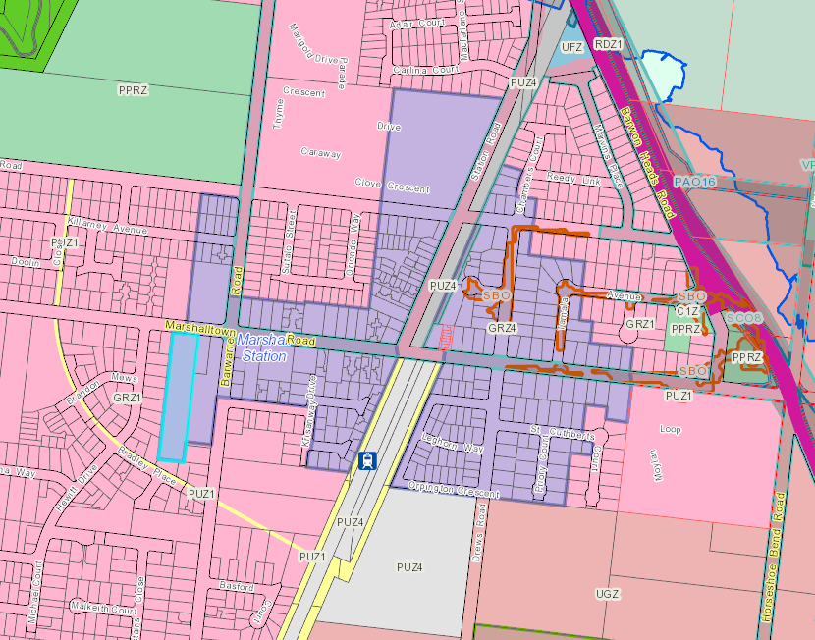
Figure 1: Subject site indicated in blue with IHDA indicated in purple, with surrounding zoning noted

The site is located in the General Residential Zone, Schedule 4, which covers the land nominated for the Increased Housing Diversity Area. Land to the west and south of the site is located in the General Residential Zone Schedule 1. There are no overlays affecting the subject site or surrounding land.

The subject site is regular in shape with a frontage to Marshalltown Rd of 40.2m and depth of 201.7m. The site contains a single dwelling and outbuildings on an area of 8093sqm. The site is flat and is not affected by any easements. A number of large trees are located generally around the perimeter of the site.

Surrounding land is generally developed with single dwellings and outbuildings with lot sizes varying, albeit significantly smaller than the subject site (except the two lots adjoining the east boundary and opposite). Most lots adjoining to the west and south front (and are oriented toward) Hewitt Dr and Bradley Place, with secluded private open space generally abutting the subject site.

A number of multi-dwelling sites are located in the surrounding area including 59, 66, 70-72, 73, 95 and 101 Marshalltown Rd. A planning permit (PP-894-2014) has also been issued for a 15 lot subdivision opposite the site at 85-89 Marshalltown Rd.

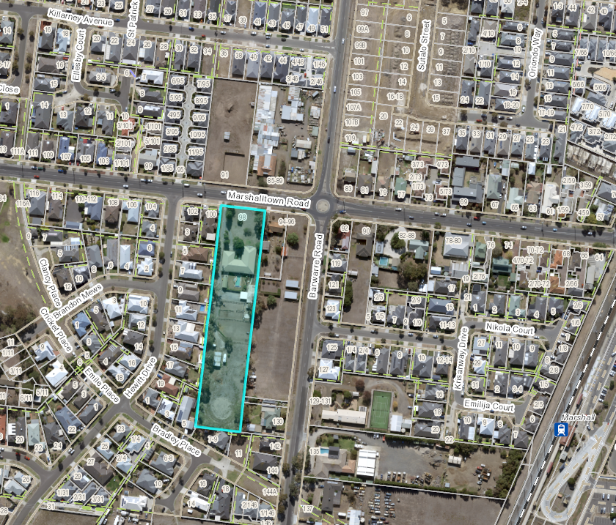
Figure 2: Site and surrounding development

PROPOSAL:

The application seeks approval under the General Residential Zone, schedule 4 for the development of 41 dwellings on the site with associated staged subdivision.

The development proposes the following dwelling (noting there are 41 dwellings in total) layouts:

- 4 x detached two bedroom single storey dwellings (Dwellings 25, 26, 27 & 39).
- 37 x double storey dwellings, attached in groups of 2 to 6 and comprising 2 x four bedroom, 9 x three bedroom and 26 x two bedroom dwelling types.
- Car parking will generally be provided as a single garage with tandem car space where required.

Dwellings 3 - 41 are proposed to be accessed via a central common property drive way and 5.5m width vehicle crossing, which would also provide access to eight visitor car spaces. Dwellings 1 and 2 will have separate driveways and one 6.4m width vehicle crossing on the frontage to Marshalltown Rd.

Dwellings 1, 2, 40 and 41 are oriented to Marshalltown Rd with all other dwellings oriented to the common property access. Dwellings are accessible at grade from ground level from the common property. The maximum building height would be 7.148m.

Dwellings 1, 2, 3, 4, 5, 6, 13, 14, 15, 16, 17, 24 & 41 and all single storey dwellings will have hipped metal roofs, while other dwellings will have flat roofs. A variety of materials are proposed to external wall including face brickwork, render, vertical and horizontal boards, timber cladding, with ground and upper storeys generally having different types. Each dwelling includes a variation to portico and/or door style.

Dwellings 1, 2 and 40 will be setback 4m from the frontage to Marshalltown Road. Side and rear setbacks would be as follows:

- 1.79 – 7.043m to the east boundary
- 1.2 – 1.8m to the south boundary
- 1.692 – 3.167m to the west boundary

Secluded private open space is provided as follows:

- Dwellings 7-12 and 18-23 will have a minimum 25sqm of secluded private open space at ground level in the east setback.
- Dwellings 1-6, 13-17, 28-38 and 41 will have a minimum 8sqm of north secluded private open space provided on balconies on upper levels. The dwellings would have a ‘reverse living’ format with living areas on the first floor. POS is also provided within rear and side setbacks at ground level.
- Dwellings 24-27, 39 & 40 would all have a minimum SPOS of 32sqm at ground level in the east or west setback.

A 1.1m high metal blade fence is proposed along the frontage of Dwellings 1, 2 and 42 to Marshalltown Rd. A 1.8m high Colorbond fence is proposed along all side and rear boundaries.

The application includes a subdivision of the development to include individual lots and a common property accessway in four stages. A large area of communal open space is also proposed in between dwellings 31 & 32. The communal open space will measure approximately 50m x 14 m and will contain 7 of the 8 visitor car parking spaces. The eighth car parking space will be located between dwellings 26 & 27. The lots will range in area from 86sqm to 273.8sqm.

Eight trees are proposed to be retained along the perimeter of the site. The trees include 7 x Tuart Gum and 1 x Yellow Gum which are all in fair to good health. A tree protection zone has been applied for all the trees.

A landscape plan was submitted with the application however this does not reflect the current layout of the development therefore a condition requiring an appropriate landscape is recommended.

PERMIT/SITE HISTORY:

The following permits/site history is applicable to this application:

- PP-1396-2018 – Construction of Forty Two (42) dwellings (including Thirty Five Double Storey and Seven Single Storey) and a Staged Forty Two (42) Lot Subdivision

The above application was refused by the Planning Committee and was appealed to VCAT by the applicant.

The previous application was refused based on the following:

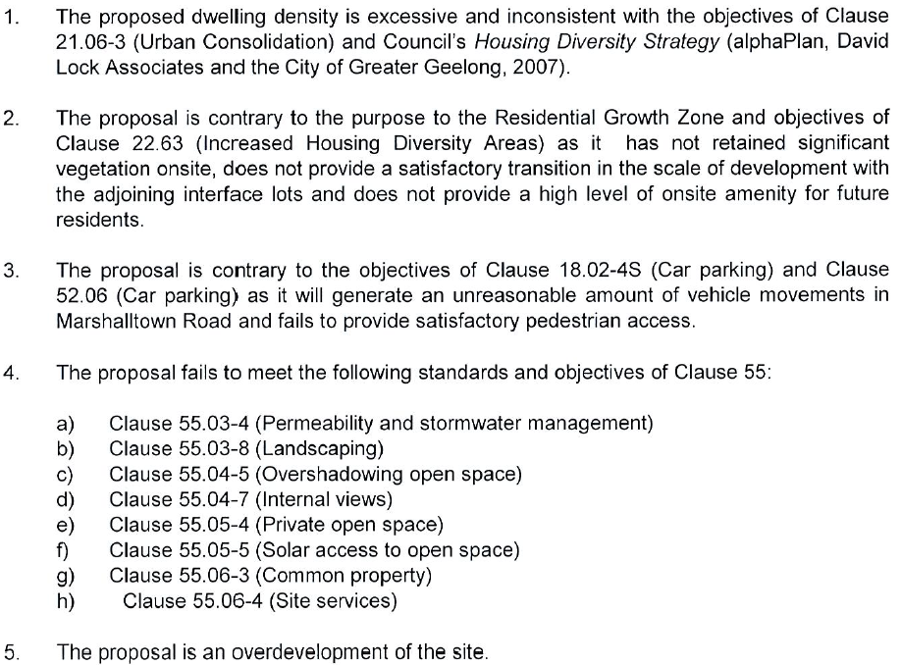

In the VCAT decision at paragraph 34 Council’s decision was upheld however this was based on the following:

For these reasons I consider that the proposed development fails to achieve a key part of the policy framework that applies to the review site. Through the failure to properly identify and protect the appropriate existing trees on the review site, the proposed development has failed to respond to this key part of the existing and preferred neighbourhood character. As such, I consider that I have no option but to refuse to grant a permit for the proposed development. However, in refusing to grant a permit I note that the fundamentals of the design before me are appropriate for this locality, subject to an appropriate analysis of which of the existing trees should be retained, and how the development should be modified to provide for their safe retention.

Notably, this application provides for the retention and protection of 8 trees and a slightly different layout to provide a large area of communal open space within common property.

A review of the vegetation on site via a Vegetation Assessment, Arboricultural Assessment and Development Impact Assessment has been undertaken; and
Council’s Environment Unit & Parks Department have agreed with the conclusions within the reports and require conditions on the permit for a Tree Protection Management Plan and Tree Protection Zones.

It is noted that the VCAT in its decision provided the following commentary at paragraph 17:

Firstly, I regard the density guidance provided in the reference document as a general guide to assist people to understand the difference between medium and higher density housing, as referred to in that document. As the decision has been made not to repeat the density guidance in the policy at Clause 22.63 of the Greater Geelong Planning Scheme, nor incorporate that guidance into the planning scheme in any other form, I cannot give the density guidance significant weight. Further, I consider that the proposed density on the review site of around 52 dwellings per hectare to be generally in accordance with the guidance provided, considering that the review site is an exceptionally large site. Larger sites provide an opportunity for efficiencies to be gained, such as through development being located on both sides of a common driveway, and through other efficiencies in design that can assist to provide a higher density, which might achieve similar built form outcomes as lower density developments on smaller sites. For these reasons I am not persuaded that the proposal should be judged or refused on the basis of a density assessment.

The extent of failure to standards and objectives of Clause 55 were also considered not unreasonable and could easily be addressed by way of permit conditions and insofar as the proposed arrangement and articulation of the built form is concerned it is an appropriate response to the interface condition of the review site.

This (new) application has sought to address the majority of Clause 55 (Rescode) issues identified in the previous application except for overshadowing of dwelling 11’s secluded private open space and some storage provisions (and these matters are considered relatively modest variations). Based on this information, overall, it is considered the proposal meets the objective of Clause 55 and relevant decision guidelines.

REFERRALS:

The following referrals were undertaken:

SECTION 55:

DETERMINING AUTHORITY

Authority: | Barwon Water, Powercor, Downer
Response: | Conditional consent
Officer Comment:
The conditions will be included on any planning permit.

Authority: | CFA
Response: | Conditional consent  1. Hydrants  Prior to the issue of a Statement of Compliance under the Subdivision Act 1988 the following requirements must be met to the satisfaction of the CFA:  1.1 Above or below ground operable hydrants must be provided. The maximum distance between these hydrants and the rear of all building envelopes (or in the absence of building envelopes, the rear of the lots) must be 120 metres and the hydrants must be no more than 200 metres apart. These distances must be measured around lot boundaries.  1.2 The hydrants must be identified with marker posts and road reflectors as applicable to the satisfaction of the Country Fire Authority.  Note –CFA’s requirements for identification of hydrants are specified in ‘Identification of Street Hydrants for Firefighting Purposes’ available under publications on the CFA web site (www.cfa.vic.gov.au)  2. Roads  The driveway must be constructed to a standard so that they are accessible in all weather conditions and capable of accommodating a vehicle of 15 tonnes for the trafficable road width.  2.1 Have a minimum trafficable width of 4 metres and 4 metres above the access way.
Officer Comment:
The conditions will be included on any planning permit.

INTERNAL

Department: | Engineering Services
Response: | 03 May 2021  Engineering have the following issues/concerns.  - Storm rating is 28% well below the 100% required.  - Stormwater management plan to address Q5, Q100, and quality at both staged or overall.  - Staging plan extents to include the required common property to allow for vehicle movements.  a condition requiring FLPs at each stage could address staging concerns for engineering. Management plan addressing volume and treatment still required.  “Functional Layout Plans”  Unless otherwise approved in writing by the Responsible Authority, prior to the commencement of works for each relevant stage of the subdivision, a Functional Layout Plan for that stage of the subdivision is to be submitted to and approved by the Responsible Authority. “  Traffic Engineering comments  It is considered that the proposal remains an overdevelopment of the site, with unreasonable amount of traffic movements and on-street parking pressures that will affect the amenity of other properties. (See below - a response to this comment)  The driveways and vehicle crossings for Unit 1 and 2 shall be 3.3 m wide, with provision of a minimum 1.5 m separator between the vehicle crossings (all dimensions measured at the road reserve boundary).  Separate pedestrian paths must be provided between the road reserve boundary and the Entry of Unit 1 and 2.  The vehicle crossing for the common property driveway shall be 6.0 m wide and located as shown on the design response drawing.  Without Prejudice Conditions  To the satisfaction of the RA, amended plans must be provided to show:  - The driveway for Unit 1 must be 3.3 m wide at its intersection with the road reserve boundary, and the vehicle crossing must be 3.3 m wide and centred on the driveway. All dimensions to be shown on the Ground Floor plan.  - The driveway for Unit 2 must be 3.3 m wide at its intersection with the road reserve boundary, and must have a minimum offset of 1.5 m from Unit 1’s driveway. The vehicle crossing must be 3.3 m wide and centred on the driveway, with provision of a 1.5 m wide separator. All dimensions to be shown on the Ground Floor plan.  - The common property driveway must be 6.0 m wide at its intersection with the road reserve boundary, and the vehicle crossing must be 6.0 m wide and centred on the driveway. All dimensions to be shown on the Ground Floor plan.  - Separate pedestrian paths must be provided between the road reserve boundary and the Entry of Unit 1 and 2.  - Separate letterboxes shall be provided for Unit 1, 2 and 42, and must be located next to their respective pedestrian paths and adjacent to the road reserve boundary.  Comments by: Grant Edmonds (Senior Development Traffic Engineer) – 9 June 2021  29 October 2021  Traffic Engineering comments  These comments are supplementary to those made on 9 June 2021 and refer to the amended plan set date stamped 6 September 2021.  The amended plans have not addressed any of the comments made on 9 June 2021. It is recommended that all ‘without prejudice permit conditions’ be included on the planning permit if the application is to be supported.  Comments by: (Senior Development Traffic Engineer) – 29 October 2021  Recommended Permit Conditions (Without Prejudice)  Note: please provide conditions whether or not supporting  Without Prejudice Conditions (Combined)  Condition 1 (Amended Plans)  To the satisfaction of the RA, amended plans must be provided to show:  - The driveway for Unit 1 must be 3.3 m wide at its intersection with the road reserve boundary, and the vehicle crossing must be 3.3 m wide and centered on the driveway. All dimensions to be shown on the Ground Floor plan.  - The driveway for Unit 2 must be 3.3 m wide at its intersection with the road reserve boundary, and must have a minimum offset of 1.5 m from Unit 1’s driveway. The vehicle crossing must be 3.3 m wide and centered on the driveway, with provision of a 1.5 m wide separator. All dimensions to be shown on the Ground Floor plan.  - The common property driveway must be 6.0 m wide at its intersection with the road reserve boundary, and the vehicle crossing must be 6.0 m wide and centered on the driveway. All dimensions to be shown on the Ground Floor plan.  - Separate pedestrian paths must be provided between the road reserve boundary and the Entry of Unit 1 and 2.  - Separate letterboxes shall be provided for Unit 1, 2 and 42, and must be located next to their respective pedestrian paths and adjacent to the road reserve boundary.  Functional Layout Plans  Unless otherwise approved in writing by the Responsible Authority, prior to the commencement of works for each relevant stage of the subdivision, a Functional Layout Plan for that stage of the subdivision is to be submitted to and approved by the Responsible Authority.  Drainage Construction Plans:  Prior to the commencement of works, Engineer designed drainage plans must be submitted to and approved by the Responsible Authority. The Engineering drainage plans must show the extent of any proposed works including longitudinal plan of future Council assets and must demonstrate that Q100 overland stormwater flows can be safely conveyed through the subdivision site.  Standard Conditions  Drainage & Vehicular Access:  Prior to the occupation of the dwellings / statement of compliance, the developer must:  - Construct the site stormwater system including separate connection for each unit / lot into the existing SEP outside No.102 Marshalltown Road via a newly constructed outfall pipe and pit, or other nominated point/s as approved by the Responsible Authority. The stormwater connection must be in accordance with City of Greater Geelong Standard Drawings.  - Construct vehicular crossings in accordance with the requirements and standards of the City of Greater Geelong.  - Remove any redundant vehicular crossings with kerb and channel and the footpath/nature strip area reinstated to match existing construction in the street;  all to the satisfaction of the Responsible Authority.  Note:  1. Construction of the site stormwater connection/s is to be inspected by Council Representative prior to any backfilling. An appropriate fee equivalent to 3.25% of total cost of civil works, excluding GST (a minimum fee of $100 applies if the 3.25% amount is less than $100), is to be paid to Council for inspection. Relevant evidential documentation of the cost is to be provided.  2. All internal property drainage must be designed and constructed to satisfy AS/NZS 3500.  3. A Vehicle Crossing Permit must be obtained prior to commencement of works.  Car Parking  Prior to the occupation of the dwellings / statement of compliance for each relevant stage of the Plan of Subdivision, the developer must construct the car park including accessways, surface with an all-weather sealed coat and linemark the car and accessways in accordance with the endorsed plans to the satisfaction of the Responsible Authority.  Common Property – PRIOR TO OCCUPATION  Prior to the occupation of the dwellings the common property / access road within the development / subdivision shall be constructed and drained to the satisfaction of the Responsible Authority.  Common Property – PRIOR TO STATEMENT OF COMPLIANCE  Prior to statement of compliance for each relevant stage of the Plan of Subdivision, the common property / access road within the development / subdivision shall be constructed and drained to the satisfaction of the Responsible Authority.  Stormwater Quality / Management  The site stormwater system must be designed and installed such that;  - The site stormwater discharge is not increased by the proposed development. An appropriate on site detention system designed in accordance with the Infrastructure Design Manual may be required;  - Runoff is to be treated to achieve current best practice pollutant removal targets by connection to an appropriate Water Treatment Facility, with capacity to treat at least a 3 month ARI storm event, unless approved otherwise by the Responsible Authority. The Water Treatment Facility must be maintained to the satisfaction of the Responsible Authority.  to the Satisfaction of the Responsible Authority  Creation of easements  The Plan of Subdivision submitted for certification must include all easements deemed necessary to protect existing or future drainage lines within the subject site, and any easements required between the subject site and the nominated legal point of discharge must be created to the satisfaction of the Responsible Authority.  NOTE  A pre-commencement meeting with Council’s engineering department is required to be undertaken prior to works starting. To organise this meeting please contact 5272 4426
Officer Comment:
It is noted that modifications were made and the STORM report now meets 100%.
Generally, the suggested conditions are to be included in any permit.
In response to Council’s Traffic Units concerns in relation to an overdevelopment of the site, unreasonable amount of traffic movements and on-street parking pressures that will affect the amenity of other properties I offer the following:
- VCAT considered that the previous design and development density was appropriate for the site. This application proposes one less dwelling and retains the previous design and interface to adjoining properties. All appropriate on-site car parking is provided along with 8 visitor car spaces. Council’s Traffic Unit provided no further justification as to why the proposal was an overdevelopment of the site and did not provide evidence of unreasonable traffic movements or on-street parking pressures. It is acknowledged that the development will increase traffic movements and when on-site visitor parking is full the site allows for on-street parking directly in front of the site.

The application provided a detailed (independent) traffic assessment which concluded that the traffic generated by the proposed development can be accommodated by the surrounding road network and there is no (traffic) reason why the proposed development should be refused on traffic related matters.

Department: | ESD Response
Response: | 13/05/2021  Summary  Council’s ESD Officer has reviewed the below documents in accordance with Council's ESD Local Planning Policy (22.71), this development has not reached an acceptable level of ESD for a permit to be issued. This is because some of the issues identified cannot yet be fixed with permit conditions.  Documents reviewed:  - Development plans by Project now, dated on November 2020 received on 1/04/2021  - Sustainable Management Plan report by EWE, date on 11 December 2020 received on 1/04/2021  - BESS report (project identifier: (78792DC9 Version 1), received on 1/04/2021  - Stormwater Management Report, STORM report (transaction ID: 761332) received on 1/04/2021  - Landscape plans by MEXTED RIMMER, No date received on 1/04/2021  And has determined that, in accordance with Council's ESD Local Planning Policy (22.71), this development has not reached an acceptable level of ESD for a permit to be issued. This is because some of the issues identified cannot yet be fixed with permit conditions.  The Applicant will need to remodel this development in BESS, whilst taking into consideration the notes/comments from Council's ESD Officer which are detailed under ESD Response.  These notes/comments have been summarised and alphabetised into items under ESD Response and should be addressed via the following ESD Resolutions Table:  There are 10 items in total and all of them need be responded to. The ESD Resolutions Table should be completed and send.  The SMP will also need to be amended to reflect any changes in the BESS modelling and both a revised SMP and BESS report, as well as plans (with additional ESD notes), will need to be re-reviewed by Council's ESD Officer.  An appropriately modelled STORM report with a ‘rating’ of 100% or more will also be required and the outputs of this should be entered into the Stormwater category in BESS. Some changes to the submitted STORM report may be required and will also need to be re-reviewed by Council’s ESD Officer.  Environment (ESD) Response  - Energy consumption: Preliminary energy (NatHERS) modelling has been undertaken. The certified NatHERS reports will need to be provided prior planning permit.  - BESS Water 1.1 Potable Water Use Reduction: The submitted report shows that Dishwasher have been selected 4-star WELS rated. It is however more likely that in a residential townhouse, the future occupiers will be using their own dishwasher, and therefore the developer has no influence on the water efficiency of the appliances in use. As per the BESS help notes, in this case ‘default or unrated’ must be selected from the drop-down list.  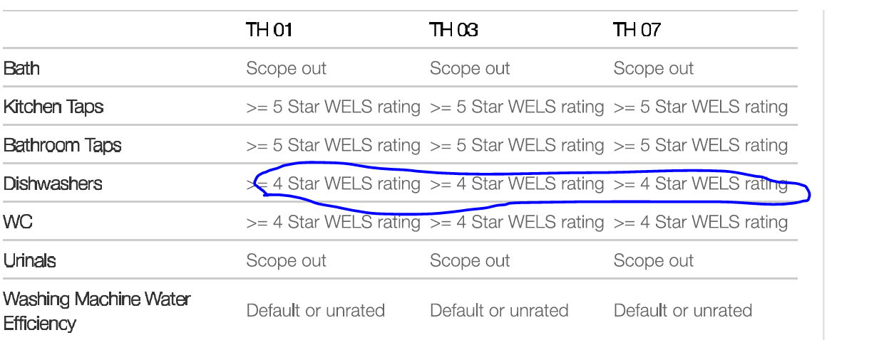  Excerpt from the submitted BESS report  - IEQ 3.1 – Thermal Comfort – Double glazing: Credits have been claimed in BESS for IEQ 3.3 – Thermal Comfort – Double Glazing. It needs to be clearly stated on the plans otherwise Thermal Comfort – Double Glazing credit should not be claimed.  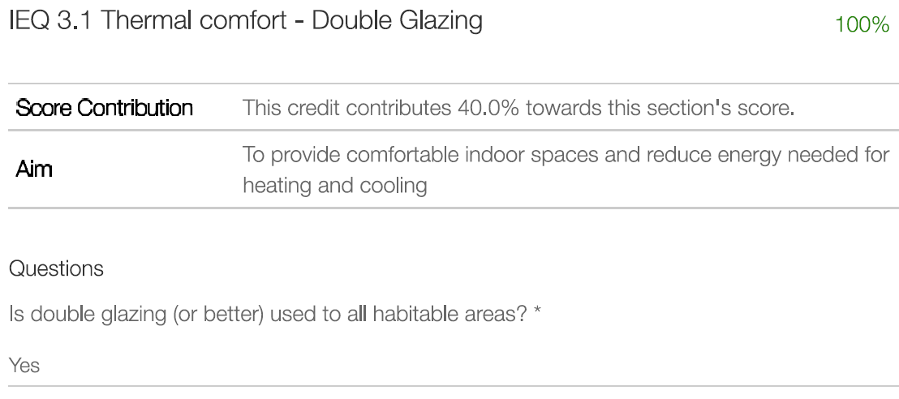  Excerpt from the submitted BESS report  - BESS IEQ 2.2 Cross Flow ventilation: It has been modelled that all the habitable rooms in the dwellings achieve natural cross flow ventilation. The Applicant must mark up the floor plans with breeze path diagrams in an attempt to demonstrate which living areas and bedrooms achieve appropriate cross ventilation. The rules for cross ventilation can be found on the BESS website.  The Applicant will need to provide cross flow ventilation diagrams to show that IEQ 2.2 is applicable to this development. Although it cannot be claimed, ventilation can be improved by providing more operable windows.  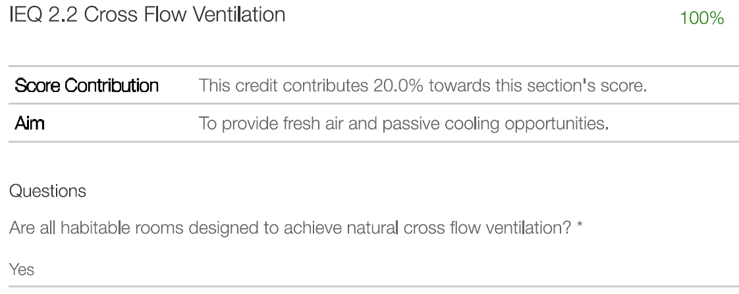  Excerpt from the submitted BESS report  - IEQ 3.3 – Thermal Comfort – Orientation: Credits have been claimed in BESS for IEQ 3.3 – Thermal Comfort – Orientation, 50% living areas oriented to the north. It appears that there are many units showing that 50% living areas are not oriented to the north. In these cases, Credits must not claim in BESS for IEQ 3.3 – Thermal Comfort – Orientation.  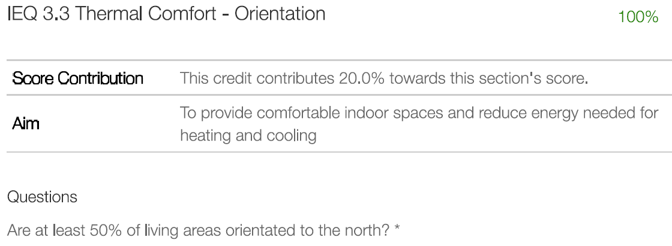  Excerpt from the submitted BESS report  - BESS tool - Urban Ecology 2.1 Vegetation: The BESS report claims that 24% of the site area is covered with vegetation. This is not evident on plans and therefore such a claim must be supported by evidence showing the extent of the vegetation and how the 24% was obtained, otherwise, the corrected percentage vegetated area may be claimed.  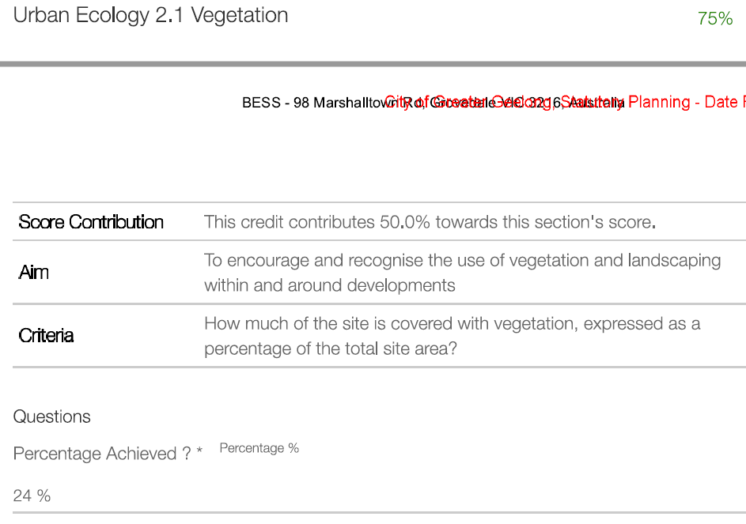  Excerpt from the submitted BESS report  - The Applicant has claimed credits for Urban Ecology 2.4 Private Open Space – Balcony / Courtyard Ecology. Taps need to be clearly marked on the plans for every balcony, otherwise this credit should be removed.  - Stormwater: An appropriately modelled STORM report with a ‘rating’ of 100% or more will also be required and the outputs of this should be entered into the Stormwater category in BESS. Some changes to the submitted STORM report will be required and will also need to be re-reviewed by Council’s ESD Officer. Two STORM reports are provided in this application as below. STORM report should not be inconsistent with SMP report as shown below.  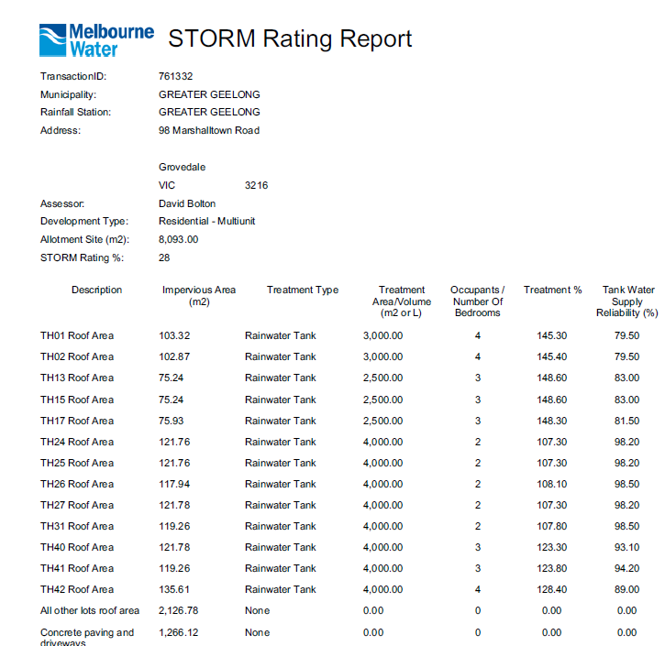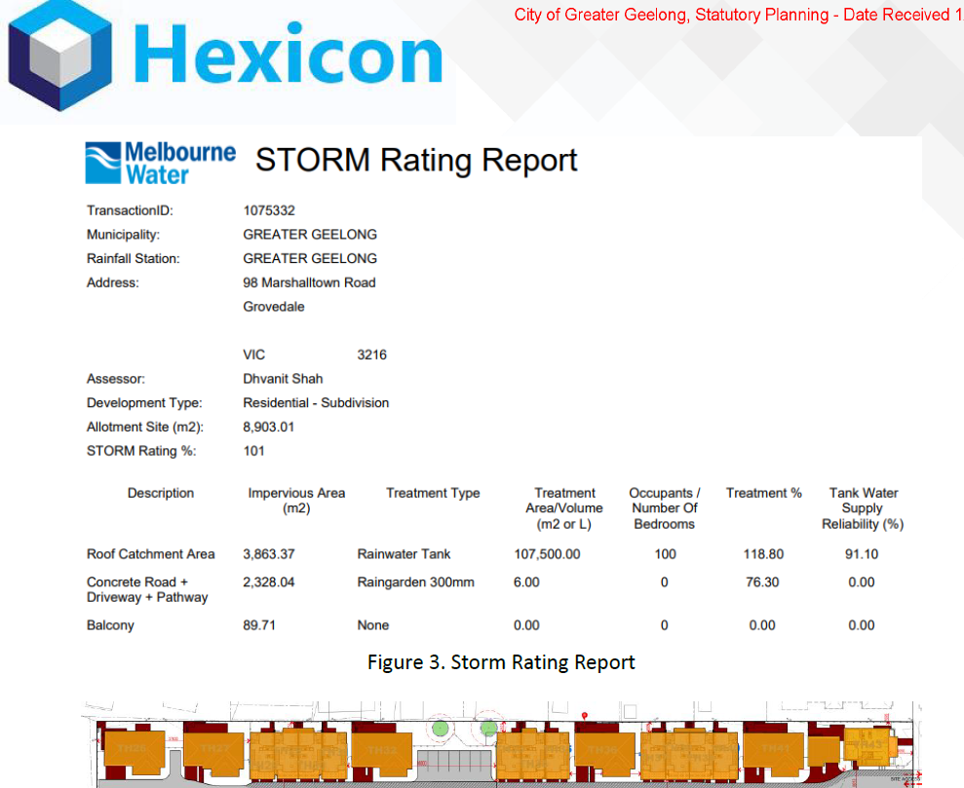  - Raingarden: The total raingarden area for the catchment would be required as acceptable standard. Rule of thumb is 1m² raingarden for the areas of every 50m². In these case, 47m² raingarden is recommended for 2328.04m² areas as in the SMP report. Raingarden must not be located on site boundary due to the risk of flooding to the neighbouring site. Permeable paving is more suitable for the subject site. A raingarden location and cross-section are needed to be included on plans. Sample cross-section is below for review only. The stormwater plan and drainage drawings must be consistent.  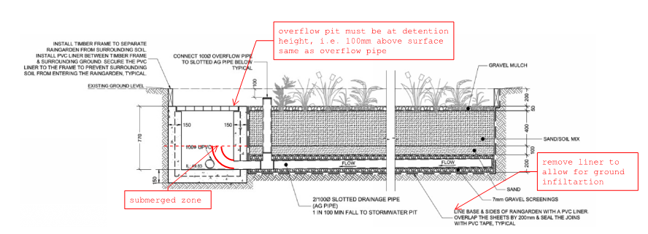  - Catchment plan: A complete response to the stormwater management requirements involves the preparation and submission of a site layout plan showing the different catchment areas size and the proposed stormwater treatment measures consistent with the STORM report, plans and the BESS report.  The underlying must be a roof plan that indicates slopes of different roofs to predict the potential path of rainwater from source to treatment destination. The catchment plan must include all the site and all the impervious areas including the paved areas in the private open space.  A catchment diagram will need to be added to the plans (e.g. below). Typically, catchment diagrams are colour coded – red shading showing the roofs draining to rainwater tanks, blue shading showing parts of the driveway draining to a raingarden, green areas showing vegetation and permeable/porous paving etc.  The Moreland Council website has some excellent resources regarding the preparation of STORM reports:  https://www.moreland.vic.gov.au/planning-building/environmentally-sustainable-design/water-sensitive-urban-design/  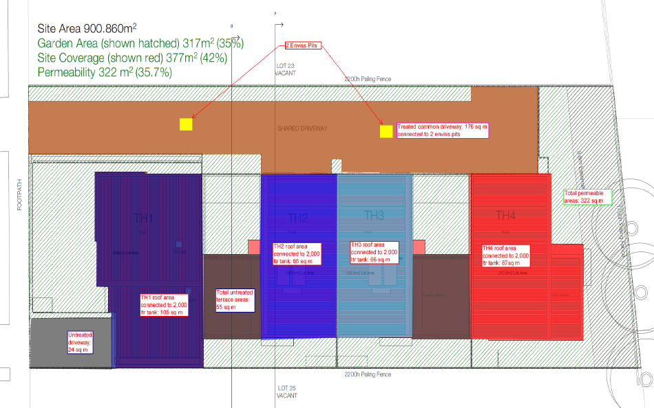  6/10/2021  This ESD response of this application is done on 6/10/2021. The applicant has not been satisfactorily responded all the previous ESD comments dated on 13/5/2020. Council’s ESD Officer has reviewed the below documents in accordance with Council's ESD Local Planning Policy (22.71), this development has not reached an acceptable level of ESD for a permit to be issued. This is because some of the issues identified can be fixed with permit conditions. The applicant will need to be resubmitted the updated reports and development plan to reflect ESD response.  Council’s ESD Officer’s has reviewed the following:  - Development plans by Project now, dated on June 2021 received on 6/09/2021  - Vegetation Assessment report dated on June 2021 received on 6/09/2021  Some of the issues raised on 13/5/2021 (previous response) which have not been addressed satisfactorily, see comments under ESD Response for further context.  30/11/2021  Recommended Permit Conditions (Without Prejudice)  - Before the use and development commences, amended plans to the satisfaction of the Responsible Authority must be submitted to and approved by the Responsible Authority. When approved, the plans will be endorsed and will then form part of the permit. The plans must be drawn to scale with dimensions. The plans must be generally in accordance with the plans received XXXX but modified to show:  - Initiatives contained within the BESS report along with the proposed changes, including:  - The Applicant can opt to provide the NatHERS certificates prior to occupancy. As a compromise, however, include a clear commitment in the plan to achieving a minimum 6.5 Star average energy rating and amend the BESS report to reflect the changes. 6-star is acceptable with minimum capacity of 2kW per dwelling for the requirements to reduce peak energy demand.  - All works must be undertaken in accordance with the endorsed Plan, ESD report and stormwater management plan to the satisfaction of the Responsible Authority. No alterations to these plans may occur without the written consent of the Responsible Authority.
Officer Comment:
Although the applicant has not responded satisfactorily the items can be addressed via permit conditions.
Generally, the suggested conditions are to be included in any permit.

Department: | Environment
Response: | 15/04/2021  I’ve reviewed the plans and the two arborist reports provided.  The application responds to 52.17 by stating that the trees onsite are planted and exempt but does not consider other native vegetation potentially present. Based on the historic land use there may be native understorey (grasses/shrubs) persisting onsite. Request a response to this aspect please.  The arborist reports are extensive for trees within the subject property but do not consider how the development may impact on private trees in surrounding allotments. This needs to be addressed now to ensure that any approved development layout does not inadvertently impact on trees outside of 98 Marshalltown Road.  25/10/2021  I have reviewed the Vegetation Assessment (Mark Trengrove June 2021) and Arborist report in response to the RFI dated 15th April 2021. Environment is satisfied there is no native vegetation on site and trees can be adequately protected during construction.  There are no landscape requirements from an environmental perspective. The landscape design must adhere to Cl. 55.03-8 standard B13.  I have provided standard conditions below.  Environment Unit Standard Conditions  No Removal of Native Vegetation  No native vegetation shall be removed other than that marked on the endorsed plan, to the satisfaction of the Responsible Authority.  Tree Protection  Removal, including pruning, of native trees must be undertaken using a suitably qualified arborist and be carried out in accordance with AS4373 – 2007; ‘Pruning of Amenity Trees to the satisfaction of the Responsible Authority’. The use of an excavator, backhoe, bulldozer blade or loader to trim branches of trees is not permitted.  Prior to any vegetation removal, vegetation to be removed must be clearly marked on site and accord with the endorsed plan. The vegetation to be retained on site shall be protected by fencing in accordance with AS4970-2009 Protection of Trees on Development Sites. The Tree Protection Fencing must have signs attached around the fencing which clearly states – TREE PROTECTION ZONE - No Access Permitted. An inspection is required once the Tree Protection Fencing has been erected. Please contact the City’s Environment Unit on 5272 5272 to arrange this inspection.  Except with the written consent of the Responsible Authority, the following is not permitted to occur within the Tree or Vegetation Protection Zone:  - vehicular or public pedestrian access.  - trenching or soil excavation.  - storage or dumping of tools, equipment, soil, stone or waste.  - construction of entry and exit pits for underground services.  - temporary or permanent installation of signs and utilities.  - any other actions or activities that may result in adverse impacts to retained native vegetation.  All work within the Tree Protection Zone of any tree to be retained above or below ground must be supervised by a suitably qualified level 5 arborist to ensure that the works are done in a manner which protects and minimises damage to those trees to the satisfaction of the Responsible Authority.
Officer Comment:
As there is no native vegetation present on site the requested conditions have not been added to the planning permit. Although the requested conditions have not been added to the planning permit Council’s Parks Department have requested similar conditions which have been added to the planning permit.

Department: | Parks
Response: | 14/04/2021  Parks Department Recommendation Response  I have been through the Development Impact Assessment. I agree with the recommendations regarding tree removals and tree retentions. While the report is titled as an impact assessment it is both an Arborist Impact Assessment and Tree Protection Management Plan.  I require further information and changes regarding some items related to tree protection. They are:  - I need to see an indicative fencing plan which shows where they propose to locate the tree protection fencing during the development. This will provide guidance and set an expectation for the end user of the report.  - There is a table that starts on Page 20 which is a schedule of works. They are to include an additional column for sign off and dating of each item as the Project Arborist they are completed to the Project Arborists.  I have included a sample of the planning permit I will be seeking for the site. I need to add the date to the planning permit in the first sentence after the applicant sends me back an updated version of the report with the additional items in it.  08/10/2021  The information (subsequently) provided has satisfied our previous RFI, this department now holds no objection to the proposal. See permit conditions below.  Standard Conditions  Tree Protection Management Plan  The Arborist Report Development Impact Assessment by Johnny’s Tree Services dated September 2020 and its recommendations are endorsed as the Tree Protection Management Plan for this site and form part of the permit.  The approved Tree Protection Management Plan must not be amended or altered without the consent of the Responsible Authority.  Tree Protection Zones  Prior to the works commencing (including any demolition works), Tree Protection Fencing must be installed in accordance with the Fence Plan Drawing Number TP-98 by Project Now dated June 2021 and maintained until works are completed to the satisfaction of the Responsible Authority.  All works within the nominated Tree Protection Zones must be:  - carried out in accordance with Australian Standard 4373–2007 Pruning of amenity trees and Australian Standard 4970–2009 Protection of trees on development sites  - overseen by a suitably qualified, level-5 arborist  - carried out to the satisfaction of the Responsible Authority by suitably trained and qualified arboricultural staff.  Works encroaching within the nominated Tree Protection Zones must not be undertaken without the written consent of the Responsible Authority.  Prior to occupation of the development/the issue of Statement of Compliance, a written statement from the Project Arborist must be submitted to the Responsible Authority that certifies that the following items have been addressed as part of the works:  - Establishment of correct placement and installation of tree protection fencing  - Attendance during Tree Protection Zone incursions  - Adherence to Australian Standard 4970–2009 Protection of trees on development sites  Note  In the instance that minor pruning is anticipated the applicant must contact Council’s Parks Planning Officers on 5272 5272 (treeplanning@geelongcity.vic.gov.au) to lodge a request and provide adequate notice.
Officer Comment:
Generally the suggested conditions are to be included in any permit.

Department: | Waste
Response: | The development layout does not allow the Council Waste and Recycling collection vehicles access to service the internal units and there is not enough kerbside space for all the units. Several units at the front are nominated in the WMP for Council collections from the kerbside, however as per Council Rates policy all the units in the development will pay the Council collection charges regardless of whether Council provides services or not.  Council Vs Private Contractors  - A Section 173 agreement of the Planning and Environment Act 1987 must be in a form to the satisfaction of the Responsible Authority and the agreement must contain covenants to be registered on the Title of the property so as to run with the land, and must provide for the following:  a) All waste services to the Residential Properties shall be undertaken by a private contractor managed by the body corporate, except for the three units that can access the kerbside in Marshalltown Road.  b) All residential units in the developments will be charged the Residential Waste Charge irrespective of who provides the waste and recycling collection services.  The agreement will be registered on Title in accordance with Section 181 of the Planning and Environment Act 1987.  Recommended Permit Conditions (Without Prejudice)  - A Waste Management Plan that is to the approval of the Responsible Authority must be provided prior to certification of the subdivision for this Development. The Approved Waste Management Plan must be incorporated into the Planning Permit.  - If the Waste Plan endorses the use of a private contractor to collect the residential waste and recycling from the development, the Applicant must enter into an agreement under Section 173 of the Planning and Environment Act 1987 with the Responsible Authority prior to the Statement of Compliance or the Certificate of Occupancy being issued for the development. The agreement must be in a form to the satisfaction of the Responsible Authority, and the applicant must be responsible for the expense of the preparation and registration of the agreement, including the Responsible Authority’s reasonable costs and expense (including legal expenses) incidental to the preparation, and enforcement of the agreement. The agreement will be registered on all the developments titles in accordance with Section 181 of the Planning and Environment Act 1987. The agreement must contain covenants to be registered on the Titles of the property so as to run with the land, and must provide for the following:  - The Council Residential Waste Service Charge is still payable even though a Private Waste Contractor provides the residential recycling and waste collection services.  - If the Waste Plan endorses the use of Councils kerbside collection contractor to collect the residential waste and recycling from inside the property boundaries of the development then an Indemnity Agreement must be entered in to prior to the Statement of Compliance for the development. The indemnity Agreement is to be with the body corporate and must indemnify, keep indemnified and hold harmless the Council’s collection contractor and the Council against any liability in respect of damage caused by any Collection Vehicles that may enter the property to provide residential waste and recycling collection services  - Any internal road within the property that will be used to provide the residential waste and recycling collection services must be designed for commercial truck traffic and the design and associated Swept Path Clearance Zones must be approved by the Responsible Authority prior to Compliance being issued.  - The residential waste and recycling collection vehicles must enter and exit the development in a forward motion.  - All Bins must be presented on the kerb for collection and removed once the bins have been emptied by the Building occupants or Body Corporate for any Council provided collection service  - The Waste Plan must include  - land use type  - waste generation for residential uses  - The bin storage area for the residential uses on a scaled plan  - waste systems and how the waste and recycling is separated in the household premises and transported to the bin storage area with meeting all access mobility requirements.  - bin quantity, size and colour  - collection frequency  - collection location  - collection contractors to be used  - additional waste requirements  - signage  - Area for parking of waste and recycling collection vehicles when bins are being emptied and the direction of travel of the vehicles, including swept paths for collection trucks.  - Location of where the bins will be presented for collection and the type of vehicles that are able to collect the bins from this nominated area
Officer Comment:
Generally, the suggested conditions are to be included in any permit.
However, the Section 173 Agreement for waste charges has not been included as this is something that is more appropriately addressed outside of the planning permit.

AMENDMENT OF THE PROPOSAL PRIOR TO PUBLIC NOTIFICATION:

The applicant made a request to amend the application pursuant to Section 50 of the Planning and Environment Act 1987 on 06/09/2021. Council accepted the amendment. The amendment made the following changes to the application:

- Revised design to comply with garden area.
- Revised Sustainability Management Plan including 100% STORM report & ESD Initiatives.

These are the plans that form the basis of this report.

PUBLIC NOTIFICATION:

The application is not exempt from the notice requirements of Section 52(1)(a), (b) and (d), the decision requirements of Section 64(1), (2) and (3) and the review rights of Section 82(1) of the Act and pursuant to Section 52 of the Planning and Environment Act 1987 the following forms of advertising were undertaken:

- Notices were sent to owners and occupiers of adjoining land (including opposite)
- 1 x A2 sign(s) was placed on the land

Seventeen (17) Objections have been lodged with Council

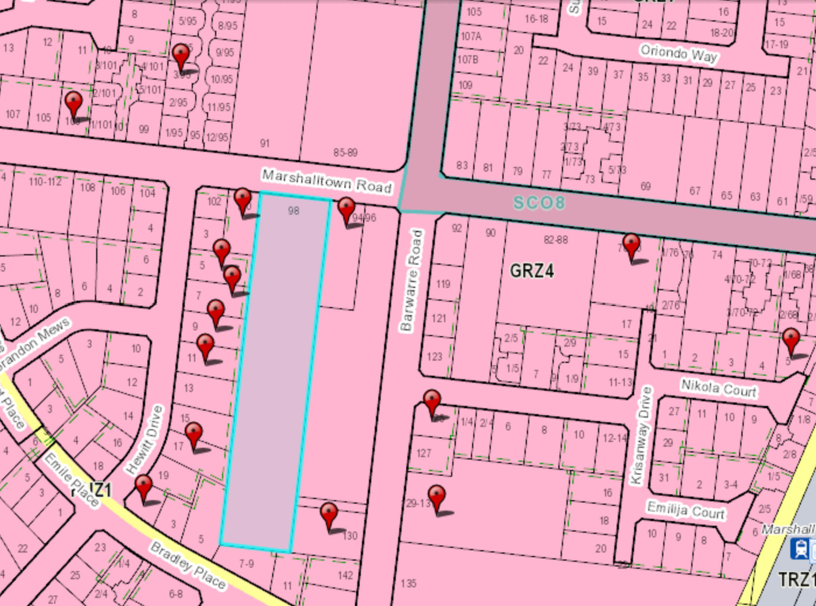
Figure 3 – Red pins indicate location of objectors in relation to the subject site highlighted in blue – One objector is located outside of the captured area.

CONSULTATION:

A consultation meeting was not held due to COVID and at the request of the applicant.

AMENDMENT OF THE APPLICATION FOLLOWING PUBLIC NOTIFICATION

The application was not amended following public notification.

OBJECTIONS:

The concerns of objectors are summarised and commented on below:

- Objection - Overshadowing

Response

As per the overshadowing diagrams provided at Sheets 91-93 of the development plans, some overshadowing does occur to the surrounding properties to the east, south and west of the proposal. The proposed dwellings will not significantly overshadow the existing secluded private open space of the adjoining properties.

Overshadowing is predicted to occur to the dwellings along Hewitt Drive, however only for the mid-morning until the sun moves further across. Of note – the Overshadowing requirements would satisfy Standard B21 of Clause 55 (Rescode).

- Objection - Overlooking

Response

All upper storey windows which will face existing habitable rooms or private open spaces have a raised windowsill height of 1.7 metres to meet the overlooking requirement Standard B22 of Clause 55. All balconies face towards the internal vehicle accessway, therefore no neighbouring properties will be subjected to unreasonable overlooking.

- Objection – Vehicle access, car parking and traffic safety

Response

The internal accessway is 6.1 metres wide at the entrance/exit to Marshalltown Road. To prevent traffic congestion along Marshalltown Road when one car is entering and exiting at the same time, a passing bay is proposed on the exiting side for the exiting car to wait while the entering car enters without creating congestion of Marshalltown Road.

Under Clause 52.06 of the Greater Geelong Planning Scheme, the minimum amount of required car spaces is 52 for residential use and 8 car spaces for visitors. The amount of car park spaces that are required have been provided within the development.

When pedestrians are crossing Marshalltown Road, the pedestrian crossings recently installed at the roundabout at the intersection of Marshalltown Road and Barwarre Road should be utilised to increase pedestrian safety.

4. Objection – Existing neighbourhood character

Response

The design of the development has considered the existing neighbourhood character whilst incorporating features of Increased Housing Diversity Areas or IHDAs.

The difference of schedules to the General Residential Zone between the development site and lots to the west have been taken into consideration. However, whilst some objectors raise that two storey dwellings are not common in the area, the same height controls apply in GRZ1 to that of GRZ4 (where the application site is). Under the General Residential Zone, the maximum building height must not exceed 11 metres and must contain no more than 3 storeys at any point. As the application site interfaces between the GRZ1 and IHDAs the built form has been designed to reduce the visual bulk of the townhouses on adjoining properties to the west. These design techniques include positioning the ‘blocks’ of townhouses so they provide a built form break along the rear boundary of the dwellings to the west, wall heights of the townhouses to the residential interface are relatively low compared to what the zone allows for and the breaks of the attached townhouses throughout the development provide for balance between the built form and surrounding residential interface.

The design of the townhouses and layout of the development is to provide an appropriate outcome between the existing neighbourhood character of the area whilst implementing the strategic guidance for development in the area through the IHDAs.

5. Objection – Proposed density

Response

As the application site is within an IHDA and GRZ4, the density proposed is higher than that of the surrounding residential area. However, the site is under utilised land which provides an opportunity to provide diverse housing options in close proximity to public transport and services. Significant focus has gone into providing a site responsive design and balancing the existing neighbourhood character that interfaces the IHDAs and implementing the medium housing density encouraged in IHDAs.

The previous VCAT decision was supportive of the proposed density of 43 dwellings while this proposal contains 41 dwellings.

6. Objection – Vegetation retention

Response

Following the previous VCAT decision, an extensive review of the vegetation on site via a Vegetation Assessment, Arboricultural Assessment and Development Impact Assessment has been undertaken. Council’s Environment Unit & Parks Department have agreed with the conclusions with the reports and require conditions on any permit for a Tree Protection Management Plan and Tree Protection Zones.The application now proposed to retain 8 trees – seven tuart trees and one yellow gum tree.

A landscape plan will be required as a condition on permit that will require the planting of various trees throughout the development along with screening plants and other vegetation.

7. Objection – Waste collection

Response

A Waste Management Plan was provided as part of the application. Three bin collection points have been provided within the development to service waste collection. The waste and recycling will be collected by private contractors across two days, as organised by Owner’s Corporation.

8. Objection – Property values

Response

The impact to property values as a result of development is not a consideration of the planning scheme.

ASSESSMENT:

ZONE:

Clause 32.08 – General Residential Zone

The purpose of the General Residential Zone is:

- To implement the Municipal Planning Strategy and the Planning Policy Framework.
- To encourage development that respects the neighbourhood character of the area.
- To encourage a diversity of housing types and housing growth particularly in locations offering good access to services and transport.
- To allow educational, recreational, religious, community and a limited range of other non-residential uses to serve local community needs in appropriate locations.

Schedule 4 to the General Residential Zone allows the following variations to Clause 55:

- Minimum Street Setback – If the site is in a heritage overlay, the average distance of the setbacks of the front walls of the existing buildings on the abutting allotments facing the front street or 9 metres, whichever is the lesser. In all other areas, the average distance of the setbacks of the front walls of the existing buildings on the abutting allotments facing the front street or 4 metres, whichever is the lesser.

- Site Coverage – Maximum site coverage 70 per cent

- Private Open Space - A dwelling or residential building should have private open space consisting of:
- An area of 20 square metres of secluded private open space at the side or rear of the dwelling or residential building with a minimum dimension of 3 metres and convenient access from a living room; or
- A balcony of 8 square metres with a minimum width of 1.6 metres and convenient access from a living room; or
- A roof-top area of 10 square metres with a minimum width of 2 metres and convenient access from a living room.

Garden Area

Pursuant to Clause 32.08-4, an application to construct or extend a dwelling on a lot must provide a minimum garden area as set out in the following table:

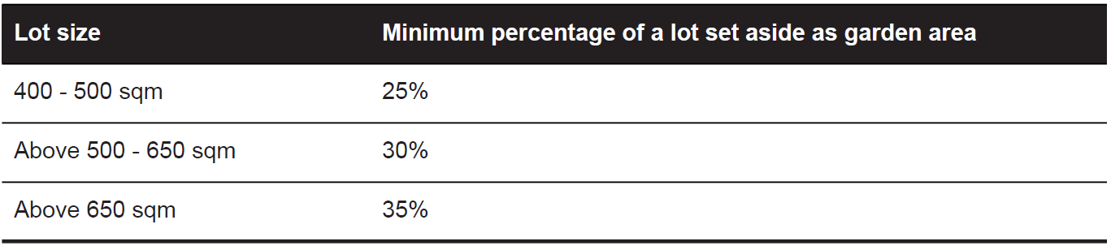

Garden Area Response

The subject site has an area of 8,051m² therefore 35% or 2,816m² is required to be set aside as garden area. The application proposes 36.09% or 2,920.46m² to be set aside as garden area and therefore complies with this requirement.

Maximum Building Height

The maximum building height measures 7.148 metres from natural ground level to the roof or parapet at the highest point. At not more than 3 storeys and less than 11 metres, the proposal complies with the maximum building height requirements in the Zone.

OVERLAY:

No overlays affect the subject site.
Response to zone

The site is located in the General Residential Zone, Schedule 4 and is within the Marshall Station Increased Housing Diversity Area. The combination of policies applying to the land results in an emphasis on development being supported for an increase in dwelling density in locations offering good access to services and transport. It also supports a diversity in housing design to address identified needs within communities. The proposal responds appropriately to Clause 55 (Rescode), will not impact any existing rooftop solar energy systems to dwellings on adjoining properties and, overall, is considered a satisfactory response to purpose of the zone.

CULTURAL HERITAGE MANAGEMENT PLAN (CHMP):

The Aboriginal Heritage Regulations 2018 specify the circumstances in which a cultural heritage management plan is required for an activity or class of activity. Division 2 of the Aboriginal Heritage Regulations 2018 specifies exempt activities which do not require a cultural heritage management plan. The proposal is not listed as an exempt activity.

Areas of cultural heritage sensitivity are defined within Divisions 3 and 4 of the Aboriginal Heritage Regulations 2018. Division 3 does not identify the site or part of the site as within an area of cultural heritage sensitivity.

In accordance with the above assessment, a cultural heritage management plan is not required.

LANDFILL GAS RISK ASSESSMENT

The subject site is not located within 500 metres of an identified former landfill site, a risk assessment is not required.

DEVELOPMENTS IN BUSHFIRE PRONE AREAS

The site is not located within a designated bushfire prone area.

THE VICTORIAN PLANNING POLICY FRAMEWORK (VPPF):

The following Victorian Planning Policies are applicable to this application:

11.01-1S - Settlement

15.01- 1S Urban Design

15.01-2S – Building design

15.01-3S - Subdivision Design

15.01-5S – Neighbourhood character

15.02-1S Energy and resource efficiency

16.01-1s - Housing supply

16.01- 2S - Housing Affordability

THE LOCAL PLANNING POLICY FRAMEWORK (LPPF)

MUNICIPAL STRATEGIC STATEMENT.

The following policies of the Municipal Strategic Statement are applicable to this application:

21.06-4 - Housing Diversity

21.06-5 - Urban Consolidation

21.06-6 – Neighbourhood Character
LPPF

The following Local Planning Policies are applicable to this application:

22.63 – Increased Housing Diversity Areas

22.71 – Environmentally Sustainable Development
Response to Policy

The subject site is located in the Marshall Station Increased Housing Diversity Area, to which the policy at Clause 22.63 seeks to accommodate intensification of residential development. There are other multi dwelling sites in the area and while the proposed built form is uncommon in this locality, it is nonetheless an acceptable addition where amenity impacts are reasonable.

Transition of character through density has been addressed in VCAT determinations previously where Senior Member Hewet commented on side-by-side and boundary-to-boundary proposals in Baric v Moreland CC [2015] VCAT 1359 (28 August 2015),

I acknowledge that side by side and boundary to boundary construction is not a feature of development in this neighbourhood. As I have previously discussed however, the character of this area is in transition. Increasingly medium density housing is becoming part of the character of this neighbourhood. In assessing this proposal’s response to neighbourhood character, I am required to be satisfied that the development is respectful of the neighbourhood’s character. I am not required to be satisfied that the proposal replicates a character that exists at a point in time.

As mentioned, the site is located in the Increased Housing Diversity Area, which is a clear marker for expected change in built form, where dwelling design is expected to make more efficient use of sites.

The proposal is considered to be an acceptable balance of current policy for infill development at an increased density, whilst offering a respectful design response taking into account the character of the locality that is expected and encouraged to change over time. The design has sought to soften the intensity of the development by incorporating appropriate setbacks to boundaries, a front setback in accordance with the schedule to the zone and single storey and hipped roof elements. Landscaping is proposed along with the retention and protection of 8 x mature Gum trees that will contribute to the character of the area.

The development meets the requirements of the State and Local Planning Policy for provision of infill development in locations with access to appropriate existing services and infrastructure. Clause 21.06-4 and Clause 21.06-5 of the Local Planning Policy Framework are policies in support of the proposal, encouraging increased density and diversity ultimately contributing to change in the area.

Clause 22.63 of the Greater Geelong Planning Scheme for Increased Housing Diversity Areas (IHDA) provides support for the implementation of general policy direction seeking to provide for more efficient housing development and decrease reliance on vehicle use as a result of urban sprawl. The policy directs that redevelopment of housing stock should be well designed, site responsive, contemporary medium density housing.

The IHDA policy provides design objectives to which proposals should appropriately respond to. With regard to ‘Built Form’, the policy seeks to:

- Encourage innovative, high quality, site responsive medium density housing development.
- Encourage development that incorporates a combination of horizontal and vertical articulation, materials, textures and colours to create visual interest.
- Encourage a sympathetic design response when addressing any unique characteristics such as heritage places, significant vegetation, topography and public spaces.
- Discourage storage areas located within the minimum area of secluded open space.

It is considered that the proposal is a satisfactory response to the criteria with the design response integrating into the site, utilising modern materials, and providing appropriate articulation to wall planes.

In response to the previous VCAT decision an extensive review of the vegetation on site via a Vegetation Assessment, Arboricultural Assessment and Development Impact Assessment has been undertaken. Council’s Environment Unit & Parks Department have agreed with the conclusions with the reports and require conditions on the permit for a Tree Protection Management Plan and Tree Protection Zones. The proposal includes the retention and protection of 8 mature Gum trees which will assist in retaining the existing tree canopy within the area.

A landscape plan will require planting throughout the site as well as in the road reserve. The landscape plan will also need to address the additional opportunities for planting in some areas of private open space as this provides a better landscape outcome for the site as well as soften the built form to adjoining lots.

The design also seeks to respect the character of the area through inclusion of hipped roof forms for some dwellings and recession of garaging (to dwellings fronting Marshalltown Rd), which are two common forms displayed by dwellings in the neighbourhood.

Storage is generally located within garages or within private open space where the minimum SPOS is exceeded.

Additional design objective of the IHDA policy that are relevant to the proposal include:

- Encourage two and three storey development. Three storey development should be encouraged on larger sites abutting the activity centre or where the amenity of adjoining properties will not be unreasonably impacted.
- Encourage the recessing of the third storey to reduce dominance of the building from adjoining properties and the streetscape.
- Ensure that the height and bulk of the new development on interface properties, between an IHDA and other residential areas, is responsive to the adjoining character and provides a transition in the built form between areas.
- Where appropriate, provide a street tree to enhance the contribution of the development to the streetscape.
- Ensure that the visual prominence of car parking structures is minimised by locating them behind the line of the front façade and designing them to form a visually unobtrusive part of the building.
- Where more than one car space is provided, encourage the use of a single-width garage or carport and a tandem parking space on existing or proposed lots with a frontage of less than 10.5m.
- Minimise the number of vehicle crossings and where possible, access should be from lower order roads and rear laneways.

The proposal satisfies the above design objectives and it is considered that the built form proposed is offering an appropriate scale of development to the site, not an underdevelopment of the site. It is also responsive to the interface with the adjoining ‘conventional’ residential area (General Residential Zone) to the west, south and south-east. Three storey built form is not proposed and the dwellings will be single or double storey, compliant with the minimum side/rear setback required under Clause 55.04-1 (Side and rear setbacks).

The dwellings are also spaced apart in a manner that maintains views through the site from adjoining properties. Visual bulk is also avoided through a variety of cladding and rooflines, as well as windows.

Landscape screening will also be required along boundaries, particularly for the double storey dwellings, in the form of trees and large shrubs.

Car parking has been designed in a form that is supported by the policy with all dwellings having single garaging and tandem spaces where required. The number of vehicle crossings is regarded as acceptable, meeting the Clause 55.03-9 (Access) standard and all dwellings except two having access via one crossing.

RELEVANT PARTICULAR PROVISIONS:

The following Particular Provisions are applicable to this application:

CLAUSE 52.06 – CAR PARKING

- To ensure that car parking is provided in accordance with the State Planning Policy Framework and the Local Planning Policy Framework.
- To ensure the provision of an appropriate number of car parking spaces having regard to the demand likely to be generated, the activities on the land and the nature of the locality.
- To support sustainable transport alternatives to the motor car.
- To promotes the efficient use of car parking spaces through the consolidation of car parking facilities.
- To ensure that car parking does not adversely affect the amenity off the locality.
- To ensure that the design and location of car parking is of a high standard, creates a safe environment for users and enables easy and efficient use.

Response

Clause 52.06 requires the provision of 60 car spaces (including 8 visitor spaces) to be located on the land. A total of 60 car spaces are provided.

Council’s Engineering Department has reviewed the carparking layout and advised the following changes are required:

- The driveway for Unit 1 must be 3.3 m wide at its intersection with the road reserve boundary, and the vehicle crossing must be 3.3 m wide and centered on the driveway. All dimensions to be shown on the Ground Floor plan.
- The driveway for Unit 2 must be 3.3 m wide at its intersection with the road reserve boundary, and must have a minimum offset of 1.5 m from Unit 1’s driveway. The vehicle crossing must be 3.3 m wide and centered on the driveway, with provision of a 1.5 m wide separator. All dimensions to be shown on the Ground Floor plan.
- The common property driveway must be 6.0 m wide at its intersection with the road reserve boundary, and the vehicle crossing must be 6.0 m wide and centered on the driveway. All dimensions to be shown on the Ground Floor plan.
- Separate pedestrian paths must be provided between the road reserve boundary and the Entry of Unit 1 and 2.
- Separate letterboxes shall be provided for Unit 1, 2 and 42, and must be located next to their respective pedestrian paths and adjacent to the road reserve boundary.

Subject to the changes recommended, the proposal will meet the requirements of Clause 52.06-9, in particular:

- Vehicles can manoeuvre within the site to exit in a forward direction, except Dwellings 1 and 2 which have their own access and therefore can reverse out.
- A passing area at the entrance to the site is provided in line with accessway standards.
- 2.1m headroom is provided above undercroft tandem parking spaces.
- On street parking space has been maximised through the limited number of vehicle crossings proposed.
- The site is flat therefore no ramps or gradients are required.
- No mechanical parking is required.
- Only two garages will front Marshalltown Road therefore not dominating the street.
- The accessway and car parking areas will be clearly signed and lit. A number of dwellings will have passive surveillance into the accessway from upper level balconies and living areas.
- Landscaping will be required to be kept to a minimum height of 1.0m at the entrance to the site allowing for sight lines onto Marshalltown Road.

Overall, the proposal will provide the required onsite car parking, in a layout that will provide for easy and efficient use and a satisfactory level of safety, including for pedestrians.

CLAUSE 53.01 – PUBLIC OPEN SPACE CONTRIBUTION

A person who proposes to subdivide land must make a contribution to the council for public open space in an amount specified in the schedule to this clause (being a percentage of the land intended to be used for residential, industrial or commercial purposes, or a percentage of the site value of such land, or a combination of both). If no amount is specified, a contribution for public open space may still be required under Section 18 of the Subdivision Act 1988.

Response

Pursuant to the schedule to Clause 53.01, the following contribution is required to be made:

Creation of one additional lot | None
Creation of two to nine additional lots | 1 percent per additional lot up to a maximum of 5 percent
Creation of 10 or more lots on land zoned for residential purposes prior to August 31st 2007 | 5 percent
Creation of 10 or more lots on land zoned for residential purposes after August 31st 2007 | 10 percent
Waurn Ponds Creek Environs | 10 percent

Pursuant to the above table a 5 percent contribution is required to be made as the application is proposing 10 or more lots on the land and it was zoned for residential purposes prior to 31 August 2007. On 19 July 2007 (Amendment C96) the subject site was identified as being within the Residential 1 Zone. A condition of permit requires a cash contribution to be made.

CLAUSE 55 - RESCODE ASSESSMENT – TWO OR MORE DWELLINGS ON A LOT

The application has been assessed against the objectives and standards of Clause 55 of the Planning Scheme.

The following are variations to Standards which are considered satisfactory:

- Clause 55.05-5 Solar Access to Open Space – Standard B29
- Clause 55.05-6 Storage Objective – Standard B30

CLAUSE 56 – SUBDIVISION

This is an application to subdivide the dwellings such that the dwellings will exist on separate titles. In this case there is no need to provide a detailed assessment of the provisions of Clause 56 as issues in relation to amenity, both on and off site, have been considered via the Clause 55 assessment, as has neighbourhood character.

The subdivision is proposed to be developed in four stages and conditions will require the stages to proceed in sequence. Allowance will be given for a longer permit expiry to accommodate the additional time needed to commence and complete the later stages.

A condition of permit ties the subdivision and development via a Section 173 Agreement so that an orderly planning outcome is achieved.

DECISION GUIDELINES OF CLAUSE 65:

CLAUSE 65.01 – APPROVAL OF AN APPLICATION OR PLAN

Clause 65.01 of the Greater Geelong Planning Scheme outlines the decision guidelines to be considered by the Responsible Authority when making decisions on applications. These decision guidelines include:

- The matters set out in Section 60 of the Act.
- The Municipal Planning Strategy and the Planning Policy Framework.
- The purpose of the zone, overlay or other provision.
- Any matter required to be considered in the zone, overlay or other provision.
- The orderly planning of the area.
- The effect on the amenity of the area.
- The proximity of the land to any public land.
- Factors likely to cause or contribute to land degradation, salinity or reduce water quality.
- Whether the proposed development is designed to maintain or improve the quality of stormwater within and exiting the site.
- The extent and character of native vegetation and the likelihood of its destruction.
- Whether native vegetation is to be or can be protected, planted or allowed to regenerate.
- The degree of flood, erosion or fire hazard associated with the location of the
- land and the use, development or management of the land so as to minimise any such hazard.
- The adequacy of loading and unloading facilities and any associated amenity, traffic flow and road safety impacts.

Response

The application has been assessed against the decision guidelines of 65.01 and is considered to respond appropriately.

CLAUSE 65.02 – SUBDIVISION

Clause 65.02 of the Greater Geelong Planning Scheme outlines the decision guidelines to be considered by the Responsible Authority when making decisions on an application to subdivide land. These decision guidelines include:

- The suitability of the land for subdivision
- The existing use and possible future development the land and nearby land
- The availability of subdivided land in the locality, and the need for the creation of further lots
- The effect of development on the use or development of other land which has a common means of drainage
- The subdivision pattern having regard to the physical characteristics of the land including existing vegetation
- The density of the proposed development
- The area and dimensions of each lost in the subdivision
- The layout of roads having regard to their function and relationship to existing roads
- The movement of pedestrians and vehicles throughout the subdivision and the ease of access to all lots
- The provision and location of reserves for public open space and other community facilities
- The staging of the subdivision
- The design and siting of buildings having regard to safety and the risk of spread of fire
- The provision of off street parking
- The provision and location of common property
- The functions of any body corporate
- The availability and provision of utility services, including water, sewerage, drainage, electricity and gas
- If the land is not sewered and no provision has been made for the land to be sewered, the capacity of the land to treat and retain all sewage and sullage within the boundaries of each lot
- Whether, in relation to subdivision patterns, native vegetation can be protected through subdivision and siting of open space areas.

Response

The application has been assessed against the decision guidelines of 65.02 and is considered to respond appropriately.

CONCLUSION:

That the Responsible Authority having considered all matters which the Planning and Environment Act 1987, requires it to consider decides to issue a Notice of Decision for Construction of Multiple Dwellings (41 dwellings) and Staged Multi Lot Subdivision at 98 Marshalltown Road, GROVEDALE generally in accordance with the plans and documentation submitted with the application subject to conditions.

APPENDIX 1 - CLAUSE 55 - RESCODE ASSESSMENT – TWO OR MORE DWELLINGS ON A LOT

Date of Assessment: 09/02/2022

Plans Assessed: Full Set - 06/09/2022

Permit Application Number PP-320-2021

The development is required to be assessed against Clause 55 as set out below:

55.02-1 Neighbourhood character objectives  To ensure that the design respects the existing neighbourhood character or contributes to a preferred neighbourhood character.  To ensure that the design responds to the features of the site and the surrounding area. | Standard B1  The design response must be appropriate to the neighbourhood and the site.  The proposed design must respect the existing or preferred neighbourhood character and respond to the features of the site. | The policies relating to dwelling density encourage an increase in this location, and recognise that the character of the area both in density and built form will evolve over time.  It is acknowledged that much of development in the area is single storey detached dwellings. There are, however, numerous multi-dwelling sites which have either been constructed or for which a permit is issued. It is further noted the Urban Growth Zone is located approximately 500m southeast of the site and therefore the broader area will be undergoing significant change.  The application has provided design details in an effort to respect the neighbourhood character for dwelling style and scale. Breaks in built form, including detached single storey dwellings with hipped roof forms, and design detail such as non-dominant garaging, and space for landscaping all serve to integrate the proposal with the existing dwelling stock. The proposal has also responded satisfactorily to the interface with adjoining lots not in the Increased Housing Diversity Area.  The proposal has also provided a substantial amount of area available for landscaping, including opportunities for the planting of canopy trees. This will both help soften the built form as well as contribute to the landscape character of the area.
55.02-2 Residential policy objectives  To ensure that residential development is provided in accordance with any policy for housing in the State Planning Policy Framework and the Local Planning Policy Framework, including the Municipal Strategic Statement and local planning policies.  To support medium densities in areas where development can take advantage of public transport and community infrastructure and services. | Standard B2  An application must be accompanied by a written statement to the satisfaction of the responsible authority that describes how the development is consistent with any relevant policy for housing in the Municipal Planning Strategy and the Planning Policy Framework | As set out above, the application complies with the planning policy framework. The required written statement has been provided.
55.02-3 Dwelling diversity objective  To encourage a range of dwelling sizes and types in developments of ten or more dwellings. | Standard B3  Developments of ten or more dwellings should provide a range of dwelling sizes and types, including:  - Dwellings with a different number of bedrooms.  - At least one dwelling that contains a kitchen, bath or shower, and a toilet and wash basin at ground floor level. | There are a variety of dwelling sizes and types. The 4 single storey dwellings will meet the accessibility requirement of this objective.  Four bedroom dwellings – 2  Three bedroom dwellings – 9  Two bedroom dwellings – 30
55.02-4 Infrastructure objectives  To ensure development is provided with appropriate utility services and infrastructure.  To ensure development does not unreasonably overload the capacity of utility services and infrastructure. | Standard B4  Development should be connected to reticulated services, including reticulated sewerage, drainage, electricity and gas, if available.  Development should not unreasonably exceed the capacity of utility services and infrastructure, including reticulated services and roads.  In areas where utility services or infrastructure have little or no spare capacity, developments should provide for the upgrading of or mitigation of the impact on services or infrastructure. | The site is serviced by the required infrastructure and the application has been referred to Council’s Engineers who have not raised any concern about the ability of the site to be drained. Conditions of permit cover off on this issue.
55.02-5 Integration with the street objectives  To integrate the layout of development with the street. | Standard B5  Developments should provide adequate vehicle and pedestrian links that maintain or enhance local accessibility.  Development should be oriented to front existing and proposed streets.  High fencing in front of dwellings should be avoided if practicable.  Development next to existing public open space should be laid out to complement the open space. | The development is designed to address Marshalltown Rd, with pedestrian and vehicle links to the street provided.  There is no high front fencing proposed for this development. The 1.1m high fence proposed is both low and visually permeable.
55.03-1 Street setback objective  To ensure that the setbacks of buildings from a street respect the existing or preferred neighbourhood character and make efficient use of the site. | Standard B6  Walls of buildings should be set back from streets:  - At least the distance specified in a schedule to the zone, or  - If no distance is specified in a schedule to the zone, the distance specified in Table B1.  Porches, pergolas and verandahs that are less than 3.6 metres high and eaves may encroach not more than 2.5 metres into the setbacks of this standard. | The application complies with the standard. Dwellings 1, 2 and 40 are all proposed to be setback 4 metres in accordance with the schedule to the zone.
55.03-2 Building height objectives  To ensure that the height of buildings respects the existing or preferred neighbourhood character. | Standard B7  The maximum building height should not exceed the maximum height specified in the zone, schedule to the zone or an overlay that applies to the land.  If no maximum height is specified in the zone, schedule to the zone or an overlay, the maximum building height should not exceed 9 metres, unless the slope of the natural ground level at any cross section wider than 8 metres of the site of the building is 2.5 degrees or more, in which case the maximum building height should not exceed 10 metres.  Changes of building height between existing buildings and new buildings should be graduated. | The height of the proposed dwellings is respectful of the character of the area. While most dwellings are double storey in scale, the overall proposal includes single storey dwellings as well as single storey elements in response to the scale of the surrounding area.
55.03-3 Site coverage objective  To ensure that the site coverage respects the existing or preferred neighbourhood character and respond to the features of the site. | Standard B8  The site area covered by buildings should not exceed:  - The maximum site coverage specified in a schedule to the zone, or  - If no maximum site coverage is specified in a schedule to the zone, 60 per cent. | The site coverage of buildings is 44.08% of the site, which is less than the 70% allowed by the schedule to the zone.
55.03-4 Permeability and stormwater management objectives  To reduce the impact of increased stormwater run-off on the drainage system.  To facilitate on-site stormwater infiltration.  To encourage stormwater management that maximises the retention and reuse of stormwater. | Standard B9  The site area covered by the pervious surfaces should be at least:  - The minimum area specified in a schedule to the zone, or  - If no minimum is specified in a schedule to the zone, 20 percent of the site.  The stormwater management system should be designed to:  - Meet the current best practice performance objectives for stormwater quality as contained in the Urban Stormwater - Best Practice Environmental Management Guidelines (Victorian Stormwater Committee, 1999).  - Contribute to cooling, improving local habitat and providing attractive and enjoyable spaces. | The site retains 26.55% permeability, assisting in on site stormwater filtration.  A STORM report has been provided which shows a rating of 100%. The STORM report corresponds with the assessment plans which show suitably sized rainwater tanks and rainwater gardens to meet best practice.
55.03-5 Energy efficiency objectives  To achieve and protect energy efficient dwellings and residential buildings.  To ensure the orientation and layout of development reduce fossil fuel energy use and make appropriate use of daylight and solar energy. | Standard B10  Buildings should be:  - Oriented to make appropriate use of solar energy.  - Sited and designed to ensure that the energy efficiency of existing dwellings on adjoining lots is not unreasonably reduced.  - Sited and designed to ensure that the performance of existing rooftop solar energy facilities on dwellings on adjoining lots in a General Residential Zone, Neighbourhood Residential Zone or Township Zone are not unreasonably reduced. The existing rooftop solar energy facility must exist at the date the application is lodged.  Living areas and private open space should be located on the north side of the development, if practicable.  Developments should be designed so that solar access to north-facing windows is maximised. | Most dwellings are primarily oriented east or west to the common accessway which runs north-south due to the circumstances of the site. The proposal, however, generally maintains solar access through the use of design features including high clerestory and roof windows. Private open space areas will also receive a reasonable level of solar access.  The proposal also does not include double storey built form near existing rooftop solar facilities on dwellings adjoining the site and therefore should not impact their performance.  The proposal also meets a satisfactory level of sustainable design as demonstrated through the submitted Sustainability Management Plan and Environmentally Sustainable Design initiatives.
55.03-6 Open space objective  To integrate the layout of development with any public and communal open space provided in or adjacent to the development. | Standard B11  If any public or communal open space is provided on site, it should:  - Be substantially fronted by dwellings, where appropriate.  - Provide outlook for as many dwellings as practicable.  - Be designed to protect any natural features on the site.  - Be accessible and useable. | The area of communal open space has been designed to retain and protect significant trees within the site. The area provides an outlook to a number of dwellings however the central location provides easy access to all dwellings within the site. The communal open space has an area of approximately 570m2 which is considered to be useable for a number of leisure activities.
55.03-7 Safety objective  To ensure the layout of development provides for the safety and security of residents and property. | Standard B12  Entrances to dwellings and residential buildings should not be obscured or isolated from the street and internal accessways.  Planting which creates unsafe spaces along streets and accessways should be avoided.  Developments should be designed to provide good lighting, visibility and surveillance of car parks and internal accessways.  Private spaces within developments should be protected from inappropriate use as public thoroughfares. | The development is designed to provide for the safety and security of residents and property. All dwelling entrances are clearly visible from the street or internal accessway and private spaces within the development will be fenced.
55.03-8 Landscaping objectives  To encourage development that respects the landscape character of the neighbourhood.  To encourage development that maintains and enhances habitat for plants and animals in locations of habitat importance.  To provide appropriate landscaping.  To encourage the retention of mature vegetation on the site. | Standard B13  The landscape layout and design should:  - Protect any predominant landscape features of the neighbourhood.  - Take into account the soil type and drainage patterns of the site.  - Allow for intended vegetation growth and structural protection of buildings.  - In locations of habitat importance, maintain existing habitat and provide for new habitat for plants and animals.  - Provide a safe, attractive and functional environment for residents.  Development should provide for the retention or planting of trees, where these are part of the character of the neighbourhood.  Development should provide for the replacement of any significant trees that have been removed in the 12 months prior to the application being made.  The landscape design should specify landscape themes, vegetation (location and species), paving and lighting.  Development should meet any additional landscape requirements specified in a schedule to the zone. | There are adequate areas available on site to allow for planting which will complement the landscape character of the area. A condition of permit requires the submission of a detailed landscape plan.  The site has been subject to a previous planning permit application which was refused by Council and upheld at VCAT. The tribunal’s decision was based around the lack of retention of vegetation onsite. In response to the Tribunal’s decision a further arborist assessment was undertaken. The design now proposes the retention and protection of 8 trees along the site’s boundary. The design also incorporates tree protection zones to ensure the long-term health and wellbeing of the trees. The retention of these trees will ensure the landscape character and tree canopy of the area is not lost. Additional planting of canopy trees and other vegetation is also possible within areas of private open space, along the common accessway and within the communal open space.
55.03-9 Access objective  To ensure the number and design of vehicle crossovers respects the neighbourhood character. | Standard B14  The width of accessways or car spaces should not exceed:  - 33 per cent of the street frontage, or  - if the width of the street frontage is less than 20 metres, 40 per cent of the street frontage.  No more than one single-width crossover should be provided for each dwelling fronting a street.  The location of crossovers should maximise the retention of on-street car parking spaces.  The number of access points to a road in a Road Zone should be minimised.  Developments must provide for access for service, emergency and delivery vehicles. | A total of 31% (12.5m) of the frontage is taken up with vehicle crossings, which complies with the standard.
55.03-10 Parking location objective  To provide convenient parking for resident and visitor vehicles.  To protect residents from vehicular noise within developments. | Standard B15  Car parking facilities should:  - Be reasonably close and convenient to dwellings and residential buildings.  - Be secure.  - Be well ventilated if enclosed.  Large parking areas should be broken up with trees, buildings or different surface treatments.  Shared accessways or car parks of other dwellings and residential buildings should be located at least 1.5 metres from the windows of habitable rooms. This setback may be reduced to 1 metre where there is a fence at least 1.5 metres high or where window sills are at least 1.4 metres above the accessway. | Convenient parking is provided for residents and shared accessways are located at least 1.5 metres from the windows of habitable rooms.  Townhouses 7-12 and 18-23 master bedrooms are setback only 1m from the accessway. However, as the master bedrooms are on the second level and the window sills are greater than 1.4m above the accessway they are compliant.  Townhouses 28-31 and 32-38 living rooms are on the second level and setback 2.5m from the accessway.  Townhouse 2, bedroom 3 window is on the ground floor and is setback 1.5m from the accessway.
55.04-1 Side and rear setbacks objective  To ensure that the height and setback of a building from a boundary respects the existing or preferred neighbourhood character and limits the impact on the amenity of existing dwellings. | Standard B17  A new building not on or within 200mm of a boundary should be set back from side or rear  boundaries:  - At least the distance specified in a schedule to the zone, or  - If no distance is specified in a schedule to the zone, 1 metre, plus 0.3 metres for every metre of height over 3.6 metres up to 6.9 metres, plus 1 metre for every metre of height over 6.9 metres.  Sunblinds, verandahs, porches, eaves, fascias, gutters, masonry chimneys, flues, pipes, domestic fuel or water tanks, and heating or cooling equipment or other services may encroach not more than 0.5 metres into the setbacks of this standard.  Landings having an area of not more than 2 square metres and less than 1 metre high, stairways, ramps, pergolas, shade sails and carports may encroach into the setbacks of this standard. | The required setbacks have been achieved for the development and all side and rear setbacks comply with the formula contained in the standard.
55.04-2 Walls on boundaries objective  To ensure that the location, length and height of a wall on a boundary respects the existing or preferred neighbourhood character and limits the impact on the amenity of existing dwellings. | Standard B18  A new wall constructed on or within 200mm of a side or rear boundary of a lot or a carport constructed on or within 1 metre of a side or rear boundary of lot should not abut the boundary:  - For a length of more than the distance specified in a schedule to the zone; or  - If no distance is specified in a schedule to the zone, for a length of more than:  - 10 metres plus 25 per cent of the remaining length of the boundary of an adjoining lot, or  - Where there are existing or simultaneously constructed walls or carports abutting the boundary on an abutting lot, the length of the existing or simultaneously constructed walls or carports,  whichever is the greater.  A new wall or carport may fully abut a side or rear boundary where slope and retaining walls or fences would result in the effective height of the wall or carport being less than 2 metres on the abutting property boundary.  A building on a boundary includes a building set back up to 200mm from a boundary.  The height of a new wall constructed on or within 200mm of a side or rear boundary or a carport constructed on or within 1 metre of a side or rear boundary should not exceed an average of 3.2 metres with no part higher than 3.6 metres unless abutting a higher existing or simultaneously constructed wall. | - N/A  There are no new walls proposed on property boundaries.
55.04-3 Daylight to windows objective  To allow adequate daylight into existing habitable room windows. | Standard B19  Buildings opposite an existing habitable room window should provide for a light court to the existing window that has a minimum area of 3 square metres and minimum dimension of 1 metre clear to the sky. The calculation of the area may include land on the abutting lot.  Walls or carports more than 3 metres in height opposite an existing habitable room window should be set back from the window at least 50 per cent of the height of the new wall if the wall is within a 55 degree arc from the centre of the existing window. The arc may be swung to within 35 degrees of the plane of the wall containing the existing window.  Where the existing window is above ground floor level, the wall height is measured from the floor level of the room containing the window. | The required light courts have been achieved and all windows have access to the required level of daylight.
55.04-4 North facing windows objective  To allow adequate solar access to existing north-facing habitable room windows. | Standard B20  If a north-facing habitable room window of an existing dwelling is within 3 metres of a boundary on an abutting lot, a building should be setback from the boundary 1 metre, plus 0.6 metres for every metre of height over 3.6 metres up to 6.9 metres, plus 1 metre for every metre of height over 6.9 metres, for a distance of 3 metres from the edge of each side of the window. A north-facing window is a window with an axis perpendicular to its surface oriented north 20 degrees west to north 30 degrees east. | - N/A  There are no north facing windows on abutting lots which require consideration.
55.04-5 Overshadowing open space objective  To ensure buildings do not significantly overshadow existing secluded private open space. | Standard B21  Where sunlight to the secluded private open space of an existing dwelling is reduced, at least 75 per cent, or 40 square metres with minimum dimension of 3 metres, whichever is the lesser area, of the secluded private open space should receive a minimum of five hours of sunlight between 9 am and 3 pm on 22 September.  If existing sunlight to the secluded private open space of an existing dwelling is less than the requirements of this standard, the amount of sunlight should not be further reduced. | The level of overshadowing associated with the development is within the requirements of the standard.  Although some shadowing will occur to the secluded private open space of houses on Hewitt Drive this will only be for part of the mid-morning and compliance with the Standard would be achieved.
55.04-6 Overlooking objective  To limit views into existing secluded private open space and habitable room windows. | Standard B22  A habitable room window, balcony, terrace, deck or patio should be located and designed to avoid direct views into the secluded private open space of an existing dwelling within a horizontal distance of 9 metres (measured at ground level) of the window, balcony, terrace, deck or patio. Views should be measured within a 45 degree angle from the plane of the window or perimeter of the balcony, terrace, deck or patio, and from a height of 1.7 metres above floor level.  A habitable room window, balcony, terrace, deck or patio with a direct view into a habitable room window of existing dwelling within a horizontal distance of 9 metres (measured at ground level) of the window, balcony, terrace, deck or patio should be either:  - Offset a minimum of 1.5 metres from the edge of one window to the edge of the other.  - Have sill heights of at least 1.7 metres above floor level.  - Have fixed, obscure glazing in any part of the window below 1.7 metre above floor level.  - Have permanently fixed external screens to at least 1.7 metres above floor level and be no more than 25 per cent transparent.  Obscure glazing in any part of the window below 1.7 metres above floor level may be openable provided that there are no direct views as specified in this standard.  Screens used to obscure a view should be:  - Perforated panels or trellis with a maximum of 25 per cent openings or solid translucent panels.  - Permanent, fixed and durable.  - Designed and coloured to blend in with the development.  This standard does not apply to a new habitable room window, balcony, terrace, deck or patio which faces a property boundary where there is a visual barrier at least 1.8 metres high and the floor level of the habitable room, balcony, terrace, deck or patio is less than 0.8 metres above ground level at the boundary. | The development is designed to meet the requirements of the standard and therefore views into existing secluded private open space areas and habitable room windows have been limited.  Views into adjoining windows and SPOS at ground level will be screened by the proposed boundary fencing.  All habitable upper storey windows facing boundaries will be highlight. The plans show a minimum sill height of 1.7m above floor level which will ensure compliance with the standard.
55.04-7 Internal views objective  To limit views into the secluded private open space and habitable room windows of dwellings and residential buildings within a development. | Standard B23  Windows and balconies should be designed to prevent overlooking of more than 50 per cent of the secluded private open space of a lower-level dwelling or residential building directly below and within the same development. | Internal views have been considered in the design solution and there is no internal overlooking.  Internal views will be screened by the proposed internal fencing at ground level, as well as use of highlight windows and screening to habitable room windows on upper levels.
55.04-8 Noise impacts objective  To contain noise sources in developments that may affect existing dwellings.  To protect residents from external noise. | Standard B24  Noise sources, such as mechanical plant, should not be located near bedrooms of immediately adjacent existing dwellings.  Noise sensitive rooms and secluded private open spaces of new dwellings and residential buildings should take account of noise sources on immediately adjacent properties.  Dwellings and residential buildings close to busy roads, railway lines or industry should be designed to limit noise levels in habitable rooms. | No noise sources are shown located near bedrooms of existing dwellings.
55.05-1 Accessibility objective  To encourage the consideration of the needs of people with limited mobility in the design of developments. | Standard B25  The dwelling entries of the ground floor of dwellings and residential buildings should be accessible or able to be easily made accessible to people with limited mobility. | The entries to the ground floor of the dwellings are accessible to those with limited mobility.
55.05-2 Dwelling entry objective  To provide each dwelling or residential building with its own sense of identity. | Standard B26  Entries to dwellings and residential buildings should:  - Be visible and easily identifiable from streets and other public areas.  - Provide shelter, a sense of personal address and a transitional space around the entry. | All dwelling entries are clearly visible and identifiable from the street providing for a sense of identity for each dwelling. A transitional space is provided at each dwelling entry.
55.05-3 Daylight to new windows objective  To allow adequate daylight into new habitable room windows. | Standard B27  A window in a habitable room should be located to face:  - An outdoor space clear to the sky or a light court with a minimum area of 3 square metres and minimum dimension of 1 metre clear to the sky, not including land on an abutting lot, or  - A verandah provided it is open for at least one third of its perimeter, or  - A carport provided it has two or more open sides and is open for at least one third of its perimeter. | All habitable room windows face an outdoor space of the required dimensions, allowing light into habitable rooms.
55.05-4 Private open space objective  To provide adequate private open space for the reasonable recreation and service needs of residents. | Standard B28  A dwelling or residential building should have private open space of an area and dimensions specified in the schedule to the zone.  If no area or dimensions are specified in the schedule to the zone, a dwelling or residential building should have private open space consisting of:  - An area of 40 square metres, with one part of the private open space to consist of secluded private open space at the side or rear of the dwelling or residential building with a minimum area of 25 square metres, a minimum dimension of 3 metres and convenient access from a living room, or  - A balcony of 8 square metres with a minimum width of 1.6 metres and convenient access from a living room, or  - A roof-top area of 10 square metres with a minimum width of 2 metres and convenient access from a living room. | The proposed development has been provided with the minimum requirements as specified in the schedule to the zone.  Townhouses 1-6, 13-17, 28-38 and 41 have a balcony greater than 8m² with a minimum width of 1.6m.  Townhouse 7-12, 18- 22 have a secluded private open space of between 20-25m².  Townhouse 13, 23-27, 39 & 40 have secluded private open space of greater than 25m².
55.05-5 Solar Access to Open Space  To allow solar access into the secluded private open space of new dwellings and residential buildings. | Standard B29  The private open space should be located on the north side of the dwelling or residential building, if appropriate.  The southern boundary of secluded private open space should be set back from any wall on the north of the space at least (2+0.9h) metres, where ‘h’ is the height of the wall. | Variation required  Comments: The subject site is a long and relatively narrow lot, on a north-south axis on south side of road. The design has responded to this constraint by providing a central common accessway, with dwellings located on both sides and oriented towards this. Due to the constraints of the site, private open space is generally located on the east or west sides of dwellings.  The only non-compliance of this standard is the secluded private open space for dwelling 11  which is affected by the height of the wall of dwelling 10 located to the north. The height of the wall is 6.0m therefore requiring a setback of the southern boundary to be 7.4m. Although the setback of the southern boundary is 13.0m only 4.5m of this area complies with the minimum 3.0m width (secluded private open space). The remainder of the area varies from 2.0m – 2.8m.  The area of secluded private open space to dwelling 11 will mostly be affected in the morning and by the afternoon very little shadowing will be received. The overall area of private open space will receive a reasonable level of solar access and given this is the only dwelling affected it is considered reasonable to vary the standard.
55.05-6 Storage objective  To provide adequate storage facilities for each dwelling. | Standard B30  Each dwelling should have convenient access to at least 6 cubic metres of externally accessible, secure storage space. | Variation required  Comments:  All townhouses have been provided with 6 cubic metres of storage that is externally accessible and secure.  Townhouses 1-3, 7, 11-15, 17, 18, 23-27, 31, 32, 35, 36, 38-40 comply with the standard and are provided with either an external storage shed or an area within the garage.  All other townhouses are provided with the appropriate storage area within each garage however their bin storage has been nominated within this area therefore, they do not technically comply with the standard.  These dwellings have very small open space areas and most likely will not require a lawn mower or other bulky garden equipment. A bike stand has been shown in the storage area of each unit and there is plenty of internal storage areas within each dwelling. A small slim line storage shed could also be accommodated within the open space area at the rear of each dwelling if occupants require additional external storage space.  Overall the development is considered to provide adequate storage facilities for each dwelling.
55.06-1 Design Detail objective  To encourage design detail that respects the existing or preferred neighbourhood character. | Standard B31  The design of buildings, including:  - Façade articulation and detailing,  - Window and door proportions,  - Roof form, and  - Verandahs, eaves and parapets,  should respect the existing or preferred neighbourhood character.  Garages and carports should be visually compatible with the development and the existing or preferred neighbourhood character. | The proposed development is considered to respond to the Planning Scheme policy directives, through the appropriate use and design of façade articulation & detailing, variety of materials, inclusion of single storey built form and avoiding continuous built form through the site. Use of verandahs, parapets and recessed upper storey levels on some dwellings will add further articulation.  The garages (facing Marshalltown Rd) is considered to be visually compatible with the development and neighbourhood character.
55.06-2 Front Fences objective  To encourage front fence design that respects the existing or preferred neighbourhood character. | Standard B32  The design of front fences should complement the design of the dwelling or residential building and any front fences on adjoining properties.  A front fence within 3 metres of a street should not exceed:  - The maximum height specified in a schedule to the zone, or  - If no maximum height is specified in a schedule to the zone, the maximum height specified in Table B3 | The front fence proposed is considered to complement the design of the dwelling and the front fences on adjoining properties and is no higher than 1.1 metres in accordance with the standard.
55.06-3 Common Property objective  To ensure that communal open space, car parking, access areas and site facilities are practical, attractive and easily maintained.  To avoid future management difficulties in areas of common ownership. | Standard B33  Development should clearly delineate public, communal and private areas.  Common property, where provided, should be functional and capable of efficient management. | The common property area provided as part of this development will be practical and can easily be maintained.
55.06-4 Site Services  To ensure that site services can be installed and easily maintained.  To ensure that site facilities are accessible, adequate and attractive. | Standard B34  The design and layout of dwellings and residential buildings should provide sufficient space (including easements where required) and facilities for services to be installed and maintained efficiently and economically.  Bin and recycling enclosures, mailboxes and other site facilities should be adequate in size, durable, waterproof and blend in with the development.  Bin and recycling enclosures should be located for convenient access by residents.  Mailboxes should be provided and located for convenient access as required by Australia Post. | The dwelling layout and design provides for sufficient space and facilities for services to be installed and maintained. Bin and recycling enclosures, mailboxes and other site facilities have been provided adequately and will blend in with the development. The site facilities including mailboxes, bin and recycling enclosures and mailboxes have been provided and located for convenient access.

ASSESSMENT REPORT - PP-1512-2020 149 Bellarine Highway, Newcomb

PERMIT TRIGGER:

A planning permit is triggered for this application pursuant to the following clauses of the Greater Geelong Planning Scheme:
- Pursuant to Clause 32.03-1 of the Low Density Residential Zone a permit is required and can be granted for the use of the land for Service Station provided the following condition is met:
The site must either:
- Adjoin a commercial zone or industrial zone.
- Adjoin, or have access to, a road in a Transport Zone 2 or a Transport Zone 3.
The site must not exceed either:
- 3000 square metres.
- 3600 square metres if it adjoins on two boundaries a road in a Transport Zone 2 or a Transport Zone 3.
- Pursuant to Clause 32.03-1 of the Low Density Residential Zone a permit is required can be granted for the use of the land for a Car Wash provided the following conditions is met:
- The site must adjoin, or have access to, a road in a Transport Zone 2 or a Transport Zone 3.
- Pursuant of Clause 32.03-1 of the Low Density Residential Zone a permit is required and can be granted for the use of the land for a Convenience Restaurant, provided the following condition is met:
- The site must adjoin, or have access to, a road in a Transport Zone 2 or a Transport Zone 3.
- Pursuant of Clause 32.03-4 of the Low Density Residential Zone a planning permit is required to construct or carry out a building or works associated with a use in Section 2 of Clause 32.03-1.
- Pursuant to Clause 44.05-2 of the Special Building Overlay a permit is required to construct a building or to construct or carry out works.
- Pursuant of Clause 52.29-2 of the Land Adjacent to the Principal Road Network particular provision, a permit is required to create or alter access to a road in a Transport Zone 2.
DEFINITIONS

Service Station
Pursuant to Clause 73.03 of the Planning Scheme a Service Station is defined as Land used to sell motor vehicle fuel from bowsers, and lubricants. It may include the:
- selling of motor vehicle accessories or parts;
- selling of food, drinks and other convenience goods;
- hiring of trailers;
- servicing or washing of motor vehicles; and
- installing of motor vehicle accessories or parts.

Pursuant to Clause 73.04-17 of the Planning Scheme Service Station is a land use term in which is not nested.
Car Wash
Car Wash is not defined under Clause 73.03, however pursuant to Clause 73.04 car wash is nested under Service Industry.
Service Industry is defined as Land used to launder, repair, service or wash articles, machinery, or vehicles.
Pursuant to Clause 73.04-5 of the Planning Scheme a Car Wash (Service Industry) is nested under the Industry Group.
Convenience Restaurant
Pursuant to Clause 73.03 of the Planning Scheme a Convenience Restaurant is defined as Land used to prepare and sell food and drink for immediate consumption, where substantial provision is made for consumption both on and off the premises.
Pursuant of Clause 73.04-11 of the Planning Scheme a Convenience Restaurant is nested under the Retail Premises group (Food and Drink Premises)

RESTRICTIVE COVENANT OR SECTION 173 AGREEMENT:

The subject land is not burdened by a Restrictive Covenant or Section 173 Agreement.

OFFICER DIRECT OR INDIRECT INTEREST:
No Council officers have any direct or indirect interest in the matter to which this report relates, in accordance with Section 130(2) of the Local Government Act.

SITE/LOCALITY:

The application site, formally identified as Lot 1 on Title Plan 959168X, is situated at the north-western corner of Bellarine Highway and Coppards Road, Newcomb, known as 149 Bellarine Highway, Newcomb. The subject land has a total area of approximately 3,867sqm, with a frontage width of 33.17 metres to the Bellarine Highway, and a side frontage (depth) of approximately 130 metres to Coppards Road.
The site is zoned Low Density Residential Zone Schedule 1 and is adjacent to a Transport Zone 2 (Bellarine Highway) and a Transport Zone 3 (Coppards Road). The subject land is wholly covered by a Special Building Overlay.
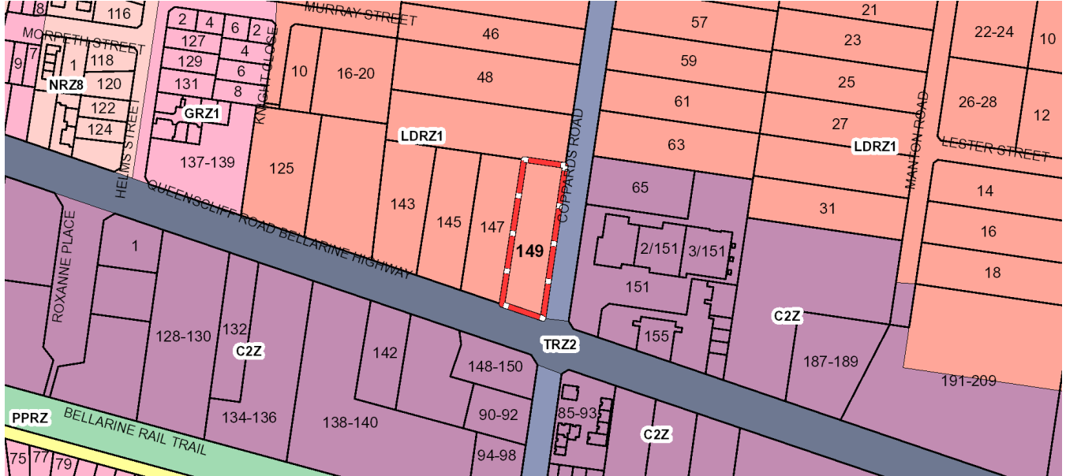
Figure 1 - Zoning
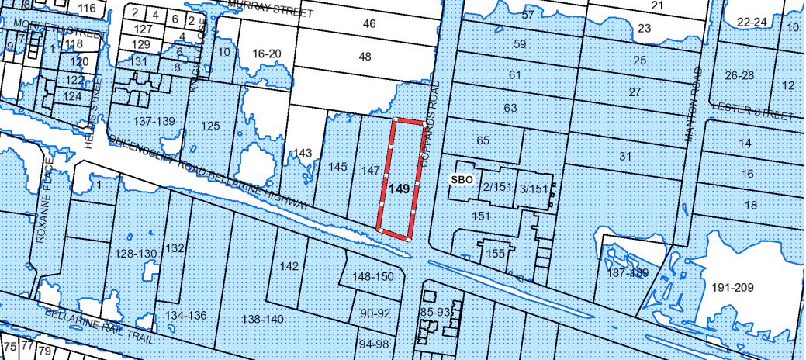
Figure 2 - Overlays
At present the subject land exhibits a single storey brick dwelling with tiled hipped roof. Numerous outbuildings exist on the site to the rear of the existing dwelling. The existing dwelling fronts the Bellarine Highway, with a front setback of approximately 9.5 metres. The dwelling features a side street setback of approximately 13 metres.
The site exhibits a low brick wall to its Bellarine Highway frontage, with a low timber paling fence to its Coppards Road frontage, which increases to 1.7m in height to the rear of the property.
Vehicle access is currently available from Bellarine Highway and Coppards Road via separate vehicle crossovers. The Bellarine Highway Road reserve exhibits a formalised footpath and nature strip, with concrete vehicle crossover to the application site. The Coppards Road road reserve exhibits an informal footpath and gravel crossover to the application site. A bus stop is situated within the Coppards Road road reserve in front of the subject land, approximately 66 metres from the junction with Bellarine Highway.

The site is relatively flat and exhibits grazing paddocks at its rear. A number of smaller and moderately sized trees are scatted through the site and on adjoining properties adjacent the application site.

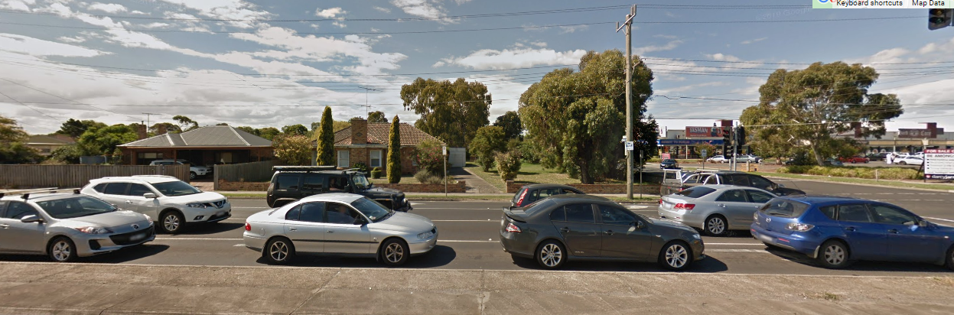
Figure 3 - View from Bellarine Highway
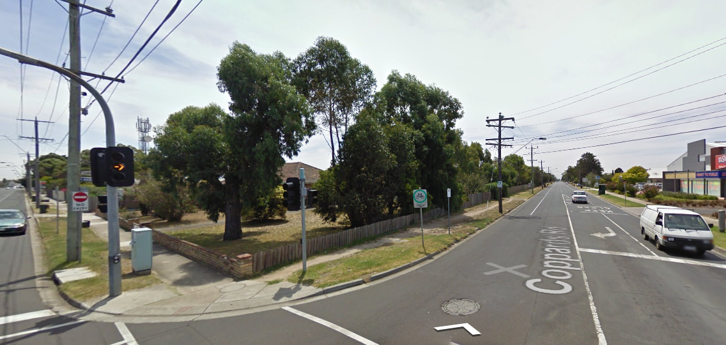
Figure 4 - Site viewed from Coppards Road
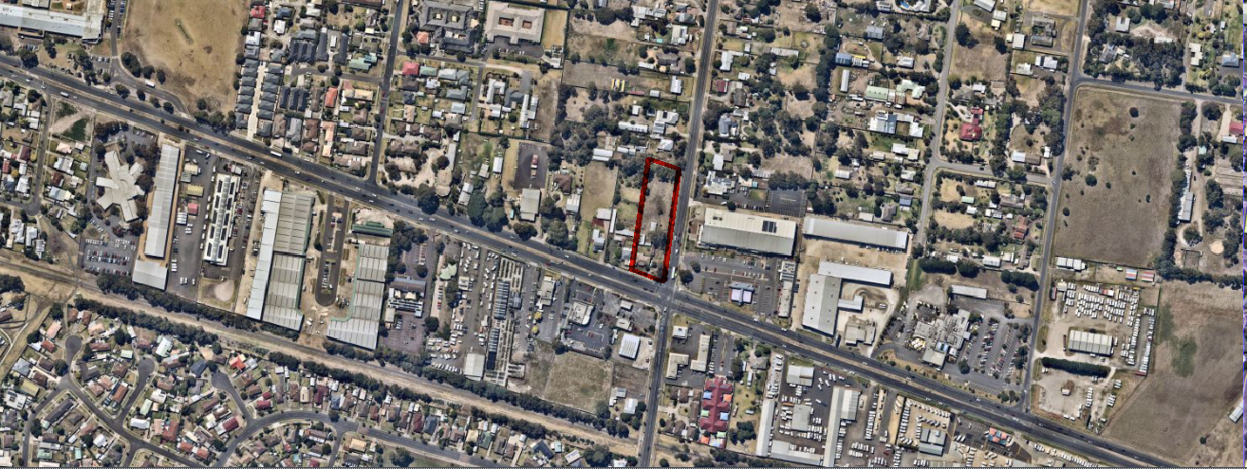
Figure 5 – Application Site and Surrounds Aerial
The site is bound by two properties, 50 Coppards Road to the north, and 147 Bellarine Highway to the west. Both of which are zoned LDRZ1.

Number 50 Coppards Road exhibits a single dwelling, constructed of timber weatherboards and corrugated metal roofing. The property features a number of outbuildings at its rear.

Number 147 Bellarine Highway exhibits a single-storey brick dwelling of similar siting, size and scale to the application site. A carport projects forward of the dwelling within its front setback and access is available via two existing crossovers from Bellarine Highway. A number of outbuildings are situated at the rear of the dwelling.

The wider locality to the south and east of the application site generally features commercial uses and development. Opposite the application site is an existing service station and various convenience restaurants, fronting the southern side of the Bellarine Highway.

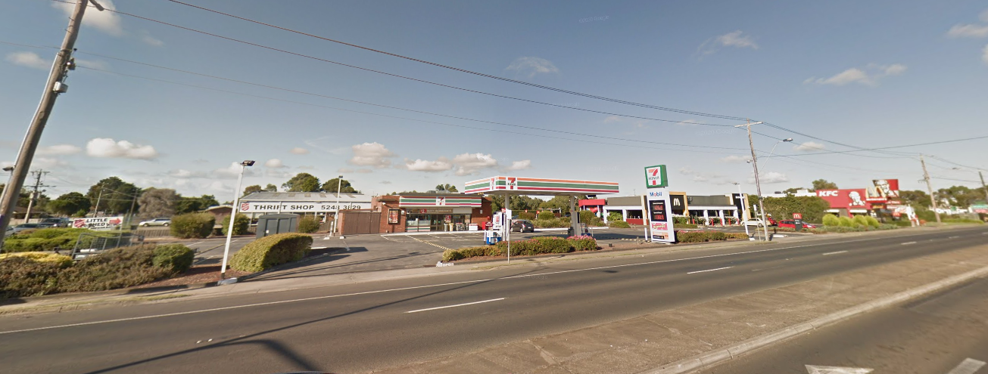
Figure 6 - Service Station and Convenience Restaurants - Southern Side of Bellarine Highway
Opposite the subject land to the east, fronting the eastern side of Coppards Road, is a shopping centre which features numerous land uses including retail premises such as take away food, restaurants and shops, as well as a 24 hour gym.
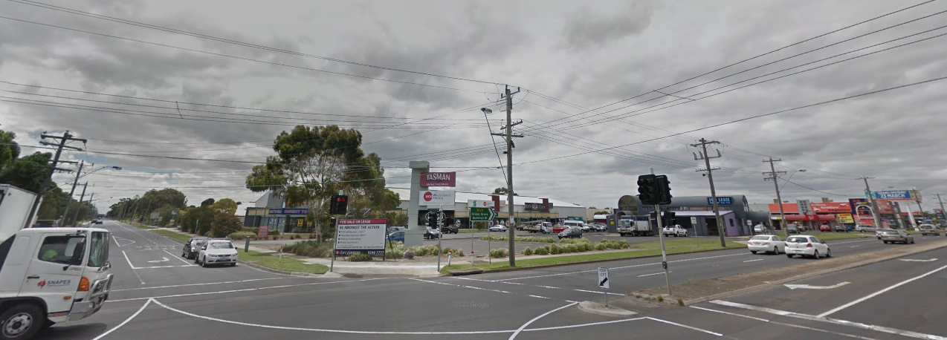
Figure 7 - Shopping Centre East of Coppards Road

PROPOSAL:

This application seeks a planning permit for the use and development of the land for a service station, food and drink premises and car wash, and alteration of access to a road in a Transport Zone 2.
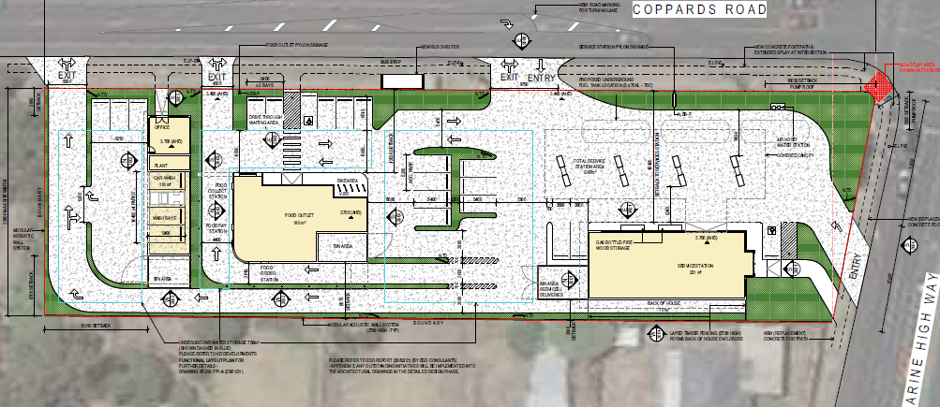
Figure 8 - Proposed Site Plan

Service Station
The service station is proposed to be sited within the southern area of the site, with vehicle access to the site available from Bellarine Highway and Coppards Road. Egress from the site would only be available along the eastern side to Coppards Road.
Eight fuel pumps are proposed to the south-eastern part of the site, with the service station building situated adjacent to the south-western boundary of the site. The service station is proposed to operate 24 hours a day, 7 days a week. The service station would be provided with 6 car parks, including one disabled access space.
The service station building would be set back approximately 3 metres from the common boundary with number 147 Bellarine Highway to the west and set back approximately 13 metres from the frontage to the Bellarine Highway. The building would be single storey with a hipped roof design with combined external materials of face brickwork, render and tiled roof. The pump area would be situated beneath a flat roof with a maximum height of 6.7 metres, set back approximately13 metres from the street.

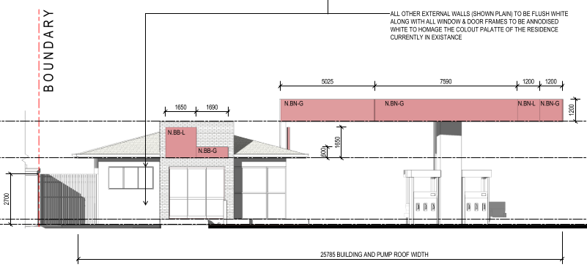
Figure 9 - Service Station - Bellarine Highway Elevation
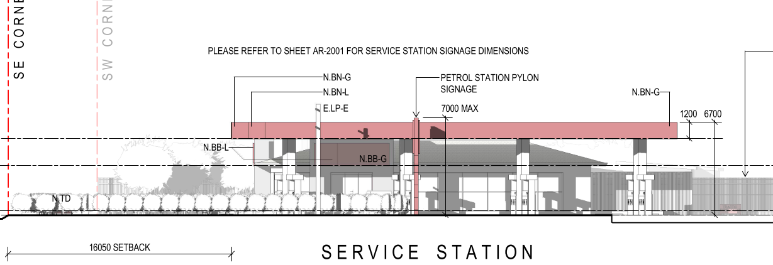
Figure 10 - Service Station - Coppards Road Elevation
The service station building would comprise a convenience shop ancillary to the service station use, with hours of operation proposed for 24 hours a day, 7 days per week.
Convenience Restaurant
The proposed convenience restaurant would adjoin the service station area to the north, sited in the middle of the application site. The building footprint would be approximately 180sqm.

The convenience restaurant building would present to Coppards Road, with vehicular access available via a crossover to Coppards Road, approximately 46 metres from the Bellarine Highway. Egress would be available from the same crossover and an exit only crossover approximately 37.5 metres further north.

The proposed convenience restaurant would incorporate a drive-through lane and windows to its western and northern elevations. Drive-through waiting areas are provided in the main car park. The hours of operation proposed are 24 hours 7 days a week, via the drive-through facility.

The number of patrons proposed are specified as 36 within the traffic impact assessment. A total of 10 car parking spaces are proposed to the south and east of the convenience restaurant building.

The convenience restaurant building would be of a flat-roof construction with projecting timber clad parapet walls and projecting awning. The external walls are shown to be a neutral colour palette. The building would be setback from the Coppards Road frontage by approximately 12 metres, and would be set back from the side western side boundary by approximately 8 metres.

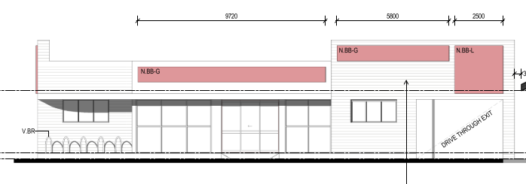
Figure 11 - Convenience Restaurant - East Elevation
Car Wash
The proposed car was would be sited within the northern area of the application site. The car wash buildings would comprise an office area, a plant room and four undercover wash bays. To the west of the car wash building, would be a bin storage area.

Access to the car wash would be available via the entry/exit crossover to Coppards road within the centre of the site, as well as from the service station area. A vehicle access from the centre of the site to the car wash would be provided adjacent the western side boundary of the site. Three car parks would be provided to the north of the car wash building, adjacent the office area.

The car was building would be sited approximately 4 metres from the Coppards Road frontage and 8.7 metres from the western side boundary of the site. The car wash would also be set back 15 metres from the northern boundary of the application site. The car wash building would have a footprint of 125sqm and would be constructed of rendered blockwork with corrugated metal gabled roofing.

Hours of operation proposed for the car wash are 7am to 6pm, seven days a week.

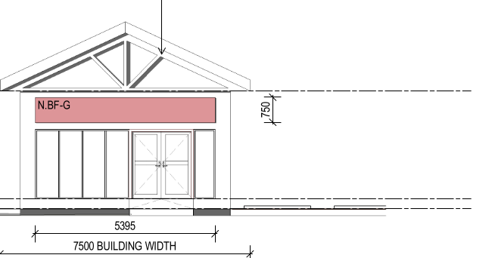
Figure 12 - Car Wash - East Elevation
Signage
As per the proposed plans and elevations, all signage is proposed to be subject of a future planning permit application.

Alteration of Access to a Road in a Transport Zone 2
The access to the site from Bellarine Highway is proposed to be altered to provide an entry only crossover to the site

PERMIT/SITE HISTORY:
There is no permit/site history relevant to the application.
REFERRALS:

The following referrals were undertaken:

SECTION 55:
DETERMINING AUTHORITY

Authority: | Department of Transport – Alter access to RDZ1
Response: | The Coppards Road bus stop (northbound) will be impacted by the service station works and will need to be relocated slightly to the north. As part of the relocation and related crossover works, the stop must be upgraded to DDA compliance.  The bus stop flag must be setback a minimum 9 metres setback from the new crossover and 2.2m from the shelter.  Please refer to the Bus Stop Location Plan below for guidance.  The Head, Transport for Victoria has considered this application and does not object if the permit is subject to the following conditions:  Public transport  - Before the development starts, or such other time agreed to in writing by the Head, Transport for Victoria amended plans to the satisfaction of the Head, Transport for Victoria must be submitted to and approved by the Responsible Authority. When approved, the plans will be endorsed and will then form part of the permit. The plans must be drawn to scale with dimensions and digital copies must be provided. The plans must be generally in accordance with the plans submitted with the application (Proposed Site Plan AR – 1000 Revision F dated 3/03/2021 prepared by Mode Design) but modified to show:  - Bus stop upgraded to generally comply with attached standard drawings (STD_S0062, STD_S0063, STD_S064 and STD_S0069) and include:  - New 150mm high barrier kerb for the whole length between the two new crossovers;  - Bus Stop Flag Pole Sleeve, to be setback a minimum 9 metre north from the service station Coppards Road crossover and 2.2 metres from the bus shelter;  - Concrete bus stop hard stand including post, flag and tactile ground surface indicators (cut into the ground and based upon standard drawings STD_0064, STD_S0062 and Bus Stop Guidelines Feb 2006);  - Both the concrete hard stand and the path in front of the shelter to be graded, between 1:40 to 1:100.  - All buildings and works in compliance with the requirements in the Disability Discrimination Act 1992;  - As part of the access works on Coppards Road, the bus stop and any associated infrastructure must be upgraded and relocated as necessary, at no cost to and to the satisfaction of the Head, Transport for Victoria and compliant with the Disability Discrimination Act 1992 (Cth) and the Disability Standards for Accessible Public Transport 2002.  - Prior to the use of the development, the Head, Transport for Victoria must be provided with GPS co-ordinates of the bus stop and high-resolution photos (300dpi) of the bus stop (streetscape perspective including the entire stop) to the satisfaction of the Head, Transport for Victoria.  - The permit holder must notify Public Transport Victoria @ Department of Transport (PTV) a minimum of 8 weeks prior to any bus stop works / or temporary relocation works approved under this permit. The permit holder must notify PTV by either calling 1800 800 007 or email customerservice@transport.vic.gov.au  - The permit holder must take all reasonable steps to ensure that disruption to bus operation along Bellarine Highway and Coppards Road are kept to a minimum during the construction of the development. Foreseen disruptions to bus operations and mitigation measures must be communicated to PTV eight (8) weeks prior by telephoning 1800 800 007 or emailing customerservice@transport.vic.gov.au.  Roads  - The new vehicle access to the site on Bellarine Highway must designed and constructed to provide for entry only traffic movement and to discourage wrong way exit movements, to the satisfaction of and at no cost to the Head, Transport for Victoria.  - Prior to the commencement of the use, the redundant vehicle crossing on Bellarine Highway must be removed and the kerb and channel reinstated to the satisfaction of and at no cost to the Head, Transport for Victoria.  - The proposed right turn lane on Coppards Road at the site access must be compatible with and not adversely impact the existing right turn lane on Coppards Road on the north approach to the Bellarine Highway intersection to the satisfaction of the Head, Transport for Victoria.  Note on planning permit:  - Separate consent for any works within the Bellarine Highway reserve and the specifications of these works is required under the Road Management Act 2004.
Officer Comment:
No objection noted. Conditions to be included on any permit granted.

RECOMMENDING AUTHORITY

Department: | SBO Team (Floodplain Manager)
Response: | Engineering Services (SBO as Floodplain Manager) does not object to the granting of the permit subject to the following conditions:  Recommended Permit Conditions (Without Prejudice)  - The Finished Floor Level (FFL) of the buildings must not be lower than the proposed 3.70m AHD.  - The finished surface/ground levels (FSL) within the site must be no higher than 3.30m AHD nor lower than 3.10m AHD (as proposed).  - Any water sensitive installations or infrastructure must be at least 150mm above the advised flood level 3.40m AHD.  - All buildings, installations, infrastructure etc. must be constructed using flood resilient materials up to minimum 3.70m AHD and any electrical fittings must be located above this minimum level.  - Any new fences and gates within the SBO must have minimum 150 mm ground clearance or 25% opening to 450 mm height from the ground.  - Any decks within SBO must not obstruct overland flows unless otherwise agreed by the responsible authority.  Special / Non-Standard Conditions (part of permit condition 1)  NIL.  Comments/Notes from Engineering Services (SBO as Floodplain Manager)  - All floors should be built minimum 150 mm above the adjoining (peripheral) ground/finished surface of the building unless otherwise justified.  - Any earth filling should be kept to a minimum on the property to ensure that existing flow paths are not impacted by the proposed works.
Officer Comment:
No objection noted – the suggested conditions are recommended to be included on any permit granted.

SECTION 52:

Authority: | Barwon Water – (referred under s.52 given subject land has access to sewer)
Response: | Barwon Region Water Corporation does not object to the granting of a planning permit.  General  1. The developer is to apply to Barwon Water for details relating to servicing requirements and costing for the provision of a potable water supply and where applicable, recycled water and/ or sewerage services to the proposal. It would be appreciated if all communication between the developer/agent and Barwon Water quote Barwon Water reference number L018333.  Potable Water  1. The provision and installation of a potable water supply to the development.  2. An additional potable water connection(s) is to be provided to service the proposed development. A dimensioned plan showing location of all new connections relative to the allotment boundaries is to be submitted, where a meter is not being fitted. Note that tappings and service lines are not to be located under existing or proposed driveways. IMPORTANT NOTE — where the existing potable water main is a cracked asbestos water pipe, Barwon Water will undertake the tapping of this pipeline, including excavation and spoil removal. Barwon Water requires your plumber to provide 5 clear working days’ notice for this work. Under no circumstances shall anyone excavate within the vicinity of this pipeline.  3. Assessment of this application has shown a potential back􀂧ow hazard exists. In line with current regulations the owner is required to employ a suitably qualified person to install an appropriate containment device located at the potable and recycled water meter, at or near the property boundary for the prevention of backflow.  4. The owner is required to submit a signed backflow application/agreement. Consent to connect will only be granted once relevant backflow documentation is completed and received by the owner. The payment of a Backflow application assessment fee is required and payable upon application.  5. Individual potable water supply meters are required for each lot or building as part of water connection works. Barwon Water's records indicate that an existing potable water service and meter is located on this property. Existing water service is required to be cut and sealed at the main and existing water meter returned to Barwon Water. A plan showing the location of the cut and sealed is to be submitted to Barwon Water.  7. The payment of a standardised New Customer Contribution is required for any new connection or any upsize to an existing connection. The number of standardised charges applied will be determined on the basis of an equivalent lot calculation and is based on potable domestic water meter size or water service size (where a meter is not being fitted). An equivalent lot is a measure of the additional demand a connection will place on the infrastructure in terms of the water consumption and sewage discharge for an average connection utilising a 20mm tapping and/ or meter. If there is more than one meter within a single meter assembly, the size of the largest meter (excluding the fire service meter) will determine the number of equivalent connections. If there is a combined fire and domestic meter assembly proposed (incorporating a low flow meter), whereby the meter size is largely dictated by the fire service requirements, the developer is required to submit to Barwon Water the proposed peak flow (probable simultaneous demand) associated with the domestic supply in accord with AS/NZS 3500. Barwon Water will then assess the equivalent number of connections.  Sewer  1. The provision and installation of a sewerage service to the development.  2. Reticulated sewer mains are required. This work must be undertaken by a Barwon Water accredited Consultant and accredited Contractor following the "Developer Works" process.  3. The provision of a new sewer connection(s) point is required. The sewer connection point is to be constructed by a Barwon Water Accredited Contractor. Where an Owners Corporation is not applicable, a separate sewer connection point is required for each allotment.  4. Assessment of your application indicates this development may require a modification to an existing Trade waste agreement or a new Trade waste agreement to be entered into. Please contact Barwon Water's Trade Waste team on Ph.: 1300 656 007 during normal business hours to arrange.  5. New or re-aligned internal private sewer drains are required. Upon completion of this work a sewer drainage plan is to be submitted to Barwon Water by a licensed plumber that complies with Victorian Building Authority requirements. Note that if any common drain or drain from another allotment crosses under a proposed dwelling, a "modification to consent" is to be obtained from the Victorian Building Authority and presented to Barwon Water with the required drainage plan. Where an Owners Corporation is not applicable, individual allotment house connection drains are to be provided for and extend into each allotment.
Officer Comment:
No objection noted.
Generally the suggested conditions are recommended to be included on any permit granted given that a new connection to sewer is required.

Authority: | Powercor - Power pole within road reserve
Response: | Subject to the following conditions, Powercor Australia Ltd (the Distributor) does not object to the issue of a planning permit for the abovementioned application.  Conditions Required by the Distributor  - This letter shall be supplied to the applicant in its entirety.  - Any buildings/structures must comply with the clearances required by the Electricity Safety (Installations) Regulations.  - Any construction work must comply with Energy Safe Victoria’s “No Go Zone” rules.  - The property owner/builder should contact Dial before you Dig, before any excavation works are undertaken on the property.  - The applicant shall provide an electricity supply to the development and negotiate for any assets relocations in accordance with the Distributor’s Requirements and standards. Notes: Extension, augmentation or rearrangement of the Distributor’s electrical assets may be required to make such supplies available, with the cost of such works generally borne by the applicant.  - The applicant shall ensure that existing and proposed buildings and electrical installations on the subject land are compliant with the Victorian Service and Installation Rules (VSIR).  Notes: Where electrical works are required to achieve VSIR compliance, a registered electrical contractor must be engaged to undertake such works.  - The applicant shall, when required by the Distributor, set aside areas for the purposes of establishing a substation or substations.  Notes: Areas set aside for substations will be formalised to the Distributor’s requirements under one of the following arrangements:  - RESERVES established by the applicant in favour of the Distributor.  - SUBSTATION LEASE at nominal rental for a period of 30 years with rights to extend the lease for a further 30 years. The Distributor will register such leases on title by way of a caveat prior to the registration of the plan of subdivision.  - The applicant shall establish easements on the title, for all existing Distributor electric lines where easements have not been otherwise provided on the land and for any new powerlines to service the lots or adjust the positioning existing easements.  Notes:  - Existing easements may need to be amended to meet the Distributor’s requirements  - Easements required by the Distributor shall be specified on the subdivision and show the Purpose, Origin and the In Favour of party as follows:  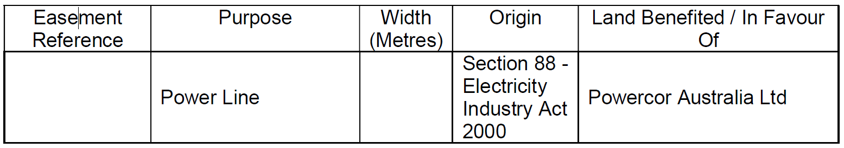
Officer Comment:
Generally the recommended conditions are included on the permit.
Conditions 8 and 9 which seek to require the applicant to create reserves and easements do not seem to be relevant as the application does not propose subdivision.
Conditions 1 and 4 are vague and do not appear to be relevant to be included should a planning permit be issued.
In light of the above, it is recommended that conditions 1, 4, 8 and 9 recommended by Powercor are not included on any permit issued.

Authority: | EPA - Referred under s.52 given proposal’s proximity to residential allotments
Response: | EPA does not object to Council issuing a planning permit for the above application according to the information that has been provided. However, to manage the impacts above, we recommend the following conditions are included:  - There must be no emissions of noise and/or vibrations from the premises which are detrimental to either of the following:  - The environment in the area around the premises; and  - The wellbeing of persons and/or their property in the area around the premises.  - A secondary containment system must be provided for liquids which if spilt are likely to cause pollution or pose an environmental hazard.  - Pollution control devices must be installed to prevent the discharge of waste to the environment and stormwater system.  - The permit holder must ensure that litter originating from the premises is not present beyond the boundaries of the premises  - 7. Prior to the commencement of use, Vapour Recovery must be installed to ensure vapours are recovered and prevented from escaping to the atmosphere.  - All tanks must be decommissioned by suitably qualified professionals, as outlined in EPA Publication 888.4 Underground Petroleum Storage Systems (UPSSs) 2015 or as amended and the Australian Standards referenced therein.  In addition to the above conditions EPA recommends the following notes be included:  - Petroleum storage tanks must be designed, installed and operated in accordance with the Guidelines on the Design, Installation and Management Requirements for Underground Petroleum Storage Systems (UPSS) (EPA Publication No. 888.4, August 2015).  The following comments are provided to Council for consideration.  Potentially contaminating activity  Product release from underground petroleum storage systems (UPSSs) can have significant adverse impacts on people, property and the environment. EPA Publication 888.4 The Design, Installation and Management Requirements for Underground Petroleum Storage Systems (UPSS) provides owners and operators of UPSSs with guidance of new and existing UPSS. This guideline is advisory in nature, however the technical details in this guideline are suggested measures for meeting the requirements of the Environment Protection Act 1970.  Section 6.1 sets out the minimum performance levels for UPSS and details advice on design, installation and management of new and existing UPSS and highlights the duty of the owner/operator to:  - Ensure UPSS removal or decommissioning is carried out in accordance with the guidance  - Manage any contamination which may remain following removal or decommissioning of UPSS  - Ensure that an assessment of the environmental condition of the site is conducted by a competent and experiences environmental assessor when removing or decommissioning a UPSS  - Maintain records associated with the UPSS removal, decommissioning for five years after the life of the tank.  The applicant should use this guideline to ensure installation, management and decommissioning of UPSS does not harm people, property or the environment in accordance with the Environment Protection Act 1970.  EPA also highlights the requirement to categorise and manage soil in accordance with EPA Publication IWRG621, Soil Hazard Categorisation and Management 2009, or as amended.  Separation Distances  This proposal is in proximity to residential dwellings. No separation distances for this type of proposal are specified in EPA Publication 1518 Recommended Separation Distances for Industrial Residual Air Emissions (March 2013). Council should consider whether the separation distance proposed is adequate to protect the health and wellbeing and amenity of the residents.  UPSS Management  EPA draws Council’s attention to ‘Guidelines on the Design, Installation and Management Requirements for Underground Petroleum Storage Systems’ (UPSS) (EPA Publication No. 888.4, August 2015) which provides owners and operators of UPSSs with guidance of new and existing UPSS. This guideline is advisory in nature, however the technical details in this guideline are suggested measures for meeting the requirements of the Environment Protection Act 1970.  The guideline advises owners and operators to:  - Establish a UPSS management system which minimises the risk of adverse effects from a release from UPSS through establishing requirements, processes and responsibilities for UPSS operation and management.  - UPSS design and equipment selection to prevent leaks and spills both under and above ground.  - UPSS installation, with appropriate quality assurance/quality control in accordance with relevant Australian standards.  - UPSS maintenance and repair.  - Leak detection and response during operation.  - UPSS removal and decommissioning in accordance with applicable Australian standards.  The applicant must use this guideline, or equivalent measures to ensure installation, management and decommissioning of UPSS does not harm people, property or the environment in accordance with the Environment Protection Act 1970, and support compliance with planning permit conditions.  Noise  EPA draws Council’s attention to the Noise Control Guidelines (EPA Publication 1254) which includes practical measures and recommended schedules for delivery times. The following sections may be of particular relevance:  • Section 9 Deliveries to shops, supermarkets and service stations.  The operation of the site has the potential to generate noise impacts if not managed appropriately. The Noise from Industry in Regional Victoria (EPA Publication 1411) guideline provides the methods to set noise levels for industry in regional Victoria. Further information can be found at:  https://ref.epa.vic.gov.au/business-and-industry/guidelines/noiseguidance/  noise-from-commercial-and-industrial-sites.  Council may wish to consider including additional conditions in the planning permit to address the potential noise risk of the activity, to the effect of:  1. Erect noise barriers such as screens around noisy equipment and operations.  2. Keep equipment in good repair and attend promptly to loose or rattling covers, worn bearings and broken equipment.  3. All ventilation and extractor fans should be noise efficient or fitted with silencers, and all ducts should be lined with sound absorbent material.  EPA Publication 1481 How to reduce noise from your business (June 2012) includes further information relating to noise source and possible mitigation measures.  Waste Water Management  The current proposal includes a manual carwash and the following guidance is provided.  EPA notes that waste water from washing and contaminated run-off must not be discharged to the stormwater system.  Guidance on washing of vehicles can be found in EPA publication IWRG642 ‘Motor Vehicle Repair and Service Premises’ (2009). In accordance with these Guidelines, vehicles should be washed in a bunded or graded pavement area. Waste water from this area should flow into an interceptor pit or separator which discharges to sewer under a Trade Waste Agreement with the relevant water authority. EPA Publication 978 ‘Reducing Stormwater Pollution: A Guide for Industry’ (2005) also provides guidance to help avoid polluting the stormwater system.  The permit applicant is reminded of their obligation to ensure compliance with the Environment Protection Act 1970 in the day to day operation of the activity.  EPA recommends that Council should consider the above prior to  determining the planning permit application.  EPA Publications can be found at:  https://www.epa.vic.gov.au/publications.
Officer Comment:
No objection noted. The suggested conditions are recommended to be included on any permit granted.
Regarding the comments provided by the EPA in relation to potentially contaminated activity, separation distances, UPSS Management, and Noise, it is noted that no objection to the grant of a permit has been raised by either the EPA, or Council’s Environmental Health Unit in respect to any of these matters.
The application has been assessed in consideration of each of these matters and it is considered that suitable conditions can be placed on any permit granted in order to safeguard the amenity of the locality with regard to potentially contaminated activity, separation distances, UPSS management, and noise. It is considered that general amenity conditions would suitably control noise and vibration emissions off site.
In addition to the above, it is not considered necessary to include conditions relating to decommissioning of tanks as any permit granted would be for the proposed use and does not relate to a change of use away from a petrol station. It is noted that there are existing legislative controls outside of the Planning and Environment Act which control handling of dangerous goods.

INTERNAL
Department: | Engineering Services
Response: | Engineering Services Recommendation: Supportive  Traffic Engineering comments  Design Issues  - The design of the ‘Entry Only’ access and vehicle crossing in Bellarine Hwy has changed and is now on a 45 degree alignment to the road. This is not necessary a worse outcome, as it reinforces the ‘entry only’ operation this access will have.  - There are no dimensions shown for this vehicle crossing; its width shall be no wider to what the swept path of the fuel tanker truck requires.  - A signage plan of all internal regulatory signage and wayfinding signage has not been provided.  - The zebra crossing shown across the parking aisle outside of the fast food outlet must be deleted from the plan.  - The footpath to be constructed in Bellarine Hwy and Coppards Rd must be against the road reserve boundary, constructed in concrete, and be 1.5 m wide.  - The bus shelter is likely to be removed completely. It is doubtful that this is a well patronised bus stop, and replacement with a seat would be satisfactory. This will need to be worked out with the Department of Transport.  - A Functional Layout Plan will be required to show all existing and proposed items within the Bellarine Hwy and Coppards Rd road reserves, including vehicle crossings, bus stop relocation and seat provision, the new footpath, and all linemarking and signage changes.  - A minimum 3 x 3 m splay must be provided on title at the intersection of Bellarine Hwy and Coppards Rd, and the infill to be constructed in concrete and form part of the footpath.  - The alignment of the parking aisle below is poor where there is a significant lateral shift, and it introduces risk of two approaching vehicles having a head-on accident.  - The area should be re-designed to allow a straight alignment of the parking aisle, and to relocate the lost car spaces to face Coppards Rd (see below) 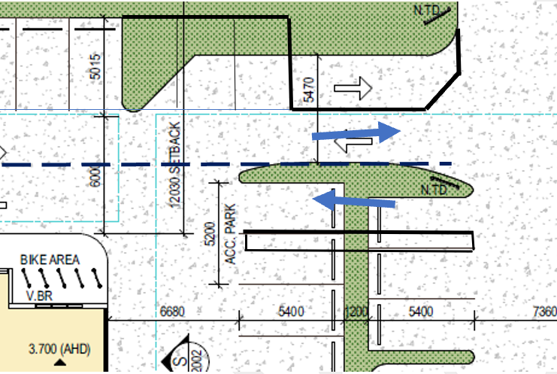  Proposed Permit Conditions  Condition 1  - The zebra crossing shown across the parking aisle outside of the fast food outlet must be deleted from the plan.  - The north-south parking aisle in front of the fast food premises must be re-designed to show a straight alignment, and the lost parking spaces relocated to the Coppards Rd side of the aisle  - Details of the location and a Signage Schedule to be provided for all regulatory and way-finding signage within the site, including signage to reinforce the one-way entry and exit at the various vehicle crossings and driveways  - The proposed footpath to be constructed in Bellarine Hwy and Coppards Rd to be shown as being 1.5 m wide and up against the respective road reserve boundaries.  - A minimum 3 x 3 m splay must be created on title at the Bellarine Hwy and Coppards Rd intersection  Car Park  - All car spaces, circulation and parking aisles must be linemarked and be in accordance with the endorsed plans and to the satisfaction of the Responsible Authority  Functional Layout Plan  To the satisfaction of the Responsible Authority, a Functional Layout Plan must be provided to show:  - all details within the Bellarine Hwy and Coppards Rd road reserves, including all proposed linemarking, linemarking to be removed, the bus stop relocation, regulatory parking signage, layout and dimensions of all vehicle crossings, an overlay of swept path diagrams for the expected fuel tanker to enter and exit the site, the proposed 1.5 m wide concrete footpath and 3 x 3m splay at the intersection, and any other item deemed appropriate for the development.  - All work in the road reserve involving all linemarking and signage, whether to be installed or removed, must be performed by a council preferred contractor and be in accordance with the endorsed Functional Layout Plan and to the full cost of the permit holder.  Standard Conditions  Drainage:  - The site must be drained to the satisfaction of the Responsible Authority and no concentrated storm water may drain or discharge from the land to adjoining properties.  Prior to Occupation  - Prior to the occupation of the buildings authorised by this Permit the developer must:  a) Construct the site stormwater system and connect into the existing stormwater drain in Coppards Road, or other nominated point/s as approved by the Responsible Authority. The stormwater connection must be in accordance with City of Greater Geelong Standard Drawings,  b) Construct vehicular crossings in accordance with the requirements and standards of the City of Greater Geelong,  c) Remove any redundant vehicular crossings with kerb and channel and the footpath/nature strip area reinstated to match existing construction in the street,  d) Construct the car park including accessways, surface with an all-weather sealed coating, and linemark the car and accessways in accordance with the endorsed plans to the satisfaction of the Responsible Authority,  e) Linemark and install signage for disabled car parking spaces as per the relevant Australian Standard code (AS/NZS 2890.6:2009),  All to the satisfaction of the Responsible Authority.  Note:  1. Construction of the site stormwater connection/s is to be inspected by Council Representative prior to any backfilling. An appropriate fee equivalent to 3.25% of total cost of civil works, excluding GST (a minimum fee of $100 applies if the 3.25% amount is less than $100), is to be paid to Council for inspection. Relevant evidential documentation of the cost is to be provided.  2. All internal property drainage must be designed and constructed to satisfy AS/NZS 3500.  3. A Vehicle Crossing Permit must be obtained prior to commencement of works.  Stormwater Quality / Management  - The site stormwater system must be designed and installed such that;  - The site stormwater discharge is not increased by the proposed development. An appropriate on site detention system designed in accordance with the Infrastructure Design Manual may be required;  - Runoff is to be treated to achieve current best practice pollutant removal targets by connection to an appropriate Water Treatment Facility, with capacity to treat at least a 3 month ARI storm event, unless approved otherwise by the Responsible Authority. The Water Treatment Facility must be maintained to the satisfaction of the Responsible Authority.  to the Satisfaction of the Responsible Authority  NOTE  A pre-commencement meeting with Council’s engineering department is required to be undertaken prior to any works starting within the road reserves. To organise this meeting please contact 5272 4426
Officer Comment:
No objection noted – generally the suggested conditions are recommended to be included on any permit granted. Some detail requested by Council’s traffic engineer is not necessary.
It is not considered necessary to require restrictions on Title for a 3m x 3m splay at the south-eastern corner of the existing lot. The 3m x 3m splay will be enforceable via conditions on any permit (including on endorsed site plans and landscape plans).
Detail of the works proposed within the road reserve are outlined within the FLP condition however it is noted that the Bellarine Highway is not a Council Road and therefore it is not considered relevant for Council traffic engineers to require detail of works within the Bellarine Highway Road Reserve or to Transport for Victoria infrastructure.
No planning permit is required for direction signs. As such it is not considered relevant to require a schedule of signage as requested. However signage locations are considered appropriate to be required by conditions.

Department: | ESD Response
Response: | No objection to the grant of a permit subject to the following conditions:  - Before the use and development commences, amended plans to the satisfaction of the Responsible Authority must be submitted to (sic) show  - Initiatives contained within the Sustainable Design Assessment along with the proposed changes, including:  - A rooftop solar photovoltaic to each of the buildings having total aggregate capacity of 15kW or more.  - Prior to the endorsement of plans, a stormwater management plan that addresses planning policy 53.18 must be submitted and approved to the satisfaction of the responsible authority. The plan must demonstrate compliance with current best practice performance objectives for stormwater quality as contained in the Urban Stormwater - Best Practice Environmental Management Guidelines (Victorian Stormwater Committee, 1999). The plan must be generally in accordance with the Stormwater Management Strategy by Khanna Design and Development dated JV3 reports must be submitted prior construction and will need to be re-reviewed by Council's ESD Officer. 14/12/2020, but modified to include the following changes:  - The MUSIC model (.sqz) must be submitted  - Prior to the endorsement of plans, a Sustainable Design Assessment (SDA) must be submitted to and approved to the satisfaction by the Responsible Authority. The Sustainable Design Assessment must demonstrate a best practice standard of environmentally sustainable design and be generally in accordance with the report by Ecologically Sustainable Design (ESD) Consultants dated 05/03/2021 and received on 10/03/2021, but modified to include the following changes:  - Provide details of the major common services that will be sub-metered, or BESS credit ‘Management 3.3 Metering’ must no longer be claimed  Where alternative ESD initiatives are proposed to those specified in conditions above, the Responsible Authority may vary the requirements of this condition at its discretion, subject to the development achieving equivalent (or greater) ESD outcomes in association with the development.  - All works must be undertaken in accordance with the endorsed plans, Sustainable Design Assessment and Stormwater Management Plan to the satisfaction of the Responsible Authority. No alterations to these plans may occur without the written consent of the Responsible Authority.  - NCC section J reports must be submitted prior construction and will need to be re-reviewed by Council's ESD Officer.
Officer Comment:
No objection noted – generally the suggested conditions are recommended to be included on any permit granted. It is noted that conditions 1 and 3 recommended by Council’s ESD officer can be incorporated into an amended plans condition.
Condition 2 is not clearly worded and the Council’s ESD officer has clarified via email that all that is required is the MUSIC modelling which the SDA and BESS assessment are based on.
It is not considered necessary to require Section J reports for ‘re-review’ by Council’s ESD officer. It is noted that section J forms part of the National Construction Code and does not form part of the planning permit.

Department: | Parks
Response: | Parks Recommendation: Supportive  The response from the applicant and discussion with the arborist is supported by Parks Planning. The tree will be retained until the site is developed and the project arborist will make the call whether the tree can be retained or removed then. The tree owner consents to this.  Standard Conditions  Tree Protection Management Plan  Prior to the commencement of the development, a Tree Protection Management Plan must be submitted to and approved by the Responsible Authority. The Tree Protection Management Plan must be prepared by a suitably qualified arborist and must include all:  - council-owned trees  - privately owned trees and  - trees owned by other parties that are located within 4 metres of the property boundary.  When approved the Tree Protection Management Plan and its recommendations will be endorsed and will then form part of the permit.  The approved Tree Protection Management Plan must not be amended or altered without the consent of the Responsible Authority.  Tree Protection Zones  Prior to the works commencing (including any demolition works), Tree Protection Fencing must be installed and maintained until works are completed to the satisfaction of the Responsible Authority.  All works within the nominated Tree Protection Zones must be:  - carried out in accordance with Australian Standard 4373–2007 Pruning of amenity trees and Australian Standard 4970–2009 Protection of trees on development sites  - overseen by a suitably qualified, level-5 arborist  - carried out to the satisfaction of the Responsible Authority by suitably trained and qualified arboricultural staff.  Works encroaching within the nominated Tree Protection Zones must not be undertaken without the written consent of the Responsible Authority.  Prior to occupation of the development/the issue of Statement of Compliance, a written statement from the Project Arborist must be submitted to the Responsible Authority that certifies that the following items have been addressed as part of the works:  - Installation and correct placement of tree protection fencing 2 weeks prior to works commencing and for the duration of works  - Attendance during Tree Protection Zone incursions  - Adherence to Australian Standard 4970–2009 Protection of trees on development sites  Note  - In the instance that minor pruning is anticipated the applicant must contact Council’s Parks Planning Officers on 5272 5272 (treeplanning@geelongcity.vic.gov.au) to lodge a request and provide adequate notice.
Officer Comment:
No objection noted – generally the recommendation conditions are to be included on any permit granted.

Department: | Urban Design
Response: | Urban Design Recommendation: Supportive with Changes  We thank the applicant for improving the design response to each street frontage and also improving the pedestrian access.  There are a couple issues which arise from the redesign which we would like to see resolved prior to permits being issued. In general, we encourage the applicant to consider how more trees be introduced into the design.  New Feedback:  - Issue: Having the internal traffic parking island complicates traffic flow and provides limited opportunities for landscaping.  Recommendation: We recommend that the applicant consider a redesign similar to below in order to provide a safer and simplified outcome. (Subject to CoGG traffic advice)  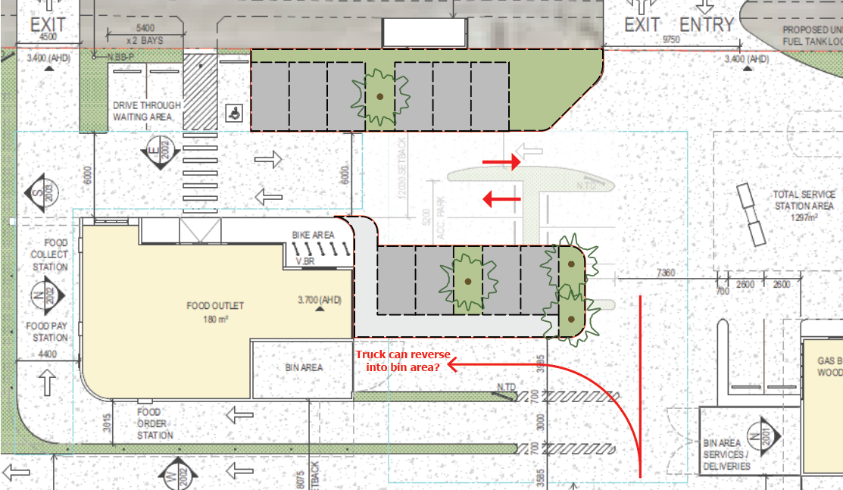  The design shown above provides the same amount of parking as the submitted plans, but as you can see there is potentially room for an additional space.  - Issue: Space is unnecessarily divided up around the carwash, and un-usable areas for landscaping are created.  Recommendation: Remove sections of landscape curb, consider reducing access lane width, create additional tree planting opportunities.  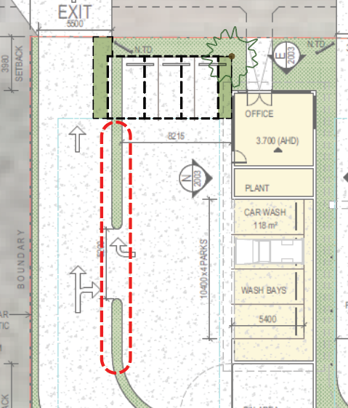  - Issue: Car parking is located in close proximity to limited lines of sight around Bellarine Hwy entrance.  Recommendation: Consider an alternative location for provision of car parking.  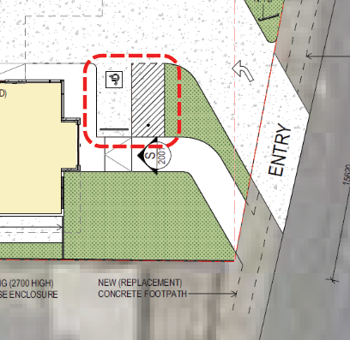
Officer Comment:
It is acknowledged that the Urban Design Unit has confirmed the revised design shown on the plans submitted 21 May 2021, provide an improved design response to both the Bellarine Highway and Coppards Road street frontages compared to the plans originally submitted at lodgement of the application.
The issues raised appear to relate to traffic engineering matters and not urban design issues. Whilst there may be opportunities for a revised landscape layout it is not considered that the landscaping opportunities as proposed are insufficient so as to warrant refusal of the application on this basis.
Issue 1) outlined by the Council’s Urban Design officer relates to the internal traffic island. It is noted that changes are recommended to this area of the internal carparking layout by Council’s Traffic Engineers and any changes will be finalised through the submission of amended plans, including a Functional Layout Plan. The changes recommended by Council’s Traffic Engineer are recommended to be required by way of conditions on permit, in lieu of the changes suggested by Urban Design officers.
Issue 2) suggests that there is an unusable area of landscaping which could be amended to provide additional tree planting. No issues have been raised from a traffic engineering perspective in regard to the landscaping proposed. It is noted that the plans show this area of landscaping will include various ground covers. It is noted that additional tree planting in this location may have negative implications on sightlines throughout the internal accessways and car parking areas. It is not recommended that the changes suggested by urban design are included on any permit as conditions.
Issue 3) relates to lines of sight at the access from Bellarine Highway. No concerns have been raised by Council’s Traffic Engineers in regard to the location of this car park relative to the proposed Bellarine Highway entrance to the site. It is not recommended to require changes to this car park as suggested by Urban Design officers. Traffic and functional layout matters will be covered off by conditions suggested by Council’s Traffic Engineers and the Department of Transport.

Department: | Environmental Health
Response: | Unit Recommendation –Support subject to conditions  Recommended Permit Conditions  Acoustic Fencing  Prior to the occupation of the building and/or the commencement of the use, the works outlined in the acoustic report must be carried out to the satisfaction of the Responsible Authority.  Waste Collection  Waste collection must not occur between the hours of 8pm and 7am on any day as per your waste management plan.  Security Alarms  All security alarms or similar devices installed on the land must be of a silent type in accordance with any current standard published by Standards Australia International Limited and be connected to a monitored security service.  No Audible Music or Announcements  No music or announcements may be audible outside the boundaries of the site to the satisfaction of the Responsible Authority.  Delivery Restrictions  Unless otherwise approved in writing by the Responsible Authority, deliveries to and from the site must only take place between:  - 7am and 10pm Monday to Friday  - 7am and 10pm Saturday  - 7am and 10pm Sunday or public holiday  to the satisfaction of the Responsible Authority.  All deliveries to the property and truck movements offsite must be in adherence with the EPA Noise Control Guidelines (publication 1245) which are:  - 7am – 10pm Monday to Saturday  - 9am – 10pm Sundays and public holidays.  Noise assessment after opening  At the written request of the Responsible Authority, the permit holder must submit a report prepared by a suitably qualified acoustic engineer which assesses any impacts of patron noise and/or compliance with the SEPP N-2 and provide any necessary recommendations to achieve compliance where noncompliance is identified or address any other issues as appropriate. Any recommendations of the assessment deemed appropriate by the Responsible Authority must be implemented within a timeframe specified by the Responsible Authority.  Plant and Equipment Insulation  All external plant and equipment must be acoustically treated or placed in soundproof housing to reduce noise to a level satisfactory to the Responsible Authority.  All air-conditioning units are to be placed in an appropriate location or alternatively acoustically treated to reduce noise to a level satisfactory to the Responsible Authority.  Amenity  Dust Emissions  Dust control measures to prevent emissions that may cause nuisance to adjoining properties must be implemented to the satisfaction of the Responsible Authority. Such as but not limited to:  - Identifying potential sources of dust and airborne particulates and processes which may generate dust and airborne particulates; and implementing dust and airborne suppression measures, including (but not limited to) covering materials and/or applying a light water spray, applying sprays before or during turning, but also avoiding excessive water- logging of organic materials and runoff;  - cessation of some activities during windy days  Light Emissions  Outdoor lighting must be designed, baffled and located to the satisfaction of the Responsible Authority to prevent any adverse effect on adjoining properties  General Amenity  The amenity of the area must not be detrimentally affected by the use or development through the:  - Transport of materials, goods or commodities to or from the land;  - Appearance of any building, works or materials;  - Emission of noise, artificial light, vibration, odour, fumes, smoke, vapour, steam, soot, ash, dust, waste water, waste products, grit or oil;  - Presence of vermin;  to the satisfaction of the Responsible Authority.  Waste Management  Garbage Storage  Waste management plan must be adhered to, provision must be made on the land for the storage and collection of garbage and other solid waste. This area must be graded, drained and screened from public view to the satisfaction of the Responsible Authority.  The storage, removal and disposal of such/garbage refuse must be undertaken in such a manner to avoid any nuisance, pollution or loss amenity to the surrounding area and must at all times be to the satisfaction of the Responsible Authority.  Concrete Washing Bay  The site must contain a concrete bay for washing vehicles. Waste from the bay must drain into a public sewer or a settlement and oil separation system. The oil separation system must comply with the Environment Protection Act 1970 and be installed to the satisfaction of the Responsible Authority. Vehicles must only be washed in the washing bay.  Odour  All odours from waste storage receptacles, food outlets, petrol bowsers must be managed to protect the amenity of the neighbouring residents  Food Registration  The proprietor of the proposed food business will be required to apply to the City of Greater Geelong Council’s, Environmental Health Unit for registration of a food premises under the Food Act 1984. Recommend that contact is made prior to internal fit-out to be able to assist with compliance.  Connection to sewer  Any dwelling on the proposed new allotment/s must be connected to reticulated sewerage, if available. If reticulated sewerage is not available, all wastewater must be treated and retained within the lots in accordance with the State Environment Protection Policy (Waters of Victoria) under the Environment Protection Act 1970.  Comply with SEPPs  Noise emitted from the premises must comply with the State Environment Protection Policy (Control of Noise from Commerce, Industry and Trade), No. N-1.  Noise emitted from the premises must comply with the State Environment Protection Policy (Control of Music Noise from Public Premises), No. N-2.  Noise emitted from the premises must not exceed the recommended levels as set out in Noise from Industry in Regional Victoria (NIRV; EPA Publication 1411, 2011) or as amended.  Construction Noise for large scale developments  Noise during construction is to be managed (and noise generating activities carried out within prescribed times) in accordance with the Environment Protection Authority Publication no. 1254 – Noise Control Guidelines.  Ensure compliance with any Commercial Noise regulations, Councils Local Laws and obtain permits where and when required
Officer Comment:
Generally, the suggested conditions are recommended to be included on any permit granted.
The proposed use and development of the land is not considered to be a use which would emit unreasonable levels of dust (given all vehicle accessways would be finished to be all-weather sealed) so as to require conditions on any planning permit controlling dust emissions.
It is not considered necessary to require conditions relating to EPA noise limit requirements. it is noted that the EPA has not recommended any such conditions in its referral response. The General Amenity condition is recommended to be included on permit and EPA controls remain enforceable by that authority.
It is not considered necessary to have multiple waste management conditions, the waste management plan can be endorsed to form part of the permit and waste collection times can be controlled by conditions so as to ensure that they occur within ‘daytime’ hours.
The suggested conditions relating to sewer connection and food registration are not necessary given that food businesses must be registered under the Food Act, and Barwon Water conditions cover off sewer connection requirements.

AMENDMENT OF THE PROPOSAL PRIOR TO PUBLIC NOTIFICATION:

The applicant made a request to amend the application pursuant to Section 50 of the Planning and Environment Act 1987 on 24 May 2021. Council accepted the amendment. The amendment made the following changes to the application:
- Remove signage from permit application
- Revised site layout following planning advice from Council and external authorities.

These are the proposed development plans that form the basis of this report.

PUBLIC NOTIFICATION:

The application is not exempt from the notice requirements of Section 52(1)(a), (b) and (d), the decision requirements of Section 64(1), (2) and (3) and the review rights of Section 82(1) of the Act and pursuant to Section 52 of the Planning and Environment Act 1987 the following forms of advertising were undertaken:
- Notices were sent to owners and occupiers of adjoining land (including opposite)
- 2 - A2 sign(s) were placed on the land
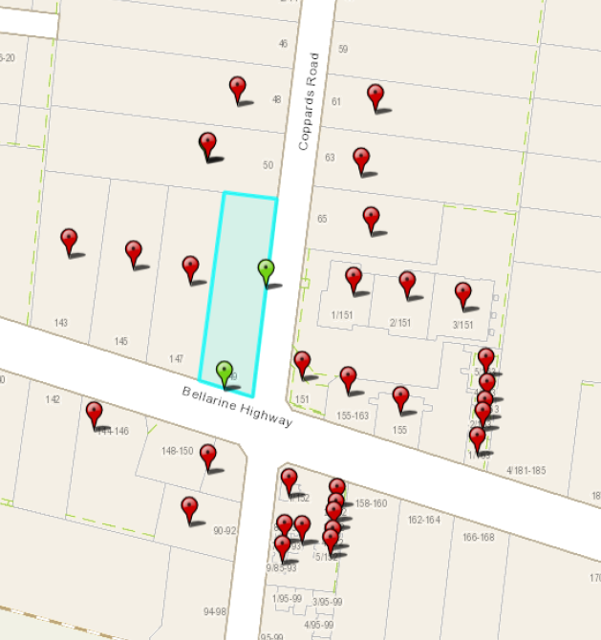
Figure 13 - Notification Letters and Signage
A total of 28 Objections have been lodged with Council.

CONSULTATION:

A consultation meeting was not held given the inability to hold face-to-face meetings during the Covid-19 Pandemic, and the number of objections received.

AMENDMENT OF THE APPLICATION FOLLOWING PUBLIC NOTIFICATION
The applicant made a request to amend the application following public notification pursuant to Section 57A of the Planning and Environment Act 1987 on 24th August 2021. Council has accepted the amendment. The amendment made the following changes to the application:
- Updated stormwater management strategy
- Consent from neighbouring property to remove trees provided.

The applicant made a further request to amend the application following public notification pursuant to Section 57A of the Planning and Environment Act 1987 on 8th November 2021. Council has accepted the amendment. The amendment made the following changes to the application:
- Revised stormwater management strategy

It was not considered necessary to readvertise the proposal based on the amendment, as the amendment would not result in any additional material detriment compared with the advertised application, for the following reasons:
- The consent of the neighbouring property owner to remove private trees is effectively a civil matter
- The revised Stormwater Management Strategy received: 24th November 2021 (following a request for further information) was submitted following discussions with Council’s SBO team. It is noted that a planning permit triggered under the Special Building Overlay is exempt from the notice requirements of section 52(1)(a), (b) and (d), the decision requirements of section 64(1), (2) and (3) and the review rights of section 82(1) of the Act.

OBJECTIONS:
The concerns of objectors are summarised and commented on below:
- Implications on traffic flow and safety within the surrounding area, including
  - Additional traffic flow on Coppards Road,
  - Existing safety concerns with intersection of Coppards Road and Bellarine Highway,
  - Rubbish trucks performing three-point turns on Coppards Road,
  - Transport Impact Assessment has not included a car parking demand assessment/traffic count,
Response

- Empirical data compiled by O’Brien Traffic by observing vehicle trips to a comparably sized service station identified that peak trip numbers to such a use typically occurs during the PM peak hour at 4:15pm – 5:15pm with a total of 12 trips per fuel pump. As such, it suggests the proposed service station would exhibit 96 PM peak hour vehicle trips (48 in and 48 out).

The Traffic Impact Assessment (TIA) forming part of the application outlines that data suggests the intersection of Coppards Road and Bellarine Highway services up to 35,000 vehicles a day. The traffic generation as a result of the proposed land use is considered to be minimal compared to the existing traffic volumes (as identified within the Department of Transport’s published traffic volume data) within the immediate surrounds of the subject land.

- This application should not be assessed based on existing road conditions as it is not the responsibility of developers to address road network issues. Nevertheless it is noted that the submitted TIA considered casualty crash history at this intersection and identified that there has been no particular crash pattern in the vicinity of the application site.

- Swept paths for waste vehicles are shown in Appendix B of the TIA. No trucks are shown required to carry out three-point turns in the road reserve.

- The TIA is not required to include a car parking demand assessment as the application does not propose a reduction in car parking under Clause 52.06.

- The land is zoned Low Density Residential Zone and is inappropriate for subdivision.
Response
The application does not proposed subdivision.
- Possible relocation of Bus stop on Coppards Road
Response
The proposed relocation of the bus stop on Coppards road has been reviewed by the Department of Transport and no objection has been raised.
- Flooding risks increased by increased stormwater runoff
Response
The application is supported by a Stormwater Management Strategy and this has been reviewed by the Council’s Special Building Overlay engineers. No objection has been raised based on increased flooding risk.
- Environmental and residential amenity impacts including contamination of land, noise, litter, air, and light pollution.
Response

As outlined within response to the Planning Policy Framework and the Municipal Strategic Statement it is not considered that the proposed use and development will unreasonably detract from neighbouring residential amenity through noise or air pollution. The application has been reviewed by both the Environmental Health Officers and the EPA and no objection has been raised to the grant of a permit on such grounds.

Any planning permit granted is recommended to be subject to conditions requiring waste to be placed in bins and for any external lighting to be suitably baffled so as to prevent unacceptable light pollution.

Similarly, the application site is considered unlikely to be contaminated given its use and development for a dwelling. The EPA manages underground petroleum storage systems within Victoria for environmental management, leaks spills etc. and it is considered that this sits outside of the remit of this planning permit application.

- Feral animals attracted to area by food waste and other environmental impacts associated with loss of faunal habitat and biodiversity as a result of site clearing.
Response
There are no planning controls preventing the removal of vegetation from the subject land. It would be unreasonable to refuse this application on such grounds.
As outlined above, it is recommended that any permit granted is subject to conditions requiring adequate waste management.

Change of use would create a precedent for further commercial land uses in LDRZ1
Response
Every planning permit application is required to be assessed on its merits. Whilst it has been found that the proposed use is appropriate at the subject land, it is not considered that this acts as justification for any other use on alternative sites within the LDRZ.

Proposed use and development do not respond to the PPF and the proposed use of land is an inadequate planning response to Clause 22.01 – Discretionary Uses in Residential Areas
Response
The application has been assessed against the Planning Policy Framework and has been found to adequately respond to relevant objectives and policies relating to use and development within the Low Density Residential Zone.
Clause 22.01 does not apply to applications for use and development within the LDRZ.
- Use of Land for a Service Station does note meet section 2 condition at Clause 32.03-1 of the Low Density Residential Zone which states:
The site must either:
- Adjoin a commercial zone or industrial zone.
- Adjoin, or have access to, a road in a Transport Zone 2 or a Transport Zone 3.
The site must not exceed either:
    - 3000 square metres.
    - 3600 square metres if it adjoins on two boundaries a road in a Transport Zone 2 or a Transport Zone 3.
Response
As outlined within this report it is considered that the proposed service station ‘site area’ does not exceed 3,600m².
- Development does not respond to neighbourhood character of the surrounding low density residential zone.
Response
As outlined within this report, the surrounding locality exhibits a substantial mix of commercial uses of varying scale and intensity. The land fronts a Transport Zone 2 and Transport Zone 3 in both the Bellarine Highway to the south and Coppards Road to the east. The application has been assessed with regard to responding to this established neighbourhood character and it is considered an adequate design response has been achieved in this regard.
- Signage
Response
Whilst the advertised proposed plans do refer to signage locations, it is noted that the plans state that all signage is to be subject of a future planning permit application. As such, this application does not seek permission to display signs.
- Numerous commercial premises, including service stations, convenience restaurants and car wash within 400 metres of the site.
Response
The planning scheme does not require the demonstration of need for applications for use of land such as this.

Whilst there are other commercial premises within the surrounding area, it is not considered that a lack of need for a proposed use would be a suitable ground for refusal. As outlined within BAMFA, VCAT has regularly found that a demonstrated need for a facility or use may be a relevant factor in decision making but lack of a need will rarely be ground for refusing to grant a planning permit.

Furthermore, the proliferation of commercial premises within the immediate surrounds of the land subject of this application is considered to demonstrate the atypical characteristics of this site and the surrounding locality for a Low Density Residential Zone.

- Accessibility to premises
Response
All of the buildings on site would be single storey and accessible to those with limited mobility.

- Transport initiatives in ESD report are misleading given the nature of the proposed use
Response
The transport initiatives within the ESD report include bicycle parking for non-residential premises. This is shown on the plans. It is not considered that the ESD report is misleading in this respect.

Whilst the service station use will more often than not service cars, the BESS tool used in the ESD report is the tool required to assess the proposal in accordance with Clause 22.71. The applicant is therefore within their right to claim transport credits in BESS.

- Insufficient on site car parking proposed and inconsistencies in propose car parking provision (objection suggests proposed plans show 15 car parks, traffic report states 19 proposed car parks and acoustic engineer report suggests 33 car parks).
Response
The proposed plans show 19 on-site car parking spaces and the submitted traffic impact assessment states 19 car parking spaces are proposed. The application has been assessed on this basis.

- Inadequate ESD Scores within BESS report
Response
The submitted ESD report includes a BESS assessment which exhibits an overall score of 53%, which is a pass. It also exhibits a pass in the mandatory categories of Water, Energy and IEQ, as well as a 100% score in Stormwater.
The scores exceed the minimum required to demonstrate best practice in ESD as required by policy at Clause 22.71.
- Convenience Restaurant land use is inappropriate in lower socio-economic areas.
Response
The concerns of convenience restaurants and more relevantly fast food facilities in lower socio-economic areas are acknowledged. However, the application is required to be assessed against the requirements of the Greater Geelong Planning Scheme and at present there is no policy or similar provision in the scheme which discourages convenience restaurants in areas based on a specific socio-economic circumstance.
- Matters relating to fencing on shared boundary, including funding of any works to acoustic barrier.
Response
The proposed use and development would be required to be carried out in accordance with any planning permit granted, including the associated endorsed plans. This would require the developer to construct acoustic fencing on the boundaries as shown on the proposed plans. Funding of proposed works is not a planning consideration in this instance.

ASSESSMENT
LAND USE

Regardless of the merits of the proposal, the discretion to grant a permit must exist before the Council is able to do so.
The use of the land for a Service Station is a section 2 (permit required) land use within the Low Density Residential Zone – Schedule 1 provided that the condition set out in the land use table is met.
As previously outlined, a permit is required and can be granted for the use of the land for Service Station in the LDRZ1 provided the following condition is met:
      - The site must either:
- Adjoin a commercial zone or industrial zone.
- Adjoin, or have access to, a road in a Transport Zone 2 or a Transport Zone 3.
  - The site must not exceed either:
- 3000 square metres.
- 3600 square metres if it adjoins on two boundaries a road in a Transport Zone 2 or a Transport Zone 3.
The first part of the condition requires that the site must adjoin land in either a commercial zone or industrial zone, or alternatively adjoin or have access to a road in a Transport Zone 2 or a Transport Zone 3. The second part of the condition states that the site must not exceed 3,600 square metres if it adjoins on two boundaries a road in a Transport Zone 2 or a Transport Zone 3.
If these conditions are not met, the use of the land for a service station would be prohibited in the Low Density Residential Zone – Schedule 1.
It is considered that the first part of the condition is clearly met. The site adjoins and has access to the Bellarine Highway and Coppards Road, which are both Transport Zone 2 and Transport Zone 3, respectively.
Regarding the second part of the condition, the land subject of this application has a total area of approximately 3,867m². It is therefore necessary to identify whether the ‘site area’ associated with the proposed service station would meet the second part of the land use condition.

A similar application was considered by VCAT in BP Australia Ltd. V Bayside CC [2004] VCAT 604. In its decision, the Tribunal found that the size of the activity area is relevant, rather than the size of the lot. The following extract from the Tribunal’s decision in BP Australia, outlines the considerations applicable in coming to this conclusion.
- It was common ground that the first part of the condition is met given that the land adjoins and has access to a road in a Road Zone. Nepean Hwy and North Road are both within the Road Zone and they adjoin the subject land. The query arises as to whether the second part of the condition is met, that is, whether the “site” to be used for service station is 3600 square metres or less. The query was raised given that the land that is the subject of the whole application has an area of just over 6000 square metres and that access from North Road to the service station is through the car park to the proposed convenience restaurant. It was suggested that if the convenience restaurant land, say the car parking area and associated accessways, is used to provide access to the service station, then this area should be included as part of the service station site. The implication would be that the service station site would exceed 3600 square metres.

- In reviewing this issue, the first point to be made is that the condition in the land use table does not set the 3600 square metres limit as the size of the lot upon which the use is to be established, rather, it requires that the “site” must not exceed this area. We note that in his submission, Mr Finanzio agreed that although “site” is not specifically defined within the planning scheme, it cannot mean “lot” which, in general terms, is defined as being a parcel of land that is capable of being disposed of (e.g.: sold) separately.

- We agree with Mr Finanzio that given that “site” is not defined within the planning scheme, it must be given its ordinary meaning having regard to the context in which it is being used. The Macquarie dictionary defines “site” as “the position of a town, building etc., especially as to its environment” and “the area on which anything, as a building, is, has been or is to be situated.” There is no mention of a site being identified by title boundaries. It follows that the “site” of a particularly use or development is not necessarily the same as the title boundaries, rather, it is the position or area upon which the use is situated.

- It is not unusual that the “site” of a use and development would coincide with title boundaries, but this is not always the case. For example, a “site” may comprise several adjoining lots. It is not uncommon for this to be the case where a “site” larger than any one lot cannot be found in a particular area to accommodate a use. Several lots may need to be combined to create one “site”. The “site” would be considered as the area upon which the use is situated rather than several “sites” following the lot boundaries.

- It can also be that the actual “site” of a use may be less than the whole of the lot upon which it is situate. This approach is consistent with the notion that there can be a number of “sites” containing separate and distinct uses on one lot

In view of the discussion outlined above, it is considered that in determining whether the use of the land for a service station is permissible within the Low Density Residential Zone Schedule 1, the site area for the proposed service station can be calculated by identifying the area upon which the use is situated.
The submitted proposed plans identify a service station area of 1,297m² however it is not absolutely clear which part of the lot contributes to the suggested service station area. When scaling the proposed site plan, it is considered that the area contributing to the service station ‘site area’ can conservatively be comprised of the Bellarine Highway frontage, the accessways and car parks serving the service station and the southern crossover to Coppards Road. When measuring this area on the proposed site plan it is noted that it exhibits a total of approximately 1,897m².
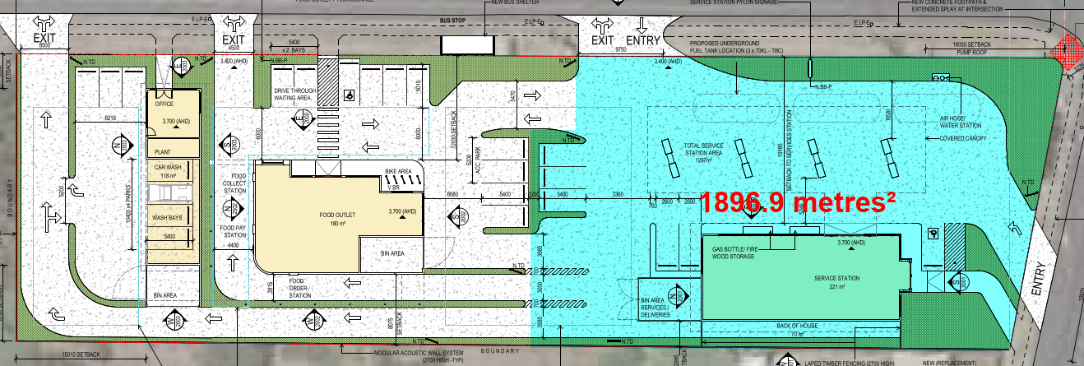
Figure 14 – Service Station Site Area

In view of the above it is considered that the service station activity area would be approximately 1,897m², it is acknowledged that to meet the site area condition within the land use table, the proposed uses must be able to be suitablycharacterized as separate land uses. Given the application does not proposed subdivision, it is considered that it must also be established that the proposed land uses are separate land uses and not a primary use of the land for a service station with ancillary food offerings and car wash.

The matter of suitably characterised convenience restaurant and service station land use on the same lot is discussed in detail within Jasbe Petroleum v Baw Baw SC [2019] VCAT 392.

Within the Tribunal’s decision in Jasbe Petroleum, Senior Member Martin outlines (paras. 51-62 that the Tribunal was satisfied that the food offerings included in that proposal were suitably characterized as falling within the ‘convenience restaurant’ definition given that:

- Each of the food offerings exhibited a generous sized area (281.5m² and 212m²),
- Substantial provision would be made for food consumption both on and off the premises,
- The proposed food offerings would have a real emphasis on ‘immediate consumption’,
- The proposed plans described the floor areas of the food offerings as having a substantial ‘back of house area’ including storeroom, cool-room, freezer and cooking area,
- It was difficult to conclude that the food offerings proposed would largely relate to selling pre-prepared food simply delivered to the location,
- The definition of ‘Convenience restaurant’ expressly includes the activity of ‘preparing food’,
- The definition of ‘Service station’ merely refers (SM Martin’s emphasis) to the “…selling of food, drinks and other convenience items…”

The Jasbe Petroleum decision also discusses whether a convenience restaurant such as that which was proposed could be considered ancillary to a service station land use. On this matter, the Tribunal found the proposed convenience restaurants were not ancillary to the service station use given that both proposed convenience restaurants would:
- Have individually large floor areas,
- will have their own separate cashiers and drive-through facilities,
- Will essentially operate independently of the sale of fuel and associated convenience items (e.g., the food offering could in theory trade at separate hours from the fuel offering),
- Any one customer visiting the facility could choose to buy food but no petrol/convenience items or vice-versa,
- The indications were that the food items would be branded differently to (and presumably leased separately from) the service station,

- The convenience restaurants would have their own separate pedestrian entry,
- The main pedestrian entrance were situated closer to the food offerings than to the service station.
- The proposed development layout included features abnormal to regular service stations including a dedicated picnic area.

In view of the matters discussed in Jasbe Petroleum, it is considered that the proposed food offering forming part of this application PP-1512-2020 is reasonably characterized as a separate land use (Convenience Restaurant) given that:

- The proposed food offering would have a generous sized area (180m²),
- The proposed food offering would have an emphasis on immediate consumption, noting the provision of a drive-through lane, typical of fast food facilities.
- The proposed plans show the food offering would be sited separate to the service station, with its own car parking area, bin storage area, pedestrian entrance.
- It is reasonable to consider that the stand alone food outlet will have its own cashiers.
- It is clearly indicated that the service station and food offering would have separate signage which would be subject of a future planning permit application.
- The service station and food offering will be able to operate independent of each other.
- A customer visiting the facility will be able to choose to buy food without attending or making a purchase from the service station.

The above discussion is considered to indicate that the service station and convenience restaurant would be separate land uses and therefore, in determining whether the application meets the service station land use condition, its ‘site area’ would not include the ‘site area’ of the convenience restaurant.
When measuring the submitted proposed plans, it is noted that a conservative estimate of the convenience restaurant site (including car parking, drive-through and street frontage areas) exhibits a total area of approximately 1,000m². Therefore, it is demonstrated that the service station site area would not exceed 3,600m² for the purpose of assessment against the land use condition for a service station in section 2 of the low density residential zone.
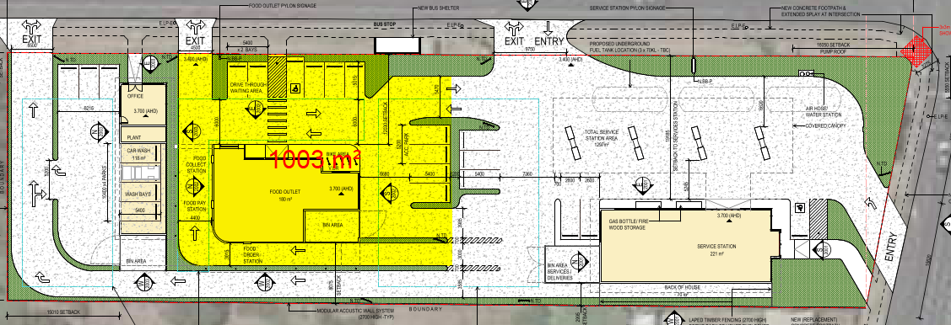
Figure 15 – Convenience Restaurant Site Area
Given the size of the site area for the convenience restaurant, whether or not the car wash is a separate land use to the service station is a moot point for the purpose of identifying whether or not the service station meets the section 2 land use condition. However, for the avoidance of doubt, it is also considered that the proposed car wash would be separate to the service station and convenience restaurant land uses given that:
- It would be sited to the northern end of the site, away from the service station and with separate access behind the convenience restaurant,
- It would have its own designated car parks and pedestrian entrance
- It would have its own office and waste storage area
- It is reasonably considered that given the separate office area, car wash customers would be entirely served within the car wash building
- It is clearly indicated that the car wash would have separate signage to the service station and food offering, which would be subject of a future planning permit application.

ZONE:

Clause 32.03 - Low Density Residential Zone – Schedule 1
The Purpose of the Low Density Residential Zone (LDRZ) is:
- To implement the Municipal Planning Strategy and the Planning Policy Framework.
- To provide for low-density residential development on lots which, in the absence of reticulated sewerage, can treat and retain all wastewater.

Clause 36.04 – Transport Zone
The purpose of the Transport Zone is:
- To implement the Municipal Planning Strategy and the Planning Policy Framework.
- To provide for an integrated and sustainable transport system.
- To identify transport land use and land required for transport services and facilities.
- To provide for the use and development of land that complements, or is consistent with, the transport system or public land reservation.
- To ensure the efficient and safe use of transport infrastructure and land comprising the transport system.

OVERLAY:

Clause 44.05 – Special Building Overlay
The purpose of the Special Building Overlay is:
- To implement the Municipal Planning Strategy and the Planning Policy Framework.
- To identify land in urban areas liable to inundation by overland flows from the urban drainage system as determined by, or in consultation with, the floodplain management authority.
- To ensure that development maintains the free passage and temporary storage of floodwaters, minimises flood damage, is compatible with the flood hazard and local drainage conditions and will not cause any significant rise in flood level or flow velocity.

- To protect water quality and waterways as natural resources by managing urban stormwater, protecting water supply catchment areas, and managing saline discharges to minimise the risks to the environmental quality of water and groundwater.

Response to Low Density Residential Zone – Schedule 1
Before Deciding on an application, in addition to the decision guidelines in Clause 65, the responsible authority must consider, as appropriate:
- The Municipal Planning Strategy (MPS) and the Planning Policy Framework (PPF)

A response to the Municipal Planning Strategy and the Planning Policy Framework is outlined in more detail later within this report.

It is noted that both the Purpose and Decision guidelines of the LDRZ do not set any specific neighbourhood character objectives, or landscape and natural resource objectives for proposed use and development. Such matters are addressed in greater detail within the MPS and the PPF. It is therefore considered that an appropriate response to relevant planning strategies and policies would indicate an appropriate response to the purpose and decision guidelines of the LDRZ in this regard.

It is acknowledged that the purpose of the LDRZ seeks to provide low-density residential development on lots which can treat and retain all wastewater. Such a purpose is somewhat superfluous in consideration of this application given that the proposed development can connect to reticulate sewerage which exists within the Coppards Road road reserve. Conditions have been recommended by Barwon Water which require that connection to the reticulated sewer must be obtained prior to commencement of any development works, and to the satisfaction of Barwon Water.
In view of the above, it is considered that the proposed use and development would suitably respond to the purpose and decision guidelines contained within the Low Density Residential Zone.

In addition to the above, as the proposed use of the land falls within section 2 of the LDRZ, it is acknowledged that the zone itself identifies that there may be circumstances where such a land use is appropriate. As the decision guidelines required under the zone require consideration of the MPS and the PPF, a detailed assessment of the proposal against the MPS and the PPF is outlined below.

Response to Transport Zone

It is noted that the Department of Transport have provided in-principle support to access.

Response to Special Building Overlay

Before deciding on an application, in addition to the decision guidelines in Clause 65, the responsible authority must consider, as appropriate:
- The Municipal Planning Strategy and the Planning Policy Framework.
- Any local floodplain development plan.
- Any comments from the relevant floodplain management authority.
- The existing use and development of the land. Whether the proposed use or development could be located on flood-free land or land with a lesser flood hazard outside this overlay.
- The susceptibility of the development to flooding and flood damage.
- Flood risk factors to consider include:
- The frequency, duration, extent, depth and velocity of flooding of the site and accessway.
- The flood warning time available.
- The danger to the occupants of the development, other floodplain residents and emergency personnel if the site or accessway is flooded.
- The effect of the development on redirecting or obstructing floodwater, stormwater or drainage water and the effect of the development on reducing flood storage and increasing flood levels and flow velocities.
- Any other matters specified in a schedule to this overlay

The application is supported by a Stormwater Management Strategy (SWMS), prepared by E2D Design Lab – Version 02 dated November 2021 (received: 29th November 2021). The SWMS has been informed by a flood impact assessment prepared by BMT Commercial (dated 23 November 2021).
The Stormwater Management Strategy and Flood Impact Assessment have been reviewed by Council’s Engineering Services Unit as the relevant floodplain management authority for areas situated within the Special Building Overlay.
It has been confirmed by Council’s Engineering Services unit that the flood impact assessment demonstrates that the proposal would suitably limit off-site flood impacts to pre-development levels and would not unacceptably impede overland flows through the site.
In addition to the above, the Council’s Engineering Services unit has confirmed that the finished floor levels and finished surface levels shown on the proposed plans are satisfactory to ensure that the development would not be unreasonably susceptible to damage as a result of flooding during the 1 in 100 year flood event.
In view of the above, it is considered that the proposed development satisfactorily responds to the Purpose and Decision Guidelines contained within the Special Building Overlay.

CULTURAL HERITAGE MANAGEMENT PLAN (CHMP):

The Aboriginal Heritage Regulations 2018 specify the circumstances in which a cultural heritage management plan is required for an activity or class of activity. Division 2 of the Aboriginal Heritage Regulations 2018 specifies exempt activities which do not require a cultural heritage management plan. The proposal is not listed as an exempt activity.

Areas of cultural heritage sensitivity are defined within Divisions 3 and 4 of the Aboriginal Heritage Regulations 2018. Division 3 does not identify the site or part of the site as within an area of cultural heritage sensitivity.

Foremost the site is not listed as an area of Aboriginal Cultural sensitivity. Also, the activity in terms of High impact activities are defined within Division 5 of the Aboriginal Heritage Regulations 2018. Division 5 lists the proposal as a high impact activity.
The site is not considered to have been the subject of significant ground disturbance which is defined as ‘disturbance of (a) the topsoil or surface rock layer of the ground or (b) a way - by machinery in the course of grading, excavating, digging, dredging or deep ripping, but does not include ploughing other than deep ripping.
In view of the above assessment, it is noted that a CHMP is not required.

LANDFILL GAS RISK ASSESSMENT

The subject land is not located within 500 metres of an identified former landfill site, a risk assessment is not required.

DEVELOPMENTS IN BUSHFIRE PRONE AREAS

The application site is not located within a designated bushfire prone area.
THE VICTORIAN PLANNING POLICY FRAMEWORK (VPPF):

The following Victorian Planning Policies are applicable to this application:
11.00 – Settlement
11.01-1S - Settlement
11.01-1R – Settlement – Geelong G21
11.03-3S – Peri-urban Areas
13.00 - Environmental Risks and Amenity
13.04-1S Contaminated and potentially contaminated land
13.05-1S Noise abatement
13.07-1S– Land Use Compatibility
15 - Built Environment and Heritage
15.01- 1S Urban Design
15.01-2S – Building design
15.01-5S – Neighbourhood character
15.02-1S – Energy and resource Efficiency
17 – Economic Development
17.01-1S – Diversified economy
17.01.1R – Diversified economy – Geelong G21
17.02-1S – Business
17-03 – Industry
18 - Transport
18.01-1S - Land use and Transport Planning
18.02-3S – Road System
18.02-4S - Car Parking

THE LOCAL PLANNING POLICY FRAMEWORK (LPPF)
MUNICIPAL STRATEGIC STATEMENT.

The following policies of the Municipal Strategic Statement are applicable to this application:
Clause 21.05-7 - Flooding
Objectives
- To protect floodplains.
- To minimise the potential for damage and risks to public safety and property from flooding.
Strategies
- Ensure that land use and development is compatible with flood prone land .
- Discourage land use and development in floodplains where flood function may be impaired.

Clause 21.06-6 – Neighbourhood Character
Objectives
- To manage the impact of urban change on existing neighbourhoods.
- To ensure that new development responds to the existing neighbourhood character.
- To protect areas with a significant garden character.
Strategies
- Ensure that development is responsive to the established character of the area.
- Retain existing vegetation wherever possible, particularly vegetation that contributes to the municipality’s tree canopy.
- Maintain the character of the Rural Living and Low Density Residential Zoned areas.

Clause 21.06-8 – Implementation
Using policy and the exercise of discretion
- Use the Discretionary Uses in Rural Living and Low Density Residential Areas at Clause 22.04.

Clause 21.07-2 – Industry
Objectives
- To direct different types of industrial development to appropriate locations.
Strategies
- Focus new industrial development around major transport routes and infrastructure assets.

LPPF
The following Local Planning Policies are applicable to this application:
Clause 22.04 – Use and Development in Rural Living and Low-Density Residential Areas
Objectives
- To protect the amenity of rural living and low density residential locations from activities incompatible with the primary residential purpose of the zones.
- To maintain the semi rural and low density character of these locations.
- To protect areas of high environmental quality.
- To ensure effective disposal of wastewater and stormwater drainage.
- To ensure the subdivision of land creates lots which have a clearly identifiable street frontage.

Clause 22.71 – Environmentally Sustainable Development
Objectives
The overarching objective is that development should achieve best practice in ESD from the design stage through to construction and operation.

Response to Policy
The planning policy framework incorporates a range of policies which seek to encourage development that responds to the needs of existing and future communities, established built form, landscape character and local context. Development should not adversely impact on community amenity and human health through noise emissions, by incorporating a range of building design and land use separation techniques appropriate to the land use functions and character of the area.
In addition, relevant state policies at Clause 17 of the Greater Geelong Planning Scheme seek to encourage a diversified economy through supporting new businesses that provide employment.

Relevant policies at Clause 18 of the Planning Scheme seek to create safe and sustainable transport systems and develop an efficient road network.
Strategies in place to achieve adopted planning policy outcomes are outlined within the Municipal Planning Strategy.

Specific to this application, relevant policy at clause 21.05-7 seeks to ensure that land use and development is compatible with flood prone land, discourage land use and discourage those land uses and developments that would impair flood function.

Clause 21.06-6 sets out objectives and strategies relevant to managing the impact of urban change on existing neighbourhoods and ensuring new development responds to the existing neighbourhood character.

Clause 21.07 relates to Economic Development and Employment and sets out that there is a need to provide for ongoing employment and economic development in the Geelong Region, and to provide a diverse range of appropriately located, well serviced industrial land while meeting the changing needs of industrial developments.

At clause 21.07-2, objectives relevant to industry seek to provide adequate supply of appropriately located industrial land, direct different types of industrial development to appropriate locations, facilitate well designed and serviced industrial development that provides a high level of amenity for workers and visitors, and to minimise land use conflicts.

Clause 22.04 Use and Development in Rural Living and Low Density Residential Areas is a key local policy that sets out objectives to protect the amenity of low density residential locations from activities incompatible with the primary residential purpose of the zone, maintain low density character of these locations and ensure effective disposal of wastewater and stormwater drainage.

Where a planning permit is required for use and development, it is policy within Clause 22.04 to:
- Discourage uses which are likely to disturb the residential amenity such as animal boarding and dog keeping.
- Discourage intensive urban activities providing accommodation for large numbers of people or which attract substantial numbers of visitors to a site.
- Discourage second dwellings on a lot
- Require new vehicle accessways to have a minimum width of 4 metres where the length of the driveway exceeds 30 metres.

The proposal removes the existing dwelling on site and would largely achieve accessway widths of 4 metres with the exception of the drive-through lane at the Convenience Restaurant, and the access to the Car Wash. No concerns have been raised by Council’s Traffic engineers with regard to accessway widths. It is noted that the submitted Traffic Impact Assessment demonstrates that vehicles, including trucks accessing the site would be able to reasonably navigate the site.

In view of the above, the first two policies of Clause 22.04 are most relevant to the assessment of this application, those being the potential for the proposed uses to unreasonably disturb the residential amenity of the area, and the consideration of whether the proposed use is an unreasonably intensive urban activity.

Built Form and Character
The LDRZ has primarily a residential purpose and generally a low density character is to be maintained. It is policy within Clause 21.06-4 to maintain the character of Low Density Residential zoned areas.

As outlined within the site description and surrounds, the subject land is surrounded by Commercial 2 Zone to its east, south-east and south, which exhibits a substantial mix of commercial uses of varying scale and intensity. The land fronts a Transport Zone 2 and Transport Zone 3 in both the Bellarine Highway to the south and Coppards Road to the east.

Department of Transport data indicates that this section of the Bellarine Highway is estimated to exhibit an annual average daily traffic volume of 15,000 vehicles east bound and 14,000 vehicles west bound, totaling 29,000 vehicles per day. This is reiterated within the submitted Traffic Impact Assessment, which further outlines that SCATS data for the intersection of Bellarine Highway and Coppards Road indicates that it served in the order of 35,000 vehicles per day on 12 February 2020 prior to the Covid-19 pandemic, with the AM and PM peak hour traffic being approximately 2,790 and 2,950 vehicles, respectively.

Unlike the wider Low Density Residential Zone to the north along Coppards Road, in view of the surrounding land uses and the significant traffic volumes, the immediate environs of the subject land are not considered to enjoy a significant low density character. Nor does the area exhibit servicing issues (given the sewer within Coppards Road). Furthermore, the subject land does not exhibit any identified environmental characteristics such as high quality vegetation.

The maximum building height would occur over the proposed fuel pump area. The service station canopy would have a maximum height of 6.7 metres in this location. The proposed service station building would be single storey with a maximum height of 5.5 metres and would exhibit external materials and a roof form which both respond directly to the prevailing materials and built forms exhibited within dwellings to the north and west. The service station building would be set back approximately 3 metres from the western side boundary, reflecting a similar side setback to the existing dwelling on site.

The proposed Convenience Restaurant would be sited approximately 25 metres north of the Service Station and would be set back approximately 8 metres from the western side boundary and 12 metres from the Coppards Road frontage. The building would include a flat roof and external materials of render and timber cladding and would exhibit a maximum height of 6.2 metres.

The proposed Car Wash building would be sited to the northern side of the subject land, set back approximately 9 metres from the western side boundary and 15 metres from the northern (rear) boundary. The Car Wash building would have a street setback of approximately 4 metres. This building would be relatively small in scale exhibiting a maximum height of 5.6 metres, with a heavily glazed elevation fronting Coppards Road and a gabled roof form.

The combined roof forms, external materials and single-storey scale of the proposed Convenience Restaurant and Car Wash would respond to the surrounding built form and established character. Particularly that of the neighbouring commercial sites opposite the subject land to the east and to the south. Furthermore, the separation between buildings and the proposed setbacks and building heights are considered to go some way to responding to the built form character of the LDRZ to the north and west. Particularly so, noting that the majority of residential sites in proximity to the subject land exhibit a proliferation of sheds and other outbuildings contributing to the built form character of this part of the Low Density Residential Zone.

Whilst the car parking proposed would be clearly visible from the street, it is noted that significant forecourt car parking is heavily prevalent within the immediate surrounds of the proposal.

In view of the above it is considered that the proposed building design, setback and landscaping opportunities are consistent with the surrounding established character.

Off Site Amenity Impacts
A key issue is the potential for noise emissions from the proposed facility. The application is supported by an Acoustic Assessment Report (Prepared by O’Callaghan Consulting Engineers), which has assessed existing environmental noise and established existing ambient noise levels and presents recommended noise controls to mitigate potential off-site amenity impacts.

The acoustic assessment identifies the nearest noise sensitive receivers as the existing dwellings to the west, north and north-east of the subject land and through measuring ambient noise levels sets relevant noise limits for noise emissions from the proposal to these receivers.

The acoustic assessment identifies that in a worst-case scenario, the proposed uses would largely comply with the relevant Daytime, Evening and Night criteria, except for the following activities:
Use | Daytime noise criteria non-compliance | Evening noise criteria non-compliance | Night-time noise criteria non-compliance
Service Station | NIL | Refrigeration delivery vehicle  Waste collection | NIL
Convenience restaurant | NIL | Refrigeration delivery vehicle  Waste collection | Refrigeration delivery vehicle  Waste collection
Car wash | NIL | NIL | N/A (closed)

The acoustic report concludes that:
- With the exception of deliveries and waste collection in the evening period, typical service station activities at a worst case scenario would comply with noise limits at sensitive receivers at all times.
- With the exception of deliveries and waste collection, the proposed convenience restaurant is predicted to comply with noise limits at sensitive receivers at all times.
- The car wash would comply with noise limits at sensitive receivers at all times.

Noting that the proposed uses are not assumed or expected to be inaudible at the nearest sensitive receivers, the acoustic assessment includes recommendations to be implemented to ensure compliance with relevant noise limits and to reduce noise annoyance. These include acoustic barriers on the northern and western side boundaries of the site and requiring acoustically treated plant equipment.

The Council’s Environmental Health Officers have reviewed the application including the submitted acoustic assessment and have advised that no objection is raised to the grant of a permit subject to appropriate conditions. As the areas of non-compliance with noise limits relate to waste collection and delivery vehicles within the evening and night-time, it is considered that such matters can be reasonably mitigated by restricting waste collection and delivery times to daytime hours (7am – 6pm).

It is acknowledged that the acoustic report submitted includes proposed plans originally submitted which haves since been amended as part of this application. The changes to the layout of the site would have no impact on the measured ambient noise levels. Furthermore the changes that occurred are not considered that result in a significant change to the predicted noise emissions. It is noted that the acoustic assessment considered a more intensive version of the proposal, with the Car Wash closer to the site boundaries than is now proposed, and with two drive-through lanes servicing the Convenience Restaurant.

In addition to the above, the application is supported by an Odour Assessment prepared by Vipac Engineers & Scientists. The odour assessment includes an air quality impact assessment for the proposed Service Station. The odour assessment against predicts that odour concentrations at all sensitive receptors would be below the criteria outlined within the State Environment Protection Policy (Air Quality Management).

Given the immediate surrounds of the subject land do not exhibit a typical, rural or bucolic low density residential character or amenity, combined with the advice of Council’s Environmental Health Officers and the suitably qualified acoustic and odour engineer’s assessments, it is not considered that the proposed uses would unreasonably detract from the amenity of the locality by way of unreasonable noise or odour impacts.

Visual Impact
The proposed built form would generally be obscured from view from neighbouring dwellings. The proposal would incorporate modular acoustic walls to the northern and western boundaries of the site, replacing the existing boundary fencing on the site. This change is not considered unreasonable given that landscaping will be proposed adjacent the site boundaries which will aid in enhancing the appearance of boundary treatments when viewed from the street.

Privacy
Given the proposed boundary acoustic fencing proposed would be in excess of 1.8 metres in height, the proposal would not impact on the privacy enjoyed by nearby dwellings.

Is the proposal an unreasonably intensive urban activity?
The proposed mix of uses are considered to be urban uses and are acknowledged to attract a considerable number of visitors. Given the context of the subject land, surrounded by commercial uses and adjacent an intersection servicing up to 35,000 vehicles a day, which is unusual for the LDRZ, it is not considered that this is reason to refuse the application.

The objectives of clause 21.07-2 include providing well designed and serviced industrial development and to minimise land use conflicts. Whilst the proposed Car Wash land use would be nested under Service Industry, it is noted that the size and scale of both the proposed building and the proposed operation are akin to that which would be expected outside industrial zoned land, on a major arterial road. The acoustic treatments proposed in accordance with the acoustic assessment recommendations are considered to suitably address potential land use conflicts with the neighbouring property to the north.

Environmentally Sustainable Development (ESD)
In response to Clause 22.71, the application is supported by a Sustainable Design Assessment which has been reviewed by the Council’s ESD Planning Officer. Council’s ESD Planning Officer has advised that some additional details are required to be submitted and shown on plans. Conditions have been recommended to require relevant additional details post permit

RELEVANT PARTICULAR PROVISIONS:

The following Particular Provisions are applicable to this application:

Clause 52.05 – SIGNS
Purpose
- To regulate the development of land for signs and associated structures.
- To ensure signs are compatible with the amenity and visual appearance of an area, including the existing or desired future character.
- To ensure signs do not contribute to excessive visual clutter or visual disorder.
- To ensure that signs do not cause loss of amenity or adversely affect the natural or built environment or the safety, appearance or efficiency of a road.

Response
The application as originally lodged included proposed Business Identification signage, including internally illuminated signage. During the course of the application, the applicant amended the proposal on 21-May-2021 to remove the proposed signage from the application.
Any signage that requires a planning permit will be required to be subject of a future application for a planning permit to display signage. To ensure this, it is recommended that any planning permit granted is subject to conditions requiring the submission of amended plans prior to commencement of use, with any signage requiring a planning permit deleted from the plans.

CLAUSE 52.06 – CAR PARKING
Purpose
- To ensure that car parking is provided in accordance with the State Planning Policy Framework and the Local Planning Policy Framework.
- To ensure the provision of an appropriate number of car parking spaces having regard to the demand likely to be generated, the activities on the land and the nature of the locality.
- To support sustainable transport alternatives to the motor car.
- To promotes the efficient use of car parking spaces through the consolidation of car parking facilities.
- To ensure that car parking does not adversely affect the amenity off the locality.
- To ensure that the design and location of car parking is of a high standard, creates a safe environment for users and enables easy and efficient use.

Response
Clause 52.06 does not specify a car parking rate requirement for the use of the land for a Service Station. As such, a car parking rate to the satisfaction of the responsible authority is applicable pursuant to Clause 52.06-6.
Clause 52.06 does require the provision of 13 car parking spaces to be located on the land (10 to the proposed Convenience Restaurant and 3 to the proposed Car Wash), plus the provision of car parking servicing the proposed service station to the satisfaction of the responsible authority.
A breakdown of the proposed car parking provision, relative to the statutory car parking requirements under Clause 52.06-5 is outlined below:
Use | Size | Statutory Rate | Required | Proposed
Service Station | N/A | To the satisfaction of the RA | 6 parking spaces | 6 parking spaces
Convenience Restaurant | 36 Patrons | 0.3 spaces to each patron permitted | 10 parking spaces | 10 parking spaces
Industry  (Car Wash) | 118m² net floor area  (including office, detailing and finishing bays) | 2.9 spaces to each 100m² of net floor area | 3 parking spaces | 3 parking spaces
Total |  |  | 19 parking spaces | 19 parking spaces

In view of the above, the application complies with the statutory car parking rates specific within Clause 52.06-5 for the proposed Convenience Restaurant and Car Wash land uses.

In accordance with Clause 52.06-6, it is necessary to assess the provision of car parking proposed for the Service Station land use.

The submitted Traffic Impact Assessment (TIA), prepared by O’Brien Traffic outlines that the proposed Service Station is likely to have 2 staff members on site. As such it is noted that staff car parking will likely require a maximum of 2 parking spaces on site.
The TIA sets out that typically customer car parking demand for mid-size service stations and associated ancillary convenience shops is approximately 3-4 parking spaces at most times (excluding vehicles at petrol pumps). With such demand, it is noted that the proposed 6 car parking spaces would provide sufficient car parking provision to accommodate both staff and customer car parking demand associated with the proposed service station.

It is acknowledged that some customers attending the Service Station would be parking vehicles at the fuel pumps and would purchase goods within the Service Station building at the same time as paying for fuel. For such customers, it is not considered that separate designated car parking spaces away from the fuel pumps is necessary.

The Service Station would exhibit a total of 8 fuel pumps and 6 designated car parking spaces. It is considered reasonable to expect that the majority of trips to the Service Station would be to refuel vehicles, with in store purchases from the ancillary convenience shop most likely to be carried out by patrons who are already purchasing fuel. It is also noted that the TIA submitted identified that the majority of trips to medium sized service stations are typically passing traffic. That is, patrons often refuel vehicles when most convenient to do so, when passing a service station for a potentially unrelated purpose such as a trip to or from work.

The Council’s Senior Traffic Engineer has reviewed the submitted proposed plans and the TIA. No objection has been raised on the grounds of insufficient on-site car parking.
In view of the above, it is considered that the provision of 6 designated car parking spaces associated with the proposed Service Station, on top of the 8 fuel pumps would satisfy the car parking demand associated with the anticipated traffic generation of the proposed Service Station.
Design Standards for Car Parking
Pursuant to Clause 52.06-9 of the Car Parking particular provision, car parking plans must meet the design standards of Clause 52.06-9 unless the responsible authority agrees otherwise.
Design Standard 1 – Accessways | Complies: all accessways are at least 3 metres wide and adequate clearances are provided. The submitted TIA includes swept paths for vehicles including cars, waste collection and fuel tanker trucks. The Swept paths demonstrate convenient access and egress for each vehicle.
Design Standard 2 – Car Parking Spaces | Complies: all parking spaces are designed to meet or exceed minimum dimension of car parking spaces required under Clause 52.06-9.
Design Standard 3 – Gradients | Complies: land is generally flat.
Design Standard 4 – Mechanical Parking | Not Applicable: no mechanical parking proposed.
Design Standard 5 – Urban Design | Complies: car parking and accessways do not visually dominate the proposal and landscaping areas are proposed for screening.
Design Standard 6 – Safety | Complies: adequate surveillance is available, and lighting will be required via conditions on any permit granted.
Design Standard 7 – Landscaping | Complies: adequate landscaping areas are proposed, and suitable water sensitive urban design treatments are incorporated into the proposal in accordance with Clause 22.71.

Clause 52.29 - LAND ADJACENT TO THE PRINCIPAL ROAD NETWORK

Purpose
- To ensure appropriate access to the Principal Road Network or land planned to form part of the Principal Road Network.
- To ensure appropriate subdivision of land adjacent to Principal Road Network or land planned to form part of the Principal Road Network.
As the application proposes to alter access to the site from the Bellarine Highway, a planning permit is required pursuant to Clause 52.29-3.

Decision Guidelines
Before deciding on an application, in addition to the decision guidelines in Clause 65, the responsible authority must consider:
- The Municipal Planning Strategy and the Planning Policy Framework.
- The views of the relevant road authority.
- The effect of the proposal on the operation of the road an on public safety.
- Any policy made by the relevant road authority pursuant to schedule 2, clause 3 of the Road Management Act 2004 regarding access between a controlled access road and adjacent land.

Response
The proposed works to alter the access to the site from the Bellarine Highway would include removal of the existing crossover and construction of a new entry only vehicle crossing at 45-degrees to the alignment of the road reserve.

The proposed alteration to access to/from the adjacent Transport Zone 2 are considered to provide appropriate access to the site from a main road while adequately maintaining the operation of the road and public safety through an entry only access point, and segregated pedestrian access.

It is noted that any planning permit granted would be subject to conditions required by the Department of Transport requiring the construction of access points and removal of redundant access points from Bellarine Highway to be carried out to the satisfaction of the satisfaction of the Head, Transport for Victoria.

As outlined within the Department of Transport referral response, no objection is raised to the proposal subject to conditions being included on the permit. It is therefore considered that the proposed alterations of access to / from the Bellarine Highway will suitably mitigate any negative effect on the operation of the road and on public safety.

Clause 52.34 – BICYCLE FACILITIES
Purpose
- To encourage cycling as a mode of transport.
- To provide secure, accessible and convenient bicycle parking spaces and associated shower and change facilities.

Response

Pursuant to Clause 52.34-5 of the Bicycle Facilities particular provision, a total of 5 bicycle parking spaces, with 3 employee spaces and 2 visitor spaces required. A breakdown of this requirement is outlined below.

Use | Size | Statutory Rate |  | Required
Use | Size | Employee | Visitor | Employee | Visitor
Service Station | N/A | N/A | N/A | 0 | 0
Convenience Restaurant | 78m² of floor area available to the public | 1 to each 25m² of floor area available to the public | 2 | 3 spaces | 2 spaces
Service Industry  (Car Wash) | 118m² net floor area  (including office, detailing and finishing bays) | 1 to each 800m² of net floor area | None | 0 | 0
Total |  |  |  | 3 | 2

The proposed plans submitted with the application show a total of 5 bicycle hoops to the south-eastern side of the proposed Convenience Restaurant. This would equate to parking spaces for up to 10 bicycles.

In view of the above, the application would exceed the minimum bicycle facilities required in accordance with Clause 52.34.
The proposal does not require 5 or more employee bicycle spaces. As such, the development is not required to provide showers or change rooms.

DECISION GUIDELINES OF CLAUSE 65:
CLAUSE 65.01 – APPROVAL OF AN APPLICATION OR PLAN

Clause 65.01 of the Greater Geelong Planning Scheme outlines the decision guidelines to be considered by the Responsible Authority when making decisions on applications. These decision guidelines include:
- The matters set out in Section 60 of the Act.
- The Municipal Planning Strategy and the Planning Policy Framework.
- The purpose of the zone, overlay or other provision.
- Any matter required to be considered in the zone, overlay or other provision.
- The orderly planning of the area.
- The effect on the amenity of the area.
- The proximity of the land to any public land.
- Factors likely to cause or contribute to land degradation, salinity or reduce water quality.
- Whether the proposed development is designed to maintain or improve the quality of stormwater within and exiting the site.
- The extent and character of native vegetation and the likelihood of its destruction.
- Whether native vegetation is to be or can be protected, planted or allowed to regenerate.
- The degree of flood, erosion or fire hazard associated with the location of the
- land and the use, development or management of the land so as to minimise any such hazard.
- The adequacy of loading and unloading facilities and any associated amenity, traffic flow and road safety impacts.

Response
The proposal is considered to satisfactorily respond to relevant planning policy, the purposes of the zone and other relevant provisions. The proposal is considered to contribute to orderly planning and is not considered to create any unreasonable impacts on the amenity of the area.

CONCLUSION:

That the Responsible Authority having considered all matters which the Planning and Environment Act 1987, requires it to consider decides to issue a Notice of Decision to Grant a Planning Permit for Use and Development of a Service Station, Convenience Restaurant (Drive-through) and Car Wash and Alter Access to a Road in a Transport Zone 2 at 149 Bellarine Highway, NEWCOMB generally in accordance with the plans and documentation submitted with the application subject to conditions.
- ttachment_.1.1 page 3
2.1.1 page 4
Attachment_2.1.1 page 5
Attachment_2.1.1 pagCLOSE OF MEETING

As there was no further business the meeting closed at 8.07pm on Thursday 26 May 2022

BAMFA Properties v Manningham CC [2008} VCAT 364
VCAT 604
VCAT 392
DoT Traffic Volumes for Freeways and Arterial Roads
Sydney Coordinated Adaptive Traffic System (SCATS)

