

minutes

PLANNING COMMITTEE MEETING
No. 229

Thursday 27 April 2023
City Hall

ALSO LIVE STREAMED ON THE CITY’S WEBSITE:

www.geelongaustralia.com.au/meetings

PANEL:

Cr Mason (Chair), Cr Cadwell, Cr Sullivan, Cr Aitken, Cr Harwood, Cr Asher

PRESENT

Present: Cr Mason (Chair), Cr Cadwell, Cr Sullivan, Cr Aitken,
Cr Harwood, Cr Asher

Council Officers: Joanne van Slageren, Manager City Development
John Rush, Coordinator Statutory Planning
Lewis Muston, Principal Planner Statutory Planning
Sylvie Tynan, Town Planner Statutory Planning

Opening: The Chair declared the meeting open at 6.59pm.

1. PROCEDURAL MATTERS

Acknowledgement Of Country

The Committee acknowledges the Wadawurrung People as the Traditional Owners of the Land, Waterways and Skies. We pay our respects to their Elders, past and present. We Acknowledge all Aboriginal and Torres Strait Islander people who are part of our Greater Geelong community today.

1.2. Introduce The Panel Members

1.3. Apologies

Cr Grzybek, Cr Murrihy, Cr Moloney, Cr Kontelj, Cr Nelson

1.4. Declarations Of Conflicts Of Interest

Nil

1.5. Confirmation Of Minutes

That the Minutes of the Planning Committee Meeting held on 30 March 2023.
be confirmed.

Moved: Cr Sullivan Seconded: Cr Aitken

CARRIED

2. MATTER(S) FOR CONSIDERATION
PP-320-2021 98 Marshalltown Road, Grovedale And PP-1512-2020 149 Bellarine Highway, Newcomb
2.1. | PP-916-2020 20-34 Newcombe St & 25-27 Fenwick St, PORTARLINGTON

Application No: | PP-916-2020
Applicant: | Monea Bros (No 1) Pty Ltd
Subject Land: | 20-34 Newcombe St & 25-27 Fenwick St, PORTARLINGTON
Zone: | 20 & 22-34 Newcombe Street: Commercial 1 Zone and adjacent to a Transport Zone 2  25 & 27 Fenwick Street: Residential Growth Zone – Schedule 3  The entirety of the site is located within an Increased Housing Diversity Area
Overlays: | 20 & 22-34 Newcombe Street: Design and Development Overlay – Schedule 21  25 & 27 Fenwick Street: Nil
Existing Use: | 20 Newcombe Street: Food and Drink Premises  22-34 Newcombe Street: Vacant  25 Fenwick Street: Vacant  27 Fenwick Street: Single dwelling
Proposed Use: | Use of the Land for Dwellings and Development of the Land for Seven (7) Shops and Fifty-Nine (59) Dwellings, Multi-Lot Subdivision Adjacent to a Transport Zone 2, Alter Access to a Transport Zone 2 and Reduction of Car Parking

Summary

Subject site and Surrounds
The subject site is located in Portarlington, approximately 32 kilometres east of Geelong. Portarlington is located on the northern coastline of the Bellarine Peninsula with views across Corio Bay and Port Phillip Bay.

The planning unit forming the subject site consists of land located at 20 and 22-34 Newcombe Street and 25 and 27 Fenwick Street, Portarlington. The land forming the subject site is formally identified as:

- 20 Newcombe Street: Lot 1 on TP 128274
- 22-34 Newcombe Street: Lot 1 on TP 825025
- 25 Fenwick Street: Lot 2 on TP 825025
- 27 Fenwick Street: Lot 3 on TP 825025

The subject sites are located to the south of Newcombe Street and contain a northern boundary frontage to Newcombe Street of approximately 56 metres in length and at its rear, contains a southern boundary frontage to Fenwick Street of approximately 40 metre in length. The combined sites have an area of 4,717m² with a slope down approximately 8 metres from its south-eastern corner to its north-western corner.

The site is presently developed with a single-storey brick dwelling with tiled roof at 27 Fenwick Street, and a single-storey commercial building at 20 Newcombe Street. The majority of the site is presently vacant.

The site is situated within the Portarlington Town Centre, with Newcombe Street being the main thoroughfare through the town centre. To the northern side of Newcombe Street, is the Portarlington Foreshore Reserve, the Portarlington Bowls Club and the Port Philip Bay Foreshore. To the north-east is the Portarlington Pier, accessed via Harding Street.

To the south, land is zoned Residential Growth Zone – Schedule 3 and is generally used for residential purposes.

Adjacent the subject site to the west are four single-storey dwellings at 3 – 7 High Street and 18 Newcombe Street. At number 16 Newcombe Street is a building previously used as a dwelling, which has been converted to a medical centre.

Adjoining the site to the east, at number 36 Newcombe Street, is a single-storey commercial building currently used as a restaurant/bar.

Adjoining the subject site to the east on Fenwick Street is an existing single-storey Victorian era dwelling, with a two-storey rear addition.

The properties fronting Newcombe Street on either side of the subject site are zoned Commercial 1 Zone and are also within the Portarlington Town Centre precinct.

Zones and Overlays
The subject site is situated within two zones and is partly covered by the Design and Development Overlay – Schedule 21.

The northern side of the site, being numbers 20 and 22-34 Newcombe Street, are zoned Commercial 1 Zone, are adjacent to a Transport Zone 2, and is within the Design and Development Overlay – Schedule 21, which applies to the Portarlington Town Centre.

The southern side of the site, being numbers 25 and 27 Fenwick Street, and an accessway portion of 22-34 Newcombe Street is zoned Residential Growth Zone – Schedule 3 and is not subject to any overlays.

Proposal
The application seeks a planning permit for use and development of the land for a mixed-use development comprising 59 dwellings, in the form of apartments, 7 commercial tenancies, associated subdivision and reduction in the on-site car parking requirements.

Given the proposed layout, site layout and relevant boundaries of planning controls applying to the planning unit, the proposed development can be relevantly described in two main elements. These being, the Fenwick Street side and the Newcombe Street Side, and segregated by a central landscaped courtyard.

The Newcombe Street side contains a maximum five-storey building at 16 metres above natural ground level comprising three ‘wings’, which would incorporate 7 retail units at street level, a common residential amenity and gym area, and 35 apartments.

Given the progressive increased street setbacks at each additional floor level, the proposed building would exhibit a three-storey elevation built from to the Newcombe Street frontage, with the top two levels being recessed from the street frontage.

The Fenwick Street side comprises a four-storey building split into two ‘wings’, which at its street frontage would appear as three-storeys given the slope of the land. The Fenwick Street side would comprise 24 apartments. A maximum building height of 11.5 metres is proposed within the Fenwick Street side.

It is proposed to provide vehicular access via Fenwick Street. Adjacent to the western side boundary is the ingress to a basement carpark comprising 85 on-site car parking spaces. Vehicles exiting the site would access Fenwick Street via a proposed egress adjacent to the eastern side boundary of the subject site.

The proposed buildings would be constructed of a combination of concrete, brick and aluminium external materials with a mix of grey toned finishes and timber appearance cladding.

The proposed landscaping incorporates four main landscaped areas. These include a landscaped courtyard segregating the two building wings fronting Fenwick Street, a central courtyard segregating the Fenwick Street and Newcombe Street buildings, and two landscaped areas at the effective first-floor level fronting Newcombe Street, segregating the three building wings fronting Newcombe Street.

Referrals
SECTION 55:

DETERMINING AUTHORITY

Authority | Response
Head, Transport for Victoria | no objection subject to conditions
Powercor | no objection subject to conditions
Barwon Water | no objection subject to conditions
Downer Utilities | no objection subject to conditions

SECTION 52:

Authority | Response
CFA | no objection and no conditions

Internal Referrals:

Department | Response
Engineering | no objection subject to conditions
ESD | no objection subject to conditions
Urban Design | concerns raised regarding:  - Site context and design response  - Movement  - Public realm and landscaping  - Built form
Environmental Health | no objection subject to conditions
Parks | no objection subject to conditions
Strategic Implementation | supportive
Strategic Planning | not supportive
Waste | no objection subject to conditions

Public Notice
Pursuant to Section 52 of the Planning and Environment Act 1987 the following forms of advertising were undertaken:

- Notices were sent to owners and occupiers of adjoining land (including opposite)
- A2 sign(s) were placed on the land

Twenty-Nine (29) objections have been lodged with Council.

Forty-Four (44) letters of support have been lodged with Council.

Relevant Planning Scheme Provisions Assessed
The application has been assessed against the relevant Planning Policy Framework (PPF), Municipal Planning Strategy (MPS), Zone, Overlay, Particular and General Provisions of the Greater Geelong Planning Scheme.
Based on the assessment, it is considered that the application accords with the Scheme by proposing a mixed use development that increases the density and diversity of housing on a site close to the activity centre of Portarlington. It is well serviced and in close proximity to retail, education, recreation and the public transport network.
The building height, bulk, form and material detail provides an appropriate design response based on the policy considerations and given the advantages of the sites location subject to some modest variations to relevant residential and apartment development standards (ResCode).
The Portarlington Structure Plan outlines that the site at 22-34 Newcombe Street is identified in the Urban Design Framework 2011 (UDF) as a major development opportunity. The 2008 Structure Plan recommended that this be a focal building to contain a mix of retail uses, tourist accommodation and tourism related activities. However, within the amended 2016 Structure Plan, it is outlined that development of the site remains a priority for the town centre. It further sets out that activated uses are necessary on the ground floor, however as a result of no development on the site to date, a mix of options including accommodation above first floor level could be considered.
In this regard, the proposal is considered to contribute to the vibrancy of the town centre. The proposal incorporates a mix of as of right commercial uses at ground level fronting Newcombe Street and proposed dwelling land uses at the upper floor levels which require a planning permit. The proposal would contribute to the vitality and vibrancy of the centre in this regard given it would provide an active retail frontage at ground level and increased dwelling density with additional dwellings within the activity centre. Furthermore, the provision of dwellings at upper levels will ensure that the development provides dwellings at densities which are complementary to the role and scale of the commercial centre. The provision of dwellings at upper floor levels will further assist in supporting the vibrancy and vitality of the centre. Particularly as more services and amenities are realized within the centre.

The part of the site fronting Newcombe Street has been considered against the performance criteria outlined within the DDO21 which implements the competing objectives for coastal planning, distinctive landscapes and activity centres to achieve acceptable planning outcomes. As outlined in detail in this report, the proposed development is considered to suitably respond to the objectives of the DDO21 to provide visually sympathetic taller built form elements, unobtrusive in views from the foreshore and high quality design, whilst providing a focal building on a site that has been identified for in multiple strategic plans as a major development opportunity.
Fronting Fenwick Street, the proposed development represents a built form that is considered to respond to the evolving character of the area and is consistent with the intent expressed in Clause 16.01-1L-02 to support evolution to more intensive development with visually interesting built forms. The design response also accords with the Purpose of the RGZ3 to provide dwellings at increased densities and diversity.

RECOMMENDATION:

Moved: Cr Harwood Seconded: Cr Sullivan

That the Responsible Authority having considered all matters which the Planning and Environment Act 1987, requires it to consider decides to issue a Notice of Decision to Grant a Planning Permit for Use of the Land for Dwellings and Development of the Land for Seven (7) Shops and Fifty-Nine (59) Dwellings, Multi-Lot Subdivision Adjacent to a Transport Zone 2, Alter Access to a Transport Zone 2 and Reduction of Car Parking at 20-34 Newcombe St & 25-27 Fenwick St, PORTARLINGTON in accordance with the plans and documentation submitted with the application subject to the following conditions.

CARRIED

DEVELOPMENT

Amended Plans

- Prior to the commencement of the development amended plans to the satisfaction of the Responsible Authority must be submitted to and approved by the Responsible Authority. When approved, the plans will be endorsed and will then form part of the permit. The plans must be drawn to scale with dimensions and must be generally in accordance with the plans submitted with the application on 22nd August 2022, but modified to show:
  - Longitudinal sections of all ramps to show all relevant design levels (to AHD), grades, transition and main ramp lengths and headroom clearances. The ramps must be designed in accordance with the standards in AS/NZS 2890.1:2004
  - Clearly detail all annotations including Finished Floor Levels and Ceiling Heights
  - Detail location of required acoustic treatments as outlined within the submitted acoustic report prepared by Resonate Consultants -ref: M200653 received: 04-12-2020.
  - A car parking allocation plan to show what tenancy is assigned to each car space(s), including the retail tenancies. The plan must provide information about how these car spaces will be assigned on the ground, whether it be line marking or signage, or a combination of both.
  - Annotate plans detailing that display of signage to be as-of-right or subject of a separate permit application.
  - Annotate proposed plans specifying detail of bathroom design types in accordance with table B9 of Standard B42 of Clause 55.07-8 of the Greater Geelong Planning Scheme and table D4 of Standard D18 of Clause 58.05-1 of the Greater Geelong Planning Scheme.
  - Annotate minimum width dimension of at least 850mm at entrance and main bedrooms of a minimum of 50% of proposed dwellings.
  - Annotate development plans detailing all commitments made within Sustainability Management Plan (prepared by Sustainable Development Consultants, Dated November 2020 ref: 53937 SMP. V2, received: 14-12-2022), including:
    - Solar PV panels on flat roof of western building fronting Newcombe Street
    - Add legend or note confirming MLB annotation in car parking areas represents overhead bike storage
    - Annotate plans to specify all dwellings will be provided with separate utility meters.
  - Annotate proposed plans detailing that all landscaping and fencing within corner splay area of vehicle accessway are to be maintained to be not more than 900mm in height above the accessway level at its street frontage in accordance with Design Standard 1 of Clause 52.06-8.
  - Shopfront elevations of commercial premises fronting Newcombe Street to accord with 3D renders on proposed development plans submitted with the application on 22 August 2022, including window, brick plinth and awning dimensions.
  - Pedestrian entrance gate from central courtyard to dwellings G.12, G.13, G.14 and G.15, with footpath access from central courtyard to each dwelling.
  - Updated Landscape Plan as per the requirements of Condition 8 of this permit.
  - Revised proposed plan of subdivision to accord with proposed development plans showing 59 dwellings.
All to the satisfaction of the Responsible Authority.

Endorsed Plans

- The development as shown on the endorsed plan(s) must not be altered without the written consent of the Responsible Authority.
Sustainability Management Plan
- The development hereby approved must not be carried out other than in accordance with the endorsed Sustainability Management Plan to the satisfaction of the Responsible Authority.
Prior to Works Commencing

- Prior to work commencing hereby approved, other than any works associated with the environmental assessment or remediation of the site:

- A preliminary risk screen assessment statement in accordance with the Environment Protection Act 2017 must be issued stating that an environmental audit is not required for the use or the proposed use; or
- An environmental audit statement under Part 8.3 of the Environment Protection Act 2017 must be issued stating that the land is suitable for the use or proposed use; or
- A certificate of environmental audit must be issued for the land in accordance with Part IXD of the Environment Protection Act 1970; or
- A statement of environmental audit must be issued for the land in accordance with Part IXD of the Environment Protection Act 1970 stating that the environmental conditions of the land are suitable for the use or proposed use.

A copy must be provided to the satisfaction of the Responsible Authority to satisfy this condition.

Waste Management
- Prior to the works commencing, a Waste Management Plan prepared by a suitably qualified or experienced, person to the satisfaction of the Responsible Authority, must be submitted to and approved by the Responsible Authority. The amended plan(s) must generally in accordance with the Waste Management Plan submitted with the application (Ref: 16019W REP01F01 Received: 20th August 2020) but revised to:
- Relevant updates to reflect the proposed development for 59 dwellings not 62 dwellings.
- Evidence that a ‘mini rear-lift vehicle’ (6.4m long and 2.1m high) is available for use within the Portarlington region for residential waste collection.
- If evidence cannot be provided in accordance with point (b), above, suitable alternative collection arrangements must be incorporated into the revised Waste Management Plan.
- If a revised collection arrangement is proposed in accordance with point (c) above, the waste management plan must detail as a minimum:
  - collection frequency
  - collection location
  - collection contractors to be used
  - signage
  - area for parking of waste and recycling collection vehicles when bins are being emptied and the direction of travel of the vehicles, including swept paths for collection trucks.
  - location of where the bins will be presented for collection and the type of vehicles that are able to collect the bins from this nominated area

When approved, the Waste Management will be endorsed to form part of the planning permit. The endorsed plan(s) must not be altered without the written consent of the Responsible Authority.
- All waste, garbage and recycling stored on the land must be regularly disposed of so as to not cause nuisance, pollution, or loss of amenity to any persons or the surrounding area to the satisfaction of the Responsible Authority.

- Unless otherwise approved in writing by the Responsible Authority, collection of waste from the commercial premises shown on the endorsed plans must not occur other than during the following times:

  - Monday to Friday – 7:00am and 8:00pm, and
  - Weekends and Public Holidays – 9:00am and 8:00pm

to the satisfaction of the Responsible Authority.

Landscaping Plans

- Prior to the works commencing, an amended landscape plan prepared by a suitably qualified or experienced, person to the satisfaction of the Responsible Authority, must be submitted to and approved by the Responsible Authority. The amended plan(s) must generally in accordance with the landscape master plan submitted with the application prepared by Perry Mills Landscape Architecture (DWG No: 1918 LMP01 – 1918 LMP06 (inclusive) – Received: 18 November 2021) but modified to show:
  - Details of the proposed materials, finishes and depth of planters for the landscape spaces;
  - Surface treatment and materials of all external, publicly accessible and/or communal open areas, paths and terraces within the site;
  - A planting schedule of all proposed trees, shrubs and ground covers including botanical names, common names, pot sizes, sizes at maturity, and quantities of each plant;
  - Inclusion of at least two (2) Type B or one (1) Type C Tree as defined within Table B7 of Clause 55.07-4 of the Greater Geelong Planning Scheme within planting schedule;
  - Detailed planter sections, including soil volumes and schedules of species with consideration given to soil volume requirements and growing medium proposed, and indicative irrigation and drainage layouts. The planter sections and soil volumes at first-floor level fronting Newcombe Street must be adequate for tree planting in accordance with the Landscape Master Plan submitted with the application;
  - Detail of planter boxes and their dimensions on balconies and roof terraces as shown on the proposed development plans drawn by SPL Architects and submitted with the application on 22 August 2022;
  - Details of proposed maintenance regimes with provision for maintenance to all communal areas beyond 2 years;
  - Align with any initiatives of the Sustainability Management Plan, including the use of drought tolerant species;
  - The addition of pergola or other similar framing structures to the balconies of dwellings 2.01 and 2.02 Apt G. The structures are to support the growth of climbing plants to the satisfaction of the Responsible Authority.

When approved, the Landscape Plan will be endorsed to form part of the planning permit.
- The landscaping shown on the endorsed plans must be maintained to the satisfaction of the Responsible Authority, including that any dead, diseased or damaged plants are replaced.
Street tree planting

- Prior to occupation of the development, street trees within the Fenwick Street and Newcombe Street road reserves must be planted to the satisfaction of the Responsible Authority and maintained for an establishment period of two years.
The applicant will be responsible for all costs associated with:

- the purchase of street trees in minimum 40cm containers
- the planting of the street trees
- the aftercare and maintenance of the street trees for a period of no less than two years
As the street trees are Council assets located within a road reserve, all works associated with tree planting must be undertaken by Council or its approved contractors. The applicant is to contact Council’s Parks Planning Officers (5272 5272) to discuss the process for the planning of street trees. A written quote will be prepared and provided to the applicant and acceptance of the quote must be provided in writing to Council prior to any works to the street tree commencing and all to the satisfaction of the Responsible Authority

Road and Drainage Plans
- Prior to works commencing and unless otherwise agreed to in writing by the Responsible Authority, the developer must submit for approval, engineer designed road and drainage plans, for new Council assets, prepared by a suitably qualified and experienced person in accordance with Council standards and the Infrastructure Design Manual (IDM) at the developer’s expense. Unless otherwise agreed in writing by the Responsible Authority, the plans must detail:

  - existing drainage through the site
  - new realigned Council assets.
  - pits and pipes sizes
  - finished and existing surface levels,
  - creation of appropriate easements and
  - connection to the existing Council drainage network.

Engineering Works

- The design and construction of the roadworks and stormwater drainage and any other new council infrastructure must be approved and supervised by council.
- A fee of 3.25% of the cost of the works is to be paid to council for the checking and supervision of these works.
- A maintenance bond of 5% of the cost of the civil works is to be paid to council and will be returned after successful completion of a twelve-month maintenance period.
- At the completion of engineering works shown on the approved plans required under condition 12 of this permit, the developer must submit:
- As-built Engineering plans in PDF, and GIS-ready AutoCAD (DXF) format plans,
- CCTV inspection report for all new Council underground drainage pipes and pits.
All to the satisfaction of the Responsible Authority.

Pump System
- Unless otherwise approved in writing by the Responsible Authority, prior to works commencing, the landowner must enter an agreement with the Responsible Authority pursuant to Section 173 of the Planning and Environment Act 1987. All costs associated with setting up the agreement must be borne by the land owner. The agreement is to be registered on title and run with the land, and is to provide to the satisfaction of the Responsible Authority:
- All storm water runoff is to be collected on site and discharged to the legal point of discharge using a pump system or as otherwise nominated by the responsible authority. The pump system is to be designed and constructed in accordance with Australian Standard 3500 Part 3.2 Section 9
- In the event of any operational difficulties with the pump system, it is the Responsibility of the land owner to rectify these difficulties;
- Any pump system is to be replaced by gravity discharge if and when available, and if directed by the Responsible Authority, at the land owner’s full cost.
- Provision is made (if appropriate) in any subdivision for Body Corporate drainage works, and access to those drainage works to be on common property or within an easement in favour of the Body Corporate.
Note: Where the legal point of discharge is kerb and channel, discharge velocity at the kerb must be no greater than 1.5 m/s with a maximum discharge flow rate of 10 l/s and the outlet directed at an angle of 45º to the direction of flow in the kerb and channel.

Verification of Building Height

- Written statements from a licensed surveyor must be submitted to the Responsible Authority confirming:

  - That the maximum building height does not exceed the maximum building height specified on the endorsed plans.

The statements must be submitted to the Responsible Authority:

  - At completion of the frame of the development; and
  - At completion of the development

to the satisfaction of the Responsible Authority.

Prior to Occupation of Development

- Prior to the occupation of the development, the developer must:
- Construct the site stormwater system including connection into a new junction pit connected to the underground drain in Newcombe Street, or other nominated point/s as approved by the Responsible Authority. The stormwater connection must be in accordance with City of Greater Geelong Standard Drawings;
- Construct drainage works in accordance with the approved engineering plans;
- Ensure any proposed vehicular crossing has satisfactory clearance to any existing crossover, side-entry pit, power, lighting or telecommunication pole, manhole cover or marker, fire hydrant or street tree. Any relocation, alteration or replacement required shall be in accordance with the requirements of the relevant Authority and shall be at the applicant’s expense;
- Construct new 4.0m wide vehicular crossings centered on the accessways in accordance with the requirements and standards of the City of Greater Geelong;
- Remove any redundant vehicular crossings with kerb and channel and the footpath/nature strip area reinstated to match existing construction in the street;
- Construct and drain the car park including accessways, surface with an all-weather sealed coat and line mark the car and accessways in accordance with the endorsed plans;
- Clean and finish all external walls on or facing property boundaries;
- Complete all buildings and works including landscaping works in accordance with the endorsed plans.

All to the satisfaction of the Responsible Authority.

Green Travel Plan

- Prior to the occupation of the development, a Green Travel Plan (GTP) to the satisfaction of the responsible authority must be submitted to and approved by the responsible authority. The GTP submitted for approval must provide detailed advice to residents and visitors of the development about how to access and use sustainable alternative, active and public transport modes. The Green Travel Plan must detail, but not be limited to:

  - facilities for bicycles, motorbikes, small cars, electric cars and onsite and nearby car share systems
  - bicycle and walking maps
  - nearby public transport stops
  - timetables for public transport services
  - transport ticketing information
  - nearby recreation areas (e.g. parks, paths and trails)
  - resident car-pooling opportunities
  - ongoing monitoring and review of the Green Travel Plan

Once approved, the approved Green Travel Plan must be implemented to the satisfaction of the responsible authority.
Acoustic Treatments

- Prior to the occupation of the building and/or the commencement of the use hereby approved, the works outlined in the Acoustic report prepared by Resonate Consultants (ref: M200653RP1) must be carried out to the satisfaction of the Responsible Authority. This includes acoustic fencing, glazing requirements for windows and doors, solid walls in habitable rooms, and acoustic separation between commercial and residential tenants.

- All external plant and equipment must be acoustically treated or placed in soundproof housing to reduce noise to a level satisfactory to the Responsible Authority.

- All air-conditioning units are to be placed in an appropriate location or alternatively acoustically treated to reduce noise to a level satisfactory to the Responsible Authority.

Stormwater Drainage

- The site must be drained to the satisfaction of the Responsible Authority and no concentrated storm water may drain or discharge from the land to adjoining properties.

- The site stormwater system must be designed and installed such that the site stormwater discharge is not increased by the proposed development. An appropriate on-site detention system designed in accordance with the Infrastructure Design Manual may be required to the satisfaction of the Responsible Authority.
Outdoor Lighting

- Prior to the occupation of the development, low intensity lighting must be provided to the satisfaction of the responsible authority to ensure that car park areas, communal outdoor areas and pedestrian accessways are adequately illuminated during evening periods without any loss of amenity to occupiers of nearby land to the satisfaction of the responsible authority. All external lighting must conform with the approved Sustainability Management Plan and AS 4282:2019 (Control of the obtrusive effects of outdoor lighting).

- Any outdoor and/or security lighting provided must be designed, baffled, and located to prevent adverse light spill on adjoining land or road reserve to the satisfaction of the Responsible Authority.

Silent Security Alarms

- All security alarms or similar devices installed on the land must be of a silent type in accordance with any current standard published by Standards Australia International Limited and be connected to a security service to the satisfaction of the Responsible Authority.

Loading and Unloading Vehicles

- All deliveries to the property and truck movements offsite must be in adherence with the EPA Noise Control Guidelines (publication 1245) which are:

  - Monday to Saturday – 7:00am and 10:00pm;
  - Sunday and Public Holidays – 9:00am and 10:00pm.

to the satisfaction of the Responsible Authority.

No Audible Announcements

- No music or announcements may be audible outside the boundaries of the site to the satisfaction of the Responsible Authority.

General Amenity

- The amenity of the area must not be detrimentally affected by the use of land hereby approved through the:

  - Transport of materials, goods or commodities to or from the land;
  - Appearance of any building, works or materials;
  - Emission of noise, artificial light, vibration, odour, fumes, smoke, vapour, steam, soot, ash, dust, waste water, waste products, grit or oil;
  - Presence of vermin;

to the satisfaction of the Responsible Authority.

SUBDIVISION

Endorsed Plan

- The layout and site dimensions of the proposed subdivision as shown on the endorsed plan(s) shall not be altered or modified without the written consent of the Responsible Authority. There are no requirements to alter or modify the endorsed plan if a plan is certified under the provisions of the Subdivision Act 1988 that is generally in accordance with the endorsed plans.

Telecommunications

- The owner of the land must enter into agreements with:

  - a telecommunications network or service provider for the provision of telecommunication services to each lot shown on the endorsed plan in accordance with the provider’s requirements and relevant legislation at the time; and,
  - a suitably qualified person for the provision of fibre ready telecommunication facilities to each lot shown on the endorsed plan in accordance with any industry specifications or any standards set by the Australian Communications and Media Authority, unless the applicant can demonstrate that the land is in an area where the National Broadband Network (NBN) will not be provided by optical fibre.

Prior to Certification

- The Plan of Subdivision submitted for certification must include all easements deemed necessary to protect existing or future drainage lines within the subject site, and any easements required between the subject site and the nominated legal point of discharge must be created to the satisfaction of the Responsible Authority.

Prior to Statement of Compliance

- Prior to the issue of Statement of Compliance, the developer must:
  - Construct the site stormwater system including connection into a new junction pit connected to the underground drain in Newcombe Street, or other nominated point/s as approved by the Responsible Authority. The stormwater connection must be in accordance with City of Greater Geelong Standard Drawings.
  - Ensure any proposed vehicular crossing has a satisfactory clearance to any existing crossover, side-entry pit, power, lighting or telecommunication pole, manhole cover or marker, fire hydrant or street tree. Any relocation, alteration or replacement required shall be in accordance with the requirements of the relevant Authority and shall be at the applicant’s expense;
  - Construct new 4.0m wide vehicular crossings centered on the accessways in accordance with the requirements and standards of the City of Greater Geelong.
  - Remove any redundant vehicular crossings with kerb and channel and the footpath/nature strip area reinstated to match existing construction in the street;
  - Construct and drain the car park including accessways, surface with an all-weather sealed coat and line mark the car and accessways in accordance with the endorsed plans;
  - Remove any buildings/services that traverse the proposed lot boundaries.

All to the satisfaction of the Responsible Authority.

- Unless otherwise approved in writing by the Responsible Authority, prior to the issue of the Statement of Compliance:

a) The development approved by Planning Permit 916-2020 must be substantially completed (e.g., lockup stage as a minimum) in accordance with the endorsed plans forming part of that Planning Permit (or any amendment to that permit) to the satisfaction of the Responsible Authority. Evidence must be submitted which demonstrates that the development is substantially completed to the satisfaction of the Responsible Authority;

or

b) The owner of the land must enter into an agreement with the Responsible Authority pursuant to Section 173 of the Planning and Environment Act 1987 which provides for all development to be in accordance with the endorsed plans forming part of the Planning Permit 916-2020 (or any amendment to that permit) or any subsequent Planning Permit.

The agreement must specify that the obligations contained within it as a consequence of this condition will no longer apply where:

- the development of the dwelling/s have been completed (as evidenced by the grant of a certificate of final inspection by the relevant building surveyor), or;
- if the dwelling/s have not been completed, ten (10) years have elapsed from the date of execution of the agreement.

The owner must pay the costs of preparation, review, execution and registration of the agreement and the agreement must be registered on the newly created title/s. The Section 173 Agreement may be ended by the Responsible Authority at the written request of the owner and at no cost to Council.

- Unless otherwise approved by the Responsible Authority, prior to the issue to statement of compliance, the landowner must enter an agreement with the Responsible Authority pursuant to Section 173 of the Planning and Environment Act 1987. All costs associated with setting up the agreement must be borne by the land owner. The agreement is to be registered on title and run with the land, and is to provide to the satisfaction of the Responsible Authority:
- All storm water runoff is to be collected on site and discharged to the legal point of discharge using a pump system or as otherwise nominated by the responsible authority. The pump system is to be designed and constructed in accordance with Australian Standard 3500 Part 3.2 Section 9
- In the event of any operational difficulties with the pump system, it is the Responsibility of the land owner to rectify these difficulties;
- Any pump system is to be replaced by gravity discharge if and when available, and if directed by the Responsible Authority, at the land owner’s full cost.
- Provision is made (if appropriate) in any subdivision for Body Corporate drainage works, and access to those drainage works to be on common property or within an easement in favour of the Body Corporate.
Note: Where the legal point of discharge is kerb and channel, discharge velocity at the kerb must be no greater than 1.5 m/s with a maximum discharge flow rate of 10 l/s and the outlet directed at an angle of 45º to the direction of flow in the kerb and channel.

- Prior to the issue of Statement of Compliance, the owner of the subject land must pay to the Council a sum equivalent to five (5) per cent of the site value of all of the land in the subdivision as a Public Open Space contribution pursuant to Section 18 of the Subdivision Act 1988. The contribution will be payable prior to the issue of a Statement of Compliance.

- Before the issue of a Statement of Compliance for any stage of the subdivision under the Subdivision Act 1988, the owner of the land must provide written confirmation from:
  - a telecommunications network or service provider that all lots are connected to or are ready for connection to telecommunications services in accordance with the provider’s requirements and relevant legislation at the item; and,
  - a suitably qualified person that fibre ready telecommunications facilities have been provided in accordance with any industry specifications or any standards set by the Australian Communications and Media Authority, unless the applicant can demonstrate that the land is in an area where the National Broadband Network will not be provided by optical fibre.

DEPARTMENT OF TRANSPORT

- Prior to the occupation of the development, the existing crossovers to Newcombe Street must be removed and the area reinstated to the satisfaction of the Responsible Authority.

- Prior to the occupation of the development, parking and loading areas adjacent to the site in Newcombe Street must be appropriately signed and line marked to the satisfaction of the Responsible Authority.

DOWNER UTILITIES

- The plan of subdivision submitted for certification must be referred to AusNet Gas Services in accordance with Section 8 of the Subdivision Act 1988.

POWERCOR

- The plan of subdivision submitted for certification under the Subdivision Act 1988 shall be referred to Distributor in accordance with Section 8 of that Act.

- The applicant shall provide an electricity supply to all lots in the subdivision in accordance with Distributor’s requirements and standards.

Note: Extension, augmentation or re-arrangement of the Distributor’s electrical assets may be required to make such supplies available, with the cost of such works generally borne by the applicant.

- The applicant shall ensure that existing and proposed buildings and electrical installations on the subject land are compliant with the Victorian Service and Installation Rule (VSIR).

Notes: Where electrical works are required to achieve VSIR compliance, a registered electrical contractor must be engaged to undertake such works.

- The applicant shall, when required by the Distributor, set aside areas within the subdivision for the purposes of establishing a substation or substations.

Note: Areas set aside for substations will be formalised to the Distributor’s requirements under one of the following arrangements:
- Reserves established by the applicant in favour of the Distributor.
- Substation lease at nominal rental for a period of 30 years with rights to extend the lease for a further 30 years. The Distributor will register such leases on title by way of a caveat prior to the registration of the plan of subdivision.

BARWON WATER

General

- The plan of subdivision must be referred to Barwon Water in accordance with the Subdivision Act 1988 and any subsequent amendments to the plan provided to Barwon Water.

- The owner shall create easements for Pipelines or Ancillary Purposes in Favour of Barwon Region Water Corporation over all existing and proposed sewer mains located within the subdivision.

- The certified plan must create implied easements under Section 12(2) of the Subdivision Act, over all proposed and existing private potable water (including recycled water where applicable) and sewerage services within the subdivision.

- The creation of an unlimited Owners Corporation to encumber all lots within the subdivision.

- The proposed development must conform with Barwon Water's Asset Protection policy and any "build over" approval issued. Structures are generally to be no closer than 1.0m to a Barwon Water pipeline. If you propose to construct a structure closer, then consent from Barwon Water is required. This application form can be downloaded via www.barwonwater.vic.gov.au – Properties and development -> Property connections. Where the applicant is required to seek approval from Barwon Water works must not commence until written approval has been issued and all fees paid. The lodgement of an application does not constitute approval of this development.

- The developer is to apply to Barwon Water for details relating to servicing requirements and costing for the provision of a potable water supply and where applicable, recycled water and/ or sewerage services to the proposal. It would be appreciated if all communication between the developer/agent and Barwon Water quote Barwon Water reference number L015586.

Potable Water

- The provision and installation of a potable water supply to the development.
- An additional potable water connection(s) is to be provided to service the proposed development. A dimensioned plan showing location of all new connections relative to the allotment boundaries is to be submitted. where a meter is not being fitted. Note that tappings and service lines are not to be located under existing or proposed driveways.

- A master meter and sub meters are required. An 'Application to fit meters' is required to be completed and submitted by the licensed plumber who will be undertaking the installation of private potable water works. This application must include a dimensioned plan indicating the location of all meters relative to existing and proposed allotment boundaries. These sub-meters will be installed by Barwon Water after the plumber has advised of completion of these preparatory private works and that the meters can be installed. This application form can be downloaded via www.barwonwater.vic.gov.au - Business Customers -> Property Connections.

- Barwon Water's records indicate that there are existing potable water services and meters located on this property. A dimensioned plan showing the location of existing meters. and the location of the meter relative to the existing boundaries. and its number. is to be submitted. Private potable water service pipes are not permitted to cross allotment boundaries and must be plugged and abandoned at the boundaries of such allotments.

- The payment of a standardised New Customer Contribution is required for any new connection or any upsize to an existing connection. The number of standardised charges applied will be determined on the basis of an equivalent lot calculation and is based on potable domestic water meter size or water service size (where a meter is not being fitted). An equivalent lot is a measure of the additional demand a connection will place on the infrastructure in terms of the water consumption and sewage discharge for an average connection utilising a 20mm tapping and/ or meter. If there is more than one meter within a single meter assembly. the size of the largest meter (excluding the fire service meter) will determine the number of equivalent connections. If there is a combined fire and domestic meter assembly proposed (incorporating a low flow meter). Whereby the meter size is largely dictated by the fire service requirements. the developer is required to submit to Barwon Water the proposed peak flow (probable simultaneous demand) associated with the domestic supply in accord with AS/NZS 3500. Barwon Water will then assess the equivalent number of connections.

Sewer

- The provision and installation of a sewerage service to the development.

- Reticulated sewer mains are required. This work must be undertaken by a Barwon Water accredited Consultant and accredited Contractor following the "Developer Works" process.

- New or re-aligned internal private sewer drains are required. Upon completion of this work a sewer drainage plan is to be submitted to Barwon Water by a licensed plumber that complies with Victorian Building Authority requirements. Note that if any common drain or drain from another allotment crosses under a proposed dwelling. a "modification to consent" is to be obtained from the Victorian Building Authority and presented to Barwon Water with the required drainage plan. Where an Owners Corporation is not applicable. individual allotment house connection drains are to be provided for and extend into each allotment.

- Any existing sewer house connection point that is to be utilised for additional connections or altered to serve the development is to be CCTV inspected by a licensed plumber and the 'CCTV Inspection Form' with the video footage submitted to Barwon Water. If the property connection point is not deemed satisfactory for use or is no longer required. it is to be decommissioned in accordance with Barwon Water's "Property connection decommissioning process". Details of this process are available on Barwon Water's website under the business -> property connections section. Also. any existing house connection drain that traverses through the proposed allotments shall be relocated so not to inhibit future development. If the existing sewer house connection
- point is deemed satisfactory for use by Barwon Water and where branching after the connection point is permitted to service an additional allotment then this work can also be undertaken by a licensed plumber. If the sewer connection point being replaced is greater than 4.0 metres deep, a new sewer manhole is to be constructed with the new property connection point connected to this structure.

- An existing Barwon Water sewerage asset is to be abandoned as part of development works. Further details will be provided in the relevant servicing requirements and costing.

EXPIRY

Development

- This permit as it relates to the development of buildings will expire if one of the following circumstances applies:

  - The development of the building(s) hereby approved has not commenced within two (2) years of the date of this permit.
  - The development of the building(s) hereby approved is not completed within four (4) years of the date of this permit.
  - The use hereby approved is not commenced within four (4) years of the date of this permit.

The Responsible Authority may extend the periods referred to if a request is made in writing before the permit expires; or

  - Within six (6) months after the permit expires where the use or development has not yet started; or
  - Within twelve (12) months after the permit expires, where the development allowed by the permit has lawfully commenced before the permit expiry.

Subdivision

- This permit as it relates to subdivision will expire if one of the following circumstances applies:
  - The plan of subdivision has not been certified within two (2) years of the date of this permit.
  - A statement of compliance is not issued within five (5) years of the date of certification.
The Responsible Authority may extend the period referred to under part ‘a)’ if a request is made in writing before the permit expires or within six (6) months afterwards.

Notes:

- A pre-commencement meeting with Council’s Engineering department is required to be undertaken prior to works starting. To organise this meeting please contact 5272 4426.
- Construction of the site stormwater connections is to be inspected by Council Representative at various stages. An appropriate fee equivalent to 3.25% of total cost of civil works, excluding GST (a minimum fee of $100 applies if the 3.25% amount is less than $100), is to be paid to Council for inspection. Relevant evidential documentation of the cost is to be provided.
- All internal property drainage must be designed and constructed to satisfy AS/NZS 3500.
- A Vehicle Crossing Permit must be obtained prior to commencement of works.
- The Applicant is also advised to seek comment from the building surveyor on the requirement, if any, for overland flow paths to be provided on the site to convey major flows through the site in accordance with Clause 5.4.2 of AS/NZS 3500.3
- Prior to the commencement of works, an Application for Permission to Build Over a Drainage Easement must be lodged with Council.

ASSESSMENT

PERMIT TRIGGERS:

A planning permit is triggered for this application pursuant to the following clauses of the Greater Geelong Planning Scheme:

- Pursuant to Clause 32.07-3 of the Residential Growth Zone, a permit is required to subdivide land.
- Pursuant to Clause 32.07-5 of the Residential Growth Zone, a permit is required to construct two or more dwellings on a lot.
- Pursuant to Clause 34.01-1 of the Commercial 1 Zone, a permit is required to use land for Accommodation (dwelling) where any frontage at ground floor exceeds 2 metres.
- Pursuant to Clause 34.01-3 of the Commercial 1 Zone, a permit is required to subdivide land.
- Pursuant to Clause 34.01-4 of the Commercial 1 Zone, a permit is required to construct a building or construct or carry out works.
- Pursuant to Clause 43.02-2 of the Design and Development Overlay, a permit is required to construct a building or construct or carry out works. This does not apply if a schedule to this overlay specifically states that a permit is not required.
  - Schedule 21 to Clause 43.02 Design and development Overlay does not specifically state that a permit is not required to construct a building or construct or carry out works.
- Pursuant to Clause 43.02-3 of the Design and Development Overlay, a permit is required to subdivide land.
- Pursuant to Clause 52.06-3 of the Car Parking Particular Provisions, a permit is required to reduce the number of car parking spaces required under Clause 52.06-5.
- Pursuant to Clause 52.29-2 of the Land Adjacent to the Principal Road Network Particular Provision, a permit is required to:
  - Create or alter access to a road in a Transport Zone 2.
  - Subdivision land adjacent to a road in a Transport Zone 2.
DEFINITIONS

Pursuant to Clause 73.03 of the Planning Scheme, Shop is defined as:

Land used to sell goods or services, or to hire goods. It includes:
- the selling of bread, pastries, cakes or other products baked on the premises;
- demonstrations of products including music performances in shops selling recorded music.
It does not include:
- food and drink premises;
- gambling premises;
- landscape gardening supplies;
- manufacturing sales;
- market;
- motor vehicle, boat, or caravan sales;
- postal agency;
- primary produce sales; or
- trade supplies.

Note: Shop is a Section 1, no permit required use in the Commercial 1 Zone.

Clause 73.01 defines an apartment as:

A dwelling located above the ceiling level or below the floor level of another dwelling and is part of a building containing two or more dwellings.

Pursuant to Clause 73.03 of the Planning Scheme, a dwelling is defined as:

A building used as a self-contained residence which must include:

a) a kitchen sink;
b) food preparation facilities;
c) a bath or shower; and
d) a closet pan and wash basin.

It includes outbuildings and works normal to a dwelling.

Pursuant to Clause 73.04 of the Planning Scheme, a dwelling is nested in the Accommodation group.

Subdivision is not defined or nested in the Planning Scheme.

A lot is defined as a part (consisting of one or more pieces) of any land (except a road, a reserve, or common property) shown on a plan, which can be disposed of separately and includes a unit or accessory unit on a registered plan of strata subdivision and a lot or accessory lot on a registered plan.

Subdivision is defined in the Subdivision Act 1988 as the division of land into two or more parts which can be disposed of separately.

RESTRICTIVE COVENANT OR SECTION 173 AGREEMENT:

The subject site is not burdened by a Restrictive Covenant or Section 173 Agreement.

OFFICER DIRECT OR INDIRECT INTEREST:

No Council officers have any direct or indirect interest in the matter to which this report relates, in accordance with Section 130(2) of the Local Government Act.

SITE/LOCALITY:

The subject site is located in Portarlington, approximately 32 kilometres east of Geelong. Portarlington is located on the northern coastline of the Bellarine Peninsula with views across Corio Bay and Port Phillip Bay.

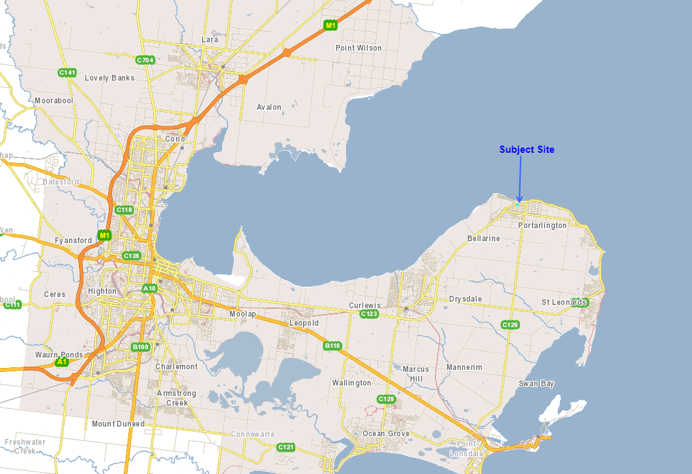
Figure 1 - Portarlington Location
The planning unit forming the subject site consists of land located at 20 and 22-34 Newcombe Street and 25 and 275 Fenwick Street, Portarlington. The land forming the subject site is formally identified as:

- 20 Newcombe Street: Lot 1 on TP 128274
- 22-34 Newcombe Street: Lot 1 on TP 825025
- 25 Fenwick Street: Lot 2 on TP 825025
- 27 Fenwick Street: Lot 3 on TP 825025

The subject sites are located to the south of Newcombe Street and contain a northern boundary frontage to Newcombe Street of approximately 56 metres in length and at its rear, contains a southern boundary frontage to Fenwick Street of approximately 40 metre in length. The combined sites have an area of 4,717m² with a slope down approximately 8 metres from its south-eastern corner to its north-western corner.

The site is presently developed with a single-storey brick dwelling with tiled roof at 27 Fenwick Street, and a single-storey commercial building at 20 Newcombe Street. The majority of the site is presently vacant.
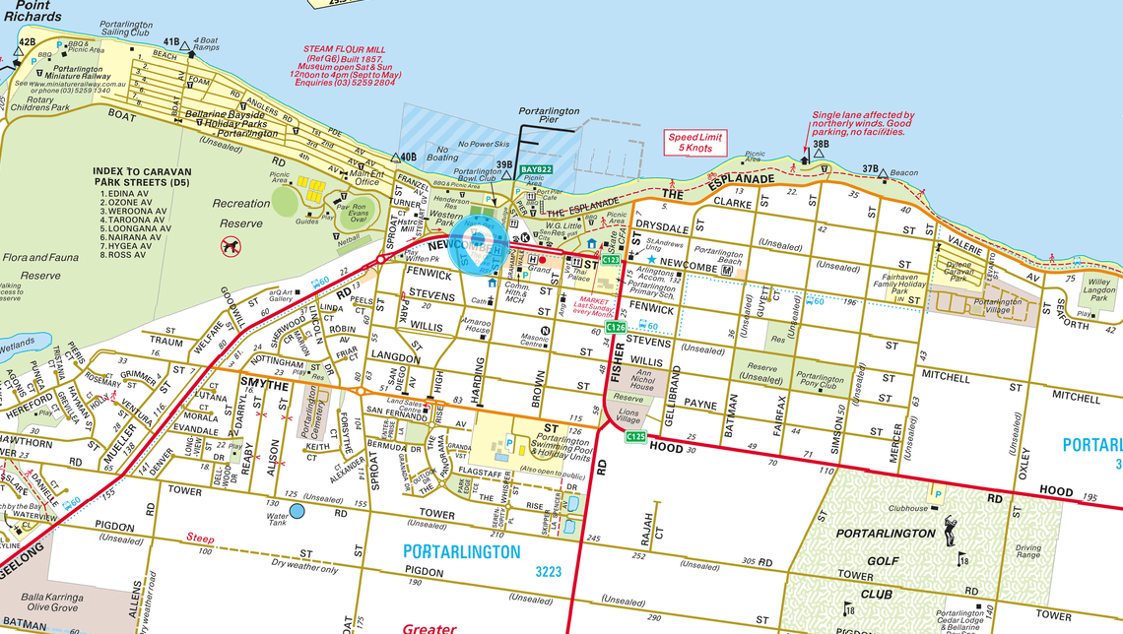
Figure 2 - Site Location - Portarlington
The subject site is situated within two zones and is partly covered by the Design and Development Overlay – Schedule 21.

The northern side of the site, being numbers 20 and 22-34 Newcombe Street, are zoned Commercial 1 Zone, are adjacent to a Transport Zone 2, and is within the Design and Development Overlay – Schedule 21, which applies to the Portarlington Town Centre.

The southern side of the site, being numbers 25 and 27 Fenwick Street, and an accessway portion of 22-34 Newcombe Street is zoned Residential Growth Zone – Schedule 3 and is not subject to any overlays.
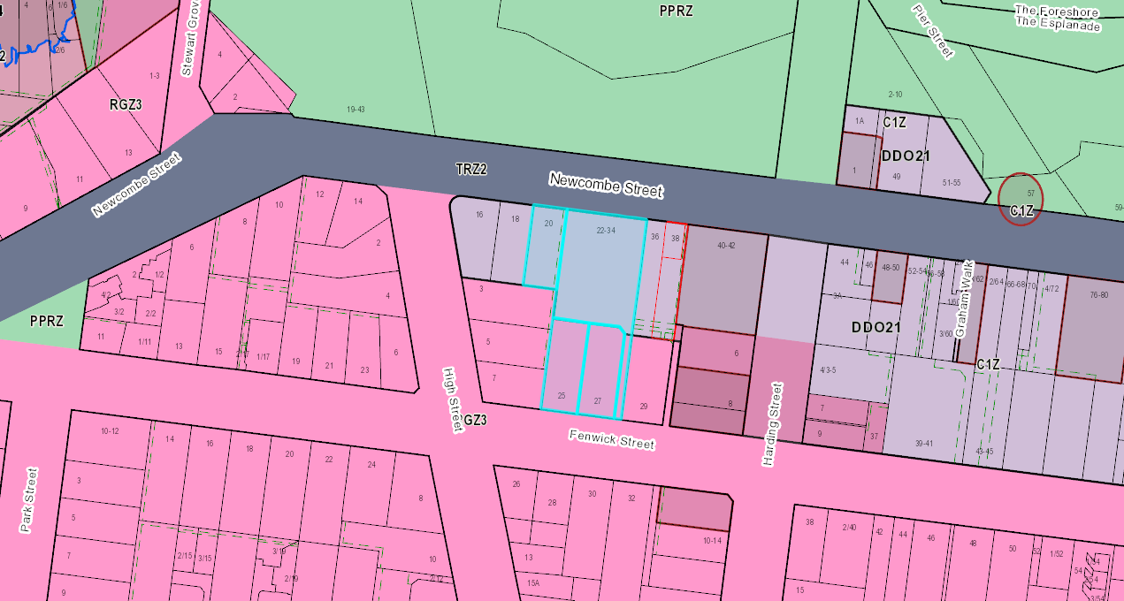
Figure 3 - Subject Site Zoning and Overlays
The site is situated within the Portarlington Town Centre, with Newcombe Street being the main thoroughfare through the town centre. To the northern side of Newcombe Street, is the Portarlington Foreshore Reserve, the Portarlington Bowls Club and the Port Philip Bay Foreshore.

The Grand Hotel is situated approximately 230 metres east of the site. The Portarlington Primary School is situated approximately 400 metres east of the subject site. The Route 60 Bus runs from Geelong Station to St Leonards via Portarlington, with bus stops situated approximately 130 metres west and 100 metres east of the site along Newcombe Street.

The Commercial 1 Zone area of the Town Centre is generally on the southern side of Newcombe Street, with the exception of a smaller segment of Commercial 1 Zoned land to the north-eastern corner of the Newcombe Street and Harding Street intersection approximately 100 metres north-east of the subject site. The built form within the surrounding town centre area generally exhibits one to two-storey development, with the exception of the Grand Hotel, which is three storeys with a central tower and the adjacent residential building which is also 3 storeys in height. Commercial buildings within the town centre are typically built to the street frontage, with a variety of heritage buildings, mid-late 20th Century buildings and some more recent 21st Century developments.

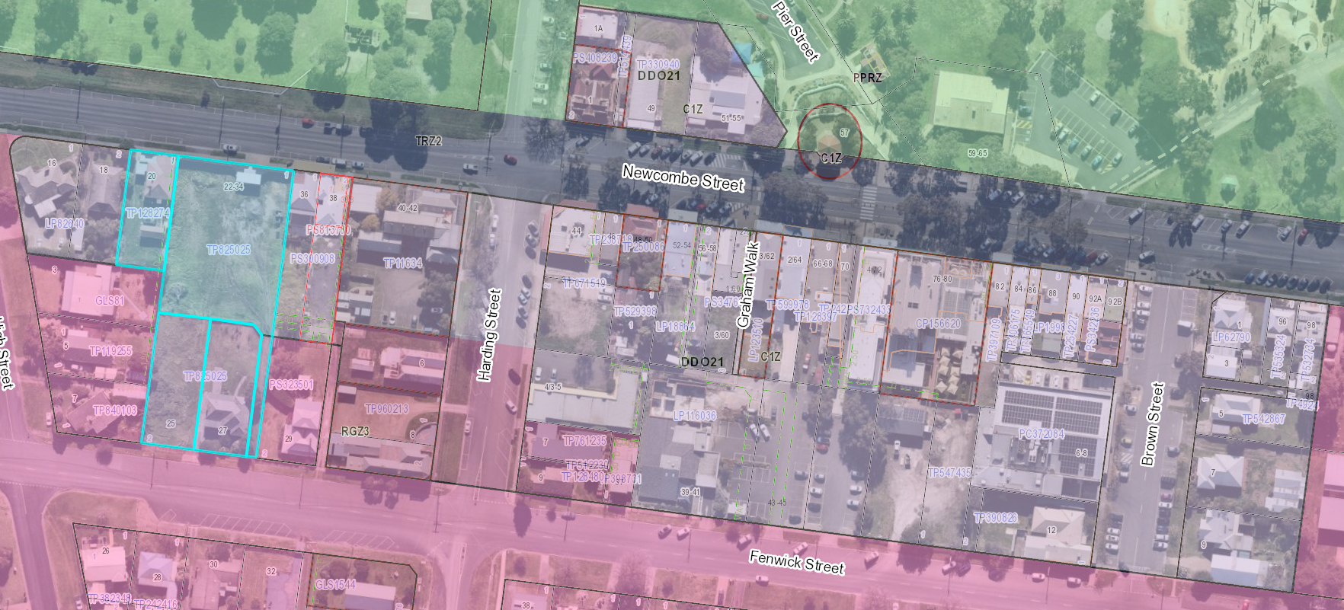
Figure 4 - Portarlington Town Centre Area
The immediate surrounds of the subject site, are described as follows:

North

To the north of Newcombe street is the Portarlington Foreshore Reserve, including the Bowls Club. To the north-east is the Portarlington Pier, accessed via Harding Street.

The site is partly obscured from view from the Portarlington Pier, due to existing vegetation within the foreshore reserve.

Line-marked on-street parking is available to the northern and southern sides of Newcombe Street in front of the subject site.

South

To the south, land is zoned Residential Growth Zone – Schedule 3 and is generally used for residential purposes. Immediately opposite the subject site is single dwellings on individual lots at 26-32 Fenwick Street. These properties are developed with dwellings of varying styles including varying external materials of weatherboard cladding, rendered masonry and face brickwork. Similarly, roof styles vary from shallow to regular hipped and gabled pitched roofs constructed of metal roofing.

Angled on-street parking is available to the southern side of Fenwick Street, in front of the dwellings at 28-32 Fenwick Street and continue towards the intersection of Fenwick Street and Harding Street.

The wider residential growth zone to the south of the subject site generally features single dwellings of one to two-storey scale. It is noted that a scattering of sites which have been redeveloped to provide additional infill housing exists throughout the wider locality.

West

Adjacent the subject site to the west are four single-storey dwellings at 3 – 7 High Street and 18 Newcombe Street.

Similarly, these dwellings exhibit varying styles, with external materials consisting of face brickwork, timber cladding and tiled, metal or fibre sheet roofing.

At number 16 Newcombe Street is a building previously used as a dwelling, which has been converted to a medical centre.

The dwellings at number 3, 5 and 7 High Street are all orientated to face west, with their secluded private open space areas situated adjacent to the western side boundary of the subject site.

East

Adjoining the site to the east, at number 36 Newcombe Street, is a single-storey commercial building currently used as a restaurant/bar. The building is constructed on its western boundary, adjoining the subject site to the east. To its street frontage, the building exhibits a bullnose verandah over the footpath.

An adjoining, smaller shopfront is situated at 38 Newcombe Street adjoining number 36 and of identical architectural style fronting the street.

Adjoining the subject site to the east on Fenwick Street is an existing single-storey Victorian era dwelling, with a two-storey rear addition.

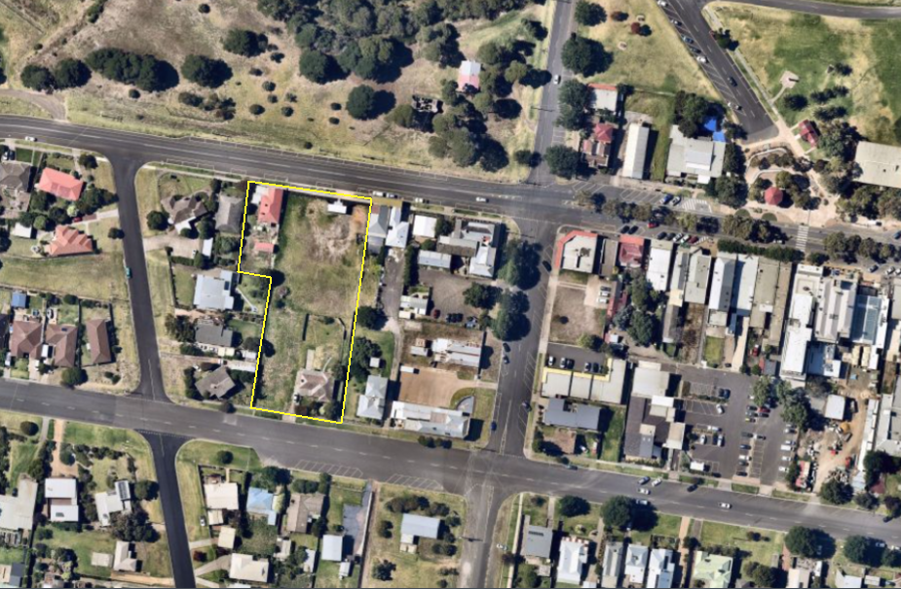
Figure 5 - Subject Site and Surrounds Aerial
PROPOSAL:

The application seeks a planning permit for use and development of the land for a mixed-use development comprising 59 dwellings, in the form of apartments, 7 commercial tenancies, associated subdivision and reduction in the on-site car parking requirements.

Given the proposed layout, site layout and relevant boundaries of planning controls applying to the planning unit, the proposed development can be relevantly described in two main elements. These being, the Fenwick Street side and the Newcombe Street Side, and segregated by a central landscaped courtyard.

The Newcombe Street side contains a maximum five-storey building at 16 metres above natural ground level comprising three ‘wings’, which would incorporate 7 retail units at street level, a common residential amenity and gym area, and 35 apartments.

The Fenwick Street side comprises a four-storey building split into two ‘wings’, which at its street frontage would appear as three-storeys given the slope of the land. The Fenwick Street side would comprise 24 apartments. A maximum building height of 11.5 metres is proposed within the Fenwick Street side.

It is proposed to provide vehicular access via Fenwick Street. Adjacent to the western side boundary is the ingress to a basement carpark comprising 85 on-site car parking spaces. Vehicles exiting the site would access Fenwick Street via a proposed egress adjacent to the eastern side boundary of the subject site.

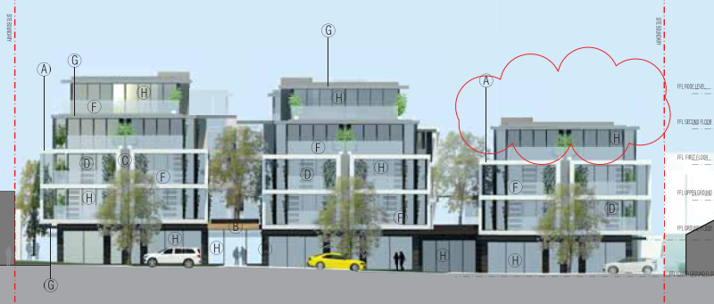
Figure 6 - Newcombe Street Elevation (North)
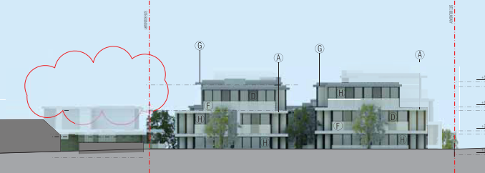
Figure 7 - Fenwick Street Elevation (south)
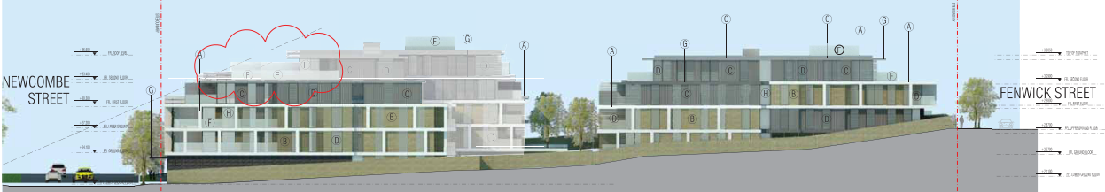
Figure 8 - Western Side Elevation showing Newcombe Street and Fenwick Street
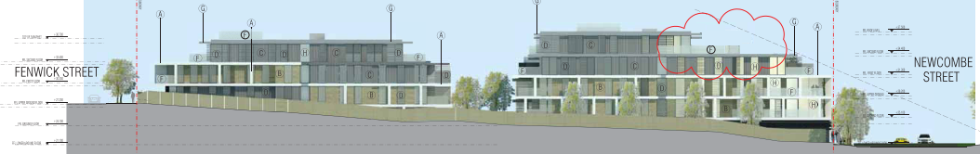
Figure 9 - Eastern Side Elevation showing Newcombe Street and Fenwick Street

The proposed buildings would be constructed of a combination of concrete, brick and aluminium external materials with a mix of grey toned finishes and timber appearance cladding.

Newcombe Street

At ground level, the proposed Newcombe Street frontage would contain 7 commercial tenancies, with a residential frontage located between proposed retail units 2 and 3, providing access to dwellings at the rear and above the proposed retail units.

The proposed retail units vary between 115-163m² in floor area. Proposed retail unit ‘5’ will be setback 2 metres from the Newcombe Street frontage, with the remaining units 1-4 and 6 and 7 being sited on the Newcombe Street boundary.

The proposed retail units would be provided with shared waste and recycling storage areas and toilets at the rear.

At the rear of the proposed retail units is a business lounge, theatre room and fitness area for use by occupants of the proposed dwellings.

One single-bedroom apartment is proposed to be located at ground level at the rear of retail unit 7, to the western side of the site.

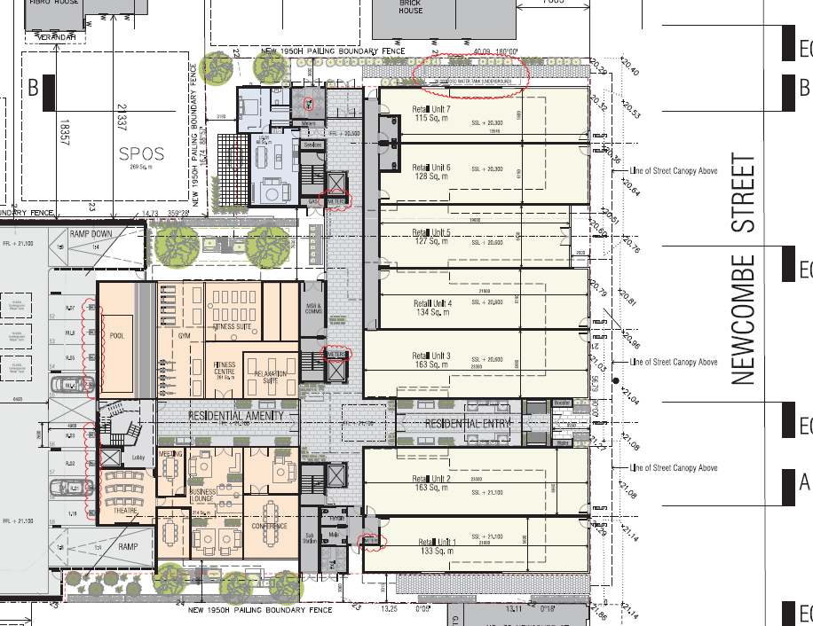
Figure 10 – Proposed Ground Floor – Newcombe Street
Sited above the commercial tenancies fronting Newcombe Street are 34 proposed apartments over four additional residential storeys, segregated into three building ‘wings’, with shared lift and stair access servicing each of the three wings. The proposed wings would be segregated by landscaped areas at the effective first-floor level fronting Newcombe Street.

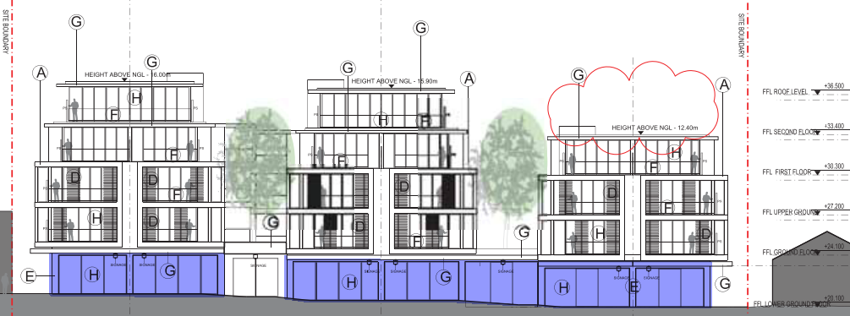
Figure 11 - Proposed Newcombe Street Building Wings (Retail shown highlighted purple)
The residential floor level above the commercial tenancies would house eleven 2 bedroom apartments. The north-facing apartments contain balconies setback 850mm from the street frontage boundary, with the dwellings set back 4.40 metres from the street frontage. The proposed south-facing apartments would be serviced by balconies overlooking a central courtyard/landscaped area.

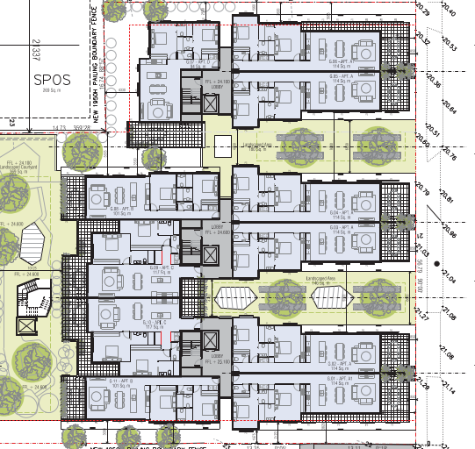
Figure 12 - Proposed First Floor - Newcombe Street

At second floor level a further eleven 2 bedroom apartments are proposed, effectively replicating the layout of the first floor, below.

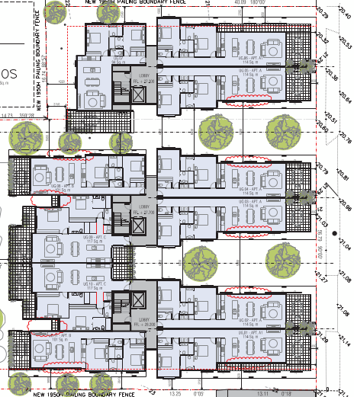
Figure 13 - Proposed Second Floor - Newcombe Street

At third floor level, a further 10 apartments are proposed. Nine of which are 2 bedroom dwellings, and one, to the western side elevation, which is a 3 bedroom dwelling. Similar to the floor below, the north-facing apartments fronting Newcombe Street would be serviced with north-facing balconies. However, the balconies and dwellings would be setback from the street frontage, with the balconies set back approximately 2.3 metres and the dwellings set back 6.25 metres from Newcombe Street.

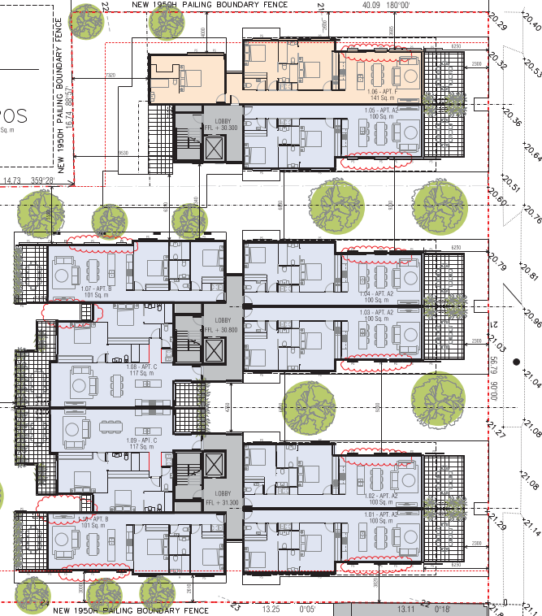
Figure 14 - Proposed Third Floor - Newcombe Street

The fourth floor-level would be the top floor fronting Newcombe Street. This level features two 3 bedroom apartments and are only located on the east and central ‘wings’. The north-facing apartments would be provided with balconies fronting Newcombe Street, set back 11.7 metres from the street frontage. With the dwellings set back 19.5 metres from the street. These dwellings would be provided with north and southern aspects however, the primary open space would be in the form of the north facing balconies.

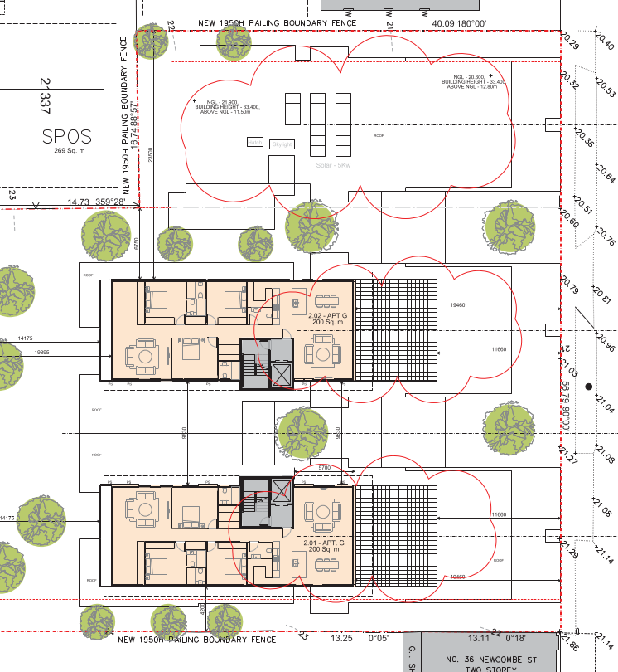
Figure 15 - Proposed Fourth Floor - Newcombe Street

Given the progressive increased street setbacks at each additional floor level, the proposed building would exhibit a three-storey elevation built from to the Newcombe Street frontage, with the top two levels being recessed from the street frontage.

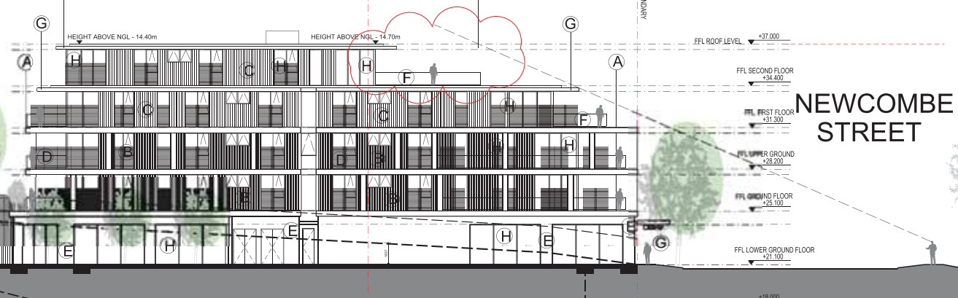
Figure 16 – East Side Elevation Showing Upper Level Recessing from Newcombe Street
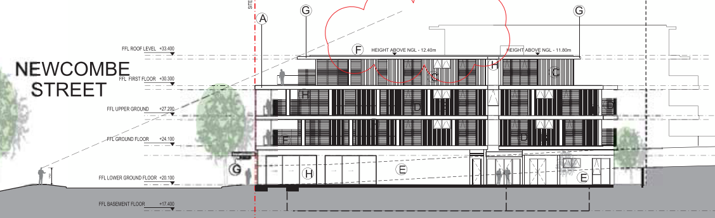
Figure 17 - West Side Elevation Showing Upper Levels Recessing from Newcombe Street
Fenwick Street

The lower ground floor of the Fenwick Street side will contain four apartments, comprising two 2 bedroom units and two 1 bedroom units. These apartments face north to the central internal courtyard. Given the slope across the site, this lower level of the proposed building fronting Fenwick Street, would effectively be at the same level as the first-floor fronting Newcombe Street, above the retail units. Each of the units would be accessed via the car park at the same level, with balconies opening up to the central courtyard as well.

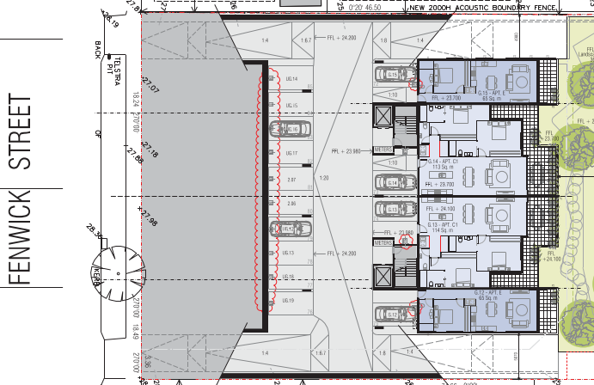
Figure 18 - Proposed Lower Ground Level - Fenwick Street
Shared access would be provided to all of the proposed apartments via two separate lift cores and stairways located centrally within the building which is accessed via a pedestrian path from Fenwick Street at ground level.

At the ground level above, the proposed building fronting Fenwick Street will contain eight 2 bedroom apartments. Four of which would front Fenwick Street with south-facing courtyards and four of which would face north with balconies overlooking the internal courtyard in the centre of the site. The south-facing apartments would be situated within two wings, segregated by a ground-level landscaped area facing Fenwick Street. The apartments facing Fenwick Street are setback 4.48 metres, with the courtyards set back 830mm from the Fenwick Street frontage.

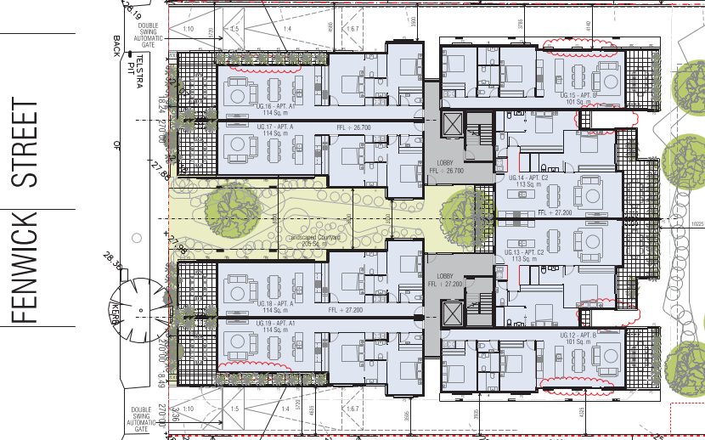
Figure 19 - Proposed Ground Floor - Fenwick Street
Shared access would be provided to all of the proposed apartments via two separate lift cores and stairways located centrally within the building accessed via a pedestrian path from Fenwick Street.

At first-floor level fronting Fenwick Street, the proposal incorporates a further eight 2 bedroom apartments, effectively replicating the ground fronting Fenwick Street below.

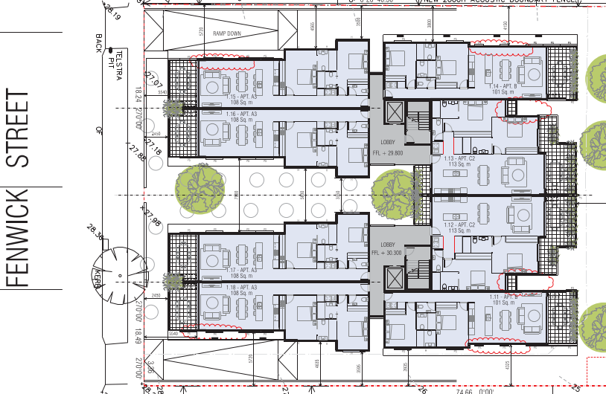
Figure 20 - Proposed First Floor - Fenwick Street
The second floor level fronting Fenwick Street would be the top level of the proposal to the Fenwick Street side of the site. The second floor level contains two 2 bedroom dwellings facing north toward the internal courtyard, and two 3 bedroom dwellings facing south towards Fenwick Street.

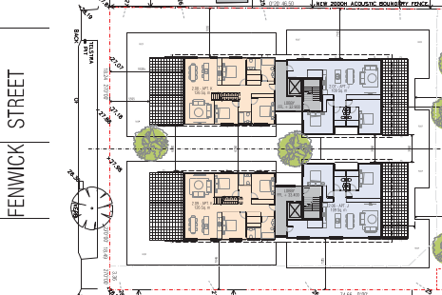
Figure 21 - Proposed Second Floor - Fenwick Street
At roof level, the proposed 3 bedroom dwellings are provided with additional private open space areas in the form of roof terraces.

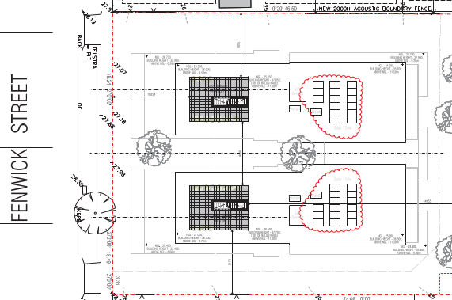
Figure 22 - Proposed Roof Level - Fenwick Street

Car Parking

The proposal seeks a reduction to the statutory car parking rate of 29 spaces. This equates to:

- 11 visitor parking spaces serving the proposed dwellings
- 18 parking spaces serving the proposed shops

Car parking is provided to service the proposed dwellings and commercial units at basement level accessed via Fenwick Street. The basement car parking is split over three basement levels which follow the slope of the land from the south to the north.

The varying basement car park levels are well illustrated within the proposed central elevations submitted with the application. The respective basement levels can be described as the southern, central and northern basement levels.

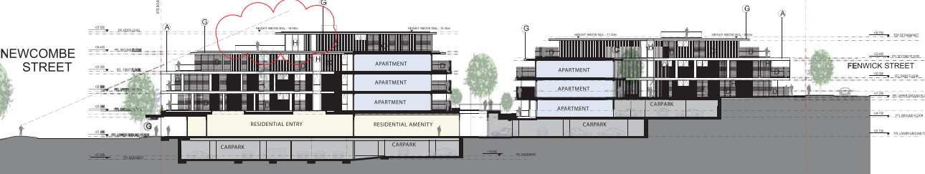
Figure 23 – Proposed Central Western Elevation - Showing Change in Basement Levels
Beneath the apartments fronting Fenwick Street, fourteen residential parking spaces are proposed within the southern basement level. Beneath the Fenwick Street apartments and the central courtyard, 20 car parks are proposed within the central basement level, 7 servicing the proposed retail units and 13 servicing residential units. An additional 51 car parking spaces are proposed within the northern basement level beneath the Newcombe Street building. Bicycle parking, waste storage and services are provided across the various basement levels.

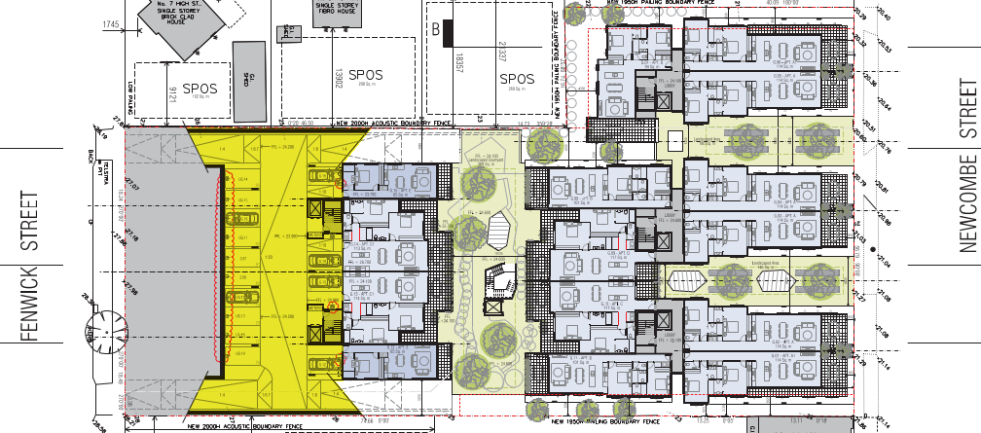
Figure 24 - Southern Basement Car Park
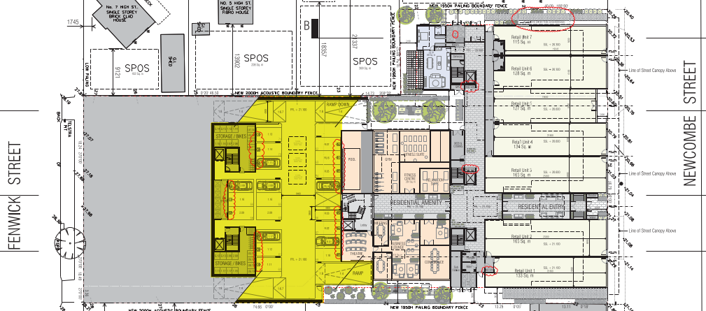
Figure 25 - Central Basement Car Park
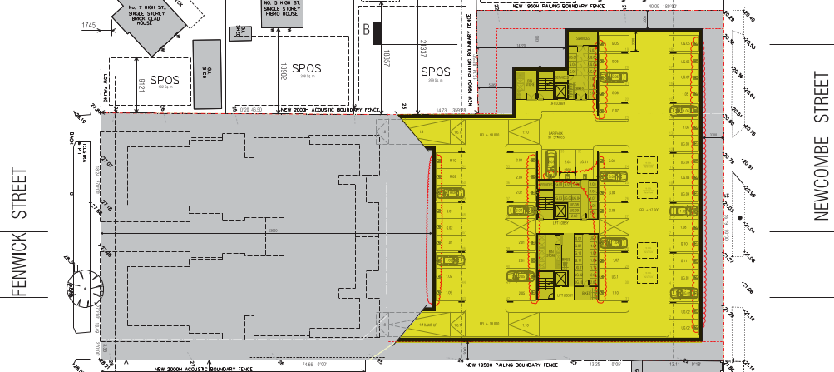
Figure 26 - Northern Basement Car Park
Landscaping

The proposed landscaping incorporates four main landscaped areas. These include a landscaped courtyard segregating the two building wings fronting Fenwick Street, a central courtyard segregating the Fenwick Street and Newcombe Street buildings, and two landscaped areas at the effective first-floor level fronting Newcombe Street, segregating the three building wings fronting Newcombe Street.

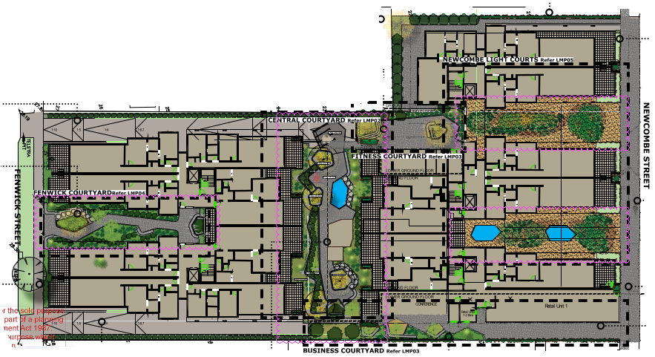
Figure 27 - Proposed Landscape Plan - Main Courtyards

PERMIT/SITE HISTORY:

The following permits/site history is applicable to this application:

- PP-566 -1994 – Alterations to Service Station
- PP-1276-2003 – Redevelopment of Site Resulting in Three Shops and Nine Dwellings
- PP-54-2006 – Construct four Shops and Part Waive of Carparking

REFERRALS:

The following referrals were undertaken:

SECTION 55:

DETERMINING AUTHORITY

Authority: | Department of Transport
Response: | The Head, Transport for Victoria has considered this application and does not object if the permit is subject to the following conditions:  1. Prior to occupation of the development, the existing crossovers to Newcombe Street must be removed and the area reinstated to the satisfaction of the Responsible Authority.  2. Prior to occupation of the development, parking and loading areas adjacent to the site in Newcombe Street must be appropriately signed and line-marked to the satisfaction of the Responsible Authority.
Officer Comment:
Noted – the conditions required by the Department of Transport are required to be included on any permit granted.

Authority: | Powercor
Response: | Subject to the following conditions, Powercor Australia Ltd (the Distributor) does not object to the issue of a planning permit for the abovementioned application.  Conditions Required by the Distributor  - This letter shall be supplied to the applicant in its entirety.  - The plan of subdivision submitted for certification under the Subdivision Act 1988 shall be referred to the Distributor in accordance with Section 8 of that Act.  - The applicant shall provide an electricity supply to all lots in the subdivision in accordance with the Distributor’s requirements and standards.  Notes: Extension, augmentation or rearrangement of the Distributor’s electrical assets may be required to make such supplies available, with the cost of such works generally borne by the applicant.  - The applicant shall ensure that existing and proposed buildings and electrical installations on the subject land are compliant with the Victorian Service and Installation Rules (VSIR).  Notes: Where electrical works are required to achieve VSIR compliance, a registered electrical contractor must be engaged to undertake such works.  - The applicant shall, when required by the Distributor, set aside areas with the subdivision for the purposes of establishing a substation or substations. Notes: Areas set aside for substations will be formalised to the Distributor’s requirements under one of the following arrangements:  - RESERVES established by the applicant in favour of the Distributor.  - SUBSTATION LEASE at nominal rental for a period of 30 years with rights to extend the lease for a further 30 years.  The Distributor will register such leases on title by way of a caveat prior to the registration of the plan of subdivision.
Officer Comment:
Noted – the conditions required by Powercor are required to be included on any permit granted.

Authority: | Barwon Water
Response: | Barwon Region Water Corporation, pursuant to Section 56 (1)(B) of the Planning and Environment Act, does not object to the granting of a planning permit subject to the following conditions being met prior to the issue of a Certificate of Compliance:  General  - The plan of subdivision must be referred to Barwon Water in accordance with the Subdivision Act 1988 and any subsequent amendments to the plan provided to Barwon Water.  - The owner shall create easements for Pipelines or Ancillary Purposes in Favour of Barwon Region Water Corporation over all existing and proposed sewer mains located within the subdivision.  - The certified plan must create implied easements under Section 12(2) of the Subdivision Act, over all proposed and existing private potable water (including recycled water where applicable) and sewerage services within the subdivision.  - The creation of an unlimited Owners Corporation to encumber all lots within the subdivision.  - The proposed development must conform with Barwon Water's Asset Protection policy and any "build over" approval issued. Structures are generally to be no closer than 1.0m to a Barwon Water pipeline. If you propose to construct a structure closer, then consent from Barwon Water is required. This application form can be downloaded via www.barwonwater.vic.gov.au — Properties and development -> Property connections. Where the applicant is required to seek approval from Barwon Water works must not commence until written approval has been issued and all fees paid. The lodgement of an application does not constitute approval of this development.  - The developer is to apply to Barwon Water for details relating to servicing requirements and costing for the provision of a potable water supply and where applicable, recycled water and/ or sewerage services to the proposal. It would be appreciated if all communication between the developer/agent and Barwon Water quote Barwon Water reference number L015586.  Potable Water  - The provision and installation of a potable water supply to the development.  - An additional potable water connection(s) is to be provided to service the proposed development. A dimensioned plan showing location of all new connections relative to the allotment boundaries is to be submitted, where a meter is not being fitted. Note that tappings and service lines are not to be located under existing or proposed driveways.  - A master meter and sub meters are required. An 'Application to fit meters' is required to be completed and submitted by the licensed plumber who will be undertaking the installation of private potable water works. This application must include a dimensioned plan indicating the location of all meters relative to existing and proposed allotment boundaries. These sub-meters will be installed by Barwon Water after the plumber has advised of completion of these preparatory private works and that the meters can be installed. This application form can be downloaded via www.barwonwater.vic.gov.au — Business Customers -> Property Connections.  - Barwon Water's records indicate that there are existing potable water services and meters located on this property. A dimensioned plan showing the location of existing meters, and the location of the meter relative to the existing boundaries, and its number, is to be submitted. Private potable water service pipes are not permitted to cross allotment boundaries and must be plugged and abandoned at the boundaries of such allotments.  - The payment of a standardised New Customer Contribution is required for any new connection or any upsize to an existing connection. The number of standardised charges applied will be determined on the basis of an equivalent lot calculation and is based on potable domestic water meter size or water service size (where a meter is not being fitted). An equivalent lot is a measure of the additional demand a connection will place on the infrastructure in terms of the water consumption and sewage discharge for an average connection utilising a 20mm tapping and/ or meter. If there is more than one meter within a single meter assembly, the size of the largest meter (excluding the fire service meter) will determine the number of equivalent connections. If there is a combined fire and domestic meter assembly proposed (incorporating a low flow meter), whereby the meter size is largely dictated by the fire service requirements, the developer is required to submit to Barwon Water the proposed peak flow (probable simultaneous demand) associated with the domestic supply in accord with AS/NZS 3500. Barwon Water will then assess the equivalent number of connections.  Sewer  - The provision and installation of a sewerage service to the development.  - Reticulated sewer mains are required. This work must be undertaken by a Barwon Water accredited Consultant and accredited Contractor following the "Developer Works" process.  - New or re-aligned internal private sewer drains are required. Upon completion of this work a sewer drainage plan is to be submitted to Barwon Water by a licensed plumber that complies with Victorian Building Authority requirements. Note that if any common drain or drain from another allotment crosses under a proposed dwelling, a "modification to consent" is to be obtained from the Victorian Building Authority and presented to Barwon Water with the required drainage plan. Where an Owners Corporation is not applicable, individual allotment house connection drains are to be provided for and extend into each allotment.  - Any existing sewer house connection point that is to be utilised for additional connections or altered to serve the development is to be CCTV inspected by a licensed plumber and the 'CCTV Inspection Form' with the video footage submitted to Barwon Water. If the property connection point is not deemed satisfactory for use or is no longer required, it is to be decommissioned in accordance with Barwon Water's "Property connection decommissioning process". Details of this process are available on Barwon Water's website under the business -> property connections section. Also, any existing house connection drain that traverses through the proposed allotments shall be relocated so not to inhibit future development. If the existing sewer house connection point is deemed satisfactory for use by Barwon Water and where branching after the connection point is permitted to service an additional allotment then this work can also be undertaken by a licensed plumber. If the sewer connection point being replaced is greater than 4.0 metres deep, a new sewer manhole is to be constructed with the new property connection point connected to this structure.  - 5. An existing Barwon Water sewerage asset is to be abandoned as part of development works. Further details will be provided in the relevant servicing requirements and costing.
Officer Comment:
Noted – the conditions required by Barwon Water are required to be included on any permit granted.

Authority: | Downer Utilities
Response: | We advise that AusNet Gas Services Pty Ltd is the owner of substantial gas assets throughout Greater Melbourne metropolitan area and regional Victoria, and that Downer – Utilities is their Operations and Maintenance provider. As part of this arrangement, we provide engineering support and act as their referral authority.  AusNet Gas Services pursuant to Section 56 (1) of the Planning and Environment Act 1987 has no objection to the granting of a permit, subject to the following condition:  - The plan of subdivision submitted for certification must be referred to AusNet Gas Services in accordance with Section 8 of the Subdivision Act 1988.
Officer Comment:
Noted – the conditions required by AusNet Gas Services are required to be included on any permit granted.

SECTION 52:

Authority: | Country Fire Authority
Response: | Thank you for providing the CFA with the opportunity to comment under Section 52 of the Planning and Environment Act. CFA does not object to the grant of a permit to Monea Bros Pty Ltd at 20-34 Newcombe Street Portarlington for Subdivision, Apartments (61), Retail (7).  CFA has no conditions.  Note: Any requirements required under the BCA or associated standards & regulations will need to be met.
Officer Comment:
No objection and no conditions noted.

INTERNAL

Department: | Engineering Services
Response: | Not objecting to a permit being granted provided conditions specified are included  Engineering Services Recommendation Response  The allowable stormwater discharge is acceptable, the calculation Tc is questionable.  Drainage plans must be provided for review and comment, JP1 grated pit must be designed to ensure that no overflow can occur across the pedestrian path.  Traffic Engineering conditions  Condition 1  - Longitudinal sections of all ramps must be provided to show all relevant design levels (to AHD), grades, transition and main ramp lengths and headroom clearances. The ramps must be designed in accordance with the standards in AS/NZS 2890.1:2004 and to the satisfaction of the RA  Traffic  - The basement car parks must be line marked and be in accordance with the endorsed plans and to the satisfaction of the RA.  - A car parking allocation plan must be provided to show what tenancy is assigned to each car space(s), including the retail tenancies. The plan must provide information about how these car spaces will be assigned on the ground, whether it be line marking or signage, or a combination of both, to the satisfaction of the RA.  Standard conditions and non-standard conditions relating to drainage infrastructure were also suggested.
Officer Comment:
Generally, the suggested conditions are recommended to be included on any permit granted.

Department: | ESD Response
Response: | The application was supported subject to conditions being included on the permit which require some minor updates to the submitted Sustainability Management Plan prior to endorsement.
Officer Comment:
Noted – conditions requiring amended SMP could be included on any permit granted. Notwithstanding, it is noted that the ESD response seeks both updates to the plans to detail commitments made in the submitted SMP. These can be required by conditions.
Other amendments have been requested to the SMP and BESS report. It is not considered necessary to require these changes as the application exhibits a score in BESS which demonstrates compliance with Best Practice in accordance with relevant ESD policy. It is not considered reasonable to require the applicant to go beyond the requirements of the policy in this regard.

Department: | Urban Design
Response: | Site Context & Design Response, Urban Structure, Dwelling Diversity and Density  - Urban design contend that the proposed architectural and material selections pickup on queues from the surrounding Portarlington context, nor do they fit in with the existing streetscape.  - Material choices and colours are not sympathetic to the character of Newcombe Street. Our initial review of material and colour choices for the area suggest bricks and weatherboarding are commonplace materials. With respect to colours; dark and light hues of cream, terracotta and raw brick are common.  The design proposed makes no effort to take the surrounding colours and materials into consideration, nor does the chosen palette represent an incremental step away from these colours. We recommend genuine use of the materials of wood and brick in the colours listed previously.  - Architectural elements and composition do not respect the emerging character of the area. Verandas, wooden posts, exposed brick walls with simple geometric detailing, and varying types of timber and brick parapets are all common. Whilst we do not expect the development to mimic these elements, we do think that the design can do a lot more to reinterpret them in a deferential architectural manner and contribute towards a more cohesive overall main street.  For the Newcomb Street frontage, DDO21 applies. Several of the design objectives have still not been addressed with the current proposal.  “Ensure appropriate building frontage rhythm that reflects a traditional strip shopping area.”  “Encourage buildings that have regard to the palette of materials and colours in the town, and demonstrate a high level of contemporary finish.”  Noting the urban rhythm of the surrounding shopping strip and given that the DDO calls for a height of two storeys on Newcomb Street, a reasonable architectural response to the context would be a ‘street wall’ of two storeys with subsequent upper levels setback from the property boundary. This ‘street wall’ should strongly draw architectural inspiration from the site’s context as per our previous comments. Additionally, the proposal’s horizontal white slabs visually emphasise an architectural design style not replicated elsewhere in the Newcombe Street context. Further, the entirety of the Newcombe street frontage visually contrasts the building massing and setbacks of other properties on the street.  More should be done to respond to the DDO, and we are happy to discuss with the applicant what architectural features could be design solutions.  Movement  - Splitting the garage driveway access into one-way entries/exits creates conflicts with pedestrians at two points. Additionally, the proposed access points are on the site boundary where there is limited future control on how pedestrian lines of sight will be protected to crossing traffic.  We recommend that entry and exits be consolidated into a single location so pedestrian safety is prioritised, so that built forms can be chamfered to support strong lines of sight inwards towards the driveway.  - The traffic report identifies that 6 and 2 bicycle parking facilities should be provided for resident and retail visitors respectively. We request that these be located in a more convenient and logical location for visitors (rather than in the basement). We suggest they could be located in key entry areas of the development.  Public Realm and Landscaping  - We request that Standard B9 be met. A deviation of 5% of the site area is not satisfactory.  - How will the first floor landscaped areas be accessed and maintained? Where are the access doors to these areas?  - We are concerned that the first floor trees won’t have root zone space to grow to the heights envisaged in the renders. We request further details on how trees of this size can be achieved.  - The proposal mentions investigating options for street trees and landscaping. We request proposed designs for this to be added to the landscape masterplan.  Built Form  - Urban Design contend that standards B26 and B12 have not been met for dwellings G12-15. The proposed design does not constitute as access from an accessway because this space is primarily focused around vehicular use. Furthermore, the pedestrian route for accessing these dwellings is convoluted having to walk out from the lift lobby and then around a portion of the basement carpark. An entry from a garage does not provide shelter, a sense of personal address and a transitional space around the entry.  We recommend the design be amended to allow for access to these dwellings via a more friendly pedestrian environment.  - We query whether dwellings G12-15 may also suffer from noise arising from vehicles in the basement and request additional information on acoustic treatments for walls abutting the basement.  - Standard B26 has not been met for dwelling LG01 due to the placement of multiple services around the door entry.  We recommend locating these elsewhere or redesigning LG01’s entry.  - Dwelling LG01 is located on the south side of the development and appears to be substantially below the floor levels of the adjacent properties. Additionally, the 1.95m timber fence around the site edge amplifies this difference. We are concerned that this dwelling will not receive enough sunlight and is unsuitable for habitation.  We suggest an alternative design be explored to mitigate this issue.  - We are concerned that locating the retail bin room in such close proximity to the bedrooms and outdoor spaces of dwelling LG01, there will be regular noise and possible odours impacting residents living there.  We recommend relocating this bin room elsewhere of lower impact.  - Will change rooms and toilets be provided for the fitness centre/pool? We request these to be shown on the plans.  - We are not satisfied that adequate privacy is provided for all apartments abutting these areas. The provided sections do not give enough detail on how lines of sight from habitable rooms into other habitable rooms will be mitigated.  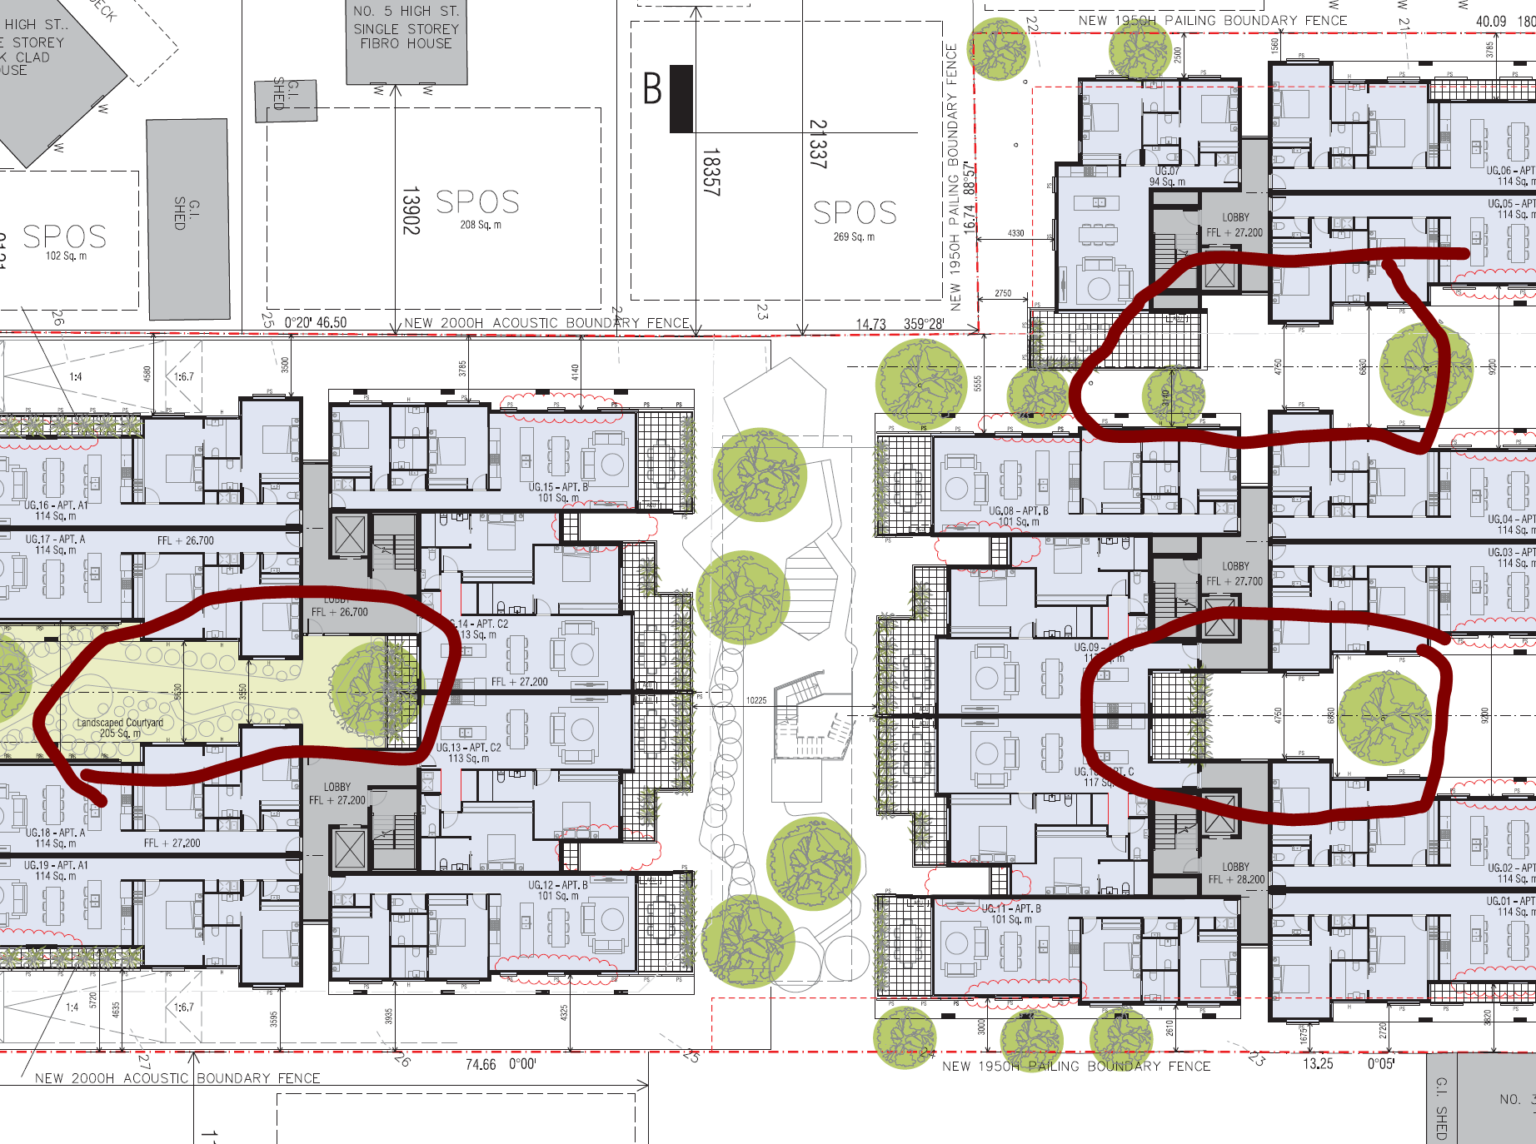  We request either a 3d model that allows us to understand all view lines or a higher degree of detail on the provided sections.
Officer Comment:
The comments from UD are responded to below:
Site Context & Design Response, Urban Structure, Dwelling Diversity and Density
- It is acknowledged that the Portarlington Structure Plan (2016, amended 2017) identifies that the low-scale form of buildings within the town centre is a consistent element, with the focal point of the centre being the Portarlington Grand Hotel. It is also noted that the Portarlington Structure Plan sets out that, “the varied styles and setbacks of buildings in the town centre have not established a clearly distinguishable coastal character compared to other Bellarine Peninsula townships.”
Whilst DDO21 applies, at no point does the DDO21 seek to copy existing built forms. It seeks to respect and reflect these built forms. This does not mean ‘more of the same’.
  - It is unclear why the UD response contends that the proposal does not reflect materials within the surrounding area. Whilst the proposal incorporates contemporary materials, it includes brick shopfronts at ground floor level, glazing and combined dark and light colour palettes, which the UD response outlines is commonplace.
  - The proposal incorporates verandas, exposed brick (at the ground level street frontage to Newcombe Street), varying types of facing materials with simple geometric detailing. It is unclear how the elevations are considered to not provide simple geometric detailing. The projecting verandahs and roofs provide exactly this. The DDO21 seeks to provide verandahs and awnings without posts wherever possible. It is unclear why the UD unit would seek details which the DDO21 specifically seeks to avoid.
Movement
These matters appear to be traffic engineering matters, not UD matters. No concerns have been raised by Council’s Traffic Engineers.
Public Realm and Landscaping
- The application has been assessed against ResCode (Clause 55 and Clause 58). A satisfactory response to the objectives and standards of ResCode has been proposed.
- 3) & 4) - it is considered that this detail can be required by conditions on any permit granted.
Built Form
All of these matters appear to be either ResCode considerations (which have been assessed to be acceptable by statutory planning) or amenity concerns associated with noise impacts. It is noted that no concerns have been raised by Environmental Health officers in regard to the potential amenity impacts on proposed dwellings. Similarly, Council’s ESD officer is satisfied that the proposal achieves an acceptable ESD outcome, including daylight and sunlight access.

Department: | Environmental Health
Response: | Supportive subject to conditions –  The recommended permit conditions have been added to protect the amenity of the existing residents but also the amenity of the proposed residents living in the apartments.  The recommendations in the acoustic report should be followed to minimise noise impact from the existing live music venue, traffic, and potential commercial tenants. This includes acoustic fencing, glazing requirements for windows and doors, solid walls in habitable rooms, and acoustic separation between commercial and residential tenants.  Some serious forethought needs to be taken to determine what retail businesses may require mechanical ventilation and exhausts systems and how this can be provided without creating noise and odour issues to the area.
Officer Comment:
Generally, the suggested conditions are recommended to be included on any permit granted.
Comments regarding future retail operations are noted. The proposed retail units are situated within the Commercial 1 Zone. The use of land for a retail premises is a Section 1 as-of-right use within the Commercial 1 Zone, and there are no conditions associated with the as-of-right use of the land for retail premises.

Department: | Parks
Response: | Supportive -  - 27 Fenwick Street – there is a street tree shown on the plans however this was removed some time ago. It should not have been showing on our database.  - 25 Fenwick Street – there is a very young juvenile Banksia integrifolia however given its age and the expected level of works required at the site it is agreed that this tree can be removed as part of the works  Conditions have been provided below for your reference as we would like to see the development incorporate new street tree plantings on the Newcombe Street and Fenwick Street frontages.
Officer Comment:
Noted – generally the suggested conditions are recommended to be included on any permit granted.

Department: | Strategic Implementation
Response: | Supportive –  Amendment C393 implements the statutory recommendations of the City of Greater Geelong Retail Strategy 2020-2036 (August 2020) into the Greater Geelong Planning Scheme. Most relevant, the amendment inserts a new Clause 21.21 Activity Centres that includes an updated Geelong Retail Centre Hierarchy and identifies the Retail Strategy as a background document. Amendment C393 was adopted by Council on 25 August 2020 and has been sent to the Minister for Planning requesting approval. The amendment is a seriously entertained policy and should be considered in decision-making.  The Portarlington C1Z land area forms the Portarlington Town Centre in the retail hierarchy. The policy supports the viability and vibrancy of existing centres, supports expanding existing centres and encourages walkable access to new development. The policy also encourages a mix of retail, cafes and higher density housing – accommodation uses above ground level floor space is specifically supported.  The schedule to the C1Z (leasable shop floor area cap) does not apply to town centres. Therefore, the proposed 968sqm of retail floor space (7 outlets) is not restricted by the policy and no Economic Impact Assessment is required. The August 2020 Retail Strategy finds that a small increase in retail floor space demand has been identified by 2036 for the Portarlington Town Centre, which could be accommodated within existing commercial 1 zoned land. The proposal is clearly consistent with the role and function of the Portarlington Town Centre.  Amendment C395 implements the statutory recommendations of the City of Greater Geelong Settlement Strategy (August 2020) into the Greater Geelong Planning Scheme. C395 was adopted by Council on 25 August 2020 and has been sent to the Minister for Planning requesting approval. The amendment is a seriously entertained policy and should be considered in decision-making.  The Settlement Strategy seeks to contain urban development within the existing settlement boundary of each Bellarine town and supports the increased housing diversity areas policy currently in the planning scheme. The Strategy continues to support the land-use planning directions in the Portarlington Structure Plan 2016 (amended July 2017). The Structure Plan identifies the site as a ‘development opportunity’ where a building of prominence is supported. The proposed development location is entirely consistent with the Structure Plan.  While the application comprises 61 apartments, the Greater Geelong and Bellarine Tourism Development Plan highlights a lack of quality short-term accommodation on the northern Bellarine. The development would provide opportunities for overnight stay in the town centre – the most suitable location. A similar proposal at 30-32 Portarlington Rd in 2016 (Amendment C321) was rejected by an independent planning panel; one of the reasons being that higher density mixed use development is encouraged in the town centre.
Officer Comment:
Noted. It is acknowledged that the comments provided are largely confined to the proposal’s in principle response to relevant planning scheme amendments and strategies.

Department: | Strategic Planning
Response: | Not Supportive  The Portarlington UDF 2011 and the Portarlington Structure Plan acknowledge the development opportunity provided by 22-34 Newcombe Street. The Portarlington Structure Plan (adopted September 2016 amended July 2017) notes that development of the site remains a priority for the town centre and both the Portarlington Structure Plan and Clause 21.14 nominate the site as a development opportunity.  However, none of these documents should be taken as outweighing or overruling the recommendations of Design and Development Overlay Schedule 21, which provides guidance to the development of land within the Town Centre. As per the comments provided by Urban Design, the reference to a “focal” building does not necessarily infer a building of significant height.  Design and Development Overlay Schedule 21, introduced into the Scheme by Amendment C129, and the Urban Design Framework both arose from the Portarlington Structure Plan 2008. The Portarlington Structure Plan 2008 set out the Town Centre Design and Development Overlay objectives on which DDO 21 is based, and also contained both a direction to prepare the UDF and to support development of a focal building at 22-34 Newcombe Street. The controls should all be seen as complementary, rather than inferring that the use of the word “focal” was intended to outweigh or overrule the DDO objectives.
Officer Comment:
It is noted that the Council’s Strategic Planning Unit and Strategic Implementation units have differing responses in this regard.
As outlined in response to the DDO21, it is considered that the design objectives are suitably met. Whilst it is acknowledged that a ‘focal building’ may not necessarily be a building of significant height, ‘focal building’ does not mean the opposite of a building defined by its height. This has been discussed in VCAT decisions as outlined within response to the PPF in this report.

Department: | Waste Services
Response: | Supportive subject to conditions.  Conditions recommended requiring submission of a waste management plan being endorsed to form part of the permit.  Additional conditions recommended relating to s.173 agreements being required to ensure the Council’s Residential Waste Service Charge remains payable.
Officer Comment:
The waste management plan can be endorsed to form part of the permit.
It is not necessary to require that the developer/landowner enter into a Section 173 Agreement as described above. The City of Greater Geelong Recycling and Waste Collection System Council Policy (document no. CPL225.1), at Clause 5.1 states that, ‘All residential properties (dwellings) within the Municipality be charged for a standard three mobile garbage bin (MGB) service in line with “the City’s Rating Strategy’. The City’s Rating Strategy, specifically states that, The Recycling and Waste Service Charge is levied on the following criteria:
- Geographic existence within those areas of the municipal district in which the City provides a domestic refuse collection and disposal service.
- The charge will be raised irrespective of whether the service is used or not.
In light of the above, City of Greater Geelong Council Policy already dictates that the Recycling and Waste Collection service charge will be raised irrespective of use of the service. There is no requirement for this to be secured through an agreement made under Section 173 of the Planning and Environment Act 1987

Victorian Design Review Panel – Office of the Victorian Government Architect

As part of the assessment of the application, the City of Greater Geelong requested an independent design review of the proposal for 20-34 Newcombe and 25-27 Fenwick Street by the Victorian Design Review Panel.

The review culminated in a report provided by the OVGA dated 22 October 2020. It is important to note that the application has been amended to revise the design response since this review. The amended application was not reviewed further by the OVGA.

A summary of issues identified by the Design Review Panel is outlined below:

In its current form the, proposal does not demonstrate the benefits identified in the DDO to justify
the additional height. A summary of key issues includes:

- The proposed building height and bulk is excessive particularly along Newport Street [sic].
- The design outcome appears generic. It does not adequately respond to Portarlington as a place. There is a disconnect between the scale, bulk and footprint of the proposal compared to the surrounding context.
- A stronger response to context regarding building height, massing, site impact and materiality is needed.
- Sightlines, including from the foreshore and pier, require further exploration to fully understand the visual impact of the mass and height of the development.
- The aspiration of the landscape design is supported, however further investigation is needed to ensure that the proposal is realistic and achievable.

Response

The application has been amended following the abovementioned review. The proposed building height has been reduced along Newcombe Street. As outlined in response to the DDO, it is considered that the proposal satisfactorily mitigates its building height and bulk when viewed from Newcombe Street in this regard.

The current design outcome incorporates materiality and finer grain shopfront building forms fronting Newcombe Street which is a specific objective of the DDO and structure plan. The structure plan identifies that there is no specific character which exists within Newcombe Street.

Information has been provided which shows that the proposal, as originally proposed, would not be clearly distinguishable when viewed from the foreshore give that there is substantial vegetation within the foreshore reserve. The application has since been amended to remove the upper level bulk from the Newcombe Street frontage and is therefore considered to suitably demonstrate that the application would not result in an unreasonable visual impact on views to the Town Centre when viewed from the Foreshore.

Details regarding landscaping can be required by conditions on any permit granted.

AMENDMENT OF THE PROPOSAL PRIOR TO PUBLIC NOTIFICATION:

The applicant made a request to amend the application pursuant to Section 50 of the Planning and Environment Act 1987 on 18 November 2021. Council accepted the amendment. The amendment made the following changes to the application:

- Revised proposed plan of subdivision submitted to correctly show LG.01
- On site detention computations updated
- Amended landscape plans submitted with updated soil volumes

PUBLIC NOTIFICATION:

The application is not exempt from the notice requirements of Section 52(1)(a), (b) and (d), the decision requirements of Section 64(1), (2) and (3) and the review rights of Section 82(1) of the Act and pursuant to Section 52 of the Planning and Environment Act 1987 the following forms of advertising were undertaken:

- Notices were sent to owners and occupiers of adjoining land (including opposite)
- A2 sign(s) were placed on the land

Twenty-Nine (29) objections have been lodged with Council.

Forty-Four (44) letters of support have been lodged with Council.

CONSULTATION:

A consultation meeting was not held because the applicant submitted amended plans pursuant to S57a of the Planning and Environment Act which were circulated to objectors.

No objections have been withdrawn.

AMENDMENT OF THE APPLICATION FOLLOWING PUBLIC NOTIFICATION

The applicant made a request to amend the application pursuant to Section 57A of the Planning and Environment Act 1987 on 22nd August 2022. Council accepted the amendment. The amendment made the following changes to the application:

- One apartment from each building’s top floor level fronting Newcombe Street has been deleted, such that three apartments have been deleted in their entirety.
- The remaining apartments at the upper level of the central and eastern buildings fronting Newcombe Street have been redesigned. These apartments are recessed approximately 19.5m from the street frontage, with balconies set back approximately 11.65m from the street frontage. The rooftop decks have been deleted from these upper level apartments fronting Newcombe Street
- At ground level fronting Newcombe Street, the proposed retail units have been amended to exhibit red brick facades in lieu of dark grey;
- Car parking provision remains as initially proposed.

These are the plans that form the basis of this report.

It was not considered necessary to re-advertise the application based on the s57a Amendments. The plans were amended to remove built form from the top floor level of the Newcombe Street building and is not considered to result in any further material detriment to neighbouring owners and occupiers compared to the advertised plans.

In addition to the above, the amended plans were circulated to objectors via email on 9th September 2022.

OBJECTIONS:

The concerns of objectors are summarised and commented on below:

Objection

Proposal does not adequately respond to relevant planning policy for Portarlington

Response

As outlined in response to the Planning Policy Framework found below in this report, it is considered that the proposed development would suitably respond to the relevant objectives and strategies contained in policy which applies to the Portarlington Township and Town Centre. In particular, it is considered that the proposal suitably accords with the competing objectives that apply to this site and the surrounding area.

Objection

Contaminated Land

Response

Conditions are recommended to require suitable environmental assessment is carried out prior to commencement of development or use for a sensitive land use.

Objection

- Building form and height does not respond to the context of the site or the existing coastal character of Portarlington and in particular DDO21 and will detract from nearby historical buildings.
- Design, including building height is not appropriate on C1Z fringe and does not protect the amenity of surrounding residential areas.
- Building height exceeds 10.5m in RGZ3.

Response

The building form and height has been considered in response to the DDO21 as outlined later in this report. It is acknowledged that the design objectives seek to ensure buildings are designed to respond to the characteristics of the site and surrounding locality and demonstrate a high standard of contemporary expressions. The design response to achieve this includes to generally restrict buildings to a maximum of two storeys. It sets out that higher elements must demonstrate that development is sympathetic to buildings of heritage significance and residential interface, be visually unobtrusive when viewed from the foreshore and are of high quality design. The design response in Table 1 to the DDO21 schedule outlines that buildings can exceed 2 storeys where this is demonstrated.

As outlined in response to the DDO21, the proposal is considered to be suitably sympathetic to buildings of heritage significance, appropriately manages the interface with residential properties and would be of a high quality design that is visually unobtrusive when viewed from the foreshore. In this regard, it is considered that the proposed building form and high appropriately responds to the preferred character as set out within the DDO21.

Whilst the site is at the western end of the Activity Centre, it is still within the Commercial 1 Zone and is considered to suitably manage its interface with nearby residential properties. It is considered that the amenity attributable to a dwelling adjacent to a commercial zone would not be expected to be that which is experienced within a residential hinterland area.

The building height within the RGZ3 would not exceed 11.5m which is allowable under the zone due to the slope of the site.

Objection

Loss of public views from Fenwick Street and private views from dwellings in RGZ3 to north-west.

Response

Whilst the proposed development would be visible outside of the Commercial 1 Zone, it is noted that the DDO21 does not apply to this land and does not seek to protect views from outside of the town centre. In fact, there are no planning controls seeking to protect views, or achieve a reasonable sharing of views within the surrounding RGZ3 land.

The Portarlington Town Centre UDF (2009, amended 2011) does not identify any specific views to be protected other than existing views and vistas from the town centre. Furthermore, the Portarlington Structure Plan (September 2016, amended July 2017), which is a reference document at Clause 11.03-6L-01, identified that the DDO14 and 19 have been put in place to allow a reasonable sharing of views to significant features, whilst also setting out that Clause 21.14 (now 11.03-6L-01), “should be amended to recognise that the requirement for development to provide reasonable sharing of views to the coast and foreshore only applies where there is an overlay that requires this”.

Objection

Unsafe traffic access point due to plateau in this part of Fenwick Street.

Response

It is noted that the Fenwick Street has a speed limit of 50kph and is approximately 30 metres wide. Council’s traffic engineers have raised no concerns with the proposed access points in regard to road safety. It is noted that planning policy and controls seek to minimise access points from Newcombe Street and provide vehicular access from the rear. Fenwick Street is relatively flat for a length of approximately 140m between its junctions with Harding Street to the east and High Street to the west.

Objection

Overflow car parking will cause unreasonable impacts on the existing car parking network on-street.

Response

As outlined in response to Clause 52.06 alter in this report, it is considered that the overflow car parking associated with the proposal can be suitably accommodated on the surrounding street network.

Objection

Proposal will prevent future commercial/retail expansion on site

Response

The Portarlington C1Z land area forms the Portarlington Town Centre in the retail hierarchy. Relevant policy supports the viability and vibrancy of existing centres, supports expanding existing centres and encourages walkable access to new development. The policy also encourages a mix of retail, cafes and higher density housing – accommodation uses above ground level floor space is specifically supported.

The schedule to the C1Z (leasable shop floor area cap) does not apply to town centres. Therefore, the proposed 968sqm of retail floor space (7 outlets) is not restricted by the policy and no Economic Impact Assessment is required. The August 2020 Retail Strategy finds that a small increase in retail floor space demand has been identified by 2036 for the Portarlington Town Centre, which could be accommodated within the existing Commercial 1 Zone land. The proposal is clearly consistent with the role and function of the Portarlington Town Centre.
Objection

Unreasonable overshadowing of health clinic at 38A Newcombe Street and proposed dwelling at 38B Newcombe Street

Response

The commercial premises at 38A Newcombe Street is not a residential premises and it is not considered appropriate to temper development within a commercial zone based on potential overshadowing of nearby commercial premises.

With regard to the proposed dwelling at number 38B Newcombe Street, it is noted that this dwelling does not exist at present and the assessment must consider the impact on the amenity of neighbouring properties at the time of the assessment. Nevertheless, it is noted that the endorsed plans forming part of PP-1409-2017 show that the western elevation of this proposed dwelling contains a significant wall on boundary with no windows. Skylight or high level windows are provided at roof level. However these windows also face north. As such, it is considered that adequate sunlight and daylight would be retained were both the proposed dwelling at 32B Newcombe Street and the proposal subject of this application be realised.

Objection

Amenity impacts and damage to neighbouring properties during construction.

Response

Such consideration extend beyond the planning assessment. Anyone proposing building work is obligated to protect property on neighbouring sites under the Building Act 1993.

Objection

Unreasonable overlooking to neighbouring dwellings in High Street to the west

Response

As outlined in response to Clause 55 and Clause 58, the proposal includes privacy screens to limit overlooking to neighbouring dwelling’s SPOS areas in accordance with the relevant Standard.

Objection

Overloading of existing utility infrastructure

Response

There is no evidence that the proposed development would overload utility infrastructure. Council’s engineers and relevant service authorities have raised no objection to the grant of a permit in this regard.
Objection

Waste storage areas would not be suitably managed

Response

The waste management plan submitted with the application requires that waste storage areas be suitably managed, including details of responsibility attributable to residential and retail tenants and future owner’s corporation. Subject to recommended conditions requiring the WMP to be updated to reflect the proposed 59 dwellings, any such requirements will be able to be endorsed to form part of and be enforceable under any permit issued.

Objection

This application should not be determined prior to the Bellarine Peninsula Statement of Planning Policy

Response

The SPP is still in Draft form and it is relevant to assess the application against the policy of the day. The existing declaration of the surrounding area as a distinctive area and landscape and associated local planning policy provides direction and intent to protect and enhance township character. There is not statutory basis for delaying the consideration of the proposal until the SPP is finalised.

Objection

Unreasonable amenity impact on 3 High Street including overshadowing and sense of enclosure, and noise impacts from commercial land uses

Response

As outlined in response to Clause 55 and Clause 58, the proposed development is not considered to result in unreasonable overshadowing of 3 High Street by virtue of compliance with relevant overshadowing requirements.

In addition to the above, this is an interface between commercial and residential zones where amenity expectations are not the same as in a residential hinterland. Despite this, the first and second floors are recessed in accordance with the side setback standard for residential hinterland areas. This is a more than acceptable degree of visual relief.

ASSESSMENT:

ZONES:

The planning unit making up the subject site is situated across both the Commercial 1 Zone (C1Z), and the Residential Growth Zone – Schedule 3 (RGZ3):

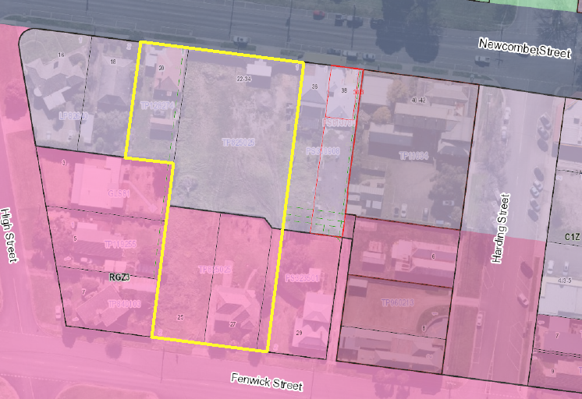
Figure 28 - Planning Unit Zones
As a result of the multiple zones applying across the planning unit, it is noted that different controls are in place for the lots fronting Newcombe Street, compared to the lots fronting Fenwick Street.

The development proposed can be described as split into two sections. This includes, the C1Z area, and the RGZ3 area. The C1Z area includes the land known as 20 Newcombe Street and 22-34 Newcombe Street. The RGZ3 area includes land known as 25 and 27 Fenwick Street, as well as a rear accessway to 22-34 Newcombe Street.

The C1Z parts would be five-storeys in height, and include 7 shops at ground level, with three ‘tower’ elements situated above, housing 35 apartments, fronting Newcombe Street.

The RGZ3 parts, would be three and four-storeys in height, and includes 24 apartments within two ‘tower’ elements fronting Fenwick Street. The siting of the proposed development relative to the zoning boundaries is shown in further detail in below.

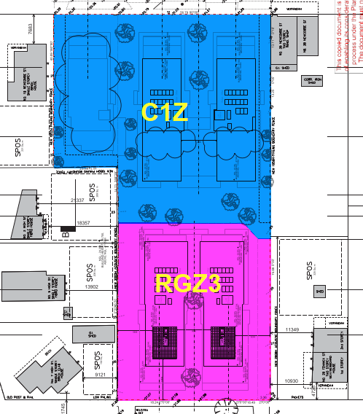
Figure 29 - Zoning Boundaries Relative to Proposed Development
A common zone purpose is to implement the Municipal Planning Strategy (MPS) and the Planning Policy Framework (PPF).

Clause 32.07 – Residential Growth Zone – Schedule 3

The purpose of the Residential Growth Zone includes:

- To provide housing at increased densities in buildings up to and including four storey buildings.
- To encourage a diversity of housing types in locations offering good access to services and transport including activity centres and town centres.
- To encourage a scale of development that provides a transition between areas of more intensive use and development and other residential areas.
- To ensure residential development achieves design objectives specified in a schedule to this zone.
- To allow educational, recreational, religious, community and a limited range of other non-residential uses to serve local community needs in appropriate locations.
Clause 55 - ResCode

A development of two or more dwellings on a lot must meet the requirements of Clause 55. This does not apply to a development of five or more storeys, excluding a basement.

As the proposed development within the RGZ3 area does not exceed four storeys, Clause 55, including Clause 55.07 is applicable.

RGZ3 Variations to Clause 55 Standards:

Schedule 3 to the RGZ varies the following standards of Clause 55:
 | Standard | Requirement
Minimum Street Setback | B6 | If the site is in a heritage overlay, the average distance of the setbacks of the front walls of the existing buildings on the abutting allotments facing the front street or 9 metres, whichever is the lesser.  In all other areas, the average distance of the setbacks of the front walls of the existing buildings on the abutting allotments facing the front street or 5.5 metres, whichever is the lesser.
Site Coverage | B8 | Maximum site coverage 70%
Private Open Space | B28 | A dwelling or residential building should have private open space consisting of:  - An area of 20 square metres of secluded private open space at the side or rear of the dwelling or residential building with a minimum dimension of 3 metres and convenient access from a living room; or  - A balcony of 8 square metres with a minimum width of 1.6 metres and convenient access from a living room; or  - A roof-top area of 10 square metres with a minimum width of 2 metres and convenient access from a living room.
Maximum Building Height

Pursuant to Clause 32.07-9 of the Residential Growth Zone, a building must not be constructed for use as a dwelling or residential building that exceeds the maximum building height specified in a schedule to the zone.

Schedule 3 to the Residential Growth Zone states a building used as a dwelling or residential building must not exceed a height of 10.5 metres.

A building may exceed the maximum building height by up to 1 metre if the slope of the natural ground level, measured at any cross section of the site of the building wider than 8 metres, is greater than 2.5 degrees.

The line of natural ground level shown on the proposed plans is shown to exceed 2.5 degrees. As such, a maximum building height of 11.5 metres is permissible pursuant to Clause 32.07-9 of the Residential Growth Zone.

The proposed maximum building height within the Residential Growth Zone – Schedule 3 area measures 11.5 metres from natural ground level to the roof or parapet at the highest point.

At not more than 11.5 metres, the proposal does comply with the maximum building height requirements in the Zone.

Decision Guidelines

Before deciding on an application, in addition to the decision guidelines in Clause 65, the responsible authority must consider, as appropriate:

General
- The Municipal Planning Strategy and the Planning Policy Framework.
- The purpose of this zone.
- The objectives set out in a schedule to this zone.
- Any other decision guidelines specified in a schedule to this zone.
- The impact of overshadowing on existing rooftop solar energy systems on dwellings on adjoining lots in a Mixed Use Zone or Residential Growth Zone.

Subdivision
- The pattern of subdivision and its effect on the spacing of buildings.
- For subdivision of land for residential development, the objectives and standards of Clause 56.

Dwellings and Residential Buildings
- For the construction and extension of two or more dwellings on a lot, dwellings on common property and residential buildings, the objectives, standards and decision guidelines of Clause 55. This does not apply to an apartment development of five or more storeys, excluding a basement.
- For the construction and extension of an apartment development of five or more storeys, excluding a basement, the objectives, standards and decisions guidelines of Clause 58.

Non-residential Use and Development
- Whether the use or development is compatible with residential use.
- Whether the use generally serves local community needs.
- The scale and intensity of the use and development.
- The design, height, setback and appearance of the proposed buildings and works. The proposed landscaping.
- The provision of car and bicycle parking and associated accessways.
- Any proposed loading and refuse collection facilities.
- The safety, efficiency and amenity effects of traffic to be generated by the proposal.

Response to Residential Growth Zone – Schedule 3

As outlined above, the purpose of the zone includes matters relating to both residential development and discretionary uses.

In regard to residential development, it seeks to provide housing at increased densities in buildings up to and including four storey buildings, to encourage diversity of housing types in locations offering good access to services and transport, including activity centres and town centres. Additionally, it seeks to encourage a scale of development that provides a transition between areas of more intensive use and development and other residential areas.

In relation to land use, the residential growth zone seeks to allow educational, recreational, religious, community and a limited range of other non-residential uses to serve local community needs in appropriate locations.

In response to the decision guidelines within the zone:

General

- The application has been considered against the municipal planning strategy and the planning policy framework as outlined later in this report. It is considered that the proposal represents an orderly response to the objectives and strategies contained within relevant planning policy and strategies.

- The application suitably responds to the purpose of the zone in that it provides housing at increased densities in a location in close proximity to the Portarlington town centre. The proposed development within the RGZ3 would be a maximum of four storeys, with the front (south) being a maximum of three storeys. As such, the built form would present its height to the centre of the site, providing a transition towards the activity centre within Portarlington, whilst presenting to the street as three-storey would ensure that the proposal suitably responds to the purpose of the zone which seeks to provide housing at increased densities including in buildings up to four-storeys in height. Furthermore, the third storey fronting Fenwick Street would be recessed from the second storey below and would provide a somewhat transitionary scale to the south to more traditional single and two-storey scale dwellings within Fenwick Street.

- Schedule 3 to the RGZ does not set specific design objectives however it does seek to incorporate the requirements of Clause 16.01-1L-02 into the decision guidelines under the zone.

  - The proposal is considered to suitably respond to the requirements of Clause 16.01-1L-02 Increased Housing Diversity Areas, as outlined in response to the MPS and PPF later in this report.

- The proposal would not cast shadow to any neighbouring dwelling’s existing rooftop solar facilities.

Subdivision

- The proposed pattern of subdivision would follow the layout of the proposed buildings. This would not result in a subdivision pattern which unreasonably competes with the traditional pattern of subdivision within the surrounding locality. It is prudent to note that the surrounding area is anticipated to see a change in neighbourhood character as it evolves to accommodate housing at increased densities.

Dwellings and Residential Buildings

- The application includes development of a four-storey apartment building within the RGZ3. This component of the application has been considered against the requirements of Clause 55, including Clause 55.07. A complete Clause 55 assessment is appended to this report at Appendix 1. It is considered that the proposal suitably responds to the objectives and standards of Clause 55.

- A Clause 58 assessment is not required for the part of the proposal within the RGZ3 as the proposal is not five or more storeys. As outlined in response to the Commercial 1 Zone, the application has been assessed against Clause 58 as relevant for the proposed apartment development within the Commercial 1 Zone where it exceeds 5 storeys.

Non-residential Use and Development

- The application does not propose non-residential use or development within the RGZ3.

Clause 34.01 – Commercial 1 Zone

The Purpose of the Commercial 1 Zone includes:

- To create a vibrant mixed use commercial centres for retail, office, business, entertainment and community uses.
- To provide for residential uses at densities complementary to the role and scale of the commercial centre.

Clause 58 - ResCode

An apartment development must meet the requirements of Clause 58.

Decision Guidelines

General
- The Municipal Planning Strategy and the Planning Policy Framework.
- The interface with adjoining zones, especially the relationship with residential areas.

Use
- The effect that existing uses may have on the proposed use.
- The drainage of the land.
- The availability of and connection to services.
- The effect of traffic to be generated on roads.
- The interim use of those parts of the land not required for the proposed use.

Subdivision
- Provision for vehicles providing for supplies, waste removal and emergency services and public transport.
- The effect the subdivision will have on the potential of the area to accommodate the uses which will maintain or enhance its competitive strengths.

Building and Works
- The movement of pedestrians and cyclists, and vehicles providing for supplies, waste removal, emergency services and public transport.
- The provision of car parking.
- The streetscape, including the conservation of buildings, the design of verandahs, access from the street front, protecting active frontages to pedestrian areas, the treatment of the fronts and backs of buildings and their appurtenances, illumination of buildings or their immediate spaces and the landscaping of land adjoining a road.
- The storage of rubbish and materials for recycling. Defining the responsibility for the maintenance of buildings, landscaping and paved areas.
- Consideration of the overlooking and overshadowing as a result of building or works affecting adjoining land in a General Residential Zone, Neighbourhood Residential Zone, Residential Growth Zone or Township Zone.
- The impact of overshadowing on existing rooftop solar energy systems on dwellings on adjoining lots in a General Residential Zone, Mixed Use Zone, Neighbourhood Residential Zone, Residential Growth Zone or Township Zone.
- The availability of and connection to services.
- The design of buildings to provide for solar access.
- The objectives, standards and decision guidelines of Clause 54 and Clause 55.
- This does not apply to an apartment development.
- For an apartment development, the objectives, standards and decision guidelines of Clause 58.

Response to Commercial 1 Zone

As outlined above, the purpose of the Commercial 1 Zone (C1Z) seeks to create vibrant mixed use commercial centres and residential uses at densities complementary to the role and scale of the commercial centre.

The Portarlington Structure Plan outlines that the site at 22-34 Newcombe Street is identified in the Urban Design Framework 2011 (UDF) as a major development opportunity. The 2008 Structure Plan recommended that this be a focal building to contain a mix of retail uses, tourist accommodation and tourism related activities. However, within the amended 2016 Structure Plan, it is outlined that development of the site remains a priority for the town centre. It further sets out that activated uses are necessary on the ground floor, however as a result of no development on the site to date, a mix of options including accommodation above first floor level could be considered.

In this regard, the proposal is considered to contribute to the vibrancy of the town centre. The proposal incorporates a mix of as of right commercial uses at ground level fronting Newcombe Street and proposed dwelling land uses at the upper floor levels which require a planning permit. The proposal would contribute to the vitality and vibrancy of the centre in this regard given it would provide an active retail frontage at ground level and increased dwelling density with additional dwellings within the activity centre. Furthermore, the provision of dwellings at upper levels will ensure that the development provides dwellings at densities which are complementary to the role and scale of the commercial centre. The provision of dwellings at upper floor levels will further assist in supporting the vibrancy and vitality of the centre. Particularly as more services and amenities are realized within the centre.
In response to the decision guidelines contained within the C1Z:

General
- The application has been considered against the municipal planning strategy and the planning policy framework as outlined later within this report. It is considered that the proposal represents an orderly response to the objectives and strategies contained within relevant planning policy and strategies.

- The part of the subject site within the C1Z abuts the RGZ3 to the south. The majority of this zone interface is within the subject site itself at the current boundary between 25 and 27 Fenwick Street and 22-34 Newcombe Street.

Notwithstanding the above, the part of the site at 20 Newcombe Street exhibits a rear boundary abutting the northern side elevation of number 3 High Street which is within the RGZ3.

As outlined in response to the DDO21 below, in anticipation of future development of RGZ3 land which can be built up to 10.5m in the surrounding IHDA, it is considered that the proposal would provide a suitable visual height difference between the RGZ3 area to the south-west and the Commercial 1 Zone, akin to that which would be expected at the interface of a residential growth zone and a local town centre.

The proposal steps down in height and overall scale at its closest proximity to the RGZ3 land situated to the west, fronting High Street, and immediately to the south of number 20 Newcombe Street. At this point, the proposal exhibits a maximum of four (4) storeys. However given the slope of the land to the south, the effective number of storeys at the rear (southern) elevation of the development on this part of the site would effectively appear as three (3) storeys given the site cut proposed resulting in the ground level of the proposal being largely submerged below the natural ground level of the neighbouring dwelling at 3 High Street.

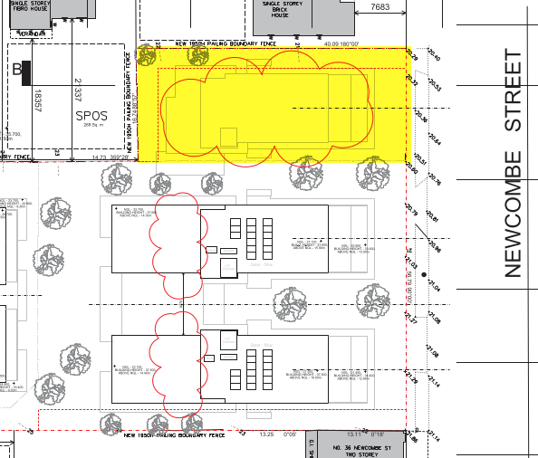
Figure 30 - 20 Newcombe Street Highlighted Yellow
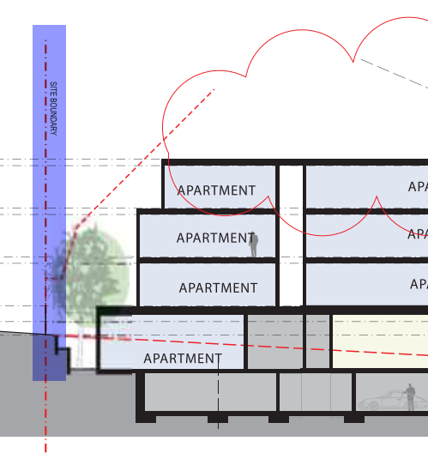
Figure 31 - Section B-B showing boundary with 3 High Street Highlighted. NGL Shown Dashed Red
Given the amended building form would step down to the west of the site, it is considered that the proposal would suitably integrate with the characteristics of the site and surrounding locality with regard to the interface to residential dwellings to the south and west.
Use

- The proposed commercial premises at ground floor level are design to be used as shops and do not require a planning permit in the C1Z for the use of land. As the proposed dwellings will have a frontage to Newcombe Street at ground level of more than 2 metres in width, a planning permit is required for the use of the land for dwellings in the C1Z.

- It is noted that the proposed dwellings would be situated in a commercial zone and therefore may be subject to amenity impacts from existing neighbouring land uses. To this end, the subject site is bound to the east by an existing live music venue to at 36 Newcombe Street, to the west, is an existing dwelling at number 18 Newcombe Street. The application is supported by an acoustic report which has been reviewed by the Council’s Environmental Health unit. Subject to conditions requiring the implementation of the recommendations within the submitted acoustic report, no objection is raised from Council’s Environmental Health unit in relation to amenity impacts on the future occupants of the proposed dwellings.

- Council’s Engineering Unit has raised no objection to the grant of a permit associated with the drainage of the land.

- Similarly, no objection has been raised from relevant servicing authorities with regard to the availability of and future connection to services. Conditions on any permit will require any such connections to be provided to the satisfaction of the relevant servicing authorities.

- The effect of traffic to be generated on road is not considered to be unreasonable. The submitted traffic impact assessment (TIA) details that the proposal as originally submitted (for 62 dwellings) would exhibit a residential traffic generation of approximately 310 daily vehicle movements with approximately 31 (10%) vehicle trips per hour during periods of peak activity. It’s noted that the application has been amended and now proposes 59 dwellings. At an anticipated daily rate of five movements per dwelling, this would equate to 295 daily residential vehicle movements.

The proposed shop tenancies are provided with 10 employee parking spaces and are considered to see traffic generation of 10 trips during both the AM and PM peak periods.

The TIA concludes that the traffic generated by the proposal is not anticipated to have an adverse impact to the operation and performance of the surrounding road network under typical traffic conditions. This assessment is supported by Council’s traffic engineers.

- The proposal seeks to develop the whole of the site and will not result in areas being used separately in the interim.

Subdivision

- The proposed subdivision would correspond with the proposed built form with the subdivision providing for common property areas at basement level where waste collection will occur for residential waste. Similarly, common property areas are provided for commercial waste which will be collected from within Newcombe Street. Loading arrangements for commercial tenancies will also occur from within Newcombe Street. The subdivision layout will not hinder access for vehicles providing for supplies, waste removal and emergency services and public transport in this regard.

- The effect of the subdivision will provide for separately disposal residential and commercial premises which can be owned and managed individually. This would go some way to enhancing the competitive strengths of the area.

Building and Works

- The proposed buildings and works provides for clearly delineated common property areas at basement level where waste collection will occur for residential waste. Similarly, common property areas are provided for commercial waste which will be collected from within Newcombe Street. Loading arrangements for commercial tenancies will also occur from within Newcombe Street. The proposed buildings and works will not hinder access for vehicles providing for supplies, waste removal and emergency services and public transport in this regard.

The site layout provides designated walkways and pedestrian access points are clearly delineated when viewed from the street. Similarly bicycle facilities will be provided to service the development. Consideration of bicycle facility provision is outlined in response to Clause 52.34 below.

- Consideration of car parking has been detailed in response to Clause 52.06 later within this report. As outlined below, it is considered that the proposed car parking provision is satisfactory, and no objection has been raised by Council’s Traffic Engineers in relation to the proposed car parking reduction.

- The subject site is presently vacant with the exception of number 20 Newcombe Street. When viewed from Newcombe Street, the subject site does not presently provide a continuous active frontage to the streetscape. The proposed buildings and works would provide an active frontage across the entire street frontage of what is presently 20 and 22-34 Newcombe Street. With the exception of the residential access at ground level.

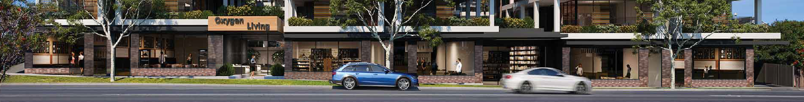
Figure 32 - 3D Render of Ground Level Street Frontage
As shown in figure 32 above, the proposal would incorporate large areas of glazing, and clearly distinguishable premises accessible to pedestrians. Projecting verandahs over the footpath within the road reserve would also provide areas of refuge for the public and improve the amenity of the public realm. The design of the proposed building is considered in more detail in the response to the DDO21 and Clause 58. It is noted that the proposal would provide an active frontage at ground level with a design response which respects the established character of the Portarlington Town Centre on the northern side of Newcombe Street. The proposed retail premises would exhibit a fine grain character with brick plinths at ground level, exhibiting an interpretation of the traditional shopfront windows exhibited throughout the town centre, while refraining from mimicking the traditional built form and detailing of the traditional shopfronts.

- Waste and recycling storage areas are incorporated into the building design response and will be obscured from public access. Furthermore, the private areas would be clearly distinguished on site and would not result in confusion as to who is responsible for management of the site.

- The application has been considered against the requirements of Clause 58 for the proposed apartment development within the C1Z. As outlined in response to Clause 58, the proposal would not result in unreasonable overlooking or overshadowing to neighbouring properties within the RGZ3. This includes in relation to rooftop solar energy systems on dwellings in the neighbouring Residential Growth Zone. A complete Clause 58 Assessment is appended to this report at Appendix 2.

In addition to the above, the availability of services and design of the buildings to provide for solar access have been considered in response to Clause 58.

DESIGN AND DEVELOPMENT OVERLAY – SCHEDULE 21:

The Design and Development Overlay Schedule 21 applies to the Portarlington Town Centre. As such, the part of the planning unit which is zoned Commercial 1 Zone is subject to the Design and Development Overlay. The part of the planning unit which is zoned Residential Growth Zone – Schedule 3 is not subject to the Design and Development Overlay Schedule 21. This is shown below:

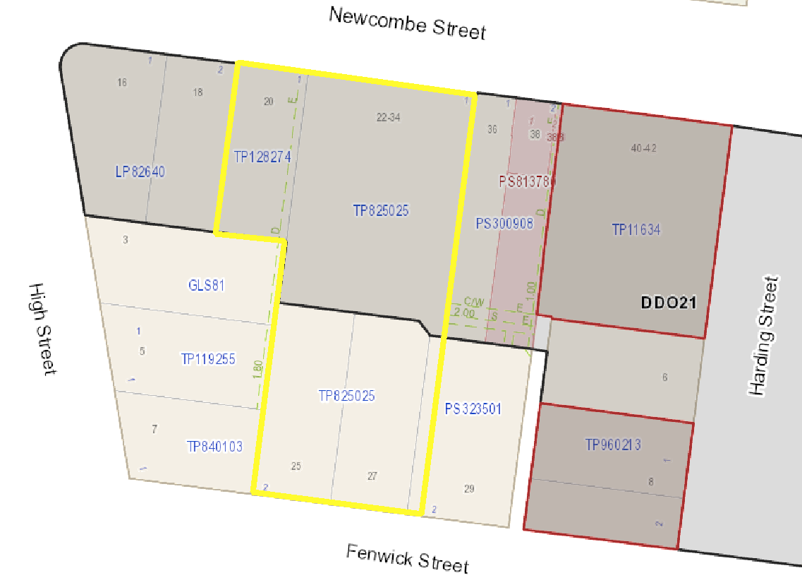
Figure 33 - DDO21 Boundaries (black) within Planning Unit (yellow)
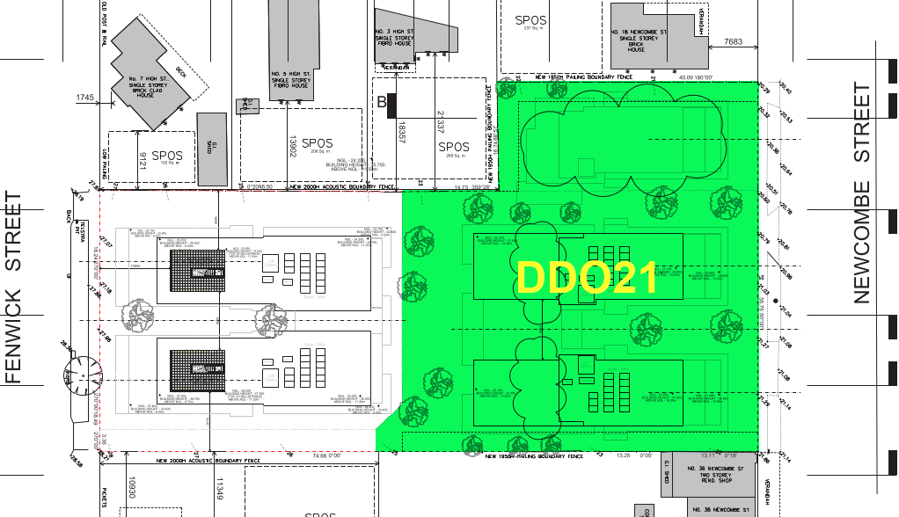
Figure 34 - DDO21 Area Relative to Proposed Development

Clause 43.02 – Design and Development Overlay – Schedule 21 (DDO21)

The purpose of the Design and Development Overlay includes:

- To identify areas which are affected by specific requirements relating to the design and built form of new development.

Buildings and works must be constructed in accordance with any requirements in a schedule to this overlay.

A permit may be granted to construct a building or construct or carry out works which are not in accordance with any requirement in a schedule to this overlay, unless the schedule specifies otherwise.

Schedule 21 to Design and Development Overlay

The design objectives of Schedule 21 to the Design and Development Overlay include:

- To protect the existing views and vistas from the Town Centre and reinforce the Town Centre’s proximity to the bay.
- To enhance the established coastal character of the Town Centre.
- To provide an attractive, safe and accessible environment within the Town Centre.
- To encourage development within the Town Centre to provide an appropriate interface to protect the amenity of surrounding residential areas.
- To encourage the creation of active frontages adjacent to existing roads and laneways.
- To encourage the redevelopment of land within the Town Centre to maximise development potential where high quality urban design can be demonstrated.

Buildings and works

Buildings and works should comply with the design objectives and responses specified in Table 1 to Schedule 21 to the DDO.

Subdivision

Subdivisions should maintain the opportunity for development to reflect the traditional built form pattern of narrow frontages.

Subdivision within the Town Centre should maximise opportunities to create active street frontages and a laneway system to the rear of property fronting Newcombe and Fenwick Streets.

Decision Guidelines

The following decision guidelines apply to an application for a permit under Clause 43.02, in addition to those specified in Clause 43.02 and elsewhere in the scheme which must be considered, as appropriate, by the responsible authority:

- The design objectives and responses of this schedule.
- The requirements of Clause 55 for the construction of two or more dwellings on a lot.
- The objectives and strategies of the Portarlington Urban Design Framework 2011.

Response to DDO21

Refer response to Table 1 over page.

Table 1 to Schedule 21 to Design and Development Overlay Assessment

Streetscape Element | Design objectives | Design Response | Comment
Bay Setting | Reinforce the centre’s proximity to the bay.  Protect existing views and vistas from the centre | Protect views of the bay and avoid signage and structures that inhibit views to the bay. | Complies  The development exceeds two storeys in height however the design objective and design response within the DDO21 seeks to protect existing views and vistas from the town centre.  The subject site is at the western edge of the town centre and on the southern side of Newcombe Street. A site visit identified that from this part of the town centre (immediately surrounding the subject site), there are limited views to the bay, unless developments seek to take advantage of available views by increasing building heights.  Whilst the proposed development would be visible outside of the Commercial 1 Zone, it is noted that the DDO21 does not apply to this land and does not seek to protect views from outside of the town centre. In fact, there are no planning controls seeking to protect views, or achieve a reasonable sharing of views within the surrounding RGZ3 land.  It is noted that the Portarlington Town Centre UDF (2009, amended 2011), does not identify any specific views to be protected other than existing views and vistas from the town centre and not further afield. Furthermore, the Portarlington Structure Plan (September 2016, amended July 2017), which is a reference document at Clause 11.03-6L-01, identified that DDO14 and 19 have been put in place to allow a reasonable sharing of views to significant features, whilst also setting out that Clause 21.14 (now 11.03-6L-01), “should be amended to recognise that the requirement for development to provide reasonable sharing of views to the coast and foreshore only applies where there is an overlay that requires this”.  Given the above, despite the height of the proposed development, it’s considered that given the proposal’s siting to the southern side of Newcombe Street, combined with the site location at the western end of the Town Centre, it would not unreasonably impede views from the town centre to the bay which is located on the northern side of Newcombe Street.  No signage is proposed at present, and future retail signage will be assessed when any planning permit applications are submitted.
Building Siting | Ensure appropriate building frontage rhythm that reflects a traditional strip shopping area. | Retain the traditional narrow frontage treatments | Complies  The narrow frontage treatment has been reflected in the width of the commercial premises and apartment entry/lobby across the front of the building at the ground floor level. The width of the shops and residential entry reflects those in Newcombe Street.  The overall frontage rhythm of the upper floors, when viewed from Newcombe Street is considered to be a contemporary residential interpretation of the narrow shop-front rhythm of the traditional strip shopping area below. The separation of the three ‘wings’ combined with the façade treatment, including projecting expressed frames and roofs, provides an accent mirroring the shop fronting widths and rhythms below.
Building Siting | Ensure that new commercial buildings address the street | Ensure new buildings match the setbacks of the front facades of adjoining shopfronts.  Where the adjoining shopfronts have varied setbacks, design buildings to respond this character.  Orientate commercial buildings to address the street and laneway | Compiles  The retail units at ground level address Newcombe Street, each having a large, glazed shopfront.  No front setback is proposed, and this reflects both adjoining properties which exhibit a zero-lot setback.  The efficient use of the site and the desire to maximise the visibility of retail units to the street has resulted in the proposed design.  The commercial strip generally reflects buildings constructed to the street frontage and as such a zero front setback is appropriate.
Building Form | Ensure that new buildings are designed to respond to the characteristics of the site and locality and demonstrate a high standard of contemporary expression. | Design buildings for energy efficiency, considering solar access and utilising sustainable energy and construction techniques wherever possible.  Articulate the form of buildings and elevations.  Generally, restrict buildings to a maximum height of two storeys.  Higher elements must demonstrate that development:  - Is sympathetic to buildings of heritage significance and any residential interface;  - Is visually unobtrusive when viewed from the public foreshore;  - Is of high quality design.  Provide articulated roof forms on new developments to provide visual interest to the street. | Complies  The elements of the proposed development within the DDO21 are designed to take advantage of solar access where possible, with northern aspect achieved to the majority of proposed dwellings living areas. Furthermore, Council’s ESD officer has confirmed that the proposed development would provide an acceptable ESD outcome in response to relevant planning policy.  The proposed building form is sufficiently articulated. The proposed elevations would incorporate a range of materials and colour schemes, with integrated, open balconies at corner locations and significant areas of glazing to provide a lightweight, well-articulated elevation treatment, particularly when viewed from Newcombe Street. It is noted that the upper floor levels (4 and 5) would be set back 6.25m and 19.46m to their northern front elevations from Newcombe Street.  The building will exceed a height of two storeys. As such, it is necessary to consider whether the proposal achieves the design response sought by DDO21 for developments exceeding 2 storey in height. Specifically, whether:  - The proposal is sympathetic to buildings of heritage significance and any residential interface.  - The proposal is visually unobtrusive when viewed from the public foreshore.  - Is of high quality design.  Where the proposed development exceeds two-storeys within the DDO21, it is considered that:  - The proposal is suitably sympathetic to buildings of heritage significance.  The nearest buildings of heritage significance are located at 40-42 Newcombe Street to the east, and 8 Harding Street to the south-east, as see below (heritage buildings within DDO21 marked orange).  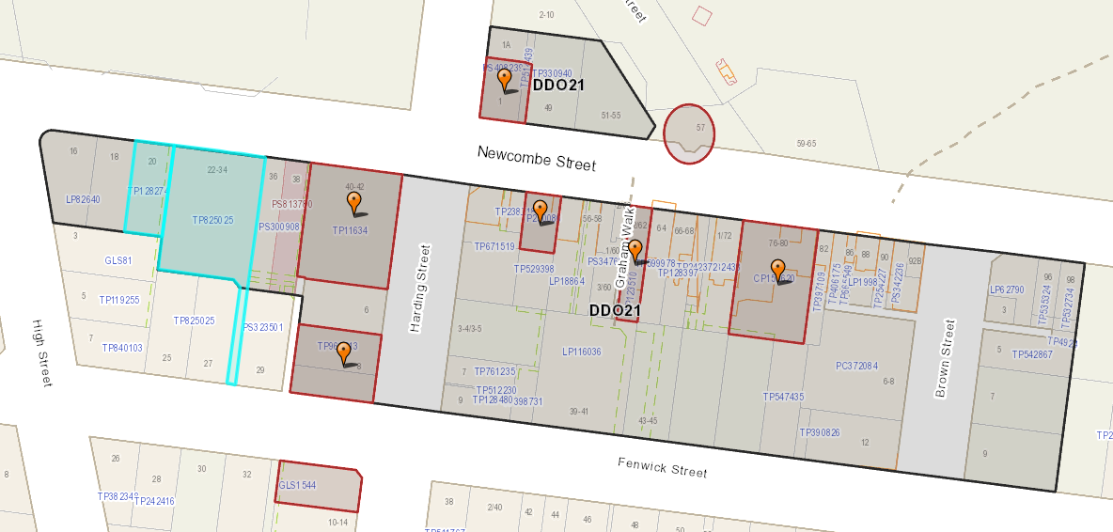  The nearby building of heritage significance at 40-42 Newcombe Street is C Listed of Local Significance. This site is prominent when viewed from the northern side of Newcombe Street and contains a complex of buildings in early Victorian Georgian and Victorian Gothic Styles. The Bellarine Heritage Study identifies this place as being of social and historic significance to the local Portarlington community and tourists to the Bellarine Peninsula, of fair integrity.  The proposed development would be situated approximately 23 metres from the nearest boundary of number 40-42 Newcombe Street (at its western boundary), when viewed from the Newcombe Street frontage. This separation would increase further to 24 metres and 24.5 metres at fourth and fifth-floor levels, respectively. This separation would be maintained given the existing buildings sited between both the subject site and the nearby 40-42 Newcombe Street. It is also noted that the buildings at 40-42 Newcombe street are sited approximately 20 metres from the western side boundary of this site (where buildings front Newcombe Street). It is considered that by reason of the increased street setbacks of the top floor levels of the proposed development, combined with a separation of up to approximately 43 metres between the proposed development (where it exceeds two-storeys in height), which increases to approximately 44.5 metres at its tallest point, would ensure that the proposal does remain sympathetic to this nearby building of local significance at 40-42 Newcombe Street.  The nearby building of heritage significance at 8 Harding Street is B Listed of Regional Significance. It is the Classical Revival style former Colonial Bank of Australia building constructed in 1888 of cement rendered brickwork. It is significant for its creative and/or technical accomplishment and its townscape and/or landscape value.  The proposed development would be situated approximately 37 metres from the nearest boundary of number 8 Harding Street (at its north-western corner), when viewed from the Harding Street Streetscape. This separation would increase further to approximately 39.4 metres at the proposal’s fifth-floor level. This separation would be maintained given the presence of additional lots between the subject site and the nearby 8 Harding Street. It is also noted that the buildings at 8 Harding Street are sited to the southern and eastern side of the site, approximately 18 metres from the north-western corner of this neighbouring site.  It is considered that by reason of the recessive top floor levels of the proposed development, combined with a separation of up to approximately 55 metres between the proposed development (where it exceeds two-storeys in height) and existing buildings at 8 Harding Street, would ensure that the proposal does remain sympathetic to this nearby building of Regional Significance at 8 Harding Street. It is noted that at the top storey of the proposed development, this separation increases to approximately 57.4 metres.  In addition to the above, given the greater separation distances of other buildings of heritage significance within the town centre, it is considered that the proposal remains sympathetic to these buildings.  It is acknowledged that the Portarlington Structure Plan (2016, amended 2017) identifies that the low-scale form of buildings within the town centre is a consistent element, with the focal point of the centre being the Portarlington Grand Hotel. The subject site is approximately 210 metres west of the Grand Hotel site. Given the substantial separation between the two sites, it is not considered that the proposal would be unsympathetic to the Grand Hotel. It is noted that the recessed upper levels of the proposal would assist in mitigating the visual bulk of the development when viewed from Newcombe Street. It is considered that the substantial recessing of these upper levels would ensure that the central tower of the Grand Hotel would remain prominent within the streetscape. Further consideration of this town centre focal point is outlined in consideration of whether the proposal appears visually obtrusive when viewed from the public foreshore.  With regard to residential interfaces, the part of the subject site within the DDO21 exhibits interfaces to adjoining dwellings to the west, south-west and to the south-east. These properties include:  - 18 Newcombe Street  - 3 Hight Street  - 29 Fenwick Street  The above properties are shown marked blue below:  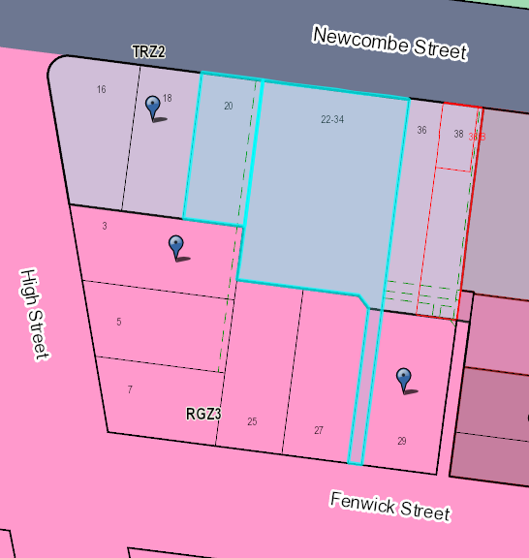  As outlined earlier in this report, it is acknowledged that the surrounding locality generally exhibits a single and double storey residential development scale, despite being zoned Residential Growth Zone Schedule 3. The properties listed above, which share a boundary with the part of the subject site which is subject to the DDO21, are zoned C1Z and RGZ3. It is noted that where the subject site is zoned RGZ3, the impact on adjoining residential properties is assessed in response to Clause 55.  It is noted that within the adjacent RGZ3, there is a maximum building height of up to 10.5 metres. There are no overlays relating to buildings heights or view sharing within the RGZ3 surrounding the subject site.  Following the amendments to the proposal to increase the top floor setback from Newcombe Street, and the removal of the fifth floor level from the western wing fronting Newcombe Street, it is considered that the proposed building would suitably respond to the characteristics of the site and the surrounding locality. In anticipation of future development of RGZ3 land which can be built up to 10.5m in the surrounding IHDA, it is considered that the proposal would provide a visual transition in building heights between the RGZ3 area to the south-west and the Commercial 1 Zone, akin to that which would be expected at the interface of a residential growth zone and a local town centre. It’s noted that the land to the west of the subject site fronting Newcombe Street is also in the C1Z and therefore does not exhibit a maximum building height but would be subject to consideration against the requirements of the DDO21 in any application for redevelopment of these sites.  Given the amended building form would step down to the west of the site, it is considered that the proposal would suitably integrate with the characteristics of the site and surrounding locality with regard to the interface to residential dwellings to the south and west.  - The proposal will not be visually obtrusive when viewed from the public foreshore. The building would provide a focal point in terms of being a significant building in the town centre, with a variety of retail offerings and a scale which contributes to its ‘focal building’ status. However, it is not considered to be visually obtrusive when viewed from the public foreshore.  The proposed building fronting Newcombe Street would have a three-storey street wall with a recessed fourth-floor and significantly recessed fifth-floor. As such, the majority of the bulk and massing of the proposal would be obscured from view from the foreshore, given the presence of well-established vegetation to the northern side of Newcombe Street in the Portarlington Foreshore Reserve.  Given the significant setback of the fifth floor level from the Newcombe Street frontage, it is noted that the overall building height would be largely obscured from view from the pier, and would be almost entirely obscured from view from the foreshore. The distribution of building heights across the site are considered to maintain the Grand Hotel as a visual focal building from these vantage points. Given the proposal’s separation from the Grand Hotel, combined with the difference in ground levels between the subject site and the town centre to the east, it is considered that the proposal suitably mitigates its visual prominence from the foreshore in order to maintain the hotel’s visual prominence.  In view of the above, given the significant separation from the Grand Hotel, combined with the proposal being relatively obscured from views from the foreshore, it is not considered that the proposal would appear visually obtrusive from the foreshore or the pier.  - The proposed development is considered to be of high quality design. Whilst the DDO21 design response for buildings over two-storeys in height specifies buildings should be of “high quality design” it is noted that the DDO21 does not distinguish what it considers “high quality design” to be. In this respect, it is considered that that this design response should be considered in view of the relevant design objective, which states, “Ensure that new buildings are designed to respond to the characteristics of the site and locality and demonstrate a high standard of contemporary expression.”  It is also noted that the Portarlington Structure Plan sets out that, “the varied styles and setbacks of buildings in the town centre have not established a clearly distinguishable coastal character compared to other Bellarine Peninsula townships.”  As outlined earlier within this report and in response to the DDO21, it is considered that the proposal, at its upper floor levels, provides a building design and form which exhibits a contemporary interpretation of the finer grained strip shopping evident along the southern side of Newcombe Street. This includes those elements of the building which exceed two-storeys in height within the DDO21, along with the recessed fourth and fifth floor levels. Furthermore, the proposed horizontal emphasis across the building facades is considered to respond to the prevailing character exhibited across a mixture of historic and contemporary buildings within the surrounding town centre locality.  In this regard it is considered that the proposal incorporates a design which exhibits a contemporary interpretation of the characteristics of the site and surrounds within the town centre which are identifiable.  The proposal provides separation between the proposed ‘wings’ at upper floor levels, with lightweight elevation treatments and visual articulation between floor levels and adequate side setbacks, while providing an active frontage along the entire ground level street frontage (excluding the residential entrance). In this regard it is considered that the proposal would assist in enhancing the coastal character of the town.  Furthermore, as identified in response to Clause 58, the proposed dwellings are considered to provide appropriate levels of amenity for future residents.  Given the above, it is considered that the proposal does in fact exhibit high quality design. Particularly given that it is visually responsive to the site and surrounds, while exhibiting an appropriate level of internal amenity.
Building Form | Design building forms that express the fine grain (narrow frontage) pattern of the town centre. | On larger sites articulate facades to emulate the fine grain (narrow frontage) pattern of the town centre. | Complies  As set out above, the overall frontage rhythm of the upper floors, when viewed from Newcombe Street is considered to be a contemporary residential interpretation of the narrow shop-front rhythm of the traditional strip shopping area below. The separation of the three ‘wings’ combined with the façade treatment, including projecting expressed frames and roofs, provides an accent mirroring the shop fronting widths and rhythms below.
Building Form | Ensure that new buildings encourage social interaction and interest at street level. | Orientate commercial buildings towards the street and laneway and provide an entrance to the building directly from street and laneway frontages.  Provide a well articulated façade, with shop front windows at street level.  On corner allotments, ensure buildings address both street frontages with shopfront windows at street level. | Complies  The retail tenancies have street frontage with large, glazed windows.
Building Details and Finishes | Encourage buildings that have regard to the palette of materials and colours in the town, and demonstrate a high level of contemporary finish | Use simple building details.  Use a mix of contemporary and traditional coastal materials, textures and finishes.  Utilise colours and finishes that compliment those occurring naturally in the area. | Complies  The proposal incorporates simple building details, and the colours can be considered to compliment the coastal environment, the building materials are considered to be of a suitably high quality.
Building Details and Finishes | Encourage details which are integrated with the architecture of the building and contribute to the character and amenity of the centre. | Provide verandahs/awnings without posts on commercial buildings wherever possible. If posts are necessary, ensure they are narrow and contribute to the street setting.  Relate the height of the verandah/awning to the building elevation.  Provide subtle façade lighting and down lighting under verandahs/ awnings where possible | Complies  A narrow awning is proposed without posts along the Newcombe Street frontage.  The awning is located at the ground floor retail shop level.  No lighting is proposed at this stage however a lighting plan could be provided as a permit condition if deemed necessary.
Building Details and Finishes | Ensure that signage does not dominate the building or streetscape and contributes to the pedestrian environment. |  | N/A- No signage requiring a planning permit is proposed as part of this application
Walkability | Provide safe, convenient pedestrian movement | Maintain existing pedestrian connections to the town centre  Encourage the provision of additional pedestrian connections within the Town Centre particularly through to Newcombe Street and the Portarlington Foreshore.  Avoid blank walls fronting onto footpaths or linkages. | Complies  No changes to pedestrian access is proposed, and no blank walls are proposed. The front of the building is well activated at both ground and upper floor levels. The proposal would provide additional pedestrian connections to the Town Centre from the RGZ3 land forming part of this application.
Vehicle Access and Car Parking | Provide a safe environment for pedestrians, and to minimise the visual impact of car parking areas | Where practical, locate car parking areas at the rear of sites to minimise visibility from Newcombe Street and adjacent residential areas. Minimise the width of vehicle access points to the car parking areas.  Provide shade trees and other planting to ground level car parks.  Design car parking areas to minimise large expanses of unrelieved hard surface.  If car parking is provided below ground level, it should be accessed from the rear of the property with no part visible from the street frontage. | Complies  Car parking has been provided at the basement level in order to minimise the visual impact of parking areas on the street. Access to the basement car parking area is solely from Fenwick Street to the south. This ensures that the car parking access points would be obscured from view from within the Town Centre. The proposal would effectively remove three existing vehicle crossovers/access points from 20 and 22-34 Newcombe Street.  Council’s Engineering Department has no objection to the location of the carpark and the width of the vehicle access point.  No shade trees are propose given the car parking is at basement level.

CULTURAL HERITAGE MANAGEMENT PLAN (CHMP):

The Aboriginal Heritage Regulations 2018 specify the circumstances in which a cultural heritage management plan is required for an activity or class of activity. Division 2 of the Aboriginal Heritage Regulations 2018 specifies exempt activities which do not require a cultural heritage management plan. The proposal is not listed as an exempt activity.

Areas of cultural heritage sensitivity are defined within Divisions 3 and 4 of the Aboriginal Heritage Regulations 2018. Division 3 does not identify the site or part of the site as within an area of cultural heritage sensitivity.

In accordance with the above assessment, a cultural heritage management plan is not required.

LANDFILL GAS RISK ASSESSMENT

The subject site is not located within 500 metres of an identified former landfill site, a risk assessment is not required.

DEVELOPMENTS IN BUSHFIRE PRONE AREAS

The site is not located within a designated bushfire prone area.

MUNICIPAL PLANNING STRATEGY (MPS):

02.01 – Context
02.02 – Vision
02.03 – Strategic Directions
    - – Settlement

Strategic Directions
  - Direct and contain growth within identified locations across the municipality.
  - Minimise the economic, environmental, visual and servicing impacts of residential development on rural areas.
  - Maintain the unique township, landscape, tourism, farming and environmental values of the Bellarine Peninsula.
  - Maintain the unique identity of Greater Geelong and its townships.
  - Locate and design urban areas to mitigate the potential impacts of climate change.

Bellarine Peninsula - Strategic Directions
- Support and preserve the individual character, identity, role and function of each Bellarine Peninsula township.
- Protect and enhance the rural and coastal environment and landscapes on the Bellarine Peninsula and maintain non-urban breaks between settlements.
- Protect the Bellarine Peninsula as a productive rural area with highly significant landscapes.

Activity Centres and Retail - Strategic Directions
- Ensure that new retail development is consistent with the Geelong Retail Centre Hierarchy.
- Encourage expanding existing centres over developing new centres in out-of-centre locations.
- Ensure the transition of retail centres to activity centres with a diverse range of uses.

    - – Environmental and landscape values

Biodiversity, waterbodies and coastal areas - Strategic Directions
- Reduce the amount of runoff from urban development and improve the quality of stormwater runoff entering waterways, estuarine and marine waters.

02.03-5 – Built environment and sustainability

Built Environment Strategic Directions
- Ensure that development enhances Geelong’s sense of place and identity.
- Support the design and provision of healthy, walkable neighbourhoods.
- Encourage environmentally sustainable design in all development.
- Encourage all development to provide high quality urban design and landscaping.

02.03-6 – Housing

Strategic Directions
- Facilitate infill development to increase its housing supply contribution.
- Support residential development where the density, mass and scale is complementary to the location, role and character of the specific IHDA.
- Ensure housing diversity is achieved in established and growth area communities.
- Increase the level of affordable and social housing in Greater Geelong.

02.04 – Strategic Framework Plans
02.04-1 – Municipal Framework Plan
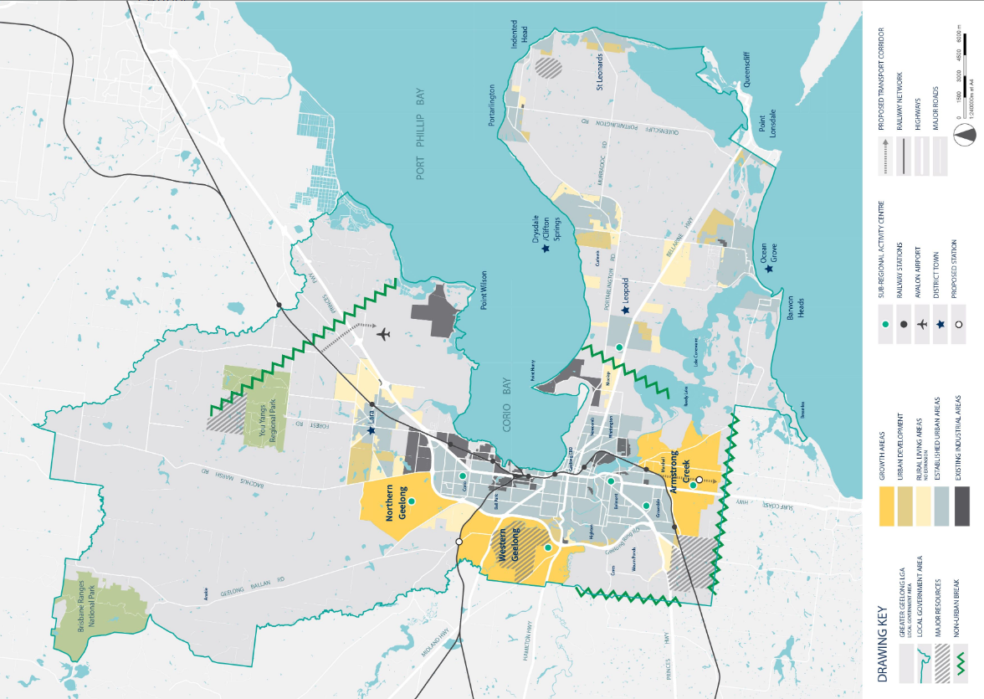

02.04-2 – Retail Activity Centre Hierarchy
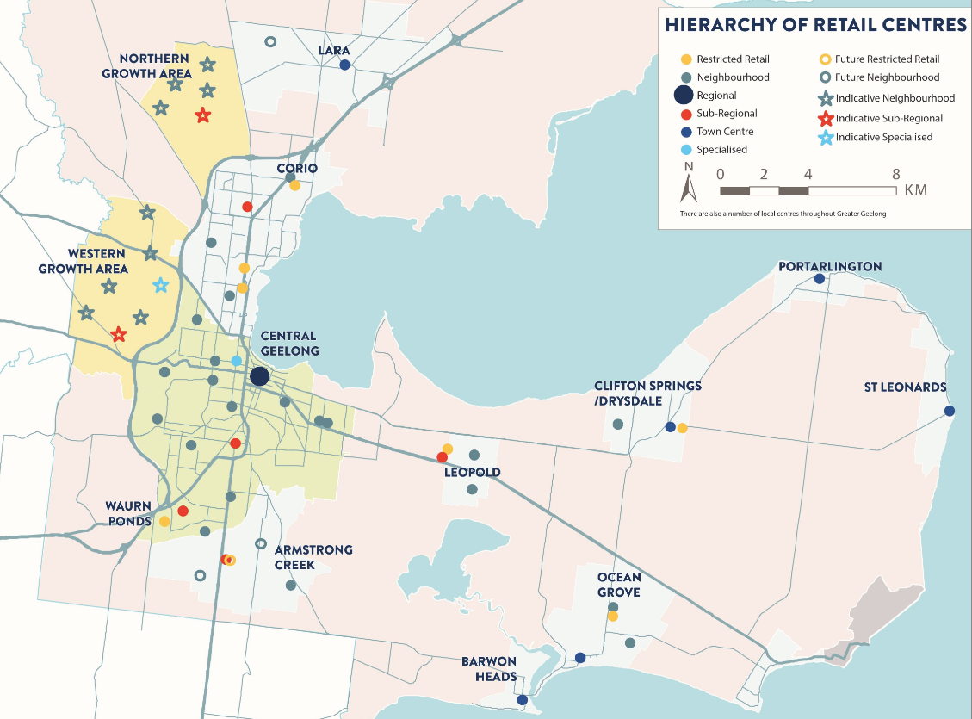

02.04-3 – Housing and Settlement Framework Plan
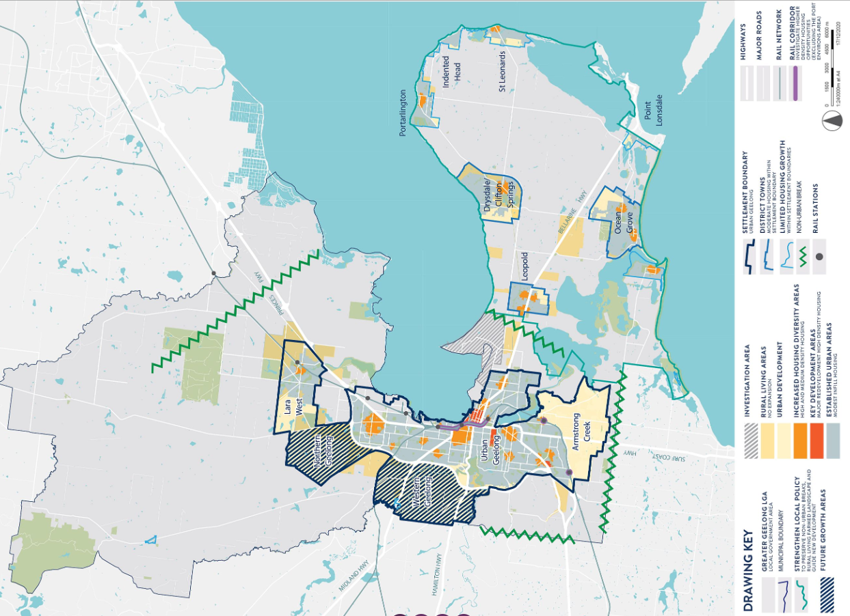

THE PLANNING POLICY FRAMEWORK (VPPF):

The Planning Policy Framework (PPF) of the Greater Geelong Planning Scheme provides a strategic context for land use planning and decision making. The PPF seeks to ensure that the objectives of planning in Victoria are achieved through appropriate land use and development planning policies and practices that integrate relevant environmental, social and economic factors in the interests of net community benefit and sustainable development outcomes.

The following Victorian Planning Policies are applicable to this application. Objectives and strategies of particular relevance to this application are outlined below:

11.00 – Settlement
11.01-1S - Settlement

Sets objectives and strategies to facilitate the sustainable growth and development of Victoria and deliver choice and opportunity for all Victorians through a network of settlements.

11.01-1R – Settlement – Geelong G21

Sets strategies to:
  - reinforce the role of district towns in providing services to surrounding areas,
  - provide for settlement breaks between towns to maintain their unique identities.

11.02-1S – Supply of Urban Land
Objective:
- to ensure a sufficient supply of land is available for residential, commercial. Retail, industrial, recreational, institutional and other community uses.

Relevant Strategies:
- Ensure the ongoing provision of land and supporting infrastructure to support sustainable urban development.
- Plan to accommodate projected population growth over at least a 15 year period and provide clear direction on locations where growth should occur. Residential land supply will be considered on a municipal basis, rather than a town-by-town basis.

- Planning for urban growth should consider:
  - Opportunities for the consolidation, redevelopment and intensification of existing urban areas.
  - Neighbourhood character and landscape considerations.
  - The limits of land capability and natural hazards and environmental quality.
  - Service limitations and the costs of providing infrastructure.

11.01-1L – Geelong Settlement
Relevant Strategies:
- Maintain the non-urban breaks between Geelong and Melbourne (Wyndham), Geelong and the Surf Coast, urban Geelong and the Bellarine Peninsula, and the townships on the Bellarine Peninsula.
- Direct the majority of future housing needs to urban Geelong (urban infill, Armstrong Creek and the Northern and Western Geelong Growth Areas).
- Ensure urban development occurs within designated settlement boundaries.
- Reduce the share of new housing development on the Bellarine Peninsula.

11.03-1L – Activity Centres in Greater Geelong
Objectives:
- To support the role and function of centres in the Geelong Retail Centre Hierarchy.
- To support continued diversification of retail centres over time.

General strategies:
- Encourage a mix of retail, office, cafes, higher density housing, education and community facilities to locate within centres, but particularly in Regional (Central Geelong), Sub-regional and Town Centres.
- Support accommodation uses above ground level floor space in retail and activity centres subject to provision of parking and access requirements to meet the needs of users.
- Direct entertainment and cultural activities to Central Geelong and support local events in other centres.
- Support increased intensity and vertical growth of centres to encourage expansion and to reduce the need to develop new centres.

Retail hierarchy strategies
- Direct new retail development to existing centres, consistent with the role and function described in the Geelong Retail Centre Hierarchy at Clause 02.03-1.
- Encourage development that supports a diversity of retail forms across the hierarchy.

Residential Growth Zone land strategies
- Ensure that retail use and development on land within the Residential Growth Zone:
  - Has a functional relationship with an existing activity centre.
  - Is designed and sited to operate without amenity impacts to neighbouring residents.

Commercial and industrial land strategies
  - Encourage use and development that will provide for strategic employment land.

11.03-4S – Coastal Settlement
Relevant Strategies
  - Plan and manage coastal population growth and increased visitation so that impacts do not cause unsustainable use of coastal resources.
  - Support a network of diverse coastal settlements that provide for a broad range of housing types, economic opportunities and services.
  - Identify a clear settlement boundary around coastal settlements to ensure that growth in coastal areas is planned and coastal values are protected. Where no settlement boundary is identified, the extent of a settlement is defined by the extent of existing urban zoned land and any land identified on a plan in the planning scheme for future urban settlement.
  - Minimise linear urban sprawl along the coastal edge and ribbon development in rural landscapes.
  - Protect areas between settlements for non-urban use.
  - Ensure a sustainable water supply, stormwater management and sewerage treatment for all development.
  - Minimise the quantity and enhance the quality of stormwater discharge from new development into the ocean, bays and estuaries.

11.03-5S – Distinctive areas and landscapes

Relevant Strategies
  - Recognise the unique features and special characteristics of these areas and landscapes.
  - Implement the strategic directions of approved Localised Planning Statements and Statements of Planning Policy.
  - Integrate policy development, implementation and decision-making for declared areas under Statements of Planning policy.
  - Recognise the important role these areas play in the state as tourist destinations.
  - Protect the identified key values and activities of these areas.
  - Enhance conservation of the environment, including the unique habitats, ecosystems and biodiversity of these areas.
  - Support use and development where it enhances the valued characteristics of these areas.
  - Avoid use and development that could undermine the long-term natural or non-urban use of land in these areas.
  - Protect areas that are important for food production.

Relevant Policy Documents:
  - Bellarine Peninsula Localised Planning Statement (Victorian Government, 2015).

11.03-6L – Bellarine Peninsula
Objectives
- To ensure development responds to the identity and preferred character of the individual township in which it is located.
- To provide attractive and sustainable industrial, commercial, retail, agricultural and tourism development in designated locations, to service the wider Bellarine community.

General Strategies
- Support the district towns of Ocean Grove, Drysdale/Clifton Springs and Leopold to fulfil their role as service hubs for the Bellarine Peninsula.
- Ensure all other townships provide retail, commercial and community uses and facilities that serve the daily needs of the community.
- Retain the land surrounding each town as rural breaks and for its agricultural and scenic values.

Portarlington Strategies
- Encourage development that respects the coastal landscape setting of Portarlington by:
- Providing reasonable sharing of views of the coast and foreshore, where a view has been identified in an overlay.
- Promoting contemporary design that reflects the existing scale, setbacks, spacing, forms and materials of the buildings in the locality.
- Ensuring that development allows for the protection of significant vegetation or planting around buildings and has minimal impact on roadside vegetation.
- Support the integration of the Portarlington town centre and pier-foreshore area.
- Support the development of the development opportunity sites including:
- Development of a focal building at 22-34 Newcombe Street, Portarlington.
- Support development in the Portarlington town centre incorporating accommodation uses above ground level retail floor space, where such development meets all parking and access requirements.

Policy Documents
- Bellarine Peninsula Strategic Plan (City of Greater Geelong, 2006)
- Portarlington Structure Plan (City of Greater Geelong, 2016, amended 2017)
- City of Greater Geelong Settlement Strategy (City of Greater Geelong, August 2020)

13 - Environmental Risks and Amenity
13.04-1S Contaminated and potentially contaminated land
Objective
- To ensure that contaminated and potentially contaminated land is used and developed safely.

Strategies
- Ensure contaminated or potentially contaminated land is or will be suitable for the proposed use, prior to the commencement of any use or development.
- Protect a sensitive use (residential use, childcare centre, kindergarten, pre-school centre, primary school, even if ancillary to another use), children's playground or secondary school from the effects of contamination.
- Facilitate the remediation of contaminated land to make the land suitable for future intended use or development.

Policy Guideline
  - Consider as relevant the potential for contamination to impact the proposed use or development through an assessment that is proportionate to the risk, including:
    - An assessment in accordance with the National Environment Protection (Assessment of Site Contamination) Measure (National Environment Protection Council, 1999)
    - A preliminary risk screen assessment or environmental audit under Part 8.3 of the Environment Protection Act 2017.

15 - Built Environment and Heritage
15.01- 1S – Urban Design
Relevant Strategies
  - Require development to respond to its context in terms of character, cultural identity, natural features, surrounding landscape and climate.
  - Ensure development contributes to community and cultural life by improving the quality of living and working environments, facilitating accessibility and providing for inclusiveness.
  - Ensure the interface between the private and public realm protects and enhances personal safety.
  - Ensure that the design and location of publicly accessible private spaces, including car parking areas, forecourts and walkways, is of a high standard, creates a safe environment for users and enables easy and efficient use.
  - Ensure that development provides landscaping that supports the amenity, attractiveness and safety of the public realm.
  - Ensure that development, including signs, minimises detrimental impacts on amenity, on the natural and built environment and on the safety and efficiency of roads.

15.01-2S – Building design
Strategies
- Ensure a comprehensive site analysis forms the starting point of the design process and provides the basis for the consideration of height, scale, massing and energy performance of new development.
- Ensure development responds and contributes to the strategic and cultural context of its location.
- Minimise the detrimental impact of development on neighbouring properties, the public realm and the natural environment.
- Improve the energy performance of buildings through siting and design measures that encourage:
  - Passive design responses that minimise the need for heating, cooling and lighting.
  - On-site renewable energy generation and storage technology.
  - Use of low embodied energy materials.
- Ensure the layout and design of development supports resource recovery, including separation, storage and collection of waste, mixed recycling, glass, organics and e-waste.
- Encourage use of recycled and reusable materials in building construction and undertake adaptive reuse of buildings, where practical.
- Encourage water efficiency and the use of rainwater, stormwater and recycled water.
- Minimise stormwater discharge through site layout and landscaping measures that support on-site infiltration and stormwater reuse.
- Ensure the form, scale, and appearance of development enhances the function and amenity of the public realm.
- Ensure buildings and their interface with the public realm support personal safety, perceptions of safety and property security.
- Ensure development is designed to protect and enhance valued landmarks, views and vistas.
- Ensure development considers and responds to transport movement networks and provides safe access and egress for pedestrians, cyclists and vehicles.
- Encourage development to retain existing vegetation.
- Ensure development provides landscaping that responds to its site context, enhances the built form, creates safe and attractive spaces and supports cooling and greening of urban areas.

15.01-2L – Environmentally Sustainable Development
Objective
- To achieve best practice in environmentally sustainable development from the design stage through to construction and operation.

General strategies
- Facilitate development that minimises environmental impacts.
- Encourage environmentally sustainable development that:
- Is consistent with the type and scale of the development.
- Responds to site opportunities and constraints.
- Adopts best practice through a combination of methods, processes and locally available technology that demonstrably minimise environmental impacts.

Energy performance strategies
- Reduce both energy use and energy peak demand through design measures such as:
  - Building orientation.
  - Shading to glazed surfaces.
  - Optimising glazing to exposed surfaces.
  - Inclusion of or space allocation for renewable technologies.

Integrated water management strategies
- Reduce total operating potable water use through appropriate design measures such as water efficient fixtures, appliances, equipment, irrigation and landscaping.
- Encourage the use of alternative water sources, including greywater, rainwater and stormwater.
- Incorporate water sensitive urban design to improve the quality of stormwater runoff and reduce impacts on water systems and water bodies.

Indoor environment quality
- Achieve a healthy indoor environment quality, including thermal comfort and access to fresh air and daylight, prioritising passive design over mechanical heating, ventilation, cooling and lighting.
- Reduce indoor air pollutants by encouraging use of materials containing chemicals that have low levels of toxicity.
- Minimise noise levels and noise transfer within and between buildings and associated external areas.

Transport strategies
- Design development to promote the use of walking, cycling and public transport, in that order; and to minimise car dependency.
- Promote the use of low emissions vehicle technologies and supporting infrastructure.

Waste management strategies
- Promote waste avoidance, reuse and recycling during the design, construction and operation stages of development.
- Encourage use of durable and reuseable building materials.
- Ensure sufficient space is allocated for future change in waste management needs, including (where possible) composting and green waste facilities.

Urban ecology strategies
- Protect and enhance biodiversity by incorporating natural habitats and planting indigenous vegetation.
- Reduce urban heat island effects through building design, landscape design, water sensitive urban design and the retention and provision of canopy trees.
- Encourage the provision of space for productive gardens, particularly in larger residential developments.

15.01-5S – Neighbourhood character
Strategies
- Support development that respects the existing neighbourhood character or contributes to a preferred neighbourhood character.
- Ensure the preferred neighbourhood character is consistent with medium and higher density housing outcomes in areas identified for increased housing.
- Ensure development responds to its context and reinforces a sense of place and the valued features and characteristics of the local environment and place by respecting the:
  - Pattern of local urban structure and subdivision.
  - Underlying natural landscape character and significant vegetation.
  - Neighbourhood character values and built form that reflect community identity

15.01-5L – Neighbourhood Character
Relevant Strategies
- Design development on the periphery of the Residential Growth Zones to be responsive to and respectful of the neighbourhood character in any adjoining residential zones.
- Retain existing vegetation wherever possible, particularly vegetation that contributes to the municipality’s tree canopy.

16 – Housing
16.01-1S - Housing supply
Objective
- To facilitate well-located, integrated and diverse housing that meets community needs.

16.01-1L-02 – Increased Housing Diversity Areas.
Objectives
- To evolve the character of Increased Housing Diversity Areas (IHDA) through more intensive development.
- To support development that makes a positive architectural and urban design contribution to the IHDA.
- To maintain streetscape character in heritage areas.
- To promote pedestrian safety within the IHDA.

General Strategies
- Maximise opportunities for housing in IHDA by accommodating:
- High density housing in the activity centres consistent with their primary commercial and retail role.
- Medium density housing in residential areas with more intensive development being located closest to the core of activity centres.
- Encourage a diversity of housing types to cater to a variety of lifestyle needs.
- Encourage development to provide a high level of on-site amenity for future residents.

Built form strategies
- Encourage development that incorporates a combination of horizontal and vertical articulation, materials, textures and colours to create visual interest.
- Encourage a sympathetic design response when addressing any unique characteristics such as heritage places, significant vegetation, topography and public spaces.
- Discourage storage areas located within the minimum area of secluded open space.
- Support development that does not reduce opportunities for neighbouring sites to reasonably develop.

Building height strategies
- Design development to recess upper levels to reduce dominance of the building from adjoining properties and the streetscape. \
- Design development on interface properties, between an IHDA and other residential areas, so that the height and bulk is responsive to the adjoining character and provides a transition in the built form between areas.

Building height policy guidelines
- Consider as relevant:
- Encouraging development of up to three stories. Three storey development should be located on larger sites abutting the activity centre or where the amenity of adjoining properties will not be unreasonably impacted.
- Encouraging the recessing of third storeys to reduce dominance of the building from adjoining properties and the streetscape.

Subdivision and consolidation strategies
- Encourage the consolidation of lots to increase development potential.
- Discourage the fragmentation of sites and underdevelopment of sites.

Car parking strategies
- Locate car parking structures behind the line of the front façade and design them to form a visually unobtrusive part of the building to minimise their visual prominence.
- Minimise the number of vehicle crossings and where possible, provide access from lower order roads and rear laneways.

Car parking policy guideline
- Consider as relevant:
- Where more than one car space is provided, encouraging the use of a single-width garage or carport and a tandem parking space on existing or proposed lots with a frontage of less than 10.5 metres.

Heritage strategies
  - Design development adjacent to heritage places to respect and be sympathetic to the significance of the place.
  - On sites adjacent to a heritage place, set back building elements above one storey in height behind the roof ridgeline of the heritage buildings.

17 – Economic Development

17.02-1S – Business
Objective
  - To encourage development that meets the community’s needs for retain, entertainment, office and other commercial services.

OTHER RELEVANT PLANNIGN STRATEGIES AND POLICIES

Bellarine Peninsula Localised Planning Statement (LPS)

Localised planning statements are State policies for protecting and enhancing distinctive areas with State significant geographic and physical features, biodiversity, natural resources, cultural and tourism values, productive rural land and regional and national infrastructure assets.

The purpose of the LPS is to identify the key valued attributes of specific areas within the Bellarine Peninsula, including Portarlington, and to put in place objectives and strategies to ensure that they are preserved and enhanced for ongoing use by present and future generations.

Portarlington is described in the LPS as:
… a smaller settlement with both a residential and tourism role. It is not a designated growth
location. Portarlington is the northern most point on the Bellarine Peninsula and is an older
settlement with strong links to its history as a fishing town and holiday resort.

Policy objectives and strategies of the LPS relevant to the consideration of this proposal are outlined below:

Policy Objective | Strategies
To protect, preserve and enhance built heritage, cultural and urban character values and preserve the individual identity and role of townships. | Ensure that development responds to the identity and  character of the individual township in which it is located.
 | Protect the character of local conservation precincts, places, objects and sites and heritage areas on the Bellarine Peninsula.
 | Encourage development which respects the setting of coastal settlements by providing reasonable sharing of views of the coast and foreshore and uses contemporary design that reflects existing built form.
To facilitate the planned residential growth of Drysdale/Clifton Springs, Leopold and Ocean Grove, consistent with adopted Structure Plans and as service hubs for the Bellarine Peninsula.  In all other townships, provide retail, commercial and community uses and facilities that serve the daily needs of the community and encourage street based  activity and local employment. | Ensure land use and development proceeds generally in accordance with the relevant Structure Plan maps.
 | Provide for a range of retail, commercial, community uses in town centres to provide services for the community and local employment opportunities in accordance with Structure Plans.
 | Direct the bulk of residential growth and retail development to the designated growth locations of Drysdale/Clifton Springs, Leopold and Ocean Grove consistent with the relevant Structure Plan maps.

G21 Regional Growth Plan 2013

The Regional Growth Plan provides broad direction for land use and development across five G21 member Councils in the Geelong region. It recognises the region’s population is growing and that there is a need to proactively plan and manage growth while protecting areas of environmental significance, biodiversity assets, unique landscapes, coastal areas and heritage assets.

The Regional Growth Plan identifies Portarlington for limited growth and identifies the Portarlington Safe Harbour as a priority project.

City of Greater Geelong Settlement Strategy 2020

The City of Greater Geelong Settlement Strategy 2020 (Settlement Strategy) was introduced to the Planning Scheme as a reference document in May 2021 through Amendment C395.

The Settlement Strategy provides:
- an overview of Geelong’s current settlement and housing policies
- an analysis of population and housing trends
- background information about issues and community aspirations
- recommendations to guide housing provision for a growing population, while protecting Geelong’s unique lifestyle and environmental values.

Recommendations include:
- preserving significant landscapes and environments from urban encroachment
- containing urban development within settlement boundaries
- encouraging urban consolidation, to increase the contribution it makes to the overall housing supply
- managing future growth to deliver more sustainable, well-serviced communities.

Portarlington Structure Plan 2016 (Amended July 2017)

The Portarlington Structure Plan, referenced in Clause 11.03-6L-01 (The Bellarine Peninsula) provides a strategic framework for the future planning and development of the township, with the purpose to:
- identify the key strategic planning issues facing the township, including community aspirations and needs
- articulate the preferred future planning directions for the township, including the location of the Settlement Boundary
- identify appropriate planning controls which will protect and enhance the distinctive elements of the township, biodiversity and landscape features.

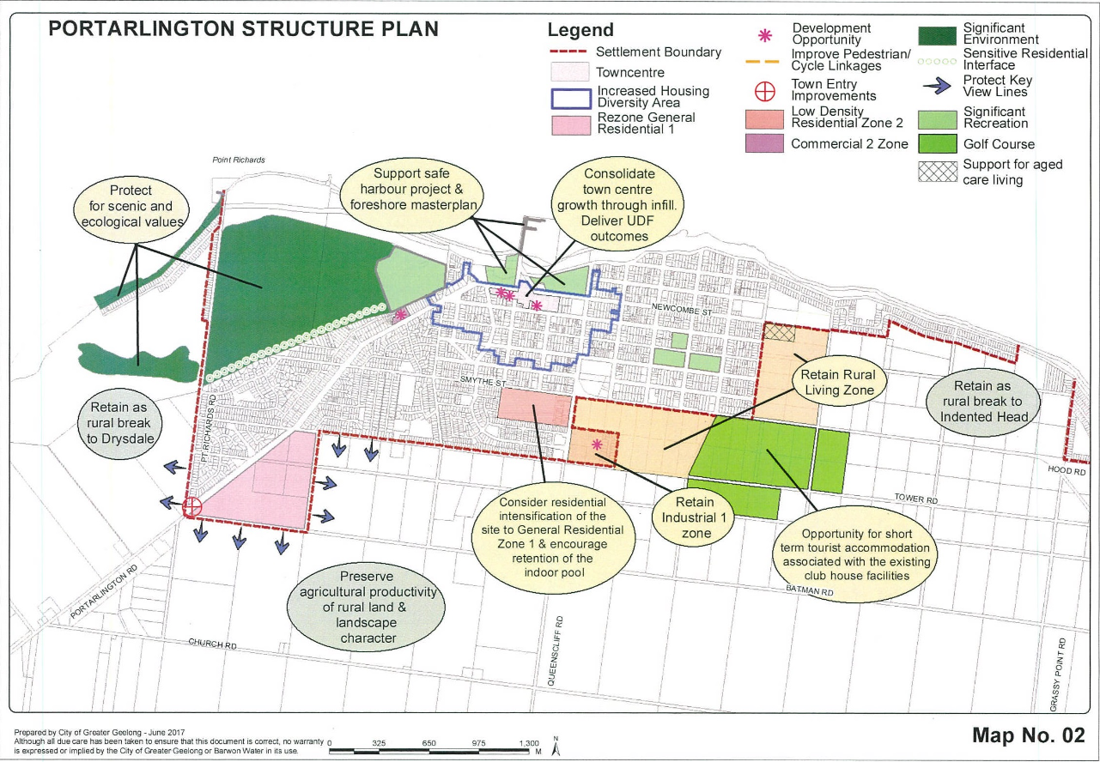
Figure 35 - Portarlington Structure Plan
The Portarlington Structure Plan provides guidance on urban growth, infrastructure, settlement and housing, natural environment, town centre and economy and rural area. It identifies the role of Portarlington has “traditionally been as a seaside holiday village on the Bellarine Peninsula serving a small permanent population”. Its direction for the subject site is to consolidate town centre growth through infill and to deliver the Portarlington Town Centre Urban Design Framework, Urban Initiatives (July 2011) (UDF). The UDF is not included as a reference document in the Planning Scheme. In this regard it sets out that there is sufficient vacant land and redevelopment options available within the town centre to cater for future growth. The structure plan seeks to encourage “shop top” accommodation where there are appropriate parking and access arrangements.

In particular regard to the Town Centre and Economy, the Portarlington Structure Plan identifies the subject site as a “major development opportunity”. It states that the 2008 Structure Plan recommended this site be developed as a focal building to contain a mix of retail uses, tourist accommodation and tourism related activities. However the updated structure plan (2016) outlines that development of this site is still a priority for the town centre. It identifies that activated uses are necessary on the ground floor, however as a result of no development on the site at the time of the amended structure plan, a mix of options could be considered above the first level, incorporating accommodation, offices or retail.

The directions formulated through the structure plan include to encourage infill development and redevelopment of the subject site for a focal building to contain activated tourist or retail uses on the ground floor and accommodation or other commercial uses above. This direction is reflected in policy at Clause 11.03-6L-01.
Response to Planning Policy Framework

The planning policy framework incorporates a range of policies which seek to encourage development that responds to the needs of existing and future communities, established built form, landscape character and local context. Development should not adversely impact on community amenity and human health through noise emissions, by incorporating a range of building design and land use separation techniques appropriate to the land use functions and character of the area.

The application can be relevantly segregated into three parts in regard to its response to the Municipal Planning Strategy and the Planning Policy Framework. These include the use and development of the land to provide 59 dwellings, the development of the land for seven (7) retail premises, and the consideration of the proposal as a major development/focal building in the context of the relevant built form and urban design policy objectives and strategies for the Portarlington Town Centre. These are responded to as follows:

Use and Development of the Land for 59 Dwellings

Whilst the proposal includes 59 dwellings, it is noted that only the dwellings within the Commercial 1 Zone require a planning permit for the use of land. Nevertheless, for continuity the following assessment considers the application as a whole including the proposed provision of 59 dwellings.

A range of policy matters within of the Scheme are relevant to the consideration of infill urban development and housing.

The subject site is located in close proximity to a range of services and facilities, including shops, recreational open spaces and a school. The proposed development is therefore considered to be supported by Clause 15.01-4S – Healthy Neighbourhoods, which seeks to promote neighbourhoods that foster healthy and active living and community wellbeing, partly through the promoting walking and cycling as part of daily life.

Clause 16 of the Scheme states that planning should provide for housing diversity which includes access to services, walkability to activity centres, public transport, open spaces and schools. The development is located in a walkable distance to all such services. The proposal provides a range of housing types, as mentioned above, which ensures that housing stock is changing to accord with the market needs and allowing for a larger choice in housing as encouraged by Clause 16.01-2S.

Clause 02.03 of the Scheme details the Council’s strategic direction for growth with regard to settlement and housing. This clause identifies key drivers to include population growth, a rapidly aging population and increased demand for smaller and low maintenance dwellings in close proximity to urban services. Clause 02.03-6 Housing sets out that to accommodate the growing population, Council has identified Increased Housing Diversity Areas (IHDA). IHDAs are located around activity centres and transport hubs and have significant capacity to accommodate residential growth and increased housing diversity. Within areas of heritage significance, new development should balance the preservation and restoration of the heritage place and other opportunities for housing.

In order to address these issues, it is outlined that there is a need to provide for a range of housing types in established communities. Adopted strategic directions include to facilitate infill development to increase its housing supply contribution, support residential development where the density, mass and scale is complementary to the location, role and character of the specific IHDA.

In view of the above, Clause 16.01-1L-02 Increased Housing Diversity Areas is relevant to the consideration of this application. In this policy, land within the Portarlington IHDA is identified in the following map:

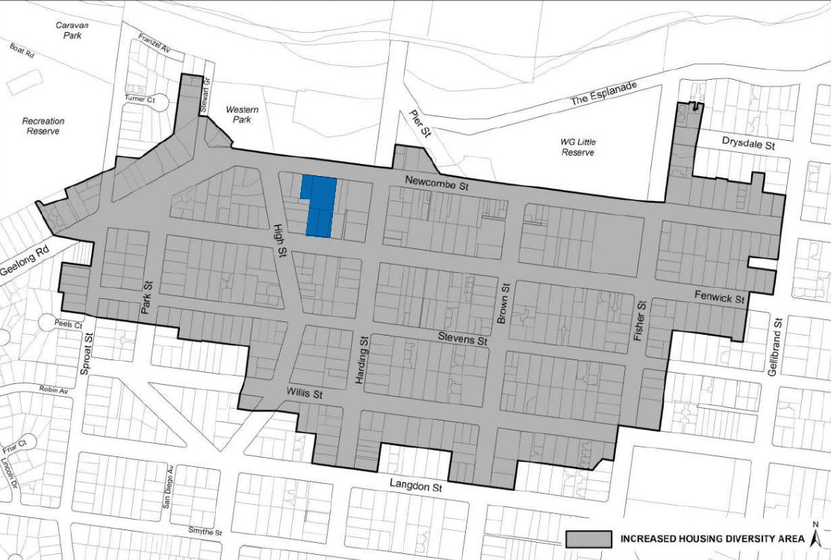
Figure 36 - Portarlington IHDA - Subject site shown blue
The IHDA policy specifies objectives to:

- Evolve the character of IHDAs through more intensive development.
- To support development that makes a positive architectural and urban design contribution to the IHDA.
- To maintain streetscape character in heritage areas.
- To promote pedestrian safety within the IHDA.

To achieve the specified objectives, a combination of General, Built Form and Building Height Strategies, Car parking and Heritage Strategies are set out. These strategies include to:

- Maximise opportunities for housing in IHDA by accommodating:
  - High density housing in activity centres,
  - Medium density housing in residential areas – with more intensive development located closest to the core of activity centres.
- Encourage a diversity of housing types to cater to a variety of lifestyle needs.
- Encourage development to provide a high level of on-site amenity for future residents.
- Encourage a sympathetic design response when addressing any unique characteristics such as heritage places.
- Discourage storage areas within the minimum area of secluded private open space.
- Support development that does not reduce opportunities or neighbouring sites to reasonably develop.
- Design development to recess upper levels to reduce dominance of the building form adjoining properties and the streetscape.
- Minimise visual prominence of car parking areas.
- Minimise the number of vehicle crossings and provide access from lower order roads where possible.
- Design development adjacent heritage places to respect and be sympathetic to the significance of the place.
- Set back building elements above one storey to be behind the ridgeline of heritage buildings.

Given Portarlington’s coastal location, additional policy relevant to Increased Housing Diversity in Coastal Areas is found at Clause 16.01-1L-03. This policy includes strategies to encourage innovative architecture that respects the coastal setting by incorporating:

- A variety of lightweight materials
- Building elements and details that contribute to a lightness of structure (including balconies, verandahs, extensive glazing, light transparent balustrading).
- Simple detailing
- Higher building elements to capture views.
- Retain the openness of the streetscape by avoiding the use of front fences or by providing low permeable front fences.
- Encourage landscaping to be incorporated into the overall development including planting of canopy trees and/or large shrubs within front setbacks.

The proposal is considered to adequately respond to the above strategies. The development of residential buildings up to three-storeys is encouraged in the IHDA policy and the RGZ seeks to encourage development up to four-storeys. While the C1Z does not contain a prescribed maximum number of storeys. It is considered that the built form proposed offers an appropriate scale of development within this location in the Portarlington town centre. The height, siting and design of the proposed apartment building is site responsive in that it limits its height to three-storeys at the frontage to Fenwick Street within the RGZ3, with the third storey being recessed approximately 10.4m from the second floor level below. At its northern frontage to Newcombe Street, the proposal would incorporate open balconies at first and second floor levels and recessed fourth and fifth floor levels of 6.25m and 19.46m, respectively. This contributes to a lightness of built form weight and responds to IHDA policy to recess upper levels to reduce dominance of the building form from adjoining properties and the streetscape.

The proposal would also provide a design response incorporating adequate side and rear setbacks in the context of the site, basement car parking which is generally obscured from view within the street, and a combination of external materials of light-weight finish such as white concrete render, glass balustrades and ‘timber look’ cladding.

The design of the building has been considered in further detail in response to the DDO21 found earlier in this report and the relevant built form policy objectives and strategies for Portarlington Town Centre elsewhere within this report. However, it is considered that the proposed development represents an appropriate balance of policy objectives and strategies for infill housing development at an increased densities, whilst offering a respectful design response to the evolving character of the locality. The proposal achieves this through providing increased housing density within the centre of the IHDA, contributing to an increase in housing diversity in this location. In principle, this is sought by IHDA policy, and contemplated by policy specific to Portarlington. Notably, the Portarlington Structure Plan (2016) specifically identifies this site as an opportunity for a major development, with accommodation at above retail premises at ground level.

The proposed side and rear setbacks will suitably limit the off-site amenity impacts to the neighbouring properties, including overshadowing, overlooking and visual bulk. In particular, as outlined in response to the DDO21 and in the relevant Clause 55 and Clause 58 assessments, it is considered that the interface of the proposal with the neighbouring residential properties fronting High Street is appropriate.

Balconies incorporating open corners and projecting roof forms will ensure that the external elevations of the proposed apartment building are well articulated and provide a high degree of visual interest, particularly when viewed from both Fenwick and Newcombe Streets, particularly in the context of the proposed landscaping design.

With specific regard to the part of the subject site that is zoned RGZ3, given the proximity to the core of the Portarlington IHDA, whilst the development exceeds three storeys, it is considered that the scale of the building is appropriate in this location. It is noted that given the slope of the site, the proposed development contains a combination of three and four storeys. The design of the proposal sees the top floor level substantially recessed from Fenwick Street, resulting in the fourth storey not covering the entirety of the buildings fronting Fenwick Street as outlined within Section A-A on the plans (below):
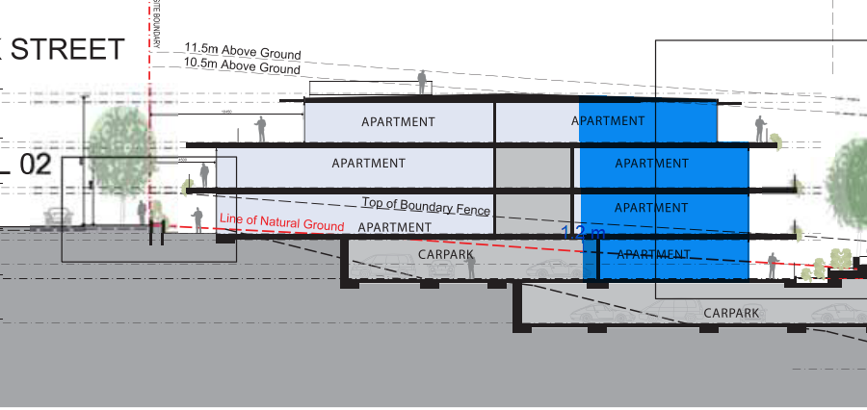
Figure 37 - Section A-A Proposed - Showing proposed Four-Storey area of buildings Fronting Fenwick Street highlighted dark blue.
With specific reference to neighbourhood character within the IHDAs, relevant policy requires acknowledgment of the reality that neighbourhood character in these areas will adapt and evolve overtime, particularly within and on the edges of activity centres, where land use and development will intensify.

It is acknowledged that the development of 59 dwellings on the site would vary the existing character of this part of Newcombe and Fenwick Streets, however it is clear that the Portarlington Town Centre and surrounding IHDA are expected to change in accordance with the relevant zoning and planning policy objectives for urban consolidation in this area.

In view of the above, it is considered that the proposal incorporates an appropriate design contribution to this location, where relevant planning policy seeks to direct infill housing at increased densities and promote dwelling diversity.

It is noted that the southern portion of the subject site zoned RGZ3 is not subject to any overlay. As such, it is prudent to note that there are no overlays applicable to the site which identifies view sharing considerations are applicable to this part of the site. Furthermore, there are no overlays applicable to any part of the subject site which require consideration of views from neighbouring dwellings in the surrounding RGZ3 towards the foreshore.

Clause 15.01-1S – Urban Design sets out strategies for safe, functional and good quality urban environments. The proposed development is supported in view of this policy given the subject site’s relative location to public transport, shopping centres and community services that allow for walking environments.

The proposed development is also considered to be consistent with Clause 15.01-2S – Building design. The development ensures that the form and scale does not detract from the amenity of the public realm. This is achieved by the combined setbacks from the boundaries, building and landscape forms and external facing materials. In particular, as the development increases in height, the setbacks also increase, limiting the visual dominance of the upper level visual bulk from the public realm and neighbouring dwellings

The application clearly proposes a contemporary design. The design response largely accords with relevant standards for siting, scale and site coverage. It is acknowledged that the Bellarine Peninsula planning policy speaks to reflect existing scale, setbacks, spacing, forms and materials within the locality. In this regard, the proposal picks up on the varied character of the surrounding area, whereby there are some examples of recent infill residential development, and older building stock which exhibit cuboid forms and minimal spacing between dwellings, as well as side and rear setbacks that are largely in accordance with the side and rear setback requirements of Clause 55 and Clause 58.

There is no significant vegetation on site, however as outlined in response to Clause 55 and Clause 58, it is considered that the proposal would exhibit an appropriate landscaping design concept. Conditions are recommended to be included on any permit issued to require a detail landscaping plan.

Retail / Shops Development

Portarlington is identified as a Town Centre within the Retail Activity Centre Hierarchy at Clause 02.4-2. In this regard, Clause 11.03-1L (Activity Centres in Greater Geelong) seeks to encourage a mix of retail, and higher density housing in Town Centres. Generally, policy supports increased intensity and vertical growth within centres to encourage expansion.

The City of Greater Geelong Retail Strategy 2020-2036, is a reference document within Clause 11.03-1L, and identifies that the Portarlington Town Centre serves the local Portarlington area and its surrounds. It acknowledges that a compact urban form is encouraged within planning policy and that as a result the role, size and intensity of the Town Centre is likely to continue into the future. A small increase in retail floor space demand has been identified by 2036 and this could be accommodated within the existing zoned land.

Specific to Portarlington, the policy applicable to coastal settlements and the Bellarine Peninsula at both Clauses 11.03-4S and 11.03-6L seeks to minimise linear urban sprawl and provide ground level retail floor space with accommodation on upper floor levels within the Portarlington Town Centre. In particular, the subject site has been strategically identified for retail premises at ground floor level fronting Newcombe Street as a priority for redevelopment.

As outlined in response to the C1Z, the proposal would contribute to the vibrancy and vitality of the Portarlington Town Centre. It would provide an additional 7 retail premises which would integrate into the established commercial centre, whilst contributing to the daily needs of residents within the proposed development and the centre itself. The proposed retail frontage would effectively activate the entire street frontage to Newcombe Street and would achieve the desired policy objectives to support the role and function of the Portarlington Town Centre.

Portarlington Town Centre / Structure Plan – Focal Building etc.

As outlined above, relevant IHDA policy anticipates that the neighbourhood character of these areas in and around activity centres will change and evolve through more intensive development. This policy applies to the C1Z and RGZ3 land forming the subject site.

In addition to this, a range of policy objectives and strategies apply to the Bellarine Peninsula, Portarlington, and the subject site in relation to coastal character and development built forms for both the township and the Town Centre. Objectives include supporting a network of diverse coastal settlements on the Bellarine Peninsula, containing growth within existing settlements and maintaining non-urban areas around settlements.

In this context, the Bellarine Peninsula is identified at Clause 11.03-5S as a distinctive area and landscape. The Bellarine Peninsula Localised Planning Statement 2015 is a reference document to this clause. Its Framework Plan map identifies eight existing coastal towns, including Portarlington. The statement seeks inter alia to maintain he non-urban breaks between settlements and preserve the individual identity and role of the townships.

It defines Portarlington as:

Portarlington is a smaller settlement with both a residential and tourism role. It is not a designated growth location. Portarlington is the northern most point on the Bellarine Peninsula and is an older settlement with strong links to its history as a fishing town and holiday resort.

Clause 11.03-6L-01 seeks to ensure development responds to the identity and preferred character of the individual township in which it is located. The objectives for Portarlington are outlined above. However prudently, the subject site is identified as a development opportunity site within this policy and support for the development of a focal building at 22-34 Newcombe Street is encouraged. The Structure Plan (2016) states at 3.3.5:

The Urban Design Framework 2011 (UDF) for Portarlington outlines a major development opportunity for a 2,380m² undeveloped site located at 22-34 Newcombe Street. The 2008 Structure Plan recommended that this site be developed as a focal building to contain a mix of retail uses, tourist accommodation and tourism related activities. Development of the site remains a priority for the town centre. While activated uses are necessary on the ground floor, as a result of no development on the site to date, a mix of options could be considered above the first level incorporating accommodation, offices or retail.

Having regard to the above, it is noted that what constitutes a ‘focal building’ is not relevantly defined within the Planning and Environment Act 1987, nor the Greater Geelong Planning Scheme. It is also noted that the structure plan does not prescribe what a ‘focal building’ would be. Rather, it simply identifies the site as a major development opportunity and outlines what the land use makeup of that development opportunity may be.

It is noted that within AGD Monea Holdings Pty Ltd v Greater Geelong CC [2021] VCAT 679, consideration of what constituted a focal building, as sought by relevant policies for the land subject of that decision, outlined that this could be a building distinguished by its height.

Whilst there are clear objectives in policy, through the structure plan and application of the DDO21 to respect the coastal landscape setting of Portarlington through reflecting existing scale, setbacks, spacing, forms and materials of buildings in the locality, it is considered that these objectives must be viewed in the context of the overall policy direction sought for the town. This includes consideration of ‘generally restricting buildings to two-storeys’ (in accordance with the DDO21), along with those other relevant objectives and strategies which seek inter alia to increase dwelling density and diversity around town centres, direct growth in coastal areas to within settlement boundaries, support development within Portarlington town centre incorporating accommodation uses above ground level retail floor space, and importantly – development of a focal building on the subject site.

Importantly in this regard, it is considered that the structure and performance based approach of DDO21 should be given substantial weight in determining whether or not the application provides an appropriate design response in view of the competing policy objectives applicable to the site and the Portarlington town centre. In effect the DDO21 integrates competing objectives for coastal planning, distinctive landscapes and activity centres to achieve acceptable planning outcomes. It distils the future built form outcome of the town centre of the Portarlington coastal settlement.

It is noted that one of the most significant elements of the proposal is its number of storeys being up to five (5) storeys. In this particular regard, the design objectives in table 1 to Schedule 21 of the DDO include:

To ensure that new buildings are designed to respond to the characteristics of the site and locality and demonstrate a high standard of contemporary expression.

The relevant design response includes:

Generally restrict buildings to a maximum height of two storeys. Higher elements must demonstrate that development:
- Is sympathetic to buildings of heritage significance and any residential interface;
- Is visually unobtrusive when viewed from the public foreshore;
- Is of high quality design.

It is noted that the design objectives do not seek to always limit building heights to two storeys within the town centre. Rather, they seek to ensure that buildings respond to the characteristic of the site and locality, with taller elements (above two-storeys) being sympathetic, visually unobtrusive in views from the foreshore and of high quality design as outlined above. It is clear through the DDO21 assessment response, that the design objectives have been met and that the proposal does provide a suitable design response which is sympathetic to buildings of heritage significance, and residential interfaces, is visually unobtrusive when viewed from the public foreshore and is of high quality design.

On balance, this is considered an acceptable response given the subject site’s physical context allows it and the planning policy promotes a focal building on this site. It is not considered that the development of the proposed building on the subject site would unreasonably impact on the typical low scale of the town centre that is identified within the Structure Plan. Importantly, it is acknowledged that the specific built-form make-up of a ‘focal building’ is not realised by the same policy which seeks development of a focal building. In this regard, it is considered a focal building may be distinguished by its height and the proposal will achieve this.

In view of the above, the application would provide a focal building on the subject site, in response to the objectives for Portarlington identified within Clause 11.03-6L-01. Given the substantial separation to the Grand Hotel, combined with the established vegetation within the foreshore reserve and the substantially recessed top floor levels, the proposed building would not unreasonably compete with the Grand Hotel as the traditional focal point of the Town Centre.

Other

As outlined within the planning history, the subject site has previously been used for a petrol station. Clause 13.04-1S applies to contaminated and potentially contaminated land. The objective seeks to ensure that contaminated and potentially contaminated land is used and developed safely. Relevant strategies include to ensure potentially contaminated land will be suitable for proposed uses prior to commencement of use or development and to protect sensitive uses from the effects of contamination.

As part of a previous planning permit to redevelop the subject site for sensitive land use, conditions were included on PP-1276-2003 which required that an environmental auditor appointed under the Environment Protection Act 1970 must make a statement that the conditions of the land are suitable for residential development.

It remains unclear whether any such statement was made as PP-1276-2003 was not acted upon. The applicant has confirmed via email dated 13 April 2022 that fuels tanks and associated infrastructure have been removed from the site and a report prepared in response to the relevant conditions on PP-1276-2020 confirmed this. The applicant further outlined that testing has occurred on site and discussions were being held with qualified consultants for the purpose of an environmental audit. Given the information available at this stage, it is considered necessary that any permit issued include conditions requiring an environmental audit prior to commencement of any development or sensitive use. The applicant has confirmed they anticipate any such condition would be required.

The application is supported by a Sustainability Management Plan (SMP) in response to Clause 15.01-2L, which seeks to achieve best practice in environmentally sustainable development from the design stage through to construction and operation. The submitted SMP has been reviewed by Council’s ESD officer who has confirmed that the proposal is supported subject to conditions requiring the detailing of commitments to relevant ESD initiatives being included on plans for endorsement. This can be required by way of conditions on any permit granted.

In addition, the application has not been supported by a Green Travel Plan, which is an application requirement under Clause 15.01-2L for developments of 10 or more dwellings. Given the application has demonstrated that the objectives of this policy can be achieved subject to appropriate conditions and noting that Council’s ESD officer has confirmed its support of the application, it is recommended that a Green Travel Plan is required to be submitted by way of conditions on any permit granted. It is recommended that any condition is suitably worded to require the Green Travel Plan be provided for review and approval by the responsible authority prior to the occupation of the development.

The proximity of the site to the neighbouring Portarlington Town Centre and main roads in the form of Newcombe Street, ensures that the proposed development would be well located for multipurpose trips and encouraging sustainable transport modes including active and public transport.

RELEVANT PARTICULAR PROVISIONS:

The following Particular Provisions are applicable to this application:

Clause 52.06 – Car Parking

Clause 52.34 – Bicycle Facilities

Clause 52.29 - Land Adjacent to the Principal Road Network

Clause 53.01 – Public Open Space Contribution

Clause 53.18 – Stormwater Management in Urban Development

Clause 55 – Construction of Two or More Dwellings on a Lot

Clause 58 – Apartment Developments

Response to Particular Provisions

CLAUSE 52.06 – CAR PARKING

- To ensure that car parking is provided in accordance with the State Planning Policy Framework and the Local Planning Policy Framework.
- To ensure the provision of an appropriate number of car parking spaces having regard to the demand likely to be generated, the activities on the land and the nature of the locality.
- To support sustainable transport alternatives to the motor car.
- To promotes the efficient use of car parking spaces through the consolidation of car parking facilities.
- To ensure that car parking does not adversely affect the amenity off the locality.
- To ensure that the design and location of car parking is of a high standard, creates a safe environment for users and enables easy and efficient use.

Response

A car parking plan has been submitted with the application. Car parking provision is proposed to be situated across three levels of basement accessed from Fenwick Street adjacent to the southern boundary of the site.

The car parking plan has been considered against the decision guidelines of Clause 52.06-10 and determined to be in accordance with the purpose of Clause 52.06.

The proposal requires the provision of 113 spaces on site as set out below:

Use | Type | Size/No. | Statutory parking Rate | Statutory parking requirement
Residential dwellings | Residents | 3 x 1-bed | 1 space per dwelling | 3 spaces
Residential dwellings | Residents | 51 x 2-bed | 1 space per dwelling | 51 spaces
Residential dwellings | Residents | 5 x 3-bed | 2 spaces per dwelling | 10 spaces
Residential dwellings | Visitors | 59 dwellings | 1 space to every 5 dwellings | 11 spaces
Residential subtotal |  |  |  | 75 spaces
Retail (Shop) |  | 963sqm | 4.0 spaces to each 100sqm | 38 spaces
Retail (shop) subtotal |  |  |  | 38 spaces
Total Required |  |  |  | 113 spaces
Total proposed |  |  |  | 85 spaces

The submitted Traffic Impact Assessment (TIA) suggests that car parking allocation on site would occur in the form of:

- Dwelling residents: 75 parking spaces
- Retail staff: 10 spaces

It is noted however, that this report was prepared on the basis of the original application which proposed 62 dwellings. Since the application was amended to remove three proposed dwellings, the proposed plans still show a total of 85 parking spaces however the allocation is revised as follows:

- Dwelling residents: 69 parking spaces
- Retail staff: 10 parking spaces
- TBA: 6 parking spaces

The information accompanying the s57a amendment did not seek to update the TIA and associated car parking demand assessment. It is not considered that it is necessary to update this information given that the car parking reduction now proposed is less than that considered by the TIA.

It is set out that the 6 car parking spaces that are no allocated would be available for purchase by future occupants if additional parking spaces are required.

The proposal seeks a reduction to the statutory car parking rate of 29 spaces. This equates to:

- 11 visitor parking spaces serving the proposed dwellings
- 18 parking spaces serving the proposed shops

The submitted traffic engineering report includes a car parking demand assessment (CPDA) in response to Clause 52.06-7. The assessment considers that the residential visitor parking demand would be akin to the statutory rate. It is expected that demand for residential visitors would likely occur during weekday evenings and on weekends; and visitors will typically seek to park in close proximity to the residential entrance to the building as practicable.
It is also outlined within the TIA that retail customer parking demand is anticipated to be greatest during business hours on weekdays and weekends. Given on-street parking is available, demand will likely be focused along Newcombe Street in the immediate vicinity of the site. It is noted that peak holiday periods will be the times when demand is highest.

It is acknowledged that customers and visitors will generally choose to park within available on-street spaces. The on-site parking will be secured for residential and retail occupants only as a result of this.

The CPDA concludes that sufficient on-street carparking is readily available to accommodate the shortfall of visitor and customer car parking on-site. This conclusion is based on car parking surveys within the locality. The surveys were carried out on Thursdays and Saturdays and identified the peak parking demand occurred at 1pm on Thursday, where 39% occupancy was recorded (236 vacant spaces remain) and 2pm on Saturday, where 38% occupancy was recorded (240 vacant spaces remain).

In terms of staff parking, it is outlined that typically 1 space to each 100m² of retail leasable floor area is expected to provide for staff parking. The proposal provides 10 spaces for the retail units to serve staff.

It is noted that Council’s traffic engineers have raised no objection to the grant of a permit to reduce the car parking on site associated with the proposal.

In view of the above, it is considered that the proposed shortfall of on-site carparking can be accommodated within the existing on-street and off-street public car parking in close proximity to the subject site.

Car Parking Design Standards

Plans prepared in accordance with Clause 52.06-8 must meet the design standards of Clause 52.06-9, unless the responsible authority agrees otherwise.

Design standard 1 – Accessways
Accessways must:  Be at least 3 metres wide. | Complies  All vehicle accessways and access to garages and car parking spaces are a minimum of 4.0 metres wide.
Accessways must:  Have an internal radius of at least 4 metres at changes of direction or intersection or be at least 4.2 metres wide. | Complies  4.2m widths are provided at changes of direction. swept path diagrams submitted as part of the transport impact assessment demonstrate all intersections and change of direction can be navigated without conflict.
Accessways must:  Allow vehicles parked in the last space of a dead-end accessway in public car parks to exit in a forward direction with one manoeuvre. | Complies  Swept path diagrams submitted as part of the traffic report demonstrate that all vehicles can enter and exit in a forward direction.
Accessways must:  Provide at least 2.1 metres headroom beneath overhead obstructions, calculated for a vehicle with a wheelbase of 2.8 metres. | Complies  Access ways to all parking spaces retain a minimum headroom of 2.2 metres and in accordance with the requirement.
Accessways must:  If the accessway serves four or more car spaces or connects to a road in a Transport Zone, the accessway must be designed so that cars can exit the site in a forward direction. | Complies  Swept path diagrams submitted as part of the traffic report demonstrate that all vehicles can enter and exit in a forward direction.
Accessways must:  Provide a passing area at the entrance at least 6.1 metres wide and 7 metres long if the accessway serves ten or more car parking spaces and is either more than 50 metres long or connects to a road in a Road Zone. | N/A – Ingress and egress points are one-way and no conflict occurs
Accessways must:  Have a corner splay or area at least 50 per cent clear of visual obstructions extending at least 2 metres along the frontage road from the edge of an exit lane and 2.5 metres along the exit lane from the frontage, to provide a clear view of pedestrians on the footpath of the frontage road. The area clear of visual obstructions may include an adjacent entry or exit lane where more than one lane is provided, or adjacent landscaped areas, provided the landscaping in those areas is less than 900mm in height. | Complies subject to conditions.  The shared accessway provides for sight lines in accordance with the design standard. Conditions are recommended requiring that the landscaping and any balustrading within the sight-line area is limited to no more than 900mm in height.
If an accessway to four or more car parking spaces is from land in a Transport Zone, the access to the car spaces must be at least 6 metres from the road carriageway. | N/A – Not connected to Transport Zone
If entry to the car space is from a road, the width of the accessway may include the road. | N/A – Parking spaces do not take direct access from a road

Design standard 2 – Car parking spaces
Car parking spaces and accessways must have the minimum dimensions as outlined in Table 2.  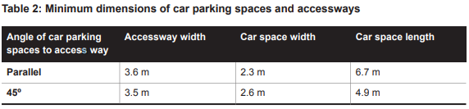  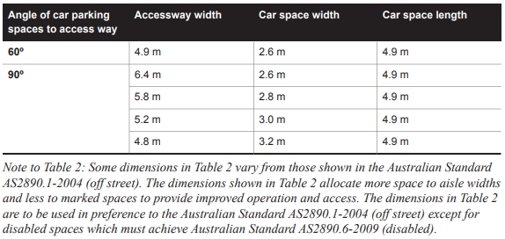 | Complies  All parking spaces are provided at 90 degrees to the relevant accessway with a minimum space dimension of 2.6 x 4.9 metres.
A wall, fence, column, tree, tree guard or any other structure that abuts a car space must not encroach into the area marked ‘clearance required’ on Diagram 1, other than:  - A column, tree or tree guard, which may project into a space if it is within the area marked ‘tree or column permitted’ on Diagram 1.  - A structure, which may project into the space if it is at least 2.1 metres above the space.  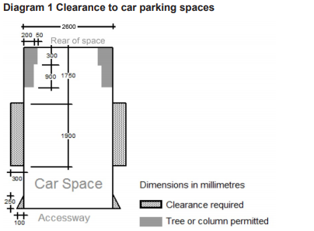 | Complies  Each car parking space provided is clear of encroachment in accordance with the requirement.  The basement car parking spaces are clear of columns and encroachments in accordance with Diagram 1 Clearance to car parking spaces of Clause 52.06-9.
Car spaces in garages or carports must be at least 6 metres long and 3.5 metres wide for a single space and 5.5 metres wide for a double space measured inside the garage or carport. | N/A – All parking provided at basement level.
Where parking spaces are provided in tandem (one space behind the other) an additional 500 mm in length must be provided between each space. | Complies  Tandem spaces are provided with an additional 500mm between each space.
Where two or more car parking spaces are provided for a dwelling, at least one space must be under cover. | Complies  All car parking spaces, are provided undercover, in excess of the requirement.
Disabled car parking spaces must be designed in accordance with Australian Standard AS2890.6-2009 (disabled) and the Building Code of Australia. Disabled car parking spaces may encroach into an accessway width specified in Table 2 by 500mm. | N/A – Disable parking spaces are not shown on the proposed plan

Design standard 3: Gradients
Accessway grades must not be steeper than 1:10 (10 per cent) within 5 metres of the frontage to ensure safety for pedestrians and vehicles. The design must have regard to the wheelbase of the vehicle being designed for; pedestrian and vehicular traffic volumes; the nature of the car park; and the slope and configuration of the vehicle crossover at the site frontage. This does not apply to accessways serving three dwellings or less. | Complies  The accessway grades are no more than 10% within 5 metres of the road frontage in accordance with the design standard.
Ramps (except within 5 metres of the frontage) must have the maximum grades as outlined in Table 3 and be designed for vehicles travelling in a forward direction.  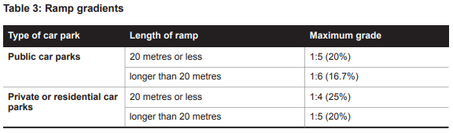 | Complies  A maximum grade of 1:4 is provided along the internal ramp within the basement carparking area in accordance with 52.06-9.
Where the difference in grade between two sections of ramp or floor is greater that 1:8 (12.5 per cent) for a summit grade change, or greater than 1:6.7 (15 per cent) for a sag grade change, the ramp must include a transition section of at least 2 metres to prevent vehicles scraping or bottoming. | Complies  A maximum change in grade of 1:8 is provided for summit changes and 1:6.7 for sag changes.
Plans must include an assessment of grade changes of greater than 1:5.6 (18 per cent) or less than 3 metres apart for clearances, to the satisfaction of the responsible authority. | N/A – Grade changes of greater than 1:5.6 are not proposed

Design standard 4: Mechanical parking

Mechanical parking may be used to meet the car parking requirement provided:  - At least 25 per cent of the mechanical car parking spaces can accommodate a vehicle height of at least 1.8 metres.  - Car parking spaces that require the operation of the system are not allocated to visitors unless used in a valet parking situation.  - The design and operation is to the satisfaction of the responsible authority. | N/A – No mechanical parking is proposed.

Design standard 5: Urban design
Ground level car parking, garage doors and accessways must not visually dominate public space. | Complies  Parking facilities are not generally visible from public space.
Car parking within buildings (including visible portions of partly submerged basements) must be screened or obscured where possible, including through the use of occupied tenancies, landscaping, architectural treatments and artworks. | Complies  Parking facilities are visually compatible with the development.
Design of car parks must take into account their use as entry points to the site. | Complies  Car parking is not proposed at the entry to the site.
Design of new internal streets in developments must maximise on street parking opportunities. | N/A – No new internal streets are proposed.

Design standard 6: Safety

Car parking must be well lit and clearly signed. | Complies, with condition recommended  No lighting detail has been proposed.  Were a permit to be granted, a condition is recommended that requires low-intensity lighting be provided in accordance with the requirement.
The design of car parks must maximise natural surveillance and pedestrian visibility from adjacent buildings. | Complies  The entrance to the parking basement parking area is clearly distinguishable when viewed from the street.
Pedestrian access to car parking areas from the street must be convenient. | Complies  Convenient access to carparking area is provided in accordance with the requirements.
Pedestrian routes through car parking areas and building entries and other destination points must be clearly marked and separated from traffic in high activity parking areas. | N/A – No high activity parking areas are proposed.

Design standard 7: Landscaping
The layout of car parking areas must provide for water sensitive urban design treatment and landscaping. | Complies  Appropriate WSUD treatments are proposed as part of the development.
Landscaping and trees must be planted to provide shade and shelter, soften the appearance of ground level car parking and aid in the clear identification of pedestrian paths. | Complies  Landscaping is provided to soften the appearance of the accessway where practical.
Ground level car parking spaces must include trees planted with flush grilles. Spacing of trees must be determined having regard to the expected size of the selected species at maturity. | N/A – No relevant ground level car parking is proposed.

CLAUSE 52.29 - LAND ADJACENT TO THE PRINCIPAL ROAD NETWORK

The purpose of Clause 52.29 is:

- To ensure appropriate access to the Principal Road Network or land planned to form part of the Principal Road Network.
- To ensure appropriate subdivision of land adjacent to Principal Road Network or land planned to form part of the Principal Road Network.

Decision guidelines

Before deciding on an application, in addition to the decision guidelines in clause 65, the responsible authority must consider:
- The Municipal Planning Strategy and the Planning Policy Framework.
- The views of the relevant road authority.
- The effect of the proposal on the operation of the road and on public safety.
- Any policy made by the relevant road authority pursuant to schedule 2, clause 3 of the Road Management Act 2004 regarding access between a controlled access road and adjacent land.

Response

The application proposes subdivision adjacent to Newcombe Street and removal of access points from Newcombe Street. As a result, the application has been referred to the Head, Transport for Victoria as the relevant road authority.

It is not considered that the proposal would cause unreasonable impacts on the operation of the road and on public safety and in this regard it is noted that no objection has been raised by the Head, Transport for Victoria.

It is therefore considered that the proposal would suitably accord with the purpose of Clause 52.29 and would address the relevant decision guidelines.

CLAUSE 52.34 – BICYCLE FACILITIES

The purpose of Clause 52.34 is:
- To encourage cycling as a mode of transport.
- To provide secure, accessible and convenient bicycle parking spaces and associated shower and change facilities

Response

Table 1 to Clause 52.34-5 requires 1 bicycle space to each 5 dwellings for residents, and 1 to each 10 dwellings for visitors. Equating to 11 resident and 5 visitor bicycle spaces.
A retail premises (shop) requires the provision of 1 employee space to each 600sqm if leasable floor area exceeds 1000sqm and 1 visitor space to each 500sqm of leasable floor area if the leasable floor area exceeds 1000sqm. The proposed leasable floor area for the shop premises does not exceed 1000sqm in total.
In view of the above, there is a required for 11 resident and 5 residential visitor bicycle spaces to be provided on site.

Whilst the submitted Traffic Impact Assessment refers to 23 proposed bicycle spaces, it is noted that the submitted Sustainability Management Plan specifies that a total of 106 bicycle parking spaces will be provided. these are in the form of 82 above bonnet bicycle spaces (identified as MLB on the proposed floor plans) and 24 bicycle spaces in a vertical ‘Ned Kelly’ arrangement within the communal storage areas. The proposal substantially exceeds the bicycle parking provision required.

Table 2 to Clause 52.34-5 sets out that showers are required for 5 or more employee bicycle spaces where required in accordance with Table 1. No employee spaces are required pursuant to Table 1. Therefore, no shower facilities are required.

Table 3 to Clause 52.34-5 sets out that change rooms are required to each shower, or access to a communal change room is required to each shower. As no showers are required, no change rooms are required.

CLAUSE 53.01 – PUBLIC OPEN SPACE CONTRIBUTION

A person who proposes to subdivide land must make a contribution to the council for public open space in an amount specified in the schedule to this clause (being a percentage of the land intended to be used for residential, industrial or commercial purposes, or a percentage of the site value of such land, or a combination of both). If no amount is specified, a contribution for public open space may still be required under Section 18 of the Subdivision Act 1988.

Response

Pursuant to the schedule to Clause 53.01, the following contribution is required to be made:

Creation of one additional lot | None
Creation of two to nine additional lots | 1 percent per additional lot up to a maximum of 5 percent
Creation of 10 or more lots on land zoned for residential purposes prior to August 31st 2007 | 5 percent
Creation of 10 or more lots on land zoned for residential purposes after August 31st 2007 | 10 percent
Waurn Ponds Creek Environs | 10 percent

Pursuant to the above table a 5% contribution is required to be made. A condition of permit requires a cash contribution to be made.

CLAUSE 53.06 – LIVE MUSIC ENTERTAINMENT VENUES

The purpose of Clause 53.06 is:
- To recognise that live music is an important part of the State’s culture and economy.
- To encourage the retention of existing and the development of new live music entertainment venues.
- To protect live music entertainment venues from the encroachment of noise sensitive residential uses.
- To ensure that noise sensitive residential uses are satisfactorily protected from unreasonable levels of live music and entertainment noise.
- To ensure that the primary responsibility for noise attenuation rests with the agent of change.

Response

Pursuant to Clause 53.06-1, this clause applies to an application required under any zone of the Greater Geelong Planning Scheme to use land for, or to construct a building or construct or carry out works associated with a noise sensitive use that is within 50 metres of a live music entertainment venue.

Adjacent the subject site to the east is an existing live music venue at 36 Newcombe Street.

The application is supported by an acoustic assessment report prepared by Resonate Consultants. The assessment considered predicted noise levels from internal and external music at the neighbouring live music venue. It recommends glazing and solid wall construction requirements to achieve adequate internal noise levels in the north-eastern proposed dwelling’s habitable rooms.

It is recommended that glazing and solid wall requirements outlined in the submitted acoustic assessment report required to be shown on plans and constructed on site prior to occupation of the dwellings. This can be required by conditions on any permit granted.

CLAUSE 53.18 – STORMWATER MANAGEMENT IN URBAN DEVELOPMENT

The purpose of Clause 53.18 is:

- To ensure that stormwater in urban development, including retention and reuse, is managed to mitigate the impacts of stormwater on the environment, property and public safety, and to provide cooling, local habitat and amenity benefits.

The requirements of Clause 53.18-3 set out that:

An application to subdivide land:

- Must meet all of the objectives of Clauses 53.18-4 and 53.18-6.
- Should meet all of the standards of Clauses 53.18-4 and 53.18-6.

An application to construct a building or construct or carry out works:
- Must meet all of the objectives of Clauses 53.18-5 and 53.18-6.
- Should meet all of the standards of Clauses 53.18-5 and 53.18-6.

An application must be accompanied by details of the proposed stormwater management system, including drainage works and retention, detention and discharges of stormwater to the drainage system.

The submitted Sustainability Management Plan details stormwater management initiatives. It is noted that the proposed subdivision is to subdivide dwellings such that the proposed dwellings would exist on separate titles. As such it is considered that the standards contained within Clauses 53.18-5 and 53.18-6 are relevantly applicable.

The SMP includes a STORM rating report which details that the proposal would meet best practice performance objectives as required by Standard W2 of Clause 53.18-5.

It is considered that subject to conditions on any permit granted, the proposal would meet the requirements of standard W3. Conditions would require that the site is suitably managed prior to and during construction to effectively manage erosion, stormwater, litter and contamination.

In view of the above, it is considered the proposal would accord with the objectives of clauses 53.18-4, 53.18-5 and 53.18-6.
CLAUSE 55 - RESCODE ASSESSMENT – TWO OR MORE DWELLINGS ON A LOT

The application has been assessed against the objectives and standards of Clause 55 of the Planning Scheme.

The Clause 55 assessment, included the Clause 55.07 assessment applies to the proposal within the RGZ3 as it is an apartment development that does not exceed 4 storeys.

A complete Clause 55 assessment is appended to this report.

CLAUSE 56 – SUBDIVISION

This is an application to subdivide the dwellings such that the dwellings will exist on separate titles. In this case there is no need to assess the application against the provisions of Clause 56 as issues in relation to amenity, both on and off site, have been considered via the Clause 55 assessment, as has neighbourhood character.

Should a permit be issued, a condition of permit is recommended which ties the subdivision and development via a Section 173 Agreement so that an orderly planning outcome is achieved.

CLAUSE 58 – APARTMENT DEVELOPMENTS

The application has been assessed against the objectives and standards of Clause 58 of the Planning Scheme.

The Clause 58 assessment applies to the proposal within the C1Z as it is an apartment development that is 5 or more storeys.

A complete Clause 58 assessment is appended to this report.

DECISION GUIDELINES OF CLAUSE 65:

CLAUSE 65.01 – APPROVAL OF AN APPLICATION OR PLAN

Clause 65.01 of the Greater Geelong Planning Scheme outlines the decision guidelines to be considered by the Responsible Authority when making decisions on applications. These decision guidelines include:

- The matters set out in Section 60 of the Act.
- The Municipal Planning Strategy and the Planning Policy Framework.
- The purpose of the zone, overlay or other provision.
- Any matter required to be considered in the zone, overlay or other provision.
- The orderly planning of the area.
- The effect on the amenity of the area.
- The proximity of the land to any public land.
- Factors likely to cause or contribute to land degradation, salinity or reduce water quality.
- Whether the proposed development is designed to maintain or improve the quality of stormwater within and exiting the site.
- The degree of flood, erosion or fire hazard associated with the location of the
land and the use, development or management of the land so as to minimise any such hazard.
- The adequacy of loading and unloading facilities and any associated amenity, traffic flow and road safety impacts.

CLAUSE 65.02 – SUBDIVISION

Clause 65.02 of the Greater Geelong Planning Scheme outlines the decision guidelines to be considered by the Responsible Authority when making decisions on an application to subdivide land. These decision guidelines include:

- The suitability of the land for subdivision
- The existing use and possible future development the land and nearby land
- The availability of subdivided land in the locality, and the need for the creation of further lots
- The effect of development on the use or development of other land which has a common means of drainage
- The subdivision pattern having regard to the physical characteristics of the land including existing vegetation
- The density of the proposed development
- The area and dimensions of each lost in the subdivision
- The movement of pedestrians and vehicles throughout the subdivision and the ease of access to all lots
- The design and siting of buildings having regard to safety and the risk of spread of fire
- The provision of off street parking
- The provision and location of common property
- The functions of any body corporate
- The availability and provision of utility services, including water, sewerage, drainage, electricity and gas

Response

The proposal has been assessed against the above and is considered to accord with the decision guidelines of both Clauses 65.01 and 65.02 of the Greater Geelong Planning Scheme.

CONCLUSION:

That the Responsible Authority having considered all matters which the Planning and Environment Act 1987, requires it to consider it is recommended that the Planning Committee decides to issue a Notice of Decision to Grant a Planning Permit for Use of the Land for Dwellings and Development of the Land for Seven (7) Shops and Fifty-Nine (59) Dwellings, Multi-Lot Subdivision Adjacent to a Transport Zone 2, Alter Access to a Transport Zone 2 and Reduction of Car Parking at 20-34 Newcombe St & 25-27 Fenwick St, PORTARLINGTON in accordance with the plans and documentation submitted with the application subject to conditions.

APPENDIX 1(a): CLAUSE 55 ASSESSMENT TOOL – TWO OR MORE DWELLINGS ON A LOT AND RESIDENTIAL BUILDINGS

Date of Assessment: 30th January 2023
Plans Assessed: S57a Plans – Received: 22nd August 2022
Permit Application Number: PP-916-2020 – 20, 22-34 Newcombe Street and 25-27 Fenwick Street

The following objectives apply to an application to:
- Construct a dwelling if there is at least one dwelling existing on the lot,
- Construct two or more dwellings on a lot,
- Extend a dwelling if there are two or more dwellings on the lot,
- Construct or extend a dwelling on common property, or
- Construct or extend a residential building,

This assessment is only applicable to the Residential Growth Zone Schedule 3 land forming part of the application site.

55.02-1 Neighbourhood character objectives  To ensure that the design respects the existing neighbourhood character or contributes to a preferred neighbourhood character.  To ensure that the design responds to the features of the site and the surrounding area. | Standard B1  The design response must be appropriate to the neighbourhood and the site.  The proposed design must respect the existing or preferred neighbourhood character and respond to the features of the site. | Yes – Complies with Standard B1  The proposal is considered to adequately respond to the preferred character of the area. The development of residential buildings up to four-storeys is encouraged under the zone, and it is considered that the built form proposed offers an appropriate scale of development within this location in close proximity to the Portarlington town centre. The height, siting and design of the proposed apartment building is site responsive in that it limits its height to three storeys at the frontage to Fenwick Street, incorporates a recessed top (4th) floor level and has been designed to provide appropriate spacing from the neighbouring dwellings and provides adequate spacing between buildings on site.
55.02-2 Residential policy objectives  To ensure that residential development is provided in accordance with any policy for housing in the State Planning Policy Framework and the Local Planning Policy Framework, including the Municipal Strategic Statement and local planning policies.  To support medium densities in areas where development can take advantage of public transport and community infrastructure and services. | Standard B2  An application must be accompanied by a written statement to the satisfaction of the responsible authority that describes how the development is consistent with any relevant policy for housing in the Municipal Planning Strategy and the Planning Policy Framework | Yes – Complies with Standard B2  As set out above, the application complies with the planning policy framework. The required written statement has been provided.
55.02-3 Dwelling diversity objective  To encourage a range of dwelling sizes and types in developments of ten or more dwellings. | Standard B3  Developments of ten or more dwellings should provide a range of dwelling sizes and types, including:  - Dwellings with a different number of bedrooms.  - At least one dwelling that contains a kitchen, bath or shower, and a toilet and wash basin at ground floor level. | Yes – Complies with Standard B3  The development proposes 24 dwellings within the RGZ3 land.  The proposal includes a total of two one-bedroom apartments, twenty two-bedroom apartments and two three-bedroom apartments.  Numerous dwellings forming part of the development are situated at ground level.
55.02-4 Infrastructure objectives  To ensure development is provided with appropriate utility services and infrastructure.  To ensure development does not unreasonably overload the capacity of utility services and infrastructure. | Standard B4  Development should be connected to reticulated services, including reticulated sewerage, drainage, electricity and gas, if available.  Development should not unreasonably exceed the capacity of utility services and infrastructure, including reticulated services and roads.  In areas where utility services or infrastructure have little or no spare capacity, developments should provide for the upgrading of or mitigation of the impact on services or infrastructure. | Yes – Complies with Standard B4  The site is serviced by the required infrastructure and the application has been referred to Council’s Engineers who have not raised any concern about the ability of the site to be drained. Conditions of permit cover off on this issue.
55.02-5 Integration with the street objectives  To integrate the layout of development with the street. | Standard B5  Developments should provide adequate vehicle and pedestrian links that maintain or enhance local accessibility.  Development should be oriented to front existing and proposed streets.  High fencing in front of dwellings should be avoided if practicable.  Development next to existing public open space should be laid out to complement the open space. | Yes – Complies with Standard B5  The development within the RGZ3 is designed to address Fenwick Street, with pedestrian and vehicle links to the street provided.  There is no high front fencing proposed for this development fronting Fenwick Street.
55.03-1 Street setback objective  To ensure that the setbacks of buildings from a street respect the existing or preferred neighbourhood character and make efficient use of the site. | Standard B6  Walls of buildings should be set back from streets:  - At least the distance specified in a schedule to the zone, or  - If no distance is specified in a schedule to the zone, the distance specified in Table B1.  Porches, pergolas and verandahs that are less than 3.6 metres high and eaves may encroach not more than 2.5 metres into the setbacks of this standard.  Schedule 3 to the Residential Growth Zone varies standard B6 as follows:  If the site is in a heritage overlay, the average distance of the setbacks of the front walls of the existing buildings on the abutting allotments facing the front street or 9 metres, whichever is the lesser.  In all other areas, the average distance of the setbacks of the front walls of the existing buildings on the abutting allotments facing the front street or 5.5 metres, whichever is the lesser. | Yes – Complies, with variation to Standard B6  The adjoining properties fronting Fenwick Street consist of number 29 Fenwick Street to the east and number 7 High Street to the west.  The dwelling at number 29 Fenwick Street is set back 4.7 metres from the street.  The dwelling at number 7 High Street fronts High Street and only exhibits a side frontage to Fenwick Street.  In view of the above the street setback standard is determined by the street setback, to the front wall, of number 29 Fenwick Street, which is 4.72 metres.  The proposed street setback to the front wall of the dwellings fronting Fenwick Street would be 4.48m at ground level.  At first-floor level, the dwellings fronting Fenwick Street would exhibit a setback to their front wall of 5.54 metres. The balconies serving these first-floor dwellings would project forwards, with a minimum setback of 2.45 metres. As the first-floor balconies would exceed 3.6m in height, it is noted that the minimum street setback for the purpose of applying standard B6 is 2.45m.  There are two points of non-compliance with standard B6. These are:  - Ground-floor dwellings set back 4.48m (non-compliance of 240mm)  - First-floor balconies setback 2.45 metres (non-compliance of 2.27 metres.  Variation required  The decision guidelines require consideration to be given to the following issues:  - The design response.  - Whether a different setback would be more appropriate taking into account the prevailing setbacks of existing buildings on nearby lots.  - The visual impact of the building when viewed from the street and from adjoining properties.  - The value of retaining vegetation within the front setback.  Comments:  The proposed design response includes substantial side setbacks and separation between the two ‘wings’ of the proposed building fronting Fenwick Street. At the Fenwick Street frontage, the proposed wings fronting Fenwick Street would be sited 7 metres would be setback from the eastern and western side boundaries by 5.7 metres, respectively.  Whilst the existing dwelling at number 7 High Street does not front Fenwick Street, it is acknowledged to provide built form presenting to Fenwick Street in the form of a side street setback of 1.745m. As such, it is considered that the proposed reduced street setback goes some way to providing a visual step between the side elevation of 7 High Street and as such responds to the immediate built form context in this regard.  It is also noted that the front walls of the proposed dwellings fronting Fenwick Street would mostly comply with the street setback standard, except for the ground-floor dwellings which exhibit a largely nominal non-compliance of 240mm.  The first floor balconies exhibit the minimum proposed street setback of 2.45 metres. As the proposed balconies would be relatively open in their appearance presenting to Fenwick Street, it is not considered that this reduced street setback would result in an unreasonable visual impact when viewed from the street or adjoining properties.  The subject site does not exhibit significant vegetation. As such it is not considered that the proposed reduction to the front setback would result in a loss of vegetation in this regard. It is noted that a landscape proposal has been submitted in support of the overall development the landscaped area between the two wings fronting Fenwick Street would retain sufficient space for landscaping and vegetation.  In view of the above it is considered that the proposed variation to standard B6 would remain in accordance with the objectives of Clause 55.03-1 to ensure that the setbacks of buildings from a street respect the existing or preferred neighbourhood character and make efficient use of the site.
55.03-2 Building height objectives  To ensure that the height of buildings respects the existing or preferred neighbourhood character. | Standard B7  The maximum building height should not exceed the maximum height specified in the zone, schedule to the zone or an overlay that applies to the land.  If no maximum height is specified in the zone, schedule to the zone or an overlay, the maximum building height should not exceed 9 metres, unless the slope of the natural ground level at any cross section wider than 8 metres of the site of the building is 2.5 degrees or more, in which case the maximum building height should not exceed 10 metres.  Changes of building height between existing buildings and new buildings should be graduated. | Yes – Complies with Standard B7  The maximum height permitted in the zone is 10.5 metres. However, this may be exceeded by up to 1 metre if the slope of the natural ground level measured at any cross section of the site of the building wider than 8metres is greater than 2.5 degrees.  The tallest part of the proposal, within the RGZ3, is sited over an area of the site where the slope is greater than 2.5 degrees. As such a maximum height of 11.5m is permissible.  The maximum height proposed is 11.3m in this respect and therefore complies with the maximum height specified in the schedule to the zone.
55.03-3 Site coverage objective  To ensure that the site coverage respects the existing or preferred neighbourhood character and respond to the features of the site. | Standard B8  The site area covered by buildings should not exceed:  - The maximum site coverage specified in a schedule to the zone, or  - If no maximum site coverage is specified in a schedule to the zone, 60 per cent.  Schedule 3 to the RGZ varies standard B8 to allow for a maximum site coverage of 70%. | Yes – Complies with Standard B8  The site coverage of buildings within the RGZ3 area is 63.8% of the site, which complies with the maximum 70% allowed by the standard.
55.03-4 Permeability and stormwater management objectives  To reduce the impact of increased stormwater run-off on the drainage system.  To facilitate on-site stormwater infiltration.  To encourage stormwater management that maximises the retention and reuse of stormwater. | Standard B9  The site area covered by the pervious surfaces should be at least:  - The minimum area specified in a schedule to the zone, or  - If no minimum is specified in a schedule to the zone, 20 percent of the site.  The stormwater management system should be designed to:  - Meet the current best practice performance objectives for stormwater quality as contained in the Urban Stormwater - Best Practice Environmental Management Guidelines (Victorian Stormwater Committee, 1999).  - Contribute to cooling, improving local habitat and providing attractive and enjoyable spaces. | Yes – Complies with variation to Standard B9  As the RGZ3 land is 1689sqm, a total of 337.8sqm of permeable areas would be required to comply with standard B9.  Variation required  The application is supported by a Sustainability Management Plan which is applicable to the whole development. The SMP sets out that approximately 100sqm of the site zoned RGZ3 would be permeable. It is noted that a total of 264sqm of the entire planning unit across the RGZ3 and the C1Z is identified as permeable. This is due to the extent of basement car parking proposed.  Notwithstanding the above, the SMP includes a STORM rating report which details that the proposed development, across the entirety of the planning unit would achieve best practice performance objectives for stormwater quality.  Decision Guidelines  - The design response.  - The capacity of the site to incorporate stormwater retention and reuse.  - The existing site coverage and any constraints imposed by existing development.  - The capacity of the drainage network to accommodate additional stormwater.  - The capacity of the site to absorb run-off.  - The practicality of achieving the minimum site coverage of pervious surfaces, particularly on lots of less than 300 square metres.  - Whether the owner has entered into an agreement to contribute to off-site stormwater management in lieu of providing an on-site stormwater management system.  Comments:  The design response exhibits limited permeable surfaces given the level of basement parking proposed. The basement parking would visually obscure the car parking provision associated with the proposed development. The design response seeks to mitigate the visual impact of car parking on site when viewed from the public realm.  As outlined above, the application is supported by an SMP which demonstrates that the proposed development, across the entire planning unit would achieve best practice. It is considered appropriate to consider the stormwater management response in the context of the entire development and not across the various zones in this respect, as the stormwater management system would be homogenous across both the RGZ3 and C1Z land.  In addition, the above it is noted that the Council’s development planning engineers have not raised any objection to the grant of a permit based on increased runoff to the existing drainage network.  The proposed development would capture runoff from roof and balcony areas within rainwater tanks with a storage capacity of 70,000L. The stored rainwater would be connected to all toilets in the residential and commercial units for reuse.  In view of the above it is considered that the proposal provides an adequate stormwater management system which can achieve best practice objectives in accordance with Standard B9.
55.03-5 Energy efficiency objectives  To achieve and protect energy efficient dwellings and residential buildings.  To ensure the orientation and layout of development reduce fossil fuel energy use and make appropriate use of daylight and solar energy.  This objective does not apply:  - To construct or extend an apartment development, or  - To construct or extend a dwelling in or forming part of an apartment development.  Refer 55.07-1 - Energy efficiency objectives | Standard B10  Buildings should be:  - Oriented to make appropriate use of solar energy.  - Sited and designed to ensure that the energy efficiency of existing dwellings on adjoining lots is not unreasonably reduced.  - Sited and designed to ensure that the performance of existing rooftop solar energy facilities on dwellings on adjoining lots in a General Residential Zone, Neighbourhood Residential Zone or Township Zone are not unreasonably reduced. The existing rooftop solar energy facility must exist at the date the application is lodged.  Living areas and private open space should be located on the north side of the development, if practicable.  Developments should be designed so that solar access to north-facing windows is maximised. | Refer – Clause 55.07-1
55.03-6 Open space objective  To integrate the layout of development with any public and communal open space provided in or adjacent to the development.  This objective does not apply:  - To construct or extend an apartment development, or  - To construct or extend a dwelling in or forming part of an apartment development.  Refer 55.07-2 Communal Open Space Objective | Standard B11  If any public or communal open space is provided on site, it should:  - Be substantially fronted by dwellings, where appropriate.  - Provide outlook for as many dwellings as practicable.  - Be designed to protect any natural features on the site.  - Be accessible and useable. | Refer – Clause 55.07-2
55.03-7 Safety objective  To ensure the layout of development provides for the safety and security of residents and property. | Standard B12  Entrances to dwellings and residential buildings should not be obscured or isolated from the street and internal accessways.  Planting which creates unsafe spaces along streets and accessways should be avoided.  Developments should be designed to provide good lighting, visibility and surveillance of car parks and internal accessways.  Private spaces within developments should be protected from inappropriate use as public thoroughfares. | Yes – Complies with Standard B12  The development is designed to provide for the safety and security of residents and property. The dwellings clearly present to Fenwick Street as an apartment building. Entrance lobbies are proposed centrally within the building, accessed via the central courtyard off Fenwick Steet. This central access point would clearly read as the access to the dwellings from Fenwick Street.  This area is entirely surrounded by dwellings and is considered to be adequately designed to maintain safety, visibility and surveillance.
55.03-8 Landscaping objectives  To encourage development that respects the landscape character of the neighbourhood.  To encourage development that maintains and enhances habitat for plants and animals in locations of habitat importance.  To provide appropriate landscaping.  To encourage the retention of mature vegetation on the site.  This objective does not apply:  - To construct or extend an apartment development, or  - To construct or extend a dwelling in or forming part of an apartment development.  Refer 55.07-4 – Landscaping Objective | Standard B13  The landscape layout and design should:  - Protect any predominant landscape features of the neighbourhood.  - Take into account the soil type and drainage patterns of the site.  - Allow for intended vegetation growth and structural protection of buildings.  - In locations of habitat importance, maintain existing habitat and provide for new habitat for plants and animals.  - Provide a safe, attractive and functional environment for residents.  Development should provide for the retention or planting of trees, where these are part of the character of the neighbourhood.  Development should provide for the replacement of any significant trees that have been removed in the 12 months prior to the application being made.  The landscape design should specify landscape themes, vegetation (location and species), paving and lighting.  Development should meet any additional landscape requirements specified in a schedule to the zone. | Refer– Clause 55.07-4
55.03-9 Access objective  To ensure the number and design of vehicle crossovers respects the neighbourhood character. | Standard B14  The width of accessways or car spaces should not exceed:  - 33 per cent of the street frontage, or  - if the width of the street frontage is less than 20 metres, 40 per cent of the street frontage.  No more than one single-width crossover should be provided for each dwelling fronting a street.  The location of crossovers should maximise the retention of on-street car parking spaces.  The number of access points to a road in a Road Zone should be minimised.  Developments must provide for access for service, emergency and delivery vehicles. | Yes – Complies with Standard B14  A total of 21.78% of the frontage is taken up with vehicle crossings, which complies with the standard.  The number of crossovers proposed is considered to be minimised as the proposal exhibits only one ingress and one egress. These access points are also from the lower order road of Fenwick Street as opposed to Newcombe Street.
55.03-10 Parking location objective  To provide convenient parking for resident and visitor vehicles.  To protect residents from vehicular noise within developments. | Standard B15  Car parking facilities should:  - Be reasonably close and convenient to dwellings and residential buildings.  - Be secure.  - Be well ventilated if enclosed.  Large parking areas should be broken up with trees, buildings or different surface treatments.  Shared accessways or car parks of other dwellings and residential buildings should be located at least 1.5 metres from the windows of habitable rooms. This setback may be reduced to 1 metre where there is a fence at least 1.5 metres high or where window sills are at least 1.4 metres above the accessway. | Yes – Complies with Standard B15  Convenient parking is provided for residents and shared accessways.  The ingress and egress ramps down adjacent the western side of proposed apartment 16 and the eastern side of apartment 19, respectively.  The bedroom windows of these dwellings are in excess of 1.4m above the accessways.  The living, kitchen and dining areas of these dwellings are within 1.5m metres of the accessways however they would be provided with a privacy screen/barrier up to at least 1.5m.
55.04-1 Side and rear setbacks objective  To ensure that the height and setback of a building from a boundary respects the existing or preferred neighbourhood character and limits the impact on the amenity of existing dwellings. | Standard B17  A new building not on or within 200mm of a boundary should be set back from side or rear  boundaries:  - At least the distance specified in a schedule to the zone, or  - If no distance is specified in a schedule to the zone, 1 metre, plus 0.3 metres for every metre of height over 3.6 metres up to 6.9 metres, plus 1 metre for every metre of height over 6.9 metres.  Sunblinds, verandahs, porches, eaves, fascias, gutters, masonry chimneys, flues, pipes, domestic fuel or water tanks, and heating or cooling equipment or other services may encroach not more than 0.5 metres into the setbacks of this standard.  Landings having an area of not more than 2 square metres and less than 1 metre high, stairways, ramps, pergolas, shade sails and carports may encroach into the setbacks of this standard. | Yes – Complies Standard B17  The required setbacks have been achieved for the development and all side and rear setbacks comply with the formula contained in the standard.  All walls in the RGZ land are sited to meet the ResCode building envelopes related to the wall height/setback ratio with only eaves projecting into the setbacks as shown in the Section G-G.  The eaves only extend a maximum of 400mm into the setbacks at Section G-G and reduce back to zero at Section E-E.
55.04-2 Walls on boundaries objective  To ensure that the location, length and height of a wall on a boundary respects the existing or preferred neighbourhood character and limits the impact on the amenity of existing dwellings. | Standard B18  A new wall constructed on or within 200mm of a side or rear boundary of a lot or a carport constructed on or within 1 metre of a side or rear boundary of lot should not abut the boundary:  - For a length of more than the distance specified in a schedule to the zone; or  - If no distance is specified in a schedule to the zone, for a length of more than:  - 10 metres plus 25 per cent of the remaining length of the boundary of an adjoining lot, or  - Where there are existing or simultaneously constructed walls or carports abutting the boundary on an abutting lot, the length of the existing or simultaneously constructed walls or carports,  whichever is the greater.  A new wall or carport may fully abut a side or rear boundary where slope and retaining walls or fences would result in the effective height of the wall or carport being less than 2 metres on the abutting property boundary.  A building on a boundary includes a building set back up to 200mm from a boundary.  The height of a new wall constructed on or within 200mm of a side or rear boundary or a carport constructed on or within 1 metre of a side or rear boundary should not exceed an average of 3.2 metres with no part higher than 3.6 metres unless abutting a higher existing or simultaneously constructed wall. | N/A  There are no new walls proposed on property boundaries within the RGZ3 land.
55.04-3 Daylight to windows objective  To allow adequate daylight into existing habitable room windows. | Standard B19  Buildings opposite an existing habitable room window should provide for a light court to the existing window that has a minimum area of 3 square metres and minimum dimension of 1 metre clear to the sky. The calculation of the area may include land on the abutting lot.  Walls or carports more than 3 metres in height opposite an existing habitable room window should be set back from the window at least 50 per cent of the height of the new wall if the wall is within a 55 degree arc from the centre of the existing window. The arc may be swung to within 35 degrees of the plane of the wall containing the existing window.  Where the existing window is above ground floor level, the wall height is measured from the floor level of the room containing the window. | Yes – Complies with Standard B19  The required light courts have been achieved and all windows have access to the required level of daylight.
55.04-4 North facing windows objective  To allow adequate solar access to existing north-facing habitable room windows. | Standard B20  If a north-facing habitable room window of an existing dwelling is within 3 metres of a boundary on an abutting lot, a building should be setback from the boundary 1 metre, plus 0.6 metres for every metre of height over 3.6 metres up to 6.9 metres, plus 1 metre for every metre of height over 6.9 metres, for a distance of 3 metres from the edge of each side of the window. A north-facing window is a window with an axis perpendicular to its surface oriented north 20 degrees west to north 30 degrees east. | N/A  There are no north facing windows on abutting lots which require consideration.
55.04-5 Overshadowing open space objective  To ensure buildings do not significantly overshadow existing secluded private open space. | Standard B21  Where sunlight to the secluded private open space of an existing dwelling is reduced, at least 75 per cent, or 40 square metres with minimum dimension of 3 metres, whichever is the lesser area, of the secluded private open space should receive a minimum of five hours of sunlight between 9 am and 3 pm on 22 September.  If existing sunlight to the secluded private open space of an existing dwelling is less than the requirements of this standard, the amount of sunlight should not be further reduced. | Yes – Complies with Standard B21  The level of overshadowing associated with the development is within the requirements of the standard.
55.04-6 Overlooking objective  To limit views into existing secluded private open space and habitable room windows. | Standard B22  A habitable room window, balcony, terrace, deck or patio should be located and designed to avoid direct views into the secluded private open space of an existing dwelling within a horizontal distance of 9 metres (measured at ground level) of the window, balcony, terrace, deck or patio. Views should be measured within a 45 degree angle from the plane of the window or perimeter of the balcony, terrace, deck or patio, and from a height of 1.7 metres above floor level.  A habitable room window, balcony, terrace, deck or patio with a direct view into a habitable room window of existing dwelling within a horizontal distance of 9 metres (measured at ground level) of the window, balcony, terrace, deck or patio should be either:  - Offset a minimum of 1.5 metres from the edge of one window to the edge of the other.  - Have sill heights of at least 1.7 metres above floor level.  - Have fixed, obscure glazing in any part of the window below 1.7 metre above floor level.  - Have permanently fixed external screens to at least 1.7 metres above floor level and be no more than 25 per cent transparent.  Obscure glazing in any part of the window below 1.7 metres above floor level may be openable provided that there are no direct views as specified in this standard.  Screens used to obscure a view should be:  - Perforated panels or trellis with a maximum of 25 per cent openings or solid translucent panels.  - Permanent, fixed and durable.  - Designed and coloured to blend in with the development.  This standard does not apply to a new habitable room window, balcony, terrace, deck or patio which faces a property boundary where there is a visual barrier at least 1.8 metres high and the floor level of the habitable room, balcony, terrace, deck or patio is less than 0.8 metres above ground level at the boundary. | Yes – Complies with Standard B22  The development is designed to meet the requirements of the standard and therefore views into existing secluded private open space areas and habitable room windows have been limited.  Proposed dwellings which have outlook to the east or west from the RGZ3 land, would be provided with privacy screens where their windows are within 9 metres of the common boundary with adjacent dwellings, as shown in section F-F Detail 02.  The same section F-F Detail 02 shows an overlooking screen to east and west facing apartments at second floor level. However it is also noted that views from these dwellings to neighbouring site would see the 9m arc screened by the projecting first-floor level ceiling below.  The rooftop balconies serving apartments 2.08 and 2.09 would be in excess of 9 metres from the common boundary with adjacent dwellings.
55.04-7 Internal views objective  To limit views into the secluded private open space and habitable room windows of dwellings and residential buildings within a development. | Standard B23  Windows and balconies should be designed to prevent overlooking of more than 50 per cent of the secluded private open space of a lower-level dwelling or residential building directly below and within the same development. | Yes – Complies with Standard B23  Internal views have been considered in the design solution and internal overlooking is prevented by privacy screens to east and west facing windows fronting the central courtyard from Fenwick Street.  Similarly, privacy screens are proposed at the sides of balconies to prevent overlooking to neighbouring proposed dwelling’s habitable rooms and balcony areas.
55.04-8 Noise impacts objective  To contain noise sources in developments that may affect existing dwellings.  To protect residents from external noise.  This objective does not apply:  - To construct or extend an apartment development, or  - To construct or extend a dwelling in or forming part of an apartment development.  Refer 55.07-7 Noise Impacts Objective | Standard B24  Noise sources, such as mechanical plant, should not be located near bedrooms of immediately adjacent existing dwellings.  Noise sensitive rooms and secluded private open spaces of new dwellings and residential buildings should take account of noise sources on immediately adjacent properties.  Dwellings and residential buildings close to busy roads, railway lines or industry should be designed to limit noise levels in habitable rooms. | Refer - Clause 55.07-7
55.05-1 Accessibility objective  To encourage the consideration of the needs of people with limited mobility in the design of developments.  This objective does not apply:  - To construct or extend an apartment development, or  - To construct or extend a dwelling in or forming part of an apartment development.  Refer 55.07-8 – Accessibility Objective | Standard B25  The dwelling entries of the ground floor of dwellings and residential buildings should be accessible or able to be easily made accessible to people with limited mobility. | Refer – Clause 55.07-8
55.05-2 Dwelling entry objective  To provide each dwelling or residential building with its own sense of identity.  This objective does not apply:  - To construct or extend an apartment development, or  - To construct or extend a dwelling in or forming part of an apartment development.  Refer 55.07-16 – Building entry and circulation objective | Standard B26  Entries to dwellings and residential buildings should:  - Be visible and easily identifiable from streets and other public areas.  - Provide shelter, a sense of personal address and a transitional space around the entry. | Refer – Clause 55.07-16
55.05-3 Daylight to new windows objective  To allow adequate daylight into new habitable room windows.  This objective does not apply:  - To construct or extend an apartment development, or  - To construct or extend a dwelling in or forming part of an apartment development.  Refer 55.07-14 – Windows objective | Standard B27  A window in a habitable room should be located to face:  - An outdoor space clear to the sky or a light court with a minimum area of 3 square metres and minimum dimension of 1 metre clear to the sky, not including land on an abutting lot, or  - A verandah provided it is open for at least one third of its perimeter, or  - A carport provided it has two or more open sides and is open for at least one third of its perimeter. | Refer – Clause 55.07-14
55.05-4 Private open space objective  To provide adequate private open space for the reasonable recreation and service needs of residents.  This objective does not apply:  - To construct or extend an apartment development, or  - To construct or extend a dwelling in or forming part of an apartment development.  Refer 55.07-9 –Private Open Space Objective | Standard B28  A dwelling or residential building should have private open space of an area and dimensions specified in the schedule to the zone.  If no area or dimensions are specified in the schedule to the zone, a dwelling or residential building should have private open space consisting of:  - An area of 40 square metres, with one part of the private open space to consist of secluded private open space at the side or rear of the dwelling or residential building with a minimum area of 25 square metres, a minimum dimension of 3 metres and convenient access from a living room, or  - A balcony of 8 square metres with a minimum width of 1.6 metres and convenient access from a living room, or  - A roof-top area of 10 square metres with a minimum width of 2 metres and convenient access from a living room. | Refer – Clause 55.07-9
55.05-5 Solar Access to Open Space  To allow solar access into the secluded private open space of new dwellings and residential buildings. | Standard B29  The private open space should be located on the north side of the dwelling or residential building, if appropriate.  The southern boundary of secluded private open space should be set back from any wall on the north of the space at least (2+0.9h) metres, where ‘h’ is the height of the wall. | Yes – Complies, with variation to Standard B29  Variation required  Given the proposed dwellings would be apartments, served by balconies for secluded private open space areas, there are a number of SPOS areas which would not meet the southern boundary setback formula contained within the standard.  Decision Guidelines  Before deciding on an application, the responsible authority must consider:  - The design response.  - The useability and amenity of secluded private open space based on the sunlight it will received.  Comments:  The proposed design response seeks to provide balconies with more than 1 aspect to the majority of proposed dwellings.  Of the 24 proposed dwellings within the RGZ3, 8 would exhibit balconies facing south. However, these all would be provided with dual aspect to either the east or west.  It is considered that the design response has sought to make efficient use of the site with the majority of dwellings being provided with SPOS balcony areas with access to northern light.  In addition to the above, it is noted that given the proposal is for an apartment development, it is unlikely all dwellings will be able to be provided with northern aspect to balconies in accordance with standard B29. The proposed balconies would all be situated with easy access from living rooms and would remain useable to an extent that is akin to that which would be expected in an apartment development. Similarly, the proposed balconies would be sufficiently open in accordance with standard B27.  In addition to the above, it is noted that the south facing balconies present to Fenwick Street and assist in providing a visual connection to the public realm in this regard.  In view of the above, it is considered that the proposed secluded private open space balcony areas would, on balance, be provided with sufficient solar access and would be suitably useable for the proposed apartments.  It is also acknowledged that there are large areas of public open space in close proximity to the subject site.
55.05-6 Storage objective  To provide adequate storage facilities for each dwelling.  This objective does not apply:  - To construct or extend an apartment development, or  - To construct or extend a dwelling in or forming part of an apartment development.  Refer 55.07-10 – Storage Objective | Standard B30  Each dwelling should have convenient access to at least 6 cubic metres of externally accessible, secure storage space. | Refer – Clause 55.07-10
55.06-1 Design Detail objective  To encourage design detail that respects the existing or preferred neighbourhood character. | Standard B31  The design of buildings, including:  - Façade articulation and detailing,  - Window and door proportions,  - Roof form, and  - Verandahs, eaves and parapets,  should respect the existing or preferred neighbourhood character.  Garages and carports should be visually compatible with the development and the existing or preferred neighbourhood character. | Yes – Complies with Standard B31  It is noted that the RGZ3 land is within an Increased Housing Diversity Area and is not subject to the DDO21.  The proposed development is considered to respect the preferred neighbourhood through the appropriate use and design of façade articulation & detailing, window and door proportions, roof form and verandahs, eaves and parapets.  It is noted that the RGZ3 does not set any design objectives and the purpose of the zone seeks to provide housing at increased densities and to encourage diversity of housing types close to town centres.  The surrounding RGZ3 are generally exhibits residential dwellings with some examples of multi-dwelling developments. The design detail of surrounding residential development is generally varied.  There is a combination of flat, and pitched roof forms, external materials including brick, weatherboard and rendered walls. As well as varying siting and building scale. It is noted that there are limited examples of three-storey dwellings within the surrounding RGZ3.  The proposed design detail would incorporate a contemporary, flat roof form with expressed projecting balconies and roof levels.  The cuboid forms and flat roofs would respond to the established examples of cuboid built forms and flat roofs within the area. The projecting expressed balconies and roof levels, with large areas of glazing surrounding the proposed dwellings, would assist in delivering a level of façade articulation which provides a light-weight coastal appearance when viewed from the street.  The recessed third-storey would both respond to the purpose of the RGZ3 to encourage housing at increased densities while respecting the existing surrounding built form where there are limited examples three-storey development.  The proposed car parking is entirely underground, mostly obscured from view within the public realm and is considered to be visually compatible with the development and neighbourhood character.
55.06-2 Front Fences objective  To encourage front fence design that respects the existing or preferred neighbourhood character. | Standard B32  The design of front fences should complement the design of the dwelling or residential building and any front fences on adjoining properties.  A front fence within 3 metres of a street should not exceed:  - The maximum height specified in a schedule to the zone, or  - If no maximum height is specified in a schedule to the zone, the maximum height specified in Table B3 | N/A  No front fence is proposed.
55.06-3 Common Property objective  To ensure that communal open space, car parking, access areas and site facilities are practical, attractive and easily maintained.  To avoid future management difficulties in areas of common ownership. | Standard B33  Development should clearly delineate public, communal and private areas.  Common property, where provided, should be functional and capable of efficient management. | Yes – Complies with Standard B33  The common property area provided as part of this development is practical and could easily be maintained.
55.06-4 Site Services  To ensure that site services can be installed and easily maintained.  To ensure that site facilities are accessible, adequate and attractive. | Standard B34  The design and layout of dwellings and residential buildings should provide sufficient space (including easements where required) and facilities for services to be installed and maintained efficiently and economically.  Bin and recycling enclosures, mailboxes and other site facilities should be adequate in size, durable, waterproof and blend in with the development.  Bin and recycling enclosures should be located for convenient access by residents.  Mailboxes should be provided and located for convenient access as required by Australia Post. | Yes – Complies with Standard B34  The dwelling layout and design provides for sufficient space and facilities for services to be installed and maintained. Bin and recycling enclosures, mailboxes and other site facilities have been provided adequately and will blend in with the development.  The site facilities including mailboxes, bin and recycling enclosures and mailboxes have been provided and located for convenient access.
APPENDIX 1(b): - CLAUSE 55.07 - RESCODE ASSESSMENT APARTMENT DEVELOPMENTS

Date of Assessment: 30th January 2023
Plans Assessed: S57a Plans – Received: 22nd August 2022
Permit Application Number: PP-916-2020 – 20, 22-34 Newcombe Street and 25-27 Fenwick Street

The development is required to be assessed against Clause 55.07 as set out below. This assessment is only applicable to the Residential Growth Zone Schedule 3 land forming part of the application site.

55.07-1  Energy Efficiency Objectives  To achieve and protect energy efficient dwellings and buildings.  To ensure the orientation and layout of development reduce fossil fuel energy use and make  appropriate use of daylight and solar energy.  To ensure dwellings achieve adequate thermal efficiency. | Standard B35  Buildings should be:  - Oriented to make appropriate use of solar energy.  - Sited and designed to ensure that the energy efficiency of existing dwellings on adjoining lots is not unreasonably reduced.  - Sited and designed to ensure that the performance of existing rooftop solar energy facilities on dwellings on adjoining lots in a General Residential Zone, Neighbourhood Residential Zone or Township Zone are not unreasonably reduced. The existing rooftop solar energy facility must exist at the date the application is lodged.  Living areas and private open space should be located on the north side of the development, if  practicable.  Developments should be designed so that solar access to north-facing windows is optimised.  Dwellings located in a climate zone identified Table B4 in should not exceed the maximum  NatHERS annual cooling load specified in the following table. | Yes – Complies with Standard B35  The dwellings are designed to take advantage of solar energy and living rooms and private open space areas are located to receive northern light where practicable.  There are 24 proposed dwellings within the RGZ3 land and a total of 14 of these apartments have northern aspect. The remainder face Fenwick Street to the south. The 10 dwellings which are proposed to front Fenwick Street would have either eastern or western aspect to their private open space areas and habitable rooms.  The proposal would exhibit sufficient side setbacks and dual aspect to dwellings which do not face north. As such, it is considered that the proposal makes sufficient use of solar energy.  It is noted that adjoining lots are zoned RGZ. Nevertheless, they do not exhibit dwellings with rooftop solar energy facilities.  The subject site is within Climate zone 64 – Cape Otway.  The submitted application includes a sustainable design assessment which outlines that the maximum cooling load for the proposed development would be <19MJ/m², which does not exceed the maximum NatHERS cooling load of Climate Zone 64 – Cape Otway, within Table B4.
55.07-2  Communal open space objective  To provide communal open space that meets the recreation and amenity needs of residents.  To ensure that communal open space is accessible, functional, and is easily maintained.  To ensure that communal open space is integrated with the layout of the development and enhances resident amenity. | Standard B36  A development of 10 or more dwellings should provide a minimum area of communal outdoor open space of 30 square metres.  If a development contains 13 or more dwellings, the development should also provide an additional minimum area of communal open space of 2.5 square metres per dwelling or 220 square metres, whichever is the lesser. This additional area may be indoors or outdoors and consist of multiple separate areas of communal open space.  Each area of communal open space should be:  - Accessible to all residents.  - A useable size, shape and dimension.  - Capable of efficient management.  - Be located to:  - Provide passive surveillance opportunities, where appropriate.  - Provide outlook for as many dwellings as practicable.  - Avoid overlooking into habitable rooms and private open space of new dwellings.  - Minimise noise impacts to new and existing dwellings.  Any area of communal outdoor open space should be landscaped and include canopy cover and trees. | Yes – Complies, with Standard B36  The application proposes the development of 24 dwellings on the RGZ3 land.  As such, the standard prescribes provision of 30sqm of communal open space, plus 2.5sqm for each proposed dwelling. This equates to 60sqm.  Therefore, the standard prescribes 90sqm of communal open space within the RGZ3 land.  The proposal provides communal open space courtyard area of 205sqm within the RGZ3 land which exceeds the minimum requirement of 90sqm.
55.07-3  Solar access to communal outdoor open space objective  To allow solar access into communal outdoor open space. | Standard B37  The communal outdoor open space should be located on the north side of a building, if appropriate.  At least 50 per cent or 125 square metres, whichever is the lesser, of the primary communal outdoor open space should receive a minimum of two hours of sunlight between 9am and 3pm on 21 June. | Yes – Complies, with variation to Standard B37  The application is not supported by shadow diagrams at the winter solstice. However, it is clear based on the heights and siting of the proposed buildings within the RGZ3 that the communal courtyard fronting Fenwick Street would be overshadowed during winter.  Decision guidelines  Before deciding on an application, the responsible authority must consider:  - The design response.  - The useability and amenity of the primary communal outdoor open space areas based on the urban context, the orientation of the building, the layout of dwellings and the sunlight it will receive.  Comments:  Given the proposed dwellings would be sited in this coastal location, it is considered that generally they would be provided with excellent amenity for open space and recreation areas. The site is opposite the foreshore reserve and therefore future occupants have a significant amenity benefit due to the site’s location in this regard, particularly in the winter months.  Furthermore, it is noted that the RGZ3 fronts Fenwick Street at its south, as such, in order to minimise the visual impact of the proposal, the majority of building forms are sited to the north of the RGZ3 land.  In addition, it is noted that the total communal courtyard areas on site are substantially larger than the minimum areas required in accordance with standard B36.  On balance it is considered that the proposed dwellings would be provided with satisfactory amenity in the communal outdoor open areas based on the urban context and the orientation of the buildings.
55.07 - 4 Landscaping Objective  To provide landscaping that supports the existing or preferred urban context of the area and reduces the visual impact of buildings on the streetscape.  To preserve existing canopy cover and support the provision of new canopy cover.  To ensure landscaping is climate responsive, supports biodiversity, wellbeing and amenity and reduces urban heat. | Standard B38  Development should retain existing trees and canopy cover.  Development should provide for the replacement of any significant trees that have been removed in the 12 months prior to the application being made.  Development should:  - Provide the canopy cover and deep soil areas specified in Table B5. Existing trees can be used to meet the canopy cover requirements of Table B5.  - Provide canopy cover through canopy trees that are:  - Located in an area of deep soil specified in Table B6. Where deep soil cannot be provided trees should be provided in planters specified in Table B6.  - Consistent with the canopy diameter and height at maturity specified in Table B7.  - Located in communal outdoor open space or common areas or street frontages.  - Comprise smaller trees, shrubs and ground cover, including flowering native species.  - Include landscaping, such as climbing plants or smaller plants in planters, in the street frontage and in outdoor areas, including communal outdoor open space.  - Shade outdoor areas exposed to summer sun through landscaping or shade structures and use paving and surface materials that lower surface temperatures and reduce heat absorption.  - Be supported by irrigation systems which utilise alternative water sources such as rainwater, stormwater and recycled water.  - Protect any predominant landscape features of the area.  - Take into account the soil type and drainage patterns of the site.  - Provide a safe, attractive and functional environment for residents.  - Specify landscape themes, vegetation (location and species), irrigation systems, paving and lighting.  Refer Table B5, B6 and B7 of Clause 55.07-4. | Yes – Complies, with variation to Standard B38 subject to conditions.  The landscaping standard applies to both the RGZ3 and the C1Z and is reasonably assessed across the whole site rather than the individual zones.  The subject site area is 4710 sqm.  As such, a minimum of 15% of the site should be provided as deep soil planting in accordance with Table B5.  Table B5 requires that 350sqm + 20% of the site area above 2500sqm is provided with canopy cover including at least two Type B Trees or one Type C Tree, equating to a total of 792sqm of canopy cover.  Given the area of basement proposed, there is minimum natural deep soil areas proposed.  Table B6 sets out soil requirements for tree types and Table B7 specifies minimum canopy diameter and minimum height at maturity for specific tree types.  Table B6 sets out that:  - Type B trees require 49square metres with a minimum dimension of 4.5m in deep soil areas or 28cubic metre planters with a minimum dimension of 4.5m and a depth of 1 metre.  - Type C trees require 121sqm of deep soil with a minimum plan dimension of 6.5 metres, or 64 cubic metre planters with a minimum dimension of 6.5 metres and a depth of 1.5 metres.  Table B7 sets out that:  - Type B Trees exhibit a minimum canopy diameter of 8m and a minimum height of 8m at maturity.  - Type C Trees exhibit a minimum canopy diameter of 12m and a minimum height of 12m at maturity.  The submitted landscape master plan indicates that a total of 15 trees are proposed.  Of which, one proposed tree on the site would exhibit a canopy dimension of 8 metres at maturity and a height exceeding 8m (type B).  However, it is noted that the proposed landscape master plan is a concept plan and the tree planting proposed would be selected from the planting palette list forming part of the concept plan. Some of these trees would clearly meet the type B tree height x width dimensions. Conditions are recommended requiring selected tree plantings to include a minimum of two type B trees.  The landscape concept plan shows an indicative canopy coverage of approximately 200sqm.  In view of the above a variation is proposed given the shortfall of canopy coverage and the lack of deep soil areas.  Decision Guidelines  Before deciding on an application, the responsible authority must consider:  - Any relevant neighbourhood character, landscaping or environmental policy, objective, strategy or statement set out in this planning scheme.  - The design response.  - The health of any trees to be removed.  - The suitability of the proposed location, deep soil area and planter soil volume for canopy trees.  - The suitability of the proposed landscaping in communal outdoor open space.  - The type and quantity of canopy cover, including any alternatives to trees.  - The soil type and drainage patterns of the site.  - The ongoing management of landscaping, including any irrigation systems  It is noted that the subject site is partially within a commercial 1 zone and is subject of policy objectives which seek to minimise the visual impact of car parking by providing rear access or underground car parking. As the proposal is seeking to accord with such an objective it remains difficult to provide natural deep soil areas on top of basement car parking.  Notwithstanding, the design response is considered to provide a landscape response which is clearly integrated into the overall design response for both the Fenwick Street and Newcombe Street frontages.  Importantly, it is noted that the subject site is presently vacant of any significant trees and the surrounding area does not exhibit a distinctive landscaped garden character, particularly that within the Portarlington Town Centre. It is noted that there are minimal, if any examples of building forms presenting to Newcombe Street with substantial canopy tree coverage due to the established layout of finer grain strip shopping. The proposed design response responds to this prevailing characteristic by providing fine grained shop frontages to Newcombe street with the intention of activating the street frontage. It is considered imperative to consider the proposal in this context, whereby it is within a commercial centre and not a residential area where there are typically substantial landscaping surrounding dwellings.  In addition to the above, the design response incorporates tree planting at first-floor level fronting Newcombe Street. This is an innovating and site responsive landscaping treatment which allows for the provision of an active frontage at ground level and a level of landscaping which will soften the visual impact of the proposed building, and contribution to reducing urban heat.  The landscaping concept submitted has been prepared by a landscape architect and details the volumes of soil required for the suggested planting palette.  Conditions are recommended to require a detailed landscaping proposal which is generally in accordance with the submitted landscape concept. Detail relating to the required soil volumes, management and irrigation would be required in any detailed response.  In addition to the above, it is considered appropriate to require conditions requiring the provision of pergola or arbour structures at the north-facing terraces serving the dwellings 2.01 and 2.02 to facilitate climbing plants at this level. This would contribute additional canopy coverage and assist in reducing urban heat.
55.07-5  Integrated water and stormwater management objectives.  To encourage the use of alternative water sources such as rainwater, stormwater and recycled  water.  To facilitate stormwater collection, utilisation and infiltration within the development.  To encourage development that reduces the impact of stormwater run-off on the drainage system and filters sediment and waste from stormwater prior to discharge from the site. | Standard B39  Buildings should be designed to collect rainwater for non-drinking purposes such as flushing toilets, laundry appliances and garden use.  Buildings should be connected to a non-potable dual pipe reticulated water supply, where available  from the water authority.  The stormwater management system should be:  - Designed to meet the current best practice performance objectives for stormwater quality as contained in the Urban Stormwater - Best Practice Environmental Management Guidelines (Victorian Stormwater Committee, 1999).  - Designed to maximise infiltration of stormwater, water and drainage of residual flows into permeable surfaces, tree pits and treatment areas. | Yes – Complies with Standard B39  The proposed building is considered to incorporate an appropriately designed stormwater collection and utilisation system.  As set out in the submitted Sustainability Management Plan, a STORM rating report has been prepared which demonstrates that the proposed development will achieve best practice performance objectives in accordance with standard B39.  The SMP Rainwater tanks will be connected to all toilets within the development for flushing of toilets and other non-drinking purposes such as irrigation.  Non-potable dual pipe reticulated water supply is not available to the subject site.
55.07-6 Access objective  To ensure that vehicle crossovers are designed and located to provide safe access for pedestrians, cyclists and other vehicles.  To ensure that vehicle crossovers are designed and located to minimise visual impact. | Standard B40  Vehicle crossovers should be minimised.  Car parking entries should be consolidated, minimised in size, integrated with the façade and where practicable located at the side or rear of the building.  Pedestrian and cyclist access should be clearly delineated from vehicle access.  The location of crossovers should maximise pedestrian safety and the retention of on-street car parking spaces and street trees.  Development must provide access for service, emergency and delivery vehicles. | Yes – Complies with Standard B40  The proposed car parking entry/exit is in the form of two one-way vehicle crossovers to Fenwick Street. Whilst two access points would be required, this would minimise vehicular conflict and promote maximising pedestrian safety.  The car parking proposed is in the form of basement car parking and the entrance is integrated into the proposed building frontage to Fenwick Street.  There are no street trees within the verge in front of the subject site.  Pedestrian and cycle entry points are clearly delineated from vehicle access points.
55.07-7 Noise impacts objective  To contain noise sources in developments that may affect existing dwellings.  To protect residents from external and internal noise sources. | Standard B41  Noise sources, such as mechanical plants should not be located near bedrooms of immediately adjacent existing dwellings.  The layout of new dwellings and buildings should minimise noise transmission within the site.  Noise sensitive rooms (such as living areas and bedrooms) should be located to avoid noise impacts from mechanical plants, lifts, building services, non-residential uses, car parking, communal areas and other dwellings.  New dwellings should be designed and constructed to include acoustic attenuation measures to reduce noise levels from off-site noise sources.  Buildings within a noise influence area specified in Table B8 should be designed and constructed to achieve the following noise levels:  - Not greater than 35dB(A) for bedrooms, assessed as an LAeq,8h from 10pm to 6am.  - Not greater than 40dB(A) for living areas, assessed LAeq,16h from 6am to 10pm.  Buildings, or part of a building screened from a noise source by an existing solid structure, or the natural topography of the land, do not need to meet the specified noise level requirements.  Noise levels should be assessed in unfurnished rooms with a finished floor and the windows closed.  Refer Table B8 of Clause 55.07-7. | Yes – Complies with Standard B41  The majority of mechanical plant is situated at basement level. The plans show lift cores have been sited to be situated away from dwellings and habitable rooms where practicable.  The layout of the proposal would suitably minimise noise transmission within the site.  It is noted that where living areas to abut communal areas these are relatively small communal areas given there are numerous lobbies serving a maximum of four dwellings per floor level.  In addition to the above, the mix of uses proposed sees residential and commercial uses segregated which would assist in reducing noise impacts on proposed dwellings. Council’s Environmental Health officers have raised no objection to the grant of a permit.  The application site is not within a noise influence area specified in Table D3.
55.07-8 Accessibility objective  To ensure the design of dwellings meets the needs of people with limited mobility | Standard B42  At least 50 per cent of dwellings should have:  - A clear opening width of at least 850mm at the entrance to the dwelling and main bedroom.  - A clear path with a minimum width of 1.2 metres that connects the dwelling entrance to the main bedroom, an adaptable bathroom and the living area.  - A main bedroom with access to an adaptable bathroom.  - At least one adaptable bathroom that meets all of the requirements of either Design A or Design B specified in Table B9.  Refer Table B9 of Clause 55.07-8. | Yes – Complies with Standard B42 subject to conditions  37 of the proposed 59 dwellings exhibit:  - A clear path with a minimum width of 1.2m that connects the dwelling entrance to the main bedroom, an adaptable bathroom and the living area  The plans submitted detail a Better Apartment Design Standards response which specifies 16 dwellings are provided with adaptable bathrooms. The plans do not specify which design option is proposed for the respective dwellings.  The plans do not detail the minimum width dimension of the entrance to the proposed dwellings.  Conditions are recommended requiring amended plans to detail the bathroom design types proposed in accordance with table B9 of Standard B42 for at least 50% of the proposed dwellings, and to include the minimum width dimension of at least 850mm at the entrance of the dwellings and main bedrooms.
55.07-9 Private open space objective  To provide adequate private open space for the reasonable recreation and service needs of residents. | Standard B43  A dwelling should have private open space consisting of at least one of the following:  - An area at ground level of at least 25 square metres, with a minimum dimension of 3 metres and convenient access from a living room.  - A balcony with at least the area and dimensions specified in Table B10 and convenient access from a living room. If a cooling or heating unit is located on a balcony, the minimum balcony area specified in Table B10 should be increased by at least 1.5 square metres.  - An area on a podium or other similar base of at least 15 square metres, with a minimum dimension of 3 metres and convenient access from a living room.  - An area on a roof of at least 10 square metres, with a minimum dimension of 2 metres and convenient access from a living room.  Refer Table B10 of Clause 55.07-9. | Yes – Complies, with Standard B43  All dwellings are provided with private open space at least the area and dimensions specified in Table B10.
55.07-10 Storage objective  To provide adequate storage facilities for each dwelling. | Standard B44  Each dwelling should have convenient access to usable and secure storage space.  The total minimum storage space (including kitchen, bathroom and bedroom storage) should meet the requirements specified in Table B11.  Refer Table B11 of Clause 55.07-10. | Yes – Complies with Standard B44  The proposed apartment detail floor plans specify that all apartments will be provided with internal and total storage exceeding the volumes specified within Table B11.
55.07-11 Waste and recycling objectives  To ensure dwellings are designed to encourage waste recycling.  To ensure that waste and recycling facilities are accessible, adequate and attractive.  To ensure that waste and recycling facilities are designed and managed to minimise impacts on residential amenity, health and the public realm | Standard B45  Developments should include dedicated areas for:  - Waste and recycling enclosures which are:  - Adequate in size, durable, waterproof and blend in with the development.  - Adequately ventilated.  - Located and designed for convenient access by residents and made easily accessible to people with limited mobility.  - Adequate facilities for bin washing. These areas should be adequately ventilated.  - Collection, separation and storage of waste and recyclables, including where appropriate opportunities for on-site management of food waste through composting or other waste recovery as appropriate.  - Collection, storage and reuse of garden waste, including opportunities for on-site treatment, where appropriate, or off-site removal for reprocessing.  - Adequate circulation to allow waste and recycling collection vehicles to enter and leave the site without reversing.  - Adequate internal storage space within each dwelling to enable the separation of waste, recyclables and food waste where appropriate.  - Waste and recycling management facilities should be design and managed in accordance with a Waste Management Plan approved by the responsible authority and:  - Be designed to meet the better practice design options specified in Waste Management and Recycling in Multi-unit Developments (Sustainability Victoria, 2019).  - Protect public health and amenity of residents and adjoining premises from the impacts of odour, noise and hazards associated with waste collection vehicle movements. | Yes – Complies with Standard B45 – subject to conditions  The proposed development is provided with adequately separated and secure waste and recycling enclosures at basement level which are easily accessible to residents.  The application in supported by a Waste Management Plan which specifies that food waste facilities are to be provided on site for the residential component, as well as bin washing facilities. The submitted WMP has been reviewed by Council’s Waste department and it has been confirmed as adequate to be endorsed to form part of any permit granted. Similarly, no objection has been raised by Council’s Traffic engineers for the ability for the waste vehicles for residences to enter and exit the site in a forward direction.  The WMP specifies that the waste generation rates adopted are based on rates specified under Sustainability Victoria’s Better Practice Guide for Waste Management and Recycling in Multi-unit Developments.  It is noted that the submitted WMP has not been updated when the application was revised to delete three dwellings. An updated WMP is recommended to be required by conditions. Similarly, conditions are recommended requiring evidence is submitted showing a mini-loader collection vehicle is available for use within the Portarlington area.
55.07-12 Functional layout objective  To ensure dwellings provide functional areas that meet the needs of residents. | Standard 46  Bedrooms should:  - Meet the minimum internal room dimensions specified in Table B12.  - Provide an area in addition to the minimum internal room dimensions to accommodate a wardrobe.  Refer Table B12 of Clause 55.07-12.  Living areas (excluding dining and kitchen areas) should meet the minimum internal room dimensions specified in Table B13.  Refer Table B13 of Clause 55.07-12. | Yes – Complies with Standard B46  Table B12 specifies that main bedrooms should have a minimum width of 3 metres and a minimum depth of 3.4m. All other bedrooms should be 3m x 3m.  The proposed plans show all main bedrooms have a minimum depth of at least 3.4m and width of 3 metres (excluding a wardrobe)  All other bedrooms are at least 3m x 3m (excluding a wardrobe).  Table B13 sets out that 1 bedroom dwellings should have livings areas at least 3.3m wide and a minimum area of 10sqm. Two or more bedroom dwellings should have a living area with a minimum width of 3.6m and minimum area of 12sqm.  - All of the proposed 1 bedroom dwellings have living areas exceeding 3.3m in width and 10sqm  - All of the proposed 2 and 3 bedroom dwellings have living areas exceeding 3.6m width and 12sqm
55.07-13  Room depth objective  To allow adequate daylight into single aspect habitable rooms. | Standard B47  Single aspect habitable rooms should not exceed a room depth of 2.5 times the ceiling height.  The depth of a single aspect, open plan, habitable room may be increased to 9 metres if all the  following requirements are met:  - The room combines the living area, dining area and kitchen.  - The kitchen is located furthest from the window.  - The ceiling height is at least 2.7 metres measured from finished floor level to finished ceiling level. This excludes where services are provided above the kitchen.  The room depth should be measured from the external surface of the habitable room window to  the rear wall of the room. | Yes, Complies with variation to standard B47  Of the total 24 proposed dwellings within the RGZ3 land, only proposed dwellings G.14 and G.13 would exhibit single aspect habitable rooms.  These apartments would front the central courtyard to the north and would have a floor to ceiling height of 2.7m and a depth of approx. 11.8m. This exceeds the maximum 9 metres prescribed by 2.8m.  Decision Guidelines  Before deciding on an application, the responsible authority must consider:  - The design response.  - The extent to which the habitable room is provided with reasonable daylight access through the number, size, location and orientation of windows.  - The useability, functionality and amenity of the dwelling based on layout, siting, size and orientation of habitable rooms.  - Any overhang above habitable room windows that limits daylight access.  Comments:  It is considered that the design response has achieved adequate daylight access across the entirety of the development. The proposal would see 2 out of 24 apartments within the RGZ3 exhibiting single-aspect habitable rooms. This equates to 8% of the proposed dwellings in the RGZ3. When extended to include the C1Z part of the site, this equates to 3%.  Whilst these two dwellings exceed the maximum depth prescribed in the standard, it is noted that they both exceed the minimum internal dimensions required by the functional layout objectives and standard B46. Furthermore, the living areas would all be open plan with the northern wall of the respective living rooms to be entirely glazed and fronting the internal courtyard. It is considered that there is a satisfactory level of amenity provided to these proposed dwellings, on balance.  In addition, it is noted that the projected shadow diagrams would not see the proposed C1Z part of the proposed development casting shadow to the northern elevation of the RGZ3 part of the development on September 22.  It is therefore considered that, on balance, the proposal provides an appropriate level of daylight access to dwellings and the proposed dwellings G.14 and G.13 would be provided with satisfactory amenity and daylight access. The Council’s ESD officer has raised no objection in this regard.
55.07-14  Windows objective  To allow adequate daylight into new habitable room windows. | Standard B48  Habitable rooms should have a window in an external wall of the building.  A window may provide daylight to a bedroom from a smaller secondary area within the bedroom  where the window is clear to the sky.  The secondary area should be:  - A minimum width of 1.2 metres.  - A maximum depth of 1.5 times the width, measured from the external surface of the window. | Yes, Complies with variation to standard B48  Variation required  All habitable rooms have windows within external walls of the proposed building.  Where bedrooms exhibit a window serving a smaller secondary area, these openings meet or exceed 1.2m in width and the depth dimensions specified by the standard.  However, these openings would not be clear to the sky and therefore do not meet the requirements of standard B28.  The apartments that do not meet the standard are Apartment Type C1 (Bedroom 02), at ground floor, and C2 (Bedroom 02) at upper ground floor and first floor as shown on the proposed plans.  These apartments are identified as G.13, G.14, UG.13, UG.14, 1.12 and 1.13.  These bedrooms windows are not clear to the sky, as the proposed apartments on the second floor would project over the openings.  Decision guidelines  Before deciding on an application, the responsible authority must consider:  - The design response.  - The extent to which the habitable room is provided with reasonable daylight access through the number, size, location and orientation of windows.  - The useability and amenity of the dwelling based on the layout, siting, size and orientation of habitable rooms.  Comments:  Notably, out of 48 bedrooms within the RGZ3 land, 6 do not achieve compliance with standard D28 with respect to openings being clear to the sky only.  It is also acknowledged that only 2 of the proposed dwellings which do not comply exhibit single-aspect living areas.  Whilst the apartment C1 and C2 bedroom 02 windows would not be clear to the sky, it is noted that it is at roof level of the entire building where the intrusion occurs, preventing these openings from being clear to the sky. Furthermore, these openings would be sited in excess of 10 metres from the buildings proposed opposite their outlook (within the C1Z land).  It is therefore considered that the bedrooms in question would be provided with sufficient daylight access, reasonable for a bedroom.  It is particularly acknowledged that living areas of these dwellings would be exceed the minimum areas and dimensions for functional layouts and room depths sought by standards B46 in relation to functional layouts.  It is therefore considered that, on balance, the proposal achieves adequate daylight to new habitable room windows
55.07-15  Natural ventilation objectives  To encourage natural ventilation of dwellings.  To allow occupants to effectively manage natural ventilation of dwelling | Standard B49  The design and layout of dwellings should maximise openable windows, doors or other ventilation devices in external walls of the building, where appropriate.  At least 40 per cent of dwellings should provide effective cross ventilation that has:  - A maximum breeze path through the dwelling of 18 metres.  - A minimum breeze path through the dwelling of 5 metres.  - Ventilation openings with approximately the same area.  The breeze path is measured between the ventilation openings on different orientations of the  dwelling. | Yes, Complies with standard B49  14 out of the 24 apartments within the RGZ3 land comply with the effective cross ventilation requirements, this being 58% of the apartments. The breeze paths are shown on the Apartment Detail Sheets.  The application is supposed by a sustainability management plan which has been reviewed by Council’s ESD officer and no objection to the grant of a permit has been raised subject to conditions being included on any permit granted.
55.07-16 Building entry and circulation objectives  To provide each dwelling and building with its own sense of identity.  To ensure the internal layout of buildings provide for the safe, functional and efficient movement of residents.  To ensure internal communal areas provide adequate access to daylight and natural ventilation. | Standard B50  Entries to dwellings and buildings should:  - Be visible and easily identifiable.  - Provide shelter, a sense of personal address and a transitional space around the entry.  The layout and design of buildings should:  - Clearly distinguish entrances to residential and non-residential areas.  - Provide windows to building entrances and lift areas.  - Provide visible, safe and attractive stairs from the entry level to encourage use by residents.  - Provide common areas and corridors that:  - Include at least one source of natural light and natural ventilation.  - Avoid obstruction from building services.  - Maintain clear sight lines. | Yes – Complies with Standard B50  The residential entrance is clearly identifiable from Fenwick Street. This entrance provides a sense of personal address and transitional space to the residential component.  No non-residential areas would be proposed within the RGZ3 land.  Communal areas around lifts and within lobby areas would exhibit windows where practicable.  Common areas and corridors are proposed to include at least one source of natural light, avoid obstruction from building services and maintain clear sight lines.  It is not considered necessary to require common corridors to exhibit operable windows to provide natural ventilation given the transient nature of the way these spaces would be used.
55.07-17 Integration with the street objective  To integrate the layout of development with the street.  To support development that activates street frontages. | Standard B51  Development should be oriented to front existing and proposed streets.  Along street frontages, development should:  - Incorporate pedestrian entries, windows, balconies or other active spaces.  - Limit blank walls.  - Limit high front fencing, unless consistent with the existing urban context.  - Provide low and visually permeable front fences, where proposed.  - Conceal car parking and internal waste collection areas from the street.  Development next to existing public open space should be designed to complement the open space and facilitate passive surveillance. | Yes – Complies with Standard B51  The proposed development within the RGZ3 fronts Fenwick Street. The development would exhibit dwellings balconies and windows to the street frontage.  Pedestrian entries would be available from Fenwick Street and the proposed development does not provide high front fencing across the street frontage.  The proposed car parking is located wholly at basement level and would be appropriately concealed from public view.  The subject site is not adjacent an existing public open space.
55.07-18 Site services objective  To ensure that site services are accessible and can be easily installed and maintained.  To ensure that site services and facilities are visually integrated into the building design or landscape. | Standard B52  Development should provide adequate space (including easements where required) for site services to be installed and maintained efficiently and economically.  Meters and utility services should be designed as an integrated component of the building or landscape.  Mailboxes and other site facilities should be adequate in size, durable, weather-protected, located for convenient access and integrated into the overall design of the development. | Yes – Complies with Standard B52  The dwelling layout and design provides for sufficient space and facilities for services to be installed and maintained.  Bin and recycling enclosures, mailboxes and other site facilities have been provided at basement level and will blend in with the development, being concealed fork public view.  Meters and utility services are designed as integrated components of the built form.  The site facilities including mailboxes, bin and recycling enclosures and mailboxes have been provided and located for convenient access.  Conditions on permit require that drainage assets and utility service requirements be designed and connected to the satisfaction of the relevant authority. As this application proposes subdivision, conditions will require the provision of any easements deemed necessary.
55.07-19 External walls and materials objective  To ensure external walls use materials appropriate to the existing urban context or preferred future development of the area.  To ensure external walls endure and retain their attractiveness. | Standard B53  External walls should be finished with materials that:  - Do not easily deteriorate or stain.  - Weather well over time.  - Are resilient to the wear and tear from their intended use.  External wall design should facilitate safe and convenient access for maintenance. | Yes – Complies with Standard B53  External materials proposed include brick, concrete and concrete render, aluminium cladding and timber look screening (aluminium).  The proposed materials are considered to suitably deteriorate over time and would be resilient to the wear and tear from their intended use.  Given the site layout and prevalence of proposed balconies, it is considered that external walls would facilitate safe and convenient access for maintenance.

APPENDIX 2: - CLAUSE 58.00 - RESCODE ASSESSMENT APARTMENT DEVELOPMENTS

Date of Assessment: 30th January 2023
Plans Assessed: S57a Plans – Received: 22nd August 2022
Permit Application Number: PP-916-2020 – 20, 22-34 Newcombe Street and 25-27 Fenwick Street

The development is required to be assessed against Clause 58 as set out below. This assessment is only applicable to the Commercial 1 Zone land forming part of the application site.

58.02-1  Urban context Objectives  To ensure that the design responds to the existing urban context or contributes to the preferred future development of the area.  To ensure that development responds to the features of the site and the surrounding area. | Standard D1  The design response must be appropriate to the urban context and the site.  The proposed design must respect the existing or preferred urban context and respond to the features of the site. | Yes – Complies with Standard D1  The design response is appropriate in the urban context of the site.  The application is accompanied by an urban context and design response report. This report identifies that character of the surrounding area as being distinctly different along Newcombe Street in comparison to the residential streets to the south. Furthermore, the Portarlington Structure Plan sets out that, “the varied styles and setbacks of buildings in the town centre have not established a clearly distinguishable coastal character compared to other Bellarine Peninsula townships.”  As outlined in response to the DDO21 within the assessment report, the proposal is considered to suitably respond to the surrounding context with regard to its relationship to the neighbouring residential growth zone schedule 3, as well as the wider Portarlington Town Centre on the northern side of Newcombe Street.  In addition to the above, the proposal is considered to accord with the design objectives of the DDO21 and therefore respects the preferred urban context of the area and responds to the features of the site.
58.02-2  Residential policy objectives  To ensure that residential development is provided in accordance with any policy for housing in the Municipal Planning Strategy and the Planning Policy Framework.  To support higher density residential development where development can take advantage of public and community infrastructure and services. | Standard D2  An application must be accompanied by a written statement to the satisfaction of the responsible authority that describes how the development is consistent with any relevant policy for housing in the Municipal Planning Strategy and the Planning Policy Framework. | Yes – Complies with Standard D2  The application is accompanied by a written statement to the satisfaction of the responsible authority that describes how the development is consistent with any relevant policy for housing in the Municipal Planning Strategy and the Planning Policy Framework.
58.02-3  Dwelling diversity objective  To encourage a range of dwelling sizes and types in developments of ten or more dwellings. | Standard D3  Developments of ten or more dwellings should provide a range of dwelling sizes and types, including dwellings with a different number of bedrooms. | Yes – Complies with Standard D3  The development proposes 35 dwellings within the C1Z Land.  The proposal includes a total of 1 one-bedroom apartment, 29 two-bedroom apartments and 3 three-bedroom apartments.  The proposed apartments would provide a range of dwelling sizes and types.
58.02-4  Infrastructure objectives  To ensure development is provided with appropriate utility services and infrastructure.  To ensure development does not unreasonably overload the capacity of utility services and infrastructure. | Standard D4  Development should be connected to reticulated services, including reticulated sewerage, drainage, electricity and gas, if available.  Development should not unreasonably exceed the capacity of utility services and infrastructure, including reticulated services and roads.  In areas where utility services or infrastructure have little or no spare capacity, developments should provide for the upgrading of or mitigation of the impact on services or infrastructure. | Yes – Complies with Standard D4  The subject site is connected to reticulated services including sewerage, drainage, electricity and gas.  The application has been referred to the Council’s Infrastructure Engineering unit and no objection has been raised with regard to the ability of the proposed development to be adequately serviced, nor with respect to load on existing services as a result of the proposed development. It is noted that conditions would be included on any permit to require submission of drainage plans to the satisfaction of the RA.  The application has also been referred to relevant servicing authorities pursuant to S.55 of the Act. No objection has been raised by servicing authorities in regard to the servicing of the proposed development.  Conditions on any permit granted would ensure that the development is provided with appropriate utility services and infrastructure and maintain that the development does not unreasonably overload the capacity of utility services and infrastructure.
58.02-5  Integration with the street objective  To integrate the layout of development with the street.  To support development that activates street frontage. | Standard D5  Development should be oriented to front existing and proposed streets.  Along street frontage, development should:  - Incorporate pedestrian entries, windows, balconies or other active spaces.  - Limit blank walls.  - Limit high front fencing, unless consistent with the existing urban context.  - Provide low and visually permeable front fences, where proposed.  - Conceal car parking and internal waste collection areas from the street.  Development next to existing public open space should be designed to complement the open space and facilitate passive surveillance. | Yes – Complies with Standard D5  The proposed development is provided with a single crossover for ingress and a single crossover for egress to/from Fenwick Street.  The proposed vehicular access and basement car park layout would minimise the visible presence of car parking areas from within Newcombe Street and the surrounding Commercial 1 Zone.  In addition to the above, the proposed single-crossovers, by way of their siting and design, would ensure that the development has a nominal impact on existing on-street carparking and accessibility.  The siting of the proposed vehicular access to and from Fenwick Street would service all of the proposed apartments across both the RGZ3 land and the C1Z land, and therefore ensures that there would be minimal pedestrian-vehicular conflict along the Newcombe Street frontage.  The commercial elements of the proposed development are oriented to front Newcombe Street, with and approx. 4.8m wide pedestrian access to a main entry lobby from Newcombe Street serving the proposed dwellings. Additional pedestrian entrances would be available adjacent to the eastern and western side boundaries, within the proposed side setbacks.  Pedestrian access to/from Newcombe Street would amount to approximately 19% of the total frontage width to Newcombe Street, ensuring that an active frontage can be provided, similar to the layout of existing commercial development fronting Newcombe Street within the Portarlington Town Centre.  No high front fencing is proposed in front of dwellings.  The development is not sited next to existing public open space.  It is therefore considered that the proposed development would integrate the layout of development with the street.
58.03-1  Energy efficiency objectives  To achieve and protect energy efficient dwellings and buildings.  To ensure the orientation and layout of development reduce fossil fuel energy use and make appropriate use of daylight and solar energy.  To ensure dwellings achieve adequate thermal efficiency. | Standard D6  Buildings should be:  - Oriented to make appropriate use of solar energy.  - Sited and designed to ensure that the energy efficiency of existing dwellings on adjoining lots is not unreasonably reduced.  Living areas and private open space should be located on the north side of the development, if practicable.  Developments should be designed so that solar access to north-facing windows is optimised.  Dwellings located in a climate zone identified in Table D1 should not exceed the maximum NatHERS annual cooling load specified in the following table. | Yes – complies with Standard D6  The proposed dwellings have been orientated to make appropriate use of solar energy. Council’s ESD unit have confirmed that the proposal can meet best practice performance objectives for ESD.  Given the proposed development’s design and siting, it is noted that the proposal would seek to limit any over shadowing of existing dwellings on adjoining lots so as to ensure that their energy efficiency is not unreasonably reduced. A review of aerial imagery dated 10th December 2022, identified that there are no dwellings on adjacent lots with solar panels at the time of writing.  Living spaces and private open space areas serving each of the proposed dwellings have been designed to be sited on the northern side of dwellings where practicable. It is noted that of the 35 Dwellings proposed within he C1Z, only 7 do not have access to north-facing windows or north facing private open space areas. Where this is the case, the SPOS areas and the habitable room windows serving these dwellings would be provided with either western or eastern aspects as well.  It is therefore considered the proposed development has been designed so as to optimised solar access to north-facing windows.  The subject site is situated in Climate Zone 64 as contained within the NatHERS Zone Map. The application is supported by a Sustainability Management Plan which provides a detailed energy efficiency assessment and breakdown of energy ratings and building fabric. The submitted SMP sets out that all of the apartments meet the NatHERS maximum cooling load of 19 MJ/m² for this zone, in accordance with Table D1.
58.03-2  Communal open space objective  To provide communal open space that meets the recreation and amenity needs of residents.  To ensure that communal open space is accessible, practical, attractive, easily maintained.  To ensure that communal open space is integrated with the layout of the development and enhances resident amenity. | Standard D7  A development of 10 or more dwellings should provide a minimum area of communal outdoor open space of 30 square metres.  If a development contains 13 or more dwellings, the development should also provide an additional minimum area of communal open space of 2.5 square metres per dwelling or 220 square metres, whichever is the lesser. This additional area may be indoors or outdoors and may consist of multiple separate areas of communal open space.  Each area of communal open space should be:  - Accessible to all residents.  - A useable size, shape and dimension.  - Capable of efficient management.  - Located to:  - Provide passive surveillance opportunities, where appropriate.  - Provide outlook for as many dwellings as practicable.  - Avoid overlooking into habitable rooms and private open space of new dwellings.  - Minimise noise impacts to new and existing dwellings.  Any area of communal outdoor open space should be landscaped and include canopy cover and trees. | Yes – Complies, with Standard D7  The application proposes the development of 35 dwellings on the C1Z land.  As such, the standard prescribes provision of 30sqm of communal open space, plus 2.5sqm for each proposed dwelling. This equates to 87.5sqm.  Therefore, the standard prescribes 117.5sqm of communal open space within the C1Z land.  The proposal provides communal open space courtyard area within the central part of the site of 369sqm within the C1Z land which exceeds the minimum requirement of 117.5sqm.
58.03-3  Solar access to communal outdoor open space objective.  To allow solar access into communal outdoor open space. | Standard D8  The communal outdoor open space should be located on the north side of a building, if appropriate.  At least 50 per cent or 125 square metres, whichever is the lesser, of the primary communal outdoor open space should receive a minimum of two hours of sunlight between 9am and 3pm on 21 June. | Yes – Complies, with variation to Standard D8  The application is not supported by shadow diagrams at the winter solstice. However, it is clear based on the heights and siting of the proposed buildings within the C1Z that the internal communal courtyard between the buildings fronting Newcombe Street and thus fronting Fenwick Street, would be overshadowed during winter.  Decision guidelines  Before deciding on an application, the responsible authority must consider:  - The design response.  - The useability and amenity of the primary communal outdoor open space areas based on the urban context, the orientation of the building, the layout of dwellings and the sunlight it will receive.  Comments:  Given the proposed dwellings would be sited in this coastal location, it is considered that generally they would be provided with excellent amenity for open space and recreation areas. The site is opposite the foreshore reserve and therefore future occupants have a significant amenity benefit due to the site’s location in this regard, particularly in the winter months.  Furthermore, it is noted that the C1Z fronts Newcombe Street at its north, as such in order to respond to relevant design objectives for the Portarlington Town Centre, the northern side of the site has sought to maximise its development potential and provides an activated street frontage along the northern side of the site.  In addition, it is noted that the total communal courtyard areas on site are substantially larger than the minimum areas required in accordance with standard D7.  On balance it is considered that the proposed dwellings would be provided with satisfactory amenity in the communal outdoor open areas based on the urban context and the orientation of the buildings.
58.03-4  Safety objective  To ensure the layout of development provides for the safety and security of residents and property. | Standard D9  Entrances to dwellings should not be obscured or isolated from the street and internal accessways.  Planting which creates unsafe spaces along streets and accessways should be avoided.  Developments should be designed to provide good lighting, visibility and surveillance of car parks and internal accessways.  Private spaces within developments should be protected from inappropriate use as public thoroughfares. | Yes – Complies with Standard D9  The main entry to the proposed dwellings would be via a designated and clearly delineated residential pedestrian access from Newcombe Street.  The proposed planting would not create unsafe spaces along streets, nor accessways and it is noted that open areas and pathways would be provided with appropriate lighting.  Private spaces have been designed so as to ensure that there are no opportunities for use as public thoroughfares.
58.03-5  Landscaping objectives  To provide landscaping that supports the existing or preferred urban context of the area and reduces the visual impact of buildings on the streetscape.  To preserve existing canopy cover and support the provision of new canopy cover.  To ensure landscaping is climate responsive, supports biodiversity, wellbeing and amenity and reduces urban heat. | Standard D10  Development should retain existing trees and canopy cover.  Development should provide for the replacement of any significant trees that have been removed in the 12 months prior to the application being made.  Development should:  - Provide the canopy cover and deep soil areas specified in Table D2. Existing trees can be used to meet the canopy cover requirements of Table D2.  - Provide canopy cover through canopy trees that are:  - Located in an area of deep soil specified in Table D3. Where deep soil cannot be provided trees should be provided in planters specified in Table D3.  - Consistent with the canopy diameter and height at maturity specified in Table D4.  - Located in communal outdoor open space or common areas or street frontages.  - Comprise smaller trees, shrubs and ground cover, including flowering native species.  - Include landscaping, such as climbing plants or smaller plants in planters, in the street frontage and in outdoor areas, including communal outdoor open space.  - Shade outdoor areas exposed to summer sun through landscaping or shade structures and use paving and surface materials that lower surface temperatures and reduce heat absorption.  - Be supported by irrigation systems which utilise alternative water sources such as rainwater, stormwater and recycled water.  - Protect any predominant landscape features of the area.  - Take into account the soil type and drainage patterns of the site.  - Provide a safe, attractive and functional environment for residents.  - Specify landscape themes, vegetation (location and species), irrigation systems, paving and lighting.  Note: Where multiple trees share the same section of soil the total required amount of soil can be reduced by 5% for every additional tree, up to a maximum reduction of 25%. | Yes – Complies, with variation to Standard D10 subject to conditions.  The landscaping standard applies to both the RGZ3 and the C1Z and is reasonably assessed across the whole site rather than the individual zones.  The subject site area is 4710 sqm.  As such a minimum of 15% of the site should be provided as deep soil planting in accordance with Table B5.  Table B5 requires that 350sqm + 20% of the site area above 2500sqm is provided with canopy cover including at least two Type B Trees or one Type C Tree, equating to a total of 792sqm of canopy cover.  Given the area of basement proposed, there is minimum natural deep soil areas proposed.  Table B6 sets out soil requirements for tree types and Table B7 specifies minimum canopy diameter and minimum height at maturity for specific tree types.  Table B6 sets out that:  - Type B trees require 49square metres with a minimum dimension of 4.5m in deep soil areas or 28cubic metre planters with a minimum dimension of 4.5m and a depth of 1 metre.  - Type C trees require 121sqm of deep soil with a minimum plan dimension of 6.5 metres, or 64 cubic metre planters with a minimum dimension of 6.5 metres and a depth of 1.5 metres.  Table B7 sets out that:  - Type B Trees exhibit a minimum canopy diameter of 8m and a minimum height of 8m at maturity.  - Type C Trees exhibit a minimum canopy diameter of 12m and a minimum height of 12m at maturity.  The submitted landscape master plan indicates that a total of 15 trees are proposed.  Of which, one proposed tree on the site would exhibit a canopy dimension of 8 metres at maturity and a height exceeding 8m (type B).  However it is noted that the proposed landscape master plan is a concept plan and the tree planting proposed would be selected from the planting palette list forming part of the concept plan. Some of these trees would clearly meet the type B tree height by width dimensions. Conditions are recommended requiring selected tree plantings to include a minimum of two type B trees.  The landscape concept plan shows an indicative canopy coverage of approximately 200sqm.  In view of the above a variation is proposed given the shortfall of canopy coverage and the lack of deep soil areas.  Decision Guidelines  Before deciding on an application, the responsible authority must consider:  - Any relevant neighbourhood character, landscaping or environmental policy, objective, strategy or statement set out in this planning scheme.  - The design response.  - The health of any trees to be removed.  - The suitability of the proposed location, deep soil area and planter soil volume for canopy trees.  - The suitability of the proposed landscaping in communal outdoor open space.  - The type and quantity of canopy cover, including any alternatives to trees.  - The soil type and drainage patterns of the site.  - The ongoing management of landscaping, including any irrigation systems  It is noted that the subject site is partially within a commercial 1 zone and is subject of policy objectives which seek to minimise the visual impact of car parking by providing rear access or underground car parking. As the proposal is seeking to accord with such an objective it remains difficult to provide natural deep soil areas on top of basement car parking.  Notwithstanding, the design response is considered to provide a landscape response which is clearly integrated into the overall design response for both the Fenwick Street and Newcombe Street frontages.  Importantly, it is noted that the subject site is presently vacant of any significant trees and the surrounding area does not exhibit a distinctive landscaped garden character, particularly that within the Portarlington Town Centre. It is noted that there are minimal, if any examples of building forms presenting to Newcombe Street with substantial canopy tree coverage due to the established layout of finer grain strip shopping. The proposed design response responds to this prevailing characteristic by providing fine grained shop frontages to Newcombe street with the intention of activating the street frontage. It is considered imperative to consider the proposal in this context, whereby it is within a commercial centre and not a residential area where there are typically substantial landscaping surrounding dwellings.  In addition to the above, the design response incorporates tree planting at first-floor level fronting Newcombe Street. This is an innovating and site responsive landscaping treatment which allows for the provision of an active frontage at ground level and a level of landscaping which will soften the visual impact of the proposed building, and contribution to reducing urban heat.  The landscaping concept submitted has been prepared by a landscape architect and details the volumes of soil required for the suggested planting palette.  Conditions are recommended to require a detailed landscaping proposal which is generally in accordance with the submitted landscape concept. Detail relating to the required soil volumes, management and irrigation would be required in any detailed response.  In addition to the above, it is considered appropriate to require conditions requiring the provision of pergola or arbour structures at the north-facing terraces serving the dwellings 2.01 and 2.02 to facilitate climbing plants at this level. This would contribute additional canopy coverage and assist in reducing urban heat.
58.03-6  Access objective  To ensure that vehicle crossovers are designed and located to provide safe access for pedestrians, cyclists and other vehicles.  To ensure the vehicle crossovers are designed and located to minimise visual impact. | Standard D11  Vehicle crossovers should be minimised.  Car parking entries should be consolidated, minimised in size, integrated with the façade and where practicable located at the side or rear of the building.  Pedestrian and cyclist access should be clearly delineated from vehicle access.  The location of crossovers should maximise pedestrian safety and the retention of on-street car parking spaces and street trees.  Developments must provide for access for service, emergency and delivery vehicles. | N/A  There is no vehicle access proposed within the Commercial 1 Zone.
58.03-7  Parking location objectives.  To provide convenient parking for resident and visitor vehicles.  To protect residents from vehicular noise within developments. | Standard D12  Car parking facilities should:  - Be reasonably close and convenient to dwellings.  - Be secure.  - Be well ventilated if enclosed.  Shared accessways or car parks of other dwellings should be located at least 1.5 metres from the windows of habitable rooms. This setback may be reduced to 1 metre where there is a fence at  least 1.5 metres high or where window sills are at least 1.4 metres above the accessway. | Yes – Complies with Standard D12  Car parking is provided in a basement car park that is accessed from Fenwick Street.  The car park is secure, well ventilate and reasonably close to all apartments, with lift access from each basement level provided.  The vehicle accessways are not within 1.5m of habitable room windows within the C1Z land.
58.03-8  Integrated water and stormwater management objectives.  To encourage the use of alternative water sources such as rainwater, stormwater and recycled water.  To facilitate stormwater collection, utilisation and infiltration within the development.  To encourage development that reduces the impact of stormwater run-off on the drainage system and filters sediment and waste from stormwater prior to discharge from the site. | Standard D13  Buildings should be designed to collect rainwater for non-drinking purposes such as flushing toilets, laundry appliances and garden use.  Buildings should be connected to a non-potable dual pipe reticulated water supply, where available from the water authority.  The stormwater management system should be:  - Designed to meet the current best practice performance objectives for stormwater quality as contained in the Urban Stormwater - Best Practice Environmental Management Guidelines (Victorian Stormwater Committee, 1999).  - Designed to maximise infiltration of stormwater, water and drainage of residual flows into permeable surfaces, tree pits and treatment areas. | Yes – Complies with Standard D13  The proposed building is considered to incorporate an appropriately designed stormwater collection and utilisation system.  As set out in the submitted Sustainability Management Plan, a STORM rating report has been prepared which demonstrates that the proposed development will achieve best practice performance objectives in accordance with standard B39.  The SMP Rainwater tanks will be connected to all toilets within the development for flushing of toilets and other non-drinking purposes such as irrigation.  Non-potable dual pipe reticulated water supply is not available to the subject site.
58.04-1  Building setback objectives.  To ensure the setback of a building from a boundary appropriately responds to the existing urban context or contributes to the preferred future development of the area.  To allow adequate daylight into new dwellings.  To limit views into habitable room windows and private open space of new and existing dwellings.  To provide a reasonable outlook from new dwellings.  To ensure the building setbacks provide appropriate internal amenity to meet the needs of residents. | Standard D14  The built form of the development must respect the existing or preferred urban context and respond to the features of the site.  Buildings should be set back from side and rear boundaries, and other buildings within the site to:  - Ensure adequate daylight into new habitable room windows.  - Avoid direct views into habitable room windows and private open space of new and existing dwellings. Developments should avoid relying on screening to reduce views.  - Provide an outlook from dwellings that creates a reasonable visual connection to the external environment.  - Ensure the dwellings are designed to meet the objectives of Clause 58. | Complies  As set out in the assessment report, the application is considered to respond appropriately to the preferred urban context as set out by the DDO21. The proposal is suitably sited away from the side and rear boundaries of the commercial 1 zone land and buildings are separate on site so as to ensure suitable daylight access and outlook, and avoidance of direct views into habitable room windows and private open space of existing and new dwellings.
58.04-2  Internal views objective.  To limit views into the private open space and habitable room windows of dwellings within a development. | Standard D15.  Windows and balconies should be designed to prevent overlooking of more than 50 per cent of the private open space of a lower-level dwelling directly below and within the same development. | Yes – complies with Standard D15  The development is designed to meet the requirements of the standard and therefore views into existing secluded private open space areas and habitable room windows have been limited.  A combination of projecting roofs over balconies and privacy screens are proposed to prevent overlooking from to SPOS areas and habitable room windows above.  The proposed dwellings within the C1Z land would be in excess of 9 metres from dwellings within the RGZ3.
58.04-3  Noise impacts objectives.  To contain noise sources in developments that may affect existing dwellings.  To protect residents from external and internal noise sources. | Standard D16.  Noise sources, such as mechanical plants should not be located near bedrooms of immediately adjacent existing dwellings.  The layout of new dwellings and buildings should minimise noise transmission within the site.  Noise sensitive rooms (such as living areas and bedrooms) should be located to avoid noise impacts from mechanical plants, lifts, building services, non-residential uses, car parking, communal areas and other dwellings.  New dwellings should be designed and constructed to include acoustic attenuation measures to reduce noise levels from off-site noise sources.  Buildings within a noise influence area specified in Table D3 should be designed and constructed to achieve the following noise levels:  - Not greater than 35dB(A) for bedrooms, assessed as an LAeq,8h from 10pm to 6am.  - Not greater than 40dB(A) for living areas, assessed LAeq,16h from 6am to 10pm.  Buildings, or part of a building screened from a noise source by an existing solid structure, or the natural topography of the land, do not need to meet the specified noise level requirements.  Noise levels should be assessed in unfurnished rooms with a finished floor and the windows closed.  Note:  The noise influence area should be measured from the closest part of the building to the noise source. | Yes – Complies with Standard D16  The majority of mechanical plant is situated at basement level. The plans show lift cores have been sited to be situated away from dwellings and habitable rooms where practicable.  The layout of the proposal would suitably minimise noise transmission within the site.  It is noted that where living areas to abut communal areas these are relatively small communal areas given there are numerous lobbies serving a maximum of four dwellings per floor level.  In addition to the above, the mix of uses proposed sees residential and commercial uses segregated which would assist in reducing noise impacts on proposed dwellings. Council’s Environmental Health officers have raised no objection to the grant of a permit.  The application site is not within a noise influence area specified in Table D3.
58.04-4  Wind impacts objective  To ensure the built form, design and layout of development does not generate unacceptable wind impacts within the site or on surrounding land. | Standard D17  Development of five or more storeys, excluding a basement should:  - not cause unsafe wind conditions specified in Table D6 in public land, publicly accessible areas on private land, private open space and communal open space; and  - achieve comfortable wind conditions specified in Table D6 in public land and publicly accessible areas on private land  within a distance of half the greatest length of the building, or half the total height of the building measured outwards on the horizontal plane from the ground floor building façade, whichever is greater.  Trees and landscaping should not be used to mitigate wind impacts. This does not apply to sitting areas, where trees and landscaping may be used to supplement fixed wind mitigation elements.  Wind mitigation elements, such as awnings and screens should be located within the site boundary, unless consistent with the existing urban context or preferred future development of the area. | Yes – Complies with Variation to Standard D17  The application is not supported by a wind impact assessment; however it is acknowledged that the proposed buildings within the C1Z would only marginally be constructed to 5 storeys.  Decision guidelines  Before deciding on an application, the responsible authority must consider:  - The urban context report.  - The design response.  - The safety, functionality and amenity of public, private and communal open space areas.  - Whether it has been demonstrated by a suitably qualified specialist that the development will not generate unacceptable wind impacts within the site or on surrounding land.  The proposed development contains two ‘wings’ that would be a maximum of 5 storeys. The majority of the overall development would be a combination of 4 and 5 storeys, with the 5th storey substantially setback from the Newcombe street frontage.  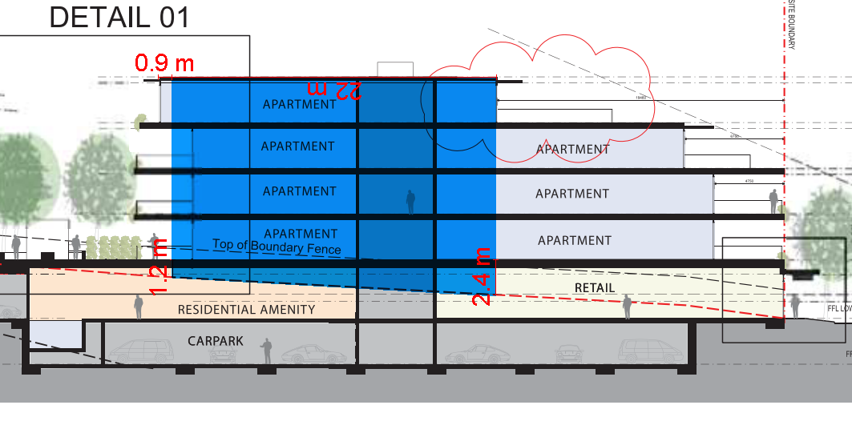  Area of buildings up to 5 storeys shown blue  It is noted that the retail units at ground level fronting Newcombe Street would protrude approx. 2.4m above NGL where the built form above extends to five storeys. As a result, it is noted that whilst the number of storeys is technically a maximum of 5, the buildings would not exhibit a maximum height which is typical of a 5 storey building.  In this regard, given only a small portion of the proposed development would be a maximum of 5 storeys, it is considered that the design response would exhibit a building form and height which would adequately limit unreasonable wind impact on the surrounding public land, private open space or communal open space.  It is noted that were the ground floor retail areas 1.2m lower, the development would not exceed four storeys at any point (excluding a basement).
58.05-1  Accessibility objective  To ensure the design of dwellings meets the needs of people with limited mobility. | Standard D18  At least 50 per cent of dwellings should have:  - A clear opening width of at least 850mm at the entrance to the dwelling and main bedroom.  - A clear path with a minimum width of 1.2 metres that connects the dwelling entrance to the main bedroom, an adaptable bathroom and the living area.  - A main bedroom with access to an adaptable bathroom.  - At least one adaptable bathroom that meets all of the requirements of either Design A or Design B specified in Table D4. | Yes – Complies with Standard D18 subject to conditions  37 of the proposed total 59 dwellings contain:  - A clear path with a minimum width of 1.2m that connects the dwelling entrance to the main bedroom, an adaptable bathroom and the living area  The plans submitted detail a Better Apartment Design Standards response which specifies 16 dwellings are provided with adaptable bathrooms. The plans do not specify which design option is proposed for the respective dwellings.  The plans do not detail the minimum width dimension of the entrance to the proposed dwellings.  Conditions are recommended requiring amended plans to detail the bathroom design types proposed in accordance with table D4 of Standard D18 for at least 50% of the proposed dwellings, and to include the minimum width dimension of at least 850mm at the entrance of the dwellings and main bedrooms.
58.05-2  Building entry and circulation objectives  To provide each dwelling and building with its own sense of identity.  To ensure the internal layout of buildings provide for the safe, functional and efficient movement of residents.  To ensure internal communal areas provide adequate access to daylight and natural ventilation. | Standard D19  Entries to dwellings and buildings should:  - Be visible and easily identifiable.  - Provide shelter, a sense of personal address and a transitional space around the entry.  The layout and design of buildings should:  - Clearly distinguish entrances to residential and non-residential areas.  - Provide windows to building entrances and lift areas.  - Provide visible, safe and attractive stairs from the entry level to encourage use by residents.  - Provide common areas and corridors that:  - Include at least one source of natural light and natural ventilation.  - Avoid obstruction from building services.  - Maintain clear sight lines. | Yes – Complies with Standard D19  The residential entrance is clearly identifiable from Newcombe Street. This entrance provides a sense of personal address and transitional space to the residential component.  The commercial areas fronting Newcombe Street would be clearly distinguishable.  Communal areas around lifts and within lobby areas would exhibit windows where practicable.  Common areas and corridors are proposed to include at least one source of natural light, avoid obstruction from building services and maintain clear sight lines.  It is not considered necessary to require common corridors to exhibit operable windows to provide natural ventilation given the transient nature of the way these spaces would be used.
58.05-3  Private open space objective.  To provide adequate private open space for the reasonable recreation and service needs of residents. | Standard D20  A dwelling should have private open space consisting of at least one of the following:  - An area at ground level of at least 25 square metres, with a minimum dimension of 3 metres and convenient access from a living room.  - A balcony with at least the area and dimensions specified in Table D8 and convenient access from a living room.  - An area on a podium or other similar base of at least 15 square metres, with a minimum dimension of 3 metres and convenient access from a living room.  - An area on a roof of 10 square metres, with a minimum dimension of 2 metres and convenient access from a living room.  If a cooling or heating unit is located on a balcony, the minimum balcony area specified in Table D8 should be increased by at least 1.5 square metres.  If the finished floor level of a dwelling is 40 metres or more above ground level, the requirements of Table D8 do not apply if at least the area specified in Table D9 is provided as living area or bedroom area in addition to the minimum area specified in Table D11 or Table D12 in Standard D25. | Yes – Complies, with Standard D20  All dwellings are provided with private open space at least the area and dimensions specified in Table D8. The FFL of the proposed dwellings do not exceed 40 metres above ground level.
58.05-4  Storage objective  To provide adequate storage facilities for each dwelling. | Standard D21  Each dwelling should have convenient access to usable and secure storage space.  The total minimum storage space (including kitchen, bathroom and bedroom storage) should meet the requirements specified in Table D10. | Yes – Complies with Standard D21  The proposed apartment detail floor plans specify that all apartments will be provided with internal and total storage exceeding the volumes specified within Table D10.
58.06-1  Common property objectives  To ensure that communal open space, car parking, access areas and site facilities are practical, attractive and easily maintained.  To avoid future management difficulties in areas of common ownership. | Standard D22  Developments should clearly delineate public, communal and private areas.  Common property, where provided, should be functional and capable of efficient management. | Yes – complies with Standard D22  Common property areas are clearly delineated and there can be no confusion between public and private areas. The common property can be managed given it comprises the car park, entry and lobby spaces along with internal corridors and external ground floor communal garden areas.  Private open space areas fronting communal areas are fenced and adequate screened to delineate between private and communal areas.
58.06-2  Site services objectives  To ensure that site services are accessible and can be installed and maintained.  To ensure that site services and facilities are visually integrated into the building design or landscape. | Standard D23  Development should provide adequate space (including easements where required) for site services to be installed and maintained efficiently and economically.  Meters and utility services should be designed as an integrated component of the building or landscape.  Mailboxes and other site facilities should be adequate in size, durable, water-protected, located for convenient access and integrated into the overall design of the development. | Yes – Complies with Standard D23  The dwelling layout and design provides for sufficient space and facilities for services to be installed and maintained.  Bin and recycling enclosures, mailboxes and other site facilities have been provided at basement level and will blend in with the development, being concealed fork public view.  Meters and utility services are designed as integrated components of the built form.  The site facilities including mailboxes, bin and recycling enclosures and mailboxes have been provided and located for convenient access.  Conditions on permit require that drainage assets and utility service requirements be designed and connected to the satisfaction of the relevant authority. As this application proposes subdivision, conditions will require the provision of any easements deemed necessary.
58.06-3  Waste and recycling objectives  To ensure dwellings are designed to encourage waste recycling.  To ensure that waste and recycling facilities are accessible, adequate and attractive.  To ensure that waste and recycling facilities are designed and managed to minimise impacts on residential amenity, health and the public realm. | Standard D24  Developments should include dedicated areas for:  - Waste and recycling enclosures which are:  - Adequate in size, durable, waterproof and blend in with the development.  - Adequately ventilated.  - Located and designed for convenient access by residents and made easily accessible to people with limited mobility.  Adequate facilities for bin washing. These areas should be adequately ventilated.  Collection, separation and storage of waste and recyclables, including where appropriate opportunities for on-site management of food waste through composting or other waste recovery as appropriate.  Collection, storage and reuse of garden waste, including opportunities for on-site treatment, where appropriate, or off-site removal for reprocessing.  - Adequate circulation to allow waste and recycling collection vehicles to enter and leave the site without reversing.  - Adequate internal storage space within each dwelling to enable the separation of waste, recyclables and food waste where appropriate.  Waste and recycling management facilities should be designed and managed in accordance with a Waste Management Plan approved by the responsible authority and:  - Be designed to meet the better practice design options specified in Waste Management and Recycling in Multi-unit Developments (Sustainability Victoria, 2019).  - Protect public health and amenity of residents and adjoining premises from the impacts of odour, noise and hazards associated with waste collection vehicle movements. | Yes – Complies with Standard D24 – subject to conditions  The proposed development is provided with adequately separated and secure waste and recycling enclosures at basement level which are easily accessible to residents.  The application in supported by a Waste Management Plan which specifies that food waste facilities are to be provided on site for the residential component, as well as bin washing facilities. The submitted WMP has been reviewed by Council’s Waste department and it has been confirmed as adequate to be endorsed to form part of any permit granted. similarly no objection has been raised by Councils Traffic engineers for the ability for the waste vehicles for residences to enter and exit the site in a forward direction.  The WMP specifies that the waste generation rates adopted are based on rates specified under Sustainability Victoria’s Better Practice Guide for Waste Management and Recycling in Multi-unit Developments.  It is noted that the submitted WMP has not been updated when the application was revised to delete three dwellings. An updated WMP is recommended to be required by conditions. Similarly, conditions are recommended requiring evidence is submitted showing a mini-loader collection vehicle is available for use within the Portarlington area.
58.06-4  External walls and materials objective  To ensure external walls use materials appropriate to the existing urban context or preferred future development of the area.  To ensure external walls endure and retain their attractiveness. | Standard D25  External walls should be finished with materials that:  - Do not easily deteriorate or stain.  - Weather well over time.  - Are resilient to the wear and tear from their intended use.  External wall design should facilitate safe and convenient access for maintenance. | Yes – Complies with Standard D25  External materials proposed include brick, concrete and concrete render, aluminium cladding and timber look screening (aluminium).  The proposed materials are considered to suitably deteriorate over time and would be resilient to the wear and tear from their intended use.  Given the site layout and prevalence of proposed balconies, it is considered that external walls would facilitate safe and convenient access for maintenance.
58.07-1  Functional layout objective  To ensure dwellings provide functional areas that meet the needs of residents. | Standard D26  Bedrooms should:  - Meet the minimum internal room dimensions specified in Table D11.  - Provide an area in addition to the minimum internal room dimensions to accommodate a wardrobe.  Living areas (excluding dining and kitchen areas) should meet the minimum internal room dimensions specified in Table D12. | Yes – Complies with Standard D26  Table D11 specifies that main bedrooms should have a minimum width of 3 metres and a minimum depth of 3.4m. All other bedrooms should be 3m x 3m.  The proposed plans show all main bedrooms have a minimum depth of at least 3.4m and width of 3 metres (excluding a wardrobe)  All other bedrooms are at least 3m x 3m (excluding a wardrobe).  Table D12 sets out that 1 bedroom dwellings should have livings areas at least 3.3m wide and a minimum area of 10sqm. Two or more bedroom dwellings should have a living area with a minimum width of 3.6m and minimum area of 12sqm.  - All of the proposed 1 bedroom dwellings have living areas exceeding 3.3m in width and 10sqm  - All of the proposed 2 and 3 bedroom dwellings have living areas exceeding 3.6m width and 12sqm
58.07-2  Room depth objective.  To allow adequate daylight into single aspect habitable rooms. | Standard D27  Single aspect habitable rooms should not exceed a room depth of 2.5 times the ceiling height.  The depth of a single aspect, open plan, habitable room may be increased to 9 metres if all the following requirements are met:  - The room combines the living area, dining area and kitchen.  - The kitchen is located furthest from the window.  - The ceiling height is at least 2.7 metres measured from finished floor level to finished ceiling level. This excludes where services are provided above the kitchen.  The room depth should be measured from the external surface of the habitable room window to the rear wall of the room. | Yes – Complies with Standard D27  All proposed ceiling heights are 2.7m  All dwellings within the C1Z land exhibit dual aspect living areas.
58.07-3  Windows objective  To allow adequate daylight into new habitable room windows. | Standard D28  Habitable rooms should have a window in an external wall of the building.  A window may provide daylight to a bedroom from a smaller secondary area within the bedroom where the window is clear to the sky.  The secondary area should be:  - A minimum width of 1.2 metres.  - A maximum depth of 1.5 times the width, measured from the external surface of the window. | Yes – Complies with Variation to Standard D28  All habitable rooms have windows within external walls of the proposed building.  Where bedrooms exhibit a window serving a smaller secondary area, these openings meet or exceed 1.2m in width and the depth dimensions specified by the standard.  However, these openings would not be clear to the sky and therefore do not meet the requirements of standard D28.  The apartments that do not meet the standard are Apartment Type C (Bedroom 02), at ground floor, upper ground floor and first floor as shown on the proposed plans.  These apartments are identified on the plans as dwellings: G.09, G.10, UG.09, UG.10, 1.08, 1.09.  These bedrooms windows are not clear to the sky, as the proposed apartments on the second floor would project over the openings.  Decision guidelines  Before deciding on an application, the responsible authority must consider:  - The design response.  - The extent to which the habitable room is provided with reasonable daylight access through the number, size, location and orientation of windows.  - The useability and amenity of the dwelling based on the layout, siting, size and orientation of habitable rooms.  Comments:  Given the orientation of the subject site, there are likely always going to be some dwellings proposed which cannot achieve northern aspect. Notably, out of 81 bedrooms within the C1Z land, 6 do not achieve compliance with standard D28.  It is also acknowledged that all proposed dwellings within the C1Z land exhibit dual aspect living areas.  Whilst the apartment C bedroom 02 windows would not be clear to the sky, it is noted that it is at roof level of the entire building where the intrusion occurs, preventing these openings from being clear to the sky. Furthermore, these openings would be sited in excess of 10 metres from the buildings proposed opposite their outlook (within the RGZ3 land).  It is therefore considered that the bedrooms in question would be provided with sufficient daylight access, reasonable for a bedroom.  It is particularly acknowledged that living areas of these dwellings (apartment type C) are all dual aspect and would be exceed the minimum areas and dimensions for functional layouts and room depths sought by standards D26 and D27 above.  It is therefore considered that, on balance, the proposal achieves adequate daylight to new habitable room windows
58.07-4  Natural ventilation objectives  To encourage natural ventilation of dwellings.  To allow occupants to effectively manage natural ventilation of dwellings. | Standard D29  The design and layout of dwellings should maximise openable windows, doors or other ventilation devices in external walls of the building, where appropriate.  At least 40 per cent of dwellings should provide effective cross ventilation that has:  - A maximum breeze path through the dwelling of 18 metres.  - A minimum breeze path through the dwelling of 5 metres.  - Ventilation openings with approximately the same area.  The breeze path is measured between the ventilation openings on different orientations of the dwelling. | Yes – Complies with Standard D29  Each proposed apartment type within the C1Z land achieves a breeze path through the dwellings less than 18 metres and greater than 5 metres.

CLOSE OF MEETING

As there was no further business the meeting closed at 8.15pm.

Portarlington Structure Plan, 2016 (Amended 2017)
Portarlington Structure Plan, 2016 (Amended 2017)
Portarlington Structure Plan, 2016 (Amended 2017)
Portarlington Structure Plan, 2016 (Amended 2017)
AGD Monea Holdings Pty Ltd V Greater Geelong CC [2021] VCAT 679

