

minutes

PLANNING COMMITTEE MEETING
No. 225

Thursday 27 October 2022
City Hall, 57 Little Malop Street, Geelong

ALSO LIVE STREAMED ON THE CITY’S WEBSITE:

www.geelongaustralia.com.au/meetings

PANEL:

Cr Grzybek (Chair)
Cr Sullivan
Cr Asher
Cr Moloney
Cr Mason
Cr Nelson

PRESENT

Present:

Cr Grzybek (Chair)
Cr Sullivan
Cr Asher
Cr Moloney
Cr Mason
Cr Nelson

Also Present:

Peter Smith, Acting Manager City Development
John Rush, Coordinator Statutory Planning
Emma Griffiths, Principal Planner

Opening: The Chair declared the meeting open at 5.45pm

1. PROCEDURAL MATTERS

Acknowledgement Of Country

The Committee acknowledges the Wadawurrung People as the Traditional Owners of the Land, Waterways and Skies. We pay our respects to their Elders, past and present. We Acknowledge all Aboriginal and Torres Strait Islander people who are part of our Greater Geelong community today.

1.2. Introduce The Panel Members

1.3. Apologies

Cr Aitken
Cr Mansfield
Cr Harwood
Cr Kontelj
Cr Murrihy

1.4. Declarations Of Conflicts Of Interest

None

1.5. Confirmation Of Minutes

That the Minutes of the Planning Committee Meeting held on 14 July 2022 be confirmed.

Moved: Cr Mason Seconded: Cr Moloney

CARRIED

2. MATTER(S) FOR CONSIDERATION
PP-320-2021 98 Marshalltown Road, Grovedale And PP-1512-2020 149 Bellarine Highway, Newcomb
- ttachment_.1.1 page 3
2.1.1 page 4
Attachment_2.1.1 pagePP-320-2021 98 Marshalltown Road, Grovedale And PP-1512-2020 149 Bellarine Highway, Newcomb
2.1. | PP-317-2022 – 7-8 Oakwood Ridge, St Albans Park

Application No: | PP-317-2022
Applicant: | Peter Burke C/- Navone Project Management
Subject Land: | 7-8 Oakwood Ridge, St Albans Park
Zone: | General Residential Zone Schedule 1
Overlays: | None
Existing Use: | Dwelling
Proposed Use: | Two lot subdivision and creation of easement

Summary
- The site is an irregular shape at the end of a forked cul-de sac
- The site is 3,488m2 in area. It has been developed with one single story existing dwelling and a shed. There is a large tree in the southwest corner and established trees and shrubs in garden beds in the front garden and along the boundaries of the site.
- The application seeks to subdivide the land into two lots and create an easement for sewerage.
- Lot 1 will be 1013sqm in area and vacant while Lot 2 will be 2487sqm in area and contain the existing dwelling, shed and large tree
- The land is zoned General Residential Zone Schedule 1 and it is not subject to any planning overlays.
- The land was part of the historic St Albans Stud and it is noted that part of the subject site has recently been included in the Victorian Heritage Inventory H7721-0545; to acknowledge significant thoroughbreds buried beneath a tree in the southwest corner of the subject site. However this is not a trigger for a Planning Permit. No works are proposed to occur on or near the tree or in the area included in the inventory.
- The application was advertised with letters sent to owners and occupiers of adjoining land and a sign placed on at the front of the site.
- Forty-five (45) objections and one (1) petition tabled ‘Stop developers from destroying this historic tree with links to Phar Lap’ were lodged with Council.
- Objections include concerns relating to the impact to the tree and horses buried on-site, the proposed lot size, neighbourhood character, drainage, vegetation on site and restrictions on title.
- The plan of subdivision was revised following the public notification with the Amended plan submitted to remove the need for any works near the significant tree in the southwest corner. This plan was circulated to all objectors along with a response to objections by the permit Applicant.
- The revised plan did not result in any withdrawal of objections.
- The proposal has been assessed against the Municipal Planning Strategy and Planning Policy Framework of the Greater Geelong Planning Scheme including Clause 56 ‘Residential Subdivision’ where it is considered to comply with the Planning Scheme requirements.
- Overall the proposed subdivision provides for one (1) additional residential lot within an existing residential area and creates land that can be developed in accordance with the City’s urban growth and housing policy objectives. The proposal is considered to assist in consolidating the existing urban fabric and makes use of existing urban infrastructure. Also, it is considered that the proposal will also provide a diversity of lot sizes to accommodate the varying housing needs of the community.
- The subdivision layout is also considered to promote energy efficiency with the lots having appropriate solar orientation. The subdivision can support development which is in keeping with the area and is serviced by the required infrastructure and does not result in any unacceptable off-site amenity impacts or overload the carrying capacity of relevant services.
- Therefore, having considered all the relevant requirements of the Planning Scheme and the objections lodged against the proposal, it is recommended that the application be supported subject to the conditions contained in this report.
Alternate Recommendation
That the Responsible Authority having considered all matters which the Planning and Environment Act 1987, requires it to consider decides to Refuse to Grant a Planning Permit for a two lot subdivision at 7-8 Oakwood Ridge, St Albans Park in accordance with the plans and documentation submitted with the application on the following grounds:

1.The subdivision does not accord with Clause 56.03-5: Neighbourhood Character as the proposed lot sizes do not respect the existing neighbourhood character.

2.The subdivision does not accord with Clause 65.02: Approval of an application to subdivide land. The new lot is not reflective of the subdivision pattern in the area.
Moved: Cr Asher Seconded: Cr Nelson
Carried

REPORT

PERMIT TRIGGER:

A planning permit is triggered for this application pursuant to the following clauses of the Greater Geelong Planning Scheme:

- Pursuant to Clause 32.08-3 of the General Residential Zone, a permit is required to subdivide land.
- Pursuant to Clause 52.02 of the Easements, Restrictions and Reserves Particular Provision, a permit is required to create an easement.
DEFINITIONS

Subdivision is not defined or nested in the Planning Scheme.

A lot is defined as a part (consisting of one or more pieces) of any land (except a road, a reserve, or common property) shown on a plan, which can be disposed of separately and includes a unit or accessory unit on a registered plan of strata subdivision and a lot or accessory lot on a registered plan.

Subdivision is defined in the Subdivision Act 1988 as the division of land into two or more parts which can be disposed of separately.

RESTRICTIVE COVENANT OR SECTION 173 AGREEMENT:

The subject site is burdened by two Restrictive Covenants and a Section 173 Agreement.

It is considered that the issuing of a planning permit for subdivision does not breach any of the restrictions on title.

Reference no: Covenant PS408242C 19/11/1997
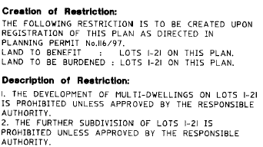

Response:

The subject site is Lot 11. The approval of the Responsible Authority is considered to include the grant of a planning permit. Therefore, this restriction is not breached by this proposal.

Reference no: Covenant V172802J 29/12/1997
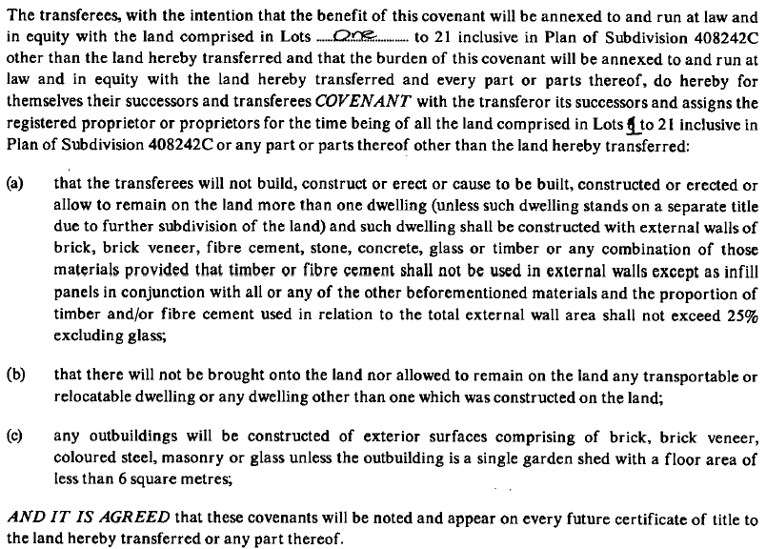

Response:

No buildings are proposed to be developed as part of this application.

The covenant contemplates further subdivision of the land, whereby a single dwelling is permitted on each lot. A planning permit will allow further subdivision of the land. Therefore, this restriction is not breached by this proposal.

Reference no: Section 173 S585040J 16/07/1993

Response: The s173 agreement related to conditions within the planning permit for the original subdivision of the land. All obligations have been fulfilled and this Agreement is no longer relevant.

OFFICER DIRECT OR INDIRECT INTEREST:

No Council officers have any direct or indirect interest in the matter to which this report relates, in accordance with Section 130(2) of the Local Government Act.

SITE/LOCALITY:

The subject site is located at the west end of Oakwood Ridge in a General Residential Zone Schedule 1 and is not subject to any overlays.
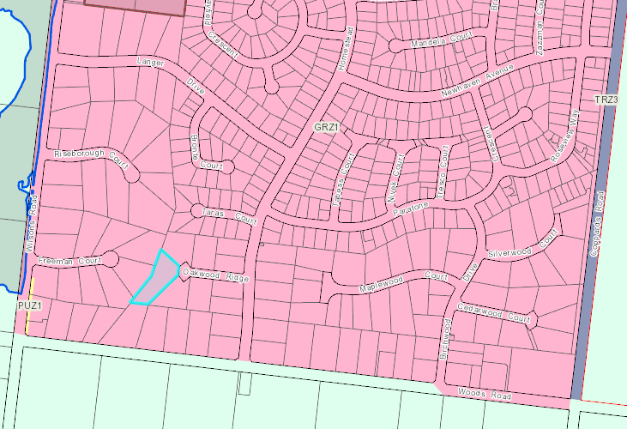
Figure 1 – Zoning Map. Source – Places Weave

The site is an irregular shape with a 16m frontage to Oakwood Ridge and side boundaries of 44.73m, 51.00m, 61.51m, 32.42m and 76.11m comprising a total area of 3,488m2.
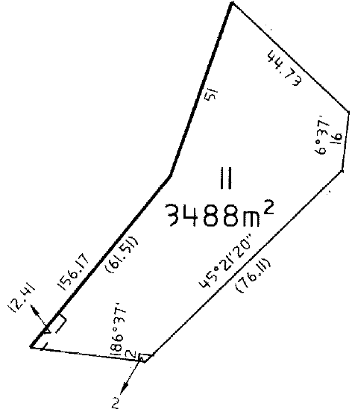
Figure 2 – Title boundaries. Source: Title Plan

The site contains a single storey dwelling in the centre, a detached shed on the southeast boundary and a planted garden including trees along the boundaries and trees and shrubs in garden beds located in the front garden.
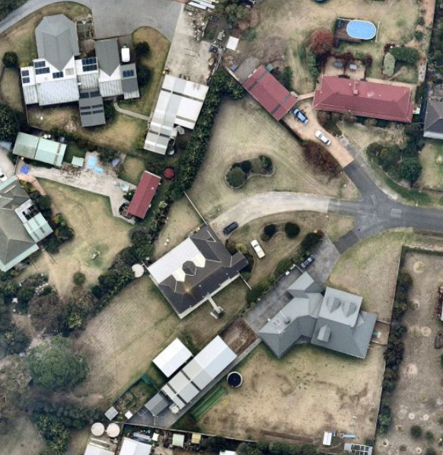
Figure 3 – Aerial Image April 2022. Source: Nearmap

The land, prior to the parent subdivision that created this estate, was part of the historic St Albans Stud. Part of the subject site has recently been included in the Victorian Heritage Inventory H7721-0545 (Burial Site 2) to acknowledge significant thoroughbreds buried beneath a tree in the southwest corner of the subject site. The inventory covers the canopy of the tree and a small buffer zone. There is a second burial site within the street frontage of Riseborough Court (Burial Site 1). The Department of Environment, Land, Water and Planning (DELWP) have written to the various place owners, providing information about the Heritage Inventory (see ‘Permit/Site History’ section in this report below for further details).

Oakwood Ridge is unusual as it has a three-pronged fork at the end rather than a traditional court bowl or hammerhead. The subject site is accessed via a single vehicle crossover located in the centre of the street frontage. The vehicle crossover provides access to a double garage attached to the dwelling at the end of the driveway.
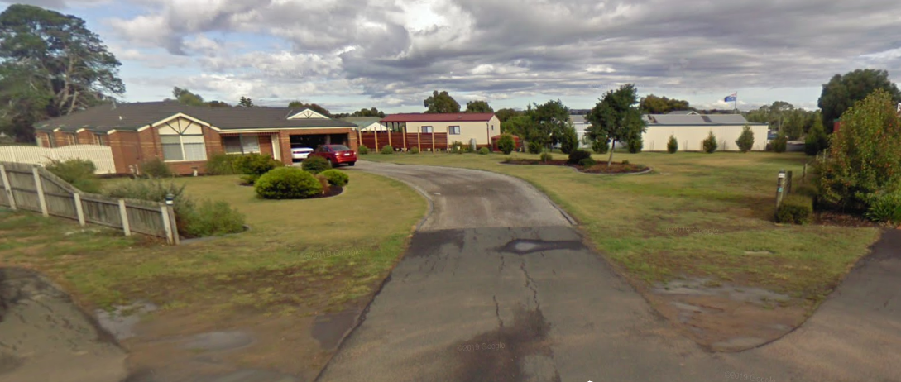
Figure 4 – Street view. Source: Google maps

Surrounding properties share the same zone and are developed for residential purposes. This part of the St Albans Park Estate contains lot sizes larger than conventional residential lots, however there is evidence of further subdivision within this estate with lot sizes range from 721m2 at 77 Woods Road to 4060m2 at 17-21 Woods Road. A more traditional residential subdivision pattern is located 63m to the north of the subject site.

Land to the west of Wilsons Road and south of Woods Road is located in the Farming Zone. These lots are not consistent with a typical farming zone with lots generally being around 3-6 ha and used for a variety of purposes ranging from rural industry, market gardens or horse keeping/agistment and rural lifestyle purposes.

PROPOSAL:

The application proposes to subdivide the land into two lots and to create an easement.
- Lot 1 to the north would be 1013m2 and be accessed by a single (3.5m) vehicle crossing.
- Lot 2 to the south would be 2487m2 and contain the existing dwelling, shed and significant tree. It would have a single (3.5m) vehicle crossing.
The proposed easement is nominated as E-6 and runs along the southeast boundary of proposed Lot 2 from the existing easement E-1 to the front of the site (where the lot adjoins the road). This easement will be 2.5m wide and will be a sewerage easement to benefit Lot 1.
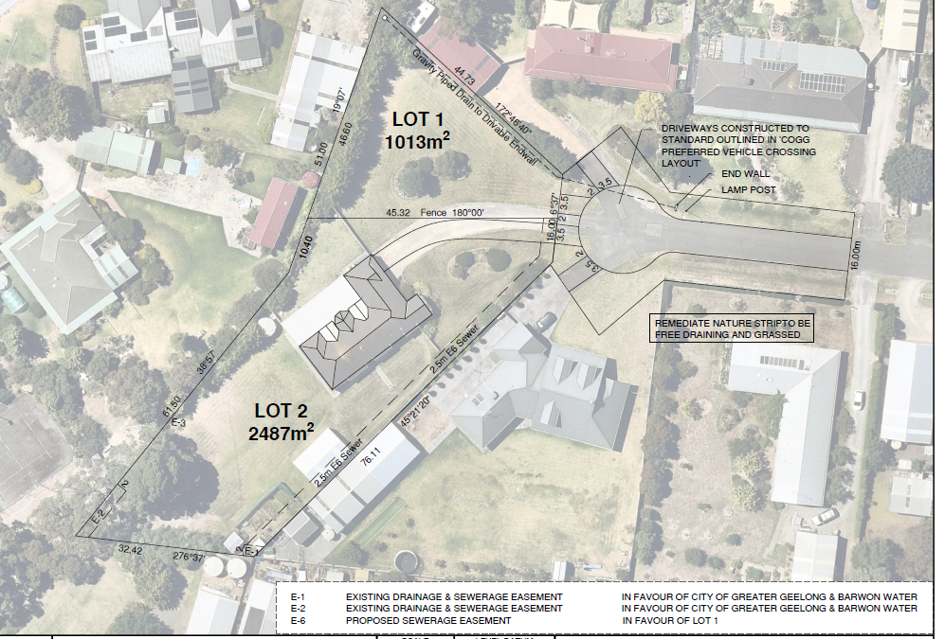
Figure 5 – Proposed Subdivision Plan. Source: Section 57A Plans

PERMIT/SITE HISTORY:

- PP-390-2019 – Staged Three (3) Lot Subdivision and Creation of a Carriageway Easements (E1 and E2) – No decision - Withdrawn following public notification, prior to a Development Hearings Panel meeting.
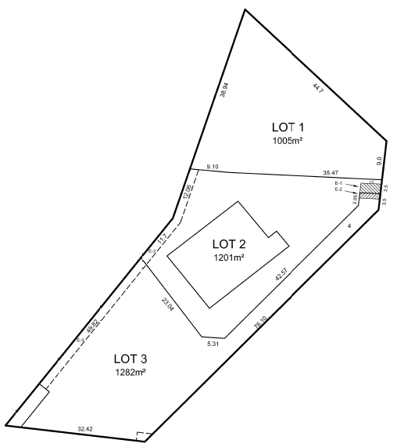
Three lot subdivision plan submitted for consideration PP-390-2019

- The subject site has recently been included in the Victorian Heritage Inventory as H7721-0545 (Burial Site 2).

Heritage Victoria need to be contacted if any works are proposed which may affect historical archaeological remains within the extent of the Heritage Inventory site. An approval (Consent) may be necessary prior to works. Heritage Victoria Principal Archaeologist, Jeremy Smith explains “A Heritage Inventory listing is unlikely to prevent works in the subject areas, but it is likely that a program of archaeological monitoring, investigation, recording and reporting (as part of a Heritage Act Consent process) would be required as part of any substantial subsurface/below-ground works…In the unlikely event that significant horse remains are uncovered that may need to be relocated, I have had discussions with the Living Legends retired racehorse establishment at Woodlands in Sunbury. They actually have a burial area for notable thoroughbreds and have said that it could be used for remains recovered from St Albans, so that may be an option, if needed.”

The Victorian Heritage Database ‘Albans Stud Horse Burial Site 2’ Statement of Significance explains… “The Oakwood Ridge burial site may contain the remains of significant thoroughbred burials in addition to that of Mischief, Musidora and Briseis (details of horse burials were not officially recorded). Although the general area of the tree and burial has been subject to suburban development, the area within the direct vicinity of the tree has not experienced significant below-ground disturbance, and it is likely that any horse burials will be substantially intact. The burials may contain tack (such as bridles) associated with the horses. The site is significant to the broader community for its association with the horse racing history and with notable, individual horses. The site has the potential to contain archaeological evidence about the burial practices of racehorses and may contain DNA evidence relating to individual horses, and their bloodlines.”

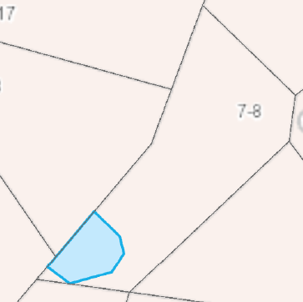

Figure 6 – Extent of Heritage Inventory. Source: Vic Plan (https://mapshare.vic.gov.au/vicplan/)

It must be noted that the Heritage Inventory listing does not trigger a need for a planning permit.

REFERRALS:

The following referrals were undertaken:

SECTION 55:

There is no requirement for referral for sites on the Victorian Heritage Inventory.
There is also no requirement to obtain a Heritage Act Consent for subdivision (provided there is no associated ground/subsurface disturbance).
Subdivision of land into two lots is not required to be referred to Servicing Authorities. Mandatory servicing authority conditions are required (in accordance with the Planning Scheme requirements) to be included on any permit granted.

SECTION 52:

Authority: | DELWP
Response: | Request for note wording email 22-6-22:  Note – There is a listed Victorian Heritage Inventory place that may be impacted by future subsurface works associated with this subdivision. Places on the Victorian Heritage Inventory are protected under the Heritage Act 2017 and can be viewed at Vicplan (mapshare.vic.gov.au). Before any subsurface works commence, the applicant must consult with Heritage Victoria and obtain the appropriate Consents.
Officer Comment: Note to be included on any permit granted.

INTERNAL

Department: | Engineering Services
Response: | First Response  Advised Request for further information.  Second Response  Support subject to the following conditions  Drainage:  The site must be drained to the satisfaction of the Responsible Authority and no concentrated storm water may drain or discharge from the land to adjoining properties.  Drainage & Vehicular Access:  Prior to the statement of compliance, the developer must:  a) Construct the site stormwater system including separate connection lot 1 via a pump system into a new drivable end wall in the swale on Oakwood Ridge or other nominated point/s as approved by the Responsible Authority. The stormwater connection must be in accordance with City of Greater Geelong Standard Drawings.  b) Construct vehicle crossings 3.5m wide in accordance with the requirements and standards of the City of Greater Geelong.  c) Any proposed vehicle crossing shall have satisfactory clearance to any existing crossover, side-entry pit, power, lighting or telecommunication pole, manhole cover or marker, fire hydrant or street tree. Any relocation, alteration or replacement required shall be in accordance with the requirements of the relevant Authority and shall be at the applicant’s expense  d) Remove any redundant vehicle crossings with kerb and channel and the footpath/nature strip area reinstated to match existing construction in the street;  all to the satisfaction of the Responsible Authority.  Note:  1. Construction of the site stormwater connection/s is to be inspected by Council Representative prior to any backfilling. An appropriate fee equivalent to 3.25% of total cost of civil works, excluding GST (a minimum fee of $100 applies if the 3.25% amount is less than $100), is to be paid to Council for inspection. Relevant evidential documentation of the cost is to be provided.  2. All internal property drainage must be designed and constructed to satisfy AS/NZS 3500.  3. A Vehicle Crossing Permit must be obtained prior to commencement of works.  Creation of easements  The Plan of Subdivision submitted for certification must include all easements deemed necessary to protect existing or future drainage lines within the subject site, and any easements required between the subject site and the nominated legal point of discharge must be created to the satisfaction of the Responsible Authority.  S173 Agreement On-site detention and Pump System  Unless otherwise approved by the Responsible Authority and prior to the Issuing of Statement of Compliance, the land owner must enter an agreement with the Responsible Authority pursuant to Section 173 of the Planning and Environment Act 1987. All costs associated with setting up the agreement must be borne by the land owner. The agreement is to be registered on title and run with the land, and is to provide to the satisfaction of the Responsible Authority:  On-Site Detention  The Owner covenants with the Council that:  a. The on-site detention for stormwater for lot 2 will be designed by a Qualified Engineer and be reviewed prior to construction. A copy of the Building Surveyor approved plans will be held by Council for future reference.  b. The on-site detention stormwater system will be constructed either prior to, or concurrently with, the construction of any dwelling on the specified lot. Each on-site detention stormwater system on the specified lots will be completed prior to connection to Council’s drainage system. The Owner will notify the Council when on-site detention works commence on the specified lots and request an inspection by Council on completion of works.  c. They will maintain, and not modify without prior written agreement of Council, each on-site detention system and will allow each on-site stormwater detention system to be inspected by a duly appointed officer of the Council at mutually agreed times.  d. The Owner will pay for all the costs associated with the construction and maintenance of each on-site detention system.  Pump System  a) All storm water runoff is to be collected on site and discharged to the legal point of discharge using a pump system or as otherwise nominated by the responsible authority. The pump system is to be designed and constructed in accordance with Australian Standard 3500 Part 3.2 Section 9  b) In the event of any operational difficulties with the pump system, it is the Responsibility of the land owner to rectify these difficulties;  c) Any pump system is to be replaced by gravity discharge if and when available, and if directed by the Responsible Authority, at the land owner’s full cost.  Note: The discharge velocity at the Swale must be no greater than 0.5 m/s with a maximum discharge flow rate of 10 l/s and the outlet directed to the direction of flow in the swale using a hydraulic jump tin the end wall to dissipate energy.  NOTE  A pre-commencement meeting with Council’s engineering department is required to be undertaken prior to works starting. To organise this meeting please contact 5272 4426.  Third Response  As waste have required a ‘T’ – The existing road is sealed , the new Vehicle Crossovers will be asphalt , internal access ways a sealed surface. The road repairs are the responsibility of the asset owner. There is insufficient space to create a 21m court bowl.  Road & Drainage Plans  Unless otherwise approved in writing by the Responsible Authority, Prior to the Certification of the Plan of Subdivision the Landowner shall submit to Council for approval engineering construction plans for new Council assets, prepared by a suitably qualified and experienced professional and at the landowner’s expense. The plans should detail the construction of the Hammer Head design waste truck turning area, 27m by 6.2 meter sealed surface . The submitted plans must also show, but are not limited to:  a) Vehicle crossings, swale drains, pipes and drivable endwalls.  b) The design and construction of the roadworks and any other new Council infrastructure which must be approved and supervised by Council.  Unless otherwise approved in writing by the Responsible Authority, Prior to Statement of Compliance, the landowner must:  c) Complete the Hammer head road construction in accordance with the approved plans;  d) Make payment equivalent to 3.25% of the cost of the works, to be paid to Council for the checking and supervision of these works;  e) Submit a maintenance bond of 5% of the cost of the works, to be paid to Council and returned after successful completion of a twelve month maintenance period;  f) Provide to Council ‘as-built’ Engineering plans in PDF, and GIS-ready AutoCAD (DXF) format plans, to the satisfaction of the Responsible Authority.  all to the satisfaction of the Responsible Authority.  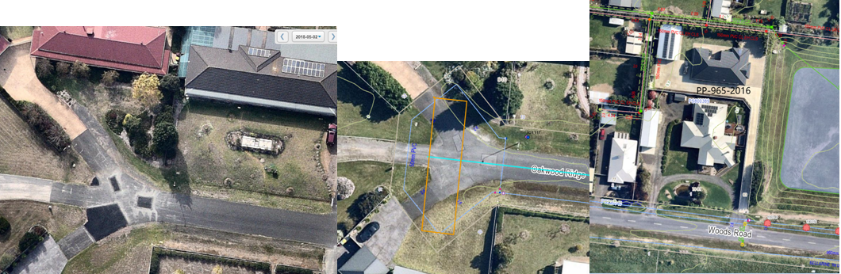
Officer Comment: The suggested conditions are recommended to be included on any permit issued.
Lot 1 (vacant) is to be drained via a Pump System and Lot 2 is draining to the Existing connection.
The S173 agreements apply to both lots and will provide onsite stormwater detention and management ensuring no negative impacts to the other landowners.
Additional condition requiring construction of hammer head added to permit following Waste Unit conditions for carriageway easement.

Department: | Waste Services
Response: | A carriageway easement must be provided over any private property that is required to create a Hammerhead Turnaround. The required hammerhead length is 26.5 metres and a width of 5.5 to 6 metres. The use of private property driveways to create a hammerhead is acceptable and must be approved by the Responsible Authority unless other options are agreed to and approved by the Responsible Authority.
Officer Comment: Council waste trucks will continue to be able to collect waste with the creation of an additional crossing.
A condition of permit will require a hammer head to be constructed as per Engineering’s requirements therefore this condition is not required.

Department: | Parks Services
Response: | The Pinus nigra subsp. nigra (Austrian Pine) at this location is a good example of the species and is most likely a remnant specimen of the original St Albans Homestead.  Relocating the proposed easement to the eastern side of the property will remove the necessity for any excavation works to occur near this tree as a result of the sub-division plan.  Other Comments from Parks Department:  Additional protection for this tree against any future building proposals within Lot 2 could be achieved by listing the TPZ area of this tree within Lot 2 as a protected area where no building works can occur.
Officer Comment:
Arborist report peer reviewed, moving easement away from tree protects tree from excavation works.
Part of the subject site now included in the Victorian Heritage Inventory H7721-0545 (Burial Site 2). A note will be included on the permit (provided by DELWP) to acknowledge there is a listed Victorian Heritage Inventory place that may be impacted by future subsurface works associated with this subdivision.

Department: | Heritage Services
Response: | 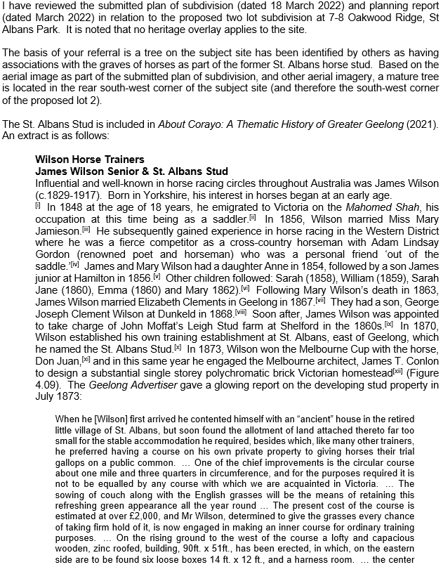  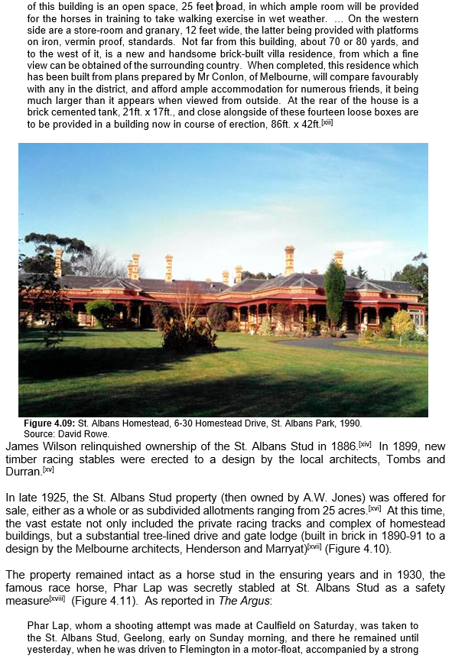  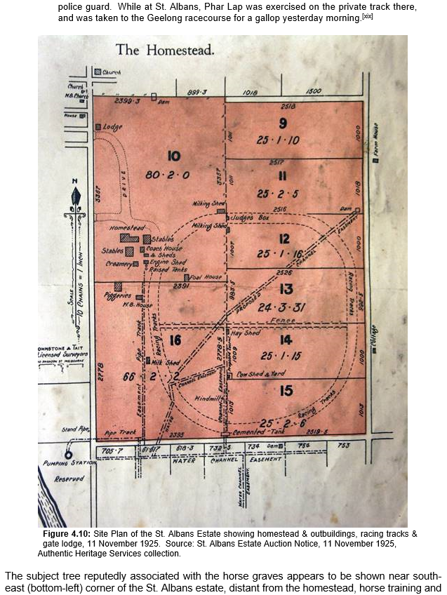  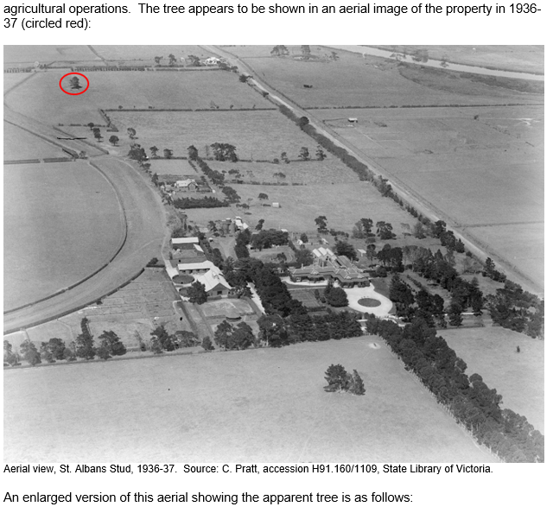  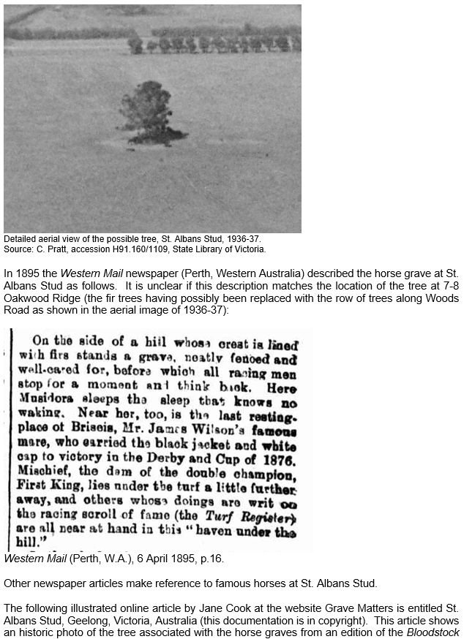  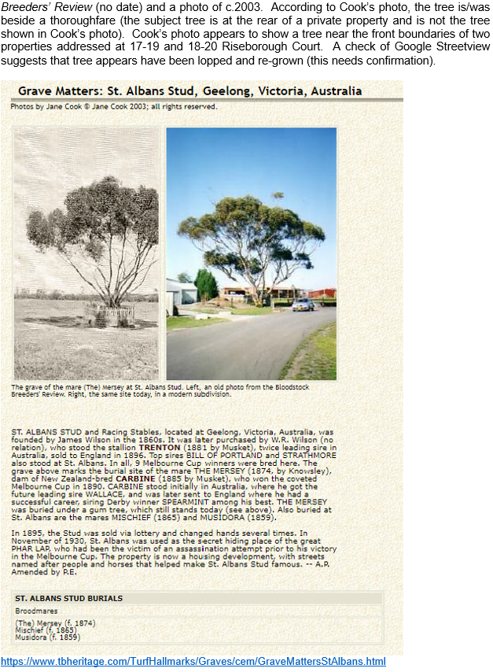  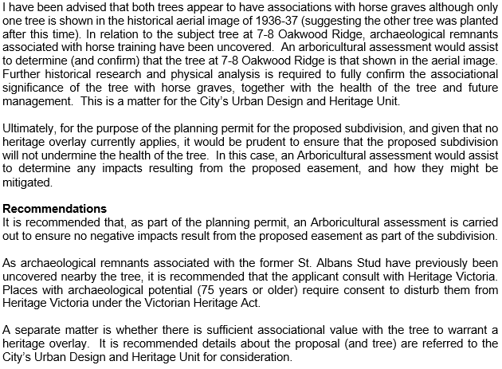  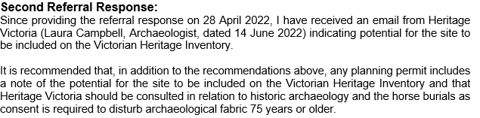  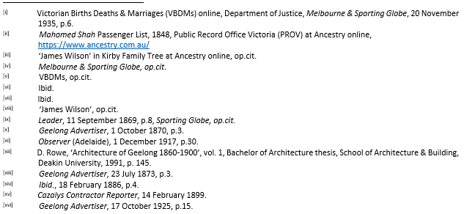  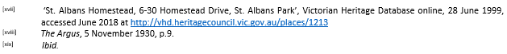
Officer Comment:
Arboricultural report submitted and revised plans show no works now near the burial site.
Part of the subject site is now included in the Victorian Heritage Inventory H7721-0545 (Burial Site 2).
A note will be included on the permit (provided by DELWP) to acknowledge there is a listed Victorian Heritage Inventory place that may be impacted by future subsurface works associated with this subdivision.

AMENDMENT OF THE PROPOSAL PRIOR TO PUBLIC NOTIFICATION:

The application was not amended prior to public notification.

PUBLIC NOTIFICATION:

The application is not exempt from the notice requirements of Section 52(1)(a), (b) and (d), the decision requirements of Section 64(1), (2) and (3) and the review rights of Section 82(1) of the Act and pursuant to Section 52 of the Planning and Environment Act 1987 the following forms of advertising were undertaken:

- Notices were sent to owners and occupiers of adjoining land (including opposite)
- One (1) A2 sign was placed on the land
Forty-five (45) objections and one (1) objecting petition have been lodged with Council. Twenty-five (25) of the objectors live in St Albans Park.
The petition organiser has provided 901 signatures and 144 comments from the change.org petition.

As of September 2022, the petition has 1136 signatures. The petition is headed “Stop developers from destroying this historic tree with links to Phar Lap”.
The petition text reads:

“Please help!
St Albans Park Residents have huge concerns over a proposed development in which a significant old tree with links to Phar Lap will be destroyed!
So many species of local wildlife also call this beautiful tree home.

The land has an existing Covenant protecting it from being subdivided, which only the Council can overturn. The Heritage and History aspects of the significant tree are priceless and should be protected. It shouldn't be allowed to be destroyed so a developer can subdivide his investment property.

Phar Lap's stablemates from his 1930 secret trip to the area before winning the famous 1930 Melbourne Cup, along with descendants of "Carbine" (winner of the 1890 Melbourne Cup) and other famous racehorses bred at the famous St Albans Park stud are all buried under this Beautiful Tree in the Developer's path. This is the only tree left of the handful which had the famous racehorse remains interred.

High ranking meetings are occurring but we need your help. Please sign this survey! Please also object to Council directly via the links below to cease this Development and help save St Albans Park Heritage and History. Please don't let this Beautiful Tree with significant burials be lost.”

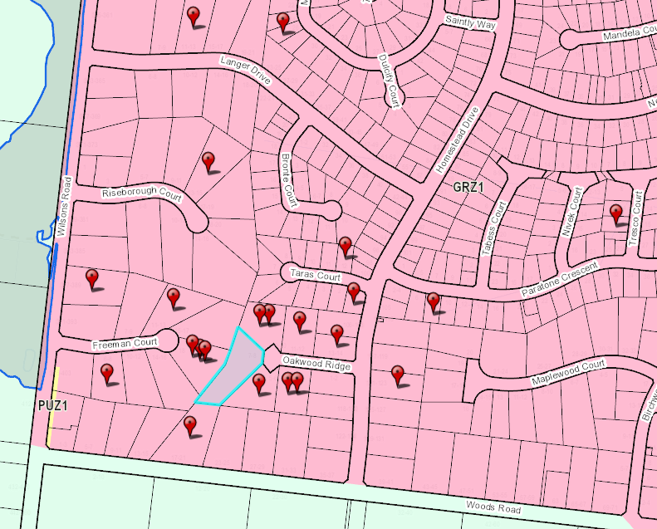
Figure 7 – Objectors (22) in Close Proximity of Site

CONSULTATION:

A consultation meeting was not held as many objections related to heritage (horse burial site) which, based on the latest plans is respectfully not considered a relevant planning consideration for this application. It was unlikely a resolution could be found to satisfy other concerns relating to lot size, drainage and amenity.

Revised plans and a response to concerns from the Applicant were circulated to all objectors in June.

Of note - this did not result in any withdrawal of objections.

Nonetheless, all objections are considered in the planning process regardless whether a consultation meeting is held.

AMENDMENT OF THE APPLICATION FOLLOWING PUBLIC NOTIFICATION

The applicant made a request to amend the application following public notification pursuant to Section 57A of the Planning and Environment Act 1987 on 14 June 2022. Council has accepted the amendment. The amendment made the following changes to the application:

- Removal of Easement E-3 for drainage and sewerage on western side of proposed Lot 2. Inclusion of E-6 for sewer on eastern side of proposed Lot 2. Addition of court bowl, crossovers, internal driveway to Lot 2, internal drainage for Lot 1 and driveable end wall. Detail changes to preamble/ permit triggers (easement).
These are the plans currently under assessment.
It was not considered necessary to readvertise the proposal based on the amendment, as the amendment would not result in any additional material detriment compared with the advertised application, but they were circulated to all objectors for consideration.
One objection was withdrawn, but not on the basis of the amended plans being lodged with Council.

OBJECTIONS:

The concerns of objectors are summarised and commented on below:

- Objection - Detrimental impact on the low density character and neighbourhood character
Response

The subject site is located within a General Residential Zone Schedule 1 and not a Low Density Residential Zone. The creation of one additional lot in excess of 1000m2 is considered to be appropriate within the setting of the existing neighbourhood. It is noted that lot sizes in the area are predominantly between 2,500m2 and 3,500m2 however there are also examples of lots less than 1,000m2 as a result of further subdivision. The general direction of planning policy relevant to this application encourages infill development in exiting urban areas to better utilise serviced areas and to reduce the reliance on green field growth to meet the diverse housing demands for the City of Greater Geelong and to reduce urban sprawl.

- Objection - Restriction on title
Response

The restriction prohibits further subdivision of the land unless otherwise agreed to by the Responsible Authority. This wording allows Council to consider further subdivision of the land and the grant of a planning permit would be the approval of the Responsible Authority, being the City of Greater Geelong Council. Therefore, the grant of a planning permit would not breach the restriction.

- Objection - Removal of trees and impact on vegetation
Response

There is no vegetation proposed to be removed. Proposed easements and servicing have now been located away from the significant tree located on the southwest corner of the site to the east of the subject site in response to objections received. However, it must be noted that as the site is less than 4,000m2 and is not affected by any overlays, there is currently no requirement for planning approval to remove a tree or any vegetation from the site or the broader neighbourhood.

- Objection - Access
Response

The existing access will be removed and replaced with two, single vehicle crossings constructed to Council standards. As the access will only service one additional lot, it is not considered to provide an unsafe environment for residents or road users. Council’s Traffic Engineering Department supported the application with the proposed accessway and the Waste Unit are also supportive – the support is subject to conditions on permit.

- Objection - Heritage & cultural heritage issues including horse burial sites
Response

Recently two sites within the St Albans Park Estate were included on the Victorian Heritage Inventory as Horse Burial Sites including the subject site which is affected by one of the two burial sites.

There are no planning requirements (under the Planning Scheme) for consideration in relation to the Horse Burial Sites for this application.
The site is not located within an area of Aboriginal Heritage therefore there are no Cultural Heritage requirements.

- Objection – Significant tree at horse burial sites linked to Phar Lap is to be destroyed
Response

The tree in the south-west corner of the site is proposed to be retained within private property as is the current situation. It was assessed by a qualified Arborist and plans were revised to remove the (E-3) sewer easement and (E-6) Sewer easement instead will be used which is located along the eastern boundary of proposed Lot 2.

Based on this the tree will no longer be impacted by works required to facilitate this subdivision.

During the application, the site was included in the Victorian Heritage Inventory as a Horse Burial Site.

The revised plans ensure no works are required in the mapped area of the Inventory or the vicinity of the tree in general.

- Objection – Impact of subdivision on row of trees along west boundary
Response

A new 2.5m wide easement is proposed along the southeast boundary of the subject site close to where there is planted vegetation along the driveway of the property to the east, but this is not significant vegetation and it is likely to have minimal impact given the width of the easement.
New drains may or may not impact on some roots of the planted (not significant) neighbouring trees. There is no planning control protecting these trees and no built form is proposed to assess the impact.

- Objection – Amenity loss
Response

The creation of one additional residential lot will not impose a loss to existing amenity for adjoining property owners. The additional lot is over 1000m2 which is a sufficient size to enable generous boundary setbacks. Building regulations will apply to any new dwelling which will mitigate any unreasonable loss of amenity.

- Objection – Increase stormwater into open spoon drains exacerbating existing issue
Response

Council Drainage Engineering Department are satisfied that conditions they have recommended on any permit granted will contain stormwater on site and not impact on surrounding properties. Conditions require the owner to enter into a Section 173 Agreement relating to on-site detention and a pump system.

The on-site detention for stormwater for both lots will be required to be designed by a Qualified Engineer and be reviewed prior to construction. It cannot be modified without prior written agreement of Council and must be maintained by the owner. All storm water runoff for Lot 1 is to be collected on site and discharged to the legal point of discharge using a pump system or as otherwise nominated by the responsible authority. In the event of any operational difficulties with the pump system, it is the responsibility of the landowner to rectify these difficulties and it must be replaced by gravity discharge, if and when available, at the landowner’s full cost.

Council Drainage Engineers have commented that “Although a piped outfall is always preferable, so is a gravity outfall, which is less costly or prone to malfunction than a pump system. In this instance it is pump to a pipe or gravity drain to the Council road reserve swale drain. The swale is for conveyance of stormwater drainage from the road and has capacity to convey the impervious surfaces of the new lot once developed. The applicant will be required to design a suitable pipe for vehicle loading and ensure the swale is graded to allow free drainage to the pipe inlet pit. If maintenance or replacement of the pipe is required, it will be the responsibility of the asset owner at 7-8 Oakwood Ridge who will bear all costs for construction…Properties have vehicle crossings for access to their properties, parking or driving in the swales is not permitted.”
- Objection – Will the 2 x 22,0000L water tanks at 17 Woods Road on a sewerage easement need to be moved?
Response

Barwon Water is the responsible authority for the sewerage connection and the water tanks will need to be subject to Barwon Water’s requirements.

ASSESSMENT:

ZONE:

Clause 32.08 – General Residential Zone

The purpose of the General Residential Zone is:
- To implement the Municipal Planning Strategy and the Planning Policy Framework.
- To encourage development that respects the neighbourhood character of the area.
- To encourage a diversity of housing types and housing growth particularly in locations offering good access to services and transport.
- To allow educational, recreational, religious, community and a limited range of other non-residential uses to serve local community needs in appropriate locations.

OVERLAY:

No overlays affect the subject site.

Response to zone

It is considered that the proposed subdivision is consistent with the purpose of the zone and relevant decision guidelines.

The proposed subdivision will retain the existing dwelling on Lot 2 with Lot 1 being created over 1000m2 allowing for setbacks to limit impact on the streetscape character and neighbouring amenity subject to the Building Regulations. Proposed Lot 1 will provide for development of a dwelling that will support a diversity of housing types while enabling a respectful design and form consistent with the existing neighbourhood character.

The proposed subdivision will respect the existing pattern of subdivision within the area and will provide sufficient space for new buildings to have generous setbacks from all boundaries.
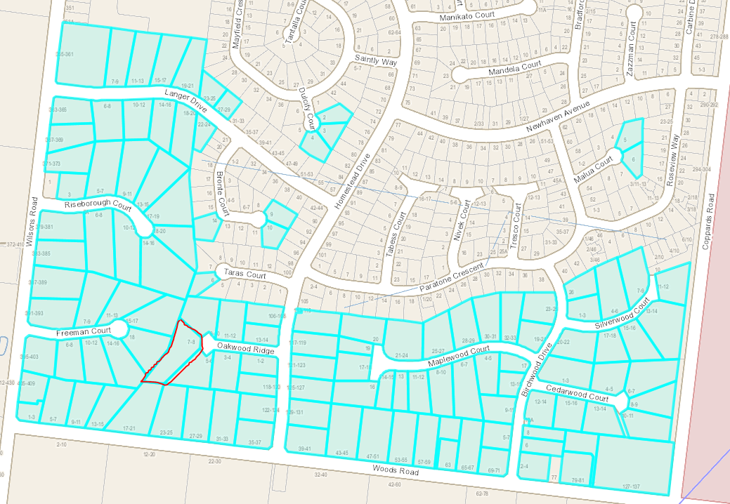
Figure 8 - Lots over 1000m2 highlighted – Source: PLACES Weave

Land 60m to the north is a more traditional subdivision pattern with lots generally 650m2 to 800m2 but with larger lots including some over 1000m2. The proposal is a compromise between the two areas and will maintain both lots over 1000m2 with Lot 1 being 1013m2 and Lot 2 at 2487m2. There will remain numerous lots in the surrounding area over 3000m2.

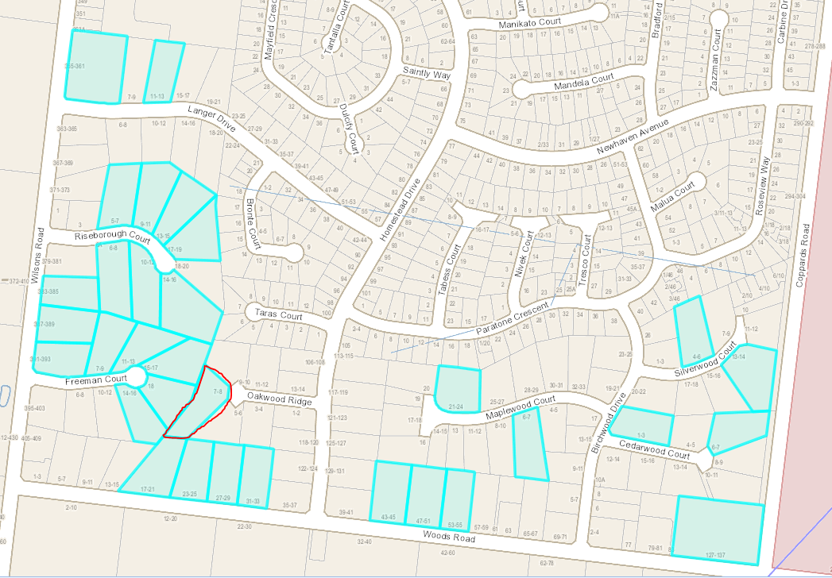
Figure 9 - Lots over 3000m2 highlighted – Source: PLACES Weave

The proposed subdivision complies with the objectives and standards of Clause 56 - Residential Subdivision. An assessment against Clause 56 is attached as an appendix to this report.

CULTURAL HERITAGE MANAGEMENT PLAN (CHMP):

The Aboriginal Heritage Regulations 2018 specify the circumstances in which a cultural heritage management plan is required for an activity or class of activity. Division 2 of the Aboriginal Heritage Regulations 2018 specifies exempt activities which do not require a cultural heritage management plan. The proposal is not listed as an exempt activity.

Areas of cultural heritage sensitivity are defined within Divisions 3 and 4 of the Aboriginal Heritage Regulations 2018. Division 3 does not identify the site or part of the site as within an area of cultural heritage sensitivity.
In accordance with the above assessment, a cultural heritage management plan is not required.

LANDFILL GAS RISK ASSESSMENT

The subject site is not located within 500 metres of an identified former landfill site, a risk assessment is not required.

DEVELOPMENTS IN BUSHFIRE PRONE AREAS
The site is not located within a designated bushfire prone area (Delete if fire prone)

THE MUNICIPAL PLANNING STRATEGY (MPS):

- Clause 02.03-1 – Settlement
- Clause 02.03-5 – Built Environment & Sustainability
- Clause 02.03-6 – Housing

THE PLANNING POLICY FRAMEWORK (PPF):

- Clause 11.01-1R – Settlement – Geelong G21
- Clause 11.01-1L-01 – Geelong Settlement
- Clause 11.02-1S – Supply of Urban Land
- Clause 11.03-6S – Regional and Local Places
- Clause 15.01-1S – Urban Design
- Clause 15.01-3S – Subdivision design
- Clause 15.01-5S – Neighbourhood character
- Clause 15.01-5L – Neighbourhood Character
- Clause 16.01-1R – Infill housing – Geelong G21

Response to Policy

The proposal is considered to be in accordance with the relevant Municipal Planning Strategy and Planning Policy Framework of the Greater Geelong Planning Scheme. The subdivision is providing for one additional residential lot in an existing urban residential area.

The subdivision will create land that can be developed in accordance with the City’s urban growth and housing policy objectives and will assist in consolidating the existing urban fabric, as encouraged in policy. It also assists in making better use of existing urban infrastructure and contributes to a more compact urban form and avoiding urban sprawl.

The proposal will also provide a diversity of lot sizes to accommodate the range of housing needs within the community. The subdivision layout is considered to promote energy efficiency with the lots having appropriate solar orientation. The subdivision can support future development which will complement the surrounding area and is serviced by all required infrastructure.

RELEVANT PARTICULAR PROVISIONS:

The following Particular Provisions are applicable to this application:

CLAUSE 52.02 – EASEMENTS, RESTRICTIONS AND RESERVES
A permit is required before a person proceeds Under Section 23 of the Subdivision Act 1988 to create an easement.

Response

The proposal has been assessed against the above and is considered to accord with the decision guidelines of Clause 52.02 of the Greater Geelong Planning Scheme. The interests of affected people have been considered with the application advertised. The easement allows for works to occur away from the horse burial site in the southwest corner of the site with the easement located along the eastern boundary. This is considered a good response to the recent Heritage Inventory listing and will benefit the community by respecting identified heritage values on the land.

CLAUSE 53.01 – PUBLIC OPEN SPACE CONTRIBUTION

A person who proposes to subdivide land must make a contribution to the council for public open space in an amount specified in the schedule to this clause (being a percentage of the land intended to be used for residential, industrial or commercial purposes, or a percentage of the site value of such land, or a combination of both). If no amount is specified, a contribution for public open space may still be required under Section 18 of the Subdivision Act 1988.

Response

Pursuant to the schedule to Clause 53.01, the following contribution is required to be made:

Creation of one additional lot | None
Creation of two to nine additional lots | 1 percent per additional lot up to a maximum of 5 percent
Creation of 10 or more lots on land zoned for residential purposes prior to August 31st 2007 | 5 percent
Creation of 10 or more lots on land zoned for residential purposes after August 31st 2007 | 10 percent
Waurn Ponds Creek Environs | 10 percent

The creation of one (1) additional lot requires no contribution to be made.

CLAUSE 56 – SUBDIVISION

The application has been assessed against the provisions of Clause 56 and is considered to comply. A copy of this assessment has been provided as an appendix to this report.

DECISION GUIDELINES OF CLAUSE 65:

CLAUSE 65.02 – SUBDIVISION
Clause 65.02 of the Greater Geelong Planning Scheme outlines the decision guidelines to be considered by the Responsible Authority when making decisions on an application to subdivide land. These decision guidelines include:

- The suitability of the land for subdivision
- The existing use and possible future development the land and nearby land
- The availability of subdivided land in the locality, and the need for the creation of further lots
- The effect of development on the use or development of other land which has a common means of drainage
- The subdivision pattern having regard to the physical characteristics of the land including existing vegetation
- The density of the proposed development
- The area and dimensions of each lost in the subdivision
- The layout of roads having regard to their function and relationship to existing roads
- The movement of pedestrians and vehicles throughout the subdivision and the ease of access to all lots
- The provision and location of reserves for public open space and other community facilities
- The staging of the subdivision
- The design and siting of buildings having regard to safety and the risk of spread of fire
- The provision of off street parking
- The provision and location of common property
- The functions of any body corporate
- The availability and provision of utility services, including water, sewerage, drainage, electricity and gas
- If the land is not sewered and no provision has been made for the land to be sewered, the capacity of the land to treat and retain all sewage and sullage within the boundaries of each lot
- Whether, in relation to subdivision patterns, native vegetation can be protected through subdivision and siting of open space areas.

Response

The proposal has been assessed against the above and is considered to accord with the decision guidelines of Clause 65.02 of the Greater Geelong Planning Scheme.
The land is suitable for subdivision and the creation of one additional residential lot in this area assists in ensuring a diversity of housing opportunities in this area. The area and dimensions of each lot are appropriate in the context of the neighbourhood and the lots will be serviced by the required infrastructure.

CONCLUSION:

That the Responsible Authority having considered all matters which the Planning and Environment Act 1987, requires it to consider decides to issue a Notice of Decision to Grant a Planning Permit for a Two Lot Subdivision and Creation of Easement at 7-8 Oakwood Ridge, ST ALBANS PARK generally in accordance with the plans and documentation submitted with the application subject to recommended conditions.
APPENDIX 1 - CLAUSE 56 - RESCODE ASSESSMENT – 2 Lots

Application Number: PP-317-2022

The development is required to be assessed against Clause 56 as set out below:

56.03-5  Neighbourhood character objective  To design subdivisions that respond to neighbourhood character. | Standard C6  Subdivision should:  - Respect the existing neighbourhood character or achieve a preferred neighbourhood character consistent with any relevant neighbourhood character objective, policy or statement set out in this scheme.  - Respond to and integrate with the surrounding urban environment.  - Protect significant vegetation and site features. | Complies  The development responds to the character of the area by providing for lot sizes of 1013m2 and 2487m2 respectively which maintains an open character. There is a diversity of lot sizes in the area with lots fronting Taras Court to the north providing lots between 700m2 to 1000m2 and lots on Oakwood Ridge between 1600m2 to 2400m2.  The existing dwelling will be retained and it is envisaged that the newly created lot will be able to be developed in a way which complements the existing character of the area.  The significant tree in the southeast corner of the site will not be impacted by this subdivision with no additional services required in the area.
56.04-2  Lot area and building envelopes objective  To provide lots with areas and dimensions that enable the appropriate siting and construction of a dwelling, solar access, private open space, vehicle access and parking, water management, easements and the retention of significant vegetation and site features. | Standard C8  An application to subdivide land that creates lots of less than 300 square metres should be accompanied by information that shows:  - That the lots are consistent or contain building envelope that is consistent with a development approved under this scheme, or  - That a dwelling may be constructed on each lot in accordance with the requirements of this scheme.  Lots of between 300 square metres and 500 square metres should:  - Contain a building envelope that is consistent with a development of the lot approved under this scheme,  or  - If no development of the lot has been approved under this scheme, contain a building envelope and be able to contain a rectangle measuring 10 metres by 15 metres, or 9 metres by 15 metres if a boundary wall is nominated as part of the building envelope.  If lots of between 300 square metres and 500 square metres are proposed to contain dwellings that are built to the boundary, the long axis of the lots should be within 30 degrees east and 20 degrees west of north unless there are significant physical constraints that make this difficult to achieve.  Lots greater than 500 square metres should be able to contain a rectangle measuring 10 metres by 15 metres and may contain a building envelope.  A building envelope may specify or incorporate any relevant siting and design requirement. Any requirement should meet the relevant standards of Clause 54, unless:  - The objectives of the relevant standards are met, and  - The building envelope is shown as a restriction on a plan of subdivision registered under the Subdivision Act 1988 or is specified as a covenant in an agreement under Section 173 of the Act.  Where a lot with a building envelope adjoins a lot that is not on the same plan of subdivision or is not subject to the same agreement relating to the relevant building envelope;  - The building envelope must meet Standards A10 and A11 of Clause 54 in relation to adjoining lot, and  - The building envelope must not regulate siting matters covered by Standards A12 to A15 (inclusive) of Clause 54 in relation to the adjoining lot. This should be specified in the relevant plan of subdivision or agreement.  Lot dimensions and building envelopes should protect:  - Solar access for future dwellings and support the siting and design of dwellings that achieve the energy rating requirements of the Building Regulations.  - Existing or proposed easements on lots.  - Significant vegetation and site features. | Complies  Each lot is able to accommodate the required building envelope and plans have been submitted showing that a 10 metre by 15 metre building envelope can be accommodated on each lot.  It is considered that the lot areas and dimensions are such that the lots can be developed in the future with dwellings with open space areas as required under the Building Regulations, along with appropriate vehicle access and car parking areas.
56.04-3  Solar orientation of lots objective  To provide good solar orientation of lots and solar access for future dwellings. | Standard C9  Unless the site is constrained by topography or other site conditions, at least 70 percent of lots should have appropriate solar orientation. Lots have appropriate solar orientation when:  - The long axis of lots are within the range north 20 degrees west to north 30 degrees east, or east 20 degrees north to east 30 degrees south.  - Lots between 300 square metres and 500 square metres are proposed to contain dwellings that are built to the boundary, the long axis of the lots should be within 30 degrees east and 20 degrees west of north.  - Dimensions of lots are adequate to protect solar access to the lot, taking into account likely dwelling size and the relationship of each lot to the street. | Complies  Each lot is provided with good access to northern sunlight and it is envisaged that the lots can be developed to capitalise on the northern aspect.
56.04-5  Common area objectives  To identify common areas and the purpose for which the area is commonly held.  To ensure the provision of common area is appropriate and that necessary management arrangements are in place.  To maintain direct public access throughout the neighbourhood street network. | Standard C11  An application to subdivide land that creates common land must be accompanied by a plan and a report identifying:  - The common area to be owned by the body corporate, including any streets and open space.  - The reasons why the area should be commonly held.  - Lots participating in the body corporate.  - The proposed management arrangements including maintenance standards for streets and open spaces to be commonly held. | N/A  No common property is proposed.
56.06-8  Lot access objective  To provide for safe vehicle access between roads and lots. | Standard C21  Vehicle access to lots abutting arterial roads should be provided from service roads, side or rear access lanes, access places or access streets where appropriate and in accordance with the access management requirements of the relevant roads authority.  Vehicle access to lots of 300 square metres or less in area and lots with a frontage of 7.5 metres or less should be provided via rear or side access lanes, places or streets.  The design and construction of a crossover should meet the requirements of the relevant road authority. | Complies  Each lot will have its own frontage to Oakwood Ridge. Council’s Engineering Services section has raised no objection to the proposed layout and required standard conditions for vehicle crossover construction.
56.07-1  Drinking water supply objectives  To reduce the use of drinking water.  To provide an adequate, cost-effective supply of drinking water. | Standard C22  The supply of drinking water must be:  - Designed and constructed in accordance with the requirements and to the satisfaction of the relevant water authority.  - Provided to the boundary of all lots in the subdivision to the satisfaction of the relevant water authority. | Complies  The lots can be provided with a reticulated water supply.
56.07-2  Reused and recycled water objective  To provide for the substitution of drinking water for non-drinking purposes with reused and recycled water. | Standard C23  Reused and recycled water supply systems must be:  - Designed, constructed and managed in accordance with the requirements and to the satisfaction of the relevant water authority, Environment Protection Authority and Department of Human Services.  - Provided to the boundary of all lots in the subdivision where required by the relevant water authority. | N/A  There is currently no opportunity within the surrounding area to reuse and recycle water.
56.07-3  Waste water management objective  To provide a waste water system that is adequate for the maintenance of public health and the management of effluent in an environmentally friendly manner. | Standard C24  Waste water systems must be:  - Designed, constructed and managed in accordance with the requirements and to the satisfaction of the relevant water authority and the Environment Protection Authority.  - Consistent with any relevant approved domestic waste water management plan.  Reticulated waste water systems must be provided to the boundary of all lots in the subdivision where required by the relevant water authority. | Complies  The lots are capable of connecting to an existing reticulated sewerage system.
56.07-4  Urban run-off management objectives  To minimise damage to properties and inconvenience to residents from urban run-off.  To ensure that the street operates adequately during major storm events and provides for public safety.  To minimise increases in stormwater run-off and protect the environmental values and  physical characteristics of receiving waters from degradation by urban run-off. | Standard C25  The urban stormwater management system must be:  - Designed and managed in accordance with the requirements and to the satisfaction of the relevant drainage authority.  - Designed and managed in accordance with the requirements and to the satisfaction of the water authority where reuse of urban run-off is proposed.  - Designed to meet the current best practice performance objectives for stormwater quality as contained in the Urban Stormwater – Best Practice Environmental Management Guidelines (Victorian Stormwater Committee 1999) as amended.  - Designed to ensure that flows downstream of the subdivision site are restricted to predevelopment levels unless increased flows are approved by the relevant drainage authority and there are no detrimental downstream impacts. | Complies  The lots are capable of connecting to the existing stormwater drainage network. It is expected that the lots could connect to the current infrastructure without placing an undue loading upon council assets. Council’s Drainage Engineers have provided conditions relating to stormwater disposal.
56.08-1  Site management objectives  To protect drainage infrastructure and receiving waters from sedimentation and contamination.  To protect the site and surrounding area from environmental degradation or nuisance prior to and during construction of subdivision works.  To encourage the re-use of materials from the site and recycled materials in the construction of subdivisions where practicable. | Standard C26  A subdivision application must describe how the site will be managed prior to and during  the construction period and may set out requirements for managing:  - Erosion and sediment.  - Dust.  - Run-off.  - Litter, concrete and other construction wastes.  - Chemical contamination.  - Vegetation and natural features planned for retention.  Recycled material should be used for the construction of streets, shared paths and other infrastructure where practicable. | Complies  The proposed subdivision is not considered to significantly impact the surrounding environment. Minor infrastructure works will be required to be undertaken such as standard service connections.
56.09-1  Shared trenching objectives  To maximise the opportunities for shared trenching.  To minimise constraints on landscaping within street reserves. | Standard C27  Reticulated services for water, gas, electricity and telecommunications should be provided in shared trenching to minimise construction costs and land allocation for underground services. | Complies  The surrounding area already has essential services and therefore the proposed subdivision will be utilising these.
56.09-2  Electricity, telecommunications and gas objectives  To provide public utilities to each lot in a timely, efficient and cost effective manner.  To reduce greenhouse gas emissions by supporting generation and use of electricity from renewable sources. | Standard C28  The electricity supply system must be designed in accordance with the requirements of the relevant electricity supply agency and be provided to the boundary of all lots in the subdivision to the satisfaction of the relevant electricity authority.  Arrangements that support the generation or use of renewable energy at a lot or neighbourhood level are encouraged.  The telecommunication system must be designed in accordance with the requirements of the relevant telecommunications servicing agency and should be consistent with any approved strategy, policy or plan for the provision of advanced telecommunications infrastructure, including fibre optic technology. The telecommunications system must be provided to the boundary of all lots in the subdivision to the satisfaction of the relevant telecommunications servicing authority.  Where available, the reticulated gas supply system must be designed in accordance with the requirements of the relevant gas supply agency and be provided to the boundary of all lots in the subdivision to the satisfaction of the relevant gas supply agency. | Complies  The surrounding area already has essential services and therefore the proposed subdivision will be utilising these.

Attachment_2.1.1 pagCLOSE OF MEETING

As there was no further business the meeting closed at 7.25pm

