

MINUTES

PLANNING COMMITTEE MEETING
No. 228

Thursday 30 March 2023
City Hall, 57 Little Malop Street, Geelong

ALSO LIVE STREAMED ON THE CITY’S WEBSITE:

www.geelongaustralia.com.au/meetings

PANEL:

Cr Mason (Chair), Cr Aitken, Cr Cadwell, Cr Murrihy, Cr Nelson, Cr Sullivan

PRESENT

Present: Cr Mason (Chair), Cr Aitken, Cr Cadwell, Cr Murrihy, Cr Nelson,
Cr Sullivan

Council Officers
Present: Julian Pollard, Shane Pritchard, John Rush, Joanne van Slageren

Opening: The Chair declared the meeting open at 5.35pm

1. PROCEDURAL MATTERS

Acknowledgement Of Country

The Committee acknowledges the Wadawurrung People as the Traditional Owners of the Land, Waterways and Skies. We pay our respects to their Elders, past and present. We Acknowledge all Aboriginal and Torres Strait Islander people who are part of our Greater Geelong community today.

1.2. Introduce The Panel Members

1.3. Apologies

Cr Harwood, Cr Kontelj, Cr Grzybek, Cr Asher, Cr Moloney

1.4. Declarations Of Conflicts Of Interest

Nil

1.5. Confirmation Of Minutes

That the Minutes of the Planning Committee Meeting held on 24 November 2022
be confirmed.

Moved: Cr Nelson Seconded: Cr Sullivan

CARRIED

That the Minutes of the Planning Committee Meeting held on 23 March 2023
be confirmed.

Moved: Cr Murrihy Seconded: Cr Nelson

CARRIED

2. MATTER(S) FOR CONSIDERATION021 98 Marshalltown Road, Grovedale And PP-1512-2020 149 Bellarine Highway, Newcomb
2.1. | PP-1312-2021: 57-59 The Parade, Ocean Grove
Application No: |  | PP-1312-2021
Applicant: |  | UXD Group
Subject Land: |  | 57-59 The Parade, Ocean Grove
Zone: |  | Residential Growth Zone
Overlays: |  | Design and Development Overlay - Schedule 14
Existing Use: |  | The site contains a single storey dwelling at 59 The Parade and a double storey dwelling at 57 The Parade.
Proposed Use: |  | Construction of a Three Storey Building containing 16 Dwellings with basement car parking

SUMMARY
- The subject sites are particularly described as Lots 131 and 132 on Plan of Subdivision 001856. The combined lot size is approximately 1,698 square metres in area, rectangular in shape, where 59 The Parade contains a single storey dwelling and 57 The Parade contains a double storey dwelling with a gentle slope of 1 metre from the north-east (rear) corner of the site to the western (side) boundary.
- The application seeks to develop the subject sites with a residential building with 16 apartments, over three storeys, with a basement car park providing 29 spaces, waste disposal, bicycle storage, with the development to a maximum of 10.45 metres in height. The building will be constructed from a variety of lightweight materials, with a large amount of glazing on the external elevations of the building.
- The land is zoned Residential Growth Zone – Schedule 3 and is included in the Design and Development Overlay – Schedule 14.
- Public notice of the application was provided via letters to adjoining and nearby properties, a sign on the land and on Council’s website.
- One hundred and seventy (170) objections have been lodged with Council. The matters raised by objectors included:
- The development is inconsistent and unsympathetic to existing neighbourhood and streetscape and is an overdevelopment of the site.
- The principle of development is out of character with Ocean Grove.
- The development is out of character with existing development in the street.
- There is a lack of on-street carparking in The Avenue and the subject site has no carparking at the front, which is inadequate and traffic issues will occur from the development within this section of The Parade.
- The proposed development is an overdevelopment of the site.
- The height is out of character with the existing development within the street and overbearing on neighbouring properties.
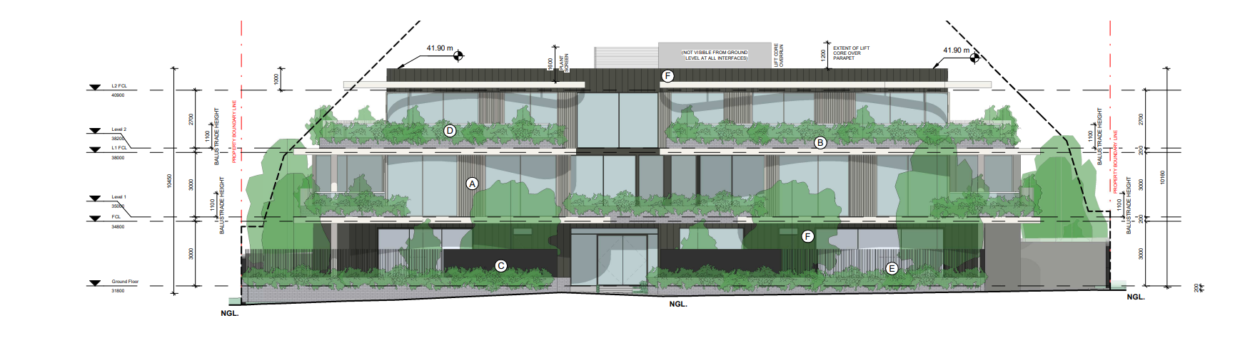
- The building design is out of character with the neighbourhood.

RECOMMENDATION:
Moved: Cr Nelson Seconded: Cr Sullivan

That the Responsible Authority having consideration of all matters which the Planning and Environment Act, 1987 requires it to consider, recommends at the Victorian Civil and Administrative Tribunal (VCAT) to Refuse to Grant a Planning Permit for the Construction of a Three Storey residential building with basement carparking containing 16 Dwellings in accordance with the plans and documentation submitted with the application subject to the following grounds:

Carried

- The proposal does not satisfy the objectives of Clause 11.03-6L-03 Bellarine Peninsula:
a) To provide reasonable sharing of views to the coast and foreshore and promote a design that respects the existing scale, setbacks, spacings forms of buildings in the locality.

2. The proposal does not satisfy the objectives of Clause 16.01-1L-03 Increased Housing Diversity Areas in Coastal Areas:
a) To ensure that the density, mass and scale of residential development is appropriate to the location, role and character of a coastal IHDA; and
b) To encourage new development to provide a high level of on-site amenity for future residents.

- The proposal does not accord with the objective of the Design and Development Overlay – Schedule 14 to ensure that the siting, height and visual bulk of dwellings achieves a reasonable sharing of views between properties to significant landscape features.

- The proposal does not sufficiently respond to the objectives and/or standards of Clause 55, including:

- 55.02-1 (Standard B1) Neighbourhood character
- 55.04-1 (Standard B17) Side and Rear Setback
- 55.06-2 (Standard B32) Front Fence objective
- 55.07-2 (Standard B36) Communal Open Space

- The proposal fails to comply with Clause 65 (Decision Guidelines) of the Greater Geelong Planning Scheme in that it does not result in orderly planning of the area.

PLANNING REPORT

PERMIT TRIGGERS:
A planning permit is triggered for this application pursuant to the following clauses of the Greater Geelong Planning Scheme:
- Pursuant to Clause 32.07-5 of the Residential Growth Zone a permit is required to construct two or more dwellings on a lot.
- Pursuant to Clause 43.02 of the Design and Development Overlay Schedule 14 a permit is required to construct a dwelling which is more than 7.5 metres above the natural ground level.

DEFINITIONS:
Pursuant to Clause 73.03 of the Planning Scheme a dwelling is defined as:
A building used as a self-contained residence which must include:
a) a kitchen sink;
b) food preparation facilities
c) a bath or shower; and
d) a closet pan and wash basin.
It includes outbuildings and works normal to a dwelling.
Pursuant to Clause 73.04 of the Planning Scheme a dwelling is nested in the Accommodation group.

Pursuant to Clause 73.01 of the Planning Scheme building height is defined as:

The vertical distance from natural ground level to the roof or parapet at any point.

RESTRICTIVE COVENANT OR SECTION 173 AGREEMENT:
The subject site is burdened by a Restrictive Covenant 0272093 and 0240076.
The covenants relate to any building being constructed on the land must not be used for the purpose of making or selling any malted, spiritous of vinous liquors.

The proposed development is not in contravention of this covenant.

OFFICER DIRECT OR INDIRECT INTEREST:
No Council officers have any direct or indirect interest in the matter to which this report relates, in accordance with Section 130(2) of the Local Government Act.

SITE/LOCALITY:
The subject sites are particularly described as Lots 131 and 132 on Plan of Subdivision 001856.

The key features of the subject land and surrounds are as follows:
- The subject site is located on the northern side of The Parade, Ocean Grove.
- The combined sites are rectangular in shape and is approximately 1,698 square metres in area.
- The site is relatively flat with the land sloping gently from the north-east (rear) boundary to the western (side) boundary.
- The site at 59 The Parade contains a single storey dwelling, located in the southern (front) section of the site, with an attached double garage located in front of the line of the dwelling, with planted mature garden vegetation to the rear of the dwelling. The site contains a 2 metre high solid front fence.
- The site at 57 The Parade contains double storey dwelling located approximately in the centre of the site, with a detached single garage located behind the dwelling. There is no front fencing.
- The surrounding properties are generally a similar size to the subject site. They contain a mixture of single, double storey and three storey dwellings, where there are examples of multi-dwelling development located at 61 The Parade (2 dwelling development), 65 The Parade (4 dwelling development), 55 The Parade (2 dwelling development), 70 The Parade (2 dwelling development), 49 The Parade (2 dwelling development), 48 The Parade (two dwelling development), 47 The Parade (2 dwelling development), 58 The Parade (directly abutting the northern property boundary, 2 dwelling development) and 54 The Avenue (2 dwelling development). As a general rule the multi-dwelling development, provides spacings between buildings to provide view lines to the Bluff and Ocean Grove beach. This section of The Parade and The Avenue are located within the Residential Growth Zone, where the zoning for the RGZ3 extends west to Field Street North, with commercial development located to the east of Presidents Avenue.

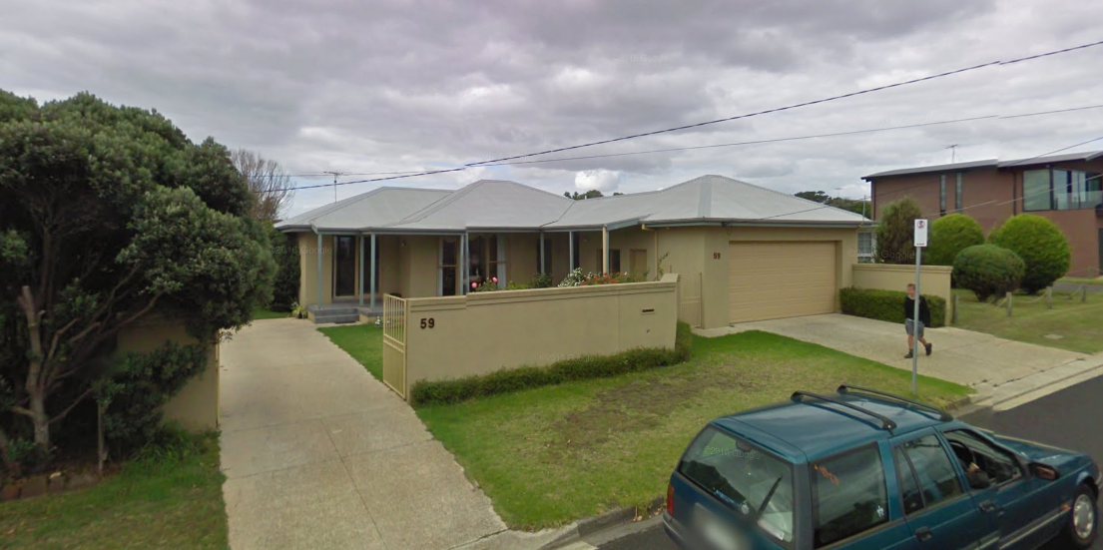

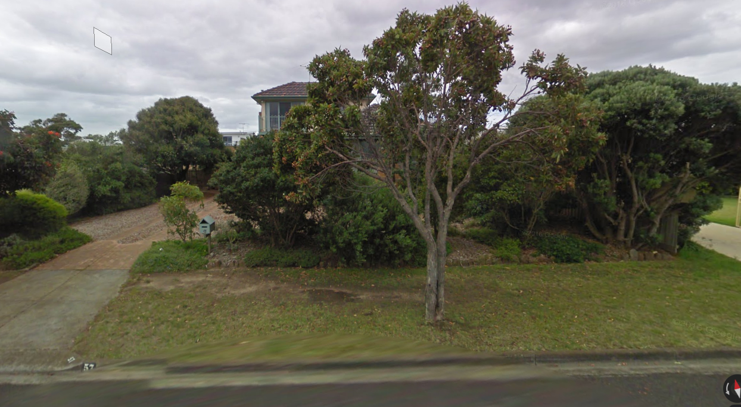
57 & 59 The Parade Ocean Grove above
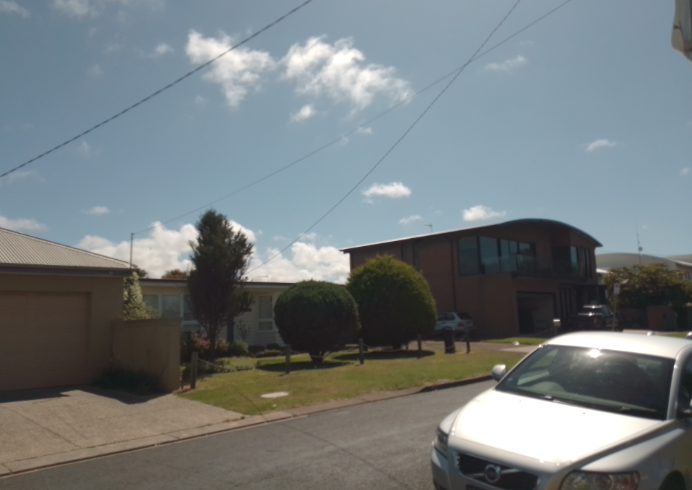
61 and 63 The Parade

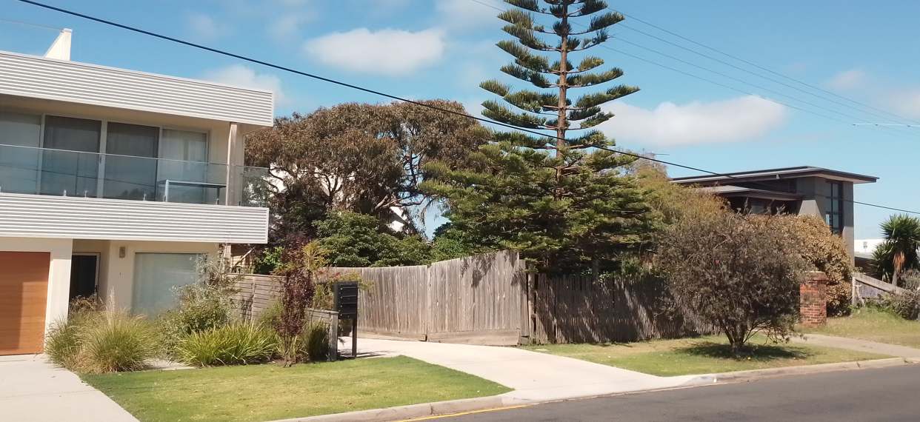
58-62 The Parade

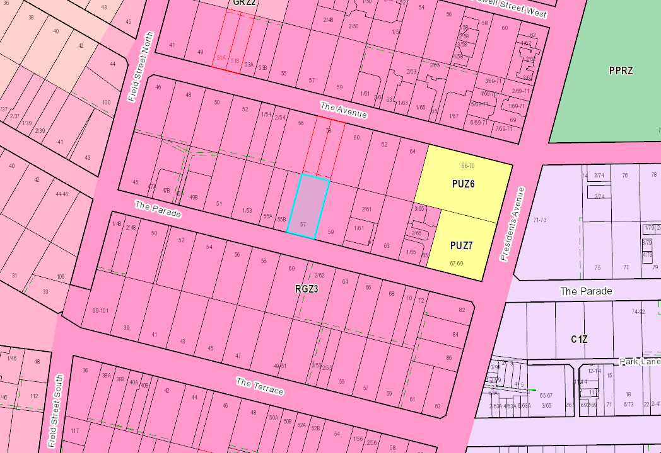

PROPOSAL:
The key features of the proposal include:
- The development of a three storey apartment building comprising of 16 apartments including basement car parking for 26 car spaces for residents and 3 visitor car spaces (29 spaces in total).
- The basement level will consist of 29 car parking spaces with access along the eastern (side) section of the site (maximum width of basement access is 6.1 metres), with a lift access and waste refuge located within the centre of the basement & 7 cubic metres storage spaces along the southern and northern basement walls abutting car parking spaces. Bicycle and storage is provided along the eastern boundary (16 bike spaces provided). The basement will be constructed in close proximity to the eastern (side) boundary setback 700mm the eastern boundary of the property, setback a minimum of 3.4 metres from the northern (rear) boundary, 5.6 metres from the western (side) boundary and 4 metres from the southern (front) boundary.
- The ground floor will consist of one (2) four (4) bedroom apartments, three (3) three (3) bedroom apartments and one (1) two (2) bedroom apartment, with private open space ranging from 167 square metres down to 49 square metres located within adjacent outside courtyards. The ground level will be setback a minimum 4.6 metres from the northern (rear) boundary, 6.5 metres from the southern (front) boundary, with the building and ramp setback a minimum 300mm up to 1 metre from the eastern (side) boundary and 3.4 metres from the western (side boundary.
- The first floor will consist of five (5) two (2) bedroom apartments and two (2) three bedroom apartments, with private open spaces located within balconies varying from 8 square metres up to 20.9 square metres in area. The first floor will be setback 4.1 metres from the eastern (side) boundary, 4.8 metres from the northern (rear) boundary, 3.4 metres from the western (side) boundary and 6 metres from the southern (front) boundary.
- The second storey will consist of four (4) three (3) bedroom apartments, with private open space located within balconies varying from 43.5 square metres up to 57.4 square metres.
- The maximum building height shown on all four elevations varies from 10.45 metres down to 9.98 metres. The plans are unclear if the measurement is taken from the highest point to the natural ground directly below.
- The building will be constructed from a variety of materials, with masonry grey bricks, glass tinted balustrade, vertical timber cladding and render grey finishes.
- The plant equipment deck and lift core roof will be 1.2 metres above the maximum height of the building, which is not included in the maximum building height as discussed in Aitken Properties Pty Ltd v Hobsons Bay CC {2016} where the following was provided:

‘The maximum height of the building to parapet or roof is 13 metres with various services functions rising approximately 1.2 metres above that height. The services proposed on the roof are setback from the site boundaries and are relatively confined in extent and height comprising solar panels, screening, hot water units, burners and a lift overrun. We find none of the proposed roof top elements are of a size, nature and type of construction to warrant consideration as a roofed element in their own right. This finding of fact allows the roof top services, as proposed, without contravening the mandatory 13 metre building height limit required by DDO11…(para 77).’

PERMIT/SITE HISTORY:
A search of Council’s records has found the following permit history (the history is for 57 The Parade only):

Permit Number | Description

PP-830-2019 | Buildings and works associated with the construction of four dwellings and a four lot subdivision
PP-1152-2017 | Construction of two dwellings exceeding 7.5 metres in height and removal of vegetation.

REFERRALS:
The following referrals were undertaken:

INTERNAL
Department: | Engineering Services
Response: | - The flowing information was requested by engineering in relation to the amended plans, and passed onto the applicant, the applicant hasn’t provided updated plans to show the below information, however these requirements could easily be conditioned as part of a planning permit:  - Provide a passing area at the entrance at least 6.1 metres wide and 7 metres long.  - Please show in the plan min 0.75m offset from Eastern property boundary line.  - Please add a note in the plan: ‘’Existing layback to be removed and reinstated to kerb & channel’’ as shown in yellow highlighted below:  Draft Standard Conditions  Drainage & Vehicular Access:  Prior to the occupation of the dwellings, the developer must:  - Construct the site stormwater system including separate connection for each unit into the underground drain in The Parade, or other nominated point/s as approved by the Responsible Authority. The stormwater connection must be in accordance with City of Greater Geelong Standard Drawings.  - Construct min 6.1m wide vehicular crossings with min 0.6m offset from western property boundary in accordance with the requirements and standards of the City of Greater Geelong.  - Any proposed vehicular crossing shall have satisfactory clearance to any existing crossover, side-entry pit, power, lighting or telecommunication pole, manhole cover or marker, fire hydrant or street tree. Any relocation, alteration or replacement required shall be in accordance with the requirements of the relevant Authority and shall be at the applicant’s expense.  - Remove any redundant vehicular crossings with kerb and channel and the footpath/nature strip area reinstated to match existing construction in the street.  all to the satisfaction of the Responsible Authority.  Note:  1. Construction of the site stormwater connection/s is to be inspected by Council Representative prior to any backfilling. An appropriate fee equivalent to 3.25% of total cost of civil works, excluding GST (a minimum fee of $100 applies if the 3.25% amount is less than $100), is to be paid to Council for inspection. Relevant evidential documentation of the cost is to be provided.  2. All internal property drainage must be designed and constructed to satisfy AS/NZS 3500.  3. A Vehicle Crossing Permit must be obtained prior to commencement of works.  Road and Drainage Construction Plans  Unless otherwise approved in writing by the Responsible Authority, prior to the commencement of works, Engineer designed roadworks and drainage construction plans must be submitted to and approved by the Responsible Authority. The Engineering construction plans must show but not limited to.  - They are submitted with the completed Design Engineers Checklist – Request for Detailed Design Approval.  - Construction of a new side entry pit in The Parade within the frontage of no: 57-59 The Parade, 1.0m clear of the vehicle crossing;  - Extension of a minimum 300mm diameter pipe from the new side entry pit to the existing pit on the western side in The Parade.  - Pits and pipe sizes;  - Finished surface and existing surface levels;  - A house connection for each Unit.  All to the satisfaction of the Responsible Authority.  Construction of Roadworks / Drainage  Unless otherwise approved in writing by the Responsible Authority, prior to the issuing of an Occupancy, roadworks and drainage works be constructed in accordance with the approved plans and specifications to the satisfaction of the Responsible Authority.  The underground site stormwater drainage system shall be constructed within the road reserve nature strip to cater for all lots, by the development and the surrounding developed and undeveloped area all to the satisfaction of the Responsible Authority.  - Install the new drains in accordance with the approved plans:  - Provide to Council ‘as-built’ Engineering plans in PDF, and GIS-ready AutoCAD (DXF) format plans, to the satisfaction of the Responsible Authority;  - Submit a CCTV inspection report for all new Council underground drainage pipes and pits;  Footpath Construction  The permit holder must construct a 1.5 m wide footpath across the entire frontage, to the satisfaction of the Responsible Authority. The existing concrete path between the road reserve boundary and the Back of Kerb must be removed to the satisfaction of the Responsible Authority.  Engineering Fees and Bonds  The design and construction of any new Council infrastructure needs to be approved and supervised by the Responsible Authority. Unless otherwise approved in writing by the Responsible Authority, prior to the issue of a Statement of Compliance for each relevant stage of the Plan of Subdivision, a fee of 3.25% of the cost of the works must be paid to the Responsible Authority for the checking and supervision of these works. A maintenance bond of 5% of the cost of the works is to be paid to Council and will be returned after successful completion of a one (1) year maintenance period, all to the satisfaction of the Responsible Authority.  CAD Drawings  Unless otherwise approved in writing by the Responsible Authority, As-Constructed plans must be submitted to the Responsible Authority prior to the issue of statement of compliance/occupancy, to the satisfaction of the Responsible Authority.  Car Parking  Prior to the occupation of the dwellings, the developer must construct the car park including accessways, surface with an all-weather sealed coat and linemark the car and accessways in accordance with the endorsed plans to the satisfaction of the Responsible Authority.  Common Property – PRIOR TO OCCUPATION  Prior to the occupation of the dwellings the common property / access road within the development shall be constructed and drained to the satisfaction of the Responsible Authority.  Stormwater Quality / Management  The site stormwater system must be designed and installed such that:  - The site stormwater discharge is not increased by the proposed development. An appropriate on site detention system designed in accordance with the Infrastructure Design Manual may be required.  to the satisfaction of the Responsible Authority.  Pump System  Unless otherwise approved by the Responsible Authority and prior to the Commencement of the Development / Issuing of Statement of Compliance, the land owner must enter an agreement with the Responsible Authority pursuant to Section 173 of the Planning and Environment Act 1987. All costs associated with setting up the agreement must be borne by the land owner. The agreement is to be registered on title and run with the land, and is to provide to the satisfaction of the Responsible Authority:  - All storm water runoff is to be collected on site and discharged to the legal point of discharge using a pump system or as otherwise nominated by the responsible authority. The pump system is to be designed and constructed in accordance with Australian Standard 3500 Part 3.2 Section 9.  - In the event of any operational difficulties with the pump system, it is the Responsibility of the land owner to rectify these difficulties.  - Any pump system is to be replaced by gravity discharge if and when available, and if directed by the Responsible Authority, at the land owner’s full cost.  - Provision is made (if appropriate) in any subdivision for Body Corporate drainage works, and access to those drainage works to be on common property or within an easement in favour of the Body Corporate.  Note: Where the legal point of discharge is kerb and channel, discharge velocity at the kerb must be no greater than 1.5 m/s with a maximum discharge flow rate of 10 l/s and the outlet directed at an angle of 45º to the direction of flow in the kerb and channel.  Non-Standard Conditions  NOTE  A pre-commencement meeting with Council’s Engineering Department is required to be undertaken prior to works starting. To organise this meeting please ring 5272 4426.
Officer Comment:
The recommended permit conditions could be included as conditions of any permit if a permit was issued.

Department: | ESD Response
Response: | This ESD response of this application is done on 2/8/2022 (2nd response). The applicant has not been satisfactorily responded all the previous ESD comments. Council’s ESD Officer has reviewed the below documents in accordance with Council's ESD Local Planning Policy (22.71), and this development has not reached an acceptable level of ESD. FYI - Clause 22.71 ESD has mostly moved to Clause 15.01 Built Environment recently.  However, permit can be issued with a permit condition. The summary conditions are:  - Information regarding xeriscaping and/or the use of drought tolerant species will need to be added to the landscape plan and architectural plan.  - The appropriate solar PV (10kw) must be provided for peak energy demand and designed and evidence must be provided in the plan.  - Note must be provided in plan that the ‘maximum illumination power density’ is 4W/m².  Documents reviewed:  - Development plans by UXD Group, dated on 9/7/2022 received on 21/7/2022  - SMP report by Passivenergy, dated on 22/6/2022 received on 21/7/2022  - BESS report (project identifier: 47EEEB37-R2 Version-BESS-6), received on 21/7/2022  Conditions provided  Before the use and development commences, amended plans to the satisfaction of the Responsible Authority must be submitted to and approved by the Responsible Authority. When approved, the plans will be endorsed and will then form part of the permit. The plans must be drawn to scale with dimensions. The plans must be generally in accordance with the plans received 21/7/2022 but modified to show:  - Initiatives contained within the Sustainable Management Plan along with the proposed changes, including:  - Information regarding xeriscaping and/or the use of drought tolerant species will need to be added to the landscape plan and architectural plan.  - The appropriate solar PV (10kw) must be provided for peak energy demand, and design and evidence must be provided in the plan that the total amount is appropriate solar PV system in this development.  - Note must be provided in plan that the ‘maximum illumination power density’ is 4W/m².  If a BESS report is included as part of the ESD report, the BESS report must achieve an overall score of 50% or higher and have a minimum ‘pass’ rates of 50% for the Energy, Water and IEQ categories and 100% for the Stormwater category.  - All works must be undertaken in accordance with the endorsed Plan, ESD report and stormwater management plan to the satisfaction of the Responsible Authority. No alterations to these plans may occur without the written consent of the Responsible Authority.
Officer Comment:
The recommended permit conditions could be included as conditions of any permit if a permit was issued.

Department: | Urban Design
Response: | First response 20/12/2021  Overall massing strategy  - It is noted that the proposed development sits within Increased Housing Diversity Area (Clause 22.63) which provides design direction with regards to development.  - The proposed development presents as a large monolithic structure to the street and surroundings. The building footprint in itself is significantly larger than its adjoining and surrounding properties. Noting that the street comprises of an eclectic architectural response, the applicant is encouraged to provide further façade articulation that builds on cues from the street consistent with the design objectives for built form “Encourage development that incorporates a combination of horizontal and vertical articulation, materials, textures and colours to create visual interest”.  - Further, although 3 storey built form is considered appropriate for this site, the applicant is encouraged to recess the third storey to reduce the dominance of the public realm as per Clause 22.63 – “Encourage two and three storey development. Three storey development should be encouraged on larger sites abutting the activity centre or where the amenity of adjoining properties will not be unreasonably impacted. Encourage the recessing of the third storey to reduce dominance of the building from adjoining properties and the streetscape.” Further this will ensure that a more acceptable transition to adjoining existing built form is achieved.  Site coverage  - We query the accuracy of the site coverage of 55% as provided in the Planning Report.  Compliance with B17  - The applicant must demonstrate compliance with B17 envelope either in section or elevation of the proposal.  Sense of address  - The applicant is encouraged to provide individual entrances to apartment units at the ground floor fronting the street as it strengthens the sense of address. Further The main entry into the lobby requires further refinement to provide a clear entryway when viewed from the street.  - The applicant is encouraged to consider how the ground floor residences contribute to the passive surveillance of the street effectively. The proposed fencing appears to hinder surveillance opportunities. It is recommended that the applicant considers individual entrances from the street to ground level residences facing the street. This will further ensure activation to the street and support an appears of finer grain rather than a monolithic building. Further the applicant must consider reducing the height of the fencing such that privacy can be maintained whilst ensuring ‘eyes on the street’. it is noted that the height of the proposed fencing has not been provided. Applicant must provide all measurements.  - SPOS to A02 must be limited to the side and not wrap around the edge of the site to ensure opportunities for lower fencing and passive surveillance the public realm.  - We encourage the applicant to consider vehicular access form the east of the site by utilising the existing crossover, this will eliminate the need to remove any on street trees.  - The applicant is to consider how safety and lines of sight can be improved around the vehicular entry area. It is recommended that the walls highlighted below are lowered.  - We query the ability to achieve adequate landscaping in the planter boxes noting that it is located to the southern façade of the building and will always remain in shade as seen in the shadow diagrams.  - Applicant must provide a landscape plan to enable the assessment of the species proposed, deep spoil planting and plants proposed to balconies. Currently the trees shown in the render do not reflect the existing landscape character of the street.  - We request the drawing set to include a roof plan. We request this plan show any items located on the roof: including solar panels, hot water systems and plant equipment. The elevations should be updated accordingly.  - The applicant must demonstrate compliance with B17 envelope either in section or elevation of the proposal.  - Landscape plan showing, deep soil planting, balcony planting and irrigation should be provided.  Second Response 5/8/2022  Urban design is supportive of the application with Landscape Plan as a condition.
Officer Comment:
The recommended permit conditions could be included as conditions of any permit.

Waste Services
The waste management references recommend a private contractor and the small street frontage for bin presentation precludes a Council collection system. The documents refer to two 1100 litre bins but the drawings show organics recycling bins. The WMP must clearly describe the system.
An endorsed WMP will be a condition of the Permit and due to the size of the development the WMP requires review as soon as possible.
The other concern is the basement waste management proposed and recent developments of this type adopt the mini rear loader waste vehicles with 6.4 metre wheelbase and low clearance heights to keep basement heights to a minimum. The availability of these small units outside the Geelong CBD is questionable and a recent Barwon Heads development had to completely change their WMP to suit larger more readily available trucks
Conditions provided
- A Waste Management Plan that is to the approval of the Responsible Authority must be provided prior to certification of the subdivision for this Development. The Approved Waste Management Plan must be incorporated into the Planning Permit.
- If the Waste Plan endorses the use of a private contractor to collect the residential waste and recycling from the development, the Applicant must enter into an agreement under Section 173 of the Planning and Environment Act 1987 with the Responsible Authority prior to the Statement of Compliance or the Certificate of Occupancy being issued for the development. The agreement must be in a form to the satisfaction of the Responsible Authority, and the applicant must be responsible for the expense of the preparation and registration of the agreement, including the Responsible Authority’s reasonable costs and expense (including legal expenses) incidental to the preparation, and enforcement of the agreement. The agreement will be registered on all the developments titles in accordance with Section 181 of the Planning and Environment Act1987. The agreement must contain covenants to be registered on the Titles of the property so as to run with the land, and must provide for the following:
  - An adjusted Council Residential Waste Service Charge is still payable even though a Private Waste Contractor provides the residential recycling and waste collection services.

Officer Comment:
The recommended permit conditions could be included as conditions of any permit.

Parks Department
The applicant has moved the access from the western boundary to the eastern boundary to not impact on the street tree.

AMENDMENT OF THE PROPOSAL PRIOR TO PUBLIC NOTIFICATION:
The application was not amended prior to public notification.

PUBLIC NOTIFICATION:
The application is not exempt from the notice requirements of Section 52(1)(a), (b) and (d), the decision requirements of Section 64(1), (2) and (3) and the review rights of Section 82(1) of the Act and pursuant to Section 52 of the Planning and Environment Act 1987 the following forms of advertising were undertaken:
- Notices were sent to owners and occupiers of adjoining land (including opposite).

- A2 sign(s) was placed on the land.
One-hundred and seventy (170) objections have been lodged with Council.

CONSULTATION:
A consultation meeting was not held given delays awaiting the submission of amended plans, where after the plans were received the applicant subsequently lodged a failure to determine the application within 60 statutory days. Notwithstanding this all parties have had the opportunity to consult at the VCAT Compulsory Conference held on the 16 February 2023.

AMENDMENT OF THE APPLICATION FOLLOWING PUBLIC NOTIFICATION
The application was amended following public notification. However the plans were not lodged formally under Section 57A of the Planning and Environment Act 1987.
Amended plans were lodged on the 14 March 2023 after the compulsory conference to respond to draft delegate report submitted with VCAT and third party objector concerns. The changes are listed below :
- The number of apartments have been reduced from 17 to 16 apartments with the basement car parking reduced from 31 spaces to 29 spaces (due to the reduction of 1 apartment).
- The location of the basement has been moved 700mm west off the eastern (side) boundary.
- A separate bike access area is provide along the eastern boundary providing 16 bike spaces, which is now located outside of basement car parking area, with a plant equipment area incorporated to the west of the bike rack..
- Waste refuge reduced to provide an increased western carriageway allow for greater circulation for waste collection manoeuvring.
- The carriageway to the basement has been extended by 1 metre (traversing under the ramp) to provide greater reversing area for vehicles.
- Plant equipment for the building located in the location of where car parking bay 31 was located.
- Mini loader swept path omitted from the plans with swept paths provide by traffix consultants.
- A 7.0 metre by 6.1 metre passing bay has been incorporated into the ramp design (southern – front section of the ramp) at the crossover.
- Above ground water tanks omitted from the eastern (side) boundary and relocated under the ramp.
- Basement floor level provided with a surveyors finished floor height.
- The ramp width has been modified to be setback 1 metre from the eastern (side) boundary, with a 700mm garden bed along the eastern boundary.
- Apartment 1 design amended, where bedroom 2 & 3 are now in line with the building footprint and not cantilevered over the ramp, with the deletion of two slim line windows along the western elevation (living dining area) for a large window to provide more natural light.
- Apartment 2 has two slim line windows along the western elevation for a larger window to provide more natural light.
- Apartment 7 has been deleted on the first floor of the development. Apartments 6 and 8 have been internally reconfigured where the first floor now has two three-bedroom apartments. All apartment numbers are reconfigured.
- Building rebate added to the southern (front) elevation to provide greater articulation to the built form when viewed from The Parade.
- Reducing the size of Apartment 8 and recessing the built form of the development along the southern (front) elevation and western (side) elevation.
- Overlooking screens added to apartment 10 and 12.
- Curved corners for all second storey apartments. The roof canopy has been replaced with pergolas (open air structures).
- Break in the built form of the balconies, with separation between the northern and southern boundaries.
The amended plans were required to be circulated to all parties for the VCAT hearing as well as the original properties listed for notification.

OBJECTIONS:
The concerns of objectors are summarised and commented on below:

- The proposed development is not in-keeping with the objectives of the Design and Development Overlay (Schedule 14) due to its design, sheer height, siting and bulk.
Response
As set out in the report below (within the response to the overlay section) the proposed development does not allow for the reasonable sharing of views through the site when viewed from the north (especially at 58 The Avenue) which will have their views to the Ocean Grove Beach and The Bluff taken away completely.

- The proposal will impact on the heritage values of the dwelling at 56 The Parade (H)1604).
Response
The subject site is located 30 metres to the north-east of 56 The Parade on the opposite of The Parade, where the proposed built form will not impact on the heritage significance of the “Almora Residence” – HO1604. It is noted that there has been other multi-dwelling development (62 The Parade 4 dwellings, greater than 7.5 metres in height) that has not impacted on the heritage significance of 56 The Parade.

- The subject site is only 6 lots from an SLO and is not in keeping with development within an SLO.
Response
The Significant Landscape Overlay (Schedule 7) is located on the western side of Field Street North (approximately 140 metres to the west of the subject site) which is also not located within Residential Growth Zone (Schedule 3), but within the General Residential Zone (Schedule 3) and Neighbourhood Residential Zone (Schedule 5), which have competing preferred neighbourhood character built forms. It is reasonable to assume that the subject site is located well within RGZ3 and not on the edge of the zone, where there isn’t the requirement to provide a graduation in built form to the Significant Landscape Overlay and Neighbourhood Residential Zone and General Residential Zones.

- Dangerous road conditions along The Parade will occur, due to cars parking on the street due to not enough parking provided within the development.
Response
The application was referred to Council’s Traffic area within the Engineering Department, who are satisfied with the number of spaces provided onsite and did not require a traffic impact assessment as part of the application.

- This development changes the towns appeal and character.
Response
The subject site is located within a section of Ocean Grove which is located within the Residential Growth Zone and within an Increased Housing Diversity Area, which seeks to provide a preferred neighbourhood character of this part of Ocean Grove, which seeks to accommodate residential growth at a significant capacity that is complementary to the location, role and character of the Coastal Increased Housing Diversity Area (see detailed response below in the report under planning policy response).
- It’s an eyesore and unnecessary to build up in this area of Ocean Grove.
Response
See above response relating to the character of this area of Ocean Grove. The application is assessed against the relevant zoning, overlay and planning policy frameworks.

- Council rules only allow 2 storey buildings.
Response
The subject site is located within the Residential Growth Zone (Schedule 3) which allows for dwellings or residential buildings to be constructed to maximum building height of 10.5 metres. There is no restriction in relation to the number of storeys allowed to be constructed onsite within the Zone, Overlay or restriction on title.
- Location of proposed access to the basement car park is too close to residential dwelling at 61 The Parade, overshadowing of the private open space of 61 The Parade.
Response
If a notice of decision is granted, conditions will be required to adhere to EPA guidelines in relation to noise. It is considered the proposed access to the basement will be located in the same location as the existing vehicle crossover, where although the number of vehicles will be increased, the vehicles will be driving underneath and will be greater than 1.5 metres setback from the habitable room window at 1/61 The Parade. A full Clause 55 assessment has been undertaken, which is an appendix to this report, where the overlooking requirements are met.

- Concerns with overlooking.
Response
A full Clause 55 assessment has been undertaken, which is an appendix to this report, where the overlooking requirements are met.

- Height of the building over 10.5 metres.
Response
The applicant has amended their plans to show on all elevations the building will be under 10.5 metres in height. After the amended plans were received, the applicant was made aware the application would be required to be re-advertised, whereby a failure to determine was lodged with VCAT.

- Noise impacts on adjoining properties from having 17 dwellings proposed.
Response
Given that the development is for apartments, there would not be a significant increase to any noise levels within this area relevant to this planning assessment due to the development.

Plant equipment is shown to be located above the roof and basement and therefore would not be considered to impact the adjoining sites.

Noise during the construction phase of the development would be required to adhere to the EPA requirements for construction noise.

- The building creates visual bulk with no break in building form across the site.
Response
The proposed development is seeking a continuous built form across the majority of the width of the site. Local policy Clause 11.03-6L-03 (Bellarine Peninsula) and the Design and Development Overlay (Schedule 14) seek that development achieves a reasonable sharing of views between properties to significant landscape features. This aspect of the proposal is addressed into greater detail within the response to the overlay and planning policy framework response, but the lack of separation in built form across the site does not allow for the sharing of views through the site, when viewed from properties to the north.

- There is no visitor car parking.
Response
The applicant has provided three visitor car parking spaces within the basement car parking, which meets the requirements of Clause 52.06 (car parking) which requires 1 visitor space per 5 dwellings. The application was referred to the City’s Engineering Department who have raised no concerns with the visitor car parking location and numbers.

- There are no electric vehicle parking stations.
Response
The City of Greater Geelong Planning Scheme has no requirements to provide electric vehicle parking spaces.

- No traffic report was provided with the application.
Response
The applicant has provided the appropriate number of car spaces required under Clause 52.06 (car parking) for the number of dwellings and visitor spaces onsite. The City’s Engineering Department have no objections to the proposal from a traffic perspective and did not require a traffic assessment as part of the application requirements.

- Removal of existing vegetation is not keeping with the character of Ocean Grove.
Response
The subject site does not have any vegetation controls through a Significant Landscape Overlay or Environmental Significance Overlay and is under 4000 square metres in area. If a Notice of Decision to Grant a Permit was issued a detailed landscape plan requiring a number of canopy trees would be required as per conditions of any permit.

- This type of development is turning Ocean Grove into a horizontal Surfers Paradise.
Response
Any application is assessed against the relevant zones, overlays, planning policy frameworks and relevant clauses of the City of Greater Geelong Planning Scheme.

- Devalue surrounding properties.
Response
VCAT have regularly determined that the issue of potential property devaluation is not a relevant planning consideration.

Senior Member Margaret Baird discussed devaluation of property in paragraph 55 in the case of Filcam Property Group Pty Ltd v Whitehorse CC [2014] VCAT 508.

Devaluation of property

55. As with the case with many other instances when this ground is identified by Respondent Objectors to a planning permit application, potential loss in property values is not a matter upon which there is any evidence. Moreover, if values are affected by adverse amenity impacts, then it is the amenity questions that must be considered, not their ramifications in terms of property values. This is the approach usually adopted by the Tribunal in these proceedings

As such, the assessment and decision making on this application should not be based on devaluation of property.

- The location of the basement will impact on the H7821-0067 a deep handmade brick well at 61 The Parade

Response
The applicant has been provided a copy of the letter from DELWP relating to the well at 61 The Parade and the requirements to obtain Heritage Act Consent to authorise works that may impact the well.

ASSESSMENT:
ZONE:

Residential Growth Zone (Schedule 3)
The purpose of the Residential Growth Zone that is most relevant to this proposal are:
- To implement the Municipal Planning Strategy and the Planning Policy Framework.
- To provide housing at increased densities in buildings up to and including four storey buildings.
- To encourage a diversity of housing types in locations offering good access to services and transport including activity centres and town centres.
- To encourage a scale of development that provides a transition between areas of more intensive use and development and other residential areas.
- To ensure residential development achieves design objectives specified in a schedule to this zone.
- Schedule of the Zone requires that future multi-dwelling development meets the requirements of Clause 22.63 (which is now Clause 16.01-2L – increased housing diversity) in relation to the siting, height, scale, materials and form of proposed buildings.

Maximum Building Height

The maximum building height on the plans show that the development is 10.45 metres from natural ground level to the roof or parapet at the highest point.

There is also a lift roof and plant equipment 1.2 metres in height above the parapet.

In Aitken Properties Pty Ltd v Hobsons Bay CC [2016] VCAT 1484 (5 September 2016), the question was raised as a matter of Law to be determined by a legal member of the Tribunal. The member Deputy President Dwyer addressed the matter in context of a mandatory height limit of 13m which was applied by a Design and Development Overlay. The member’s opinion was applied in that case where:

‘The maximum height of the building to parapet or roof is 13 metres with various services functions rising approximately 1.2 metres above that height. The services proposed on the roof are setback from the site boundaries and are relatively confined in extent and height comprising solar panels, screening, hot water units, burners and a lift overrun. We find none of the proposed roof top elements are of a size, nature and type of construction to warrant consideration as a roofed element in their own right. This finding of fact allows the roof top services, as proposed, without contravening the mandatory 13 metre building height limit required by DDO11…(para 77).’

Given this, it is considered the maximum building height of the building, measure to the top of the parapet is 10.45 metres which is in-keeping with the maximum height required under the zone and is therefore considered to comply. At not more than 3 storeys and less than 10.5 metres, the proposal does comply with the maximum building height requirements in the Zone. It is also considered the applicant has taken the maximum height on the elevations onto the roof services fence on top of the building.

OVERLAY:

Design and Development Overlay (Schedule 14)
Has the following objective:
- To ensure that the siting, height and visual bulk of dwellings achieves a reasonable sharing of views between properties to significant landscape features such as the coast (ocean and foreshore), Corio Bay, Barwon River, Central Geelong, Barrabool Hills and the You Yangs.
The decision guidelines seek that development must consider the following:
- The impact of the proposed buildings and works on the view from another property as result of the design, siting, height, size and bulk (including the roof).
- Whether opportunities exist to avoid a building being visually obtrusive by the use of alternative building designs, including split level and staggered building forms, that follow the natural slope of the land and reduce the need for site excavation or filling.
- The opportunity for a reasonable sharing of views having regard to the extent of the available view(s) and the significance of the view(s) from the properties affected.
Response to zone and overlay(s)

The proposal is in keeping with the purpose of the zone given it provides an increase in housing density and diversity on a site in close location to services and transport and the Ocean Grove town centre.

The Design and Development Overlay (Schedule 14) requires that development provides an appropriate transition from single dwellings to multi-dwelling development, with a maximum building height of 10.5 metres to still provide a design response that provides view lines between built form to significant landscape features and views.
The correct approach to the assessment of what is a reasonable sharing of views is explored in the decision of Healy v Surf Coast SC [2005] VCAT 990. In that decision the relevant principles are refined as follows:
(a) there is no legal right to a view;
(b) views form part of the existing amenity of a property and their loss is a relevant consideration to take into account;
(c) the availability of views must be considered in the light of what constitutes a reasonable sharing of those views;
(d) in addressing the concept of “reasonableness”, it is relevant to consider
(i) the importance of the view to be lost within the overall panorama available; and
(ii) whether those objecting have taken all appropriate steps to optimise development of their own properties.
(e) added emphasis will be placed on principles (b) and (c) above if the issue of views is specifically addressed in the planning scheme.
The above principles in the above Healy decision assist greatly in analysing the loss of views within this application. The key concepts are the value of the view to be lost and the parts of the dwelling where the view will be lost. The Healy decision explains that the loss of views should be assessed from parts of the dwelling that are most commonly used.

Presently there is a three storey, two dwelling development under construction directly to the rear (north) of the site at 58 The Avenue Ocean Grove. The dwellings have been designed with views from their second storey living area directly to the south to take views of The Bluff and Ocean Grove Beach, with an upper level deck also constructed to maximise the views to these significant landmarks. It is considered the living room, living room balcony will be the most utilised and valued living areas of both dwellings, as the upper-level deck is an open space with no shelter.

The proposed development of the three storey apartment complex with its proposed siting and design on site, with no break in built form across the majority of the width of the site (32 metres in width along the upper level including balconies), will block out the majority of the eastern dwellings views from the north (58 The Avenue), which as mentioned above have been designed where the second storey of the dwellings living room encapsulates the panoramic view of the Barwon Heads Bluff, which is the most prominent view line within Ocean Grove, The Ocean and RAAFS Beach, with views to the Barwon River inlet further west. It is considered the design of this development is to optimise these views, which will be largely lost as a result of the proposed development. The proposed design has failed to minimise the loss of views from the immediate north at 58 The Avenue.

The loss of views will be extensive and have a very significant and unreasonable impact on the amenity of the eastern dwelling near completion at 58 The Avenue. In no way the does the height, scale and siting of the proposed residential building with 16 dwellings, provide a reasonable sharing of views to the ocean, where it completely blocks out the Bluff and the majority of RAAFS Beach, leaving the Barwon River inlet views only.

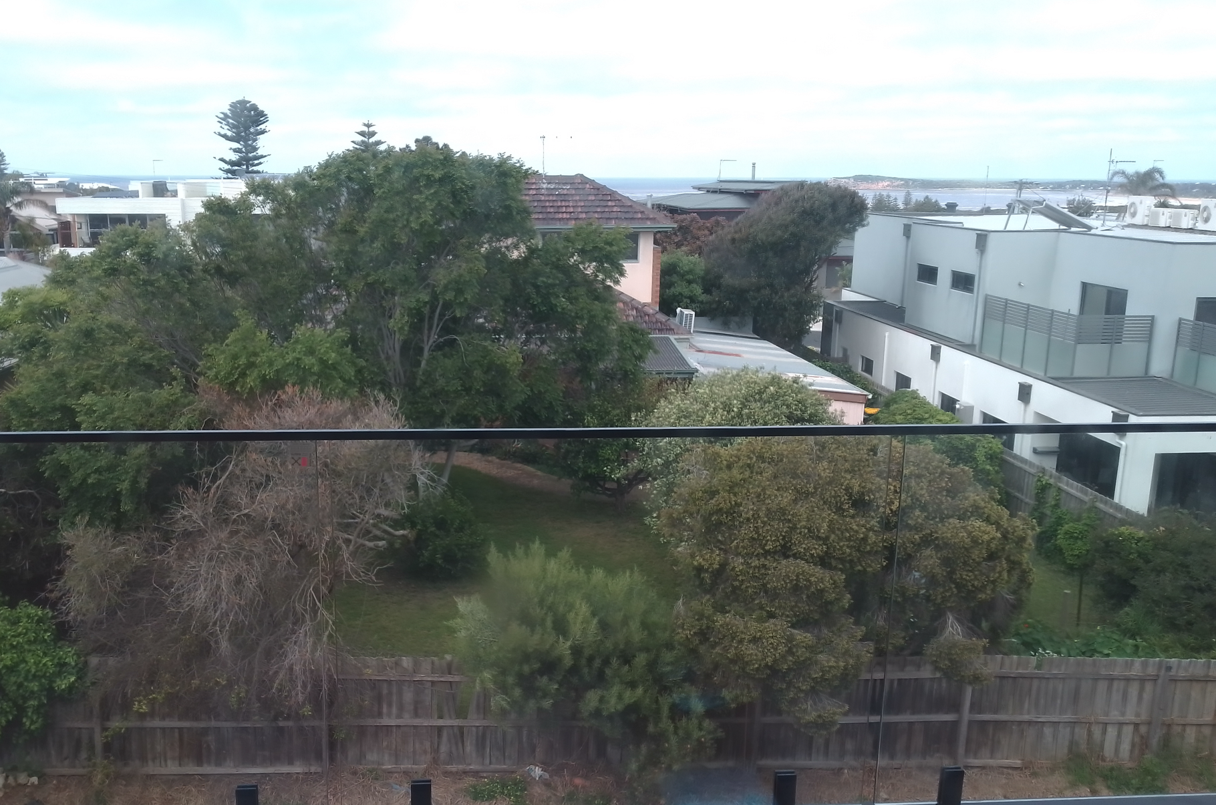
View from 58 The Parade Second storey living area looking to the Bluff
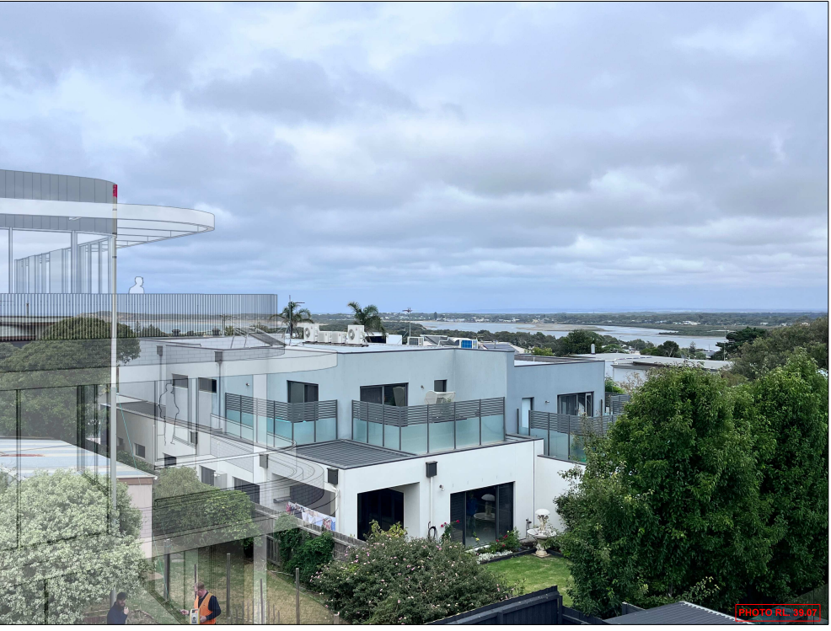
View from first floor balcony of eastern dwelling at 58 The Avenue, from Applicants View Impact Analysis

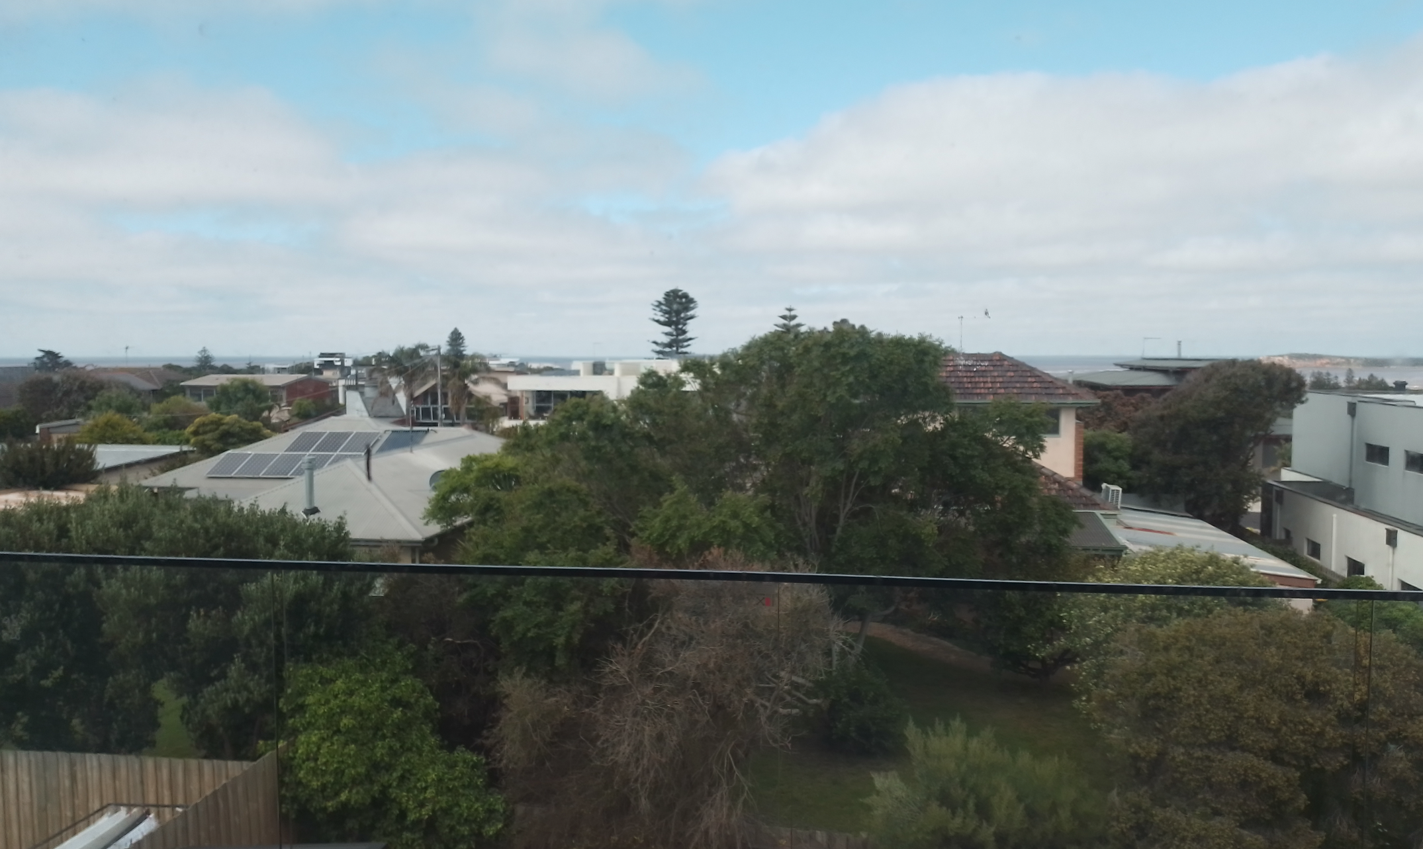
View from 58 The Parade looking south.
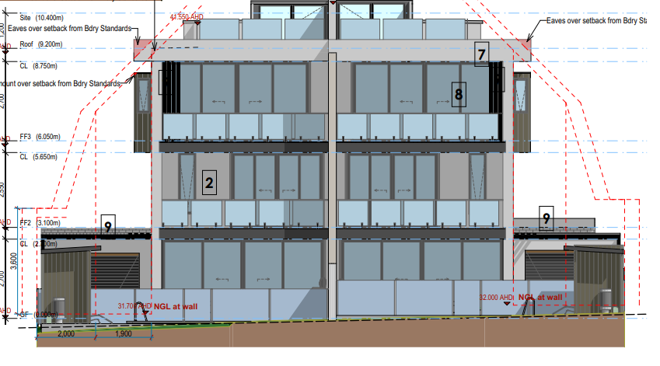
Southern elevation of the two dwelling development at 59 The Avenue, where the main areas of the dwellings are considered to be second level living room and balcony and upper level deck area.

CULTURAL HERITAGE MANAGEMENT PLAN (CHMP):

The development area is not located in an area of declared cultural significance. Therefore, a Cultural Heritage Management Plan is not required.

LANDFILL GAS RISK ASSESSMENT

The subject site is not located within 500 metres of an identified former landfill site, a risk assessment is not required.

DEVELOPMENTS IN BUSHFIRE PRONE AREAS

The site is not located within a designated bushfire prone area.

THE VICTORIAN PLANNING POLICY FRAMEWORK (VPPF):
The following Victorian Planning Policies are applicable to this application:
Clause No. | Clause name
11 | Settlement
11.01-1R | Settlement Geelong G21
11.02 | Managing Growth
11.03-2S | Growth Areas
11.03-4S | Coastal Settlement
11.03-6L-01 | Bellarine Peninsula
15.01-1S | Urban Design
15.01-2L | Environmentally Sustainable Design
16.01 | Residential Development
16.01-2S | Location of residential development
16.01-2L | Increased Housing Diversity Area
16.01-2L-03 | Increased Housing Diversity Area for coastal areas

Response to Policy

Given the requirements of the planning policies, there is significant guidance to provide for increased dwelling density into existing activity centres to limit urban sprawl and reliance on vehicles. Thus there have been a number of large developments occurring within this area of Ocean Grove which will provide for the intensification of dwellings in these existing activity centres and identified housing diversity areas.

The subject site is located within an increased housing diversity area which centres around the Ocean Grove Town Centre, which seeks dwelling intensification, and there is strong planning policy for where intensification and substantial change in built form is envisaged and subject to consideration of the proposed built form.

Within Clause 11.01-1R – Settlement Geelong G21, Ocean Grove is identified as supported for planned growth and reinforce its role as a district town.

Subject to the above, where there is strong policy weight given to the site being developed for increased residential options, there is significant planning policy around what is an acceptable outcome for this area, including the Increased Housing Diversity Area Policy (IHDA) for coastal areas, Design and Development Overlay – Schedule 14, Clause 55 and the Bellarine Peninsula policy, which provide strategies in relation to the proposed built form outcomes of development.
The Bellarine policy clause 11.03-6L-03 (Bellarine Peninsula) sets out the below strategies for development within Ocean Grove:

- Providing reasonable sharing of views of the coast and foreshore.
- Promoting contemporary design that reflects the existing scale, setbacks, spacing, forms and materials of the buildings in the locality.
- Ensuring that development allows for the protection of significant trees or planting around buildings and has minimal impact on roadside vegetation.
Furthermore, Clause 16.01-1L-02 (Increased Housing Diversity Areas) seeks the following strategies in relation to the built form of development:
- Encourage development that incorporates a combination of horizontal and vertical articulation, materials, textures and colours to create visual interest.
- Encourage a sympathetic design response when addressing any unique characteristics such as heritage places, significant vegetation, topography and public spaces.
- Discourage storage areas located within the minimum area of secluded open space.
- Support development that does not reduce opportunities for neighbouring sites to reasonably develop.
To provide further direction Clause 16.01-1L-03 seeks within the Increased Housing Diversity Area for coastal areas the following strategies:

- A variety of lightweight materials.
- Building elements and details that contribute to a lightness of structure (including balconies, verandahs, extensive glazing, light transparent balustrading).
- Simple detailing.
- Higher building elements to capture views.
It is considered from the above polices that development must be lightweight and innovative in design, where a more intensive bult form outcome is anticipated, any development must also fit in with the preferred neighbourhood character within the coastal setting of Ocean Grove.

In light of the above it is considered the proposed development will use lightweight materials that are contemporary in design, where the applicant proposes to use extensive glazing around the upper level balconies and simple detailing of the building which is consistent with Clause 16.01-1L-03 (increase housing diversity in coastal areas).
However, it is not consistent with Clause 11.03-6L-03, which specifically addresses the issues of sharing of views, where the following strategy Providing reasonable sharing of views of the coast and foreshore.
It is considered the proposed development does not meet this design objective. When viewed from the properties to the north, the development provides a monotonous horizontal built form across the majority of the site at 10.4 metres in height that does not respond to the rhythm and spacing of recent multi-dwelling development within The Avenue and The Parade. Furthermore, although it does provide higher building elements to capture the views, the design of the building to capture views is not considered to be an element of the design, rather a continuous built form across the majority of the width of the site. A greater level of modulation is required with breaks in the height of the built form to provide view lines through the site to properties to the north.
Although buildings have been constructed to 10.5 metres in height, within the immediate area of The Parade and The Avenue, the proposed development does not provide a break in the height of built form to allow for reasonable views through the site to the coastline and The Bluff, with only some views on the inlet left. The multi-dwelling development at the rear (two dwellings) only has a small part of the site, where the building height is a maximum of 10.5 metres, which are the stair voids for the upper-level deck area, where there are sufficient setbacks from each property boundary to allow for views through the site to the coastline.

The IHDA policy supports three storey development where the site abuts the activity centre or where the amenity of the adjoining properties will not be unreasonably impacted. It also seeks to encourage the recessing of third storeys to reduce dominance of the building on adjoining properties and the streetscape. It is considered that the third storey is not recessed enough from property boundaries to provide view lines through the site from the north and has not reduced the third storey impacts on the adjoining dwellings. Overall, it is considered that the continuous built form of the upper third storey is not an acceptable outcome for this site.

There has been a recent VCAT decision for multi-dwelling development for an apartment storey complex, similar in height, that provide guidance on development applications within the Residential Growth Zone in relation to the preferred neighbourhood character and built form. QPC Pty Ltd v City of Moreland [2021] which affirmed Council’s decision to refuse a four storey, six dwelling apartment complex with underground car parking where although the development of the site was supported by policy it was refused in relation to the design.

In summary, some of the key findings of the decision include:

- I accept that the review site benefits from its location in the RGZ1 and the Brunswick Activity Centre where substantial change is encouraged. However, there are other factors which I must also consider in assessing whether the proposal will result in an acceptable outcome.
- I consider that the key factors that weigh against the grant of a planning permit for this proposal in favour of refusal are:
  - the proposal does not provide an appropriate transition to the adjoining low-rise residential properties in Hickford Street;
  - the design, form, layout, proportion and scale of the proposal is not compatible with the period, style, form, proportion and scale of the heritage places surrounding the review site in light of the interim heritage controls and adopted permanent heritage controls;
  - the level of activation sought by planning policy is not achieved;
  - the off-site amenity impacts on the property to the south contribute to my finding that on balance the proposal is not acceptable given my concerns about the setbacks and overshadowing impacts as well as the potential limiting effect on equitable development of that property should the review site be developed as proposed.
Although the proposed development is not located within a Heritage area, it is located within a coastal environment, which is a sensitive area for multi-dwelling development where there are requirements for sharing of view lines through the site and consistent rhythm of development in the spacing of buildings from property boundaries, which the design of the proposed residential building has not considered. An application where the zoning of the land within a Residential Growth Zone and Increased Housing Diversity Areas although receiving high policy support for intensification of development still needs to be responsive in context to its locality and other local policy design requirements.

The design response and intensity of development proposed is considered to not strike an appropriate balance with all the relevant planning policy and design standards that apply in context with the proposed location. The proposal would have a dominating appearance in the streetscape and when viewed from neighbouring residential properties, especially from both abutting secluded private open space areas of the dwellings either side of the site and to the rear of the site.

It is therefore considered that such an intensity of development proposed does not represent an appropriate step to an evolution for this location, where dwelling diversity will be the predominant character as envisaged by the IHDA coastal policy and Bellarine Peninsula policy.

CLAUSE 52.06 – CAR PARKING

- To ensure that car parking is provided in accordance with the State Planning Policy Framework and the Local Planning Policy Framework.
- To ensure the provision of an appropriate number of car parking spaces having regard to the demand likely to be generated, the activities on the land and the nature of the locality.
- To support sustainable transport alternatives to the motor car.
- To promotes the efficient use of car parking spaces through the consolidation of car parking facilities.
- To ensure that car parking does not adversely affect the amenity off the locality.
- To ensure that the design and location of car parking is of a high standard, creates a safe environment for users and enables easy and efficient use.
Response

Clause 52.06 requires the provision of 29 car spaces to be located on the land. A total of 29 car spaces are provided, including 3 visitor parking spaces which meets the requirements of Clause 52.06.

CLAUSE 55 - RESCODE ASSESSMENT – TWO OR MORE DWELLINGS ON A LOT

The application has been assessed against the objectives and standards of Clause 55 of the Planning Scheme.

The following are variations to Standards which are considered satisfactory:

Standard B17 side and rear setback
The side and rear setbacks contain minor encroachments, where the balconies of the upper levels and roof form have minor variations to the standards.

Standard B32 front fence objective
The proposed development is seeking front fencing to 1.8 metres in height. It is noted that there is other front fencing within The Parade to 1.8 metres in height, whereby on this basis it is considered a minor encroachment.

Standard B36 Communal open space

For over 10 dwellings, communal open space is required. The application does not meet the standard as no communal open space has been provided. It is considered that the majority of apartments contain over the minimum requirements for private open space and there is the Ocean Grove Park within 200 metres from the subject site and Ocean Grove Beach within 600 metres from the subject site. Given the majority of apartments exceed the minimum requirements for private open space and the proximity to nearby public reserves a variation to the requirements of Standard B36 is acceptable.

DECISION GUIDELINES OF CLAUSE 65:
CLAUSE 65.01 – APPROVAL OF AN APPLICATION OR PLAN

Clause 65.01 of the Greater Geelong Planning Scheme outlines the decision guidelines to be considered by the Responsible Authority when making decisions on applications. These decision guidelines include:
- The matters set out in Section 60 of the Act.
- The Municipal Planning Strategy and the Planning Policy Framework.
- The purpose of the zone, overlay or other provision.
- Any matter required to be considered in the zone, overlay or other provision.
- The orderly planning of the area.
- The effect on the amenity of the area.
- The proximity of the land to any public land.
- Factors likely to cause or contribute to land degradation, salinity or reduce water quality.
- Whether the proposed development is designed to maintain or improve the quality of stormwater within and exiting the site.
- The extent and character of native vegetation and the likelihood of its destruction.
- Whether native vegetation is to be or can be protected, planted or allowed to regenerate.
- The degree of flood, erosion or fire hazard associated with the location of the
- land and the use, development or management of the land so as to minimise any such hazard.
- The adequacy of loading and unloading facilities and any associated amenity, traffic flow and road safety impacts.

Response

The location of the site is appropriate for an increased dwelling density given its close proximity to public transport, recreation facilities, retail and community services. The increase in dwellings at the site will utilise established infrastructure and provide for a diversity of choice in the area. This aspect of the proposal generally complies with the direction of the Local Planning Policy Framework for infill development in residential areas.

However, on balance, the site is not an appropriate location for a development of the intensity proposed. The Increased Housing Diversity Area policy objectives include the consideration of the density, mass and scale of a proposal in context with the location, role and character of the IHDA. Assessment of the proposal has resulted in there being likely amenity impacts resulting from the intensity proposed, and that the context of the location within a coastal area, where the sharing of views through the site has not been adequately demonstrated.

Further, it is considered that the design response is lacking in areas as a result of a desire to maximise the development potential of the site, creating some undesirable amenity outcomes for future occupants.

As such, in accordance with the considerations of the assessment, the application is recommended for refusal.

CONCLUSION:

That the Responsible Authority having consideration of all matters which the Planning and Environment Act 1987 requires it to consider, recommends at the Victorian Civil and Administrative Tribunal (VCAT) to Refuse to Grant a Planning Permit for the Construction of a Three Storey residential building with basement carparking containing 16 Dwellings at 57-59 The Parade, Ocean Grove in accordance with the plans and documentation submitted with the application.
APPENDIX 1

CLAUSE 55 ASSESSMENT TOOL – TWO OR MORE DWELLINGS ON A LOT AND RESIDENTIAL BUILDINGS

Date of Assessment: 14/3/2023
Plans Assessed: amended plans 14/3/2023
Permit Application Number: PP-1312-2021

The following objectives apply to an application to:
- Construct a dwelling if there is at least one dwelling existing on the lot,
- Construct two or more dwellings on a lot,
- Extend a dwelling if there are two or more dwellings on the lot,
- Construct or extend a dwelling on common property, or
- Construct or extend a residential building,

in the Neighbourhood Residential Zone, General Residential Zone, Residential Growth Zone, Mixed Use Zone or Township Zone.

The following objectives are current up to and including Amendment VC174 on 20/12/2021.

 | 55.02-1 Neighbourhood character objectives  To ensure that the design respects the existing neighbourhood character or contributes to a preferred neighbourhood character.  To ensure that development responds to the features of the site and the surrounding area. | Standard B1  The design response must be appropriate to the neighbourhood and the site.  The proposed design must respect the existing or preferred neighbourhood character and respond to the features of the site. |  | No – Does not meet the objective  The development provides a monotonous horizontal built form across the majority of the site at 10.5 metres in height that does not respond to the rhythm and spacing of recent multi-dwelling development within The Avenue and The Parade. Although it is noted the subject site is located within an Increased housing Diversity Area, it is not consistent with other multi-dwelling development within the IHDA and RGZ3. Although it is considered the applicant has provided an effort to break up the built form of the development it is still considered not in line with the neighbourhood character of The Parade.
 | 55.02-2 Residential policy objectives  To ensure that residential development is provided in accordance with any policy for housing in the Municipal Planning Strategy and the Planning Policy Framework.  To support medium densities in areas where development can take advantage of public transport and community infrastructure and services. | Standard B2  An application must be accompanied by a written statement to the satisfaction of the responsible authority that describes how the development is consistent with any relevant policy for housing in the Municipal Planning Strategy and the Planning Policy Framework. |  | Yes – Complies with Standard B2  The application complies with the planning policy framework and the required written statement has been provided.
 | 55.02-3 Dwelling diversity objective  To encourage a range of dwelling sizes and types in developments of ten or more dwellings. | Standard B3  Developments of ten or more dwellings should provide a range of dwelling sizes and types, including:  - Dwellings with a different number of bedrooms.  - At least one dwelling that contains a kitchen, bath or shower, and a toilet and wash basin at ground floor level. |  | Yes – Complies with Standard B3  The proposal seeks to provide a range of different dwelling sizes ranging from 2 bedroom up to 4 bedrooms.
 | 55.02-4 Infrastructure objectives  To ensure development is provided with appropriate utility services and infrastructure.  To ensure development does not unreasonably overload the capacity of utility services and infrastructure. | Standard B4  Development should be connected to reticulated services, including reticulated sewerage, drainage, electricity and gas, if available.  Development should not unreasonably exceed the capacity of utility services and infrastructure, including reticulated services and roads.  In areas where utility services or infrastructure have little or no spare capacity, developments should provide for the upgrading of or mitigation of the impact on services or infrastructure. |  | Yes – Complies with Standard B4  The site is serviced by the required infrastructure and the application has been referred to the City’s Engineers who have not raised any concern about the ability of the site to be drained. Conditions of permit cover off on this issue.
 | 55.02-5 Integration with the street objective  To integrate the layout of development with the street. | Standard B5  Developments should provide adequate vehicle and pedestrian links that maintain or enhance local accessibility.  Development should be oriented to front existing and proposed streets.  High fencing in front of dwellings should be avoided if practicable.  Development next to existing public open space should be laid out to complement the open space. |  | Yes – Complies with Standard B5  The development is designed to address The Parade, with pedestrian and vehicle links to the street provided.  Although there is a high fence proposed it is semi-transparent in design with landscaping which will break up the built form of the fence and there is clear pedestrian access to the building and vehicle access.
 | 55.03-1 Street setback objective  To ensure that the setbacks of buildings from a street respect the existing or preferred neighbourhood character and make efficient use of the site. | Standard B6  Walls of buildings should be set back from streets:  - At least the distance specified in a schedule to the zone, or  - If no distance is specified in a schedule to the zone, the distance specified in Table B1.  Porches, pergolas and verandahs that are less than 3.6 metres high and eaves may encroach not more than 2.5 metres into the setbacks of this standard.  RGZ3 – has a variation to the standard  The average distance of the setbacks of the front walls of the existing buildings on the abutting allotments facing the front street or 5.5 metres, whichever is the lesser. |  | Yes – Complies with Standard B6  The proposed apartments at ground level propose a front street setback of 5.5 metres to The Parade. This is consistent and compliant with the Residential Growth Zone setback requirements under Schedule 3.
 | 55.03-2 Building height objective  To ensure that the height of buildings respects the existing or preferred neighbourhood character. | Standard B7  The maximum building height should not exceed the maximum height specified in the zone, schedule to the zone or an overlay that applies to the land.  If no maximum height is specified in the zone, schedule to the zone or an overlay, the maximum building height should not exceed 9 metres, unless the slope of the natural ground level at any cross section wider than 8 metres of the site of the building is 2.5 degrees or more, in which case the maximum building height should not exceed 10 metres.  Changes of building height between existing buildings and new buildings should be graduated.  RGZ3 Variation to the Standard  Maximum building height 10.5 metres. |  | Yes – Complies with Standard B7  The residential building has a maximum building height of 10.45 metres which complies with the requirements of Schedule 3 of the Residential Growth Zone.
 | 55.03-3 Site coverage objective  To ensure that the site coverage respects the existing or preferred neighbourhood character and responds to the features of the site. | Standard B8  The site area covered by buildings should not exceed:  - The maximum site coverage specified in a schedule to the zone, or  - If no maximum site coverage is specified in a schedule to the zone, 60 per cent.  RGZ3 variation to the standard  Maximum site coverage 70% |  | Yes – Complies with Standard B8  The maximum site coverage specified for this site is 70%.  The proposed site coverage of buildings is 56% of the site, which is less than the maximum allowed by the standard.
 | 55.03-4 Permeability and stormwater management objectives  To reduce the impact of increased stormwater run-off on the drainage system.  To facilitate on-site stormwater infiltration.  To encourage stormwater management that maximises the retention and reuse of stormwater. | Standard B9  The site area covered by the pervious surfaces should be at least:  - The minimum area specified in a schedule to the zone, or  - If no minimum is specified in a schedule to the zone, 20 percent of the site.  The stormwater management system should be designed to:  - Meet the current best practice performance objectives for stormwater quality as contained in the Urban Stormwater - Best Practice Environmental Management Guidelines (Victorian Stormwater Committee, 1999).  - Contribute to cooling, improving local habitat and providing attractive and enjoyable spaces. |  | Yes – Complies with Standard B9  The site retains 30% permeability, assisting in on site stormwater filtration.  A STORM & ESD report has been provided which corresponds with the assessment plans which show suitably sized rainwater tanks and/or raingardens to meet best practice.
 | 55.03-7 Safety objective  To ensure the layout of development provides for the safety and security of residents and property. | Standard B12  Entrances to dwellings and residential buildings should not be obscured or isolated from the street and internal accessways.  Planting which creates unsafe spaces along streets and accessways should be avoided.  Developments should be designed to provide good lighting, visibility and surveillance of car parks and internal accessways.  Private spaces within developments should be protected from inappropriate use as public thoroughfares. |  | Yes – Complies with Standard B12  The development is designed to provide for the safety and security of residents and property. All dwelling entrances are clearly visible from the street or internal accessway and private spaces within the development will be fenced.  There is clear access from The Parade for pedestrian access to the building with low height plantings to provide clear surveillance from the street.
 | 55.03-9 Access objective  To ensure the number and design of vehicle crossovers respects the neighbourhood character. | Standard B14  The width of accessways or car spaces should not exceed:  - No more than one single-width crossover should be provided for each dwelling fronting a street.  - The location of crossovers should maximise the retention of on-street car parking spaces.  The number of access points to a road in a Transport Zone 2 or a Transport Zone 3 should be minimised.  Developments must provide for access for service, emergency and delivery vehicles. |  | Yes – Complies with Standard B14  A total of 14% of the frontage is taken up with vehicle crossings, which complies with the standard for this site with a street frontage of 40 metres.  Not more than one vehicle crossover is proposed for residential building.
 | 55.03-10 Parking location objective  To provide convenient parking for resident and visitor vehicles.  To protect residents from vehicular noise within developments. | Standard B15  Car parking facilities should:  - Be reasonably close and convenient to dwellings and residential buildings.  - Be secure.  - Be well ventilated if enclosed.  Shared accessways or car parks of other dwellings and residential buildings should be located at least 1.5 metres from the windows of habitable rooms. This setback may be reduced to 1 metre where there is a fence at least 1.5 metres high or where window sills are at least 1.4 metres above the accessway. |  | Yes – Complies with Standard B15  Convenient parking is provided for residents and shared accessways are located at least 1.5 metres from the windows of habitable rooms.
 | 55.04-1 Side and rear setbacks objective  To ensure that the height and setback of a building from a boundary respects the existing or preferred neighbourhood character and limits the impact on the amenity of existing dwellings. | Standard B17  A new building not on or within 200mm of a boundary should be set back from side or rear  boundaries:  - At least the distance specified in a schedule to the zone, or  - If no distance is specified in a schedule to the zone, 1 metre, plus 0.3 metres for every metre of height over 3.6 metres up to 6.9 metres, plus 1 metre for every metre of height over 6.9 metres.  Sun blinds, verandahs, porches, eaves, fascias, gutters, masonry chimneys, flues, pipes, domestic fuel or water tanks, and heating or cooling equipment or other services may encroach not more than 0.5 metres into the setbacks of this standard.  Landings having an area of not more than 2 square metres and less than 1 metre high, stairways, ramps, pergolas, shade sails and carports may encroach into the setbacks of this standard. |  | Yes – Complies, with variation to Standard B17  Before deciding on an application, the responsible authority must consider:  - Any relevant neighbourhood character objective, policy or statement set out in this scheme.  - The design response.  - The impact on the amenity of the habitable room windows and secluded private open space of existing dwellings.  - Whether the wall is opposite an existing or simultaneously constructed wall built to the boundary.  - Whether the wall abuts a side or rear lane.  The majority of the built form is contained with the standards of B17, with parts of balconies and small sections of the roof that encroach into the setbacks. This is illustrated within the elevation plans.
 | 55.04-2 Walls on boundaries objective  To ensure that the location, length and height of a wall on a boundary respects the existing or preferred neighbourhood character and limits the impact on the amenity of existing dwellings. | Standard B18  A new wall constructed on or within 200mm of a side or rear boundary of a lot or a carport constructed on or within 1 metre of a side or rear boundary of lot should not abut the boundary:  - For a length of more than the distance specified in a schedule to the zone; or  - If no distance is specified in a schedule to the zone, for a length of more than:  - 10 metres plus 25 per cent of the remaining length of the boundary of an adjoining lot, or  - Where there are existing or simultaneously constructed walls or carports abutting the boundary on an abutting lot, the length of the existing or simultaneously constructed walls or carports,  whichever is the greater.  A new wall or carport may fully abut a side or rear boundary where slope and retaining walls or fences would result in the effective height of the wall or carport being less than 2 metres on the abutting property boundary.  A building on a boundary includes a building set back up to 200mm from a boundary.  The height of a new wall constructed on or within 200mm of a side or rear boundary or a carport constructed on or within 1 metre of a side or rear boundary should not exceed an average of 3.2 metres with no part higher than 3.6 metres unless abutting a higher existing or simultaneously constructed wall. |  | Not Applicable  No new walls on or within 200mm of a boundary, or carport within 1m of a boundary are proposed as part of this application.  There are no requirements for the basement to be setback from property boundaries.
 | 55.04-3 Daylight to windows objective  To allow adequate daylight into existing habitable room windows. | Standard B19  Buildings opposite an existing habitable room window should provide for a light court to the existing window that has a minimum area of 3 square metres and minimum dimension of 1 metre clear to the sky. The calculation of the area may include land on the abutting lot.  Walls or carports more than 3 metres in height opposite an existing habitable room window should be set back from the window at least 50 per cent of the height of the new wall if the wall is within a 55 degree arc from the centre of the existing window. The arc may be swung to within 35 degrees of the plane of the wall containing the existing window.  Where the existing window is above ground floor level, the wall height is measured from the floor level of the room containing the window. |  | Not Applicable  There are no existing habitable room windows opposite the proposed buildings that require consideration. All existing windows are setback a minimum 1 metre and have 3 square metres clear to sky views.
 | 55.04-4 North facing windows objective  To allow adequate solar access to existing north-facing habitable room windows. | Standard B20  If a north-facing habitable room window of an existing dwelling is within 3 metres of a boundary on an abutting lot, a building should be setback from the boundary 1 metre, plus 0.6 metres for every metre of height over 3.6 metres up to 6.9 metres, plus 1 metre for every metre of height over 6.9 metres, for a distance of 3 metres from the edge of each side of the window. A north-facing window is a window with an axis perpendicular to its surface oriented north 20 degrees west to north 30 degrees east. |  | Not Applicable  There are no north facing habitable room windows on abutting lots that require consideration.
 | 55.04-5 Overshadowing open space objective  To ensure buildings do not significantly overshadow existing secluded private open space. | Standard B21  Where sunlight to the secluded private open space of an existing dwelling is reduced, at least 75 per cent, or 40 square metres with minimum dimension of 3 metres, whichever is the lesser area, of the secluded private open space should receive a minimum of five hours of sunlight between 9 am and 3 pm on 22 September.  If existing sunlight to the secluded private open space of an existing dwelling is less than the requirements of this standard, the amount of sunlight should not be further reduced. |  | Yes – Complies with Standard B21  The extent of overshadowing associated with the proposed development is within the requirements of the standard.  Shadow diagram plans attached with the application show this.
 | 55.04-6 Overlooking objective  To limit views into existing secluded private open space and habitable room windows. | Standard B22  A habitable room window, balcony, terrace, deck or patio should be located and designed to avoid direct views into the secluded private open space of an existing dwelling within a horizontal distance of 9 metres (measured at ground level) of the window, balcony, terrace, deck or patio. Views should be measured within a 45 degree angle from the plane of the window or perimeter of the balcony, terrace, deck or patio, and from a height of 1.7 metres above floor level.  A habitable room window, balcony, terrace, deck or patio with a direct view into a habitable room window of existing dwelling within a horizontal distance of 9 metres (measured at ground level) of the window, balcony, terrace, deck or patio should be either:  - Offset a minimum of 1.5 metres from the edge of one window to the edge of the other.  - Have sill heights of at least 1.7 metres above floor level.  - Have fixed, obscure glazing in any part of the window below 1.7 metre above floor level.  - Have permanently fixed external screens to at least 1.7 metres above floor level and be no more than 25 per cent transparent.  Obscure glazing in any part of the window below 1.7 metres above floor level may be openable provided that there are no direct views as specified in this standard.  Screens used to obscure a view should be:  - Perforated panels or trellis with a maximum of 25 per cent openings or solid translucent panels.  - Permanent, fixed and durable.  - Designed and coloured to blend in with the development.  This standard does not apply to a new habitable room window, balcony, terrace, deck or patio which faces a property boundary where there is a visual barrier at least 1.8 metres high and the floor level of the habitable room, balcony, terrace, deck or patio is less than 0.8 metres above ground level at the boundary. |  | Yes – Complies with Standard B22  The development is designed to meet the requirements of the standard with overlooking into existing secluded private open space areas and habitable room windows limited in accordance with the standard.
 | 55.04-7 Internal views objective  To limit views into the secluded private open space and habitable room windows of dwellings and residential buildings within a development. | Standard B23  Windows and balconies should be designed to prevent overlooking of more than 50 per cent of the secluded private open space of a lower-level dwelling or residential building directly below and within the same development. |  | Yes – Complies with Standard B23  Internal views have been considered in the design solution and there is no internal overlooking.
55.05-3 Daylight to new windows objective  To allow adequate daylight into new habitable room windows. |  | - Standard B27  - A window in a habitable room should be located to face:  - An outdoor space clear to the sky or a light court with a minimum area of 3 square metres and minimum dimension of 1 metre clear to the sky, not including land on an abutting lot, or  - A verandah provided it is open for at least one third of its perimeter, or  - A carport provided it has two or more open sides and is open for at least one third of its perimeter. | Yes – Complies with Standard B27  All habitable room windows face an outdoor space of the required dimensions, allowing light into habitable rooms.
 | 55.05-4 Private open space objective  To provide adequate private open space for the reasonable recreation and service needs of residents. | Standard B28  A dwelling or residential building should have private open space of an area and dimensions specified in the schedule to the zone.  If no area or dimensions are specified in the schedule to the zone, a dwelling or residential building should have private open space consisting of:  - An area of 40 square metres, with one part of the private open space to consist of secluded private open space at the side or rear of the dwelling or residential building with a minimum area of 25 square metres, a minimum dimension of 3 metres and convenient access from a living room, or  - A balcony of 8 square metres with a minimum width of 1.6 metres and convenient access from a living room, or  - A roof-top area of 10 square metres with a minimum width of 2 metres and convenient access from a living room.  RGZ3 variation to the standard  A dwelling or residential building should have private open space consisting of:  - An area of 20 square metres of secluded private open space at the side or rear of the dwelling or residential building with a minimum dimension of 3 metres and convenient access from a living room; or  - A balcony of 8 square metres with a minimum width of 1.6 metres and convenient access from a living room; or  - A roof-top area of 10 square metres with a minimum width of 2 metres and convenient access from a living room |  | Yes – Complies with Standard B28  The ground floor dwellings contain a minimum 20 square metres of private open space with a minimum width of 3 metres.  The upper level dwellings all contain private open space within balconies that exceed the 8 square metres requirements with a minimum width of 1.6 metres.  The private open space for dwellings are located off living areas.
 | 55.05-5 Solar Access to Open Space  To allow solar access into the secluded private open space of new dwellings and residential buildings. | Standard B29  The private open space should be located on the north side of the dwelling or residential building, if appropriate.  The southern boundary of secluded private open space should be set back from any wall on the north of the space at least (2+0.9h) metres, where ‘h’ is the height of the wall. |  | Yes – Complies  Before deciding on an application, the responsible authority must consider:  - The design response.  - The useability and amenity of the secluded private open space based on the sunlight it will receive.  The application was referred to Council’s ESD officer who was satisfied that the development meets ESD requirements, where only Apartment 1 on the ground floor has been amended to provide a large window to meet the requirements. .
 | 55.06-1 Design Detail  To encourage design detail that respects the existing or preferred neighbourhood character. | Standard B31  The design of buildings, including:  - Façade articulation and detailing,  - Window and door proportions,  - Roof form, and  - Verandahs, eaves and parapets,  - should respect the existing or preferred neighbourhood character.  Garages and carports should be visually compatible with the development and the existing or preferred neighbourhood character. |  | No – Does not meet the objective  As detailed above in this assessment and within the officer report, the proposed development does not respect the existing or preferred neighbourhood character for multi-dwelling development within the IDHA and RGZ3 within a coastal area. This is given the development does not provide a break in the built form, with limited view lines through the built form of the site and a consistent building height of 10 to 10.45 metres across the majority of the width of the site.
 | 55.06-2 Front Fences  To encourage front fence design that respects the existing or preferred neighbourhood character | Standard B32  The design of front fences should complement the design of the dwelling or residential building and any front fences on adjoining properties.  A front fence within 3 metres of a street should not exceed:  - The maximum height specified in a schedule to the zone, or  - If no maximum height is specified in a schedule to the zone, the maximum height specified in Table B3. |  | Yes – Complies, with variation to Standard B32  Before deciding on an application, the responsible authority must consider:  - Any relevant neighbourhood character objective, policy or statement set out in this scheme.  - The design response.  - The setback, height and appearance of front fences on adjacent properties.  - The extent to which slope and retaining walls reduce the effective height of the front fence.  - Whether the fence is needed to minimise noise intrusion.  The proposed front fence is approximately 1.8 metres in height.  There is development within The Parade, which contains high solid front fencing. The proposed fencing will have breaks in the built form to show the entrance to the residential building from The Parade and is therefore considered to be acceptable from a neighbourhood character perspective.
 | 55.06-3 Common Property  To ensure that communal open space, car parking, access areas and site facilities are practical, attractive and easily maintained.  To avoid future management difficulties in areas of common ownership. | Standard B33  Development should clearly delineate public, communal and private areas.  Common property, where provided, should be functional and capable of efficient management. |  | Yes – Complies with Standard B33  The common driveway is of functional design and will be shared by all residents. Additionally, landscaping to the common space has been designed to be easily maintained by respective occupants or a body corporate. Management of all common and shared spaces does not pose any foreseeable problems which will be further determined upon development strata & subdivision.
 | 55.06-4 Site Services  To ensure that site services can be installed and easily maintained.  To ensure that site facilities are accessible, adequate and attractive. | Standard B34  The design and layout of dwellings and residential buildings should provide sufficient space (including easements where required) and facilities for services to be installed and maintained efficiently and economically.  Bin and recycling enclosures, mailboxes and other site facilities should be adequate in size, durable, waterproof and blend in with the development.  Bin and recycling enclosures should be located for convenient access by residents.  Mailboxes should be provided and located for convenient access as required by Australia Post. |  | Yes complies – Complies with Standard B34  The applicant ensures that all services will be installed to the satisfaction of the relevant authorities and in areas that can be screened from the public domain whilst still remaining easily accessible & maintainable. Please refer to architectural documentation for location of bin and recycling enclosures, other site facilities and mailboxes

Clause 55.07 APARTMENT DEVELOPMENTS

In addition to Clause 55.01 to 55.05 (inclusive), the following Clause 55.07-1 to 55.07-19 (inclusive) apply only:
- To construct or extend an apartment development, or
- To construct or extend a dwelling in or forming part of an apartment development.

These provisions do not apply to an application to construct or extend a development of five or more storeys, excluding a basement or to construct or extend a dwelling in a development of five or more storeys, excluding a basement.

 | 55.07-1 Energy efficiency objectives  To achieve and protect energy efficient dwellings and buildings.  To ensure the orientation and layout of development reduce fossil fuel energy use and make appropriate use of daylight and solar energy.  To ensure dwellings achieve adequate thermal efficiency. |  | Standard B35  Buildings should be:  - Oriented to make appropriate use of solar energy.  - Sited and designed to ensure that the energy efficiency of existing dwellings on adjoining lots is not unreasonably reduced.  - Sited and designed to ensure that the performance of existing rooftop solar energy systems on dwellings on adjoining lots in a General Residential Zone, Neighbourhood Residential Zone or Township Zone are not unreasonably reduced. The existing rooftop solar energy system must exist at the date the application is lodged.  Living areas and private open space should be located on the north side of the development, if practicable.  Developments should be designed so that solar access to north-facing windows is optimised.  Dwellings located in a climate zone identified Table B4 in should not exceed the maximum NatHERS annual cooling load specified in the following table.  Refer Table B4 of Clause 55.07-1. |  | Yes – Complies with the standard  The application was referred to council’s ESD officer, where living spaces are facing north as practical as possible and when not possible to the east or west to optimise solar access to living areas.
 | 55.07-2 Communal open space objective  To provide communal open space that meets the recreation and amenity needs of residents.  To ensure that communal open space is accessible, functional, and is easily maintained.  To ensure that communal open space is integrated with the layout of the development and enhances resident amenity. |  | Standard B36  A development of 10 or more dwellings should provide a minimum area of communal outdoor open space of 30 square metres.  If a development contains 13 or more dwellings, the development should also provide an additional minimum area of communal open space of 2.5 square metres per dwelling or 220 square metres,  whichever is the lesser. This additional area may be indoors or outdoors and consist of multiple separate areas of communal open space.  Each area of communal open space should be:  - Accessible to all residents.  - A useable size, shape and dimension.  - Capable of efficient management.  - Be located to:  - Provide passive surveillance opportunities, where appropriate.  - Provide outlook for as many dwellings as practicable.  - Avoid overlooking into habitable rooms and private open space of new dwellings.  - Minimise noise impacts to new and existing dwellings.  Any area of communal outdoor open space should be landscaped and include canopy cover and trees. |  | Yes – Complies, with variation to Standard B36  Before deciding on an application, the responsible authority must consider:  - Any relevant urban design objective, policy or statement set out in this scheme.  - The design response.  - The availability of and access to public open space.  No communal private open space is provided. However the majority of the dwellings have exceeded the private open space requirements for each dwelling. The apartment complex is located 200 metres from the Ocean Grove Park and approximately 600 metres from Ocean Grove, where the variation is considered appropriate.
 | 55.07-3 Solar access to communal outdoor open space objective  To allow solar access into communal outdoor open space. |  | Standard B37  The communal outdoor open space should be located on the north side of a building, if appropriate.  At least 50 per cent or 125 square metres, whichever is the lesser, of the primary communal outdoor open space should receive a minimum of two hours of sunlight between 9am and 3pm on 21 June. |  | No – Does not meet the objective  No communal open space is provided. The standard seeks a minimum area for communal open space of 30 square metres and for 13 or more dwellings, the development should also provide 2.5 square metres per dwelling or 220 square metres. As no communal private open space is provided the objective is not met.
 | 55.07-4 Landscaping objective  To provide landscaping that supports the existing or preferred urban context of the area and reduces the visual impact of buildings on the streetscape.  To preserve existing canopy cover and support the provision of new canopy cover.  To ensure landscaping is climate responsive, supports biodiversity, wellbeing and amenity and reduces urban heat. |  | Standard B38  Development should retain existing trees and canopy cover.  Development should provide for the replacement of any significant trees that have been removed in the 12 months prior to the application being made.  Development should:  - Provide the canopy cover and deep soil areas specified in Table B5. Existing trees can be used to meet the canopy cover requirements of Table B5.  - Provide canopy cover through canopy trees that are:  - Located in an area of deep soil specified in Table B6. Where deep soil cannot be provided trees should be provided in planters specified in Table B6.  - Consistent with the canopy diameter and height at maturity specified in Table B7.  - Located in communal outdoor open space or common areas or street frontages.  - Comprise smaller trees, shrubs and ground cover, including flowering native species.  - Include landscaping, such as climbing plants or smaller plants in planters, in the street frontage and in outdoor areas, including communal outdoor open space.  - Shade outdoor areas exposed to summer sun through landscaping or shade structures and use paving and surface materials that lower surface temperatures and reduce heat absorption.  - Be supported by irrigation systems which utilise alternative water sources such as rainwater, stormwater and recycled water.  - Protect any predominant landscape features of the area.  - Take into account the soil type and drainage patterns of the site.  - Provide a safe, attractive and functional environment for residents.  - Specify landscape themes, vegetation (location and species), irrigation systems, paving and lighting.  Refer Table B5, B6 and B7 of Clause 55.07-4. |  | Yes – complies with the standard  The site requires at least 2 canopy trees of type B or 1 canopy tree of type 1. The applicant has provide amended plans to show that the landscaping provision is met.
 | 55.07-5 Integrated water and stormwater management objectives  To encourage the use of alternative water sources such as rainwater, stormwater and recycled water.  To facilitate stormwater collection, utilisation and infiltration within the development.  To encourage development that reduces the impact of stormwater run-off on the drainage system and filters sediment and waste from stormwater prior to discharge from the site. |  | Standard B39  Buildings should be designed to collect rainwater for non-drinking purposes such as flushing toilets, laundry appliances and garden use.  Buildings should be connected to a non-potable dual pipe reticulated water supply, where available from the water authority.  The stormwater management system should be:  - Designed to meet the current best practice performance objectives for stormwater quality as contained in the Urban Stormwater - Best Practice Environmental Management Guidelines (Victorian Stormwater Committee, 1999).  - Designed to maximise infiltration of stormwater, water and drainage of residual flows into permeable surfaces, tree pits and treatment areas. |  | Yes – Complies with Standard B39  The apartment design encompasses provisions for integrated water and stormwater management. Council’s ESD officer supports the proposal and the submitted Sustainability Management Plan would be endorsed if a permit were to be issued.
 | 55.07-6 Access objective  To ensure that vehicle crossovers are designed and located to provide safe access for pedestrians, cyclists and other vehicles.  To ensure that vehicle crossovers are designed and located to minimise visual impact. |  | Standard B40  Vehicle crossovers should be minimised.  Car parking entries should be consolidated, minimised in size, integrated with the façade and where practicable located at the side or rear of the building.  Pedestrian and cyclist access should be clearly delineated from vehicle access.  The location of crossovers should maximise pedestrian safety and the retention of on-street car parking spaces and street trees.  Development must provide access for service, emergency and delivery vehicles. |  | Yes – Complies with Standard B40  The proposed development provides a single vehicle crossover that provides a double width in accordance with DoT requirements to the basement car park.  Pedestrian access is clearly visible and is provided from its own access pathway.  Delivery vehicles and emergency service vehicles can access the site from The Parade or from the underground car park area.
 | 55.07-7 Noise impacts objective  To contain noise sources in developments that may affect existing dwellings.  To protect residents from external and internal noise sources. |  | Standard 41  Noise sources, such as mechanical plants should not be located near bedrooms of immediately adjacent existing dwellings.  The layout of new dwellings and buildings should minimise noise transmission within the site.  Noise sensitive rooms (such as living areas and bedrooms) should be located to avoid noise impacts from mechanical plants, lifts, building services, non-residential uses, car parking, communal areas and other dwellings.  New dwellings should be designed and constructed to include acoustic attenuation measures to reduce noise levels from off-site noise sources.  Buildings within a noise influence area specified in Table B8 should be designed and constructed to achieve the following noise levels:  - Not greater than 35dB(A) for bedrooms, assessed as an LAeq,8h from 10pm to 6am.  - Not greater than 40dB(A) for living areas, assessed LAeq,16h from 6am to 10pm.  Buildings, or part of a building screened from a noise source by an existing solid structure, or the natural topography of the land, do not need to meet the specified noise level requirements.  Noise levels should be assessed in unfurnished rooms with a finished floor and the windows closed.  Refer Table B8 of Clause 55.07-7. |  | Yes – Complies with Standard B41  There are no external noise sources that require consideration.  Noise sensitive rooms are located away from mechanical plant, including the lift, and the site is not within a nominated noise influence area.
 | 55.07-8 Accessibility objective  To ensure the design of dwellings meets the needs of people with limited mobility |  | Standard 42  At least 50 per cent of dwellings should have:  - A clear opening width of at least 850mm at the entrance to the dwelling and main bedroom.  - A clear path with a minimum width of 1.2 metres that connects the dwelling entrance to the main bedroom, an adaptable bathroom and the living area.  - A main bedroom with access to an adaptable bathroom.  - At least one adaptable bathroom that meets all of the requirements of either Design A or Design B specified in Table B9.  Refer Table B9 of Clause 55.07-8. |  | Yes – Complies with Standard B42  A clear opening width is provided to the main door and all bedrooms.  A clear path with a minimum width of 1.2 metres that connects the main bedroom to the bathroom and living area is provided.  All main bedrooms have an ensuite.  All bathrooms meet Design A.
 | 55.07-9 Private open space objective  To provide adequate private open space for the reasonable recreation and service needs of residents. |  | Standard 43  A dwelling should have private open space consisting of at least one of the following:  - An area at ground level of at least 25 square metres, with a minimum dimension of 3 metres and convenient access from a living room.  - A balcony with at least the area and dimensions specified in Table B10 and convenient access from a living room. If a cooling or heating unit is located on a balcony, the minimum balcony area specified in Table B10 should be increased by at least 1.5 square metres.  - An area on a podium or other similar base of at least 15 square metres, with a minimum dimension of 3 metres and convenient access from a living room.  - An area on a roof of at least 10 square metres, with a minimum dimension of 2 metres and convenient access from a living room.  Refer Table B10 of Clause 55.07-9. |  | Yes – Complies with Standard B43  Apartments 1-5 on the ground level all easily exceed the private open space requirements of 25 square metres and minimum width of 3 metres. All provide an open space area of a minimum of 25 square metres with a minimum dimension of 3 metres. The minimum POS on the ground level is 49 square metres.  On the first floor the minimum balcony areas for private open space are 8 square metres with a minimum width of 2 metres.  The second floor of all apartments have a minimum area of 40 square metres and minimum width of 2 metres, which exceeds the standard.
 | 55.07-10 Storage objective  To provide adequate storage facilities for each dwelling. |  | Standard B44  Each dwelling should have convenient access to usable and secure storage space.  The total minimum storage space (including kitchen, bathroom and bedroom storage) should meet the requirements specified in Table B11.  Refer Table B11 of Clause 55.07-10. |  | Yes – Complies with Standard B44  Adequate storage areas are located in the each of the apartments as well as the basement associated with the car parking spaces.
55.07-11 Waste and recycling objectives  To ensure dwellings are designed to encourage waste recycling.  To ensure that waste and recycling facilities are accessible, adequate and attractive.  To ensure that waste and recycling facilities are designed and managed to minimise impacts on residential amenity, health and the public realm |  | - Standard B45  - Developments should include dedicated areas for:  - Waste and recycling enclosures which are:  - Adequate in size, durable, waterproof and blend in with the development.  - Adequately ventilated.  - Located and designed for convenient access by residents and made easily accessible to people with limited mobility.  - Adequate facilities for bin washing. These areas should be adequately ventilated.  - Collection, separation and storage of waste and recyclables, including where appropriate opportunities for on-site management of food waste through composting or other waste recovery as appropriate.  - Collection, storage and reuse of garden waste, including opportunities for on-site treatment, where appropriate, or off-site removal for reprocessing.  - Adequate circulation to allow waste and recycling collection vehicles to enter and leave the site without reversing.  - Adequate internal storage space within each dwelling to enable the separation of waste, recyclables and food waste where appropriate.  - Waste and recycling management facilities should be design and managed in accordance with a Waste Management Plan approved by the responsible authority and:  - Be designed to meet the better practice design options specified in Waste Management and Recycling in Multi-unit Developments (Sustainability Victoria, 2019).  - Protect public health and amenity of residents and adjoining premises from the impacts of odour, noise and hazards associated with waste collection vehicle movements. |  | Yes – Complies with Standard B45  It is intended that waste will be managed by a private contractor.  If a permit were to issue the applicant would be required to submit a waste management plan for endorsement.
 | 55.07-12 Functional layout objective  To ensure dwellings provide functional areas that meet the needs of residents. |  | Standard 46  Bedrooms should:  - Meet the minimum internal room dimensions specified in Table B12.  - Provide an area in addition to the minimum internal room dimensions to accommodate a wardrobe.  Refer Table B12 of Clause 55.07-12.  Living areas (excluding dining and kitchen areas) should meet the minimum internal room dimensions specified in Table B13.  Refer Table B13 of Clause 55.07-12. |  | Yes complies to Standard B46  The amended plans meet the standard  All living areas comply with the requirements of this standard.
 | 55.07-13 Room depth objective  To allow adequate daylight into single aspect habitable rooms. |  | Standard B47  Single aspect habitable rooms should not exceed a room depth of 2.5 times the ceiling height.  The depth of a single aspect, open plan, habitable room may be increased to 9 metres if all the following requirements are met:  - The room combines the living area, dining area and kitchen.  - The kitchen is located furthest from the window.  - The ceiling height is at least 2.7 metres measured from finished floor level to finished ceiling level. This excludes where services are provided above the kitchen.  The room depth should be measured from the external surface of the habitable room window to the rear wall of the room. |  | Yes – Complies with Standard B47  The minimum proposed single aspect habitable room ceiling height is 2.7 metres requiring a maximum room depth of not more than 9 metres.
 | 55.07-14 Windows objective  To allow adequate daylight into new habitable room windows. |  | Standard B48  Habitable rooms should have a window in an external wall of the building.  A window may provide daylight to a bedroom from a smaller secondary area within the bedroom where the window is clear to the sky.  The secondary area should be:  - A minimum width of 1.2 metres.  - A maximum depth of 1.5 times the width, measured from the external surface of the window. |  | Yes – Complies with Standard B48  Adequate daylight is provided to all habitable room windows. No borrowed light is proposed. All habitable room windows are located on external walls, with no saddle back designed apartments.
 | 55.07-15 Natural ventilation objectives  To encourage natural ventilation of dwellings.  To allow occupants to effectively manage natural ventilation of dwellings. |  | Standard B49  The design and layout of dwellings should maximise openable windows, doors or other ventilation devices in external walls of the building, where appropriate.  At least 40 per cent of dwellings should provide effective cross ventilation that has:  - A maximum breeze path through the dwelling of 18 metres.  - A minimum breeze path through the dwelling of 5 metres  - Ventilation openings with approximately the same area.  The breeze path is measured between the ventilation openings on different orientations of the dwelling. |  | Yes – Complies with Standard B49  66% per cent of the dwellings meet the effective cross ventilation requirements, where the minimum requirements are for 40% of dwellings to meet cross ventilation.
55.07-16 Building entry and circulation objectives  To provide each dwelling and building with its own sense of identity.  To ensure the internal layout of buildings provide for the safe, functional and efficient movement of residents.  To ensure internal communal areas provide adequate access to daylight and natural ventilation. |  | - Standard B50  - Entries to dwellings and buildings should:  - Be visible and easily identifiable.  - Provide shelter, a sense of personal address and a transitional space around the entry.  - The layout and design of buildings should:  - Clearly distinguish entrances to residential and non-residential areas.  - Provide windows to building entrances and lift areas.  - Provide visible, safe and attractive stairs from the entry level to encourage use by residents.  - Provide common areas and corridors that:  - Include at least one source of natural light and natural ventilation.  - Avoid obstruction from building services.  - Maintain clear sight lines. |  | Yes – Complies with Standard B50  The proposed development exceeds the requirements. 66.6% achieve, this compared to the 40% required.
 | 55.07-17 Integration with the street objective  To integrate the layout of development with the street.  To support development that activates street frontages. |  | Standard B51  Development should be oriented to front existing and proposed streets.  Along street frontages, development should:  - Incorporate pedestrian entries, windows, balconies or other active spaces.  - Limit blank walls.  - Limit high front fencing, unless consistent with the existing urban context.  - Provide low and visually permeable front fences, where proposed.  - Conceal car parking and internal waste collection areas from the street.  Development next to existing public open space should be designed to complement the open space and facilitate passive surveillance. |  | Yes – Complies with Standard B51  The proposed development is orientated towards The Parade with access provided via a front gate that is easily accessible.
 | 55.07-18 Site services objective  To ensure that site services are accessible and can be easily installed and maintained.  To ensure that site services and facilities are visually integrated into the building design or landscape. |  | Standard B52  Development should provide adequate space (including easements where required) for site services to be installed and maintained efficiently and economically.  Meters and utility services should be designed as an integrated component of the building or landscape.  Mailboxes and other site facilities should be adequate in size, durable, weather-protected, located for convenient access and integrated into the overall design of the development. |  | Yes – Complies with Standard B52  The development provides adequate space for services and required easements
 | 55.07-19 External walls and materials objective  To ensure external walls use materials appropriate to the existing urban context or preferred future development of the area.  To ensure external walls endure and retain their attractiveness. |  | Standard B53  External walls should be finished with materials that:  - Do not easily deteriorate or stain.  - Weather well over time.  - Are resilient to the wear and tear from their intended use.  External wall design should facilitate safe and convenient access for maintenance. |  | Yes – Complies with Standard B53  The development is considered to be clad in materials that are appropriate and would be resilient to the conditions of the area.  The materials are modern and are considered to be in keeping with the preferred materials of existing development within this area.

The meeting closed at 6.45pm.

