

minutes

PLANNING COMMITTEE MEETING
No. 230

Wednesday 31 May 2023
City Hall

ALSO LIVE STREAMED ON THE CITY’S WEBSITE:

www.geelongaustralia.com.au/meetings

PANEL:

- Cr Mason (Chair)
- Cr Sullivan
- Cr Moloney
- Cr Kontelj
- Cr Asher
- Cr Nelson

PRESENT

Present: Cr Mason, Cr Sullivan, Cr Moloney, Cr Kontelj, Cr Asher, Cr Nelson

Council Officers:

Julian Pollard, Senior Statutory Planner
Shane Pritchard, Team Leader Statutory Planning
John Rush, Coordinator Statutory Planning
Joanne van Slageren, Manager City Development

Opening: The Chair declared the meeting open at 5.30pm

1. PROCEDURAL MATTERS

Acknowledgement Of Country

The Committee acknowledges the Wadawurrung People as the Traditional Owners of the Land, Waterways and Skies. We pay our respects to their Elders, past and present. We Acknowledge all Aboriginal and Torres Strait Islander people who are part of our Greater Geelong community today.

1.2. Introduce The Panel Members

1.3. Apologies

Cr Aitken, Cr Harwood, Cr Murrihy, Cr Cadwell

1.4. Declarations Of Conflicts Of Interest

Nil

1.5. Confirmation Of Minutes

That the Minutes of the Planning Committee Meeting held on 27 April 2023
be confirmed.

Moved: Cr Sullivan Seconded: Cr Asher

CARRIED

2. MATTER(S) FOR CONSIDERATION

Application Number: | PP-1065-2022
Responsible Officer: | Julian Pollard
Applicant’s Name: | 49 Newcombe Street Pty Ltd
Address/Title Details: | 49 Newcombe Street, PORTARLINGTON
Proposal: | Buildings and works for the development of a mutli-level building for 10 dwellings (apartments), 2 retail spaces, Subdivision, Create access to a Transport Zone 2 and reduction of car parking requirement
Date Received: | 19-Sep-2022
Date Report Prepared: | 20-Apr-2023
Was a site inspection done? | Yes
Overlays: | - Design and Development Overlay 21- Portarlington Town Centre (“DDO21”)  - Part Heritage Overlay 1562- Residence (Former Post Office) (“HO1562”)
Zone | - Commercial 1 Zone (“C1Z”)  The site is located within an Increased Housing Diversity Area
Current Use/Development: | Most recent use was retail - Nauticalia World, Nautical Clearance Centre, selling ship and sea related items / Tourist Information Office, which is closing down.
Date(s) of Plans Under Assessment | 25-Nov-2022– Site/Floor Plans/Elevations Etc.

PP-320-2021 98 Marshalltown Road, Grovedale And PP-1512-2020 149 Bellarine Highway, Newcomb

Summary
- The subject site is known as 49 Newcombe Street, Portarlington. It consists of two titles, known as TP330940 and Lot 1 TP514439. It is approximately 940.7m² in total area and has a rectangular shape. The site does not contain any easements, however an implied sewerage easement runs along the eastern boundary of the site. The site has a slope of approximately 3m from the street level at Newcombe Street to the northern rear boundary.

- The site is located on the western gateway to the township, within a small commercial pocket on the north side of the street of the Portarlington Commercial Strip Shopping Centre, adjacent to a Transport Zone 2 to the south and the Public Park and Recreation Zone (public foreshore and pier) to the north. This town is not identified as a growth location, nor as a location for extensive commercial or business activity.

- The site is visually prominent when viewed from the pier and the foreshore. The pier is considered to be an important secondary gateway, as it accommodates a ferry that runs regular trips to and from Melbourne to Portarlington. The pier and foreshore are a significant tourist feature of the township. Views to and from this area assists in setting the character of this seaside tourist town.

- The site has a street frontage of approximately 25m to Newcombe Street and shares a side boundary of approximately 40m with the Kindergarten to the west; a side boundary of approximately 26.5m with the former Post Office (of heritage significance) and approximately 13.5m with a café to the west. It is accessed from Newcombe Street and angled parking is located in front of the site.

- A telephone box and power pole are located on the Newcombe Street road reserve in front of the site.

- The site has most recently been used for the purposes of a retail premise and a part time tourist information centre. It contains a rundown building that is to be demolished. No vegetation is located on site.

- The site is located in a Commercial 1 Zone within a Design and Development Overlay 21 and part Heritage Overlay 1562- Residence (Former Post Office).

- The DDO21 has been included over the entire commercially zoned land to improve the built form of the town centre and encourage building forms that are of an appropriate scale and contemporary design which respects the coastal landscape setting. The aim is to protect the seaside holiday village character of the township and improve the integration between the adjacent foreshore reserve and the town centre.

- The plans submitted with this application seek approval for mixed use Five (5) storey building comprising ten (10) dwellings (apartments) and two (2) commercial tenancies, the subdivision of the land, and the partial reduction of car parking.

- The development proposes 2 x two-bedroom apartments and 7 x 3 three-bedroom apartments and 1 x four bedroom apartment, with varying layouts and sizes.

- The retail shops are to be located on the southern side of the building at street level fronting Newcombe Street, whilst the apartments are to be located behind and above the shops.

- The retail component is to be located on the title boundary and have an area of 80 and 87 square metres. They will contain large front windows orientated to the street and will have a veranda protruding over the footpath. The shops will be divided by the entry lobby for the residential apartments.

- Due to the slope of the land, the development will generally have the appearance of being three levels when viewed from Newcombe Street and four levels when viewed from the parkland and pier to the rear.

- The development is to be built to the front and setback 2 metres from the rear boundary, with the upper levels recessed. The top level is setback 6.5m from the front boundary and 13.37m from the rear boundary (from the edge of each balcony).

- The side setbacks also vary on each level. The setbacks varying from on the boundary to 3.4m on the western elevation (shared boundary with the historic post office) and 3m to 4.7 on the eastern elevation (shared boundary with the kindergarten).

- The building is to have a contemporary design, with a curved roof line and balconies orientated towards Newcombe Street and the parkland to the rear. Screening will be located on the side boundaries, with the exception of the top level, to prevent any windows overlooking into neighbouring properties.

- The building is to have an overall height of 10.6m above Natural Ground Level on Newcombe Street and up to 11.9m from Natural Ground Level on the northern elevation fronting the parkland. The lift overrun is also to be 0.5m higher than the roofline.

- The building is to be clad in a mixture of concrete, Colorbond, brickwork and aluminium cladding with a timber look. The plans have been amended from the previous application to include less glazing to respond to the committee report.

- Vehicle access is provided along western boundary via a widened vehicle crossover. The construction of the vehicle crossover will result in the loss of two on street parking bays. It is also proposed to use one of the on-street parking bays as a part time loading bay.

- The basement car park is to provide 21 spaces. A reduction in parking is sought for visitor and customer parking.

- A private waste contractor will collect both commercial and residential waste. Waste will be stored in the bin room in the basement carpark and be collected on Newcombe Street in front of the building.

- The application was advertised and 243 objections were received and 48 letters of support were also received.

- Objections were based on matters including - the overall height and massing of the development conflicting with the existing character of the township; the impact to important viewlines within the township; the impact the development will have on the adjoining kindergarten and heritage building; concerns about parking reduction and traffic and pedestrian safety; the location of waste disposal (bins placed on naturestrip); a poor ESD outcome; impacts during construction; and an inappropriate use (as objections raised that the use of land should be converted back to a public use such as a public park).

- A consultation meeting was not held noting the application has been appealed to VCAT.

- There was a previous application. This application (PP-710-2019) was refused by Council and following this the Minister for Planning called in the VCAT proceeding and appointed the Portarlington Advisory Committee to consider the matter.

- The Advisory Committee accepted the urban design evidence on behalf of Council that the scale and massing of the building as viewed from the foreshore is not consistent with the character of the town and would not be visually unobtrusive in the landscape. Further the extent of glazing and landscaping was unfamiliar to Portarlington and that the height and mass would compete with the landmark status of the Grand Hotel.

- The Portarlington Advisory Committee concluded:

• The urban design response is unsatisfactory as it does not sufficiently protect and enhance the valued attributes of the area in line with the declaration of area as a DAL and other policy provisions relating to urban design and Portarlington’s character.
• The proposal does not make a positive architectural and urban design contribution to its context when viewed from the foreshore.
• The proposal does not satisfy the requirements of the DDO21 and is not visually unobtrusive when viewed from the public foreshore.

- The recommendation of the Portarlington Advisory Committee was:

Planning Permit PP-710-2019 (VCAT call in P415/2021) for the 'development of a multilevel mixed use building containing two shops, use of eleven apartments and basement car park, subdivision, creation of access to a Road Zone Category 1 and partial reduction in car parking' not be issued.

- The applicant has re-applied with a view of addressing the above concerns raised by the Advisory Committee. The second appeal is an attempt at a “correcting repeat appeal” where the permit application is genuinely seeking to address the findings and modify the proposal accordingly.

- In terms of the planning process - The application was referred to external and internal referral authorities, where it gained support from many of the authorities, such as the City’s Heritage Advisor (previously Council’s Heritage Advisor opposed the first application).

- However, the City’s Urban Design department still do not support the second application as, in their view, the application does not meet the urban design requirements when viewed from the foreshore in relation to building height, quality of landscaping along the northern interface, width of the building and the inclusion of breaks in the built form. They are however supportive of the changes made to reduce the glazing along the northern elevation

- It is important to acknowledge that improvements have been made. However, the submitted design has been assessed that it does not go far enough to meet the recommendations of the Portarlington Advisory Committee conclusions in relation to urban design and views and building and landscape design and therefore does meet the State clauses 11.03-5S and 15.01-5S and the Design and Development Overlay provisions of the City of Greater Geelong Planning. Based on this the proposal is hereby recommended to advocate to VCAT that the application be refused based on the grounds in this report.

RECOMMENDATION:

Moved: Cr Sullivan Seconded: Cr Asher

CARRIED

That the Responsible Authority having consideration of all matters which the Planning and Environment Act, 1987 requires it to consider, advocates to the Victorian Civil and Administrative Tribunal (VCAT) that the application be refused to grant a permit for Buildings and works for the development of a multi-level building for 10 dwellings (apartments), 2 retail spaces, Subdivision, Create access to a Transport Zone 2 and reduction of car parking requirement in accordance with the plans and documentation submitted with the application subject to the following grounds:

- The proposal does not meet Clause 11.03-5S in regard to the urban design response when viewed from the Portarlington public foreshore and does not sufficiently protect and enhance the valued attributes of the area in line with the declaration of area as a Distinctive Area and Landscape and other policy provisions relating to urban design and Portarlington’s character.

- The proposal does not meet Clause 15.01-5S in relation making a positive architectural and urban design contribution to its context when viewed from the Portarlington public foreshore.

- The proposal does not satisfy the requirements of the Design and Development Overlay Schedule 21 (DDO21) and is not visually unobtrusive when viewed from the Portarlington public foreshore.

- The proposal does not meet the recommendations of the Portarlington Advisory Committee report in relation to urban design, views, building and landscape design.

- The proposal does not sufficiently respond to the objectives and/or standards of Clause 58, including:

- 58.02-1 (Standard D1) Urban Context
- 58.03-5 (Standard D10 Landscaping

REPORT

PERMIT TRIGGER:

A planning permit is triggered for this application pursuant to the following clauses of the Greater Geelong Planning Scheme:

- Pursuant to Clause 34.01-1 of the Commercial 1 Zone a permit is required to use the land for the purposes of dwellings (apartments).
- Pursuant to Clause 34.01-3 of the Commercial 1 Zone a permit is required to subdivide land.
- Pursuant to Clause 34.01-4 of the Commercial 1 Zone a permit is required for buildings and works.
- Pursuant to Clause 43.01-2 of the Heritage Overlay a permit is required for subdivision and buildings and works.
- Pursuant to Clause 43.02-2 of the Design and Development Overlay 21 a permit is required for buildings and works.
- Pursuant to Clause 43.02-3 of the Design and Development Overlay 21 a permit is required for subdivision.
- Pursuant to Clause 52.06 of the Carparking Particular Provisions a permit is required to reduce onsite parking requirements.

- Pursuant to Clause 52.29 of the Land Adjacent to a Principal Road Network Particular Provisions as a permit is required to subdivide and the intensification of the use.

DEFINITIONS

Pursuant to Clause 73.03 of the Planning Scheme a retail premise is defined as:
Land used to:

- sell goods by retail, or by retail and wholesale;
- sell services; or
- hire goods.

A retail premise allows for the following land uses: Food and drink Premises; Gambling premises; Landscape gardening supplies; Manufacturing sales Market; Motor vehicle, boat, or caravan sales; Postal agency; Primary produce sales; Shop; Trade supplies.

Note: These are all section 1 uses in the Commercial 1 Zone.
Clause 73.01 defines an apartment as:

A dwelling located above the ceiling level or below the floor level of another dwelling and is part of a building containing two or more dwellings.
Pursuant to Clause 73.03 of the Planning Scheme a dwelling is defined as:

A building used as a self-contained residence which must include:

- a kitchen sink;
- food preparation facilities
- a bath or shower; and
- a closet pan and wash basin.

It includes outbuildings and works normal to a dwelling.

Pursuant to Clause 73.04 of the Planning Scheme a dwelling is nested in the Accommodation group.
Subdivision is not defined or nested in the Planning Scheme.

A lot is defined as a part (consisting of one or more pieces) of any land (except a road, a reserve, or common property) shown on a plan, which can be disposed of separately and includes a unit or accessory unit on a registered plan of strata subdivision and a lot or accessory lot on a registered plan.

Subdivision is defined in the Subdivision Act 1988 as the division of land into two or more parts which can be disposed of separately.

RESTRICTIVE COVENANT OR SECTION 173 AGREEMENT:

The subject site is not burdened by a Restrictive Covenant or Section 173 Agreement.
The titles however include reference to a Crown Grant.

A Crown Grant is created when Crown Land (that has been set aside for a public purpose) is released to the public. It is said to be alienated from the Crown and a Crown Grant, in the name of the purchaser, is issued.

All Crown grants are generally subject to reservations to the Crown of the minerals in the land and the grant is usually limited in depth. A Crown Grant can also reserve to the Crown the right to resume the land or to use part of it for the construction of public works.
The Title references a Crown Grant that relates to:

Crown Allotment 22 Section 1B Township of Portarlington Parish of Bellarine also known as TP330940
- The Commonwealth being able to use the land to sink wells.
- The right to access the property for mining purposes to extract silver gold or minerals and install mining equipment/machinery.
- The right to access to search for petroleum.
- Right of way to access pipelines for petroleum.
- Right of any person who holds a miner’s licence or miner’s right or miner’s lease.

Lot 1 TP514439
- The Commonwealth being able to use the land to sink wells.
- The right to access the property for mining purposes to extract silver gold or minerals and install mining equipment/machinery.
- Reserving and excepting the use the land be required for making railway canals, watercourse reservation drains or sewers over or through the property.
- Reserving or excepting the public use of the land as shall from time to time be proclaimed as or become either a main or district road or other public highway or thoroughfare.
Crown Grants are governed under the Land Act 1958. Under Section 362A of the Land Act, certain conditions, reservations etc. in the Crown Grant may be declared no longer necessary.
Under Clause 52.02 (Easements, Restrictions and Reserves) of the Greater Geelong Planning Scheme, removal of any restriction under Section 362A of the Land Act 158 is not subject to a planning permit. The person would need to proceed under Section 362A of the Land Act 1958 to remove any restriction (if required).

It is unclear if the applicant has formally applied to remove the restrictions or if indeed the restrictions need to be removed. This will require further investigation (at later stage) by the applicant.
It is however noted that the Portarlington Community Association called for:
- …. the Commonwealth, in consultation with the Victorian Government, the City of Greater Geelong and any other relevant parties, to explore avenues for the reacquisition of the land as part of a project to reinstate open space and bay views….

OFFICER DIRECT OR INDIRECT INTEREST:

No officer involved in the preparation of this report declared a general or material conflict of interest.

SITE/LOCALITY:

The subject site is located at 49 Newcombe Street, Portarlington. The land consists of two titles, being Crown Allotment 22, Section 1B, Township of Portarlington, Parish of Bellarine also known as TP330940 and Lot 1 TP514439. It is approximately 940.7m² and is rectangular in shape. The site is located within a small commercial pocket on the north side of the street of the Portarlington Commercial Strip Shopping Centre, adjacent to a Road Zone Category 1 to the south and the Public Park and Recreation Zone to the north. The Public Park and Recreation Zone forms part of the public foreshore.

The site has a street frontage of approximately 25m to Newcombe Street and shares a side boundary of approximately 40m with the Kindergarten to the west; a side boundary of approximately 26.5m with the former Post Office (of heritage significance) and approximately 13.5m with a café to the west.
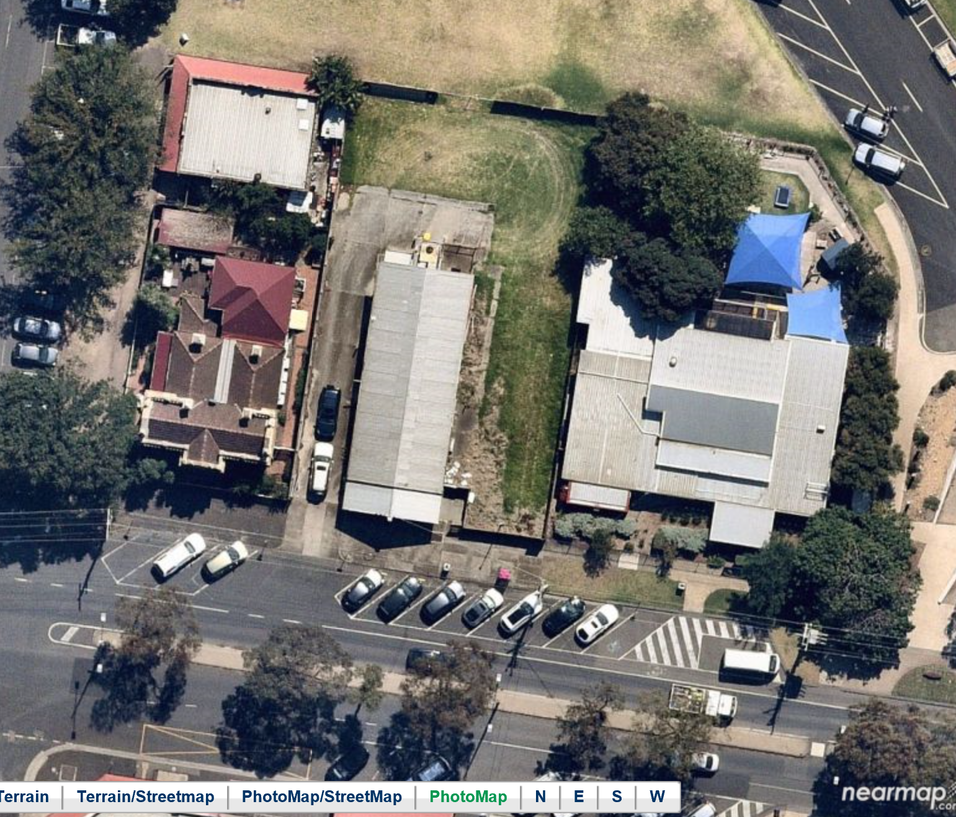
The subject site and surrounds
Source: Nearmap- Aerial taken 11 March 2021.

The land has a slope of approximately 3m from the street level at Newcombe Street to the northern rear boundary.
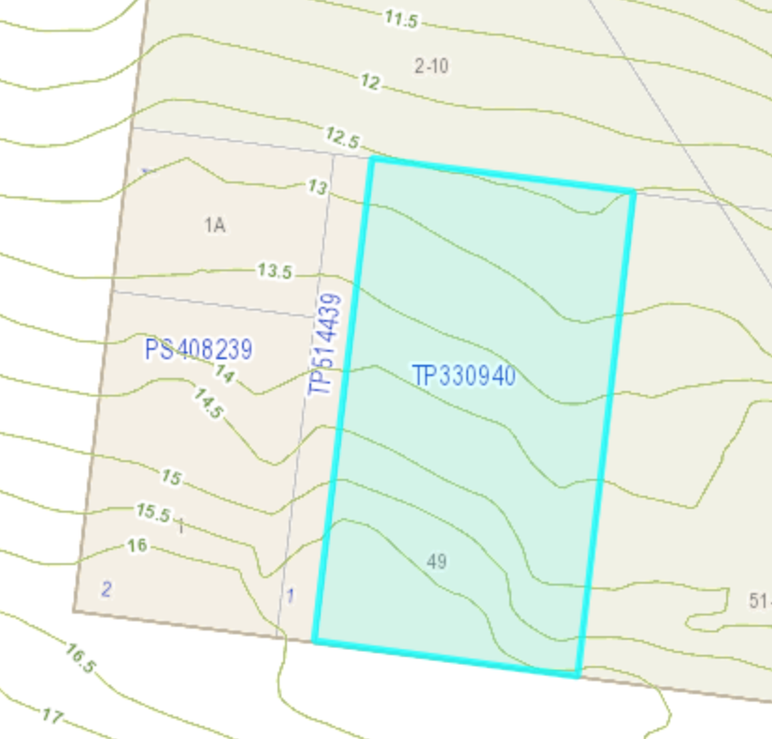
Slope of the subject land
Source: Places Weave

The site is accessed from Newcombe Street and angled parking is located in front of the site. In addition, a telephone box and power pole are located on the Newcombe Street road reserve in front of the site.

Newcombe Street has a divided carriageway, as such, the site can only be entered in one direction. The road also provides on-road bicycle lanes in each direction. Bicycle racks are provided along the shop fronts with one directly adjacent to the subject site.

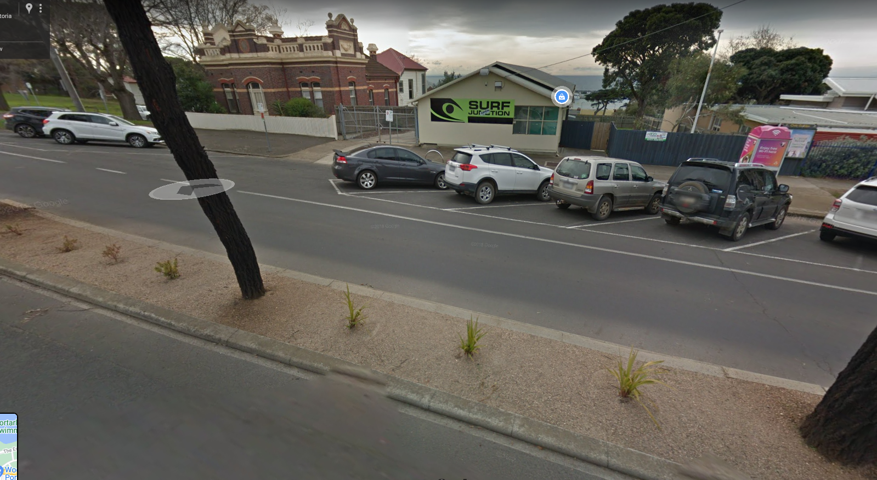
Photo of the divided carriageway in front of the subject site
Source: Google Maps

The site does not contain any easement on title, however it is relevant to note that there is an implied sewage easement that runs the length of the western boundary, as seen below.

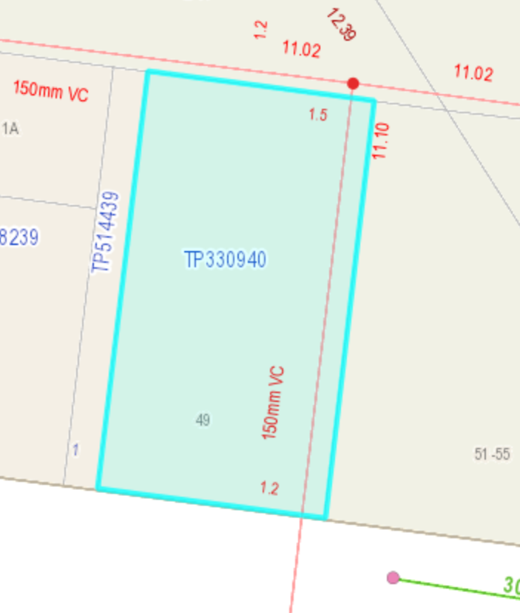

The site has most recently been used for the purposes of a Tourist Information Centre and Nautical Clearance Centre, selling ship and sea related items.
In the past, the subject site however was temporarily reserved as a market reserve in 1880. By 1911, the site boasted a public garden. In 1949, the market reservation was changed as a site for a public hall. This was revoked in 1954. The land was subsequently acquired by the Postal Department.

Furthermore, as you can see below, the majority of building development in central Portarlington in Newcombe Street was located on the south side, the foreshore land largely taken up by reserves.

The subject site is located in a Commercial 1 Zone, within a Design and Development Overlay (DDO21) and part Heritage Overlay 1562.
The Commercial 1 Zone is mostly located on the southern side of Newcombe Street.

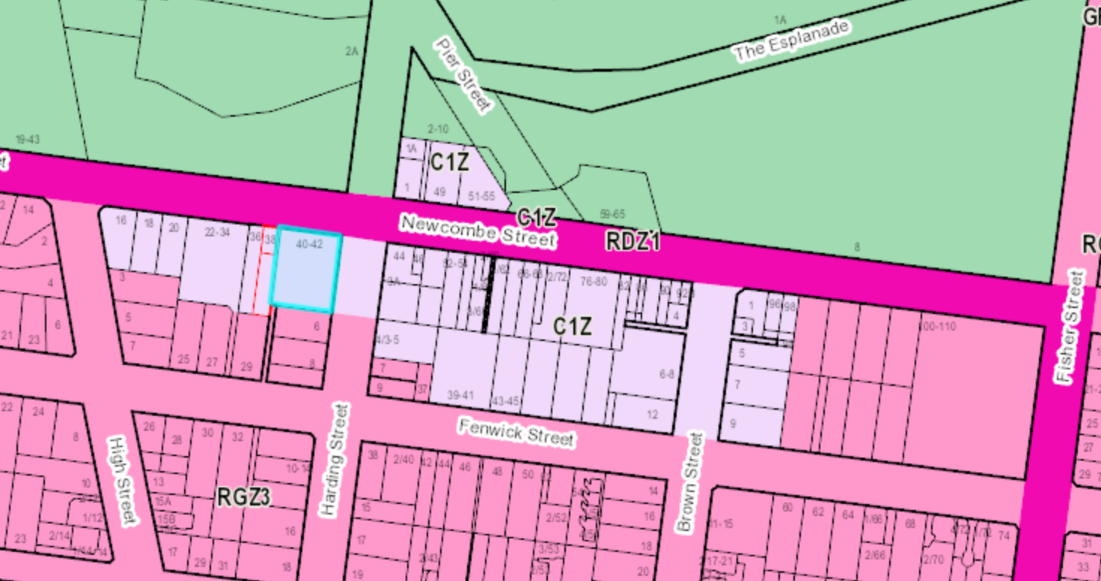

A narrow portion of HO1562 extends over the subject site at 49 Newcombe Street. This would appear to have resulted from a previous subdivision in more recent times. This narrow HO extent is considered to be anomalous because the significance of HO1562 is based on the former Portarlington Post Office.

The DDO21 has been included over the entire commercially zoned land, and some land located in a Residential Growth Zone 3 that surrounds the township, to improve the built form of the town centre and encourage building forms that are of an appropriate scale and contemporary design which respects the coastal landscape setting. The aim is to protect the seaside holiday village character of the township and improve the integration between the adjacent foreshore reserve than the town centre.

To achieve this, the DDO21 generally restrict buildings to a maximum height of two storeys. The scheme does encourage focal buildings to be established within the township, however, does nominate the establishment of limited focal buildings to be established on specific sites on the southern side of Newcombe Street.

Development on the northern side of Newcombe Street, within the Commercial 1 Zone, is considered to be low scale and limited to:

- A kindergarten, adjoining the subject site to the east.
- A former heritage listed Post Office, adjoining the subject to the west.
- A café, adjoining the subject site to the west.

The kindergarten is housed in a low scale brick building and surrounded by trees and shrubs and a high blue steel fence. Access to the kindergarten (Preschool) is via Newcombe Street and the site also backs onto the public park, with Pier Street abutting the north east corner of the site. The site has some medium sized trees and play equipment and shade structures as typically occurs in kindergartens. Beyond this, to the east, is public park and recreation space, including a large timber rotunda.

The Portarlington Kindergarten is a Council owned early childhood facility operated by Bethany Kindergarten Services Pty Ltd and situated on crown land that is owned by the Department Environment, Land, Water and Planning (DEWLP). The facility comprises two large activity rooms licensed for 53 places. The centre operates five days per week (Mon-Fri) accommodating 5 separate kindergarten groups scheduled over the week, plus local playgroup programs and activities (operating three days per week), and a toy library. The 2021 Session Times are between the hours of 9am and 2pm.

The Portarlington Kindergarten is the only kindergarten and early childhood facility located and servicing the 3223- postcode area (comprising the coastal communities of Portarlington, Indented Head, and St Leonards). Population growth combined with the introduction of funded three-year-old kindergarten from the year 2022 onwards across Greater Geelong, will result in increasing utilisation and demand on Portarlington Kindergarten into the future. The kindergarten has been extensively refurbished and extended, including a recent major upgrade of the outdoor playground.

The former Post Office is located at 1 Harding Street, is a Heritage listed, double storey brick and weatherboard dwelling. A white picket fence runs along the south and west boundaries, and both pedestrian and vehicular access is obtained via Harding Street. The building is of Regional Significance in its contribution to the commercial main street of Portarlington and to the township and surrounding rural area as a centre of communication. It was important in linking Portarlington to the wider world by post and telegraph and later was also the site of the telephone exchange. It is one of the few elaborate architectural works constructed on the Bellarine Peninsula in the nineteenth century. (Victorian Heritage Database).

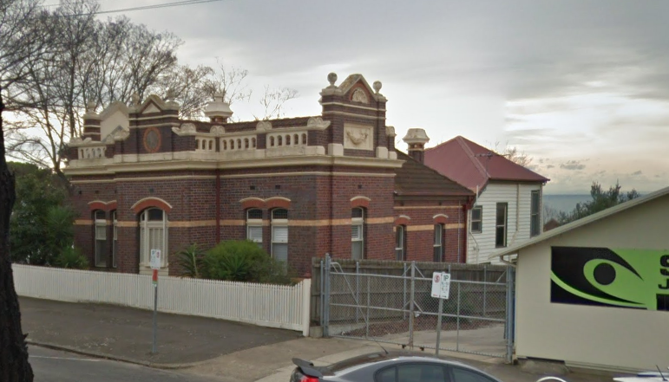
Photo of former Post Office – view from Newcombe Street

As you can see in the photo above, windows on the heritage building are orientated towards the shared boundary of the subject site. Windows are also orientated to the public parkland to the rear.

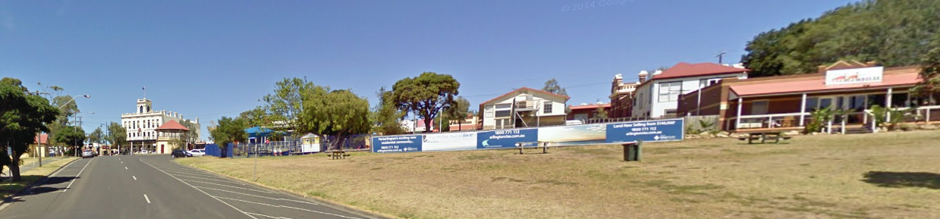
View of former Post Office from public land to the rear.

As seen above, the heritage building can currently be seen from the public foreshore to the rear, though its view is not dominant.

The Edina Waterfront Café is located at 1a Harding Street. It is a low level brick commercial building with pedestrian entry from Harding Street and a verandah spanning the north and west sides. The north verandah overlooks the parkland to the foreshore and the bay beyond. The building does not have any windows orientated towards the shared side boundary.

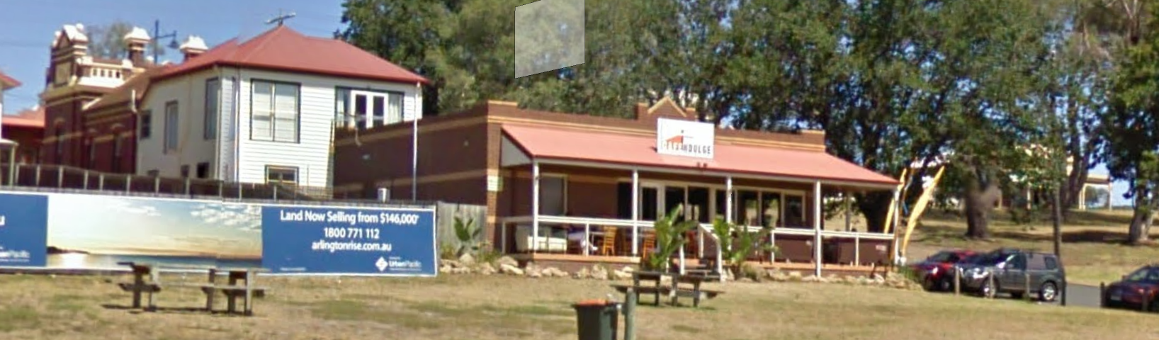

View of Edina Waterfront Café fronting the public land to the rear.

Development on the southern side of Newcombe Street, within the Commercial 1 Zone, is mostly commercial buildings of low scale. However, towards the middle of this section sits the three-storey Grand Hotel, at 76 Newcombe Street and, immediately to the west is a four-storey apartment building that has been recently completed, providing apartment living at the upper levels and commercial/retail space at the ground floor.

To the north of the site is the public foreshore. This land is zoned PPRZ.
The Portarlington Safe Harbour is located to the north of the property and the Port Phillip Ferries run between Melbourne and Portarlington from this harbor. The Portarlington Bowls Club is located to the north-west and further west on Sproat Street is the cricket and football club. There is a masterplan in place to promote future development on the public foreshore that enhances the seaside holiday village character of the township.

The township currently has a low scale appearance when viewed from the pier, with the focal building when viewed from the pier is the Grand Hotel. The Portarlington Structure Plan recommends that this aspect not be changed, noting the importance of maintaining low scale buildings, with the focal point of the centre being the Portarlington Grand Hotel.

There are numerous options for public parking with the commercial precinct and foreshore area, including:

- On street parking within Newcombe Street.
- On street parking in Harding Street.
- Informal parking near the Senior Citizens Club on public land.
- On street parking in Pier Street.
- Parking at the pier.
- The public carpark on Fenwick Street.

The nearest formal loading zone is located on the frontage of the Grand Hotel which is approximately 100m to the west of the subject site.

PROPOSAL:

The application proposes the development of a mixed use 3-4 storey building comprising 10 apartments and 2 commercial tenancies, the subdivision of the land (12 lots with common property), and the partial reduction of car parking.

Retail Shops

The retail shops are located on the ground floor fronting Newcombe Street. The shops are sited on the title boundary. The retail shops have an area of 80 and 87 square metres respectively. Retail shop 1 also is oriented to have alfresco dining in between the building and the western boundary.

Apartments

The entry lobby for the residential apartments is located in between the retail tendencies, fronting Newcombe Street on the ground floor. The entrance lobby at street level exceeds 2m in width. A secure entry will be provided to the letterboxes, then an additional door will be provided that accesses the residential lobby.

The lobby opens up to a large circulation area whereby stairs and lift access is provided to the upper two residential levels and the lower basement carpark.

The basement level will consist of 21 car spaces, with 19 spaces provided for the residents and 2 spaces provided for the retail use, with a secured access ramp located along the western boundary.

The ground floor when viewed from the northern elevation will have one, 2 bedroom dwelling and one, 3 bedroom dwelling located in the northern section of the building, with the southern section of this level set aside for residential storage, bicycle storage and residential amenity space.

The upper-ground level which is the ground level fronting Newcombe Street contains two retail units (80 & 87 square metres in area) to front Newcombe Street with a separate access provided for the residential dwellings and lobby in the centre of the building. Two, 3 bedroom dwellings and one 2 bedroom dwelling are provided on this level.

The first floor contains four, 3 bedroom dwellings, each with balconies used as their secluded private open space.

The second floor contains one, 4 bedroom dwelling, with a balcony surrounding the entire dwelling to provide secluded private open space.

The applicant has provided the building footprint on each level to show the previous design to demonstrate the reduced building footprint on the upper levels.

Due to the slope of the land, the building is considered that it will have a three-storey appearance from Newcombe Street and four storey appearance from the parkland to the rear. Each floor will have a curved roof line, with varying setbacks from boundaries, as seen in the pictures above.

When viewed from Newcombe Street, the ground floor will be built 4.4m to the western boundary to allow room for the car ramp and 3m from the eastern boundary to avoid building over the easement. A car ramp will be located along the western boundary, providing access to the basement level carpark.

The shops will be built to the front boundary and contain large front windows orientated to the street. A veranda is to also cantilever over the footpath. A pergola or similar will be located on the eastern boundary, proving alfresco opportunity for one of the shops. Residential apartments are located on the two levels above.

The building has been scaled to have an overall height of 10.9m above Natural Ground Level on Newcombe Street and above 13.9m to 14.3m above Natural Ground Level on the northern elevation fronting the parkland. The lift overrun is also to be 0.5m higher than the roofline.

The building is to be clad in a mixture of concrete, Colorbond, brickwork and aluminium cladding with a timber look.

The sectional diagrams below provide an indication of setbacks to boundaries on each level and extent of earthworks (cut) required. Excluding the underground water tank, a maximum cut of 3.6m appears to be required.

Access

Access to the basement parking area will be gained from a ramp directly off Newcombe Street.

All vehicles can exit in a forward direction and a revised parking layout on Newcombe Street is proposed to ensure maximum visibility for exiting vehicles, and therefore pedestrian safety is not compromised.

Carparking

The concept development plans show the provision of 21 spaces in the basement level car park.

The carpark is to be secured by an automatic security gate, which will be setback approximately 7.2m from the front boundary.

Loading and unloading

Loading and unloading to the two commercial tenancies is expected to occur from the street, relying on on-street loading bays as most other properties along Newcombe Street also do.

Bicycle parking

Secure facilities for residential bicycle storage will be provided in the car park as part of the storage area allocation for each residential unit (shown on the drawings below). Four bicycle spaces will be provided.

Waste Management

A private waste contractor will collect both commercial and residential waste.

The waste will be stored in a fully enclosed bin store in the carpark. The residential and commercial waste will be located in the same room.

Landscaping

Landscaping is to consist of canopy trees, balcony gardens and screen plantings.
Plantings are to consist of both local and exotic plants.

An arborist report was also submitted with this application that explains how the development has been designed so as not to impact on neighbouring trees. There is a large tree located in the playground area associated with the kindergarten to the east. The report notes that trees within the adjacent Portarlington Pre-School are all essentially outside of any rootzone or canopy impact, as a 3m easement runs along the eastern aspect of 49 Newcombe Street and large trees are sufficiently setback within the Pre-School.

Subdivision
It is proposed to subdivide the building (12 lot subdivision) so that each retail premise and apartment is located on a separate title, with the remainder of the land included within common property.

PERMIT/SITE HISTORY:

The following permits/site history is applicable to this application:
- PP-710-2019 – for the development of 11 dwellings (apartments), two retail spaces, subdivision of the land and creation of access to a Road Zone Category 1.

In February 2021 the Applicant lodged an Application for Review to the Victorian Civil and Administrative Tribunal (VCAT), pursuant to section 79, based on the failure of the responsible authority to determine the permit application within the prescribed time. Council resolved it would have refused to grant a permit, and to advocate to VCAT against the grant of the permit.

The Applicant submitted an amended proposal in July 2021 to remove the top level of the building (fourth level as viewed from Newcombe Street and fifth level as viewed from the foreshore) and to reduce the number of apartments, together with some other design changes. The amended proposal included eight three-bedroom apartments and three two-bedroom apartments, two ground floor shops, provision of 23 basement car parking spaces, subdivision, creation of access to a Road Zone Category 1 and a reduction in the parking requirement.
The building would present as three storeys to Newcombe Street and four storeys to the foreshore given the fall of the land. In July 2021 the Minister for Planning called-in VCAT Proceeding P415/2021 and appointed the Portarlington Advisory Committee to consider the matter. The Terms of Reference stated that the purpose of the Committee was to:

- provide all parties to the called-in VCAT proceeding with an opportunity to present submissions and evidence and provide advice to the Minister for Planning on the planning merits of the proposed development including whether a planning permit should be issued and if so what would be the appropriate conditions for the permit.

The Minster for Planning called-in the proceeding on the basis that it raised a major issue of policy and that determination of the proceeding may have a substantial effect on the achievement or development of planning objectives. This included the declaration of Portarlington, as part of the Bellarine Peninsula, as a ‘Distinctive area and landscape’ (Clause 11.03-5S) as well as matters of Urban design (Clause 15.01-1S) and Housing supply (Clause 16.01-1S). Key issues raised in objections and submissions included:

• consistency with planning policy and provisions
• urban and building design, including views and amenity
• heritage
• traffic and car parking
• waste management
• environmentally sensitive design
• community and economic benefits.

The Committee considered the site is unique due to its sensitive location within the town centre, with frontages to both Newcombe Street and the foreshore reserve. There are many layers of relevant planning policies and provisions for the site. Portarlington is part of the Bellarine VCAT Proceeding P415/2021 | Portarlington Advisory Committee Report | 7 October 2021 Page vi of vi OFFICIAL Peninsula ‘distinctive area and landscape’, and the subject site is located within the Commercial 1 Zone, an increased Housing Diversity Area and is subject to the Design and Development Overlay – Schedule 21 (Portarlington Town Centre) (DDO21). These provisions support the retailing and additional diversity and density of housing on the site, however, make it very clear that development needs to respect and enhance the valued character of Portarlington, including protecting key views to and from Corio Bay and Port Phillip Bay.

To be acceptable, the proposal must provide a satisfactory urban design response including a positive contribution to the coastal character of the area, be reflective of local context and protect significant views. The Committee considered that the proposal fails to achieve this. The urban design response is unacceptable as it is not consistent with planning policies and provisions of the Geelong Planning Scheme relating to urban design, including the ‘distinctive area and landscape’, DDO21, Clause 21.14 (The Bellarine Peninsula) and the Portarlington Structure Plan.

The Committee accepted the urban design evidence on behalf of Council that the scale and massing of the building as viewed from the foreshore is not consistent with the character of the town and would not be visually unobtrusive in the landscape. Further the extent of glazing and landscaping was unfamiliar to Portarlington and that the height and mass would compete with the landmark status of the Grand Hotel.

The Committee concludes:

• The urban design response is unsatisfactory as it does not sufficiently protect and enhance the valued attributes of the area in line with the declaration of area as a DAL and other policy provisions relating to urban design and Portarlington’s character.
• The proposal does not make a positive architectural and urban design contribution to its context when viewed from the foreshore.
• The proposal does not satisfy the requirements of the DDO21 and is not visually unobtrusive when viewed from the public foreshore.

Recommendations
Based on the reasons set out in this Report, the Committee recommends:
Planning Permit PP-710-2019 (VCAT call in P415/2021) for the 'development of a multilevel mixed use building containing two shops, use of eleven apartments and basement car park, subdivision, creation of access to a Road Zone Category 1 and partial reduction in car parking' not be issued.

It was also recognised that the Advisory Committee’s report needs to form a basis for further assessment for any future development of the land on the subject site.

REFERRALS:

The following referrals were undertaken:
SECTION 55:

DETERMINING AUTHORITY

Authority: | Downer EDI
Response: | Referred 3 October 2022, no response received
Officer Comment: Council has noted that No response was received.

Authority: | Barwon Water
Response: | I refer to your letter received 04 October 2022 concerning the proposed development and wish to advise that the Barwon Region Water Corporation, pursuant to Section 56 (1)(B) of the Planning and Environment Act, does not object to the granting of a planning permit subject to the following conditions being met prior to the issue of a Certificate of compliance.
Officer Comment: All recommended conditions can be included in any permit, should one issue.

Authority: | Powercor
Response: | Subject to the following conditions, Powercor Australia Ltd (the Distributor) does not object to the issue of a planning permit for the abovementioned application.
Officer Comment: All recommended conditions could be included in any permit.

Authority: | DOT
Response: | No response received after referred 3 October 2022.
Officer Comment: Noted, however the location of the access has not altered from the previous application, so the existing conditions provided by DOT could be used in any permit issued.

INTERNAL

Department: | Engineering Services
Response: | 1st response -  Onsite drainage will be to kerb and channel via a pump system. On-site detention is required and will need to be shown on the plans with calculations for sizing of the detention system limiting the rate of discharge to 10 l/s.  Preliminary comments on traffic .  The proposed ramp will need to show further consideration to site distance at the entrance.  A loss of 1 on-street carpark is likely to result from the reconstruction of the existing crossing to 6.1m.  The traffic report references that rate of traffic as 5 per dwelling is the low end of the scale and a rate of 6.5 should be adopted.  Can the consent (previous permits) of Council agreeing to car parking waiver for this lot that I could ascertain.  2nd response -  I’ve provided Conditions for a permit to be issued relating to drainage and the vehicle crossing.  Engineering recommend changes to the access and car parking to meet the minimum requirements of 52.06 and the Australian standards.  Minimum design requirements to be considered:  - Consideration of the entire accessway should be given not just the ramp i.e. 74m from the road to the last car space and subsequent requirement for a 6.1m x 7.0m long passing area at the entrance.  - Inclusion of 1m turning bay at the dead end lane.  - Visitor parking is required  - Modify parallel parks line marking to show as 2.3m wide with 300mm setback of from northern wall of car park.  Standard Conditions  Drainage:  The site must be drained to the satisfaction of the Responsible Authority and no concentrated storm water may drain or discharge from the land to adjoining properties.  Drainage & Vehicular Access:  Prior to the occupation of the dwellings / statement of compliance, the developer must:  - Construct the site stormwater system including connection into the Grated Side Entry Pit in in Newcombe Street via a pump system, or other nominated point/s as approved by the Responsible Authority. The stormwater connection must be in accordance with City of Greater Geelong Standard Drawings.  - Construct vehicular crossings in accordance with the requirements and standards of the City of Greater Geelong.  - Remove redundant on-street carpark line marking and reinstate Line marking.  - Remove any redundant vehicular crossings with kerb and channel and the footpath/nature strip area reinstated to match existing construction in the street.  all to the satisfaction of the Responsible Authority.  Note:  1. Construction of the site stormwater connection/s is to be inspected by Council Representative prior to any backfilling. An appropriate fee equivalent to 3.25% of total cost of civil works, excluding GST (a minimum fee of $100 applies if the 3.25% amount is less than $100), is to be paid to Council for inspection. Relevant evidential documentation of the cost is to be provided.  2. All internal property drainage must be designed and constructed to satisfy AS/NZS 3500.  3. A Vehicle Crossing Permit must be obtained prior to commencement of works.  Car Parking  Prior to the occupation of the dwellings / statement of compliance, the developer must construct the car park including accessways, surface with an all-weather sealed coat and linemark the car and accessways in accordance with the endorsed plans to the satisfaction of the Responsible Authority.  Stormwater Management  The site stormwater system must be designed and installed such that the site stormwater discharge is directed to the kerb and Channel with a maximum flow rate of 10 l/s. An appropriate on site detention system designed in accordance with the Infrastructure Design Manual may is required, to the satisfaction of the Responsible Authority.  Creation of easements  The Plan of Subdivision submitted for certification must include all easements deemed necessary to protect existing or future drainage lines within the subject site, and any easements required between the subject site and the nominated legal point of discharge must be created to the satisfaction of the Responsible Authority.  Pump System  Unless otherwise approved by the Responsible Authority and prior to the Commencement of the Development / Issuing of Statement of Compliance, the land owner must enter an agreement with the Responsible Authority pursuant to Section 173 of the Planning and Environment Act 1987. All costs associated with setting up the agreement must be borne by the land owner. The agreement is to be registered on title and run with the land, and is to provide to the satisfaction of the Responsible Authority:  All storm water runoff is to be collected on site and discharged to the legal point of discharge using a pump system or as otherwise nominated by the responsible authority. The pump system is to be designed and constructed in accordance with Australian Standard 3500 Part 3.2 Section 9  In the event of any operational difficulties with the pump system, it is the Responsibility of the land owner to rectify these difficulties;  Any pump system is to be replaced by gravity discharge if and when available, and if directed by the Responsible Authority, at the land owner’s full cost.  Provision is made (if appropriate) in any subdivision for Body Corporate drainage works, and access to those drainage works to be on common property or within an easement in favour of the Body Corporate  Note: Where the legal point of discharge is kerb and channel, discharge velocity at the kerb must be no greater than 1.5 m/s with a maximum discharge flow rate of 10 l/s and the outlet directed at an angle of 45º to the direction of flow in the kerb and channel.  DRAINAGE NOTES  Flooding – Overland Flow Paths  The Applicant is also advised to seek comment from the building surveyor on the requirement, if any, for overland flow paths to be provided on the site to convey major flows through the site in accordance  Non-Standard Conditions  NOTE  A pre-commencement meeting with Council’s Engineering Department is required to be undertaken prior to works starting. To organise this meeting please contact 5272 4426.  The application was supported and standard conditions were suggested.
Officer Comment:
Generally the suggested conditions could be included in any permit.

Department: | ESD Response
Response: | 1st response -  Council’s ESD Officer has reviewed the below documents in accordance with Council's ESD Local Planning Policy (15.01), this development has not reached an acceptable level of ESD for a permit to be issued.  Documents reviewed:  - Development plans by SPL Architect, dated on September 2022 received on 19/9/2022  - SMP report by Zero C Architects, received on 19/9/2022  - BESS report (project identifier: (6DBD12F7-R1 Version-BESS-6), received on 19/9/2022  The Applicant may need to remodel this development in BESS, whilst taking into consideration the notes/comments from Council's ESD Officer which are detailed under ESD Response. These notes/comments have been summarised and alphabetised into items under ESD Response and should be addressed via the following ESD Resolutions Table:  There are 14 items in total and all of them need be responded to. The ESD Resolutions Table must be completed and send. The ESD report may also need to be amended to reflect any changes in the BESS modelling and both a revised ESD and BESS report, as well as plans (with additional ESD notes), will need to be re-reviewed by Council's ESD Officer.  2nd Response  This ESD response of this application is done on 19/12/2022 (2nd response). The applicant has not been satisfactorily responded all the previous ESD comments. Council’s ESD Officer has reviewed the below documents in accordance with Council's ESD Local Planning Policy (22.71), and this development has not reached an acceptable level of ESD requirement. FYI-Clause 22.71 ESD has mostly moved to Clause 15.01 Built Environment recently.  However, permit can be issued with permit condition. The summary conditions are:  - The Applicant will need to be provided detailed Building User Guide prior occupation.  - Prior to construction, a detail Section J modelling which aligns with the modelling/commitments in the submitted SDA report will need to be submitted.  Documents reviewed:  - Development plans by SPL Architect, dated on November 2022 received on 25/11/2022  - SMP report by Zero C Architects, received on 25/11/2022  - BESS report (project identifier: (6DBD12F7-R2 Version-BESS-6), received on 25/11/2022  Environment (ESD) Response  - All works must be undertaken in accordance with the endorsed Plan, ESD report and stormwater management plan to the satisfaction of the Responsible Authority. No alterations to these plans may occur without the written consent of the Responsible Authority. The summary conditions are:  - The Applicant will need to be provided appropriate Building User Guide prior occupation.  - Prior to construction, a detail Section J modelling which aligns with the modelling/commitments in the submitted SDA report will need to be submitted.
Officer Comment: Generally the suggested conditions could be included in any permit.

Department: | Parks Department
Response: | I have assessed the plans for the site and there is unlikely to be any impact to trees in adjoining properties if they are protected in accordance with Australian Standard 4970-2009 Protection of trees on development sites (I have included a permit condition for this).  I have looked at the landscape plans and the plant species are supported by Parks Planning
Officer Comment: No conditions required.

Department: | Urban Design Response
Response: | Urban Design has considered the Applicant’s current design against the conclusions made by VCAT Proceeding P415/2021.  A report published on the 7 October 2021 was in reference to a previous proposal for the site and provides important considerations for the current application. The VCAT Committee determined the previous proposal had the following issues in relation to Urban Design.  - That the urban design response is unsatisfactory as it does not sufficiently protect and enhance the valued attributes of the area in line with the declaration of area as a DAL and other policy provisions relating to urban design and Portarlington’s character.  - That the proposal does not make a positive architectural and urban design contribution to its context, when viewed from the foreshore.  - That the proposal does not satisfy the requirements of DDO21 and it is not visually unobtrusive when viewed from the public foreshore.  These issues solely relate to the visual impact of the developments Northern interface which is visible from the foreshore. Concerns relating to views from the Town to the Bay were determined to be less of an issue. The discussion summary from the VCAT report indicated some key design considerations to assess the visual impact of future proposals. Urban Design will assess the current application’s foreshore visual impact against the following.  - Building Height  - Quality of landscaping on the Northern interface  - Width of building and the inclusion of breaks in built form  - Materiality with specific concern over the amount of glazing  Our response will assess the current proposal on its own merits against the above criteria.  Overall, we are unsupportive of the proposed development due to it failing to meet some of the criteria outlined as detailed below.  Building Height  The proposal consists of four storeys as viewed for the foreshore with large setbacks on the 3rd and 4th levels (labelled First and Second floor in the applicant’s plan set). DDO21 was mentioned in the 7 October 2021 VCAT report in relation to building height. DDO21 states a maximum height for new development should be two storeys in height unless the development demonstrates it;  • Is sympathetic to buildings of heritage significance and any residential interface;  • Is visually unobtrusive when viewed from the public foreshore;  • Is of high-quality design.  The upper-level setbacks of the proposed design to not address all the requirements outlined above. Urban Design has determined that the design is not visually unobtrusive when viewed from the public foreshore. Both levels 3 and 4 which sit above the two-storeys of permissible development have a significant visual presence.  RECOMMENDATION:  The applicant should remove level 4 and create a greater setback for level 3 to ensure it has minimal visual presence when viewed from the foreshore.  Quality of landscaping on the Northern interface  The 7 October 2021 VCAT report noted that on the Northern interface ‘layered landscaping of more appropriate species to break up the built form would assist in integrating it within [the] sensitive landscape.’ Any new development should ensure that the open space provided allows for a layering of planting sufficient to breaking up the building form on the Northern boundary.  The Landscape plan submitted with the current proposal is misleading as only 2m of setback is suitable for planting not 4m as shown due to balcony overhangs and hardscaping. A 2m wide open space will not provide sufficient opportunity for layering planting or to support species suitable for breaking up the form. This is demonstrated by the single row of trees that are even if they did grow to full height would only just reach the second storey.  RECOMMENDATION:  Provide a larger setback at the rear of the property that will allow for a layering of the planting and more substantial tree species to be planted.  Width of building and the inclusion of breaks in built form  The current application does not feature any breaks in the built form as viewed from the foreshore. The design does include some minor articulation of the North facing elevation. This articulation consists of a 2m setback of balcony floor slab in the centre which breaks the elevation into three parts as shown in the plan set. When viewed from the foreshore however the articulation would have minor visual impact with the same materials being predominant through the entire elevation.  RECOMMENDATION:  The applicant should provide a greater setback to the articulated area of the elevation. This should include actual articulation of the building external walls (not just balconies) and a change of material in this area.  Materiality with specific concern over the amount of glazing  A concern outlined in the VCAT report was the area of glazing on the previous proposals. The report states a large amount of glazing would be ‘unfamiliar to the township and is likely to make the building more reflective and stand out.’  The current proposal has a large, glazed North facing elevation but is covered to a significant degree by timber screens. It is Urban Design’s view that the timber screens do provide enough coverage to address potential concerns in relation to glazing. The elevation provided in the plan set demonstrated that the proposed development would not include any large areas of exposed glazing visible to the foreshore. The use of timber is also not unfamiliar to the surrounding context with other structures consisting of timber panels.
Officer Comment: It is acknowledged that Council’s Urban Design Department do not support the proposal and that The Portarlington Advisory Committee Report refused the first application largely on urban design grounds when viewed from the public foreshore. This second application also does not readily satisfy the conclusion points of the Committee Report.

Department: | Environmental Health
Response: | Recommended Permit Conditions (Without Prejudice)  Non- Standard Conditions:  Adopt noise attenuation measures outlined on approved plan set dated November 2022  Standard Conditions:  No amplified music from the proposed retail premises:  No amplified music, including live amplified music, must be played or piped to external areas without the further written consent of the Responsible Authority.  Noise Management  The premises must reasonably comply with all noise legislation and regulations in force including EPA publication 1254.2 “Noise control guidelines”  Comply with EPA publication 1834 “Civil construction, building and demolition guide”  Waste Collection  If commercial waste collections are to occur with two or more collections per week, they must only occur during these times:  - 7 am – 8 pm Monday to Saturday  - 9 am – 8 pm Sunday and public holidays  Delivery Restrictions  All deliveries to the property and truck movements offsite must be in adherence with the EPA Noise Control Guidelines (publication 1254.2) which are:  - 7am – 10pm Monday to Saturday  - 9am – 10pm Sundays and public holidays.  Security Alarms  All security alarms or similar devices installed on the land must be of a silent type in accordance with any current standard published by Standards Australia International Limited and be connected to a monitored security service.  Plant and Equipment Insulation  All external plant and equipment must be acoustically treated or placed in soundproof housing to reduce noise to a level satisfactory to the Responsible Authority.  All air-conditioning units are to be placed in an appropriate location or alternatively acoustically treated to reduce noise to a level satisfactory to the Responsible Authority.  Light Emissions  Outdoor lighting must be designed, baffled and located to the satisfaction of the Responsible Authority to prevent any adverse effect on adjoining properties  General Amenity  The amenity of the area must not be detrimentally affected by the use or development through the:  - Transport of materials, goods or commodities to or from the land;  - Appearance of any building, works or materials;  - Emission of noise, artificial light, vibration, odour, fumes, smoke, vapour, steam, soot, ash, dust, waste water, waste products, grit or oil;  - Presence of vermin;  to the satisfaction of the Responsible Authority.  Garbage Storage  Provision must be made on the land for the storage and collection of garbage and other solid waste. This area must be graded, drained and screened from public view to the satisfaction of the Responsible Authority.  The storage, removal and disposal of such/garbage refuse must be undertaken in such a manner so as to avoid any nuisance, pollution or loss amenity to the surrounding area and must at all times be to the satisfaction of the Responsible Authority.  Notes: Environmental Health has considered the information submitted with the application for a planning permit at the abovementioned property. Environmental Health has no objection to the granting of a planning permit providing the following notes are included within:  Food Registration  The proprietor of the proposed food business will be required to apply to the City of Greater Geelong Council’s, Environmental Health Unit for registration of a food premises under the Food Act 1984. Recommend that contact is made prior to internal fit-out to be able to assist with compliance.  Beauty Registration  The proprietor of the proposed beauty business will be required to apply to the City of Greater Geelong Council’s, Environmental Health Unit for registration of a registered premises under the Public Health and Wellbeing Act 2008. Recommend that contact is made prior to internal fit-out to be able to assist with compliance.  Noise  Ensure compliance with any Commercial Noise regulations, Councils Local Laws and obtain permits where and when required  Construction noise for residential and commercial construction  Noise during construction is to be managed and not emit unreasonable noise at any time of the day under the Environment Protection Act 2017
  Comments from Unit
  Reasons for conditions
  Request for further information - requested:
  The applicant must adopt the concept of “agent of change” and accept that this site may be subject to external noise generated by existing businesses in the area, noise reduction measures should be implemented during planning phase such as the inclusion of double glazed windows, sound proofing air-conditioning units, and a high level of quality of insulation . Detail how this is going to be achieved?
  Response on page 16 of the Clause 58 Assessment states:
  - There are no off-site noise impacts likely to cause any disruption to residential amenity, or will require any acoustic treatment
  This statement is incorrect, the proposal is situated in commercial zone surrounded by existing businesses. Noise from commercial deliveries, rubbish collection, and existing plant equipment have the potential to cause noise disruptions to the proposed residents.
  Updated plan set:
  - Noise Attenuation Measures to be adopted include installation of double-glazed windows, screen to balcony A/C units, and R2 insulation between party walls and internal stud walls to meet BCA requirements.
  Reflected in recommended non-standard condition.
Officer Comment: Generally the conditions provided could be included in any permit issued.

Department: | Open Space Planning
Response: | Standard Conditions  Amended plans  Prior to the commencement of works, amended plans to the satisfaction of the Responsible Authority must be submitted to and approved by the Responsible Authority. When approved, the plans will be endorsed and will then form part of the permit. The plans must be drawn to scale with dimensions and must be generally in accordance with the plans submitted with the application but modified to show:  - Fencing details adjoining the Council reserve must be of permeable design and no higher than 1.5m.  - Amended landscaping plan that does not screen the development at ground floor and allows for passive surveillance.  Access and Storage Prohibited on Council Reserves  There must be no parking, access through or storage on the adjoining council reserve known as W.G. Little Playground located at 2-10 Pier Street, Portarlington at any time during construction.  Fencing of Council Reserves  Prior to the issuing of a Statement of Compliance for any relevant stage of the subdivision which includes, or is adjacent to, a Council reserve, the subdivider must erect a fence on the boundaries of the Council Reserve in accordance with endorsed landscaping plans and to the satisfaction of the Responsible Authority and at no cost to the City unless otherwise approved in writing by the Responsible Authority.  No Utility Services On Public Open Space  Utility service substations, kiosk sites and the like must not be located on any land identified as open space unless otherwise agreed in writing by the Responsible Authority. Any existing or future easements affecting all land which is to be vested in council must be clearly identified on the detailed landscape plans.
Officer Comment: Generally the conditions could be included in any permit issued.

Department: | Waste Department
Response: | Recommended Permit Conditions (Without Prejudice)  A Waste Management Plan that is to the satisfaction and approval of the Responsible Authority must be provided prior to certification of the subdivision for this Development.  The Approved Waste Management Plan must be incorporated into any Planning Permit issued.  If the Waste Plan endorses the use of a private contractor to collect the residential waste and recycling from the development, the Applicant must enter into an agreement under Section 173 of the Planning and Environment Act 1987 with the Responsible Authority prior to the Statement of Compliance or the Certificate of Occupancy being issued for the development. The agreement must be in a form to the satisfaction of the Responsible Authority, and the applicant must be responsible for the expense of the preparation and registration of the agreement, including the Responsible Authority’s reasonable costs and expense (including legal expenses) incidental to the preparation, and enforcement of the agreement. The agreement will be registered on all the developments titles in accordance with Section 181 of the Planning and Environment Act 1987. The agreement must contain covenants to be registered on the Titles of the property so as to run with the land, and must provide for the following:  - An adjusted Council Residential Waste Service Charge is still payable even though a Private Waste Contractor provides the residential recycling and waste collection services.
Officer Comment: Generally the conditions could be included in any permit, however the requirement for a Section 173 Agreement to advise the Residential Waste Service Charge is still applicable – this is not considered to be necessary as this charge is not directly related to the issue of a planning permit for the proposal.

PUBLIC NOTIFICATION:

The application is not exempt from the notice requirements of Section 52(1)(a), (b) and (d), the decision requirements of Section 64(1), (2) and (3) and the review rights of Section 82(1) of the Act and pursuant to Section 52 of the Planning and Environment Act 1987 the following forms of advertising were undertaken:
- Notices were sent to owners and occupiers of adjoining land (including opposite)
- A2 sign(s) was placed on the land
- 243 objections have been lodged with Council and 48 letters of support.

CONSULTATION:

A consultation meeting was not held because the applicant has lodged a failure to determine with VCAT, where there will be compulsory conference through the VCAT process.

AMENDMENT OF THE APPLICATION FOLLOWING PUBLIC NOTIFICATION

The application was not amended following public notification.

OBJECTIONS:

The concerns of objectors are summarised and Officer comments are provided below:

- Objection- The modern design and bulk does not compliment the coastal heritage town
  - This multi-story development will change Port’s relaxing charm and outlook forever. It is totally NOT in keeping with the narrow street and community feel and will spoil a unique holiday destination.
  - The development will permanently rob the town of its major drawcard, the vista, (and many other characteristics). Portarlington has so much more to lose forever than to gain by allowing this development to go ahead. This development SHOULD NOT be approved.

  - The development is more appropriate to Noosa

  - The proposal has an excessive overall height, and by virtue of its massing, will result in unreasonable visual bulk to the public realm and streetscape and will impact upon important views and vistas within the Town Centre.

  - The building is visually out of scale compared to other buildings on the north side of the street. This location should be low level commercial allowing the open space feel of the North side of Newcombe Street to remain.

  - The limited space provided for landscaping exacerbates the visual bulk impacts by failing to provide meaningful landscaping to soften the building mass, although we note that the overall height of the building presents the biggest challenge in this respect.

  - It would be a great shame to allow our township heart to become an enclosed strip of shops that could be in any suburban setting. We must maintain the bayside feel of the town for future generations.

Response

This is a relevant planning consideration. This is discussed later in the report in relation to the upper level bulk of the bulk of the building, and lack of space along the northern boundary. Overall it is considered that a more appropriate built form to reduce the mass and a more layered landscaping result would lessen the built form.

- Objection- The proposal will detrimentally change the character of the town when viewed from the foreshore.

  - Will be seen as an overdevelopment for a quaint fishing village.

  - The ferry is going again, and I have heard visitors saying that they specially love the historic aspect of this - what was once - a fishing village. Have a look at villages in Europe where they treasure their historic centres and will erect buildings which will enhance the beautiful streetscape which is already in place.

  - The proposed construction is an overdevelopment of the site, it's height and bulk will dominate the foreshore reserve (notwithstanding the disingenuous placing of foreshore trees in the photos attempting to screen out such impact).

Response

Character is a relevant planning consideration and is discussed later in the report.

- Objection- The proposal will impact view lines to the water from the town centre

  - The building height and bulk is too high.

  - View/vista of bay from the south side of Newcombe Street will be impeded.

  - Higher buildings should stay on the south side of the street.

  - The beauty of Portarlington’s main street is due to commercial & apartment buildings only being on the higher, southern side of the side giving those buildings and pedestrians views down the hill to the bay. Compare this to Lorne, which also has maintained a relatively open foreshore of low rise buildings that do not impede views of the water from the main street. All multi story development should be restricted to the other side of Newcombe Street away from the pristine coastline.

  - Inappropriate location - residential, high-rise development should not be on the south side of Newcombe Street - this area of Portarlington is predominantly open space to be enjoyed by residents and visitors. The public space on the south side between Newcombe Street and the beach is a high asset for Portarlington and sets our town apart from most other towns on the Bellarine. As a resident, I very much value the public space for the Mussel Festival, Celtic Festival, playgrounds and markets.

  - The businesses across the road and residential area will lose views of the bay and You Yangs due to the size of the building.

Response

Impact on views is a relevant planning consideration, noting the recommendations of the Portarlington Advisory Committee discuss development needs to fit into the wider landscape setting of Portarlington and not be an overly dominant feature. It is considered the upper levels proposed result in a dominant development which will be discussed further later in the report.

- Objection- The proposal will be detrimentally noticeable on the gateway entrances into the township

  - The development proposed in this application will change the streetscape of Portarlington dramatically, forever and certainly not for the better. It will be the first thing visitors see when coming from Geelong or the ferry and the current plans do not merge with the character of the town or the low density plan of the main street which make it so attractive for visitors.

Response

It is acknowledged that the applicant has reduced the footprint of the upper levels, however the upper two levels will still be a dominant built form when entering Portarlington, particularly from the foreshore. The bulk of the upper levels will be discussed later in the report, however the overall built form is considered to provide a form of visual bulk, along the southern side of Newcombe Street, when entering the town.

- Objection- The proposal will place pressure on available parking spaces in the township

  - The proposal will impact cause increased traffic and parking congestion. A request for a loading bay adjacent and the reduction in parking spaces will put a strain on an already limited parking in the area.

Response

Car Parking is a relevant planning consideration and is discussed later in the report.

- Objection- The proposal will negatively impact on traffic movement within the township

  - This zone is already difficult, with the Harding - Newcomb intersection confusing for many, and being on a hill it is hard to estimate the speed of oncoming traffic when turning. The proposed development will make the situation worse, with added entry and exit traffic, and increased pressure on scarce parking spaces. This already busy zone needs better management and direction rather than making the situation worse with an unsuitable development.

  - Twelve apartments and their associated parking and traffic movements will further block already choked access to the township during summer months, despite the lovely wide empty streets depicted in the accompanying photographs - taken during a pandemic lockdown.

Response

The City’s Engineering Department who have no objections to the application from a traffic management perspective, more information is provided in the later end of this report.

- Objection- The overall height will set a precedent

  - The creation of a precedence for development on the north side of Newcombe St will be of enormous detriment to Portarlington. The culture and accessibility of the town will suffer as a result. There is plenty of opportunity for residential development of this type across the established residential areas of Portarlington, with access to bay views, and within close reach of the central part of town.

  - Once permission is granted, there will be a mass of private entities thinking they can have personal access to a view originally destined to include everyone.

Response

The overall height of any development on this site is guided by policy requirements outlined in the planning scheme. The Portarlington Advisory Committee recommends development must not be dominant when viewed from the public foreshore. It is considered the development that will be viewed to the parapet of the Grand Hotel, when viewed from the public foreshore is too dominant of a feature in the wider landscape setting, which is addressed is greater detail further in the report.

- Objection- The site should be used as a community space, not a commercial development

  - The site was once the Portarlington Gardens and I ask the council to compulsory acquire the land and return it as an indigenous garden. Create a space where the community and visitors can sit and enjoy the views.

  - Historically, the north side of Newcombe Street’s business centre has always been reserved for the buildings for services for the community by the city, by the Shire and the State Government.

  - The subject site needs to be open for public amenities that preserve and enhance the view from the main street.

Response

There is no policy in the planning scheme that would support the application being refused on this basis.

It is noted that the site in the past was owned by the Crown and used for the purposes of a community garden, however, was sold, subject to conditions in the Crown Grant, for private use.

- Objection- Developers are cashing in to sell expensive waterfront apartments with no regard to the character of the township.

  - Developers have no long term interest in Portarlington.

  - I object as this developer does not build well designed or built buildings, they are not in keeping with the town's image. Thus bringing down the value of all neighbouring buildings.

Response

This is not a relevant planning consideration under the relevant policies of the Greater Geelong Planning Scheme.

ASSESSMENT:

ZONE:

The purpose of the Commercial 1 Zone is:

- To implement the Municipal Planning Strategy and the Planning Policy Framework.
- To create vibrant mixed use commercial centres for retail, office, business, entertainment and community uses.
- To provide for residential uses at densities complementary to the role and scale of the commercial centre.

Before deciding on an application, in addition to the decision guidelines in Clause 65, the responsible
authority must consider, as appropriate:

General
- The Municipal Planning Strategy and the Planning Policy Framework.
- The interface with adjoining zones, especially the relationship with residential areas.

Use
- The effect that existing uses may have on the proposed use.
- The drainage of the land.
- The availability of and connection to services.
- The effect of traffic to be generated on roads.
- The interim use of those parts of the land not required for the proposed use.

Subdivision
- Provision for vehicles providing for supplies, waste removal and emergency services and public transport.
- The effect the subdivision will have on the potential of the area to accommodate the uses which will maintain or enhance its competitive strengths.

Building and works

- The movement of pedestrians and cyclists, and vehicles providing for supplies, waste removal, emergency services and public transport.
- The provision of car parking.
- The streetscape, including the conservation of buildings, the design of verandahs, access from the street front, protecting active frontages to pedestrian areas, the treatment of the fronts and backs of buildings and their appurtenances, illumination of buildings or their immediate spaces and the landscaping of land adjoining a road.
- The storage of rubbish and materials for recycling.
- Defining the responsibility for the maintenance of buildings, landscaping and paved areas.
- Consideration of the overlooking and overshadowing as a result of building or works affecting adjoining land in a General Residential Zone, Neighbourhood Residential Zone, Residential Growth Zone or Township Zone.
- The impact of overshadowing on existing rooftop solar energy systems on dwellings on adjoining lots in a General Residential Zone, Mixed Use Zone, Neighbourhood Residential Zone, Residential Growth Zone or Township Zone.
- The availability of and connection to services.
- The design of buildings to provide for solar access.
- For an apartment development, the objectives, standards and decision guidelines of Clause 58

OVERLAY:

The design objectives of the Design and Development Overlay 21- Portarlington Town Centre are:

- To protect the existing views and vistas from the Town Centre and reinforce the Town Centre’s proximity to the bay.
- To enhance the established coastal character of the Town Centre.
- To provide an attractive, safe and accessible environment within the Town Centre.
- To encourage development within the Town Centre to provide an appropriate interface to protect the amenity of surrounding residential areas.
- To encourage the creation of active frontages adjacent to existing roads and laneways. To encourage the redevelopment of land within the Town Centre to maximise development potential where high quality urban design can be demonstrated.

Subdivisions should maintain the opportunity for development to reflect the traditional built form pattern of narrow frontages.
Subdivision of land within the Town Centre should maximise opportunities to create active street frontages and a laneway system to the rear of property fronting Newcombe and Fenwick Streets.

The following decision guidelines apply to an application for a permit under Clause 43.02, in addition to those specified in Clause 43.02 and elsewhere in the scheme which must be considered, as appropriate, by the responsible authority:

- The design objectives and responses of this schedule (referenced later in this report)
- The requirements of Clause 54 for the construction of one dwelling on a lot.
- The requirements of Clause 55 for the construction of two or more dwellings on a lot.
- The objectives and strategies of the Portarlington Urban Design Framework 2011.

Clause 43.01 – Heritage Overlay

The purpose of the Heritage Overlay is:

- To implement the Municipal Planning Strategy and the Planning Policy Framework.
- To conserve and enhance heritage places of natural or cultural significance.
- To conserve and enhance those elements which contribute to the significance of heritage places.
- To ensure that development does not adversely affect the significance of heritage places.
- To conserve specified heritage places by allowing a use that would otherwise be prohibited if this will demonstrably assist with the conservation of the significance of the heritage place.

The site is partly included in a Heritage Overlay 1562- Residence (former Post Office). This overlay relates to the property next door at 1 Harding Street. Under the schedule to the Overlay, the former post office has external paint controls and prohibited uses may be considered.

Response to zone and overlay(s)

The purpose of the Commercial 1 Zone (C1Z) seeks to create vibrant mixed use commercial centres and residential uses at densities complementary to the role and scale of the commercial centre.

In this regard, the proposal is considered likely to contribute to the vibrancy of the town centre.

The proposal incorporates a mix of as-of right commercial uses at ground level fronting Newcombe Street and proposed dwelling land uses at the upper floor levels which require a planning permit. The proposal would contribute to the vitality and vibrancy of the centre in this regard given it would provide an active retail frontage at ground level and increased dwelling density with additional dwellings within the activity centre.

Furthermore, the provision of dwellings at upper levels would ensure that the development provides dwellings at densities which are complementary to the role and scale of the commercial centre. The provision of dwellings at upper floor levels will further assist in supporting the vibrancy and vitality of the Portarlington main street centre. Particularly as more services and amenities are realized within the centre.

The application is also seeking to subdivide the land into 12 lots. The proposed subdivision would correspond with the proposed built form with the subdivision providing for common property areas at basement level where waste collection will occur for residential waste. Similarly, common property areas are provided for commercial waste which will be collected from within Newcombe Street. Loading arrangements for commercial tenancies will also occur from within Newcombe Street. The subdivision layout is not likely to hinder access for vehicles providing for supplies, waste removal and emergency services and public transport in this regard.

That said, whilst the use of the land for the development of dwellings and retail spaces is considered appropriate for a Commercial 1 Zone, the design, bulk, mass, finishes of the development need to be sympathetic to the existing and preferred neighborhood character for development in the Commercial Zone and Design and set out in Development Overlay (Schedule 21).

On these matters it is considered that the upper elements of the proposed development provide the building with greater bulk, that within a coastal setting is not altogether consistent with the requirements set out within the Design and Development Overlay (Schedule 21). These are discussed in greater detail in the design response to the Portarlington Advisory Committee conclusions further in the report. Overall it is considered the bulk of the upper two levels of the development does not meet the design objectives and cannot be supported from an officer perspective.

In relation to the Heritage Overlay - The Advisory Committee’s report made mention of the above recommendations in relation to the applicant’s expert heritage evidence that was given at the hearing. The amended proposed is now for a two storey street façade set back from the southern (Newcombe Street) boundary by 3500mm with a third level setback 7500mm from the southern boundary. The previous application proposed was for a single storey façade with recessive and stepped upper levels (the second level according with the above recommendations).
The design of the proposed development has been further considered as part of this proposal. The drawings show that the proposed first floor balcony to Newcombe Street is to extend further towards the street, but that the south-west corner has been further recessed to provide exposure to the front (south) and side (east) facades of the neighbouring significant former Post Office. Also shown is that the proposed second floor is to be forward of the previously proposed second floor component in relation to Newcombe Street.

The Section A-A drawing further reveals that the mass of the first floor and the balcony of the second floor are to be set back to the roof ridgeline/gable apex of the east elevation of the neighbouring former Post Office. The submitted drawings also show further articulation to the first floor southern façade in the projecting rectangular bays, the concept of this street-facing façade (to first floor height at least) being an innovative interpretation of the composition of the neighbouring former Post Office building with its slightly projecting central Flemish-gabled bay.

The scale of the curved brick first floor fascia flanking the front projecting rectangular bay, and returning on the east and west sides, has been reduced from that presented pre-application proposal. The visual prominence of the second floor, while more forward of the proposal subject to the previous planning permit application, has also been tempered by a reduction in the scale of the roof fascia and the lightweight (and light grey coloured) Colorbond wall cladding.

The Bellarine Peninsula Distinctive Area and Landscape: Final draft Statement of Planning Policy gives high level direction for future development in stating that it is to be ‘designed to respect the unique identifies of settlements, including their highly valued landscape, environmental and heritage values and coastal characters.’ Specifically in relation to Portarlington, the Policy states:

“Future urban development will be carefully managed through infill and greenfield development within the protected settlement boundary shown on Map 15. It will be planned and designed to maintain and enhance the village’s relaxed, low-scale coastal character, which is enhanced by generous public spaces that integrate with the highly valued public foreshore, including the environmentally significant Point Richards Flora and Fauna Reserve. Views out over the bay and surrounding rural hinterland will be maintained. Built form is mostly low-scale, one and two storeys. Development within and around the town centre provides more diverse housing and will be at a scale and designed to respect the historic built form character. For example, the prominence and heritage character of the Portarlington Grand Hotel’s landmark tower will be maintained It will be sensitively designed to interface with the valued foreshore reserve and to respect the surrounding low-scale built form”.

Returning to the basis of previous heritage recommendation, the focus of this assessment is the Design Response in the Decision Guidelines to DD21, which from a heritage perspective is as follows:
Generally restrict buildings to a maximum height of two storeys. Higher elements must demonstrate that development:
- Is sympathetic to buildings of heritage significance and any residential interface;

It is recognised that the overall development will read as a three storey development when viewed from the southern side of Newcombe Street. This is apparent in viewlines in the Section drawings and in the massing views.

However, the revised design is considered to have had sufficient regard to the former Post Office in relation to the setbacks, built form articulation and building construction materials proposed. While the upper level might be visible, the key heritage consideration is that the new work will allow for the continued visual exposure of the former Post Office from the east and west. The redesign of the uppermost level should mitigate its visual prominence in relation to the neighbouring heritage asset to some degree. From a heritage perspective, the revised proposal continues to align with the Portarlington Advisory Committee’s conclusion in providing ‘an acceptable response to heritage values. And therefore, from a heritage perspective the amended deign is considered to be appropriate.

CULTURAL HERITAGE MANAGEMENT PLAN (CHMP)

The Aboriginal Heritage Regulations 2018 specify the circumstances in which a cultural heritage management plan is required for an activity or class of activity. Division 2 of the Aboriginal Heritage Regulations 2018 specifies exempt activities which do not require a cultural heritage management plan. The proposal is not listed as an exempt activity.
Areas of cultural heritage sensitivity are defined within Divisions 3 and 4 of the Aboriginal Heritage Regulations 2018. Division 3 identifies the site or part of the site as within an area of cultural heritage sensitivity. High impact activities are defined within Division 5 of the Aboriginal Heritage Regulations 2018. Division 5 lists the proposal as a high impact activity.
The site is not considered to have been the subject of significant ground disturbance which is defined as ‘disturbance of (a) the topsoil or surface rock layer of the ground or (b) a way - by machinery in the course of grading, excavating, digging, dredging or deep ripping, but does not include ploughing other than deep ripping.
In accordance with the above assessment, a cultural heritage management plan is required, and a cultural heritage management plan has been approved.

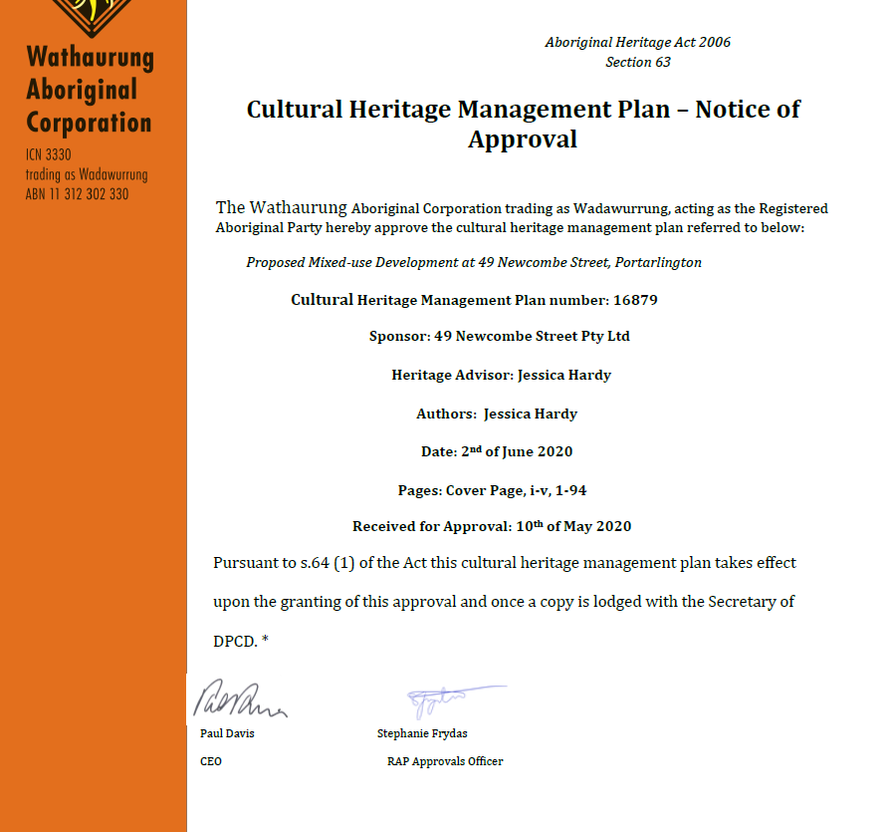

The CHMP noted that:
- No Aboriginal cultural material was located during the complex assessment. The land-use history for the activity area demonstrated disturbance to the activity area in the form of the importation of soils during the 1920s to moderate the north/south slope within the activity area. Further disturbance was caused by the construction of the existing structure during the 1960s. The soil profile revealed during the complex assessment demonstrates it is unlikely that any cultural material will be located within the activity area.
- No specific measures are needed for the management of Aboriginal cultural heritage as no Aboriginal cultural heritage was located during the assessment for this CHMP.
- In the unlikely event that Aboriginal cultural material is located during the proposed works, management and custody arrangements will be required.

LANDFILL GAS RISK ASSESSMENT

The subject site is not located within 500 metres of an identified former landfill site, a risk assessment is not required.

DEVELOPMENTS IN BUSHFIRE PRONE AREAS

The site is not located within a designated bushfire prone area.

THE VICTORIAN PLANNING POLICY FRAMEWORK (VPPF):
Clause No. | Clause name
02.03-1 | Settlement
02.03-2 | Environment and Sustainability
02.03-5 | Built Environment and Sustainability
02.03-6 | Housing
02.04-1 | Municipal Framework Plan
02.04-2 | Retail Activity Centre Hierarchy
02.04-3 | Housing & Settlement Framework Plan
11 | Settlement
11.01-1R | Settlement Geelong G21
11.02 | Managing Growth
11.03-2S | Growth Areas
11.03-4S | Coastal Settlement
11.03-5S | Distinctive Areas and Landscapes
11.03-6L-01 | Bellarine Peninsula
15.01-1S | Urban Design
15.01-2L | Environmentally Sustainable Design
15.01-5S | Neighbourhood Character
15.01-5L | Neighbourhood Character
16.01 | Residential Development
16.01-2S | Location of residential development
16.01-2L | Increased Housing Diversity Area
16.01-2L-03 | Increased Housing Diversity Area for coastal areas
17.02-1S | Business

OTHER RELEVANT PLANNIGN STRATEGIES AND POLICIES

Bellarine Peninsula Localised Planning Statement (LPS)

Localised planning statements are State policies for protecting and enhancing distinctive areas with State significant geographic and physical features, biodiversity, natural resources, cultural and tourism values, productive rural land and regional and national infrastructure assets.

The purpose of the LPS is to identify the key valued attributes of specific areas within the Bellarine Peninsula, including Portarlington, and to put in place objectives and strategies to ensure that they are preserved and enhanced for ongoing use by present and future generations.

Portarlington is described in the LPS as:

… a smaller settlement with both a residential and tourism role. It is not a designated growth location. Portarlington is the northern most point on the Bellarine Peninsula and is an older settlement with strong links to its history as a fishing town and holiday resort.

Policy objectives and strategies of the LPS relevant to the consideration of this proposal are outlined below:

Policy Objective | Strategies
To protect, preserve and enhance built heritage, cultural and urban character values and preserve the individual identity and role of townships. | Ensure that development responds to the identity and character of the individual township in which it is located.
 | Protect the character of local conservation precincts, places, objects and sites and heritage areas on the Bellarine Peninsula.
 | Encourage development which respects the setting of coastal settlements by providing reasonable sharing of views of the coast and foreshore and uses contemporary design that reflects existing built form.
To facilitate the planned residential growth of Drysdale/Clifton Springs, Leopold and Ocean Grove, consistent with adopted Structure Plans and as service hubs for the Bellarine Peninsula.  In all other townships, provide retail, commercial and community uses and facilities that serve the daily needs of the community and encourage street based activity and local employment. | Ensure land use and development proceeds generally in accordance with the relevant Structure Plan maps.
 | Provide for a range of retail, commercial, community uses in town centres to provide services for the community and local employment opportunities in accordance with Structure Plans.
 | Direct the bulk of residential growth and retail development to the designated growth locations of Drysdale/Clifton Springs, Leopold and Ocean Grove consistent with the relevant Structure Plan maps.

G21 Regional Growth Plan 2013

The Regional Growth Plan provides broad direction for land use and development across five G21 member Councils in the Geelong region. It recognises the region’s population is growing and that there is a need to proactively plan and manage growth while protecting areas of environmental significance, biodiversity assets, unique landscapes, coastal areas and heritage assets.

The Regional Growth Plan identifies Portarlington for limited growth and identifies the Portarlington Safe Harbour as a priority project.

City of Greater Geelong Settlement Strategy 2020

The City of Greater Geelong Settlement Strategy 2020 (Settlement Strategy) was introduced to the Planning Scheme as a reference document in May 2021 through Amendment C395.

The Settlement Strategy provides:

- an overview of Geelong’s current settlement and housing policies
- an analysis of population and housing trends
- background information about issues and community aspirations
- recommendations to guide housing provision for a growing population, while protecting Geelong’s unique lifestyle and environmental values.

Recommendations include:

- preserving significant landscapes and environments from urban encroachment
- containing urban development within settlement boundaries
- encouraging urban consolidation, to increase the contribution it makes to the overall housing supply
- managing future growth to deliver more sustainable, well-serviced communities.

Portarlington Structure Plan 2016 (Amended July 2017)

The Portarlington Structure Plan, referenced in Clause 11.03-6L-01 (The Bellarine Peninsula) provides a strategic framework for the future planning and development of the township, with the purpose to:

- identify the key strategic planning issues facing the township, including community aspirations and needs
- articulate the preferred future planning directions for the township, including the location of the Settlement Boundary
- identify appropriate planning controls which will protect and enhance the distinctive elements of the township, biodiversity and landscape features.

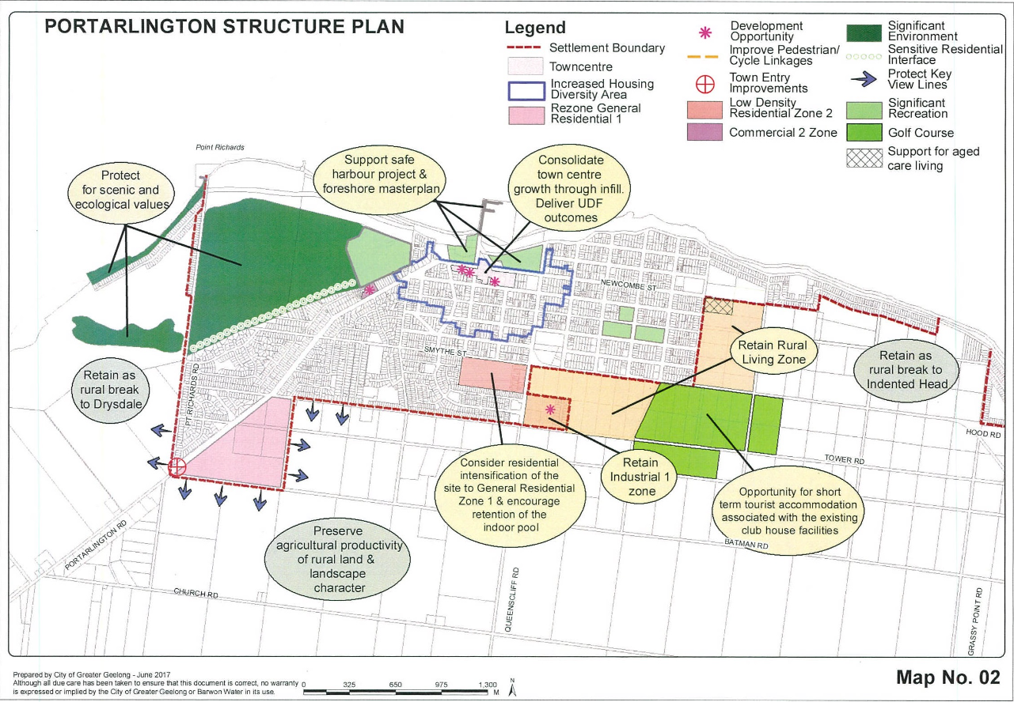
Figure 1 - Portarlington Structure Plan
The Portarlington Structure Plan provides guidance on urban growth, infrastructure, settlement and housing, natural environment, town centre and economy and rural area. It identifies the role of Portarlington has “traditionally been as a seaside holiday village on the Bellarine Peninsula serving a small permanent population”. Its direction for the subject site is to consolidate town centre growth through infill and to deliver the Portarlington Town Centre Urban Design Framework, Urban Initiatives (July 2011) (UDF). The UDF is not included as a reference document in the Planning Scheme. In this regard it sets out that there is sufficient vacant land and redevelopment options available within the town centre to cater for future growth. The structure plan seeks to encourage “shop top” accommodation where there are appropriate parking and access arrangements.

In particular regard to the Town Centre and Economy, the Portarlington Structure Plan identifies the subject site as a “major development opportunity”. It states that the 2008 Structure Plan recommended this site be developed as a focal building to contain a mix of retail uses, tourist accommodation and tourism related activities. However the updated structure plan (2016) outlines that development of this site is still a priority for the town centre. It identifies that activated uses are necessary on the ground floor, however as a result of no development on the site at the time of the amended structure plan, a mix of options could be considered above the first level, incorporating accommodation, offices or retail.

The directions formulated through the structure plan include to encourage infill development and redevelopment of the subject site for a focal building to contain activated tourist or retail uses on the ground floor and accommodation or other commercial uses above. This direction is reflected in policy at Clause 11.03-6L-01.
Response to Policy

The relevant planning policy framework to this application listed above seek to incorporate a range of policies which seek to encourage development that responds to the needs of existing and future communities, established built form, landscape character and local context. Development should not adversely impact on community amenity and human health through noise emissions, by incorporating a range of building design and land use separation techniques appropriate to the land use functions and character of the area.

The subject site is located in close proximity to a range of services and facilities, including shops, recreational open spaces and a school. The proposed development is therefore considered to be supported by Clause 15.01-4S – Healthy Neighbourhoods, which seeks to promote neighbourhoods that foster healthy and active living and community wellbeing, partly through the promoting walking and cycling as part of daily life.

Clause 16 of the Scheme states that planning should provide for housing diversity which includes access to services, walkability to activity centres, public transport, open spaces and schools. The development is located in a walkable distance to all such services. The proposal provides a range of housing types, as mentioned above, which ensures that housing stock is changing to accord with the market needs and allowing for a larger choice in housing as encouraged by Clause 16.01-2S.

Clause 02.03 of the Scheme details the Council’s strategic direction for growth with regard to settlement and housing. This clause identifies key drivers to include population growth, a rapidly aging population and increased demand for smaller and low maintenance dwellings in close proximity to urban services. Clause 02.03-6 Housing sets out that to accommodate the growing population, Council has identified Increased Housing Diversity Areas (IHDA). IHDAs are located around activity centres and transport hubs and have significant capacity to accommodate residential growth and increased housing diversity. Within areas of heritage significance, new development should balance the preservation and restoration of the heritage place and other opportunities for housing.

In order to address these issues, it is outlined that there is a need to provide for a range of housing types in established communities. Adopted strategic directions include to facilitate infill development to increase its housing supply contribution, support residential development where the density, mass and scale is complementary to the location, role and character of the specific IHDA.

In view of the above, Clause 16.01-1L-02 Increased Housing Diversity Areas is relevant to the consideration of this application. In this policy, land within the Portarlington IHDA is identified in the following map:

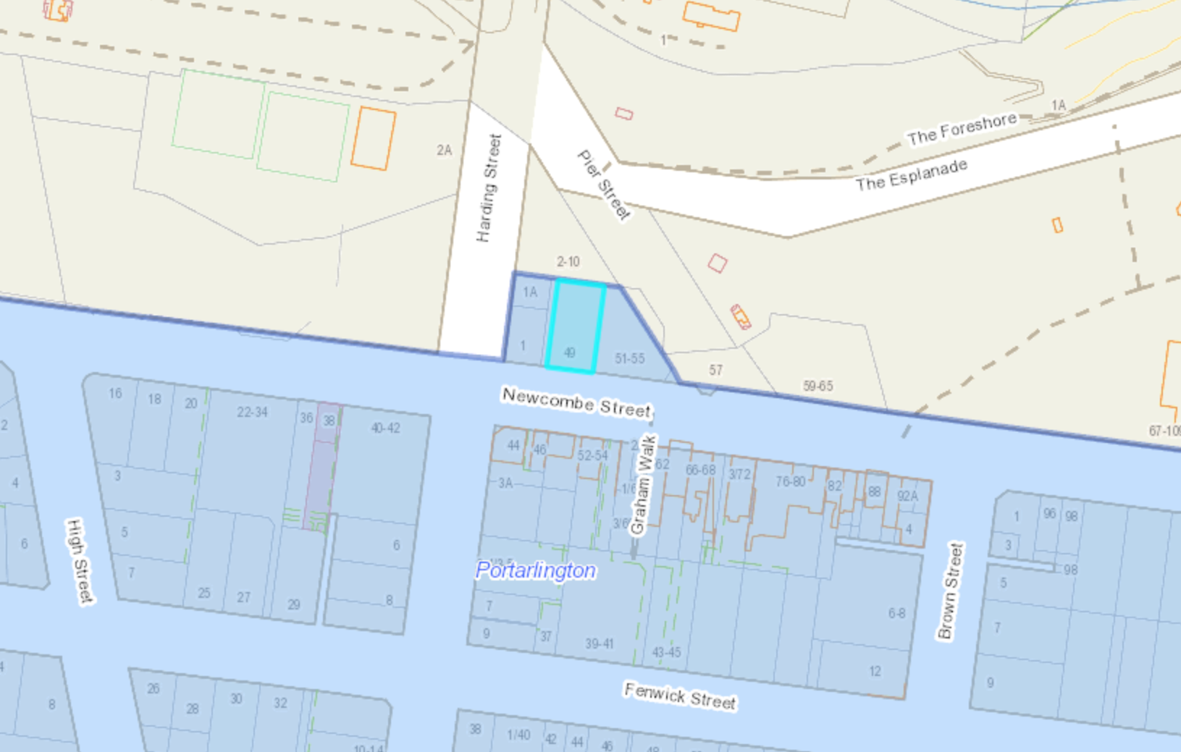
Figure 2 - Portarlington IHDA - Subject site shown blue
The IHDA policy specifies objectives to:

- Evolve the character of IHDAs through more intensive development.
- To support development that makes a positive architectural and urban design contribution to the IHDA.
- To maintain streetscape character in heritage areas.
- To promote pedestrian safety within the IHDA.

To achieve the specified objectives, a combination of General, Built Form and Building Height Strategies, Car parking and Heritage Strategies are set out. These strategies include to:

- Maximise opportunities for housing in IHDA by accommodating:
  - High density housing in activity centres,
  - Medium density housing in residential areas – with more intensive development located closest to the core of activity centres.
- Encourage a diversity of housing types to cater to a variety of lifestyle needs.
- Encourage development to provide a high level of on-site amenity for future residents.
- Encourage a sympathetic design response when addressing any unique characteristics such as heritage places.
- Discourage storage areas within the minimum area of secluded private open space.
- Support development that does not reduce opportunities or neighbouring sites to reasonably develop.
- Design development to recess upper levels to reduce dominance of the building form adjoining properties and the streetscape.
- Minimise visual prominence of car parking areas.
- Minimise the number of vehicle crossings and provide access from lower order roads where possible.
- Design development adjacent heritage places to respect and be sympathetic to the significance of the place.
- Set back building elements above one storey to be behind the ridgeline of heritage buildings.

Given Portarlington’s coastal location, additional policy relevant to Increased Housing Diversity in Coastal Areas is found at Clause 16.01-1L-03. This policy includes strategies to encourage innovative architecture that respects the coastal setting by incorporating:

- A variety of lightweight materials
- Building elements and details that contribute to a lightness of structure (including balconies, verandahs, extensive glazing, light transparent balustrading).
- Simple detailing
- Higher building elements to capture views.
- Retain the openness of the streetscape by avoiding the use of front fences or by providing low permeable front fences.
- Encourage landscaping to be incorporated into the overall development including planting of canopy trees and/or large shrubs within front setbacks.

In relation to the built form a section below is set aside insofar as the findings of the Portarlington Advisory Committee Report relating to the built form, which goes into great detail about the design response when viewed from the public foreshore to the north of the subject site.

It is accepted that the proposed development is appropriately located for some form of future residential and commercial development. As outlined in response to the C1Z, the proposal would contribute to the vibrancy and vitality of the Portarlington Town Centre. It would provide an additional 2 retail premises which would integrate into the established commercial centre, whilst contributing to the daily needs of residents within the proposed development and the centre itself. The proposed retail frontage would effectively activate the entire street frontage to Newcombe Street and would achieve the desired policy objectives to support the role and function of the Portarlington Town Centre.

In this context, the Bellarine Peninsula is identified at Clause 11.03-5S as a distinctive area and landscape. The Bellarine Peninsula Localised Planning Statement 2015 is a reference document to this clause. Its Framework Plan map identifies eight existing coastal towns, including Portarlington. The statement seeks inter alia to maintain he non-urban breaks between settlements and preserve the individual identity and role of the townships.

It defines Portarlington as:

Portarlington is a smaller settlement with both a residential and tourism role. It is not a designated growth location. Portarlington is the northern most point on the Bellarine Peninsula and is an older settlement with strong links to its history as a fishing town and holiday resort.

Clause 11.03-6L-01 seeks to ensure development responds to the identity and preferred character of the individual township in which it is located.
The Portarlington Advisory Committee report goes into detail how the first design failed to meet fit into the wider landscape setting of Portarlington when viewed from the public foreshore and failed to provide a design response that was appropriate in the wider setting including the Grand Hotel building, where it was considered the design was a dominant feature and overpowered the Grand Hotel within the prominent landscape vista when viewed from the foreshore.

The new application has attempted to provide a design response to meet these concerns, however it is still considered the amended design for the building is still a dominant feature within this view and in its current form still does not meet the local Bellarine policy of 11.03-6L or clause 11.03-5S. The design response of the building is raised in further detail through this report, including how the new application has been assessed section against the conclusions of the Portarlington Advisory Committee report.

RELEVANT PARTICULAR PROVISIONS:

The following Particular Provisions are applicable to this application:

CLAUSE 52.06 – CAR PARKING

- To ensure that car parking is provided in accordance with the State Planning Policy Framework and the Local Planning Policy Framework.
- To ensure the provision of an appropriate number of car parking spaces having regard to the demand likely to be generated, the activities on the land and the nature of the locality.
- To support sustainable transport alternatives to the motor car.
- To promotes the efficient use of car parking spaces through the consolidation of car parking facilities.
- To ensure that car parking does not adversely affect the amenity off the locality.
- To ensure that the design and location of car parking is of a high standard, creates a safe environment for users and enables easy and efficient use.

Response

Pursuant to Clause 52.06-5, the proposed development has a statutory car parking requirement of 26 spaces, including 18 resident spaces, 2 visitor spaces and 6 shop spaces.
The application has provided a total of 21 spaces proposed, which is 5 statutory spaces short of the requirement.

Of the 21 spaces provided 19 are resident spaces and 2 are retail spaces, and so the application is seeking a reduction of the standard car parking requirement under Clause 52.06-7 notably the reduction seeks to reduce the requirement for the 4 shop spaces and 1 visitor spaces onsite. As tabled below the existing use for retail has a credit of 2 car spaces onsite, so therefore the car parking reduction is seeking two retail spaces and the visitor space.

The decision guidelines outlined in Clause 52.06 Carparking provides guidance on how to determine whether this reduction is appropriate.

Having regard to these decision guidelines it is considered that this reduction is appropriate for the following reasons:

- The car parking demand is anticipated to be long-stay for residents and shop staff, and short-stay for customers and residential visitors.

- It is noted that sufficient parking has been provided for the residents. No reduction to this requirement is proposed. Notably, additional parking has been provided for 3 of the 2 bedroom apartments.

- It is noted that one staff car park has been provided on site for each shop.

- Given the proposed retail tenancies are located within a commercial area of the township and taking into account multipurpose trips associated with customers to the site are highly likely, and so this is considered an acceptable response. It is widely accepted by the Tribunal (VCAT) that customer parking for the retail component is to be provided within the area designated for public parking with the commercial centre.

- Having regard to the location of the site within a seaside town, and that multipurpose trips are highly likely, the additional parking demand generated by the retail tenancies would be relatively modest.

- Also Bus Route 60 – Geelong Station to St Leonards (via Leopold, Drysdale and Portarlington) operates in the vicinity of the site. There are weekday and weekend services typically operating at approximately 1 to 2-hour frequencies.

- The car parking surveys provided indicates within 100m of the subject site, approximately 50 spaces, including one accessible space are available. Observation of these spaces showed that occupancy is approximately 50% during the business day and low occupancy in the evenings to cater for any overflow parking that may be generated by residential visitors and the proposed retail tenancies.

- It is also acknowledged that the site (in the past) was used for the purposes of a retail premise and the car parking credit for this use is 4 spaces.

- Based on the information provided (Traffic assessment) and taking into account the policy areas to be considered there is sufficient capacity in the local on-street and off-street parking opportunities to accommodate any parking shortfall from the development (visitor and customer parking). The parking shortfall can be accommodated by the available on-street parking supply of Newcombe Street, Pier Street and Harding Street.

Furthermore, a Traffic and Parking Impact Assessment was conducted by Kevin J Flynn of Civil & Traffic Consulting and the application was referred to the City’s Engineering Department, who support the reduction of visitor spaces for the retail and dwelling development as they are not seen as practical for a secured basement car park, where the reduction of 3 spaces is seen as appropriate, due to the location of the development and number of street car parking available in the area.

CLAUSE 52.29 – Land Adjacent to the Principal Road Network

The purpose of this Clause is to:
- To ensure appropriate access to the Principal Road Network or land planned to form part of the Principal Road Network.
- To ensure appropriate subdivision of land adjacent to Principal Road Network or land planned to form part of the Principal Road Network.
Before deciding on an application, in addition to the decision guidelines in Clause 65, the responsible
authority must consider:

- The Municipal Planning Strategy and the Planning Policy Framework.

- The views of the relevant road authority.

- The effect of the proposal on the operation of the road and on public safety.

- Any policy made by the relevant road authority pursuant to Schedule 2, Clause 3 of the Road Management Act 2004 regarding access between a controlled access road and adjacent land.

It is considered that the proposal will not adversely impact upon traffic movement in the surrounding area as:

- Given that the site is located within the commercial centre of the seaside township it is likely that customers would make multipurpose trips to the centre rather than to just visit one retailer or business. Therefore, the customers of the proposed retail tenancies are not expected to generate a significant number of additional trips. That is; customers are likely to combine a trip to existing uses (e.g. the supermarket) with a trip to one of the proposed retail tenancies.

- Staff may generate some additional trips. There would be one car space provided on the site per tenancy which is likely to result in 1 trip to the site per tenancy in the morning, and 1 trip away from the site per tenancy in the afternoon/evening. It is anticipated that these trips would not all occur in the same hour.

- It has been predicted that the residential/retail parking component will generate 7 trips per hour at carpark entry at peak demand. Being situated in a shopping precinct, it is expected that traffic generation will have minimal impact on the performance and safety of the local road system.

The application was referred to Regional Roads, who have no objection to the proposal subject to conditions.

CLAUSE 53.01 – PUBLIC OPEN SPACE CONTRIBUTION

A person who proposes to subdivide land must make a contribution to the council for public open space in an amount specified in the schedule to this clause (being a percentage of the land intended to be used for residential, industrial or commercial purposes, or a percentage of the site value of such land, or a combination of both). If no amount is specified, a contribution for public open space may still be required under Section 18 of the Subdivision Act 1988.

Response

Pursuant to the schedule to Clause 53.01, the following contribution is required to be made:

Creation of one additional lot | None
Creation of two to nine additional lots | 1 percent per additional lot up to a maximum of 5 percent
Creation of 10 or more lots on land zoned for residential purposes prior to August 31st 2007 | 5 percent
Creation of 10 or more lots on land zoned for residential purposes after August 31st 2007 | 10 percent
Waurn Ponds Creek Environs | 10 percent

Pursuant to the above table a 5% contribution is required to be made. This could be addressed as a condition of any permit.

CLAUSE 52.34 - Bicycle Facilities

Under Clause 52.34 Bicycle Facilities of the Greater Geelong Planning Scheme, the bicycle rate to be applied is outlined below.

As such, the scheme requires 3 spaces to be provided. Two for residents and one for a visitor.

The scheme does not require bicycle spaces to be provided for the retail shops, as the shops have a leasable floor area less than 300m².

The proposal complies with the requirements of the scheme as provision for 4 bicycle spaces have been provided as shown below:
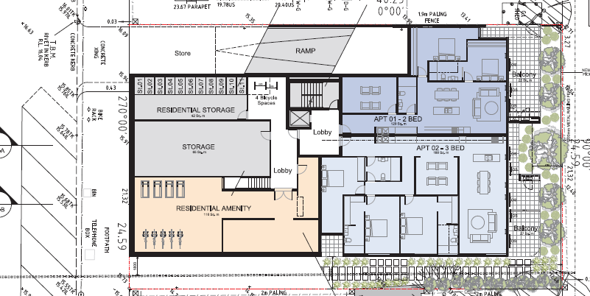

CLAUSE 58 - RESCODE ASSESSMENT – TWO OR MORE DWELLINGS ON A LOT

Compliance with Clause 58 Apartment Developments

The application has been assessed against the objectives and standards of Clause 58 of the Planning Scheme (See ResCode Assessment Report).

The applicant does not comply with standards:

Standard | Objectives | Reason
D1 | Urban context Objectives  Residential policy objectives | The development does not adequately respond to the low scale character of the township for reasons outlined in the report that accompanies this application.
D10 | Landscaping Objectives | As detailed within the assessment report, the landscaping along the northern (rear) section of the site, is not wide enough to allow for layered landscaping to lessen the visual bulk of the development when viewed from the public foreshore, greater separation is required from the rear boundary to development on the site.

In addition, the applicant seeks the following variations to the standard requirements:

Standard | Objectives
D7 | Communal Open Space
D19 | Building entry and circulation objectives
D27 | Room depth
D28 | Windows

CLAUSE 56 – SUBDIVISION

This is an application to subdivide the dwellings such that the dwellings will exist on separate titles. In this case there is no need to assess the application against the provisions of Clause 56 as issues in relation to amenity, both on and off site, have been considered via the Clause 58 assessment, as has neighbourhood character.

A condition of any permit could tie the subdivision and development via a Section 173 Agreement so that an orderly planning outcome is achieved.

RESPONSE TO PORTARLINTON ADVISORY COMMITTEE

As discussed above planning permit PP-710-2019 was refused for 11 dwellings (eight, 3 bedroom dwellings and 2, two bedroom dwellings) two ground floor shops, facing Newcombe Street and the provision of 23 basement car spaces, access to a Road Zone Category 1 and a reduction in car spaces.

The building would present as a three level development from Newcombe Street and four levels when viewed from the north, the Portarlington public foreshore.
Planning Panels Victoria issued the Portarlington Advisory Committee Report dated 7 October 2021 where the Committee concluded the following:

- The proposal is generally supported by planning policy relating to settlement and activity centres with the provision of retailing and additional density and diversity of housing on commercially zoned land within the Portarlington town centre and within the IHDA area.
- An acceptable proposal must provide a satisfactory urban design response on the subject site including a positive contribution to the coastal character of the area, be reflective of local context and protect significant views.
- The urban design response is unacceptable as it is not consistent with policies relating to urban design, the nomination within a DAL, the DDO21, Clause 21.14 and the Portarlington Structure Plan, as discussed in Chapter 4 of this report.

The Committee recommended:

That Planning Permit PP-710-2019 (VCAT call in P415/2021) for the 'development of a multi-level mixed use building containing two shops, use of eleven apartments and basement car park, subdivision, creation of access to a Road Zone Category 1 and partial reduction in car parking' not be issued.

After the above conclusions, the current (second) application was lodged with Council. This application is to be determined against the findings listed above within the first application.
This raises if the application is a “classic repeat appeal” where the re-application is to regurgitate the same application of effectively the same terms as had previously been considered and refused, with the hope the later attempt find a sympathetic ear. A “correcting repeat appeal” on the other hand is a re-application that seeks to address the findings.
It is considered the second application has made a genuine effort to meet the conclusions within the Portarlington Advisory Report.

Chapter 4 of the report breaks down the application into the following headings, where the following table below shows the theme, the Committee conclusions and how the application responds to the Committee conclusions:

Committee  themes | Committee Conclusions |  | Amended design response
Urban Design and views | - That the urban design response is unsatisfactory as it does not sufficiently protect and enhance the valued attributes of the area in line with the declaration of area as a DAL and other policy provisions relating to urban design and Portarlington’s character.  - That the proposal does not make a positive architectural and urban design contribution to its context, when viewed from the foreshore.  - That the proposal does not satisfy the requirements of DDO21 and it is not visually unobtrusive when viewed from the public foreshore. |  | Does not comply  The Committees position is that the previous design severely compromised the visual prominence of the Grand Hotel when viewed from the foreshore and the proposed building would not be unobtrusive when viewed from the foreshore as discussed below.  It is noted this application has been designed with a two-storey solid base, a third storey setback above, along with a further recessed upper ‘cap’ finishing the building. The two-storey base is designed with a 5m setback from the front boundary line, an increase of 0.725m from the previous application.  The ground floor terraces are setback a minimum of 2m from the northern boundary, with a central recess providing additional space for landscaping. The second storey above (Upper Ground) holds the same setbacks, with the central recess carried upwards. The third storey (First Floor) is setback 7.2m from the northern boundary, a further 2.2m from the levels below, with the depth of the central recess increased by approximately 1 metre. Above, the upper level (Second Floor) is setback substantially from the northern boundary by 16.4m (from 10.8m), 5.6m from the east boundary and 4.6m from the west boundary (previously 3.65m on each side).  Although the Committee report accepts that if the subject site is developed the loss of the current clear view of the bay will be lost and there is there is the reasonable expectation the redevelopment of the site in a C1Z within the town centre, the below points needs to be addressed and met for a design response to meet the advisory committee report  There is still a need to provide viewlines through the site. Although the new application has reduced the upper levels of the building to the northern boundary from the existing application (dimensions listed above), it is considered the upper levels when viewed from the north (3rd and 4th storey elements) the design is not visually unobtrusive when viewed from the public shoreline where the built form still retains a visual presence. The building will be still seen to the parapet of the Grand Hotel.  The City’s Urban Design team recommends to address this the upper level should be removed and third storey should have greater recession from the northern boundary to not dominate within the wider landscape setting when viewed from the Shoreline.  It is noted that the proposal seeks to break up the built form and its associated bulk, where the northern façade now includes a central recess which assists in breaking down what was a larger mass, into two distinct modules. It is considered these elements by the City’ Urban Design Department are minor elements of articulation to the northern elevation.  It is considered this articulation provided when viewed from the shoreline is inadequate, as the materials along the northern elevation are predominantly the same and a similar colour.  To further break up the northern elevation, the City’s Urban Design Department are of the view that greater setbacks of the articulated middle section of the building are recessed further, where articulation should include the external walls of the northern elevation of the building, not just balconies, as well as changing the materials of this section of the building.
Building and Landscape Design | The Committee considers the Newcombe Street elevation is generally an acceptable response to DDO21 provisions and the streetscape character. The Committee considers either a zero or a small street setback would be an appropriate design response to Newcombe Street; with a zero frontage as proposed being an efficient use of the land and typical of retail in strip centres, or alternatively a small setback of in the order of three metres would match the small setbacks of the former Post Office and Kindergarten. The retail uses at ground level would provide a positive infill land use contribution to the town centre and the clearly identifiable separate apartment entry is supported. The single storey presentation to the street is primarily in response to heritage considerations and the upper level setbacks are generous which, in the Committee’s view, allow the building to sit comfortably within the streetscape. The improvements in relation to removing the air conditioning units and addition of a plinth to the retail premises is supported. The Committee does not agree with Council that the building as viewed in an easterly direction along Newcombe Street would overwhelm the former Post Office building. Rather it considers it would provide a positive infill to the retail strip as shown in View 1 of the 3D montages. The Committee considers a more comprehensive and considered landscape response is required. While the proposed landscaping could provide for some softening of the building, particularly at the upper levels, it does not appear to be integrated with the building design nor is it responsive to the character of Portarlington. The Committee agrees with Ms Roberts that the extent of glazing as viewed from the north is uncharacteristic of the town’s character and would likely to contribute to its prominence and dominance in the landscape. The Committee concludes: • That the presentation of the building to Newcombe Street is acceptable. • That a more comprehensive and considered landscape response is required to be responsive to the character of Portarlington |  | Does not comply  The front setback of zero metres to Newcombe Street has been retained to meet the Committee conclusions.  It is noted the amended design response has generally maintained the profile to Newcombe Street, aside from a change to the top level setback (Second Floor) which has been reduced from 12.05m to 9.05m. The upper level will remain setback behind the main gable of the Post Office building to meet the heritage requirements.  The air conditioning units have been relocated to meet the Committee conclusions.  However there are concerns with the 2 metre setbacks (due to the location of balconies) along the northern boundary to provide appropriate landscaping that is a layered design or support the ability for appropriate species to be used within the landscaping that are suitable for breaking up the built form. This is demonstrated within the landscape plan where the single row of trees would only grow to the second storey of the proposed building.  The City’s Urban design Department seeks that there needs to a greater setback provided from the northern boundary that will allow for a layered response to landscaping and selecting substantial plant species to be planted to lessen the built form of the development  It is agreed that the applicant has provided a sufficient design response to reduce the amount of glazing along the northern elevation. The glazing along this elevation is covered to a significant degree by timber screening. It is also considered the timber screening is a consistent material element located within building designs along this section of Portarlington.
Heritage | Ms Bashta’s evidence was largely undisputed at the Hearing. No other heritage evidence was called, and Ms Bashta outlined how the amended plans had responded to recommendations of the Heritage Officer at Council. Council was concerned about the visual impact of the building diminishing the significance of the Post Office, as viewed in an easterly direction along Newcombe Street. The Committee however, was not persuaded this would have an unreasonable impact on the heritage significance of the former Post Office, noting the decorative elements of the former Post Office would remain visible as the corner building, addressing both Newcombe and Harding Streets. As discussed in Chapter 5, the presence of the higher built form, well setback from the site’s frontage is a comfortable fit within this streetscape and is a reasonable expectation within the commercial town centre. The Committee accepts that views from the foreshore are not a heritage consideration, however the prominence of the Grand Hotel in the township given its historic significance is relevant with the requirement of DDO21 to ensure the design of any higher built form elements must demonstrate the development is sympathetic to buildings of heritage significance. While the Committee considers the massing, bulk and overall appearance of the proposal unacceptable from the foreshore, the this is primarily for urban design reasons rather than heritage considerations. The Committee concludes:  • The proposed development provides an acceptable response to heritage values. |  | Complies  As explained above (within the response to the Heritage Overlay), the amended design response still meets the heritage requirements when viewed from Newcombe Street.
Amenity | As the Committee does not support the proposed building due to character and interface issues, it has not undertaken a detailed assessment of the building and overlooking from each window. The following discussion provides a high level response to issues raised in objections and submissions. The Committee accepts the tests established in Golden Seven Star P/L v Port Phillip CC are reasonable and provide an appropriate balance between privacy and some overlooking. The Kindergarten open space area is located to the north of the building, with open fencing to Pier Street and the coastal reserve. There are large north facing windows that provide an outlook to the playground and beyond. Accordingly, the outdoor area, and to some degree the inside area, are currently visible from the public realm. Within the outdoor play area, there are canopy trees in the north/west corner of the property, predominately along the common boundary, and some shade sails over the remainder of the playground. The trees are a mixture of evergreen and deciduous species, with an evergreen tree of approximately eight metres located close to the north/west corner. Combined, the trees and shade sails result in much of the playground being shaded, with pockets of the playground, in particular near the northern boundary, allowing for areas of sun. Given this context, and on the basis of the shadow plans provided, the Committee accepts the extent of afternoon overshadowing (only after 1pm) from the proposed building is acceptable and will largely fall within already shaded areas of the playground. The two west facing windows will be overshadowed in the afternoon, however as ground floor windows sited close to the common boundary, some overshadowing of these windows is a reasonable outcome in a C1Z context and would result with almost any redevelopment of the site. In terms of overlooking, the existing Kindergarten playground is not private and a degree of casual observation by passers-by or causal users of the recreation reserve is already available to and from Pier Street and the foreshore reserve. However, the Committee considers that direct views from apartments may be more intrusive. On this basis, the Committee considers some screening should be provided to windows or balcony areas where there would be direct views into the Kindergarten and this may include additional screening beyond that shown on the amended plans. The primary aspect from the proposed development is to the north towards the Bay, and some easterly views could be maintained from the development while preventing direct downward views into the Kindergarten playground. Overshadowing to 1 Harding Street would be limited to early morning and is acceptable |  | Complies  As required as part of the Committee conclusions the amended design response has shown greater levels of screening on the upper levels to meet the overlooking requirements and has reduced the level of wrap around balconies within this design to further reduce any overlooking within the subject site.
Traffic and Car parking |  | The Committee accepts the evidence of Ms Dunstan that the car parking, traffic and loading arrangements for the proposal are satisfactorily dealt with. The reduction in car parking relates to visitor uses only, and not to resident car parking and some provision is made for staff of the retail tenancies. While car parking demand and availability within the surrounding area varies considerably depending on holiday and peak periods, there is a general supply of public car parking available in close proximity of the site and the Committee considers it reasonable for residential visitors or customers of the retail uses to rely on these spaces. In relation to loading, the Committee accepts the infrequency of deliveries and notes on street loading is often required in strip shopping centres. While it may result in a loss of some on street car parking, a satisfactory arrangement could be made if a loading bay was created outside the site (for at least a specified period), or alternatively, while not as convenient, the existing loading bay outside the Grand Hotel could be relied on. The Committee notes Council accepted the evidence of Ms Dunstan, and considered loading and traffic management impacts could be managed through planning permit conditions | Complies  The amended design of the building is still seeking a reduction in the number of car parking spaces provided on site. The application was referred to the City’s Engineering Department who have no concerns with the reduction of spaces or loading areas for the subject site.
Waste and Recycling |  | The Committee is satisfied waste management issues can be satisfactorily managed through permit conditions and an appropriate Waste Management Plan. Noting Ms Dunstan’s evidence that waste collection can be restricted to off-peak times (such as early morning), the Committee considers this could be implemented to avoid conflict with drop off or pick up of children from the Kindergarten | Complies  The application was referred to the City’s Waste Department who have no concerns with the proposal.
Environmentally Sustainable Design |  | The final comments from Council on compliance with ESD planning requirements was on the Revision D plans, and not the amended plans. The Committee agrees with Council that given there have been further changes to the plans, further work is required to ensure the amended proposal can still meet ESD requirements to satisfy the requirements of the Planning Scheme. As the Committee does not support the proposal it provides no further comment on this issue, but notes Clause 22.71 requires early consideration of sustainability initiatives during the design phase to ensure efficiencies and benefits are achieved | Complies  The application was referred to the City’s ESD officer who has concerns with the application subject to conditions being placed on any permit.

It is considered from the above table the amended design response to the subject site has carefully considered the findings and recommendations of the Portarlington Advisory Committee and the amended design from a built form perspective fails to adequately meet the requirements of the DDO21 and Advisory Committee and therefore the application cannot be supported from an officer perspective.

DECISION GUIDELINES OF CLAUSE 65:

CLAUSE 65.01 – APPROVAL OF AN APPLICATION OR PLAN

Clause 65.01 of the Greater Geelong Planning Scheme outlines the decision guidelines to be considered by the Responsible Authority when making decisions on applications. These decision guidelines include:
- The matters set out in Section 60 of the Act.
- The Municipal Planning Strategy and the Planning Policy Framework.
- The purpose of the zone, overlay or other provision.
- Any matter required to be considered in the zone, overlay or other provision.
- The orderly planning of the area.
- The effect on the amenity of the area.
- The proximity of the land to any public land.
- Factors likely to cause or contribute to land degradation, salinity or reduce water quality.
- Whether the proposed development is designed to maintain or improve the quality of stormwater within and exiting the site.
- The extent and character of native vegetation and the likelihood of its destruction.
- Whether native vegetation is to be or can be protected, planted or allowed to regenerate.
- The degree of flood, erosion or fire hazard associated with the location of the
- land and the use, development or management of the land so as to minimise any such hazard.
- The adequacy of loading and unloading facilities and any associated amenity, traffic flow and road safety impacts.

CLAUSE 65.02 – SUBDIVISION

Clause 65.02 of the Greater Geelong Planning Scheme outlines the decision guidelines to be considered by the Responsible Authority when making decisions on an application to subdivide land. These decision guidelines include:

- The suitability of the land for subdivision
- The existing use and possible future development the land and nearby land
- The availability of subdivided land in the locality, and the need for the creation of further lots
- The effect of development on the use or development of other land which has a common means of drainage
- The subdivision pattern having regard to the physical characteristics of the land including existing vegetation
- The density of the proposed development
- The area and dimensions of each lost in the subdivision
- The layout of roads having regard to their function and relationship to existing roads
- The movement of pedestrians and vehicles throughout the subdivision and the ease of access to all lots
- The provision and location of reserves for public open space and other community facilities
- The staging of the subdivision
- The design and siting of buildings having regard to safety and the risk of spread of fire
- The provision of off street parking
- The provision and location of common property
- The functions of any body corporate
- The availability and provision of utility services, including water, sewerage, drainage, electricity and gas
- If the land is not sewered and no provision has been made for the land to be sewered, the capacity of the land to treat and retain all sewage and sullage within the boundaries of each lot
- Whether, in relation to subdivision patterns, native vegetation can be protected through subdivision and siting of open space areas.

Response

In light of the above, it is considered the proposed second design does not meet the Portarlington Advisory Report conclusions in relation to urban Design and views, building and landscape design, state based policy in relation to distinctive landscapes, the DDO21, the variations to Clause 58 and therefore it is respectfully considered the application is refused.

CONCLUSION:

That the Responsible Authority having consideration of all matters which the Planning and Environment Act, 1987 requires it to consider, advocates at the Victorian Civil and Administrative Tribunal (VCAT) to refuse to grant a permit for Buildings and works for the development of a multi-level building for 10 dwellings (apartments), 2 retail spaces, Subdivision, Create access to a Transport Zone 2 and reduction of car parking requirement in accordance with the plans and documentation submitted with the application subject to the following grounds:

- The proposal does not meet Clause 11.03-5S in regard to the urban design response when viewed from the Portarlington public foreshore and does not sufficiently protect and enhance the valued attributes of the area in line with the declaration of area as a Distinctive Area and Landscape and other policy provisions relating to urban design and Portarlington’s character.
- The proposal does not meet Clause 15.01-5S in relation making a positive architectural and urban design contribution to its context when viewed from the Portarlington public foreshore.
- The proposal does not satisfy the requirements of the Design and Development Overlay Schedule 21 (DDO21) and is not visually unobtrusive when viewed from the Portarlington public foreshore.
- The proposal does not meet the Portarlington Advisory Committee report in relation to urban design and views and building and landscape design.
- The proposal does not sufficiently respond to the objectives and/or standards of Clause 85, including:

- 58.02-1 (Standard D1) Urban Context
- 58.03-5 (Standard D10 Landscaping

Appendix

APPENDIX 1 - CLAUSE 58.00 - RESCODE ASSESSMENT APARTMENT DEVELOPMENTS

Application Number: PP-1065-2022

The development is required to be assessed against Clause 55 as set out below:

58.02-1  Urban context Objectives  To ensure that the design responds to the existing urban context or contributes to the preferred future development of the area.  To ensure that development responds to the features of the site and the surrounding area. | Standard D1  The design response must be appropriate to the urban context and the site.  The proposed design must respect the existing or preferred urban context and respond to the features of the site. | Does not comply  Comments:  Although the applicant has made changes to the new application the proposal is considered to fail to meet the neighbourhood character as it will be a dominating feature when viewed from the public foreshore to the north, with the upper levels not recessed or articulated enough.
58.02-2  Residential policy objectives  To ensure that residential development is provided in accordance with any policy for housing in the Municipal Planning Strategy and the Planning Policy Framework.  To support higher density residential development where development can take advantage of public and community infrastructure and services. | Standard D2  An application must be accompanied by a written statement to the satisfaction of the responsible authority that describes how the development is consistent with any relevant policy for housing in the Municipal Planning Strategy and the Planning Policy Framework. | - N/A  Complies
58.02-3  Dwelling diversity objective  To encourage a range of dwelling sizes and types in developments of ten or more dwellings. | Standard D3  Developments of ten or more dwellings should provide a range of dwelling sizes and types, including dwellings with a different number of bedrooms. | Complies  The application complies with the standard. It provides dwellings between 2 and 4 bedrooms.
58.02-4  Infrastructure objectives  To ensure development is provided with appropriate utility services and infrastructure.  To ensure development does not unreasonably overload the capacity of utility services and infrastructure. | Standard D4  Development should be connected to reticulated services, including reticulated sewerage, drainage, electricity and gas, if available.  Development should not unreasonably exceed the capacity of utility services and infrastructure, including reticulated services and roads.  In areas where utility services or infrastructure have little or no spare capacity, developments should provide for the upgrading of or mitigation of the impact on services or infrastructure. | Complies  The site is easily connected to services.
58.02-5  Integration with the street objective  To integrate the layout of development with the street.  To support development that activates street frontage. | Standard D5  Development should be oriented to front existing and proposed streets.  Along street frontage, development should:  - Incorporate pedestrian entries, windows, balconies or other active spaces.  - Limit blank walls.  - Limit high front fencing, unless consistent with the existing urban context.  - Provide low and visually permeable front fences, where proposed.  - Conceal car parking and internal waste collection areas from the street.  Development next to existing public open space should be designed to complement the open space and facilitate passive surveillance. | Complies  The development will be orientated with frontage to Newcombe Street and zero setback. All pedestrian entry to retail tenancies and residential dwellings is provided via the street frontage. The ground floor retail tenancies will activate the street frontage. Balconies and windows on the upper level dwellings along the Newcombe Street interface will enhance passive surveillance of the public realm.  No other vehicle access arrangements are available to the site, and so vehicle entry and exit is provided via a single cross over fronting Newcombe Street. Ample space has been given to vehicle movement to ensure all vehicles can exit forward facing, ensuring pedestrian safety. Dwellings to the rear of the site are orientated to the north. The north facing windows and balconies will further enhance passive surveillance of the adjoining Foreshore Reserve
58.03-1  Energy efficiency objectives  To achieve and protect energy efficient dwellings and buildings.  To ensure the orientation and layout of development reduce fossil fuel energy use and make appropriate use of daylight and solar energy.  To ensure dwellings achieve adequate thermal efficiency. | Standard D6  Buildings should be:  - Oriented to make appropriate use of solar energy.  - Sited and designed to ensure that the energy efficiency of existing dwellings on adjoining lots is not unreasonably reduced.  Living areas and private open space should be located on the north side of the development, if practicable.  Developments should be designed so that solar access to north-facing windows is optimised.  Dwellings located in a climate zone identified in Table D1 should not exceed the maximum NatHERS annual cooling load specified in the following table. | Complies  A BESS assessment has been prepared accompanying the Sustainability Design Assessment provided at Appendix H of this application. The BESS score is 60% which demonstrates best practice. Refer to Sustainability Management Plan for further details. Council’s ESD officer is satisfied with the BESS 87uureport, subject to conditions
58.03-2  Communal open space objective  To provide communal open space that meets the recreation and amenity needs of residents.  To ensure that communal open space is accessible, practical, attractive, easily maintained.  To ensure that communal open space is integrated with the layout of the development and enhances resident amenity. | Standard D7  A development of 10 or more dwellings should provide a minimum area of communal outdoor open space of 30 square metres.  If a development contains 13 or more dwellings, the development should also provide an additional minimum area of communal open space of 2.5 square metres per dwelling or 220 square metres, whichever is the lesser. This additional area may be indoors or outdoors and may consist of multiple separate areas of communal open space.  Each area of communal open space should be:  - Accessible to all residents.  - A useable size, shape and dimension.  - Capable of efficient management.  - Located to:  - Provide passive surveillance opportunities, where appropriate.  - Provide outlook for as many dwellings as practicable.  - Avoid overlooking into habitable rooms and private open space of new dwellings.  - Minimise noise impacts to new and existing dwellings.  Any area of communal outdoor open space should be landscaped and include canopy cover and trees. | Does not comply  Variation required  Comments:  10 dwellings requires a communal outdoor space of 30 square metres. As the application is on the threshold of 10 dwellings and given its location to parkland, it is accepted that this variation is relatively modest and appropriate.
58.03-3  Solar access to communal outdoor open space objective.  To allow solar access into communal outdoor open space. | Standard D8  The communal outdoor open space should be located on the north side of a building, if appropriate.  At least 50 per cent or 125 square metres, whichever is the lesser, of the primary communal outdoor open space should receive a minimum of two hours of sunlight between 9am and 3pm on 21 June. | - N/A  No communal open space is provided
58.03-4  Safety objective  To ensure the layout of development provides for the safety and security of residents and property. | Standard D9  Entrances to dwellings should not be obscured or isolated from the street and internal accessways.  Planting which creates unsafe spaces along streets and accessways should be avoided.  Developments should be designed to provide good lighting, visibility and surveillance of car parks and internal accessways.  Private spaces within developments should be protected from inappropriate use as public thoroughfares. | Complies  Pedestrian entry to the retail tenancies and dwellings is via Newcombe Street. Resident access is clearly identified by the secure entry in which residents will be able to close the secure door before proceeding through the entry lobby of the residency. A security gate will also be installed at the vehicle entry to ensure safety.  Low tufting plants within proposed masonry planter adjacent the driveway will grow to a maximum height of 900mm to maintain visibility.
58.03-5  Landscaping objectives  To provide landscaping that supports the existing or preferred urban context of the area and reduces the visual impact of buildings on the streetscape.  To preserve existing canopy cover and support the provision of new canopy cover.  To ensure landscaping is climate responsive, supports biodiversity, wellbeing and amenity and reduces urban heat. | Standard D10  Development should retain existing trees and canopy cover.  Development should provide for the replacement of any significant trees that have been removed in the 12 months prior to the application being made.  Development should:  - Provide the canopy cover and deep soil areas specified in Table D2. Existing trees can be used to meet the canopy cover requirements of Table D2.  - Provide canopy cover through canopy trees that are:  - Located in an area of deep soil specified in Table D3. Where deep soil cannot be provided trees should be provided in planters specified in Table D3.  - Consistent with the canopy diameter and height at maturity specified in Table D4.  - Located in communal outdoor open space or common areas or street frontages.  - Comprise smaller trees, shrubs and ground cover, including flowering native species.  - Include landscaping, such as climbing plants or smaller plants in planters, in the street frontage and in outdoor areas, including communal outdoor open space.  - Shade outdoor areas exposed to summer sun through landscaping or shade structures and use paving and surface materials that lower surface temperatures and reduce heat absorption.  - Be supported by irrigation systems which utilise alternative water sources such as rainwater, stormwater and recycled water.  - Protect any predominant landscape features of the area.  - Take into account the soil type and drainage patterns of the site.  - Provide a safe, attractive and functional environment for residents.  - Specify landscape themes, vegetation (location and species), irrigation systems, paving and lighting.  Note: Where multiple trees share the same section of soil the total required amount of soil can be reduced by 5% for every additional tree, up to a maximum reduction of 25%. | Does not comply  Comments:  Although landscaping is provided along the northern boundary, the two metre setback is not considered enough space to layer the landscaping as per the Portarlington Advisory Committee report recommendations.
58.03-6  Access objective  To ensure that vehicle crossovers are designed and located to provide safe access for pedestrians, cyclists and other vehicles.  To ensure the vehicle crossovers are designed and located to minimise visual impact. | Standard D11  Vehicle crossovers should be minimised.  Car parking entries should be consolidated, minimised in size, integrated with the façade and where practicable located at the side or rear of the building.  Pedestrian and cyclist access should be clearly delineated from vehicle access.  The location of crossovers should maximise pedestrian safety and the retention of on-street car parking spaces and street trees.  Developments must provide for access for service, emergency and delivery vehicles. | Complies  Only one crossover is proposed, located on the west side of the property. Location of the vehicle entry utilising an existing crossover also provides an uninterrupted view line to the east wall of the adjacent heritage building. Ample room for vehicle movement is provided within the basement car parking allowing vehicles to exit forward facing, ensuring pedestrian safety.  On-street loading bays are proposed for delivery vehicles, this is current practice for businesses along Newcombe Street.
58.03-7  Parking location objectives.  To provide convenient parking for resident and visitor vehicles.  To protect residents from vehicular noise within developments. | Standard D12  Car parking facilities should:  - Be reasonably close and convenient to dwellings.  - Be secure.  - Be well ventilated if enclosed.  Shared accessways or car parks of other dwellings should be located at least 1.5 metres from the windows of habitable rooms. This setback may be reduced to 1 metre where there is a fence at  least 1.5 metres high or where window sills are at least 1.4 metres above the accessway. | Complies  Basement level car parking will be provided. An all access lift from the basement level to all apartments will be provided. A security gate that allows for adequate ventilation will be installed
58.03-8  Integrated water and stormwater management objectives.  To encourage the use of alternative water sources such as rainwater, stormwater and recycled water.  To facilitate stormwater collection, utilisation and infiltration within the development.  To encourage development that reduces the impact of stormwater run-off on the drainage system and filters sediment and waste from stormwater prior to discharge from the site. | Standard D13  Buildings should be designed to collect rainwater for non-drinking purposes such as flushing toilets, laundry appliances and garden use.  Buildings should be connected to a non-potable dual pipe reticulated water supply, where available from the water authority.  The stormwater management system should be:  - Designed to meet the current best practice performance objectives for stormwater quality as contained in the Urban Stormwater - Best Practice Environmental Management Guidelines (Victorian Stormwater Committee, 1999).  - Designed to maximise infiltration of stormwater, water and drainage of residual flows into permeable surfaces, tree pits and treatment areas. | Complies  No objections form council’s engineering department
58.04-1  Building setback objectives.  To ensure the setback of a building from a boundary appropriately responds to the existing urban context or contributes to the preferred future development of the area.  To allow adequate daylight into new dwellings.  To limit views into habitable room windows and private open space of new and existing dwellings.  To provide a reasonable outlook from new dwellings.  To ensure the building setbacks provide appropriate internal amenity to meet the needs of residents. | Standard D14  The built form of the development must respect the existing or preferred urban context and respond to the features of the site.  Buildings should be set back from side and rear boundaries, and other buildings within the site to:  - Ensure adequate daylight into new habitable room windows.  - Avoid direct views into habitable room windows and private open space of new and existing dwellings. Developments should avoid relying on screening to reduce views.  - Provide an outlook from dwellings that creates a reasonable visual connection to the external environment.  - Ensure the dwellings are designed to meet the objectives of Clause 58. | Complies  The development will be built with zero setback to reflect the existing front setbacks along Newcombe Street.  The upper levels have generous setbacks to maximise view sharing from Newcombe Street as well as respecting the heritage value of the adjacent former Post Office and the Grand Hotel. All dwellings will have good solar access and views to the bay, with majority of apartments accessing uninterrupted northern views to the bay while providing passive surveillance of the adjacent Foreshore Reserve
58.04-2  Internal views objective.  To limit views into the private open space and habitable room windows of dwellings within a development. | Standard D15.  Windows and balconies should be designed to prevent overlooking of more than 50 per cent of the private open space of a lower-level dwelling directly below and within the same development. | Complies  All balconies and windows have been designed to minimise overlooking to lower-level private open space.
58.04-3  Noise impacts objectives.  To contain noise sources in developments that may affect existing dwellings.  To protect residents from external and internal noise sources. | Standard D16.  Noise sources, such as mechanical plants should not be located near bedrooms of immediately adjacent existing dwellings.  The layout of new dwellings and buildings should minimise noise transmission within the site.  Noise sensitive rooms (such as living areas and bedrooms) should be located to avoid noise impacts from mechanical plants, lifts, building services, non-residential uses, car parking, communal areas and other dwellings.  New dwellings should be designed and constructed to include acoustic attenuation measures to reduce noise levels from off-site noise sources.  Buildings within a noise influence area specified in Table D3 should be designed and constructed to achieve the following noise levels:  - Not greater than 35dB(A) for bedrooms, assessed as an LAeq,8h from 10pm to 6am.  - Not greater than 40dB(A) for living areas, assessed LAeq,16h from 6am to 10pm.  Buildings, or part of a building screened from a noise source by an existing solid structure, or the natural topography of the land, do not need to meet the specified noise level requirements.  Noise levels should be assessed in unfurnished rooms with a finished floor and the windows closed.  Note:  The noise influence area should be measured from the closest part of the building to the noise source. | Complies  All apartments where possible have been orientated to ensure all noise sensitive rooms are located away from the lift area. Apartment 10 is the only apartment on the second floor, as such, the layout of the dwelling surrounding the lift is unavoidable.  Noise impact to Bedroom 2 is reduced by orientation of the ensuite and walk in robe to adjacent the lift well. Acoustic treatment between apartments will ensure noise penetration from other apartments is minimised. If a permit was issued there would be the requirement for double glazed windows wo minimise the surrounding noise of the kindergarten from future residents
58.04-4  Wind impacts objective  To ensure the built form, design and layout of development does not generate unacceptable wind impacts within the site or on surrounding land. | Standard D17  Development of five or more storeys, excluding a basement should:  - not cause unsafe wind conditions specified in Table D6 in public land, publicly accessible areas on private land, private open space and communal open space; and  - achieve comfortable wind conditions specified in Table D6 in public land and publicly accessible areas on private land  within a distance of half the greatest length of the building, or half the total height of the building measured outwards on the horizontal plane from the ground floor building façade, whichever is greater.  Trees and landscaping should not be used to mitigate wind impacts. This does not apply to sitting areas, where trees and landscaping may be used to supplement fixed wind mitigation elements.  Wind mitigation elements, such as awnings and screens should be located within the site boundary, unless consistent with the existing urban context or preferred future development of the area. | N/A the development is 4 storeys.
58.05-1  Accessibility objective  To ensure the design of dwellings meets the needs of people with limited mobility. | Standard D18  At least 50 per cent of dwellings should have:  - A clear opening width of at least 850mm at the entrance to the dwelling and main bedroom.  - A clear path with a minimum width of 1.2 metres that connects the dwelling entrance to the main bedroom, an adaptable bathroom and the living area.  - A main bedroom with access to an adaptable bathroom.  - At least one adaptable bathroom that meets all of the requirements of either Design A or Design B specified in Table D4. | Complies  Five of the 10 apartments are designed to be accessible, meeting the 50% standard. Details of the nominated accessible apartments are shown on drawings TP-020, TP-021, TP-023 and TP-024.
58.05-2  Building entry and circulation objectives  To provide each dwelling and building with its own sense of identity.  To ensure the internal layout of buildings provide for the safe, functional and efficient movement of residents.  To ensure internal communal areas provide adequate access to daylight and natural ventilation. | Standard D19  Entries to dwellings and buildings should:  - Be visible and easily identifiable.  - Provide shelter, a sense of personal address and a transitional space around the entry.  The layout and design of buildings should:  - Clearly distinguish entrances to residential and non-residential areas.  - Provide windows to building entrances and lift areas.  - Provide visible, safe and attractive stairs from the entry level to encourage use by residents.  - Provide common areas and corridors that:  - Include at least one source of natural light and natural ventilation.  - Avoid obstruction from building services.  - Maintain clear sight lines. | Does not comply  Variation required  Comments:  Entry to the apartments is easily identifiable due to the security door access.  All pedestrians access the building via one entry central to the building. The two commercial tenancies will have separate designated entries. Resident entry is secure due to the self-closing locked gate and second entry via the lobby. Customers will be unable to access the apartment building. Lobbies on each floor are located central to the building with access to the lift and stairwell. Due to the layout of the floorplans and location of lift and stairwell, natural light and natural ventilation is only available to communal areas on the upper level. A system will be in place to allow for ventilation of lobby spaces which will be well illuminated.
58.05-3  Private open space objective.  To provide adequate private open space for the reasonable recreation and service needs of residents. | Standard D20  A dwelling should have private open space consisting of at least one of the following:  - An area at ground level of at least 25 square metres, with a minimum dimension of 3 metres and convenient access from a living room.  - A balcony with at least the area and dimensions specified in Table D8 and convenient access from a living room.  - An area on a podium or other similar base of at least 15 square metres, with a minimum dimension of 3 metres and convenient access from a living room.  - An area on a roof of 10 square metres, with a minimum dimension of 2 metres and convenient access from a living room.  If a cooling or heating unit is located on a balcony, the minimum balcony area specified in Table D8 should be increased by at least 1.5 square metres.  If the finished floor level of a dwelling is 40 metres or more above ground level, the requirements of Table D8 do not apply if at least the area specified in Table D9 is provided as living area or bedroom area in addition to the minimum area specified in Table D11 or Table D12 in Standard D25. | Complies  Each apartment exceeds the required private open space, with balcony areas between 14m2 and 153m2.  All balconies are accessed via a living room providing opportunity for a variety of indoor-outdoor living and passive surveillance opportunities to Newcombe Street and the Foreshore Reserve. Where a cooling unit is located on a balcony, balcony areas still meet the minimum area with an additional 1.5 square metre requirement.
58.05-4  Storage objective  To provide adequate storage facilities for each dwelling. | Standard D21  Each dwelling should have convenient access to usable and secure storage space.  The total minimum storage space (including kitchen, bathroom and bedroom storage) should meet the requirements specified in Table D10. | Complies  Each dwelling exceeds the required storage and internal total minimum storage volume. Each dwelling has a total storage of between 20.5 cubic metres and 32.9 cubic metres, and a total internal storage of between 14.5 cubic metres and 26.9 cubic metres. All residential storage located on the Ground Floor is easily accessible and identifiable
58.06-1  Common property objectives  To ensure that communal open space, car parking, access areas and site facilities are practical, attractive and easily maintained.  To avoid future management difficulties in areas of common ownership. | Standard D22  Developments should clearly delineate public, communal and private areas.  Common property, where provided, should be functional and capable of efficient management. | Complies  Common property areas are easily identifiable and clearly delineated between public space and private space. Common property comprises the basement level and entry area and can be easily managed.
58.06-2  Site services objectives  To ensure that site services are accessible and can be installed and maintained.  To ensure that site services and facilities are visually integrated into the building design or landscape. | Standard D23  Development should provide adequate space (including easements where required) for site services to be installed and maintained efficiently and economically.  Meters and utility services should be designed as an integrated component of the building or landscape.  Mailboxes and other site facilities should be adequate in size, durable, water-protected, located for convenient access and integrated into the overall design of the development. | Complies  Provision of site services are designed to be integrated within the design of the building. Letterboxes are conveniently located at the entry of the building.
58.06-3  Waste and recycling objectives  To ensure dwellings are designed to encourage waste recycling.  To ensure that waste and recycling facilities are accessible, adequate and attractive.  To ensure that waste and recycling facilities are designed and managed to minimise impacts on residential amenity, health and the public realm. | Standard D24  Developments should include dedicated areas for:  - Waste and recycling enclosures which are:  - Adequate in size, durable, waterproof and blend in with the development.  - Adequately ventilated.  - Located and designed for convenient access by residents and made easily accessible to people with limited mobility.  Adequate facilities for bin washing. These areas should be adequately ventilated.  Collection, separation and storage of waste and recyclables, including where appropriate opportunities for on-site management of food waste through composting or other waste recovery as appropriate.  Collection, storage and reuse of garden waste, including opportunities for on-site treatment, where appropriate, or off-site removal for reprocessing.  - Adequate circulation to allow waste and recycling collection vehicles to enter and leave the site without reversing.  - Adequate internal storage space within each dwelling to enable the separation of waste, recyclables and food waste where appropriate.  Waste and recycling management facilities should be designed and managed in accordance with a Waste Management Plan approved by the responsible authority and:  - Be designed to meet the better practice design options specified in Waste Management and Recycling in Multi-unit Developments (Sustainability Victoria, 2019).  - Protect public health and amenity of residents and adjoining premises from the impacts of odour, noise and hazards associated with waste collection vehicle movements. | Complies  A dedicated waste area and bin tug is located in the north east corner of the basement level – for commercial and residential use – concealed to minimise impact on residential amenity and the public realm. The bin area is secure and provides for general waste, recyclables and green waste. The Owner Corporation will be responsible for managing the waste system. Staff and contractors if required will transfer bins between the building and kerbside. Residents will sort their waste and dispose garbage and recyclables into their respective collection bins. Council’s waste department are satisfied if a permit was to be issued, that conditions applied would meet the standard.
58.06-4  External walls and materials objective  To ensure external walls use materials appropriate to the existing urban context or preferred future development of the area.  To ensure external walls endure and retain their attractiveness. | Standard D25  External walls should be finished with materials that:  - Do not easily deteriorate or stain.  - Weather well over time.  - Are resilient to the wear and tear from their intended use.  External wall design should facilitate safe and convenient access for maintenance. | Complies  A combination of traditional low maintenance materials will integrate the design of the building with the existing streetscape character as well as providing a more contemporary response. Using brick will ensure external walls will not easily deteriorate or stain.
58.07-1  Functional layout objective  To ensure dwellings provide functional areas that meet the needs of residents. | Standard D26  Bedrooms should:  - Meet the minimum internal room dimensions specified in Table D11.  - Provide an area in addition to the minimum internal room dimensions to accommodate a wardrobe. | Complies  All internal room dimensions meet or exceed the minimal area requirement. All living areas meet or exceed the minimum areas based on 2 or more bedroom dwelling type
58.07-2  Room depth objective.  To allow adequate daylight into single aspect habitable rooms. | Standard D27  Single aspect habitable rooms should not exceed a room depth of 2.5 times the ceiling height.  The depth of a single aspect, open plan, habitable room may be increased to 9 metres if all the following requirements are met:  - The room combines the living area, dining area and kitchen.  - The kitchen is located furthest from the window.  - The ceiling height is at least 2.7 metres measured from finished floor level to finished ceiling level. This excludes where services are provided above the kitchen.  The room depth should be measured from the external surface of the habitable room window to the rear wall of the room. | Does not comply  Variation required  Comments:  All single aspect habitable rooms generally comply with the Standard. The exceptions being Apartments 1, 2, 4, and 7, where the kitchen cabinetry is not located on the rear wall.  It is considered a reasonable variation to the Standard for the following reasons: Apartments 1 and 7 are designed to maximise accessibility, as such, kitchen cabinetry is positioned as necessary while also being far from the windows as possible. Apartments 2 and 4 are constrained by their orientation, and kitchen cabinetry is located as far from the windows as possible. Apartments 5 and 9 require a variation to the room depth standard. It is considered a minor variation and will have minimum impact on amenity given the room size all exceed requirements. All apartments comply with ceiling heights being 2.7m.
58.07-3  Windows objective  To allow adequate daylight into new habitable room windows. | Standard D28  Habitable rooms should have a window in an external wall of the building.  A window may provide daylight to a bedroom from a smaller secondary area within the bedroom where the window is clear to the sky.  The secondary area should be:  - A minimum width of 1.2 metres.  - A maximum depth of 1.5 times the width, measured from the external surface of the window. | Does not comply  Variation required  Comments:  All habitable rooms have adequate daylight provided by windows on external walls. Some bedrooms rely on secondary areas (funnel design), however, complies with the standard. On this basis it is considered all apartments will receive adequate light into each space. Apartment 1, Bedroom 2 requires a variation, having a secondary area width of 1.1m. Apartment 2, Bedroom 3 requires a variation, having a secondary area depth of 3.55m. Apartment 3, Bedroom 1 requires a variation, having a secondary area width of 0.99m. It is considered all apartments allow adequate daylight into all new habitable room windows, with variations to the standard having minimal impact to amenity.
58.07-4  Natural ventilation objectives  To encourage natural ventilation of dwellings.  To allow occupants to effectively manage natural ventilation of dwellings. | Standard D29  The design and layout of dwellings should maximise openable windows, doors or other ventilation devices in external walls of the building, where appropriate.  At least 40 per cent of dwellings should provide effective cross ventilation that has:  - A maximum breeze path through the dwelling of 18 metres.  - A minimum breeze path through the dwelling of 5 metres.  - Ventilation openings with approximately the same area.  The breeze path is measured between the ventilation openings on different orientations of the dwelling. | Complies  All apartments are provided with cross ventilation as demonstrated on drawings TP020 to TP-024. 70% of all apartments meet the cross ventilation standard, exceeding the 40% requirement.
- ttachment_.1.1 page 3
2.1.1 page 4
Attachment_2.1.1 page 5
Attachment_2.1.1 pagCLOSE OF MEETING

As there was no further business the meeting closed at 6.30pm on Wednesday 31 May 2023.

