

minutes

PLANNING COMMITTEE MEETING
No. 234

Thursday 7 December 2023
City Hall, 57 Little Malop Street, Geelong

ALSO LIVE STREAMED ON THE CITY’S WEBSITE:

www.geelongaustralia.com.au/meetings

PANEL:

Cr Mason
Cr Nelson
Cr Wilkinson
Cr Cadwell
Cr Murrihy
Cr Hathway

PANEL MEMBERS PRESENT

Cr Mason
Cr Nelson
Cr Wilkinson
Cr Cadwell
Cr Murrihy
Cr Hathway

Council Officers:

Sylvie Tynan, Senior Statutory Planner
John Rush, Coordinator Statutory Planning
Peter Smith, Acting Manager City Development
Nicholas Brasier, Town Planner

Opening: The Chair declared the meeting open at 5.30pm.

1. PROCEDURAL MATTERS

Acknowledgement Of Country

The Committee acknowledges the Wadawurrung People as the Traditional Owners of the Land, Waterways and Skies. We pay our respects to their Elders, past and present. We Acknowledge all Aboriginal and Torres Strait Islander people who are part of our Greater Geelong community today.

1.2. Introduce the Panel Members

1.3. Apologies

Cr Moloney, Cr Kontelj

1.4. Declarations of Conflicts Of Interest

Nil

1.5. Confirmation of Minutes

That the Minutes of the Planning Committee Meeting held on 23 November 2023
be confirmed.

Moved: Cr Hathway Seconded: Cr Cadwell

CARRIED

2. MATTER(S) FOR CONSIDERATION
PP-320-2021 98 Marshalltown Road, Grovedale And PP-1512-2020 149 Bellarine Highway, Newcomb
2.1. | 2/380 Ryrie Street, EAST GEELONG

Application No: | PP-421-2023
Applicant: | Projekt Evolve
Subject Land: | 2/380 Ryrie Street, East Geelong
Zone: | General Residential Zone Schedule 4  The site is located within an Increased Housing Diversity Area
Overlays: | Heritage Overlay 1642  Design and Development Overlay – Schedule 36
Existing Use: | Vacant Land
Proposed Use: | Buildings and Works in a Heritage Overlay for the Purpose of a Rooming House

Summary
- The subject site is located at 2/380 Ryrie Street, East Geelong. It is approximately 405sqm and is rectangular in shape. The site contains no easements. The site is generally flat with a small slope falling to the east.
- The subject site has a frontage of 10.06m to Ryrie Street, and side boundaries measuring 40.25m. The site is currently vacant, void of any significant vegetation and gains vehicle access from a rear unnamed laneway. The site previously contained a significant Edwardian dwelling, which has since been demolished.
- The surrounding area is predominantly an established residential neighbourhood with a mixture of single and double storey detached dwellings. To the north of the subject site is Geelong High School and the City’s Botanical Gardens. The subject site is located approximately 500m from the eastern boundary of the Geelong CBD.
- The subject site is zoned General Residential Zone – Schedule 4 and is affected by the Heritage Overlay – Schedule 1642 and the Design and Development Overlay – Schedule 36.
- The application proposes buildings and works in a Heritage Overlay for the Purpose of a Rooming House.
- It is noted that no planning permit is required under the General Residential Zone – Schedule 4 or the Design and Development Overlay – Schedule 36.
- Also, no planning permit is required for the use of the land as a rooming house under Clause 52.23.
- In terms of the assessment of the application it must only be considered against the relevant planning permit trigger, which is Clause 43.01-1 for the construction of a building within a Heritage Overlay.
- The proposed rooming house is to be double storey and provide eight (8) bedrooms, a common kitchen area and a balcony or courtyard and ensuite for each bedroom, five (5) carparking spaces and is to have a maximum overall height of 6.49m.
- The application was advertised in accordance with the requirements of the Planning Scheme and received 51 objections and one (1) letter of support.
- A summary of the objections is that they relate to non-compliance with the Heritage Overlay (consistency with the design guidelines, bulk, visual prominence, proposed cladding), not meeting the minimum garden area, supply of parking and traffic issues, residential amenity, siting (ResCode matters), inconsistency with the character of the area, future development, high density accommodation, use of the land as a rooming house (number of people accommodated) and landscaping.
- No consultation was held as the applicant did not want to make any changes to the plans.
- The application has been assessed against the relevant planning permit trigger Clause 43.01 (Heritage Overlay) and the relevant planning policy and municipal planning strategy. Overall, the assessment is that the proposed development is considered to appropriately comply with the Heritage Overlay.
- The application suitably responds to the Design Guidelines of the Heritage Overlay by providing a building which is responsive to neighbourhood by incorporating a design and materials which are reflective of the overlay. The proposed development is not considered to adversely affect the significance of the heritage place.
- The application was also considered to comply with all relevant policies in the Planning Policy Framework including Environmentally Sustainable Development (Clause 15.01-2L) and the Increased Housing Diversity Area (Clause 16.01.1L-02).
- Based on the assessment of the proposal it is recommended that the application be supported given the compliance with the relevant permit requirement under Clause 43.01 Heritage Overlay.
.

Alternate Recommendation
Moved: Cr Cadwell Seconded: Cr Murrihy
That the Responsible Authority having considered all matters which the Planning and Environment Act 1987, requires it to consider decides to Refuse to Grant a Planning Permit for Buildings and Works in a Heritage Overlay for the Purpose of a Rooming House at 2/380 Ryrie Street, East Geelong in accordance with the plans and documentation submitted with the application on the following grounds:

- The proposed development will adversely affect the significance of the heritage place and is therefore contrary to the purpose and decision guidelines of Clause 43.01 Heritage Overlay of the Greater Geelong Planning Scheme.

- The proposed development would not positively contribute to the local heritage context, suitably manage the impact of urban change on the existing neighbourhood, nor respond to its content within a heritage area taking into consideration the following policies: Clause 15.01 (Built Environment), Clause 15.01-2S (Building Design), Clause 15.03-1S (Heritage Conversation), Clause 15.03-1L (Heritage Conservation) and Clause 16.01-1L-02 (Increased Housing Diversity Areas).

- The proposed development is not consistent with Clause 65 of the Greater Geelong Planning Scheme as it fails to:

- Accord with the Municipal Planning Strategy and the Planning Policy Framework,
- Accord with the purpose and decision guidelines of the Heritage Overlay,
- Provide for the orderly planning of the area.
CARRIED

PERMIT TRIGGER:

A planning permit is triggered for this application pursuant to the following clauses of the Greater Geelong Planning Scheme:
- Pursuant to Clause 43.01 of the Heritage Overlay a permit is required to construct a building.
Note: A permit is not required for the use of land as a Rooming House. Please see later in this report under the Particular Provision (Clause 52.23) a response to this provision.
DEFINITIONS
Pursuant to Clause 73.03 of the Planning Scheme a Rooming House is defined as:
- Land used for a rooming house as defined in the Residential Tenancies Act 1997.
In the Residential Tenancies Act 1997 defines a Rooming House as:
- "Rooming house" means a building, other than an SDA enrolled dwelling, in which there is one or more rooms available for occupancy on payment of rent:
- in which the total number of people who may occupy those rooms is not less than 4; or
- in respect of which a declaration under section 19(2) or (3) is in force.
Pursuant to Clause 73.04 of the Planning Scheme a Rooming House is nested in the Accommodation group.

RESTRICTIVE COVENANT OR SECTION 173 AGREEMENT:
The subject site is not burdened by a Restrictive Covenant or Section 173 Agreement

OFFICER DIRECT OR INDIRECT INTEREST:

No officer involved in the preparation of this report declared a general or material conflict of interest.

SITE/LOCALITY:

The subject site is located on the southern size of Ryrie Street and is zoned General Residential Zone – Schedule 4 and is affected by Heritage Overlay – Schedule 1642 and the Design and Development Overlay – Schedule 36. The subject site has a frontage of 10.06m to Ryrie Street, a site area of 405sqm and is currently vacant. The site currently gains access from a rear unnamed laneway. The site previously contained a significant Edwardian dwelling however it has since been removed from the site.
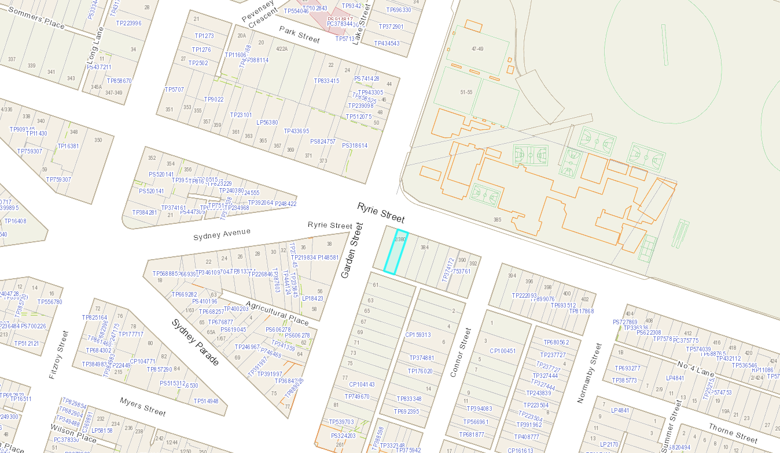
Figure 1: Map of Subject Site and Locality (Source - Weave, accessed - 18 Sep 2023)
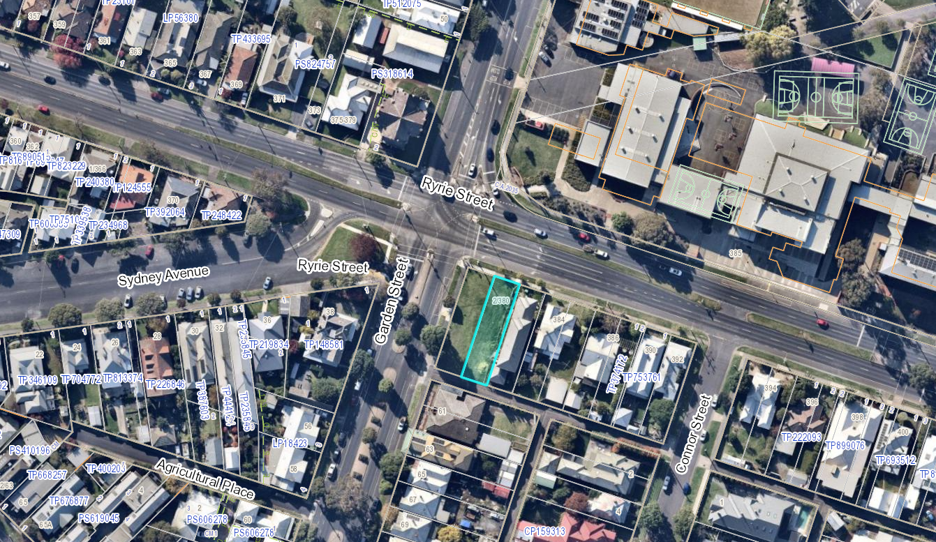
Figure 2: Nearmap Image of the Subject Site (Image Date - 14 May 2023)
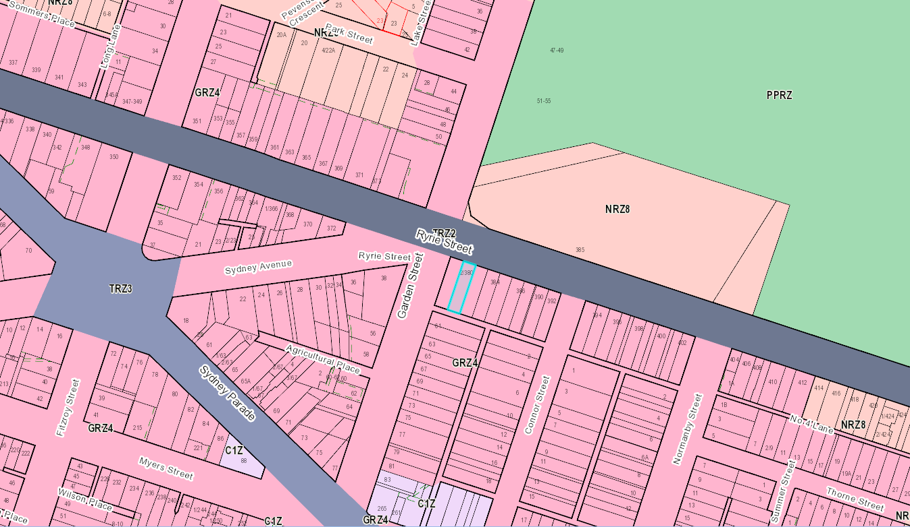
Figure 3: Map of Zones (Source - Weave, accessed - 18 Sep 2023)
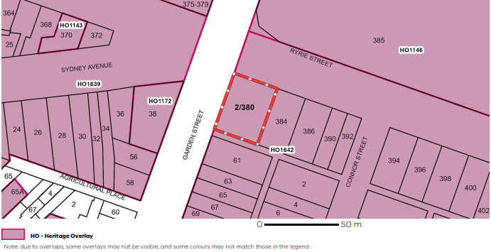
Figure 4: Map of Heritage Overlays (Source - VicPlan, accessed - 18 Sep 2023)
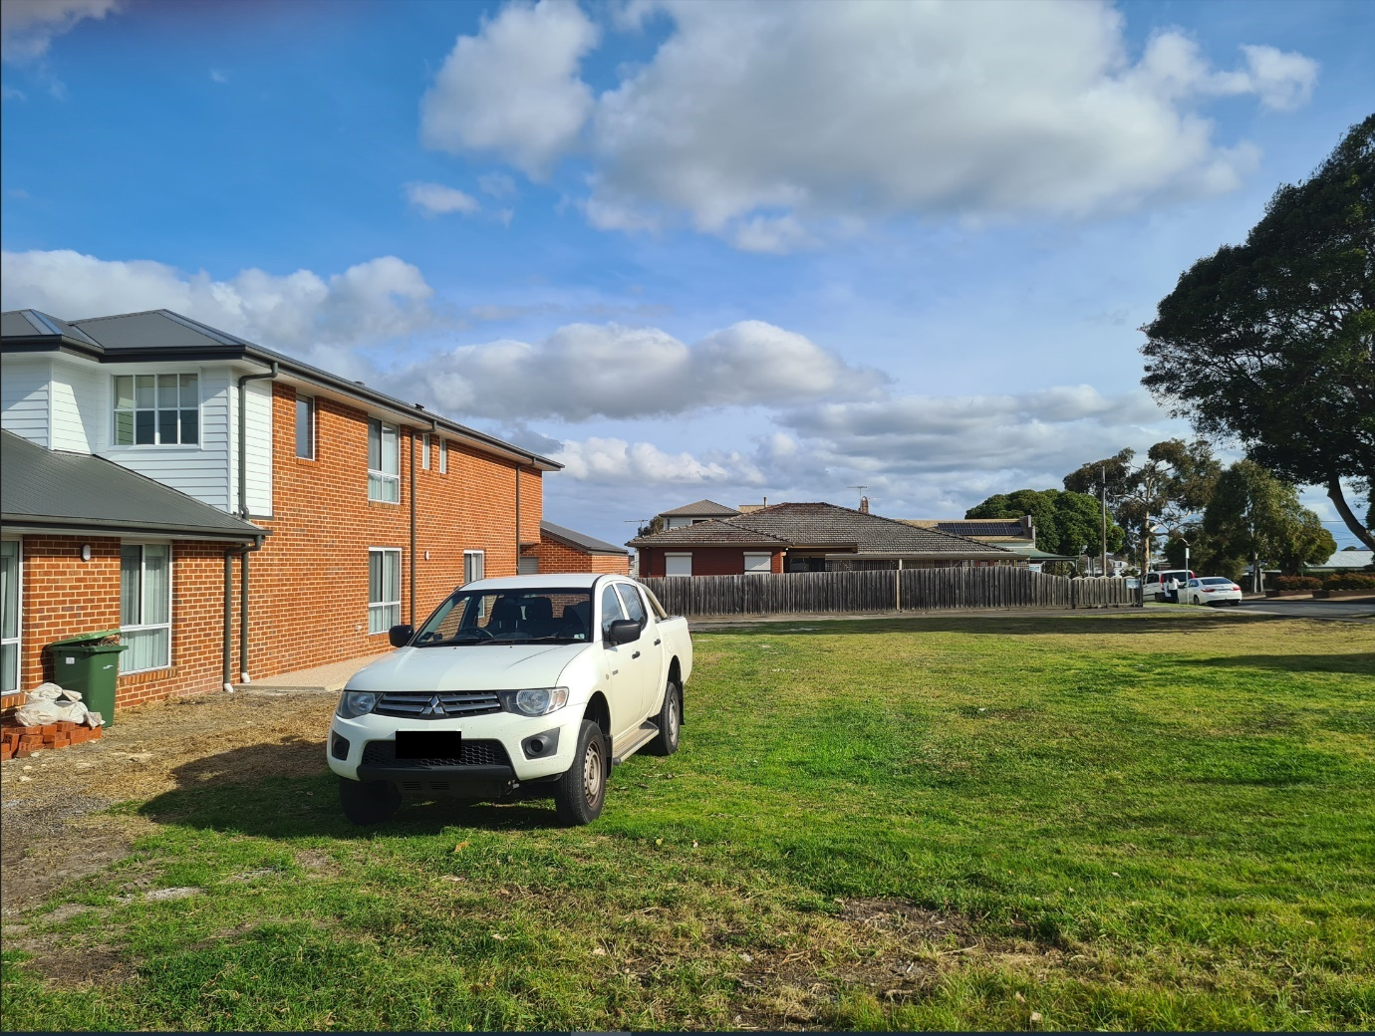
Figure 5: Photo of Subject Site (Officer Image, Image Date - 11 Sep 2023)

The subject site is located within the Early Twentieth Century Residential Heritage Area. The Statement of Significance details the following:

This Heritage Area is a well-preserved example of early twentieth century residential, suburban development dating from the 1890s to the 1930s. It is dominated by Californian Bungalow and Edwardian timber villas which provide typical examples of these styles and the transition phase between the two. The area contains a high proportion of substantially intact original buildings and is significant for the cohesion and integrity of the streetscape. Houses are typically modestly proportioned, detached, single-storey and timber with decorative timber fretwork and gable infill. The street widths and allotment size vary considerably but generally include garden settings, nature strips, street planting and footpaths.

Opposite the subject site on Garden Street is a heritage dwelling of Regional Significance at 38 Sydney Parade (“Clifton”).

The surrounding locality consists of mostly single storey and some double storey detached dwellings. Most dwellings in the locality are established and have been in the area for a significant period of time with the exception of 3/380 Ryrie Street which was recently constructed as part of approved planning permit PP-692-2021. To the north of the subject site is Geelong High School and the City’s Botanical Gardens. The subject site is located approximately 500m from the eastern boundary of the Geelong CBD. Ryrie Street is a Transport 2 Zone, a major arterial road.
PROPOSAL:

The application seeks a permit for the construction of a double storey building which is to be used for the purpose of a Rooming House. The building is to consist of eight (8) bedrooms, a common kitchen area and a balcony or courtyard and ensuite for each bedroom. Five (5) carparking spaces are proposed to the rear of the lot. The ground floor component accounts for approximately half of the building footprint with the first floor overhanging the car park and supported by structural columns.

The proposed building is to be setback 6.39m from the northern title boundary on Ryrie Street and the first floor is proposed to be setback 12.76m. The proposed rear boundary setback is 0.62m, the eastern boundary setback of 1.478m and a 10.27m wall on the western boundary. The proposed buildings maximum overall height is 6.49m.

The proposed building is to be constructed with a combination of horizontal weatherboard and vertical axon cladding with a pitched Colorbond Roof at 22.5 degrees. The front façade includes windows presenting to the street at ground and first floor, with the entry on the west side. The upper storey balconies are to be screened with a 1.7m high timber screen. A 1.2m high, square capped, timber picket front fence is proposed.
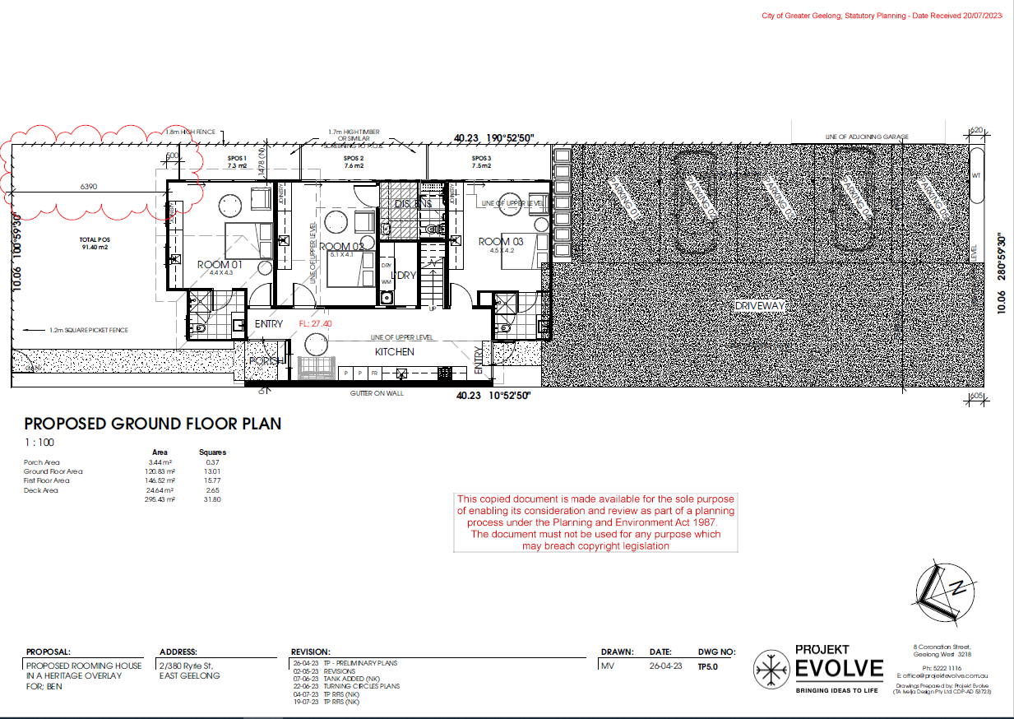
Figure 6: Proposed Ground Floor Plan (received - 20 Jul 2023)
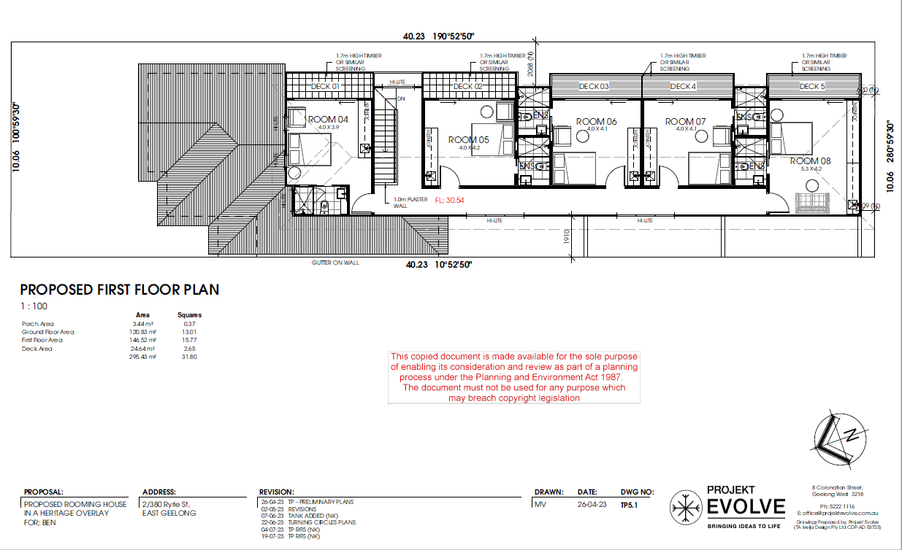
Figure7: Proposed First Floor Plan (received - 20 Jul 2023)
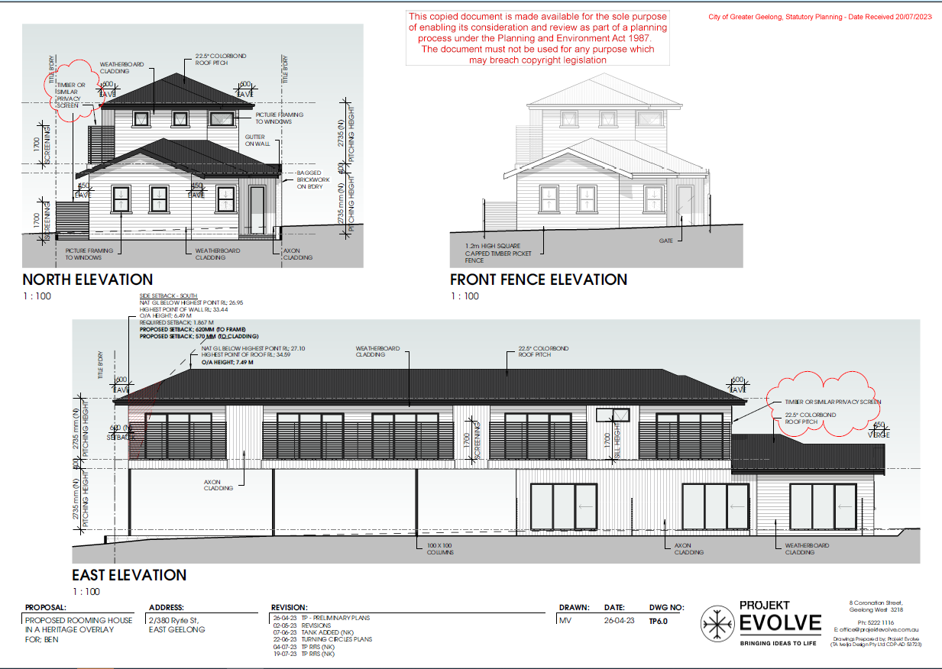
Figure 8: Proposed Plan of Elevations Page 1 (received - 20 Jul 2023)
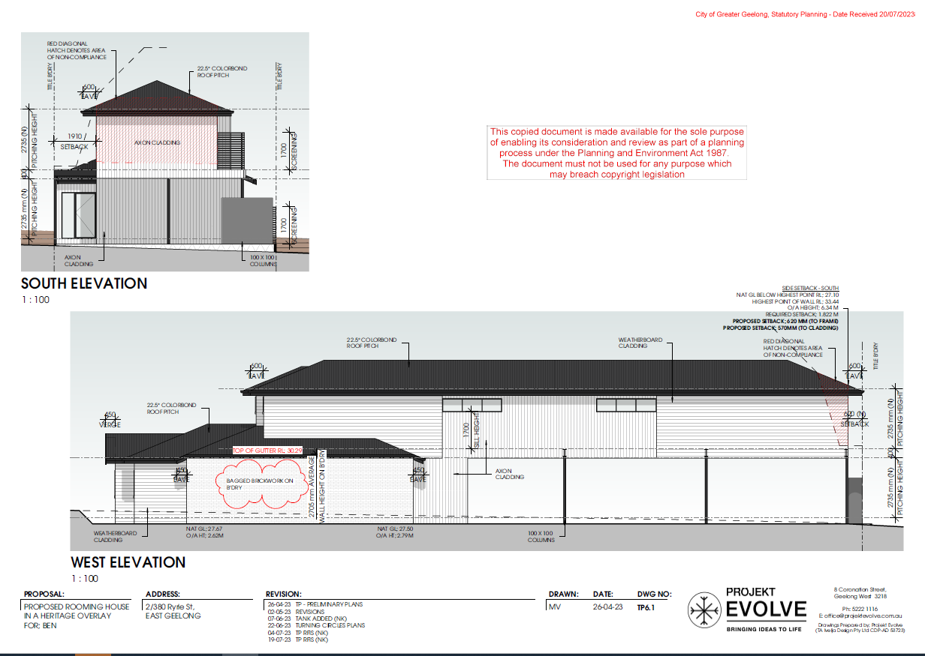
Figure 9: Proposed Plan of Elevations Page 2 (received - 20 Jul 2023)

PERMIT/SITE HISTORY:

The following permits/site history is applicable to this application:
- PP-692-2021: Construction of a Dwelling and Garage. It is still capable of being acted upon.

REFERRALS:

The following referrals were undertaken:
INTERNAL

Department: | Engineering Services – Final Response
Response: | Engineering Services Recommendation Response  Engineering is supportive of the application with following conditions.  Traffic Comments (Supportive)  The design of the parking satisfies the requirements of 52.06 as the parking bays are 3.2m wide and the aisle width provided (5.1m) exceeds the required 4.8m requirement.  Standard Conditions  Drainage & Vehicular Access:  Prior to the occupation of the dwellings, the developer must:  - Construct the site stormwater system from the lot into the kerb & channel in Ryrie Street or other nominated point/s as approved by the Responsible Authority. The stormwater connection must be in accordance with City of Greater Geelong Standard Drawings.  - Construct vehicular crossings in accordance with the requirements and standards of the City of Greater Geelong.  - Any proposed vehicular crossing shall have satisfactory clearance to any existing crossover, side-entry pit, power, lighting or telecommunication pole, manhole cover or marker, fire hydrant or street tree. Any relocation, alteration or replacement required shall be in accordance with the requirements of the relevant Authority and shall be at the applicant’s expense  - Remove any redundant vehicular crossings with kerb and channel and the footpath/nature strip area reinstated to match existing construction in the street;  all to the satisfaction of the Responsible Authority.  Note:  1. Construction of the site stormwater connection/s is to be inspected by Council Representative prior to any backfilling. An appropriate fee equivalent to 3.25% of total cost of civil works, excluding GST (a minimum fee of $100 applies if the 3.25% amount is less than $100), is to be paid to Council for inspection. Relevant evidential documentation of the cost is to be provided.  2. All internal property drainage must be designed and constructed to satisfy AS/NZS 3500.  3. A Vehicle Crossing Permit must be obtained prior to commencement of works.  Car Parking  Prior to the occupation of the dwellings, the developer must construct the car park including accessways, surface with an all-weather sealed coat and linemark the car and accessways in accordance with the endorsed plans to the satisfaction of the Responsible Authority.  Stormwater Management  The site stormwater system must be designed and installed such that;  - The site stormwater discharge is not increased by the proposed development. An appropriate on site detention system designed in accordance with the Infrastructure Design Manual may be required;  to the Satisfaction of the Responsible Authority  Pump System  Unless otherwise approved by the Responsible Authority and prior to the Commencement of the Development / Issuing of Statement of Compliance, the land owner must enter an agreement with the Responsible Authority pursuant to Section 173 of the Planning and Environment Act 1987. All costs associated with setting up the agreement must be borne by the land owner. The agreement is to be registered on title and run with the land, and is to provide to the satisfaction of the Responsible Authority:  - All storm water runoff is to be collected on site and discharged to the legal point of discharge using a pump system or as otherwise nominated by the responsible authority. The pump system is to be designed and constructed in accordance with Australian Standard 3500 Part 3.2 Section 9  - In the event of any operational difficulties with the pump system, it is the Responsibility of the land owner to rectify these difficulties;  - Any pump system is to be replaced by gravity discharge if and when available, and if directed by the Responsible Authority, at the land owner’s full cost.  - Provision is made (if appropriate) in any subdivision for Body Corporate drainage works, and access to those drainage works to be on common property or within an easement in favour of the Body Corporate  Note: Where the legal point of discharge is kerb and channel, discharge velocity at the kerb must be no greater than 1.5 m/s with a maximum discharge flow rate of 10 l/s and the outlet directed at an angle of 45º to the direction of flow in the kerb and channel.
Officer Comment:
Generally, the suggested conditions have been included in the permit. Engineering Service’s first referral response required for the provision of vehicle swept paths. Following the applicant supplying this information, Engineering were supportive of the application.

Department: | Heritage Advisor
Response: | I have reviewed the submitted drawings and planning report date-stamped 8 May 2023 in relation to the proposed two storey rooming house building at 2/380 Ryrie Street, East Geelong. The site is currently vacant and included in the Early Twentieth Century Residential Heritage Area HO1642. I provide the following responses to my pre-application advice:  - Site Significance and Context: the subject site was previously part of a larger property that included a significant Edwardian dwelling (it was situated on three Titles) that formed the western bookend to an intact streetscape of single storey, hipped and gabled, timber weatherboard, Late Victorian, Federation and interwar Bungalow dwellings. There have only been a few introduced dwellings on this southern side of Ryrie Street, east of Garden Street. These dwellings largely feature front and/or return verandahs and address Ryrie Street. A vacant site, it is included within the Early Twentieth Century Residential Heritage Area HO1642. The context of this part of Ryrie Street relates to the statement of significance for the Early Twentieth Century residential Heritage Area (at least architecturally) which reads in part:  “This Heritage Area is a well-preserved example of early twentieth century residential, suburban development dating from the 1890s to the 1930s. It is dominated by Californian Bungalow and Edwardian timber villas which provide typical examples of these styles and the transition phase between the two. The area contains a high proportion of substantially intact original buildings and is significant for the cohesion and integrity of the streetscape. Houses are typically modestly proportioned, detached, single-storey and timber with decorative timber fretwork and gable infill. The street widths and allotment size vary considerably but generally include garden settings, nature strips, street planting and footpaths.”  Response:  As above.  - Proposed Two Storey Rooming House: a two storey rooming housing of cuboid form and sheer wall planes, highly recessive entry and narrow first floor decks on the east side is proposed for the site. A 4000 mm front setback is proposed. It is unclear whether this front setback matches the neighbouring dwellings to the east, which was advised. Although only floor plans were provided, at issue is the independent scale, height and appearance of a two storey cuboid form in this heritage context. As advised for the recently constructed two storey dwelling to the immediate east of the site, it was suggested that the following form part of a redesign:  - Front setback to match existing of the immediately neighbouring dwelling to the east.  Response:  The drawings show that the proposed front setback will match that at 3/380 Ryrie Street to accord with the Heritage Design Guidelines. This has been achieved.  - The two storey component is setback in line with the front of the two storey component of the immediately neighbouring dwelling to the east given that this location is in line with the roof ridgeline of the neighbouring, significant, Federation era dwelling, and therefore accords with the Heritage and Design Guidelines.  Response:  The submitted drawings show that the front portion of the first floor component will be forward of the first floor component at 3/380 Ryrie Street. As previously advised, it is suggested that the proposed first floor component be in line with the first floor component of the neighbouring dwelling at 3/380 Ryrie Street.  - The roof forms accord with the character and appearance of the heritage area: i.e.., hipped and/or gabled, and articulated like the roof forms of the dwellings in this part of the dwelling (i.e. more than one roof form). It was outlined that there may be opportunities for a modest attic gabled roof form within a single storey hipped roof at the front, if this is not visually prominent or larger and taller than the single storey significant dwellings to the east.  Response:  The proposed building has been articulated with hipped and gabled roof form forms to accord with some of the characteristics of this part of the heritage area as per the Heritage Design Guidelines.  - A front or return post-supported verandah is constructed to accord with the character of this part of the heritage area and provided a focus for the side access to the building.  Response:  No verandah is shown but a recessive porch only.  - Any ground floor brick wall construction is rendered where visible from Ryrie Street. The use of corrugated non-highly reflective roof cladding and horizontal Linea wall cladding accords with the character of the street and the Heritage Design Guidelines for the area. Front windows to be proportioned in a similar manner as those of the significant neighbouring dwellings in the heritage area.  Response:  Apart from the face brick wall construction for the single storey component in the north-west corner (face brick boundary wall and end portion of wall to face Ryrie Street), the proposed materials accord with the Heritage Design Guidelines. The endorsed plans for the neighbouring dwelling at 3/380 Ryrie Street shows the front façade and return side walls (one metre in depth) to be rendered, the upper floors having weatherboard cladding for the front and sides to a similar depth. You may wish to carry out a site visit to determine the extent face brickwork for the side (and particularly first floor walls) of this neighbouring development to confirm whether (or not) the face brick wall for the front portion of proposed rooming house building should be bagged or rendered as per the Heritage Design Guidelines (as previously advised). Certainly the face brick boundary wall (west boundary) will have notable public exposure, at least until the adjoining site at 1/380 Ryrie Street is developed. The previous advice for rendering the front ground floor portions of proposed building was because of its close proximity to the lightweight timber Federation dwelling of contributory significance at 384 Ryrie Street. It is recognised that the proposed face brickwork at 2/380 Ryrie Street has more distant from this dwelling, will be minimal overall and has some visual connections to other significant face brick buildings (including the former church to the north-west and the two storey mansion house to the west). This may provide a sufficient basis for supporting the face brickwork. In the absence of any photographs, I am unable to advise further.  - Front Fence and Gate: A front visually permeable fence and gate (such as a capped timber picket fence and gate) were advised, the height according with the Heritage and Design Guidelines, and the front fence heights that prevail in this part of the street.  Response:  A visually permeable, 1300 mm high, pointed picket fence and gate with expressed posts (higher than the bays) are proposed. No details have been construction on the proposed construction of the fence and ideally the pointed tops to the pickets could be more streamlined to reflect the streamlined lines of the proposed dwelling (such as a capped timber picket fence). Otherwise, the proposed height, visual permeability and vertical alignment should complement this part of the Ryrie Street streetscape.  Other Matters  First floor screening is proposed to the decks on the east side, and similar horizontally aligned screening at the ground floor. No details have been given on the proposed construction of the screens. At issue are the following:  - The proposed first floor screening will be visible from Ryrie Street because it will be forward of the north-west corner of the neighbouring first floor component at 3/380 Ryrie Street and atypical to the prevailing character of the street. Part of this exposure may be mitigated if the front first floor component of the development is recessed in line with the front first floor component of the dwelling at 3/380 Ryrie Street and then the screening being setback so that it is not in line with the front (north) wall of the building proper.  - The proposed ground floor screening is to be in line with the front ground floor wall. Ideally, a setback from the front of the wall could be considered.  Recommendations  The proposed rooming house building will introduce a noticeable development to this part of the Early Twentieth Century Residential Heritage Area. However, generally, the development will be similar to that approved at 3.380 Ryrie Street which largely accorded with the Heritage Design Guidelines (as per the endorsed plans). Given this, it is recommended that this application is supported subject to:  - The front setback of the first floor component be in line with the first floor component of the neighbouring dwelling at 3/380 Ryrie Street.  - Ideally, the face brickwork to the ground floor component at the front being bagged or rendered. Visual connections with other face brick buildings nearby might be sufficient basis for the proposed face brickwork and given its physical distance from the significant timber dwelling at 3/380 Ryrie Street. You may wish to confirm with a site visit.  - The construction of the proposed front fence and gate are clarified. Ideally the pointed tops to the pickets could be more streamlined to reflect the streamlined lines of the proposed dwelling (such as a capped timber picket fence).  The proposed ground floor and first floor screens are set back from the front wall planes and the construction documented.
Officer Comment:
The recommendations were forwarded to the applicant to address at the Further Information period of the application. The following changes were made:
- The first floor setback of the proposed building was increased by approximately 1 metre to bring it in line with the neighbouring dwelling at 3/380 Ryrie Street.
- The face brickwork wall on boundary to be bagged.
- The front fence modified to a capped timber picket fence.
It is considered appropriate to place a condition on permit (should it be granted) which sets back the timber screening on the upper level from the first floor wall plane. A setback of 500mm has been chosen in order to make it consistent with the setback provided on the ground floor.

Department: | Waste Services
Response: | Requested further information including a waste management plan.
Officer Comment:
It was ultimately determined by the assessing officer to proceed with the assessment of the application without requiring a waste management plan. The planning permission required for the application is solely buildings and works in a Heritage Overlay. As the rooming house meets the requirements of the particular provision (Clause 52.23), it is not considered appropriate to consider waste management.

Department: | Environmentally Sustainable Development
Response: | Summary  Council’s ESD Officer has reviewed the below documents in accordance with Council's ESD Local Planning Policy (15.01), this development has not reached an acceptable level of ESD for a permit to be issued.  However, permit can be issued with permit conditions. The summary of the conditions or concerns are as below:  - Solar PV capacity system must be stated and designed in the development plan.  - All external lighting will be controlled by motion detectors. A note will need to be added to the plans.  - The Applicant needs to clearly annotate in the Development Plans with a note to say what will be the maximum illumination power density for this development.  - It needs to be clearly stated on the Development Plans that double glazing will be used for all external windows. This note should be littered throughout the floor plans and elevations and should also appear on the Materials Schedule.  - The Bicycle parking will need to be designed and annotated on the plan. The plan must show that bicycle parking’s are secure and undercover.  - Revised STORM report will need to be submitted including all the driveway and impervious areas of the development.  - An updated catchment plan clearly marked and dimensioned based on the proposed treatment measures in the development plan.  Documents reviewed:  - Development plans by Projekt Evolve, dated 4/7/2023 received on 11/7/2023  - SDA report by Passivenergy, dated on 11/07/2023 received on 11/7/2023  - Draft BESS report (project identifier: (48CCA369 Version-BESS-7), received on 11/7/2023  There are 7 items in total and all of them need be responded to. The ESD Resolutions Table should be completed and sent. The ESD report may need to be amended to reflect any changes in the BESS modelling and both a revised ESD and BESS report, as well as plans (with additional ESD notes).  Environment (ESD) Response  - Solar PV: This application is being committed 4.5kw solar PV as specified in BESS and SDA report. The solar PV should be noted and designed in the plan.  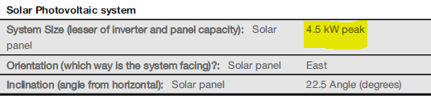  Excerpt from the submitted BESS report  - The Energy 3.3 External Lighting: The Applicant has claimed credits in BESS for Energy 3.3 External Lighting, meaning that all external lighting will be controlled by motion detectors. A note will need to be added to the plans which adequately captures this commitment.  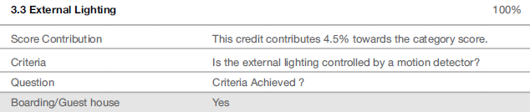  Excerpt from the submitted BESS report  - The Energy 3.7 Internal Lighting –Non-Residential credit has been claimed in BESS. The Applicant needs to clearly annotate on the plans with a note to say that the maximum illumination power density.  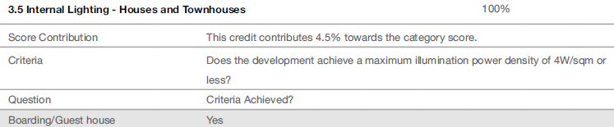  Excerpt from the submitted BESS report  - Credits have been claimed in BESS for IEQ 3.1 – Thermal Comfort – Double Glazing, but there is no mention of double glazing on the Development Plans. It needs to be clearly stated on the Development Plans that double glazing will be used for all external windows. This note should be littered throughout the floor plans and elevations and should also appear on the Materials Schedule.  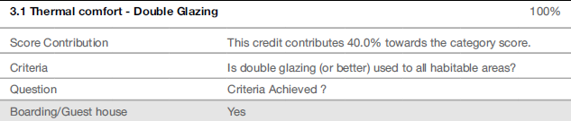  Excerpt from the submitted BESS report  - Transport 1.4 Bicycle parking – Non-Residential: Credits have been claimed in BESS for transport 1.4 Bicycle parking -Non-Residential credit. It needs to be clearly noted and design on the plans otherwise Transport 1.4 Bicycle parking – Non-Residential credit should not be claimed.  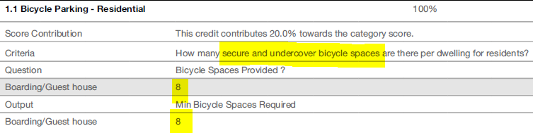  Excerpt from the submitted BESS report  - STORM report: Whether the submitted STORM calculation is appropriate or not, it appears that all the driveway and other impervious is not included in this STORM report. Evidence must be needed why all the other driveway and other impervious area was not included in these calculations. Catchment diagram should be included all the driveway and other impervious areas.  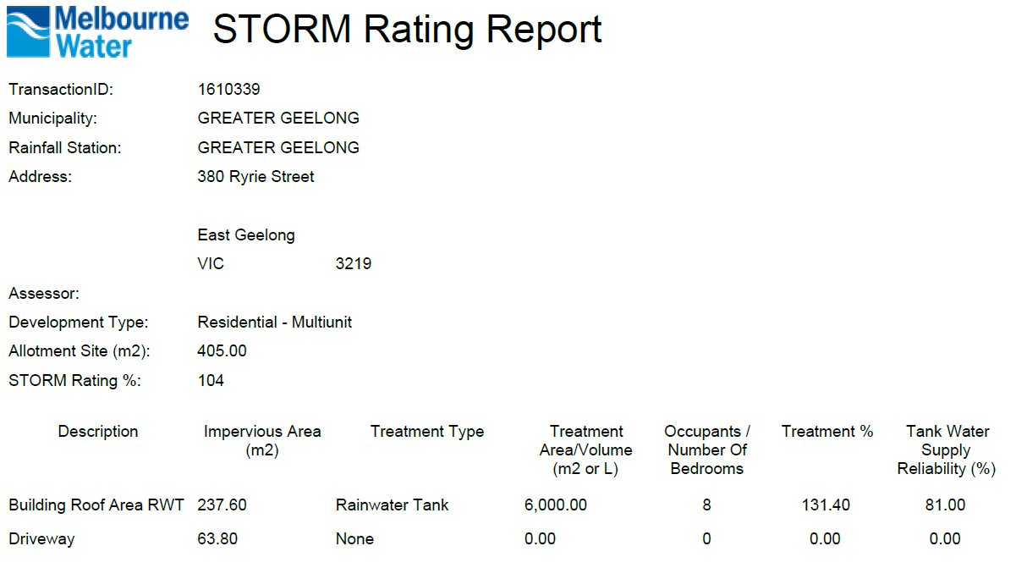  Excerpt from the submitted STORM report  The applicant needs to be provided revised STORM report including appropriate treatment measures with all the driveway and other impervious areas.  - Catchment plan: A complete response to the stormwater management requirements involves the preparation and submission of a site layout plan showing the different catchment areas size and the proposed stormwater treatment measures consistent with the STORM report, plans and the BESS report.  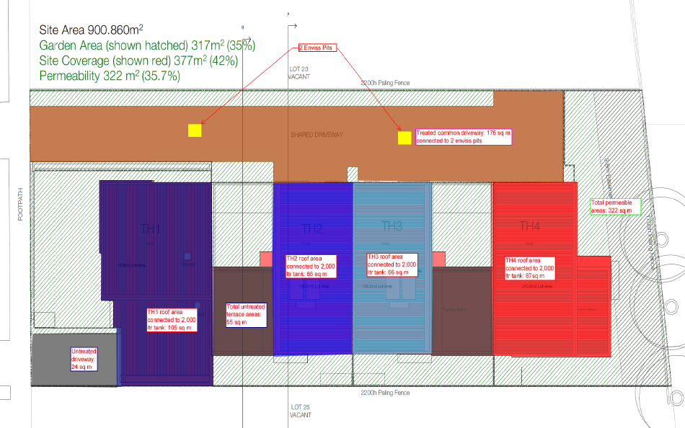  The underlying must be a roof plan that indicates slopes of different roofs to predict the potential path of rainwater from source to treatment destination. The catchment plan must include all the site and all the impervious areas including the paved areas in the private open space.  A catchment diagram will need to be added to the plans (e.g. above). Typically, catchment diagrams are colour coded – red shading showing the roofs draining to rainwater tanks, blue shading showing parts of the driveway draining to a raingarden, green areas showing vegetation and permeable/porous paving etc.  Recommended Permit Conditions (Without Prejudice)  - Before the use and development commences, amended plans to the satisfaction of the Responsible Authority must be submitted to and approved by the Responsible Authority. When approved, the plans will be endorsed and will then form part of the permit. The plans must be drawn to scale with dimensions. The plans must be generally in accordance with the plans received 11/7/2023 but modified to show:  - Initiatives contained within the ESD (SDA) report along with the proposed changes, including:  - Solar PV capacity system must be stated and designed in the development plan.  - All external lighting will be controlled by motion detectors. A note will need to be added to the plans.  - The Applicant needs to clearly annotate in the Development Plans with a note to say what will be the maximum illumination power density for this development.  - It needs to be clearly stated on the Development Plans that double glazing will be used for all external windows. This note should be littered throughout the floor plans and elevations and should also appear on the Materials Schedule.  - The Bicycle parking will need to be designed and annotated on the plan. The plan must show that bicycle parking’s are secure and undercover.  - An updated catchment plan clearly marked and dimensioned based on the proposed treatment measures in the development plan.  If a BESS report is included as part of the SMP, the BESS report must achieve an overall score of 50% or higher and have a minimum ‘pass’ rates of 50% for the Energy, Water and IEQ categories and 100% for the Stormwater category. BESS report will need to modify to show:  - All works must be undertaken in accordance with the endorsed Plan, ESD report and stormwater management plan to the satisfaction of the Responsible Authority. No alterations to these plans may occur without the written consent of the Responsible Authority. The other conditions are as below:  Revised STORM report will need to be submitted including all the driveway and impervious areas of the development.
Officer Comment:
Generally, the suggested conditions have been included in the permit.

AMENDMENT OF THE PROPOSAL PRIOR TO PUBLIC NOTIFICATION:

The applicant made a request to amend the application pursuant to Section 50 of the Planning and Environment Act 1987 on 7-Jun-2023. Council accepted the amendment.
The amendment made the following changes to the application:
- Modifications to plans to include water tank and notes regarding stormwater.

The applicant made a request to amend the application pursuant to Section 50 of the Planning and Environment Act 1987 on 23-Jun-2023 Council accepted the amendment. The amendment made the following changes to the application:
- Provided Turning Circles and Swept Paths
- Clarified Estimated Cost of Development on the Application Form.

The applicant made a request to amend the application pursuant to Section 50 of the Planning and Environment Act 1987 on 11-Jul-2023. Council accepted the amendment. The amendment made the following changes to the application:
- Addition of ESD Report
- Revision to the Façade
- Revision to the Proposed Front Fence and Gate

The applicant made a request to amend the application pursuant to Section 50 of the Planning and Environment Act 1987 on 20-Jul-2023. Council accepted the amendment. The amendment made the following changes to the application:
- Increased front setback
- Revision to ground floor and first floor screens

These are the plans that form the basis of this report.

PUBLIC NOTIFICATION:

The application is not exempt from the notice requirements of Section 52(1)(a), (b) and (d), the decision requirements of Section 64(1), (2) and (3) and the review rights of Section 82(1) of the Act and pursuant to Section 52 of the Planning and Environment Act 1987 the following forms of advertising were undertaken:
- Notices were sent to owners and occupiers of adjoining land (including opposite)
- 2X A2 signs were placed on the land
51 Objections and one (1) Letter of Support have been lodged with Council.

CONSULTATION:

A consultation meeting was not held because the applicant was not prepared to amend the proposal on the basis of the objections received.

AMENDMENT OF THE APPLICATION FOLLOWING PUBLIC NOTIFICATION

The application was not amended following public notification.

OBJECTIONS:

The concerns of objectors are summarised and commented on below:

- Objection – Not Consistent with Early 20th Century Residential Heritage Area Statement of Significance

Response
The proposed application requires assessment against the Heritage Overlay’s purpose and decision guidelines. The purpose of the Heritage Overlay seeks to ensure development does not adversely impact the significance of the heritage place. Furthermore, the application requires consideration in the decision guidelines for the significance of the heritage place and any applicable statement of significance. The application has been considered against these matters and is detailed further in the response to the Heritage Overlay in the Report.
In summary, it was considered the proposal appropriately responded to the design guidelines of the heritage area and therefore it is not expected that the proposal will adversely impact the significance of the heritage place.

- Objection – Not Consistent with City of Greater Geelong Heritage and Design Guidelines

Response
The application has been assessed against Clause 15.03-1L – Heritage Conservation which says to consider the City of Greater Geelong Heritage and Design Guidelines 1997 as relevant. A full assessment against has occurred against these guidelines in the policy response of this report. Overall, the proposed building is considered to adequately respond to City of Greater Geelong Heritage and Design Guidelines 1997.

- Objection – Double Storey Bulk in the Heritage Overlay

Response
Within the Heritage Design Guidelines for the Early 20th Century Residential Heritage Area, the following is to be considered regarding built form:
- Retain the uniformity of scale of the area including single storey height and building separation to streets of varying widths with varying subdivision patterns.

Whilst double storey, the proposed building presents as a single storey-built form to the street. The proposed first floor component is setback 12.76m from the northern title boundary and is to be in line with the existing neighbouring (3/380 Ryrie Street) first floor component. Therefore, the bulk of the built form of the first-floor component is not expected to interrupt the uniformity of single storey-built form found in the heritage area. Furthermore, the proposed setback of the ground floor is expected to match the existing neighbouring (3/380 Ryrie Street) ground floor setback.

- Objection – Visual Prominence from the Laneway and Side Boundary

Response
The Heritage Overlay or heritage policies within the Greater Geelong Planning Scheme do not specify or take into account visual prominences from the rear laneway or side boundary. The main consideration of visual prominence is with regards to the streetscape and what impact the proposed buildings and works may have on the significance of the heritage area.

- Objection – Proposed Cladding of Building

Response
Within the Heritage Design Guidelines for the Early 20th Century Residential Heritage Area, the following is to be considered regarding building materials:
- Encourage the contemporary interpretation of traditional building design within the area.
- Encourage the use of traditional construction materials in the area.
- Design buildings to incorporate the following:
  - Horizontal timber weatherboard wall cladding (an alternative to horizontal weatherboard cladding is a smooth render over masonry).

It is considered the proposed building is a contemporary interpretation of traditional building design within the area. The use of horizonal weatherboard cladding is considered to be respectful of traditional construction materials found in the heritage area. Whilst Axon vertical cladding is proposed for the side wall cladding of the rooming house, it is considered appropriate as it is unlikely to be visually prominent from the streetscape and thus not expected to impact the heritage significance of the area.

- Objection – Garden Area Requirement

Response
The subject site has an area of 405sqm and therefore a minimum garden area of 25% (101.25sqm) is required. The proposal demonstrates 102.48sqm of garden area and therefore meets the requirement of Clause 32.08-4.

- Objection – Supply of Parking and Increase in Traffic in Surrounding Area and the Rear Laneway, Pedestrian Safety

Response
A planning permit is only required under the Heritage Overlay for buildings and works. As such, impacts on traffic including the rear laneway and vehicle and pedestrian safety are not a consideration of this application’s planning assessment.
Clause 52.06 does apply to the application and the provision of car parking has been considered. Clause 52.06 requires the provision of two (2) car spaces to be located on the land. A total of five (5) car spaces are provided.

- Objection – Residential Amenity

Response
A planning permit is only required under the Heritage Overlay for buildings and works. As such, impacts on residential amenity including but not limited to noise, lights and traffic have not been considered as part of the application’s assessment.

- Objection – Siting (including Side and Rear Setbacks, Site Coverage, Overlooking and Further ResCode Matters)

Response
A planning permit is only required under the Heritage Overlay for buildings and works. A permit is not required under the General Residential Zone for the use of land, or buildings and works. Except as relevant to considerations under the Heritage Overlay, an assessment is not required under Clause 54 or Clause 55 (ResCode) for this proposal. These matters are to be considered during the building permit process (should a planning permit be granted).

- Objection – Not Consistent with the Character of the Area

Response
A planning permit is only required under the Heritage Overlay for buildings and works. A permit is not required under the General Residential Zone for the use of land or buildings and works. Except for heritage matters, the character of the area is not a matter which has been considered in the assessment of this planning application.

- Objection – Future Development of 1/380 Ryrie Street and 384 Ryrie Street

Response
Future development of neighbouring sites is not considered to be a relevant consideration.
- Objection – Higher Density Accommodation

Response
A planning permit is only required under the Heritage Overlay for buildings and works. A permit is not required under the General Residential Zone for the use of land or buildings and works. The impacts of higher density accommodation are not considered as part of this application as the proposed building meets the rooming house use exemptions at Clause 52.23.

- Objection – Objections Relating to the Use of Land for a Rooming House

Response
Pursuant to Clause 32.08, a planning permit is not required to use land for a rooming house where the requirements of Clause 52.23 are satisfied. As such, matters relating to the rooming house use have not been considered.

Objection – Number of Persons Accommodated

Response
Pursuant to Clause 32.08, a planning permit is not required to use land for a rooming house where the requirements of Clause 52.23 are satisfied. In order to meet the requirements of Clause 52.23, a condition will be placed on the permit (should it be granted) that no more than 12 persons are to be accommodated.

- Objection – Landscaping

Response
A planning permit is only required under the Heritage Overlay for buildings and works. The Heritage Overlay does not have any landscaping requirements which are required to be considered as part of this planning application.

ASSESSMENT:

ZONE:

Clause 32.08 – General Residential Zone Schedule 4
Purpose
- To implement the Municipal Planning Strategy and the Planning Policy Framework.
- To encourage development that respects the neighbourhood character of the area.
- To encourage a diversity of housing types and housing growth particularly in locations offering good access to services and transport.
- To allow educational, recreational, religious, community and a limited range of other non-residential uses to serve local community needs in appropriate locations.

Garden Area
Pursuant to Clause 32.08-4, an application to construct or extend a dwelling on a lot must provide a minimum garden area as set out in the following table:
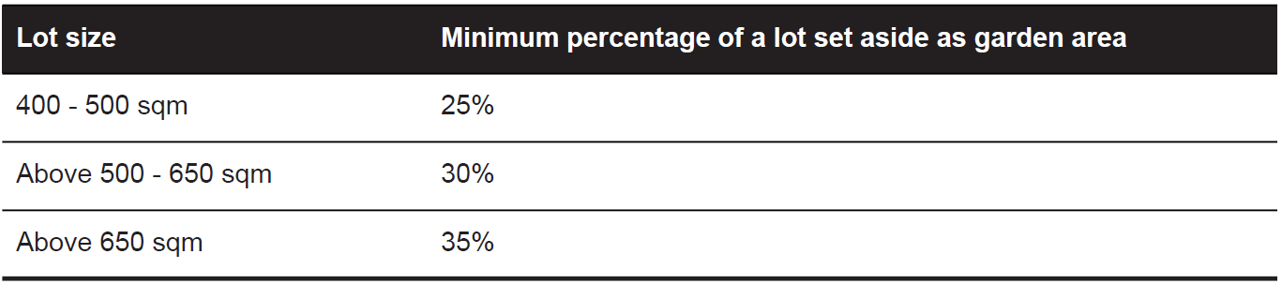
Garden Area Response
The subject site has an area of 405sqm and therefore a minimum garden area of 25% (101.25sqm) is required. The proposal demonstrates 102.48sqm of garden area and therefore meets the requirement of Clause 32.08-4.

Maximum Building Height
The maximum building height measures 6.49 metres from natural ground level to the roof or parapet at the highest point. At not more than 3 storeys and less than 11 metres, the proposal complies with the maximum building height requirements in the Zone.

OVERLAY:
Clause 43.01 – Heritage Overlay
Purpose
- To implement the Municipal Planning Strategy and the Planning Policy Framework.
- To conserve and enhance heritage places of natural or cultural significance.
- To conserve and enhance those elements which contribute to the significance of heritage places.
- To ensure that development does not adversely affect the significance of heritage places.
- To conserve specified heritage places by allowing a use that would otherwise be prohibited if this will demonstrably assist with the conservation of the significance of the heritage place.

Decision Guidelines
- The Municipal Planning Strategy and the Planning Policy Framework.
- The significance of the heritage place and whether the proposal will adversely affect the natural or cultural significance of the place.
- Any applicable statement of significance (whether or not specified in the schedule to this overlay), heritage study and any applicable conservation policy.
- Any applicable heritage design guideline specified in the schedule to this overlay.
- Whether the location, bulk, form or appearance of the proposed building will adversely affect the significance of the heritage place.
- Whether the location, bulk, form and appearance of the proposed building is in keeping with the character and appearance of adjacent buildings and the heritage place.
- Whether the demolition, removal or external alteration will adversely affect the significance of the heritage place.
- Whether the proposed works will adversely affect the significance, character or appearance of the heritage place.
- Whether the proposed subdivision will adversely affect the significance of the heritage place.
- Whether the proposed subdivision may result in development which will adversely affect the significance, character or appearance of the heritage place.
- Whether the proposed sign will adversely affect the significance, character or appearance of the heritage place.
- Whether the lopping or development will adversely affect the health, appearance or significance of the tree.
- Whether the location, style, size, colour and materials of the proposed solar energy system will adversely affect the significance, character or appearance of the heritage place.

Clause 43.02 – Design and Development Overlay Schedule 36
Purpose
- To implement the Municipal Planning Strategy and the Planning Policy Framework.
- To identify areas which are affected by specific requirements relating to the design and built form of new development.

Response to zone and overlay(s)
No planning permit is required for the application under the General Residential Zone – Schedule 4 or the Design and Development Overlay – Schedule 36. No assessment has been undertaken against the purpose and decision guidelines of the General Residential Zone or the Design and Development Overlay.
With regards to the purpose and decision guidelines of the Heritage Overlay, the proposal is considered to achieve an acceptable planning outcome. The proposed development is not considered to adversely affect the significance of the heritage place, the Early Twentieth Century Heritage Area.
The proposed infill development on the vacant lot is considered to appropriately respond to the relevant Design Guidelines of the Early Twentieth Century Heritage area by:
- Despite being double-storey, the building presents a single-storey facade to Ryrie Street, with the first floor set back 12.76m from the northern title boundary, maintaining consistency with the neighbouring property at 3/380 Ryrie Street. This design choice ensures that the first-floor component's bulk does not disrupt the uniformity of the single-storey built form prevalent in the heritage area. The ground floor setback also matches that of the neighbouring property at 3/380 Ryrie Street.
- The building offers a contemporary interpretation of traditional design within the area, incorporating vertical weatherboard cladding as a respectful nod to the heritage area's traditional construction materials.
- The built form features mostly detached structures, with a minor wall on the boundary accounting for approximately 25% of the western title boundary. It includes a hipped roof with a pitch of 20 to 30 degrees, eaves, a recessive porch, vertical rectangular windows on the front facade, and avoids the use of zincalume or reflective materials.

Additionally, the application was referred to Council’s independent Heritage Advisor who did not object to the application. Any outstanding design recommendations raised by the Heritage Advisor have been discussed in the referral response section of the report and are to be addressed by permit condition (should a permit be granted).
On balance, the proposal is considered to be appropriate with regards to the purpose and decision guidelines of the Heritage Overlay.

CULTURAL HERITAGE MANAGEMENT PLAN (CHMP):
The Aboriginal Heritage Regulations 2018 specify the circumstances in which a cultural heritage management plan is required for an activity or class of activity.
Areas of cultural heritage sensitivity are defined within Divisions 3 and 4 of the Aboriginal Heritage Regulations 2018. Division 3 does not identify the site or part of the site as within an area of cultural heritage sensitivity.
In accordance with the above assessment, a cultural heritage management plan is not required.

LANDFILL GAS RISK ASSESSMENT
The subject site is not located within 500 metres of an identified former landfill site, a risk assessment is not required.

DEVELOPMENTS IN BUSHFIRE PRONE AREAS
The site is not located within a designated bushfire prone area.

THE PLANNING POLICY FRAMEWORK (PPF):
MUNICIPAL STRATEGIC STATEMENT
The following Municipal Planning Strategies are applicable to this application:
02.03 – Strategic Direction
- 02.03-5 – Built Environment and Heritage

PLANNING POLICY FRAMEWORK
The following Planning Policy Framework is applicable to this application:
15 – Built Environment and Heritage
- 15.01 – Built Environment
- 15.01-2S – Building Design
- 15.01-2L – Environmentally Sustainable Development
- 15.03 – Heritage
- 15.03-1S – Heritage Conservation
- 15.03-1L – Heritage Conversation
16 – Housing
- 16.01 – Residential Development
- 16.01-1L-02 – Increased Housing Diversity Areas
72.04 – Incorporated Documents
- HO1642 Early Twentieth Century Residential Heritage Area
- HO1642 Heritage Design Guidelines (2022)
- HO1642 Statement of Significance (2022)

Response to Policy
The proposal has been assessed against the relevant objectives and decision guidelines of the Victorian and Local Planning Policy Framework, and it is considered to achieve an acceptable planning outcome.

The proposed building and works demonstrate respect for the Early Twentieth Century Heritage Area, aligning with the Design Guidelines. Visually, the building appears as a single-storey structure with a recessive first floor. The materials used represent a contemporary interpretation of the area's historical significance, featuring a front façade predominantly constructed from horizontal weatherboard cladding with eaves and a recessive porch, while the side walls utilize axon vertical cladding.

In compliance with the City of Greater Geelong Heritage & Design Guidelines, the proposed building employs a consistent front setback, mirroring that of the neighbouring property at 3/380 Ryrie Street, including the first-floor front setback. The significant first floor setback ensures a predominantly single-storey appearance from the streetscape. The chosen materials draw inspiration from the Early Twentieth Century Heritage Area, with the design incorporating horizontal weatherboard cladding, eaves, and a recessive porch, as outlined in the Heritage Area’s Design Guidelines.

Regarding Clause 15.01-2L – Environmentally Sustainable Design, the application was referred to the Council’s ESD Officer, who supports the application subject to conditions.

The subject site is situated within an Increased Housing Diversity Area and is considered to appropriately respond to the policy though exhibiting appropriate levels of horizontal and vertical articulation in cladding materials and eaves. The design is sympathetic to the heritage area, with the upper storey appropriately recessed, minimizing its visual dominance from the streetscape. Car parking has been located at the rear with a single access point aligning with Clause 16.01-1L-02 car parking strategies, ensuring it is not visually prominent within the proposed development.

RELEVANT PARTICULAR PROVISIONS:
The following Particular Provisions are applicable to this application:

CLAUSE 52.06 – CAR PARKING
- To ensure that car parking is provided in accordance with the State Planning Policy Framework and the Local Planning Policy Framework.
- To ensure the provision of an appropriate number of car parking spaces having regard to the demand likely to be generated, the activities on the land and the nature of the locality.
- To support sustainable transport alternatives to the motor car.
- To promotes the efficient use of car parking spaces through the consolidation of car parking facilities.
- To ensure that car parking does not adversely affect the amenity off the locality.
- To ensure that the design and location of car parking is of a high standard, creates a safe environment for users and enables easy and efficient use.

Response
Clause 52.06 requires the provision of two (2) car spaces to be located on the land. A total of five (5) car spaces are provided.
The proposed car parking layout plan is considered to appropriately comply with Clause 52.06-9. The accessway exceeds the minimum width of three metres. All vehicles are able to enter and exit in a forward direction. The car parking spaces meet the minimum dimension requirements for a 90 degree car parking space. Furthermore, the application was referred to Council’s Engineering Services who did not raise any concerns with the car parking layout or function.

CLAUSE 52.23 – ROOMING HOUSE
Pursuant to Clause 52.23-2, any requirement in the Activity Centre Zone, Capital City Zone, Commercial 1 Zone, General Residential Zone, Mixed Use Zone, Neighbourhood Residential Zone, Residential Growth Zone or Township Zone to obtain a permit to use land for a rooming house does not apply if all of the following requirements are met:
- Any condition opposite the use ‘rooming house’ in the table of uses in the zone or schedule to the zone is met.
- The total floor area of all buildings on the land, measured from the outside of external walls or the centre of party walls, does not exceed 300 square metres, excluding outbuildings.
- No more than 12 persons are accommodated.
- No more than 9 bedrooms are provided.

Pursuant to Clause 52.23-3, any requirement in the General Residential Zone, Mixed Use Zone, Neighbourhood Residential Zone, Residential Growth Zone or Township Zone to obtain a permit to construct a building or construct or carry out works for a rooming house does not apply if all of the following requirements are met:

- No more than 9 bedrooms are developed on the land.
- Bedrooms can only be accessed from within the building.
- The total floor area of all buildings on the land, measured from the outside of external walls or the centre of party walls, does not exceed 300 square metres, excluding outbuildings.
- If the development is in the General Residential Zone or Neighbourhood Residential Zone, a garden area is provided in accordance with the minimum garden area requirement specified in the zone.
- Shared entry facilities and common areas, including a kitchen and living area, are provided.

Response
The proposed building is exempt under the Rooming House particular provision for the use of the land and the buildings and works as it:
- Meets all conditions opposite the use ‘rooming house’ in the table of uses in the General Residential Zone Schedule 4. The condition opposite the land use in the table of uses is that it must meet the requirements of Clause 52.23-2.
- The total floor area of all buildings on the land, measured from the outside of external walls or the centre of party walls is calculated to be 267.35sqm.
- No more than 12 persons are to be accommodated. This requirement is to be conditioned on a planning permit should it be granted.
- The proposed building contains eight (8) bedrooms.
- Bedrooms can only be accessed from within the building.
- The minimum garden area of 25% has been demonstrated.
- Shared entry facilities and common areas have been provided.

DECISION GUIDELINES OF CLAUSE 65:
CLAUSE 65.01 – APPROVAL OF AN APPLICATION OR PLAN
Clause 65.01 of the Greater Geelong Planning Scheme outlines the decision guidelines to be considered by the Responsible Authority when making decisions on applications. These decision guidelines include:
- The matters set out in Section 60 of the Act.
- The Municipal Planning Strategy and the Planning Policy Framework.
- The purpose of the zone, overlay or other provision.
- Any matter required to be considered in the zone, overlay or other provision.
- The orderly planning of the area.
- The effect on the environment, human health and amenity of the area
- The proximity of the land to any public land.
- Factors likely to cause or contribute to land degradation, salinity or reduce water quality.
- Whether the proposed development is designed to maintain or improve the quality of stormwater within and exiting the site.
- The extent and character of native vegetation and the likelihood of its destruction.
- Whether native vegetation is to be or can be protected, planted or allowed to regenerate.
- The degree of flood, erosion or fire hazard associated with the location of the
- land and the use, development or management of the land so as to minimise any such hazard.
- The adequacy of loading and unloading facilities and any associated amenity, traffic flow and road safety impacts.

Response
The application is considered to appropriately comply with the decision guidelines outlined in Clause 65 and is considered to be an orderly planning outcome which meets the purpose of the Heritage Overlay.

CONCLUSION:

That the Responsible Authority having considered all matters which the Planning and Environment Act 1987, requires it to consider decides to issue a Notice of Decision to Grant a Planning Permit Buildings and Works in a Heritage Overlay for the Purpose of a Rooming House at 2/380 Ryrie Street, EAST GEELONG, generally in accordance with the plans and documentation submitted with the application subject to conditions.

pagCLOSE OF MEETING

As there was no further business the meeting closed at 6.50pm on 23 November 2023.

