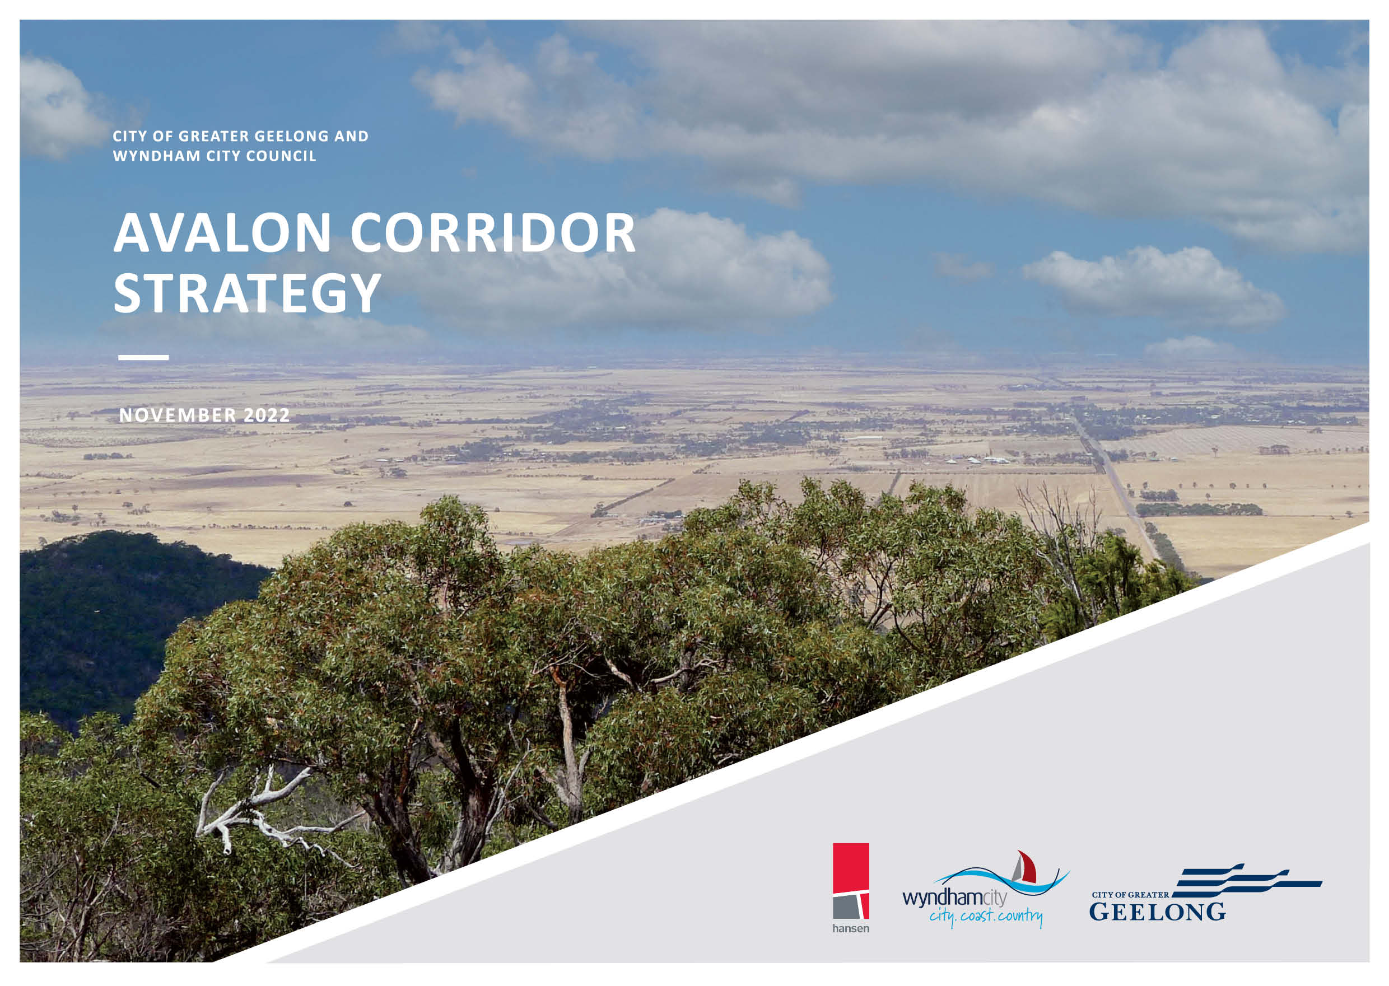
CITY OF GREATER GEELONG AND WYNDHAM CITY COUNCIL

AVALON CORRIDOR STRATEGY

NOVEMBER 2022

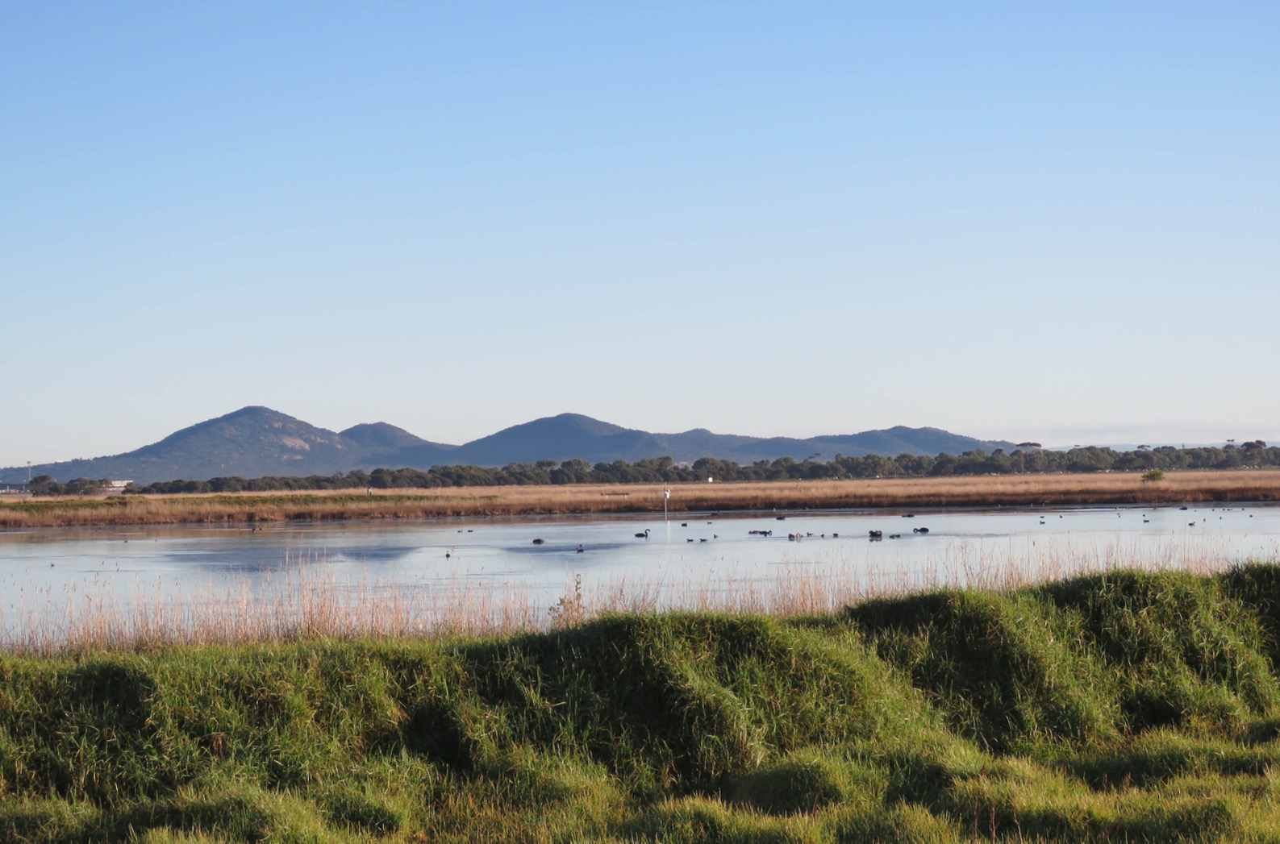

2 | CITY OF GREATER GEELONG AND WYNDHAM CITY COUNCIL Open landscapes within the Avalon Corridor with longer range views to Wurdi Youang / the You Yangs (image courtesy of D.Jones: Wadawurrung Traditional Owners Aboriginal Corporation, 2021)

ACKNOWLEDGEMENT OF COUNTRY

The City of Greater Geelong and Wyndham City Council acknowledge the Wadawurrung People as the Traditional Owners of the land, waterways and skies of the Avalon Corridor. We pay our respects to their Elders, past and present. We acknowledge all Aboriginal and Torres Strait
Islander people who are part of our Greater Geelong and Wyndham communities today.

WADAWURRUNG CULTURAL VALUES STATEMENT OF SIGNIFICANCE
Mula mula-a Anakie Youang baa Wurdi Youang ngubitj-iyu baa
maiwan parrarr Nerm baa Wadawurrung ngoon di kinkinbil bango di tonak baa benganak marlo, booyankal, tolam ngubitj baa
lakoora- bul, wul-a baa karringa-a.
In the shadows of Anakie Youang / The Anakies and Wurdi Youang / You Yangs down to the
waters and former grasslands of Nerm / Port Phillip Bay and Corio Bay, this is a special place for Wadawurrung People and their animals, plants, birds, waters and skies; a place to care for and
nurture.

Wadawurrung Traditional Owners Aboriginal Corporation

EXECUTIVE SUMMARY

The Avalon Corridor is an area of approximately 30,000 hectares of land between Geelong and Melbourne, which contains a
number of state and regionally significant assets such as Avalon Airport and the Melbourne Water Western Treatment Plant
(WTP). It encompasses the township of Little River and parts
of Lara, and accommodates a wealth of biodiversity values and landscapes of environmental and cultural importance.
The Avalon Corridor requires clear strategic guidance regarding potential land use and development change, and direction on how to foster opportunities associated with its strategic location and the
presence of significant assets and infrastructure. Within this context, the Avalon Corridor Strategy (the Strategy) has been prepared to provide a long-term strategic vision for the Avalon Corridor
to 2050 in order to guide planning decisions for individual sites and the surrounding region. The
Avalon Corridor Strategy has been jointly commissioned by the City of Greater Geelong (CoGG) and Wyndham City Council (WCC), in collaboration with the Victorian Department of Environment, Land, Water and Planning (DELWP).
The development of the Avalon Corridor Strategy has involved:
- Desktop review of existing strategic work which either broadly or specifically considers the future land use and development potential of the Avalon Corridor.
- Examination of opportunities and constraints within the Avalon Corridor with a view to define
areas capable of being developed and areas to be retained as part of a green break to separate
urban Melbourne and Geelong and to protect the area’s significant views, grasslands and wetland habitat areas and cultural heritage.
- Engagement with major stakeholders – including local and state government, Melbourne Water,
Avalon Airport, Wadawurrung Traditional Owners and other major landowners –to inform the preparation of the Strategy and to guide future development within the corridor.
- Development of a Framework Plan suitable for inclusion in the Wyndham & Greater Geelong Planning Schemes.
The key output of the Avalon Corridor Strategy is the Framework Plan (Figure 19), which outlines strategic guidance on the broader pattern of land use within the corridor and provides direction for future land use and development. The Framework Plan outlines various objectives and strategies at broad and precinct/sub-precinct level that relate to the strategic context and spatial representation of land uses across the corridor. These objectives and strategies will need to be considered when planning for future land use and development proposals.
The key guiding principles which underpin the Framework Plan include:
- Maintain and reinforce a green break between Geelong (regional Victoria) and Werribee (metropolitan Melbourne).
- Protect green wedge and rural landscapes, as well as cultural and environmental features of identified value.
- Protect ongoing and future operations of the Western Treatment Plant.
- Protect ongoing and future expanded functional operations of Avalon Airport as per Avalon Airport, Master Plan.
- Focus appropriate commercial and industrial development within and surrounding Avalon Airport, as per the Framework Plan.
- Create economic development and employment opportunities in the northern part of Geelong.
- Highlight the ongoing importance of the economic and transport connections between Werribee and Geelong.
- Protect and enhance traffic movement on major roads (current and proposed) and rail corridors.
- Avoid residential development within the Avalon Corridor.
- Protect areas of acknowledged environmental value including coastline and Ramsar wetlands and grasslands (Figure 15).
- Protect Wadawurrung cultural values and areas of known cultural heritage significance, as
well as post-contact heritage sites (in addition to undertaking further investigations as part of specific land use change and development proposals).

Although the Framework Plan sets out the broader directions for land use and development within the Avalon Corridor, it cannot anticipate all potential land use and development proposals of state or regional significance. Therefore, it needs to be flexible enough to be able to consider alternate
outcomes which have not previously been identified. It will also be necessary for further detailed work to be completed, as outlined in Section 16.

Future work to be undertaken includes (but is not limited to) the following:
  - Progressing relevant planning scheme amendments to implement the Avalon Corridor Strategy.
  - Reviewing the extent of relevant Significant Landscape Overlays (SLOs).
  - Developing Precinct Structure Plans (PSPs) for Werribee Junction and Mambourin East, as well as a Structure Plan for a Structure Plan for the proposed Greater Avalon Employment Precinct.
  - Undertaking further environmental and cultural heritage assessments prior to future land use or development changes.
  - Undertaking further assessments of movement and access within the corridor, particularly around proposed development areas.
  - Reserving land required for major infrastructure projects, such as the Bay West Port.
  - Establishing a formal township settlement boundary around Little River.
  - Working with Avalon Airport to finalise the proposed Australian Noise Exposure Forecast (ANEF) and revise the Avalon Airport Master Plan, as required.

VISION STATEMENT
The Avalon Corridor will continue to provide a green break between Geelong (regional Victoria) and Werribee (metropolitan Melbourne),
while protecting areas of recognised environmental, landscape, heritage and cultural value. It will limit residential growth while supporting the expanded operations of Avalon Airport as Victoria’s second international airport and fostering new land use, development and employment
opportunities on airport land and immediate surrounds (as appropriate).
It will protect operations of the Western Treatment Plant to ensure it can continue to provide low-cost sewage treatment, recycled water for irrigation and support broader biodiversity values in the region.

CONTENTS

ACKNOWLEDGEMENT OF COUNTRY 3
EXECUTIVE SUMMARY 4
Vision Statement 5
  - INTRODUCTION 8
  - Project Context and Aims 9
  - Methodology 10
  - Stakeholder Consultation 10
  - METROPOLITAN AND MUNICIPAL CONTEXT 12
  - Environmental Assets 14
  - Major Infrastructure Assets 14
  - Melbourne and Geelong Green Break 16
  - Access and Movement 19
  - Other Influential Assets 20
  - STRATEGIC LAND USE STUDIES AND
PLANNING POLICY 22
  - Strategic Land Use Studies 23
  - Planning Policy 33
  - Summary of Key Considerations 44
  - LAND USE ANALYSIS 46
  - Major Land Uses 47
  - Land Size and Ownership 50
  - Buffer Separation and Amenity Management 51
- AVALON AIRPORT ANALYSIS 54
- ECONOMIC ANALYSIS 58
  - Economic Overview 59
  - Land Available for Development 60
  - Relevant Economic Trends 60
  - Key Issues and Opportunities 61
  - Economic Planning Implications 61
  - TRANSPORT ANALYSIS 62
  - Princes Freeway 63
  - OMR Transport Corridor 64
  - Avalon Airport Access Upgrades 64
  - Broader Road Network 65
  - Bay West Port Freight Network 65
  - Future Freight Network 67
  - Rail Network 68
  - Aviation Infrastructure 69
  - UTILITIES SERVICING ANALYSIS 70
  - Summary of Corridor Utilities 71
  - Gas and Oil Pipelines 72
  - CULTURAL VALUES AND HERTIAGE ANALYSIS
74
  - Aboriginal Cultural Heritage 75
  - Cultural Values Assessment 76
  - Post Contact Heritage 79
  - LANDSCAPE CHARACTER ANALYSIS 82
  - Summary of Key Considerations 84
  - Landscape Recommendations 86
  - ENVIRONMENTAL ANALYSIS 89
  - Flora and Fauna Analysis 90
  - Western Grassland Reserve 92
  - Important Wetlands 92
  - Marine Environment 94
  - Climate Change, Sea Level Rise and Flooding 94
  - Bushfire Risk 97
  - Weeds and Pest Plants 97
  - Hydrology, Salinity and Acid Sulphate Soils 97
- EMERGING TRENDS AND INFLUENCES 98
- OPPORTUNITIES, CONSTRAINTS AND ISSUES
100
  - Opportunities 101
  - Constraints 102
  - Issues 103
- TOWARD A CONCEPTUAL FRAMEWORK PLAN104
  - Major Land Uses and Influences 105
  - Key Drivers and Role of the Framework Plan 105
  - Transport Synergies 106
  - Timing 106
  - Future Urban Development 108
  - Precincts - North and South 108
- FRAMEWORK PLAN 110
  - Framework Plan Objectives and Strategies 111
  - South Precinct 112
  - North Precinct 116
- IMPLEMENTATION 120
  - Framework Plan Implementation 121
  - Further Work to be Undertaken 124
- APPENDIX 1 128
  - Planning Policy Framework 129

FIGURES DIAGRAMS
ABBREVIATION

BIFT – Beveridge Interstate Freight Terminal
Figure 1: | Study area | 11
Figure 2: | Regional context | 15
Figure 3: | Green break | 18
Figure 4: | Access and movement | 21
Figure 5: | Planning controls implemented as part of the SERA pilot project | 26
Figure 6: | Status of Green Wedge Management Plans | 29
Figure 7: | Zones | 40
Figure 8: | Overlays | 43
Figure 9: | Existing land use | 49
Figure 10: | Bay West Port development transport connection concepts | 66
Figure 11: | Envisaged road and road freight interactions in Melbourne’s west | 67
Figure 12: | Cultural and post contact heritage | 81
Figure 13: | Landscape assessment summary | 85
Figure 14: | Landscape character | 88
Figure 15: | Environmental influences | 93
Figure 16: | Climate change, flooding and bushfire influences | 95
Figure 17: | Major land uses and external influences | 107
Figure 18: | Key principles | 109
Figure 19: | Framework Plan | 119

Diagram 1: | Agricultural land quality class | 29
Diagram 2: | Wyndham soil classifications | 32
Diagram 3: | ANEC for 2019 airport operations | 57
Diagram 4: | Proposed ANEC for ultimate airport operations | 57
Diagram 5: | Key features in the view | 87
Diagram 6: | Extent of landscape character area with high landscape value | 87

BPA – Bushfire Prone Area
CHMP – Cultural Heritage Management Plan
CoGG – City of Greater Geelong
DELWP – Department of Environment, Land Water and Planning
DJPR – Department of Jobs, Precincts and Regions
DoT – Department of Transport
EIIA – Extractive Industry Interest Area
EPBC Act – Environment Protection & Biodiversity Conservation
FZ – Farming Zone
FFG Act – Flora and Fauna Guarantee
GRZ – Green Wedge Zone
Hansen – Hansen Partnership Pty Ltd
NEIC – National Employment and Innovation Cluster
NIW – Nationally Important Wetland
OMR – Outer Metropolitan Ring
P&E Act – Planning & Environment PPF – Planning Policy Framework PSP – Precinct Structure Plan
RDF – Refuse Disposal Facility
RLUS – Rural Land Use Strategy
SERA – Strategic Extractive Resource Area
SLO – Significant Landscape Overlay
UGB – Urban Growth Boundary
VHI – Victorian Heritage Inventory
WCC – Wyndham City Council
WIFT – Western Interstate Freight Terminal
WTOAC – Wadawurrung Traditional Owners Aboriginal Corporation
WSUD – Water Sensitive Urban Design
WTP – Western Treatment Plant

INTRODUCTION
1.0

  - Introduction 9
  - Project Context and Aims 9
  - Methodology 10
  - Stakeholder Consultation 10

INTRODUCTION

The Avalon Corridor Strategy (the Strategy) has been prepared by Hansen Partnership, the City of Greater Geelong (CoGG) and Wyndham City Council (WCC), in collaboration with the Victorian Department of Environment, Land, Water and Planning (DELWP).
Key specialist inputs which have informed the Strategy have included:
    - Landscape Character Assessment (2021) – Hansen Partnership
    - Economic Outlook Report (2021) – Ethos Urban
    - Existing Conditions Report, Flora and Fauna (2021) – Ecology & Heritage Partners
    - Servicing Report (2021) – GHD
    - Cultural Values Assessment (2021) – Unearthed Heritage and Wadawurrung Traditional Owners Aboriginal Corporation

Additional detailed commentary, input and guidance has been provided by the community and government agencies throughout the course and development of the Strategy.

PROJECT CONTEXT AND AIMS
The Avalon Corridor constitutes the large extent of land located between Geelong and Werribee, including the township of Little River and part of the township of Lara. The Avalon Corridor covers approximately 30,000 hectares of land and is illustrated in Figure 1.
Project aims:

To prepare a Framework Plan to guide land use and development in the Avalon Corridor to 2050 and to identify:
    - Land to be protected for its environmental, cultural and landscape values.
    - Land with capacity to be developed for infrastructure and other complementary employment generating uses.
    - Issues and opportunities such as land capability and national and state infrastructure planning.
    - Measures required to maintain a green break between Melbourne and Geelong.
The key project tasks have included:
    - Desktop review of existing strategic work which either broadly or specifically considers the future land use and development potential of the Avalon Corridor.
    - Examination of opportunities and constraints within the Avalon Corridor with a view to define areas capable of being developed and areas to be retained as green break to delineate a break between Melbourne and Geelong and to protect the area’s significant views, grassland and
wetland habitat areas and cultural heritage.
    - Engagement with government and other major stakeholders including Melbourne Water, Avalon Airport, Wadawurrung Traditional Owners and other major landowner interests to inform the
preparation of the Framework Plan to guide the future development of the corridor.
    - Development of a Framework Plan suitable for inclusion in the Wyndham & Greater Geelong Planning Schemes.

AVALON CORRIDOR STRATEGY | 1.0 INTRODUCTION 9

1.1–1.3

Key matters the Avalon Corridor Strategy seeks to address include:
      - Provide direction on suitable future land uses, including areas suitable for development and those that should be protected.
      - Outline high level infrastructure commitments.
      - Address buffer or separation issues (as appropriate).
      - Define issues that need to be addressed by development proponents.

As a Land Use Framework Plan, the Strategy sits at the highest level of the Victorian planning hierarchy and guides subsequent planning processes such as Precinct Structure Plan (PSP)
development. It is intended for key aspects of the Strategy to be incorporated both into the State
and Local Planning Policy Framework, and for the Strategy itself to be designated as a background document.

METHODOLOGY
Preparation of the Avalon Corridor Strategy involved:
    - Project inception, including guided project team tour of the Avalon Corridor.
    - Desktop review of relevant policies, strategies and reports relating to the corridor.
    - Targeted engagement with a range of major stakeholders.
    - Initial community and stakeholder engagement from October to November 2016.
    - Development and preparation of draft Framework Plan and associated report.
    - Additional community and stakeholder engagement on the draft Strategy and Framework Plan from August to September 2021.
    - Finalisation of Strategy following community and stakeholder engagement.

STAKEHOLDER CONSULTATION
A wide range of government agencies and other authorities were
consulted during preparation of the Avalon Corridor Strategy, including:
    - APA
    - AusNet
    - Avalon Airport
    - Barwon Water
    - CitiPower and Powercor
    - Commonwealth Department of Defence (DoD)
    - Commonwealth Department of Climate Change, Energy, the Environment and Water (DCCEEW)
    - Department of Environment Land, Water & Planning (DELWP)
    - Department of Jobs, Precincts and Regions (DJPR)
    - Department of Transport (DoT)
    - Environmental Protection Agency (EPA)
    - Greater Western Water
    - Parks Victoria
    - Melbourne Water
    - VIVA Energy
    - Victorian Planning Authority
    - Wadawurrung Traditional Owners Aboriginal Corporation

10 | CITY OF GREATER GEELONG AND WYNDHAM CITY COUNCIL

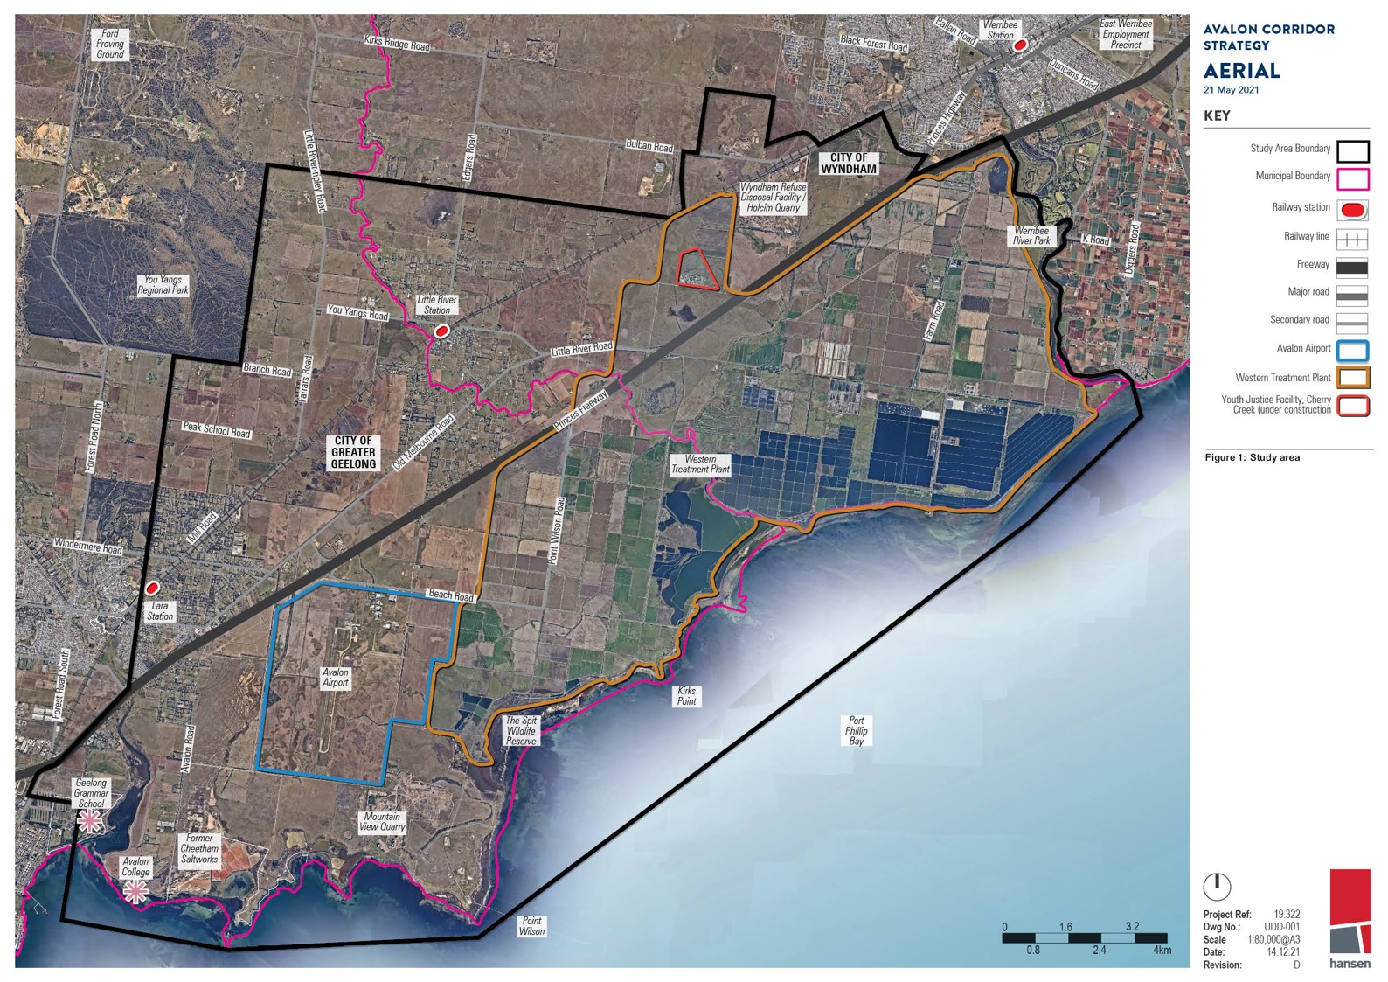
AVALON CORROR

METROPOLITAN AND MUNICIPAL CONTEXT
2.0
  - Metropolitan and Municipal Context 13
  - Environmental Assets 14
  - Major Infrastructure Assets 14
  - Melbourne and Geelong Green Break 15
  - Access and Movement 18
  - Other Influential Assets 20

METROPOLITAN AND MUNICIPAL CONTEXT

Policies within Plan Melbourne were a key driver for the development of this Strategy.
Avalon Airport is recognised in Plan Melbourne 2017-2050 as a state significant Transport Gateway, with the purpose to secure adequate gateway capacity for moving passengers and freight into and out of Victoria and support future employment and economic development opportunities at major ports, airports and interstate terminals.
Key policies:

Policy 4.5.2 Protect and enhance valued attributes of distinctive areas and landscapes seeks to recognise and protect green wedges and peri-urban areas which contain landscapes that have significant geographic and physical features.

Policy 7.2.2 Strengthen transport links on national networks for the movement
of commodities seeks to foster economic opportunities associated with the movement of goods within Victoria, interstate and internationally. This policy seeks to identify key freight corridors and interstate freight terminals.

Policy 7.2.2 specifically recognises that ‘the Avalon corridor near Geelong contains nationally
significant economic assets, including airport, road, rail and waste facilities. This corridor must be safeguarded for state infrastructure opportunities and complementary development in the future, as well as maintaining a settlement break between Melbourne and Geelong. Land use buffers for
infrastructure and Avalon Airport and areas of high biodiversity value, including Ramsar conservation areas, must be protected.’

The G21 Regional Growth Plan is a reference document to State Planning Policy Clause 11.01- 1R Geelong G21. The Plan provides a strategic land use and growth framework to manage population growth of the region to 500,000 by 2050. The Plan identifies Avalon Airport and surrounds as an ‘employment growth’ opportunity and the development of a national transport and logistics precinct which includes and connects Avalon Airport, the Port of Geelong and the Geelong Ring Road Employment Precinct to maximise efficiencies in freight movement. This includes improving road and rail access to and from existing broad and standard gauge rail networks and major roads, including the Princes Freeway and the Geelong Ring Road.
In its metropolitan and municipal context the Avalon Corridor is strategically located between the
outer edge of metropolitan Melbourne at Werribee and Victoria’s second largest city of Geelong. The Avalon Corridor spans part of WCC and CoGG, with the alignment of Little River forming the municipal boundary line.

The Avalon Corridor contains a significant range of cultural and environmental values, as well as
important infrastructure and assets. There is limited residential development within the established settlements of Lara and Little River.

The existence of important environmental and infrastructure assets gives rise to competing objectives. A particular strategic consideration is how these matters can be balanced and
appropriately addressed through relevant policy frameworks. Noting this will constitute a functional role of the Frameworks Plan, there is a need to first consider the existing context and the range
of relevant and influential considerations. This includes matters such as the long held planning
principle of maintaining a green break between Melbourne and Geelong (land maintained for farming and agriculture, environmental value, landscape setting, and some low density and rural residential
living). For clarity a green break is also referred to in some policy documents as a ‘settlement break’ or ‘non-urban break’).

The general metropolitan and municipal context of the Avalon Corridor is illustrated in Figure 2, with further details of environmental and infrastructure assets within the Avalon Corridor outlined under relevant headings.

AVALON CORRIDOR STRATEGY | 2.0 METROPOLITAN & MUNICIPAL CONTEXT 13

2.1 – 2.2

ENVIRONMENTAL ASSETS
A range of significant environmental assets are located within the Avalon Corridor, including:
- Port Phillip Bay (Western Shoreline) Ramsar site
- Conservation reserves, such as:
  - Port Phillip Bay Coastal Reserve
  - Limeburners Bay Flora and Fauna Reserve
  - The Spit Wildlife Reserve
  - Werribee River Regional Park
  - Werribee Plains South and Werribee South green wedges
  - Western Grasslands Reserve
- Significant waterbodies, such as:
  - Western Treatment Plant (WTP) sewage treatment and conservation ponds
  - Werribee-Avalon Area Nationally Important Wetlands (including the former Cheetham Saltworks site)
  - Waterways and riparian corridors (including Werribee River, Little River, Lollypop Creek, Cherry Tree Creek and Hovells Creek)
  - Swamplands (Ryans Swamp Wetland, Paul and Belfrages Swamp, Edgars Road Swamp and Cherry Swamp)

The above environmental assets are notable for providing for significant wildlife habitat for a number of endangered and critically endangered species and communities, such as the Orange-bellied Parrot and Natural Temperate Grasslands of the Victorian Volcanic Plains.

MAJOR INFRASTRUCTURE ASSETS
The regional and metropolitan significance of the Avalon Corridor is reinforced by the number of state and nationally significant infrastructure assets it contains. Major infrastructure assets identified below are further expanded upon in subsequent sections of this Strategy.
Major infrastructure assets within the Avalon Corridor Strategy include:
- Avalon Airport, as Victoria’s second international airport
- Princes Freeway, as the main road transport corridor between Melbourne and Geelong
- Geelong-Melbourne rail line, including the possible Avalon Airport Rail Link
- Melbourne Water WTP
- Wyndham refuse disposal facility (RDF), which serves a metropolitan catchment
- Cherry Creek Youth Justice Facility
- Point Wilson Munitions Facility
- Oil pipelines and high pressure gas pipelines
- The Outer Metropolitan Ring (OMR) Transport Corridor, as a future transport project with alignment confirmed and protected
- Bay West Port, designated by state government as the location for Melbourne’s second container port terminal (targeted for operation from around 2055)
- Areas identified as containing or potentially containing extractive resources needed for the
construction industry, such as rock, sand and gravel. These are shown as either Work Authorities (WAs) where quarries are operating or have licence to operate, Extractive Industry Interest
Areas (EIIAs) where potential extractive resources of state significance have been identified, or Strategic Extractive Resource Areas (SERAs) where extractive resources of state significance have been confirmed.

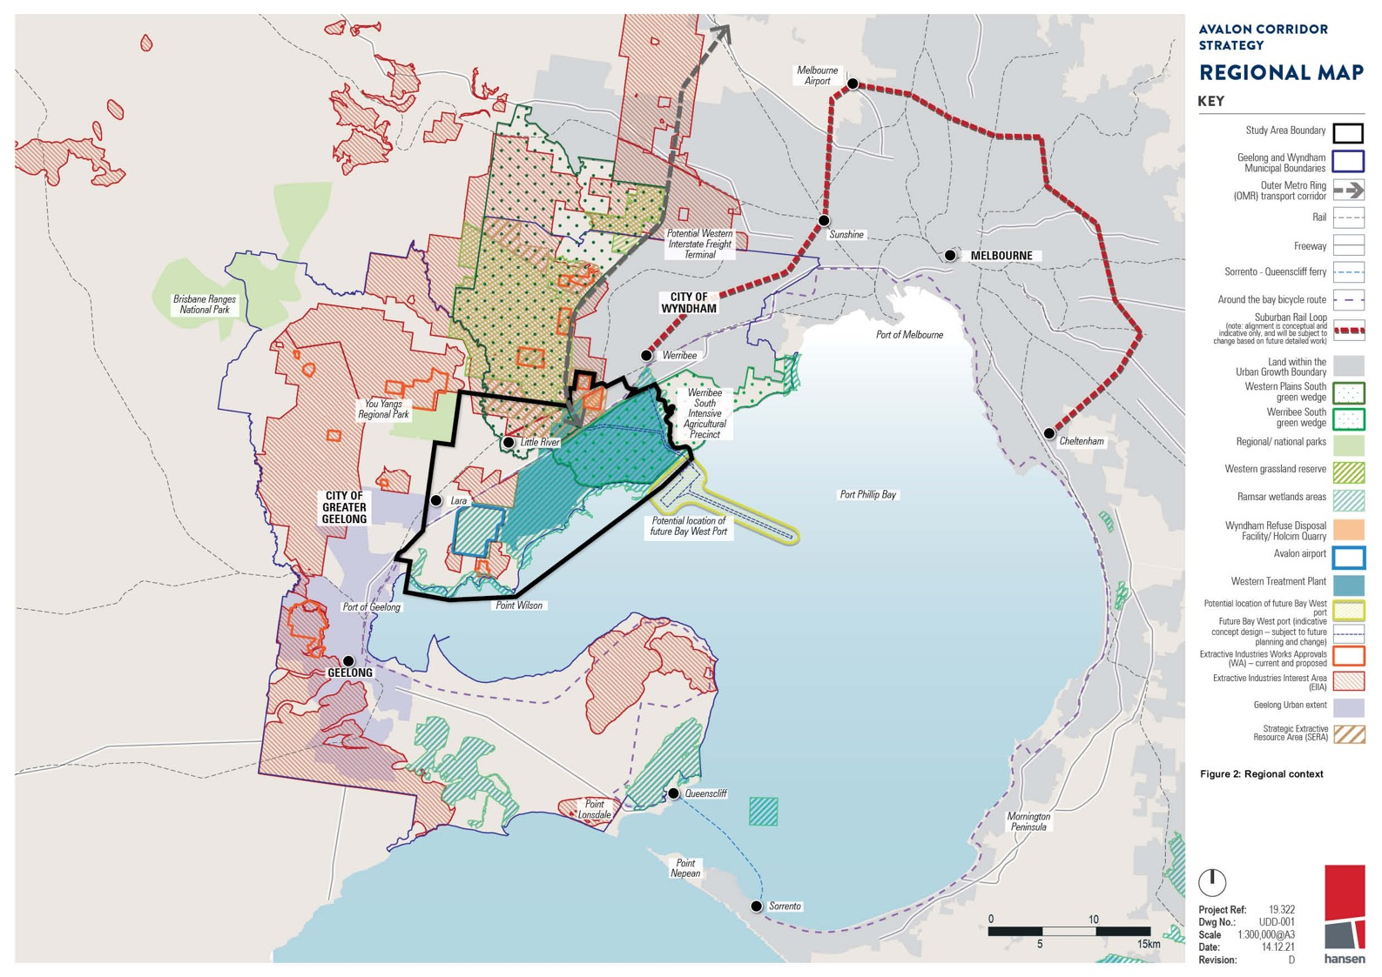

MELBOURNE AND GEELONG GREEN BREAK
The Avalon Corridor provides a physical break in urban development between Melbourne and Geelong, being Victoria’s capital city and second largest city respectively.

HISTORY OF GREEN BREAK
The concept of containing the extent of Melbourne growth has its basis in Town and Country Planning Act 1944, and has been progressively enshrined in planning policy in the following decades, culminating in the application of the current Metropolitan Melbourne Urban Growth Boundary (UGB).
Whilst there has also been a long held planning principle to maintain a green break between Melbourne and Geelong, this has rarely been explicitly stated with the metropolitan strategic documents prepared for Melbourne over recent decades.

Of interest, Planning Policies for Metropolitan Melbourne 1971 prepared by the former Metropolitan Board of Works (MMBW) adopted a corridor approach for accommodating future population growth, which resulted in the creation of green wedge areas still found within the boundary of metropolitan Melbourne, identified by the Green Wedge Zone (GWZ). This 1971 document also identified the need for a metropolitan-regional boundary and identified land south of the Princes Freeway as an important non-urban area. This included land still known as the Werribee South agricultural precinct.

Melbourne 2030 introduced the concept of the UGB in 2002 and served to formally cement this break between the outer edge of Metropolitan Melbourne at Werribee. Since then, there have been significant expansions to the UGB, including in 2010 and the subsequent logical inclusions process.

Plan Melbourne 2017-2050 outlines the importance of connection between cities and regions under Direction 7.2 Improve connections between cities and regions. This Direction explicitly states that the Avalon Corridor should be preserved for state infrastructure opportunities but also to ensure a maintenance of a settlement break between Melbourne and Geelong.

The Greater Geelong Planning Scheme (Clause 21.06-2) and Wyndham Planning Scheme (Clause 21.02-1) both identify the need to maintain a green break between Geelong and Werribee. For Greater Geelong, the G21 Strategy further contains a principle relating to ‘connected communities’, which refers to the need to provide settlement breaks between towns to maintain their unique identities.

Currently the state government is undertaking program of investigating Distinctive Areas and
Landscapes within designated peri-urban areas (through relevant legislation including Part 3AAB of the P&E Act 1987). However no part of the Avalon Corridor has to date been designated as an area
for investigation. Despite this, large areas of the study area form part of the Port Phillip Bay (Western Shoreline) and Bellarine Peninsula Ramsar Site, in addition to numerous sites of Aboriginal Cultural Heritage sensitivity and Victorian Heritage Register listings.

GREATER GEELONG SETTLEMENT STRATEGY
The principle of a settlement break between Melbourne and Geelong is reinforced by the Greater Geelong Settlement Strategy 2020, which was formally incorporated into the Greater Geelong Planning Scheme on 6 May 2021 via amendment c395. The Settlement Strategy clarifies what is defined as the green
break or non-urban break, and its location between Geelong and Melbourne (Wyndham), as per the following statement (page 78-79):

Non-urban breaks are critical to the identity of our municipality and individual townships and will also help establish long term settlement boundaries. There are some physical land constraints
and uses that, by their nature, help maintain these breaks. However, in other cases, non-urban breaks will need to be more actively managed. Non-urban areas outside the Urban Growth
Boundary in Melbourne are known as green wedges and are managed via a Green Wedge
Management Plan. This could be an option for managing the non-urban breaks outside long term boundaries in Greater Geelong.

The following areas help maintain a non-urban break between Geelong and Melbourne:
- The Ramsar wetlands (mainly associated with Melbourne Water WTP and areas along the northern shore of Corio Bay and Outer Harbour)
- Areas reserved for conservation purposes, including the You Yangs Regional Park, part of the Brisbane Ranges National Park, the Serendip Sanctuary and the Mount Rothwell Conservation and Research Centre
- Areas with landscape value, such as the Barrabool Hills and You Yangs
- Areas containing infrastructure of regional and state significance, such as WTP and Avalon Airport.

2.3

The Settlement Strategy contains further principles and directions relating to the settlement boundary. Principles and directions relevant to the green break between Geelong and Melbourne (Wyndham)
include:

Principle
Maintain the unique identity of Greater Geelong and its townships.

Directions
- Maintain the non-urban breaks between Geelong and Melbourne (Wyndham), Geelong and
the Surf Coast, urban Geelong and the Bellarine Peninsula, and the townships on the Bellarine Peninsula.

- Assess areas with special local environmental or landscape values and consider options to help preserve and manage these breaks into the future.

DELWP GREEN WEDGE STRATEGIC WORK
Melbourne’s green wedges are also vital for protecting green break land on the metropolitan
fringe, with the concepts around the need to protect these dating back to the 1860s. Protection of
Melbourne’s green wedges is included in the Planning and Environment Act 1987 as well as throughout the Victoria Planning Provisions.

Of relevance, DELWP is undertaking detailed strategic work to strengthen the green break role of
nominated GWZ areas, which includes part of the Avalon Corridor within WCC. This project is part of
the Victorian Government’s commitment to protecting Melbourne’s green wedge and peri-urban areas as outlined in Actions 17, 72 and 73 of Plan Melbourne. The project considers agricultural land within 100km from Melbourne and therefore has implications for both CoGG and WCC.

In 2020, DELWP released the Planning for Melbourne’s Green Wedges and Agricultural Land Consultation Paper for public consultation. Page 20 of the Consultation Paper notes that ‘the western study area is an important non-urban break between Melbourne and Geelong’. As such, the current
designated GWZ land and the additional strategic work being undertaken to strengthen controls for its planning and protection will function to further reinforce a green break within and beyond the Avalon Corridor.

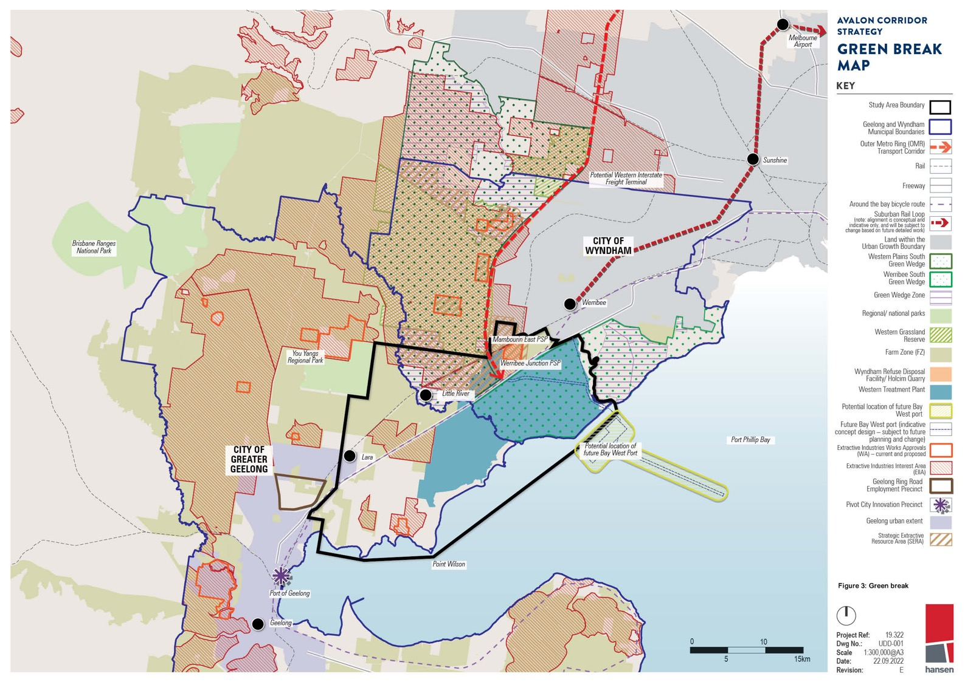
AVALON CORRIDOR STRATEGY
GREEN BREAK

MAP
KEY

----/
/
I I I I

Study Area Boundary D
Geelong and Wyndham Municipal Boundaries
Outer MetroRing (OMA) Transport Corridor
naiBl
Fr-eewayB
Around the bny bicycle route
SuburbanRail LooP,

Brisbane R{jnges
Nntinnnl Pnrk
,,,,,,,
/
I I I
\
I
,/'
(note ai nment is concl!ptual and indicali\/eonly, and will be su ·ect to chan!Jiblased on Muredetail work!
Land within the Urban Growth Boundaiy
Western Plains South
E!]

□

I Gree11 Wedye ,
I
I Werribee South
I Green Wedge
I
I
I Green Wedge Zorie E3
I
I
RegionaV national parks

'\
\
\
\
\
\
\
\
\
\
\
'
'
'
\ I I
l
\
\ \ ,-
\ 1/ ,,
Western Grassland
R!!SQIV(l
Farm Zone (FZ)

Wyridham Refuse Disposal Facility/ Holcim Quar,y
Western Treatment rlant

Pot nfoil lnr.fltinn nf fitf11r Rily
West port
Future Bay West port (indicative

\
I
I .,,/
\
<. >
.,-;.,

Port Phillip Bay
concept design - subj!!cl to future E3
D
pla1mi11y aml d1,mye)

\ Pote ial Ideation of
I future Bay West Port
I
I
\
I
\
\
\
' \

................
,_.... -z.: -,
.......:.:.::::::::.......
. ,
......:.:-.......
..........:..-............ ...
Extractive lndu3trie3 Works Approvllls (WA) - current am! proposed
ExtractiveIndustries Interest Area
IEIIA)
D
•
,
Geelong Ring Road Employmerit Precinct

Pivot City Innovation Preci11ct

Geelm1g urbanextent

StrntegicExtractive Resource Area (SEAAI

\
"1'1rj
J

Figure 3: Green break

Port of Gcclong

t(
eelong
I
'' '
'
"I
I
I
I
I

ACCESS AND MOVEMENT
The key access and movement networks within the Avalon Corridor are illustrated on Figure 4.

AVALON AIRPORT
Avalon Airport accommodates domestic and international flights, thereby playing a supporting role to functions and operations of Tullamarine Airport. Operational capacity of the airport has room for expansion, in line with the federally endorsed Avalon Airport Master Plan (2015). Expansion of airport activities will elevate Avalon Airport’s status as Melbourne’s second international airport.

PRINCES FREEWAY AND OMR TRANSPORT CORRIDOR
Princes Freeway is the major piece of road infrastructure which bisects the Avalon Corridor,
consisting of a separated carriageway with three lanes of traffic in each direction. Princes Freeway plays a significant role on the movement of freight and people between Melbourne, Geelong and the regions beyond. Ensuring quick and reliable travel times between Melbourne and Geelong on the
Princes Freeway is an important strategic priority to be maintained into the future. The functional role and operation of the Princes Freeway will be further augmented with the construction of the multi-modal OMR Transport Corridor, estimated to be built within 15-30 years.

GEELONG-MELBOURNE RAIL LINE
Like the Princes Freeway, the Geelong-Melbourne rail-line plays a significant role in the movement of people between Melbourne, Geelong and the regions beyond. The potential for a future rail link to Avalon Airport has been protected through a Public Acquisition Overlay (PAO). The existing rail-line
configuration consists of three running lines: the eastern two being broad gauge (BG) intrastate lines servicing mainly passenger trains to Geelong; and the third western line being a standard gauge (SG) single bi-directional intrastate line.

The Western Rail Plan is a major Commonwealth and Victorian Government initiative that sets out
objectives to deliver a faster, high-capacity rail network servicing growing outer suburbs and regional cities. The Plan seeks to deliver full separation of regional and metro services on the Geelong and
Ballarat lines. The Geelong Fast Rail project is a targeted aspect of the Western Rail Plan and seeks to deliver faster journeys between Geelong and Melbourne, with a travel time of around 50 minutes. Construction is anticipated to commence in 2023.
Another associated rail project is the Suburban Rail Loop (SRL), a 90 kilometre rail line that will
link every major service from the Frankston Line to the Werribee Line via Melbourne Airport. SRL West from Melbourne Airport to Werribee will build on the major road and rail projects already being delivered in the west, including Geelong Fast Rail.

INTERSTATE FREIGHT TERMINALS
The Victorian Government Freight Strategy (2018-2050) designates the Western Interstate Freight
Terminal (WIFT) and the Beveridge Interstate Freight Terminal (BIFT) as the future intermodal freight terminals for Melbourne and Victoria. At a metropolitan scale the proposed WIFT at Truganina (north of the Avalon Corridor) is a major infrastructure initiative of state importance in the longer term. The Victorian Government is currently finalising the full business case for the WIFT and BIFT, including
the preferred transport connections and staging. The business case is jointly funded by the Victorian and Commonwealth Government. The location of the WIFT is shown on Figure 2.

The Department of Transport’s fact sheet on Victoria’s new intermodal freight precincts notes that “the Victorian Government is planning to deliver new intermodal freight precincts at Truganina in Melbourne’s west and Beveridge in Melbourne’s outer north. The role of the new precincts will be primarily to handle interstate freight, but also the import and export container trade.”

Currently, interstate freight containers are railed to terminals at Dynon adjacent to the Port of
Melbourne, and then trucked to the outer suburbs and regional areas. However, the Dynon terminals have limited space and capacity, and can be difficult to access due to increasing congestion on the
inner Melbourne road and rail networks.

The intended benefits of the WIFT is to allow more efficient freight movement by providing modern terminal facilities closer to the large industrial cluster in Melbourne’s west, which in turn will reduce the time and length of truck trips. This will have the added benefit of reducing freight traffic through the inner west, potentially removing up to 2,000 truck movements daily. It is also intended for the
WIFT to include provision for connection to the Bay West Port. Other benefits of the WIFT as a long term strategic option have been highlighted to:
- Significantly improve the capacity of interstate freight transport in the north-south and east-west national corridors connecting Melbourne;
- Complement other improvements to the north-south intermodal rail supply chain with matching capacity and service level improvements;
- Enhance national productivity by lowering the door-to-door cost of freight for interstate movements;

2.4–2.5

  - Create opportunities for urban renewal in the North Dynon area;
  - Reduce truck movements through Melbourne’s inner west; and
  - Improve rail access for port-related freight by removing many non-port freight movements from the Dynon precinct.

The West Growth Corridor Plan (2020) locates the WIFT on the northern side of Boundary Road, Truganina, between Christie’s Road and the OMR Transport Corridor (well outside the Avalon Corridor study area).

Once state government determines its preferred solution, necessary steps will be taken to reserve
land and access corridors required for future interstate terminals through relevant planning scheme provisions.

With regard to timing, 0-5 years has been indicated for planning and prioritisation of further investigation, and then between 10-30 years for the anticipated completion.

OTHER INFLUENTIAL ASSETS
The Avalon Corridor is also located adjacent to a number of important environmental, open space, extractive resource and tourism related
assets, including:
- Port Phillip Bay and Corio Bay coastal environs (to the south).
- The Western Grasslands Reserve (to the north), which will become Victoria’s largest native grasslands reserve and a site of strategic importance as an offset for Melbourne’s continued urban expansion within the UGB. The reserve plays a strategic role in firming up Metropolitan
Melbourne’s UGB and supporting the protection of the green break between Wyndham and Greater Geelong. A small part of the reserve is located within the Avalon Corridor.
- The You Yangs Regional Park (to the west), which constitutes the single most significant landscape feature within the wider region. Strategic land use directions for the You Yangs Regional Park are guided by the You Yangs Precinct Master Plan (2021).
- The Werribee Open Plains Zoo and Werribee Mansion (to the east), which is a regionally important tourism node. The state government recently announced $84 million funding to make Werribee
Open Plains Zoo the most significant open range zoo in Australia, to transform it into a world class facility, including a 1.6km tree top Sky Safari gondola boasting 360-degree views.
- Strategic Extractive Resource Areas (SERAs) in WCC, which contain strategic extractive
resources (hard rock) needed for the construction industry and major state infrastructure projects.
To protect these resources, the Victorian Government introduced the State Resource Overlay (SRO) in 2021.
The Avalon Corridor is also broadly influenced by the location of the other major land uses outside of, but within close proximity, including:
- Geelong Ring Road Employment Precinct
- Port of Geelong
- Pivot City Innovation Precinct
- Northern Geelong Growth Area

Ongoing investigations into the East Werribee Employment Precinct (EWEP), located just outside of the Avalon Corridor to the east are being undertaken. EWEP is proposed to be developed as a mixed
use business precinct generating over 50,000 new jobs. It will be centred on a new lake and capitalise on the current heritage and economic base of the former Werribee Technology Precinct and emerging Health, Education and Justice Precincts. The proposed development will help to establish Werribee
as a key business, service and employment hub of Melbourne’s west.

20 | CITY OF GREATER GEELONG

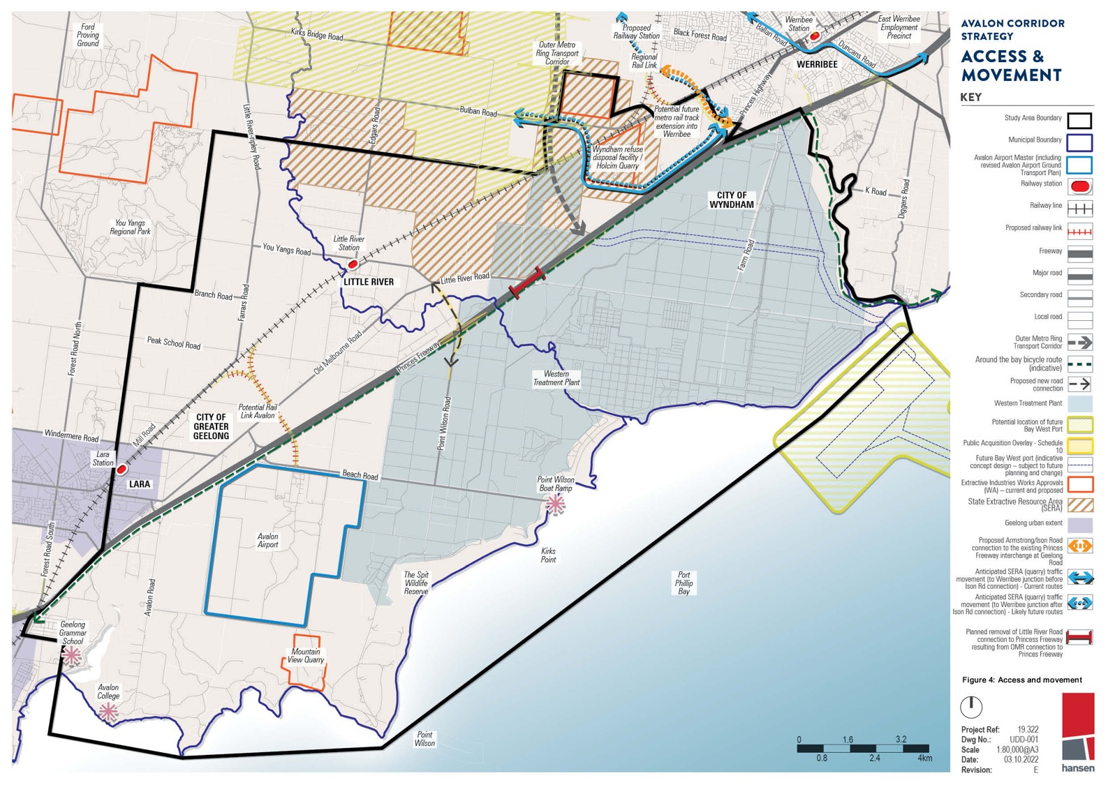
AVALON coRR\OOR STRATEGY
ACCESS &
MOVEMEt-11
KEY

Oate:

STRATEGIC LAND USE STUDIES AND PLANNING POLICY
3.0
  - Strategic Land Use Studies and Planning Policy 23
  - Strategic Land Use Studies 23
  - Planning Policy 33
  - Summary of Key Considerations 46

STRATEGIC LAND USE STUDIES AND PLANNING POLICY

A wealth of existing background documentation is available which provides relevant strategic context for the Avalon Corridor. This work is critical for understanding the evolving scope of strategic
influences within the Avalon Corridor, which have influenced the findings and recommendations relating to the Avalon Corridor
Strategy.
A desktop analysis was undertaken of key policy and strategy documents across a range of
professional expertise. An overview of key documents is provided in the following sections, along with a summary of key findings and directions.

STRATEGIC LAND USE STUDIES
A substantial number of background strategic land use related studies
have been prepared which have either direct or indirect relevance to the Avalon Corridor Strategy. These include:
- Plan Melbourne 2017-2050 (DELWP, 2017)
- Rural Land Use Strategy (CoGG, 2007)
- Outer Metropolitan Ring/E6 Transport Corridor Planning Assessment Report (VicRoads, 2009)
- Delivering Melbourne’s Newest Sustainable communities: Program Report (Victorian Government, 2009)
- Werribee-Geelong: Planning Investigation of Strategic Intent Developable Land Analysis (Department of Transport Planning and Local Infrastructure, 2014)
- G21 Regional Growth Plan and Implementation Plan Background Report (G21, 2013)
- South West Victoria Landscape Assessment Study - Regional Overview Report: 2013
- Avalon Airport Rail Link: Rail Corridor Establishment: September 2014, Department of Transport Planning & Local Infrastructure
- Native Vegetation Precinct Plan: Geelong Ring Road Employment Precinct (Amendment C423)
(Ecology Partners Pty Ltd, 2013)
- Victorian Coastal Strategy (Victorian Government, 2014)
- West Growth Corridor Plan (Growth Area Authority, 2012)
- Avalon Airport Master Plan (Avalon Airport, 2015)
- Inundation Report: Bellarine Peninsula – Corio Bay Local Coastal Hazard Assessment (Cardno, 2015)
- Extractive Resources in Victoria: Demand and Supply Study 2015-2050 (PWC, 2016)
- Werribee South Green Wedge Policy and Management Plan (Wyndham City Council, 2016)
- Victoria’s 30-Year Infrastructure Strategy (Infrastructure Victoria 2016)
- Preparing Advice on Victoria’s Future Port Capacity: Discussion Paper (Infrastructure Victoria, 2016)
- Second Container Port Advice: Evidence Base (Infrastructure Victoria, 2017)
- Port Phillip Environmental Management Plan 2017-2027 (DELWP, 2017)
- Avalon Airport Ground Transport Plan (Avalon Airport, 2017)
- Protecting Victoria’s Environment – Biodiversity 2037 (DELWP, 2017)
- City Forest and Habitat Strategy 2017-2040 (WCC, 2017)
- Healthy Waterways Strategy 2018-28 (Melbourne Water, 2018)
- Port Phillip Bay (Western Shoreline) and Bellarine Peninsula Ramsar Site Management Plan
(DELWP, 2018)
- Helping Victoria Grow – Extractive Resources Strategy (DEDJTR, 2018)
- Western Rail Plan (Victorian Government, 2018)

3.1

  - Western Plains South Green Wedge Management Plan: Background Report (WCC, 2018)
  - Melbourne Sewage Strategy (Melbourne Water, 2018)
  - Industrial Land Supply Report (CoGG, 2018)
  - Victorian Freight Plan: Delivering the Goods (DJPR, 2018)
  - Avalon Signage Audit (SMEC, 2019)
  - Greater Geelong Settlement Strategy (CoGG, 2020)
  - Strategic Extractive Resource Areas Pilot Project (DELWP, 2020)
  - Planning for Melbourne’s Green Wedges and Agricultural Land: Consultation Paper (DELWP, 2020)
  - Avalon Airport ANEC Study: Noise modelling report (GHD, 2020)
  - Victoria’s 30-Year Infrastructure Strategy (Infrastructure Victoria, 2020)
  - Lara Flood Study (Amendment C339) (CoGG, 2020)
  - Lower Barwon and Lower Moorabool Flood Investigation (DELWP, 2019)
  - Bellarine Peninsula - Corio Bay Local Coastal Hazard Assessment (DELWP, 2015)
  - Marine and Coastal Policy (DELWP, 2020)
  - Wyndham Coastal & Marine Management Plan 2020-2025 (WCC, 2020)
  - Independent review of the Victoria Ports System (Victorian Government, 2021)
  - Draft Western Metro Land Use Framework Plan, 2021 (DELWP, 2021)

The context and influence of these documents have been analysed along with a further analysis of a range of further municipal level strategies which have relevance with the context of the WCC
and CoGG. The following text is a high level abridged summary of the key matters of influence and relevance to the Avalon Corridor Strategy.
GENERAL SUMMARY
The Avalon Corridor has been acknowledged as a strategic location of cultural values, economic assets, natural resources and existing infrastructure including:
- Avalon Airport
- Point Wilson Munitions Facility
- Western Treatment Plant (WTP)
- Existing major road and rail infrastructure
- Areas containing strategic extractive resources (hard rock and gravel) needed for the construction industry
- Ramsar-listed wetlands;
- Landscapes of recognised importance
- Cultural heritage and values
- Regional waterways
- Commonwealth and State-listed flora, fauna and communities
- Green wedge land.
Further summary commentary on the above items is provided below:
- The State significance and strategic importance of Avalon Airport is strongly highlighted through various documents, noting it provides opportunities for domestic travel and future growth in
international capacity, freight services, and aeronautical industry.
- Avalon Airport is acknowledged as an important major employment node in Geelong’s north, which also promotes economic opportunities on adjacent land. This precinct benefits from proximity and links to the Geelong Ring Road Employment Precinct, Geelong Port and freight and passenger rail networks. It therefore has major potential relating to export of regional products.

3.1

  - A future rail link to Avalon Airport connecting Melbourne and Geelong passengers has been contemplated by a number of studies, with a preferred alignment protected through the
application of a Public Acquisition Overlay (PAO14).
  - The federally endorsed Avalon Airport Master Plan (2015) outlines future development plans, including details for ground transport and surface access. Excluding current runways and
associated taxiways, the Master Plan notes that total developable land at Avalon Airport is
approximately 1,600 hectares. It identifies seven developable precincts for the airport to guide its expansion and defines individual development objectives and indicative land uses into the future. These precincts are further outlined in the Land Use Plan attached to the Master Plan
which provides details regarding the management and permissibility of development within the precincts.
  - An update to the Master Plan has been flagged by Avalon Airport in light of emerging strategic
directions and considerations around the need for a third cross runway. While it has not yet been confirmed when a revised Master Plan would be available, there remains a need to safeguard the option for a third runway into the future. Potential updates to the Master Plan would not change
the overall intent of this Strategy to protect the operations of the airport and the option to develop the third runway.
  - The Victorian Freight Plan (2018) nominates Bay West as the preferred location for Victoria’s second container port. The preferred location of Bay West Port is within the Avalon Corridor, along the WTP coastline. Actions for the Bay West Port nominated in the Freight Plan include:
    - Short term (1-5 years):
Further investigate the feasibility of Bay West as a container port including:
      - Determining the location of the port site at Bay West
      - Identifying preferred land transport corridors and the required land area
      - Commence a baseline environmental program for the Bay West Port site
      - Monitor key indicators to inform future decisions such as the size of container vessels.
    - Medium term (5-10 years):
Subject to study outcomes, progressively plan, reserve land, and prepare for development of Bay West as a container port.
    - Long term (10+ years):
Progressively plan and prepare for development of Bay West as a container port.
- Earlier work of Infrastructure Victoria, which informed the designation of the Bay West Port as the preferred option, noted that the capacity of Victoria’s existing commercial ports should be optimised before any investment in a second major container port. Infrastructure Victoria also noted that:
  - The Port of Melbourne should be developed to have a capacity of approximately 8 million shipping containers.
  - A second major container port will not be required until the Port of Melbourne reaches approximately 8 million shipping containers, which is likely to be around 2055.
  - Detailed development planning for a second major container port needs to begin
approximately 15 years prior to the port being required. Based on current analysis and
projections, detailed planning for a second major container port should begin around 2040, with the new port to begin operation around 2055.
  - Bay West Port is the preferred location for a second major container port.
  - Bay West Port has strong transport, land use, environmental and amenity advantages, when compared to Hastings. Bay West Port is a good option for catering to container demand once capacity at the Port of Melbourne has been exhausted and is also well suited to becoming
Melbourne’s future container port in the long term.
  - Government should act now to protect the future Bay West Port option. This includes
immediately identifying and securing land, applying planning protection for transport corridors and buffers (particularly future road and rail connections within the UGB), and commencing
baseline environmental monitoring.

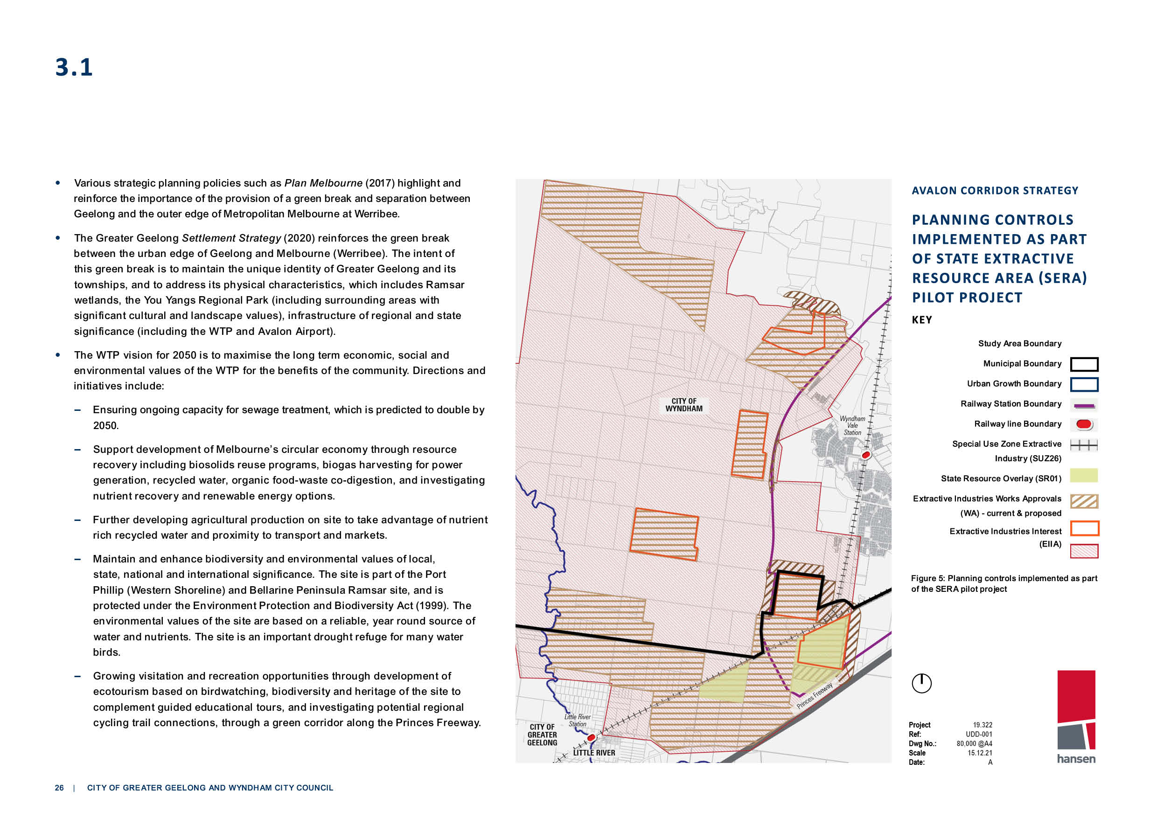
3.1

- Various strategic planning policies such as Plan Melbourne (2017) highlight and reinforce the importance of the provision of a green break and separation between Geelong and the outer edge of Metropolitan Melbourne at Werribee.
- The Greater Geelong Settlement Strategy (2020) reinforces the green break between the urban edge of Geelong and Melbourne (Werribee). The intent of this green break is to maintain the unique identity of Greater Geelong and its
townships, and to address its physical characteristics, which includes Ramsar wetlands, the You Yangs Regional Park (including surrounding areas with
significant cultural and landscape values), infrastructure of regional and state significance (including the WTP and Avalon Airport).
- The WTP vision for 2050 is to maximise the long term economic, social and
environmental values of the WTP for the benefits of the community. Directions and initiatives include:
  - Ensuring ongoing capacity for sewage treatment, which is predicted to double by 2050.
  - Support development of Melbourne’s circular economy through resource recovery including biosolids reuse programs, biogas harvesting for power
generation, recycled water, organic food-waste co-digestion, and investigating nutrient recovery and renewable energy options.
  - Further developing agricultural production on site to take advantage of nutrient rich recycled water and proximity to transport and markets.
  - Maintain and enhance biodiversity and environmental values of local, state, national and international significance. The site is part of the Port Phillip (Western Shoreline) and Bellarine Peninsula Ramsar site, and is
protected under the Environment Protection and Biodiversity Act (1999). The environmental values of the site are based on a reliable, year round source of water and nutrients. The site is an important drought refuge for many water birds.
  - Growing visitation and recreation opportunities through development of
ecotourism based on birdwatching, biodiversity and heritage of the site to complement guided educational tours, and investigating potential regional

AVALON CORRIDOR STRATEGY
PLANNING CONTROLS
IMPLEMENTED AS PART OF STATE EXTRACTIVE RESOURCE AREA (SERA) PILOT PROJECT
KEY

Figure 5: Planning controls implemented as part of the SERA pilot project

cycling trail connections, through a green corridor along the Princes Freeway.
Project Ref: Dwg No.: Scale Date:
19.322
UDD-001 80,000 @A4
15.12.21
A

3.1

- The Victorian Government’s SERA pilot project identified areas within WCC as containing
strategic extractive resources (hard rock) needed for the construction industry and major state infrastructure projects.
- The SERA pilot project made the following commentary regarding land of interest within WCC:
  - The Wyndham area is recognised for its vast flat basalt plains. A number of hard rock quarries have been operating in the area for decades, producing good quality road base and aggregate from the extracted basalt, which is used for major road projects and other infrastructure in and around greater Melbourne.
  - The large Western Grassland Reserve and the location of small settlements and nearby towns have helped to shape the proposed SERA boundary, which avoids these important areas. The SERAs encompass existing quarries and areas where there are potential extractive resources that may be suitable for future quarry development.
  - The formal gazettal of the pilot project into the Wyndham Planning Scheme has resulted in
new planning controls in the form of the State Resource Overlay (SRO) being applied over the identified land, as shown in Figure 5.
- CoGG’s Industrial Land Supply Report (2018) concluded there is an adequate supply of zoned and unzoned industrial land stocks to meet current trends and accelerated consumption rates across
the municipal area of Geelong. It concluded there is no immediate shortfall of industrial land by specific lot size with an ample availability of smaller lots as well as the ability to service larger
industrial users if required within the Geelong Ring Road Employment Precinct and Armstrong Creek North East Industrial Precinct.
- The study area is noted to include land formally known as the New Corio Estate. Planning issues associated with this area have previously been considered in detail as part of Amendment C243 which formalised the designation of a Native Vegetation Precinct Plan area associated with the Geelong Ring Road Employment Precinct.
- CoGG’s Rural Land Use Strategy (2007) remains a strategically valid document and provides
commentary regarding agricultural land use within the study area. The recommendations of the strategy include reinforcing rural activity and farmed landscapes, while protecting and providing opportunities for productive agriculture.
- The Werribee-Geelong: Planning Investigation of Strategic Intent Developable Land Analysis
prepared by GHD (2014) for the former Department of Transport Planning & Local Infrastructure informed the preparation of Plan Melbourne and is relevant to the Avalon Corridor Strategy. This analysis divided the Avalon Corridor into five main investigation areas:
  - North Plains - including land north of the Melbourne-Geelong railway alignment
  - Central East - including land east of Little River between the Melbourne-Geelong railway alignment and Princes Freeway
  - Central West - including land south of Melbourne-Geelong railway alignment between Lara and Little River
  - Central Coast - including Melbourne Water land to west of Little River
  - Airport Environs - including the current extent of Avalon Airport land.
- Land constituting the larger extent of the Lara and Little River townships and WTP land (east of the Little River waterway) were excluded from the investigation area for the GHD analysis.
- Based on the designated investigation areas, the report provides a high level analysis of the constraints posed by the identified environmental, heritage, planning, infrastructure and other land constraints within the area, and outlines development opportunities for the investigation areas. The study also highlights the role played by the green break between Geelong and Melbourne for landscape, heritage and social values and its implications for development.
- While the significant existing and planned transport infrastructure for the area poses opportunities for development, the report highlighted considerable constraints including biodiversity and
conservation values, airport and quarry buffer requirements, odour impact from the WTP,
landscape and visual impacts, flooding and drainage issues, and servicing upgrade requirements.

3.1

- The report designates land based on three indicators including:
  - Land potentially suitable for development
  - Further investigation required
  - Land unsuitable for development.
- Of note, the majority of land identified as being potentially suitable for development is quite fragmented, with the only larger continuous area being located to the west of Avalon Airport. As this report was based on a desktop assessment of available information, further investigation of development potential is required. The merits of any proposal should be assessed against relevant Planning Scheme requirements.
- In general, the report acknowledges potential for employment and infrastructure development.
It does not identify residential development opportunities due to considerable constraints. The
report suggests leveraging key infrastructure assets for compatible and complimentary land uses, including industrial and logistical uses in areas subject to noise, odour and height constraints
(such as Avalon Airport).
- Green wedge considerations are also relevant to the Avalon Corridor Strategy. Green wedge land has protection under Part 3AA of the P&E Act, which requires any planning scheme amendment
to alter or remove controls over GWZ land to be approved by the Minister for Planning and ratified by both Houses of Parliament. In addition to this legislative protection, DELWP are facilitating a
major piece of strategic work to better plan for the management and protection of green wedge land.
- DELWP’s Planning for Melbourne’s Green Wedges and Agricultural Land: Consultation Paper (2020) was out for community consultation until February 2021. This project is part of the Victorian Government’s commitment to protecting Melbourne’s green wedge and peri-urban areas as
outlined in Actions 17, 72 and 73 of Plan Melbourne. The project considers agricultural land within 100km from Melbourne and therefore has implications for both CoGG and WCC.
- Land within the Avalon Corridor designated as GWZ is located within WCC. This includes land located outside of the UGB and extending to Little River which forms the municipal boundary between WCC and CoGG.
- The Consultation Paper identifies that while green wedge areas have been largely protected from urban encroachment, existing policy and planning measures are no longer effective. The paper
highlighted the following concerns:
- Increased land speculation and pressure to convert farmland to other uses
- Increased appetite for rural lifestyles and use of these areas for a range of urban activities
- Incremental and irreversible loss of land that is agriculturally productive or has important non urban uses
- More land use conflicts, particularly where urban areas adjoin rural areas.
- The Consultation Paper outlined a number of recommendations that aim to deliver lasting protection of agricultural land and guide decision-making on green wedge areas, including:
- Anticipate challenges to agricultural productivity under climate change
- Realise the unique and strategic opportunities afforded by the study area’s unique natural attributes, proximity to Melbourne and infrastructure capabilities
- Protect the special qualities and significant features of the environmental, economic, cultural and health values of the study area for our communities
- Achieve greater certainty and consistency of planning and decision-making across the study area to realise a sustainable future for our growing city and state.
- Strategic land use decisions affecting green wedge land in WCC are further guided by the Green Wedge Management Plans for Werribee South (2016) and Western Plains South (ongoing).
- The Werribee South Green Wedge Management Plan (2016) covers land within WCC located
outside of the UGB and south of the Princes Freeway. Land within the Avalon Corridor affected
by the Werribee South Green Wedge Management Plan is noted to exclusively fall within the WTP site.

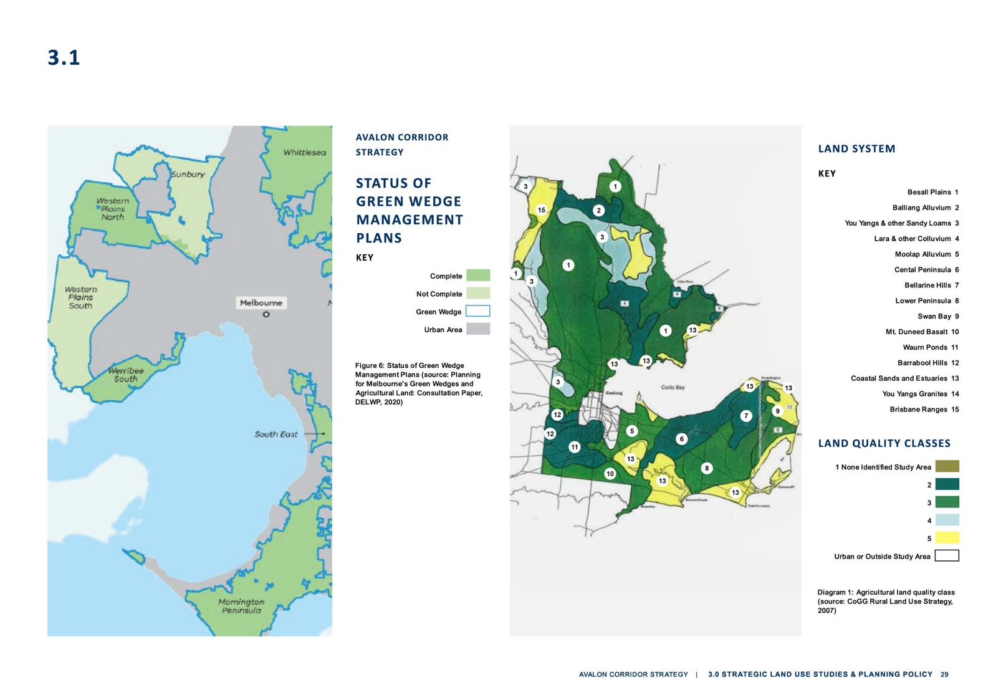
3.1

3.1

- The Western Plains South Green Wedge Management Plan: Background Report (2018), covers a
larger area of land within WCC located outside of the UGB to the west and northwest of Werribee.
Large areas of this green wedge are located within the Western Grasslands Reserve and have therefore already been identified for long term conservation.
- For other parts of the Western Plains South Green Wedge within the Avalon Corridor, the
Background Report raises a range of considerations for further analysis through the development of a draft Green Wedge Management Plan:
  - Develop a clear vision, strategic objectives and land use outcomes that reinforces the role and function of the green wedge and UGB.
  - Encourage improved interfaces between the green wedge and future urban and infrastructure development to prevent land use conflict and protect visual amenity.
  - Consider precincts as a mechanism to acknowledge diversity of landscapes, land uses and values within the green wedge and tailor policy to respond to localised issues
and opportunities.
  - Consider natural attributes of the land, current land use, strategic directions and preferred land use outcomes including opportunities for agriculture, tourism and recreation.
  - Consider a landscape character study of the green wedge including identification of views and viewpoints.
  - Consider appropriate planning controls and management measures for sensitive landscape areas on the basis of the landscape character study.
  - Consider tourism and recreation opportunities that support protection and enhancement of biodiversity values.
  - Continue to apply measures that recognise and protect heritage values.
  - Consider measures to improve understanding and appreciation of dry stone walls and the role of landholders as custodians.
  - Continue to engage with Traditional Owners in the planning and management of the green wedge.
- Consider opportunities for beneficial reuse of recycled water from the Melton Recycled Water Plant.
- Continue to apply measures to protect utilities and extractive industry from encroachment by sensitive uses.
- Work closely with VicRoads and relevant agencies to reduce impacts arising from the implementation of road infrastructure including the OMR Transport Corridor.
- The Port Phillip Bay (Western Shoreline) and Bellarine Peninsula Ramsar Site Management Plan (DELWP, 2018) sits within an overarching framework for the management of coastal ecosystems in Victoria and Australia. At the national level, the Environment Protection and Biodiversity
Conservation Act 1999 (EPBC Act) establishes the basis for managing Ramsar sites and provides a set of national guidelines for describing ecological character and developing management plans (DEWHA 2008). In Victoria, the Victorian Waterway Management Strategy guides the management of rivers, estuaries and wetlands. The Site Management Plan aligns with Action 3.4 and 3.9 in
Water for Victoria by improving waterway health and knowledge of waterways and catchments.
- The primary purpose of the Site Management Plan is to maintain ecological character
and promote appropriate land use within the Ramsar site. The site supports a number of
environmental, economic, social and cultural values, which need to be maintained. Accordingly, the Site Management Plan aims to ‘maintain, and where necessary improve, the ecological
character of the Port Phillip Bay (Western Shoreline) and Bellarine Peninsula Ramsar Site and support wise and sustainable use.’
- CoGG’s Rural Land Use Strategy (2007) (RLUS) provides direction for agricultural land use within the Avalon Corridor. The strategic directions outlined in the Executive Summary (page 4) state
that the Rural Land Use Strategy sets out a long term vision for the City’s rural areas that:
  - Reinforces a rural, farmed landscape beyond urban areas
  - Continues to protect and provide opportunities for productive agriculture
  - Enhances the condition of the environment and the natural resource base
  - Contributes to the ongoing economic prosperity and quality lifestyle of the region.

3.1

    - The RLUS includes an agricultural land quality class map (Diagram 1). Within the Avalon Corridor the following land quality classifications are present:
      - Class 2 - high quality agricultural land
      - Class 3 - moderate quality agricultural land
    - Section 10.8 (Northern area) of the RLUS is relevant to the Avalon Corridor Strategy and notes:
      - The northern areas of the City comprise rural landscapes used for cropping, grazing and viticulture
      - The You Yangs and Brisbane Ranges are significant landscape features
      - Land is largely of Class 3 quality, with some areas of Class 2 quality land
      - Land is still largely in parcels of productive size, and there are a number of large properties comprising many parcels of land being farmed.
    - The RLUS nominates that land within the Avalon Corridor should be maintained for agricultural use, and development adjacent to the You Yangs should be limited and carefully managed to
protect landscape features.
    - Section 10.9 Avalon notes that Avalon Airport is a significant state and regional transport facility. Rural and agricultural land near the airport provides potential for intensive horticulture activities and presents significant opportunities for export of high quality produce to domestic and
international markets. Such activities should be supported as a part of the agricultural economy of Greater Geelong.
    - Recommendations of the RLUS are clear in seeking to reinforce rural activity and farmed
landscapes, while protecting and providing opportunities for productive agriculture. Key types of agriculture identified by the RLUS are outlined below:
      - Broad acre farming relates to the large scale production of grains and other crops, or the grazing of livestock for meat or wool, on a large scale.
      - Intensive farming relates to methods of agricultural production that requires high inputs to maximize productivity of a small piece of land for either crops or animals.
      - Dryland farming relates to the cultivation of crops without irrigation in regions of limited moisture, typically less than 50 centimetres of precipitation annually.
      - Irrigation farming relates to the agricultural process of applying controlled amounts of water to land to assist in the production of crops, as well as to grow landscape plants and lawns.
  - Greenhouse farming relates to the farm practice of growing crops within sheltered structures covered by a transparent, or partially transparent, material. The main purpose of greenhouses is to provide favourable growing conditions and to protect crops from unfavourable weather
and pests.
- Agricultural viability within the study area is noted to be moderate to high based on the RLUS.
There is also potential for alternate forms of agriculture such as greenhouse farming to be
contemplated. However, this form of farming is generally not supported by the community for
amenity reasons, and could impact the broader rural landscape character of the Avalon Corridor.
If greenhouse farming is pursued within the Avalon Corridor, siting and design considerations would be of critical importance.
- There are opportunities to consider potential use of recycled water within the Avalon Corridor
from the WTP (Melbourne Water), Northern Treatment Plant in Corio (Barwon Water) and Melton Recycled Water Plant (Greater Western Water). Currently, the production of recycled water is not cost-effective. However, recycled water may become more financially viable in the future through technical advancement or Government investment, incentives and subsidies.
- The soil profile of the Avalon Corridor aligns with the Newer Volcanics Province, which extends
from the west of Melbourne to Mount Gambier. The underlying bedrock is generally characterised by basalts and lavas, with later sedimentary units around waterways and the coastline. Ongoing quarrying activities in the area have also created deposits south of the Princes Highway.
- Due to the underlying geology, soils in WCC vary across the municipality with Brown Sodosols being the most common unit (Diagram 2). Red Sodosols are also present within localised areas of WCC, such as the Werribee Irrigation District. Sodic soils contain high levels of sodium and can be challenging to manage due to their chemistry, structure and behaviour in wet and dry
environments. Areas containing sodic soils within WCC and the wider Avalon Corridor require ongoing management of erosion and soil stability, as well as flow on impacts on surrounding natural systems.

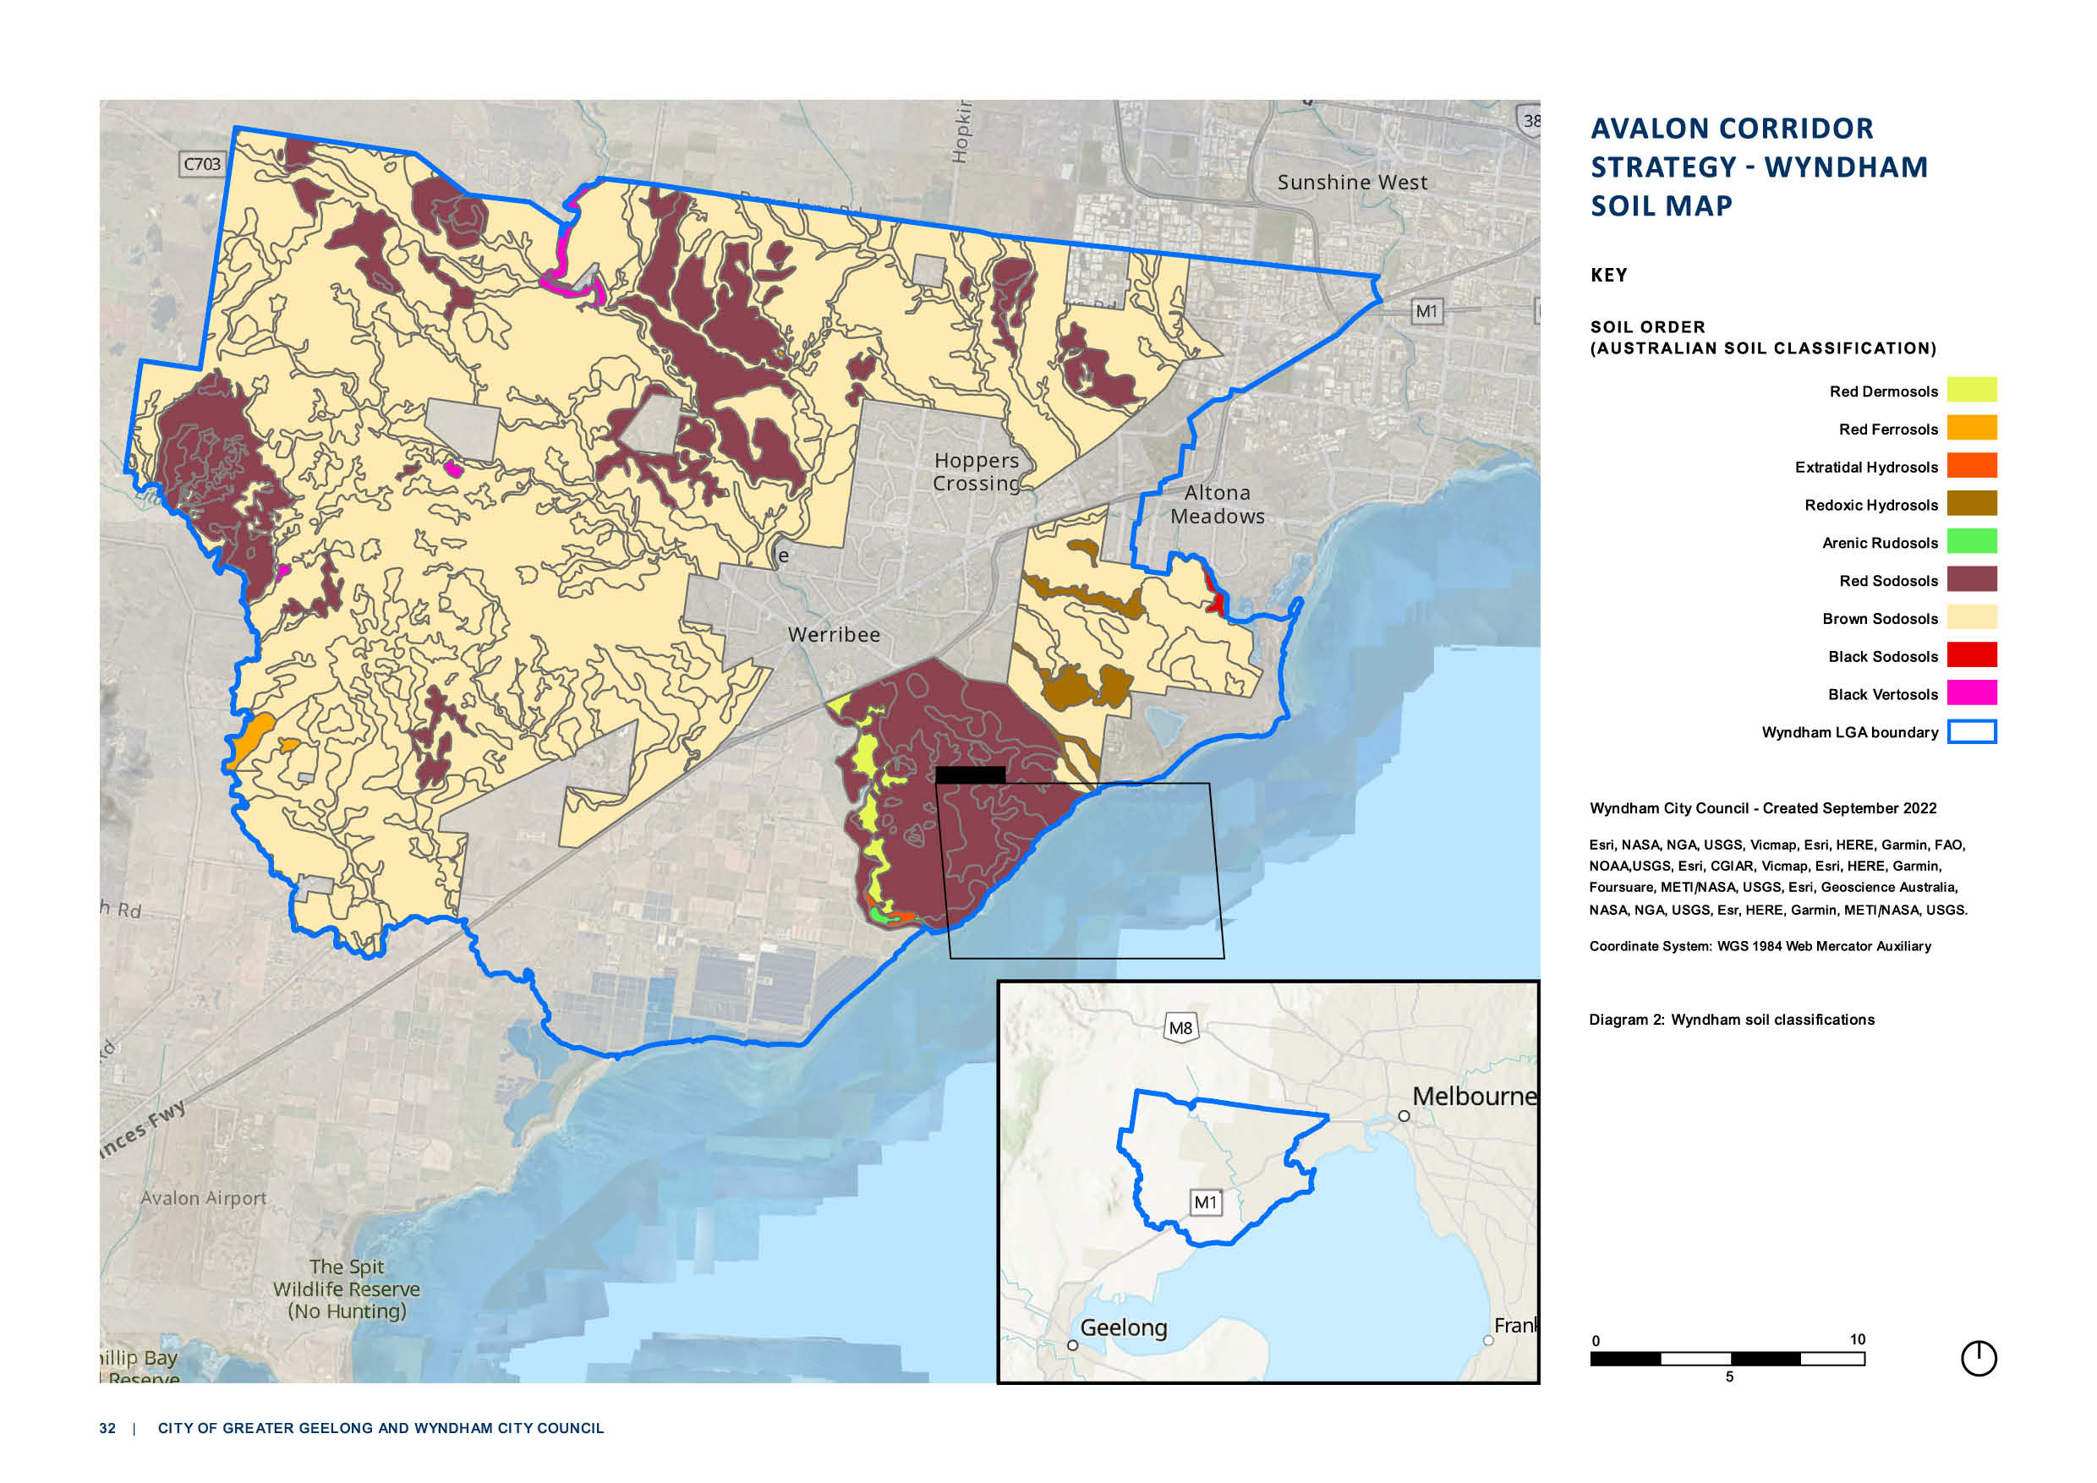

AVALON CORRIDOR
STRATEGY - WYNDHAM SOIL MAP

KEY

SOIL ORDER
( AUSTRALIAN SOIL CLASSIFICATION)

Red Dermosols

Red Ferrosols

Extratidal Hydrosols

Redoxic Hydrosols

Arenic Rudosols

Red Sodosols

Brown Sodosols

Black Sodosols

Black Vertosols

Wyndham LGA boundary

Wyndham City Council - Created September 2022

Esri, NASA, NGA, USGS, Vicmap, Esri, HERE, Garmin, FAO, NOAA,USGS, Esri, CGIAR, Vicmap, Esri, HERE, Garmin, Foursuare, METI/NASA, USGS, Esri, Geoscience Australia, NASA, NGA, USGS, Esr, HERE, Garmin, METI/NASA, USGS.

Coordinate System: WGS 1984 Web Mercator Auxiliary

Diagram 2: Wyndham soil classifications

0 10
5

3.2

PLANNING POLICY
A range of planning policies are relevant to the Avalon Corridor Strategy, including the State Planning Policy Framework (PPF) and the Local PPF contained in both the Wyndham and Greater Geelong
Planning Schemes. A summary of relevant planning policies at both State and municipal level are outlined below.

PLAN MELBOURNE
Plan Melbourne (2017) contains a number of directions, policies, principles and outcomes of
relevance to the Avalon Corridor. It identifies Avalon Airport and the proposed Bay West Port as a
state significant transport gateways and recognises the need to secure adequate capacity for moving passengers and freight into and out of Victoria. Plan Melbourne also supports future employment and economic development opportunities at major ports, airports and interstate terminals, noting the need to protect these assets from incompatible land uses.

POLICIES
      - Policy 1.1.5 Support major transport gateways as important locations for employment
and economic activity - speaks specifically to designated ports, and airports and acknowledges the Bay West Port as a possible seaport within the Avalon Corridor. This policy seeks to ensure
that land around state-significant transport gateways are protected from incompatible land uses to ensure they keep generating economic activity and new jobs.
      - Policy 1.1.6 Plan for industrial land in the right locations to support employment and investment opportunities - highlights the economic contribution of industrial land, the need to protect existing industrial land from incompatible land uses to allow for future growth, and to identify strategic locations for major development linked to the Principal Freight Network and
transport gateways and networks. The Plan Melbourne 2017-2050 Addendum 2019 recognises Avalon Airport as a transport gateway and identifies the Avalon Rail Link and the Western Rail Plan as potential transport infrastructure improvements.
      - Policy 3.4.1 Support sufficient gateway capacity with efficient landside access - seeks to evaluate appropriate locations for Victoria’s second container port and also speaks to the
importance of the WIFT and Avalon Airport.
- Policy 4.5.1 Strengthen protection and management of green wedge land - identifies the Avalon Corridor as being partially within a green wedge area (Western Plains South) and a peri urban area and seeks to protect GWZ areas from inappropriate land use and development.
- Policy 7.2.2 Strengthen transport links on national networks for the movement of commodities - specifically refers to the Avalon Corridor, noting:
  - “Victoria’s economy depends on its ability to move goods between state-significant places (such as regional cities and Melbourne) and to interstate and international markets. Transport network planning must ensure that industries such as Victoria’s food and fibre industry remain viable and competitive. This should include
identification of key freight corridors and interstate freight terminals. For example, the Avalon corridor near Geelong contains nationally significant economic assets, including airport, road, rail and waste facilities. This corridor must be safeguarded
for state infrastructure opportunities and complementary development in the future, as well as maintaining a settlement break between Melbourne and Geelong. Land
use buffers for infrastructure and Avalon Airport and areas of high biodiversity value, including Ramsar conservation areas, must be protected.”

PRINCIPLES
- A globally connected and competitive city - relates to developing and delivering on infrastructure to support competition across different sectors
- Environmental resilience and sustainability - relates to the protection of biodiversity and natural resources
- A city of centres link to regional growth - relates to physical, social and economic connections between Melbourne and regional areas

3.2

OUTCOMES AND DIRECTIONS IMPLEMENTATION

Outcome 1
Melbourne is a productive city that attracts investment, supports innovation and
creates jobs

Outcome 3
Melbourne has an integrated transport system that connects people to jobs and services and goods to market

Outcome 4
Melbourne is a distinctive and liveable city with quality design and amenity

Outcome 6
Melbourne is a sustainable resilient city

Outcome 7
Regional Victoria is productive, sustainable and supports jobs and economic growth

Direction 1.1
Seeks to strengthen competitiveness of the economy and direction 1.4 seeks to support the productive use of land in non-urban areas

Direction 3.4
Seeks to improve freight efficiency and
increase capacity of gateways while protecting urban amenity

Direction 4.5
Seeks to protect green wedges and peri-urban areas

Direction 6.5
Seeks to protect and restore natural habitats, this is relevant due to the Avalon Corridor’s
environmentally significant sites

Direction 7.2
Seeks to improve connections between cities and regions
Plan Melbourne includes a separate implementation plan with short, medium and long term actions.
- Action 17 Support strategic planning for agriculture seeks to ‘improve planning decision- making to support sustainable agriculture by identifying areas of strategic agricultural land in
OUTCOME DIRECTION
Melbourne’s green wedges and peri-urban areas. This will give consideration to climate change, soils and landscape, access to water, integration with industry and significant government
investment in agricultural infrastructure.’
- Action 18 Management of extractive industry seeks to ‘protect the extractive industry and future extractive-resource assets from incompatible land uses by adopting planning options
consistent with the findings of the Extractive Resources in Victoria, Demand and Supply Study, 2015–2050.’
- Action 48 Strategy for future gateways seeks to ‘protect options for future air and sea ports and intermodal terminals through appropriate planning frameworks.’
- Action 72 Review green wedge planning provisions seeks to ‘review green wedge planning provisions to ensure they support Plan Melbourne outcomes for green wedges.’
- Action 73 Green Wedge Management Plans seeks to ‘support local government to complete and implement green wedge management plans to protect and enhance the agricultural,
biodiversity, environmental, natural resource, tourism, landscape and other values of each of Melbourne’s green wedges.’
- Action 74 Localised planning statements for distinctive areas and landscapes seeks to ‘prepare localised planning statements for other distinctive areas within Melbourne’s green wedges and peri-urban areas.’
- Action 95 Environmental protection for coastlines and waters of Port Phillip Bay and Western Port seeks to ‘improve environmental protection for Melbourne’s coasts and the waters of Melbourne’s bays through local planning schemes.’

3.2

PLANNING POLICY FRAMEWORK
The PPF is contained in all Victorian Planning Schemes and include policies that relate to the use and development of land throughout Victoria. The PPF covers issues of state importance that address
settlement planning, residential development, environmental and landscape values, natural resource management, built environment and heritage, housing, economic development, transport and
infrastructure, in addition to more specific regional focused policies.

Beyond the overarching Plan Melbourne strategy, there are a number of Regional Strategic Plans embedded into Clause 11 - Settlement. The regional Development Plan relevant for the CoGG is the G21 Regional Growth Plan directly referenced at Clause 11.01-1R - Geelong (G21).

Further relevant policies of the PPF are listed in Appendix 1.

PLANNING POLICY FRAMEWORK: WYNDHAM PLANNING SCHEME
The PPF at a local level includes two key sections, including: the Municipal Planning Strategy
(MPS) and local planning policies. The MPS sets out the vision documents for Council. Within the Wyndham Planning Scheme, the MPS acknowledges expected increases in population growth
and sets out key strategies for settlement planning, land use direction, environmental protection, economic development, transport, infrastructure and landscape values.

In relation to the Avalon Corridor, the MPS places an importance on safeguarding areas of
environmental significance and landscape value (with specific mention to the Ramsar sites), maintaining the green break between Werribee and Geelong, diversifying the local economy,
supporting integrated transport networks and providing for increased industrial land development opportunities.
Relevant Clauses within the Wyndham MPS include:
- Clause 02.03-1 Settlement – Little River includes strategic directions to provide for limited consolidation in the Little River area, subject to resolution of airport noise from Avalon Airport,
infrastructure constraints and development of a township plan; and to Manage the development of Little River to avoid overdevelopment, protect adjoining rural precincts from development impacts and prevent further expansion of the township into the surrounding rural precincts.
- Clause 02.03-1 Settlement – Green Wedges includes the strategic direction to protect Wyndham’s Green Wedges from inappropriate development and urban intrusion. Broadly
it seeks to protect green wedges from inappropriate development, retain biodiversity values, and encourage compatible rural uses.
- Clause 02.03-2 Environmental and landscape values contains objectives to protect
and restore biodiversity and natural habitats; to protect Wyndham’s natural environment and landscape with respect to growth, land use and the impacts of climate change; to protect and
enhance the distinctive sense of place, cultural identity and landscape within the growth areas of Wyndham; to manage urban encroachment on the coast and its impacts on environmental values along the coast.
- Clause 02.03-3 Environmental risks and amenity contains objectives to promote
environmental sustainability through built form, urban infrastructure and consolidation; to apply the ‘precautionary principle’ when planning for the City to help avoid serious or irreversible
climate change effects; to minimise the City’s contribution to climate change and gas emissions and minimise the impacts of climate change on Wyndham’s natural and built environment;
to protect the community from the economic, social and environmental risks associated with
flooding; to ensure that new use and development include adequate fire protection measures.
- Clause 02.03-4 Natural resource management contains objectives to minimise the loss of productive agricultural land and the impacts of incompatible uses on farming operations; to protect the Werribee South market gardens as an area of State agricultural significance;
to support the role of rural areas beyond the Urban Growth Boundary to protect and restore
biodiversity and viable future rural land uses; and to protect waterways, aquatic areas, wetlands, swamps, catchments, riparian land and waterway valleys.
- Clause 02.03-7 Economic development contains objectives to provide sufficient land to
attract investment and generate additional jobs, and to promote Wyndham as a place for long term business attraction and expansion.
- Clause 02.03-8 Transport contains relevant objectives to: provide improved and accessible transport options, and to maintain and enhance existing road infrastructure.

Local planning policies contained in the Wyndham Planning Scheme provide more specific
policy direction in relation to neighbourhood character, amenity associated with non-residential
development, telecommunications, advertising signage, heritage and electronic gaming machines. It
is noted that none of these local policies have particular relevance to the scope of the Avalon Corridor Strategy.

3.2

PLANNING POLICY FRAMEWORK: GREATER GEELONG PLANNING SCHEME
The PPF at a local level includes two key sections: the Municipal Planning Strategy (MPS) at Clause 02 and local components of planning policies at Clauses 11 to 19. At Clause 02.02 the MPS sets out
the overarching vision for Greater Geelong: Geelong, coast, country and suburbs, is the best place to live through prosperity and cohesive communities in an exceptional environment.
Relevant Clauses within the Greater Geelong MPS include:
      - Clause 02.03-1 Settlement provides strategic direction for settlement growth in Greater
Geelong, particularly directing and containing residential growth within identified areas of the municipality, and limiting rural living developments to existing zoned land. With respect to
Lara, this clause notes that the Avalon Airport and nearby land provide significant opportunities for employment and economic growth and includes a direction to protect and enhance key
environmental, cultural and landscape features, including the rural characteristics of Lara.
      - Clause 02.03-7 Industry notes the need to provide support for ongoing employment and economic development in the Geelong region and the need to support industry through the
maintenance and improvement of infrastructure including roads, rail and Avalon Airport. The clause provides strategic directions to:
        - Provide an adequate supply of industrial land that meets the needs of different industries.
        - Focus new industrial development around major transport routes and infrastructure assets.
        - Encourage the growth of new and economically sustainable industry sectors.
        - Provide a diverse range of high quality industrial and commercial land.
      - Clause 02.03-8 Transport notes that Avalon Airport is a major economic and tourism asset to
the region and includes a direction to protect and enhance the role of the Avalon Airport, including its expansion options and ongoing technical viability and operational requirements.
      - Clause 02.03-2 Environmental and landscape values
The Local Planning Policy Framework (Clauses 11 to 19) also includes various policies relevant to the Avalon Corridor, including:
- Clause 11.01-1L-01 Settlement – Greater Geelong
  - Retention of the rural landscape setting including views to the You Yangs.
  - Protection of agricultural land, particularly to the north of Lara and aquaculture or intensive agricultural production activities adjacent and complementary to Avalon Airport.
  - Protection of opportunities for a potential intermodal transport facility [With regard to the
‘potential intermodal transport facility’, the Lara Structure Plan Map contained in Clause 11.01- L-03 Lara clarifies this to be to the northeast of the township and between the Melbourne/
Geelong railway alignment and Old Melbourne Road].
  - Protection of the current and future operations and development of Avalon Airport including associated or compatible uses.
- Clause 14.01-1L-02 Dwellings and subdivision in farming areas
  - An objective to ensure that the development of dwellings and excision of existing dwellings are consistent with the use of land for sustainable rural uses.
  - A strategy to discourage house lot excisions.
  - A strategy to support construction of a dwelling where:
    - The dwelling will not result in the property being removed from agricultural production and the primary use of the land will continue to be agriculture.
    - Existing agricultural activity on adjoining land will not be compromised.
    - The proportion of the property used for the dwelling and ancillary infrastructure is minimised and located on the area of lowest agricultural quality.
- Clause 17.01-1L-01 Diversified economy – Greater Geelong
  - Support the development of seafood and aquaculture industries, particularly in North Geelong, Portarlington and Avalon.
  - Support the development of aerospace industries within the confines of the Avalon Airport site.
- Clause 17.04-1L-02 Tourism in rural areas
  - Support tourism uses associated with an agricultural activity on the land.
  - Discourage tourism uses not associated with an agricultural activity on the land
unless specified criteria apply.

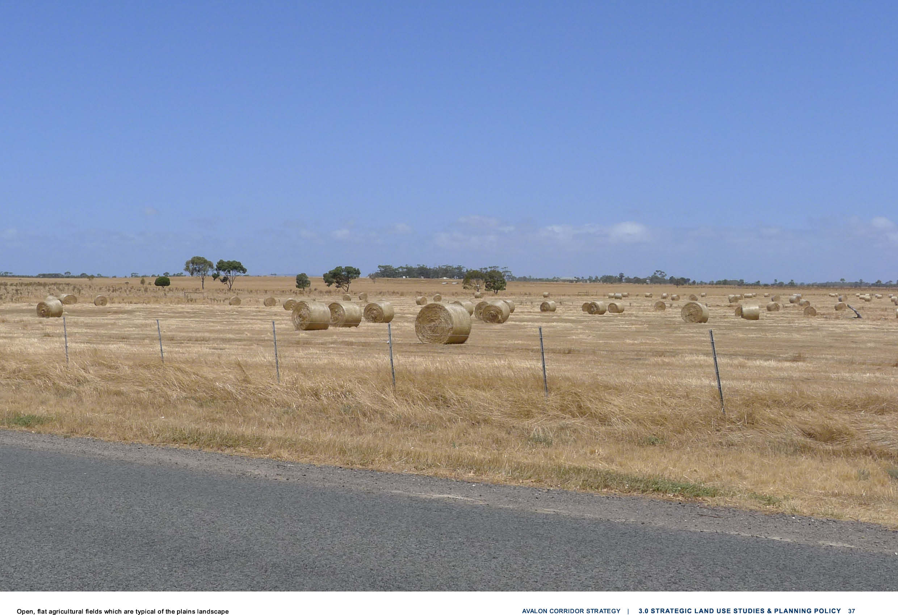

3.2

ZONES
A variety of zones are applied in the Avalon Corridor through the Greater Geelong and Wyndham
Planning Schemes. The largest single zone within the Avalon Corridor is the Public Use Zone (PUZ) which applies to the WTP, followed by the Green Wedge Zone (GWZ) within WCC and the Farming
Zone (FZ) predominantly found within CoGG.

Both the GWZ and FZ seek to limit development and maintain larger lots for rural and related
activities, which is further articulated through relevant state and local policies of the PPF. The result of such zones and policies is that land within these areas is relativity free of development and
generally maintains larger lot sizes and an open landscape rural character.

A summary of the applicable zones and overlays is provided below and in Figures 7 and 8.

PUBLIC USE ZONE

The Public Use Zone (PUZ) recognises public land use for community services and facilities. It
applies to publicly owned land and includes a variety of uses as outlined in the relevant Schedule.
- PUZ1 applies to land containing services and utilities. Within the Avalon Corridor, this includes the WTP, which extends across both Wyndham and Geelong municipality.
- PUZ2 applies to land used for education. In the Avalon Corridor this relates to Little River Primary School.

TRANSPORT ZONE

The Transport Zone (TRZ) seeks to provide for an integrated and sustainable transport system, and
applies to land previously controlled by the PUZ. Land within the Avalon Corridor is allocated for state transport infrastructure (TRZ1 – regional railway), principal road network (TRZ2 – Princes Highway
and intersections) and significant municipal roads (TRZ3).
SPECIAL USE ZONE

The Special Use Zone (SUZ) applies to sites that have been developed or used for a specific purpose that is listed within the relevant Schedule. The SUZ includes areas that are within the Port Phillip
(Western Shoreline) and Bellarine Peninsula Ramsar site. The Ramsar site needs to be taken into
consideration in any planning or development proposals, given it is a matter of national environmental significance under the Environment Protection and Biodiversity Conservation ACT 1999.
- SUZ6 in the Wyndham Planning Scheme relates to the Earth and Energy Resource Industry and provides for the operation of a number of quarry sites, both active and approved, including the Wyndham RDF and Holcim Quarry, the Holcim extractive industry site adjacent to the west and the proposed extractive industry site to the north.
- SUZ1 in the Greater Geelong Planning Scheme relates to Environmental Wetlands, Salt
Production and Land Based Aquaculture Activities, and applies to the former Cheetham Saltworks site west of Avalon Airport.
- SUZ11 in the Greater Geelong Planning Scheme relates to the Avalon Airport precinct and contains the following specific purposes:
  - To provide for an operational airport and associated activities.
  - To provide for a range of employment generating land uses which do not adversely interfere with the operation of the airport.
  - To provide for use and development that facilitates the vision and development objectives contained in any approved Master Plan for the airport.
  - To provide for a range of commercial, industrial and retail facilities which add to the diversity of economic generating activities.
  - To ensure the use and development of the site are compatible with existing uses in the vicinity.
  - To ensure that land uses have consideration of environmental attributes of the area.

3.2

INDUSTRIAL 2 ZONE

The Industrial 2 Zone (I2Z) applies to the Mountain View Quarry Site and surrounds. The I2Z
prioritises land to be available for heavy industry which requires substantial buffers, as articulated within the relevant zone purposes:
    - To provide for manufacturing industry, the storage and distribution of goods and associated facilities in a manner which does not affect the safety and amenity of local communities.
    - To promote manufacturing industries and storage facilities that require a substantial threshold distance within the core of the zone.
    - To keep the core of the zone free of uses which are suitable for location elsewhere so as to be available for manufacturing industries and storage facilities that require a substantial threshold distance as the need for these arises.

PUBLIC PARK & RECREATION ZONE

The Public Park & Recreation Zone (PPRZ) applies to publicly owned land that provides community facilities. Within the Avalon Corridor this relates to land on the north-eastern border next to the
Werribee River and also adjacent to the Little River watercourse.

PUBLIC CONSERVATION & RESOURCE ZONE

The Public Conservation & Resource Zone (PCRZ) applies to land south-west of the WTP
along the coastline including the Spit Wildfire Reserve. The PCRZ provides for the protection of
environmentally sensitive landscape while also allowing for some nature based recreation activities or accommodation.

RURAL CONSERVATION ZONE

A small portion of the study is affected by the Rural Conservation Zone (RCZ), to the north of the railway adjacent to the Wyndham RDF. The RCZ identifies land of high environmental value and
aims to protect the land from inappropriate urban encroachment and agricultural use. RCZ within the Avalon Corridor is associated with the Western Grasslands Nature Conservation Reserve that forms part of the Melbourne Strategic Assessment (MSA) area.
LOW DENSITY RESIDENTIAL ZONE

Land zoned Low Density Residential Zone (LDRZ) within the Avalon Corridor exists on the outskirts of Little River township. The LDRZ is a residential zone that provides for dwellings to be built on lots as small as 0.4 hectares.

GREEN WEDGE ZONE

The GWZ only applies to land within Wyndham and seeks to recognise, protect and conserve
green wedge land for its agricultural, environmental, historic, landscape, recreational and tourism opportunities, and mineral and stone resources. GWZ land within the Avalon Corridor is located
north of the alignment of the Little River watercourse, extending broadly north to the Avalon Corridor boundary.

RURAL LIVING ZONE

Rural Living Zone (RLZ) land within the Avalon Corridor is located on the edge of Lara, both north
and south of the Princes Freeway. The RLZ is a residential zone that provides for small scale hobby farming and dwellings on lots no smaller than two hectares.

FARMING ZONE

The FZ applies to a small portion of land within Wyndham, to the north east of the Avalon Corridor around the Wyndham RDF and Holcim Quarry. A much larger portion of FZ land is located within CoGG, including land north of the Princes Freeway extending from Lara through to Little River, as well as land south of the Princess Freeway to the west of Avalon Airport. The purpose of the FZ is
to prioritise and protect agricultural uses, but also allow complementary activities such as tourism. Minimum lot sizes apply to subdivision and development within FZ land:
- CoGG: 80 hectare minimum lot subdivision and for an area for which no permit is required to construct a dwelling; and
- Wyndham: 40 hectare minimum lot subdivision and for an area for which no permit is required to construct a dwelling.

Ford Proving Ground

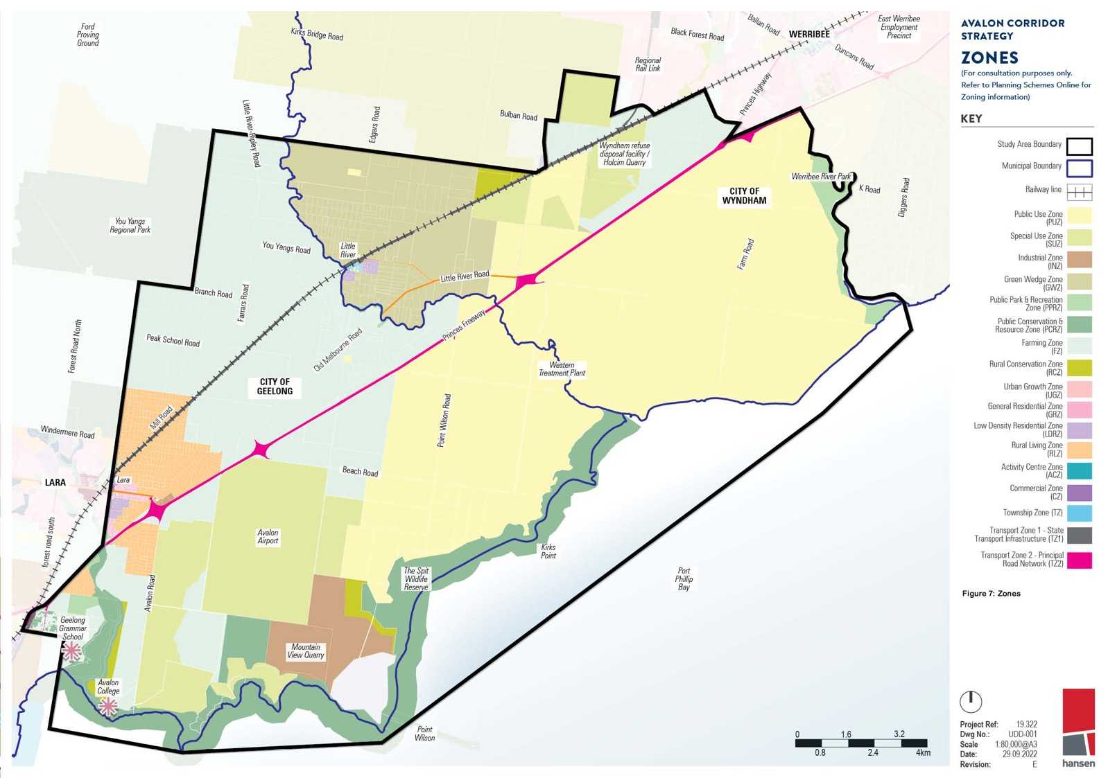

3.2

OVERLAYS
A variety of overlays are applied to the Avalon Corridor through the Greater Geelong and Wyndham Planning Schemes.

LAND SUBJECT TO INUNDATION OVERLAY

The Land Subject to Inundation Overlay (LSIO) is a floodway overlay aimed to ensure the protection of water quality and reduce the impact of development. It also aims to ensure that the free passage and flow of floodwaters is not restricted. The LSIO affects only land located within CoGG, including land within Avalon Airport and the WTP, as well as land north of the Princes Freeway between Lara and Little River.

ENVIRONMENTAL SIGNIFICANCE OVERLAY

The Environmental Significance Overlay (ESO) serves to ensure that development “is compatible with identified environmental values.” Land within CoGG is affected by ESO2 and ESO4, while land in Wyndham is affected by ESO1, ESO4 and ESO5. Each Schedule sets out the permit triggers and environmental objectives to be achieved on affected sites.
      - ESO2 in Greater Geelong relates to “High Value Wetlands and Associated Habitat Protection” and applies broadly along the coastal environs and the WTP land within the CoGG.
      - ESO4 in Greater Geelong and ESO5 in WCC were introduced to protect areas of Natural Temperate Grassland of the Victorian Volcanic Plain – a critically endangered ecological
community and matter of national environmental significance. The presence of ESO4 and ESO5 represents a significant commitment and obligation of the Victorian Government to secure
grassland protection outcomes.
      - ESO1 in Wyndham relates to “Waterway Corridors” and applies to narrow sections of land along the Werribee River, Cherry Creek and Lollypop Creek.
      - ESO4 in Wyndham relates to the “Western Grasslands Reserve” and applies to a band of land along the northern boundary of the Avalon Corridor. This overlay functions to recognise and protect grasslands through the creation of a grasslands reserve.
ENVIRONMENTAL AUDIT OVERLAY

The Environmental Audit Overlay (EAO) identifies land where there is a potential risk of contamination due to previous land use, and applies to a small area of land to the south west corner of the Avalon
Corridor within Wyndham.

HERITAGE OVERLAY
- The Heritage Overlay (HO) identifies land or precincts with heritage significance. Five overlays
exist for places of state historical significance on the Victorian Heritage Register and are subject to the provisions of the Heritage Act (2017):
- Former Metropolitan Farm (VHR H2400)
- Water Tank (VHR H1416)
- Little River Railway Station and Goods Yard (VHR H1572)
- Hume and Hovell Memorial (VHR H1547)
- Rothwell Bridge (VHR H1454)

Outside the townships of Lara and Werribee, there are 29 places of local historical significance, which are subject to specific HO controls. 16 of these occur within the township of Little River (13 building
features, two riverside reserves, and the Grant Bridge), with six further rural places and three remnant networks of drystone walling along road and paddock boundaries in the area north of Little River. All of the preceding places occur within Wyndham. Two further rural places associated with the Avalon
College and Geelong Grammar occur within CoGG adjoining Limeburners Bay. Dry stone walls within the CoGG area between Little River and Lara are subject to generic protection under the Greater
Geelong Planning Scheme rather than individual HOs.

Beyond these specific sites, there are other numerous elements of historical interest within the study area. These include 23 sites on the Victoria Heritage Register/Victorian Heritage Inventory (VHI) that are the subject of archaeological permits under the Heritage Act. These places are predominantly
ruins or minor surface features associated with past rural and marine/coastal activities. A specific area of historical interest includes the historical crossing place of the Old Melbourne Road over the
Little River at Rothwell, with the Travellers Rest Inn ruin and other potential archaeological features in the vicinity.

3.2

Heritage Overlays are evolving. Municipal heritage studies undertaken by CoGG and a Heritage Review (Gap Study) undertaken by WCC in 2019 have identified a number of historical sites that have the potential to meet the threshold for protection under a HO. Both Councils are proposing to undertake further investigation of these over the next five years.

DEVELOPMENT PLAN OVERLAY

The Development Plan Overlay (DPO) identifies areas where a development plan has been prepared specific to that land to guide future land use and development. DPO1 in CoGG applies to the ‘Special Industrial Area, Point Wilson’. The Schedule further clarifies the intent of the overlay with the
following statement:

“This schedule applies to the Industrial 2 zone located in Dandos Road, Point Wilson. Whilst this land has not been developed apart from an existing quarry operation, the zoning of the land recognises
its potential as a site for a large scale industrial development requiring substantial buffer distances. A development plan is required to ensure that the area’s environmentally significant flora and fauna is protected and that all planning issues are fully addressed prior to the issue of a permit for the
development of the land.”

DESIGN AND DEVELOPMENT OVERLAY

The Design and Development Overlay (DDO) provides specific design and built form requirements to land. DDO20 is a CoGG specific schedule that applies to all Industrial 1, 2 & 3 Zone land within the
municipality.

PUBLIC ACQUISITION OVERLAY

The Public Acquisition Overlay (PAO) affects land that has been designated for a future project and will need to be acquired. PAO14 applies within CoGG and relates to land put aside for train
infrastructure associated with the alignment of the potential Avalon Airport Rail Link. PAO5 applies to land within Wyndham and relates to land designated to accommodate the OMR/E6 Transport Corridor. PAO10 in CoGG also relates to the OMR/E6 Transport Corridor. Although located outside of the study area, PAO11 in CoGG and PAO7 in Wyndham relate to the Western Grasslands Reserve.
VEGETATION PROTECTION OVERLAY

The Vegetation Protection Overlay (VPO) affects land with identified significant vegetation and aims
to prevent further loss. VPO1 is located within CoGG and relates to “Significant Roadsides and Linear Reserves”, including sections of Sandy Creek Road and Gillets Road.

SIGNIFICANT LANDSCAPE OVERLAY

The Significant Landscape Overlay (SLO) affects land identified to contain significant landscape character values. SLO1 affects a small portion of the north western corner of the Avalon Corridor within CoGG and relates to the protection of the foothills of the You Yangs (located immediately outside of the Avalon Corridor to the west).

STATE RESOURCE OVERLAY

The State Resource Overlay (SRO) affects land within Wyndham, and functions to protect areas of mineral, stone and other resources that have been identified as being of state significance from use and development that would prejudice the current or future productive use of the resource. Land
within the Avalon Corridor affected by the SRO consists of large areas to the west of Werribee and to the north of the Princes Freeway.
Two schedules to the SRO apply within Wyndham:
- SRO1 (Strategic Extractive Resource Areas) – applies to land within Wyndham known as SERAs. These are locations with a state-significant supply of hard rock resources, and where future investment in extractive industries is encouraged.
- SRO2 (Protecting Extractive Industries) – applies a 500 metre separation distance
around land that contains a work authority issued under the Mineral Resources (Sustainable Development) Act (1990).
These Schedules ensure that new uses and developments do not inhibit current or future productivity of existing extractive industry operations, or the potential future establishment of extractive industry operations within SERAs.

42 | CITY OF GREATER GEELONG AND WYNDHAM CITY COUNCIL

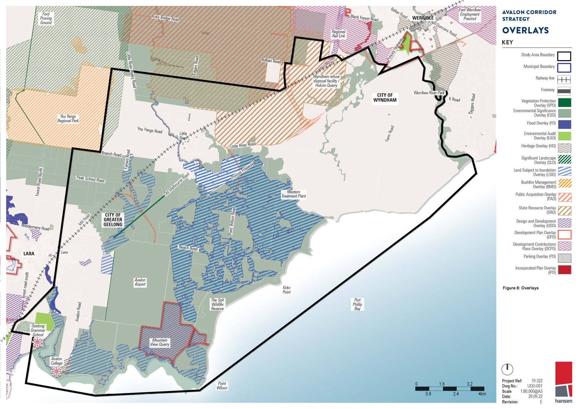
Port Phillip Bay

C)
Proiect Ret owgNo.: -_
Scale
oate:

3.3

SUMMARY OF KEY CONSIDERATIONS
Based on the review of strategic land use studies and planning policies, the key strategic considerations for the Avalon Corridor are:
- Management of ongoing airport activities, and facilitation of major future expansion to a full scale international airport.
- Potential for substantial economic activity in and around Avalon Airport for compatible land uses such as commercial, industrial, agricultural and tourism.
- Safeguarding land for the expansion and development of major state infrastructure projects such as the OMR Transport Corridor and Bay West Port.
- Limitations on residential development into important non-urban land, as identified through the GWZ and other policy.
- Importance of environmental protection for key flora, fauna, ecological communities and habitats such as the Western Grasslands Reserve and Ramsar site.
- The importance of protecting and managing identified EIIAs and SERAs within the Avalon Corridor.
To further summarise the desktop analysis, matters of strategic influence to the Avalon Corridor also include:
- Various planning policies and strategies - which reinforce a physical green break between the
outer edge of metropolitan Melbourne (Werribee) and Geelong, including the Western Grasslands Reserve.
- The possible Avalon Airport Rail Link - which is safeguarded through PAO14 in the Greater Geelong Planning Scheme.
- The OMR Transport Corridor - which is incorporated within the Wyndham Planning Scheme and has an indicative timeframe of completion within 15-30 years.
- The WIFT - which is currently under investigation, with Infrastructure Victoria indicating up to 5 years for finalising planning and 10-30 years for construction.
- Bay West Port - which has been nominated by Infrastructure Victoria as the preferred location for the Melbourne’s second container port terminal and is targeted for operations from around 2055.
- The Western Treatment Plant (WTP) - Melbourne Water is investigating options for increased community access to select areas through regional cycling path connections, bird watching and ecotourism opportunities that are compatible with the site’s primary purpose and environmental values.
- Avalon Airport - acknowledged as a significant land use and economic, employment and tourism generating asset for the region.
- West Growth Corridor Plan - which includes the Mambourin East and Werribee Junction Precinct Structure Plans (PSPs). These PSPs are designated for primarily industrial and related activity.
These future industrial areas will be influenced by and have an influence on future activities within the Avalon Corridor.
- East Werribee National Employment and Innovation Cluster (NEIC) - although the status and potential timing for future development of the NEIC are unknown, it remains of contextual
relevance given the site is located just outside the Avalon Corridor and will be guided by the East Werribee Employment Precinct PSP.
- Avalon Airport Master Plan (2015) - which was endorsed by the Commonwealth Department of Defence in 2015 and sets out the long term vision of the expanded operations of the airport over
the next 20 years. While this Master Plan sits as a reference document within the Greater Geelong Planning Scheme, updates to the Avalon Airport Master Plan are ongoing. Further work is
required to secure ongoing operations (both current and future) and protect the option for a third cross runway. This will require further protections within the relevant Planning Schemes (both
Greater Geelong and Wyndham).
- Lara Structure Plan (2011) - which guides any future development and land use change within the Lara township.
- Little River - while Little River does not have a Structure Plan, it is constrained by a number of surrounding land uses and other considerations including Avalon Airport, WTP and existing zoning.
- Land use buffers - for sites such as WTP, Wyndham RDF, Holcim Quarries (WA184 and WA420), Mountain View Quarry (WA41) and an approved extractive industry site south of Little River (WA980). Specific buffer analysis identified that potential odour impact arising from landfill operations is the most important consideration for setting buffer distances, where sensitive uses are within medium to high risk areas. Specific modelling further determined that areas of medium to high risk of odour may extend beyond the ‘default’ EPA 500 metre buffer distance, although some areas of encroachment would need consideration through later PSP processes.

3.3

  - Basalt Dimension Stone Quarry (WA980) - which is located to the north of Avalon Airport and was granted permission to develop a new materials recycling facility on site through Planning Permit PP-852-2015 issued by CoGG.
  - Point Wilson Munitions Facility - depending on the types of munitions to be stored by the
Department of Defence in future, buffers distances may be required once the facility is fully
operational. Early advice indicates that an ‘Outer Explosive Ordnance Safety Arc’ of 1.5 to 2.0 kilometres should be maintained.
  - Industrial land supply - although considerable supply in Greater Geelong was identified in the 2018 study, there is a lack of land to accommodate large scale industrial uses requiring buffer zones of 1 kilometre from sensitive uses.
  - Wurdi Youang / the You Yangs - as a prominent landscape feature and visual backdrop, as well as a site of cultural significance. Limited protection for the foothills of the You Yangs is currently offered by SLO1.
  - EIIAs, WAs and SERAs - a number of extractive industry values and operating quarries are present in the Avalon Corridor. These are protected through different planning and land
use controls.
  - GWZ and peri-urban land - the Victorian Government is undertaking strategic planning work to strengthen the role of Melbourne’s green wedges and wider peri-urban areas. This work
underpins the intent of the Avalon Corridor Strategy to protect and reinforce the green break between Melbourne and Geelong.
  - Melbourne Sewerage Strategy (2018) - a 50-year strategy developed by Melbourne Water, Greater Western Water, South East Water, Western Water and Yarra Valley Water, which outlines how
the sewerage system needs to be transformed into a resource recovery system to enhance its contribution to public health, the environment and affordable essential services. Water for Life - a
50-year strategy under development by Melbourne Water, Greater Western Water, South East Water, Western Water and Yarra Valley Water, which seeks to provide a secure water future for Greater
Melbourne and build system resilience and manage future climate variability.
  - Flood risks - which are associated with the low lying coastal wetland interface of the Avalon Corridor. Flood risk will increase as a result of climate change, sea level rise and coastal
erosion. It is important to ensure land use and development is compatible with flood risk, to the satisfaction of Melbourne Water as the floodplain management authority.

LAND USE ANALYSIS POLICY
4.0
  - Land Use Analysis Policy 47
  - Major Land Uses 47
  - Land Size and Ownership 50
  - Buffer Separation And Amenity Management 51

LAND USE ANALYSIS

Established land uses within the Avalon Corridor are outlined below and illustrated on Figure 10.

MAJOR LAND USES
The major land uses within the Avalon Corridor include:
    - Princes Freeway
    - Melbourne-Geelong rail line
    - Western Treatment Plant (WTP)
    - Avalon Airport
    - Point Wilson Munitions Facility
    - Extractive industries and quarries (various locations)
    - Wyndham RDF
    - Agriculture
    - Township of Little River
    - Township of Lara
    - Education facilities, including Geelong Grammar and Avalon College
    - Cherry Creek Youth Justice Facility
    - Crown land and coastal conservation reserves
    - Aquaculture (onshore and offshore), including Bates Point Aquaculture Fisheries Reserve
These major land uses are described briefly below:
    - The Princes Freeway transport corridor constitutes a dual, divided road carriageway with 3 lanes in each direction. Due to carriageway width and treatment the Princes Freeway effectively bisects the Avalon Corridor into a northern and southern precinct.
    - The Melbourne-Geelong rail transport corridor consists of three running lines, with the eastern two being broad gauge (BG) intrastate lines servicing mainly passenger trains to Geelong and
the third western line being a standard gauge (SG) single bi-directional intrastate line. Two train stops are located with the Avalon Corridor at the townships of Lara and Little River. Although the
rail alignment creates a physical barrier through the landscape, it is not a substantial as the divide created by the Princes Freeway.
    - The largest single land use and land holding within the Avalon Corridor is the WTP, comprising approximately 10,500 hectares. The WTP provides an essential service, treating over half
of Melbourne’s sewage. Land uses and activities across the site include treatment lagoons,
resource recovery (recycled water, biosolids and biogas), agriculture, biodiversity conversation, wetland and grassland ecosystems, heritage conservation, education and tourism (recreational birdwatching). Other relevant considerations include:
      - Approximately 5,000 hectares of the site is competitively outsourced for broad acre
agriculture, which is a compatible land use within the sewage treatment odour buffer and makes use of recycled water produced on site. Agriculture is also compatible with the
biodiversity conservation function of WTP and overall land management needs.
      - In addition to low-cost sewage treatment, the site is a Ramsar-listed wetlands of international significance, forming a major segment of the Port Phillip Bay (Western Shoreline) and Bellarine Peninsula Ramsar site. Over 300 bird species have been recorded on site and the lagoons
and foreshore supports over 120,000 waterbirds including internationally significant migratory birds. Melbourne Water is obligated to protect these values under the Environment Protection and Biodiversity Conservation Act (EPBC Act) 1999.
      - Biodiversity offset credit sites have been established under DELWP’s program on WTP land parcels north of the Princes Freeway. Additional sites are being explored, including south of the freeway. These require on-going protection under the biodiversity offset credit program, limiting potential future land use changes.

4.1

    - A further concentration of land use and activity is associated with Avalon Airport, which
comprises approximately 1,750 hectares. Although all current operations of the airport are
concentrated towards the northern end of the site and all flights are currently accommodated on the existing north-south runway, the Avalon Airport Master Plan (2015) outlines future
development and land use across the landholding. The Master Plan accommodates a second
north-south aligned runway and third east-west aligned runway. Land use and development within the Avalon Corridor must not impact on the ability to develop these additional runways.
    - The Department of Defence (DoD) Point Wilson Munitions Facility is a 326 hectare site located
to the south of Avalon Airport, which has been operating since 1961 and is the only government owned importation facility capable of large scale movement of explosive ordinances. It is the
primary importation and storage point for munitions in Australia, including capability for road and sea transportation. Recognising the importance of this asset, DoD has commenced remediation of the existing waterside infrastructure in order to recommence large scale importation. Due to
the use of the site for munitions storage and distribution, ‘safety arc’ separation distances are a relevant consideration to the Avalon Corridor Strategy.
    - A number of existing and proposed quarries are located within the Avalon Corridor.
Currently operational quarries include the Holcim Quarry (to the northeast) and the Mountain View Quarry (south of Avalon Airport). A further two approved quarries are located to the north
and west of the Holcim Quarry. EIIAs across the Avalon Corridor indicate the likely presence of additional extractive resources to be protected for possible future extraction.
    - The Wyndham RDF is located adjacent to the Holcim Quarry and functions as a solid waste
landfill. The RDF effectively fills in previously excavated quarry areas and has EPA approval to ‘mound’ buried refuse above ground level to a height of approximately 24 metres.
    - Open rural landscapes located north of the Princes Freeway are located within the FZ or GWZ. Landholdings in this area have become fragmented over time and are generally not of adequate scale to accommodate broad acre farming. Smaller scale cropping and livestock grazing is
undertaken on various land parcels.
- The township of Little River is located within the Avalon Corridor to the north of the Princes Freeway. While Little River straddles the municipal boundary between WCC and CoGG, the township core is located to the east of the alignment of the Little River waterway (within
Wyndham). Urban zoned land (Township Zone and Low Density Residential Zone) within Little
River covers approximately 40 hectares. Surrounding this township core, the wider extent of Little River consists of dwellings on larger rural allotments within the FZ or GWZ.
- The eastern extent of the Lara township extends into the Avalon Corridor along its western edge, with land use being predominantly residential within the Rural Living Zone (RLZ). The urban
zoned land of Lara (predominantly General Residential Zone) within the Avalon Corridor covers in the order of 890 hectares.
- Apart from two small clusters of dwellings to the west and south of Avalon Road, there are no other dwellings or residential settlements located to the south of the Princes Freeway.
- Part of the Geelong Grammar campus is located within the south western corner of the Avalon Corridor. Geelong Grammar also owns the Avalon College campus located on Avalon Road.
- Cherry Creek Youth Justice Facility is a newly constructed youth justice facility located southwest of the Wyndham RDF, between the Princes Freeway and Melbourne-Geelong rail line.
- Werribee River Regional Park is located along the eastern boundary. Parks Victoria has plans for a redevelopment of the park which will improve accessibility down to the bay from the Princes
Freeway.

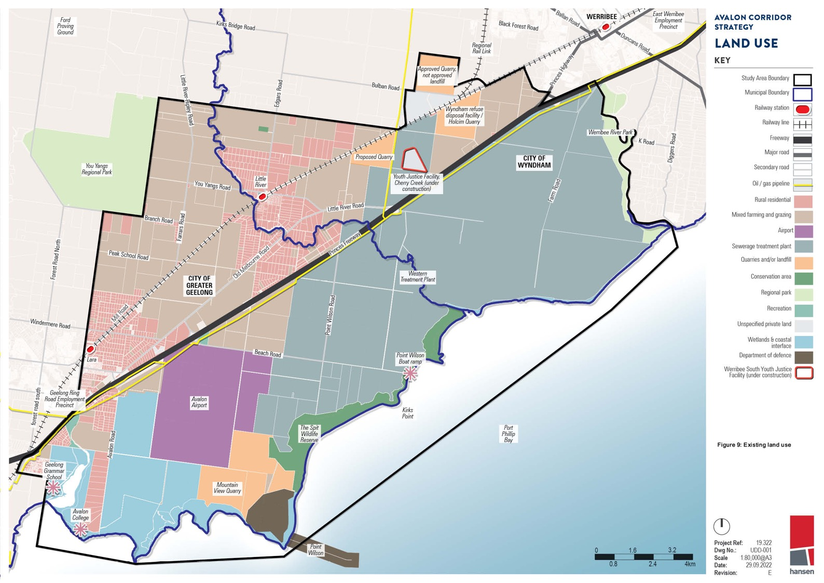

WERR\BE

East Werribee Employment
Precinct
AVALOt-1 coRR\OOR SlRA1EGY

Port

4.2

LAND SIZE AND OWNERSHIP
The following observations are made regarding patterns of land size and ownership within the Avalon Corridor:
    - The WTP constitutes the single largest land holding within the Avalon Corridor, comprising approximately 10,500 hectares of state government owned and controlled land.
    - Other larger land holdings within the Avalon Corridor include Avalon Airport, the former Cheetham Saltworks site, Mountain View Quarry, Point Wilson Munitions Facility, Wyndham RDF and Holcim Quarry, the coastal foreshore reserve (Crown land) and Cherry Creek Youth Justice Facility.
    - The smallest land holdings generally constitute residential properties within the township centres of Lara and Little River, along with rural residential lots surrounding these settlements.
    - The balance of land within the Avalon Corridor is broadly characterised by moderate to large rural properties which are relatively free of development and exhibit an open rural landscape character.

BUFFER SEPARATION AND AMENITY MANAGEMENT
Amendment VC175 (gazetted May 2020) updated the Planning Policy Framework and Clause 53.10 - Uses with Adverse Amenity Potential to improve how the planning system addresses buffers for amenity, human health and safety impacts. Major current and proposed land uses in the Avalon Corridor that require buffer separation and amenity management include:
    - Western Treatment Plant (WTP)
    - Bay West Port
    - Avalon Airport (see Section 5)
    - Point Wilson Munitions Facility
    - Quarries, including designated SERAs
    - Wyndham RDF
Buffer considerations for these land uses are outlined below:
    - There is potential for odour impacts associated with the WTP. Odour risk during routine operation is generally low due to the large scale of the site and associated buffer distances between
treatment plant odour sources and the site boundary. Odour risk increases in association
with periodic maintenance activities which can result in complaints. Increasing development encroachment will increase the odour risk profile of the WTP.
    - Avalon Airport has the potential to create amenity impacts through aircraft noise. Aircraft noise is likely to increase in the future as airport operations are expanded to accommodates the possible second and third runways. This issue is separately addressed in Section 5.
    - Safety arc separation distances are relevant to the Point Wilson Munitions Facility. These distance requirements vary depending on the type of munitions being stored at the site. Department of
Defence have advised that a safety arc of 1.5 to 2 kilometres from the external boundaries of the site should be maintained.
- Buffer separation and amenity impacts from the Wyndham RDF and various quarries in the Avalon Corridor are similar as both are subject to EPA guidelines and requirements. In 2015,
WCC commissioned GHD to prepare the Wyndham Vale Buffer Study: Environmental Audit Report
to assess potential environmental risks. The report also outlines appropriate buffer distances for sensitive land uses and considers potential land uses that may be located within the buffer distance.
- Landfills have the potential to impact the surrounding environment and community by discharging landfill gas for more than 30 years after closure. Any building or structure is considered a
sensitive use due to the risk of explosion or asphyxiation. Consequently, land use change or development near landfills require specific consideration.
- Potential odour impact arising from landfill operations is also an important consideration for
setting buffer distances. Specific modelling further determined that the area of medium to high risk of odour may extend beyond the default EPA 500 metre buffer distance. However, a default 500m buffer for landfills that accept putrescible waste (also known as Type 2 landfills) should
be applied in accordance with EPA Publication 788.3 Best Practice Environmental Management: Siting, design, operation and rehabilitation of landfills (2015).
- In an operational capacity, basalt quarries tend to utilise blasting to prepare rock for excavation. Buffers of 500 metres may be required in some situations.
- As part of the SERA project, the Victorian Government introduced a State Resource
Overlay (SRO). SRO2 extends around existing quarries in certain circumstances to discourage encroachment of incompatible uses.
- The future Bay West Port is likely to require buffers for noise and light. This should be further
investigated by state government, with a focus on potential impacts to migratory birds at WTP. WTP forms part of the Port Phillip Bay (Western Shoreline) and Bellarine Peninsula Ramsar site.
Buffers will be needed to protect treatment lagoons and other critical habitats from potential
noise, light and pollution associated with the proposed port infrastructure. Project design should minimise requirements for buffers on WTP land.
- It is also important that the ‘agent of change’ principle is considered as part of any new land use or development within the Avalon Corridor. Under this principle, the person or organisation who seeks to change the existing environment has a responsibility for mitigating any offsite impacts.

AVALON CORRIDOR STRATEGY | 4.0 LAND USE ANALYSIS 51

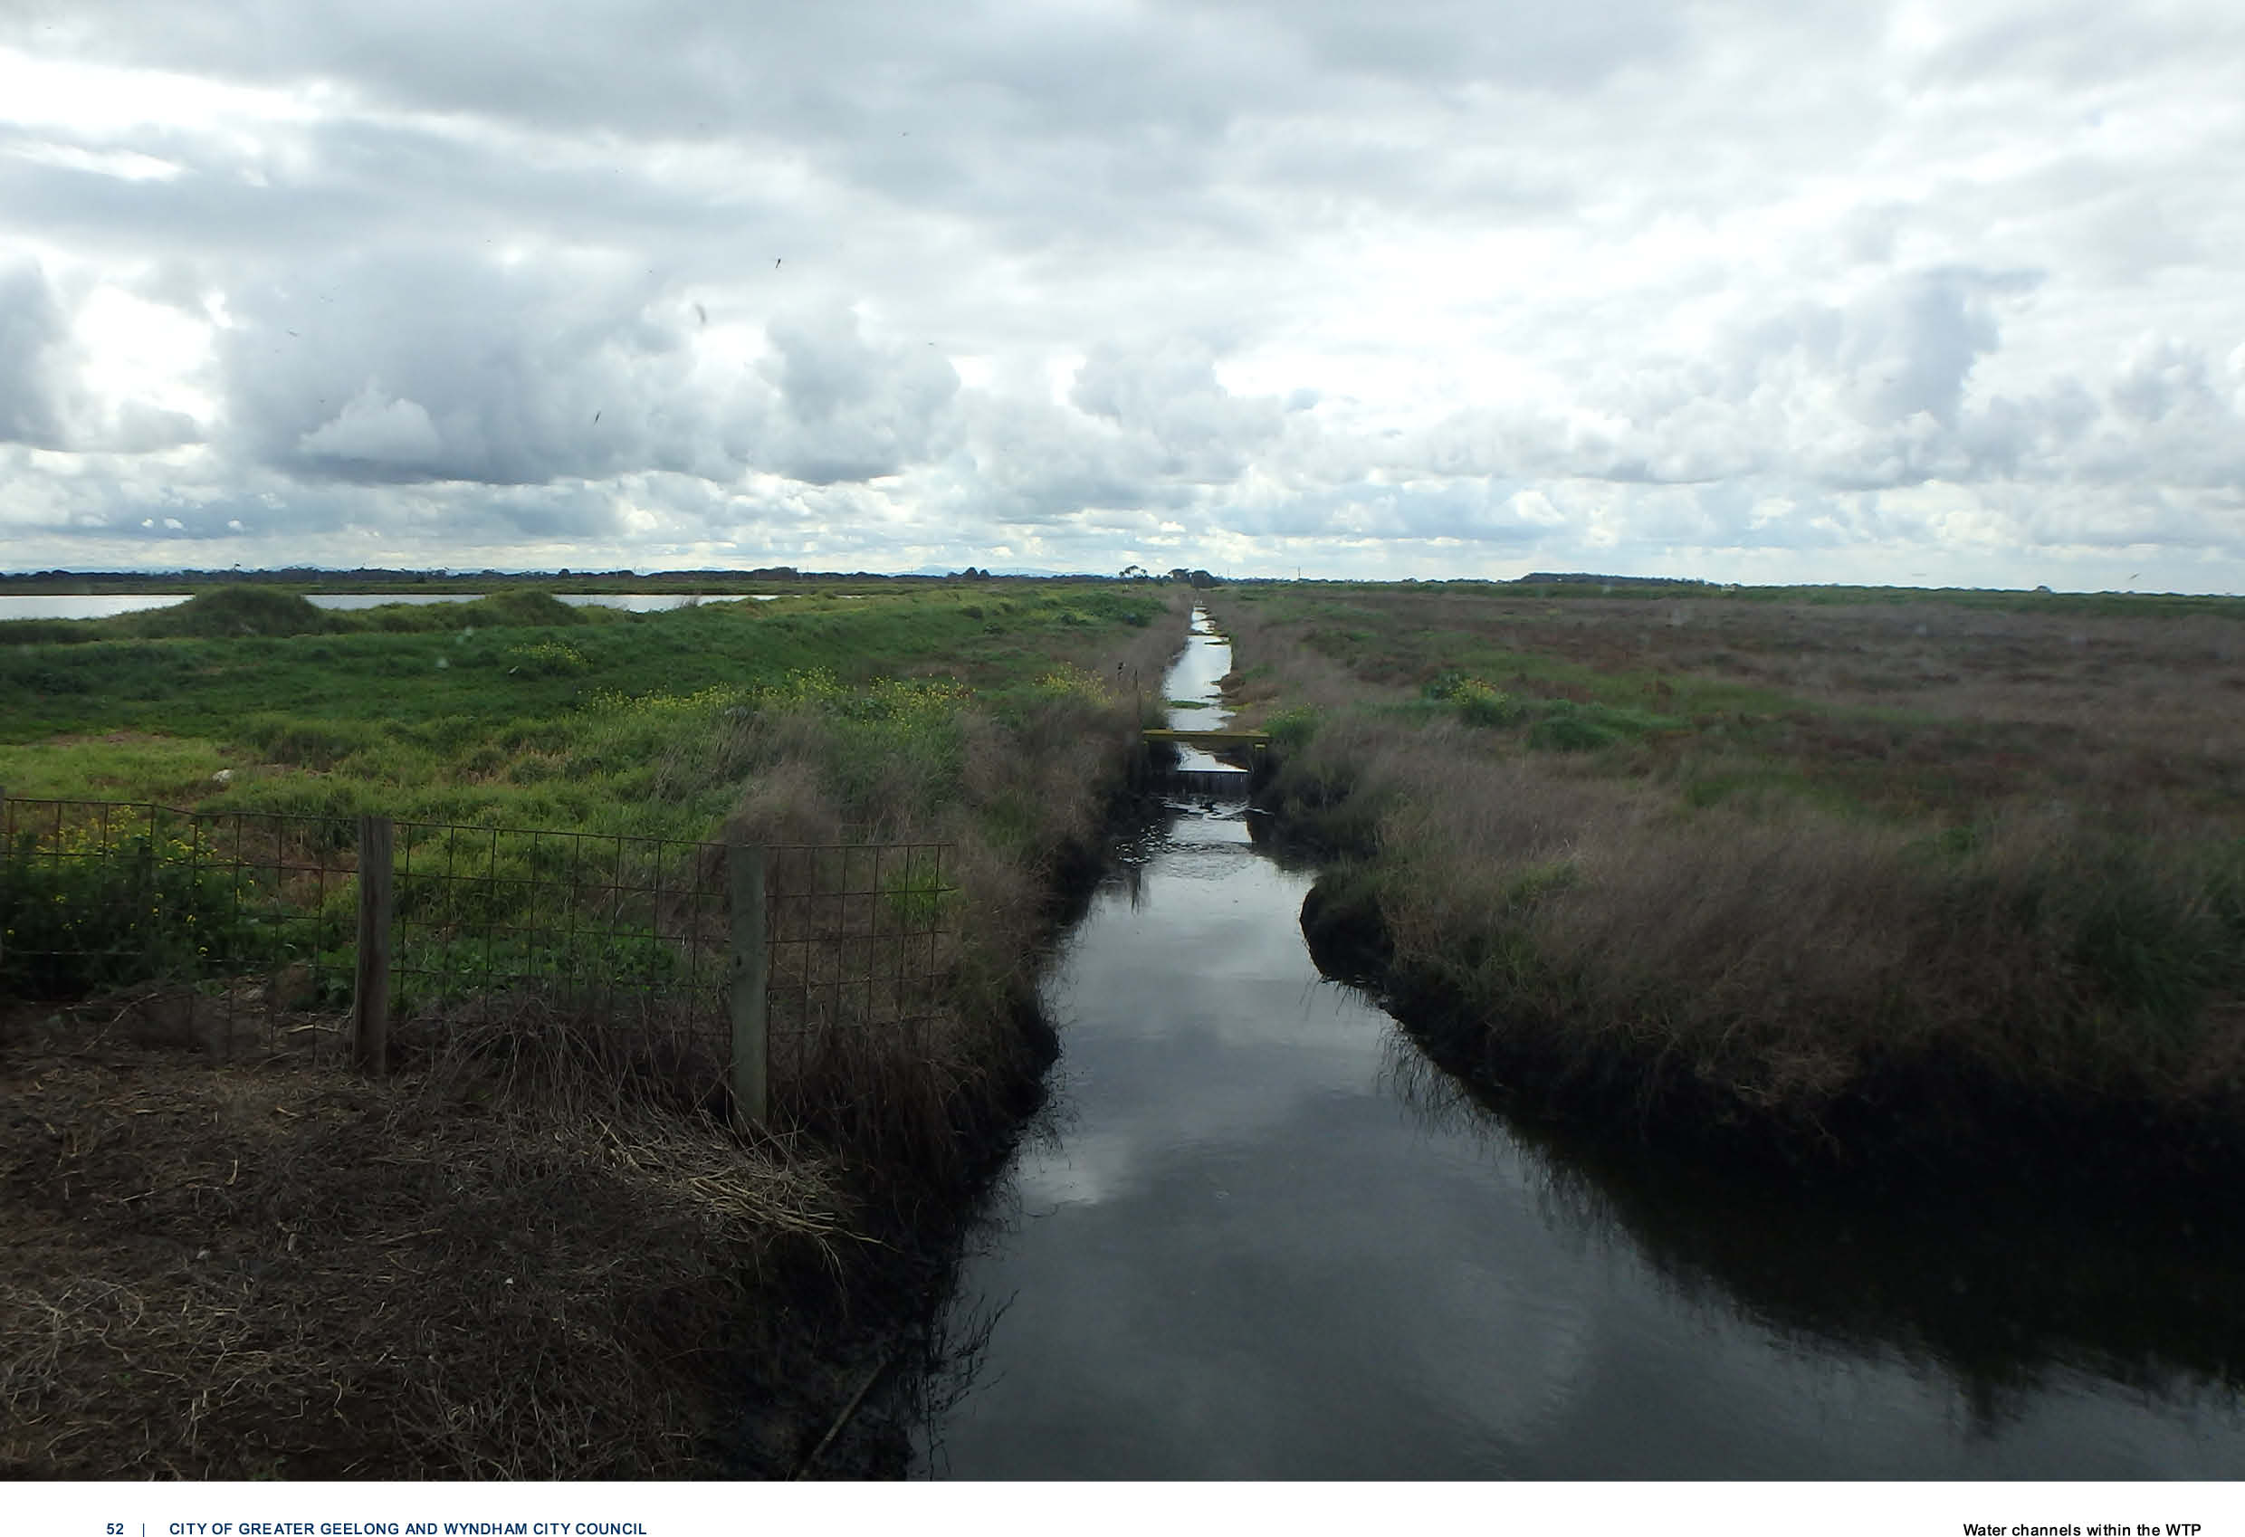

52 | CITY OF GREATER GEELONG AND WYNDHAM CITY COUNCIL Water channels within the WTP

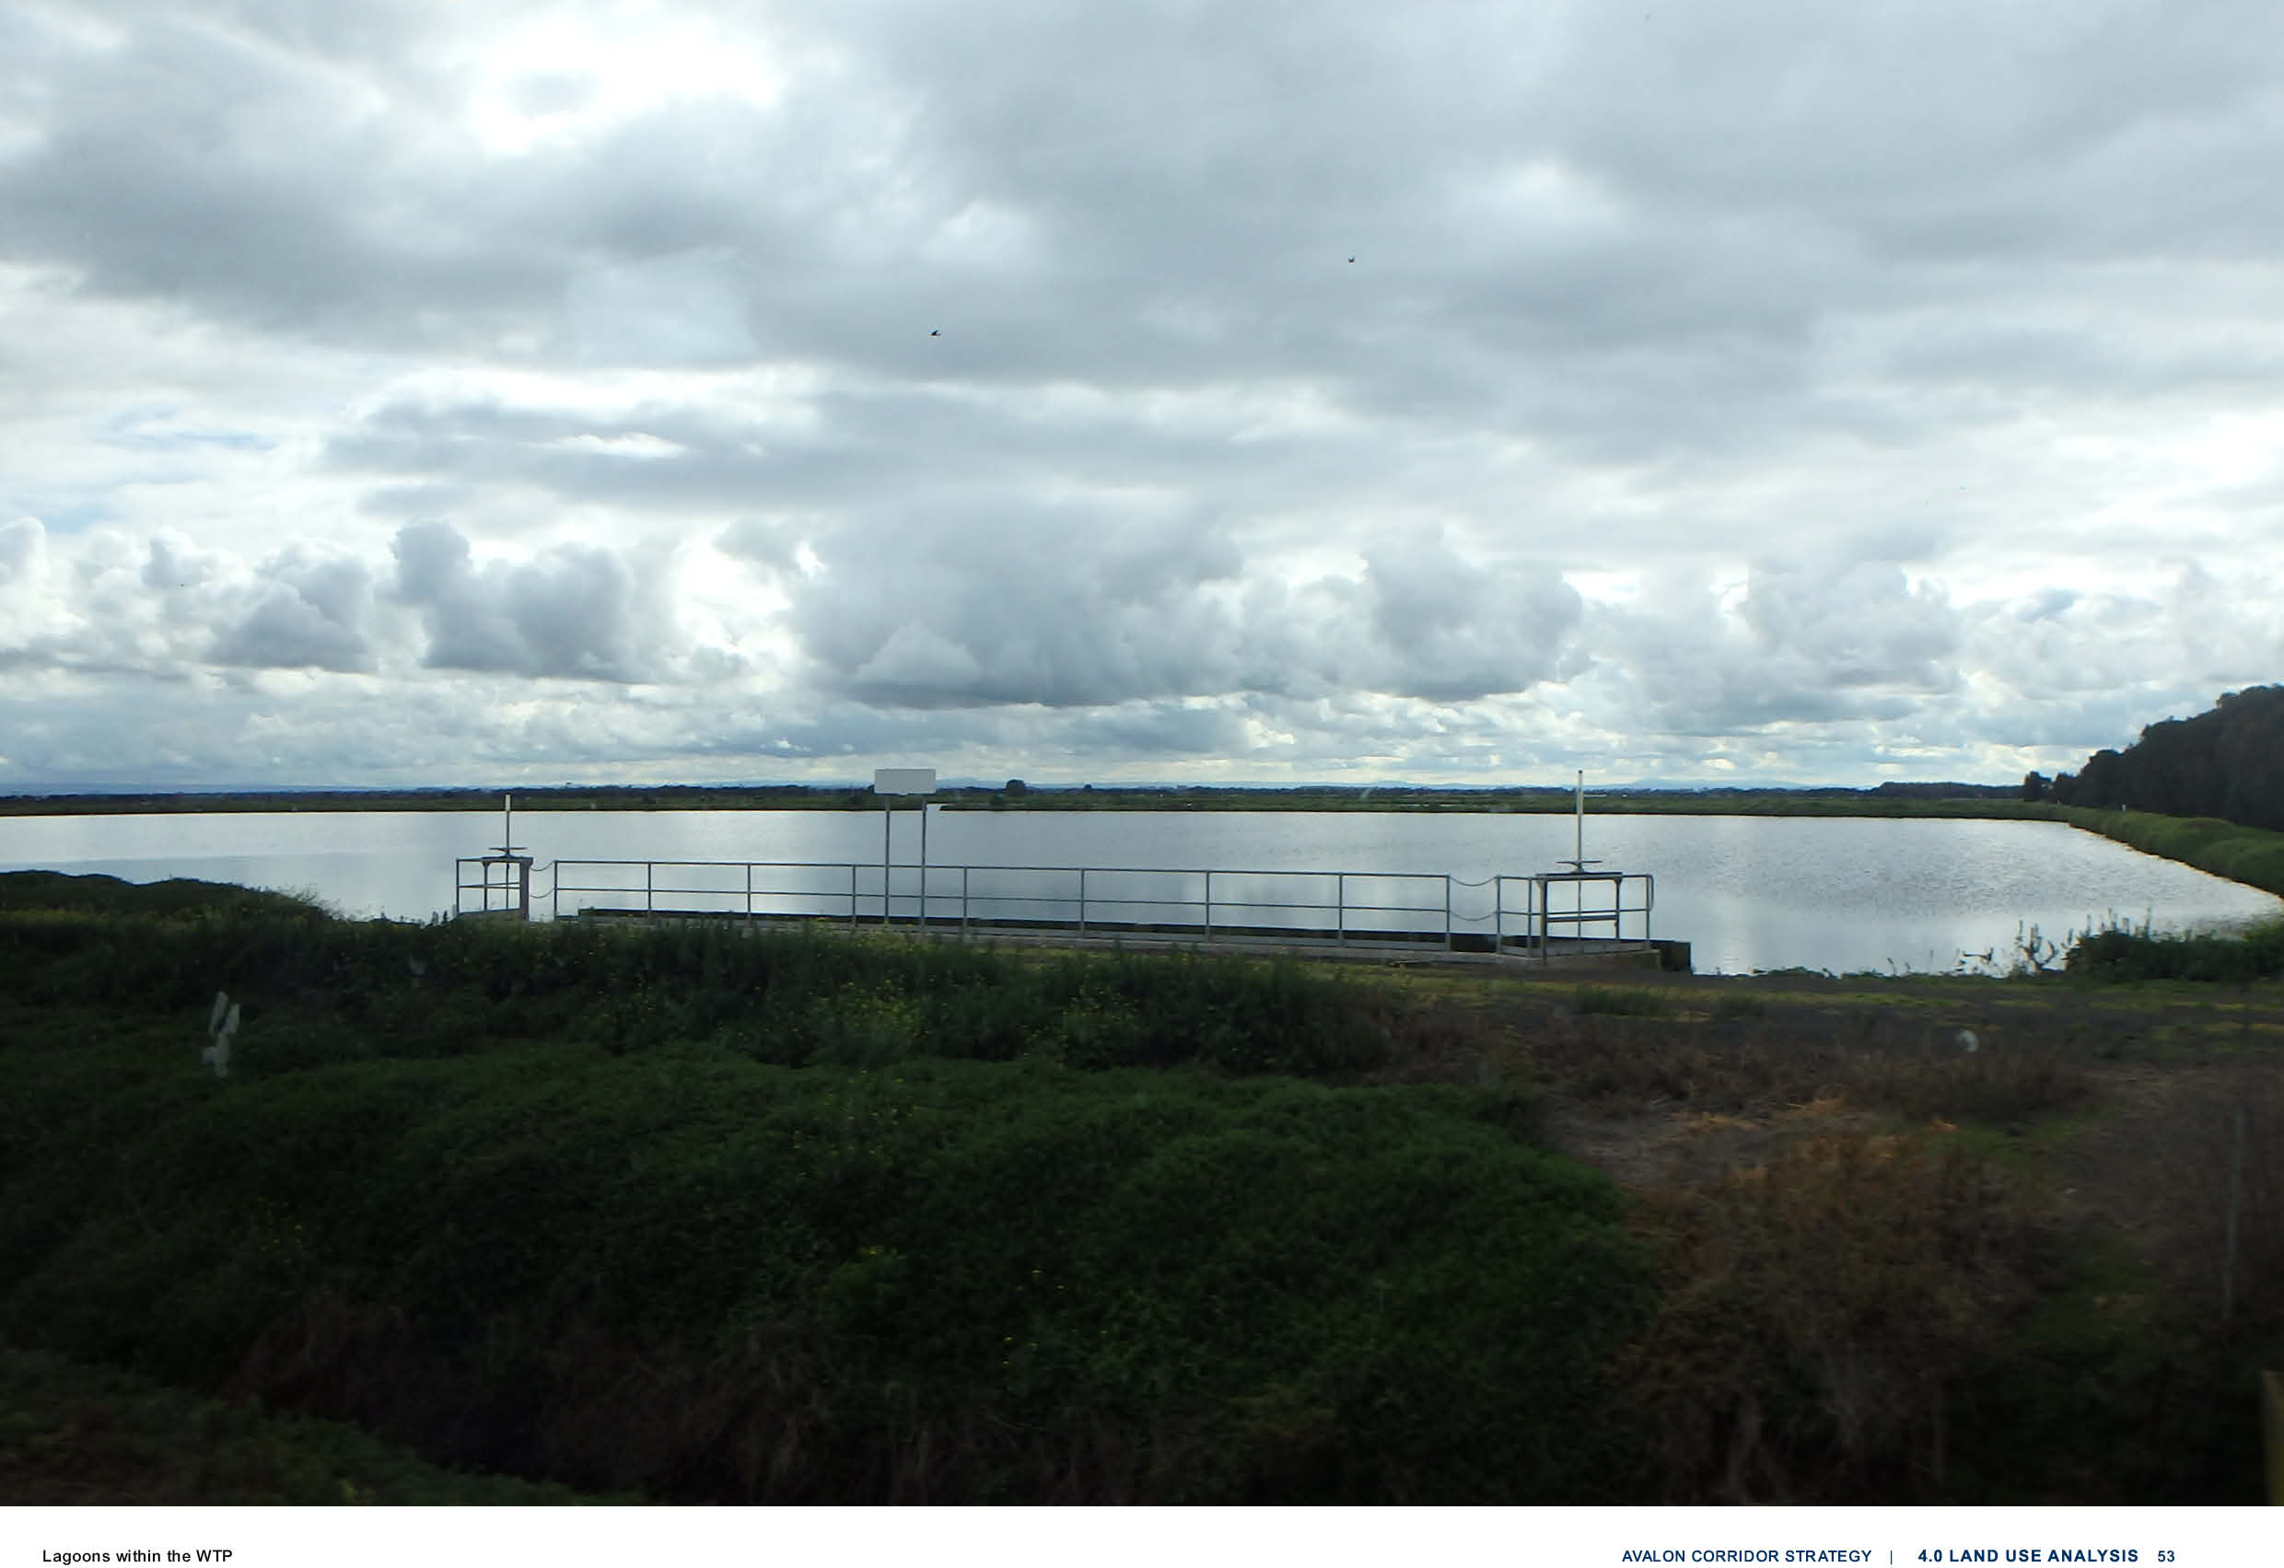

AVALON AIRPORT ANALYSIS
5.0
  - Avalon Airport Analysis 55

AVALON AIRPORT ANALYSIS

Avalon Airport comprises approximately 1,750 hectares of land, including land on long-term lease
from the Commonwealth Government. Existing operations of the airport are currently concentrated towards the northern end of the site and all flights are accommodated on the existing north-south
runway, which is anticipated to meet demand for the next 20 years.

The Avalon Airport Master Plan (2015) was endorsed by the Commonwealth Department of Defence in 2015 and sets out the long-term vision for expanded operations and activities of the airport.
This intended expansion will elevate Avalon Airport’s role and function as Melbourne’s second international airport.
Development of Avalon Airport is guided by four principles:
- Increasing passenger operations
- Increasing freight operations
- Increasing retail and commercial developments
- Increasing technical aviation operations.
The Master Plan is underpinned by the following objectives:
- Maintain the safe, secure and efficient movement of passengers, freight and aircraft at all times.
- Ensure airport capacity is increased and delivered on-time to accommodate forecast demands.
- Strengthen the airport’s role as a major driver of economic activity in the Geelong, Melbourne and regional Victoria region.
- Realise commercial, retail and industrial development opportunities that are compatible with on- site aviation activity to support economic development and employment creation in Victoria.
- Improve the integration of the airport with the surrounding community; and maintaining the curfew free status of the airport.

The Master Plan outlines future development plans as well as details regarding the future need
for ground transport and surface access. Excluding current runways and associated taxiways, the total developable land at Avalon Airport is around 1,600 hectares. The Master Plan identifies seven developable precincts for the airport to guide its expansion and defines individual development
objectives and indicative land uses into the future. For land on the airport site not designated for core airport activities, the Master Plan indicates precincts for non-aviation business, retail, commercial,
and industrial facilities. The associated Land Use Plan provides details on the management and
permissibility of development within the precincts.

With regard to airport activities, the Master Plan provides for the establishment of a new high capacity parallel runway (to the east of the existing north-south runway), as well as a third cross (east-west)
runway to reduce conflict between general aviation activity and commercial airline and charter activity, and to accommodate aircraft during periods of strong cross winds.

While Avalon Airport has the potential to expand into the future without curfews or any other
operational constraints, expansion is likely to create offsite amenity impacts through additional
aircraft noise, particularly as the airport grows through the potential development of the two additional runways. Of note, the Australian Noise Exposure Concept (ANEC) contained in the current Master
Plan extends directly over the township of Little River.

In 2020, Avalon Airport commissioned GHD to undertake a revised ANEC analysis of future
operations. The 2020 ANEC models the second parallel runway, though does not model the third cross runway. From consultations with Avalon Airport, it is understood that the 2020 ANEC will be
used to produce a new 20-year Australian Noise Exposure Forecast (ANEF) to replace the existing ANEF endorsed by the Commonwealth Government (via Airservices Australia) in 2011. While not
governed by the provisions of the Airports Act 1996, conditions within the Avalon Airport lease require the preparation of an ANEF on a 20 year basis.

Following endorsement of the ANEF, an update to the Master Plan has been flagged by Avalon Airport in light of emerging strategic directions and considerations around the need for the third cross (east- west runway). Any proposal to remove the third cross runway would have to be justified on a detailed evidence base by the airport operator. The operator would also need to demonstrate that removal of the third runway would not result in any safety or efficiency implications, nor limitations to long-term capacity and growth opportunities at Avalon Airport.

However, as the potential third cross runway is included in the current endorsed Avalon Airport
Master Plan (2015) – and no subsequent updates to the Master Plan have yet been formalised – the Avalon Corridor Strategy acknowledges and protects the opportunity for this runway into the future. It is recommended that all subsequent detailed planning processes for land at and around Avalon
Airport should take a conservative approach on the potential development of the third cross runway. Ongoing work on an updated Master Plan will not change the overall intent of the Strategy to protect operations of the airport and the option of the third runway.

Of further relevance, Amendment VC218 (gazetted May 2022) made changes to the VPPs by updating the Planning Policy Framework to further implement the National Airports Safeguarding Framework in Victoria.

5.0

Clause 18.02-7S Airports and airfields seeks to ‘strengthen the role of Victoria’s airports and airfields within the state’s economic and transport infrastructure, guide their siting and expansion,
and safeguard their ongoing, safe and efficient operation.’ It contains strategies to protect airports
and airfields from incompatible land use and development and lists the current Avalon Airport Master Plan (2015) as a relevant policy document.
Avalon Airport has yet to submit a revised Master Plan showing its preferred ultimate runway
configuration for Commonwealth and Victorian Government approval. Any update to the Master Plan will need to be endorsed by the Commonwealth, before Minister for Planning approves a VC amendment to include it in the PPF at Clause 18.02-7S.

Following the preparation and approval of the revised Master Plan, it is recommended that an updated ANEF for the preferred ultimate capacity runway system is adopted into relevant planning schemes
and additional controls are pursued, such as:
- An Airport Environs Overlay (AEO)
- Protections to address other safeguarding matters, such as public safety areas, intrusions into protected airspace and risk of wildlife strike.

56 | CITY OF GREATER GEELONG AND WYNDHAM CITY COUNCIL Existing aircraft hangers at Avalon Airport

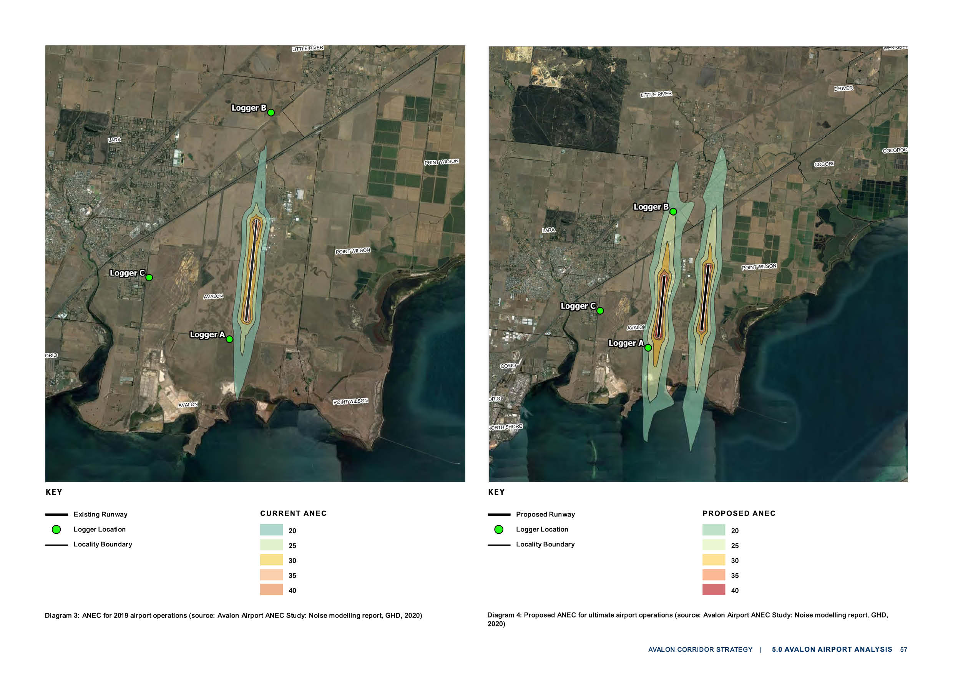

ECONOMIC ANALYSIS
6.0

  - Economic Analysis 59
  - Economic Overview 59
  - Land Available For Development 60
  - Relevant Economic Trends 60
  - Key Issues and Opportunities 61
  - Economic Planning Implications 61

ECONOMIC ANALYSIS

A preliminary Economic Outlook Report was prepared by Ethos Urban in 2021 to inform the Avalon Corridor Strategy. The report provides an overview and assessment of economic issues and
opportunities associated with proposed land use change and development. The land supply and job
creation figures provided in this section are estimates only and will be refined through future planning processes.

ECONOMIC OVERVIEW
The following sections highlight the economic outlook for the Avalon Corridor, including consideration of issues and opportunities and associated implications that will need to be considered in the future
planning of this area.

The aim of the Strategy is to set the direction for the future use and development of land between Geelong and Werribee. It examines how the green break between Lara and Little River can be
protected, with potential for the wider area to accommodate utilities and other complementary employment generating uses. Identifying the land use and development potential of the state significant Avalon Airport is also a strategic aim of the project.

Resident population numbers in the surrounding region incorporating the cities of Greater Geelong
and Wyndham are expected to increase from 547,880 people in 2021 to reach 865,000 people over the 20-year period to 2041. This represents a net increase of +317,120 residents at an average annual rate of +2.3%.

Almost two-thirds of the increase in population (64%) is forecast to be generated in WCC (a net increase of +203,080 residents), with the remainder occurring in Greater Geelong (+114,040 residents).

The resident labour force in Greater Geelong and Wyndham combined is expected to increase by an estimated +148,530 people over the period 2021 to 2041. This estimate takes into account the growth in resident population noted above and application of the estimated (crude) labour force participation rate in Greater Geelong and Wyndham (46.8% combined).
The Avalon Corridor has the potential to accommodate a substantial
share of new jobs for the region, in light of its unique attributes. These attributes include:
- A high level of accessibility via the Princes Freeway, the Geelong Ring Road, the planned OMR Transport Corridor and the Geelong-Melbourne rail line.
- Major infrastructure including Avalon Airport, WTP and the proposed Bay West Port.

An analysis of existing and future infrastructure in the Avalon Corridor highlights several important opportunities to support investment and job creation. Avalon Airport is a significant feature, which has potential to attract further investment and development (both airport and non-airport related). Such investment would likely strengthen the airport’s existing economic role in the Avalon Corridor and generate net economic benefits extending further afield.

Other important factors supporting the Avalon Corridor’s development include road and rail
transport infrastructure, especially the OMR Transport Corridor that will provide links to the north of metropolitan Melbourne and to the Hume Freeway. Development of a new seaport at Bay West
in the long-term would alleviate container freight capacity pressures for the Port of Melbourne and strengthen the Avalon Corridor’s freight role.

Potential for the development of tourism associated with the Avalon Corridor is noted which builds
on existing events such as the Avalon Airshow, the nearby Wurdi Youang / You Yangs, environmental features (including the Ramsar wetlands with associated bird species) and the development of bike paths and coastal walks. The Port Phillip Bay Trail will be a visitor attraction when the missing link
between Wyndham and Greater Geelong is completed. However, this is unlikely to result in the Avalon Corridor becoming a noted visitor destination in its own right (such as the Bellarine Peninsula).

6.2–6.3

LAND AVAILABLE FOR DEVELOPMENT
Land identified in the Avalon Corridor with potential to be developed for employment purposes totals approximately 1,800 hectares in net developable area (NDA). This land supply would indicatively
support around 36,000 jobs, assuming 1 hectare of developable employment land would support 20 full time equivalent (FTE) jobs.

Assuming annual employment land consumption is equivalent to 15 percent of the recent uptake per annum of industrial land in Greater Geelong and Wyndham (combined), the Avalon Corridor could accommodate an estimated additional 5,040 direct FTE jobs over a 20 year period. This is
equivalent to 14 percent of the 36,000 additional FTE jobs that could be supported if full development of identified land was to occur. As such, existing and potential land supply in the Avalon Corridor
exceeds the likely area of land that could be developed over the next 20 years.

However, employment figures outlined in this section are highly indicative and are based on
preliminary modelling only. Job estimates and targets will be further refined through subsequent planning processes, once precinct boundaries have been confirmed and land uses have been
further refined.

While an employment land demand and supply assessment is applicable to Avalon Corridor, future development will also be informed by its strategic location between Melbourne and Geelong and key infrastructure such as Avalon Airport. In this regard, the actual development trajectory of the Avalon Corridor is influenced by a wide range of factors and a significant level of uncertainty.

In light of the large quantum of developable land, it will be necessary to avoid fragmented
development that detracts from functionality and economic viability of new employment areas. A key outcome of the Avalon Corridor Strategy is therefore to identify strategic areas for future employment land supply.

A number of development proposals for land located nearby Avalon Airport demonstrate
private sector interest in developing sites for industrial and employment activities. An important
consideration for the Avalon Corridor Strategy is to ensure that development is complementary to existing uses (such as Avalon Airport) and consistent with broader strategic planning directions for Greater Geelong and Wyndham.

RELEVANT ECONOMIC TRENDS
The Avalon Corridor Strategy needs to acknowledge that emerging economic trends, such as
continued economic expansion in Asia and population growth in Melbourne and Geelong, will impact on the locational decisions of firms and prospects for future investment and employment. The
Strategy needs to be sufficiently flexible to respond to changing circumstances, as technological advancements and associated impacts become more clearly understood.

Important trends that influence future development include continuing growth in agricultural exports, digital technologies and advanced manufacturing, economic growth among Australia’s trading
partners and the Avalon Corridor’s linkages to metropolitan Melbourne and regional Victoria where population growth continues.

60 | CITY OF GREATER GEELONG AND WYNDHAM CITY COUNCIL

6.4–6.5

KEY ISSUES AND OPPORTUNITIES
Key issues:
    - The need to protect the Avalon Corridor as a location for state significant infrastructure, including the Avalon Airport, Melbourne Water WTP, road and rail infrastructure, Wyndham RDF, quarries
and the future Bay West Port.
    - The need to accommodate for substantial population and labour force growth in western metropolitan Melbourne (including Wyndham) and Greater Geelong.
    - The need to ensure that development of new employment precincts and services in the Avalon Corridor does not undermine existing industrial land provisions or centre hierarchies of Greater Geelong and Wyndham.
    - The need to identify owner-occupier opportunities for long term, confident investment in
the precinct, noting that Avalon Airport is largely made up of leasehold land owned by the Commonwealth Government.
Key opportunities:
    - Promoting the development potential of the Avalon Corridor as an important employment node, with state significant infrastructure and associated services.
    - Ensuring the continued growth and development of Avalon Airport and recognising its national
and international function for air travel and freight, as well as its role as an emerging employment hub.
    - Land surrounding Avalon Airport benefits from the transport gateway and presents an opportunity for a varied scale of owner-occupier investment in development which is compatible with the
airport, such as commercial and industrial land uses.
    - Potential to position the Avalon Corridor as a tourism gateway and focal point in the region, as well as to support tourism opportunities associated with existing assets including the Avalon Airshow, Wurdi Youang / the You Yangs, the Port Phillip Bay Trail, ecotourism associated with coastal wetlands (such as bird watching and guided educational tours) and other rural focused tourism uses.

ECONOMIC PLANNING IMPLICATIONS
Given the Avalon Corridor’s unique economic context and attributes, there is an opportunity for development of employment precincts with modern business park attributes. Employment precincts could accommodate
activities such as:
    - Metropolitan and regional scale warehouse and distribution facilities exceeding 40,000 square metres in built floorspace
    - Commercial offices within business park settings, supported by retail and other amenities.

However, it is important that the Avalon Corridor Strategy achieves a balance between:
    - Potential economic benefits, including creation of local jobs and employment opportunities; and
    - Potential impacts on activity centre hierarchies and the orderly supply of employment land in the wider region.

To reach a balance between these considerations, the Avalon Corridor Strategy provides broad guidance on the type and extent of future employment uses to be established within the Avalon Corridor.

TRANSPORT ANALYSIS
7.0

  - Transport Analysis 63
  - Princes Freeway 63
  - OMR Transport Corridor 64
  - Avalon Airport Access Upgrades 64
  - Broader Road Network 65
  - Bay West Port Freight Network 65
  - Future Freight Network 67
  - Rail Network 68
  - Aviation Infrastructure 69

TRANSPORT ANALYSIS

To inform preparation of the Avalon Corridor Strategy, GHD prepared a background Servicing Report in 2021. The Servicing Report includes an analysis of transport and utility infrastructure servicing
considerations to ensure the early identification of potential issues and opportunities. The report also includes a high level summary of relevant policies and strategies of relevance to the Avalon Corridor. This section contains a summary of key transport considerations from the GHD Servicing Report.

Key transport policies and strategies of relevance to the Avalon Corridor include:
    - Delivering the Goods: Victorian Freight Plan (Victorian Government, 2018)
    - Outer Metropolitan Ring/E6 Transport Corridor Planning Assessment Report (VicRoads, 2009)
    - G21 Regional Growth Plan (G21, 2013)
    - Avalon Airport Master Plan (Avalon Airport, 2015)
    - Extractive Resources in Victoria: Demand and Supply Study 2015-2050 (PWC, 2016)
    - Victoria’s 30-Year Infrastructure Strategy (Infrastructure Victoria, 2016)
    - Preparing Advice on Victoria’s Future Port Capacity: Discussion Paper (Infrastructure Victoria, 2016)
    - Second Container Port Advice - Evidence Base: Discussion Paper (Infrastructure Victoria, 2017)
    - Avalon Airport Ground Transport Plan (Avalon Airport, 2017)
    - Helping Victoria Grow: Extractive Resources Strategy (DEDJTR, 2018)
    - Western Rail Plan (Victorian Government, 2018)
    - Independent review of the Victorian Ports System (Victorian Government, 2021)

PRINCES FREEWAY
The Princes Freeway is the key piece of road infrastructure in the Avalon Corridor. It is controlled
and managed by the DoT, as the only declared road within the study area. The Princes Freeway is the major transport link between Melbourne and Geelong, generally comprising a three lane carriageway in each direction (six lanes in total).
The Princes Freeway is a link to many key features within and beyond the Avalon Corridor including:
    - Avalon Airport
    - Western Treatment Plant (WTP)
    - Point Wilson Defence Facility
    - You Yangs Regional Park
    - Werribee Regional Park
    - Werribee Open Range Zoo
    - A number of operating and planned quarries
    - Townships of Lara and Little River

There are currently no major upgrade plans for the Princes Freeway between Geelong and Werribee.
However, there is future provision for the addition of an extra lane in each direction, should this be required.

The Princes Freeway is susceptible to flooding in the section running over the Lollypop and Skeleton Creek catchments, following the equivalent of a 1-in-30-year rain event. There is not currently a
mitigation strategy for flood events, though DoT have indicated that possible future raising of the
road would be preferred over realignment. The frequency and severity of flood events is expected to increase in future years as climate change and sea level rise impact on the ability of the catchment to drain to Port Phillip Bay.

Closures to the Princes Freeway occurred in 2018 during the Little River fires. These closures
highlight a lack of resilience and alternate route options that exists in the case of unplanned closure. The only workable alternative is to re-route traffic via Bacchus Marsh. There are no state government plans at present to develop an emergency by-pass route.

7.2–7.3

OMR TRANSPORT CORRIDOR
The Outer Metropolitan Ring (OMR) Transport Corridor provides an opportunity for the investigation of rail connections in the short to medium term and orbital road and rail traffic solutions around
Melbourne in the long term. The entire corridor is around 100 kilometres in length and includes a planned road and rail system that will connect the Princes Freeway through Werribee, Melton,
Tullamarine, Craigieburn, Mickleham, Epping and Thomastown. The current alignment of the OMR was gazetted in 2010 by means of Public Acquisition Overlay (PAO). However, further works are
required prior to any construction, including relevant environmental and planning approvals.

The planning for the OMR provides options for an ultimate freeway standard road, capable of up to four lanes in each direction.
The OMR aims to:
- Create better connections to key international transport hubs such as Melbourne Airport, Avalon Airport and the Port of Geelong.
- Improve access to the proposed Donnybrook/Beveridge Interstate Rail Terminal.
- Serve as an important travel and freight route to interstate and regional destinations
- Link residential and employment growth areas in the north and west of Melbourne.
- Improve access in this major employment corridor, which includes Avalon Airport, Werribee, Melton, Melbourne Airport, Mickleham and Donnybrook.

While current planning suggests development of the OMR is well into the future, the development of greenfield land either side of the corridor is progressing quickly up to its boundaries.

The OMR connection to the Princes Freeway presents significant opportunities for transport and freight movement in Melbourne’s West, with a particular focus on improving connections between
the Princes Freeway and the Western Freeway, where increased efficiencies could be achieved with earlier development.
The OMR is also expected to require the reconfiguration of the existing Little River Road Interchange to increase separation distances. The on ramp will be integrated with the Point Wilson Junction
further to the west.

Further details on the role of the OMR Transport Corridor relating to road and rail freight movements associated with the future Bay West Port is addressed in Section 7.5.

AVALON AIRPORT ACCESS UPGRADES
Avalon Airport has developed a ground transport plan for future road upgrades within and surrounding the airport in conjunction with DoT. Upgrades will respond to the anticipated growth in passenger movements through the airport, in order to address road safety and capacity issues.
Proposed upgrades include:
    - Reservation of a potential rail link corridor through a PAO
    - Upgrade to terminal access from Beach Road
    - Upgrade and expansion of parking within the terminal
    - Upgrade of the Beach Road and Princes Freeway interchange
    - Upgrade works to the Point Wilson Road Interchange.

Upgrade works to the Point Wilson Road Interchange involve increasing the design speed for ramp
connections onto the freeway. This forms part of an interim stage of works, which seeks to align Point Wilson Road Interchange as a future airport access route. The future plan contemplates Point Wilson Road working in conjunction with Beach Road with separation of passenger and freight vehicle
movements.

The future upgrade of the Point Wilson Interchange will also involve the realignment of Little River Road on the northern side of the Princes Freeway. Modifications will ensure sufficient clearance is maintained for the future OMR intersection.

7.4–7.5

BROADER ROAD NETWORK
Broader considerations that influence the present and future road network within the Avalon Corridor include:
    - The long term role of Point Wilson Road for passenger and freight access to Avalon Airport and Little River.
    - Upgrades to the Beach Road and Avalon Road Interchange to accommodate future passenger and freight growth.
    - New roads and traffic demand expected to arise from the predominantly industrial areas of Werribee Junction and Mambourin East.
    - Quarrying activity associated with SERA identified land is expected to require new freight movements.
    - Future upgrades to Ison Road and Armstrong Road will result in an existing road becoming an
arterial road (four lanes) under the control of DoT. The road will create an additional connection to the Princes Freeway via the Geelong Road Interchange at Werribee.
    - The creation of a new Parks Victoria site intended for recreational use and sporting facilities, with vehicle access proposed via William Thwaites Drive (off the Werribee Intersection).
    - The existing Peak School Road functions as an access point from the Princes Freeway through to Bacchus Marsh Road and presents a potential bypass between Lara and Little River, with direct
connection to the Barwon Prison Precinct.

BAY WEST PORT FREIGHT NETWORK
In 2018, Infrastructure Victoria recommended that Victoria’s second container port be located at Bay West Port on the western shores of Port Phillip Bay. The development is proposed to include a land reclamation area of around 4.5 kilometres in length that will be connected to the shore via a multi
lane bridge and connect to Victoria’s road and rail freight network. Bay West Port is proposed to be
integrated into the region’s future network of logistics facilities, including the WIFT (located outside of the Avalon Corridor).

Following Infrastructure Victoria’s recommendations, the location of the Bay West Port was confirmed as state policy in the Victorian Freight Plan (2018). Updates to the Victorian Commercial Ports
Strategy (expected in 2023) will provide further detail on the scope of the Bay West project and update the proposed timing based on current forecasts.

In recognition of the state government’s commitment to the Bay West Port there is a short term need to undertake detailed design to further define the port site location and supporting land connections.
Following this, there is a need to protect associated buffers and transport connections through appropriate planning controls.

Landside development of the Bay West Port is planned to include a future rail marshalling facility west of or within the OMR Transport Corridor (to be confirmed). Associated port precinct areas are also to be confirmed through specific studies proposed as part of the updated Victorian Commercial Ports
Strategy. The Infrastructure Victoria report considered options for locating port precinct areas within the land reclamation footprint, on WTP land or in land areas either side of the existing rail corridor.

The OMR will include a future southbound connection into the Bay West Port to enable road and rail
freight movements. Whilst this southbound connection has not yet formally reserved, planning for the Bay West Port assumes that future north-south road and rail connections to the OMR will be elevated over the Princes Freeway, while east-west road connections will be at grade with the Princes Freeway.

The preferred Bay West Port road network concept includes a westbound and northbound connection at the OMR intersection, as well as a separate eastbound interchange located closer to Farm Road or the Werribee Main Road intersection.

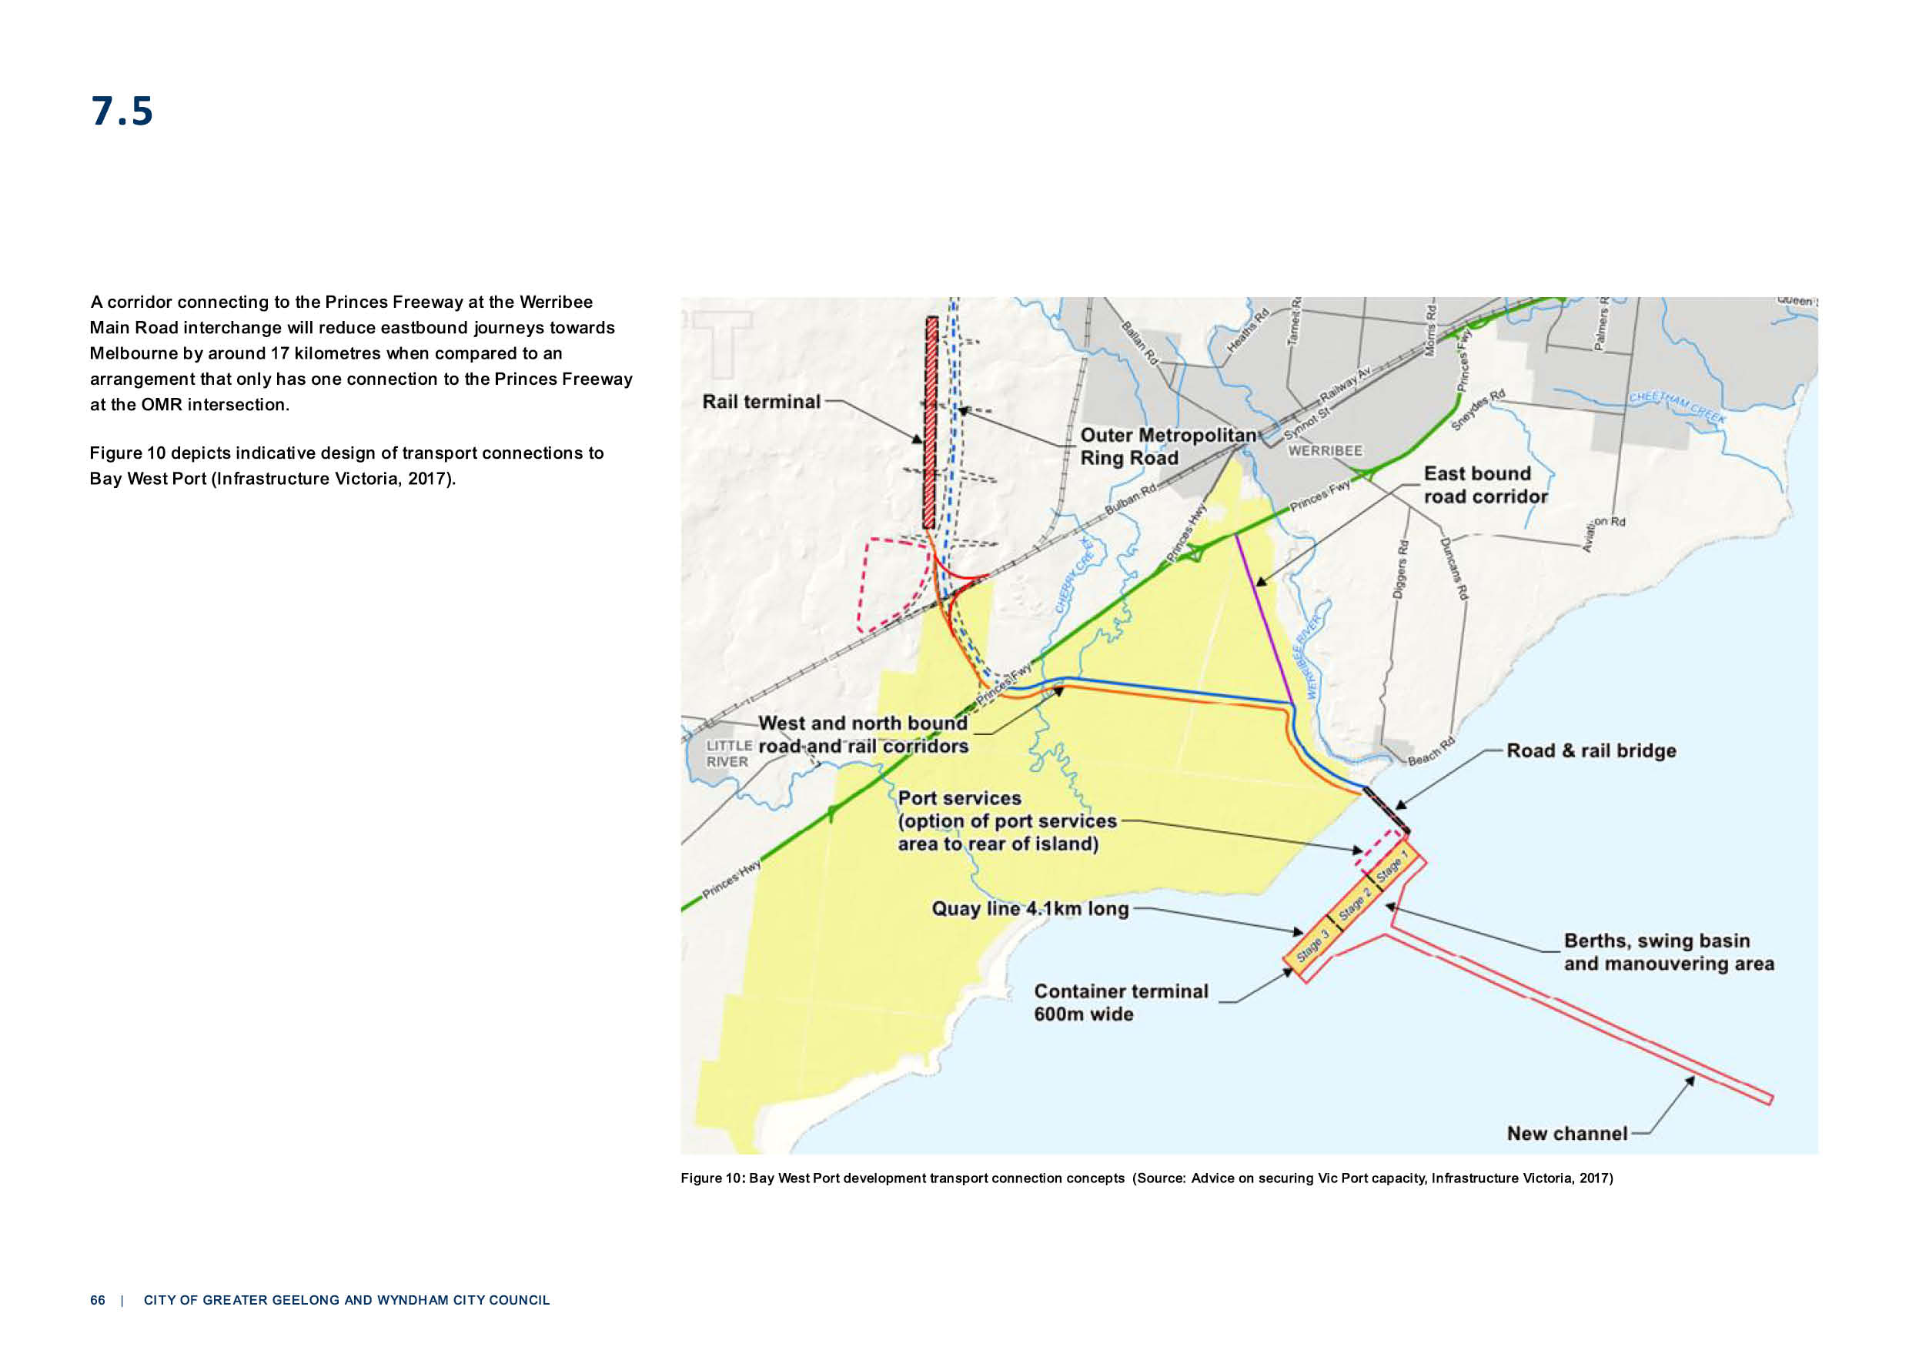
7.5

A corridor connecting to the Princes Freeway at the Werribee
Main Road interchange will reduce eastbound journeys towards Melbourne by around 17 kilometres when compared to an
arrangement that only has one connection to the Princes Freeway at the OMR intersection.

Figure 10 depicts indicative design of transport connections to Bay West Port (Infrastructure Victoria, 2017).
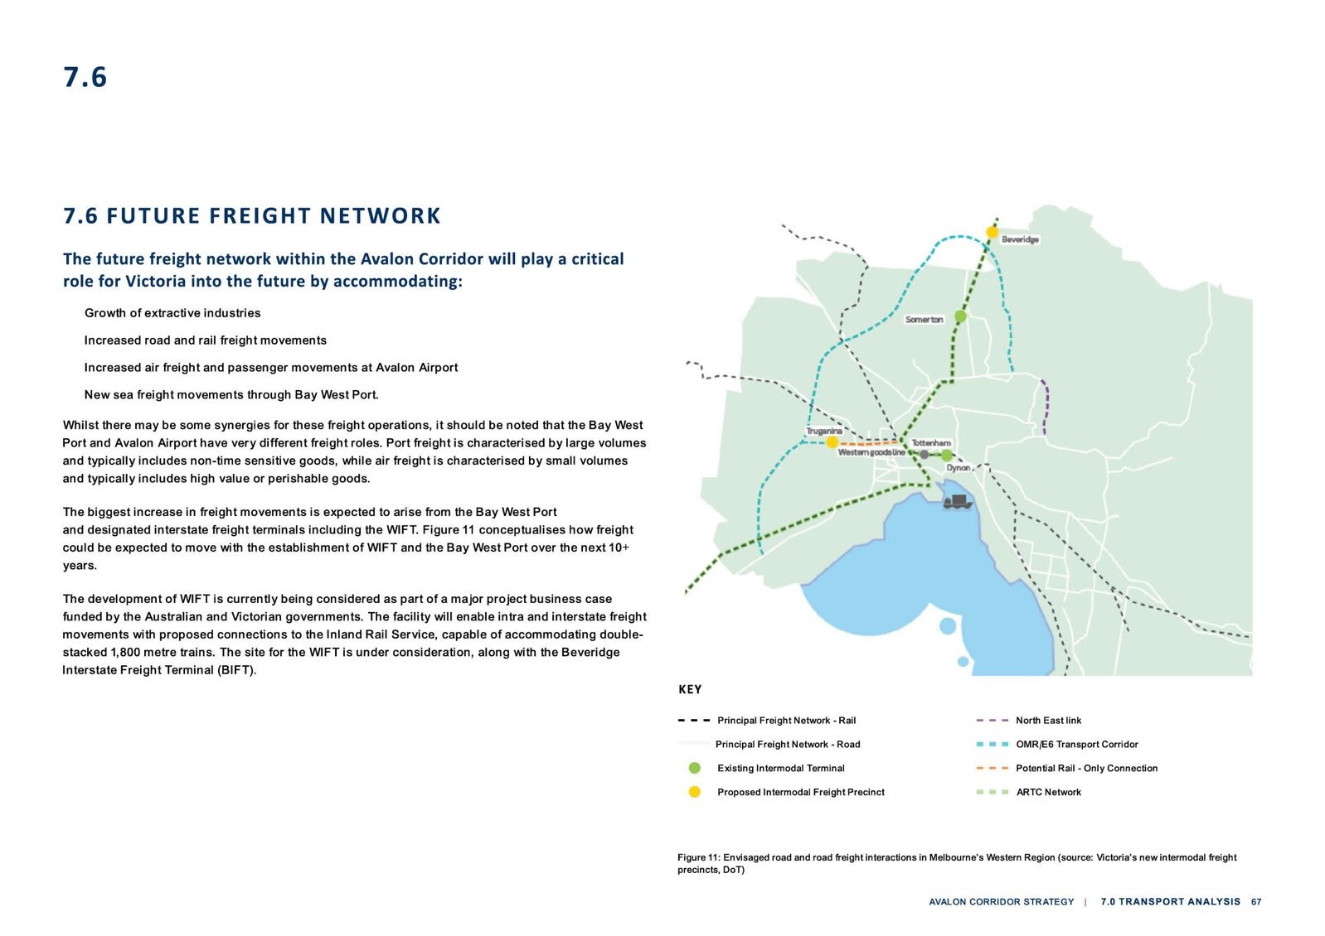

7.6

Figure 11: Envisaged road and road freight interactions in Melbourne’s Western Region (source: Victoria’s new intermodal freight precincts, DoT)

7.7

RAIL NETWORK
The existing rail network within the Avalon Corridor can be summarised as follows:
    - One standard gauge (SG) track servicing freight (north of BG tracks)
    - Two broad gauge (BG) tracks servicing passengers (south of SG track)
    - Existing Train stations at Lara and Little River
    - Current V/Line passenger connections to and from Geelong via the Regional Rail Link (RRL)
    - Historic passenger connection to from Geelong via the Werribee Line (up until 2015), which includes separate SG and BG tracks to Melbourne
    - Current freight connections via the Werribee Line.
Future rail infrastructure development can be summarised as follows:
    - Freight rail connections to Bay West Port (refer to Section 7.5)
    - Rail connections within the OMR Transport Corridor (refer to Section 2.4.2)
    - Western Rail Plan including Geelong Fast Rail (refer to Section 2.4.3)
    - Suburban Rail Loop (SRL), a 90 kilometre rail line linking major services from the Frankston to Werribee Lines via Melbourne Airport (refer to Section 2.4.3)
    - Connection of the RRL to metro services via Werribee Station
    - Potential rail line and station to service Avalon Airport
    - Potential duplication of the standard gauge ARTC line through the Avalon Corridor.

7.8

AVIATION INFRASTRUCTURE
Existing aviation infrastructure at Avalon Airport can be summarised as follows:
    - Provides both passenger and freight transport services.
    - Currently houses a 1.5 million litre fuel storage facility which is serviced by regular road tankers out of the Geelong Refinery site.
    - Currently has mains connection supplies for gas, water and electricity.
    - Sewerage is a standalone system incorporating detention ponds on the site, without an EPA discharge license.
Future aviation infrastructure can be summarised as follows:
- The Avalon Airport Master Plan (2015) includes direction for infrastructure development over the next 20 years.
- The long-term plan includes two additional runways with one running parallel (north-south) to
the east of the existing runway, and another potential runway running in an east-west direction to allow for full utilisation of the airport in any weather condition.
- Development of the second parallel runway will likely be 20 years away, while the potential development of the third cross runway would be 50 years away (if determined necessary).
- Future provision for a direct fuel connection between the existing VIVA Energy pipeline and the airport. Estimated cost is up to $20 million dollars and is currently not financially viable.
- Planned pipeline to connect to on site fuel storage facility within 10 years, with fuel tanks to be relocated to the western boundary.
- Possible future rail link to Avalon Airport via the Geelong-Melbourne rail line has been reserved by a Public Acquisition Overlay (PAO) and is reflected under the current Avalon Airport Master Plan (2015).
- Although a rail reservation to the airport has been designated through a PAO, Avalon Airport has indicated their preference for a new airport station to be located on the existing rail line, rather
than bringing a new rail connection into the airport terminal.
- Avalon Airport has indicated a longer term plan to relocate the main terminal to the same location as their preferred station location (along the existing rail line). However, this proposal needs to be considered against the completion of the Geelong high speed rail investigation and objectives to protect the existing green break north of the Princes Freeway.

UTILITIES SERVICING ANALYSIS
8.0
  - Utilities Servicing Analysis 71
  - Summary of Corridor Utilities 71
  - Gas and Oil Pipelines 72

UTILITIES SERVICING ANALYSIS

Alongside analysis of transport infrastructure, the background Servicing Report prepared by GHD (2021) provides utility infrastructure considerations for the Avalon Corridor to ensure the early
identification of potential issues and opportunities. This section contains a summary of the report’s findings and recommendations.

SUMMARY OF CORRIDOR UTILITIES
Consultation was undertaken with utility providers to understand high level servicing opportunities and constraints in the corridor.
Key findings:
    - There is limited access to reticulated sewerage infrastructure in the corridor and the sewer system does not cross south of the Princes Freeway.
    - No feasibility investigation has been completed for sewering the Avalon Corridor but initial discussions with Barwon Water have indicated that it could be possible.
    - An alternative to a mains connected sewer network could include the potential use of small package systems with reuse of waste effluent for beneficial purposes.
    - Currently there is no recycled water reticulation to properties within the Avalon Corridor, despite the immediate proximity of the Melbourne Water WTP and Barwon Water Northern Treatment
Plant in Corio.
    - The ability to discharge additional treated wastewater to Corio Bay and other local waterways would need to be further investigated and consider EPA licencing requirements.
    - The Northern Treatment Plant in Corio (just outside the Avalon Corridor) would likely be able to process sewage and produce recycled water for nearby reuse. However, the commercial viability of this would need to be further investigated. A connection to WTP could also be investigated for commercial viability.
    - No major issues were identified from a water supply perspective. Most of the area could be supplied with asset upgrades and extensions to the existing network.
    - Additional feeder mains may be required to service growth in the demand for power from development and operations of Avalon Airport and other employment precincts.
- The Avalon Corridor largely constitutes low lying, flat plains. The majority of flood outlet locations for waterway catchments exist at the coastal interface. Key issues relate to stormwater sediment and retention.
- Flood plains of the Lollypop Creek and Little River systems are known to be extensive and are under further investigation by WCC.
- CoGG recently completed the Lara Flood Study and will be implementing updated LSIO mapping via Amendment C339.
- High pressure oil and gas pipelines traverse the corridor. Future development near these major
pipelines will require further investigation and possible preparation of a Safety Management Study (SMS).

GAS AND OIL PIPELINES
The Avalon Corridor contains a high pressure gas pipeline owned and operated by APA Group, as
well as three oil pipelines owned and operated by VIVA Energy. The high pressure gas pipeline raises a number of technical and planning considerations for adjacent land, including the need to consider
relevant measurement lengths from the pipeline easement.

The general intent is to discourage the establishment of sensitive uses within the nominated
measurement lengths such as community facilities, aged care, hospitals, schools and early learning
centres. Where development or land use change is proposed within a nominated measurement length, a SMS must be prepared in accordance with AS 2885 to assess and reduce potential risks.

There is also a general preference to avoid construction of roads and road crossings over gas
pipeline easements, due to the challenges this can cause to management and maintenance of the
pipeline. Where this is unavoidable, a proponent must demonstrate that the number of crossings has been minimised and that crossings have been designed to be as perpendicular as possible to the
pipeline to minimise the area of impact.

Any proposed landscaping within or nearby the easement should consider the APA Site Planning and Landscape National Guidelines (2020). Relevant considerations include maintaining a line of sight
along the pipeline easement and avoiding large selection of species with large root zones.

The three VIVA Energy oil pipelines in the Avalon Corridor accommodate more than half of Victoria’s fuel requirements and are therefore critical to the state’s economy. The pipelines operate in a single direction only, with the WAG pipeline supplying crude oil to the Geelong Refinery and the WOPL and BOPL pipelines supplying refined oil back to Newport.

The major priority for the VIVA Energy pipelines is to ensure that any development occurring adjacent or near the pipelines meets the current standards, which may differ to the standards that applied
when the pipelines were originally built. The requirements for the VIVA Energy pipelines are similar
to the APA Group gas pipeline, being also covered under AS 2885. An SMS needs to be completed to determine the risk profile of any significant land use change or development adjacent to the pipeline easement and to consider how the risk can be appropriately mitigated.

72 | CITY OF GREATER GEELONG AND WYNDHAM CITY COUNCIL

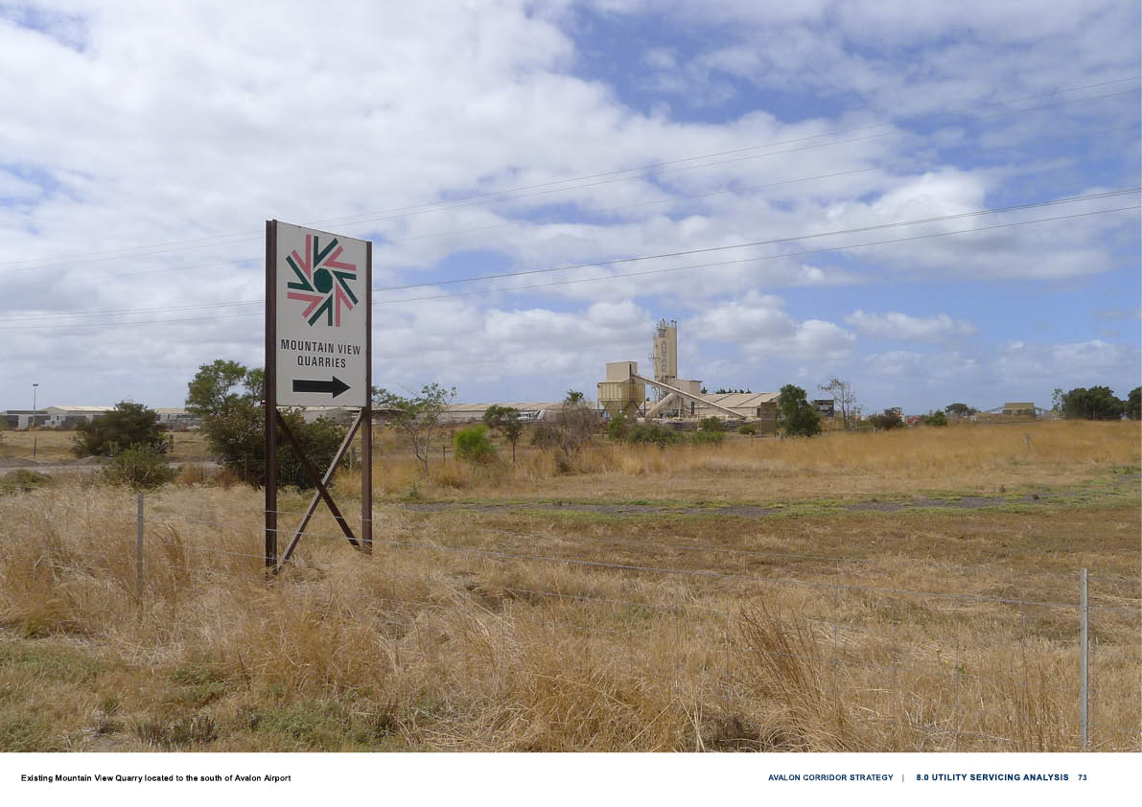

CULTURAL VALUES AND HERITAGE ANALYSIS
9.0
  - Cultural Values and Heritage Analysis 75
  - Aboriginal Cultural Heritage 75
  - Cultural Values Assessment 76
  - Post Contact Heritage 79

CULTURAL VALUES & HERITAGE ANALYSIS

The Traditional Owners of the lands, waters, seas and skies relating to the Avalon Corridor and
surrounding region are acknowledged as the Wadawurrung, who are represented by the Wadawurrung Traditional Owners Aboriginal Corporation (WTOAC) as the Registered Aboriginal Party (RAP).

A background Cultural Values Assessment (CVA) was prepared by Unearthed Heritage and WTOAC in 2021 to inform the Avalon Corridor Strategy. The CVA was informed by the Healthy Country Plan
(WTOAC, 2020), which provides high-level principles, values and strategies for protecting and caring for Wadawurrung Country.

ABORIGINAL CULTURAL HERITAGE
As is illustrated on Figure 12 large sections of the Avalon Corridor are nominated as being ‘areas of
cultural heritage sensitivity.’ Such areas are defined in the Aboriginal Heritage Regulations (2018) (the Regulations) and relate to landforms and soil types where places of Aboriginal heritage significance
are more likely to be located. This generally includes land within 200 metres of named waterways and land within 50 metres of registered Aboriginal cultural heritage sites.

The function of the designation of ‘areas of cultural heritage sensitivity’ is to specifically identify when a Cultural Heritage Management Plan (CHMP) must be prepared under the Aboriginal Heritage Act
(2006).

As noted within the relevant regulations, some land use and development activities are more likely
to harm Aboriginal cultural heritage when carried out in an area of cultural heritage sensitivity. These activities are defined as ‘high impact activities’. If a high impact activity is proposed in an area of
cultural heritage sensitivity, a CHMP must be prepared before the activity can be carried out.
High impact activities generally include buildings and works that result in significant ground disturbance. The specified activities include, but are not limited to:
- Subdivisions of three or more lots
- The construction of three or more dwellings
- The construction of roads, bicycle and walking tracks over 100 metres in length
- Activities that require an Earth Resources Authorisation
- Industrial developments.

Given that large tracts of the Avalon Corridor are considered areas of cultural heritage sensitivity, including the Avalon Airport site and surrounding land, future land use change and development applications for high impact activities would need to undertake more detailed analysis and site
investigations to address the requirement for the preparation and development of a CHMP.

CULTURAL VALUES ASSESSMENT
Unearthed Heritage were commissioned to undertake a Cultural Values Assessment (CVA) of the Avalon Corridor. The aims of this assessment were:
    - To determine the level of previous Wadawurrung and Aboriginal heritage investigation of the study area and the surrounding region, in partnership with WTOAC.
    - To determine the presence of registered Wadawurrung and Aboriginal heritage places within the study area and the surrounding region.
    - To determine the environmental context of the study area.
    - To review the historical and cultural setting of the study area and surrounding region.

In addition to tangible aspects of Wadawurrung and Aboriginal cultural heritage in the
Avalon Corridor, the assessment also considered less tangible, living cultural values and narratives inherent in the landscape.
High level recommendations of the CVA are provided in full below
(with further detailed recommendations included within the CVA itself):
- The WTOAC/RAP supports and recognises the merits in ensuring that the Avalon Corridor retains its non-urban character and that no future residential developments be permitted
outside of existing zoned lands for that purpose. Thus, the WTOAC/RAP recommends that residential development is contained within in existing locations, with no further extensions to developable land in Lara or Little River. WTOAC/RAP recommends that all industrial or
commercial development should be contained to appropriate areas immediately adjacent to Avalon Airport, subject to thorough investigation of potential impacts on Wadawurrung living cultural heritage and the natural and avian environment.
- The WTOAC/RAP recommends that any future planning scheme amendment or land use or
development inside the Corridor needs to embody statutory provisions that require respect of the unalienable spiritual and visual relationship that Wurdi Youang has upon this living cultural
landscape that stretches across the Avalon Plain to the shores of Nerm (Port Phillip Bay). Thus, any future development needs to respect and consciously engage with and be assessed against this relationship.
- The WTOAC/RAP supports maintaining the current nature of statutory and strategic planning instruments and provisions over this Corridor, but would recommend the strengthening and enhancement of these provisions (including VPP 42.01 Environmental Significance and VPP 42.03 Significant Landscape and the associated Schedule 1 to Clause 42.03 provisions) and their geographical scope to better respect and conserve Wadawurrung Country values and
lands and waters attributes (including cultural flows, environmental management of vegetation and water systems, visual connections and cultural landscapes, migratory and inter-tidal bird habitats, and unrecorded sites of Wadawurrung cultural heritage).

76 | CITY OF GREATER GEELONG AND WYNDHAM CITY COUNCIL

9.2

- The WTOAC strongly supports and raises as a matter of urgency that an Aboriginal Cultural Heritage Impact Assessment be undertaken for the foreshore corridor from the mouth of
Werribbi Yulluk (Werribee River) down to Point Wilson to better assess, appraise and identify
resilience measure to prevent future negative impacts to existing Wadawurrung tangible cultural heritage sites and places along this corridor, and especially to provide evidence to underpin an ecosystem-based adaptation response to sea level rise from climate change.
- The WTOAC strongly supports the current Melbourne Water ethos in carefully managing
its fragile ecosystems to enable and support existing and future bird and animal communities, and also ensuring the conservation of extant vegetation communities that possess integrity of species mosaic and host known rare, endangered and vulnerable species.
- The WTOAC invites co-design opportunities with all proponents and project designers to enable the above Recommendations, and any opportunities for Wadawurrung to be afforded
employment experience associated with the project’s further design, construction and operation.
The above recommendations of the CVA have informed the preparation of the Avalon Corridor Strategy. Some recommendations are beyond the
scope of the Strategy to address and require further investigation through subsequent processes, including:

- Further detailed investigation into potential expansion of the SLO to address matters of cultural value, including consideration of whether the SLO is the most appropriate planning scheme tool (refer to Recommendation C).

- The completion of an Aboriginal Cultural Heritage Impact Assessment and/or CHMP for land use change and development proposals (refer to Recommendation D).

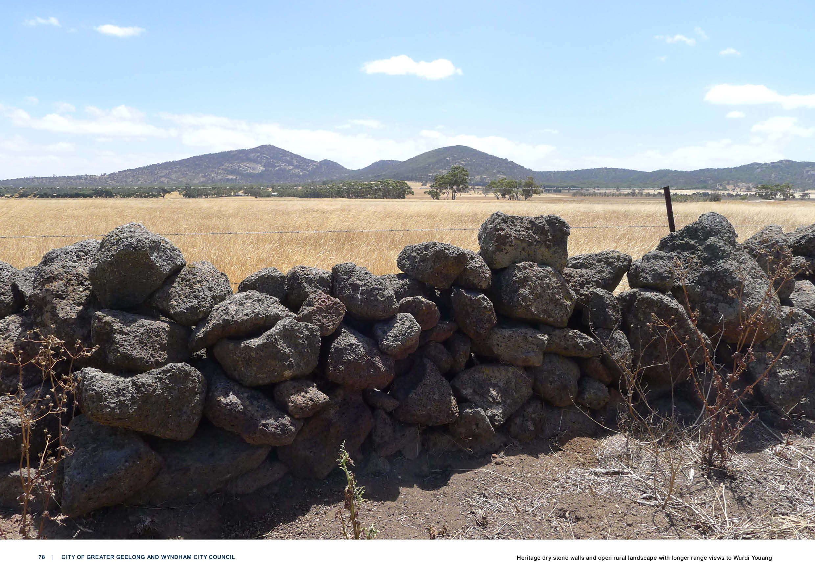

78 | CITY OF GREATER GEELONG AND WYNDHAM CITY COUNCIL Heritage dry stone walls and open rural landscape with longer range views to Wurdi Youang

POST CONTACT HERITAGE
Based upon a number of studies undertaken by WCC and CoGG and public consultation on the draft report, the post contact heritage values of the Avalon Corridor centre around four themes:

EXPLORATION, COLONISATION AND DISPOSSESSION

Point Wilson is believed to be in the vicinity of where the expedition of Hamilton Hume and William Hovell reached the southern coast of Australia in 1824 after setting out from Yass in NSW. This feat of European exploration is significant to Aboriginal peoples and Europeans. For Europeans, the
expedition opened up southeast Australia to colonisation and settlement, and the Australian-born Hume was a remarkable bushman who guided the expedition utilising traditional bush skills he had learned amidst the Dharawal people of NSW. For Aboriginal peoples, the expedition is a symbolic
catalyst for the invasion and dispossession of traditional lands across southeast Australia.

Whilst peripheral to this Strategy, it should be recognised that the management of the memory and physical manifestations of that event needs to be handled with sensitivity and respect, including
future management of the registered Hume and Hovell Centenary Memorial (VHR H1547) on the fringe of Lara, and the current application of the name Hovells Creek to the traditional waterway discharging into Limeburners Bay.

Little River is a residential and farming community on the western boundary of WCC and takes its name from the deep river that flows from the Brisbane Ranges to the sea near Lake Borrie. The
river is slightly smaller than the Werribee, hence its name. In early days of settlement, the road from Melbourne to Geelong had a crossing at Little River. The Traveller’s Rest Inn was built in 1839 and a
post office was opened in 1858. Lot 14, one of the Port Phillip Association’s first allotments, was taken up by pioneer James Simpson. Little River later became part of the vast Chirnside empire. When the Geelong to Melbourne railway opened in 1876, bluestone station buildings and goods sheds were
constructed.

Little River became an important hub for local farmers, graziers and haycarters who used the railway to carry their goods to markets in both Geelong and Melbourne. The line is still heavily used today
carrying commuters in both directions.
TRANSPORT AND UTILITIES

The heritage values of the registered former Metropolitan Farm (VHR H2400) at WTP need to be
conserved for their significance as a major early civil engineering feature. Early related structures
from the farm may also occur within the surrounding coastal foreshore area. Where practicable, these should be left in place and conserved if still in use, or left as redundant structures or ruins if not.
The Old Melbourne Road that runs through Little River delineates the general route of one of the earliest European tracks within Victoria. Running between Melbourne and Geelong from the mid-
1830s, Old Melbourne Road developed into a major road over the following decade. The crossing of this route over the Little River at Rothwell formed a key stopping place at which the Traveller’s Rest Inn was developed in 1839.

The Rothwell Bridge was later built to replace the adjacent ford. The heritage value of the registered Rothwell Bridge (VHR H1454) needs to be conserved and the historical and archaeological
importance of this crossing place requires further investigation, along with potential shared values as a camp and crossing place for Wadawurrung Traditional Owners.

Secondary transport features on the Victorian Heritage Inventory (VHI) include a number of coastal jetties and trig stations. These are reasonably protected within the coastal foreshore reserves, but may warrant further investigation.

Avalon Airport is not considered to be of heritage significance at this time, though may take on some historical or social significance in the long term as Melbourne’s second airport and the home of
Australia’s major airshow.

9.3

RESOURCE HARVESTING

The landscape between the Princes Freeway and the base of Wurdi Youang (the You Yangs) is
predominantly a pastoral landscape divided into rectilinear blocks by fencelines, tree plantings and remnants of dry stone walls. There are a number of Heritage Overlay (HO) farm homesteads and
complexes, which need to be conserved for their heritage value. The historical and archaeological significance of dry stone walls south of Little River requires further investigation.

Secondary natural resource harvest areas include the former Cheetham Saltworks adjoining
Avalon Airport, which are included on the VHI and may warrant further investigation prior to any redevelopment. The lime burning kilns on the foreshore adjoining Geelong Grammar, also on the
VHI, may warrant investigation should they be at risk of disturbance. There are a number of minor recreational fishing sites included on the VHI which are of no special significance but may also
warrant investigation prior to any disturbance.
EDUCATION

Geelong Grammar is located on the southern edge of the study area and is protected under a HO.
Nature based research and education associated with the Port Phillip foreshore is the subject of
increasing social and educational importance to the community. These values are generally protected under the Natural Resource Management policies for the area and do not. Some smaller reservations along water courses in the Avalon Corridor are also of heritage significance, including two are
protected under HOs at Little River.

Beyond the above themes, significant post contact aesthetic and social values complement
Wadawurrung cultural values relating to natural heritage of the native bushland of the You Wurdi
Youang (the You Yangs). Wurdi Youang has importance to the wider community as one of the two most significant natural landmarks within Greater Geelong, with the other being Corio Bay. Community
consultation also indicates they possess wider aesthetic significance as a backdrop to the pastoral landscape between Lara and Little River.

Municipal heritage studies undertaken by CoGG and a Heritage Review (Gap Study) undertaken by WCC in 2019 have identified a number of historical sites that have the potential to meet the threshold for protection under HOs. Both CoGG and WCC are proposing to undertake further investigation of
these sites over the next 5 years. The WCC gap study has identified 15 potential HO places within the study area, relating primarily to residential and non-residential (community, commercial, industrial,
military and landscapes) themes within settlement areas.

80 | CITY OF GREATER GEELONG AND WYNDHAM CITY COUNCIL

4

Hovells Creek
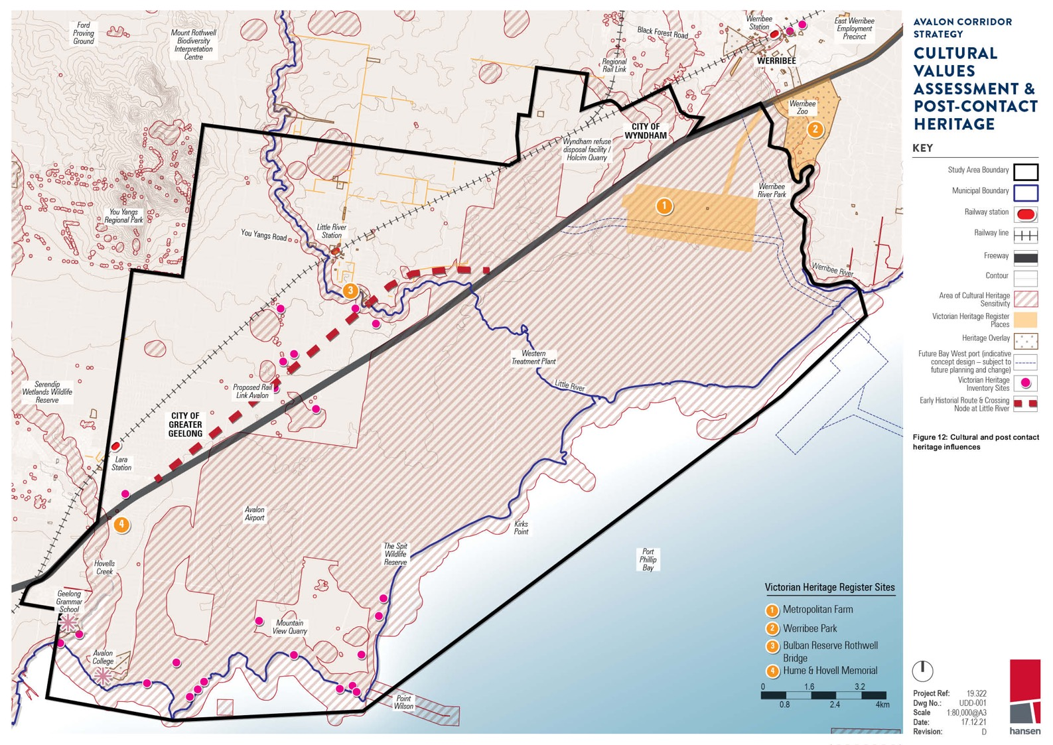
Avalon Airport

19.322
UDD-001

Scale
Date: Revision:
1:80,000@A3
17.12.21
D

LANDSCAPE CHARACTER ANALYSIS
10.0
  - Landscape Character Analysis 83
  - Summary of Key Considerations 84
  - Landscape Recommendations 86

LANDSCAPE CHARACTER ANALYSIS

A background Landscape Character Assessment was prepared by Hansen Partnership in 2021 to
inform the Avalon Corridor Strategy. A summary of key findings and recommendations is provided in this section and Figure 14.
Key findings from desktop assessment:
    - The concentration of landscape character and visual values are located within the northern
portion of the Avalon Corridor, including FZ and GWZ agricultural areas, the You Yangs Regional Park and the concentration of dry stone walls around Little River.
    - Key view corridors exist along the Princes Freeway, Melbourne-Geelong rail line, a number
of minor roads around Wurdi Youang (the You Yangs) and from the edge of the Urban Growth Boundary (UGB) in WCC.
    - Much of the western portion of the Avalon Corridor is covered by an Environmental Significance Overlay (ESO). While the intention of the ESO is primarily to protect environment and habitat,
areas deemed significant enough to require environmental protection often also provide valuable landscape character.
    - Identified landscape character and visual values are relatively limited within the southern portion of the Avalon Corridor, though include a significant stretch of coastline as a Public Conservation and Resource Zone (PCRZ), some areas of Rural Conservation Zone (RCZ) and a Heritage
Overlay (HO) associated with Geelong Grammar.
    - The South West Victoria Landscape Assessment Study (DELWP, 2013) previously considered a portion of the Avalon Corridor and identified two landscape character areas of note:
– Western Volcanic Plain: “Volcanic activity has shaped much of South West Victoria’s
landscape. This extensive Character Type is formed by a flat to undulating basaltic plain scattered with volcanic features including stony rises, old lava flows, numerous volcanic
cones and old eruption points which together create a unique visual landscape. This is a place of big skies, long views with volcanic rises that punctuate the horizon. Shelterbelts of cypress and pine were planted to protect crops and livestock from the winds that sweep the plain and are now a defining characteristic of the Type. Many paddocks and roadsides are edged with
beautifully formed dry stone walls that were created when early pastoralists cleared the land of rocks for agricultural purposes.”
– Uplands: “Defined by topography, this diverse Character Type rises dramatically to the north of the flat volcanic plain, stretching from near the Grampians Ranges in the west to the edge of the study area at Bacchus Marsh in the east. Granitic intrusions have formed steeply
sloping peaks and ridges, some of which are carpeted in vegetation at higher elevations.
While the Uplands are largely cleared for agriculture they also support numerous large
areas of public land, including Parks, Reserves and State Forests which contain a wealth of vegetation including wet and dry forests, Box-Ironbark woodlands and endangered
grasslands.”
- The You Yangs Regional Park is also identified as a state significant landscape, defined as: “the designation of a particular landscape as special or important arising from its cultural landscape
values, including aesthetic values (both visual and non-visual) historic, environmental, scientific, social or other values.”

AVALON CORRIDOR STRATEGY | 10. LANDSCAPE CHARACTER ANALYSIS 83

10.0–10.1

Following the desktop assessment, fieldwork was undertaken to confirm landscape character areas and significant visual amenity values within the Avalon Corridor. Landscape character areas can be described as areas of similar patterns of elements in the landscape such as landform, vegetation, waterbodies, features and land use.

The Avalon Corridor contains a number of landscape character areas, including:
- Agricultural Plains
- Township
- Rural Dwelling
- Airport
- Former Salt Works
- Active Industry
- Wastewater Treatment
- Education
- Coastal Fringe

A number of landscape character areas adjacent to the Avalon Corridor have also been identified, including:
- Granite Hills
- Bushland Foothills
- Cleared Foothills
- Elevated Plains
- Recreation
- Small Scale Agriculture

SUMMARY OF KEY CONSIDERATIONS
A number of key views associated with Wurdi Youang (the You Yangs) were identified within the Avalon Corridor, including:
    - Landmark journey segments on the Princes Freeway and Melbourne-Geelong rail line, as identified in the South West Victoria Landscape Assessment Study (DELWP, 2013).
    - Major viewline from the Wyndham UGB, as identified in the Wyndham Landscape Context Guidelines (WCC, 2013).
    - Local views from You Yangs Road, Little River-Ripley Road and Branch Road, as identified in the
South West Victoria Landscape Assessment Study (DELWP, 2013).

These views were verified through fieldwork, recognising that views in the northern portion of the Avalon Corridor have a key relationship to the You Yangs. Given the prevalence of the You Yangs in views from the Avalon Corridor, it was also considered of high importance to also consider views to the Avalon Corridor from the You Yangs.

The proposed amendment to SLO1 recommended by the 2013 South West Victoria Landscape Assessment Study includes a series of decision guidelines that address how to consider impacts on landscape character, view points and vegetation conservation and how to minimise intrusion of built form. Of note to the Avalon Corridor is the consideration of the visible impact of building or works from Flinders Peak.

The Landscape Character Assessment for the Avalon Corridor sought to understand the extent of views from Flinders Peak in the You Yangs. This is illustrated by Diagram 5 and 6 which include
photos taken from the Flinders Peak viewpoint. The landscape between the You Yangs and the Princes Freeway forms the middle ground of this view from Flinders Peak, with the You Yangs bushland foothills in the foreground. While the coastline of Port Phillip Bay and the Bellarine Peninsula can be seen in the distance, they do not form a prominent view from Flinders Peak.

Significant views associated with the You Yangs are further illustrated on Figure 13.

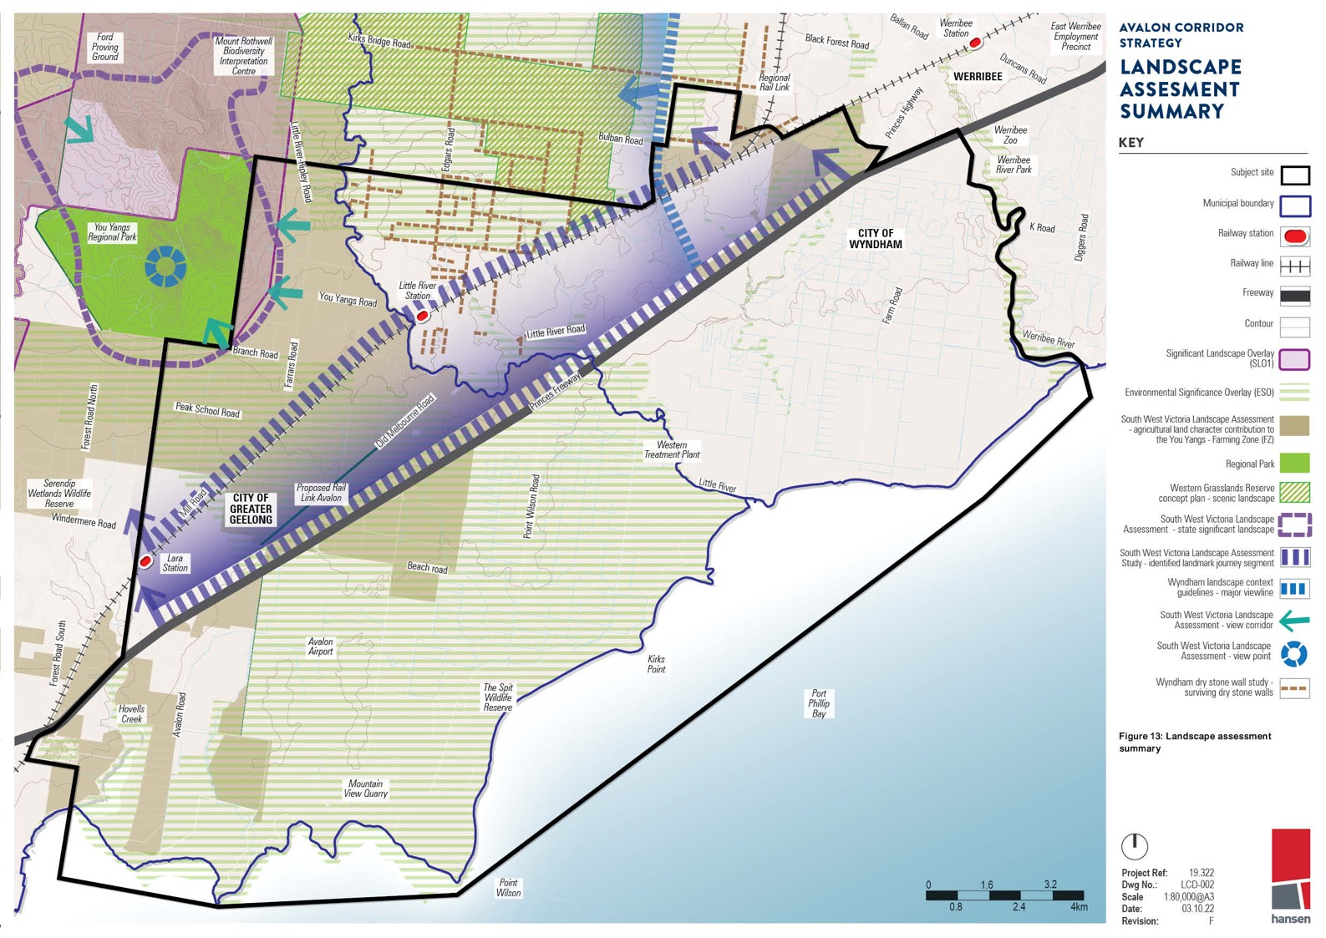
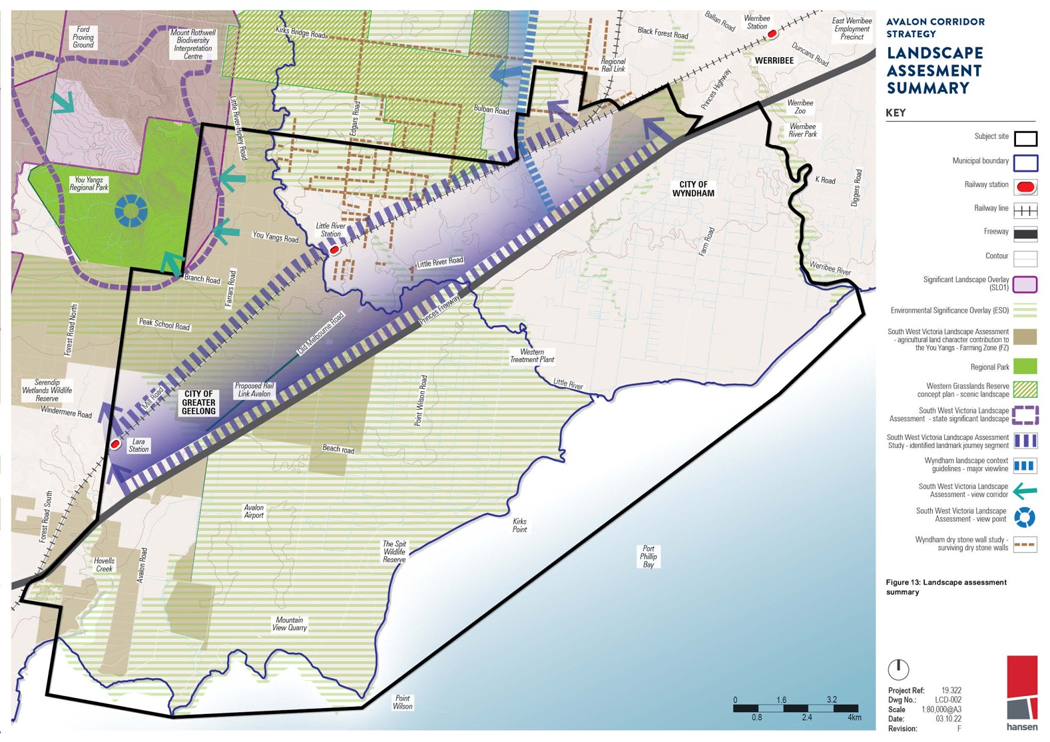/ - Ba Wr,rrihf'f' , "

I " a, k
Yl ,9, S . fost Werribee
AVALON CORRIDOR

#• Mount Rothwell
      - ac Foret R
Oad fatlon•
Fm'PlnymPnt
STRATEGY

# Biodiversity
Interpretation
Centre
I ,-J s oad ...xY Preci•nct
I , - 01.1.
f.J ! 11/ ""a-?.s

LANDSCAPE

1 Regional ,. WERRIBEE ,.......

Point

3.2
Project Ref:
Dwg Nlo.:
19.322
LCD-002

Date:Revision:
1:00,000@AJ
03.10.22
F hansen

LANDSCAPE RECOMMENDATIONS
The background Landscape Character Assessment (Hansen Partnership, 2021) identified significant landscape qualities and views for the Avalon Corridor. Areas of high, moderate and low landscape value were identified, along with areas with a visually sensitive relationship to the You Yangs.

The Agricultural Plains landscape character area contains high overall landscape value and is of importance to the setting for the You Yangs. There is a strong inter-relationship of views between these two areas.

Important landscape character values and views are currently protected in part by the Significant Landscape Overlay (SLO1) in the Greater Geelong Planning Scheme for the Foothills of the You Yangs. SLO1 contains the following objectives:
    - To protect and enhance the open character, contrast and scenic quality of the landscape.
    - To maintain an open view path to the regionally significant You Yangs.
    - To protect the landscape from visual intrusion by inappropriate buildings and works and their siting, design or materials.
    - To encourage the siting, design and landscaping of buildings and works to be responsive to the landscape values of the area.
    - To facilitate the rehabilitation of extractive industries when they reach the end of their economic life.

The northern portion of the Avalon Corridor has open and expansive views to the You Yangs due to the flat landscape that prevails over much of the Avalon Corridor. This includes portions of the Avalon Corridor determined to have moderate or low overall landscape value in their own right. It is recommended that views to and from the You Yangs are considered in the development of the Framework Plan.
The key recommendation of the Landscape Character Assessment is to investigate the potential expansion of SLO1 to accommodate the landscape setting and views to and from the You Yangs. This recommendation aligns with recommendations of the CVA to expand SLO1 to protect areas of
Wadawurrung cultural significance. Relevant government agencies should work with WTOAC to consider the potential extent of SLO1 and should consult with affected landowners on any proposed changes.

The Landscape Character Assessment further notes opportunities for rehabilitation, restoration
and regeneration of former quarry and landfill sites to complement the cultural, environmental and landscape values of the Avalon Corridor.

AVALON CORRIDOR STRATEGY | 10. LANDSCAPE CHARACTER ANALYSIS 87

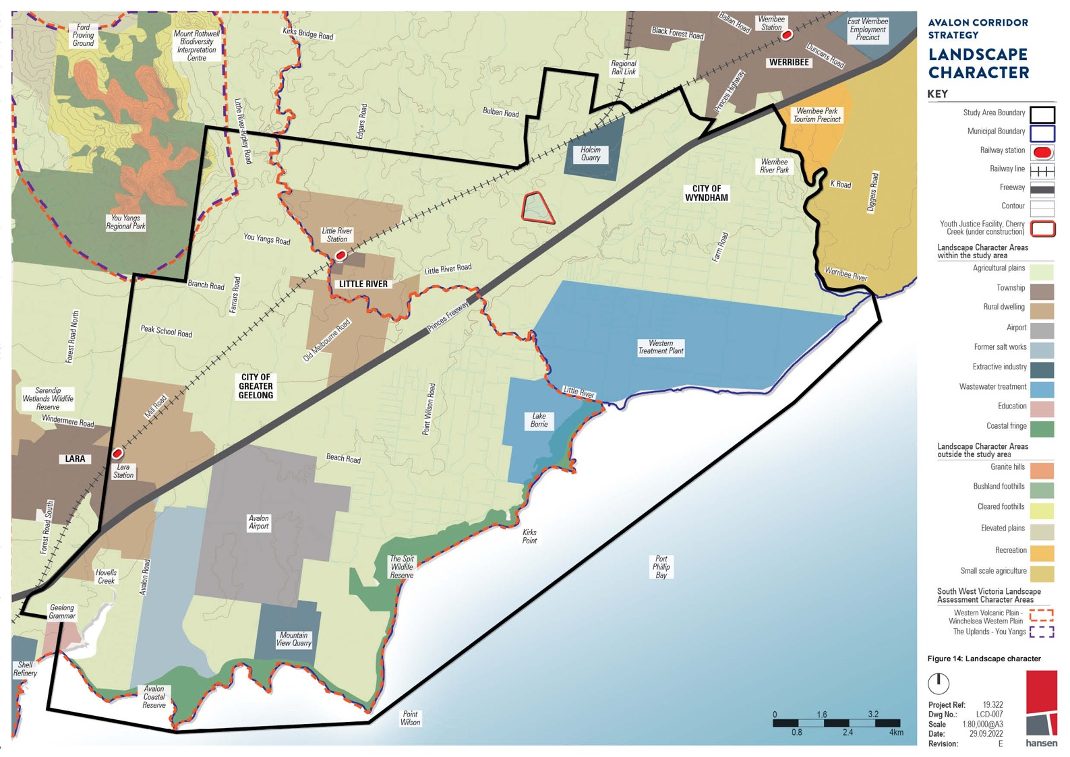
r

Putiil
Project Ref:
Dwg No.:
19322
LCD-007

Wilson
0_8 2-4 4km
Scale Date: Revision:

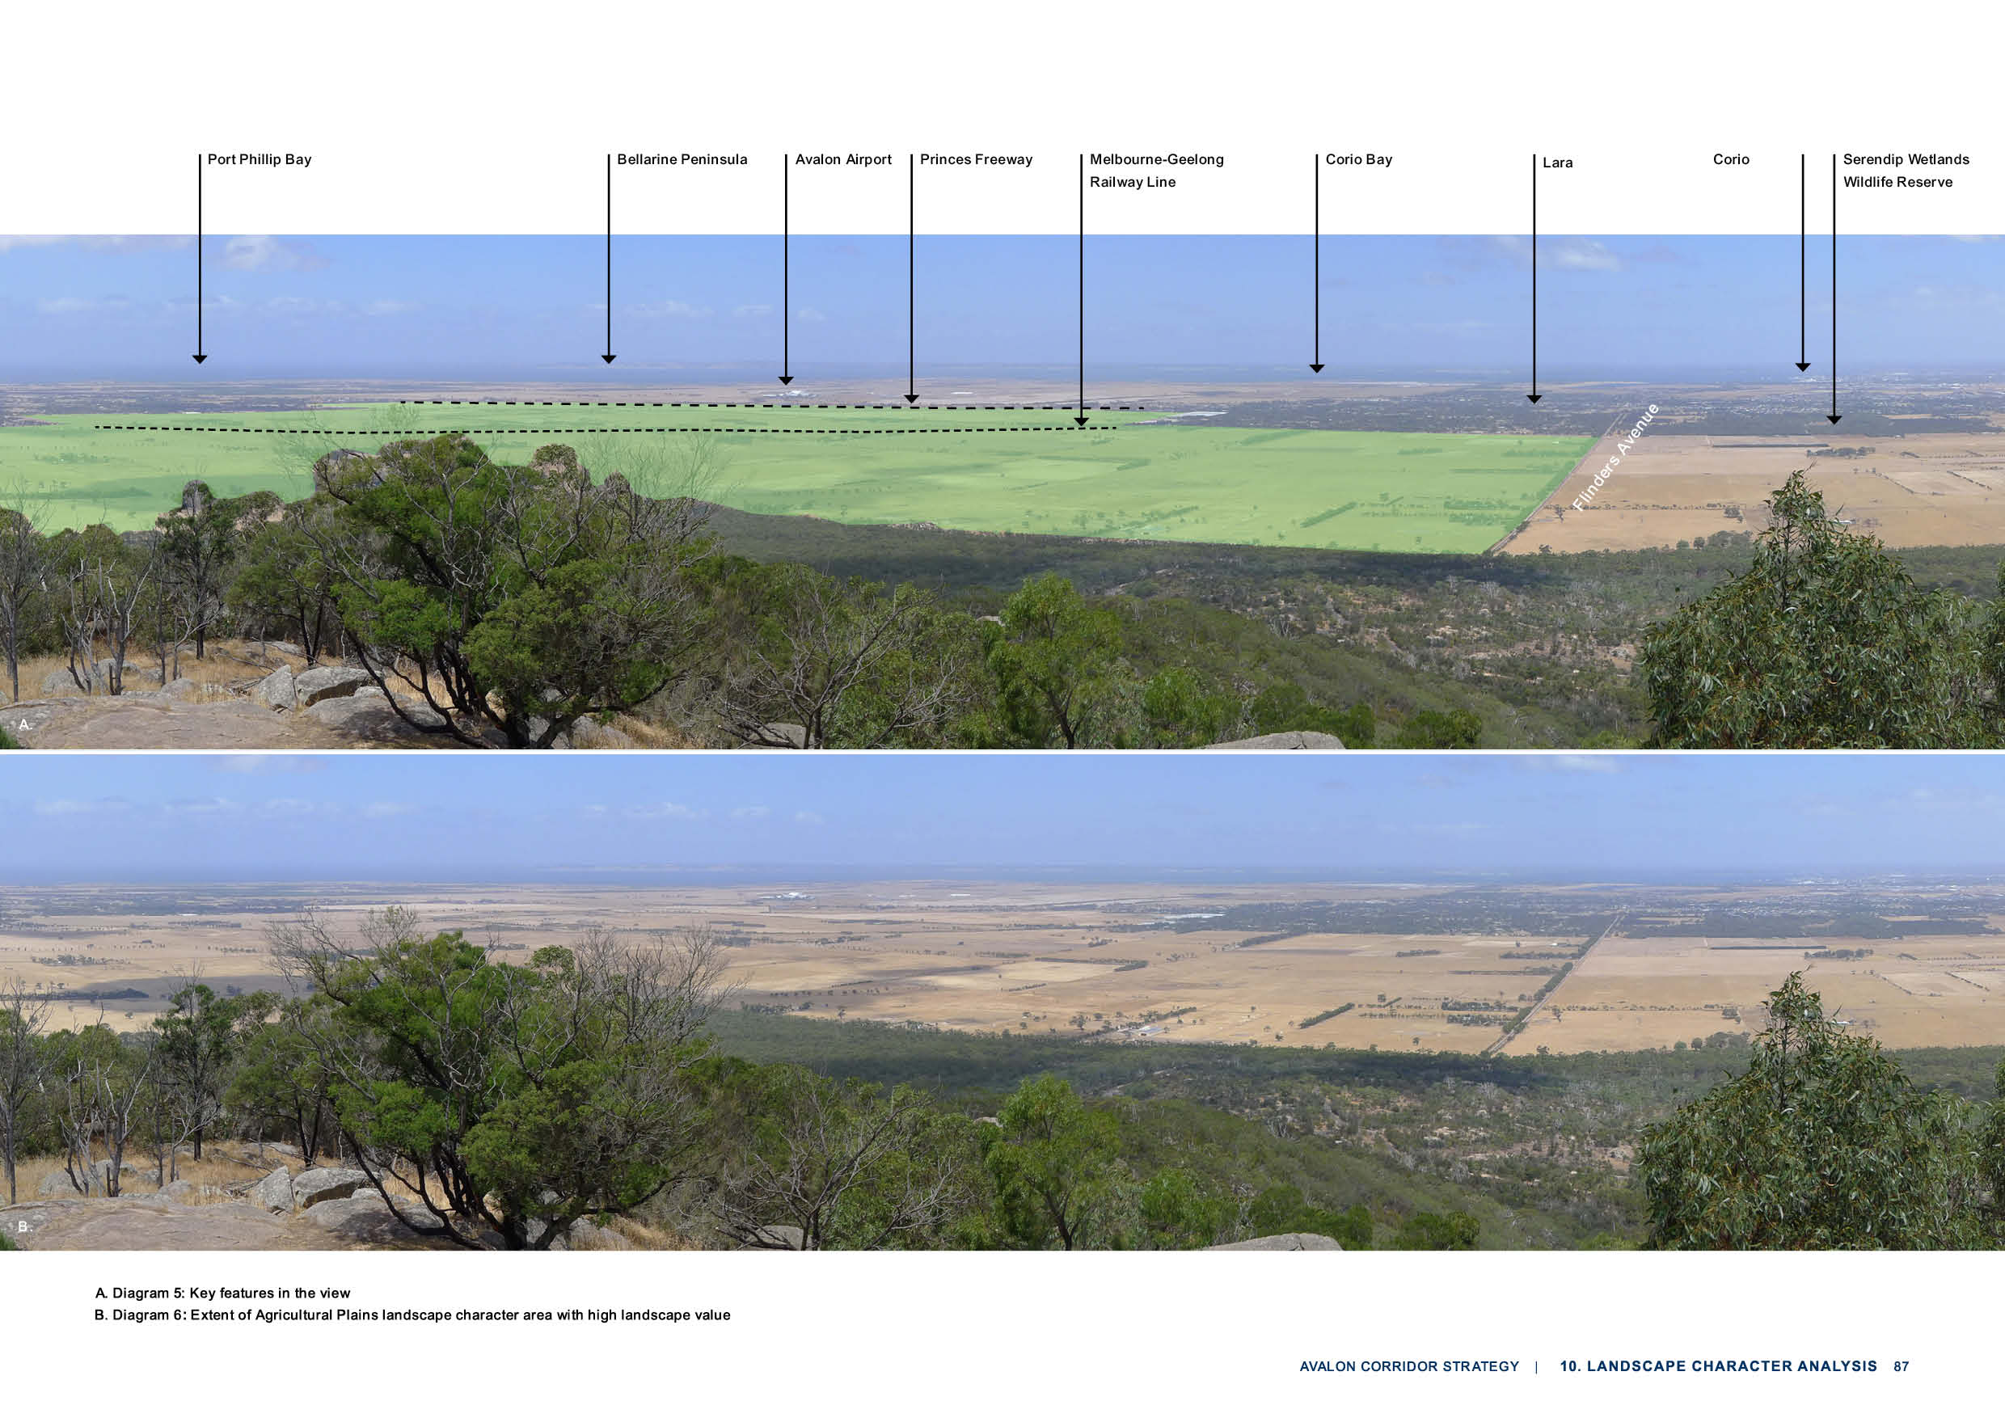

ENVIRONMENTAL ANALYSIS
11.0

  - Environmental Analysis 90
  - Flora and Fauna Analysis 90
  - Western Grassland Reserve 92
  - Important Wetlands 92
  - Marine Environment 94
  - Climate Change, Sea Level Rise and Flooding 94
  - Bushfire Risk 97
  - Weeds and Pest Plants 97
  - Hydrology, Salinity and Acid Sulphate Soils 97

ENVIRONMENTAL ANALYSIS

A background Existing Conditions Report (Flora and Fauna) was prepared by Ecology and
Heritage Partners in 2021 to inform the Avalon Corridor Strategy. A summary of key findings and recommendations is provided in this section and Figure 15.

The legislative framework for environmental considerations in the Avalon Corridor includes
obligations which exist under the Flora and Fauna Guarantee Act (1988). Public authorities and
Ministers have duties under Section 4B to consider potential biodiversity impacts when exercising their functions.

Also of relevance is the Melbourne Strategic Assessment (MSA) program facilitated by the
Victorian Government, which seeks to protect biodiversity in Melbourne’s growth areas. Under the Commonwealth Environment Protection and Biodiversity Conservation Act (1999) (EPBC Act), four development actions that relate to the MSA program were approved. This means that developers
don’t need any further approvals under the EPBC Act in affected growth areas, as long as they follow relevant conditions set out under the MSA.

FLORA & FAUNA ANALYSIS
The Existing Conditions Report (Flora and Fauna) aimed to inform the Avalon Corridor Strategy by providing:
- An overview of the natural environment within and adjacent to the Avalon Corridor
- Maps and descriptions of the natural assets within and adjacent to the Avalon Corridor
- Identification of issues affecting natural assets that need to be considered
- Identification of opportunities affecting natural assets within the Avalon Corridor which could drive land use outcomes
- Identification of opportunities to integrate and grow natural assets with planning for open space, drainage and broader land use planning.
The Existing Conditions Report (Flora and Fauna) identified the following key ecological values within the Avalon Corridor:
- Native vegetation, including remnant patches and scattered trees
- 74 ‘Current Wetland’ sites mapped by DELWP
- Significant waterbodies, including the WTP sewage treatment ponds, former Cheetham Saltworks, Werribee River, Little River, Lollypop Creek, Cherry Tree Creek, Hovells Creek, Ryan’s Swamp
Wetland, Paul and Belfrages Swamp, Edgars Road Swamp and Cherry Swamp
- The Port Phillip Bay and Corio Bay marine environment
- A diverse assemblage of plants and animals, with 739 flora species and 469 fauna species previously recorded
- The known occurrence of 13 nationally significant and 79 state significant flora species recorded since 1980
- The known occurrence of 18 nationally significant, 32 state significant and 17 regionally significant fauna species recorded since 1980
- The known and potential presence of ecological communities of national and state significance, including the internationally significant Port Phillip (Western Shoreline) and Bellarine Peninsula Ramsar site and nationally important Werribee-Avalon Area wetland
- Conservation reserves, including the Werribee Regional Park, Port Phillip Bay Coastal Reserve, Spit Wildlife Reserve, Limeburners Bay Flora and Fauna Reserve, Freshwater Swamp and Little River Wildlife Reserve and Western Grassland Reserve
- Sites of biological significance (BioSites), mapped by DELWP and CoGG
- Ecological values supported within the WTP
- Biodiversity corridors formed by established reserves, waterbodies and tracts of native vegetation.

11.1

SUMMARY OF KEY CONSIDERATIONS
Key threats to ecological values identified in the Avalon Corridor include:
      - The introduction and spread of diseases and invasive plant and animal species
      - Direct impacts associated with vegetation clearing
      - Inappropriate grazing and fire regimes
      - Fragmentation of habitat and edge effects associated with expanding development
      - Increased traffic (direct mortality)
      - Changes to hydrology
      - Chemical run-off, sedimentation and erosion
      - Impacts associated with climate change, including direct loss of habitats and increases in ambient ultraviolet-B (UV-B) radiation.
      - Increased community access.

Key considerations related to native grasslands and habitats under Commonwealth and Victorian Government regulations include:
      - The difficulty in identification of grasslands (visually inconspicuous)
      - Likely wide dispersal across the Avalon Corridor
      - Likely high conservation significance
      - Very limited offset opportunities for removal (offsets can be entirely unavailable).
Key recommendations for the Avalon Corridor Strategy and further work to be undertaken include:
- Further assess areas of native vegetation and populations of threatened species and communities.
- Retain areas of native vegetation (remnant patches and scattered trees) and habitat where possible.
- Improve and create biodiversity corridors within the Avalon Corridor, potentially through revegetation activities that provide greater connectivity between established reserves, waterbodies and tracts of
native vegetation. Establish a formalised environmental corridor between the Western Grasslands Reserve and the coast, through the WTP.
- Determine strategies to protect sensitive habitats from new industrial or commercial land uses and development, as required.
- Ensure key ecological values are protected through the application of relevant overlays and other planning tools such as Precinct Structure Plans.
- Consider potential impacts of increased community access on areas of significant ecological value which have been relatively isolated and ensure appropriate protections are in place.
- Consider new and existing policy instruments that can be implemented to reduce the rate of habitat loss and its effect on biodiversity.
- Establish a new biolink along the Princes Freeway and create linear habitat corridors to link conservation reserves with the aim of supporting biodiversity.
- Determine whether developable land west of Avalon Airport is constrained by the presence of the
Werribee-Avalon Area Nationally Important Wetland and habitat for state and federally listed species. It is recommended that any development proposed to be located west of Avalon Airport is subject to further investigation to confirm development potential.
- Consider relevant recommendations and actions for improvement and protection of waterway health from existing government strategies and policies.

The Existing Conditions Report was based on a high level assessment of ecological values within the Avalon Corridor, drawing predominately on the findings of a detailed desktop review. The report
concludes that “any future development proposals within the study area must be informed and supported by detailed ecological studies, including vegetation surveys and targeted surveys for significant species of flora and fauna.”

AVALON CORRIDOR STRATEGY | 11. OPPORTUNITIES, CONSTRAINTS & ISSUES 91

11.2–11.3

WESTERN GRASSLAND RESERVE
The Western Grassland Reserve was established by the Victorian Government, covering
15,000 hectares outside the UGB southeast of Melton and west of Werribee. The area contains the largest and highest quality example of Natural Temperate Grassland remaining in Victoria, and is a key biodiversity asset for the state. The reserve also protects a range of habitat types including
ephemeral wetlands, waterways, Red Gum swamps, rocky knolls and open grassy woodlands. The
reserve will connect the You Yangs Regional Park to the Werribee River across the Victorian Volcanic Plains. Land in the Western Grassland Reserve is subject to a PAO and ESO under relevant planning schemes.

The Western Grassland Reserve is central to the Melbourne Strategic Assessment (MSA) program - a long term initiative that works alongside urban development in Melbourne’s growth areas. 18 percent of land within the Western Grassland Reserve has already been purchased, resulting in permanent
protection for more than 2,630 hectares of threatened grasslands and wetlands. Negotiations with landowners to acquire more land are ongoing and are funded by revenue raised through the MSA Levy.

WCC is a delivery partner for the Western Grassland Reserve and has supported landowners
to control weeds on more than 3,220 hectares of private land. Other activities include controlled
burning, spraying artichoke thistle with drones, planting native grasses, managing serrated tussock and cane needle grass and surveying 1,264 hectares of vegetation.

Select areas of the Western Grassland Reserve have been identified as containing strategic extractive resources (hard rock and gravel) needed for the construction industry. These areas were identified by the Victorian Government’s SERA pilot project, with new planning controls introduced over affected
land. Other areas of the Western Grassland Reserve were identified by Infrastructure Victoria as
having potential value in accommodating a rail stabling yard associated with the future Bay West Port proposal. This includes land immediately to the west of the alignment of the OMR Transport Corridor.

These alternate uses pose a potential land use conflict with the designation of the Western Grassland Reserve for biodiversity conservation. Such conflicts would need to be further considered and
addressed through relevant planning processes at the state government level. It is not the intention of the Avalon Corridor Strategy to resolve all potential land use conflicts identified.

IMPORTANT WETLANDS
The Port Phillip (Western Shoreline) and Bellarine Peninsula Ramsar site covers approximately 15,182 hectares (51 percent) of the study area. The entire Ramsar wetland covers an area of approximately
22,897 hectares.

The Ramsar site is characterised by:
- A range of marine and inland wetlands characteristic of the South East Coastal Plain bioregion as well as artificial wetlands.
- Significant habitat that provides one of the most important sites in Victoria for migratory shorebirds and supports more than 20,000 waterbirds (including large numbers of migratory waders, black swans, ducks, ibis and cormorants).
Any potential future development in close proximity to the Ramsar site would need to consider possible direct and indirect impacts on the wetlands and may need to be referred to the
Commonwealth Department of Climate Change, Energy, the Environment and Water (DCCEEW). Impacts could include loss of habitat for migratory wetland birds or reductions in water quality.

Development would need to have regard to the policy for managing Ramsar sites in Victoria as set out in the Victorian Waterway Management Strategy (DEPI, 2013), as well as the Port Phillip (Western Shoreline) and Bellarine Peninsula Ramsar Site Management Plan (DELWP, 2018).

In addition to the internationally significant Ramsar site, the Avalon Corridor contains approximately 3,220 hectares of the Werribee-Avalon Area Nationally Important Wetlands, which is listed on
the Australian Directory of Important Wetlands (DoEE, 2016) and are covered under the Ramsar Convention on Wetlands (1971). The extent of the Werribee-Avalon Area Nationally Important Wetlands overlaps with the Ramsar site and includes additional areas to the north including the former Cheetham Saltworks site.

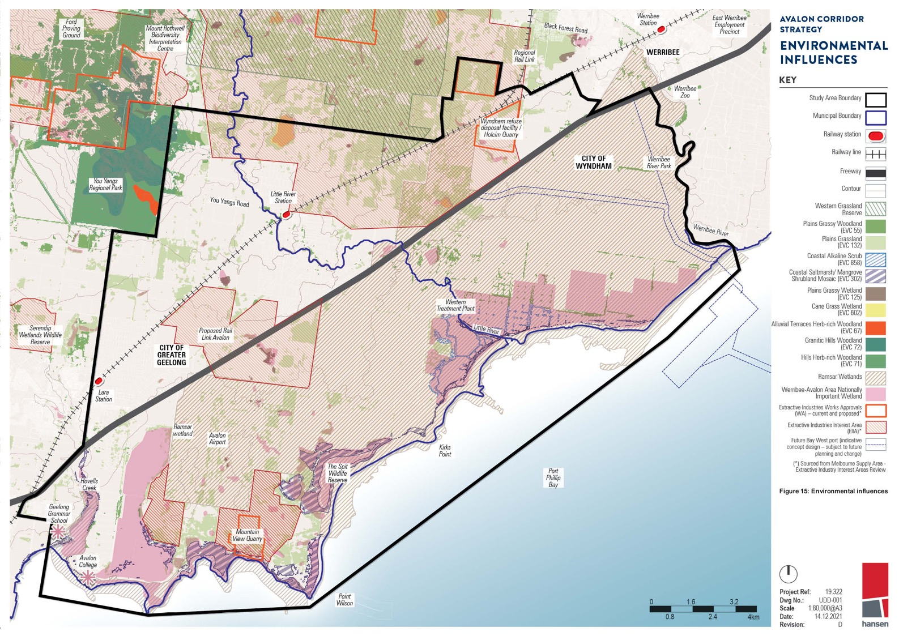
.A.V.A.lO coRR\OOR SlR.A.lEGY
ENV\RONMENTA'-
\NfLUENCES
KE'< 0
Stud'/ Area Boundaf'/
Phillip Bay

Pr•o\ect Ret

owgNo:.
,-_s

Scale oate:
0 1.6

11.4–11.5

MARINE ENVIRONMENT
The Avalon Corridor encompasses approximately 6,900 hectares of the Port Phillip Bay and Corio Bay marine environment. While there are no marine national parks or sanctuaries present, the boundaries of the Spit Wildlife Reserve and Port Phillip Bay Coastal Reserve encroach into the intertidal areas of Port Phillip Bay and Corio Bay.

Mapping was undertaken by Natural Resource Systems for the Land Conservation Council as part of a Marine and Coastal Special Investigation. This investigation encompassed the marine area
of the Bidentified that the Bates Point Aquaculture Fisheries Reserve - a 20 hectare area located
approximately 900 metres south of Bates Point. The investigation found that the marine environment supports a range of habitat types, including intertidal sandy beaches, seagrass beds and subtidal
rocky reefs. Seagrass and microalgae mapping datasets held by the Victorian Department of Jobs, Precincts and Regions (DJPR) also indicate that seagrass beds and large areas of macroalgae are present.

CLIMATE CHANGE, SEA LEVEL RISE AND FLOODING
Climate change is increasing the risk and severity of coastal hazards as a result of sea level rise and more frequent and severe extreme weather events. This will impact on the future use and
development of land along the coast and inland locations along waterways. Understanding the
dynamic processes of the coastal environment within the Avalon Corridor is important for ensuring any future development responds appropriately to these increased risks.

In the context of Port Phillip Bay, key risks to the coastline resulting from sea level rise include:
- Coastal inundation - this includes both permanent inundation, which will see high tide levels permanently increase as a result of sea level rise, and periodic inundation, caused by the
combined effects of high tide and storm surge events.
- Coastal erosion - the shoreline will be progressively eroded and moved inland as a result of sea level rise and storm surges. The level of vulnerability is greatly affected by the geology of the
shoreline.
- Groundwater change and salinity - as sea levels rise, the underground water table will also increase in height and salinity, which can affect groundwater and soils. This can potentially
impact on buildings, infrastructure, vegetation and crops. There is currently limited data available to understand the likely risks associated with this hazard in the Avalon Corridor and Port Phillip
Bay more broadly.

Current state planning policy seeks to plan for sea level rise of no less than 0.8 metres by 2100. This benchmark is subject to evolving science and international standards that could result in an increase to 1.1 metres. The current benchmark is based on the Intergovernmental Panel on Climate Change’s Fifth Assessment Report (2014), which projects sea level rise between 0.52 to 0.98 metres by 2100.

The Victorian Coastal Inundation Dataset was released by DELWP in 2012 and provides a high level assessment of the risks associated with sea level rise and storm surge along the Victorian coast.
The regional scale data provides an understanding of both permanent and periodic inundation under various scenarios out to 2100. The data includes a layer that is based on a 0.8 metre increase to the
high water mark for permanent inundation, with a 1% Annual Exceedance Probability (AEP) storm tide flood event added for periodic inundation.

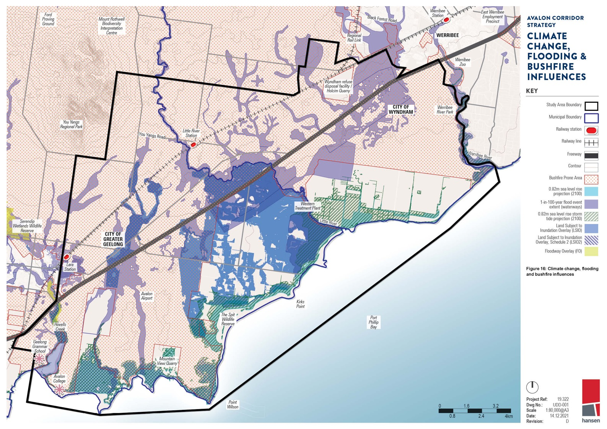
AVALON CORRIDOR STRATEGY
19-322
LJDD-001

0.8 2.4 4km
Scale
Date: Revis'ion:
1:80,000@A3
14.12.2021
n hansen

11.5

Amendment VC171 (gazetted September 2021) makes changes to the VPPs to implement the Marine and Coastal Policy (DELWP 2020), support coastal hazard planning and sea level rise adaptation
and update policy references. Functionally the changes strengthen the planning scheme provisions to plan for and mitigate coastal hazard risk to reduce the exposure of settlements to coastal hazard risks.

CoGG has undertaken further work as part of the Our Coast project, which involved the preparation of the detailed Bellarine Peninsula - Corio Bay Local Coastal Hazard Assessment (2015). This work
resulted in updates to the Land Subject to Inundation Overlay (LSIO) in the Greater Geelong Planning Scheme, including a new Schedule (LSIO2) that was introduced as part of Amendment C394ggee
(September 2020). LSIO2 applies to land affected by the combined impacts of a 1% AEP flood event and a 0.8 metre sea level rise.

DELWP’s Coastal Erosion Vulnerability mapping provides an indication of sections of the Victorian
coast that are most vulnerable to erosion. While the data is high level, areas of high and very high risk have been mapped along the Avalon Corridor coastline (see Figure 16).

A large portion of land within the Avalon Corridor affected by coastal inundation under a 0.8 metre sea level rise scenario is classified as public land with a direct interface to the coast or tributaries. Responding to the impacts of sea level rise in these locations will generally be the responsibility of the various public land managers and authorities.

The most significantly impacted location is the WTP. Engineered solutions and protection measures will play a significant role in locations that contain state significant infrastructure to ensure ongoing viability and reliability of assets.

A significant portion of the salt production and aquaculture activities surrounding the Avalon Coastal Reserve is projected to be periodically and permanently inundated. Areas within this location are also subject to high or very high vulnerability to coastal erosion.

Planning responses that seek to manage the use and development of land to mitigate risks of climate change, sea level rise and flooding will have a role to play within the Avalon Corridor. As recognised by the application of the LSIO in Greater Geelong, built form solutions related to the siting of
buildings and floor level heights are necessary in vulnerable locations. Such solutions should also be considered during detailed design for the future Bay West Port.
There is a need to ensure land use and development consider flood risk to the satisfaction of
Melbourne Water or the relevant Floodplain Management Authority. Where severe risks are identified, the long term development viability of the land will need to be considered. Options could include
restricting sensitive uses, limiting the intensification of existing activity or identifying planned retreat options.

Of further note, CoGG exhibited Amendment C339ggee in 2021 which seeks to address riverine flooding risk through the targeted application of the Flood Overlay and LSIO to land within and beyond the Avalon Corridor.

Reports underpinning Amendment C339ggee include:
- Bellarine Peninsula - Corio Bay Local Coastal Hazard Assessment (2015)
- Lower Barwon and Lower Moorabool Flood Investigation (2018)
- Lara Flood Study (2020)

11.6–11.8

BUSHFIRE RISK
Although no areas of the Avalon Corridor are covered by the Bushfire Management Overlay (BMO), large sections are mapped as Designated Bushfire Prone Areas as illustrated in Figure 16.

Such areas are identified by the Bushfire Prone Area (BPA) Map, which was introduced in response to the recommendations made by the 2009 Victorian Bushfires Royal Commission. The Minister for Planning makes a formal determination to designate BPAs under section 192A of the Building Act (1993), based on Bushfire Hazard Level - an indicator of how extreme a bushfire can be, based on landscape conditions.

The BPA Map identifies bushfire hazards for most of Victoria, including grassland areas. Minimum construction standards apply to new residential buildings, schools, child care centres, hospitals, aged care facilities and associated buildings in designated BPAs. For example, a minimum Bushfire Attack Level (BAL) of 12.5 is applied to certain buildings, such as dwellings.

Noting that the BMO does not apply within the Avalon Corridor, potential impacts of bushfire need to be considered on a case-by-case basis as part of specific applications for building and planning permits.

WEEDS AND PEST PLANTS
Activities within the Avalon Corridor potentially involve the removal and transportation of plant material through the use of various machines, vehicles and equipment. This creates risks of
spreading plant diseases and pest plants (weeds). The Avalon Corridor is noted to contain a range of environmental and noxious weeds, such as Chilean needle grass and serrated tussock, which
threaten native vegetation and agricultural activities. Preventing further spread of weeds and invasive flora species should be a priority for land managers.

HYDROLOGY, SALINITY AND ACID SULPHATE SOILS
Wetlands, waterways and the coastal interface are characteristic landscape and ecological features of the Avalon Corridor. Landscape scale and site specific hydrological knowledge is required to ensure these environmental assets can function appropriately alongside current and future land uses.

Overland flows and stormwater management must be carefully considered across the entire Avalon Corridor area, in particular areas flagged for development and land use change. Freshwater inputs into saline environments can be detrimental to the point of impacting on Matters of National Environmental Significance (MNES). Salinity is therefore a relevant consideration to the Avalon Corridor, both
in terms of its relation to ecological systems and the constraints it may place on certain types of development.

Management arrangements will need to be considered which support the protection and function of the Werribee-Avalon Area Nationally Important Wetlands (ref. VIC121), particularly the former Cheetham Saltworks site. The functioning of these ponds is reliant on hydrological regimes that extend beyond the area of Crown land managed by Parks Victoria.

It is further important to ensure development considers and mitigates risks associated with the disturbance of coastal acid sulphate soils, which may be present within the Avalon Corridor.

EMERGING TRENDS AND INFLUENCES
12.0
  - Emerging Trends and Influences 99

EMERGING TRENDS AND INFLUENCES

Beyond strategic, economic and environmental considerations relating to the Avalon Corridor, there are a range of emerging technological mega-trends and advancements which will influence future
land use and development.

The current pace of technological change is expected to create significant changes in future
employment markets, including the creation of new jobs and industries that do not currently exist.
Administrative, manufacturing and production roles are most likely to see dramatic declines with the rise of automation. Conversely, the demand for advanced mathematics and computer science skills will likely increase. While there are anticipated increases in skilled employment associated with the
implementation, management and servicing of new and emerging technologies, the true extent of this employment cannot be accurately estimated.

Future advancement and wider usage of 3D printing will reduce manufacturing costs and provide greater opportunity to deliver new products to the market. Future energy sources and potential
decreases in energy costs could drive productivity, leading to further economic growth. However, technological advancements also have potential to create greater disparity in income distribution, resulting from a loss of lower skilled labour opportunities.

Rapid population growth and urbanisation will continue globally throughout the course of the century.
Such processes will drive growth and demand in numerous sectors, particularly food production. A growing global population is expected to demand 35 percent more food by 2030, whilst the demand for a variety of food products will increase as incomes rise, particularly in cities. Although urban
expansion continues to accelerate in metropolitan Melbourne and central Geelong, the rate of expansion is considerably slower than that experienced at a global level.

Rapid global urbanisation will drive new commercial opportunities in food production, to respond
to growing demand. The Avalon Corridor is well positioned to capture some of these opportunities, in light of its unique attributes and assets such as available agricultural land, potential access to
recycled water, a robust transport and freight network and the ability to move goods domestically and internationally via Avalon Airport and the future Bay West Port.

The Avalon Corridor also presents potential renewable energy and circular economy opportunities that will help to address climate change. This includes generation of recycled water, biosolids and
biogas at the Melbourne Water WTP, which currently treats 50 percent of Melbourne’s sewage. Based on projected population growth, sewage load is expected to double by 2050. Similar opportunities are associated with the Barwon Water Northern Treatment Plant in Corio.
Noting the availability of agricultural land and potential access to a significant supply of recycled
water, food production would appear to have substantial potential within the Avalon Corridor, with the added benefit of easy access to Avalon Airport for rapid export to global markets.

In this context, a variety of technological and scientific advancements are having significant impacts on agricultural and food production sectors,
including:
- Precision agriculture or satellite farming, involving GPS tracking systems and satellite imagery to monitor crop yields, soil levels, and weather patterns to increase efficiency.
- Technological farming assistance, including the use of drones and wireless sensors.
- Emerging water conservation and sustainability initiatives, including strategically placed irrigation and dry land agriculture techniques.

The cost of producing recycled water to support agricultural production in the Avalon Corridor
remains an issue, with price exceeding farmers’ willingness to pay. However, this has the potential to change in future either through technological advancements reducing the cost of recycled water production, or (as an example) state or federal governments subsidising water recycling costs to
generate investment in this sector. There is opportunity to also consider recycled water use beyond farming and food production.

These considerations represent only a fraction of changes anticipated through technological
advancements. Opportunities and issues associated with these changes will need to be managed by various sectors. Governmental policies at the global and national level will form an integral part of
this process. While it is beyond the scope of the Avalon Corridor Strategy to predict or respond to the breadth of anticipated technological advancements and associated impacts, the Strategy recognises the need for flexibility to adapt to future change.

OPPORTUNITIES,
13.0
CONSTRAINTS AND ISSUES

  - Opportunities, Constraints and Issues 101
  - Opportunities 101
  - Constraints 102
  - Issues 103

OPPORTUNITIES, CONSTRAINTS AND ISSUES

The earlier sections of this Strategy have summarised a significant volume of information and
highlight matters associated with land use and development of relevance to the Avalon Corridor. This section seeks to further summarise this background work into a list of opportunities, constraints and issues to inform the Framework Plan.

The Avalon Corridor benefits from a unique combination of attributes that is not found elsewhere within Victoria. However, the role of this Strategy is to provide strategic guidance regarding
appropriate development within targeted areas (based on relevant opportunities), and avoid development in inappropriate areas (based on relevant constraints).

OPPORTUNITIES
    - Princes Freeway and the Geelong-Melbourne rail corridor bisect the Avalon Corridor. Both constitute regionally significant major transport assets which provide substantial opportunity relating to the movement of freight and people and facilitate wider regional connections.
    - Road and rail access to the Princes Freeway will be augmented by the future OMR Transport
Corridor. The alignment for the OMR has been designated and formally protected through relevant planning scheme controls.
    - Development at Avalon Airport is controlled by a federally endorsed Master Plan which
anticipates major development and expansion of airport and non-airport activities in coming
decades. Airport activities at Avalon Airport have the potential to expand without curfews or other operational constraints.
    - Avalon Airport has potential to substantially expand on its status as Melbourne’s second international airport to further support Tullamarine Airport.
    - Avalon Airport has potential for a future rail link, which has been protected through a PAO.
    - Substantial availability of undeveloped land both at and surrounding Avalon Airport and
opportunity to leverage off the state significant transport gateway for economic growth and employment in the Avalon Corridor and wider region.
    - The state policy designation of the future Bay West Port within the Avalon Corridor as the preferred location for Melbourne’s second port facility.
    - Limited residential development to the south of the Princes Freeway, with the exception of a small number of RLZ and FZ allotments west of Avalon Road.
- Transport opportunities associated with Geelong Fast Rail and the Western Rail Plan.
- Majority of the land to the south of the Princes Freeway accommodates the WTP, which is in public ownership. This provides state government with the opportunity to maximise the value and use of the WTP site for Victorians, through private sector and community partnerships in areas such as ecotourism, circular economy and agriculture.
- WTP is a long term, state significant infrastructure asset which will remain in long term operation to service metropolitan Melbourne. Ongoing operations provide opportunities for recycled water access by nearby farms and agricultural properties to the north of Princes Freeway (if cost and salinity challenges can be overcome).
- Preservation of views to Wurdi Youang (the You Yangs) as a regional landmark and tourism gateway.
- Potential to create artistic gateway features on the Princes Freeway to demarcate the edge of metropolitan Melbourne at Werribee and the entrance to Greater Geelong at Avalon Airport.
- Potential co-location of activities which have direct synergies with the ongoing activities at the Wyndham RDF and otherwise require buffers from urban areas.
- Potential to improve public access to the Port Phillip Bay coastline at appropriate points.
- Potential to protect environmental and biodiversity values associated with coastal environs and to explore opportunities these natural assets may offer including blue carbon, climate change adaptation, biodiversity offsets and ecotourism.
- Potential for aquaculture facilities both onshore (Crown parcel 2008\PP3891) and offshore (Bates Point Aquaculture Fisheries Reserve) on Crown and freehold land.
- Potential to improve local and regional cycling trails and shared path networks, including the potential to complete missing link of the Port Phillip Bay Trail between Werribee and Geelong.
- Potential for rehabilitated quarries to have an innovative end use such as recreation or biodiversity conservation.
- Potential of regional extractive resources to supply the infrastructure and urban development needs for Melbourne and Geelong.
- Opportunity to protect, enhance and celebrate living Wadawurrung cultural heritage and values, as well as sites of post contact heritage significance.

CONSTRAINTS
    - Strong existing policy position to protect the role of the Avalon Corridor as a green break between Victoria’s two largest cities.
    - Potential for future increased traffic to negatively impact on the functional operation of the Princes Freeway as the main regional access road between Melbourne, Geelong and beyond.
    - Rain shadows from Wurdi Youang and the Otway Ranges creating drier than average conditions in the Avalon Corridor (compared to the rest of southern Victoria).
    - General constraints relating to farming, rural activities and land management including water
access, weed and pest management, bushfires, access to networks and supplier inability to move goods due to existing vehicle restrictions on lower order roads.
    - Current costs associated with producing recycled water of a suitable quality for agriculture exceed willingness to pay.
    - Extent of residual land contamination within large sections of the WTP site due to historic land use activities.
    - Significant environmental assets requiring careful management and protection including native grasslands, riparian corridors, coastal environs and Ramsar wetlands.
    - Requirements for buffer separation from quarries (both current and future), Wyndham RDF and Point Wilson Munitions Facility.
    - Landscapes character values and views associated with the foothills of Wurdi Youang.
    - Need to manage potential biodiversity impacts of future land use change and development
including expansion of services and road networks into critically endangered grassland EVCs.
    - Need to limit impacts of development and operations of Avalon Airport on surrounding townships and settlements in Avalon, Lara and Little River.
- Need to manage, mitigate and avoid potential impacts of development on sites of identified cultural heritage significance.
- Gas and oil pipelines traversing the Avalon Corridor including the need to avoid sensitive land uses in relevant measurement lengths and to limit road crossings within easements.
- The requirement for landscaping along to gas and oil pipeline easements to maintain sight lines and avoid impacts of large tree roots.

102 | CITY OF GREATER GEELONG AND WYNDHAM CITY COUNCIL

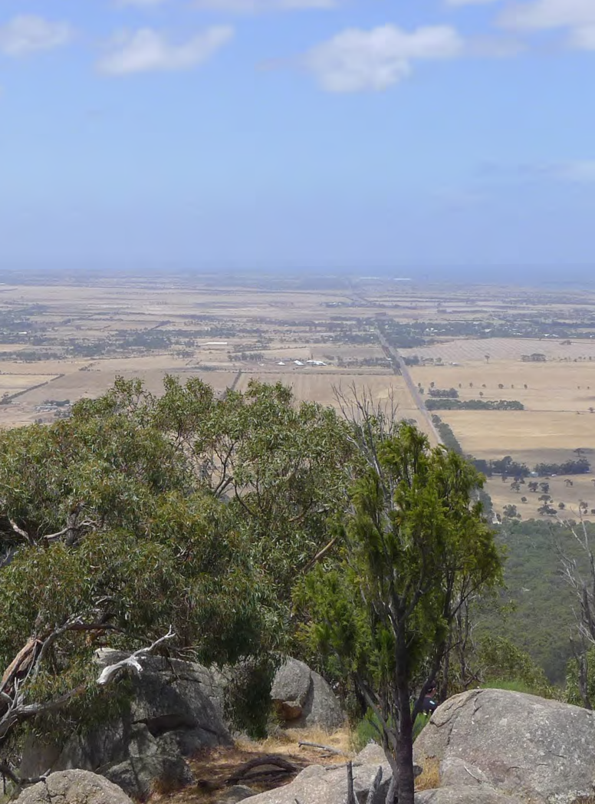

ISSUES
    - Potential amenity impacts for existing residential and rural living properties in Avalon, Lara and Little River associated with significant future expansion of Avalon Airport and adjacent land to accommodate employment uses.
    - Need to manage future traffic movements on Princes Freeway between Melbourne and Geelong and risks associated with increased volumes of freight and commuter vehicles.
    - Need to protect areas required for development of the future Bay West Port through appropriate planning controls.
    - Need to consider and manage potential impacts of Bay West Port on WTP and the adjoining sensitive coastal interface, including the internationally significant Ramsar wetlands.
    - Ensuring protection of the ongoing long-term operations of the WTP.
    - Potential for further fragmentation of rural land located to the north of the Princes Freeway.
    - Potential for small scale or incremental land use and development to be in conflict with broader strategic aspirations.
    - Potential conflicts between present and future land uses north of the Princes Freeway with identified landscape character values.
    - Potential conflicts between extractive industry aspirations with the Western Grasslands Reserve, as well as other areas of high cultural, environmental and landscape values.
    - Exacerbated impacts of flooding, inundation and sea level rise as a result of climate change.
    - Need to further undertake assessments of cultural heritage significance for large tracts of the Avalon Corridor, including the coastline of WTP.
    - Need for planning to have a degree of flexibility in light of uncertainty over the future impacts of emerging technologies on industry, manufacturing, food production, freight logistics and employment.

TOWARD A CONCEPTUAL FRAMEWORK PLAN
14.0

  - Toward a Conceptual Framework Plan 105
  - Major Land Uses and Influences 105
  - Key Drivers and Role of the Framework Plan 105
  - Transport Synergies 106
  - Timing 106
  - Future Urban Development 108
  - Precincts - North and South 108

TOWARD A CONCEPTUAL FRAMEWORK PLAN

This section summarises recommendations and spatial considerations relevant to development of the Framework Plan.

MAJOR LAND USES AND INFLUENCES
Major land uses and influences in the Avalon Corridor of relevance to the Framework Plan are spatially illustrated on Figure 17. These include:
    - The extent of land area influenced by the future expansion of the Avalon Airport to full capacity, including associated noise contours and building height restrictions.
    - The extent of buffers and separation distances associated with various land uses such as quarries, landfills and the Point Wilson Munitions Facility.
    - The location of the future Bay West Port at WTP and its landside connections to the Princes Freeway and the OMR Transport Corridor.
    - The extent of designated Green Wedge Zone land within WCC
    - The small area of the Western Grasslands Reserve within WCC.
    - The extent of the WTP site.
    - The location of the Youth Justice Facility at Cherry Creek.
    - The location and alignment of the potential Avalon Airport rail link and the OMR Transport Corridor, as designated by relevant PAOs.
    - Land located inside the UGB that is identified to be included within future PSPs.
    - The landscape character values and visual significance of Wurdi Youang (the You Yangs) and foreground landscapes, including the foothills.
    - Existing quarries and extractive resources, as identified by WAs, EIIAs and SERAs.
    - The extent of important flora and fauna habitat along the coastal foreshore, including the Ramsar site.
    - Significant flora, fauna and ecological communities extending beyond the coastal foreshore.

KEY DRIVERS AND ROLE OF THE FRAMEWORK PLAN
The key driver of the Avalon Corridor Strategy is to maintain the green break between Melbourne and Geelong and to protect important infrastructure and significant cultural and environmental values.

The Framework Plan seeks to spatially identify high level future land uses within the Avalon Corridor and to clearly designate areas that are suitable for development. The Framework Plan does not
attempt to identify all possible land uses within the area. Greater spatial detail on future land use will be provided through subsequent planning processes, such as the development of Structure Plans.

The Framework Plan must address the overarching project aims by spatially identifying:
    - Land to be protected for its environmental, cultural and landscape values.
    - Land with capacity to be developed for infrastructure and other complementary employment generating uses.
    - Issues and opportunities such as land capability and national and state infrastructure planning.
    - Measures required to maintain a green break between Melbourne and Geelong.

14.3 – 14.4

TRANSPORT SYNERGIES

In order to inform the opportunities and directions of the Framework Plan, it is important to
understand synergies and locational attributes associated with different modes of transport, including road, rail, air and sea.

Engagement with Infrastructure Victoria highlighted there are no direct synergies between port and airport activities, due to the types of freight preferred by each mode:
    - Sea freight typically handles large, bulky items (generally of low value)
    - Air freight typically handles small, lightweight items (generally of high value)

This understanding of the role of different freight modes suggests that there is no justification for the future Bay West Port to be collocated near or connected to Avalon Airport. However there are direct synergies to be drawn between sea and rail freight, as both typically carry larger bulky items over
long distances.

TIMING
The Framework Plan is influenced by the timing of various parallel land use and infrastructure development projects within the Avalon Corridor, including:
    - Further expansion of international flights at Avalon Airport.
    - Construction of the second parallel runway.
    - The long term status of the third cross runway, and whether it is likely to be ultimately required and constructed.
    - Construction of improved public transport connections to Avalon Airport.
    - Uptake of developable employment land within and surrounding the Avalon Airport site.
    - Updates to the Avalon Airport Master Plan in relation to Greater Avalon Employment Precinct (GAEP) Structure Plan.
    - Preparation of the Werribee Junction and Mambourin East PSPs.
    - Construction of the OMR Transport Corridor.
    - Development of the Bay West Port and associated landside connections.
    - Construction of the WIFT at Truganina.
    - Upgrades to the Geelong-Melbourne rail line and completion of other public transport projects such as the Suburban Rail Loop.

As the delivery of these projects is outside the control of the Avalon Corridor Strategy, it is difficult
for the Strategy to predict or respond to their timing. However, the Framework Plan should still have
regard for confirmed or proposed projects that influence overall land use and development directions.

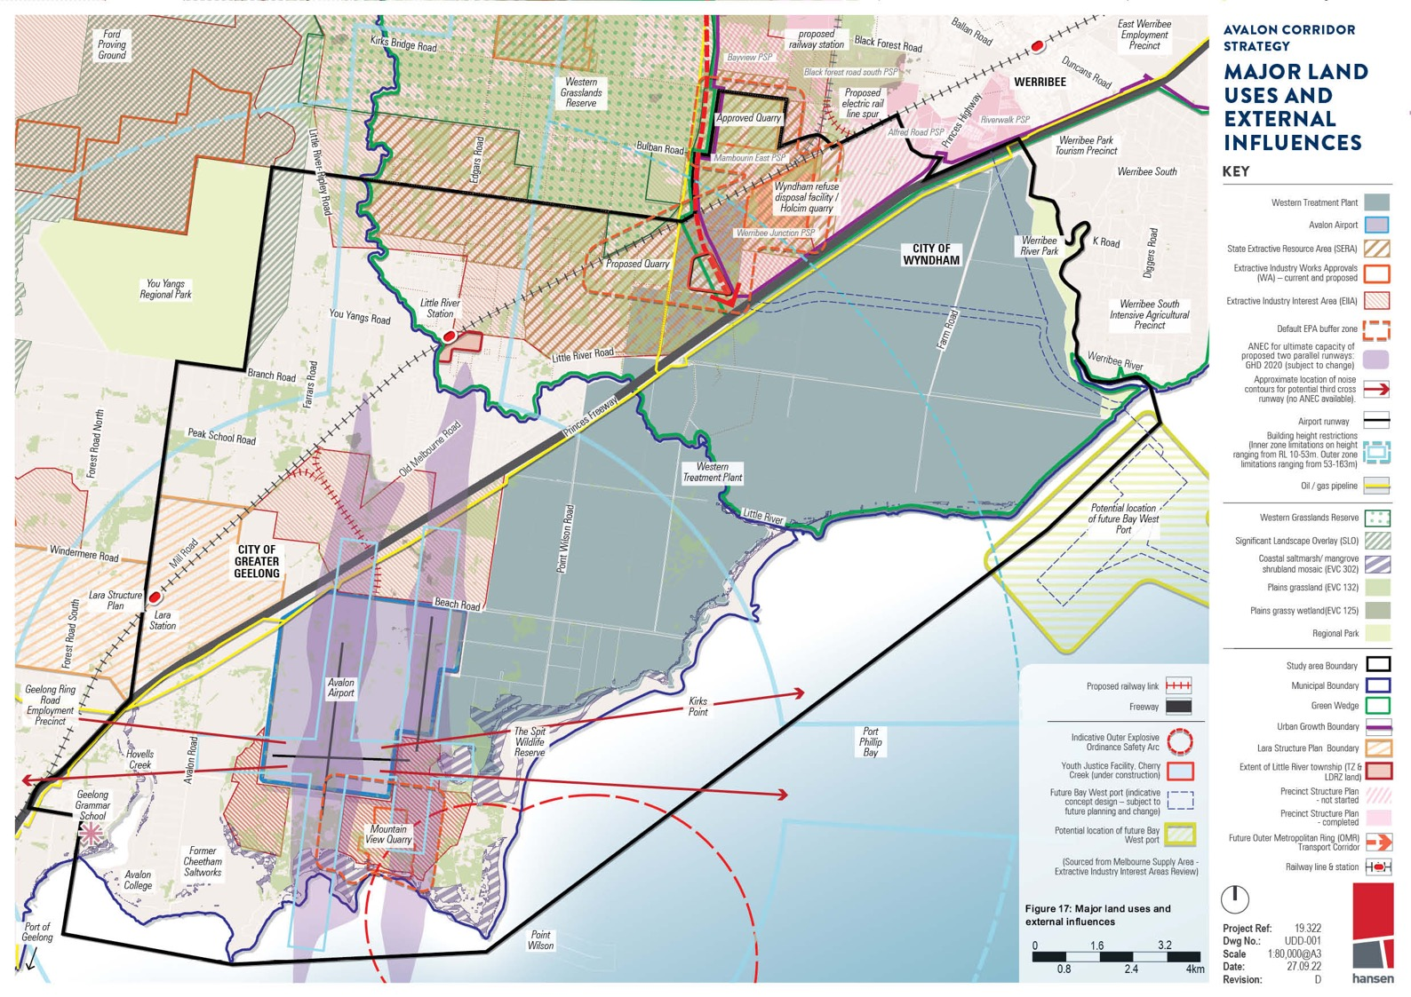
£ .
proposed ,
raifwa srotionBlack Forest Road
Bcyu -._
'<111,9,••-
Or9d

/ Ou,.,.

East Werribee Employment Precinct

AVALON CORRIDOR STRATEGY

tumlsu11tl1PSP ----- ····-•.x0 - WERRIBEE Va,;,.s,9 d

Railway line & station
Project Ref: 19.322
DwgNo.: UDD-001
Scale 1:00,000@AJ

0..8 2.4 4km Date: 27.0922
Revision: D hansen

14.5–14.6

FUTURE URBAN DEVELOPMENT
Plan Melbourne (2017) and other strategic documents such as the Greater Geelong Settlement Strategy (2020) set out clear objectives to protect green wedge and peri-urban areas, in order to maintain the green break between Geelong and Melbourne. These policy positions preclude
consideration of further residential and urban development within the Avalon Corridor, beyond what is already planned.

The Avalon Corridor Strategy has focused on the designation of appropriate future land uses within the Avalon Corridor to take advantage of the region’s strategic location and assets, whilst not undermining the long term intent for protection of green wedge and peri-urban areas.

PRECINCTS - NORTH AND SOUTH
Based on background analysis presented in earlier sections of this Strategy, two high level precincts have been identified - the North and South Precinct. These precincts are delineated the Princes
Freeway and have been utilised to spatially differentiate the Avalon Corridor based on land use, land ownership and landscape considerations. The further designation of sub-precincts in the Framework Plan allows for the development of more targeted strategies and objectives.

NORTH PRECINCT

The North Precinct includes all land located to the north of the Princes Freeway. Apart from residential and rural residential land use associated with Lara and Little River, the North Precinct is characterised by open rural landscapes and farming land with limited development. Due to the limited presence
of canopy vegetation (other than in isolated patches and along road corridors), substantial open
views towards Wurdi Youang (the You Yangs) are available throughout the North Precinct, including glimpses along the Princes Freeway.

The Wyndham RDF, Holcim Quarry and Cherry Creek Youth Justice Facility are located to the
north eastern corner of the North Precinct. Additionally, the precinct contains substantial tracts of potential stone resources designated as EIIAs or SERAs. Further investigations will be required to
determine the appropriateness of this land for quarrying and to assess potential impacts against other objectives and values within the Avalon Corridor.
The North Precinct also includes the Werribee Junction and Mambourin East PSP areas located within the edge of the UGB.
North sub-precincts
    - Lara and Little River townships
    - Open rural landscapes and farming land
    - Princes Freeway corridor (north side)
    - Land within the UGB and OMR Transport Corridor alignment

SOUTH PRECINCT

The South Precinct includes all land located to the south of the Princes Freeway. Land ownership and existing land use plays a large role in defining this area, noting that the WTP covers approximately
three quarters of the South Precinct. Other larger specific land holdings within the South Precinct
includes Avalon Airport, former Cheetham Saltworks, Mountain View Quarry, Point Wilson Munitions Facility and Crown land reserves.

Despite these major land holdings, the South Precinct is particularly hidden through a combination of the following factors:
    - Alignment of the Princes Freeway creating a land use barrier.
    - Extent of mature vegetation along the southern side of the Princes Freeway which limits views into and across the South Precinct.
    - Flat topography, with no significant landforms such as Wurdi Youang to frame or draw visual focus.
    - Limited road access points and the lack of established township settlements (other than a small area of rural residential living west of Avalon Road).
South sub-precincts:
    - Avalon Airport and surrounding environs
    - Western Treatment Plant (WTP) and environs
    - Bay West Port and environs
    - Princes Freeway corridor (south side)
    - Existing settlement areas west of Avalon Road
    - Coastal environs

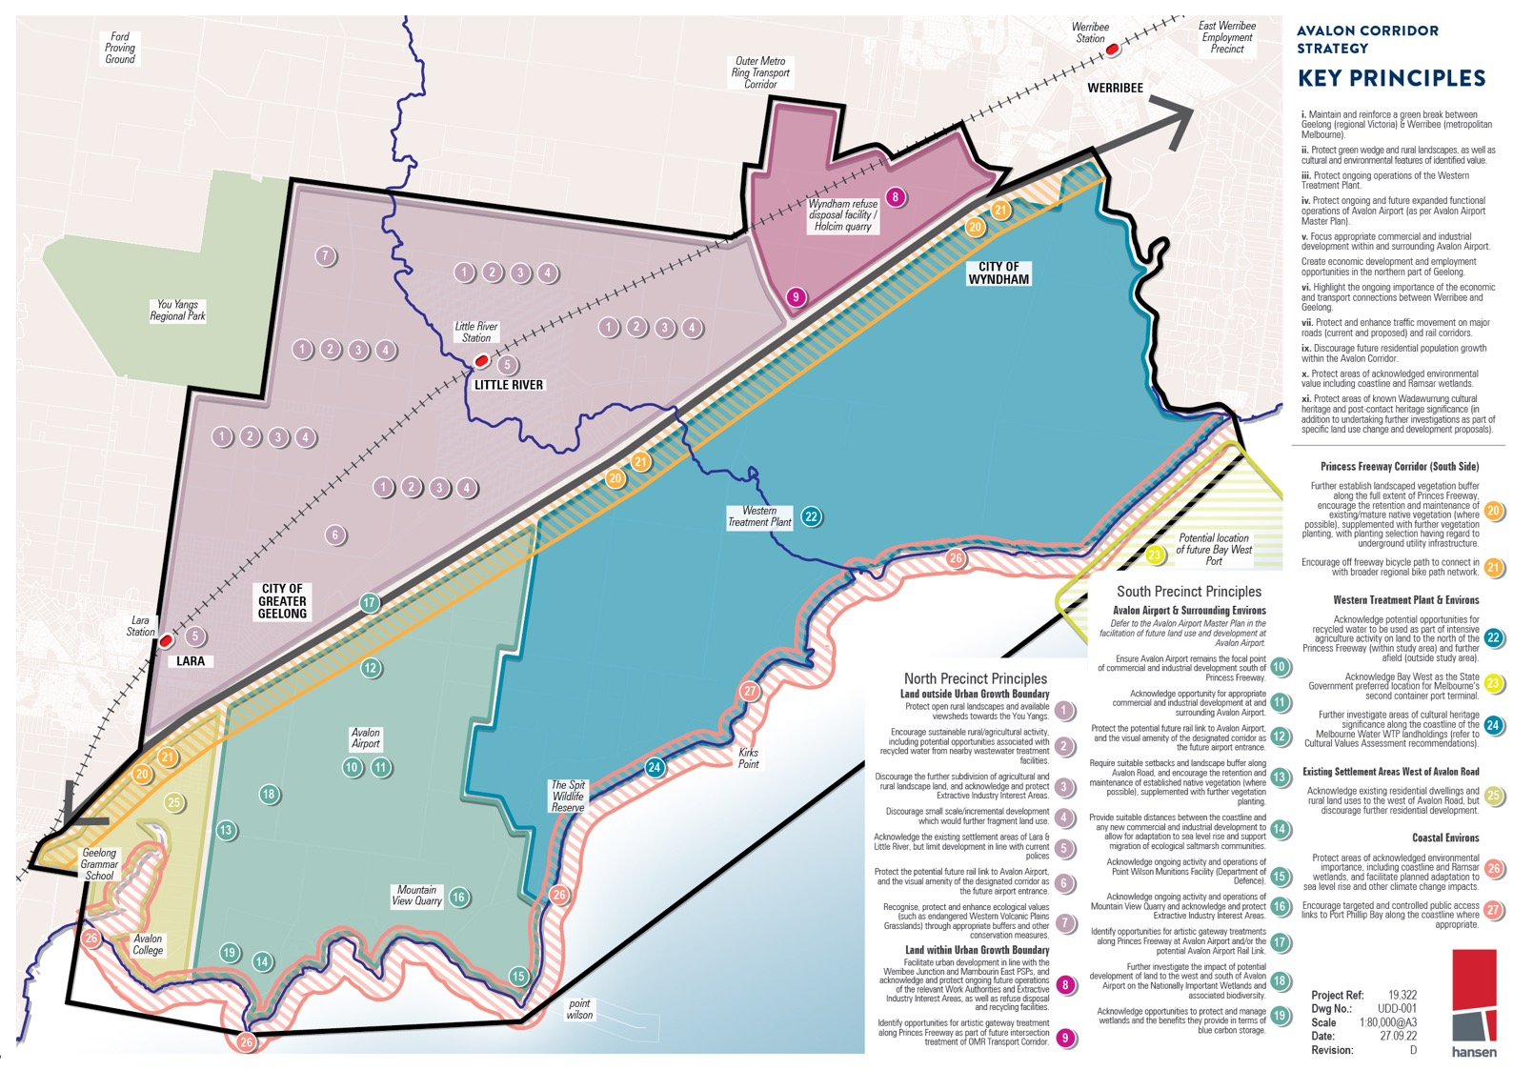
Ford
Proving
Ground
East Werribee Employment Precinct
AVALON CORRIDOR
STRATEGY

KEY PRINCIPLES

You Yangs
Regional Park

CHY OF
WYNDHAM
i. Marntain and retnforce a green break between Geelong (regional Victoria) & Werribee tmetropolitan
Existing Settliement Areas West of Avalon Road
Acknowledge existing residential dwellings and
\
rural land uses to the west of Avalon Road. bl.II y
discournge further residential development

Coastal Environs
Protec, areas of acknowledged snvironmental importance including coo stline arid Ramsar wetlands. and facilrtate planned adaptation to sea level rise and other clim11te ch11nge impacts

5ncoumge targeted and controlled public access links to P"ort Phrllip Bay along the coastline where
appropriate

Figure 18: Key principles

Project Ref: 19322
DwgNo.: UDD-001
Scale 1:80,000@A3
Date: 27-0922
Revision: D hansen

FRAMEWORK PLAN
15.0

  - Framework Plan 111
  - Framework Plan Objectives and Strategies 111
  - South Precinct 112
  - North Precinct 116

FRAMEWORK PLAN

The Framework Plan (Figure 19) guides future detailed land use and development in the Avalon Corridor out to 2050.

The Framework Plan is guided by a series of overarching objectives and strategies. More specific
objectives and strategies also apply to the North and South Precincts and associated sub- precincts.

FRAMEWORK PLAN OBJECTIVES AND STRATEGIES
Objectives
- To identify and protect land within the Avalon Corridor that constitutes the green break between Geelong and Melbourne.
- To acknowledge and protect land within the Avalon Corridor which has known cultural, environmental and landscape character values.
- To identify various state significant assets and promote a coordinated approach to infrastructure planning and development.
- To identify developable land for future employment uses.
Strategies
- Maintain and reinforce green break between Geelong and metropolitan Melbourne and discourage further population growth within existing settlements, beyond that outlined in current strategies.
- Protect ongoing and future expanded operations of Avalon Airport.
- Centralise future commercial and industrial development on land located south of the Princes Freeway at Avalon Airport (in line with the Master Plan) and immediate surrounds.
- Enable the future preparation of a Structure Plan for the GAEP.
- Encourage strategic land uses with a focus on employment generating activities.
- Prioritise protection of views to the culturally significant Wurdi Youang north of Princes Freeway.
    - Acknowledge the location of the future Bay West Port.
    - Protect and enhance the existing and future transport network.
    - Minimise and eliminate (where possible) impacts of future land use and development on environmental values and sensitive ecosystems, including the Ramsar wetlands.
    - Ensure impacts of climate change, including sea level rise, are considered and appropriately mitigated as part of all future land use and development.
    - Protect green wedge and rural landscapes.
    - Protect agricultural areas and the right to farm from incompatible land uses and further urban encroachment.
    - Protect areas of acknowledged environmental importance, including grasslands, coastline and Ramsar wetlands.
    - Protect non-urban land areas within the Avalon Corridor which are recognised for their cultural and landscape values.
    - Protect ongoing operations of the WTP.
    - Protect identified SERAs and EIIAs for potential future quarrying activities to meet demand for stone and sand for construction in the metropolitan Melbourne and Geelong areas.
    - Position the Avalon Corridor as a tourism gateway and support tourism opportunities associated with existing activities and assets within the region.
    - Ensure the protection of existing environmental linkages and wildlife corridors and encourage
the provision of new environmental linkages both within the study area and to areas adjacent and beyond the study area.
    - Undertake future detailed biodiversity assessments as part of future Structure Plan processes.

SOUTH PRECINCT

AVALON AIRPORT AND SURROUNDING ENVIRONS
Objectives
      - To support and facilitate the major expansion of Avalon Airport and the opportunity for
commercial and industrial development which benefits from the transport gateway anchored by the airport.
Strategies
      - Acknowledge future expansion of Avalon Airport consistent with the Avalon Airport Master Plan (or future updates), including potential for substantial increase in airport traffic and possibility of two additional runways.
      - Ensure Avalon Airport remains the critical focus of commercial and industrial development south of Princes Freeway.
      - Acknowledge opportunities for airport and related commercial and industrial development of land surrounding Avalon Airport, but apply the following guiding principles to future development on
and surrounding Avalon Airport:
        - Airport land – development to be consistent with Avalon Airport Master Plan.
        - Land surrounding Airport – ensure development of land immediately surrounding the airport includes commercial or industrial activities which are compatible with the airport and benefit the transport gateway locational attributes of the precinct.
        - Non-airport related – discourage activities, which are incompatible with the functional operation of the airport.
      - Prepare a Structure Plan for the Greater Avalon Employment Precinct (GAEP).
      - Acknowledge the need to undertake additional investigations regarding the current values of
the Werribee-Avalon Area Nationally Important Wetland located to the west and south of Avalon Airport, including the former Cheetham Saltworks site. Such investigations should be undertaken as part of the Structure Plan process for the GAEP.
- Investigate the potential for an environmental buffer interface between the GAEP and adjacent coastal environs.
- Consider the direct and indirect impacts of the potential development of Avalon Airport and
surrounding land on Ramsar wetland sites, and consider opportunities to restore the wetlands, either as part of development proposal or if development does not proceed.
- Consider visual amenity buffers for existing rural residential areas, such as setbacks and landscape buffers along Avalon Road.
- Acknowledge ongoing activities and operations of the Point Wilson Munitions Facility.
- Acknowledge ongoing activities and operations of Mountain View Quarry, and have regard for future rehabilitation opportunities.
- Identify opportunities for artistic gateway treatments along Princes Freeway at Avalon Airport and the potential future Avalon Airport Rail Link.
- Acknowledge land identified as EIIAs and land with authorised quarries.
- Undertaken a Safety Management Study (SMS) in accordance with AS 2885 for proposed land use change and development within applicable measurement lengths from gas and oil pipeline easements.
- Consult the Site Planning and Landscape National Guidelines (APA, 2020) for guidance on tree species selection within proximity of the gas pipeline easement.

112 | CITY OF GREATER GEELONG AND WYNDHAM CITY COUNCIL

15.2

WESTERN TREATMENT PLANT AND ENVIRONS
Objectives
      - To ensure the long term operation of the WTP and its role relating to resource recovery.
      - To support opportunities for sustainable and beneficial recycled water use.
      - To encourage renewable energy generation opportunities.
      - To ensure the Bay West Port infrastructure and operations do not compromise current or future sewage treatment capacity or operations within the WTP site.
Strategies
      - Protect ongoing operations of the WTP.
      - Encourage a range of land uses and activities on the WTP site which broadly relate to waste water treatment and resource recovery.
      - Protect identified post contact and cultural heritage values and undertake further assessment of Wadawurrung cultural values present at WTP.
      - Develop community water literacy and environmental awareness through site based education and visitation programs.
      - Investigate the potential use of recycled water for agriculture within the Avalon Corridor.
      - Encourage expanded opportunities for alternative forms of energy generation on WTP site, including biogas and solar.
      - Further develop agricultural production within the WTP site.
      - Protect the role of WTP as a functioning part of the Ramsar wetland site and a significant habitat for a number of migratory and shorebird species.

5.2.3 BAY WEST PORT AND ENVIRONS
Objectives
- To recognise the future Bay West Port as the location of Melbourne’s second container port terminal, as supported by state policy.
- To ensure the Bay West Port infrastructure and operations do not compromise current or future sewage treatment capacity or operations within the WTP.
- To ensure the Bay West Port infrastructure planning and design considers and protects current and future infrastructure and operational requirements of the WTP.
- To minimise and eliminate impacts from the development and operations of the Bay West Port on significant biodiversity and environmental values, including sensitive coastal ecosystems and
wetlands of international significance.
Strategies
- Implement necessary planning controls to protect long term development opportunities associated with the Bay West Port.
- Undertake baseline environmental and Aboriginal Cultural Heritage Impact Assessments for the final location of the Bay West Port.

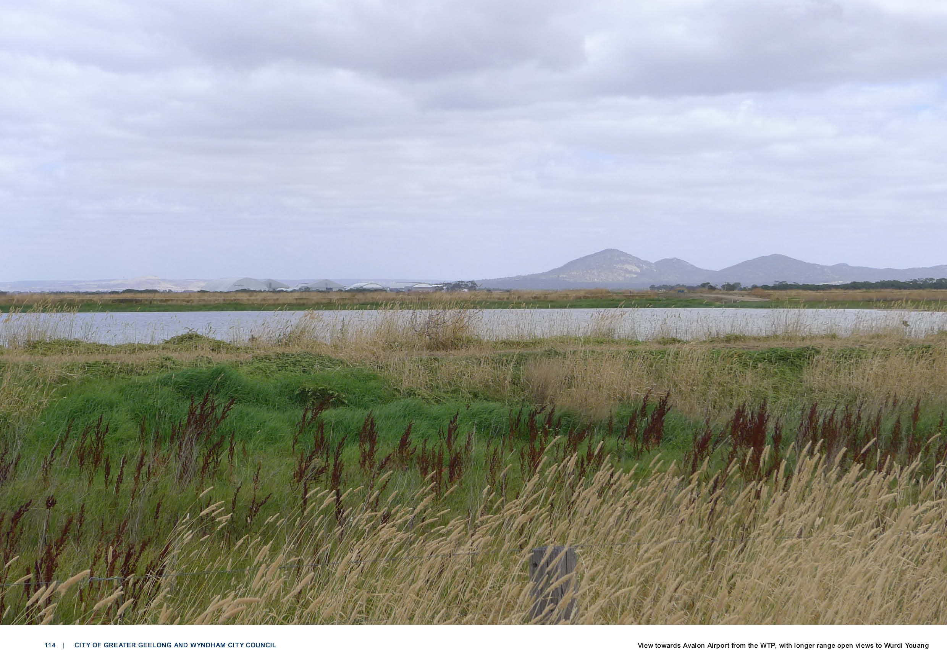

114 | CITY OF GREATER GEELONG AND WYNDHAM CITY COUNCIL View towards Avalon Airport from the WTP, with longer range open views to Wurdi Youang

15.2

PRINCES FREEWAY CORRIDOR (SOUTH SIDE)
Objectives
      - To create a substantially landscaped vegetation corridor along the south side of the Princes Freeway.
      - To further investigate and develop an off-road bicycle route or shared path to connect the missing link of the Port Phillip Bay Trail between Werribee and Geelong.
Strategies
      - Encourage landscaped vegetation buffer along full extent of Princes Freeway, ensuring the
selection of suitable species which will not impact negatively on gas or oil pipeline easements.
      - Encourage development of an off-road bicycle or shared path to connect to the broader regional bike path network, including the Port Phillip Bay Trail and trails to the northern areas of Little
River, Lara and the You Yangs.

EXISTING SETTLEMENT AREAS WEST OF AVALON ROAD
Objectives
      - To acknowledge existing settlements in Avalon and protect their visual amenity and character through appropriate design controls for development of the GAEP and Avalon Airport.
Strategies
      - Acknowledge existing rural residential dwellings and land uses to the west of Avalon Road, but discourage further residential development.
      - Protect visual amenity through suitable design strategies such as setbacks and landscape buffers to the east side of Avalon Road (within the GAEP boundary).

COASTAL ENVIRONS
Objectives
      - To protect the coastal environment, including areas of acknowledged environmental importance such as the Ramsar wetlands.
      - To enhance public knowledge and appreciation of significant coastal environ areas.
Strategies
      - Protect areas of environmental importance, through existing relevant policy frameworks.
      - Encourage targeted and controlled public access links to Port Phillip Bay along the coastline, where appropriate.
      - Investigate and address impacts of sea level rise and coastal erosion on coastal environs and habitat.
      - Encourage regeneration and rehabilitation of wetlands areas, including saltmarsh within the areas of the former Cheetham Saltworks site (both public and private land).
      - Investigate opportunities to expand areas of protected wetlands, where appropriate.

NORTH PRECINCT

LARA AND LITTLE RIVER TOWNSHIPS
Objectives
      - To acknowledge the existing settlement area of Lara and facilitate residential development in line with the Lara Structure Plan (2012) and Greater Geelong Settlement Strategy.
      - To investigate a township plan and permanent settlement boundary for Little River, which protects the current character of Little River and discourages further residential expansion.
      - To protect future operations of Avalon Airport from residential encroachment.
      - To recognise that the neighbouring townships of Lara and Little River have differences in scale, aspirations and resources.
Strategies
      - Implement residential land use planning in line with the relevant policies and strategies of the Wyndham and Greater Geelong Planning Scheme.
      - Investigate a permanent settlement boundary for Little River and implement appropriate planning controls which discourage further residential expansion.
      - Implement appropriate planning controls for Avalon Airport to limit noise impacts on surrounding areas.

OPEN RURAL LANDSCAPES
Objectives
      - To protect open rural landscapes and viewsheds towards the You Yangs.
      - To protect identified green wedge and peri-urban land for agricultural and rural land uses.
      - To support landowners to undertake rural landscape restoration.
      - To acknowledge land identified as EIIAs or SERAs.
Strategies
      - Encourage broad scale rural and agricultural activity.
      - Discourage the further fragmentation of land.
      - Discourage small scale, incremental development which would be in conflict with broader land designations.
      - Discourage large scale buildings which would interrupt views to the You Yangs, including greenhouses.
      - Implement appropriate planning controls to protect areas of acknowledged cultural or landscape significance, such as the foothills to Wurdi Youang (the You Yangs).

116 | CITY OF GREATER GEELONG AND WYNDHAM CITY COUNCIL

15.3

AVALON AIRPORT GATEWAY
Objectives
      - To protect the potential opportunity for the Avalon Airport rail link.
      - To enhance the visual amenity of connections into Avalon Airport as the entrance gateway to the Greater Geelong region and Melbourne Western Metro region.
Strategies
      - Discourage development which would visually detract from the future Avalon Airport gateway entrance.

OMR TRANSPORT CORRIDOR ALIGNMENT AND LAND WITHIN UGB
Objectives
      - To acknowledge the future alignment of the OMR Transport Corridor and its connection with the Princes Freeway.
      - To identify opportunities for artistic gateway treatments at the future intersection of the OMR Transport Corridor with the Princes Freeway.
      - To support and protect ongoing future operations of the Wyndham RDF and Holcim Quarry.
Strategies
      - Encourage an artistic gateway as part of the future OMR Transport Corridor as a new visual marker for the entrance to Werribee.
      - Maintain and enforce appropriate buffers associated with the Wyndham RDF and Holcim Quarry.

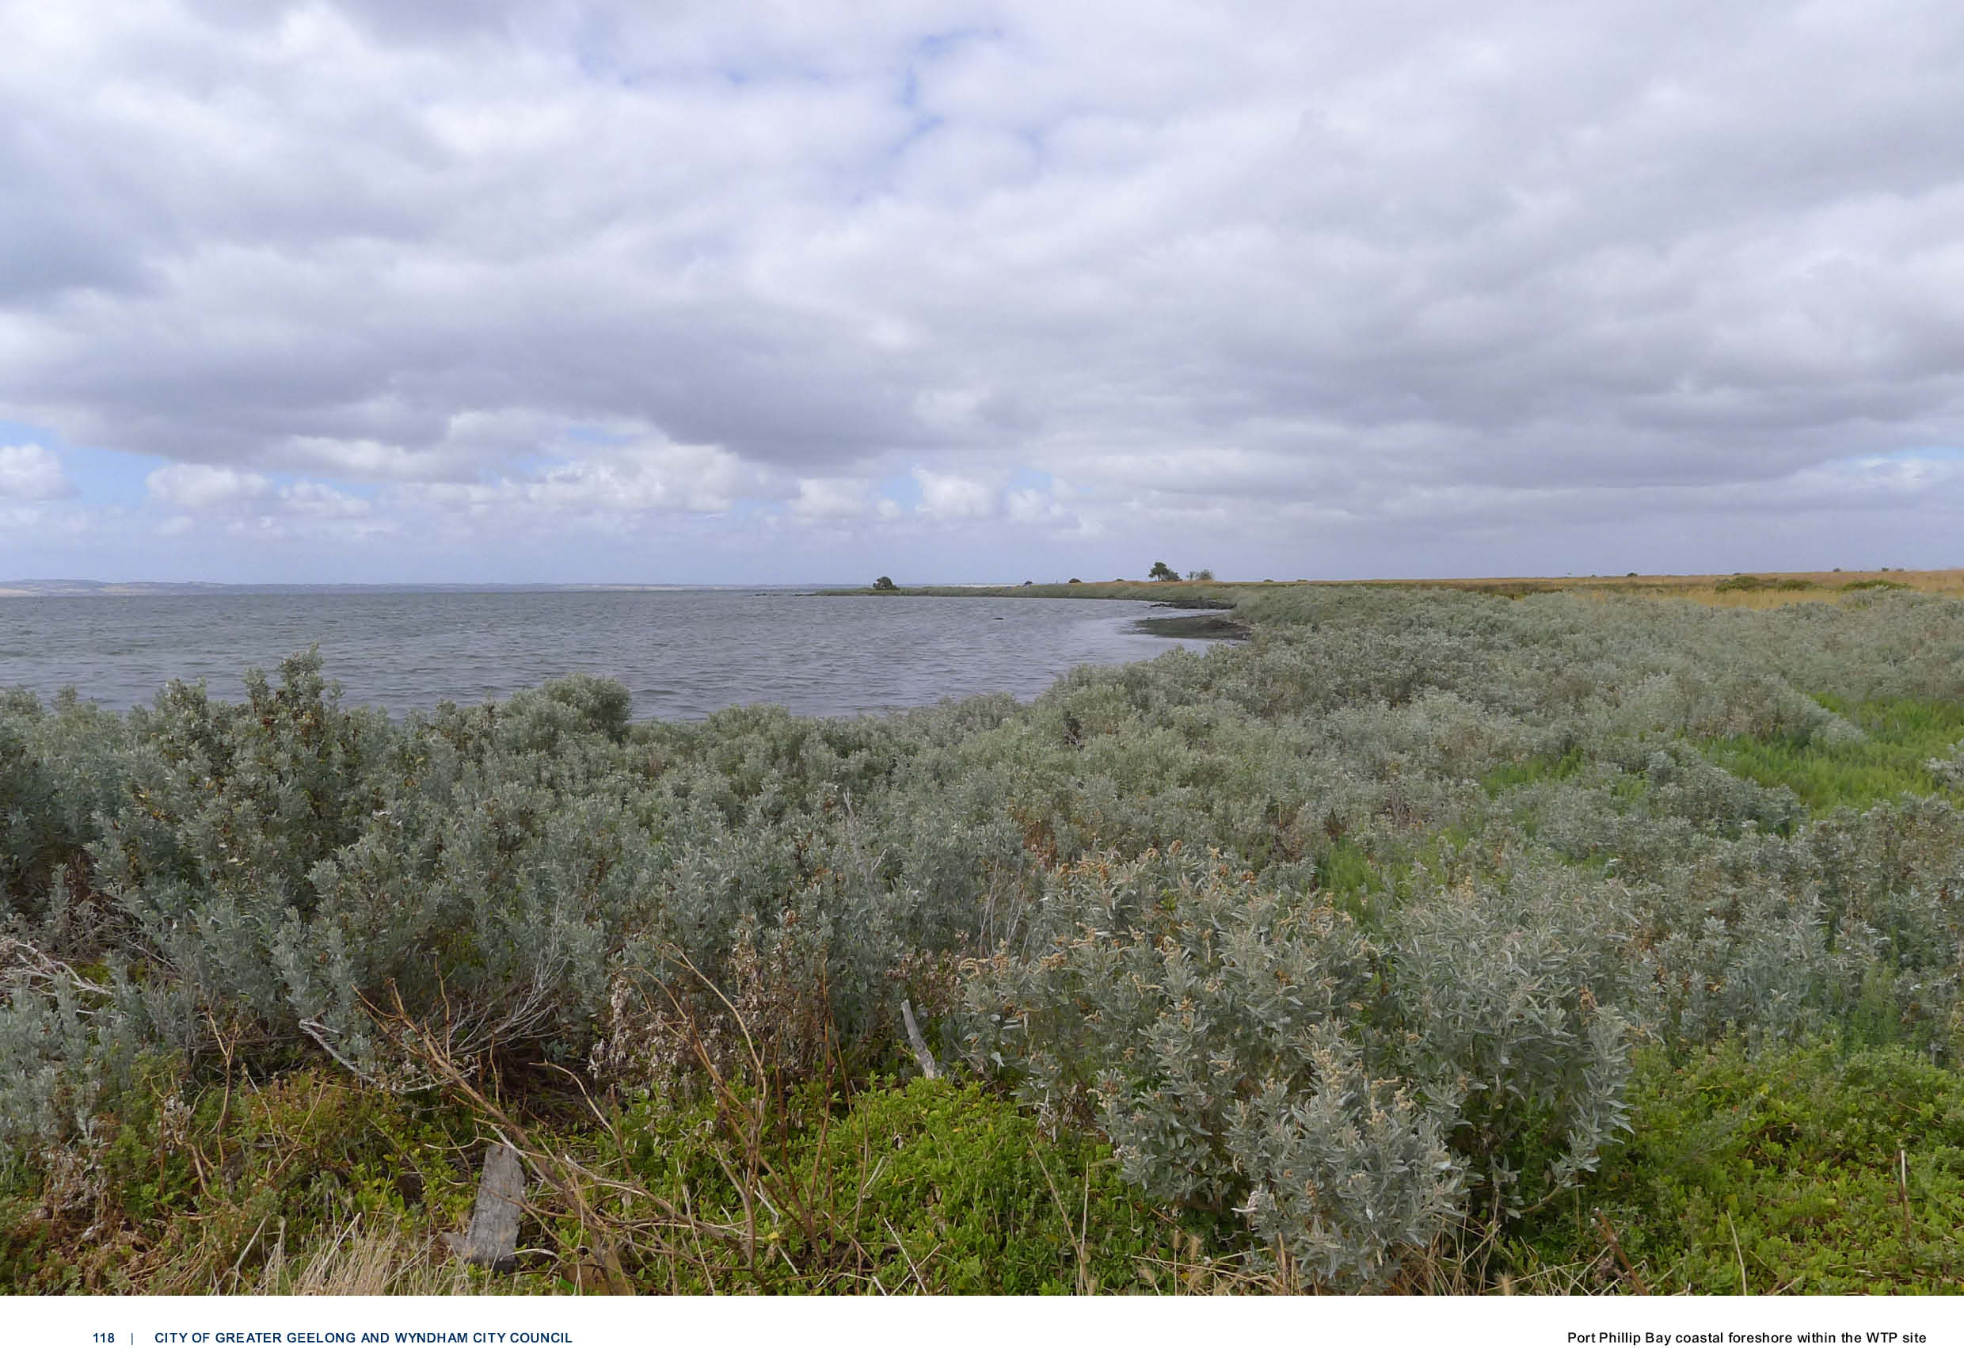

118 | CITY OF GREATER GEELONG AND WYNDHAM CITY COUNCIL Port Phillip Bay coastal foreshore within the WTP site

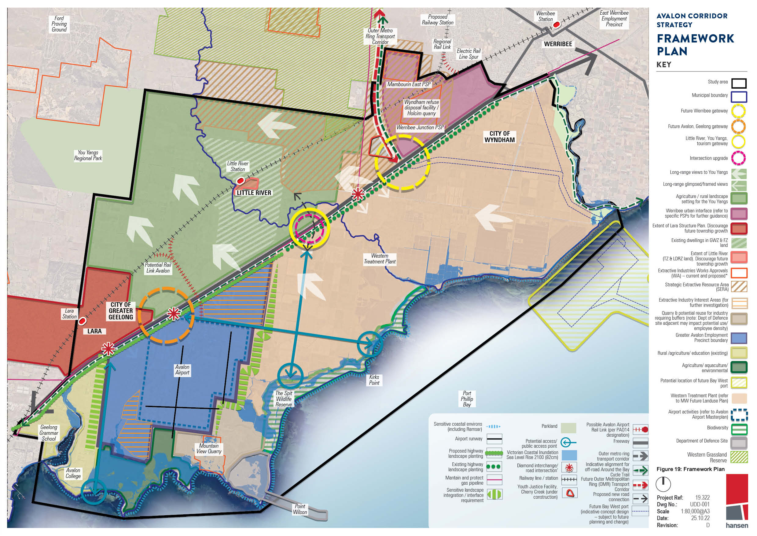
Ford
Scale 1:80,000@A3
Date: 2510-22
Revision: D hansen

IMPLEMENTATION
16.0

  - Implementation 121
  - Framework Plan Implementation 121
  - Further Work to be Undertaken 124

IMPLEMENTATION

FRAMEWORK PLAN IMPLEMENTATION
The Avalon Corridor Strategy provides a long term strategic vision of the Avalon Corridor to ensure planning decisions on individual sites are made in context of the broader vision for the region. The Avalon Corridor Strategy has been tasked with preparing strategic guidance for a large tract of land, which extends from the eastern edge of Geelong to the western edge of Werribee.

The key output of the Avalon Corridor Strategy is the Framework Plan, which outlines the broader spatial pattern of land use for the Avalon Corridor and identifies relevant objectives and strategies for sub-precincts. The Framework Plan is high level in focus and therefore does not go into details that will be determined through subsequent planning processes, such as the development of Structure Plans for the GAEP, Werribee Junction and Mambourin East.

WERRIBEE URBAN INTERFACE

The Werribee urban interface area as illustrated on the Framework Plan will be the subject of further
detailed investigations and concept planning associated with the preparation of the Werribee Junction and Mambourin East PSPs. These PSPs are to be led and developed by the VPA in collaboration with WCC.

The Mambourin East PSP and majority of the Werribee Junction PSP are identified as ‘regionally significant industrial precincts’ for potential employment uses focused on industry and logistics,
per the West Growth Corridor Plan, Melbourne Industrial and Commercial Land Use Plan (MICLUP) and Draft Western Metro Land Use Framework Plan. Land use relating to industry and logistics in
these PSPs will likely benefit from proximity to Avalon Airport, the future Bay West Port and the OMR Transport Corridor.
GREATER AVALON EMPLOYMENT PRECINCT

While the Framework Plan sets out the broader directions for land use and development, it will be necessary for further detailed work to be completed to assess a range of specific land use/ development issues and options at and surrounding Avalon Airport.

The Framework Plan identifies land which has potential for commercial/ industrial airport related
development given locational attributes and proximity to Avalon Airport. However, it is not a matter of simply rezoning and redeveloping individual sites around the airport on a piecemeal basis, as this could undermine the intent of why the Avalon Corridor Strategy is being prepared i.e., the significant
opportunities provided by an integrated airport and related commercial business precinct focused on Avalon Airport.

Therefore, it will be necessary to prepare a Structure Plan for the land identified in the Framework
Plan as ‘potential commercial / industrial / airport related business’ which will function to strategically consider the optimal arrangement and integration of future land use and development of land
surrounding the Avalon Airport, and would be broadly guided by the Avalon Corridor Strategy and
Framework Plan. During the planning and development of the Structure Plan there is a need to consider practices and principles relating to Water Sensitive Urban Design (WSUD) and Biodiversity Sensitive
Urban Design (BSUD), particularly for land west of Avalon Airport.

It will be the role of the Structure Plan to investigate and develop an appropriate response to key
matters prior to development proceeding. Although the Avalon Corridor Strategy sets high-level land use and policy direction, more detailed matters will need to be addressed through relevant structure planning processes

Functionally speaking, the Structure Plan would be informed and guided by the broader findings, conclusions and recommendations of the Avalon Corridor Strategy. The preparation of a Structure Plan would enable the consideration of all specific issues at a detailed and comprehensive level, to achieve the best outcome for the entire airport precinct. This approach avoids addressing issues on a site by site basis, which could lead to a fragmented assessment, consequently undermining the opportunity to maximise the potential to develop this area as a fully integrated airport and related precinct.

Given a Structure Plan functions to take a precinct wide approach, it allows precinct wide issues to be considered and addressed. For example, through the preparation of a precinct wide transport management strategy and precinct wide drainage catchment strategy, where an optimal response to such matters can be embedded into the Structure Plan. This process then also allows the preparation and implementation of a Development Contributions Plan (DCP) to fund required items, such as drainage as one particular example.

16.1

It is also highlighted that the Framework Plan contains numerous
elements which fall outside of the immediate control of Greater Geelong & Wyndham Councils to influence or implement, with these relating to matters of state significance such as:
    - Avalon Airport being granted approval for further international flights
    - Construction of improved public transport connections to Avalon Airport
    - Construction of the OMR Transport Corridor
    - Construction of the Bay West Port as the preferred port option and its potential construction
IMPLICATION OF PLANNING POLICY
- Incorporate necessary policy references within the Planning Policy Framework (PPF), including State, Regional, Local and MSS of both the Greater Geelong and Wyndham Planning Schemes.
- Incorporate necessary policy references within the G21 Regional Growth Plan.

APPLICATION OF ZONES AND OVERLAYS
- Implement overlay controls to address airport noise contours and building height restriction associated with the functional operation of Avalon Airport.
- Implement required zones and overlays in the short term to protect long term development opportunities associated with the Bay West Port.
- Consider amending the existing Farming Zone of the Geelong Motor Sports Complex to
recreational open space or other suitable zone, which could be facilitated via a future rezoning associated with the implementation of the Greater Avalon Employment Precinct Structure Plan.
The above implementation of the Avalon Corridor Strategy into the Greater Geelong and Wyndham Planning Scheme should be undertaken in the short term (0-2 years).

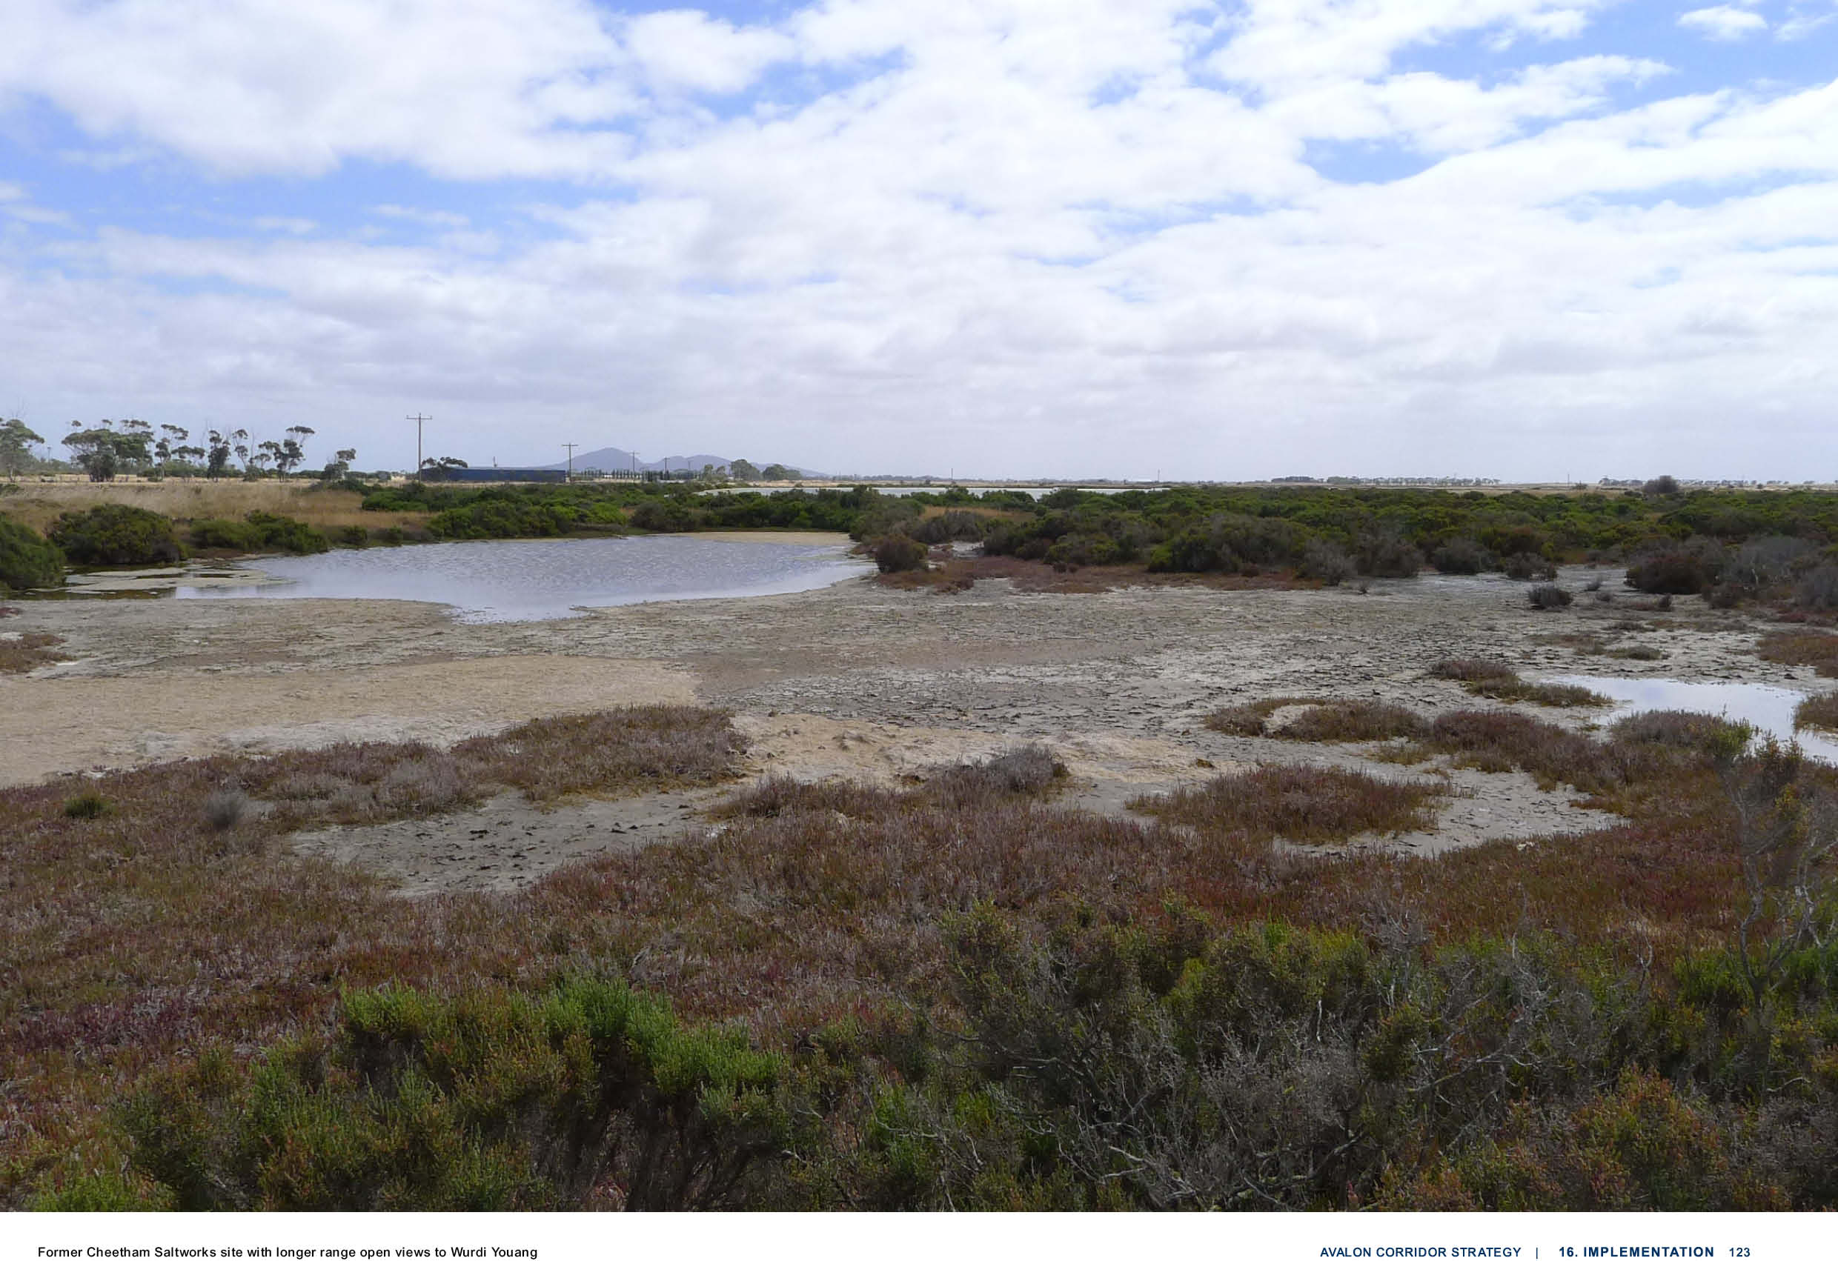

FURTHER WORK TO BE UNDERTAKEN
The Framework Plan functions as high level strategic planning strategy to guide future land use and development. However, the Framework Plan is not resolved to a level to contemplate and spatially
map out all potential future land use and development, nor address every potential issue to a specific and detailed level.

Accordingly, the next level of detailed strategic analysis will be captured by other formal steps involved in the consideration of the future land use and development, including:
    - Planning Scheme Amendment process to implement aspects of this strategy;
    - Preparation of detailed Structure Plans for key future development areas; &
    - Required statutory approvals for site specific proposals.

In the final drafting stages of this Strategy, the Victoria Planning Authority (VPA) were appointed by the Minister for Planning to become the planning authority to prepare a Structure Plan for the
proposed employment precinct adjacent to Avalon Airport, known as the Greater Avalon Employment Precinct (GAEP). Initial background site investigations for the Structure Plan has already commenced by the VPA.

Following below is further strategic work which should be undertaken by CoGG and WCC (as
applicable), following the formal adoption of this strategy. This list is not exhaustive, and other items of work are likely to be identified in due course. Future work to be actioned includes the following
which has been set out in terms of short, medium and longer term priority:

SHORT TERM (1-5 YEARS):
- CoGG to work with the VPA to commence the preparation of a Structure Plan for the GAEP (refer to Section 16.1 for further discussion and detail on the role and function of the Structure Plan),
including:
– Undertake detailed environmental assessments of land immediately to the west of Avalon Airport to consider potential impacts of future development on identified Werribee-Avalon Area Nationally Important Wetlands (NIW).
- CoGG and/or the VPA and DoT to assess movement and access in developing the Structure Plan, including:
  - The long-term role of Point Wilson Road for passenger and freight access to Avalon Airport and access to Little River.
  - Upgrades of Beach Road and Avalon Road interchange to accommodate future passenger and freight growth.
- WCC and the VPA to continue the preparation of the Werribee Junction and Mambourin East
PSPs in a manner that is consistent with the high-level objectives and land use guidance of the Avalon Corridor Strategy.
- VPA to undertake further environmental assessments as part of the investigation and
confirmation of the Greater Avalon Employment Precinct Structure Plan including mitigation of stormwater runoff on wetlands, and the current values of the nationally important wetlands (Former Cheetham Saltworks) to the west and south of Avalon Airport.
- CoGG, WCC, DELWP and WTOAC to undertake further analysis and investigation regarding the potential expansion of the SLO to address cultural values, noting that:
  - The Cultural Values Assessment completed for the Avalon Corridor Strategy included a
recommendation from the WTOAC to look at extending the SLOs for the You Yangs (Wurdi Youang) and Anakie Ranges.
  - This request is influenced by current work of DELWP, which is considering the purpose
and use of SLOs on a number of fronts, including whether SLOs are an appropriate tool for protecting cultural heritage.
- CoGG and WCC to advocate to CCMA, Melbourne Water and Barwon Water to improve
catchment health through relevant IWM Forums, including returning environmental flows and creating wildlife corridor through to WTP.
- CoGG and WCC to confirm alternate water supply opportunities for the Avalon Corridor region, such as through development of Integrated Water Management (IWM) plans with relevant
stakeholders (e.g. Melbourne Water, Barwon Water and Greater Western Water), in consultation with relevant IWM Forums.

16.2

MEDIUM TERM (5-10 YEARS):
- CoGG and WCC to investigate opportunities to create a strategic biodiversity link between the You Yangs, the adjacent native grassland remnants, and the Western Grasslands Reserve.
- CoGG to review outstanding post-contact heritage recommendations for Heritage overlays
identified in the Outer Areas Heritage Study and investigate the HO potential of early dry stone walls and other features in the area, as part of a five year program looking at the Outer Areas.
- WCC to implement the recommendations of the Stage 1 Heritage Review Gap Study2019 as
endorsed by Council in June 2021; this work is proposed to be carried out in a staged manner in the next one to five years.
- CoGG, in discussion with Heritage Victoria and community groups, to explore the potential inclusion of the Wurdi Youang/You Yangs in the Victorian Heritage Register or a Heritage
Overlay.
- DoT, COGG and WCC to undertake further investigations to understand the need for transport network upgrades, based on current and future demand.

LONGER TERM (10+ YEARS):
- CoGG and WCC to work together to prepare a township plan for Little River and to establish a township settlement boundary to restrict further urban/residential expansion.
- CoGG and WCC to further investigate investment and infrastructure needs for facilitating
sustainable ecotourism activities such as fishing, birdwatching, water sports, bay trail rides in the corridor.
- CoGG and WCC to investigate and consider opportunities with DELWP and Parks Victoria to expand coastal park and Ramsar wetland areas on publicly owned land.
- CoGG and WCC to review the Avalon Corridor Strategy and associated Framework Plan, if justified by significant changes to overarching state policy and land use directions for the Avalon Corridor.
Beyond matters that CoGG and WCC can action, further work has been identified which should be undertaken by other organisations:
- Relevant state government departments to urgently undertake further design to define the port site location and supporting connections, and investigate the implementation of appropriate
planning scheme mechanisms to protect future potential alignment/s to facilitate the preferred location of the Bay West Port.
- Relevant state government departments to undertake further work to address connectivity and
expansion of significant biodiversity and native vegetation areas, including Ramsar sites, coastal reserves, waterways/wetlands, conservation reserves, patches of native vegetation and biosites etc.
- Relevant state government departments to undertake further work to assess potential
environmental and cultural heritage impacts of major infrastructure projects, such as the Bay West Port.
- Relevant state government departments to undertake further work to assess potential buffer requirements around high value biodiversity areas for prevention of noise/light/pollution impacts, particularly with regard to migratory birds around Ramsar wetlands and WTP.
- Relevant state government departments to advance acquisition and protection of the Western Grasslands Reserve and to resolve any potential existing or future land use conflicts within the reserve.
- Relevant state government departments to undertake a further work to analyse timing, sequencing and delivery of major various projects within the Avalon Corridor (i.e. OMR Transport Corridor,
Bay West Port etc.).
- Relevant state government departments to undertake further work to preserve the functional importance of the Princes Freeway and rail link between Werribee and Geelong including
considerations of:
  - Safeguarding against climate change – sea level rise, intense rainfall and increased flooding.
  - Resilience for longer-term freight security – including backup routes in case of closure and functional limits on bridges and culverts.

16.2

– Avalon Airport to finalise and incorporate the proposed ANEF into a revised Master Plan, in consultation with relevant local, state and federal government departments/agencies.
Interim planning work for and around the airport (including the proposed PSP for the Avalon employment precinct) to protect the option to develop a second parallel and third cross
runway, as signalled under the current 2015 Master Plan, unless superseded by an updated Master Plan.
- CoGG and WCC to liaise with relevant entities to identify and protect remaining volcanic ecosystems.
- DELWP to further investigate the extent and condition of native grasslands predicted to be present in the study area.

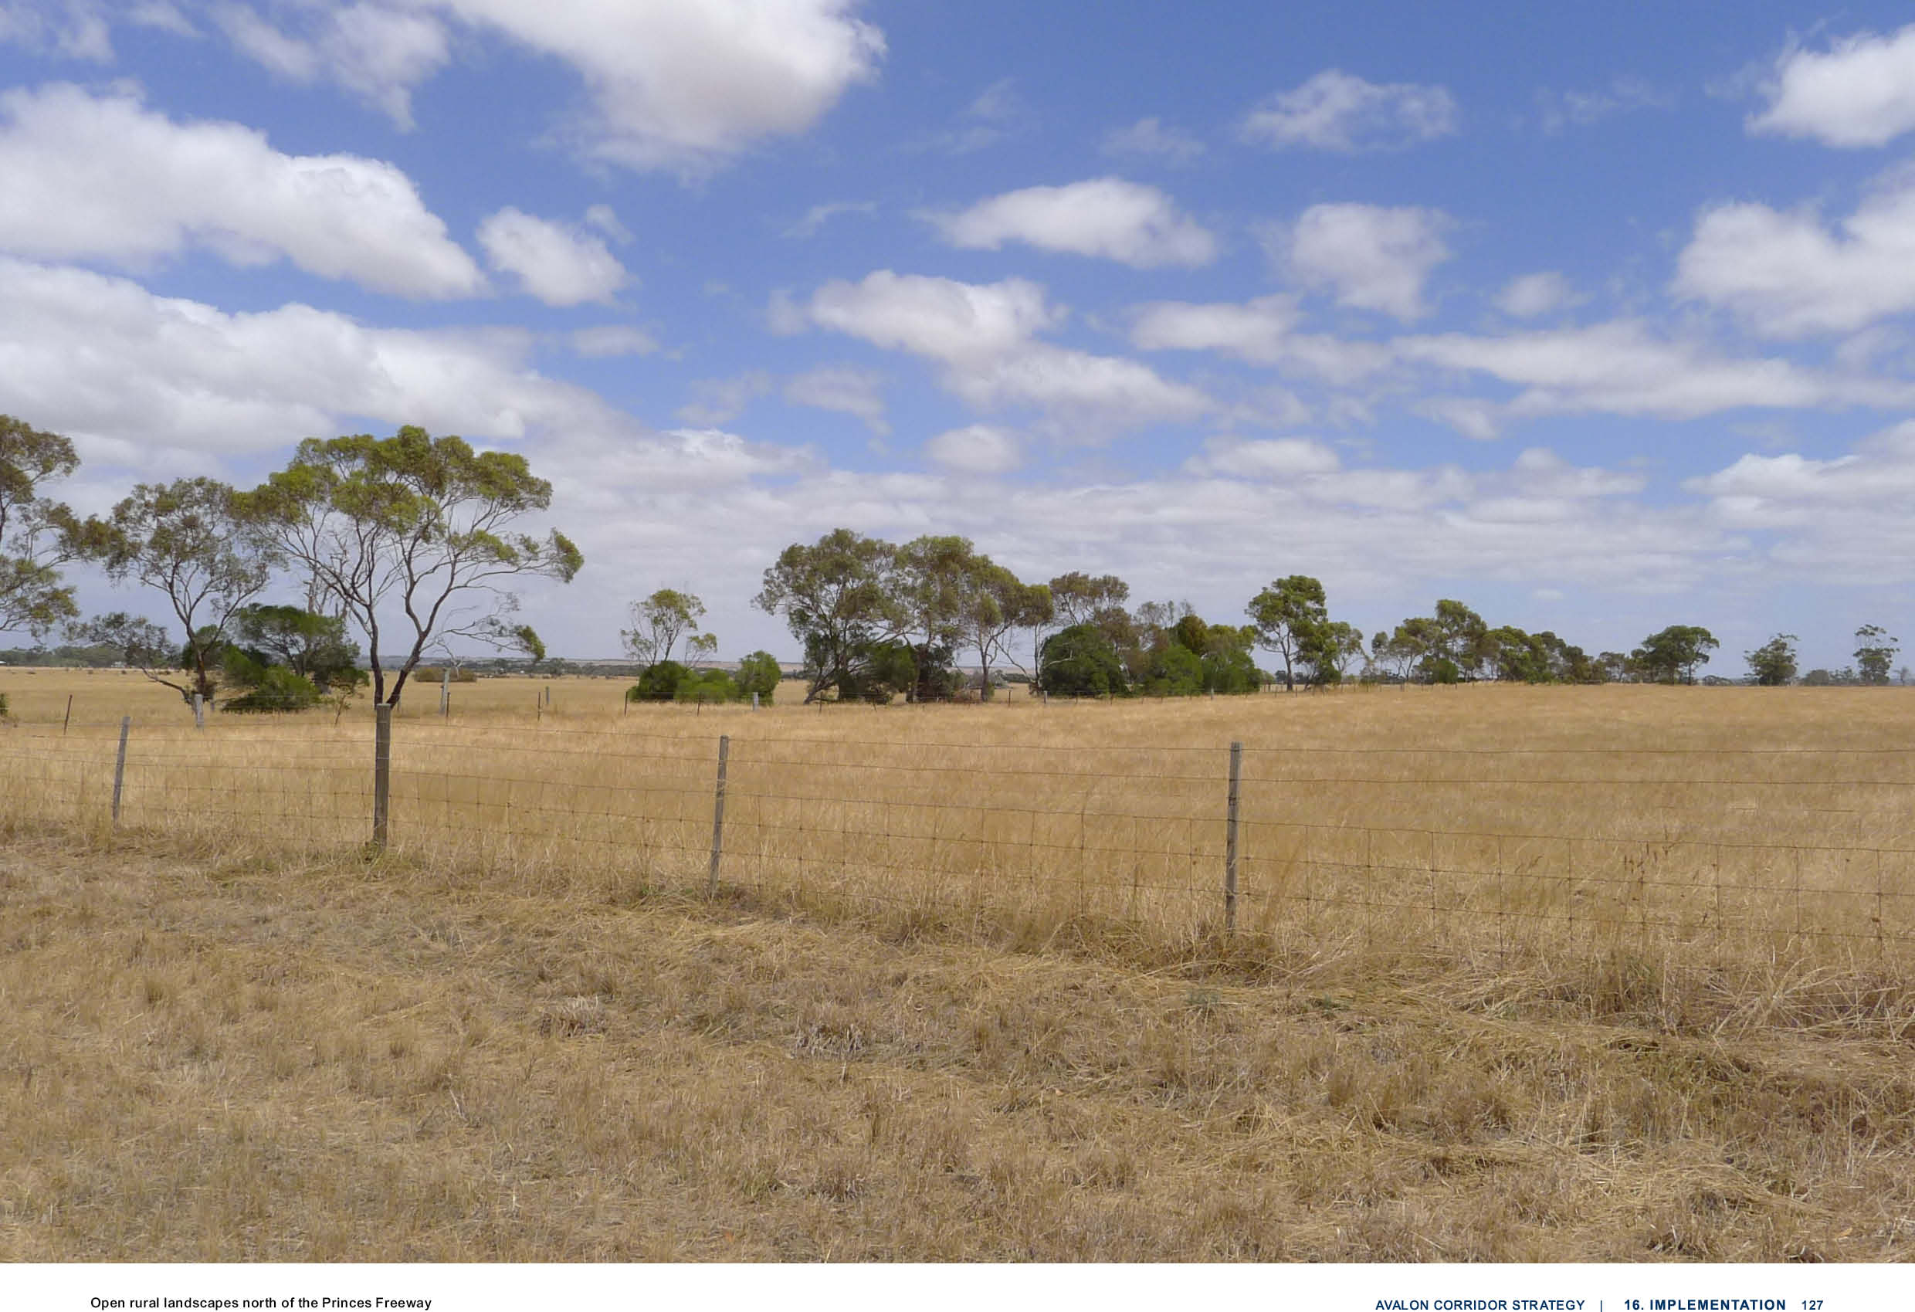

APPENDIX 1
17.0

  - Appendix 1 129
  - Planning Policy Framework 129

APPENDIX 1

PLANNING POLICY FRAMEWORK
The following policies of the Planning Policy Framework (PPF) are of relevance to the Avalon Corridor Strategy:
    - Clause 11.01-1S - Settlement includes a strategy to focus investment and growth in places of state significance in Metropolitan Melbourne and the major regional cities.
    - Clause 11.01-1R - Settlement - Geelong G21 (Greater Geelong) seeks to Maintain a significant settlement break between the region and Melbourne.
    - Clause 11.01-R - Green Wedges Metropolitan Melbourne (Wyndham) seeks to protect
the green wedges of Metropolitan Melbourne from inappropriate development. Further relevant strategies include:
      - Promote and encourage the key features and related values of each green wedge area.Support development in the green wedge that provides for environmental,
economic and social benefits.
      - Plan and protect major state infrastructure and resource assets, such as airports and ports with their associated access corridors, water supply dams, water
catchments and waste management and recycling facilities.
      - Support existing and potential agribusiness activities, forestry, food production and tourism.
      - Protect areas of environmental, landscape and scenic value such as biodiversity assets, national and state parks, Ramsar wetlands and coastal areas.
      - Protect significant resources of stone, sand and other mineral resources for extraction purposes.
      - Provide opportunities for renewable energy generation.

    - Clause 11.01-1R Settlement - Metropolitan Melbourne (Wyndham) seeks to maintain
a permanent UGB around Melbourne to create a more consolidated, sustainable city and protect the values of non-urban land.
- Clause 11.03-3R Peri-urban areas (Greater Geelong) includes a number of relevant strategies:
  - Identify and protect areas that are strategically important for the environment, biodiversity, landscape, open space, water, agriculture, energy, recreation,
tourism, environment, cultural heritage, infrastructure, extractive and other natural resources.
  - Prevent dispersed settlement and provide for non-urban breaks between urban areas.
  - Improve connections to regional and metropolitan transport services.

- Clause 12 - Environmental and landscape values outlines that:
  - Planning should help to protect the health of ecological systems and the
biodiversity they support (including ecosystems, habitats, species and genetic
diversity) and conserve areas with identified environmental and landscape values.
  - Planning should protect, restore and enhance sites and features of nature conservation, biodiversity, geological or landscape value.

- Clause 12.01-1S – Protection of biodiversity seeks the protection and conservation of
Victoria’s biodiversity, including important habitat for flora and fauna and strategically valuable biodiversity sites.
- Clause 12.01-2S Native vegetation management seeks to ensure that there is no net loss to biodiversity as a result of the removal, destruction or lopping of native vegetation.
- Clause 12.02-1S - Protection of the marine and coastal environment seeks to recognise the value of coastal areas to the community, conserve and enhance coastal areas and ensure
sustainable use of natural coastal resources, in addition to enhancing ecological values; avoiding cumulative impacts on ecosystems; and avoiding disturbing acid sulphate soils etc.
- Clause 12.03-1S River corridors, waterways, lakes and wetlands seeks to protect and enhance river corridors, waterways, lakes and wetlands.
- Clause 12.05-1S Environmentally sensitive areas seeks to protect and conserve environmentally sensitive areas.

17.1

- Clause 13 Environmental Risks and Amenity outlines that:
  - Planning should strengthen the resilience and safety of communities by adopting a best practice environmental management and risk management approach.
  - Planning should identify, prevent and minimise the risk of harm to the environment, human health, and amenity through: Land use and development compatibility and Effective controls to prevent or mitigate significant impacts.
  - Planning should identify and manage the potential for the environment and environmental changes to impact on the economic, environmental or social wellbeing of society.
  - Planning should ensure development and risk mitigation does not detrimentally interfere with important natural processes.
  - Planning should prepare for and respond to the impacts of climate change.
- Clause 13.01-1S Natural hazards and climate change seeks to minimise the impacts of natural hazards and adapt to the impacts of climate change through risk-based planning.
- Clause 13.01-2S Coastal inundation and erosion seeks to plan for and manage the potential coastal impacts of climate change, and includes specific strategies to:
  - Plan for sea level rise of not less than 0.8 metres by 2100 and allow for the combined effects of tides, storm surges, coastal processes and local conditions such as topography and geology when assessing risks and coastal impacts associated with climate change.
  - Ensure that land subject to hazards is identified and appropriately managed to ensure that future use and development is not at risk.
  - Avoid use and development in areas vulnerable to coastal inundation and erosion.
  - Respond to marine and coastal processes in the context of the coastal compartment type.
  - Assess the effectiveness, costs, benefits, impacts (direct, cumulative and synergistic) and path dependency of available adaptation options in the following order: 1. non- intervention; 2. avoid; 3. nature-base methods; 4. accommodate; 5. retreat; & 6. protect
  - Ensure that development or protective works that seek to respond to coastal hazard risks avoid detrimental impacts on coastal processes.
- Clause 13.03 Floodplains seeks to assist the protection of:
  - Life, property and community infrastructure from flood hazard, including coastal inundation, riverine and overland flows.
  - The natural flood carrying capacity of rivers, streams and floodways.
  - The flood storage function of floodplains and waterways.
  - Floodplain areas of environmental significance or of importance to river, wetland or coastal health.
- Clause 13.07-1S Land use compatibility seeks to protect community amenity and human
health and safety while facilitating appropriate commercial, industrial, infrastructure or other uses with potential adverse off-site impacts.
- Clause 14 Natural Resource Management outlines that:
  - Planning is to assist in the conservation and wise use of natural resources including energy, water, land, stone and minerals to support both environmental quality and sustainable
development.
  - Planning should ensure agricultural land is managed sustainably, while acknowledging the economic importance of agricultural production.
- Clause 14.01-1S Protection of agricultural land seeks to protect the state’s agricultural activities by preserving productive farmland.
- Clause 14.01-2R Agricultural productivity - Geelong G21 (Greater Geelong) seeks to support new opportunities in farming and fisheries.
- Clause 14.01-1R Protection of agricultural land - Metropolitan Melbourne (Wyndham)
seeks to protect agricultural land in Metropolitan Melbourne’s green wedges and peri-urban areas to avoid the permanent loss of agricultural land in those locations.
- Clause 14.02-1S Catchment planning and management seeks to assist the protection and restoration of catchments, water bodies, groundwater, and the marine environment.
- Clause 14.02-2S Water quality seeks to protect water quality, including water catchments and natural environs.
- Clause 14.03-1S Resource exploration and extraction seeks to encourage exploration and extraction of natural resources in accordance with acceptable environmental standards.

17.1

- Clause 15.03-1S Heritage conservation seeks to ensure the conservation of places of heritage significance.
- Clause 17 Economic Development outlines that:
  - Planning is to provide for a strong and innovative economy, where all sectors are critical to economic prosperity.
  - Planning is to contribute to the economic wellbeing of the state and foster economic growth by providing land, facilitating decisions and resolving land use conflicts, so that each region may build on its strengths and achieve its economic potential.
- Clause 17.01-1S Diversified economy seeks to strengthen and diversify the economy.
- Clause 17.01-1R Diversified economy - Geelong G21 (Greater Geelong) contains the following strategies:
  - Build on the region’s competitive strengths, including tourism and agricultural land resources and economic, social and natural assets.
  - Support new businesses that provide employment and innovation opportunities in identified employment nodes across the region.
  - Support industries that utilise skills within the region.

- Clause 17.03-1S Industrial land supply seeks to ensure there is an adequate supply and availability of land for industry.
- Clause 18 Transport outlines that planning should ensure a safe, integrated and sustainable
transport system that: provides access to social and economic opportunities to support individual and community wellbeing; facilitates economic prosperity; actively contributes to environmental
sustainability; Facilitates network-wide efficient, coordinated and reliable movements of people and goods; & supports health and wellbeing.
- Clause 18.01-1S Land use and transport planning seeks to facilitate access to social, cultural and economic opportunities by effectively integrating land use and transport.
- Clause 18.01-2S Transport system seeks to facilitate the efficient, coordinated and reliable movement of people and goods by developing an integrated and efficient transport system.
- Clause 18.01-2R Transport system - Geelong G21 (Greater Geelong) seeks to support improved transit and access within Geelong and the wider region and support a greater
connection to the Werribee growth corridor and Melbourne.
- Clause 18.02-1S Cycling seeks to facilitate an efficient and safe bicycle network and increase the proportion of trips made by cycling.
- Clause 18.02-2R Cycling - Metropolitan Melbourne (Wyndham) seeks to develop
local cycling networks and new cycling facilities that support the development of 20-minute
neighbourhoods and that link to and complement the metropolitan-wide network of bicycle routes
- the Principal Bicycle Network.
- Clause 18.02-3S Public Transport seeks to facilitate an efficient and safe public transport network and increase the proportion of trips made by public transport.
- 18.02-3R Principal Public Transport Network (Wyndham) seeks to facilitate high quality public transport access and improve the Principal Public Transport Network.
- Clause 18.02-4S Roads seeks to facilitate an efficient and safe road network that integrates all movement networks and makes best use of existing infrastructure.
- Clause 18.02-5S Freight seeks to facilitate an efficient, coordinated, safe and sustainable
freight and logistics system that enhances Victoria’s economic prosperity and liveability. Further relevant strategies include:
  - Support the movement of freight within Victoria’s freight and logistics system.
  - Improve freight efficiency and capacity.
  - Manage negative impacts of freight generating activities on urban amenity, the development of urban areas, and on the efficient operation of movement networks.
  - Prioritise new technologies that enhance road and rail safety, optimise the metropolitan road network, better manage congestion and reduce supply chain costs.
  - Increase the capacity of the rail network to carry larger volumes of freight.
  - Protect and develop the Principal Freight Network, including freight movement corridors and freight places, and Principal Transport Gateways, by:
    - Facilitating the movement of high volumes of freight and freight of strategic value.
    - Linking areas of production and manufacturing to national and international gateways and export markets.
    - Increasing the capacity of Principal Transport Gateways and supporting their use and
    - Development as important locations for employment and economic activity.

17.1

      - Designing the Principal Freight Network to adapt to commodity, market and operating changes.
      - Managing encroachment from incompatible land use and development that would undermine its ability to operate.
      - Support the development of freight and logistics precincts in strategic locations within and adjacent to Principal Transport Gateways and along the Principal Freight Network movement corridors by:
      - Allocating land for complementary uses and employment-generating activities, such as distribution and warehousing.
      - Reserving and appropriately zoning land for interstate freight terminals to support development that allows for the direct and immediate delivery of goods to market.
      - Allocating land to allow high-volume freight customers to locate adjacent to interstate freight terminals, including the Western Interstate Freight Terminal and the Beveridge Interstate Freight Terminal.
- Clause 18.02-5R Freight links - Geelong G21 (Greater Geelong) seeks to recognise and develop a national transport and logistics precinct to the north of Geelong, connecting Avalon Airport, Geelong Port and the Geelong Ring Road Employment Precinct.
- Clause 18.02-5R Freight links - Metropolitan Melbourne (Wyndham) seeks to ensure suitable sites are provided for intermodal freight terminals at key locations around Metropolitan Melbourne, particularly for the Beveridge Interstate Freight Terminal and the WIFT.
- Clause 18.02-6S Ports seeks to support the effective and competitive operation of Victoria’s commercial trading ports at local, national and international levels, and to facilitate their ongoing sustainable operation and development. Further relevant strategies include:
  - Identify and protect key transport corridors linking ports to the broader transport network.
  - Manage any impacts of a commercial trading port and any related industrial development on nearby sensitive uses to minimise the impact of vibration, light spill, noise and air emissions from port activities.
  - Protect commercial trading ports from encroachment of sensitive and incompatible land uses in the port environs.
  - Plan for and manage land in the port environs to accommodate uses that depend upon,
or gain significant economic advantage from, proximity to the port’s operations.
- Ensure that industrially zoned land within the environs of a commercial trading port is
maintained and continues to support the role of the port as a critical freight and logistics precinct.
- Identify and protect key transport corridors linking ports to the broader transport network.
- Ensure any new use or development within the environs of a commercial trading port does not prejudice the efficient and curfew-free operations of the port.
- Clause 18.02-7S Airports and airfields seeks to strengthen the role of Victoria’s airports
and airfields within the state’s economic and transport infrastructure, facilitate their siting and expansion, and protect their ongoing operation. Further relevant strategies include:
  - Protect airports from incompatible land uses.
  - Ensure that in the planning of airports, land use decisions are integrated, appropriate land use buffers are in place and provision is made for associated businesses that service airports.
  - Ensure the planning of airports identifies and encourages activities that complement the role of the airport, and enables the operator to effectively develop the airport to be efficient and
functional and contribute to the aviation needs of the state.
  - Protect the environs of Avalon Airport so it can operate as a full-size jet airport focusing on freight, training and services.
  - Plan the location of airfields, nearby existing and potential development, and the land-based transport system required to serve them, as an integrated operation.
  - Plan the visual amenity and impact of any use or development of land on the approaches to an airfield to be consistent with the status of the airfield.
  - Plan for areas around all airfields so:
    - Any new use or development that could prejudice the safety or efficiency of an airfield is precluded.
    - The detrimental effects of aircraft operations (such as noise) are taken into account in regulating and restricting the use and development of affected land.
    - Any new use or development that could prejudice future extensions to an existing airfield or aeronautical operations, in accordance with an approved strategy or master plan for
that airfield, is precluded.

17.1

–
- Clause 19 Infrastructure outlines that:
  - Planning for development of social and physical infrastructure should enable it to be provided in a way that is efficient, equitable, accessible and timely.
  - Planning should ensure that the growth and redevelopment of settlements is planned in a manner that allows for the logical and efficient provision and maintenance of infrastructure, including the setting aside of land for the construction of future transport routes.
  - Planning should minimise the impact of use and development on the operation of major
infrastructure of national, state and regional significance, including communication networks and energy generation and distribution systems.
  - Planning authorities should consider the use of development and infrastructure contributions in the funding of infrastructure.
- Clause 19.03-3S Integrated water management seeks to sustainably manage water supply, water resources, wastewater, drainage and stormwater through an integrated water management approach.
- Clause 19.03-5S Waste and resource recovery seeks to reduce waste and maximise resource recovery so as to reduce reliance on landfills and minimise environmental, community amenity
and public health impacts.

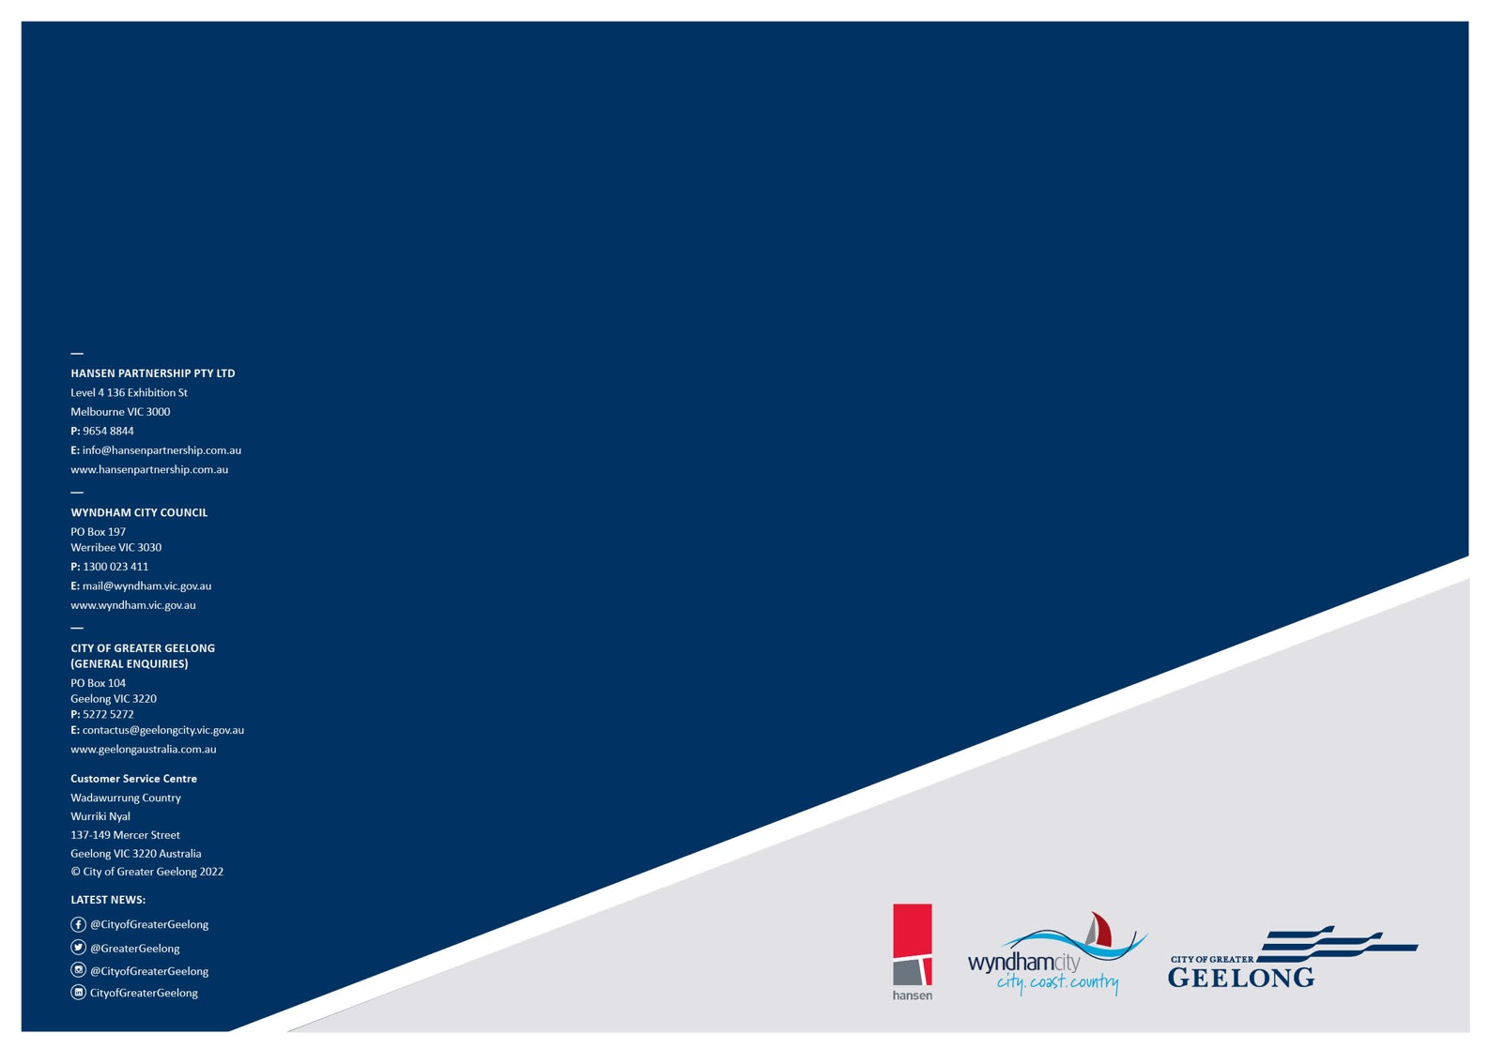
Wadawurrung Country Wurriki Nyal
137-149 Mercer Street Geelong VIC 3220 Australia
© City of Greater Geelong 2022

LATEST NEWS:
@CityofGreaterGeelong @GreaterGeelong
@CityofGreaterGeelong CityofGreaterGeelong

