No 10 - November 2016
Service Authority Cabinets
Introduction:

This Design Note, No 10, provides guidelines and requirements for the design and locating of cabinets and surrounds required for the housing of service authority above ground infrastructure.

Service Authorities Implicated

- Barwon Water – Scour Valves and Pressure Reducing Valves
- Powercor – Power Substation Kiosk
- NBN Co. – FDH, TFAN and FTTN cabinets
- Telstra, Optus and Vodafone – mobile phone cabinets

General Issues with placement in road reserve

The placement of a large number of service authority cabinets within the narrow road reserves of newer subdivisions has created a number of issues in meeting the requirements of the road to serve its primary purpose – vehicle and pedestrian traffic.

Service Authority cabinets located close to the kerb often fall within the clear zones specified in the AustRoads Guide To Road Safety Part 9: Roadside Hazard Management and Guide to Road Design Part 6: Roadside Design. Where inadequately protected the cabinets create a safety hazard when impacted by an errant vehicle.

Additional implications are related to siting of the cabinets in front of private allotments where they create a visual impact, restrict planting of street trees or prevent the construction of a vehicle crossover on the opposite side of the allotment from that shown on the design plans.

Approval of Cabinet Locations

The proposed location of all cabinets must be shown on Engineering Plans submitted for approval. Proposed cabinet locations should also be shown on Landscaping Plans with reference to the location as subject to approval via the Engineering Plans. Final cabinet locations will be to the satisfaction of the City and the relevant Service Authority.

Statement of compliance will not be issued for subdivisions where the placement of Service Authority cabinets is not in accordance with these requirements.

Locating Service Authority Cabinets

Service Authority Cabinets, where possible, should be located in a reserve set aside in favour of the service authority (see Figure 1). Reserves will not reduce the requirements for open space contribution or drainage reserves and shall be in addition to these requirements. Reserves shall not be in or combined within the overall boundary of a open space reserve.

Where the size and nature of the subdivision do not allow for the creation of a separate reserve for service authority cabinets as assessed by the relevant planning authority, the location of any required infrastructure must be approved by the City prior to any agreements with Service Authorities being signed. In these situations preference will be given to locating cabinets along the boundary of drainage (Figure 3) and recreation reserves (Figure 4) or if not available the side of corner allotments shielded by a fence (Figure 2).

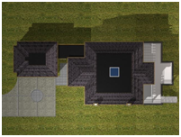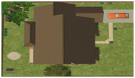
Figure 1 Service Authority Cabinet in designated reserve
Preferred Service Authority Cabinet Location
Preferred Service Authority Cabinet Location
Figure 2 Service Authority Cabinet outside residential property

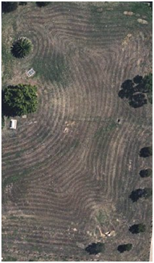
Preferred Service Authority Cabinet Location
Figure 3 Service Authority Cabinet in drainage reserve
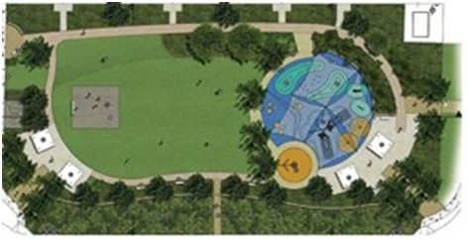
Preferred Service Authority Cabinet Location
Figure 4 Service Authority Cabinet outside recreation reserve
Reserve Sizes

Reserves shall be sized to allow for unimpeded access to all sides of the cabinet or as required by the individual Service Authority. Generic advice for 1200mm clearance based on Powercor requirements is shown in the diagram below.
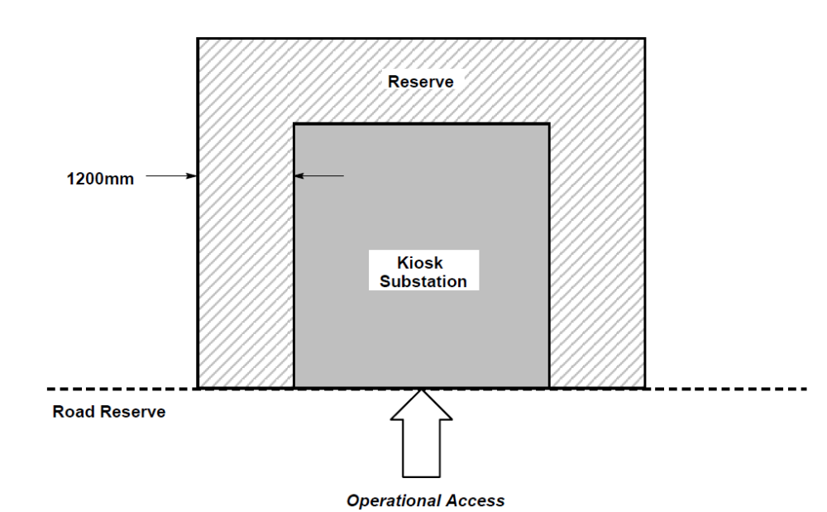

Other guidelines

The following shall also be applied to the design and construction of these structures –
- Must not impede vehicle sightlines
- Where in the clear zone on a road with a speed limit greater than 60km/hr protection must be installed
- Shall not to be installed in front of a property or at a property boundary location where a vehicle crossover may reasonably be requested
- An area of less than 0.5m between a cabinet plinth and footpath or kerb must be paved to improve naturestrip maintenance and public safety
- Cabinets in drainage reserves should be screened with material sympathetic to the environment

Typical Installations

FDH cabinets
Fibre Distribution Hub cabinets which service 200 – 300 homes or businesses with connection to the National Broadband Network. Each cabinet is 1030mm high, up to 1090mm wide and 505mm deep on a concrete pad.
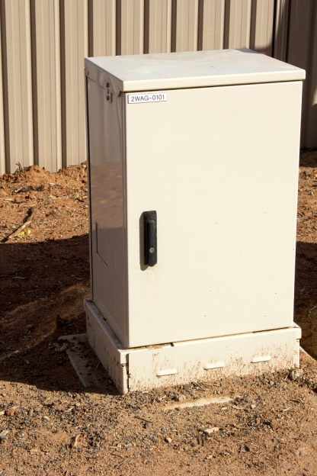

TFAN cabinets
Temporary Fibre Access Node cabinets are used where the facilities in the exchange have not been constructed. Each cabinet is 850mm wide x 1150mm high x 500mm deep on a concrete pad.
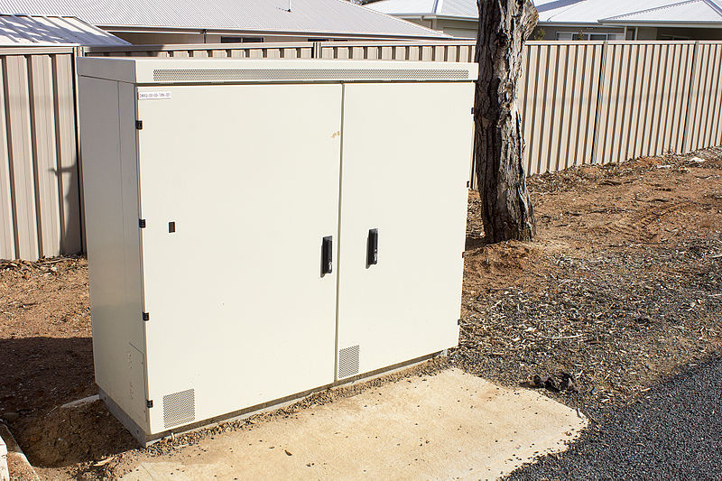

FTTN cabinets
Fibre to the Node cabinets are used as an intermediate point between the telephone exchange and copper cable pillars as a conversion point between the fibre optic and copper cable network. Each cabinet is 850mm wide x 1150mm high x 500mm deep on a concrete pad.
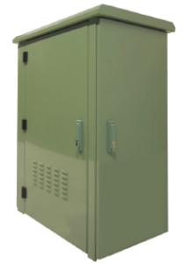

PRV cabinets
Pressure Reducing Valve cabinets are used to house water infrastructure which regulates the mains water pressure within a distribution area. Each cabinet is 2800mm wide x 1900mm high x 1500mm deep on a concrete pad.
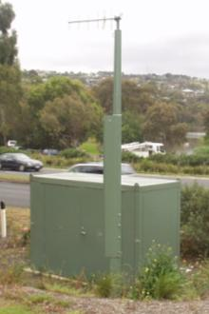

Power Substation Kiosk
Kiosk substations are used to convert higher voltage electricity into the lower voltage required by homes and businesses. Cabinets are of varying sizes with smaller installations approximately 1700mm wide x 1400mm high x 600mm deep on a concrete pad. Size requirements will be advised by Powercor

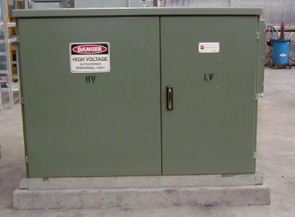

Water main Air Scour Valves
Air in the line not only reduces the flow by causing a restriction but amplifies the effects of pressure surges. Air Valves are placed in the water pipeline at intervals so that air, which would otherwise reduce the water flow by causing a restriction or amplify the effect of a pressure surge can be evacuated, or, if the line is drained, air can enter the line.

Scour Valves are located at low points or between valved sections of water pipeline. Their function is to allow periodic flushing of the lines to remove sediment and to allow the line to be drained for maintenance and repair work.

Each valve is housed in a concrete surround with a steel cover.