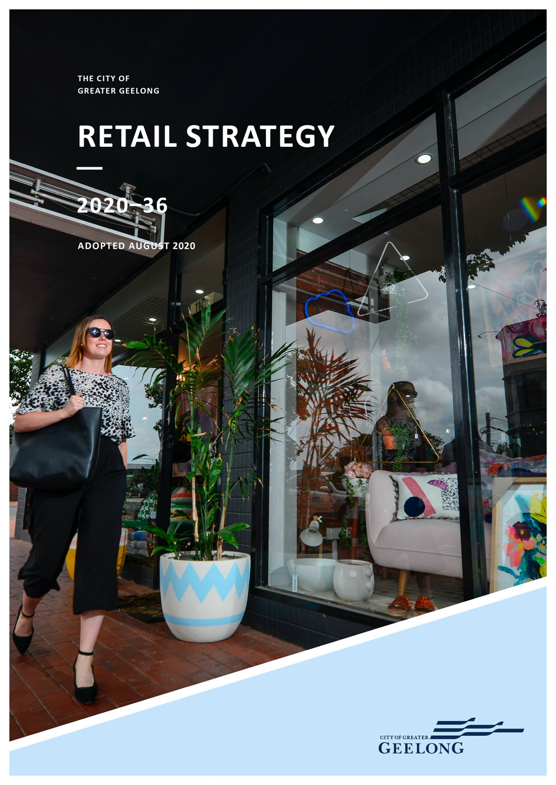
THE CITY OF
GREATER GEELONG

RETAIL STRATEGY
2020–36

ADOPTED AUGUST 2020

CONTENTS

ACKNOWLEDGEMENTS 5
EXECUTIVE SUMMARY 6
SUMMARY OF KEY FINDINGS 7
Strategic findings 7
Statutory recommendations 7
INTRODUCTION 8
Why undertake this review 11
How this strategy was developed 11
A GROWING GREATER GEELONG 12
Population growth 12
Age structure 14
Household types 15
Retailing trends 16
Fast retail 16
Slow retail 16
Cultural retail 17
Restricted, large-format retailing or
wholesale shopping 17
Online retailing 17
Recommended retail types for Greater Geelong 18
EXISTING PLANNING POLICY 19
State Planning Policy Framework 19
G21 Regional Growth Plan (2013) 19
Local Planning Policy Framework 21
Current retail assessment 21
FUTURE RETAIL DEMAND 36
A base-case scenario 36
Supportable retail floor space demand 36
and sub-regional alignment

CENTRE CATCHMENTS | 40
Definition of primary catchments | 38
OPPORTUNITIES AND CHALLENGES | 41
Whole of network opportunities and challenges | 41
Opportunities for major retail investment 42
Supportable retail floor space by centre 43
RETAIL OBJECTIVES AND STRATEGIES 46
Retail development objectives 46
Retail development strategies to support objectives 46
Further work for individual centres 48
RECOMMENDED CHANGES TO POLICY 49
Summary of changes to The Greater 49
Geelong Planning Scheme
Floor space caps 49
Regional centres 52
Sub-regional centres 52
Specialised centres 54
Town centres 54
Neighbourhood centres (in existing urban areas) 54
Neighbourhood centres 54
(in areas experiencing greenfield growth)
Local activity centres 57
Assessing retail development applications 58
Specific local policies | 21
Greater Geelong: Clever and Creative Future | 23 | CONCLUSION | 60
RETAIL HIERARCHY | 24 | APPENDIX 1 | 61
Importance of a retail hierarchy | 24
Indicative retail centres in the Northern and Western Geelong Growth Areas | 28
Definition of a retail centre | 28
A GRAVITY MODEL FOR GREATER GEELONG | 29
Floor space audit | 29
Retail centre turnover | 34
Expenditure in Greater Geelong | 35

APPENDIX 2 88
REGIONAL CENTRES 88
Central Geelong 88
SUB-REGIONAL CENTRES 90
Armstrong Creek Town Centre, Surf Coast Highway, 90
Armstrong Creek
Corio Village, Bacchus Marsh Road, Corio 92
High Street, Belmont 94
Leopold Gateway Plaza, Bellarine Highway, Leopold 96
Waurn Ponds, Pioneer Road, Grovedale 98
SPECIALISED CENTRES 100
Pakington Street, Geelong West 100
TOWN CENTRES 102
High Street, Drysdale 102
Hitchcock Ave, Barwon Heads 104
Murradoc Road, St Leonards 106
Newcomb Street, Portarlington 108
Station Lake Road, Lara 110
The Terrace, Ocean Grove 112
NEIGHBOURHOOD CENTRE 114
Ash Road, Leopold 114
Barrabool Hills, Province Bvd, Highton 116
Bell Post, Anakie Road, Norlane 118
Ballarine Village, Bellarine Highway, Newcomb 120
Dorothy Street, Leopold 122
Grovedale Central, Heyers Road, Grovedale 124
Highton, Barrabool Road, Highton 126
Hyland Street, Fyansford 128
Jetty Road, Centennial Bvd, Curlewis 130
Kingston Village, Grubb Road, Ocean Grove 132
Marketplace, Shell Road, Ocean Grove 134
Newcomb Central, Bellarine Highway, Newcomb 136
Ormond Road, Geelong East 138
Pakington Street, Newtown 140
Rosewell, Broderick Road, Corio 142
Separation Street, North Geelong 144
Shannon Ave, Geeloong West 146
Shannon Ave, Newtown 148
Surf Coast Highway, Grovedale 150
Vines Road, Hamlyn Heights 152
Warralily Village, Barwon Heads, Armstrong Creek 154
RESTRICTED RETAIL 156
Armstrong Creek Town Centre,
Surf Coast Highway, Armstrong Creek 156
Leopold Gateway Plaza, Bellarine Highway, Leopold 157
Colac Road, Waurn Ponds 158
Geelong Gateway, Princes Highway, Corio 160
Melbourne Road, Norlane 162
Melbourne Road, North Geelong 164
Murradoc Road, Drysdale 166
Sinclair Street, Ocean Grove 168
PLANNED CENTRES 170
Armstrong Creek West 170
Horseshoe Bend, North East 171
Lara West, Lara 172
INDICATIVE CENTRES 173
Central Restricted Retail Centre - WGGA 173
Elcho Road East - North - NGGA 174
Elcho Road East - South - NGGA 175
Elcho Road West - NGGA 176
Heales Road West - NGGA 177
Lakeside West - WGGA 178
Lakeside South - WGGA 179
Midland Hwy - WGGA 180
Northern Centre - WGGA 181
Specialised Centre - WGGA 182
Sub-regional Centre - WGGA 183
Sub-regional Centre - NGGA 184
Western Centre - WGGA 185
DISPERSED CENTRES 186
Anakie Road, Ball Park 186
Bacchus Marsh Road, Corio 188
Bellarine Highway, Newcomb 190

Gordon Avenue, Geelong West 192
Gregory Avenue, Newtown 194
Harpur Road- Princes Highway, Corio 196

Figure 21: Restricted retail supply-and-demand 38
equation 2016
Figure 22: Restricted retail supply-and-demand 38
equation 2026

Mackey Street, North Geelong | 198 | Figure 23: Restricted retail supply-and-demand | 38
Moorabool-Fyans Street, South Geelong | 200 | equation 2036
Settlement Road and Breakwater Road, Belmont | 202 | Figure 24: Kingston Downs – approved development plan | 56
Sharon Court, Bell Park | 204 | Figure A9: Supermarket centre primary catchment | 213
Smithton Grove, Ocean Grove | 206 | Figure A10: Discount department store primary catchment | 214
Surf Coast Highway, Grovedale | 208 | Figure A11: Restricted retail centre primary catchment | 215
West Fyans Street, Newtown | 210 | Figure A12A: Supermarket supply-and-demand equation 2016 | 217

Figure A12B: Supermarket supply-and-demand equation 2026 |  |  | 218
Figure A12C: Supermarket supply-and-demand |  |  | 219
equation 2036
Figure A13A: Discount department store supply-and |  |  | 220
demand equation 2016
Figure A13B: Discount department store supply-and |  |  | 221
demand equation 2026
Figure 3: Forecast age structure – 5-year age group 14
 |  | Figure A13C: Discount department store supply-and | 222
Figure 4: Forecast household type | 15 | demand equation 2036
Figure 5: G21 regional growth context plan | 20 | Figure A14A: Restricted retail supply-and-demand | 223

Figure 6: Location of retail centre 25
Figure 7: Retail floor space supply, by centre 32
and store type, 2018
Figure 8: Retail turnover density for selection of centres 34
Figure 12: Overall supply demand 36
floor space alignment
Figure 14: supply demand floor space alignment – 37
Geelong sub-regions
Figure 15: Supermarket supply-and-demand 37
equation 2016
equation 2016
Figure A14B: Restricted retail supply-and-demand 224
APPENDIX 3 | 212
APPENDIX 4 | 216
LIST OF FIGURES
Figure 1: Study areas and location map | 9
Figure 2: Population growth and locations – SGS Economics and Planning | 13

equation 2026
Figure A14C: Restricted retail supply-and-demand 225
equation 2036

LIST OF TABLES
Table 1: Population growth City of Greater Geelong. 12
Table 2: Retail hierarchy – role and function of centres 26
Table 3: Retail floor space audit 2018 30

Figure 16: Supermarket supply-and-demand | 38 | Table 4: Current and target retail density estimates | 35
equation 2026 |  | Table 5: Supportable floor space – all retail | 43
Figure 17: Supermarket supply-and-demand equation 2036 | 38 | Table 7: Proposed floor space caps | 51
Figure 18: Discount department store | 38
supply-and-demand equation 2016
Figure 19: Discount department store | 38
supply-and-demand equation 2026
Figure 20: Discount department store | 38
supply-and-demand equation 2036

The Greater Geelong municipality is located on the traditional lands of the Wadawurrung people. The land was created by the great ancestor spirit, Bunjil, the wedge
tailed eagle. Wadawurrung territory extends from the Great Dividing Range in the north, to the coast around Port Phillip and Western Port Bays. The City acknowledges the Wadawurrung people as the Traditional Owners of this land who to this day practice their culture and uphold the dignity of their ancestors.
The final version of the Retail Strategy is a collaboration between the City of Greater Geelong and SGS Economics and Planning. It is based on work undertaken by SGS Economics and Planning, with input from the City of Greater Geelong.

The retail sector in Greater Geelong will need to grow to meet future demand for retail services by 2036. Support to grow the retail sector within planned and existing retail centres will continue.
This report provides a technical analysis of Greater Geelong’s retail network, proposing changes to the Greater Geelong Planning Scheme to accommodate the findings.
Greater Geelong has a well-established hierarchy of supermarket-based retail centres to support the community’s daily needs.
Demand for additional floor space in these centres will increase over the next 20 years. To meet this need, it is better to expand existing centres than deliver new ones, as it helps achieve urban consolidation and reduce travel times for those who visit and work there.
Demand for new retail centres is strongest in locations experiencing population growth, including:
- Armstrong Creek
- Drysdale/Clifton Springs
- Ocean Grove
- Fyansford and
- Lara.
However, with plans already in place in these areas of high population growth, no new centres are required.
There is demand for additional restricted retail services in Greater Geelong. Restricted retailing in Greater Geelong should continue to be directed to identified restricted retail centres and existing commercial-zoned land, as there is sufficient space to accommodate this.
New department stores and discount department stores, such as Myer, Big W and Target, will continue to be supported in Central Geelong and in sub-regional centres throughout the municipality.

The following is a summary of the key findings and recommendations of the retail strategy.

STRATEGIC FINDINGS
The location of retail centres, particularly supermarket based centres, provide convenient access for residents. Most centres can be reached in less than a 20 minute drive from home.
Greater Geelong has a large amount of Commercial 2 zoned land, particularly on the Bellarine Peninsula where previous planning strategies have recommended re-zoning land to enable the establishment of restricted retailing and service- related businesses. However there will continue to be demand for more restricted retail floor space across Greater Geelong.
The strategy continues to support a hierarchy of retail centres across Greater Geelong that reflects shopping behaviour and reduced travel times for residents. Central Geelong continues to sit at the top of the retail hierarchy. Local place making initiatives and strategies continue to prioritise Central Geelong as the city’s premier cultural, social and shopping precinct.
Geelong is experiencing increasing population growth. Population growth will drive demand for expanded, and in some instances new retail centres, within both existing and growing suburbs.
Planning policy will direct retail development to existing centres within the retail hierarchy in preference to establishing new ones. This will support our established centres, and support other outcomes such as higher density housing development around retail centres.
Retailing that encourages people to spend time at a location or have an experience (slow or cultural retailing) should be the basis for a new approach to developing and enhancing retail centres across Greater Geelong.
There are retail uses located in industrial areas few synergies to industrial activity. These uses should be encouraged to locate within existing retail centres.

STATUTORY RECOMMENDATIONS
The following changes will be made to the Greater Geelong Planning Scheme:
- a new policy context, including objectives to deliver convenient access to services, improved competition, walkability, continued support for existing centres and better urban design outcomes
- an updated retail hierarchy that reflects the role and function of centres across the retail network
- an updated local policy that requires economic impact assessments to be undertaken for new development that challenge the retail hierarchy
- use of floor space caps applied as part of a schedule to the Commercial 1 Zone, to ensure that the timing and size of development will not impact on the retail hierarchy or other nearby centres.

The City of Greater Geelong is located in south-western Victoria, about 75 kilometres south-west of the Melbourne CBD (see Figure 1).

VICTORIA
GREATER GEELONG

The retail trade is one of Greater Geelong’s largest employment sectors, employing 10,836 people, or 10.5 per cent of people in 2016.1

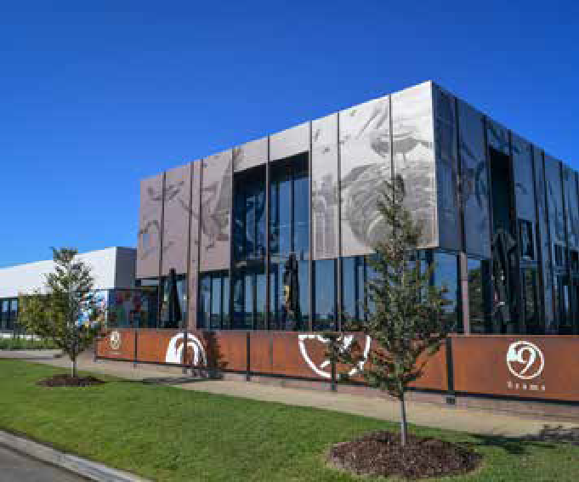
10,836

Our existing retail centres have many uses, including:
- retail • education
- commercial • social
- accommodation • entertainment
- community • leisure and
- cultural • civic services.
Continued support for our existing and planned centres is important to develop healthy, well- connected neighbourhoods that contribute to the vibrancy and attractiveness of the suburbs.

PEOPLE

1. .id community (2017) City of Greater Geelong Estimated Resident Population. https://profile.id.com.au/geelong/population-estimate (accessed on 12 June 2018).

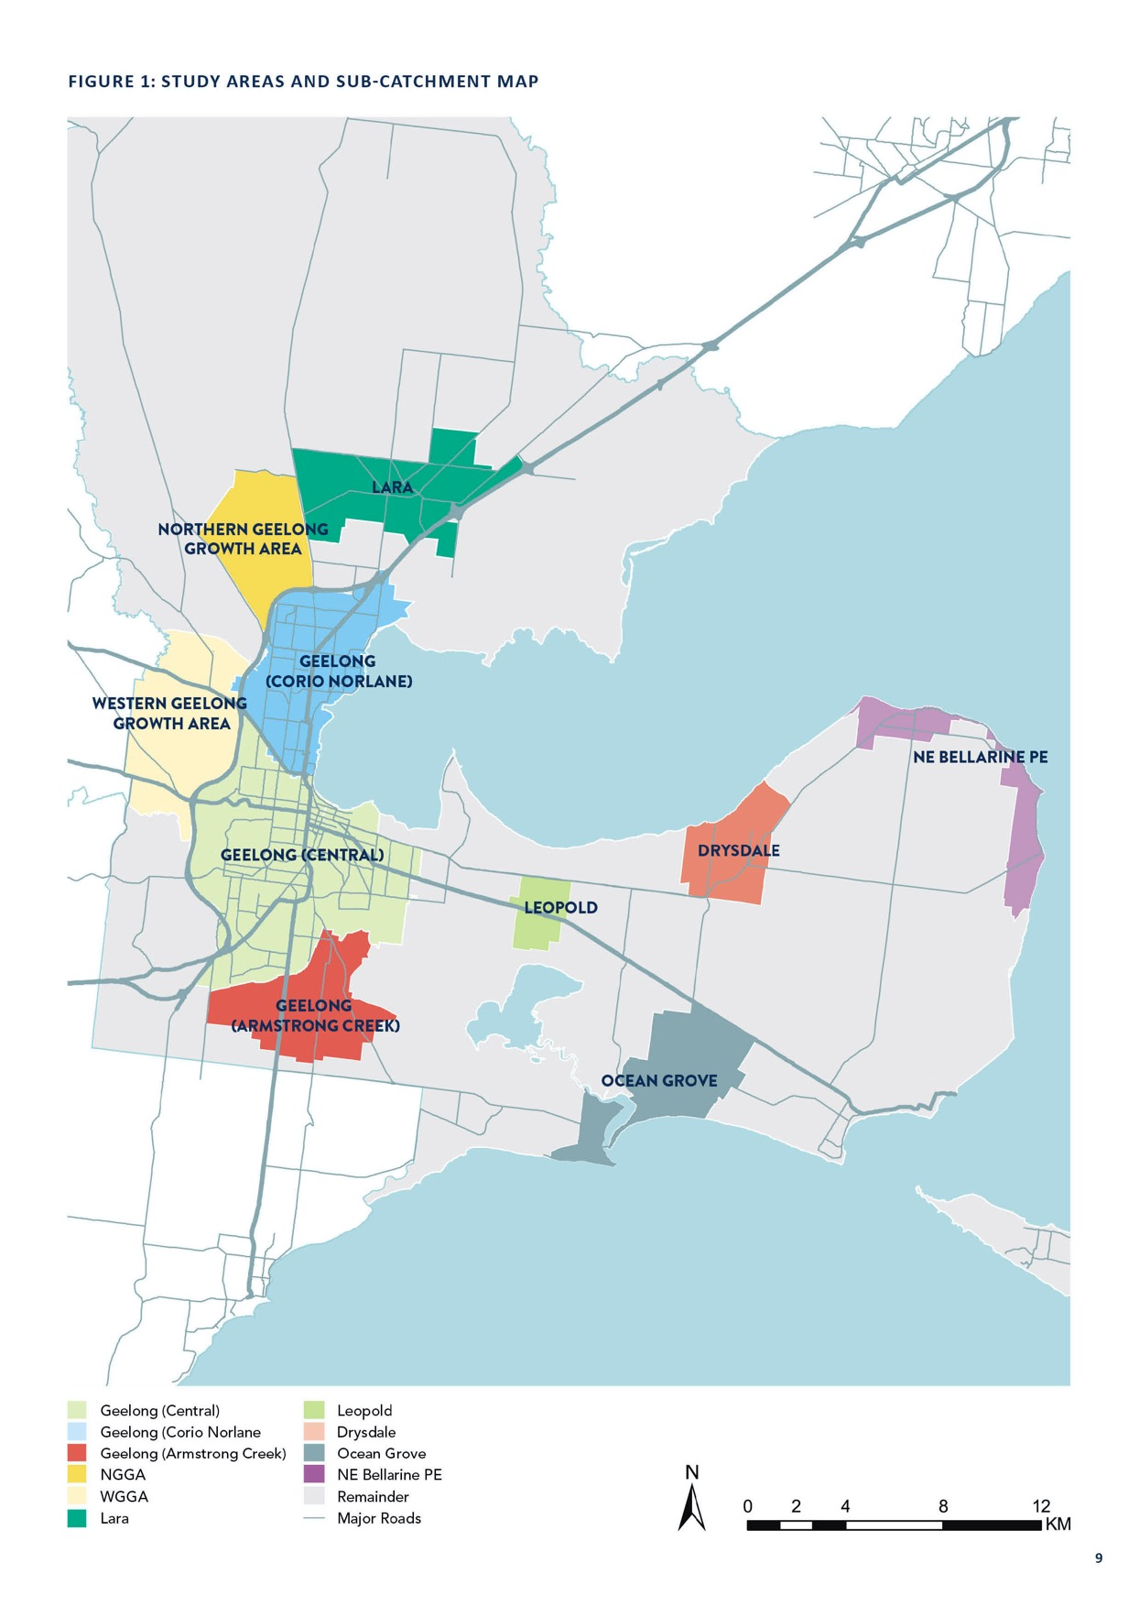

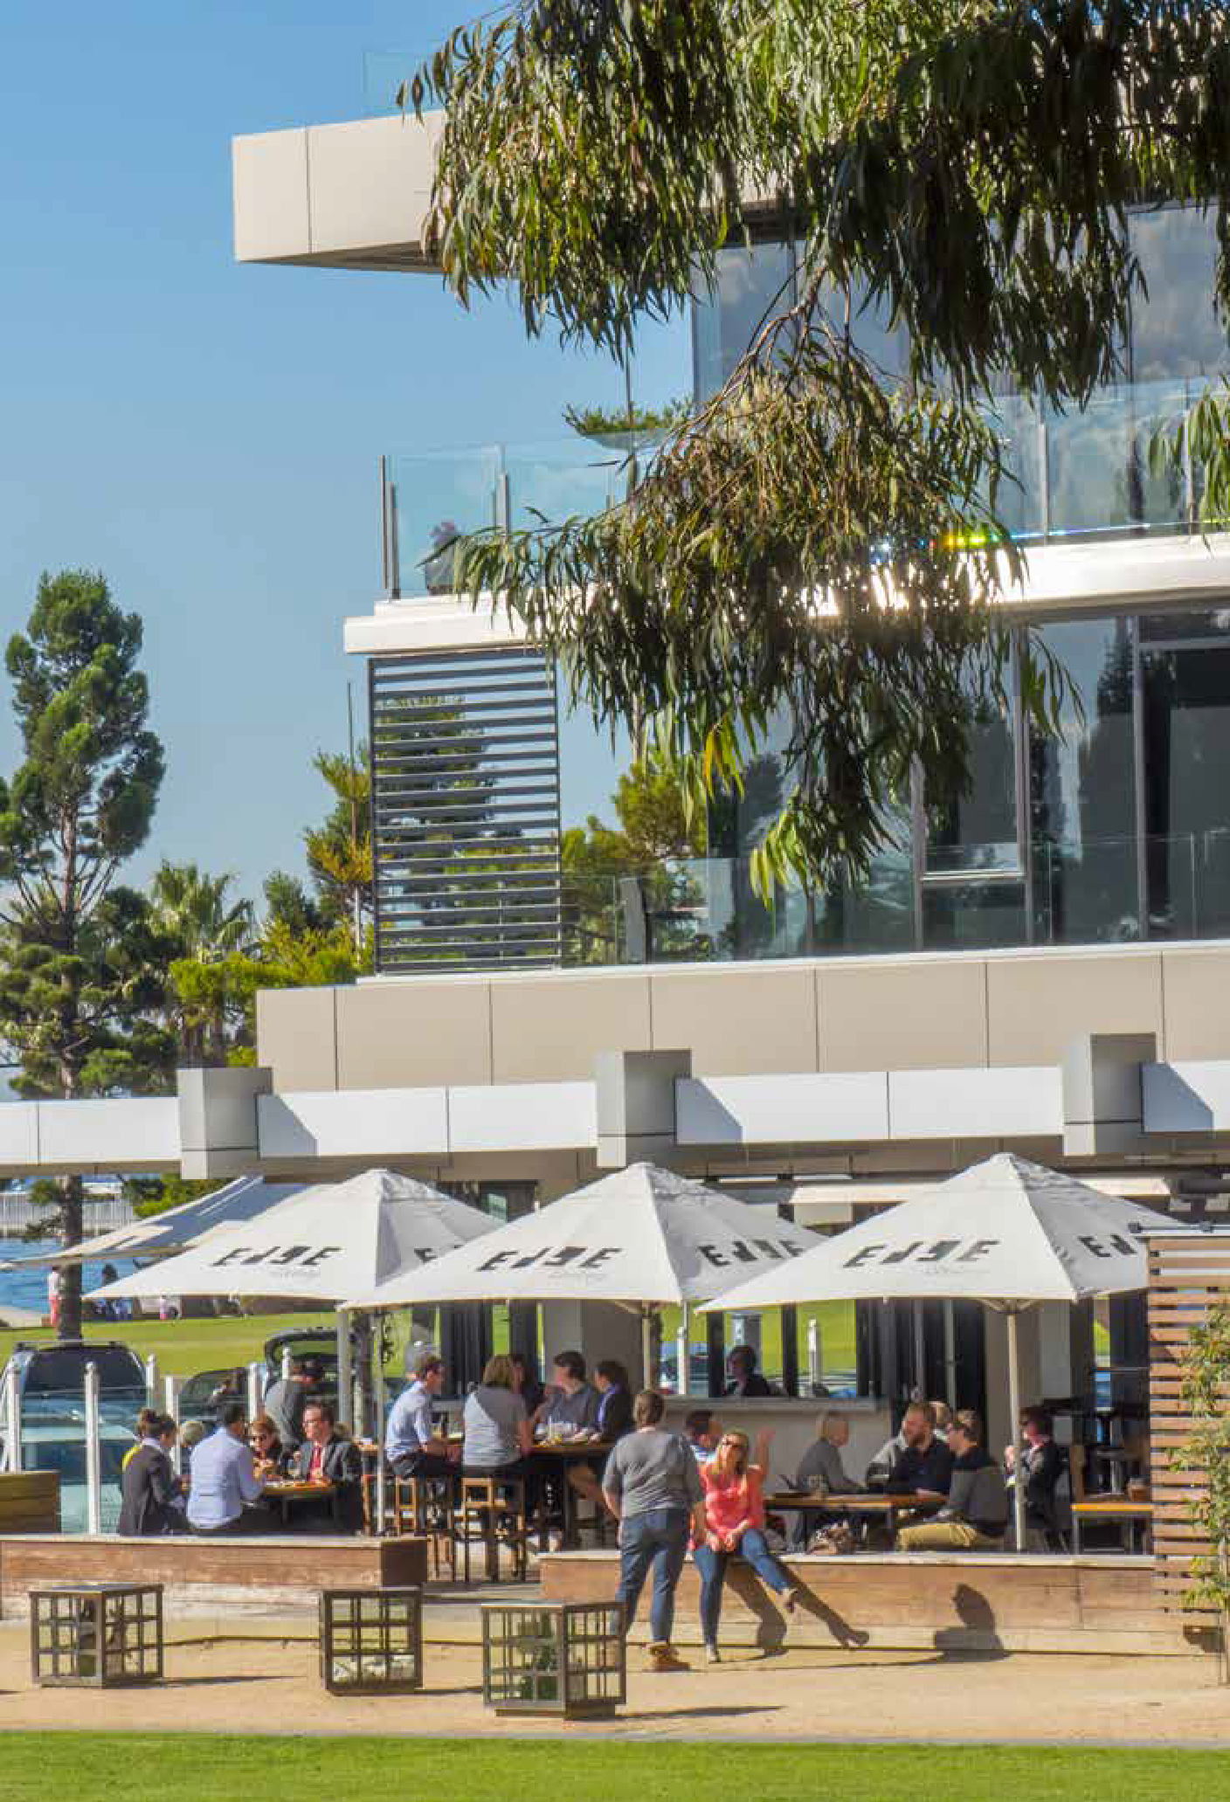

WHY UNDERTAKE THIS REVIEW
Residents need access to essential retail services, particularly at a neighbourhood-level and within a 20-minute drive of their homes. Our last retail strategy was prepared in 2006 and the region has undergone a number of changes, which this strategy must reflect.
The intent of undertaking the Retail Strategy is to:
  - forecast future retail demand within the City of Greater Geelong
  - check that the local planning framework supports the predicted demand for retail floor space
  - guide this development in a way that is consistent with State and Local planning policies.

CHANGES IN OUR RETAIL SECTOR
Since 2006, a number of retail centres have been built and expanded to meet population growth in existing and new suburbs. Additionally, a number of new retail centres within new suburbs have been planned.

HOW THIS STRATEGY WAS DEVELOPED
We engaged SGS Economics and Planning to undertake a technical analysis of Greater Geelong’s retail network, in the context of:
- recent retailing trends
- land use
- population growth and
- planning policy.
SGS Economics and Planning consulted with major retailers, developers, centre mangers and trader groups to gain an understanding of the current retail situation in Greater Geelong.
Their recommendations about future retailing needs across Greater Geelong will guide the development of the retailing sector through to 2036.

1. .id community (2017) City of Greater Geelong Estimated Resident Population. https://profile.id.com.au/geelong/population-estimate (accessed on 12 June 2018).
2. Australian Bureau of Statistics compiled by.id Forecast prepared for the City of Greater Geelong.
3. SGS Economics and Planning 2018 – Forecast using 2.0% annual average population change (excluding Surf Coast Shire and Borough Queenscliff).

A GROWING GREATER GEELONG

POPULATION GROWTH
Greater Geelong will continue to grow over the next 20 years. Much of this growth will be associated with new housing development in Armstrong Creek, the Northern and Western Geelong Growth Areas and, to a lesser extent, Lara, Leopold, Ocean Grove and Drysdale. This can be seen in Figure 2 and Table 1 below. Table 1 shows that Greater Geelong is forecast to grow by 114,370 people between 2016 and 20364.
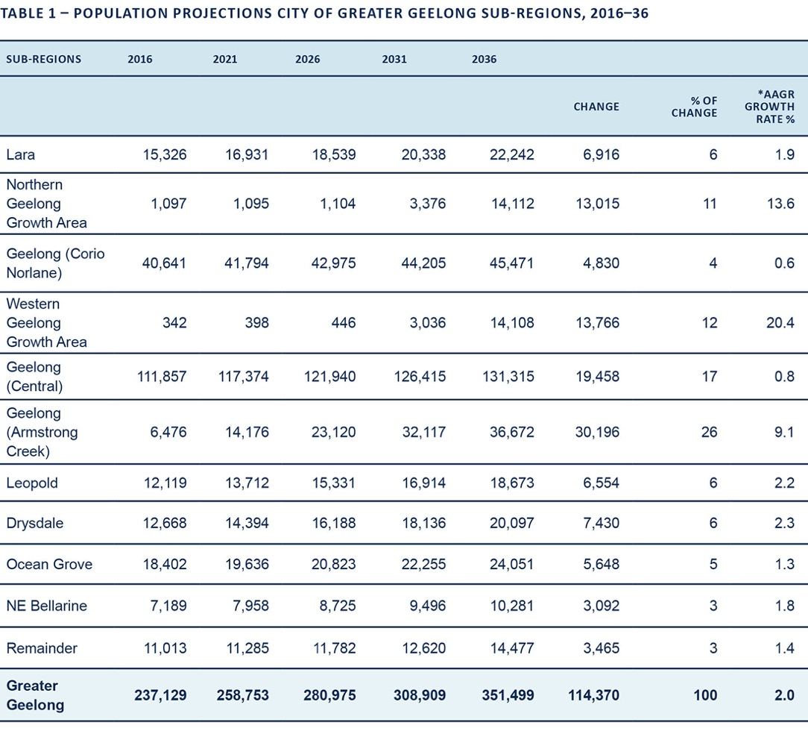

*AAGR = Average Annual Growth Rate
Note: The City of Greater Geelong Settlement Strategy August 2020 applies an AAGR of 2.5%. The Settlement Strategy applied the G21 Regional Growth Plan aspirational rate. The curent 5 year growth rate for Greater Geelong is 2% which has been applied within the Retail Strategy.

4. .id community (2017) City of Greater Geelong Estimated Resident Population. https://profile.id.com.au/geelong/population-estimate (accessed on June 2018) and SGS Economics and Planning 2018 – Forecast using 2.0% annual average population change (excluding Surf Coast Shire and Borough Queenscliff)
5. SGS Economics and Planning, Population Forecast 2.0% Growth Rate

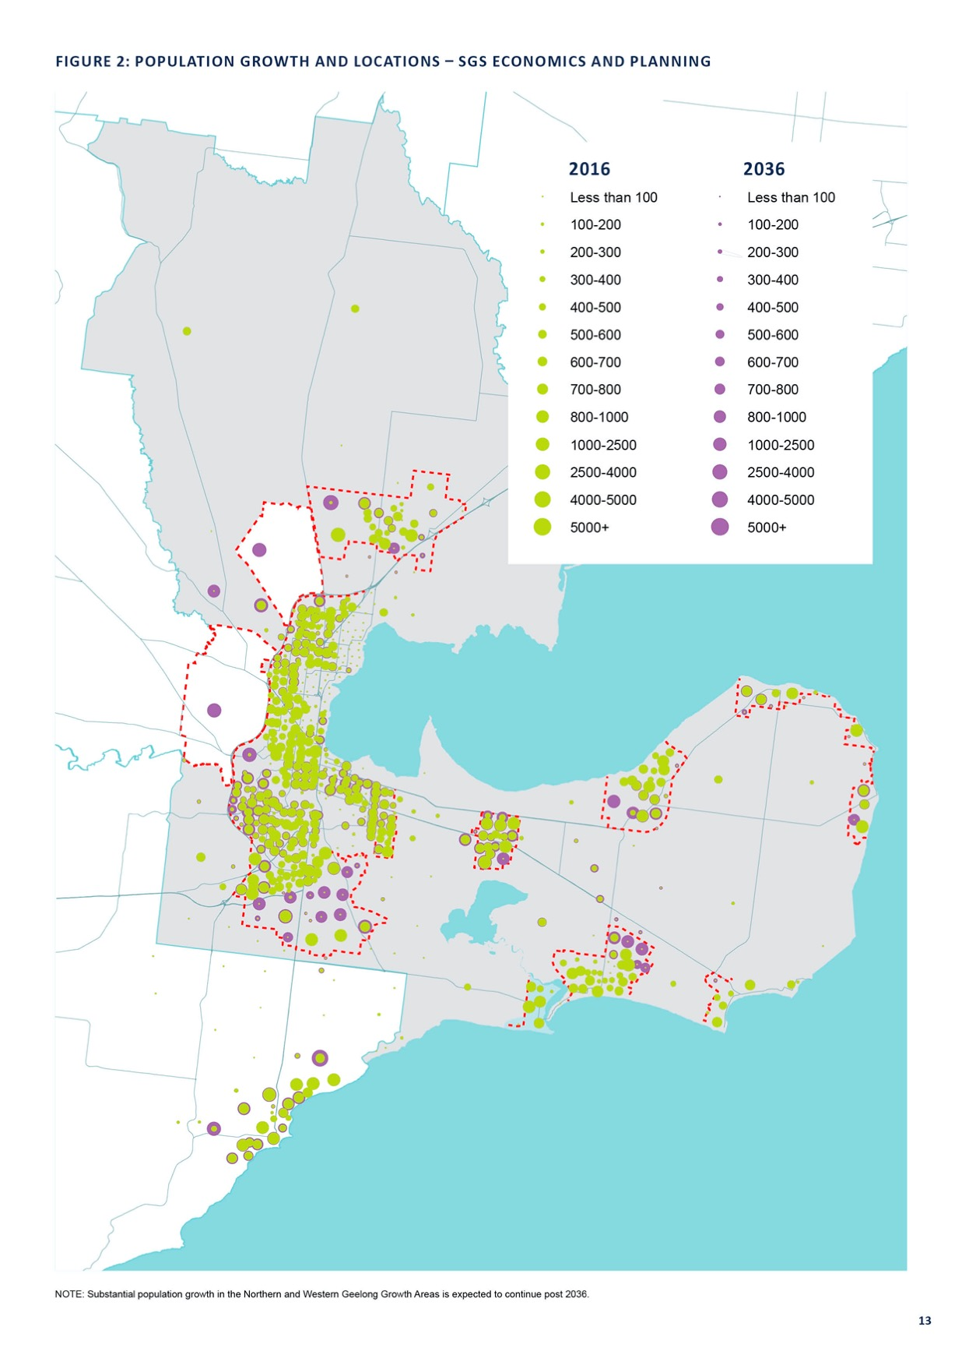

AGE STRUCTURE
Growth is forecast to occur across all age structures. In 2016, the dominant age structure for persons in Greater Geelong was 20 to 24 years, accounting for 6.7 per cent of total persons5. Between 2016 and 2036, the majority of growth will occur in the 35-39 age cohort. The age structure can be seen in Figure 3

FIGURE 3: FORECAST AGE STRUCTURE – 5 YEAR AGE GROUP

25,000

20,000

15,000

10,000

5,000
NUMBER OF PERSONS

0
0–4 5–9

10–14 15–19 20–24 25–29 30–34 35–39 40–44 45–49 50–54 55–59 60–64 65–69 70–74 75–79 80–84 85+

AGE GROUP (YEARS)

2016
2026
2036

Source: .id Forecast prepared for the City of Greater Geelong.

HOUSEHOLD TYPES
In 2016, the dominant household type in Greater Geelong was couples without dependents, which accounted for 28.4 per cent of all households. By 2036, the most noticeable change to household types will be an increase in the number of lone person households 28.3% and couples without dependents 29.6% of households (see Figure 4)6.
The growth in the number of lone person households and couples without dependents over the next 20 years is expected to increase the demand for smaller dwelling sizes close to existing services. Currently 66.1% of dwellings within Greater Geelong are classified as separate houses, 22.9% are medium density and 10.1% are high density7.

FIGURE 4: FORECAST HOUSEHOLD TYPE

40,000

30,000

20,000

10,000
NUMBER OF HOUSEHOLDS

0
Couple families with dependents

Couples without dependents

Group Households

Lone person Households

, One parent

family, Other families

HOUSEHOLD TYPE

2016
2026
2036

Source: .id Forecast prepared for the City of Greater Geelong.

5. id community (2017) City of Greater Geelong Population Forecast (https://forecast.id.com.au/geelong/population-age-structure) (accessed on June 2018)
6. https://forecast.id.com.au/geelong/household-types (accessed July 2018)
7. Australian Bureau of Statistics, Census of Population and Housing 2016. Compiled and presented by .id forecast (accessed July 2018)

RETAILING TRENDS
The retail industry is one of the most important economic sectors in regional Victoria given its contribution to employment, income and the provision of goods and services across diverse spatial geographies. Acting as a primary shaper of local economies, the retail sector also impacts land use, form and function. However, changing technology and consumer preferences are altering how we use physical retail centres, and this disruption is expected to continue. Centres will need to focus on providing more services and higher-quality, unique experiences to be successful in the future.
With this rapidly evolving context in mind, forms of retailing that overlap with traditional formats, such as supermarkets, department stores and speciality, should be considered.
Below are some examples:

FAST RETAIL

Key features
  - Capitalises on efficiency, time savings and cost savings.
  - High-turnover model.
  - Relies on large population catchments to capitalise on technological innovations, such as automated checkouts.
  - Recent growth in retail activities across Greater Geelong has predominantly been in this domain.

Examples
  - Supermarkets and bottle shops.

Things to consider
  - While fast retail proposals will highlight positive local employment benefits, most jobs associated with this form of retailing are low income and/or casual.
  - Employment opportunities are further impacted by new technologies, such as electronic check-out machines.
  - Fast retail stores are often stocked with the inexpensive goods available in the global market, driving a preference for imported products over locally-produced or manufactured products. This further erodes the market share of local manufacturers and primary producers.
  - Ownership structures are also typically highly detached from the local community.

SLOW RETAIL

Key features
• Engages consumers at a more comfortable pace.
• Typically owner-operated shops, with individuality and personality.
• Particularly well suited to smaller, rural townships.
• The retailer must build relationships and generate repeat sales with local customers, given the limited population catchment available to support trade.
• Quality of customer interaction, store design and finding a ‘niche’ in the market are key competitive advantages.

Examples
• Local cafés and delis.

Things to consider
• Typically owned and operated by local resident
• More likely to hire skilled, full-time employees on more reasonable wages
• More likely to stock locally-produced goods.
• Higher price points are justified by their higher price points, by providing customer solutions and service.

CULTURAL RETAIL

Key features
• Positions the arts as the centrepiece of a unique offer.
• Cultural facilities usually the major anchor of a commercial district/precinct.
• Any combination of museums, galleries, studios, arts retailers, offices and dwellings can typically be found within a mixed-use precinct.
• Can attract visitors, but ideally concentrated in areas where sufficient critical mass and exposure can be achieved – for example, Central Geelong.
• Requires strong collaboration between local government, the local arts community and retailers, due to the inherent link between private shops and public space.
• Cultural retail is an important aspect of tourism development.

Examples
• Surf shops in coastal towns.
• Arts and crafts stalls in cultural precincts.

Things to consider
• Cultural retailers tend to differentiate their products and services, which is essential for attracting tourism and contributing to the overall ‘Geelong’ brand.
• They often generate positive amenities in vibrant and attractive public spaces. This helps attract businesses engaged in higher-order professional services – an industry sector likely to be important to the economic future of Geelong. This is starting to become evident in the Geelong Cultural Precinct which includes the library, Johnstone Park, Geelong Performing Arts Centre, Work Cover and National Disability Insurance Agency.

RESTRICTED, LARGE FORMAT RETAILING OR
WHOLESALE SHOPPING

Key features
- A well-established element in retailing.
- Has limited synergies with centre-based shopping.
- Can reasonably be managed independently, with due regard to variables such as car access, availability of large footprint sites and highway exposure.
- ‘Bulky retailing’ often involves smaller goods, such as tableware, linen and other small furnishings.
- Can often be encouraged to co-locate with activity centres as larger-format specialty stores, perhaps on the edge of centres.

Examples
- Restricted retail centres and hardware.
- Furniture and white good stores.

ONLINE RETAILING
Since 2006, online retailing has increased significantly. Once considered a direct competition to store-based retail, maintaining a physical and online presence is now regarded as the best way to maximise potential revenue sources.
Online retailing trends and how they have been factored in Geelong Retail Strategy is discussed in Appendix 1.

RECOMMENDED RETAIL TYPES FOR GREATER GEELONG
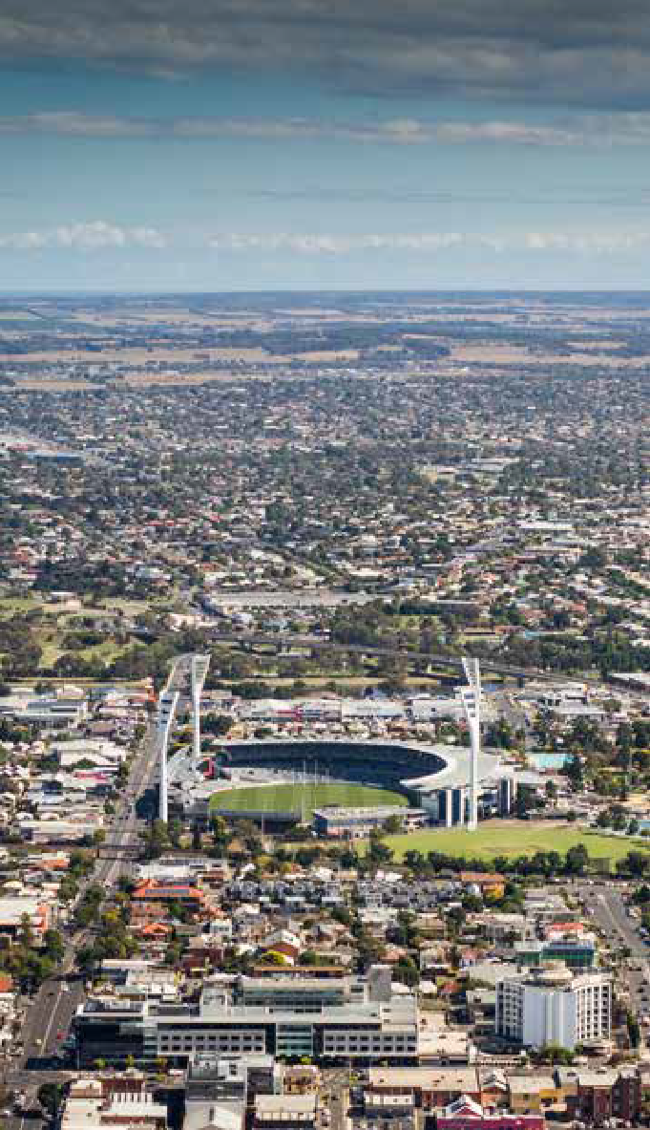
Slow and cultural retail have the greatest potential to progress retail in Geelong’s largest centres, and should be the basis for new approaches to developing activity centres. Typically, they have the strongest links to the local economy, supporting further output growth and improving local employment outcomes.

EXISTING PLANNING POLICY

A primary focus of this strategy is to guide decision making about planning permit applications and requests to zone land for retail purposes.
The current planning policies and factors that have shaped the recommendations include:

STATE PLANNING POLICY FRAMEWORK
  - This is the overall planning framework policy direction for Victoria. It encourages concentrating major retail, residential, commercial and cultural developments into
activity centres. It also prioritises directing growth towards key road and rail networks.
  - In relation to our region, it:
    - supports the role of Geelong as both ‘the regional city’ and Victoria’s second city
    - supports development of district towns within their established boundaries, such as, Drysdale/Clifton Springs, Lara, Leopold, and Ocean Grove, by improving and expanding existing infrastructure, and developing new infrastructure
    - supports growth in areas north and west of Geelong.

G21 REGIONAL GROWTH PLAN (2013)
- Figure 5 shows a map of the G21 regional growth context plan. The plan, which covers the City of Greater Geelong and surrounding municipalities:
  - identifies the retail sector as one of the key drivers of economic growth in Geelong over the last 10 years
  - cites a need to review the City of Greater Geelong Retail Strategy 2006 as a strategic planning priority
  - suggests infrastructure and services within the overall G21 region should be optimised and consolidated, particularly if near central retail and transport nodes.

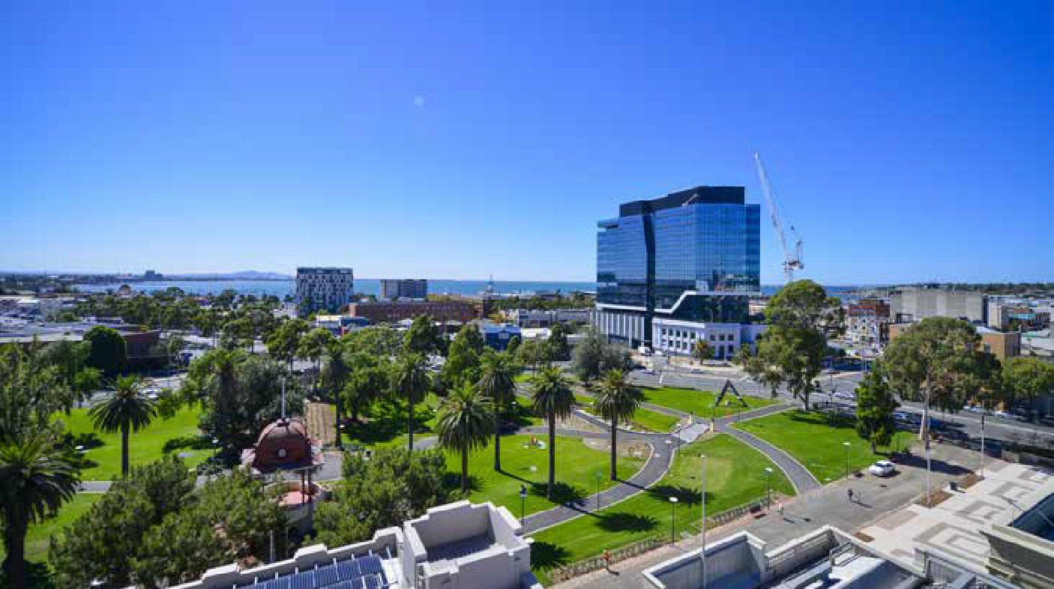

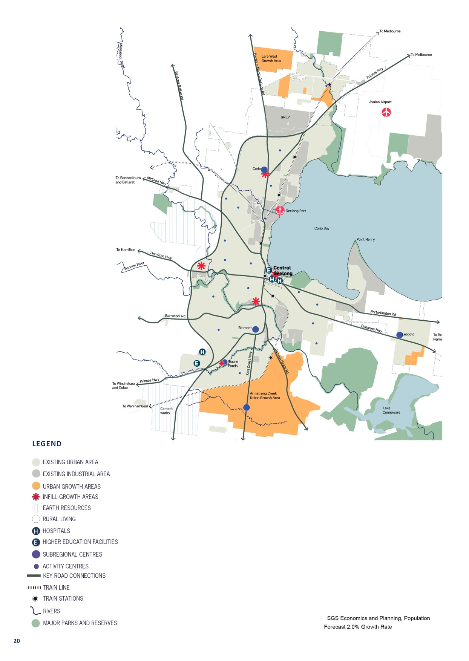
Barrabool Rd
Portarlington Rd
Hamilton Hwy
Bellarine Hwy
Midland Hwy
Barwon River

LOCAL PLANNING POLICY FRAMEWORK
This planning framework works with zones and overlays to guide development that is responsive to local conditions and opportunities. The framework:
    - highlights a need for a mix of retail, office, cafés, entertainment, housing, education and community facilities in activity centres
    - provides a retail centre hierarchy for Greater Geelong, establishing the role of each centre by size and function
    - supports the role of Central Geelong as the focus for retail activity in the region
There is increased development pressure from certain retail types for sites located away from activity centres, including restricted retail and developments needing large sites and/ or significant car parking.

CURRENT RETAIL ASSESSMENT
Currently, all major retail developments and out-of-centre developments must provide a net community benefit to be approved. Applications for new centres must prove the need, according to the retail hierarchy, and establish that it will not negatively impact on the hierarchy.
Assessment criteria for retail planning applications, planning scheme amendments and floor space restrictions have also been established.

SPECIFIC LOCAL POLICIES
There are several features in the policy framework that are specific to particular centres, townships and growth areas, as summarised below:

CENTRAL GEELONG
    - The subject of a number of strategic planning initiatives and public realm improvements in recent years, as part of the revitalisation of the Central Geelong.
    - Changes to the urban environment have been complemented by a comprehensive calendar of events and a range of place-making initiatives that are monitored and reviewed regularly.
    - Central Geelong is to be the focus for investment, retail, education, culture, leisure, commerce, services and higher-density residential living.

CENTRE MANAGEMENT ISSUES

Central Geelong continues to be the focus of strategic planning initiatives to encourage more people to live, work, learn and play in Central Geelong. The revitalisation projects for the CBD, including significant public realm improvements, is outlined in Council’s Central Geelong
Action Plan and the State Government’s Revitalising Central Geelong Action Plan.
The Central Geelong and Waterfront department act as the place managers for the public spaces in central Geelong and along the waterfront and undertake a diverse range of activities including attracting new businesses and improving the environment for existing businesses; facilitating upgrades to infrastructure; management of public space assets; oversee the night time economy; promote central Geelong’s business and cultural assets and deliver events and activities to encourage community.
Place Making in central Geelong is further supported by Council’s ongoing commitment to the Central Geelong Marketing Committee. Council in 2001, using its powers under section 86 of the Local Government Act 1989, established a special committee – The Central Geelong Marketing Committee. A special committee is any committee to which the Council delegates a duty, function or power. In this instance the committee is the peak body representing the traders and property owners in Central Geelong. The committee is primarily responsible for promoting central Geelong as the City’s premier retail and cultural hub.

This committee is funded by a Special Rates Scheme under section 163 the Local Government Act 1989, whereby all landowners within Central Geelong contribute funds to support the operations of the committee.
Under the Local Government Act 1989 there is an ability for Council to create similar special committee’s to promote other activity centres. This would need to be considered on a case by case basis.

Under the Local Government Act 1989, Council can create similar special committees to promote other activity centres. Given the resources required to manage such committees, these would need to be considered on a case-by-case basis.

ARMSTRONG CREEK GROWTH AREA
    - Identified in the Local Policy Planning Framework as the primary growth area for the G21 Region (as shown in Figure 6).
    - The framework identifies a need to establish a network of mixed-use activity centres to provide for the needs of the incoming community.
    - Planning for this growth area is well progressed, including an understanding of future retail demand.

TOWNSHIPS
    - Structure plans have been prepared for all townships within the City of Greater Geelong including Lara, Leopold, Drysdale/Clifton Springs, Ocean Grove, Portarlington, Indented Head and St Leonards.
    - Each structure plan considers the future retail needs of the respective township and identifies if additional retail floor space is needed, where it’s needed and when.
    - Leopold has been identified as the preferred location for a sub-regional centre to service the Bellarine Peninsula.

HOUSING DIVERSITY STRATEGY 2007
- Identifies our preferred locations for increasing housing densities.
- Higher-density housing is particularly being encouraged around retail centres.
- By increasing residential densities around retail centres, it should strengthen the role and number of services provided.

NORTHERN AND WESTERN GEELONG GROWTH AREAS

The land within the Northern Growth Area (16,000 dwellings) and the Western Growth Area (18,000 dwellings) has the combined capacity to accommodate 110,000 residents.
The project is the largest urban growth project in regional Victoria, comprising 5,367 hectares.
A portion of the Northern Growth Area was rezoned by the Minister for Planning in 2014 to Urban Growth Zone. A framework plan for both the Northern and Western
Geelong Growth Areas was adopted by Council on 26 March 2019. Precinct structure plans must be completed before development can begin in these areas.
The planning for both the Northern and Western Geelong Growth Areas should encourage a mix of housing types and densities, including a number of retail and
employment centres.

GREATER GEELONG: CLEVER AND CREATIVE FUTURE

This work represents the voices of more than 16,000 members of the Geelong community.
Greater Geelong: A Clever and Creative Future is a 30- year vision that guides all levels of government, community organisations, businesses and anyone wanting to make a genuine contribution to the Geelong city-region.
The community’s vision is:

“By 2047, Greater Geelong will be internationally recognised as a clever and creative city- region that is forward looking, enterprising and adaptive, and cares for its people and environment.”
At the heart of the 30-year vision are nine community aspirations. The aspiration most relevant to this strategy are:

“A prosperous economy that supports jobs and education opportunities.”

“Sustainable development that supports population growth and protects the natural environment.”
The community values we seek to support include:
- business diversity, education and employment opportunities
- people who are willing to create new business opportunities
- sustainable development that responds to climate change
- design that makes best use of technology for better and more sustainable living
- development that enhances the identity of diverse neighbourhoods
- design excellence and innovation in new buildings and public spaces
- creating high amenity neighbourhoods that are well- connected and sustainable.

RETAIL HIERARCHY

This strategy continues to support a hierarchy of retail centres. The hierarchy defines the roles of centres in the retail network across Greater Geelong.
The location of centres in the retail hierarchy is illustrated in Figure 6.
Table 2 (page 26) describes the different levels in the hierarchy, their principal role and function.

IMPORTANCE OF A RETAIL HIERARCHY
The centre hierarchy typically reflects the following shopping behaviours:
  - more frequent, short-distance and low-spend visits are made to a local or neighbourhood centre
  - occasional high-spend visits to sub-regional centres, offering higher order goods and services.
If shopping opportunities are spatially arranged in this way, the cost of travel to consumers and the environment will be minimised.
There is often a strong link between centre policy and urban consolidation. Vibrant nodes of commercial, retail, entertainment, health and civic services provide a centre around which housing density can increase, helping to support the retail network.
A review of each retail centre has been undertaken. Each centre has been assessed against the hierarchy definitions in Table 2, current planning policy direction and forecast floor space projections. In some cases, we’ve identified further strategic work that could be done to support the growth of centres. The retail centre review can be found in Appendix 2 (page 88).

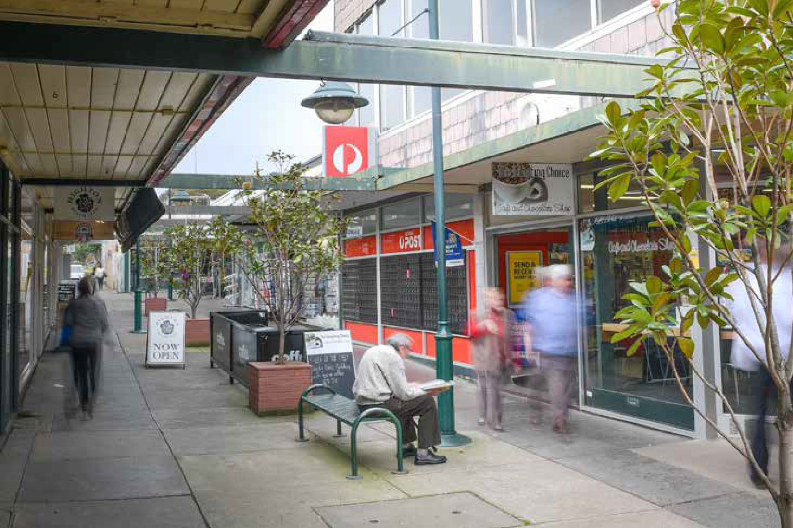

FIGURE 6: LOCATION OF RETAIL CENTRE
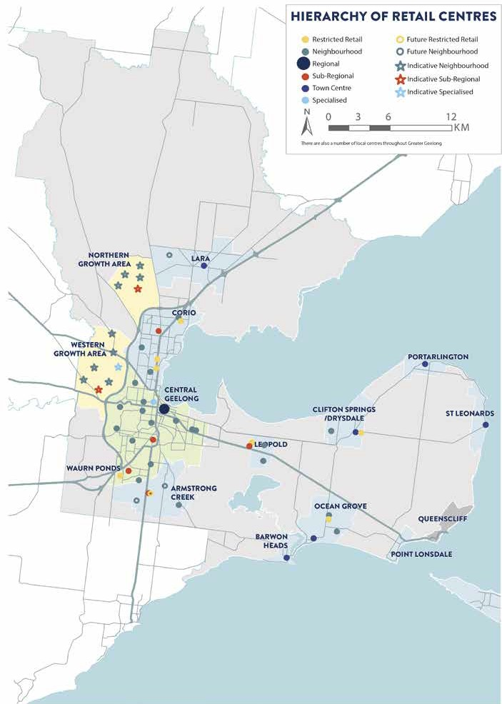

There are also a number of local centres throughout Greater Geelong.

DEFINITION OF A RETAIL CENTRE
Greater Geelong has a number of retail centres, but not all of these centres will form part of the identified retail hierarchy. A retail centre is:
Any place where retail transactions take place for household goods and services, and where one or more of the following conditions apply:
The retail activity is lawful under all relevant statutes, including the Planning and Environment Act 1987.
The location accommodates at least one shop, and the total floor space of the shop(s) exceeds 500 square metres (this is a nominal limit to signify a significant concentration of shops or sales activity).
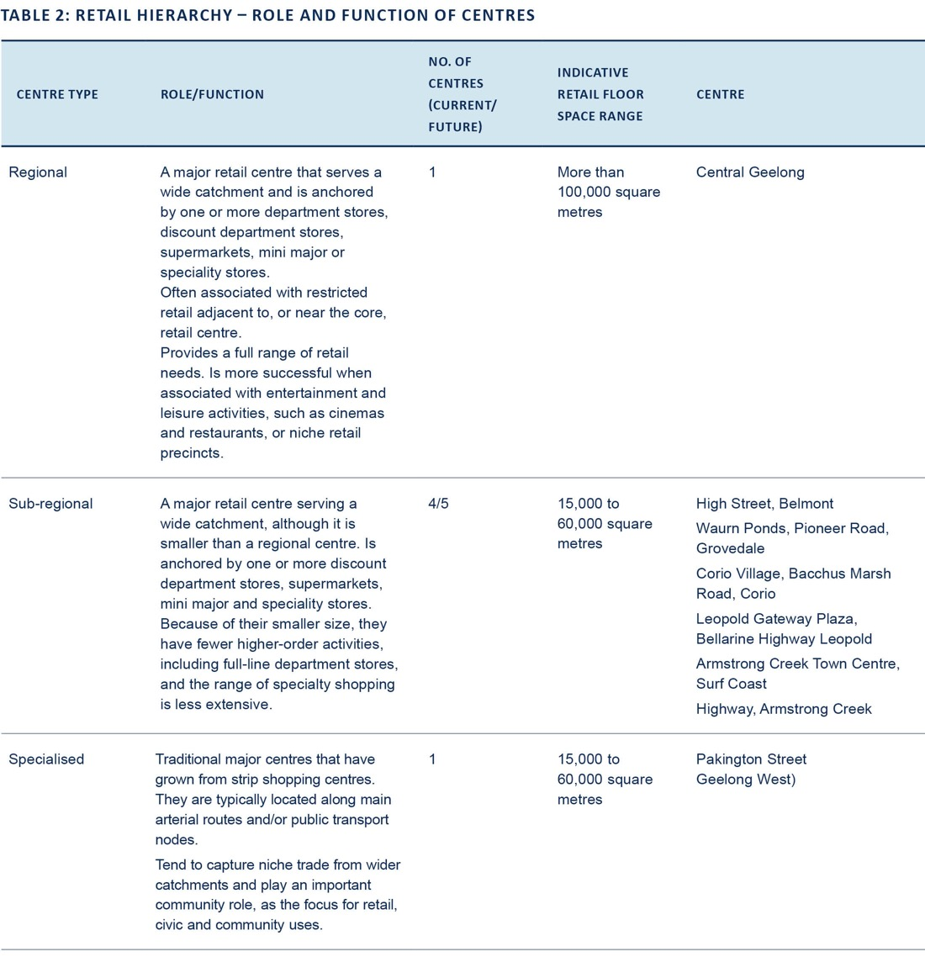
The boundary of all retail centres identified in Figure 6 of this Strategy is as delineated in Appendix 2. The boundary of all other retail centres will be determined by those contiguous land parcels which may lawfully be used for the purpose of a ‘shop’ without the need for a planning scheme amendment.
‘Out-of-centre retailing’ is defined as proposals which are not consistent with the planned hierarchy of retail centres and which are not permissible ‘as of right’.
Based on the above definition, planning policy will primarily direct retail development to existing centres identified in the retail hierarchy in Table 2.

NO. OF CENTRES INDICATIVE RETAIL
CENTRE TYPE ROLE/FUNCTION (CURRENT/ FLOOR SPACE CENTRE
FUTURE) RANGE

Town centre Major community shopping locations. Provide weekly grocery shopping for
the local township, in combination with specialty store shopping that also services visitors.
6 2,000 to 20,000
square metres
The Terrace, Ocean Grove High Street, Drysdale, Station Lake Road, Lara, Hitchcock Ave,
Barwon Heads
Newcombe Street, Portarlington Murradoc Road, St Leonards

Neighbourhood
A retail centre that serves a neighbourhood catchment and is anchored by one or more supermarkets, plus speciality stores.
21/24 2,000 to 15,000
square metres
Shannon Avenue, Geelong West Separation Street, North Geelong Pakington Street, Newtown Barrabool Road, Highton
Newcomb Central, Bellarine Highway, Newcomb
Ormond Road, East Geelong
Bellarine Village, Bellarine Highway, Newcomb
Bell Post, Anakie Road (Norlane) Barrabool Hills, Province Bvd, Highton Shannon Ave, Newtown,
Marketplace, Shell Road, Ocean Grove, Vines Road, Hamlyn Heights,
Hyland Street, Fyansford,
Grovedale Central, Heyers Road, Grovedale
Dorothy Street, Leopold Ash Road, Leopold
Rosewall, Broderick Road, Corio Jetty Road, Curlewis
Warralily Village, Barwon Heads Road, Armstrong Creek
Lara West, Lara
Armstrong Creek West, Mount Duneed Horseshoe Bend North East, Charlemont Kingston Village, Grubb Road,
Ocean Grove
Surf Coast Highway, Grovedale

Local Small groups of shops, serving a limited catchment and typically providing for the daily convenience needs
of residents in the surrounding area.
69/75 Up to 5,000
square metres
Dispersed throughout Greater Geelong

Excludes Northern and Western Growth Areas.

*The City of Greater Geelong is also home to a number of dispersed ‘restricted retail areas’ opportunistically distributed throughout industrial and similar areas, with no linkages or synergies with established centres.

NO. OF CENTRES INDICATIVE RETAIL
CENTRE TYPE ROLE/FUNCTION (CURRENT/ FLOOR SPACE CENTRE
FUTURE) RANGE

Restricted retail* A collection of restricted
retail stores, generally comprising furniture, white goods, electrical, floor and window coverings, lighting, hardware and related retail operations. Can be adjacent to core retail centres, or in stand-alone precincts.
7/8 50,000+ Murradoc Road Drysdale
Geelong Gateway, Princess Highway, Corio
Colac Road, Waurn Ponds Melbourne Road, Norlane, Melbourne Road, North Geelong Sinclair Street, Ocean Grove
Leopold Gateway Plaza, Bellarine Highway, Leopold
Armstrong Creek Town Centre, Surf Coast Highway, Armstrong Creek

Excludes Northern and Western Growth Areas.

*The City of Greater Geelong is also home to a number of dispersed ‘restricted retail areas’ opportunistically distributed throughout industrial and similar areas, with no linkages or synergies with established centres.

INDICATIVE RETAIL CENTRES IN THE NORTHERN AND WESTERN GEELONG GROWTH AREAS
The Northern and Western Geelong Growth Areas will require a number of retail centres to ensure future communities have access to retail services within a reasonable and walkable distance from home. Like Armstrong Creek, it is intended that the Northern and
Western Growth Areas will contain diverse localised and sustainable neighbourhoods that prioritise self-sufficiency while maximising connections to the broader Geelong community and economy.
Work undertaken to date on the Northern and Western Geelong Growth Areas project includes assessment of the retail needs of these future communities. The project has considered the ultimate population of each growth area and proposes that twelve additional retail centres are required – five in the north and seven in the west.
In determining the type and location of centres within the growth areas, we have considered how the proposed retail network will interact with the existing and future network.

The timing and scale of new retail centres, particularly
sub-regional centres, will proceed in a planned way to give existing centres time to consider how they might adjust to their changed circumstances – for example, by reviewing the retail offer, investing in online sales or renewing infrastructure.
Each growth area will be planned sequentially via multiple precinct structure plans. These plans will control the timing, location and scale of proposed retail centres, particularly the sub-regional centres. They will also consider impacts on the existing centre network and will consider applying floor space caps.
Overall, these processes will give us the opportunity to assess the economic impacts of a new retail centre on the network at the time the development of each centre is proposed.

A GRAVITY MODEL
FOR GREATER GEELONG

The SGS Economics and Planning gravity model has been used to estimate the future retail needs of Greater Geelong by 2036. The gravity model simulates the flow of shoppers to different activity centres, taking into account the ease of access, size and attractiveness (or offer) of the various centres. The model takes a whole-of-network approach and uses calculations to model human behaviour. The retail gravity model theory, assumptions and approach are discussed further in Appendix 1.

Key inputs must be considered to make these calculations, including:
  - population growth (refer to section on ‘a Growing Greater Geelong’)
  - retail trends by commodity and location, with adjustments for resident, student, workers and tourist
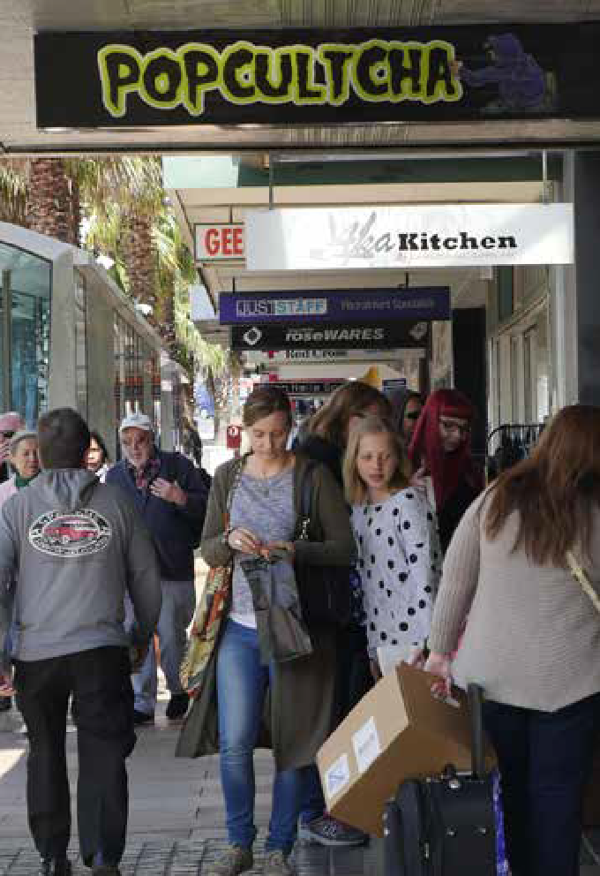
  - a centre floor space audit and typical retail centre turnover estimates
- travel times between expenditure origins - such as houses, business,es, tertiary institutions - and centres.
Based on these inputs the gravity model simulates the system under a base case, or business-as-usual, scenario. This determines how centres are performing today, and how they’ll perform in the future, given known existing and planned floor space.

FLOOR SPACE AUDIT
Table 3 shows the results of the March 2018 floor space audit used to determine the current retail floor space provided in each centre across Greater Geelong (see Table 3). The audit reviewed all retail land uses across industrial, commercial and mixed-use zoned land within Greater Geelong. Non-retail uses were also recorded.
The audit assessed:
- the gross floor space for each lot
- the predominant floor space type (including six retail categories and seven non-retail categories)
- the amount of vacant land or vacant units in each precinct
- future centres (currently with no floor space) and allowing for early retail development in the Northern
and Western Geelong Growth Areas.
Local retailers and centre managers were also consulted, to develop an in-depth local understanding of retail floor space supply across the municipality. The audit approach is further discussed in Appendix 1 (page 61).
According to the audit, Greater Geelong has approximately 903,812 square metres of retail floor space spread across 121 retail centres. Of the total retail floor space, Central Geelong makes up approximately 21 per cent, the four existing sub-regional centres represent 15 per cent and restricted retail centres make up 15 per cent.

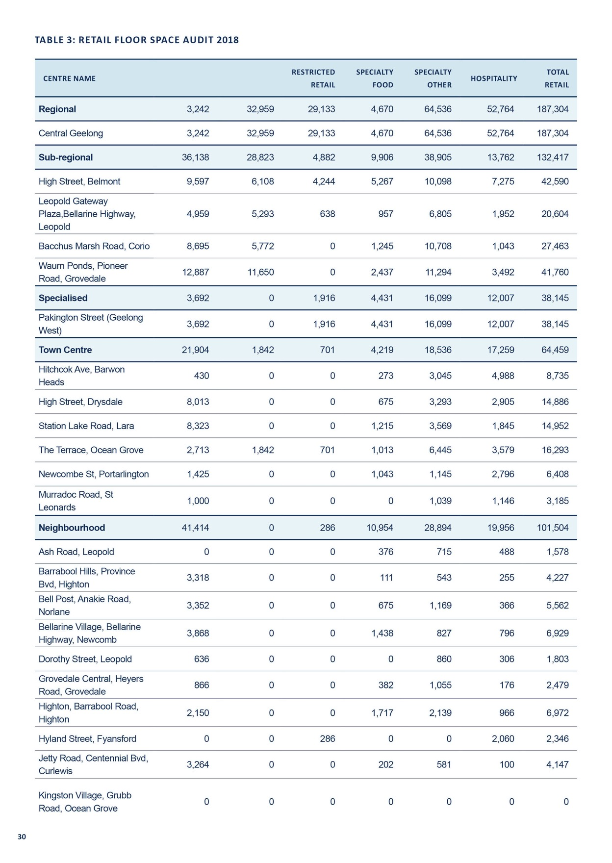
DEPARTMENT RESTRICTED SPECIALTY SPECIALTY TOTAL
CENTRE NAME SUPERMARKET HOSPITALITY
STORES RETAIL FOOD OTHER RETAIL

Highway, Newcomb Ocean Grove Geelong
Lara West, Lara 0 | 0 | 0 | 0 | 0 | 0 | 0
Newcomb Central, Bellarine 5,251 | 0 | 0 | 630 | 1,194 | 315 | 7,390
Marketplace, Shell Road, 3,566 | 0 | 0 | 287 | 910 | 985 | 5,748
Ormond Road, East 627 | 0 | 0 | 516 | 4,256 | 519 | 5,917
Pakington Street, Newtown 0 | 0 | 0 | 446 | 4,759 | 3,946 | 9,151
Rosewall, Broderick Road, 1,740 | 0 | 0 | 0 | 0 | 0 | 1,740
Separation St, North 0 | 0 | 0 | 908 | 1,898 | 2,766 | 5,572
Shannon Avenue, Geelong 4,340 | 0 | 0 | 1,727 | 4,903 | 1,978 | 12,948
Shannon Avenue, Newtown 1,967 | 0 | 0 | 151 | 740 | 1,637 | 4,495
Surf Coast Highway, 1,781 |  |  | 648 | 204 | 757 | 3,390
Warralily Village, Barwon  Heads Road, Armstrong 3,826 Creek | 0 | 0 | 341 | 773 | 1,060 | 6,000
Vines Road, Hamlyn 862 | 0 | 0 | 399 | 1,368 | 480 | 3,110

Corio Geelong West

Grovedale

Heights
Local (68) | 0 | 0 | 1,852 | 21,571 | 28,185 | 17,850 | 69,459
Restricted Retail | 2,156 | 0 | 107,109 | 4,456 | 31,833 | 35,994 | 136,021

Highway, Corio
Murradoc Road, Drysdale 0 | 0 | 1,655 | 328 | 755 | 436 | 3,174
Geelong Gateway, Princes 0 | 0 | 26,022 | 1,540 | 2,775 | 1,125 | 31,463
Leopold Gateway Plaza, Bellarine Highway, Leopold | 0 | 12,343 | 0 | 0 | 0 | 12,343
Melbourne Road, Norlane 0 | 0 | 18,968 | 1,400 | 2,286 | 998 | 23,652
Melbourne Road, North 0 | 0 | 9,084 | 0 | 4,802 | 436 | 14,322
Sinclair Street, Ocean 0 | 0 | 724 | 0 | 2,836 | 535 | 4,095
Colac Road, Waurn Ponds 0 | 0 | 31,398 | 473 | 14,821 | 280 | 46,972

Geelong Grove

Dispersed Restricted Retail | 3,775 | 0 | 174,501 | 7,425 | 31,106 | 12,886 | 229,693
Dispersed Retail | 5,400 | 0 | 84,500 | 4,200 | 10,600 | 10,700 | 115,300
Total Audit Floor space | 115,565 | 63,624 | 353,676 | 71,117 | 265,136 | 160,994 | 1,030,013

Figure 7 shows the breakdown of uses across all centre types. The graphs shows that there is a high level of hospitality within Central Geelong and generally across all centre types. There is also a large amount of floor space across Greater Geelong occupied by restricted retail, mostly within restricted retail centres.

FIGURE 7: RETAIL FLOOR SPACE SUPPLY, BY CENTRE AND STORE TYPE, 2014

250,000

200,000

150,000

100,000

50,000
RETAIL FLOOR SPACE

0
Regional Sub-regional Specialised Town centre Neighbourhood

Local

Restricted Dispersed restricted retail

TYPE OF CENTRE

Supermarket Specialty Food

Department Stores Specialty other

Restricted Retail Hospitality

Source: SGS Economics and Planning



RETAIL CENTRE TURNOVER
For a strategic level study such as this, exact turnovers are not actually required. This is because the modelling is not trying to predict an individual centre’s performance in a
particular year. Rather the modelling is trying to understand the general alignment, or misalignment, of the quantum and location of retail floor space supply and demand now and in the future. For this purpose, turnovers can largely reflect the typical performance of a centre.
Typical centre performance is determined using a measure called ‘retail turnover density’, which is calculated as follows:

Retail turnover density = total shop turnover ($) divided by shop floor space area
Retail turnover densities are varied by store type, commodity and centre role, and they’re aligned to actual turnover for the few centres where information is available. Overall turnover is also aligned to the total amount of floor space and the total expenditure pool across the entire Greater Geelong retail system. This is further discussed in
Appendix 1 (page 61).
Figure 8 shows retail turnover density for a selection of centres across Victoria, including Geelong.

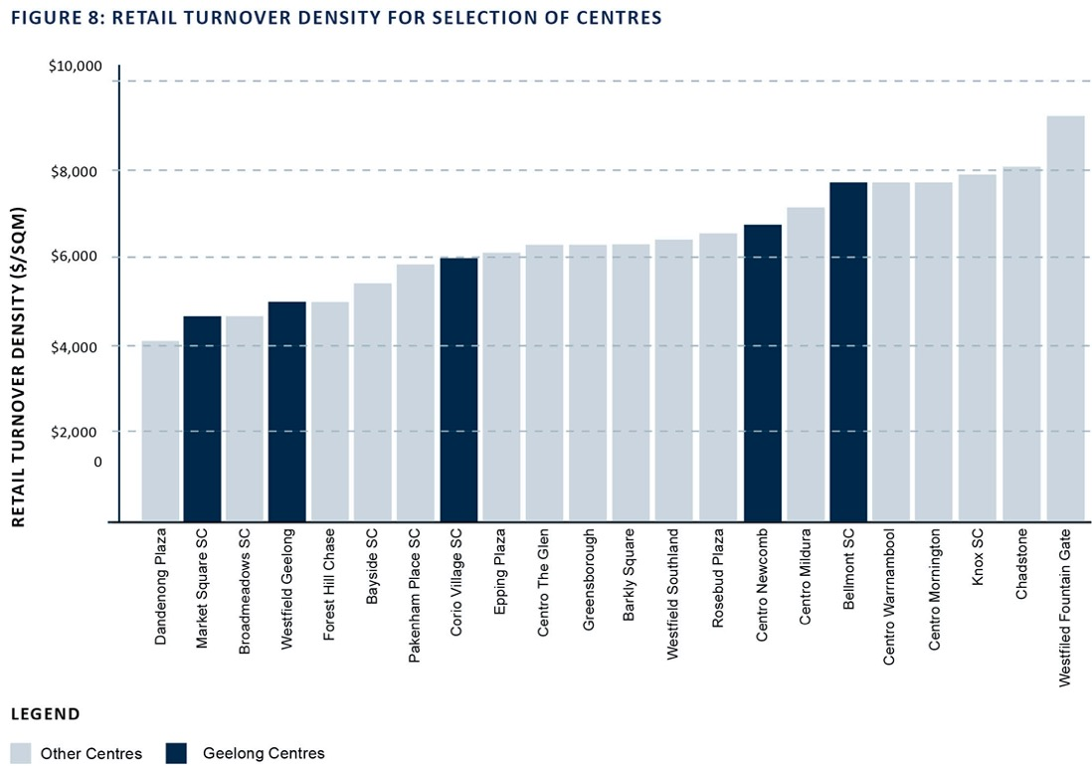

Source: Australian Shopping Centre Database - Property Council Australia

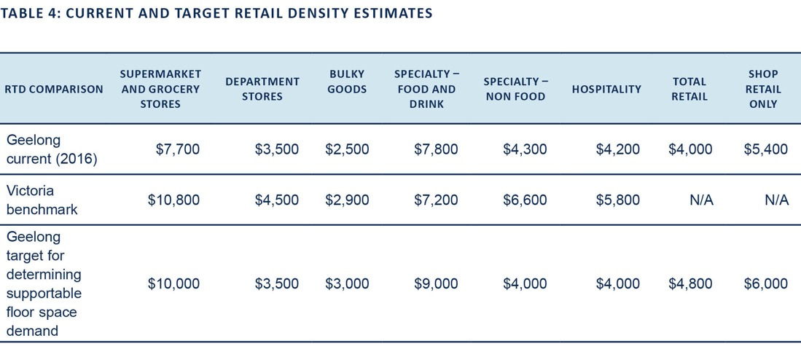

EXPENDITURE IN GREATER GEELONG
Expenditure by commodity type has been forecast for the gravity model. Expenditure forecasts have considered local retail expenditure trends, resident population forecasts and the impact of spending decisions linked to place of work, study (for tertiary students in particular) and tourism. The role of online retailing has also been factored into the expenditure modelling. This is discussed in detail in Appendix 1 (page 61).
The following commodity types have been modelled:
  - fresh food and groceries
  - pharmaceutical, toiletries and cosmetics
  - tobacco and bottle shop spending
  - restaurants, cafés and take-away spending
  - clothing and shoes
  - newsagent and lotto
  - personal items and services
  - furniture, whitegoods, manchester and home decoration
  - electronic home entertainment
  - hardware and gardening.

The analysis identified a total retail expenditure pool of
$3,648 million across Geelong in 2016. This will increase to
$6,465 million by 2036, representing growth of 2.9 per cent per annum (in real terms) over the next 20 years, based on population and expenditure growth.

FUTURE RETAIL DEMAND

A BASE CASE SCENARIO
In planning for retail centres across Greater Geelong over the next 20 years, it is important to understand the
‘business-as-usual’ or base case scenario. In this theoretical scenario, it is assumed that existing and planned retailers will absorb increasing levels of demand in the current/ committed floor space and store mix, with no extra floor space above that which is planned. Using the retail gravity model, the growing population and expenditure across the region would be allocated to larger, more ‘attractive’ (or higher-order) centres closer to growth. Unchanged, these centres would experience ever-increasing retail turnover density for all store types. By comparing this predicted performance back to target retail turnover densities, the level of supportable floor space and potential provision gaps can be determined.
Floor space guidelines and caps for selected centres are based on estimates of ‘base case supportable floor space by centre’. This is detailed further in the remainder of this strategy and local policy.

SUPPORTABLE RETAIL FLOOR SPACE
DEMAND AND SUB-REGIONAL ALIGNMENT
Figure 12 presents the current and prospective supply- demand balance under the base case scenario for retail floor space across all commodity/store types in Greater Geelong. This has been derived from the population and expenditure forecasts, target retail turnover densities and gravity modelling (further discussed in Appendix 1 (page 61)
).
Based on existing and currently planned floor space and projected population growth, the following under supply of retail floor space is predicted:
- 2016 (current) – 106,000 square metre oversupply
- 2026 – 89,900 square metre under supply
- 2036 – 418,200 square metre under supply.
Using the gravity model, this can be further disaggregated to better understand where under supply will be at the
sub-regional level

FIGURE 12: OVERALL SUPPLY DEMAND FLOOR SPACE ALIGNMENT

1,400,000

1,200,000

1,000,000

800,000
FLOOR SPACE (SQM)

600,000

400,000

200,000

0
2016

2026

2036

Existent and planned supply
Demand at centres (2016)
Demand at centres (2026)
Demand at centres (2036)

Source: SGS Economics and Planning

The sub-regional alignment below compares existing and planned floor space supply to supportable floor space demand at centres within each sub-region, based on the base case gravity modelling. This analysis highlights several opportunities and challenges across the network:
- Geelong – Central sub-region Includes 47 per cent of Greater Geelong’s population, 17 per cent of projected population growth and a larger share of employment and services for the broader region. From a supply perspective, it includes 68 per cent of total retail floor
space across Greater Geelong, including Central Geelong Regional Centre, two Sub regional centres and the only Specialised centre.
It is estimated to see significant growth in retail demand partly due to the significant existing and future population of the sub-region itself and partly due to its established higher order role in the broader Greater Geelong hierarchy.
Over the next 20 years the base case scenario suggests there could be demand for a further 338,200 sqm metres of retail floor space across the 66 centres, once
accounting for existing and planned supply this creates a potential under supply of 256,600 square metres by 2036.
- Geelong – Corio Norlane sub-region which includes 17 per cent of Greater Geelong’s population and existing 26 centres, including one Sub-regional centre (Corio) is also estimated to see strong growth in supportable floor space demand at centres within the sub-region under the base
case scenario. This would result in an under supply of 86,200 square metres by 2036.
- Growth area sub-regions around Geelong, including Geelong (Armstrong Creek), Northern Geelong Growth Area and Western Geelong Growth Area are all anticipated to see strong growth in supportable floor space demand at centres due to demand from growing local populations. The current planned floor space and network of centres aligns with supportable floor space
demand forecasts, with a potential gap in Armstrong Creek appearing in 2036.
- Other major settlements, including Lara, Leopold, Drysdale and Ocean Grove represent 25 per cent of current population and are anticipated to see a similar level of population growth in the future. The base case scenario suggests these sub-regions will see supportable floor space demand growth that meets current floor space. This will provide for growth in existing centres, as well as the establishment of a few planned centres to support expanded urban footprints. While this growth is largely planned already for Ocean Grove, potential gaps may arise in Drysdale and Leopold by 2036, largely within the restricted retail sector. However, these gaps could be met within the existing and planned network
of centres.

FIGURE 14: SUPPLY DEMAND FLOOR SPACE ALIGNMENT – GEELONG -
CENTRAL
FIGURE 15: SUPPLY DEMAND FLOOR SPACE ALIGNMENT – GEELONG -
CORIO NORLANE

1,00,000

800,000
Floor space (SQM)

600,000

400,000

200,000
0

2016 2026 2036
300,000
250,000
Floor space (SQM)
200,000

150,000

100,000
50,000

0

2016 2026 2036

Note: Geelong (Central) includes Geelong, Geelong West, South Geelong, East Geelong, Hamlyn Heights, Herne Hill, Manifold Heights, Newtown, Highton, Wandana Heights, Grovedale, Belmont, Waurn Ponds, Breakwater, St Albans Park, Whittington, Newcomb and Thomson.
Note: Geelong (Corio Norlane) includes the suburbs of Corio, Norlane, Bell park, Bell Post Hill (part), North Geelong, North Shore, Rippleside and Drumcondra.

Existing and planned supply
Demand at centres (2016)
Demand at centres (2026)
Demand at centres (2036)

Source: SGS Economics & Planning.

FIGURE 16: SUPPLY DEMAND FLOOR SPACE ALIGNMENT – GEELONG (LARA)
FIGURE 17: SUPPLY DEMAND FLOOR SPACE ALIGNMENT – GEELONG (ARMSTRONG CREEK)

40,000

30,000
Floor space (SQM)

20,000

10,000

0

2016 2026 2036

120,000
100,000
Floor space (SQM)
80,000

60,000

40,000
20,000

0

2016 2026 2036

Source: SGS Economics & Planning Source: SGS Economics & Plannin
FIGURE 18: SUPPLY DEMAND FLOOR SPACE ALIGNMENT – GEELONG (LEOPOLD)
FIGURE 19: SUPPLY DEMAND FLOOR SPACE ALIGNMENT – GEELONG (DRYSDALE)

80,000 40,000

60,000 30,000
Floor space (SQM)
Floor space (SQM)

40,000 20,000

20,000 10,000

0
2016

2026

2036
0
2016

2026

2036

Source: SGS Economics & Planning Source: SGS Economics & Planning
FIGURE 20: SUPPLY DEMAND FLOOR SPACE ALIGNMENT – GEELONG (OCEAN GROVE)
FIGURE 21: SUPPLY DEMAND FLOOR SPACE ALIGNMENT – GEELONG (NORTH EAST BELLARINE PENINSULA)

70,000
60,000
Floor space (SQM)
50,000
40,000
30,000
20,000
10,000
0

2016 2026 2036
25,000

20,000

Floor space (SQM)

15,000

10,000

5,000

0

2016 2026 2036

Note Ocean Grove includes Ocean Grove and Barwon Heads Source: SGS Economics & Planning
Source: SGS Economics & Planning
FIGURE 22: SUPPLY DEMAND FLOOR SPACE ALIGNMENT – GEELONG (NORTHERN GEELONG GROWTH AREA)
FIGURE 23: SUPPLY DEMAND FLOOR SPACE ALIGNMENT – GEELONG (WESTERN GEELONG GROWTH AREA)

14,700

11,760
Floor space (SQM)

8,820

5,880

2,940

0

2016 2026 2036
30,000
25,000
Floor space (SQM)

20,000

15,000

10,000
5,000
0

2016 2026 2036

Source: SGS Economics & Planning Source: SGS Economics & Planning

Existing and planned supply
Demand at centres (2016)
Demand at centres (2026)
Demand at centres (2036)

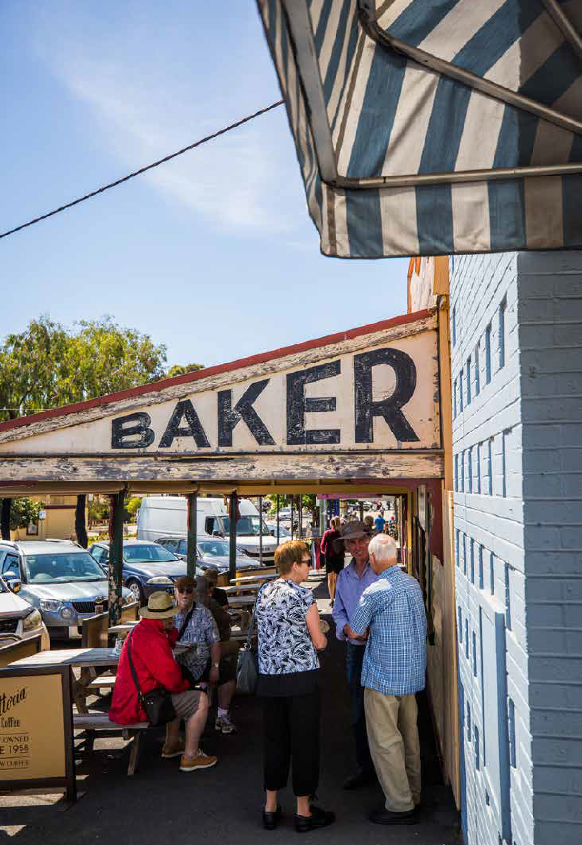

CENTRE CATCHMENTS

DEFINITION OF PRIMARY CATCHMENTS
The retail gravity model simulates the retail economy across 606 zones and 151 centres, creating synthetic and graduated market catchments for each centre. From this, a primary catchment can be defined to gain a simplified
understanding of all the zones that contribute at least 50 per cent of their expenditure to the respective centre.
Appendix 3 map the trade areas for all significant centres across Greater Geelong. The maps shows the primary trade area for each centre. Areas that do not fall under any centre’s primary catchment trade area are ‘contested’,
which means expenditure is fairly evenly distributed among multiple centres. It does not necessarily mean there is an undersupply of retail floor space in that area – indeed in some cases, it is due to significant competition between multiple nearby centres.
Due to the car-oriented nature of shopping trips in Greater Geelong, catchment areas are defined with the use of road-based travel time calculations, along with the relative attractiveness of each centre from the gravity model (see
Appendix 1 for further information on how the gravity model determines centre catchments).
The maps indicate that the most dominant centres across the retail network are Belmont, Waurn Ponds, Leopold and Corio. These centres each contain discount department stores, multiple supermarkets and a large number of specialty shops.
The neighbourhood centres catchment areas are more localised. Central Geelong typically captures no more than 10–20 per cent of people residing in the catchment of another centre, which could be improved if the retail offer was stronger. Competition from other centres also plays a role in this.

OPPORTUNITIES AND CHALLENGES

WHOLE-OF-NETWORK OPPORTUNITIES AND CHALLENGES

The retail economy in Greater Geelong faces both challenges and opportunities:
- Population growth is being directed to both greenfield and infill locations, which creates demand for new retail centres and may provide the population base needed to increase support for existing centres.
- Supermarket and bottle shops dominate retail sales across Geelong and do little to support other stores within a centre. Planning policy should encourage new
supermarket-based developments to feature a diversity of businesses, creating opportunities for local, independent enterprises.
- Successful shopping centre networks strongly represent the four approaches to retail (see page 16), however this is not currently happening, particularly in Central
Geelong, where sub-regional centres may be considered to have a similar retail offer.
- Townships on the Bellarine struggle to create a year- round retail market, relying heavily on the summer tourism period. Improvements in the hospitality and cultural tourism offer will be important for these locations.
- Restricted retail is generally oversupplied across the
municipality, except on the Bellarine. Here residents need to travel significant distances to reach the nearest restricted retail centre.
- Most existing centres are forecast to support additional floor space by 2036. Managing how and where this growth occurs will require robust planning policy combined with further strategic work to guide future development.
- While online retailing was initially seen as direct competition to traditional retail stores, many retail stores have adapted by providing both an online and store experience.

OPPORTUNITIES FOR MAJOR RETAIL INVESTMENT

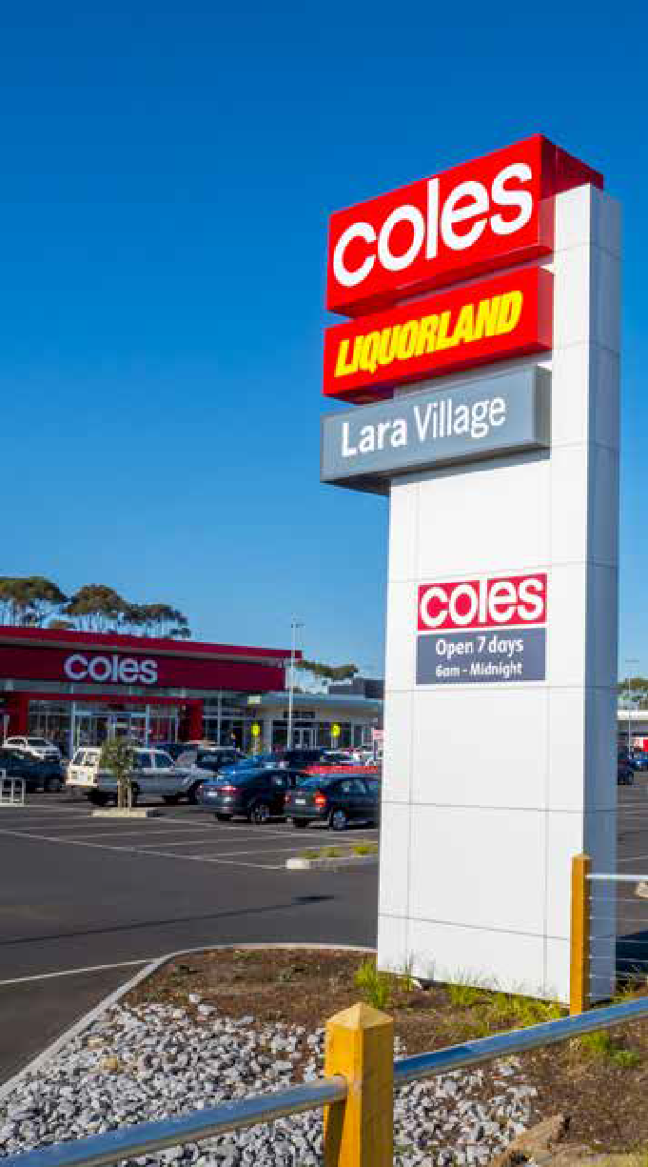
The demand and supply data from the gravity modelling has been further examined to determine the areas that may be under supplied for major store types in the future.
Whether such floor space can actually locate in these areas depends on many factors, such as site availability, market appetite and alternative centre expansions.
By 2036 there is demand for additional retail floor space in most retail centres across Greater Geelong.
The demand for retail floor space is represented spatially on the maps shown in Appendix 4.

SUPPORTABLE RETAIL FLOOR SPACE BY CENTRE

Table 5 further shows this analysis by focusing on the supportable retail floor space demand at each centre to 2036 and compares it to existing and planned floor space supply. Population growth, plus trends, in retail expenditure increase the demand for additional retail floor space across the hierarchy. By 2036, most centres in Greater Geelong will have the potential to expand from a supportable-demand perspective. While this opportunity exists, actual outcomes will need to be considered alongside centre performance, supply availability options, market appetite and alternative centre uses. It is also worth noting that existing and approved floor space in some centre is already in excess of what is expected to be supportable in 2036.
The calculations provided here are not intended to limit the growth of a centre beyond what has been indicated in this table. Indeed, some centres may never achieve the supportable floor space identified for a range of reasons,
such as land constraints. This demand may then be taken up by a nearby centre or new centre. Planning policy contained in the Greater Geelong Planning Scheme should be used to determine whether growth of a centre
should occur.
The time scale provided in the table is not intended to prevent centres expanding earlier than identified.
If population growth rates were to increase above the projected 2 per cent average annual growth rate, then it is likely that planning policy would support more retail floor space sooner.
Floor space has not been attributed to individual indicative centres in the Northern and Western Geelong Growth Areas. Detailed floor space assessments will be undertaken as part of the preparation of Precinct Structure Plans.

TABLE 5 – SUPPORTABLE FLOOR SPACE 2016–2036
PRECINCT | Existing and planned to 2036 (as of March 2018) total retail floor space supply |  | Base case scenario total retail floor space demand projections | Total supply less demand
PRECINCT |  |  |  | I = E – D J = F – D K = G – D  2016 2026 2036
A. EXISTING B. VACANT C. PLANNED D = A+B+C FLOOR SPACE FLOOR SPACE NEW/ ADD TOTAL |  |  | H = G – E  E. 2016 F. 2026 G. 2036  2016–36 | I = E – D J = F – D K = G – D  2016 2026 2036
GREATER 903,812 55,967 GEELONG |  | 149,786 1,109,564 | 853,599 1,120,759 1,527,750 674,151 | 255,965 -11,194 -418,186
Regional 187,304 25,985 0 213,289 |  |  | 189,091 253,737 345,803 156,712 | 24,198 -40,448 -132,514
Central Geelong 187,304 25,985 0 213,289 |  |  | 189,091 253,737 345,803 156,712 | 24,198 -40,448 -132,514
Sub-regional 132,416 1,370 40,000 173,900 |  |  | 125,759 180,747 259,300 133,600 | 48,100 -6,700 -85,774
Belmont, 42,590 1,370 0 43,960  High Street |  |  | 40,209 51,635 64,809 24,600 | 3,751 -7,675 -20,849
Waurn Ponds, Pioneer 41,760 0 0 41,760 Road, Grovedale |  |  | 39,556 51,541 64,455 24,899 | 2,204 -9,781 -22,695
Corio Village, Bacchus 27,463 0 0 27,463 Marsh Road, Corio |  |  | 26,136 33,002 44,081 17,945 | 1,327 -5,539 -16,618
Leopold Gateway  Plaza, Bellarine 20,604 0 0 20,604 Highway, Leopold |  |  | 19,858 26,930 36,376 16,518 | 746 -6,326 -15,772
Armstrong Creek Town  Centre, 0 0 40,000 40,000  Surf Coast Highway,  Armstrong Creek |  |  | 0 17,640 49,574 49,574 | 40,000 22,360 -9,574
Sub-regional Centre - 0 0 0 0  WGGA |  |  | 0 0 0 0 | 0 0 0
Sub-regional Centre - 0 0 0 0  NGGA |  |  | 0 0 0 0 | 0 0 0
Specialised 38,145 5,015 0 43,160 |  |  | 38,243 47,306 61,124 22,882 | 4,917 -4,146 -17,964
Pakington Street, 38,145 5,015 0 43,160 Geelong West |  |  | 38,243 47,306 61,124 22,882 | 4,917 -4,146 -17,964
Specialised Centre - 0 0 0 0  WGGA |  |  | 0 0 0 0 | 0 0 0
Town 64,460 2,653 522 67,634 |  |  | 61,128 74,744 91,271 30,143 | 6,506 -7,109 -23,637
The Terrace, 16,293 408 0 16,701  Ocean Grove |  |  | 16,095 17,807 20,231 4,136 | 606 -1,106 -3,530
High Street, Drysdale 14,886 187 0 15,073 |  |  | 13,372 18,035 23,193 9,821 | 1,701 -2,963 -8,120
Station Lake Road, 14,952 98 0 15,050 Lara |  |  | 13,249 16,392 20,847 7,597 | 1,800 -1,343 -5,797
Hitchcock Ave, Barwon 8,735 1,066 522 10,323 Heads |  |  | 9,115 10,389 11,853 2,738 | 1,208 -66 -1,530
Newcomb Street, 6,408 774 0 7,182 Portarlington |  |  | 6,200 7,797 9,708 3,508 | 983 -615 -2,526
Murradoc Road, 3,185 120 0 3,306 St Leonards |  |  | 3,098 4,323 5,440 2,343 | 208 -1,017 -2,135

PRECINCT | Existing and planned to 2036 (as of March 2018) total retail floor space supply | Base case scenario total retail floor space demand projections | Total supply less demand  I = E – D J = F – D K = G – D  2016 2026 2036
A. EXISTING B. VACANT C. PLANNED D = A+B+C FLOOR SPACE FLOOR SPACE NEW/ ADD TOTAL |  | H = G – E  E. 2016 F. 2026 G. 2036  2016–36
Neighbourhood 101,504 2,953 37,300 141,700 |  | 93,767 134,283 176,400 80,300 | 47,900 7,400 -34,700
Shannon Avenue, 12,948 0 0 12,948 Geelong West |  | 12,184 14,571 18,109 5,925 | 763 -1,623 -5,162
Separation Street, 5,572 409 0 5,981 North Geelong |  | 5,754 7,124 9,545 3,791 | 228 -1,143 -3,563
Pakington Street, 9,151 301 0 9,452 Newtown |  | 9,655 12,045 14,848 5,193 | -204 -2,593 -5,396
Highton, Barrabool 6,972 77 0 7,049 Road, Highton |  | 6,463 7,973 9,852 3,388 | 586 -924 -2,803
Newcomb Central,  Bellarine Highway, 7,390 0 0 7,390 Newcomb |  | 6,210 7,741 9,900 3,690 | 1,180 -352 -2,510
Ormond Road, 5,917 165 0 6,083 East Geelong |  | 6,023 7,606 9,624 3,601 | 60 -1,524 -3,541
Bellarine Village, 6,929 0 0 6,929 Newcomb |  | 5,967 7,443 9,495 3,528 | 962 -514 -2,566
Bell Post, Anakie 5,562 0 0 5,562 Road, Norlane |  | 4,811 5,845 8,270 3,459 | 751 -283 -2,708
Barrabool Hills,  Province Bvd, 4,227 0 0 4,227 Highton |  | 3,508 4,511 5,646 2,138 | 719 -284 -1,419
Shannon Avenue, 4,495 363 0 4,858 Newtown |  | 4,178 5,089 6,307 2,129 | 680 -231 -1,449
Marketplace, Shell 5,748 72 0 5,820 Road, Ocean Grove |  | 5,020 5,754 6,862 1,842 | 800 66 -1,042
Vines Road, 3,110 136 0 3,245  Hamlyn Heights |  | 2,983 3,597 4,885 1,902 | 263 -352 -1,640
Hyland Street, 2,346 0 9,500 11,846 Fyansford |  | 2,429 7,877 11,327 8,898 | 9,417 3,969 520
Grovedale Central,  Heyers Road, 2,479 248 0 2,726 Grovedale |  | 2,313 2,812 3,400 1,087 | 413 -86 -674
Dorothy Street, 1,803 0 0 1,803 Leopold |  | 1,734 2,211 2,851 1,118 | 69 -409 -1,049
Ash Road, Leopold 1,578 191 0 1,769 |  | 1,608 2,372 3,220 1,612 | 161 -603 -1,451
Rosewall, Broderick 1,740 0 0 1,740 Road, Corio |  | 1,344 1,658 2,193 849 | 397 82 -452
Jetty Road,  Centennial Bvd, 4,147 95 0 4,242 Curlewis |  | 3,422 4,127 5,559 2,137 | 820 115 -1,317
Warralily, Barwon  Heads Road, 6,000 897 1,863 8,760  Armstrong Creek |  | 5,201 11,059 16,600 11,399 | 3,559 -2,299 -7,840
Surf Coast 3,390 0 0 3,390 Hwy, Grovedale |  | 2,961 3,905 4,812 1,850 | 429 -515 -1,422
Kingston Village,  Grubb Road, 0 0 11,177 11,177  Ocean Grove |  | 0 4,385 6,257 6,257 | 11,177 6,792 4,920
Lara West, Lara 0 0 4,700 4,700 |  | 0 565 829 829 | 4,700 4,135 3,871
Armstrong Creek West, 0 0 3,000 3,000 Mount Duneed |  | 0 1,146 1,572 1,572 | 3,000 1,854 1,428
Horseshoe Bend 0 0 7,000 7,000 Charlemont |  | 0 2,864 4,424 4,424 | 7,000 4,136 2,576
Elcho Rd East - North 0 0 0 0  - NGGA |  | 0 0 0 0 | 0 0 0
Elcho Rd East - South 0 0 0 0  - NGGA |  | 0 0 0 0 | 0 0 0
Elcho Rd West - NGGA 0 0 0 0 |  | 0 0 0 0 | 0 0 0
Heales Rd West - 0 0 0 0  NGGA |  | 0 0 0 0 | 0 0 0
Northern Centre - 0 0 0 0  WGGA |  | 0 0 0 0 | 0 0 0
Midland Hwy - WGGA 0 0 0 0 0 0 0 0 0 0 0

PRECINCT | Existing and planned to 2036 (as of March 2018) total retail floor space supply | Base case scenario total retail floor space demand projections | Total supply less demand  I = E – D J = F – D K = G – D  2016 2026 2036
B. VACANT  A. EXISTING C. PLANNED D = A+B+C FLOOR  FLOOR SPACE NEW/ ADD TOTAL SPACE |  | H = G – E  E. 2016 F. 2026 G. 2036  2016–36
Lakeside West - 0 0 0 0  WGGA |  | 0 0 0 0 | 0 0 0
Lakeside South - 0 0 0 0  WGGA |  | 0 0 0 0 | 0 0 0
Western Centre - 0 0 0 0  WGGA |  | 0 0 0 0 | 0 0 0
Local (82 centres)# 69,459 5,863 11,800 87,122 |  | 69,371 85,603 114,764 45,392 | 17,751 1,519 -27,642
Restricted Retail 136,021 2,904 25,000 163,925 |  | 121,584 189,682 290,349 168,765 | 42,340 -25,758 -126,425
Geelong Gateway,  Princes Highway, 31,463 2,121 0 33,584 Corio |  | 27,346 39,950 59,746 32,400 | 6,238 -6,367 -26,162
Colac Road, 46,972 333 0 47,305  Waurn Ponds |  | 42,876 64,564 90,913 48,037 | 4,428 -17,259 -43,608
Melbourne Road 23,652 92 0 23,744 (Norlane) |  | 20,644 29,802 43,474 22,830 | 3,101 -6,058 -19,729
Melbourne Road, 14,322 0 0 14,322 North Geelong |  | 13,211 18,411 26,131 12,920 | 1,111 -4,089 -11,809
Sinclair Street, 4,095 0 0 4,095 Ocean Grove |  | 4,200 6,146 8,851 4,650 | -105 -2,051 -4,756
Murradoc Road, 3,174 358 0 3,532 Drysdale |  | 2,944 4,252 5,586 2,643 | 588 -720 -2,055
Leopold Gateway  Plaza, Bellarine 12,343 0 0 12,343 Highway, Leopold |  | 10,363 16,428 24,480 14,117 | 1,980 -4,085 -12,137
Armstrong Creek Town  Centre, 0 0 25,000 25,000  Surf Coast Highway,  Armstrong Creek |  | 0 10,129 31,168 31,168 | 25,000 14,871 -6,168
Western Growth Area 0 0 0 0 |  | 0 0 0 0 | 0 0 0
Dispersed Bulky 174,502 9,226 0 183,728 Goods |  | 154,655 154,655 154,655 0 | 29,072 29,072 29,072
Bellarine Highway, 19,234 1,332 0 20,566 Newcomb |  | 17,661 17,661 17,661 0 | 2,905 2,905 2,905
Settlement and  Breakwater Road, 32,959 210 0 33,169 Belmont |  | 28,179 28,179 28,179 0 | 4,989 4,989 4,989
Smithton Grove, 4,277 0 0 4,277 Ocean Grove |  | 3,988 3,988 3,988 0 | 289 289 289
Mackey Street, 11,199 0 0 11,199 North Geelong |  | 9,403 9,403 9,403 0 | 1,796 1,796 1,796
Sharon Court, 10,519 0 0 10,519 Bell Park |  | 8,832 8,832 8,832 0 | 1,687 1,687 1,687
Harpur Road- 290 0 0 290  Princess Hwy, Corio |  | 243 243 243 0 | 47 47 47
Gordon Avenue, 20,302 1,825 0 22,127 Geelong West |  | 17,850 17,850 17,850 0 | 4,277 4,277 4,277
Moorabool-Fyans 42,460 3,121 0 45,582 Street, South Geelong |  | 38,084 38,084 38,084 0 | 7,498 7,498 7,498
Anakie Road, 3,909 339 0 4,248 Bell Park |  | 3,658 3,658 3,658 0 | 590 590 590
Gregory Avenue, 2,509 0 0 2,509 Newtown |  | 2,284 2,284 2,284 0 | 225 225 225
West Fyans Street, 13,316 384 0 13,700 Newtown |  | 12,389 12,389 12,389 0 | 1,310 1,310 1,310
Surf Coast Highway, 13,528 2,015 0 15,543 Grovedale |  | 12,083 12,083 12,083 0 | 3,460 3,460 3,460
Bacchus Marsh Road, 0 0 0 0  Corio |  | 0 0 0 0 | 0 0 0

Source: SGS Economics and Planning
*Future floor space growth of dispersed centres has been restricted. Growth will be directed to centre’s identified in the retail hierarchy at Table 2 # Supportable floorspace was not calculated for local centres individually

Source: SGS Economics and Planning
A. EXISTING B. VACANT C. PLANNED D = A+B+C H = G – E I = E – D J = F – D K = G – D E. 2016 F. 2026 G. 2036
FLOOR SPACE FLOOR SPACE NEW/ ADD TOTAL 2016–36 2016 2026 2036

Planned or indicative centre

Total

RETAIL OBJECTIVES AND STRATEGIES

RETAIL DEVELOPMENT OBJECTIVES
Retail land use and development in Greater Geelong is expected to:
  - provide convenient access to goods and services, minimising the number, and length, of car trips
  - encourage a competitive supply of goods and services, keeping prices down
  - encourage walkable access to suppliers of day-to-day essentials
  - create vibrant and inviting town and neighbourhood centres
  - maintain an appropriate mix of sub-regional centres, that offer a wide range of retail goods and services
  - improve and strengthen Central Geelong, acting as a flagship for the commercial and cultural life of Greater Geelong
  - distribute restricted-retail activity within a hierarchy, with retailers located in centres in a selected number of specialised regional-restricted retail nodes.

RETAIL DEVELOPMENT STRATEGIES TO SUPPORT OBJECTIVES
A revised Local Planning Policy Framework should reflect these objectives, in the following ways:

CONVENIENT ACCESS
  - Where possible, reduce the need for shoppers to travel long distances from home to access retail services.
  - Address service gaps identified in Greater Geelong’s retail system, taking into account the effect on existing levels of retail competition and customer choice.
  - Locate any new retail centres on sites that have existing, or potential future, access to public transport services and quality road access for private vehicles.

COMPETITIVE SUPPLY OF GOODS AND SERVICES
  - Provide an appropriate forward land supply for retail and activity centre development to meet current and anticipated needs of communities and stimulate competition.
  - Where demand is expected to exceed supply, encourage new stores to establish in existing retail centres, in conformity with the agreed retail hierarchy.
  - Allow the development of new retail centres only where all of the following can be demonstrated:
  - supply in the existing network of centres is constrained
  - they are justified by demand growth and
  - where they generate a net community benefit.

  - Where possible, provide retail-zoned land in multiple land ownerships, to avoid monopoly conditions in catchments. Monopoly holdings can encourage restrictive lease practices and anti-competitive land withholding behaviour, leading to undersupply of retail floor space within the network.
  - Require advocates for new supermarket-based centres to encourage a diversity of businesses in their proposals, creating opportunities for local, independent enterprises.

WALKABLE ACCESS TO DAY-TO-DAY ESSENTIALS
  - Reduce travel distances for day-to-day needs by encouraging development of a dense network of convenience-based local and neighbourhood centres within walking distance for all residential areas of Greater Geelong (approximately 800 metres).

VIBRANT AND INVITING RETAIL CENTRES
  - Distribute supermarket-based neighbourhood and town centres across the municipality to perform the role of primary food centres for communities
  - Consolidate the demand base of individual retail centres by integrating housing where possible.
  - Where demand exists, make it easier to expand existing centres, without undermining the structure of the centre’s hierarchy.
  - Encourage a broad mix of activities in higher-order town and sub-regional centres, including office and community uses.
  - Minimise amenity impacts by ensuring the built form of new or expanding centres maintain an appropriate interface with abutting sensitive land uses.
  - Maintain active frontages to abutting streets in new or expanding centres.

RESTRICTED RETAIL
- A number of regional-scale, specialised, restricted-retail centres should continue to service regional catchments to accommodate large-scale and low-density
restricted retail.
- Encourage smaller-scale and/or higher-density restricted retail to locate in Central Geelong and sub-regional centres, in preference to the specialised restricted
retail precincts.
- Discourage restricted retail in other locations, unless it can be proven that a net community benefit will be created by the proposed development.

INDUSTRIAL AREAS
- Support retail uses where they have direct synergies to industrial land use activities.
- Retail premises should be directed to commercial 1 or 2 zoned land.
- Retail uses should not detrimentally impact on current and future industrial operations.

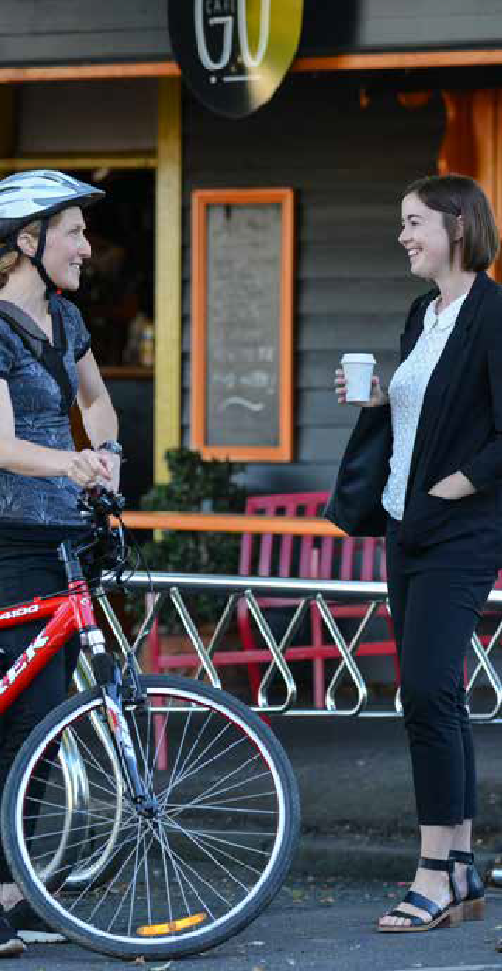
FURTHER WORK FOR INDIVIDUAL CENTRES
To further support the retail hierarchy in Greater Geelong, the following is recommended (see Appendix 2 on page 88 for the rationale):
  - Prepare an urban design framework, or structure plan, for Belmont sub-regional centre to guide it’s ongoing development. The plan should investigate future retail needs and high-density housing opportunities.
  - Prepare a structure plan for the Waurn Ponds sub-regional centre. The plan should investigate future retail needs
and high-density housing opportunities. There is also an opportunity to include the surrounding area between Pioneer Road and the ring road as part
of this study.
  - Prepare an urban design framework, or structure plan, for Pakington Street (Geelong West). The plan should consider rezoning opportunities within the northern end of Pakington Street and review the role of the Gordon Avenue restricted retail precinct.
  - Support the redevelopment of the Bellarine Village and Newcomb Shopping Centres by identifying opportunities to expand the centre, which may include land acquisition, redeveloping existing car parking and/or encouraging multi-storey development.
  - Prepare an urban design framework, or structure plan, for the Separation Street neighbourhood centre in North Geelong. The plan should investigate opportunities to develop a supermarket anchor within this centre and consider streetscape upgrades.
  - Prepare an urban design framework or structure plan the neighbourhood centre in Shannon Avenue, Geelong West. The plan should investigate opportunities to expand this centre and consider streetscape upgrades.
  - Review the Development Plan Overlay Schedule 30, the approved Development Plan and urban design framework for the Leopold Gateway Plaza sub-regional centre. The review would consider urban design improvements, and strategies to transition the centre to a true activity centre with a diverse range of uses. The extent of the review should be limited to the boundaries of the existing centre.

RECOMMENDED CHANGES TO POLICY

SUMMARY OF CHANGES TO THE GREATER GEELONG PLANNING SCHEME
Based on the findings in this strategy, the following changes to the Greater Geelong Planning Scheme are recommended:
  - A new policy context, including objectives to deliver convenient access to services, improved competition, walkability, continued support for existing centres and better urban design outcomes.
  - An updated retail hierarchy which reflects the role and function of centres across the retail network.
  - An updated local policy that requires economic impact assessments for new development which challenge the retail hierarchy.
  - Revised floor space caps will be introduced as part of a schedule to Commercial 1 Zone land, to ensure that the timing and size of development will not impact on the retail hierarchy or other nearby centres.

FLOOR SPACE CAPS

THE VICTORIA PLANNING PROVISIONS
Floor space caps (or maximum ‘leasable floor area’, as defined in Clause 73.01) require a planning permit in cases where a development exceeds the cap, even if a planning permit is not otherwise required for use.
In the Greater Geelong Planning Scheme, floor space caps can only be applied as a schedule to land zoned
Commercial Zone 1.Furthermore, floor space caps can only apply to ‘shop’ uses (other than restricted retail premises).
A ‘shop’ is defined at Clause 73.03 of the Greater Geelong Planning Scheme as:
Land used to sell goods or services, or to hire goods. It includes the selling of bread, pastries, cakes or other products baked on the premises. It does not include
food and drink premises, gambling premises, landscape gardening supplies, manufacturing sales, market, motor vehicle, boat, or caravan sales, postal agency, primary produce sales or trade supplies.

BENEFITS OF FLOOR SPACE CAPS
Floor space caps further sharpen the definition of our preferred retail hierarchy. They are intended to clarify the role and function of each centre in the hierarchy, as well as the development application and approvals process.
They provide a number of benefits to existing retail centres, potential investors, the community and Council. These benefit all relate to preserving the retail hierarchy and include:
- support co-location of services (non-retail) and/or infrastructure/investment. This is particularly relevant for Town centres in a regional settlement context, where
these locations act as a ‘heart’ for the location community. Supporting a strong vibrant Town centre benefits the community and local council in particular
- promote and optimise accessibility and create more consolidated urban centres. Supporting this ensure efficient use of infrastructure and investment and benefits community, council and existing retail centres/investors
- manage impact on existing centres (i.e. significant over investment in new centres can undermine the viability of existing creating high vacancy and other social issues)
– this benefits community, council, retail centres and investors
- ensuring that the amount of floor space within the retail hierarchy is consistent with population growth demands.
In addition, the caps provide certainty around the size and location of investment opportunities, reducing uncertainty risk and speculation. This clearly benefits both investors and retail centres in particular.

PROPOSED CHANGES TO FLOOR SPACE CAPS
While floor space caps are not new to the Greater Geelong Planning Scheme, we recognise they have been inconsistently applied in the past.
This has created confusion over their role and purpose. Table 7 identifies the recommended floor space caps for sub-regional and growth area locations. These caps are further discussed below for individual centres. These floor space caps relate to shop uses only.

The table demonstrates:
  - existing floor space caps have been retained for some sub-regional centres and growth-area locations
  - in other centres, floor space caps have been informed by the gravity model supportable floor space
demand (2026)
  - in some individual cases, discussed below, an alternative floor space cap has been recommended.
Table A14 (Appendix 1, page 61) describes the base case scenario for shop retail floor space provision in individual centres from 2016 to 2036.

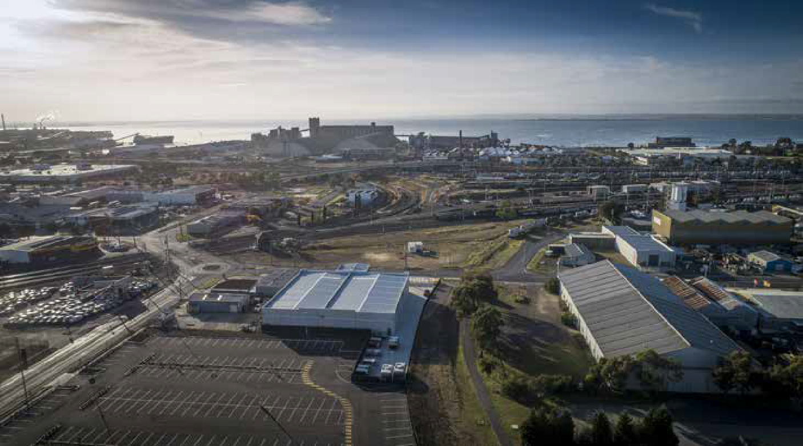

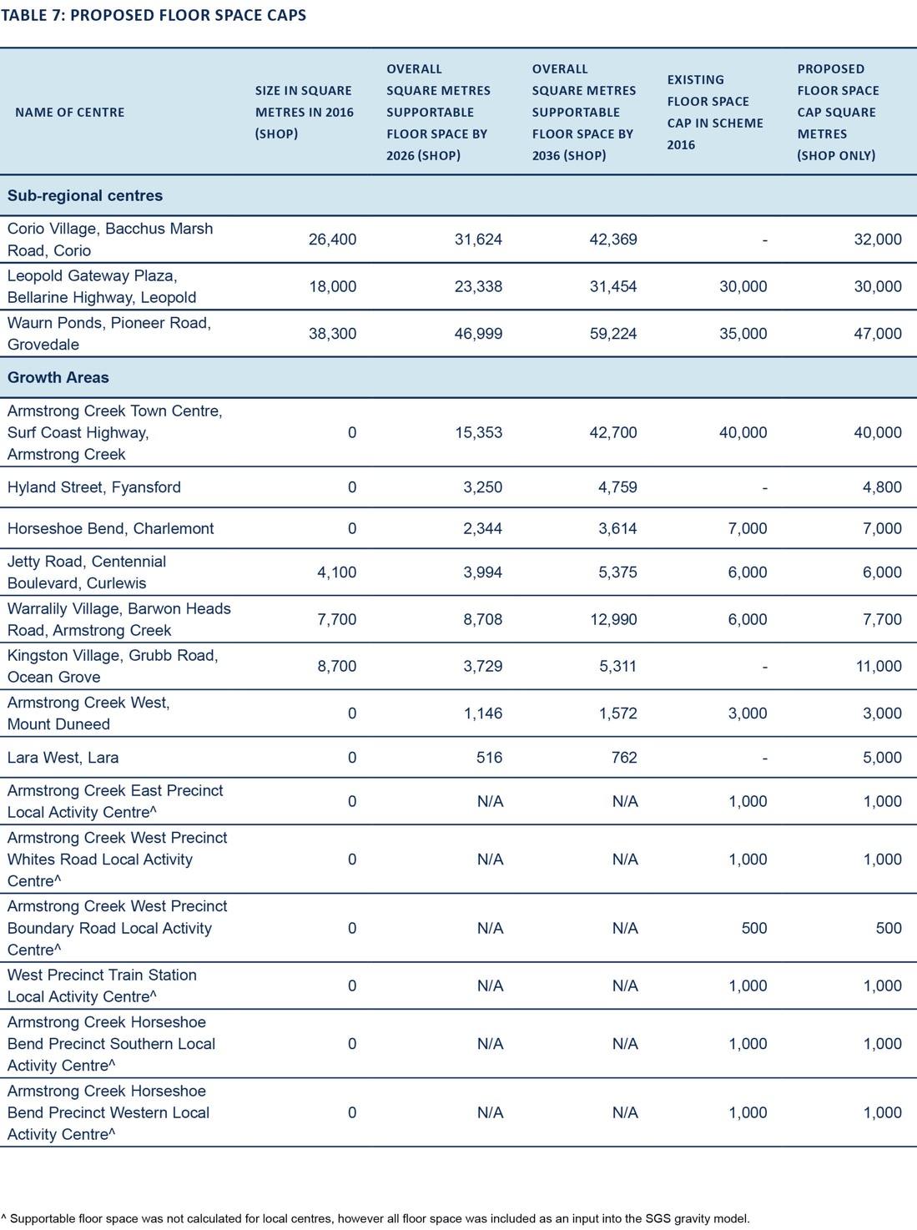

REGIONAL CENTRES

CENTRAL GEELONG

Existing floor space total: 213,300 square metres Existing shop floor space: 131,400 square metres Current floor space cap: No
Recommendation: Floor space cap not recommended
Central Geelong sits at the top of our retail hierarchy and will remain the focus of investment, retail, education, culture, leisure, commerce, services and higher-density residential living.
The retail audit has identified that sub-regional centres compete strongly with Central Geelong, as they are conveniently located near residents and have a similar retail offering.
We have a number of strategies in place to strengthen the role of Central Geelong as a regional centre and create a point of difference with other sub-regional centres. A strong focus has been on encouraging arts and culture, hospitality and accommodation.

SUB-REGIONAL CENTRES
A floor space cap, applied to sub-regional centres, will support the retail hierarchy, by giving us an opportunity to review the size, timing and offering of such centres through the planning permit process.

HIGH STREET, BELMONT

Existing floor space total: 44,000 square metres Existing shop floor space: 32,500 square metres Current floor space cap: No
Recommendation: Floor space cap not recommended
This centre is primarily a strip shopping centre, which is anchored by a Coles and Kmart (discount department stores). The centre has a high proportion of hospitality and speciality shops. Property within the centre is controlled by multiple owners, making it difficult to manage in comparison to a large shopping complex. Paired with constant small changes to the use of land and multiple ownership patterns, it make administrating a floor space cap for this centre complex
Future floor space demand for this centre is estimated to be 20,800 square metres by 2036 (13,600 square metres of this relates to shop uses). While some of this
growth may be accommodated within existing zoned land without significantly impacting the retail hierarchy, growth beyond this would likely require land rezoned. This would enable Council to consider the timing and impact of new development on the retail hierarchy.

LEOPOLD GATEWAY PLAZA, BELLARINE HIGHWAY, LEOPOLD

Existing floor space total: 20,600 square metres Existing shop floor space: 18,000 square metres Current floor space cap: 30,000 square metres Recommendation: Retain existing floor space cap
Leopold is identified in the retail hierarchy as a subregional centre, servicing the Bellarine Peninsula. An urban design framework and existing Development Plan Overlay (DPO30) currently guide the development of the centre.
Recent development within the centre has included a Bunnings Warehouse. The location of this building fronting the Bellarine Highway has had an impact on the layout and functionality of the centre. Two key objectives of the urban design framework were to provide a ‘main street frontage’ to Melaluka Road, to integrate the centre with the Leopold Memorial Park opposite, and an internal pedestrian friendly street network that would connect the existing centre with
the future development on the land to the north. The location of the Bunnings, including the positioning of truck loading and access areas, challenges this idea.
It is considered a review of the Development Plan Overlay Schedule 30 Leopold Sub Regional Activity Centre, the approved Development Plan and urban design framework, is appropriate particularly given the location of the Bunnings store and existing built form of the centre. The review would consider urban design improvements, and strategies to transition the centre to a true activity centre with a diverse range of uses. The extent of the review should be limited to the boundaries of the existing centre.
It is not recommended to alter the existing floor space cap of this centre. The cap is considered sufficient to allow this centre to grow in line with population growth on the Bellarine Peninsula.

CORIO VILLAGE, BACCHUS MARSH ROAD, CORIO

Existing floor space total: 27,500 square metres Existing shop floor space: 26,400 square metres Current floor space cap: No
Recommendation: Introduce a floor space cap of 32,000 square metres
The centre currently has 26,400 square metres of shop floor space. It is proposed to introduce a floor space cap of 32,000 square metres, in line with the supportable floor
space demand that has been projected for 2026. By setting the cap above the current shop floor space, only proposals to increase the size of the centre above the cap will require a planning permit, giving us an opportunity to consider the timing and impact of any further development on the retail hierarchy.

WAURN PONDS, PIONEER ROAD, GROVEDALE

Existing floor space total: 41,800 square metres Existing shop floor space: 38,300 square metres Current floor space cap: 35,000 square metre
Recommendation: Increase floor space cap to 47,000 square metres
This centre has expanded in recent years to the current floor space of 41,800 square metres. The centre currently exceeds or is close to the current maximum floor space cap. It is proposed to increase the floor space cap to 47,000 square metres, in line with the supportable floor space demand that has been projected for 2026. Proposals to increase the size of the centre above the cap will require
a planning permit, giving us an opportunity to consider the timing and impact of any further development on the
retail hierarchy.

SPECIALISED CENTRE

PAKINGTON STREET, GEELONG WEST

Existing floor space total: 43,100 square metres Existing shop floor space: 29,200 square metres Current floor space cap: No
Recommendation: Floor space cap not recommended
This centre is similar in size and character to Belmont, in that it is primarily a strip-shopping centre. However, it
doesn’t meet the definition of a sub-regional centre because it does not contain a discount department store.
This centre plays an important role in the Greater Geelong retail hierarchy. It acts as a core retail, commercial and community centre in the municipality, with a broader employment role.
Future floor space demand is forecast to be an additional 18,700 square metres by 2036 (8,400 of this relates to shop uses). Whilst some of this growth may be able to be accommodated within existing commercial zoned land, growth beyond 18,700 square metres would likely require
land to be rezoned, giving us the opportunity to consider the timing and impact of new development on the
retail hierarchy.

TOWN CENTRES
Recommendation: Do not apply floor space caps
Town centres are similar to neighbourhood centres in that they support the daily retail needs of residents. However they are often larger, due to the isolated nature of the townships. Additional retail investment should be encouraged in town centres as our analysis indicates that
town centres can accommodate additional retail investment without posing a threat to the hierarchy.

NEIGHBOURHOOD CENTRES
(IN EXISTING URBAN AREAS)
Recommendation: Floor space caps not recommended
Floor space caps are not recommended for neighbourhood centres, as most are ‘land locked’ and require significant redevelopment of existing buildings and car parking areas, or rezoning, to accommodate additional growth. Additionally, if rezoning of nearby land was required, it would give us
the opportunity to consider the timing and impact of the development on the retail hierarchy.

NEIGHBOURHOOD CENTRES (IN AREAS EXPERIENCING GREENFIELD GROWTH)

GENERAL
Recommendation: Various floor space caps between 3,000and 11,000 square metres
There are several locations experiencing growth within Greater Geelong, including Armstrong Creek, Drysdale/ Clifton Springs, Fyansford, Ocean Grove and Lara. The development of each area is supported by a precinct structure plan or development plan. The location, size and make-up of centres have been agreed on and, in most instances, have also been reviewed by an independent planning panel.
All planned centres are located in convenient places for residents, and their size determined by the estimated surrounding population. In most cases, planned centres have a current floor space cap.
We propose retaining floor space caps where they already exist and applying them where they don’t. This will allow each centre to service a particular trade area.
Removing or increasing the floor space caps in these locations may:

    - make it difficult for new centres to establish, as those established early are likely to dominate
    - make established centres more attractive as an investment for new business and delay other planned centres from establishing
    - remove an opportunity to review the impacts of additional retail floor space – both on the established hierarchy and any planned or existing centres
    - delay good access to essential retail services for residents in new communities.

KINGSTON VILLAGE NEIGHBOURHOOD ACTIVITY
CENTRE, GRUBB ROAD, OCEAN GROVE

Planned retail floor space total: 12,800 square metres Existing Shop Floor Space: 10,700 square metres (Commercial 1 and 2 Zoned land)
Current floor space cap: No
Recommendation: Floor space cap of 11,000 square metres
The Ocean Grove Structure Plan 2007, and subsequent Amendment C60, rezoned:
    - 9.7 hectares of land to Commercial 1 Zone and
    - 14.5 hectare to Commercial 2 Zone.
This centre opened in late 2019. The centre has an approved development plan for the Kingston Neighbourhood Activity Centre and Industrial estate. This shows the
location of future land uses, road network and other details (see Figure 24). A planning application (PP233/2016) was approved to develop stage 1 of the Kingston Neighbourhood Centre. Separate permits have also been granted for a convenience restaurant and
service station.
The northern side of the centre (Commercial 1 Zone) will have a total floor space of 9,400 square metres, of which 8,700 square metre will relate to shop uses. It will consist of:
    - 3,895 square metre Woolworths Supermarket
    - 1,376 square metre Dan Murphy’s
    - 3,202 square metres of floor space dedicated to specialty retail tenancies, which will comprise a variety of uses including shops, cafés, takeaway food premises and other retail uses
- 215 square metre service station and
- 714 square metres dedicated to non-retail uses, such as office spaces and gym.
The southern side of the centre (Commercial 2 Zone) will have a total floor space of 3,370 square metres, of which 1,969 will relate to shop uses. It will consist of:
- 1690 square metre Aldi Supermarket
- 279 square metres of specialty retail
- 1,401 square metres of non retail floor space
Taking into consideration the existing development and that floor space caps do not apply to Commercial 2 Zone land, a floor space cap of 11,000 square metres should be applied to the Kingston Village Neighbourhood Centre.
The size of the cap will allow the centre to grow in line with its role and function as a neighbourhood acvity centre. Growth of the centre beyond this cap, will need to be supported by an economic impact assessment.
This will provide us with an opportunity to review the impact of further development on the retail hierarchy. In particular the future role and function of the centre and impacts on the Ocean Grove Town Centre and Leopold Sub-regional Centre.

WARRALILY VILLAGE NEIGHBOURHOOD ACTIVITY
CENTRE, BARWON HEADS ROAD, ARMSTRONG CREEK

Retail floor space total: 9,625 square metres Existing shop floor space: 7,700 square metres Current floor space cap: 6,000 square metres Recommendation: Increase floor space cap to 7,700
square metres, consistent with current planning approvals
Known as The Village Warralily, this centre opened in 2017 and includes:
- a full line 3,800 square metre Woolworths supermarket
- 1,544 square metres of speciality retail
- 2,424 square metres of hospitality and other uses and
- 400 car parking spaces.
A subsequent planning permit (PP722/2016) has been approved to include a 1,600 square metre Aldi supermarket and 257 square metres of speciality retail within this
centre. Combined with the existing centre, this means approximately 9,625 square metres will be dedicated to retail uses. This centre currently has a floor space cap of

FIGURE 24: KINGSTON DOWNS – APPROVED DEVELOPMENT PLAN
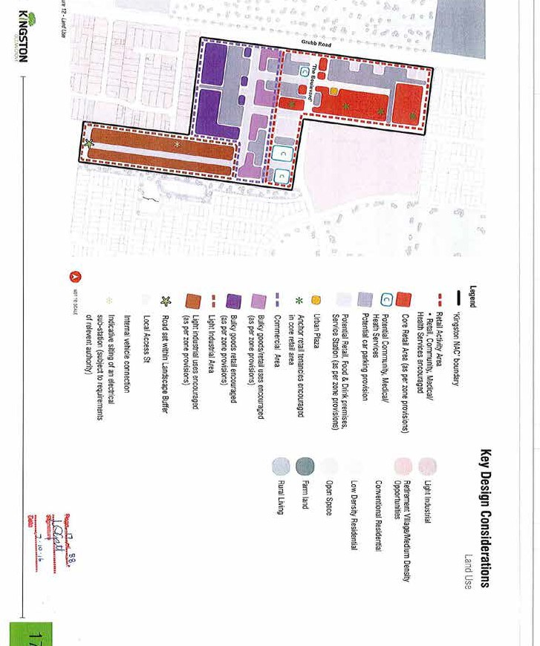

6,000 square metres.
It is forecast that this centre could support 16,100 square metres of retail floor space (13,000 dedicated to shop uses) by 2036.
The precinct structure plan anticipates there will be a number of non-retail uses within this centre, including office and community uses. Sufficient land has already been identified for this purpose.
Prior to granting additional planning permits for retail development in this centre, we should consider whether there is sufficient land available to deliver a variety of uses within the centre and review the impact on other planned centres within Armstrong Creek.

LARA WEST NEIGHBOURHOOD CENTRE, LARA

Planned Retail floor space total: 5,000 Current Floor space cap: No
Recommendation: Introduce a floor space cap of 5,000 square metres
The Lara West growth area is located on the western edge of Lara. A neighbourhood centre has been identified in the approved precinct structure plan (amendment C246) as necessary to service future residents. Amendment C246 suggests the size of the centre should be approximately 5,000 square metres and include a full-line supermarket and speciality retail, however no floor space cap was proposed. Forecasting suggests that a centre of this size is appropriate. A planning permit has not been lodged to develop the neighbourhood centre, however subdivision permits to commence development of the land have been lodged. The proposed centre would likely be delivered between 2020 and 2030.
It is recommended that a 5,000 square metre floor space cap be applied to this centre. Additionally, the Lara West Neighbourhood Centre should be included within the retail hierarchy and identified as our preferred location for additional retail services to support residential growth.

LOCAL ACTIVITY CENTRES
Recommendation: Floor space caps of 1,000 square metres retained for all local activity centres within the Armstrong Creek Growth Area
The retail audit accounted for all local activity centres, but did not attribute growth modelling to them.
The Armstrong Creek Growth Area has been planned to accommodate a number of smaller local activity centres. Floor space caps of 1,000 square metres have been applied to these, to make sure the majority of retail growth is directed to identified neighbourhood activity centres.

ASSESSING RETAIL DEVELOPMENT APPLICATIONS
A revised planning policy aims to provide convenient access to retail services, by supporting the established retail centre hierarchy. Significant departures from the established hierarchy may be supported to address changes in development outcomes, trends in retail or supply opportunities, but only where clear merit and a net community benefit can be demonstrated.
To assess this, applications requiring a planning permit for a retail use will be required to address the decision
guidelines listed below (see ‘Economic impact assessment’). Additionally, applications requiring a buildings and works permit for a new, revitalised or expanded centre must address the decision guidelines listed under ‘Buildings and works permit considerations’ (see page 59).

ECONOMIC IMPACT ASSESSMENT
The amount of information we require for an economic impact assessment will vary depending on the timing and size of the retail floor space for which approval is sought. The following should therefore be used as a guide only and prospective developers should contact us to discuss their proposal before formally lodging a planning permit application, or rezoning request. Once an application has been submitted, we reserve the right to request additional information as required.

General
  - Amount of overall retail floor space
  - Number of retail tenancies and their floor area
  - All proposed land uses
  - The location and amount of floor space dedicated to shop uses within the development if, the centre is listed in the schedule to the Commercial 1 Zone
  - Assessment of any likely impact on existing, planned or approved retail facilities
  - Description of anticipated benefits to the community (whether or not these can be monetised)
  - Estimated net employment benefits (if any)

Retail supply
- The existing supply of retail floor space serving the catchment by type, size, role and function
- Details of any other proposals for new or expanded retail development in the catchment or beyond, which could have an effect on the proposal, existing centres or planned development
- Demonstrate how the proposed retail floor space would fit into the Geelong retail centre hierarchy, as detailed in Clause 21.21
- Demonstrate whether the existing supply of retail floor space is adequate to meet existing and foreseeable demand levels over a 15 year period
- Whether there are any existing retail gaps in merchandise/ services which the proposal will fill

Retail demand
- The need or demand for new or expanded retail floor space to serve the identified catchment, taking into consideration the objectives and strategies contained in Clause 21.19
- The current catchment population, forecast population and retail spending growth rate for a 15-year period
- The extent to which the proposal will draw trade from beyond the catchment, and from passing trade
- Whether the proposed or expanded retail provision would mean an expansion in the size of the catchment of that centre
- Impacts on the catchment of nearby centres and the effect this may have on centres within those catchments

Escape spending
- Estimates of existing levels of escape spending from the catchment
- Estimates on the share of this escape spending that could reasonably be retained by the proposal

Impact on existing retail facilities
  - Assessment of the expected trading effects on existing or planned retail facilities based on each of the following scenarios (where relevant):
- The proposal did not go ahead and existing centres in the catchment continue to trade.
- The proposal is located adjoining an existing nearby centre already identified in the retail hierarchy or
- Where an out of centre development is proposed, if the centre was approved.
  - Demonstration of the extent to which the proposal is expected to lead to an overall improvement in the
provision of retail facilities to the catchment population, including the potential for retaining spending that would otherwise escape to other centres
  - Demonstrate that the proposal will improve access to services by reducing travel times for residents
  - Demonstrate that a proposal which results in a development exceeding the maximum floor area specified in the schedule to the Commercial 1 Zone, does not impact on the timing, delivery and viability of other retail centres including planned centres.

Out-of-centre applications
  - In addition to the above information, out-of-centre applications must also demonstrate:
o why the proposal cannot be accommodated within an existing centre identified in the retail hierarchy
o why the proposal cannot be accommodated on the border of an existing centre identified in the retail hierarchy
o that the proposal will not significantly impact on the character and amenity of the surrounding area
o that the location of the centre will reduce travel times for the community when compared to nearby existing centres with a similar retail offer
o that the centre has excellent connectivity to the surrounding residential area(s)
o that the proposal will not result in traffic and safety conflicts between cars, trucks and pedestrians external to the site

BUILDINGS AND WORKS PERMIT CONSIDERATIONS
New, revitalised or expanded centres that require a planning permit for buildings and works must demonstrate that the proposed design and layout will have minimal amenity impacts on surrounding uses and contribute positively to the streetscape. It will therefore be policy that all applications must adhere to the following:
- Ensure blank walls and loading bays are not adjacent to sensitive land uses and key vehicle and pedestrian access ways to a centre
- Ensure illuminated signage does not impact on sensitive land uses
- Ensure new development provides visually interesting and active street frontages where buildings abut the street or a public space
- Encourage car parking areas to be located to the side or rear of a centre
- Ensure car parking areas do not visually dominate a centre by providing landscaping including canopy trees
- Ensure there are safe and convenient pedestrian connections from car parking areas and the surrounding footpath network to the entrance(s) of a centre

CONCLUSION

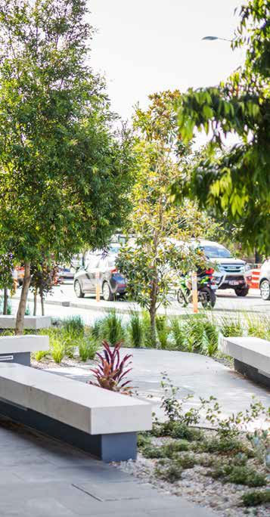
The retail sector in Greater Geelong must grow to meet projected demand for services between now and 2036. Support to meet this demand within planned and existing retail centres will continue.
A significant amount of retail planning and development has occurred in Greater Geelong over the last 10 years, to meet existing and forecast population growth. Most residents currently have access to a retail centre capable of meeting their daily retail needs within a 20-minute drive of their home. Population growth will see existing centres increase retail turnover densities, creating demand for additional retail floor space. This strategy seeks to direct this demand for floor space to existing retail centres, supporting the established retail hierarchy and meeting a
number of broader planning policy objectives, such as urban consolidation.
This may not always be possible, as demand for new centres in out-of-centre locations will continue. However, an updated planning policy will strengthen the assessment criteria for these applications, making sure the established retail hierarchy will not be undermined.

APPENDIX 1: RETAIL METHOD

This report was prepared by SGS Economics and Planning in December 2019. It provides additional detail regarding the retail gravity model approach, data inputs and assumptions used for the City of Greater Geelong Retail Strategy 2020–36.

  - Retail model method overview
Forecast population, retail expenditure demand and known current and future retail floor space was combined in a custom gravity model to simulate the Geelong retail economy. The model was used to understand how the system is currently performing and likely to perform in the future under a base case, or business as usual, scenario.
The model also forms the basis of supportable floor space and floor space caps across the centre hierarchy.
Figure A1 provides a high-level overview of the retail modelling process. The three coloured components (orange, blue and green) are summarised below and further detailed in the remainder of this appendix.

FIGURE A1: GEELONG RETAIL GRAVITY MODEL APPROACH OVERVIEW

ORIGIN DESTINATION

Population
Resident spend
Gravity model to simulate system
Adjusted spend
Centre turnover
Floor space demand
(ORIGIN)
Floor space demand
(DESTINATION)
Actual floor space supply
(DESTINATION)

Source: SGS Economics and Planning

RETAIL DEMAND AND EXPENDITURE (ORANGE)
Retail expenditure by small area is estimated based on population forecasts, expenditure per capita trends and escape/capture adjustments. Adjustments seek to capture the impact of online, student, worker, and tourist expenditure flows on the system.

RETAIL SUPPLY AND TURNOVER (BLUE)
The gravity model assumes a closed system (once addressing expenditure escape/capture adjustments
noted above). Therefore in 2016 (the base year) the system- wide retail turnover is equal to system-wide adjusted expenditure. This is allocated down to individual centres and store types based on the retail floor space audit data, actual turnover data for selected centres and relativities in retail turnover densities for various store/commodity types.

RETAIL ECONOMY SIMULATION (GREEN)
A gravity model is then used to simulate the flow of shoppers to different centres taking into account the ease of access (i.e. travel time) and the estimated attractiveness of the various centres. In simplest terms the model assumes:
- if all centres were identical, I would spend money at the closest,
- if all centres were at my doorstep, I would go to the biggest and most ‘attractive’ centre.
The model is calibrated for 2016, forecast expenditure and additional floor space is then added and future flows and performance of existing/new centres are simulated.
A gravity modelling approach is well-suited to a largely self- contained and complex system such as Greater Geelong because:
- all spending across the retail system is accounted for once, and only once
- it avoids having to define individual centre catchments that may double count and/or exclude areas when considered at a system wide level and
- catchments are dynamic, based on demand, supply, transport and retail segments.

Modelling scope and dimensions
To create a largely self-contained system, the model includes all of the City of Greater Geelong, Queenscliff and parts of Surf Coast. From an origin perspective, the model includes 606 zones (See Figure A2). Population and various expenditure (further discussed in Section 1.3) is estimated for each origin zone. From a destination perspective, the model includes 151 current and future centre locations.
Zones and centres have been aligned to 11 sub-regions across Greater Geelong (see Figure A3) for summary reporting purposes. These sub-regions broadly align with urban settlements.

FIGURE A2: GEELONG MODEL ZONES
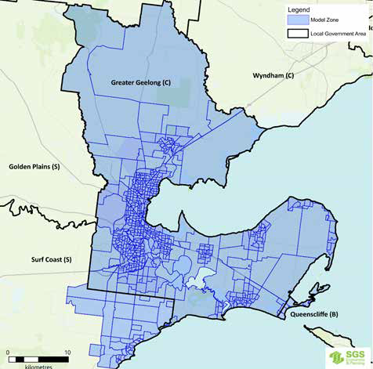
Source: SGS Economics and Planning

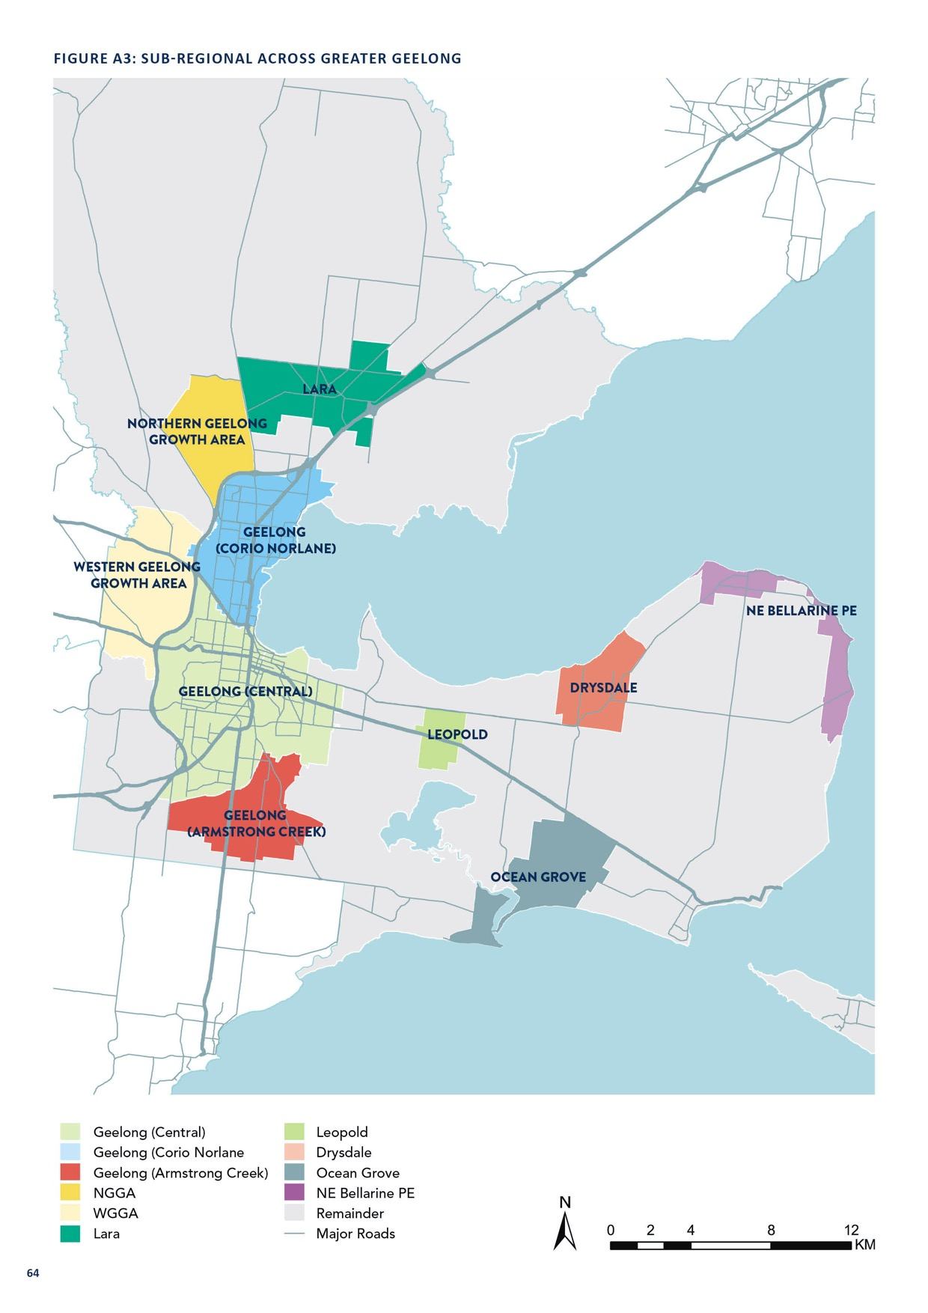

Retail demand and expenditure forecasting

The following section presents the approach to estimating retail expenditure demand anticipated across the Greater Geelong retail system. The two key inputs include:
  - population – developed by SGS Economics and Planning in 2016, and assumes a 2 per cent population growth across Greater Geelong
  - base expenditure per capita – sourced from 2016 MarketInfo MDS
  - retail trends – sourced from ABS Retail Trade and IBIS World.
Several other datasets related to retail trends were used and discussed below.

RETAIL EXPENDITURE FORECASTING OVERVIEW
SGS has forecast retail expenditure in Greater Geelong using the following steps:
  - Step 1: Expenditure per capita
  - Step 2: Projected expenditure per capita
  - Step 3: Total resident retail expenditure
  - Step 4: Total adjusted retail expenditure
As noted above Queenscliff Local Government Area (LGA) and the Torquay part of Surf Coast LGA are also included in the model and associated expenditure analysis. Results which include these areas outside the City of Greater Geelong have been clearly identified.

STEP 1: PER CAPITA EXPENDITURE
Expenditure per capita for each ABS Statistical Area 1 and by 10 commodity types is sourced from 2016 MarketInfo - Market Data Systems (MDS). MarketInfo uses a microsimulation approach that draws on the latest ABS Household Expenditure Survey (HES), 2016 ABS Census and other datasets to
create small-area expenditure estimates for all of Australia. Expenditure includes all expenditure behaviour, including online and at physical stores.
The table A1 below summarises average expenditure per capita by commodity types for Greater Geelong and
comparator areas. This highlights that Geelong residents, on average, spend below the state and metropolitan Melbourne averages, and have a largely similar expenditure profile to the Regional Victorian average.
Given the diverse urban and demographic profile of Greater Geelong, these average expenditure trends can vary considerably within the municipality. SA1 data from MarketInfo 2016 is mapped to the Origin zones to capture localised variations in per capita spend.
Table A2 provides a summary of this localised variation across the 11 sub-regions of Geelong. Significant (greater than 5
per cent) variations above or below the Greater Geelong average have been highlighted green and red respectively. This highlights higher spend in Ocean Grove and Drysdale, and lower spend in Geelong (Corio Norlane).

TABLE A1: 2016 ANNUAL PER CAPITA SPEND BY COMMODITY TYPE, 2016 DOLLARS

COMMODITY GROUP | GREATER GEELONG | VICTORIA | REGIONAL VICTORIA | GREATER  MELBOURNE
COMMODITY GROUP | $ % DIFF FROM VIC

Food/groceries | $3,415 | 99% | $3,432 | $3,323 | $3,470
Pharmaceutical goods | $1,195 | 95% | $1,261 | $1,179 | $1,290
Tobacco/bottle shops | $1,570 | 105% | $1,499 | $1,606 | $1,461
Restaurants/cafés/takeaway | $1,708 | 89% | $1,909 | $1,691 | $1,986
Clothing/shoes | $1,138 | 89% | $1,277 | $1,134 | $1,327
Personal | $1,102 | 89% | $1,244 | $1,055 | $1,310
Furniture/white goods/ manchester | $1,379 | 96% | $1,430 | $1,386 | $1,445
Electronics | $1,606 | 92% | $1,754 | $1,604 | $1,806
Hardware/gardening | $823 | 92% | $894 | $831 | $915
Newsagent/lotto | $650 | 98% | $664 | $651 | $668

Total retail spend per capita $14,586 95% $15,364 $14,460 $15,680

FOOD/
GROCERIES

PHARMA’ GOODS

TOBACCO/
BOTTLE SHOPS

RESTAURANTS/ CAFÉS/
TAKEAWAY

CLOTHING/ SHOES

PERSONAL

FURNITURE/
WHITE GOODS/ MANCHESTER

ELECTRONICS

HARDWARE/ GARDENING

NEWSAGENT/ LOTTO

TOTAL RETAIL

(Armstrong Creek)
Drysdale $3,792 | $1,235 | $1,608 | $1,750 | $1,209 | $1,149 | $1,564 | $1,635 | $984 | $741 | $15,668
Geelong $3,451 | $1,045 | $1,632 | $1,678 | $1,189 | $949 | $1,331 | $1,553 | $834 | $609 | $14,271
Geelong (Central) $3,447 | $1,238 | $1,573 | $1,820 | $1,198 | $1,181 | $1,409 | $1,680 | $827 | $672 | $15,047
Geelong (Corio $2,893 | $1,025 | $1,532 | $1,361 | $887 | $787 | $1,099 | $1,396 | $598 | $509 | $12,087
Lara $3,373 | $1,168 | $1,596 | $1,696 | $1,117 | $1,195 | $1,372 | $1,579 | $827 | $647 | $14,571
Leopold $3,540 | $1,182 | $1,600 | $1,685 | $1,120 | $1,199 | $1,423 | $1,613 | $870 | $654 | $14,886
NE Bellarine Pe $3,837 | $1,359 | $1,748 | $1,629 | $1,009 | $908 | $1,525 | $1,578 | $922 | $718 | $15,233
Northern Geelong $3,501 | $1,206 | $1,557 | $1,760 | $1,217 | $1,238 | $1,396 | $1,553 | $752 | $681 | $14,863
Ocean Grove $3,717 | $1,216 | $1,529 | $1,810 | $1,271 | $1,267 | $1,541 | $1,677 | $999 | $717 | $15,744
Remainder $3,653 | $1,328 | $1,469 | $1,729 | $1,229 | $1,095 | $1,509 | $1,547 | $999 | $695 | $15,255
Western Geelong $4,225 | $1,471 | $1,903 | $2,267 | $1,436 | $1,315 | $1,632 | $1,826 | $1,156 | $879 | $18,110
Greater Geelong $3,415 | $1,195 | $1,570 | $1,708 | $1,138 | $1,102 | $1,379 | $1,606 | $823 | $650 | $14,586

Norlane)

Growth Area

Growth Area (Average)

Note figures over +/- 5% of the Greater Geelong average have been highlighted green (above) or red (below) Source: Market Info, 2016

STEP 2: PROJECTED PER CAPITA EXPENDITURE
Per capita expenditure by commodity group is then projected to 2036 using trends in the ABS Retail Trade Survey (Cat. 8501.0) and broad retail industry trends evident in IBIS World and other industry publications. These commodity type growth rates are then applied to each zone within Greater Geelong to retain local variation in spending behaviour.
Table A3 shows projected growth in per capita expenditure by commodity group out to 2036. From this we can observe that pharmaceutical goods, clothing/shoes and electronics represent the largest increase in expenditure going forward.

TABLE A3: PROJECTED GREATER GEELONG SPEND PER CAPITA BY COMMODITY TYPE, 2016-36,
2016 DOLLARS

CHANGE GROWTH RATE
COMMODITY TYPE 2016 2026 2036
2016 - 36 2016 - 36

Food/groceries | $3,415 | $3,773 | $4,164 | $750 | 1.00%
Pharmaceutical goods | $1,195 | $1,430 | $1,683 | $488W | 1.73%
Tobacco/bottle shops | $1,570 | $1,699 | $1,849 | $279 | 0.82%
Restaurants/cafés/takeaway | $1,708 | $1,939 | $2,188 | $479 | 1.24%
Clothing/shoes | $1,138 | $1,349 | $1,567 | $429 | 1.61%
Personal | $1,102 | $1,260 | $1,426 | $324 | 1.30%
Furniture/white goods/manchester | $1,379 | $1,602 | $1,834 | $455 | 1.44%
Electronics | $1,606 | $1,910 | $2,213 | $607 | 1.62%
Hardware/gardening | $823 | $957 | $1,091 | $268 | 1.42%
Newsagent/lotto | $650 | $368 | $86 | -$564 | -9.61%

Total Spend per capita $14,586 $16,289 $18,100 $3,515 1.09%

Source: SGS Economics and Planning based on Market Info, ABS Retail Trade and other sources

STEP 3: TOTAL RESIDENT RETAIL EXPENDITURE
Expenditure per capita projections are then multiplied by zone level population projections to generate total resident expenditure forecasts. Results for the whole of Greater Geelong by commodity type and each sub-region are presented in Table A4 and Table A5.
This highlights a total resident expenditure pool of $3,459 million in 2016. Over the next 20 years this will increase by
3.09 per cent per annum in real terms. This is partly due to population growth (2 per cent) and partly due to increased real spend per capita (1 per cent).
Growth in resident expenditure largely follows population growth, with Armstrong Creek, Northern Geelong Growth Area, Western Geelong Growth Area and Geelong (Central) all seeing strong growth in resident expenditure.
An additional $354 million is also estimated in neighbouring Surf Coast (part) and Point Lonsdale Local Government Area. These are considered when modelling escape/capture expenditure flows.

TABLE A4: PROJECTED GREATER GEELONG RESIDENT SPEND BY COMMODITY GROUP, 2016–36 ($ MILLION), 2016 DOLLARS

2016–36 2016–36
COMMODITY TYPE 2016 2026 2036
CHANGE GROWTH RATE

Food/groceries | $810 | $1,060 | $1,464 | $654 | 3.00%
Pharmaceutical goods | $283 | $402 | $591 | $308 | 3.75%
Tobacco/bottle shops | $372 | $477 | $650 | $278 | 2.83%
Restaurants/Cafés/takeaway | $405 | $545 | $769 | $364 | 3.26%
Clothing/shoes | $270 | $379 | $551 | $281 | 3.63%
Personal | $261 | $354 | $501 | $240 | 3.31%
Furniture/white goods/manchester | $327 | $450 | $645 | $318 | 3.45%
Electronics | $381 | $537 | $778 | $397 | 3.64%
Hardware/gardening | $195 | $269 | $383 | $188 | 3.44%
Newsagent/lotto | $154 | $103 | $30 | -$124 | -7.82%

Total Geelong resident spend $3,459 $4,577 $6,362 $2,904 3.09%

TABLE A5: PROJECTED RESIDENT SPEND BY SUB REGION, 2016–36 ($MILLION), 2016 DOLLARS

2016–36 2016–36
COMMODITY TYPE 2016 2026 2036
CHANGE GROWTH RATE

Lara | $223 | $300 | $394 | $171 | 2.88%
Northern Geelong GA | $16 | $18 | $259 | $243 | 14.84%
Geelong (Corio Norlane) | $491 | $576 | $671 | $180 | 1.57%
Western Geelong GA | $6 | $9 | $291 | $285 | 21.24%
Geelong (Central) | $1,683 | $2,053 | $2,445 | $762 | 1.89%
Geelong (Armstrong Creek) | $92 | $370 | $647 | $554 | 10.22%
Leopold | $180 | $256 | $345 | $165 | 3.29%
Drysdale | $198 | $289 | $398 | $199 | 3.53%
Ocean Grove | $290 | $358 | $448 | $158 | 2.20%
NE Bellarine | $110 | $148 | $193 | $83 | 2.87%
Remainder | $168 | $200 | $271 | $103 | 2.41%

Total Geelong resident spend | $3,459 | $4,577 | $6,362 | $2,904 | 3.09%
Surf Coast (part) and Point Lonsdale resident spend | $354 | $493 | $682 | $328 | 3.33%
Total system resident spend | $3,813 | $5,069 | $7,045 | $3,232 | 3.12%

Source: SGS Economics and Planning based on Market Info and ABS Retail Trade series.

STEP 4: TOTAL ADJUSTED RETAIL EXPENDITURE
While a large proportion of retail spend is still linked to a person’s place of residence, spending decisions are
also linked to place of work, study (for tertiary students in particular) and tourism. Online retailing has also increased its role and impact on this system. These factors vary spatially and across commodity/store types and can significantly influence the actual amount and location of retail demand.
SGS has completed analysis on each factor and adjusted expenditure accordingly to estimate an adjusted origin spend. A summary of the overall effect of these adjustments is presented in Figure A4 below. These adjustments
were completed at a system-wide level, including all of Greater Geelong, Surf Coast (part) and Queenscliff Local Government Areas.
Key assumptions for each component is further discussed on next page (82).

FIGURE A4: SYSTEM ESCAPE/ CAPTURE AND EXPENDITURE ADJUSTMENTS
Resident Spend Adjusted Spend ($3,812m) ($3,975m) – whole system

($3459m) ($3648m) – Geelong only
Home-based ($3,512m)
Worker-based ($137m)
Student-based ($21m)
Online spend
($126m)
Worker-based
($158m)
Student-based
($15m)
Tourists ($303m)
Geelong retail system escape/
capture adjustments

1.Productivity Commission, ‘Economic Structure and Performance of the Australian Retail Industry’, November 2011.

STEP 4A: ONLINE ESCAPE EXPENDITURE
While online retail growth is still strong, it is slowing. Consumer preferences continue to evolve and emerging trends (evident in 18 to 35 year olds) shows a focus on wanting an increasingly unique ‘retail experience’ rather than a homogeneous product at the lowest price.
When online retailing emerged, it was initially seen as a direct competitor to physical retailing. However, multi- channel is increasingly being used in retailing, where
manufacturers and physical retailers have attempted to set up online shops to complement their offer. Increasingly, retailers will invest as much in their physical store front as their online presence and gain sales from both. This will increasingly blur the lines of ‘online versus physical’.
Given uncertainty about the future, SGS has not sought to estimate future trends in online retail or the role of
multi-channelling. Rather, it has assumed that the online ‘leaked’ shares conservatively remain fixed per the latest Productivity Commission report. This is the share of expenditure that leaves the catchment entirely due to online retailing. There are further online sales which will remain in the local system due to multi-channelling of
local retailers.
The figure A5 below shows the estimated online leakage share by commodity group. Perishable commodities are assumed to lose a negligible share of turnover to online retailing. For other non-perishable commodities, the overall online share of retail sales has been applied.

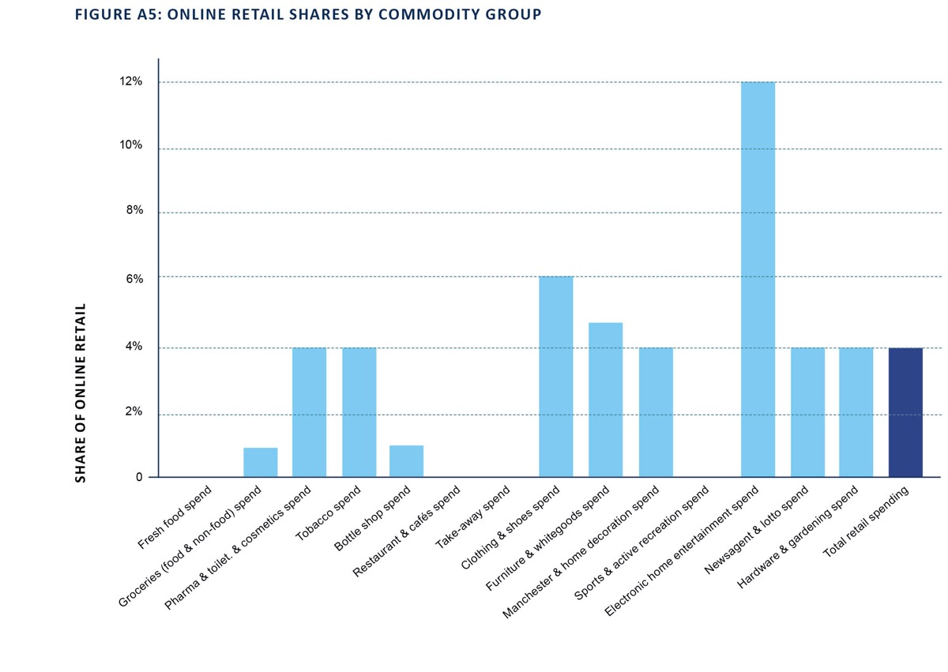

Source: SGS Economics and Planning based on Productivity Commission, 2011.

STEP 4B/C: WORKER AND STUDENT ESCAPE/CAPTURE ADJUSTMENTS

Resident expenditure is spatially reallocated to account for retail spending linked to work and/or study (tertiary) locations, this factors both flows within and in/out of the Geelong system. Overall there is a net inflow of students and outflow of workers.
The redistribution of expenditure is completed as follows:
- Resident workers (51 per cent of total population) and tertiary students (6 per cent of total population) are identified based on 2016 ABS Census.
- A proportion of resident worker and tertiary student spend is then removed from each resident location. Spend reallocation rates are presented in Figure A6 below. This results in the removal of $158 million based on worker expenditure and $15 million based on student expenditure in 2016. Similar shares are removed in forecast periods.
- The number of workers and tertiary students by place of work/institution within Geelong is initially estimated from 2016 ABS Census (with adjustments to account for undercount) and uCube Higher Education Statistics. Worker and tertiary student estimates are forecast out to 2036 based on SGS zone-level employment and student forecasts.
- Expenditure per worker and tertiary student is then added
back into the system. The expenditure profile for workers and students is based on the average estimated in dot point two above. This expenditure is then added back into the system based on the location of jobs and tertiary institutions. This results in the addition of $137 million based on worker expenditure and $21 million based on student expenditure. Similar shares are added in forecast periods.
- The number of workers and tertiary students by place of work/institution within Geelong is initially estimated from 2016 ABS Census (with adjustments to account for undercount) and uCube Higher Education Statistics.
Worker and tertiary student estimates are forecast
out to 2036 based on SGS zone level employment and student forecasts.
- Expenditure per worker and tertiary student is then added back into the system. The expenditure profile for workers and students is based on the average estimated in dot point two above. This expenditure is then added back into the system based on the location of jobs and tertiary institutions. This results in the addition of $137 million based on worker expenditure and $21 million based on
student expenditure. Similar shares are added in forecast periods.

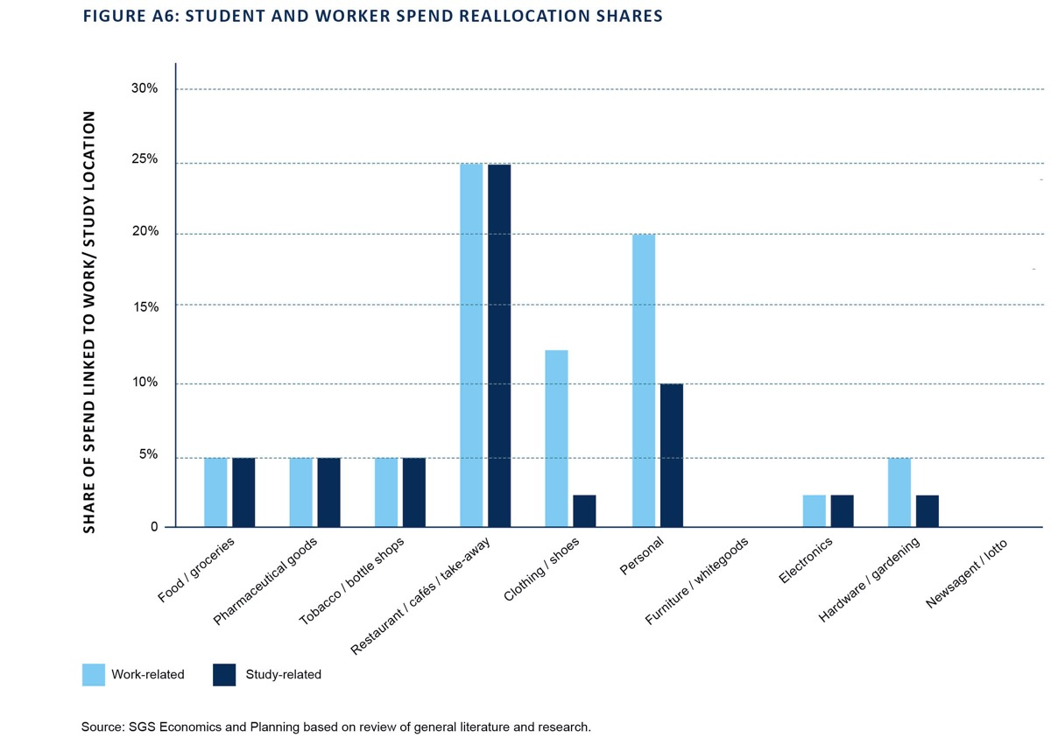

STEP 4D: TOURISM CAPTURE OF EXPENDITURE

Expenditure is adjusted to account for visitor expenditure, which is added to the system.
  - REMPLAN tourism data, provided by the City of Greater Geelong, is used to estimate visitor total spend and numbers (incorporating domestic day, domestic overnight and international visitors). This data identifies 7.5 million visitors in 2016 with an average spend of $40 per visitor. This represents a total expenditure pool of $303 million in 2016. Visitor projections are then based on Victoria-wide population growth, as the largest share of visitors are from within the state.
  - Total spend is then allocated across the commodity types based on Figure A7 assumptions.
  - Tourism expenditure is then distributed spatially based on arts, recreation and accommodation related employment as a proxy for tourism locations.
  - The number of workers and tertiary students by place of work/institution within Geelong is initially estimated from 2016 ABS Census (with adjustments to account for undercount) and uCube Higher Education Statistics.
Worker and tertiary student estimates are forecast
out to 2036, based on SGS zone-level employment and student forecasts.
- Expenditure per worker and tertiary student is then added back into the system. The expenditure profile for workers and students is based on the average estimated in dot point two above. This expenditure is then added back into the system based on the location of jobs and tertiary institutions. This results in the addition of $137 million based on worker expenditure and $21 million based on student expenditure. Similar shares are added in forecast periods.

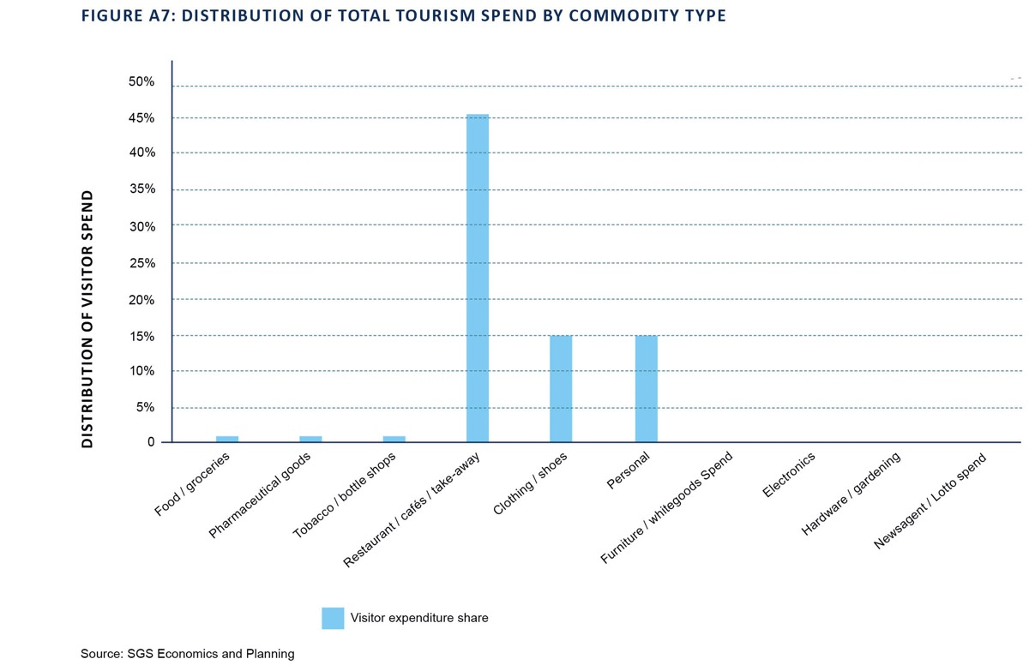

OTHER FORMS OF ESCAPE/CAPTURE OF EXPENDITURE
Beyond these major components of retail escape/capture of expenditure, there is still likely to be a small amount of retail expenditure flowing in/out of the system for other reasons. Analysis of the 2010-11 Victorian Integrated Survey of Travel and Activity (VISTA) suggests that the net flow (-87 trips) (retail trips out of Geelong less retail trips into Geelong) represents less than 0.2 per cent of all retail trips originating from Geelong (44,864) on an ‘Average Day’. Given this, the model has ignored this small aspect of escape expenditure.
Table A6 and Table A7 present these final adjusted expenditure estimates used to determine retail floor space requirements and flows in the gravity model. From this we can see there is an overall net inflow into the retail economy as Geelong acts as a major economic node for the broader region. This is most felt in the hospitality (restaurants/ cafés/ take-away), apparel (clothing/ shoes) and personal goods commodity types.
There are also spatial implications within Greater Geelong from these adjustments. Due largely to the location of employment and major education institutions, we see a shift toward the Geelong (Central) sub-region. There is also a small shift to Ocean Grove and the remainder sub-regions, which contain tourist attractors that generate local retail demand.

TABLE A6: PROJECTED ADJUSTED SPEND BY COMMODITY GROUP, 201–36 ($ MILLION), 2016 DOLLARS

CHANGE GROWTH RATE
COMMODITY TYPE 2016 2026 2036
2016–36 2016–36

Food/groceries | $816 | $1,065 | $1,462 | $646 | 2.96%
Pharmaceutical goods | $277 | $391 | $571 | $294 | 3.68%
Tobacco/bottle shops | $374 | $477 | $644 | $270 | 2.76%
Restaurants/cafés/takeaway | $591 | $750 | $979 | $388 | 2.55%
Clothing/shoes | $300 | $408 | $569 | $268 | 3.24%
Personal | $308 | $405 | $550 | $241 | 2.93%
Furniture/white goods/manchester | $311 | $429 | $613 | $302 | 3.45%
Electronics | $335 | $472 | $683 | $348 | 3.62%
Hardware/gardening | $187 | $257 | $366 | $179 | 3.41%
Newsagent/lotto | $148 | $99 | $29 | -$119 | -7.82%

Total Geelong adjusted Spend | $3,648 | $4,753 | $6,465 | $2,817 | 2.90%
Surf Coast (part) and Point Lonsdale adjusted spend | $326 | $453 | $627 | $300 | 3.32%
Total system adjusted spend | $3,975 | $5,206 | $7,092 | $3,117 | 2.94%
Total system resident spend | $3,813 | $5,069 | $7,045 | $3,232 | 3.12%

Source: SGS Economics and Planning based on Market Info and ABS Retail Trade series.

TABLE A7: GREATER GEELONG PROJECTED ADJUSTED SPEND BY SUB REGION, 2016–36 ($M), 2016 DOLLARS

CHANGE GROWTH RATE
SUB-REGIONS 2016 2026 2036
2016–36 2016– 36

Lara | $216 | $289 | $377 | $161 | 2.82%
Northern Geelong GA | $17 | $19 | $241 | $224 | 14.21%
Geelong (Corio Norlane) | $519 | $609 | $708 | $189 | 1.56%
Western Geelong GA | $7 | $10 | $269 | $262 | 19.91%
Geelong (Central) | $1,816 | $2,179 | $2,545 | $729 | 1.70%
Geelong (Armstrong Creek) | $95 | $373 | $667 | $572 | 10.23%
Leopold | $169 | $239 | $320 | $152 | 3.26%
Drysdale | $193 | $278 | $379 | $186 | 3.42%
Ocean Grove | $301 | $368 | $456 | $154 | 2.09%
NE Bellarine Pe | $111 | $148 | $190 | $79 | 2.73%
Remainder | $204 | $240 | $313 | $109 | 2.16%

Total Geelong
$3,648 $4,753 $6,465 $2,817 2.90%
adjusted spend

Source: SGS Economics and Planning based on Market Info and ABS Retail Trade series.

Retail floor space supply and turnover

The following section presents the approach used to determining retail floor space supply and turnover across the system. The two key inputs include:
  - Centre Floor space audit – completed by SGS in 2015, and updated by Council in 2018
  - turnover per square metre – based on adjusted expenditure pool (from Section 1.3), 2015 Australian Shopping Centre Database – Property Council of Australia and 2010 Australian Retail Averages
Report- Urbis.
Several other datasets related to retail trends were used and discussed below.

FLOOR SPACE AUDIT
In 2015, SGS completed a land use audit for 108 existing centres across the municipality. The audit assessed the total floor space, predominant use and amount of vacant land/floor space. The following use categories were recorded:
  - (Shop) Retail – Supermarket
  - (Shop) Retail – Department Stores
  - (Shop) Retail - Speciality Food
  - (Shop) Retail - Speciality Non-Food
  - (Non-shop) Retail – Bulky Goods or Restricted Retail
  - (Non-shop) Retail – Hospitality
  - Non-retail - Commercial
  - Non-retail - Commercial Services
  - Non-retail - Industrial
- Non-retail - Entertainment
- Non-retail - Medical
- Non-retail – Education
- Non-retail - Public facilities
- Vacant land and units/floor space.
Supplementary datasets for enclosed malls were also sourced and added to this floor space dataset. This audit was also coupled with consultation with local retailers and centre managers to provide an in-depth local understanding of the supply of retail floor space across
the municipality.
For local centres no site-based visit was completed. However, floor space estimates were created via building footprint measurements through the use of satellite imagery. These centres largely provide a local convenience role, typically with no supermarket, department store or bulky retailing. They would likely contain a range of
local retail uses (such as specialty – other, specialty – food or hospitality) along with non-retail based uses or
vacant shops.
There is also a loose cluster of restricted retailing activities in other dispersed locations. The City has audited these locations and SGS has incorporated this into the database.
In addition, known future retail floor space in new or expanded centres is sourced from the city based on approved plans at the time.
In 2018, the City reviewed and updated the floor space database, including refining information on existing centres and adding and update information around new centres,

particularly in the newly-declared Northern and Western Geelong Growth Areas.
Based on floor space audit, it is estimated that (as of 2018) Greater Geelong has 903,812 square metres of retail floor space spread across 121 existing centres in the hierarchy.
There is an additional 55,967 square metres of vacant floor space across the existing network. On average this represents 6 per cent of retail floor space, which is a reasonable level of vacancy to enable the normal churn and redevelopment of centres. However, it is not evenly distributed with some centres well above this rate (i.e.
Geelong CBD at 14 per cent).
A further 149,786 square metres of known planned, new or additional floor space is also recorded across the existing network, plus 30 new centres in the network. This final database is detailed in full in Appendix B and forms the basis of the retail modelling.

CENTRE TURNOVER ESTIMATES
Actual turnover data for every shop/centre across Geelong cannot be sourced directly.
However, for a strategic-level study such as this, specific turnovers are not actually required. This is because the modelling is not trying to predict an individual centre’s exact performance in a particular year. Rather the modelling is trying to understand the general alignment, or misalignment, of the quantum and location of retail floor space supply and demand now and in the future. For this purpose, turnovers
can largely reflect the typical performance of a given centre, and supportable floor space estimates can be derived from this perspective.
In reality, individual centres will over or under perform and may draw on smaller or larger catchments, which both may vary significantly year to year. This actual lived performance reflects many other localised factors which can not be captured in a strategic study.
Therefore, centre turnovers for the gravity model are estimated by comparing system-wide floor space (identified as 903,812 square metres) to total-system retail expenditure, as summarised in Table A6 and Table A7. This is presented in columns A and B of Table A8 below.
These are combined to estimate average turnover per square metre by store types (i.e. Retail Turnover Density or RTD) for the entire system (column C). This is applied to individual centres by store and commodity floor space profile. with further adjustments for actual turnover information (where available). This system estimated RTD was found to be generally below industry averages,
which reflects a general over provision of floor space in the Geelong retail system currently. As such, a ‘target’ RTD (Column D) was developed for forecasting base case future retail floor space demand requirements across Greater Geelong.

Retail economy simulation
The following section presents the gravity model approach used to align retail demand with supply, to determine trade catchments, future performance and provision gaps.

TABLE A8: SYSTEM ALIGNMENT AND RETAIL TURNOVER DENSITIES AT 2016
D) ‘TARGET’ RETAIL
TURNOVER DENSITY
($PSM)
B) FLOOR SPACE C= B/A) ESTIMATE RETAIL
SUPPLY (SQM) TURNOVER DENSITY ($PSM)
A) TOTAL SYSTEM ADJUSTED
SPEND / TURNOVER ($M)
STORE TYPES

Supermarket and grocery stores | $850 | 110,166 | $7,720
Department stores | $224 | 63,624 | $3,524 | $3,500
Bulky goods | $673 | 267,323 | $2,519 | $3,000
Specialty – food & drink | $514 | 65,510 | $7,843 | $9,000
Specialty – non food | $1,069 | 250,515 | $4,266 | $4,000
Hospitality | $623 | 146,673 | $4,249 | $4,000

Total system | $3,954 | 903,812 | $4,374 | $4,632
Shop retail (ex. bulky and hospitality) | $2,657 | 489,815 | $5,425 | $5,613

Source: SGS Economics and Planning.

The key inputs to the gravity model include:
  - adjusted retail expenditure – for (606) zones from Section 1.3
  - centre turnover estimates – for (154) current and future centre from Section 1.4
  - travel times – based on uncongested car road network travels times (as of 2018). Created by SGS using VicMap road network and GIS network analysis.

GRAVITY MODEL THEORY AND CONCEPTS

Retail modelling options and alternatives
There are a range of approaches to analysing retail systems for impact analysis and planning studies. These are broadly defined as:
- Survey-based – where detailed customer and centre based surveys are conducted to understand where shoppers go and how much they spend at various locations. These are invariably very expensive to operate and often do not fully capture all behavioural aspects and/ or are skewed by various forms of survey bias. They also provide very little means for predicting changes in the retail environment, such as growth areas or new shopping centres. However, they can be effective at understanding one specific centre in detail
- Defined trade areas (or shift-share analysis) – where distance catchments or judgment-based trade areas (using natural/physical barriers), are defined and ‘market share’ assumptions are made for each area to determine how expenditure is captured by a centre. This is often coupled with in-centre/customer survey, to refine market share estimates. However, this approach is generally
not undertaken on a network-wide approach and oversimplifies the system around one, or a few centres. It is also highly dependent on an individual’s personal judgment regarding how these trade areas are defined and the market shares used.
- Gravity modelling – takes a whole-of-network approach and seeks to use mathematics to model human behaviour. As well as being less expensive, mathematical models are
much more reliable when predicting future consequences of changes in the retail environment.This is due to their ability to systematically adjust all catchments given changes in input data (such as extra retail floor space or population growth).
In addition, to these models and methods, some strategies take a design or place-based approach. While this can
be very useful in understanding broader factors, it can be disconnected from market realities, or network requirements, if done in isolation.
The the City of Greater Geelong Retail Strategy 2016–2036 used a gravity model approach to simulate the flow of shoppers.

History of gravity modelling for retail economics
The first person to create a mathematical model to analyse the retail environment was Reilly in 1929. He created Reilly’s Law of Gravitation that states:
“Two centres attract trade from intermediate places approximately in direct proportion to the size of the centres and in inverse proportion to the square of the distances from these centres to the intermediate place”
This law can be rewritten as a formula:

Floor space of shopping centre

Distance to shopping centre
Propensity to shop at a centre =
Further work by Huff in 1949 added a probability-based approach to the original formula (i.e. a person can shop at multiple locations with varying probability).
This is achieved by breaking up the study area into many smaller sections. The market share in each section can then be found by dividing the propensity of the shopping centre in question by the total propensity acting on the area. By evaluating the amount of retail expenditure in each small section, it is then possible to evaluate the shopping centre’s turnover by adding up the market share from
each section.

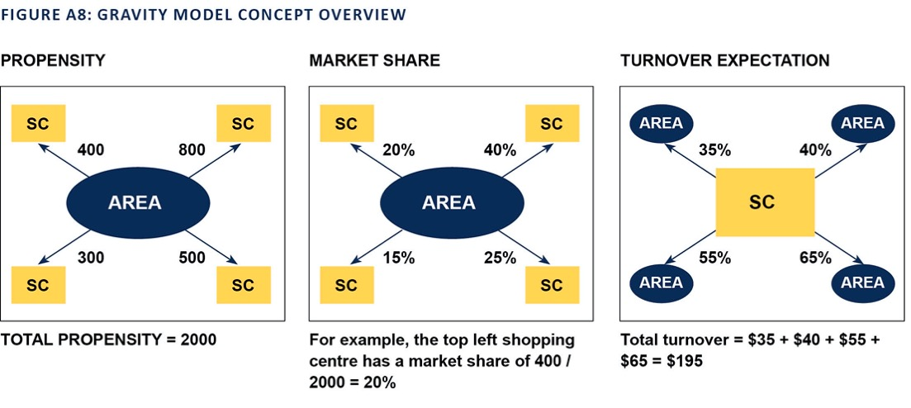

However, at this point, we have assumed the only feature that is important with regards to how attractive the shopping centre is to its consumers is the shopping
centre size. Obviously. this would most likely be incorrect, as this does not take into account other attributes,
such as entertainment complexes, urban design, product range and so on.
Since the original formulation of the theory, there has been many variations to the core model concept and a wide variety of applications across Australia and the World. This has been supported by dramatic increases in the availability of detailed data and computational power.

SGS Retail Gravity Model approach
The SGS Retail Model is built upon this research, as well as the extensive experience SGS has gained conducting many retail studies over the past 25 years. The SGS retail model uses various aspects from the later work of Huff (1963), Lakshanan and Hansen (1965), and Bökemann (1982), among others. What makes the SGS retail model distinct from many other models is that the model modifies the above approach in the following way:

“Attractiveness” Floor space of
Propensity to shop at a centre
of centre
X
shopping centre
=
Travel time to shopping centre2

The ‘attractiveness’ of a shopping centre is a value that represents external attributes, such as the centre’s
appearance or design layout. Another important change is that time has replaced distance as a factor. This is to
account for consumers going to alternative shopping centres that are based along major freeways or to restrict others based on (natural) barriers.
Unlike other gravitational models, the SGS model does not attempt to define the effects of design layout or product mix directly. Instead, it uses typical estimated turnover data by centre to find the “attractiveness” value at the present time. This attractiveness value is then used to forecast how the shopping centre will perform in the
future given an increase in floor space or expenditure. This technique has only become possible in recent years due to advances in computer technology and optimisation theory.
Another unique advantage of attractiveness values is the ability to forecast the viability of a new shopping centre.
By assuming that the new shopping centre will be able to achieve a certain amount of turnover each year, it is possible to work out how much more attractive the shopping centre will have to appear compared to the surrounding opposition.
If the attractiveness value for
the new centre is similar to the attractiveness of the opposition, then the centre is viable in that particular location.
A collateral benefit of the modelling approach is that it lends itself to ready estimation of some of the variables likely
to be crucial in any net community benefit assessment of out-of-centre development proposals. In particular, impacts on competing centres can be calculated relatively quickly to see whether they are likely to be so severe as to cause persistent vacancies and blighting. But, perhaps more importantly, the gravity modelling can be harnessed to estimate the extent to which the out-of-centre proposal will lead to additional vehicle kilometres travelled each year.
To reiterate, mitigation of growth of vehicle kilometres is one of the main ‘missions’ of a retail hierarchy, and yet this effect tends to be ignored in the evaluation of out-of-centre proposals.

SGS RETAIL GRAVITY MODEL DEVELOPED FOR GREATER GEELONG
The Greater Geelong gravity model includes 606 origin zones, by 154 centre locations, by 6 store types, by 5 time periods. The model is calibrated for 2016, based on the adjusted expenditure data, floor space/turnover data and travel time information noted previously. This forms base year ‘attractiveness’ factors for each centre and store
type. Projected adjusted expenditure and known additional floor space is then added into the model and, using the ‘attractiveness’ factors, future performance and flows
are simulated.
From this simulation, every origin zone can be presented in terms of its market share, by store type to every centre in the network. Conversely, every centre has a continuous catchment covering all origin zones (while typically focused on those within close proximity). This ensures every dollar of demand/turnover is allocated across the system once, and only once, and catchments consider the full network hierarchy, from local through to regional.
The gravity model approach enables results to be presented in a wide range of ways to understand various segments of the retail economy. The following seeks to systematically breakdown how results are created and linked in the model, and what they represent.

Base case retail scenario
The gravity model detailed in the City’s retail strategy reflects a base case, or business as usual, scenario for the system. This is a theoretical scenario, which assumes future demand will be absorbed by existing and already planned future centres, via the gravity model. This helps
understand the level of trade that these centres will attract if no further development occurs. This provides an important starting point from which future changes to the retail system can be assessed. It does not necessarily reflect the only or best outcome.
Increased base case trade at these existing/planned centres can then also be translated back to estimates of future supportable floor space using the target RTDs. This is the basis of the projected floor space demand and caps presented in the City’s retail strategy.
This base case scenario can be compared to any number of alternative scenarios, which may consider alternative population or expenditure trends and new/alternative centre

networks. The gravity model will then be able to output comparable performance metrics around supply/demand alignment, centre performance and vehicle kilometres travelled to enable an informed assessment as to how the alternative scenario is better or worse than the base case.

System-wide alignment
Table A9 summarises total retail floor space demand forecasts for Greater Geelong. Population (Row A) and known floor space supply data from the floor space audit (row C) is also included. Floor space demand is essentially determined by converting expenditure/turnover data to floor space demand using Target RTDs. This can be done based on expenditure origin, as reflected by the ‘adjusted spend (from Geelong origins)’ (row C), or expenditure destination, as reflected in ‘adjusted spend (at Geelong Centres)’ (row
- The difference between row C and row F reflects flows within the system, but between Geelong and Queenscliff/ Surf Coast and is further discussed at the sub-regional alignment stage.
It should be noted current floor space demand (853,599 sqm) is below actual levels (903,812 occupied + 55,967 vacant = 959,779 sqm) due to the higher ‘target RTDs’ used in the modelling and further discussed in Table A8.
Row G (highlighted light blue) is the basis of the projected floor space demand presented in the Retail Strategy. This reflects demand allocated to centres based on the
gravity model.

TABLE A9 TOTAL RETAIL FLOOR SPACE DEMAND, 2016–36

2016 2026 2036 2016–2036

A Population | 237,129 | 280,975 | 351,499 | 114,370
B Floor space supply (audited at centres) Existing and planned to 2036 (March 2018) | 959,779 | 1,030,855 | 1,109,564 | 149,786
C Adjusted spend ($m) (from Geelong origins) | $3,648 | $4,753 | $6,465 | $2,817
D Floor space demand (from Geelong origins) based on adjusted spend and $4,632 RTD | 787,685 | 1,026,121 | 1,395,821 | 608,136
E Floor space per capita | 3.3 | 3.7 | 4.0
F Adjusted spend ($m) (at Geelong centres) | $3,954 | $5,183 | $7,066 | $3,112

G Floor space demand (at Geelong centres) based on 853,599 1,120,759 1,527,750 674,151 gravity model base case assignment and $4,632 RTD
H Floor space per capita 3.6 4.0 4.3 $3,112

Floor space supply includes all retail types plus 55,967 sqm of vacant retail floor space. Source: SGS Economics and Planning

Table 10 presents the same analysis for just shop retail (excluding bulky goods and hospitality). Row F (highlighted light blue) aligns with shop retail demand projections included in the City’s retail strategy and was used to inform floor space caps. This indicates current shop retail provision of 2.0 square metres per person, increasing to 2.4 by 2036.

Sub-regional alignment
Row B, D and G from Table A9 and Table A10 can then be further disaggregated into sub-regions to understand the spatial distribution of supply origin and destination demand. This is summarised in Table A11 and Table A12 for total retail and shop retail respectively.
  - Floor space Supply simply reflects results of the floor space audit and identifies the spatial distribution of current and future floor space that has already been planned. This highlights the significant amount of floor space already within Geelong (Central), which captures the Geelong CBD along with one specialised, two sub- regional centres and twelve neighbourhood centres.
The additional floor space planned for the growth areas (Northern Geelong Growth Area, Western Geelong Growth Area, Armstrong Creek) can also be observed, along with small increases elsewhere.
  - Floor space demand from Geelong origins aligns with the spatial distribution of population, plus the adjustments for students, worker and tourism. It does not consider where this demand might be realised. As modelled in
the gravity model. The results reflect a more dispersed distribution of demand consistent with general settlement patterns, rather than the established centre hierarchy
and location of supply. Strong growth in the established central sub-region and growth areas can also be observed.
- Floor space demand at Geelong centres allocates origin demand to centres based on the gravity model. In 2016, this deliberately aligns more closely to actual floor space supply due to the calibration process. This process, therefore, accounts for the established retail
centre hierarchy and overall supply network. This means each sub-region is not seen as a self-contained ‘island’, where all demand must only be provided for locally.
Rather a clear established hierarchy of local convenience through to high-order centres is reflected in the modelled results. Central Geelong (which includes the Geelong CBD, one specialised and two sub-regional centres, plus many other small centres) sees a considerable net inflow, given its large established population and higher-order functions in the overall network. Other sub-regions see varying flows that reflect their local network and proximity to other established/high-order aspects of the hierarchy. Additional demand at Geelong centres, as modelled via the gravity model, is then a reflection of the established supply and hierarchy, plus the location of additional origin demand. That is, additional demand will be allocated to larger, more ‘attractive’ centres, which are also close to growing areas. This ensures the supportable floor space demand attributes growth to high-growth locations, such as Armstrong Creek, while still supporting the existing established network by continuing to account for these cross sub-region flows.

TABLE A10 SHOP RETAIL FLOOR SPACE DEMAND, 2016–36

2016 2026 2036 2016–2036

A Population | 237,129 | 280,975 | 351,499 | 114,370
B (SHOP) Floor space supply (audited at centres) Existing and planned to 2036 (March 2018) | 545,782 | 597,224 | 650,863 | 105,081
C Adjusted spend ($m) (from Geelong origins) | $2,452 | $3,197 | $4,371 | $1,919
D (SHOP) Floor space demand (from Geelong origins) based on adjusted spend and $5,613 RTD | 436,790 | 569,551 | 778,626 | 341,836
E Floor space per capita | 1.8 | 2.0 | 2.2

F Adjusted spend ($m) (at Geelong centres) $2,657 $3,487 $4,777 $2,120

G (SHOP) Floor space demand (at Geelong centres) based | 473,340 | 621,638 | 851,824 | 378,484
on gravity model base case assignment and $5,613 RTD
H Floor space per capita | 2.0 | 2.2 | 2.4 | $3,112

Floor space supply includes all retail types plus 55,967 sqm of vacant retail floor space. Source: SGS Economics and Planning.

TABLE A11: TOTAL RETAIL FLOOR SPACE DEMAND, BY SUB-REGION, 2016–36
2016–
2036
2016
2016–
2036
2016
2016–
2036
2016
PRECINCT
Floor space SUPPLY
Total retail floor space supply Existing, vacant and planned to 2036 (as of March 2018)

Floor space demand from Geelong
origins based on adjusted spend and $4,632 RTD
Floor space demand at Geelong centres based on gravity model base case assignment and
$4,632 RTD

 |  |  | 2036 |  |  | 2036 |  |  | 2036
Lara | 22,043 | 30,043 | 8,000 | 46,715 | 81,408 | 34,693 | 19,843 | 33,933 | 14,090
NGGA | 0 | 12,022 | 12,022 | 3,647 | 51,956 | 48,309 | 0 | 9,302 | 9,302
Geelong (Corio Norlane) | 163,103 | 163,103 | 0 | 112,076 | 152,855 | 40,779 | 142,881 | 249,331 | 106,451
WGGA | 0 | 23,202 | 23,202 | 1,539 | 58,161 | 56,622 | 0 | 24,800 | 24,800
Geelong (Central) | 648,488 | 657,988 | 9,500 | 392,043 | 549,490 | 157,447 | 576,409 | 914,606 | 338,197
Geelong (Armstrong Creek) | 7,257 | 91,620 | 84,363 | 20,533 | 144,045 | 123,512 | 5,540 | 109,554 | 104,014
Leopold | 36,518 | 36,518 | 0 | 36,439 | 69,150 | 32,711 | 33,563 | 66,928 | 33,365
Drysdale | 25,353 | 25,353 | 0 | 41,747 | 81,844 | 40,097 | 22,096 | 37,307 | 15,211
Ocean Grove | 42,716 | 55,415 | 12,699 | 65,021 | 98,370 | 33,349 | 40,383 | 61,404 | 21,021
NE Bellarine Pe | 14,299 | 14,299 | 0 | 23,913 | 40,996 | 17,083 | 12,884 | 20,585 | 7,701
Remainder | 0 | 0 | 0 | 44,013 | 67,548 | 23,534 | 0 | 0 | 0
Total | 959,779 | 1,109,564 | 149,785 | 787,685 | 1,395,821 | 608,136 | 853,599 | 1,527,750 | 674,151

Source: SGS Economics and Planning

TABLE A12: SHOP RETAIL FLOOR SPACE DEMAND, BY SUB-REGION, 2016–36
2016–
2036
2016
2016–
2036
2016
2016–
2036
2016
PRECINCT
Floor space SUPPLY
Total retail floor space supply Existing, vacant and planned to 2036 (as of March 2018)

Floor space demand from Geelong
origins based on adjusted spend and $4,632 RTD
Floor space demand at Geelong centres based on gravity model base case assignment and
$4,632 RTD

 |  |  | 2036 |  |  | 2036 |  |  | 2036
Lara | 15,921 | 22,631 | 6,710 | 25,905 | 45,411 | 19,507 | 13,643 | 23,166 | 9,522
NGGA | 0 | 8,898 | 8,898 | 2,022 | 28,983 | 26,960 | 0 | 6,006 | 6,006
Geelong (Corio Norlane) | 74,940 | 74,940 | 0 | 62,149 | 85,267 | 23,118 | 66,212 | 106,247 | 40,034
WGGA | 0 | 19,245 | 19,245 | 854 | 32,444 | 31,590 | 0 | 20,813 | 20,813
Geelong (Central) | 371,317 | 379,077 | 7,760 | 217,397 | 306,520 | 89,123 | 320,072 | 516,673 | 196,601
Geelong (Armstrong Creek) | 6,117 | 57,740 | 51,623 | 11,386 | 80,352 | 68,966 | 4,329 | 64,903 | 60,574
Leopold | 20,791 | 20,791 | 0 | 20,206 | 38,574 | 18,367 | 19,746 | 35,925 | 16,179
Drysdale | 19,700 | 19,700 | 0 | 23,150 | 45,655 | 22,505 | 16,460 | 27,181 | 10,722
Ocean Grove | 27,485 | 38,330 | 10,845 | 36,056 | 54,873 | 18,818 | 25,081 | 38,641 | 13,561
NE Bellarine Pe | 9,510 | 9,510 | 0 | 13,260 | 22,868 | 9,608 | 7,797 | 12,270 | 4,473
Remainder | 0 | 0 | 0 | 24,406 | 37,680 | 13,273 | 0 | 0 | 0
Total | 545,782 | 650,863 | 105,081 | 436,790 | 778,626 | 341,836 | 473,340 | 851,824 | 378,484

Source: SGS Economics and Planning

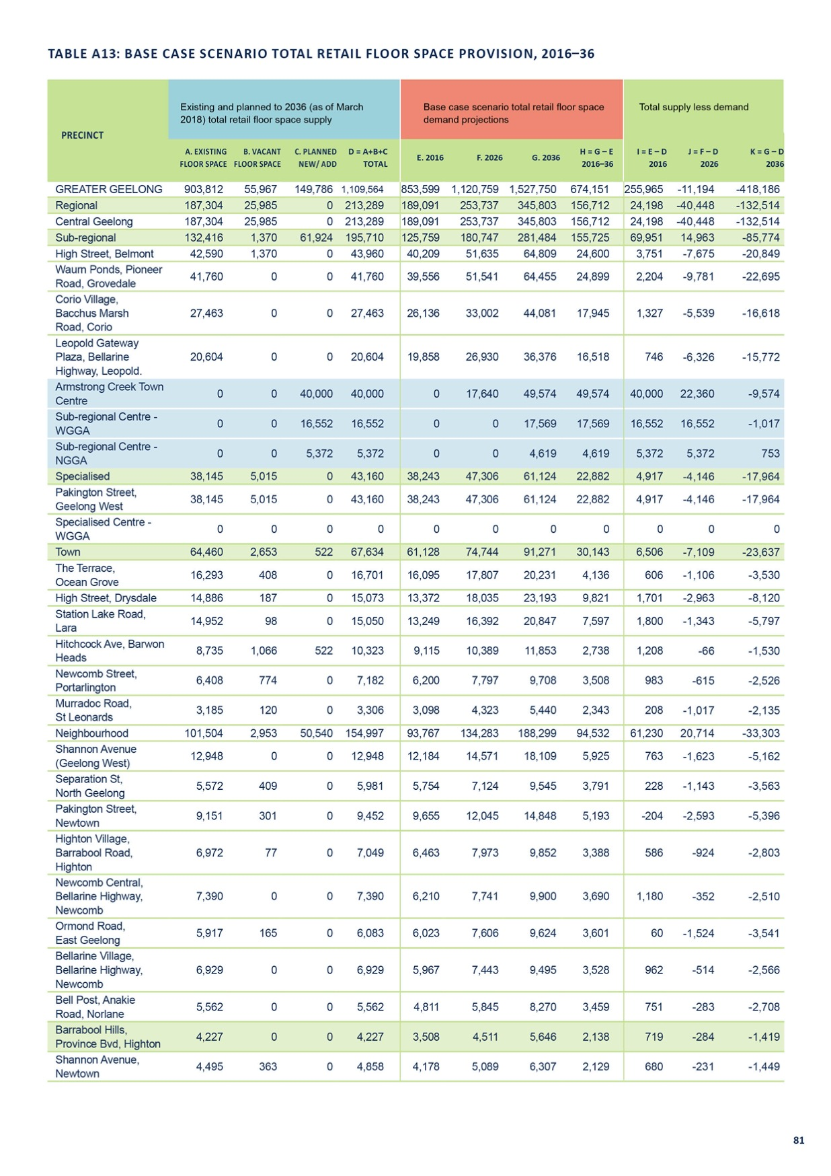

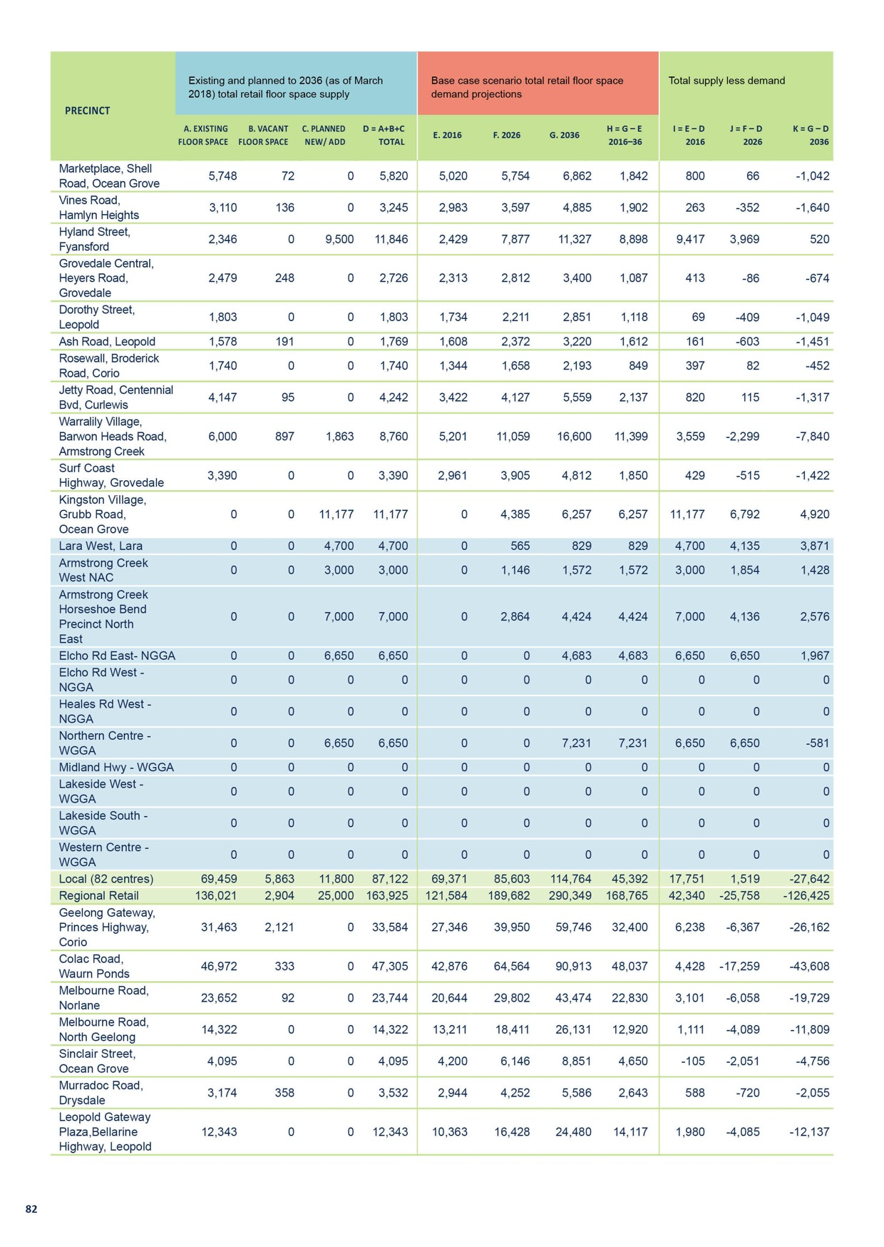

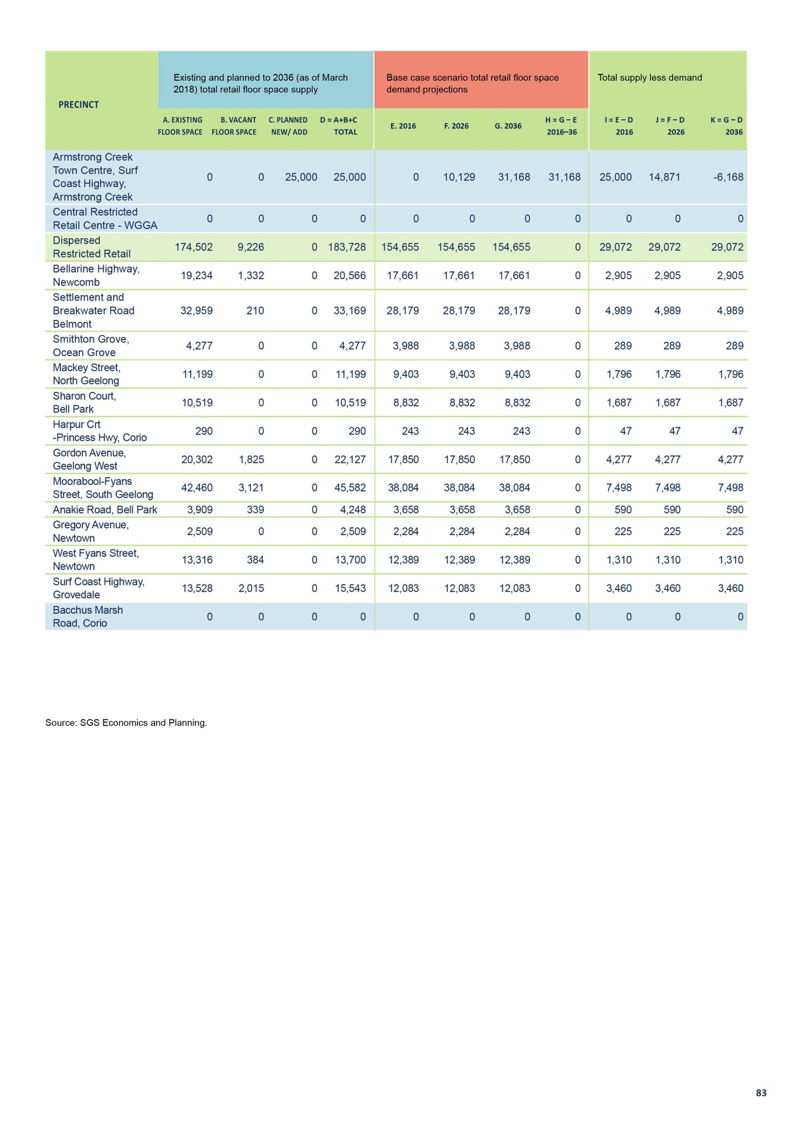

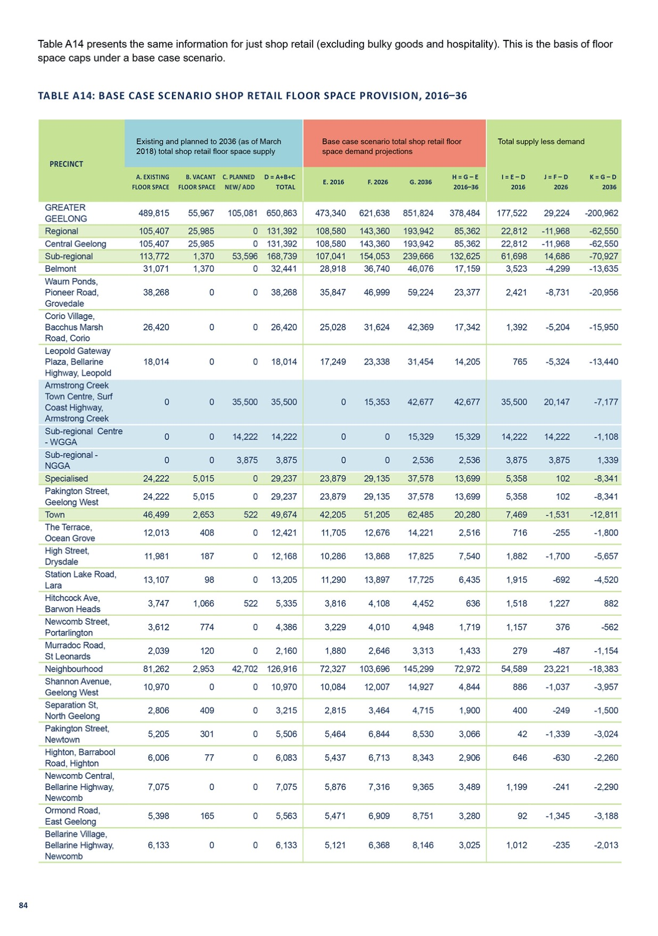
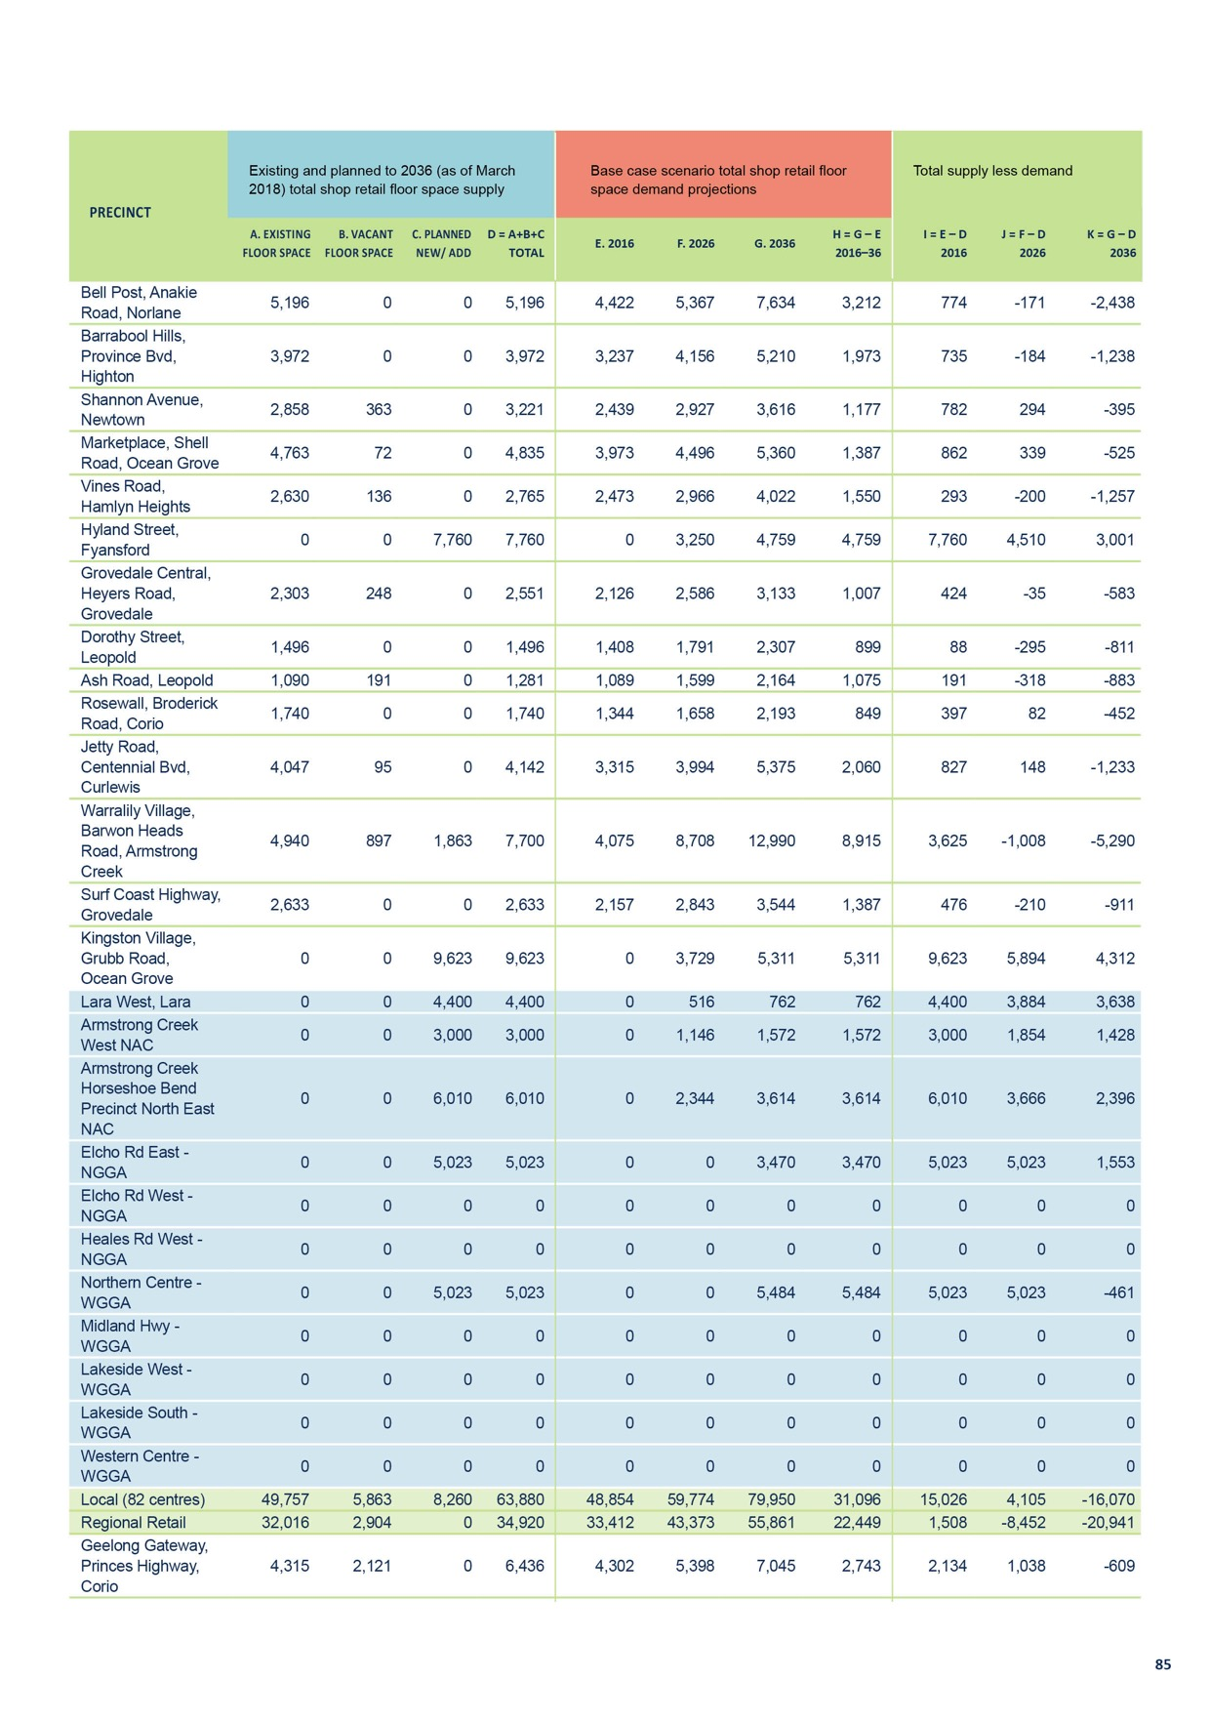

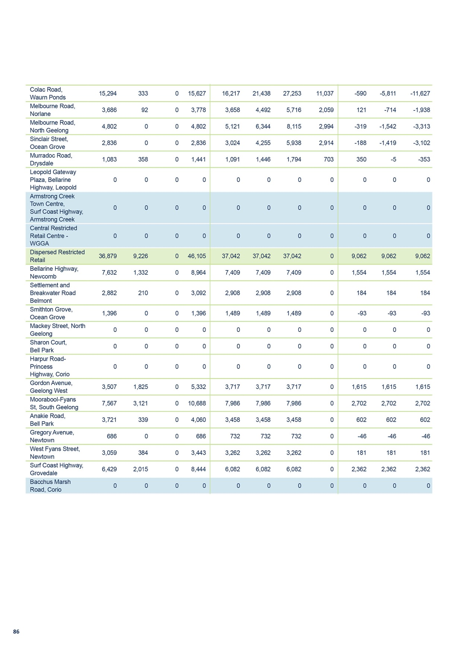

APPENDIX 2
REGIONAL CENTRES

CENTRAL GEELONG

CENTRE NAME: CENTRAL GEELONG
Hierarchy status: | Regional
Location: | Geelong
Key characteristics: | Large retail and commercial precinct with two shopping centres (Westfield Geelong and Market Square Geelong). There is limited on-street pedestrian activity and high vacancy levels in parts  of the precinct.
Current role: | Strong retail and business focus, but is faced with strong competition from surrounding centres including Pakington Street (Geelong West), Belmont and Waurn Ponds.
Zoning (sqm): | ACZ |  |  |  |  | C1Z |  |  |  | C2Z |  | MUZ |  |  |  | Other
Zoning (sqm): | 974,206 |  |  |  | 1,481 |  |  | 0 |  |  |  |  |  | 44,280 |  |  |  | 186,164
Retail and commercial floor space* (sqm): | Super market | Depart’ Store |  | Restricted Retail |  |  | Specialty Food |  | Specialty Other |  |  |  | Hospitality |  | Total Retail |  | Other Employ’ |  | Vacant
Retail and commercial floor space* (sqm): | 3,242 | 32,959 |  | 29,133 |  |  | 4,670 |  | 64,536 |  |  |  | 52,764 |  | 187,304 |  | - |  | 25,985
Retail anchors: | 1 Department store (Myer), 3 Discount department store (Big W, Dimmeys, Harris Scarfe, Target), 1 supermarket (2,542 sqm Coles)
Transport connections: | Public |  | Geelong Railway Station (approx. 400 m), South Geelong Railway Station (approx. 1.1 km), bus service (several bus routes)
 | Private |  | Several blocks on either side of Ryrie Street, accessible via Princes Highway, Hamilton Highway, Bellarine Highway and Portarlington Road
Future role and opportunities: | Recent public realm, residential and office investment within Central Geelong has resulted in more people working and living within the precinct. The number of people living and working in Central Geelong is expected to increase overtime.  The City of Greater Geelong is committed to promoting a strong arts and cultural precinct focused around the Geelong Gallery and Geelong Performing Arts Centre, located in Little Malop Street.  The development of Central Geelong is guided by the Central Geelong Structure Plan, Central Geelong Action Plan and the Revitalising Central Geelong Action Plan. Council in partnership with the Victorian Government, we will continue to promote economic productivity and pedestrian activity in the precinct by implementing the recommendations of these plans.  Whilst there is currently a strong retail and business focus in Central Geelong there is strong competition from surrounding centres, including Pakington St (Geelong West), Belmont and Waurn Ponds.  An additional 132,500 square metres of floor space could be supported within Central Geelong by 2036. It is considered that this growth could be accommodated within existing zoned land with support for higher and more dense development.
Action required: | Nil
Growth Opportunities | Forecast supportable floor space 2016–2036 sqm (difference from total floor space) |  |  |  |  | Potential to grow within current zoned land |  |  |  |  |  | Sub-precinct planning required |  |  |  | Potential for rezoning to align with centre boundary
Growth Opportunities | 132,500 |  |  |  |  | Yes |  |  |  |  | No |  |  |  |  | No
* Excludes non employment uses such as residential, car parking and sites under construction.

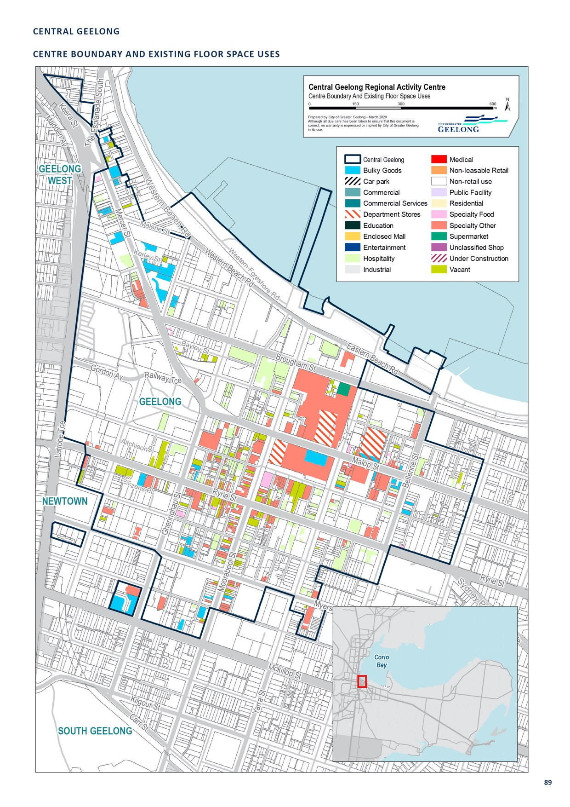

ARMSTRONG CREEK TOWN CENTRE, SURF COAST HIGHWAY, ARMSTRONG CREEK

CENTRE NAME: ARMSTRONG CREEK TOWN CENTRE, SURF COAST HIGHWAY, ARMSTRONG CREEK
Hierarchy status: | Sub-regional
Location: | Armstrong Creek
Key characteristics: | Sub-regional centre, under construction.
Current role: | Nil
Zoning (sqm): | ACZ |  |  |  |  | C1Z |  |  |  | C2Z |  | MUZ |  |  |  | Other
Zoning (sqm): | 0 |  |  |  | 0 |  |  | 0 |  |  |  |  |  | 0 |  |  |  | 0
Retail and commercial floor space* (sqm): | Super market | Depart’ Store |  | Restricted Retail |  |  | Specialty Food |  | Specialty Other |  |  |  | Hospitality |  | Total Retail |  | Other Employ’ |  | Vacant
Retail and commercial floor space* (sqm): | 0 | 0 |  | 0 |  |  | 0 |  | 0 |  |  |  | 0 |  | 40,000 |  | 0 |  | 0
Retail anchors: | Supermarkets and Discount department stores
Transport connections: | Public |  | Bus service (routes 50, 51)
 | Private |  | Surf Coast Highway
Future role and opportunities: | A sub-regional centre located on the Surf Coast Highway in Armstrong Creek. The Armstrong Creek Town Centre Precinct Structure Plan was approved in March 2016. This centre will be the civic, commercial and social heart of the Armstrong Creek Urban Growth Area. The centre is to include a mixture of traditional retailing, restricted retailing, offices, medical, sporting and civic facilities. Higher- density housing surrounding the centre is also encouraged. This centre has been planned to support 40,000 square metres of retail floor space and 25,000 of restricted retail floor space.  Planning permit 1338/2016 was granted in January 2018 for the use of a supermarket, retail premises, food and drink, office and a gym. Development has recently commenced.  Planning permit 733/2018 was also granted in October 2018 for a second supermarket, more retail premises, a service station, child care facility, tavern and food and drink premises. Construction has commenced.  If these permits were acted upon the town centre would contain a number of uses of benefit to the wider community and encourage further development within the Armstrong Creek Growth Area.
Action required: | Nil
Growth Opportunities | Forecast supportable floor space 2016–2036 sqm (difference from total floor space) |  |  |  |  | Potential to grow within current zoned land |  |  |  |  |  | Sub-precinct planning required |  |  |  | Potential for rezoning to align with centre boundary
Growth Opportunities | 9,600 (retail) 6,168 (restricted retail) |  |  |  |  | Yes |  |  |  |  | No |  |  |  |  | No

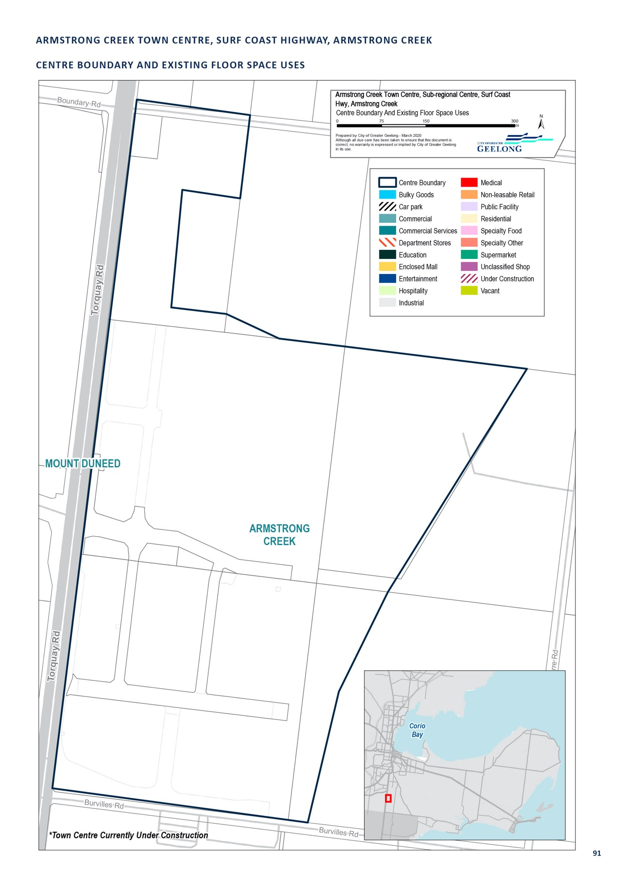

CORIO VILLAGE, BACCHUS MARSH ROAD, CORIO

CENTRE NAME: CORIO VILLAGE, BACCHUS MARSH ROAD, CORIO
Hierarchy status: | Sub-regional
Location: | Corio
Key characteristics: | Major, double-storey shopping centre with over 95 stores and services, including a City-operated service centre.
Current role: | The centre plays a central role in providing retail and services in the wider Corio area.
Zoning (sqm): | ACZ C1Z C2Z MUZ Other
Zoning (sqm): | 0 |  |  |  | 100,860 |  |  | 0 |  |  |  | 0 |  |  |  | 0
Retail and commercial floor space* (sqm): | Super Depart’ Restricted Specialty market Store Retail Food |  |  |  |  |  |  |  | Specialty Hospitality Total Retail Other |  |  |  |  |  | Other Vacant Employ’
Retail and commercial floor space* (sqm): | 8,695 | 5,772 |  | 0 |  |  | 1,245 |  | 10,708 |  | 1,043 |  | 27,463 |  | 3,500 |  | 0
Retail anchors: | 1 Discount department store (6,156 sqm Kmart), 2 supermarkets (3,634 sqm Coles, 3,655 sqm Woolworths)
Transport connections: | Public |  | Bus service (routes 10, 11, 12, 30 and 45)
 | Private |  | Corner of Bacchus Marsh Road and Purnell Road, accessed via the Geelong Ring Road and Princes Highway.
Future role and opportunities: | The residential area surrounding the centre is part of a large Increased Housing Diversity Area which supports higher density housing.  The Corio-Norlane Structure Plan 2012 supports the development of a mixed-use precinct on the residential land directly opposite the shopping centre. This precinct could be a focus for community activity in the area.  A number of different initiatives to provide housing choice and services for the community are underway, which may help to encourage growth in this area.  There is demand for an additional 16,600 square metres of floor space within this centre by 2036. Given the constraints of the site, it is likely that given surrounding site constraints, any further expansion of this centre will occur within the existing boundaries of the site. New development should be encouraged over existing car parking or buildings.
Action required: | Nil
Growth Opportunities | Forecast supportable Potential to grow Sub-precinct planning Potential for rezoning floor space 2016–2036 within current zoned required to align with centre sqm (difference from land boundary  total floor space)
Growth Opportunities | 16,600 |  |  |  |  | Yes – but with constraints |  |  |  | No |  |  |  | No

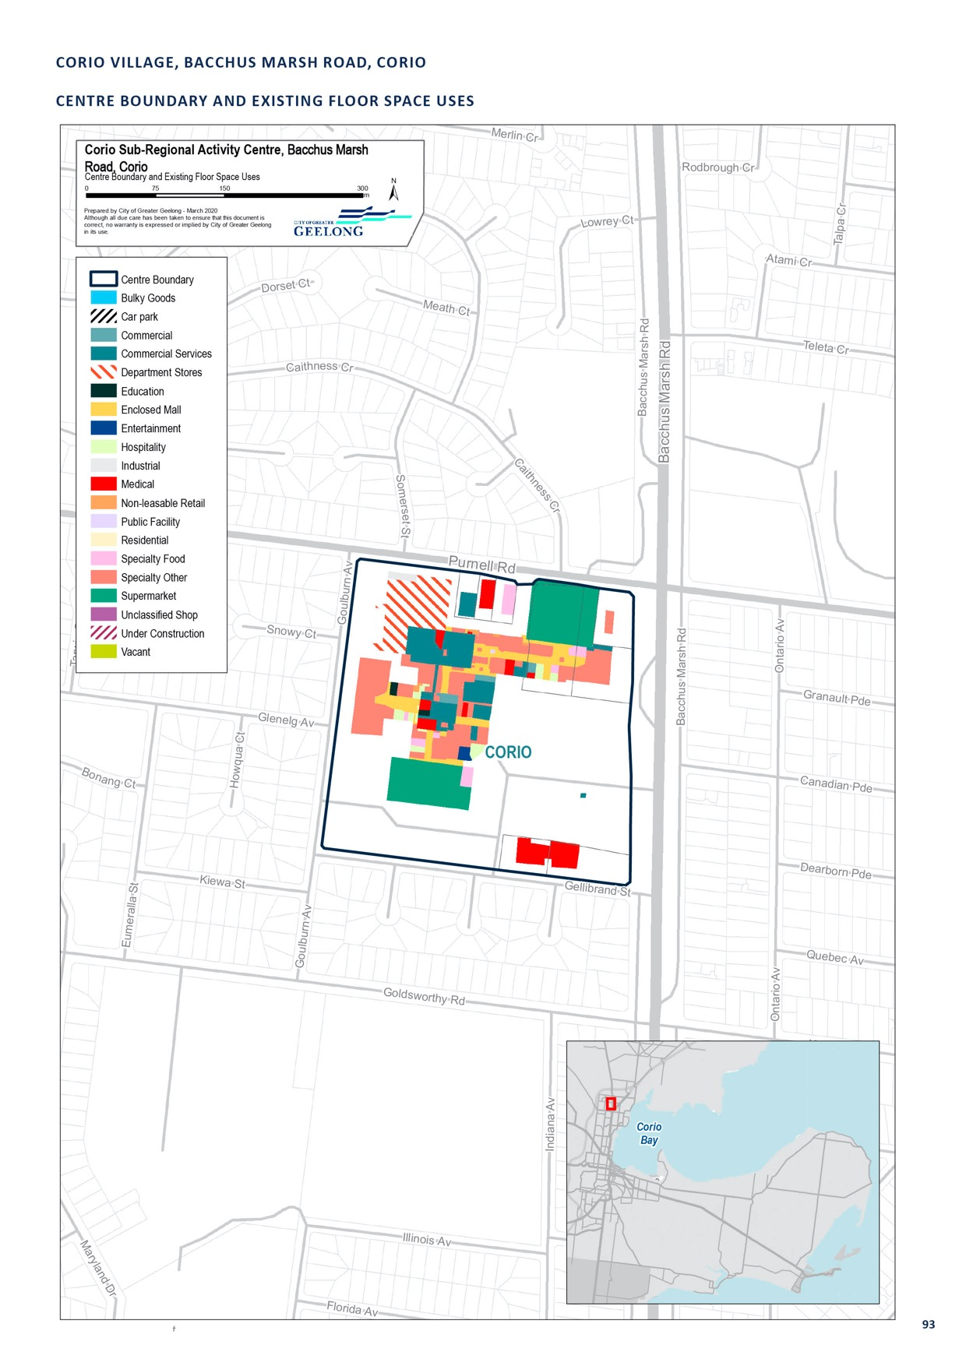

HIGH STREET, BELMONT

CENTRE NAME: HIGH STREET, BELMONT
Hierarchy status: | Sub–regional
Location: | Belmont
Key characteristics: | Major shopping strip located in close proximity to Central Geelong and well-connected to bus services. Contains Belmont Shopping Village (anchored by Coles) to the north and finer-grain built form to the south, and includes a library and a Kmart (DDS).
Current role: | This precinct contains a range of specialty shops, office, retail and hospitality services, and is particularly active at the southern end.
Zoning (sqm): | ACZ |  |  |  |  | C1Z |  |  |  | C2Z |  | MUZ |  |  |  | Other
Zoning (sqm): | 0 |  |  |  | 156,570 |  |  | 0 |  |  |  |  |  | 1,000 |  |  |  | 0
Retail and commercial floor space* (sqm): | Super market | Depart’ Store |  | Restricted Retail |  |  | Specialty Food |  | Specialty Other |  |  |  | Hospitality |  | Total Retail |  | Other Employ’ |  | Vacant
Retail and commercial floor space* (sqm): | 9,597 | 6,108 |  | 4,244 |  |  | 5,267 |  | 10,098 |  |  |  | 7,275 |  | 42,590 |  | 5,780 |  | 1,370
Retail anchors: | 1 Discount department store (6,108 sqm Kmart), 3 supermarkets (6,027 sqm Coles, 1,927 sqm Coles,  1,643 sqm Aldi)
Transport connections: | Public |  | South Geelong Railway Station (approx. 2 km), bus service along High Street (routes 14, 15, 16, 17, 19, 20 and 74)
 | Private |  | High Street, Belmont from Barwon Heads Road to Roslyn Road
Future role and opportunities: | There is demand for an additional 20,800 square metres of floor space within this centre by 2036. Council should prepare an urban design framework or structure plan to guide the growth and development of the centre, investigating how additional floor space could be accommodated within existing zoned land. The plan should also include the surrounding residential land, already identified as an increased housing diversity area, to look for opportunities to increase housing densities around the sub-regional centre and help promote increased activity within the centre.  The precinct is likely to continue to thrive, playing a continued retail, service and employment role in the local Belmont and wider Geelong area.
Action required: | Develop an urban design framework or structure plan for Belmont. The plan should consider; how to accommodate additional floor space, housing options, built form, car parking and streetscape improvements, among other things.
Growth Opportunities | Forecast supportable floor space 2016–2036 sqm (difference from total floor space) |  |  |  |  | Potential to grow within current zoned land |  |  |  |  |  | Sub-precinct planning required |  |  |  | Potential for rezoning to align with centre boundary
Growth Opportunities | 20,800 |  |  |  |  | Yes |  |  |  |  | Yes |  |  |  |  | No

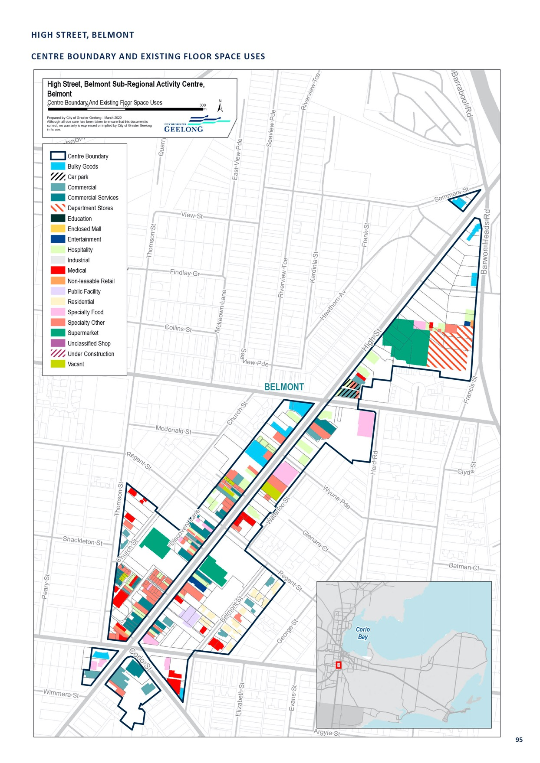

LEOPOLD GATEWAY PLAZA, BELLARINE HIGHWAY, LEOPOLD

CENTRE NAME: LEOPOLD GATEWAY PLAZA, BELLARINE HIGHWAY, LEOPOLD
Hierarchy status: | Sub-regional
Location: | Leopold
Key characteristics: | Gateway Plaza is a sub-regional centre located along the Bellarine Highway. It contains Coles and Aldi Supermarkets, Kmart, Bunnings and a number of specialty stores.
Current role: | This centre largely serves the township of Leopold, as well as commuters to and from the western region of Greater Geelong and the Bellarine Peninsula. It is complemented by small, local retail shopping strips found at Dorothy Street and Ash road and the mixed-use precinct diagonally opposite the site.
Zoning (sqm): | ACZ |  |  |  |  | C1Z |  |  |  | C2Z |  | MUZ |  |  |  | Other
Zoning (sqm): | 0 |  |  |  | 89,750 |  |  | 0 |  |  |  |  |  | 29,130 |  |  |  | 0
Retail and commercial floor space* (sqm): | Super market | Depart’ Store |  | Restricted Retail |  |  | Specialty Food |  | Specialty Other |  |  |  | Hospitality |  | Total Retail |  | Other Employ’ |  | Vacant
Retail and commercial floor space* (sqm): | 4,959 | 5,293 |  | 12,343 |  |  | 957 |  | 6,805 |  |  |  | 1,952 |  | 32,309 |  | 660 |  | 0
Planned Floor space sqm (additional) | Nil
Retail anchors: | 2 supermarkets (3,018 sqm Coles, 1,900 sqm Aldi), 1 Discount department store (5,293 sqm Kmart),  Bunnings 12,343 sqm
Transport connections: | Public |  | Bus service (routes 75, 76, 77, 83)
 | Private |  | Corner of Bellarine Highway and Melaluka Road
Future role and opportunities: | This centre consists of a Coles, Aldi, Kmart, Bunnings and speciality stores. The increase from 6,900 square metres to 32,309 square metres completes the transition of this centre to one with a sub-regional centre status. With this expansion, the centre may attract consumers from the wider Bellarine Peninsula.  This centre is also supported by a small number of retail uses, mainly hospitality, on the south-east corner of the Bellarine Hwy and Melaluka Road. This area is considered part of the sub-regional centre and is zoned Mixed Use.  The Leopold Urban Design Framework 2010 and the Leopold Structure Plan 2011 supported the transition of this centre from a neighbourhood centre to a sub-regional centre that will service the Bellarine Peninsula.  Existing planning policy (DPO30) supports the future expansion of the centre in a northerly direction, along Melaluka Road.  It is considered a review of the Development Plan Overlay Schedule 30 Leopold Sub Regional Activity Centre and the approved Development Plan is appropriate and urban design framework, particularly given the location of the Bunnings store and existing built form of the centre. The review would consider urban design improvements, and strategies to transition the centre to a true activity centre with diverse range of uses. A review also provides an opportunity to explore how to better integrate the Melaluka Road ‘main street’ concept and  opposite Leopold Memorial Park with the centre. Providing for high density housing in or adjacent to the centre should be supported where possible.
Action required: | Nil
Growth Opportunities | Forecast supportable floor space 2016–2036 sqm (difference from total floor space) |  |  |  |  | Potential to grow within current zoned land |  |  |  |  |  | Sub-precinct planning required |  |  |  | Potential for rezoning to align with centre boundary
Growth Opportunities | 15,800 (retail)  12,200 (restricted Retail) |  |  |  |  | No |  |  |  |  | No – already complete |  |  |  |  | Yes – already planned

* Excludes non employment uses such as residential, car parking and sites under construction.

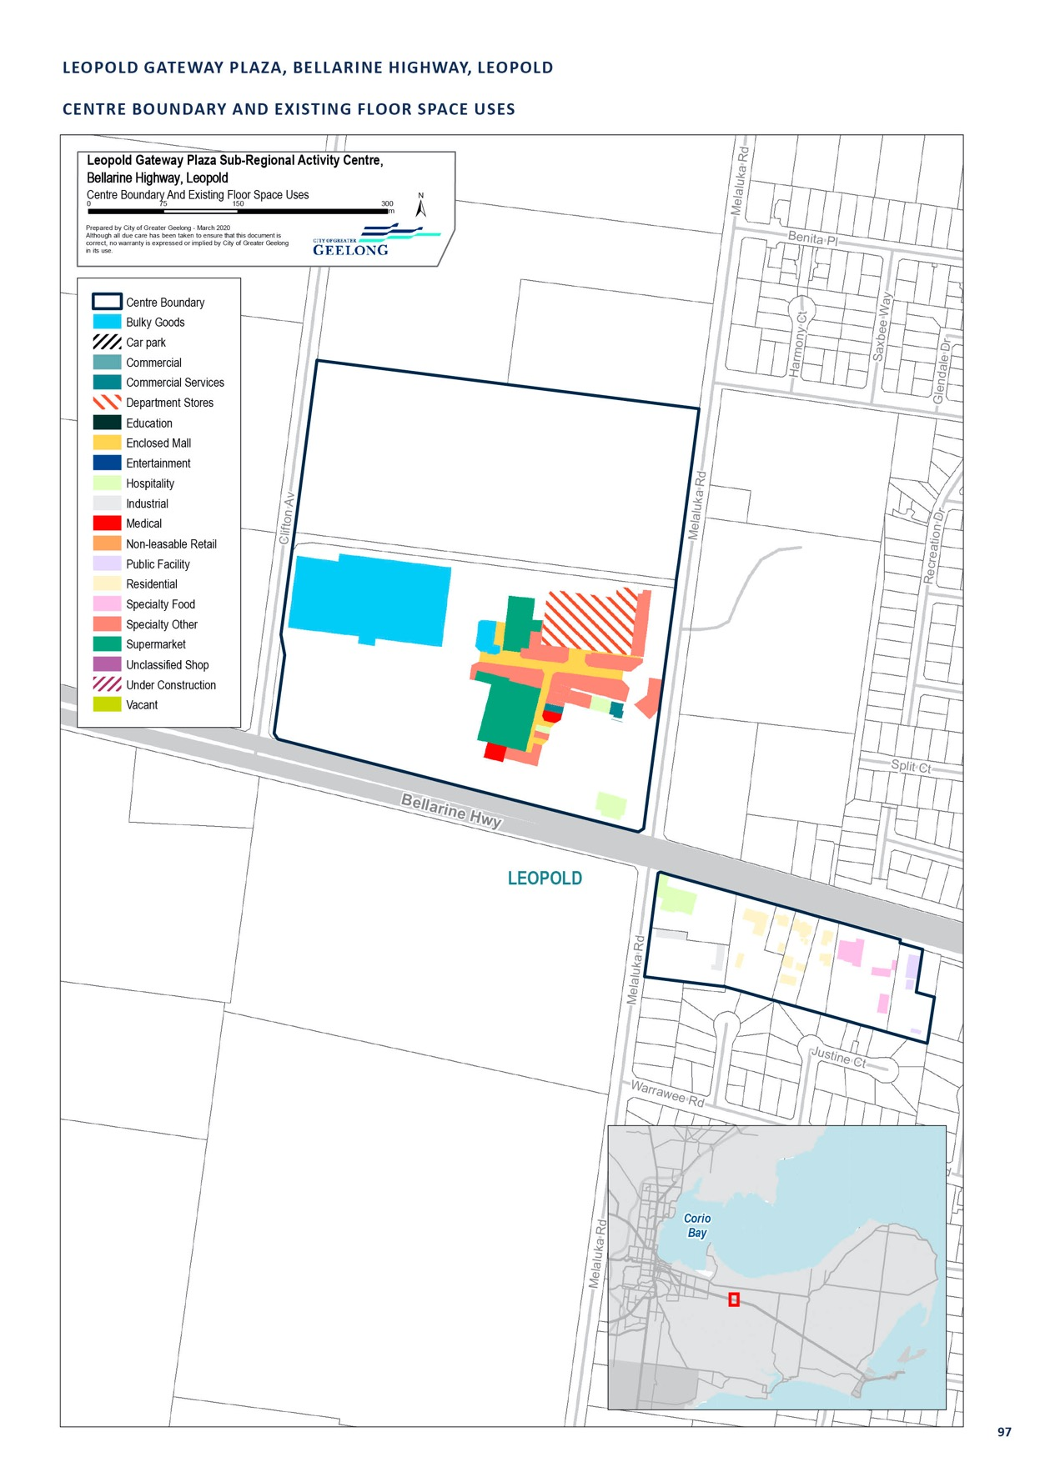

WAURN PONDS, PIONEER ROAD, GROVEDALE

CENTRE NAME: WAURN PONDS, PIONEER ROAD, GROVEDALE
Hierarchy status: | Sub-regional
Location: | Grovedale
Key characteristics: | Major shopping centre in the south-west of Greater Geelong with over 115 stores, along with an Aldi supermarket across the Highway. In close proximity to Deakin University’s Waurn Ponds campus, as well as a recreation centre and library.
Current role: | This centre serves a wide catchment, with the closest competing retail centres located in Belmont and Highton.
Zoning (sqm): | ACZ |  |  |  |  | C1Z |  |  |  | C2Z |  | MUZ |  |  |  | Other
Zoning (sqm): | 0 |  |  |  | 147,330 |  |  | 0 |  |  |  |  |  | 0 |  |  |  | 14,080
Retail and commercial floor space* (sqm): | Super market | Depart’ Store |  | Restricted Retail |  |  | Specialty Food |  | Specialty Other |  |  |  | Hospitality |  | Total Retail |  | Other Employ’ |  | Vacant
Retail and commercial floor space* (sqm): | 12,480 | 11,640 |  | 0 |  |  | 2,437 |  | 11,294 |  |  |  | 3,492 |  | 41,760 |  | 2,330 |  | 0
Retail anchors: | 2 Discount department stores (6,155 sqm Kmart, 5,488 sqm Target), 3 supermarkets (6,800 sqm Coles,  3,712 sqm Woolworths, 1,563 sqm Aldi)
Transport connections: | Public |  | Bus service (14, 15, 17, 70 and 71)
 | Private |  | Corner of Pioneer Road and Princes Highway (Colac Road), accessed via the Geelong Ring Road and Surf Coast Highway
Future role and opportunities: | It is recommended that the centre boundary include Aldi and the commercial properties on the north- western side of Colac Road, as well as the Waurn Ponds Shopping Centre.  Land to the south-west of the centre (135-177 Colac Road) is owned by the shopping centre, but is identified as a key (residential) development area in the Housing Diversity Strategy and is zoned  Residential Growth Schedule 1. Any future expansion of the shopping centre should occur within the existing Commercial 1 Zone land. The shopping centre should be encouraged to redevelop existing car parking areas and consider two or three storey development to achieve an increase in floor space.  This centre is located directly to the east of the Waurn Ponds restricted retail precinct. Over time it is expected that there will be demand to grow both the sub-regional and restricted retail centres.  Given the mix of land uses within the area, including some farming and residential-zoned land, it is recommended that a structure plan for the area between Pioneer/South Valley Road and Pigdons Road be undertaken to inform future land use and built-form outcomes. It is recommended this review consider the rezoning of the land at 250 South Valley Road and 126–138 Colac Road to a Commercial Zone.
Action required: | Amend the boundary of the Waurn Ponds Sub-regional centre to include the north-western side of Colac Road, to incorporate the Aldi, Apco Service Station, McDonalds and takeaway food premises.
Growth Opportunities | Forecast supportable floor space 2016–2036 sqm (difference from total floor space) |  |  |  |  | Potential to grow within current zoned land |  |  |  |  |  | Sub-precinct planning required |  |  |  | Potential for rezoning to align with centre boundary
Growth Opportunities | 22,700 |  |  |  |  | Yes – but with constraints |  |  |  |  | Yes |  |  |  |  | Yes

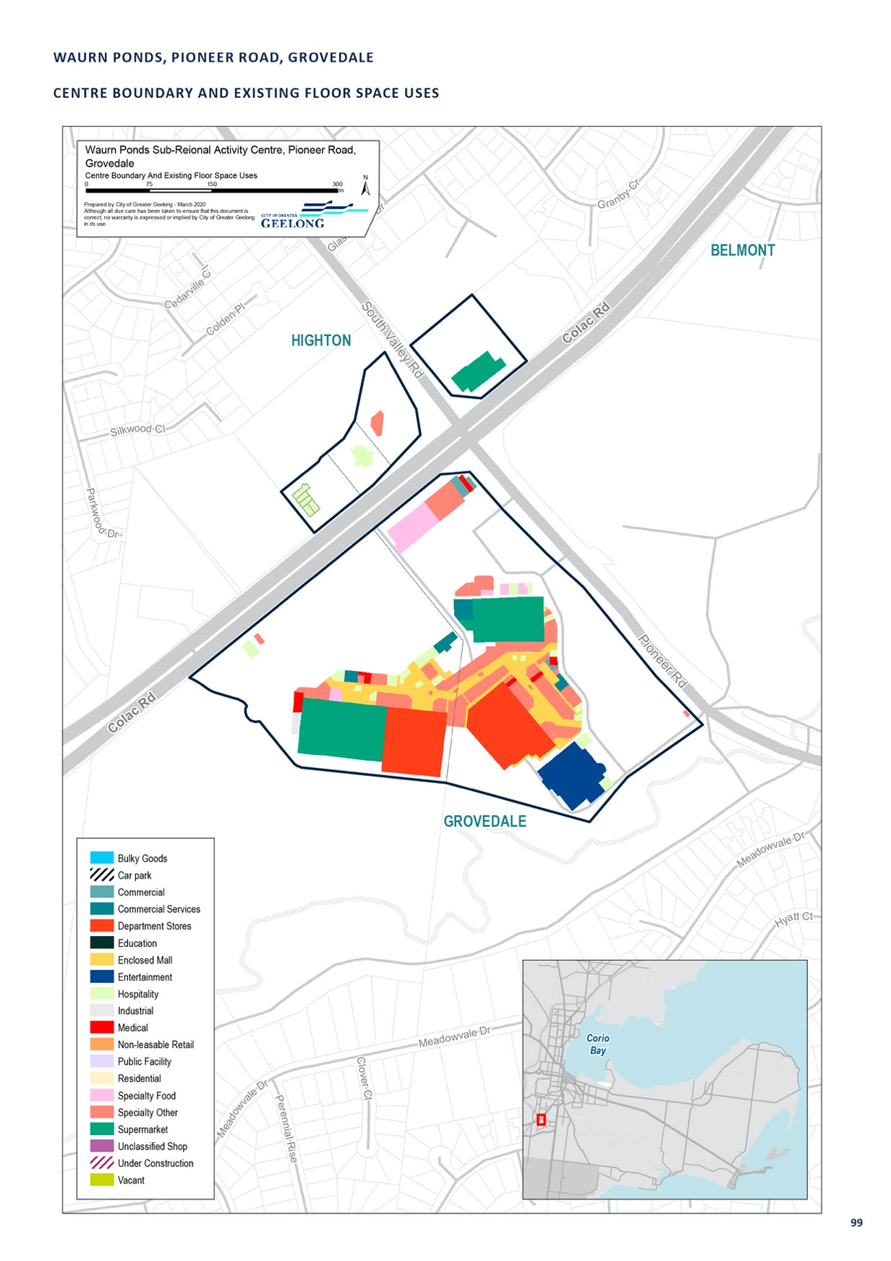

PAKINGTON STREET, GEELONG WEST

CENTRE NAME: PAKINGTON STREET, GEELONG WEST
Hierarchy status: | Specialised
Location: | Geelong West
Key characteristics: | Major, vibrant retail strip in close proximity to Central Geelong. Contains Pakington Strand (anchored by Woolworths) and a library that is well-serviced by bus and rail services. The southern end of the precinct has continuous street frontages and a traditional walkable shopping strip role, while the northern end has variable facades and more office and restricted retail use.
Current role: | Pakington Street (Geelong West) acts as a core retail, commercial and community centre in Greater Geelong, with a number of diverse retail and hospitality offers and community events. It serves both a local and wider regional role.
Zoning (sqm): | ACZ |  |  |  |  | C1Z |  |  |  | C2Z |  | MUZ |  |  |  | Other
Zoning (sqm): | 0 |  |  |  | 115,640 |  |  | 56,280 |  |  |  |  |  | 22,560 |  |  |  | 0
Retail and commercial floor space* (sqm): | Super market | Depart’ Store |  | Restricted Retail |  |  | Specialty Food |  | Specialty Other |  |  |  | Hospitality |  | Total Retail |  | Other Employ’ |  | Vacant
Retail and commercial floor space* (sqm): | 3,692 | 0 |  | 1,916 |  |  | 4,431 |  | 16,099 |  |  |  | 12,007 |  | 38,145 |  | 4,530 |  | 5,000
Retail anchors: | 3,754 sqm Woolworths supermarket
Transport connections: | Public |  | Geelong Railway Station (approx. 1 km), bus service (routes 10, 11, 12, 30, 45,  50 and 51)
 | Private |  | Pakington Street, from Church Street to Gordon Avenue, accessible via Princes Highway and Hamilton Highway
Future role and opportunities: | Pakington Street (Geelong West) is expected to continue thriving as a retail hub and community centre into the future.  Much of Pakington Street is covered by a Heritage Overlay, which plays a significant role in guiding development within the area.  Further planning work is needed to better define the role and function of the various sub-precincts within this broader centre, including the Commercial 2 Zone land located to the north. Attention is needed to ensure Pakington Street maintains its specialty retailing function and does not undermine the Geelong CBD.  We have has commenced work on an Urban Design Framework for the Commercial 1 Zone land in Pakington Street. This project primarily seeks to identify streetscape upgrades. There is scope to broaden this piece of work to investigate re-development and re-zoning opportunities at the northern end of Pakington Street as well as along Gordon Avenue.
Action required: | Prepare an urban design framework or structure plan for Pakington Street (Geelong West). The plan should consider development and re-zoning opportunities in Pakington Street, north of Waratah and Wellington streets and within the dispersed restricted retail area along Gordon Avenue.
Growth Opportunities | Forecast supportable floor space 2016–2036 sqm (difference from total floor space) |  |  |  |  | Potential to grow within current zoned land |  |  |  |  |  | Sub-precinct planning required |  |  |  | Potential for rezoning to align with centre boundary
Growth Opportunities | 18,000 |  |  |  |  | Yes |  |  |  |  | Yes |  |  |  |  | Yes

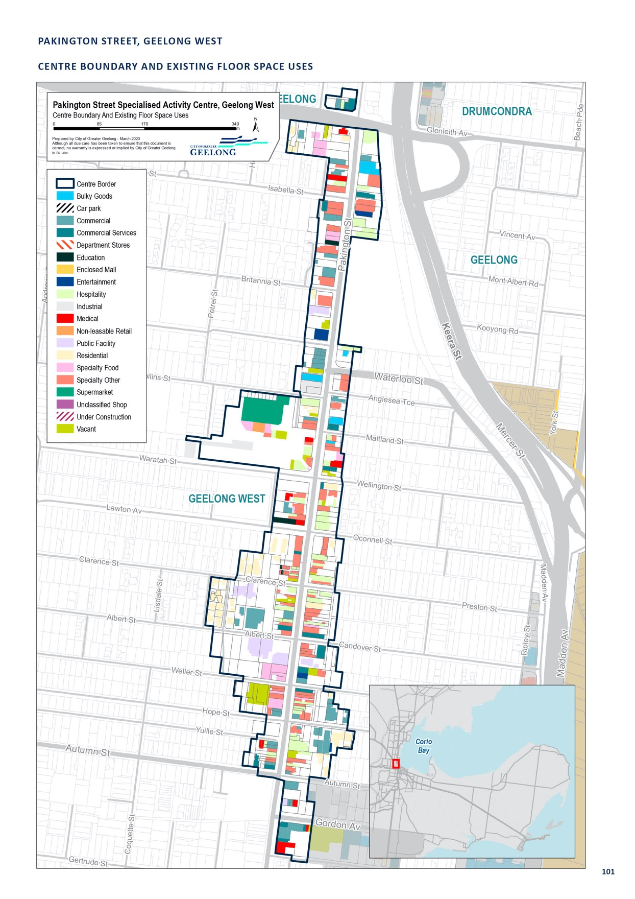

HIGH STREET, DRYSDALE

CENTRE NAME: HIGH STREET, DRYSDALE
Hierarchy status: | Town
Location: | Drysdale
Key characteristics: | A significant area in terms of size, the Drysdale Town Centre can be divided into two distinct areas in terms of land use and appearance. The areas are bounded by Portarlington Road, to the north, and Princess Street to the south. The western section comprises the main Drysdale retail centre, while the eastern section is largely industrial.
Current role: | Anchored by three supermarkets - Woolworths, Aldi and Coles - this centre is significant in both the local and sub-regional context.
Zoning (sqm): | ACZ |  |  |  |  | C1Z |  |  |  | C2Z |  | MUZ |  |  |  | Other
Zoning (sqm): | 0 |  |  |  | 97,140 |  |  | 0 |  |  |  |  |  | 0 |  |  |  | 0
Retail and commercial floor space* (sqm): | Super market | Depart’ Store |  | Restricted Retail |  |  | Specialty Food |  | Specialty Other |  |  |  | Hospitality |  | Total Retail |  | Other Employ’ |  | Vacant
Retail and commercial floor space* (sqm): | 8,013 | 0 |  | 0 |  |  | 675 |  | 3,293 |  |  |  | 2,900 |  | 14,886 |  | 1,710 |  | 200
Retail anchors: | 3 supermarkets (2,560 sqm Woolworths, 1,396 sqm Aldi, 4,000 sqm Coles)
Transport connections: | Public |  | Bus service (routes 78, 79 and 81)
 | Private |  | Intersection of Portarlington Road, Murradoc Road and Princess Street
Future role and opportunities: | With Drysdale a designated urban growth area, there may be pressure to increase stores and services in the centre. However, with new retail development, Coles in the town centre and Woolworths in Curlewis, there is unlikely to be a need for additional supermarkets in Drysdale and Clifton Springs  The development of Drysdale and Clifton Springs is guided by the Drysdale Urban Design Framework 2012 and the Drysdale/Clifton Springs Structure Plan 2010. The recommendations of these documents have been implemented into the Geelong Planning Scheme through various amendments. Most recently land along Murradoc Road has been rezoned from the Farming Zone to Commercial 2.  The Urban Design Framework identifies a number of vacant sites within the Commercial 1 Zone. Any additional demand for floor space can be achieved within existing zoned land.
Action required: | Nil
Growth Opportunities | Forecast supportable floor space 2016–2036 sqm (difference from total floor space) |  |  |  |  | Potential to grow within current zoned land |  |  |  |  |  | Sub-precinct planning required |  |  |  | Potential for rezoning to align with centre boundary
Growth Opportunities | 8,100 |  |  |  |  | Yes |  |  |  |  | No |  |  |  |  | No

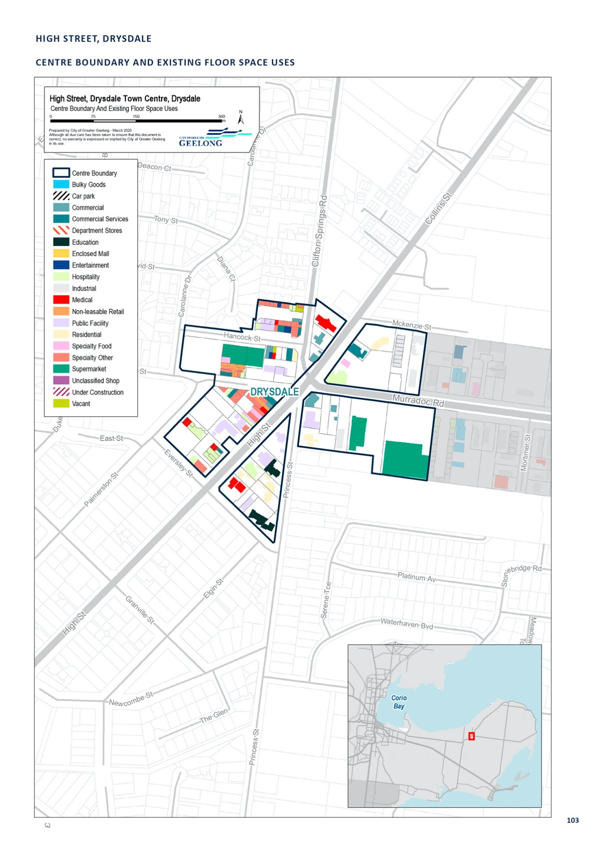

HITCHCOCK AVE, BARWON HEADS

CENTRE NAME: HITCHCOCK AVE, BARWON HEADS
Hierarchy status: | Town
Location: | Barwon Heads
Key characteristics: | Small township located on the mouth of the Barwon River. The town centre has a strong hospitality and specialty retail offer. The main street (Hitchcock Avenue) comprises a mix of commercial and residential uses.
Current role: | This centre serves the local Barwon Heads area. It has a small supermarket anchor.
Zoning (sqm): | ACZ |  |  |  |  | C1Z |  |  |  | C2Z |  | MUZ |  |  |  | Other
Zoning (sqm): | 0 |  |  |  | 26,490 |  |  | 0 |  |  |  |  |  | 29,820 |  |  |  | 0
Retail and commercial floor space* (sqm): | Super market | Depart’ Store |  | Restricted Retail |  |  | Specialty Food |  | Specialty Other |  |  |  | Hospitality |  | Total Retail |  | Other Employ’ |  | Vacant
Retail and commercial floor space* (sqm): | 1,100 | 0 |  | 0 |  |  | 270 |  | 3,040 |  |  |  | 4,990 |  | 10,300 |  | 370 |  | 1,100
Retail anchors: | 1 supermarket IGA (430 sqm (current), with plans to expand to 1,100 sqm)
Transport connections: | Public |  | Bus service (route 80)
 | Private |  | Hitchcock Avenue and Bridge Road, accessible via Barwon Heads Road and Barwon Heads-Ocean Grove Road
Future role and opportunities: | Barwon Heads is small township located on the Barwon River, opposite to Ocean Grove. It has a strong hospitably and speciality retail offer, but with only a small supermarket anchor. A planning permit has been granted to expand the supermarket, but construction has not yet commenced. Barwon Heads relies strongly on the services within Ocean Grove to meet the daily retail needs of the township.  With little residential growth planned for Barwon Heads and the need to protect areas of environmental and indigenous heritage value within and surrounding the town, the current role of Barwon Heads as a local town centre is likely to be maintained into the future.  There is limited demand for additional retail floor space within Barwon Heads between 2016 and 2036. The Barwon Heads Urban Design Framework 2003 (urban design framework) and Barwon  Heads Structure Plan 2018 relate to the Barwon Heads Town Centre (and wider township). The  recommendations of urban design framework have been implemented through significant streetscape upgrades. The structure plan does not identify the need for any additional commercial-zoned land in the township.
Action required: | Nil
Growth Opportunities | Forecast supportable floor space 2016–2036 sqm (difference from total floor space) |  |  |  |  | Potential to grow within current zoned land |  |  |  |  |  | Sub-precinct planning required |  |  |  | Potential for rezoning to align with centre boundary
Growth Opportunities | 1,600 |  |  |  |  | Yes |  |  |  |  | No |  |  |  |  | No

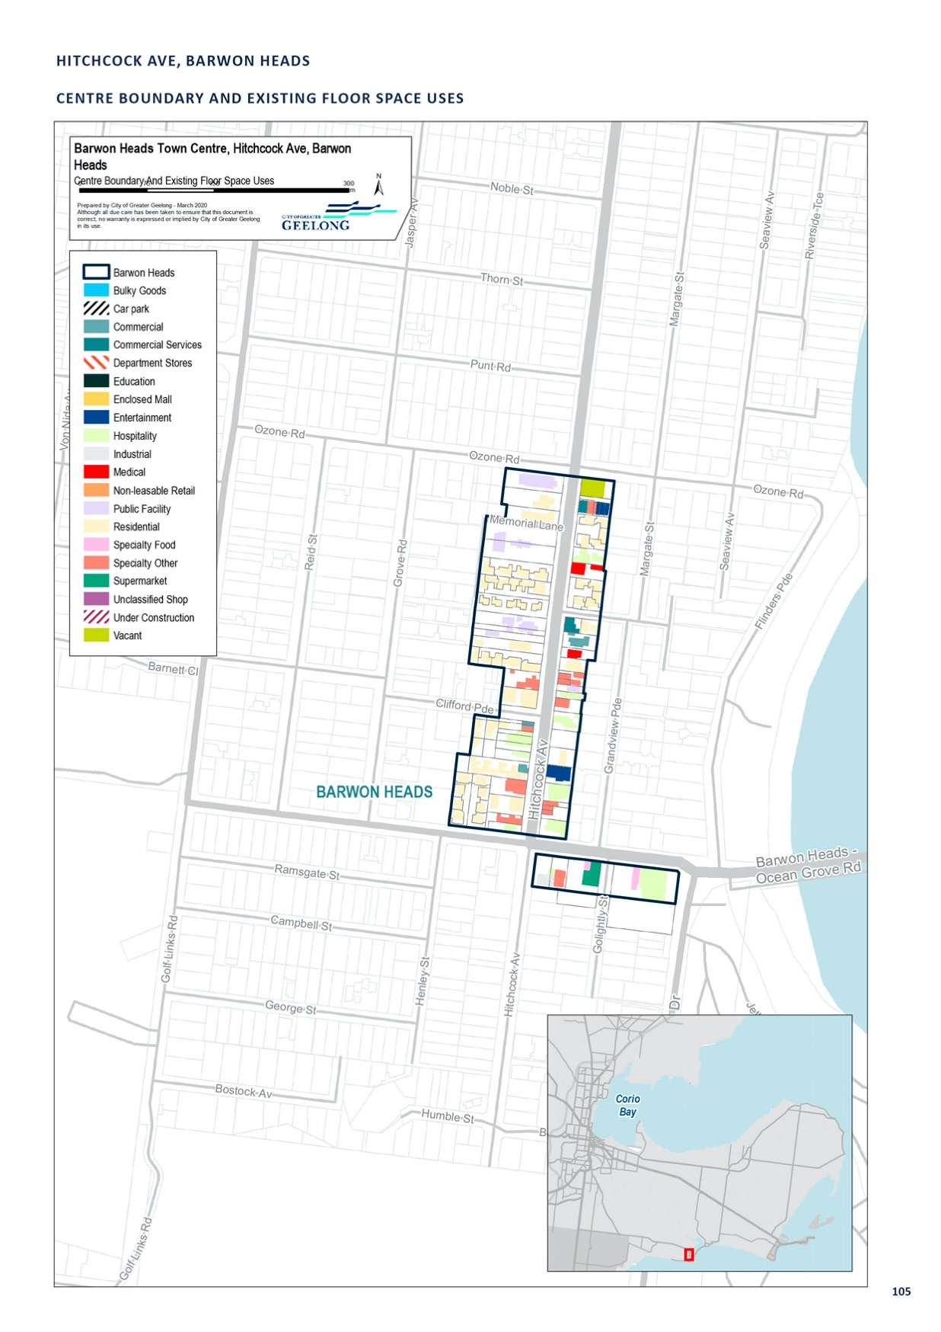

MURRADOC ROAD, ST LEONARDS

CENTRE NAME: MURRADOC ROAD, ST LEONARDS
Hierarchy status: | Town
Location: | St Leonards
Key characteristics: | Small seaside holiday town on the northern Bellarine Peninsula, with a low permanent population base that grows significantly over the summer months.
Current role: | Small town centre anchored by a small IGA and speciality retail.
Zoning (sqm): | ACZ |  |  |  |  | C1Z |  |  |  | C2Z |  | MUZ |  |  |  | Other
Zoning (sqm): | 0 |  |  |  | 15,440 |  |  | 0 |  |  |  |  |  | 0 |  |  |  | 0
Retail and commercial floor space* (sqm): | Super market | Depart’ Store |  | Restricted Retail |  |  | Specialty Food |  | Specialty Other |  |  |  | Hospitality |  | Total Retail |  | Other Employ’ |  | Vacant
Retail and commercial floor space* (sqm): | 1,000 | 0 |  | 0 |  |  | 0 |  | 1,039 |  |  |  | 1,146 |  | 3,185 |  | 0 |  | 100
Retail anchors: | 1,000 sqm IGA supermarket
Transport connections: | Public |  | Bus Service (route 60)
 | Private |  | Murradoc Road, accessible via Drysdale-St Leonards Road (Murradoc Road) and Portarlington-Road
Future role and opportunities: | St Leonards is a popular holiday destination with a relatively low permanent population in comparison to the number of dwellings within the township.  Since the 2006 retail strategy was completed, a 1,000 m2 supermarket has been constructed within the township. The township relies on Drysdale for the majority of its daily retail needs. The rezoning of land to accommodate 1500 new residential lots within the township should help to encourage additional retail investment within the town centre over time.  St Leonards has been elevated in the retail hierarchy to ’Town Centre’ to service the growing St Leonards population. A small increase in retail floor space demand has been identified by 2036, which could be accommodated within existing zoned land.  The St Leonards Urban Design Framework 2006 made recommendation regarding improvement to the streetscape within the town centre. The St Leonards Structure Plan 2015 recommended a review of the retail needs of the township in 10 years due to the potential population growth of the town, but also acknowledged there were vacant sites within the centre that could accommodate growth.
Action required: | Nil
Growth Opportunities | Forecast supportable floor space 2016–2036 sqm (difference from total floor space) |  |  |  |  | Potential to grow within current zoned land |  |  |  |  |  | Sub-precinct planning required |  |  |  | Potential for rezoning to align with centre boundary
Growth Opportunities | 2,100 |  |  |  |  | Yes |  |  |  |  | No |  |  |  |  | No

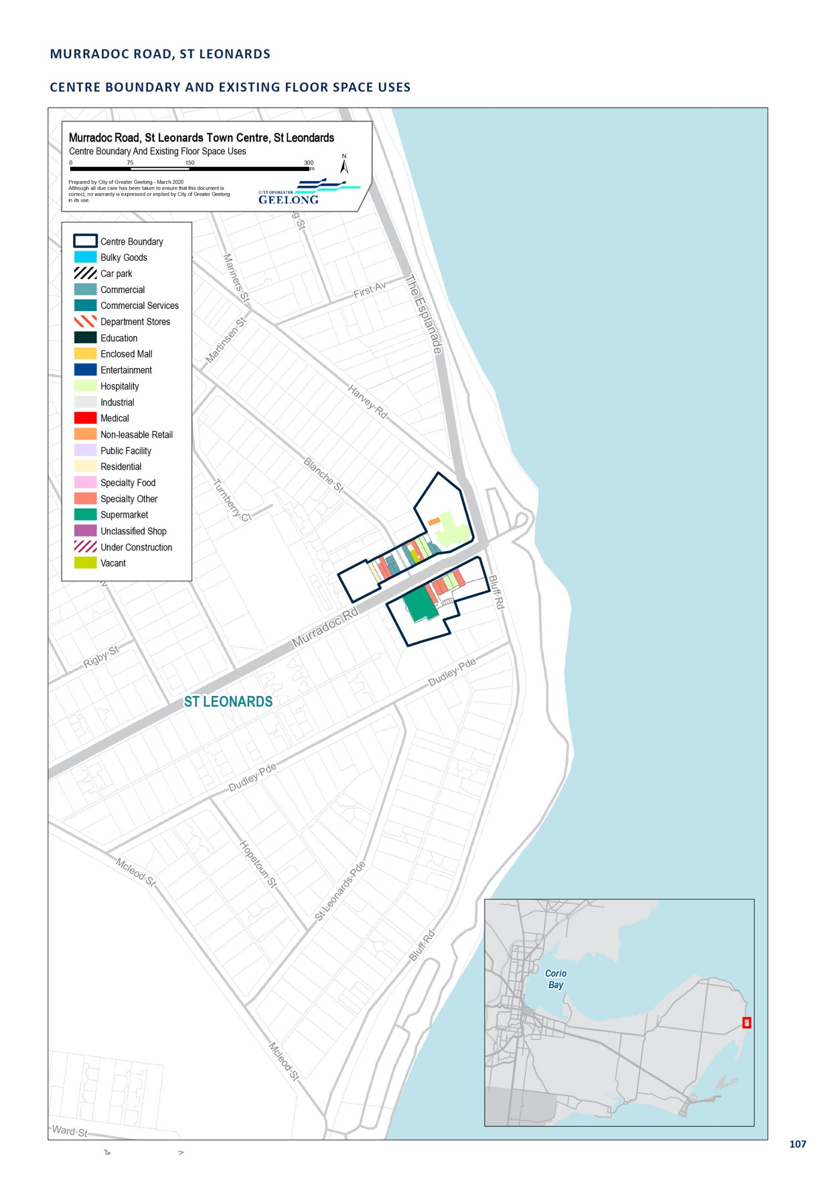

NEWCOMB STREET, PORTARLINGTON

CENTRE NAME: NEWCOMB STREET, PORTARLINGTON
Hierarchy status: | Town
Location: | Portarlington
Key characteristics: | Small, but lively, beachside retail strip with a significant hospitality component.
Current role: | This centre serves the local Portarlington area and its surrounds. Its beachside location and high amenity makes its tourism and hospitality offer attractive to a regional catchment.
Zoning (sqm): | ACZ |  |  |  |  | C1Z |  |  |  | C2Z |  | MUZ |  |  |  | Other
Zoning (sqm): | 0 |  |  |  | 38,080 |  |  | 0 |  |  |  |  |  | 0 |  |  |  | 0
Retail and commercial floor space* (sqm): | Super market | Depart’ Store |  | Restricted Retail |  |  | Specialty Food |  | Specialty Other |  |  |  | Hospitality |  | Total Retail |  | Other Employ’ |  | Vacant
Retail and commercial floor space* (sqm): | 1,430 | 0 |  | 0 |  |  | 1,043 |  | 1,145 |  |  |  | 2,796 |  | 6,408 |  | 1,010 |  | 800
Retail anchors: | 2 supermarkets (1,425 sqm Woolworths, 501 sqm IGA)
Transport connections: | Public |  | Bus services (route 79)
 | Private |  | Newcombe Street, accessible via Geelong Road and Portarlington-Queenscliff Road
Future role and opportunities: | With little residential growth planned for the area, and a compact urban form encouraged in planning policy, the role, size and intensity of the Portarlington Town Centre is likely to continue into the future.  The Portarlington Urban Design Framework 2011 and Portarlington Structure Plan 2016 relate to the Portarlington Town Centre and wider township. The urban design framework introduced a number  of Design and Development Overlays to guide the ongoing development of the town centre. It also identified development opportunities within the town centre. A small increase in retail floor space demand has been identified by 2036, which could be accommodated within existing zoned land.
Action required: | Nil
Growth Opportunities | Forecast supportable floor space 2016–2036 sqm (difference from total floor space) |  |  |  |  | Potential to grow within current zoned land |  |  |  |  |  | Sub-precinct planning required |  |  |  | Potential for rezoning to align with centre boundary
Growth Opportunities | 2,500 |  |  |  |  | Yes |  |  |  |  | No |  |  |  |  | No

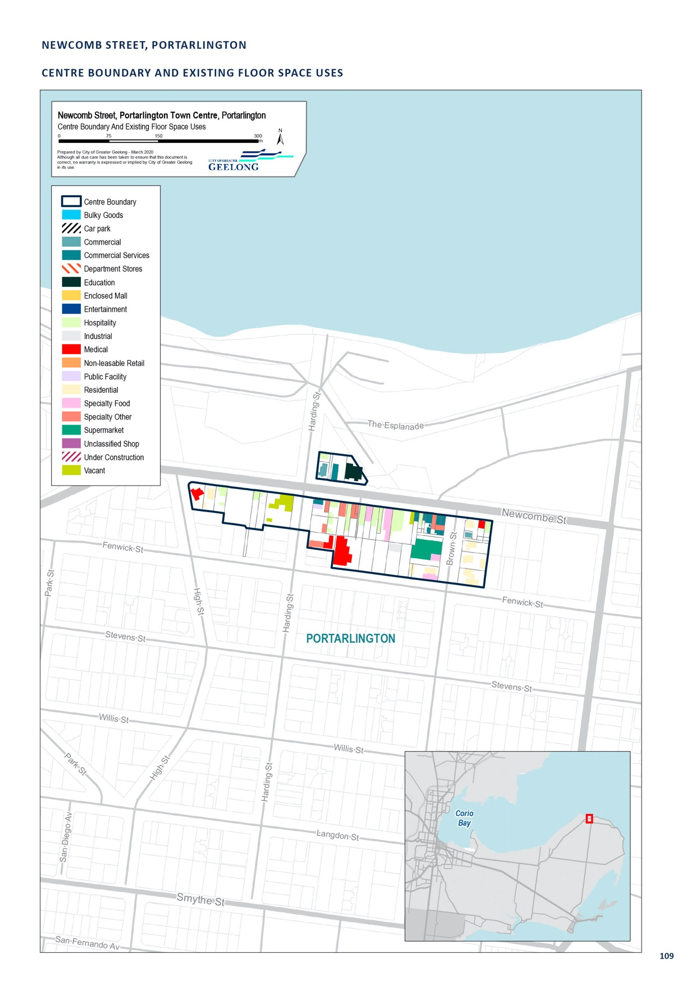

STATION LAKE ROAD, LARA

CENTRE NAME: STATION LAKE ROAD, LARA
Hierarchy status: | Town
Location: | Lara
Key characteristics: | Lara’s main, walkable retail area is anchored by Woolworths (recently redeveloped) and Coles (new). Though the Lara area has been growing in population in recent years, this centre does not appear to be performing as well as other town centres in Greater Geelong. Now the township has two full-line supermarkets spending may be more likely to be retained within the township.
Current role: | This centre serves both the Lara area and commuter traffic.
Zoning (sqm): | ACZ |  |  |  |  | C1Z |  |  |  | C2Z |  | MUZ |  |  |  | Other
Zoning (sqm): | 0 |  |  |  | 48,180 |  |  | 0 |  |  |  |  |  | 0 |  |  |  | 20
Retail and commercial floor space* (sqm): | Super market | Depart’ Store |  | Restricted Retail |  |  | Specialty Food |  | Specialty Other |  |  |  | Hospitality |  | Total Retail |  | Other Employ’ |  | Vacant
Retail and commercial floor space* (sqm): | 8,395 | 0 |  | 0 |  |  | 1,215 |  | 3,500 |  |  |  | 1,842 |  | 14,952 |  | 960 |  | 100
Retail anchors: | 2 supermarkets (Woolworths expanded to 4,200 sqm in June 2016 , 4,195 sqm Coles)
Transport connections: | Public |  | Bus service (route 12)
 | Private |  | Station Lake Road, accessible via Princes Freeway and Forest Road North/South
Future role and opportunities: | The Lara Urban Design Framework 2006 and Lara Structure Plan 2011 relate to the Lara Town Centre and the wider township. The recommendations from these documents have been implemented into the Greater Geelong Planning Scheme. The urban design framework is of particular note, as it facilitated the redevelopment of the Lara Town Centre to create additional retail floor space, consisting of a Coles supermarket and speciality stores. Since the opening of the Coles Supermarket, the Woolworths store has been redeveloped.  The further outward expansion of the Lara Town Centre may be challenging to achieve given the abutting land uses. We would encourage increasing the height of buildings within the town centre to achieve additional floor space and land use mix.
Action required: | Nil
Growth Opportunities | Forecast supportable floor space 2016–2036 sqm (difference from total floor space) |  |  |  |  | Potential to grow within current zoned land |  |  |  |  |  | Sub-precinct planning required |  |  |  | Potential for rezoning to align with centre boundary
Growth Opportunities | 5,700 |  |  |  |  | Yes – with constraints |  |  |  |  | No |  |  |  |  | No

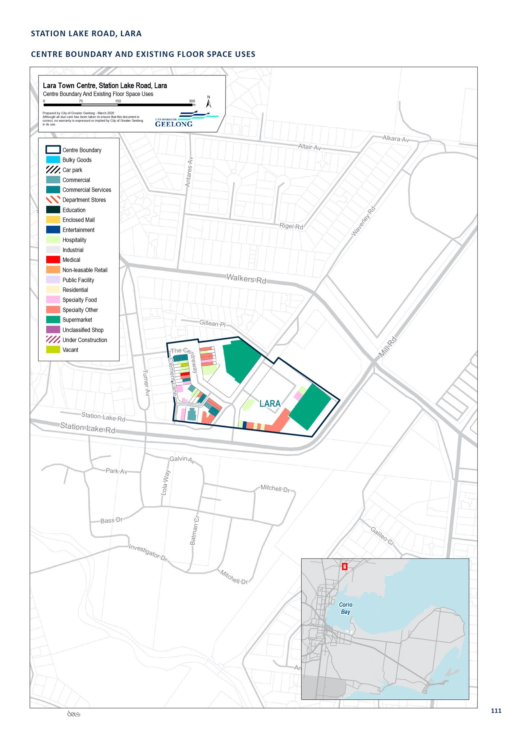

THE TERRACE, OCEAN GROVE

CENTRE NAME: THE TERRACE, OCEAN GROVE
Hierarchy status: | Town
Location: | Ocean Grove
Key characteristics: | Thriving, beachside centre with high-quality streetscape along main road (The Terrace). The precinct is, to a degree, disjointed by the large, centrally-located car park and the sprawling retail uses to the north, northeast and east of the fine-grain, walkable retail strip along The Terrace.
Current role: | This centre has a mix of retail, restricted retail, offices, services, hospitality and industrial use. As one of the larger retail offers in the southern Bellarine Peninsula sub-region, including Barwon Heads, Point Lonsdale and Queenscliff, it plays both a local and wider sub-regional role.
Zoning (sqm): | ACZ |  |  |  |  | C1Z |  |  |  | C2Z |  | MUZ |  |  |  | Other
Zoning (sqm): | 0 |  |  |  | 53,170 |  |  | 0 |  |  |  |  |  | 3,240 |  |  |  | 40
Retail and commercial floor space* (sqm): | Super market | Depart’ Store |  | Restricted Retail |  |  | Specialty Food |  | Specialty Other |  |  |  | Hospitality |  | Total Retail |  | Other Employ’ |  | Vacant
Retail and commercial floor space* (sqm): | 2,713 | 1,842 |  | 701 |  |  | 1,013 |  | 6,445 |  |  |  | 3,579 |  | 16,293 |  | 2,400 |  | 400
Retail anchors: | 1 Discount department store (1,840 sqm Target), 1 supermarket (2,711 sqm Coles)
Transport connections: | Public |  | Bus service (routes 80, 81, 82 and 83)
 | Private |  | Hodgson Street, between The Avenue and Dare Street, accessible via Grubb Road, Shell Road and Bellarine Highway
Future role and opportunities: | While relatively near the Ocean Grove (Marketplace) neighbourhood centre, the diversity and extent of the retail offer at the Ocean Grove Town Centre ensures that it will likely continue to be very competitive, even in the sub-regional context. With Ocean Grove a designated district town, there may be pressure to increase stores and services in the centre.  The Ocean Grove Urban Design Framework 2016 and the Ocean Grove Structure Plan 2015 relate to the development of the Town Centre and wider township. Recently Planning Scheme Amendment C346 has implemented the recommendations from these documents into the Planning Scheme, including Design and Development Overlays to guide the development of the town centre. The urban design framework identifies development opportunities within the town centre which would achieve additional retail floor space.
Action required: | Nil
Growth Opportunities | Forecast supportable floor space 2016–2036 sqm (difference from total floor space) |  |  |  |  | Potential to grow within current zoned land |  |  |  |  |  | Sub-precinct planning required |  |  |  | Potential for rezoning to align with centre boundary
Growth Opportunities | 3,500 |  |  |  |  | Yes |  |  |  |  | No |  |  |  |  | No

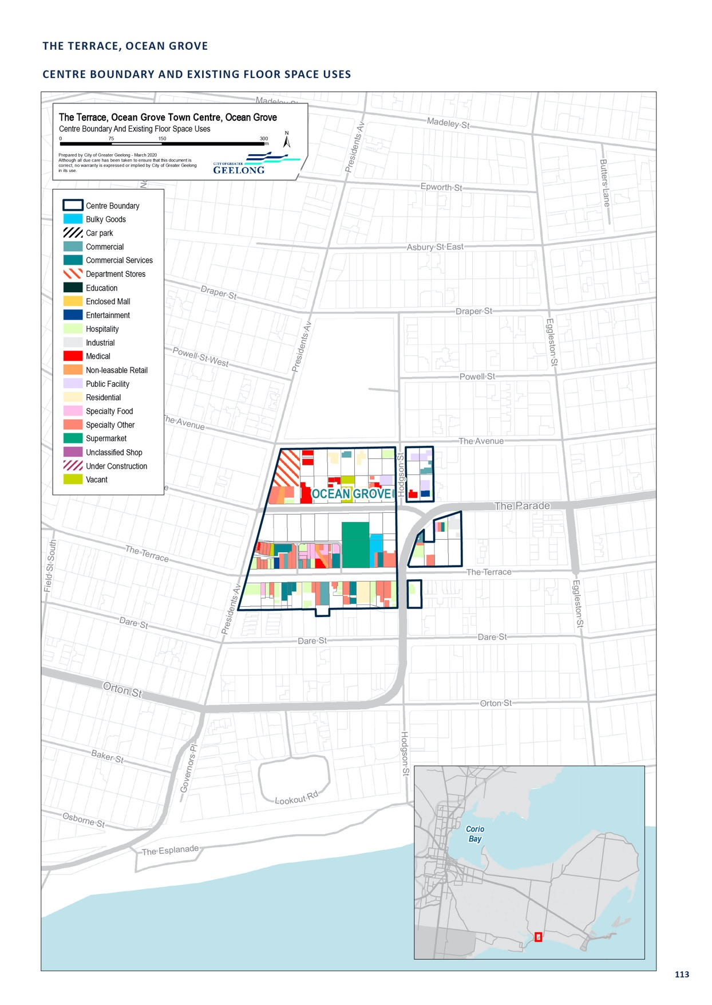

ASH ROAD, LEOPOLD

CENTRE NAME: ASH ROAD, LEOPOLD
Hierarchy status: | Neighbourhood
Location: | Leopold
Key characteristics: | Small local shopping strip in residential area with a Friendly Grocer.
Current role: | Serves the Leopold area at a very local level.
Zoning (sqm): | ACZ |  |  |  |  | C1Z |  |  |  | C2Z |  | MUZ |  |  |  | Other
Zoning (sqm): | 0 |  |  |  | 2,450 |  |  | 0 |  |  |  |  |  | 0 |  |  |  | 0
Retail and commercial floor space* (sqm): | Super market | Depart’ Store |  | Restricted Retail |  |  | Specialty Food |  | Specialty Other |  |  |  | Hospitality |  | Total Retail |  | Other Employ’ |  | Vacant
Retail and commercial floor space* (sqm): | 0 | 0 |  | 0 |  |  | 380 |  | 710 |  |  |  | 490 |  | 1,580 |  | 0 |  | 190
Retail anchors: | 1 supermarket (376 sqm Friendly Grocer)
Transport connections: | Public |  | Bus service (route 77)
 | Private |  | Ash Road, between Lawrence Street and Anzac Avenue, accessible via Bellarine Highway
Future role and opportunities: | Serves the Leopold area at a very local level. May experience changes in the future as it has been included as an Increased Housing Diversity Area in the Planning Scheme
Action required: | Nil
Growth Opportunities | Forecast supportable floor space 2016–2036 sqm (difference from total floor space) |  |  |  |  | Potential to grow within current zoned land |  |  |  |  |  | Sub-precinct planning required |  |  |  | Potential for rezoning to align with centre boundary
Growth Opportunities | 1,400 |  |  |  |  | No |  |  |  |  | No |  |  |  |  | No

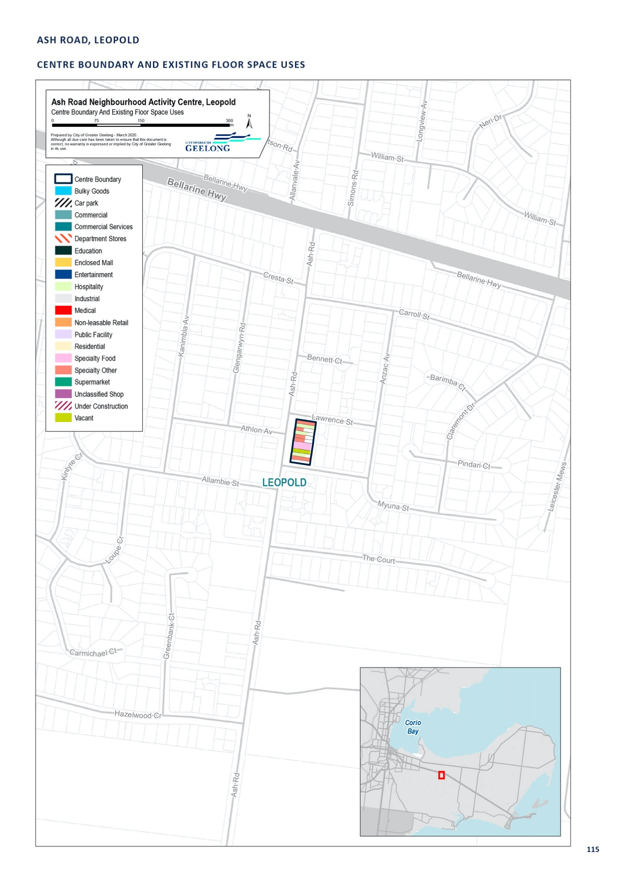

BARRABOOL HILLS, PROVINCE BVD, HIGHTON

CENTRE NAME: BARRABOOL HILLS, PROVINCE BVD, HIGHTON
Hierarchy status: | Neighbourhood
Location: | Highton
Key characteristics: | This centre is anchored by a Woolworths supermarket and specialty stores.
Current role: | Neighbourhood centre
Zoning (sqm): | ACZ |  |  |  |  | C1Z |  |  |  | C2Z |  | MUZ |  |  |  | Other
Zoning (sqm): | 0 |  |  |  | 19,410 |  |  | 0 |  |  |  |  |  | 0 |  |  |  | 0
Retail and commercial floor space* (sqm): | Super market | Depart’ Store |  | Restricted Retail |  |  | Specialty Food |  | Specialty Other |  |  |  | Hospitality |  | Total Retail |  | Other Employ’ |  | Vacant
Retail and commercial floor space* (sqm): | 3,318 | 0 |  | 0 |  |  | 110 |  | 543 |  |  |  | 255 |  | 4,226 |  | 0 |  | 0
Retail anchors: | 1 supermarket (3,318 sqm Woolworths)
Transport connections: | Public |  | Bus service (route 34)
 | Private |  | Corner Stoneleigh Crescent and Province Boulevard, accessible via Barrabool Road
Future role and opportunities: | The centre services Highton and Wandana Heights, an area that has a growing residential population and was strongly lacking a retail offer prior to this centre opening.  This centre was opened in 2015. Further expansion of the centre may be limited given land constraints.
Action required: | Nil
Growth Opportunities | Forecast supportable floor space 2016–2036 sqm (difference from total floor space) |  |  |  |  | Potential to grow within current zoned land |  |  |  |  |  | Sub-precinct planning required |  |  |  | Potential for rezoning to align with centre boundary
Growth Opportunities | 1,400 |  |  |  |  | No |  |  |  |  | No |  |  |  |  | No

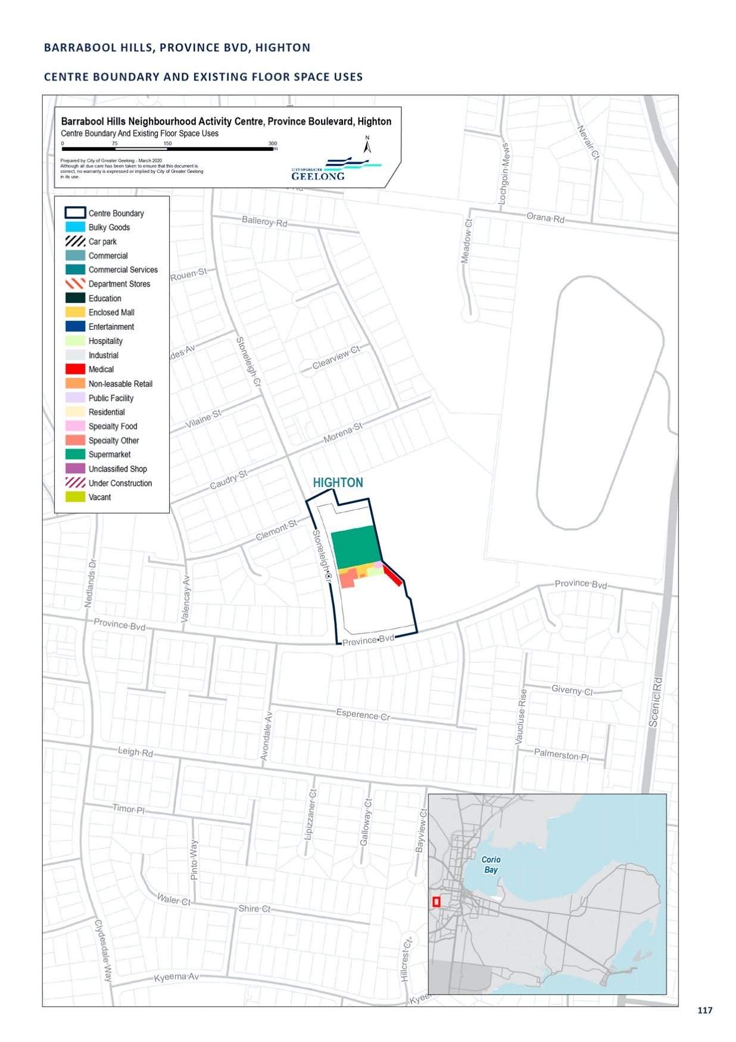

BELL POST, ANAKIE ROAD, NORLANE

CENTRE NAME: BELL POST, ANAKIE ROAD, NORLANE
Hierarchy status: | Neighbourhood
Location: | Norlane
Key characteristics: | Mid-sized shopping centre (anchored by Woolworths) along Anakie Road. The centre appears to have low customer activity (a trend unchanged from the 2006 Geelong Retail Strategy) and has poor accessibility, due to its position north of Cowies Creek, which has limited road traffic permeability.
Current role: | This centre serves the local Bell Post Hill area and is complemented by several small local centres.
Zoning (sqm): | ACZ |  |  |  |  | C1Z |  |  |  | C2Z |  | MUZ |  |  |  | Other
Zoning (sqm): | 0 |  |  |  | 24,930 |  |  | 0 |  |  |  |  |  | 0 |  |  |  | 0
Retail and commercial floor space* (sqm): | Super market | Depart’ Store |  | Restricted Retail |  |  | Specialty Food |  | Specialty Other |  |  |  | Hospitality |  | Total Retail |  | Other Employ’ |  | Vacant
Retail and commercial floor space* (sqm): | 3,352 | 0 |  | 0 |  |  | 675 |  | 1,169 |  |  |  | 366 |  | 5,562 |  | 390 |  | 0
Retail anchors: | 1 supermarket (3,403 sqm Woolworths)
Transport connections: | Public |  | Bus service (route 45)
 | Private |  | Anakie Road, between Donnybrook Road and Braund Avenue/Furner Avenue
Future role and opportunities: | With its location and anchor, there is significant potential for the performance of the shopping centre to be improved.  An Aldi store has been constructed 800m to the south of this centre, on Anakie Road. This may create competition for this centre.  This centre could look at ways to improve the retail offer to attract more trade.
Action required: | Nil
Growth Opportunities | Forecast supportable floor space 2016–2036 sqm (difference from total floor space) |  |  |  |  | Potential to grow within current zoned land |  |  |  |  |  | Sub-precinct planning required |  |  |  | Potential for rezoning to align with centre boundary
Growth Opportunities | 2,700 |  |  |  |  | Yes – with constraints |  |  |  |  | No |  |  |  |  | No

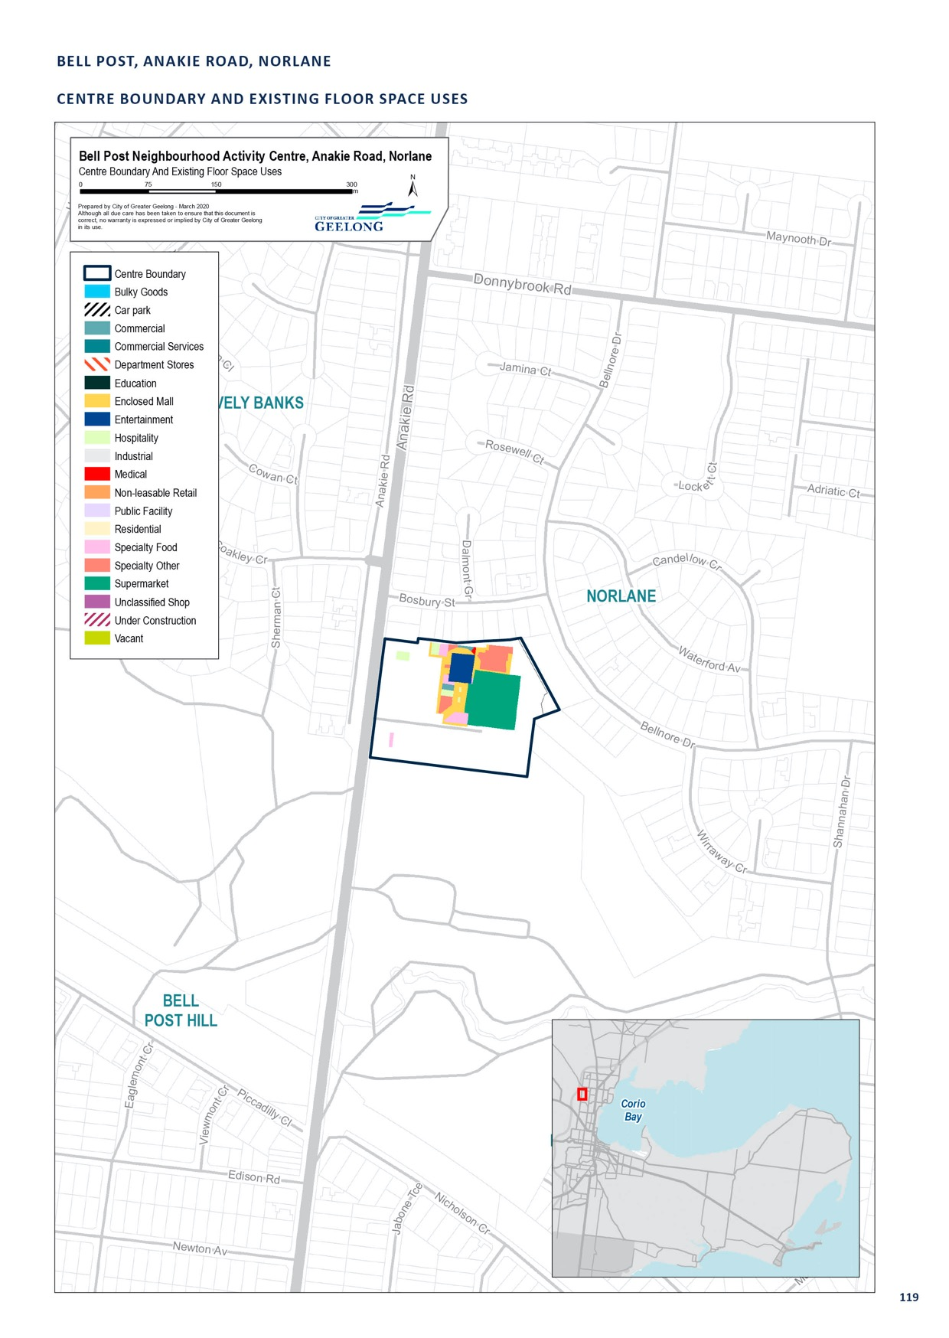

BELLARINE VILLAGE, BELLARINE HIGHWAY, NEWCOMB

CENTRE NAME: BELLARINE VILLAGE, BELLARINE HIGHWAY, NEWCOMB
Hierarchy status: | Neighbourhood
Location: | Newcomb
Key characteristics: | Mid-sized shopping centre (anchored by Woolworths) along the Bellarine Highway in Newcomb. It is in very close proximity (under 400 m) to the larger Newcomb Central Shopping Centre.
Current role: | This centre offers a mix of retail and services, with some hospitality. Along with Newcomb Central, it serves the Newcomb area, along with the wider Thomson, Whittington, Breakwater, St Albans Park and Moolap areas. These areas offer only small, local retail and no supermarkets. The centre also serves commuters travelling to and from the western region of Greater Geelong and the Bellarine Peninsula.  It benefits from being located along the highway ahead of Newcomb Central for commuters travelling from Geelong.
Zoning (sqm): | ACZ |  |  |  |  | C1Z |  |  |  | C2Z |  | MUZ |  |  |  | Other
Zoning (sqm): | 0 |  |  |  | 20,740 |  |  | 0 |  |  |  |  |  | 0 |  |  |  | 2,480
Retail and commercial floor space* (sqm): | Super market | Depart’ Store |  | Restricted Retail |  |  | Specialty Food |  | Specialty Other |  |  |  | Hospitality |  | Total Retail |  | Other Employ’ |  | Vacant
Retail and commercial floor space* (sqm): | 3,868 | 0 |  | 0 |  |  | 1,438 |  | 827 |  |  |  | 796 |  | 6,929 |  | 430 |  | 0
Retail anchors: | 1 supermarket (3,868 sqm Woolworths)
Transport connections: | Public |  | Bus service (routes 45, 75, 76, 77 and 83)
 | Private |  | Bellarine Highway, between Boundary Road and Wilsons Road
Future role and opportunities: | A moderate amount of retail growth is forecast for this centre through to 2036. The centre is landlocked but redevelopment over existing car parking or acquisition of adjacent housing could provide additional floor space in the future.
Action required: | Nil
Growth Opportunities | Forecast supportable floor space 2016–2036 sqm (difference from total floor space) |  |  |  |  | Potential to grow within current zoned land |  |  |  |  |  | Sub-precinct planning required |  |  |  | Potential for rezoning to align with centre boundary
Growth Opportunities | 2,600 |  |  |  |  | Yes – but with constraints |  |  |  |  | No |  |  |  |  | No

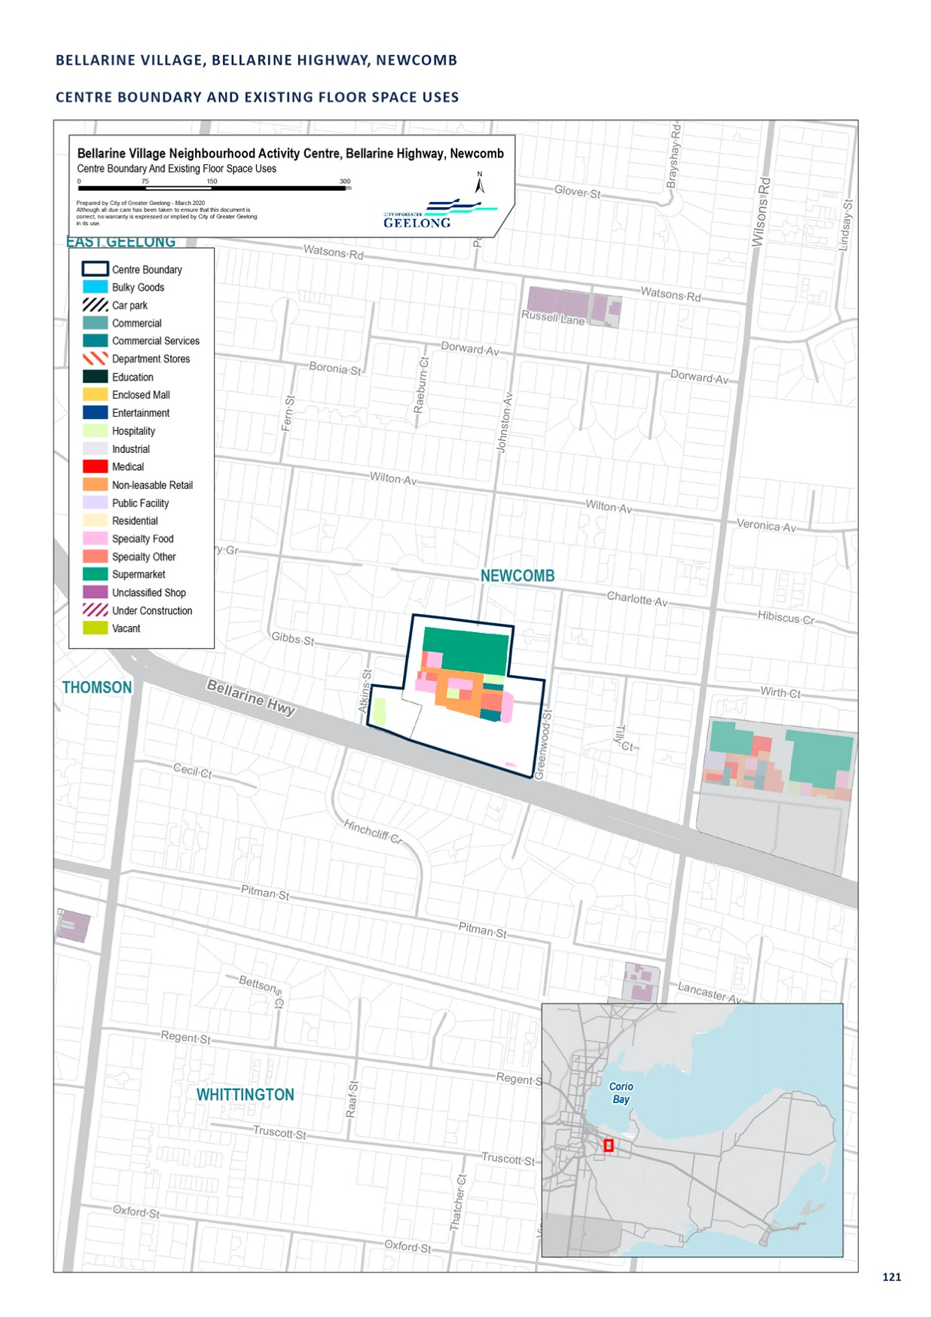

DOROTHY STREET, LEOPOLD

CENTRE NAME: DOROTHY STREET, LEOPOLD
Hierarchy status: | Neighbourhood
Location: | Leopold
Key characteristics: | Small local shopping strip in residential area with a Foodworks supermarket.
Current role: | Serves the Leopold area at a very local level.
Zoning (sqm): | ACZ |  |  |  |  | C1Z |  |  |  | C2Z |  | MUZ |  |  |  | Other
Zoning (sqm): | 0 |  |  |  | 3,030 |  |  | 0 |  |  |  |  |  | 0 |  |  |  | 2,480
Retail and commercial floor space* (sqm): | Super market | Depart’ Store |  | Restricted Retail |  |  | Specialty Food |  | Specialty Other |  |  |  | Hospitality |  | Total Retail |  | Other Employ’ |  | Vacant
Retail and commercial floor space* (sqm): | 636 | 0 |  | 0 |  |  | 0 |  | 860 |  |  |  | 306 |  | 1,803 |  | 240 |  | 0
Retail anchors: | 1 supermarket (636 sqm Foodworks)
Transport connections: | Public |  | Bus service (route 77)
 | Private |  | Dorothy Street, between Simonds Road and Longview Avenue, accessible via Bellarine Highway and Portarlington Road
Future role and opportunities: | This centre serves the Leopold area at a very local level. This centre may experience changes in the future as it has been included as an Increased Housing Diversity Area in the Planning Scheme.
Action required: | Nil
Growth Opportunities | Forecast supportable floor space 2016–2036 sqm (difference from total floor space) |  |  |  |  | Potential to grow within current zoned land |  |  |  |  |  | Sub-precinct planning required |  |  |  | Potential for rezoning to align with centre boundary
Growth Opportunities | 1,100 |  |  |  |  | No |  |  |  |  | No |  |  |  |  | No

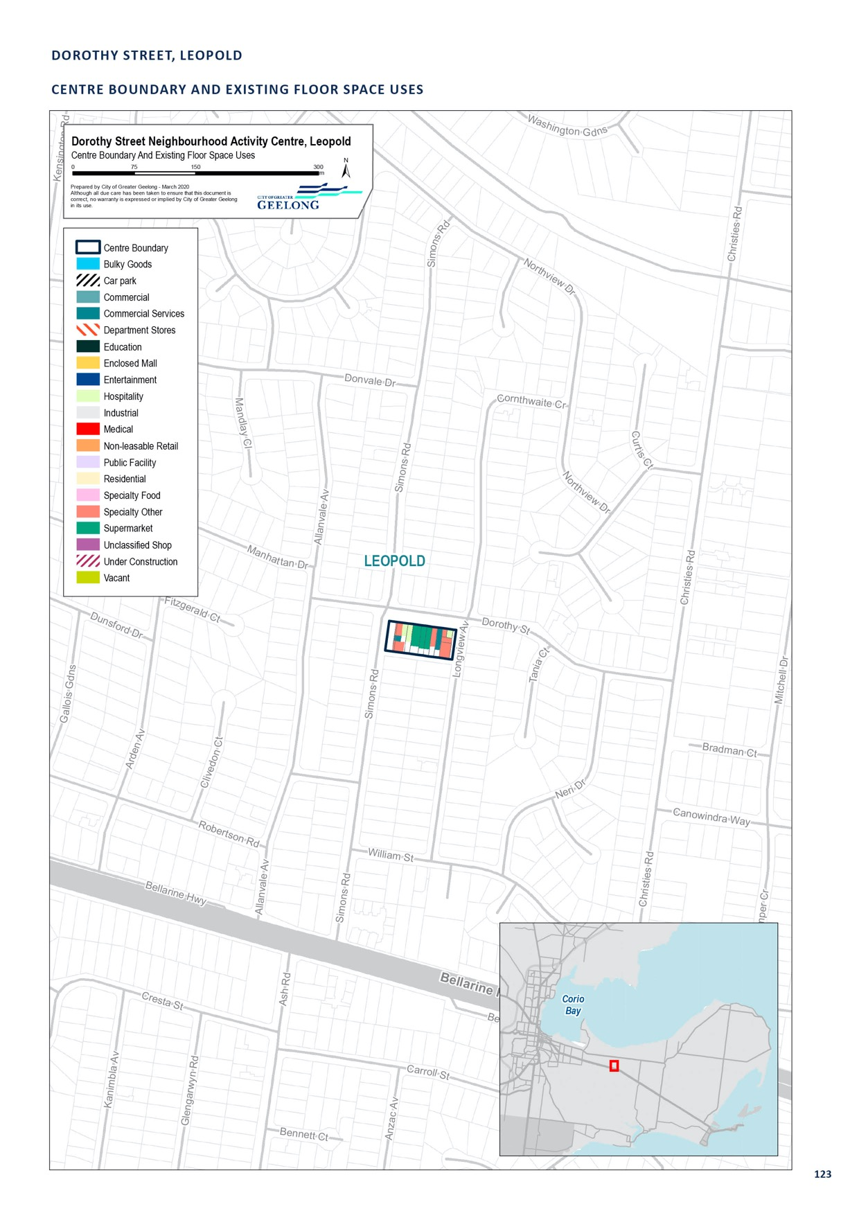

GROVEDALE CENTRAL, HEYERS ROAD, GROVEDALE

CENTRE NAME: GROVEDALE CENTRAL, HEYERS ROAD, GROVEDALE
Hierarchy status: | Neighbourhood
Location: | Grovedale
Key characteristics: | Small local shopping centre with IGA and medical centre. Adjacent to primary school and high school.
Current role: | While the centre’s key outer stores and services, such as the medical centre, pharmacy and IGA supermarket, attract a sufficient number of customers, the internal plaza area is relatively empty, with two vacancies and an unwelcoming character.
Zoning (sqm): | ACZ C1Z C2Z MUZ Other
Zoning (sqm): | 0 |  |  |  | 10,870 |  |  | 0 |  |  |  | 0 |  |  |  | 0
Retail and commercial floor space* (sqm):
Retail and commercial floor space* (sqm): | Super market | Depart’ Store |  | Restricted Retail |  |  | Specialty Food |  | Specialty Other |  | Hospitality |  | Total Retail |  | Other Employ’ |  | Vacant
Retail and commercial floor space* (sqm): |  |  |  |  |  |  |  |  |  |  |  |  | 2,479
Retail anchors: | 866  1 superm | 0  arket (866 |  | 0  sqm IGA) |  |  | 382 |  | 1,055 |  | 176 |  |  |  | 0 |  | 200
Transport connections: | Public |  | Bus service (route 19)
 | Private |  | Corner Heyers Road and Burdoo Drive, accessible via Pioneer Road and Surf Coast Highway
Future role and opportunities: | Several new hospitality businesses have recently established within this centre, occupying shops that appear to have been vacant for some time.  With revitalisation, this centre has the potential to fulfill a neighbourhood centre role for the Grovedale area, though it is limited by its proximity to the Waurn Ponds sub-regional Centre.
Action required: | Nil
Growth Opportunities | Forecast supportable Potential to grow Sub-precinct planning Potential for rezoning floor space 2016–2036 within current zoned required to align with centre sqm (difference from land boundary  total floor space)
Growth Opportunities | 700 |  |  |  |  | Yes – but with constraints |  |  |  | No |  |  |  | No

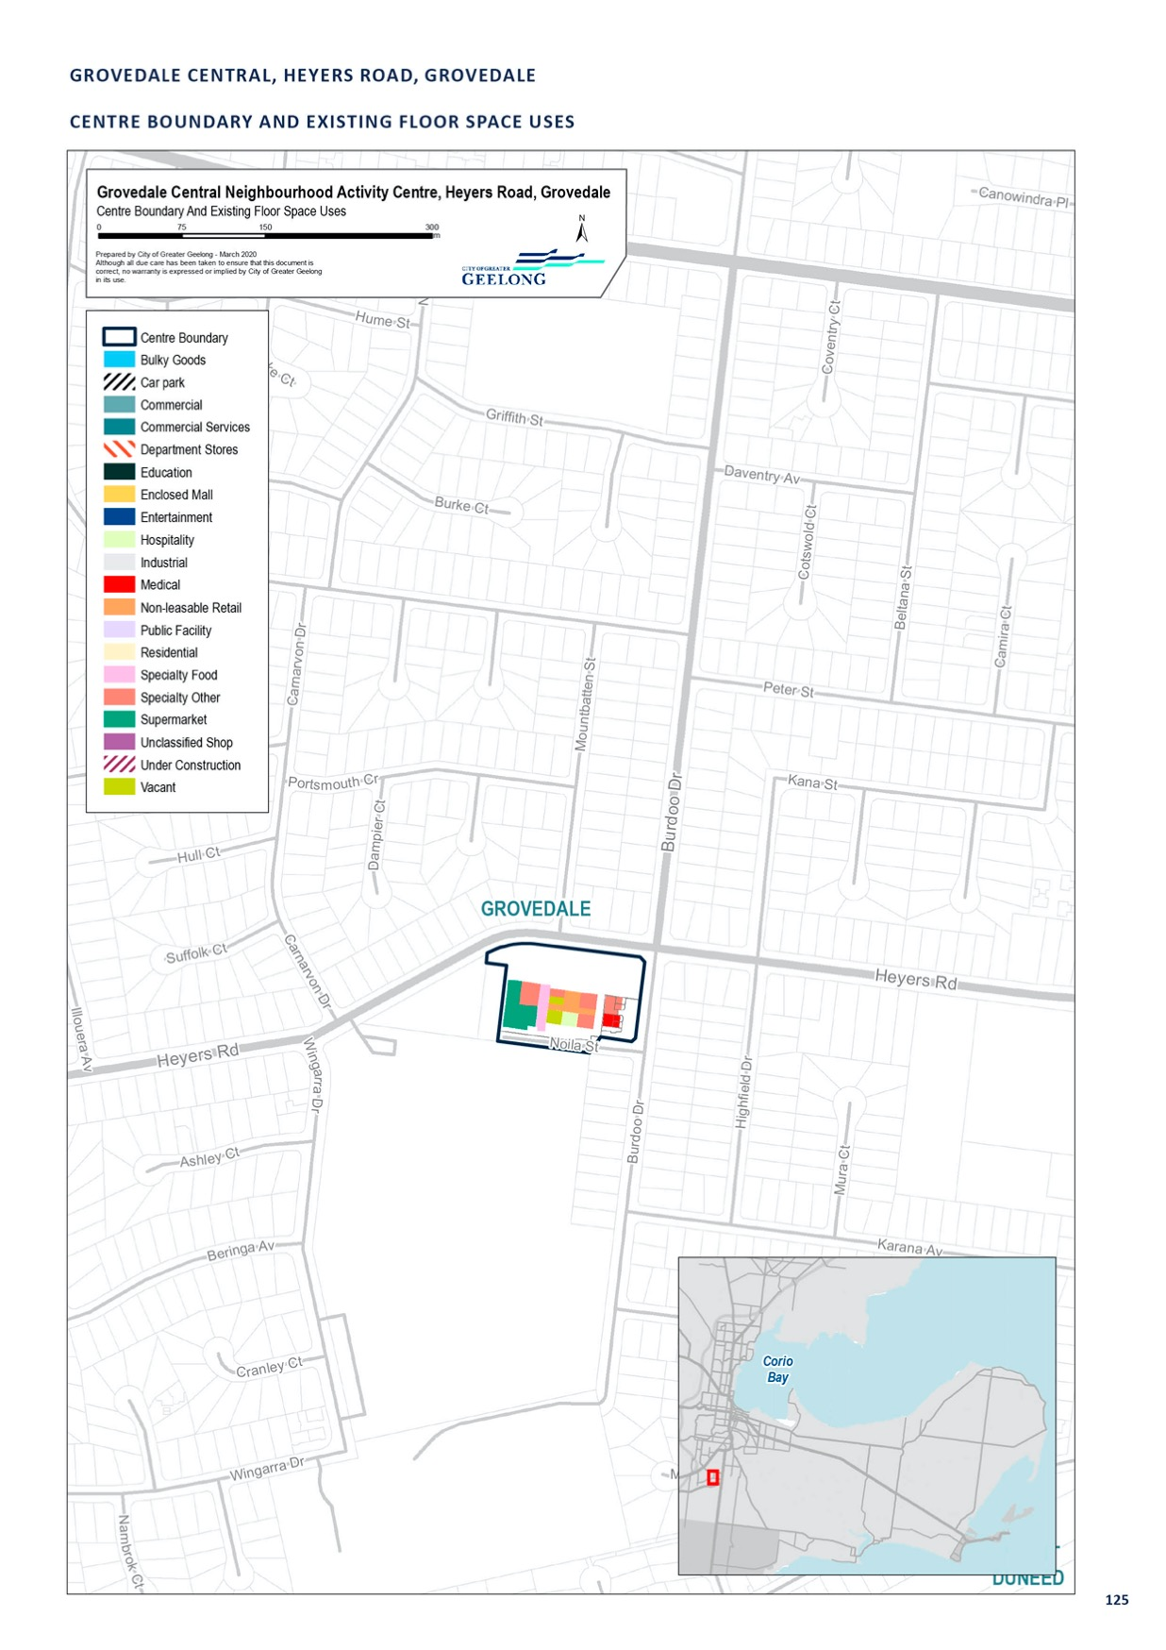

HIGHTON, BARRABOOL ROAD, HIGHTON

CENTRE NAME: HIGHTON, BARRABOOL ROAD, HIGHTON
Hierarchy status: | Neighbourhood
Location: | Highton
Key characteristics: | Strong performing neighbourhood centre in Highton, with significant amounts of office and community/ public use.
Current role: | This thriving centre plays a local day-to-day retail and hospitality role within Highton.
Zoning (sqm): | ACZ |  |  |  |  | C1Z |  |  |  | C2Z |  | MUZ |  |  |  | Other
Zoning (sqm): | 0 |  |  |  | 16,960 |  |  | 0 |  |  |  |  |  | 0 |  |  |  | 3,690
Retail and commercial floor space* (sqm): | Super market | Depart’ Store |  | Restricted Retail |  |  | Specialty Food |  | Specialty Other |  |  |  | Hospitality |  | Total Retail |  | Other Employ’ |  | Vacant
Retail and commercial floor space* (sqm): | 2,150 | 0 |  | 0 |  |  | 1,717 |  | 2,139 |  |  |  | 966 |  | 6,972 |  | 1,140 |  | 100
Retail anchors: | 1 supermarket (2,150 sqm Woolworths)
Transport connections: | Public |  | Bus service (routes 16 and 34)
 | Private |  | Belle Vue Avenue, between Barrabool Road and Roslyn Road
Future role and opportunities: | This thriving centre plays a local day-to-day retail and hospitality role within Highton. Given that the nearby Waurn Ponds and Belmont centres cover the wider catchment, it is likely that Highton will continue to play a local, neighbourhood centre role.  This centre contains a Woolworths supermarket and a large number of specialty shops. Improvements to the streetscape would help improve the appearance of the centre.  A small amount of floor space growth is forecast for this centre between 2016–2036. We have developed a draft urban design framework for this centre. The framework has identified development opportunities that would deliver additional floor space within the centre. It also has a strong focus on streetscape upgrades, pedestrian and traffic movements.
Action required: | Finalise the draft urban design framework
Growth Opportunities | Forecast supportable floor space 2016–2036 sqm (difference from total floor space) |  |  |  |  | Potential to grow within current zoned land |  |  |  |  |  | Sub-precinct planning required |  |  |  | Potential for rezoning to align with centre boundary
Growth Opportunities | 2,800 |  |  |  |  | Yes – with constraints |  |  |  |  | Yes |  |  |  |  | Yes

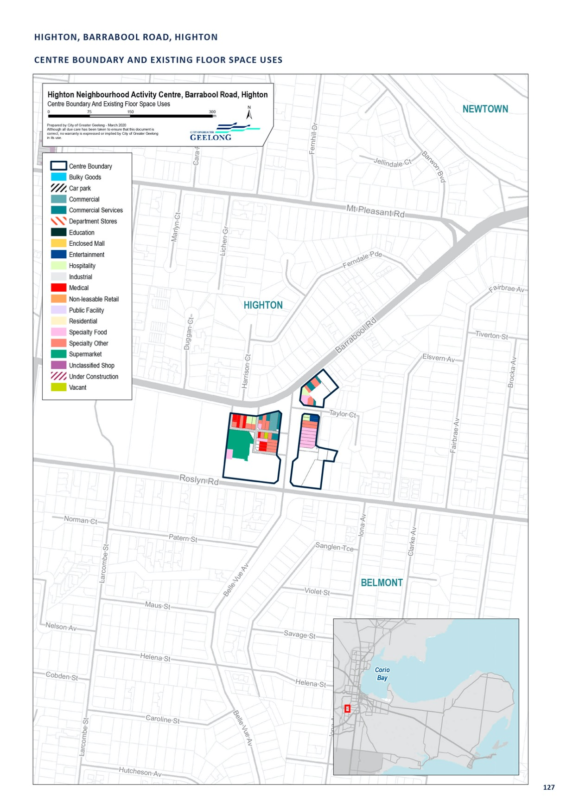

HYLAND STREET, FYANSFORD

CENTRE NAME: HYLAND STREET, FYANSFORD
Hierarchy status: | Neighbourhood
Location: | Fyansford
Key characteristics: | Small shopping strip (under 15 shops) along the Hamilton Highway and adjacent to the Moorabool River. Contains a mix of uses, including hospitality, specialty shops, restricted retail and residential. Does not have high accessibility from the south, due to its proximity to the Barwon and Moorabool Rivers.
Current role: | Plays a local role within the emerging Fyansford and existing Herne Hill community.
Zoning (sqm): | ACZ |  |  |  |  | C1Z |  |  |  | C2Z |  | MUZ |  |  |  | Other
Zoning (sqm): | 0 |  |  |  | 63,000 |  |  | 0 |  |  |  |  |  | 18,430 |  |  |  | 0
Retail and commercial floor space* (sqm): | Super market | Depart’ Store |  | Restricted Retail |  |  | Specialty Food |  | Specialty Other |  |  |  | Hospitality |  | Total Retail |  | Other Employ’ |  | Vacant
Retail and commercial floor space* (sqm): | 0 | 0 |  | 290 |  |  | 0 |  | 0 |  |  |  | 2,060 |  | 2,350 |  | 0 |  | 0
Planned Floor space sqm | 11,800
Retail anchors: | None
Transport connections: | Public |  | Bus service (route 50) approximately 900m from centre
 | Private |  | Hyland Street, accessible via Hamilton Highway and McCurdy Road
Future role and opportunities: | Significant residential development is planned for the Fyansford area, including a new neighbourhood centre to service the new community. Land on the southern side of Hyland Street has been rezoned to Commercial 1 to accommodate a future centre. Whilst the site is large, much of it isn’t able to be developed due to the steep topography of the site.  A Development Plan was approved for this neighbourhood centre on 18 November 2019. The Development Plan supports an activity centre consisting of retail, dining, residential, community, and health and wellbeing facilities. The economic impact assessment submitted with the Development Plan suggests the centre could support 4,270 square metres of retail floor space (supermarket and speciality stores), and an overall centre of approximately 8,500 square metres by 2031. This is generally consistent with the outputs from the SGS gravity model.  No additional retail floor space is required for this centre beyond what has been planned for. In the future this centre may be challenged by planned retail centres in the Western Geelong Growth Area.
Action required: | Nil
Growth Opportunities | Forecast supportable floor space 2016–2036 sqm (difference from total floor space) |  |  |  |  | Potential to grow within current zoned land |  |  |  |  |  | Sub-precinct planning required |  |  |  | Potential for rezoning to align with centre boundary
Growth Opportunities | -500 |  |  |  |  | Yes |  |  |  |  | Yes – as per the DPO |  |  |  |  | No

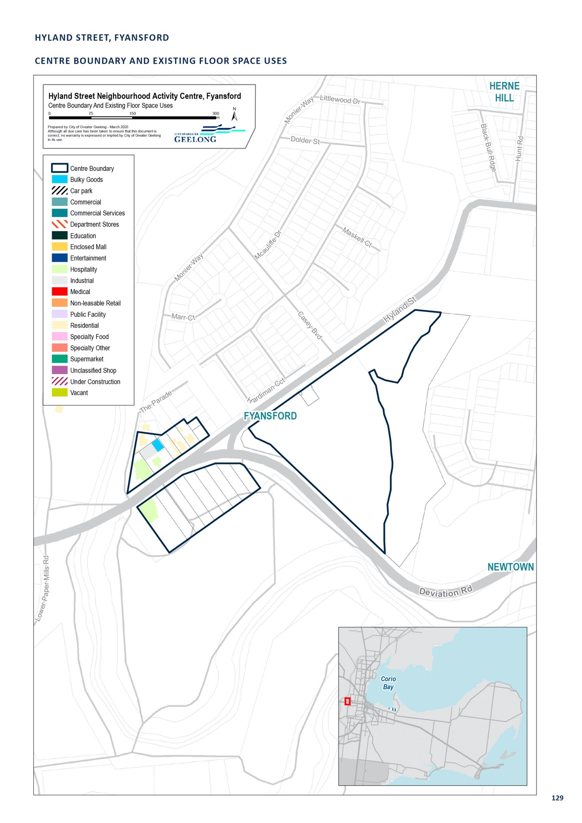

JETTY ROAD, CENTENNIAL BVD, CURLEWIS

CENTRE NAME: JETTY ROAD, CENTENNIAL BVD, CURLEWIS
Hierarchy status: | Neighbourhood
Location: | Curlewis (Drysdale/Clifton Springs)
Key characteristics: | New neighbourhood centre in growth area of Drysdale-Clifton Springs, anchored by Woolworths supermarket, limited by existing residential growth surrounding centre.
Current role: | Neighbourhood Centre
Zoning (sqm): | ACZ |  |  |  |  | C1Z |  |  |  | C2Z |  | MUZ |  |  |  | Other
Zoning (sqm): | 0 |  |  |  | 0 |  |  | 158,470 |  |  |  |  |  | 0 |  |  |  | 0
Retail and commercial floor space* (sqm): | Super market | Depart’ Store |  | Restricted Retail |  |  | Specialty Food |  | Specialty Other |  |  |  | Hospitality |  | Total Retail |  | Other Employ’ |  | Vacant
Retail and commercial floor space* (sqm): | 3,400 | 0 |  |  |  |  | 0 |  | 1,100 |  |  |  | 0 |  | 4,500 |  | 0 |  | 0
Retail anchors: | 1 supermarket (3,400 sqm Woolworths)
Transport connections: | Public |  | Bus Service (Route 61)
 | Private |  | Portarlington Road via Jetty Road and Centennial Bvd
Future role and opportunities: | A Neighbourhood Activity Centre comprising a Woolworths supermarket and 11 speciality stores, opened in August 2015. This centre will service the Jetty Road Growth Area (located in Curlewis) (west of Drysdale/Clifton Springs). The centre may be attractive to the wider Drysdale Clifton Springs community given ease of parking and less congestions when compared to the town centre.  This centre has been developed early in the life of the growth area relative to population growth. Land has been zoned around the centre to allow for the future growth of the centre. The planning for the size of this centre has taken into account the Jetty Road Growth area at completion
Action required: | Nil
Growth Opportunities | Forecast supportable floor space 2016–2036 sqm (difference from total floor space) |  |  |  |  | Potential to grow within current zoned land |  |  |  |  |  | Sub-precinct planning required |  |  |  | Potential for rezoning to align with centre boundary
Growth Opportunities | 1320 |  |  |  |  | Yes |  |  |  |  | No |  |  |  |  | No

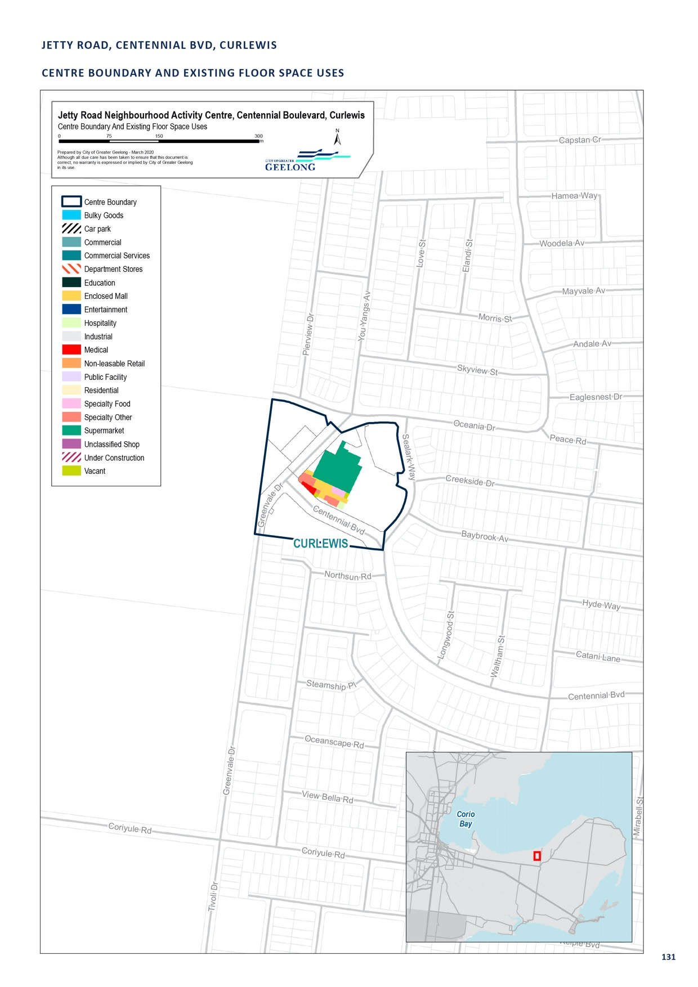

KINGSTON VILLAGE, GRUBB ROAD, OCEAN GROVE

CENTRE NAME: KINGSTON VILLAGE, GRUBB ROAD, OCEAN GROVE
Hierarchy status: | Neighbourhood
Location: | Grubb Road, part of the Kingston Downs Estate, Ocean Grove
Key characteristics: | Kingston Downs is a neighbourhood centre located on Grubb Road in Ocean Grove. The centre is anchored by Woolworths and Aldi Supermarkets and Dan Murphy’s Liquor Store.
Current role: | Services the northern growth area of Ocean Grove
Zoning (sqm): | ACZ |  |  |  |  | C1Z |  |  |  | C2Z |  | MUZ |  |  |  | Other
Zoning (sqm): | 0 |  |  |  | 97,000 |  |  | 15,000 |  |  |  |  |  | 0 |  |  |  | 0
Retail and commercial floor space* (sqm): | Super market | Depart’ Store |  | Restricted Retail |  |  | Specialty Food |  | Specialty Other |  |  |  | Hospitality |  | Total Retail |  | Other Employ’ |  | Vacant
Retail and commercial floor space* (sqm): | 5,865 | 0 |  | 0 |  |  | 0 |  | 4,860 |  |  |  | 0 |  | 10,725 |  | 2,115 |  | 0
Retail anchors: | Woolworths and Aldi supermarkets, Dan Murphy’s Liquor
Transport connections: | Public |  | Bus Service (Route 56)
 | Private |  | Grubb Road
Future role and opportunities: | A Neighbourhood Activity Centre (NAC) in the northern growth area in Ocean Grove. The Ocean Grove Structure Plan 2007 supported the rezoning of 9.7 hectares of land on the corner of Grubb Road and Coastal Bvd to what is now a Commercial 1 Zone. The boundary of this centre has  been determined by the ‘Retail Activity Area’ identified within the approved Kingston Down Development Plan.  The Kingston Down NAC and restricted retail precinct, which form part of the north-east growth area, will provide for the needs of the growing population, but also the needs of the broader town population, surrounding rural areas and the seasonal population influx.  Planning permits have been granted for the construction of Woolworths and Aldi supermarkets,  Dan Murphy’s Liquor Store, McDonalds and specialty retail. Planning permits also allow for a medical centre, gym and office space. The proposal provides for 12,800 sqm of floor space of which  approximately 10,700 sqm is retail floor space (8,700 sqm dedicated to shop uses). The centre opened in late 2019.  The retail strategy indicates that between 2016 and 2036, this centre could support approximately 6,300 sqm of retail floor space. A large amount of commercially zoned land is available within the Kingston Down neighbourhood centre, which is considered sufficient to support the growth of this centre. The potential size of the neighbourhood centre may compete strongly with Ocean Grove Market Place, the Ocean Grove Town Centre and the Leopold Sub-regional centre.
Action required: | Apply a floor space cap of 11,000 square metres, allowing for centre growth in line with its neighborhood activity centre role and function
Growth Opportunities | Forecast supportable floor space 2016–2036 sqm (difference from total floor space) |  |  |  |  | Potential to grow within current zoned land |  |  |  |  |  | Sub-precinct planning required |  |  |  | Potential for rezoning to align with centre boundary
Growth Opportunities | -4,900 |  |  |  |  | Yes |  |  |  |  | No |  |  |  |  | No

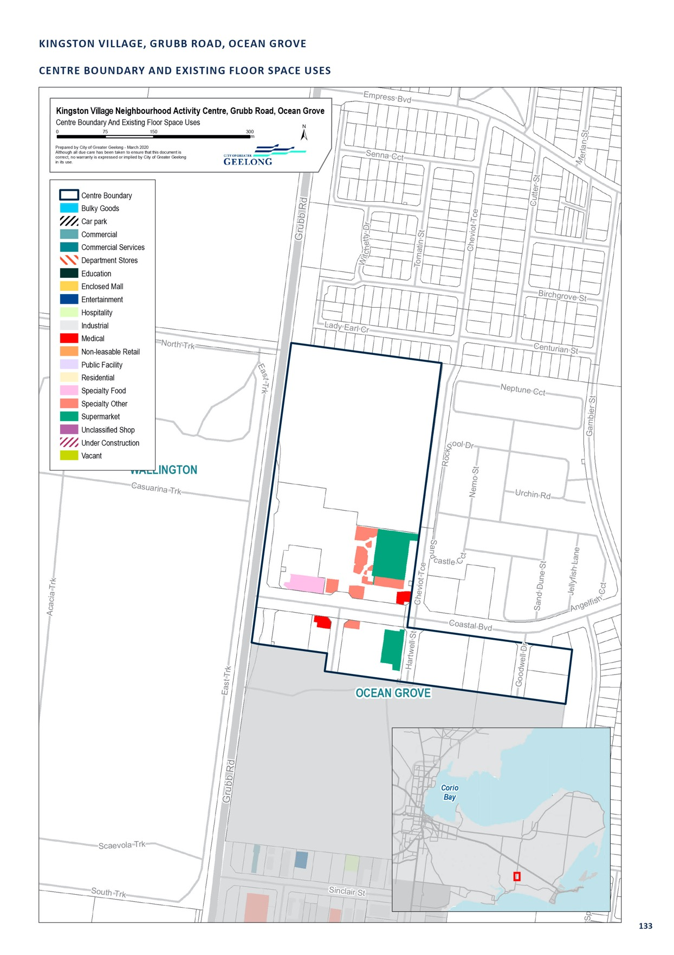

MARKETPLACE, SHELL ROAD, OCEAN GROVE

CENTRE NAME: MARKETPLACE, SHELL ROAD, OCEAN GROVE
Hierarchy status: | Neighbourhood
Location: | Ocean Grove
Key characteristics: | Mid-sized shopping centre (anchored by Woolworths) along Shell Road. Strong hospitality base, along with specialty and food retail.
Current role: | This centre serves the local community and the wider-southern region of the Bellarine Peninsula.
Zoning (sqm): | ACZ |  |  |  |  | C1Z |  |  |  | C2Z |  | MUZ |  |  |  | Other
Zoning (sqm): | 0 |  |  |  | 25,720 |  |  | 0 |  |  |  |  |  | 0 |  |  |  | 0
Retail and commercial floor space* (sqm): | Super market | Depart’ Store |  | Restricted Retail |  |  | Specialty Food |  | Specialty Other |  |  |  | Hospitality |  | Total Retail |  | Other Employ’ |  | Vacant
Retail and commercial floor space* (sqm): | 3,566 | 0 |  | 0 |  |  | 287 |  | 910 |  |  |  | 985 |  | 5,748 |  | 90 |  | 100
Retail anchors: | Expired planning permit for additional 1,500 sqm
Transport connections: | Public |  | Bus service (routes 76, 80, 81, 82 and 83)
 | Private |  | Corner of Shell Road and Kingston Downs Drive, accessible via Grubb Road and Bellarine Highway
Future role and opportunities: | While the larger and nearby Ocean Grove Town Centre is more well-rounded in its offer of shops and services, the presence of a supermarket anchor in this centre helps to ensure its attractiveness into the future.  An expired planning permit (PP399/2010/A) allowed the centre to expand to the north of the site. This would have increased the floor space from 5,670 m2 to 7,085 m2. This development could still occur subject if a new planning permit is approved.
Action required: | Nil
Growth Opportunities | Forecast supportable floor space 2016–2036 sqm (difference from total floor space) |  |  |  |  | Potential to grow within current zoned land |  |  |  |  |  | Sub-precinct planning required |  |  |  | Potential for rezoning to align with centre boundary
Growth Opportunities | 1,100 |  |  |  |  | Yes |  |  |  |  | No |  |  |  |  | No

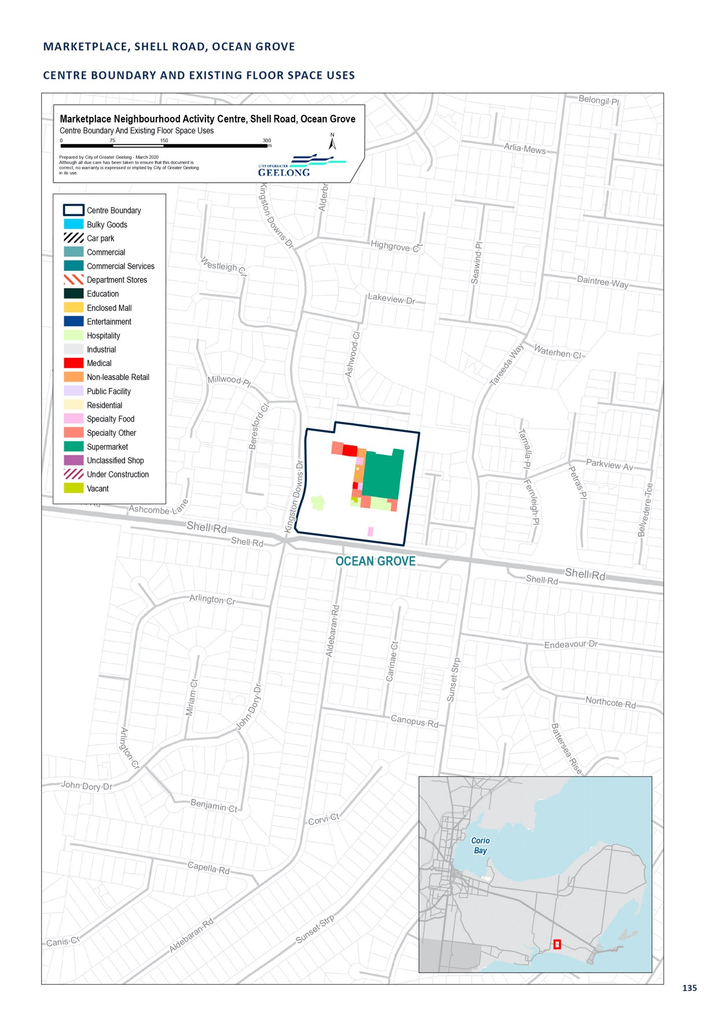

NEWCOMB CENTRAL, BELLARINE HIGHWAY, NEWCOMB

CENTRE NAME: NEWCOMB CENTRAL, BELLARINE HIGHWAY, NEWCOMB
Hierarchy status: | Neighbourhood
Location: | Newcomb
Key characteristics: | Mid-sized shopping centre (anchored by Woolworths and Aldi) along the Bellarine Highway, in Newcomb. It is in very close proximity (under 400 m) to the smaller Bellarine Village Shopping Centre. It contains a library and adjoins Newcomb Secondary College to the east.
Current role: | This centre offers a mix of retail, offices, medical services and hospitality. Along with Bellarine Village, it serves the Newcomb area, as well as the wider Thomson, Whittington, Breakwater, St Albans Park and Moolap areas, which largely offer only small, local retail and no supermarkets. The centre also serves commuters travelling to and from the western region of Greater Geelong and the Bellarine Peninsula.
Zoning (sqm): | ACZ C1Z C2Z MUZ Other
Zoning (sqm): | 0 |  |  |  | 24,730 |  |  | 0 |  |  |  | 0 |  |  |  | 0
Retail and commercial floor space* (sqm):
Retail and commercial floor space* (sqm): | Super market | Depart’ Store |  | Restricted Retail |  |  | Specialty Food |  | Specialty Other |  | Hospitality |  | Total Retail |  | Other Employ’ |  | Vacant
Retail anchors: | 4,691  2 superm | 0  arkets (3, |  | 0  533 sqm W |  |  | 630  oolworths, 1, |  | 1,194  158 sqm Ald |  | 315  i) |  | 6,820 |  | 430 |  | 0
Transport connections: | Public |  | Bus service (routes 45, 55, 75, 76, 77 and 83)
 | Private |  | Corner of Bellarine Highway and Wilsons Road
Future role and opportunities: | A moderate amount of retail growth is forecast for this centre through to 2036. The centre is landlocked but could redevelop over existing car parking, or through acquisition of adjacent housing, to provide additional floor space in the future.  Given the lack of retail offers in surrounding suburbs, and the relatively uncompetitive nature of Bellarine Village, Newcomb Central is likely to continue to thrive.
Action required: | Nil
Growth Opportunities | Forecast supportable Potential to grow Sub-precinct planning Potential for rezoning floor space 2016–2036 within current zoned required to align with centre sqm (difference from land boundary  total floor space)
Growth Opportunities | 2,500 |  |  |  |  | Yes – With constraints |  |  |  | No |  |  |  | No

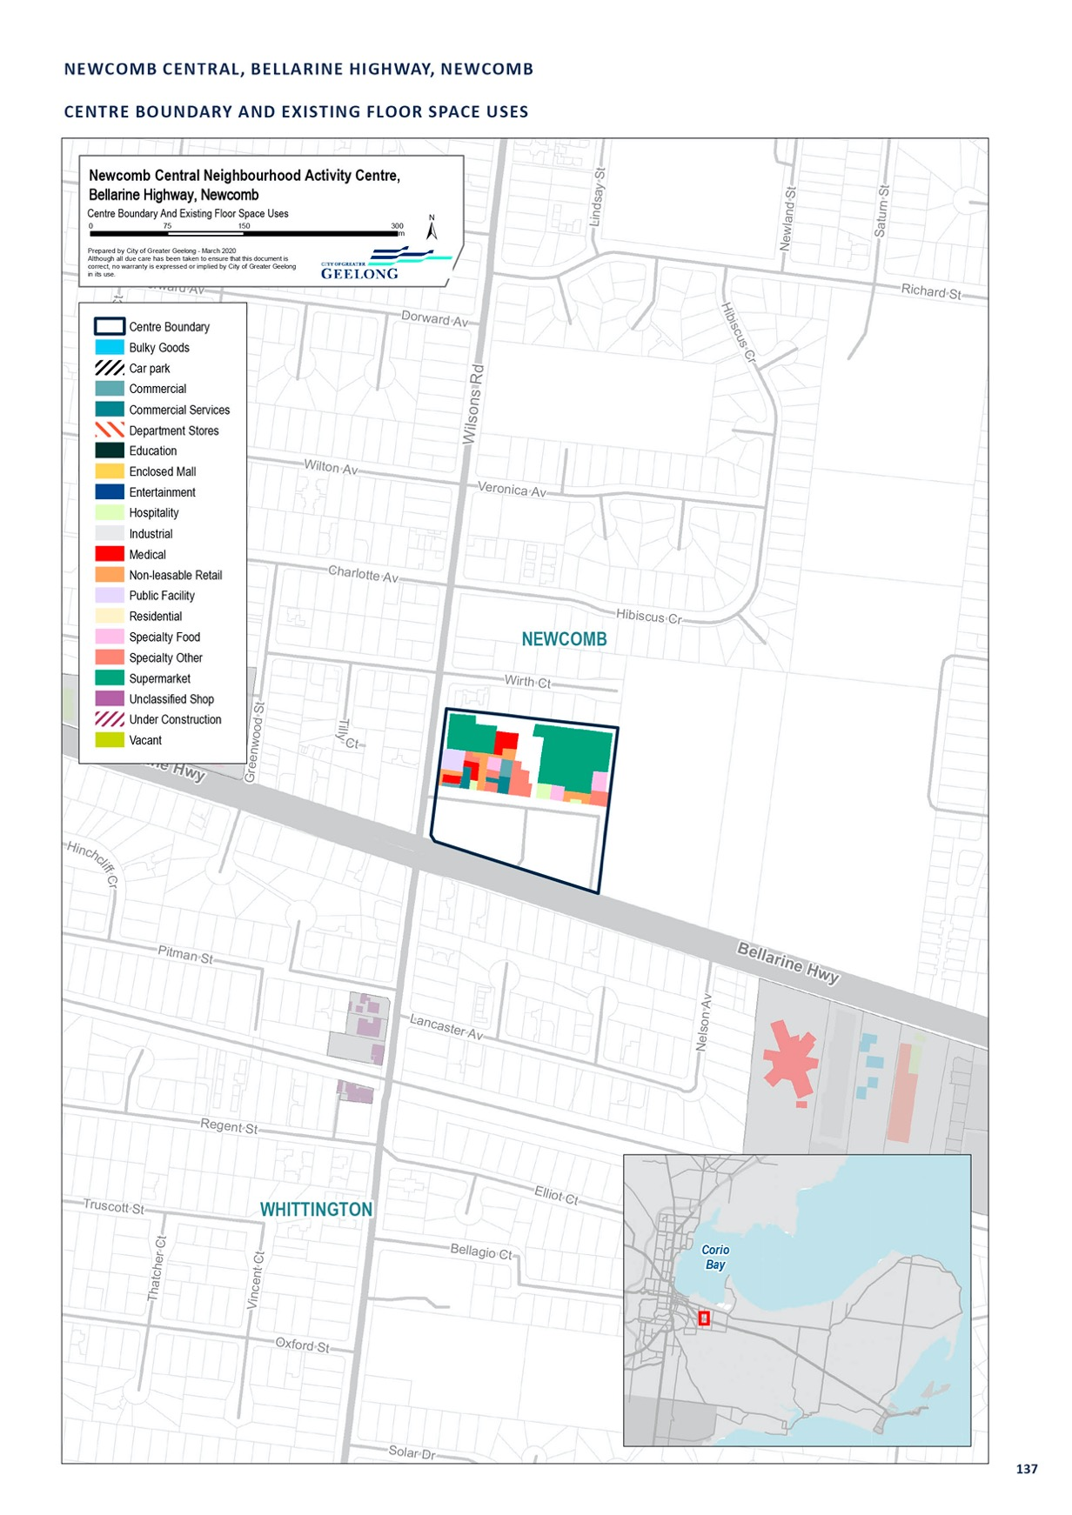

ORMOND ROAD, GEELONG EAST

CENTRE NAME: ORMOND ROAD, GEELONG EAST
Hierarchy status: | Neighbourhood
Location: | East Geelong
Key characteristics: | Sprawling retail precinct. While individual strip sections have good visual and pedestrian amenity, walkability between sections is restricted by the busy and wide Ormond Road/Garden Street/Myers Street intersection.
Current role: | This centre plays a local, day-to-day role in the East Geelong community, and to a smaller degree serves commuters travelling to and from the eastern region of Greater Geelong and the Bellarine Peninsula.
Zoning (sqm): | ACZ |  |  |  |  | C1Z |  |  |  | C2Z |  | MUZ |  |  |  | Other
Zoning (sqm): | 0 |  |  |  | 13,690 |  |  | 0 |  |  |  |  |  | 0 |  |  |  | 1,230
Retail and commercial floor space* (sqm): | Super market | Depart’ Store |  | Restricted Retail |  |  | Specialty Food |  | Specialty Other |  |  |  | Hospitality |  | Total Retail |  | Other Employ’ |  | Vacant
Retail and commercial floor space* (sqm): | 627 | 0 |  | 0 |  |  | 516 |  | 4,256 |  |  |  | 519 |  | 5,917 |  | 880 |  | 200
Retail anchors: | 1 supermarket (627 sqm Foodworks)
Transport connections: | Public |  | Bus service (routes 45, 75, 76, 77 and 83)
 | Private |  | Intersection of Ormond Road, Myers Street and Garden Street
Future role and opportunities: | The neighbourhood role of Ormond Road is likely to be maintained into the future. There are significant constraints to growth of this centre, given the proximity to major roads, Central Geelong and the Newcomb centres. We have undertaken some streetscape upgrades, but its disjointed nature means there may be opportunities to investigate ways to better integrate the centre.
Action required: | Nil
Growth Opportunities | Forecast supportable floor space 2016–2036 sqm (difference from total floor space) |  |  |  |  | Potential to grow within current zoned land |  |  |  |  |  | Sub-precinct planning required |  |  |  | Potential for rezoning to align with centre boundary
Growth Opportunities | 3,500 |  |  |  |  | Yes – but with constraints |  |  |  |  | No |  |  |  |  | No

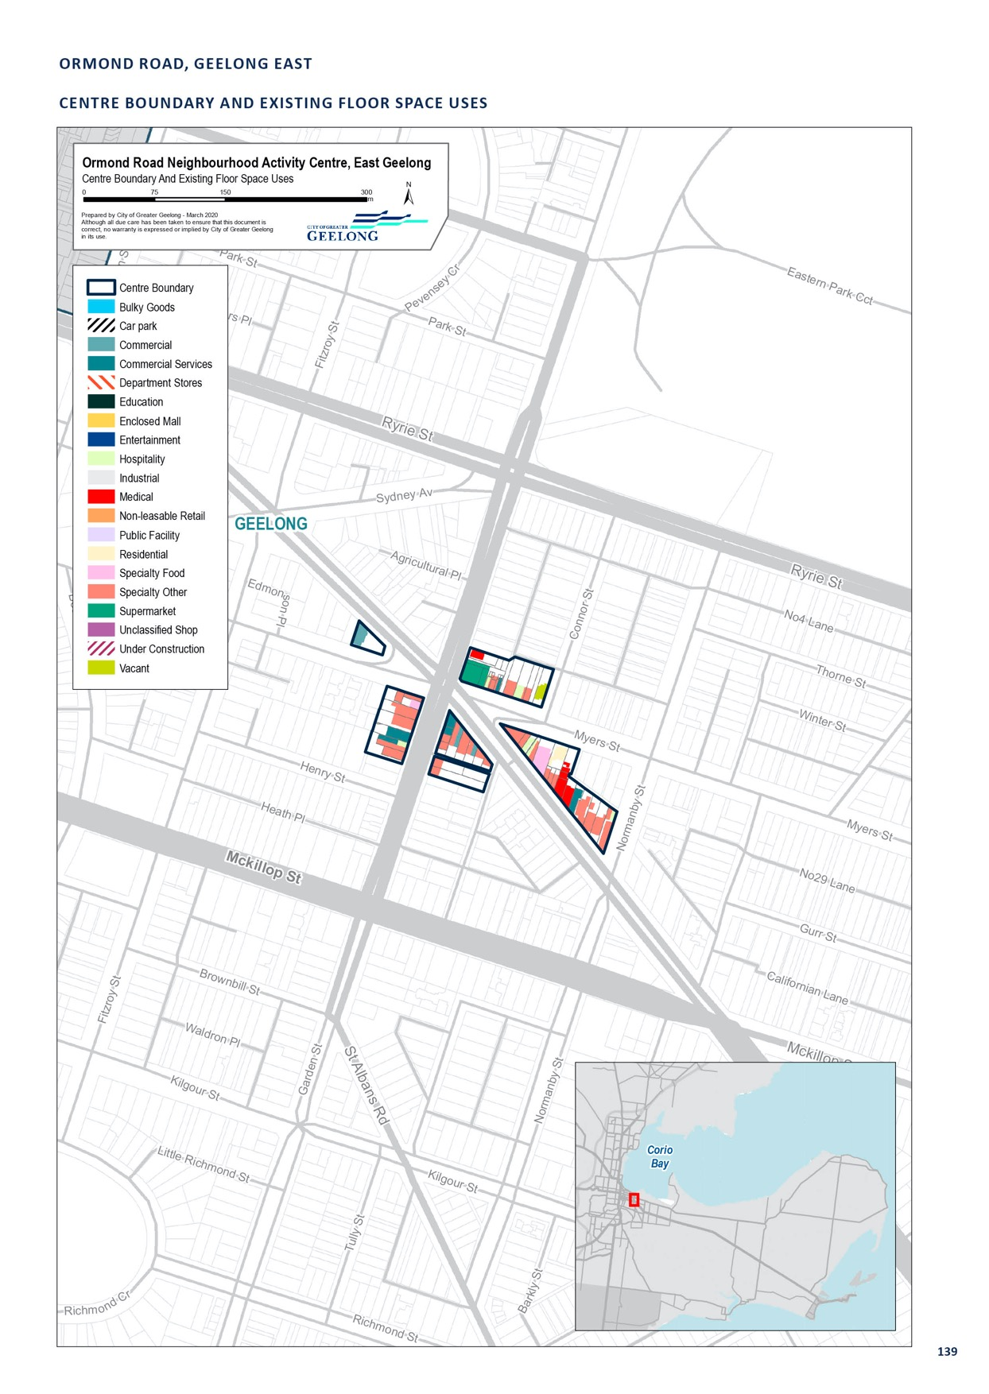

PAKINGTON STREET, NEWTOWN

CENTRE NAME: PAKINGTON STREET, NEWTOWN
Hierarchy status: | Neighbourhood
Location: | Newtown
Key characteristics: | Mid-sized, lively retail strip near southern end of Pakington Street. South of Russell Street the western side of the strip is largely residential, which dilutes activity at this end. With fine-grain, active frontages and outdoor cafés, the northern end of the precinct resembles the Geelong West Pakington Street precinct, while amenity is not as high at the southern end of the precinct.
Current role: | While this centre has no anchors, it offers a high-quality, attractive and walkable environment, with several cafés and higher-end stores that are not commonly found in other activity centres in the municipality.
Zoning (sqm): | ACZ |  |  |  |  | C1Z |  |  |  | C2Z |  | MUZ |  |  |  | Other
Zoning (sqm): | 0 |  |  |  | 29,670 |  |  | 0 |  |  |  |  |  | 0 |  |  |  | 0
Retail and commercial floor space* (sqm): | Super market | Depart’ Store |  | Restricted Retail |  |  | Specialty Food |  | Specialty Other |  |  |  | Hospitality |  | Total Retail |  | Other Employ’ |  | Vacant
Retail and commercial floor space* (sqm): | 0 | 0 |  | 0 |  |  | 446 |  | 4,759 |  |  |  | 3,946 |  | 9,151 |  | 1,130 |  | 300
Retail anchors: | None
Transport connections: | Public |  | Bus service (34, 35 and 36)
 | Private |  | Pakington Street, from Noble Street to West Fyans Street
Future role and opportunities: | This centre is likely to continue to thrive, and development and activity may continue to spread south, with higher-density housing supported closer to the river-end of Pakington Street, through the implementation of the West Fyans-Fyans Street Precinct Structure Plan 2009.  A re-zoning of land (C204) along Pakington Street, adjoining the Commercial 1 Zone in 2012, has created additional retail space. The Independent Panel considering the re-zoning suggested a parking precinct plan for the area, given limited parking in the area. Given the types of land use occurring in the centre (as of right uses), the limited amount of new development and high land values, it is unlikely that a parking precinct plan would be successful in delivering much in the way of additional car parking.  While the centre does not currently have a supermarket anchor, there is sufficient floor space demand over the next 20 years to support a supermarket in this centre. However, high land values, and lack of large parcels of land, may make it difficult to establish a supermarket in this location. If a supermarket- based development was proposed, it should directly adjoin the existing centre and have frontage to Pakington Street.
Action required: | Nil
Growth Opportunities | Forecast supportable floor space 2016–2036 sqm (difference from total floor space) |  |  |  |  | Potential to grow within current zoned land |  |  |  |  |  | Sub-precinct planning required |  |  |  | Potential for rezoning to align with centre boundary
Growth Opportunities | 5,300 |  |  |  |  | No |  |  |  |  | No |  |  |  |  | No

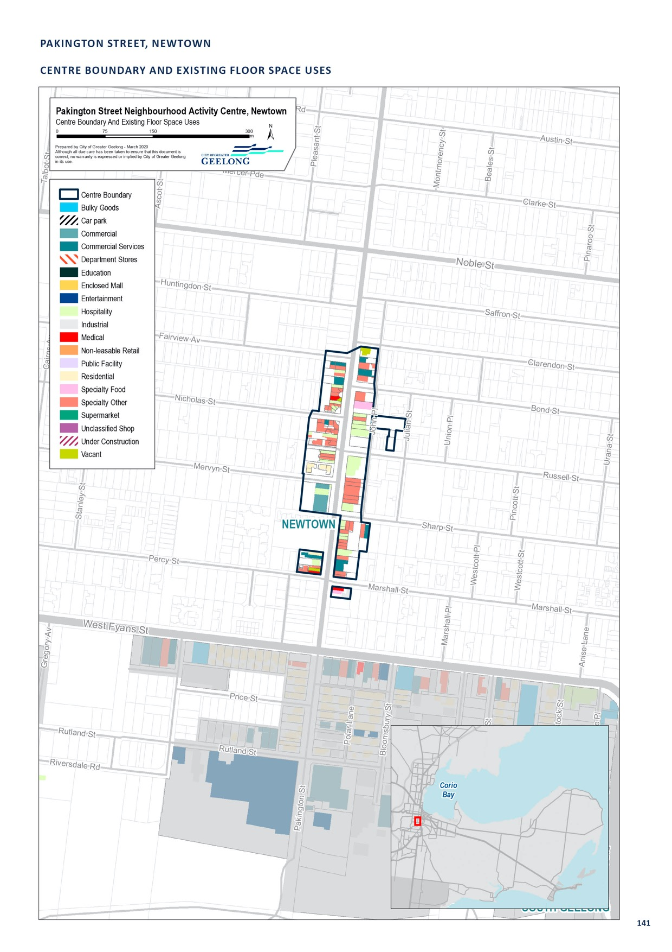

ROSEWALL, BRODERICK ROAD, CORIO

CENTRE NAME: ROSEWALL, BRODERICK ROAD, CORIO
Hierarchy status: | Neighbourhood
Location: | Corio
Key characteristics: | Comprises a single Aldi supermarket and a vacant, adjacent site at Fairbairn Drive which is also zoned Commercial 1.
Current role: | This centre serves the local community with a supermarket.
Zoning (sqm): | ACZ |  |  |  |  | C1Z |  |  |  | C2Z |  | MUZ |  |  |  | Other
Zoning (sqm): | 0 |  |  |  | 15,710 |  |  | 0 |  |  |  |  |  | 0 |  |  |  | 20
Retail and commercial floor space* (sqm): | Super market | Depart’ Store |  | Restricted Retail |  |  | Specialty Food |  | Specialty Other |  |  |  | Hospitality |  | Total Retail |  | Other Employ’ |  | Vacant
Retail and commercial floor space* (sqm): | 1,740 | 0 |  | 0 |  |  | 0 |  | 0 |  |  |  | 0 |  | 1,740 |  | 0 |  | 0
Retail anchors: | 1 supermarket (1,740 sqm Aldi)
Transport connections: | Public |  | Corio Railway Station (approx. 1.2km), bus service (route 12)
 | Private |  | Intersection of Princess Highway and Broderick Road
Future role and opportunities: | Comprises a single Aldi supermarket and a 0.8 ha site at 12–20 Fairbairn Drive, which is zoned Commercial 1. Planning approval (pp366–2011) for a medical centre and four speciality retail stores at the Fairbairn Drive site has expired, and the site remains vacant.  Even though the planning permit has expired, there is still support to maintain the centre as a neighbourhood centre within the retail hierarchy. The future development of additional retail floor space, adjacent to the established supermarket anchor, would help to provide additional retail and other services for the nearby community. This centre would continue to service a local catchment and would be unlikely to have any trade impacts on the Corio shopping centre which is approximately  2 km away.
Action required: | Nil
Growth Opportunities | Forecast supportable floor space 2016–2036 sqm (difference from total floor space) |  |  |  |  | Potential to grow within current zoned land |  |  |  |  |  | Sub-precinct planning required |  |  |  | Potential for rezoning to align with centre boundary
Growth Opportunities | 500 |  |  |  |  | Yes |  |  |  |  | No |  |  |  |  | No

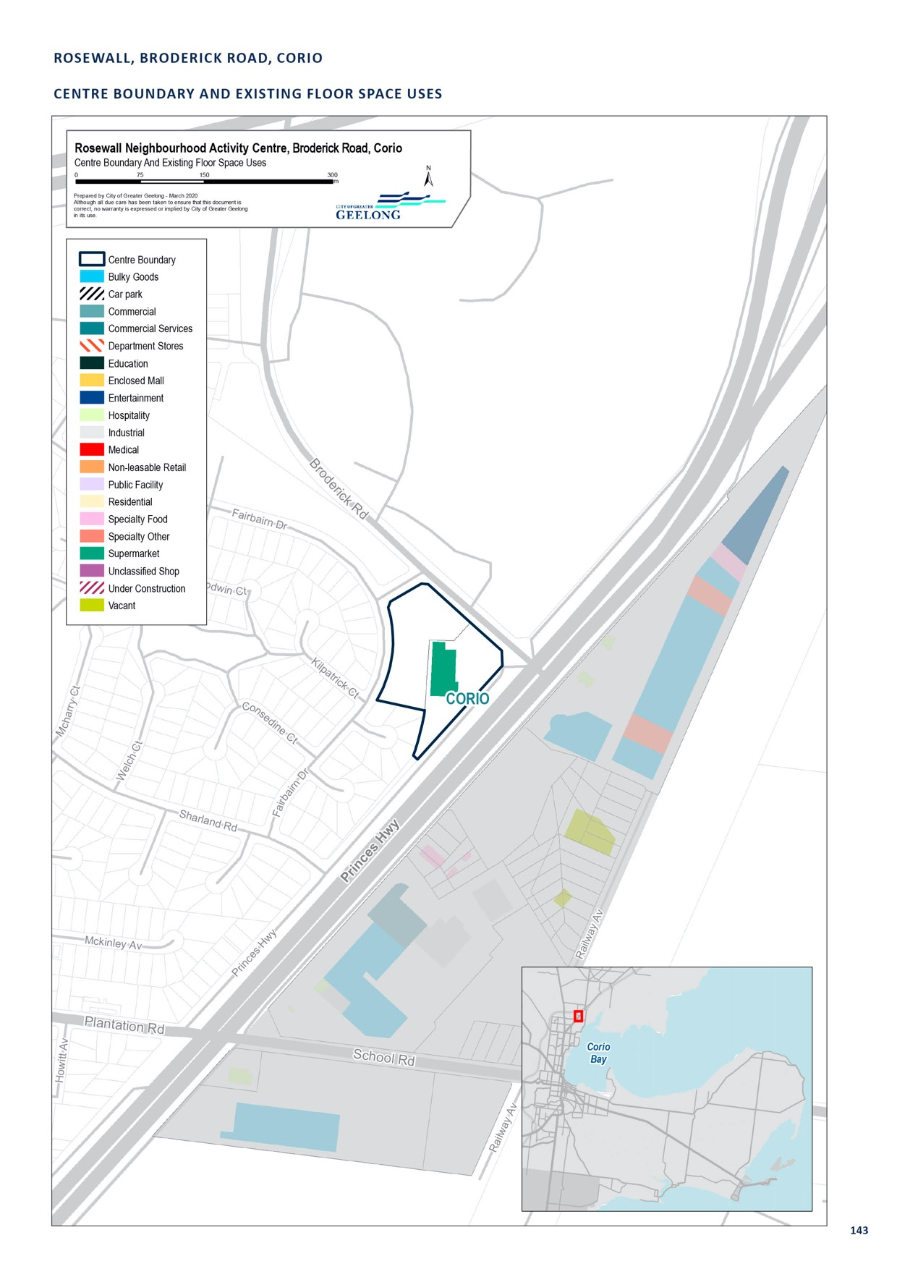

SEPARATION STREET, NORTH GEELONG

CENTRE NAME: SEPARATION STREET, NORTH GEELONG
Hierarchy status: | Neighbourhood
Location: | North Geelong
Key characteristics: | Neighbourhood centre with two distinct areas. The western section is a small retail strip, with a mix of hospitality and specialty shops, and a significant degree of shop-top housing. The eastern section is predominantly comprised of single-storey office floor space.
Current role: | This centre serves the local Bell Park and North Geelong community.
Zoning (sqm): | ACZ |  |  |  |  | C1Z |  |  |  | C2Z |  | MUZ |  |  |  | Other
Zoning (sqm): | 0 |  |  |  | 9,150 |  |  | 20,850 |  |  |  |  |  | 0 |  |  |  | 20
Retail and commercial floor space* (sqm): | Super market | Depart’ Store |  | Restricted Retail |  |  | Specialty Food |  | Specialty Other |  |  |  | Hospitality |  | Total Retail |  | Other Employ’ |  | Vacant
Retail and commercial floor space* (sqm): | 0 | 0 |  | 0 |  |  | 908 |  | 1,898 |  |  |  | 2,766 |  | 5,572 |  | 1,130 |  | 400
Retail anchors: | None
Transport connections: | Public |  | Bus service (12 and 30)
 | Private |  | Separation Street from Tallin Street to Mina Place, accessible via Anakie Road, Thompson Road and Princes Highway
Future role and opportunities: | The neighbourhood role of Separation Street is likely to be maintained into the future.  This centre was identified as a small neighbourhood centre in the 2006 strategy. This centre does not contain a supermarket, but contains a large proportion of hospitality. This centre could benefit from the presence of a small supermarket. Streetscape improvement could also improve the appearance of the centre. There is demand for additional retail floor space within this centre by 2036.  A natural extension of the centre would be to the east, along Separation Street, in the location of the existing Commercial 2 zoned land at 35–57 Separation Street. These sites combined would be large enough to support a future supermarket and additional speciality retail. A planning permit can be sought, for a full-line supermarket within the Commercial 2 zone.  For this reason, the Commercial 2 Zone land has been included within the centre boundary.  An urban design framework or structure plan should be developed for this centre. It should investigate streetscape upgrades and identify a preferred supermarket site.
Action required: | Develop an urban design framework or structure plan for this centre and investigate streetscape upgrades and a preferred location for a supermarket.
Growth Opportunities | Forecast supportable floor space 2016–2036 sqm (difference from total floor space) |  |  |  |  | Potential to grow within current zoned land |  |  |  |  |  | Sub-precinct planning required |  |  |  | Potential for rezoning to align with centre boundary
Growth Opportunities | 3,500 |  |  |  |  | Yes |  |  |  |  | Yes |  |  |  |  | No

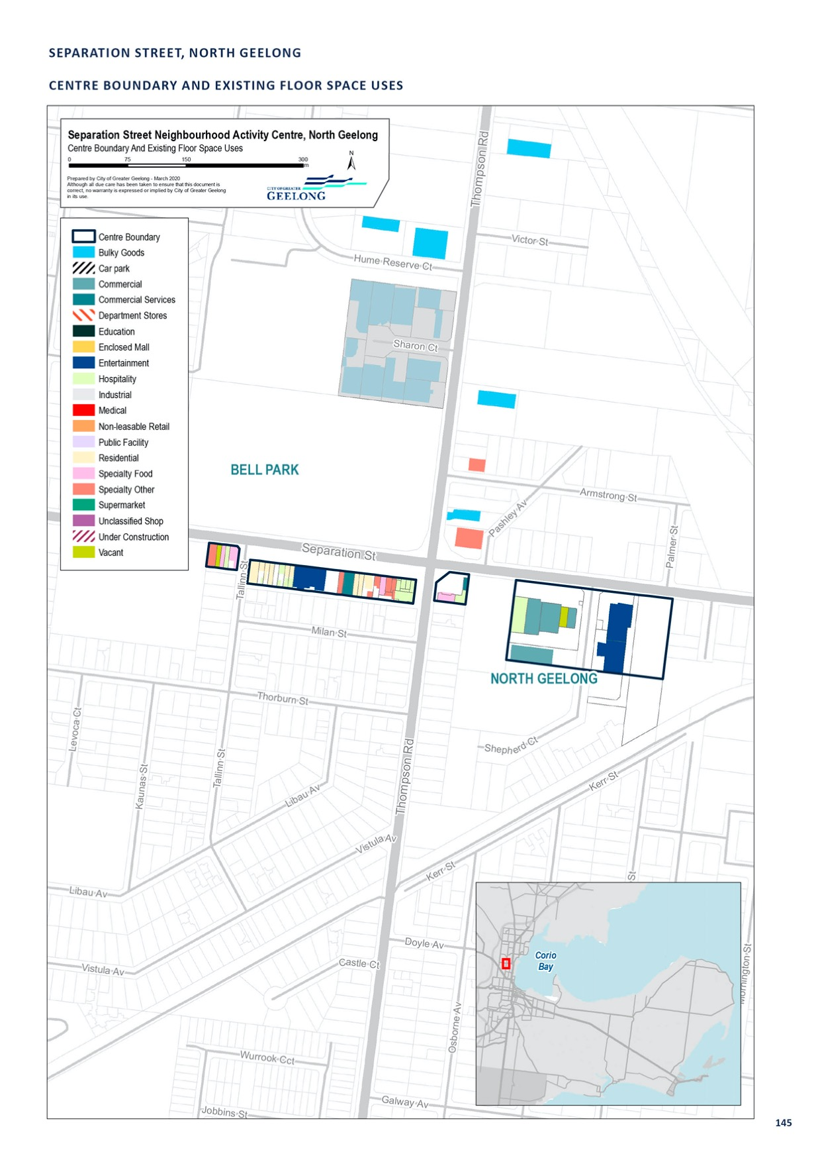

SHANNON AVENUE, GEELONG WEST

CENTRE NAME: SHANNON AVENUE, GEELONG WEST
Hierarchy status: | Neighbourhood
Location: | Geelong West
Key characteristics: | The Shannon Avenue, Geelong West precinct is a mid-sized, medium-density retail strip containing a Coles and Aldi supermarket, various specialty shops, hospitality and services. Built form in the precinct is varied, with a mix of styles and sizes. Streetscape amenity is adequate but not of a  high quality.
Current role: | This centre serves the local community, including residents of Manifold Heights. As a section of a minor north-south thoroughfare through the eastern section of the municipality, it also serves commuters within Greater Geelong.
Zoning (sqm): | ACZ |  |  |  |  | C1Z |  |  |  | C2Z |  | MUZ |  |  |  | Other
Zoning (sqm): | 0 |  |  |  | 39,930 |  |  | 0 |  |  |  |  |  | 0 |  |  |  | 10
Retail and commercial floor space* (sqm): | Super market | Depart’ Store |  | Restricted Retail |  |  | Specialty Food |  | Specialty Other |  |  |  | Hospitality |  | Total Retail |  | Other Employ’ |  | Vacant
Retail and commercial floor space* (sqm): | 4340 | 0 |  | 0 |  |  | 1,730 |  | 4,900 |  |  |  | 1,980 |  | 12,950 |  | 940 |  | 0
Retail anchors: | 2 supermarkets (2,543 sqm Coles, 1,797 sqm Aldi)
Transport connections: | Public |  | Bus service (routes 12, 30, 50 and 51)
 | Private |  | Shannon Avenue, from Douglass Street/Britannia Street to Autumn Street
Future role and opportunities: | While the Shannon Avenue, Geelong West precinct is an established retail strip, this centre is forecast to support an additional 5,950 square metres of retail floor space by 2036. The centre is already anchored by reasonably sized supermarkets. The centre including the supermarkets, may be able  to expand if redevelopment of car parking areas occurred or adjacent housing was purchased. The proximity of this centre to Pakington Street (Geelong West) may limit the practical demand for future growth and forecast growth may be taken up by a nearby centre.
Action required: | Prepare a structure plan or urban design framework for this centre. The plan should investigate opportunites to grow the centre and consider streetscape upgrades.
Growth Opportunities | Forecast supportable floor space 2016–2036 sqm (difference from total floor space) |  |  |  |  | Potential to grow within current zoned land |  |  |  |  |  | Sub-precinct planning required |  |  |  | Potential for rezoning to align with centre boundary
Growth Opportunities | 5,950 |  |  |  |  | Yes – with constraints |  |  |  |  | No |  |  |  |  | No

* Excludes non employment uses such as residential, car parking and sites under construction.

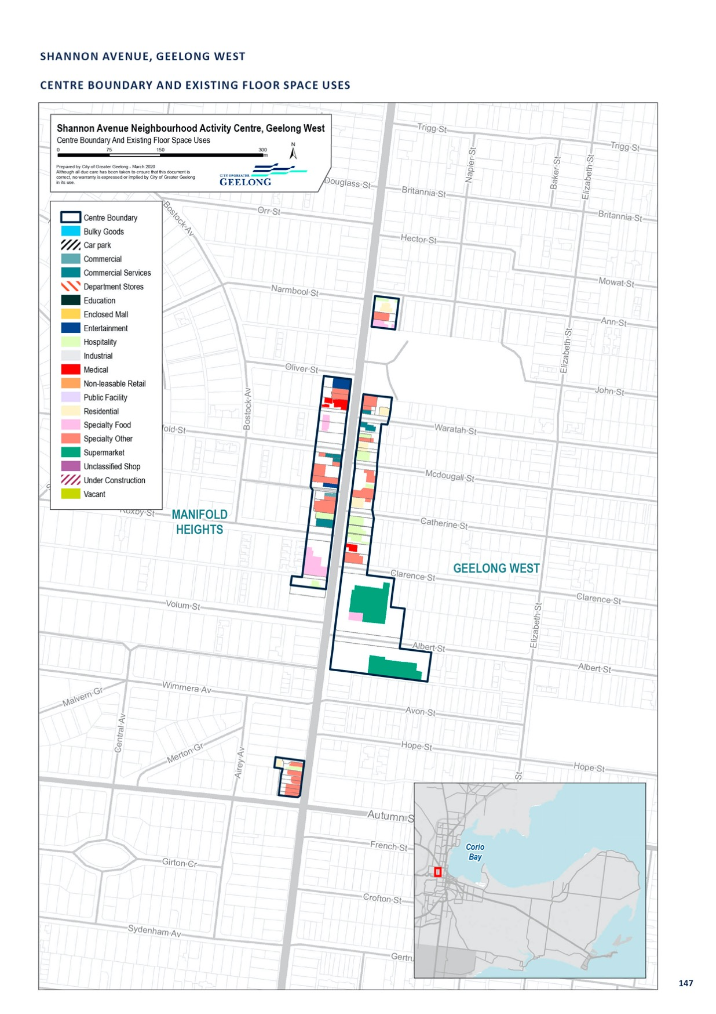

SHANNON AVENUE, NEWTOWN

CENTRE NAME: SHANNON AVENUE, NEWTOWN
Hierarchy status: | Neighbourhood
Location: | Newtown
Key characteristics: | The southern Shannon Avenue precinct is a very small retail strip anchored by Woolworths. It has strong representation from the medical industry, with medical practices comprising over 20 per cent of total floor space, and a pharmacy also available in the precinct.
Current role: | This centre plays a local role in the community, with a significant role in catering to medical needs. The presence of a drive-through coffee service indicates that a large proportion of its customer base is also derived from road traffic.
Zoning (sqm): | ACZ |  |  |  |  | C1Z |  |  |  | C2Z |  | MUZ |  |  |  | Other
Zoning (sqm): | 0 |  |  |  | 11,960 |  |  | 0 |  |  |  |  |  | 2,660 |  |  |  | 3,000
Retail and commercial floor space* (sqm): | Super market | Depart’ Store |  | Restricted Retail |  |  | Specialty Food |  | Specialty Other |  |  |  | Hospitality |  | Total Retail |  | Other Employ’ |  | Vacant
Retail and commercial floor space* (sqm): | 1,967 | 0 |  | 0 |  |  | 151 |  | 740 |  |  |  | 1,637 |  | 4,495 |  | 0 |  | 400
Retail anchors: | 1 supermarket (1,967 sqm Woolworths)
Transport connections: | Public |  | Bus service (35 and 36)
 | Private |  | Intersection of Shannon Avenue and Aberdeen Street
Future role and opportunities: | A new service station has opened on the north-west corner of Aberdeen Street and Shannon Avenue. There may be opportunities to redevelop car parking areas to provide additional retail floor space in the future.  The Great Western Hotel, on the corner of Shannon Avenue and Aberdeen Street is located in the Neighbourhood Residential Zone and forms part of this retail centre. This zone could restrict the future use of the site for other commercial purposes. Rezoning of the site to a commercial zone could be considered if the site were to be re-developed.  The role of the southern Shannon Avenue precinct is likely to be maintained into the future.
Action required: | Nil
Growth Opportunities | Forecast supportable floor space 2016–2036 sqm (difference from total floor space) |  |  |  |  | Potential to grow within current zoned land |  |  |  |  |  | Sub-precinct planning required |  |  |  | Potential for rezoning to align with centre boundary
Growth Opportunities | 1,400 |  |  |  |  | Yes – with constraints |  |  |  |  | No |  |  |  |  | Yes

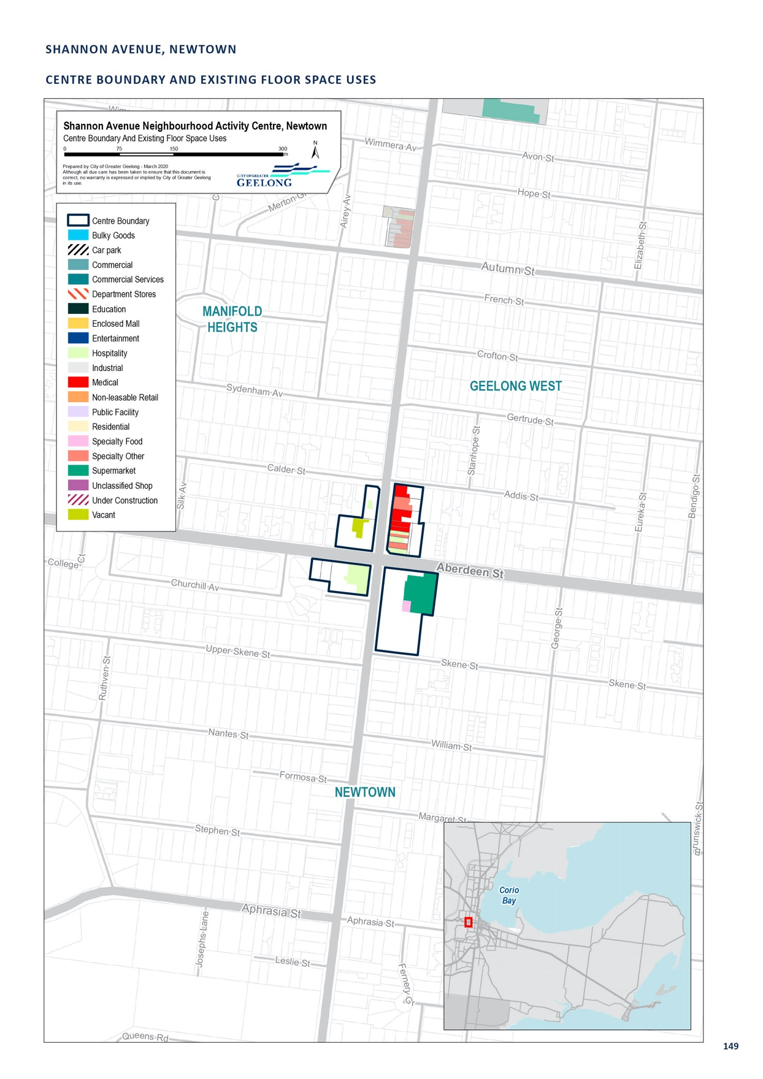

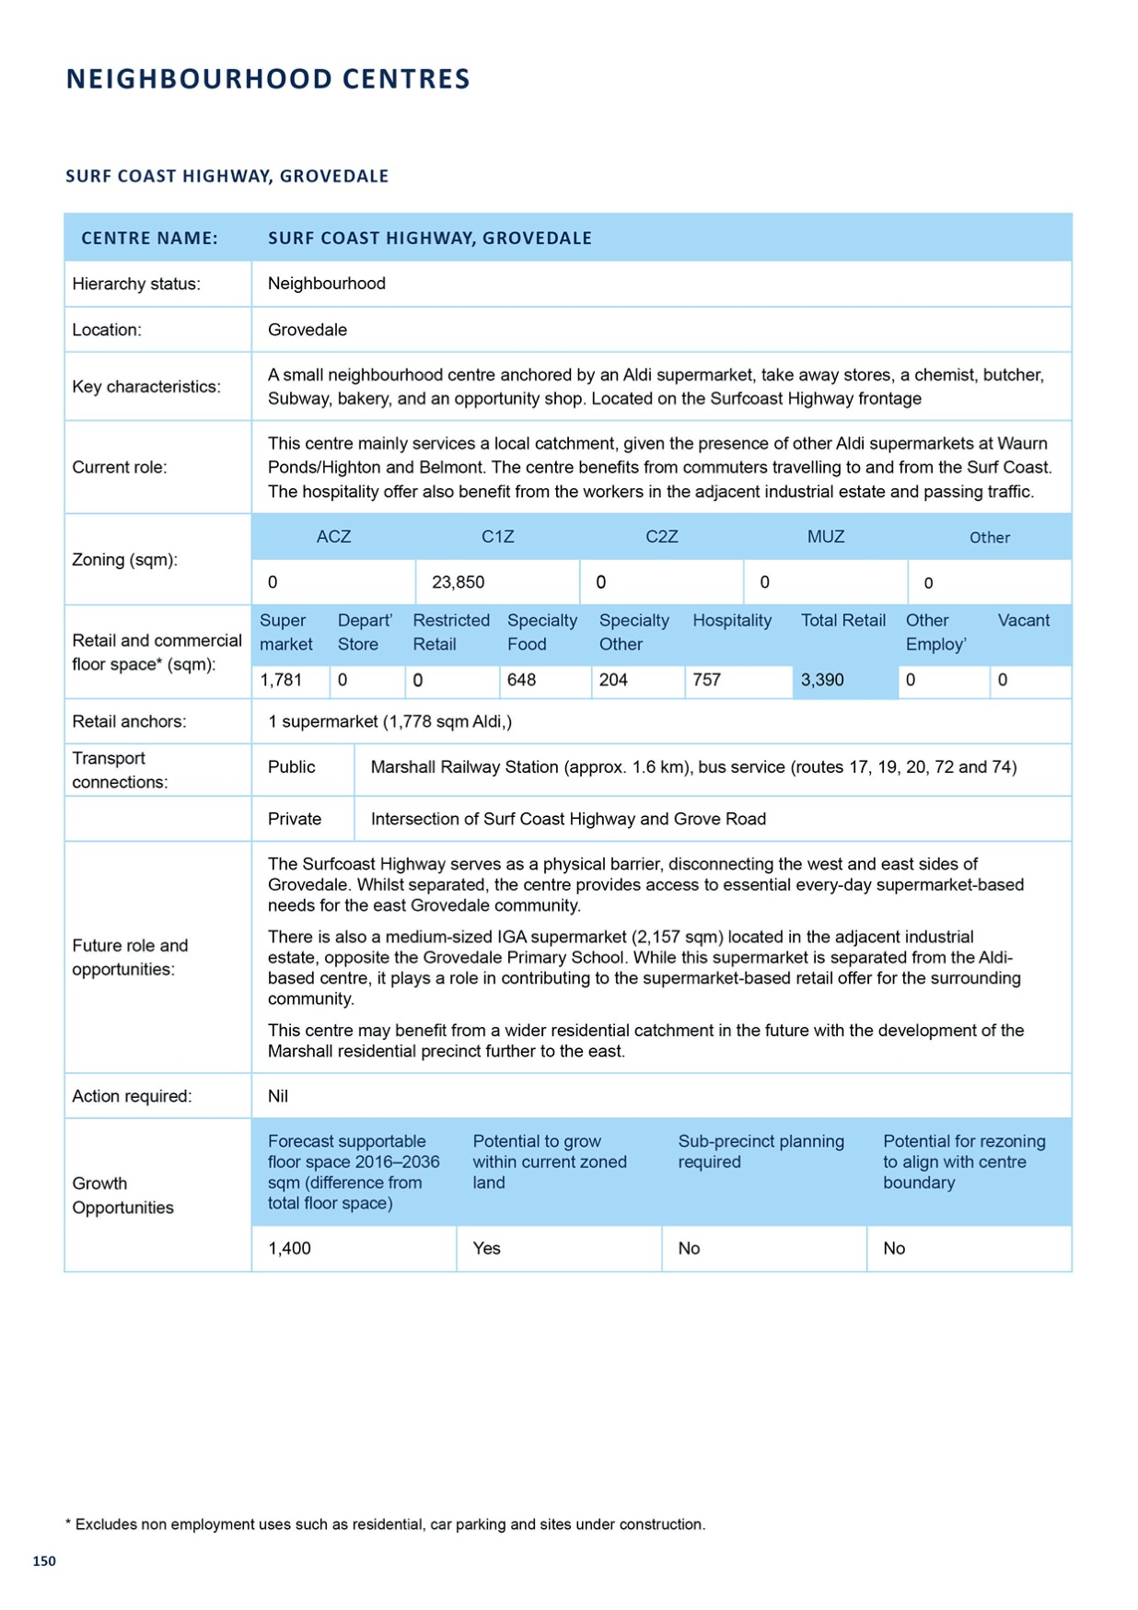

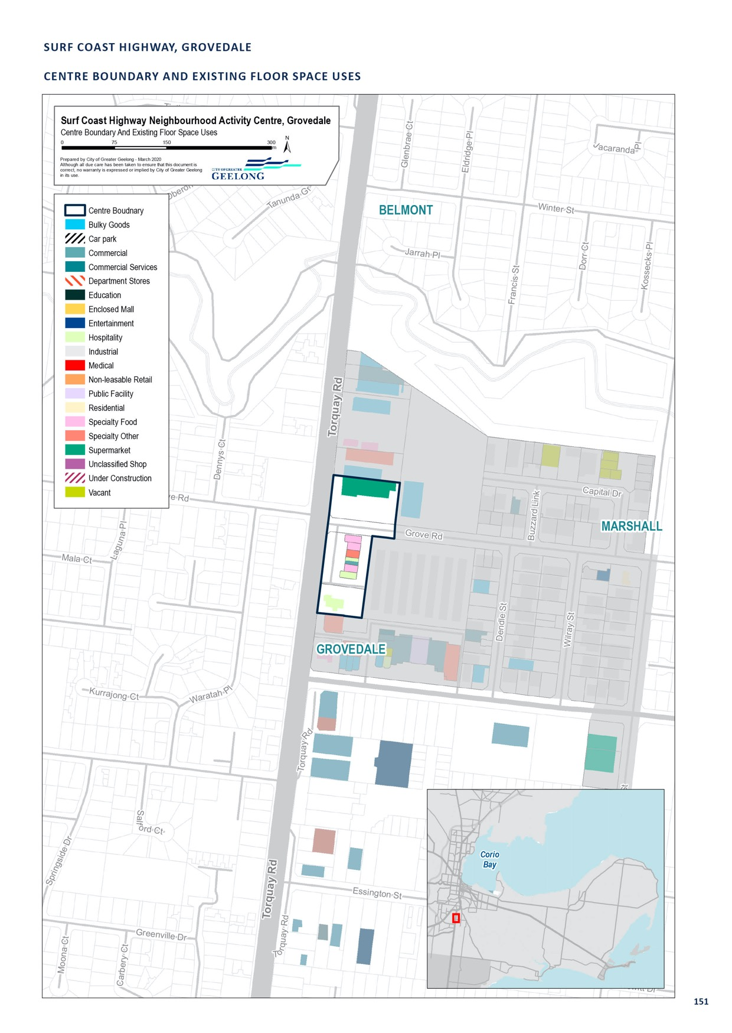

VINES ROAD, HAMLYN HEIGHTS

CENTRE NAME: VINES ROAD, HAMLYN HEIGHTS
Hierarchy status: | Neighbourhood
Location: | Hamlyn Heights
Key characteristics: | Local retail strip adjacent to a library, senior citizens centre and high school. Contains a mix of specialty shops and an IGA supermarket.
Current role: | Plays a local role within the Hamlyn Heights community.
Zoning (sqm): | ACZ |  |  |  |  | C1Z |  |  |  | C2Z |  | MUZ |  |  |  | Other
Zoning (sqm): | 0 |  |  |  | 7,940 |  |  | 0 |  |  |  |  |  | 0 |  |  |  | 0
Retail and commercial floor space* (sqm): | Super market | Depart’ Store |  | Restricted Retail |  |  | Specialty Food |  | Specialty Other |  |  |  | Hospitality |  | Total Retail |  | Other Employ’ |  | Vacant
Retail and commercial floor space* (sqm): | 862 | 0 |  | 0 |  |  | 399 |  | 1,368 |  |  |  | 480 |  | 3,110 |  | 250 |  | 100
Retail anchors: | 1 supermarket (862 sqm IGA)
Transport connections: | Public |  | Bus service (routes 50 and 51)
 | Private |  | Vines Road, between Olive Street/Kalimna Street and Sycamore Street/Waymouth Street, accessible via Ballarat Road and Church Street
Future role and opportunities: | A small amount of floor space growth is forecast for this centre by 2036. But demand for services may increase over time given the areas is identified as an Increased Housing Diversity Area in the Planning Scheme.
Action required: | Nil
Growth Opportunities | Forecast supportable floor space 2016–2036 sqm (difference from total floor space) |  |  |  |  | Potential to grow within current zoned land |  |  |  |  |  | Sub-precinct planning required |  |  |  | Potential for rezoning to align with centre boundary
Growth Opportunities | 1,700 |  |  |  |  | Yes - with constraints  – City owned car park site |  |  |  |  | No |  |  |  |  | No

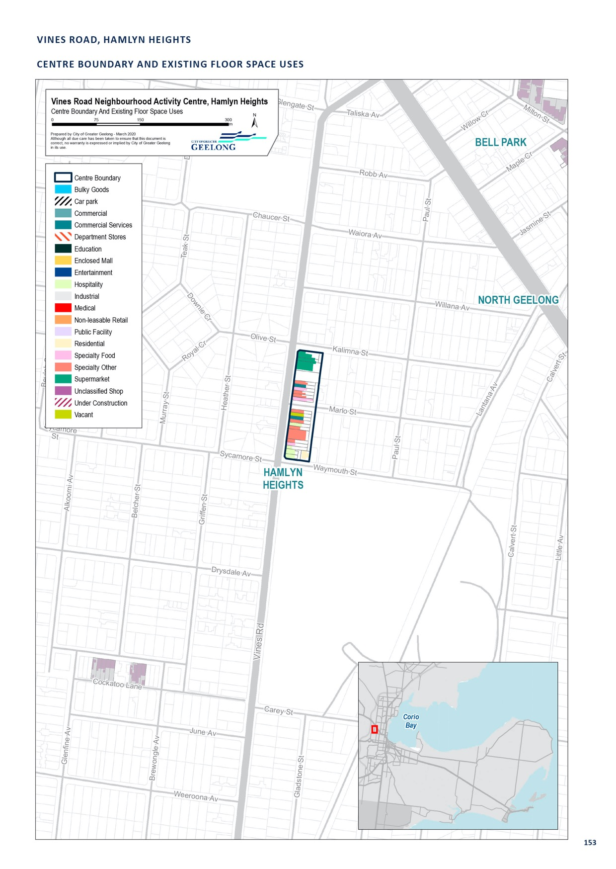

WARRALILY VILLAGE, BARWON HEADS ROAD, ARMSTRONG CREEK

CENTRE NAME: WARRALILY VILLAGE, BARWON HEADS ROAD, ARMSTRONG CREEK
Hierarchy status: | Neighbourhood Centre
Location: | Barwon Heads Road, Armstrong Creek
Key characteristics: | New supermarket base centre with several speciality stores, cafés, liquor store, medical centre and dentist. Several stores are still vacant.
Current role: | Services the local area of Armstrong Creek (Warralily Estate) and potentially commuters to Geelong from Barwon Heads and Ocean Grove
Zoning (sqm): | ACZ |  |  |  |  | C1Z |  |  |  | C2Z |  | MUZ |  |  |  | Other
Zoning (sqm): | 0 |  |  |  | 0 |  |  | 0 |  |  |  |  |  | 0 |  |  |  | Unknown
Retail and commercial floor space* (sqm): | Super market | Depart’ Store |  | Restricted Retail |  |  | Specialty Food |  | Specialty Other |  |  |  | Hospitality |  | Total Retail |  | Other Employ’ |  | Vacant
Retail and commercial floor space* (sqm): | 3,826 | 0 |  | 0 |  |  | 341 |  | 773 |  |  |  | 1,060 |  | 6,000 |  | 650 |  | 897
Retail anchors: | Woolworths and Aldi supermarkets
Transport connections: | Public |  | Bus Service (Route 61)
 | Private |  | Portarlington Road, via Jetty Road and Centennial Bvd
Future role and opportunities: | A neighbourhood centre located within the Armstrong Creek Growth Area south of Geelong, on Barwon Heads Road. Known as the Warralily Village, this centre contain a full line Woolworths supermarket and 14 specialty stores totalling 4,000 sqm of floor space. There is a medical centre, pharmacy, office space, gym and cafés with 400 car parking spaces. The centre opened in 2017.  A recent planning permit 722/2016 has been granted which allows an Aldi supermarket (1,600 sqm) and specialty retail 250 sqm. Construction is yet to commence. This would bring the total size of the centre to 8,100 sqm.  A significant amount of land has been identified for retail and community purposes to form part of the Warralily Neighbourhood Activity Centre and is identified in the Armstrong Creek East Precinct Structure Plan. Future development applications will need to consider the timing and demand for  additional retail uses, above what has been approved. We should ensure that the centre provides for a range of other uses; not just retail uses.
Action required: | Nil
Growth Opportunities | Forecast supportable floor space 2016–2036 sqm (difference from total floor space) |  |  |  |  | Potential to grow within current zoned land |  |  |  |  |  | Sub-precinct planning required |  |  |  | Potential for rezoning to align with centre boundary
Growth Opportunities | 7,800 |  |  |  |  | Yes |  |  |  |  | No |  |  |  |  | No

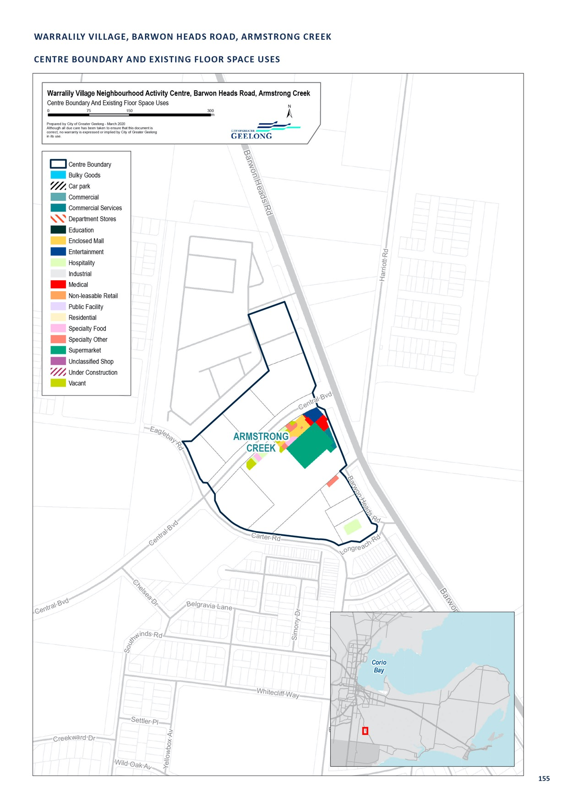

ARMSTRONG CREEK TOWN CENTRE, SURF COAST HIGHWAY, ARMSTRONG CREEK

Refer to the section on sub-regional centres at page 90
for information regarding the Armstrong Creek Town Centre Restricted Retail Centre.

RESTRICTED RETAIL

LEOPOLD GATEWAY PLAZA, BELLARINE HIGHWAY, LEOPOLD

Refer to the section on sub-regional centres at page 96 for information regarding the Leopold Gateway Plaza Restricted Retail Centre.

COLAC ROAD, WAURN PONDS

CENTRE NAME: COLAC ROAD, WAURN PONDS
Hierarchy status: | Restricted retail
Location: | Waurn Ponds
Key characteristics: | Large, low-density restricted retail precinct on Princes Highway, close to Waurn Ponds Shopping Centre and Deakin University Waurn Ponds campus. Includes the Geelong Restricted Retail Centre.
Current role: | This centre is a large, restricted retail precinct in the south-west area of Greater Geelong. It contains a significant proportion of low-density restricted retail, including a Bunnings and Harvey Norman.
Zoning (sqm): | ACZ |  |  |  |  | C1Z |  |  |  | C2Z |  | MUZ |  |  |  | Other
Zoning (sqm): | 0 |  |  |  | 0 |  |  | 158,470 |  |  |  |  |  | 0 |  |  |  | 0
Retail and commercial floor space* (sqm): | Super market | Depart’ Store |  | Restricted Retail |  |  | Specialty Food |  | Specialty Other |  |  |  | Hospitality |  | Total Retail |  | Other Employ’ |  | Vacant
Retail and commercial floor space* (sqm): | 0 | 0 |  | 31,398 |  |  | 473 |  | 14,821 |  |  |  | 280 |  | 46,972 |  | 0 |  | 333
Retail anchors: | Bunnings, Harvey Norman, SuperAmart
Transport connections: | Public |  | Bus service (routes 14, 18, 19 and 20)
 | Private |  | Intersection of Princes Highway and Pigdons Road, accessible via Princes Freeway, Pioneer Road and Surf Coast Highway
Future role and opportunities: | The Waurn Ponds restricted retail precinct provides a genuine restricted retail offer to the southern suburbs of Geelong. Whilst slightly disjointed in nature, there are sufficient retail anchors to make this centre attractive for consumers. The centre also benefits from its location at the Grovedale on/off ramp of the Geelong Ring Road.  This centre has synergies with the Waurn Ponds sub-regional precinct in terms of its location along Colac Road. There may be opportunities to visually connect the two centres and promote the area as major retail, employment and residential hub in Geelong.  As per the recommendations from the Waurn Pond sub-regional centre, a structure plan for the broader area should be developed.
Action required: | Prepare a structure plan for the broader Waurn Ponds area, between South Valley/Pioneer Road and Pigdons Road.
Growth Opportunities | Forecast supportable floor space 2016–2036 sqm (difference from total floor space) |  |  |  |  | Potential to grow within current zoned land |  |  |  |  |  | Sub-precinct planning required |  |  |  | Potential for rezoning to align with centre boundary
Growth Opportunities | 43,600 |  |  |  |  | No |  |  |  |  | Yes |  |  |  |  | No

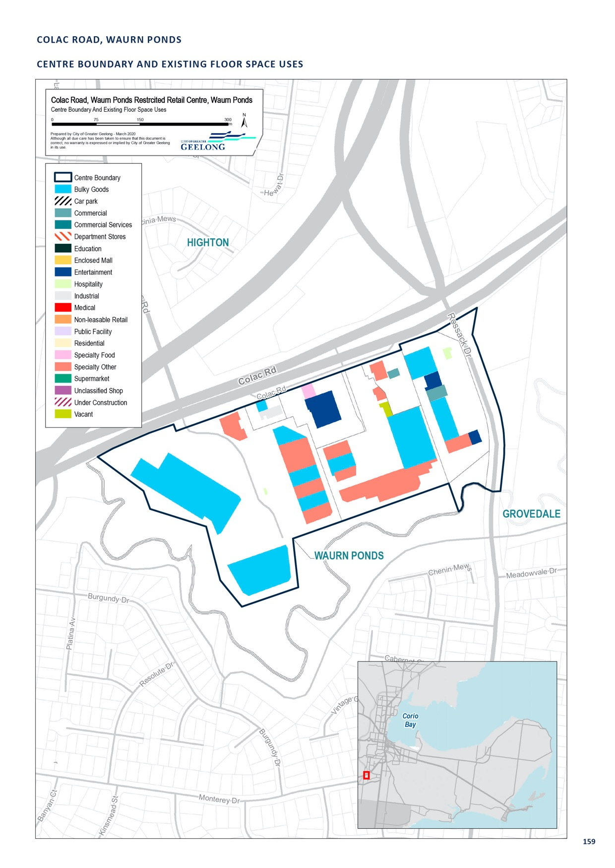

GEELONG GATEWAY, PRINCES HIGHWAY, CORIO

CENTRE NAME: GEELONG GATEWAY, PRINCES HIGHWAY, CORIO
Hierarchy status: | Restricted retail
Location: | Corio
Key characteristics: | Mid-sized restricted retail precinct located along the Princes Highway, across from Rosewall Activity Centre. Comprises Geelong Gate Restricted retail centre and land south of Broderick Road. Major stores include Fantastic Furniture and Harvey Norman.
Current role: | Acts as the gateway to the central Geelong region.
Zoning (sqm): | ACZ |  |  |  |  | C1Z |  |  |  | C2Z |  | MUZ |  |  |  | Other
Zoning (sqm): | 0 |  |  |  | 0 |  |  | 194,810 |  |  |  |  |  | 0 |  |  |  | 0
Retail and commercial floor space* (sqm): | Super market | Depart’ Store |  | Restricted Retail |  |  | Specialty Food |  | Specialty Other |  |  |  | Hospitality |  | Total Retail |  | Other Employ’ |  | Vacant
Retail and commercial floor space* (sqm): | 0 | 0 |  | 26,022 |  |  | 1,540 |  | 2,775 |  |  |  | 1,125 |  | 31,463 |  | 0 |  | 2,120
Retail anchors: | Multiple large format chain stores, such as Fantastic Furniture and Plush, and includes a large gymnasium
Transport connections: | Public |  | Corio Railway Station (approx. 1.2km), bus service (route 12)
 | Private |  | Princes Highway, between Princes Freeway and School Road
Future role and opportunities: | Amendment C282 to the Geelong Planning Scheme rezoned this area from the Industrial 1 and Industrial 3 Zone to the Commercial 2 Zone, and included the area as a restricted retail precinct in the retail hierarchy. This amendment was approved on 16 October 2016. There is still vacant land within this centre that could be developed for future restricted retailing uses.
Action required: | Nil
Growth Opportunities | Forecast supportable floor space 2016–2036 sqm (difference from total floor space) |  |  |  |  | Potential to grow within current zoned land |  |  |  |  |  | Sub-precinct planning required |  |  |  | Potential for rezoning to align with centre boundary
Growth Opportunities | 26,100 |  |  |  |  | Yes |  |  |  |  | No |  |  |  |  | No

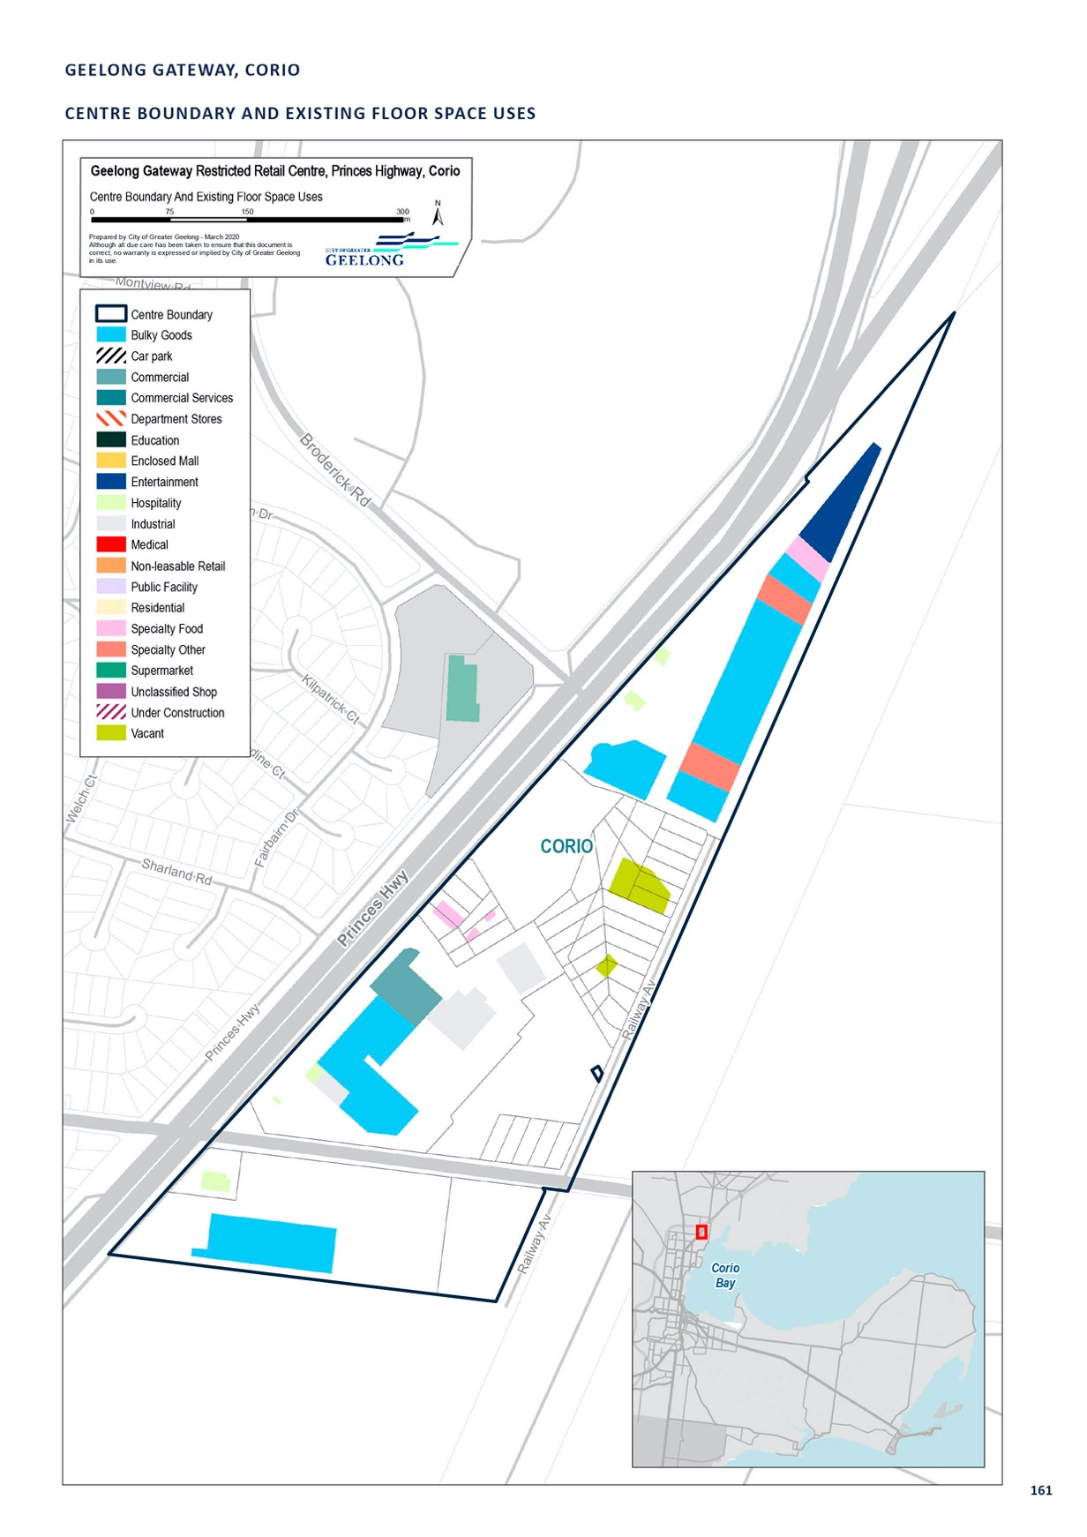

MELBOURNE ROAD, NORLANE

CENTRE NAME: MELBOURNE ROAD, NORLANE
Hierarchy status: | Restricted retail
Location: | Norlane
Key characteristics: | Low-density restricted retail precinct with several fast food restaurants and services located along the Princes Highway.
Current role: | With a significant proportion of low-density restricted retail (including Bunnings), this precinct serves the northern Greater Geelong area with restricted retail needs, as well as commuters along the highway.
Zoning (sqm): | ACZ C1Z C2Z MUZ Other
Zoning (sqm): | 0 |  |  |  | 7,680 |  |  | 85,460 |  |  |  | 0 |  |  |  | 2,860
Retail and commercial floor space* (sqm):
Retail and commercial floor space* (sqm): | Super market | Depart’ Store |  | Restricted Retail |  |  | Specialty Food |  | Specialty Other |  | Hospitality |  | Total Retail |  | Other Employ’ |  | Vacant
Retail anchors: | 0  Bunnings | 0 |  | 18,968 |  |  | 1,400 |  | 2,286 |  | 988 |  | 23,652 |  | 0 |  | 92
Transport connections: | Public |  | North Shore Railway Station (approx. 1.4 km), bus service (routes 10 and 11)
 | Private |  | Princes Highway, at North Shore Road intersection
Future role and opportunities: | Given the presence of a Bunnings store, this precinct is likely to continue to play this role into the future.  There are several sites in the Commercial 2 Zone which have development potential and could accommodate the additional demand for restricted retail floor space in this location.
Action required: | Nil
Growth Opportunities | Forecast supportable Potential to grow Sub-precinct planning Potential for rezoning floor space 2016–2036 within current zoned required to align with centre sqm (difference from land boundary  total floor space)
Growth Opportunities | 19,700 |  |  |  |  | Yes |  |  |  | No |  |  |  | No

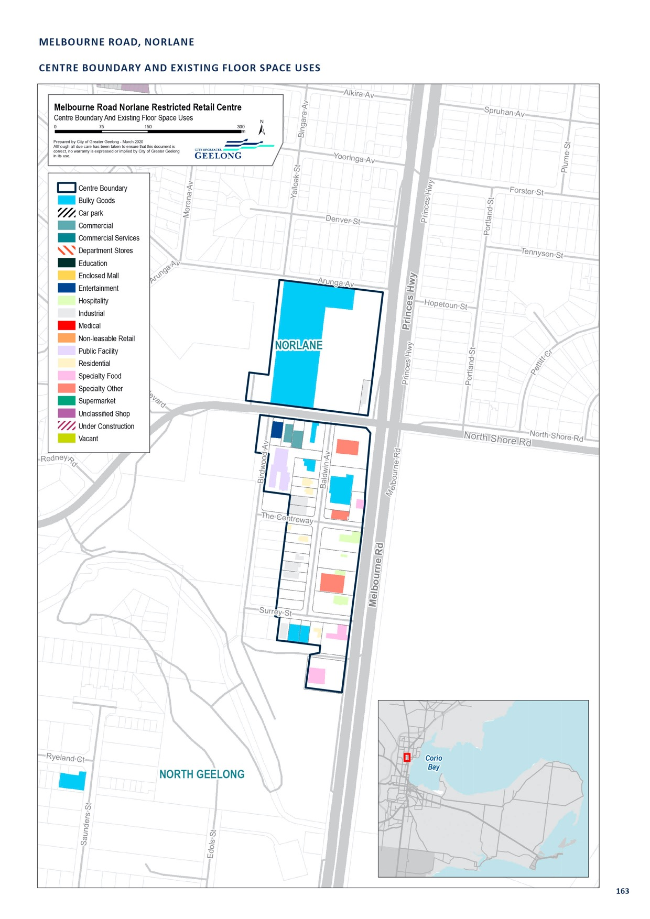

MELBOURNE ROAD, NORTH GEELONG

CENTRE NAME: MELBOURNE ROAD, NORTH GEELONG
Hierarchy status: | Restricted retail
Location: | North Geelong
Key characteristics: | Mid-sized, low density restricted retail precinct with under 25 stores and services. Has high exposure along the Princes Highway.
Current role: | With a mix of uses, including fireplace sales, bakery, furniture sales, post office (depot) and Beacon lighting. This precinct largely serves the northern Greater Geelong area with restricted retail and industrial service needs.
Zoning (sqm): | ACZ |  |  |  |  | C1Z |  |  |  | C2Z |  | MUZ |  |  |  | Other
Zoning (sqm): | 0 |  |  |  | 0 |  |  | 42,640 |  |  |  |  |  | 0 |  |  |  | 0
Retail and commercial floor space* (sqm): | Super market | Depart’ Store |  | Restricted Retail |  |  | Specialty Food |  | Specialty Other |  |  |  | Hospitality |  | Total Retail |  | Other Employ’ |  | Vacant
Retail and commercial floor space* (sqm): | 0 | 0 |  | 9,080 |  |  | 0 |  | 4,800 |  |  |  | 440 |  | 14,320 |  | 3,620 |  | 0
Retail anchors: | None
Transport connections: | Public |  | North Geelong Station (approx. 1.7 km), bus service (routes 10 and 11)
 | Private |  | Princes Highway, at Dunne Street intersection, near Separation Street
Future role and opportunities: | This precinct is likely to continue to play this role into the future.  The recent closure of Rays Outdoors a key anchor in the area may have an impact on the trading of this centre. There may be some redevelopment opportunities within the existing zoned area to accommodate the forecast demand for retail in the centre. A new showroom has been developed at 346 Melbourne Road, which may attract new uses in the area.
Action required: | Nil
Growth Opportunities | Forecast supportable floor space 2016–2036 sqm (difference from total floor space) |  |  |  |  | Potential to grow within current zoned land |  |  |  |  |  | Sub-precinct planning required |  |  |  | Potential for rezoning to align with centre boundary
Growth Opportunities | 11,800 |  |  |  |  | Yes |  |  |  |  | No |  |  |  |  | No

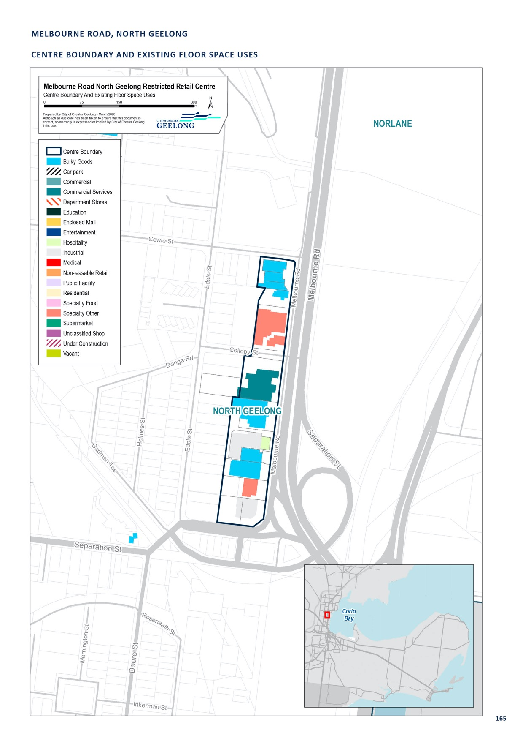

MURRADOC ROAD, DRYSDALE

CENTRE NAME: MURRADOC ROAD, DRYSDALE
Hierarchy status: | Restricted retail
Location: | Drysdale
Key characteristics: | Largely undeveloped commercial/industrial estate on the eastern edge of the Drysdale Town Centre.
Current role: | Restricted retail precinct
Zoning (sqm): | ACZ |  |  |  |  | C1Z |  |  |  | C2Z |  | MUZ |  |  |  | Other
Zoning (sqm): | 0 |  |  |  | 0 |  |  | 200,000 |  |  |  |  |  | 0 |  |  |  | 0
Retail and commercial floor space* (sqm): | Super market | Depart’ Store |  | Restricted Retail |  |  | Specialty Food |  | Specialty Other |  |  |  | Hospitality |  | Total Retail |  | Other Employ’ |  | Vacant
Retail and commercial floor space* (sqm): | 0 | 0 |  | 1,655 |  |  | 328 |  | 755 |  |  |  | 436 |  | 3,174 |  | 0 |  | 0
Retail anchors: | Nil
Transport connections: | Public |  | Bus service (routes 60)
 | Private |  | Murradoc Road
Future role and opportunities: | A significant area in terms of size, the Drysdale restricted retail precinct is located directly to the west of the town centre. Much of the land is vacant. Land uses along Murradoc Road are generally industrial in nature, however with recent rezoning of additional Commercial 2 zoned land, it is likely that the area will increase its retail offer overtime.  The development of Drysdale and Clifton Springs is guided by the Drysdale Urban Design Framework 2012 and the Drysdale/Clifton Springs Structure Plan 2010. The recommendations of these documents have been implemented into the Geelong Planning Scheme through various amendments. Most recently, land along Murradoc Road has been rezoned from the Farming Zone to Commercial 2 to join up with the future Drysdale bypass.  There is demand for restricted retailing in the Northern Bellarine and on the Bellarine more generally by 2036. There is approximately 19 hectares of developable Commercial 2 Zoned land in Drysdale, which is considered more than sufficient to meet the future restricted retail retailing needs of the Northern Bellarine until 2036.
Action required: | Nil
Growth Opportunities | Forecast supportable floor space 2016–2036 sqm (difference from total floor space) |  |  |  |  | Potential to grow within current zoned land |  |  |  |  |  | Sub-precinct planning required |  |  |  | Potential for rezoning to align with centre boundary
Growth Opportunities | 2,000 |  |  |  |  | Yes |  |  |  |  | No |  |  |  |  | No

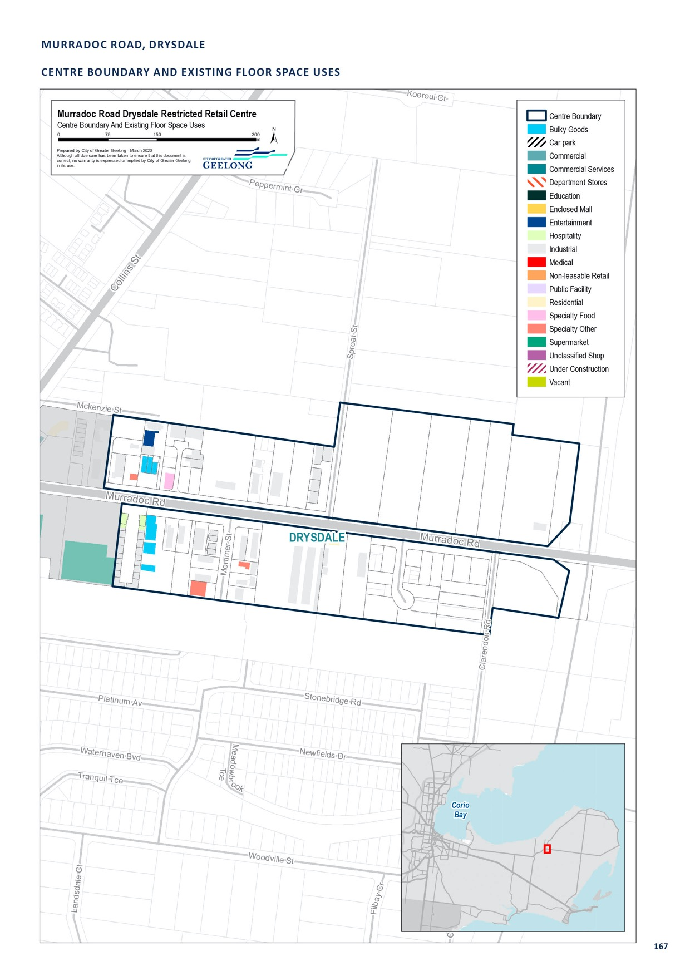

SINCLAIR STREET, OCEAN GROVE

CENTRE NAME: SINCLAIR STREET, OCEAN GROVE
Hierarchy status: | Restricted retail
Location: | Ocean Grove
Key characteristics: | Small existing restricted retail centre located in the north of Ocean Grove that was recently expanded to cater for the long-term growth of the town.
Current role: | Meets the retail and industrial needs of Ocean Grove
Zoning (sqm): | ACZ |  |  |  |  | C1Z |  |  |  | C2Z |  | MUZ |  |  |  | Other
Zoning (sqm): | 0 |  |  |  | 0 |  |  | 187,500 |  |  |  |  |  | 0 |  |  |  | 0
Retail and commercial floor space* (sqm): | Super market | Depart’ Store |  | Restricted Retail |  |  | Specialty Food |  | Specialty Other |  |  |  | Hospitality |  | Total Retail |  | Other Employ’ |  | Vacant
Retail and commercial floor space* (sqm): | 0 | 0 |  | 724 |  |  | 0 |  | 2,836 |  |  |  | 998 |  | 4,095 |  | 9,500 |  | 0
Retail anchors: | None
Transport connections: | Public |  | Bus service (routes 56)
 | Private |  | Grubb Road via Bellarine Highway, Grubb Road Via Shell Road
Future role and opportunities: | An existing restricted retail precinct in Ocean Grove. This centre has a minimum of restricted retail industrial and retail use. The area consists of mechanics, furniture sales, plumbing supplies, an opportunity shop and other retail uses. In the past this commercial area was the only location available for service business and large format retail uses.  An expanded Commercial 2 Zone located to the north of Sinclair Street has been added to this existing restricted retail precinct to accommodate demand from the northern residential growth area of Ocean Grove. A Development Plan has been approved for this area, but development of this area has not yet occurred.  The rezoning of 7 hectares of land, to the east of the Commercial 2 Zone, to an Industrial 3 Zone may also encourage light industrial uses to establish in this new precinct, allowing for more restricted retail type uses to establish in the Commercial 2 Zone.  With the large amount of Commercial 2 Zone land available, It is highly likely that any forecast demand for additional retail will be able to be met.
Action required: | Nil
Growth Opportunities | Forecast supportable floor space 2016–2036 sqm (difference from total floor space) |  |  |  |  | Potential to grow within current zoned land |  |  |  |  |  | Sub-precinct planning required |  |  |  | Potential for rezoning to align with centre boundary
Growth Opportunities | 4,800 |  |  |  |  | Yes |  |  |  |  | No |  |  |  |  | No

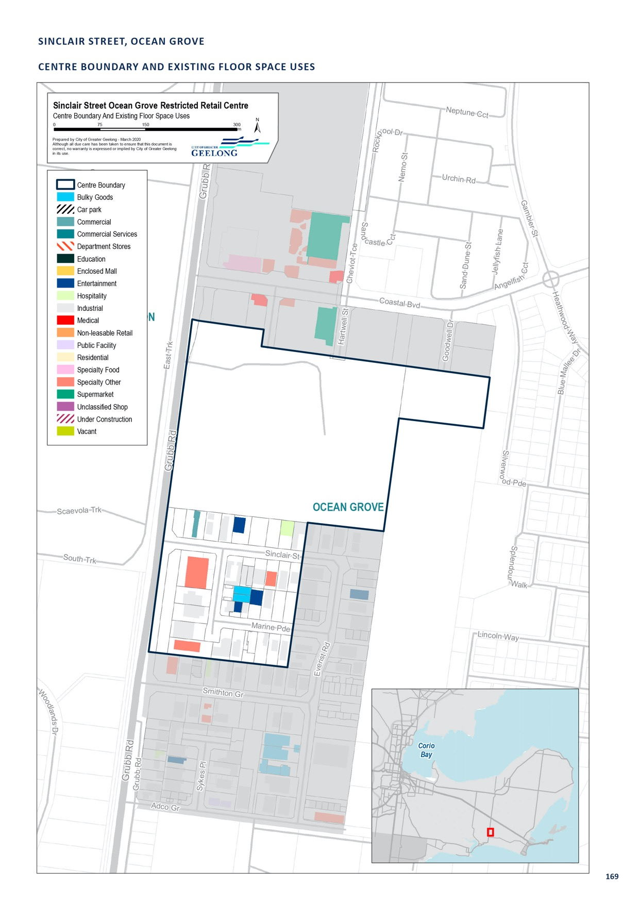

ARMSTRONG CREEK WEST

CENTRE NAME: ARMSTRONG CREEK WEST
Hierarchy status: | Neighbourhood Centre
Location: | Armstrong Creek West Growth Area
Key characteristics: | Planned Neighbourhood Centre yet to be developed.
Current role: | Services the local area of Armstrong Creek.
Zoning (sqm): | ACZ |  |  |  |  | C1Z |  |  |  | C2Z |  | MUZ |  |  |  | Other
Zoning (sqm): | 0 |  |  |  | 0 |  |  | 0 |  |  |  |  |  | 0 |  |  |  | Unknown
Retail and commercial floor space* (sqm): | Super market | Depart’ Store |  | Restricted Retail |  |  | Specialty Food |  | Specialty Other |  |  |  | Hospitality |  | Total Retail |  | Other Employ’ |  | Vacant
Retail and commercial floor space* (sqm): | 0 | 0 |  | 0 |  |  | 0 |  | 0 |  |  |  | 0 |  | 3,000 |  |  |  | 0
Retail anchors: | Future supermarket
Transport connections: | Public |  | Nil
 | Private |  | Surf Coast Highway
Future role and opportunities: | A planned neighbourhood centre within the Armstrong Creek Growth Area south of Geelong. The Armstrong Creek Neighbourhood Activity Centre, will form part of the Armstrong Creek West Precinct. An approved precinct structure plan for this area has identified that approximately 3,000 square metres of retail floor space is needed to service this future community. A planning permit will be required for this activity centre.
Action required: | Nil
Growth Opportunities | Forecast supportable floor space 2016–2036 sqm (difference from total floor space) |  |  |  |  | Potential to grow within current zoned land |  |  |  |  |  | Sub-precinct planning required |  |  |  | Potential for rezoning to align with centre boundary
Growth Opportunities | -1,600 |  |  |  |  | Yes |  |  |  |  | No |  |  |  |  | No

HORSESHOE BEND NORTH EAST

CENTRE NAME: HORSESHOE BEND NORTH EAST
Hierarchy status: | Neighbourhood Centre
Location: | Horseshoe Bend North East Precinct
Key characteristics: | Planned Neighbourhood Centre yet to be developed.
Current role: | Will service the Horseshoe Bend North East precinct.
Zoning (sqm): | ACZ |  |  |  |  | C1Z |  |  |  | C2Z |  | MUZ |  |  |  | Other
Zoning (sqm): | 0 |  |  |  | 0 |  |  | 0 |  |  |  |  |  | 0 |  |  |  | 0
Retail and commercial floor space* (sqm): | Super market | Depart’ Store |  | Restricted Retail |  |  | Specialty Food |  | Specialty Other |  |  |  | Hospitality |  | Total Retail |  | Other Employ’ |  | Vacant
Retail and commercial floor space* (sqm): | 0 | 0 |  | 0 |  |  | 0 |  | 0 |  |  |  | 0 |  | 7,000 |  | 0 |  | 0
Retail anchors: | Nil
Transport connections: | Public |  | Bus Service (Route 61)
 | Private |  | Horseshoe Bend Road
Future role and opportunities: | A planned neighbourhood centre within the Armstrong Creek Growth Area, south of Geelong. The Horseshoe Bend Neighbourhood Activity Centre will form part of the Horseshoe Bend Precinct. An approved precinct structure plan for this area has identified that approximately 7,000 square metres of retail floor space is needed to service this future community. A planning permit will be required for this activity centre.
Action required: | Nil
Growth Opportunities | Forecast supportable floor space 2016–2036 sqm (difference from total floor space) |  |  |  |  | Potential to grow within current zoned land |  |  |  |  |  | Sub-precinct planning required |  |  |  | Potential for rezoning to align with centre boundary
Growth Opportunities | -2,600 |  |  |  |  | Yes |  |  |  |  | No |  |  |  |  | No

LARA WEST, LARA

CENTRE NAME: LARA WEST, LARA
Hierarchy status: | Neighbourhood Centre
Location: | Lara West Growth Area
Key characteristics: | Planned neighbourhood centre yet to be developed.
Current role: | Will service the Lara West Growth Area
Zoning (sqm): | ACZ |  |  |  |  | C1Z |  |  |  | C2Z |  | MUZ |  |  |  | Other
Zoning (sqm): | 0 |  |  |  | 0 |  |  | 0 |  |  |  |  |  | 0 |  |  |  | Unknown
Retail and commercial floor space* (sqm): | Super market | Depart’ Store |  | Restricted Retail |  |  | Specialty Food |  | Specialty Other |  |  |  | Hospitality |  | Total Retail |  | Other Employ’ |  | Vacant
Retail and commercial floor space* (sqm): | 3,600 | 0 |  |  |  |  | 0 |  | 1,100 |  |  |  | 0 |  | 4,700 |  | 0 |  | 0
Retail anchors: | Supermarket based centre
Transport connections: | Public |  | Bus Service (Route 12)
 | Private |  | Bacchus Marsh Road, Forest Road North via Elcho or Windermere Roads
Future role and opportunities: | The Lara West Neighbourhood Activity Centre will form part of the Lara West Growth Area. A precinct structure plan has been approved for this area, which identified the need for approximately 4,700 square metres of retail floor space to service the future community. The Lara West Precinct Structure Plan requires an urban design framework to be approved prior to the development of the neighbourhood centre.  We will is currently considering two planning applications for subdivision, for approx. 2500 lots.
Action required: | Nil
Growth Opportunities | Forecast supportable floor space 2016–2036 sqm (difference from total floor space) |  |  |  |  | Potential to grow within current zoned land |  |  |  |  |  | Sub-precinct planning required |  |  |  | Potential for rezoning to align with centre boundary
Growth Opportunities | -800 |  |  |  |  | Yes |  |  |  |  | No |  |  |  |  | No

CENTRAL RESTRICTED RETAIL CENTRE - WGGA

CENTRE NAME: CENTRAL RESTRICTED RETAIL CENTRE - WGGA
Hierarchy status: | Neighbourhood Centre
Location: | Western Geelong Growth Area – Batesford
Key characteristics: | Indicative restricted retail centre yet to be developed.
Current role: | Will service the western growth area in Batesford
Zoning (sqm): | ACZ |  |  |  |  | C1Z |  |  |  | C2Z |  | MUZ |  |  |  | Other
Zoning (sqm): | 0 |  |  |  | 0 |  |  | 0 |  |  |  |  |  | 0 |  |  |  | 0
Retail and commercial floor space* (sqm): | Super market | Depart’ Store |  | Restricted Retail |  |  | Specialty Food |  | Specialty Other |  |  |  | Hospitality |  | Total Retail |  | Other Employ’ |  | Vacant
Retail and commercial floor space* (sqm): | 0 | 0 |  |  |  |  | 0 |  | 0 |  |  |  | 0 |  | 0 |  | 0 |  | 0
Retail anchors: | Nil
Transport connections: | Public |  | Unknown
 | Private |  | Unknown
Future role and opportunities: | An indicative restricted retail centre in the Western Geelong Growth Area in Batesford. It is anticipated that this centre would not be constructed in the forecast period.
Action required: | N/A
Growth Opportunities | Forecast supportable floor space 2016–2036 sqm (difference from total floor space) |  |  |  |  | Potential to grow within current zoned land |  |  |  |  |  | Sub-precinct planning required |  |  |  | Potential for rezoning to align with centre boundary
Growth Opportunities | N/A |  |  |  |  | N/A |  |  |  |  | N/A |  |  |  |  | N/A

ELCHO ROAD EAST - NORTH - NGGA

CENTRE NAME: ELCHO ROAD EAST - NORTH - NGGA
Hierarchy status: | Neighbourhood Centre
Location: | Northern Geelong Growth Area – Lovely Banks
Key characteristics: | Indicative neighbourhood centre yet to be developed.
Current role: | Will service the northern growth area in Lovely Banks
Zoning (sqm): | ACZ |  |  |  |  | C1Z |  |  |  | C2Z |  | MUZ |  |  |  | Other
Zoning (sqm): | 0 |  |  |  | 0 |  |  | 0 |  |  |  |  |  | 0 |  |  |  | 0
Retail and commercial floor space* (sqm): | Super market | Depart’ Store |  | Restricted Retail |  |  | Specialty Food |  | Specialty Other |  |  |  | Hospitality |  | Total Retail |  | Other Employ’ |  | Vacant
Retail and commercial floor space* (sqm): | 0 | 0 |  |  |  |  | 0 |  | 0 |  |  |  | 0 |  | 0 |  | 0 |  | 0
Retail anchors: | Nil
Transport connections: | Public |  | Unknown
 | Private |  | Unknown
Future role and opportunities: | An indicative neighbourhood centre in the Northern Geelong Growth Area in Lovely Banks. It is anticipated that this centre would not be constructed during the forecast period.
Action required: | Consider applying floor space caps during preparation of precinct structure plan
Growth Opportunities | Forecast supportable floor space 2016–2036 sqm (difference from total floor space) |  |  |  |  | Potential to grow within current zoned land |  |  |  |  |  | Sub-precinct planning required |  |  |  | Potential for rezoning to align with centre boundary
Growth Opportunities | N/A |  |  |  |  | N/A |  |  |  |  | N/A |  |  |  |  | N/A

ELCHO ROAD EAST - SOUTH - NGGA

CENTRE NAME: ELCHO ROAD EAST - SOUTH - NGGA
Hierarchy status: | Neighbourhood Centre
Location: | Northern Geelong Growth Area – Lovely Banks
Key characteristics: | Indicative neighbourhood centre yet to be developed.
Current role: | Will service the northern growth area in Lovely Banks
Zoning (sqm): | ACZ |  |  |  |  | C1Z |  |  |  | C2Z |  | MUZ |  |  |  | Other
Zoning (sqm): | 0 |  |  |  | 0 |  |  | 0 |  |  |  |  |  | 0 |  |  |  | 0
Retail and commercial floor space* (sqm): | Super market | Depart’ Store |  | Restricted Retail |  |  | Specialty Food |  | Specialty Other |  |  |  | Hospitality |  | Total Retail |  | Other Employ’ |  | Vacant
Retail and commercial floor space* (sqm): | 0 | 0 |  |  |  |  | 0 |  | 0 |  |  |  | 0 |  | 0 |  | 0 |  | 0
Retail anchors: | Nil
Transport connections: | Public |  | Unknown
 | Private |  | Unknown
Future role and opportunities: | An indicative neighbourhood centre in the Northern Geelong Growth Area in Lovely Banks. It is anticipated that this centre would not be constructed during the forecast period.
Action required: | Consider applying floor space caps during preparation of precinct structure plan
Growth Opportunities | Forecast supportable floor space 2016–2036 sqm (difference from total floor space) |  |  |  |  | Potential to grow within current zoned land |  |  |  |  |  | Sub-precinct planning required |  |  |  | Potential for rezoning to align with centre boundary
Growth Opportunities | N/A |  |  |  |  | N/A |  |  |  |  | N/A |  |  |  |  | N/A

* Excludes non employment uses such as residential, car parking and sites under construction.

ELCHO ROAD WEST - NGGA

CENTRE NAME: ELCHO ROAD WEST - NGGA
Hierarchy status: |  | Neighbourhood Centre
Location: |  | Northern Geelong Growth Area – Lovely Banks
Key characteristics: |  | Indicative neighbourhood centre yet to be developed.
Current role: |  | Service the northern growth area in Lovely Banks
Zoning (sqm): |  | ACZ C1Z C2Z MUZ Other
 |  | 0 |  |  |  | 0 |  |  |  | 0 |  |  | 0 |  |  | 0
Retail and commercial floor space* (sqm):
Retail anchors: |  | Nil
Transport  connections: | Super market |  | Depart’ Store |  | Restricted Retail |  |  | Specialty Food | Specialty Other |  | Hospitality |  |  | Total Retail | Other Employ’ |  | Vacant
0 |  | Priv | a0te |  | U0nknown |  |  | 0 | 0 |  | 0 |  |  | 0 |  |  | 0
Future role and opportunities: |  | An indicative neighbourhood centre in the Northern Geelong Growth Area in Lovely Banks. It is anticipated that this centre would not be constructed during the forecast period.
Action required: |  | Consider applying floor space caps during preparation of precinct structure plan
Growth Opportunities |  | Forecast supportable Potential to grow Sub-precinct planning Potential for rezoning floor space 2016–2036 within current zoned required to align with centre sqm (difference from land boundary  total floor space)
 |  | N/A |  |  |  |  | N/A |  |  |  |  | N/A |  |  | N/A

HEALES ROAD WEST - NGGA

CENTRE NAME: HEALES ROAD WEST - NGGA
Hierarchy status: | Neighbourhood Centre
Location: | Northern Geelong Growth Area – Lovely Banks
Key characteristics: | Indicative neighbourhood centre yet to be developed.
Current role: | Will service the northern growth area in Lovely Banks
Zoning (sqm): | ACZ |  |  |  |  | C1Z |  |  |  | C2Z |  | MUZ |  |  |  | Other
Zoning (sqm): | 0 |  |  |  | 0 |  |  | 0 |  |  |  |  |  | 0 |  |  |  | 0
Retail and commercial floor space* (sqm): | Super market | Depart’ Store |  | Restricted Retail |  |  | Specialty Food |  | Specialty Other |  |  |  | Hospitality |  | Total Retail |  | Other Employ’ |  | Vacant
Retail and commercial floor space* (sqm): | 0 | 0 |  |  |  |  | 0 |  | 0 |  |  |  | 0 |  | 6,600 |  | 0 |  | 0
Retail anchors: | Nil
Transport connections: | Public |  | Unknown
 | Private |  | Unknown
Future role and opportunities: | An indicative neighbourhood centre in the Western Geelong Growth Area in Lovely Banks. It is anticipated that this centre would be constructed late in the forecast period.
Action required: | Consider applying floor space caps during preparation of precinct structure plan
Growth Opportunities | Forecast supportable floor space 2016–2036 sqm (difference from total floor space) |  |  |  |  | Potential to grow within current zoned land |  |  |  |  |  | Sub-precinct planning required |  |  |  | Potential for rezoning to align with centre boundary
Growth Opportunities | N/A |  |  |  |  | N/A |  |  |  |  | N/A |  |  |  |  | N/A

LAKESIDE WEST - WGGA

CENTRE NAME: LAKESIDE WEST - WGGA
Hierarchy status: | Neighbourhood Centre
Location: | Western Geelong Growth Area – Batesford
Key characteristics: | Indicative neighbourhood centre yet to be developed.
Current role: | Will service the western growth area in Batesford
Zoning (sqm): | ACZ |  |  |  |  | C1Z |  |  |  | C2Z |  | MUZ |  |  |  | Other
Zoning (sqm): | 0 |  |  |  | 0 |  |  | 0 |  |  |  |  |  | 0 |  |  |  | 0
Retail and commercial floor space* (sqm): | Super market | Depart’ Store |  | Restricted Retail |  |  | Specialty Food |  | Specialty Other |  |  |  | Hospitality |  | Total Retail |  | Other Employ’ |  | Vacant
Retail and commercial floor space* (sqm): | 0 | 0 |  |  |  |  | 0 |  | 0 |  |  |  | 0 |  | 0 |  | 0 |  | 0
Retail anchors: | Nil
Transport connections: | Public |  | Unknown
 | Private |  | Unknown
Future role and opportunities: | An indicative neighbourhood centre in the Western Geelong Growth Area in Batesford. It is anticipated that this centre would not be constructed in the forecast period.
Action required: | Consider applying floor space caps during preparation of precinct structure plan
Growth Opportunities | Forecast supportable floor space 2016–2036 sqm (difference from total floor space) |  |  |  |  | Potential to grow within current zoned land |  |  |  |  |  | Sub-precinct planning required |  |  |  | Potential for rezoning to align with centre boundary
Growth Opportunities | N/A |  |  |  |  | N/A |  |  |  |  | N/A |  |  |  |  | N/A

LAKESIDE SOUTH - WGGA

CENTRE NAME: LAKESIDE SOUTH - WGGA
Hierarchy status: | Neighbourhood Centre
Location: | Western Geelong Growth Area – Batesford
Key characteristics: | Indicative neighbourhood centre yet to be developed.
Current role: | Will service the western growth area in Batesford
Zoning (sqm): | ACZ |  |  |  |  | C1Z |  |  |  | C2Z |  | MUZ |  |  |  | Other
Zoning (sqm): | 0 |  |  |  | 0 |  |  | 0 |  |  |  |  |  | 0 |  |  |  | 0
Retail and commercial floor space* (sqm): | Super market | Depart’ Store |  | Restricted Retail |  |  | Specialty Food |  | Specialty Other |  |  |  | Hospitality |  | Total Retail |  | Other Employ’ |  | Vacant
Retail and commercial floor space* (sqm): | 0 | 0 |  |  |  |  | 0 |  | 0 |  |  |  | 0 |  | 0 |  | 0 |  | 0
Retail anchors: | Nil
Transport connections: | Public |  | Unknown
 | Private |  | Unknown
Future role and opportunities: | An indicative neighbourhood centre in the Western Geelong Growth Area in Batesford. It is anticipated that this centre would not be constructed in the forecast period.
Action required: | Consider applying floor space caps during preparation of precinct structure plan
Growth Opportunities | Forecast supportable floor space 2016–2036 sqm (difference from total floor space) |  |  |  |  | Potential to grow within current zoned land |  |  |  |  |  | Sub-precinct planning required |  |  |  | Potential for rezoning to align with centre boundary
Growth Opportunities | N/A |  |  |  |  | N/A |  |  |  |  | N/A |  |  |  |  | N/A

MIDLAND HWY - WGGA

CENTRE NAME: MIDLAND HWY - WGGA
Hierarchy status: | Neighbourhood Centre
Location: | Western Geelong Growth Area – Batesford
Key characteristics: | Indicative neighbourhood centre yet to be developed.
Current role: | Will service the western growth area in Batesford
Zoning (sqm): | ACZ |  |  |  |  | C1Z |  |  |  | C2Z |  | MUZ |  |  |  | Other
Zoning (sqm): | 0 |  |  |  | 0 |  |  | 0 |  |  |  |  |  | 0 |  |  |  | 0
Retail and commercial floor space* (sqm): | Super market | Depart’ Store |  | Restricted Retail |  |  | Specialty Food |  | Specialty Other |  |  |  | Hospitality |  | Total Retail |  | Other Employ’ |  | Vacant
Retail and commercial floor space* (sqm): | 0 | 0 |  |  |  |  | 0 |  | 0 |  |  |  | 0 |  | 0 |  | 0 |  | 0
Retail anchors: | Nil
Transport connections: | Public |  | Unknown
 | Private |  | Unknown
Future role and opportunities: | An indicative neighbourhood centre in the Western Geelong Growth Area in Batesford. It is anticipated that this centre would not be constructed in the forecast period.
Action required: | Consider applying floor space caps during preparation of precinct structure plan
Growth Opportunities | Forecast supportable floor space 2016–2036 sqm (difference from total floor space) |  |  |  |  | Potential to grow within current zoned land |  |  |  |  |  | Sub-precinct planning required |  |  |  | Potential for rezoning to align with centre boundary
Growth Opportunities | N/A |  |  |  |  | N/A |  |  |  |  | N/A |  |  |  |  | N/A

NORTHERN CENTRE - WGGA

CENTRE NAME: NORTHERN CENTRE - WGGA
Hierarchy status: | Neighbourhood Centre
Location: | Western Geelong Growth Area – Batesford
Key characteristics: | Indicative neighbourhood centre yet to be developed.
Current role: | Will service the western growth area in Batesford
Zoning (sqm): | ACZ |  |  |  |  | C1Z |  |  |  | C2Z |  | MUZ |  |  |  | Other
Zoning (sqm): | 0 |  |  |  | 0 |  |  | 0 |  |  |  |  |  | 0 |  |  |  | 0
Retail and commercial floor space* (sqm): | Super market | Depart’ Store |  | Restricted Retail |  |  | Specialty Food |  | Specialty Other |  |  |  | Hospitality |  | Total Retail |  | Other Employ’ |  | Vacant
Retail and commercial floor space* (sqm): | 0 | 0 |  | 0 |  |  | 0 |  | 0 |  |  |  | 0 |  | 0 |  | 0 |  | 0
Retail anchors: | Nil
Transport connections: | Public |  | Unknown
 | Private |  | Unknown
Future role and opportunities: | An indicative neighbourhood centre in the Western Geelong Growth Area in Batesford. It is anticipated that this centre would not be constructed in the forecast period.
Action required: | Consider applying floor space caps during preparation of precinct structure plan
Growth Opportunities | Forecast supportable floor space 2016–2036 sqm (difference from total floor space) |  |  |  |  | Potential to grow within current zoned land |  |  |  |  |  | Sub-precinct planning required |  |  |  | Potential for rezoning to align with centre boundary
Growth Opportunities | N/A |  |  |  |  | N/A |  |  |  |  | N/A |  |  |  |  | N/A

SPECIALISED CENTRE - WGGA

CENTRE NAME: SPECIALISED CENTRE - WGGA
Hierarchy status: | Neighbourhood Centre
Location: | Western Geelong Growth Area – Batesford
Key characteristics: | Indicative specialised centre yet to be developed.
Current role: | Will service the western growth area in Batesford
Zoning (sqm): | ACZ |  |  |  |  | C1Z |  |  |  | C2Z |  | MUZ |  |  |  | Other
Zoning (sqm): | 0 |  |  |  | 0 |  |  | 0 |  |  |  |  |  | 0 |  |  |  | 0
Retail and commercial floor space* (sqm): | Super market | Depart’ Store |  | Restricted Retail |  |  | Specialty Food |  | Specialty Other |  |  |  | Hospitality |  | Total Retail |  | Other Employ’ |  | Vacant
Retail and commercial floor space* (sqm): | 0 | 0 |  | 0 |  |  | 0 |  | 0 |  |  |  | 0 |  | 0 |  |  |  | 0
Retail anchors: | Nil
Transport connections: | Public |  | Unknown
 | Private |  | Unknown
Future role and opportunities: | An indicative specialised centre in the Western Geelong Growth Area in Batesford. It is anticipated that this centre would not be constructed in the forecast period.
Action required: | Nil
Growth Opportunities | Forecast supportable floor space 2016–2036 sqm (difference from total floor space) |  |  |  |  | Potential to grow within current zoned land |  |  |  |  |  | Sub-precinct planning required |  |  |  | Potential for rezoning to align with centre boundary
Growth Opportunities | N/A |  |  |  |  | N/A |  |  |  |  | N/A |  |  |  |  | N/A

SUB-REGIONAL CENTRE - NGGA

CENTRE NAME: SUB-REGIONAL CENTRE - NGGA
Hierarchy status: | Sub-regional
Location: | Northern Geelong Growth Area – Lovely Banks
Key characteristics: | Indicative sub-regional centre yet to be developed.
Current role: | Will service the northern growth area in Lovely Banks
Zoning (sqm): | ACZ |  |  |  |  | C1Z |  |  |  | C2Z |  | MUZ |  |  |  | Other
Zoning (sqm): | 0 |  |  |  | 0 |  |  | 0 |  |  |  |  |  | 0 |  |  |  | 0
Retail and commercial floor space* (sqm): | Super market | Depart’ Store |  | Restricted Retail |  |  | Specialty Food |  | Specialty Other |  |  |  | Hospitality |  | Total Retail |  | Other Employ’ |  | Vacant
Retail and commercial floor space* (sqm): | 0 | 0 |  | 0 |  |  | 0 |  | 0 |  |  |  | 0 |  | 5,372 |  |  |  | 0
Retail anchors: | Nil
Transport connections: | Public |  | Unknown
 | Private |  | Unknown
Future role and opportunities: | An indicative sub-regional centre in the Northern Geelong Growth Area in Lovely Banks. It is anticipated that this centre would be constructed in the forecast period.
Action required: | Consider applying floor space caps during preparation of precinct structure plan
Growth Opportunities | Forecast supportable floor space 2016–2036 sqm (difference from total floor space) |  |  |  |  | Potential to grow within current zoned land |  |  |  |  |  | Sub-precinct planning required |  |  |  | Potential for rezoning to align with centre boundary
Growth Opportunities | -753 |  |  |  |  | N/A |  |  |  |  | N/A |  |  |  |  | N/A

SUB-REGIONAL CENTRE - WGGA

CENTRE NAME: SUB-REGIONAL CENTRE - WGGA
Hierarchy status: | Sub-regional
Location: | Western Geelong Growth Area – Batesford
Key characteristics: | Indicative sub-regional centre yet to be developed.
Current role: | Will service the western growth area in Batesford
Zoning (sqm): | ACZ |  |  |  |  | C1Z |  |  |  | C2Z |  | MUZ |  |  |  | Other
Zoning (sqm): | 0 |  |  |  | 0 |  |  | 0 |  |  |  |  |  | 0 |  |  |  | 0
Retail and commercial floor space* (sqm): | Super market | Depart’ Store |  | Restricted Retail |  |  | Specialty Food |  | Specialty Other |  |  |  | Hospitality |  | Total Retail |  | Other Employ’ |  | Vacant
Retail and commercial floor space* (sqm): | 0 | 0 |  | 0 |  |  | 0 |  | 0 |  |  |  | 0 |  | 16,552 |  | 0 |  | 0
Retail anchors: | Nil
Transport connections: | Public |  | Unknown
 | Private |  | Unknown
Future role and opportunities: | An indicative sub-regional centre in the Western Geelong Growth Area in Batesford. It is anticipated that this centre would be constructed in the forecast period.
Action required: | Consider applying floor space caps during preparation of precinct structure plan.
Growth Opportunities | Forecast supportable floor space 2016–2036 sqm (difference from total floor space) |  |  |  |  | Potential to grow within current zoned land |  |  |  |  |  | Sub-precinct planning required |  |  |  | Potential for rezoning to align with centre boundary
Growth Opportunities | 1,017 |  |  |  |  | N/A |  |  |  |  | N/A |  |  |  |  | N/A

WESTERN CENTRE - WGGA

CENTRE NAME: WESTERN CENTRE - WGGA
Hierarchy status: | Neighbourhood Centre
Location: | Western Geelong Growth Area – Batesford
Key characteristics: | Indicative neighbourhood centre yet to be developed.
Current role: | Will service the western growth area in Batesford
Zoning (sqm): | ACZ |  |  |  |  | C1Z |  |  |  | C2Z |  | MUZ |  |  |  | Other
Zoning (sqm): | 0 |  |  |  | 0 |  |  | 0 |  |  |  |  |  | 0 |  |  |  | 0
Retail and commercial floor space* (sqm): | Super market | Depart’ Store |  | Restricted Retail |  |  | Specialty Food |  | Specialty Other |  |  |  | Hospitality |  | Total Retail |  | Other Employ’ |  | Vacant
Retail and commercial floor space* (sqm): | 0 | 0 |  |  |  |  | 0 |  | 0 |  |  |  | 0 |  | 0 |  | 0 |  | 0
Retail anchors: | Nil
Transport connections: | Public |  | Unknown
 | Private |  | Unknown
Future role and opportunities: | An indicative neighbourhood centre in the Western Geelong Growth Area in Batesford. It is anticipated that this centre would not be constructed in the forecast period.
Action required: | Consider applying floor space caps during preparation of precinct structure plan
Growth Opportunities | Forecast supportable floor space 2016–2036 sqm (difference from total floor space) |  |  |  |  | Potential to grow within current zoned land |  |  |  |  |  | Sub-precinct planning required |  |  |  | Potential for rezoning to align with centre boundary
Growth Opportunities | N/A |  |  |  |  | N/A |  |  |  |  | N/A |  |  |  |  | N/A

ANAKIE ROAD, BELL PARK

CENTRE NAME: ANAKIE ROAD, BELL PARK
Hierarchy status: | Dispersed retail
Location: | Bell Park
Key characteristics: | Known as the Bell Park Plaza, this supermarket-based centre is 800 m south of the Bell Post Shopping Centre. The centre contains an Aldi supermarket, Cheap as Chips, liquor store, café,  and fish and chip shop. Recently opened, this centre replaces a previous Mitre 10 that was located on this site.
Current role: | Retail
Zoning (sqm): | Retail |  |  |  |  | C1Z |  |  |  | C2Z |  | MUZ |  |  |  | Other
Zoning (sqm): | 0 |  |  |  | 1,725 |  |  | 9,500 |  |  |  |  |  | 0 |  |  |  | 0
Retail and commercial floor space* (sqm): | Super market | Depart’ Store |  | Restricted Retail |  |  | Specialty Food |  | Specialty Other |  |  |  | Hospitality |  | Total Retail |  | Other Employ’ |  | Vacant
Retail and commercial floor space* (sqm): | 1,619 | 0 |  | 0 |  |  | 170 |  | 1,932 |  |  |  | 188 |  | 3,909 |  | 0 |  | 0
Retail anchors: | Aldi supermarket, Cheap as Chips
Transport connections: | Public |  | Bus service on Station Street (route 22)
 | Private |  | Anakie Road
Future role and opportunities: | This centre was previously occupied by a Mitre 10 store. Changes in 2013 to the provisions of the Commercial 2 Zone, facilitated the development of small supermarkets (up to 1800 m2) and 500 m2 of shop uses. A planning permit was only required to develop the site.  This site is located close to the Bell Post Shopping Centre. We have not had the opportunity to assess the impact of this development on the retail hierarchy or the Bell Post centre. Therefore, this centre has not been included in the retail hierarchy to support the viability of Bell Post Shopping Centre and other smaller surrounding centres.  In the future, this centre may be included as a neighbourhood centre in the hierarchy if it can be demonstrated that it does not impact on the viability of nearby centres.
Action required: | Nil
Growth Opportunities | Forecast supportable floor space 2016–2036 sqm (difference from total floor space) |  |  |  |  | Potential to grow within current zoned land |  |  |  |  |  | Sub-precinct planning required |  |  |  | Potential for rezoning to align with centre boundary
Growth Opportunities | -500 |  |  |  |  | No |  |  |  |  | No |  |  |  |  | No

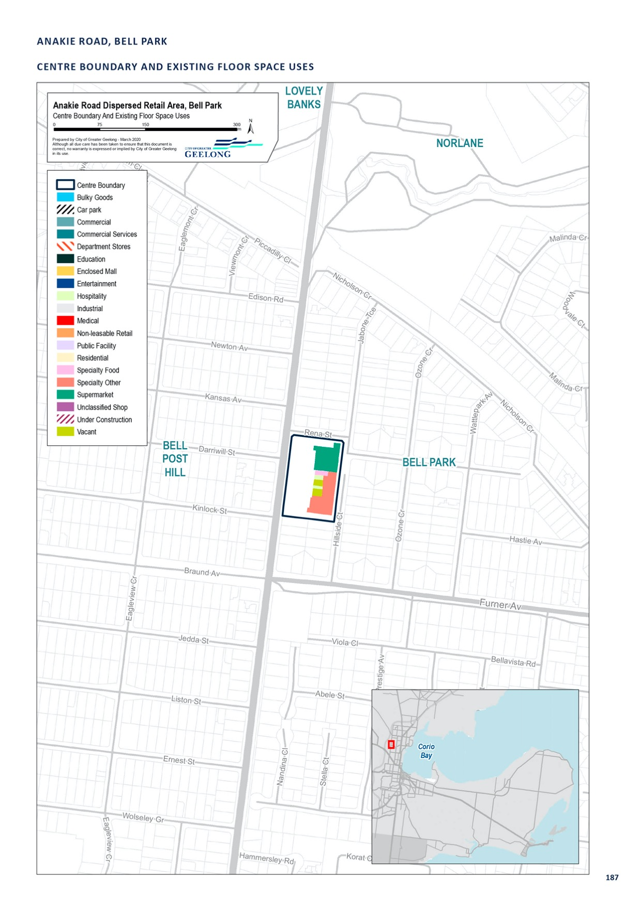

BACCHUS MARSH ROAD, CORIO

CENTRE NAME: BACCHUS MARSH ROAD, CORIO
Hierarchy status: | Dispersed restricted retail
Location: | Corio
Key characteristics: | Large vacant Commercial 2 Zoned land with good access to and from the Geelong Ring Road and the Geelong Employment Precinct. Approximately 1 km north of the Corio Shopping Centre.
Current role: | None
Zoning (sqm): | ACZ |  |  |  |  | C1Z |  |  |  | C2Z |  | MUZ |  |  |  | Other
Zoning (sqm): | 0 |  |  |  | 0 |  |  | 100,000 |  |  |  |  |  | 0 |  |  |  | 0
Retail and commercial floor space* (sqm): | Super market | Depart’ Store |  | Restricted Retail |  |  | Specialty Food |  | Specialty Other |  |  |  | Hospitality |  | Total Retail |  | Other Employ’ |  | Vacant
Retail and commercial floor space* (sqm): | 0 | 0 |  |  |  |  | 0 |  | 0 |  |  |  | 0 |  | 0 |  | 0 |  | 0
Retail anchors: | None
Transport connections: | Public |  | Bus service on Bacchus Marsh Road (route 10)
 | Private |  | Bacchus Marsh Road
Future role and opportunities: | The site was rezoned from Residential to Commercial 2 to support the development of a Master Homemaker store. The store was never developed and the site remains vacant.  The centre has not been identified as a restricted retail centre as the site is vacant.
Action required: | Nil
Growth Opportunities | Forecast supportable floor space 2016–2036 sqm (difference from total floor space) |  |  |  |  | Potential to grow within current zoned land |  |  |  |  |  | Sub-precinct planning required |  |  |  | Potential for rezoning to align with centre boundary
Growth Opportunities | 0 |  |  |  |  | Yes |  |  |  |  | No |  |  |  |  | No

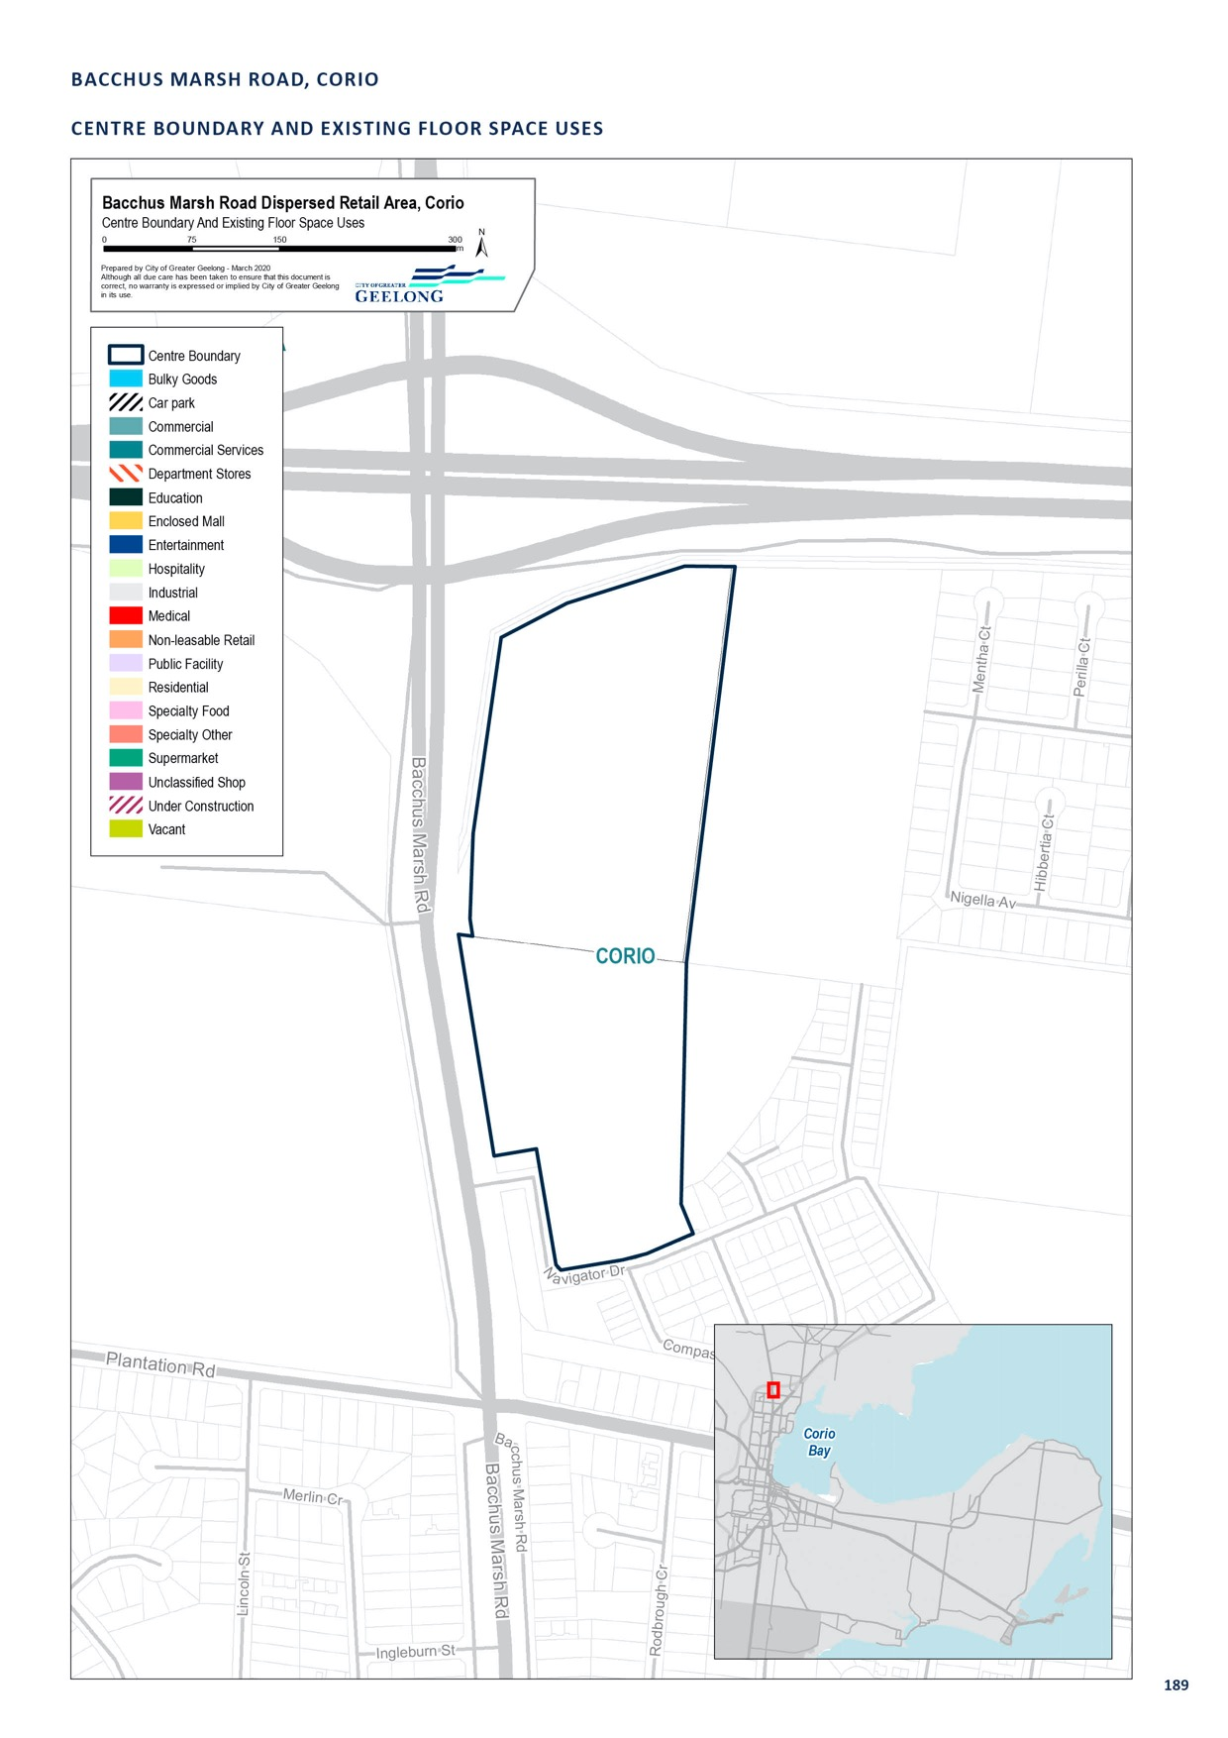

BELLARINE HIGHWAY, NEWCOMB

CENTRE NAME: BELLARINE HIGHWAY, NEWCOMB
Hierarchy status: | Dispersed restricted retail
Location: | Newcomb
Key characteristics: | Land on the southern side of the highway consists of low-density retailing, in the form of caravan sales as well as a McDonalds, KFC, car wash and light industrial uses. The northern side of the highway includes take away food premises, shops, a petrol station and hotel. Caravan sales are a prominent feature of this centre.
Current role: | Nil
Zoning (sqm): | Retail |  |  |  |  | C1Z |  |  |  | C2Z |  | MUZ |  |  |  | Other
Zoning (sqm): | 0 |  |  |  | 0 |  |  | 200,000 |  |  |  |  |  | 0 |  |  |  | 0
Retail and commercial floor space* (sqm): | Super market | Depart’ Store |  | Restricted Retail |  |  | Specialty Food |  | Specialty Other |  |  |  | Hospitality |  | Total Retail |  | Other Employ’ |  | Vacant
Retail and commercial floor space* (sqm): | 0 | 0 |  | 9,300 |  |  | 3,740 |  | 3,892 |  |  |  | 2,292 |  | 19,234 |  | 0 |  | 1,332
Retail anchors: | Caravan Sales, Mill Market
Transport connections: | Public |  | Bus service (routes 30, 32, 56, 61)
 | Private |  | Bellarine Highway
Future role and opportunities: | A dispersed, restricted retail centre on the northern and southern sides of the Bellarine Highway, located at the edge of urban Geelong, heading towards the Bellarine Peninsula. To the south of the centre is the Bellarine Rail Trail which provides a buffer to the residential and farming land further to the south.  The Eastern Boundary Review 2009 provides policy direction around the potential to expand Geelong in an easterly direction. The report identifies an urban growth boundary for Geelong, which limits development to existing residential and commercial-zoned land. The review seeks to retain the rural buffers between Urban Geelong and the Bellarine Peninsula due to drainage, sewerage and amenity issues.  There are some opportunities to develop vacant and underutilised land within the existing Commercial 2 Zone. The expansion of this centre should not be encouraged, so the centre has not been identified as a designated restricted retail centre.
Action required: | Nil
Growth Opportunities | Forecast supportable floor space 2016–2036 sqm (difference from total floor space) |  |  |  |  | Potential to grow within current zoned land |  |  |  |  |  | Sub-precinct planning required |  |  |  | Potential for rezoning to align with centre boundary
Growth Opportunities | -2,800 |  |  |  |  | Yes |  |  |  |  | No |  |  |  |  | No

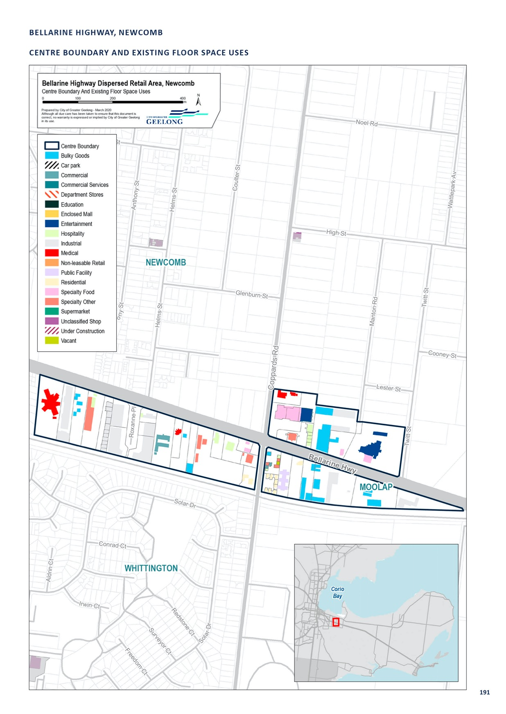

GORDON AVENUE, GEELONG WEST

CENTRE NAME: GORDON AVENUE, GEELONG WEST
Hierarchy status: | Dispersed restricted retail
Location: | Geelong West
Key characteristics: | Mid-sized restricted retail precinct located along the Princes Highway, close to Central Geelong and perpendicular to Pakington Street (Geelong West), but very distinct from it in terms of built form, use and amenity. Stores and services are mostly located along Autumn, Gordon and Spring Streets and have low-density built form.
Current role: | This centre plays a typical restricted retail precinct role, though it also has a significant proportion of office and industrial floor space.
Zoning (sqm): | ACZ |  |  |  |  | C1Z |  |  |  | C2Z |  | MUZ |  |  |  | Other
Zoning (sqm): | 0 |  |  |  | 0 |  |  | 91,200 |  |  |  |  |  | 0 |  |  |  | 0
Retail and commercial floor space* (sqm): | Super market | Depart’ Store |  | Restricted Retail |  |  | Specialty Food |  | Specialty Other |  |  |  | Hospitality |  | Total Retail |  | Other Employ’ |  | Vacant
Retail and commercial floor space* (sqm): | 0 | 0 |  | 16,650 |  |  | 120 |  | 3,390 |  |  |  | 140 |  | 20,300 |  | 0 |  | 1,800
Retail anchors: | None
Transport connections: | Public |  | Geelong Railway Station (approx. 500 m), bus service (12, 30, 45, 50 and 51)
 | Private |  | Autumn Street, Gordon Avenue and Spring Street, between Pakington Street and Princes Highway
Future role and opportunities: | This centre is directly opposite the Geelong Train Station and has excellent pedestrian connections into Central Geelong and Pakington Street. There are opportunities to transition this area into a more mixed-use precinct, which could incorporate retail, office and light industrial uses, with residential uses particularly on the first floor.  This area should not be identified as a restricted retail precinct in the retail hierarchy to help support the potential transition of the area over time. This area should be identified as a dispersed restricted retail centre.
Action required: | Prepare an urban design framework or structure plan for this area. The plan should focus on transitioning this area into a mixed-use precinct, which would incorporate residential, office, retail and light industrial uses. The plan should also consider improving connections through to Central Geelong and Pakington Street (Geelong West) centres.
Growth Opportunities | Forecast supportable floor space 2016–2036 sqm (difference from total floor space) |  |  |  |  | Potential to grow within current zoned land |  |  |  |  |  | Sub-precinct planning required |  |  |  | Potential for rezoning to align with centre boundary
Growth Opportunities | -4,200 |  |  |  |  | Yes |  |  |  |  | Yes |  |  |  |  | No

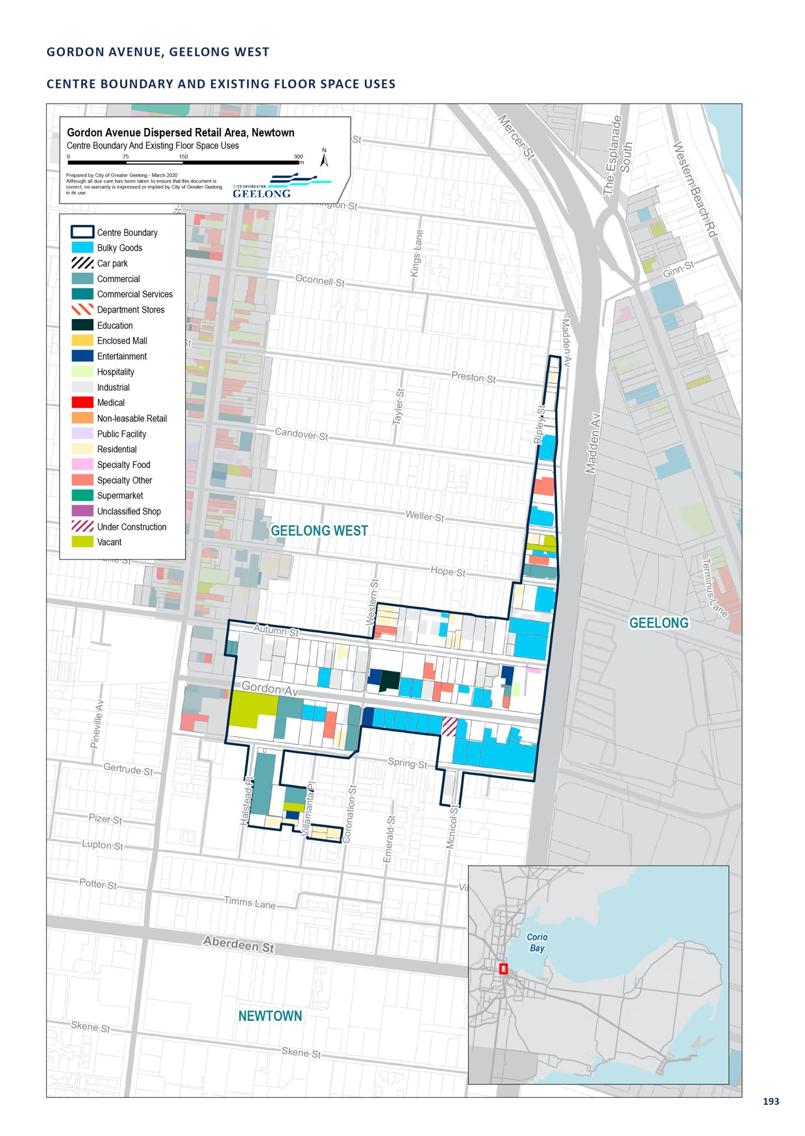

GREGORY AVENUE, NEWTOWN

CENTRE NAME: GREGORY AVENUE, NEWTOWN
Hierarchy status: | Dispersed restricted retail
Location: | Newtown
Key characteristics: | An old industrial precinct containing automotive industries such as mechanics, window tinting, window manufacturing and steel fabrication. The area also contains a roller skating rink and, in more recent times, has expanded to include cafés and a number of recreation uses.  A key land use in this precinct is a wool scouring operation, which has been operating in the area since the 1920’s.
Current role: | In very close proximity to the Pakington Street (Newtown) centre.
Zoning (sqm): | ACZ |  |  |  |  | C1Z |  |  |  | C2Z |  | MUZ |  |  |  | Other
Zoning (sqm): | 0 |  |  |  | 0 |  |  | 94,120 |  |  |  |  |  | 7,798 |  |  |  | 0
Retail and commercial floor space* (sqm): | Super market | Depart’ Store |  | Restricted Retail |  |  | Specialty Food |  | Specialty Other |  |  |  | Hospitality |  | Total Retail |  | Other Employ’ |  | Vacant
Retail and commercial floor space* (sqm): | 0 | 0 |  | 1,725 |  |  | 0 |  | 686 |  |  |  | 98 |  | 2,509 |  | 28,169 |  | 0
Retail anchors: | None
Transport connections: | Public |  | Bus service (24, 43)
 | Private |  | West Fyans/Fyans Street, Shannon Avenue, La Trobe Terrace
Future role and opportunities: | The development of this area, south of Fyans and West Fyans Street is guided by the Fyans-West Fyans Precinct Structure Plan 2009. This plan divides the area into several precincts.  Gregory Ave area  This area is located in precinct 2 which seeks to support low-scale business or light industrial uses, with a long-term transition to mixed-use that maintains a business and employment focus.  This area was rezoned from Industrial 1 to Business 3 as part of the implementation of the structure plan in 2009–10. Victorian Government zone reform in 2013 then saw this area rezoned to Commercial  2. This change meant that restricted retailing and other retailing use are encouraged in the zone - a shift that is not necessarily consistent with the long-term objectives of the Fyans-West Fyans Street Precinct Structure Plan. This plan is due to be reviewed and consideration should be given to the continuing use of a Commercial 2 Zone in this location.  It is recommended that the Gregory Ave area be identified as dispersed restricted retail - not be dedicated restricted retail centre - to discourage restricted retail activity and to accommodate the long- term vision for this area.
Action required: | Review the use of the Commercial 2 Zone in this location and any planning policies associated with the long-term vision for this area.
Growth Opportunities | Forecast supportable floor space 2016–2036 sqm (difference from total floor space) |  |  |  |  | Potential to grow within current zoned land |  |  |  |  |  | Sub-precinct planning required |  |  |  | Potential for rezoning to align with centre boundary
Growth Opportunities | -200 |  |  |  |  | No |  |  |  |  | No |  |  |  |  | No

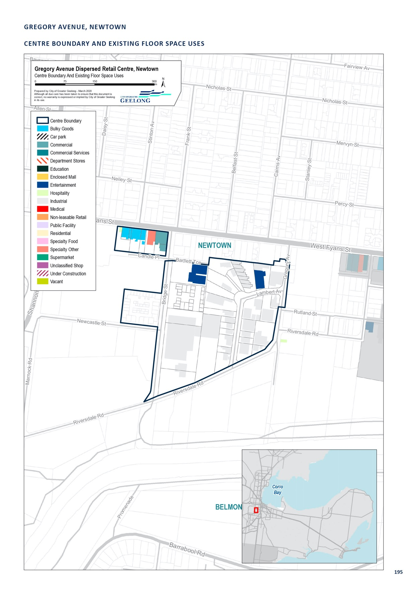

HARPUR ROAD-PRINCESS HIGHWAY, CORIO

CENTRE NAME: HARPUR ROAD-PRINCESS HIGHWAY, CORIO
Hierarchy status: | Dispersed Restricted Retail
Location: | Corio
Key characteristics: | Industrial 1 Zoned land including Harpur Rd, Kambouris Crt and Station Street. A small number of retail uses are located in this precinct, including Petstock, The Gateway Hotel, Dan Murphy’s bottle shop, Caltex service station, and car and vehicle sales. These retail uses have highway frontage, with land located away from the highway used for more traditional industrial uses.
Current role: | Industrial
Zoning (sqm): | ACZ |  |  |  |  | C1Z |  |  |  | C2Z |  | MUZ |  |  |  | Other
Zoning (sqm): | 0 |  |  |  | 0 |  |  | 0 |  |  |  |  |  | 0 |  |  |  | 150,000
Retail and commercial floor space* (sqm): | Super market | Depart’ Store |  | Restricted Retail |  |  | Specialty Food |  | Specialty Other |  |  |  | Hospitality |  | Total Retail |  | Other Employ’ |  | Vacant
Retail and commercial floor space* (sqm): | 0 | 0 |  | 5,300 |  |  | 0 |  | 0 |  |  |  | 0 |  | 5,300 |  | 0 |  | 0
Retail anchors: | Dan Murphy’s, Gateway Hotel, Petstock
Transport connections: | Public |  | Bus service on Station Street (route 23)
 | Private |  | Princess highway, Harpur Road
Future role and opportunities: | The centre has not been identified as a designated restricted retail centre given its industrial zoning. Existing retail uses benefit from the highway frontage. This area should be used for industrial purposes rather than retail purposes.
Action required: | Nil
Growth Opportunities | Forecast supportable floor space 2016–2036 sqm (difference from total floor space) |  |  |  |  | Potential to grow within current zoned land |  |  |  |  |  | Sub-precinct planning required |  |  |  | Potential for rezoning to align with centre boundary
Growth Opportunities | -100 |  |  |  |  | No |  |  |  |  | No |  |  |  |  | No

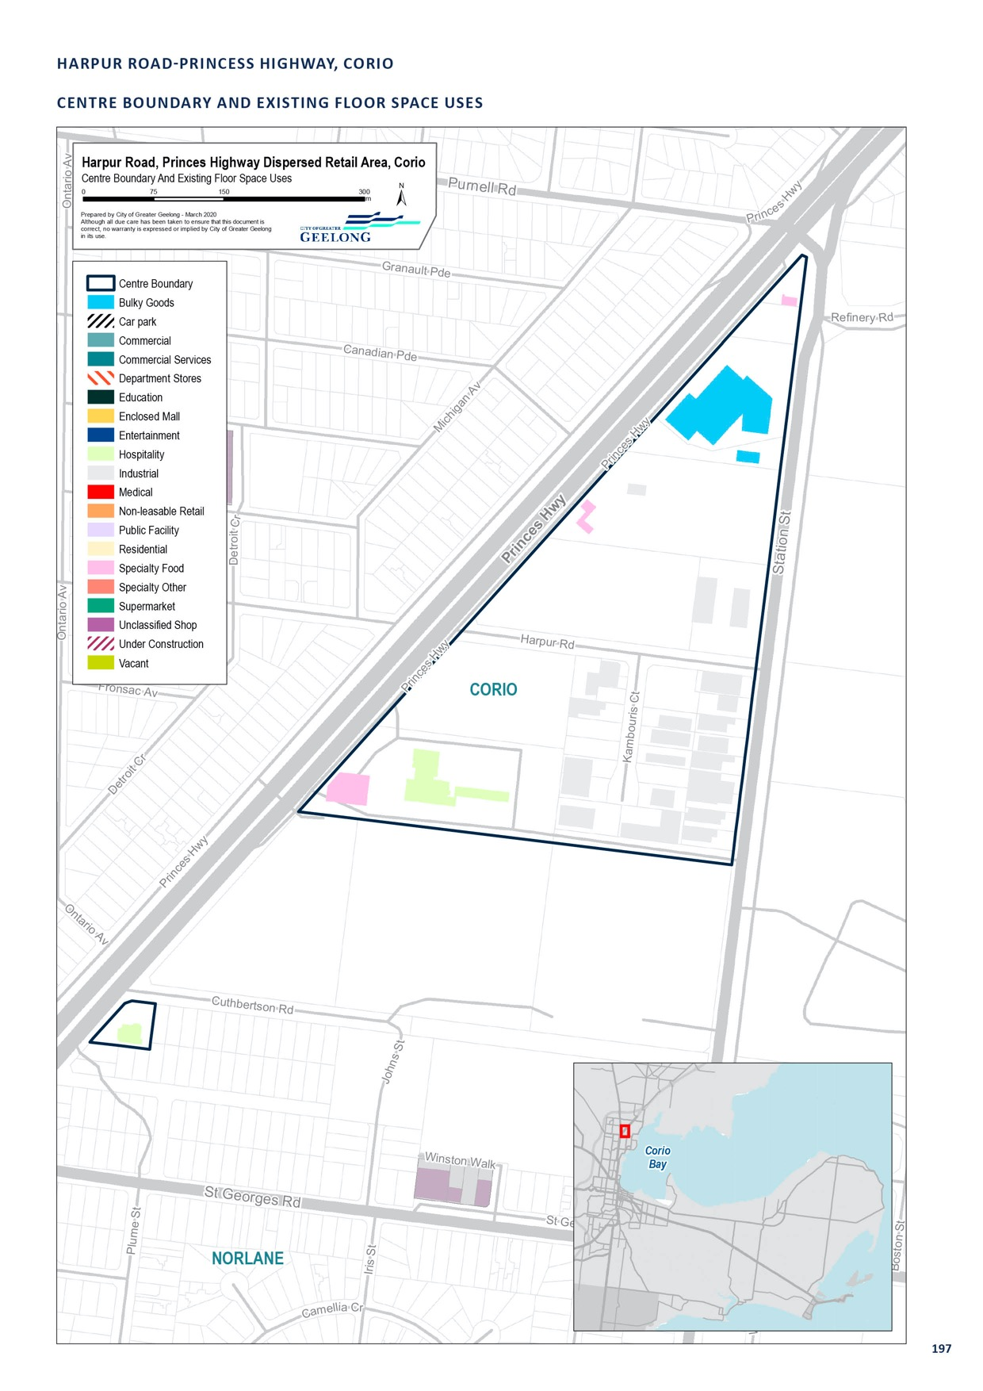

MACKEY STREET, NORTH GEELONG

CENTRE NAME: MACKEY STREET, NORTH GEELONG
Hierarchy status: | Dispersed restricted retail
Location: | North Geelong
Key characteristics: | An industrial area in North Geelong, located within the Geelong port environs in an Industrial 2 Zone,
Current role: | Industrial Precinct
Zoning (sqm): | ACZ |  |  |  |  | C1Z |  |  |  | C2Z |  | MUZ |  |  |  | Other
Zoning (sqm): | 0 |  |  |  | 0 |  |  | 0 |  |  |  |  |  | 0 |  |  |  | 77,910
Retail and commercial floor space* (sqm): | Super market | Depart’ Store |  | Restricted Retail |  |  | Specialty Food |  | Specialty Other |  |  |  | Hospitality |  | Total Retail |  | Other Employ’ |  | Vacant
Retail and commercial floor space* (sqm): | 0 | 0 |  | 0 |  |  | 0 |  | 20 |  |  |  | 0 |  | 11,200 |  | 0 |  | 0
Retail anchors: | Mill Markets, Shots emporium
Transport connections: | Public |  | Bus service (routes 20, 42, 55)
 | Private |  | Melbourne Road
Future role and opportunities: | The Mackey Street precinct, in North Geelong is located within the Geelong port environs in an Industrial 2 Zone. The area is occupied by offices, industry, antique markets, cafés, furniture sales and an adult superstore. A Heritage Overlay affects the majority of buildings within this precinct which has attracted a number of alternative uses such as offices, to this otherwise industrial area. The Federal Mills complex is a key feature of the are,a.  Land surrounding this precinct is occupied by heavy industry and uses associated with the Geelong Port. The area is accessed 24/7 by large trucks and commercial vehicles.  Both state and local planning policy support the protection of industrial land, including the Geelong Port from sensitive and incompatible uses. Retail uses in close proximity to the port can pose a safety risk by encouraging more visitors and car movements in an area frequently used by heavy vehicles and noxious industries that operates 24/7.  The centre has not been identified as a designated restricted retail centre. While the area now contains a number of large format retail stores and offices the further expansion of retail and offices uses is not supported at this location.
Action required: | Nil
Growth Opportunities | Forecast supportable floor space 2016–2036 sqm (difference from total floor space) |  |  |  |  | Potential to grow within current zoned land |  |  |  |  |  | Sub-precinct planning required |  |  |  | Potential for rezoning to align with centre boundary
Growth Opportunities | -1,800 |  |  |  |  | No |  |  |  |  | No |  |  |  |  | No

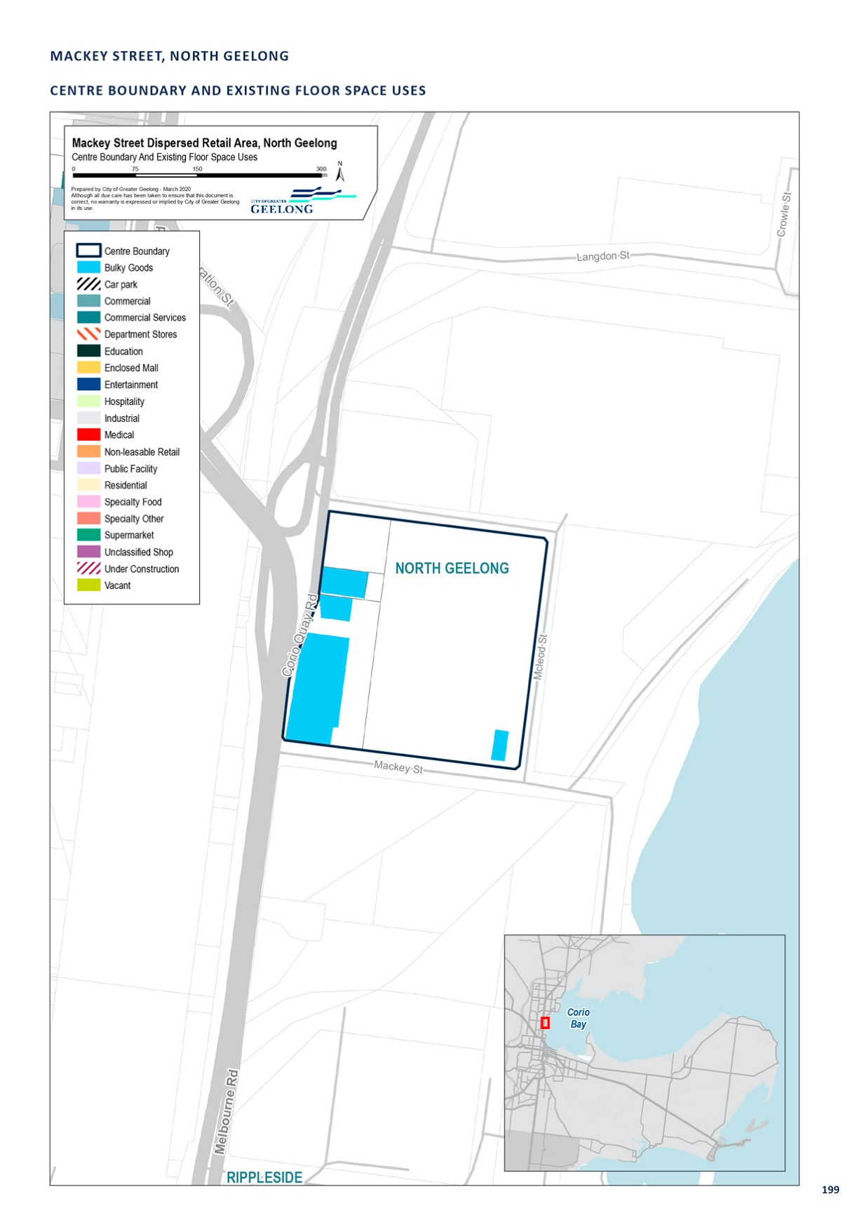

MOORABOOL-FYANS STREET, SOUTH GEELONG

CENTRE NAME: MOORABOOL-FYANS STREET, SOUTH GEELONG
Hierarchy status: | Dispersed restricted retail
Location: | South Geelong
Key characteristics: | Large, low-density retail precinct, with low-density restricted retail along Fyans Street and Moorabool Street, and industrial uses largely in the back streets of the southern area of the precinct. There is a significant proportion of very low-density restricted retail, due to the presence of several car yards. A mix of activity centre retail, office and residential use can also be found in the precinct.
Current role: | In very close proximity to Central Geelong and Belmont centres, the Moorabool/Fyans Street area has a diverse range of stores and services that attracts a wide catchment
Zoning (sqm): | ACZ |  |  |  |  | C1Z |  |  |  | C2Z |  | MUZ |  |  |  | Other
Zoning (sqm): | 0 |  |  |  | 0 |  |  | 110,792 |  |  |  |  |  | 89,000 |  |  |  | 0
Retail and commercial floor space* (sqm): | Super market | Depart’ Store |  | Restricted Retail |  |  | Specialty Food |  | Specialty Other |  |  |  | Hospitality |  | Total Retail |  | Other Employ’ |  | Vacant
Retail and commercial floor space* (sqm): | 0 | 0 |  | 31,297 |  |  | 428 |  | 7,139 |  |  |  | 3,596 |  | 42,460 |  | 22,001 |  | 3,121
Retail anchors: | Mitre 10, E&S Trading, car yards
Transport connections: | Public |  | South Geelong Railway Station (approx. 800m), Bus service (routes 1, 41, 42, 51, 50 and  55)
 | Private |  | West Fyans/Fyans Street and Moorabool Street, accessible via Princes Highway
Future role and opportunities: | The development of this area south of Fyans and West Fyans Street is guided by the Fyans-West Fyans Precinct Structure Plan 2009. This plan divides the area into several precincts.  Moorabool/Fyans (Moorabool Street) Area  The Moorabool/Fyans area is located in precincts 5 and 7. Precinct 5 (west of Moorabool Street) seeks to maintain a business focus and is zoned Commercial 2. Precinct 7 (east of Moorabool Street) is a mixture of business, office and residential uses and has been zoned Mixed Use. The structure plan supports precinct 5’s continued use for restricted retail activity, but anticipates a shift away from this type of land use for precinct 7 – acknowledging that there are some well-established restricted retail uses which are likely to remain.  Land north of Fyans Street, within the Commercial 2 Zone, consists mainly of speciality retail and commercial services. Some restricted retail is present, but this is not a dominant land use. The small block sizes and lack of car parking make this area unattractive as a modern restricted retail precinct.  It is recommended that the Moorabool-Fyans Street area be identified as dispersed restricted retail - not a dedicated restricted retail centre - to discourage restricted retail activity and to accommodate the long- term vision for this area.
Action required: | Ensure that local planning policy identifies the location of preferred restricted retail precincts and provides guidance around the future use and development of restricted retail and dispersed restricted retail precincts.
Growth Opportunities | Forecast supportable floor space 2016–2036 sqm (difference from total floor space) |  |  |  |  | Potential to grow within current zoned land |  |  |  |  |  | Sub-precinct planning required |  |  |  | Potential for rezoning to align with centre boundary
Growth Opportunities | -7,500 |  |  |  |  | No |  |  |  |  | No |  |  |  |  | No

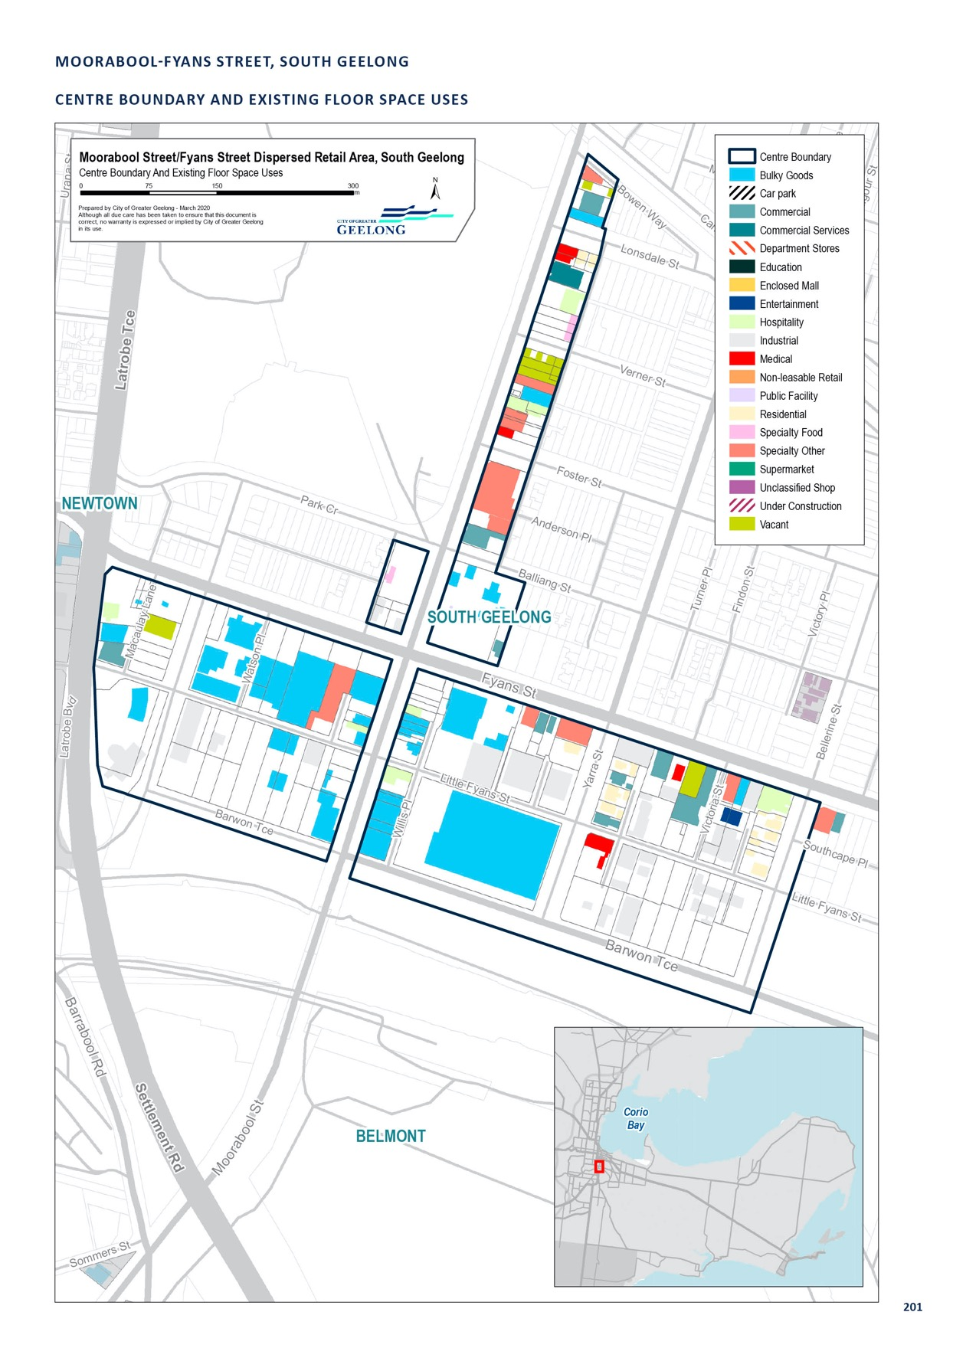

SETTLEMENT ROAD AND BREAKWATER ROAD, BELMONT

CENTRE NAME: SETTLEMENT ROAD AND BREAKWATER ROAD, BELMONT
Hierarchy status: | Dispersed restricted retail
Location: | Belmont
Key characteristics: | Industrial precinct anchored by a large retail complex consisting of a Spotlight, Anaconda, Clarke Rubber and a safety clothing store. A large timber and hardware store is located opposite this site. Car and boat sales are located in the north of the precinct. The remainder of the precinct is industrial in nature, consisting mainly of light industrial uses.
Current role: | Industrial
Zoning (sqm): | ACZ |  |  |  |  | C1Z |  |  |  | C2Z |  | MUZ |  |  |  | Other
Zoning (sqm): | 0 |  |  |  | 0 |  |  | 0 |  |  |  |  |  | 0 |  |  |  | 200,000
Retail and commercial floor space* (sqm): | Super market | Depart’ Store |  | Restricted Retail |  |  | Specialty Food |  | Specialty Other |  |  |  | Hospitality |  | Total Retail |  | Other Employ’ |  | Vacant
Retail and commercial floor space* (sqm): | 0 | 0 |  | 29,995 |  |  | 846 |  | 2,036 |  |  |  | 82 |  | 32,959 |  | 0 |  | 210
Retail anchors: | Spotlight, Anaconda, Clarke Rubber, Belmont Timber
Transport connections: | Public |  | Bus service (routes 51, 55)
 | Private |  | Settlement and Barwon Heads Roads
Future role and opportunities: | A dispersed restricted retail precinct located within Industrial Zoned land in the south of Geelong. The precinct is anchored by a large retail complex consisting of Spotlight, Anaconda, Clarke Rubber and a safety clothing store. This centre benefits from frontage to two key arterial roads, Settlement and Barwon Heads Roads.  The area is zoned Industrial 1 and while there are a number of retail uses occurring within the area, further development of the area for retail uses should be discouraged. Retail development should be directed to existing Commercial 1 and 2 Zoned land. The centre has not been identified as a designated restricted retail centre.
Action required: | Nil
Growth Opportunities | Forecast supportable floor space 2016–2036 sqm (difference from total floor space) |  |  |  |  | Potential to grow within current zoned land |  |  |  |  |  | Sub-precinct planning required |  |  |  | Potential for rezoning to align with centre boundary
Growth Opportunities | -5,000 |  |  |  |  | No |  |  |  |  | No |  |  |  |  | No

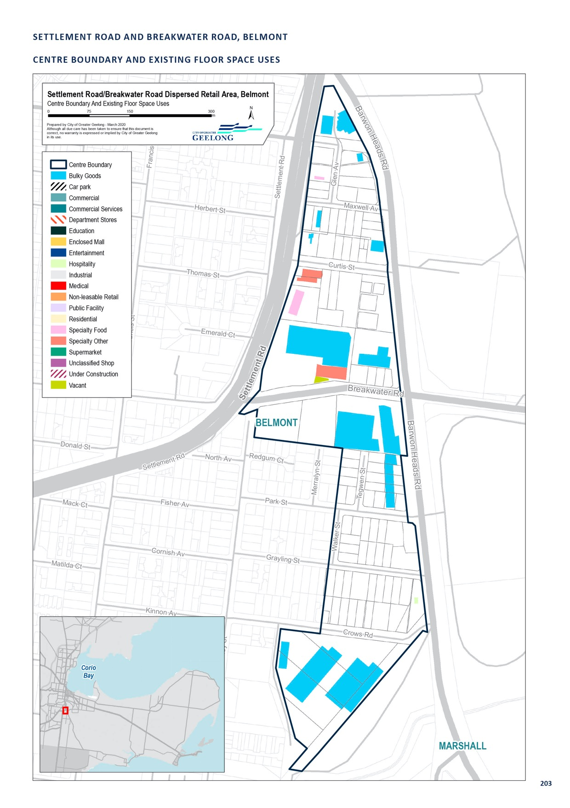

SHARON COURT, BELL PARK

CENTRE NAME: SHARON COURT, BELL PARK
Hierarchy status: | Dispersed restricted retail
Location: | Bell Park
Key characteristics: | Sharon Court, Bell Park, is a small pocket of Commercial 2 Zoned land just north of the Separation Street neighbourhood centre. The precinct contains a Salvation Army store, tile sales, car wash, a window manufacturer and showrooms.
Current role: | Dispersed restricted retail
Zoning (sqm): | ACZ |  |  |  |  | C1Z |  |  |  | C2Z |  | MUZ |  |  |  | Other
Zoning (sqm): | 0 |  |  |  | 0 |  |  | 19,820 |  |  |  |  |  | 0 |  |  |  | 0
Retail and commercial floor space* (sqm): | Super market | Depart’ Store |  | Restricted Retail |  |  | Specialty Food |  | Specialty Other |  |  |  | Hospitality |  | Total Retail |  | Other Employ’ |  | Vacant
Retail and commercial floor space* (sqm): | 0 | 0 |  | 10,519 |  |  | 0 |  | 0 |  |  |  | 0 |  | 10,500 |  | 0 |  | 0
Retail anchors: | None
Transport connections: | Public |  | Bus service (routes 56)
 | Private |  | Thompson Road via Separation Street
Future role and opportunities: | There is no room to expand this centre beyond what currently exists. There is no support to rezone surrounding industrial land to expand this centre. Given the presence of the Commercial 2 Zone, it is likely existing or similar uses will remain in Sharon Court for the long term.
Action required: | Nil
Growth Opportunities | Forecast supportable floor space 2016–2036 sqm (difference from total floor space) |  |  |  |  | Potential to grow within current zoned land |  |  |  |  |  | Sub-precinct planning required |  |  |  | Potential for rezoning to align with centre boundary
Growth Opportunities | -1,700 |  |  |  |  | Yes |  |  |  |  | No |  |  |  |  | No

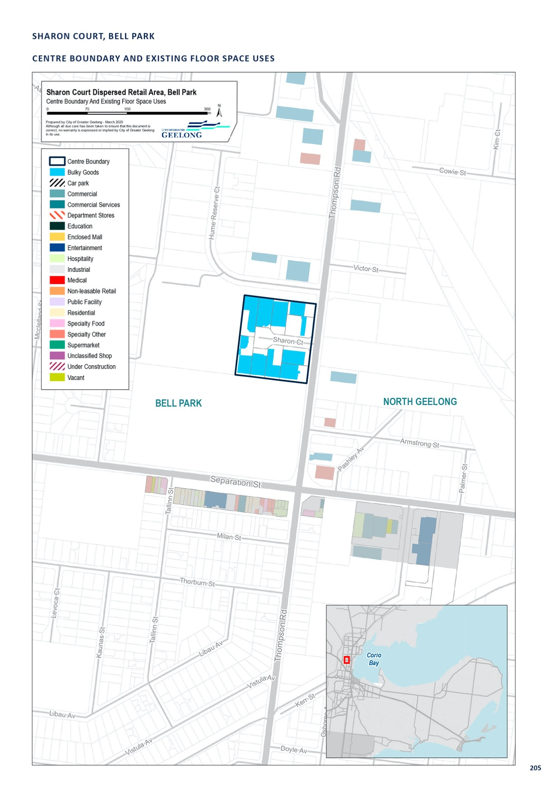

SMITHTON GROVE, OCEAN GROVE

CENTRE NAME: SMITHTON GROVE, OCEAN GROVE
Hierarchy status: | Dispersed restricted retail
Location: | Ocean Grove
Key characteristics: | Small existing restricted retail centre located in the north of Ocean Grove recently expanded to cater for the long-term growth of the town.
Current role: | Meets the retail and industrial needs of Ocean Grove
Zoning (sqm): | ACZ |  |  |  |  | C1Z |  |  |  | C2Z |  | MUZ |  |  |  | Other
Zoning (sqm): | 0 |  |  |  | 0 |  |  | 0 |  |  |  |  |  | 0 |  |  |  | 191,910
Retail and commercial floor space* (sqm): | Super market | Depart’ Store |  | Restricted Retail |  |  | Specialty Food |  | Specialty Other |  |  |  | Hospitality |  | Total Retail |  | Other Employ’ |  | Vacant
Retail and commercial floor space* (sqm): | 0 | 0 |  | 2,518 |  |  | 0 |  | 1,396 |  |  |  | 363 |  | 4,277 |  | 25,300 |  | 0
Retail anchors: | None
Transport connections: | Public |  | Bus service (routes 56)
 | Private |  | Grubb Road via Bellarine Highway, Grubb Road via Shell Road
Future role and opportunities: | This industrial area has, until recently, been used to meet the service business and restricted retailing needs of Ocean Grove. While the area is zoned industrial, there is a large amount of restricted retail uses occurring within this centre. Given the historic use of this centre for a mix of retail and industrial uses, this centre has been included as a dispersed restricted retail centre.  Recent planning work undertaken to develop the Kingston Downs and Oakdene residential estates in Ocean Grove resulted in the rezoning of 7 hectares of land to the east of the Industrial 1 Zone - from farming to Industrial 3 Zone. A further 15 hectares of land has been rezoned to the Commercial 2 Zone.  Prior to this rezoning, there was limited commercial and industrial land available in Ocean Grove. Now that more land is available, it is likely that retail and industrial uses will locate in the appropriate zone. Potentially, this industrial area will transition away from retail uses over time.  Future retail uses should be directed to locate in commercial-zoned land.
Action required: | Nil
Growth Opportunities | Forecast supportable floor space 2016–2036 sqm (difference from total floor space) |  |  |  |  | Potential to grow within current zoned land |  |  |  |  |  | Sub-precinct planning required |  |  |  | Potential for rezoning to align with centre boundary
Growth Opportunities | -300 |  |  |  |  | Yes |  |  |  |  | No |  |  |  |  | No

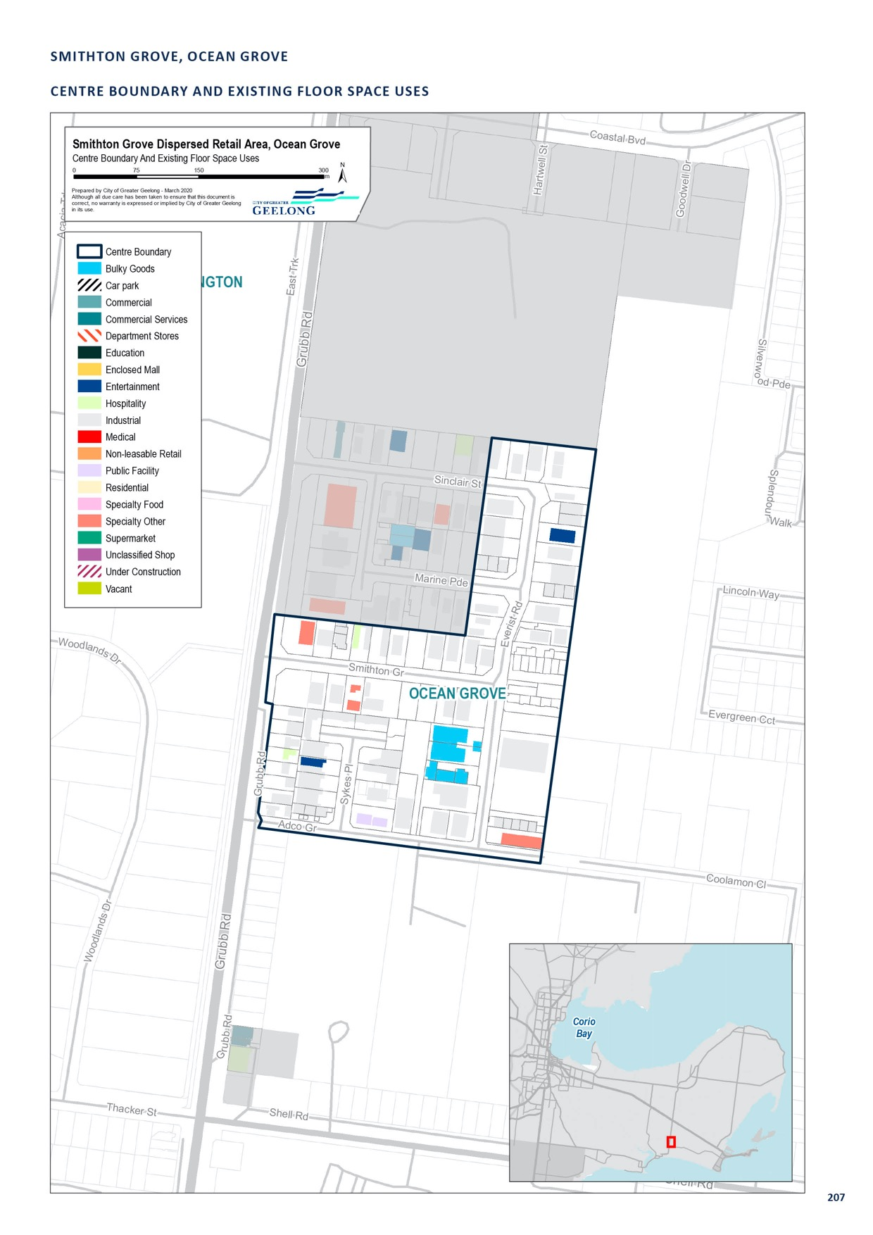

SURF COAST HIGHWAY, GROVEDALE

CENTRE NAME: SURF COAST HIGHWAY, GROVEDALE
Hierarchy status: | Dispersed Restricted Retail
Location: | Grovedale
Key characteristics: | A large car-oriented precinct with a typically industrial feel, especially along streets set back from the highway.
Current role: | This precinct has a significant proportion of industrial uses. Restricted retail use is also strongly represented in the precinct, mainly along the Surf Coast Highway frontage. This precinct plays a strong manufacturing and industrial services role and is less significant from a restricted retail or wholesale retail perspective.  This centre directly adjoins the Surf Coast Highway Neighbourhood Centre.
Zoning (sqm): | ACZ |  |  |  |  | C1Z |  |  |  | C2Z |  | MUZ |  |  |  | Other
Zoning (sqm): | 0 |  |  |  | 23,850 |  |  | 165,690 |  |  |  |  |  | 0 |  |  |  | 0
Retail and commercial floor space* (sqm): | Super market | Depart’ Store |  | Restricted Retail |  |  | Specialty Food |  | Specialty Other |  |  |  | Hospitality |  | Total Retail |  | Other Employ’ |  | Vacant
Retail and commercial floor space* (sqm): | 2,156 | 0 |  | 6,915 |  |  | 715 |  | 3,558 |  |  |  | 184 |  | 13,528 |  | 37,668 |  | 2,015
Retail anchors: | 1 supermarket (2,157 sqm IGA)
Transport connections: | Public |  | Marshall Railway Station (approx. 1.6 km), bus service (routes 17, 19, 20, 72 and 74)
 | Private |  | Intersection of Surf Coast Highway and Marshalltown Road
Future role and opportunities: | There are a limited number of vacant sites remaining within the Commercial 2 Zoned land, and development is now starting to take place within the adjacent Industrial 1 Zone land. There is also pressure to develop land more generally along the Surf Coast Highway for commercial uses. With limited high-quality industrial land available in the south of Geelong, this precinct has been a popular location to establish service business uses, such as mechanics, cabinet makers and showroom sales, rather than retail uses.  A Supa IGA supermarket is located within this precinct, which combined with the Aldi supermarket located in the neighbourhood centre, provides a grocery offer to surrounding residents and workers.  With the limited vacant land within this rezoned for restricted retail precinct and proximity of this area to the Waurn Ponds Restricted Retail Precinct, there may be limited demand for additional restricted retail retailing in the area.  There are a number of existing commercial uses in the General Residential Zone on the east side of Torquay Road, between the industrial zone and Reserve Road. These uses currently consist of vacant land, a medical centre, a motel, car wash, the Grovedale Hotel and 8 houses (ex-display homes).  While the area is outside the Surf Coast Highway Centre boundary, we have received numerous verbal requests to rezone this land to a commercial zone. Given the lack of amenity in this location, and the mix of existing commercial uses, we should consider whether the development outcomes of this area would be improved if the centre boundary was expanded and land was zoned commercial. This may deliver an improved land use and built form outcome for this busy road frontage without significantly adding additional commercial floor space.
Action required: | Review zoning controls on Surf Coast Highway, between the industrial zoned land and Reserve Road.
Growth Opportunities | Forecast supportable floor space 2016–2036 sqm (difference from total floor space) |  |  |  |  | Potential to grow within current zoned land |  |  |  |  |  | Sub-precinct planning required |  |  |  | Potential for rezoning to align with centre boundary
Growth Opportunities | -3,400 |  |  |  |  | Yes |  |  |  |  | No |  |  |  |  | No

208
- Excludes non employment uses such as residential, car parking and sites under construction.

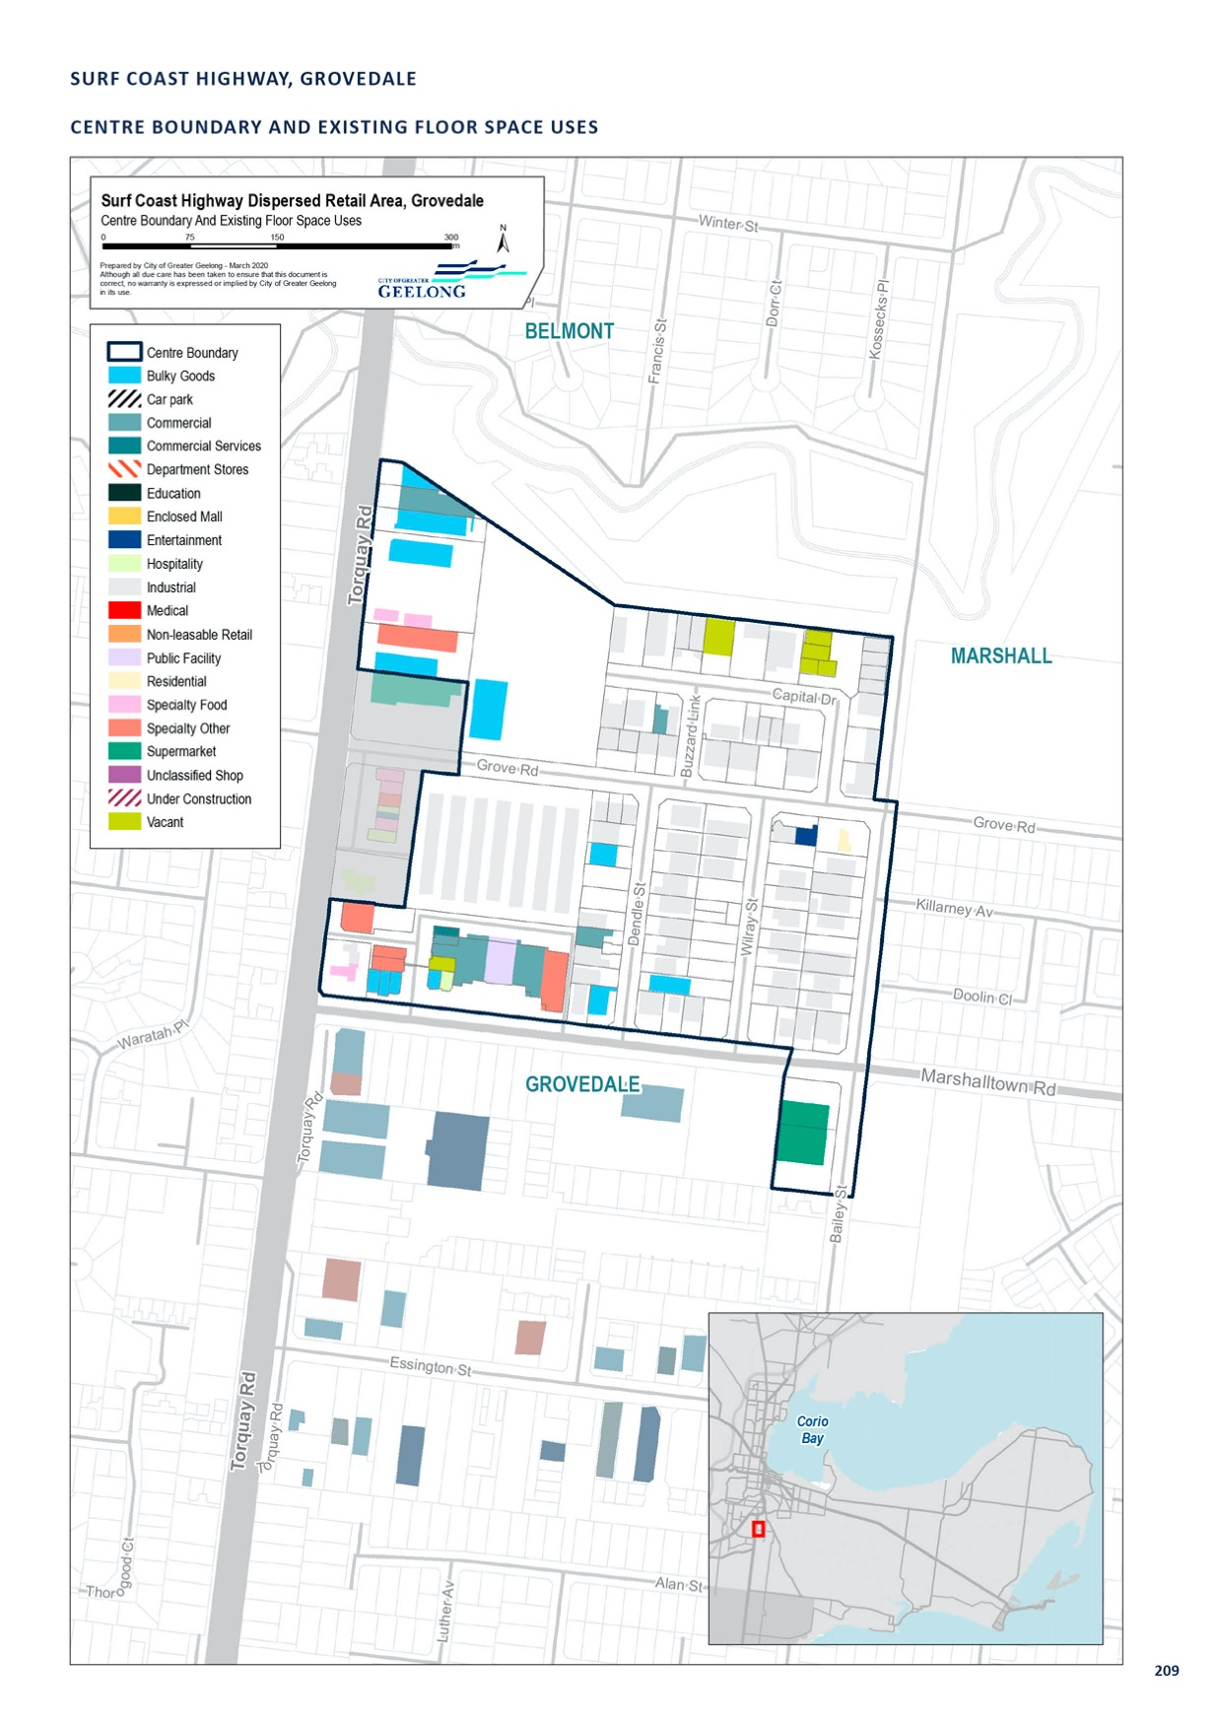

WEST FYANS STREET, NEWTOWN

CENTRE NAME: WEST FYANS STREET, NEWTOWN
Hierarchy status: | Dispersed restricted retail
Location: | Newtown
Key characteristics: | Large, low-density retail precinct. There is a significant proportion of very low-density restricted retail due to the presence of land used for car storage. A mix of activity centre retail, office and residential use can also be found in the balance of the precinct. A key arts area can be found at the corner of Rutland and Pakington Streets.
Current role: | In very close proximity to Central Geelong and the Pakington Street (Newtown) centres, the West Fyans Street area is currently transitioning to a mixed-use environment.
Zoning (sqm): | ACZ |  |  |  |  | C1Z |  |  |  | C2Z |  | MUZ |  |  |  | Other
Zoning (sqm): | 0 |  |  |  | 0 |  |  | 22,550 |  |  |  |  |  | 214,380 |  |  |  | 0
Retail and commercial floor space* (sqm): | Super market | Depart’ Store |  | Restricted Retail |  |  | Specialty Food |  | Specialty Other |  |  |  | Hospitality |  | Total Retail |  | Other Employ’ |  | Vacant
Retail and commercial floor space* (sqm): | 0 | 0 |  | 7,940 |  |  | 0 |  | 3,059 |  |  |  | 184 |  | 13,528 |  | 52,794 |  | 384
Retail anchors: | None
Transport connections: | Public |  | Bus service (routes 24 and 43)
 | Private |  | West Fyans/Fyans Street, and Moorabool Street, accessible via Princes Highway
Future role and opportunities: | The development of this area south of Fyans and West Fyans Street is guided by the Fyans-West Fyans Precinct Structure Plan 2009. This plan divides the area into several precincts.  Moorabool/West Fyans Area  The West Fyans end of this precinct is similar to the Fyans Street end in that there is a large proportion of low-density restricted retail (car yards) but, unlike the Fyans Street end, the area has started to evolve with a number of artistic businesses, offices and recreation uses appearing amongst older, more established industry.  This area is located in precincts 3A, 3B and 4. These precincts encourage office and retail uses to front West Fyans Street, with the remainder of the areas to be developed with low to high density residential uses.  It is recommended that the West Fyans Area be identified as dispersed restricted retail, as current planning policy supports a significant shift away from retail uses to residential uses over time.
Action required: | Ensure that local planning policy supports the transition of this area over time to a mixed-use/residential precinct.
Growth Opportunities | Forecast supportable floor space 2016–2036 sqm (difference from total floor space) |  |  |  |  | Potential to grow within current zoned land |  |  |  |  |  | Sub-precinct planning required |  |  |  | Potential for rezoning to align with centre boundary
Growth Opportunities | -1,300 |  |  |  |  | No |  |  |  |  | No |  |  |  |  | No

* Excludes non employment uses such as residential, car parking and sites under construction.

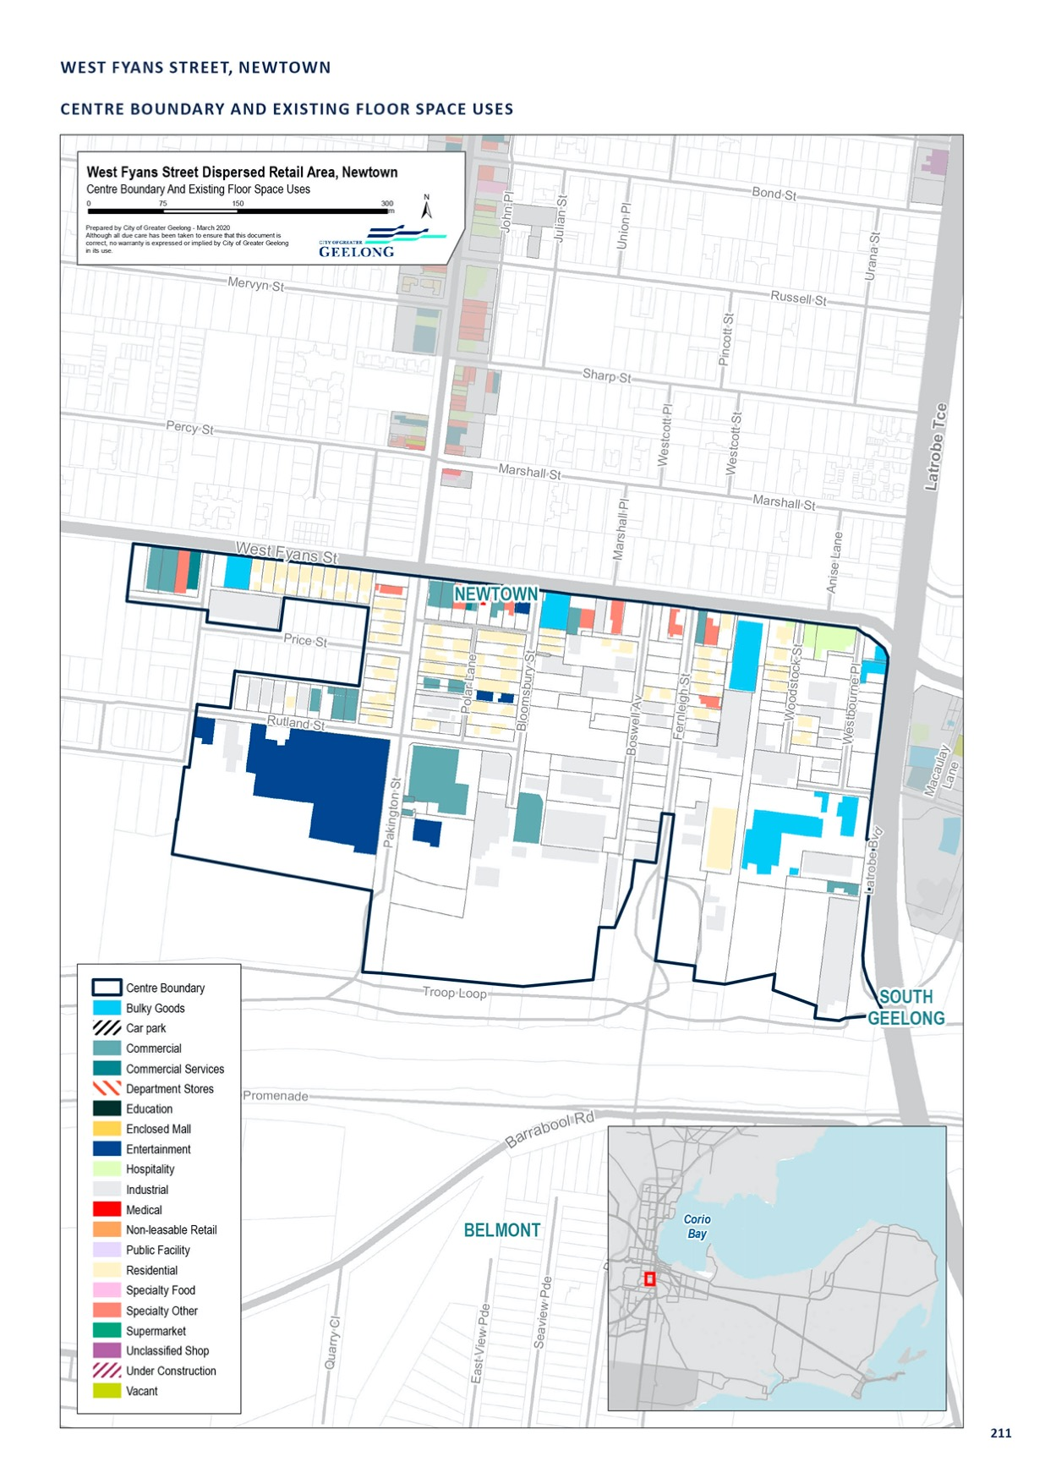

APPENDIX 3

PRIMARY CATCHMENT

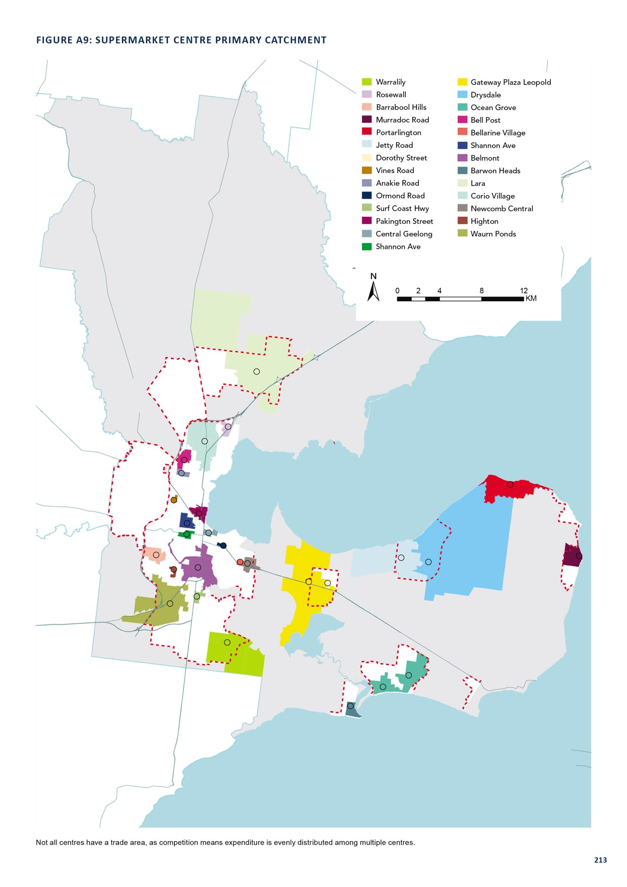

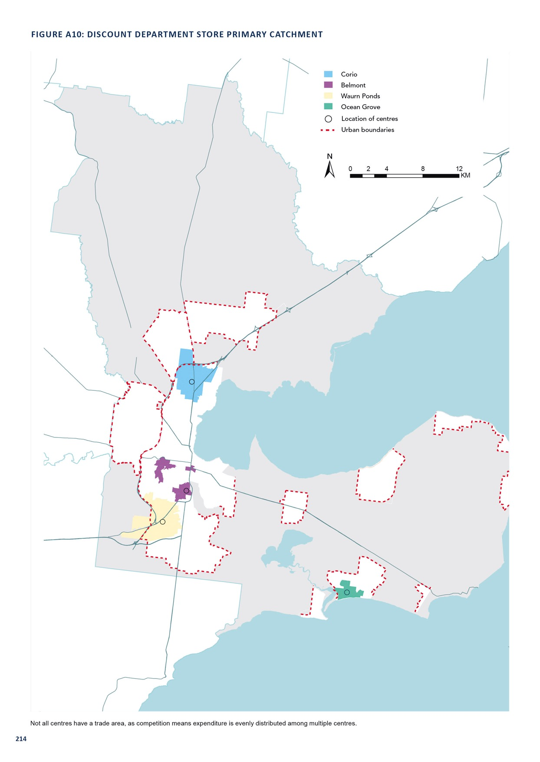

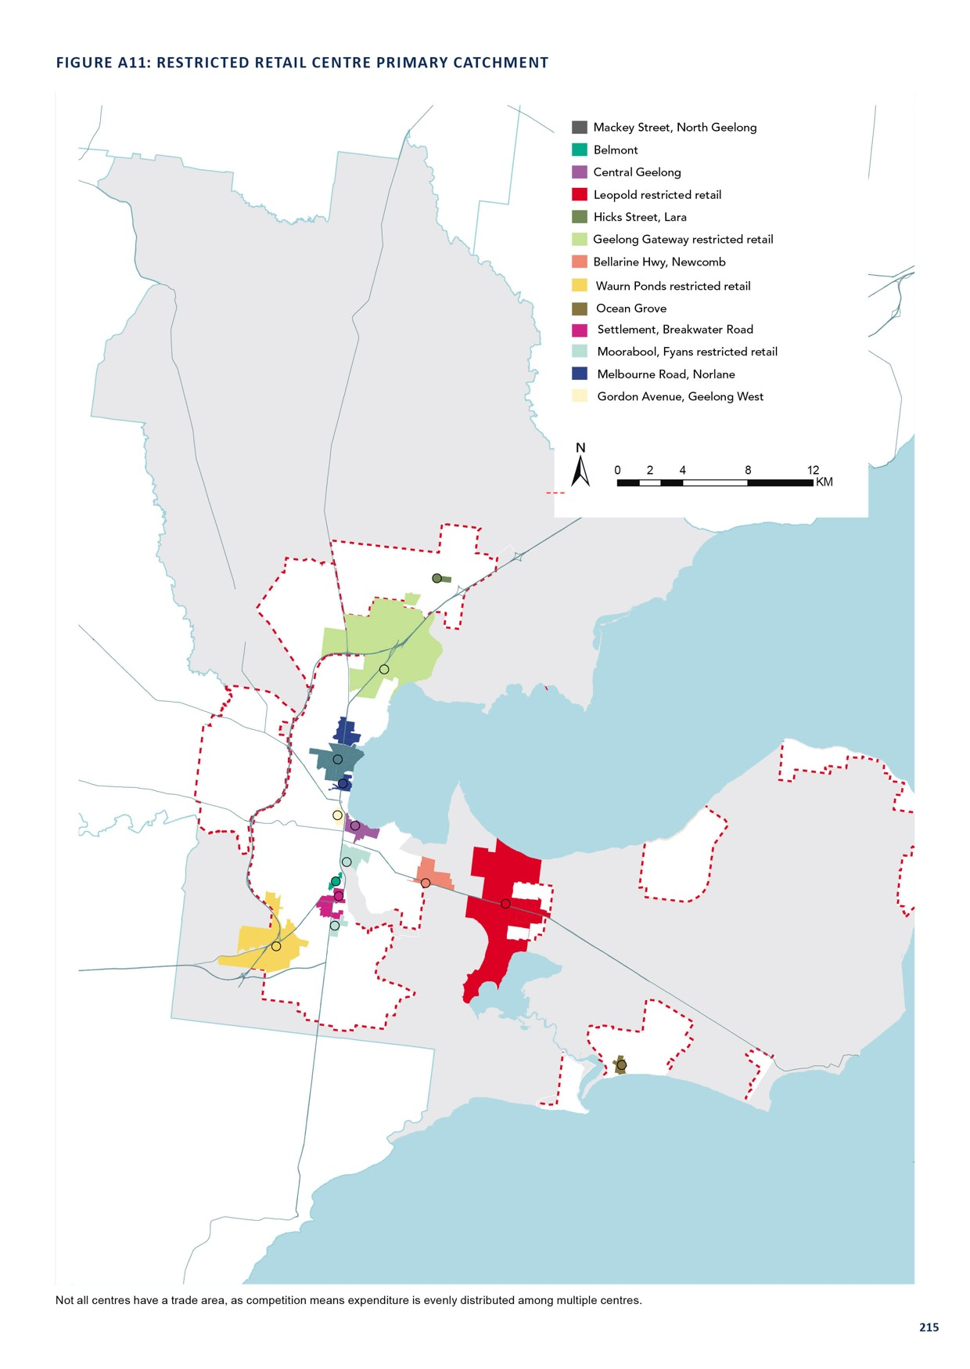

APPENDIX 4

SUPPLY-AND-DEMAND EQUATION

For the maps on the following pages:
  - grey circles indicate floor space demand that is met by supply (up to a 20-minute drive for supermarkets and 30-minutes for department stores and restricted retail)
  - red circles indicate unmet demand based on travel time or supply availability compared to demand
  - the size of the circles represent the quantum of floor space demand.
This analysis assumes no increase in floor space supply over and above that already planned for across the network.
Demand is based on adjusted expenditure demand – that is resident demand, with adjustments for online, workers, students and tourists – and target retail turnover density to determine floor space needs. These concepts are further discussed in Appendix 1 (page 61).
Whether a circle is grey or red is determined by travel times and the underlying supply and demand equation, based on trade area catchments. When red circles appear within a 20 to 30 minute drive of a centre, it suggests that these centres are potentially over-trading, and there is a case for supplying new floor space either:
  - at the nearby centre(s) or
  - in a new centre if:
  - the nearest centre is relatively distant and
  - there is sufficient demand to justify a new centre

