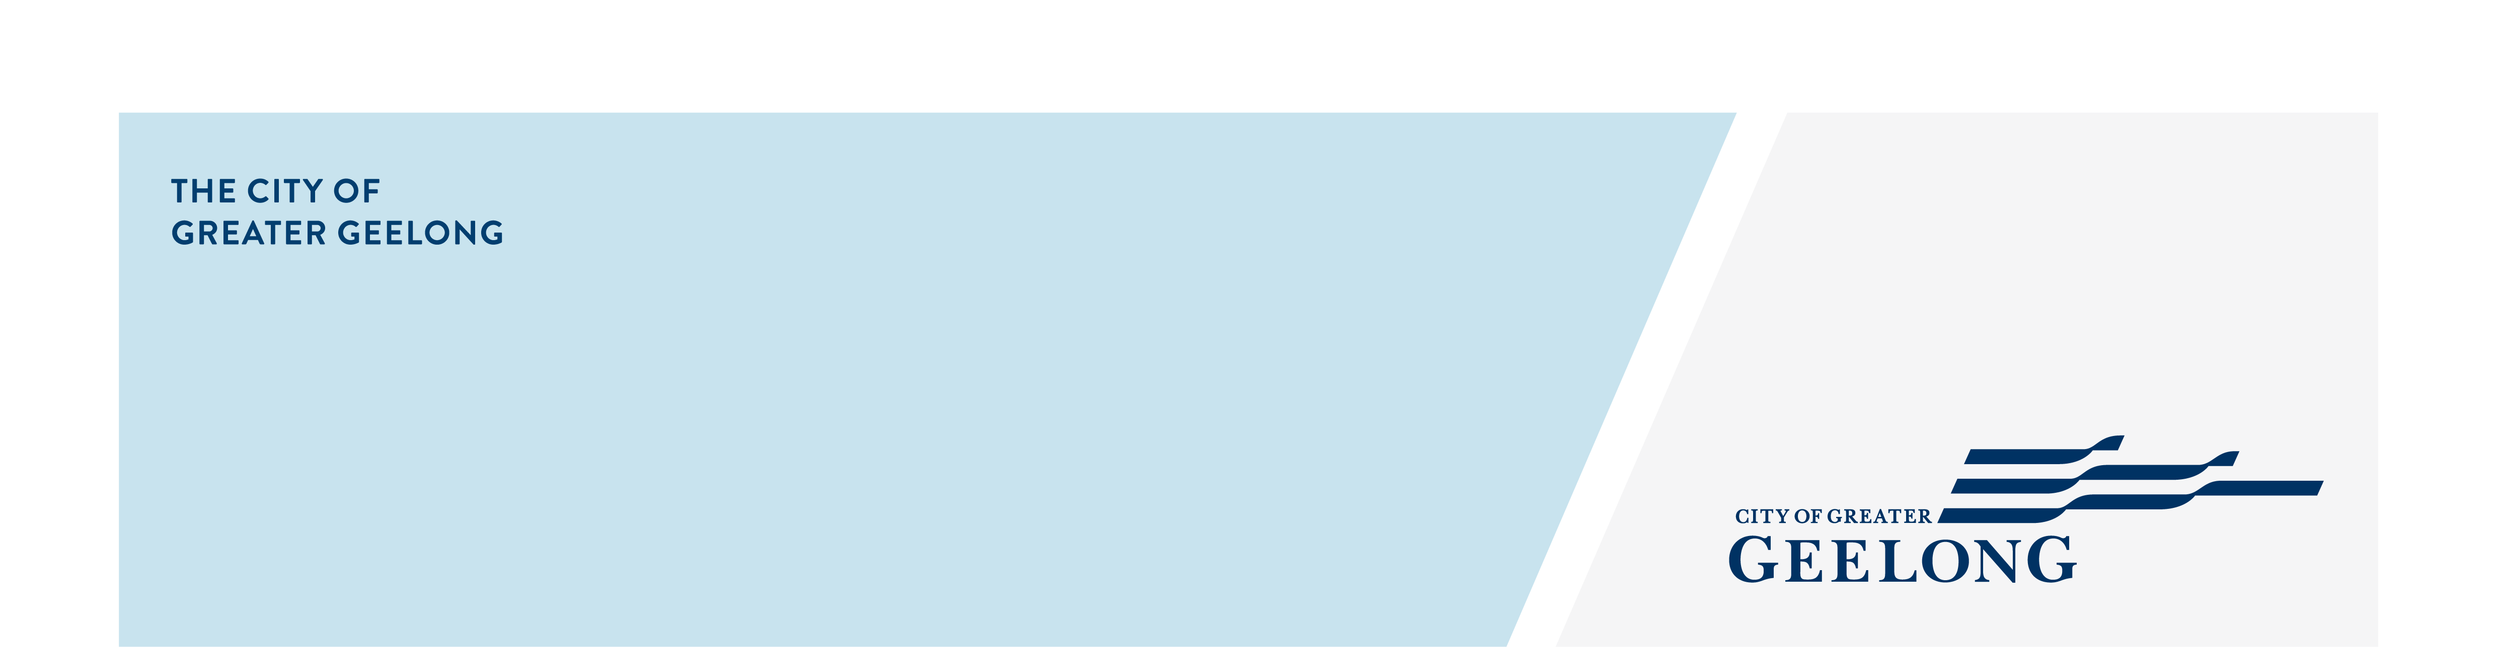
cancel an

additional bin

To complete this form online, please go to www.geelongaustralia.com.au/bins
personal detailS
first name | SURNAME
property address
suburb | POSTCODE
PHONE NUMBER/MOBILE | RATE NUMBER (on your property’s rates notice)
EMAIL ADDRESS

NOMINATE THE BIN YOU WOULD like TO CANCEL

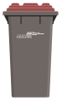
PLEASE TICK ALL THAT APPLY
Please cancel my ADDITIONAL 120/140/240 litre garbage bin (red lid)
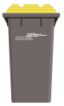
Serial number W ________________________________
Please cancel my ADDITIONAL 240 litre recycling bin (yellow lid)
Serial number RL _________________________________
Please cancel my ADDITIONAL 240 litre green waste bin (green lid)
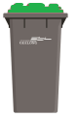

Serial number GL _________________________________

Please contact us on 5272 5272 if:
- the bin we have identified in the letter is no longer held at the property or
- you wish to return a bin not listed in this letter.
- Only empty bins will be collected.

Please nominate the earliest date we can collect your emptied bin/s ____________________________________

terms and conditions
- Cancellations must be received by 30 June to avoid being charged for the next financial year. No refunds will be issued.
- Leave the cancelled bin/s on the nature strip, or near the letterbox outside the fence line, until it is collected.
- Bins will remain the property of the City of Greater Geelong at all times.

Signature ___________________________________________________ Date______________________________________

Return completed form
Email Post Need more information?
wasteadmin@geelongcity.vic.gov.au City of Greater Geelong Contact us on 5272 5272
Attn: Waste
PO BOX 104
GEELONG VIC 3220

Privacy Statement

We will comply with the Information Privacy and Health Privacy Principles as set out in the Privacy and Data Protection Act 2014 and Health Records Act 2001. For more information, search for ‘privacy’ on our website.

