FRP Pit Lids
Introduction:

This Design Note, No 13, provides guidelines and requirements for the use of FRP pit lids in roadside and pathway areas, excluding vehicle crossings.

FRP Pit Lids

FRP (Fibreglass Reinforced Plastic) pit lids are a lightweight alternative to traditional concrete and steel side entry and junction pit lids. They provide significant benefits to the health and safety of maintenance crews through reduced lifting weight and need for special equipment.

FRP pit lids as manufactured by R&S Grating and Terrafirma Pit Lids have been considered in the preparation of this design note, however, equivalent products from alternative manufacturers may be used by approval of the responsible authority.

Definitions

Activity Centre - Vibrant hubs where people shop, work, meet, relax and often live. Usually well-served by public transport, they range in size and intensity of use from local neighbourhood strip shopping centres to universities and major regional shopping malls.

Neighbourhood Centre - Centres which have a limited mix of uses meeting local needs and are dominated by small businesses and shops and some community services. They offer local convenience services and limited public transport provision but are not necessarily well located on the transport network.

Residential Zone – An area which provides for the housing and accommodation needs of the local population. For the purposes of this design note a single shop within a predominantly residential area will be classified as residential, but any pits adjoining a delivery access area for the shop shall require a pit cover equivalent to a Neighbourhood Centre.

Industrial Zone - An area which provides for manufacturing industry, the storage and distribution of goods and associated uses in a manner that does not affect the safety and amenity of local communities.

FRP – Fibre Reinforced Plastic. A lightweight composite material which can be used as an alternative to conventional building materials.

Australian Standard Design Criteria

All FRP pit lids are required to comply with the Australian Standard 3996—2006 Access covers and grates for loading, durability in service and markings.

 | Class  rating | Typical use | Nominal  wheel load  (kg) | Serviceability  design load (kN) | Ultimate limit  state design  load (kN)
 | Class  rating | Typical use | AS3996 | AS3996 | AS3996
 | A | Areas (including footways) accessible only to pedestrians and pedal cyclists and closed to other traffic (extra-light duty) | 330 | 6.7 | 10
 | B | Areas (including footways and light tractor paths) accessible to vehicles (excluding commercial vehicles) or livestock (light duty) | 2670 | 53 | 80
 | C | Malls and areas open to slow moving commercial vehicles (medium duty) | 5000 | 100 | 150
 | D | Carriageways of roads and areas open to commercial vehicles (heavy duty) | 8000 | 140 | 210

NOTES:
- Nominal wheel loads are given for guidance only. Consideration should be given to the type, size and pneumatic pressure of the load applied.
- Class B design loads exceed AS 5100.2 requirements for footway loading.
- Class D design loads exceed AS 5100.2 requirements for a W80 wheel load.
- Class C units are based on an intermediate load.
- The serviceability load is set at 2/3 of the ultimate limit state design load.
- A force of 1 kN approximately equal to the weight of 100 kg.

AS 3996-20006 CLAUSE 1.6 PERMANENT MARKING

Unless otherwise specified, covers and grates shall bear the following permanent marks:
- Manufacturer’s name or registered trademark.
- Date of manufacture.
- The number of this Standard, i.e. AS 3996.
- Load classification in accordance with Table 3.1 (see previous), which may nominate more than one class, for example ‘Classes C-D’
- The approximate mass of the cover (including any infill) or grate, excluding the frame.
- Covers that are sealed to be marked as such in accordance with Clause 1.5(c) (Covers shall be classified as ventilated, unsealed, sealed, sealed watertight or sealed gas-tight. Covers classified as sealed shall be both watertight and gas-tight)
- Grates designed for a particular direction of inflow to indicate the direction of inflow on their upper surface.
- Grates that are not bicycle tyre penetration resistant in all directions to indicate the direction on their upper surface for which they are bicycle tyre penetration resistant.
- Covers requiring structural infill on site to be marked ‘STRUCTURAL INFILL’.

Markings specified in Items (d) to (h) shall be visible on the top of covers (including recessed covers after in-filling) and grates, as appropriate. Markings specified in Items (a) to (c) and (i) shall be visible on the top of covers (including recessed covers after in-filling) and grates. Alternatively, they may be on the underside, such that they are visible when the cover is removed and overturned.

Location vs. Pit Class

The following table provides a quick guide for the selection of appropriate class of pit lid for various locations. In new subdivisions due to construction vehicles associated with residential housing mounting kerbs whilst accessing individual blocks during the build out phase, a minimum C class pit lid has been specified for all installations.

Condition | Location Type | Area | Class
New Subdivision | Collector Rd Intersection – within 10m of kerb tangent point | Roundabout | C
 |  | Signalised Intersection | C
 |  | Unsignalised Cross Intersection | C
 |  | Unsignalised T Intersection | C
 | Local Rd Intersection – within 10m of kerb tangent point | Roundabout | C
 |  | Unsignalised Cross Intersection | C
 |  | Unsignalised T Intersection | C
 | Residential Zones | Midblock | C
 | Activity & Neighbourhood Centres | All behind kerb | C
 | Industrial Zones | All behind kerb | D
Existing Area - Retrofit | Collector Rd Intersection – within 10m of kerb tangent point | Roundabout | C
 |  | Signalised Intersection | B
 |  | Unsignalised Cross Intersection | C
 |  | Unsignalised T Intersection | C
 | Local Rd Intersection – within 10m of kerb tangent point | Roundabout | C
 |  | Unsignalised Cross Intersection | B
 |  | Unsignalised T Intersection | B
 | Residential Area | Midblock | B
 | Activity & Neighbourhood Centres | All behind kerb | C
 | Industrial Zone | All behind kerb | D

Product Colour Selection

Product colour selection needs to be sympathetic to the surrounding streetscape. In most instances it is expected that either a green or grey finish will be appropriate.

Supplier product images

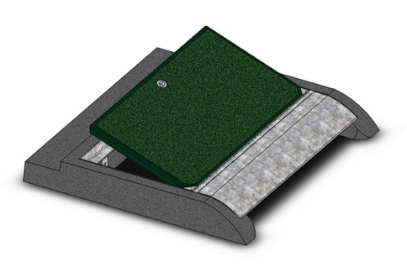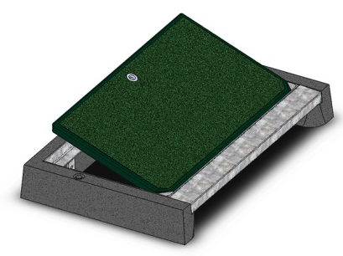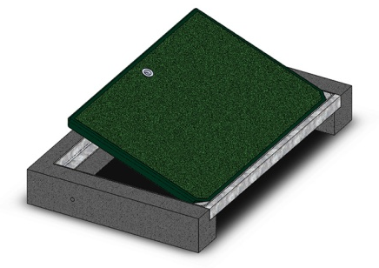
Terra-Firma Pit Lid types

Terra-Firma Pit lid retrofit
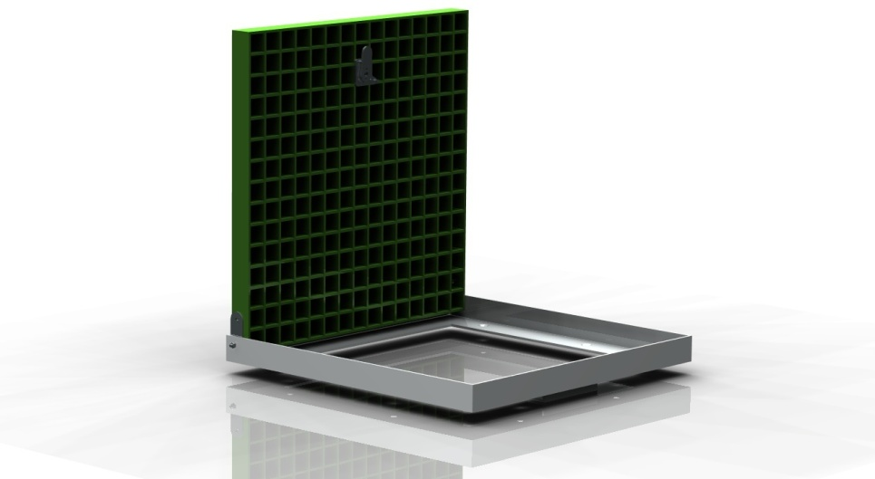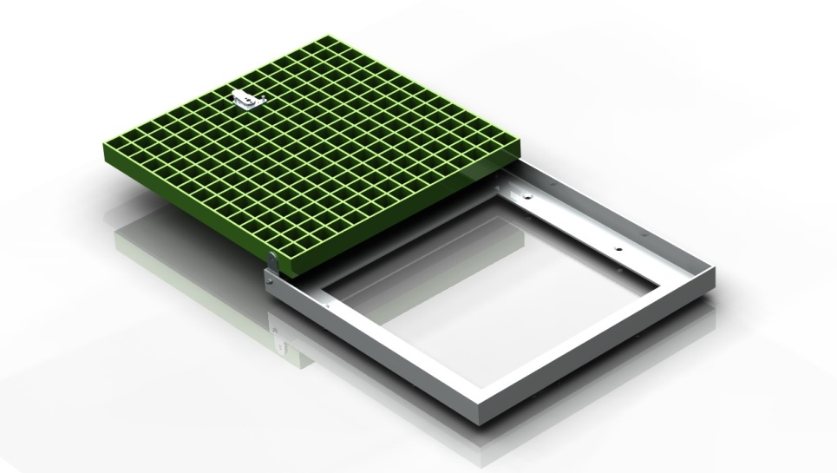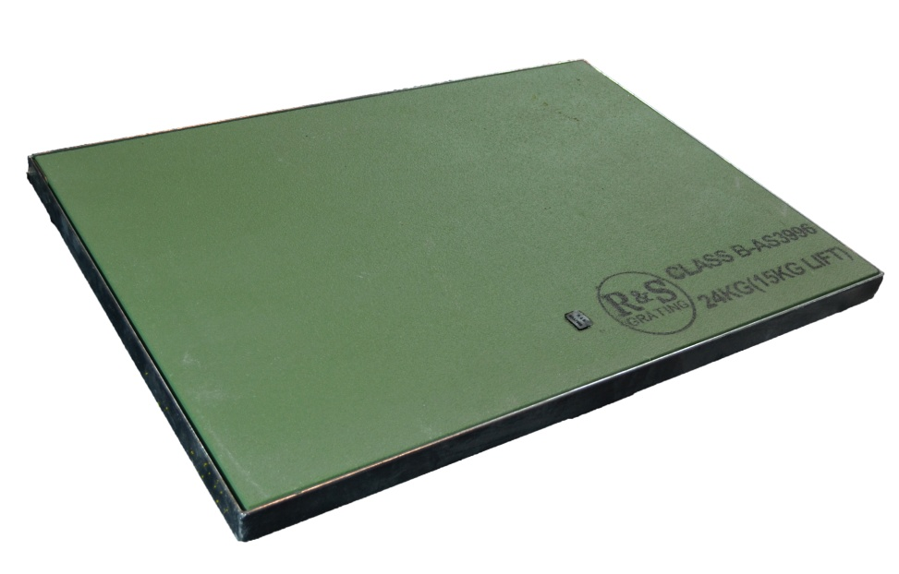
R&S Grating hinged pit lid in frame

