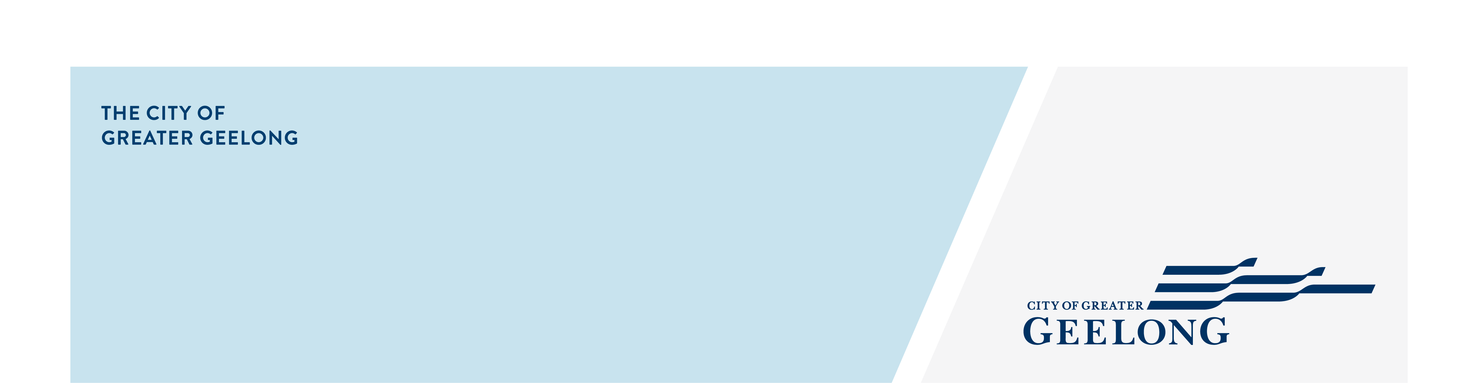
guidelines for the placement of Electoral signs

The following guidelines are provided for the placement of electoral signs within the City of Greater Geelong.

Signs not requiring a permit under the Planning Scheme
Electoral signs can be placed on or affixed to private property provided the property owner’s permission is obtained and the following requirements are observed:
A sign with an advertisement area not exceeding 5 square metres publicising a local educational, cultural, political, religious, social or recreational event not held for commercial purposes.
Only one sign may be displayed on the land, it must not be an animated or internally-illuminated sign.
The sign must not be displayed longer than 14 days after election day, or for longer than 3 months duration, whichever is sooner.
A sign publicising a local political event may include information about a candidate for an election.

Where signs cannot be placed (Council Land)
Electoral signs are not permitted on roads, on municipal buildings, reserves or Council land, including any structures such as bus shelters, light poles within road reserves.
No electoral signs, apart from simple directional signage, is able to be displayed in the common public areas of a City facility being hired.
Definitions are overleaf, however in general terms no electoral advertising is permitted on roads, parkland or Council property.
The following conditions apply to the placing of electoral signage in accordance with Council's Neighbourhood Amenity Local Law 2014 (Clauses 46, 70 and 92) and Election Period Policy (for Council elections), the Environmental Protection Act 2017 (part 6.3 Litter and other waste), the Greater Geelong Planning Scheme and Councils General Signage (including Electoral Advertising) On Council Road Reserves and Land Policy.
(1) No signage can be placed / erected on any council road or reserve (including parks) this also includes any VicRoads, roads or reserves.
(2) Mobile billboards, (trailer types and signs that are placed in or on a motor vehicle) are not to be left standing / stationary as in (1) above. This type of signage has to be mobile at all times.
(3) Motor vehicles (other than trailers) that are permanently sign written may display signage, provided that they meet parking legislation requirements including time limits etc.
(4) The Environmental Protection Act 2017 (Part 6.3 Litter and other waste) prohibits the placing of any form of advertising on the windscreens of vehicles anywhere (public or private land)
(5) Banners, flags are also prohibited as in (1) above and are not to be attached to any fixtures located on any of the roads or reserves as in (1).

Authorisation of Electoral material
It is the responsibility of each candidate to ensure all electoral matter is appropriately authorised.

Removal of Signs
Candidates are encouraged to comply with the above guidelines, as any electoral sign placed in a manner contrary to legislation or Council’s local law will be impounded by Council Officers without reference to the candidate.
Release fees and infringement notices may also be applied.
If you have any queries in relation to this matter, please do not hesitate to contact Community Safety & Regulation on 5272 4500.

Council Neighbourhood Amenity Local Law 2014

Definitions:
- any Council building;
“Municipal Building” means any building (and its grounds) owned, occupied, controlled or managed by the Council, which has some or all areas designated for public or community access but may also have some or all areas designated for employee or staff only access, including a recreation centre.
- any Road
“Road” has the meaning ascribed to it by Section 3 of the Local Government Act, as amended from time to time and includes a public highway.
“road” includes—
(a) a street; and
(b) a right of way; and
(c) any land reserved or proclaimed as a street or road under the Crown Land (Reserves) Act 1978 or the Land Act 1958; and
(ca) a public road under the Road Management Act 2004; and
(d) a passage; and
(e) a cul de sac; and
(f) a by-pass; and
(g) a bridge or ford; and
(h) a footpath, bicycle path or nature strip; and
(i) any culvert or kerbing or other land or works forming part of the road;

- any Council Land
“Council Land” means any land vested in, or under the control or management of the Council excluding a Road, but including a Municipal Reserve or other reservation, watercourse, Foreshore Reserve, jetty, pontoon or boat ramp, and includes any structures, artworks, public decorations or other public displays erected upon or situated at these places including any waterway.
- any Municipal Reserve
“Municipal Reserve” means any land, water, waterway or water course either owned or vested in, or under the control and management of the Council, and used or set aside as a reserve, whether for outdoor cultural, environmental, recreational or other purposes, including any artworks, public decorations, other public displays and any structures other than a building, erected upon or situated at these places including any waterway, but excludes a Road.

Clause 46.1
A person must not, except in accordance with a Permit, erect or place an Advertising Sign on or over any part of a Road or Council Land, or cause or in any way authorise another Person to do so. (20 penalty units); and

Clause 70.1 (a) (ii)
A person must not, without a permit leave or allow to be left any other thing on a Road or Council Land which encroaches on, or obstructs the free use of, the Road or Council Land or which reduces the breadth, or confines the limits, of the Road or Councils Land. (20 penalty units)

Clause 92.1
If an Authorised Officer or Delegated Officer detects an Animal, item or other thing in breach of, or being used contrary to, the provisions of this Local Law and, in the opinion of that Authorised Officer or Delegated Officer, the continuation of that breach or use is contrary to Clauses in Councils Neighbourhood Amenity Local Law 2014 or presents a potential hazard or risk to any Person or property, the Authorised Officer or Delegated Officer may impound that Animal, item or other thing.

