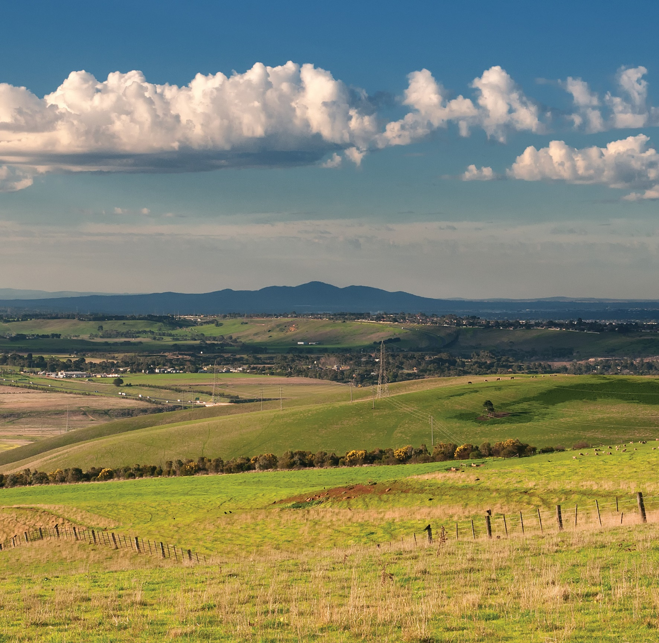



THE CITY OF
GREATER GEELONG
NORTHERN AND WESTERN GEELONG GROWTH AREAS

VISION AND PRINCIPLES WORKSHOP SUMMARY OCTOBER 2017

&

GROWTH AREAS


...,
I,'
' r
w,
/ )JI 1,I
··,
J

. ' ' I ' '

I I
,,
) '
I
) ,' '
/ I
I

r
hi I / I
r. i I , 1
,,
}', \
,,
'

r '\ , .
\ \

I'·

r ''
- ,1 \'

r\ ...._,
j I I

4 /1
) /

'I,

,I


\ ( I

-:- J

I , I,
I • ' I
r]
I , , I
I
I I
'liJI
/'
J.
,,''1·,.l
'

1 1

I, '
/ , : ll\1/J!!
I \'lnJ '
I
'I //2 r)

. , . ,I

,r r
, ., J
l't

I'

I I



WHAT IS THE PROJECT?
THE PROJECT

The Northern and Western Geelong Growth Areas is the largest urban growth project in regional Victoria with the potential to accommodate more than 100,000 new Geelong residents. The growth areas are identified in the G21 Regional Growth Plan and their transformation from rural and semi-rural areas to urban communities is now being initiated by the City of Greater Geelong.
The project will deliver a framework plan and an integrated infrastructure delivery plan to guide strategic land use and development of the two growth areas. The project presents a rare and substantial opportunity for the City to commit to an ambitious future and deliver new communities that enhance the identity of Geelong.
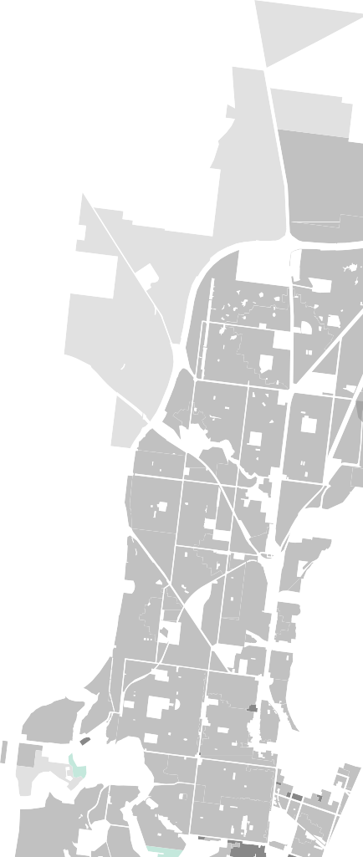





















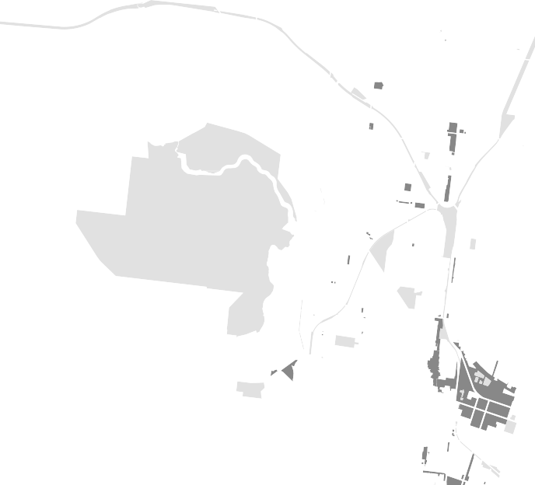

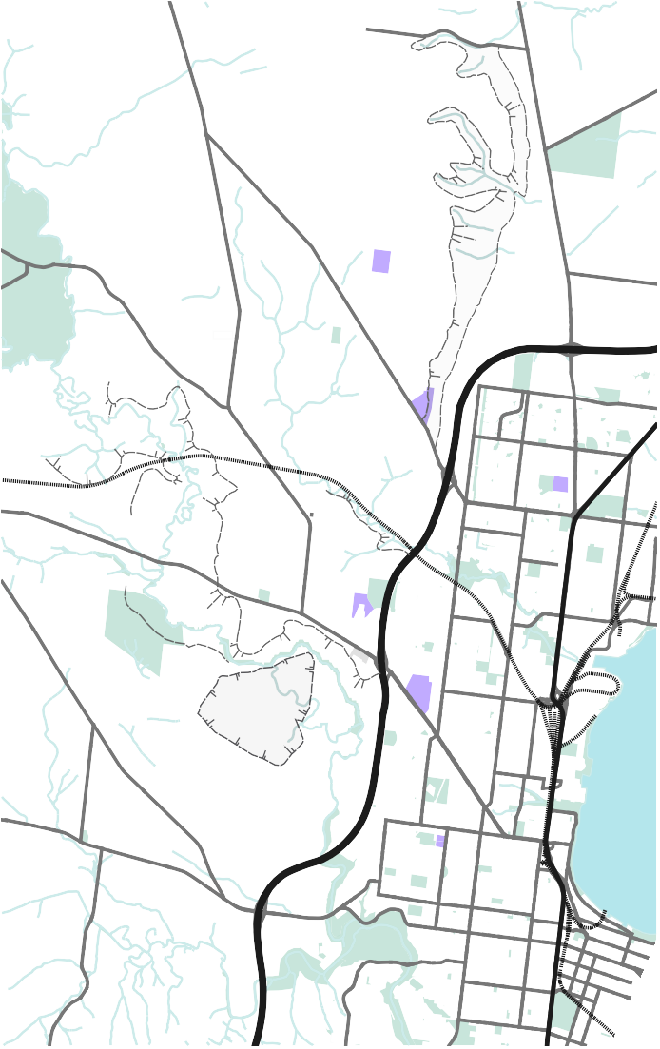
NORTHERN GEELONG GROWTH AREA
WESTERN GEELONG GROWTH AREA

VISION + PRINCIPLES WORKSHOPS
Describes the desired future state
Influenced by contemporary expectations
VISION OF A FUTURE URBAN
AREA
Emerges out
of place, but also recognises the transformation of that place
Identifies the elements that will lead to positive change
The emergence of these urban communities requires leadership, collaboration and the confidence to challenge conventional ‘business as usual’ greenfield planning processes. A foundational shared vision must be formulated with stakeholder support and collaboration between technical experts, government agencies, service authorities, landholders, the private sector and the Geelong community.
The ‘Visions + Principles’ workshops facilitated stakeholder input to articulate a shared vision for each growth area and to identify potential opportunities, barriers and catalysts for their realisation. The workshops were structured to refine and elaborate on the G21 vision. The vision and principles will establish a touchstone for all development outcomes in the future.

WHAT IS A VISION?
In the context of Geelong’s future growth, the project’s vision creates identity and consensus and aligns the interests of all stakeholders through implementation.
A vision should be concise and place-specific – it does not need to be all-encompassing to be meaningful. The most powerful and effective visions are targeted to a singular and specific goal that creates a clear direction for leadership, guidance and future actions.
“What is a vision?” This question launched the workshop to invite stakeholders to consider the role of a vision in growth area planning and to challenge conventional thinking.
3

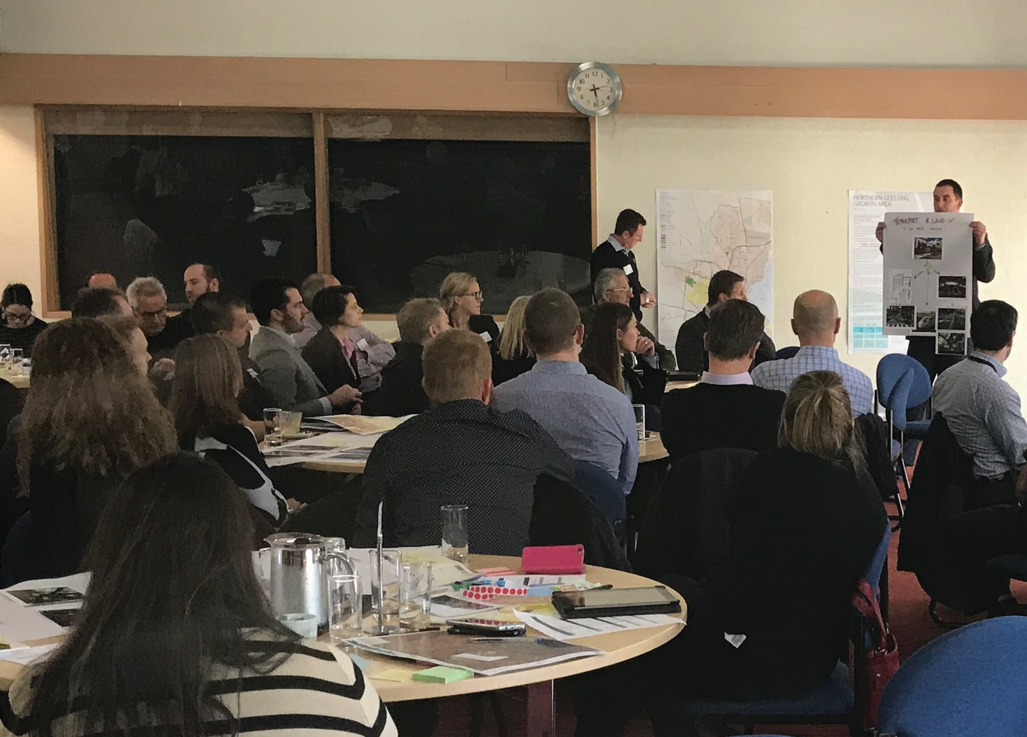
WORKSHOPS
The workshops comprised three distinct phases: ‘Discover’, ‘Inspire’ and ‘Define’ with an overarching focus on “big picture thinking” for Geelong’s future urban areas.
Key questions were asked about the desired future state of the growth areas, such as “What is and will be the essence of the place?”, “What will be its personality?” and “When people describe the place in the future, what will they say?”
WORKSHOP PHASE
DISCOVER | ‘Discover’ introduced the project and the unique attributes of each growth area. The scale of the combined growth areas was emphasised to convey the “city shaping” opportunity and encourage stakeholders to think big.
INSPIRE | ‘Inspire’ was led by technical experts offering insights into vision creation, best practice delivery of sustainable urban environments and the improved outcomes that can be achieved when ‘business as usual’ models are challenged.
DEFINE | ‘Define’ enabled stakeholder collaboration through a set of dynamic and facilitated activities that provoked ideals to underpin place transformation and define a vision and set of principles for the project.

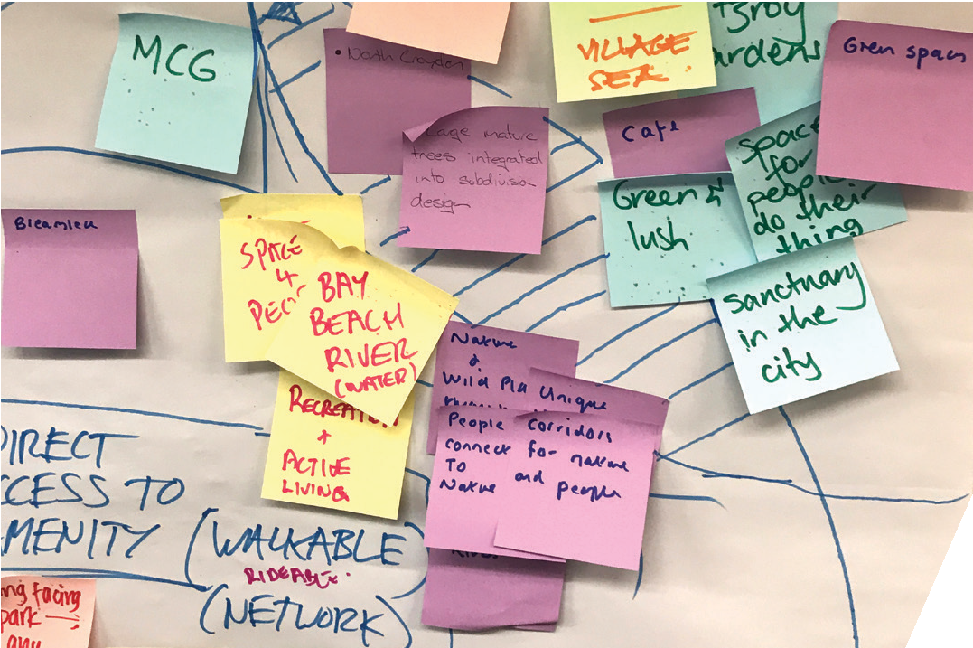

4

GREATER GEELONG

A CLEVER & CREATIVE FUTURE
G21 REGIONAL GROWTH PLAN

From September 2016 to May 2017, over 16,000 people participated in the City’s ‘Our Future’ project to develop a long term community vision for Geelong. The community’s vision was endorsed by the City in July 2017 and will guide the region’s development over the next 30 years:
GREATER GEELONG VISION
By 2047, Greater Geelong will be internationally recognised as a clever and creative city-region that is forward looking, enterprising and adaptive, and cares for its people and environment.

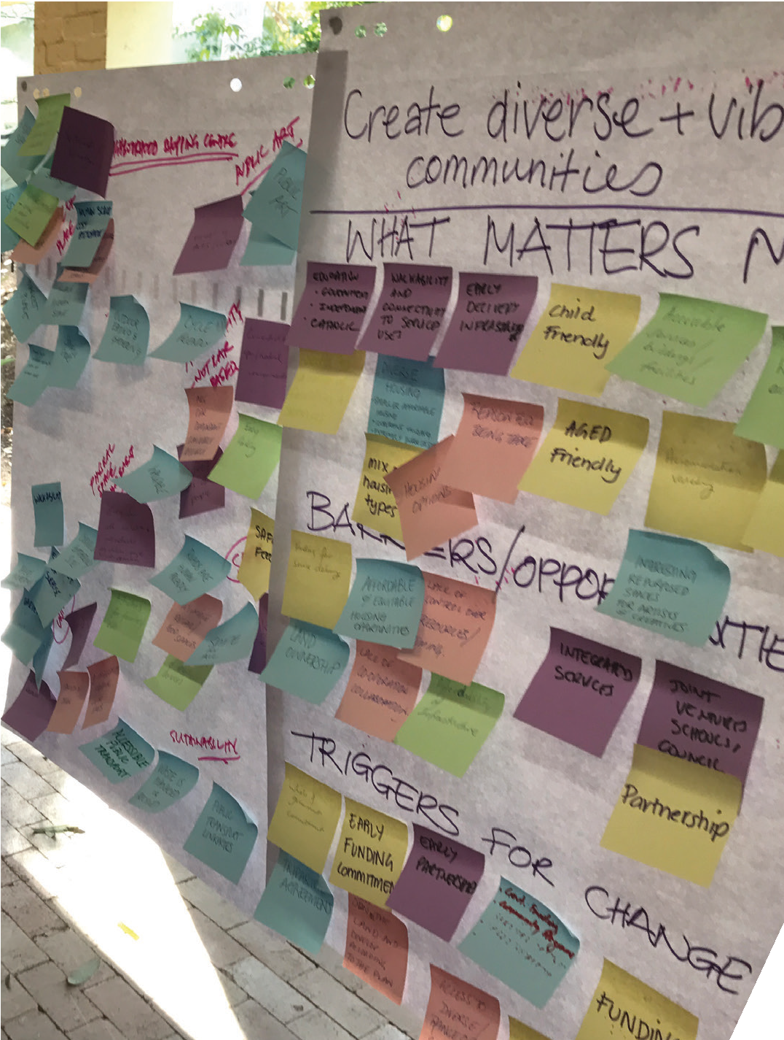
The G21 Regional Growth Plan sets a vision for the growth of the Geelong region that has initiated the project:
G21 VISION
The Geelong region is Australia’s most desirable destination for living, visiting, working and investing; it
is renowned for its vibrant cohesive community, exceptional physical environment and vigorous economy.

PROJECT PRINCIPLES FOR THE NORTHERN AND WESTERN GEELONG GROWTH AREAS
Project principles have been adopted from Growth Corridor Plans: Managing Melbourne’s Growth (Victorian Planning Authority, 2012). Whilst it is acknowledged that each growth area is unique, the following greenfield planning principles can be applied to Geelong’s growth areas:
- Create diverse and vibrant new urban communities
- Integrate transport and land use planning
- Plan for local employment
- Create growth areas with high amenity and character
- Protect biodiversity, waterways and cultural heritage values
- Create integrated open space networks
- Plan for environmental sustainability
- Stage development to ensure the efficient and orderly provision of infrastructure and services.

5

PRINCIPLES
EXPLORATION

PRINCIPLES EXPLORATION

The G21 vision and project principles set the framework for exploring attributes that will shape the growth areas. Stakeholders universally agreed that Geelong’s future urban communities should be sustainable, vibrant and diverse and contain the typical
‘building blocks’ required by the community.
The exploration of principles confirmed that there is mutual understanding and acceptance of what constitutes aspirational communities; however,
implementation is more difficult and this is the phase where these aspirations are constrained. Stakeholders identified the need to rise above these barriers to overcome uniform and unsustainable outcomes.
Opportunities, constraints and triggers for change have been identified for each project principle.

CREATE DIVERSE AND VIBRANT NEW URBAN COMMUNITIES
 Neighbourhood character based on natural landscape features
 Infrastructure funding and construction
 Flexible regulations and incentives created by stakeholder partnerships
 Excessive regulation and standardisation

INTEGRATE TRANSPORT AND LAND USE PLANNING
 Connections to Geelong (linear links) and Melbourne (freeway and rail)
 Flexible and adaptive uses that can transition with economic change
 “Car free routine”
 Railway station to service Northern Geelong
 Car-dependent culture
 Slow provision of public transport

PLAN FOR LOCAL EMPLOYMENT
 Innovative, high-tech industries that provide jobs for the Geelong region
 Proximity to the Geelong Ring Road
 Locally-based employment
 ‘24-hour’ employment hub
 Incentives for businesses to locate in growth areas
 Decline of manufacturing and industry
 Impact of surrounding industrial land use

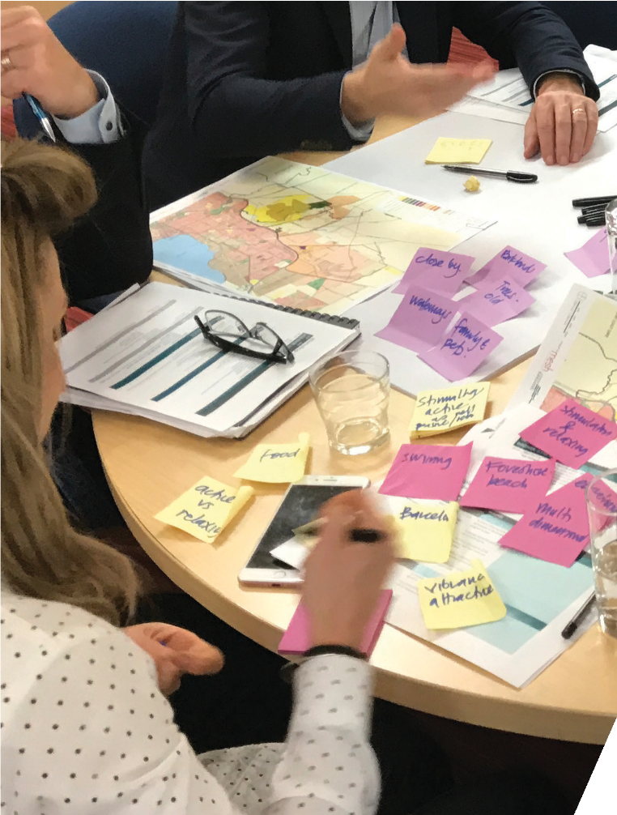

6

CREATE GROWTH AREAS WITH HIGH AMENITY AND CHARACTER
 Monocline escarpment and its views defining character of the Northern Geelong growth area
 Rivers and quarry lake defining character of the Western Geelong growth area
 Character elements borrowed from the older, established Geelong neighbourhoods
 Gateways from the Geelong Ring Road
 Diverse streetscapes and street tree planting
 Standardised processes resulting in uniform greenfield suburbs
 Geelong Ring Road isolating the growth areas from existing Geelong

PROTECT BIODIVERSITY, WATERWAYS AND CULTURAL HERITAGE VALUES
 Existing natural and heritage assets incorporated into future development
 Quarry rehabilitated and established as a lake
 Multi-purpose open spaces and waterways
 Varying standards to allow for innovation
 Holistic value of natural assets emphasised in urban development
 Maintenance requirements and strict standards

CREATE INTEGRATED OPEN SPACE NETWORKS
 Multi-purpose spaces for movement, recreation and community events
 Adaptive guidelines for creating open space
 Shared ownership of open space between public and private sectors
 Maintenance requirements and strict standards

PLAN FOR ENVIRONMENTAL SUSTAINABILITY
 Sustainability as a non-negotiable
 “Visible sustainability” in the urban environment
 Financial incentives
 Developer resistance

STAGE DEVELOPMENT TO ENSURE THE EFFICIENT AND ORDERLY
PROVISION OF INFRASTRUCTURE AND SERVICES
 Early and flexible infrastructure provision for emerging communities
 Small scale, diverse neighbourhoods
 Strong partnerships between public and private sectors to manage conflicting priorities
 Value capture
 Infrastructure funding

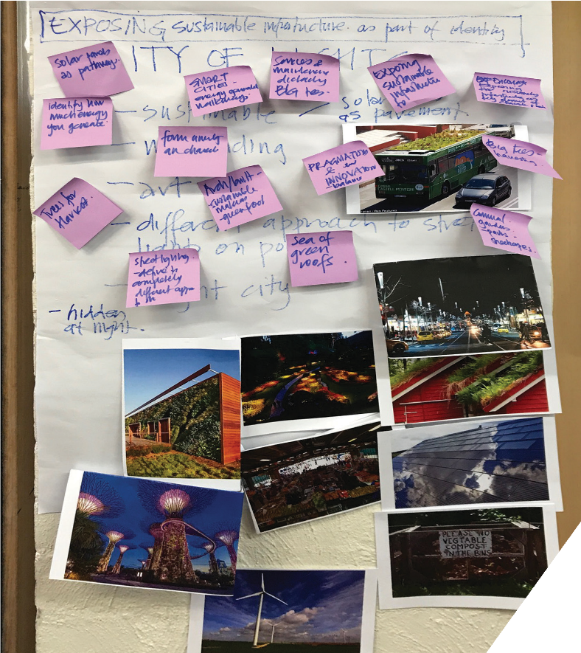

7

NORTHERN AND WESTERN GEELONG GROWTH AREAS
PROJECT VISION
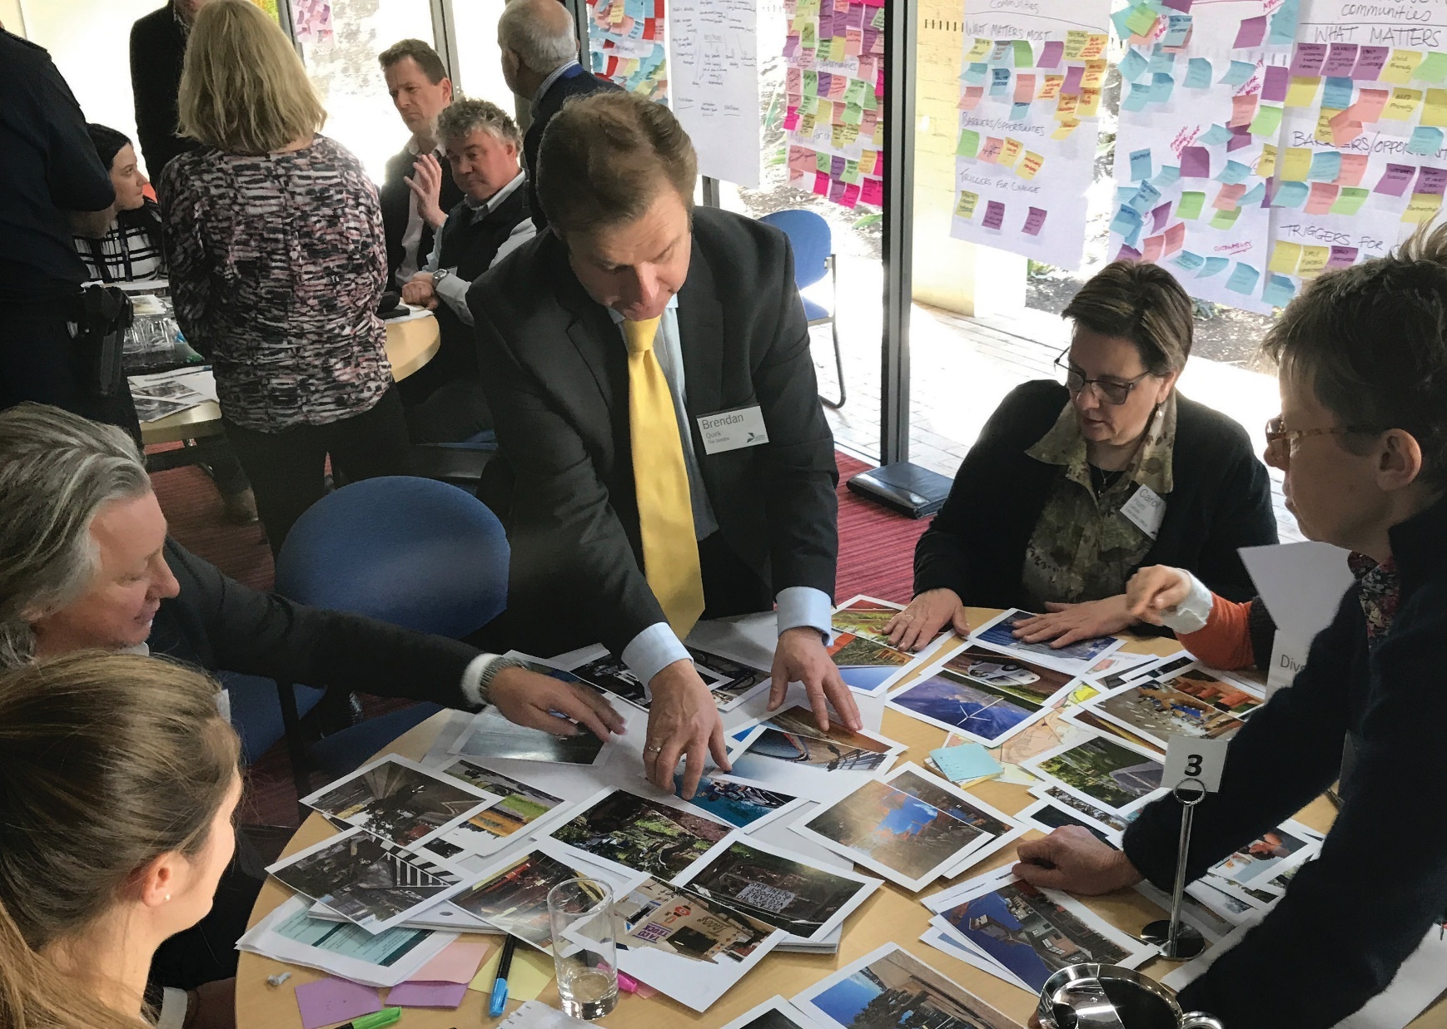

The project vision, applicable to both growth areas, outlines an initial statement for establishing the future communities and their contribution to shaping Geelong’s future.
PROJECT VISION
The Northern and Western Geelong Growth Areas will exemplify Geelong’s transformation as a clever and creative city by building diverse, localised
and sustainable neighbourhoods that prioritise self-sufficiency whilst
maximising connections to the Geelong community, economy and identity.
Subsequently, a standalone vision and set of principles has been formulated for each growth area to establish a unique and strong sense of identity that will guide their transformation.

8

NORTHERN GEELONG GROWTH AREA

THE GROWTH AREA
The Northern Geelong Growth Area is renowned for the Lovely Banks monocline that defines the local landscape and allows stunning views to the You Yangs, Corio Bay and across Geelong. Stakeholders valued the strategic location of the area for its proximity to transport infrastructure and employment land that can
facilitate adaptive and innovative business development in proximity to attractive residential neighbourhoods.
VISION FOR NORTHERN GEELONG
Northern Geelong will be distinguished by neighbourhoods with panoramic views across the region and built around diverse and accessible employment hubs that epitomise Geelong’s creativity, innovation and enterprise.

PRINCIPLES
Create diverse and vibrant new urban communities: Plan for a dynamic mix of residential
and commercial neighbourhoods that easily interconnect and identify as part of the established Geelong community.

Integrate transport and land use planning:
Deliver a comprehensive public transport network that facilitates convenient access to local employment hubs and central Geelong.
Plan for local employment: Optimise local job creation by establishing a diverse, adaptable employment
Evans Rd
hub to capitalise of future trends and leverage the growth area’s proximity to the Geelong Ring Road Employment Precinct, the Port of Geelong, Avalon Airport and Melbourne.
Anakie Rd
Create growth areas with high amenity and character: Establish a district of neighbourhoods that
Evans Rd
exploit the panoramic vistas across the region, deliver an attractive interface to neighbouring precincts and enhance Geelong’s local character.
Purnell Rd
larat Railway
tone Bridge Rd
Princess Rd
elong Ring Rd
Protect biodiversity, waterways and cultural heritage values: Protect and regenerate biodiversity
values of the natural and constructed waterways along the Lovely Banks monocline and heritage values of the Elcho Homestead.

Create integrated open space networks:
Cultivate a stunning trail along the ridgeline of the Lovely Banks monocline and substantial green links along infrastructure easements with an adjoining network of recreation reserves and local parks.

Plan for environmental sustainability: Create a
carbon positive community that implements ecologically sustainable development principles by prioritising renewable energy production and minimising resource use.
Stage development to ensure the efficient and orderly provision of infrastructure and services: Ensure that staging of development creates
early provision of public transport to central Geelong and facilitates coordinated delivery of employment precincts to support job growth in Northern Geelong.
Staceys Rd
Patullos Rd
Monocline
hus Marsh Rd
Elcho Rd

Elcho Rd
Gibbons Rd
Houston Rd
Heales Rd
Heales Rd
Bacchus Marsh Rd
Emmersons Rd
Tower Hill Dr
Monocline

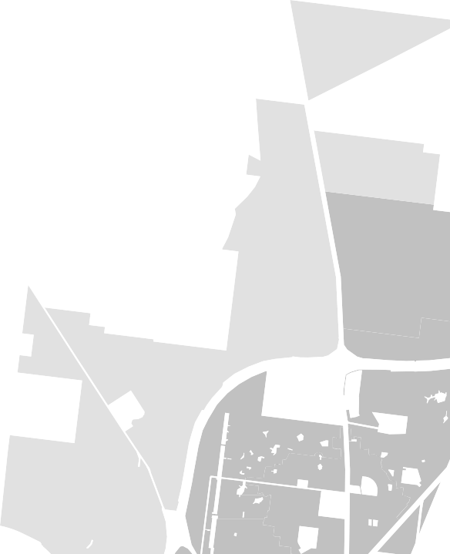










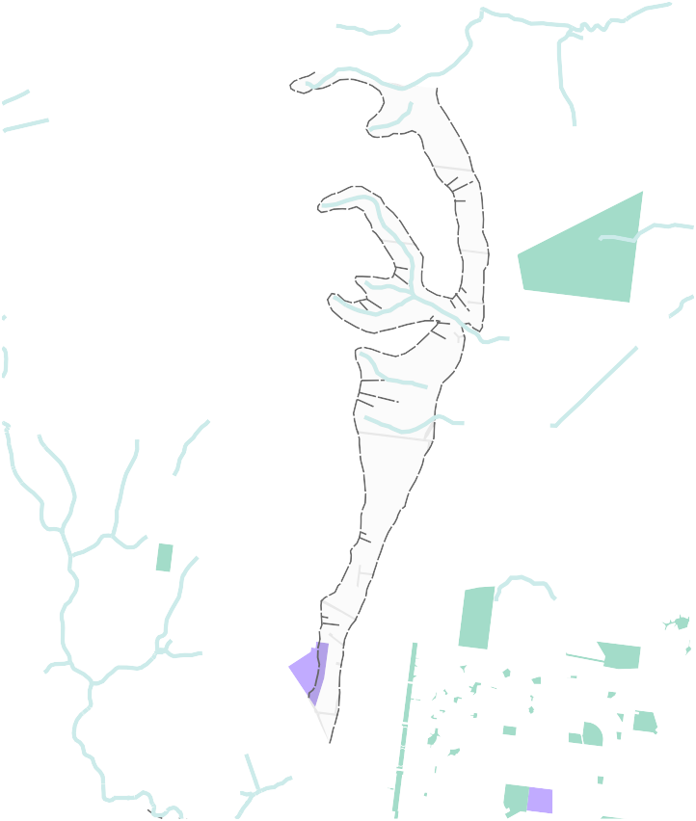
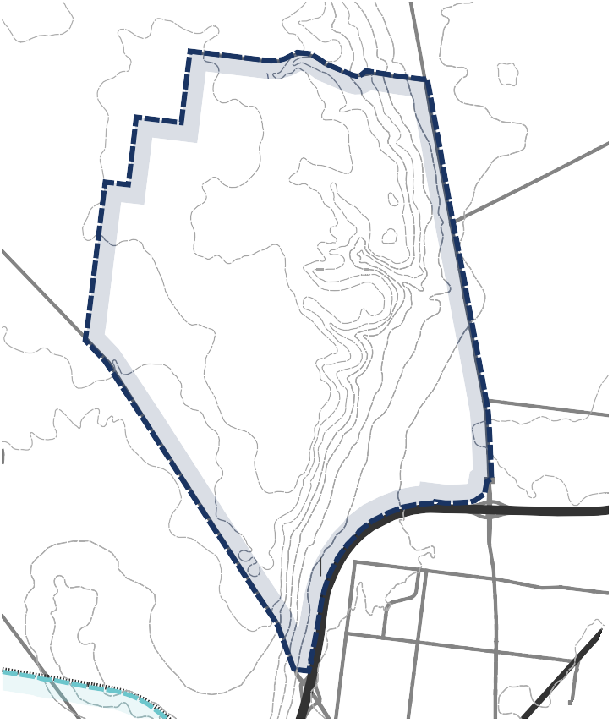
9
LEMMP
NORTHERN GEELONG GROWTH AREA
Elcho Park
Elcho Golf Course Park
Lovely Banks Basin
Northbound Service Centre
Sutcliffe
Reserve M.C. Herd
Meat Wholesaler
Geelong Baptist College
Hendy Street Reserve
Corio Central

Northern Bay College
GEEL EMPLO
LOVELY BANKS
OORABOOL
Lovely Banks Rd
Plantation Rd
Tower Hill Dr
C
Emmersons Rd

WESTERN GEELONG GROWTH AREA

THE GROWTH AREA
The Western Geelong Growth Area is an iconic landscape characterised by the Barwon and Moorabool Rivers
with views across the Barrabool Hills and the Batesford quarry as its centrepiece. Stakeholders valued the future prosperity of the waterways and transformation of the quarry to an iconic lake.
VISION FOR WESTERN GEELONG
Western Geelong will prosper as a district of lakeside neighbourhoods connected
by healthy waterways and attractive open spaces that strengthen Geelong’s identity as a city built around water.
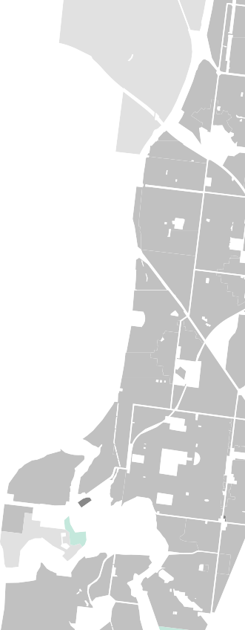


















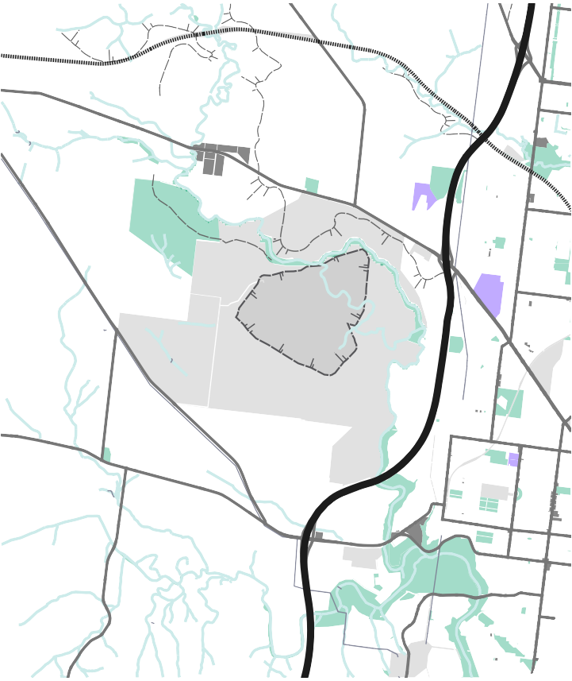
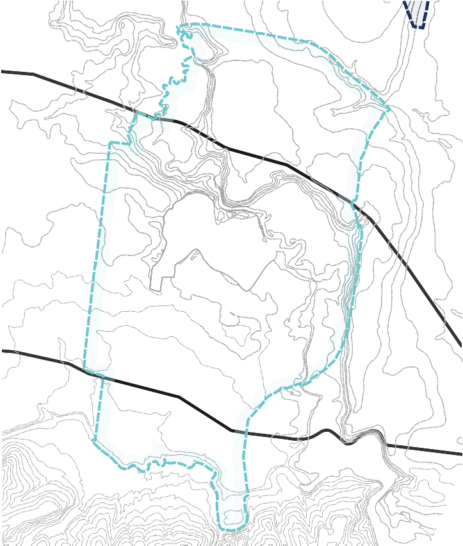
Bell Park Sports Club
WESTERN GEELONG GROWTH AREA
Haines Reserve
Barwon River
BATESFORD
Myers Reserve

Covenant College
Dog Rocks Flora & Fauna Sanctuary
Kardina International College
QUARRY
NOR
Hamlyn Park
Fyansford Waste Disposal
Queens Park

PRINCIPLES
Create diverse and vibrant new urban communities: Plan for neighbourhoods that
encourage community interaction by maximising public access and activity in high amenity destinations throughout the growth area.

Integrate transport and land use planning:
Deliver a comprehensive active transport network utilising the substantial river corridors and acknowledge the future potential of the rail corridor.
Plan for local employment: Optimise local employment by establishing a network of activity centres
positioned to profit from the natural splendour of the area, highway connections to the Western District and proximity to central Geelong.
Create growth areas with high amenity and character: Establish a district of lakeside and riverside
neighbourhoods recognised for their healthy waterways and attractive open spaces that will enhance Geelong’s local character.
Protect biodiversity, waterways & cultural heritage values: Protect and regenerate biodiversity
and cultural heritage values along the Barwon and Moorabool Rivers, Cowies Creek and the Dog Rocks Sanctuary and establish vegetated constructed waterways.

Create integrated open space networks:
Cultivate an exemplary open space network that links the Barwon and Moorabool Rivers to an iconic lake at the Batesford quarry and supports a network of recreation reserves and local parks.

Plan for environmental sustainability:
Create an integrated water management system based around the major catchments and prioritise active and public transport networks.
Stage development to ensure the efficient and orderly provision of infrastructure and services: Ensure that staging of development creates
early provision of public transport to central Geelong and preserves long term development aspirations adjoining the Batesford quarry.

10

NEXT STEPS

The vision and principles formulated for the Northern and Western Geelong Growth Areas will underpin their transformation into Geelong’s newest urban communities.
This report presents a summary of findings at the Vision
+ Principles workshops that will inform the upcoming framework planning process to establish high-level land use outcomes for the growth areas.

THANKS TO

We thank the following stakeholders for their contribution to developing the vision and principles for the Northern and Western Geelong Growth Areas:

Department of Environment, Land, Water and Planning, Department of Health and Human Services, Department of Justice, Department of Education and Training, Transport For Victoria, VicRoads, Barwon Health, Barwon Water, Corangamite Catchment Management Authority, Ambulance Victoria, Country Fire Authority, Victoria Police, Golden Plains Shire, The Gordon, Geelong Regional Library Corporation, Catholic Education Office,
APA Group, AusNet Services, Powercor Australia, Give Where You Live Foundation and landowners of the Northern and Western Geelong Growth Areas.

11







CITY OF GREATER GEELONG
PO Box 104
Geelong VIC 3220
P: 03 5272 5272
E: contactus@geelongcity.vic.gov.au W: www.geelongaustralia.com.au
NORTHERN AND WESTERN GEELONG GROWTH AREAS
Nat Anson - Project Manager Planning Strategy and Urban Growth City of Greater Geelong
E: geelonggrowthareas@geelongcity.vic.gov.au
P: 03 5272 4589
W: www.geelongaustralia.com.au
CUSTOMER SERVICE CENTRE
Geelong
100 Brougham Street
Geelong VIC 3220 8:00am –5:00pm
LATEST NEWS:
geelongaustralia
@GreaterGeelong
@CityofGreaterGeelong CityofGreaterGeelong

&

GROWTH AREAS

