NORTHERN GEELONG GROWTH AREA

THE GROWTH AREA
The Northern Geelong Growth Area is renowned for the Lovely Banks monocline that defines the local landscape and allows stunning views to the You Yangs, Corio Bay and across Geelong. Stakeholders valued the strategic location of the area for its proximity to transport infrastructure and employment land that can facilitate adaptive and innovative business development in proximity to attractive residential neighbourhoods.
VISION FOR NORTHERN GEELONG
Northern Geelong will be distinguished by neighbourhoods with panoramic views across the region and built around diverse and accessible employment hubs that epitomise Geelong’s creativity, innovation and enterprise.

PRINCIPLES
Create diverse and vibrant new urban communities: Plan for a dynamic mix of residential
and commercial neighbourhoods that easily interconnect and identify as part of the established Geelong community.

Integrate transport and land use planning:
Deliver a comprehensive public transport network that facilitates convenient access to local employment hubs and central Geelong.
Plan for local employment: Optimise local job
creation by establishing a diverse, adaptable employment hub to capitalise of future trends and leverage the growth area’s proximity to the Geelong Ring Road Employment Precinct, the Port of Geelong, Avalon Airport and Melbourne.
Create growth areas with high amenity and character: Establish a district of neighbourhoods that
exploit the panoramic vistas across the region, deliver an attractive interface to neighbouring precincts and enhance Geelong’s local character.
larat Railway
e Bridge Rd
rincess Rd
Protect biodiversity, waterways and cultural heritage values: Protect and regenerate biodiversity
values of the natural and constructed waterways along the Lovely Banks monocline and heritage values of the Elcho Homestead.

Create integrated open space networks:
Cultivate a stunning trail along the ridgeline of the Lovely Banks monocline and substantial green links along infrastructure easements with an adjoining network of recreation reserves and local parks.

Plan for environmental sustainability: Create a
carbon positive community that implements ecologically sustainable development principles by prioritising renewable energy production and minimising resource use.
Stage development to ensure the efficient and orderly provision of infrastructure and services: Ensure that staging of development creates

















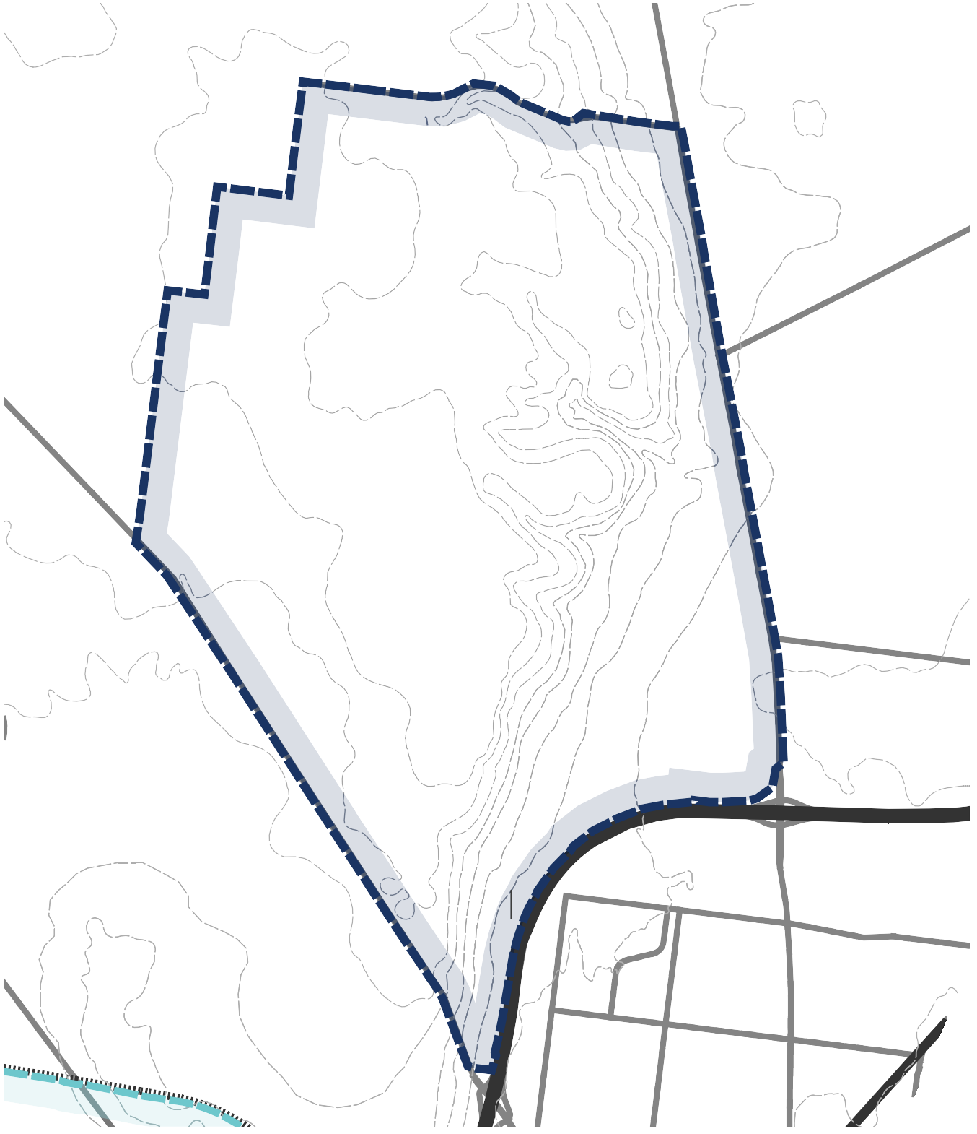
early provision of public transport to central Geelong and facilitates coordinated delivery of employment precincts to support job growth in Northern Geelong.
Heales Rd
LEMMP
NORTHERN GEELONG GROWTH AREA
Elcho Park
Elcho Park Golf Course
Lovely Banks Basin
Northbound Service Centre
Sutcliffe
Reserve M.C. Herd
Meat Wholesaler
Geelong Baptist College
Hendy Street Reserve
Corio Central

Northern Bay
GEEL EMPLO
LOVELY BANKS
OORABOOL
Staceys Rd
Patullos Rd
hus Marsh Rd
Lovely Banks Rd
Elcho Rd
Gibbons Rd
Houston Rd
Heales Rd
Plantation Rd
Purnell Rd
Tower Hill Dr
Anakie Rd
Monocline
Bacchus Marsh Rd
Evans Rd
Evans Rd
Emmersons Rd
Emmersons Rd
Tower Hill Dr
Monocline
Elcho Rd



&
4
ong Ring Rd

