WESTERN GEELONG
GROWTH AREA

THE GROWTH AREA
The Western Geelong Growth Area is an iconic landscape characterised by the Barwon and Moorabool Rivers with views across the Barrabool Hills and the Batesford quarry as its centrepiece. Stakeholders valued the future prosperity of the waterways and transformation of the quarry to an iconic lake.
VISION FOR WESTERN GEELONG
Western Geelong will prosper as a district of lakeside neighbourhoods connected by healthy waterways and attractive open spaces that strengthen Geelong’s identity as a city built around water.

PRINCIPLES
Create diverse and vibrant new urban communities:
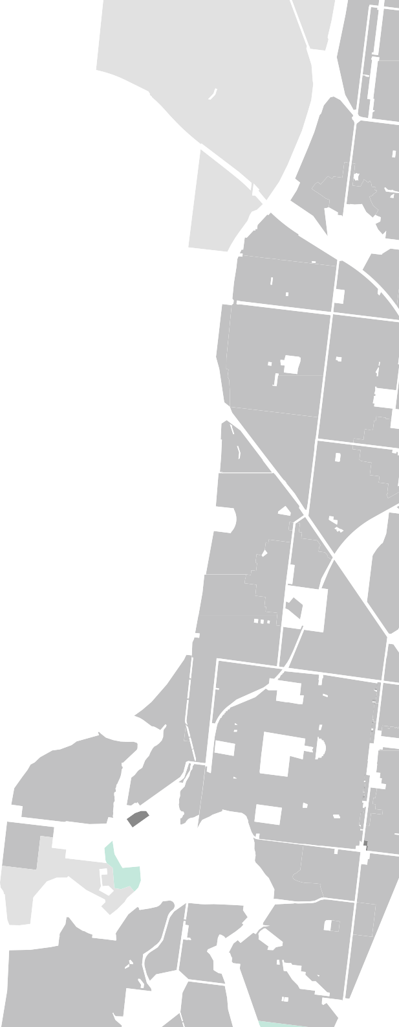



















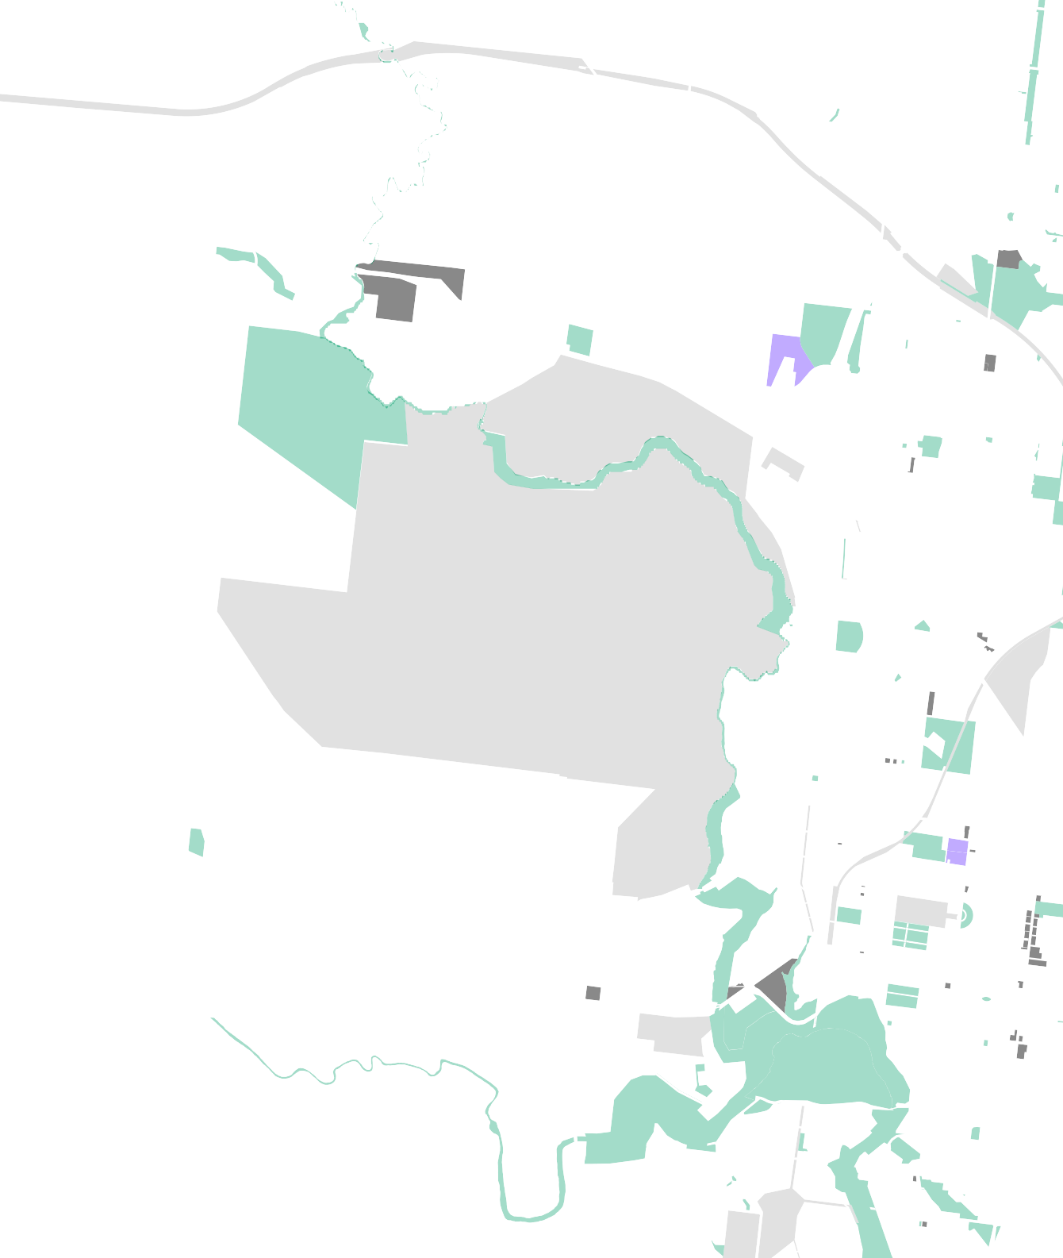
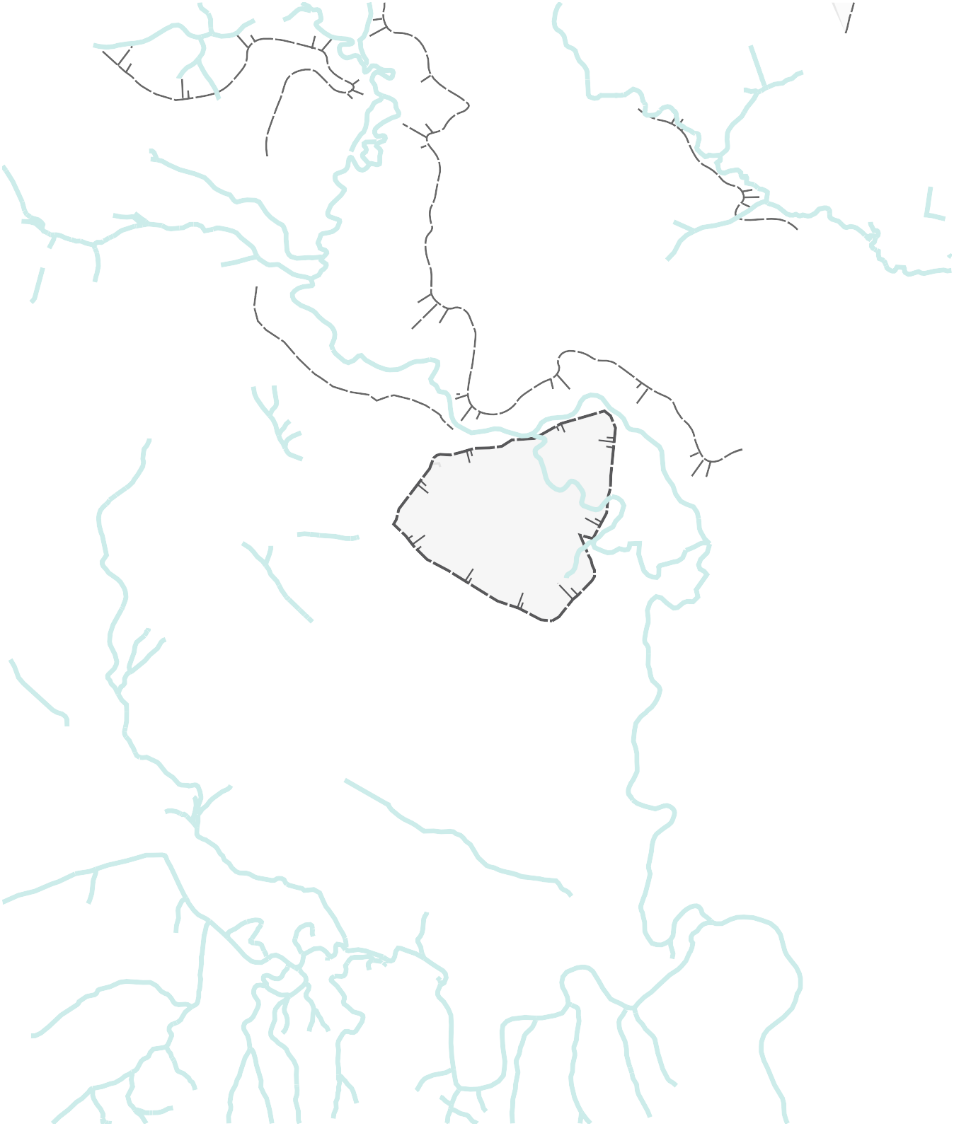
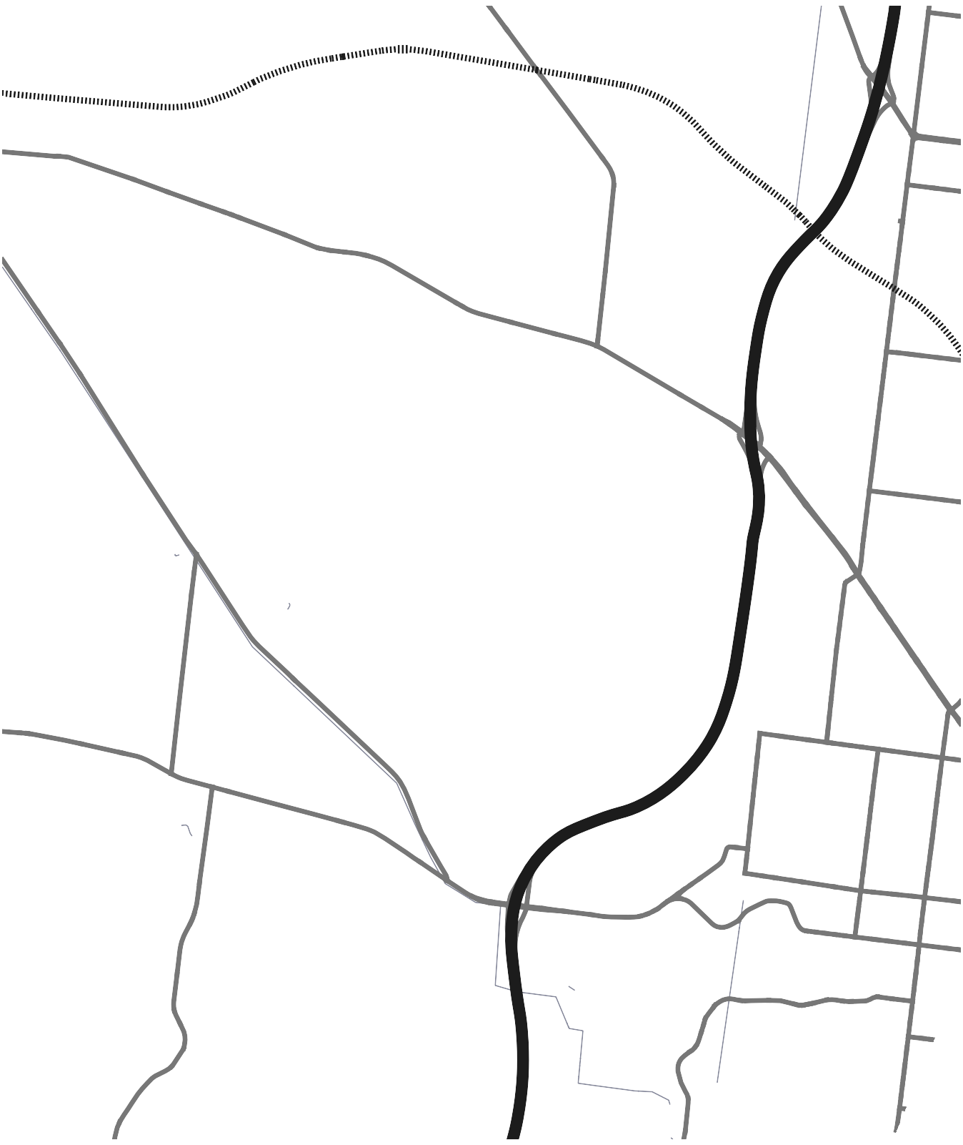
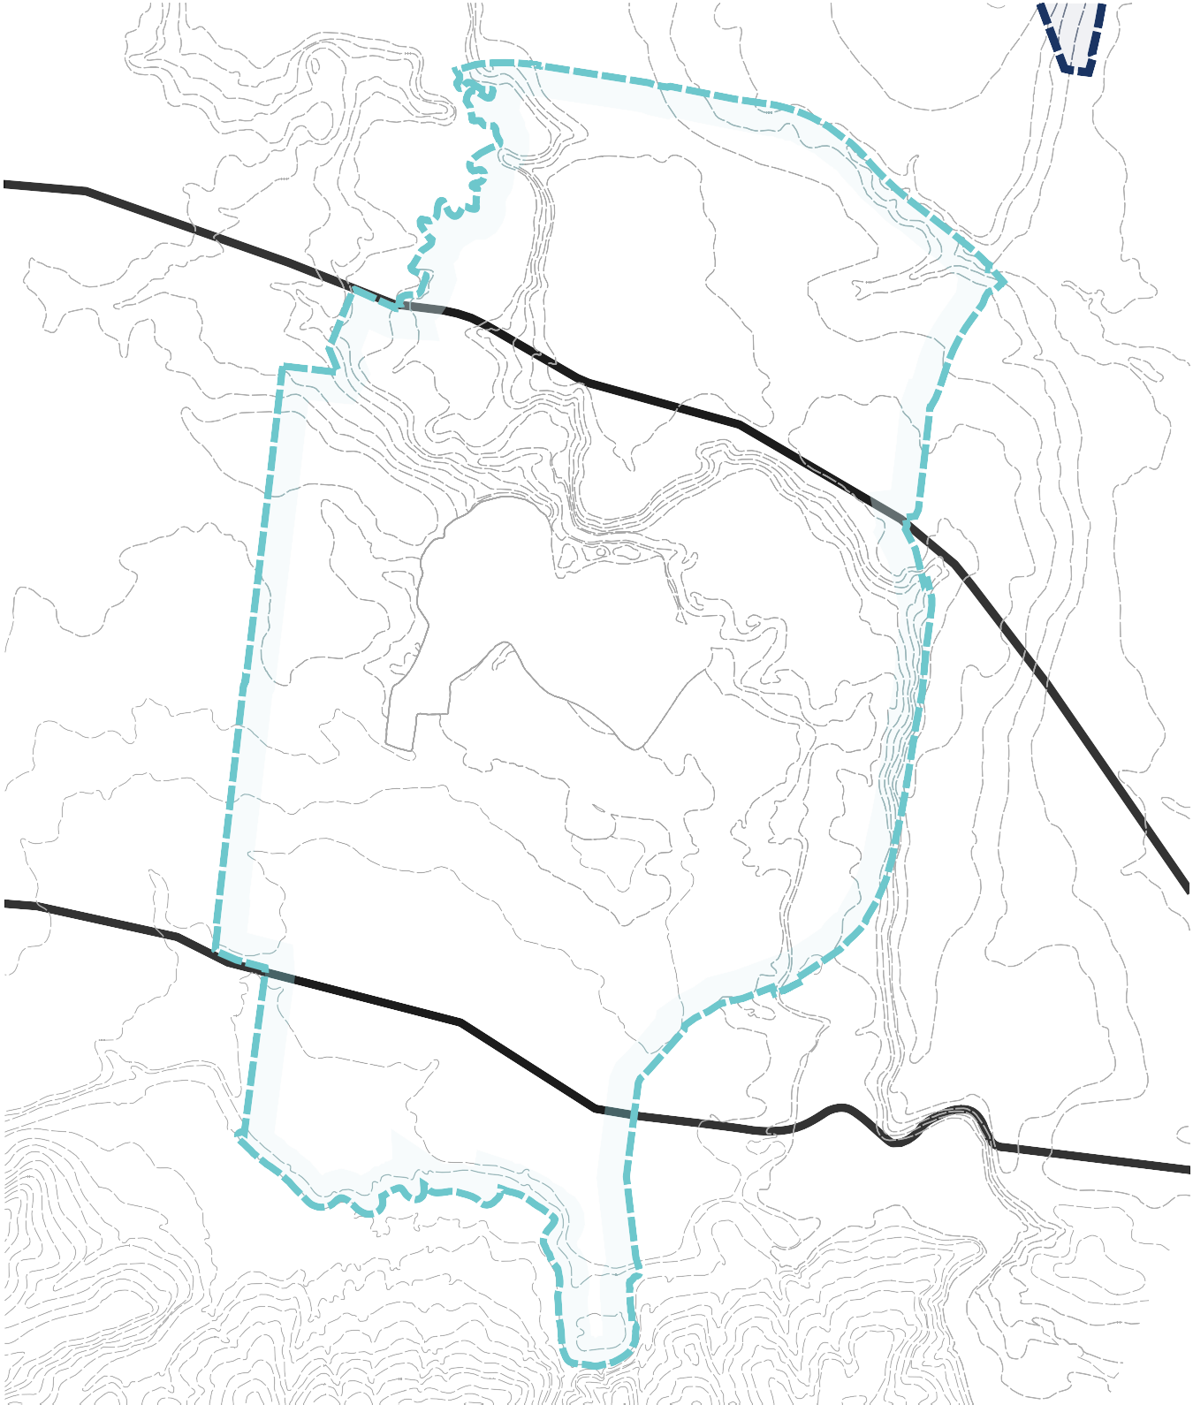
Plan for neighbourhoods that encourage community interaction by maximising public access and activity in high amenity destinations throughout the growth area.
Geelong-Ballarat Railway
Bell Park Sports Club
WESTERN GEELONG GROWTH AREA
Haines Reserve
Barwon River
BATESFORD
Myers Reserve

Covenant College
Dog Rocks Flora & Fauna Sanctuary
Kardina International College
QUARRY
NOR
Hamlyn Park
Fyansford Waste Disposal
Queens Park

Integrate transport and land use planning:
Cowies Creek
Midland Hwy
Deliver a comprehensive active transport network utilising the substantial river corridors and acknowledge the future potential of the rail corridor.
Geelong-Ballan Rd
Plan for local employment:
Moorabool River
Midland Hwy
Optimise local employment by establishing a network of activity centres positioned to profit from the natural splendour of the area, highway connections to the Western District and proximity to central Geelong.
Dog Rocks Rd
Geelong Ring Rd
Create growth areas with high amenity and character:
Fyansford-Gheringhap Rd
Establish a district of lakeside and riverside neighbourhoods recognised for their healthy waterways and attractive open spaces that will enhance Geelong’s local character.
Merrawarp Rd
Hamilton Hwy
Protect biodiversity, waterways & cultural heritage values:
Protect and regenerate biodiversity and cultural heritage values along the Barwon and Moorabool Rivers, Cowies Creek and the Dog Rocks Sanctuary and establish vegetated constructed waterways.

Create integrated open space networks:
Cultivate an exemplary open space network that links the Barwon and Moorabool Rivers to an iconic lake at the Batesford quarry and supports a network of recreation reserves and local parks.

Plan for environmental sustainability:
Create an integrated water management system based around the major catchments and prioritise active and public transport networks.
Stage development to ensure the efficient and orderly provision of infrastructure and services:
Ensure that staging of development creates early provision of public transport to central Geelong and preserves long term development aspirations adjoining the Batesford quarry.
Geelong Ring Rd
Bluestone Bridge Rd

Co
Mc Canns Ln



GROWTH AREAS
&
ng Ring Rd

