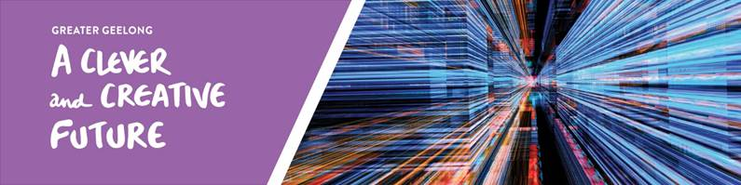

Vision Baseline Report

By 2047, Greater Geelong will be internationally recognised as a clever and creative city-region that is forward looking, enterprising and adaptive, and cares for its people and environment.
Between September 2016 and May 2017, over 16,000 people told us what they value about the region and how they would like to see it grow, and evolve. The resulting vision, Greater Geelong: A Clever and Creative Future is a community-led blueprint for our region to be recognised regionally, nationally and internationally, as a clever and creative city-region.
The vision is a guide for all levels of government, community organisations, businesses and anyone wanting to make a genuine contribution to the future of Greater Geelong.
At the heart of the vision are a series of aspirations developed by the community. They are focused on our region’s economy and employment, the environment, arts and culture, transport connections, tourism, efficient and equitable digital access, and good governance.
The vision’s implementation will be monitored through 37 key indicators and measures which will be reviewed periodically and may be adjusted. New measures may also be considered as part of any review.
COMMUNITY ASPIRATIONS
 | 
 | 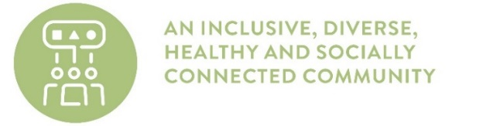
 | 
 | 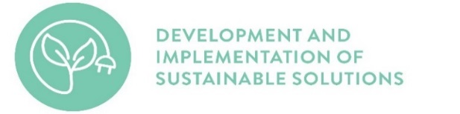
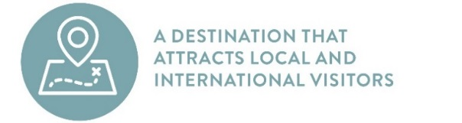
#clevercreative
www.geelongaustralia.com.au/clevercreative

VISION BASELINE REPORT
INDICATOR | BASELINE | COMMUNITY  ASPIRATION
SCHOOL LEAVERS – The number of school leavers engaged in work or post-school study is higher than the Victorian average.  Source: Census of Population and Housing, Australian Bureau of Statistics. | Greater Geelong - 29.4%  Victoria - 30.6%  (2016). | 
EDUCATION – Education provides graduates with the skills businesses require in our city-region.  Source: To be determined. | To be determined.
EMPLOYMENT – Greater Geelong’s workforce participation rate is higher than the Victorian average.  Source: Census of Population and Housing, Australian Bureau of Statistics. | Greater Geelong - 57.9%  Victoria - 60.5%  (2016).
BUSINESS DIVERSITY – An increase in the diversity of businesses  Source: Regional Development Victoria (RDV) Information Portal Geelong LGA Regional. Snapshot. A lower index value signifies higher industry diversity, a higher value signifies higher industry specialisation. | 50 (2011).
DIGITAL INCLUSION – A Digital Inclusive Index score greater than 70.  Source: The Australian Digital Inclusion Index Report. | 58.7 (2017). | 
TECHNOLOGICAL BUSINESSES – An increase in the number of technology based businesses.  Source: To be determined. | To be determined.
ARTS AND CULTURE PARTICIPATION – Increasing the percentage of the community actively participating in arts and cultural activities.  Source: To be determined. | This indicator is no longer available and an alternative source or indicator will be determined. | 
CREATIVE OCCUPATIONS – Increasing the percentage of the workforce employed in creative occupations*.  Source: Census of Population and Housing, Australian Bureau of Statistics. | 4.75% of workers in Greater Geelong were employed in creative occupations in 2016. An increase from 4.26% in 2011.
AN INNOVATION ECONOMY – Greater Geelong rated in the top 200 of the Global Innovation Cities index.  Source: Innovation Cities™ Indexs, 2thinknow. | 334 (2017).
NEW BUSINESSES – Increasing the number of innovative start-ups in the city-region.  Source: To be determined. | To be determined.
TRAVEL TO MELBOURNE – Being able to travel to Melbourne from Geelong within 30 minutes, and from the Bellarine Peninsula within 65 minutes, utilising a variety of travel options.  Source: To be determined. | Measurements and source data for an integrated transport network in Greater Geelong are still under investigation. | 
AIR TRAVEL – An international freight terminal and passenger airport within the city-region, connecting Greater Geelong to all Australian state capitals and Asia.  Source: To be determined. | Measurements and source data for an integrated transport network in Greater Geelong are still under investigation.
TRAVEL WITHIN GREATER GEELONG – Being able to access all parts of Greater Geelong within 30 minutes through a variety of travel options.  Source: To be determined. | Measurements and source data for an integrated transport network in Greater Geelong are still under investigation.
METHOD OF TRAVEL TO WORK – 50 per cent of journeys to work are made by public transport, walking or cycling.  Source: Journey to Work, Australian Bureau of Statistics / .id City of Greater Geelong community profile. | 8.7% (2016).
NUMBER OF VISITORS – The total number of visitors to the city-region increases by 2.1 per cent per annum.  Source: Tourism Greater Geelong and The Bellarine. | 5.3m YE September 2017. An increase of 23.2% from YE September 2016. | 
VISITOR EXPENDITURE – Expenditure by visitors to the city-region increases by 3.8 per cent per annum.  Source: Tourism Greater Geelong and The Bellarine. | $907m YE September 2017. An increase of 8.3% from YE September 2016.
INTERNATIONAL VISITORS – International overnight visitors grow at a rate of 4.9 per cent per annum.  Source: Tourism Greater Geelong and The Bellarine. | 52,000 YE September 2017. A decrease of 12.4% from YE September 2016.
DOMESTIC VISITORS – Domestic overnight visitors grow at a rate of 1.9 per cent per annum.  Source: Tourism Greater Geelong and The Bellarine. | 1.4m YE September 2017. An increase of 11.5% from YE September 2016.
TOURISM EMPLOYMENT – Tourism employment increases 1.6 per cent per annum.  Source: Tourism Greater Geelong and The Bellarine. | An estimated 5,185 jobs in tourism 2016-17 FY. An increase of 10.3% from the 2015-16 FY.
*Amended measure. YE – Year Ending FY – Financial Year

INDICATOR | BASELINE | COMMUNITY  ASPIRATION
PERCEPTIONS OF SAFETY – 95 per cent of residents agree that they feel safe in the area where they live.  Source: Geelong Preventative Health Survey, City of Greater Geelong. | 54% (2017). | 
CRIME – Crime statistics are 20 per cent below the state average.  Source: Victoria Police Crime Statistics, Crime Statistics Agency. | Greater Geelong – rate of offences per 100,000 population: 7,222.3  Victoria – rate of offences per 100,000 population: 6,352.4  (Year: 2017 to 30 September)
SOCIAL EQUITY – No Greater Geelong suburbs in the bottom 20 per cent of the Index of Relative Socio-Economic Disadvantage (IRSD)*.  Source: Census of Population and Housing, Australian Bureau of Statistics. | 13 (2011). | 
ACCESSIBILITY TO PUBLIC PLACES – 100 per cent of public places in Greater Geelong are disability access compliant.  Source: To be determined. | To be determined.
EMPLOYMENT IN AREAS OF DISADVANTAGE – Workforce participation in the most vulnerable suburbs is higher than the state average*.  Source: Census of Population and Housing, Australian Bureau of Statistics. | All 13 of the Greater Geelong state suburbs in the bottom 20 per cent of IRSD have a lower workforce participation rate than the state average (2011).
CITIZEN ENGAGEMENT – The percentage of residents who participate in citizen engagement activities exceeds the state average.  Source: To be determined. | This indicator is no longer available and an alternative source or indicator will be determined.
SOCIAL SUPPORT – Index score for community connectedness exceeds 80.  Source: To be determined. | This indicator is no longer available and an alternative source or indicator will be determined.
SELF REPORTED HEALTH – Over 50 per cent of residents reporting their health as very good or excellent.  Source: Geelong Preventative Health Survey, City of Greater Geelong. | 59% (2017).
SUBURBAN TREE CANOPY – Suburban tree canopy is greater than 25 per cent.  Source: City of Greater Geelong. | 14% (2017). | 
NATURAL HABITAT – An increase in the quantity and quality of protected natural habitat.  Source: City of Greater Geelong. | The measure will be defined by the development of the State of Nature Geelong and the Biodiversity Strategy.
BIODIVERSITY – An increase in biodiversity with no loss of species and vegetation.  Source: To be determined. | The measure will be defined by the development of the State of Nature Geelong and the Biodiversity Strategy.
PUBLIC OPEN SPACES – In urban areas, 95 per cent of dwellings are within 400m of public open space  Source: City of Greater Geelong. | The measure for public open spaces is currently in development and shall be available in 2018.
SUBURBAN OPEN SPACE – No net loss of open space by suburb.  Source: City of Greater Geelong. | 530 sites in Greater Geelong with a total area of 2,147.6 hectares.
CENTRAL GEELONG – 10,000 people living in Central Geelong.  Source: Census of Population and Housing, Australian Bureau of Statistics. | 1,599 (2016).
URBAN DEVELOPMENT – 50 per cent of new housing construction to be conducted within existing urban areas.  Source: City of Greater Geelong. | 37.8% (2016).
WASTE MANAGEMENT – Performing better than the Victorian average in solid and green waste diverted from landfill.  Source: City of Greater Geelong. | Greater Geelong - 56.32%  Victorian average - 44.52%  (2016-17 FY). | 
CARBON EMISSIONS – Greater Geelong being a carbon neutral  city-region.  Source: To be determined. | The Community Zero Carbon Action Plan is in development and will map and prioritise projects, programs and partnerships to support a zero carbon Geelong. It will also highlight partnership projects and who is best placed to deliver zero carbon actions.
WATER USE – 20 per cent of all water provided to the municipality is recycled water*.  Source: Barwon Water. | 9.4% (2016-17 FY).
*Amended measure. YE – Year Ending FY – Financial Year

FIND OUT MORE
Through the clever and creative page at www.geelongaustralia.com.au/clevercreative you can read about our community’s clever and creative vision, how it was established and what success will look like.
GET INVOLVED
You have an important role to play in the vision’s implementation by getting involved in the clever and creative initiatives that will be promoted on
our website, signing-up for newsletter updates;
or by simply using our social media hashtag #clevercreative to let us know what you think.
Demonstrate your commitment to Greater Geelong’s future by posting a clever and creative pledge and let everyone know what you’ll be doing to support the vision.
PLEDGE
Step into the future by telling us how you’ll contribute
to our community-led vision for Greater Geelong.
Start by thinking about our nine community aspirations, outlined at www.geelongaustralia.com.au/clevercreative
and how you’ll impact them over the next 30 years.
Creating a pledge makes others aware of the practical things that you’ll be doing as an individual, organisation, or business to ensure Greater Geelong is regionally, nationally and internationally recognised as a clever
and creative city-region.
CREATE YOUR PLEDGE NOW!
www.geelongaustralia.com.au/clevercreative

