If you need help to complete this form, read MORE INFORMATION at the end of this form.
- The City of Greater Geelong is committed to protecting your privacy. Our privacy policy is available on our website and at our Customer Service Centres.
- The personal information requested on this form is being collected by the City of Greater Geelong for the purpose of assessing planning permit applications, parts of which are set out in the Planning and Environment Act 1987.
The personal information will be used for the following purposes:
- Correspond with you about your permit application.
- If necessary, notify affected parties who may wish to inspect your application so that they can respond - this may be a notice onsite, a notice online, a notice in the newspaper and/or by post.
- Or for any other directly related or reasonably related purposes.
The information you provide will be made available:
- Online on the City’s website (geelongaustralia.com.au) during the public notice period of the application.
- On the City’s permit register.
- To any person who may wish to inspect your application until the application process is concluded, including any review at the Victorian Civil and Administrative Tribunal.
- To the relevant officers within the City and other pertinent Government agencies directly involved in the planning process.
- To persons accessing information in accordance with the Public Records Act 1973, Planning and Environment Act 1987 or the Freedom of Information Act 1982.
Your personal information will not be disclosed on the City of Greater Geelong’s website without your consent except in accordance with the Planning and Environment Act 1987. If the personal information is not collected, we may not be able to process your application. If you wish to access or alter any of the personal information you have supplied to the City of Greater Geelong, please contact the Planning Department on 5272 4456 or via email statplanning@geelongcity.vic.gov.au or privacy@geelongcity.vic.gov.au
Questions marked with an asterisk (*) must be completed, including all required signatures.
- If the space provided on the form is insufficient, please attach a separate sheet.

The Land
i
Address of the land. Complete the street address and one of the formal land descriptions.
Street Address *
Unit No.:
Street No.:
Street Name:
Suburb/Locality:
Postcode:
A Lodged Plan Title Plan Plan of Subdivision
OR
B
Crown Allotment No.:
Section No.:
Parish/Township Name:
Lot No.:
No.:

Provide additional information about the proposal, including plans and elevations; any information required by the planning scheme, requested by Council, or outlined in a Council planning permit checklist; and if required, a description of the likely effect of the proposal.
You may be required to verify this estimate.
Insert ‘0’ if no development is proposed.
Cost $
Formal Land Description *
Complete either A or B.
This information can be found on the certificate of title.
If this application relates to more than one address, please attach a separate sheet setting out any additional property details.

The Proposal
You must give full details of your proposal and attach the information required to assess the application.
Insufficient or unclear information will delay your application.
For what use, development or other matter do you require a permit? *
i
Estimated cost of any development for which the permit is required *
i

Existing Conditions
Provide a plan of the existing conditions. Photos are also helpful.

Does the proposal breach, in any way, an encumbrance on title such as a restrictive covenant, section 173 agreement or other obligation such as an easement or building envelope?
Yes (If ‘yes’ contact Council for advice on how to proceed before continuing with this application)
No
Not applicable (no such encumbrance applies).
Provide a full, current copy of the title for each individual parcel of land forming the subject site.
The title includes: the covering ‘register search statement’, the title diagram and the associated title documents, known as ‘instruments’, for example, restrictive covenants.

Name
Postal Address If it is a P.O. Box, enter the details here
Unit No.:
St. No.:
St. Name:
First Name:
Suburb/Locality:
State:
Organisation (if applicable):
Postcode:
Surname:
Title:
As the applicant, I give my consent for my personal name, contact details and signature to be made available on the City’s website for the purposes of the Planning and Environment Act 1987 and may only be used for those purposes. Yes No
day / month / year
Signature:
(Required)
Date:
Contact person’s details *
Name
Postal Address If it is a P.O. Box, enter the details here
Suburb/Locality:
State:
Postcode:
St. No.:
St. Name:
Organisation (if applicable):
First Name:
Surname:
Title:
Unit No.:
As the contact, I give my consent for my personal name, contact details and signature to be made available on the City’s website for the purposes of the Planning and Environment Act 1987 and may only be used for those purposes. Yes No
day / month / year
Signature:
(Required)
Date:
i
Describe how the land is used and developed now *
For example, vacant, three dwellings, medical centre with two practitioners, licensed restaurant with 80 seats, grazing.

Title Information
i
Encumbrances on title *

Applicant and Contact Details
i
Provide details of the applicant, contact and the owner of the land.
Applicant *
The person who wants the permit.
Note: The consent relates to personal information to be available on the City’s website. Business information is public information therefore consent is not required.

Contact *
Where the preferred contact person for the application is different from the applicant, provide the details of that person
OR
Same as Applicant

Applicant/Contact Details
Note: The consent relates to personal information to be available on the City’s website. Business information is public information therefore consent is not required.

i
Business Phone:
Mobile Phone:
Email:
Please provide at least one contact phone number and an email address *

Owner Details
i
Owner *
Owner’s details
Name
Postal Address If it is a P.O. Box, enter the details here
Suburb/Locality:
State:
Postcode:
St. No.:
St. Name:
Organisation (if applicable):
First Name:
Surname:
Title:
Unit No.:
Owner’s Signature:
(Optional)
Date:
day / month / year
The person or organisation who owns the land
Where the owner is different from the applicant, provide the details of that person or organisation
OR

Same as Applicant:

Declaration
i
This form must be signed by the applicant *
I declare that I am the applicant; and that all the information in this application is true and correct; and the owner (if not myself) has been notified of the permit application.
day / month / year
Signature:
(Required)
Date:
No Yes
If ‘Yes’, with whom?
Date:
day / month / year

Filled in the form completely?
Paid or included the application fee?
Provided all necessary supporting information and documents?
A full, current copy of title information for each individual parcel of land forming the subject site.
A plan of existing conditions.
Plans showing the layout and details of the proposal.
Any information required by the planning scheme, requested by council or outlined in a council planning
permit checklist.
If required, a description of the likely effect of the proposal (for example, traffic, noise, environmental impacts).
If your application includes any personal information (name, phone numbers, email addresses, signature) we ask that a Personal Information Consent form be completed and submitted (if they are not the applicant/contact) with your application, or that you remove or redact the personal information from your application documents.
Completed the relevant council planning permit checklist?
Signed declaration above?
Remember it is against the law to provide false or misleading information, which could result in a heavy fine and cancellation of the permit.

Need help with the Application?
i
General information about the planning process is available at planning.vic.gov.au
Contact Council’s planning department to discuss the specific requirements for this application and obtain a planning permit checklist. Insufficient or unclear information may delay your application.
Has there been a pre-application meeting with a council planning officer?

Checklist

Most applications require a fee to be paid.
Contact Council to determine the appropriate fee or click Planning Fees Online to view the fees via the Council website.
i
Have you: *

Lodgement
City of Greater Geelong
PO Box 104
Geelong VIC 3220
Wurriki Nyal
137-149 Mercer Street
Geelong VIC 3220
statplanning@geelongcity.vic.gov.au
Contact information:
Phone: (03) 5272 4456
i
Lodge the completed and signed form, the fee
and all documents with:

Deliver application in person, by post or by electronic lodgement.

MORE INFORMATION
i

The Land
Planning permits relate to the use and development of the land. It is important that accurate, clear and concise details of the land are provided with the application.

How is land identified?
Land is commonly identified by a street address, but sometimes this alone does not provide an accurate identification of the relevant parcel of land relating to an application. Make sure you also provide the formal land description – the lot and plan number or the crown, section and parish/township details (as applicable) for the subject site. This information is shown on the title.
See Example 1.

The Proposal

Why is it important to describe the proposal correctly?
The application requires a description of what you want to do with the land. You must describe how the land will be used or developed as a result of the proposal. It is important that you understand the reasons why you need a permit in order to suitably describe the proposal.
By providing an accurate description of the proposal, you will avoid unnecessary delays associated with amending the description at a later date.
Planning schemes use specific definitions for different types of use and development. Contact the Council planning office at an early stage in preparing your application to ensure that you use the appropriate terminology and provide the required details.

How do planning schemes affect proposals?
A planning scheme sets out policies and requirements for the use, development and protection of land. There is a planning scheme for every municipality in Victoria. Development of land includes the construction of a building, carrying out works, subdividing land or buildings and displaying signs.
Proposals must comply with the planning scheme provisions in accordance with Clause 61.05 of the planning scheme. Provisions may relate to the Victorian Planning Policy Framework, the Local Planning Policy Framework, zones, overlays, particular and general provisions. You can access the planning scheme by either contacting Council’s planning department or by visiting the Planning Schemes Online section of the department’s website http://planning-schemes.delwp.vic.gov.au
You can obtain a planning certificate to establish planning scheme details about your property. A planning certificate identifies the zones and overlays that apply to the land, but it does not identify all of
the provisions of the planning scheme that may be relevant to your application. Planning certificates for land in metropolitan areas and most rural areas can be obtained by visiting www.landata.vic.gov.au Contact your local Council to obtain a planning certificate in Central Goldfields, Corangamite, Macedon Ranges and Greater Geelong. You can also use the free Planning Property Report to obtain the same information.
See Example 2.

Estimated cost of development
In most instances an application fee will be required. This fee must be paid when you lodge the application. The fee is set down by government regulations.
To help Council calculate the application fee, you must provide an accurate cost estimate of the proposed development. This cost does not include the costs of development that you could undertake without a permit or that are separate from the permit process. Development costs
should be calculated at a normal industry rate for the type of construction you propose.
Council may ask you to justify your cost estimates. Costs are required solely to allow Council to calculate the permit application fee. Fees are exempt from GST.
Costs for different types of development can be obtained from specialist publications such as Cordell Housing: Building Cost Guide or Rawlinsons: Australian Construction Handbook.
Contact the Council to determine the appropriate fee. Go to planning.vic.gov.au to view a summary of fees in the Planning and Environment (Fees) Regulations.

Existing Conditions

How should land be described?
You need to describe, in general terms, the way the land is used now, including the activities, buildings, structures and works that exist (e.g. single dwelling, 24 dwellings in a three-storey building, medical centre with three practitioners and 8 car parking spaces, vacant building, vacant land, grazing land, bush block).
Please attach to your application a plan of the existing conditions of the land. Check with the local Council for the quantity, scale and level of detail required. It is also helpful to include photographs of the existing conditions.
See Example 3.

Title Information

What is an encumbrance?
An ‘encumbrance’ is a formal obligation on the land, with the most common type being a ‘mortgage’. Other common examples of encumbrances include:
- Restrictive Covenants: A ‘restrictive covenant’ is a written agreement between owners of land restricting the use or development of the land for the benefit of others, (eg. a limit of one dwelling or limits on types
of building materials to be used).
- Section 173 Agreements: A ‘section 173 agreement’ is a contract between an owner of the land and the Council which sets out limitations on the use or development of the land.
- Easements: An ‘easement’ gives rights to other parties to use the land or provide for services or access on, under or above the surface of the land.
- Building Envelopes: A ‘building envelope’ defines the development
boundaries for the land.
Aside from mortgages, the above encumbrances can potentially limit or even prevent certain types of proposals.

What documents should I check to find encumbrances?
Encumbrances are identified on the title (register search statement) under the header ‘encumbrances, caveats and notices’. The actual details of an encumbrance are usually provided in a separate document (instrument) associated with the title. Sometimes encumbrances are also marked on the title diagram or plan, such as easements or building envelopes.

What about caveats and notices?
A ‘caveat’ is a record of a claim from a party to an interest in the land. Caveats are not normally relevant to planning applications as they typically relate to a purchaser, mortgagee or chargee claim, but can sometimes include claims to a covenant or easement on the land. These types of caveats may affect your proposal.
Other less common types of obligations may also be specified on title in the form of ‘notices’. These may have an effect on your proposal, such as a notice that the building on the land is listed on the Heritage Register.

What happens if the proposal contravenes an encumbrance on title?
Encumbrances may affect or limit your proposal or prevent it from proceeding. Section 61(4) of the Planning and Environment Act 1987 for example, prevents a Council from granting a permit if it would result in a breach of a registered restrictive covenant. If the proposal contravenes any encumbrance, contact the Council for advice on how to proceed.
You may be able to modify your proposal to respond to the issue. If not, separate procedures exist to change or remove the various types of encumbrances from the title. The procedures are generally quite involved and if the encumbrance relates to more than the subject property, the process will include notice to the affected party.
You should seek advice from an appropriately qualified person, such as a solicitor, if you need to interpret the effect of an encumbrance or if you seek to amend or remove an encumbrance.

Why is title information required?
Title information confirms the location and dimensions of the land specified in the planning application and any obligations affecting what can be done on or with the land.
As well as describing the land, a full copy of the title will include a diagram or plan of the land and will identify any encumbrances, caveats and notices.

What is a ‘full’ copy of the title?
The title information accompanying your application must include a ‘register search statement’ and the title diagram, which together make up the title.
In addition, any relevant associated title documents, known as ‘instruments’, must also be provided to make up a full copy of the title.
Check the title to see if any of the types of encumbrances, such as a restrictive covenant, section 173 agreement, easement or building envelope, are listed. If so, you must submit a copy of the document
(instrument) describing that encumbrance. Mortgages do not need to be provided with planning applications.
Some titles have not yet been converted by Land Registry into an electronic register search statement format. In these earlier types of titles, the diagram and encumbrances are often detailed on the actual title, rather than in separate plans or instruments.

Why is ‘current’ title information required?
It is important that you attach a current copy of the title for each individual parcel of land forming the subject site. ‘Current’ title information accurately provides all relevant and up-to-date information.
Some Councils require that title information must have been searched within a specified time frame. Contact the Council for advice on their requirements.
Copies of title documents can be obtained from Land Registry: Level 10, 570 Bourke Street, Melbourne; 03 8636 2010; www.landata.vic.gov. au – go direct to “titles & property certificates”.

Applicant and Owner Details
This section provides information about the permit applicant, the owner of the land and the person who should be contacted about any matters concerning the permit application.
The applicant is the person or organisation that wants the permit. The applicant can, but need not, be the contact person.
In order to avoid any confusion, the Council will communicate only with the person who is also responsible for providing further details. The contact may be a professional adviser (e.g., architect or planner) engaged to prepare or manage the application. To ensure prompt communications, contact details should be given.
Check with council how they prefer to communicate with you about the application. If an email address is provided this may be the preferred method of communication between Council and the applicant/contact.
The owner of the land is the person or organisation who owns the land at the time the application is made. Where a parcel of land has been sold and an application made prior to settlement, the owner’s details should be identified as those of the vendor. The owner can, but need not, be the contact or the applicant.
See Example 4.

Declaration
The declaration should be signed by the person who takes responsibility for the accuracy of all the information that is provided. This declaration is a signed statement that the information included with the application is true and correct at the time of lodgement.
The declaration can be signed by the applicant or owner. If the owner is not the applicant, the owner must either sign the application form or must be notified of the application which is acknowledged in the declaration.
Obtaining or attempting to obtain a permit by wilfully making or causing any false representation or declaration, either orally or in writing, is an offence under the Planning and Environment Act 1987 and could result in a fine and/or cancellation of the permit.

Need help with the Application?
If you have attended a pre-application meeting with a Council planner, fill in the name of the planner and the date, so that the person can be consulted about the application once it has been lodged.

Checklist

What additional information should you provide to support the proposal?
You should provide sufficient supporting material with the application
to describe the proposal in enough detail for the Council to make a decision. It is important that copies of all plans and information submitted with the application are legible.
There may be specific application requirements set out in the planning scheme for the use or development you propose. The application should demonstrate how these have been addressed or met.
The checklist is to help ensure that you have:
- provided all the required information on the form
- included payment of the application fee
- attached all necessary supporting information and documents
- completed the relevant Council planning permit checklist
- signed the declaration on the last page of the application form
The more complete the information you provide with your permit application, the sooner Council will be able to make a decision.

Lodgement
The application must be lodged with the Council responsible for the planning scheme in which the land affected by the application is located. In some cases, the Minister for Planning or another body is the responsible authority instead of Council. Ask the Council if in doubt.
Check with Council how they prefer to have the application lodged. For example, they may have an online lodgement system, prefer email or want an electronic and hard copy. Check also how many copies of plans and the size of plans that may be required.
Contact details are listed in the lodgement section on the last page of the form.
Approval from other authorities: In addition to obtaining a planning permit, approvals or exemptions may be required from other authorities or Council departments. Depending on the nature of your proposal, these may include food or health registrations, building permits or approvals from water and other service authorities.

EXAMPLES

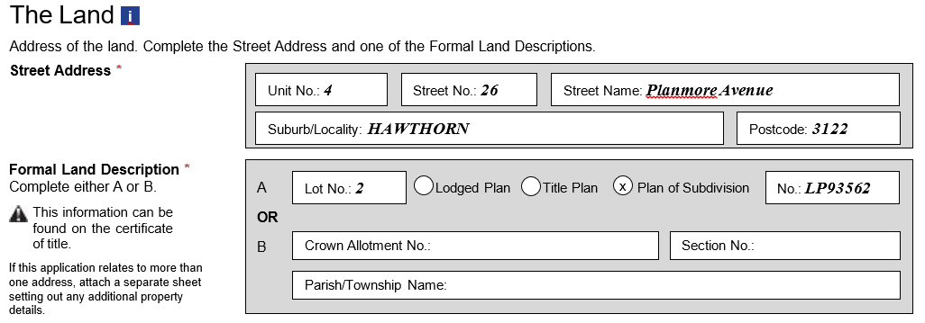
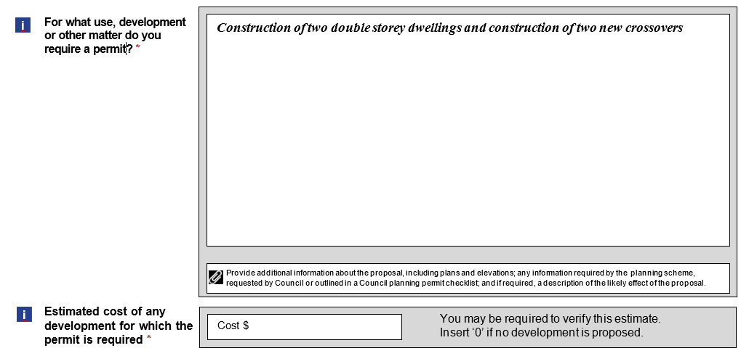
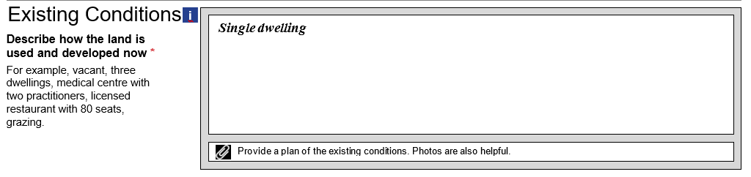
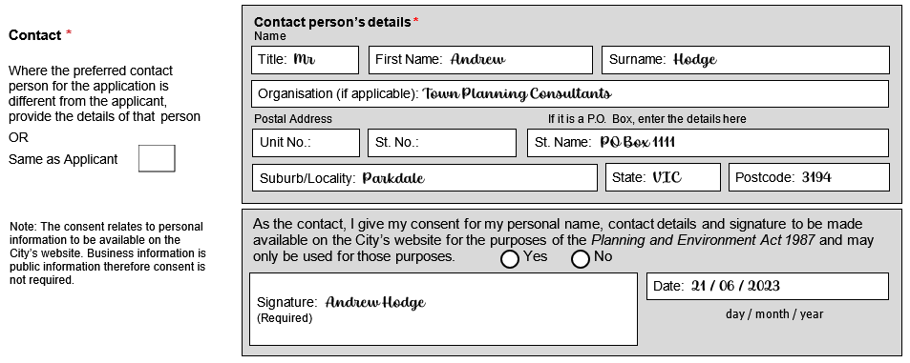

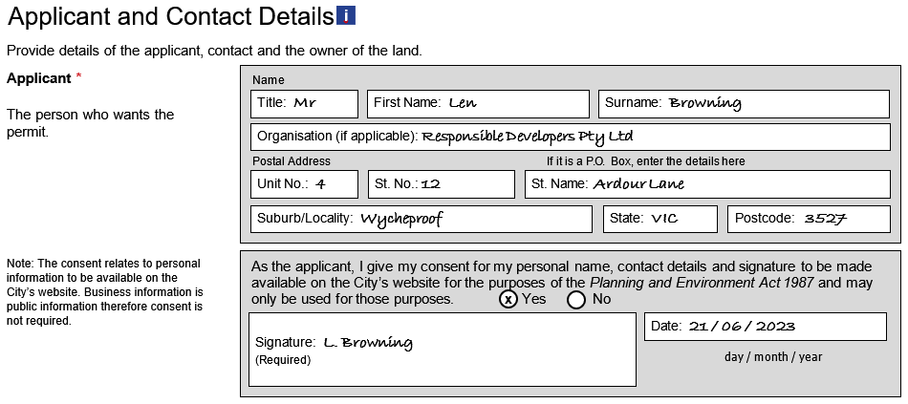
Example 1

Example 2

Example 3

Example 4

