

THE CITY OF GREATER GEELONG

GEELONG MAJOR EVENTS STRATEGY 2024-29

THE PREMIER REGIONAL DESTINATION FOR EVENTS IN AUSTRALIA

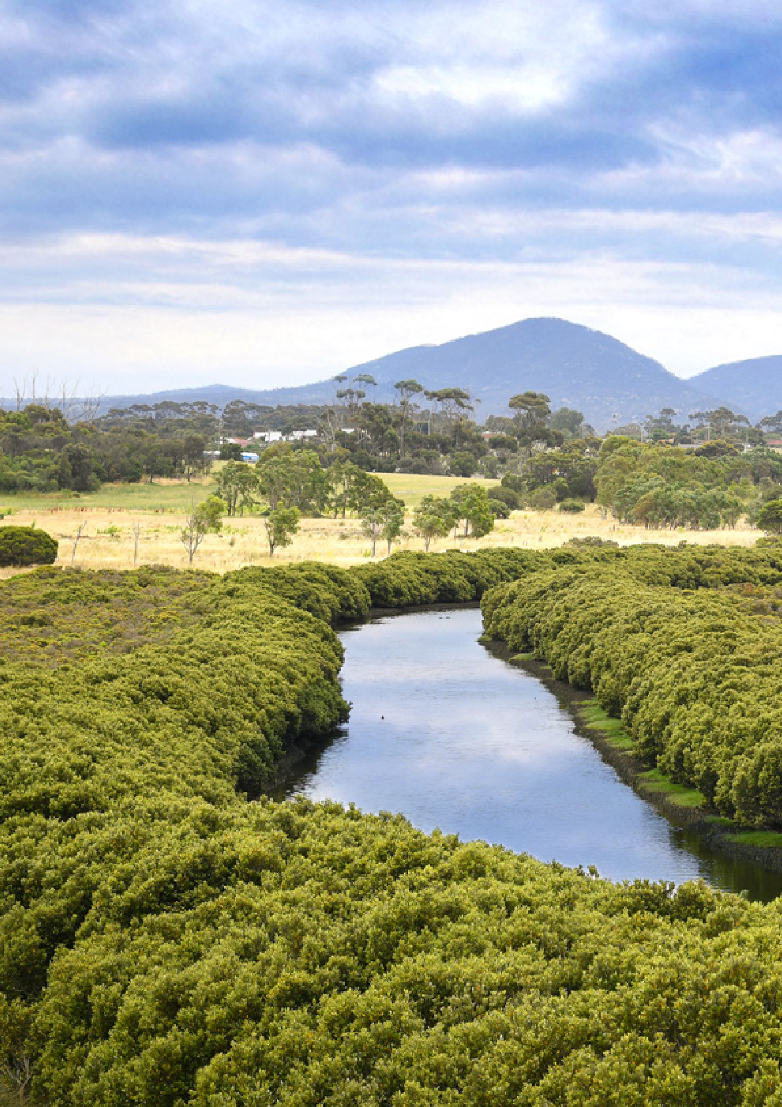
We Acknowledge the Wadawurrung People as the Traditional Owners of the Land,

Waterways and Skies. We pay our respects to their Elders, past, present and emerging. We Acknowledge all Aboriginal and Torres Strait Islander people who are part of our Greater Geelong community today.

Image credit:
View of the You Yangs, from Hovells Creek.

2.


CONTENTS
MAYOR’S MESSAGE 4
MESSAGE FROM THE CHAIR 5
INTRODUCTION 6
EXECUTIVE SUMMARY 8
REGIONAL OVERVIEW 12
STRATEGIC ALIGNMENT 14
MAJOR EVENT CLASSIFICATION 15
EVENT SELECTION AND INVESTMENT FRAMEWORK 16
IDENTITY PILLARS 17
STRATEGIC PRIORITIES 19
MAJOR EVENT OUTCOMES AND MEASURES 20
EVENT SCREENING PROCESS 21
MEASURES OF SUCCESS 21
KEY ACTION AREAS 22

GEELONG MAJOR EVENTS ACKNOWLEDGEMENT
We acknowledge the significant role that major events play in affording opportunities for traditional owners to exhibit their cultural heritage, wisdom, and deep connection to the land. As custodians of invaluable cultural knowledge, the Wadawurrung People provide essential guidance and support in event planning and execution, ensuring that our region’s major events authentically reflect Indigenous cultures and respect the lands on which they occur.
We value their active involvement, which is crucial to foster greater understanding and respect among participants and the broader community, enriching the cultural tapestry of our region.

3.


MAYOR’S MESSAGE

It is my pleasure to introduce the Geelong Major Events Strategy, a roadmap that will guide the direction of our major events sector for the next five years, from 2024 to 2029.
As we strive to become Australia’s leading regional events destination, this strategy aligns seamlessly with our commitment to hosting world-class events that showcase Geelong’s unique character and charm.
For years, we’ve known how important major events are for our city’s growth and reputation. That’s why we established the Geelong Major Events Committee back in 1998 – to make sure we’re fostering a
vibrant events program that benefits everyone in our community.
In 2022-2023 alone, we hosted 18 major events, bringing in an incredible $77.5 million to our region.
These events supported around 650 full-time jobs and attracted over 758,000 spectators and participants.
This remarkable return on investment highlights the significant economic impact generated by major events in our region.
With tourism on the rise, we have a golden opportunity to use major events to attract even more visitors to our region. By carefully planning our events calendar, we can showcase everything that makes Geelong special and keep our local economy thriving.
This new strategy seeks to maximise the benefits of major events, not only in terms of economic gains but also in their broader positive impacts on the Greater Geelong region. By leveraging our reputation for hosting premier events, we are poised to continue our growth as a leading destination for major events, enriching our community and economy alike.
I thank all Geelong major events partners for their input into this strategy and for their continued support and dedication in making Geelong a truly extraordinary place to live, work, and play.

CR TRENT SULLIVAN
Mayor, City of Greater Geelong

4.


MESSAGE FROM THE CHAIR

As Chair of the Geelong Major Events Committee, I enthusiastically welcome the new Geelong Major Events Strategy. It outlines our path over the next
five years towards establishing Geelong as Australia’s premier regional destination for events.
We envision a future where major events not only bring excitement and entertainment to our
community but also deliver exceptional outcomes that elevate our region’s reputation on the national stage.
To achieve this vision, collaboration is key. We recognise the importance of working closely with event organisers, stakeholders, and our community to ensure the success of our major events strategy. By harnessing the collective expertise and resources of all involved, we can create experiences that leave a lasting impact on our community and beyond.
Our commitment to sustainability and innovation is central to our strategy. We understand the
importance of minimising our environmental footprint and leaving a positive legacy for future generations. Through innovative approaches and practices, we aim to maximise sustainability in all aspects of our events, from planning and execution to post-event cleanup.
But perhaps most importantly, we value the input and involvement of our community. We believe that
major events should reflect the values and interests of the people they serve. That is why we are committed to engaging with residents every step of the way, ensuring that their voices are heard, and their priorities are reflected in our strategy.
I would also like to acknowledge and thank the current Geelong Major Event Committee
members, my fellow councillors, city officers and stakeholders who have contributed significantly to the development of this strategy.
Together, we can build a future where major events not only entertain and inspire but also contribute to the prosperity and well-being of our community.

CR ANTHONY AITKEN
Chair, Geelong Major Events Committee

5.

INTRODUCTION

For decades, the Geelong region has recognised the pivotal role that major events play in driving economic growth, enhancing the region’s brand, and improving overall liveability.
The establishment of the Geelong Major Events Committee (GME) in 1998 by the City of Greater Geelong underscored a commitment to fostering a vibrant events program with far-reaching impacts.
Over the years, the Geelong region has earned global acclaim for its ability to host international standard events, with the fiscal year 2022-23 alone witnessing the successful execution of 18 major events, yielding an impressive economic benefit of $77.5 million to the region.
These events not only supported approximately 650 full-time equivalent jobs but also drew in a substantial audience of 758,000 spectators and participants.
Remarkably, this economic impact was achieved through an investment of just over
$1.6 million, illustrating the remarkable return on investment generated by major events in the region.
Furthermore, with the Geelong region’s recent surge in tourism visitation, a significant opportunity arises to further leverage major events as catalysts for driving additional visitors to the region. This includes not only increasing the number of visitors but also extending their length of stay, thereby maximising the economic benefits derived from tourism. This strategic approach is crucial in supporting the exceptional growth in room stock around the region facilitated by ongoing hotel developments, ensuring sustained demand and viability for these accommodations.
As a renowned destination for both domestic and international travellers, the Geelong region’s major events serve as magnets, attracting visitors from far and wide. Our events inject vitality into the local economy and amplify the region’s appeal. By strategically aligning major events with the burgeoning tourism market, the Geelong region can elevate its status as a premier destination, enticing visitors with a diverse and compelling events calendar that showcases the region’s unique charm and offerings.
Amidst these successes and opportunities, it became evident the existing Geelong Major Events Strategy 2016-2026 required re-evaluation to remain responsive to the evolving landscape. Hence, the development of a new strategy was deemed timely, aimed at redefining how GME oversees its major events portfolio.
This new strategy seeks to maximise the benefits of major events, not only in terms of economic gains but also in their broader positive impacts on the Geelong region. By leveraging its reputation for hosting world-class events, the Geelong region is poised to continue its growth as a premier destination for major events, enriching the community and economy alike.

FISCAL YEAR 2022-2023. THE BELOW WAS ACHIEVED WITH AN INVESTMENT OF $1.6MILLION BY GME:



18
MAJOR EVENTS

$77.5M
ECONOMIC BENEFIT TO THE REGION
650
FULL-TIME EQUIVALENT JOBS

758,000
SPECTATORS AND PARTICIPANTS



Festival of Sails, Corio Bay 7.

EXECUTIVE SUMMARY

FUTURE STATE

The Geelong Major Events Strategy 2024-29 is dedicated to maximising the region’s potential, ensuring that major events align with the community’s vision for Geelong to attain international recognition as a Clever and Creative city-region.

STRATEGY VISION
To establish Geelong as Australia’s premier regional destination for events, where major events deliver exceptional outcomes for Geelong that elevate the region’s reputation on the national stage.

2029 TARGET

ECONOMIC IMPACT
Achieve an annual increase of 10 per cent in total economic impact generated by major events in the Geelong region over the next five years to $131 million by 2029.

BRAND MARKETING IMPACT
Position the Geelong region as the preeminent regional destination for hosting events in Victoria, fostering strong partnerships and consistently delivering exceptional experiences that surpass our partners’ expectations. The major events portfolio has 20 per cent Anchor Events.

COMMUNITY IMPACT
Increase in local resident participation and attendance
at major events. Increase by 30 per cent by 2029.

SUSTAINABILITY IMPACT

Reduce the major events carbon footprint by 50 per cent by 2029.



Avalon International Airshow

8.

PURPOSE
The Geelong Major Events Strategy aims to strategically plan and coordinate significant events to maximise their positive impact on the region. It seeks to attract events aligned with community values, enhance Geelong’s reputation, stimulate economic growth, and promote social cohesion.
By outlining clear objectives and priorities, the strategy ensures that all supported major events contribute effectively to the overall vision and development goals of the Geelong region, fostering sustainable growth and prosperity for the region.

EVENT SELECTION AND ASSESSMENT PROCESS
GME’s event selection process begins with aligning events with the Identity Pillars. Events that align are then assessed against strategic priorities and outcome measures. Following this, event screening evaluates risk profiles before final decisions are made. GME works to continue to grow and attract new events to the region.

STRATEGIC OUTCOMES AND OBJECTIVES
In alignment with the City’s Community Vision document, Greater Geelong: A Clever and Creative Future the objectives for supporting major events in the region have been refined through extensive consultation with valued stakeholders, partners and the community. The primary objectives for major events in the Geelong region are to achieve:
- Economic Impact: Measure the financial benefits of major events, including spending, job creation, and business growth.
- Brand Marketing Impact: Enhance Geelong’s reputation and attract visitors, residents, and investment through effective promotion and positive media coverage.
- Community Impact: Foster community pride, social inclusion, and cultural exchange,
contributing to social well-being and quality of life.
- Sustainability Impact: Minimise environmental impacts and maximise positive legacies, advancing the City’s sustainability goals.

IDENTITY PILLARS
The Identity Pillars shape the selection of major events, reflecting the region’s core values and priorities. These pillars guide event assessments, ensuring alignment with the Geelong region’s vision for liveability, community, innovation, sustainability, heritage, and nature. By integrating these pillars into the event selection process, the strategy ensures that each chosen event contributes meaningfully to the region’s identity and development goals.
- Enhances liveability: Major events aim to enhance community vibrancy and liveability, ensuring events align with the region’s lifestyle appeal and contribute positively to community pride and cohesion.
- Clever and Creative: Major events strive to align with the Geelong regions’s vision of becoming internationally recognised as a forward-thinking, enterprising, and creative city-region that
values innovation and cares for its people and environment.
- Sport and leisure recreation: Major events capitalise on the region’s focus on active recreation and sporting infrastructure, leveraging assets like Kardinia Park and natural environments to promote active pursuits and recreational tourism.
- UNESCO City of Design: Major events in Geelong celebrate the region’s rich history of design innovation and creativity, highlighting its ongoing design excellence, promoting well-being, sustain our community and align with Geelong’s identity as a City of Design.
- Supports our key industries and heritage: Major events acknowledge the Geelong regions’s industrial heritage and support key industries such as food and wine, education, design, manufacturing, sport, social insurance, and
defence, contributing to the region’s economic and cultural identity.
- Nature and Sustainability: Major events leverage the Geelong region’s natural beauty and promote sustainability, showcasing the region’s environmental assets while aligning with sustainability goals and targets outlined in our Environment Strategy 2020-30.

9.



STRATEGIC PRIORITIES
Several strategic priorities have been identified for the region, serving as guidelines for the alignment of the major events portfolio. These priorities include:
  - Audience Reach and Target Markets: Major events in Geelong aim to engage diverse demographics and geographic regions through tailored programming and targeted marketing efforts.
  - Ownership: Geelong fosters a sense of community ownership and pride by involving local residents, businesses, and artists in the planning and execution of major events.
  - Night-time Economy: Geelong’s major events contribute to a vibrant night- time economy by programming evening activities and extending operating hours for local businesses and entertainment venues.
  - Event Calendar Gaps: Major events in Geelong strategically supplement seasonal and thematic gaps in the event calendar providing a diverse range of experiences throughout the year that showcase the city’s unique strengths and appeal to underrepresented demographics.
  - Partnerships: Geelong leverages strategic partnerships with government agencies, tourism organisations, and industry stakeholders to enhance the quality and impact of major events, along with developing place-based activations ensuring sustainable growth and community support.
  - Dispersal: Major events in Geelong promote dispersal and place-based activations across different neighbourhoods and precincts, distributing economic benefits and encouraging visitors to explore diverse areas of the city beyond the event site.
Moving forward, our intention is to adopt a place-based approach to supporting our major event calendar. This strategic shift is driven by our desire to enhance the celebration of our local talents, enrich visitor experiences, foster community pride, and stimulate greater engagement among residents and visitors alike.
With opportunities for engagement and discovery we can forge deeper connections and cultivate a sense of belonging within our community benefiting both residents and visitors. Our place-based approach not only fosters cultural enrichment, but also aims to cultivate a sense of pride and ownership among community members. By showcasing the best of what our locality has to offer, we empower residents to take pride in the region’s heritage and play an active role in shaping the narrative of our community. Through participation in events and initiatives, individuals can contribute to the collective identity of our locale, strengthening the bonds that tie us together.


VIC Open Golf, Thirteenth Beach Golf Club

10.



RONE Exhibition at Geelong Art Gallery

11.



REGIONAL OVERVIEW

The City of Greater Geelong, located 75km southwest of Melbourne is Victoria’s largest regional city, with a current population of 282,809 residents—a figure expected to surpass 400,000 by 2040.
Boasting a thriving economy, the Geelong region is home to several major Australian businesses and over 22,000 small and medium-sized enterprises, contributing to a Gross Regional Product (GRP) of $17.6 billion.
With two-thirds of its population residing in urban areas, residents enjoy easy access to retail, sports, recreational facilities, and various lifestyle opportunities. The region’s natural beauty is evident, with a stunning waterfront, pristine coastline, and scenic hinterlands offering abundant outdoor recreational activities.
Annually, over 6.4 million visitors flock to the Geelong region, with strong visitor growth anticipated in the coming years, bolstered by new travel routes and infrastructure developments. Tourism plays a vital role in the region’s economic landscape, accounting for $1.8 billion in visitor spend and supporting over 5 per cent of the total labour force directly.
Notably, significant investments in infrastructure projects and cultural precincts are poised to elevate visitation levels, positioning Geelong as a regional hub destination for domestic and international visitors. While domestic visitation remains robust, efforts to revive international visitation are crucial, aligning with the region’s growth targets and strategic priorities outlined in Greater Geelong: A Clever and Creative Future. Moreover, deeper data analysis reveals key insights into peak visitation periods and potential strategies to drive increased overnight stays, underscoring the region’s potential for further growth in event content, particularly within the thriving arts and cultural sector.

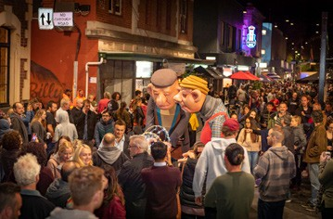
Bonkel Theatre at Geelong After Dark, 2019

12.

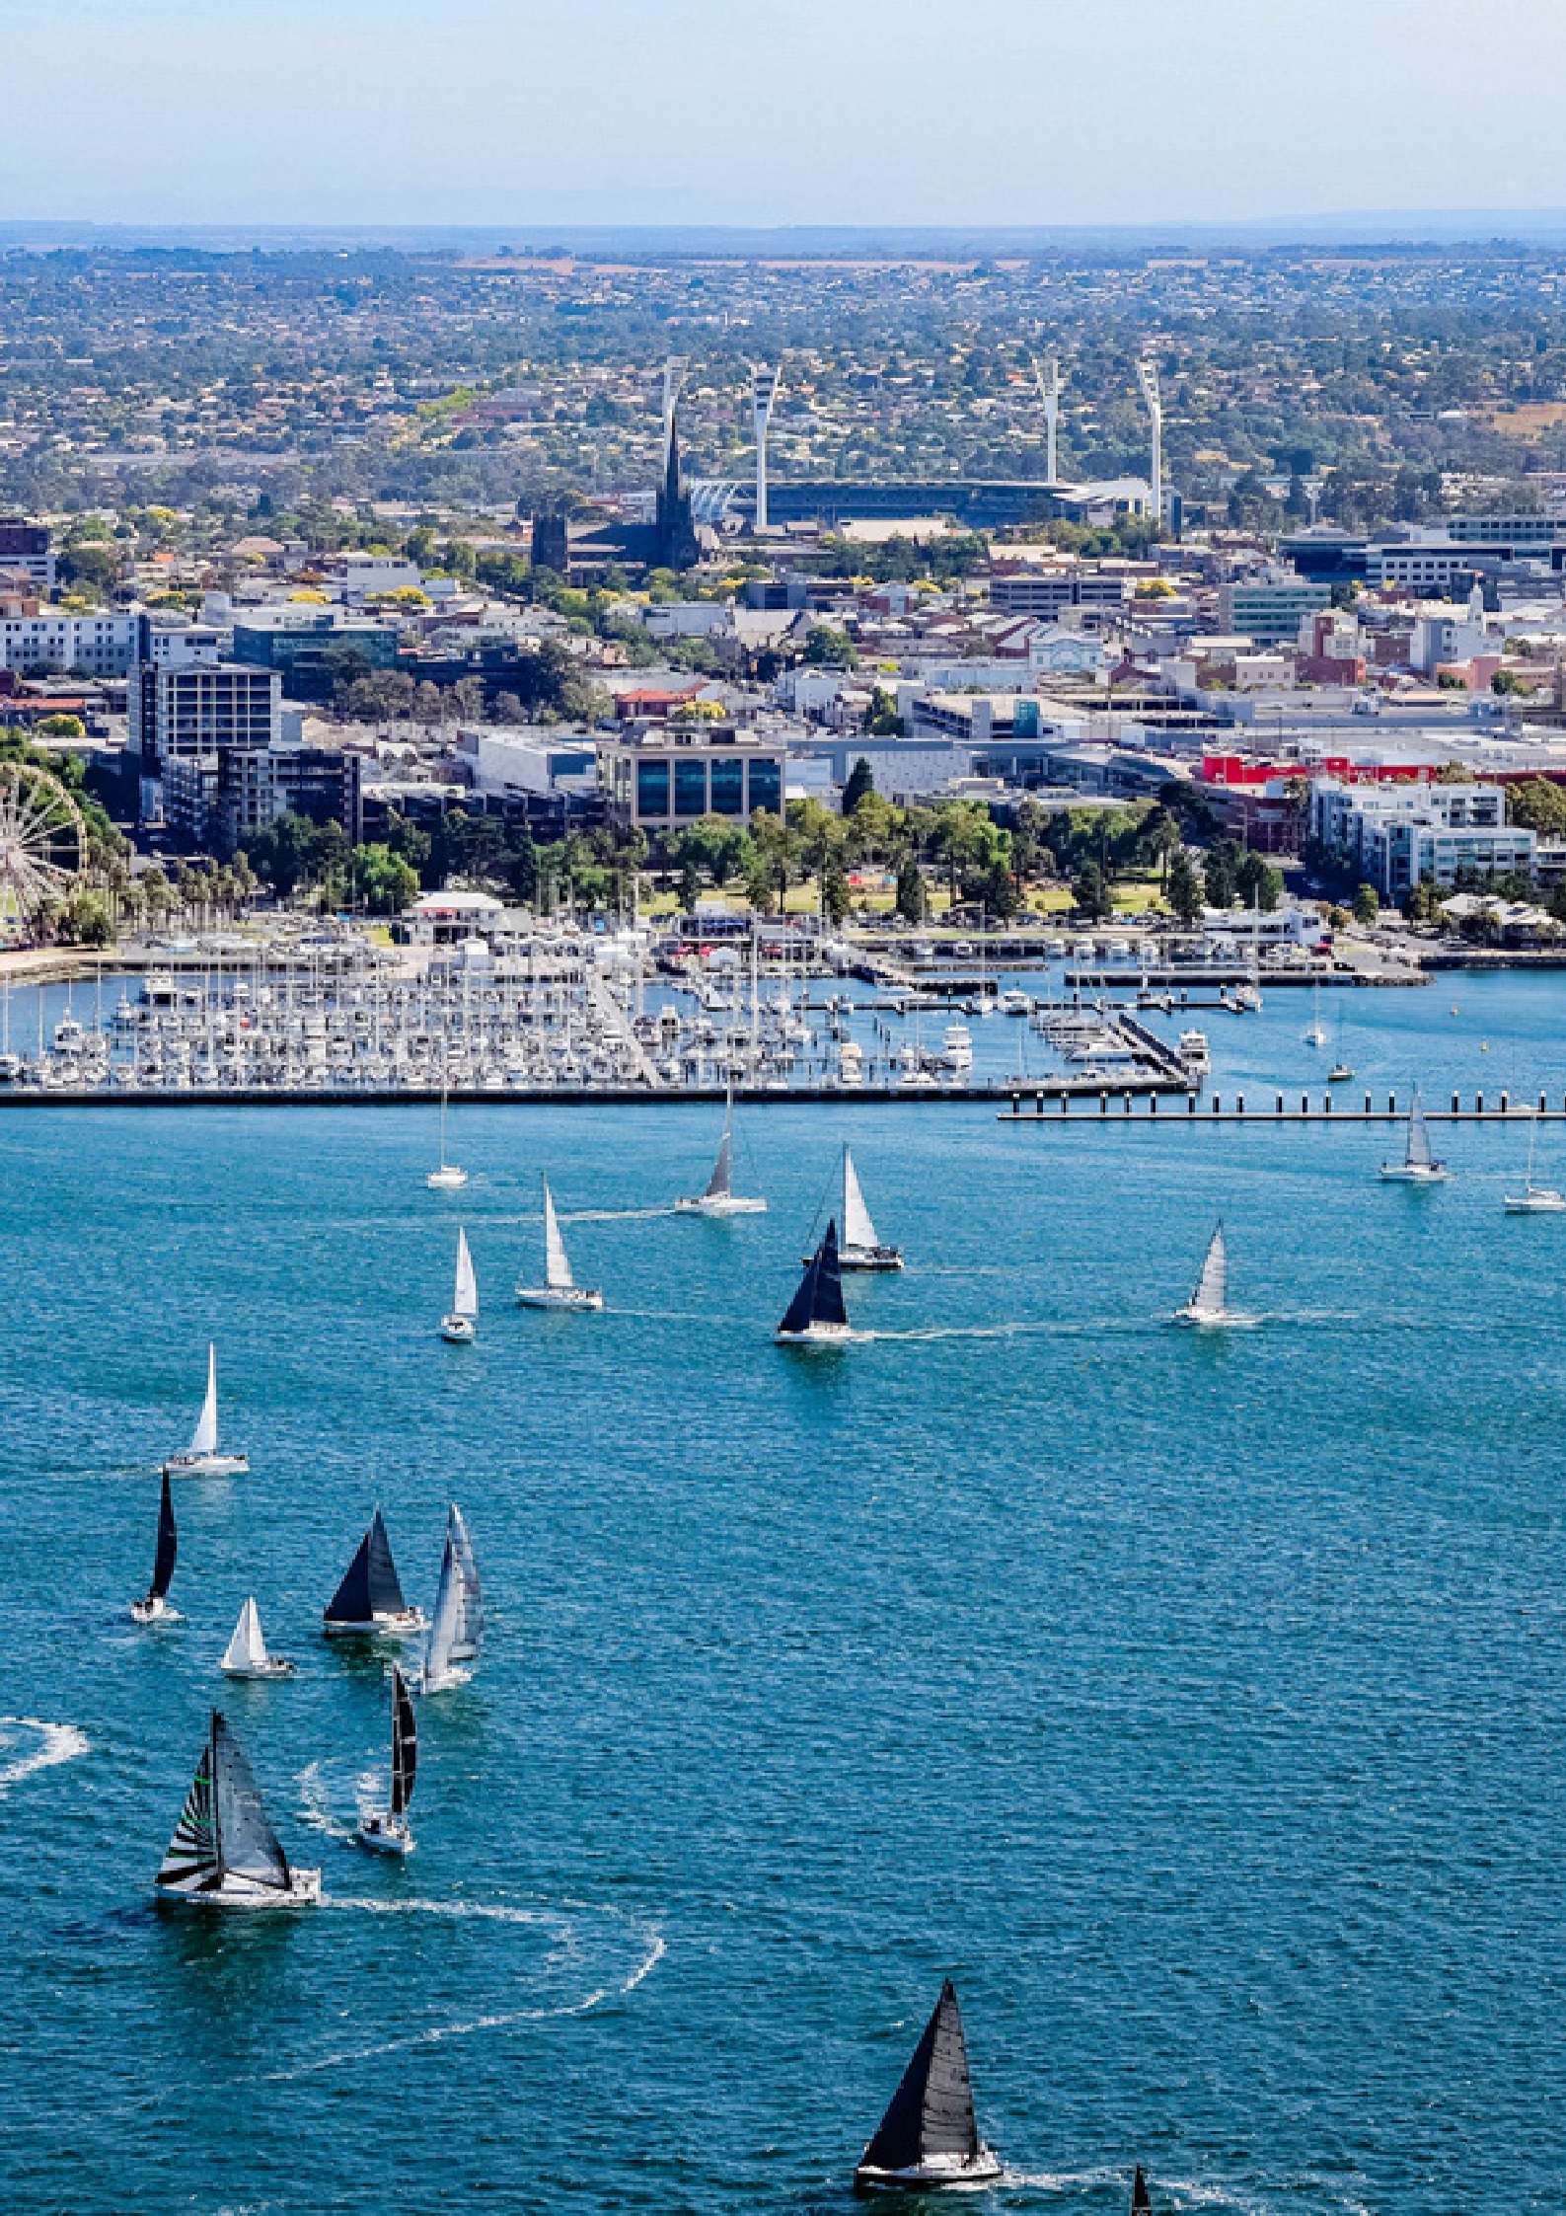

Festival of Sails, looking back onto Geelong

13.

STRATEGIC ALIGNMENT
g
n
o
l
l
a
e
r
e
u
t
G
l
u
r
C
e
t
d
0
a
n
2
e
a
r
y
g
G
s
t
e
r
t
f
o
A
a
r
–
t
y
S
g
it
i
C
c
e
P
l
s
a
’
V
i
n
g
c
y
t
n
2
o
g
o
0
e
r
l
i
3
e
t
a
a
3
e
r
G
t
S
0
3
r
t
e
-
n
0
t
e
2
a
m
0
e
r
2
n
G
o
O
r
f
i
u
o
v
r
n
2
y
E
C
0
t
o
i
2
m
C
1
m
–
u
n
2
i
0
t
2
y
5
Pla
n
T
o
t
h
u
1
r
e
T
is
0
m Be ou
-y 2
l
r
e
G
l
i
0
a
s
a
r
r
2
e
i
m
r
a
n
2
t
e
D
M
e
–
r
-
e
a
s
s
G
S
2
u
ti
t
0
e
e
e
e
s
n
3
l
t
a
r
v
a
2
i
o
i
t
P
t
n
n
i
l
r
n
o
a
a
o
g
a
a
e
i
b
n
n
e
s
a
l
r
Y
i
n
C
V
e
d
0
d
3
y
t
n
i
–
n
a
e
u
r
r
m
e
u
t
m
N
F
v
a
V
e
u
o
r
F
ti
a
i
l
C
s
C
o
m
i
n
t
e
A
a
o
l
w
r
o
E
r
c
o
n
O
s
C
e
n
l
S
p
g
E
i
i
s
c
N
e
n
i
D
r
U
P
f
g
o
n
y
o
t
l
i
e
C
e
G

In developing this strategy, we’ve engaged in extensive consultation with a wide range of stakeholders, including industry experts, representatives from the City, and members of the community who shared their thoughts through our Have Your Say platform.
This collaborative approach has played a crucial role in shaping our strategy, helping us identify the most important areas going forward. The consultation process has provided valuable insights into what our region’s major events scene needs and the aspirations we should aim to fulfill.
A total of 328 stakeholders and community residents were engaged via the consultation process involving internal and external workshops, one on one interviews, councillor and GME workshops and community survey.
Additionally, we’ve conducted in-depth reviews of strategies and policies at national, state and local levels, as well as within our industry and among competitors. This comprehensive analysis has enriched our understanding and guided the development of our strategy.

Furthermore, our strategy has been strategically aligned with several key documents and initiatives from federal, state and local government and industry.
S
Geelong Major Events Strategy 2024-29
2
s
C
N
t
0
r
3
a
a
0
ti
t
e
–
o
n
g
a
y
l
S
E
t
x
r
p
a
t
e
r
e
i
S
e
T
n
c
A
T
E
S
u
s
k
t
a
f
i
n
o
r
o
a
b
t
m
h
il
y
N
t
e
i
y
A
T
I
O
N
A
A
T
L
u
o
T
s
u
t
H
r
r
R
a
i
s
I
li
V
a
m
E
’

14.
O
L
1
3
0
2
–
1
2
g
n
i
d
i
u
G
L
A

MAJOR EVENT CLASSIFICATION

The Geelong Major Events Committee has established a classification system comprising three pillars: Anchor Events, Priority Events, and Developing Events, to manage its major events portfolio and allocate resources strategically.
These pillars guide the assessment of event applications and determine the level of funding support provided by GME. By evaluating events against specific criteria and benchmarks, they are categorised into one of these pillars, ensuring optimal resource allocation to maximise their impact on the Geelong region.
This section outlines the criteria used for event evaluation and provides clarity on funding support levels for each event type, promoting transparency in the selection and allocation process.

Classification | Anchor Events | Priority Events | Developing Events
Summary | Iconic events that elevate the Geelong region to the world or national stage, delivering substantial economic impact and aligning closely with agreed strategic priorities. These events should possess strong ties  to the Geelong community and are uniquely positioned within the region, making relocation impractical. | Pivotal events that significantly contribute to priority outcomes and play a crucial role in shaping the  major events calendar. These events align closely with  our strategic aims and may consist of regular fixtures or one-off spectacles. | Events with promising potential to evolve into Anchor or regular Priority Events and align closely with our strategic aims.
Key Criteria | › Events must align with strategic priorities as a prerequisite. | › Alignment with strategic priorities is essential. | › Alignment with strategic priorities is a prerequisite.
 | › They should anticipate a visitor attendance exceeding 10,000 or generate a minimum economic impact of $8 million.  › Events should demonstrate reach to interstate and international audiences, align with at least  two Identity Pillars, and have a significant impact on three or more strategic priorities.  › Events should incorporate sustainable elements, receive support from Visit Victoria or other government departments, and show potential for retention in Geelong. | › Events should anticipate a visitor attendance of up to 10,000 or generate a minimum economic impact of $2 million.  › Preference is given to events with interstate and/or international audience reach.  › Events should align with at least two Identity Pillars and have a substantial impact on three or more strategic priorities. | › Events are particularly sought after to fill out the calendar during off-peak seasons.  › Events should incorporate sustainable elements and anticipate a visitor attendance of up to 5,000, or generate a minimum economic impact of $1 million.  › While intrastate reach is essential, preference is given to events with interstate audience reach, though not deemed essential.  › Events should align with at least two Identity Pillars and have a strong impact on three or more strategic priorities.  › Sustainability is also a key consideration in event evaluation.
Required Return on Investment (ROI) ** | 40:1 | 30:1 | 20:1
Target mix of events | 20% | 75% | 5%
Target Balance of Investment | 40% | 50% | 10%
Maximum investment per event annually | $200,000 | $100,000 | $50,000
Maximum Contract term | 5 years | 3 Years | 2 Years
**ROI is calculated based on GME’s investment and total economic impact.

15.

EVENT SELECTION AND
INVESTMENT FRAMEWORK

Each potential new event will be assessed against how it can contribute to the Identity Pillars, Strategic Priorities, and their ability to impact the Strategic Outcomes.






EVENT SCREENING
Is the event well- resourced with experienced management and has a risk assessment been completed?

MAJOR EVENT OUTCOMES
How will the event contribute to the major event outcomes we are aiming to achieve?
STRATEGIC PRIORITIES
Does the event align to our defined Strategic Priorities?
IDENTITY

Does the event align to the Identity Pillars?

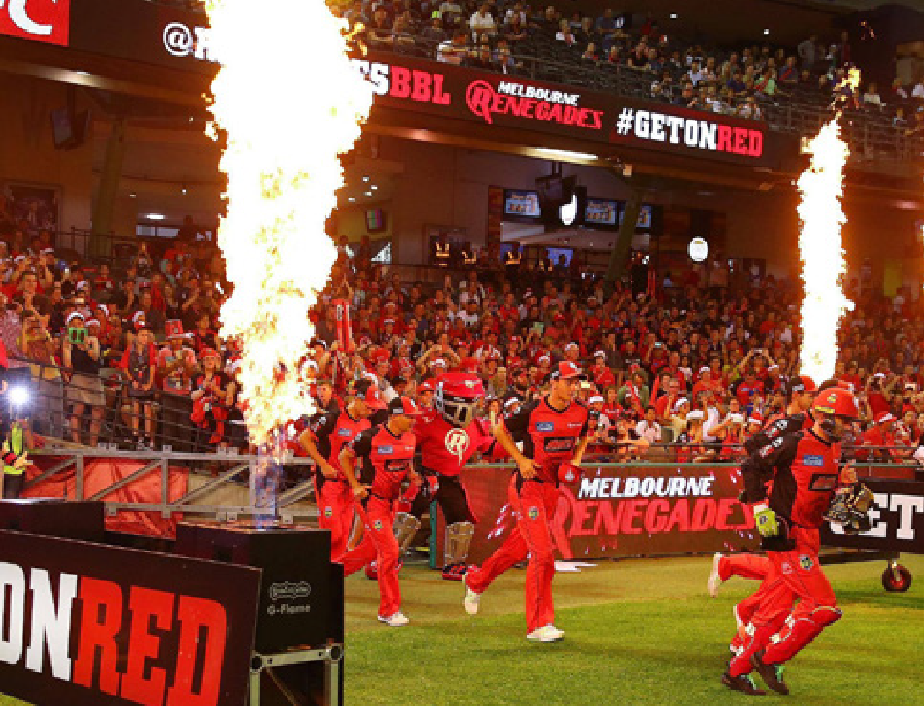
T20 Cricket at GMHBA Stadium

16.

IDENTITY PILLARS

The Identity Pillars guide event selection and shape the region’s strategic event portfolio.
They reflect the essence of the Geelong region’s identity and aspirations, encapsulating core values, strengths, and priorities. Each pillar represents facets of the region’s character and vision, including commitment to liveability, community cohesion, innovation, sustainability, and cultural heritage.
Aligned with Greater Geelong: A Clever and Creative Future these pillars provide a framework for evaluating new events, ensuring alignment with overarching goals and meaningful contributions to identity and development. As integral components of the Geelong Major Events Strategy, they guide decision-making to enrich the region’s fabric.
Events should align with a minimum of two out of the six Identity Pillars to qualify for funding support from GME.

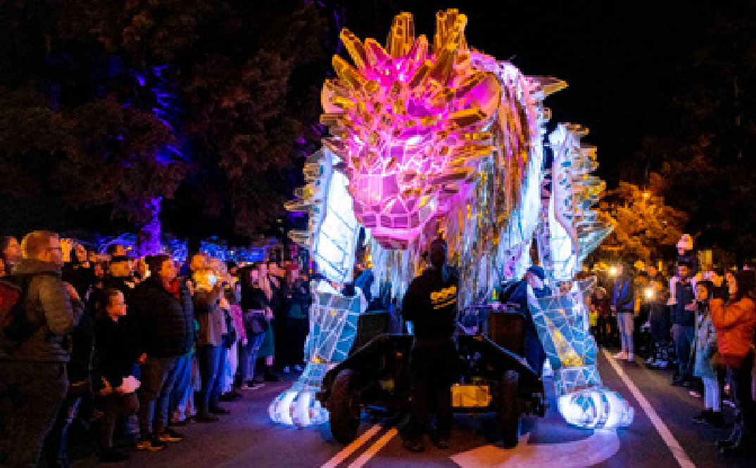
1
Enhances Liveability: Fostering a vibrant community and improving quality
of life are central to our major events
strategy. Events are evaluated based
on their potential to build community pride, develop local capacity, and contribute to the Geelong region’s
appeal as a desirable place to live.
2
Clever and Creative: Aligned with our vision for innovation and creativity, Geelong region aims to be recognised as a hub of ingenuity and forward-thinking initiatives. Major events are curated to showcase our inventive spirit
while prioritising sustainability and community well- being.

17.

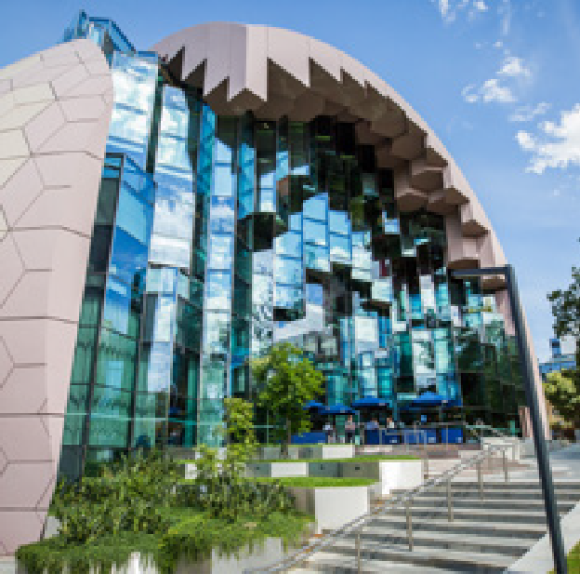
3
Sports and Recreation: With a strong emphasis on active living, the Geelong region boasts extensive sporting infrastructure and natural landscapes ideal for outdoor pursuits. Major events align with our commitment to promoting health, well-being, and recreational activities for all.
4
UNESCO City of Design: Celebrating our rich design heritage and fostering creativity are integral to the Geelong region’s identity. Major events pay homage to our history of innovation, showcasing groundbreaking designs and nurturing a culture of sustainability and inclusivity.


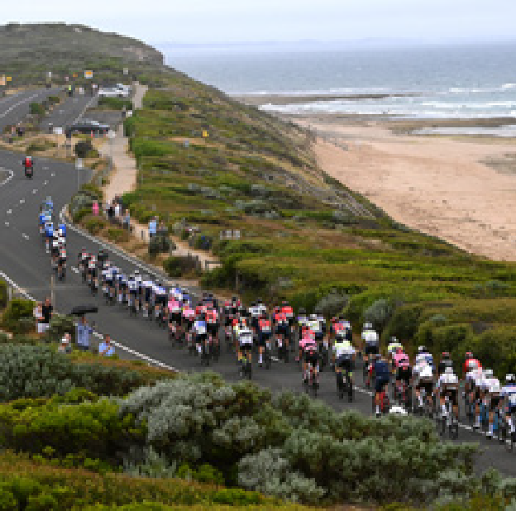
5
Supports Key Industries and Heritage: Rooted in a strong industrial legacy, the Geelong region honours its heritage while driving economic growth across key sectors. Major events celebrate our industrial prowess and support industries such as food and wine, education, design, manufacturing, sports, social insurance, and defence.
6
Nature and Sustainability: The Geelong region’s natural beauty and commitment to sustainability are showcased through major events that highlight our stunning landscapes and environmental initiatives. Events are evaluated based on their alignment with our sustainability goals and their contribution to making Geelong a sustainable destination.

18.

STRATEGIC PRIORITIES

The strategic priorities assessment will follow once the Identity Pillars are supported.
A range of strategic priorities for the region have been identified which the major events portfolio should align to.
Events must align with a minimum of three out of the seven strategic priorities to qualify for funding support from GME.


Audience Reach and Target Markets:
Major events in the Geelong region strive to
engage diverse demographics and promote the brand to priority markets including international and interstate visitors.
Ownership: Major events in the Geelong region are intricately intertwined with the region’s unique identity
and Anchor Events complemented by a diverse array of promoter-led and acquired events for a well-rounded and balanced calendar.

Nighttime Economy:
Major events in the Geelong
region contribute to a vibrant night- time economy
by programming evening activities and extending operating hours for local businesses and entertainment venues.
Event Calendar Gaps: Major events in the Geelong region fill seasonal and thematic gaps in the event calendar, offering a diverse range of experiences year-round that showcase the city’s unique strengths and appeal to underrepresented demographics.

Partnerships: Major events in the Geelong region leverage strategic partnerships
with government agencies, tourism organisations, and industry stakeholders. These partnerships enhance the quality and impact of major events, ensuring sustainable growth and community support.
Dispersal: Major events in the Geelong region promote dispersal across different neighbourhoods and precincts, distributing economic benefits and encouraging visitors to explore diverse areas of the city beyond the event site.

Alignment with Council and/
or Victorian Government priorities: Major events in the Geelong region are aligned to local, state and
federal government strategies, such as Experience Victoria 2033, which may incentivise funding support for major events.

19.

20.

MAJOR EVENT OUTCOMES AND MEASURES

This section outlines the specific goals and metrics aligned with the four objectives of the GME Strategy.
It defines clear targets for events to aim for and support the City in achieving, serving as a way to measure their success and impact.

Outcome | Objectives | Areas |  | Measures
Economic Impact | › Maximise direct economic return to the region as a result of hosting events. | ›  › | Tourism Business | › Visitor nights, direct visitor spend, occupancy levels.  › Occupancy levels, value of contracts awarded to Greater Geelong companies, organisational spend in the region, jobs supported.
Brand Marketing Impact | › Media benefits through brand exposure and audiences delivered in key markets to drive future visitation. | ›  ›  › | International Interstate Local | › Broadcast and media coverage, press and online reporting, reader, and viewer numbers.  › Sentiment analysis.
 | › Showcase the region to drive changes to a host destination perception, increase likeliness to revisit and positive advocacy to family and friends.
Community Impact | › Measuring the engagement, appeal, social licence for events, civic pride and increase in liveability  from local residents and businesses.  › Aim for diversity of timing, location, and event type in the selection process. | ›  ›  › | Volunteering  Social licence for events  Pride and liveability | › Local volunteering opportunities, $ value of volunteering.  › Community acceptance of major events  › Percentage of residents who have pride in their region and believe it is a good place to live.
Sustainability Impact | › Using our Environment Strategy 2020-30 as a guide to achieve sustainability compliance.  › Investment will help to drive long term financial sustainability of events. | ›  › | Environmental Financial | › Measuring impact on the sustainability framework pillars identified through our Environment Strategy 2030 and the National Sustainability Framework for the Visitor Economy  › Evaluation of the financial stability and sustainability of events, and growth strategies.

EVENT SCREENING PROCESS

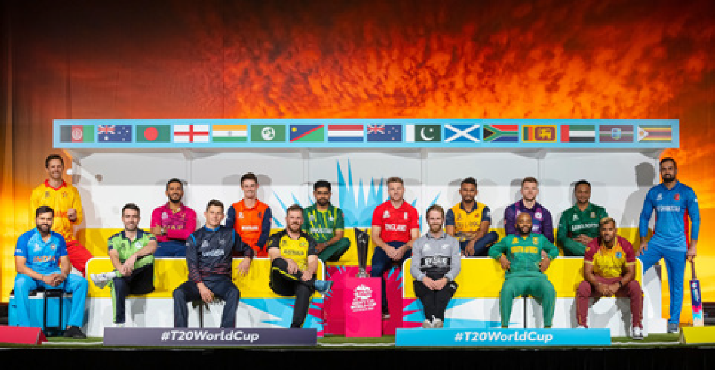
T20 World Cup international representation

The final step in the event selection framework, evaluates the event’s viability and the risk it poses to Council and Geelong Major Events Committee regarding financial or other support.
Implementing this formalised system enables the identification and systematisation of risk management processes related to any major event investment. The primary goal is to minimise, mitigate, or preferably eliminate event risks. Identifying the unique key risks associated with each specific event is crucial.
Event risk assessment extends beyond operational risks, encompassing a broader range of risks faced by GME and will cover:

Event owner risk Reputation, background checks, solvency/litigation checks, contracting entity verifiability.

Reputational risk Potential political sensitivities.

Financial risk Financial viability and support, who bears the risk if the event not successful?

Operational risk Risks to participant and spectators & appropriate risk management plans. Key draw card risk Risk to high profile player or performer not attending marketed events. Marketing risk Can the event form part of the wider tourism and marketing effort?
Timing risk Is there enough time to promote the event to deliver key event outcomes?

Stakeholder risk Is there enough time to co-ordinate key stakeholders to ensure event success?

21.

MEASURES OF SUCCESS


Ajak Kwai at Surround Sounds 2022

In alignment with Greater Geelong: A Clever and Creative Future the successful implementation of our Geelong Major Events Strategy aims to support the region in achieving several key measures of success.
These targets include increasing community engagement in arts and cultural activities, boosting visitor numbers and expenditure, and fostering growth in both international and domestic overnight visitation.
By striving to meet these targets, our strategy seeks to enhance the region’s cultural vibrancy, economic prosperity, and global recognition as a premier events destination while supporting the Clever and Creative Vision measures of success.
Directly, this strategy seeks to achieve the following targets by 2029:

ECONOMIC IMPACT
Achieve an annual increase of 10 per cent in total economic impact generated by major events in the Geelong region over the next five years to achieve an economic impact target of $131 million by 2029.

BRAND MARKETING IMPACT
Increase brand awareness and recognition of the Geelong region as a major events destination by 15 per cent among the target audience within the next five years.

COMMUNITY IMPACT
Enhance community engagement in major events by achieving a 30 per cent increase in local resident
participation and attendance over the next five years.

SUSTAINABILITY IMPACT
Reduce the carbon footprint of major events in the Geelong region by 50 per cent within the next five years through the implementation of sustainable practices and initiatives.

22.

KEY ACTION AREAS


Geelong Revival at Geelong Waterfront

Given the strong local support for major events in the Geelong region, as evidenced by the community survey results and extensive engagement with industry and stakeholders, GME is committed to continue investing in major events.
This commitment comes with the crucial responsibility of ensuring that future event investments deliver the greatest positive impact. Our strategy is pivotal in positioning GME to achieve its vision to “establish Geelong as Australia’s premier regional destination for events, where major events deliver exceptional outcomes for Geelong that elevate the region’s reputation on the national stage.”
To achieve this, the following key action areas have been identified:

- Governance: A fundamental shift in governance is crucial for GME to transition from a reactive to a strategic approach in event management,
necessitating a thorough analysis of existing models and potential options to ensure future success.
- Funding and Budget: GME faces budget constraints that require a fundamental shift in approach to attract diverse event types to the region, necessitating exploration of various funding opportunities such as a major events levy and government grants.
- Stakeholders and Advocacy: Closer stakeholder relationships are essential for effective advocacy and funding support, requiring the development of
stakeholder mapping and an advocacy plan to ensure regional needs are well communicated.
- Objectives and Measurement: GME must establish updated objectives and measurements aligned with its vision of becoming the premier regional events destination, necessitating a dedicated plan
addressing best practices observed in leading event destinations.
- Processes and Documents: Operationalising updated processes and documentation is imperative to support the strategy’s objectives, including the integration of
a new Sustainability Framework and establishment of event benchmarks for decision-making.
- Event Selection: Implementing a transparent event selection process aligned with strategic objectives, requiring operationalisation of a 4-step event selection process outlined by GME.
- Event Evaluation: New events must align with the identity pillars and strategic priorities, contributing to the region’s strategic outcomes.
- Communications: A comprehensive communications plan is vital to ensure industry and stakeholder buy- in, involving website updates, City promotions, and regular updates on event portfolio performance.
- Infrastructure: Infrastructure development is crucial to support an extensive events calendar, requiring solutions for venue availability challenges and investment in transport and accommodation infrastructure to accommodate the region’s growth.

23.







CITY OF GREATER GEELONG
Wadawurrung Country PO Box 104
Geelong VIC 3220
P: 5272 5272
E: contactus@geelongcity.vic.gov.au www.geelongaustralia.com.au

© City of Greater Geelong 2024

LATEST NEWS:
@CityofGreaterGeelong @GreaterGeelong @CityofGreaterGeelong CityofGreaterGeelong

