MINOR LOW INTEREST

HERITAGE LOAN FUND

APPLICATION FORM

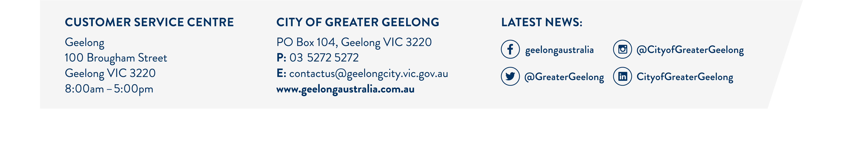

Please refer to the minor fund “guidelines for applicants” to determine eligibility before completing this application form.
Applications should be made either by the owner or occupier of the Building or Place and be addressed to:

Co-ordinator
City of Greater Geelong
PO Box 104
GEELONG VIC 3220

OWNER OF BUILDING OR PLACE:
Full Name: ………………………………………………………………………………………………….
Postal Address: ……………………………………………………………………………………………
……………………………………………………………………………Post Code: ……………………
Telephone Home: ……………………………. ..Business: …………………………………………….

OCCUPIER OR BUILDING OR PLACE:
Full Name: ………………………………………………………………………………………………….
Postal Address: ……………………………………………………………………………………………
…………………………………………………………………………….Post Code: ……………………
Telephone Home: ……………………………….Business: …………………………………………….

THE LOCATION OF THE BUILDING OR PLACE:
Building Name (if applicable): ……………………………………………………………………………
Address (if different from above specify): ……………………………………………………………….
……………………………………………………………………………Post Code: …………………….
Telephone Home: ………………………………Business: ……………………………………………..

BRIEF DESCRIPTION OF WORKS TO BE UNDERTAKEN AND ASSOCIATED COSTS:
(quotes to be attached)
……………………………………………………………………………………………………………….
……………………………………………………………………………………………………………….
……………………………………………………………………………………………………………….
……………………………………………………………………………………………………………….

Amount of Loan Sought: $ ………………………………………………………………………………..
Period for carrying out the works: From:_____/_____/_____ To: _____/_____/_____
Term (years): ………………………………………………………………………………………………

NOTE: Extent of loan available $1,000 - $10,000 typically $5,000. Term of Loan between 1-4 years, typically 203 years.

Signature of owner (if not applicant): ………………………….. ………..Date: _____/_____/_____

Signature of Occupier (if not applicant: …………………………………..Date: _____/_____/_____

If assistance is sought by occupier copy of lease to be attached.

CERTIFICATE OF TITLE

Volume: ………………………………………….. Folio: …………………………………………………
Include a full copy of title.

General Law Land:
Conveyance No: ……………………………….. Book: ………………………………………………...

DESCRIPTION OF SITE AND PROPERTY ADDRESS:
……………………………………………………………………………………………………………….
……………………………………………………………………………………………………………….
……………………………………………………………………………………………………………….
……………………………………………………………………………………………………………….
……………………………………………………………………………………………………………….

PROJECT DOCUMENTATION:
……………………………………………………………………………………………………………….
……………………………………………………………………………………………………………….
……………………………………………………………………………………………………………….
……………………………………………………………………………………………………………….
……………………………………………………………………………………………………………….

Total Cost of Works to be undertaken: $ ………………………………………………………………..
Owner/Occupier contribution: $ ……………………………… or ……………………………………%
(if applicable)

Photo of building to be included:

WHY FUND ASSISTANCE IS NEEDED FOR THIS PROJECT
(Outline other areas where funds have been spent in restoration works on the building in the last five years):
……………………………………………………………………………………………………………….
……………………………………………………………………………………………………………….
…………………………………………………………………………………………………………….....
……………………………………………………………………………………………………………….
……………………………………………………………………………………………………………….
……………………………………………………………………………………………………………….
……………………………………………………………………………………………………………….

Has a planning permit and building permit been sought for the works?: ……………………………

If assistance is sought for a new colour scheme, a copy of the approved colour scheme should be attached.
NOTE: On average it will take one (1) month to consider a loan application.
Stage 1 – assessment of loan application
Stage 2 – Manager to consider loan application

OFFICE USE ONLY
Date Received: …………………………………. Application No: ……………………………………...
Approved: ………………………………………... Loan No: ……………………………………………
Individually Listed Building: ………………………………………………………………………………
Urban Conservation Precinct: ……………………………………………………………………………

