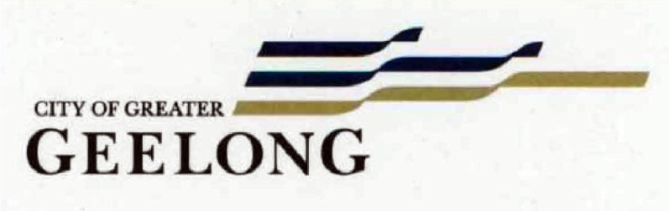

Nominations for the National Trust of Victoria (Geelong & Region Branch) & City of Greater Geelong Heritage Awards 2017

Award Nominations

- Dwelling, 104-106 Kilgour Street, Geelong.

- National Hotel, 193-195 Moorabool Street, Geelong.

- ‘Chesterfield’, 221 Noble Street, Newtown.

- Barwon Health Library (former St. Mary’s Parish Hall), 190-192 Myers Street, Geelong.

- New Dwelling, 98 Noble Street, Newtown.

- ‘Kirrewur Court’, 77 Prospect Road, Newtown.

- Federal Woollen Mills, 13 Mackey Street, North Geelong

- Dwelling, 106 Kilgour Street, Geelong.
Works/Reason for Award: Repairs, chimney reconstruction, respectful 2 storey additions
Significance: Local significance as included in the Greater Geelong Planning Scheme.
Owner: Michael and Megan Aylett
Designer: Craig Cantwell

The dwelling at 106 Kilgour Street originally comprising two, three-roomed semi-detached brick houses built in 1853-54. Each house had two rooms with an attached weatherboard kitchen at the rear. They were built for Mrs Margaret McMurrich, widow of Mr Robert McMurrich who died in 1852 at the age of 38. [GAd 18 Nov 1852, p.2] Mrs McMurrich lived in one of the dwellings with her son, John, and leased the other. In 1859, Mrs McMurrich married James Sinclair, a boat builder. The Geelong Advertiser reported of Mr Sinclair’s abilities in 1875, declaring that “his talent as a designer has been recognised in a manner that can hardly fail to still further increase in his reputation” with the commission of a model for a 16 ton yacht by an Australian resident in England. [Gad 28 Dec 1875, p.2] The Sinclairs maintained ownership of the dwellings until 1875.

Today, the dwelling has significance as a rare, very early surviving example of Victorian duplex housing of brick construction in suburban Geelong. The early character is shown in the simple gable roof form, central brick chimney (which serviced both original dwellings), gabled brick parapets, and the shallow-arched timber framed windows and doors.

By 2012, the dwelling was in poor condition. Rear wings were demolished and the original portion protected from the weather. In 2014, a planning permit was issued for the reconstruction of the front chimney (which had completely deteriorated) and rear two storey additions to a design by Craig Cantwell. Works subsequently commenced and then stalled until the present owners, Michael and Megan Aylett, purchased the property. The dwelling was in a perilous state at this time, as it did not have any floors and urgent remedial works were required. Since then, the front chimney has been reconstructed to the original design and the rear additions have also been built. They are hardly visible from Kilgour Street and allow the original character of this rare dwelling to be retained. The repairs and additions have ensured that this important dwelling has a long term future. Consideration is currently being given to the removal of the introduced paintwork to the front façade, to return the dwelling to its original face brick appearance.

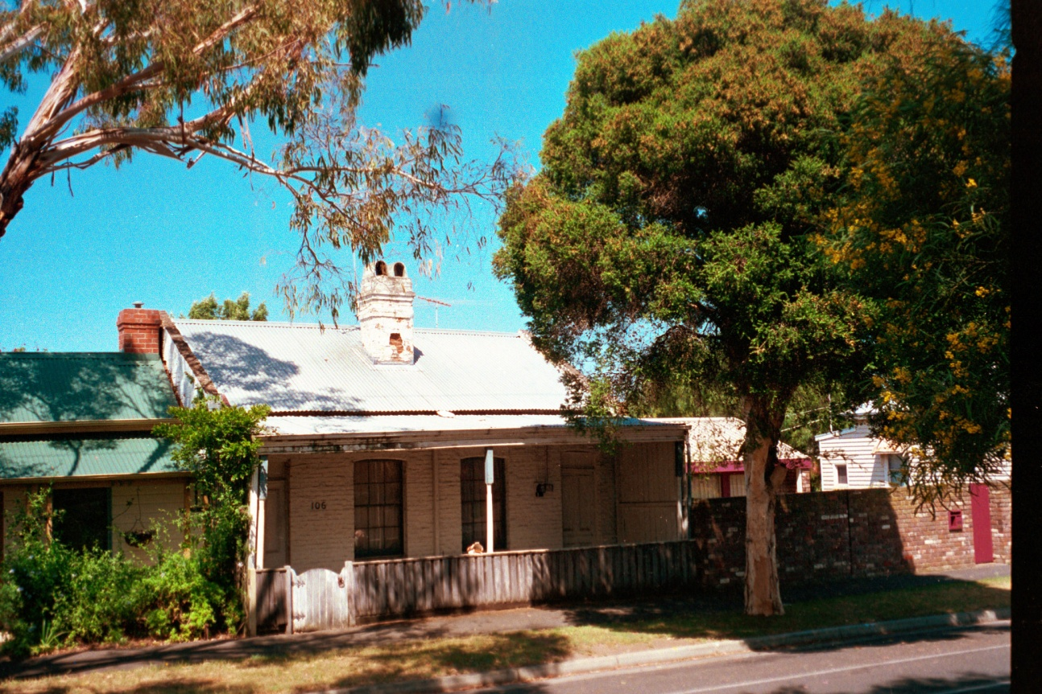
Dwelling, 2002. Source: David Rowe.
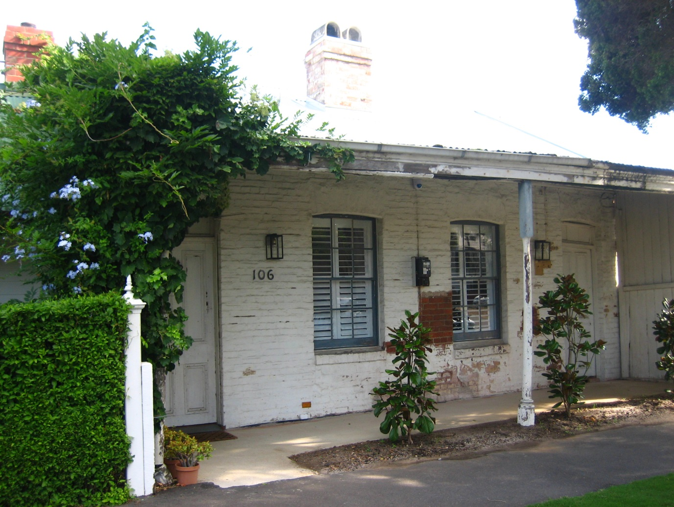
Dwelling, 106 Kilgour Street, 2017. Source: Jennifer Bantow.
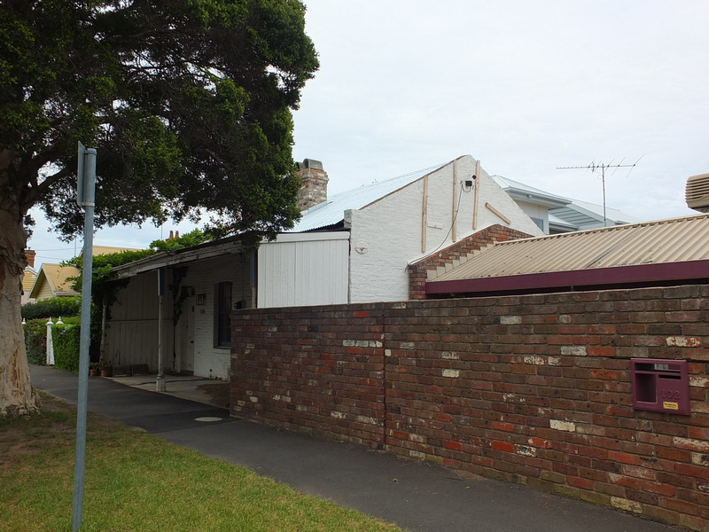
Dwelling, 2016. Source: David Rowe.
- National Hotel, 193-195 Moorabool Street, Geelong.
Works/Reason for Award: Major upgrade to ensure longer term viability of building (including retention of parts of original roof behind parapets & inventive reconstruction of original roof structure), external colour scheme
Significance: Local significance as identified in the Greater Geelong Planning Scheme.
Owner: James Ramia, Dun-Ra Investments Pty Ltd
Designers: Wendy Hastrich of Wendy Hastrich Architect Pty Ltd.

Land at the corner of Moorabool and Little Ryrie Street was acquired by Timothy Hardyman by 1850. He had a three storey, 13 roomed brick hotel constructed in 1855-56. This he named the National Hotel. It would have been an imposing, landmark building at this very early time in Geelong’s development. The building was surmounted by a projecting cornice at the parapet, the second floor windows being round-arched. The corners of the building feature quoinwork. There was a projecting post-supported portico on the Moorabool Street frontage by the late 1930s.

In 1944 as part of a major building program by Carlton and United Breweries (then owners), the building underwent a facelift, giving it a later interwar Modern functionalist appearance. The parapeted façade has moulded stringcourses and incise horizontal lines in the walls that accentuated the glazing bars in the timber framed double first and second floor windows. It is significant as a representative and intact example of interwar hotel design in Geelong, and for its enduring associations with hotel life in Geelong from the middle of the 19th century.

In recent times, the National Hotel has been in need of much-needed repairs and maintenance. Works have involved an open roof top area, cleverly created to a design by Wendy Hastrich Architect by the reconstruction of the form of the central roof in the exposed roof structures, and the retention of the existing roofs at the northern and south ends. This therefore has retained the original (1850s) roof. The removal of plaster and paint internally in the roof deck space has exposed the forms and details of the original windows. The external painting has also highlighted the significant interwar design of the building in a contemporary but respectful way.

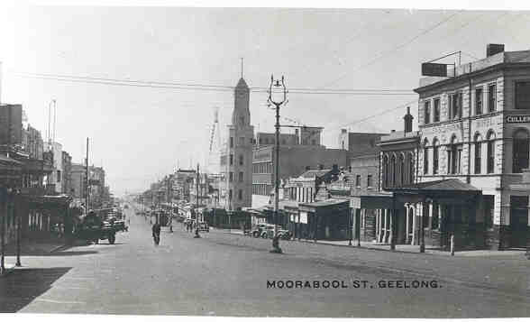
Moorabool Street showing the original design of the National Hotel (right), n.d. [c.1938].
Source: Geelong Heritage Centre collection, image 0317.

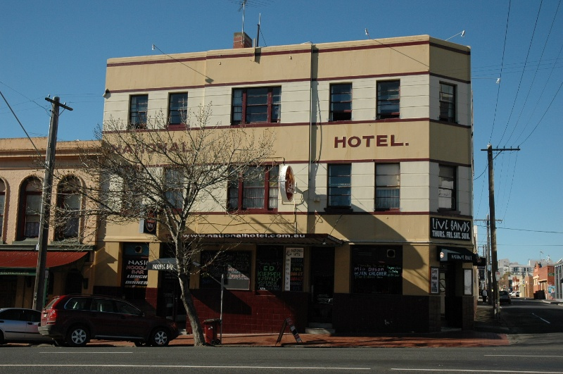
National Hotel, 2005. Source: David Rowe.
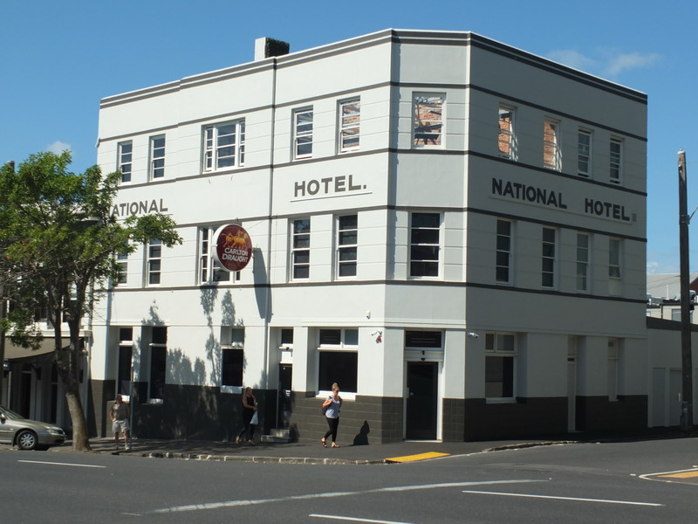
National Hotel, 2017. Source: David Rowe.

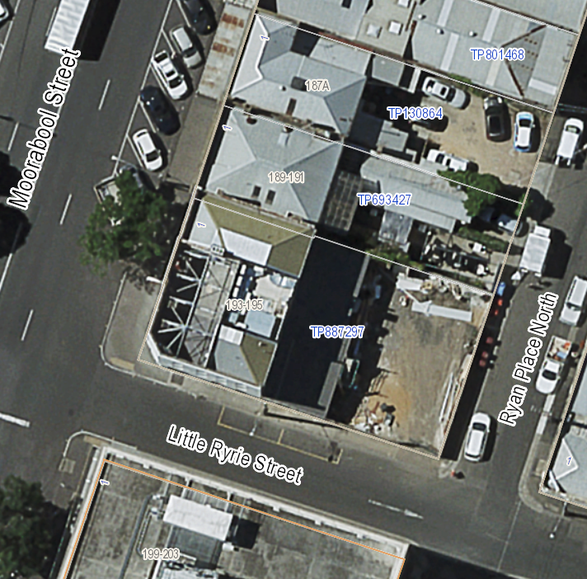
Aerial showing retained roof and inventive reconstruction of roof structure, November 2016. Source: City of Greater Geelong.

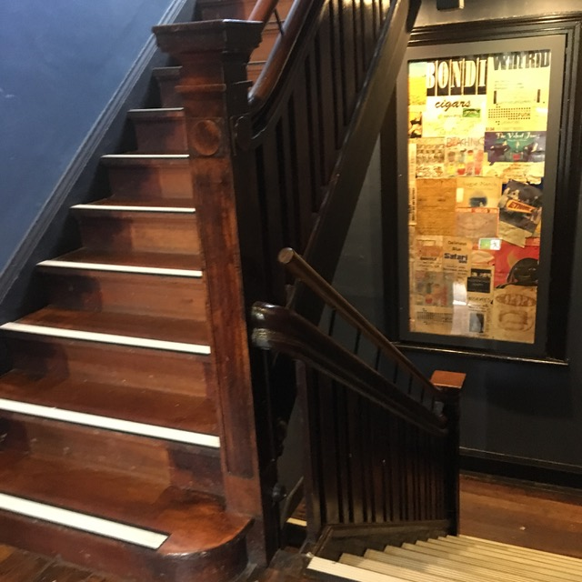 | 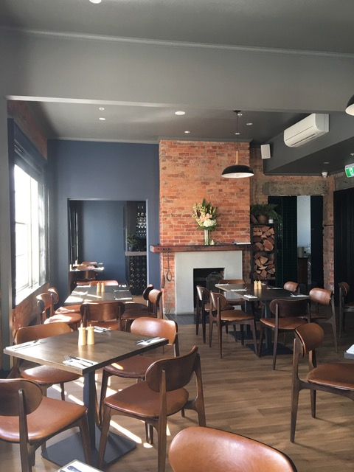
National Hotel, Newell post & stair detail.  Source: Jennifer Bantow, 2 May 2017. | National Hotel, Dining Room.  Source: Jennifer Bantow, 2 May 2017.
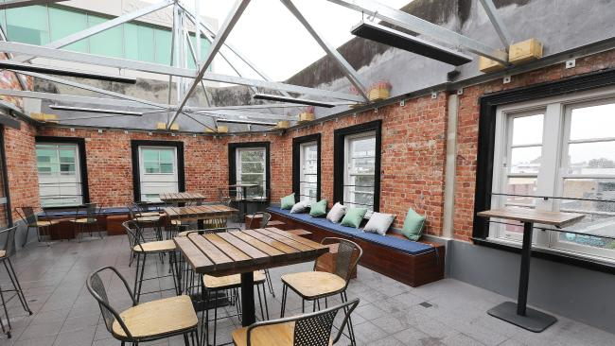 | 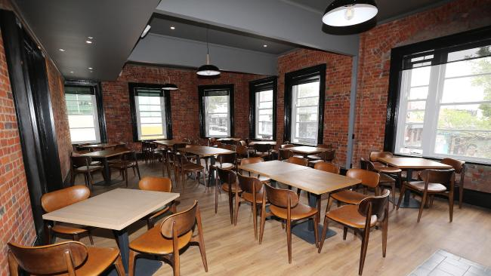
National Hotel, Roof Top deck.  Source: M. Dugdale, Geelong Advertiser, 14 Jan 2017. | National Hotel, Dining Room.  Source: M. Dugdale, Geelong Advertiser, 14 Jan 2017.

- ‘Chesterfield’, 221 Noble Street, Newtown.
Works/Reason for Award: External painting, Internal repairs and redecoration, Retention of Significant Garden Setting, Remediation & Upgrading of Landscape with historic plantings retained, external painting.
Significance: Regional significance as included in the Greater Geelong Planning Scheme.
Owners: Mary-Jane Walker & Chris Bulford
Landscape Architect: Stephen Read of Stephen Read Landscape Design
Interior Designer: Catherine Seclen-Bowen

This historic dwelling at the western end of Noble Street was built in 1854-55 for James Tannock, an auctioneer, carpenter and timber merchant. He was born at Riccarton, Ayre, Scotland in 1820 came to Geelong in 1850. The dwelling was completed in 1855 as a 7 roomed house built of stone and brick with a verandah and kitchen. The garden had been established by 1857-58 as it was at this when it was listed in the Geelong Town Council Rate Books. By April 1859, Tannock was operating a hotel at Viaduct, the location of the great railway viaduct in course of construction over the Moorabool River. He appears to have sold “Chesterfield” to George Thomas by this time. It seems that Thomas named the property “Llandilo”, the first reference to this name being in the Geelong Advertiser on 25 November 1859 when Mrs Thomas gave birth there to a son. In c.1868-69, the property was acquired by the local architect, Joseph Shaw. He initially leased it to the Honorable W.H. Pettite [sic.]. Pettet was born at Greenwich, London, in 1814 and arrived in Van Diemens Land in 1832. In Victoria in 1837, he entered the Gap to the Amphitheatre and discovered the Pyrenees, and later took up Warra Warra Station. In 1878, Joseph Shaw advertised “Chesterfield” for sale. It was described as “A genteel and well-built family residence in Newtown, Geelong, with 3 acres of garden and paddock.” Having no success in selling, Shaw again placed the property on the market in 1880 and it was sold to William Marsland Pye, a School teacher. With his removal to Melbourne in 1888, he sold it to William Purnell and Sons, builders. It was during the Purnell’s brief ownership that the house name appears to have been changed to “Chesterfield”. In 1889, the property was acquired by George W. Cole, a storekeeper from the Wimmera district. The property had a succession of owners in the early 20th century, including Thomas and Mary Grant between 1911 and 1935, and John Ingram between 1935 and 1938. The owners during much of the 20th century were William and Hazel Heath, whose occupation extended from 1938 until 1980.

“Chesterfield” has regional significance as a now rare mid 19th century residence built on a large allotment with the fine rural setting for Newtown’s gentry. Despite its alterations, the dwelling has architectural significance for its Early Victorian Conservative Classical design.

The exterior of “Chesterfield” has recently been refreshed by painting. Internally, the dwelling has been revitalised with fireplaces in the front rooms reinstated, plasterwork repaired (including the deep coved cornice) and in the new colour scheme, assistance being given by Catherine Seclen-Bowen. Valuable help with the restoration, including the acquisition of carriage lamps and other fixtures, has been kindly provided by Sue Apted.

Mary-Jane and Chris saved the property from multiple subdivision and the loss of the magnificent early garden. This garden has been brought back to life by Mary-Jane and Chris, and their landscape architect, Stephen Read. This amazing transformation has involved respecting the layers of history in the garden while introducing new plants. Much of the old planting has been retained and new plants introduced in keeping with the traditional character. A mid 20th century asphalt tennis court has been removed and replaced with a kitchen garden. An ongoing project, “Chesterfield” is a very rare example of stemming the tide from higher density residential development, with the painstaking work carried out returning the intentions of the original owners in providing a substantial rural setting for this significant and unusual mid 19th century residence.

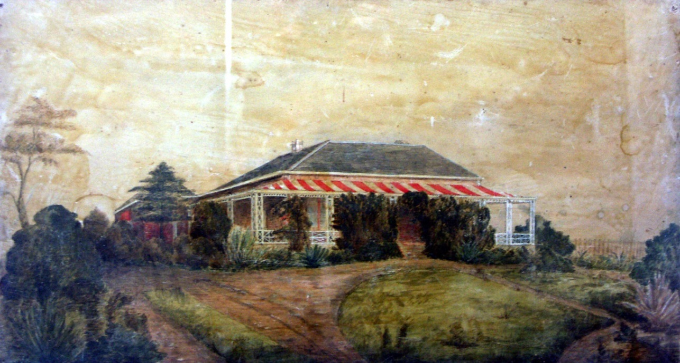
Painting of ‘Chesterfield’ showing original appearance & early setting.
Source: Photograph of painting in entrance hall at Chesterfield.
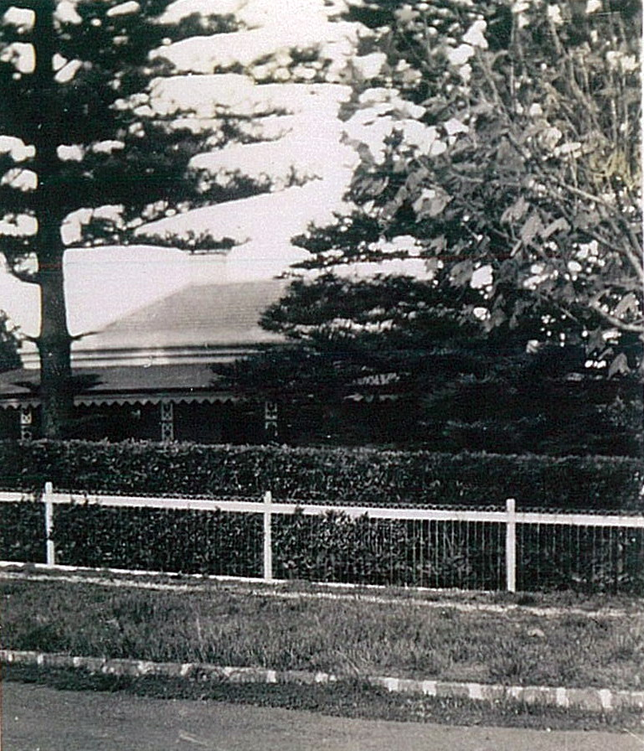
‘Chesterfield’ from Noble Street, c.1926. Source: Grant-Irving Family Album c/o Mary-Jane Walker, owner.
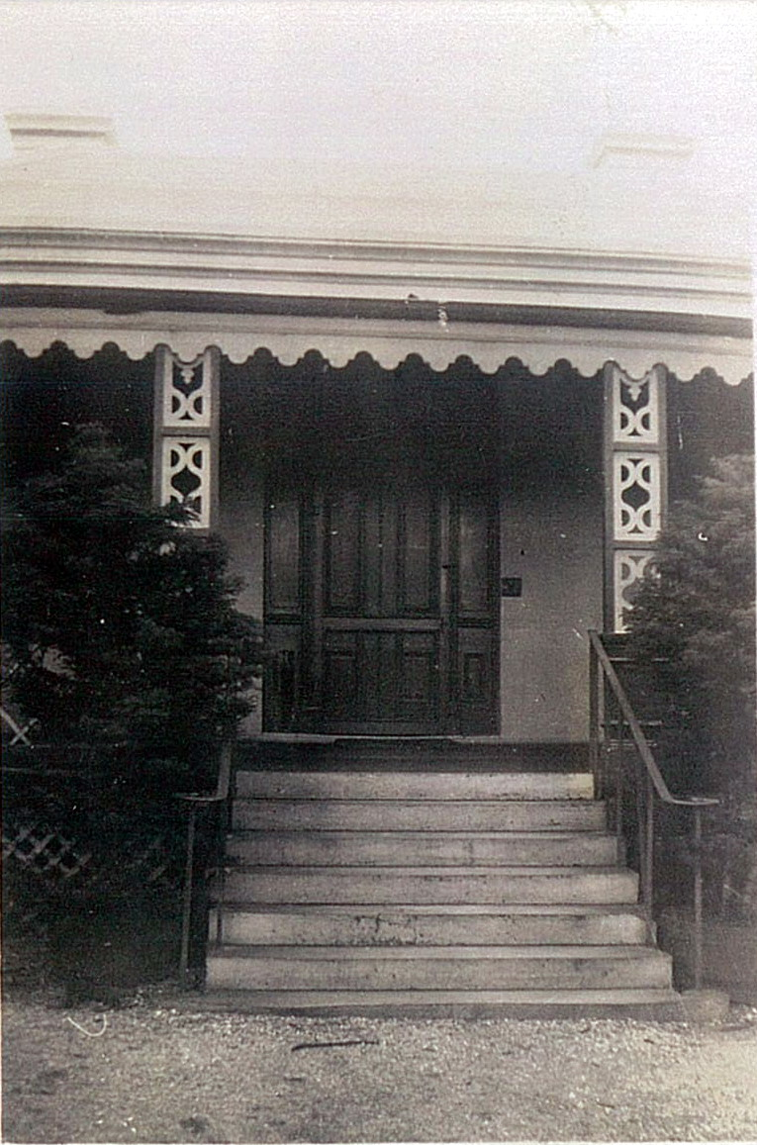
Chesterfield, front steps and doo, c.1926. Source: Grant-Irving Family Album c/o Mary-Jane Walker, owner.
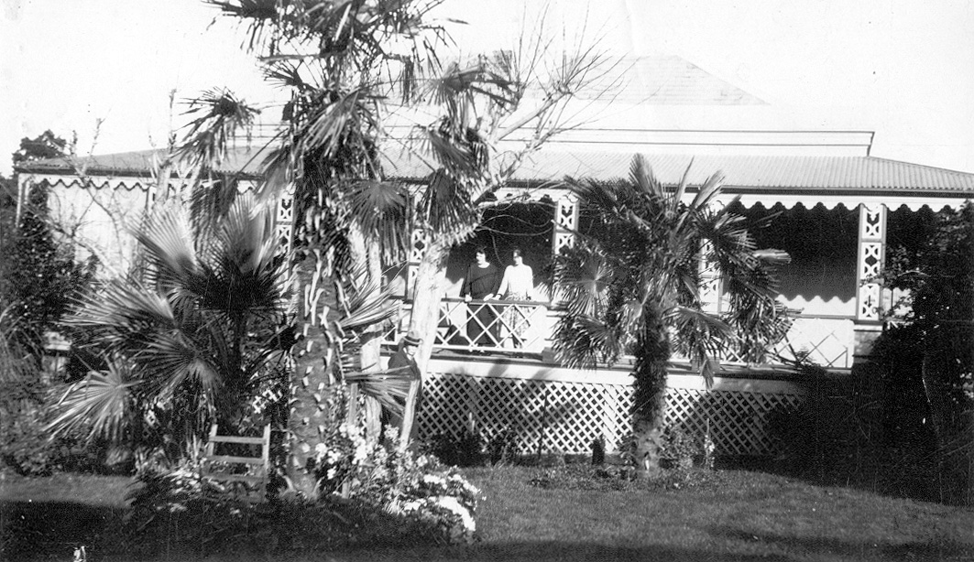
Chesterfield, east elevation, n.d. [c.1915]. Source: Grant-Irving Family Album c/o Susie Zada.
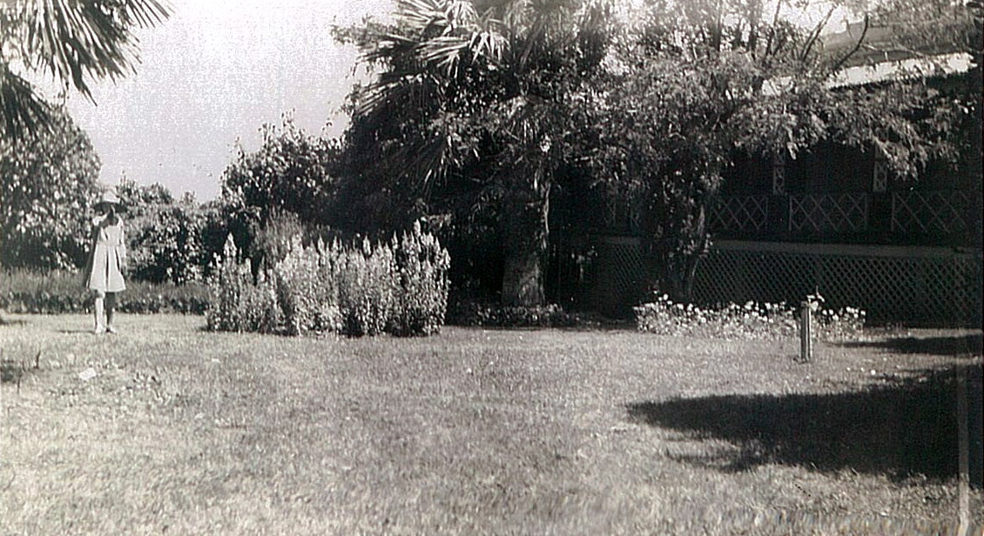
Chesterfield garden to east of dwelling, c.1926. Source: Grant-Irving Family Album c/o Mary-Jane Walker, owner.
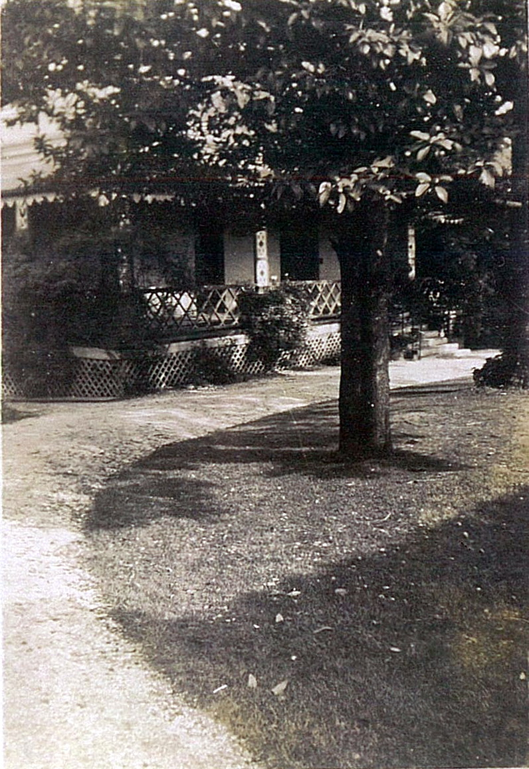
‘Chesterfield’, showing garden to the north-west of dwelling before 1938.
Source: Grant-Irving Family Album c/o Mary-Jane Walker, owner.

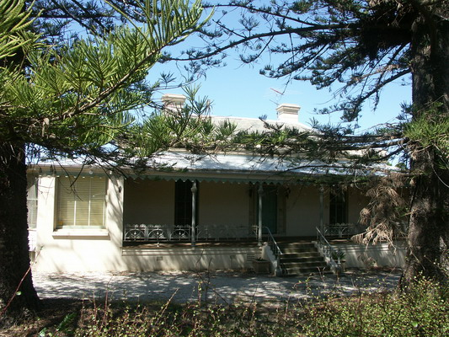
‘Chesterfield’, front view, 2010. Source: David Rowe.
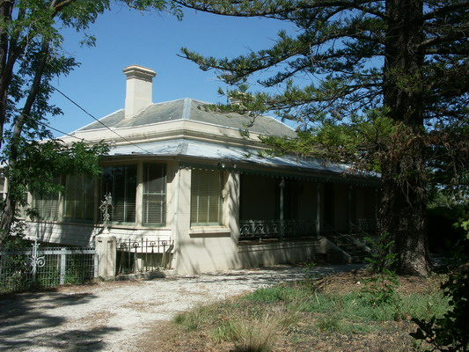
‘Chesterfield’, front garden and dwelling (north-east area), 2010. Source: David Rowe.
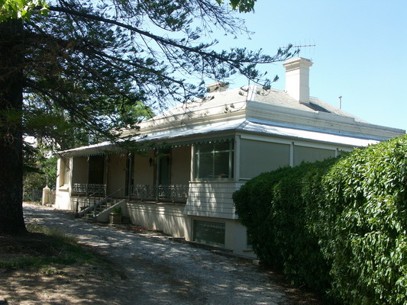
‘Chesterfield’, Front Garden, west end, 2010. Source: David Rowe.

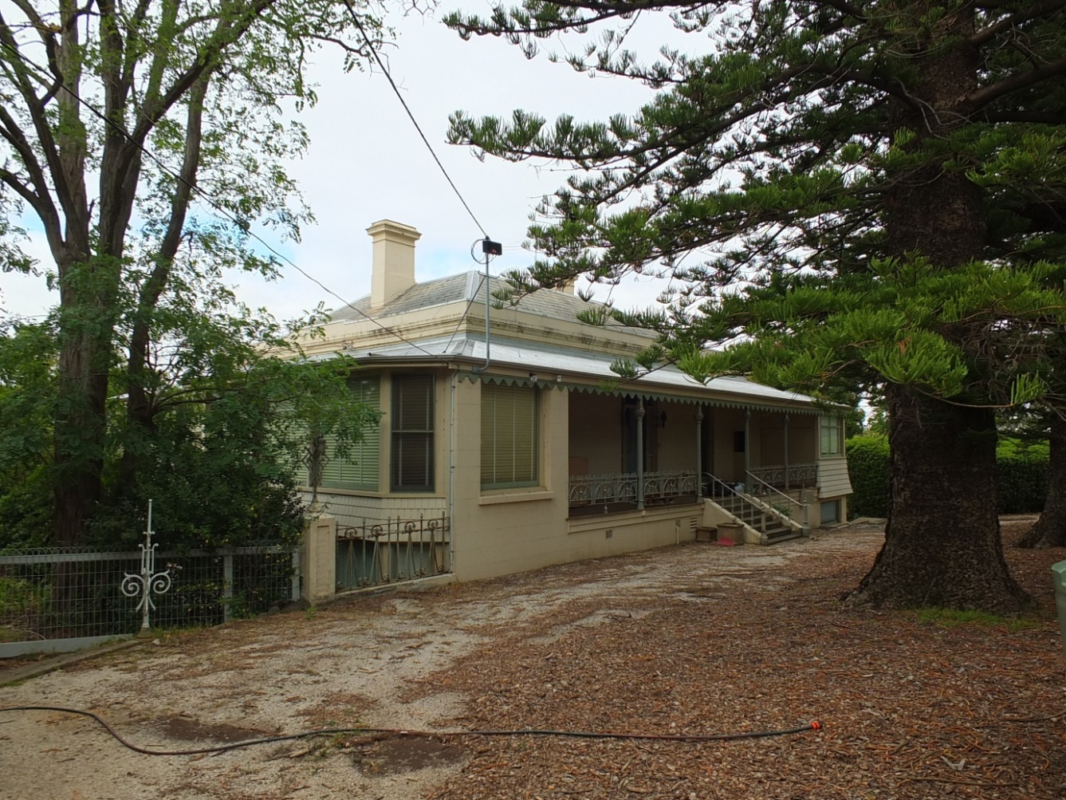
‘Chesterfield’, 2014. Source: David Rowe.

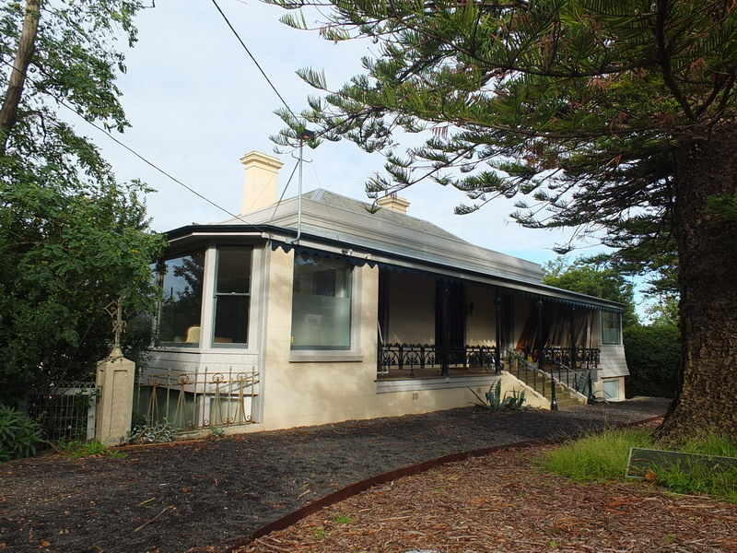
‘Chesterfield’, 2017. Source: David Rowe

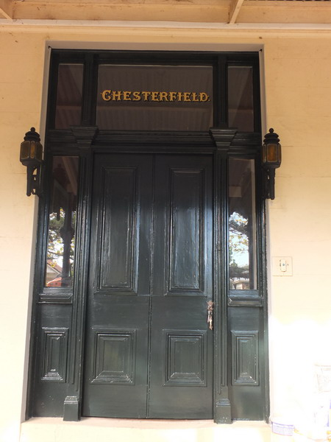
Front door detail, 2017. Source: David Rowe.

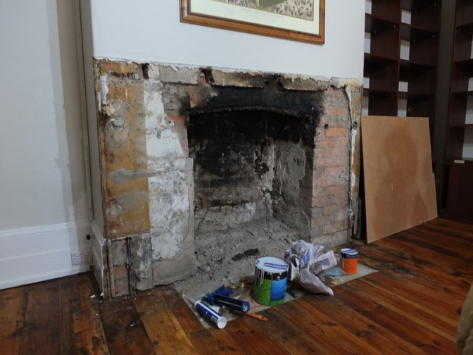 | 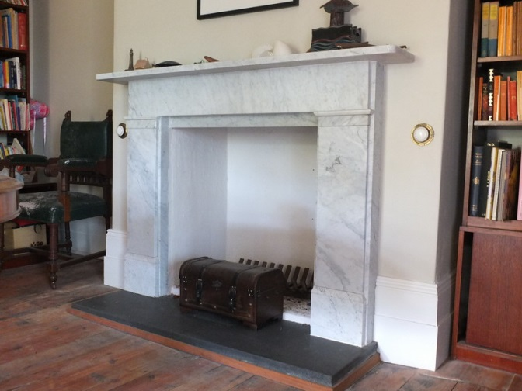
Fireplace during repair & prior to surround reinstatement, 2014. Source: David Rowe. | Introduced fireplace following mid 19th century design, 2017. Source: David Rowe.

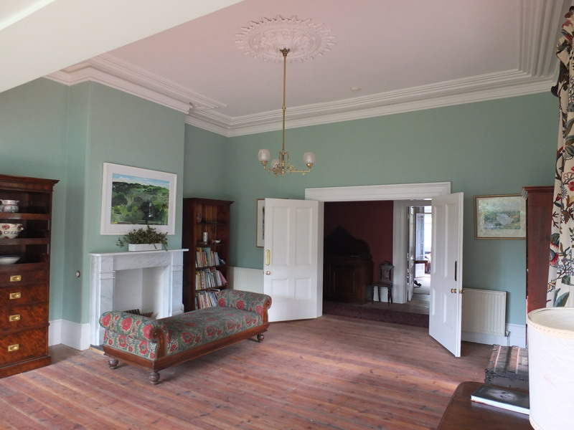
Interior, 2017. Source: David Rowe.

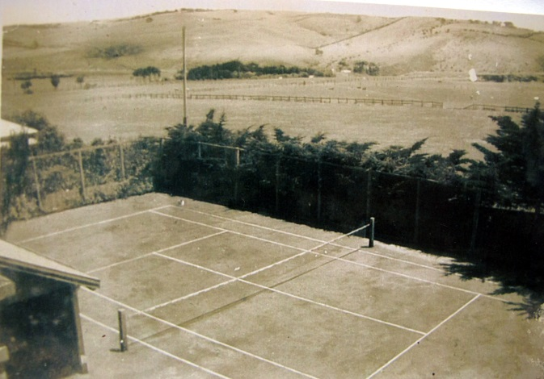 | 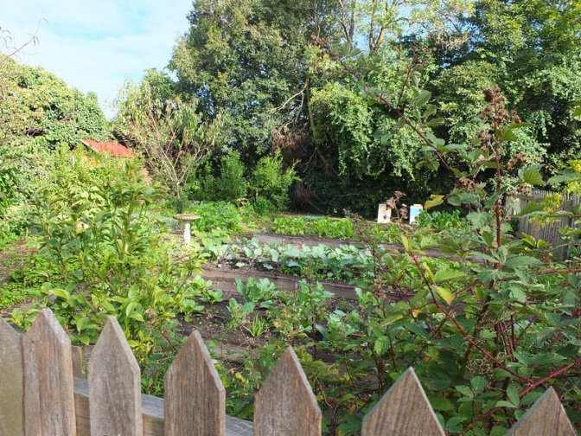
Tennis court, c.1950s. Source: Mary-Jane Walker, owner. | Kitchen Garden, 2017. Source: David Rowe.

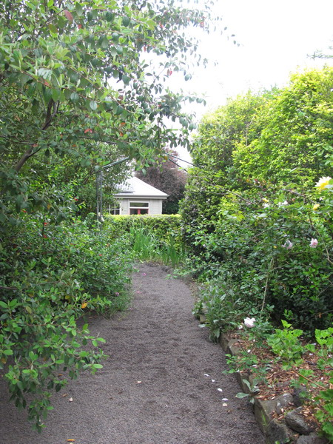
Garden path, 2016. Source: Mary-Jane Walker, owner.

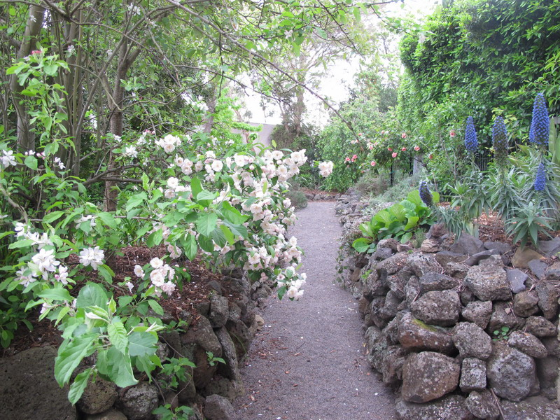
Garden path, 2016. Source: Mary-Jane Walker, 2016.

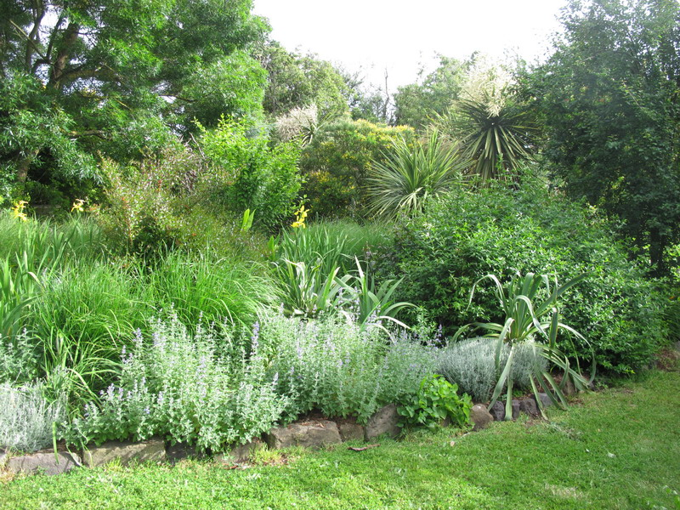
Garden, 2016. Source: Mary-Jane Walker, owner.

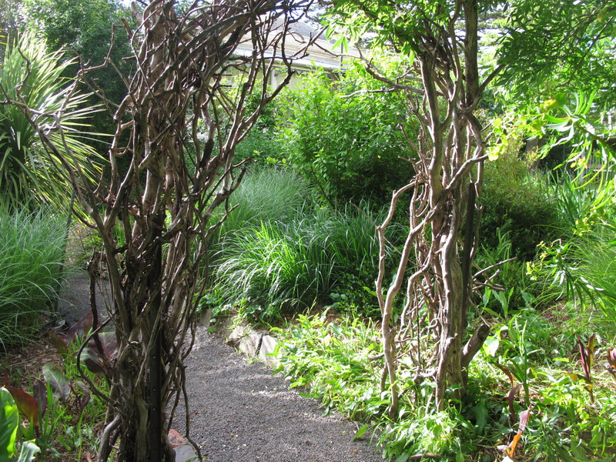
Arbor, 2016. Source: Mary-Jane Walker, owner.

- Barwon Health Library (former St. Mary’s Parish Hall), 190-192 Myers Street, Geelong.
Works/Reason for Award: Creative & Respective Adaptation of former Parish Hall, Interpretation of history of St. Mary’s Hall & School.
Significance: State significance as included on the Victorian Heritage Register.
Owner: Barwon Health
Architect: Daryl Pelchen
Contractors: Becon Constructions Pty Ltd including Phillip Herkess, Director; Stephen Hallett Senior Project Manager; and Damien Webster, Site Foreman.
Interpretation: Sue Hodges Productions Pty Ltd

St. Mary’s Catholic Parish Hall was built in 1891-92 to a design by the local architectural firm, Watts and Durran. It was built by House and Sims. The building was also used as classrooms for the Catholic School until 1918, with the neighbouring School finished in 1919.

St. Mary’s Hall is a highly unusual and extraordinary example of Classical Revival design for the late 19th century, at a time when the Catholic Church favoured the more pointed Gothic style. It has state significance for this reason. It also has high historical significance for its associations as a meeting place for the local Catholic Church following hostilities engendered by the Irish Home Rule question, leading to the Catholic Church being denied access to other local halls. The imposing scale expresses the functional and symbolical importance of the building to St. Mary’s Church.

In late 2013, it was publicly announced that the St. Mary’s Hall and School site was to be revitalised and transformed into housing estate. A centrepiece of the development was the adaptation of the Hall into a library for Barwon Health. Repairs were carried out to parts of the exterior, the original design remaining unchanged. Inside, the adaptation and change designed by Daryl Pelchen Architects has been creative and respectful, the highly contemporary steel and glass library and office mezzanine ensuring an understanding of the original hall space. The history of the site and the original Catholic Hall function of the interior have also been celebrated in the interpretive display in the Board Room, and the retention of part of the early stage that now acts as a bench, the work of Sue Hodges Productions Pty Ltd. Overall, this new location of the Barwon Health Library provides a highly successful heritage and educational outcome for Geelong.

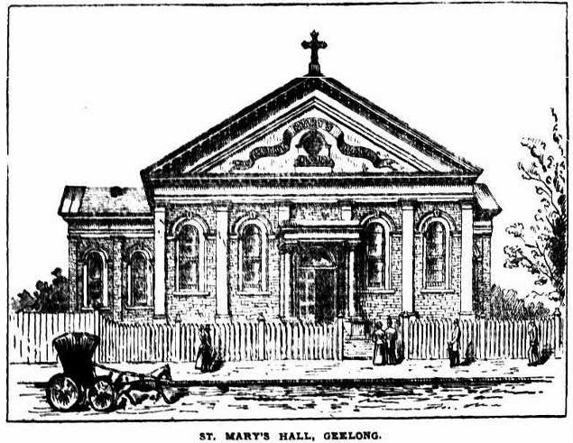
Source: The Advocate, 5 March 1892, p.9.

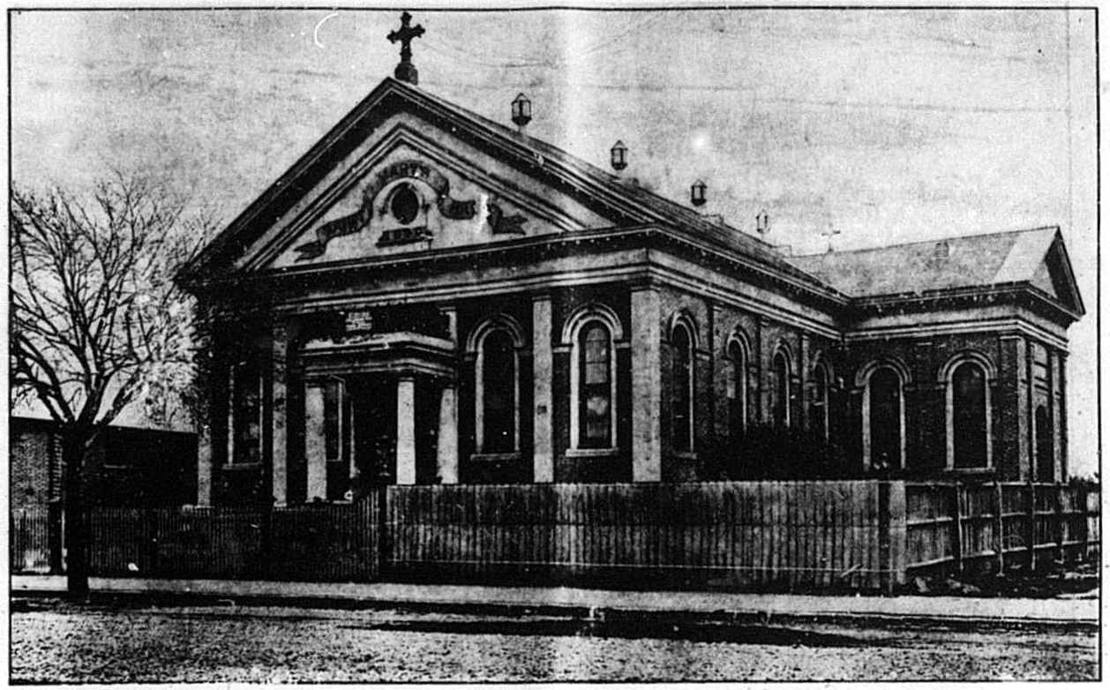
St. Mary’s Hall, 1907. Source: News of the Week, 22 August 1907.
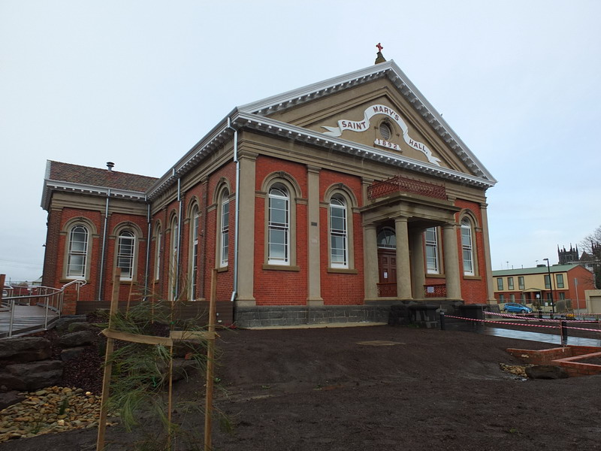
Parish Hall, 2016. Source: David Rowe.
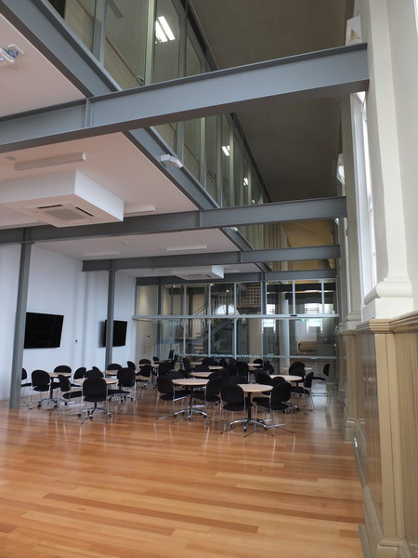
Interior, showing introduced mezzanine, distinguished by contemporary construction, but original volume of former hall retained, 2016. Source: David Rowe.
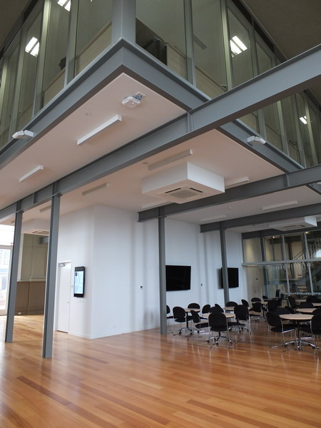
Interior, showing introduced mezzanine, distinguished by contemporary construction, 2016.
Source: David Rowe
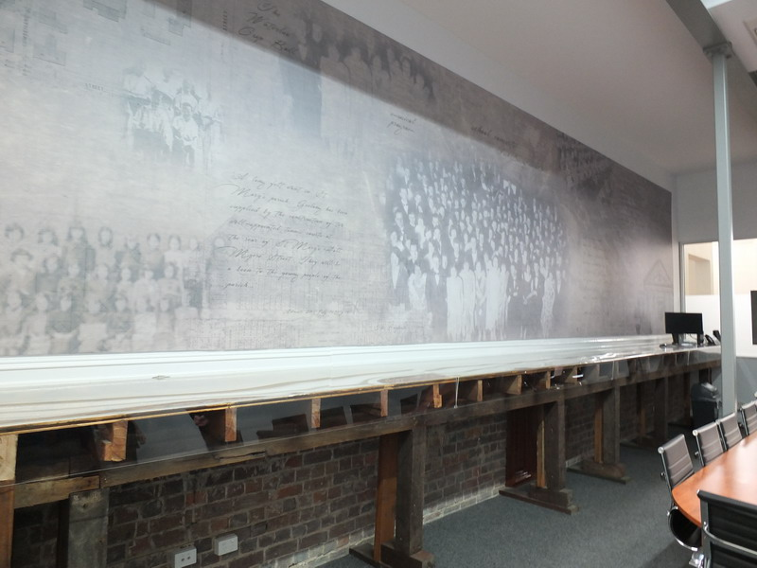
Interpretive panel & retained portion of former hall stage in Board Room, 2016. Source: David Rowe.
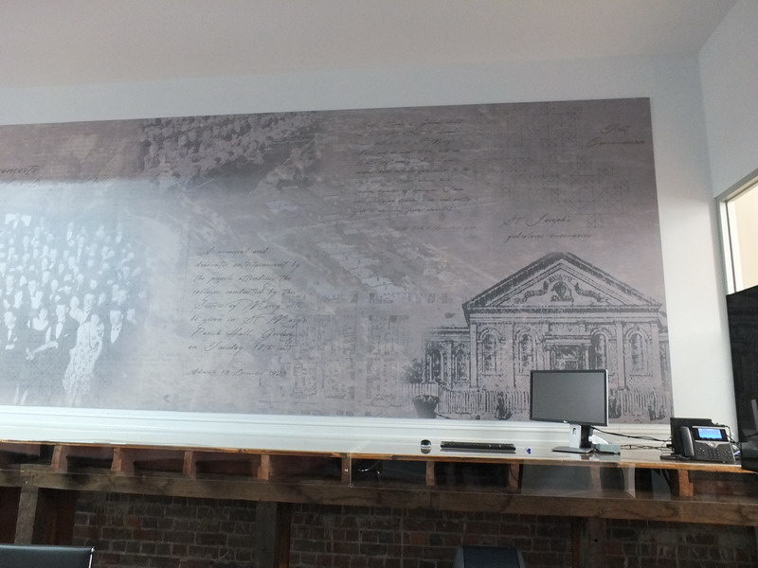
Detail of interpretive panel and retained stage element, 2016. Source: David Rowe.

- New Dwelling, 98 Noble Street, Newtown.
Works/Reasons for Award: Contemporary and inventive interpretation of significant buildings in the area.
Significance: Land included in the Mercer’s Hill Heritage Area which as local significance in the Greater Geelong Planning Scheme
Owner: Bernadette Lipscomb
Architect: Tony Hobba
Contractor: Spence Constructions including Glenn McVilly, Director, and Luke O’Brien, Site Foreman.

The site at 98 Noble Street, Newtown, is located within the Mercer’s Hill Heritage Area. This area is significant for its Late Victorian, Edwardian, Federation and particularly interwar Bungalow styled dwellings. A large number of the dwellings have elevated and sloping landscape settings. Most of the dwellings have hipped and/or gabled roof forms, front and side verandahs, timber weatherboard and rendered brick wall construction and broad eaves. Historically, the area is significant for its important eras of residential development after the subdivision of the area in the mid 1880s, when the Mercer’s Hill Estate created a number of residential allotments fronting Noble Street and Mercers Parade. Further development occurred in the late 19th and early 20th centuries. Yet, it was during the interwar period when the area was largely transformed by residential development.

The design of buildings in heritage areas can excite a sense of proud creativity, striking innovation or comforting resemblance. Ultimately, infill development can either enhance or diminish established community identity. At the heart of infill development is context: how it relates to the significance of the heritage place; and the creation of a design field that does not offend that significance. Issues of setback, scale, height, form, texture and colour can play a key role in the success of new buildings in heritage areas. The design by Tony Hobba Architects and construction by Spence Construction of the dwelling at 98 Noble Street captures the essence of the significant heritage character of neighbouring interwar hipped roofed, weatherboard and rendered dwellings without being a slavish copy. Instead, it is an inventive interpretation of the heritage dwellings nearby, and sits comfortably and respectfully within this significant streetscape context of Noble Street.

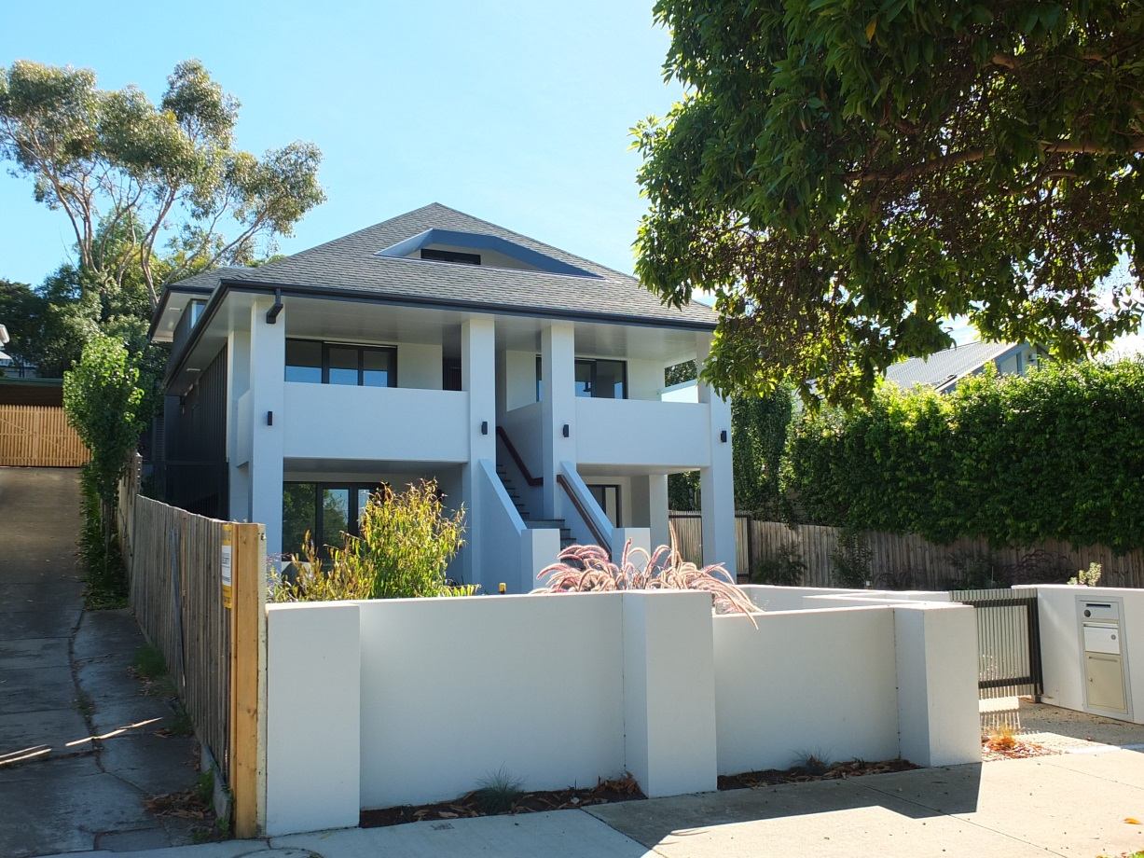
New Dwelling, 98 Noble St, 2017. Source: David Rowe.
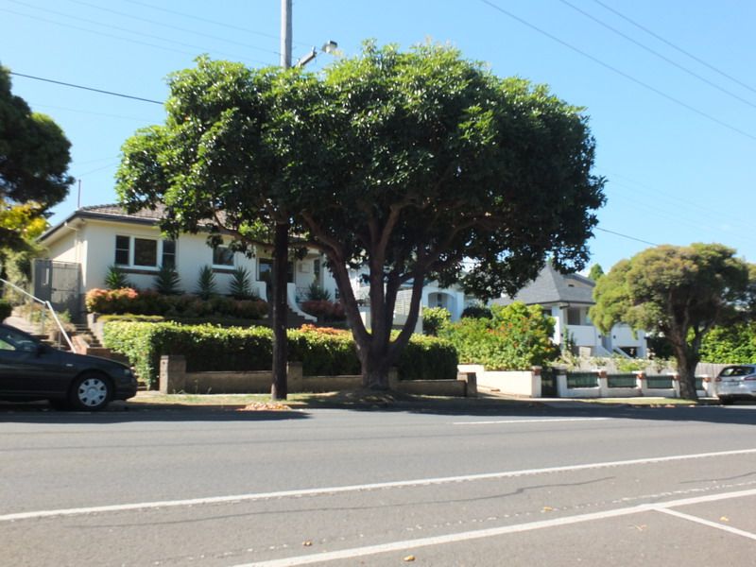
Streetscape, Noble St (new building on right), 2017. Source: David Rowe.
- Kirrewur Court, 77 Prospect Road, Newtown
Works/Reason for Award: Demolition of introduced additions, reconstruction of bay windows, walls, verandah and other details, reinstatement of dwelling to original design, & exterior colour scheme.
Significance: Regional significance as included in the Greater Geelong Planning Scheme
Owners: Cam and Penny Hamilton
Designer: Sash Miceski, Another Dimension Building Design

This substantial dwelling, “Kirrewur Court” was built in 1891 for Charles Shannon, wool merchant, to a design by the Ballarat architect, Charles Figgis. Charles Shannon (1841-1922), wealthy wool broker, woollen mill owner and fellmonger, was one of the leading pioneers in Geelong's business sector, having emigrated from Greenock, Scotland, in 1870. He was also prominent in public life, having been a Councillor of the Geelong Town (later City) Council from 1879 until 1883 and a member of the Council of Newtown and Chilwell between 1894 and 1920. The mansion remained under the ownership of the Shannon family until at least the 1940s. It operated as a guest house in the 1950s and in 1958 it was transformed into a function centre. Several alterations and additions were made to service this new role for the building.

“Kirrewur Court” has high architectural significance as an important early and unusual face brick mansion distinguished by its picturesque hipped and gabled terra cotta roofs, and its landmark circular tower, derived from the French chateaux of the early 16th century. The Newtown Heritage Study declares that it “may be the finest tower of this type in Australia”.

In recent times, Cam and Penny Hamilton have kept true to their vision of returning the dwelling to its original character and appearance. The works have involved the removal of the function centre and other additions, and the reconstruction of bay windows, wall and verandah details, based on historical photographs of the 1950s kindly supplied by Bob Kelly, and physical evidence. Documentation for this highly successful transformation was prepared by Sash Miceski of Another Dimension Building Design.

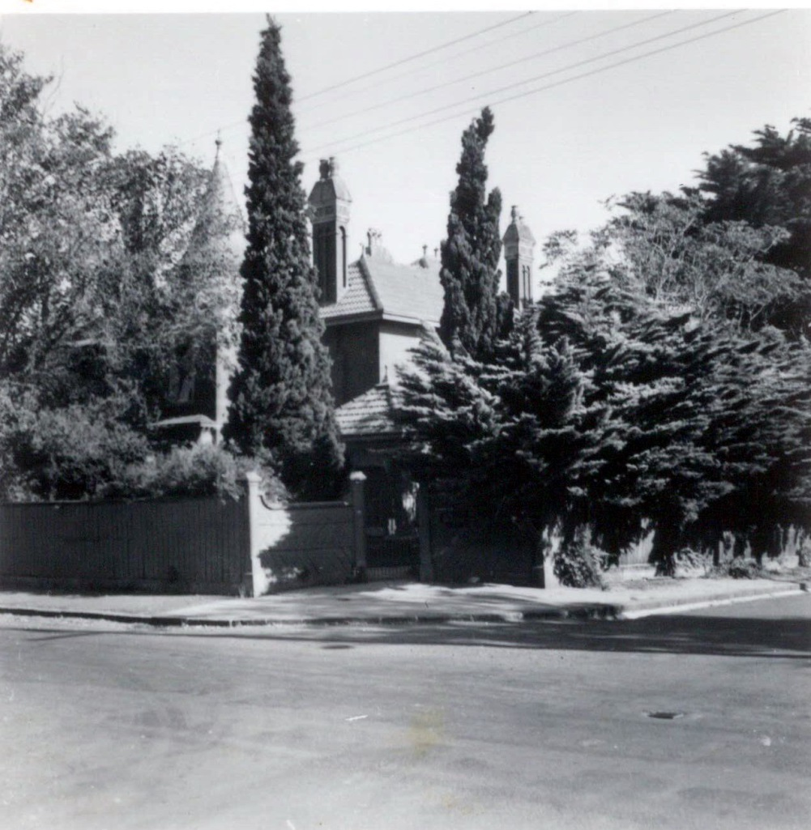
Kirrewur Court, 77 Prospect Road, Newtown, n.d. [c.1950s]. Source: Bob Kelly via Cam Hamilton, owner.

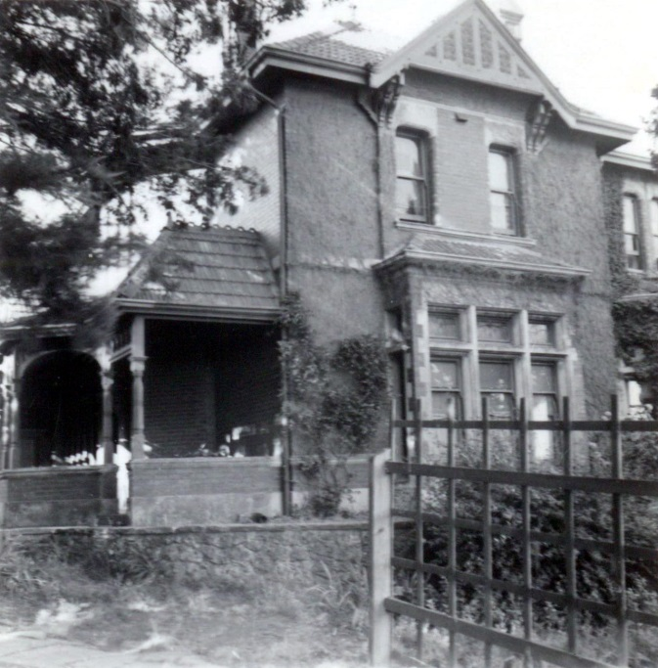 | 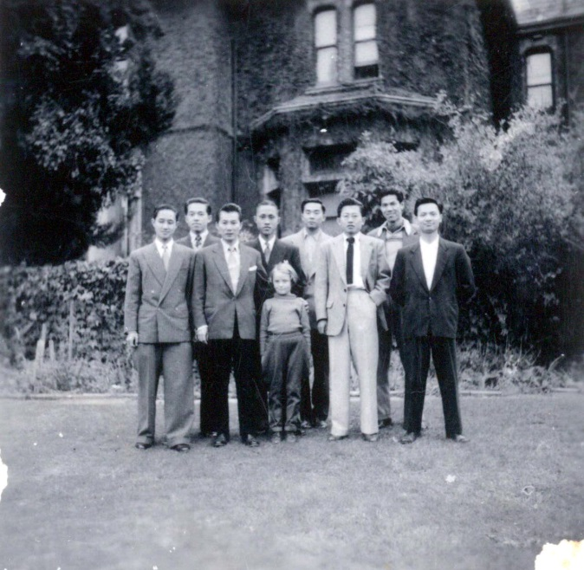
Kirrewur Court, south elevation (& west verandah), n.d. [c.1950s]. Source: Bob Kelly via Cam Hamilton, owner. | Kirrewur Court, part south elevation, n.d. [c.1950s].  Source: Bob Kelly via Cam Hamilton, owner.

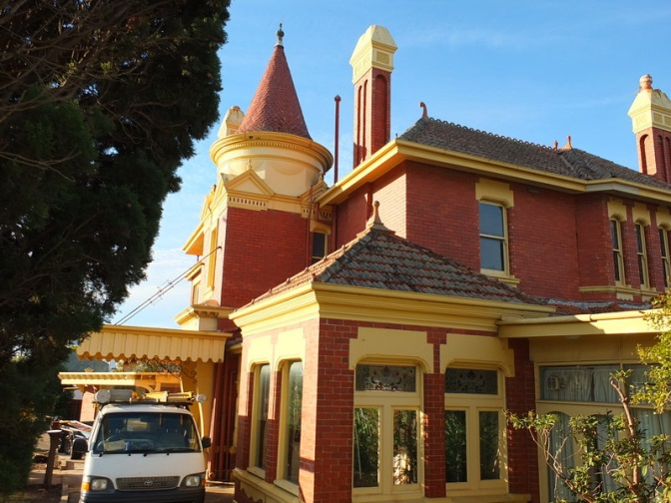 | 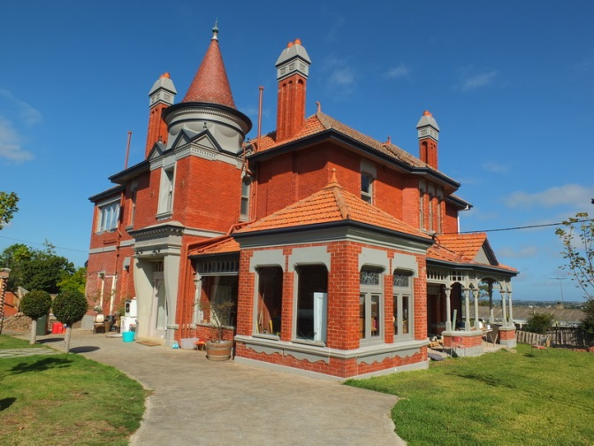
Kirrewur Court, north & west elevations, 2015.  Source: David Rowe. | Kirrewur Court, north & west elevations (from north end), 2017. Source: David Rowe.
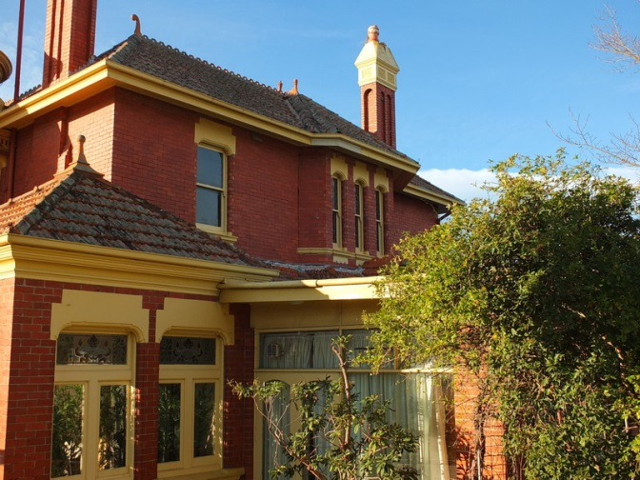 | 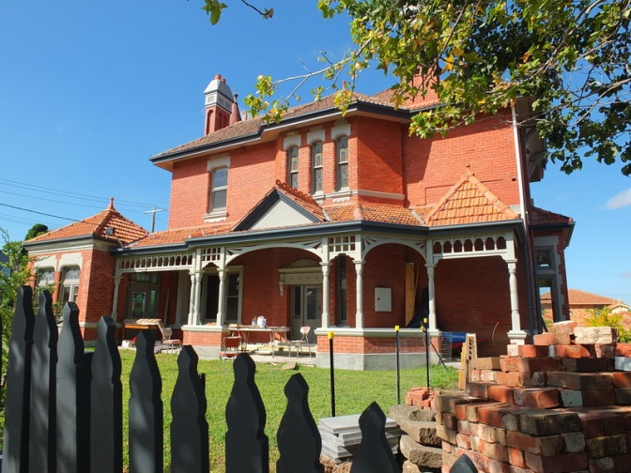
Kirrewur Court, west elevation (from north end), 2015.  Source: David Rowe. | Kirrewur Court, west elevation, 2017.  Source: David Rowe.
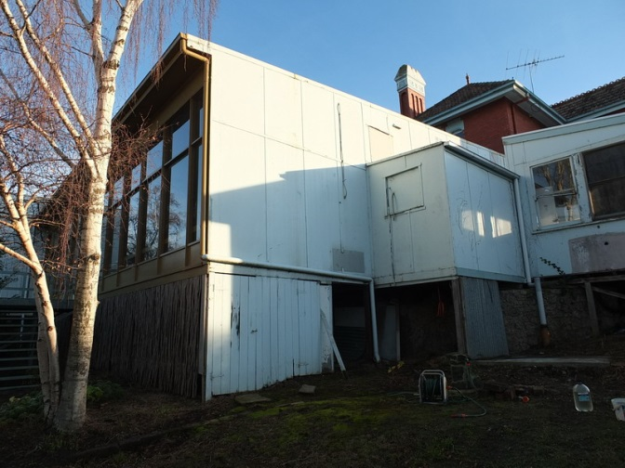 | 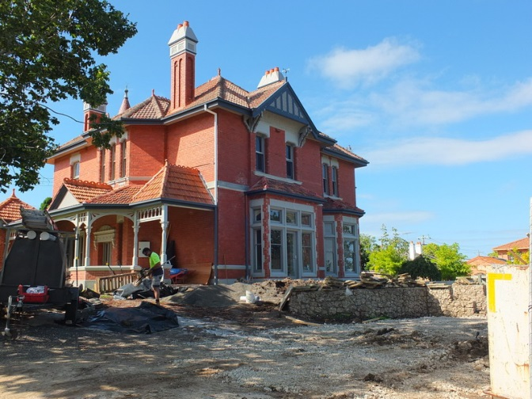
Kirrewur Court, south elevation (from east) with large introduced addition, 2016. Source: David Rowe. | Kirrewur Court, south elevation (from west), 2017.  Source: David Rowe.

- Federal Woollen Mills, 13Mackey Street, North Geelong
Works/Reason for Award: Respectful Adaptation of Industrial Buildings to ensure long term sustainability of this significant site.
Significance: State significance as included on the Victorian Heritage Register
Owner: David Hamilton Group & Dennis More
Designer: Sash Miceski, Another Dimension Building Design

The former Federal Woollen Mills was completed in 1915 for the Commonwealth Department of Defence on land donated by the Geelong Harbour Trust. The mills took raw wool which was scoured, carded, dyed, spun and woven into the cloth for army uniforms. The mill was the final component of a system of factories planned in 1910 by the newly formed Commonwealth government and designed to make Australia self-sufficient in essential military equipment. The buildings at Woollen Mill were designed by John Smith Murdoch, Chief Architect of the Commonwealth Department of Works and Railways, and they are similar to his other factories of the period built in red brick in a Free Classical/Commonwealth vernacular style. The factory was revolutionary for its time in employing a logical and linear work flow through all stages of the processes which were housed in single storey "sheds" grouped around a central thoroughfare rather than in the usual multi-storeyed building. As well, the buildings were particularly well designed with regard to light and ventilation. Another innovation was that all processes were electrically powered from the mill’s own power plant. When the war ended in 1918 the factory switched to making cloth for other than defence uses and by 1923 the whole enterprise was sold into private hands. As the Federal Woollen Mills it was a successful textile manufacturer until the lifting of protective tariffs in the 1970s.

The former Federal Woollen Mills has State significance for the quality of its factory design and its integrity. Buildings with strong design qualities were not typical to factories, yet are well represented at the former Federal Woollen Mills. The Federal Woollen Mills is historically important as a key component in the system of factories set up by the Commonwealth in an attempt to make Australia self-sufficient in defence production in the years leading up to the First World War. Of those original factories, this former woollen mills is the most intact in terms of its building stock and original design layout.

In recent times, the former Federal Woollen Mills has been transformed by the David Hamilton Group and Dennis Moore as Federal Mills Park, a unique and contemporary series of office, commercial, retailing and warehousing spaces that celebrate the history of the place through the retention of the early buildings, and their adaptation with the introduction of new fabric that highlights the heritage character. Design documentation was by Sash Miceski of Another Dimension Building Design. The original design – which allowed natural light throughout each of the interiors – and the exposure of original fabric – are key features of this extraordinary redevelopment project. The hustle of the original mill, with the many people employed on the site, has returned in a new, 21st century way, given the numerous people employed at the IT businesses, gymnasium, café, photographic studio and other businesses which give a particular campus character. Underpinning the redevelopment is the heritage fabric, a celebration of the past, present and future.

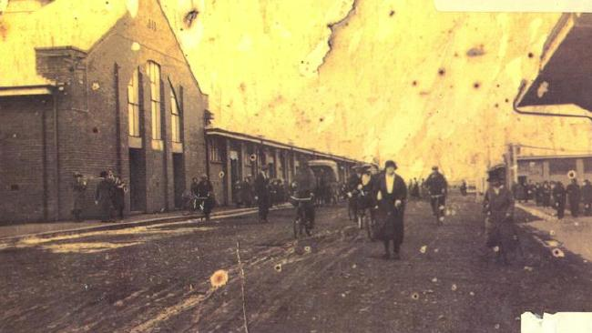
Federal Woollen Mills, c.1920s. Source: Geelong Advertiser online.
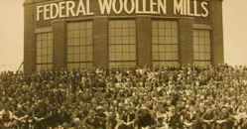
Federal Woollen Mills, 1928-29. Source: Geelong Heritage Centre collection.
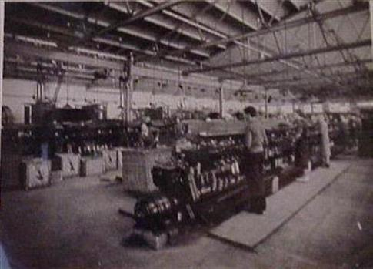
Interior, Federal Woollen Mills, n.d. Source: Victoria collections online.

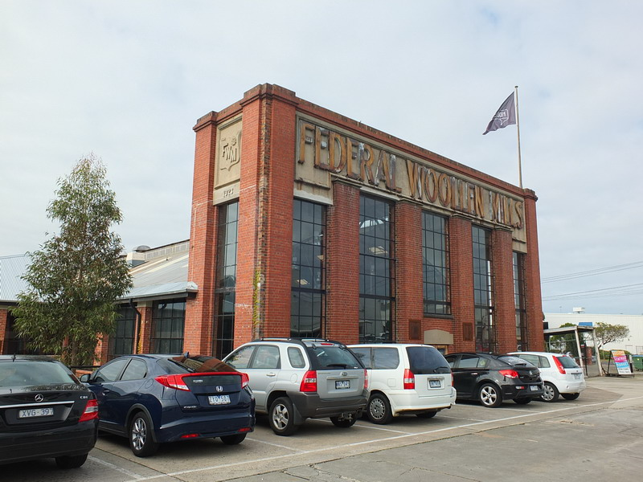
Federal Woollen Mills, 2017. Source: David Rowe.
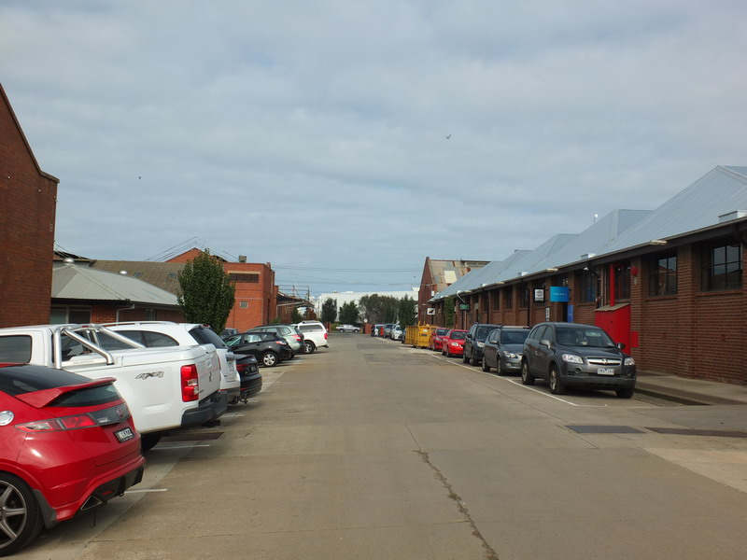
Main thoroughfare, Federal Woollen Mills, 2017. Source: David Rowe.

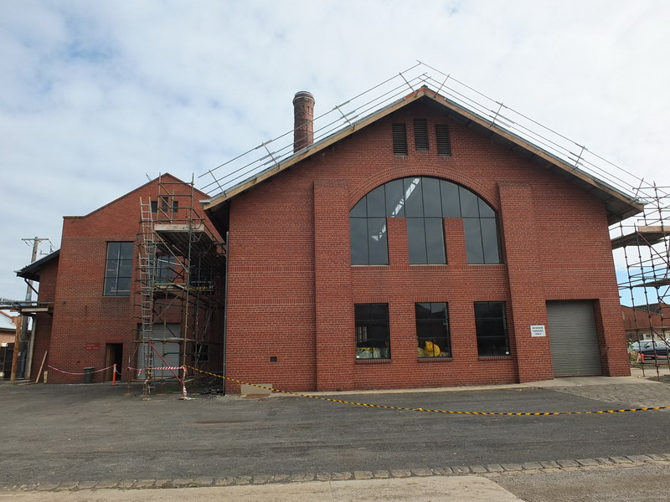
Federal Woollen Mills, 2017. Source: David Rowe.

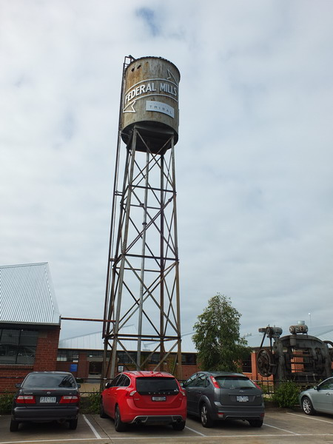
Tank and stand, Federal Woollen Mills, 2017. Source: David Rowe.

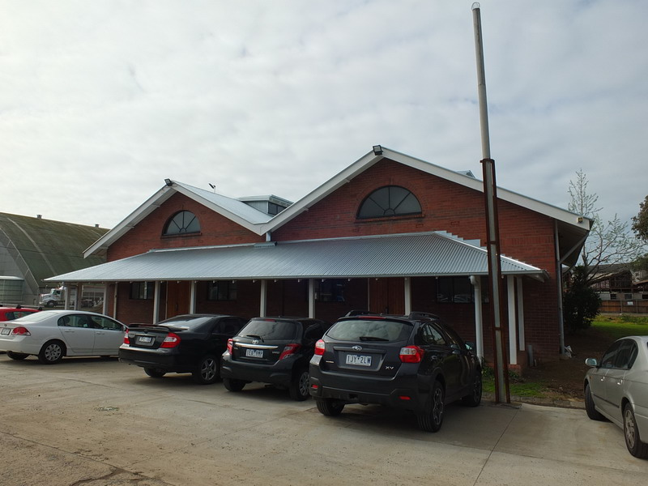
Federal Woollen Mills, 2017. Source: David Rowe.
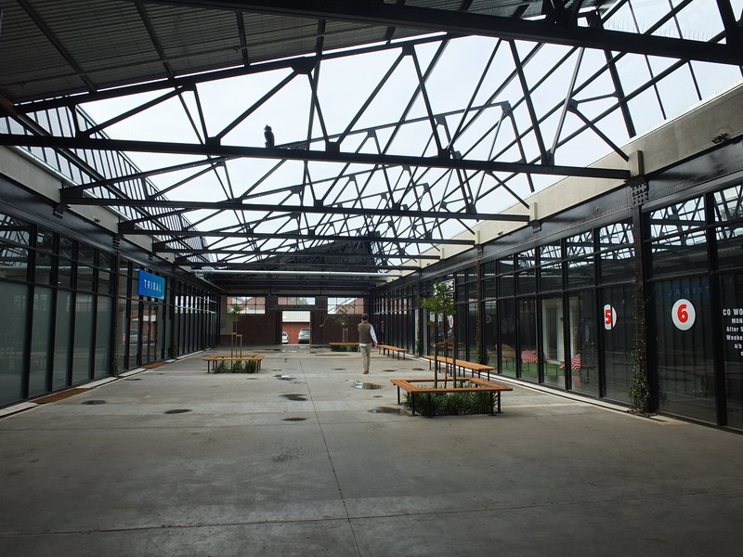
Open plaza, 2017. Source: David Rowe.
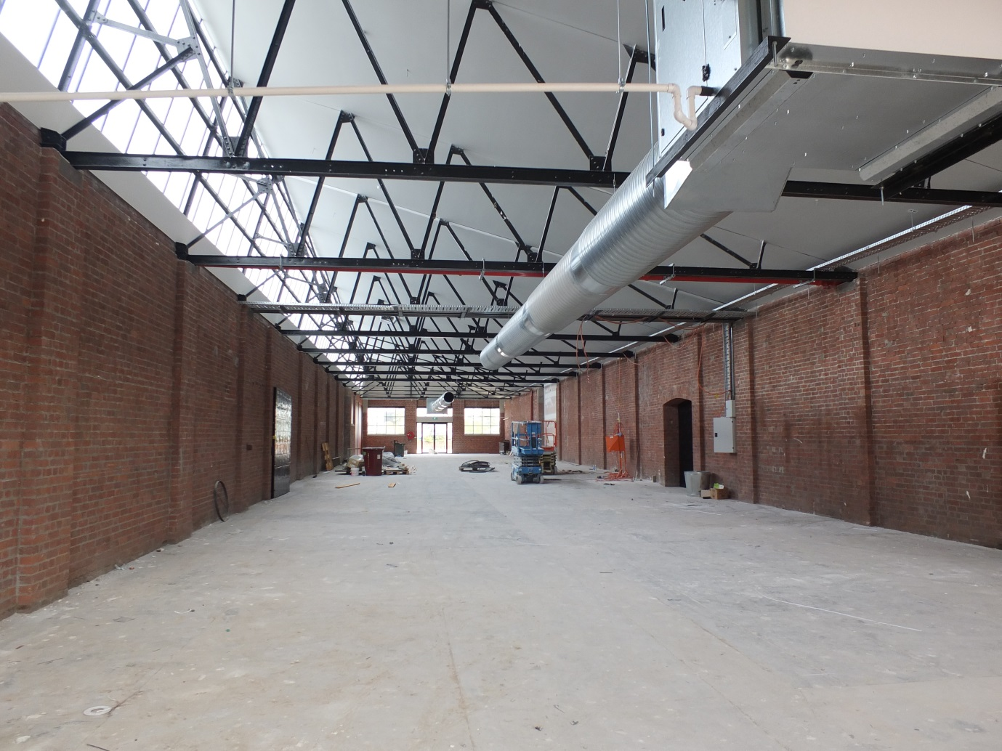
Former mill building under adaptation, 2017. Source: David Rowe.
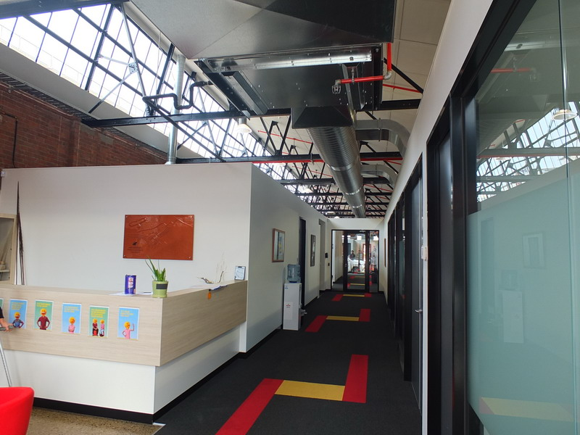
Office adaptation, 2017. Source; David Rowe.

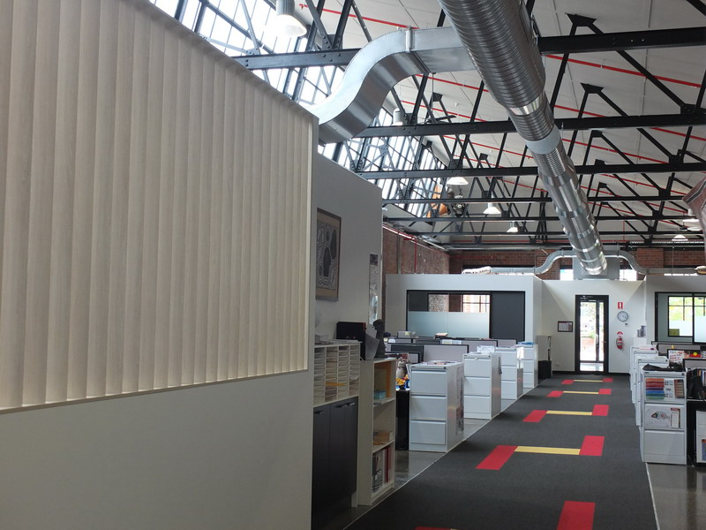
Office adaptation, 2017. Source; David Rowe.
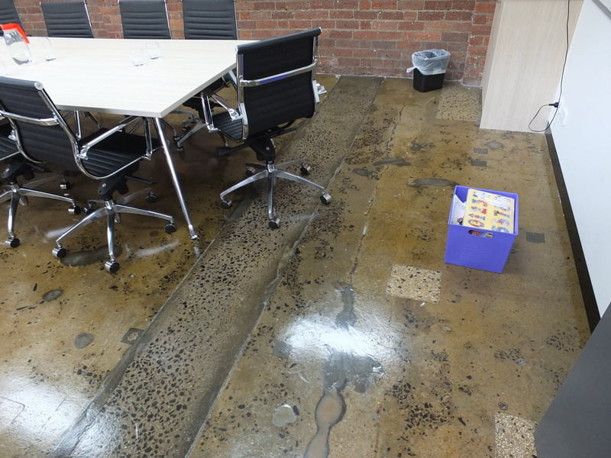
Original exposed aggregate concrete floor, showing earlier changes as part of original industrial use, 2017.
Source: David Rowe.
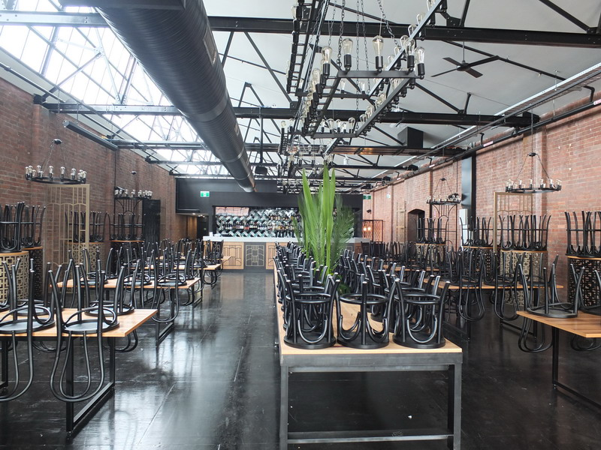
Restaurant/café adaptation, 2017. Source: David Rowe.
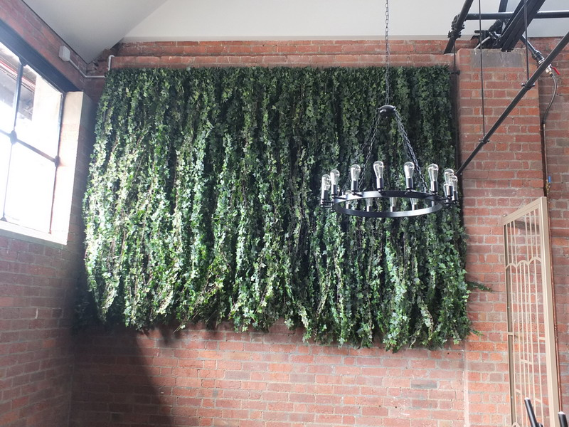
Vertical garden, restaurant/café adaptation, 2017. Source: David Rowe.
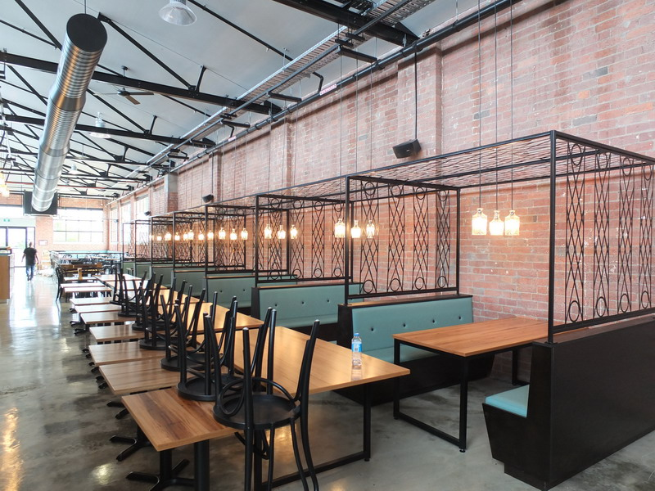
Art Deco-inspired café/restaurant booths, 2017. Source: David Rowe.
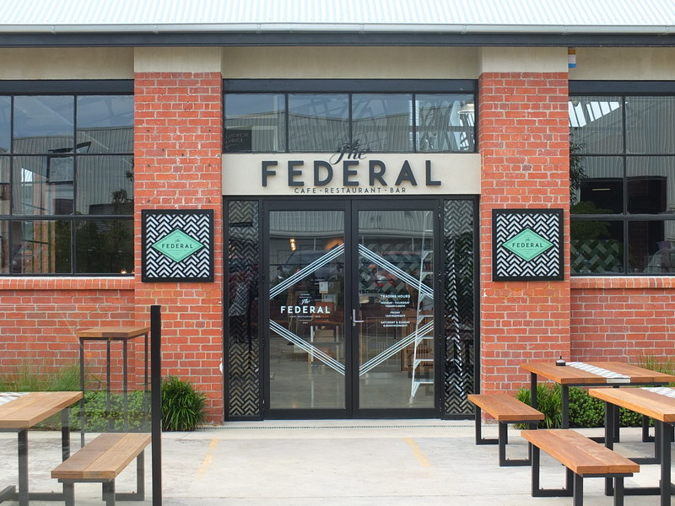
Exterior, café/restaurant adaptation, 2017. Source: David Rowe.
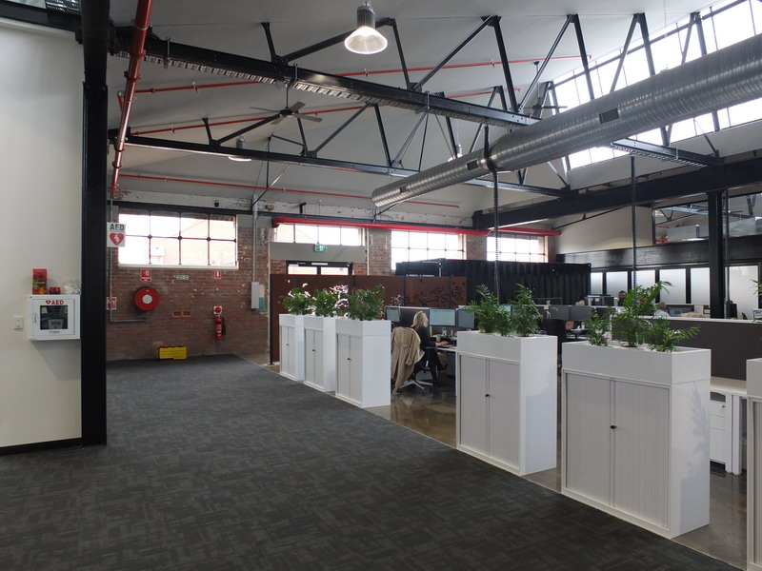
Office adaptation, 2017. Source; David Rowe.
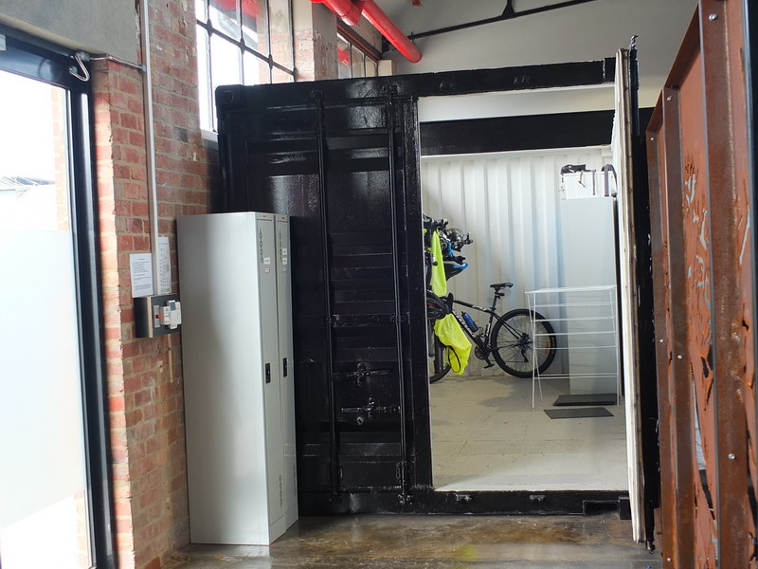
Former shipping container adapted into bicycle storage, 2017. Source: David Rowe.
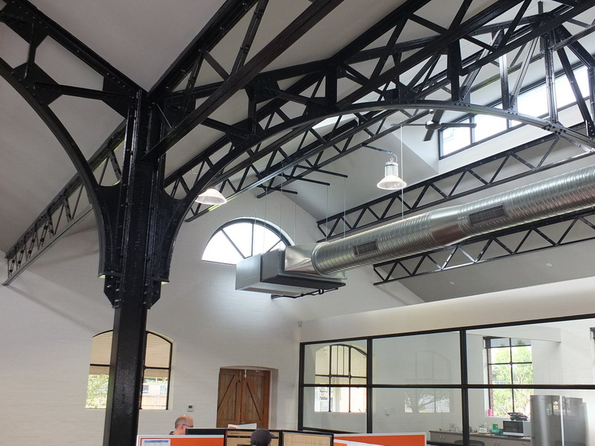
Office adaptation showing emphasis on original structure (the steelwork has been painted with three way rust inhibitor, primer and black paint), 2017. Source: David Rowe.
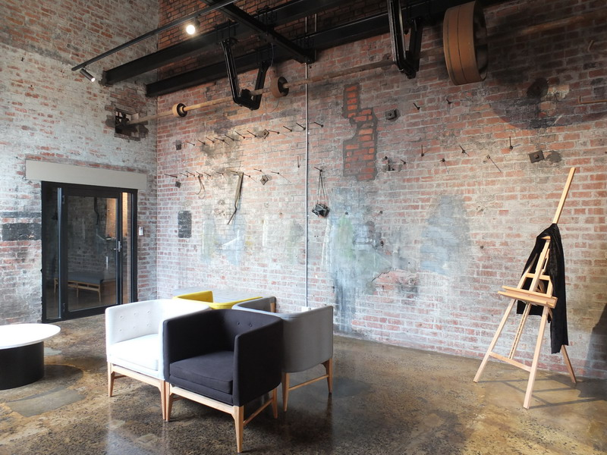
Photographic studio foyer, 2017. Source: David Rowe.
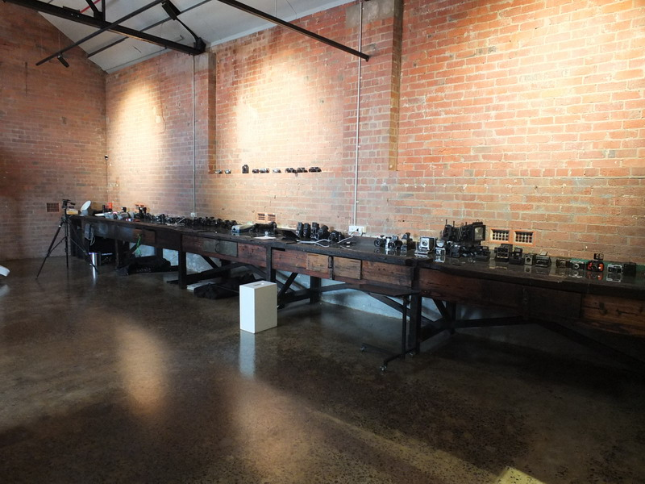
Photographic studio showing reuse of original timber work bench, 2017. Source: David Rowe.
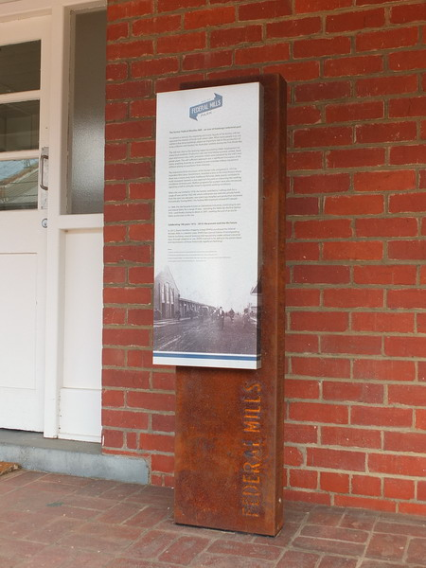
Interpretive signage, 2017. Source: David Rowe.

