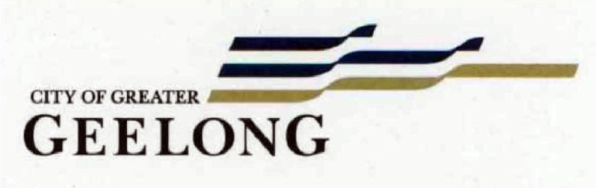

Nominations for the National Trust of Victoria (Geelong & Region Branch) & City of Greater Geelong Heritage Awards 2018

Award Nominations

- Dwelling, 59 Fairview Avenue, Newtown.

- Former Boat House, 20 Ozone Road, Barwon Heads.

- Former Belcher’s Corner building, 147 Ryrie Street, Geelong.

- Dwelling, 39 Cumberland Street, Newtown.

- ‘Brookville’, 28 Candover Street, Geelong West.

- The Hive Early Learning Centre (former Cunningham Hall & Memorial Library), 70-72 Portarlington Road, Newcomb.

- Barwon Paper Mills, Lower Paper Mills Road, Fyansford

- Dwelling, 59 Fairview Avenue, Newtown.
Category:
- Restoration of a Heritage Place

Works: Substantial repairs, additions, front fence
Significance: Contributory significance to the Bareena Estate Heritage Area.
Planner: Claire McVilly, pp 1139/15 bp BSU 23052/20160062/0
Owner: Damien Burns and Heidi Towill
Designer: Bryce Dowling Building Design, ph 0408 671 701 e: info@bdbuildingdesign.com.au
Builder: Not Known

The timber Edwardian styled dwelling at 59 Fairview Avenue was built in 1913-14 for W.N. Richardson, estate agent, who also had the neighbouring and similarly-designed dwellings at 53 and 55 Fairview Avenue built at this time. The house makes a significant contribution to the Edwardian and interwar residential area known as the Bareena Estate.

By 2015, the dwelling was in disrepair. Some repairs had been carried out but considerable restoration was required to ensure its long term future. In recent times, the roof has been replaced, weatherboards replace and the front verandah and original detailing reconstructed. The sympathetic restoration has greatly improved the appearance of this important dwelling. The rear contemporary additions and recessed garage have ensured the retention in the three dimensional integrity of the original dwelling given their subservience and respectful distinction. The flat timber picket front fence is also a contemporary interpretation of traditional design but like the additions, its streamlined design has allowed the heritage dwelling to remain the dominant feature when viewed from Fairview Avenue.

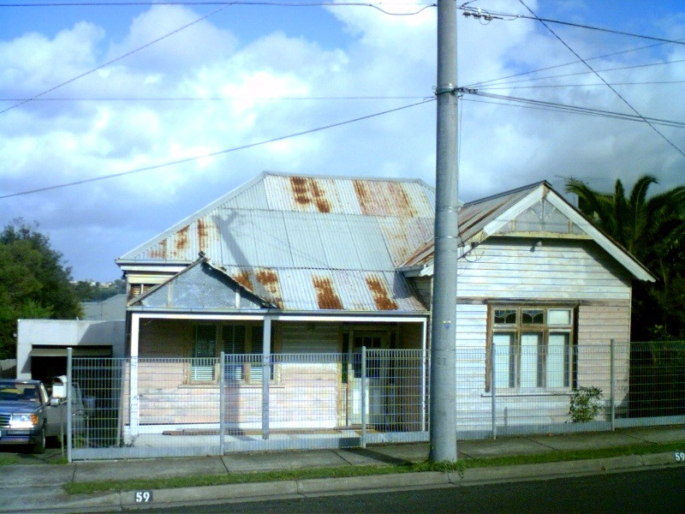
59 Fairview Avenue, 2007. Source: Kevin Krastins, Newtown Heritage Review 2009.
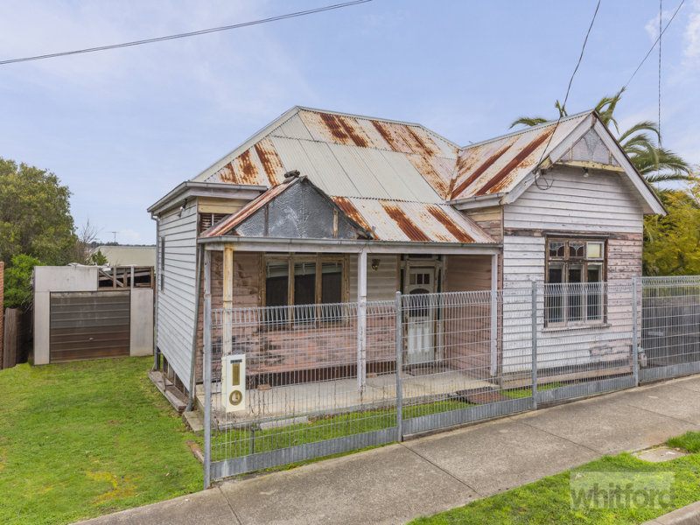
59 Fairview Avenue, 2015. Source: Whitford Real Estate at www.realestate.com.au

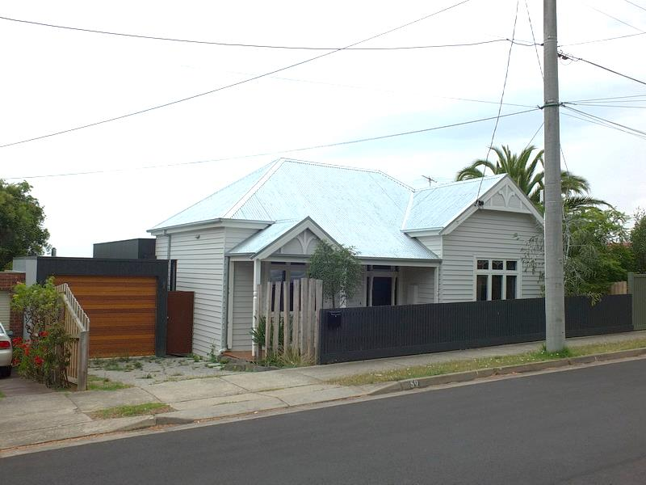
59 Fairview Ave, 2018.
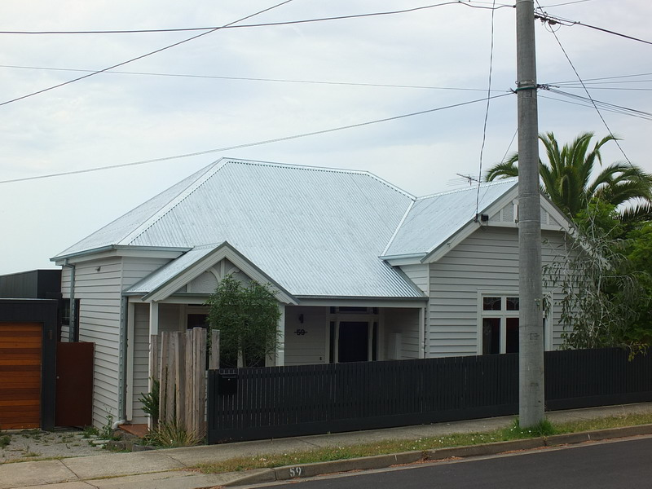
59 Fairview Ave, 2018.

- Former Boat House, 20 Ozone Road, Barwon Heads.
Categories:
- Restoration of a Heritage Place.
- Creative Reuse of a Heritage Place

Works: Substantial repairs, construction of new dwelling incorporating former boat house
Significance: Local significance.
Planner: Steve Roussac, pp 382/16, bp 1242/008239/2 REV1
Owners: Alexander and Wendy Gemmell, 43 William Street, Mt Waverley, 3149/ 20 Ozone Rd, Barwon Heads, 3227
Designers: Ron Riddle, Riddle Design Group ph 0411 954 056, e: ron_riddle@hotmail.com
Builder: Not Known

With the growing appeal of Barwon Heads as a tourist destination from the late 19th century, several boat house were built on the Barwon River foreshore. In 1905, the Geelong architects, Seeley and King, prepared a standard design for boat houses for the Geelong Harbour Trust. A second standard design was also prepared in c.1913. Although the drawing was signed by Harbour Trust engineer, A.C. Mackenzie, it is likely that this was the work of Thomas Seeley, architect. The reason for the standard design was to bring the boat houses along the foreshore up to a proper standard, improving the ‘nondescript class of boat sheds’ there.

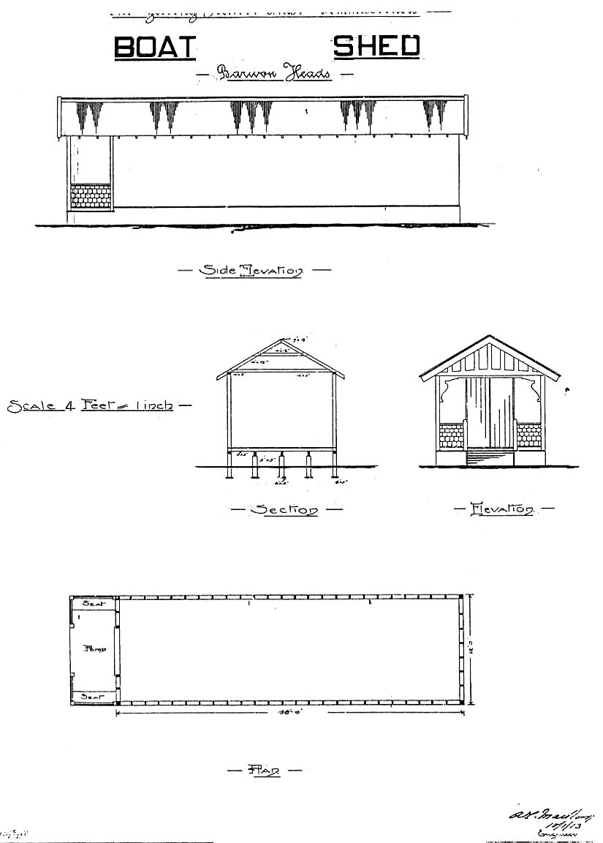
Geelong Harbour Trust, Standard drawing of boat house, 1913.
Source: D. Rowe, The Pleasure Grounds of the Barwon Coast: A History.

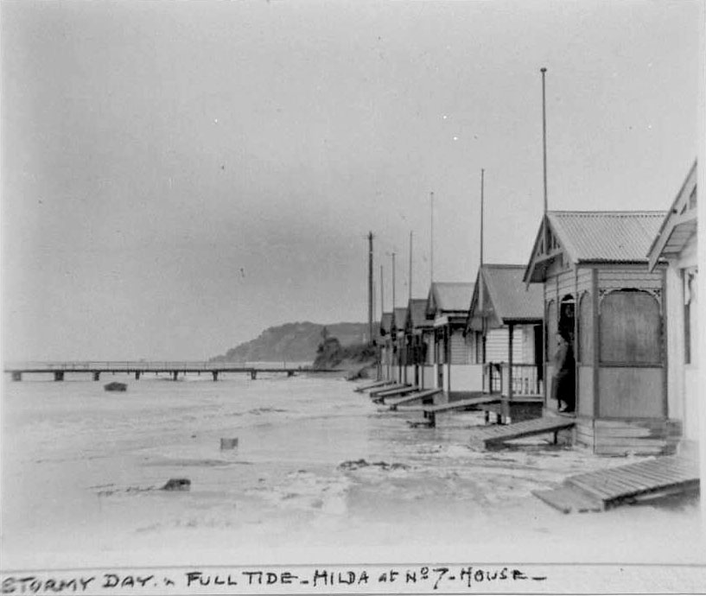
Boat houses on Barwon River foreshore, c.1930. Source: Susie Zada.

In 1925, John and Victoria Warren Watkins, carpenters of Richmond Street, East Geelong, purchased allotment 32 in Ozone Road, Barwon Heads, which formed part of the McArthur subdivision in 1916. It seems that the site remained vacant in the ensuing years. From 1920 until 1935, controversy had raged between local residents, the Harbour Trust, Health Commission and the Victorian State Government about the increased number of licenses issued for boat sheds, and that the beach was being overtaken. Some had electricity connected and were being used as holiday houses, and in 1920 Catholic mass was held at one of the structures. This led to the State Government introducing a uniform policy for the removal of boatsheds on coastal foreshore areas (apart from Port Phillip Bay) in 1936. The first boat shed to leave Barwon Heads was on 5 June 1936.

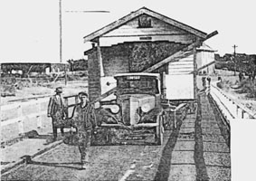
Boat House on Barwon Heads Bridge being transported to Ocean Grove. Source: The Sun 11 June 1936.

The need to remove the boat sheds from the Barwon Heads foreshore appears to have been the impetus of John and Victor Watkins, carpenters of Richmond Street, East Geelong, to relocate a boat shed to their block in Ozone Road, Barwon Heads. From 1957, the boatshed was owned by George Arthur Laird and his architect nephew, Ewen Laird, and they may have added a side extension. In 1959, Miss Jessie McKechnie, well-known and respected school teacher, purchased the property. Following her death in 1961, it passed to her nephew, Bill Howard and his wife, Barbara. They had a rear extension built in 1988.

In 2016, the previous additions (which had detracted from the character of the boat shed) were removed, and the boat shed was faithfully restored and integrated into a new dwelling. The interface with the boat shed, and the design and siting of the dwelling have ensured that the boat shed stands proud and is clearly distinguishable in the Ozone Road streetscape. While now part of a more substantial development, the early three dimensional composition and character of the boat shed has been retained. In doing so, an important part of the history of Barwon Heads has been protected into the future.

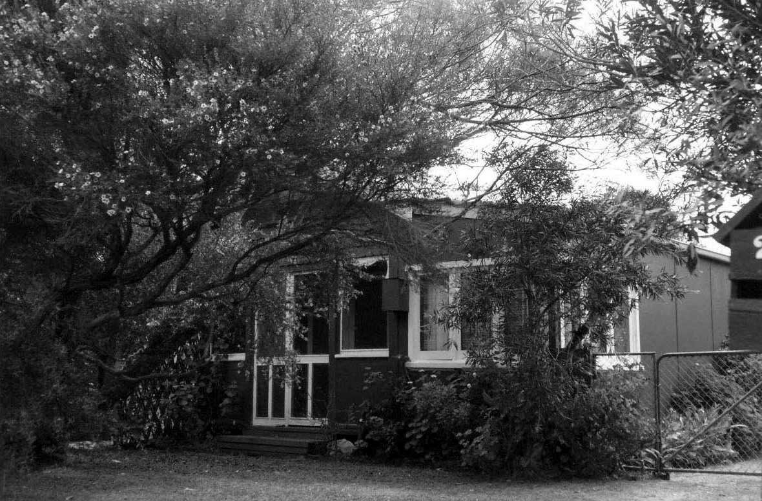
20 Ozone Road, 1998. Source: David Rowe.

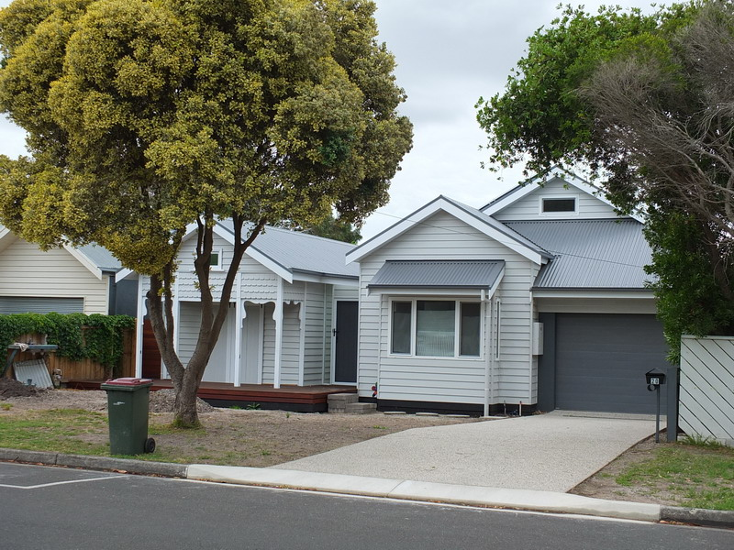
20 Ozone Rd, 2018.
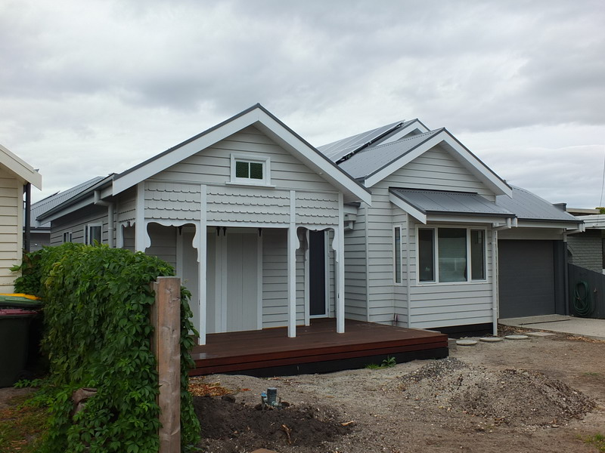
20 Ozone Rd, 2018.
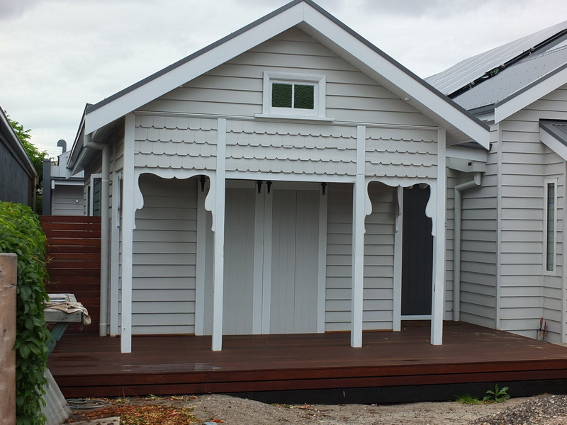
20 Ozone Rd, 2018.

- Former Belcher’s Corner building, 147 Ryrie Street, Geelong.
Category:
- Restoration of a Heritage Place

Works/Reason for Award: External painting, removal of introduced signage, new signage.
Significance: Local significance as included in the Greater Geelong Planning Scheme.
Planners: Verity Bright
Owners: Owners CorporationPS316440K, c/0 Mrs Leighanne Crocker, ph 0414 519 730, e: leighann.jackson@oze3mailcom.au, Suite 5, Level 1, 147 Ryrie St, Geelong 3220 [responsible for external painting]

Applicant for Cake Bar signage: Mr Kaiser Khater, ph 0410 681 428, e: kaisser@kayterco.com, 8 Adeline St, Rydalmere, NSW 2116 {talk to Leighanne about

In 1926, Norman Belcher, auctioneer and estate agent, commissioned the local architect, I.G. Anderson to design a new commercial building at the prominent north-west corner of Moorabool and Ryrie Streets. Construction commenced by J.C. Taylor and Sons of Geelong in the latter months of 1926. Although Anderson had originally envisaged a four storey building a less-preferred three storey option result, the first floor level providing office accommodation with shops on the ground floor. Constructed in rendered masonry and concrete, the interwar Modern Renaissance styled building, known as Belcher’s Corner, has a distinctive presence and is a local heritage landmark.

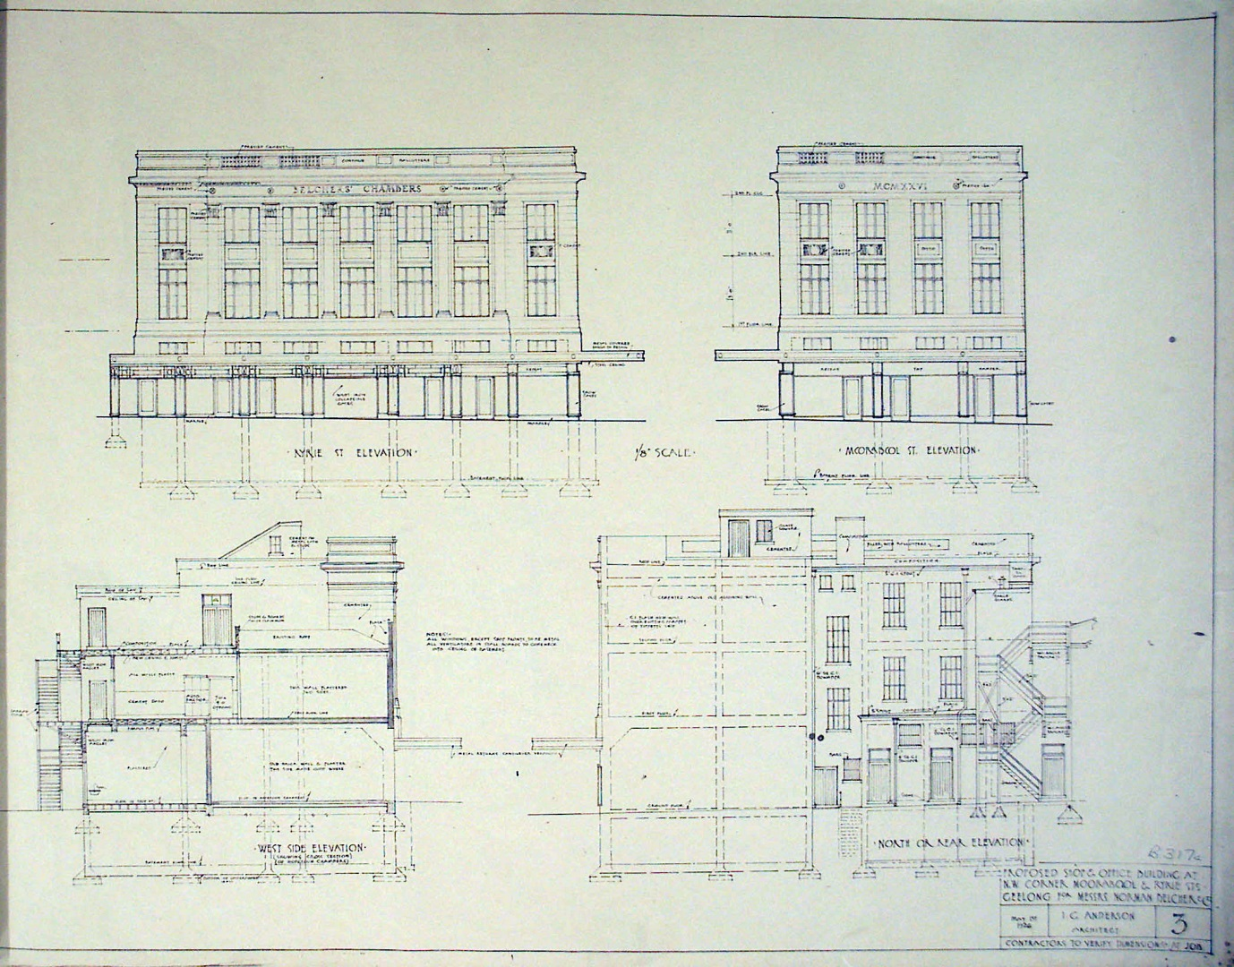
I.G. Anderson, Elevation & Section Drawings of Proposed Belcher’s Corner building, 1926.
Source: Geelong Heritage Centre maps and plans collection A152.

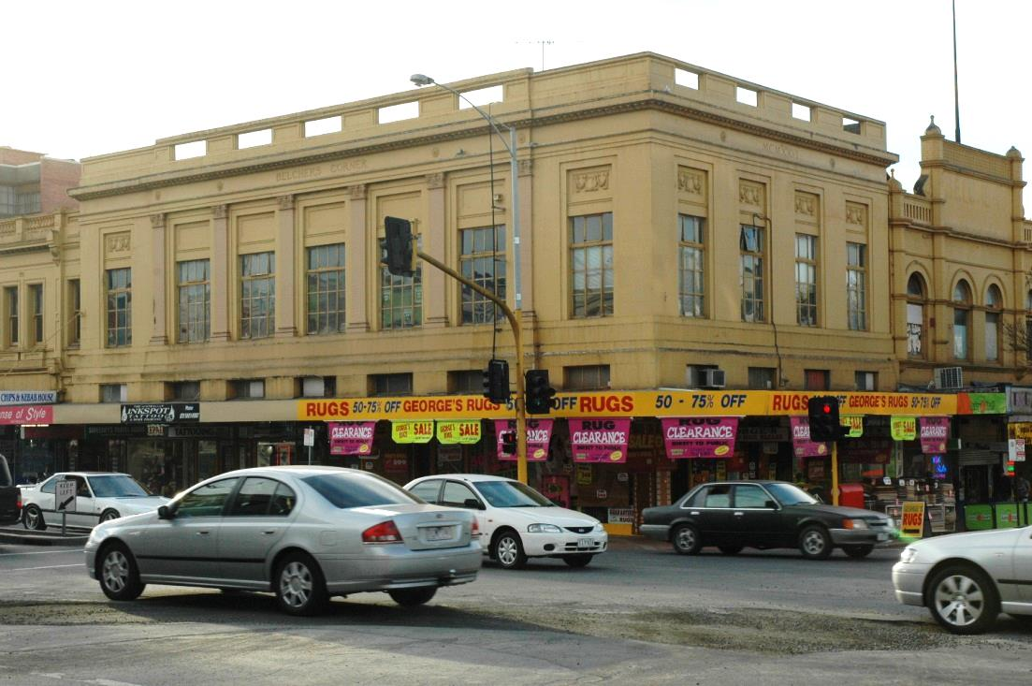
Belcher’s Corner, 147 Ryrie St, 2005.

For years, the exterior walls had been painted in an unfortunate pale yellow colour. Some years ago, the first floor windows and walls were painted in colours more applicable to the era and design of the building. However, the appearance of the building was undermined by the proliferation of signage over the shopfronts and verandah fascias, especially at the corner.

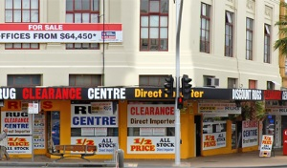
Detail of shopfronts & signage, 147 Ryrie Street, c.2015. Source: Google Maps (streetview).

In 2017, the shopfront windows were revealed once again, the ground floor wall surrounds painted in the sympathetic colour of the upper floor, and more restrained signage was installed. This has greatly enhanced the character of this important interwar commercial building in Geelong, and has created a talking point in the community about how the relatively simple task of external painting and the appropriate number and locations of signs can do much to improve and central City streetscape.

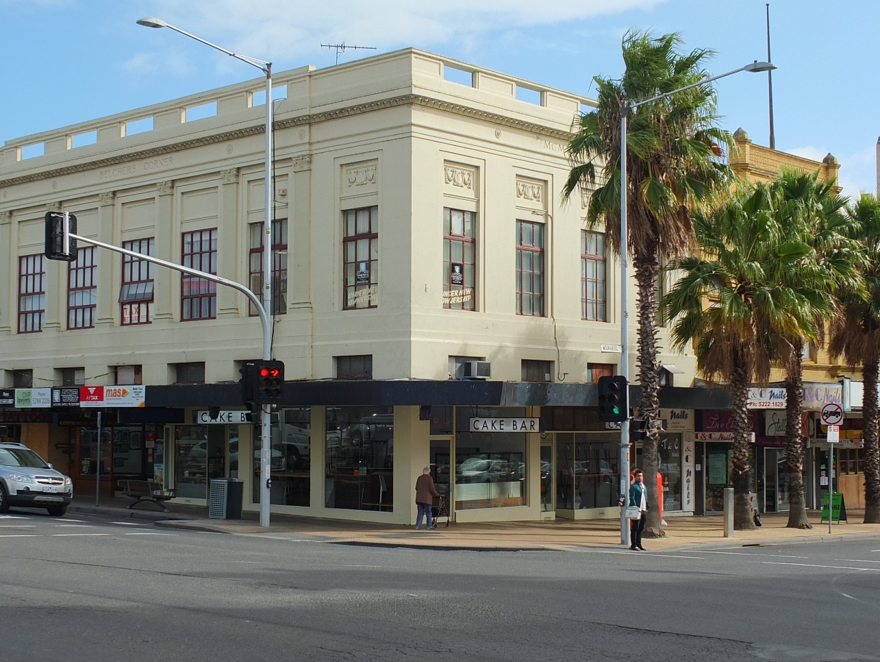
147 Ryrie St, 2018.

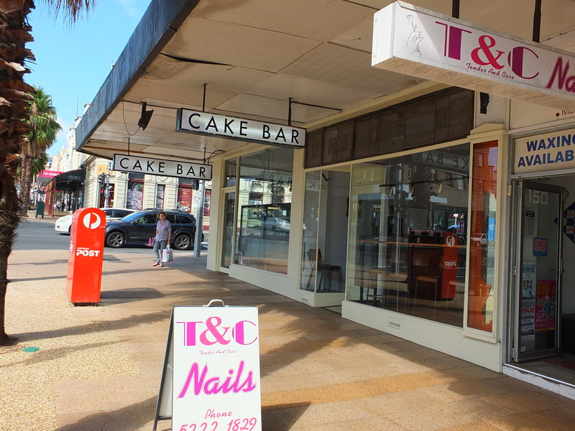
147 Ryrie St, 2018.

- Dwelling, 39 Cumberland Street, Newtown.
Categories:
- Restoration of a Heritage Place.
- Specialist Heritage Trade Skills.
Works: Tuckpointing and reconstruction of front brick fence.
Significance: Local significance as included in the City of Greater Geelong Planning Scheme.
Planner: Claire McVilly, pp 231/17
Owner: Mrs Christine Adelwohrer, e: cadelwohrer@gmail.com, 39 Cumberland St, Newtown 3220
Tradesperson: Nat de Palma, Kobrix Masonry

The dwelling at 39 Cumberland Street was built in 1926-27 for William Murphy, bricklayer. It is likely that he built the house himself. The interwar Bungalow design is distinctive for its brick construction, as especially identified in the clinker brick soldier coursing, clinker brick dados, and in the brick verandah piers.

The recent tuckpointing of the brickwork has greatly enhanced the distinctive character of the dwelling’s exterior. The reconstruction of the front brick fence has also enhanced the presentation of the dwelling to the street.

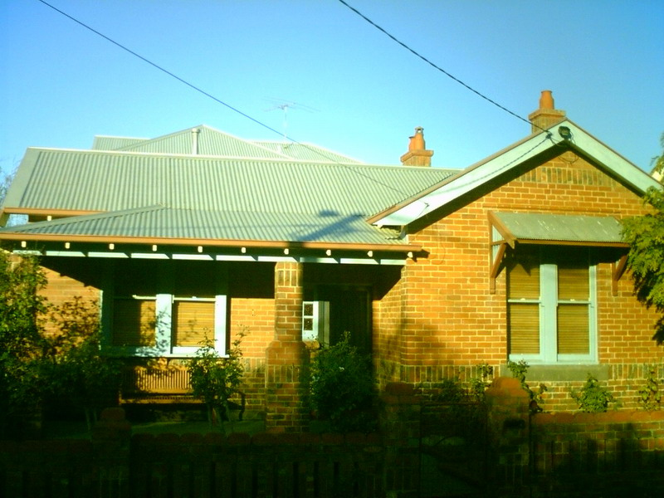
39 Cumberland St, 2007. Source: Kevin Krastins, Newtown Heritage Review 2009.

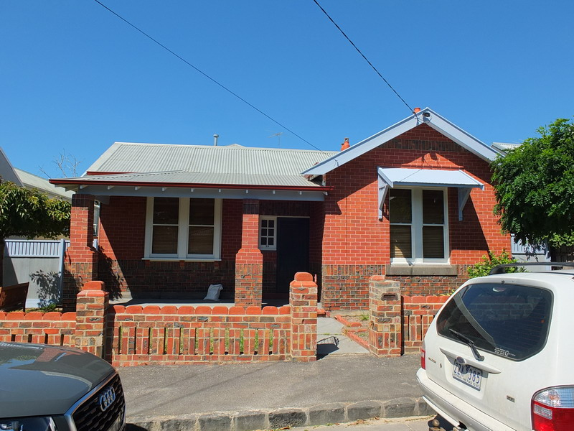
39 Cumberland St, 2018.
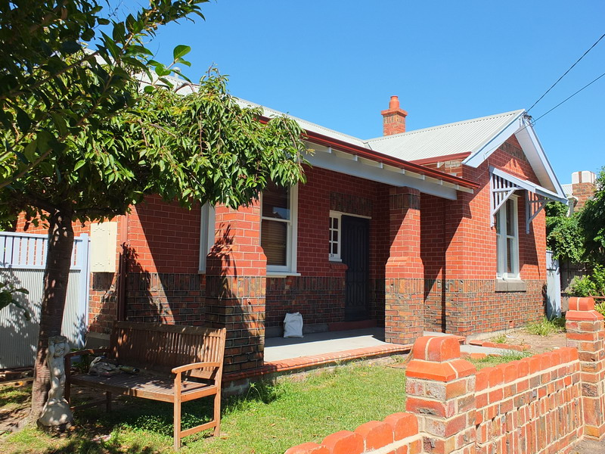
39 Cumberland St, 2018.

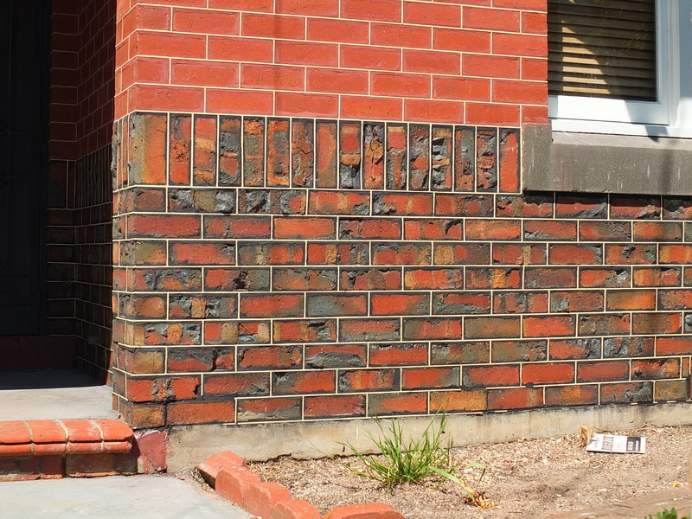
39 Cumberland St, 2018.

- ‘Brookville’, 28 Candover Street, Geelong West.
Categories:
- Restoration of a Heritage Place.
- Specialist Heritage Trade Skills.
Works: Major repairs, front verandah reconstruction, rear additions and front fence.
Significance: Contributory significance as part of the Waterloo Heritage Area
Planner: Steve Roussac, pp 1677/15, bp BS-L 34029 20160675/0, BS-U 23797/20160093/0
Owner: Samuel & Susie Bush, email: susiebush@gmx.com
Architect: Pati Seiler Architect, ph 0431 983 112, e: psiler@hotmail.com
Contractor: Paul Jenkinson, Modern Heritage Builders.

‘Brookville’ at 28 Candover Street was built in 1884-185 for Miss Sarah Homewood. The timber Victorian styled dwelling was designed with a hipped roof and symmetrical front façade with central front door and flanking windows, typical for the late 19th century. Originally, a feature of the dwelling was the front verandah. Possibly as earlier as the interwar (1920s-40s) era, the original front verandah had been replaced with a shallow-pitched, hipped roofed verandah supported by timber shingled piers and square posts. There was also shingled balustrades. A low cream brick fence had been added in the 1960s. These changes detracted from the original Victorian design.

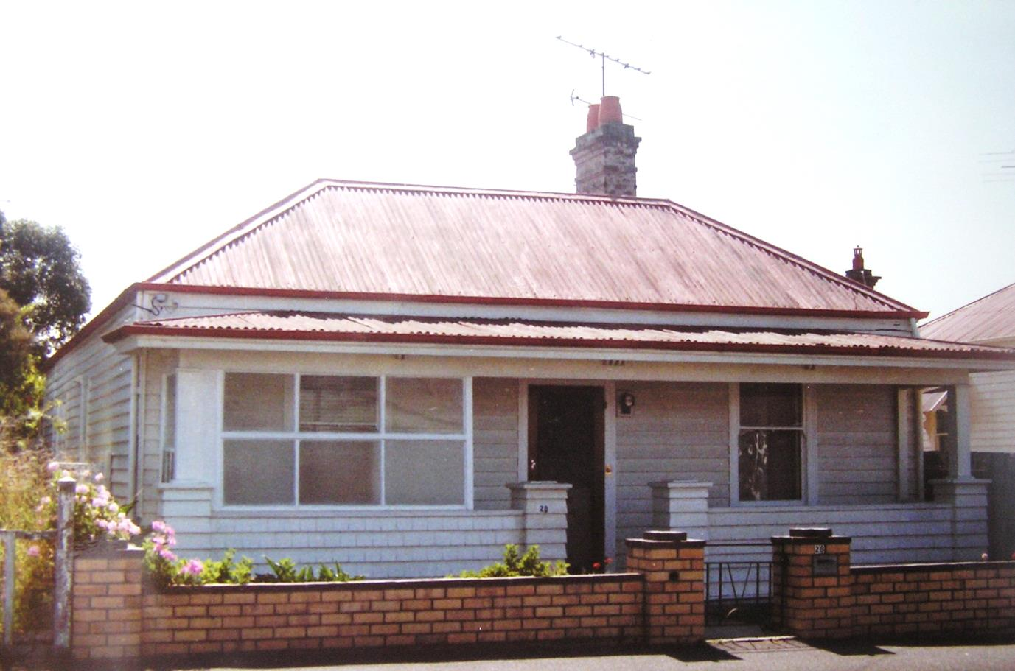
28 Candover St, 1986. Source: Honman, Huddle & Aitken, Geelong West Urban Conservation Study.

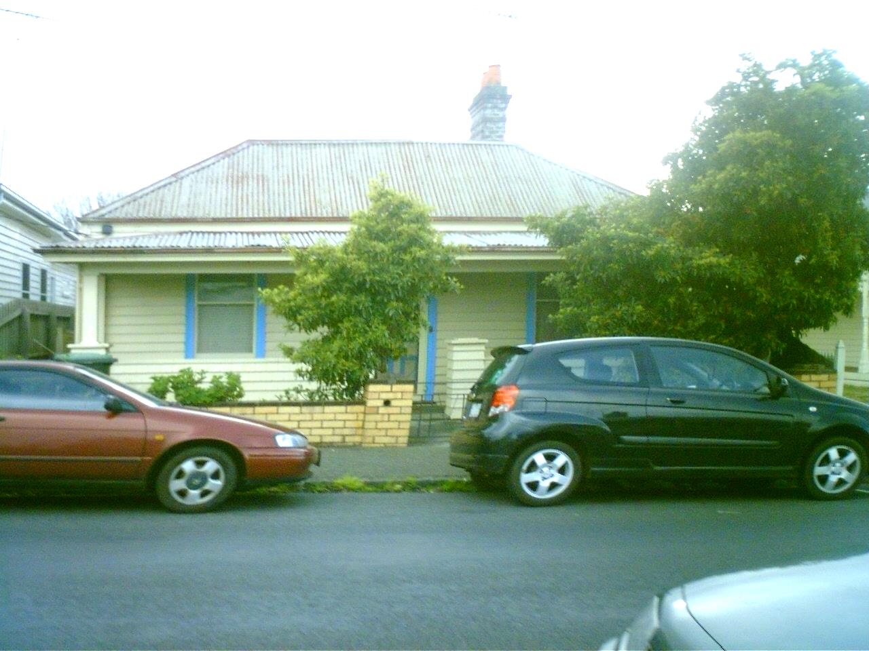
28 Candover St, 2008. Source: David Rowe.

By 2015, the dwelling was in a state of disrepair but there was sufficient fabric and potential for it to be repaired and original details reconstructed. In the absence of any historical photographs of the dwelling, a photo of a similarly-designed Late Victorian house in Lawton Avenue formed a basis for the reconstruction of the front verandah and front door. Considerable restoration as carried out to the dwelling, including restumping, recladding and a new verandah floor. Contemporary, single storey additions were built at the rear, distinguishing old from new, but without any negative heritage impacts given that the original front three dimensional integrity of the dwelling was retained and the additions are hardly visible from Candover Street. A new front timber picket fence and gate was also built at the front. The result has been dramatic: the works having greatly transformed ‘Brookville’ to what appears to have been its original appearance as much as possible and with the rear additions, has ensured that it has a viable future.

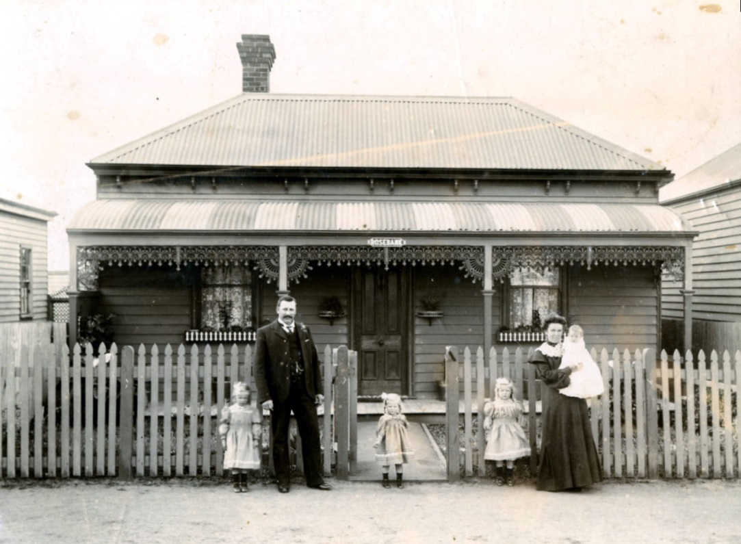
“Rosebank”, 28 Lawton Ave, c.1900. Source: Emerald Museum.

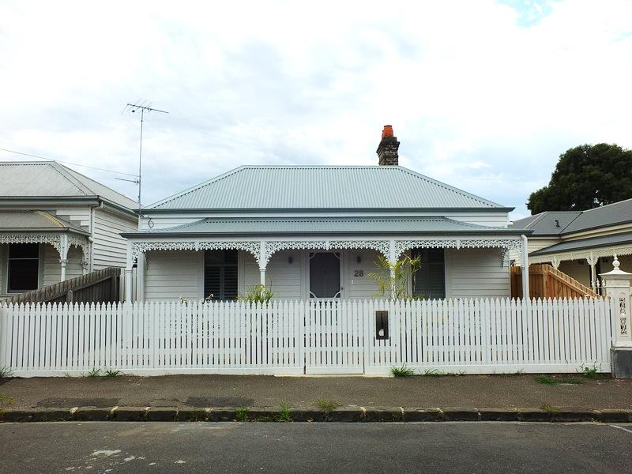
28 Candover St, 2018.
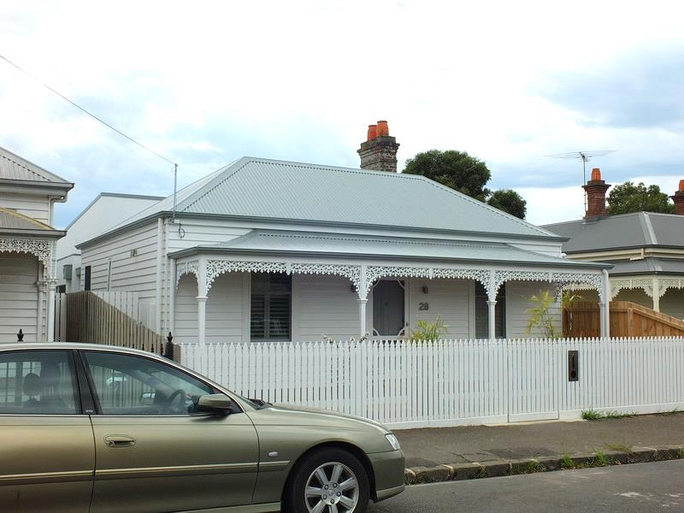
28 Candover St, 2018
6. “The Hive” Early Learning Centre (former Cunningham Hall & Memorial Library), 70-72 Portarlington Road, Newcomb
Categories:
- Restoration of a Heritage Place.
- Creative Reuse of a Heritage Place.
Planner: Ann Gove (Heritage Victoria), Steve Roussac, pp1403/15, bp 1100/20170152/0V1
Works: Restoration and respectful adaptation of former hall and library into an early learning centre.
Significance: State significance as included on the Victorian Heritage Register
Planner: Ann Gove (Heritage Victoria),
Owner: Mr Duke Fonias, 214 Booran Rd, Ormond, 3204
Designer: Daniel Galtieri, Architecton Pty Ltd, ph 041 610 475 e: daniel@architecton.com.au

In 1888, Richard Cheetham, a manufacturing chemist, established saltworks at Moolap on 650 acres of land leased from the Crown. The saltworks were modelled on examples in the south of France. The business was highly successful, prosperous and enduring. In 1890, the retired bank manager, Alexander W. Cunningham joined the company and provided financial backing. Following his death in 1916, a brick hall was opened in 1921 in his memory for use of the Cheetham Welfare Club. Built on the south side of the Portarlington Road, A.W. Cunningham’s son, Andrew Hassell Cunningham, a Managing Director of Cheetham Salt, gave a speech where he “appreciated the references to his late father’s part in the formation of the salt works and was gratified at the naming the hall to perpetuate his father’s memory as a founder of the company.” Tragically, just 2.5 months after the opening of the A.W. Cunningham Memorial Hall, Andrew Cunningham passed away. Efforts were then made to honour his memory with the construction of a Memorial Library wing on the west side of the hall. Tenders were called by the local architect, Fred Purnell, in 1922 and so it is assumed he also designed the hall. The A.H. Cunningham Memorial Library was opened in July 1923 by the Managing Director (and brother of A.H. Cunningham), A.J. Cunningham.

The single storey face brick building has hipped roofs clad in terracotta, with a recessed linking entrance bay. Both wings are similarly-designed, although the variations in the timber framed windows give a subtle indication that they were built at different times. The Memorial Hall and Library building has State significance for its historical associations with the early and highly important salt industry – and particularly two of its founding and early Managing Directors, A.W. and A.H. Cunningham, and the provision of recreational and educational facilities for the employees of Cheetham Salt Pty Ltd. Architecturally, the buildings are a distinctive example of transitional Late Federation and early interwar design by Fred Purnell.

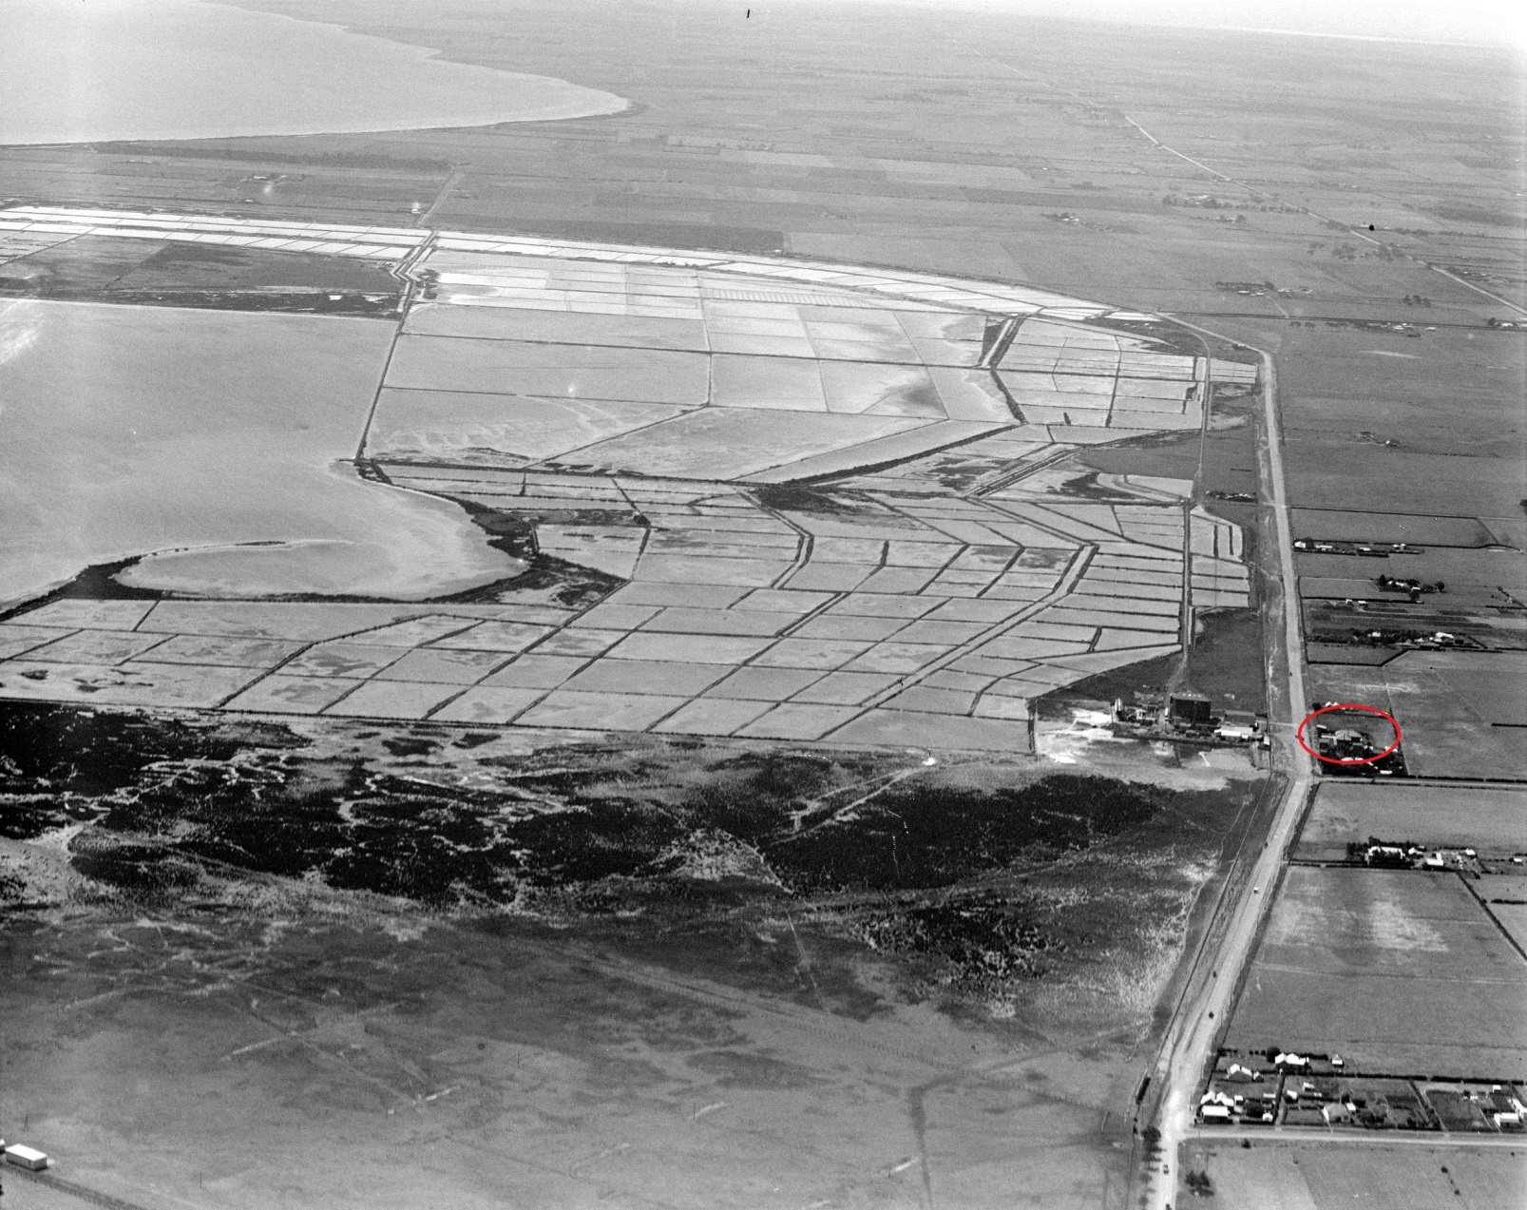
C. Pratt, Aerial view of Cheetham saltworks (the Cunningham Memorial Hall & Library is circled in red on the right), c.1927. Source: State Library of Victoria, H2000.222/9.

For many years, the Cunningham Memorial Hall and Library has been languishing without a viable use. Although a damp proof course was installed around 15 years ago, the building fell into disrepair. In recent times, this important building has been given new, vibrant and relevant use as an Early Learning Centre. Contemporary, single storey, flat-roofed additions had been constructed and linked to the old building as part of its adaptation. These additions are subservient, providing a respectful distinction with the heritage fabric. New landscaping and fencing has been introduced and significantly, the historic building has been repaired and minor modifications made to the front entrance to meet current needs and legislative requirements. The outcome has created a new future for the heritage building that continues to dominate the site today.

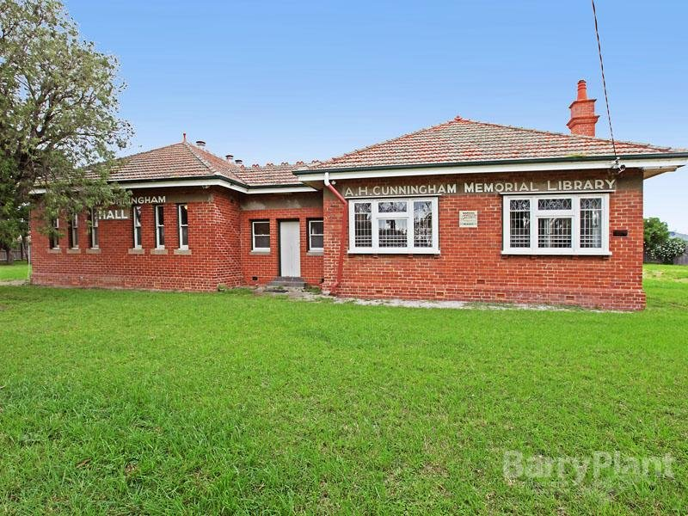
Cunningham Memorial Hall & Library, 70-72 Portarlington Rd, 2013. Source: Barry Plant Real Estate, www.realestate.com.au

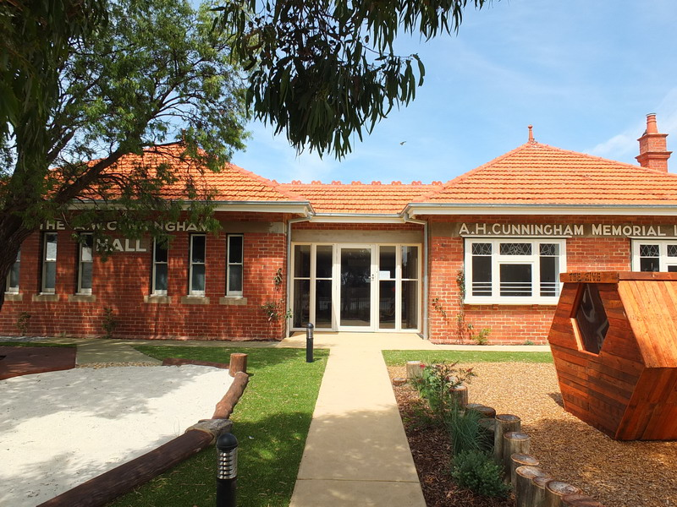
Cunningham Memorial Hall & Library, 70-72 Portarlington Rd, 2018.

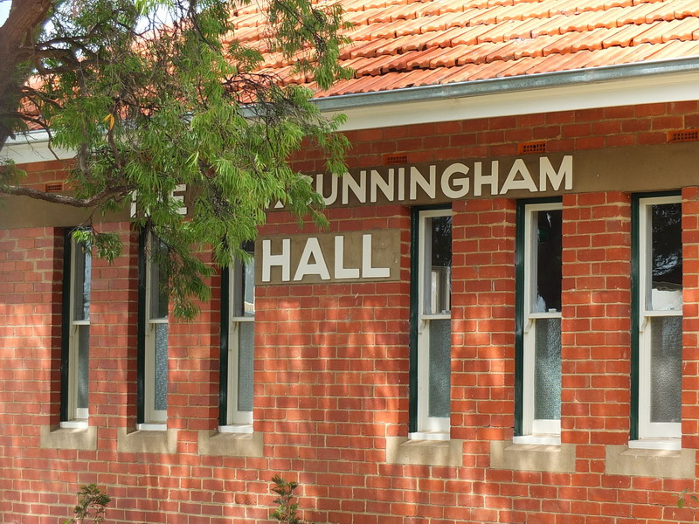
Detail of Cunningham Memorial Hall front elevation, 2018.

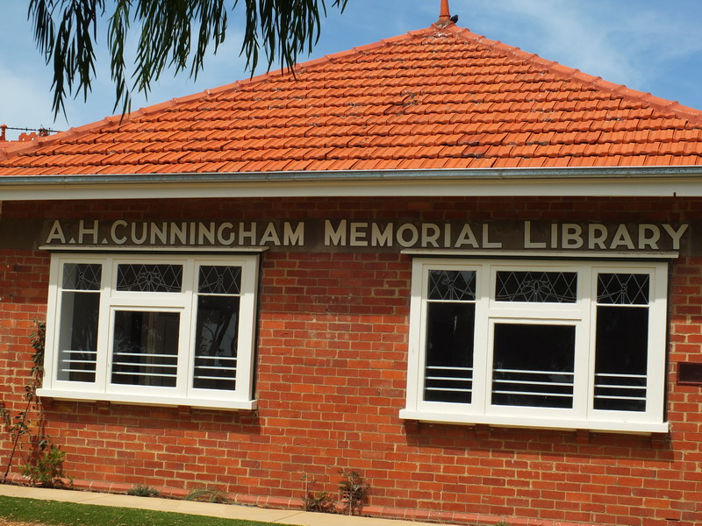
Detail of Cunningham Memorial Library front elevation 2018.

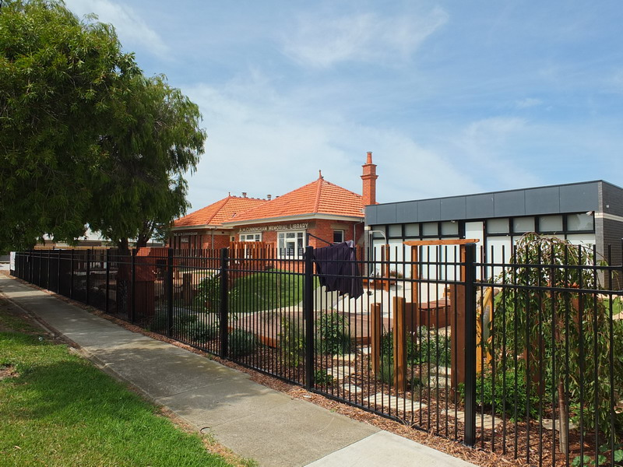
The Hive Early Learning Centre, 2018.

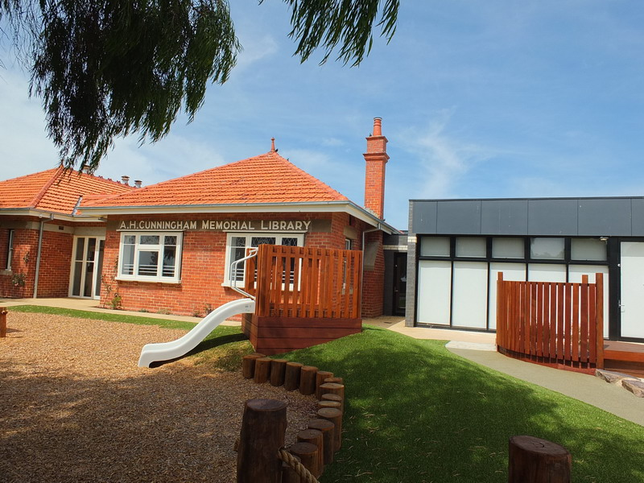
The Hive Early Learning Centre, 2018.

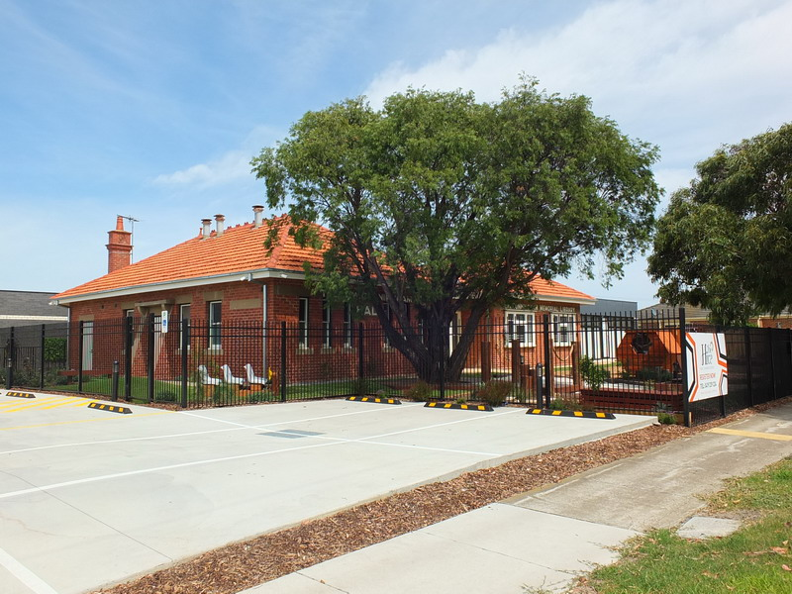
The Hive Early Learning Centre, 2018.

7. Barwon Paper Mills, 100 Lower Papers Mill Road, Fyansford
Categories:
- Restoration of a Heritage Place.
- Creative Reuse of a Heritage Place.

Works: Respectful Adaptation and restoration of Industrial Buildings into café, arts precinct, and winery, cellar door and function space.
Significance: State significance as included on the Victorian Heritage Register
Planner: Ann Gove (Heritage Victoria), Lisa Tanev (City of Greater Geelong), pp966/2016, bp COM/2017/340
Property Owner: Alex Robins, mob 0409 430 772
Business Owners: Scott Ireland, Melbourne Wine Company (recently opened winery & cellar door known as “The Mill – Provenance”, ph. 5272 2362 mob 0418 348 108
Consultants:
Designer: Croxon Ramsay, ph 6429 1005

In 1875, the Scottish engineer, Andrew Millar, was granted the mill site at Fyansford, and the right to operate a mill race on the Barwon River as part of a Paper Mill complex. According to the Geelong Advertiser, Millar went to England where he purchased ‘the latest and best machinery’ for the venture. This machinery arrived in December 1876 and work commenced on the mill buildings soon after. The substantial bluestone and brick mills buildings, a work and timber and iron office, where erecting a the sloping 6.5 acre site. A stone manager’s house and row of workers’ cottages were also constructed, to a design by the prolific Geelong architect, Joseph Watts. In 1877, the mill race was constructed, being a unique engineering feat. A water turbine, supplied the Belfast firm, McAdam, was the principal power source that drove the milling machinery. It was that the turbine was the largest in the colony in 1878, and remained in use until the introduction of hydro electricity in 1939.

Paper production commenced at the paper mill in August 1878. It was one of only a few paper mills establish in Australia, and produced paper for approximately 45 years. The complex is one of the most complete example of its kind given the surviving mill buildings, manager’s house, workers’ cottage and stone water race and weir.

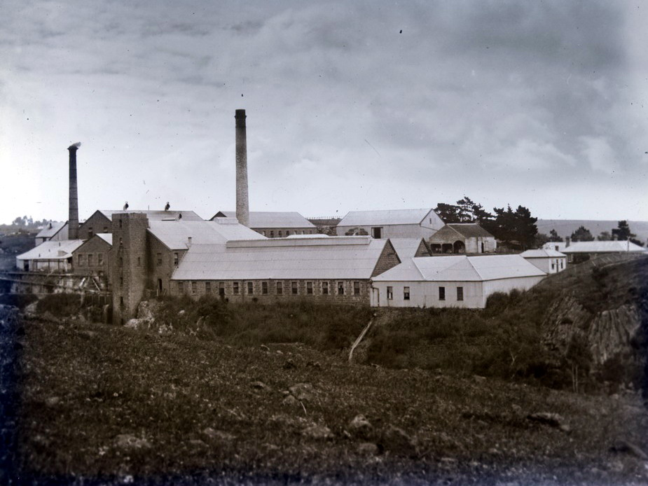
Barwon Paper Mill complex, 1875-1938.
Source: J.H. Harvey, State Library of Victoria, H2009.100/426.

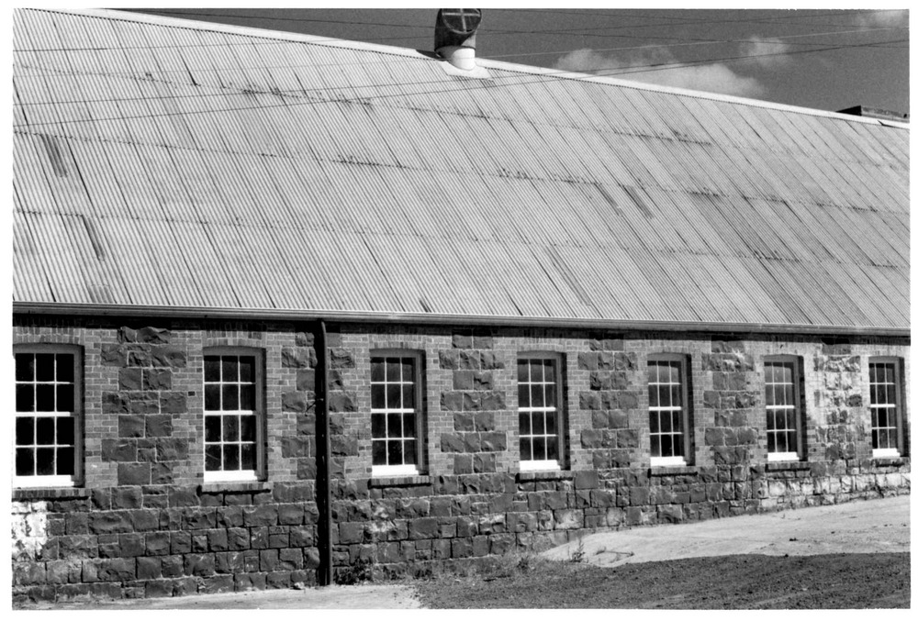
Barwon Paper Mill, 2 December 1978.
Source: J.T. Collins, State Library of Victoria, H96.210/317.

In 2015, the owner of the mill complex, Alex Robins, proposed an arts precinct, function centre and café. The main mill building was leased to art tenants who carried out the restoration of their studio spaces whilst retaining the essential fabric and character of the place. Other developments within this arts precinct have included an mosaic workshop, art gallery (“UBU Gallery”) and “The Door Gallery Café”.

In 2016, Scott Ireland commenced work on the adaptation and restoration of the former Machine Room, Paper Store and Finish Room into a winery, cellar door and function space known as “The Mill – Provenance.” In disrepair, the Machine and Finishing Room are constructed of bluestone and brick, the Paper Store being of corrugated steel construction. Like the adaptation of the main mill building, the key principal behind the adaptation has been to conserve as much historic fabric as possible. The structures have been stabilised, corrugated galvanised steel roofs and walls patched, and where the fabric has been beyond repair (such as rotted and missing timber window frames), they have been replaced “like for like” to match existing. Some modifications have been required to meet current legislative requirements (including the new entrance door with steel framed canopy, installation of amenities, and new reinforced concrete floor slabs over early concrete floors) but the buildings have retained their integrity.

The adaptation and conservation outcome at the Barwon Paper Mills has been remarkable. Not only have the different developments ensuring the longer term viability of the mill complex, they celebrate and interpret the heritage significance of the place in a meaningful and enduring way. This adaptation has created a benchmark for the redevelopment of other industrial heritage places across Victoria.

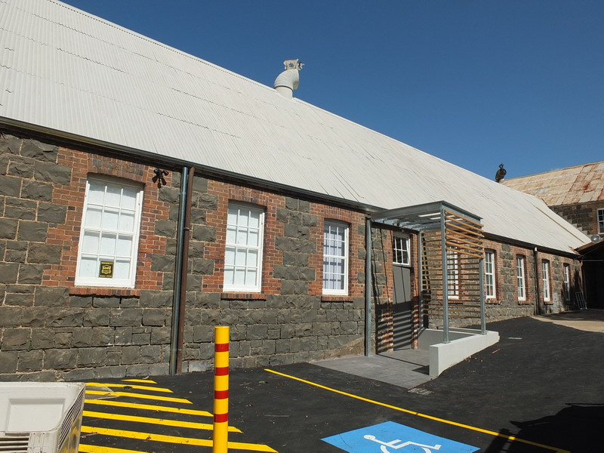
Exterior (north elevation), 2018.
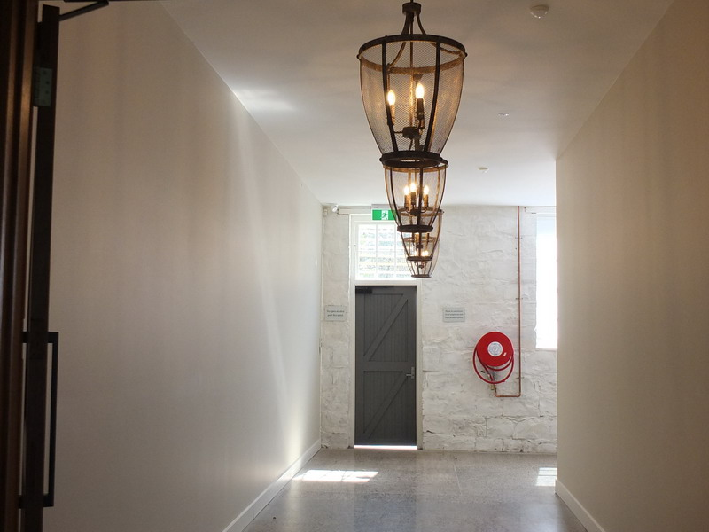
Entry to cellar door/function space, 2018.

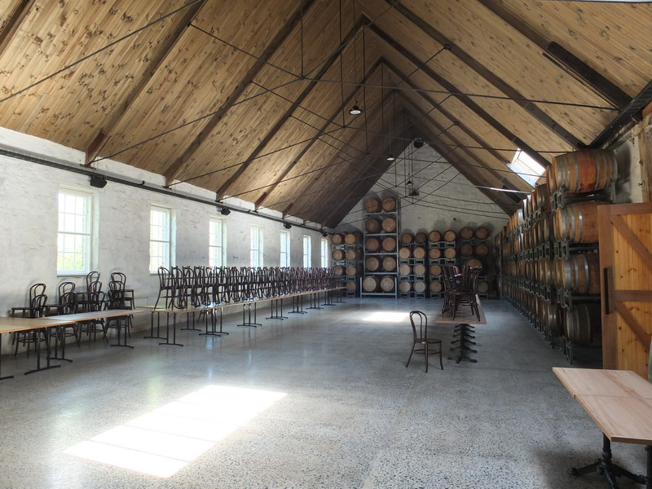
Main Function Space, 2018.
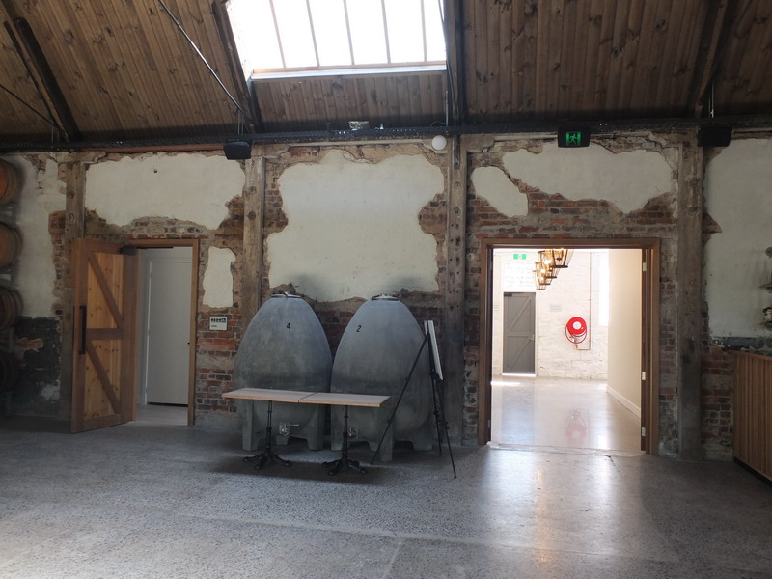
Wall and door opening detail, main function space, 2018.

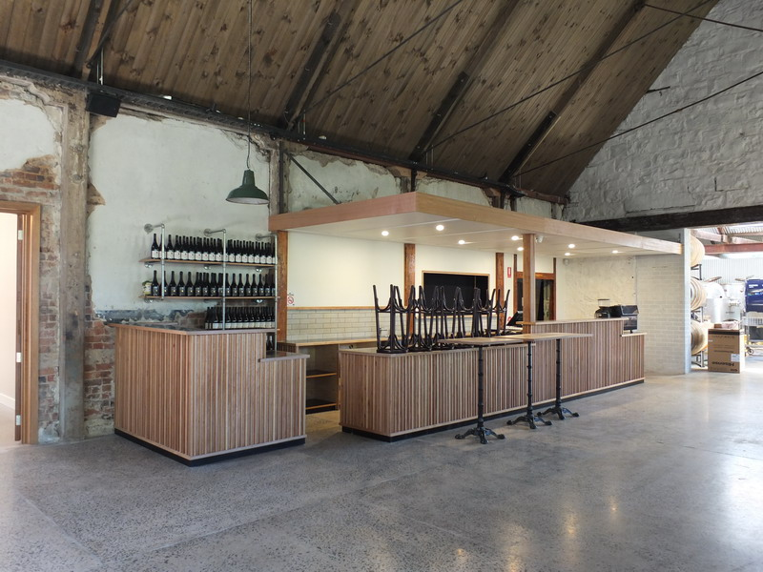
Cellar door/wine tasting area, 2018.
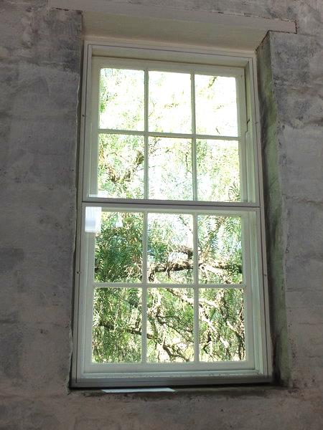
Window detail showing secondary glazing, 2018.

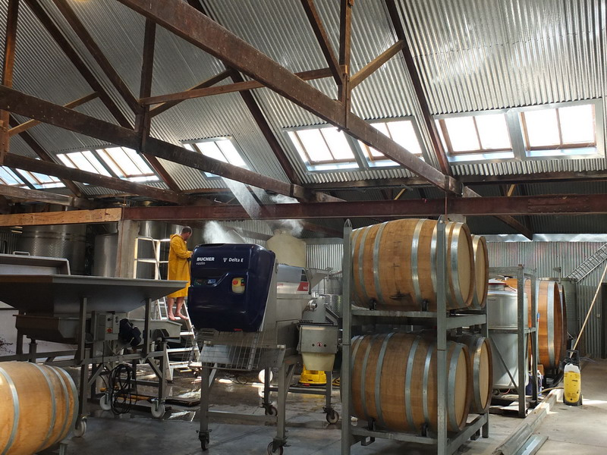
Winery interior, showing early exposed timber trussed roof structure and corrugated galvanised steel ceiling lining (disguising insulation), 2018.

