

National Trust of Victoria (Geelong & Region Branch)
&
City of Greater Geelong

Heritage Awards 2023

- Strathcona, 2-4 Ascot Street, Newtown

- Dwelling, 93 Prospect Road, Newtown

- Village 11 Cinema, 192-194 Ryrie Street, Geelong.

- Geelong West Grandstands, West Oval, Church Street, North Geelong.

- Former Richardson’s Garage, 151 Mercer Street, Geelong.

- Former Portarlington Post Office, 1 Harding Street, Portarlington.

- Grand Hotel, 76 Newcombe Street, Portarlington.

- ‘Strathcona’, 2-4 Ascot Street, Newtown.
Category:
- Restoration of a Heritage Place
- New Work in a Heritage Overlay

Works: Partial demolition, restoration, alterations & additions, garage and fencing
Significance: Regional significance, HO1923
Planning Application: 206/2020, 239/2020
Planner: Sophie Williams (dwelling), Phil Mabbs (garage)
Owner: Sheri and Hayden Gross
Architect: Brendan Henry (garage)
Builder: Hayden Gross

Strathcona was designed and constructed in 1900 by the pioneering Geelong building firm, Purnell and Sons, the patriarch being William Purnell (1831-1904). Tonight gives us an opportunity to appreciate the work of this firm. William Purnell senior He arrived in Melbourne in 1851 and later travelled to Geelong where his brother, Joseph, had settled. Having trained as a carpenter, William Purnell formed a building firm in partnership with A.C.S. Clutterbuck, and when this partnership dissolved in 1876, the building firm of Purnell and Sons was established.

Possibly responsible for the design of ‘Strathcona’ was William’s son, Frederick Charles Purnell. He was educated at Geelong College before studying architecture and joining his father and brother as an architectural draftsman. He travelled extensively during his architectural studies, and was a Fellow of the Australian Institute of Architects. In 1899 he enlisted in the Geelong militia battery of the Garrison Artillery. During the First World War he commanded the A.I.F. Camp at Geelong Racecourse, was promoted through the ranks to that of Lieutenant-Colonel by 1917, and served in France in the initial tank service until January 1919. After the war, Frederick became the first Secretary of the Geelong and District Branch of the Town Planning Association which formed in 1924. Yet, he was best known for his architectural designs throughout the early 20th century.

It originally had a frontage to Noble Street and is notable for its picturesque roof forms and timber verandah decoration. It was the Purnell firm’s “display home”, giving prospective clients the opportunity to inspect and select different roof forms, chimneys and architectural details.

Works carried out:
- External repairs.
- Basement alterations.
- Rear additions that complement the unique design.
- Restoration, alterations and adaptation of an outbuilding.
- Construction of a garage of complementary design and construction as ‘Strathcona’
- Fencing and gates

Overall, the extensive and painstaking restoration, and the new work celebrates the unique Edwardian design, ensuring that ‘Strathcona’ will have a viable future as one of the more important works of the Purnell family firm of builders, merchants and architects. It is a credit to Hayden for his passion for respecting the design and construction of this property in this high quality outcome.

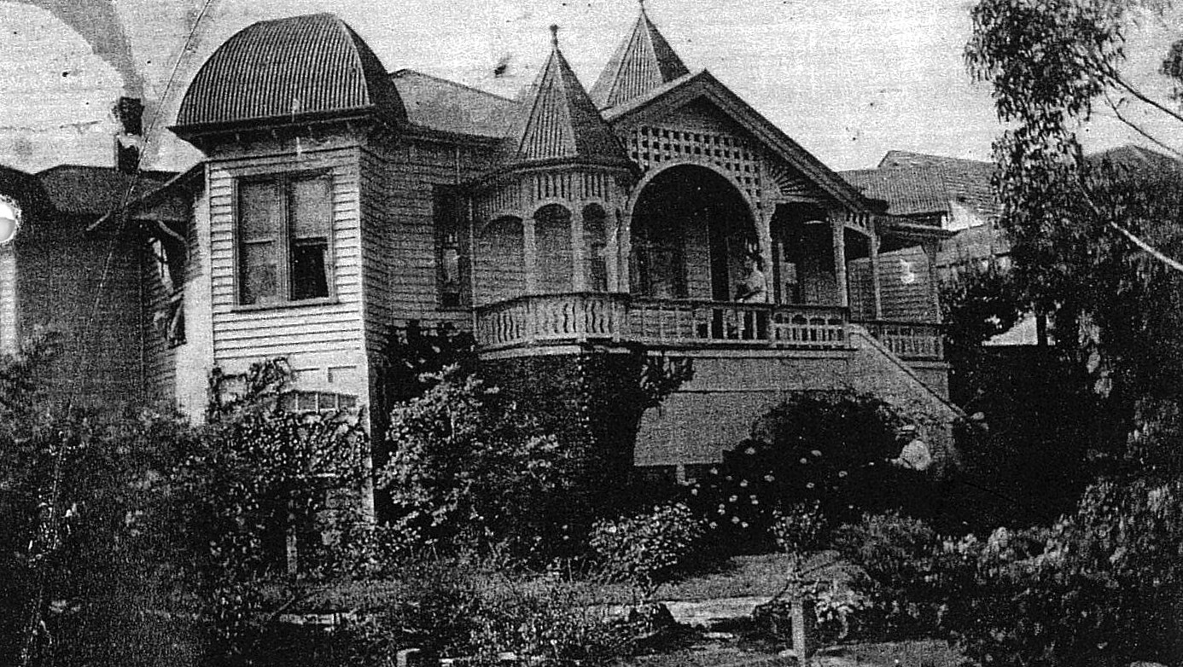
‘Strathcona’, 2-4 Ascot Street, c.1930. Source: City of Greater Geelong.

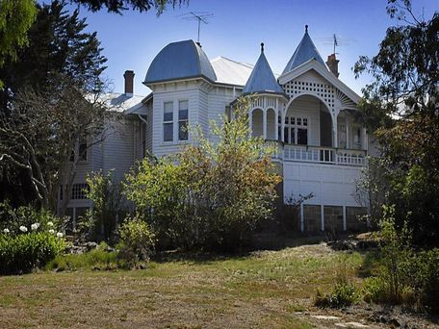
‘Strathcona’, 2010. Source: City of Greater Geelong.

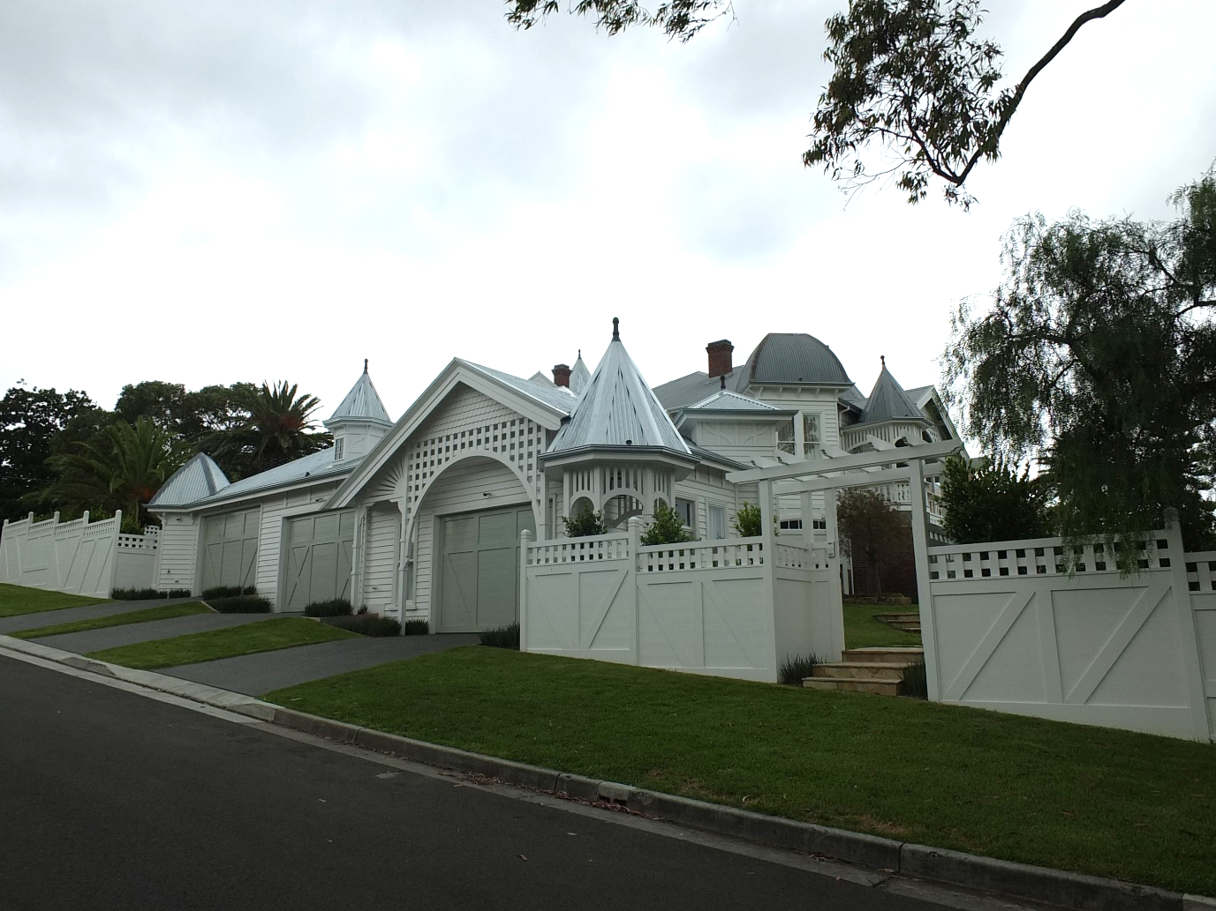
‘Strathcona’, 2022. Source: David Rowe.

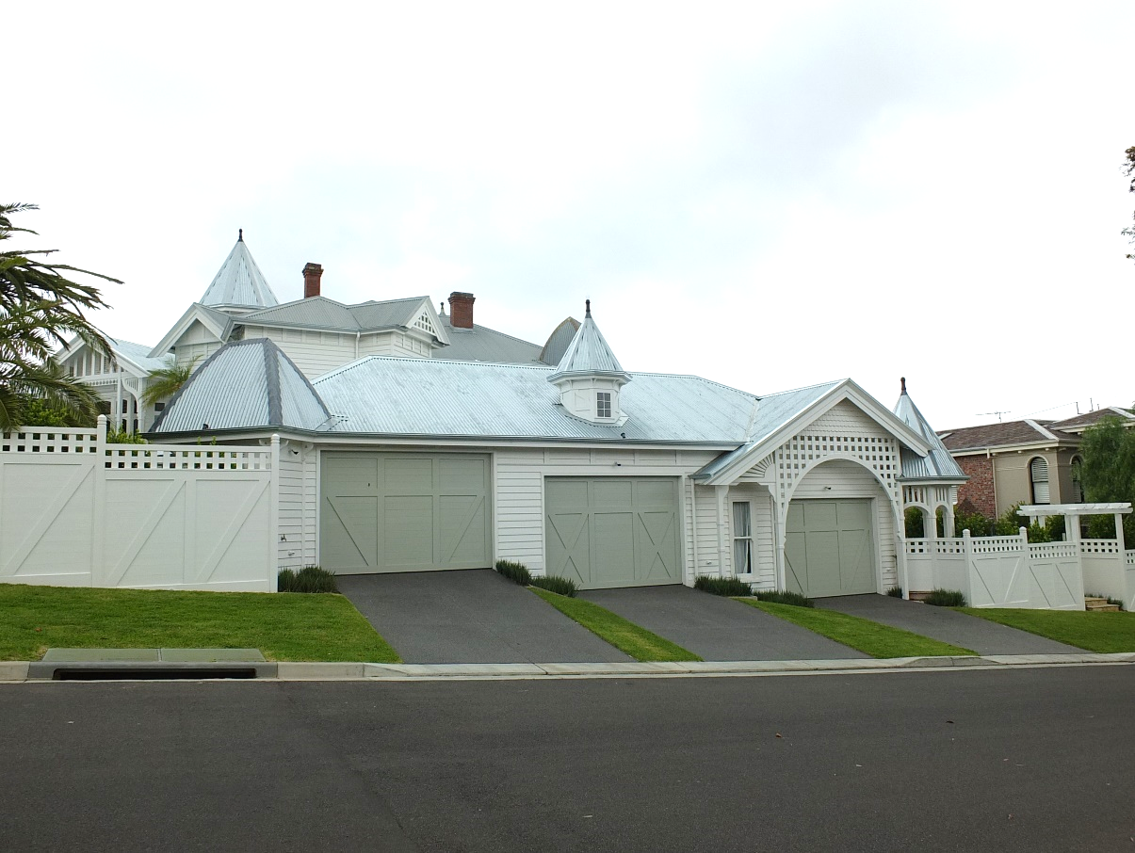
‘Strathcona’, 2022. Source: David Rowe.

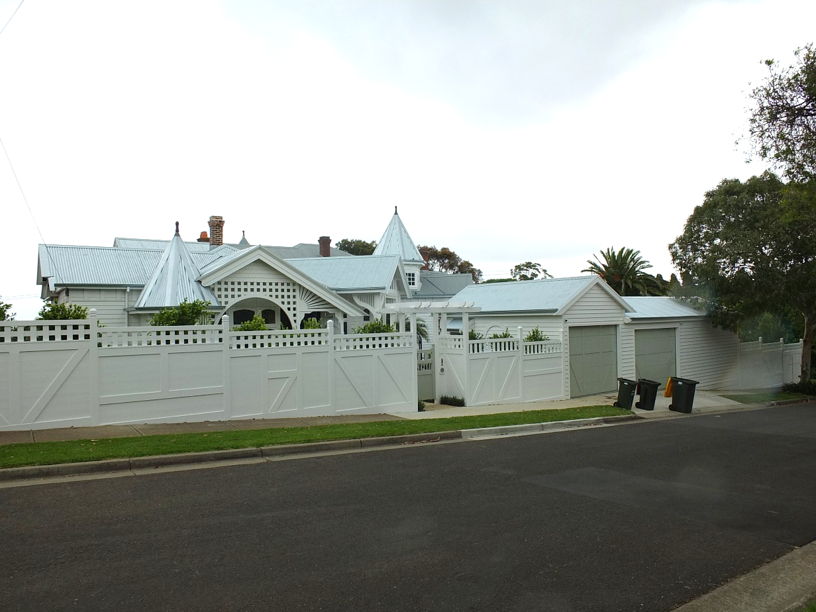
‘Strathcona’, 2022. Source: David Rowe.

- ‘Eurymina’, 93 Prospect Road, Newtown
Category:
- Restoration of a Heritage Place

Works: Partial demolition of a front addition, reconstruction of a front verandah, rear alterations and additions
Significance: Local significance in the Aphrasia Street Heritage Area HO1627
Planning Permit: 1320/2020
Planner: Phil Mabbs
Owner: Jash Pty Ltd
Designer: Diane Poolton, Artex Designs
Builder: Michael Leake Construction Management Pty Ltd

Another distinctive timber Edwardian dwelling built in 1902 is the dwelling formerly known as ‘Eurymina’, 93 Prospect Road, Newtown. It is especially characterised by complex hipped and gabled roof forms, and front verandahs featuring lattice catenary-curved valances, an unusual lantern in the verandah and a corner gabled bay with bay window. It is my opinion that the house was designed and bult by the Purnells – there are similarities with ‘Strathcona’. ‘Eurymina’ makes a significant contribution to the streetscape of Prospect Road.

Works carried out:
- Removal of the introduced front skillion wing that detracted from the original intended Edwardian appearance of the dwelling.
- Reconstruction of the western corner of the front verandah based on historical and physical evidence.
- Restoration.
- Rear alterations and additions carried out in a manner that has retained the integrity of the dwelling.
- Fencing and gates

The reconstruction of the front verandah and other restorative works have greatly enhanced this important Edwardian dwelling in Newtown. The owners and Michael Leake and his team are to be congratulated for the returning ‘Eurymina’ to its original appearance.

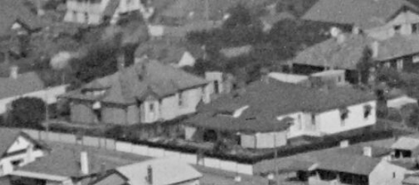
Aerial showing 93 Prospect Road (left) & 95 Prospect Road (right), c.1936.
Source: C. Pratt, accession no. H91.160/914, State Library of Victoria.

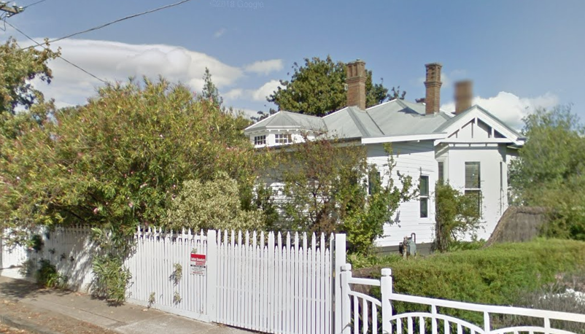
‘Eurymina’, 2015, showing skillion addition at the front. Source: Google Maps streetview.

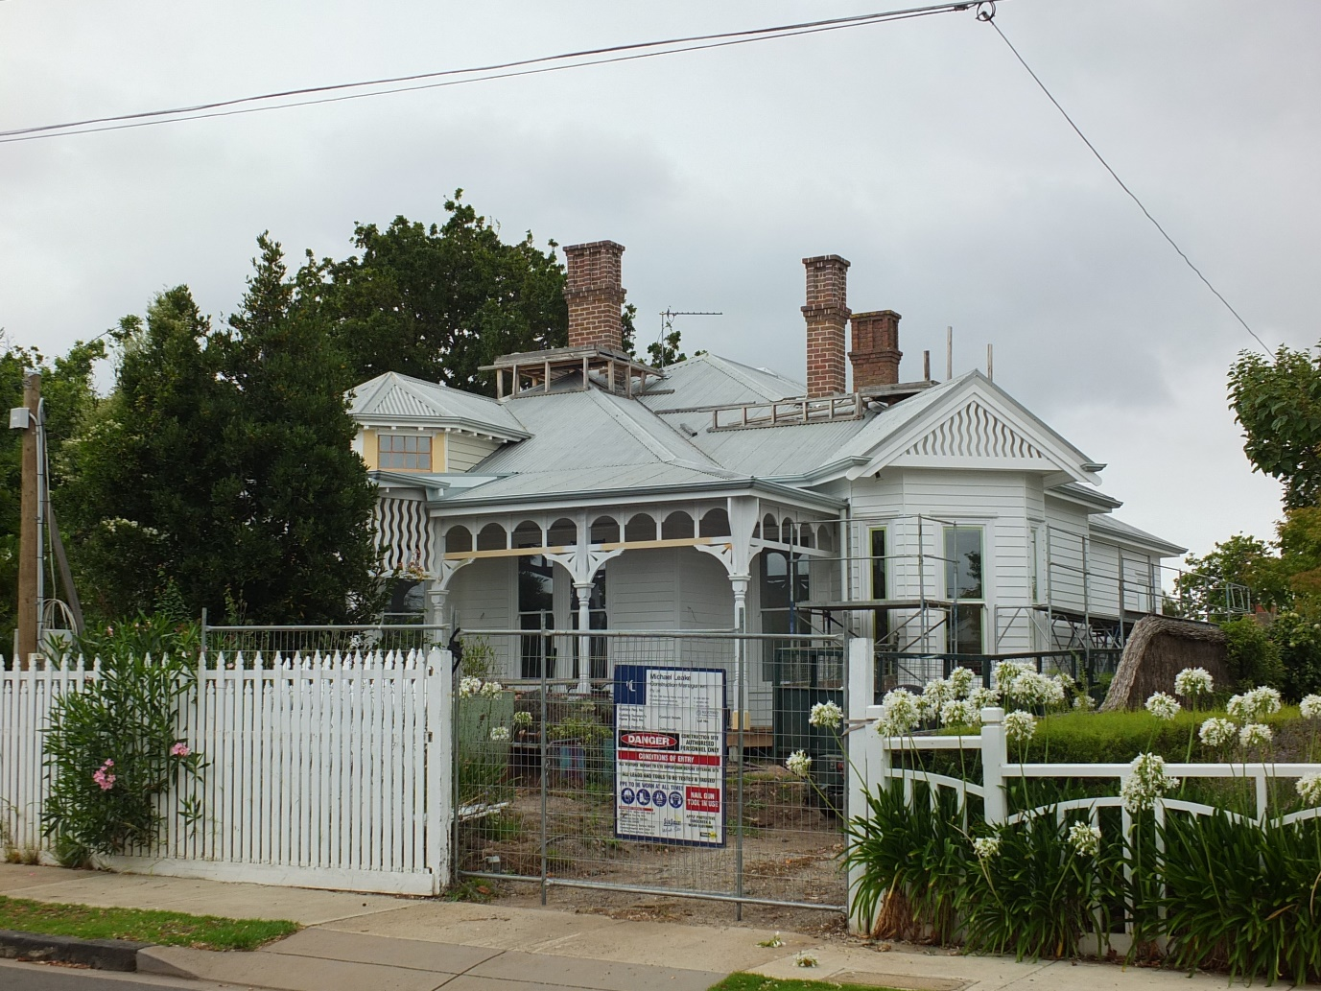
‘Eurymina’, showing the reconstructed front verandah and the wavy timber fretwork in the corner gable infill, and the restoration of the verandah lantern, 2022.

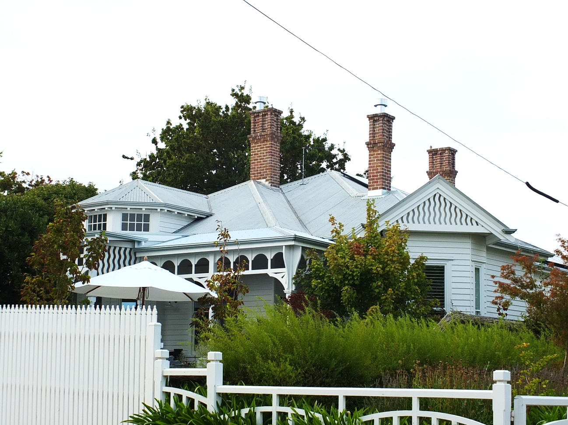
‘Eurymina’, March 2023. Source: David Rowe.
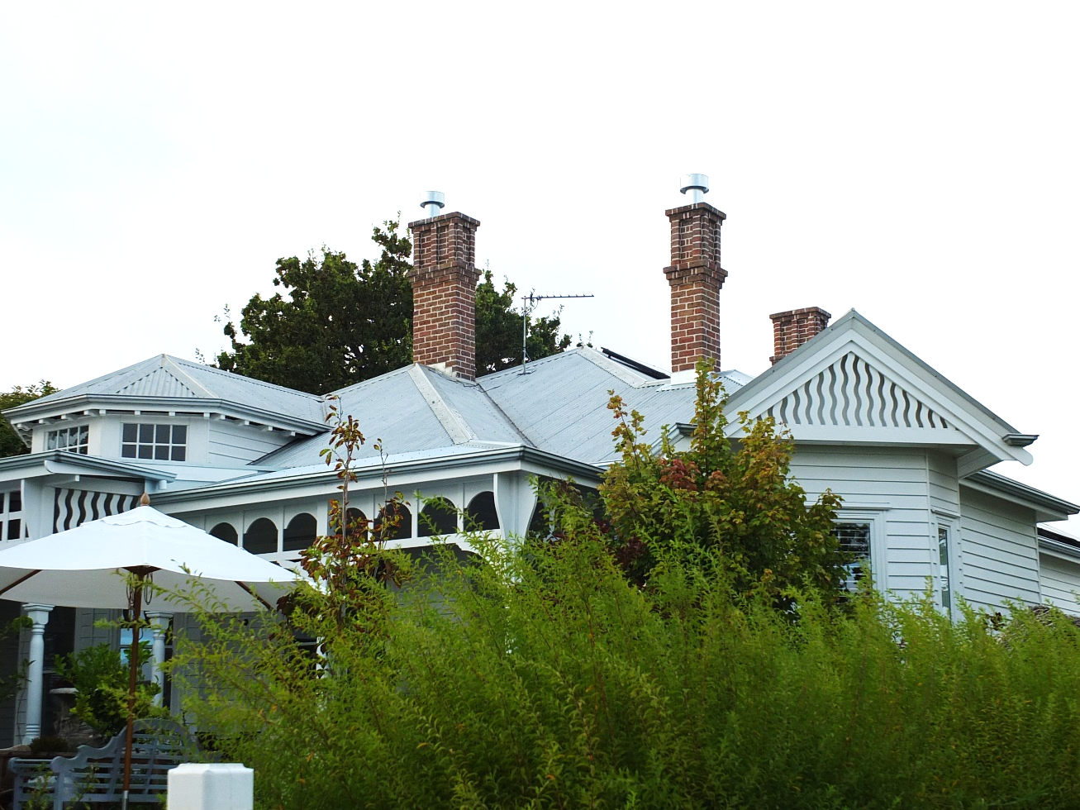
‘Eurymina’, March 2023. Source: David Rowe.

- Village 11 Cinema, 192-194 Ryrie Street, Geelong.
Categories:
- Restoration of a Heritage Place.

Works: External painting.
Significance: Local significance, HO1128.
Planning Permit: 1379/2021
Planner: Phil Mabbs
Owners: Cromwell Property Group c/o Josh Greer, Josh.Greer@cromwell.com.au
Architect: Noel Thomson Architecture, Wagga Wagga

The Geelong Theatre was opened to a capacity audience on 26 May 1913 by the Mayor of Geelong, Alderman W.R. Anderson The theatre had been established by Amalgamated Pictures Co. Ltd., its managing director being J.H. Tait. To accommodate 1750 people, the new theatre was designed by local architects, Tombs and Durran and based on J. and N. Tait’s theatre on St. Kilda Road, Melbourne. The new two storey rendered brick Federation Free style building made a notable statement in this part of Ryrie Street and is the only purpose-built theatre continuing to serve its original purpose in Geelong today.

The cinematic experience has certainly changed from the days of silent pictures accompanied by live orchestras. The cinema has also hosted other musical events. Noteworthy was the premiere of the “national song” for “Greater Geelong” in 1928. It was obviously not an enduring success.

In the c.1970s, the characteristic front façade was clad in aluminium. In the late 1990s, the original façade was again reveal but a colour scheme was chosen more reflective of the company colours than the original appearance.

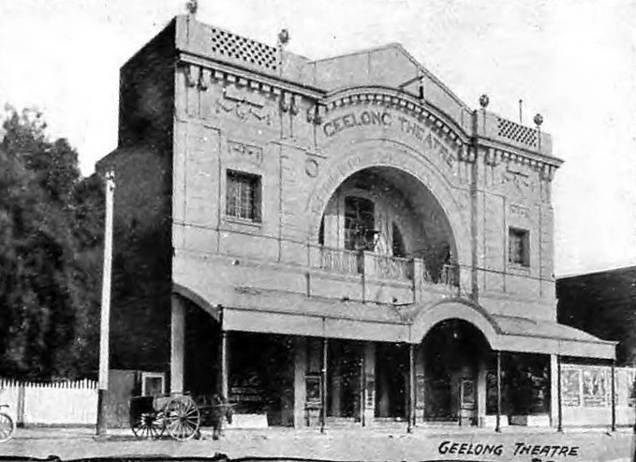
Geelong Theatre, c.1918. Source: Geelong for Business, Health, Pleasure, The Geelong City Council and Geelong Progress Association, Geelong, 1918, p.47.

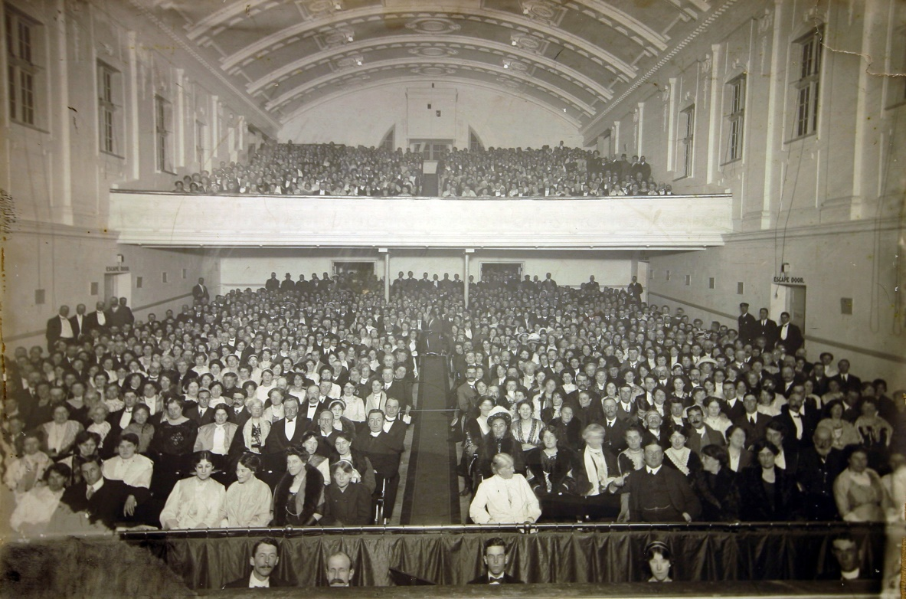
Interior, Geelong Theatre, showing capacity crowd at the opening night, 26 May 1913.
Source: GRS 2010/58, Geelong Heritage Centre collection.

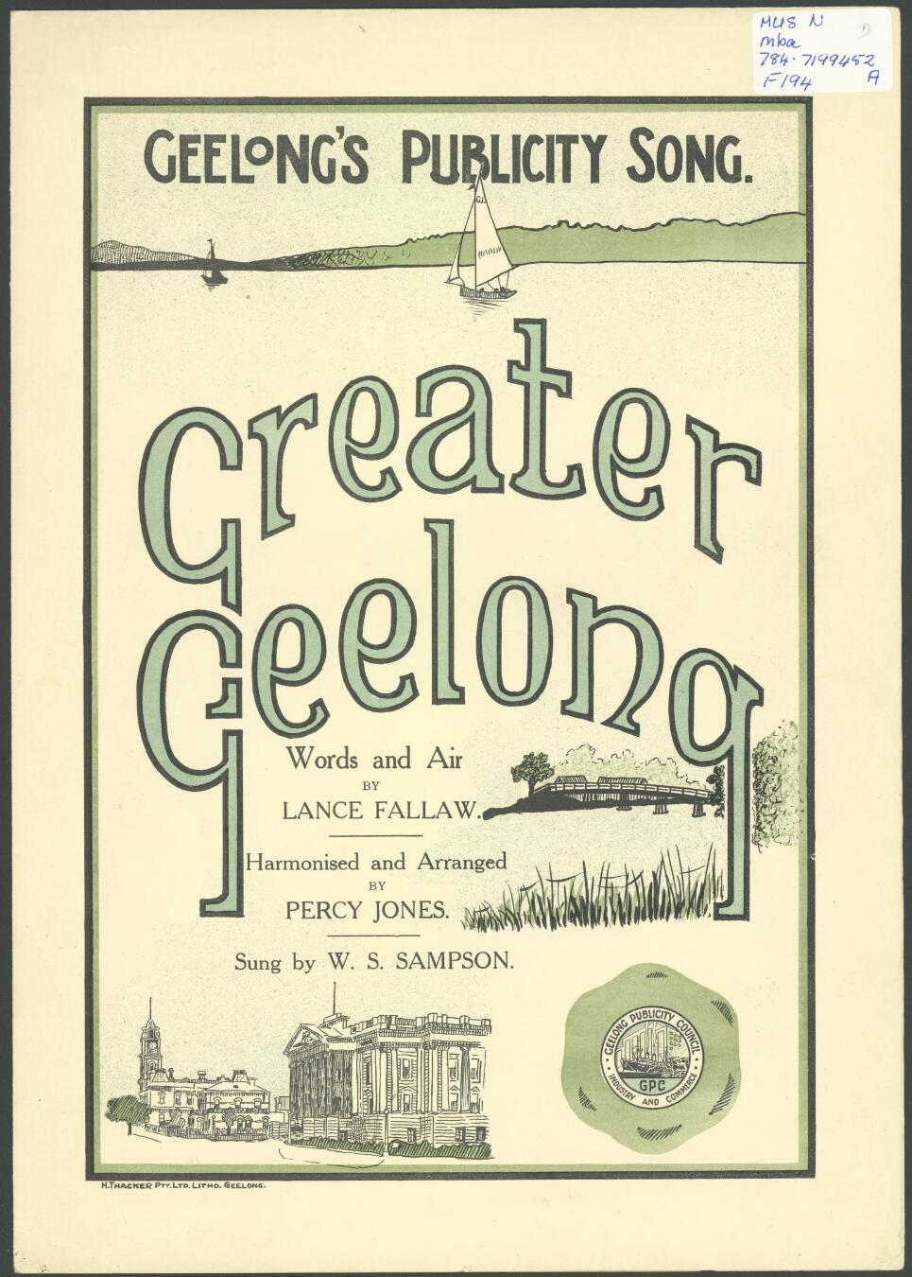
Lance Fallow & Percy Jones, ‘Greater Geelong son, 1928.
Source: State Library of Victoria.
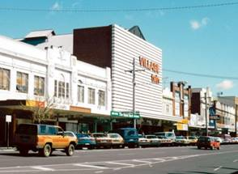
Geelong Theatre – Village, c.1970s.
Source: F. Bambino, ‘Geelong Theatre Conservation Analysis Report’, Deakin University, 1989.

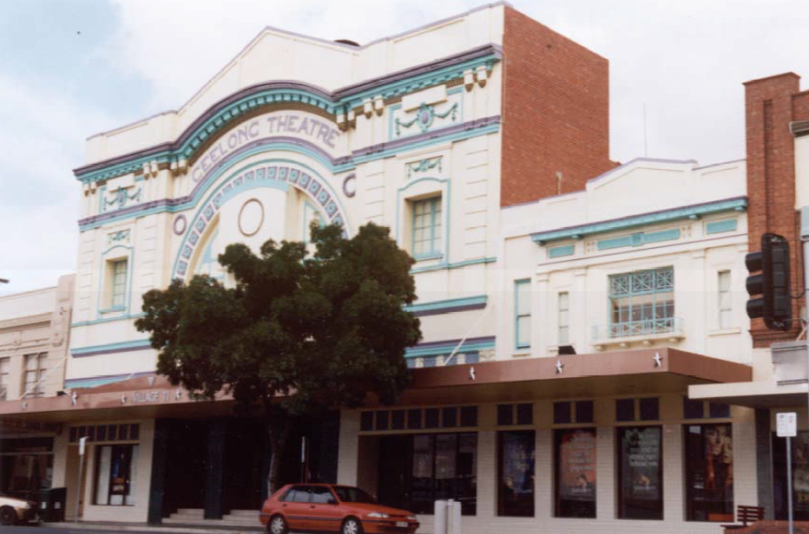
Geelong Theatre, 2002. Source: David Rowe.

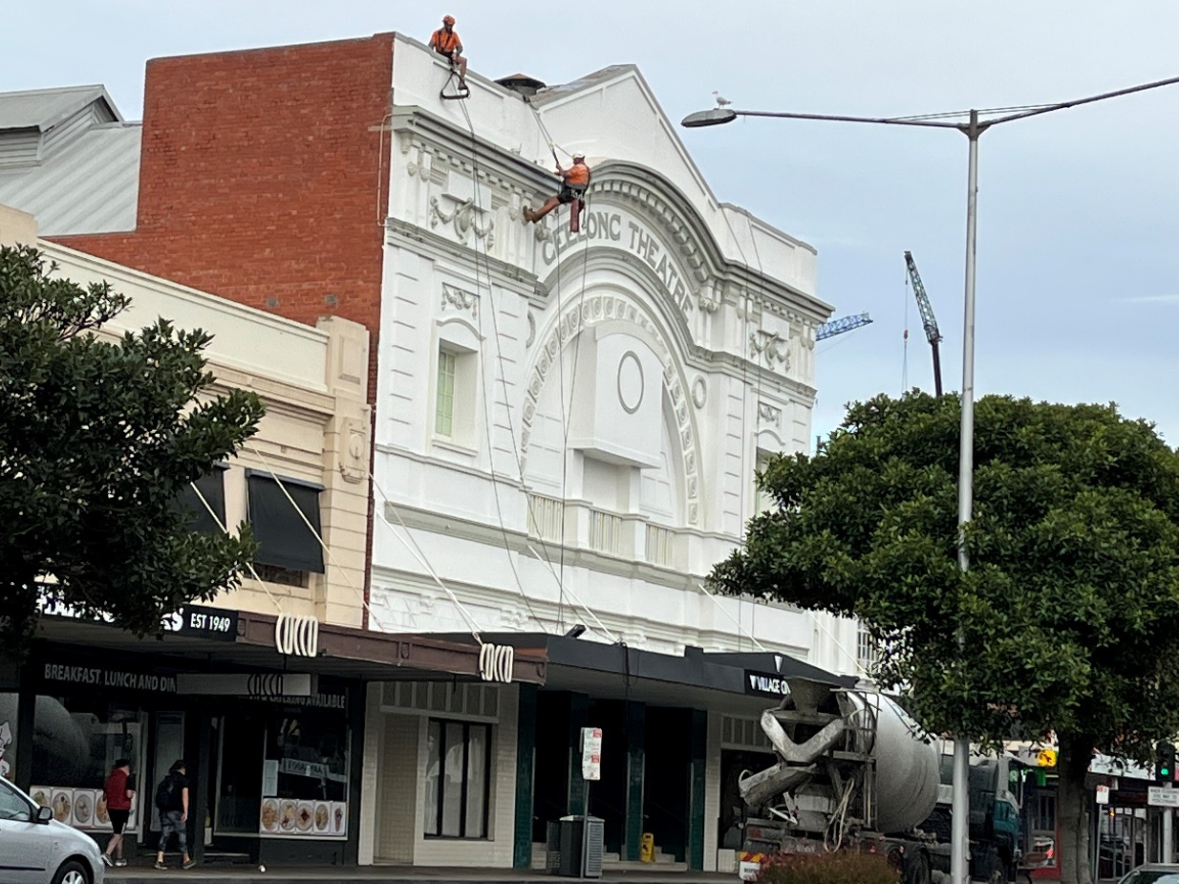
Geelong Theatre with painting in progress, 28 March 2022. Source: David Rowe.

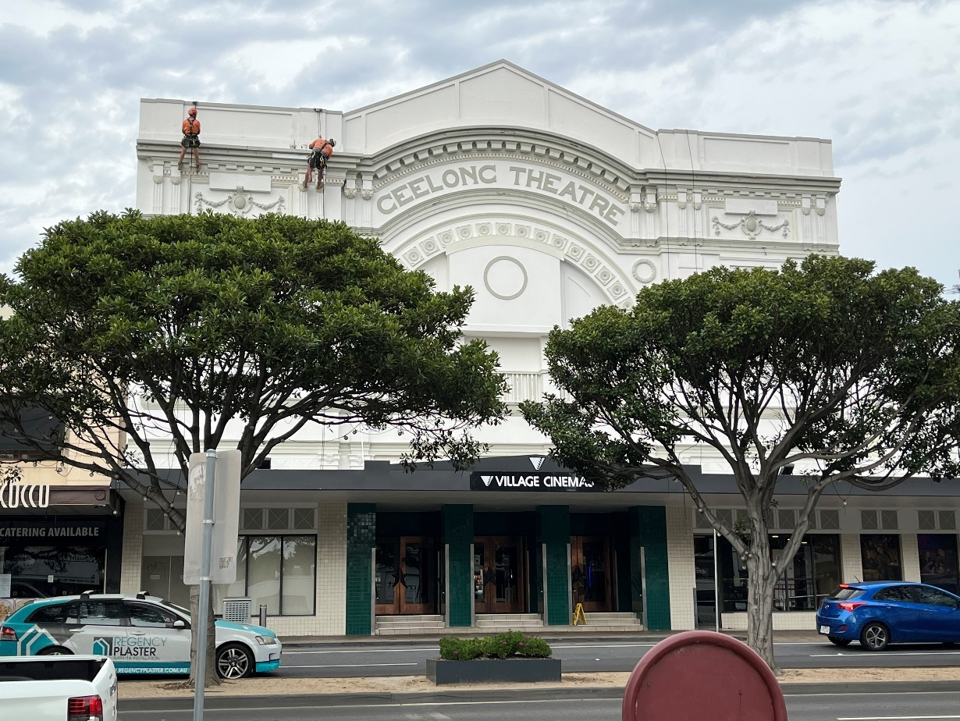
Geelong Theatre with painting in progress, 28 March 2022. Source: David Rowe.

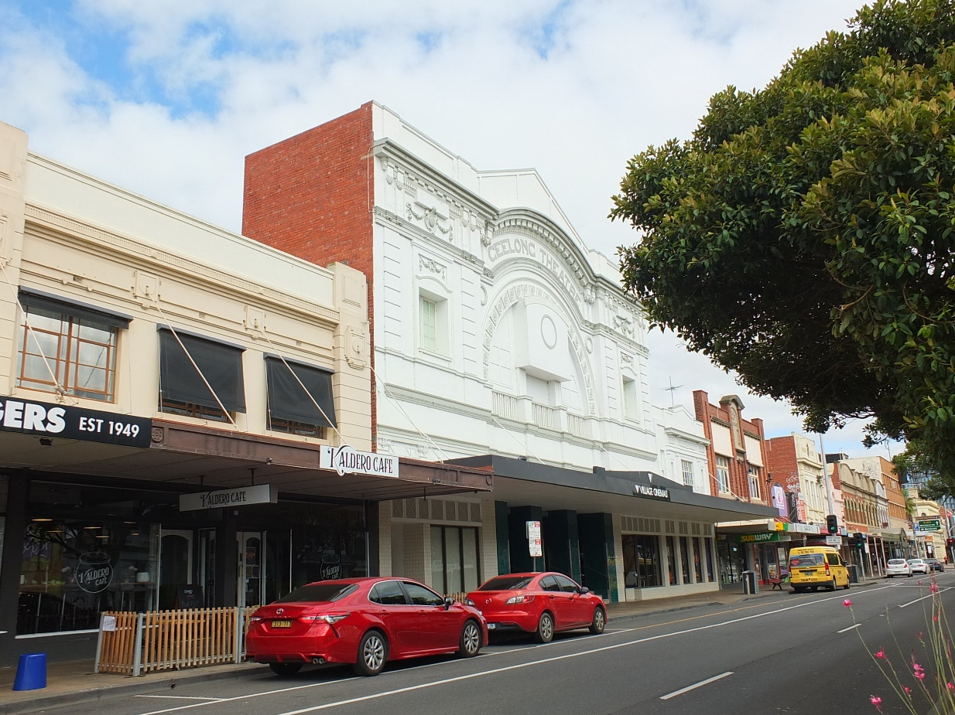
Geelong Theatre with painting completed, 20 March 2023. Source: David Rowe.

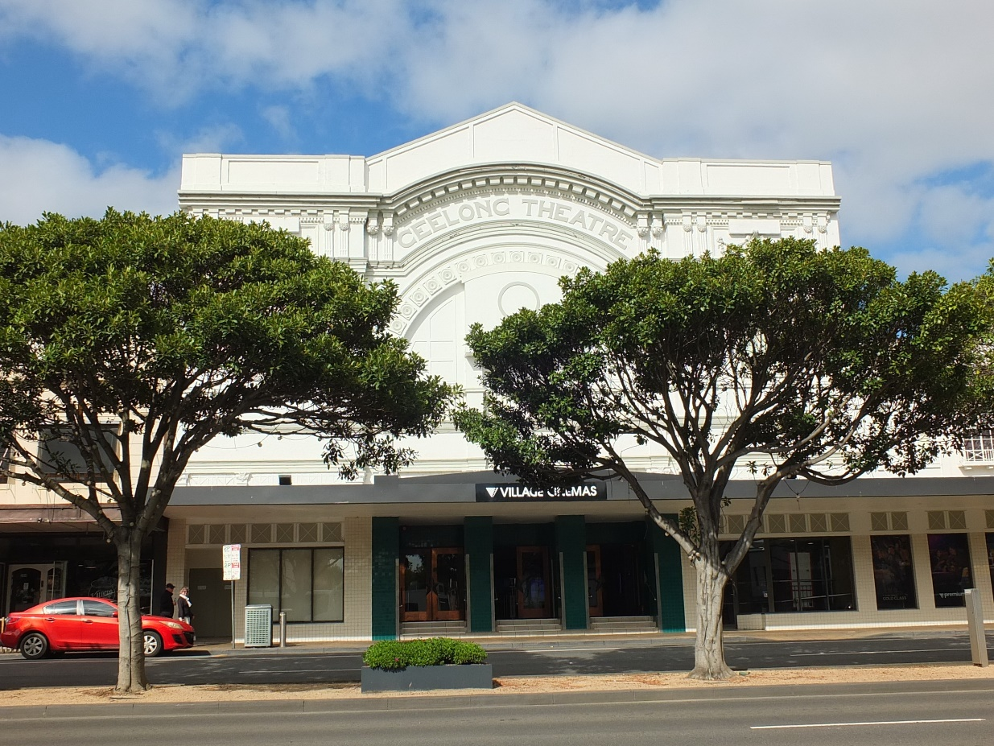
Geelong Theatre with painting completed, 20 March 2023. Source: David Rowe.

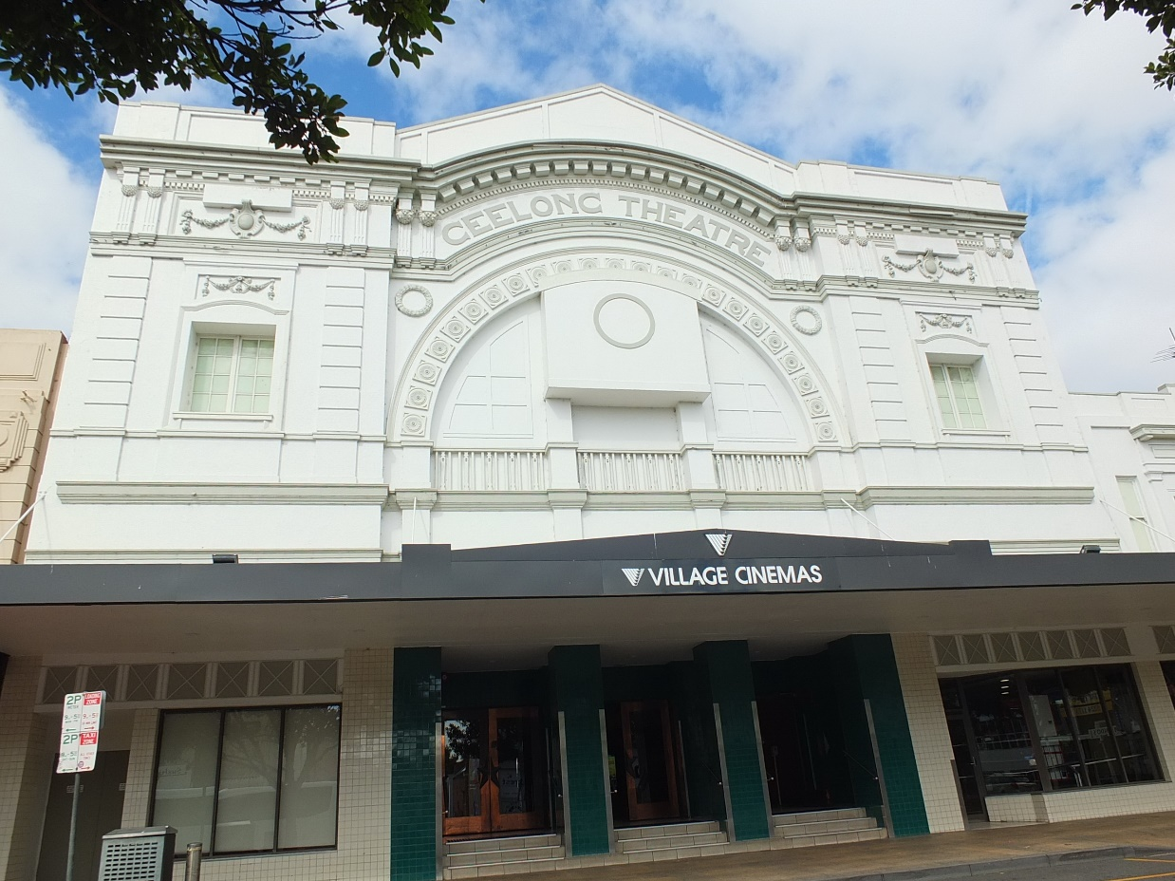
Geelong Theatre with painting completed, 20 March 2023. Source: David Rowe

- Geelong West Grandstands, West Oval, 66-76 Church Street, North Geelong.
Category:
- Restoration of a Heritage Place
- New work in a Heritage Overlay

Works: Partial demolition, repairs, external painting to a heritage grandstand and construction of a new grandstand
Significance: Local significance, HO777.
Planning Application:
Planner: Verity Bright
Owner: City of Greater Geelong
Architect: Brand Architects
Builder: Plan Group

The Western Grandstand, now known as the Flowers Family stand, was built in 1925 to the design of the Geelong architects, Laird and Buchan. It is constructed of bluestone and timber, being unusually for the 1920s, the quoinwork detailing being more typical of 19th century design. The grandstand has been a centrepiece of the West Oval for almost 100 years. The grandstand had experienced some alterations throughout the 20th century, including minor additions and various paint colour schemes. In 2016, it suffered significant fire damage.

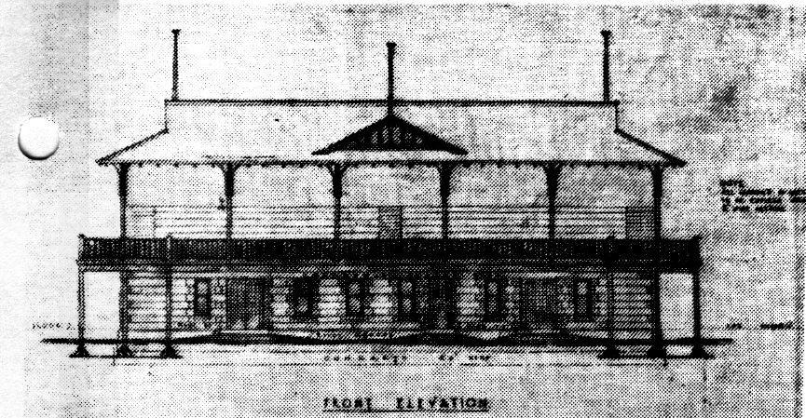
Laird and Buchan, Front elevation drawing, 1925. Source: City of Geelong West Urban Conservation Study 1986.

Recent conservation works have involved the removal of some introduced fabric and necessary repairs including repointing. A new colour scheme, reflective of the 1920s era and construction of the building but in a contemporary way, has greatly enhanced this heritage asset.

A new grandstand has been constructed adjacent to the old building. The new building is distinctive in appearance and yet the height, articulation of forms and bulk, and construction materials and colours have respect for the heritage landmark on the site as a separate, contemporary entity. Congratulations to the whole team for this project: Scott Annand, City of Greater Geelong, Brand Architects and Plan Group.

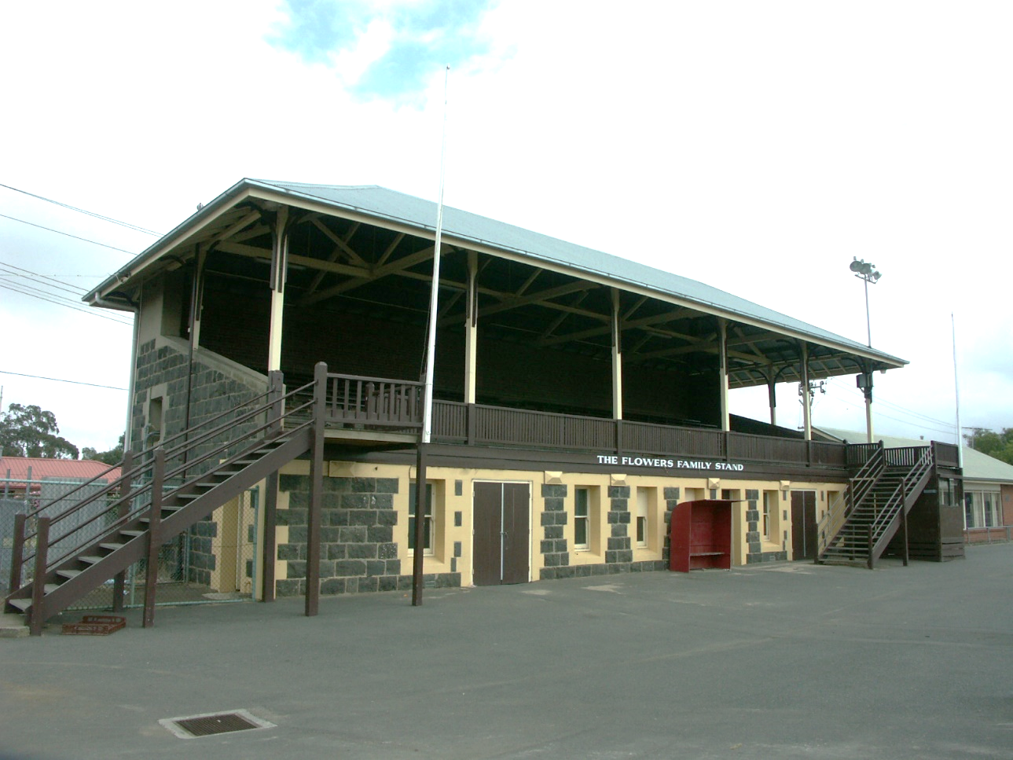
Flower Family Stand, 2006. Source: David Rowe.

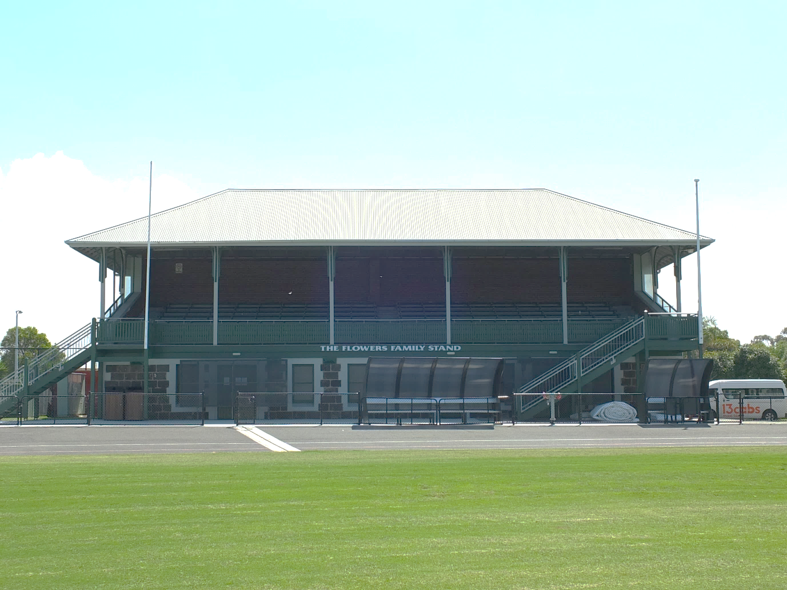
Restored and repainted Flowers Family Stand, 2022. Source: David Rowe.
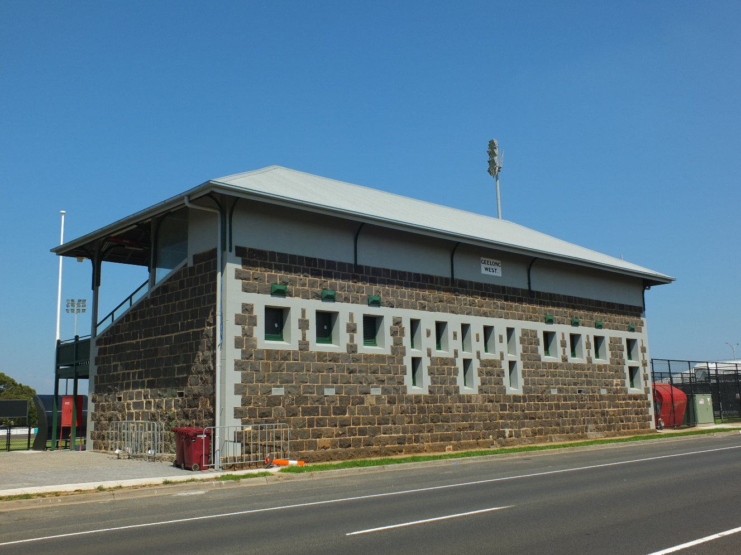
Restored and repainted Flowers Family Stand, 2022. Source: David Rowe.

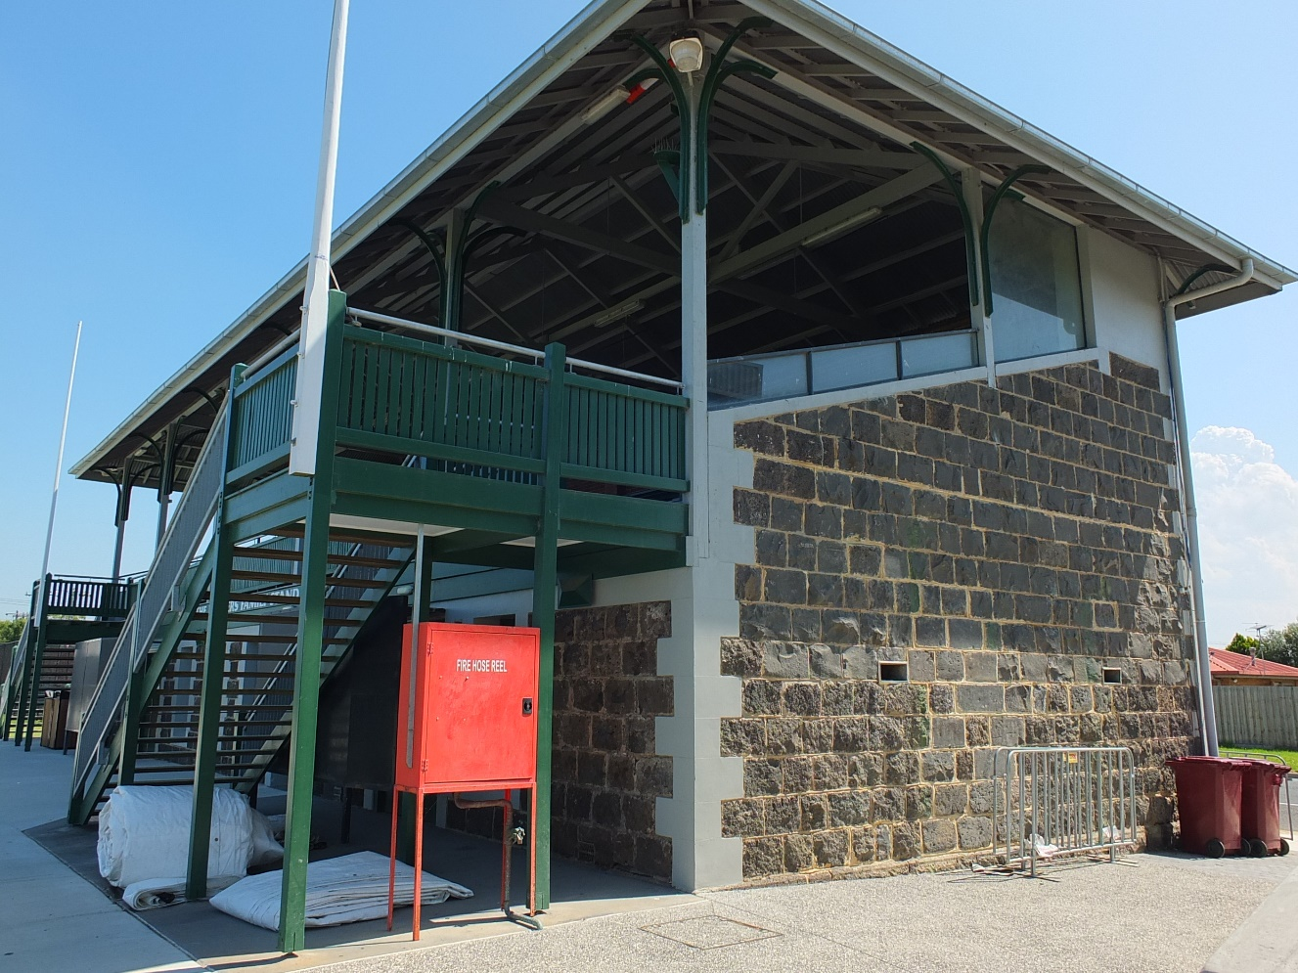
Restored and repainted Flowers Family Stand, 2022. Source: David Rowe.

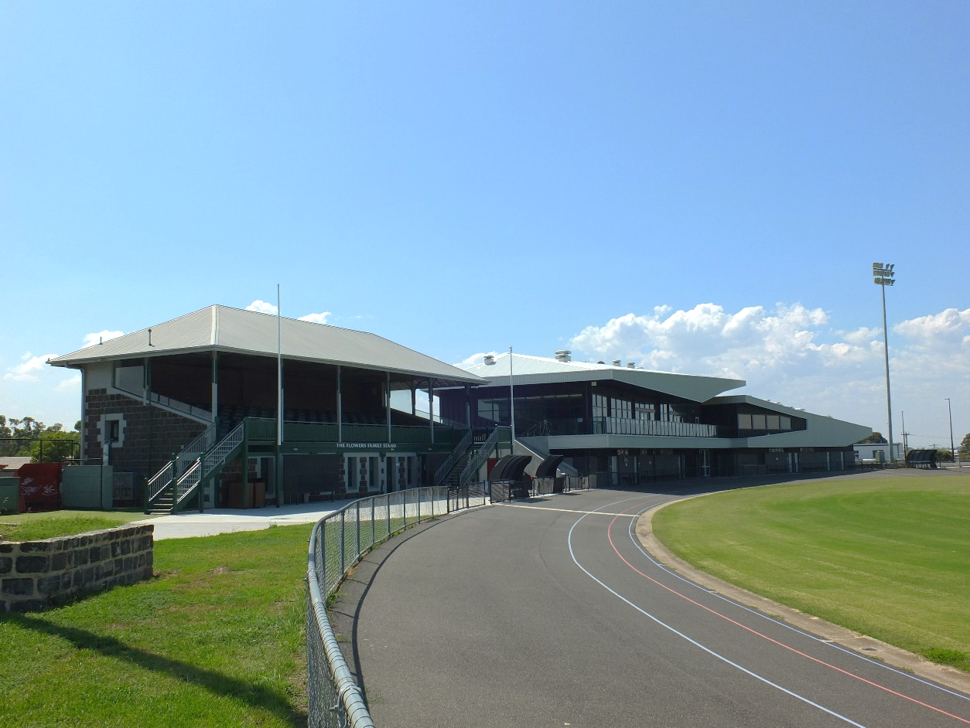
Flowers Family Stand and new Stand, 2022. Source: David Rowe.

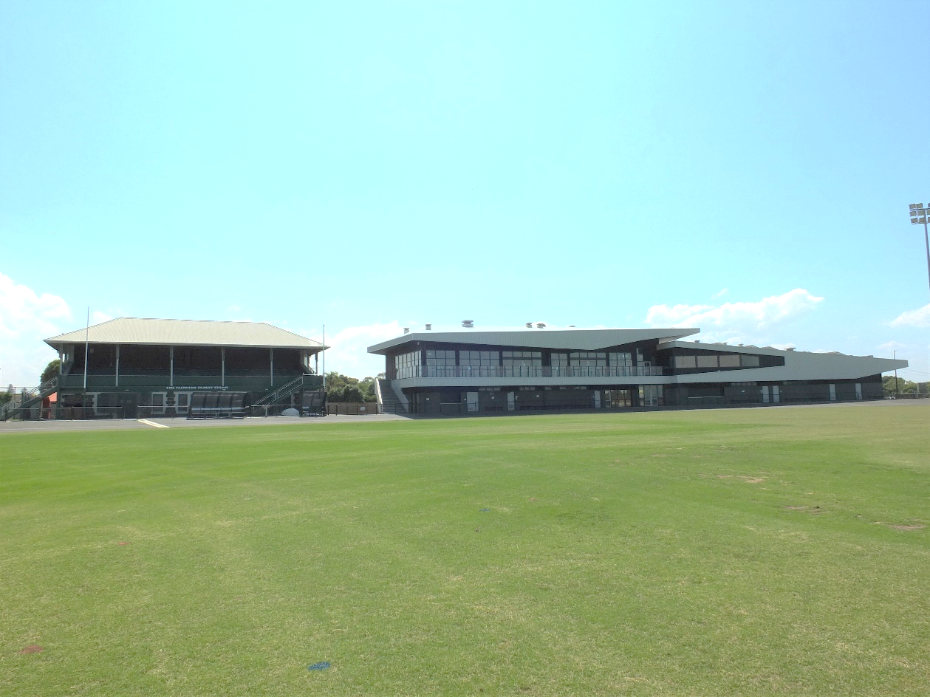
Flowers Family Stand and new Stand, 2022. Source: David Rowe.

- Richardson’s Garage, 151 Mercer Street, Geelong – TO BE CONFIRMED
Category:
- Restoration of a Heritage Place

Works: Partial demolition, reconstruction, restoration, adaptation
Significance: Contributory significance to the Geelong Civic Heritage Area HO1640.
Planner: Tim Webb
Owner: City of Greater Geelong
Architect: Cox Architecture and Trethowan Architecture, Interiors and Heritage
Contractor: Creative Maintenance Solutions

The two storey brick building at 151 Mercer Street was built in 1921 as a motor garage for Henry George Richardson (c.1883-1971). He was a previous employee of the neighbouring Balfours Motors at the corner of Mercer and Gheringhap Streets. Richardson extended his motor garage to an identical design as his original building next door at 153 Mercer Street in 1927.

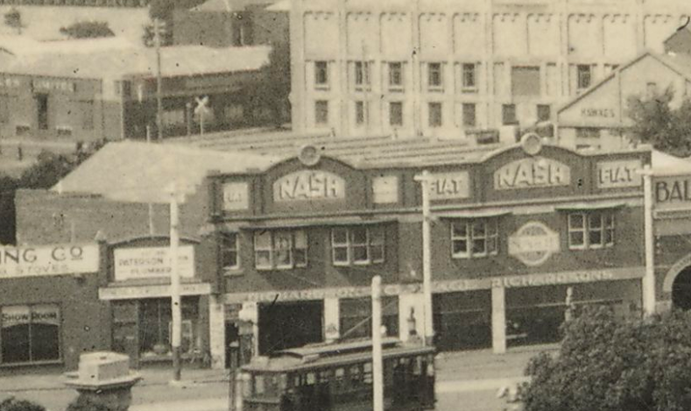
Richardson’s motor garage, 151-153 Mercer Street, c.1927-54 (the subject building is on the left).
Source: C. Pratt, Johnstone Park, accession H2009.40/245, State Library of Victoria.

From 1940 until 1955, the building at 151 Mercer Street was occupied by Pivot Auto Services, Motor Engineers. This business traded as the Green Star Passenger Services Pty Ltd in 1939 and later the Geelong Associated Buslines Pty Ltd. In 1954, the subject building had been overpainted in white. The business sold Olympic tyres, the Olympic name being displayed on the parapet.

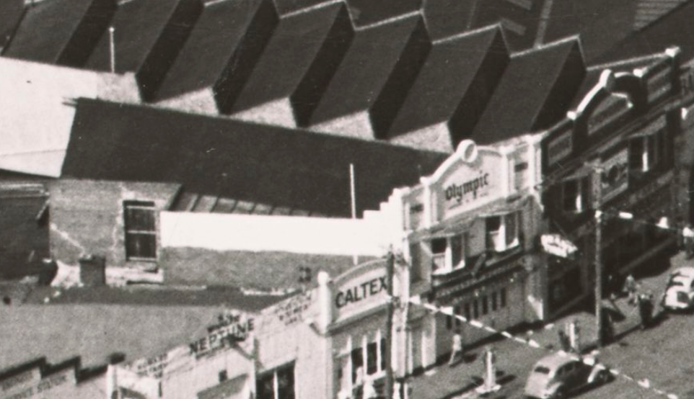
Pivot Auto Services, 151 Mercer Street (centre), 6 March 1954.
Source: C. Pratt, Aerial view of Geelong during the Queen’s visit, 1954, accession H2008.41/127,
State Library of Victoria.

The building at 151 Mercer Street represents only one of three purpose-built early 20th century motor garages in Geelong. In addition to 153 Mercer Street, the most substantial motor garage building of this period in Geelong is the former Balfour’s Motors at 155-159 Mercer Street. External changes had undermined its original appearance but the early design has remained discernible over the years.

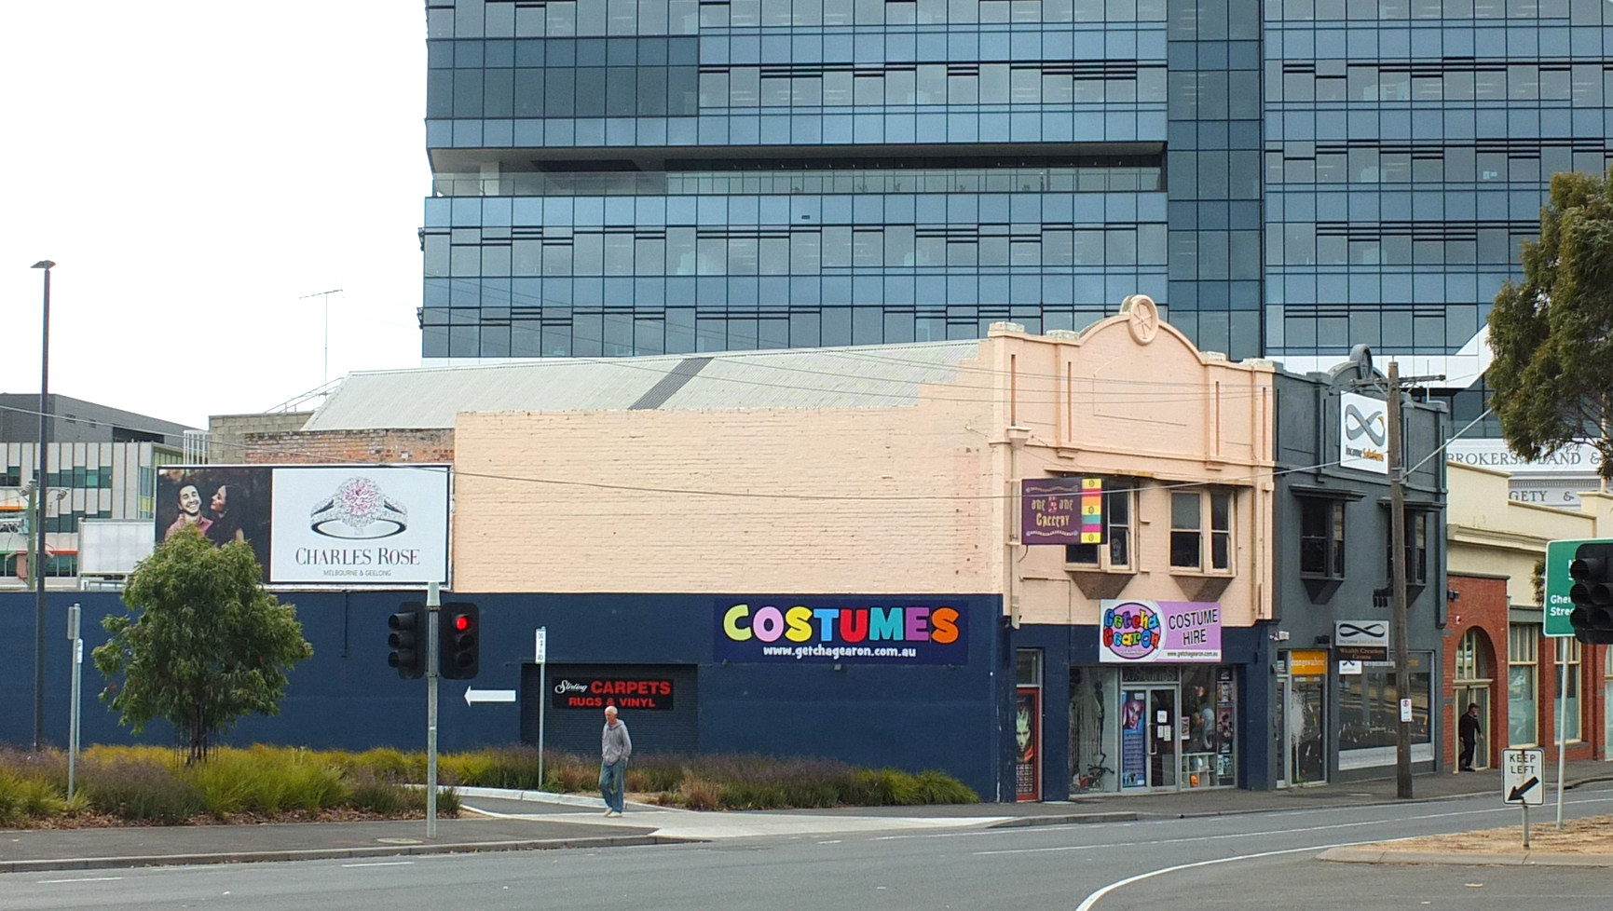
Former Richardson’s Garage, November 2019. Source: David Rowe.

As part of the Wurriki Nyal development, in recognition of Geelong’s motor car heritage, the former Richardson’s Garage has been brought back to life with the removal of the exterior painting, and the construction (and adaptation) of missing elements on the front façade. The reconstruction and restoration now celebrates the building as largely originally intended. It now makes a significant contribution to the streetscape of former garages in this part of Mercer Street, and it is a notable legacy of the importance of the motor in Geelong at a time when the Ford Motor Company factory was being established at North Geelong, further enhancing Geelong’s former reputation as a premier manufacturing City.

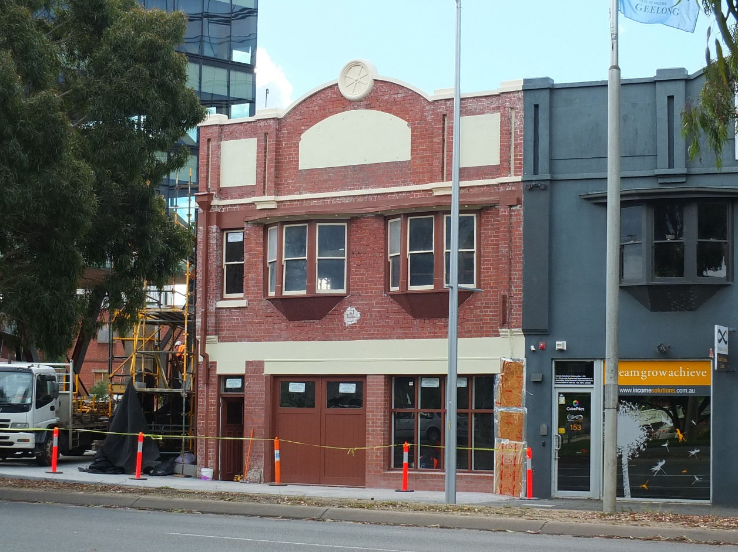
Former Richardson’s Garage, Mercer Street, 2 May 2023. Source: David Rowe.

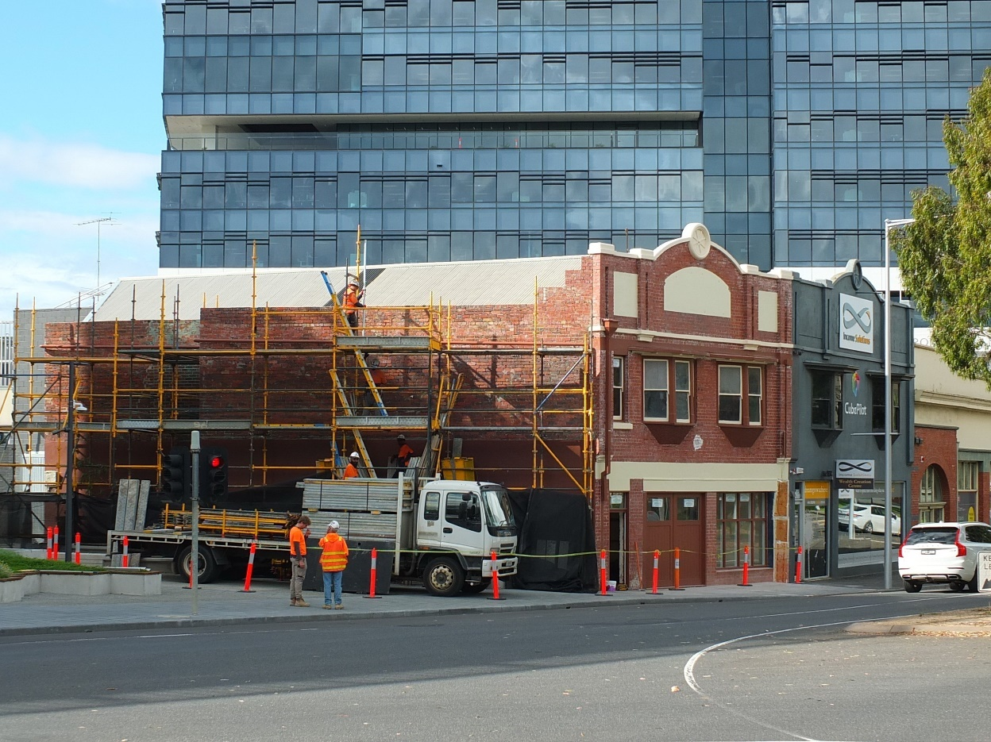
Former Richardson’s Garage, Mercer Street, 2 May 2023. Source: David Rowe.
- Former Portarlington Post Office, 1 Harding Street, Portarlington
Categories:
- Restoration of a Heritage Place

Works: Installation of a new damp proof course, repairs to label moulds, re-pointing and re-tuckpointing
Significance: Regional significance, HO1562
Planning Permit: 723/2022
Owners: Grant and Michelle Mitchell
Planner: Alex Lawrence
Specialist Tradesperson: Nat De-Palma, Kobrix Masonry

Initial preparation was made for a new post and telegraph office in 1887 when the Board of Land and Works excised a site from the market square reserve. A commodious post and telegraph office with attached quarters was designed by G.B.H. Austin of the Public Works Department in late 1887. Austin had previously designed the Geelong West Post and Telegraph Office, and like the Geelong West building, the proposed Portarlington Post Office design included the familiar features in the Flemish gables and other details of the architectural branch of the Department. Construction was carried out in 1888 by Messrs. Gross and McClure of Williamstown. The foundation stone was laid in September of that year – the largest public gathering ever held in the Bellarine Shire at the time. In November 1888, the Portarlington Town and District Improvement Association was able to gauge a more accurate appreciation of how the building would appear when completed, and it found that the walls ‘would not be high enough to give the structure anything but a miserable, dwarfed, and insignificant appearance, quite unworthy of our rapidly growing town. The Association’s concerns found favour with the Department and the walls were subsequently raised 2-3 feet ‘and ornamented to some extent.’ The building opened in April 1889.

The restoration has included the installation of a new damp proof course, repairs to label moulds and tuckpointing.

While not quite finished, the result has been transformative. It has returned this heritage landmark in Portarlington to its intended appearance, celebrating the craftsmanship of the brickwork. It is a credit to the owners and to Na De Palm of Kobrix Masonry.

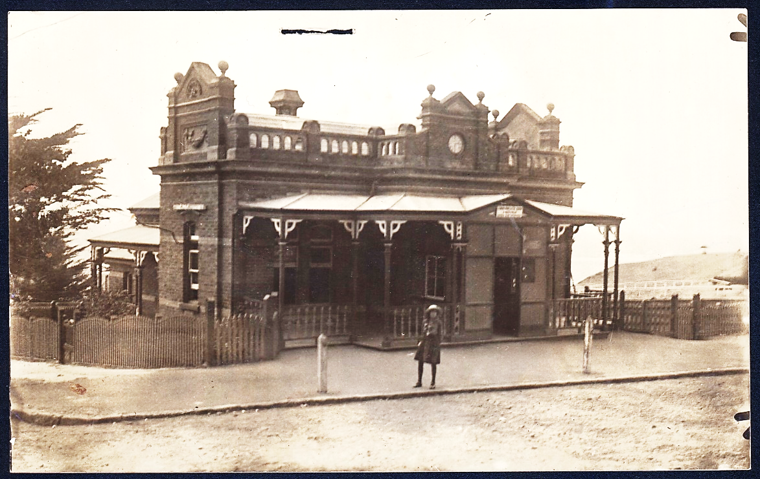
Portarlington Post Office, c.1917-30. Source: accession H89.105/189 State Library of Victoria.
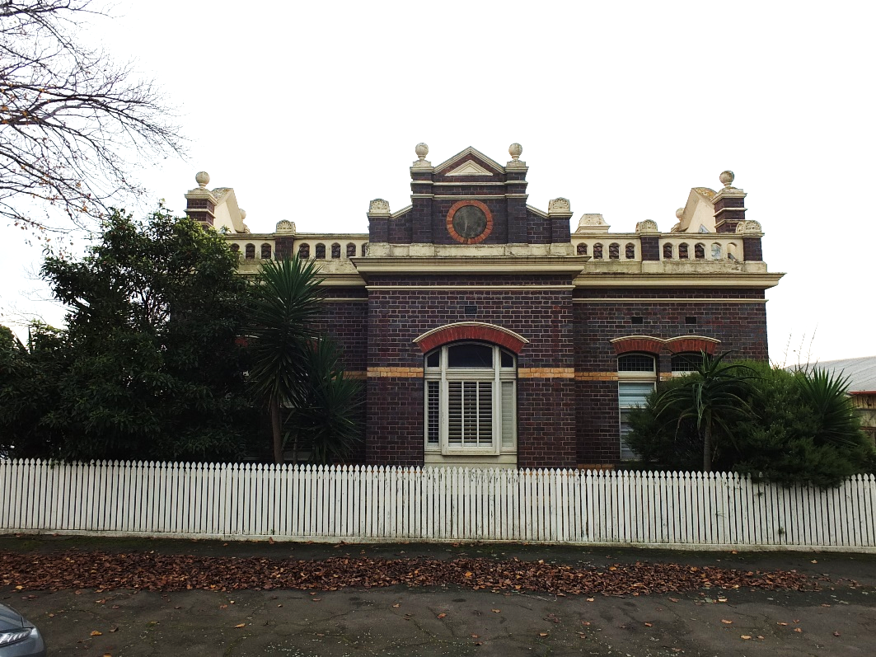
Former Portarlington Post Office, June 2022. Source: David Rowe.

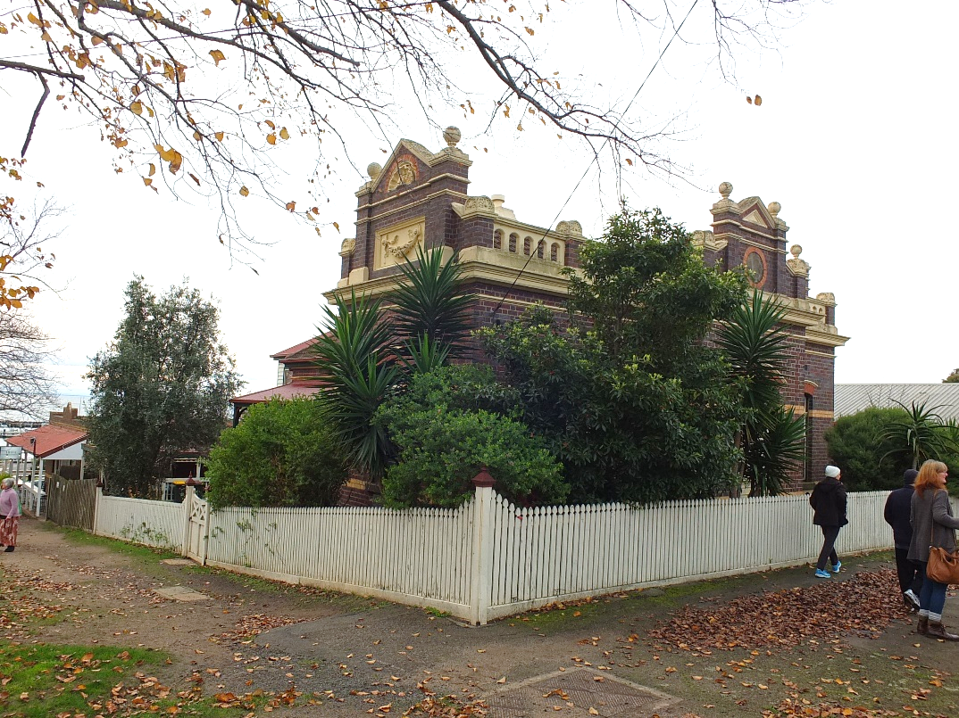
Former Portarlington Post Office, June 2022. Source: David Rowe.

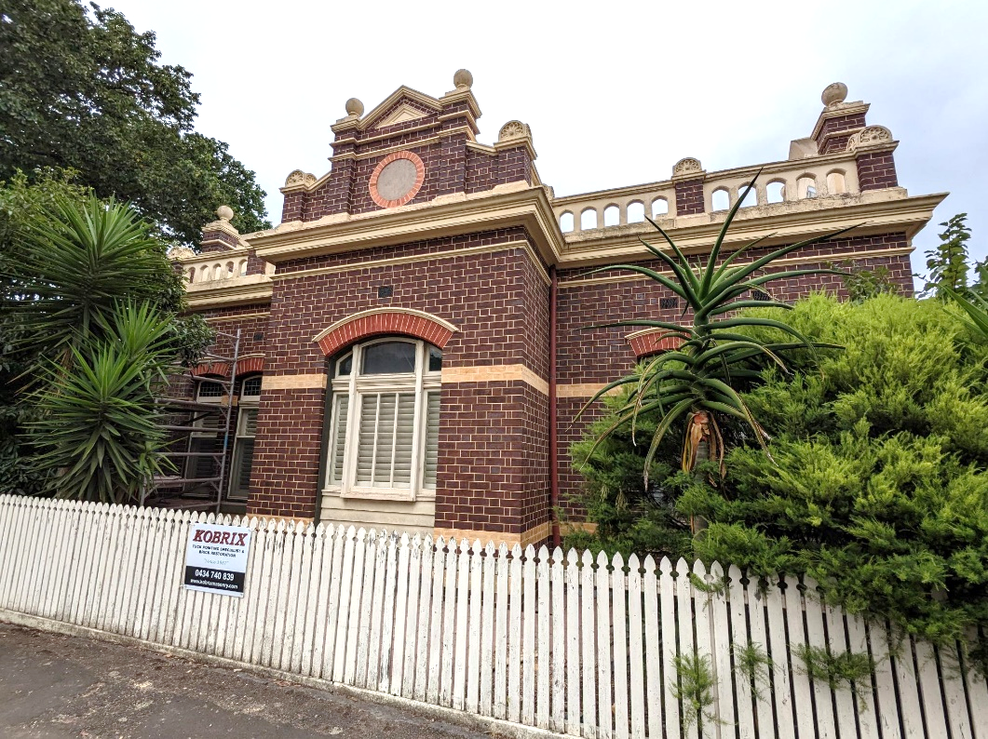
Former Portarlington Post Office, February 2023. Source: Alex Lawrence, City of Greater Geelong.

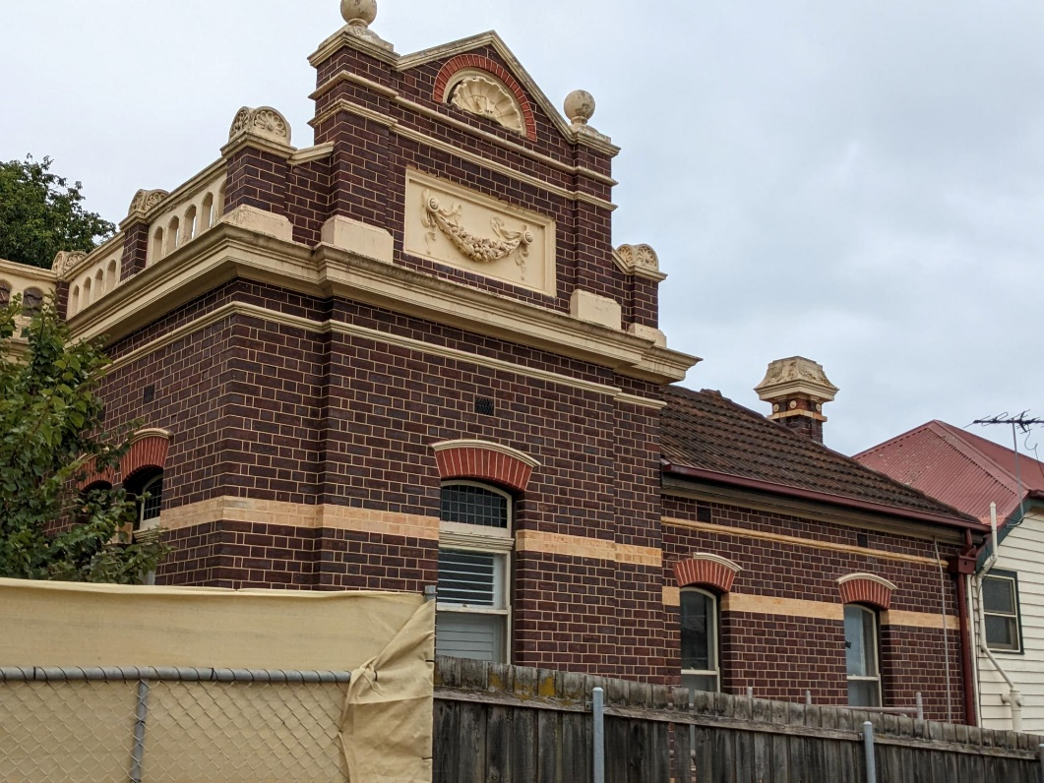
Former Portarlington Post Office, February 2023. Source: Alex Lawrence, City of Greater Geelong.

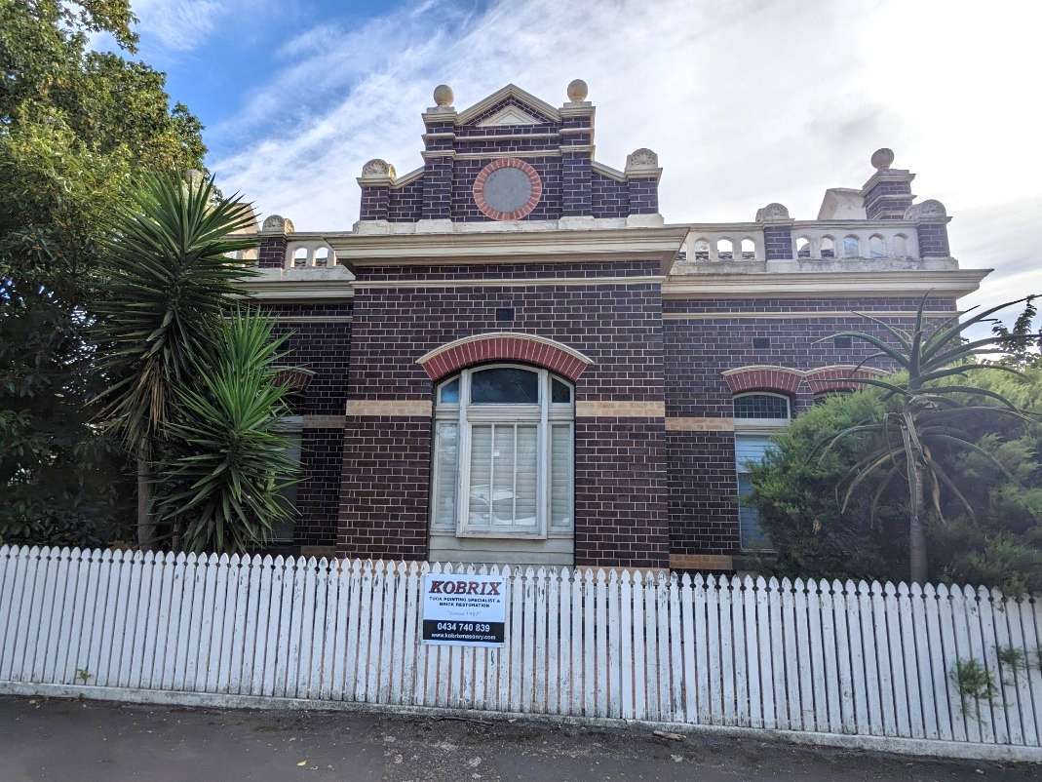
Former Portarlington Post Office, 31 March 2023. Source: Alex Lawrence, City of Greater Geelong.

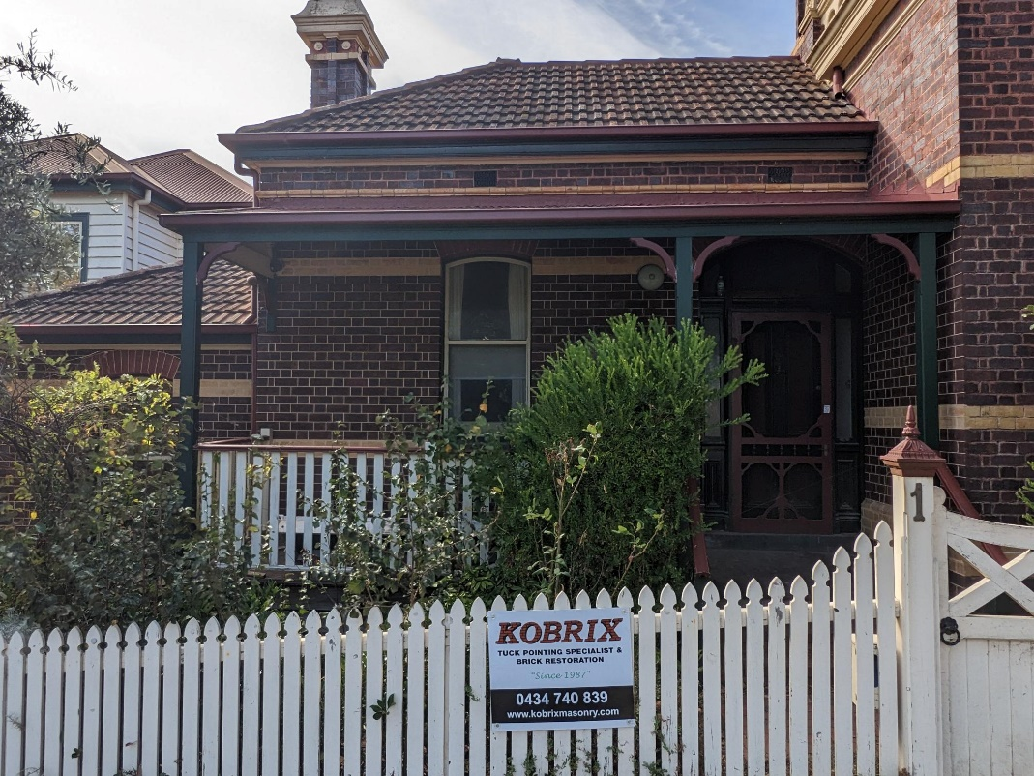
Former Portarlington Post Office, 31 March 2023. Source: Alex Lawrence, City of Greater Geelong.

- Grand Hotel, 76 Newcombe Street, Portarlington
Categories:
- Restoration of a Heritage Place.

Works: Restoration of external walls and openings, reconstruction of the three storey verandah and balcony, adaptation.
Significance: Local significance, HO323
Planning Permit: 1449/2020
Planner: Rhys Male & Tom Hams
Planning Consultant: Michael Dunn, Metropol Planning Solutions Pty Ltd
Architect: Techne Architecture & Interior Design, and Michael Taylor Architecture and Heritage
Owner: LG Marine Assets Pty Ltd
Contractor: Arc Projects (Mark Henderson)

In 1887, an ambitious proposal was made by Samuel Davies, a cordial manufacturer, to erect a substantial hotel at Portarlington. Opening in 1888, the three storey Boom style building designed by the Melbourne architect, William Wolf, included projecting cast iron balconies and central tower, reflecting the wealth and opulence favoured by Melbourne’s nouveau-riche. From this time, the Grand Hotel has been a significant landmark at Portarlington.

The hotel has been a social hub for community meetings, balls and dances, and as an auction house, in addition to being a place to catch up.

Throughout the early 20th century, while the hotel remaining an important heritage asset to the town, the original appearance of the building had been undermined by the removal of the original three storey veranda and balconies.

Recent works have included:

- Repairs to exterior render.
- External painting in colours reflective of the era of the dwelling.
- Reconstruction of the three storey verandah and balcony.
- Extensive refurbishment of the interior.

The extensive works to the Grand Hotel have returned this important Boom style building to its original appearance – the jewel in Portarlington’s crown. This building is one of the most prominent on the Bellarine Peninsula and its character has been greatly enhanced. It is truly remarkable result. Congratulations to all those involved: the owners, to Michael Dunn of Metropol Planning Solutions, Techne Architecture and Interior Design, Michael Taylor Heritage Architect, and Mark Henderson and Arc Projects.

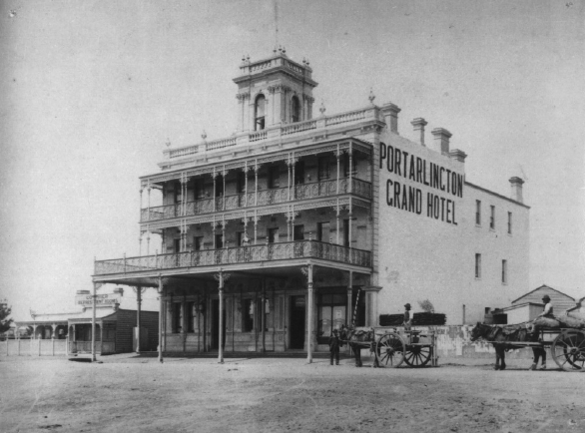
Grand Hotel, n.d. Source: Michael Taylor.

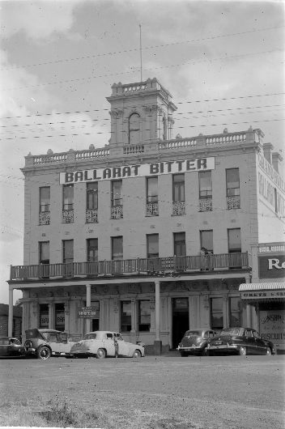
Grand Hotel, c.1920-54. Source: State Library of Victoria.

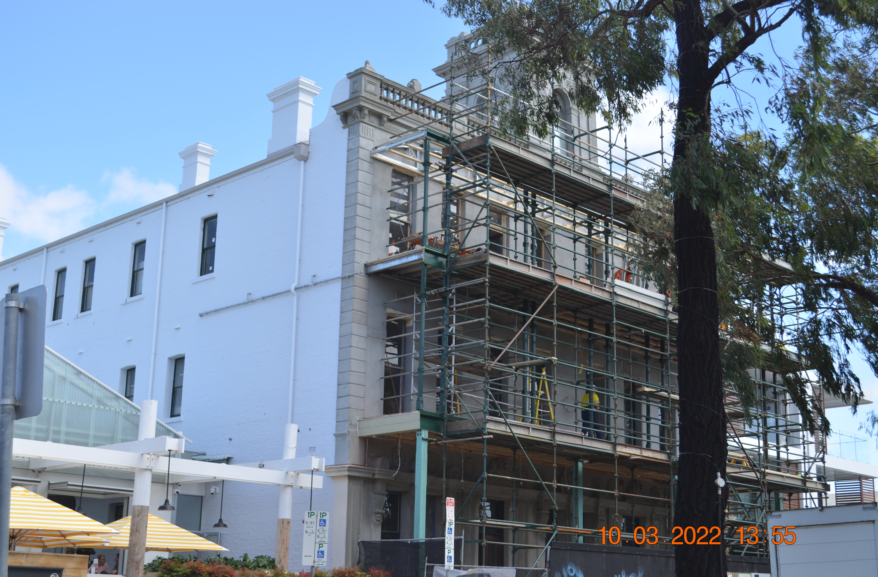
Grand Hotel, works in progress, 10 March 2022. Source: Susan Brown, City of Greater Geelong.

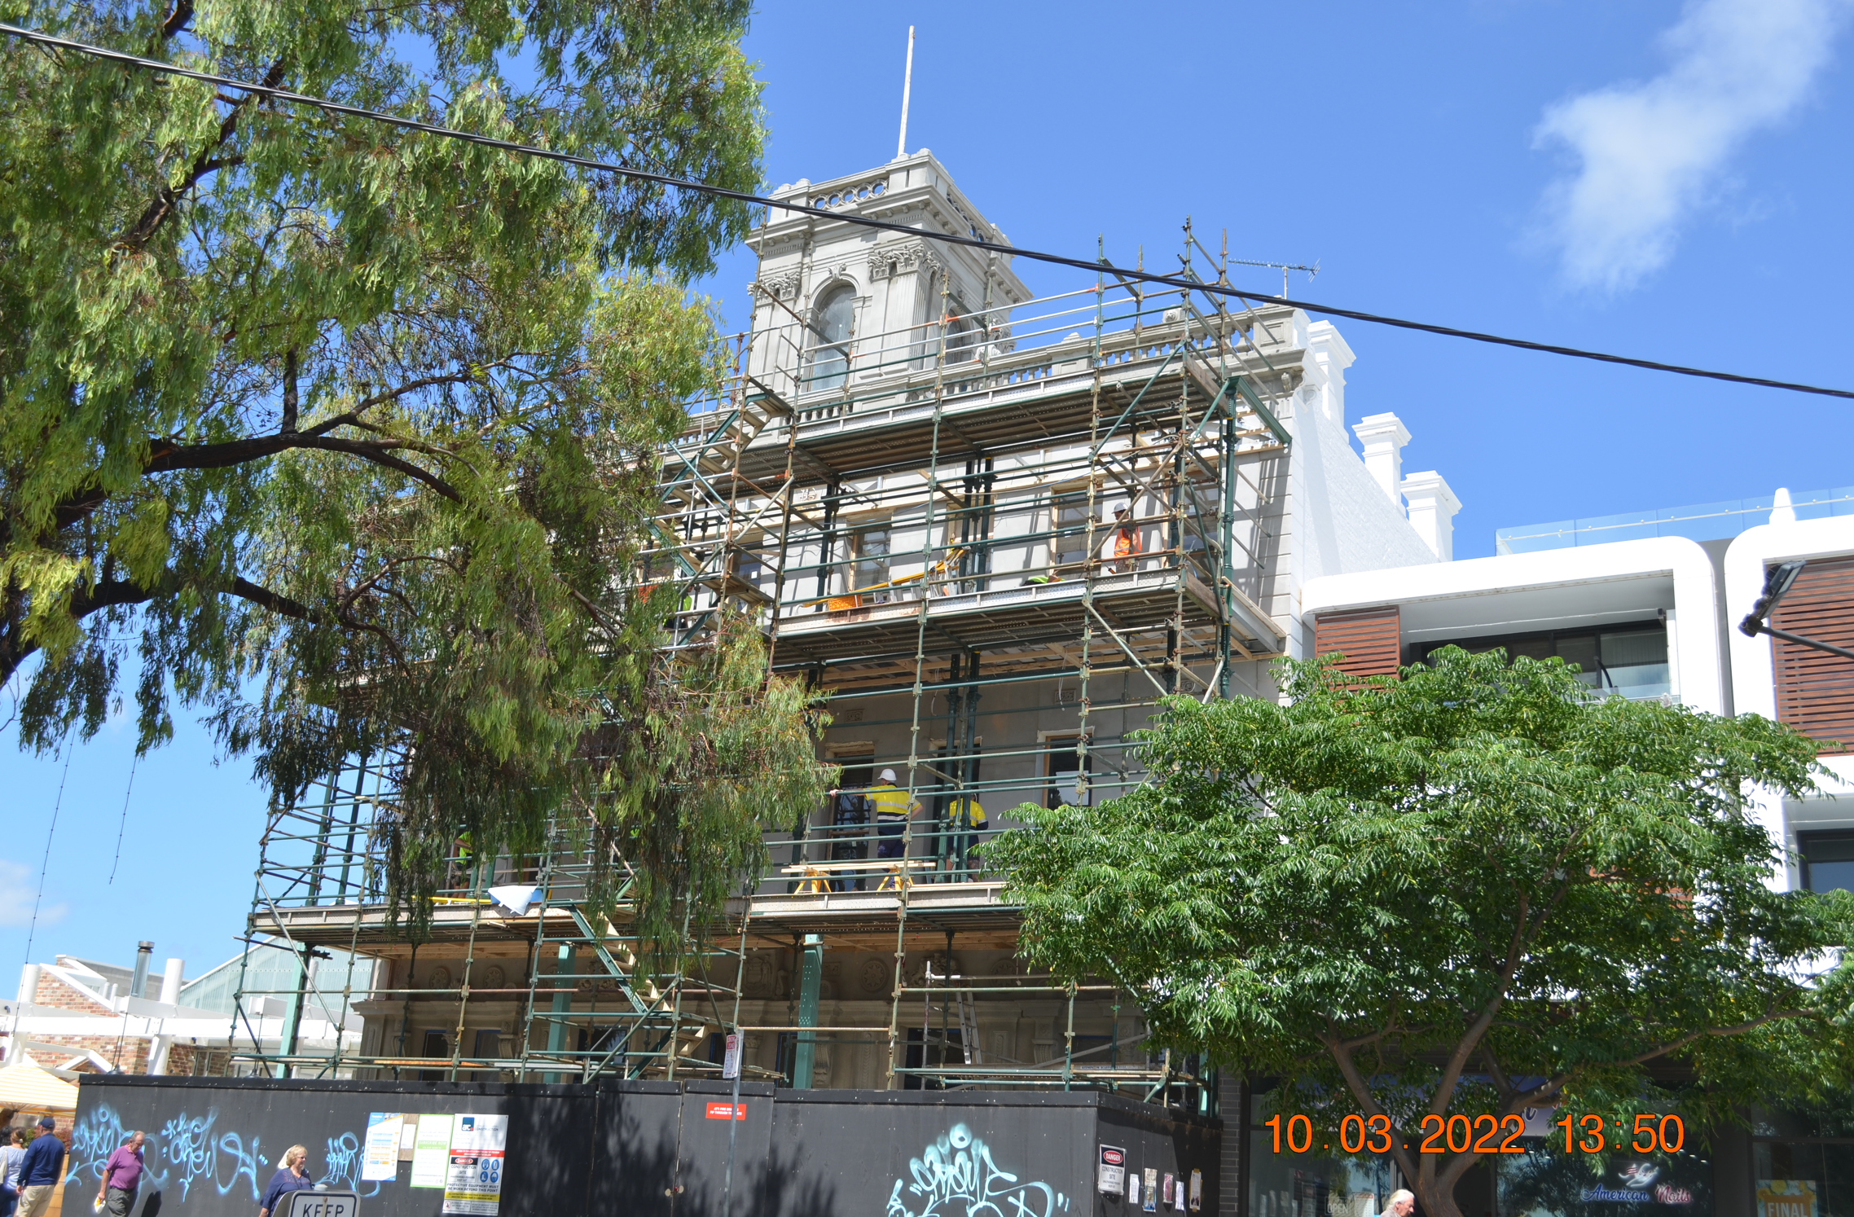
Grand Hotel, works in progress, 10 March 2022. Source: Susan Brown, City of Greater Geelong.

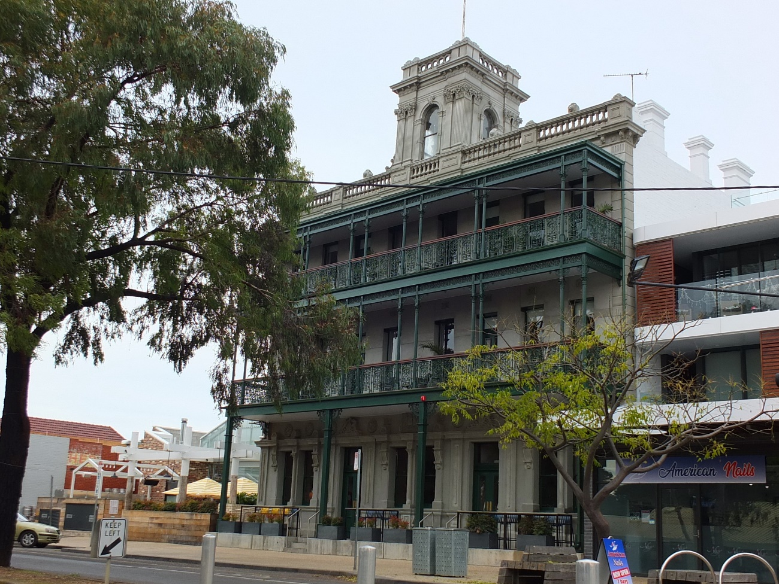
Restored Grand Hotel, 2022. Source: David Rowe.

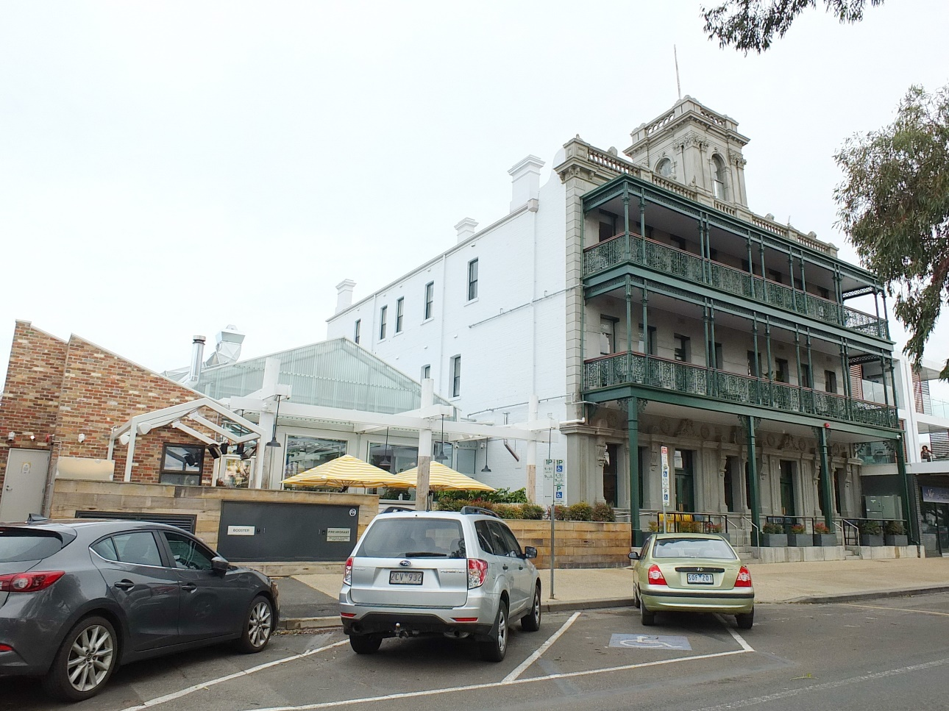
Restored Grand Hotel, 2022. Source: David Rowe.

