The City Of
Greater Geelong

g21 agribusiness economic profile

NOVEMBER 2018

  - data updates to
  - g21 sustainable agribusiness strategy, issues paper

This report has been prepared by:

Economic Development
City of Greater Geelong
PO Box 104
100 Brougham Street
Geelong, Victoria 3220

P: (03) 5272 4888
E: ecoinfo@geelongcity.vic.gov.au
W: www.geelongaustralia.com.au/business

Table of Contents

Objective and Data Highlights 5
1 What is Agribusiness? 6
2 Agribusiness Data Sources 7
Agribusiness in the G21 Region 8
3 Agribusiness in the G21 Economy 8
3.1 Value-Added 8
3.2 Value-Added Industry Comparison 9
3.3 Employment 10
3.4 Employment Industry Comparison 10
3.5 Exports 11
4 Regional Comparisons within Victoria 12
4.1 Employment Comparisons 12
4.2 Value-Added Comparisons 13
4.3 Export Comparisons 14
5 Sectors within Agribusiness in the G21 Region 15
5.1 Employment by Sector 15
5.2 Value of Primary Production by Sector 15
5.3 Growth in Value of Primary Production by Sector 16
6 G21 Agribusiness by Local Government Area 18
6.1 Employment by Local Government Area 18
6.2 Value of Primary Production by Local Government Area 20
7 Diversity of Processors 22
8 G21 Agribusiness Farm Sizes 23
9 Land Use and Value 27
10 Agritourism 28
11 Summary 29

List of Tables

Table 2-1: Data sources 7
Table 3-1: Value-added by industry in G21 agribusiness sector 8
Table 3-2: Employment in G21 agribusiness 2016 10
Table 6.1: Value of primary production by commodity and local government area ($million), 2016 21
Table 6.2: Value of primary production by sector and local government area ($million), 2016 21
Table 7-1: Processor output in the G21 region, 2017 22
Table 8-1: G21 property numbers and value of production by business turnover ranges, 2011-2016 24
Table 9-1: Value of primary production by hectare, 2016 27

List of Figures

Figure 3-1: Value-added in G21 region 9
Figure 3-2: Employment by industry in G21 region, 2016 10
Figure 3-3: G21 exports by industry 11
Figure 4-1: Agribusiness employment by sector and region, 2016 12
Figure 4-2: Agribusiness contribution to employment by region, 2016 13
Figure 4-3: Agribusiness contribution to value-added by region, 2016 13
Figure 4-4: Agribusiness contribution to exports by region, 2016 14
Figure 5-1: G21 employment in agribusiness by sector 15
Figure 5-2: Value of primary production by detailed sector breakdown G21, 2016 16
Figure 5-3: Annual growth in the value primary production by sector G21, 2011 - 2016 17
Figure 5-4: Value of primary production by sector, 2006/07 - 2016/17 17
Figure 6-1: Employment by function in the supply chain by local government area, 2016 18
Figure 7-1: G21 agribusiness processing output ($million), 2017 22
Figure 8-1: Number of farms and value of production by business turnover ranges, 2016 23
Figure 8-2: Value of production by business turnover ranges, 2011 - 2016 25
Figure 8-3: Percentage change in number of farms and value of production by business turnover ranges 25
Figure 8-4: Farm numbers by turnover range and sector in the G21 region, 2016 26
Figure 9-1: Agricultural land use by sector in the G21 region, 2011 - 2016 27
Figure 11-1: Conceptual map of agribusiness in the G21 region 31

Objective and Data Highlights

The objective of this profile is to update data in the G21 Sustainable Agribusiness Strategy Issues Paper prepared by RMCG and Dench McClean Carlson in May 2017.
Since the Issues Paper was published both the Australian Bureau of Statistics’ 2016 Census of Population and Housing and data from the 2016 Agricultural Census has been released. All data in Section 3 of the Issues Paper – Agribusiness in the G21 Region – has been updated wherever possible.

Data highlights

AGRIBUSINESS IN THE G21 REGION:

- Contributes $1.5 billion annually to Gross Regional Product making up 9.3% of regional value-added.
- Value-added increased by 24.8% in the five years to 2016, moving from the eighth largest industry in the region to the fifth largest.
- Employs 10,643 people, an increase of 19.2% or 1,699 jobs between 2011 and 2016.
- Is the region’s second largest exporter at $1.4 billion, accounting for 17% of total exports.
- The total value of agricultural commodities produced in the G21 region in 2016 was $817 million.
- There was an overall decrease of 7% in land used for agriculture in the five years to 2016, yet there was an increase of 86% in the value of primary production.
- Food and beverage processing contributes $1.7 billion or 5% of total output in the G21 region.
- The top processing revenue earners in the G21 region include meat and meat product manufacturing ($577 million), followed by dairy product manufacturing ($436m), beer manufacturing ($128m), wine and spirit manufacturing ($127m) and bakery product manufacturing ($118m).
- Farms with a turnover greater than $2 million per annum represent only 4% of farms but make up 54% of the value of production.
- Tourism generates $1.5 billion in regional output or revenue and the most popular activity is dining at local restaurants and cafes - a major opportunity for local growers and producers.

Defining Agribusiness

1.0 What is Agribusiness?

The value of agribusiness can be underestimated because of a focus on farm production alone.
Farming is only one step in a supply chain that includes:
- The inputs into agriculture: agronomists, chemical suppliers, machinery companies, transport and so on. The scale of this step of the supply chain has been estimated using REMPLAN. The employment for this step of the agribusiness supply chain is primarily located in the ABS industries: ‘transport, postal and warehousing’; ‘professional, scientific and technical’, ‘retail trade’ and ‘wholesale trade’.
- Primary production or farming, including forestry. Data on primary production employment is sourced from the ABS Census of Population and Housing, 2011 and 2016.
- Manufacturing activities that process the primary products, such as abattoirs, milk factories, wineries and sawmills. As with primary production, data on employment is sourced from the ABS Census of Population and Housing, 2011 and 2016.
- Wholesaling the primary or processed products. Geelong has a significant wholesaling and logistics sector, such as grain storage and export through the Port of Geelong. Some of this agribusiness related wholesale employment can be isolated from ABS Census data, for instance employment in ‘cereal grain wholesaling’.

Agribusiness supply chain

Agribusiness is a ‘base’ industry, which exports from the region and draws wealth from outside. Tourism, mining and manufacturing are also commonly considered base industries. Other industries, such as education and healthcare support the base industries.
The upstream (input) and downstream (processing) industries would not exist if not for the production, therefore it is valid to include the linked input and processing sectors in an assessment of the size of the industry.
Source: RMCG and Dench McClean Carlson, G21 Sustainable Agribusiness Strategy, Issues Paper, 22 May 2017.
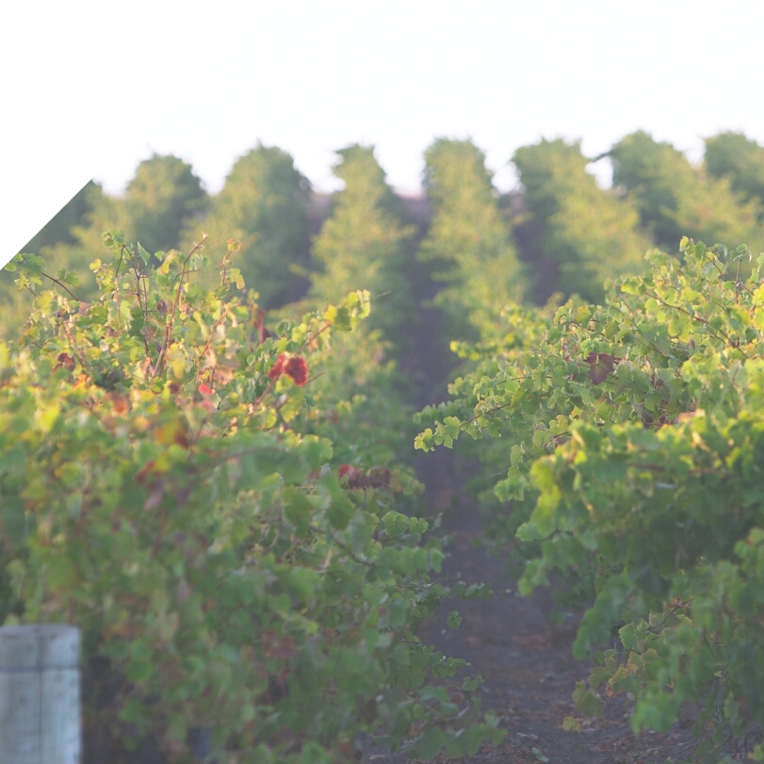

2.0 Agribusiness Data Sources
The data in this report is sourced from the Australian Bureau of Statistics, REMPLAN and Neil Clark and Associates. This data provides a picture of agribusiness in the G21 region and how the industry has changed over time. Table 2-1 details the data sources used in this report.

Table 2-1: Data sources

Source | Data
Australian Bureau of Statistics (ABS)  Census of Population and Housing (2016 and 2011) | - Employment by industry (place of work)
REMPLAN Economy | - Value-added  - Regional exports  - Processing output  - Estimate of value-added and employment inputs
Neil Clark and Associates custom data request using ABS Agricultural Census (2016 and 2011)  - Agricultural Commodities, Australia (catalogue 7121.0)  - Value of Agricultural Commodities Produced, Australia (catalogue 7503.0)  Note: Data from these catalogues is focused on the strict definition of agriculture rather than the broader definition of agribusiness. | - Value of primary production  - Land use  - Value of production and number of properties by business turnover

Australian Bureau of Statistics statistical area maps: http://stat.abs.gov.au/itt/r.jsp?ABSMaps
All figures and tables created by Economic Development, City of Greater Geelong.
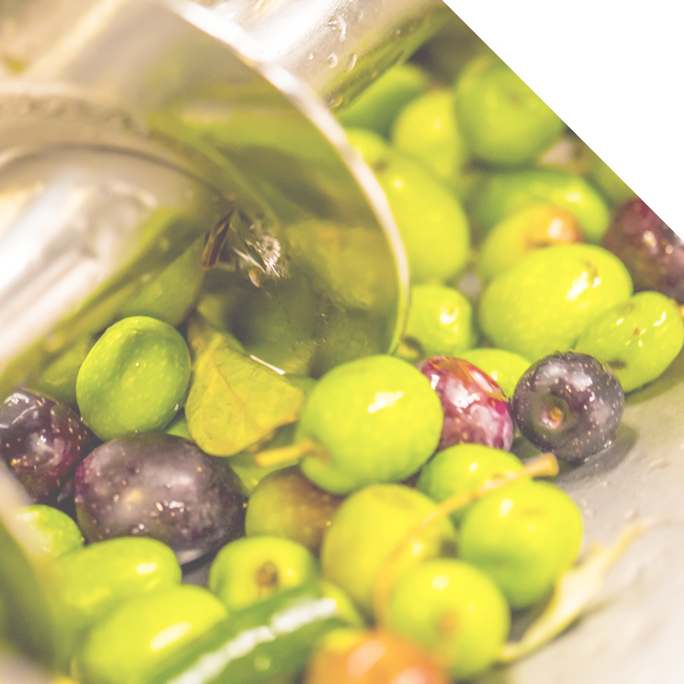

Agribusiness in the G21 Region

3.0 Agribusiness in the G21 Economy

3.1 Value-added estimate
Value-added is the economic value that is added by an industry sector and is the industry contribution to Gross Regional Product. It is calculated as the value of sales minus input purchases, and is equal to wages and profits. Value-added is estimated using REMPLAN (latest available dataset as at December 2017).
The value-added of each part of the supply chain is shown in Table 3-1. The total value-added of the G21 economy is estimated at $15,654m. Agribusiness, including supply chain inputs, farming, processing and wholesaling accounted for $1,456m, or 9.3% of the G21 economy (up from 8.3% in 2011). This represents an increase of $290m or 24.8% compared to the 2011 estimate.
Compared to 2011, the value-added generated by all segments of the agribusiness sector have increased: inputs by 22%; farming by 31%; processing by 20%; and wholesaling by 38%.

Table 3-1: Value-added by industry in G21 agribusiness sector
 | Inputs | Farming | Processing | Wholesaling* | Total 2016 | Total 2011 | Change (No.) | Change  (%)
Value-added | $417m | $505m | $454m | $81m | $1,456m | $1,166m | +$290m | +24.8%
% of G21 total | 2.7% | 3.2% | 2.9% | 0.5% | 9.3% | 8.3%

Source: REMPLAN Economy (using December 2017 dataset). The references to 2016 and 2011 are a guide only as the REMPLAN datasets are updated throughout the year based on the release of relevant data. However, the majority of change is seen with the release of the ABS’ Census of Population and Housing every five years. Since the previous Issues Paper in 2017 the 2011 Census place of work data has been updated with 2016 data and 2011 data has been revised since the release of the 2017 Issues Paper to make it comparable with 2016 Place of Work data (scaled 2011 data sourced from REMPLAN based on ABS advice).
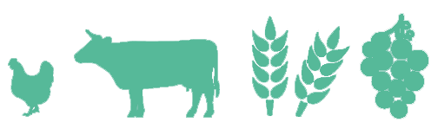
*Wholesaling value-added is estimated on the basis of agribusiness related wholesaling employment as a share of total wholesaling employment (16.9%).

AGRIBUSINESS
contributes
to GRP in the G21 region
$1.5B

3.2 Value-added Industry Comparison
In order to have a like-with-like comparison with other industries, it is necessary to remove input (supply chain) value-added from the agribusiness estimate in Table 3-1. Estimates for other industries do not include supply chain value-added. The following chart includes farming ($505m) + processing ($454m) + wholesaling ($81m) value-added, which totals $1,039m, see Figure 3-1. Agribusiness is the 5th largest industry in the G21 region by value-added. The previous estimates based on 2011 data, ranked agribusiness as the 8th largest industry in terms of value-added.
Rental, hiring and real estate services make a significant contribution to value-added because it includes ‘ownership of dwellings’ - an imputed value of the services of owner-occupied dwellings which accounts for $1.6b or 12.6% of total value-added. The imputation of rent to owner-occupied dwellings enables dwellings of owner-occupiers to be treated consistently with the marketed services provided by rented dwellings to their tenants. If ownership of dwellings was removed from the data, agribusiness would be the fourth largest industry in terms of value-added in the G21 region.

Figure 3-1: Value-added in G21 region
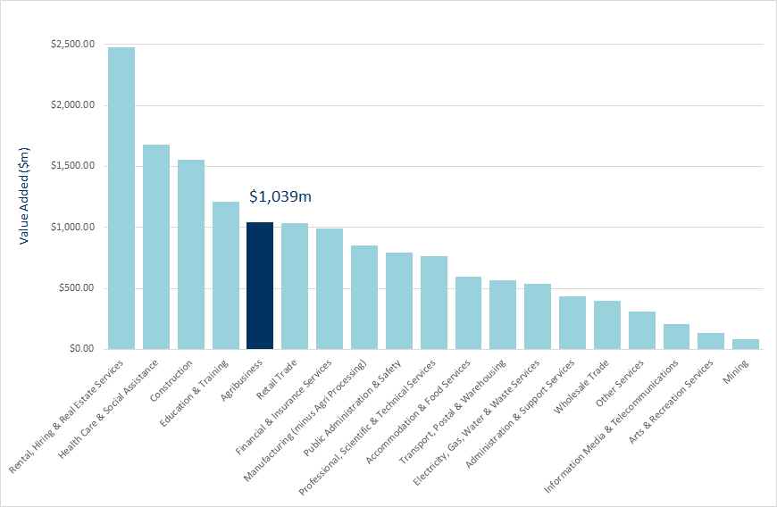
Source: REMPLAN Economy (using December 2017 dataset).
Note: Supply chain inputs removed to compare agribusiness with other industries on a like-with-like basis.

agribusiness is THE 5th largest industry in terms of value-added IN THE G21 REGION, up from 8th largest in 2011

3.3 Employment
It is estimated that 10,634 people work in the agribusiness sector in the G21 region, an increase of 1,699 jobs or 19% in the five years since the 2011 Census. The number of jobs in each part of the agribusiness supply chain is shown in Table 3-2. Total employment in the G21 region in 2016 was 118,000, therefore agribusiness, including upstream and downstream processing, employed 9.0% of the G21 working population.

Table 3-2: Employment in G21 agribusiness
 | Inputs | Farming | Processing | Wholesaling | Total 2016 | Total 2011 | Change (No.) | Change  (%)
Jobs | 3,077 | 3,373 | 3,634 | 550 | 10,634 | 8,935 | +1,699 | +19.0%
% of G21 total | 2.6% | 2.9% | 3.1% | 0.5% | 9.0% | 8.2%

Source: ABS 2016 Census of Population and Housing (place of work data) 2011 data has been revised since the release of the 2017 Issues Paper to make it comparable with 2016 Place of Work data (scaled 2011 data sourced from REMPLAN based on ABS advice).

3.4 Employment Industry Comparison
As with value-added, input employment (supply chain data) has been removed to compare agribusiness with other industries. Therefore, Figure 3-2 showing the ranking of industries by employment only includes agribusiness employment in farming, processing and wholesaling, which totals 7,557 jobs. Figure 3-2 shows that agribusiness is the 6th largest industry in the G21 region by employment, up from 7th largest in 2011.

Figure 3-2: Employment by industry in G21 region, 2016
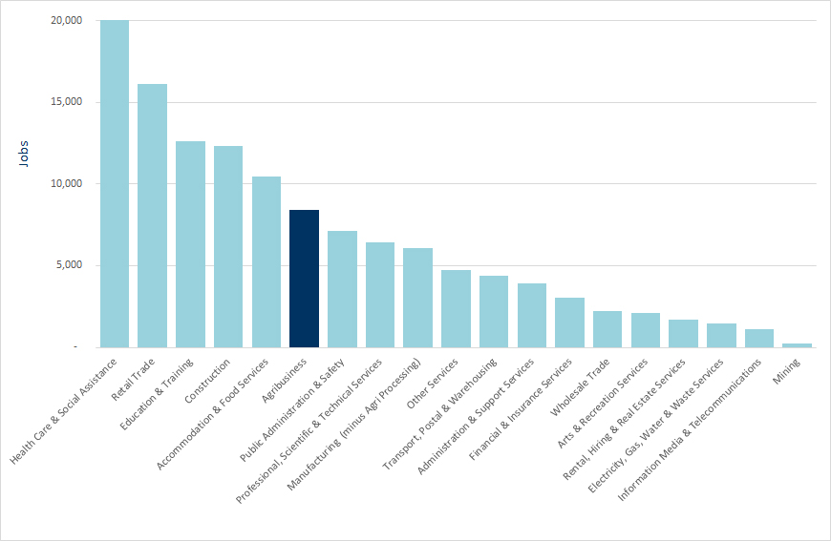
Source: REMPLAN Economy (using December 2017 dataset).
Note: Supply chain inputs are removed to enable a like-with-like comparison to other industries. Data does not exactly correlate with Table 3-2 because detailed place of work employment data was sourced from raw 2016 ABS Census data yet the industry comparisons were generated using REMPLAN Economy, which applies a statistical methodology to the raw ABS data.
agribusiness is THE 6th largest industry in terms of EMPLOYMENT IN THE G21 REGION, up from 7th largest in 2011

3.5 Exports
The G21 Sustainable Agribusiness Strategy Issues Paper released in May 2017 was based on data from the 2011 ABS Census. It was noted that ‘manufacturing has historically dominated G21 exports, with large companies exporting cars, petroleum and aluminium’ and that ‘the closure of large companies in manufacturing industries, particularly Ford and Alcoa, in recent years means that the quantity of (non-agribusiness) manufacturing exports has reduced since 2011’.
The Issues Paper showed that agribusiness accounted for 8% of regional exports and in the absence of 2016 Census data at the time, estimated that agribusiness exports accounted for between 8% and 16% of all exports from the G21 region since the full closure of Alcoa and manufacturing ceased at Ford (vehicle design and testing continues).
An analysis of the latest data using REMPLAN shows this to be an accurate estimate and that agribusiness (including farming, processing and wholesaling) exports $1.4b from the G21 region accounting for 17% of total exports.

Figure 3-3: G21 exports by industry
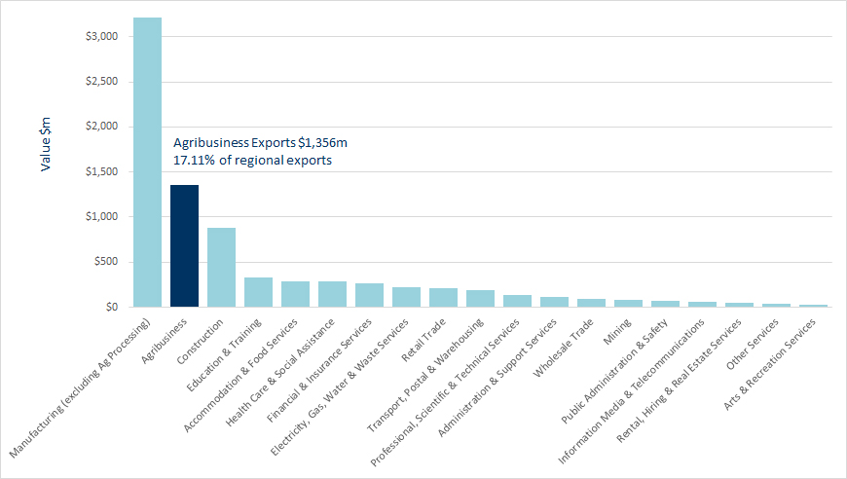
Source: REMPLAN Economy (using December 2017 dataset).
Note: Exports are the value of goods and services produced by industry sectors in the G21 region, which are sold to consumers, businesses, and governments based outside the region's boundaries. So there is no distinction between intrastate, interstate or international.

2ND LARGEST
AGRIBUSINESS
is the region’s

EXPORTER (17% of total exports)

4.0 Regional Comparisons within Victoria

4.1 Employment Comparisons
Three benchmarking areas have been selected to compare the size of the agribusiness sector to the G21 region. Regions are based on Regional Development Victoria Designated Regional Partnerships (areas). Gippsland has the largest number of agribusiness jobs overall (13,277 jobs), followed by the Bendigo region (11,275 jobs), G21 region (7,557 jobs) and the Ballarat region (5,518 jobs). Excludes estimated jobs from inputs.
Employment in primary production and agribusiness wholesaling is largest in Gippsland and employment in processing is largest in the Bendigo region. Primary production jobs in Gippsland are mainly in dairy cattle farming (38%), beef cattle farming (specialised) (22%) and outdoor vegetable growing (8%). Processing jobs in the Bendigo region are mainly in cured meat and smallgoods manufacturing (17%), meat processing (14%), poultry processing (13%), factory based bread manufacturing (8%) and non-factory based bakery product manufacturing (7%).

Figure 4-1: Agribusiness employment by sector and region, 2016
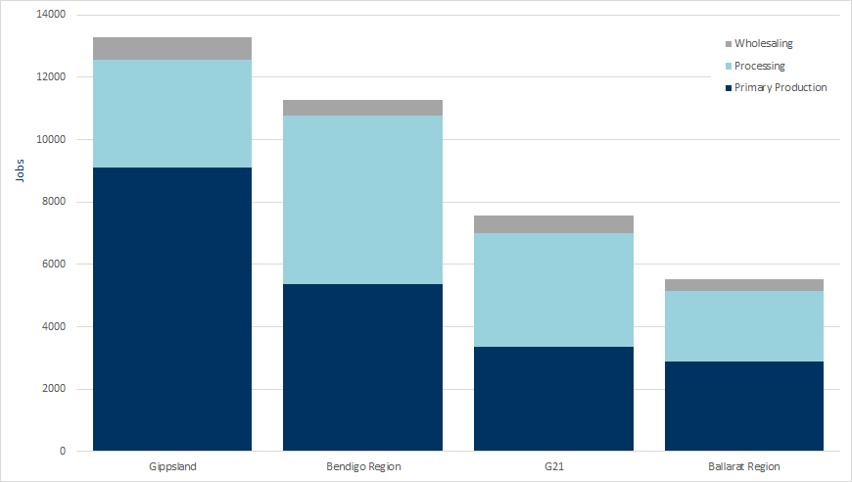
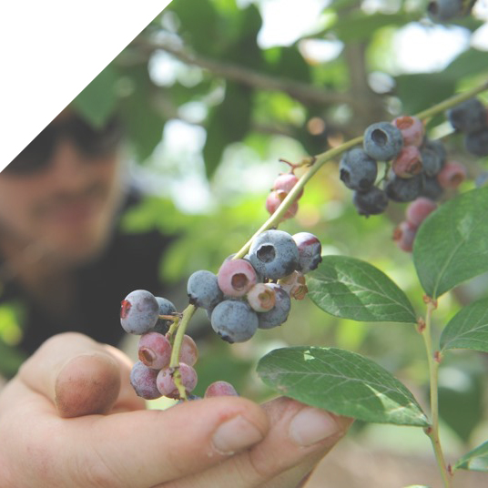
Source: ABS 2016 Census of Population and Housing (place of work data).
The agribusiness contribution to total regional employment from highest to lowest is: Gippsland (13%), Bendigo region (13%), Ballarat region (9%) and G21 region (6%). This data excludes agribusiness inputs.

Figure 4-2: Agribusiness contribution to employment by region, 2016
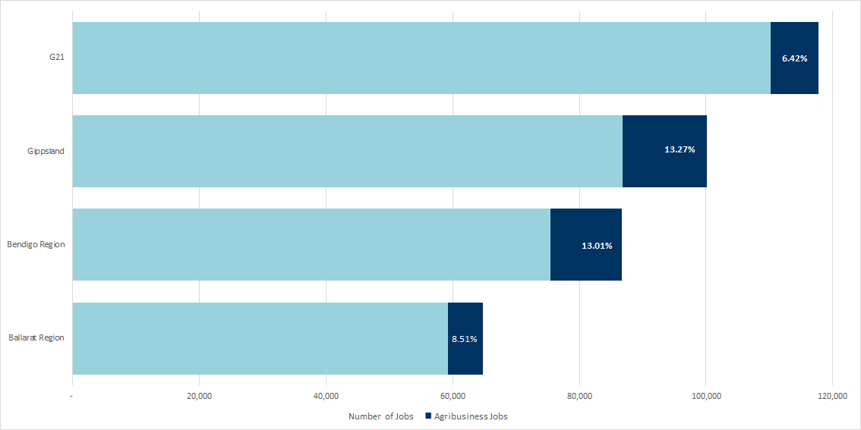
Source: ABS 2016 Census of Population and Housing (place of work data).

4.2 Value-added Comparisons
The contribution of agribusiness to total regional value-added is largest in the Bendigo region (13%), followed by Gippsland (12%), Ballarat region (11%) and G21 region (7%).

Figure 4-3: Agribusiness contribution to value-added by region, 2016
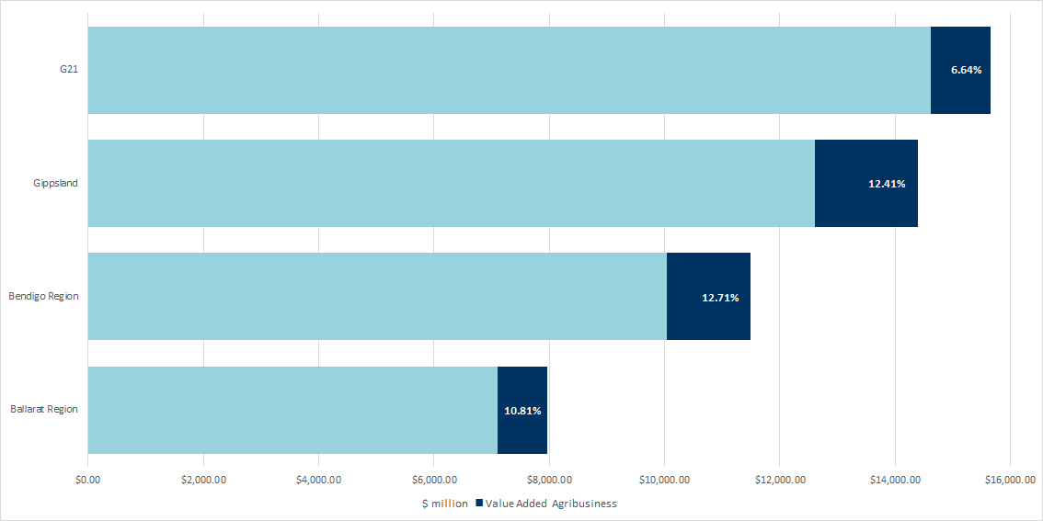
Source: REMPLAN Economy (using December 2017 datasets).

4.3 Export Comparisons
The agribusiness contribution to total regional exports from highest to lowest is: Bendigo region (44%), Gippsland (30%), Ballarat region (30%) and G21 region (17%).

Figure 4-4: Agribusiness contribution to total exports by region, 2016
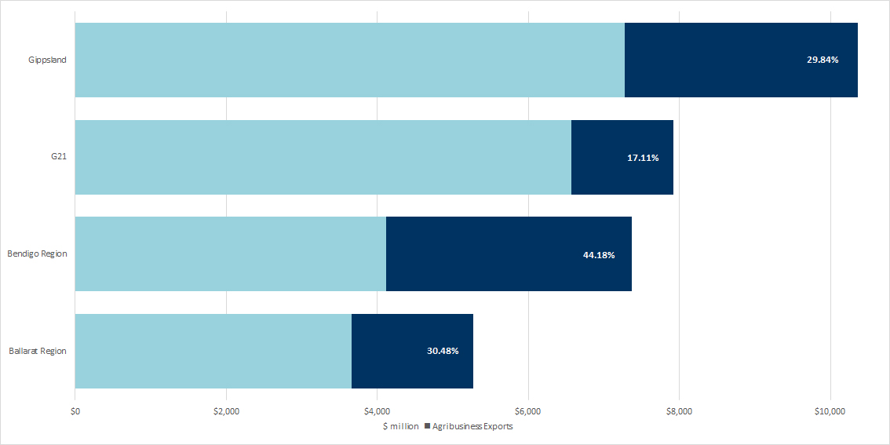
Source: REMPLAN Economy (using December 2017 dataset).

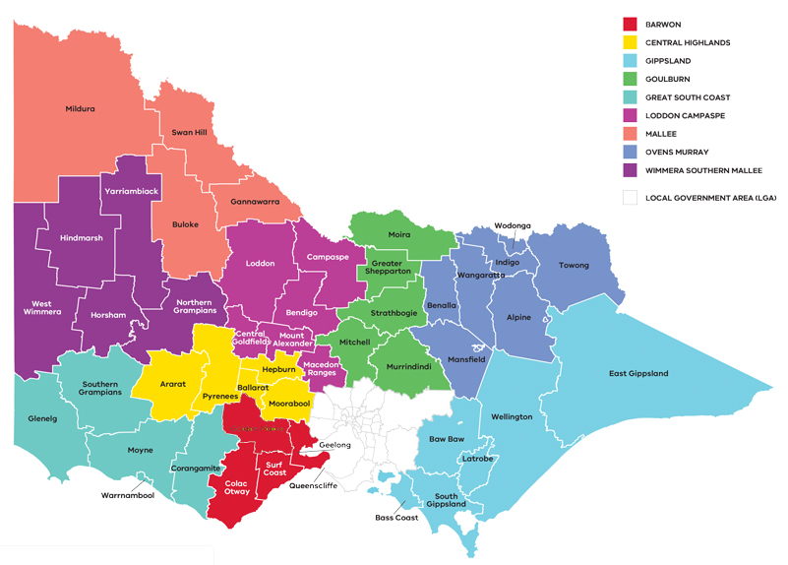
Geography notes
G21

BALLARAT REGION

GIPPSLAND

GOULBURN

GREAT SOUTH COAST

BENDIGO REGION

MALLEE

OVENS MURRAY

WIMMERA SOUTHERN MALLEE

G21 region municipalities: City of Greater Geelong, Surf Coast Shire, Colac Otway Shire, Golden Plains Shire, Borough of Queenscliffe.
Ballarat region municipalities: Ararat Rural City, City of Ballarat, Hepburn Shire*, Moorabool Shire, Pyrenees Shire
Bendigo region municipalities: City of Greater Bendigo, Central Goldfields Shire*, Campaspe Shire, Loddon Shire, Macedon Ranges Shire, Alexander Shire.
Gippsland municipalities: Baw Baw Shire, Bass Coast Shire, East Gippsland Shire, City of Latrobe, South Gippsland Shire, Wellington Shire.
* REMPLAN data not available so excluded from the value-added and export data.

5.0 Sectors within Agribusiness in the G21 Region

5.1 Employment by Sector
In employment terms, the largest sectors within G21 agribusiness are sheep/lamb and beef, further processing and dairy. Figure 5-1 shows employment combined across primary production, processing and wholesaling within each sector of the agribusiness industry. For example:
- The ‘sheep and beef’ data point shows employment on farms (primary production), in abattoirs (processing) and in ‘wool wholesaling’.
- The ‘chicken meat’ data point shows employment on farms (primary production) and workers at Turosi Foods’ processing plant in Breakwater.
The mix of employment between the primary production and processing functions varies by sector, with employment in the sheep and beef sector being mostly primary production, and employment within the forestry, chicken meat and wine sectors being mostly in the processing sector. Agribusiness-specific wholesaling employment data is only available in some sectors, i.e. sheep and beef, grains, horticulture and forestry.
‘Further processing’ employment includes workers involved in a secondary processing stage e.g. in the grains sector, milling is primary processing, while baking is further processing of the flour from the mill. The main employment in further processing in the G21 region is Wooden Structural Fitting and Component Manufacturing, Bread Manufacturing (factory based), Bakery Product Manufacturing (non-factory based), Beer Manufacturing, Cake and Pastry Manufacturing (factory based) and Cured Meat and Smallgoods Manufacturing. It’s also worth noting that general Food Product Manufacturing unable to be classified in any greater detail is also strongly represented in further processing.

Figure 5-1: G21 employment in agribusiness by sector
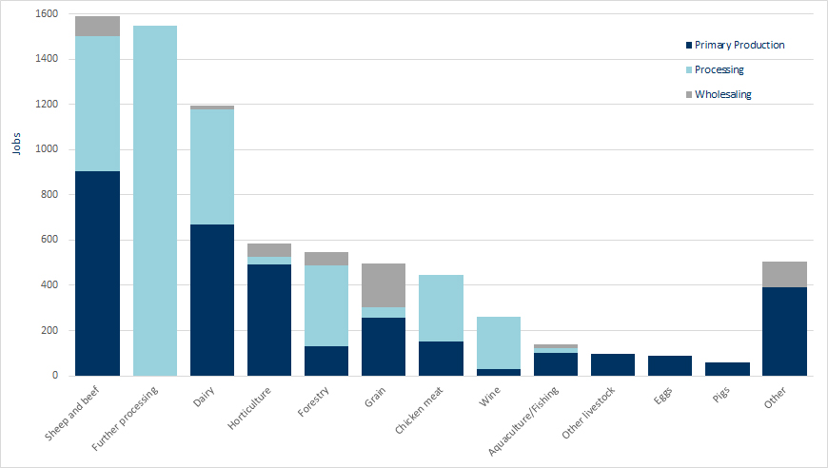
Source: ABS 2016 Census of Population and Housing (place of work data).

5.2 Value of primary production by sector
Note: data in sections 5.2 to 5.4 is sourced from the ABS’ Agricultural Census. Therefore, it is focused on the strict definition of agriculture rather than the broader definition of agribusiness profiled in earlier sections.
The value of primary production in 2016 was greatest in poultry meat ($242.4m), milk ($145.1m), cattle ($111.9m), cropping ($73.8m) and sheep ($72.7m).
The value of production mainly reflects the employment data with milk, cattle and sheep also being large sectors in terms of value. The greatest difference appears in poultry with the highest value of production but a lower contribution in terms of employment.

Figure 5-2: Value of primary production by detailed sector breakdown G21, 2016
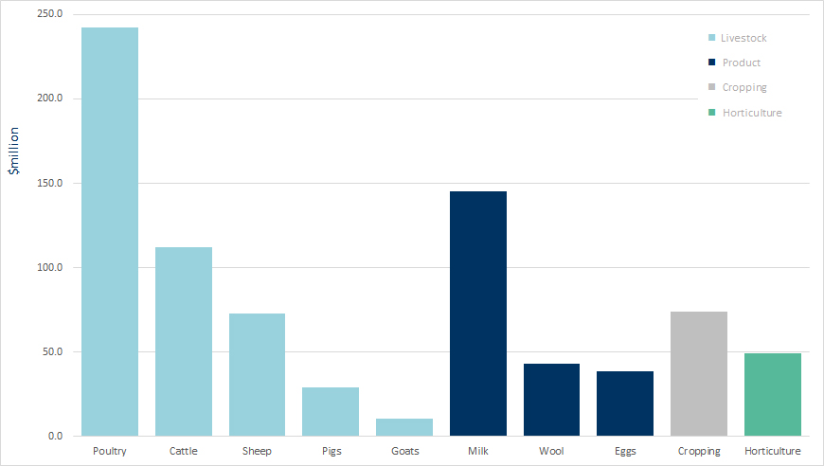

Source: Neil Clark & Associates (using ABS 2016 Agricultural Census data).
Note: Agricultural census data does not include the value of forestry, fishing or processing.

5.3 Growth in value of primary production by sector
A comparison between the 2011 and 2016 agricultural commodities data shows the largest growth in the value of production is in poultry livestock (21.3%pa) followed by milk (21.1%pa), goats (18.7%pa - off the smallest base value), wool (13.1%pa), pigs (12.5%pa), cattle (10.5%pa), eggs (6.9%pa), sheep (1.6%pa), horticulture (1.2%pa) and a decline in cropping (-1.0%pa).
The sectors can be grouped into the broad classifications of intensive and extensive agriculture. Intensive agriculture is an agricultural production system that uses higher amounts of inputs for higher yields per area of land. These sectors include poultry (meat and eggs), pigs and horticulture. Extensive agriculture is an agricultural production system that uses small inputs of labour, fertilisers and capital, relative to the land area being farmed. Extensive industries include cattle (beef and milk), sheep (meat and wool), goats and cropping.
Intensive industries have grown by 14%pa between 2011 and 2016, especially chicken meat, pig and egg production, whilst the extensive industries have grown more slowly at 4%pa. The growth in the extensive industries is largely due to growth in the value of goats (but off the lowest base level of production) and dairy. It’s acknowledged since the 2016 Agricultural Census the dairy industry has experienced a sudden downturn in what has been coined the Australian dairy crisis and production levels and profitability have yet to recover.
This growth is shown in Figure 5-3 where the data has been presented by sector and aggregated into intensive and extensive primary production to the right of the figure.
Between 2011 and 2016, the value of production has grown more rapidly in intensive industries (14%pa) compared to extensive industries (4%pa)

Figure 5-3: Annual growth in primary production value by sector G21, 2011 - 2016

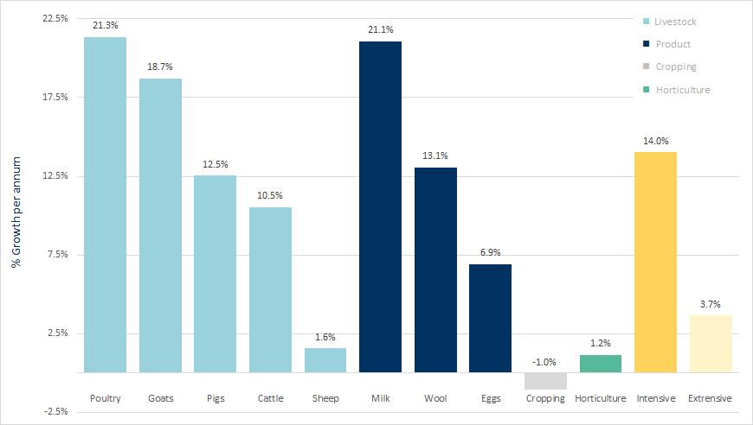
Intensive= poultry, eggs. pigs and horticulture
Extensive= cattle, sheep, goats, milk, wool, and cropping
Source: Neil Clark & Associates (using ABS 2016 Agricultural Census data).

Over the past ten years the general trend in the value of production has increased significantly in livestock, risen moderately in product (milk, eggs and wool), increased slightly in horticulture and declined slightly in cropping.

Figure 5-4: Value of primary production by sector, 2006/07 – 2016/17
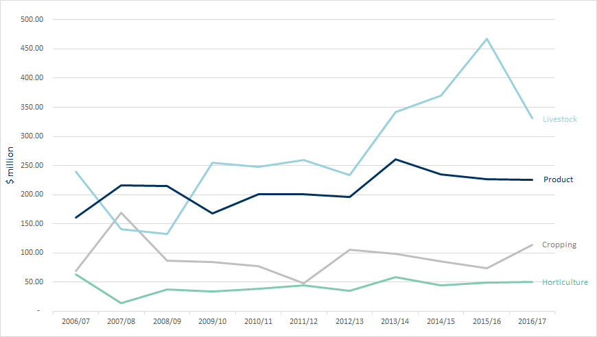

Source: Neil Clark & Associates (using ABS 2016 Agricultural Census data).

6.0 G21 Agribusiness by Local Government Area

6.1 Employment by Local Government Area
The profile of agribusiness within each of the local government areas of the G21 region differs markedly in terms of the dominant sectors and variation in the supply chain. Employment within the primary production, processing and wholesaling functions for each local government area is shown in figure 6-1.

Figure 6-1: Employment by function in the supply chain by local government area, 2016
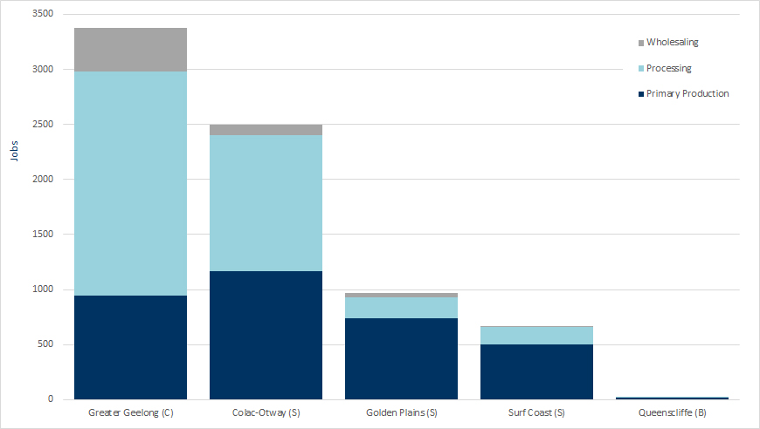

Source: ABS 2016 Census of Population and Housing (place of work data).
Employment in primary production is reasonably well spread across the four largest local government areas in the region. The majority of processing and wholesaling is located in Greater Geelong. Some of this processing draws feedstock from the G21 region (in the case of chicken meat processing for example), while some of it draws from the rest of Victoria and beyond.
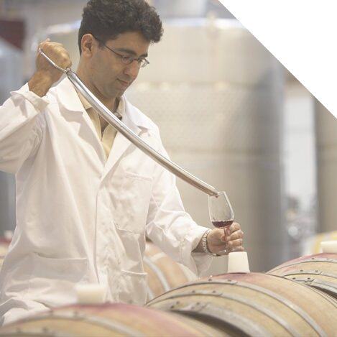
Greater Geelong Sector Breakdown

Processing contributes 2,033 or 60% of agribusiness jobs in Greater Geelong, the major sectors include:
- Meat, poultry and smallgoods manufacturing (563 jobs);
- Bakery product manufacturing (548 jobs);
- Wooden structural fitting and component manufacturing (314 jobs); and
- Wine, beer and other alcoholic beverage manufacturing (229 jobs).
Primary production contributes 945 or 28% to agribusiness employment, dominated by:
- Horticulture (328 jobs);
- Sheep, beef and dairy farming (159 jobs);
- Poultry farming (83 jobs); and
- Aquaculture and fishing (63 jobs).
Agribusiness related wholesaling makes up 396 jobs or the remaining 12% of employment, mainly in grain wholesaling and storage (104 jobs), timber wholesaling (55 jobs) and fruit and vegetable wholesaling (49 jobs).

Colac Otway Sector Breakdown

Processing accounts for 1,237 or 49% of agribusiness jobs in Colac Otway, mainly in:
- Dairy product manufacturing (423 jobs);
- Meat product manufacturing (343 jobs);
- Log sawmilling and timber dressing (266 jobs); and
- Bakery product manufacturing (114 jobs).

Primary production contributes 1,164 or 47% of total agribusiness jobs. The largest sectors include:
- Dairy cattle farming (491 jobs);
- Sheep and beef farming (340 jobs); and
- Forestry and logging (92 jobs).
Wholesaling makes up the remaining 100 jobs or 4% of the total, mainly in agricultural and construction machinery wholesaling with 45 jobs.

Golden Plains Sector Breakdown
Primary production accounts for 743 jobs or 77% of agribusiness employment in the Golden Plains, with greater representation in:
- Sheep and beef farming (354 jobs);
- Poultry farming (eggs) (71 jobs);
- Poultry farming (meat) (60 jobs); and
- Grain growing (58 jobs).
Processing contributes 19% or 188 jobs to the agribusiness sector. The major sectors are:
- Dairy product manufacturing (61 jobs);
- Wine manufacturing (45 jobs); and
- Poultry processing (38 jobs).
The remaining 37 jobs are in agricultural product wholesaling.

Surf Coast Sector Breakdown
Primary production contributes 498 or 75% of agribusiness related jobs in the Surf Coast. The largest sectors include:
- Sheep and beef farming (201 jobs);
- Horse farming (47 jobs);
- Horticulture (41 jobs); and
- Grain growing (27 jobs).
Agribusiness processing accounts for 159 jobs or 24% of agribusiness employment, mainly in:
- Bakery product manufacturing (75 jobs); and
- Wine manufacturing (41 jobs).
The remaining 1% of employment is in wholesaling.

Queenscliffe Sector Breakdown

Queenscliffe agribusiness supports 27 jobs in aquaculture, fishing and bakery product manufacturing.

6.2 Value of Primary Production by Local Government Area
Note: this section only focuses on primary production sectors not the full definition of agribusiness.
Table 6-1 shows the value of primary production by sector and local government area in 2016.
The data shows that:
- The total value of agricultural commodities produced in the G21 region in 2016 was $817 million;
- 85% of regional agricultural commodity value comes from livestock (meat) and agricultural products (eggs, dairy & wool)
- Over 75% of cropping, livestock (for meat) and agricultural product value is located in Golden Plains and Colac Otway;
- Over 85% of regional horticulture value is produced in Greater Geelong and the Surf Coast;
- Golden Plains’ high value commodities include poultry meat, sheep and lambs, eggs, cropping and wool;
- Colac Otway’s high value commodities include milk, beef and cropping; and
- High value commodities produced in Greater Geelong and the Surf Coast include poultry meat and horticulture.


The TOTAL VALUE
of agricultural commodities in the G21 region is

$817M

Table 6-1: Value of primary production by commodity and local government area ($million), 2016
Municipalities with the highest ranked value of production in each commodity is in bold italics.
Commodity | Golden Plains | Colac Otway | Surf Coast | Greater Geelong* | TOTAL G21
CROPPING | 31.0 | 25.1 | 11.6 | 6.1 | 73.8
HORTICULTURE | 1.0 | 6.0 | 20.9 | 21.5 | 49.4
BEEF | 9.7 | 87.0 | 11.0 | 4.2 | 111.9
GOATS | 10.3 | 0.2 | 0.0 | 0.7 | 10.7
PIGS | 15.0 | 2.0 | 12.3 | 0.0 | 29.3
POULTRY | 184.0 | 4.2 | 26.3 | 28.0 | 242.4
SHEEP & LAMBS | 42.1 | 12.3 | 12.2 | 6.1 | 72.7
EGGS | 38.1 | 0.3 | 0.5 | 0.0 | 38.9
MILK | 0.3 | 138.2 | 5.7 | 0.8 | 145.1
WOOL | 25.6 | 7.1 | 6.4 | 3.8 | 42.9
TOTAL | 357.2 | 282.4 | 106.9 | 70.1 | 817.1
% TOTAL | 43.7% | 34.6% | 13.1% | 8.6% | 100.0%
Source: Neil Clark & Associates (using ABS 2016 Agricultural Census data).
*ABS Statistical Area 2 (SA2) data - Borough of Queenscliffe included in City of Greater Geelong.

Table 6-2: Value of primary production by sector and local government area ($million), 2016
Sector | Golden Plains | Colac Otway | Surf Coast | Greater Geelong | TOTAL G21
CROPPING | 31.0 | 25.1 | 11.6 | 6.1 | 73.8
HORTICULTURE | 1.0 | 6.0 | 20.9 | 21.5 | 49.4
LIVESTOCK | 261.2 | 105.7 | 61.8 | 38.3 | 467.0
PRODUCT | 64.1 | 145.6 | 12.6 | 4.6 | 226.9
TOTAL | 357.2 | 282.4 | 106.9 | 70.1 | 817.1

Source: Neil Clark & Associates (using ABS 2016 Agricultural Census data).

*SA2 data - Borough of Queenscliffe included in City of Greater Geelong.

COMMODITY VALUES IN THE G21 REGION 2016

(Local Government Areas with the largest contribution highlighted in brackets)

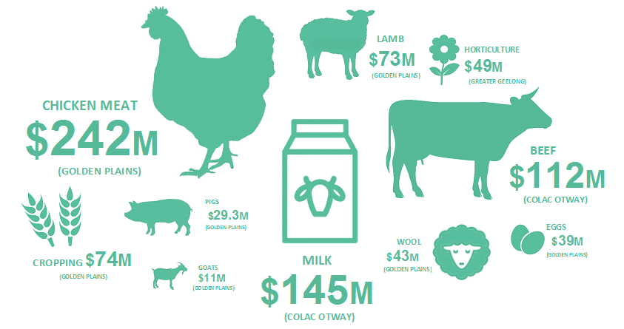

7.0 Diversity of Processors
The G21 region has a large diversity of processors with most located in the City of Greater Geelong and Colac Otway Shire. The output (revenue) from food and beverage product manufacturing is presented Table 7-1.
Food and beverage processing contributes $1.7 billion or 5% of total output in the G21 region. The data shows that whilst there is a large diversity of processors, 60% of the output is produced by the meat and dairy sectors. Meat and meat product manufacturing earns $577 million, followed by the other big revenue earners of dairy product manufacturing ($436m), beer manufacturing ($128m), wine and spirit manufacturing ($127m) and bakery product manufacturing ($118m).

Table 7-1: Processor output in the G21 region, 2017
Food Product Manufacturing | Output ($m) | % Total G21 Output
Meat & Meat Product Manufacturing | $577 | 1.6%
Dairy Product Manufacturing | $436 | 1.2%
Bakery Product Manufacturing | $118 | 0.3%
Other Food Product Manufacturing | $99 | 0.3%
Grain Mill & Cereal Product Manufacturing | $53 | 0.2%
Processed Seafood Manufacturing | $39 | 0.1%
Fruit & Vegetable Product Manufacturing | $39 | 0.1%
Oils & Fats Manufacturing | $36 | 0.1%
Sugar & Confectionery Manufacturing | $28 | 0.1%
Total Food Product Manufacturing | $1,426 | 4.1%
Beverage Manufacturing | Output ($m) | % Total G21 Output
Beer Manufacturing | $128 | 0.4%
Wine, Spirits & Tobacco Manufacturing | $127 | 0.4%
Soft Drinks, Cordials & Syrup Manufacturing | $10 | 0.0%
Total Beverage Manufacturing | $266 | 0.8%
Total Food and Beverage Manufacturing | $1,692 | 4.8%

Source: REMPLAN Economy (using December 2017 dataset).
Apparent errors in totals due to rounding.

Figure 7-1: G21 agribusiness processing output ($million), 2017

60%
of agribusiness PROCESSING
OUTPUT
is attributed to MEATand DAIRY products
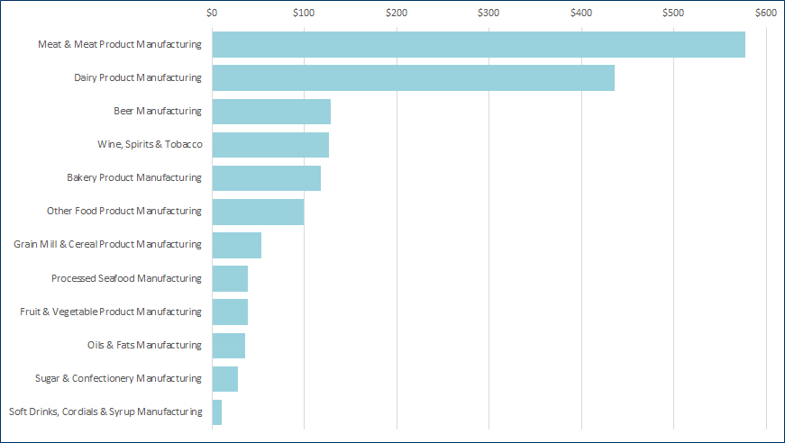

Source: REMPLAN Economy (using December 2017 dataset).
Note: The total output estimate for the G21 Region is $35,051.041 million (December 2017).

8.0 G21 Agribusiness Farm Sizes
The scale of farm businesses in the G21 region ranges from those with a turnover of less than $50,000 per year to large businesses with an annual turnover in excess of $2 million. The data presented in Figure 8-1 compares the number of farms and the total value of production by business turnover ranges.
Figure 8-1 shows that large farms with a turnover greater than $2 million per annum represent 4% of farms overall but make up 54% of the total value of production. Farms generating less than $2 million per annum represent the remaining 96% of farms but only generate 45% of the total value of production.

Figure 8-1: Number of farms and value of production by business turnover ranges, 2016
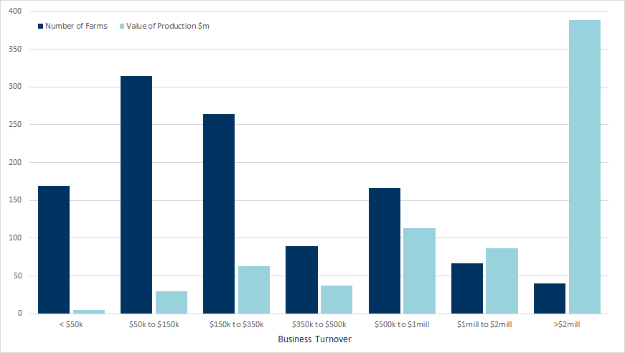
Source: Neil Clark & Associates (using ABS 2016 Agricultural Census data).

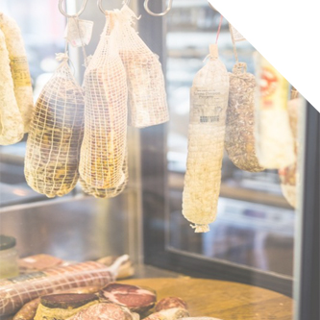

Farms with a turnover greater than $2M per annum represent only 4% of farms but make up 54% of production value

G21 Agribusiness Farm Sizes (continued)
As reported in the 2017 Issues Paper, there is a trend towards larger farms in Australian agriculture and farms in the G21 region are also following this trend (as shown in Table 8-1 and Figure 8-2).
Table 8-1 shows that there are 1,111 businesses undertaking agricultural activity in the G21 region. It’s difficult to make comparisons between 2011 and 2016 regarding the overall change in farm numbers since 2011 and the change in the number of farms in the less than $50,000 turnover range. The ABS changed the scope of the Agricultural Census in 2016 and increased the cut-off of surveyed businesses from an estimated value of operations (EVAO) of $5,000 to $40,000 (the extent to which this has impacted the data is unknown but would have definitely contributed to the reduction of 614 farms in the under $50,000 category).
A look at the other turnover ranges that haven’t been impacted by the survey change shows that the only category with reduced farm numbers is the $50k to $150k turnover range. All other farms, which are considered to be in the SME and larger size ranges have increased.
The production value data would have been impacted to a lesser extent than the farm numbers because businesses with over $40,000 turnover represent the vast majority of production value. Overall, the value of production increased by 86% in the five years to 2016. The value of production of businesses earning over $150,000pa doubled (+113%) during this time. Of particular note, the value of production of businesses with a turnover greater than $2 million increased three-fold (+195%).

Table 8-1: G21 property numbers and value of production by business turnover ranges, 2011-2016
 |  |  | Property Numbers |  | Production Value ($m)
Business Turnover | Production Value ($m)  2016 | Number of Properties 2016 | CHANGE (No.)  2011-2016 | CHANGE  (%)  2011-2016 | CHANGE (No.)  2011-2016 | CHANGE (%)  2011-2016
>$2mill | 388.4 | 40 | +18 | +76.4% | +256.8 | +195.2%
$1mill to $2mill | 86.8 | 66 | +31 | +87.3% | +41.8 | +93.1%
$500k to $1mill | 112.8 | 167 | +72 | +76.6% | +46.7 | +70.6%
$350k to $500k | 36.9 | 90 | +10 | +11.9% | +2.8 | +8.1%
$150k to $350k | 62.5 | 264 | +16 | +6.5% | +2.6 | +4.3%
$50k to $150k | 30.1 | 314 | -66 | -17.4% | -4.6 | -13.1%
< $50k | 4.6 | 169 | -614 | -78.4% | -12.5 | -73.0%
TOTAL | 722.1 | 1,111 | -533 | -32.4% | +333.6 | +85.8%

Source: Neil Clark & Associates (using ABS 2016 Agricultural Census data).

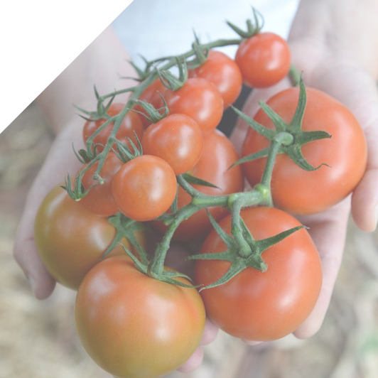

Figure 8-2: Value of production by business turnover ranges, 2011 to 2016
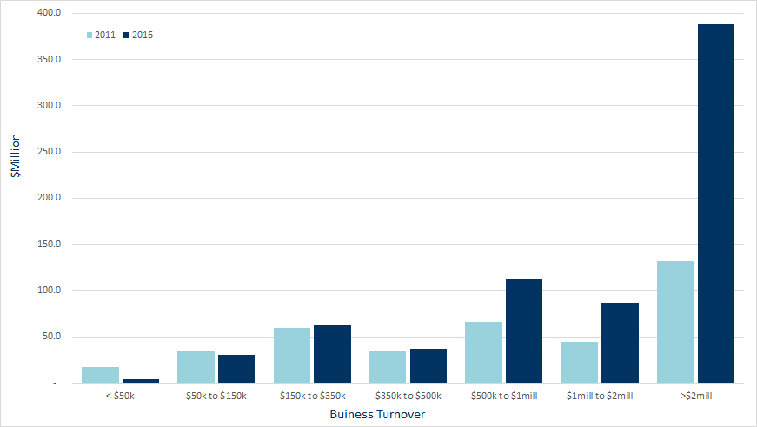
Source: Neil Clark & Associates (using ABS 2016 Agricultural Census data).

Figure 8-3: Percentage change in number of farms and value of production by business turnover ranges, 2011-2016
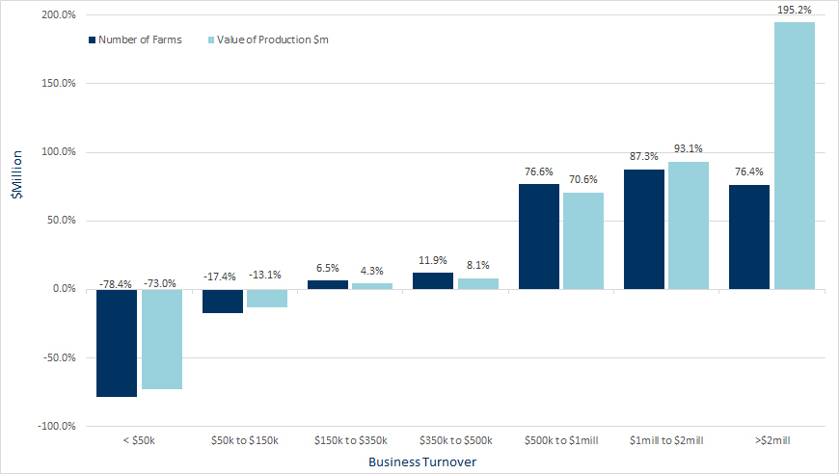
Source: Neil Clark & Associates (using ABS 2016 Agricultural Census data).

Note: The less than $50,000 category should be used with caution (particularly the number of farms) due to a change in the ABS Agricultural Census collection.
the value of AGRICULTURAL production IN THE G21 REGION increased by 86% BETWEEN 2011 AND 2016

G21 Agribusiness Farm Sizes (continued)
The increase in large scale farms is not only due to the ongoing industry transformation (as described in the 2017 Issues Paper), but also the increase in intensive livestock production in the G21 region. The value of production in intensive industries grew by 14%pa between 2011 and 2016, whereas extensive industries grew more slowly at 4%pa (as shown in Figure 5-3).
Most livestock farms are niche or small lifestyle farms, many horticulture businesses are small businesses, most cropping and mixed farms are small to medium enterprises (SMEs), the majority of dairy farms are SMEs or towards the larger end of the scale and a high percentage of intensive agriculture businesses are large businesses in terms of value.
Although all sectors have a skew towards a certain business size, it’s important to note there are large businesses across all sectors earning in excess of $1 million per annum.

Figure 8-4: Farm numbers by turnover range and sector in the G21 region, 2016
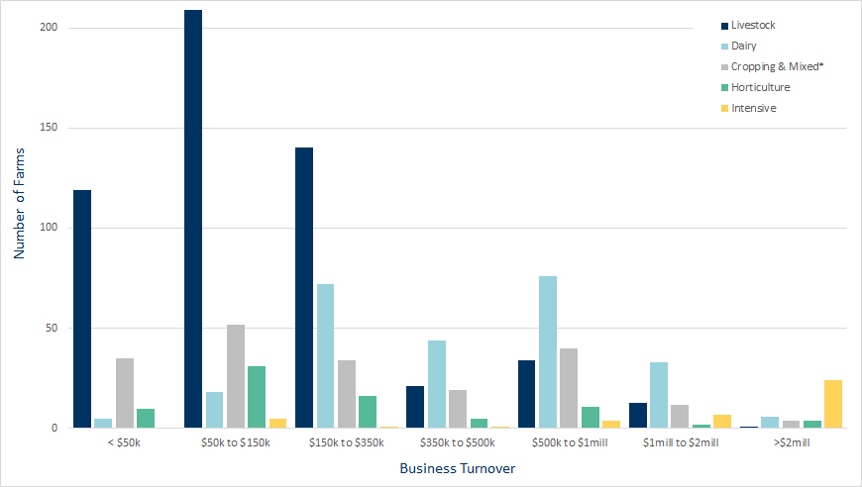
Source: Neil Clark & Associates (using ABS 2016 Agricultural Census data).
*Mixed includes combined livestock and cropping farms.
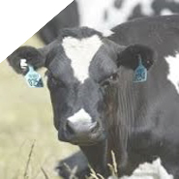

9.0 Land Use and Value
An analysis of agricultural land use in the G21 region shows that livestock and grain farms occupy 80% of the land area. In the five years between 2011 and 2016 the land used by intensive agricultural industries increased by 2% and extensive livestock land use increased by 1%. Land used for horticulture, cropping/mixed and dairy all reduced by 39%, 22% and 2% respectively. Intensive agricultural industries now occupy more land than horticulture compared to five years ago.
Some of these movements differ markedly from the previous Issues Paper and the ten years previous (2001-2011). During that time extensive livestock land reduced significantly and cropping/mixed use increased significantly.

Figure 9-1: Agricultural land use by sector in the G21 region, 2011-2016

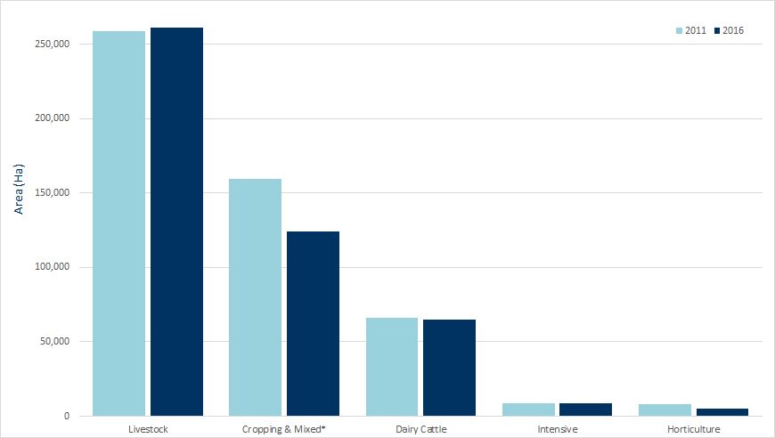
Source: Neil Clark & Associates (using ABS 2016 Agricultural Census data).
*Mixed includes combined livestock and cropping farms.

Table 9-1: Value of primary production by hectare, 2016
Sector | Area (ha) | % change Area 2011-2016 | Value of Production ($m) | % change Value 2011-2016 | Value (per ha)
Broad Acre Farming^ | 385,610 | -8% | $186.3 | +55% | $483/ha
Dairy Cattle Farming | 65,010 | -2% | $149.6 | +16% | $2,302/ha
Intensive | 8,933 | +2% | $332.8 | +197% | $37,259/ha
Horticulture | 4,919 | -39% | $52.3 | +88% | $10,640/ha
TOTAL | 464,472 | -7% | $721.1 | +86% | $1,553/ha

Source: Neil Clark & Associates (using ABS 2016 Agricultural Census data).
^Broad acre farming is the total of livestock and cropping & mixed categories.

The intensive animal industries are the highest value primary production sector per HECTARE

Land Use and Value (Continued)
Table 9-1 shows that although there was an overall decrease of 7% in land used for agriculture in the past five years, there was an increase of 86% in the value of primary production.
The vast majority of the region’s agricultural land is used for broad acre farming (livestock and cropping/mixed use), yet the highest value use per hectare is intensive animal industries (including poultry meat and eggs and pigs). As concluded in the 2017 Issues Paper, there may be the opportunity to significantly increase the value of primary production on relatively small amounts of land. This occurred in the five years to 2016, with land used for intensive industries only increasing by 2% while the value of production during the same period increased three-fold.

10.0 Agritourism
The visitor economy is a key growth sector in the G21 economy. The region (Tourism Research Australia regions: Geelong and the Bellarine and Great Ocean Road) welcomes 10.5 million visitors per year. Tourism is estimated to create more than 9,000 jobs or 7.2% of all employment in the region, growing by 1,950 jobs since 2011.
Agritourism is a key part in the region’s offer to visitors through the combination of food, wine and related experiences it provides through local cafes, wineries, providores, and farm-gate, tour and trail experiences as well as the agricultural landscapes. Tourism generates $1.5 billion in regional output or revenue and the most popular activity based on Tourism Research Australia surveys is dining at local restaurants and cafes. This offers a substantial opportunity for local growers, producers and processors to develop paddock to plate experiences. REMPLAN estimates that 43% of every tourism dollar is spent on accommodation and food services and 9% on manufacturing (including wine production).



The broader region welcomes 10.5 million visitors a year
(geelong and the bellarine and great ocean road)

11.0 Summary
Agribusiness includes inputs into agriculture, primary production, processing and wholesaling.

Overall Size of the G21 region agribusiness Industry
- Contributes $1.5 billion annually to Gross Regional Product making up 9% of regional value-added.
- Value-added increased by 25% in the five years to 2016, moving from the eighth largest industry in the region to the fifth largest.
- Agribusiness employs 10,634 people, an increase of 19% or 1,699 jobs between 2011 and 2016.
- Makes up 9% of jobs in the G21 region, shifting from the seventh to sixth largest employer.
- Is the region’s second largest exporter at $1.4 billion, accounting for 17% of total exports.

geographic analysis and regional comparisons
- The City of Greater Geelong has the largest share of agribusiness employment in the G21 region with 3,374 jobs, most in the processing sector. Job numbers in Colac Otway are not far behind Greater Geelong, with 2,501 jobs and an almost even split between primary production and processing.
- A more detailed look at 2016 industry of employment data shows the largest sectors in Greater Geelong to be meat, poultry and smallgoods manufacturing (563 jobs); bakery product manufacturing (548 jobs); and horticulture (328 jobs).
- The largest number of jobs in Colac Otway by detailed breakdown include dairy cattle farming (491 jobs); dairy product manufacturing (423 jobs) and meat product manufacturing (343 jobs). In Golden Plains and Surf Coast sheep and beef farming dominates (354 and 201 jobs respectively).
- The G21 region agribusiness sector is proportionally less dominant than the other Victorian regions of Gippsland, Bendigo and Ballarat.

detailed sector breakdown
- The top three sectors making up 57% of total employment in the G21 region are lamb and beef farming and processing (1,592), further processing (1,548) and dairy farming and processing (1,196).
- The top three commodities making up 61% of the value of production are poultry meat ($242m), milk ($145m) and beef ($112m).
- The main difference between employment and value is in the chicken meat sector where it’s dominant in relation to the value of production but less so in terms of employment.
- Between 2011 and 2016, the value of production has grown more rapidly in intensive industries (14%pa) compared to extensive industries (4%pa).
- The top three growth sectors in the five years to 2016 are poultry livestock (21%pa) followed by milk (21%pa) and goats (19%pa - off the smallest base).
- The sectors experiencing a decline in value or limited growth are cropping (-1%pa), horticulture (1%pa) and sheep/lamb (2%pa).

value of primary production and processing
- The total value of agricultural commodities produced in the G21 region in 2016 was $817 million.
- Although the largest agribusiness employment is in Greater Geelong, it sits last in terms of the value of production at $70m with Golden Plains producing the most value ($357m), followed by Colac Otway ($282m) and the Surf Coast ($107m).
- Over 75% of cropping, livestock (for meat) and agricultural product value is located in Golden Plains and Colac Otway.
- Over 85% of regional horticulture value is produced in Greater Geelong and the Surf Coast (particularly in floriculture, nursery production, vegetable, berry and grape growing).
- Food and beverage processing contributes $1.7 billion or 5% of total output in the G21 region.
- The top processing revenue earners in the G21 region include meat and meat product manufacturing ($577 million), followed by dairy product manufacturing ($436m), beer manufacturing ($128m), wine and spirit manufacturing ($127m) and bakery product manufacturing ($118m).

farm size and land use
- Farms with a turnover greater than $2 million per annum represent only 4% of farms but make up 54% of the value of production. The remaining 96% of farms generate 45% of the total value of production.
- The intensive animal industries are the highest value primary production per unit area of land and the fastest growing sector in primary production.
- All farm types experienced a lift in the value of production per unit area in the five years to 2016.
- There was an overall decrease of 7% in land used for agriculture in the five years to 2016, yet there was an increase of 86% in the value of primary production.

Agritourism
- Agribusiness is a key part in the region’s offer to visitors through the combination of food, wine and related experiences it provides through local cafes, wineries, providores, farm-gate, tour and trail experiences and the agricultural landscapes.
- Tourism generates $1.5 billion in regional output or revenue and the most popular activity is dining at local restaurants and cafes - a substantial opportunity for local growers and producers.

Next Steps
During the process of updating the 2017 Issues Paper, other data was discovered and may be worth further exploration for inclusion in future editions of this economic profile.
Source | Data
Australian Bureau of Statistics (ABS)  Census of Population and Housing (2016 and 2011) | - Detailed (4 digit ANZSIC breakdown) of employment by industry (place of work)  - Detailed (4 digit ANZSCO breakdown) of employment by occupation (place of work)
REMPLAN Economy | - Local expenditure data  - Regional imports (for import replacement analysis)  - Workforce profile  - Output (revenue) data shows $3.3B industry – third in terms of revenue (if exclude ‘ownership of dwellings’)
Australian Bureau of Statistics (ABS)  Agricultural Census (2016 and 2011)  - Agricultural Commodities, Australia  (catalogue 7121.0)  - Value of Agricultural Commodities Produced, Australia (catalogue 7503.0) | - Detailed breakdown in the value of commodities (i.e. what type of cropping and horticulture is dominant?)  - Detailed mapping of land use by smaller areas (SA2s)  - Farm numbers by detailed type  - Livestock counts
IBIS World or similar product (subscription cost) | - State and National industry context
ABS Chain Volume Measures | - To better understand how price and volume impact the value of production
Australian Business Register | - Business counts by detailed industry type

Figure 11-1: Conceptual map of agribusiness in the G21 Region
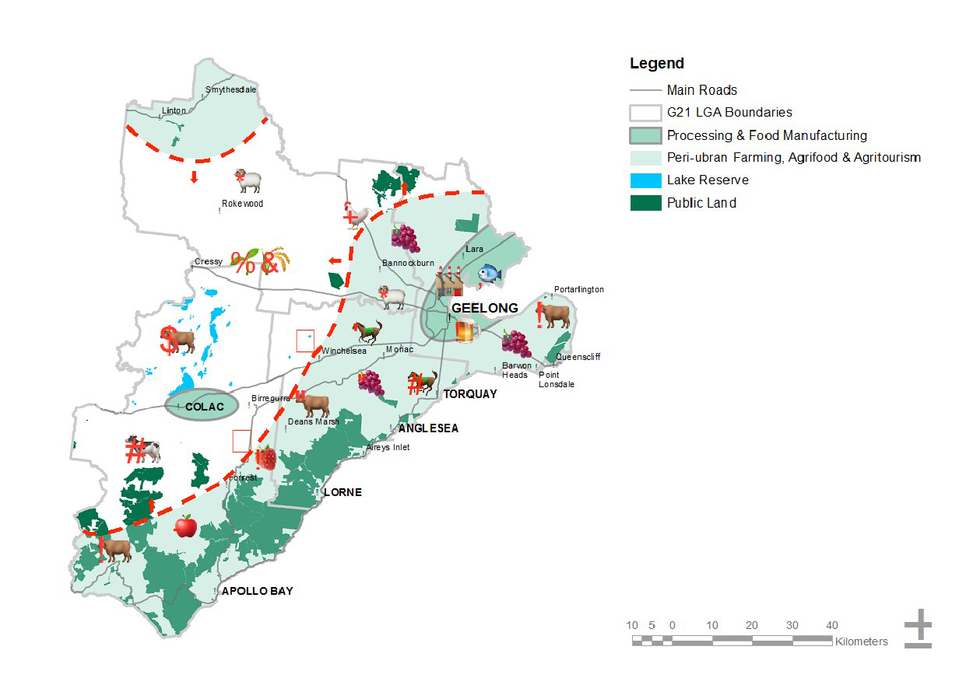

Map Source: RMCG and Dench McClean Carlson, G21 Sustainable Agribusiness Strategy, Issues Paper, 22 May 2017.

