
heritage information sheet

demolition

Prepared by Authentic Heritage Services Pty Ltd
Under Cause 43 (Heritage Overlay) of the Greater Geelong Planning Scheme, a planning permit is required to demolish (including partial demolition) a heritage place in a Heritage Overlay.
This Information Sheet expands on the Strategy at Clause 15.03-L of the Greater Geelong Planning about the retention and conservation of significant (including contributory) heritage places and discouraging their demolition as heritage places form a key part of the community identity within the City of Greater Geelong.

Definitions:

A Heritage Place:
- is an individual site that has heritage value - these types of heritage places can be a building, structure, fence, bridge, cultural landscape (such as: Botanic garden, park, avenue of honour, ruin, monument or cemetery).
- is an area that contains a group of buildings, landscapes, etc., such as a historical town, suburb, smaller residential area or large complex site.

Heritage Significance:
Heritage significance is the reason the heritage place is important: aesthetic/architectural, historical, scientific, social or spiritual.

Fabric:
This is all the building material of the heritage place, including elements and fixtures.

Significant Places:
Heritage places are defined by a particular significance level. Those applicable in the City of Greater Geelong are:
- A level (State significance): most places of state significance are on the Victorian Heritage Register, administered by Heritage Victoria. Heritage permits are required from Heritage Victoria for all buildings and works (including advertising signs) and subdivision.
- B Level (Regional significance): places of regional significance are included as heritage overlays in the Greater Geelong planning scheme, requiring planning permits for change.
- C level (Local significance): places of local significance are included as heritage overlays in the Greater Geelong planning scheme, requiring planning permits for change.
- D level (Contributory significance): places of contributory significance are included within heritage overlays in heritage precincts identified in the Greater Geelong Planning Scheme. In addition to demolition and partial demolition, any external buildings and works require a planning permit.
- No level (No significance): places that have no significance that are situated with heritage precincts also require a planning permit for external buildings and works because of their location in an important heritage area.

Purpose of the Heritage Overlay
Clause 43.01 of the Greater Geelong Planning outlines the purpose of the heritage overlay which includes:
- To conserve and enhance heritage places of natural or cultural significance.
- To conserve and enhance those elements which contribute to the significance of heritage places.
“Conserve” is a derivation of “Conservation”. The Burra Charter: The Australia ICOMOS Charter for Places of Cultural Significance (which is a policy guideline in the Planning Scheme) defines conservation as:
all the processes of looking after a place so as to retain its cultural significance.
The Burra Charter also ‘advocates a cautious approach to change: do as much as necessary to care for the place and to make it useable, but otherwise change it as little as possible so that its cultural significance is retained.’

Retention Rather Than Replacement
Most heritage buildings may not comply with the Building Regulations and the National Construction Code because they were built many years prior to the existence of these legislative requirements. Ensuring that heritage places are structurally sound and compliant is therefore important. Investigate methods of reinforcing existing structure to meet these requirements rather than complete demolition and/or replacement. While the outcome of a completely new structure might take on the appearance of the heritage building, it may not accord with the Australia ICOMOS Burra Charter principle of taking a cautious approach and conserving significant fabric where possible.
Retention rather than replacement might also provide a more sustainable outcome. The City’s Heritage and Design Guidelines (that forms part of the Greater Geelong Planning Scheme as an Incorporated Document) include the following statement:
“Regardless of whether the building has a heritage listing, it should be appraised for the opportunities and constraints it brings to the site. Consider the merits of the existing structure and whether it can be recycled successfully. It is a waste of energy, in terms of the materials and labour, to unnecessarily demolish a building available for recycling.”
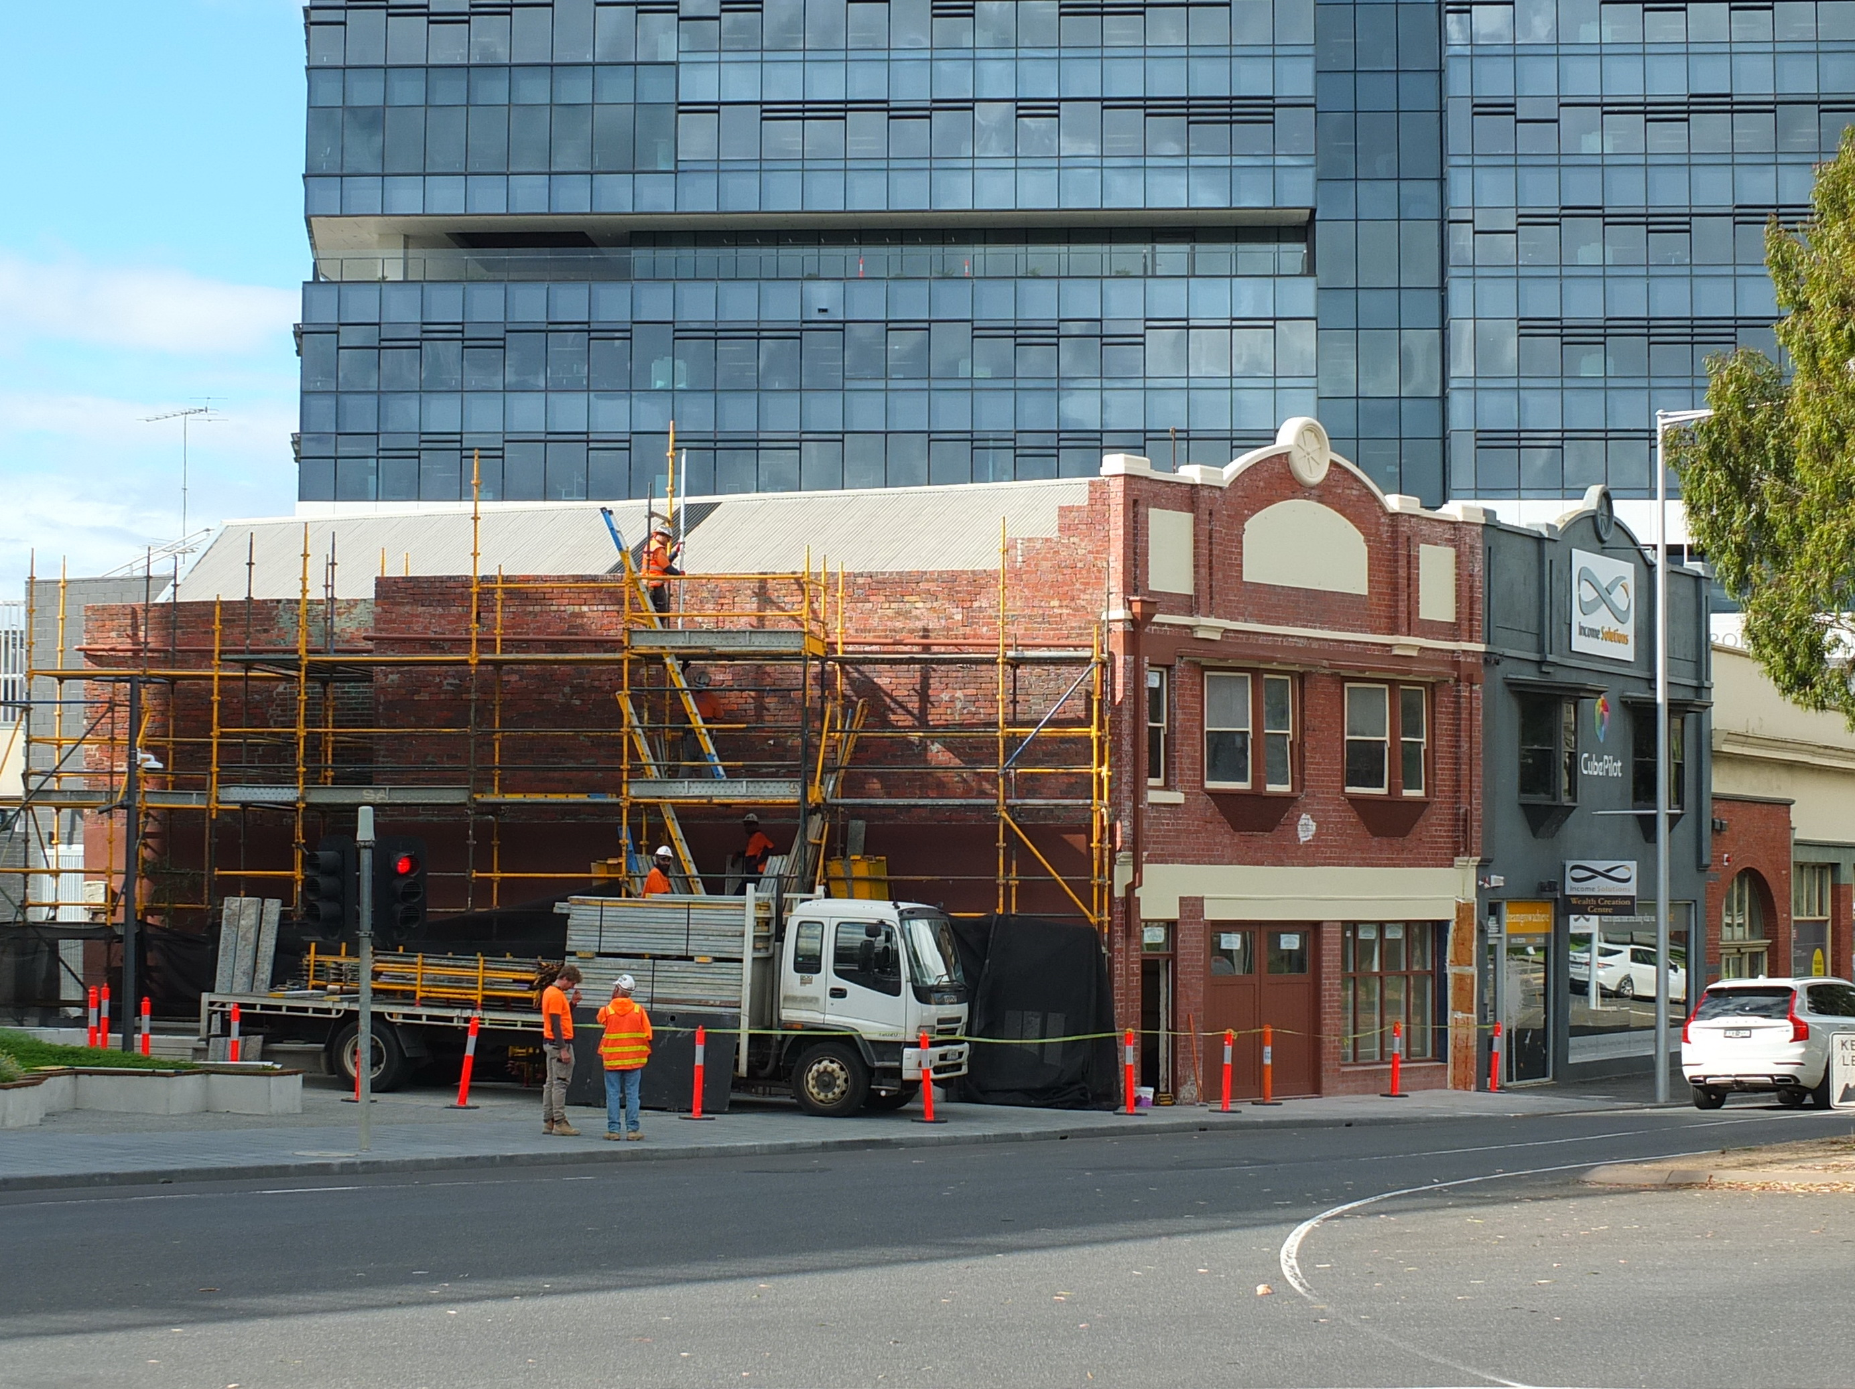
Former Richardson’s Garage, Mercer Street, Geelong, 2023.
This building was repaired and restored rather than being demolished.
Source: Dr David Rowe.

Complete Demolition
Heritage places make a significant contribution to community. As stated in the Heritage and Design Guidelines:
- It is only in exceptional cases that the demolition or removal of a listed building would be considered.
The majority of heritage places in the Geelong municipality have contributory significance in heritage areas. The gradual loss of contributory buildings in heritage areas, will greatly impact the significance of the area and the reason for its protection in the first instance.
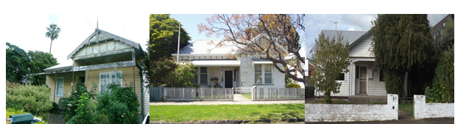
Significant dwellings proposed for demolition and not supported by VCAT. Source: Dr David Rowe.
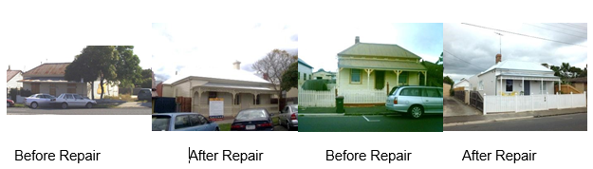
Before Repair. Source: Dr David Rowe. |  | After Repair. Source: Dr David Rowe.
Before Repair. Source: Dr David Rowe. |  | After Repair. Source: Dr David Rowe.
Significant dwellings proposed for demolition and later repaired.

Factors Influencing Complete Demolition Applications
From a statutory planning perspective, as assessment of proposals to demolish significant places will depend on a number of factors including:
- Significance: whether the information to support the significance of the place is accurate. This includes the statement of significance and other documentation in the heritage study or Incorporated Documents in the Planning Scheme. If the building is listed in one of Council’s studies (available in the Victorian Heritage Database) as having no significance, demolition can be readily supported (as long as the design of the replacement building is supported. The replacement building must be included as part of the application.

- Integrity: There is an expectation that most places will be of sufficient integrity, given they have been part of a Planning Scheme amendment at some earlier date to give the heritage listing. Even some altered places may have significance.

- Condition: The condition of a heritage place will not always be the main factor in deciding whether demolition should be supported.

Consideration of whether the demolition of a significant place is fair, orderly, economic and sustainable (Section 4A of the Planning and Environment Act 1987) requires a thorough assessment of the significance, integrity and condition of the place. Some key issues might be:
- Is the place currently lived in/used?

- Is the place ruinous?

- Can the place be repaired and changed to provide for an environmentally sustainable outcome?
In relation to the above, the Heritage and Design Guidelines include the following statement:
“Regardless of whether the building has a heritage listing, it should be appraised for the opportunities and constraints it brings to the site. Consider the merits of the existing structure and whether it can be recycled successfully. It is a waste of energy, in terms of the materials and labour, to unnecessarily demolish a building available for recycling.”

Information Required in Support of Complete Demolition
Where there might be a convincing case that a building is beyond repair – both physically and financially – an application to demolish must be accompanied by a Structural Engineering Assessment that includes:
- A statement that the assessment has been carried out according to the conservation practices of the Australia ICOMOS Burra Charter. The Structural Engineering Assessment should especially address why there are not opportunities for retention, repair and reinforcement, with a considered response to the relevant Articles of the Burra Charter.

- An assessment of the fabric in disrepair and requiring replacement, and particularly whether the extent of replacement fabric is substantial (including much of the roof and wall structure) or incidental and routine (such as replacement of roof and wall cladding or restumping). The method/s of repair should also be outlined.

- A cost estimate for repairing the building and whether this cost could be considered to be reasonable (when compared to a replacement building of the same size and construction, and given the expectation that building repairs are often more expensive). Any cost estimates should include demolition costs for the cost estimate for a new dwelling. In this regard, the City’s Heritage and Design Guidelines state:

“If the condition of a building is a major cause for concern, objectively quantify the costs of remedial works. It is no use stating that the place is a ‘dump’. This could mean it just needs a fresh coat of paint or that it has been burnt out and derelict for years. Get a building practitioner or similarly qualified person to provide estimates for rectification works. For example, most old buildings require restumping, repairs to the roof and rainwater disposal system and rewiring. Do not include the cost of the new Jacuzzi or third bedroom, just quantify costs for essential remedial works.”

- Once the planning permit has been submitted proposing demolition, the Statutory Planning Department may have the Structural Assessment verified by another independent Engineer. Any application must include the proposed replacement development.

Partial Demolition
Demolition also includes the removal of modifications and additions that do not contribute to the significance of the place. They could also involve the removal of part of a significant building, such as the rear roof and walls to allow for an addition. In most cases proposals to partially demolish fabric that does not undermine the purpose of the heritage overlay as the fabric of most significance (including the three-dimensional form, construction and detailing) is retained can be supported. The three dimensional form and fabric of most significance includes all the building within the main roof structure (including chimneys and eaves), irrespective of whether it is or is not visible from the public realm.

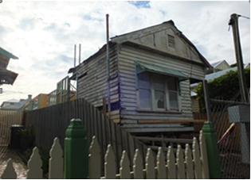 |  | 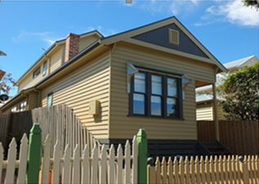
Dwelling temporarily propped during demolition and construction. Source: Dr David Rowe. |  | Completed works, including substantial repairs, rear additions and chimney reconstruction.  Source: Dr David Rowe.

Information Required in Support of Partial Demolition
An application to partially demolish a significant building should be accompanied by a Demolition Method Statement marked on the Demolition Plan. For partial demolition involving minimal intervention of significant fabric, the Demolition Method Statement does not have to be extensive, but documented to respond to the following:
- How the retained significant fabric will be safeguarded during demolition works? That is, how damage to the significant fabric will be avoided/reduced during the demolition.

- How the retained significant fabric will be protected during new construction? That is, whether the retained fabric will be weatherproofed and/or propped/stabilised to prevent structural collapse, rainwater entry, etc.

- Are there required repairs to retained fabric? Any required repairs to existing fabric should be marked on the drawings. For example, it might include ‘existing timber weatherboards in good condition are to be kept where possible, and replacement weatherboards to match existing profile and material.”
For more extensive partial demolition, the Demolition Method Statement should be prepared by a Structural Engineer.

Chimneys
Chimneys make a significant contribution to the character and appearance of a heritage building, particularly where visible from public areas. Their construction, design, profile and details are also often key indicators of when the building was constructed. Chimneys should be kept instead of being removed.
In most situations, a planning permit is not required for internal works, including the demolition of fireplaces and internal chimney flues. As these types of internal works have a direct impact on the structural stability of the external chimney, a permit application should document:
- How the chimney will be kept and supported within the roof space.

Information Required in Support of Demolition of Chimneys
For chimneys that are structurally unsound and ruinous, an Engineering Assessment should be submitted as part of the planning permit application indicating the method of reconstruction.

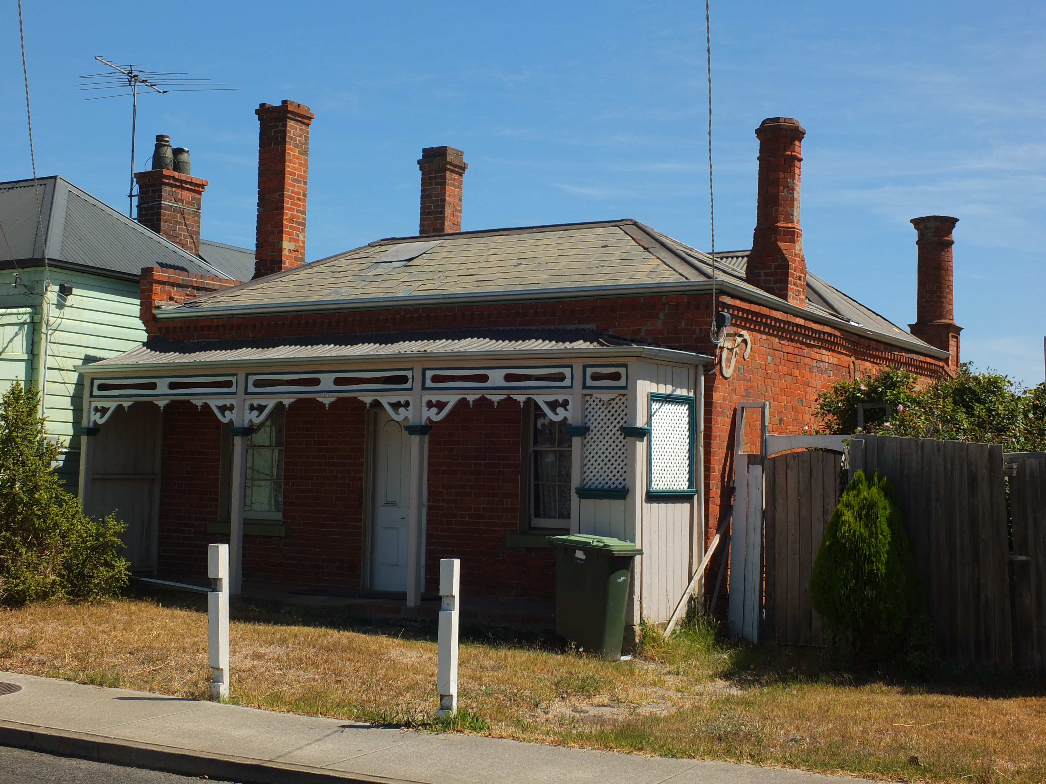
‘St. Elmo’, Geelong West, built in 1866 by the brickmaker and bricklayer, George Arnott.
He demonstrated his bricklaying skills in the stylistic variations in the four chimneys.
Source: Dr David Rowe.

