Conditions of Hire
Community Buses
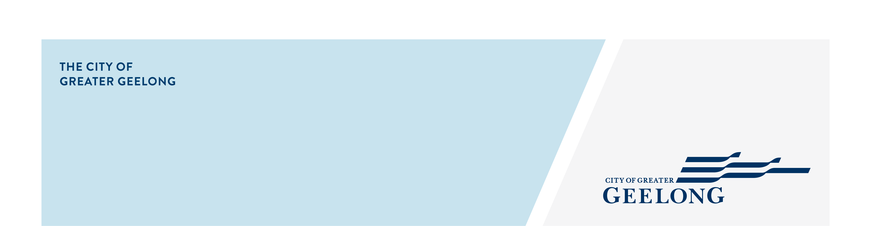

CITY OF GREATER GEELONG COMMUNITY BUS HIRE
Community buses provide affordable transport opportunities for community groups with costs subsidised by the City of Greater Geelong.

ELIGIBILITY FOR HIRE
Our community buses are available for hire exclusively for registered charities and not-for-profit, volunteer-run, incorporated community groups.
Our buses are not available for use by commercial organisations, individuals, private companies (unless registered charity) for paying passengers or for parties.
If you are unsure of your eligibility, contact us at busbookings@geelongcity.vic.gov.au

YOUR RESPONSIBILITIES
As a hirer your responsibilities are to ensure the safety of your passengers at all times, abide by the laws and regulations of VicRoads and return the bus in good condition. Bus hirers should report any problems immediately on 5272 5272.

BUS DETAILS
We have a modern fleet of reliable and economical mini buses:
• 9 seat bus (with wheelchair hoist)
• 12 seat buses
All seating numbers include the driver.
Eligible community groups are required to supply their own driver. The bus will be provided to the hirer with a full tank of petrol and is to be returned with a full tank of petrol at the hirer’s expense.
PLEASE NOTE: all of our buses are long wheel base vehicles. Extra care and room is required when cornering.

BOOKING PROCEDURES
There are 3 steps to booking a community bus:
1. Register group with City of Greater Geelong (annually)
2. Each driver must submit driver declaration (annually)
3. Submit your booking/s online (at least seven days notice)
Advanced bookings are preferred.

CANCELLATIONS
Require at least three working days notice or normal hire charges will still apply and be invoiced.

FEES
We subsidise the costs to make this service more affordable for community groups. Hire charged is $66.50 per day. Fees include GST and are charged in 24 hour blocks.
The bus will be provided to the hirer with a full tank of petrol and must be returned with a full tank of petrol at the hirer’s expense.
(Prices correct at time of printing – please confirm prices before making booking).

PAYMENT
Payment is required within 30 days of invoice date and can be made:
• in person at any of our customer service centres
• by phone on 5272 5272
• by mail (cheque or money order)
• online at www.geelongaustralia.com.au

CONDITIONS OF USE
The following conditions are required by law:
• Drivers of the 9 and 12 seat buses require a full drivers licence (not probationary licence).
• Driver blood alcohol levels must remain at 0.00%.
• Drivers must not be under the influence of drugs.

SMOKING AND ALCOHOL CONSUMPTION
Is strictly not permitted on buses at any time.

OVERNIGHT PARKING
For overnight hire, the bus must be secured off street

HEIGHT LIMITS
All drivers are to familiarise themselves with the height of the bus and avoid locations with height restrictions.
Due to height restrictions and tight spaces, buses are not permitted to be driven through any of the following under any circumstances:
• automatic car-wash
• commercial parking station
• drive-through facilities at fast food outlets

HIRE DURATION
A two day limit applies. Please enquire at the time of your booking for further details.

DESTINATIONS
Buses are not to be used for trips to hazardous areas
eg; in snow or rough terrain. Buses are only to be driven to Victorian destinations.

CITY LINK / EAST LINK
Hirers are responsible for any toll fees or charges relating to City Link or East Link.
A standard day pass can be purchased from:
• The Citylink website www.citylink.com.au or by phone 132 629
• The Eastlink website www.eastlink.com.au or phone 135 465
Should hirers fail to obtain a pass, they will be invoiced for the late toll fine.

BUS LOCATIONS
Buses are conveniently located in Geelong as well as the Bellarine Peninsula.
• Geelong: Corio Operations Centre - 299 Anakie Road, Corio
• Bellarine: Drysdale Operations Centre - McKenzie Street, Drysdale

CHECKLIST
The checklist provided at key collection should be carefully completed at the beginning and on completion of the hire and returned with the bus keys at the pick up location.

ACCIDENT AND INSURANCE
Bus incidents must be reported in the first instance to Transport Safety Victoria on 1800 301 151 (operates 24 hours, seven days a week) as soon as possible.
Once incident is reported to Transport Safety Victoria, the City of Greater Geelong’s Booking Office must be notified on 5272 4732 during business hours.
The Booking Officer will record all the relevant details for Transport Safety Victoria submission within 72 hours of receiving call.
You are responsible for paying the insurance excess of $500 for any damage to the bus.
You must do everything necessary to enable the insurer of the bus to recover compensation from any third party in respect of damage to the bus.

EMERGENCY SITUATIONS
The City of Greater Geelong is a member of the RACV. In the case of any difficulties please contact RACV on 1800 646 464.

CLEANING EXPECTATIONS
To keep hire costs low, all bus users share the responsibility for cleaning the vehicle.
Please use the petrol bowser as an indicator that the tank is full and not the fuel gauge in the bus.
Failure to comply with any of the above may result in a $25 admin fee to your group and jeopardise future bookings.
Additional costs could include refuelling charge equal to the value of petrol plus admin fee and/or cleaning charges of up to $60.
After bus use, it is the responsibility of the hirer to remove any rubbish and belongings from the floor and seats and wash the exterior of the vehicle (automatic carwash not permitted).

BUS RETURN
The bus must be returned by the specified booking time with a full tank of fuel. The bus should be filled up at the nearest fuel station to the bus depot.

PLEASE NOTE
The City of Greater Geelong reserves the right to terminate any booking or future bookings due to any breach of Conditions of Hire and/or misconduct by patrons including non payment.

