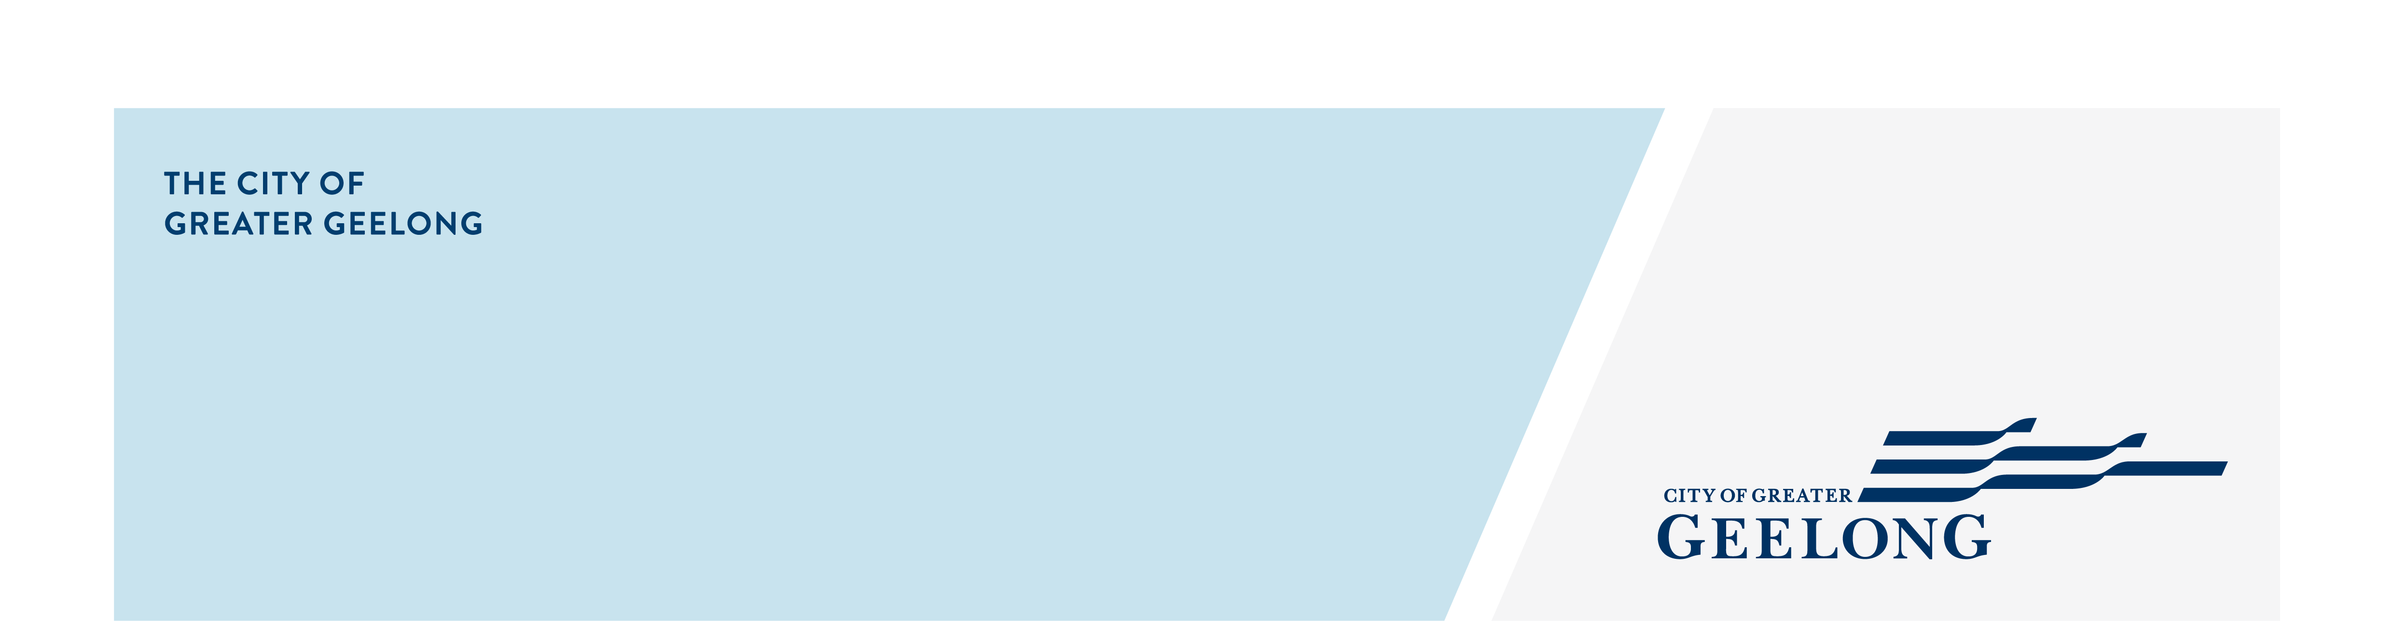
Network TERMS OF REFERENCE

Network name - Community agencies, organisations & services (CAOS) NETWORK
Document No: | D23-365584
Approval Date: | 14 October 2024
Approved by: | Manager, Community Strengthening
Review Date: | Every two years from approval date
Version No: | 3.0
Responsible Officer: | Team Leader, Community Inclusion Unit
Authorising Officer: | Coordinator, Community Inclusion Unit

- SUMMARY
The CAOS network commenced in 2003, with a focus on the northern suburbs of Geelong after the Victorian government invested heavily in placed-based community development projects in areas of socio-economic disadvantage. The northern suburbs of Geelong received funding for 18 separate projects, such as Neighbourhood Renewal and Streetwise.
The network was formed for community development workers and community groups to come together to form connections, develop an understanding of each other’s contributions, minimise duplication, form partnerships, share understandings of community need and avoid over consulting the community. The network newsletter is a vehicle for promoting what is happening in the region and for highlighting professional development opportunities.
Whilst the original principles remain the same the network has evolved and expanded to working across the City of Greater Geelong. Members of the network represent a cross-section of representatives from the community, not for profit organisations and governments agencies with an interest in community development.
The CAOS network is currently a function of the City’s Community Inclusion Unit.

- OBJECTIVES

- Facilitate the community capacity to participate, lead and socialise locally through sharing of information on current services, trends, good practice and activities relevant to community development.
- To increase collaboration between network members to minimise duplication, form partnerships and share understandings of community need.
- Provide information on the role of community development for an inclusive, diverse, healthy and sustainable communities and reduce barriers for community members to participate in community programs.
- Provide opportunities for professional development and learning through workshops to support the local community development workforce to be agile and respond to community need equitably.
This will be achieved through:
- 6 network meetings yearly
- Monthly newsletters
- Professional development opportunities

- DEFINITIONS
In this Terms of Reference:
CAOS refers to Community Agencies, Organisations & Services (name of this network).
City of Greater Geelong refers to the geographical local government area.
The City refers to the organisation of the City of Greater Geelong.
Members refers to individuals from organisations representing community groups, not for profit organisations and government agencies on the CAOS distribution list.

- terms of reference
  - Expected / Definite life of the Network
This update of the Terms of Reference becomes effective upon adoption by the network on 14/11/2024. A biennial review of the networks role and function will inform new iterations of the Terms of Reference.
  - Constituency of the Network
The network is comprised of and open to members from organisations that align with community development principles working in community groups, not for profit organisations and government agencies.
Registration as member is completed by signing up on this link https://comms.geelongcity.vic.gov.au/CAOS

  - Authority of the Network
The network has no authority. The network membership commits to:
- Creating a shared understanding of the current status of activity within organisations to increase participation and inclusion for people experiencing barriers to community life.
- Participating as partners in the identification of, and responses to, barriers to participation in existing programs that aim to address disadvantage in the City of Greater Geelong.
- Taking a leadership role in increasing organisational knowledge and commitment to improving outcomes for residents within the City of Greater Geelong.
- Actively participate in meetings and in the development and implementation of priorities and activities of the network.

  - Meeting Procedure
    - The network meets 6 times per year but may meet more regularly, if deemed necessary.
    - Meeting agendas will be posted at least one week prior to the meeting.
    - Minutes will be posted no later than one week following the meeting.
    - The agenda and minutes for each meeting will also be made available on the Geelong Australia website. The weblinks to these documents will be distributed to network members via the CAOS newsletter.

  - Reporting Requirements
    - The network reports its activity and achievements annually.
    - Minutes are kept on electronic file at the City.

  - Secretariat
    - The City’s Community Inclusion Unit will appoint an officer to act as Chair and Secretariat.

  - Facilities & Resources
    - In person meetings to be held in location/s deemed suitable by members.

- QUALITY RECORDS

Quality records shall be retained for at least the period shown below.
Record | Retention/Disposal Responsibility | Retention Period | Location
CAOS - Agendas | City of Greater Geelong | 5 years | REX – SUB-18-3894
CAOS - Minutes | City of Greater Geelong | 5 years | REX – SUB-18-3894
Documentation from Meeting Presentations | City of Greater Geelong | 5 years | REX – SUB-18-3894

- ATTACHMENTS

