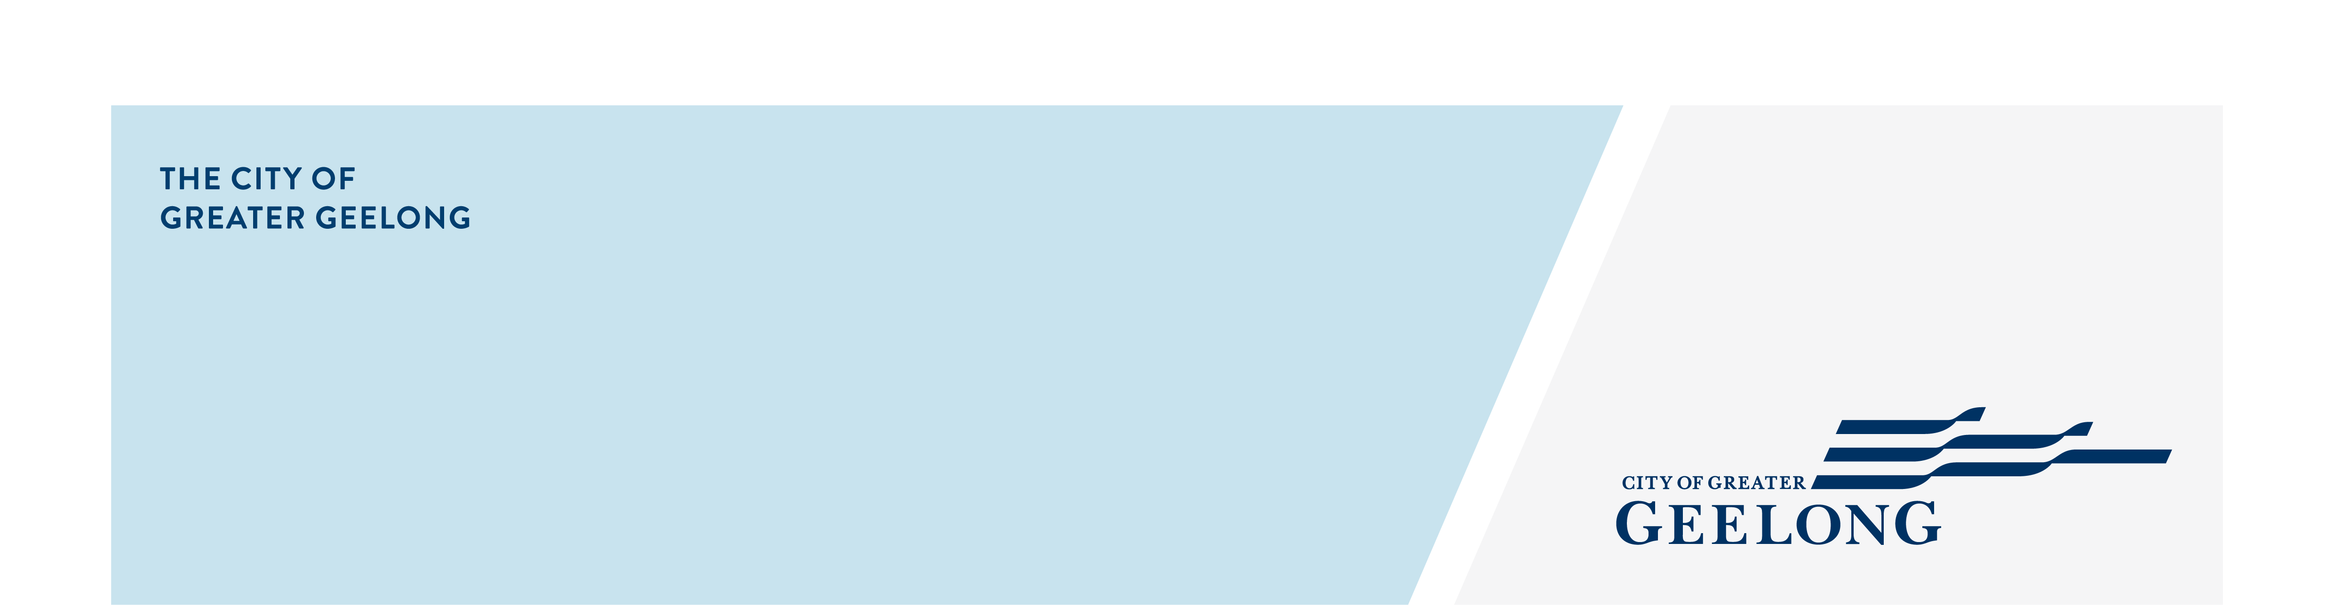
minutes

caos network meeting

10 september 2024, 10:00am-11:15pm, virginia todd hall

Attendees
Lisa Sitlington (chair), Olivia Nicholls, Chris Swain, Shannon Mackey

Apologies
Ally Upton, Amy Bellia, Amanda Miggins, Lisa Charleson, Tess Boocock

- Welcome
Lisa Sitlington completed Acknowledgement of Country

Welcomed everyone to the meeting and introduced the speaker for the meeting.

- Meli – Olivia Nicholls – Community Engagement Connector
- Meli Parenting Education Programs https://www.meli.org.au/support-families-parents-carers/parent-and-family-group/
- To connect with Olivia Nicholls olivia.nicholls@meli.org.au

- Around the Room Discussion
Chris Swain – Place Based Manager – Drummond Street
- QHub is running the following programs:
  - Monday - Under 12’s
  - Thursday 12 – 18 years after school
  - Wednesday fortnightly 18 – 25+ years
  - Parents Group
- GASP is now located at Drummond Street premises.
- Family Mental Health Service quota have been met.
- Offering outreach at schools, schools in the eastern suburbs have scheduled seminars for their parents/carers.
- Term 4 Newsletter will be published soon, to be on the mailing list email: Christopher.swain@ds.org.au
- Visit website for more programs https://ds.org.au/

Lisa Sitlington – Community Inclusion – Community Development Project Officer
- The City is developing a LGBTQIA+ Action Plan, there is a Have Your Say page which is open for anyone to share their thoughts and actions and closes 16th September.
- Nateesha Thomassen – Co-ordinator of GNH has taken a new role within my team and will be a point of contact for NH’s and our Healthy & Connected Community and NH Grants.
- Nominations for the Geelong Awards for People with Disability are open at present, 4 categories: Achievement, Leadership & Advocacy, Volunteering and Business Leadership Access & Inclusion Award. Closes 23rd September. Winners announced at our International Day of People with Disability Event on Tuesday 3rd December.
- EOI for the intake of the 2025 Greater Geelong Community Leadership Program will be opening on Monday 28th October. Look out for promotions through the City’s socials.
- Caretaker period (election period) is from 17th – 26th September. There are restrictions in place during this time e.g. Councils ability to make decisions, implementing new City services, community engagements and marketing, communications etc.

- Next Meetings
CAOS Network Meeting – Thursday 14th November 10:00am
Register: https://tickets.geelongaustralia.com.au/event/caos-network-meeting-november

