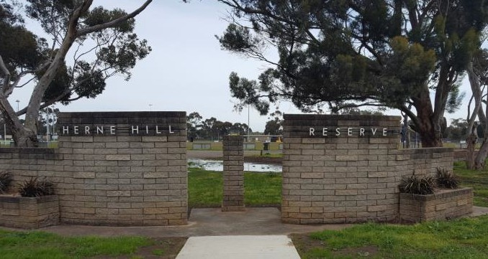

Attachment 3

HERNE HILL RESERVE MASTER PLAN

Prepared for:
CITY OF GREATER GEELONG

Prepared by Project Consultants on conjunction with City of Greater Geelong Project Manager:

LAND DESIGN PARTNERSHIP PTY. LTD
52-54 Rathdowne Street
P.O. Box 1164, Carlton, Victoria 3053 www.landdesign.com.au

CAPIRE CONSULTING PTY LTD
96 Pelham Street,
Carlton Victoria 3053 www.capire.com.au

HASKELL ARCHITECTURE
Level 7, 552 Lonsdale Street
Melbourne Victoria 3000 www.haskell.com.au
Version: May 2018


TABLE OF CONTENTS

Page
6 NEXT STEPS 53

INTRODUCTION 04
  - | Purpose 04
  - | About This Document 04

LIST OF FIGURES

Page

  - | Key Drivers 04
  - | Herne Hill Reserve 05
  - | Herne Hill Reserve Master Plan 05
  - | Project Area 06
  - | Project Methodology 09
  - | Project Governance 09
- CONTEXT AND CONSIDERATIONS 10
  - | Policy Considerations 10
  - | Planning Considerations 18
  - | Site Considerations 20
  - | Stakeholder and Community Consultation 40
- MASTER PLAN PRINCIPLES 47
- COMPONENTS AND DESIGN BRIEF 48
- MASTER PLAN 50
  - | Landscape Plan 50
  - | Pavilion Development Concept 51
  - | Priority Staging and Cost Estimates (Proposed) 52
Figure 1 – Herne Hill Reserve, Herne Hill, Geelong Victoria 06
Figure 2 – Study Area 08
Figure 3 – Planning Overlays 18
Figure 4 – Surrounding Open Space Provision (within 1.2km) 20
Figure 5 – Overview of Current Facilities 27
Figure 6 – Buildings and Structures 30
Figure 7 – St Joseph’s Football Netball Club – Existing Clubrooms 31
Figure 8 – St Peters Cricket Club – Existing Clubrooms 32
Figure 9 – Site Circulation 37
Figure 10 – Landscape and Passive Recreation Areas 39

LIST OF APPENDICES

Appendix 1 – Local Resident Survey and Summary Report
Appendix 2 – Herne Hill Reserve – Landscape Plan
Appendix 3 – Herne Hill Reserve – Draft Pavilion Concept Diagram

INTRODUCTION

PURPOSE
The purpose of this Master Plan is to guide the future development and improvement of Herne Hill Reserve, Herne Hill and ensure that the character and functionality of the open space reserve is enhanced.

ABOUT THIS DOCUMENT
The Herne Hill Reserve Master Plan Report considers the issues and opportunities as they relate to the development and improvement of Herne Hill Reserve. It brings together the key findings captured throughout the development process and provides the necessary context for the reader to better understand the justification behind the proposed design response, prioritisation and approach to implementation.

The following Master Plan aligns with the City’s 30-year vision and ensures that the long-term development aspirations of the tenant clubs, community groups and residents are taken into consideration. The plan addresses functional issues with the existing landscape (such as drainage and safe pedestrian movement) with a focus on passive recreation areas to encourage community use of the reserve.

The Herne Hill Reserve Master Plan Report will be made available for community comment through a public exhibition period, before producing a final report.

KEY DRIVERS
The City of Greater Geelong provides for a diverse mix of stakeholder groups, infrastructure and services. With the shift in the economic and operating climate, The City will need to critically understand, prioritise and rationalise its infrastructure investment in order to future proof its provision going forward.
The City is currently experiencing an organisation-wide shift in approach to planning and the development of strategic drivers for decision making and prioritisation. The City believes the Greater Geelong community must look beyond the short term to ensure a thriving, inclusive and sustainable future.

In order to create a network of suburbs and towns that make Greater Geelong a desirable place to live, work, invest and visit, there needs to be greater emphasis on improved and sustainable asset planning, investment and delivery.
The City are currently developing the Geelong 2030 Vision project that will address current challenges and highlight future opportunities, recognising what the municipality will look like in 20-30 years. The City recognises that they must better understand and embrace the emerging needs of the community and the challenging environment globally and look at local level influences to ensure better outcomes for everyone now and into the future.
Community health and wellbeing as well as efficient and effective infrastructure provision are key drivers for the City going forward.
The City of Greater Geelong contains a comprehensive network of open space and recreation facilities that are planned within walking distance of homes and workplaces and are linked by a network of trails, walking and cycling paths that contribute to forming a healthy and active community.
Community facilities are focal points for community interaction. They are places where people can build relationships, a community identity and a sense of ownership related to their surroundings. The layout and distribution of these facilities can positively influence sustainable behaviour patterns. Sporting infrastructure provision on public open space needs to be master planned to inform the delivery and development of sporting infrastructure and to enhance opportunities for change and improved wellbeing.

HERNE HILL RESERVE
Herne Hill Reserve is an active sports reserve located between Finchaven Street, Norwood Street and Edinburgh Avenue in the suburb of Herne Hill, located west of Geelong’s CBD.
Herne Hill Reserve has a mix of active uses including football, cricket and netball use. The reserve serves as the home ground for the St Joseph’s Football and Netball Club and the St Peters Cricket Club. Provided below is a summary overview of participation associated with the tenant clubs as at 2017/18. Club participation is relatively high and there is a good mix of juniors, seniors, males and females represented at the club.
In addition to sporting clubs, the reserve is used extensively for passive recreation with a number of recreation assets including, a playground and toilet facilities. The reserve is a highly valued open space area and is well utilised by the broader community.
The Herne Hill Reserve Master Plan will guide planning for community sports and social infrastructure that fosters social interaction, health and wellbeing and promote an environmentally sustainable way of living, while delivering on the City’s strategic objectives and levels of service obligations, in a coordinated and sustainable manner.
There are six sport and recreation reserves within a 1km radius of Herne Hill Reserve although has a well-documented shortfall of passive open space. The City is always seeking opportunities to enhance informal parkland and the amenity value of sports open space, such as Herne Hill Reserve. This will be a key objective of the Master Plan.

HERNE HILL RESERVE MASTER PLAN
The City has received several requests over the last few years from tenant clubs at the reserve to undertake a host of developments ranging from drainage management, sports lighting, netball courts, car park improvements and additional pavilion developments.
Since 2007, the City has invested $1.6 million in capital works improvements and developments at Herne Hill Reserve, resulting in a series of detached and at times ad-hoc provision of infrastructure across the reserve. There is a need to assess the distribution, functionality and practicality of the built form within the reserve to ensure that it meets, and continues to meet, the needs of the community and its users.
The development of this Master Plan seeks to balance these requests with the need to maintain and enhance the reserve as an important public open space resource for the broader community and provide for the local user groups in a coordinated and sustainable approach.
The City recognises the benefits of clustering recreational uses to diversify and maximise benefits to the community. Community pavilions are taking precedent over traditional sports pavilions, allowing for use by various community groups, including sporting clubs.
The integrated open space network and location of Herne Hill Reserve will provide for:
    - residents and visitors to have access to a variety of open spaces for relaxation, sport and recreation;

937 ACTIVE SPORTS CLUB MEMBERS
 521 MEMBERS

 349 MEMBERS

67 MEMBERS
98% OF LOCAL RESIDENTS VISIT THE RESERVE

29.3% VISIT DAILY AND
29.3% VISIT WEEKLY
- Local resident survey (2017)
- public spaces to promote and maintain healthy lifestyles and strong communities;
- sports fields which are to be co-located with, playgrounds, landscaped areas and sports courts, where possible;
- consolidation of built form throughout the reserve where possible; and
- a network of quality and well distributed open space.




28% SENIORS
63% MALES
72% JUNIORS
37% FEMALES
HERNE HILL RESERVE MASTER PLAN | FINAL REPORT | NOVEMBER 2018
5

PROJECT AREA

CITY OF GREATER GEELONG
The City of Greater Geelong is located in south-western Victoria, approximately 75 kilometres south west of Melbourne. The City of Greater Geelong is bounded by Wyndham City to the North and the Borough of Queenscliff in the east, Bass Strait in the south and Surf Coast Shire and Golden Plains Shire in the west.
The City of Greater Geelong is a rural, residential, resort, industrial and commercial area. Geelong is the largest regional city in Victoria and the leading commercial centre for south- western Victoria. The City encompasses a total land area of about 1,250 square kilometres. Over two-thirds of the population live in the urban areas.

HERNE HILL - FYANSFORD
Herne Hill - Fyansford is bounded by the Moorabool River, a line running continuous of Church Street in the north, Minerva Road in the east, Autumn Street, McCurdy Road and the Barwon River in the south and Merrawarp Road, Hamilton Highway, Friend In Hand Road and Dog Rocks Road in the west.
The 2016 population forecast for Herne Hill - Fyansford is 3,660 and is forecast to grow to 6,120 (67%) by 2036.

HERNE HILL RESERVE
Herne Hill Reserve is an active sports reserve located between Finchaven Street, Norwood Street and Edinburgh Avenue in the suburb of Herne Hill, located west of Geelong’s CBD.
Herne Hill Reserve is bordered by the Geelong Cemetery to the north and residential areas to the east, west and south. The total area of the reserve is approximately 5.4 hectares (0.054 square kilometres).
Herne Hill Reserve is located on City of Greater Geelong owned land zoned under the Planning Scheme as a PPRZ – Public Park and Recreation Zone. The Geelong Cemetery located at the northern border is owned by the Geelong Cemeteries Trust and is a PUZ5 – Public Use Zone 5 Cemeteries and Crematoriums.
An aerial photograph of Herne Hill Reserve and its surrounds is shown in Figure 1.

FIGURE 1: HERNE HILL RESERVE, HERNE HILL, GEELONG, VICTORIA


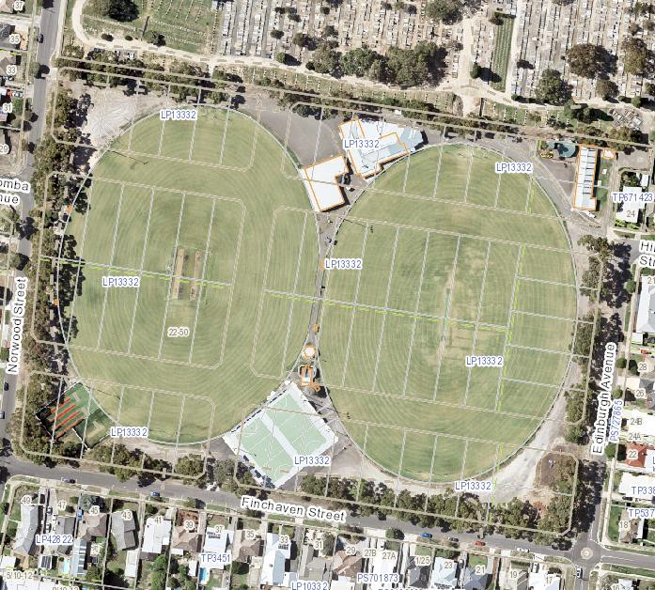
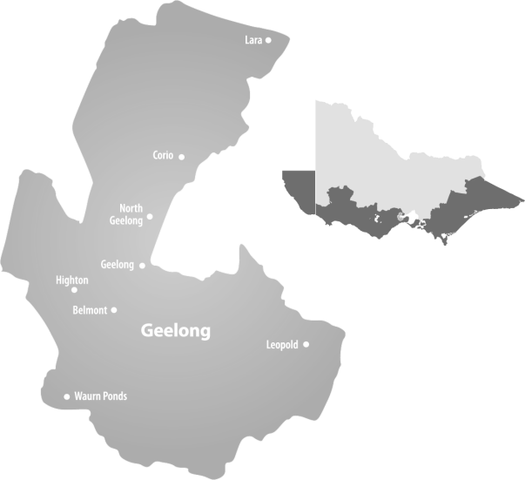
GEELONG CEMETERY

HERNE HILL RESERVE
HERNE HILL RESERVE MASTER PLAN | FINAL REPORT | NOVEMBER 2018 6

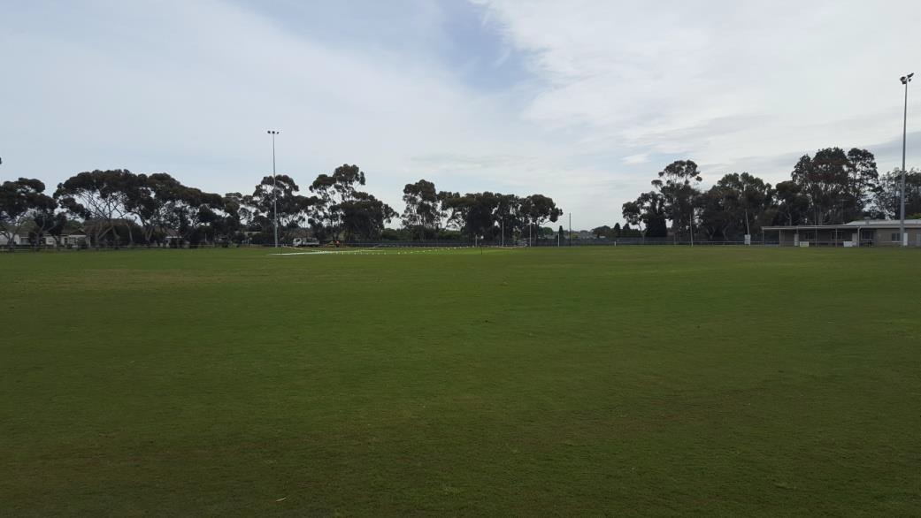
View north-west to Walker Oval northern goals
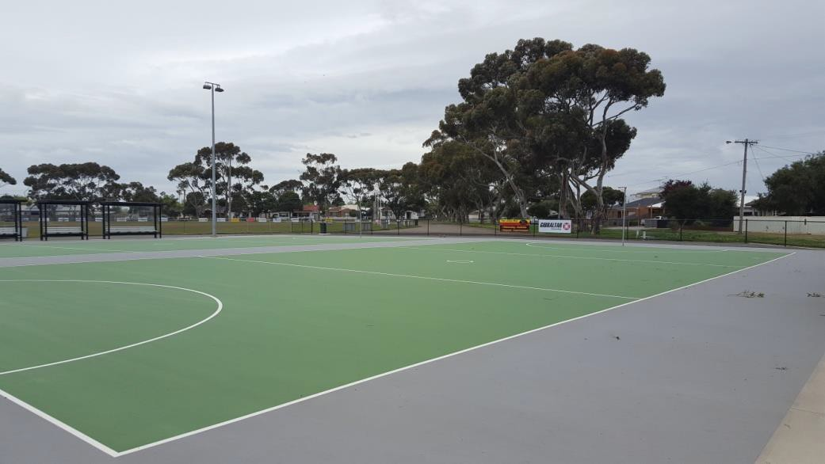
View east across netball courts

The master plan study area is indicated in Figure 2 on the following page shows the structures, roads, playing fields and passive landscape areas which comprise the reserve.

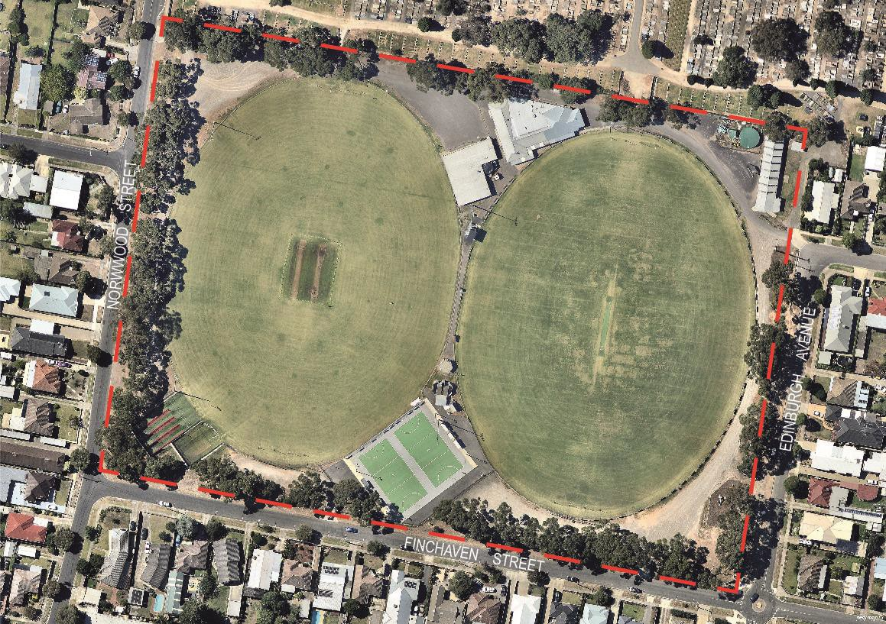
FIGURE 2: STUDY AREA - HERNE HILL RESERVE

PROJECT METHODOLOGY
The preparation of the Herne Hill Reserve Master Plan is being undertaken using the following approach:

1 STAGE 1 – PROJECT ESTABLISHMENT
2 STAGE 2 – ISSUES AND OPPORTUNITIES
3 STAGE 3 – DESIGN AND COST PLAN
4 STAGE 4 – DRAFT MASTER PLAN
5 STAGE 5 – FINAL MASTER PLAN THIS DOCUMENT

PROJECT GOVERNANCE
To guide the development of the Herne Hill Master Plan and its engagement activity a Project Governance Structure was established with the following roles and representatives:
KEY STAKEHOLDERS
KS
Role: To be informed and briefed on the progress of the Herne Hill Reserve Master Plan (including tenant club members, local residents and the broader community).
PROJECT REFERENCE GROUPS
PRGs
Role: Provide input, direction and feedback into the project at key stages (including tenant clubs and regional / state sporting associations – AFL Victoria, AFL Barwon, Netball Victoria, Cricket Victoria and Geelong Cricket Association).
PROJECT WORKING GROUP
PWG
Role: Provide technical advice and input into the project (including City of Greater Geelong officers from various relevant departments).

PROJECT CONTROL GROUP
PCG

Role: Provide high-level strategic direction on key issues, opportunities and approve draft reports. Also responsible for contract management (including The City’s Social Planning and Investment Department within Community Life Division, Management and Senior Staff).

Note: The Master Plan was developed by independent consultants Land Design Partnerships.

- CONTEXT
Herne Hill Reserve is an active sports reserve covering approximately 5.4 hectares located between Finchaven Street, Norwood Street and Edinburgh Avenue in the suburb of Herne Hill, located approximately 3km west of Geelong’s CBD.
Herne Hill Reserve has a mix of active uses including football, cricket and netball. The reserve serves as the home ground for the St Joseph’s Football and Netball Club and the St Peters Cricket Club. In addition to sporting clubs, the reserve is used for passive recreation with a number of recreation assets including a playground and public toilet facilities. The reserve is a highly valued open space area and is well utilised by the broader community.
The Reserve is owned and managed by the City of Greater Geelong, with the tenant clubs undertaking some maintenance activities.
The background assessment as it relates to Herne Hill Reserve comprised a review of the following four foundation areas:

Policy Context
To understand current State and Local Government policies impacting upon the reserve.

Planning Context
To understand the planning controls relevant to the reserve.

Site Context
To understand the existing physical characteristics of the reserve.

Stakeholder and Community Context
To understand the needs and desires of current reserve users and the surrounding community.

POLICY CONSIDERATIONS
A large number of local and state policies and previous studies have been reviewed in order to inform the Master Plan. A number of strategies and policies have direct relevance to the outcome of this master plan project. Of particular note are:

State Government Policy related to shared community facilities
One of the key government platforms for the development and management of community facilities (including recreational facilities) is the principle of shared use. The Victorian Government’s policy framework for shared facilities (including recreational facilities) is largely established by two documents: Growing Victoria Together (2005) and A Fairer Victoria (2008).
One of the five broad visions of the Growing Victoria Together policy is ‘Caring Communities’ with the high-level goal of ‘building friendly, confident and safe communities’. One target of this goal is to increase the ‘extent and diversity of participation in community, cultural and recreational organisations’ (Government of Victoria 2005a, pp. 16–17).
Because the key characteristics of sharing include greater community engagement, encouraging diversity in activities, improving access to facilities, and increasing the use of facilities, such sharing could potentially contribute to achieving the goals of Growing Victoria Together.
The Government’s commitment to stronger communities, efficient investment and enhanced asset utilisation is further outlined in the policy A Fairer Victoria.
A Fairer Victoria identifies five key objectives:
- improving access to universal services (with a focus on improving services for children, young people and older Victorians)
- reducing barriers to opportunities to participate in economic and social life
- supporting disadvantaged groups
- supporting disadvantaged places (in both new and existing communities)
- making it easier to work with government (by developing new ways of working with communities).

Through the Growing Victoria Together and A Fairer Victoria policies, it is clear that shared facilities is not just a government objective, but is also a means to achieve other, broader social policy objectives (Getting it Together: An Inquiry into the Sharing of Government and Community Facilities September, 2009).
Implementation of State Government policy related to shared facilities is investigated and directed by reports and policies such as Getting it Together: An Inquiry into the Sharing of Government and Community Facilities September (2009) and A Guide to Governing Shared Community Facilities DPCD (2010). These documents outline a clear view as to the benefits and responsibilities of shared facilities and the sharing of facilities as a potential basis for grant funding.
The opportunity to integrate and share the currently separate facilities at Herne Hill Reserve should be guided by these policies.

City of Greater Geelong Policy
Geelong Play Strategy: Part 1 A Great Place to Play (2012 -2021) – City of Greater Geelong
The Greater Geelong Play Strategy outlines a range of principles governing the provision and design of places of play within the City of Greater Geelong.
In response to these principles the strategy identifies a number of strategic opportunities which will be relevant to the development of the Herne Hill Reserve master plan, such as:
- Improve supporting infrastructure at play spaces, such as natural shade, seats and paths.
- Create better connections to cycling / walking networks.
- Improve play opportunities throughout the municipality by focussing on developing a diversity of opportunities and creating informal, spontaneous play opportunities throughout the City for people of all ages and abilities as well as programs to encourage play in public spaces.
- Increase the number of public play spaces to ensure that the majority of residents in the urban area can access a public play space within 400m of their home (approximately a five minute walk).
- Provide play opportunities for under-serviced age groups (e.g. 0-2 year old’s and young people over 10 years of age).
- Increase natural play opportunities and loose materials in play spaces.
- Increase the number of play spaces which offer tactile / sound / sensory experiences.
- Improve opportunities for people with disabilities to access and use play spaces.

Urban Forest Strategy (2015 – 2025), City of Greater Geelong
The City of Greater Geelong’s Urban Forest Strategy has the stated vision that “Geelong will be a cool green city for the future”.
The Strategy states that “the City has enormous potential to develop a healthier and more dynamic urban forest and improve canopy cover in our streetscapes, urban growth areas, open spaces and reserves.” It outlines a number of opportunities by which this potential could be achieved.
One key objective relevant to the Herne Hill Recreation Reserve Master Plan is:
- Improving the quality of streetscapes and open space in urban growth areas.
This objective will have a key application in the development of the master plan.

Geelong Cycle Strategy Volume 1 (March 2008), City of Greater Geelong
The strategy’s vision for the future of Geelong includes:
- increasing the network of on and off-road paths and connecting these paths,
- creating a cycle friendly Central Geelong and cycle friendly schools and workplaces throughout the municipality,
- maximising opportunities to increase cycle tourism and attract cyclists to the City.
The potential to develop a shared trail system and integrate this with the local path networks is a key implication of this strategy for the Herne Hill Reserve Master plan.

Geelong Public Health and Wellbeing Plan (2013 – 2017), City of Greater Geelong
The Geelong Health and Wellbeing Plan 2013 – 2017 outlines a range of health and wellbeing priorities and provides an action guide for each priority.
Action Guide 3 – Physical Activity and Active Communities is of most relevance to the Herne Hill Reserve Master Plan and includes objectives that will influence the master plan including:
- Embed ‘Healthy by Design’ principles in the City’s planning processes to support active living in existing and future growth areas.
- Review the Open Space Strategy that supports opportunities for physical activity and active living and contributes to the health and wellbeing of the community.
- Develop an active transport plan that provides an ‘integrated accessible network of walking and cycling routes for safe and convenient travel to local destinations and points of interest’ (Healthy by Design).
- Work with local sport and active recreation settings to address barriers to participation by vulnerable groups within our community.

Asset Management Strategy Version 1.09 (May 2016), City of Greater Geelong
The City of Greater Geelong is custodian of approximately $2.2 billion of assets that it provides to facilitate delivery of its services to the community.
The goal of asset management is to meet the required level of service in the most cost- effective way throughout the life cycle of the various assets to provide for existing and future customers.
The objective of the City’s Asset Management Strategy is to ensure that The City meets the required level of service, both now and for the future, in the most cost-effective way through the creation, acquisition, maintenance, operation, renewal/disposal of community assets.
The phases through which an asset passes during its life cycle are:
- The identification of need - where the requirement for a new asset is planned for, specified and established;
- The acquisition phase – where the asset is purchased, constructed or otherwise created;
- The operation & maintenance phase – where the asset is used for its intended purpose.
- The renewal phase – where the asset is replaced to its equivalent capacity of performance capability
- The disposal phase – initiated when the economic life of the asset has expired, when its service specification is no longer relevant, or when the need for the service provided by the asset has disappeared

The City’s infrastructure assets include, but are not limited to;
- Buildings and facilities of various types that provide a focus for services (such as administrative facilities, child care centres, health centres, youth centre, kindergartens, community halls and sports stadiums);
- Parks and recreation facilities, including active and passive recreation areas and sporing centres
- The road & street network;
- Flood protection and stormwater drainage systems;
- Waste management facilities (landfills and waste transfer stations);
- Special high usage precincts such as Waterfront Geelong and the CAA where infrastructure can be at a higher standard than normally used;
- Plant and equipment, including Workshop and Depot facilities;
- Information technology networks (computer & telecommunication systems.

As custodian of these assets, The City is responsible for funding their maintenance and upkeep at a level of service that satisfies both the safety and amenity requirements of the community.
It is therefore contingent upon the City to ensure that there is an appropriate level of funding which enables assets to be maintained to an acceptable standard and balanced against increasing the City’s asset base.
Strategic directions may be implemented whereby the service levels of a particular asset group may be increased or decreased depending on the competing priorities of the City and the expectations of the community.

Asset Management Strategy Objectives
- To provide the service required by our community:
  - by determining service levels required by the community
  - by focussing on outputs and outcomes with a view to continuously improving the match between service requirements and our service delivery
  - by ensuring our assets are appropriately used and maintained

- To optimise the service potential of our assets:
  - through improved management of our existing assets
  - through improved flexibility of our asset base
  - through rigorous planning, evaluation and budgetary processes
  - by using economies of scale for more cost-effective service delivery

- To maximise value for money:
  - by taking account of the full costs of holding, using and disposing of assets throughout their life cycles
  - by ensuring asset management decisions are responsive to performance measurement and monitoring
  - by producing costed options for the delivery of asset services.

- To contribute to economic growth:
  - by appropriate matching of assets to meet service delivery demands
  - by ensuring that all asset management decisions are made within the context of the City’s overall resource allocation and management framework

- To assign responsibility and accountability:
  - by clearly defining ownership and control of assets through asset information systems that meet both government and management decision making requirements
  - by determining and communicating accountability and reporting responsibilities throughout each step of the integrated approach to asset management.

- To promote balance between development and sustainability:
  - by balancing the demand for new assets through the use of non-asset service delivery alternatives where appropriate
  - by making asset decisions that consider and protect the needs of future generations
  - through consideration of asset renewal and rehabilitation options wherever feasible

- To minimise risks to the community and to the City’s financial viability:
  - through the application of risk assessment and reduction strategies
  - by regular condition audits consistent with the criticality of the various asset categories
  - through the delivery of appropriate asset maintenance and renewal programs

Sustainable Communities - Infrastructure Development Guidelines (October 2010), City of Greater Geelong
The Infrastructure Development Guidelines, while directed more to growth areas than established neighbourhoods, do contain a number of objectives and principles which will be relevant to the development of the Herne Hill Reserve master plan. These include:

Landscape and Streetscape - Objectives
High quality Streetscape and Landscape development, enhancement and protection shall aim to achieve the following goals:
  - Integration of engineering infrastructure and buildings with the landscape features to create a unified and visually appealing design.
  - Creation of aesthetically pleasing landscape environments, increased community enjoyment of everyday life and a greater sense of meaningful connection between people and the environment.
  - Fulfilment of the recreational and social needs of the wider and evolving community that reflect the values of the surrounding regional community.

Landscape and Streetscape - Principles
Ensure that the planning and design for landscape in Streetscape and Open Space settings is sustainable and follows the City’s guidelines and best practice principles, including:
  - Making open space areas contribute to the health of the local community and provide an experience and landscape that creates opportunity for active and passive recreation.
  - Developing a sustainable landscape that is drought tolerant and minimises maintenance requirements.

Sport, Recreation & Open Space - Objectives
The provision of quality and accessible sport, recreation and open space in communities is vital to provide for the long-term recreation and sporting needs of an active and healthy community.
The objectives for the development of sport, recreation and open space are designed to promote ‘sense of place’ and community for people of all ages, providing opportunities to meet and interact in appropriate spaces in suitable ways and times. They can also give character to an area, define landscapes and provide a focus to connect a community.
Sport, recreation and open space should provide popular and responsive active (sport and active recreation) and passive (including walking, sitting, contemplating and picnicking) spaces and landscapes. Spaces should be well designed and create places that are ‘fit-for-purpose’, useable and be located where people want to be. They should maximise active and passive surveillance from adjoining areas and passers-by.
Active recreation spaces and facilities should be designed to facilitate shared use including schools and different community users.

Sport, Recreation & Open Space - Principles
Council endorsed principles as part of its Study of Open Space Networks (Aug 2001) that are applicable to the provision of sport, recreation and open space. These include:
  - Conserving and protecting the natural and cultural environment.
  - Reflecting community needs.
  - Enhancing recreation and tourism opportunities.
  - Improving provision and optimising access.
  - Ensuring diversity of provision.
  - Expanding the network of linkages.
  - Providing for people with disabilities.
  - Implementing site responsive uses.

Environment Management Strategy (2014 – 2017), City of Greater Geelong
The Environment Management Strategy 2014-2017 is a key document for guiding planning, decision-making and activities that impact on the Greater Geelong environment and community. The Strategy shapes future planning and growth and provides a framework and roadmap for navigating future environmental challenges and opportunities.
- One key objective of the Strategy impacting on the Herne Hill Recreation Reserve Master Plan is to “strategically increase vegetation cover in urban areas to reduce heat island impact and increase community amenity and wellbeing”.

Domestic Animal Plan (2013 – 2017), City of Greater Geelong
One aim of the Domestic Animal Plan is to offer the Geelong community a fair and balanced environment – where people can enjoy the many public open spaces of Geelong to their fullest extent, regardless of whether they are a pet owner or not.
Under the Domestic Animal Plan policy, residents will have various dedicated Off Leash ‘Supervised’ areas, including some beach locations and most sporting grounds.
An objective arising from this policy which will impact the Herne Hill Reserve Master Plan will be:
- Dogs in Public Places
8.3 Promote the availability of all public general waste bins for the disposal of dog litter using any type of bag. Decals to be put on public waste bins, (refer p26 of the policy).

Other Relevant Policy
A range of other policies and guidelines were reviewed, directly relevant to the Herne Hill Reserve Master Plan, and are summarised below.

G21 Physical Activity Strategy (2014 – 2017), G21 Sport and Recreation Pillar
The main body of the strategy report “provides an overview of the importance of physical activity and the ways in which the G21 region can help to create environments that support physical activity in the community”.
- The City of Greater Geelong specific action plan within the report has a number of actions which may be embodied within the Herne Hill Reserve master plan, including:
- Develop an active transport plan that provides an ‘integrated accessible network of walking and cycling routes for safe and convenient travel to local destinations and points of interest’ (Healthy by Design).
- Develop accessible walking and cycling resources to encourage and support participation in safe active travel.
- Work with local sport and active recreation settings to address barriers to participation by vulnerable groups within our community.
- Encourage broader community access to tenanted sport and recreation facilities.
- Ensure that all active sport and recreation settings such as recreation reserves, stadiums, tennis courts and so on are planned, designed, managed and maintained in such a way as to be accessible and appropriate to the needs of all user groups.

Community Cricket Facility Guidelines (Version September 2015), Cricket Australia
Cricket Australia guidelines produced by Cricket Australia are predominantly detailed and specific to cricket facilities, they do make some statements relevant to the preparation of the Herne Hill Reserve master plan, such as the following from Guidance Note 6.

Social amenities and cricket ground surrounds
With cricket being a sport played over several hours for juniors and the best part of a day for senior competition, it is important ‘family friendly’ supporting amenities be incorporated into wider cricket facility precinct design.
Supporting facilities, equipment and amenities to be considered when planning a community friendly facility include:
- Shade and shelter
- Spectator seating incorporated into the park environment
- Adequate and accessible car parking
- Play equipment, skate or BMX park
- Bicycle racks
- Shared and connecting pathways or trails
- Public BBQ
- Access to food and beverage
- Public toilet facilities
- Drinking fountains
- Tree plantings, garden beds and vegetated areas
- Landscaped treatments
- Venue and club signage

Netball Victoria National Facilities Policy (2016), Netball Victoria
Netball Australia’s National Facilities Policy provides netball in Australia with an overarching framework to guide facility planning and development. These guidelines provide very detailed facility design guidance including core and optional components of a facility along with proposed preferred square metre allowances or estimates for these components.
The key objectives of the Policy are to:
- Support participation growth and sustainability
- Provide key stakeholders with guidance in facility planning and development
- Provide a technical manual that can be applied nationally
- Improve the overall consistency, quality and accessibility of netball facilities

Netball facility planning and development is to be focused on supporting the growth of the sport. In order to do this, facilities will be planned and developed with consideration of the following guiding principles:
- Strategic need, facility demand and participation growth opportunities
- Accessibility and inclusion, catering for multiple formats of the sport
- Maximising utilisation and improved programming
- Best practice technical and design standards
- Alignment with the needs of key stakeholders and partners

In the development of the design brief, the following should be incorporated into the overall facility provision on site (including shared infrastructure):
- Change rooms and umpires change rooms
- Public toilets (including accessible)
- Competition / Administration office
- First Aid room
- Kiosk / canteen
- Social area
- Storage

Other functionality such as kitchens, dedicated function space, meeting rooms, warm-up areas, spectator seating and amenities can be considered on a needs basis.
The Policy does not provide specific guidance on court proximity to amenity provision.

2.1.4 Policy Implications and Considerations for the Master Plan

The following policy implications and considerations as they relate to the Herne Hill Reserve Master Plan are summarised below;

- Reserve and facility function is considered community level provision
- Shared use of facilities
- Broad community use of open space through appropriate facilities and amenities
- Encouragement of activity and exercise
- Enhanced tree planting to reduce “urban heat island” impacts
- Enhanced and diverse play opportunities
- Encouragement of active transport – walking and cycling
- Competing priorities and need for investment in like facilities
- Standard provision of facilities commensurate with levels of service
- Sustainable and equitable development and maintenance of facilities across the City
- Design response and recommendations will be subject to the City’s Business Drivers
- All decisions subject to the City’s overall resource allocation and management framework

AFL Preferred Facility Guidelines for State, Regional and Local Facilities (August 2012), Cricket Australia
The purpose of the preferred facility guidelines is to act as a key tool during used during the planning phase of a project. The document provides relevant guidance, particularly around spatial requirements that can inform concept and/or master plans. While much of the document is detailed and specific as to layout and spatial configuration, the recent Appendix related to Amenities Upgrades for Unisex Use is particularly applicable to the Herne Hill Reserve master plan.

Amenities Upgrade for Unisex Use (July 2015)
This document has been developed to provide more detail around what is considered best practice in the design of unisex football change rooms and amenities.
People often think of female change rooms as separate dedicated change facilities. This is not the case, rather it is about transforming the existing amenities to cater for unisex use, removing urinals and open showers and replacing with toilet cubicles and shower cubicles that allow showering and changing in privacy. In other words, great change facilities cater equally well for both genders.

G21 and Barwon Region AFL Strategy (2015), G21 Strategic Pillar and AFL Victoria
The strategy aims to “guide the future planning and development of football and netball delivered through football-netball clubs throughout the G21 and AFL Barwon regions. The strategy addresses infrastructure and sports development needs of both sports, as well as establishes clear priorities for local delivery.”

The key findings affecting the preparation of the Herne Hill Reserve Master Plan include:

- Herne Hill Reserve and associated infrastructure is rated in the top five facilities across the region in terms of overall quality and provision.
- Herne Hill Reserve is considered a community level facility.

PLANNING CONSIDERATIONS
Herne Hill Reserve is subject to the requirements of the zones and overlays outlined in the Greater Geelong Planning Scheme. Refer to Figure 3: Zoning.

Municipal Planning Framework
Within the Municipal Planning Framework, the Greater Geelong Planning Scheme encourages the development of open space which is safe, is accessible to communities (particularly through proximity by walking), and which contributes to the diversity of recreational experience available to members of the community.

Zoning
Public Park and Recreation Zone (PPRZ)
Herne Hill Reserve is zoned PPRZ. PPRZ recognises areas of public land that are designated as public park and recreation zone and encourages enhancement of the subject land in support of appropriate recreation uses and activities. It also seeks to protect and conserve areas of significance and provide for commercial areas where appropriate.
Under the zone a permit is required to:
- Construct a building or construct or carry out works. This does not apply to:
  - Pathways, trails, seating, picnic tables, drinking taps, shelters, barbeques, rubbish bins, security lighting, irrigation, drainage or underground infrastructure.
  - Playground equipment or sporting equipment provided these facilities do not occupy more than 10 square metres of parkland.
  - Navigational beacons and aids.
  - Planting or landscaping.
  - Fencing that is 1 metre or less in height above ground level.
  - A building or works shown in an Incorporated plan which applies to the land.
  - A building or works carried out by or on behalf of a public land manager or Parks Victoria under the Local Government Act 1989, the Reference Areas Act 1978, the National Parks Act 1975, the Fisheries Act 1995, the Wildlife Act 1975, the Forest Act 1958, the Water Industry Act 1994, the Water Act 1989, the Marine Act 1988, the Port of Melbourne Authority Act 1958 or the Crown Land (Reserves) Act 1978.
- Subdivide land.

Overlays
Herne Hill Reserve is not the subject of any overlays within the City of Greater Geelong Planning Scheme.

FIGURE 3: HERNE HILL RESERVE, PLANNING OVERLAY
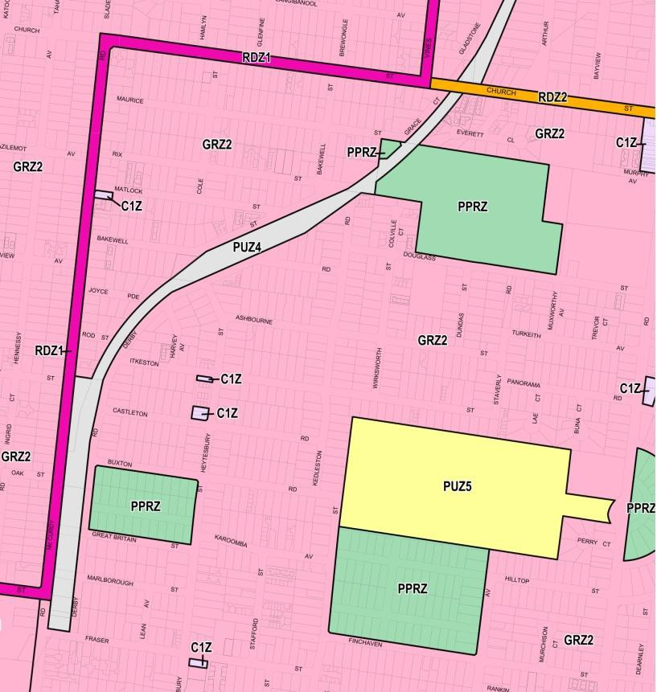
HERNE HILL RESERVE – PPRZ ZONE

2.2.4 Planning Implications and Considerations for the Master Plan
The following planning implications and considerations as they relate to the Herne Hill Reserve Master Plan are summarised below;
- The planning context contained within the Greater Geelong Planning Scheme creates no specific issues for the provision of recreation within the reserve.
- The planning scheme encourages opportunities to increase the diversity of the recreational experience offered by the reserve.
- However, depending on the type and value of proposed works, a planning permit may be required under the City of Greater Geelong Planning Scheme.
- No constraints upon recreation use of the reserve, although planning permit required for buildings.

SITE CONSIDERATIONS

    - Location and Setting
Herne Hill Reserve is located west of Geelong’s CBD between Finchaven Street, Norwood Street and Edinburgh Avenue in the suburb of Herne Hill.
The reserve is located in a predominantly residential setting, with each of the surrounding streets characterised by standard residential development on blocks of approximately 700m2
– 800 m2 with the exception of the northern boundary of the reserve, adjoining the Geelong Western Cemetery.
There are up to seven other open space land parcels provided within 1.2km of the reserve. These reserves offer a range of recreation opportunities, including;

The reserve is connected to these open spaces via the local street network. There is no local off-street trail network, other than the Geelong Western Cemetery path system.

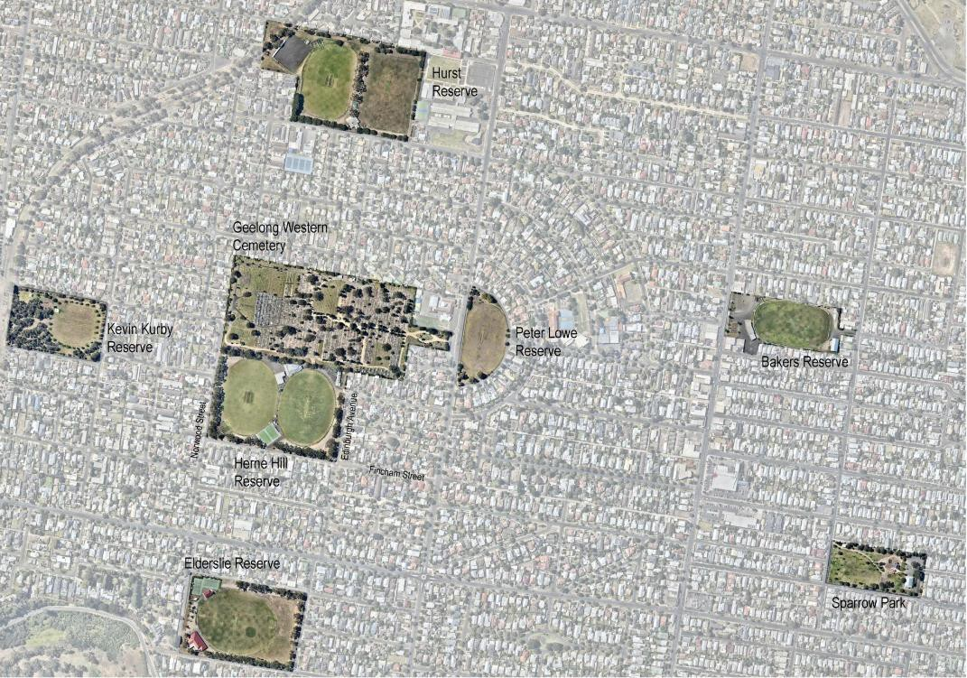
FIGURE 4: SURROUNDING OPEN SPACE PROVISION (WITHIN 1.2KM VICINTY)
5
2
1
4
6
HERNE HILL RESERVE
7
3

Name | Distance from Herne Hill Reserve | Provisions
1. Geelong Western Cemetery | Adjoining | Walking trails
2. Kevin Kirby Reserve | 260m | Informal recreation spaces, playground, picnic / barbecues and walking
3. Elderslie Reserve | 320m | Formal active recreation: AFL / cricket field, tennis courts and pavilions
4. Peter Lowe Reserve | 350m | Formal sports field and a public toilet
5. Hurst Reserve | 800m | Formal active recreation: AFL / cricket field, netball, pavilion and playground
6. Bakers Oval | 1000m | Formal active recreation: AFL / cricket field, pavilion and a playground
7. Sparrow Park | 1200m | Informal active recreation spaces, playground, picnic / barbecues and walking.

Refer to Figure 4 for a visual representation of local open space provision.

2.3.2 Location and Setting Implications and Considerations for the Master Plan
The following location and setting implications and considerations as they relate to the Herne Hill Reserve Master Plan are summarised below;
- The proximity of open space of a similar scale and function to Herne Hill reserve suggests an opportunity to provide a greater diversity of recreation experience.
- The presence of other similar scale community open space within a walkable proximity suggests the potential to see Herne Hill as part of a local open space network rather than a single reserve.
- There is potential to better integrate the reserve with the adjoining cemetery, particularly as part of a local walking network.
- Car parking, either on-site or on-street, is currently constrained. There are opportunities for more integrated parking solutions.
- The location and residential setting of Herne Hill Reserve limits the future development and growth potential at the site but also confirms the appropriateness of a local level recreation facility provision.

2.3.3 Sports Facilities
The club-based sporting user groups at Herne Hill Reserve are St Joseph’s Football & Netball Club and the St Peters Cricket Club. Figure 5 (page 28) provides an overview of current Sports Facilities.

Ovals
The reserve contains two sports ovals, Walker Oval on the west and NH Drew Oval on the east. Both are used for cricket and football with Walker Oval (and turf wicket table) being the primary cricket field and NH Drew Oval (and synthetic cricket pitch) being the primary AFL oval.
Both ovals are maintained to a Community 1 standard, the highest community level provision. The provision of two Community 1 ovals at one site is not a common occurrence (standard provision for a two oval facility is a Community 1 and a Community 2 standard oval) and is permitted in recognition of the size and level of usage by tenant clubs.

Key characteristics of Walker Oval:
- Aligned in a north - south orientation
- Approximate playing surface dimensions of 157m x 128m (larger than average size)
- Defined by perimeter rail fence
- Caters for senior cricket competition and training and senior football competition and training
- Includes lighting compliant with current Australian Standards for sports lighting for training (100lux)
- Central 4 pitch turf table for senior cricket competition
- Includes synthetic and turf cricket practice wickets, located on the south-western boundary of the oval
- Two coaches boxes
- Suffers from poor drainage, with the eastern wing subject to occasional inundation, particularly in winter months, leading to soft playing surface conditions. Lack of drainage impacts also on the area between Walker Oval and NH Drew Oval
- Has no spectator amenity or shade apart from the clubrooms.

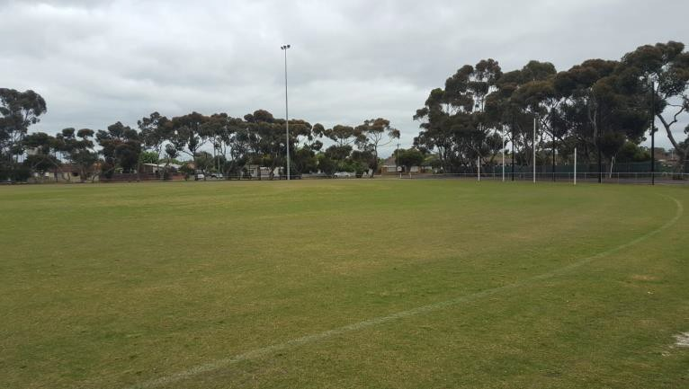
View west across Walker Oval
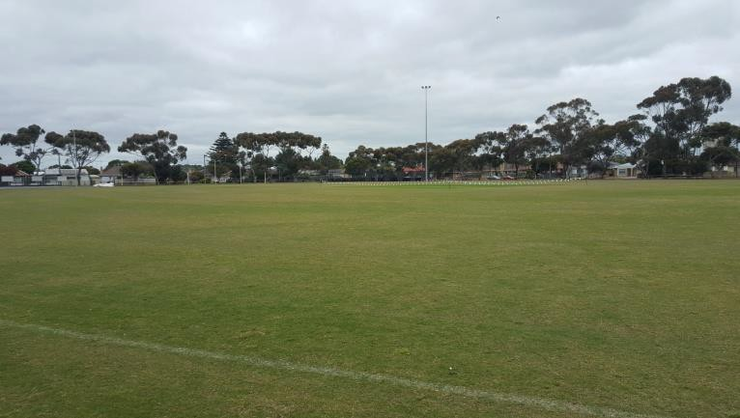
View south-east to Walker Oval southern goals
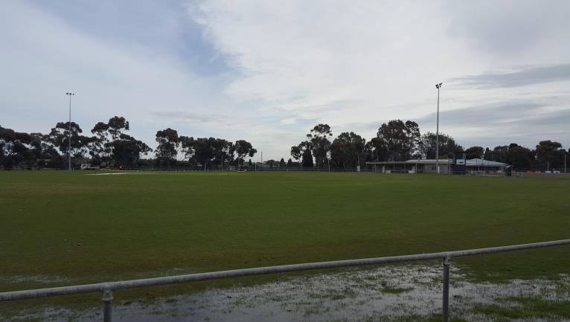
View north to clubrooms with poor drainage on Walker Oval eastern wing

Key characteristics of NH Drew Oval:
- Aligned in a north - south orientation
- Approximate playing surface dimensions of 157m x 128m (larger than average size)
- Defined by perimeter rail fence
- Caters for Senior Cricket competition and Senior Football competition and training
- Has no lighting
- Has a single hard (concrete) centre-wicket cricket pitch
- Has an electronic scoreboard and a now redundant scoreboard
- Has a recently constructed timekeepers and scorers box with storage
- Has had drainage installed in recent years and is well drained
- Has no spectator amenity or shade apart from the clubrooms

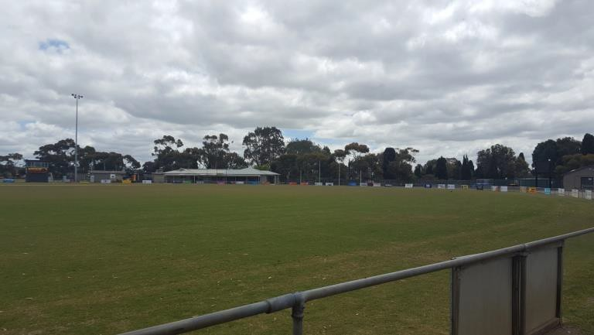
View north to clubrooms across NH Drew Oval eastern wing

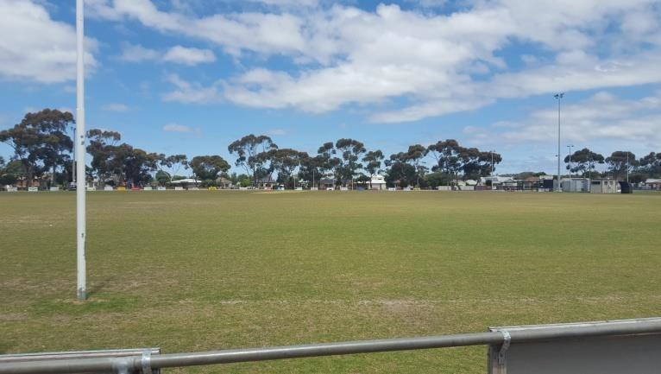
View south to NH Drew Oval southern goals
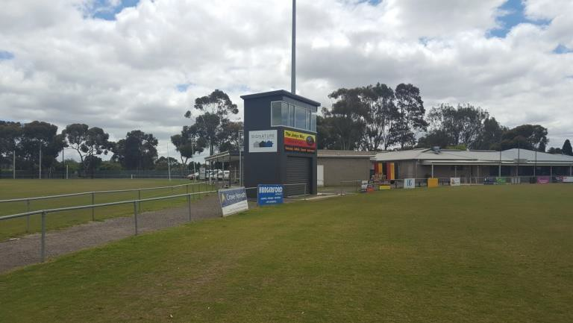
NH Drew Oval timekeepers box and storage

Netball Courts
The reserve contains two netball courts, located on its southern (Finchaven Street) boundary. The courts have been constructed in the last five years and have a high quality plexipave playing surface.

Key characteristics of the netball courts:
- Have a south-east / north-west orientation
- Have full run-off areas as required by Netball Australia regulations
- Have lighting that complies with current Australian Standards for netball training lighting
- Are separate from the Football and Netball Club rooms, with older storage toilet and scoreboard structures between
- Has courtside players shelters and spectator areas
- Ageing court-side facilities including public toilet, storage and administration space / first aid facilities

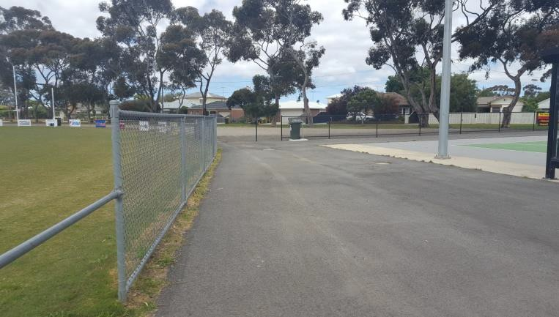
South-eastern corner of netball courts, looking towards Finchaven Street

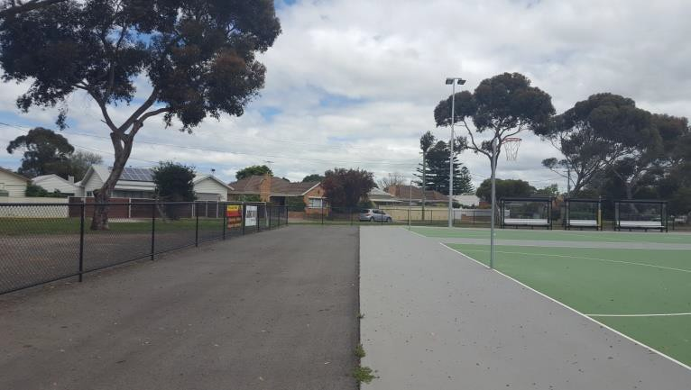
View south-west from eastern edge of netball courts

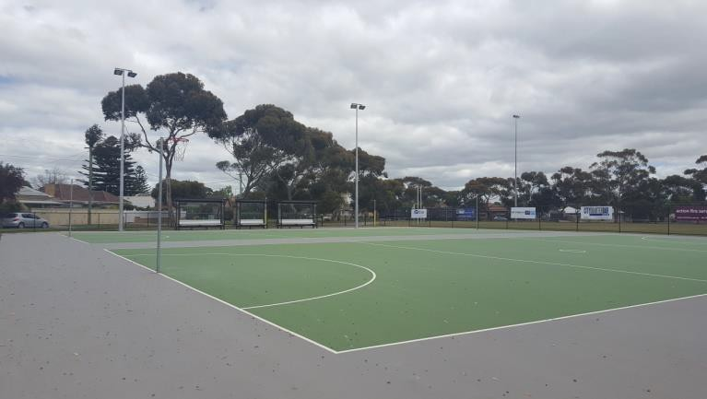
View across netball courts to Walker Oval southern goals

Cricket Practice Nets
The reserve includes a cricket practice net complex comprising 4 synthetic and 2 turf practice pitches with retractable “soft” fencing and a single turf practice pitch with retractable netting. The practice nets were constructed within the last 5 years in line with the netball court installations.

Key characteristics of the cricket practice nets:
- Located on south-western pocket of Walker Oval
- Have 4 synthetic pitches with fixed fencing and 2 turf practice pitches with retractable dividing net
- Has run-ups extending onto the oval (not in accordance with Cricket Australia guidelines), leading to wearing of the playing surface
- Has no power for bowling machine or storage area for equipment

AFL Scoreboard
A new electronic scoreboard has been constructed adjacent NH Drew Oval, leaving the previous scoreboard redundant.

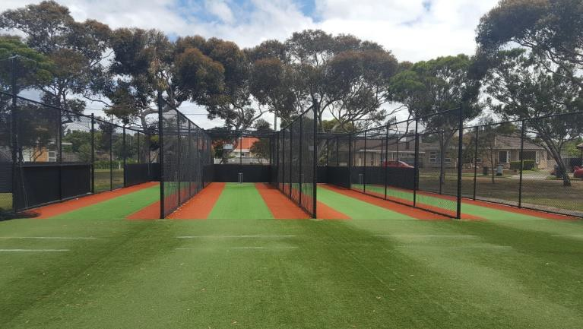
Synthetic cricket practice pitches

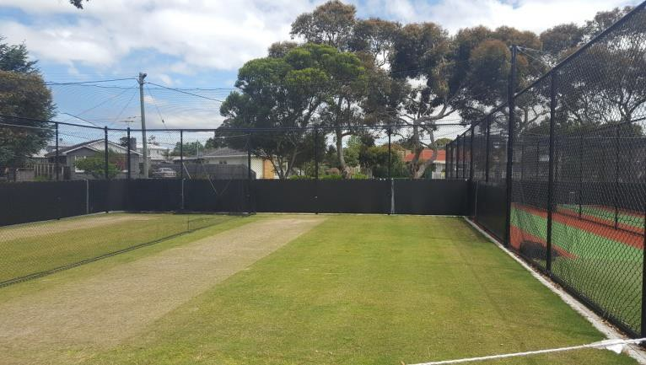
Turf cricket practice pitches
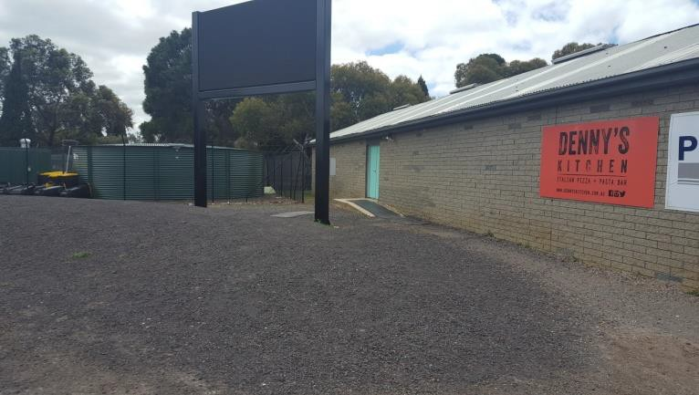
Electronic AFL scoreboard

Coaches Boxes
NH Drew Oval has two simple coaches’ boxes which, while not substantial, are adequate. The oval does not have interchange areas or interchange boxes, as recommended by AFL facility guidelines for local facilities.

Timekeepers Box and Storage Shed
This is a recently constructed 2-storey masonry structure providing storage for ground- keeping equipment at the lower level and a timekeeper’s box at the upper level, with a view over NH Drew Oval.
Inspection of the building reveals that:
- It is good condition and appears to meet the needs of the club.
- Its location allows for improved circulation between the netball courts and the clubrooms, compared to the storage shed further to the south.
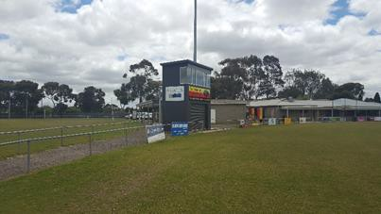
- Despite being a recent installation, the facility is not considered compliant under the Disability Discrimination Act as it has no provision for access for all abilities.
NH Drew oval western wing - Northern coaches’ box

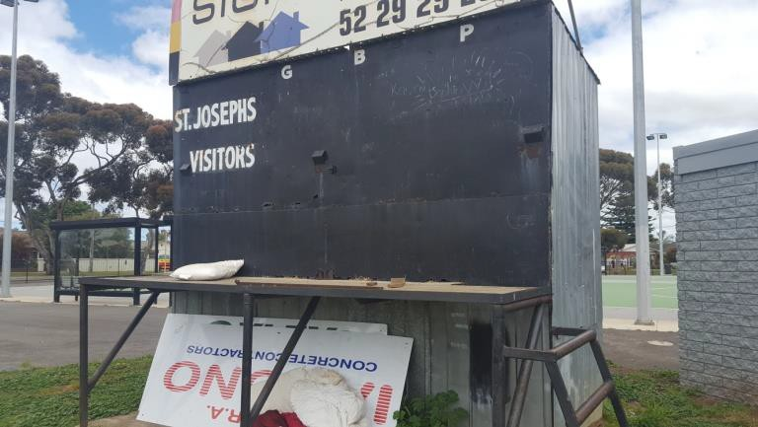
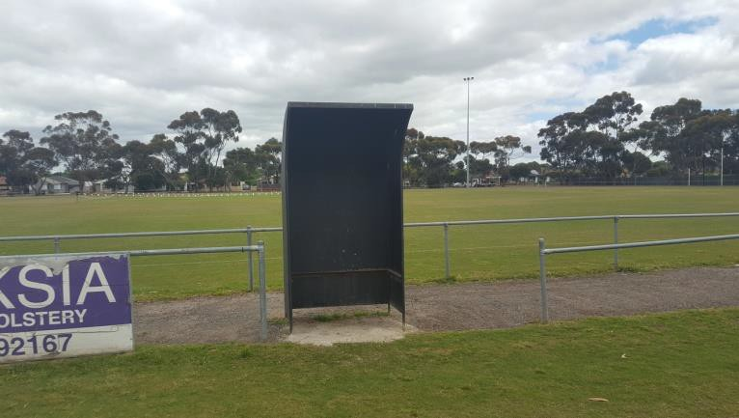
NH Drew Oval – Redundant Manual AFL scoreboard

NH Drew oval western wing - Northern coaches’ box

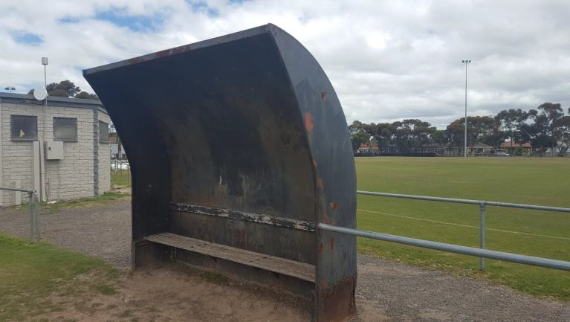
NH Drew oval western wing – Southern coaches’ box

FIGURE 5: HERNE HILL RESERVE, OVERVIEW OF CURRENT SPORTS FACILITIES

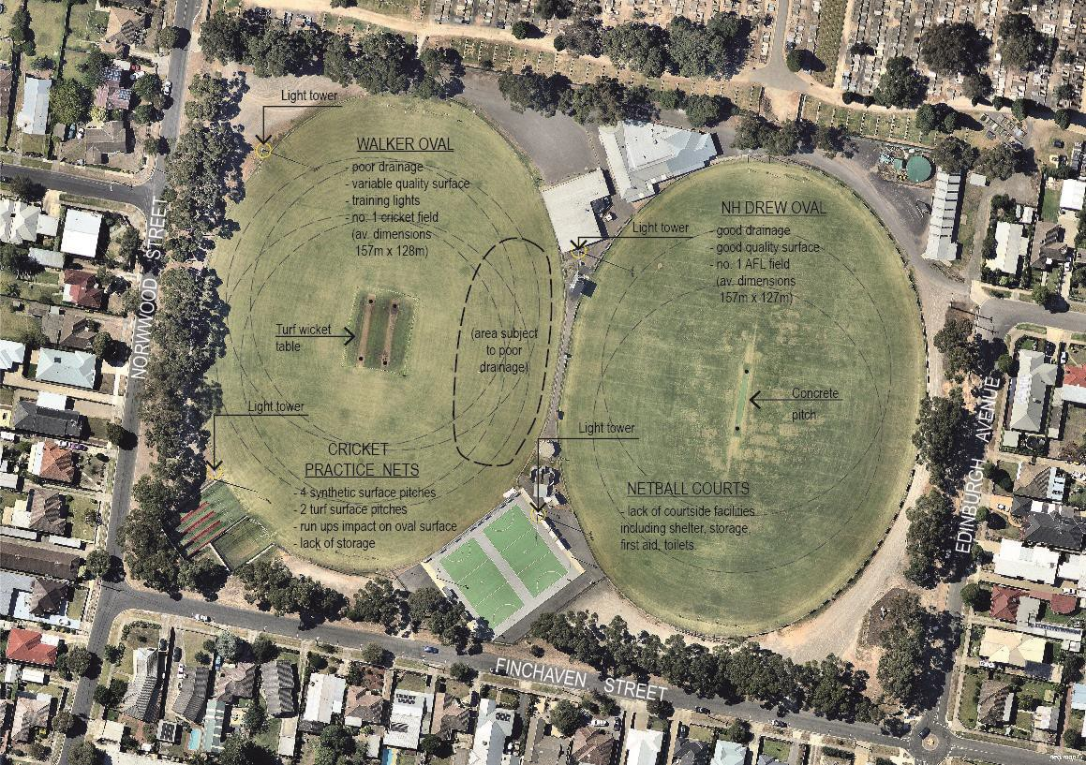

2.3.4 Sports Facility Implications and Considerations for the Master Plan
The following sports facility implications and considerations as they relate to the Herne Hill Reserve Master Plan are summarised below;
While the formal sports facilities at Herne Hill Reserve are generally of a high quality, placing it in the top 3 community sports venues for football within the City of Greater Geelong via the G21 AFL Barwon Regional Strategy and the broader G21 region, there are opportunities to improve facilities in areas such as:
- Provision and/or upgrade of appropriate netball courtside support facilities such as shelter, storage and the public toilet.
- Provision of cricket training storage facilities.
- Enhancement of drainage within Walker Oval.
- Provision of coaches and interchange facilities in accordance with AFL guidelines
- Provision of appropriate netball courtside infrastructure.

2.3.5 Buildings and Structures
There are four main buildings located at Herne Hill Reserve, these are:
- St Joseph’s Football and Netball Clubrooms
- St Peters Cricket Clubrooms
- Former Scout Hall
- Public Toilets
These buildings are supplemented by a range of support structures including storage rooms and other coaches boxes).
The buildings and structures are visually located on Figure 6 – Overview of Buildings and Structures on the following page.

St Joseph’s Football and Netball Clubrooms
The St Joseph’s Football and Cricket Clubrooms are located against the north-eastern pocket of NH Drew Oval, as indicated on Figure 7. The Clubrooms comprise the following spaces:
- Social space, consisting of lounge and viewing areas, with operable wall between
- 2 AFL change rooms
- AFL support amenities (toilets, showers)
- 1 Netball change room
- Netball support facilities (toilet)
- Umpires change room
- 1 junior change room
- Kitchen, bar and store rooms
- Meeting room with external veranda looking towards both fields
- Public toilet facilities

Inspection of the building and comparison with current AFL Preferred Facility Guidelines for local facilities reveals the following:
- Social areas, kitchen and bar, and meeting spaces are consistent with current AFL square metre area recommendations.
- Public toilets comply with current AFL square metre area recommendations.
- Internal storage areas comply with current AFL square metre area recommendations.
- AFL change rooms and player amenities are not consistent with current AFL guidelines in relation to square metre area recommendations.
- Umpires change room does not comply with AFL square metre area recommendations.
- There is no nominated first aid / medical room or massage / strapping room within the main building, which are optional features within current AFL area guidelines.
- There is no nominated third umpire / match referee or venue management office, which is an optional space within current AFL area guidelines.
- The current netball change room is adequate but is currently being used for storage.
- There is currently no specific provision for female AFL change or amenities.
- The building does not comply with current general building requirements such as DDA, BCA Section J compliance, OH&S requirements and fire regulations. All such requirements would be likely considerations in the event of any major renovation of the current buildings.

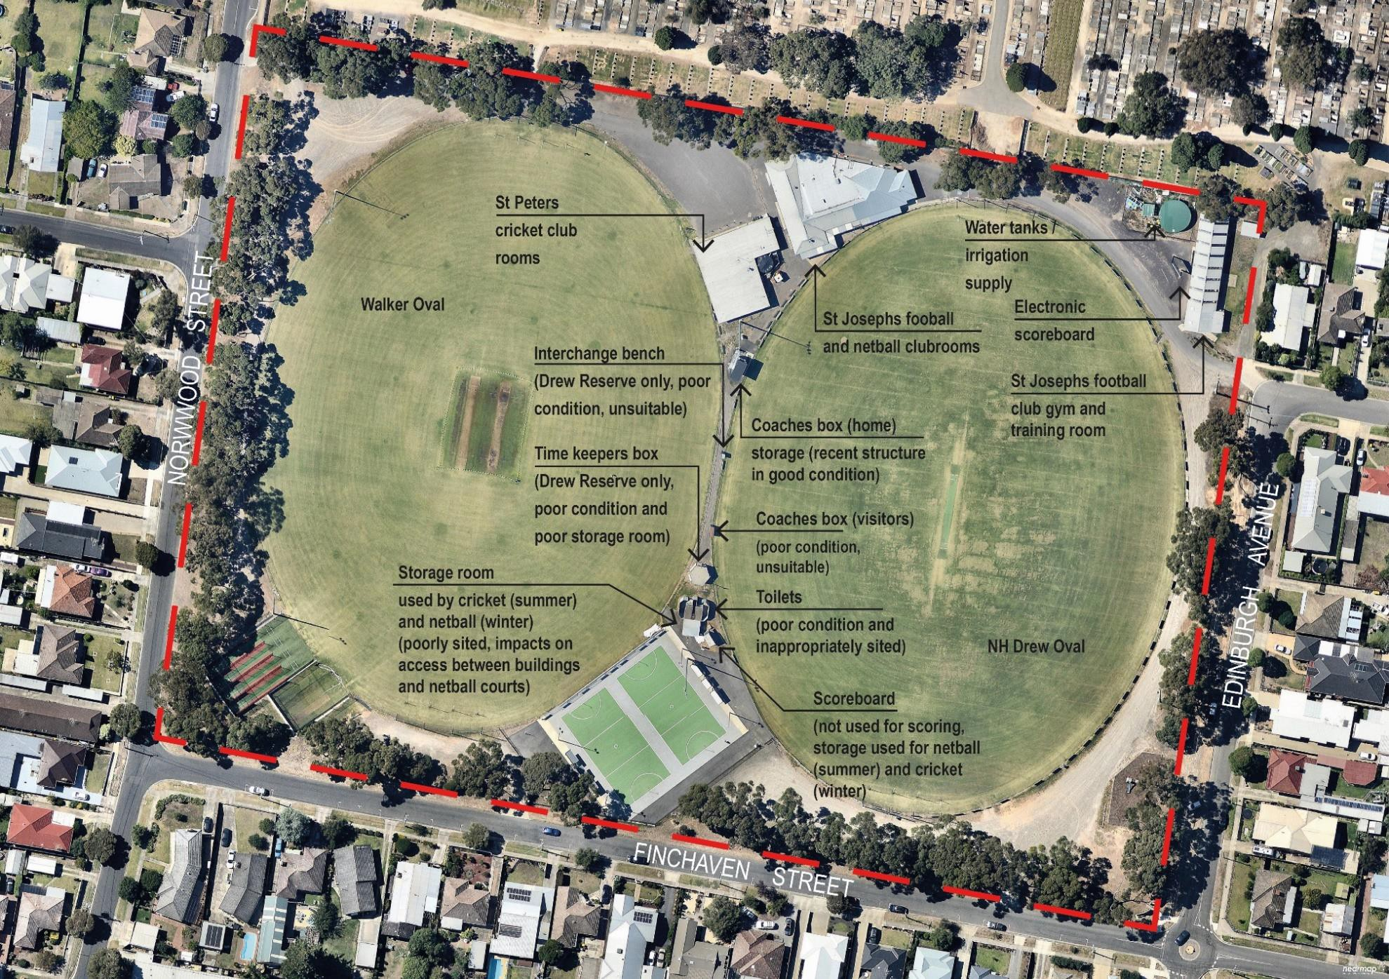
FIGURE 6: HERNE HILL RESERVE BUILDINGS AND STRUCTURES

- FIGURE 7: ST JOSEPH’S FOOTBALL & NETBALL CLUBROOMS (NOT TO SCALE)
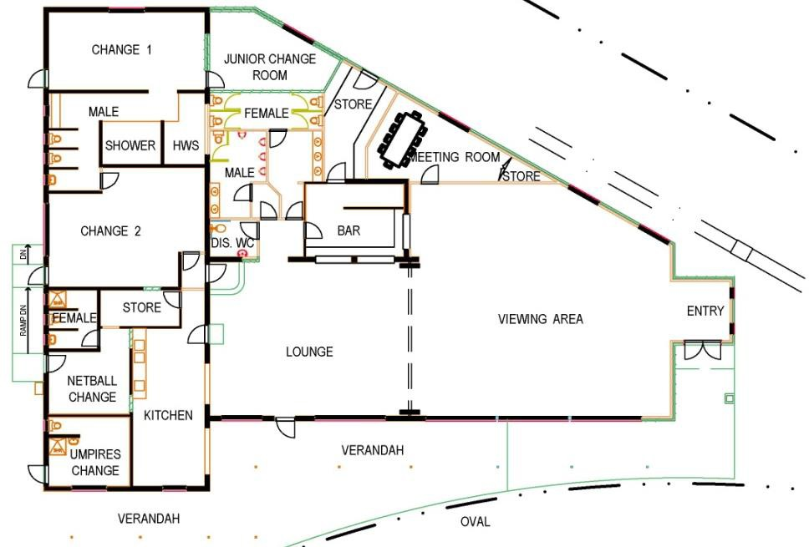

St Peters Cricket Club rooms
The St Peters Cricket Club rooms are located against the south-eastern pocket of Walker Oval, as indicated in Figure 8. The club rooms comprise the following spaces:
- Social space with external veranda looking towards both fields
- Change rooms for home and visiting teams
- Male Toilet
- Unisex disabled toilet
- Kitchen, bar and store rooms

Inspection of the building, and comparison with current Cricket Australia (CA) Community Cricket Facility Guidelines reveals the following:
- Social / community areas are consistent with current CA area guidelines
- Change rooms are consistent with current CA area guidelines
- Accessible and public toilets are not consistent with current CA area guidelines
- Kitchen / kiosk and kitchen store areas are not consistent with current CA area guidelines (unless the existing bar area is considered as part of this provision)
- There is no current designated umpires room, medical / first aid room or scorers viewing area as recommended by current CA area guidelines
- Internal and external storage areas are not consistent with current CA area guidelines
- There is no specific provision for female change or amenities except for a female toilet.
- The building will not comply with current general building requirements such as DDA, BCA Section J compliance, OH&S requirements and fire regulations. All such requirements would be likely considerations in the event of any major renovation of the current buildings.

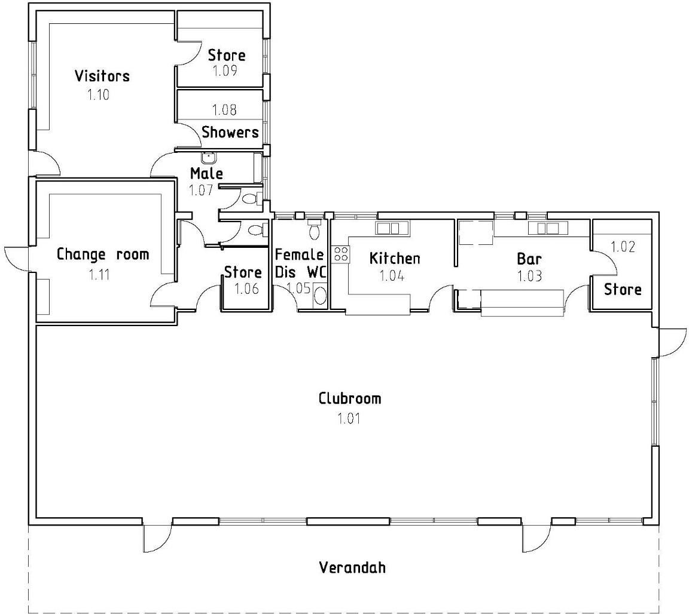
FIGURE 8: ST PETERS CRICKET CLUBROOMS (NOT TO SCALE)

Former Scout Hall
The former scout hall in the north-east corner of the site has been converted to an AFL training room / gym and home team pre-match room and change facility. It comprises the following spaces:
- A small entry / pre-match address room
- A larger gym / raining room
- Change room with open shower block (capacity for 4 people), 1 toilet and 1 urinal.
The facility has no other amenities such as a first aid room. While it provides a serviceable and functional facility, it suffers from lack of connection with the main club room and from the lack of these facilities.

Public Toilets
The reserve includes a public toilet located between the two ovals, just north of the existing tennis courts, as shown on Figure 6 – Buildings and Structures.
Inspection of the building reveals that it:
- Creates a barrier to easy pedestrian movement and visual connection between the netball courts and the main clubrooms
- Has poor quality and outdated fittings
- Lacks security that may lead to concerns about personal safety

Storage Shed
A brick storage shed is located adjacent to the public toilet block referred to above, as shown on Figure 6.
Inspection of the building reveals that it:
- Contributes to a barrier to easy pedestrian movement and visual connection between the netball courts and the main clubrooms
- Is potentially functionally redundant, having been replaced by the recent structure located closer to the St Peter’s Cricket Clubrooms

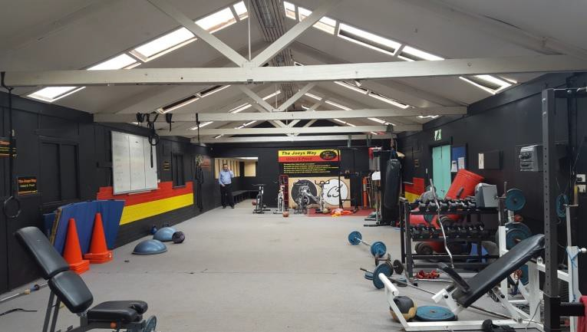
Former scout hall – current use as home team change and gym.
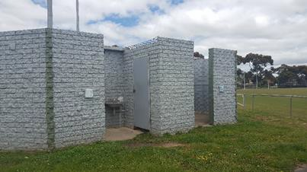
Existing Public Toilet Block
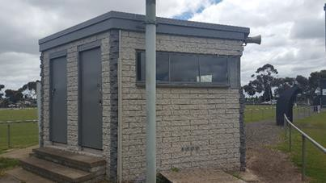
Existing Time Keepers Box / Storage Shed

2.3.6 Buildings and Structures Implications and Considerations for the Master Plan
- While both current clubroom buildings have served their clubs for a long period of time and remain in serviceable condition, they do not completely meet the current sports association facility guidelines. Opportunities associated with these buildings fall into three categories:
  - accept the buildings as they are and continue to utilise them while they are serviceable;
  - consider upgrades and/or retirement of the existing buildings in order to overcome current limitations;
  - or consider a new facility in place of the current two clubrooms.
- There is an opportunity to remove a number of redundant structures, particularly the existing scoreboard, and potentially the brick storage building and toilet block.
- The existing public toilet block presents significant issues in relation to the condition of the facility and its location. Opportunity for a new facility should be considered within the master plan.
- Due to the building condition, refurbishment as it relates to the St Peter Cricket Club pavilion would not be considered a cost-effective option and does not offer an opportunity to provide for the desired design outcomes.
A series of planning and design considerations have been prepared based on the issues and opportunities presented by the existing buildings at Herne Hill Reserve and these are outlined in Section 4.

2.3.7 Vehicular Access and Car Parking
Key points associated with vehicle access and movement at Herne Hill Reserve are summarised on Figure 9 on page 38. These points include:
- Formal vehicle access into the reserve occurs at two key points as indicated on Figure 9
– Norwood Street near the cemetery entrance, and the corner of Edinburgh Avenue and Hilltop Street.
- Sealed vehicle access is limited to the area around the main club rooms. Asphalt roadways lead from each of the main entry points to sealed but informally laid out parking areas. The larger of these is located to the north-west of the St Peter Cricket Club rooms, nominating the Norwood Street entrance as the most highly used.
- Car parking and access around the ovals is informal and unsealed. The surface of these areas is uneven and subject to ponding in times of heavy rain.
- There are no traffic management devices within the reserve, meaning that vehicle movement and parking is largely uncontrolled, allowing vehicles to park in a haphazard fashion in almost any area of the reserve.

2.3.8 Vehicular Access and Car Parking Issues and Considerations for the Master Plan
- Consideration of the opportunity to formalise car parking around both fields, integrated with drainage to improve ground surfaces and with pedestrian circulation to enhance user amenity
- Consideration of formalised parking along adjoining streets
- Consideration of traffic management measures to control vehicle movement and enhance pedestrian safety in and around the site

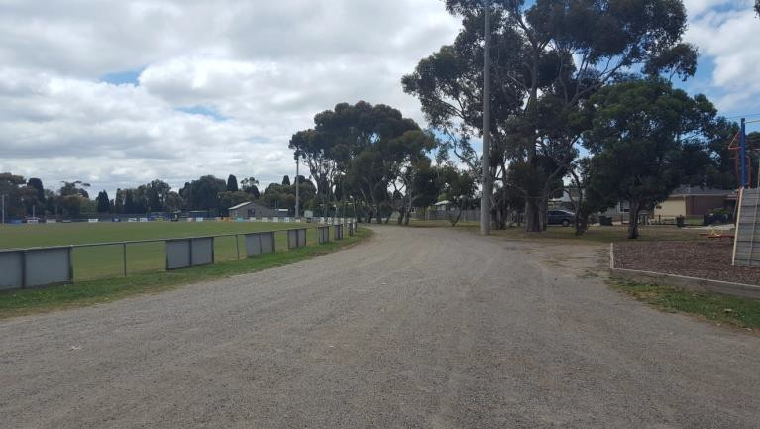
Undefined vehicle access and parking around NH Drew Oval

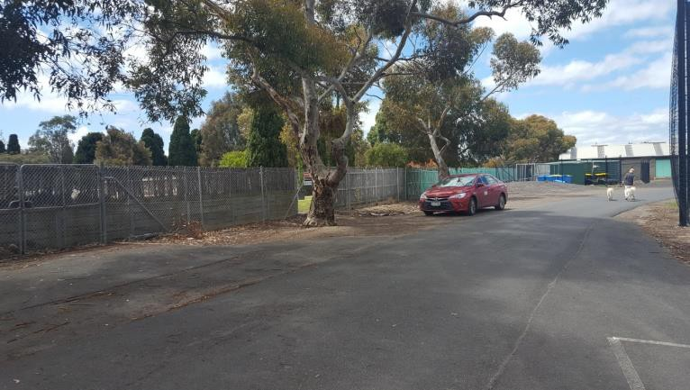
Sealed roadway to north of Walker Oval

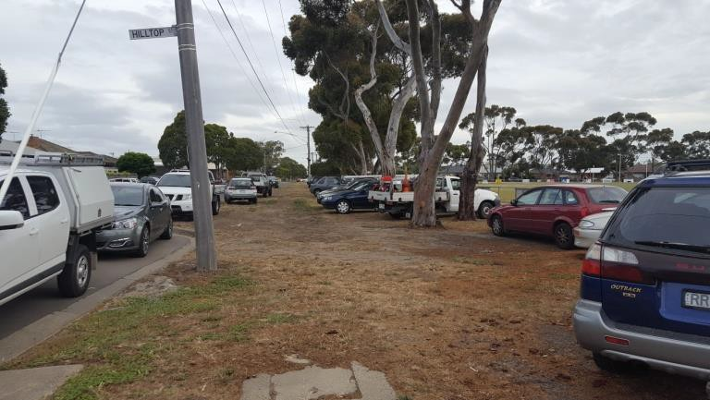
Parking east of NH Drew Oval

2.3.9 Pedestrian Access and Circulation
Key points associated with pedestrian movement at Herne Hill Reserve are summarised on Figure 9 on page 38. These points include:
- There are no formal pedestrian paths through the reserve. Pedestrians moving across the reserve or between facilities utilise either sealed roadways and parking areas or the broad unsealed areas around the ovals.
- While there are no formal footpaths on the reserve street boundaries, the path network within the Geelong Western Cemetery leads directly into the reserve, creating an opportunity for improved pedestrian connection with the broader neighbourhood.
- There are currently no footpaths along streets forming the western, southern and eastern boundaries of the site (i.e. Norwood Street, Finchaven Street and Edinburg Avenue.).
- Pedestrian access between the netball courts and the main clubroom buildings is compromised by the location of potentially redundant structures, and by the narrow and poorly drained nature of this connection.

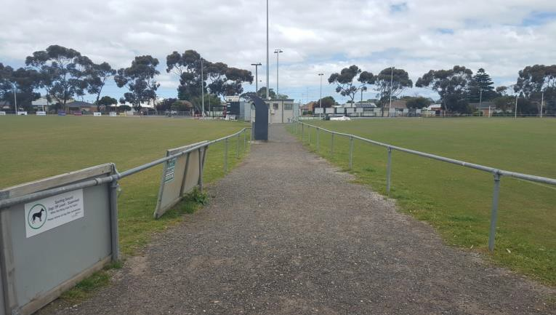
Poor amenity pedestrian connection between netball courts and buildings
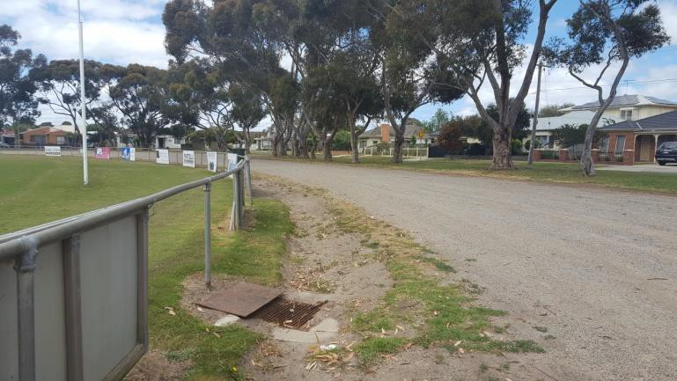
Lack of pedestrian paths around NH Drew Oval

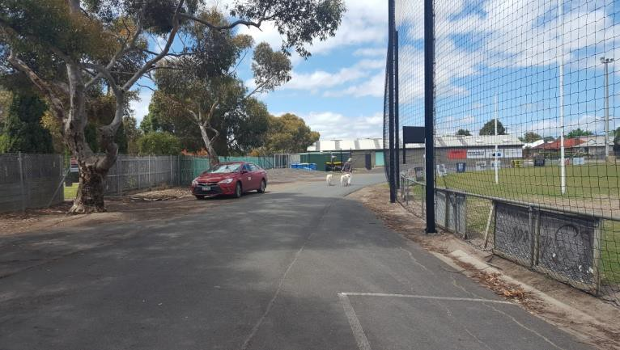
Lack of defined pedestrian paths to north of Walker Oval

2.3.10 Pedestrian Access Issues and Considerations for the Master Plan
- There is an opportunity to provide a formal pedestrian circulation system, integrated with potential improvements to vehicle circulation and parking to enhance pedestrian safety and amenity.
- The opportunity to improve the connection between the netball courts and the main clubrooms should be investigated.

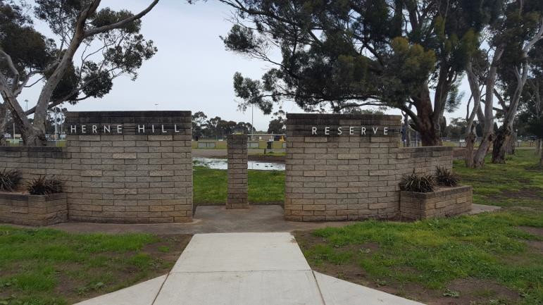
No pedestrian connection to street path network.

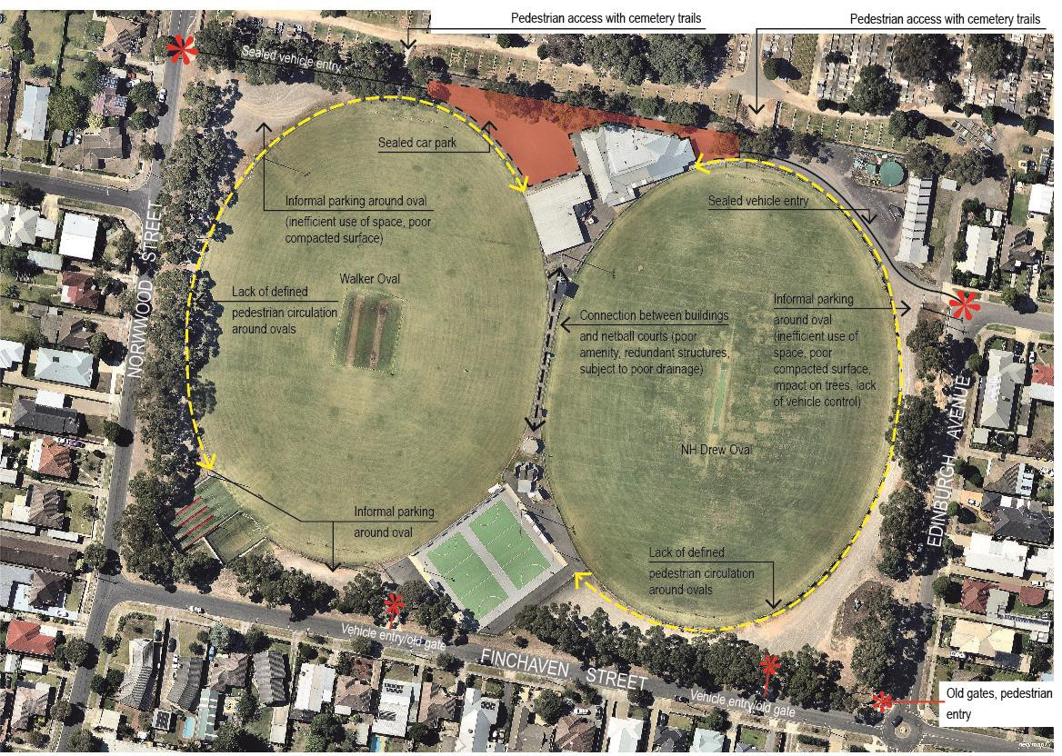
FIGURE 9: HERNE HILL RESERVE SITE CIRCULATION

2.3.11 Landscape and Passive Recreation Areas
Key points arising from the review of the existing landscape and passive recreation areas of the reserve are summarised on Figure 10 on page 40. These points include:
- The reserve is lined on each of its street frontages by mature Eucalyptus cladocalyx (Sugar Gum). While these plantations provide a strong definition of the reserve boundary, as well as useful shade, they are mature trees which are close to, or have reached a senescent stage of development. There is evidence of limb drop from a number of specimens.
- Apart from the lines of Sugar Gums there are no established or mature trees within the reserve to provide shade or visual landscape amenity.
- There is a small existing playground near the south-eastern corner of the reserve. The equipment in this playground is old and out of date.
- There is no park furniture or amenities, such as seats, shelters or bicycle racks across the reserve.
- Passive recreation areas are not well defined and are often use for vehicle parking.
- Remnants of three former entry gates into the reserve are located at the corner of Finchaven Street and Edinburgh Avenue, and along Finchaven Street at the locations highlighted on Figure 9.
2.3.12 Landscape and Passive Recreation Issues and Considerations for the Master Plan
- There is an opportunity to re-define the visual landscape of the reserve in line with City of Greater Geelong strategic directions, given the senescent condition of the existing Sugar Gums.
- The potential to provide enhanced opportunities for passive recreation should be explored, in line with the objectives of City of Greater Geelong strategic documents. This would include opportunities for play, walking, seating, group socialising and picnicking.
- Enhancement of the existing landscape and passive recreation opportunities should be considered along with improvement to reserve drainage and vehicle circulation and parking. This extends to the opportunity to redefine areas for quality and safely accessible passive recreation.

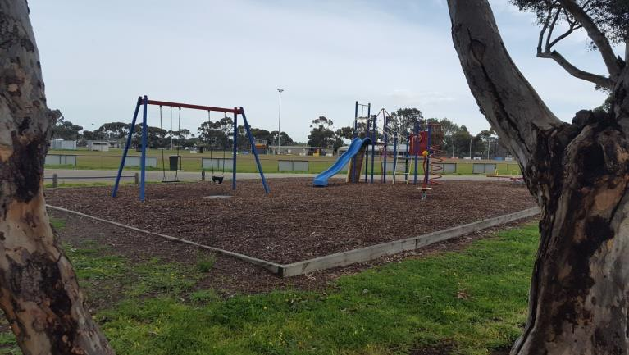
Playground in south-eastern corner of reserve

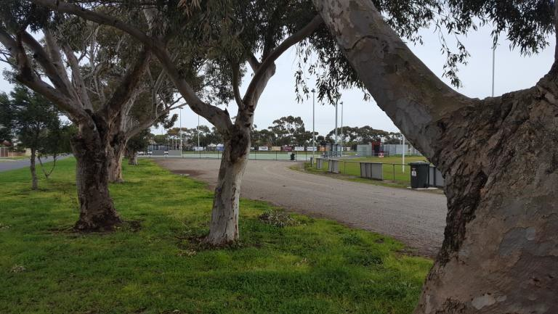
Sugar Gums along Finchaven Street edge of reserve

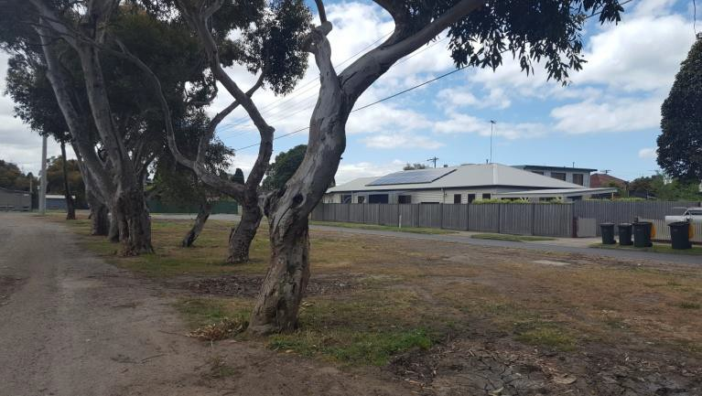
Sugar Gums along Edinburgh Avenue edge of reserve

FIGURE 10: HERNE HILL RESERVE LANDSCAPE AND PASSIVE RECREATION AREAS
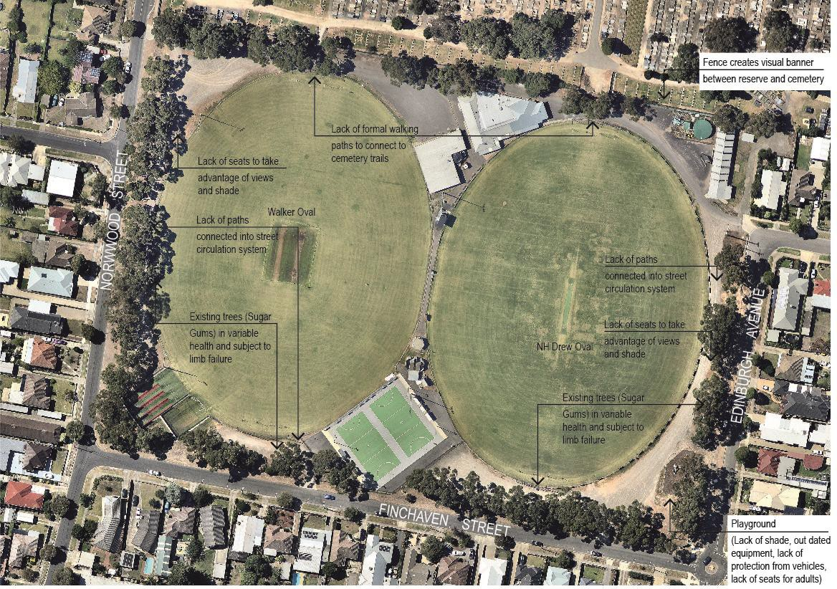

  - STAKEHOLDER AND COMMUNITY CONSULTATION

The first round of community consultation, to inform the identification of needs, issues and opportunities involved four key avenues and as they aligned with the project governance structure:
- Interviews and regular meetings with tenant clubs (Project Reference Group 1)
- Interviews and workshop with governing sports associations (Project Reference Group 2)
- Survey of immediate residents (400 households), and
- Discussions and workshops with relevant technical City officers and managers (Project Steering Group)
The next phase of community engagement consisted of the broader community to have opportunity to provide some commentary on the draft masterplan:
- Letter drop to all residents within a 400m radius of the Herne Hill Reserve, providing a range of opportunities to provide comment and submission.
- The Herne Hill Master Plan was also available via the geelongaustralia.com.au website to provide the opportunity for the broader community to make comment.
The following section provides a summary of each stakeholder groups needs and aspirations as they relate to the development and improvement of Herne Hill Reserve.

Tenant Clubs (Project Reference Group 1)
Individual and group meetings were held throughout the process from December 2016 to May 2018 with representative members of each of the tenant clubs. The purpose of these meetings was to understand the current activities of each tenant and, particularly, their needs and aspirations for the future which could be considered within the master plan.
Each of the meetings covered a range of topics and at key stages throughout master plan development. Key directions, ideas and priorities arising from each of the clubs is provided following.

St Joseph’s Football and Netball Club
The following provides a summary of the football and netball club needs, preferences and aspirations:
Big Ideas
- Opportunity to move netball courts to improve connections / consolidate the number of buildings.
- Audit of existing buildings to provide an understanding of current conditions, lifespan, opportunities for redevelopment (What are the opportunities for renovating?).
- Suggested netball change facility could be integrated and smaller if existing pavilions were upgraded / new.
- Opportunity to improve the connection between the ovals.
- Opportunity to reduce Walker Oval in size to accommodate a wider central connection.
- Improving drainage would improve use of car-parking, access to buildings, interchange runout, use of oval 2 (Walker Oval).
- Opportunity to formalise car parking for more efficient use.
- Scout Hall could go if the gym could be relocated.
- Could tender for finals if the reserve was fenced (for ticketing).
- Opportunity to share building with cricket club has been discussed in a preliminary manner.
- No parking around netball – people would need to come back past club rooms.
- Opportunity for swipe access to buildings to address immediate access / security problems.
- Opportunity to improve link through the cemetery.
- Old scoreboard could go as there is a new one recently built.

Primary Priorities
- Netball: change rooms / toilets and showers / storage / administration / umpires rooms / first aid.
- General: improve drainage.
- General: formalisation / improvement of parking.
- Football: opposition coaches box.
- Football: 2 coaches boxes for juniors.

Secondary Priorities
- General: connection of netball facilities with main pavilion.
- Football: gym relocated.

St Joseph’s Football Netball Club also submitted plans demonstrating their desired infrastructure outcomes for a standalone netball change facility, known as ‘The Wedge’, this was noted as the non-preferred option due to a number of standalone facilities already existing on site.

St Peters Cricket Club
The following provides a summary of the cricket club needs, preferences and aspirations:
Big Ideas
- Shelters at the netball courts could be spread out to allow room for scorers’ box to service cricket.
- Retention of viewing space to western oval in any new community pavilion
- Provision of kiosk/canteen facilities in western viewing area
- Audit of existing buildings to provide an understanding of current conditions, lifespan, opportunities for redevelopment (What is the potential for renovating / converting?).
- Improve the connection between the ovals and create a thoroughfare.
- Improving drainage would improve use of car parking, access to buildings, interchange run out, use of oval 2 (Walker Oval).
- Formalise car parking for more efficient use.
- Opportunity to build underground car park to provide additional car spaces without compromising open space.
- Opportunity to build a storage shed at the rear of the cricket nets.
- Opportunity to build an indoor / covered training space.
- Opportunity to change the sub-base of the oval to sand.
- Opportunity to re-grade oval to improve its fall.
- Opportunity to install underground drainage to alleviate drainage issues on oval 2 (Walker Oval).
- Opportunity to seal car park and integrate drainage solution.
- Joint building tenants with football netball club. Some discussions with SJFNC about this but very preliminary and concerns raised over what shared use looks like.
- Opportunity to convert cricket pavilion into change facilities and build a second storey social space.
- Opportunity to knock down existing building and build new two storey pavilion that addresses everyone’s needs.

Priorities (in order of preference)
- Address drainage solutions on ovals and surrounds.
- Storage shed at cricket nets (min 32sqm).
- Change room refurbishment (of existing).
- Gender neutral change facilities (female friendly and more of them).
- Car park sealing and formalisation and improvements to playground and surrounds.
- Sub-base of ovals, preference for sand.
- New pavilion (including an indoor training space).

Joint Club Submission
St Joseph’s Football and Netball Club and St Peters Cricket Club also met to prepare a joint submission to inform the master plan process.
The key shared priorities arising out of this joint submission were:
- Futureproofing
- Vastly improved drainage
- Contemporary change rooms, training facilities, arenas and lighting which meet the independent criteria for impaired and able-bodied competitors and umpires of both sexes as set by Cricket Australia, Netball Australia and Australian Football League.
- Contemporary, distinct, fit for purpose and accessible allied amenities for each sporting section inclusive of:
  - Administration
  - Storage – Merchandise Equipment
  - Officials – Umpires, Scorers, Timekeepers, Coaches boxes, Interchange
  - Scoreboards
- Engagement – Improved car parking, spectator seating, spectator viewing
- Connectivity and accessibility
- Commercial functionality
- Community Use
- Beautification, and
- Overall affordability to deliver proposed outcomes.

The key potential solutions outlined in the joint submission involved two linked actions:
- 1. Two storey main building incorporating the prioritised amenities identified above, and
- 2. Netball court relocation

Sports Associations (Project Reference Group 2)
A combined meeting and workshop was held on 1st February 2017 with representatives from AFL Barwon, Cricket Victoria and Netball Victoria. The primary purpose of the meetings was to understand the level of facilities which the association would view as appropriate at Herne Hill Reserve, given the level of competition which is played there, as well as any future aspirations the associations may have for the reserve.
In addition to each association facility development guidelines, strategies and specifications, each were represented by their respective regional managers. AFL Barwon was represented by Lee Hartman and Katie Geerings. Netball Victoria was represented by Melanie Taylor and Cricket Victoria was represented by Julie Allan.
Meetings covered a range of topics however, the key directions raised by each association as key considerations for the master plan are summarised below:

AFL Barwon
- Facilities should be provided in accordance with the current AFL Preferred Facility Guidelines for State, Regional and Local facilities – August 2012, including the current Appendix addressing female change facilities.
- Herne Hill Reserve is not considered a regional ground by AFL Barwon. It would not therefore be scheduled for senior finals and does not require permanent fencing. While it is used for junior finals these are not ticketed and so do not require fencing.
- It was noted that there are currently three (3) girls AFL teams fielded by St Joseph’s Football and Netball Club, which are growing and are intended to lead into open
women’s competition in coming years.
- Girls’ games are currently scheduled on Sundays, separate from netball and both senior and junior male football competition, although the future direction is leaning towards scheduling boys and girl’s games on the same day, therefore requiring greater change room capacity and preference for unisex change facilities.
- The current gym facilities at Herne Hill Reserve are adequate but not ideal.

Netball Victoria
- Facilities should be provided in accordance with current Netball Australia National Facilities Policy (March 2016).
- Change facilities required are home team change, away team change and umpire change and could be part of improved facilities in a central building.
- Required courtside facilities are first aid equipment, accessible toilet, storage area, water and shelter.
- Current facility provision guidelines do not specify change facility proximity to courts.

Cricket Victoria
- Facilities should be provided in accordance with Cricket Australia Community Cricket Guidelines (2015).
- Fencing of reserve not preferred.
- AFL change room provision guidelines will be adequate for cricket requirements.
- Walker Oval could be made marginally smaller, but 50m radius from popping crease remains as minimum playing field dimension (refer Cricket Australia Community Cricket Guidelines, 2015).
- Improved drainage on Walker Oval would lead to an improved turf table.

Sports Association Collection Preferences and Priorities
- Total change room requirement – 2 AFL home team change, 2 AFL away team change, 1 netball home team change, 1 netball away team change – 6 change rooms sufficient, while 8 would be preferred. Suggested mix would be adequate for cricket use also. Note: In recognition of the site and the size of the clubs, the recommended provision is greater than specified in the guidelines for a community level facility.
- Improved connection between netball courts and main pavilion, to provide a wider, more direct and higher amenity access.
- Minor revision of size of ovals (particularly Walker Oval) was seen as raising no obvious issues.
- Highest Priorities - improvement in car parking, improved female friendly amenities and improved drainage (including Walker Oval).

Immediate Residents
A survey of the local community was undertaken between 13th January 2017 and 13th February 2017. A letterbox drop and online survey was distributed to local residents of Herne Hill Reserve to gauge the usage behaviours, needs and aspirations of the local community. A postcard advising survey was delivered to 400 households and 46 responses were received. These insights have been included in the development of the Master Plan.
The survey asked simple questions with a view to understanding how the local community views Herne Hill Reserve, especially what they appreciate about the reserve, how the use it and how they would like to see it improved.
In total 46 responses were received. Of these respondents, 7 were members of tenant clubs. A copy of the survey questions along with the summary report is included in Appendix 1.
Overwhelmingly, participants saw the reserve as their backyard and any future design needs to encourage and support informal activities such as walking, sitting, play and exercise, while still balancing the needs of the tenant clubs.
In terms of priorities, some participants raised ideas around improved infrastructure to support a more comfortable environment. Examples were more seating, shade and improved public toilets. A few participants specifically requested that these improvements be provided across the whole reserve, and not just concentrated around the children's play area, to be more inclusive of all ages / activities (including dog walkers). Others talked about the need to improve the landscaping and appearance of the park, car parking and traffic management.
Residents who also access the sporting facilities wanted to see improvements to the playing fields and club infrastructure such toilets, club rooms, car parking and for the drainage to be improved to reduce impacts of flooding.
Overall the key opportunities for the reserve, as identified by local residents, could be grouped into five key themes:
- Improve / upgrade the existing playground
- Increase the amount / quality of seating, shade and walking paths to be more inclusive and welcoming of all ages and activities
- Improve infrastructure to better support sporting club activities
- Improve landscaping and appearance of the reserve, and
- Improve car parking and traffic management

A detailed summary of the Local Resident Survey can be found in Appendix 1.

Internal Stakeholders and Departments
Several meetings and workshop discussions were held with City of Greater Geelong officers in reviewing the site and understanding the issues and opportunities to be addressed by the master plan.
Discussions were held with representatives of the following the City’s technical departments that formed the Project Steering Group:
- Recreation and Open Space (Now known as Social Planning and Investment and Connected Communities) – Inclusive of Asset Management
- Engineering Services – Infrastructure Management (Drainage) Unit
- Parks and Gardens
- City Services – Tree Management Unit
- Property and Procurement
- Strategy and Engagement

A summary of key considerations and directions arising from these discussions are provided below:
- The City supports consolidation of buildings and encourages shared uses, over the construction of new single use facilities.
- All recommendations and options need to explore the repurposing and/or enhancement of existing infrastructure or alternatively new built infrastructure.
- Ensure recommendations consider flexible, multiuser opportunities.
- All recommendations need to be considered in relation to the increasing cost of on-going management of the City’s assets across the municipality.
- All recommendations need to be considered in relation to equity of asset provision across the municipality. At Herne Hill Reserve this will mean aligning future plans with the standard provision for a community level facility and with associated levels of service, although notwithstanding being fit-for-purpose.

- Acknowledge error in G21 and AFL Barwon Regional Strategy 2015 facility audit and subsequent inventory (page 21) where netball change facilities (netball amenities) are reported as ‘0’ or no provision. The refurbished netball change rooms were opened in 2011 and were misidentified as they were being used as drink fridge storage at the time of the audit. The City has been reassured that this will be corrected in the next facility audit.
- Provision for play should reflect a local catchment. The reserve is not considered a district park and therefore does not technically require a public toilet.
- Drainage of both Walker Oval and the perimeter crushed rock areas is a key issue on the site, impacting both sporting surfaces and general use of the reserve.
- Formalisation of circulation and car parking is an opportunity to resolve drainage issues, control vehicle movement and provide improved pedestrian safety and amenity.
- Formalisation and enhancement of the connection from the netball courts to the clubrooms is an opportunity to enhance circulation and address drainage issues.
- Investigate occupancy status of existing Scout Hall facility to ensure appropriate land lease is in place following disbandment of previous tenant, the Scout Group and recent occupancy of the St Joseph’s Football Netball Club.
- Minor revision of the size of ovals (particularly Walker Oval) is an opportunity to enhance circulation and drainage.
- All future and/or improvement of change facilities should be gender neutral, meaning female friendly as standard.
- The existing perimeter Sugar Gums are mature and have a poor Useful Life Expectancy, presenting issues associated with limb drop and grass growth beneath. Replacement of the trees is an opportunity to enhance amenity and formalise circulation. It is recommended that tree replacement program be completed in stages to ensure transition over time.
- Key opportunities to enhance amenity within the reserve include construction of pedestrian paths, provision of shaded seating and enhance of play and passive recreation opportunities.
- A final pavilion design will need to be supported by all tenant clubs prior to any building works commencing

2.4.5 Stakeholder Issues and Considerations for the Master Plan Issues
- Lack of adequate change facilities and amenities for female sport
- Lack of suitable cricket specific storage facilities
- Lack of game day facilities for AFL (i.e. interchange bench and coaches boxes)
- Netball courts not directly connected to clubrooms and amenities
- Poor drainage of Walker Oval and across reserve
- Public toilets in poor condition and unsafe
- Existing playground dated and lacking amenity
- Existing trees senescent and hazardous
- Parking and vehicle movement uncontrolled
- Pedestrian movement not provided for
- No passive recreation amenities
Opportunities
- Provide consolidated shared facilities to meet needs of all users
- Provide a viewing area and associated kiosk/canteen on western end of new pavilion to accommodate for cricket match days
- Provide improved amenity and passive recreation / play opportunities for local neighbourhood
- Enhance connection to other open space and encourage walking
- Enhance the existing landscape to provide shade, habitat and improved landscape character
- Improve all abilities and ages access to recreation
- A final pavilion design will need to be supported by all tenant clubs prior to any building works commencing

MASTER PLAN PRINCIPLES
In reviewing the planning and policy context, site and facilities considerations along with the needs, preferences and aspirations of key stakeholders, the following principles we developed to guide the preparation of the Herne Hill Reserve Master Plan.

CONSOLIDATE BUILT FORM
- New built facilities and improved existing facilities at the reserve should encourage shared use i.e. use by a number of different groups and activities.
- New built facilities should consolidate built form to minimise management and maintenance expense, while providing an enhanced and connected facility for the benefit of all users
- A final pavilion design will need to be supported by all tenant clubs prior to any building works commencing
- There is a need for the viewing area facing Walker oval to be expanded and reconfigured to provide sufficient space to suitably accommodate 50-60 spectators during match times.
- Design options to achieve the above may include consolidation and relocation of first aid facilities, player and umpire amenities, but should seek to minimise any net increase in overall pavilion footprint.
- The existing lounge and east facing viewing area within the St Joseph’s Football and Netball Club pavilion will serve as the primary social space within the pavilion as well as the primary viewing area for matches played on NH Drew Oval.
- Council does not support duplication of kitchen and bar facilities, but accepts the club may seek to provide basic fridge and canteen facilities to service the viewing area at their own cost.

IMPROVE ACCESS AND SAFTEY
- On-going development of the reserve should encourage pedestrian access to and within the reserve, while ensuring that required vehicle access remains safe and viable.
- Ongoing development of the reserve should focus on designing infrastructure that increases public safety and amenity.

MAKE FIT FOR PURPOSE
- On-going enhancement of the reserve should balance the range of identified reserve users’ needs and identify facilities which are of an appropriate level for year-round use of the reserve (i.e. change facilities that satisfy AFL, cricket and netball guidelines.
- On-going development of the reserve should reflect the core aspirations of the community and key stakeholders, expressed through the consultation process.

PROVIDE AND PROTECT OPEN SPACE
- On-going development of the reserve should focus on the enhancement of facilities and landscape to support both active sport and passive recreation activities.
- On-going enhancement of active and passive recreation facilities and spaces should recognise the broader context of the reserve and contribute to a spectrum of open space uses for the local neighbourhood.

ENSURE FINANCIAL VIABILITY AND SUSTAINBILITY
- On-going development should respond to Council budgets and on-going financial feasibility for management.

COMPONENTS AND DESIGN BRIEF
In reviewing the planning and policy context, site and facilities considerations along with the needs, preferences and aspirations of key stakeholders and in response to the agreed principles, the following components and design brief was developed to guide the preparation of the Herne Hill Reserve Master Plan.

 TABLE 01 – SITE LAYOUT NEEDS AND RECOMMENDED REPONSE

SITE LAYOUT ISSUES AND OPPORTUNITIES | RECOMMENDED RESPONSE
Sports Facilities and Infrastructure
- Provision of appropriate netball courtside facilities  - Provision of cricket equipment storage facilities  - Enhancement of drainage within Walker Oval  - Provision of coaches and interchange facilities in accordance with AFL guidelines  - Provision of gender neutral change facilities | - Lockable shelter with first aid, access to water, storage space and dry-change area to eastern side of netball courts  - Space for demountable seating to western side of netball courts  - Lockable storage shed, with access to power, located next to cricket training nets  - Provision of perimeter spoon drainage to both fields, in conjunction with new sealed path (refer below)  - Find alternative fridge storage and reinstate netball change facilities for immediate use. Integrate gender neutral change facilities in all proposed new change facilities and/or retrofit existing change facilities to be gender neutral in provision (at a minimum).
Pedestrian Access and Circulation
- Provide a formal pedestrian circulation system, integrated with potential improvements to vehicle circulation and parking to enhance pedestrian safety and amenity  - Improve the connection between the netball courts and the main clubrooms | - Provide a sealed path of both ovals, including sealed connection between oval.  - Investigate the potential to remove structures along this connection to provide greater passive surveillance and improve proximity.  - Widen access between ovals through reduction in Walker Oval by 1500mm (noting both ovals are oversized).  - Provide a sealed path adjoining streets to the proposed oval perimeter path network.

SITE LAYOUT ISSUES AND OPPORTUNITIES | RECOMMENDED RESPONSE
Vehicle Access and Parking
- Provide formalised car parking around both fields (where appropriate)  - Provide formalised parking along adjoining streets  - Consider traffic management measures to control vehicle movement and enhance pedestrian safety | - Provide formal parking internally, asphalt surface, drainage to oval edge and integrated with oval perimeter drainage.  - Provide formal parking externally, on adjoining streets, asphalt surface, indented parallel parking to create additional capacity while keeping streets clear.  - Provide speed humps at intervals along driveways  - Provide vehicle intrusion barriers (e.g. low fence or other fixtures) to perimeter of reserve to control vehicle access
Landscape and Passive Recreation
- Opportunity to redefine the visual landscape of the reserve  - Remove senescent trees and replace with new high canopy varieties  - Provide enhanced opportunities for passive recreation as a priority  - Enhancement of the existing landscape and passive recreation should be integrated with reserve drainage and vehicle circulation and parking. | - Remove existing trees over time and replace with new planting in response to parking and path layouts. Consider high canopy varieties that provide shade while allowing passive surveillance throughout the reserve  - Provide a new passive recreation space in the south-eastern corner of the reserve and on the western edge of the reserve.  - Replace playground equipment and provide a new playground in the south-eastern corner  - Provide and integrate new seating and shelter locations with path alignments  - Retain provision of a public toilet in the reserve and replace existing facilities with a new public toilet integrated with netball courtside facilities.

- MASTER PLAN
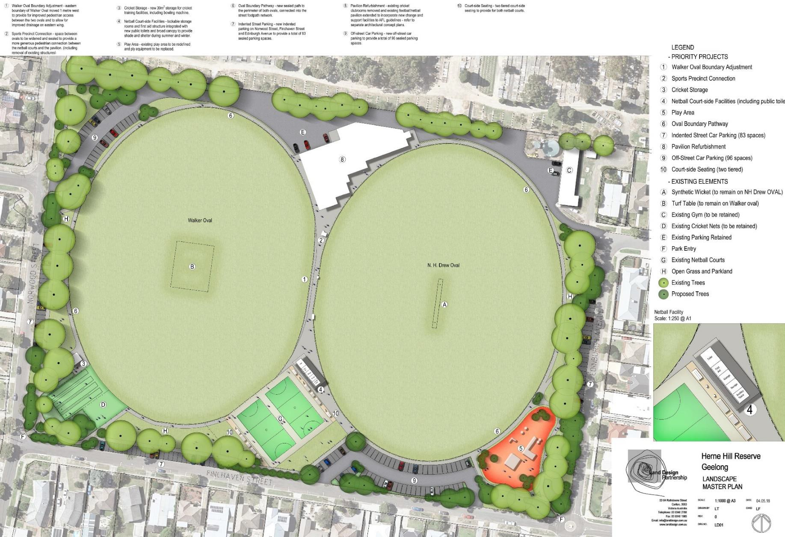
  - LANDSCAPE PLAN

  - PAVILION DEVELOPMENT CONCEPT PLAN
The current pavilion concept as shown below is considered a high level planning diagram which illustrates the general connections and relationships between the various spaces and facilities to be delivered. As a high level concept, it is understood that further design work needs to be undertaken in a collaborative fashion with all tenant sporting clubs to refine the pavilion layout. It is Councils intention to achieve a final pavilion design that is supported and valued by all clubs and meets the functional needs of the various user groups.

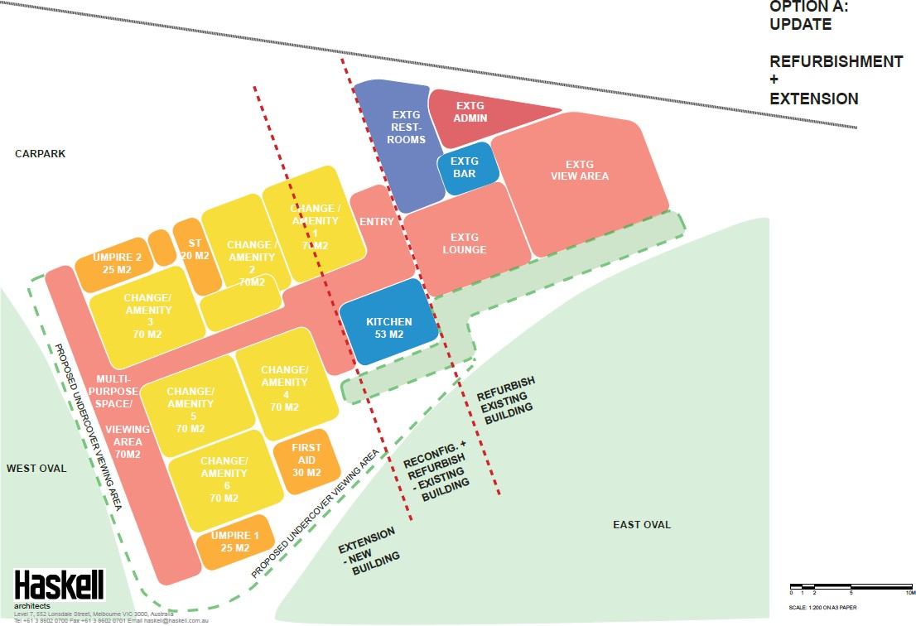

  - PROPOSED PRIORITY STAGING AND COST ESTIMATES

Priority Staging and Cost Estimates
Table 02 provides a summary of key elements of the overall Master Plan, cost estimates and associated priority staging. As per the visual representation of the Herne Hill Reserve Master Plan and Pavilion Concept Design is provided in section 7.1 and 7.2 respectively.

 TABLE 02 – PRIORITY STAGING AND COST ESTIMATES (PROPOSED)

PRIORITY STAGING | ITEMS | COST ESTIMATE
1 | A. Oval boundary, drainage solution and parkland paths* | $100,000
 | B. Sports precinct connection (including removal of existing decrepit buildings) | $150,000
 | C. Netball courtside support facilities (including public toilet) | $150,000
 | D. New cricket net storage (next to cricket nets) | $30,000
2 | E. New playground and formalise passive recreational area | $200,000
 | F. New street parking and parkland improvement | $200,000
 | G. Pavilion refurbishment and significant extension (including removal and integration of St Peter’s Cricket Club pavilion) | $3,000,000
 | H. New internal parking | $350,000
Total |  | $4,180,000
*completed as part of the 2017/18 budget

Interim Measures and Stage One Priority
The key and most significant deliverable is the new pavilion (refer item G in Table 02), to be shared by both clubs during their respective seasons. This will meet the needs of all clubs. A significant element of the new pavilion is the delivery of 6 gender neutral change facilities which will enable the growth and development of female participation in netball, football and cricket.
In response to the immediate pressures experienced by tenant clubs, stage one measures have been allocated in the 2018/19 Council Budget at a cost of $500,000.
The stage one measures include the delivery of:
- Item A - Walker Oval boundary realignment, drainage solution and formalise pathways between ovals (completed as part of 2017/18 budget).
- Items B, C and D - Sports precinct connection (including removal of existing decrepit buildings) and construct netball courtside support facilities (including public toilet). An important note being that this facility will remain a permanent facility for the reserve and clubs (combined cost estimate $300,000, 2018/19 budget). New cricket storage (next to cricket nets). Also, a permanent installation (cost estimate $30,000, 2018/19 budget).
In addition to the following interim measure;
An interim retrofit to meet the immediate needs of the St Joseph’s Football and Netball Club to provide gender neutral change facilities in St Joseph’s FNC existing change room provision (cost estimate $170,000, 2018/19 budget).

Funding Strategy
An investment of $500K for the delivery of initial priority stages relating to the Master Plan has been allocated in the 2018/19 draft Council budget, including some interim works to provide suitable female friendly change facilities.
It is proposed that the delivery of remaining stages would be achieved via a funding partnership between the state government, local sporting clubs and the City of Greater Geelong.

NEXT STEPS
Subject to Council endorsement of the Herne Hill Reserve Master Plan, the next phase will be to undertake detailed design of the community pavilion through a submission to Council’s 2019/20 Budget. Furthermore, the $500,000 noted within Council’s 2018/19 Budget for the netball court side facility, oval drainage and retrofitting of showers and toilets in existing pavilion to unisex compliance will be undertaken. No further funding has been allocated at the time of writing this report.

APPENDIX
Appendix 1 – Local Resident Survey and Summary Report
Appendix 2 – Herne Hill Reserve – Landscape Plan
Appendix 3 – Herne Hill Reserve – Draft Pavilion Concept Diagram

Appendix 1 – Local Resident Survey and Summary Report

Improve/upgrade the existing playground
Example comments included:
  - “Definitely a half descent playground to attract more children and families to the reserve. Something more along the lines of Sparrow Park in Geelong West”.
  - “Improve the playground”
  - “Bigger playground with some shelter and a picnic area”
  - “More choice with regard to the playground equipment.”

Increase the amount/quality of seating, shade and walking paths to be more welcoming and inclusive of all ages and activities
Example comments included:
  - “Some seating or even a table somewhere to just sit down and relax. I've just gone down to the park to get some sun and away from the home office and end up on the playground”.
  - “To keep the reserve dog friendly”
  - “Dog drinking tap, maybe near toilet block this would be central”
  - “Update public toilets”
  - “Roller skating path”
  - “Making sure all have access to the grounds for sport and exercise”

Improve infrastructure to better support sporting club activities
Example comments included:
  - “Playing surface”
  - “Making sure the ground is right for sport”
  - “New toilet facilities closer to the netball courts. Current toilets are very old and are not suitable especially for younger girls”
- “The netball players need a modern appropriate building to house change rooms, toilets, showers, and meeting spaces. This needs to be adjacent to the netball courts”
Continued…
- “Stop the huge puddles around the oval in winter. Norwood St and Finchaven St sides”
- “Making certain that utilities, men’s, women’s toilets are modern and funding for regular hygiene activities are undertaken”.
- “Facilities need to be upgraded”
- “Changing rooms for the Netballers”

Improve landscaping and appearance of the reserve
Example comments included:
- “Updating it, it looks worn and old”
- “The Reserve as a whole looks dated so anything in the way of an upgrade would do wonders for it.”
- “Possibly a fence around the reserve or an oval to help keep dogs and kids safe”
- “More rubbish bins. I walk passed the reserve 3-4 times per week and there is often rubbish and alcohol bottle left all over the place”
- “Keep the gum trees manageable. The road in winter is very muddy”
- “Getting rid of dangerous trees”
- “More planting. Trees and shrubs. Improve drainage Cnr Edinburgh and Hilltop Area gets very muddy after rain”
- “Beautifying the surrounds. More trees or shrubs. Better walking paths”
- “Trees need changing - the ones here drop branches all the time”
- “The Sugar Gums around the perimeter are ageing and frequently drop limbs. Can they be brought back from the brink yet again or should some be replaced with suitable trees for shade etc?”

  - “Pressure wash the signs. :) They are cool and of an era and shouldn't be removed, but a pressure wash would go a long way. Please keep them though
- it's a nice touch and makes it feel homely”
  - “Lighting”
  - “Powered lighting and supply is solar power, independent of grid”

Improve car parking and traffic management
Example comments included:
  - “Off street parking”
  - “Fix the car park drainage”
  - “Improved parking. When football or cricket is on it is very difficult to drive past as there are usually cars parked on both sides of the road”
  - “Allocated parking for spectators”
  - “Traffic flows & parking issues in nearby streets during high peak use, football season”
  - “To stop vehicles using it as a thoroughfare between Norwood St and Edinburgh Ave”
  - “More safe walking areas with some seating along the way and make the children's place area safer from traffic.”

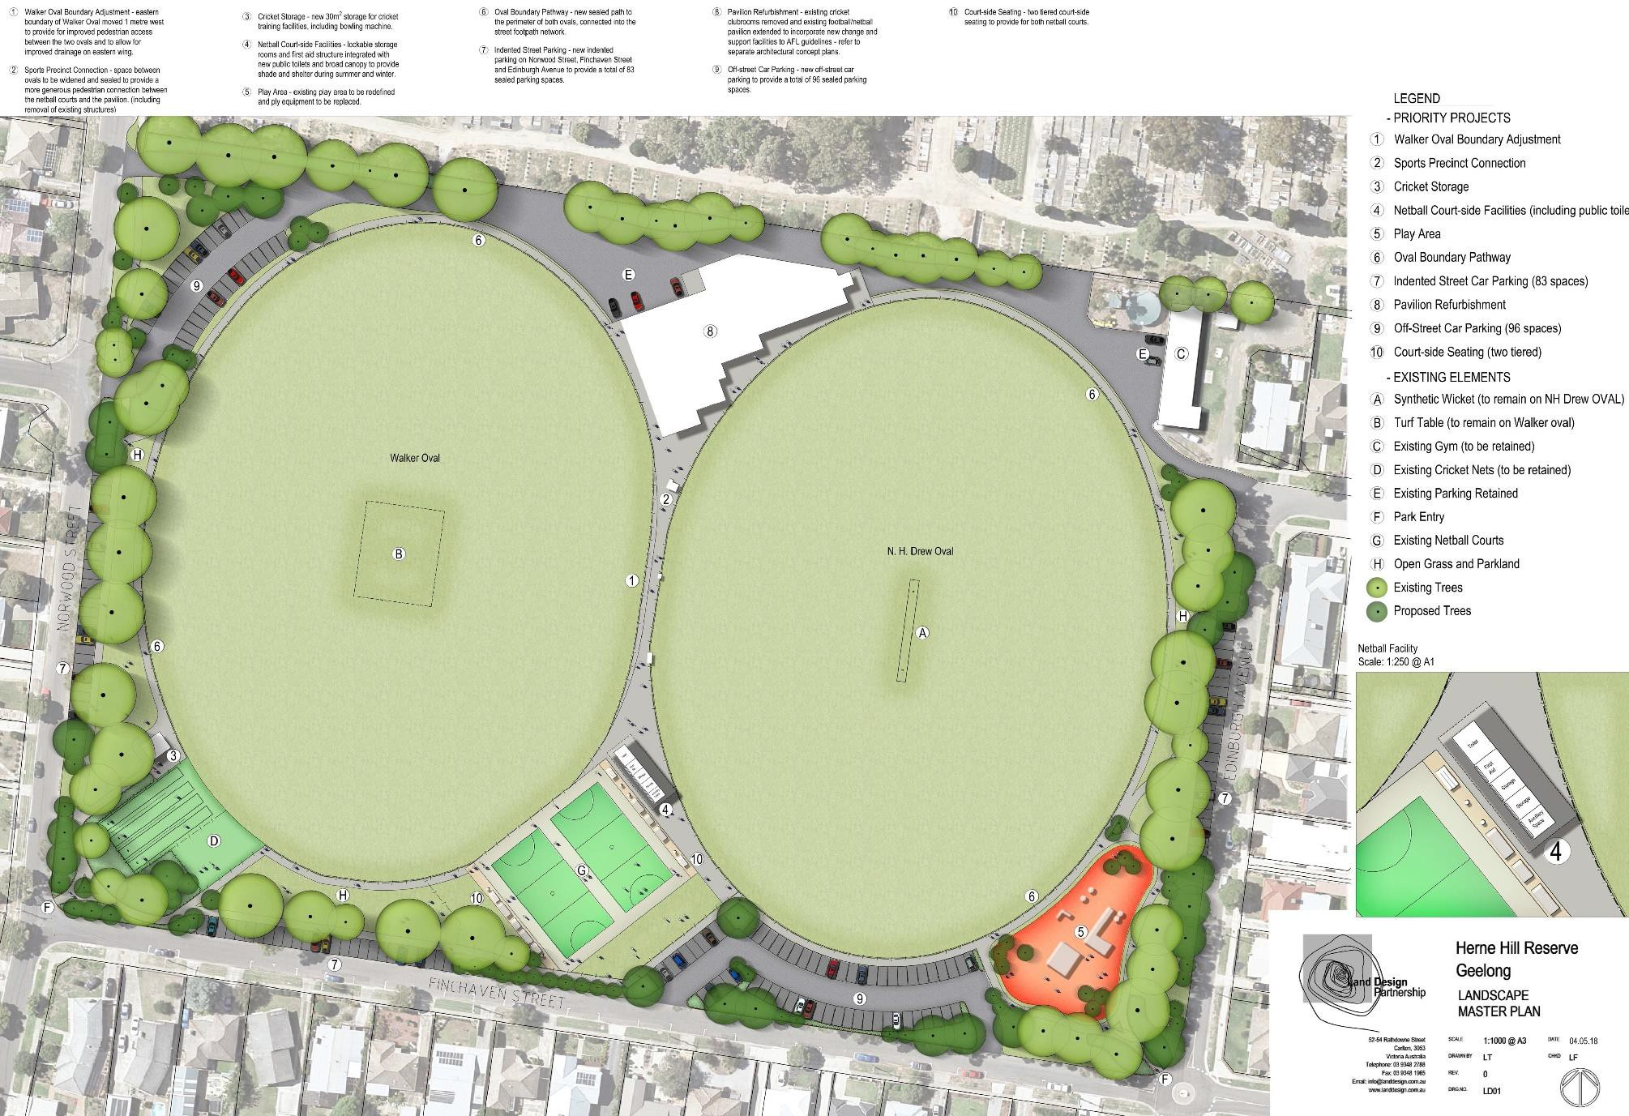
Appendix 2 – Herne Hill Reserve – Landscape Plan

Appendix 3 – Herne Hill Reserve – Draft Pavilion Concept Diagram
The current pavilion concept as shown below is considered a high level planning diagram which illustrates the general connections and relationships between the various spaces and facilities to be delivered. As a high level concept, it is understood that further design work needs to be undertaken in a collaborative fashion with all tenant sporting clubs to refine the pavilion layout. It is Councils intention to achieve a final pavilion design that is supported and valued by all clubs and meets the functional needs of the various user groups.

